Abstract:

This project is analysis and design for garage concrete structure.
This garage is for Pal-Tal Company, its 3 stories, each story with area about 1460$m^{2}$, and its capacity about 135 cars.
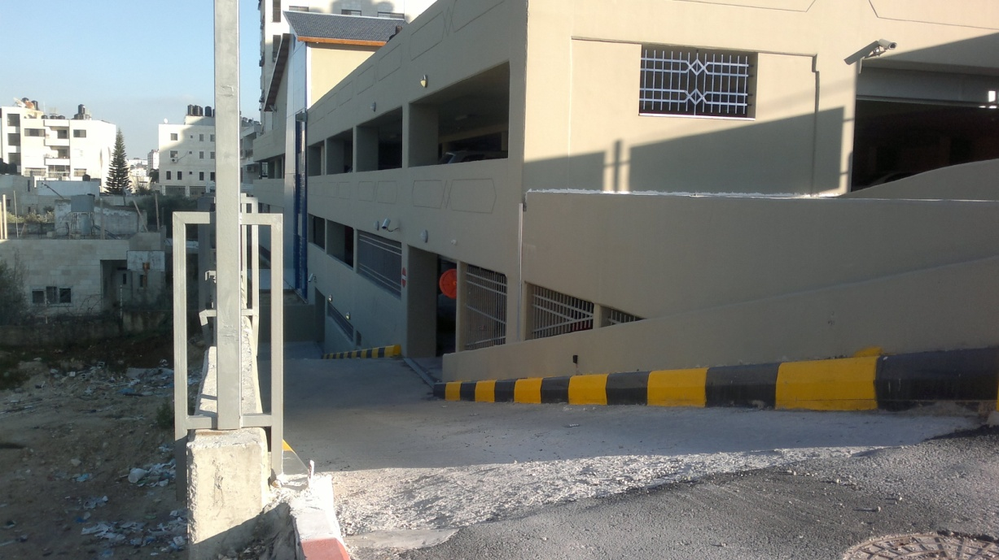
The purpose of this project is to design all structural components to provide:
- Safety.
- Valuable.
- Best cost.
To ensure the stability of that construction, the design should provide a safe way to transfer loads through all structural components.
The transfer of loads (cars, people and building self weight) will be through slabs, the slabs connect to the beams, the beams transfer through columns, the columns will transfer loads to the ground through the footings.
The parking garage is made from reinforced concrete. Reinforced concrete has been chosen because that mixture provides best properties, concrete offer a high level of resistance to strong winds and high temperature, more over protects the steel.
Components to design:
- Columns.
- Beams.
- Slaps.
- Footings.
- Retaining wall.
- Ramps.
- Bearing walls.
- Tie beams.
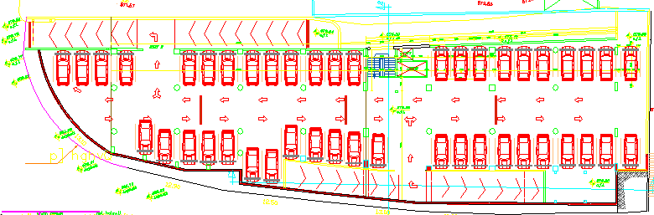
Figure a Architecture plan
Principles must be taken in consideration:

In this project, the code/specifications used for the design of the elements is the (ACI 318-08). American Concrete Institute. The different categories of the loads (Live and soil pressure) in this project will be taken from the ASCE07 code.

Columns are structural compression members which transmit loads from the upper floors to the lower levels and then to the soil through the foundations.
For manual column design will be using tributary area to calculate the load on each column.
1D analysis will be applied for manual beam and slab design; the design will be against shear and flexural loads.
1D and 3D analysis will be applied, and then compare between them.
3D analysis will be using computer software (SAP2000).
To ensure that the structure will be safe for all loading scenarios, we generate envelope from all possible load cases "envelope for moment and shear". SAP 2000 generates the envelope for each beam in the design process.

Since the height of retaining wall is about 9m, we chose a counter fort retaining wall to reduce the deflection in the wall.
We use tie beams because its decrease deferential settlement of the footing due to loads transfer from other elements of structure.

