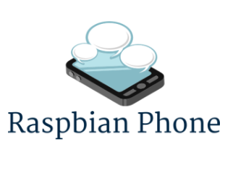


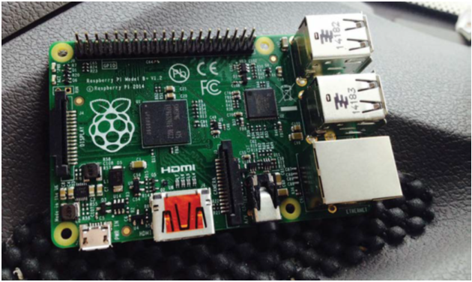
Raspberry Pi Phone Based Dedicated Applications
Tasbeeh Taysir Tawfiq Hamadneh(11525416)
Amon Hamed Ibrahem Bani Jaber(11525934)
Anagheem Ahmad Rajeh Hamad(11524577)
Dr. Saed Tarapiah

An- Najah National University
Faculty of Engineering
Technology Telecommunication and Electrical
Engineering Department
2019/2020
Table of Contents:
List of Figures iii
List of Abbreviations: vi
Abstract: vii
Problem Definition: viii
Literature Review: viii
Objectives: ix
Alternative Solution: ix
Report organization: ix
Chapter 1: Introduction 1
1.1 Overview: 1
1.1.1 Raspberry Pi 1
1.1.2 Raspberry Pi structure 3
1.1.3 The Raspberry Pi 3 Model B+ . 4
1.1.4 The Raspberry Pi operating system 5
1.1.5 The 20 Best Operating Systems For Raspberry Pi 5
1.1.6 Raspbian Operating System 6
Chapter 2: constraints and Standards: 7
2.1 Constraints: 7
2.2 Standard: 7
Chapter 3: Components and Programming 9
3.1 Hardware components: 9
3.2 Software Components: 14
3.2.1 Programming supported by Raspberry 14
3.2.2 Python program 15
Chepter4 : Proposal System : 16
Chapter 5: Methodology 17
5.1 Flow Chart: 17
5.2 Electronic: 20
5.2.1 Installing Raspbian and getting it up and running 20
5.2.2 Downloading Raspbian And Image Writer 20
5.2.3 Setting Up the Raspberry Pi 23
5.3 Mechanical 25
5.4 Electrical 25
5.5 Telecommunications 27
Chapter 6: SWOT and Estimated 28
6.1 SWOT analysis: 28
6.2 Feasibility Study 29
Chapter 7:Result and Discussion 29
Chapter 8: Conclusion and Recommendations 34
8.1: Conclusion 35
8.2: Recommendations 35
Bibliography 36

List of Figures
Figure 1: The Raspberry Pi 3Model B+ structure 4
Figure 2: The Raspberry Pi3 Model B+ 4
Figure 3: Raspbian Interface 6
Figure 4: The Raspberry Pi3 Model B+ 9
Figure 5: SanDisk (SD card) 9
Figure 6: The raspberry pi camera model 10
Figure 7: HDMI cable 11
Figure 8: DC-DC converter 11
Figure 9: FONA 12
Figure 10: Right-angle Mini GSM Quard Band Antenna 12
Figure 11: Lipoly Battery 12
Figure 12: Small electrical switch 13
Figure 13: SIM Card 13
Figure 14: Foam board 13
Figure 15: GPIO 14
Figure 16: Proposal System 16
Figure 17: Flow Chart 19
Figure 18: Raspbian operating systems 20
Figure 19: Memory card with letter F 21
Figure 20: Format Removable disk 21
Figure 21: Image Writing on SD card 22
Figure 22: Memory card in the Raspberry Pi panel 22
Figure 23: Power source (phone charger) 23
Figure 24: Raspberry configuration 23
Figure 25: Raspberry configuration 24
Figure 26: Raspberry configuration 24
Figure 27: How to configure Mobile 25
Figure 28: How to deliver the Power 26
Figure 29: How to deliver the GSM 26
Figure 30: SOWT analysis 28
Figure 31: Sexes 30
Figure 32: Age 30
Figure 33: Education level 30
Figure 34: Places of living 31
Figure 35: Storage capacity 31
Figure 36: Do you use all applications 31
Figure 37: Any OpeartingSystem Using 31
Figure 38: The number of hours that I spend using the smartphone 32
Figure 39: The reason for subscribers' use of a smartphone 32
Figure 40: Is it easy to use applications? 32
Figure 41: Are all the applications on the device using? 32
Figure 42: If yes, do you recommend using it? 33
Figure 43: Most used applications 33
Figure 44: Applications preferred and not available 33
Figure 45: Are there any unnecessary apps? 34
Figure 46: If not, what these apps do? 34

List of Abbreviations:
ARM: Acorn RISC Machine.
BCM: Band Corporal Major.
CSI: Camera Serial Interface.
DSI: Display Serial Interface port.
EMC: Electromagnetic Compatibility Directive.
ETSI: European Telecommunications Standards Institute.
GPIO: General-Purpose Input/ Output.
GPU: Graphics Processing Unit.
GSM: The Global System for Mobile Communications.
HDMI: High-Definition Multimedia Interface.
IOT: Internet Of Things.
LCD: Liquid-Crystal Display.
LXDE: Lightweight X11 Desktop Environment.
MSOL: Master of Science in Organizational Leadership.
OS: Operation System.
OSMC: Open Source Media Center.
PITFT: Thing Film Transistor Displays.
PIXEL: Pi Improved X-Window Environment.
PSP: Play Station Portable.
ROHS: Restriction of Hazardous Substances.
SIM: Subscriber Identity Module.
SoC: System On Chip.

Abstract:
The Raspberry Pi is a low-cost single-board computer which is nowadays become so popular. In this system we used a low-cost stand-alone device which transmits data using the Raspberry Pi and has a resistive touch screen display providing a user interface. The display contains a graphical user interface which provides data entry via an onscreen keyboard. Also, the system for the same has been developed in python environment which the default is programming environment provided by Raspberry Pi. Results show the efficient implementation of proposed system for smartphone. With a smartphone, waiting for things becomes less of a pain because you can keep yourself entertained. Having a smartphone makes it much more convenient to check your email, social media or even your bank account while on the go. But there are also limitations of smartphone because we cannot connect directly to a USB or Ethernet cable with our phone and other multiple devices. So, we provide the solution of that making pi phone using raspberry pi which is advancement in smartphone.

Problem Definition:
Evolution in the world as a whole tends to build or develop smart devices, especially smartphones. The development increases day by day and from a different place from somewhere. It has spread all over the world. So, the smartphone has become the primary thing in life. Given the effect of the lack of awareness and culture among most people on the use of applications that are made with the mobile phone, and the suffering of people from the high prices of these phones, we conducted a research to make a suitable mobile phone for these to solve these problems using making a mobile phone with a cheap Raspberry, and downloading the programs most used by people And their awareness of how to use for fear that there are applications that the person does not realize how dangerous it is to use them.

Literature Review:

Pi Phone - A Raspberry Pi based Cellphone [7] this paper they successfully designed smartphone using raspberry pi kit 3. In this they made Raspberry Pi 3 using cellphone. From this interfacing with different modules and also information of smartphone using raspberry pi. Pi phone –A Smartphone using Raspberry Pi [10] this paper they successfully designed smartphone using raspberry pi kit 3. In this they by using Raspberry made smartphone . From this interfacing with different modules and also information of smartphone using raspberry pi In order to connect and send messages, I must use the card and GSM, and for voice calls using the loudspeaker and microphone, Sometimes the wireless connection to the cell is lost, for example when you go to the ground. This means that the phone cannot make or receive calls until it is called again. GPS is used to track the location of the mobile phone and shows the current location of the phone using Google Earth. By combining these two works, we found that we can make a smartphone using Raspberry B+, to suit groups that suffer from high prices and the difficulty of using modern technology due to the lack of cultural technology.

Objectives:
Our project aims primarily to provide a simple and affordable low-cost mobile phone.

Alternative Solution:
We can use to connect to another phone using Raspberry and its related functions, and is appropriate for the applications they use.

Report organization:
- We will clarify is the first published Chapter, Introduction, Overview about Raspberry Pi, Raspberry pi structure, The Raspberry Pi 3 Model B +, The Raspberry pi operating system, The 20 Best Operating Systems for Raspberry Pi, Raspbian Operating System.
- We will clarify is the second published Chapter, Constraints and Standard.
- We will clarify is the third published Chapter, Software Components and Hardware Components and programming
- We will clarify is the fourth published Chapter, Proposal System.
- We will clarify is the fifth published Chapter, Methodology , Flow Chart , Electronic , Mechanical, Telecommunication, Electrical.
- We will clarify is the sixth published Chapter, SWOT and Feasibility study.
- We will clarify is the seventh published Chapter, Result And Discussion.
- We will clarify is the eighth published Chapter, Conclusion, Recommendations
- We will clarify is the ninth published Chapter, References.

Chapter 1: Introduction
After discussing the development and progress that is happening in the world, and from here to here. Has become engineering specialization the most in our live?
We were multidisciplinary, including Telecommunication Engineering, Electricity, Electronics, Computer and Information Technology, we are all talking about the impact of specialization in life. And programming languages ​​such as Python and Java, we find that software engineers do not approach their field of work from near or far in the field of control and electricity.
However, it was different from the appearance of the electronic piece called “Raspberry Pi”, a term that dissolved the boundaries between control science, electronics, electricity, operating systems, programming, communications and even the management of servers and all disciplines of information technology.
Because of this simple piece, we have merged together with one amazing document to change the world view of electrical and electronic devices and even the world of computers simultaneously.
In these humble pages, we will learn about this wonderful electronic masterpiece called Raspberry Pi, learn how it appeared to the world, how it affected it, what its possibilities, what we can do with it and Why are there 3 million of monthly searches on Google for that word “Raspberry Pi”.
1.1 Overview:
1.1.1 Raspberry Pi
The Raspberry Pi is an integrated computer made of a single chip that contains the traditional computer components: data processing CPU single-core 700 (MHz), graphics processor GPU (GHz) dual-core , The Raspberry Pi can be used for many of the things that a normal desktop PC does, including word-processing, spreadsheets, Capable of playing HD movies and 3D games with memory RAM up to 250 (MHz). In addition to digital control outputs that can control various electronic and electrical parts such as microcontrollers, all these possibilities on a small chip only known as the BCM 2835 “system on a chip (SoC)” and this microcomputer is powered by open source Linux systems.
The Raspberry Pi panel features dimensions of (5.6*8.5) cm and a weight 45 g, Making it one of the lightest computer boards on the planet. [5]

Why “Raspberry Pi”?
Raspberry Pi is not an Arduino nor BegaleBone because it is a small, powerful, permeable, cheap, flexible, customizable, fully programmable and fast computer board that is used in many discoveries, inventions and large projects including the installation of a complete operating system for use as a personal computer, robot control Simple, connect it with a surveillance camera that can sense motion, a web server to connect to your blog or your own site, convert your regular TV to a Smart TV, use it as a Wi-Fi booster, and turn it into a VPN router.
The Raspberry Pi is a low cost, credit-card sized computer that plugs into a computer monitor or TV, and uses a standard keyboard and mouse. It is a capable little device that enables people of all ages to explore computing, and to learn how to program in languages like Scratch and Python. It’s capable of doing everything you’d expect a desktop computer to do, from browsing the internet and playing high-definition video, to making spreadsheets, word-processing, and playing games.
What’s more, the Raspberry Pi has the ability to interact with the outside world, and has been used in a wide array of digital maker projects, from music machines and parent detectors to weather stations and tweeting birdhouses with infra-red cameras. We want to see the Raspberry Pi being used by kids all over the world to learn to program and understand how computers work. [5]

What can I do with Raspberry Pi?
Raspberry Pi features its operating system which is Linux and it features many features including free and open source, a safe and reliable system, when you use this system do not worry about viruses, very fast updates thanks to the giant community of developers who are working on the development of daily, and the presence of distributions and versions Suitable for thousands of electronic devices ranging from supercomputers to supercomputers.
Because of these features we find that most of the Embedded Devices developed by companies rely on the Linux system, for example, all computer networking devices such as routers, switches and Access Points wired and wireless are all operating system Linux.
Also,80% from the servers that run large sites such as (Facebook, Google, Yahoo and ....) are running Linux, in fact because you are using the Internet and browsing websites and e-mail means that you are using millions of devices running Linux and connected to the giant network called the Internet.
Linux system is not only limited to devices and products of companies, but enter into our daily lives such as Android smartphones, as well as we find Linux system located in the most dangerous and sensitive places in the world, for example, management and control devices used in the operation of nuclear reactors, submarines, warships Fighter planes and even vehicles and space stations all run on Linux, Design control systems for smart home (Smart Home Automation), Manufacture of robots and submarines as well as drones , Surveillance applications such as action cameras to broadcast video and photos remotely, Environmental monitoring is like a remote temperature and humidity control system, Smart TV, Different Linux servers , Supercomputers and Balloon satellites.[5]
1.1.2 Raspberry Pi structure
The Raspberry Pi family has expanded considerably. the current range consists of five mainstream models: The Raspberry Pi Model A+, Raspberry Pi Model B+, Raspberry Pi 2, Raspberry Pi 3, and Raspberry Pi Zero.
All Raspberry Pi boards is a square semiconductor, more commonly known as an integrated circuit or chip. This is the system-on-chip (SoC) module, which provides the Pi with its general-purpose processing, graphics rendering, and input/output capabilities. Depending on the model, this may be the original Broadcom BCM2835, the faster quad-core BCM2836, or the more powerful still 64-bit BCM2837.
In the case of the Model A+, B+, and Zero, stacked on top of that chip is another semiconductor which provides the Pi with memory for temporary storage of data while it’s running programs; on the Raspberry Pi 2 and 3, this chip is instead located on the underside of the board. This type of memory is known as random access memory (RAM), because the computer can read from or write to any part of the memory at any time. RAM is volatile, meaning that anything stored in the memory is lost when the Pi loses power or is switched off.
Below the SoC are the Pi’s video outputs. The wide silver connector is a High-Definition Multimedia Interface (HDMI) port. When connected to a modern TV or monitor, the HDMI port provides high-resolution video and digital audio.
The pins to the top left of the Pi compose the general-purpose input/output (GPIO) header, which you can use to connect the Pi to other hardware. The most common use for this port is to connect an add-on board.
The plastic and metal connector below the GPIO port is the Display Serial Interface (DSI) port, which is used to connect digitally driven flat-panel display systems. These are rarely used because the HDMI port is more flexible, though the official Raspberry Pi touchscreen accessory is one of the few displays to make use of the port. A second plastic and metal connector, found to the right of the HDMI port, is the Camera Serial Interface (CSI) port, which provides a high-speed connection to the Raspberry Pi Camera Module.
At the very bottom left of the board is the Pi’s power socket. This is a micro-USB socket, the same type found on most modern smartphones and tablets. Connecting a micro-USB cable to a suitable power adapter.

On the underside of the Raspberry Pi board on the left-hand side is a micro-SD card slot. A Secure Digital (SD) memory card provides storage for the operating system, programs, data and other files, and is non-volatile. [6]

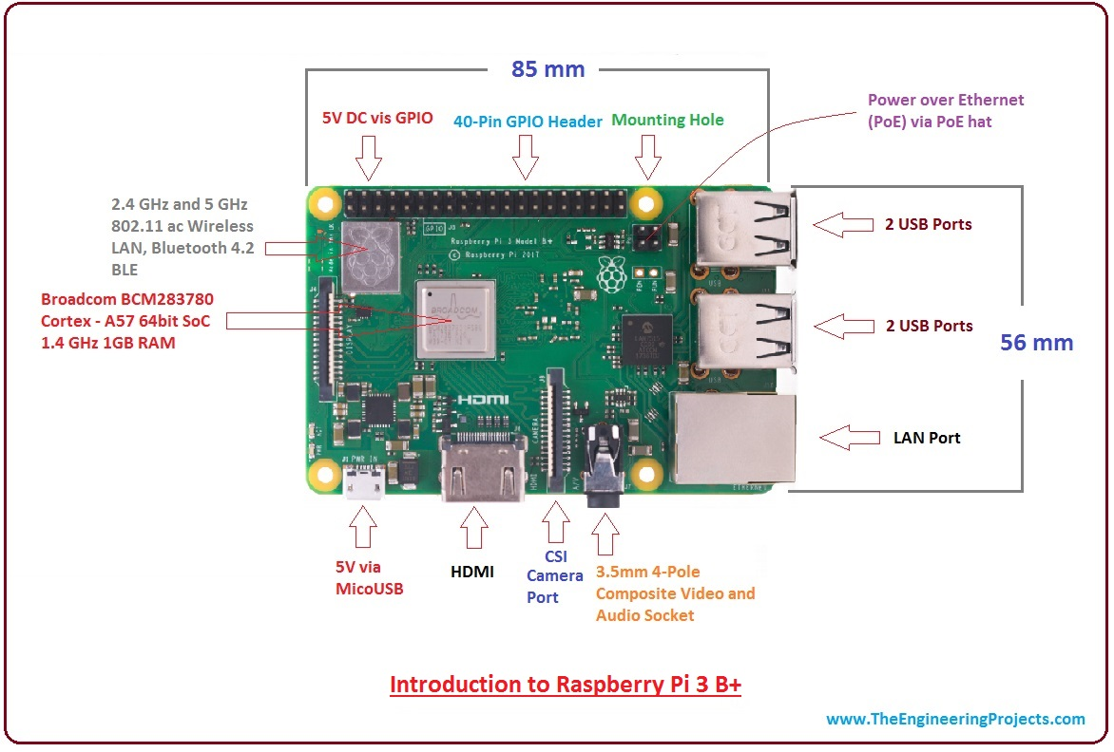
Figure 1: The Raspberry Pi 3Model B+ structure
1.1.3 The Raspberry Pi 3 Model B+ .
In our project we will use Raspberry Pi 3 Model B+. The Raspberry Pi 3 Model B+ is the updated revision of the Raspberry Pi 3 B, featuring a 64-bit quad core processor running at 1.4 (GHz), It is also the first model to get built-in wireless support, featuring a radio capable of connecting to 2.4(GHz) Wi-Fi networks and Bluetooth devices. the power supply included in this kit incorporates a noise filter to provide the highest stability also Model B+ has 512 MB of memory, four USB ports, and a 10/100 wired network. [3]
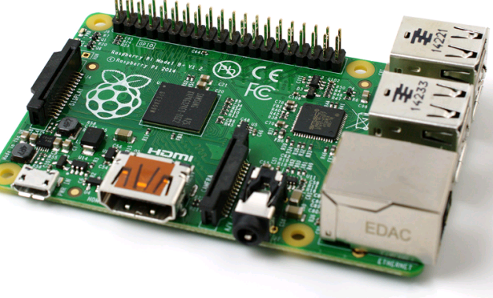
Figure 2: The Raspberry Pi3 Model B+
1.1.4 The Raspberry Pi operating system
Raspberry Pi supports many well-known operating systems, but it can run certain versions of it due to the limited capacity of its processors, as well as the type of ARM that is not compatible with the versions of known operating systems that support the architecture of X86 for Intel and AMD processors. You cannot install an OS via Raspberry Pi directly, as you must format the memory card and install the OS on it first.
Raspberry Pi Foundation recommends on its official website the use of Raspbian, a version based on the Debian distribution, which is one of the most popular distributions of the Linux system, there are many other Linux system distributions that you can install on Raspberry Pi such as Ubuntu Mate, Kali, Kano OS and many others.
Unfortunately, so far there is no real full Windows support on Raspberry Pi. Although there are versions of Windows 10 running on ARM processors, there is no official version that supports Raspberry Pi except Windows 10 IoT Core which never resembles the known Windows versions. It cannot run its known applications as it is only for IoT project management. [4]
1.1.5 The 20 Best Operating Systems For Raspberry Pi
RASPBIAN is the official distribution of Raspberry Pi Based on Debian it is built on the same philosophy, i.e., stability and performance. A large number of Debian packages are available on Raspberry Pi. UBUNTU MATE this is distribution runs on a shorter development cycle and therefore provides the latest news much earlier than Debian.
RETROPIE is gives you the possibility to play old games from classic PC to N64 games. OSMC is can play most of the media formats and stream from all kind of sources. KALI LINUX is the best penetration testing distribution with a lot of security tools. LAKKA created for games emulation It will turn your Raspberry Pi into a retro gaming console. OPENMEDIAVAULT is you want to create a network drive easily and at low cost. GENTOO is a lightweight distribution that you can build as you want, to install any package you need. KANO OS Links is a manufacturer selling computer kits for school or kids. ROKOS is turn it into a Bitcoin miner node. RECALBOX Is dedicated to retro gaming It allows you to play old games. MINIBIAN is a minimal version of Raspbian without GUI and unneeded software This distribution takes advantage of the stability and support of Raspbian while proposing a lighter system for embedded systems You can boot a Minibian image in seconds from a 512MB SD Card. WINDOWS 10 is only Windows 10 IOT was available on Raspberry Pi. RISC OS is designed by the same team that invented the original ARM processors. LINUTOP OS is designed for companies, mainly for retail outlets It’s a light operating system. PIDORA is a Fedora Remix distribution optimized for the Raspberry Pi computer If you are a regular Fedora, you will be at home. CHROME OS is the open-source version of the Google operating system running on Chrome book computers. ALPINE LINUX is an independent distribution aimed at power users, you can use it as a workstation with XFCE, Firefox and the main Linux Software. SCREENLY is a software that allows you to install and manage a complete digital signage solution in your browser Serenely exists in an open source edition. LIBREELEC is design to load the basics to run Kodi It's the most efficient way to run Kodi. [9]
1.1.6 Raspbian Operating System
Raspbian is the official operating system of the Raspberry Pi and it is based on one of the original Linux distributions Debian, a version adapted by the community for a particular task, there are several versions of Raspbian including Raspbian Buster and Raspbian Stretch, Raspbian uses PIXEL, Lightweight as its main desktop environment. It is composed of a modified LXDE desktop environment and the Openbox stacking window manager with a new theme and few other changes. The distribution is shipped with a copy of computer algebra program Mathematica and a version of Minecraft called Minecraft Pi as well as a lightweight version of Chromium as of the latest version.[6]
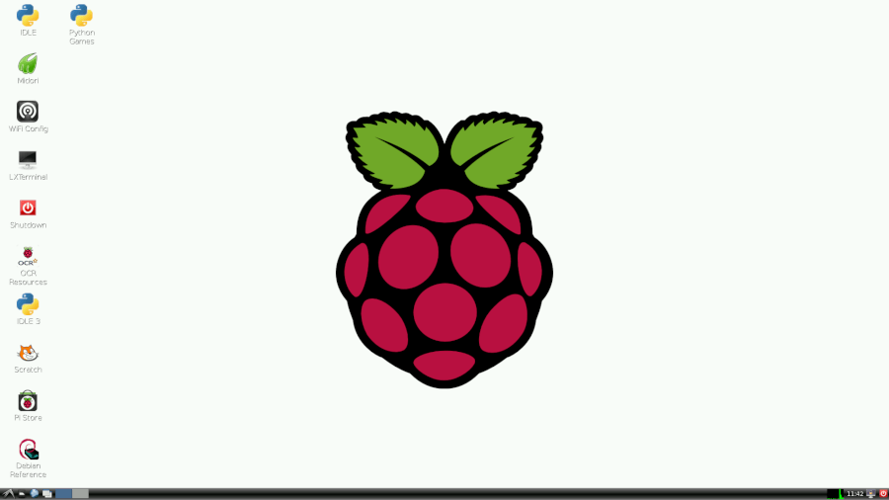
Figure 3: Raspbian Interface

Why we using Raspbian?
Raspbian is one of the longest-running Linux distributions and concentrates on stability, high compatibility, and excellent performance even on modest hardware making it a great partner for the Raspberry Pi. And adds custom tools and software to make using the Raspberry Pi as easy as possible also it does have enough resources to run LXDE and a handful of applications and provide the Epiphany web browser and a few other desktop programs. This is what we make it suitable for this project. [6]

Chapter 2: Constraints and Standards:
2.1 Constraints:
While we work on the project, we face a number of problems:
- The first problem it was get all parts and tools with the specifications we need as storage capacity.
- It was unable to provide some parts like DC-DC converter due to the lack of availability in our country and the time it takes to receive it.
- We encountered a problem in choose the operating system of the raspberry pi which suitable with our goals.
- We encountered a problem in loading the operating system of the raspberry pi.
- We face problems through the PiTFT Setup and Python development libraries.
- We had trouble getting reliable and accurate references.
- Difficulty dealing with people in completing and accepting the questionnaire.
2.2 Standard:

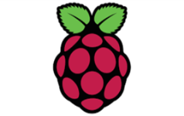Raspberry Pi :The Raspberry Pi is a series of small single-board computers developed in the United Kingdom by the Raspberry Pi Foundation to promote teaching of basic computer science in schools and in developing countries Garboard – A Raspberry Pi Foundation sanctioned device, designed for educational purposes, that expands the Raspberry Pi's GPIO pins to allow interface with and control of LEDs, switches, analog signals, sensors and other devices. It also includes an optional Adriano compatible controller to interface with the Pi, raspberry pi take the defult user name : pi and take the raspberry as password .[2]

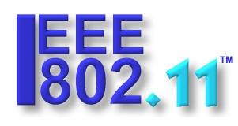 Raspberry pi 3 model B: It is used for controlling and management of all functions which having following features. Processor: Broadcom BCM2387 chipset.1.2GHz Quad-Core ARM Cortex-A53802.11 b/g/n Wireless LAN and Bluetooth 4.1, The Official IEEE 802.11 Working Group Project Timelines page is published by IEEE to indicate the status of each of the networking standards under development, 802.11a: 54 Mbps standard, 5 GHz signaling (ratified 1999), 802.11b: 11 Mbps standard, 2.4 GHz signaling (1999) , 802.11g: 54 Mbps standard, 2.4 GHz signaling (2003), 802.11n: 100+ Mbps standard improvements over 802.11g (2009). Memory: 1GB LPDDR2, Operating System Boots from Micro SD card, running a version of the Linux operating system or Windows 10, Dimensions: 85 x 56 x 17mm, Power : Micro USB socket 5V1, 2.5A .[1]
 GSM Module-SIM900A: It is used for calling and messaging of mobile phone. Dual band GSM/GPRS 900/1800MHz, The Global System for Mobile Communications (GSM) is a standard developed by the European Telecommunications Standards Institute (ETSI) to describe the protocols for second-generation (2G) digital cellular networks used by mobile devices such as mobile phones and tablets. It was first deployed in Finland in December 1991.[2] By the mid-2010s, it became a global standard for mobile communications achieving over 90% market share, and operating in over 193 countries and territories.[3] SIM card holder, Built in network status LED, Operating voltage: +12V DC, Weight < 140g.[8]
 TFT Screen: It is used for performing task and displays all functions. 1. AR 110 Restive touch screen 2. 24 bit color pixel 3. Display resolution: 800 *480 4. Display: 5’ with 50mA backlight. Adafruit PiTFT 3.5" Touch Screen for Raspberry Pi Created by lady ada. [7]
 Bosch CCS-CML Conference Chairman Unit with longer microphone for the Bosch conference system. The CCS CML incorporates all functions of the CCS700 Delegate Priority button for chairman microphone Chairman priority button. It is used to when we dial a number or make a call then it will decode our speaking sound. , Model CML , Omni directional , Low impedance , Range 100cm.

Chapter 3: Components and Programming
3.1 Hardware components:

1. Raspberry Pi3 model B+:
The main component that we will use to finish our project is Raspberry B3 Model B + which fits the work in this project in terms of memory capacity in this type compared to other types where the memory capacity up to 512 MB and also contains a network port Ethernet which gives us the possibility of connecting to the Internet where the other type does not contain this port. [3]

Figure 4: The Raspberry Pi3 Model B+

2. SanDisk (SD card)
The second basic component in our project is SD card, which holds the operating system and all the files on the raspberry pi, the Best SD Card for the Raspberry Pi 3 B+ is SanDisk and we use it with 64GB size Class 10 .

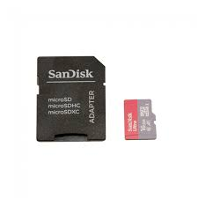
Figure 5: SanDisk (SD card)

3. PITFT TouchScreen
The other basic component we need to display the result is TFT touchscreen and we use it as 3.5 inches that come with many futures For example the hardware resolution it is 480x320 also this touchscreen provide 125MHz High-Speed ​​SPI signal transmission, and it Combined with the 50Hz refresh rate Raspberry Pi, allow to Watch videos with multi format like MP4 and Play video games ,take photos by touching up to 17 camera modes . [7]
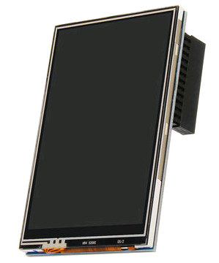
Figure 6: 3.5 inches touchscreen

4. The Raspberry Pi Camera Model
It designed by engineers working for the Raspberry Pi Foundation, the Raspberry Pi Camera Module is the most compact way of adding the ability to record still images or video to project and it designed to connect to the Camera Serial Interface (CSI) of the Raspberry Pi, the Camera Module measures just 25mm on its longest edge and weighs just 3 grams it draws considerably less power, so it doesn’t strain the Raspberry Pi’s power supply or drain the batteries and it is considerably smaller than USB-connected cameras The Camera Module is compatible with all models and revisions of Raspberry Pi .[7]
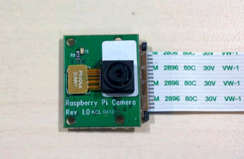
Figure 6: The raspberry pi camera model

5. HDMI cable
we need this cable to connect the raspberry pi with TFT touch screen.
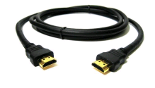
Figure 7: HDMI cable

6. DC-DC Converter
Is the perfect power supply for project This little DC/DC boost converter module can run from 1.8V batteries or higher, and convert that voltage to 5.2V DC for running your 5V also it has 2A internal switch, synchronous conversion, excellent efficiency, and 700KHz high-frequency operation.
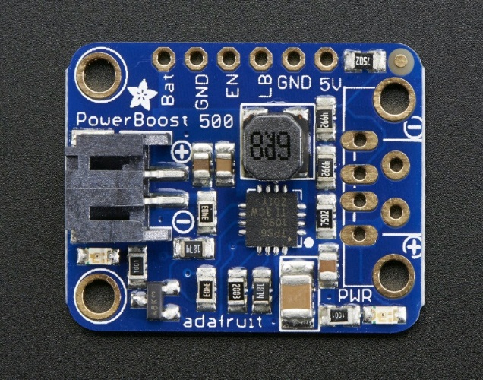.
Figure 8: DC-DC converter

7. Adafruit FONA(GSM) module
It's breadboard Introducing Adafruit's FONA MiniGSM, an all-in-one cellular phone module that lets we add voice, text, SMS and data in little package. This module measures only 1.75"x1.25" but packs a surprising amount of technology into its little frame. At the heart is a GSM cellular module (we use the latest SIM800) the size of a postage stamp, we can run it with 2.8V to 5V logic, send and receive voice calls using headset or an external 8Ω speaker ,electret microphone and iPhone or Android headphone jack.
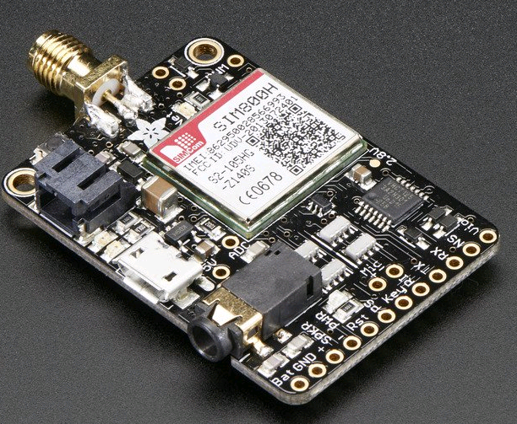.
Figure 9: FONA

8. Right-angle Mini GSM/Cellular Quad-Band Antenna
This 2.4"/61mm long antenna has 2dBi of gain and 50Ω impedance. considered as the main communications module, because allow us to send standard AT commands to it to make calls, hang up, send texts, data etc.
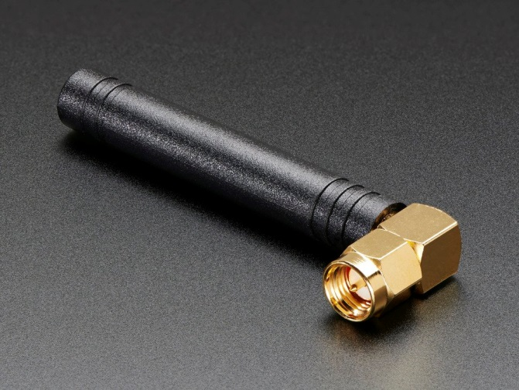
Figure 10: Right-angle Mini GSM Quard Band Antenna

9. Lipoly Battery
Lithium ion polymer batteries is thin, light and powerful. The output ranges from 4.2V when completely charged to 3.7V this battery has a capacity of 1200mAh for a total of about 4.5 Wh.
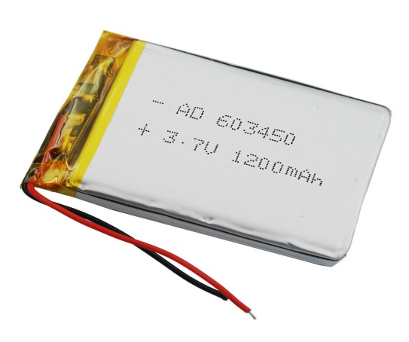
Figure 11: Lipoly Battery

10. Small electrical switch
We will connect it with the battery and with antenna in order to hook up the electricity.
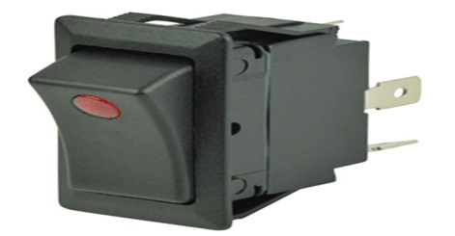
Figure 12: Small electrical switch

11. SIM Card
Which allow the GSM module to associate with local GSM network.
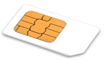
Figure 13: SIM Card

12. Foam board
This board separating the GSM module from the Raspberry Pi, and we must ensure to no electrical connections between them and we will use it as the same size of raspberry pi.

Figure 14: Foam board
Also, we need some additional part such as Cables, Zip ties, Headphone, Microphone, Duct tape During work on the project.

3.2 Software Components:
In this section, we present the use of Raspberry Pi in electronic control projects through the general points that are used as input or output (GPIO), so that the Raspberry Pi becomes an advanced alternative to microcontrollers.
Control Exist GPIO:
GPIO is abbreviated to General-Purpose Input /Output, The Raspberry has an electrical connection point ( pins) called GPIO, Some are used for electronic control (output), some are for sensors(input), some are for power supply, some are for communication protocols between different components and electronic devices.[5]
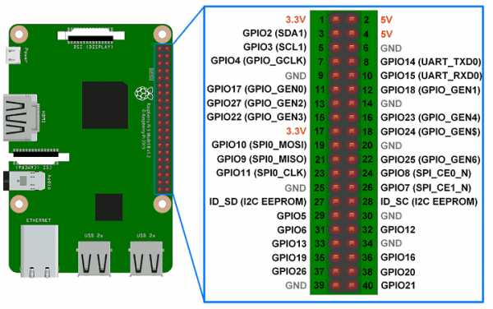
Figure 15: GPIO
3.2.1 Programming supported by Raspberry

It works with Linux, which means that it has full support for most of the programming languages that Linux supports, such as Pascal, Ruby, Perl, Python, Java, C#, C++, C(Mono)………etc.

All of these languages we can use to make any kind of applications, whether desktop applications, servers, or even applications to control electronic ports (GPIO), where we found software libraries that can be added to any of these languages to transform into a tool to control GPIO easily , As for the best languages in controlling these ports (GPIO), the answer is difficult because each language supports certain properties, but we chose the Python language because it is supported in an excellent way and the most famous languages in controlling these ports (GPIO).[5]

3.2.2 Python program
In our project, we will use python language to make our project functional, python is a high-level language. This means that Python code is written in largely recognizable English, providing the Pi with commands in a manner that is quick to learn and easy to follow.
It works on all operating systems and different versions of Windows, Linux and its derivatives, Unix and its derivatives, mobile phone systems such as Android, Symbian. The presence of most of the additional libraries with it, including libraries included with the language and the other can be downloaded such as the Bluetooth library, electronic control ports, web interfaces, dealing with the network and the Internet, programming of supercomputers, desktop applications, and libraries for the design of 3D and 3D games. Integration with Java ,C++. It works in an interactive environment or via written (file) scripts. Dealing with the following databases Oracle, Sybase, PostGres, mSOL, Persistence. Python ability to control electronic ports GPIO.[5]

Chepter4 :

Proposal System :
When the operating mode of the mobile phone is connected to the nearest station or communication tower to request the service from it, and the basic devices responsible for the station verify that the phone is allowed to use the network by sending a message explaining the success of the request to use the network.
In order to connect and send messages, I must use the card and GSM, and for voice calls using the loudspeaker and microphone, the call is successfully made by simply calling the station or the nearest communication tower on the card, since the call has been receiving calls from someone to this phone, we use the downloaded applications on Phone by pressing the application terminals.
This is illustrated by the following diagram:
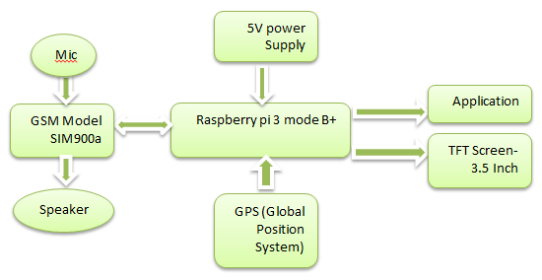
Figure 16: Proposal System

Chapter 5: Methodology
When building any project that goes through multiple stages and visits many places so that we look at the best and collect the core of ideas, steps and the correct stages, we in this project we passed in more than one stage through construction and outputs the results, in this chapter we will explain to you what we have gone through from the relationship of our project and the collection of multiple sections In one project of mechanics, electricity, information technology, computer, communications and electronics. 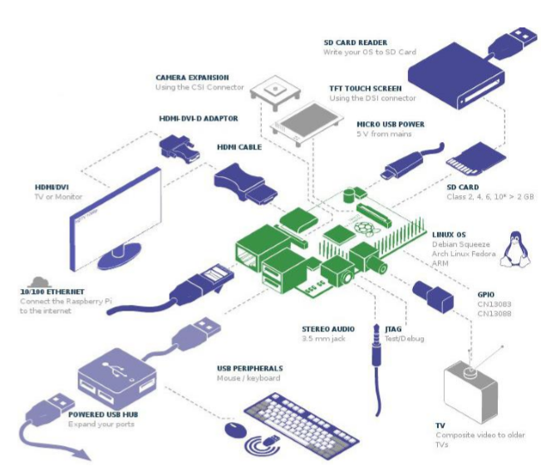
5.1 Flow Chart:
Step1: The mobile phone is on, waiting seconds to receive the values ​​from SIM900A, contact the GPS.
Step2: The screen shows the operations and movements that we want to make, go to the keyboard by clicking the icons, to make a call we must ask the number from SIM900A.
Step3: If we want to make the call, you should go to the terminal.
Step4: By sudo python swati.pi we selects the connection function.
Step5: Enter the number of the person we want to call.
Step6: The required person is contacted.
Step7: Go to the designated terminal to send a message.
Step8: By sudo python swati.pi we selects the function of sending the message.
Step9: Enter the number of the person we want to send to.
Step10: Fill out the message.
Step11: The message has been completed.
Step12: To find the app you want, go to the terminals and choose what we want.
Step13: Wait a little while.
These steps are illustrated in the following diagram:
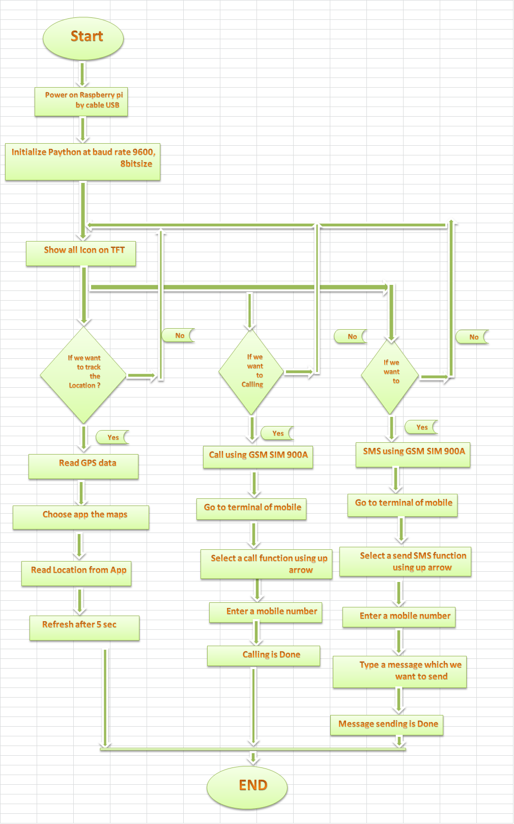
Figure 17: Flow Chart

5.2 Electronic:
In this section, we learned about how to deal with electronic parts of Raspberry Pi, what it follows and how it works and programming it, and which languages we will need to program these electronic parts,
We ran the Raspberry and by running it we dealt with the Linux system upon initialization and then we used the Python language to program these pieces and prepare them for the work of the project, including preparing the Raspberry settings to suit our project, with some of the following steps.
5.2.1 Installing Raspbian and getting it up and running
The first thing we do to start building the project with the Raspberry pi is installing the Raspbian and a desktop environment, and we use some hardware to do successful setup as An HDMI capable and SD card that is compatible with your Raspberry Pi that use a USB keyboard and mouse also, we use Standard Ethernet cable and Micro USB power supply.
5.2.2 Downloading Raspbian And Image Writer
The first step to run Raspberry Pi is to download one of the operating systems based on Linux and to do this you have to go to the site http://www.raspberrypi.org/downloads , where will find many operating systems in the form of compressed files In this project we will use Raspbian as the operating system Official Raspberry Pi .

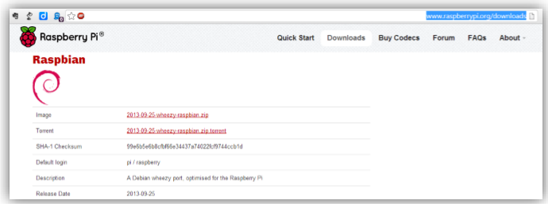
Figure 18: Raspbian operating systems

Where we will find many operating systems in the form of compressed files and in this project we will use the system of Raspbian as the official operating system for Raspberry Pi To find the operating system file named wheezy-raspbia.img

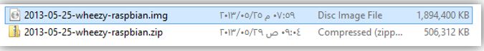
Install the operating system on the card from Windows at first we have to connect the memory card to the card reader and then connect the reader to a port in the computer and wait until the memory card be loads, will appear an icon in my computer carrying one of the alphabet in the following picture Memory card was carrying the letter (F).

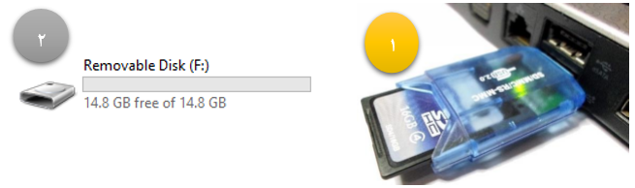
Figure 19: Memory card with letter F

After connecting the memory card we will scan and format the card to confirm that it is working on the system FAT32, By right-clicking on the icon in the following image and then choose format.

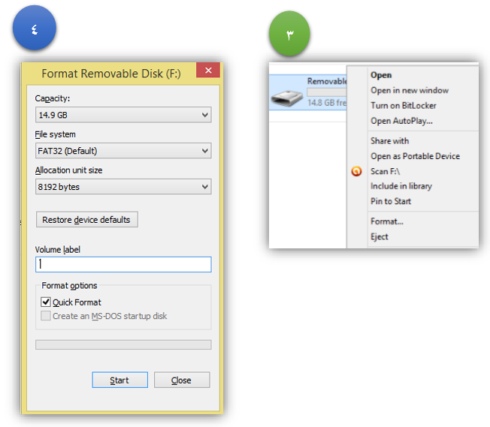
Figure 20: Format Removable disk
After the card is formatted, we will download a program Win32 Disk Image Write from the following link: http://sourceforge.net/projects/win32diskimager/files/latest/download, We will use this program to transfer and install the operating system on the memory card through the following steps.
First: we have opened the program and we have selected the device name card memory card (F), Then we choose the operating system file wheezy-raspbia.img, Clicking on the folder icon in the right side of the program as in the following picture.

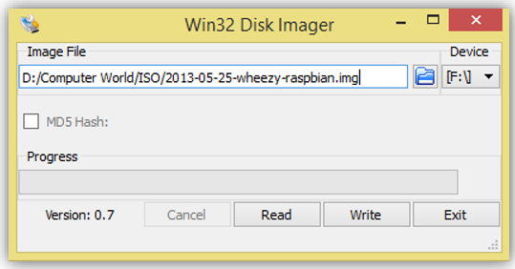

Figure 21: Image Writing on SD card
Secondly, click on the button Write to start the program to transfer and install the operating system and waited a little bit.
After completing the installation of the operating system on the memory card, install the card in the space provided for it in the Raspberry Pi panel, as in the following image:

Figure 22: Memory card in the Raspberry Pi panel

After that we connected the power source (phone charger) to the port MicroUSB , Under the specifications that have been mentioned in the topic components.

Figure 23: Power source (phone charger)
5.2.3 Setting Up the Raspberry Pi
Now we have connected the keyboard and mouse to appear with us on the computer screen, we loaded it on and then we set the system for the first time means setting the settings .
After running the Raspberry Pi we set a default user name and password (standard login) as follow:
login: pi
password: raspberry
Figure 24: Raspberry configuration
We entered an option Expand_rootfs until the system can take advantage of the entire memory card space because without performing this step the system will only see a gigabyte of memory, we waited until it is the expansion process, we entered to do a restart and enter the graphic interface.
Figure 25: Raspberry configuration
We pressed boot_behaviour let's go to the desktop in Raspberry By
Figure 26: Raspberry configuration
So here we finished running Raspberry Pi and entering it.

5.3 Mechanical
In this section, we will design and equip project requirements for equipment, using a special program called Autodesk Fusion360 which is a program specializing in mechanical designs, which is design, manufacture and engineering using a three-dimensional computer that integrates multiple functions across a cloud-based platform, it is smart manufacturing software that combines production planning, job tracking and machine monitoring. This app is a companion to the browser-based interface, providing real-time visibility, and instant access to your production data.
An illustration of what the design will look like in the next time:
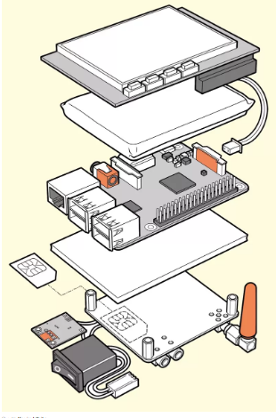
Figure 27: How to configure Mobile
5.4 Electrical

In this section, we learned about how to deal with the connection of electronic parts with each other, and how to take into account the amount of current and voltage inside and outside on these parts so that we do not fall into the wrong path during networking, so one of the parts is damaged because they are sensitive.
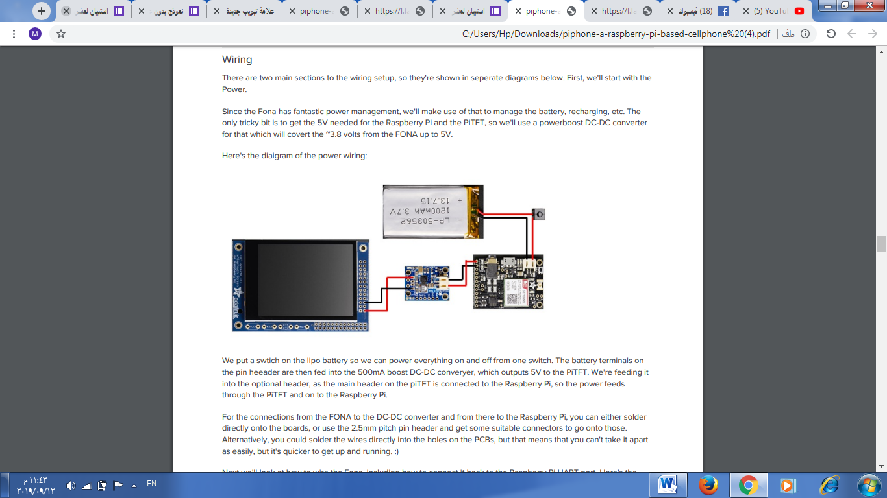
Figure 28: How to deliver the Power
We put a swtich on the lipo battery so we can power everything on and off from one switch. The battery terminals on the pin heaader are then fed into the 500mA boost DC-DC converter, which outputs 5V to the PiTFT. We're feeding it into the optional header, as the main heaader on the piTFT is connected to the Raspberry Pi, so the power feeds through the PiTFT and on to the Raspberry Pi. For the connections from the FONA to the DC-DC converter and from there to the Raspberry Pi, you can either solder directly onto the boards, or use the 2.5mm pitch pin heaader and get some suitable connectors to go onto those. Alternatively, you could solder the wires directly into the holes on the PCBs, but that means that you can't take it apart as easily, but it's quicker to get up and running. Next we'll look at how to wire the Fona, including how to connect it back to the Raspberry Pi UART port. Here's the diagram:

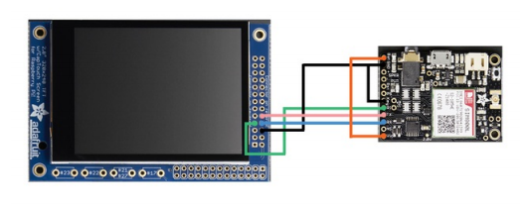
Figure 29: How to deliver the GSM
For the connections from the FONA to the DC-DC converter and from there to the Raspberry Pi, you can either solder directly onto the boards, or use the 2.5mm pitch pin header and get some suitable connectors to go onto those. Alternatively, you could solder the wires directly into the holes on the PCBs, but that means that you can't take it apart as easily, but it's quicker to get up and running.

5.5 Telecommunications
In this section, we will clarify the relationship of the project with communications, this project is a mobile that means sending and receiving data and making calls and sending messages that are done in special ways, we used the piece GSM , it contains a SD card through this card we knew the network and the communication towers with the information of this card, GPS is connected to the GSM , Through it we can know the Location on the maps through the card defined by the communication towers And antenna is connected to the GSM, through this antenna, it broadcasts and sends the data that it needs to send through many operations, including using the protocols that Raspberry By supports, and among these protocols 802.11g is the most popular wireless communication protocol for Wi-Fi technology that we use to connect to Wireless networks and the protocol TCP/IP used in the organization of networking and Internet addresses .
The Raspberry supports four communication protocols for electronic parts is i2C,UART, 1Wire, and SPI. Which enables us to communicate with many electronic components and increase the ability of Raspberry to control dozens and even hundreds of electronic devices. These protocols work on the same GPIO ports as the port is set to work either as an input or as an output or a communication protocol which is managed by manipulating the settings of these ports in the Linux operating system and by using programming languages such as Python.

Chapter 6: SWOT and Estimated
6.1 SWOT analysis:
A SWOT analysis is a strategy method that can be used to evaluate these focus areas involved in a project or organization for strategic planning.
SWOT Analysis, also known as the SWOT matrix, is an acronym for:
Strengths: positive characteristics that give an advantage in it’s being.
Weaknesses: critical characteristics that give a disadvantage in it’s being.
Opportunities: a set of circumstances that makes it possible to do something in advantage.
Threats: a set of circumstances that could have a negative influence on the desired goal.
By estimating the strengths, weaknesses, opportunities and threats in this project, the answer will become known. Through these factors this project is also evaluated and knowing how much positive.
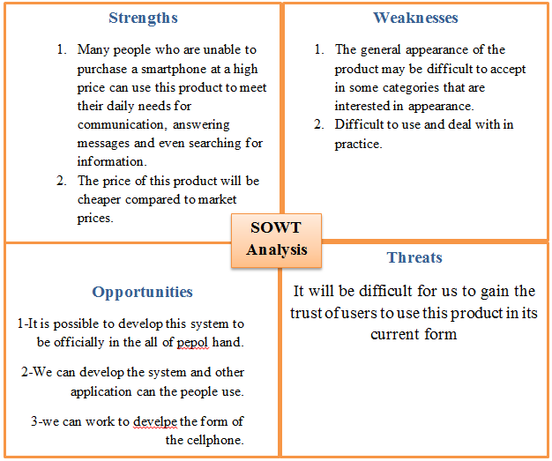
Figure 30: SOWT analysis
6.2 Feasibility Study
We will study and analyze the economical part of our project. These prices are according to the local market.

Raspberry pi model B+: 180 NIS
- Raspberry Pi 3.5-inch HDMI Touch LCD: 120NIS
- Camera:60 NIS
- SDcard:75NIS
- HDMI cable:19NIS
- DC-DC converter:35NIS
- Adafruit FONA:157 NIS
- Antenna:17NIS
- Lipoly Battery:35NIS
- SIM card:15NIS
- Cables+ Zip ties Headphone +Microphone +Small electrical switch:35NIS
Total budget almost :750NIS

Chapter 7:Result and Discussion
In our project, we carried out a questionnaire to show the opinions of people about the smartphone, taking into account the need for it and keeping pace with development and technology, then we relied on it for this project.
Through a sample which consisted of 160 people of different sexes and ages, the answers to the questions were as follows:
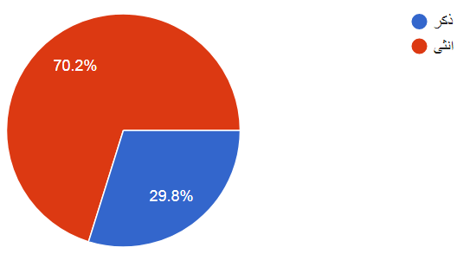
Figure 31: Sexes
As for the ages participating in the questionnaire, their ages were as follows:
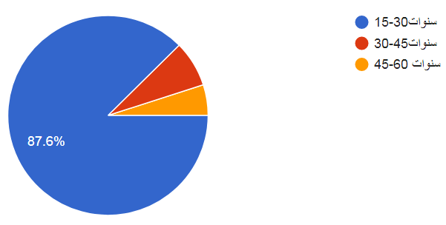
Figure 32: Age
As for the educational groups that participated in filling the questionnaire, they were multiplied as follows:
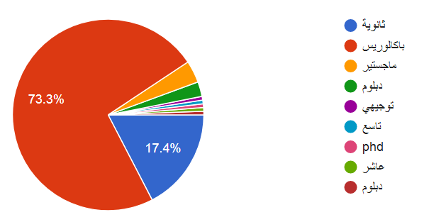
Figure 33: Education level
One of the questions was also the question about the place of residence and the answer was as follows:
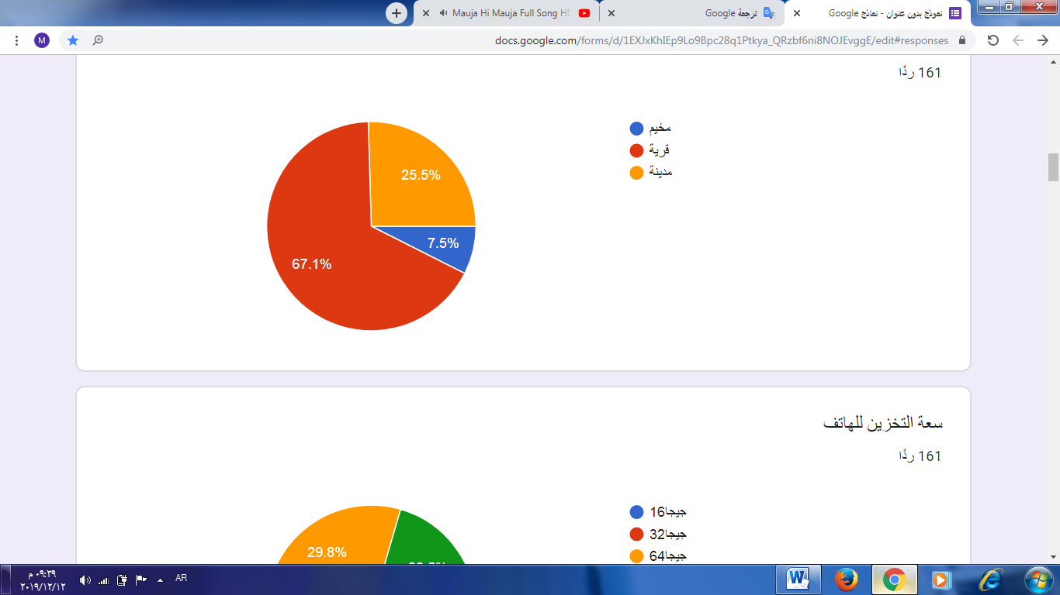
Figure 34: Places of living
As for the smartphone, the question at the beginning was about the storage capacity of the phone, as it appears with us:
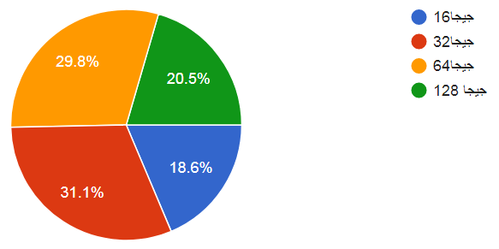
Figure 35: Storage capacity
As for the question, do I want to use a phone that matches the largest number of applications, the answer appeared as follows:
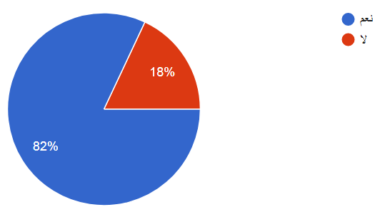
Figure 36: Do you use all applications
We also asked what kind of operating system participants use for their smartphones, and so was the result:
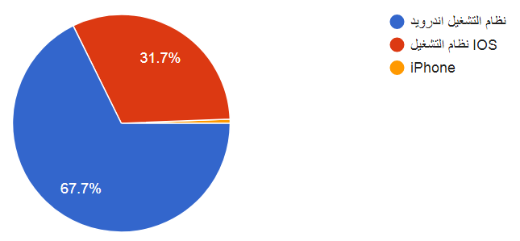
Figure 37: Any OpeartingSystem Using
When asked the question about the number of hours that I spend using the smartphone, the number of hours was as follows:
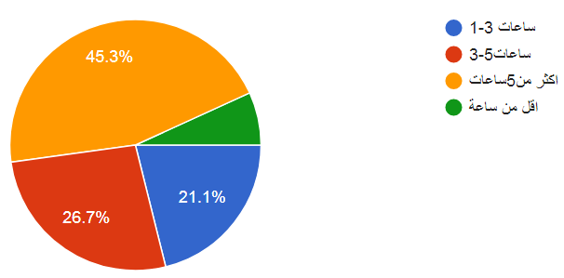
Figure 38: The number of hours that I spend using the smartphone
As for when we were asked about the reason for subscribers' use of a smartphone, the opinions of the participants differed as follows:
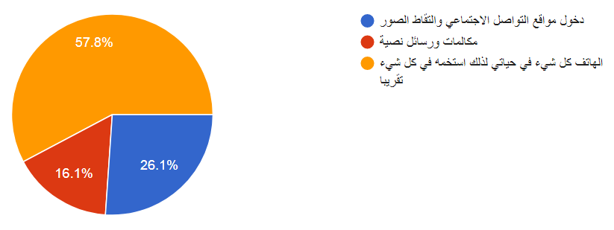
Figure 39: The reason for subscribers' use of a smartphone
When we asked subscribers how easy it is to use the applications on your device when purchasing it, the answers are as follows:
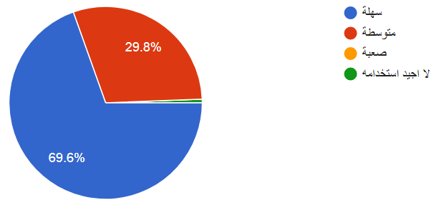
Figure 40: Is it easy to use applications?
When asked, "Are all the applications on the device using?" The answers are limited to the following:
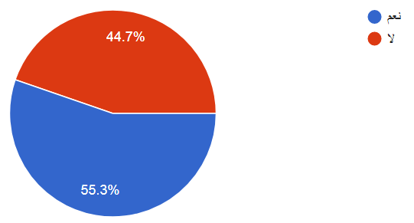
Figure 41: Are all the applications on the device using?
As for the people who answered yes, they were asked: Do you advise others to use the applications on their phones? Their answers were as follows:
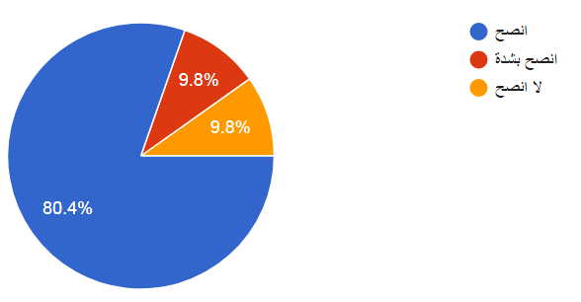
Figure 42: If yes, do you recommend using it?
As for the people who answered no, we asked them about the applications that they do not use, And their answers ranged from storage and compass applications.
We also asked the participants about the applications that you recommend to have on your device permanently, so we got the following ratios:
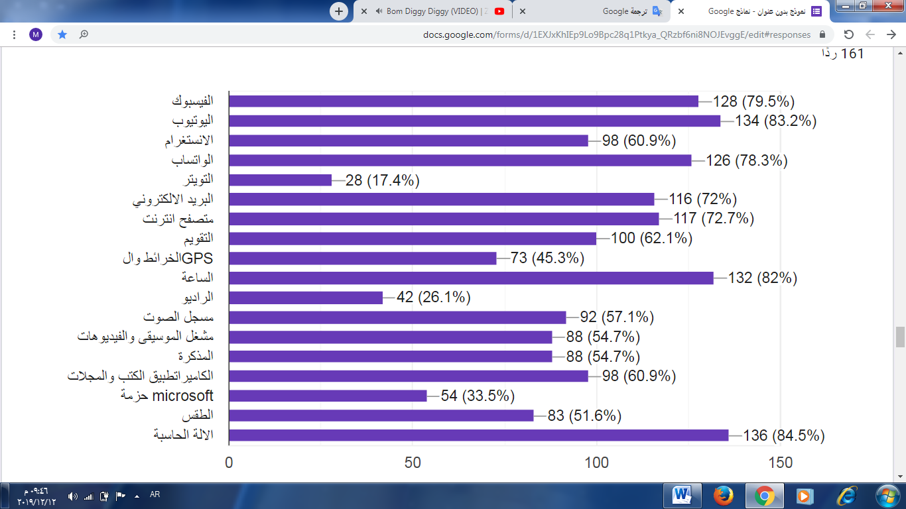
Figure 43: Most used applications
We also asked the participants about the applications that advise their presence on your device permanently and their answers were as follows:
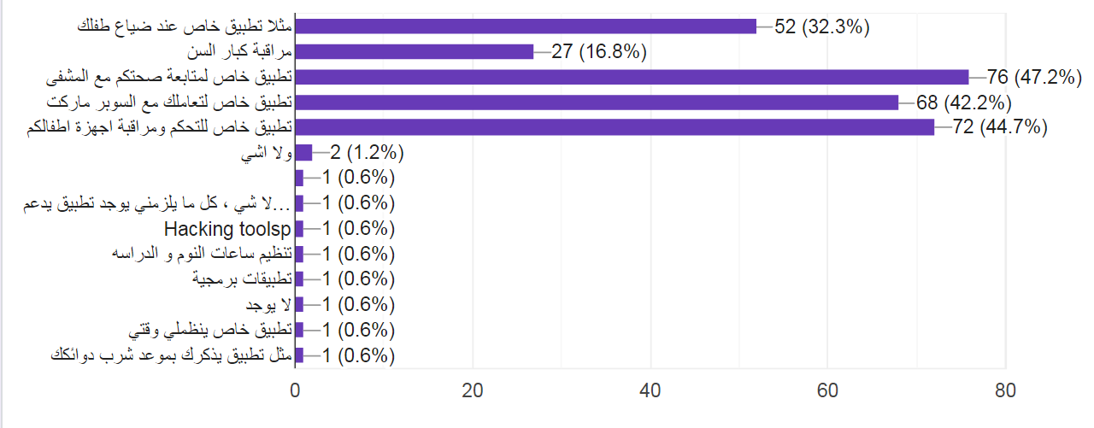
Figure 44: Applications preferred and not available
And when we asked the participants, "Are there applications on your device that are there and not one (not required)?" They answered as follows:
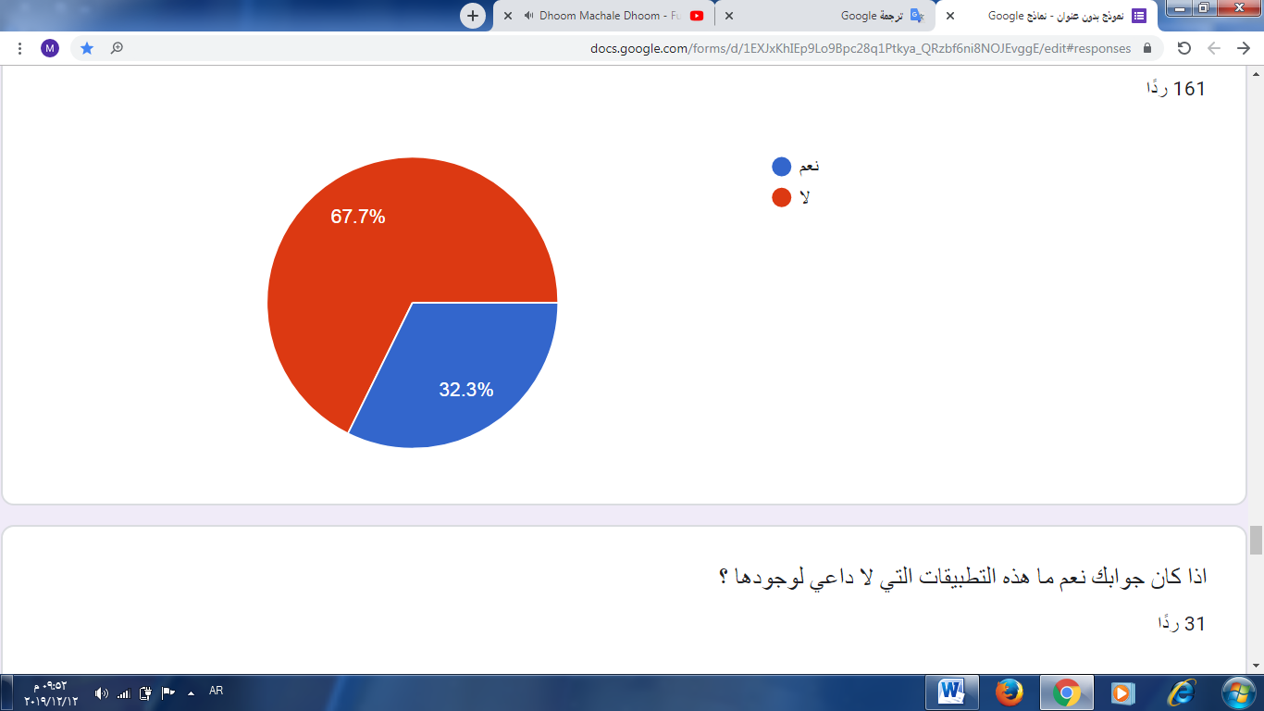
Figure 45: Are there any unnecessary apps?
As for the people who answered yes to the previous question, we asked them about the applications that do not need to exist and they answered me as follows:
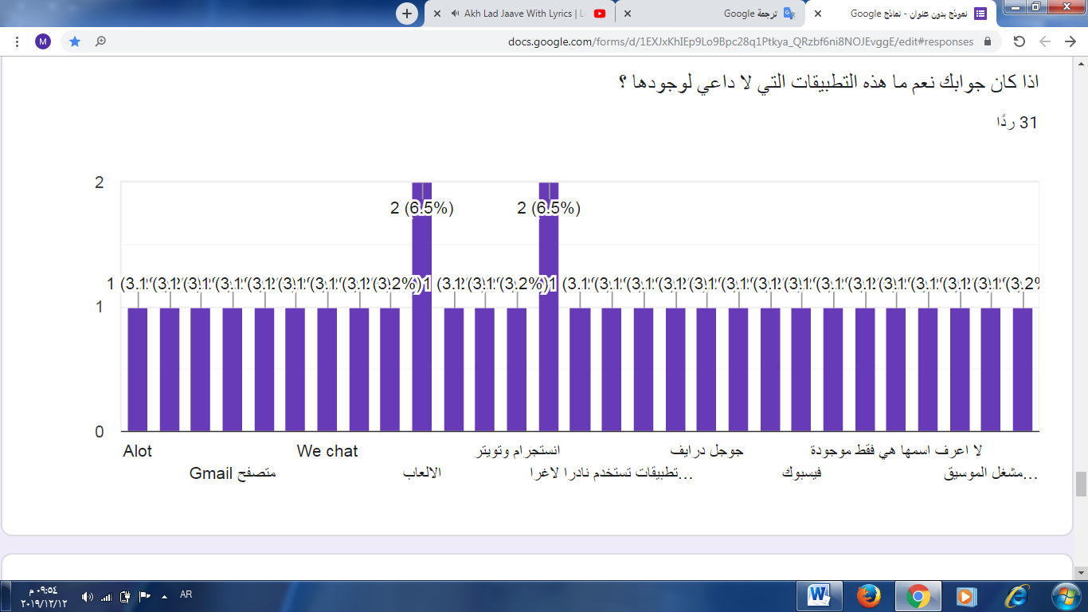
Figure 46: If not, what these apps do?
We also asked the participants about the applications that you use in your daily life and download them from the App Store, Google play, Most of the answers were Facebook, WhatsApp and the camera.
Finally, we asked the participants about their suggestions to improve the applications on their devices, the answers required applications that work without the Internet
After analyzing the results of the questionnaire that we obtained, we were able to know the most important rules that we will rely on in our project to achieve our goal in building a smartphone that fits the largest number of users in light of the economic and educational situation and at the same time keeps pace with development and technology.

Chapter 8: Conclusion and Recommendations
8.1: Conclusion
Recently, smart phones are becoming increasingly popular and the number there of has increased greatly in the past few years, it become basic need for all life field's such as educational and industrial field, the idea of this project give efficient cellphone because in that all features and function of laptops easily available, this is possible only when we used raspberry pi without need to carry the laptop or other high priced smart phone.
8.2: Recommendations
In the second graduation project, we will create a complete system consisting of hardware and software components, to made a cellphone using raspberry pi 3B+ in which calling, messaging are possible , Where communication and messages are made, no matter what important features are available on the laptop or computer in our system, download applications that suit the uses of people.

Bibliography

[1] "Official IEEE 802.11 working group project timelines". ( 23 March 2016). Archived from the original on 7 April 2016. Retrieved 20 April 2016.

[2] What is a Raspberry Pi? (2014, 4 2). Retrieved from https://www.raspberrypi.org/.

[3] Raspberry Pi Model B+. (2019). Retrieved from Pololu robotics and electronics .

[4] Thenextpro.net. (2019, 7 5). Retrieved from https://thenextpro.net

[5] Abdallal, A. A. (2014). Simply Raspberry pi. https://asnadstore.com/p/67no.

[6] Halfacree, E. U. (2016). Raspberry Pi® User Guide. UK: 2016.

[7] Hunt, D. (, July 2015.). “Pi Phone - A Raspberry Pi based Cellphone”. Article of adafruits.

[8] Huurdeman, A. A. (31 July 2003). The Worldwide History of Telecommunications. John Wiley & Sons, .

[9] I, R. A. (2014). The 20 Best operating system for Rasberry Pi. China: 2014.

[10] Ankita Kawashte, Swati Bhagit, Diksha Dhoke Prof. Pramod Sonawane. (4, April 2018). Pi phone –A Smartphone using. India: www.ijirset.com.

