An-Najah National University
Faculty of Engineering & Information Technology
Chemical Engineering Department

Improving design of the continuous solar desalination unit

Prepared by:
Iman Sbaih
Saja Mohammed

Supervisor:
Eng. Mays Ali Shadeed

A Graduation Project Report Submitted to Chemical Engineering Department
in Partial Fulfillment of the Requirements for Bachelor Degree in Chemical Engineering

10th May, 2019

شكروتقدير
قـال رسول االله صلى االله عليه و سلم:
"من لم يشكر الناس لم يشكر االله"
صدق رسول االله صلى االله عليه و سلم
الحمد الله على إحسانه و الشكر له على توفيقه و إمتنانه و نشهد أن لا إله إلا االله وحده لا شريك له تعظيما لشأنه و نشهد أن سيدنا و نبينا محمد عبده و رسوله الداعي إلى رضوانه صلى االله عليه و على آله و أصحابه و أتباعه و سلم.
بعد شكر االله سبحانه و تعالى على توفيقه لنا لإتمام هذا البحث المتواضع أتقدم بجزيل الشكر إلى الوالدين العزيزين الذين أعانوني و شجعوني على الإستمرار في مسيرة العلم و النجاح،و إكمال الدراسة الجامعية و البحث؛ كما نتوجه بالشكر الجزيل إلى من شرفتنا بإشرافها على هذا المشروع , المهندسة والاستاذه الفاضلة " ميس شديد "التي لن تكفي حروف هذه المذكرة لإيفـائها حقها بصبرها الكبير علينا، ولتوجيهاتها العلمية التي لا تقدر بثمن فجزاها الله عنا كل خير فلها منا كل التقدير والاحترام
كما نتوجه بخالص شكرنا و تقديرنا إلى كل من ساعدنا من قريب أو من بعيد على إنجاز و إتمام هذا العمل.
"رب أوزعني أن أشكر نعمتك التي أنعمت علي و على والدي و أن أعمل صالحاً ترضاه و أدخلني برحمتك في عبادك الصالحين"

Abstract

Adequate quality and reliability of drinking water supply is a fundamental need of all people. Industries and Agriculture need fresh water as well. Despite water covers 70% of the earth surface the fresh accessible water doesn’t exceed 3% of the total existing amount of water on the earth, this is due to the lack of accessibility or the high salinity of sea water. Therefore, improving a feasible and ecofriendly desalination process becomes an urgent need. Solar distillation presents a promising alternative for saline water desalination. A group of environmental engineering students designed an innovative continuous solar desalination unit (CSDU) which was constructed at the roof of the engineering faculty building at An-Najah National University, this project aims to improve their design and to investigate its productivity after modifications.
Many modifications were made and the productivity was measured along three months
, promising results were achieved. The maximum and minimum evaporation fluxes measured were 7.663 and 1.43 (L/m².day), respectively.
In addition, results indicated that the evaporation rate was highly affected by weather conditions. and highly effected by increasing the belt speed.

Finally, a double tubular condenser was designed, and the following values were obtained 1.31 m/s was the velocity in the tube and 1.72 m/s in the shell. The pressure drop was 2.4and 0.078 kPa in tube & shell, respectively. The length and the outside diameter of the tube was 3.2 m and 0.3 m. where the diameter for the shell side was 0.62m.
the expected total capital cost was estimated it’s around 1600 NIs while the annual operating cost is 1912 NIS/yr.

Contents
Abstract I
Acronyms and Abbreviations VII
Chapter 1: Literature Review 17
Chapter 2 : Water in our life
2.1 The importance of water 1
2.1.1 Human uses 2
2.2 Water Scarcity 8
2.3Water Salinity 10
2.2.1 What is Salt (Brine)? 13
2.3Desalination Basics 14
Chapter 3 : An Introduction to Desalination
3.1 Definition and Brief history 20
3.2 Desalination Technologies 21
3.2.1 Membrane Technologies 22
1. Electro Dialysis (ED) and Electro Dialysis Reversal (EDR) 22
2. ED relies upon the accompanying general standards: 22
3. Reverse Osmosis And Nano Filtration (NF) 23
3.2.1Nano filtration (NF) 27
3.2.2 Thermal Technology 28
a) Multi-Stage Flash 30
b) Multiple Effect Distillation 32
c) Solar Still 33
Chapter 4 : Solar Still (SS)
4.1Solar Still (SS) 35
4.2 Passive And Active Solar Still 36
4.3 Solar Still Enhancement Techniques 38
4.3.1 Basin (Absorber) 38
4.3.2 Glass 40
4.3.3 Other Enhancements Technology 42
4.3 Factors Affecting Solar Still Performance. 44
4.3.1 Environmental Parameters 44
4.3.2 Design Parameters 45
4.3.3 Operational Parameters 46
Chapter 5 : Condenser design
5.1 Introduction 48
5.2 Classifications of Heat Exchangers 49
5.2.1 Double Pipe Condenser 49
5.3Theoretical Background And Sample Of Calculation 52
5.3.1 Sample of calculation 61
5.3.2 AutoCAD design 78
5.4 Discussion 79
Chapter 6 : Results and Discussion
6.1 Procedures 82
6.1.1 Measurements 83
6.2 Constrains 83
6.3 Evaporation Rate Measurements 83
6.3.1 Maximum and Minimum Evaporation Rate Achieved. 84
6.3.2 The Effect Of Low Speed And High Speed Of The Belt 86
6.3.3The Effect of (turn on and turn off) the CSDU 87
6.4 Environmental Parameters Affecting Solar Still Performance 90
6.4.1Effect Of Solar Radiation. 90
6.4.2 Effect of Temperature 93
chapter 7 : Conclusions And Recommendations 95
7.1 Conclusions 95
7.2 Recommendations 95
Chapter 8: Conclusions and Recommendations ………………………..………………………96
9. References 97
8.Appendices 101

List of Figure

Figure 1:Use of water in agriculture 3
Figure 2:The importance of water to the human body 4
Figure 3:Heat exchange 6
Figure 4 :global physical and economic water scarcity 9
Figure 5 :Water Salinity 10
Figure 6:The Mariana Arc, Mariana islands is part of the "Ring of Fire" in the western Pacific Ocean where tectonic plates are moving relatively quickly. Hydrothermal vents, such as these, are present, and they release large amounts of carbon dioxide and mineral 12
Figure 7:salt 13
Figure 8:A simulation portrays how brine plumes would disperse when discharged from a proposed desalination plant in California. 15
Figure 9 :mechanism of osmosis and reverse osmosis 24
Figure 10 : reverse osmosis desalination process 26
Figure 11 : overview of seawater desalination concept 26
Figure 12: Nominal Molecular Weight Cut Off (MWCO)of Different Membrane Types 27
Figure 13:Relative Size Of Common Materials 28
Figure 14 : thermal Desalination principle 29
Figure 15:single-effect distiller 29
Figure 16 :Multi-Stage Flash 30
Figure 17 :Multi-Stage Flash Distillation 32
Figure 18 :Multiple Effect Distillation 33
Figure 19 :The solar radiation distribution around the world 35
Figure 20:A schematic diagram of single effect passive solar still 37
Figure 21 :A schematic diagram of single effect active solar still 37
Figure 22:Pictorial view of Spherical Solar Still 39
Figure 23 :Schematic view of tubular solar still 39
Figure 24:A schematic diagram of multi effect passive solar still 40
Figure 25:Schematic view of hemispherical solar still 41
Figure 26 :Schematic view of pyramid solar still 41
Figure 27 :Classifications of PCMs 42
Figure 28 :A photo of the modified stepped solar still 43
Figure 29 :the variation of solar intensity and still output 44
Figure 30 :the effect of the variation of evaporation area on distillation yield 45
Figure 31 :The effect of water depth on the solar still productivity 46
Figure 32 :humidity chart 62
Figure 33: condensation coefficient for vertical l tubes 68
Figure 34:tube -side fraction factor 69
Figure 35 : shell-bundle clearance 71
Figure 36: shell-side heat transfer factor 73
Figure 37: shell and tube heat exchangers (time base 2004 ) 75
Figure 38:cost index2019 76
Figure 39:cost index2004 76
Figure 40: 3D condenser design …………….…………………………………………..78 Figure 41 : 2d condenser design 78
Figure 42: Water System Unit. 82
Figure 43:The accumulative volume for Maximum and minimum cases. 84
Figure 44:accumulative volume under different environmental conditions 85
Figure 45 :accumulative volume at different speeds of the belt 86
Figure 46:Daily flux at different speeds of the belt 87
Figure 47: accumulative volume for each case 88
Figure 48:daily flux for each case 88
Figure 49:ambient temperature for each case 89
Figure 50:solar radiation for each case 90
Figure 51:The effect of solar radiation on unit’s evaporation rate 91
Figure 52:The effect of solar radiation on unit’s evaporation rate for 18.3.2019 91
Figure 53: The effect of solar radiation on unit’s evaporation rate for 25.3.2019 92
Figure 54: Relationship between solar radiation and daily flux 92
Figure 56:Relationship between ambient temperature and evaporation flux 94
Figure 56:Temperature variation with solar radiation for25.3.2019 94
Figure 57:Temperature variation with solar radiation for18.3.2019 95

List of Tables

Table 1:Water salinity based on dissolved salts 11
Table 2:Desalination Technologies and processes 21
Table 3 :factors that must be considered to decide the allocation of the fluid in tube and shell 63
Table 4: fouling factor 64
Table 5 :Tube side(steam) 65
Table 6: Type of heat exchanger 66
Table 7 :Shell side(water) 70
Table 8 :Cost of condenser 74
Table 9 : The ambient conditions for maximum and minimum evaporation rate 84
Table 10:: The ambient conditions for several day Under different environmental conditions 85
Table 11:The ambient conditions for several day under different speed of the belt 86
Table 12:ambient conditions for each case 89
Table 13: Daily flux and average solar radiation 92
Table 14:Daily flux and Ambient Temperature. 93
Table 15:properties of saturated water 101
Table 16: row data for speed 5 102
Table 17:row data for speed 10 102
Table 18:row data for speed 15 103
Table 19::row data for speed 20 103
Table 20::row data for speed 30 104
Table 21:17.3.2019 104
Table 22:18.3.2019 105
Table 23:25.3.2019 105
Table 24:26/3/2019 106
Table 25:27/3/2019 106
Table 26: 5 min off during every 30 min. 107
Table 27: 10 min off during every 30 min on 107
Table 28:5 min off during every 45 min. 108
Table 29: Physical properities 108
Table 30: Tube side design 109
Table 31: Shell side design 109
Table 32: Power 110
Table 33: error estimated. 110
Table 34:cost in which cost of kilowatt is 0.574 111
Table 35: finding Tw. 111

Acronyms and Abbreviations

Symbol | Definition | Unit
H₂O | Water | -
W. A | Wet air | -
 | Temperature of liquid enter the shell | ˚C
 | Temperature of liquid exit from the shell | ˚C
 | Temperature enter the tube | ˚C
 | Temperature exit from tube | ˚C
µ | Viscosity | Pa. s
K_{w} | Thermal conductivity of tube wall material | W/m.˚C
K | Thermal conductivity of fluid | W/m.˚C
 | Specific Heat Capacity | J / kg. ˚C
Pr | Prandtl Number | Dimensionless
ṁ | Flow Rate | kg/s
ΔT | Temperature Differences | ˚C
ΔT_{lm} | Log Mean Temperature | ˚C
ΔT_{m} | Mean Temperature Differences | ˚C
FT | Correction Factor | Dimensionless
Q | Heat Transfer Rate | W
U | Overall Heat Transfer Coefficient | W/m².˚C
A_{pro} | Heat Transfer Area | m²
A_{t} | Flow Area of Tube | m²
 | Flow Area of Shell | m²
L | Length of One Tube | m
N_{t} | Number of Tubes | Tube
A_{c} | Cross Sectional Area | m²
P_{t} | Tube Pitch | m
D_{b} | Bundle Diameter | m
Ds | Diameter of Shell | m
$$d_{°}$$ | Tube Outside Diameter | m
$$d_{i}$$ | Tube Inside Diameter | m
l_{B} | Baffle Spacing | m
ΔP | Pressure Drop | Pa
G_{s} | Mass Velocity | m/s
$$u$$ | Velocity | m/s
Re | Reynolds Number | Dimensionless
Rec | Reynolds number in tube side in condenser | Dimensionless
N_{p} | Number of Passes | Passes
d_{e} | Equivalent Diameter | m
 | Overall heat transfer coefficient | W/m.⁰C
$$η$$ | Efficiency | Dimensionless
A.C.C | Annual capital cost | $/yr.
A.O.C | Annual operating cost | $/yr.
T.A.C | Total annual cost | $/yr.

Chapter 1: Literature Review

The water crisis is one of the most serious problems facing humanity, although it has been on the continuance and continues to solve it, but caused many deaths in 2013. 17,000 people died around the world because of water shortages and pollution. ^{[1]}

There are many reasons for the pollution and lack of water and the most important sudden increase in the world's population and the industrial and agricultural revolution to the urgent need for clean water and this is the reason for the lack of water. At the same time, the industrial revolution led to large pollution of water, especially from the uncontrolled remnants of factories. Also, the geographical difference of water distribution led to water shortages in some areas. ^{[21]}
Desalination is the removal of dissolved salts from different types of water. This process transforms the water that is unfit for use into water suitable for human consumption, irrigation, industry and other applications. ^{[1]}

The current desalination process needs and consumes a large amount of energy and therefore is expensive and is only applicable in areas where freshwater sources are not available economically. ^{[2]}
Desalination technology is one of the most suitable solutions to solve the problem of water shortage facing the world, which is one of the most important forms of water treatment. Arab chemists used this technique to obtain fresh water in 1551. ^{[3]}

Generating electricity from solar energy by solar cells requires high prices, but research and experiments have led to a reduction in the price of kilowatt produced. To create a solar plant of silicon supported by very small substations that increase the efficiency of the cells significantly than the kilo watt produced and prices will drop by a large amount of up to about half and the allocation in the Arab countries to have a large solar radiation and doubles that exist in Europe. ^{[23]}
Desalination technologies are classified based on the separation process adopted either thermal or membrane. Thermal process includes multi-stage flash (MSF), multiple-effect distillation (MED), mechanical vapor compression (MVC), and solar still. ^{[4]}

Research shows the characteristics of the performance of solar snapshots that the temperature on the surface of water is linked to solar radiation and ambient air temperature and wind speed. ^{[4]}
Information for all research in this field has been collected to improve water quality and increase fresh water productivity through an effective thermodynamic tool such as energy analysis, especially solar snapshots, which are similar to their extensive applications in complex thermal systems such as steam turbines or gas turbines, boilers and dual generation systems. ^{[4]}

In the early 14th century, Arosto first described a method of evaporation of water and then its condensate and use to drink. Nevertheless, Arab ancient chemists were the first to document the first oldest work of solar distillation. Della Porta (1589) used wide earthen pots that when exposed to the sun rays caused the evaporation of water and condensate are collecting water in vases under pot placed.^{[5]}

Talbert et al. (1970) triggered a wave of historical development of water distillation.
Gokhale (1988) studied in detail solar distillation technique in accordance with the principles of the Indians. Faith (1998) introduced different designs for solar distillation system and studied the effect of solar radiation to get drinking water. ^{[6]}

Solar still is simple in its designs, which consist of a glass-covered basin that allows sunlight to pass through and allows salt water to be condensed into the basin, covered with black to absorb and store the largest amount of solar energy required for evaporation and fresh water harvesting. The investigation of solar continuous desalination process is of great importance to this industry, since most of the previous studies used batch desalination processes. According to the knowledge of the best authors, few studies have been done on the design of a continuous solar desalination system. A group of environmental engineering students designed an innovative continuous solar desalination unit (CSDU) which was constructed at the roof of the engineering faculty building at An-Najah National University, a promising result were achieved this project aims to improve their design and to investigate its productivity after modifications.

Chapter 2: Water in our life

2.1 The importance of water

Water is one of the most important substances on earth. All plants and animals must have water to survive. If there was no water, there would be no life on earth.” Water is the foundation of life” Our bodies are made up of over 60% of water but we also require safe and clean water to survive and to grow our food.
What is the water?
Water, a substance composed of the chemical element’s hydrogen and oxygen -H₂O- and existing in gaseous, liquid, and solid states. It is one of the most plentiful and essential of compounds. A tasteless and odorless liquid at room temperature, it has the important ability to dissolve many other substances. ^{[7]}
It has several characteristics that distinguish it from other compounds, and make it the basis of the planet. The most important of these characteristics:
- The water is chemically neutral, since the pH is 7, which means that it cannot be considered acidic or alkaline.
- Water is a good solvent for many organic and inorganic substances ^{[8]}
- Water anomaly, which helps marine organisms survive in frozen and icy conditions, where water shrinks with cooling until it reaches 4 ° C and then begins to cool with cold. Other substances that shrink in cold and heat.
- The strength of cohesion, a gravitational force that appears between molecules of a single substance, where water molecules tend to act as interrelated groups rather than as separate molecules, which helps to increase the surface tension of the water. ^{[8]}
- The power of adhesion, which is the forces of attraction between the molecules are not identical, where the strength of the adhesion of water molecules with the walls of the container in which the height of water in the container, and the most important examples of this force, the rise of water in the capillary walls whose walls consist of water-absorbing materials such as cellulose. ^{[9]}

- The ability of the water to move from the low salinity to the medium of high salinity, and shows the effect of this property in how the water from the soil to the roots of higher salt density.

- For the thermal properties of water which are: ^{[8]}
- The specific temperature is the amount of heat required to raise the temperature of 1 gram of material by one degree. The specific temperature of the water is higher than that of other substances, reaching 4.18 g / g. The high temperature of the water helps keeps the heat for the greatest time Possibly contributing to several benefits at the cellular and air-level.
- Heat evaporation is the amount of heat necessary to change the state of a particular mass of matter from the liquid to the gaseous state, and the importance of this property to rid the human body and other organisms of excess heat in his body.

Human uses

- Agriculture
The most important use of water in agriculture is for irrigation, which is a key component to produce enough food. Irrigation takes up to 90% of water withdrawn in some developing countries^{[4]} and significant proportions in more economically developed countries (in the United States, 30% of freshwater usage is for irrigation).^{[10]}
Fifty years ago, the common perception was that water was an infinite resource. At the time, there were fewer than half the current number of people on the planet. People were not as wealthy as today, consumed fewer calories and ate less meat, so less water was needed to produce their food. They required a third of the volume of water we presently take from rivers. Today, the competition for the fixed amount of water resources is much more intense, giving rise to the concept of peak water.^{[11]} This is because there are now nearly seven billion people on the planet, their consumption of water-thirsty meat and vegetables is rising, and there is increasing competition for water from industry, urbanization and biofuel crops. In future, even more water will be needed to produce food because the Earth's population is forecast to rise to 9 billion by 2050.^{[12 ]}
An assessment of water management in agriculture was conducted in 2007 by the International Water Management Institute in Sri Lanka to see if the world had sufficient water to provide food for its growing population.^{[11]} It assessed the current availability of water for agriculture on a global scale and mapped out locations suffering from water scarcity. It found that a fifth of the world's people, more than 1.2 billion, live in areas of physical water scarcity, where there is not enough water to meet all demands. A further 1.6 billion people live in areas experiencing economic water scarcity, where the lack of investment in water or insufficient human capacity make it impossible for authorities to satisfy the demand for water. The report found that it would be possible to produce the food required in future, but that continuation of today's food production and environmental trends would lead to crises in many parts of the world. To avoid a global water crisis, farmers will have to strive to increase productivity to meet growing demands for food, while industry and cities find ways to use water more efficiently.^{[12]}

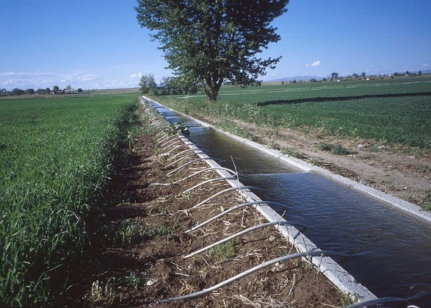
Figure 1:Use of water in agriculture

- Drinking
The human body contains from 55% to 78% water, depending on body size. ^{[10]}To function properly, the body requires between one and seven liters of water per day to avoid dehydration; the precise amount depends on the level of activity, temperature, humidity, and other factors. Most of this is ingested through foods or beverages other than drinking straight water.
An original recommendation for water intake in 1945 by the Food and Nutrition Board of the United States National Research Council read: "An ordinary standard for diverse persons is 1 milliliter for each calorie of food. Most of this quantity is contained in prepared foods.^{[11]} The latest dietary reference intake report by the United States National Research Council in general recommended, based on the median total water intake from US survey data (including food sources) : 3.7 liters for men and 2.7 liters of water total for women, noting that water contained in food provided approximately 19% of total water intake in the survey.^{[11]}

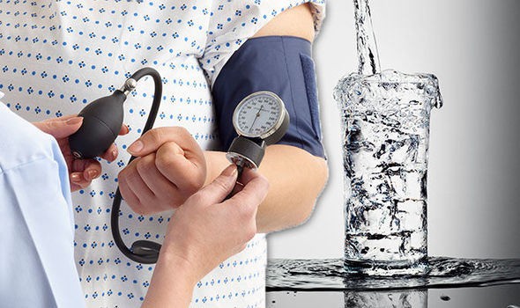
Figure 2:The importance of water to the human body

- Washing
The propensity of water to form solutions and emulsions is useful in various washing processes. Washing is also an important component of several aspects of personal body hygiene. Most of personal water use is due to showering, doing the laundry and dishwashing, reaching hundreds of liters per day in developed countries.

- Transportation
The utilization of water for transportation of materials through streams and channels just as the global delivery paths is an essential piece of the world economy.

- Chemical uses
Water is widely used in chemical reactions as a solvent or reactant and less commonly as a solute or catalyst. In inorganic reactions, water is a common solvent, dissolving many ionic compounds, as well as other polar compounds such as ammonia and compounds closely related to water. In organic reactions, it is not usually used as a reaction solvent, because it does not dissolve the reactants well and is amphoteric (acidic and basic) and nucleophilic. Nevertheless, these properties are sometimes desirable. Also, acceleration of Diels-Alder reactions by water has been observed. Supercritical water has recently been a topic of research. Oxygen-saturated supercritical water combusts organic pollutants efficiently. Water vapor is used for some processes in the chemical industry. An example is the production of acrylic acid from acrolein, propylene and propane.^{[13]} The possible effect of water in these reactions includes the physical-, chemical interaction of water with the catalyst and the chemical reaction of water with the reaction intermediates.

- Heat exchange
Water and steam are a common fluid used for heat exchange, due to its availability and high heat capacity, both for cooling and heating. Cool water may even be naturally available from a lake or the sea. It's especially effective to transport heat through vaporization and condensation of water because of its large latent heat of vaporization. A disadvantage is that metals commonly found in industries such as steel and copper are oxidized faster by untreated water and steam. In almost all thermal power stations, water is used as the working fluid (used in a closed loop between boiler, steam turbine and condenser), and the coolant (used to exchange the waste heat to a water body or carry it away by evaporation in a cooling tower). In the United States, cooling power plants is the largest use of water.^{[14]}
In the nuclear power industry, water can also be used as a neutron moderator. In most nuclear reactors, water is both a coolant and a moderator. This provides something of a passive safety measure, as removing the water from the reactor also slows the nuclear reaction down. However other methods are favored for stopping a reaction and it is preferred to keep the nuclear core covered with water so as to ensure adequate cooling. ^{[14]}

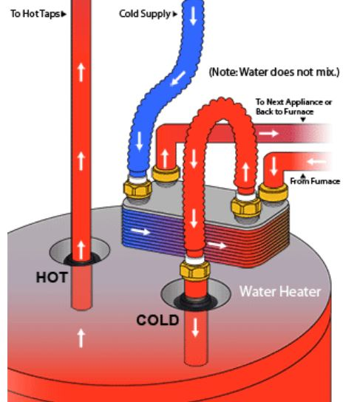
Figure 3:Heat exchange

- Water industry
The water industry provides drinking water and wastewater services (including sewage treatment) to households and industry. supply facilities include water wells, cisterns for rainwater harvesting, water supply networks, and water purification facilities, water tanks, water towers, water pipes including old aqueducts. Atmospheric water generators are in development.^{[15]}
Drinking water is often collected at springs, extracted from artificial borings (wells) in the ground, or pumped from lakes and rivers. Building more wells in adequate places is thus a possible way to produce more water, assuming the aquifers can supply an adequate flow. Other water sources include rainwater collection. Water may require purification for human consumption. This may involve removal of undissolved substances, dissolved substances and harmful microbes. Popular methods are filtering with sand which only removes undissolved material, while chlorination and boiling kill harmful microbes. Distillation does all three functions. More advanced techniques exist, such as reverse osmosis. Desalination of abundant seawater is a more expensive solution used in coastal arid climates.
Reducing usage by using drinking (potable) water only for human consumption is another option. In some cities such as Hong Kong, sea water is extensively used for flushing toilets citywide in order to conserve fresh water resources.
Municipal and industrial wastewater are typically treated at wastewater treatment plants. Mitigation of polluted surface runoff is addressed through a variety of prevention and treatment techniques. ^{[15]}

- Industrial applications
Any industrial processes rely on reactions using chemicals dissolved in water, suspension of solids in water slurries or using water to dissolve and extract substances, or to wash products or process equipment. Processes such as mining, chemical pulping, pulp bleaching, paper manufacturing, textile production, dyeing, printing, and cooling of power plants use large amounts of water, requiring a dedicated water source, and often cause significant water pollution.
Water is used in power generation. Hydroelectricity is electricity obtained from hydropower. Hydroelectric power comes from water driving a water turbine connected to a generator. Hydroelectricity is a low-cost, non-polluting, renewable energy source. The energy is supplied by the motion of water. Typically, a dam is constructed on a river, creating an artificial lake behind it. Water flowing out of the lake is forced through turbines that turn generators.
Pressurized water is used in water blasting and water jet cutters. Also, very high pressure water guns are used for precise cutting. It works very well, is relatively safe, and is not harmful to the environment. It is also used in the cooling of machinery to prevent overheating, or prevent saw blades from overheating.
Water is also used in many industrial processes and machines, such as the steam turbine and heat exchanger, in addition to its use as a chemical solvent. Discharge of untreated water from industrial uses is pollution. Pollution includes discharged solutes (chemical pollution) and discharged coolant water (thermal pollution). Industry requires pure water for many applications and utilizes a variety of purification techniques both in water supply and discharge. ^{[16]}

2.2 Water Scarcity

Water covers 70% of our planet, and it is anything but difficult to feel that it will dependably be abundant. Be that as it may, freshwater the stuff we drink, bathe in, irrigate our farm fields with is incredibly rare. Just 3% of the world's water is new water, and 66% of that is concealed in solidified ice sheets or generally inaccessible for our utilization.
Subsequently, some 1.1 billion individuals overall need access to water, and a sum of 2.7 billion discover water rare for no less than one month of the year. Lacking sanitation is likewise an issue for 2.4 billion people they are presented to maladies, for example, cholera and typhoid fever, and other water-borne ailments. Two million individuals, generally, amazing year from diarrheal illnesses alone.
Water scarcity includes water stress, water shortage or deficits, and water crisis. While the idea of water stress is moderately new, it is the trouble of getting wellsprings of new water for use amid a timeframe and may result in further exhaustion and disintegration of accessible water assets. Water deficiencies might be brought about by environmental change, for example, adjusted climate designs including dry seasons or floods, expanded contamination, and expanded human interest and abuse of water. A water emergency is where the accessible consumable, unpolluted water inside a district is not as much as that area's interest. Water shortage is being driven by two uniting wonders: developing freshwater use and exhaustion of usable freshwater assets.

Water scarcity can be a consequence of two instruments: physical (supreme) water shortage and financial water shortage, where physical water shortage is an aftereffect of insufficient regular water assets to supply an area's interest, and monetary water shortage is an aftereffect of poor administration of the adequate accessible water assets. As indicated by the United Nations Development Program, the last is observed all the more frequently to be the reason for nations or locales encountering water shortage, as most countries or regions have enough water to meet household, industrial, agricultural, and environmental needs, but lack the means to provide it in an accessible manner. ^{[17]}

Figure 4 :global physical and economic water scarcity [17]

With human populace expected to expand another half by 2050, asset chiefs are progressively seeking elective situations for extinguishing the world's developing thirst. Desalination, the way toward transforming seawater into drinking water, is utilized by numerous nations as a method for making a progressively solid water supply that doesn't rely upon downpour. ^{[17]}

2.3Water Salinity

You may realize that the seas spread about 70% of the Earth's surface, and that around 97 % of all water on and in the Earth is saline. The salt focus is normally communicated in parts per thousand (per mile, ‰) or parts per million (ppm). he United States Geological Survey classifies saline water in three salinity categories. Salt focus in marginally saline water is around 1,000 to 3,000 ppm (0.1-0.3%), in respectably saline water 3,000 to 10,000 ppm (0.3-1%) and in very saline water 10,000 to 35,000 ppm (1-3.5%). Seawater has a saltiness of around 35,000 ppm, comparable to 35 grams of salt for each one liter (or kilogram) of water. ^{[18]}
Figure 5 :Water Salinity^{[18]}

Table 1:Water salinity based on dissolved salts
Water salinity based on dissolved salts
Fresh water | Brackish water | Saline water | Brine
< 0.05% | 0.05–3% | 3–5% | > 5%

Some oceanographers devote their life to estimating exceptionally little changes in saltiness, since this can influence vast scale sea flow designs and can likewise give profitable data about changes in precipitation and tempest designs. Truth be told, little changes in in salinity are what first alerted scientists that global warming has already caused large-scale changes in the Pacific and Atlantic Oceans.
By certain assessments, if the salt in the sea could be evacuated and spread uniformly over the Earth's property surface it would shape a layer in excess of 166-meter-thick, about the tallness of a 40-story place of business. Be that as it may, where did this salt originated from. ^{[18]}
- Why Seawater is saline?
First, "fresh" water is not completely free of dissolved salt. Even rainwater has traces of dissolved substances captured while passing through the atmosphere. Many of these substances that are "washed" from the atmosphere today are pollution, but there are also natural substances present. ^{[19]}
- From precipitation to the land to the rivers to the sea
The rain that falls on the land contains some dissolved carbon dioxide from the surrounding air. This causes the rainwater to be slightly acidic due to carbonic acid. As rainwater passes through soil and percolates through rocks, it dissolves some of the minerals, a process called weathering. This is the water we drink, and of course, we cannot taste the salt because its concentration is too low. Eventually, this water with its small load of dissolved minerals or salts reaches a stream and flows into lakes and the ocean. The annual addition of dissolved salts by rivers is only a tiny fraction of the total salt in the ocean. The dissolved salts carried by all the world’s rivers would equal the salt in the ocean in about 200 to 300 million years.

- Salt comes up from below, too
Rivers and surface runoff are not the only source of dissolved salts. Hydrothermal vents are recently-discovered features on the crest of oceanic ridges that contribute dissolved minerals to the oceans. These vents are the exit point on the ocean floor from which sea water that has seeped into the rocks of the oceanic crust has become hotter, has dissolved some of the minerals from the crust, and then flows back into the ocean. With the hot water comes large amounts of dissolved minerals. Estimates of the amount of hydrothermal fluids now flowing from these vents indicate that the entire volume of the oceans could seep through the oceanic crust in about 10 million years. Thus, this process has a very important effect on salinity. The reactions between seawater and oceanic basalt, the rock of ocean crust, are not one-way, however; some of the dissolved salts react with the rock and are removed from seawater^{[19]}
Figure 6:The Mariana Arc, Mariana islands is part of the "Ring of Fire" in the western Pacific Ocean where tectonic plates are moving relatively quickly. Hydrothermal vents, such as these, are present, and they release large amounts of carbon dioxide and mineral ^{[19]}

A last procedure that gives salts to the seas is submarine volcanism, the ejection of volcanoes submerged. This is like the past procedure in that seawater is responding with hot shake and dissolving a portion of the mineral constituents.

2.2.1 What is Salt (Brine)?

Brackish water is a solution of salt (as a rule sodium chloride) in water. Sodium chloride, otherwise called salt, normal salt, table salt or halite, is an ionic compound with the concoction recipe NaCl, representing equal proportions of sodium and chlorine.
The attraction between the Na+ and Cl− ions in the solid is so strong that only highly polar solvents like water dissolve NaCl well. When dissolved in water, the sodium chloride framework disintegrates as the Na+ and Cl− ions become surrounded by the polar water molecules. ^{[19]}

2NaCl(aq) + 2H₂O(l) →2NaOH(aq) + H₂(g) + Cl₂(g)

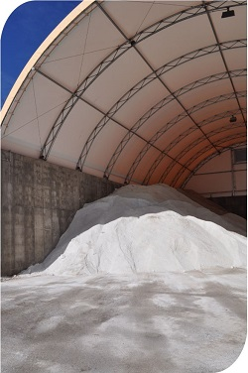
Figure 7:salt^{[19]}

2.3Desalination Basics

Reducing salt water to its basic elements - salt and water - is simple to the point that it's turned into a science exercise for first-graders. In fact, a "solar still" can turn salt water into fresh water in just a few days. Simply fill a large bowl with salt water and set an empty glass at the center. Then cover the bowl empty glass and all -- with plastic wrap that has a small hole poked in the middle. Place the contraption in direct sunlight, and watch the water cycle at work: The salt water evaporates, leaves salt crystals behind, and creates condensation that rises, gathers on the plastic membrane and drips into the empty glass. The resulting fresh water is good enough to drink. ^{[20]}

Be that as it may, why expel salt in any case? Turns out, drinking salt water can slaughter you. Ingesting salt flags your cells to flush water atoms to weaken the mineral. An excessive amount of salt, and this procedure can cause a downright terrible chain response: Your cells will be drained of dampness, your kidneys will close down and your cerebrum will end up harmed. The best way to counterbalance this interior tumult is to pee with more noteworthy recurrence to oust such salt, a cure that could work just in the event that you approach loads of crisp drinking water.

Desalinization is the process in which salt is removed from water to make it consumable. Desalinization still proves to be a costly method of acquiring freshwater. When it comes to desalinating salt water, two of the main options are thermal distillation and reverse osmosis. Thermal distillation involves boiling the water and collecting the resulting freshwater condensation, while reverse osmosis involves pressurizing the salt water and forcing it through a semi-permeable membrane, which will allow water molecules to pass through, but not salt. And then there's membrane distillation which is a cross between thermal distillation and reverse osmosis. It involves heating the salt water then passing it through a tube made from a semi-permeable membrane, which allows water vapor to pass through while not admitting salt molecules. All of these methods, however, require a considerable amount of energy – not as environmentally sound as they could be, nor entirely practical for use in developing nations, where electricity isn't readily available. ^{[20]}
Another issue with these techniques for gaining freshwater isn't just their cost, yet the way that desalinization produces brackish water, which should be redirected back to the seas or oceans, and makes a shakiness that was non-existent previously. This side-effect of desalinated water contains high groupings of salt and, when discharged once more into a characteristic waterway, can make harm marine life. That is on the grounds that salt water, which is typically denser than the water into which it's discharged, settles on low-lying silt where it exhausts encompassing waters of oxygen. Likewise, the plants that do desalinization frequently radiate some kind of toxin, which can be an uneasy exchange off much of the time. ^{[20]}
Figure 8:A simulation portrays how brine plumes would disperse when discharged from a proposed desalination plant in California.

In the next chapter, water desalination will be discussed in more detail (see chapter3).

Chapter 3: An Introduction to Desalination

3.1 Definition and Brief history

Desalination can be characterized as any procedure that expels salts from water. Desalination procedures might be utilized in metropolitan, mechanical, or business applications. With upgrades in innovation, desalination forms are getting to be cost-aggressive with different techniques for creating usable water for our developing needs.
Amid World War II, it was felt that desalination innovation - 'desalting' as it was called at that point - ought to be created to change over saline water into usable water, where crisp water supplies were restricted. In this manner, "The Saline Water Act" was passed by Congress in 1952 to give government backing to desalination. The U.S. Department of the Interior, through the Office of Saline Water (OSW) provided funding during the 1950s and 60s for initial development of desalination technology, and for construction of demonstration plants. Desalination is a relatively new science that has developed to a large extent during the latter half of the 20th century, and continues to undergo technological improvements even at the present time.
It is intriguing to take note of that one of the principal seawater desalination showing plants to be worked in the United States was at Freeport, Texas in 1961. Dow, in cooperation with the U.S. Department of the Interior built a 1 million gallons per day (mgd) long tube vertical distillation (LTV) plant at a cost of $1.2 million, that produced water for the City of Freeport and for Dow operations. The plant was officially opened on June 21, 1961 by then President John F. Kennedy, by pressing a button from the White House. Vice President Lyndon Johnson attended the inaugural event in Freeport.
Amid his discourse to devote the desalination plant, President Kennedy said “No water resources program is of greater long-range importance than our efforts to convert water from the world’s greatest and cheapest natural resources – our oceans – into water fit for our homes and industry. Such a break-through would end bitter struggles between neighbors, states and nations”. Those announcements are genuine even today, over 40 years after the fact. ^{[20]}

3.2 Desalination Technologies

A desalination process essentially separates saline water into two parts - one that has a low concentration of salt (treated water or product water), and the other with a much higher concentration than the original feed water, usually referred to as brine concentrate or simply as ‘concentrate’.
The two noteworthy sorts of advances that are utilized far and wide for desalination can be comprehensively named either thermal or membrane. The two innovations need energy to work and create crisp water. Inside those two wide sorts, there are sub-classes (processes) utilizing diverse methods. The real desalination forms are recognized in Table 2. ^{[20]}

Table 2:Desalination Technologies and processes
Thermal Technology | Membrane Technology
Multi-Stage Flash Distillation (MSF) | Electro dialysis (ED)
Multi-Effect Distillation (MED) | Electro dialysis reversal (EDR)
Vapor Compression Distillation (VCD) | Reverse Osmosis (RO)

Thermal and membrane capacity on an overall premise was around 7 billion gallons for every day (bgd) in mid-2000, with about 50% in thermal processes and 50% in membrane technologies. This is all out introduced limit since the mid-1950s, and not the majority of that limit might be in activity. On a worldwide premise, desalination limit expanded at right around 12 percent for each year, from 1972 through 1999. There have been more than 8,600 desalination plants introduced around the world, with roughly 20 percent of them in the U.S., the biggest number of any nation on the planet. As far as limit in any case, the U.S. positions second universally. ^{[20]}

Membrane Technologies

Electro Dialysis (ED) and Electro Dialysis Reversal (EDR)

Membrane technologies can be subdivided into two general classifications: Electro dialysis/Electro dialysis Reversal (ED/EDR), and Reverse Osmosis (RO).
Electro dialysis (ED) is a voltage-driven membrane process. An electrical potential is utilized to move salts through a membrane, abandoning crisp water as item water. ED was financially presented during the 1960s, around 10 years before reverse osmosis (RO), Although ED was initially considered as a seawater desalination process, it has by and large been utilized for salty water desalination. ^{[20]}

ED relies upon the accompanying general standards:

- Most salts dissolved in water are ions, either positively charged (cations), or negatively charged (anions).
- Since like poles repel each other and unlike poles attract, the ions migrate toward the electrodes with an opposite electric charge.
- Suitable membranes can be constructed to permit selective passage of either anions or cations.
In a saline solution, dissolved ions such as sodium (+) and chloride (-) migrate to the opposite electrodes passing through selected membranes that either allow cations or anions to pass through (not both). Membranes are usually arranged in an alternate pattern, with anion-selective membrane followed by a cation-selective membrane. During this process, the salt content of the water channel is diluted, while concentrated solutions are formed at the electrodes. Concentrated and diluted solutions are created in the spaces between the alternating membranes, and these spaces bound by two membranes are called cells. ED units consist of several hundred cells bound together with electrodes, and is referred to as a stack. Feed water passes through all the cells simultaneously to provide a continuous flow of desalinated water and a steady stream of concentrate (brine) from the stack.

In the mid-1970s, the Electro Dialysis Reversal (EDR) process was presented (Buros, 2000). An EDR unit works on a similar general rule as an ED unit, then again, actually both the item and concentrate directs are indistinguishable in development. At interims of a few times 60 minutes, the extremity of the terminals is turned around, making particles be pulled in the other way over the membranes. Quickly following inversion, the item water is evacuated until the lines are flushed out and wanted water quality reestablished. The flush takes only a couple of minutes before continuing water generation. The inversion procedure is helpful in separating and flushing out scales, oozes, and different stores in the cells before they develop. Flushing helps in diminishing the issue of membrane fouling. ^{[20]}
As a result of the inalienable attributes of the electrical procedure utilized in ED units, they are regularly used to desalinate salty water, as opposed to high saltiness water, for example, seawater. The couple of ED units that are situated in Texas are those that are utilized in low-saltiness applications, for example, surface water desalination (for example Lake Granbury and Sherman). ^{[20]}

Reverse Osmosis And Nano Filtration (NF)

Turn around Osmosis (RO) is a generally new procedure that was popularized during the 1970s ^{[27]}. Presently, RO is the most broadly utilized strategy for desalination in the United States. The RO procedure utilizes pressure as the driving force to push saline water through a semi-permeable membrane into a product water stream and a concentrated brine stream. Nano filtration (NF) is additionally a membrane process that is utilized for evacuation of divalent salt particles, for example, Calcium, Magnesium, and Sulfate. RO, on the other hand, is utilized for removal of Sodium and Chloride. RO processes are utilized for desalinating saline water (TDS>1,500 mg/l), and seawater.
Keep in mind why it's so terrible to drink salt water? At the point when your cells pass water through the external membrane to shield you from getting dried out, osmosis is occurring. By moving the water through the film, the cell is endeavoring to balance its high inner salt fixation with a low outside salt focus. That's called osmosis. Reverse osmosis occurs when, for instance, you put salt water on one side of a semi-permeable membrane and weight moves the water particles through the separating membrane as the bigger atoms - including salt particles - stay caught behind. For salty sea or ocean water, a considerable amount of pressure is required to move the water through a filter, where each pore is just a fraction of the size of a human hair This means a series of pumps are usually in play.
RO tends to be a costly process due to the amount of energy needed to operate the pumps to raise the pressure applied to feed water. Broad treatment should likewise be connected to the feed water, before being siphoned, to secure the RO membranes. Chlorine can't be utilized because of how delicate the membrane is to this synthetic. Post-treatment of the membrane is likewise required in certain conditions, depending on the use of the product water. The measure of freshwater created from the measure of feed water, or the recuperation rate, fluctuates from 30-80%. It could be contended that now and again, individuals are not getting the "value for their money" in view of these rates. ^{[20]}

Figure 9 :mechanism of osmosis and reverse osmosis ^{[20]}

Here's a look at the step-by-step process of reverse osmosis desalination:
1. To set up a reverse osmosis declinator, you first need an intake pump at the source of the seawater.
2. Next, you have to make move through the membrane. This will make water go through the salted side of the layer to the unsalted side. Pressure comes from a water column on the salted side of the membrane. This will both evacuate the common osmotic Pressure create additional pressure on the water column, which will push the water through the membrane. Generally, to desalinate saltwater, you have to get the pressure up to around 50 to 60 bars. ^{[21]}
3. Feed water is then pumped into a shut compartment. As the water goes through the membrane, the rest of the feed water and salt arrangement become increasingly focused. To reduce the concentration of the remaining dissolved salts, some of the feed water and salt solution is taken out of the container because the dissolved salts in the feed water would continue to increase and thus require more energy to overwhelm the natural osmotic pressure.
4. When water is moving through the membrane, and the pressure is equivalent on the two sides, the desalination procedure starts. After reverse osmosis has happened, the water level will be higher on the side where salt was added. The distinction in water level is brought about by the addition of the salt and is called osmotic pressure; generally, the osmotic pressure of seawater is 26 bars. The quality of water is determined by the pressure, the concentration of salts in the feed water, and the salt permeation constant of the semi-permeable membrane. To improve the quality of the water, you can do a second pass of membrane.

Once the freshwater and saltwater are separated, the freshwater should be stabilized; that is, the pH should be tested to make sure it's fit for consumption. ^{[21]}

Figure 10 : reverse osmosis desalination process^{[22]}

Figure 11 : overview of seawater desalination concept^{[23]}

3.2.1Nano filtration (NF)

Nano filtration (NF) membranes have applications in several areas. One of the main applications has been in salty and ocean water treatment for drinking water creation just as for wastewater treatment. NF can either be utilized to treat a wide range of water including ground, surface, and wastewater or utilized as a pretreatment for desalination. The presentation of NF as a pretreatment is viewed as a leap forward for the desalination procedure. NF membranes can evacuate turbidity, hardness, fluoride and nitrate just as a noteworthy part of dissolved salts. Desalination can be performed with a significantly lower operating pressure and becomes a much more energy‐efficient process. ^{[20]}
There are fundamentally four sorts of membranes, each representing a smaller pore size and increased ability to capture contaminants. Moving from largest to smallest (in terms of pore-size): microfiltration (0.1 microns) and ultrafiltration (0.01 microns) are good, but Nano filtration offers even smaller pores (0.001 microns) to filter out pollutants and bacteria, and reverse osmosis (at 0.0001 microns) provides the smallest pores. ^{[20]}

Figure 12: Nominal Molecular Weight Cut Off (MWCO)of Different Membrane Types^{[20]}

Figure 13:Relative Size Of Common Materials^{[20]}

Thermal Technology

Thermal-based advancements are regularly utilized for both energy generation and water desalination. Multi-stage flash (MSF) and vapor compression (VC) are the two most regular thermal technologies utilized, the former being utilized primarily in the Middle East. The MSF process is a mind boggling process in which saltwater goes through tubes and is preheated by water vapor. The saltwater at that point discharges into a brackish water pool, called a stage, where it evaporates. The vapor from evaporation is utilized to heat the approaching saltwater. The vapor at that point consolidates to form potable water. ^{[20]}

Vapor pressure utilizes compacted vapor to warm saline or seawater in a distillation process
Figure 14 : thermal Desalination principle^{[20]}

In a single-effect distiller, a warming component warms the water until it bubbles and in the long run moves toward becoming steam. The steam is then drawn far from the boiling chamber, where it cools, gathering into exceedingly treated refined water. The contaminants in the first water are abandoned in the boiling chamber. ^{[20]}

Figure 15:single-effect distiller ^{[20]}

Multi-Stage Flash

In contrast to reverse osmosis, which depends on a membrane to sift through salt particles, the multistage flash method utilizes heat to change over salt water into fresh water. Why such an unordinary name? "Flash" alludes to quickly heating the water to the point of boiling, and this happens on various occasions, or in stages. As the salt water enters each stage of the conversion unit, it is subjected to externally supplied steam heat and pressure. Amid each stage, water vapor frames and is gathered. This water vapor is fresh water and the deserted salty concentrate is known as brine. In multistage flash distillation - as with reverse osmosis - chemicals or water softening agents are not usually added MSF can handle large quantities of water, but requires the greatest amount of energy of all technologies. ^{[20]}

Figure 16 :Multi-Stage Flash^{[20]}

Seawater enters the Brine Heater in a bank of tubes, where steam is condensing outwardly. The warmed seawater streams to o the first stage, where it flashes upon entry. Amid flashing, some of the water vapor (steam) is removed from seawater. The flashed vapor is then condensed on the outside of the tubes carrying seawater feed to the brine heater.
The dense steam is pulled back as fresh water. The unflushed segment of seawater presently contains more salts, and is send to the second stage for further glimmering. The second stage is worked at a weight lower than the primary stage so as to bring down the breaking point of seawater.
At the second stage, more water vapor (steam) is flashed off, and is again recouped as crisp water by consolidating on the tubes convey seawater feed to the main stage. The rest of the seawater is then send to the third stage, at a lower weight than the second stage, for more partition.
Multi-stage flash distillation plants assembled economically has limits going from 4,000 to 30,000 m3/day, and for the most part works at the top feed temperature (after the brine heater) of 90 - 120 Cº. A run of the mill MSF plant can contain from 4 to around 40 stages, with each successive stage operating at a lower pressure and temperature than the previous one. This permits the decrease of boiling point of the seawater as it gets progressively moved in going down the stages. Multiple boiling is thus possible without the supply additional heat after the brine heater. ^{[20]}
Figure 17 :Multi-Stage Flash Distillation ^{[20]}

Multiple Effect Distillation

In this procedure, sea water is warmed at 70-80°C. Evaporation takes place on an exchange surface next to a boiler. The vapor delivered in the primary pool is condensed and goes out by a pipe. The remainder of the water goes in the second pool by another pipe. Water is warmed once more, vapor goes out in a pipe and the water in the third pool. Water is brought persistently in the pools and the bittern is cleared. This strategy isn't extravagant on the grounds that heat is just important to warm the water of the first pool. For the others, the warm of the vapor in utilized.
The plant can be seen as a sequence of closed spaces separated by tube walls, with a heat source in one end and a heat sink in the other end. Each space consists of two communicating subspaces, the exterior of the tubes of stage n and the interior of the tubes in stage n+1. Each space has a lower temperature and pressure than the previous space, and the tube walls have intermediate temperatures between the temperatures of the fluids on each side. The pressure in a space cannot be in equilibrium with the temperatures of the walls of both subspaces. It has an intermediate pressure. Then the pressure is too low or the temperature too high in the first subspace, and the water evaporates. In the second subspace, the pressure is too high or the temperature too low, and the vapor condenses. This carries evaporation energy from the warmer first subspace to the colder second subspace. At the second subspace the energy flows by conduction through the tube walls to the colder next space. ^{[20]}
Figure 18 :Multiple Effect Distillation ^{[20]}

Solar Still
Solar Still is one of the most promising thermal techniques. More details can be found in chapter4.

Chapter 4: Solar Still (SS)

4.1Solar Still (SS)

Investments in solar energy are now rapidly growing in the world as an alternative solution instead of using fossil fuel. Due to high costs of energy production and the need for addressing the increasing demand on energy, solar energy is going to be the competitive and future energy source. The amount of solar energy incident on a geographical location is considered as one of the most important factors determining the applicability of using this type of energy. ^{[24]}
The solar energy, which reaches the earth’s surface, is approximated by 1.08×10¹⁸ kWh, if one ten thousandth of the total solar energy used in producing energy, the global energy demand will be covered. The figure below shows the solar radiation distribution around the world. ^{[24]}

Figure 19 :The solar radiation distribution around the world [24]

In Palestine, there is high potential for solar energy that helps in promoting the use of solar energy in many applications such as water heating, water desalination and producing electricity in remote locations isolated from the electrical networks. Palestine receives about 3,000 hours of sunshine per year and has an average solar radiation of 5.4 kWh/m2 daily ^{[25].}
SS is a thermal desalination technique used to get distilled water by using solar energy as the main power source. Moreover, the dependency on solar energy and the need for less fossil fuel makes it a good solution to be used in remote and arid areas with portable water shortage. Where there is an urgent need to access fresh and clean water in an effective way, with a relatively low cost and environmentally friendly technique.
The conventional solar still (CSS) mainly depends on evaporation and condensation in natural way, where solar radiation passes through a transparent glass cover, to heat the water at the basin, then the evaporation start. Then the evaporated water is condensed in the glass cover to get pure water.
The condensation on the glass cover is considered as one of the main disadvantages of this technique since the water droplets form district the solar radiation. The thermal efficiency for CSS is around (35-40 %) with normal daily productivity of (3-4 L/m².day ),which is considered very low compared with other thermal desalination process. These drawbacks motivate researchers to improve S.S, and optimizing its design to increase its productivity through enhancing evaporation and condensation rate using heat storage and by reducing thermal losses. ^{[25]}

4.2 Passive And Active Solar Still

Passive solar still is classified into two categories according to operation mode: passive and active SS. For passive SS, the source of heat to evaporate saline water is directly through the sun. While active SS, an external source can be used like pumps, fans, PV and solar heaters, which are coupled to the still. ^{[26]}

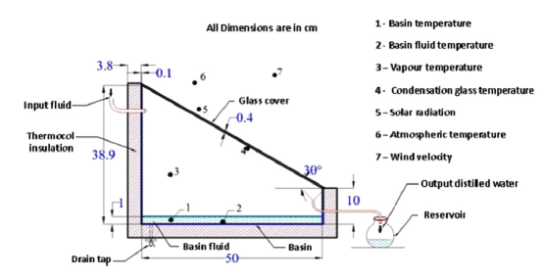
Figure 20:A schematic diagram of single effect passive solar still ^{[26]}

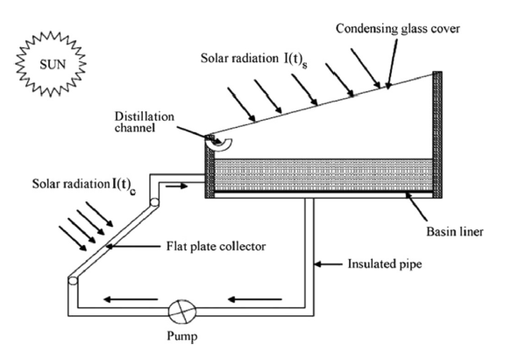
Figure 21 :A schematic diagram of single effect active solar still ^{[26]}

4.3 Solar Still Enhancement Techniques

SS efficiency can be enhanced utilizing various techniques and several parameters affecting its productivity. Most of the studies investigate these techniques on solar still components that will be discussed in the next sections. ^{[27]}

4.3.1 Basin (Absorber)

The basin is considered as an absorber for the SS. It can be shaped as rectangular, which is common one, hemispherical or tubular, which are shown in figure 24 and25 respectively. Moreover, absorber can be horizontal or inclined which is considered as one of the enhancement technique. The concept of inclined solar still based on the fact that, larger evaporation surface area and an efficient angle to the sun, which in turns lead to increase the amount of distilled water. Kumar kaviti et al. reviewed the most important parameter influencing the productivity. In this study, they concluded that the inclination could enhance the productivity. In addition, the basin can be single, double or multi layers figure 29. More layers improve SS efficiency by utilizing the dissipated latent heat. ^{[27]}
Figure 22:Pictorial view of Spherical Solar Still ^{[27]}

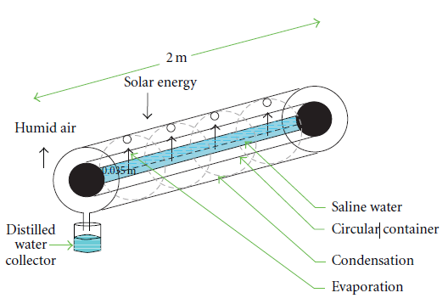
Figure 23 :Schematic view of tubular solar still ^{[27]}

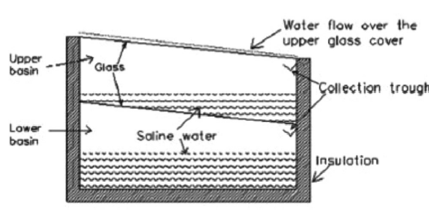
Figure 24:A schematic diagram of multi effect passive solar still ^{[27]}

Furthermore, absorbing and storage materials acts as a good enhancer for still basement. Wick materials such as sponge, cotton and jute cloth are commonly used in many experimental works. Sengar et al.conducted an experiment using black cotton to improve the evaporation rate and increase in productivity of SS by 12%. Black painted and asphalt is a simple and cheap way to improve basin absorptive. ^{[27]}

4.3.2 Glass

Glass is the transparent cover that should be air tightness and has low reflectivity. Incident solar radiation passes through it to heat basin saline water, then vapor condensation takes place. So cleaning glass cover continuously increasing solar transmission therefore, increasing SS performance. ^{[27]}
Glass cover can be finding in different shapes. It can be single or double slope, hemispherical figure 30, pyramid figure 31 or tubular. Glass plays an important role in condensation process. The cover should be inclined toward the best orientation where inclination angle equal to the latitude of the place. The thickness should be low as possible to increase the transmissivity^{[27]}.
Glass temperature is an important parameter that affect solar still yield. This can be achieved in several cooling ways via water film or fan to provide airflow over the glass to enhance the condensation process. The need for cooling comes from high temperature inside the basin due to greenhouse effect, which cause high glass cover temperature. ^{27]}
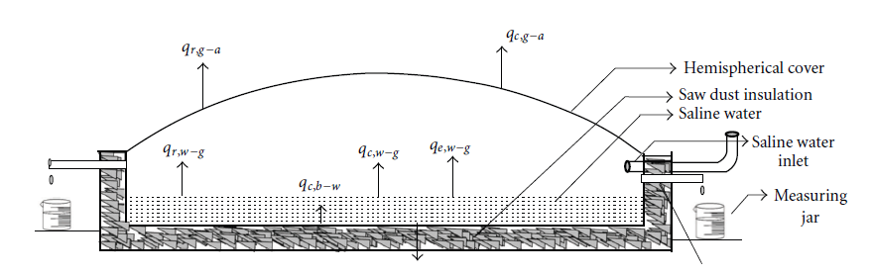
Figure 25:Schematic view of hemispherical solar still [27]

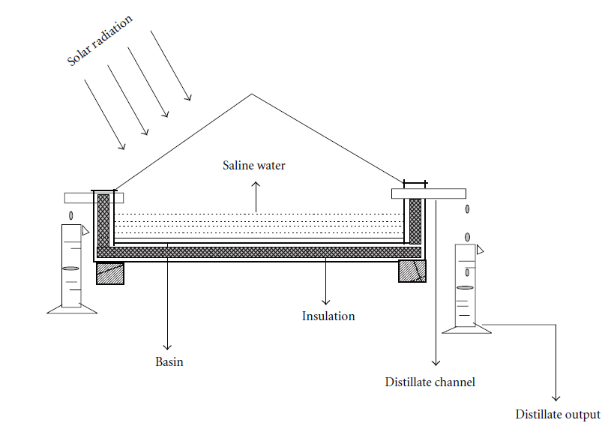
Figure 26 :Schematic view of pyramid solar still ^{[27]}

4.3.3 Other Enhancements Technology

Phase change material (PCM) is a storage material using in the basin as an enhancement technique. It depends on melting and freezing principle, where it absorbs heat during sunny days and change its phase to liquid form. Then release it during the night and cloudy days and backs to its original solid phase. PCMs stores 5-14 times more heat per unit volume, unlike sensible thermal energy storage materials such as masonry or rocks ^{[28]}
PCM classified into three categories: Organic, inorganic and eutectic as shown in figure 27 Organic compound includes paraffin wax, Easters, acids and alcohols that used for household application. Where salty hydrates are the most well-known inorganic PCMs. While eutectic is a mix of organic and inorganic PCMs. ^{[28]}
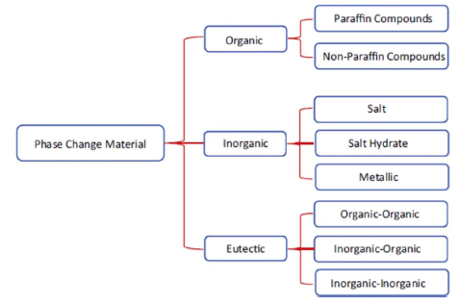
Figure 27 :Classifications of PCMs ^{[29]}

Another modification to enhance the thermal performance of solar still is reflectors either external or internal. Reflectors concentrate or radiant large amount of solar radiation. Moreover, it is more practical in places where solar radiation is weak and the ambient temperature is relatively low. Besides, it decreases the waste heat energy from the SS. ^{[30]}
A modified stepped solar still with internal and external reflectors (figure 28) was investigated by Omaro.et al. He concluded that the modified SS performance enhanced by 125% more than CSS [30]
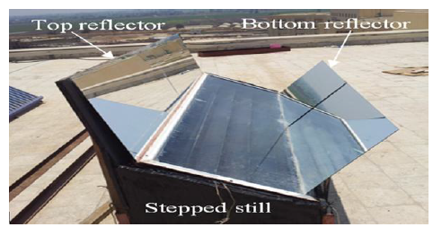
Figure 28 :A photo of the modified stepped solar still ^{[31]}

In addition, one of the significant improvements is fins attached with still basin. Integration of fins allows much exposure area, which in turns increase the heat transfer rate.
Naggar conducted an experimental work to compare between the SS with finned surfaces alternatively, without. The results showed that the efficiency of the finned surface was 55.3%, while it was 42.36% in non-finned surface of the still.^{[30]}
Fins can be found in various shapes: spherical, helical, rectangular or square fins. It can be aluminum or stainless steel, however aluminum fins has higher productivity than stainless steel. ^{[30]}

Factors Affecting Solar Still Performance.

There are different parameters affecting S.S productivity. They are classified to environmental, design and operational parameters as Abujazar et.al. classified it ^{[32]}.

Environmental Parameters

Solar still productivity influence highly by environmental parameters because its metrological factors are unpredictable. These factors include solar intensity, ambient temperature, relative humidity and wind velocity. ^{[32]}
The intensity of solar radiation is the most metrological factor affecting solar still positively. Increasing solar radiation, increases temperature difference between glass and water, which increase the operation process. Figure 29 shows the relationship between solar intensity and SS productivity. ^{[32]}
Figure 29 :the variation of solar intensity and still output ^{[32]}

Air temperature is considered as one of climatic parameters that affect the performance of solar still. Ambient temperature affect condensing glass cover, which will affect temperature difference between glass cover and water. Moreover, ambient temperature is affected by solar radiation ^{[32]}
The effect of relative humidity from previous studies has not been extensively studied. This is because no air enters the device to affect its inside relative humidity. At variance of CSDU that uses a fan to increase the driving force in the unit, which will highly affected the humidity inside the solar still.
For the wind velocity, it is directly proportional to SS productivity. The increasing in wind speed causes an increasing in convicted heat transfer from the cover to the atmosphere, and consequently increase glass-water temperature difference. The performance of SS increases with increasing wind speed up to a certain velocity. ^{[32]}

Design Parameters

There are different design parameters affect SS productivity rate, which can be controlled and designed. These parameters include evaporation area, water depth and insulation.
The exposure evaporated surface area is directly proportional to water evaporation rate in SS, where larger surface area leads to evaporation to increase as shown in figure 30. For achieving this, fins, sponges and wick types can be used at the basin water. ^{[32]}

Figure 30 :the effect of the variation of evaporation area on distillation yield ^{[29]}

The water deepness is inversely proportional to the still heat. The maximum yield has been at minimum water depth. The optimum water depth is 4 cm, which was determined for an optimized SS production. Constant thin layer of water depth may cause a dry spot, so a stepped water still to achieve the least deepness. Furthermore, as water depth increase in the SS basin the water volume and the water volumetric heat capacity increase. ^{[32]}

Figure 31 :The effect of water depth on the solar still productivity ^{[32]}

Insulation is an important physical parameter that plays an important role in preventing the release of thermal energy as waste heat from the sides of the basin.

Operational Parameters

Operational parameters, which include dust accumulation and system maintenance. Most of SS is generally fixed and there is no moving parts, so it does not require much maintenance. On the other hand, some of the designs have moving parts, such as rotating belt and fan, so maintenance is required regularly. In addition, cleaning continuously is necessary, due to its effect on the productivity. ^{[32]}

Chapter 5: Condenser design

5.1 Introduction

Temperature is the average kinetic energy in the molecules of a substance. Heat exchangers are used to transfer that energy from one substance to another. In process plants it is necessary to control the temperature of incoming and outgoing process streams. These streams can either be gases or liquids. Heat exchangers raise or lower the temperature of these streams by transferring heat to or from the stream. ^{[33]}
Heat exchangers are devices that exchange the heat between two fluids of different temperatures that are separated by a solid wall.
The temperature gradient or differences in temperature is the driving force for heat transfer. Transfer of heat occurs in three modes: Radiation, Conduction and Convection.
In the use of heat exchangers, radiation does not take place. However, in comparison to conduction and convection, radiation does not play a major role.
Conduction occurs as the heat from the higher temperature fluid passes through the solid pipe wall. To maximize the heat, transfer the wall should be thin and made of a very conductive material. The biggest contribution to heat transfer in a heat exchanger is made through convection.
In heat exchanger, forced convection allows for the transfer of heat of one moving stream to another moving stream. With convection, as heat is transferred through the pipe wall it is mixed into the stream and the flow of the stream removes the transferred heat. This maintains a temperature gradient between the two fluids. ^{[33]}

The double pipe heat exchanger is one of the simplest types of heat exchangers. It is called double pipe heat exchanger because one fluid flows inside a pipe and the other fluid flows between that pipe and another pipe that surrounds the first. This is concentric tube construction.
Flow in a double-pipe heat exchanger can be co-current or countercurrent. There are two flow configurations: co-current is when the flow of the two streams is in the same direction. Countercurrent is when the flow of the streams is in opposite directions.
As conditions in the pipes change: inlet temperatures, flow rates, fluid properties, fluid composition etc.; the amount of heat transferred also changes. This transient behavior leads to change in process temperatures, which will lead to a point where the temperature distribution becomes steady. ^{[34]}
When heat is beginning to be transferred, this changes the temperature of the fluids. Until these temperatures reach a steady state, their behavior is dependent on time. In the double pipe heat exchanger, a hot process fluid flowing through the inner pipe transfers its heat to the cooler fluid flowing in the outer pipe.
The system is in steady state until conditions change such as flowrate or inlet temperature. These changes in conditions cause the temperature distribution to change with time until a new steady state is reached. The new steady state will be observed once the inlet and outlet temperatures for the process and coolant fluid becomes stable. ^{[33]}

5.2 Classifications of Heat Exchangers

There are a number of exchanger types based on the type of flow configuration, method of heat transfers and constructional features. The process designer has to select the best suitable type that meets the performance and operational requirements. Following is the list of heat transfer equipment. ^{[34]}
- Based on Principles of Operation (Transfer process) ^{[33]}
- Recuperative Type (Direct Transfer).
- Regenerative type (Storage).
- Fluidized Bed Type.

- Based on Fluid Flow Arrangement ^{[33]}
- Counter flow.
- Parallel flow.
- Cross Flow.

5.2.1 Double Pipe Condenser

In this project the condenser was design as double tubular the water pass through inside tube and the wet air inter in shell (outside tube). then the enthalpy is exchanged between the steam and water by converting the wet air into pure water.^{[34]}
The construction of a condenser will be similar to other shell and tube exchangers.
Four condenser conﬁgurations are possible:
1. Horizontal, with condensation in the shell, and the cooling medium in the tubes.
2. Horizontal, with condensation in the tubes.
3. Vertical, with condensation in the shell.
4. Vertical, with condensation in the tubes.

Horizontal shell-side and vertical tube-side are the most commonly used types of condenser. A horizontal exchanger with condensation in the tubes is rarely used as a process condenser, but is the usual arrangement for heaters and vaporizers using condensing steam as the heating medium. ^{[31]}

The purpose of condenser design was to apply the experiments of solar desalination to collect pure water that produced by the device. fundamental of condenser theory in the design of a heat condenser and to optimize the total cost.
The transfer of heat to and from fluids was an essential part of most chemical process. Where the commonly used type of heat transfer or condenser equipment was shell and tube heat or double tubular.
The double tubular condenser was used to condensate the hot wet air at 40c˚, and the fluid which was used for this process was cold water. This project was started by calculate the property for both fluids. Then, the project was continued by selection the material construction of the shell and tube side, both was decided to manufacture from stainless steel. Then allocated the two fluids in the shell and tube side were dependent on several factors (corrosion, fouling, pressure drop…). H2O was put in the shell and wet air was placed in the tube . For condenser arrangement different parameters were calculated, and each parameter was defined to a certain limit. To reach the specific limit, several iterations were done. this to select the best one which was fitted with the available Circumstances and was minimized the total cost. The double tubular condenser and the following values were obtained for the parameter, and 1.31 m/s was the velocity in the tube and 1.72 m/s in the shell. The pressure drop was 2.4, .078 kPa, respectively. The length and the outside diameter of the tube was 3.2 m and 0.3 m. where the diameter for the shell side was 62m.
The project was finished by calculated the total cost. 1561 NIs/yr was the annual operating cost and the annual capital cost was 1912 NIS/yr. the total annual cost was 3474NIS/yr.

5.3Theoretical Background And Sample Of Calculation

Most of equations were taken from Volume 6 (Sinnot, 2005)^{[35]}

- Heat duty
Physical properties of fluid were taken from appendix A at average temperature; the following equation was to find average temperature^{[1]}

$T=\frac{T_{i}+T_{o}}{2}$ ………………………………………………. (1)

Where:
$T_{i}$: The inlet temperature of fluid (˚C).
$T_{o}$: The outlet temperature of fluid (˚C).

  - The amount of heat transfers or heat duty Q (phase change) for condenser can be determined by:
$Q = ṁ λ (latent heat)$ ………………………………………………. (2)

Where:
$Q$: Heat transferred per unit time (W).
$ṁ$: flow rate of process fluid
λ = latent heat of process fluid

- Log Mean Temperature Difference
The logarithm mean temperature differences can be estimated by:

${∆T}_{lm}=\frac{(T_{h,i}-T_{c,o})-(T_{h,o}-T_{c,i})}{ln⁡\left(\frac{T_{h,i}-T_{c,o}}{T_{h,o}-T_{c,i}}\right)}$………………………………………………. (3)

Where:
${∆T}_{lm}$ Log mean temperature differences (˚C).
$T_{h,i}$: The inlet temperature of hot fluid (˚C).
$T_{h,o}$: The outlet temperature of hot fluid (˚C).
$T_{c,i}$: The inlet temperature of cold fluid (˚C).
$T_{c,o}$: The outlet temperature of cold fluid (˚C).

- Temperature correction factor
The correlation factor is a function of the shell and tube fluid temperature, which was equal 1 for condenser.

- Mean Temperature Difference
The mean temperature difference determined by:
${ ∆T}_{m}={∆T}_{lm}×FT$………………………………………………. (4)

Where:
${∆T}_{m}$: Mean temperature differences (˚C).
$FT$: Correlation factor.
$${∆T}_{lm}:the\log{mean temperature differences.}$$

- Heat transfer rate
The general equation for heat transfer across a surface is:
$Q=U×A_{pro}×{∆T}_{m}$………………………………………………. (5)

Where:
$U$: Overall heat transfer coefficient (W/m².˚C).
$A_{pro}$: Heat transfer surface area (m²).

- For tube side

- Number of tube (Nt)
$N_{t}=\frac{A_{pro}}{A_{°}}$………………………………………………. (6)

- Surface area of one tube ($A_{°}$)
$A_{°}=π×L×d_{ₒ}$………………………………………………. (7)

Where:
$d_{ₒ}$: Outside diameter of the tube (m).
$L$: Length of tube (m).
$A_{°}$: Surface area of one tube (m²).
- For double tubular condenser Nt =1

- Flow area of tube
The cross-sectional area was found by:
$A_{c}=\frac{π}{4}×d_{i}$………………………………………………. (8)
Where:
$A_{c}$: Cross-sectional area of tube (m²).
$d_{i}$: Inside diameter of tube (m).

- Total flow area of tube was calculated by using the following equation
$A_{t}=A_{c}×tube per passes$………………………………………………. (9)
Where:
$tube per passes$: Number of tube divided by passes, $\frac{N_{t}}{no. passes}$.
$A_{t}$: Total flow area (m²).
$no. passes=1$, for tabular condenser
So, Number of tube= 1

- Mass velocity of fluid tube
Mass velocity proportional to flow area and flow rate of fluid:
$G_{s}=\frac{m˙}{A_{t}}$………………………………………………. (10)
Where:
$G_{s}$: Mass velocity of fluid (kg/m².s).

- Tube velocity
Linear velocity for water expressed by:
$u_{t}=\frac{G_{s}}{ρ}$………………………………………………. (11)
Where:
$u_{t}$: Linear tube velocity (m/s).
$ρ:$Density of fluid in tube side (kg/m³).

- Heat transfer coefficient
For condensation inside and outside vertical tubes the Nusselt model gives:
$h_{c i/o}=Fc×Kl×{\left(\frac{μ^{2}}{ρl\left(ρl-ρv\right)g}\right)}^{-\frac{1}{3}}$ ………………………………………………. (12)
Where:
$h_{c i/o}:$The inside or outside heat transfer coefficient (W/m².˚C).
$ρl:$ Density of fluid in tube side (kg/m³).
$ρv$: Density of fluid in shell side (kg/m³).

- Pressure drop
${ΔP}_{t}=N_{p}×\left[8×j_{f}×\frac{L}{di}×{\left(\frac{μ}{μ_{w}}\right)}^{-m}+2.5\right]×\frac{ρ×{u_{t}}^{2}}{2}$ ……………………………………. (13)
Where:
${ΔP}_{t}:$Pressure drop in the tube side (Pa).
$N_{p}:$No. of tube passes.
$j_{f}:$Fraction factor for tube side.
$m=0.25$for laminar flow, Re< 2100.
= 0.14 for turbulent flow, Re> 2100.
$μ:$Fluid viscosity at the bulk fluid temperature ( Pa.s).
$μ_{w}:$Fluid viscosity ( Pa.s) at the wall temperature (Tw).

- Reynolds number
Reynolds number (Rec) in tube side in condenser was estimated by:
$Rec=\frac{4×┌v}{μl}$………………………………………………. (14)

Where:
$┌v$ : vertical tube loading, condensate rate per unit tube perimeter, kg/m s
$┌v$=$\frac{m∙}{Di or o}$
$Di or o$: In or out side diameter of tube (m).

- Wall temperature
Wall temperature ($Tw)$ was calculated by:
$T_{w}=0.5×\left[\frac{T_{c,i}+T_{c,o}}{2}+\frac{T_{h,i}+T_{h,o}}{2}\right]$………………………………………………. (15)

- Pumping power
$P_{tube}=\frac{{ṁ}_{t}×{ΔP}_{t}}{ρ×η}$………………………………………………. (16)
Where:
$P_{tube}$ : Pumping power in tube (W).
$η:$ Pump efficiency and equal to 0.6

- For shell side

- Diameter of shell
An estimated of the bundle diameter $D_{b}$ can be obtained by:
$D_{b}=d_{ₒ}×{\left(\frac{N_{t}}{k_{1}}\right)}^{\frac{1}{n_{1}}}$………………………………………………. (17)

Where:
$k_{1}, n_{1}$: Constant depends on the number of passes and type of pitch

- Shell diameter (Ds) can be determined by:

$D_{s}=D_{b}+clearnce$………………………………………………. (18)

- Tube pitch
Tube pitch diameter can be estimated by:
$P_{t}=1.25×d_{ₒ}$………………………………………………. (19)
Where:
$Pt$: Tube pitch diameter, which is the distance between the centers of two adjacent tubes.

- Baffle spacing
Baffle spacing is the longitudinal or centerline-to-centerline distance between adjacent baffles:
$l_{B}=factor×D_{s}$………………………………………………. (20)
Where:
$l_{B}$: Baffle spacing (m).
$factor$: One fifth of shell inside diameter, whichever is greater.

- Flow area of shell
The area for cross-flow at the shell, given by:
$A_{s}=\frac{(P_{t}-d_{ₒ})×D_{s}×l_{B}}{P_{t}}$………………………………………………. (21)
Where:
$A_{s}$: Cross-flow area for shell (m²)

- Linear velocity
Linear velocity for fluid expressed by:
$u_{s}=\frac{G_{s}}{ρ}$………………………………………………. (22)
Where:
$u_{s}$: Linear shell velocity (m/s).
$ρ$: Density of fluid in shell (kg/m³).

- Equivalent diameter
The equivalent diameter ($d_{e}$) in m was calculated by:
$d_{e}=\frac{1.27×({P_{t}}^{2}-0.785×{d_{°}}^{2})}{d_{°}}$………………………………………………. (23)

- Reynolds number
$Re=\frac{Gs×d_{e}}{μ}$………………………………………………. (24)

- Heat transfer coefficient
$h_{s}=\frac{j_{h}×Re×{Pr}^{1/3}×({\frac{μ}{μ_{w}})}^{0.14}×Kf}{d_{e}}$………………………………………………. (25)

Where:
$h_{s}$: Heat transfer coefficient (W/m².˚C).
$j_{h}:$Heat transfer factor
$Pr:$Prandtl number.
$Kf:$Fluid thermal conductivity, (W/m.˚C).
$d_{e}:$Equivalent diameter (m)

- Pressure drop

${ΔP}_{s}=8×j_{f}×\left[\left(\frac{Ds}{d_{e}}\right)×\left(\frac{L}{l_{B}}\right)×{\left(\frac{μ}{μ_{w}}\right)}^{-0.14}×\frac{ρ×{u_{s}}^{2}}{2}\right]$……………………………………. (26)

Where:
${ΔP}_{s}$: Shell pressure drop (Pa).
$j_{f}:$Fraction factor for shell side

- Pumping power
$P_{shell}=\frac{{ṁ}_{s}×{ΔP}_{s}}{ρ×η}$……………………………………. (27)
Where:
$P_{shell}$ : Pumping power in shell (W).

- overall heat transfer
The overall heat transfer coefficient was calculated by:
$\frac{1}{U_{o, cal}}=\frac{1}{h_{o}}+\frac{1}{h_{od}}+d_{o}×\frac{ln⁡(\frac{d_{o}}{di})}{2×K_{w}}+\frac{d_{o}}{di}×\left(\frac{1}{h_{i}}+\frac{1}{h_{id}}\right)$……………………………………. (28)

Where:
$U_{o, cal}:$Overall heat transfer coefficient (W/m².˚C).
$h_{o}:$Outside fluid film coefficient (W/m².˚C) and it was equal $h_{s}$ .
$h_{i}:$Inside fluid film coefficient (W/m².˚C) and it was equal to $h_{i}$.
$h_{od}:$Outside dirt coefficient (fouling factor) (W/m².˚C).
$h_{id}:$Inside dirt coefficient (W/m².˚C) .
$K_{w}:$Thermal conductivity of the tube wall material (W/m².˚C).

- Error% was calculated by:
$Error\%=\frac{U_{o, cal}-U_{o, assm}}{U_{o, assm}}×100$……………………………………. (29)
Where:
$U_{o, cal}:$Calculated overall heat transfer coefficient (W/m².˚C).
$U_{o, assm}:$Assumed overall heat transfer coefficient (W/m².˚C).

- Cost calculation

- Annual operating cost
$AOC=P×attainment×t×K$……………………………………. (30)

Where:
$AOC$: Annual operating cost (NIS/yr).
$t$: operating time (year).
$P$: pumping power (KW).
$K$: Cost of electrical energy and equal 0.574(NIS/kW).
$$attainment=0.93$$

- Purchased cost
$purchased cost 2004=bare cost ×type factor×pressure factor$………………. (31)

- $purchased cost 2018=purchased cost 2004×\frac{cost index 2018}{cost index 2004}$……………. (32)

- Capital cost
$TCC=purchasd cost+installation cost$……………………………. (33)

Where:
$TCC$: Total capital cost (NIS).
$$installation cost=purchasd cost×0.2$$
$$so, TCC=1.2*purchasd cost$$

- Annual capital cost ……………………………………. (34)
$$ACC=\frac{TCC}{useful life of the project}$$
Where:
$ACC$: Annual capital cost (NIS/yr).

- Total annual cost
$TAC=AOC+ACC$……………………………………. (35)
Where:
$TAC$: Total annual cost (NIS/yr)
$AOC:annual operating cost(NIS/yr)$

5.3.1 Sample of calculation

- The calculation of water was found as follow:
$$T=\frac{T_{c,i}+T_{h,o}}{2}$$
$$T=\frac{23+30}{2}$$
$$T=26.5 ˚C$$
$$T=26.5+273$$
$$T=299.5 K$$
Some interpolations were made to find properties of water from appendix A-9:
$$ρ @ 25˚C =997 kg/m^{3}$$
$$ρ @ 30 ˚C=996 kg/m^{3}$$
$$ρ @ 26.5˚C→\frac{26.5-25}{30-25}=\frac{ρ-997}{996-997}$$
$$ρ @ 26.5 ˚C=996.7 kg/m³$$
The same calculations and interpolations were done to calculate all properties of water so,

$$ϻ @ 26.5˚C=.8631×{10}^{-3} Pa.s$$
$$K @ 26.5˚C=0.6094 W/m.˚C$$
$$Pr @ 26.5˚C=5.924$$
$$cp @ 26.5˚C=2.673 kJ/kg.˚C$$
See appendix A

- For properties of wet air

Find humidity from stoichiometric chart figure 32
H=.05 kg H2O/kg dry air
Humid heat($Cs)$=1.005+1.88H=1.099 kj /kg dry air .K

Humid volume ($ѵ)=\left(2.83*{10}^{-3}+ 4.56*{10}^{-3}H\right)*T9(k)$
=.957 $\frac{m^{3}}{kg dry air}$

Density $ρ=\frac{1}{ѵ}$
= 1.045 kg dry air /m³

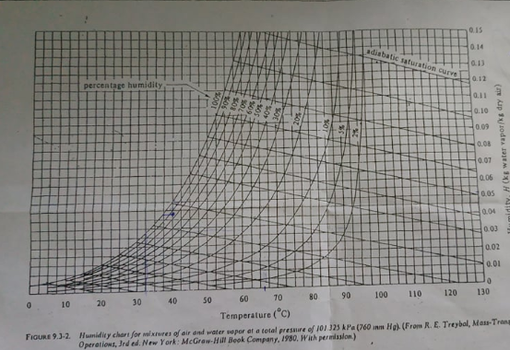
Figure 32 :humidity chart

Where There are several factors that must be considered to decide the allocation of the fluid in tube and shell as shown follow in table3.

Table 3 :factors that must be considered to decide the allocation of the fluid in tube and shell
Factor | High /Low | Tube Side | Shell Side
Corrosion | High corrosion in tube  Low corrosion in shell | H₂O , high corrosion since the relative humidity was high, also increasing in temperature will improve the corrosion.( fromvol.6) | Wet air, low corrosion than H₂O .Decreasing in temperature will decrease the corrosion. ( from vol.6)
Fouling factor | High fouling factor( coefficient) in tube  Low fouling factor (coefficient) in shell | H₂O, from table 4, It has a high coefficient than air. ( 6000-12000W/ m².˚C). | air, from table4, it has a low coefficient than water (5000 W/ m².˚C)
Fluid Temperatures | High fluid temperature in tube  Low temperature fluid in shell | air, it has the high mean temperature and it was equal 40 ˚C. | H₂O, low mean temperature and it was equal 26.5 ˚C.
Viscosity | High viscous fluid in shell  Low viscous fluid in tube | air, viscous fluid with a value of  1.70E-05 Pa.s. | H₂O, low viscosity with a value of  8.63E-04 Pa.s.
Stream Flow- Rate | High stream flow rate in tube  Low flow rate in shell | H₂O, higher flow rate (  86.174682 kg/s), (by calculation and it was illustrated in the sample of calculation). | air, lower flow rate than H2O (1 KG/S,.

Table 4: fouling factor

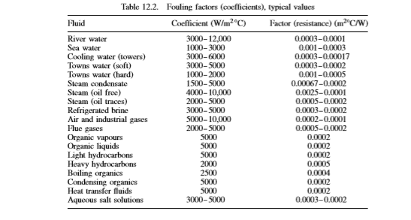

$$3. Q = \dot{m}λ \left(latent heat\right) from figure$$
=1* 2409.3 = 2409.3 kJ/s

$${4. ∆T}_{lm}=\frac{\left(T_{h,i}-T_{c,o}\right)-\left(T_{h,o}-T_{c,i}\right)}{\ln\left(\frac{T_{h,i}-T_{c,o}}{T_{h,o}-T_{c,i}}\right)}$$

$${∆T}_{lm}=\frac{\left(40-30\right)-(40-23)}{ln\left(\frac{40-30}{40-23}\right)}$$
${∆T}_{lm}=$13 $˚C$

For tube side:

Table 5 :Tube side(steam)
Tube side(steam)
1 | Passes
1 | tube per pass
0.0660 | total flow area (m²)
1305.3111 | water mass velocity (kg/s.m²)
1.3096 | water linear velocity (m/s)
4.39E+05 | Re
287.2489 | Ꞅv out(condensate rate per unit tube perimeter)(kg/m.s)
1.33E+06 | Rec
0.09 | From Figure 12.43
1291.9684 | hc (W/m².C)
284.0706 | Ꞅv in(condensate rate per unit tube perimeter)(kg/m.s)
1.32E+06 | Rce
0.01 | From Figure 37
143.5520 | hc (W/m².C)
3094.7759 | hi՝(W/m².C)
49341.2749 | hc(W/m².C)

Assume overall heat transfer coefficient from figure-36 for hot fluid (wet air) and cold fluid (water)
$$30<U<60$$
as initial guess$U=60 m^{2}.˚\frac{C}{W}$
Table 6: Type of heat exchanger
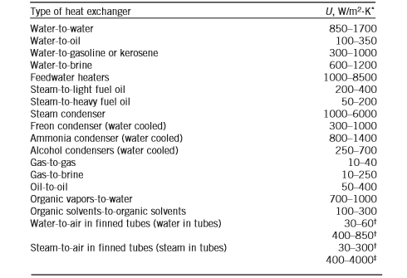

- To find provisional area
$$A_{pro}=\frac{Q}{U×∆T_{m}}$$
$$A_{pro}=\frac{2409.3}{60×13.1919}$$
$A_{pro}=$3.0439$m^{2}$
Assume tube inside & outside diameter, and
tube length L=area of tube/(3.14*Do)
=3.23m

Area of one tube
$A_{°}= π×d_{°}× L$= $A_{pro}=$3.0439$m^{2}$
$$N_{t}=\frac{A_{pro}}{A_{°}}=1$$
$$A_{c}=\frac{π}{4}×d_{i}²$$
$$A_{c}=\frac{π}{4}×0.024948²$$
$A_{c}=$0.066$m^{2}$
$$G_{s}=\frac{m˙}{A_{t}}$$
$$G_{s}=\frac{86.17}{0.066}$$
$=$1305.3111$\frac{kg}{m^{2}.s}$
$$u_{t}=\frac{G_{s}}{ρ}$$
$$u_{t}=\frac{1305.311}{996.7}$$
$u_{t}=1.31\frac{m}{s}$, it was within the range of tube side

- To find heat transfer coefficient for water
For condensation inside and outside vertical tubes the Nusselt model gives:
$$h_{c i/o}=Fc×Kl×{\left(\frac{μ^{2}}{ρl\left(ρl-ρv\right)g}\right)}^{-\frac{1}{3}}$$

Ꞅv out(condensate rate per unit tube perimeter)(kg/m.s)
$┌v$=$\frac{m∙}{Di or o}$
Ꞅvo = 287.2489
Ꞅvo = 284.0706
$$Rec i,o=\frac{4×┌v}{μl}$$
R_{eci}= 1.33E+06
Fc=.09 from figure 33
R_{eco}=1.32E+06
Fc=.01

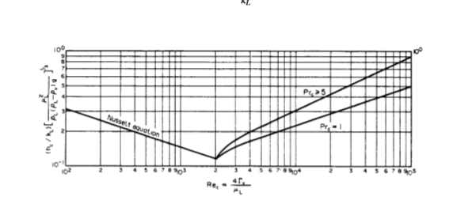
Figure 33: condensation coefficient for vertical l tubes

$${}_{\begin{aligned}hc i=\left(.09*.6094\right)*{\left(\frac{{\left(8.6*{10}^{-4}\right)}^{{}^{2}}}{996.7*\left(996.7-1.0477\right)*9.81}\right)}^{-\frac{1}{3}} \\ \end{aligned}}$$

hci= 1291.9684(W/m².C)
hco= 143.552 (W/m².C)

$${ΔP}_{t}=N_{p}×\left[8×j_{f}×\frac{L}{di}×{\left(\frac{μ}{μ_{w}}\right)}^{-m}+2.5\right]×\frac{ρ×{u_{t}}^{2}}{2}$$

Jf= .0035 (tube side) (figure 34)

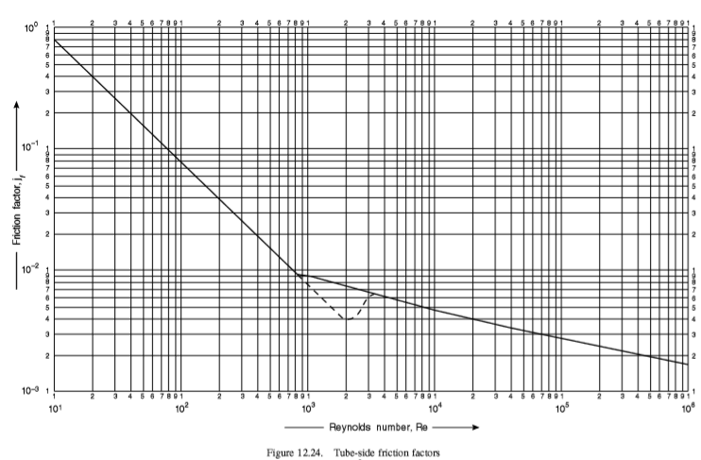
Figure 34:tube -side fraction factor

$${ΔP}_{t}=\left(1*996.7*\frac{{1.31}^{2}}{2}\right)*\left(\left(8*.0035*\frac{3.2}{.29}*{1.14}^{-}.14\right)+2.5\right)$$
=2398.5781 pa
=2.39 kpa

For shell side

Table 7 :Shell side(water)
Shell side(water)
0.1237 | baffle space (m)
0.375 | tube pitch(m)
0.0153 | As (m²)
1.7996 | mass velocity, Gs (kg/s.m²)
0.213 | de (m)
1.7225 | Shell velocity (m/s)
2.25E+04 | Re
0.7255 | Pr
0.015 | jh (figure 36)
63.9776 | hc (W/m².C)

$$D_{b}=d_{°}×{\left(\frac{N_{t}}{k_{1}}\right)}^{\frac{1}{n_{1}}}$$
=.3*(1/0.215)^1/2.207
=0.6019m
$clearnce=$0.017$m$ , from figure35

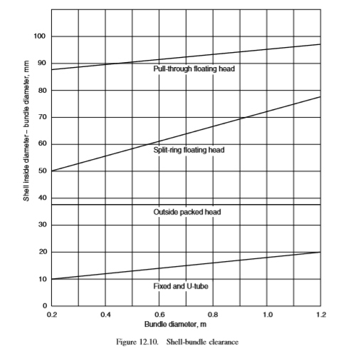
Figure 35 : shell-bundle clearance

$$D_{s}=0.6019+0.017$$
Ds= 0.6189m
$$P_{t}=1.25×d_{°}$$
$P_{t}=1.25×0.3$.
$P_{t}=$0.375$m$
$$l_{B}=factor×D_{s}$$
$$l_{B}=.2×0.6189$$
$l_{B}=$0.1237m
$$A_{s}=\frac{(P_{t}-d_{°})×D_{s}×l_{B}}{P_{t}}$$

$$A_{s}=\left(\frac{\left(0.375-0.3\right)×0.6189×0.1237}{0.375}\right)$$
$A_{s}=$0.0153m²

$$G_{s}=\frac{{ṁ}_{s}}{A_{s}}$$
$$G_{s}=\frac{1}{0.0153}$$
$G_{s}=$1.7996$kg/m^{2}.s$
$$u_{s}=\frac{G_{s}}{ρ}$$

$$u_{s}=\frac{1.7996}{1.044}$$
$$u_{s}=1.72 m/s$$
$$d_{e}=\frac{1.27×\left({P_{t}}^{2}-0.785×{d_{°}}^{2}\right)}{d_{°}}$$
$$d_{e}=\frac{1.27×\left({.375}^{2}-0.785×{.3}^{2}\right)}{.3}$$
$d_{e}=$0.213$m$

$$Re=\frac{G_{s}×d_{e}}{µ}$$
$$Re=\frac{1.799×.213}{1.7*{10}^{-5}}$$
$Re=$2.25E+04
$Re=2.25E+04$, turbulent flow $Re$> 2100
$$h_{s}=\frac{j_{h}×Re×{Pr}^{\frac{1}{3}}×({\frac{μ}{μ_{w}})}^{0.14}×K}{d_{e}}$$
$j_{h}=0.$015from figure36

$$h_{s}=\frac{.015×22500×{.7255}^{\frac{1}{3}}×({1.69)}^{0.14}×.0266}{.213}$$

$$hs=62.977 W/m^{2}˚C$$

$${ΔP}_{s}=8×j_{f}×\left[\left(\frac{Ds}{d_{e}}\right)×\left(\frac{L}{l_{B}}\right)×{\left(\frac{μ}{μ_{w}}\right)}^{-0.14}×\frac{ρ×{u_{s}}^{2}}{2}\right]$$
$j_{f}=0.09, from figure$35

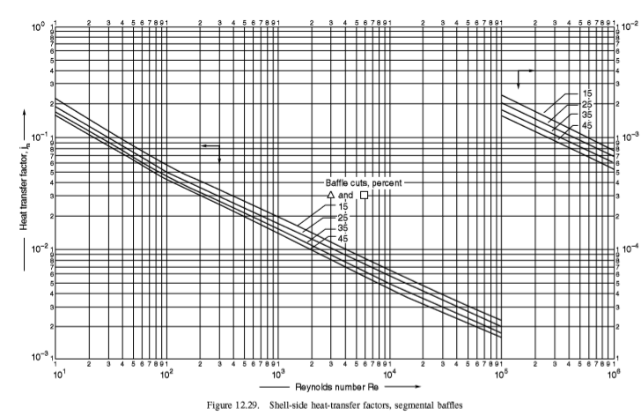
Figure 36: shell-side heat transfer factor

$${ΔP}_{s}=8×.09×\left[\left(\frac{.6189}{d_{e}}\right)×\left(\frac{3.2}{.1237}\right)×{\left(1.69\right)}^{-0.14}×\frac{1.044×{1.72}^{2}}{2}\right]$$
${ΔP}_{s}=$78.6709$Pa$
$${ΔP}_{s}=.0786 kpa$$
$$\frac{1}{U_{o}}=\frac{1}{h_{o}}+\frac{1}{h_{od}}+d_{o}×\frac{ln⁡(\frac{d_{o}}{di})}{2×K_{w}}+\frac{d_{o}}{di}×(\frac{1}{h_{i}}+\frac{1}{h_{id}})$$
$$\frac{1}{U_{o}}=\frac{1}{36.97}+\frac{1}{5000}+0.3×\frac{ln⁡(\frac{0.03}{0.29})}{2×16}+\frac{0.3}{0.29}×(\frac{1}{29341}+\frac{1}{6000})$$
$\frac{1}{U_{o}}=$0.0163$m^{2}.˚C/W$
$U_{o}=\frac{1}{0.0163}=$61.1932$W/m^{2} ˚C$
$$Error\%=\frac{U_{o, cal}-U_{o, assm}}{U_{o, assm}}×100$$
$$Error\%=1.9888$$

Cost of condenser

Table 8 :Cost of condenser
16.1869 | A.O.C (NIS/yr) shell
1545.1175 | A.O.C (NIS/yr) tube
1.1 | Pressure factor
0.8 | Type factor
4400 | Purchased cost 2004($)
114 | index cost 2004
118 | index cost 2019
4554.3859 | Purchased cost 2019($)
5465.2631 | Total capital cost ($)
19128.421 | TCC (NIS)
1912.8421 | A.C.C(NIS/yr)
3474.1466 | T.A.C(NIS/yr)
992.6133 | T.A.C($/yr)
1561.3045 | T.O.C(NIS/yr)

$$P_{tube}=\frac{{\dot{m}}_{t}×{ΔP}_{t}}{ρ×η}$$
$$P_{tube}=\frac{86.17×2.39}{996.7×0.6}$$
$P_{tube}=$0.3456$kW$
$${AOC}_{tube}=P×attainment×t×K$$
${AOC}_{tube}=$0.3456$×0.93×24×365×0.574$
${AOC}_{tube}=$1616.2807$NIS/yr$
$$P_{shell}=\frac{{\dot{m}}_{s}×{ΔP}_{s}}{ρ×η}$$
$$P_{shell}=\frac{1×.078}{1.044×0.6}$$
$P_{shell}=$0.0034$kW$
$${AOC}_{shell}=P×attainment×t×K$$

$${AOC}_{shell}=0.0034×0.93×24×365×0.574$$
${AOC}_{shell}=$16.1869$NIS/yr$
$$AOC={AOC}_{tube}+{AOC}_{shell}$$
$$AOC=1616.2807+16.1869$$
$AOC=$1632.4677$NIS/yr$

$$purchased cost 2004=bare cost ×type factor×pressure factor$$
$$bare cost=5×1000$$
$bare cost=5000\$$from figure 37

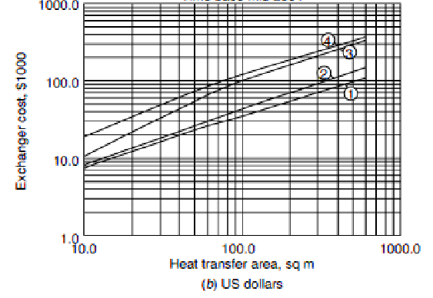
Figure 37: shell and tube heat exchangers (time base 2004 )

$$purchased cost 2019=purchased cost 2004×\frac{cost index 2019}{cost index 2004}$$
$cost index2019=118$from figure 38
$cost index2004=114$from figure 39

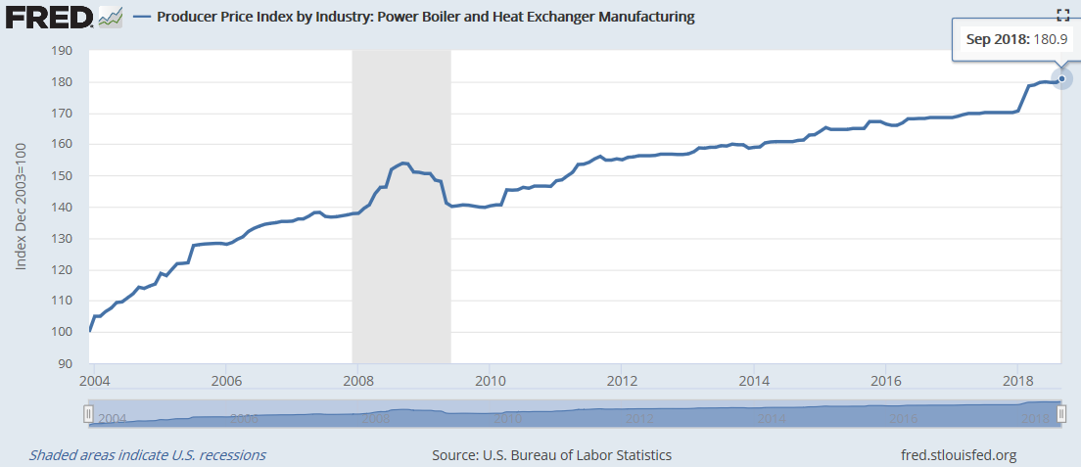
Figure 38:cost index2019

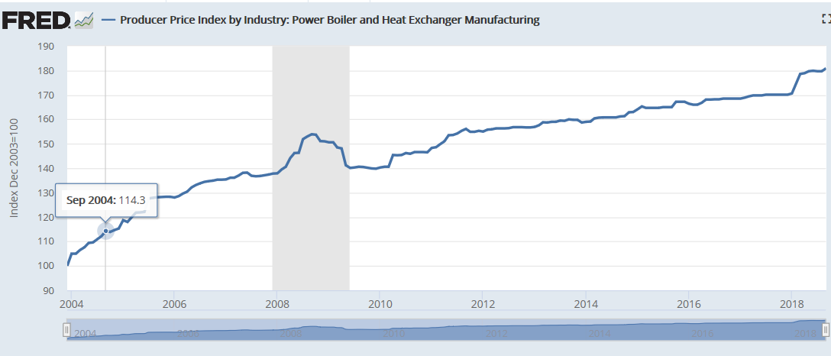
Figure 39:cost index2004

$$purchased cost 2019=3920×\frac{118}{114}$$
$purchased cost 2018=$4554.3859$\$$
$$TCC=purchasd cost+installation cost$$
$$TCC=4554+0.2×4554$$
$TCC=$5465.2631$\$$

$$TCC=7597×3.5$$
$1\$=3.5 NIS$ (bank of Palestine)
$TCC=$19128.421$NIS$
$$ACC=\frac{TCC}{useful life of the project}$$
$$ACC=\frac{19128.42}{10}$$
$ACC=$1912.8421$NIS/yr$
$$TAC=AOC+ACC$$
$TAC=1632.4677+$1912.8421

$TAC=$3545.3098$NIS/yr$
$$TAC=\frac{3545.3098}{3.5}$$
$TAC=$1012.9456$\$/yr$

5.3.2 AutoCAD design

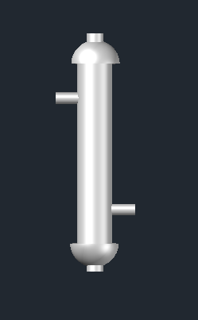
Figure 40: 3D condenser design Figure 41 : 2d condenser design

5.4 Discussion

It was aimed to design double tubular condenser with minimum cost and highest efficiency to condense saturated air from 40˚C by using cold water which was entered and left at 23, 30 ˚C, respectively.
Viscosity is an important parameter to determine the fluid location. it was 8.63E-04, 1.70E-05(Pa.s) the viscosity of water and wet air, respectively. Viscous fluid was put in shell because it has low velocity so this increase rate of heat transfers. Also, mass flow rate of two fluid is found that 86.174682, 1 kg/s for water and wet air, respectively. Fluid with low flow rate was put in shell side. Another factor was studied was corrosion, more corrosive fluid was put in the tube side because it is easily to clean and place, and water was more corrosive than wet air. As the result of this factor, water was put in the tube side and in shell, wet air was put.
According to energy balance, rate of heat transfer is found from latent heat of air because phase change occurs. Then temperature correction factor was equal 1 for condenser. In design, after that, some parameters were assumed at the beginning and some iteration were made to find the geometry of shell and tube of condenser.
Tube side, the calculations were started by assume different values for parameters such as, the outside & inside diameter of the tube, length and. Then the effect of change any parameter on velocity and pressure drop was studied and was checked if it in the limit standard. The result was illustrated that as the length of the tube increased, the velocity and the pressure drop increased. While, if the outside diameter increased, both pressure drop and velocity decreased. Velocity and pressure drop will increase if (thickness) decrease. These parameters then were changed to obtain pressure drop and velocity in the acceptable range. Finally, the heat transfer coefficient was calculated.
The baffle spacing was assumed in the range of one-fifth of the tube diameter or greater than it. It was changed to obtain the value of velocity and pressure drop in the standard limit. It was used to increase rate of heat transfer and to support the tube.
The final step of calculation was calculating the cost of the project. Assuming life of project 10 years, the operating cost was calculated by assuming efficiency of heat exchanger 60%, and the cost of electricity was 0.574 NIS/KWh. To convert cost to dollar, the factor was used is 3.5. The total annual cost for condenser 1012.9456 $/yr.
There were some errors in the calculations, such as human errors. Also a lot of assumptions were used which caused error. Pressure drop was more important than velocity because it may cause explosion to the system at high pressure value, but velocity helping in the removal of fouling that can be remove by mechanical cleaning of tube and shell.
The dimensions adopted are, for the tube side: double tubular, length is 3.2m inside and outside diameters are 0.3m and 0.29m; sequentially. For the shell side diameter 0.618m.

Chapter 6: Results and Discussion

6.1 Procedures

Experimental studies were carried out during February, March and April of 2019. Generally, the following procedures were followed to operate the system unit:
- The measurement devices were installed
- 11-12 L of tap water was supplied to the basin to reach a height of 15.5-16 cm.
- Each experiment was performed approximately for 7-8 hours from 8:00 am to 4:00 pm.
- Lower and upper fans were operated at a volumetric flow rate 125 m3/h and 95 m3/h; respectively, where the rotating belt was running at speed 0.21 rpm at different weathers and in cases of turn on and turn off the CSDU. And different speeds at same weather condition in other cases.
- During the day, the Inlet and outlet temperature and relative humidity were measured at 10-second interval by two data loggers located at lower fan and upper fan. Solar radiation and basin water temperature were taken every 30 minutes manually.
- The evaporation rate was measured every 30 minutes by measuring the volume in the basin.
- At the end of the day, the remaining water (the not evaporated water) was drained at the end of the day from a tap, which is fixed at the bottom side of the basin.
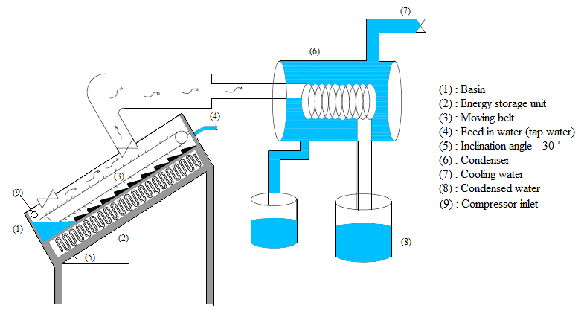

Figure 42: Water System Unit.

6.1.1 Measurements

The measured data were taken in two parts. For the first part, the data were collected manually every 30 minutes including, solar radiation, water temperature and water height (h). For the second group of data, it was measured using two data loggers to measure relative humidity and temperature for the inlet air (ambient air); the other one is used to measure relative humidity and temperature inside the basin.
TM-946 thermometers with two thermocouples were used to measure water temperature every half hour in two different places. The accuracy of thermocouples are ± 0.4 %. And the Solar radiation was collected from energy center at an An-Najah National University.

6.2 Constrains

There are some of the challenges we have experienced:
- Security men were delayed in opening the roof door early, and this leads to the failure to operate the device and take information accurately
- The TM-946 thermometer stopped working, prompting us to use the manual thermometer to take the water temperature every half hour.
- Error in the data logger.
- The weather is not similar, Because of this we did not take more data for comparison.
- Insulation damage and tear.

6.3 Evaporation Rate Measurements

The efficiency of CSDU along various climate conditions was estimated and examined. The results are represented by accumulative volume of evaporated water where the volume was measured on the whole day every 30 minutes; also it was measured by daily flux (L/m².day).

6.3.1 Maximum and Minimum Evaporation Rate Achieved.

The productivity of the CSDU was measured during February to April under different weather Condition. The maximum and minimum values for accumulative volume of evaporated water are shown in figure 43 and refer to Appendix

Figure 43:The accumulative volume for Maximum and minimum cases.

As shown in figure 44 the maximum evaporation rate was achieved in 18-march 2019 and the minimum evaporation rate was achieved in 25-maech 2019, and the daily Flux for maximum and minimum is (7.663 and 1.43 L/m².day), respectively.
A summary of ambient conditions for these results are presented in table 9.

Table 9 : The ambient conditions for maximum and minimum evaporation rate
Day | Accumulative volume (ml) | Solar radiation(W/m²) | ambient Temperature(Cº)
18.3.2019 | 3372.08 | 837.05 | 19.22
25.3.2019 | 628.64 | 200.8 | 13.33

As the table 9 shows the solar radiation on 18-3-2019 is 837.05 W/m² and the Accumulative volume is 3372.08 ml and the Solar radiation on 25-3-2019 is 200.8 W/m2 and the accumulative Volume is 628.4 ml, so it was noticed that the high accumulative volume was achieved when the ambient condition was high.

Figure 44:accumulative volume under different environmental conditions

And the table shows the data as below:

Table 10:: The ambient conditions for several day Under different environmental conditions
Day | Daily Flux (l/ml.day) | Solar radiation (W/m2) | Ambient temp
17.3.2019 | 3.989 | 481.62 | 16.2
18.3.2019 | 7.663 | 837.05 | 19.2
25.3.2019 | 1.43 | 200.832 | 13.3
26.3.2019 | 4.273 | 421.386 | 15.8
27.3.2019 | 3.706 | 452.683 | 18.7

6.3.2 The Effect Of Low Speed And High Speed Of The Belt

In this case the CSDU was turned on at the same weather condition, the belt was turned on at variable speed (0.0321 ,0.0661 ,0.095.0.1366 and 0.21) rpm and the accumulative volume at this speed was showed in figure 45

Figure 45 :accumulative volume at different speeds of the belt

It is clear from the previous figure that the highest accumulative volume was achieved at the lowest speed 0.0321 rpm (speed 5) and the lowest accumulative volume was achieved at the highest speed of the belt 0.21 rpm (speed 30).
A summary of ambient conditions for these results are presented in table 11.

Table 11:The ambient conditions for several day under different speed of the belt
Motor Speed | Day | Daily Flux (l/ml. day) | Solar radiation (W/m²) | Ambient temp (Cº)
5 | 19.3.2019 | 9.63 | 852.66 | 21.3
10 | 9.4.2019 | 9.07 | 779.73 | 23.01
15 | 7.4.2019 | 7.95 | 751.375 | 23.73
20 | 4.4.2019 | 6.25 | 600.04 | 20.3
30 | 27.3.2019 | 3.706 | 452.68 | 18.7

At the following figure, shows the daily flux at different speeds of the belt and it was noticed that the daily flux was achieved high value at low speed.

Figure 46:Daily flux at different speeds of the belt

6.3.3The Effect of (turn on and turn off) the CSDU

The device was operated for 7 hours as usual and readings were taken every half hour under the same weather condition. This case was done at several day during April month (17,18,20 and 23) /4/2019.
The plan of this situation was as follows:
- Case I: the CSDU was turned off 5 min then turn on half hour and the reading fixed every 30min.
- Case II: the CSDU was turned off 10 min then turn on half hour and the reading fixed every 30min.
- Case III: the CSDU was turned off 5 min then turn on 45min and the reading fixed every 30min.
- Case IV: the CSDU was turned off 10 min then turn on 45min and the reading fixed every 30min.

The maximum accumulative volume was achieved at (case IV) and the minimum accumulative volume was achieved at (Case I) as show on the following figure; see appendix.

Figure 47: accumulative volume for each case

Figure 48:daily flux for each case

A summary of ambient conditions for these results are presented in the following table:

Table 12:ambient conditions for each case
Case | Day | Daily Flux (l/ml.day) | Solar radiation(W/m²) | Ambient temp. (Cº)
5 min off /30 min On | 17.4.2019 | 3.705 | 462.61 | 16.93
10 min Off /30 min On | 18.4.2019 | 5.41 | 697.98 | 17.2
5 min off / 45 On | 20.4.2019 | 3.71 | 404.26 | 15.86
10 min Off / 45 On | 23.4.2019 | 7.66 | 743.4 | 22.01

As shown in the table above the ambient condition of case IV is different and this cusses an error to analyses this result.

Figure 49:ambient temperature for each case

Figure 50:solar radiation for each case

6.4 Environmental Parameters Affecting Solar Still Performance

The evaporation rate is highly influenced by environmental parameters. Several experiments were conducted and reported during February to April, at same operational conditions and with belt speed 0.21 rpm. The studied ambient parameters include ambient temperature, relative humidity and solar radiation. In the following sections, the effect of each parameter will be described.

6.4.1Effect Of Solar Radiation.

The behavior of solar radiation during two different days (18/3/2018 and 25/3/2018) was showed in following figure to investigate the relationship between solar radiation and the evaporation rate.

Figure 51:The effect of solar radiation on unit’s evaporation rate

Figure 52:The effect of solar radiation on unit’s evaporation rate for 18.3.2019

Figure 53: The effect of solar radiation on unit’s evaporation rate for 25.3.2019

Figure 54: Relationship between solar radiation and daily flux

The result also shown in the following table:

Table 13: Daily flux and average solar radiation
Day | Daily Flux (l/day.m2) | Solar radiation(W/m2)
17.3.2019 | 3.989 | 481.62
18.3.2019 | 7.663 | 837.05
25.3.2019 | 1.43 | 200.832
26.3.2019 | 4.273 | 421.386
27.3.2019 | 3.706 | 452.683

As previous results show, the maximum daily flux was achieved is 7.663 l/day.m² at solar radiation 837.05 w/m² and the minimum daily flux if 1.43 l/ m² day at solar radiation 200.832 W/m2, so noticed that the daily flux is affected by Solar radiation, the relationship between solar radiation and daily flux is proportional relationship.

6.4.2 Effect of Temperature

Temperature plays an important role on affecting the unit’s productivity. Temperature depends mainly on solar radiation, thus when solar radiation is relatively high during the day, ambient temperature will also be high. So this will affect the unit’s evaporation flux positively, the following results prove this.

Table 14:Daily flux and Ambient Temperature.
Day | Daily Flux(l/m2.day) | Solar radiation(W/m2) | Ambient Temperature(cº)
17.3.2019 | 3.989 | 481.62 | 16.2
18.3.2019 | 7.663 | 837.05 | 19.2
25.3.2019 | 1.43 | 200.832 | 13.3
26.3.2019 | 4.273 | 421.386 | 15.8
27.3.2019 | 3.706 | 452.683 | 18.7

Figure 56:Relationship between ambient temperature and evaporation flux

Table-14 show that the high ambient temperature is 19.2 Cº at high value of solar radiation 837.05 l/m2.day and the daily flux achieved was the highest value 7.663 l/m2.day, so noticed that the relationship between solar radiation and ambient temperature and daily flux is proportional relationship.

Figure 56:Temperature variation with solar radiation for25.3.2019

Figure 57:Temperature variation with solar radiation for18.3.2019

Chapter 7: standers, codes and constrains

There are some of the challenges we have experienced:
- Security men were delayed in opening the roof door early, and this leads to the failure to operate the device and take information accurately
- The TM-946 thermometer stopped working, prompting us to use the manual thermometer to take the water temperature every half hour.
- Error in the data logger.
- The weather is not similar, Because of this we did not take more data For comparison.
- Insulation damage and tear

Chapter 8: Conclusions and Recommendations

8.1 Conclusions

- The evaporation rate is directly affected by the weather conditions so, the evaporation rate increases with increasing the solar radiation and temperature while it decreases as the relative humidity decreases.
- The evaporation rate is directly affected by moving belt speed, at low moving belt speed the evaporation rate was high.
- The evaporation rate affected by turn on and turn off the CSDU, at longer period of time of CSDU on the evaporation rate is high (case IV).

8.2 Recommendations

- To enhance the performance of the condenser, many parameters must be studied and optimized, such as; cooling water flow rate and temperature.
- The outlet of cooling water from the condenser can be fed directly to the basin to increase the energy integration.
- The aluminum frame used in the CSDU should be replaced with a wood frame to reduce the heat loss from the basin.
- It is recommended to replace the 6-mm glass cover with 3-mm one, because the thickness of transparent cover affect highly on the penetration of solar radiation
- It is recommended to use a PV with storage batteries to provide the unit with its required energy during the day, so it can be used everywhere.
- Improve the shape of the external device and clean it constantly.

9.References

- World Wildlife Fund. (2019). Water Scarcity | Threats | WWF. [online] Available at: https://www.worldwildlife.org/threats/water-scarcity [Accessed 6 Feb. 2019].
- Gude, V. (2016). Desalination and sustainability – An appraisal and current perspective. Water Research, 89, pp.87-106.
- Ricaurte-Quijano, P. and Carli-Álvarez, A. (2016). The Wiki Learning Project: Wikipedia as an Open Learning Environment. Comunicar, 24(49), pp.61-69.
- Nashar, A. (2008). Multiple effect distillation of seawater using solar energy. New York, NY: Nova Science Publ.
- Solar distillation. (1984). Solar Energy, 33(6), pp.643-644.
- Howe, E., Tleimat, B. and Laird, A. (1967). Solar distillation. Richmond: University of California, College of Engineering, Sea Water Conversion Laboratory.
- Britannica Out of the Doghouse. (1993). Science, pp.158-158.
- Nagler, P. and Glenn, E. (2013). TamarixandDiorhabdaLeaf Beetle Interactions: Implications forTamarixWater Use and Riparian Habitat. JAWRA Journal of the American Water Resources Association, 49(3), pp.534-548.
- Van der Leeden, F., Troise, F. and Todd, D. (1990). The water encyclopedia. Chelsea, Mich.: Lewis Publishers.
- Paustian, K. (2012). Agriculture, farmers and GHG mitigation: a new social network?. Carbon Management, 3(3), pp.253-257.
- Willrich, T. and Smith, G. (1971). Agricultural practices and water quality. Ames: Iowa State University Press
- En.wikipedia.org. (2019). Farm water. [online] Available at: https://en.wikipedia.org/wiki/Farm_water [Accessed 8 Feb. 2019].
- En.wikipedia.org. (2020). Water. [online] Available at: https://en.wikipedia.org/wiki/Water [Accessed 8 Feb. 2019].
- . En.wikipedia.org. (2019). Heat exchanger. [online] Available at: https://en.wikipedia.org/wiki/Heat_exchanger [Accessed 8 Feb. 2019].
- Gezerman, A., Corbacioglu, B. and Gurjar, B. (n.d.). Effective solutions to pollution mitigation for public welfare.
- Hydroelectric power. (1992). Golden, Colo.: Western Area Power Administration, Electric Power Training Center.
- En.wikipedia.org. (2019). Water scarcity. [online] Available at: https://en.wikipedia.org/wiki/Water_scarcity [Accessed 8 Feb. 2019].
- Gramling, C. (2015). Salty water lurks beneath Antarctica. Science.
- Saving Earth | Encyclopedia Britannica. (2019). Water Supply System | Saving Earth | Encyclopedia Britannica. [online] Available at: https://www.britannica.com/explore/savingearth/water-supply-system/ [Accessed 8 Feb. 2019].
- Introduction to desalination technologies in Australia. (2002). Canberra: The Dept.
- Reverse osmosis cartridges and reverse osmosis membranes. (2001). Filtration & Separation, 38(4), p.20.
- Koutsou, C., Kritikos, E., Karabelas, A. and Kostoglou, M. (2020). Analysis of temperature effects on the specific energy consumption in reverse osmosis desalination processes. Desalination, 476, p.114213.
- Desalination of seawater by reverse osmosis. (1981). Ocean Engineering, 8(4), p.437.
- Earthlyissues.com. (2020). Earthly Issues. [online] Available at: http://www.earthlyissues.com/solar.htm [Accessed 8 Feb. 2019].
- A. Juaidi, I. Ibrik, Francisco Manzano-Agugliaro, Renewable and Sustainable Energy Reviews. Renewable and Sustainable Energy Reviews, 2016. 65: p. 943–960
- A. Kaviti, A. Shukla, Inclined solar still designs: A review. Renewable and Sustainable Energy Reviews, 2015. 54(1364-0321): p. 429-451.
- T. Arunkumar, K.V., Amimul Ahsan, R. Jayaprakash,and SanjayKumar, Experimental Study onVarious Solar Still Designs. International Scholarly Research Network, 2012. 2012: p. 10.
- A. Sharma, C. Chen, D. Buddhi, Review on thermal energy storage with phase change materials and applications. Renew Sustain Energy Rev, 2009. 13: p. 318-345
- . Z. Haddada, A. Chakera, A. Rahmani, Improving the basin type solar still performances using a vertical rotating wick. Desalination, 2017. 418: p. 71-78
- S. Sharshir, N, Guilong Peng, A. Kabeel, Factors affecting solar stills productivity and improvement techniques: a detailed review. Applied Thermal Engineering. http://dx.doi.org/doi: 10.1016/j.applthermaleng.
- Y. Abakr, Theoretical and experimental investigation of a novel multistage evacuated solar still. J. Sol. Energy Eng., 2005. 127: p. 381–385.
- M. Abujazar , M. Shahroma, The effects of design parameters on productivity performance of a solarstill for seawater desalination: A review. Desalination, 2016: p. 178–193.
- Adel Juaidi,Francisco G. Montoya,Francisco Manzano-Agugliaro.Imad Ibrik (2015). An overview of renewable energy potential in Palestine. Researchgate, p.959
- Allen, D. (1977). Preliminary chemical engineering plant design, Engineering and Process Economics, 2(1), pp.75-77.
- Al-Amoudi, A. (2015). Nanofiltration membrane cleaning characterization. Desalination and Water Treatment, pp.1-12.

Appendices

- Appendices A

Table 15:properties of saturated water
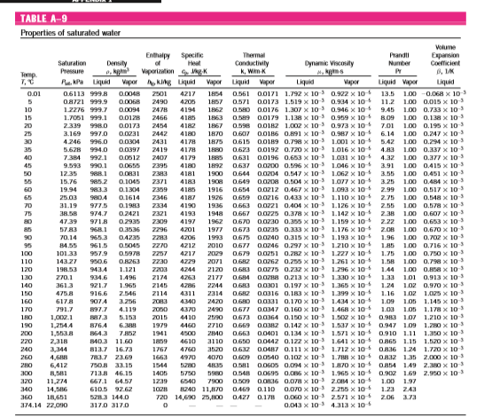

- Appendices B (row data for speed experiment)

Table 16: row data for speed 5
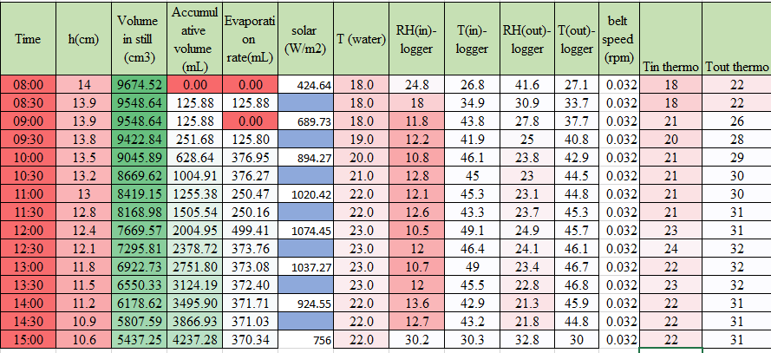

Table 17:row data for speed 10
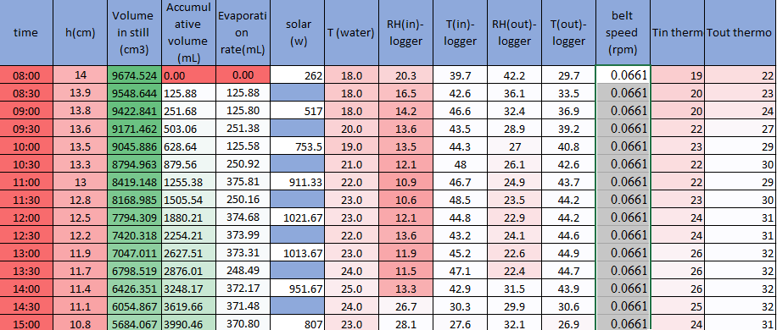

Table 18:row data for speed 15
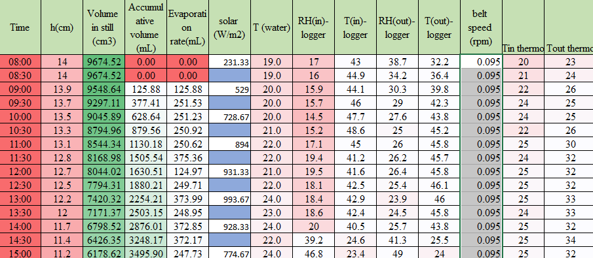

Table 19::row data for speed 20
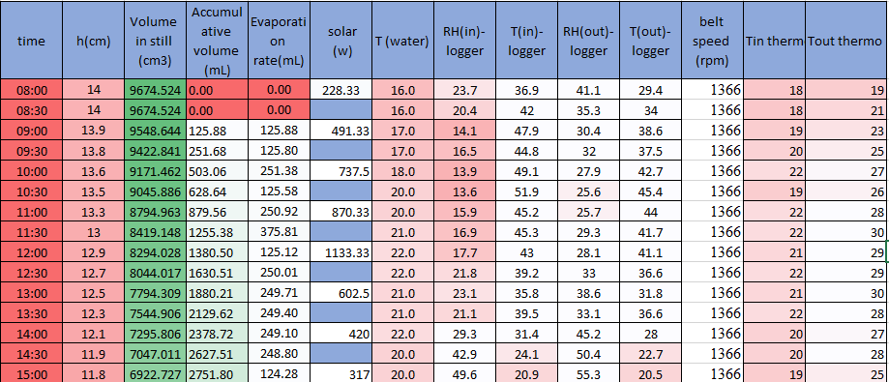

Table 20::row data for speed 30


- Appendix C (row data for weather condition)

Table 21:17.3.2019
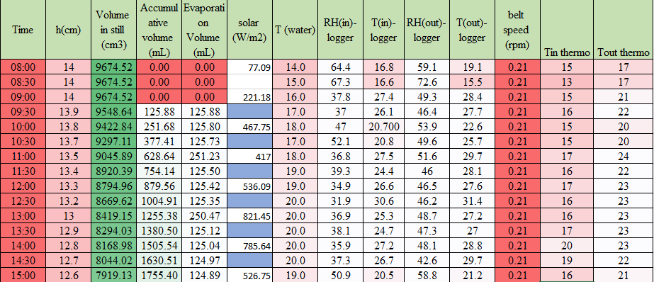

Table 22:18.3.2019
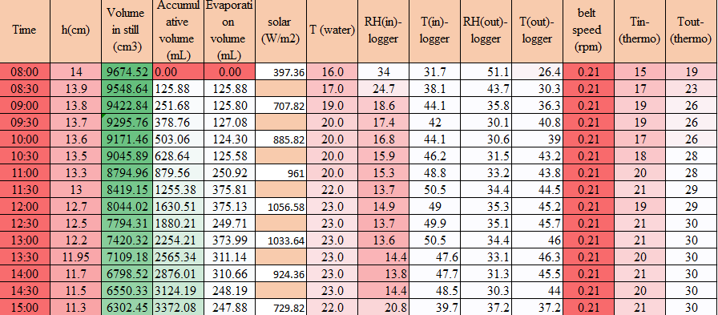

Table 23:25.3.2019
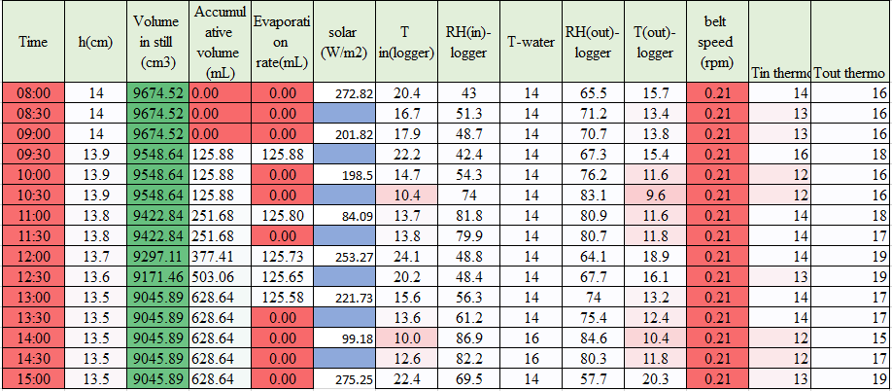

Table 24:26/3/2019
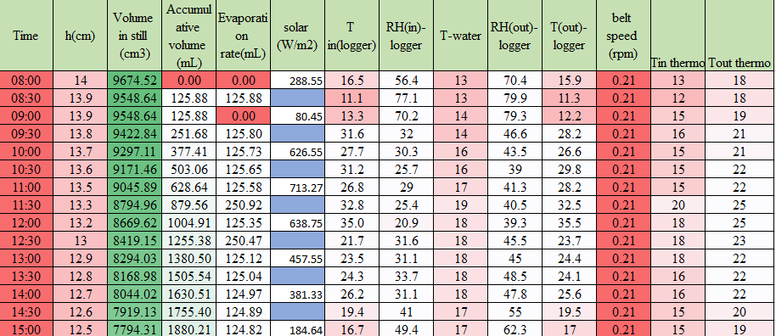

Table 25:27/3/2019
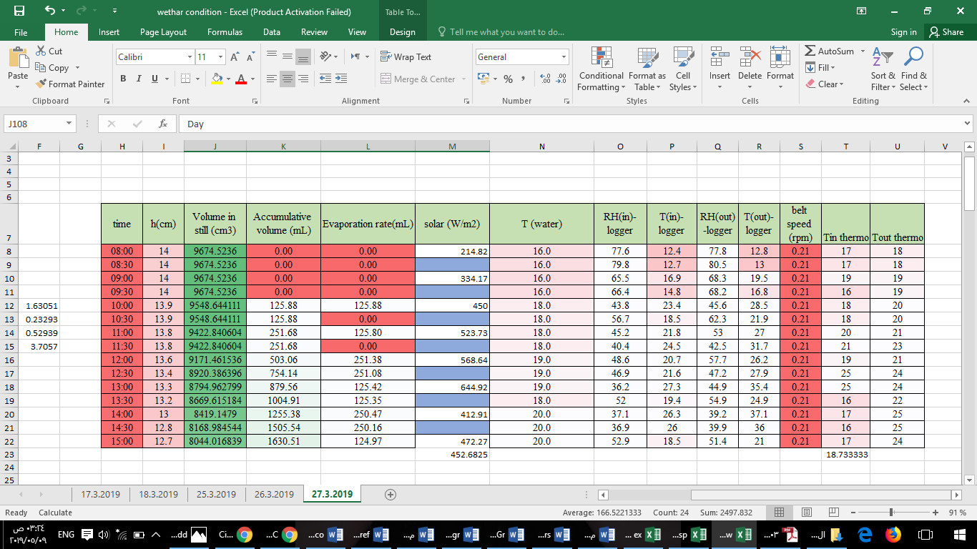

- Appendices C (row data for on/off experiment)

Table 26: 5 min off during every 30 min.
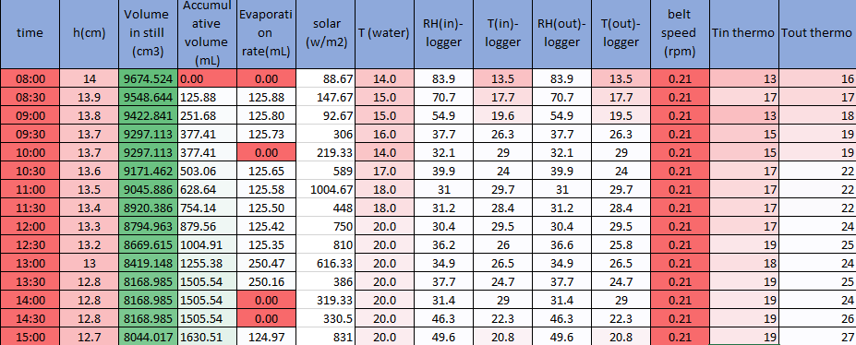

Table 27: 10 min off during every 30 min on
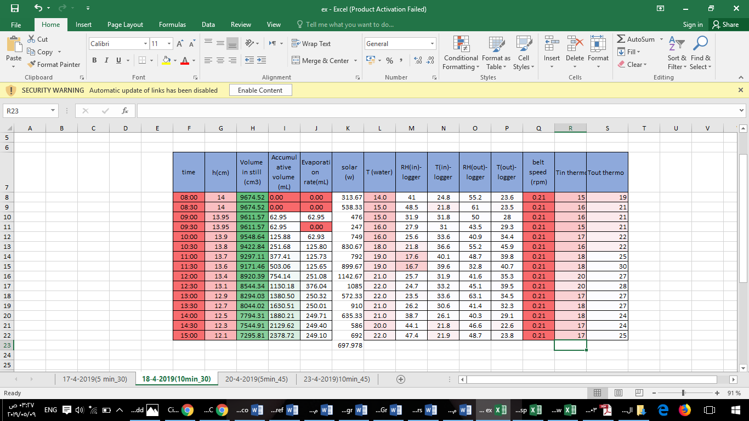

Table 28:5 min off during every 45 min.
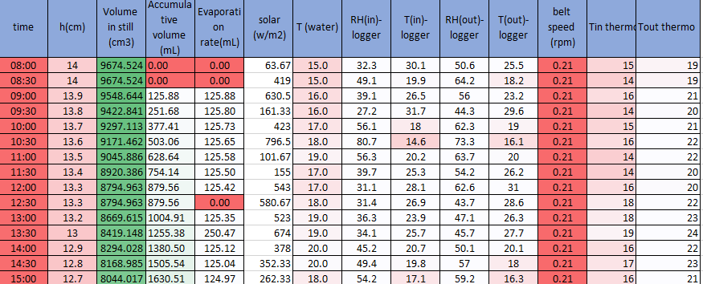

Table 29: Physical properities

Hot fluid(wet air/Shell) | Cold fluid (water/Tube) | Physical property @ Tavg
40 | 23 | Tin (⁰C)
40 | 30 | Tout (⁰C)
40 | 26.5 | T avg (⁰C)
1.044 | 996.7 | Density(kg/m3)
0.0266 | 0.609 | Kf (w/m.⁰C)
1.70E-05 | 8.63E-04 | viscosity (kg/m.s)
0.725 | 5.924 | Pr number
1.099 | 4.178 | specific heat(kj/kg.⁰k)
1 | 86.174 | Mass flowrate(ṁ)(kg/s)
28.358 | 18 | Mw(kg/kmol)
0.3007 | 0.066 | cross section area,A( m²)
1.69E+00 | 1.14E+00 | vis. Ratio M/Mw
5000 | 6000 | Fouling Coefficient (W/m² .⁰C)
0.0264 | 0.086 | volum flowrate(v̇)(m³/s)
1.01E-05 | 7.55E-04 | vis. @ Tw Mw(table A)
2409.3 |  | from steam table (app. F) (kj/kg)
0.05 |  | humidty for air (kg H2O/kg dry air)
0.957 |  | Ѵ humid volum (m³/kg dry air)

Table 30: Tube side design

Tube side(steam)
 | 1 | Passes
 | 1 | tube per pass
 | 0.066 | total flow area (m²)
 | 1305.31 | water mass velocity (kg/s.m²)
 | 1.31 | water linear velocity (m/s)
 | 4.39E+05 | Re
 | 287.24 | Ꞅv out(condensate rate per unit tube perimeter)(kg/m.s)
 | 1.33E+06 | Rec
 | 0.09 | From Figure 12.43
 | 1291.96 | hc (W/m².C)
 | 284.07 | Ꞅv in(condensate rate per unit tube perimeter)(kg/m.s)
 | 1.32E+06 | Rce
 | 0.01 | From Figure 12.43
 | 143.55 | hc (W/m².C)
 | 3094.77 | hi՝(W/m².C)
 | 49341.27 | hc(W/m².C)

Table 31: Shell side design
Shell side(water)
0.123 | baffle space (m)
0.375 | tube pitch(m)
0.015 | As (m²)
1.799 | mass velocity,Gs (kg/s.m²)
0.213 | de (m)
1.722 | Shell velocity (m/s)
2.25E+04 | Re
0.725 | Pr
0.015 | jh (figure 12.29)
63.977 | hc (W/m².C)

Table 32: Power
0.0035 | Jf(tube side) (figure29)
2398.57 | Pressure(tube)
2.39 | P(kpa)
0.345 | power kw
0.09 | Jf(Shell side) 15% cut (figure30)
78.67 | P(Shell) (PA)
0.078 | P(Shell(Kpa))
0.0034 | power

Table 33: error estimated.
1 | Nt new
0.3 | ODt(m)
0.29 | ID
10.62 | L tube (ft)
3.23 | L tube (m)
0.1237 | LB(m)
 | Baffeles no.
3.04E+00 | A of one tube(m2)
0.01634 | 1/Uo
61.19 | Uo
11.14 | L/Di
1.98 | error

 | Table 34:cost in which cost of kilowatt is 0.574
16.18 | A.O.C (NIS/yr) shell
1616.28 | A.O.C (NIS/yr) tube
1.1 | Pressure factor
0.8 | Type factor
4400 | Purchased cost 2004($)
114 | index cost 2004
118 | index cost 2019
4554.38 | Purchased cost 2019($)
5465.26 | Total capital cost ($)
19128.42 | TCC (NIS)
1912.84 | A.C.C(NIS/yr)
3545.31 | T.A.C(NIS/yr)
1012.94 | T.A.C($/yr)
1632.46 | T.O.C(NIS/yr)

Table 35: finding Tw.

10 | ∆T1(⁰C)
17 | ∆T2(⁰C)
60 | Uass(W/m² °C)(Table 10)
2409.3 | Q (KJ/s)
13.19 | ∆Tlm
1 | F
13.19 | ∆Tm(⁰C)
3.043 | A total(m²)=Atube
1.00E+00 | Nt
16 | Ksteel (w/m.⁰C) @30 ⁰C (Table 12.6)
0.215 | K1 (square)(1-p) (Table 12.4)
2.207 | n1(square)(1-p)(Table 12.4)
0.60 | Db(m)/fixed and U tube
0.017 | clearance (figure 12.10)m
0.61 | Ds (m)
33.25 | Tw

