



Prepared by: Muna Dmaidi
Mai tubailah

Abstract:
Teachers are responsible for taking students attendance at the beginning of each lecture and this will waste a lot of time, so our project main objective is to save time and money by making your system computerized.
In our project we developed a system that controls all rooms at the university and takes students attendance automatically based on time.
This small system got two parts one of them is attached to each room at the university, the other part will be connected to the main server.

Techniques:
In our project we used several techniques .
Hardware:
The wireless: MRF 24j40
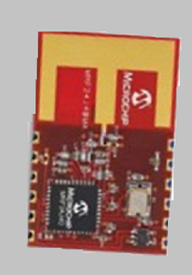

this technique helped us to keep all the rooms at the university connected to a main server , this server controls the rooms and store students attendance data.

In our project we use this chip to transmit and receive The data via wireless. so at each room one chip Will be installed to be transmitter and receiver at the same time.
One of the challenges with this chip is it’s stack IS IT’S STACK!!!!

PIC to MRF 24j40 interface:
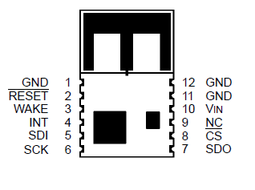

I/O
SDO
SDI
SCK
INTx
I/O
I/O
CS
SDI
SDO
SCK
INT
WAKE
_______
RESET

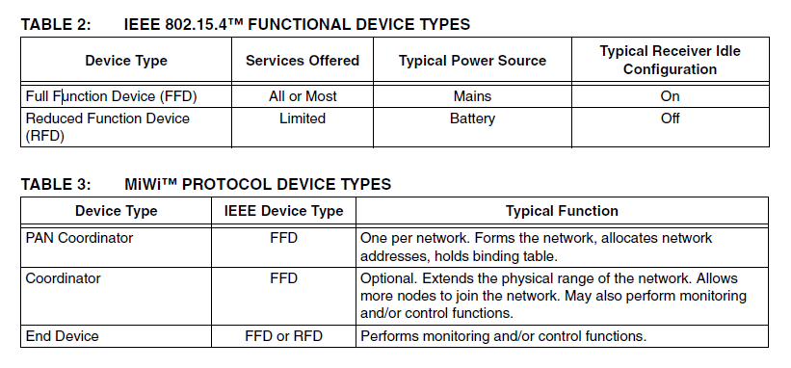
We used end device with type (FFD ).
The configuration in our project was Peer To Peer(P2P)
A peer-to-peer configuration is the simplest form of communication, with just one device talking directly to another device. In this configuration, there is no distinction of parent or child, or routing to other nodes.

Barcode Reader:
It is a PS2 implemented barcode ,see the description in the picture below. Barcode is used to scan students ID cards as soon as it receives start commands from the main server.

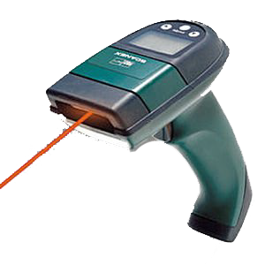

SAMPLES OF THE SCAN CODES (PRESSED AND RELEASED )THAT WAS USED IN THE PROJECT.
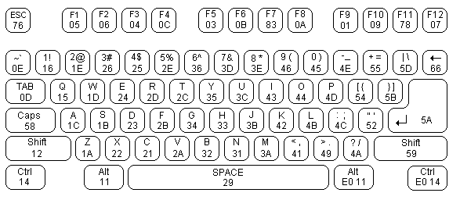

We used in our project the numbers only since ID cards only contain numbers.
Barcode connector:

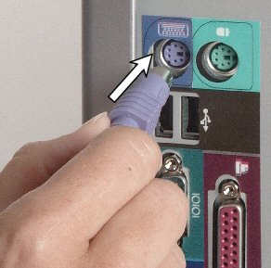

The barcode is connected to PIC using four wires. These wires are shown below for the 5 Pin DIN Male Plug & PS/2 Plug or 6 pin Din male which it had been used in the project
Both the KBD Clock and KBD Data are Open Collector bi-directional I/O Lines. If desired, the Host can talk to the keyboard using these lines.
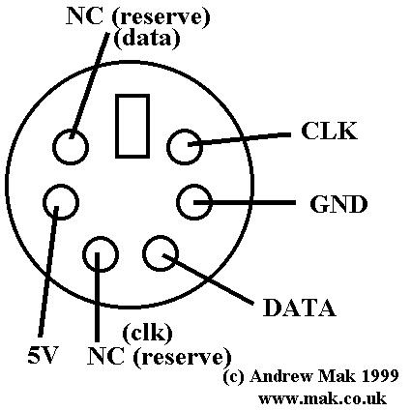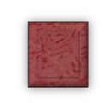
1
2
3
6
4

Protocol that we used in Barcode:
Device to host communication protocol:
The Data line changes state when Clock is high and that data is valid when Clock is low.
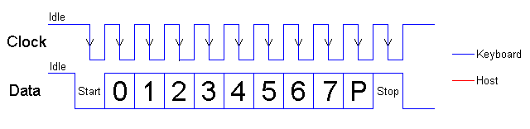
Software:

SQL server 2008:
aims to make data management self-tuning, self organizing, and self maintaining.
We used SQL server in order to create our own Database which includes tables for students, teachers and courses.(see figure below)

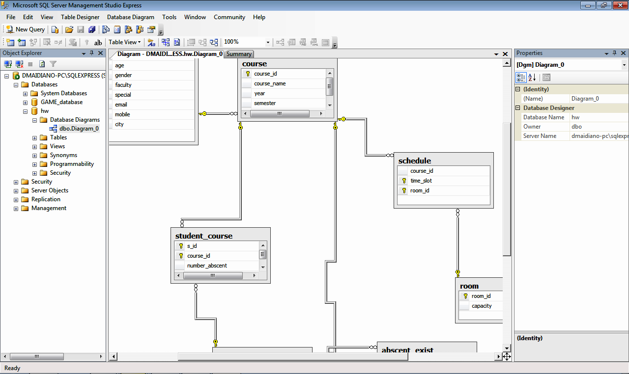

C# express edition 2008:
Microsoft Visual C# is Microsoft's implementation of the C# programming language specification, included in the Microsoft Visual Studio suite of products
We used it in our project to create an application that is connected to a database and tracks all the rooms at the university in order to give them commands(START,STOP,GET) based on time.this will be described at the operation field.

Microsoft visual web developer 2008 express edition:
The Visual Web Developer Express is a freeware web development tool that allows developers to evaluate the web development and editing capabilities of the other Visual Studio 2008 editions at no charge
We used it in our project to create a website that allows students and teachers to track their attendance.

Microchip MPLAB (c18 compiler): (Wireless stack)
MPLAB Integrated Development Environment (IDE) is a free, integrated gcc-based toolset for the development of embedded applications employing Microchip's PIC and dsPIC microcontrollers. The MPLAB IDE runs as a 32-bit application on Microsoft Windows, and includes several free software components for application development, hardware emulation and debugging

In our project we used wireless stack which was programmed in MPLAB . Based on this stack be programmed coordinator(It is the main device that is connected serially to the main server) and enddevice(It is the system that is attached to each room at the university to control it and take students attendance)

Operation:
Coordinator: Is the main device that is connected serially to the server, The coordinator sends three types of commands :START,STOP,GET
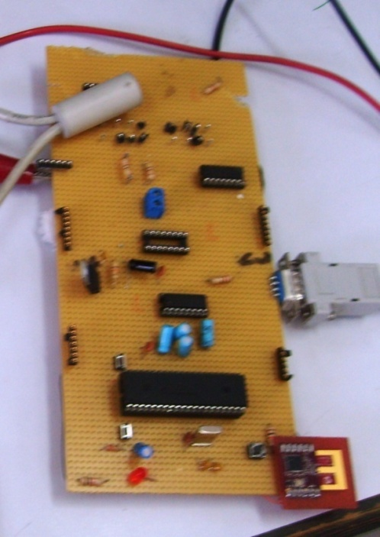

End Device: It is provided to each room to control lights, open the doors, open the LCD projector and tack students attendance.
It Receives Commands from coordinator .

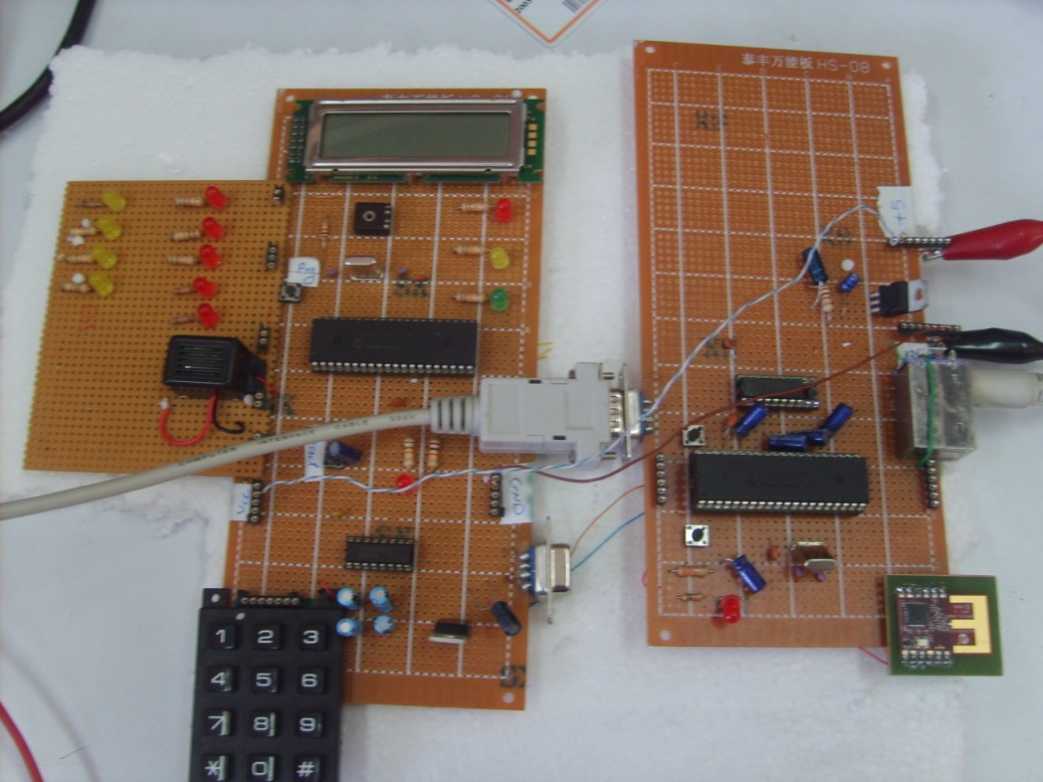

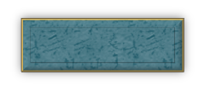

Coordinator
End Device
At The beginning of lecture 8:00 Coordinator Sends START command for the End device .
End Device turn on the lights in the Room and the system starts taking students attendance.
START

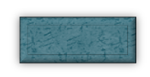

Coordinator
End Device

At 8:10 Coordinator Sends STOP command for the End device .
End Device stops taking the attendance

STOP
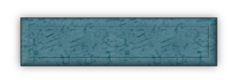

Coordinator
End Device
After a while Coordinator will begin to get data from each room by it’s turn by sending get data command.

GET DATA

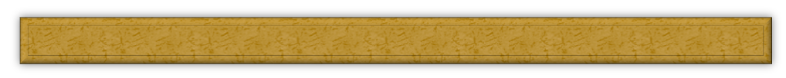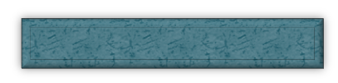

Coordinator
End Device
After the End device will got the get data command it will begin to send all the id’s of the students who attends the course.

Students IDS will be stored in Database
At the end of the day lights in Rooms will shut down
STUDENT’S IDS

SQL SERVER

How to track students attendance:
We provided Students and teachers several ways to track their attendance:

Website: see figure below
Each student and teacher got an account, they can sign in using unique ID number and Password.
Our website show student all the courses he is registered in and how many absents he got at each course.
Teachers also see all the course they teach, number of students at each course and how many absents each student got
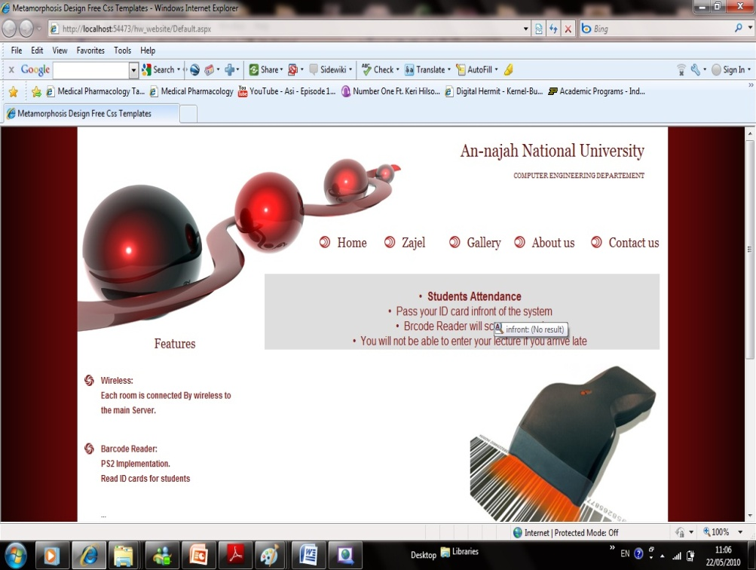

WAP:
Wherever you are all you need is to write down our URL(www.thurayasoft.com/MAI) at your mobile WAP , you can track your attendance. This is provided for both students and teachers.
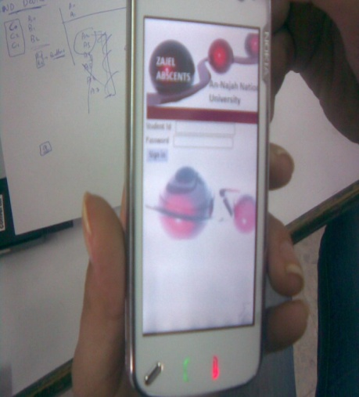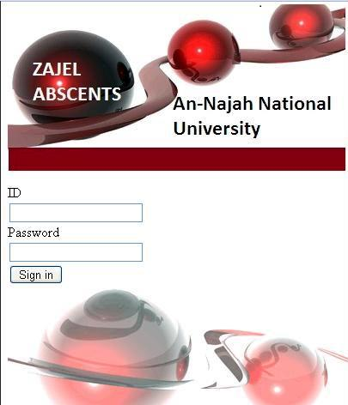

SMS:
Our system automatically check your attendance, if you got 6 absences it will warn you that you got only one absence before being expelled from the course.(see figure below)

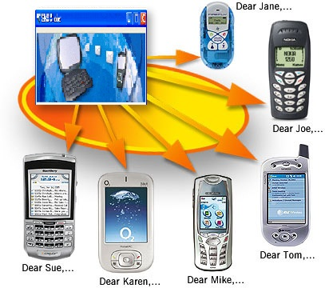

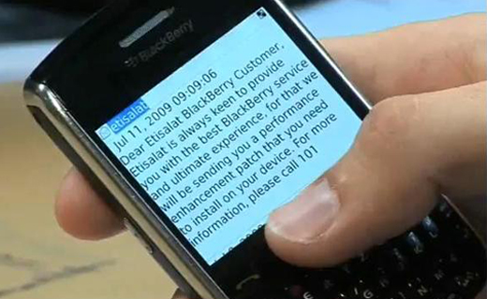
hiiiiiiiiiiiiiiiiiiiiiiiiiiiiiiiiiiiiiiiiiiiiii

From :ZAJEL ABSENCES
Mai Tbaileh be attention one absence remains for you bef0re being expelled from Operating System.

From:Zajel Absences
Mai Tbaileh be attention one absence remains for you before being expelled from the Operating System Course.

