
An-Najah National University
Faculty of Engineering & Information Technology
Building Engineering Department
Redesign of Jenin chamber of commerce
Graduation project report (II)
Prepared by:
Danya Al-atrash
Hala Assaf
Oday Arafat
Supervised by:
Eng. Fady Fatayer.

Presented in partial fulfillment of the requirements for Bachelor degree in Building Engineering.
May 2023
  - DEDICATION
بسم الله الرحمن الرحيم

يا حُلُماً ما هانَ يوماً، يا دعاءً ألحقته بآمين

الحمد لله الذي لولا هداه لما اهتدينا ولا خُطّ دربٌ ولا خُتمَ سعيٌ، الحمد لله حين البدء وعند الختام
بعد الثناء والصلاة على خاتم الأنبياء والمرسلين، نهدي مشروع تخرجنا إلى والدِينا الذين حصدوا الأشواك عن دربنا ليمهدوا لنا طريق العلم، فنحن هنا بفضل دعواتهم الصادقة التي لامست عنان السماء، وإلى كل من علمنا حرفا أو كلمة، إلى مدرسينا الأعزاء في كلية الهندسة، وإلى أصدقائنا وزملائنا، إلى شهداء الوطن، شهداء فلسطين، وإلى أسرانا البواسل، وإلى كل من كان في طريقنا، مر عابرا أو استندنا إليه.
  - ACKNOWLEDGMENT
First and foremost, we thank God for giving us the strength and motivation to pursue this project. We also want to express our sincere appreciation to Eng. Fady Fatayer for his guidance and assistance in researching and writing our report. The faculty at An-Najah National University's Building Engineering Department have also been a valuable source of support, providing us with the necessary information and answering our questions throughout this semester. And we don’t forget to thank our families and friends for their continuous support and encouragement, and for providing all means of comfort for us to do the work in the best possible way.
Finally, we would like to acknowledge the contributions of all those who have helped us complete this project, and we extend our heartfelt thanks to all those who have contributed to the success of this project. As we reflect on the skills and insights gained and the memories made, we hope that our project will be remembered for years to come.

  - DISCLAIMER STATEMENT
This report was written by Danya Al-Atrash, Hala Assaf and Oday Arafat at the Building Engineering Department, Faculty of Engineering, and An-Najah National University. It has not been altered or corrected, other than editorial corrections, as a result of assessment and it may contain language as well as content errors. The views expressed in it together with any outcomes and recommendations are solely those of the student(s). An-Najah National University accepts no responsibility or liability for the consequences of this report being used for a purpose other than the purpose for which it was commissioned.

Table of Contents
DEDICATION I
ACKNOWLEDGMENT I
DISCLAIMER STATEMENT II
List of Figures VII
List of Tables XII
I. List of symbols XIV
ABSTRACT 1
Ch1. Introductory 2
1.1 Introduction 2
1.2 Project Problem 2
1.3 Objectives 2
1.4 Scope of the Work 2
1.5 Methodology 3
1.6 Limitations and Constraints: 4
1.7 Codes and Standards 5
1.8 Earlier Course Work 5
Ch2. Environmental- Architectural Aspects 6
2.1. Literature Review 6
2.1.1. Standards and Specifications 6
2.2. Case Study 15
2.3. Site analysis 22
2.3.1. Location 22
2.3.1. Topography 23
2.3.2. Site plan 23
2.3.3. Sun Path diagram 24
2.3.4. Climate in Jenin 26
2.3.5. Noise readings 28
2.3.6. Shading analysis 28
2.3.7. Solar radiation analysis 33
2.3.8. Wind 57
2.4. Architectural modifications 58
2.4.1. Bubbles Diagram after modifications 62
2.4.2. Conclusion for architectural modifications 65
2.4.3. Edited plans 66
2.4.4. 3D model 76
2.4.5. Elevations 78
2.5. Environmental analysis and Design 82
2.5.1. Design builder simulation 82
2.5.2. Daylight factor 84
2.5.3. Heating and cooling load before treatments: 93
2.5.4. Heating and cooling load after treatments: 94
2.5.5. Thermal comfort 97
2.5.6. Shading systems 97
2.5.7. Ventilation and CFD analysis (Internal and External) 98
Ch3. Structural Aspects 104
3.1. Introduction 104
3.2. Problem Definition 104
3.3. Methodology 104
3.4. Assumptions 105
3.4.1. Structural code and design 105
3.4.2. Material 105
3.4.3. Loads 105
o Structural system 106
▪ Slab Design: 106
▪ Columns Design 109
▪ Expansion Joint 111
3.5. Structural Model 111
3.5.1. Structural model checks 113
3.5.2. Manual design for column 124
3.6. Seismic Design 131
3.6.2. Assumptions in seismic design 132
3.6.3. Seismic model checks 133
3.7. Design 142
3.7.2. Slab design 142
3.7.3. Column design 144
3.7.4. Foundation system design 146
3.8. Detailing 152
3.9. Septic water tank design: 158
3.10. Stair design 161
Ch4. Electro-mechanical Aspects 163
4.1. Artificial lighting design 163
4.1.1. Meeting room 163
4.1.2. Meeting room 2 166
4.1.3. Waiting room 169
4.1.4. Bedroom 171
4.1.5. Corridor 174
4.1.6. Lobby 176
4.1.7. Coffee 179
4.1.8. WC 182
4.1.9. Coffee 2 184
4.1.10. Furniture room 187
4.2. HVAC Design 190
4.2.1. Introduction 190
4.2.2. Loads calculations 190
4.2.3. Equipment selection 193
4.2.4. Design results 198
4.2.5. Exhaust system 203
4.3. Power design 207
4.3.1. Circuit breaker and distribution board 207
4.4. Acoustical design 227
4.4.1. Introduction: 227
4.4.2. Selected spaces for design: 227
4.4.3. Literature review 229
4.4.4. Design 231
4.4.5. Electro Acoustics design 239
4.5. Fire alarm and Firefighting systems 240
4.5.1. Introduction 240
4.5.2. Evacuation ways 240
4.5.3. Suppression system 242
4.5.4. Detection & notification system 244
4.6. Water supply system 247
4.6.1. Introduction 247
4.6.2. Water tanks calculations 247
4.6.3. Design piping system 248
4.6.4. Drainage and rain water system 253
4.7. Vertical Transportation 259
Ch5. Quantity surveying & Cost Estimate 260
5.1 Introduction: 260
5.2 Cost estimation Techniques: 260
5.2.1 Analogous estimation 260
5.2.2 Parametric estimation 260
5.2.3 Three-point estimation 260
5.2.4 Bottom-Up estimation 261
5.1. Methodology 261
5.2. Elemental cost breakdown 262
5.3. Data collections: 262
5.3.1. Cost breakdown structure 263
Ch6. Conclusion 266
6.1 ARCHITECTURAL Aspects 266
6.2 ENVIRONMENTAL Aspects 267
6.3 Structural Aspects 268
6.4 Electro Mechanical Aspects 269
6.4.1. Artificial lighting 269
6.4.2. HVAC system 269
6.4.3. Acoustics design 269
6.4.4. Fire Alarm and firefighting system 270
6.4.5. Water supply system 270
6.5 Quantity surveying & Cost Estimation 270
I. References 271

List of Figures
Figure ‎2.1: Computer work station.(ADLER, 2007) 6
Figure ‎2.2: disable people.(ADLER, 2007) 7
Figure ‎2.3: disable people path requirements.(ADLER, 2007) 7
Figure ‎2.4: disable people ramp requirements.(ADLER, 2007) 7
Figure ‎2.5: Toilets design requirements.(ADLER, 2007) 8
Figure ‎2.6: Disable people Toilets design requirements.(ADLER, 2007) 8
Figure ‎2.7: Disable people Toilets design requirements.(ADLER, 2007) 9
Figure ‎2.8: Meeting hall stairs standards. (Neufert & Neufert, 2012) 10
Figure ‎2.9: Stairs distribution in the meeting hall according to standards. 11
Figure ‎2.10: Stage standards.(Neufert & Neufert, 2012) 11
Figure ‎2.11: Restaurant tables layout(ADLER, 2007) 12
Figure ‎2.12: Parking spaces standard distances. (ADLER, 2007) 13
Figure ‎2.13: Chamber of commerce building. 18
Figure ‎2.14: ground floor plan 18
Figure ‎2.15: First floor plan 19
Figure ‎2.16: Third floor plan. 20
Figure ‎2.17: Ground floor plan 21
Figure ‎2.18 : Location of the project. 23
Figure ‎2.19: Topography of the project 23
Figure 2.20: figure for site plan 24
Figure ‎2.21: Sun path diagram. 24
Figure ‎2.22: Revit model. 25
Figure ‎2.23: Monthly climate in Jenin(weatherspark, 2022) 26
Figure ‎2.24: Average High and Low Temperature(weatherspark, 2022) 26
Figure ‎2.25: Average Monthly Rainfall(weathers park, 2022) 27
Figure ‎2.26: Hours of Daylight and Twilight(weathers park, 2022) 27
Figure ‎2.27: Average Wind Speed in Jenin(weather spark, 2022) 27
Figure ‎2.28: Noise readings 28
Figure ‎2.29: Elevations of the building. 28
Figure ‎2.30: Shading in winter at 8AM. 29
Figure ‎2.31: Shading in winter at 12PM. 29
Figure ‎2.32: Shading in winter at 2PM. 30
Figure ‎2.33: Shading in summer at 8AM. 31
Figure ‎2.34 Shading in summer at 12PM. 31
Figure ‎2.35 Shading in summer at 2PM. 32
Figure ‎2.36: Solar radiation on south east elevation in winter at 8 am 33
Figure ‎2.37: Solar radiation on south west elevation in winter at 8 am 34
Figure ‎2.38: Solar radiation on North West elevation in winter at 8 am 35
Figure ‎2.39: Solar radiation on north east elevation in winter at 8 am 36
Figure ‎2.40: Solar radiation on south east elevation in winter at 12 Pm 37
Figure ‎2.41: Solar radiation on south west elevation in winter at 12 Pm 38
Figure ‎2.42: Solar radiation on North West elevation in winter at 12 Pm 39
Figure ‎2.43: Solar radiation on north east elevation in winter at 12 Pm 40
Figure ‎2.44: Solar radiation on south east elevation in winter at 2 Pm 41
Figure ‎2.45: Solar radiation on south west elevation in winter at 2 Pm 42
Figure ‎2.46: Solar radiation on North West elevation in winter at 2 Pm 43
Figure ‎2.47: Solar radiation on north east elevation in winter at 2 Pm 44
Figure ‎2.48: Solar radiation on South East elevation in summer at 8 am 45
Figure ‎2.49: Solar radiation on South West elevation in summer at 8 am 46
Figure ‎2.50: Solar radiation on North West elevation in summer at 8 am 47
Figure ‎2.51: Solar radiation on north east elevation in summer at 8 am 48
Figure ‎2.52: Solar radiation on South East elevation in summer at 12 Pm 49
Figure ‎2.53: Solar radiation on South West elevation in summer at 12 Pm 50
Figure ‎2.54: Solar radiation on North West elevation in summer at 12 Pm 51
Figure ‎2.55: Solar radiation on North East elevation in summer at 12 Pm 52
Figure ‎2.56: Solar radiation on south east elevation in summer at 2 Pm 53
Figure ‎2.57: Solar radiation on south west elevation in summer at 2 Pm 54
Figure ‎2.58: Solar radiation on North West elevation in summer at 2 Pm 55
Figure ‎2.59: Solar radiation on north east elevation in summer at 2 Pm 56
Figure ‎2.60: Wind direction. 57
Figure ‎2.61: Wind direction of the building. 57
Figure ‎2.62: Bubbles diagram legend. 62
Figure ‎2.63: Ground floor bubbles diagram 62
Figure ‎2.64: first floor bubbles diagram 63
Figure ‎2.65: second and third floor bubbles diagram 63
Figure ‎2.66: fourth floor bubbles diagram 5th floor 64
Figure ‎2.67: fifth floor bubbles diagram 5th floor 64
Figure ‎2.68: First basement plan before modifications. 66
Figure ‎2.69: Second basement plan before modifications. 66
Figure ‎2.70: First basement plan before modifications. 67
Figure ‎2.71: Second basement plan before modifications. 67
Figure ‎2.72: Third basement plan before modifications. 68
Figure ‎2.73: Ground floor before modifications. 68
Figure ‎2.74: Ground floor after modifications. 69
Figure ‎2.75: First floor before modifications. 69
Figure ‎2.76: First floor after modifications. 70
Figure ‎2.77: Second floor before modifications. 70
Figure ‎2.78: Second floor after modifications. 71
Figure ‎2.79: Third floor before modifications. 71
Figure ‎2.80: Third floor after modifications. 72
Figure ‎2.81: Fourth floor before modifications. 72
Figure ‎2.82: Fourth floor after modifications. 73
Figure ‎2.83: Fifth floor before modifications. 73
Figure ‎2.84: Fifth floor after modifications. 74
Figure ‎2.85: sixth floor before modifications. 74
Figure ‎2.86: Sixth floor after modifications. 75
Figure 2.87: figure 1, 3D model from twinmotion 76
Figure2.88: figure 2, 3D model from twinmotion. 76
Figure 2.89: figure 3, 3D model from twinmotion 77
Figure ‎2.90: North- East Elevation. 78
Figure ‎2.91: South- East Elevation. 78
Figure ‎2.92: South- West Elevation. 79
Figure ‎2.93: North- West Elevation. 79
Figure ‎2.94: Section A-A. 80
Figure ‎2.95: Section B-B. 81
Figure 96.92:3D Model 82
Figure ‎2.97: Wall layers and U-value. 82
Figure ‎2.98: Roof layers and U-value. 83
Figure ‎2.99: Internal Floor layers and U-value 83
Figure ‎2.100: Daylight factor in ground floor before. 84
Figure ‎2.101: Daylight factor in first floor before. 84
Figure ‎2.102: Daylight factor in 2nd floor before. 85
Figure ‎2.103: Daylight factor in 3rd floor before. 85
Figure ‎2.104: Daylight factor in 4th floor before. 86
Figure ‎2.105: Daylight factor in 5th floor before. 86
Figure ‎2.106: Daylight factor in 6th floor before. 87
Figure ‎2.107: Daylight factor in ground floor After. 87
Figure ‎2.108: Daylight factor in 1st floor After. 88
Figure ‎2.109: Daylight factor in 2nd floor After. 88
Figure ‎2.110: Daylight factor in 3rd floor After. 89
Figure ‎2.111: Daylight factor in 4th floor After. 89
Figure ‎2.112: Daylight factor in 5th floor After. 90
Figure ‎2.113: Daylight factor in 6th floor after. 90
Figure2.114 :percentage of saving for building 92
Figure ‎2.115: PMV results. 97
Figure ‎2.116: Atrium used. 97
Figure ‎2.117: Double skin façade used. 98
Figure ‎2.118 section through courtyard 99
Figure ‎2.119: Exterior CFD 100
Figure ‎2.120: Exterior CFD 100
Figure ‎2.121: Exterior CFD 101
Figure ‎2.122: Interior CFD 101
Figure ‎2.123: Interior CFD in double skin facade. 102
Figure ‎2.124: Interior CFD 102
Figure ‎2.125: Interior CFD 103
Figure ‎3.1: Section in U-boot 107
Figure ‎3.2: Uboot dimensions. 108
Figure ‎3.3: Uboot arrangement. 108
Figure ‎3.4: Expansion Joint location. 111
Figure ‎3.5: 3d structural model before separation. 111
Figure ‎3.6: part 1 structural model. 112
Figure ‎3.7: part 2 structural model. 112
Figure ‎3.8: Compatibility check for part 1. 113
Figure ‎3.9: Compatibility check for part 2. 113
Figure ‎3.10: Deflection from live load for part 1. 115
Figure ‎3.11: Deflection from service load for part 1. 115
Figure ‎3.12: Deflection from live load for part 2. 116
Figure ‎3.13: Deflection from service load for part 2. 116
Figure ‎3.14: Shear for B3 floor from ETABS for part 1 model. 117
Figure ‎3.15: Shear for B3 floor from ETABS for part 2 model. 118
Figure ‎3.16: Design results for part 1 model. 120
Figure ‎3.17: Design results for part 2 model. 121
Figure ‎3.18: Punching shear in typical floor in part 1. 122
Figure ‎3.19: Punching shear in parking's in part 1. 122
Figure ‎3.20: Punching shear in typical floor in part 2. 123
Figure ‎3.21: Punching shear in parking's in part 2. 123
Figure ‎3.22: Column section. 125
Figure ‎3.23: Interaction diagram of X-direction gamma. 129
Figure ‎3.24: Interaction diagram of Y-direction gamma. 130
Figure ‎3.25: Seismic Hazard map 131
Figure ‎3.26: Period for part 1. 133
Figure ‎3.27: Period for part 2. 137
Figure ‎3.28: Bottom bars slab reinforcement results for part. 142
Figure ‎3.29: Top bars slab reinforcement results for part. 143
Figure ‎3.30: Column design for Part1. 144
Figure ‎3.31: Column design for Part2. 145
Figure ‎3.32: Bearing capacity check. 146
Figure ‎3.33: Punching shear check. 147
Figure ‎3.34: Bottom Reinforcement results in x direction. 148
Figure ‎3.35: Top Reinforcement results in x direction. 149
Figure ‎3.36: Bottom Reinforcement results in y direction. 150
Figure ‎3.37: Top Reinforcement results in y direction. 151
Figure ‎3.38: Column’s stirrups details used. 152
Figure ‎3.39 153
Figure ‎3.40 sections 154
Figure ‎3.41 foundation reinforcement 155
Figure ‎3.42 slab reinforcement 155
Figure ‎3.43 section in slab 156
Figure ‎3.44: Shear wall detailing. 157
Figure ‎3.45: Water Tank Roof Plan. 158
Figure ‎3.46: Water Tank Elevation. 158
Figure ‎3.47: Water Tank Reinforcement details. 160
Figure ‎3.48: Stair reinforcement details. 162
Figure ‎3.49: Stair reinforcement details. 162
Figure ‎4.1 luminaire layout plan of meeting room 163
Figure ‎4.2 Meeting room DIALUX results. 163
Figure ‎4.3 UGR Check 164
Figure ‎4.4 Artificial light only result from DIALUX EVO. 164
Figure ‎4.5 Luminaire list. 165
Figure ‎4.6 3D view meeting room. 165
Figure ‎4.7 luminaire layout plan of meeting room 166
Figure ‎4.8 Meeting room DIALUX results. 167
Figure ‎4.9 Artificial light only result from DIALUX EVO 167
Figure ‎4.10 3D view meeting room 168
Figure ‎4.11 Luminaire list. 168
Figure ‎4.12 UGR CHECK 170
Figure ‎4.13: the result Artificial light only for bedroom 173
Figure ‎4.14: 3d view bedroom 174
Figure ‎4.15: the result Artificial light only for corridor 174
Figure ‎4.16: 3d view 175
Figure ‎4.17: luminaire layout plan of lobby 176
Figure ‎4.18: the result Artificial light only for lobby 176
Figure ‎4.19: the result Artificial light only for bedroom 177
Figure ‎4.20: Luminaire list 177
Figure ‎4.21 3d view 178
Figure ‎4.22 luminaire layout plan of coffee 179
Figure ‎4.23 the result Artificial light only for coffee 179
Figure ‎4.24 UGR Check 180
Figure ‎4.25 the result Artificial light only for coffee 181
Figure ‎4.26 3d view 182
Figure ‎4.27 luminaire layout plan for WC. 182
Figure ‎4.28 WC room DIALUX results. 183
Figure ‎4.29 Simulation spatial layout in DIALUX EVO from Artificial light only. 183
Figure ‎4.30 3D view of WC 183
Figure ‎4.31 Luminaire list 184
Figure ‎4.32 luminaire layout plan of coffee 184
Figure ‎4.33 Coffee room DIALUX results. 185
Figure ‎4.34 the result Artificial light only for coffee 185
Figure ‎4.35 3d view for coffee 186
Figure ‎4.36 luminaire layout plan of furniture room 187
Figure ‎4.37 furniture room DIALUX results. 187
Figure ‎4.38: the result Artificial light only for furniture 188
Figure ‎4.39: 3d view for furniture room 189
Figure ‎4.40: 3d view for furniture room 189
Figure ‎4.41: Outdoor unit selected. 194
Figure ‎4.42: Cassette unit selected. (DAIKIN, 2018) 195
Figure ‎4.43: Split unit used. 196
Figure ‎4.44: Fan coil unit selected. 196
Figure ‎4.45: Slot linear diffuser selected. 197
Figure ‎4.46: Slot linear diffuser. 197
Figure ‎4.47: Exhaust system principle. 203
Figure ‎4.48: Duct design in REVIT. 204
Figure ‎4.49: Ground floor HVAC plan. 204
Figure ‎4.50: First floor HVAC plan. 205
Figure ‎4.51: Second floor HVAC plan. 205
Figure ‎4.52: Third and fourth floors HVAC plan. 206
Figure ‎4.53: Fifth floor HVAC plan. 206
Figure ‎4.54: Sixth floor HVAC plan. 207
Figure ‎4.55 location of the main distribution board in basement floor1. 208
Figure ‎4.56 the socket symbol 208
Figure ‎4.57 Main distribution board for GF 225
Figure ‎4.58 distibution board for part 1 from GF 226
Figure ‎4.59 main distribution board for building 226
Figure ‎4.60: Office plan 227
Figure ‎4.61: Coffee shop plan 228
Figure ‎4.62: Meeting hall plan 228
Figure ‎4.63: Bed room plan 229
Figure ‎4.64: RT60 results for office. 232
Figure ‎4.65: Meeting hall Ease model. 233
Figure ‎4.66: Reverberation time of meeting hall room. 233
Figure ‎4.67: Bed room ease model. 234
Figure ‎4.68: RT60 for bed room. 234
Figure ‎4.69: Coffee shop Ease model. 235
Figure ‎4.70: Reverberation time of Coffee. 235
Figure ‎4.71: Partition layers. 236
Figure ‎4.72: Floor IIC 236
Figure ‎4.73: Double skin facade layers. 237
Figure ‎4.74: Direct sound pressure level in meeting hall 237
Figure ‎4.75: Articulation loss in meeting hall 238
Figure ‎4.76: STI in meeting hall 238
Figure ‎4.77: STI mapping. 239
Figure ‎4.78: Ceiling mounted Loud speaker selected. 239
Figure ‎4.79: Loud speaker coverage 240
Figure ‎4.80 zone 1 evacuation 1 241
Figure ‎4.81 zone 2 evacuation 2. 241
Figure ‎4.82 symbols of supervision system. 242
Figure ‎4.83 the distribution of water sprinkler in first floor 243
Figure ‎4.84 fire hose station. 243
Figure ‎4.85 inside dry standpipe. 244
Figure ‎4.86 distribution of fire hose station, dry standpipe and extinguishers in second floor. 244
Figure ‎4.87 manual fire alarm. 245
Figure ‎4.88 smoke detector. 245
Figure ‎4.89 heat detector. 245
Figure ‎4.90 flame detector. 246
Figure ‎4.91 symbols of detection &notification system. 246
Figure ‎4.92 distribution of heat and flame detector. 246
Figure ‎4.93 tank 248
Figure ‎4.94 water flow as a function of fixture units 249
Figure ‎4.95 Friction loss in PVC pipes. (Grondzik and Kwok, 2015) 250
Figure ‎4.96 Friction loss in steel pipes. (Grondzik and Kwok, 2015) 250
Figure ‎4.97 required diameter of branch and stacks 256
Figure ‎4.98 required diameter of sewers and the maximum number of DFU connected. 256
Figure ‎4.99 rain water 258
Figure ‎4.100: Normal elevator used. 259
Figure ‎6.1: Atrium used. 267
Figure ‎6.2: Double skin façade used. 267
Figure ‎6.3: Slab section. 268

List of Tables
Table ‎I-1: List of symbols and abbreviations. XIV
Table ‎2-1: Staff required toilets. (ADLER, 2007) 9
Table ‎2-2: Number of required Toilets in each floor. (ADLER, 2007) 9
Table ‎2-3: Tables standard dimensions.(ADLER, 2007) 12
Table ‎2-4: General spaces standard areas. 14
Table ‎2-5: Average High and Low Temperature(weatherspark, 2022) 24
Table ‎2-6: Shading analysis summary in winter. 28
Table ‎2-7: Shading analysis summary in summer. 30
Table ‎2-8: Ground floor spaces assessment 56
Table ‎2-9: 1st floor spaces assessment 56
Table ‎2-10: 2nd and 3rd floors spaces assessment 57
Table ‎2-11: 4th floor spaces assessment 58
Table ‎2-12: 5th floor spaces assessment 58
Table ‎2-13: 6th floor spaces assessment 59
Table ‎2-14: Floors functions before and after modifications. 63
Table ‎2-15: Site and source energy before treating. 89
Table ‎2-16: Site and source energy after treating. 89
Table ‎2-17 cooling load before treatments 91
Table ‎2-18: heating load before treatments 91
Table ‎3-1: Live loads for floors. 103
Table ‎3-2: Building parts weight. (Minimum Design Loads for Buildings and Other Structures, 2005) 104
Table ‎3-3: Slab thickness table. 105
Table ‎3-4: U-boot pattern used. 107
Table ‎3-5: Equilibrium check results for part 1 model. 112
Table ‎3-6: Equilibrium check results for part 2 model. 112
Table ‎3-7 maximum computed deflection 112
Table ‎3-8: Stress strain check result for columns in part 1 model. 116
Table ‎3-9: Stress strain check result for columns in part 2 model. 117
Table ‎3-10: Stress strain check result for slab in part 1 model. 117
Table ‎3-11: Stress strain check result for slab in part 2 model. 117
Table ‎3-12: Column’s information. 123
Table ‎3-13: Period check for part 1. 132
Table ‎3-14: Model participant mass ration check for part 1. 133
Table ‎3-15: Drift check for part 1. 134
Table ‎3-16: Period check for part 2. 136
Table ‎3-17: Model participant mass ration check for part 2. 137
Table ‎3-18: Drift check for part 2. 138
Table ‎3-19: Shear design for shear wall from ETABS. 154
Table ‎3-20:Flexural design results from ETABS. 154
Table ‎3-21: Boundary element check from ETABS. 155
Table ‎3-22: Equilibrium check results 157
Table ‎3-23: Equilibrium check results of stair. 159
Table ‎4-1: Spaces cooling loads. 188
Table ‎4-2: Floors total cooling loads. 192
Table ‎4-3: Cassette unit selected specifications. (DAIKIN, 2018) 193
Table ‎4-4: Slot linear diffuser selected. 196
Table ‎4-5 wire resistance & drop voltage calculation. 208
Table ‎4-6 demand factor. 212
Table ‎4-7: Total power for lighting loads in ground floor 213
Table ‎4-8: Total power for lighting loads in first floor 214
Table ‎4-9: Total power for lighting loads in second floor 215
Table ‎4-10: Total power for lighting loads in 3d floor & 4 f 216
Table ‎4-11: Total power for lighting loads in 5floor 217
Table ‎4-12: Total power for lighting loads in 6 floor 218
Table ‎4-13: Total power for Normal load of all floor 218
Table ‎4-14: demand factor 220
Table ‎4-15: main distribution for building 221
Table ‎4-16: cable calculatin. 222
Table ‎4-17: Required STC for spaces (commercial-acoustics, 2022) 228
Table ‎4-18: Articulation loss categories(T. Grondzik, G. Kwok, Stein, & S.Reynolds, 2010) 228
Table ‎4-19: STI categories(Stout, 2015) 229
Table ‎4-20: Finishing materials used in rooms and its sound absorption coefficient. 229
Table ‎4-21 capacity of tank 246
Table ‎4-22 water supply fixture units (WSFU) 246
Table ‎4-23 water supply units and demand for building 247
Table ‎4-24 material of the pipes 247
Table ‎4-25 fixture unit for 4th floor 249
Table ‎4-26 Main Vertical feeder loss 249
Table ‎4-27 Main branch diameter and loss 249
Table ‎4-28 Sub branch diameter and loss 250
Table ‎4-29 Horizontal (cold water) branch diameter and loss 250
Table ‎4-30 Horizontal (hot water) branch diameter and loss 250
Table ‎4-31 meter diameter and loss 251
Table ‎4-32Diameters selection and loss 251
Table ‎4-33 drainage fixture unit 252
Table ‎4-34 Ground floor fixture units 252
Table ‎4-35 First floor fixture units 252
Table ‎4-36 second floor fixture units 253
Table ‎4-37 fourth floor fixture units 253
Table ‎4-38 fifth floor fixture units 253
Table ‎4-39 sixth floor fixture units 253
Table ‎4-40 Ground floor fixture unit and pipe sizing 254
Table ‎4-41 first floor fixture unit and pipe sizing 255
Table ‎4-42 second floor fixture unit and pipe sizing 255
Table ‎4-43 third floor fixture unit and pipe sizing 255
Table ‎4-44 fourth floor fixture unit and pipe sizing 255
Table ‎4-45 fifth floor fixture unit and pipe sizing 256
Table ‎4-46 sixth floor fixture unit and pipe sizing 256
Table ‎4-47: Number of elevators needed. 257
Table ‎4-48: Normal elevator specifications.(Office Building Elevators, 2021) 257
Table ‎5-1 BOQ 261
Table ‎6-1: Floors functions before and after modifications. 264

List of symbols
Table ‎I-1: List of symbols and abbreviations.
Symbol | Description
₪ or ILS | Israeli shekel
% | Parentage
N | North direction
mm | millimeter
cm | Centimeter
m | Meter
mm² | Square millimeter
cm² | Square centimeter
m2 | Square meter
mm³ | Cubic millimeter
cm³ | Cubic centimeter
m3 | Cubic meter
KN | Kilo newton
Pa | Pascal
Mpa | Mega Pascal
Kw | Kilo watt
W | watt
Wh | Watt hour
DF% | Daylight factor
dB | Decibels (acoustics measurement unit)
Lux | Unit used to quantify illumination
fʹc | Compressive strength of concrete
fy | Yield stress of steel
D.L | Dead load
L.L | Live load
S.I. D | Super imposed dead load
W | Load
Wu | Ultimate load
Ws | Service load
W. L | Wind load
S. L | Snow load
M | Moment
Mu | Ultimate moment
V | Shear force
Vu | Ultimate shear force
@ | at
Z | Seismic zone factor
Symbol | Description
L/s | Liter per second
Symbol | Description
m/s | Meter per second
C.S | Column strip
M.S | Middle strip
C/C | Center to center
Psf | Pound per square foot

ABSTRACT
All countries want to enhance its economics. In order to enhance the country situation to provide the better life for the people, promote initiatives and businesses, and form partnerships. Which leads to the prosperity of the country.
Redesigning the Jenin Chamber of Commerce building is the planned graduation project, and it will serve a variety of objectives, including achieving comfort for the people working in this place to enhance productivity. That’s will lead to more accurate work, which will lead to enhance the quality of work done by this vital institution.
A strategy was based on research and analysis and provided the best solutions have been adopted to achieve the above objectives.
The aforementioned procedure was carried out in two parts, the first part was done in the first semester which relied on evaluating the status of the building through conducting a literature review based on reading books, research, articles, and case studies to collect all the required criteria. That helped in the assessment process, making site analysis of where the building is located, environmental assessment for the current situation, and a schematic of a structural design.
The first part was done using some computer software, in order to evaluate the environmental analysis, Revit software was used and to verify the structural design, ETABS 2016 was used
The second phase was designed during the second phase of the graduation project, in which mechanical distribution was established, which includes water, air conditioning and sanitation systems, as well as electrical distribution, which includes power systems and control panel, in conjunction with the architectural, detailed structural designs, and finishing materials details.
The results of our project were finally presented in the form of a report with associated bid sheets, containing design details, bills of quantities and shop drawings. The final results will be presented in a presentation.

Introductory

Introduction
During the rapid increase in companies, there are needs to provide an institution that protect these companies. (Jamie Johnson, 2021)
Chamber of commerce is very vital institution located in each city in the world, and contains a group of business people to protects and promote the interest if its members. (Jamie Johnson, 2021)
The first chamber of commerce was established in 1599 in France, and all over the world the chamber of commerce exists. (Jamie Johnson, 2021)

Project Problem
There are many problems existing in office buildings, the most important problem is environmental comfort which based on providing natural lighting in the building, which causes uncomfortable work area also the visual design comfort which impacts on the productivity inside the building.(FIVE OFFICE DESIGN PROBLEMS THEIR AND SOLUTIONS, 2022) Therefore, an integrated redesign will make for this project.

Objectives
There are many objectives in this study, but the main objective is to perform an integrated redesign of Jenin Chamber of Commerce building based on the retrieved architectural plans from Al-Aqsa engineering office located in Jenin. Also seeking to provide fully environmentally comfort building considering safety instructions in the design which based on compliance with civil defense laws in the design.
Based on that, there are many stages will be followed step by step to make this, the first stage is making an evaluation for the architectural design which will based on literature review that contains the architectural design standards and codes also analyzing a case study related to these types of the facilities. The second stage is making an evaluation for the environmental design which contains the following steps: the first step is making sun analysis and over shadowing analysis; the second step is making sound analysis by visiting the site in the rush hours the final step is CFD analysis for air movement outside and inside the building. The third stage is analyzing of the structural system which base on the making a model verification check for the ETABS structural model.

Scope of the Work
The scope of this research is to reach to an integrated building and comfortable.

Methodology
The research project follows a systematic methodology to achieve the objectives of the integrated redesign of the Jenin Chamber of Commerce building. The methodology consists of several key steps, as described below:
- Evaluation of Architectural Design: The initial step involves conducting a thorough evaluation of the existing architectural design of the building. This evaluation includes a comprehensive literature review of relevant architectural standards and requirements for each function and space within the project, comparing them with the functions in the original design. Additionally, a case study analysis is performed to gain insights into successful architectural designs for similar projects.
- Site Analysis: A detailed site analysis is conducted to assess the passive environmental design factors. This includes analyzing aspects such as sun exposure, wind patterns, noise levels, and topography. The surroundings of the building, including nearby buildings, streets, main axes, entrances, and views, are also taken into consideration. Site regulations and requirements are studied to ensure compliance.
- Architectural Modifications: Based on the findings from the evaluation and site analysis, architectural modifications are proposed to enhance the design in terms of standards and functions relationship, safety, passive environmental issues, and service spaces. The modifications consider factors such as parking areas, mechanical rooms, and other necessary facilities. Detailed architectural drawings are prepared, including site plans, floor plans with dimensions and furniture layout, sections, and elevations, highlighting the proposed modifications.
- Environmental Aspect Evaluation: The environmental aspects of the project are evaluated using Design Builder software. Various factors are analyzed, including daylight factor, HVAC systems for heating and cooling, thermal comfort, shading systems, and Computational Fluid Dynamics (CFD) analysis for assessing air movement both inside and outside the building.
- Structural Analysis and Design: The structural aspect involves adding seismic loads and other relevant loads to the 3D structural models developed in Graduation Project I. Seismic checks are performed according to the design code to ensure the structural integrity of the building. Detailed design calculations are carried out for all structural elements, including beams, columns, and additional structures such as steel coverage, retaining walls, water tanks, and sheet piles. Modern or untraditional structural systems, such as pre-stressed concrete, composite structures, and thin shell elements, may be explored to improve the project's quality.
- Electro-Mechanical Design: The electro-mechanical aspects of the project include the design of artificial lighting using Dialux software, HVAC system design encompassing ducts and equipment selection, power design covering wiring systems and calculations, acoustical design for both architectural and electro-acoustic aspects, and the design of fire alarm and firefighting systems in accordance with relevant codes. Water supply systems, drainage, rainwater harvesting, and vertical and horizontal transportation systems are also designed.
- Quantity Surveying and Cost Estimate: A detailed cost analysis and estimate are prepared, aligned with the tentative budget developed in Graduation Project I. The cost estimation process includes a complete elemental cost breakdown for the design, showcasing the variations, if any. The methodology for cost estimation is explained, highlighting the techniques and methods used in the analysis.
Throughout the research project, relevant engineering standards, codes, and specifications are referenced, such as ACI318-14 and EN12464-2:2014, to ensure compliance with industry standards and requirements.
By following this systematic methodology, the research project aims to achieve an optimized redesign proposal that integrates architectural, environmental, structural, and electro-mechanical aspects while considering functionality, sustainability, and cost-effectiveness.

Limitations and Constraints:
There are many limitations and constraints that may effect on the redesign phase:
      - The original architectural plans don’t contain the detailed site plan.
      - Accuracy in topography received from the office is not high.
      - Surrounding buildings.
      - Street directions in the region.
      - Outdoor noise.
      - Land area.
      - Allowable building area.

Codes and Standards
- ACI 318-14 for concrete design
- ASCE/SEI 7-16 for structural design loads
- Metric Handbook for architectural design standards
- Neufert for architectural design standards

Earlier Course Work
Architectural Design
Design of concrete structures 1,2
Construction building materials
Building construction engineering 1, 2
Thermal design
Acoustics design
Lighting design
Building core systems
HVAC design
Operation and maintenance
Construction economics and quantity surveying
Integration of building systems
Steel design

Environmental- Architectural Aspects
Figure SEQ Figure \* ARABIC 1: Earlier Course Work

Literature Review
Literature review was divided into two parts, the first one is standard and specifications and the second is needed spaces for that facility.

Standards and Specifications

General design standards
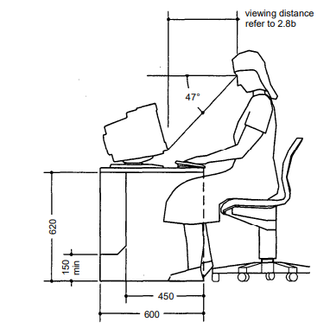
Figure ‎2.1: Computer work station.(ADLER, 2007)

Disabled people requirements (ADLER, 2007)
- Entrance width >=1.3m
- Width of door >=0.9
- Threshold height<=15mm
- Tread width >=0.3m
- Raise height <=0.15m
- Ramp slop <=6%
- Providing handrails at 0.90 height for two ends

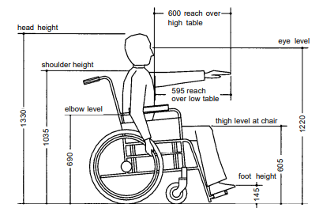
Figure ‎2.2: disable people.(ADLER, 2007)
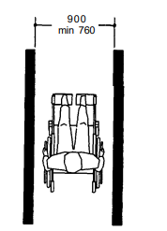
Figure ‎2.3: disable people path requirements.(ADLER, 2007)
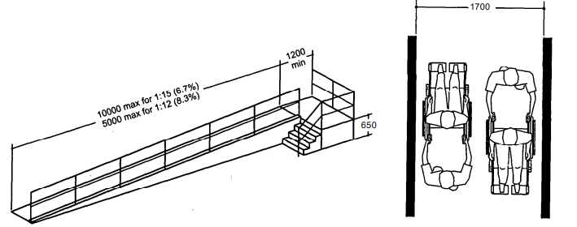
Figure ‎2.4: disable people ramp requirements.(ADLER, 2007)

Toilets
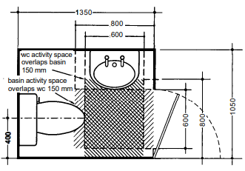
Figure ‎2.5: Toilets design requirements.(ADLER, 2007)
Minimum toilet area = 1.41 m2(ADLER, 2007)
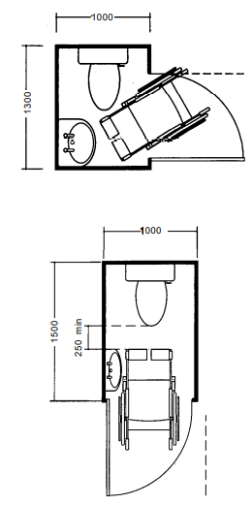
Figure ‎2.6: Disable people Toilets design requirements.(ADLER, 2007)

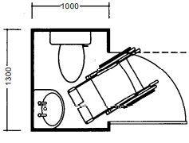
Figure ‎2.7: Disable people Toilets design requirements.(ADLER, 2007)
Minimum area = 1.30m2
Table ‎2-1: Staff required toilets. (ADLER, 2007)

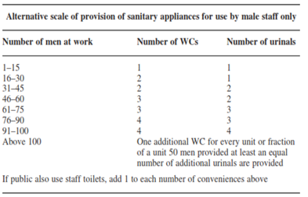
Table ‎2-2: Number of required Toilets in each floor. (ADLER, 2007)

Floor | Needed Men and women WC |  | Case | Needed Disabled WC |  | Case
Floor | Exists | Required | Case | Exists | Required | Case
GF | 8 | 6 | Ok | 1 | 1 | Ok
1st | 9 | 8 | Ok | 1 | 1 | Ok
2nd | 13 | 10 | Ok | 0 | 1 | Add one toilet for disabled
3rd | 13 | 10 | Ok | 0 | 1 | Add one toilet for disabled
4th | 4 | 4 | Ok | 1 | 1 | Ok
5th | 13 | 10 | Ok | 1 | 1 | Ok
6th | 4 | 4 | Ok | 1 | 1 | Ok

For meeting hall
Chairs:
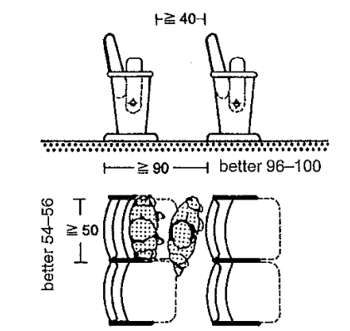
Figure ‎2.8: Meeting hall stairs standards. (Neufert & Neufert, 2012)
As shown, stairs width >=0.50 m and clear distance between chairs >=0.40 m (Neufert & Neufert, 2012)
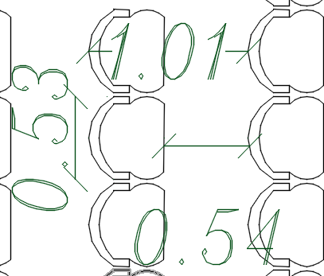
Figure ‎2.9: Stairs distribution in the meeting hall according to standards.
Stage:
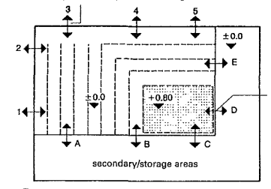
Figure ‎2.10: Stage standards.(Neufert & Neufert, 2012)
The stage height = 0.80 m, and the dimensions is based on the space dimensions.(Neufert & Neufert, 2012)

Restaurant and coffee shop
Table ‎2-3: Tables standard dimensions.(ADLER, 2007)
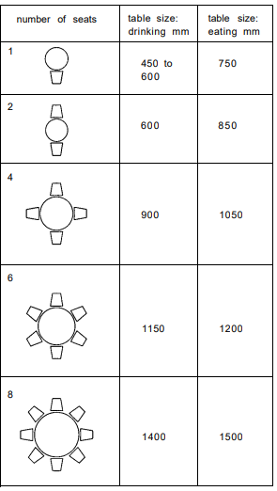
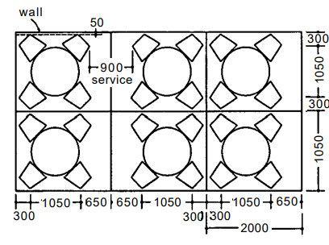
Figure ‎2.11: Restaurant tables layout(ADLER, 2007)

Parking spaces and car ramps
The required number of parking spaces = 1/60m2(Jittrapirom, 2010)
Total building area = 6000m2---->number of parking spaces = 100

A three additional parking spaces are needed for disabled people. (Jittrapirom, 2010)
A one floor needed to add for the building
Total number of needed parking spaces = 103
- Parking space dimensions
The standard dimensions of the parking space are 5.00 m length and 2.20 m width. (ADLER, 2007)
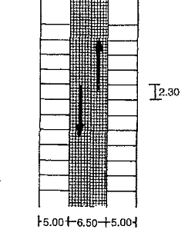
Figure ‎2.12: Parking spaces standard distances. (ADLER, 2007)
- Car ramp slope<=15% (ADLER, 2007)

Elevators
After calculations, the total number of elevators required = 3

Emergency exits
- The number of emergency exists >=2 (Ontario Building Code 2012, 2012)
- Stairs width not less than 1 m. (Ontario Building Code 2012, 2012)
- Width of emergency exits door not less than 1m. (Ontario Building Code 2012, 2012)

Fire egressing distance
Codes define the distance of travel required to enter an exit, this is extremely important where the taken time to find an exit, people may be exposed to fire or smoke.
A general rule is that the overall travel distance for at least one exit must not exceed
150 feet (45.72m) in non-sprinkled buildings or 200 feet (61.00m) in buildings that
Covered by a sprinkler system. (Life Safety - Means of Egress / Exits – NFPA 101, 2020)

Corridors
The width corridor >=1.8m (Neufert & Neufert, 2012)

Spaces standard areas
Table ‎2-4: General spaces standard areas.
Space name | Standard Area | Reference
WC | 1.41 | (ADLER, 2007)
WC Disabled | 2.20 | (ADLER, 2007)
Office | 9.00 | (ADLER, 2007)
Bedroom | 12.00 | (Mahajan, 2022)
Kitchen | 3.00 | (ADLER, 2007)
Public Services | 60.00 | (Ambiencedore, 2022)
Secretary | 15.00 | (ADLER, 2007)
Waiting Room | 12.00 | (Mahajan, 2022)
President office | 20.00 | (ADLER, 2007)
General manager office | 20.00 | (ADLER, 2007)
Secretary | 15.00 | (Ambiencedore, 2022)
Meeting Room | 22.00 | (Ambiencedore, 2022)

Figure SEQ Figure \* ARABIC 6: Nablus Municipality departments.

Case Study
Adana Chamber of Commerce Service Building
“The building, on the land of Turhan Cemal Beriker Boulevard, as being Adana’s outward gate meets at the same time, new comers to the city”(YEGENAarchitectural, 2022).
Design concept:
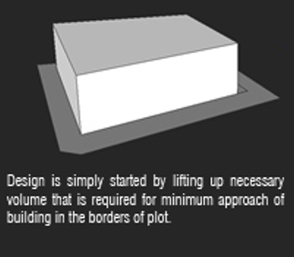
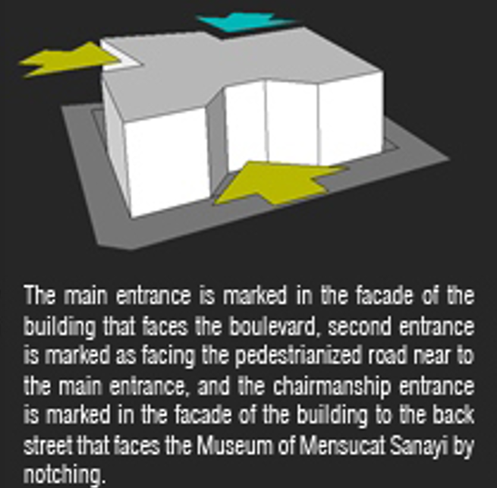
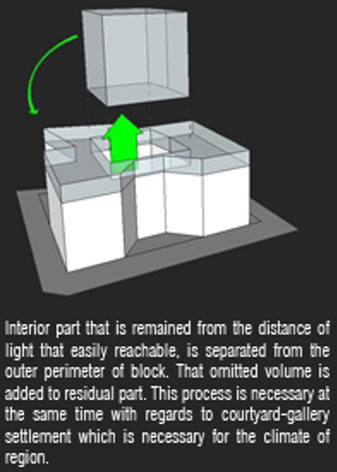
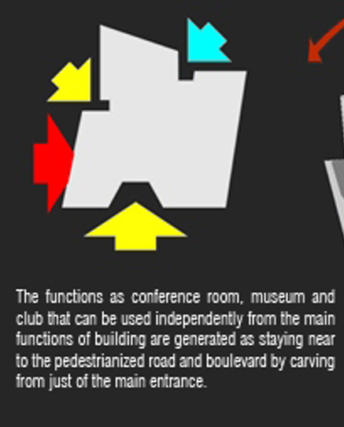
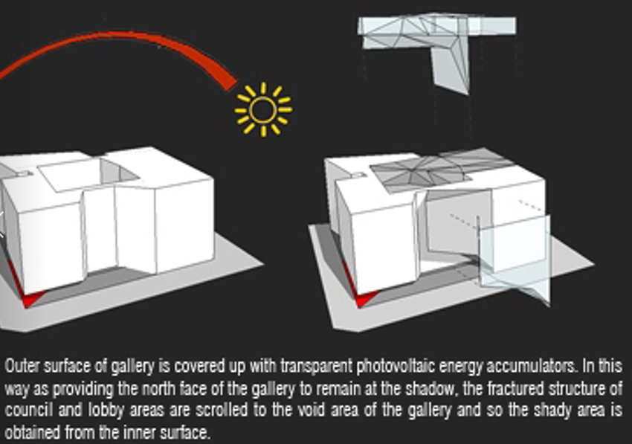
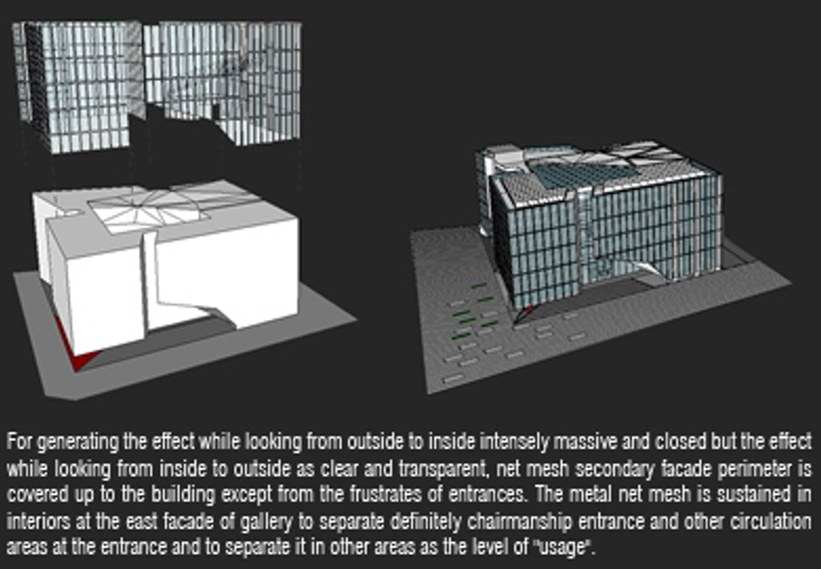
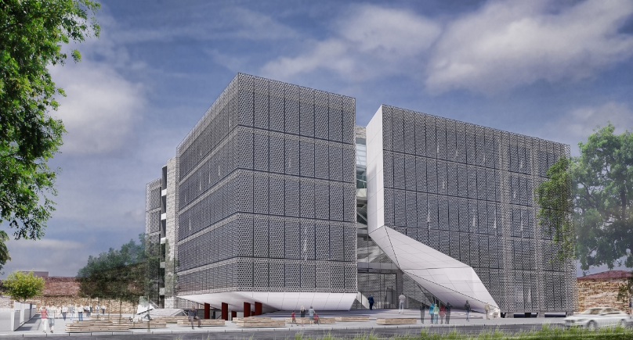
Figure ‎2.13: Chamber of commerce building.
Plans:
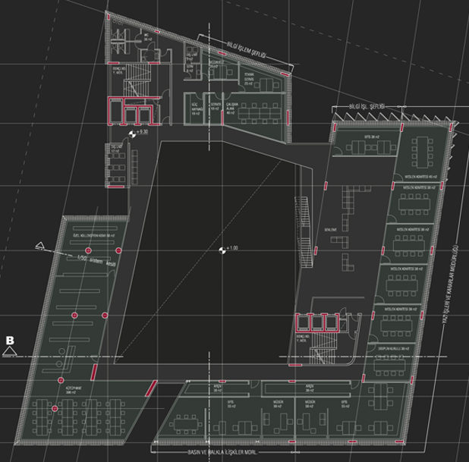
Figure ‎2.14: ground floor plan
This floor contains meeting rooms.

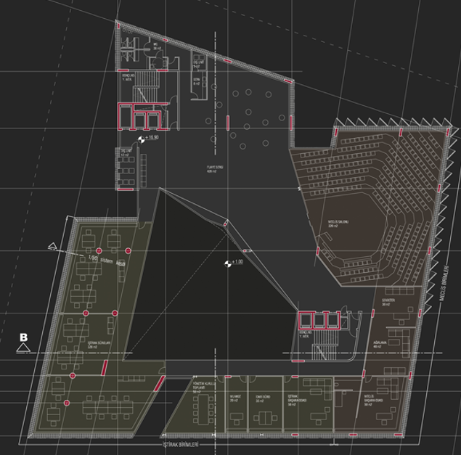
Figure ‎2.15: First floor plan
This floor contains offices and meeting hall.
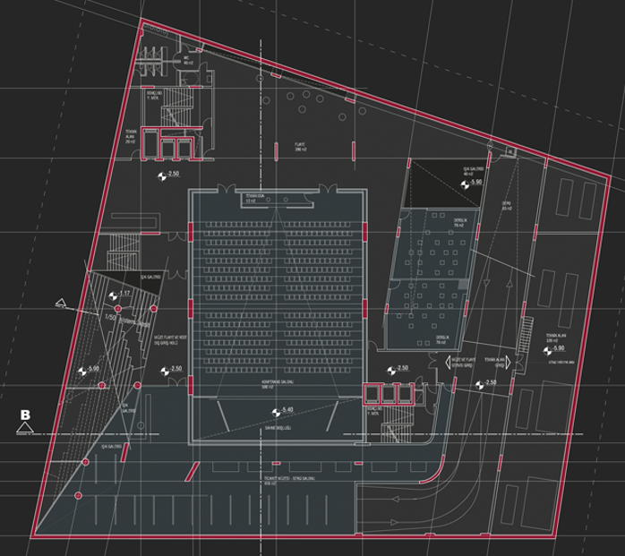
Figure ‎2.16: Third floor plan.
This floor contains meeting hall.
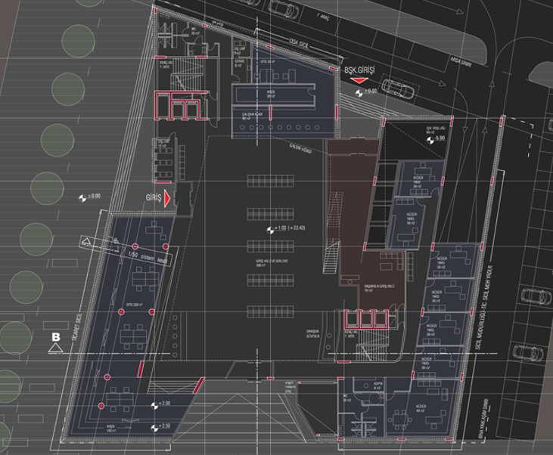
Figure ‎2.17: Ground floor plan
This floor contains public service hall, offices and president office.
- Spaces existed in the facility and its achievement in this project:
Offices
Meeting hall
Public service hall
President office
Kitchen
Archive
IT and servers' room
Reception
Waiting areas

Site analysis

Location
The location of the building in Jenin-Haifa Street.
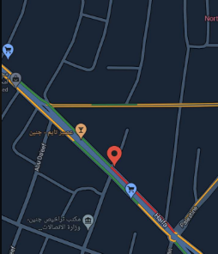
Figure ‎2.18 : Location of the project.

Topography
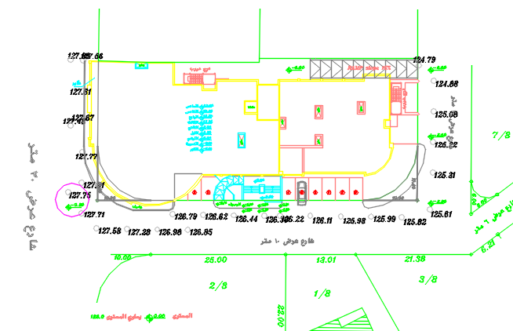
Figure ‎2.19: Topography of the project.

Site plan
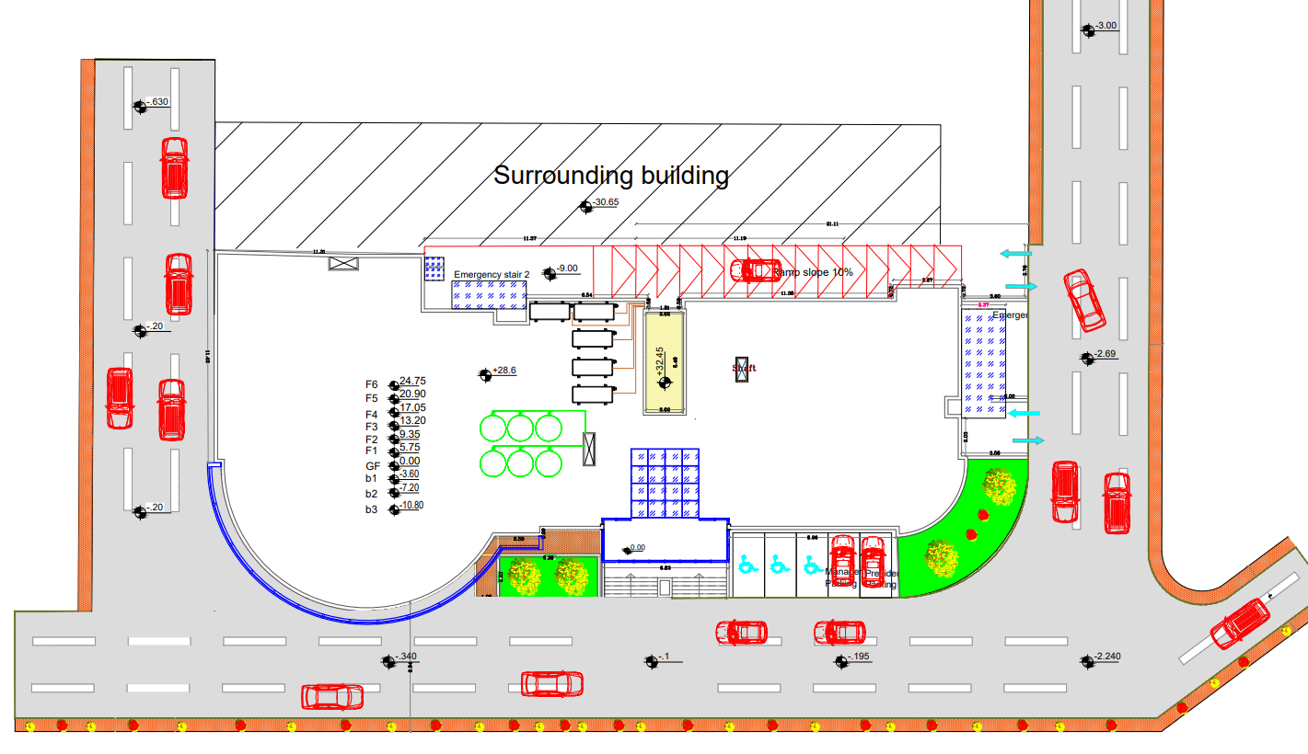
Figure 2.20: figure for site plan

Sun Path diagram
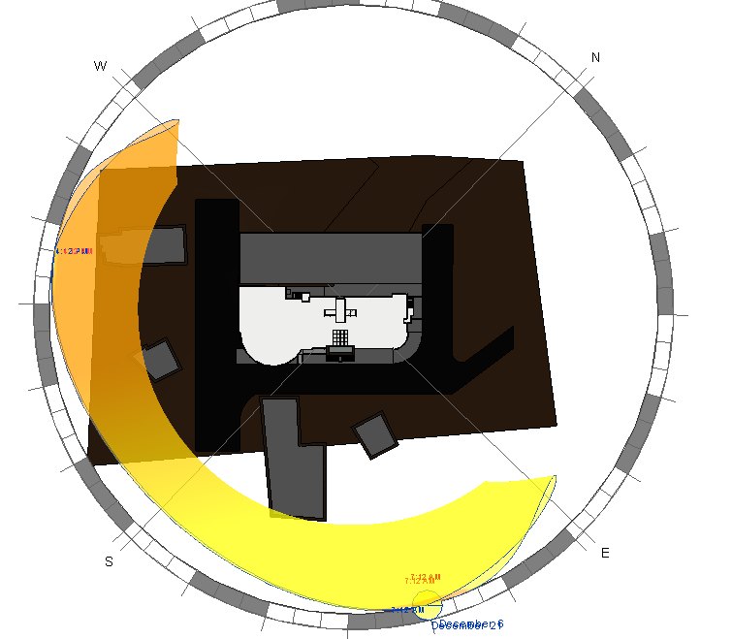
Figure ‎2.21: Sun path diagram.
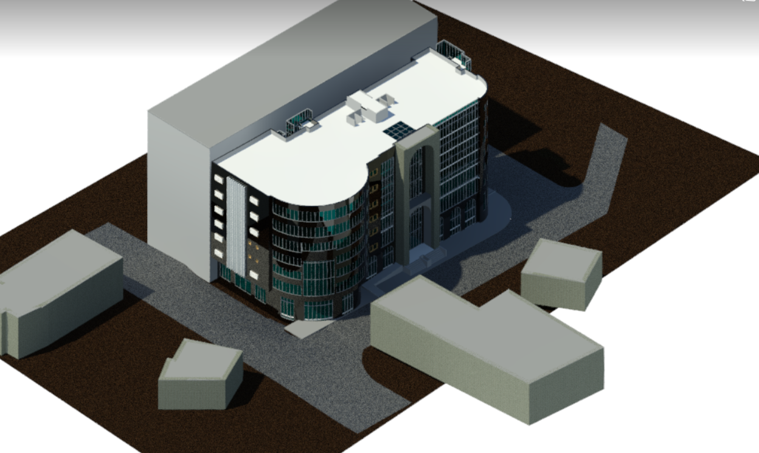
Figure ‎2.22: Revit model.

Figure SEQ Figure \* ARABIC 23: Sun path diagram.

Climate in Jenin
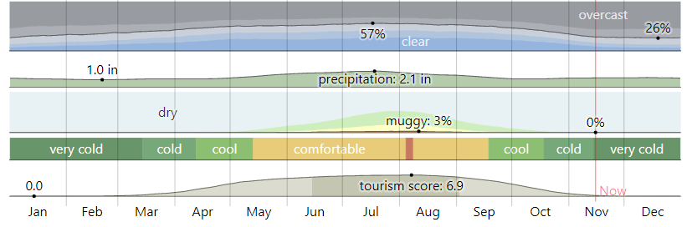
Figure ‎2.23: Monthly climate in Jenin(weatherspark, 2022)
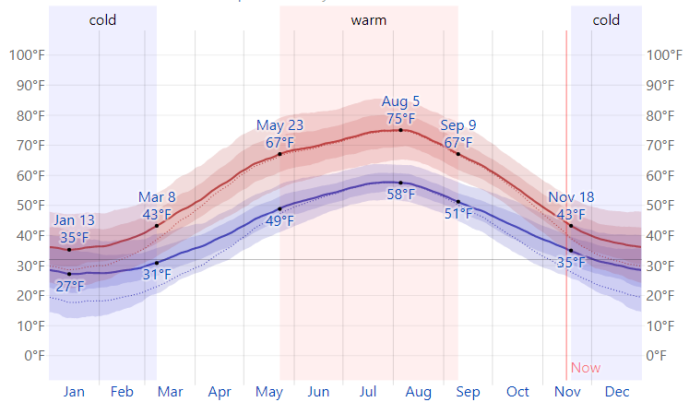
Figure ‎2.24: Average High and Low Temperature(weatherspark, 2022)
Table ‎2-5: Average High and Low Temperature(weatherspark, 2022) 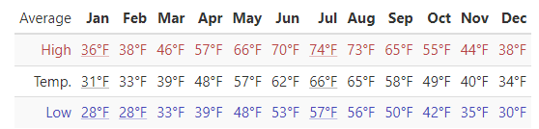
.
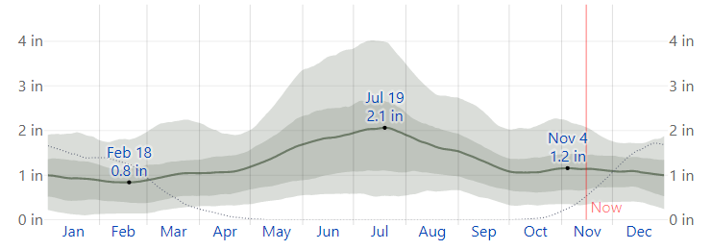
Figure ‎2.25: Average Monthly Rainfall(weathers park, 2022)

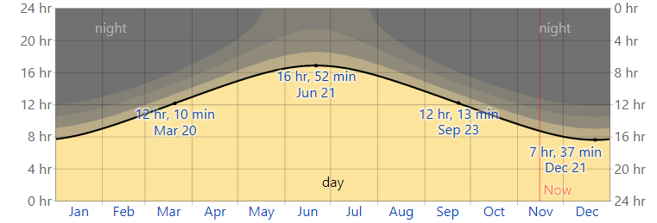
Figure ‎2.26: Hours of Daylight and Twilight(weathers park, 2022)
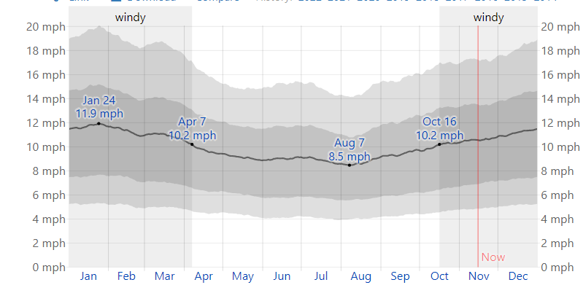
Figure ‎2.27: Average Wind Speed in Jenin(weather spark, 2022)

Noise readings
The readings were done using mobile application for sound level meter.
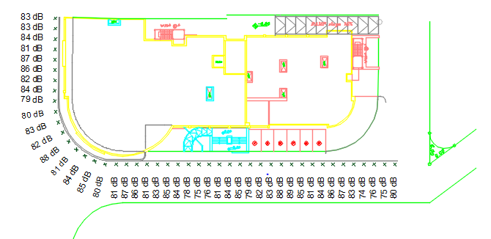
Figure ‎2.28: Noise readings
From the previous readings, the background noise from vehicles is high, which will need a treatment for example: acoustical barriers.

Shading analysis
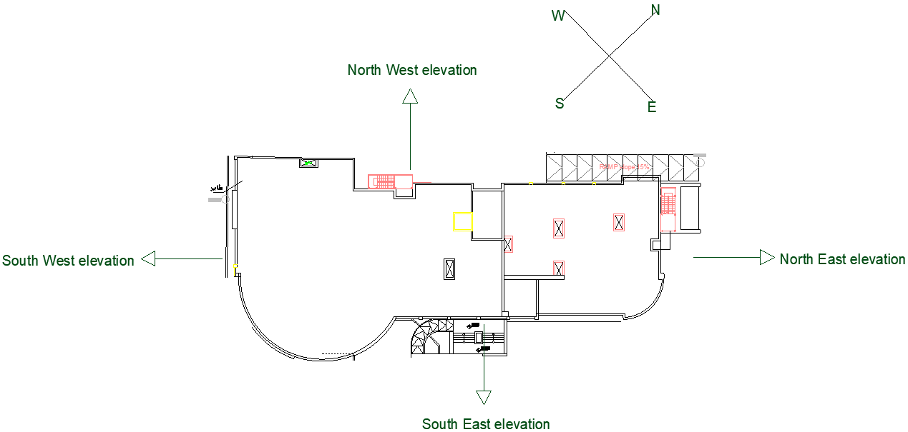
Figure ‎2.29: Elevations of the building.

The shading analysis will be divided into two parts, the first one is winter shading analysis and the second is summer shading analysis and through these two parts, three times will be analyzed (8.00AM, 12.00PM and 2.00 AM) before and after modifications.
Summer day: 21/6
Winter day: 21/12
- Before modifications
- Winter:
At 8AM
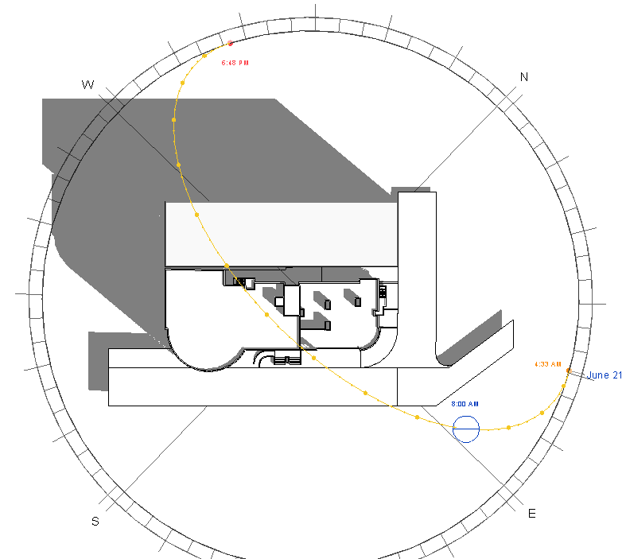
Figure ‎2.30: Shading in winter at 8AM.
At 12PM
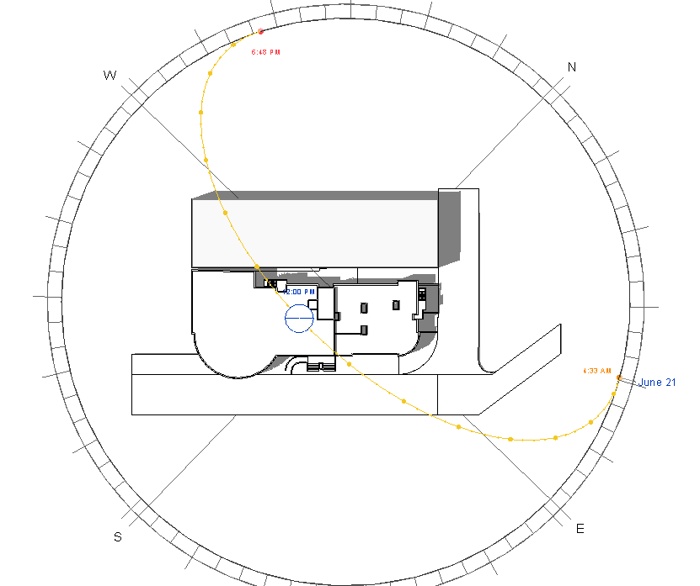
Figure ‎2.31: Shading in winter at 12PM.

At 2PM
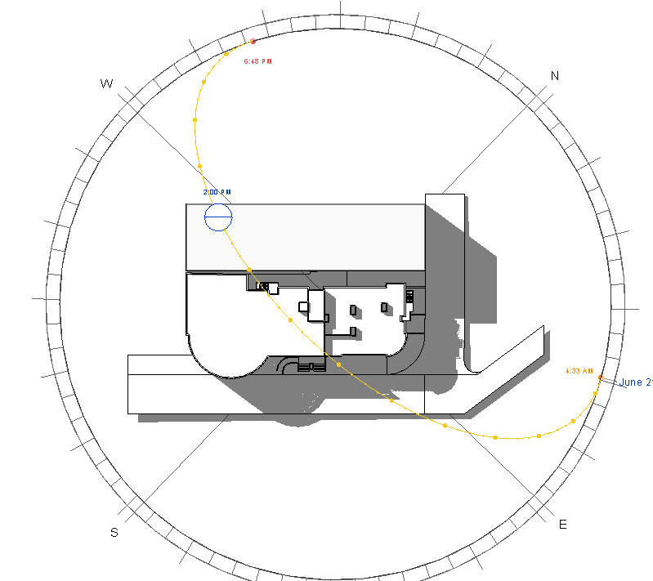
Figure ‎2.32: Shading in winter at 2PM.
Summary
Table ‎2-6: Shading analysis summary in winter.
Time | Elevation Name | Shading | Shadowing | Case
8AM | North West | Yes | Yes | Not ok
8AM | South East | No | No | Ok
8AM | North East | No | No | Ok
8AM | South West | No | Yes | Ok
12PM | North West | Yes | No | Not ok
12PM | South East | No | Yes | Ok
12PM | North East | No | No | Ok
12PM | South West | No | No | Ok
2PM | North West | Yes | No | Not ok
2PM | South East | No | Yes | Ok
2PM | North East | No | Yes | Ok
2PM | South West | No | No | Ok

The big problem is that the high building faces the chamber of commerce building.

- Summer:
At 8AM

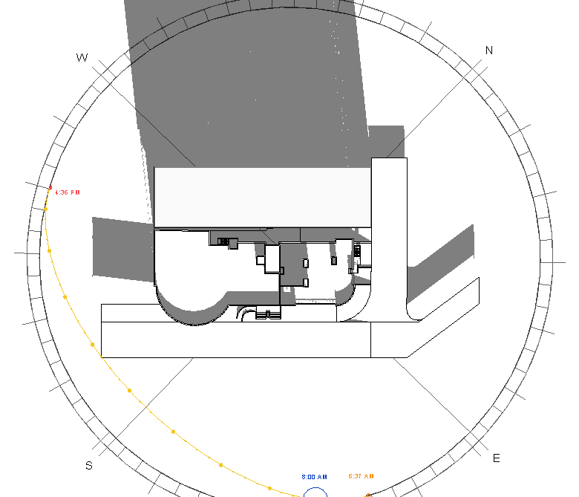
Figure ‎2.33: Shading in summer at 8AM.
At 12PM
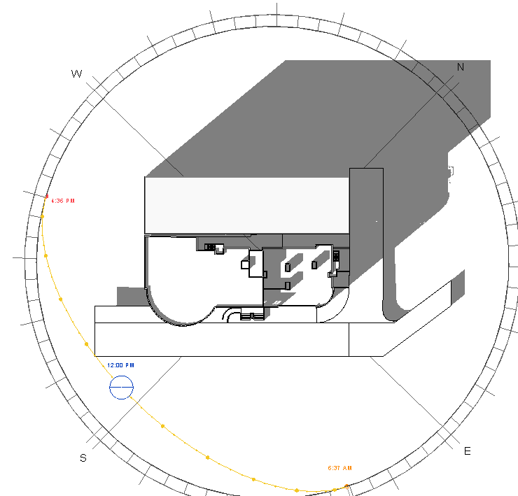
Figure ‎2.34 Shading in summer at 12PM.

At 2PM
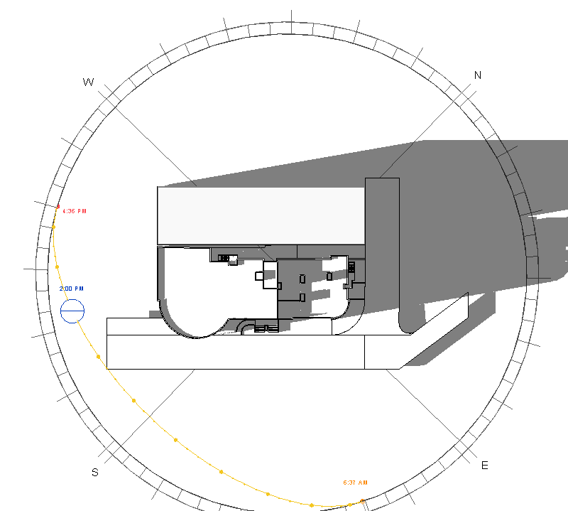

Figure ‎2.35 Shading in summer at 2PM.
Summary
Table ‎2-7: Shading analysis summary in summer.
Time | Elevation Name | Shading | Shadowing | Case
8AM | North West | Yes | No | Not ok
8AM | South East | No | No | Ok
8AM | North East | No | No | Ok
8AM | South West | No | Yes | Ok
12PM | North West | Yes | No | Not ok
12PM | South East | No | Yes | Ok
12PM | North East | No | No | Ok
12PM | South West | No | No | Ok
2PM | North West | Yes | No | Not ok
2PM | South East | No | Yes | Ok
2PM | North East | No | Yes | Ok
2PM | South West | No | No | Ok

Summary:
From the previous analysis, the environmental treatments will be for west and east elevations.

Solar radiation analysis
Solar radiation analysis will be in summer and winter at three different times (8.00AM, 12.00PM and 2.00 AM) before and after architectural modifications because there is no changing in building shape after modifications.
Summer day: 21/6 and Winter Day: 21/12
- Winter (21/12)
At 8AM
South East elevation
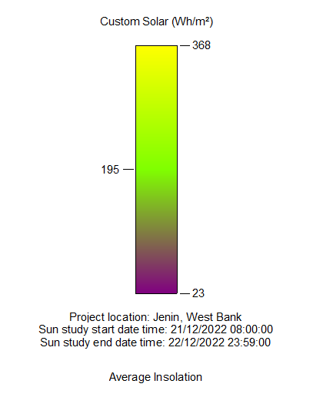
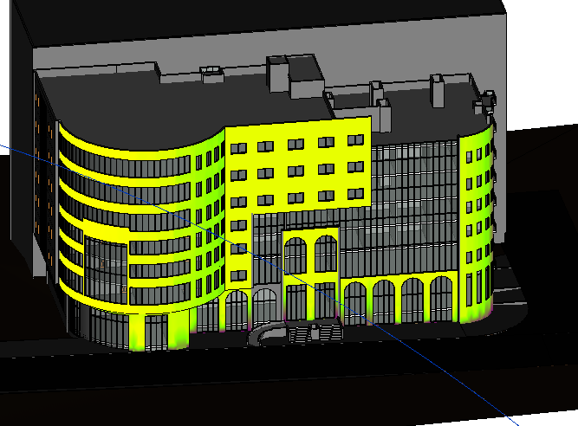
Figure ‎2.36: Solar radiation on south east elevation in winter at 8 am
As shown in the previous figure the solar radiation is high, which is good for daylighting and in winter for heating purposes.
South West elevation
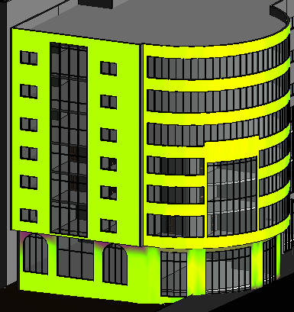
Figure ‎2.37: Solar radiation on south west elevation in winter at 8 am
As shown in the previous figure the solar radiation is high, which is good for daylighting and in summer there is no high gain.

North West elevation
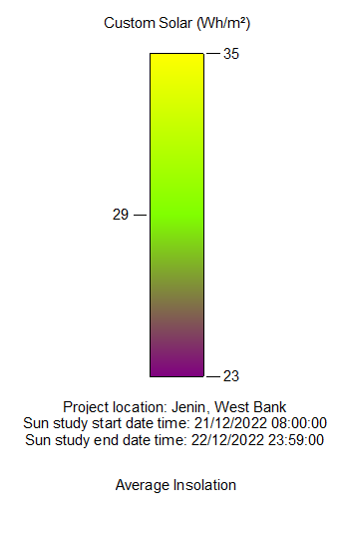
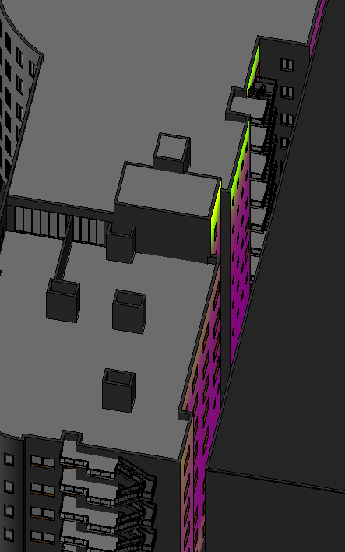
Figure ‎2.38: Solar radiation on North West elevation in winter at 8 am
As shown in the previous figure the solar radiation is very bad because of the existing of the adjacent building which is very bad and there is no solution for that just artificial lighting.

North East elevation
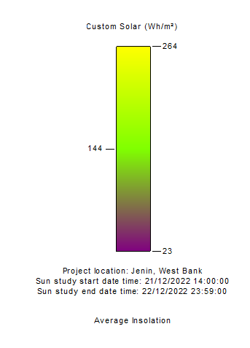

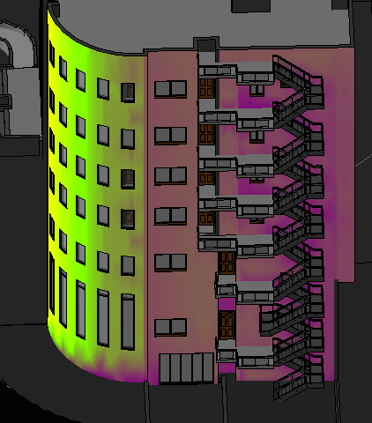
Figure ‎2.39: Solar radiation on north east elevation in winter at 8 am
As shown in the previous figure the solar radiation is not a big on the north elevation which is not good for daylight factor and artificial lighting needed.

At 12PM
South East elevation
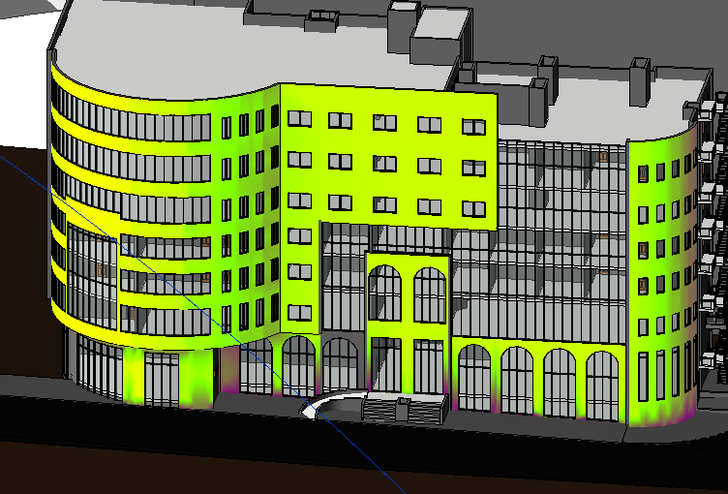
Figure ‎2.40: Solar radiation on south east elevation in winter at 12 Pm
As shown in the previous figure the solar radiation is high, which is good for daylighting and in winter for heating purposes.

South West elevation
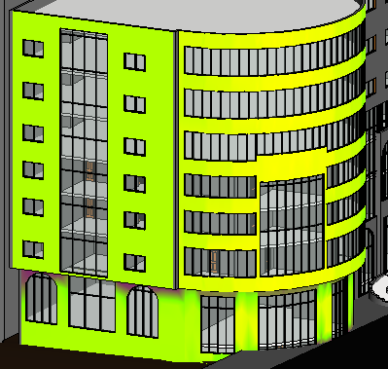
Figure ‎2.41: Solar radiation on south west elevation in winter at 12 Pm
As shown in the previous figure the solar radiation is high, which is good for daylighting and in summer there is no high gain.

North West elevation
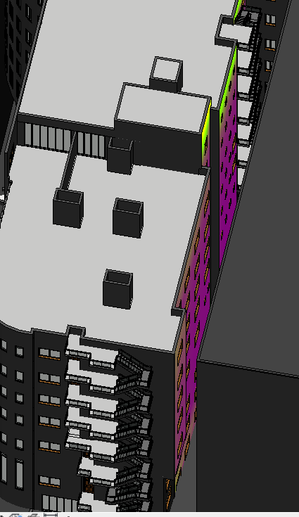
Figure ‎2.42: Solar radiation on North West elevation in winter at 12 Pm
As shown in the previous figure the solar radiation is very bad because of the existing of the adjacent building which is very bad and there is no solution for that just artificial lighting.
North East elevation
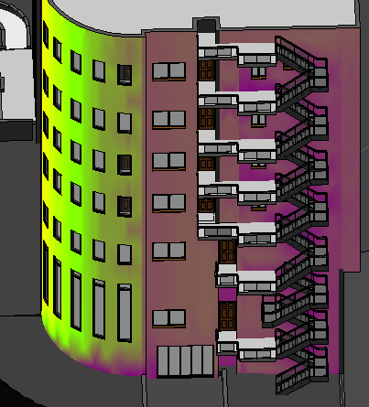
Figure ‎2.43: Solar radiation on north east elevation in winter at 12 Pm
As shown in the previous figure the solar radiation is not good.
At 2PM
South East elevation
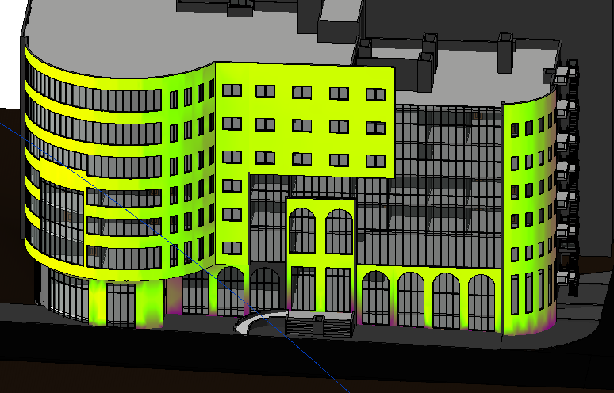
Figure ‎2.44: Solar radiation on south east elevation in winter at 2 Pm
As shown in the previous figure the solar radiation is high, which is good for daylighting and in winter for heating purposes.

South West elevation

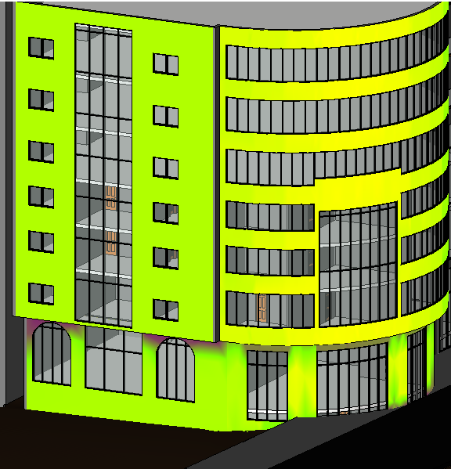
Figure ‎2.45: Solar radiation on south west elevation in winter at 2 Pm
As shown in the previous figure the solar radiation is high, which is good for daylighting and in winter for heating purposes.

North West elevation
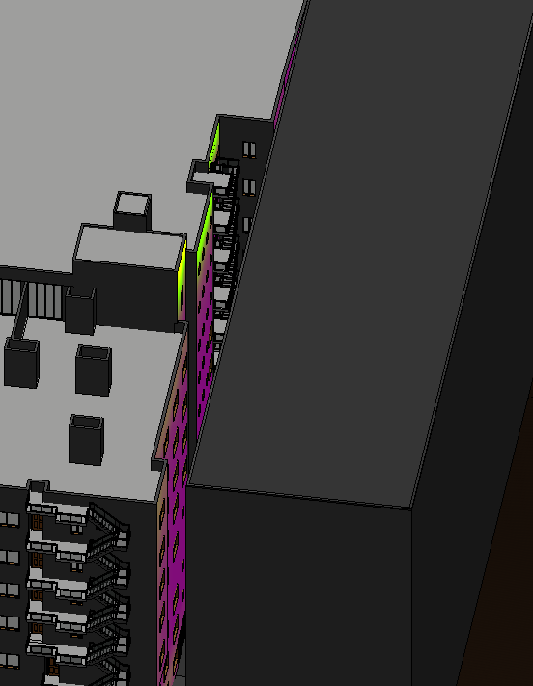
Figure ‎2.46: Solar radiation on North West elevation in winter at 2 Pm
As shown in the previous figure the solar radiation is very bad because of the existing of the adjacent building which is very bad and there is no solution for that just artificial lighting.
North East elevation
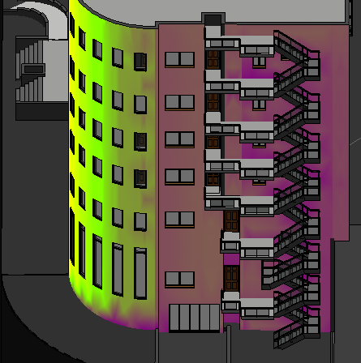
Figure ‎2.47: Solar radiation on north east elevation in winter at 2 Pm
As shown in the previous figure the solar radiation is not good

- Summer (21/6)
At 8AM
South East elevation
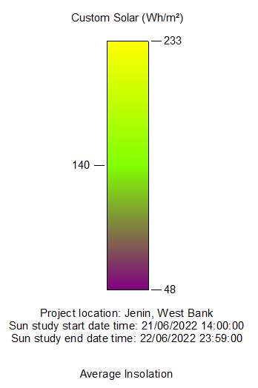
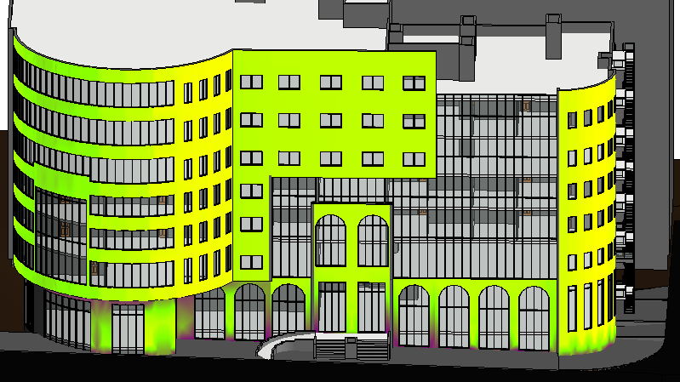
Figure ‎2.48: Solar radiation on South East elevation in summer at 8 am
As shown in the previous figure the solar radiation is high, which is good for daylighting and in summer there is no high gain.

South West elevation
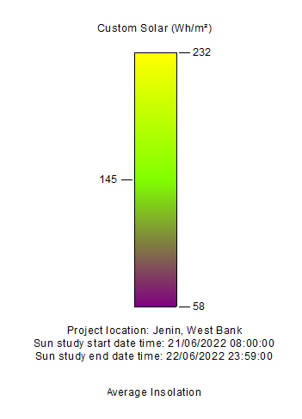
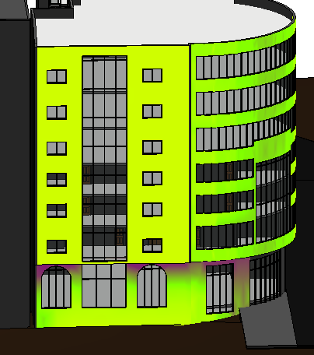
Figure ‎2.49: Solar radiation on South West elevation in summer at 8 am
As shown in the previous figure the solar radiation is high, which is good for daylighting and in winter for heating purposes.
North West elevation
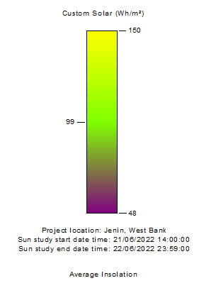
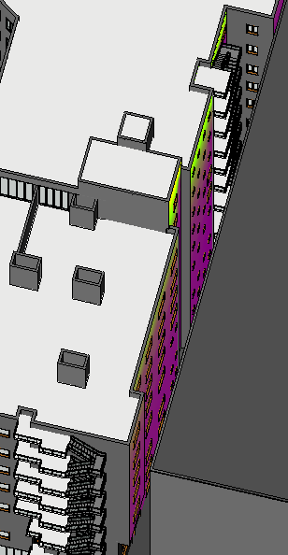
Figure ‎2.50: Solar radiation on North West elevation in summer at 8 am
As shown in the previous figure the solar radiation is very bad because of the existing of the adjacent building which is very bad and there is no solution for that just artificial lighting.
North East elevation
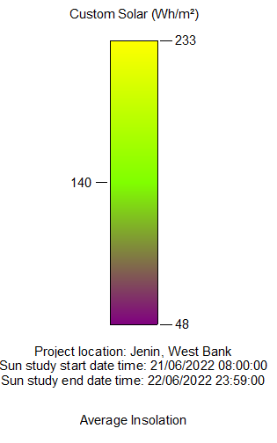

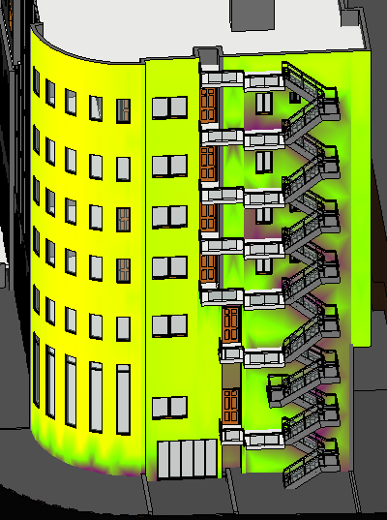
Figure ‎2.51: Solar radiation on north east elevation in summer at 8 am
As shown in the previous figure the solar radiation fair which is good for daylighting.
At 12PM
South East elevation
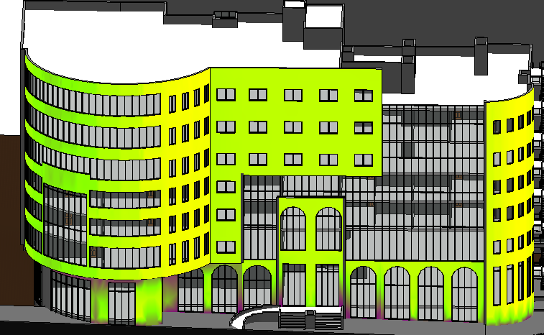
Figure ‎2.52: Solar radiation on South East elevation in summer at 12 Pm
As shown in the previous figure the solar radiation is high, which is good for daylighting and in summer there is no high gain.

South West elevation
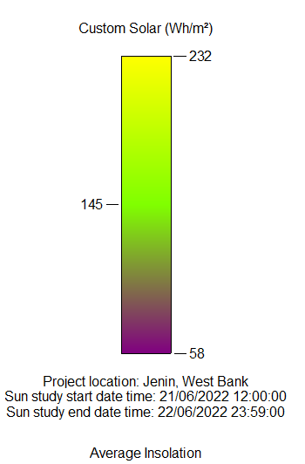
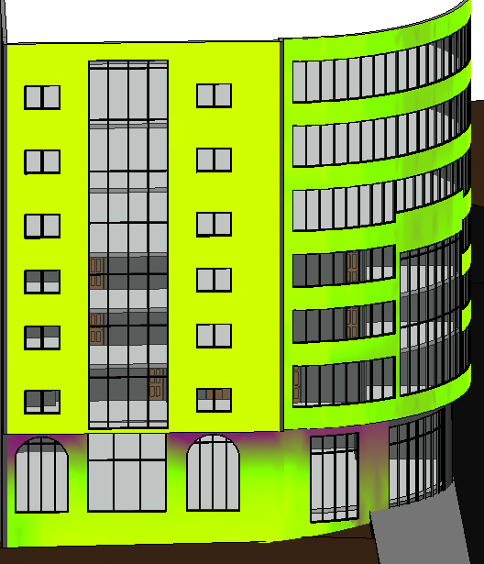
Figure ‎2.53: Solar radiation on South West elevation in summer at 12 Pm
As shown in the previous figure the solar radiation is high, which is good for daylighting and in summer there is no high gain.
North West elevation
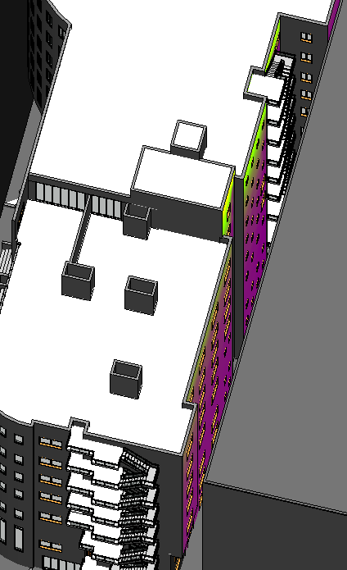
Figure ‎2.54: Solar radiation on North West elevation in summer at 12 Pm
As shown in the previous figure the solar radiation is very bad because of the existing of the adjacent building which is very bad and there is no solution for that just artificial lighting.

North East elevation
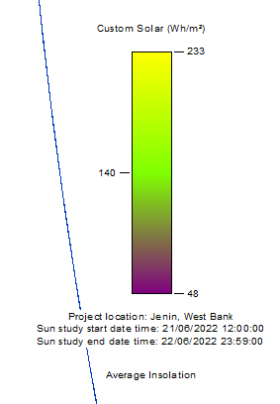
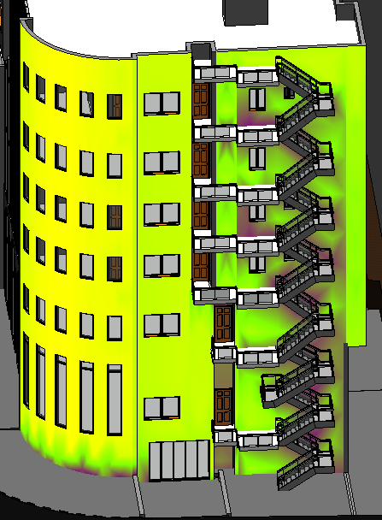
Figure ‎2.55: Solar radiation on North East elevation in summer at 12 Pm
As shown in the previous figure the solar radiation is high, which is good for daylighting and in summer there is no high gain.

At 2PM
South East elevation
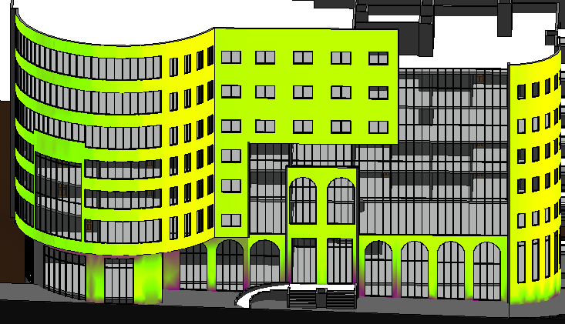
Figure ‎2.56: Solar radiation on south east elevation in summer at 2 Pm
As shown in the previous figure the solar radiation is high, which is good for daylighting and in summer there is no high gain.

South West elevation
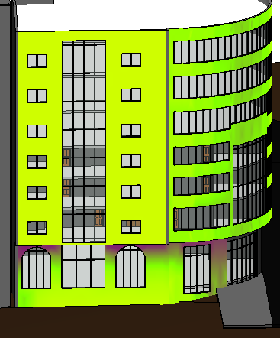
Figure ‎2.57: Solar radiation on south west elevation in summer at 2 Pm
As shown in the previous figure the solar radiation is high, which is good for daylighting and in summer there is no high gain.

North West elevation
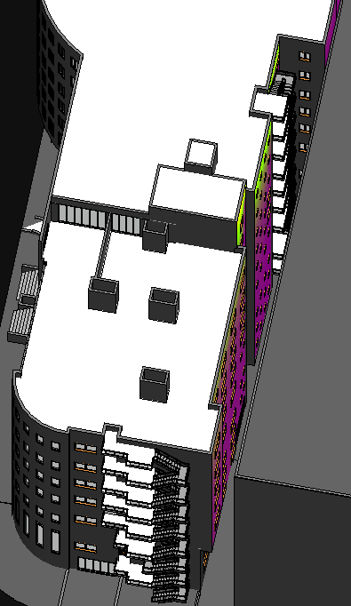
Figure ‎2.58: Solar radiation on North West elevation in summer at 2 Pm
As shown in the previous figure the solar radiation is very bad because of the existing of the adjacent building which is very bad and there is no solution for that just artificial lighting.
North East elevation

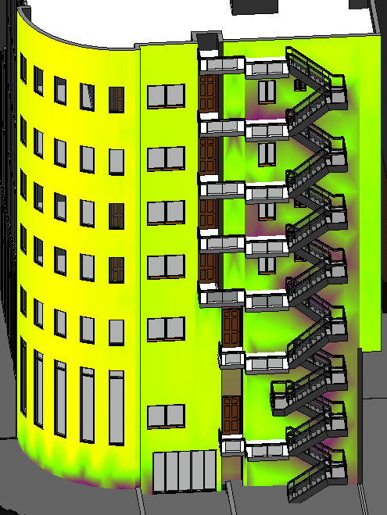
Figure ‎2.59: Solar radiation on north east elevation in summer at 2 Pm
As shown in the previous figure the solar radiation is good.

Wind
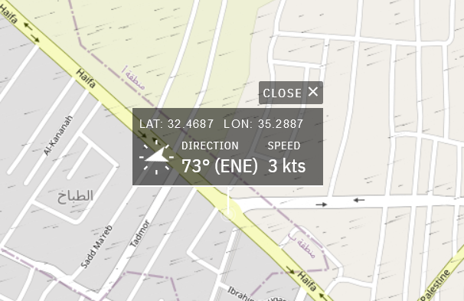
Figure ‎2.60: Wind direction.
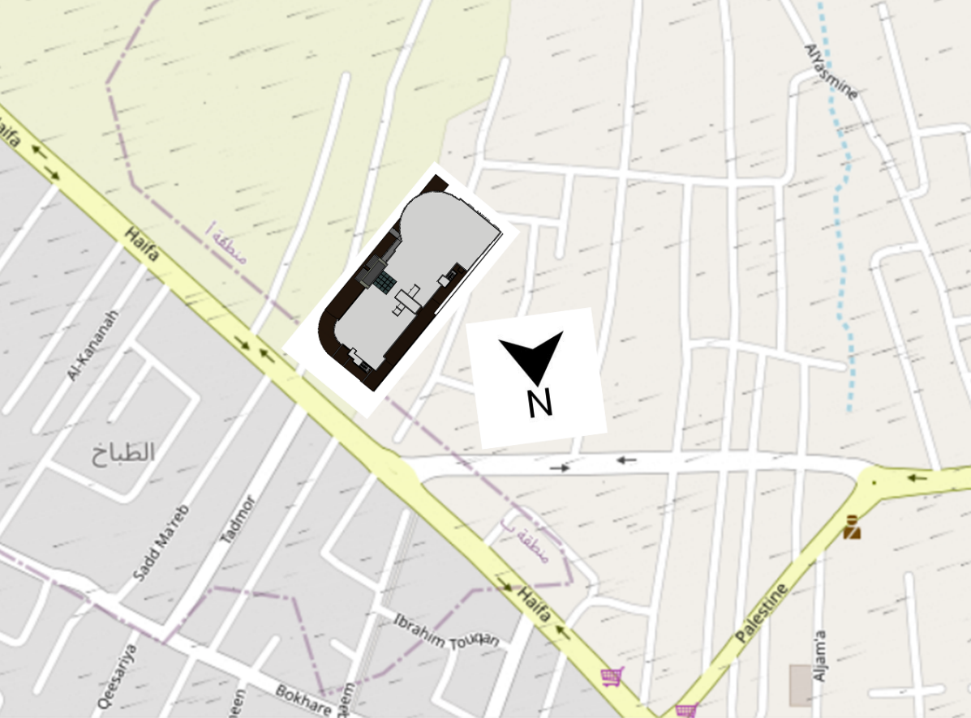
Figure ‎2.61: Wind direction of the building.

Architectural modifications
Spaces area assessment:
- Ground floor
Space Name | Current Area | Count | Standard Area | Case
WC1 | 1.5 | 4 | 1.41 | Ok
WC2 | 1.8 | 2 | 1.41 | Ok
WC security | 2.4 | 1 | 1.41 | Ok
WC3 | 2.65 | 1 | 1.41 | Ok
WC4 | 2.18 | 1 | 1.41 | Ok
WC disabled | 4.14 | 1 | 2.2 | Ok
Investment unit 1 | 375 | 1 | - | Ok
Investment unit 2 | 200 | 1 | - | Ok
Investment unit 3 | 360 | 1 | - | Ok
Table ‎2-8: Ground floor spaces assessment

- 1st floor
Table ‎2-9: 1st floor spaces assessment
Space Name | Current Area | Count | Standard Area | Case
IT Room | 24.3 | 1 | 20 | Ok
Archive | 8.18 | 1 | 12 | Not ok
Department of Economic | 29 | 1 | 20 | Ok
Kitchen | 13.95 | 1 | 3 | Ok
Store | 3.68 | 1 | - | Ok
Servers room | 7.36 | 1 | - | Ok
Meeting Room | 30.46 | 1 | 22 | Ok
WC1 | 1.65 | 1 | 1.41 | Ok
WC2 | 1.53 | 1 | 1.41 | Ok
WC3 | 3.27 | 1 | 1.41 | Ok
WC4 | 1.8 | 6 | 1.41 | Ok
WC disabled | 4.14 | 1 | 2.2 | Ok
Public Relations | 26.04 | 1 | 20 | Ok
President of the Chamber of Commerce | 22.4 | 1 | 20 | Ok
General manager | 28 | 1 | 20 | Ok
Secretary | 17.5 | 1 | 24 | Not ok
Public Services | 69.3 | 1 | 60 | Ok
Waiting area | 104.5 | 1 | - | Ok
Meeting Hall | 365 | 1 | - | Ok
WC | 1.8 | 2 | 1.41 | Ok
Meeting Hall Kitchen | 4.32 | 1 | 3 | Ok

- 2nd and 3rd floor
Table ‎2-10: 2nd and 3rd floors spaces assessment
Space Name | Current Area | Count | Standard Area | Case
Office 1 | 27.00 | 1 | 9.00 | Ok
Office 2 | 20.58 | 1 | 9.00 | Ok
Office 3 | 18.90 | 1 | 9.00 | Ok
Office 4 | 27.93 | 1 | 9.00 | Ok
Office 5 | 35.73 | 1 | 9.00 | Ok
Office 6 | 17.22 | 1 | 9.00 | Ok
Office 7 | 18.45 | 1 | 9.00 | Ok
Office 8 | 18.00 | 1 | 9.00 | Ok
Office 9 | 18.00 | 1 | 9.00 | Ok
Office 10 | 12.94 | 1 | 9.00 | Ok
Office 11 | 17.25 | 1 | 9.00 | Ok
Office 12 | 18.00 | 1 | 9.00 | Ok
Office 13 | 18.00 | 1 | 9.00 | Ok
Office 14 | 16.44 | 1 | 9.00 | Ok
Office 15 | 19.21 | 1 | 9.00 | Ok
Office 16 | 19.00 | 1 | 9.00 | Ok
Waiting 1 | 22.00 | 1 | 12.00 | Ok
Waiting 2 | 28.56 | 1 | 12.00 | Ok
Waiting 3 | 54.00 | 1 | 12.00 | Ok
Waiting 4 | 25.10 | 1 | 12.00 | Ok
Waiting 5 | 24.30 | 1 | 12.00 | Ok
Waiting 6 | 24.30 | 1 | 12.00 | Ok
Waiting 7 | 16.48 | 1 | 12.00 | Ok
Waiting 8 | 13.50 | 1 | 12.00 | Ok
Waiting 9 | 21.24 | 1 | 12.00 | Ok
Waiting 10 | 24.30 | 1 | 12.00 | Ok
Waiting 11 | 17.86 | 1 | 12.00 | Ok
Waiting 12 | 13.60 | 1 | 12.00 | Ok
Waiting 13 | 19.00 | 1 | 12.00 | Ok
Kitchen1 | 6.00 | 1 | 4.00 | Ok
Kitchen2 | 5.70 | 1 | 3.00 | Ok
Kitchen3 | 6.75 | 1 | 3.00 | Ok
Kitchen4 | 4.32 | 1 | 3.00 | Ok
Kitchen5 | 3.65 | 1 | 3.00 | Ok
Kitchen6 | 6.00 | 1 | 3.00 | Ok
Kitchen7 | 3.00 | 1 | 3.00 | Ok
Kitchen8 | 3.00 | 1 | 3.00 | Ok
Kitchen9 | 6.00 | 1 | 3.00 | Ok
Kitchen10 | 3.65 | 1 | 3.00 | Ok
Kitchen11 | 3.45 | 1 | 3.00 | Ok
Space Name | Current Area | Count | Standard Area | Case
Kitchen12 | 3.00 | 1 | 3.00 | Ok
Kitchen13 | 4.00 | 1 | 3.00 | Ok
WC1 | 2.43 | 1 | 1.41 | Ok
WC2 | 2.50 | 1 | 1.41 | Ok
WC3 | 3.55 | 1 | 1.41 | Ok
WC4 | 2.40 | 1 | 1.41 | Ok
WC5 | 2.15 | 1 | 1.41 | Ok
WC6 | 2.58 | 1 | 1.41 | Ok
WC7 | 1.95 | 1 | 1.41 | Ok
WC8 | 1.50 | 1 | 1.41 | Ok
WC9 | 2.58 | 1 | 1.41 | Ok
WC10 | 2.15 | 1 | 1.41 | Ok
WC11 | 1.80 | 1 | 1.41 | Ok
WC12 | 1.62 | 1 | 1.41 | Ok
WC13 | 2.52 | 1 | 1.41 | Ok
Store1 | 6.60 | 1 | - | Ok
Store2 | 5.00 | 1 | - | Ok
- 4th floor
Table ‎2-11: 4th floor spaces assessment
Space Name | Current Area | Count | Standard Area | Case
Show Area 1 | 640.00 | 1 | - | Ok
Show Area 2 | 365.00 | 1 | - | Ok
WC1 | 1.50 | 4 | 1.41 | Ok
WC disabled | 4.14 | 1 | 2.2 | Ok

- 5th floor
Table ‎2-12: 5th floor spaces assessment
Space Name | Current Area | Count | Standard Area | Case
Convention Hall | 640 | 1 | - | Ok
Room1 | 16.65 | 1 | 12.00 | Ok
Room2 | 17.10 | 1 | 12.00 | Ok
Room3 | 15.75 | 1 | 12.00 | Ok
Room4 | 15.20 | 1 | 12.00 | Ok
Bed Room1 | 14.30 | 1 | 12.00 | Ok
Bed Room2 | 12.20 | 1 | 12.00 | Ok
Bed Room3 | 18.00 | 1 | 12.00 | Ok
Salon1 | 13.50 | 1 | 10.00 | Ok
Salon2 | 16.23 | 1 | 10.00 | Ok
Salon3 | 24.30 | 1 | 10.00 | Ok
Reception | 47.70 | 1 | 40.00 | Ok
Space Name | Current Area | Count | Standard Area | Case
Kitchen1 | 3.00 | 1 | 3.00 | Ok
Kitchen2 | 4.00 | 1 | 3.00 | Ok
Kitchen3 | 4.94 | 1 | 3.00 | Ok
Kitchen4 | 6.51 | 1 | 3.00 | Ok
Kitchen5 | 7.68 | 1 | 3.00 | Ok
WC1 | 2.55 | 1 | 1.41 | Ok
WC2 | 2.50 | 1 | 1.41 | Ok
WC3 | 3.44 | 1 | 1.41 | Ok
WC4 | 1.65 | 1 | 1.41 | Ok
WC5 | 1.87 | 1 | 1.41 | Ok
WC6 | 3.87 | 1 | 1.41 | Ok
WC7 | 3.44 | 1 | 1.41 | Ok
WC8 | 3.44 | 1 | 1.41 | Ok
WC9 | 3.20 | 1 | 1.41 | Ok
WC10 | 1.50 | 2 | 1.41 | Ok
WC11 | 1.50 | 2 | 1.41 | Ok
WC disabled | 2.66 | 1 | 2.20 | Ok
Store | 1.68 | 1 | - | Ok

- 6th floor
Table ‎2-13: 6th floor spaces assessment
Space Name | Current Area | Count | Standard Area | Case
Restaurants | 640 | 1 | - | Ok
WC | 1.50 | 4 | 1.41 | Ok
WC disabled | 4.14 | 1 | 2.20 | Ok

There are some weakness points in the previous design:
- Spaces relations.
- Lack of elevators.
- Inappropriate locations of shafts.
- Lack of disabled people Wc’s
- Lack of parking spaces needed.

Bubbles Diagram after modifications
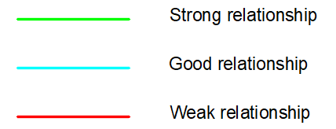
Figure ‎2.62: Bubbles diagram legend.
- Ground floor
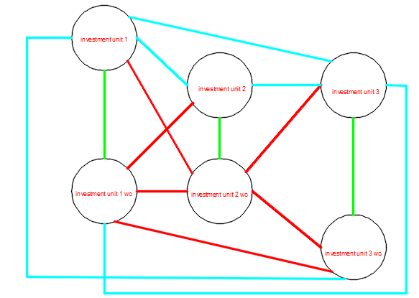
Figure ‎2.63: Ground floor bubbles diagram
All spaces in the ground floor are within the standards and the functional relationships are ok but the function will change to Shops for all floor.

- 1st floor
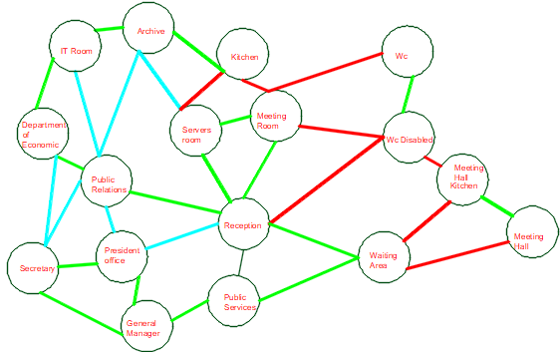
Figure ‎2.64: first floor bubbles diagram
All spaces in the first floor are within the standards and the functional relationships are ok, but there is needing to increase some areas such that Manger room and adding Wc for management department
- 2nd and 3rd and floors
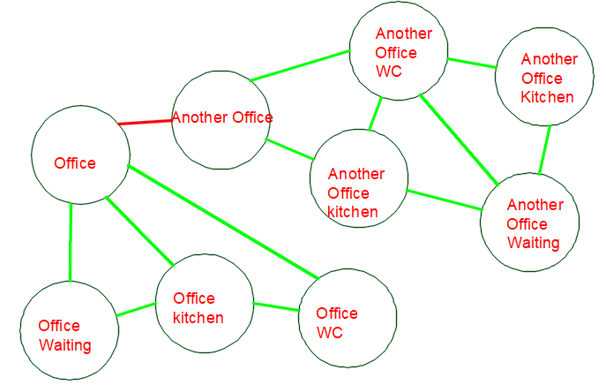
Figure ‎2.65: second and third floor bubbles diagram
Not all spaces in the second and third floor are within the standards especially the waiting areas are big than offices, so a redistribution and increasing offices areas will have made and the functional relationships are ok.

- 4th floor
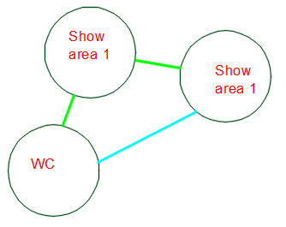
Figure ‎2.66: fourth floor bubbles diagram 5th floor
All spaces in the fourth floor are within the standards and the functional relationships are ok, but the function will change to be furniture showroom and the location of this floor will in the first floor and chamber of the commerce floor will be in the third floor.
- 5th floor
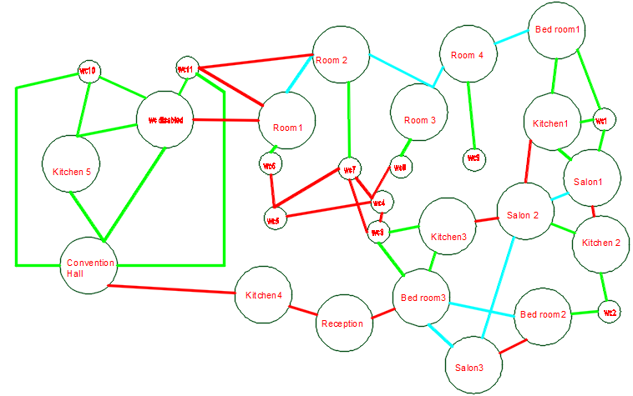
Figure ‎2.67: fifth floor bubbles diagram 5th floor
Figure SEQ Figure \* ARABIC 41: Bubbles diagram of the third floor.
All spaces in the 5th floor are within the standards and the functional relationships are ok but the convention hall area will change to be a coffee shop.

Note: For 6th floor there is only Restaurant and its area is fair.

Conclusion for architectural modifications
After making the assessment for the existed spaces and based on literature review data and asking architectural engineers in the faculty, all spaces are within the standards, but the modifications will only make on the floor's functions arrangement, changing some of the floors functions and rearrange of the floors.
The importance points that added and changings to the floors are the following:
            - Adding three elevators, so total number of elevators will be 4 elevators for people, and service elevator will be added as service elevator for restaurant and coffee shop.
            - Adding shops in the ground floor.
            - Adding WC’s in the third and fourth floors for people and disabled people.
            - Distribution of restaurant spaces.
            - Increasing doors areas.
            - Increasing the width of the main entrance.
            - Changing the shape of the disabled people ramp and its slope to be 6% as per standards.
            - Adding a new basement to increase the number of parking spaces and considering an extra three parking spaces will add for disabled people at the main entrance of the building.
            - Adding atrium on the south-East elevation.
            - Adding a double skin façade on the South elevation.
Here is a summary of the floors’ functions before and after
Table ‎2-14: Floors functions before and after modifications.
Floor Name | Function before | Function After
Ground floor | Investments units | Shops
First floor | Chamber of commerce | Furniture show areas
Second floor | offices | Chamber of commerce
Third floor | offices | offices
Fourth floor | Furniture show areas | offices
Fifth floor | Sweets | Sweets and coffee shop
Sixth floor | Restaurant | Restaurant

Edited plans
After making modifications there is a comparison between before and after plans.
- Parking
- Before
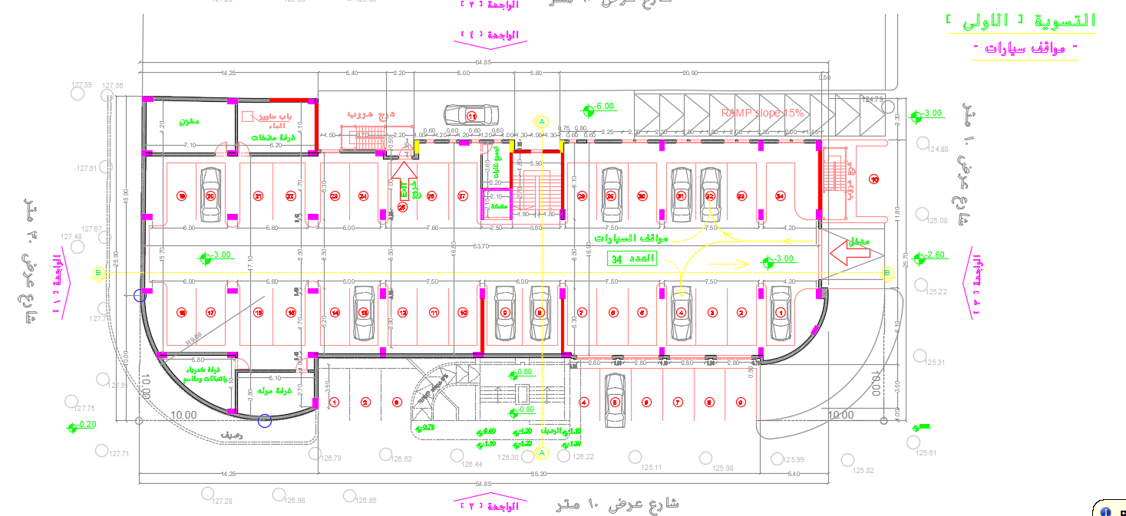
Figure ‎2.68: First basement plan before modifications.
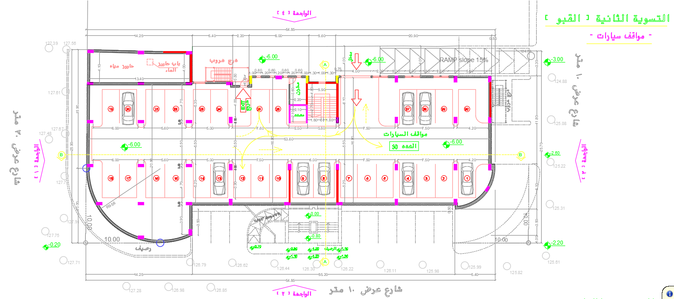
Figure ‎2.69: Second basement plan before modifications.
Two basements with total number of parking spaces of 77.

- After
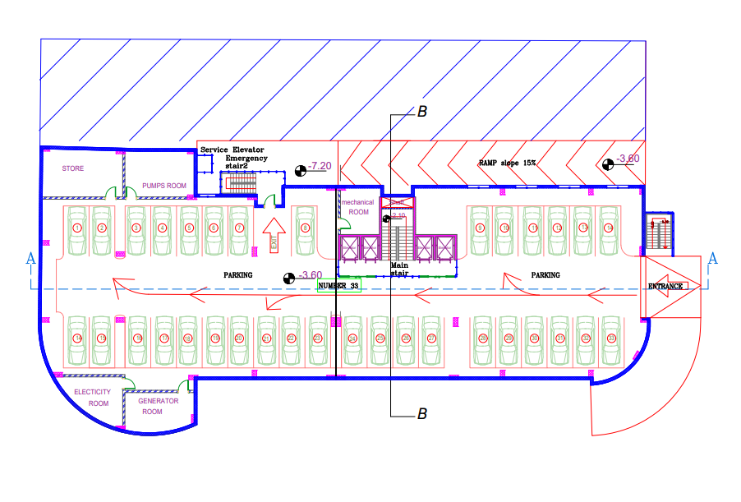
Figure ‎2.70: First basement plan before modifications.
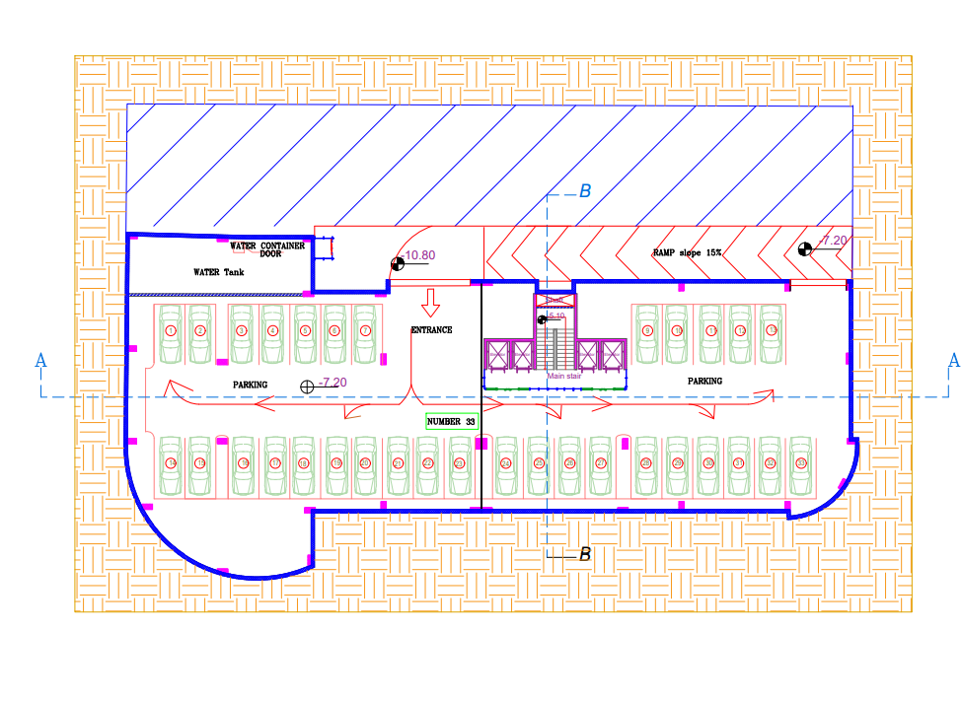
Figure ‎2.71: Second basement plan before modifications.

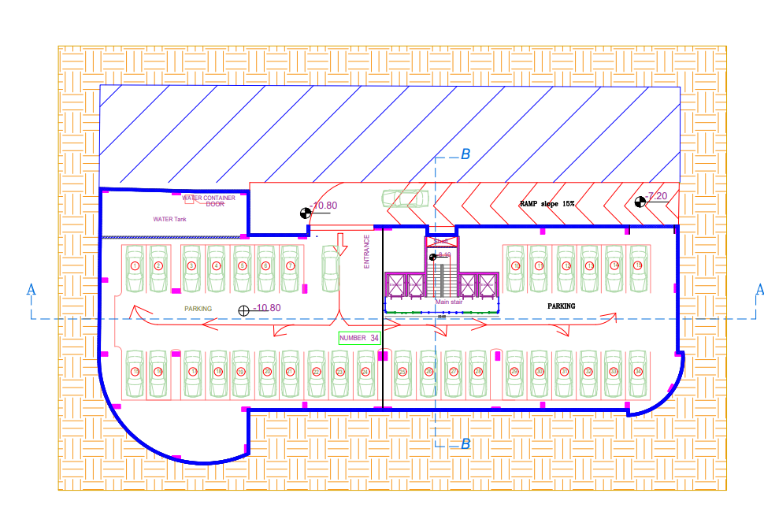
Figure ‎2.72: Third basement plan before modifications.
Another basement was added and the total number of parking spaces is 100.
- Ground floors
- Before
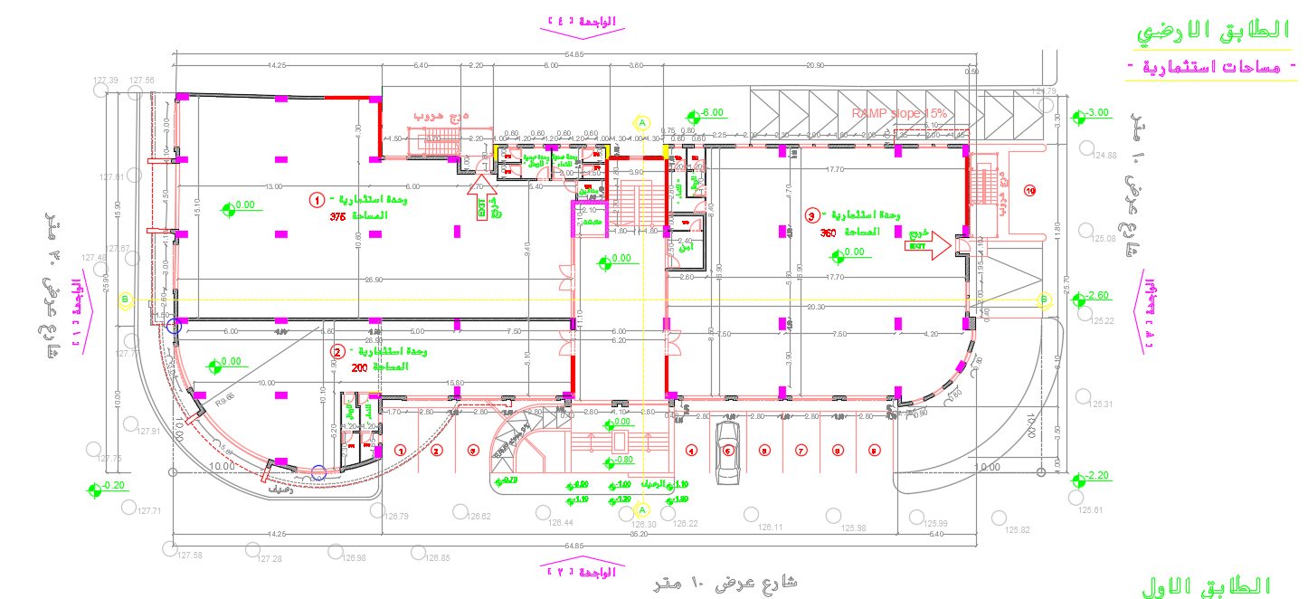
Figure ‎2.73: Ground floor before modifications.

- After
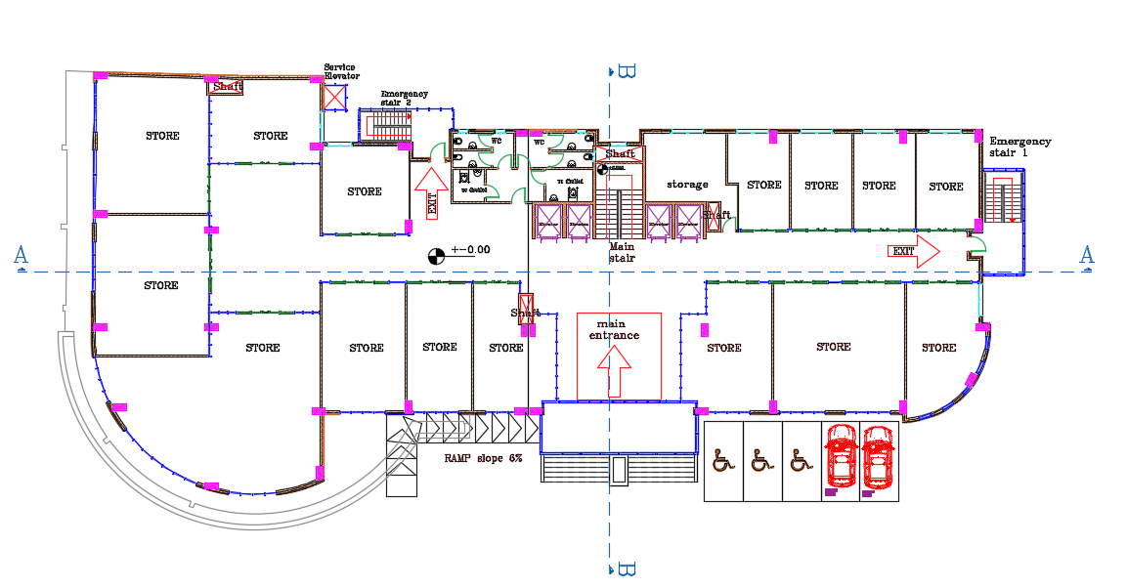
Figure ‎2.74: Ground floor after modifications.

- 1st floors
- Before
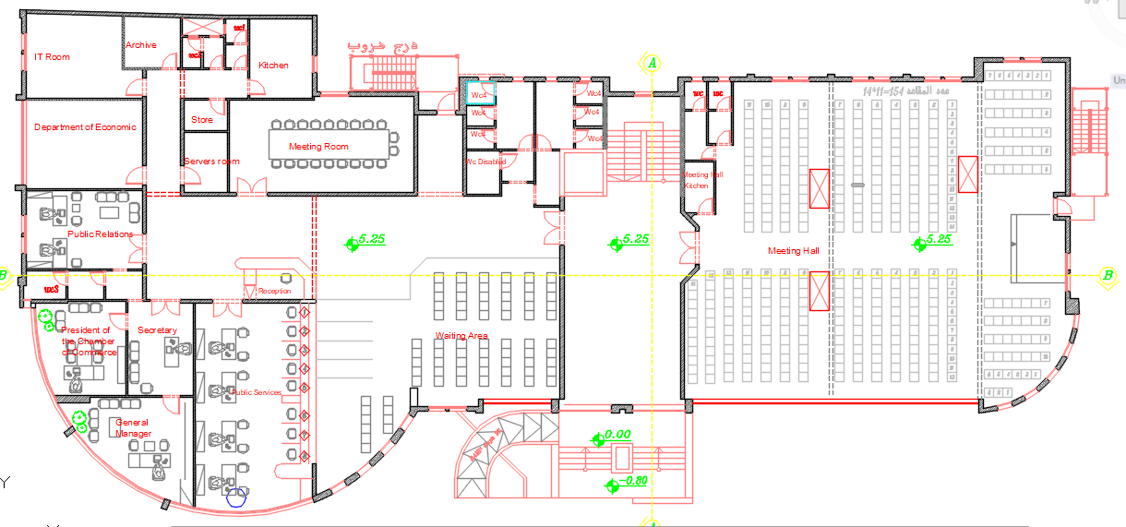
Figure ‎2.75: First floor before modifications.
The function was chamber of commerce floor.

- After
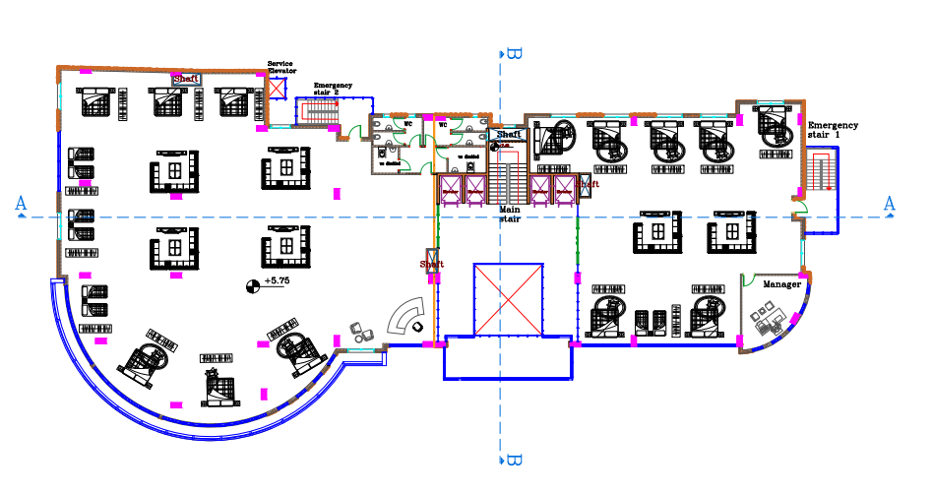
Figure ‎2.76: First floor after modifications.
The function has become a furniture showroom
- 2nd floor
- Before
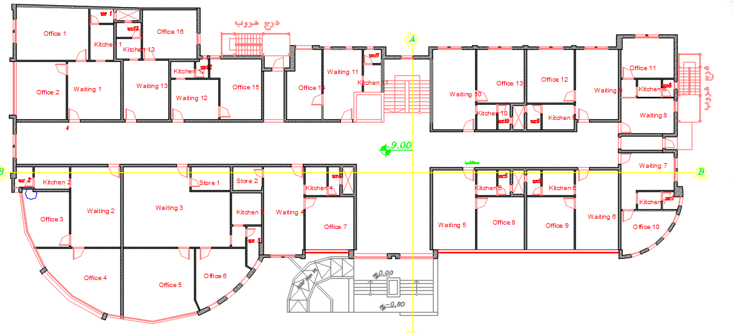
Figure ‎2.77: Second floor before modifications.
The function was offices

- After
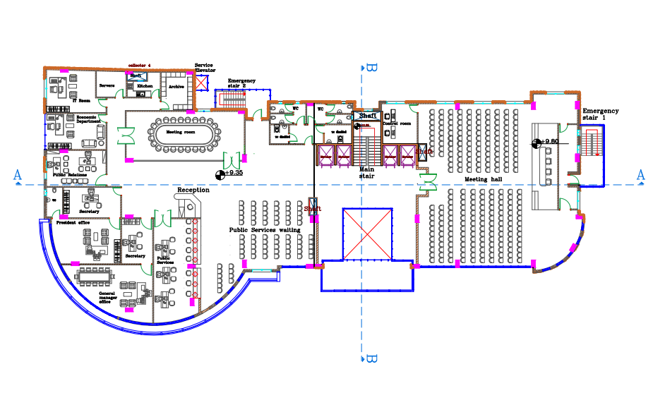
Figure ‎2.78: Second floor after modifications.
Figure SEQ Figure \* ARABIC 50: Old second floor design.
The function has become chamber of commerce floor.
- 3rd floor
- Before
Figure ‎2.79: Third floor before modifications.
The function was offices

- After
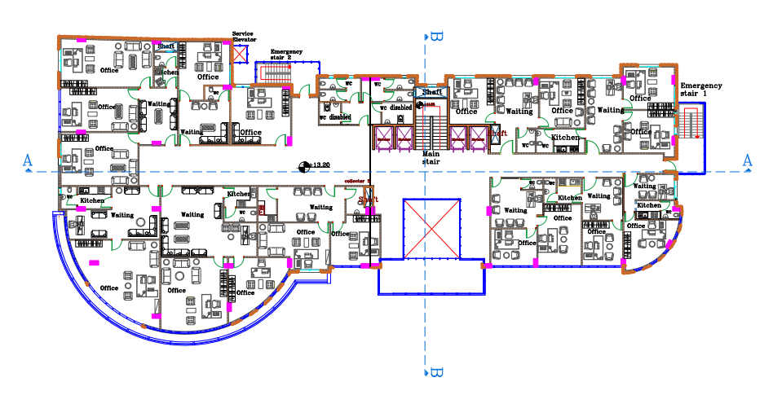
Figure ‎2.80: Third floor after modifications.
The function has still offices
- 4th floors
- Before
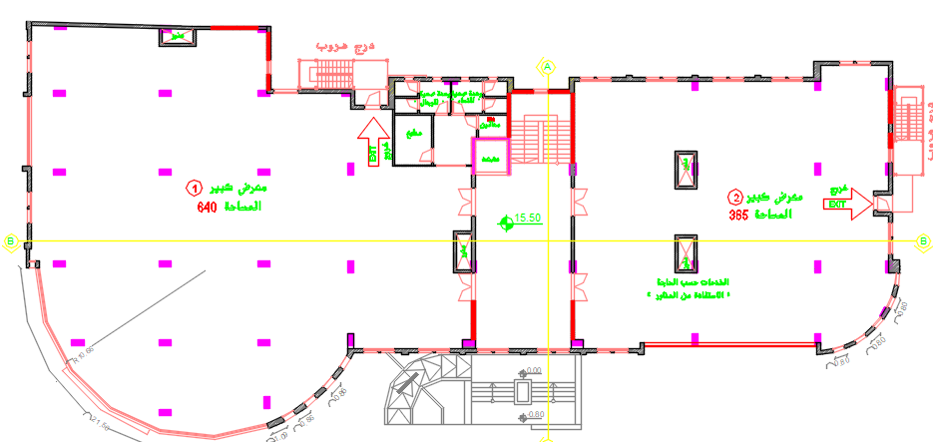
Figure ‎2.81: Fourth floor before modifications.
The function was show areas.

- After
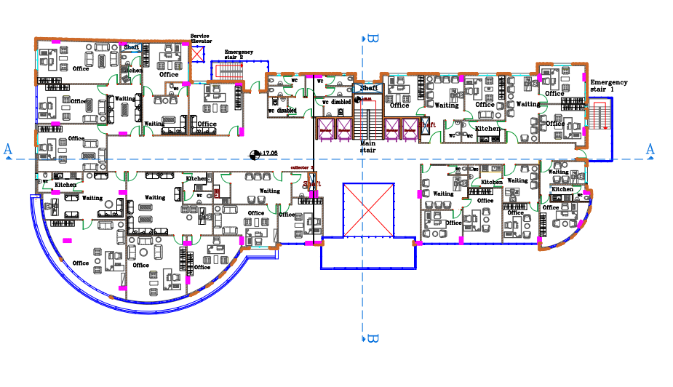
Figure ‎2.82: Fourth floor after modifications.
The function has become offices.
- 5th floor

- Before
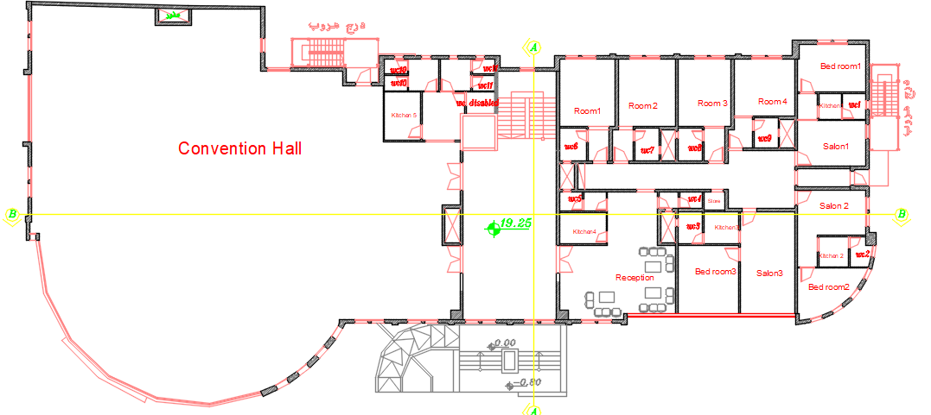
Figure ‎2.83: Fifth floor before modifications.

- After
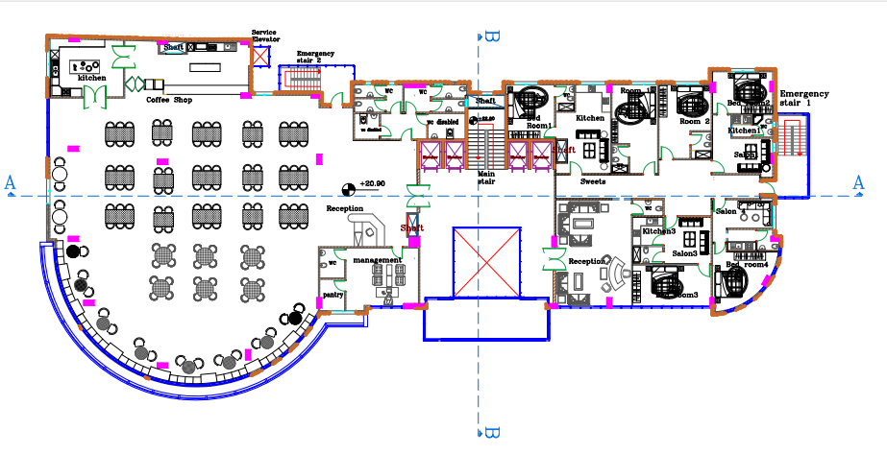
Figure ‎2.84: Fifth floor after modifications.
- 6th floor
- Before
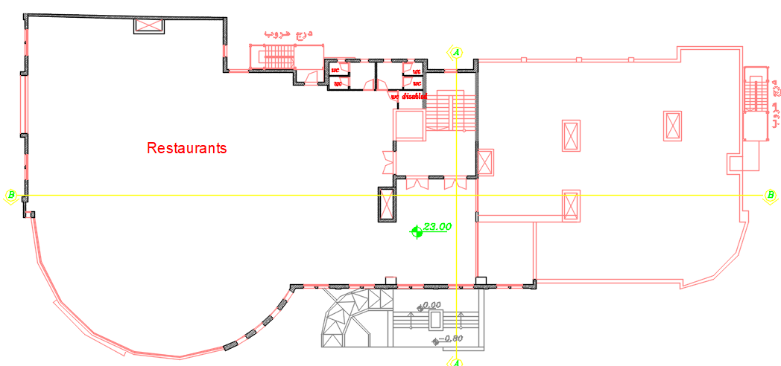
Figure ‎2.85: sixth floor before modifications.

- After
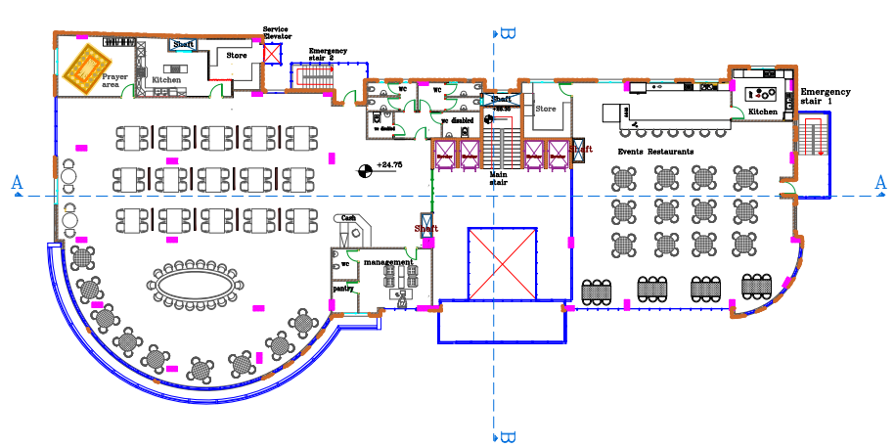
Figure ‎2.86: Sixth floor after modifications.

3D model
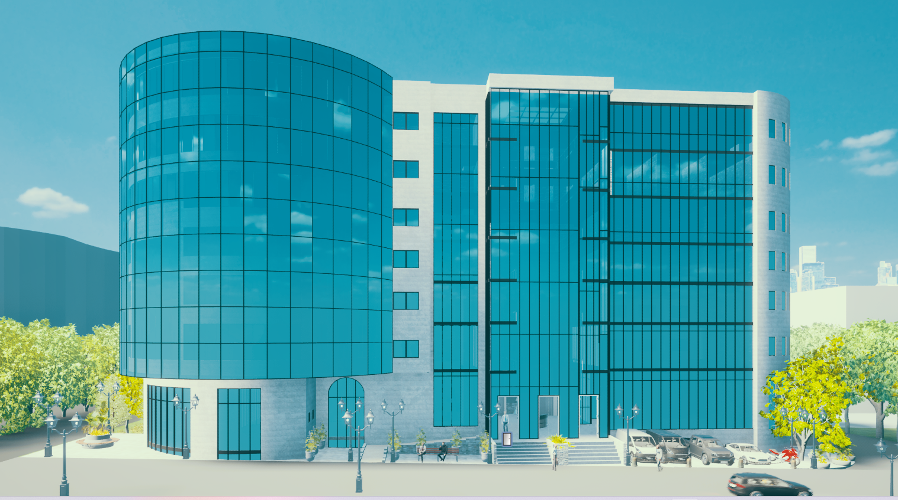
Figure 2.87: figure 1, 3D model from twinmotion
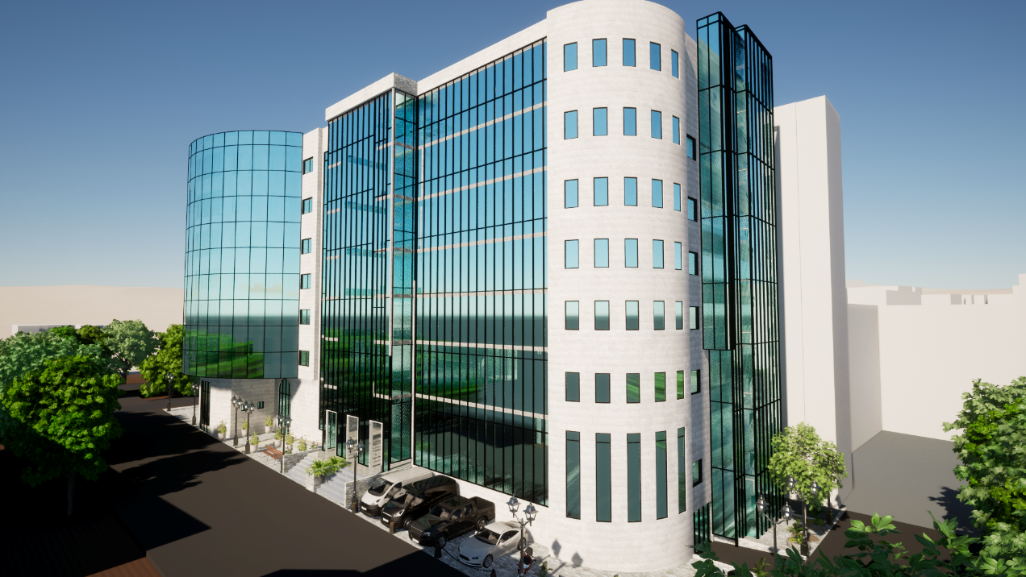
Figure2.88: figure 2, 3D model from twinmotion.
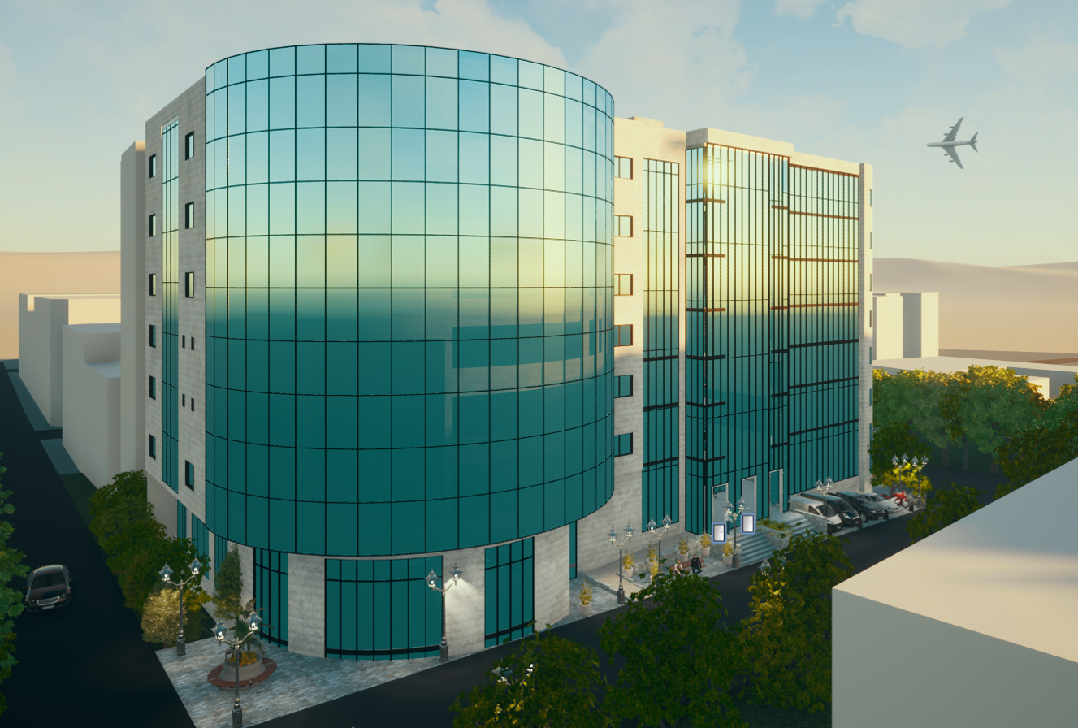
Figure 2.89: figure 3, 3D model from twinmotion

Elevations 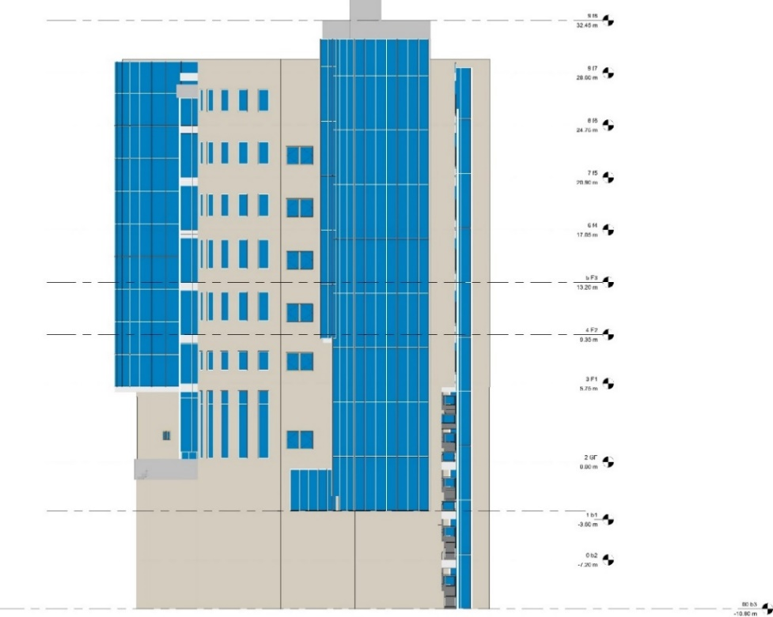
Figure ‎2.90: North- East Elevation.
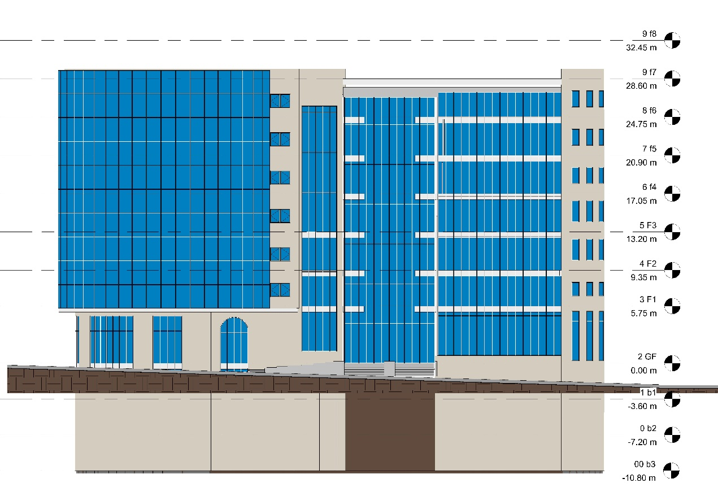
Figure ‎2.91: South- East Elevation.

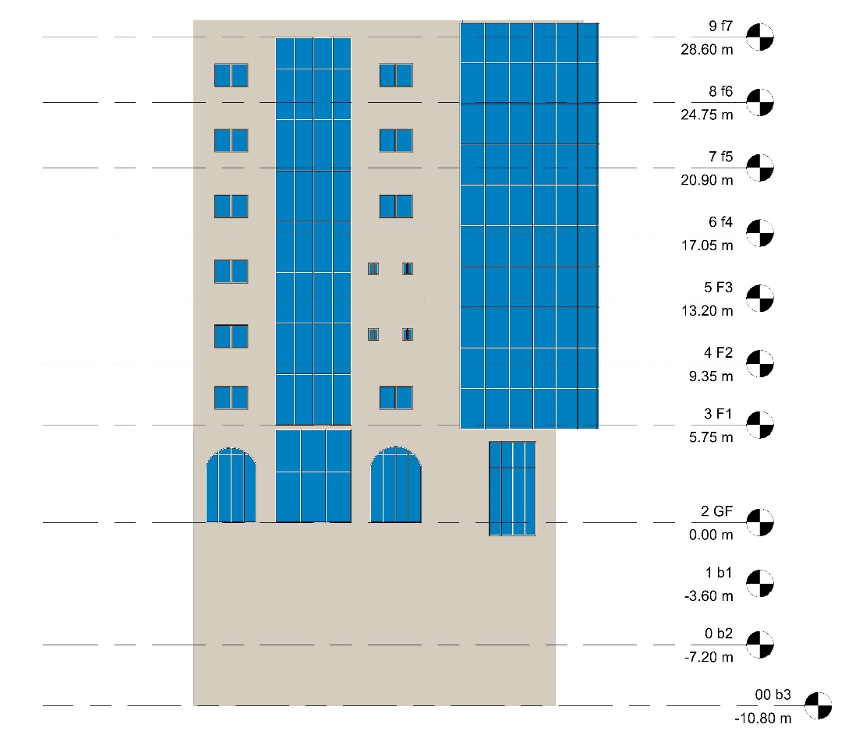
Figure ‎2.92: South- West Elevation.
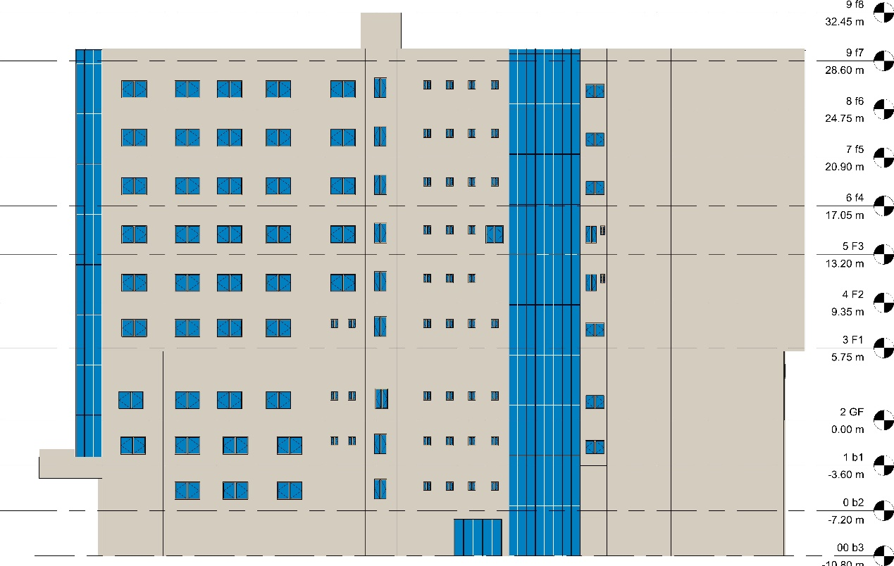
Figure ‎2.93: North- West Elevation.

- Sections:
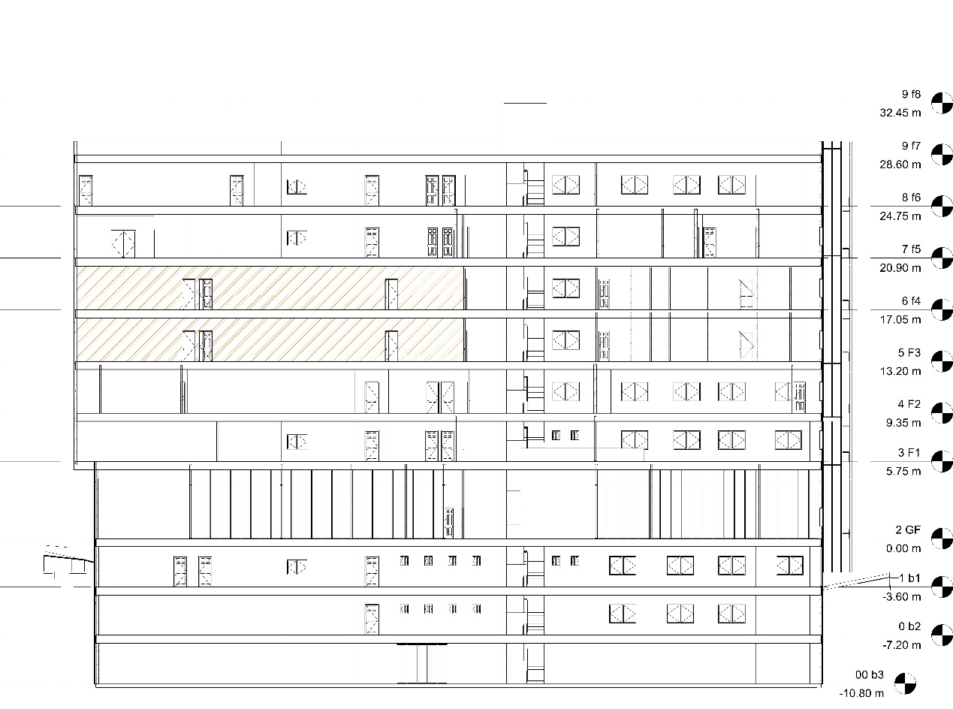
Figure ‎2.94: Section A-A.
Figure SEQ Figure \* ARABIC 55: New fourth floor design
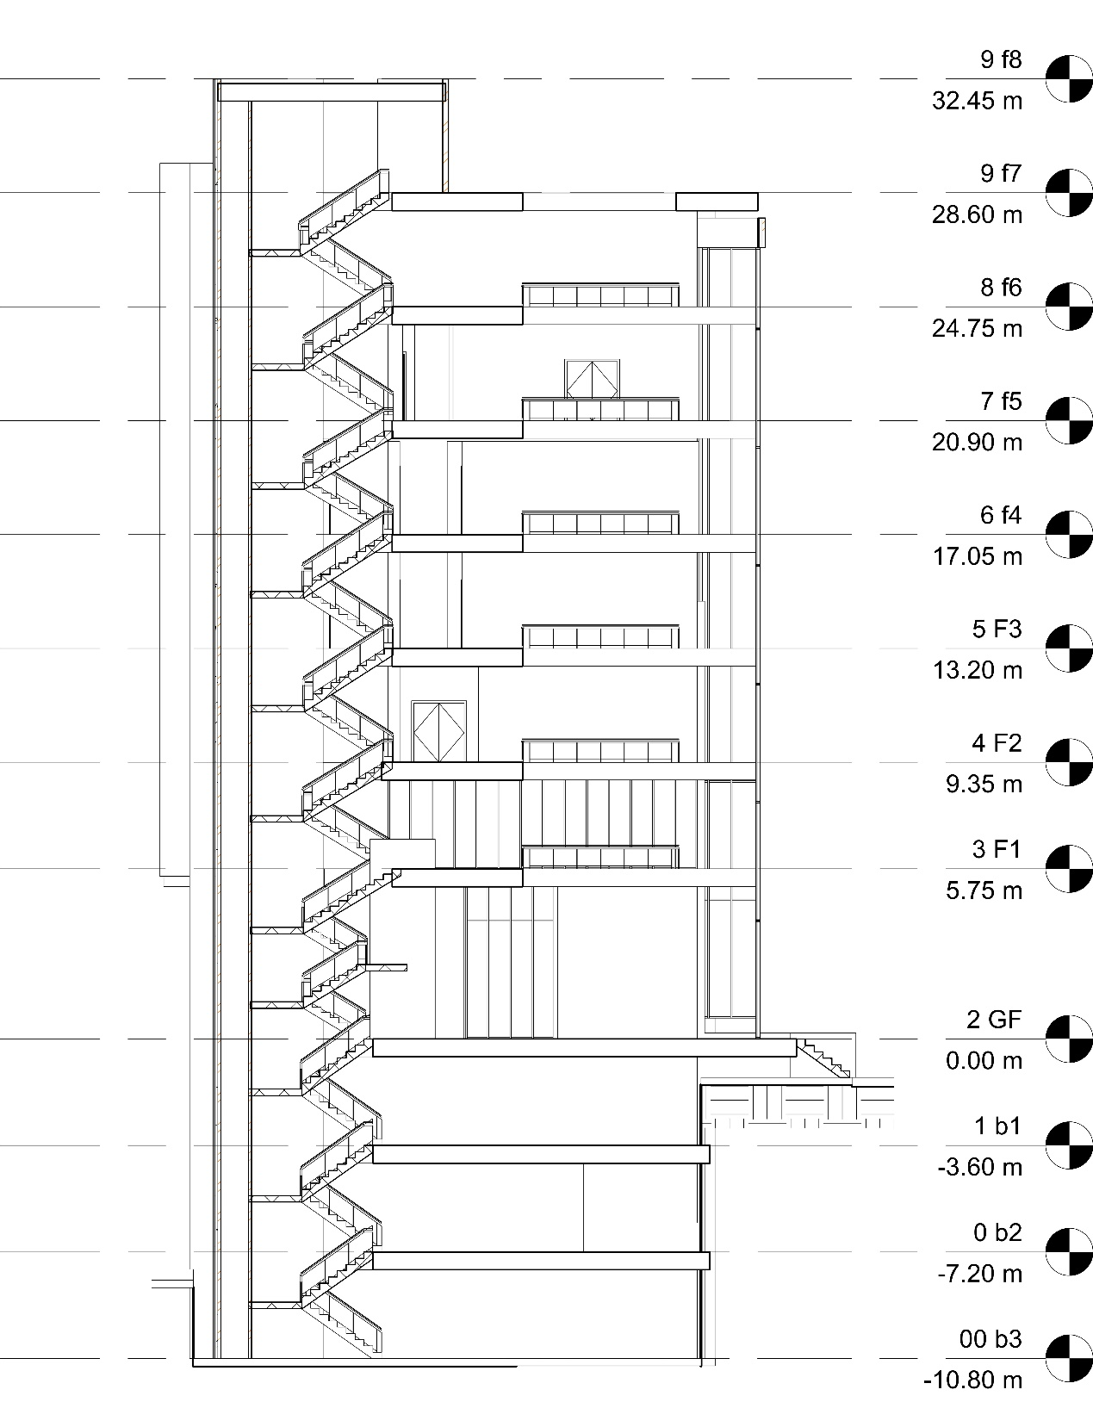
Figure ‎2.95: Section B-B.

Environmental analysis and Design

Design builder simulation
- 3D Model
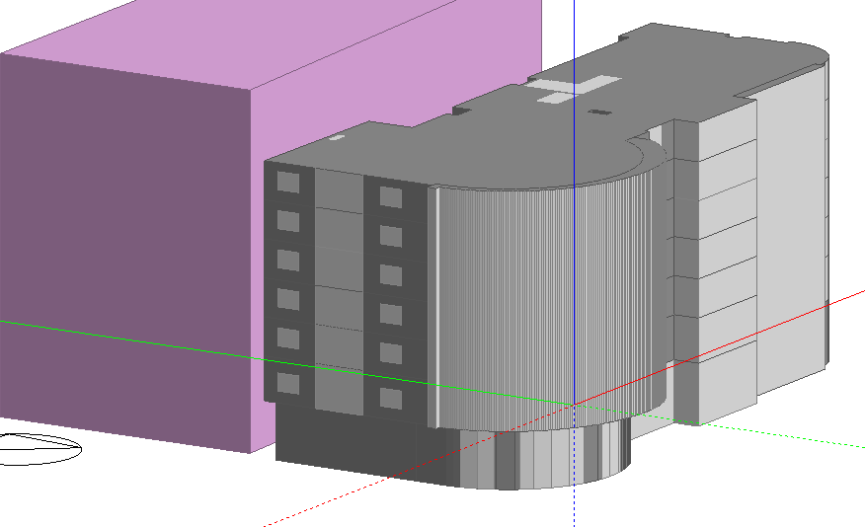
Figure 96.92:3D Model
- Layers

- Wall layers
U-value = 0.454 W/m2-K.

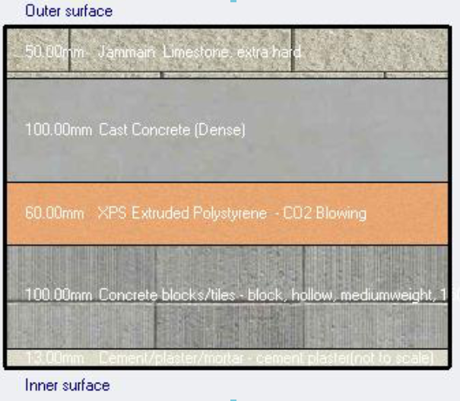

Figure ‎2.97: Wall layers and U-value.
- Roof layers
U-Value = 0.40 W/m2-K.
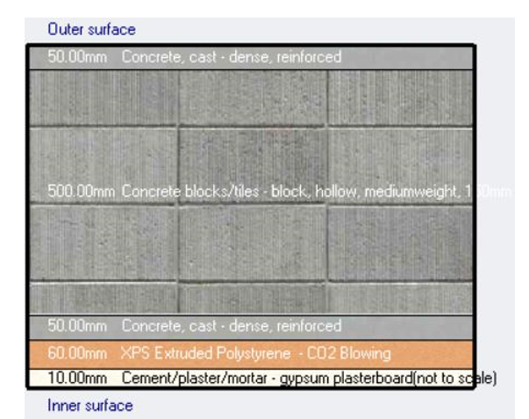
Figure ‎2.98: Roof layers and U-value.
- Internal Floor
U-value = 0.56 W/m2-K
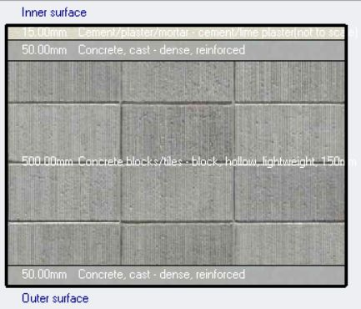
Figure ‎2.99: Internal Floor layers and U-value

Daylight factor
Daylight factor:
Before
GF
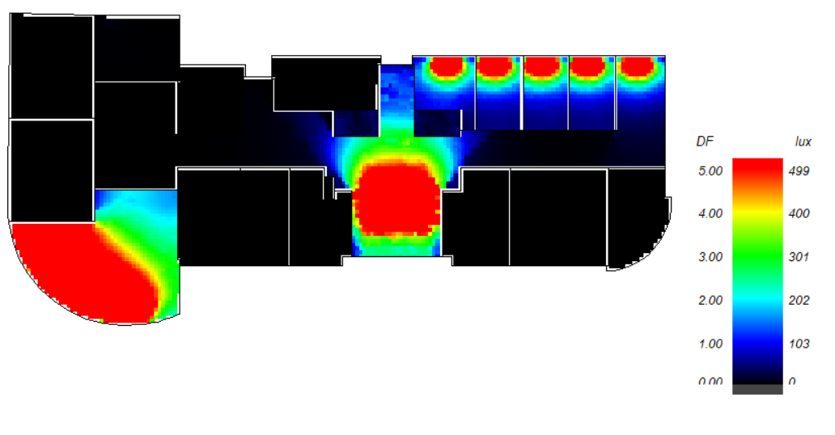
Figure ‎2.100: Daylight factor in ground floor before.
As shown the daylight factor in most times is not suitable and need treatments.

1st floor
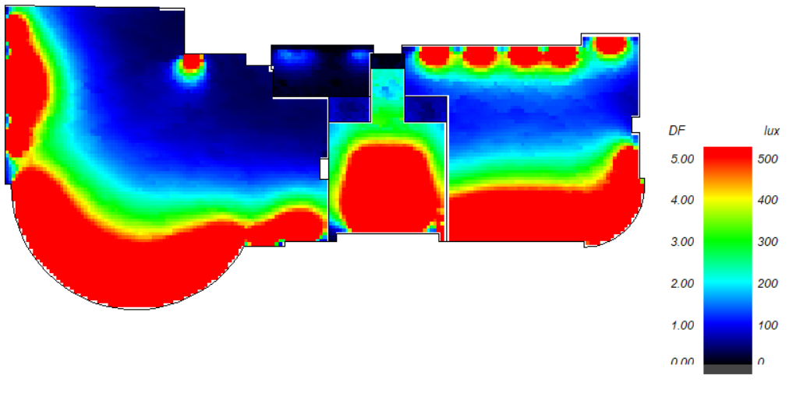
Figure ‎2.101: Daylight factor in first floor before.
As shown the daylight factor in most times is not suitable and need treatments.
2nd floor
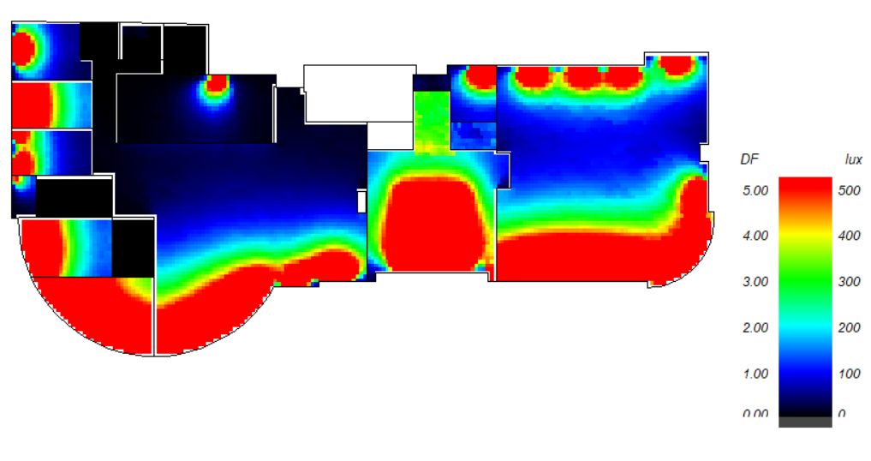
Figure ‎2.102: Daylight factor in 2nd floor before.
As shown the daylight factor in most times is not suitable and need treatments.

3rd floor
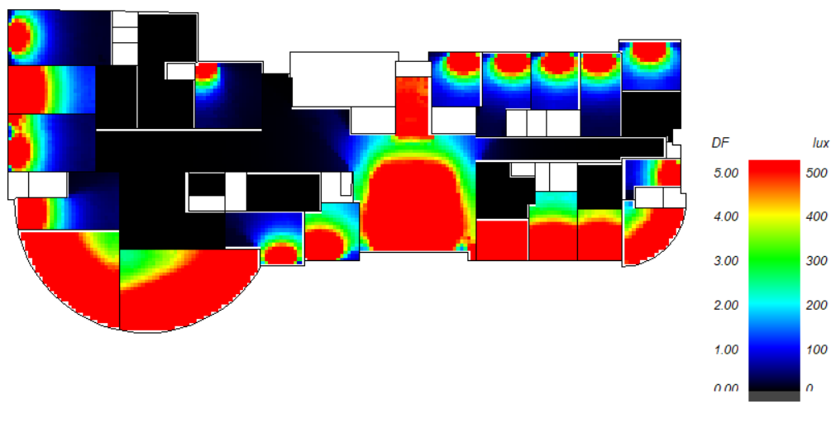
Figure ‎2.103: Daylight factor in 3rd floor before.

As shown the daylight factor in most times is not suitable and need treatments.

4th floor
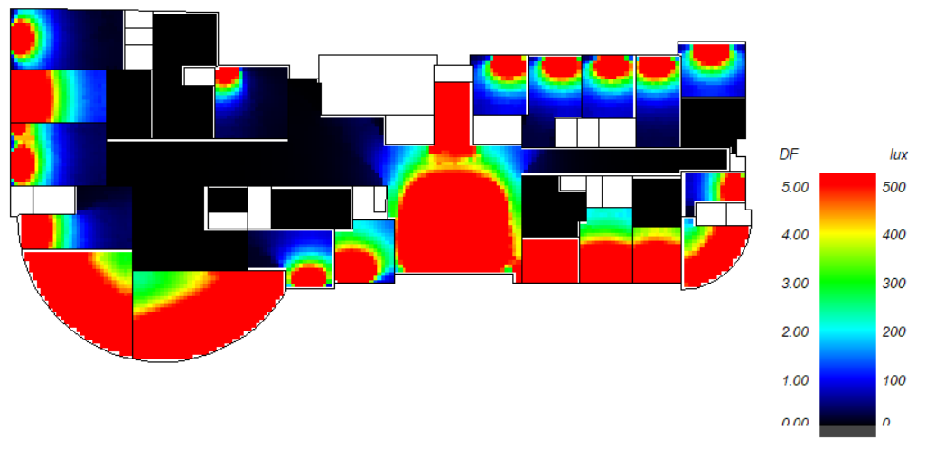
Figure ‎2.104: Daylight factor in 4th floor before.
As shown the daylight factor in most times is not suitable and need treatments.

5th floor
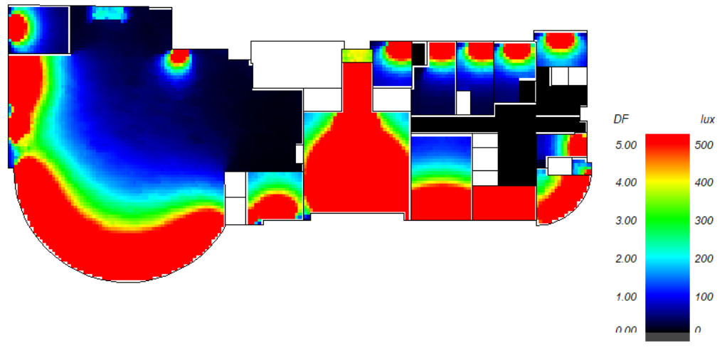
Figure ‎2.105: Daylight factor in 5th floor before.

As shown the daylight factor in most times is not suitable and need treatments.

6th floor
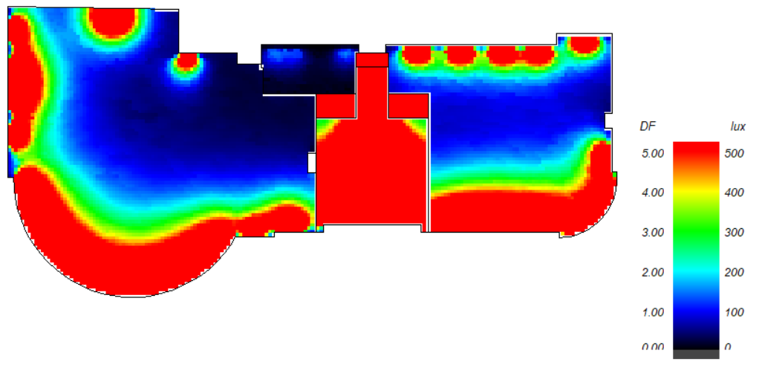
Figure ‎2.106: Daylight factor in 6th floor before.
As shown the daylight factor in most times is not suitable and need treatments.

After
GF
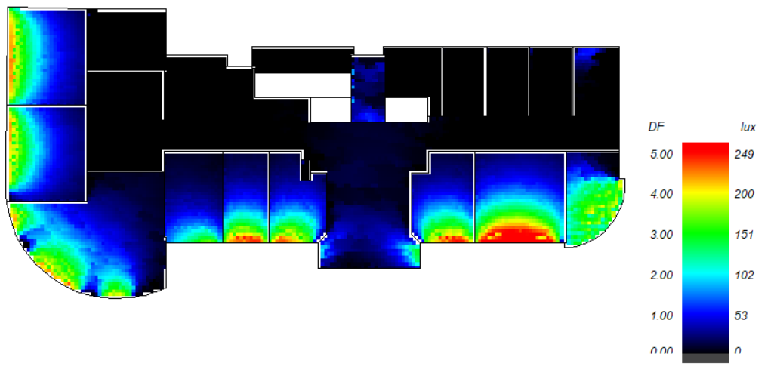

Figure ‎2.107: Daylight factor in ground floor after.
As shown the daylight factor s is suitable and there is a big change between the base model and the treated model.
1st floor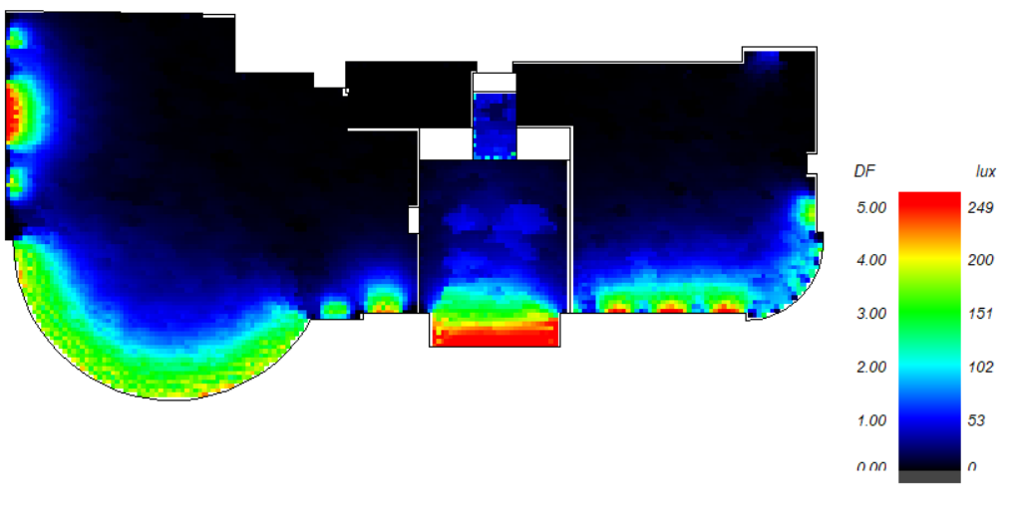
Figure ‎2.108: Daylight factor in 1st floor after.
As shown the daylight factor s is suitable and there is a big change between the base model and the treated model.

2nd floor
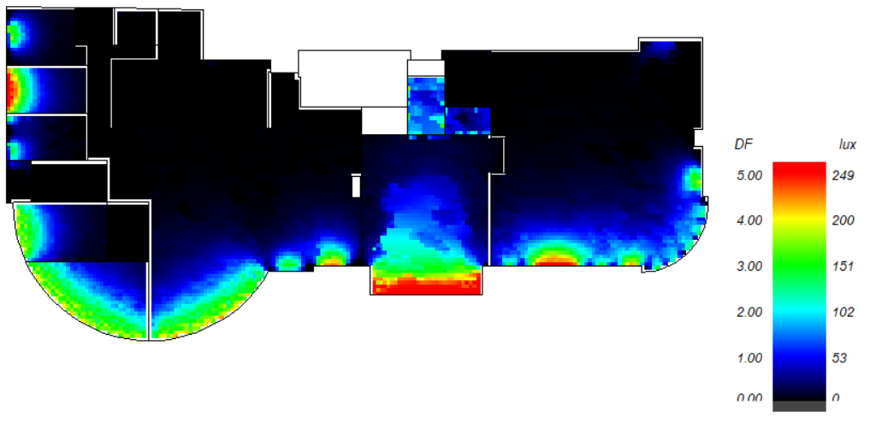
Figure ‎2.109: Daylight factor in 2nd floor after.

As shown the daylight factor s is suitable and there is a big change between the base model and the treated model.
3rd floor
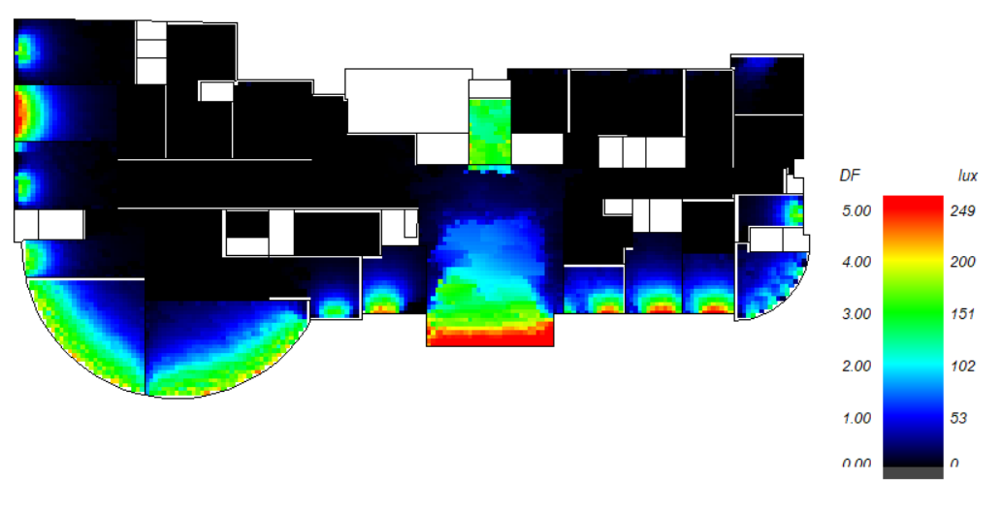
Figure ‎2.110: Daylight factor in 3rd floor after.
As shown the daylight factor s is suitable and there is a big change between the base model and the treated model.

4th floor
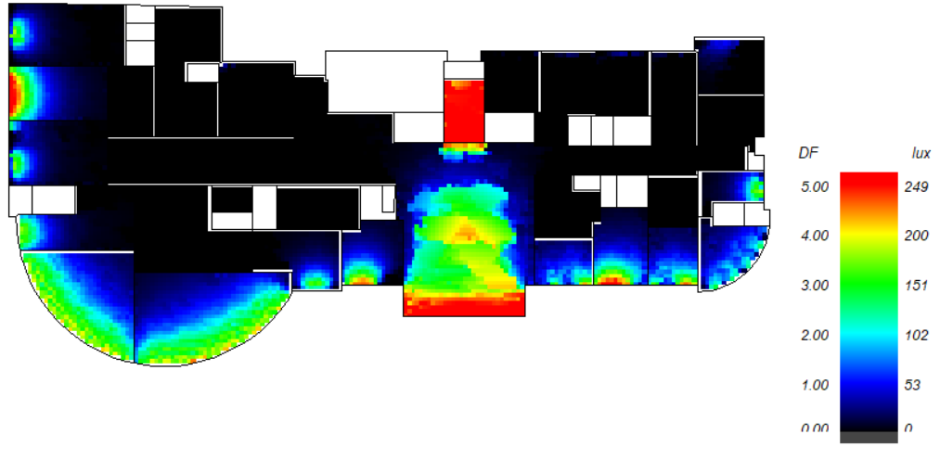
Figure ‎2.111: Daylight factor in 4th floor after.
As shown the daylight factor s is suitable and there is a big change between the base model and the treated model.
5th floor
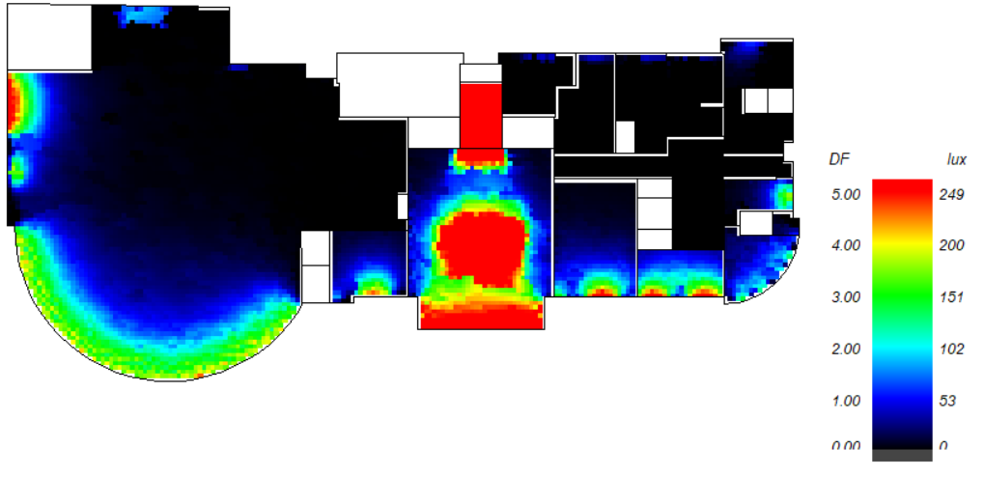
Figure ‎2.112: Daylight factor in 5th floor after.

As shown the daylight factor s is suitable and there is a big change between the base model and the treated model.

6th floor
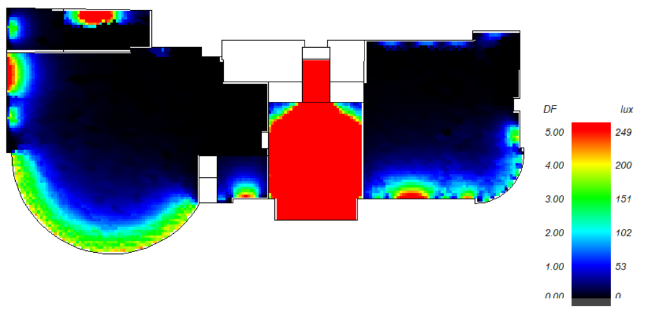
Figure ‎2.113: Daylight factor in 6th floor after.
As shown the daylight factor s is suitable and there is a big change between the base model and the treated model.
In general, the daylight factor has been changed to the suitable case.

Energy consumption:
The baseline energy is 198.5 KWH/m2

Before treating
Table ‎2-15: Site and source energy before treating.
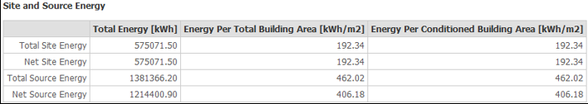
Energy consumption before = 192.34 KWh/m2

After treating
Table ‎2-16: Site and source energy after treating.
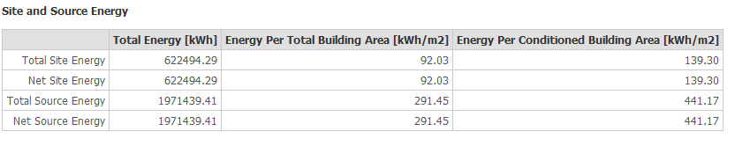
Energy consumption after = 92.03KWh/m2
% of saving = (192.34-92.03)/192.34) *100%=52%
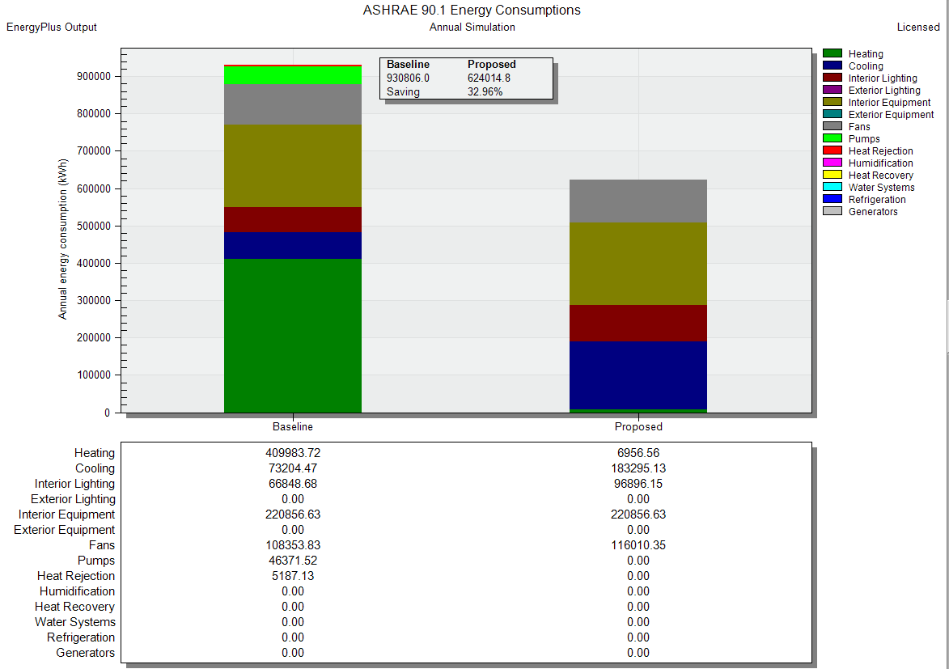
Figure 2.114 : percentage of saving for building

Heating and cooling load before treatments:

Cooling load
Table ‎2-17 cooling load before treatments
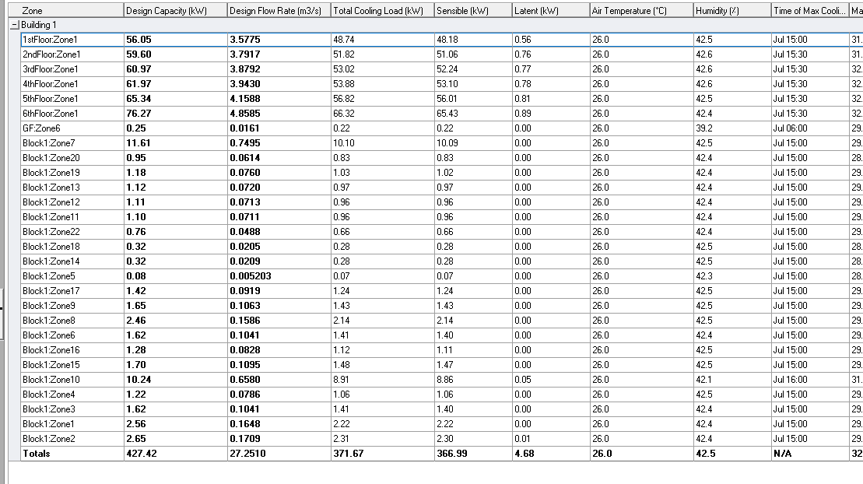

Heating load
Table ‎2-18: heating load before treatments
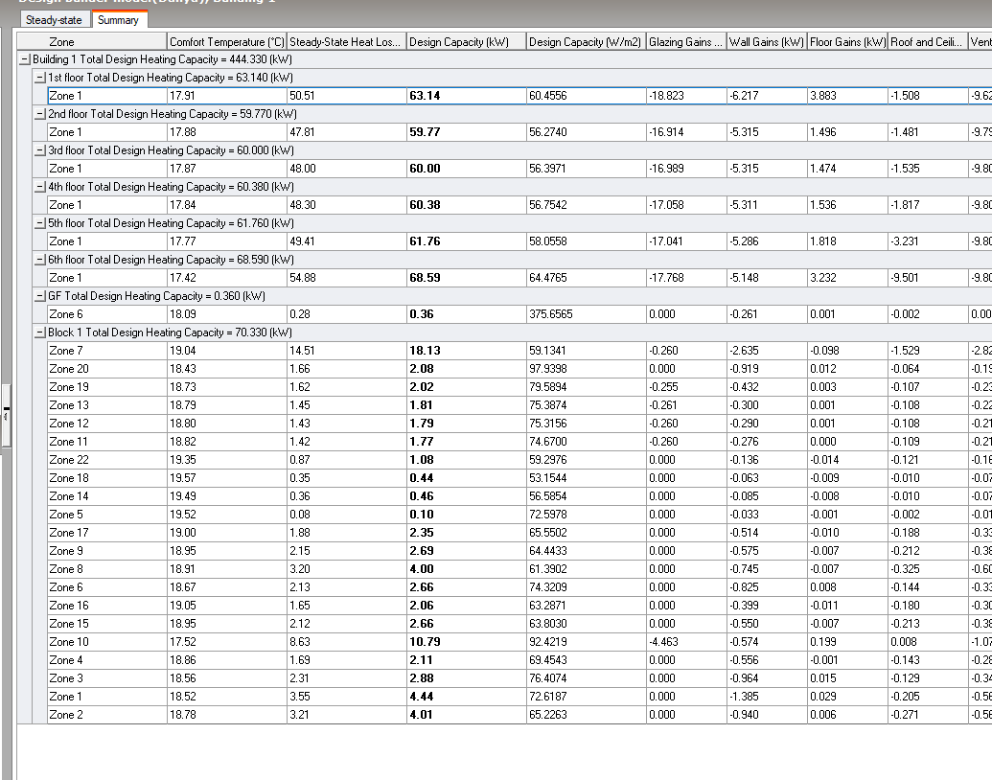

Heating and cooling load after treatments:
Block | Zone | Cooling load | Design Cooling/(W/m2) | Heating load | Design Heating/(W/m2)
GF | Zone21 | 17.83 | 56.5 | 20.68 | 65.5106
GF | Zone20 | 2.29 | 80.7 | 1.89 | 88.8983
GF | Zone19 | 2.81 | 74.5 | 2.22 | 87.5217
GF | Zone13 | 2.64 | 83 | 2.08 | 86.2799
GF | Zone12 | 2.6 | 65 | 2.06 | 86.6297
GF | Zone11 | 2.6 | 63 | 2.12 | 89.3704
GF | Zone5 | 0.2 | 55.6 | 0.29 | 206.7417
GF | Zone7 | 5.77 | 54 | 3.71 | 102.7713
GF | Zone9 | 7.83 | 82 | 4.27 | 101.4878
GF | Zone8 | 7.5 | 67.5 | 6.49 | 99.7513
GF | Zone6 | 9.01 | 57.5 | 4.93 | 134.3466
GF | Zone16 | 6.04 | 63.2 | 3.35 | 102.8415
GF | Zone15 | 5.82 | 73.6 | 4.19 | 100.7325
GF | Zone10 | 14.71 | 78.6 | 11.15 | 95.5604
GF | Zone4 | 3.17 | 51.6 | 2.61 | 85.79
GF | Zone3 | 4.01 | 67.1 | 3.25 | 86.0019
GF | Zone1 | 10.69 | 63.2 | 6.49 | 106.171
GF | Zone2 | 9.84 | 53.7 | 6.15 | 100.0614
1st floor | Zone4 | 15 | 71.3 | 15 | 58.8122
1st floor | Zone5 | 21 | 69.7 | 19 | 56.9501
1st floor | Zone6 | 10.58 | 83 | 7.48 | 70.9982
1st floor | Zone1 | 1.83 | 46.4 | 1.78 | 45.0338
2nd floor | Zone5 | 0.4 | 63.2 | 0.36 | 57.0036
2nd floor | Secretary | 0.95 | 47.6 | 0.81 | 40.5375
2nd floor | Public Service | 16.98 | 57.8 | 13.01 | 44.309
2nd floor | MainStair1 | 9.95 | 91.7 | 7.29 | 67.1571
2nd floor | Meeting Hall | 22.13 | 75.1 | 20 | 87.0763
2nd floor | Servers | 0.51 | 52.8 | 0.46 | 46.8992
2nd floor | Kitchen | 0.48 | 55.6 | 0.45 | 52.0899
2nd floor | Archive | 0.73 | 49.7 | 0.7 | 47.799
2nd floor | Control Room | 0.98 | 57.2 | 0.92 | 53.8642
2nd floor | Meeting Room | 3.07 | 44.9 | 2.69 | 39.4602
2nd floor | IT Room | 1.53 | 55.8 | 1.35 | 49.4381
2nd floor | Economic Department | 2.59 | 80.5 | 1.44 | 57.5972
2nd floor | Public Relations | 1.47 | 58.4 | 1.19 | 47.5722
2nd floor | Preidentified | 2.45 | 70.9 | 1.94 | 56.3349
2nd floor | Secretary1 | 0.8 | 50 | 0.68 | 42.7886
2nd floor | General Manager Office | 4.37 | 97.1 | 3.28 | 72.6895
3rd floor | Office1 | 1.98 | 50.1 | 1.7 | 43.0045
3rd floor | Office2 | 1.08 | 44.9 | 0.97 | 40.0567
3rd floor | Office3 | 1.02 | 52.6 | 0.91 | 46.8643
3rd floor | Waiting1 | 1.29 | 51.8 | 1.12 | 44.8293
3rd floor | Office4 | 1.07 | 53.7 | 0.92 | 46.0844
3rd floor | Zone | Cooling load | Design Cooling/(W/m2) | Heating load | Design Heating/(W/m2)
3rd floor | Waiting2 | 1.24 | 51.6 | 1.07 | 44.5658
3rd floor | Office5 | 1.15 | 56.2 | 1.07 | 52.0546
3rd floor | Office6 | 0.91 | 48.2 | 0.81 | 43.1402
3rd floor | Corridor2 | 14.6 | 62.4 | 12.94 | 55.2994
3rd floor | Waiting3 | 0.69 | 47.4 | 0.59 | 40.2978
3rd floor | Office7 | 2.57 | 53.7 | 1.37 | 68.0976
3rd floor | Waiting4 | 0.84 | 66.1 | 0.66 | 52.0472
3rd floor | Office8 | 2.13 | 132.7 | 1.11 | 69.1124
3rd floor | Office9 | 2.48 | 77 | 1.4 | 61.7778
3rd floor | Waiting5 | 0.92 | 47 | 0.8 | 40.8217
3rd floor | Office10 | 2.27 | 50.3 | 1.18 | 75.7218
3rd floor | Office11 | 1.54 | 59.4 | 1.12 | 43.4982
3rd floor | Corridor | 1.85 | 88.6 | 1.13 | 54.0794
3rd floor | Waiting6 | 0.9 | 44.9 | 0.73 | 36.3928
3rd floor | Waiting7 | 2.05 | 44.3 | 1.63 | 35.3027
3rd floor | Kitchen | 0.28 | 48.2 | 0.23 | 38.5038
3rd floor | Office12 | 9.03 | 50.3 | 4.03 | 61.2035
3rd floor | Office13 | 1.39 | 45.8 | 1.26 | 41.6691
3rd floor | Waiting8 | 0.81 | 43 | 0.66 | 34.8184
3rd floor | Waiting9 | 0.82 | 44.4 | 0.65 | 35.4342
3rd floor | Waiting | 1.95 | 59.4 | 1.52 | 46.4287
3rd floor | Office14 | 4.31 | 87.9 | 3.39 | 69.229
3rd floor | Office15 | 1.86 | 52.7 | 1.49 | 42.0694
3rd floor | Office | 2.75 | 94.3 | 1.51 | 51.5427
4th floor | Office1 | 2.12 | 53.6 | 1.67 | 42.2978
4th floor | Office2 | 1.27 | 52.9 | 0.97 | 40.1135
4th floor | Office3 | 1.16 | 59.6 | 1 | 51.841
4th floor | Waiting1 | 1.42 | 56.8 | 1.2 | 48.087
4th floor | Office4 | 1.18 | 59.5 | 0.98 | 49.3663
4th floor | Waiting2 | 1.36 | 56.5 | 1.14 | 47.3326
4th floor | Office5 | 1.2 | 58.7 | 1.14 | 55.5899
4th floor | Office6 | 0.94 | 50 | 0.85 | 45.2097
4th floor | Corridor2 | 10.5 | 67.9 | 5 | 56.4743
4th floor | Waiting3 | 0.74 | 50.6 | 0.63 | 43.581
4th floor | Office7 | 2.78 | 50.3 | 1.48 | 73.7276
4th floor | Waiting4 | 0.91 | 71.8 | 0.71 | 55.8513
4th floor | Office8 | 2.27 | 141 | 1.2 | 74.9889
4th floor | Office9 | 2.73 | 50.3 | 1.49 | 65.8245
4th floor | Waiting5 | 1.11 | 56.8 | 0.89 | 45.5917
4th floor | Office10 | 2.24 | 50.3 | 1.24 | 79.7345
4th floor | Office11 | 1.61 | 62.3 | 1.11 | 42.9491
4th floor | Corridor | 1.91 | 91.7 | 1.14 | 54.7305
4th floor | Waiting6 | 1 | 49.9 | 0.73 | 36.1209
4th floor | Waiting7 | 2.33 | 50.3 | 1.62 | 35.0802
4th floor | Kitchen | 0.32 | 54.7 | 0.23 | 38.2229
4th floor | Zone | Cooling load | Design Cooling/(W/m2) | Heating load | Design Heating/(W/m2)
4th floor | Office13 | 1.62 | 53.3 | 1.27 | 41.971
4th floor | Waiting8 | 0.96 | 50.4 | 0.67 | 35.2912
4th floor | Waiting9 | 0.95 | 51.2 | 0.66 | 35.6071
4th floor | Waiting | 2.19 | 66.7 | 1.49 | 45.5651
4th floor | Office14 | 4.6 | 93.9 | 3.24 | 66.1905
4th floor | Office15 | 2.13 | 60.3 | 1.48 | 41.9209
4th floor | Office | 2.9 | 79.1 | 1.47 | 50.1539
5th floor | Zone31 | 2.37 | 86.7 | 2.03 | 74.3107
5th floor | Zone5 | 9.12 | 86.6 | 3.4 | 32.2573
5th floor | Zone13 | 2.34 | 76.9 | 1.19 | 23.9597
5th floor | Zone10 | 2.12 | 101.9 | 0.83 | 39.8932
5th floor | Zone14 | 1.71 | 83.8 | 0.68 | 33.3949
5th floor | Zone8 | 0.48 | 35.3 | 0.18 | 12.9506
5th floor | Zone30 | 20 | 77.7 | 24 | 97.6954
5th floor | Zone9 | 0.23 | 73.2 | 0.28 | 90.3273
5th floor | Zone26 | 0.74 | 33 | 0.4 | 17.6411
5th floor | Zone21 | 1.27 | 30.4 | 0.6 | 14.4606
5th floor | Zone22 | 0.44 | 27.9 | 0.2 | 12.7375
5th floor | Zone25 | 0.66 | 31.6 | 0.35 | 16.9887
5th floor | Zone19 | 0.16 | 47.5 | 0.21 | 60.8515
5th floor | Zone24 | 0.51 | 29.2 | 0.38 | 21.8287
5th floor | Zone23 | 0.84 | 31 | 0.44 | 16.3614
5th floor | Zone18 | 0.11 | 32.5 | 0.06 | 16.2185
5th floor | Zone20 | 0.45 | 26.1 | 0.41 | 23.6043
5th floor | Zone16 | 0.46 | 37.4 | 0.24 | 19.4844
6th Floor | Main Restaurant | 26 | 92.8 | 25 | 102.328
6th Floor | Events Restaurant | 25.06 | 90.5 | 30.68 | 110.7523
6th Floor | Kitchen | 1.58 | 76.9 | 1.34 | 64.9322
6th Floor | Zone6 | 18.74 | 64.9 | 8 | 110.6225
6th Floor | Rest Management | 2.72 | 75.5 | 1.64 | 60.855
6th Floor | Prayer Area | 2.17 | 73.3 | 1.81 | 61.3633
Total |  | 370.66 |  | 326.24

Thermal comfort
One of the most important objectives for the building is to achieve thermal comfort since it is crucial for ensuring occupant satisfaction and because achieving thermal comfort shows that the alterations were successful as originally intended.
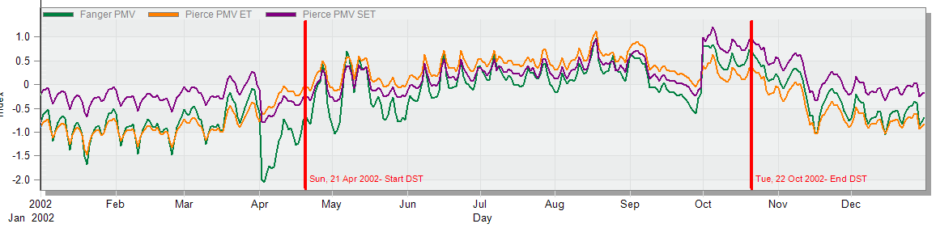
Figure ‎2.115: PMV results.
The projected mean vote, as seen in Figure, between (-0.50 - 0.50), which is favorable.

Shading systems
The quantity of energy or lighting derived from solar insolation is estimated as needed, and shading is a crucial component to improving the thermal or lighting efficiency of buildings. The types of shading systems vary depending on their location and the nature of they use. Including atrium and double skin façade that will be explained in the following:
            - Using an atrium on the south-East elevation to increase the amount of natural light and a rail to increase ventilation and air flow.
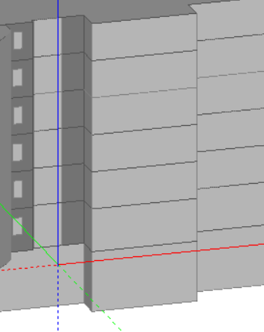
Figure ‎2.116: Atrium used.

            - Using a double skin façade on the South elevation to improve daylight factor.

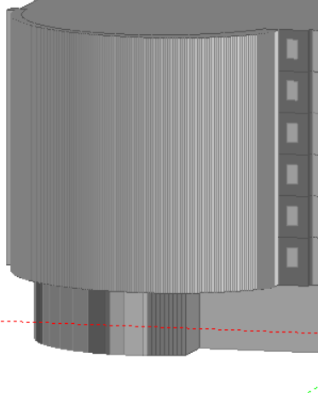
Figure ‎2.117: Double skin façade used.

Ventilation and CFD analysis (Internal and External)
- Ventilation
The ventilation process is very important within the structure to receive fresh air and get rid of poisonous carbon dioxide gas, and this is done through many methods according to the type of building. Because there were no adjacent buildings on three sides of the structure, we employed window openings to assist with ventilation. In addition, use Variable Refrigerant Volume (VRV) system that will be illustrated in the part of the HVAC design, court and double skin façade.

- Court
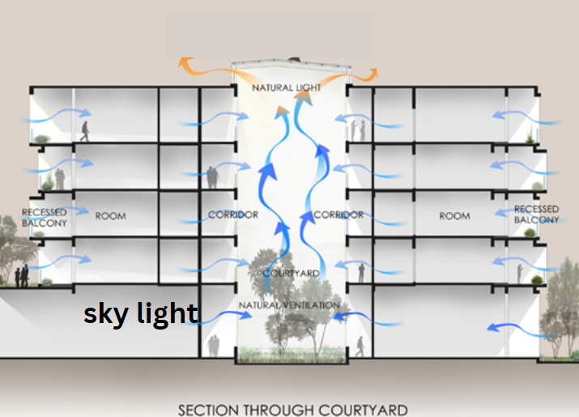
Figure ‎2.118 section through courtyard

- double skin façade: In most cases, double skin façade is containing two glazed layers and an air gap in between. it has many benefits such as improving the energy use efficiency in the building because the double skin façade is act as a solar chimney which mean it can help to improve the thermal comfort and decrease the heating and cooling loads and the building’s consumption also it helps to improve the visual comfort also acoustical comfort because of the existing of an air gap it can help to reduce the background noise and the most important thing is improving the providing of natural ventilation.(T.Grondzik et al., 2021)

- CFD analysis
Average wind speed used in design builder = 5 m/s.
In CFD analysis, 1000 iterations are required in order to achieve an acceptable result.

- Exterior CFD
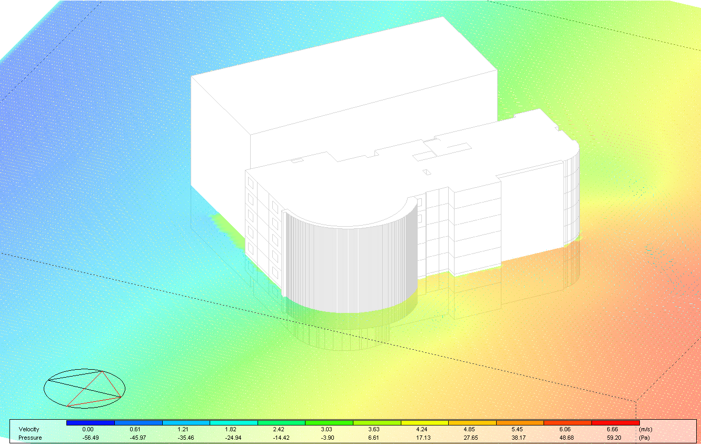
Figure ‎2.119: Exterior CFD

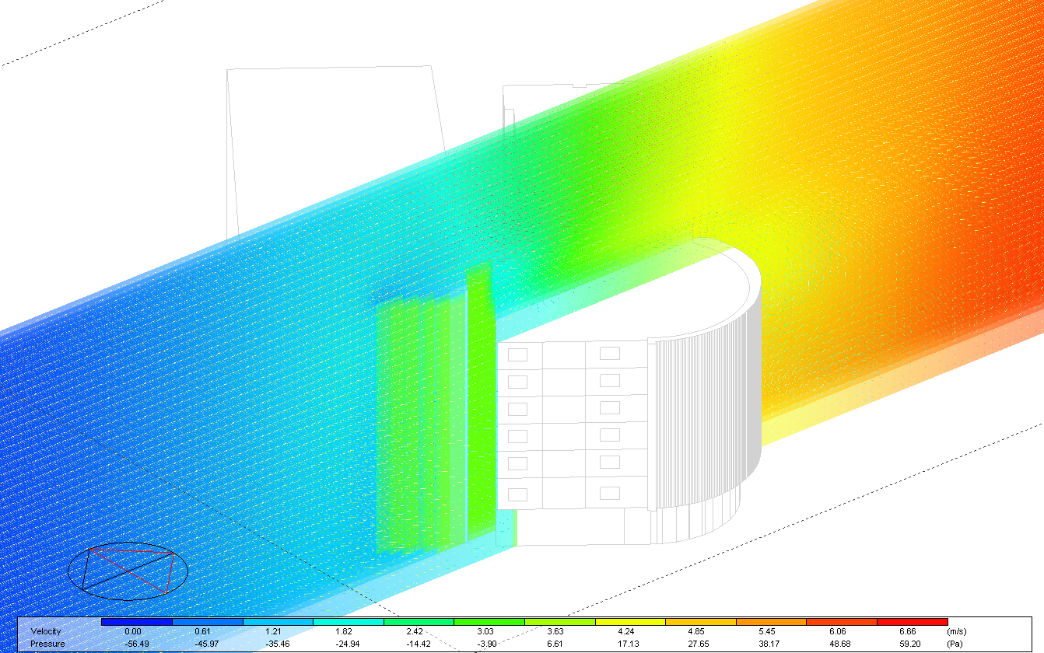
Figure ‎2.120: Exterior CFD
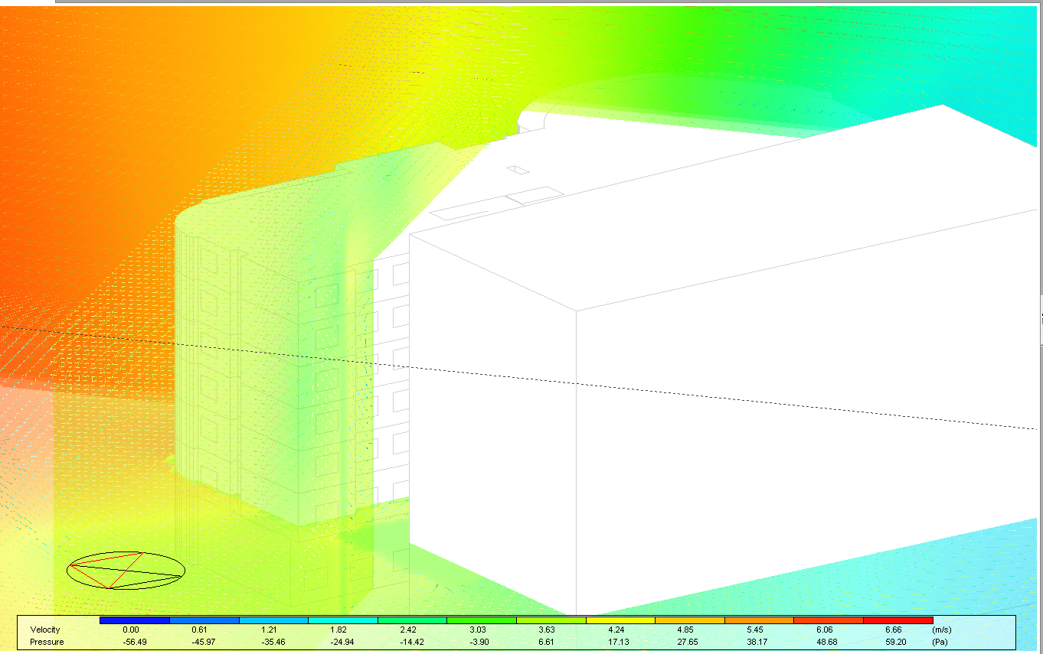
Figure ‎2.121: Exterior CFD
The air moves smoothly over the building, and there is no effect from the surrounding buildings in the building on the movement of the wind, but the shape of the building plays a major role in the movement of the wind.
- Interior CFD
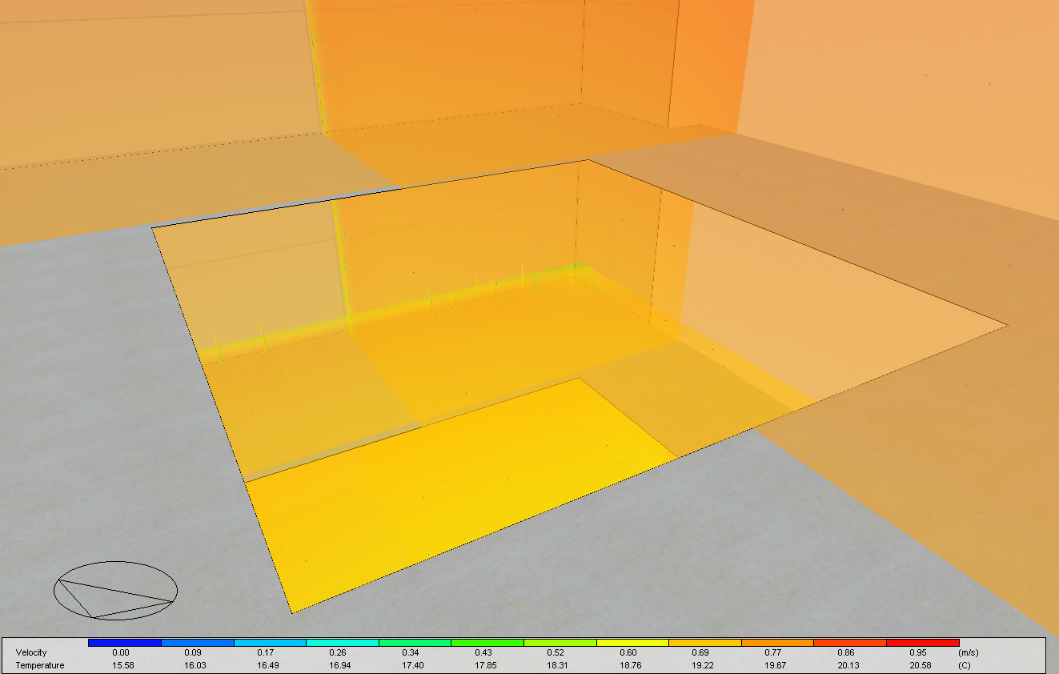
Figure ‎2.122: Interior CFD

The air moment from bottom to the top, which maker a circulation inside the court.
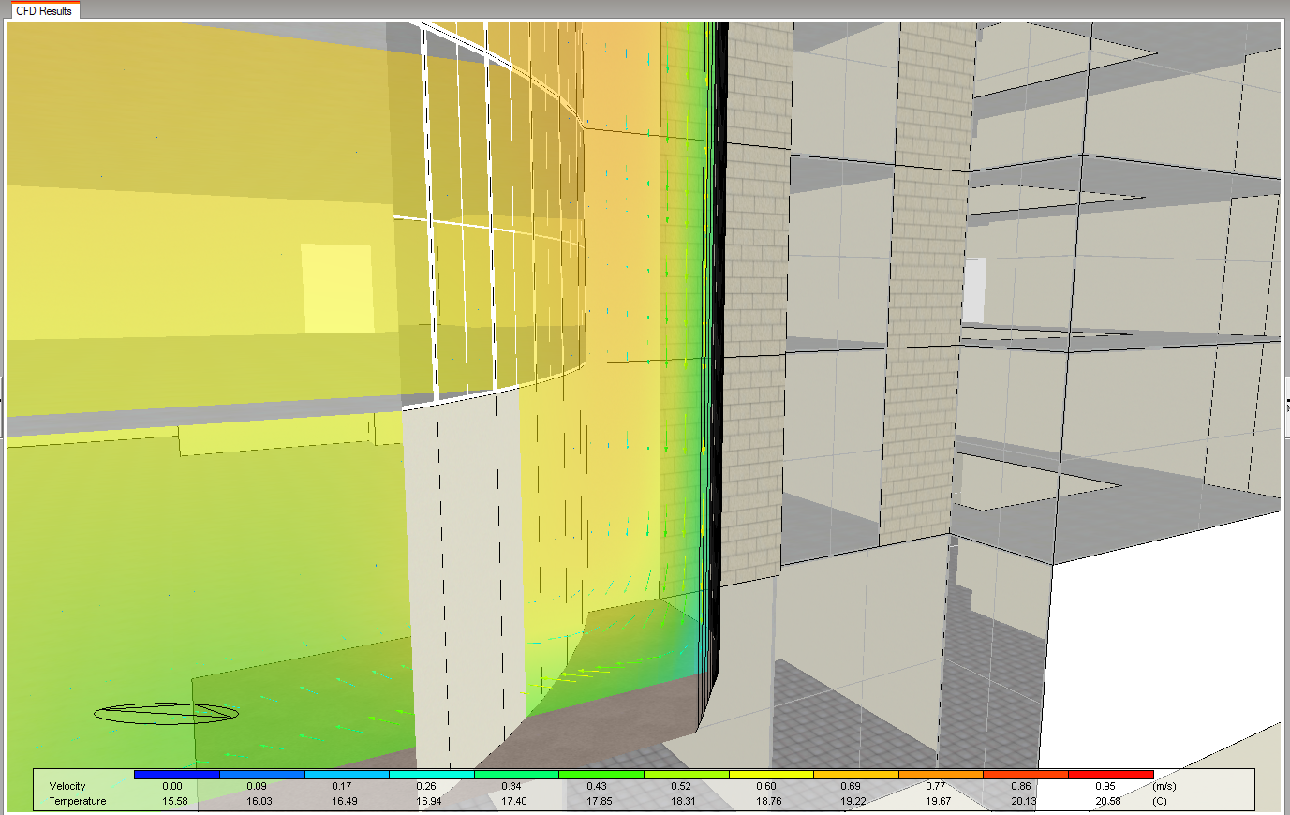
Figure ‎2.123: Interior CFD in double skin facade.
As shown inside the double skin facade there are air circulation which sucks air from bottom to top.
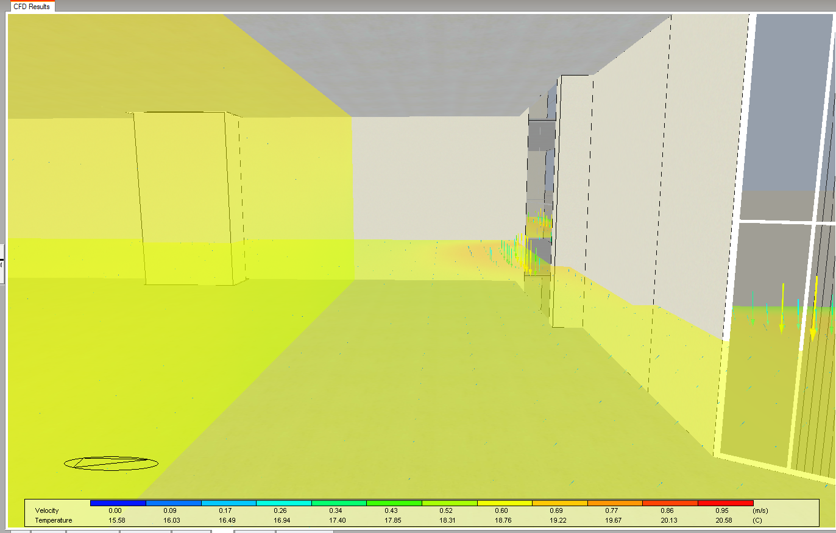
Figure ‎2.124: Interior CFD

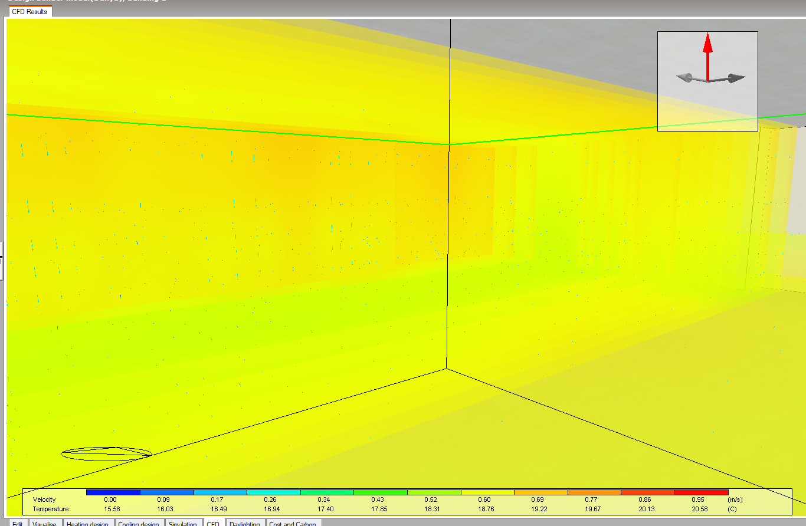
Figure ‎2.125: Interior CFD
the air movement is from bottom to top which is comfortable.
Energy results and saving:

Structural Aspects

Introduction
In this part of the project, all parts of the structural model of the building were designed, and the building was separated into two parts construction separators then inspections were carried out to verify the correct design.
The basic concept of structural design entails examining the stability, strength, and rigidity of structures, In order to make sure that the skeleton can withstand the imposed loads.

Problem Definition
In this project we were asked to design a 9-story concrete building two-way flat plate and rectangular columns with the following specifications: a superimposed dead load on the concrete slab =4 kN/m² the live load on the concrete slab is different from floor to another. We assumed the compressive strength of concrete to be 28 MPa and the yield strength of steel to be 420 MPa. And the floor height for ground floor = 5m and other floors = 3.5m and the perimeter wall weight =15 kN/m.

Methodology
For the first graduation project, a suggestion made for the columns and their locations, after which the slabs drawn and the loads distributed in accordance with the slab's shape, then model implemented on the Etabs computer program in order to obtain the required loads and data from it after entering the data for the supposed design.
Three checks will be done at this stage:
- Compatibility
- Equilibrium
- Stress-strain
For the second graduation project, the full design for every structural component was made using the model developed for the first project. Seismic checks were made and considered throughout the designing process, and Etabs software used for the modeling and results extraction.

Assumptions

Structural code and design
- American concrete Institute ACI 318-2014. (Building Code Requirements for Structural Concrete (ACI318-14), 2014)
- American Society of Civil Engineer (ASCE) (Minimum design loads for buildings and other structures-ASCE 7-16, 2016)
- The specific weight of concrete = 25 KN/ 𝑚².

Material
The material used in the design have the following proparites:
- Reinforcement steel:
The structural element that resists tensile forces fy= 420 mpa
- Concrete:
A structural element that withstands stress, but is weak in resisting the tensile forces on it.
fc’ =28 mpa.

Loads
- Live load:
Table ‎3-1: Live loads for floors.
Floor category | Live load (KN/m2)
Parking | 4.78
Stores | 6.00
Offices | 4.78
Sweets | 2.87
Restaurants | 4.78

- Superimposed dead load
Include the weight of partitions, materials of floors, and external walls.
- Minimum load for partition =1 KN/m²
- External wall in commerce building divide into two parts: masonry wall with thickness 30 mm and curtain wall.
- Weight of external wall =15KN/m
- Curtain walls have a minimum dead load of 1 KN/m.

Table ‎3-2: Building parts weight. (Minimum Design Loads for Buildings and Other Structures, 2005)
Element | Weight (KN/m²)
Ceramic or quarry tile | 1.1
Partition | 1.87
Sand | 0.328
CEILINGS | 0.05
Mortar | 0.816
Total | 4.164
Superimposed dead load used = 4 KN/m²
- Loads combination:
The basic ultimate load combinations used:
- 1.4 D.L
- 1.2 D.L + 1.6 L.L
- 1.00 D.L+ 1.00 L.L +1.00 S.I.D as service load combination.

To ensure more safety in the structural design, the code (ACI 318-14) required using specific equations that include a safety factor.
  - Structural system
    - Slab Design:
After distributing the columns in the building to achieve the regularity in structural and architectural aspects the flat plate with U-Boot system will used because of the high spans between columns and to reduce slab weight.
Slab thickness:
H= thickness of slab
αm = 0

From ACI code:
Table ‎3-3: Slab thickness table.
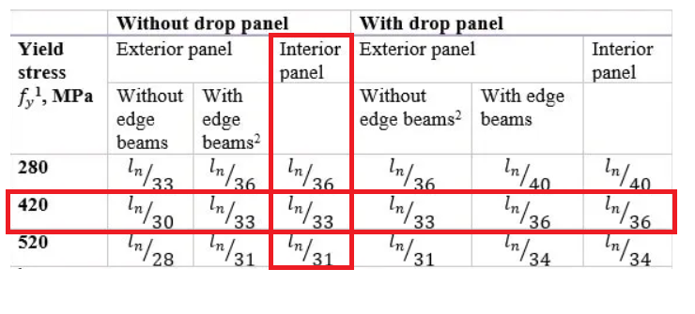
H_{soild} =Ln/33 = 16 /33 = 0.48 m
H voided = $\frac{4}{3}$ h solid= = $\frac{4}{3} ×480 =640mm$ → Use H=600mm.
We are choosing the pattern with h =60cm.
ᴕ = $\frac{moment of inertia voided}{moment of inertia full }$
=$\frac{ 1431.857}{1800}$= 0.795
Heq = $\sqrt[3]{.795}×H voided$ =.9265 $×$600=555.827 mm
h equivalent = 0.60m
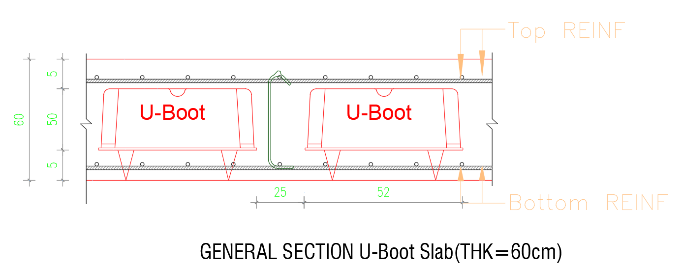
Figure ‎3.1: Section in U-boot

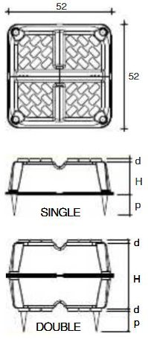
Figure ‎3.2: Uboot dimensions.
The U-boot dimensions is 52 cm * 52 cm
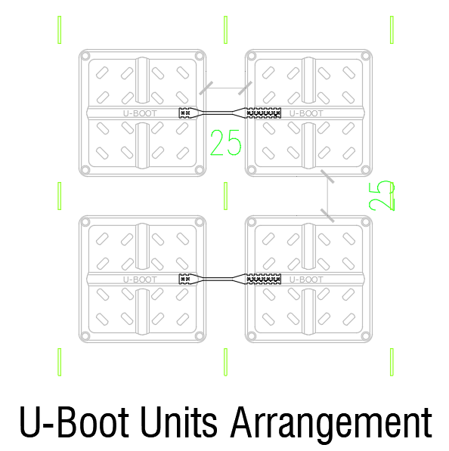
Figure ‎3.3: Uboot arrangement.

Table ‎3-4: U-boot pattern used.
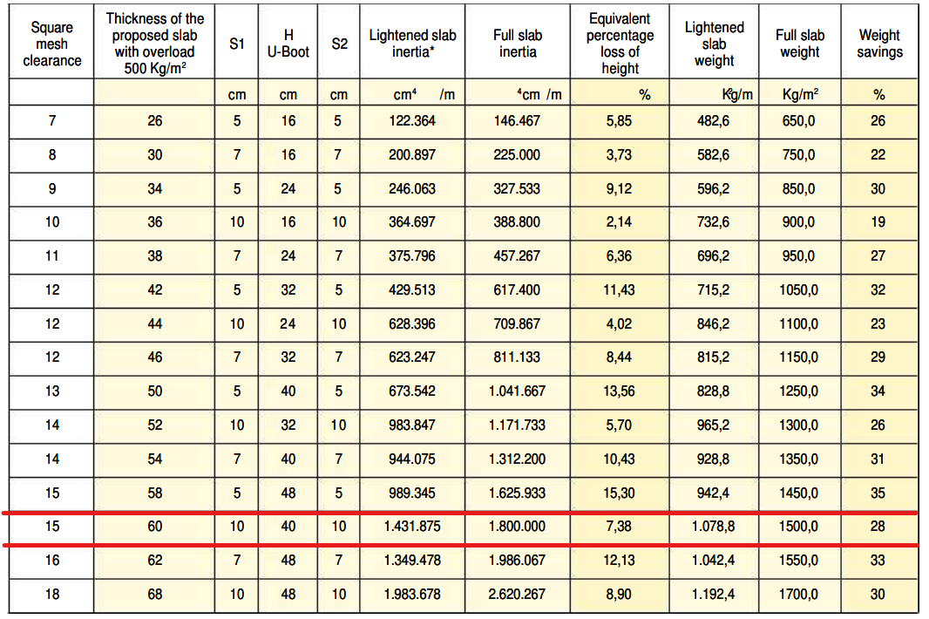
    - Columns Design
The columns dimensions are calculated based on the building loads, for interior column
Tributary area = 47 m²
Slab unit load = 10.78 KN/m² --->Approximate column’s load = 47*10.78*9 = 4560.94 KN
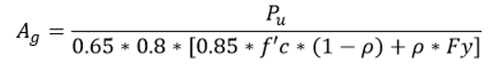
𝜌 = 1%
Ag = 315867.56 mm² ---->Assumed column’s dimension = 80*40 cm
For edge column:
Tributary area = 20 m²
Slab unit load = 10.78 KN/m² --->Approximate column’s load = 20*10.78*9 = 1940.4 KN
𝜌 = 1%
Ag = 134.41 mm² ---->Assumed column’s dimension = 50*30 cm

For corner column:
Tributary area = 18 m²
Slab unit load = 10.78 KN/m² --->Approximate column’s load = 18*10.78*9 = 1746.36 KN
𝜌 = 1%
Ag = 120.9 mm² ---->Assumed column’s dimension = 50*30 cm

    - Expansion Joint
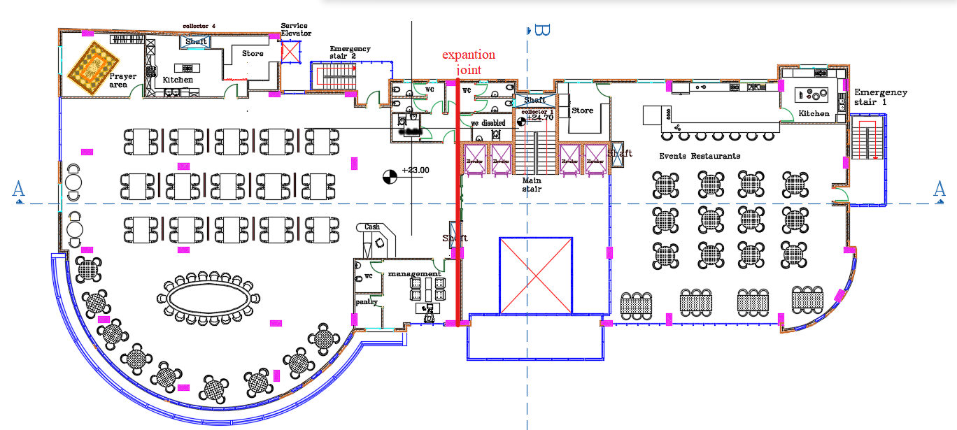
Figure ‎3.4: Expansion Joint location.
Because of the existing of expansion joint, the structural model was divided into two parts (Part 1 and Part 2).

Structural Model
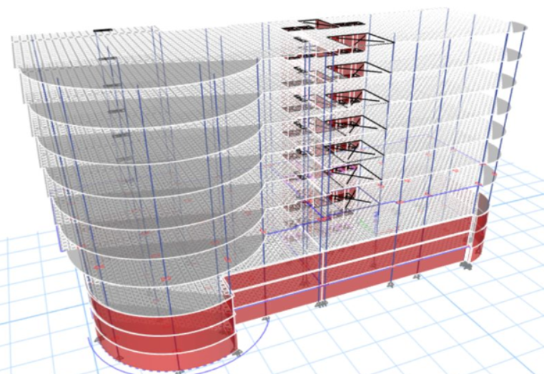
Figure ‎3.5: 3d structural model before separation.

- Part 1
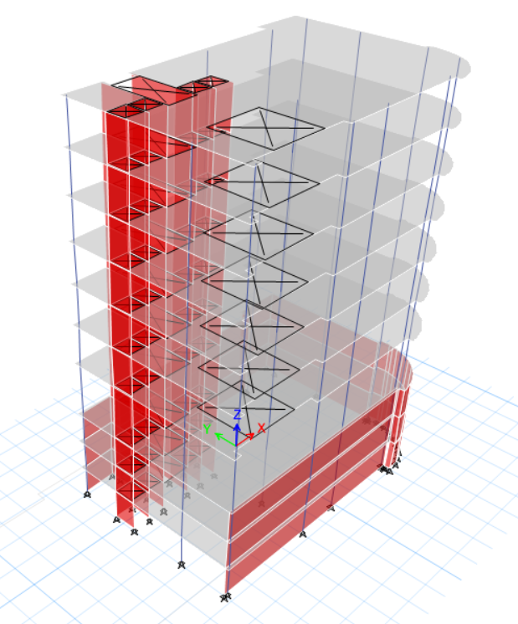
Figure ‎3.6: part 1 structural model.
.
- Part 2
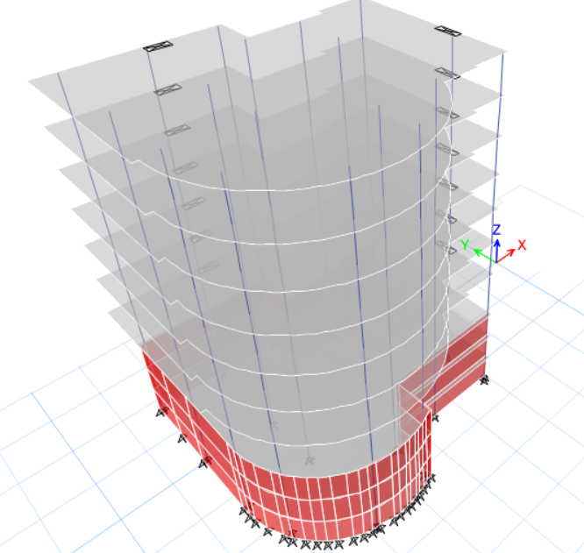
Figure ‎3.7: part 2 structural model.

Structural model checks
      - Compatibility check
- Part 1
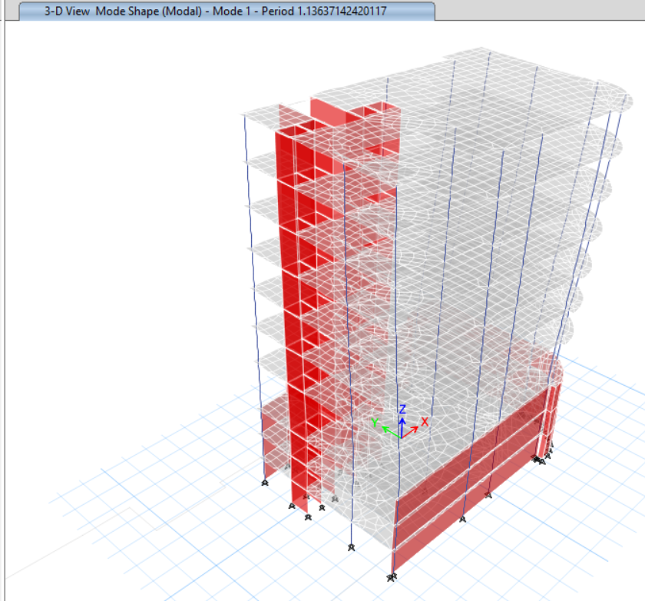
Figure ‎3.8: Compatibility check for part 1.

- Part 2
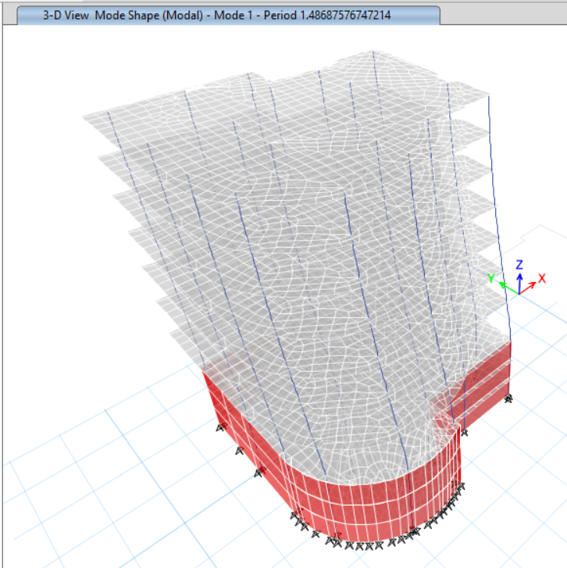
Figure ‎3.9: Compatibility check for part 2.
The figures demonstrate how all of the structural components are held together and moved as a unit.

Equilibrium check:
The loads resulting from hand calculations in this section must be equivalent to the loads produced by the Etabs program (Fz) with a 10% error rate.
- Part 1
Table ‎3-5: Equilibrium check results for part 1 model.
Load | Manual | Base reaction | %Error | Ok/Not
Live | 20661.105 | 20634.28 | 0.13% | ok
SID | 17121.69 | 17082.4 | 0.23% | ok
Dead | 71533.447 | 69476.93 | 2.96% | ok
- Part 2
Table ‎3-6: Equilibrium check results for part 2 model.
Load | Manual | Base reaction | %Error | Ok/Not
Live | 28997.121 | 28947.91 | 0.17% | ok
SID | 24027.272 | 23950.63 | 0.32% | ok
Dead | 89769.524 | 86499.83 | 3.78% | ok

Deflection check
The purpose of this check is to confirm that the building's roof displacement is within the range allowed by the ACI-14 code, which is shown in Table.
Table ‎3-7 maximum computed deflection
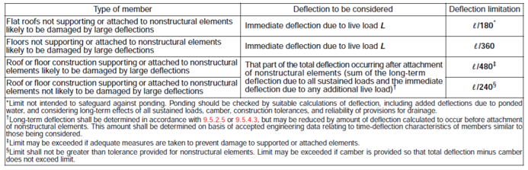
- Part 1
From Live load
ΔLimit = 𝐿/360 = 16.5/360= 45.8 mm.

From ETABS:
Maximum deflection:
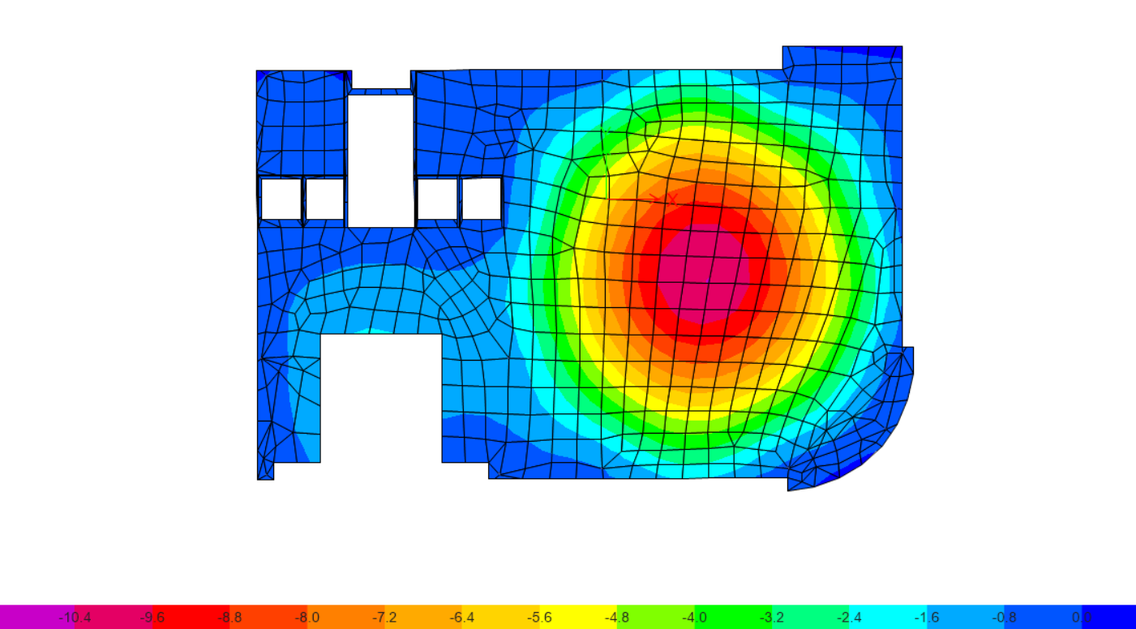
Figure ‎3.10: Deflection from live load for part 1.
ΔETABS = 10.4- ((3.4+3+3+3.6)/4) = 7.06mm<45.8mm---->OK.
From service load
ΔLimit = 𝐿/240 = 16.5/240= 68.75mm.
From ETABS:
Maximum deflection:
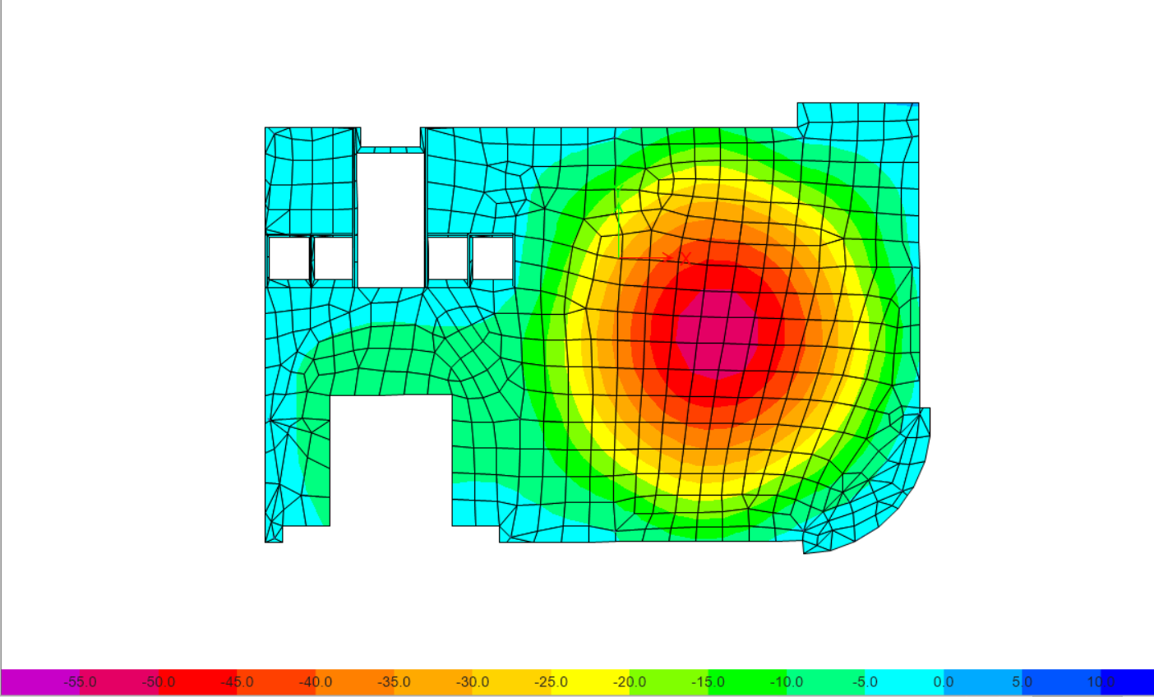
Figure ‎3.11: Deflection from service load for part 1.
deflection from service load
ΔETABS = 55-((11.7+13.6+9+13)/4) = 43.18mm<68mm---OK.
- Part 2
From Live load
ΔLimit = 𝐿/360 = 12/360= 33.3mm.

From ETABS:
Maximum deflection:
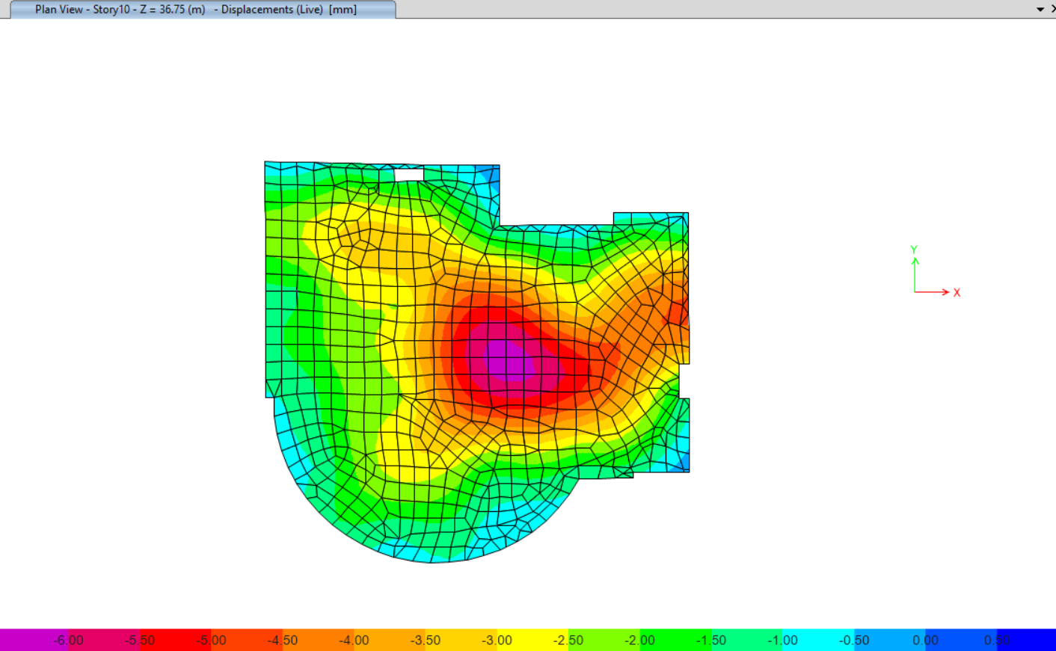
Figure ‎3.12: Deflection from live load for part 2.
Deflection from Live load
ΔETABS = 6.00- ((3.1+2.1+3+3.2)/4) = 3.15mm<33.33mm---OK.
- From service load
ΔLimit = 𝐿/240 = 12/240= 50mm.
From ETABS:
Maximum deflection:
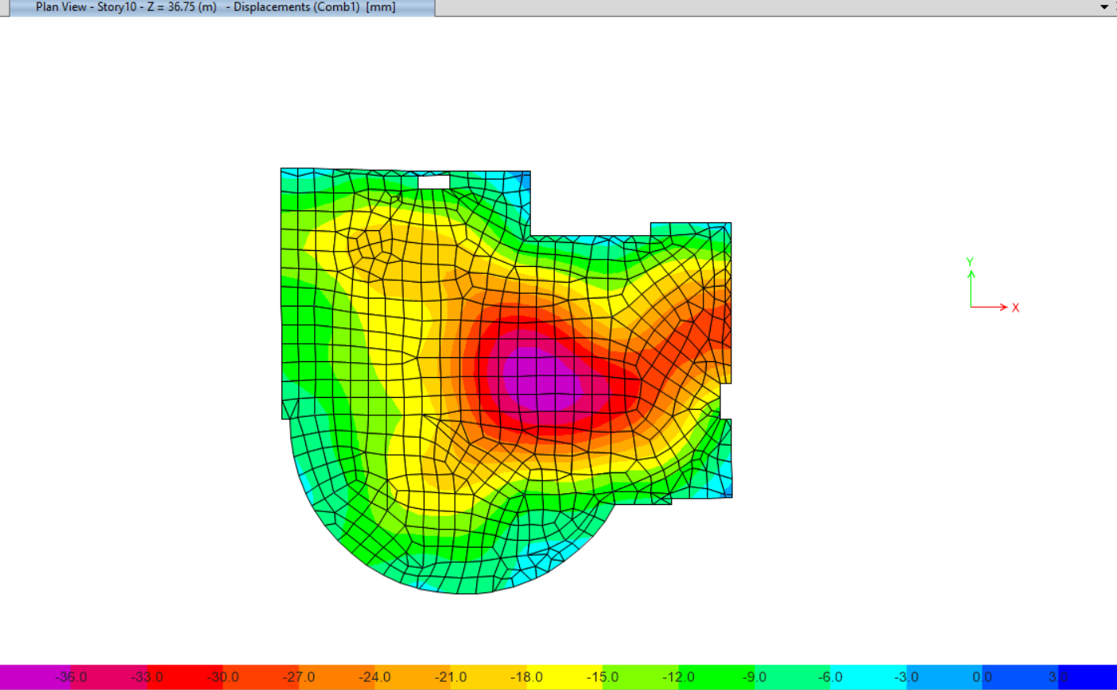
Figure ‎3.13: Deflection from service load for part 2.
ΔETABS = 36-((11.7+12.3+9.15+13.2)/4) = 24.4mm<50mm---OK.

Shear check
- Part 1
ØVc = (0.75/6) * √𝑓𝑐 * bw *d =(0.75/6)*√40 *250 * 520=182.7 KN/ rib
B3 floor
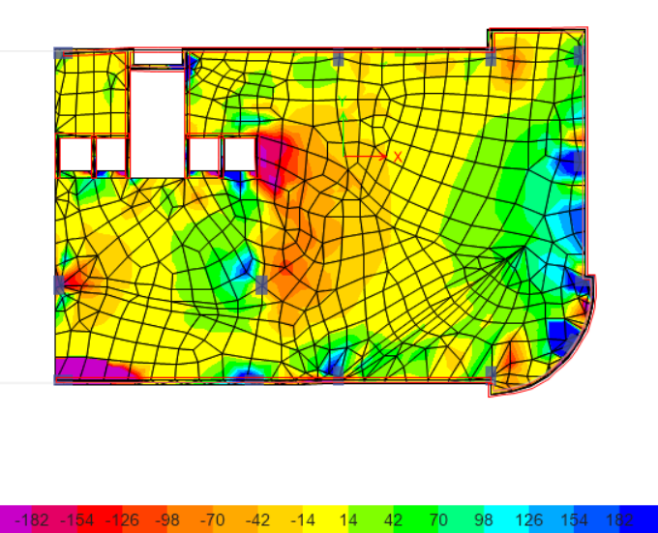
Figure ‎3.14: Shear for B3 floor from ETABS for part 1 model.
- Part 2
B3 floor
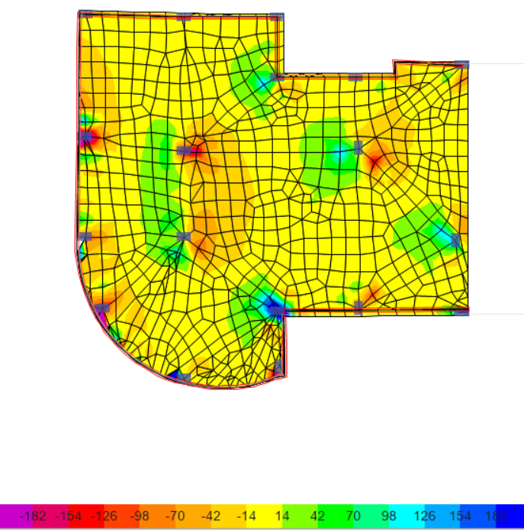
Figure ‎3.15: Shear for B3 floor from ETABS for part 2 model.
The previous check is ok, but at the regions that exceed ØVc, the solution is increase reinforcement or put a stirrup at these regions.

Stress strain check

Columns check
From ultimate loads
- Part 1
Table ‎3-8: Stress strain check result for columns in part 1 model.
Column Type | Etabs | Manual | %Error | Ok/Not
Interior | 12633.28 | 13151.24 | 4.10% | Ok
Corner | 1574.09 | 1576.14 | 0.13% | Ok
Edge | 5104.97 | 5213.71 | 2.13% | Ok

- Part 2
Table ‎3-9: Stress strain check result for columns in part 2 model.
Column Type | Etabs | Manual | %Error | Ok/Not
Interior | 16587.23 | 17205.93 | 3.73% | Ok
Corner | 1653.81 | 1672.33 | 1.12% | Ok
Edge | 4187.15 | 4322.39 | 3.23% | Ok

Slab check
From live load
- Part 1
Table ‎3-10: Stress strain check result for slab in part 1 model.
Panel type | Etabs | Manual | %Error | Ok/Not
Exterior | 22 | 24.01 | -9.13% | Ok

- Part 2
Table ‎3-11: Stress strain check result for slab in part 2 model.
Panel type | Etabs | Manual | %Error | Ok/Not
Exterior | 33.1 | 37.17 | -12.30% | Ok

Design check
- Part 1
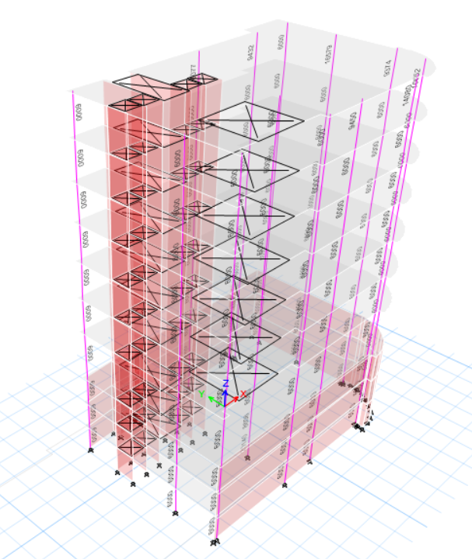
Figure ‎3.16: Design results for part 1 model.
As shown, the check is ok
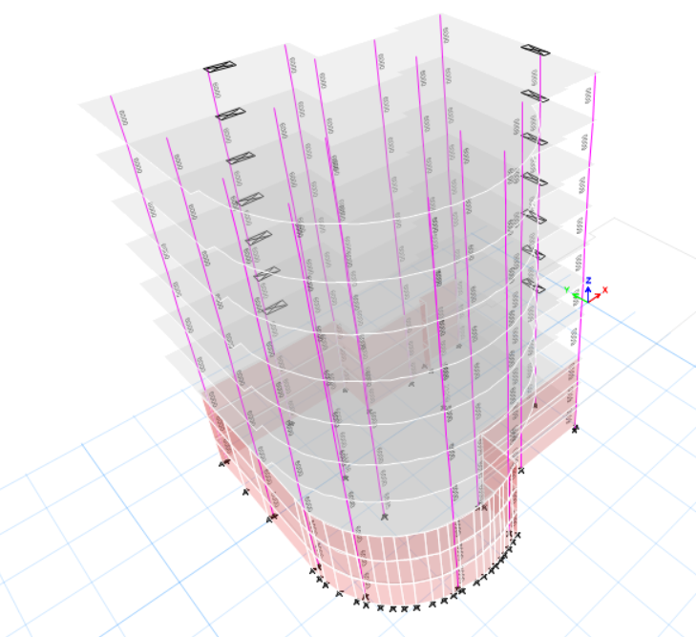

Figure ‎3.17: Design results for part 2 model.

As shown, the check is ok

Punching shear Check
- Part1:
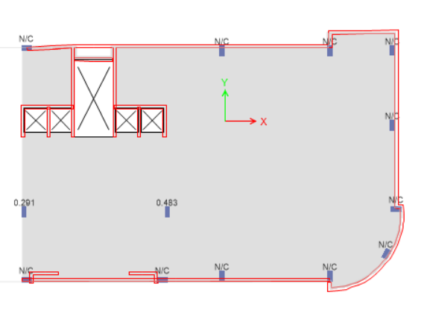
Figure ‎3.18: Punching shear in typical floor in part 1.
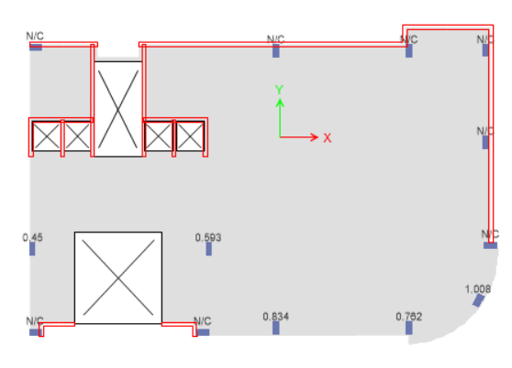
Figure ‎3.19: Punching shear in parking's in part 1.
As shown in the previous figure, punching shear ok, and N/C at shear walls which is ok.
- Part2:
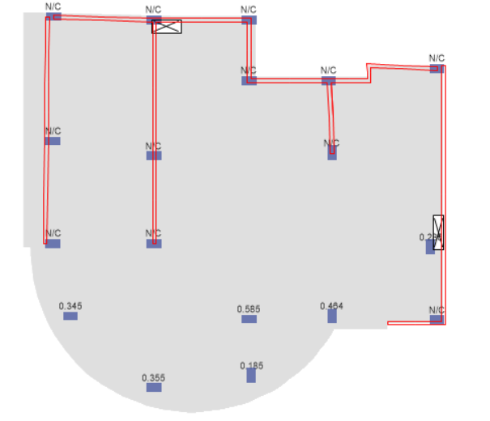
Figure ‎3.20: Punching shear in typical floor in part 2.

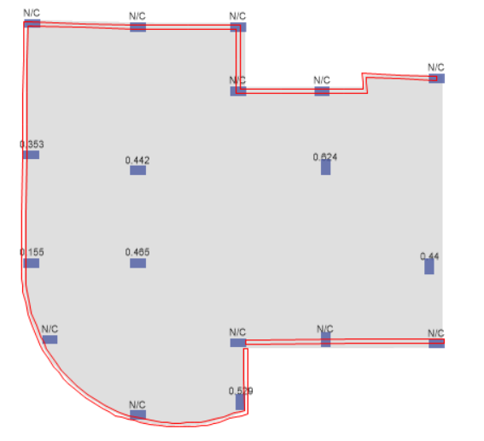
Figure ‎3.21: Punching shear in parking's in part 2.
As shown in the previous figure, punching shear ok, and N/C at shear walls which is ok.

Manual design for column
- Manual design of one column

Column loads
From dead load:
- Column’s weight =288 KN

- Slab’s weight:
The total slabs weight = 7.13× (58.10×2+15.10×5) = 1366.80 KN.
Total weight = 1654.80 KN

- From live load
- Manual
Live load from ground to last floor = 3.90 KN/m².
Live load at the basement 1 = 2.40 KN/m².
Total column live load on column from manual = 3.90×58.10+3.90×17.43×5+ 2.40×58.10 = 705.91 KN.
- From super imposed dead load (S.I.D)
- Manual
S.I.D = 3.50 KN/m².
Total column’s S.I.D on column from manual = 3.50×58.10×2+3.50×15.10×5 = 670.95 KN.
Total ultimate load on the column = 1.2× (2151.40+670.95) +1.6×705.91= 4516.26 KN.
Column design:
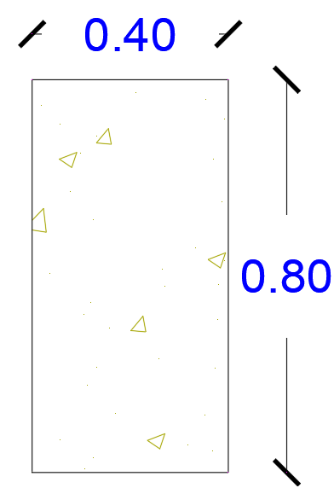
Figure ‎3.22: Column section.
From Figure ‎3.43, the gross area of the section is = 400×800 = 320000 mm² and the area of steel is = $\frac{\text{π}}{\text{4}}\text{×}{\text{25}}^{\text{2}}\text{×}\text{12=}\text{5890.48} {\text{mm}}^{\text{2}}$---> $Ratio of steel=\frac{5890.48}{320000}=1.84\%$
Check for ratio of steel
Pu should be ≤ ΦPn.
Φ = 0.65 for tied columns.
Pn = 0.80× (0.85×fc`×AC+ fy×Ast).
fc` = 28 Mpa and Fy = 420 Mpa.
AC = Total area – Steel area = 320000 – 5890.48 = 274109.52 mm².
As = 5890.48 mm².
---> Pn = 0.80× ((0.85×28×274109.52 + 420×5890.48) ×10⁻³) = 7086.09 KN.
---> ΦPn = 0.65×7086.09 = 4605.96 KN > Pu ----> Ok.
Table ‎3-12: Column’s information.
Height(m) | 0.80
Width(m) | 0.40
Pu (KN) | 4516.28
K | 0.80
Column height(m) | 4.00

See Figure ‎3.92 for column section information.
Check for long column
$$\frac{K×L}{r}≤34$$
K = 0.80, L = 4.00 m
In X-direction:
rx = 0.30 × 0.70 = 0.21
$$\frac{K×L}{r}= \frac{0.80×4.00}{0.21}=15.23<34--->Designed as short column.$$
In Y-direction:
rx = 0.30 × 0.40 = 0.12
$$\frac{K×L}{r}= \frac{0.80×4.00}{0.12}=26.67<34--->Designed as short column.$$
$$EI eff= \frac{0.40×EC×Ig}{1+βd}$$
EC = $4700×\sqrt{fc}=4700×\sqrt{28}=24870.00$
$$βd=\frac{Wu sustained}{Wu}= \frac{1.20×\left(7.13+3.90\right)+1.60×(25\%×3.50)}{1.20×\left(7.13+3.90\right)+1.60×3.50}=0.78$$
In X-direction:
$$Ig X= \frac{1}{12}×400×{700}^{3}=1.14×{10}^{10} mm^{4}.$$
$$EI eff X= \frac{0.40×24870×1.14×{10}^{10}×{10}^{-9}}{1+0.78}=64005.42 KN.m^{2}.$$
In Y-direction:
$$Ig Y= \frac{1}{12}×700×{400}^{3}=3.73×{10}^{9} mm^{4}.$$
$$EI eff X= \frac{0.40×24870×3.73×{10}^{9}×{10}^{-9}}{1+0.78}=20899.73 KN.m^{2}.$$
$$Pc=\frac{π^{2}×EIeff}{(K{L)}^{2}}$$
In X-direction:
$$Pc x=\frac{π^{2}×64005.42}{{\left(0.8×4.00\right)}^{2}}=61690.25.$$
In Y-direction:
$$Pc y=\frac{π^{2}×20899.73}{{\left(0.8×4.00\right)}^{2}}=20143.76.$$
$$δns=\frac{1}{1-\frac{Pu}{0.75×Pc}}$$
$$δnsx=\frac{1}{1-\frac{4516.28}{0.75×61690.25}}=1.11>1--->Ok.$$
In X-direction:
M max = Pu×emin
emin =0.03+0.015×h.
M max = 4516.28× (0.015+0.03×0.70) = 162.59.
-->Mux = 1.11×162.59 = 180.17 KN.m.
In Y-direction:
$$δnsy=\frac{1}{1-\frac{4516.28}{0.75×20899.73}}=1.43>1--->Ok.$$
M max = 4516.28× (0.015+0.03×0.40) = 121.94.
-->Mux = 1.43×121.94 = 173.94 KN.m.

Interaction diagram data:
$$\frac{Pu}{Ag×fc}=\frac{4516.28}{400×700×28}=0.58.$$
$$\frac{Mux}{Ag×h×fc}=\frac{180.17}{400×700×700×28}=0.03.$$
$$\frac{Muy}{Ag×h×fc}=\frac{173.94}{400×700×400×28}=0.06.$$
In x-direction:
$$γ x=\frac{400-(2×40+2×10-2×25×0.5)}{400}=0.81$$
Use chart of 0.80
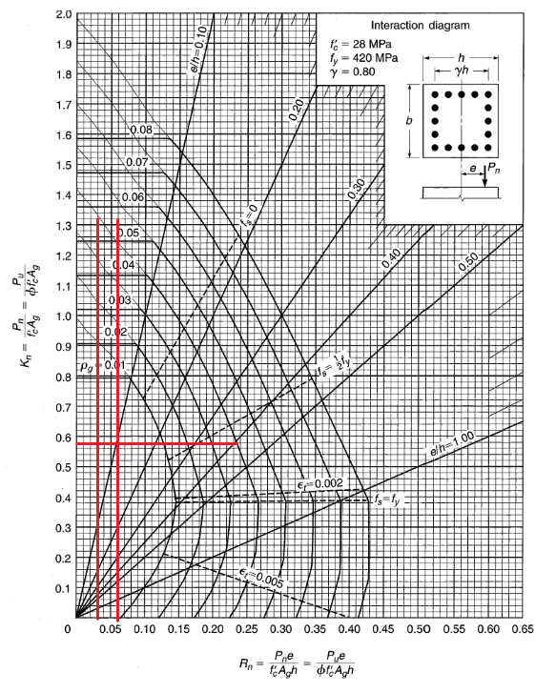
Figure ‎3.23: Interaction diagram of X-direction gamma.

In y-direction:
$$γ y=\frac{700-(2×40+2×10-2×25×0.5)}{700}=0.89$$
Use chart of 0.90

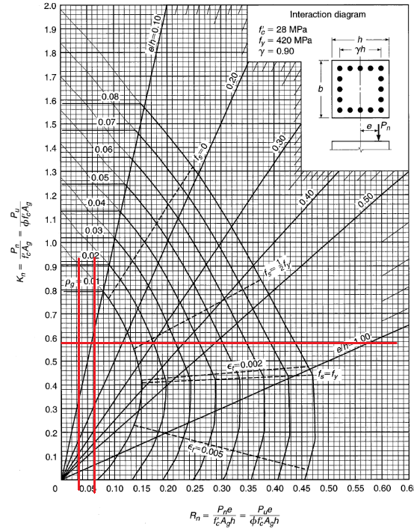
Figure ‎3.24: Interaction diagram of Y-direction gamma.

Seismic Design

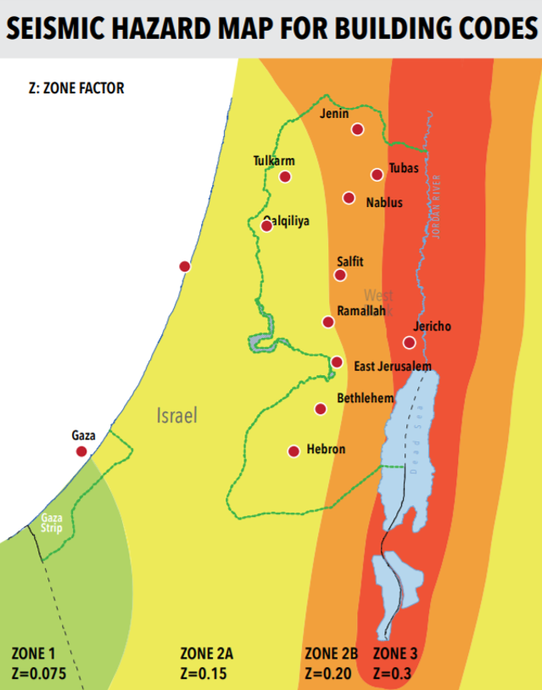
Figure ‎3.25: Seismic Hazard map
Zone: Jenin
As shown, project’s zone: Jenin------> Z=0.20

Based on the type of soil of the land and “TABLE 16-J-page 2-30” from UBC 97 code, the soil profile type is SD.(Uniform Building Code 1997 1997)
Seismic importance factor is 1.25 from “TABLE 16-K” in UBC 97 code (Uniform Building Code 1997 1997)
The structural system is intermediate moment resisting frame systems, and the R value of that system is 5.50 based on “TABLE 16-N” in UBC 97 code. (Uniform Building Code 1997, 1997)”
From UBC 97 code, the seismic coefficients Ca and Cv are 0.28, 0.40 respectively. (Uniform Building Code
1997, 1997)

Assumptions in seismic design
Seismic loads combinations used:
➢ Ultimate loads combinations:
- 1.4 D.L
- 1.2 D. L + 1.6 L.L
- 1.34 D. L + 1.00 L. L + 1.00 EQx + 0.30 EQy
- 1.34 D. L + 1.00 L. L + 1.00 EQx - 0.30 EQy
- 1.34 D. L + 1.00 L. L - 1.00 EQx + 0.30 EQy
- 1.34 D. L + 1.00 L. L - 1.00 EQx - 0.30 EQy
- 0.76 D. L + 1.00 EQx + 0.30 EQy
- 0.76 D. L + 1.00 EQx - 0.30 EQy
- 0.76 D. L - 1.00 EQx + 0.30 EQy
- 0.76 D. L - 1.00 EQx - 0.30 EQy
➢ Service loads combinations:
- 1.00 D. L + 1.00 L.L
- 1.00 D. L + 0.71 EQx + 0.30 EQy
- 1.00 D. L + 0.71 EQx - 0.30 EQy
- 1.00 D. L - 0.71 EQx + 0.30 EQy
- 1.00 D. L - 0.71 EQx - 0.30 EQy
- 0.90 D. L + 0.71 EQx + 0.30 EQy
- 0.90 D. L + 0.71 EQx - 0.30 EQy
- 0.90 D. L - 0.71 EQx + 0.30 EQy
- 0.90 D. L - 0.71 EQx - 0.30 EQy
- 1.00 D. L + 0.75 L. L + 0.54 EQx + 0.16 EQy
- 1.00 D. L + 0.75 L. L + 0.54 EQx - 0.16 EQy
- 1.00 D. L + 0.75 L. L - 0.54 EQx + 0.16 EQy
- 1.00 D. L + 0.75 L. L - 0.54 EQx - 0.16 EQy
Envelope combination = the maximum among all the previous load combinations

Seismic model checks

Part 1

Period Check:

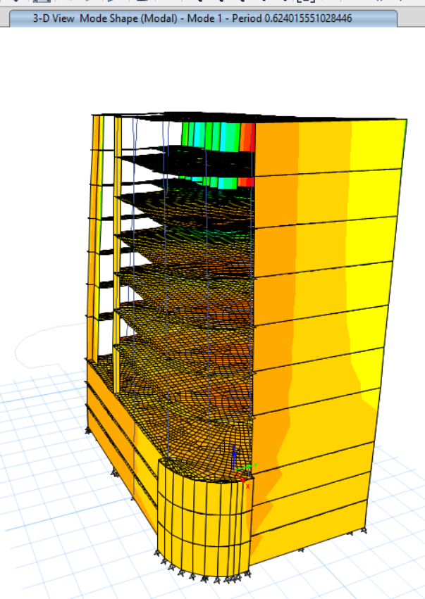
Figure ‎3.26: Period for part 1.

Table ‎3-13: Period check for part 1.
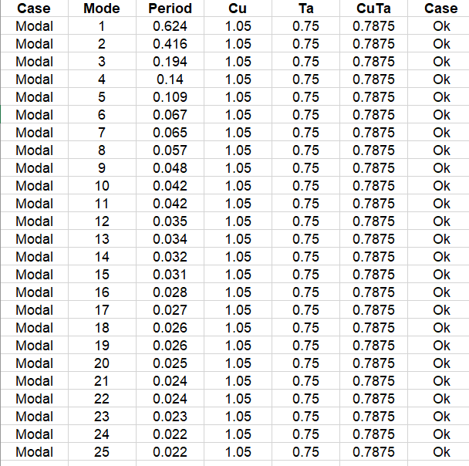

Model participant mass ration check:

Table ‎3-14: Model participant mass ration check for part 1.
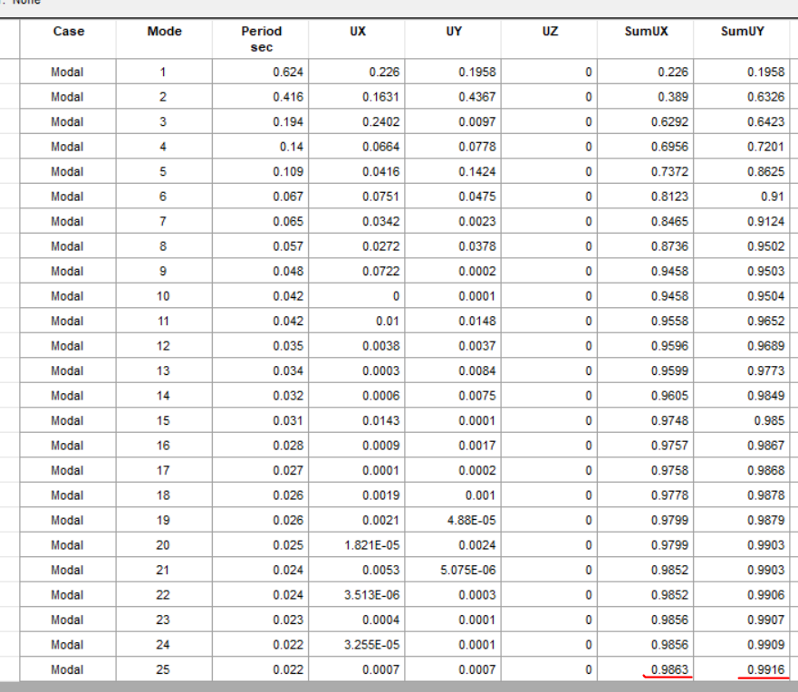
Sum ux and sum uy > 90%----->Ok

Drift check
Table ‎3-15: Drift check for part 1.
Story | Height | X displacement(mm) | Y displacement(mm) | X drift | Y drift | Delta limit | Case
Story10 | 3.25 | 1.048 | 0.83 | 2.61 | 2.37 | 97 | Ok
Story9 | 3.25 | 1.091 | 0.851 | 2.62 | 2.38 | 88 | Ok
Story8 | 3.25 | 1.115 | 0.855 | 2.6 | 2.36 | 79 | Ok
Story7 | 3.25 | 1.114 | 0.841 | 2.52 | 2.29 | 70 | Ok
Story6 | 3.25 | 1.069 | 0.795 | 2.39 | 2.18 | 61 | Ok
Story5 | 3.25 | 1.002 | 0.729 | 2.19 | 2 | 52 | Ok
Story4 | 3.25 | 0.898 | 0.552 | 1.92 | 1.75 | 43 | Ok
Story3 | 3.25 | 0.199 | 0.29 | 1.55 | 1.41 | 34 | Ok
Story2 | 3.75 | 0.115 | 0.113 | 0.95 | 0.86 | 25 | Ok
Story1 | 5.25 | 0.095 | 0.029 | 0.31 | 0.27 | 14.6 | Ok

Base Shear Check:
V=CsW
$$\text{Cs=}\frac{\text{S}\text{DS}}{\frac{R}{\text{I}\text{e}}}$$
SDS = 0.50
Ie =1.25
R = 5.5
$$Cs should≤\frac{SDS}{T\left(\frac{R}{Ie}\right)}=\frac{0.50}{0.62*\left(\frac{5.5}{1.25}\right)} =0.18$$
$$\text{Cs=}\frac{0.50}{\frac{5.5}{\text{1.25}}} =0.11---→Ok$$
Cs = 0.044 SDSIe ≥ 0.01-----> 0.044×0.62×1.25 = 0.034>0.01 ----> Ok.

P-delta Check
$$θmax =\frac{0.50}{βCd}≤0.25$$
Where:
“Cd: the deﬂection ampliﬁcation factor”
“β: the ratio of shear demand to shear capacity for the story between Levels x and x –1. This ratio is permitted to be conservatively taken as 1.0.”
From “Table 12.2-1-pages 73-75” in ASCE 7-10 code, the type of structural system is “Ordinary reinforced concrete shear walls” and the deﬂection ampliﬁcation factor (Cd) is 4.50.
β = 1
$$\text{θmax =}\frac{\text{0.50}}{\text{1}\text{×}\text{4.50}}\text{=} \text{0.11≤} \text{0.25----->Ok}$$

Part 2

Period Check:
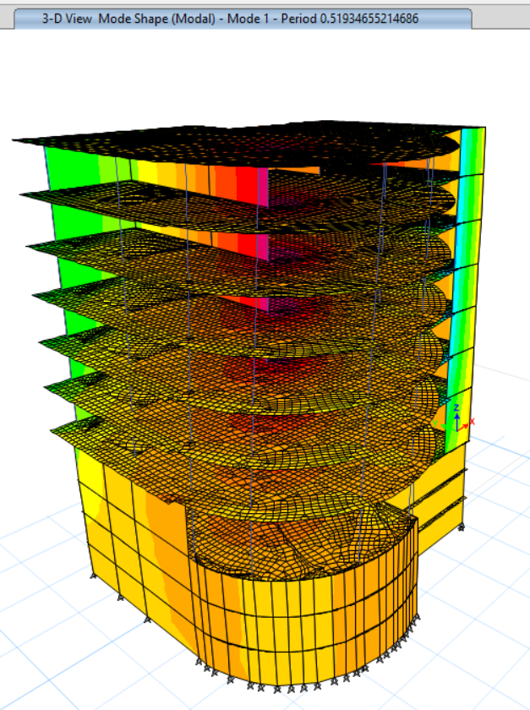
Figure ‎3.27: Period for part 2.

Table ‎3-16: Period check for part 2.
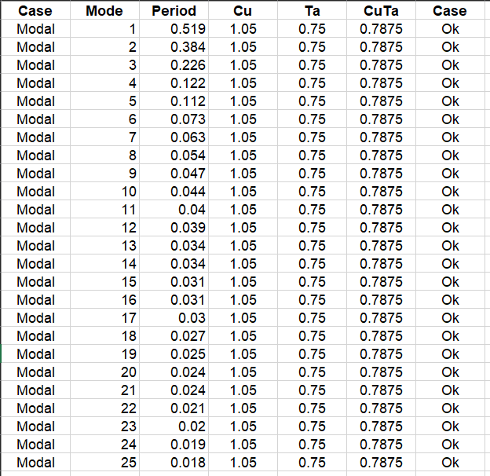

Model participant mass ration check:
Table ‎3-17: Model participant mass ration check for part 2.
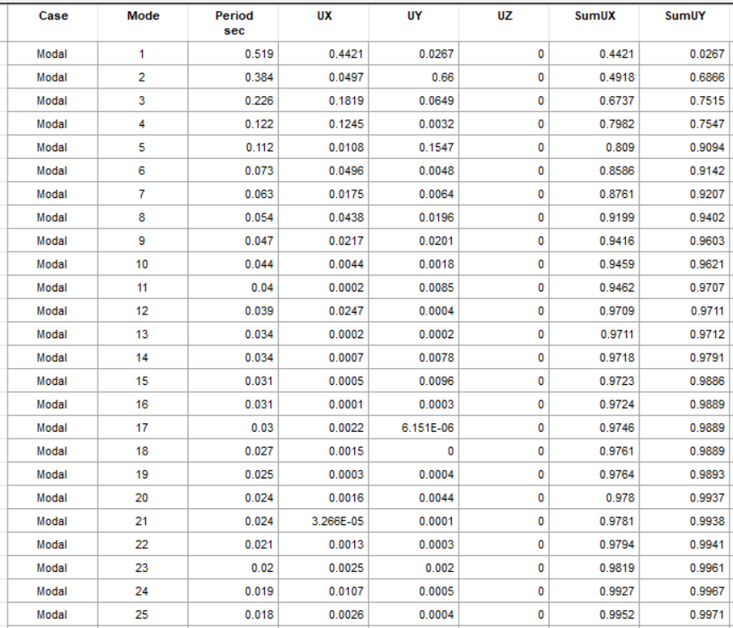

Drift check:
Table ‎3-18: Drift check for part 2.

Story | Height | X displacement(mm) | Y displacement(mm) | X drift | Y drift | Delta limit | Case
Story10 | 3.25 | 0.861 | 0.501 | 2.61 | 2.37 | 97 | Ok
Story9 | 3.25 | 0.924 | 0.539 | 2.62 | 2.38 | 88 | Ok
Story8 | 3.25 | 0.972 | 0.568 | 2.6 | 2.36 | 79 | Ok
Story7 | 3.25 | 1 | 0.263 | 2.52 | 2.29 | 70 | Ok
Story6 | 3.25 | 1.002 | 0.259 | 2.39 | 2.18 | 61 | Ok
Story5 | 3.25 | 0.961 | 0.225 | 2.19 | 2 | 52 | Ok
Story4 | 3.25 | 0.748 | 0.239 | 1.92 | 1.75 | 43 | Ok
Story3 | 3.25 | 0.213 | 0.362 | 1.55 | 1.41 | 34 | Ok
Story2 | 3.75 | 0.071 | 0.356 | 0.95 | 0.86 | 25 | Ok
Story1 | 5.25 | 0.162 | 0.313 | 0.31 | 0.27 | 14.6 | Ok

Base Shear Check:
V=CsW
$$\text{Cs=}\frac{\text{S}\text{DS}}{\frac{R}{\text{I}\text{e}}}$$
SDS = 0.50
Ie =1.25
R = 5.5
$$Cs should≤\frac{SDS}{T\left(\frac{R}{Ie}\right)}=\frac{0.50}{0.51*\left(\frac{5.5}{1.25}\right)} =0.22$$
$$\text{Cs=}\frac{0.50}{\frac{5.5}{\text{1.25}}} =0.11---→Ok$$
Cs = 0.044 SDSIe ≥ 0.01-----> 0.044×0.51×1.25 = 0.028>0.01 ----> Ok.

P-delta Check:

$$θmax =\frac{0.50}{βCd}≤0.25$$
Where:
“Cd: the deﬂection ampliﬁcation factor”
“β: the ratio of shear demand to shear capacity for the story between Levels x and x –1. This ratio is permitted to be conservatively taken as 1.0.”
From “Table 12.2-1-pages 73-75” in ASCE 7-10 code, the type of structural system is “Ordinary reinforced concrete shear walls” and the deﬂection ampliﬁcation factor (Cd) is 4.50.
β = 1
$$\text{θmax =}\frac{\text{0.50}}{\text{1}\text{×}\text{4.50}}\text{=} \text{0.11≤} \text{0.25----->Ok}$$

Design

Slab design
A steel minimum = 1900 mm2/m
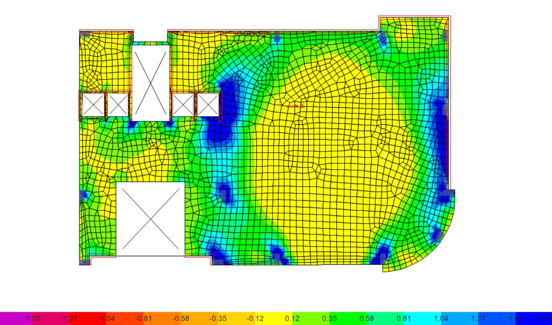
Figure ‎3.28: Bottom bars slab reinforcement results for part.
As shown in the previous figure, the reinforcement is minimum.
8Փ18mm/m will be used as bottom bars
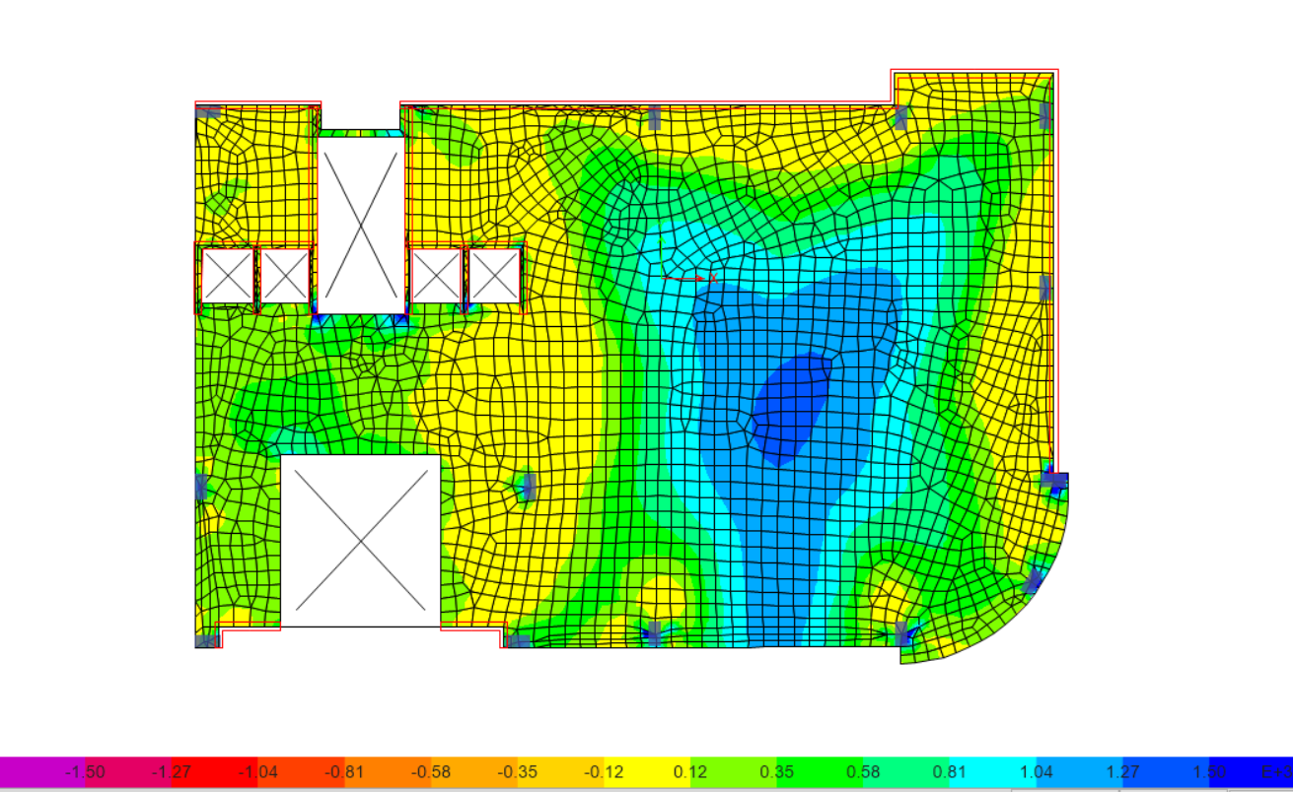
Figure ‎3.29: Top bars slab reinforcement results for part.
As shown in the previous figure, the top reinforcement is minimum in most regions, but at column will increased.
8Փ18mm/m will be used as Top bars and add 2Փ18 at columns regions.

Column design

Part1
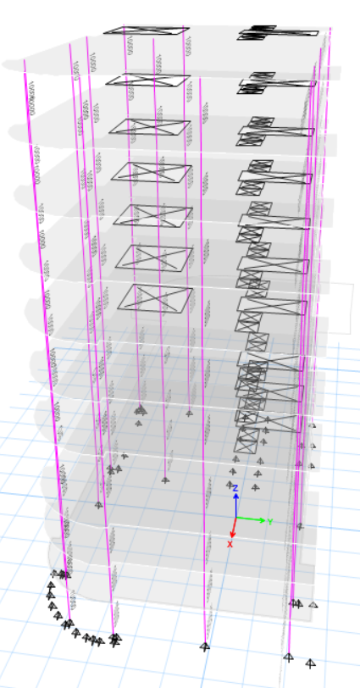
Figure ‎3.30: Column design for Part1.

Part 2
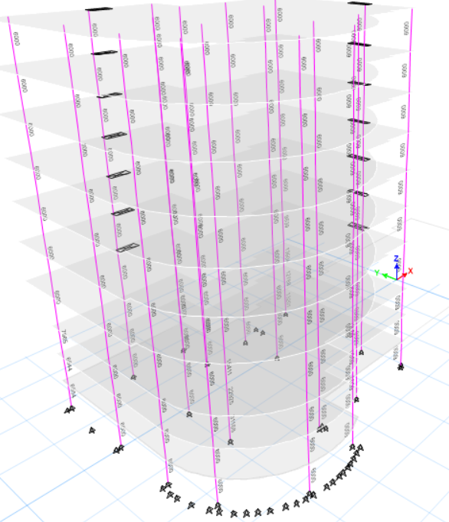
Figure ‎3.31: Column design for Part2.

Foundation system design
Allowable bearing capacity = 200 KN/m2
System used: Mat foundation.
Assume thickness for foundation 1.30 m and we will check it for punching shear.

Bearing Capacity check:
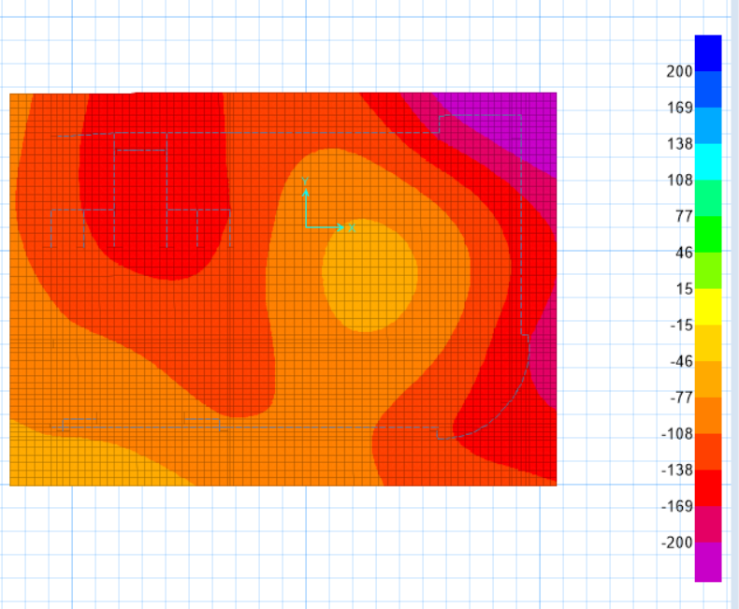
Figure ‎3.32: Bearing capacity check.
As shown in the previous figure, the footing stresses in less than 200 KN/m2 in most regions, which is ok.

Punching shear check:
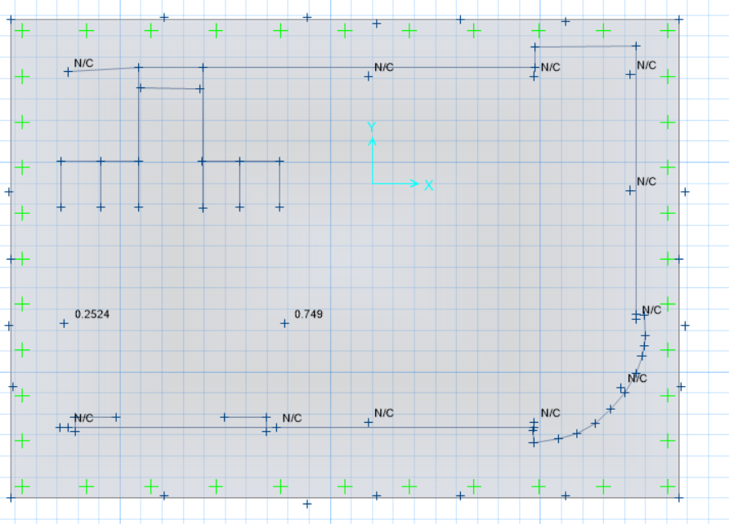
Figure ‎3.33: Punching shear check.

The punching shear is ok

Reinforcement
X-direction:
Bottom Bars
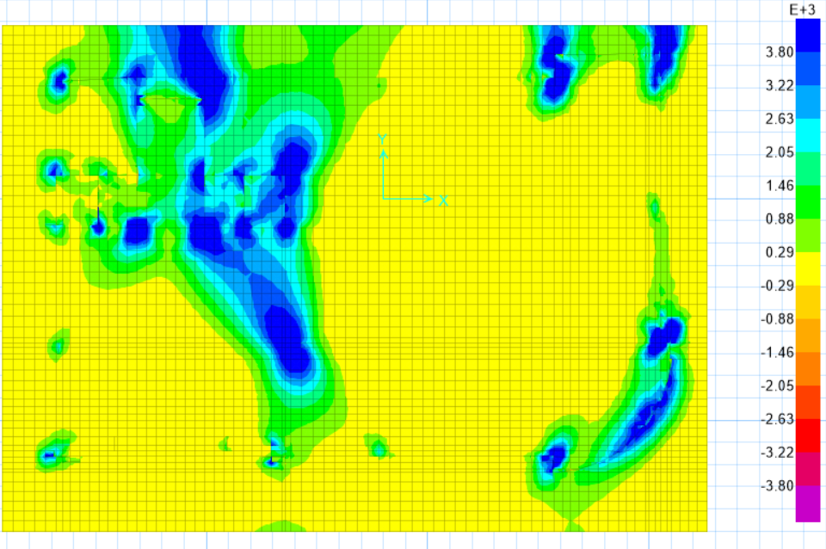
Figure ‎3.34: Bottom Reinforcement results in x direction.

Minimum area of steel is 3800 mm²
As shown in the previous figure, the most regions have minimum area of steel,
And the regions have more than minimum is under columns and shear walls directly.
Use 8Փ25 mm/m

Top Bars
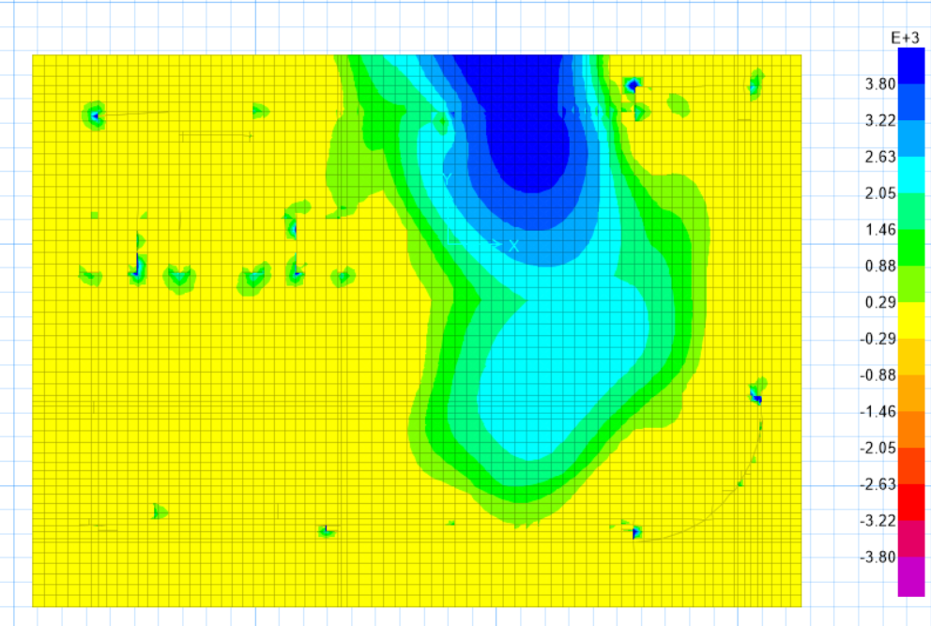
Figure ‎3.35: Top Reinforcement results in x direction.

Minimum area of steel is 3800 mm²
As shown in the previous figure, the most regions have minimum area of steel,
And the regions have more than minimum is under columns and shear walls directly.
Use 8Փ25 mm/m

Y-Direction
Bottom Bars
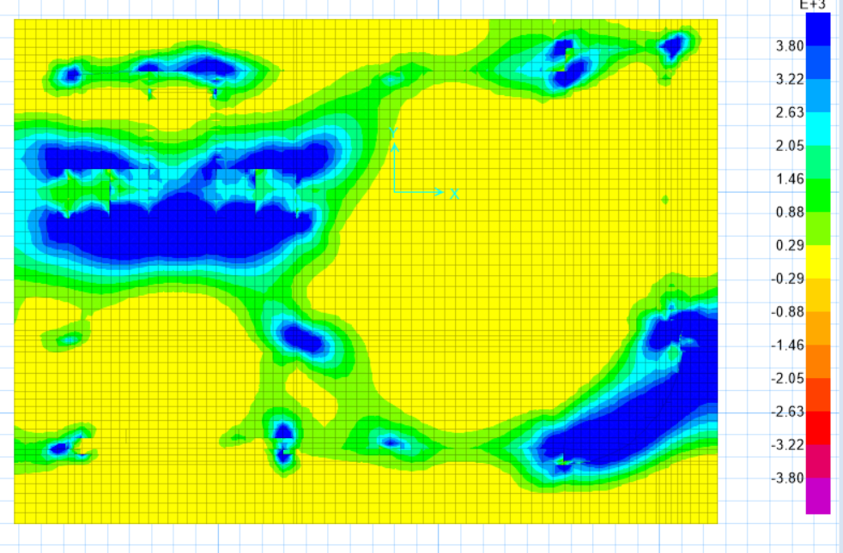
Figure ‎3.36: Bottom Reinforcement results in y direction.

Minimum area of steel is 3800 mm²
As shown in the previous figure, the most regions have minimum area of steel,
And the regions have more than minimum is under columns and shear walls directly.
Use 8Փ25 mm/m

Top Bars
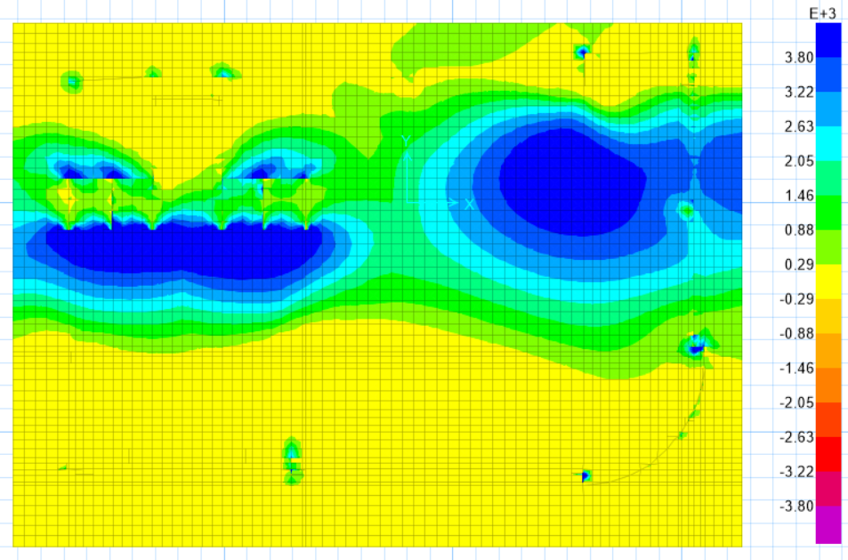
Figure ‎3.37: Top Reinforcement results in y direction.
Minimum area of steel is 3800 mm²
As shown in the previous figure, the most regions have minimum area of steel,
And the regions have more than minimum is under columns and shear walls directly.
Use 8Փ25 mm/m

Detailing
Reinforcement details
Seismic reinforcement details
Column’s stirrups
Figure ‎3.38: Column’s stirrups details used.
where:
$s_{0}=Min\left\{\begin{aligned}\text{least} \text{column dimension/2} \\ 8d_{b} \\ 24d_{s} \\ \text{300 mm}\end{aligned}\right\}$ ---->S0 used = 100mm.
$s_{1}=Min\left\{\begin{aligned}\text{least column dimension} \\ 16d_{b} \\ 48d_{s}\end{aligned}\right\}$ --->S1 used = 150mm.

Column’s longitudinal reinforcement
The development length at the half height of the columns.

Frame type: Intermediate moment resisting frame

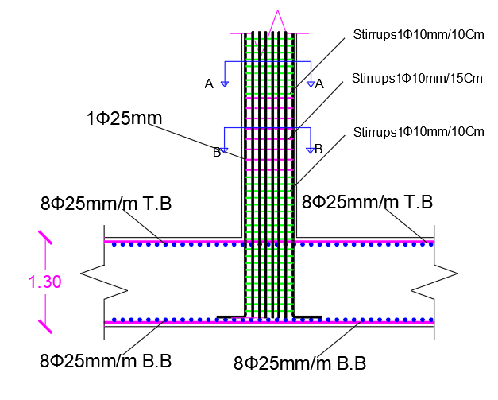
Figure ‎3.39

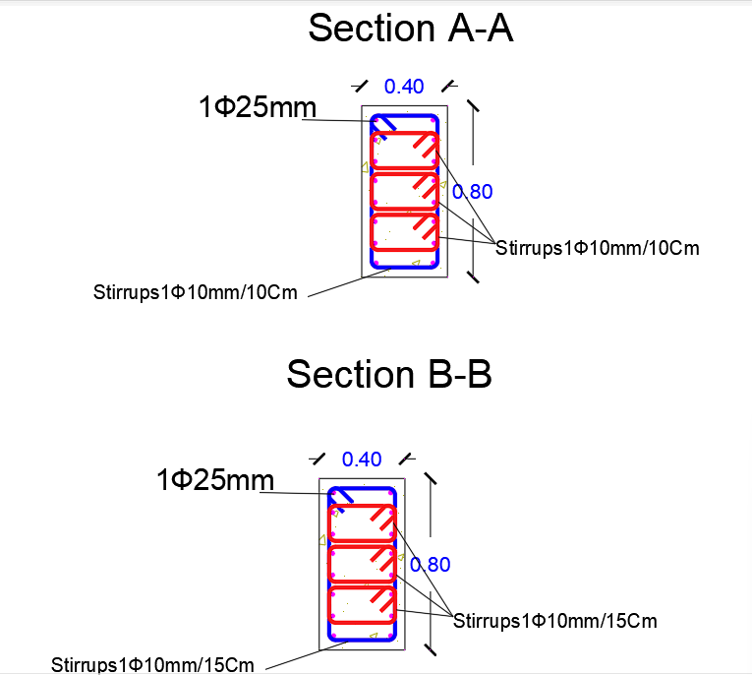
Figure ‎3.40 sections

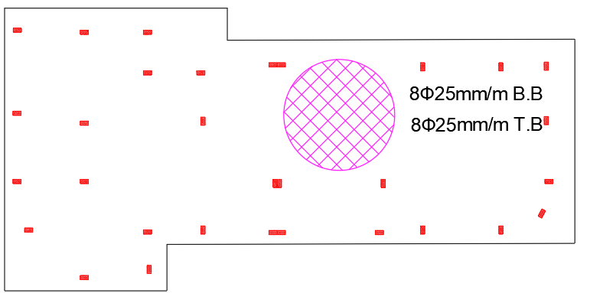
Figure ‎3.41 foundation reinforcement
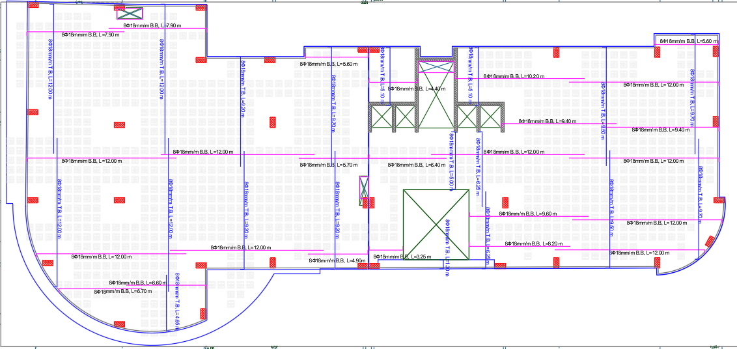
Figure ‎3.42 slab reinforcement
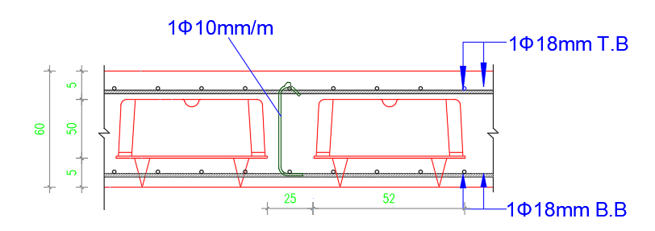
Figure ‎3.43 section in slab
Shear wall design:
Shear design
Vu value should be ≤ ΦVc
Table ‎3-19: Shear design for shear wall from ETABS.
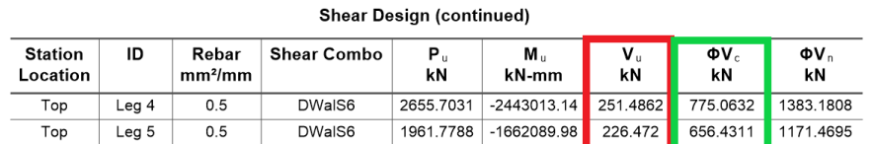
Moment design:
Table ‎3-20:Flexural design results from ETABS.
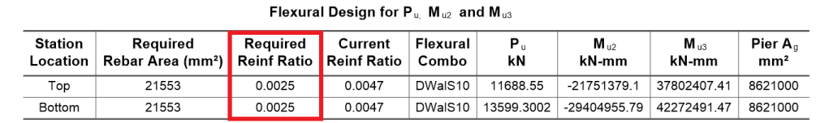
The flexural design depends on the required reinforcement ratio as shown in Table ‎3.38.
For boundary element design
Table ‎3-21: Boundary element check from ETABS.
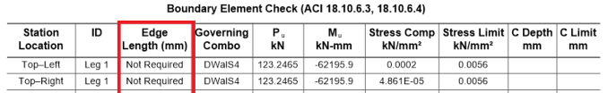
The boundary elements will design if the boundary elements check was Not ok.
The reinforcement of shear wall
5Փ14/m Longitudinal bars
5Փ12/m Transversal bars
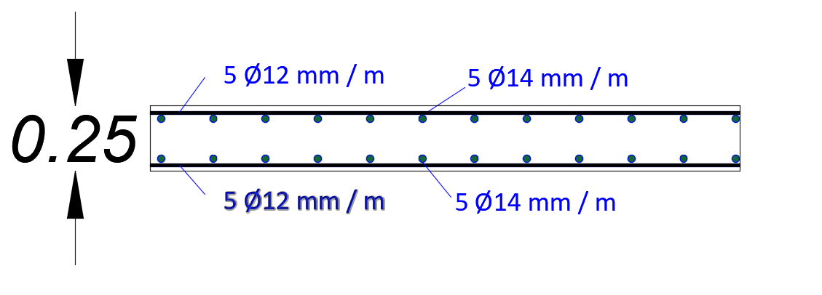
Figure ‎3.44: Shear wall detailing.

Septic water tank design:
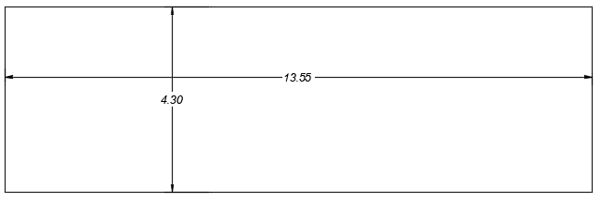
Figure ‎3.45: Water Tank Roof Plan.
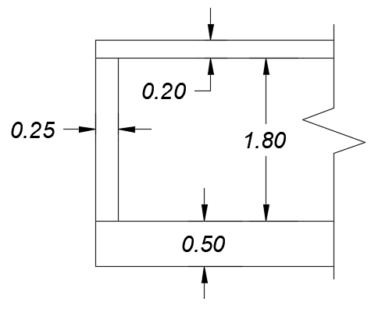
Figure ‎3.46: Water Tank Elevation.

Assumptions for water tank design
Density of water = 9.81 KN/m². (Gravity Density Specific Weight and Specific 2021)
Density of soil = 18 KN/m².

Loads:
- For water loads
Density of water ×height of the water tank = 9.81×2 = 19.62 KN/m²
- For soil loads
Density of soil ×height of the water tank = 18×2.20 = 39.62 KN/m²
fʹc = 28 mpa.
Load combination used:
Ultimate water pressure = 1.4 ×water pressure.
SAP model:

Water tank model checks

Compatibility check
Compatible

Equilibrium check
Table ‎3-22: Equilibrium check results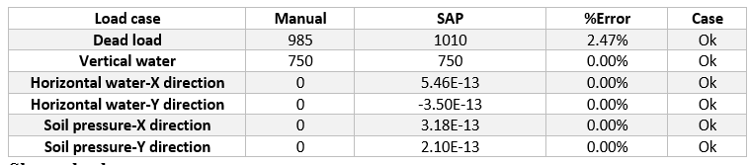

Shear check
- Roof
Thickness = 0.20 m.
d = 0.17 m.
$$ΦVc =\frac{0.75}{6}\sqrt{fʹc}*b*d =\frac{0.75}{6}\sqrt{28}*1000*170*{10}^{-3}=112.45 KN/m.$$
From SAP:
From SAP---->Vu<$ΦVc$--->Ok.
- Walls
Thickness = 0.25 m.
d = 0.19 m.
$$ΦVc =\frac{0.75}{6}\sqrt{fʹc}*b*d =\frac{0.75}{6}\sqrt{28}*1000*190*{10}^{-3}=125.67 KN/m.$$
From SAP---->Vu<$ΦVc$--->Ok.
Water tank footing bearing capacity check:
Allowable bearing capacity of the soil = 150 KN/m².
From SAP:
Stresses< Qall -->ok
Stress-strain check
- Manual:
Moment at bottom from water = $\frac{γH^{3}}{15}\text{=5.34 KN.m/m.}$
From SAP:
M = 5.49 KN
%Error = 2.80%--->ok.
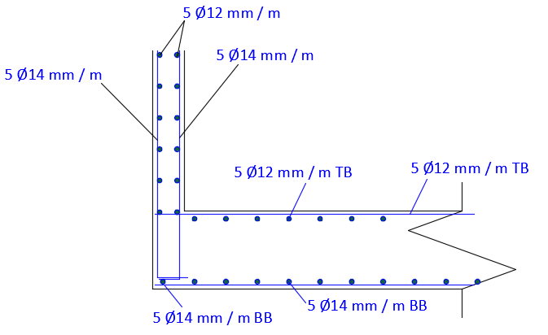
Figure ‎3.47: Water Tank Reinforcement details.

Stair design

Assumption
Super imposed dead load = 3.90 KN/m²
Live load = 3.50 KN/m².

Model checks

Compatibility check
Compatible.

Equilibrium check
Table ‎3-23: Equilibrium check results of stair.
Load case | Manual | ETABS | %Error | Case
Dead load | 190 | 189.6 | 0.21% | Ok
Live load | 133 | 132.79 | 0.16% | Ok
SID | 148.2 | 147.96 | 0.00% | Ok
- Shear check:
Stair slab thickness = 250 mm---->d = 220 mm.
ΦVc = $\frac{0.75}{6}×\sqrt{28}×1000×220=145.5KN.$
Flexural design:
Stair’s Slab thickness = 0.25 m.
The minimum reinforcement area = (1.4/420) ×1000×220=733.33 mm².
---->Use 5Փ14/m

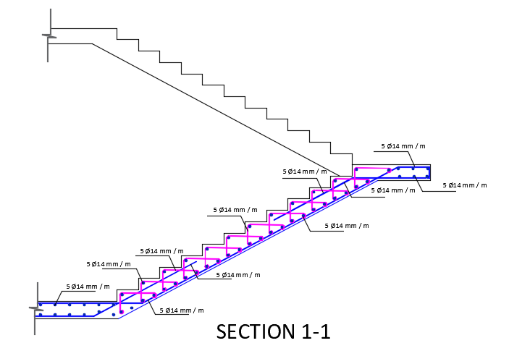
Figure ‎3.48: Stair reinforcement details.
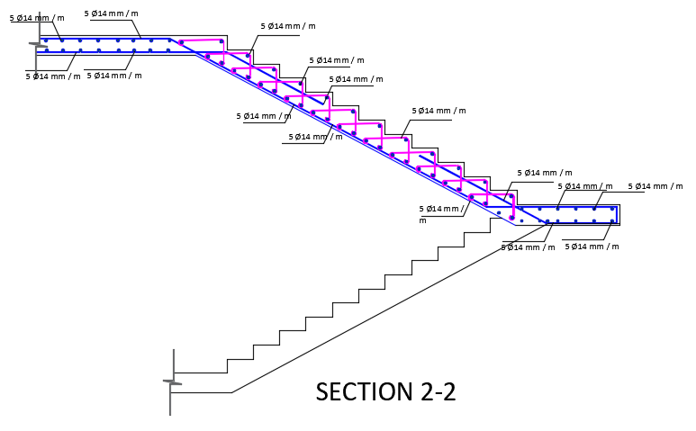
Figure ‎3.49: Stair reinforcement details.

Electro-mechanical Aspects

Artificial lighting design

Meeting room
Administration and office for visual task according to European code needs 500 Lux, uniformity 0.6, and a glare less than 19.

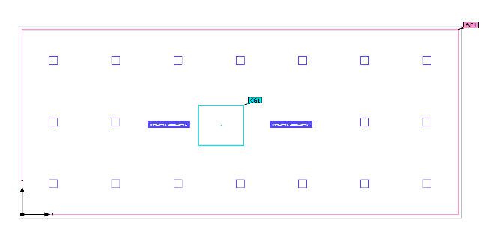
Figure ‎4.1 luminaire layout plan of meeting room
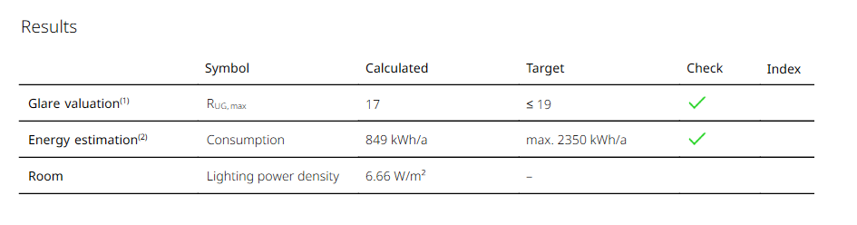
Figure ‎4.2 Meeting room DIALUX results.
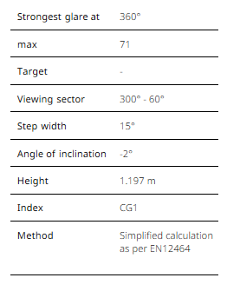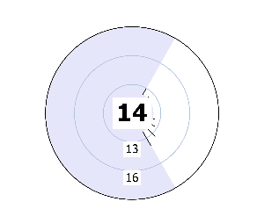
Figure ‎4.3 UGR Check
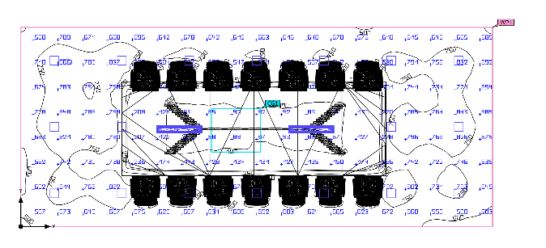
Figure ‎4.4 Artificial light only result from DIALUX EVO.
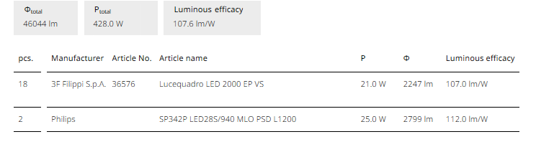
Figure ‎4.5 Luminaire list.
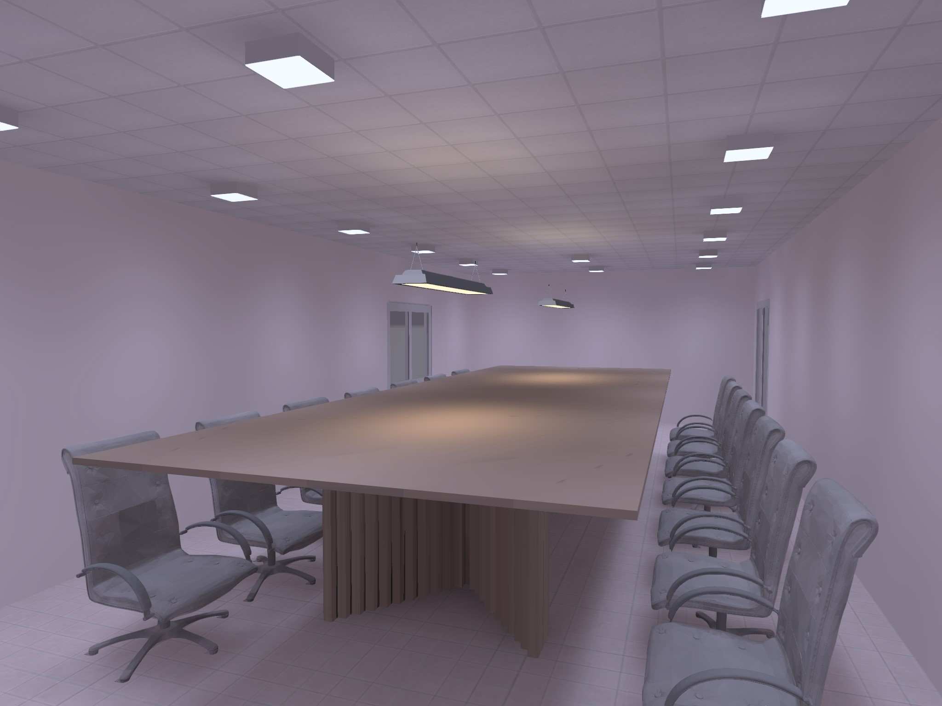
Figure ‎4.6 3D view meeting room.

Meeting room 2
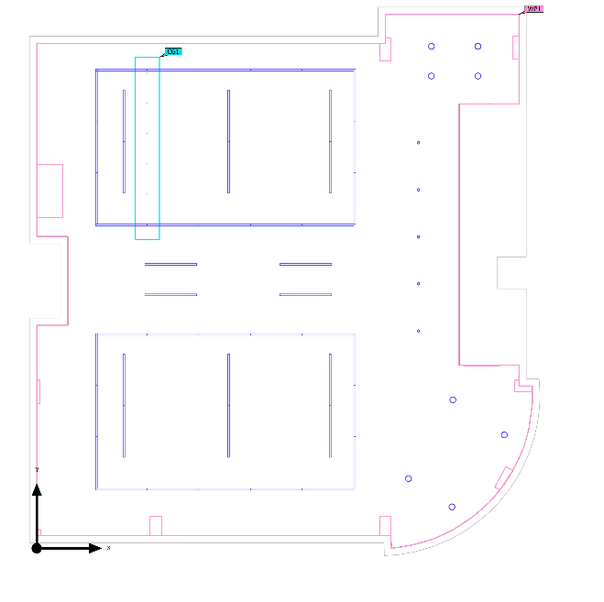
Figure ‎4.7 luminaire layout plan of meeting room
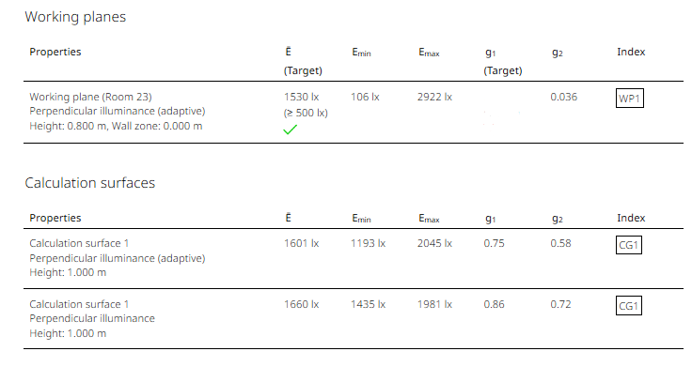
Figure ‎4.8 Meeting room DIALUX results.
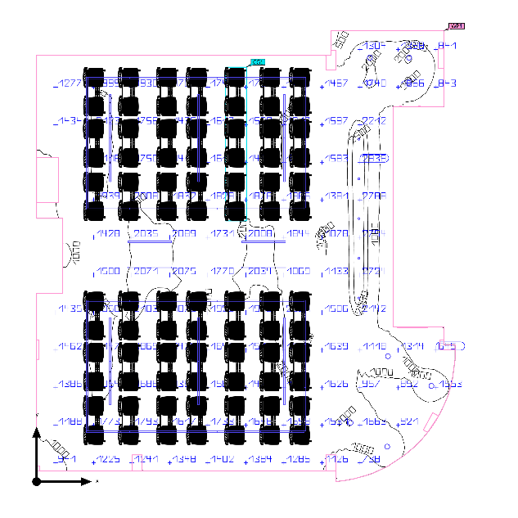
Figure ‎4.9 Artificial light only result from DIALUX EVO
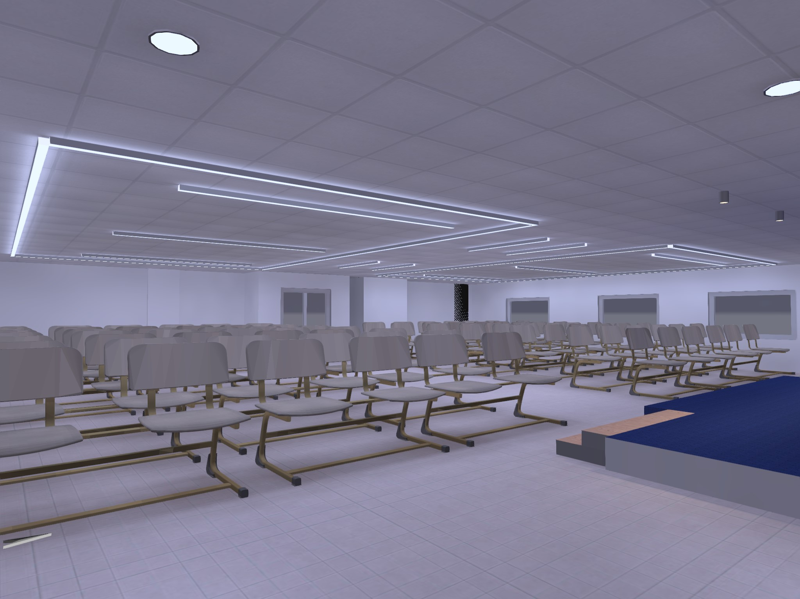
Figure ‎4.10 3D view meeting room
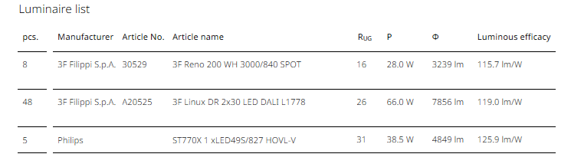
Figure ‎4.11 Luminaire list.

Waiting room
Waiting for visual task according to European code needs 200 Lux, uniformity 0.4, and a glare less than 19.

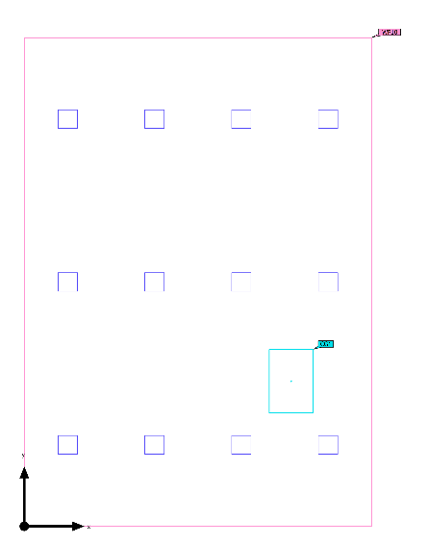
Figure 7 luminaire layout plan of waiting room
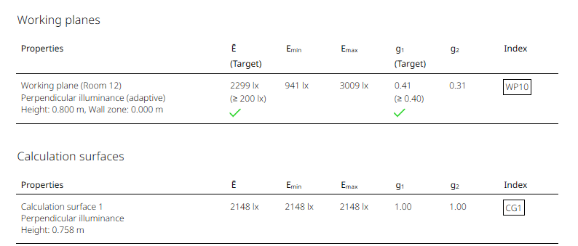
Figure 8 waiting and reception room DIALUX results.
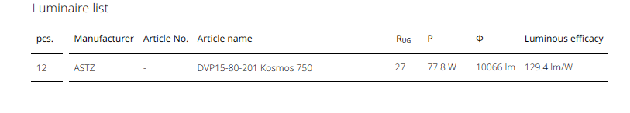
Figure 9 Luminaire list
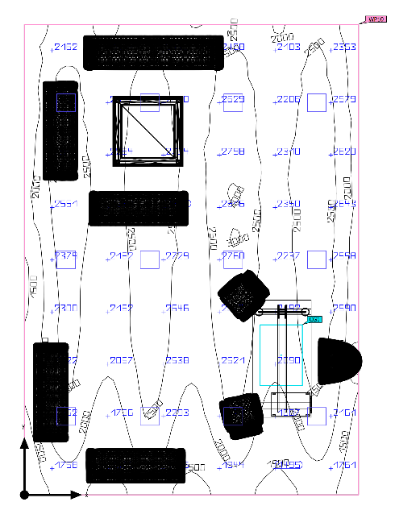
Figure 10 the result Artificial light only for waiting room.
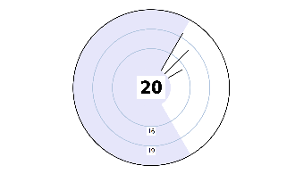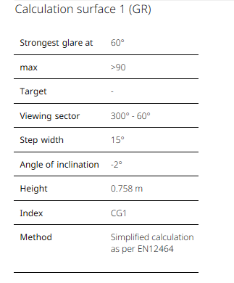
Figure ‎4.12 UGR CHECK

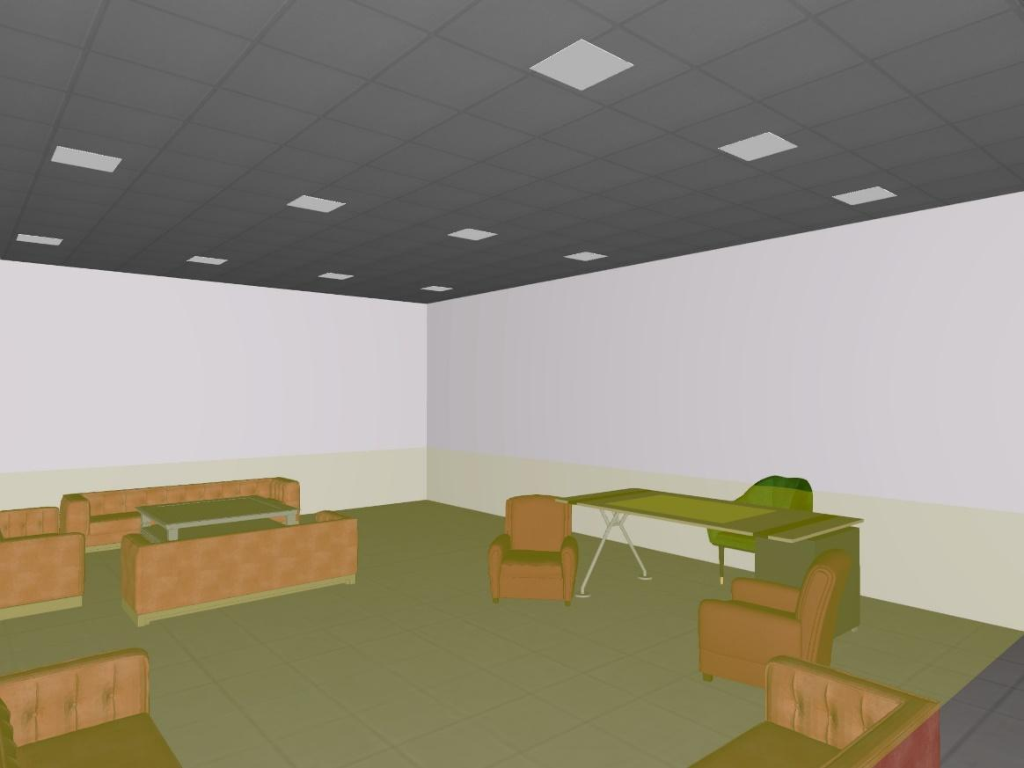
Figure 11: 3d view reception room

Bedroom
Bedroom for visual task according to European code needs 300-500 Lux, uniformity 0.6, and a glare less than 19
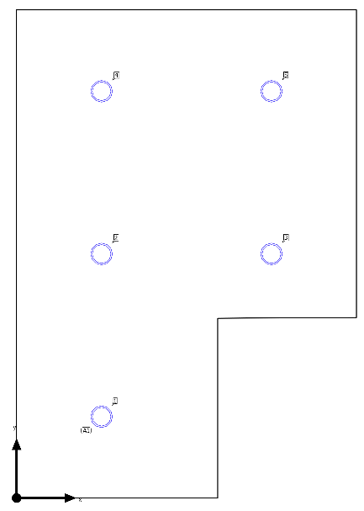
Figure 12: luminaire layout plan of bedroom /hotel.

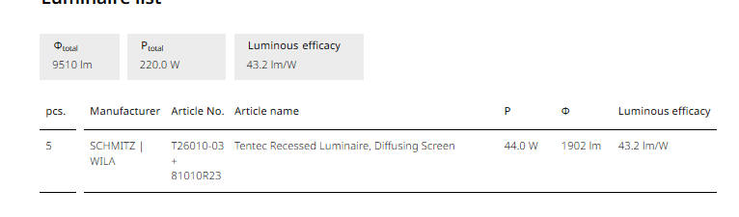.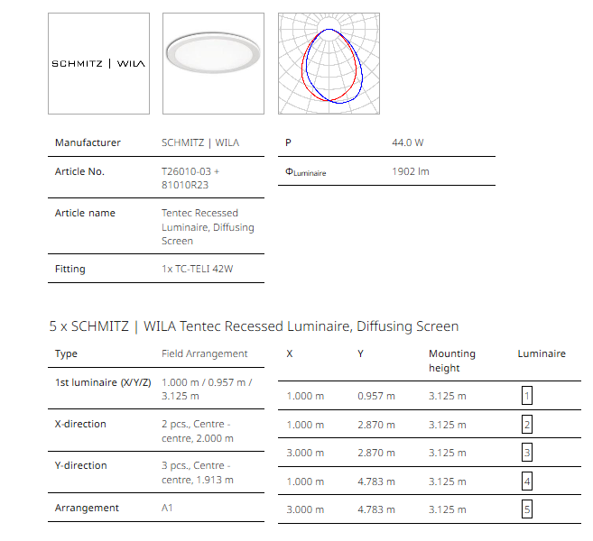
Figure 13: Luminaire list
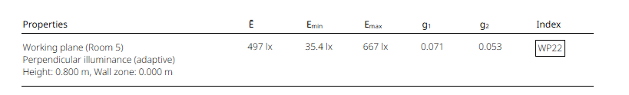
Figure 14 bedroom/hotel DIALUX results.

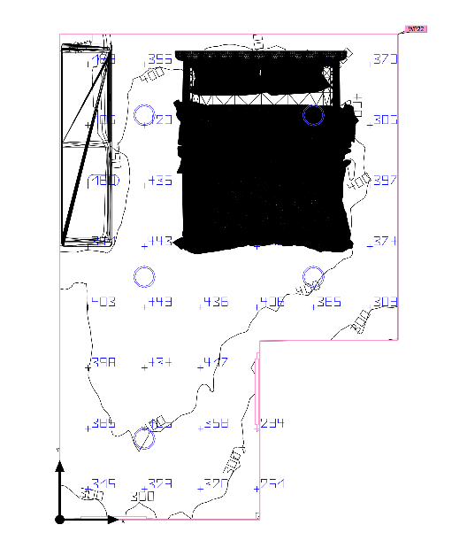
Figure ‎4.13: the result Artificial light only for bedroom
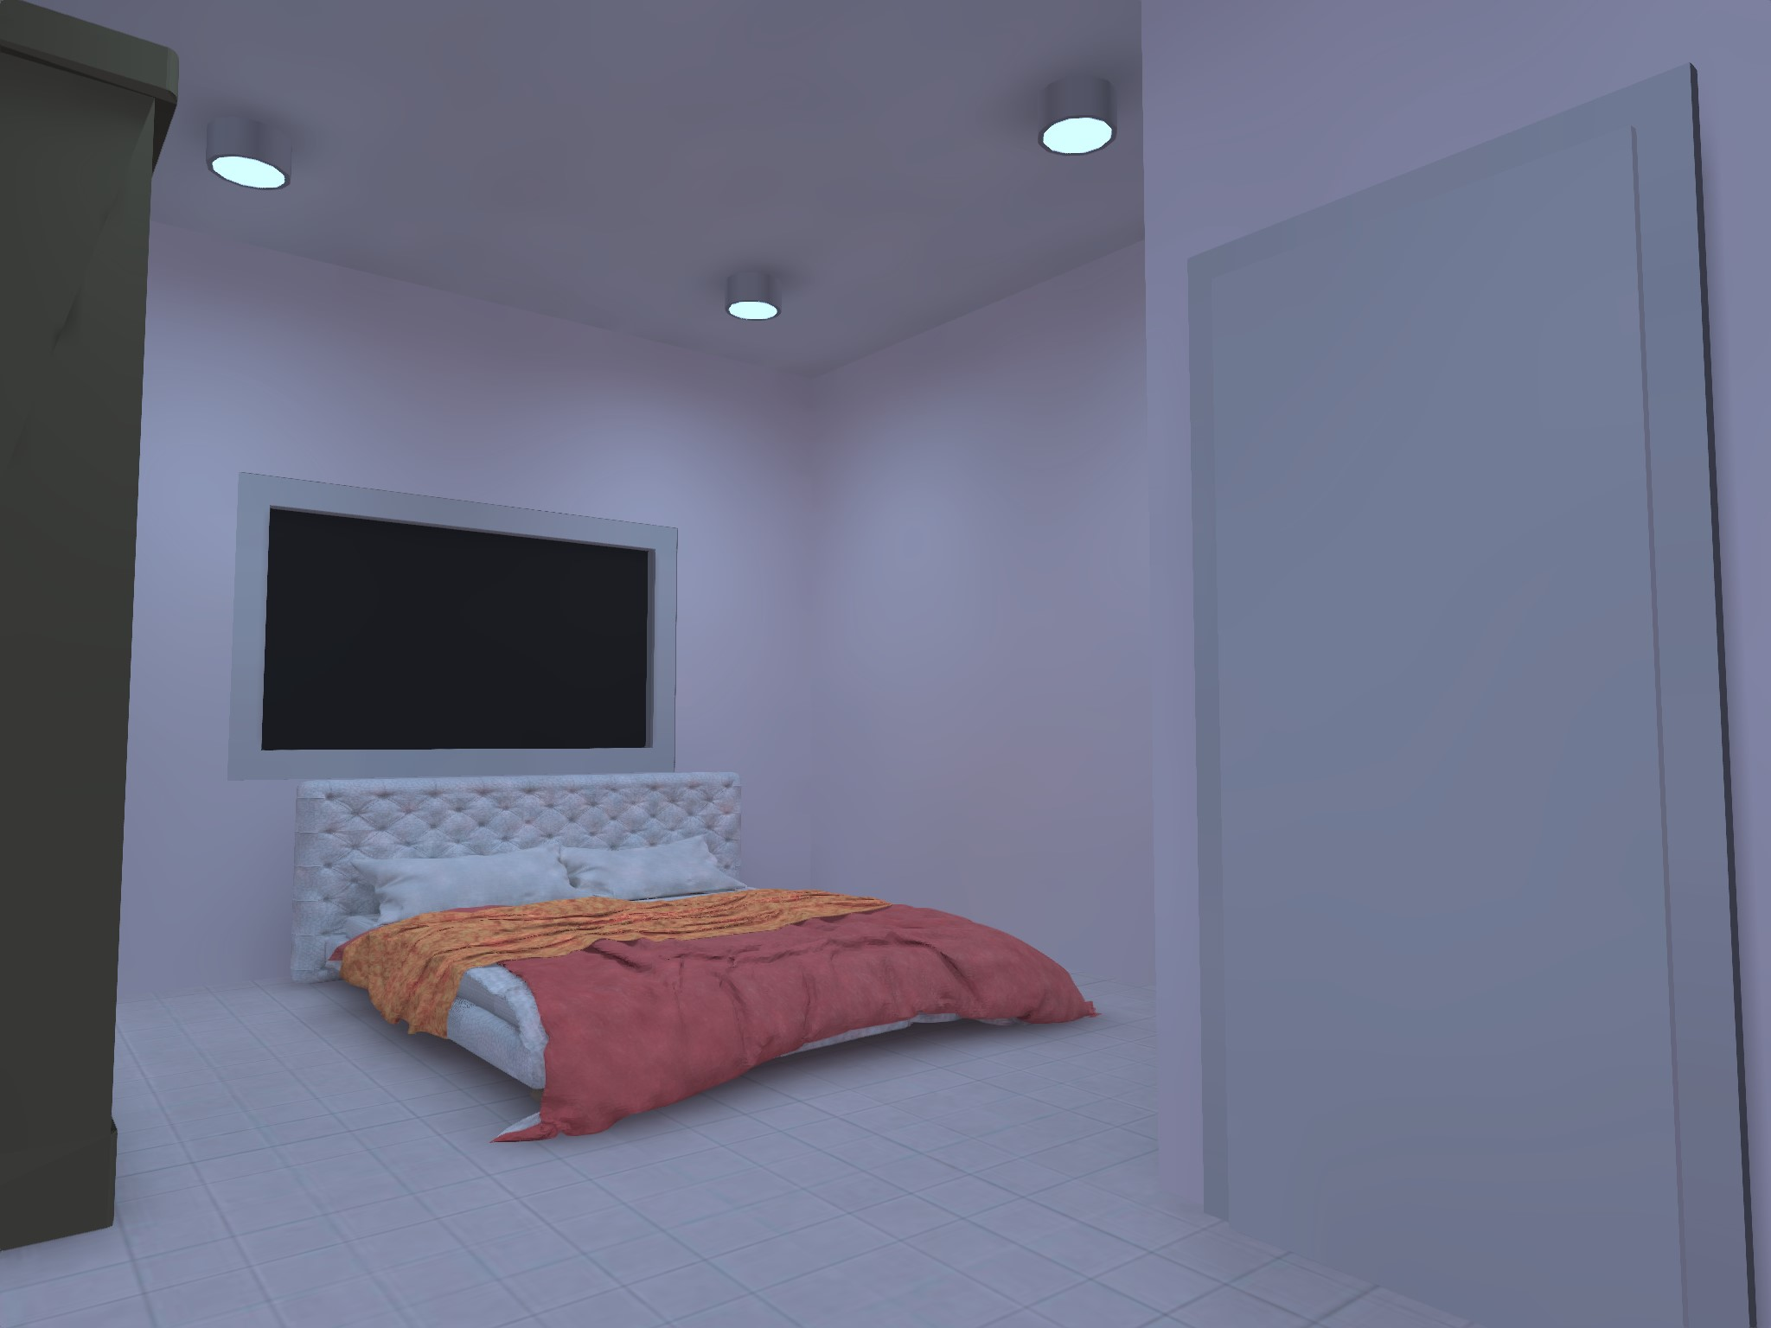
Figure ‎4.14: 3d view bedroom

Corridor
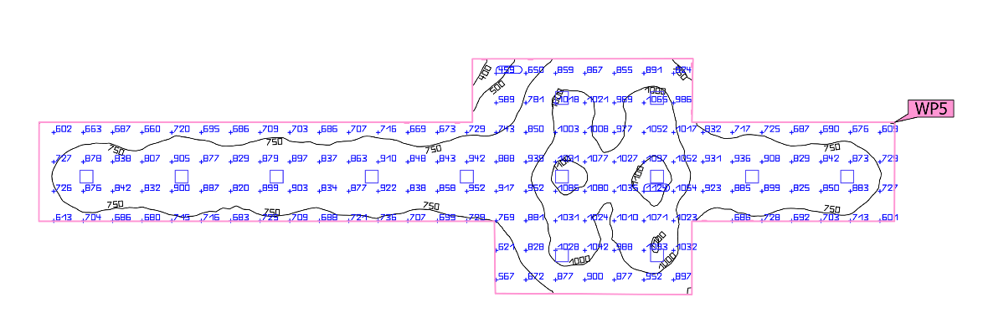
Figure ‎4.15: the result Artificial light only for corridor
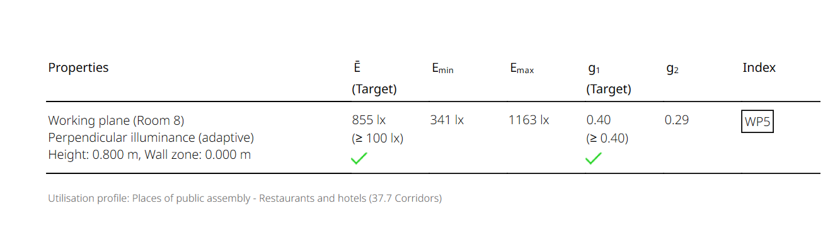

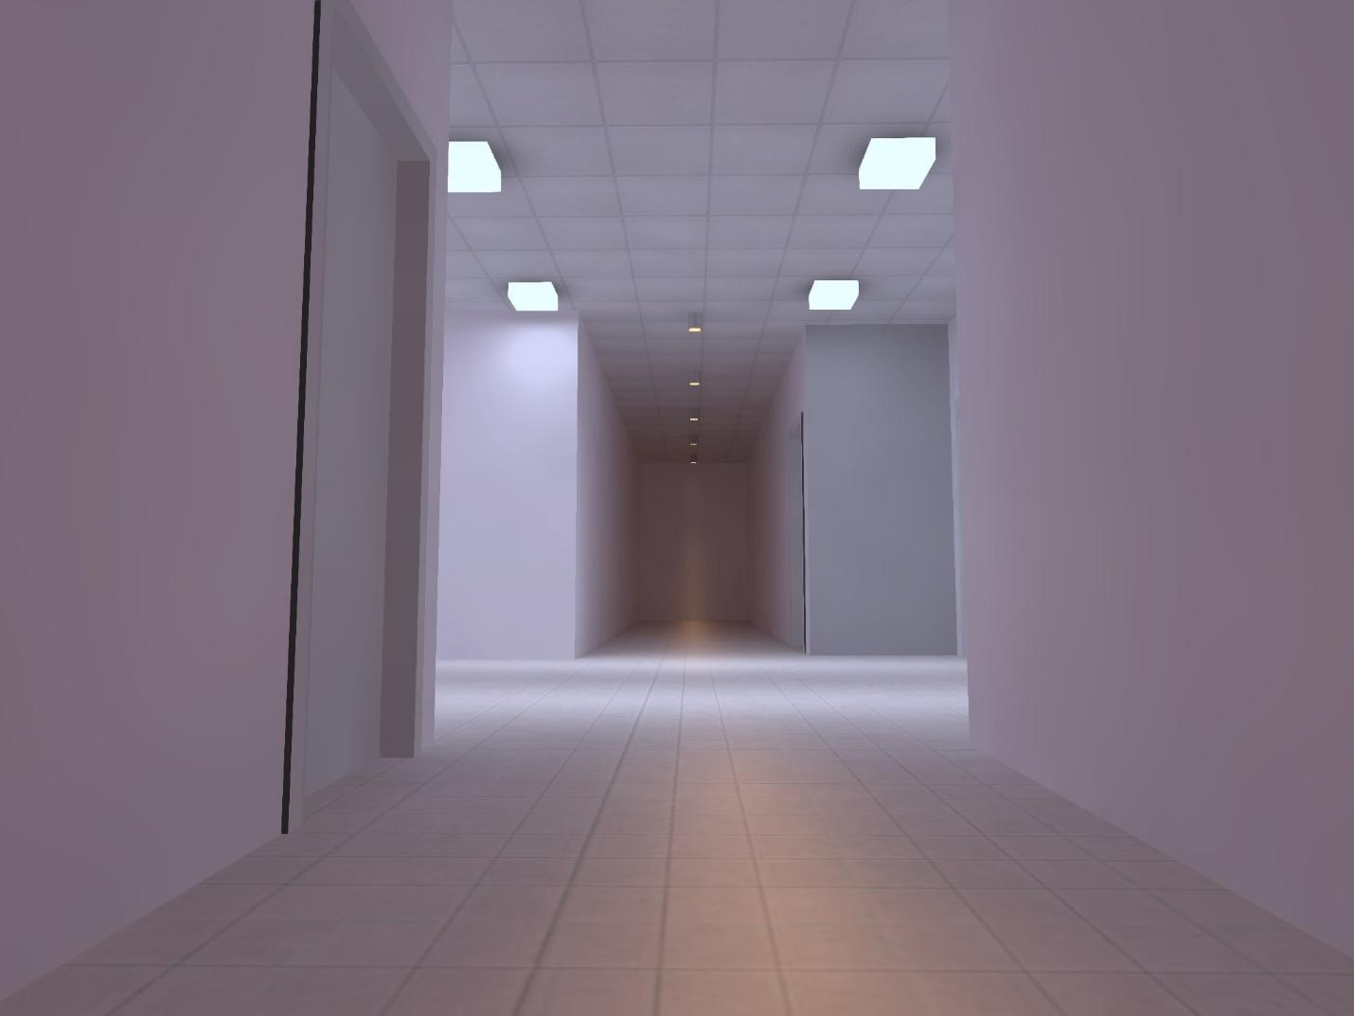
Figure ‎4.16: 3d view

Lobby
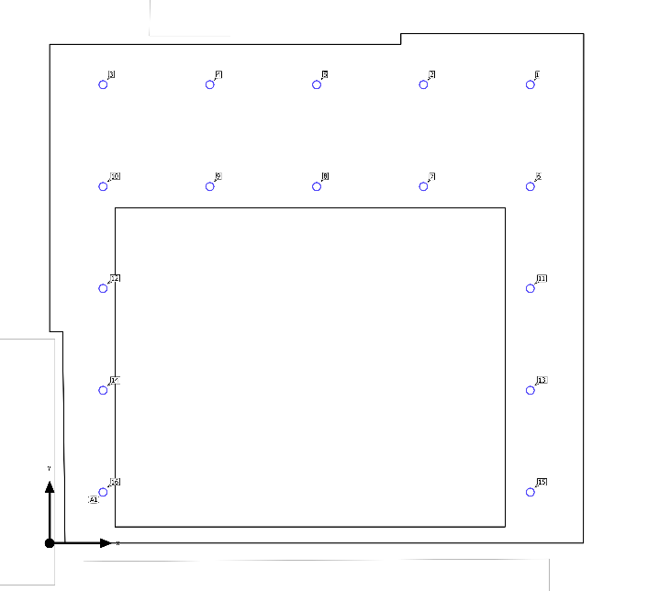
Figure ‎4.17: luminaire layout plan of lobby
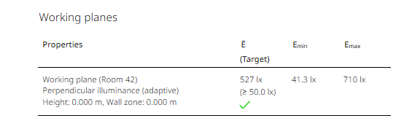
Figure ‎4.18: the result Artificial light only for lobby
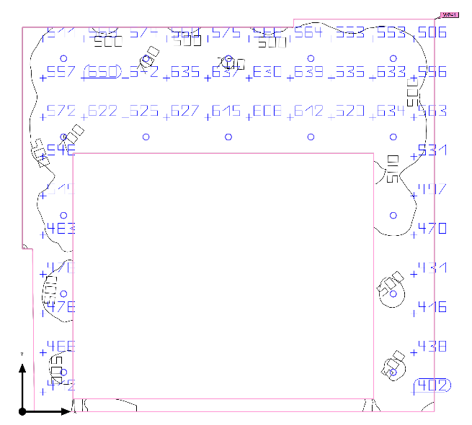
Figure ‎4.19: the result Artificial light only for bedroom
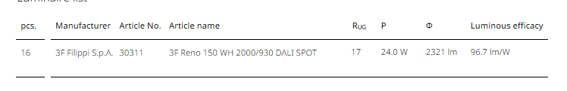
Figure ‎4.20: Luminaire list
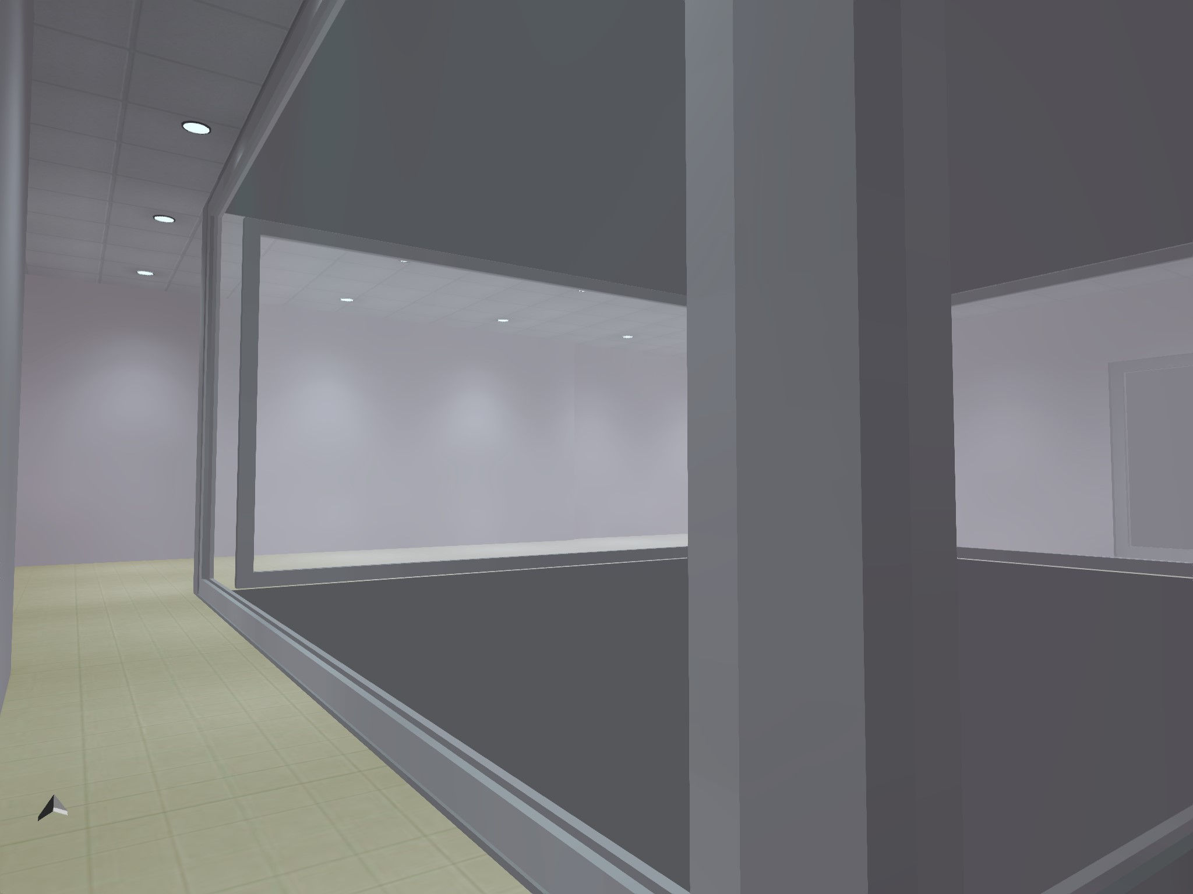
Figure ‎4.21 3d view

Coffee
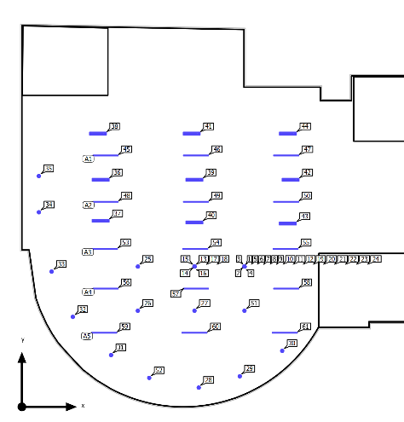
Figure ‎4.22 luminaire layout plan of coffee
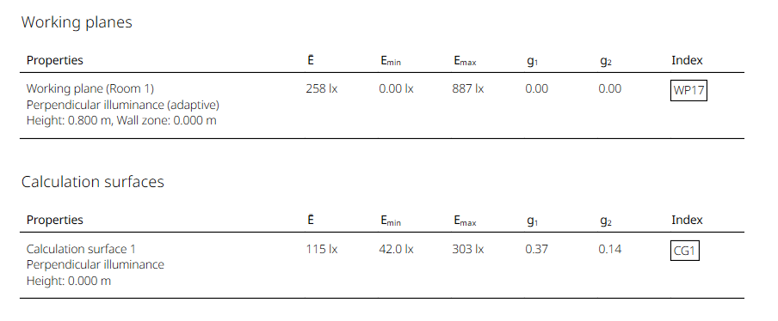
Figure ‎4.23 the result Artificial light only for coffee
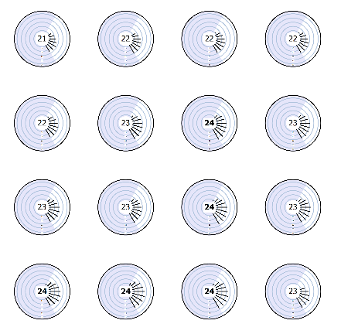
Figure ‎4.24 UGR Check
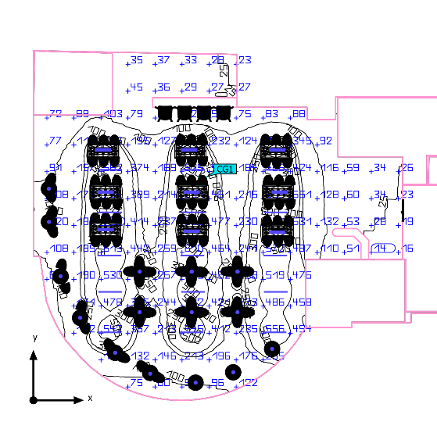
Figure ‎4.25 the result Artificial light only for coffee
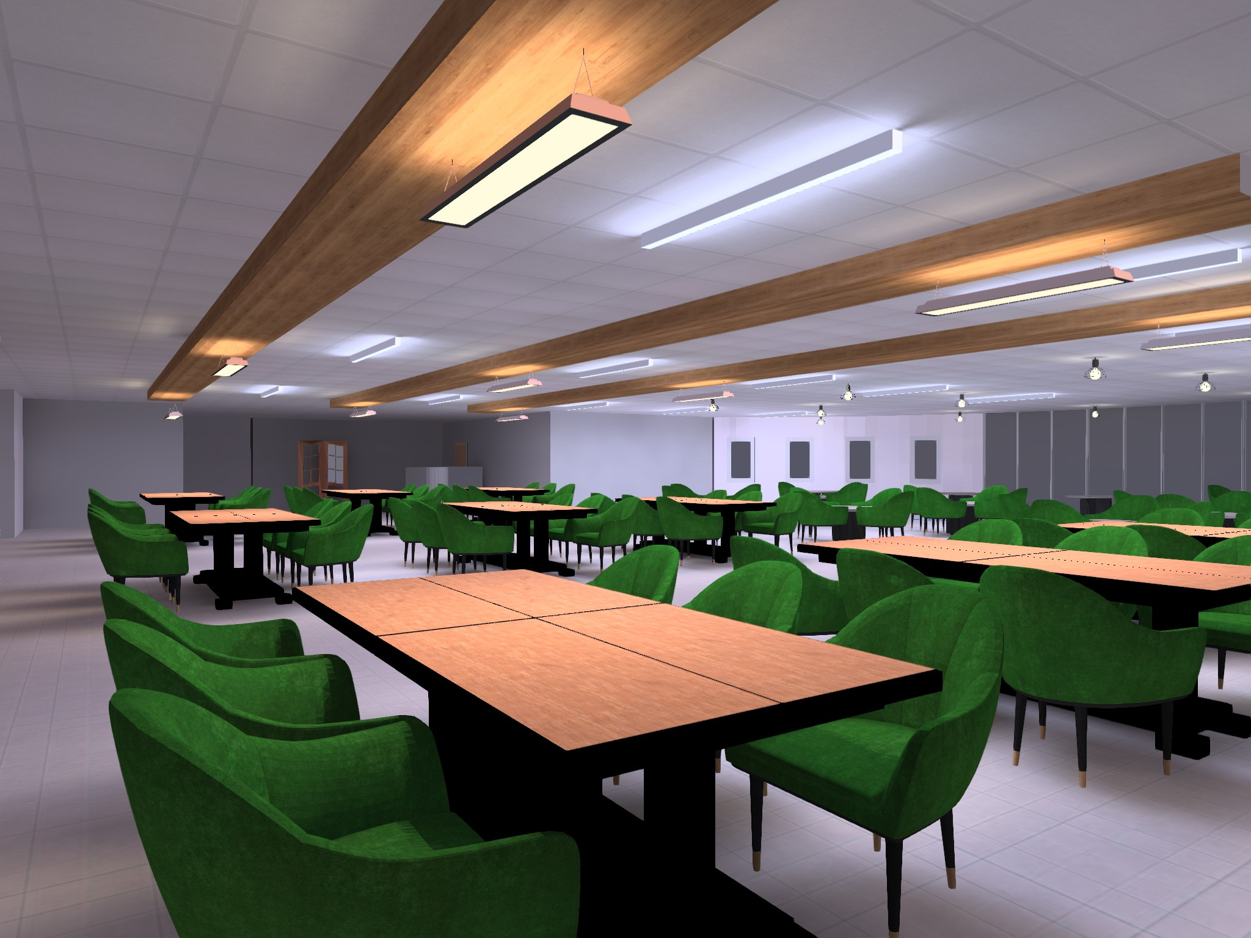
Figure ‎4.26 3d view

WC
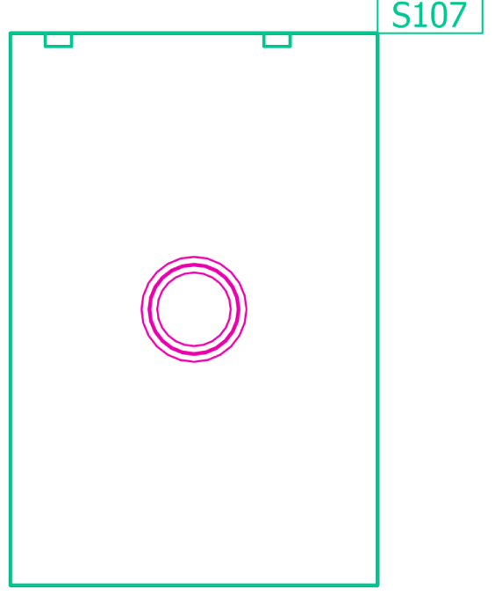
Figure ‎4.27 luminaire layout plan for WC.
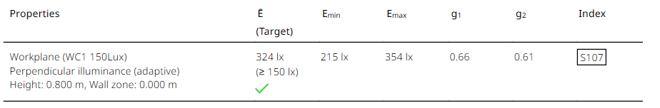
Figure ‎4.28 WC room DIALUX results.
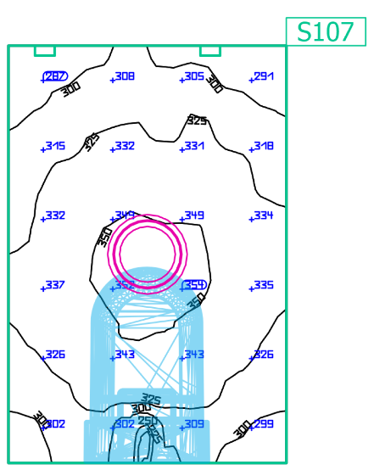
Figure ‎4.29 Simulation spatial layout in DIALUX EVO from Artificial light only.
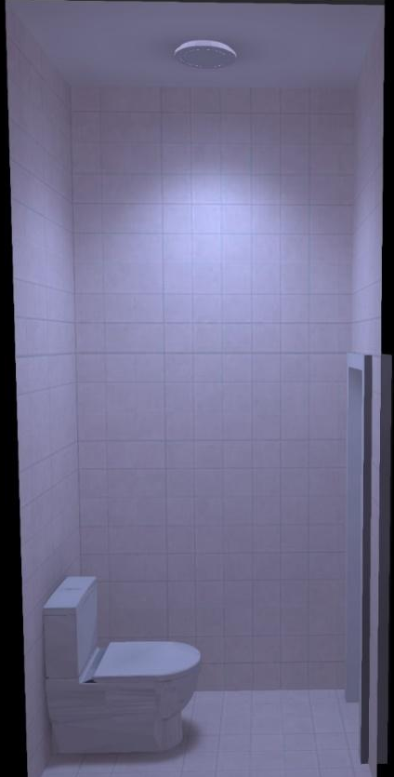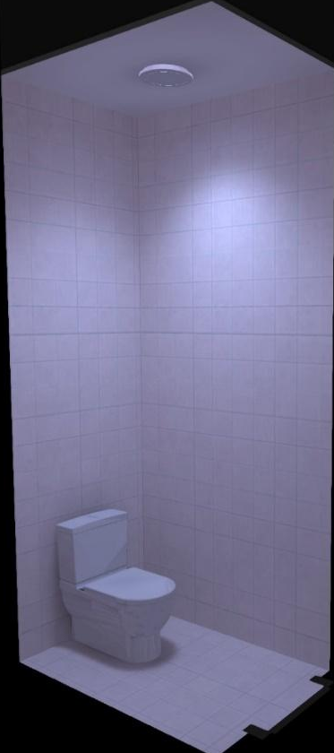
Figure ‎4.30 3D view of WC

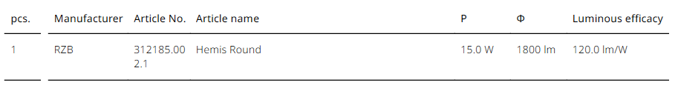
Figure ‎4.31 Luminaire list

Coffee 2
Coffee for visual task according to European code needs 150 Lux, uniformity 0.6, and a glare less than 19.

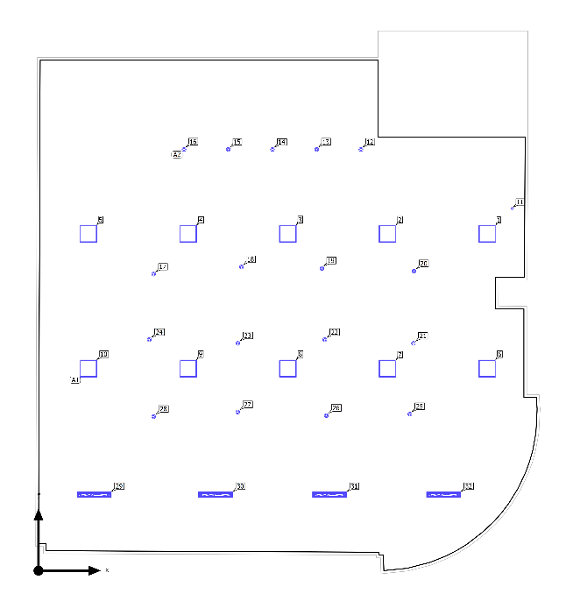
Figure ‎4.32 luminaire layout plan of coffee
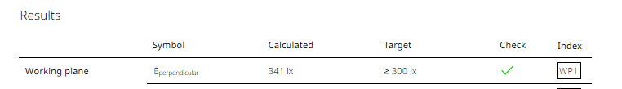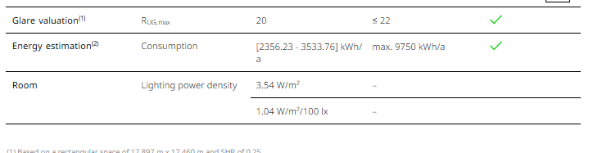
Figure ‎4.33 Coffee room DIALUX results.
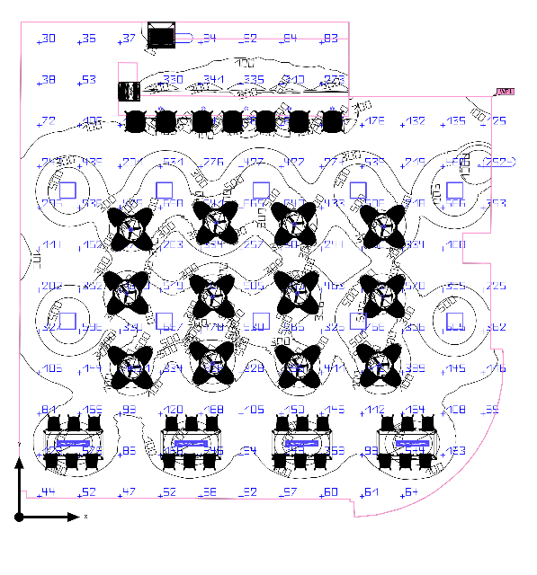
Figure ‎4.34 the result Artificial light only for coffee
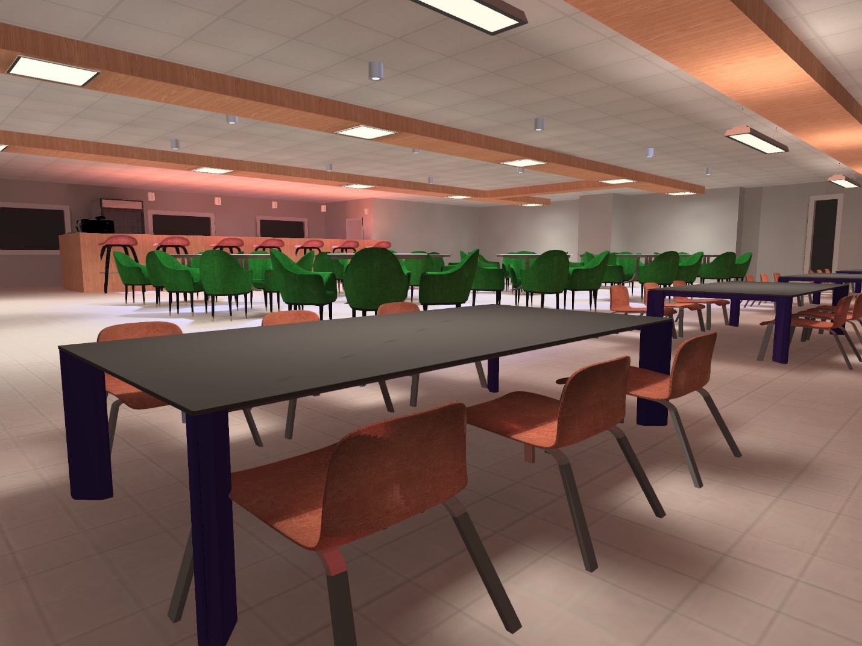
Figure ‎4.35 3d view for coffee

Furniture room
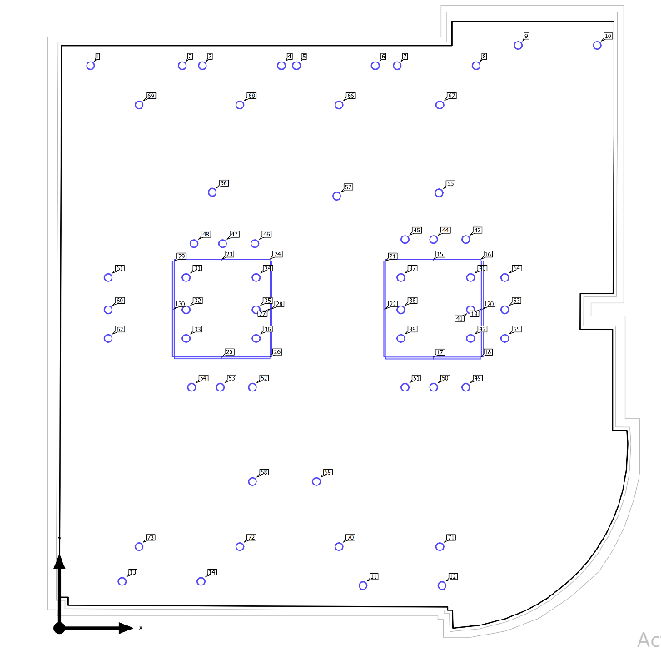
Figure ‎4.36 luminaire layout plan of furniture room
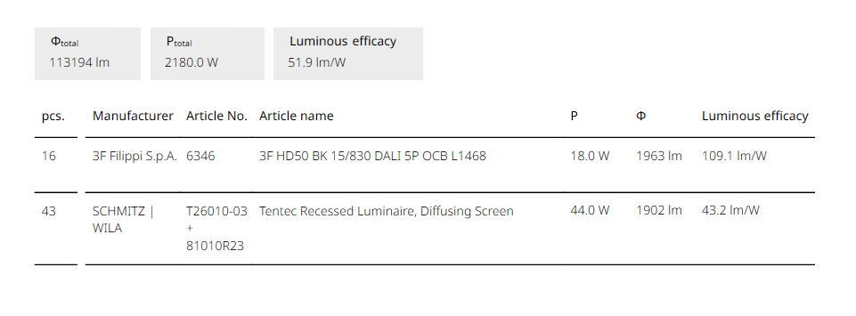
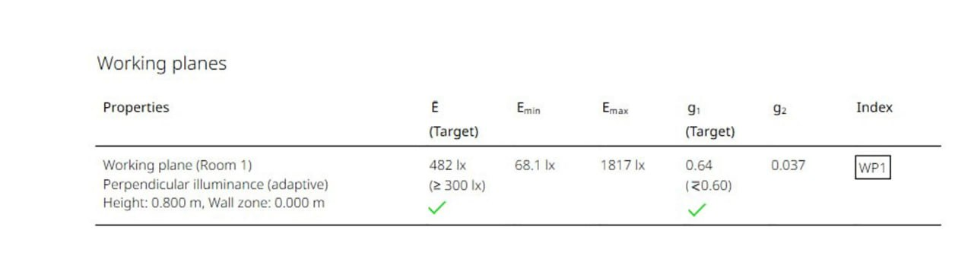
Figure ‎4.37 furniture room DIALUX results.
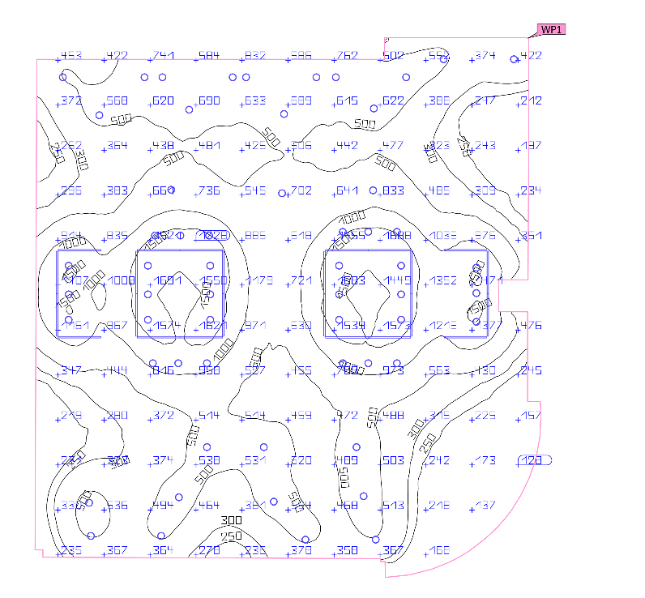
Figure ‎4.38: the result Artificial light only for furniture

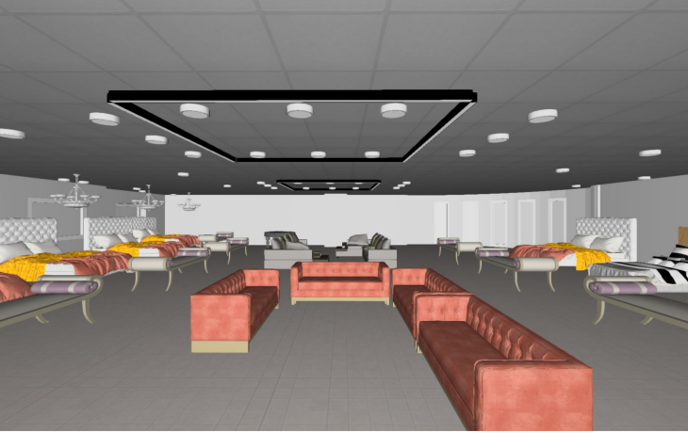
Figure ‎4.39: 3d view for furniture room
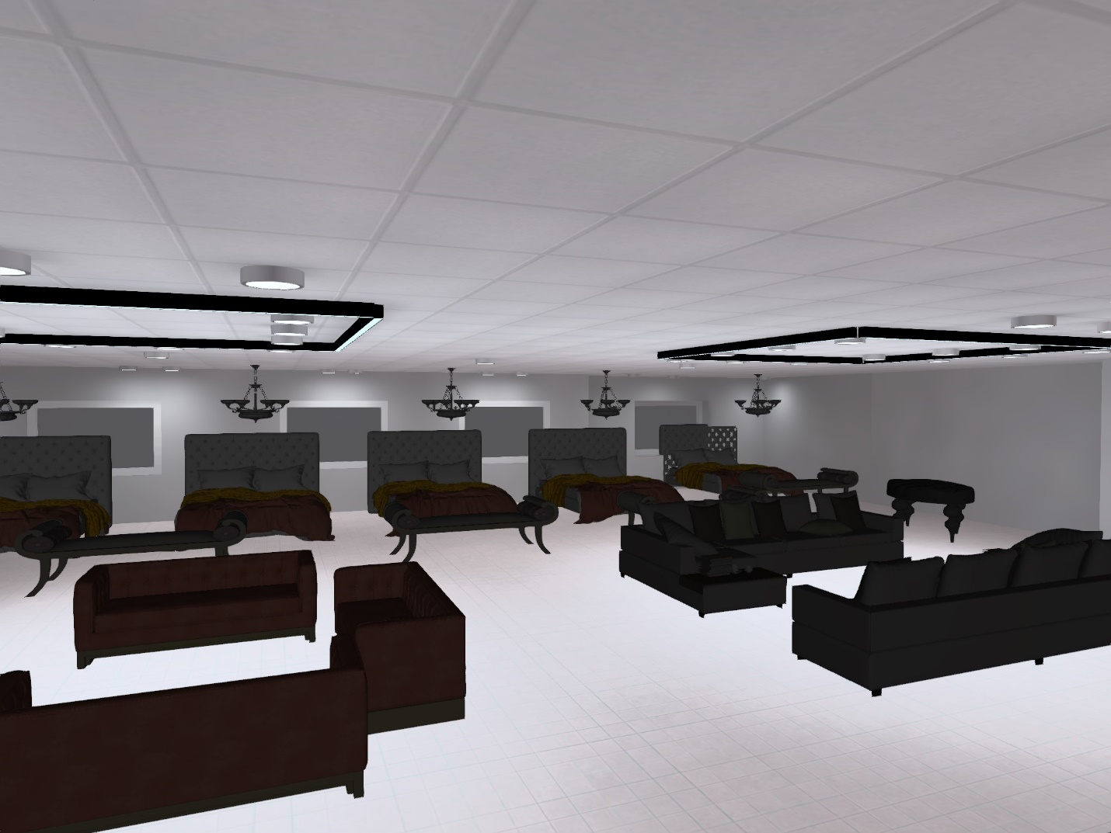
Figure ‎4.40: 3d view for furniture room

HVAC Design

Introduction
Heating, Ventilation, and Air Conditioning (HVAC) systems are essential components of modern office buildings, providing a comfortable and healthy indoor environment for occupants. HVAC systems are designed to maintain indoor air quality, temperature, and humidity levels within acceptable ranges while also minimizing energy consumption and operating costs.
The design of an HVAC system for an office building requires careful consideration of factors such as building size, occupancy levels, local climate, and energy efficiency goals. A well-designed system should provide efficient and effective heating, cooling, and ventilation while also ensuring good indoor air quality, noise levels, and thermal comfort.
The design process typically involves several stages, including load calculation, equipment selection, ductwork design, and control system design. During load calculation, engineers determine the heating and cooling requirements of the building based on factors such as its size, orientation, and insulation levels. This information is then used to select appropriate HVAC equipment and design the ductwork system that distributes conditioned air throughout the building.

Loads calculations
The cooling loads were calculated using Design builder software:
- Total cooling load =370.66 KW
- Total heating load = 326.24 KW

Note: The cooling load will be uses for building the HVAC system since it is greater than the heating load.
The next table shows cooling load for each space.

Table ‎4-1: Spaces cooling loads.
Block | Zone | Cooling load | Design Cooling/(W/m2)
GF | Zone21 | 17.83 | 56.5
GF | Zone20 | 2.29 | 80.7
GF | Zone19 | 2.81 | 74.5
GF | Zone13 | 2.64 | 83
GF | Zone12 | 2.6 | 65
GF | Zone11 | 2.6 | 63
GF | Zone5 | 0.2 | 55.6
GF | Zone7 | 5.77 | 54
GF | Zone9 | 7.83 | 82
GF | Zone8 | 7.5 | 67.5
GF | Zone6 | 9.01 | 57.5
GF | Zone16 | 6.04 | 63.2
GF | Zone15 | 5.82 | 73.6
GF | Zone10 | 14.71 | 78.6
GF | Zone4 | 3.17 | 51.6
GF | Zone3 | 4.01 | 67.1
GF | Zone1 | 10.69 | 63.2
GF | Zone2 | 9.84 | 53.7
1st floor | Zone4 | 15 | 71.3
1st floor | Zone5 | 21 | 69.7
1st floor | Zone6 | 10.58 | 83
1st floor | Zone1 | 1.83 | 46.4
2nd floor | Zone5 | 0.4 | 63.2
2nd floor | Secretary | 0.95 | 47.6
2nd floor | Public Service | 16.98 | 57.8
2nd floor | MainStair1 | 9.95 | 91.7
2nd floor | Meeting Hall | 22.13 | 75.1
2nd floor | Servers | 0.51 | 52.8
2nd floor | Kitchen | 0.48 | 55.6
2nd floor | Archive | 0.73 | 49.7
2nd floor | Control Room | 0.98 | 57.2
2nd floor | Meeting Room | 3.07 | 44.9
2nd floor | IT Room | 1.53 | 55.8
2nd floor | Economic Department | 2.59 | 80.5
2nd floor | Public Relations | 1.47 | 58.4
2nd floor | Preidentified | 2.45 | 70.9
2nd floor | Secretary1 | 0.8 | 50
2nd floor | General Manager Office | 4.37 | 97.1
3rd floor | Office1 | 1.98 | 50.1
3rd floor | Office2 | 1.08 | 44.9
3rd floor | Office3 | 1.02 | 52.6
3rd floor | Waiting1 | 1.29 | 51.8
3rd floor | Office4 | 1.07 | 53.7
3rd floor | Zone | Cooling load | Design Cooling/(W/m2)
3rd floor | Waiting2 | 1.24 | 51.6
3rd floor | Office5 | 1.15 | 56.2
3rd floor | Office6 | 0.91 | 48.2
3rd floor | Corridor2 | 14.6 | 62.4
3rd floor | Waiting3 | 0.69 | 47.4
3rd floor | Office7 | 2.57 | 53.7
3rd floor | Waiting4 | 0.84 | 66.1
3rd floor | Office8 | 2.13 | 132.7
3rd floor | Office9 | 2.48 | 77
3rd floor | Waiting5 | 0.92 | 47
3rd floor | Office10 | 2.27 | 50.3
3rd floor | Office11 | 1.54 | 59.4
3rd floor | Corridor | 1.85 | 88.6
3rd floor | Waiting6 | 0.9 | 44.9
3rd floor | Waiting7 | 2.05 | 44.3
3rd floor | Kitchen | 0.28 | 48.2
3rd floor | Office12 | 9.03 | 50.3
3rd floor | Office13 | 1.39 | 45.8
3rd floor | Waiting8 | 0.81 | 43
3rd floor | Waiting9 | 0.82 | 44.4
3rd floor | Waiting | 1.95 | 59.4
3rd floor | Office14 | 4.31 | 87.9
3rd floor | Office15 | 1.86 | 52.7
3rd floor | Office | 2.75 | 94.3
4th floor | Office1 | 2.12 | 53.6
4th floor | Office2 | 1.27 | 52.9
4th floor | Office3 | 1.16 | 59.6
4th floor | Waiting1 | 1.42 | 56.8
4th floor | Office4 | 1.18 | 59.5
4th floor | Waiting2 | 1.36 | 56.5
4th floor | Office5 | 1.2 | 58.7
4th floor | Office6 | 0.94 | 50
4th floor | Corridor2 | 10.5 | 67.9
4th floor | Waiting3 | 0.74 | 50.6
4th floor | Office7 | 2.78 | 50.3
4th floor | Waiting4 | 0.91 | 71.8
4th floor | Office8 | 2.27 | 141
4th floor | Office9 | 2.73 | 50.3
4th floor | Waiting5 | 1.11 | 56.8
4th floor | Office10 | 2.24 | 50.3
4th floor | Office11 | 1.61 | 62.3
4th floor | Corridor | 1.91 | 91.7
4th floor | Waiting6 | 1 | 49.9
4th floor | Waiting7 | 2.33 | 50.3
4th floor | Kitchen | 0.32 | 54.7
4th floor | Zone | Cooling load | Design Cooling/(W/m2)
4th floor | Office13 | 1.62 | 53.3
4th floor | Waiting8 | 0.96 | 50.4
4th floor | Waiting9 | 0.95 | 51.2
4th floor | Waiting | 2.19 | 66.7
4th floor | Office14 | 4.6 | 93.9
4th floor | Office15 | 2.13 | 60.3
4th floor | Office | 2.9 | 79.1
5th floor | Zone31 | 2.37 | 86.7
5th floor | Zone5 | 9.12 | 86.6
5th floor | Zone13 | 2.34 | 76.9
5th floor | Zone10 | 2.12 | 101.9
5th floor | Zone14 | 1.71 | 83.8
5th floor | Zone8 | 0.48 | 35.3
5th floor | Zone30 | 20 | 77.7
5th floor | Zone9 | 0.23 | 73.2
5th floor | Zone26 | 0.74 | 33
5th floor | Zone21 | 1.27 | 30.4
5th floor | Zone22 | 0.44 | 27.9
5th floor | Zone25 | 0.66 | 31.6
5th floor | Zone19 | 0.16 | 47.5
5th floor | Zone24 | 0.51 | 29.2
5th floor | Zone23 | 0.84 | 31
5th floor | Zone18 | 0.11 | 32.5
5th floor | Zone20 | 0.45 | 26.1
5th floor | Zone16 | 0.46 | 37.4
6th Floor | Restaurant main | 26 | 92.8
6th Floor | Events Restaurant | 25.06 | 90.5
6th Floor | Kitchen | 1.58 | 76.9
6th Floor | Zone6 | 18.74 | 64.9
6th Floor | Rest Management | 2.72 | 75.5
6th Floor | Prayer Area | 2.17 | 73.3
Totals |  | 370.66

Equipment selection
Daikin company was selected for design, and VRV system will be used for the design.
VRV system concept:
Variable Refrigerant Volume (VRV) system is a type of heating, ventilation, and air conditioning (HVAC) system that offers precise temperature control, energy efficiency, and flexibility in building design. This system uses a single outdoor unit that connects to multiple indoor units through a network of refrigerant pipes, allowing each indoor unit to operate independently and provide heating or cooling as required. (DAIKIN, 2018)
The VRV system uses a refrigerant, which circulates through the system to transfer heat. The outdoor unit houses the compressor, which compresses the refrigerant gas, and the heat exchanger, which dissipates heat from the refrigerant to the outdoor air. Inside the building, each indoor unit has its own fan and heat exchanger, which circulates air over the heat exchanger to provide heating or cooling. (DAIKIN, 2018)
- For stores, meeting room and offices cassette unit system will be used.
- For Hotel, split unit system will be used.
- For Restaurant, coffee shop and show area VRV system with slot linear diffusers will be used with exhaust system for ventilation purposes.

- Outdoor units’ selection
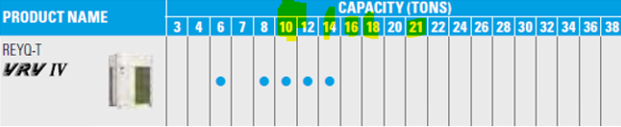
Figure ‎4.41: Outdoor unit selected.

The table below shows the floors Total cooling load and the number of outdoor units required:
Table ‎4-2: Floors total cooling loads.
Floor | Total cooling load (Kw) | Outdoor unit capacity (Ton) | Outdoor unit capacity (KW) | Number of outdoor units
Ground floor | 73.50 | 21 | 73.85 | 1
First floor | 45.03 | 14 | 49.23 | 1
Second floor | 55.01 | 16 | 56.27 | 1
Third floor | 50.05 | 16 | 56.27 | 1
Fourth floor | 49.35 | 14 | 49.23 | 1
Fifth floor | 35.01 | 10 | 35.17 | 1
Sixth floor | 63.30 | 18 | 63.30 | 1

Cassette unit
The Cassette unit system has been used in hotel offices, stores and meeting hall

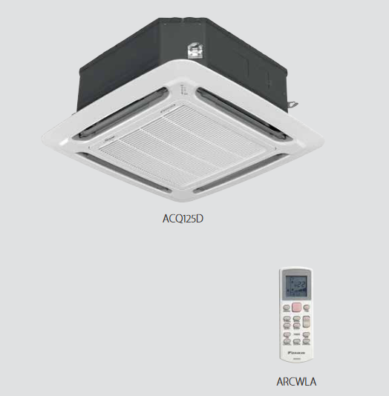
Figure ‎4.42: Cassette unit selected. (DAIKIN, 2018)

Table ‎4-3: Cassette unit selected specifications. (DAIKIN, 2018)

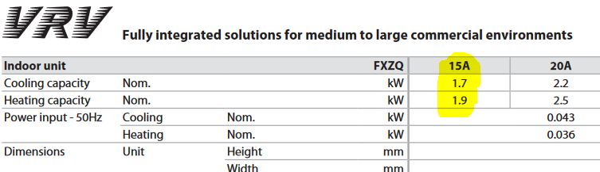

Number of cassette unit = $\frac{Space cooling load (Kw)}{Cassette unit capacity from catalogue }$

Split unit
The split unit system has been used in hotel sweets
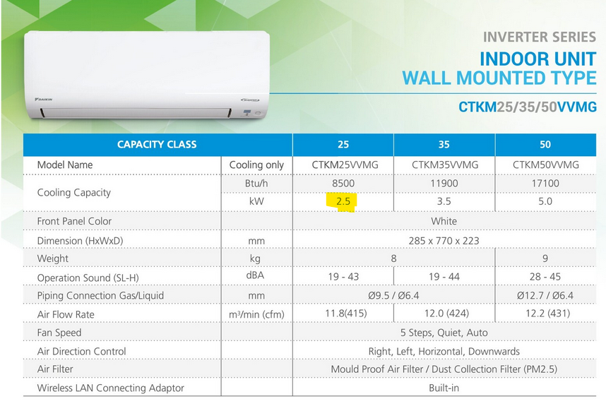
Figure ‎4.43: Split unit used.
Number of Split unit = $\frac{Space cooling load (Kw)}{split unit capacity from catalogue }$

Fan coli unit
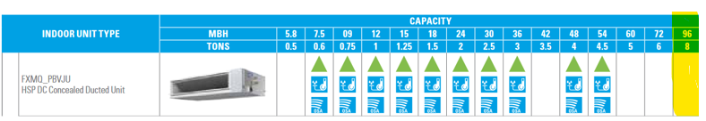
Figure ‎4.44: Fan coil unit selected.
Fan coil unit will be used only for VRV ducted system, and the number of fan coils depends on the capacity of the covered zones.
Number of fan coil unit =$\frac{Covered zones capacity}{Fan coil capcity}$

Diffuser
The diffuser has been selected based on the Noise criteria and Through.
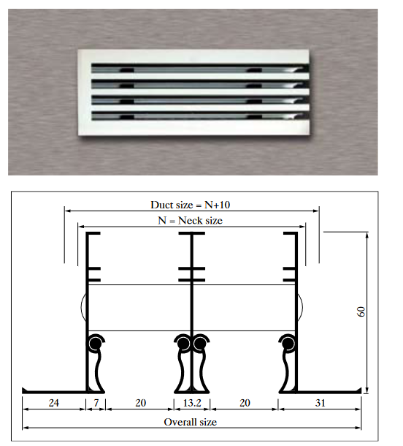
Figure ‎4.45: Slot linear diffuser selected.

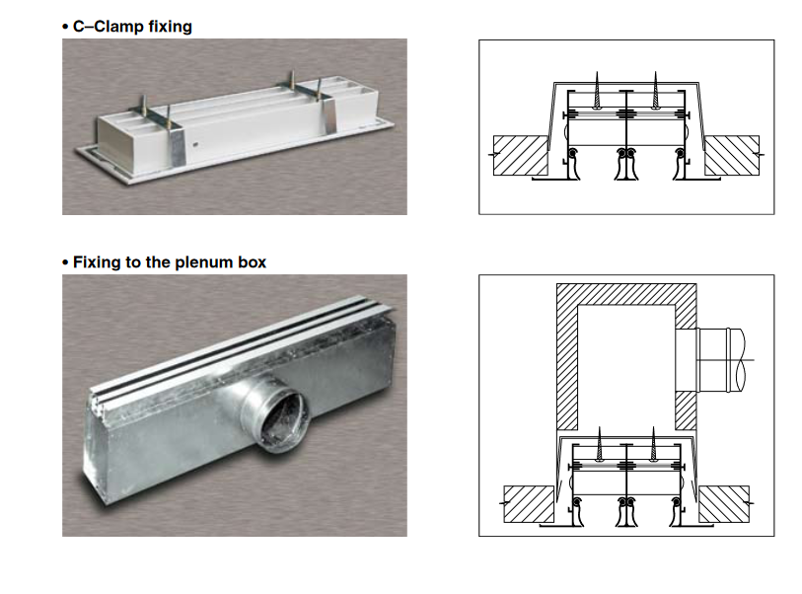
Figure ‎4.46: Slot linear diffuser.

Table ‎4-4: Slot linear diffuser selected.
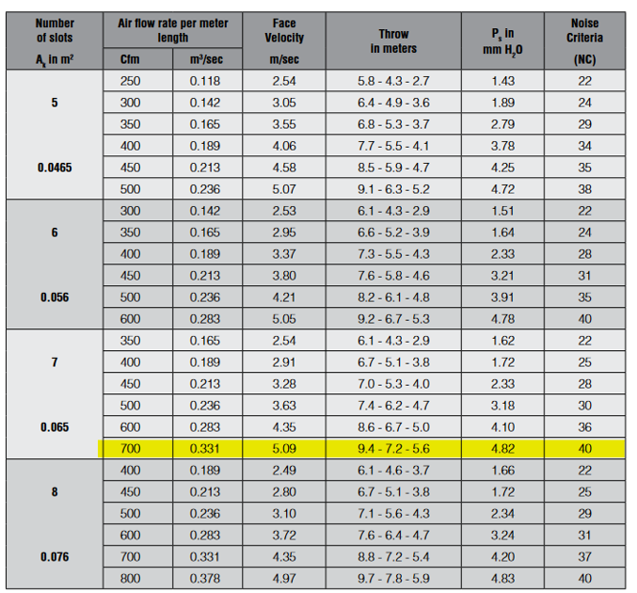

Design results

The tables below show the number of outdoor and indoor unit for each floor
- Ground floor
Block | Zone | System type | Number of outdoor unit | Number of indoor units
GF(stores) | Zone21 | Cassette unit | 1 | 1
GF(stores) | Zone20 | Cassette unit | 1 | 1
GF(stores) | Zone19 | Cassette unit | 1 | 1
GF(stores) | Zone13 | Cassette unit | 1 | 2
GF(stores) | Zone12 | Cassette unit | 1 | 1
GF(stores) | Zone11 | Cassette unit | 1 | 1
GF(stores) | Zone5 | Cassette unit | 1 | 2
GF(stores) | Zone7 | Cassette unit | 1 | 2
GF(stores) | Zone9 | Cassette unit | 1 | 1
GF(stores) | Zone8 | Cassette unit | 1 | 3
GF(stores) | Zone6 | Cassette unit | 1 | 1
GF(stores) | Zone16 | Cassette unit | 1 | 1
GF(stores) | Zone15 | Cassette unit | 1 | 1
GF(stores) | Zone10 | Cassette unit | 1 | 1
GF(stores) | Zone4 | Cassette unit | 1 | 1
GF(stores) | Zone3 | Cassette unit | 1 | 1
GF(stores) | Zone1 | Cassette unit | 1 | 1
GF(stores) | Zone2 | Cassette unit | 1 | 1

- First floor

Block | Zone | System type | Number of outdoor units | Number of indoor units
1st floor (furniture show area) | Zone4 | VRV system with diffusers | 1 | 14
1st floor (furniture show area) | Zone5 | VRV system with diffusers | 1 | 24
1st floor (furniture show area) | Zone6 | VRV system with diffusers | 1 | 9

- second floor
Block | Zone | System type | Number of outdoor units | Number of indoor units
2nd floor | Zone5 | Cassette unit | 1 | 1
2nd floor | Secretary | Cassette unit | 1 | 1
2nd floor | Public Service | Cassette unit | 1 | 3
2nd floor | MainStair1 | Cassette unit | 1 | 6
2nd floor | Meeting Hall | Cassette unit | 1 | 1
2nd floor | Servers | Cassette unit | 1 | 1
2nd floor | Kitchen | Cassette unit | 1 | 1
2nd floor | Archive | Cassette unit | 1 | 1
2nd floor | Control Room | Cassette unit | 1 | 2
2nd floor | Meeting Room | Cassette unit | 1 | 1
2nd floor | IT Room | Cassette unit | 1 | 1
2nd floor | Economic Department | Cassette unit | 1 | 1
2nd floor | Public Relations | Cassette unit | 1 | 1
2nd floor | Preidentified | Cassette unit | 1 | 1
2nd floor | Secretary1 | Cassette unit | 1 | 1
2nd floor | General Manager Office | Cassette unit | 1 | 1
2nd floor | Office1 | Cassette unit | 1 | 1
2nd floor | Office2 | Cassette unit | 1 | 1

- Third floor

Block | Zone | System type | Number of outdoor units | Number of indoor units
3rd floor | Office3 | Cassette unit | 1 | 1
3rd floor | Waiting1 | Cassette unit | 1 | 1
3rd floor | Office4 | Cassette unit | 1 | 1
3rd floor | Zone | Cassette unit | 1 | 1
3rd floor | Waiting2 | Cassette unit | 1 | 1
3rd floor | Office5 | Cassette unit | 1 | 1
3rd floor | Office6 | Cassette unit | 1 | 1
3rd floor | Corridor2 | Cassette unit | 1 | 1
3rd floor | Waiting3 | Cassette unit | 1 | 1
3rd floor | Office7 | Cassette unit | 1 | 1
3rd floor | Waiting4 | Cassette unit | 1 | 1
3rd floor | Office8 | Cassette unit | 1 | 1
3rd floor | Office9 | Cassette unit | 1 | 1
3rd floor | Waiting5 | Cassette unit | 1 | 1
3rd floor | Office10 | Cassette unit | 1 | 1
3rd floor | Office11 | Cassette unit | 1 | 1
3rd floor | Corridor | Cassette unit | 1 | 1
3rd floor | Waiting6 | Cassette unit | 1 | 1
3rd floor | Waiting7 | Cassette unit | 1 | 1
3rd floor | Kitchen | Cassette unit | 1 | 1
3rd floor | Office12 | Cassette unit | 1 | 1
3rd floor | Office13 | Cassette unit | 1 | 1
3rd floor | Waiting8 | Cassette unit | 1 | 1
3rd floor | Waiting9 | Cassette unit | 1 | 1
3rd floor | Waiting | Cassette unit | 1 | 1
3rd floor | Office14 | Cassette unit | 1 | 1
3rd floor | Office15 | Cassette unit | 1 | 1
3rd floor | Office | Cassette unit | 1 | 1

- Fourth floor
Block | Zone | System type | Number of outdoor units | Number of indoor units
5th floor | Office3 | Cassette unit | 1 | 1
5th floor | Waiting1 | Cassette unit | 1 | 1
5th floor | Office4 | Cassette unit | 1 | 1
5th floor | Zone | Cassette unit | 1 | 1
5th floor | Waiting2 | Cassette unit | 1 | 1
5th floor | Office5 | Cassette unit | 1 | 1
5th floor | Office6 | Cassette unit | 1 | 1
5th floor | Corridor2 | Cassette unit | 1 | 1
5th floor | Waiting3 | Cassette unit | 1 | 1
5th floor | Office7 | Cassette unit | 1 | 1
5th floor | Waiting4 | Cassette unit | 1 | 1
5th floor | Office8 | Cassette unit | 1 | 1
5th floor | Office9 | Cassette unit | 1 | 1
5th floor | Waiting5 | Cassette unit | 1 | 1
5th floor | Office10 | Cassette unit | 1 | 1
5th floor | Office11 | Cassette unit | 1 | 1
5th floor | Corridor | Cassette unit | 1 | 1
5th floor | Waiting6 | Cassette unit | 1 | 1
5th floor | Waiting7 | Cassette unit | 1 | 1
5th floor | Kitchen | Cassette unit | 1 | 1
5th floor | Office12 | Cassette unit | 1 | 1
5th floor | Office13 | Cassette unit | 1 | 1
5th floor | Waiting8 | Cassette unit | 1 | 1
5th floor | Waiting9 | Cassette unit | 1 | 1
5th floor | Waiting | Cassette unit | 1 | 1
5th floor | Office14 | Cassette unit | 1 | 1
5th floor | Office15 | Cassette unit | 1 | 1
5th floor | Office | Cassette unit | 1 | 1

- Fifth floor
Block | Zone | System type | Number of outdoor units | Number of indoor units
5th floor | Zone31 | VRV system with diffusers | 1 | 2
5th floor | Zone5 | VRV system with diffusers | 1 | 6
5th floor | Zone13 | Split unit | 1 | 1
5th floor | Zone10 | Split unit | 1 | 1
5th floor | Zone14 | Split unit | 1 | 1
5th floor | Zone8 | Split unit | 1 | 1
5th floor | Zone30 | VRV system with diffusers | 1 | 17
5th floor | Zone9 | VRV system with diffusers | 1 | 5
5th floor | Zone26 | Split unit | 1 | 1
5th floor | Zone21 | VRV system with diffusers | 1 | 5
5th floor | Zone22 | Split unit | 1 | 1
5th floor | Zone25 | Split unit | 1 | 1
5th floor | Zone19 | VRV system with diffusers | 1 | 5
5th floor | Zone24 | Split unit | 1 | 1
5th floor | Zone23 | Split unit | 1 | 1
5th floor | Zone18 | VRV system with diffusers | 1 | 3
5th floor | Zone20 | Split unit | 1 | 1
5th floor | Zone16 | Split unit | 1 | 1

- Sixth floor
Block | Zone | System type | Number of outdoor units | Number of indoor units
6th Floor | Restaurant main | VRV system with diffusers | 1 | 17
6th Floor | Events Restaurant | VRV system with diffusers | 1 | 11
6th Floor | Kitchen | VRV system with diffusers | 1 | 2
6th Floor | Zone6 | VRV system with diffusers | 1 | 10
6th Floor | Rest Management | VRV system with diffusers | 1 | 3
6th Floor | Prayer Area | VRV system with diffusers | 1 | 2

Exhaust system
The exhaust system was used in the spaces that need to air circulation and fresh air.

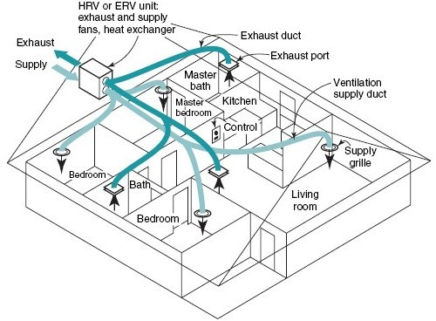
Figure ‎4.47: Exhaust system principle.
Duct Sizing
The duct sizing was done using Revit software, the width of main duct = 45 cm and for Branch = 30 cm, and there is restriction to 20 cm to the duct depth.
Drawings:

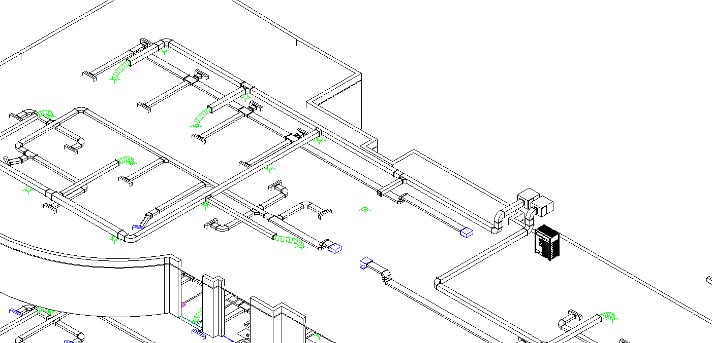
Figure ‎4.48: Duct design in REVIT.

Ground floor
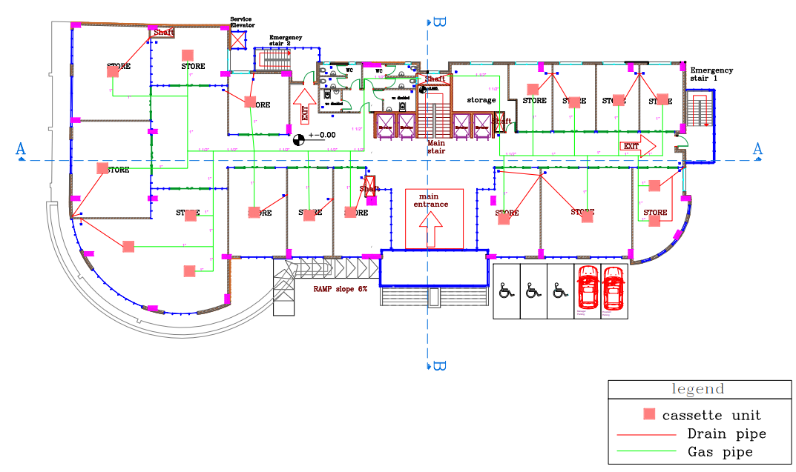

Figure ‎4.49: Ground floor HVAC plan.

First floor

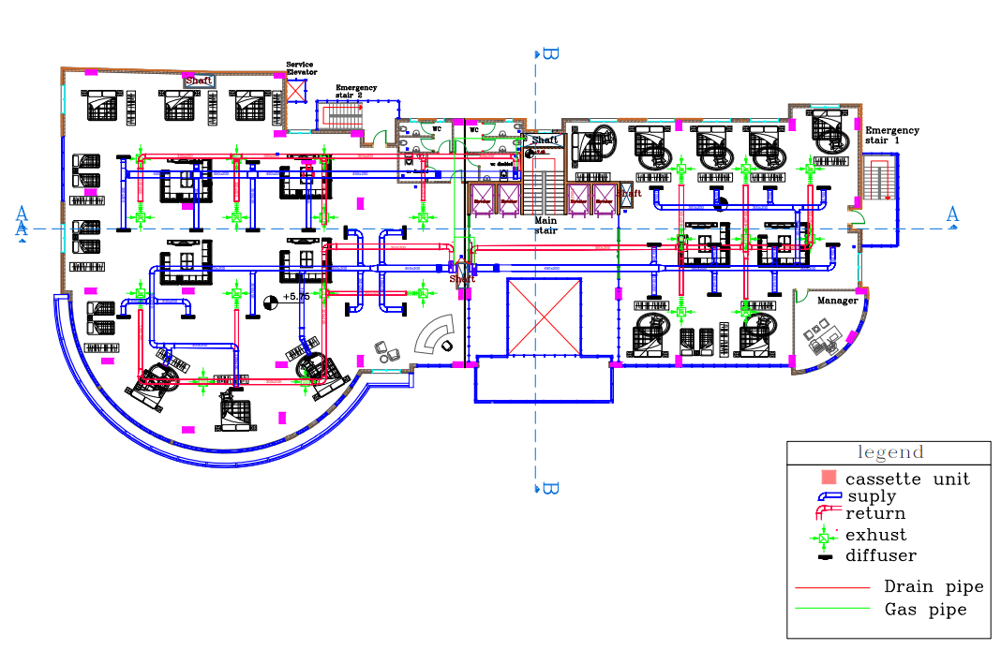
Figure ‎4.50: First floor HVAC plan.

Second floor
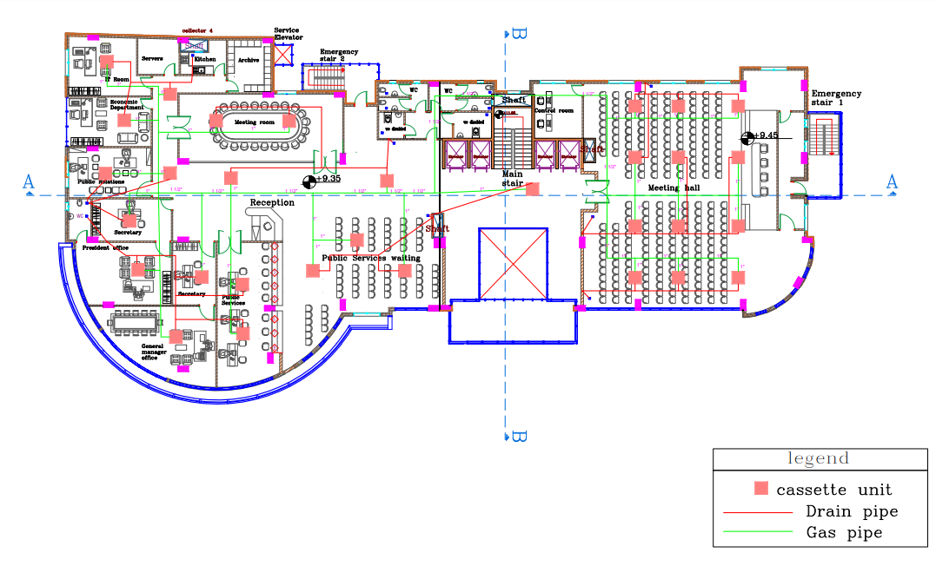
Figure ‎4.51: Second floor HVAC plan.

Third and fourth floor:
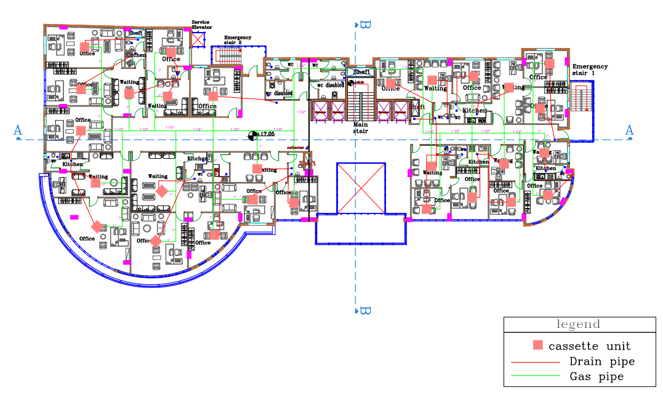
Figure ‎4.52: Third and fourth floors HVAC plan.

Fifth floor:
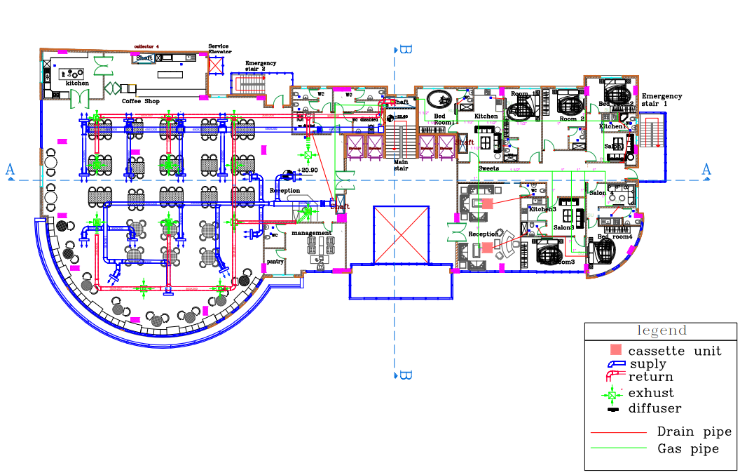
Figure ‎4.53: Fifth floor HVAC plan.
Sixth floor:
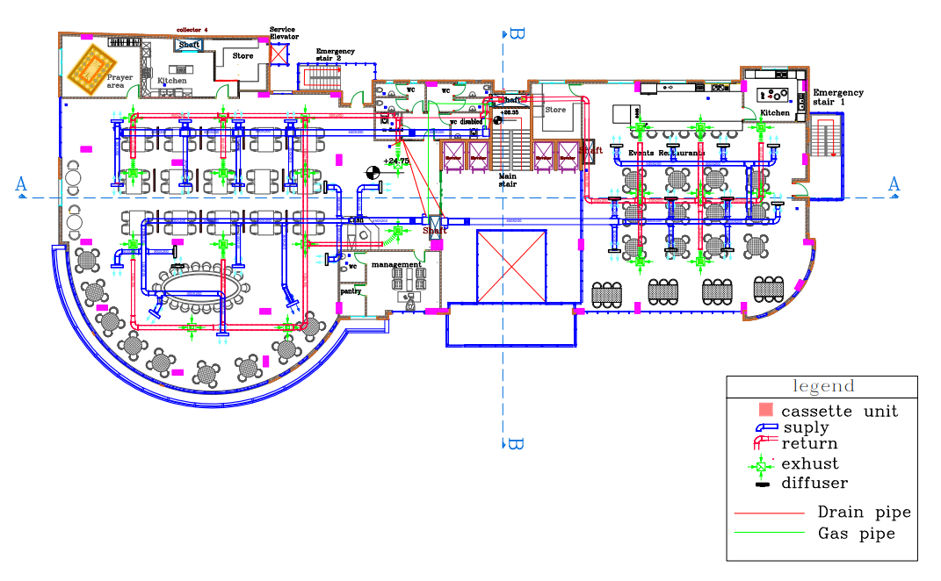
Figure ‎4.54: Sixth floor HVAC plan.

Power design
A main distribution board, a sub distribution board on each level, luminaires, outlets, switches, and copper wires that connect the distribution boards to the other components make up the chamber of commerce building's electrical system. To ensure life safety, all electrical loads shall be computed in this area.

Circuit breaker and distribution board
Each floor of the building has a main distribution board, followed by multiple sub distribution boards on each floor, and all electrical loads will be identified.

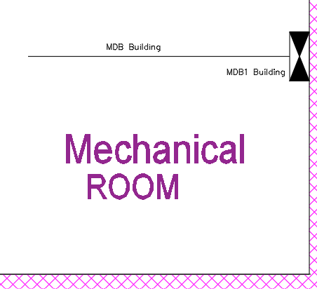
Figure ‎4.55 location of the main distribution board in basement floor1.

Electric equipment is connected to the alternating current (AC) power supply in buildings and other locations via AC power plugs and sockets. Different voltage and current ratings, shapes, sizes, and connector types distinguish different electrical plugs and sockets from one another. Around the world, various standard systems for plugs and sockets are in use.

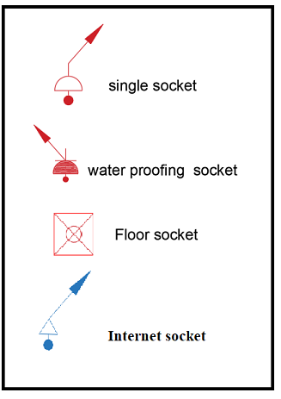
Figure ‎4.56 the socket symbol

- Power load calculation:

- Special load
In the cafeteria kitchen, there are two devices that require a specific load of 3000 watts each.
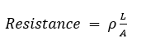
ρ : copper resistivity.
A : Cross section area of the wire.
L: The maximum distance between the socket and D. B.
R = $\frac{\left(1.68 ×{10}^{-8}× \left(28\right)\right)}{A} = 4.7×{10}^{-7}/A Ω$.
The Current for the Special socket according to the maximum assumed power.
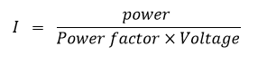
= $\frac{3000}{0.9×220}$=15.15 Amp

Drop voltage = I × R wire
I: load current
R: wire Resistance
Allowable voltage drop max in the wire= (3-5) % × 220V.
=8.8 V.
Area = $\frac{15.15*4.7*{10}^{-7}}{8.8}$
A= .81mm².
we use A=2.5 mm² as shown in the figure below with 21 Amp.
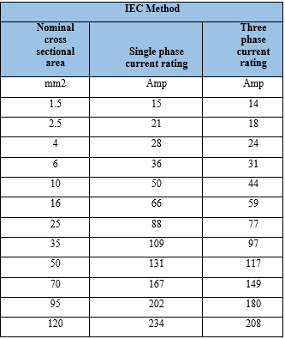
R=0.254 Ω.
Drop voltage = I × R
= 15.15*0.254
= 3.8 V
Check:
$$Voltag drop \% = \frac{3.8}{220}× 100\% = 0.76\% < 1\% …_ ok$$

Table ‎4-5 wire resistance & drop voltage calculation.
Wire resistance for power of GF
Index | ρ (Ohm.m) | Maximum length (m) | Cross section area (mm²)) | R(Ohm) | I load | V | Drop voltage % | check
D.B1 | 1.68E-08 | 22 | 2.50E-06 | 0.148 | 11.36 | 1.68 | 0.76 | ok
D.B2 | 1.68E-08 | 22 | 2.50E-06 | 0.148 | 7.58 | 1.12 | 0.51 | ok
D.B3 | 1.68E-08 | 33 | 2.50E-06 | 0.222 | 7.58 | 1.68 | 0.76 | ok
D.B4 | 1.68E-08 | 34 | 2.50E-06 | 0.228 | 6.31 | 1.44 | 0.66 | ok
D.B5 | 1.68E-08 | 34 | 2.50E-06 | 0.228 | 8.84 | 2.02 | 0.92 | ok
Wire resistance for power of FF
Index | ρ (Ohm.m) | Maximum length (m) | Cross section area (mm²) | R(Ohm) | I load | V | Drop voltage % | check
D.B1 | 1.68E-08 | 58.4 | 2.50E-06 | 0.39 | 5.05 | 1.98 | 0.90 | ok
D.B2 | 1.68E-08 | 57 | 2.50E-06 | 0.38 | 3.79 | 1.45 | 0.66 | ok
D.B3 | 1.68E-08 | 36 | 2.50E-06 | 0.24 | 6.31 | 1.53 | 0.69 | ok
D.B4 | 1.68E-08 | 36 | 2.50E-06 | 0.24 | 7.58 | 1.83 | 0.83 | ok
D.B5 | 1.68E-08 | 36 | 2.50E-06 | 0.24 | 8.84 | 2.14 | 0.97 | ok
Wire resistance for power of SF
Index | ρ (Ohm.m) | Maximum length (m) | Cross section area (mm²) | R(Ohm) | I load | V | Drop voltage % | check
D.B1 | 1.68E-08 | 52.4 | 2.50E-06 | 0.35 | 5.05 | 1.78 | 0.81 | ok
D.B2 | 1.68E-08 | 60.1 | 2.50E-06 | 0.40 | 2.53 | 1.02 | 0.46 | ok
D.B3 | 1.68E-08 | 36 | 2.50E-06 | 0.24 | 7.58 | 1.83 | 0.83 | ok
D.B4 | 1.68E-08 | 66.6 | 2.50E-06 | 0.45 | 2.53 | 1.13 | 0.51 | ok
D.B5 | 1.68E-08 | 44 | 2.50E-06 | 0.30 | 3.79 | 1.12 | 0.51 | ok
Wire resistance for power of 3F
Index | ρ (Ohm.m) | Maximum length (m) | Cross section area (mm²) | R(Ohm) | I load | V | Drop voltage % | check
D.B1 | 1.68E-08 | 46.9 | 2.50E-06 | 0.32 | 6.31 | 2.0 | 0.90 | ok
D.B2 | 1.68E-08 | 58.2 | 2.50E-06 | 0.39 | 2.53 | 1.0 | 0.45 | ok
D.B3 | 1.68E-08 | 44 | 2.50E-06 | 0.30 | 15.15 | 4.5 | 0.99 | ok
D.B4 | 1.68E-08 | 54 | 2.50E-06 | 0.36 | 17.68 | 6.4 | 0.87 | ok
D.B5 | 1.68E-08 | 45 | 2.50E-06 | 0.30 | 13.89 | 4.2 | 0.84 | ok
Wire resistance for power of 4F
Index | ρ (Ohm.m) | Maximum length (m) | Cross section area (mm²) | R(Ohm) | I load | V | Drop voltage % | check
D.B1 | 1.68E-08 | 46.9 | 2.50E-06 | 0.32 | 6.31 | 2.0 | 0.90 | ok
D.B2 | 1.68E-08 | 58.2 | 2.50E-06 | 0.39 | 2.53 | 1.0 | 0.45 | ok
D.B3 | 1.68E-08 | 44 | 2.50E-06 | 0.30 | 15.15 | 4.5 | 0.99 | ok
D.B4 | 1.68E-08 | 54 | 2.50E-06 | 0.36 | 17.68 | 6.4 | 0.87 | ok
D.B5 | 1.68E-08 | 45 | 2.50E-06 | 0.30 | 13.89 | 4.2 | 0.84 | ok
Index | ρ (Ohm.m) | Maximum length (m) | Cross section area (mm²) | R(Ohm) | I load | V | Drop voltage % | check
D.B1 | 1.68E-08 | 52 | 2.50E-06 | 0.35 | 17.68 | 6.18 | 0.87 | ok
D.B2 | 1.68E-08 | 60 | 2.50E-06 | 0.40 | 13.89 | 5.60 | 0.75 | ok
D.B3 | 1.68E-08 | 44 | 2.50E-06 | 0.30 | 12.63 | 3.73 | 0.70 | ok
D.B4 | 1.68E-08 | 63 | 2.50E-06 | 0.42 | 12.63 | 5.35 | 0.53 | ok
D.B5 | 1.68E-08 | 46.4 | 2.50E-06 | 0.31 | 6.31 | 1.97 | 0.89 | ok
Wire resistance for power of 6F
Index | ρ (Ohm.m) | Maximum length (m) | Cross section area (mm²) | R(Ohm) | I load | V | Drop voltage % | check
D.B1 | 1.68E-08 | 54.2 | 2.50E-06 | 0.36 | 2.53 | 0.9 | 0.45 | ok
D.B2 | 1.68E-08 | 63 | 2.50E-06 | 0.42 | 5.05 | 2 | 0.93 | ok
D.B3 | 1.68E-08 | 49 | 2.50E-06 | 0.33 | 3.79 | 1.1 | 0.51 | ok
D.B4 | 1.68E-08 | 45 | 2.50E-06 | 0.30 | 5.05 | 2 | 0.93 | ok
D.B5 | 1.68E-08 | 44.2 | 2.50E-06 | 0.30 | 3.79 | 1.1 | 0.51 | ok

- Normal load
Sample of calculation:
The longest wire was selected as the most important one to be built and connect across the other wires.
L: The maximum distance between the socket and D. B1 in Ground Floor (GF) nearly 58.4m
R = $\frac{\left(1.68 ×{10}^{-8}× \left(28\right)\right)}{2.5×{10}^{-6}} = 0.188 Ω$
Table ‎4-6 demand factor.
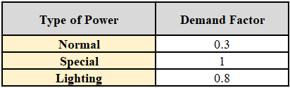
Two single normal sockets are linked to one branch, and the current for each is determined by the maximum expected power:
=2*250 = 500 watt.
So, I = 2.53 Amp.
$$Voltag drop = 2.53 × .339= .857 V$$
$$Voltag drop \% = \frac{.857}{220}× 100\% = 0.389 \% < 1\% … ok$$
- Artificial lighting load
The lighting loads for building were taken from DIALUX

Table ‎4-7: Total power for lighting loads in ground floor
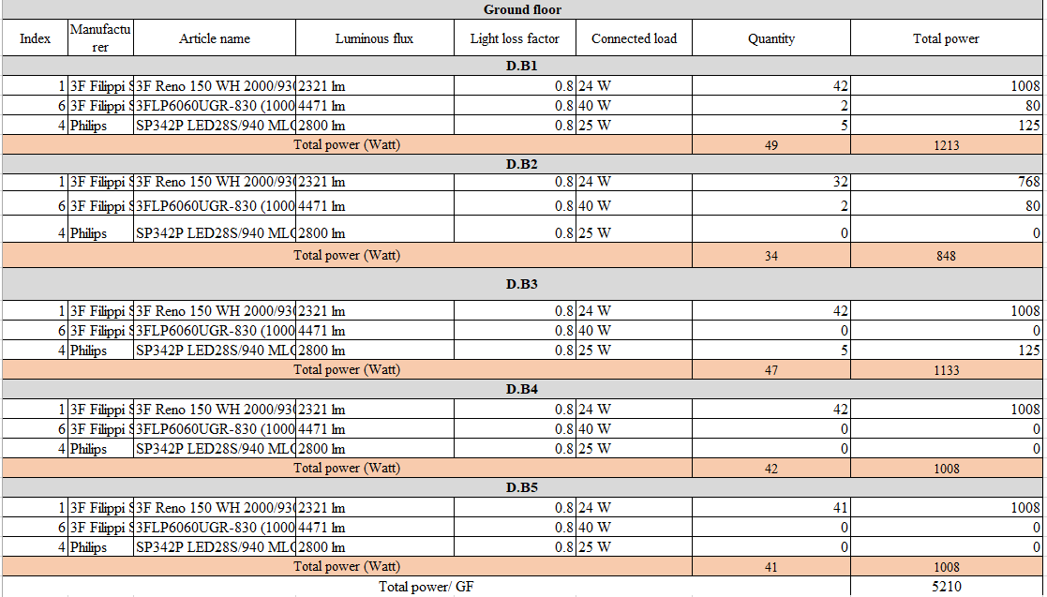
Table ‎4-8: Total power for lighting loads in first floor
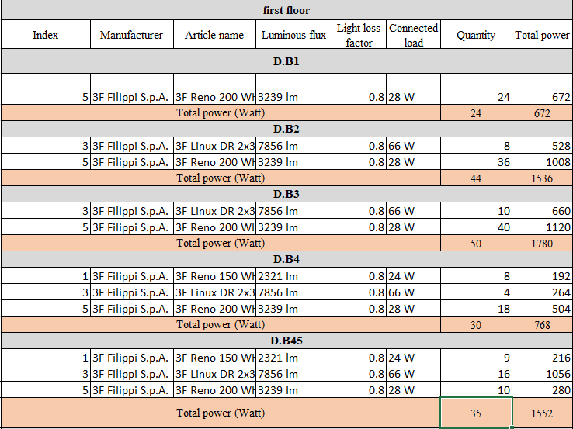
Table ‎4-9: Total power for lighting loads in second floor
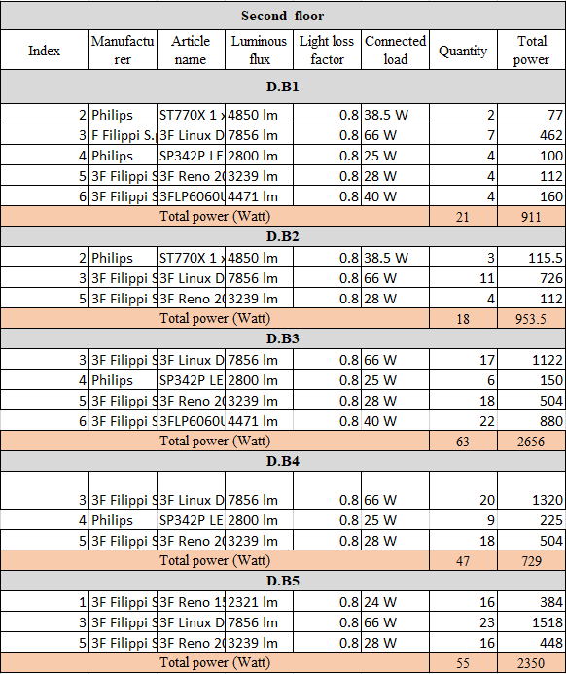
Table ‎4-10: Total power for lighting loads in 3d floor & 4 f
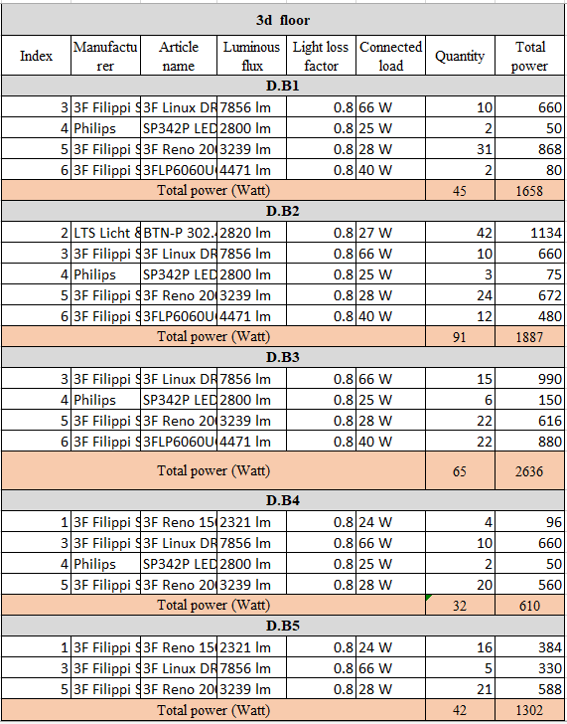
Table ‎4-11: Total power for lighting loads in 5floor
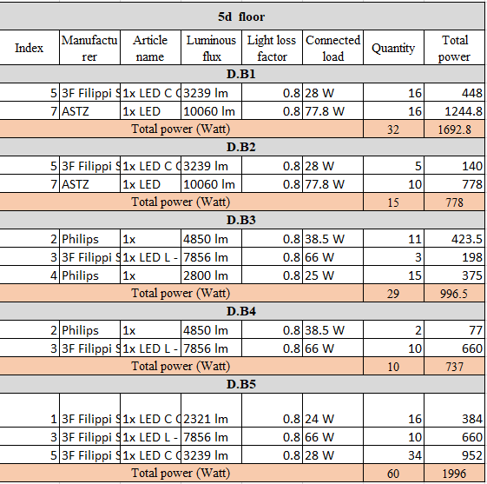
Table ‎4-12: Total power for lighting loads in 6 floor
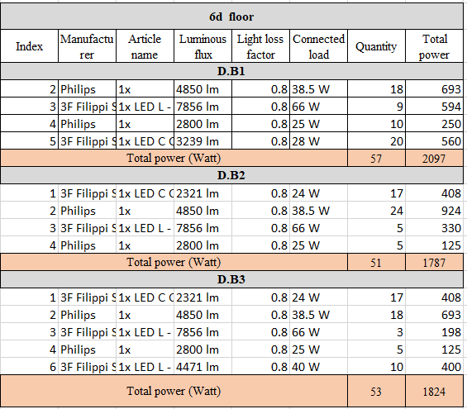

Table ‎4-13: Total power for Normal load of all floor
 | Index | # of sockets (quantity) | Connected load | Total power
 | Normal load for power GF (Watt)
 | D.B1 | 19 | 250 | 4750
 | D.B2 | 12 | 250 | 3000
 | D.B3 | 12 | 250 | 3000
 | D.B4 | 10 | 250 | 2500
 | D.B5 | 14 | 250 | 3500
 | Total power (Power Load) MBD-GF (Watt) |  |  | 16750
 | Normal load for power FF (Watt)
 | D.B1 | 10 | 250 | 2500
 | D.B2 | 11 | 250 | 2750
 | D.B3 | 6 | 250 | 1500
 | D.B4 | 11 | 250 | 2750
 | D.B5 | 10 | 250 | 2500
 | Total power (Power Load) MBD-FF (Watt) |  |  | 12000
 | Normal load for power SF (Watt)
 | D.B1 | 9 | 250 | 2250
 | D.B2 | 8 | 250 | 2000
 | D.B3 | 21 | 250 | 5250
 | D.B4 | 19 | 250 | 4750
 | D.B5 | 23 | 250 | 5750
 | Total power (Power Load) MBD-SF (Watt) |  |  | 20000
 | Normal load for power 3F (Watt)
 | D.B1 | 32 | 250 | 8000
 | D.B2 | 36 | 250 | 9000
 | D.B3 | 25 | 250 | 6250
 | D.B4 | 23 | 250 | 5750
 | D.B5 | 24 | 250 | 6000
 | Total power (Power Load) MBD-3F (Watt) |  |  | 35000
 | Normal load for power 4F (Watt)
 | D.B1 | 32 | 250 | 8000
 | D.B2 | 36 | 250 | 9000
 | D.B3 | 25 | 250 | 6250
 | D.B4 | 23 | 250 | 5750
 | D.B5 | 24 | 250 | 6000
 | Total power (Power Load) MBD-4F (Watt) |  |  | 35000
 | Normal load for power5F (Watt)
 | D.B1 | 20 | 250 | 5000
 | D.B2 | 17 | 250 | 4250
 | D.B3 | 14 | 250 | 3500
 | D.B4 | 15 | 250 | 3750
 | D.B5 | 13 | 250 | 3250
 | Total power (Power Load) MBD-5F (Watt) |  |  | 19750
 | Normal load for power 6F (Watt)
 | D.B1 | 17 | 250 | 4250
 | D.B2 | 13 | 250 | 3250
 | D.B3 | 14 | 250 | 3500
 | Total power (Power Load) MBD-6F (Watt) |  |  | 11000

- Sample calculation of DB1 in the ground floor.
The total power load in ground floor for DB1 = (normal load*D.F) + (special load * D.F) + (lighting load *D.F).
D.F: demand factor.

Table ‎4-14: demand factor

The total power load in ground floor for DB1 = (4750*.3) + (0 * 1) + (1213 *.8). =2395.4< 10000, so one phase will use for distribution board.
Current for DB.1 =$\frac{ total power}{v×power fator}$
=$\frac{ 2395.4}{220×0.9}$
= 13.31Amp
I C.B is = I load*S.F
Safety factor (S.F) always considered be 1.15
I C.B = 13.6 *1.15= 15.3 Amp.
21 Amp will be used for CB, with cross section area 2.5 mm².
I Cable is = I C.B*1.15= 14.5*1.15= 17.6 Amp.
C.B 21Amp will use of D.B.1, with cross section area 2.5 mm².
M.D.B1 in the building
Total Load =78325.04 >10000, three phases
Table ‎4-15: main distribution for building
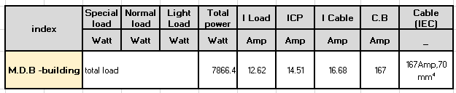

Table ‎4-16: cable calculatin.
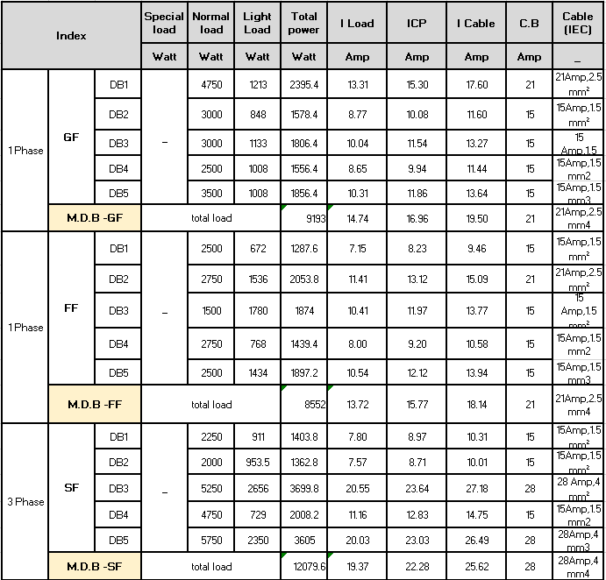
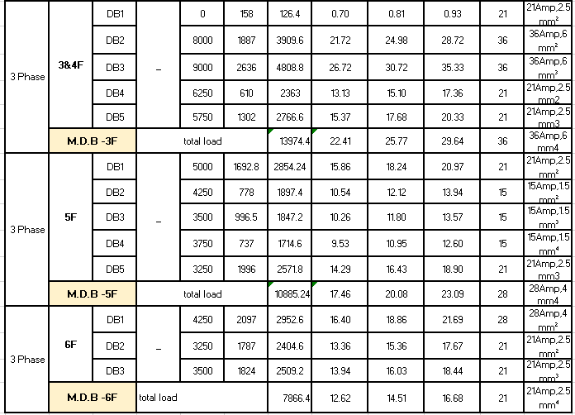
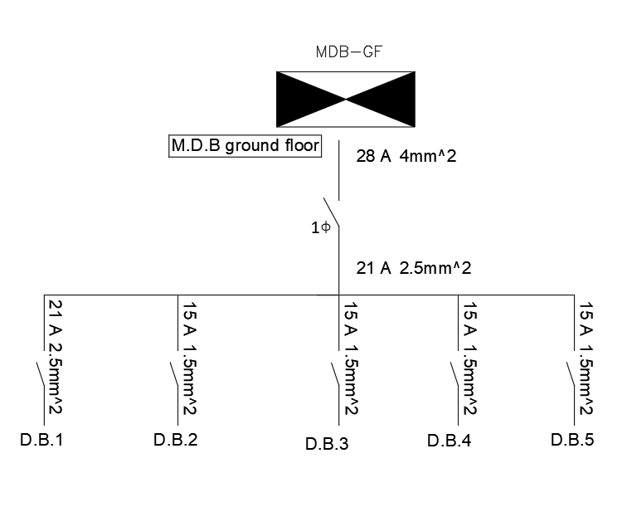
Figure ‎4.57 Main distribution board for GF
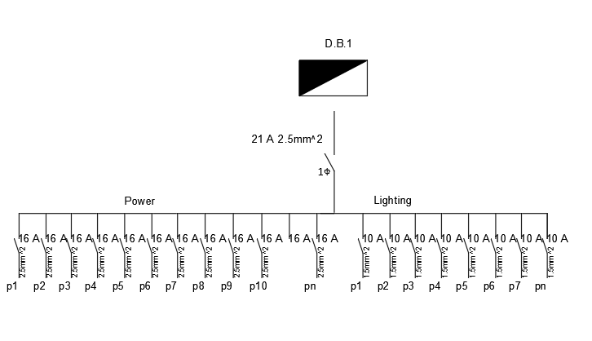
Figure ‎4.58 distibution board for part 1 from GF
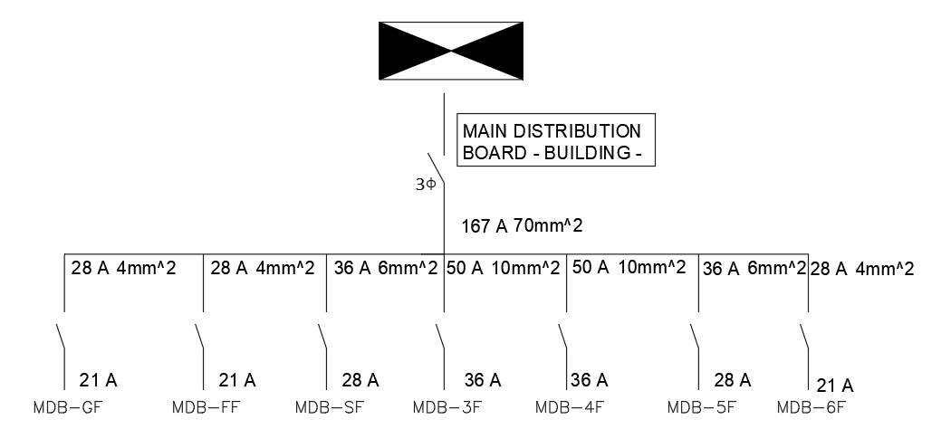
Figure ‎4.59 main distribution board for building

Acoustical design

Introduction:
Acoustical design for a building involves the intentional design of the sound environment within a space. The primary goal of acoustical design is to control sound and noise levels within a building in order to create a comfortable and functional environment for its occupants. This involves considering various factors such as the purpose of the space, the desired sound quality, and the expected noise sources.
The acoustical design process typically includes an analysis of the room's acoustic properties, which involves measuring and analyzing sound reflections, reverberation, and other acoustic characteristics. Based on this analysis, designers may recommend specific acoustic treatments such as absorption panels, diffusers, or other materials and construction techniques to optimize the sound environment.

Selected spaces for design:
- Office
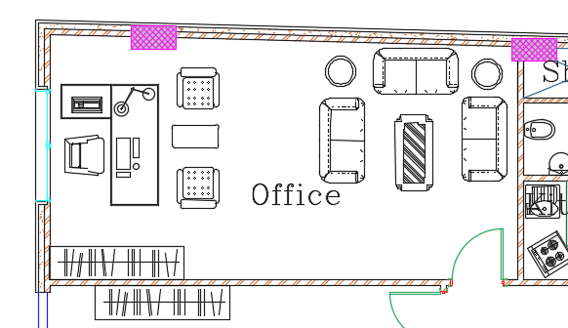
Figure ‎4.60: Office plan

- Coffee shop
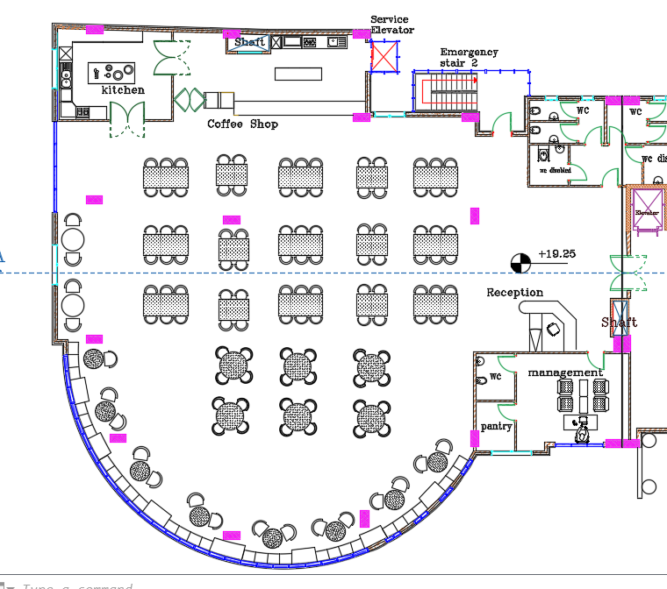
Figure ‎4.61: Coffee shop plan

- Meeting hall
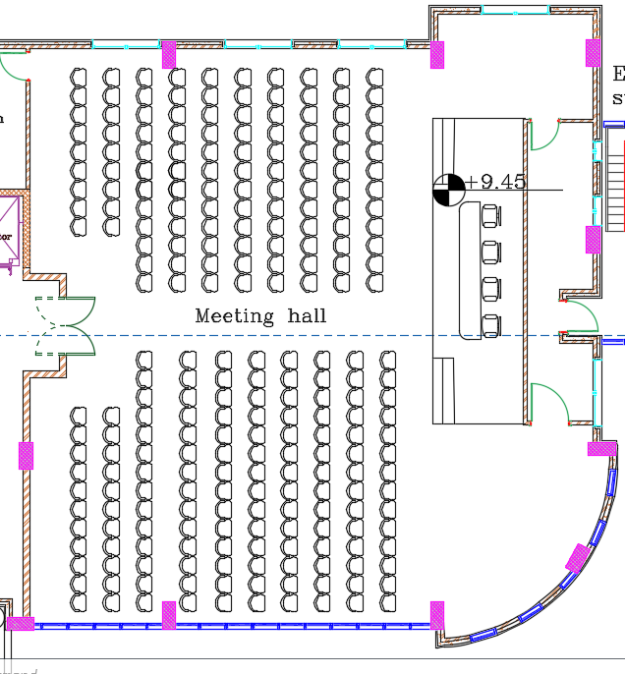
Figure ‎4.62: Meeting hall plan

- Bed room

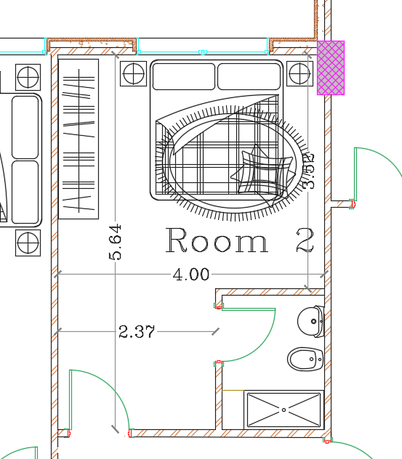
Figure ‎4.63: Bed room plan

Literature review
- Recommended reverberation time:
For offices: (0.40-0.70) sec (Recommended reverberation times for 7 key spaces, 2020)
For Meeting room: (0.80-1.90) sec (Davis, 2022)
For coffee shop and restaurants: (1-1.80) sec (Davis, 2022)
For Bed room: (0.40-0.60) sec (Davis, 2022)

- STC
The table below shows the STC for selected areas
Table ‎4-17: Required STC for spaces (commercial-acoustics, 2022)
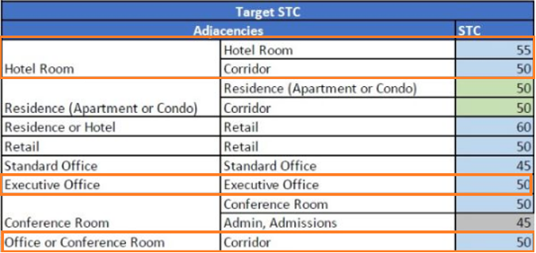
- IIC
IIC >50 dB(Acoustics.com: Codes & Testing - Impact Insulation Class (IIC), 2020)

- Articulation loss%
Table ‎4-18: Articulation loss categories(T. Grondzik, G. Kwok, Stein, & S.Reynolds, 2010)
AL | Category
>0.3 | Bad
0.21–0.3 | Minimal
0.06–0.2 | Normal
0–0.05 | Excellent

- Noise Criteria
For offices: NC 30-35 dB(The Engineering toolbox, 2022)
For corridors: NC 35-40 dB(The Engineering toolbox, 2022)

- STI
Table ‎4-19: STI categories(Stout, 2015)
STI | Category
0.75 – 1.0 | Excellent
0.6 – 0.75 | Good
0.45 – 0.6 | Fair
0.3 – 0.45 | Poor
0 – 0.3 | Bad

Design
INSUL and EASE Software programs were used for design and analysis
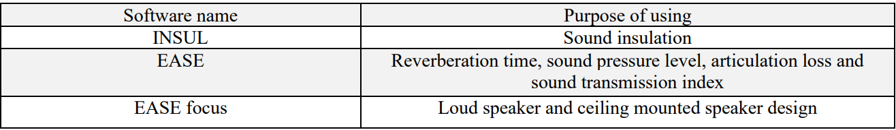
- Material
Table ‎4-20: Finishing materials used in rooms and its sound absorption coefficient.
 | Frequency (HZ) | 125HZ | 250HZ | 500HZ | 1000HZ | 2000HZ | 4000HZ
Material
Tile |  | 0.01 | 0.01 | 0.01 | 0.01 | 0.02 | 0.02
Paint |  | 0.01 | 0.02 | 0.02 | 0.03 | 0.04 | 0.05
Windows Glass |  | 0.04 | 0.04 | 0.03 | 0.03 | 0.02 | 0.02
Gyptone Line (Ceiling) |  | 0.61 | 0.75 | 0.67 | 0.65 | 0.51 | 0.41
Miniperf for Ceiling |  | 0.01 | 0.05 | 0.22 | 0.55 | 0.35 | 0.18
Seats for meeting hall |  | 0.25 | 0.3 | 0.3 | 0.3 | 0.3 | 0.3
Moquette sur thibaude |  | 0.13 | 0.22 | 0.51 | 0.61 | 0.81 | 0.85
Carpet for bed room |  | 0.2 | 0.2 | 0.25 | 0.25 | 0.25 | 0.25

- RT60 design
- For Office
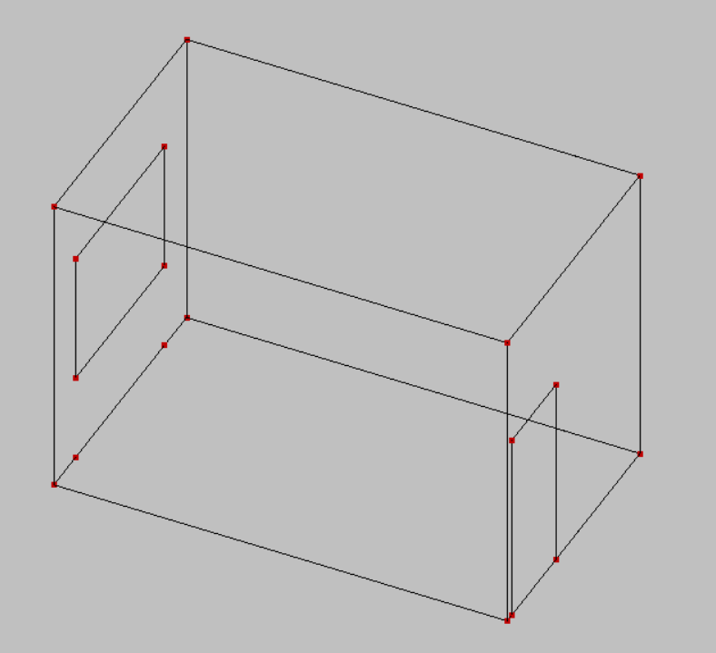

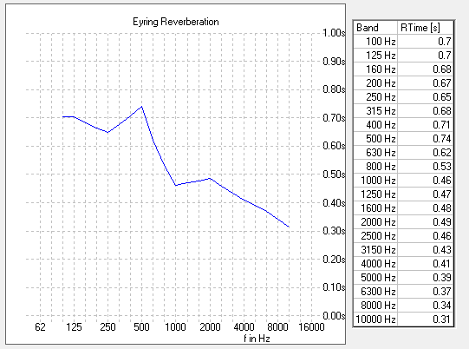
Figure ‎4.64: RT60 results for office.
As shown, RT60 is from (0.40-0.70) which is ok.

- Meeting hall
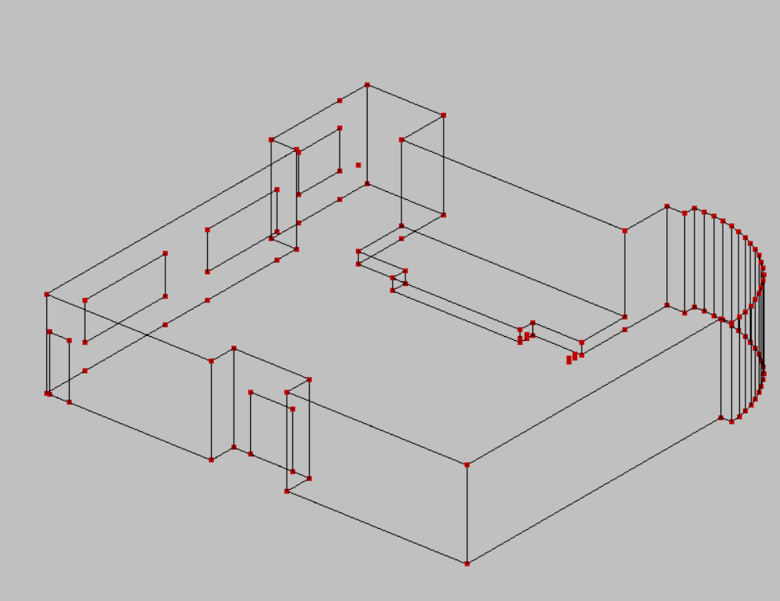
Figure ‎4.65: Meeting hall Ease model.
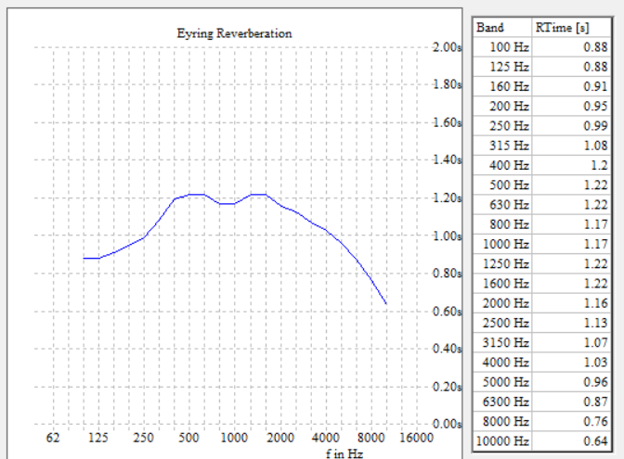
Figure ‎4.66: Reverberation time of meeting hall room.
As shown, the Rt60 is within the standard )0.80-1.90 Sec. which is ok.

- bead room
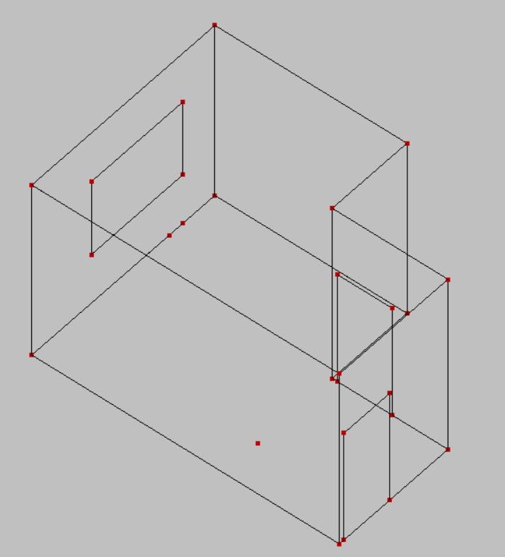
Figure ‎4.67: Bed room ease model.

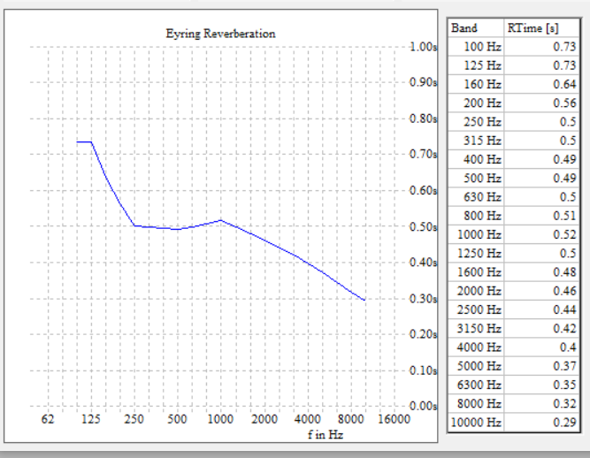
Figure ‎4.68: RT60 for bed room.
- Coffee shop
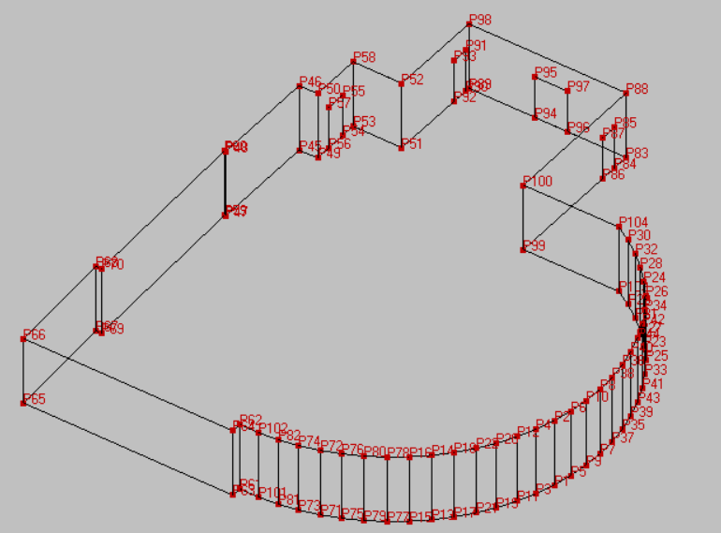
Figure ‎4.69: Coffee shop Ease model.
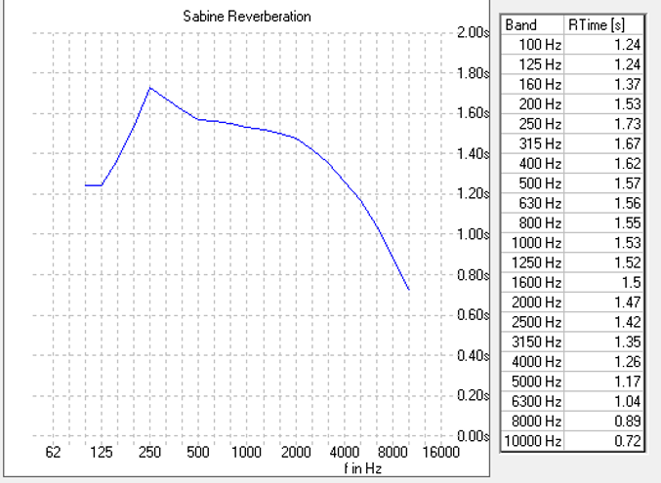
Figure ‎4.70: Reverberation time of Coffee.
As shown, the Rt60 is within the standard )1-1.80) Sec. which is ok.

- Sound Insulation design

- partitions
The partitions will design for a minimum STC of 50 dB
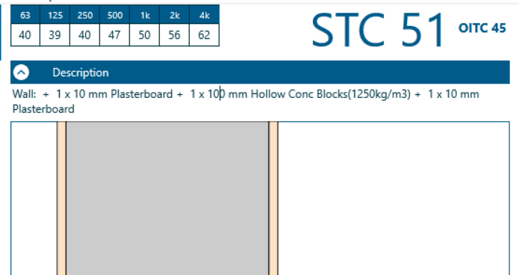

Figure ‎4.71: Partition layers.
STC > 50 dB which is ok.
- Floor
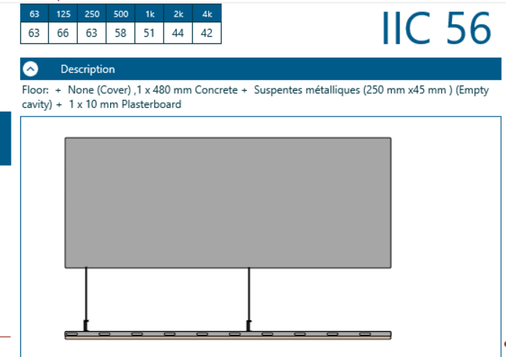
Figure ‎4.72: Floor IIC
IIC > 50 dB which is ok.

- Double skin façade:
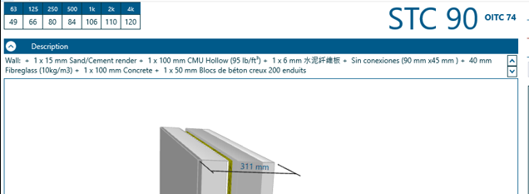
Figure ‎4.73: Double skin facade layers.

STC >40 dB---->Ok

- Sound inelegance design in meeting hall
- Direct SPL
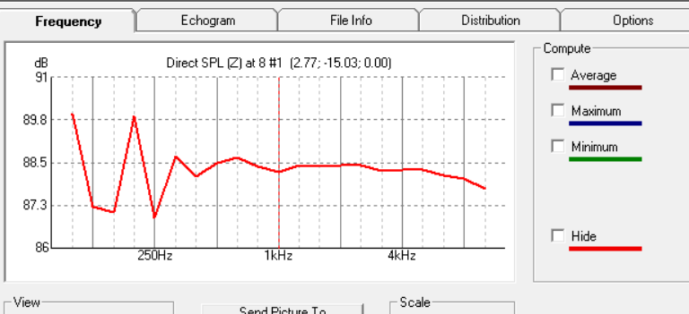
Figure ‎4.74: Direct sound pressure level in meeting hall
As shown in the figure above, Direct SPL is fair.

- Articulation loss
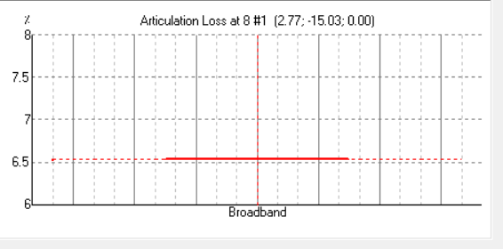
Figure ‎4.75: Articulation loss in meeting hall

As shown in the figure above, Articulation loss is normal.
- Sound transmission index (STI)
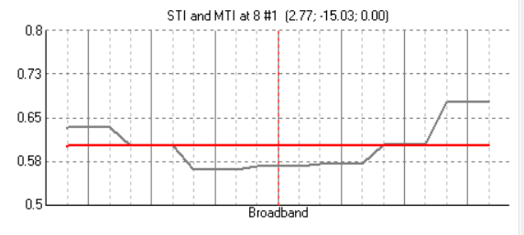
Figure ‎4.76: STI in meeting hall
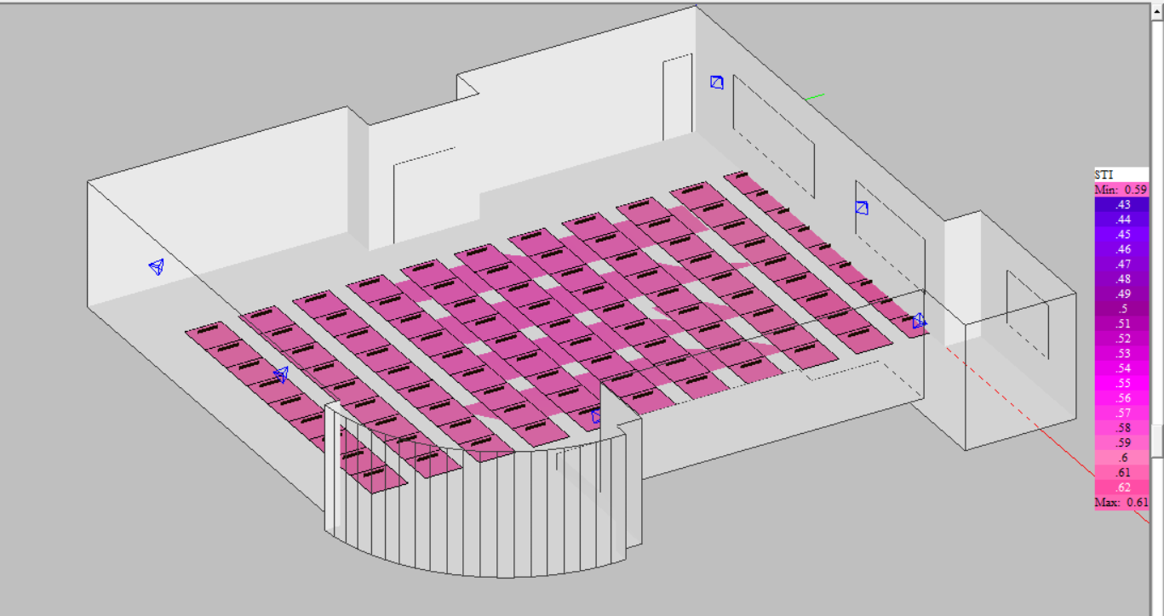
Figure ‎4.77: STI mapping.

As shown in the figure above, MAX STI is 0.61 which is good and minimum STI is 0.59 which is fair.

Electro Acoustics design

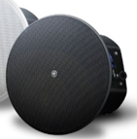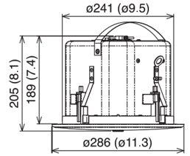
Figure ‎4.78: Ceiling mounted Loud speaker selected.

- Coverage angle: 110°
- Sound pressure level = 86dB SPL

The loud speakers will be distributed in meeting hall.
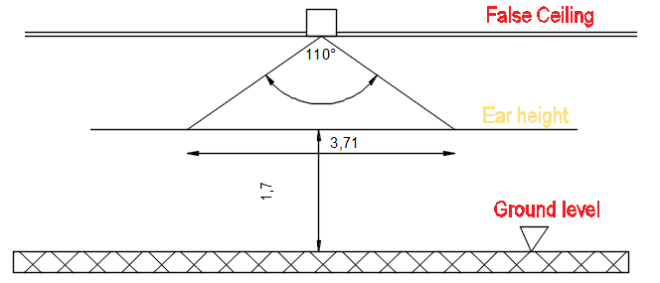
Figure ‎4.79: Loud speaker coverage
The distance between two loud speakers is 2.50 m.

Fire alarm and Firefighting systems

Introduction
There is no denying the need of fire suppression and alarming systems in any building, but especially in public buildings that house a lot of people and have expensive real estate.
A fire alarm system and a firefighting system must be constructed with the availability of safe and efficient evacuation routes in order to provide life safety.

Evacuation ways
The building's floors are divided into two zones, each of which has two emergency exits.

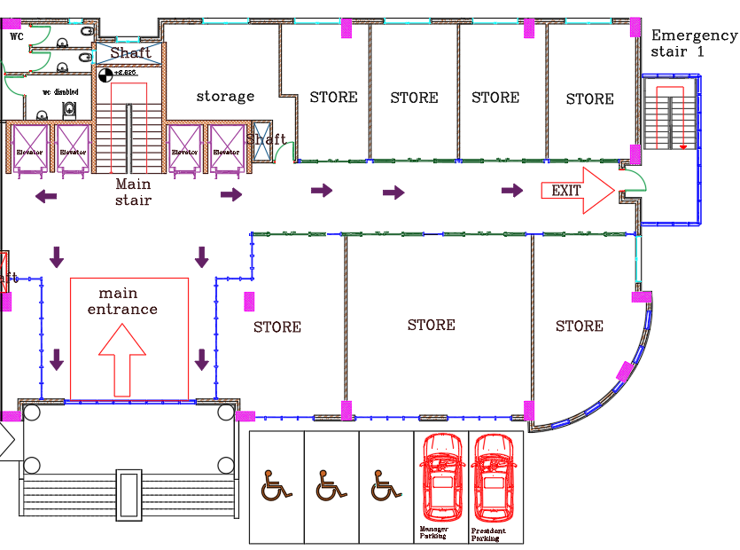
Figure ‎4.80 zone 1 evacuation 1
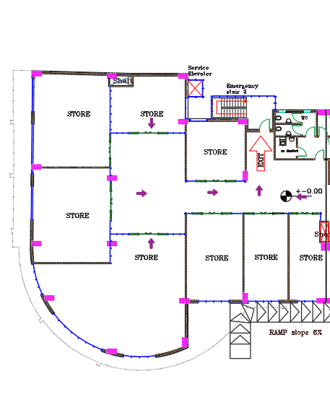
Figure ‎4.81 zone 2 evacuation 2.

Suppression system
The figure shows the symbols for the plans supervision system:
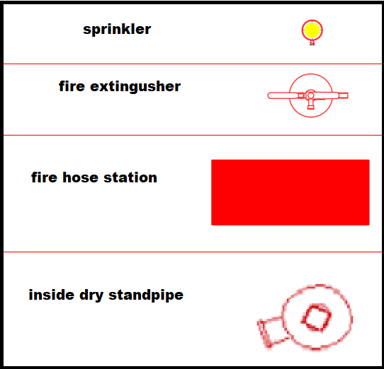
Figure ‎4.82 symbols of supervision system.
- Sprinklers
The automatic fire sprinkler system, which activates in response to a fire alarm, is a reliable technique of preventing fires.
- The parking lot, hallways, and cafeteria water sprinklers.
- The meeting room and office dry powder sprinkler.
- The chemical wet sprinkler utilized in the room with the electrical and mechanical equipment.
The coverage area of sprinkler according to Jordanian code (Dawod, j Kamel, n.d.)Is 12m²
Sample of calculation:
The area of multipurpose hall is 279.64m²
The number of sprinklers $\frac{279.64}{12}$= 24.
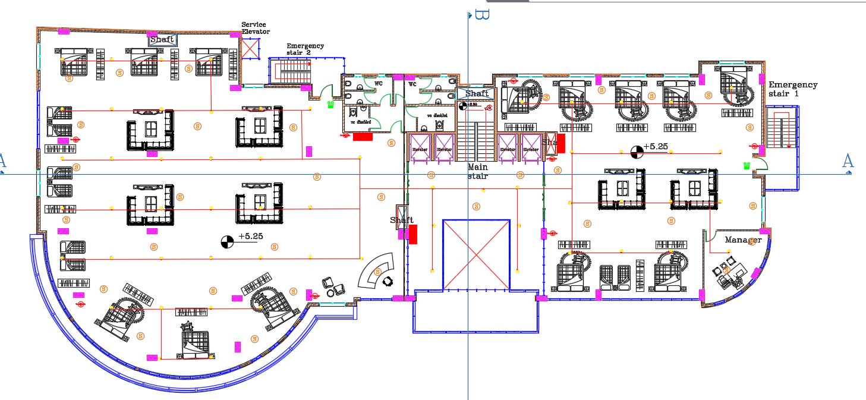

Figure ‎4.83 the distribution of water sprinkler in first floor
- Fire hose station
Although it is one of the human methods of putting out a fire and does not take the place of automatic systems, its presence in a structure is crucial since it enables prompt action in the event of an emergency.
The coverage area for hose station is 300m² , For example the area of first floor is 1052.7m² ,the number of hose station is$\frac{1052.7}{300}$= 4.
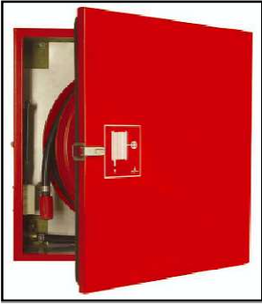
Figure ‎4.84 fire hose station.
- Fire extinguisher
It is a manual device used to extinguish small fires that can be controlled.
According to Jordanian code (Dawod, j Kamel, n.d.), the distribution of fire extinguisher at least each
200 m².
The area of first floor is 1052.7m2, the number of fire extinguisher is $\frac{1052.7}{200}$= 5.
- The cafeteria, hallways, and corridor water extinguishers.
- The dry powder extinguisher found in offices and kitchens.
- The CO2 extinguisher used in the space for mechanical and electrical equipment
Outside and inside Dry standpipe:
It is a type of water pipe placed in multi-story buildings vertically, where fire hoses are
Connected to it and work to extinguish the fire manually.
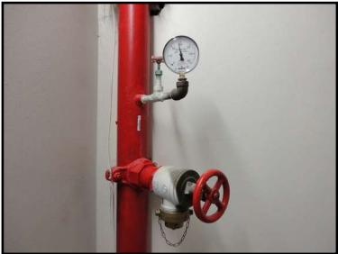
Figure ‎4.85 inside dry standpipe.
The figure below shows the distribution of extinguishers, fire hose station and dry standpipe in second floor.
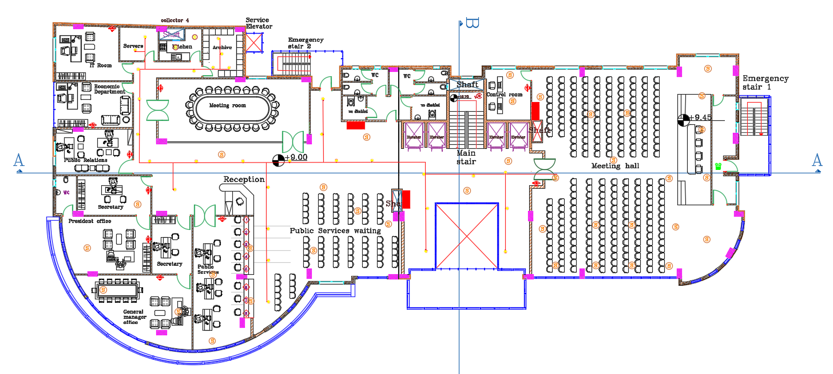

Figure ‎4.86 distribution of fire hose station, dry standpipe and extinguishers in second floor.

Detection & notification system
This system is required to lower the danger of fire since it provides early warning prior to the fire, which lowers the potential for fire and its spread and lessens the damage that results.
There are two different types of detection and notification systems: manual and automated fire alarms.
- Manual fire alarm:
- The main aim of this alarm is to alert citizens before a fire occurs.
- Manual fire alarm is used by citizens when it is noticed that there is going to be a fire.
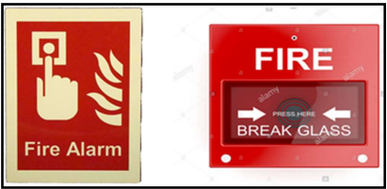
Figure ‎4.87 manual fire alarm.
- Automate fire alarm:
There are several types of this system and each type depends on the function of space.
- Smoke detector:
This type used in spaces which contain combustible material as cafeteria and in corridors
and open areas.
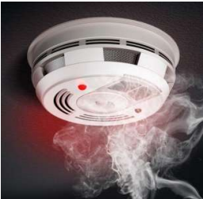
Figure ‎4.88 smoke detector.
- Heat detector:
This type used in spaces which contain smoke and vapor as car parking.
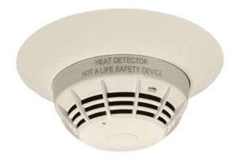
Figure ‎4.89 heat detector.
- Flame detector: This type used in kitchen.
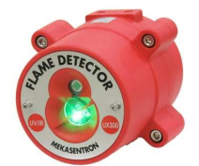
Figure ‎4.90 flame detector.
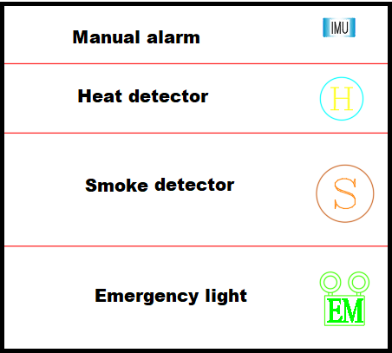
Figure ‎4.91 symbols of detection &notification system.
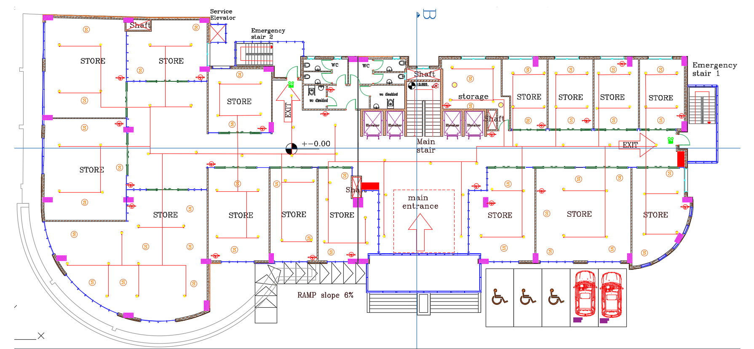
Figure ‎4.92 distribution of heat and flame detector.

Water supply system

Introduction
It is very important to construct an adequate system to meet all of these requirements since this system provides water to every structure and is used for a variety of purposes, including drinking, cleaning, and other functions.

Water tanks calculations
maximum occupancy = 707 person
daily consumption of cold water = 15 L/day
daily consumption of hot water = 3 L/day
1) Roof Tank:
There is barely enough for one day.
The volume = 707 x 15 = 10605 L/day ≈ 11 m3
Number of tanks needed:
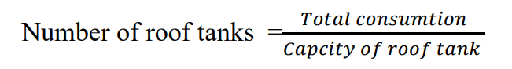
Tank capacity will be chosen from catalog = 2000 L
$number of roof tank=\frac{11 m^{3} }{2 m^{3}}$ = 5.5 ≈ 6 tanks
2) Basement tank
Hot water: 707 x 3 = 212 L/day = 3 $m^{3}$/ day = 12 $m^{3}$/ 4 days
Cold water: 15 x 707 x 4 = 42420 = 43 $m^{3}$/ 4 days
Total volume required ≈ 50 $m^{3}$ /4 day
Note: we have a water tank in basement one and two and the volume for each one = 72 $m^{3}$

Tank description
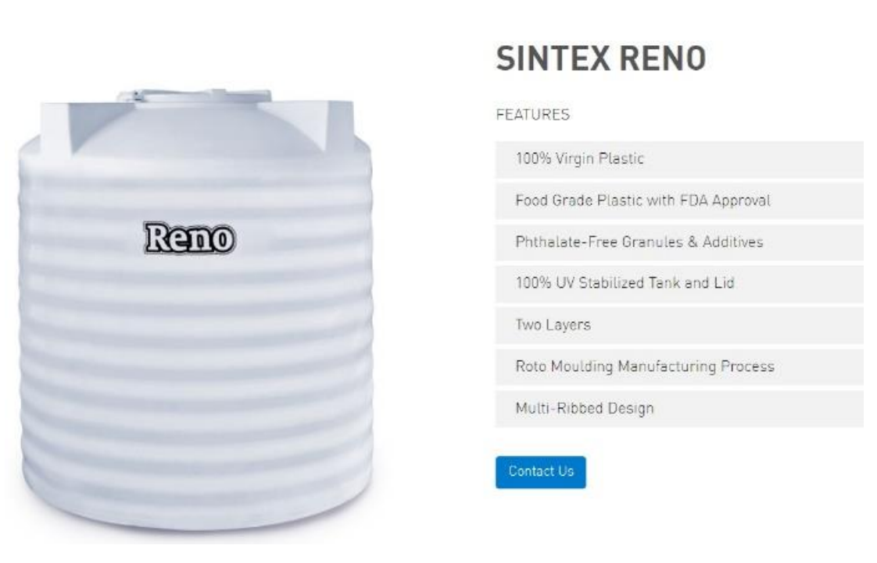
Figure ‎4.93 tank
Table ‎4-21 capacity of tank
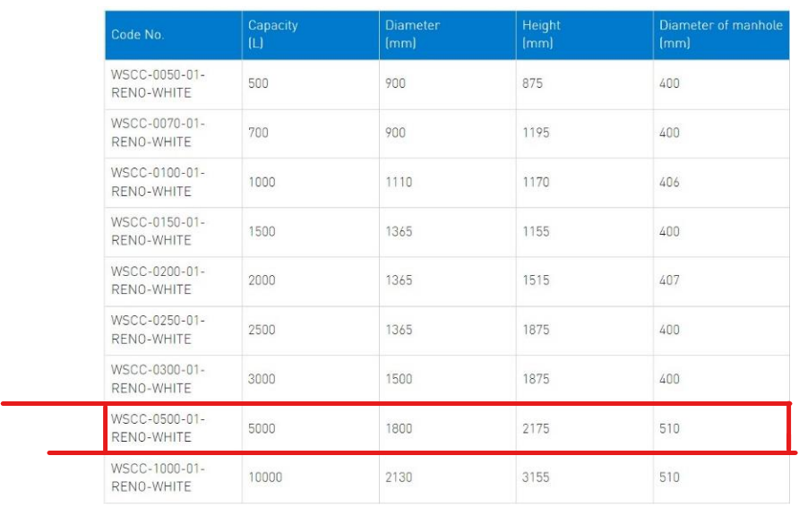

Design piping system
This table shows Water Supply Fixture Units

Table ‎4-22 water supply fixture units (WSFU)
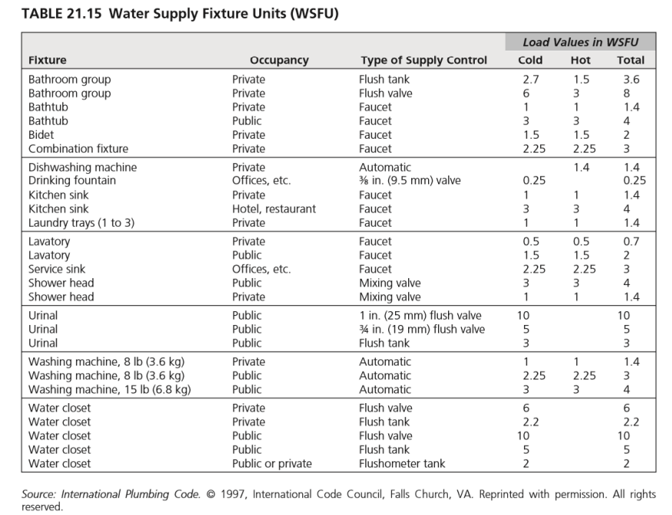
This Figure shows Water flow as a function of fixture units

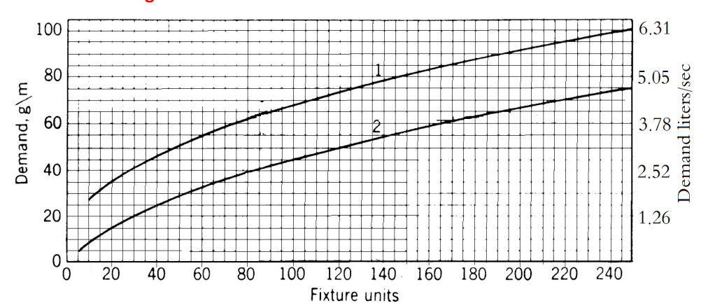
Figure ‎4.94 water flow as a function of fixture units

This table shows the water supply fixture units and demand for building
Table ‎4-23 water supply units and demand for building

- material of the pipes:
This table shows the material of the pipes uses
Table ‎4-24 material of the pipes

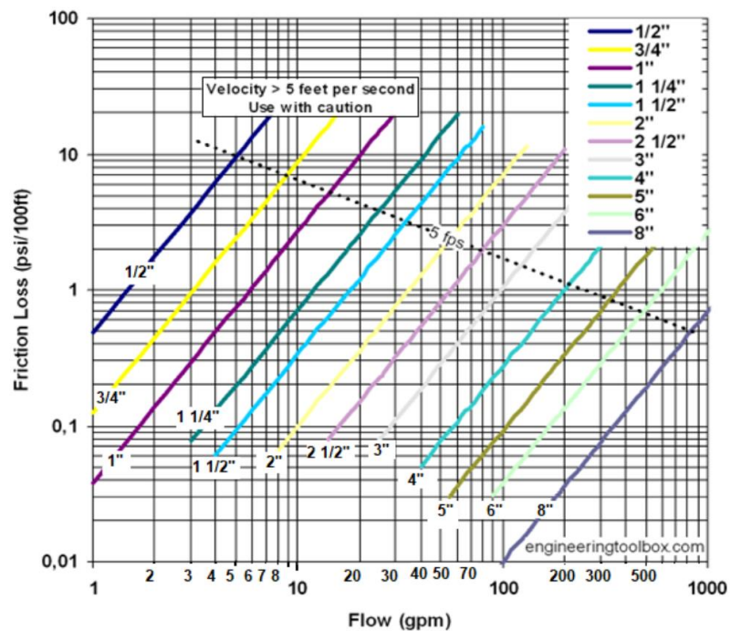
Figure ‎4.95 Friction loss in PVC pipes. (Grondzik and Kwok, 2015)

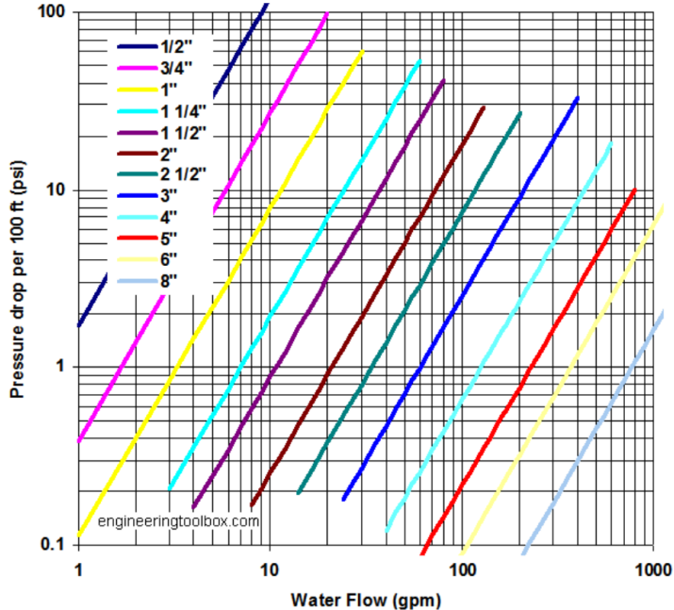
Figure ‎4.96 Friction loss in steel pipes. (Grondzik and Kwok, 2015)

- Pressure calculations
sink height = 4 ft
height =26.75 m = 87.74 ft
P = $p_{o}$ - .433 x h = 55- .433 (87.74 + 4) = 15.276 psi ≈ 15.3 psi
- Design for critical floor (4th floor)
This table shows fixture unit for 4th floor
Table ‎4-25 fixture unit for 4th floor

- Main Vertical feeder 1 (collector 1 – cold water)
Material: Galvanized steel
flow = 37 gpm
length = 18.75 m = 61.5 ft, eq.length = 61.5 ft x 1.5= 92.25 ft
Table ‎4-26 Main Vertical feeder loss
- Main branch
Material: PVC
Flow = 3 gpm
Length 4 m = 13.12 ft , eq.length = 13.12 ft x 1.2 = 15.7 ft
Table ‎4-27 Main branch diameter and loss

- Sub branch
Material: PVC
Flow = 0.5 gpm
Length 29.55 m = 96.9 ft, eq length = 96.9 ft x 1.2 = 116.3 ft
Table ‎4-28 Sub branch diameter and loss
- Horizontal (cold water)
Material: PVC
Flow =8 gpm
Length 10 m = 32.8ft, eq length = 96.9 ft x 1.2 = 39.36 ft
Table ‎4-29 Horizontal (cold water) branch diameter and loss
- Horizontal (hot water)
Material: PVCD
Flow =6 gpm
Length 10 m = 32.8ft, eq length = 96.9 ft x 1.2 = 39.36 ft
Table ‎4-30 Horizontal (hot water) branch diameter and loss

- Meter
flow = 35 gpm.
Table ‎4-31 meter diameter and loss

Critical fixture required pressure = 8 psi
Water pressure = 15.3 psi
Max possible loss in pressure = 15.3 – 8 = 7.3 psi
- Diameters selection
Table ‎4-32Diameters selection and loss
Total loss = .3 +.4+ .03 + .5 +4.5 = 5.73 psi < 7.3 OK
Note: An auxiliary pump is needed for fifth and sixth floor.

Drainage and rain water system
It is a system in a building that uses gravity to transport waste water from drainage pipes to a domestic septic tank or drainage sewer. The system's goals are to keep people healthy, keep odors and gases out of buildings, and remove waste water from buildings. The various components of the system are, stacks, drainage sewers, sewer fittings, vents and manholes.
- design
- To design a drainage system is calculating the number of fixture unit for each floor and This table shows drainage fixture unit
Table ‎4-33 drainage fixture unit
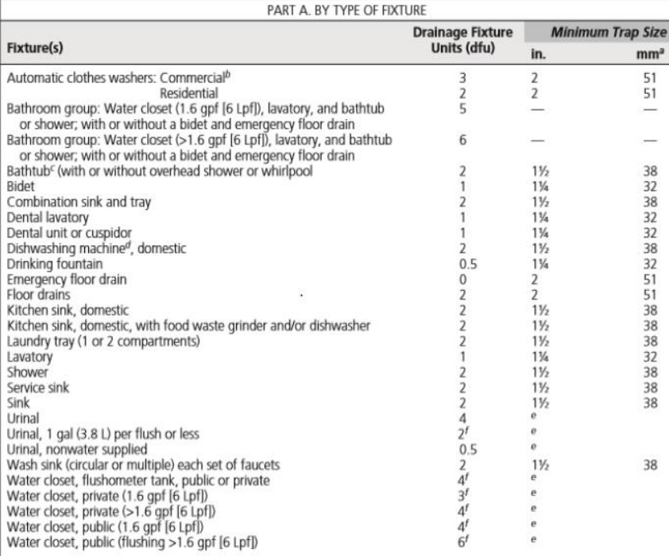

These tables explain the calculations of total fixture units for each floor in the building.
1- Ground floor
Table ‎4-34 Ground floor fixture units
2- First floor

Table ‎4-35 First floor fixture units
3-secod floor
Table ‎4-36 second floor fixture units
4-fourth floor
Table ‎4-37 fourth floor fixture units
5-fifth floor
Table ‎4-38 fifth floor fixture units
6-sixth floor
Table ‎4-39 sixth floor fixture units
- calculating the required diameter and the maximum fixture units.

The figure below shows the required diameter of branch and stacks:
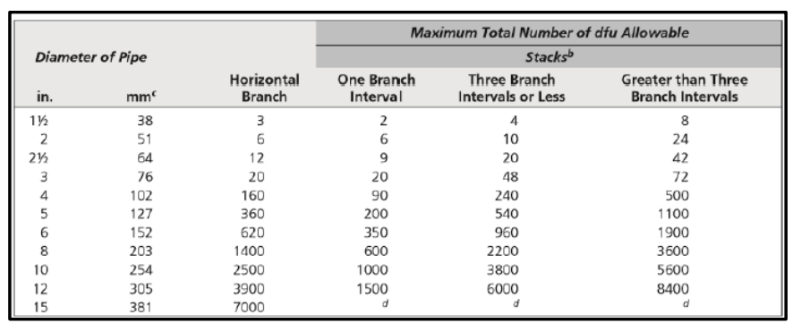
Figure ‎4.97 required diameter of branch and stacks

The figure below shows the required diameter of sewers and the maximum number of DFU connected.
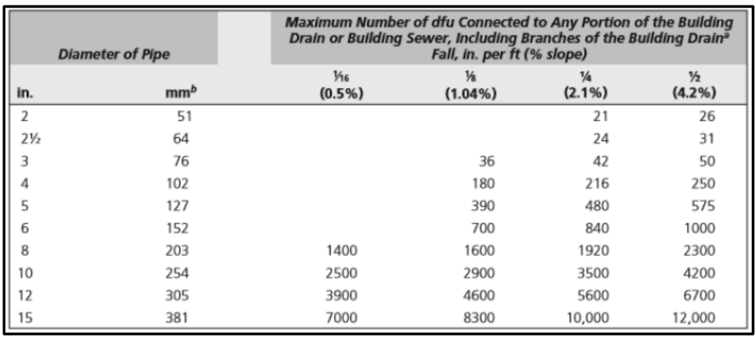
Figure ‎4.98 required diameter of sewers and the maximum number of DFU connected.

These Tables show the summery of pipe sizing and the number of fixture units for each floor:
- Ground floor
Table ‎4-40 Ground floor fixture unit and pipe sizing
- First floor
Table ‎4-41 first floor fixture unit and pipe sizing
- second floor
Table ‎4-42 second floor fixture unit and pipe sizing
- Third floor
Table ‎4-43 third floor fixture unit and pipe sizing
- fourth floor
Table ‎4-44 fourth floor fixture unit and pipe sizing

- fifth floor
Table ‎4-45 fifth floor fixture unit and pipe sizing
- sixth floor
Table ‎4-46 sixth floor fixture unit and pipe sizing

Rain water:
This building's roof provides the water, which is then stored in a water tank in the basement. The roof's permissible slope, which should range from (0.5 to 1.5%), must be taken into mind in order to drain rainwater. A slope of 1% is recommended.
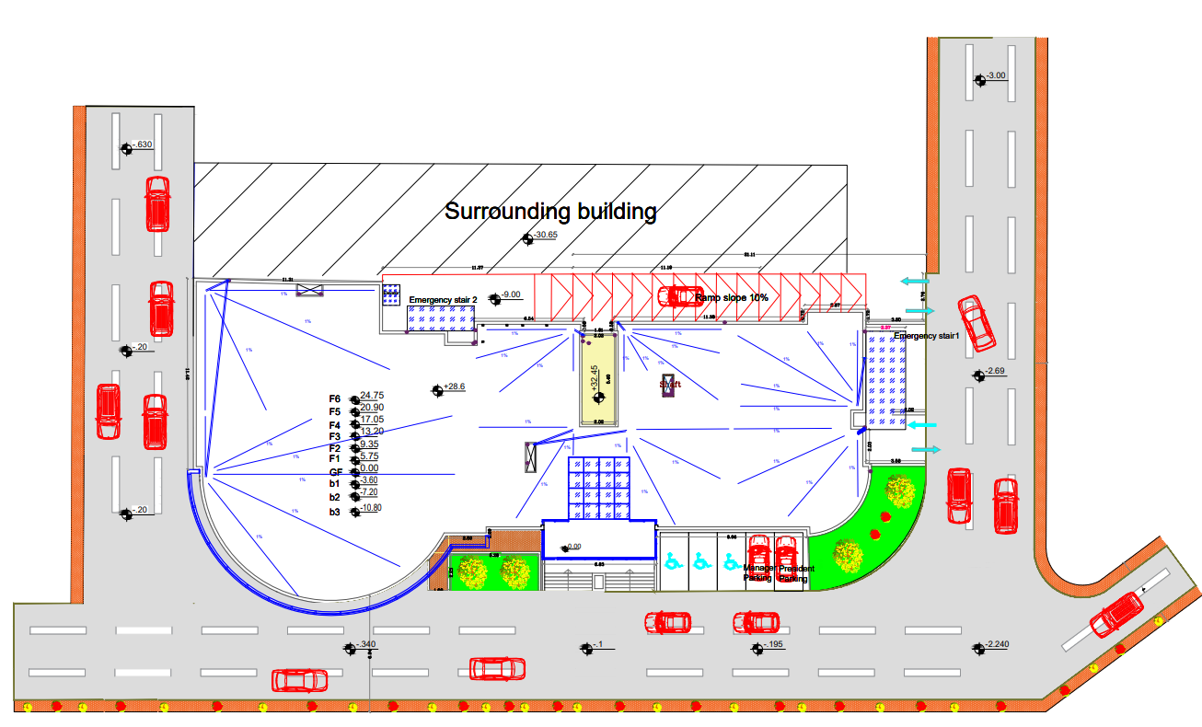
Figure ‎4.99 rain water

Vertical Transportation
Table ‎4-47: Number of elevators needed.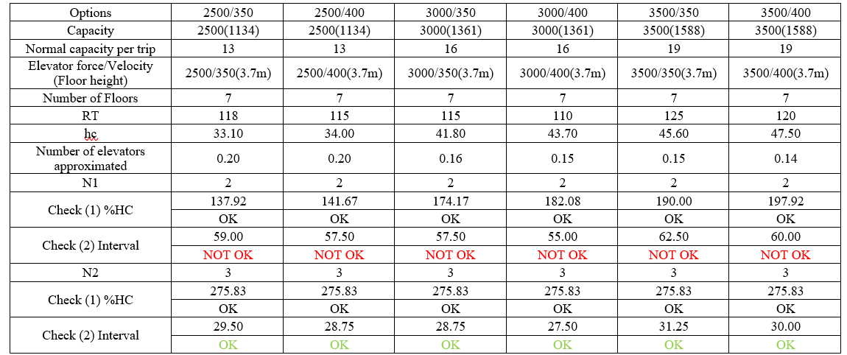
The required number of elevators = 3.
The selection was done from FUJI
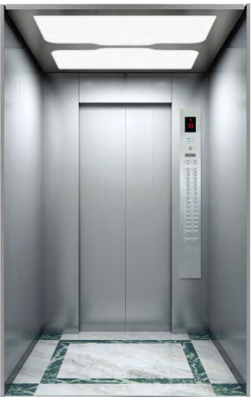
Figure ‎4.100: Normal elevator used.
Elevator specifications:
Table ‎4-48: Normal elevator specifications.(Office Building Elevators, 2021)
Speed(m/s) | 4.00
Max load (kg) | 2000
Max No. of persons | 26

Quantity surveying & Cost Estimate

Introduction:
Quantity surveying was utilized by the ancient Egyptian culture when they assigned people to estimate costs. It was developed in the 17th century following the great fire in London's rebuilding. (Reddy, 2017)
Money is the only thing that can govern any operation in our lives all over the universe.
What precisely is Quantity Surveying?
It may be defined as a position that guarantees that the project's assets are utilized most efficiently and cost-effectively possible by employing project management techniques. (Reddy, 2017)
This chapter will provide a detailed cost estimation based on a certain technology.

Cost estimation Techniques:
There are several cost-estimating procedures, however, the following include the most common:

Analogous estimation
It is also called top-down approximation, and it is utilized when there is no valuable knowledge about the project. It requires less deep knowledge of the project. (4 Most Used Cost Estimation Techniques Used by Project Managers | Opus Kinetic, 2018)

Parametric estimation
This strategy, also known as past project unit cost, is based upon statistical historical information from previous projects and components. (4 Most Used Cost Estimation Techniques Used by Project Managers | Opus Kinetic, 2018)

Three-point estimation
Three parameters must be established when employing this strategy, which are as follows:

Most likely cost (Cm): a normal situation is studied, and everyone is assumed to be ordinary. (4 Most Used Cost Estimation Techniques Used by Project Managers | Opus Kinetic, 2018)

Pessimistic cost (Cp): considers a worst situation and assumes all goes very wrong. (4 Most Used Cost Estimation Techniques Used by Project Managers | Opus Kinetic, 2018)

Optimistic cost (Co): the best result scenario is examined, and it all works out better than anticipated. (4 Most Used Cost Estimation Techniques Used by Project Managers | Opus Kinetic, 2018)

Bottom-Up estimation
This strategy relies on determining the cost for project tasks, which provides a more precise assessment that roughly represents the project's final price. (4 Most Used Cost Estimation Techniques Used by Project Managers | Opus Kinetic, 2018)

Methodology
The "Bottom-Up estimation technique" was employed at this stage, and since it has complete, precise information on every component of the structure, it is more accurate than any of the other techniques and may reduce estimation error to a very small percentage.
It is used by dividing all construction elements into a work breakdown structure and determining what tasks need to be completed for each component, such as earthwork and foundation work for all sub-structural components (as Figure shown's below), among others.

Elemental cost breakdown
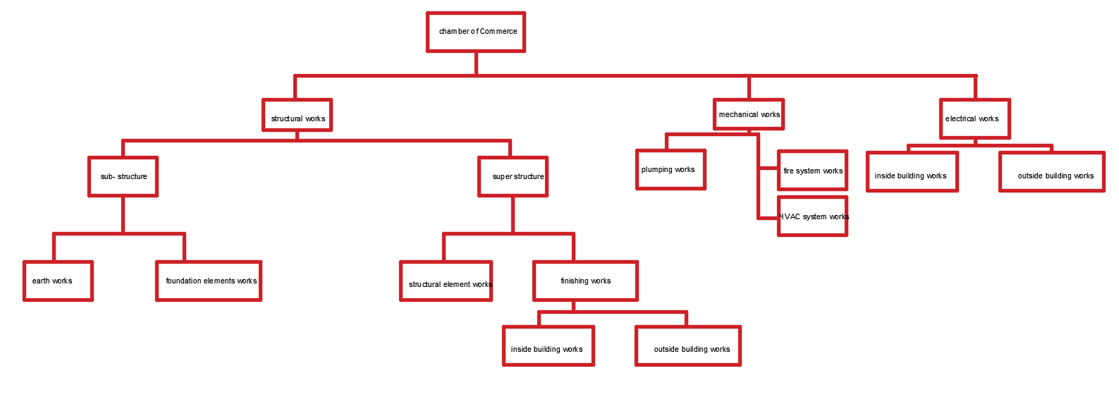
Figure 5:1 cost breakdown structure

Data collections:
In this project, we used two different methods to collect data: first, we used the project information from the plans, such as dimensions of building components; second, we questioned people (contractors) with construction experience about labor productivity and labor costs, which are the foundation for all project calculations.
After analysis the total direct cost for building =29,448,383.74 ILS and the unit cost = 3424.32 ILS/m2
Because each component in this process was computed as if it were a fact and not an estimate, the "Bottom-Up estimation technique in this stage is more accurate than the stage in the first semester, but there is a significant difference in the overall cost between both of them.
The Building total cost =29,448,383.74 ILS
Building total estimation cost = 32,649,872.5592 ILS

Cost breakdown structure
Table ‎5-1 BOQ

Item No | Description | Unit | Quantity | Total Direct Cost
 |  |  |  | Unit Cost  (ILS/m2) | Total Cost(ILS)
1 | Jenin chamber of commerce building | - | - | 3424.23 | ILS 29,448,383.74
1.1 | Earthworks | - | - | 189.57 | ILS 1,600,000.00
1.1.1 | Excavation works | - | - | - | ILS 1,600,000.00
1.1.1.1 | Land excavation | m3 | 40000 | - | ILS 1,600,000.00
1.2 | Structural |  |  | 3028.89 | ILS 25,563,849.68
1.2.1 | Sub-structural |  |  | 404.65 | ILS 3,415,224.44
1.2.1.3 | Water tank | - | - | - | ILS 62,223.81
1.2.1.3.1 | Water tank formwork | m2 | 155.00 | - | ILS 2,036.31
1.2.1.3.2 | Water tank reinforcement works | Ton | 15.00 | - | ILS 43,734.38
1.2.1.3.3 | Water tank concrete pouring | m3 | 45.00 | - | ILS 16,453.13
1.2.1.4 | Mat foundation | - | - | - | ILS 2,557,973.75
1.2.1.3.1 | Mat foundation formwork | m2 | 400.00 | - | ILS 7,130.00
1.2.1.3.2 | Mat foundation reinforcement works | Ton | 350.00 | - | ILS 1,015,218.75
1.2.1.3.3 | Mat foundation concrete pouring | m3 | 4200.00 | - | ILS 1,535,625.00
1.2.2 | super-structural |  |  | 2624.24 | ILS 22,148,625.24
1.2.2.1 | Structural elements |  |  | 936.55 | ILS 7,904,523.00
1.2.2.1.1 | Columns concrete pouring | m3 | 200.00 | - | ILS 72,500.00
1.2.2.1.2 | Columns reinforcement works | Ton | 50.00 | - | ILS 176,250.00
1.2.2.1.3 | Columns formwork | m2 | 25000.00 | - | ILS 62,812.50
1.2.2.1.4 | Slabs concrete pouring | m3 | 2400.00 | - | ILS 870,000.00
1.2.2.1.5 | Slabs formwork | m2 | 8400.00 | - | ILS 89,355.00
1.2.2.1.6 | Slabs reinforcement works | Ton | 980.00 | - | ILS 3,454,500.00
1.2.2.1.12 | Stairs formwork | m2 | 1450.00 | - | ILS 4,690.00
1.2.2.1.13 | Stairs reinforcement works | Ton | 8.00 | - | ILS 28,200.00
1.2.2.1.14 | Stairs concrete pouring | m3 | 98.00 | - | ILS 88,812.50
1.2.2.1.15 | Shear wall formwork | m2 | 3900.00 | - | ILS 67,735.00
1.2.2.1.16 | Shear wall reinforcement works | Ton | 35.00 | - | ILS 616,875.00
1.2.2.1.17 | Shear wall concrete pouring | m3 | 110.00 | - | ILS 126,875.00
1.2.2.2 | Finishing works |  |  | 937.91 | ILS 7,915,923.60
1.2.2.2.1 | Stone | m2 | 1800.00 | - | ILS 216,000.00
1.2.2.2.2 | Pointing | m2 | 2800.00 | - | ILS 97,692.00
1.2.2.2.3 | Interior tiles | m2 | 7500.00 | - | ILS 299,925.00
1.2.2.2.5 | Block | m2 | 8350.00 | - | ILS 399,130.00
1.2.2.2.6 | Plaster | m2 | 2500.00 | - | ILS 68,125.00
1.2.2.2.7 | Epoxy for basements | m2 | 4000.00 | - | ILS 281,250.00
1.2.2.2.8 | Painting | m2 | 4500.00 | - | ILS 82,125.00
1.2.2.2.10 | Exterior glazed wall with louvers | m2 | 930.00 | - | ILS 930,000.00
1.2.2.2.11 | Exterior glazed wall | m2 | 1300.00 | - | ILS 1,300,000.00
1.2.2.2.13 | Normal elevators | Unit | 4.00 | - | ILS 1,400,000.00
1.2.2.2.15 | Doors | Unit | 250.00 | - | ILS 625,000.00
1.2.2.2.16 | Fire doors | Unit | 10.00 | - | ILS 90,000.00
1.3 | Electrical and low voltage works |  |  | 57.33 | ILS 483,833.40
1.3.1 | Loud speakers | Unit | 200.00 | - | ILS 45,875.00
1.3.2 | Surface loud speakers | Unit | 5.00 | - | ILS 7,546.88
1.3.4 | Electrical wiring | - | - | - | ILS 248,974.00
1.3.4.1 | cables (1.5mm) | m | 900.00 | - | ILS 630.00
1.3.4.2 | Cable 2.5mm | m | 600.00 | - | ILS 540.00
1.3.4.3 | Lighting circuit braker(10A) | Unit | 60.00 | - | ILS 600.00
1.3.4.4 | Power circuit braker(16A) | Unit | 70.00 | - | ILS 700.00
1.3.4.5 | Power circuit braker(32A) | Unit | 35.00 | - | ILS 350.00
1.3.4.6 | Main circuit braker(Touch) | Unit | 20.00 | - | ILS 1,700.00
1.3.4.7 | SDB | Unit | 20.00 | - | ILS 10,000.00
1.3.4.8 | MDB | Unit | 1.00 | - | ILS 1,000.00
1.3.4.9 | Socket outlet (single) | Unit | 300.00 | - | ILS 3,600.00
1.3.4.10 | Single Switches | Unit | 350.00 | - | ILS 1,750.00
1.3.4.11 | Double Switches | Unit | 120.00 | - | ILS 840.00
1.3.4.12 | Fixel Switches | Unit | 33.00 | - | ILS 264.00
1.3.4.13 | Telephone socket outlet | Unit | 35.00 | - | ILS 3,500.00
1.3.4.14 | Led Florecent | Unit | 350.00 | - | ILS 87,500.00
1.3.4.15 | Spot light | Unit | 800.00 | - | ILS 120,000.00
1.3.4.16 | Stair light | Unit | 80.00 | - | ILS 16,000.00
1.4 | Mechanical Works |  |  | 213.35 | ILS 1,800,700.66
1.4.2 | Plumping works | - | - | - | ILS 142,750.66
1.4.2.1 | Water closet | unit | 56.00 | - | ILS 33,600.00

Item No | Description | Unit | Quantity | Total Direct Cost
 |  |  |  | Unit Cost  (ILS/m2) | Total Cost(ILS)
1.4.2.2 | Lavatory | unit | 56.00 | - | ILS 28,000.00
1.4.2.3 | Sink | unit | 15.00 | - | ILS 6,750.00
1.4.2.4 | manhole (60*60 cm) | unit | 10.00 | - | ILS 10,000.00
1.4.2.5 | floor drainage | unit | 50.00 | - | ILS 12,500.00
1.4.2.6 | PVC pipe 4'' | m | 200.56 | - | ILS 2,005.56
1.4.2.7 | pvc pipe 6” slope 1% | m | 178.72 | - | ILS 3,574.44
1.4.2.8 | pvc pipe 2” | m | 125.73 | - | ILS 754.38
1.4.2.9 | Pvc fitting (4”) | Unit | 4.00 | - | ILS 16.00
1.4.2.10 | Pvc fitting (2”) | Unit | 20.00 | - | ILS 60.00
1.4.2.11 | w.c elbow (4”) | Unit | 55.00 | - | ILS 275.00
1.4.2.12 | PVC fitting (6”) | Unit | 6.00 | - | ILS 48.00
1.4.2.13 | Boiler | Unit | 9.00 | - | ILS 6,300.00
1.4.2.14 | Water meter | Unit | 11.00 | - | ILS 1,100.00
1.4.2.15 | collector | Unit | 20.00 | - | ILS 900.00
1.4.2.16 | Beday | Unit | 55.00 | - | ILS 5,500.00
1.4.2.17 | Sink | Unit | 13.00 | - | ILS 2,600.00
1.4.2.18 | Cold water pipe (pvc 1") | m | 809.28 | - | ILS 2,427.84
1.4.2.19 | Hot water pipe (pvdc 1") | m | 707.76 | - | ILS 2,831.04
1.4.2.20 | Cold water pipe (pvc 2") | m | 809.28 | - | ILS 4,046.40
1.4.2.21 | Steel pipes (2.5") | m | 68.40 | - | ILS 3,762.00
1.4.2.22 | Tanks | Unit | 29.00 | - | ILS 14,500.00
1.4.2.23 | Water pump | Unit | 2.00 | - | ILS 1,200.00
1.4.3 | HVAC system | - | - | - | ILS 1,400,000.00
1.4.3.1 | AC central system | m2 | 8000.00 | - | ILS 1,400,000.00
1.4.4 | Fire system | - | . | - | ILS 257,950.00
1.4.4.1 | Water sprinklers | Unit | 150.00 | - | ILS 30,000.00
1.4.4.2 | Dry powder extinguishers | Unit | 80.00 | - | ILS 8,000.00
1.4.4.3 | Fire Hose Cabinet class 1 | Unit | 9.00 | - | ILS 9,000.00
1.4.4.4 | Fire Hose Cabinet class 2 | Unit | 18.00 | - | ILS 12,600.00
1.4.4.5 | Steel pipes | m | 608.00 | - | ILS 30,400.00
1.4.4.6 | Smoke detector | Unit | 90.00 | - | ILS 18,000.00
1.4.4.7 | Heat detector | Unit | 13.00 | - | ILS 2,600.00
1.4.4.8 | Fire speaker | Unit | 50.00 | - | ILS 1,250.00
1.4.4.9 | Fire Bell | Unit | 35.00 | - | ILS 2,100.00
1.4.4.10 | Manual call point | Unit | 60.00 | - | ILS 6,000.00
1.4.4.11 | Fire extinguisher | Unit | 72.00 | - | ILS 108,000.00
1.4.4.12 | Fire system pumps | Unit | 2.00 | - | ILS 30,000.00

Conclusion

ARCHITECTURAL Aspects
After making the assessment for the existed spaces and based on literature review data and asking architectural engineers in the faculty, all spaces are within the standards, but the modifications will only make on the floor's functions arrangement, changing some of the floors functions and rearrange of the floors.
The importance points that added and changings to the floors are the following:
            - Adding three elevators, so total number of elevators will be 4 elevators for people, and service elevator will be added as service elevator for restaurant and coffee shop.
            - Adding shops in the ground floor.
            - Adding WC’s in the third and fourth floors for people and disabled people.
            - Distribution of restaurant spaces.
            - Increasing doors areas.
            - Increasing the width of the main entrance.
            - Changing the shape of the disabled people ramp and its slope to be 6% as per standards.
            - Adding a new basement to increase the number of parking spaces and considering an extra three parking spaces will add for disabled people at the main entrance of the building.
            - Adding atrium on the south-East elevation.
            - Adding a double skin façade on the South elevation.

Here is a summary of the floors’ functions before and after
Table ‎6-1: Floors functions before and after modifications.
Floor Name | Function before | Function After
Ground floor | Investments units | Shops
First floor | Chamber of commerce | Furniture show areas
Second floor | offices | Chamber of commerce
Third floor | offices | offices
Fourth floor | Furniture show areas | offices
Fifth floor | Sweets | Sweets and coffee shop
Sixth floor | Restaurant | Restaurant

ENVIRONMENTAL Aspects
The quantity of energy or lighting derived from solar insolation is estimated as needed, and shading is a crucial component to improving the thermal or lighting efficiency of buildings. The types of shading systems vary depending on their location and the nature of they use. Including atrium and double skin façade that will be explained in the following:
            - Using an atrium on the south-East elevation to increase the amount of natural light and a rail to increase ventilation and air flow.
Figure ‎6.1: Atrium used.

            - Using a double skin façade on the South elevation to improve daylight factor.

Figure ‎6.2: Double skin façade used.

- Using double low e glass
- Using thermal insulation in walls and roof to enhance cooling load
- Skylight and make court concept in courtyard

Structural Aspects
The design was performed to resist the earthquake forces
- Slab system:
Figure ‎6.3: Slab section.
- Design of concrete columns
- The columns dimensions are calculated based on the building loads, for interior column
- Tributary area = 47 m²
- Slab unit load = 10.78 KN/m² --->Approximate column’s load = 47*10.78*9 = 4560.94 KN
- 𝜌 = 1%
- Ag = 315867.56 mm² ---->Assumed column’s dimension = 80*40 cm
- For edge column:
- Tributary area = 20 m²
- Slab unit load = 10.78 KN/m² --->Approximate column’s load = 20*10.78*9 = 1940.4 KN
- 𝜌 = 1%
- Ag = 134.41 mm² ---->Assumed column’s dimension = 50*30 cm

- For corner column:
- Tributary area = 18 m²
- Slab unit load = 10.78 KN/m² --->Approximate column’s load = 18*10.78*9 = 1746.36 KN
- 𝜌 = 1%
- Ag = 120.9 mm² ---->Assumed column’s dimension = 50*30 cm
Expansion joint:

Electro Mechanical Aspects

Artificial lighting
The artificial lighting inside the building was built with the quantity of illumination, glare, and uniformity required for each location in mind.

HVAC system
The Cassette unit system has been used in hotel offices, stores and meeting hall
The split unit system has been used in hotel sweets
Fan coil unit will be used only for VRV ducted system in other spaces

Acoustics design
Consists of following stages:
      - Design of room acoustics based on the standrads for the room acoustical design.
      - Electro-acoustic design based on the areas that need loudspeakers.

Fire Alarm and firefighting system
Smoke and heat detectors with loud speakers and manual bells were used as a notification system for emergency cases.
Water sprinkler system, dry powder extinguishers and fire hose cabinet were used as a firefighting system.

Water supply system
The number of required water tanks was determined based on the number of individuals who could be present inside the structure. The needed pipe sizes were determined by the number of fixture units on each floor.

Quantity surveying & Cost Estimation
Based on the bottom up estimation technique
After analysis the total direct cost for building =29,448,383.74 ILS and the unit cost = 3424.32 ILS/m2

References

- ACI-318. 2014. American Concrete Institute Building Code Requirements for Structural Concrete (ACI 318S-14) and Commentary (ACI 318SR-14).
- ADLER, DAVID. 2007. “Metric Handbook Planning and Design Data.” : 1–851. file:///Volumes/750G/%23 setting/%23 Papers2 Library/Papers2/Files/Metric Handbook_ Planning and Design Data, Third Edition - David Littlefield.pdf%5Cnpapers2://publication/uuid/1B514042-DB7B-4A29-B7D2-7521D5BBE614.
- Aelenei, Laura et al. 2018. COST Action TU 1403 Adaptive Facade Network Case Studies – Adaptive Facade Network.
- AISC-360. 2016. “Specification for Structural Steel Buildings, ANSI / AISC 360-16.” American Institute of Steel Construction: 676.
- Al-Dabbeek, Jalal N., and Radwan J. El-Kelani. 2008. “Site Effect and Expected Seismic Performance of Buildings in Palestine-Case Study: Nablus City.” AIP Conference Proceedings 1020(PART 1): 191–98.
- Arnold, Christopher. 2016. “Earthquake Effects on Buildings.” Tall Building Design: 69–221.
- Building Code Requirements for Structural Concrete (ACI318-14). 2014. Building Code Requirements for Structural Concrete (ACI 318-14). 14th ed. Texas: ACI Committee 318.
- Daylight Factor | Daylighting Pattern Guide. 2020. “Daylight Factor | Daylighting Pattern Guide.” https://patternguide.advancedbuildings.net/using-this-guide/analysis-methods/daylight-factor (November 13, 2020).
Available At: https://patternguide.advancedbuildings.net/using-this- guide/analysis-methods/daylight-factor
- Energy Use Intensity by Property Type. 2013. “Technical Reference: Technical Reference Canadian Energy Use Intensity by Property Type.” (July): 1–6. https://portfoliomanager.energystar.gov/pdf/reference/Canadian National Median Table.pdf.
Avaliable At: https://portfoliomanager.energystar.gov/pdf/reference/Canadian National Median Table.pdf.
- Fire prevention code. 1993. Fire Prevention Code. Royal Society Building Research Focus.
- Gravity Density Specific Weight and Specific. 2021. “Density, Specific Weight and Specific Gravity.” https://www.engineeringtoolbox.com/density-specific-weight-gravity-d_290.html (March 13, 2021).
Avaliable At: https://www.engineeringtoolbox.com/density-specific-weight-
gravity-d_290.html

- “IMPORTANCE OF STRUCTURAL DESIGN - Aarushi Associates.” 2020. http://www.aarushiassociates.in/uncategorized/importance-of structural-design/ (December 18, 2020).
Avaliable At: //www.aarushiassociates.in/uncategorized/importance-of-structural-design/
- International Code Council. 2012. “International Code Council.”
- IS. 2000. “Concrete, Plain and Reinforced.” Bureau of Indian Standards,New Dehli: 1–114.
- Keerthirathna, W. A. D., Gayani Karunasena, and V. A. K. Rodrigo. 2018. “Disability Access in Public Buildings.” International Research Conference on Sustainability in Built Environment (June 2010).

- Kimley, Bob, Bill Horn, and Ed Vick. 2016. “Recommended Parking Ramp Design Guidelines.”
- Life Safety - Means of Egress / Exits – NFPA 101. 2020. “Life Safety - Means of Egress / Exits – NFPA 101.”
- MATHalino Unit Weights and Densities of Soil | Geotechnical Engineering Review at. 2021. “Unit Weights and Densities of Soil | Geotechnical Engineering Review at MATHalino.” https://mathalino.com/reviewer/geotechnical-engineering/unit-weights-and-densities-soil (March 13, 2021).
- Avaliable At: https://mathalino.com/reviewer/geotechnical-engineering/unit-weights-and-densities-soil
- Minimum design loads for buildings and other structures-ASCE 7-16. 2016. “Minimum Design Loads for Buildings and Other Structures-ASCE 7-16.” ASCE Standard (7–5): 1–456.
- Minimum Design Loads for Buildings and Other Structures. 2005. Minimum Design Loads for Buildings and Other Structures Supplement to Minimum Design Loads for Buildings and Other Structures (ASCE/SEI 7-05).
- Avaliable At: http://mapleintegration.com/noise_cri.php
- National Fire Alarm and Signaling Code. 2010. National Fire Alarm and Signaling Code. http://www.nfpa.org/aboutthecodes/AboutTheCodes.asp?DocNum=72.
- Office Building Elevators. 2021. “Office Building Elevators.” FUJIHD. https://www.fujihd.net/elevator/officebuilding.html?gclid=Cj0KCQjwytOEBhD5ARIsANnRjViFRNiJ5L6D1J2SFol88N2uzsyOz2L3kXY0lC8hPhspLpDwppL0zYEaAvXtEALw_wcB (May 7, 2021).
- Avaliable At: //www.fujihd.net/elevator/officebuilding.html?gclid=Cj0KCQjwytOEBhD5ARIsANnRjViFRNiJ5L6D1J2SFol88N2uzsyOz2L3kXY0lC8hPhspLpDwppL0zYEaAvXtEALw_wcB
- Ontario Building Code 2012. 2012. “Ontario Building Code 2012.” (1): 9–10.

- Palestinian Environmental NGOs Network. 2016. “Pre Master Plan Solar Energy Production in Palestine : Opportunities and Challenges.” ().
- AvaliaReddy, Yeshwanth Babu. 2017. “Modern Quantity Surveying- A Complete Package Adding Values to Projects.” (March).
- Rizos, Claire. 2013. “How Many Fire Exits Are Required in a Building?” IFSEC Global’. https://www.ifsecglobal.com/fire/how-many-fire-exits-are-required-in-a-building/ (November 27, 2020).
- Avaliable At: https://www.ifsecglobal.com/fire/how-many-fire-exits-are-required-in-a-building/
- Scarlet, Douglas. 2013. 53 Journal of Chemical Information and Modeling ERNST NEUFERT 4th.
- The Importance Of Structural Design | ipl.org. 2020. “The Importance Of Structural Design | Ipl.Org.” https://www.ipl.org/essay/The-Importance-Of-Structural-Design-F38MBAHEAJF6 (December 18, 2020).
- Avaliable At: https://www.ipl.org/essay/The-Importance-Of-Structural-Design-F38MBAHEAJF6
- Uniform Building Code 1997. 1997. “Uniform Building Code 1997.” Immunological Reviews 57(1): 107–26.
- commercial-acoustics. (2022). Determine Target STCs – Sound Transmission Class Ratings. Retrieved November 29, 2022, from commercial-acoustics
Available at: https://commercial-acoustics.com/target-stcs/
36. Davis, L. (2022). Reverberation Time Measurements. Retrieved November 29, 2022, from Larson davis
Avaialble at:http://www.larsondavis.com/learn/building-acoustics/Reverberation-Time-in-Room-Acoustics

THE END

