


An-Najah National University.

Faculty of Engineering.
Electrical Engineering.

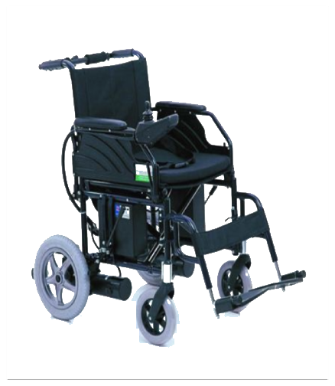
Supervisor: Dr.Samer Mayaleh
Students: Hazem Saleh & Jehad Joma’a

2011/2012

Electric Wheel Chair
Contents
Abstract 5
Introduction. 6
Project block diagram : 7
Items required 8
BACKGROUND AND MOTIVATION: 8
ASSESSMENT OF BRUSHLESS DIRECT-DRIVE DESIGN 9
MOTOR TOPOLOGIES: 11
Conventional dc motors : 11
motor selection: 12
Electric Motor GP 90: 12
Mechanical design : 13
Movement and turning operation description: 14
Project description & circuit diagram : 16
Microcontroller PIC18 4620 17
10-BIT ANALOG-TO-DIGITAL CONVERTER (A/D) MODULE 17
Capture/Compare/PWM (CCP) Modules 19
Joystick 24
LCD ITM-1602DSTL 26
Pulse-width modulation (PWM) 28
IRF P460 32
Optocoupler 4N25 32
Dot/bar display driver LM3914 34
Regulator 7805 35
Relay 36
KSP 2222A transistor 38
Heat sink & cooling system: 39
Economical Study : 42
Future development: 42
PIC (micro C) Code : 41

Table of Figures
Fig(1) 6
Fig(2) 7
Fig(3) 11
Fig(4) 12
Fig(5) 13
Fig(6) 14
Fig(7) 15
Fig(8) 16
Fig(9) 17
Fig(11) 19
Fig(12) 19
Fig(13) 20
Fig(14) 21
Fig(15) 23
Fig(16) 24
Fig(17) 25
Fig(18) 25
Fig(19) 26
Fig(20) 27
Fig(21) 28
Fig(22) 28
Fig(23) 29
Fig(24) 30
Fig(25) 30
Fig(26) 32
Fig(27) 33
Fig(28) 34
Fig(29) 35
Fig(30) 36
Fig(31) 37
Fig(32) 37
Fig(33) 38
Fig(34) 38
Fig(35) 39
Fig(36) 41
Fig(37) 34

الإهداء...

الى الذين رووا بدمائهم ثرى فلسطين.. إلى من هم أفضل منا جميعاً.. إلى الذين ارتقوا إلى السمو .. شهداء فلسطين
إلى الذين عشقوا الحرية التي تفوح منها رائحة الليمون والبرتقال والنرجس.. إلى أبطال هذه الأرض .. أسرانا البواسل
إلى سندنا وقوتنا وملاذنا بعد الله .. إلى من آثرونا على أنفسهم .. إلى من أظهروا لنا ما هو أجمل من الحياة أهلنا الأعزاء
إلى النور الذي ينير لنا طريق المجد .. إلى من غرسوا معنى العطاء في جنبات خافقنا..
أساتدتنا الأفاضل
إلى من كانوا ملاذي وملجئي .. إلى من تذوقت معهم أجمل اللحظات .. إلى من سأفتقدهم .. إلى من جعلهم الله أخوتي بالله .. و من أحببتهم بالله ..
زملاؤنا في قسم الهندسة الكهربائية

شكر وتقدير ..

الشكر والحمد والثناء والتبجيل لله رب العالمين .. فالأمر كله لك، والفضل كله لك، والحمد كله لك.. ما فعلنا شيئًا إلا بإذنك وتقديرك، وما حققنا نجاحًا إلا ببركتك وتوفيقك .. فالحمد لله حمداً كثيرا
والشكر للآباء والأمهات الدين ضحوا من أجلنا، وحرصوا على أن نسلك سبيل الجد والاجتهاد..
والشكر والتقدير لكل من علمنا حرفا.. .. يامن تحملون أسمى رسالة في الحياة ..فشكراً أساتدتنا الأفاضل أعضاء الهيئة التدريسية على كل ما قدمتموه لنا..
ولو أنني أوتيت كل بلاغة وأفنيت بحر النطق في النظم والنثر
لما كنت بعد القول إلا مقصرا ومعترفا بالعجز عن واجب الشكر
شكراً لمن قضينا معه عاماً من المعرفة والعلم والعطاء..فكان المرشد لما هو خيرٌ لنا ..والناصح الأمين لمصلحتنا .. فلك كل الشكر أستادنا الفاضل .. الدكتور /سامر مياله
والشكر لكل من رفع يده للسماء يدعو الله أن يوفقنا ...
حقًّا.. الشكر كل الشكر.. لكم.

Abstract
In our project we design an electric wheel chair for special needs, and as we know the price of this equipment in market is very high , we are trying to provide affordable. It consists of: four wheels, two permanent magnet motors fixed at the back wheels ,12v-26 Ah dry battery , micro controller and joystick.

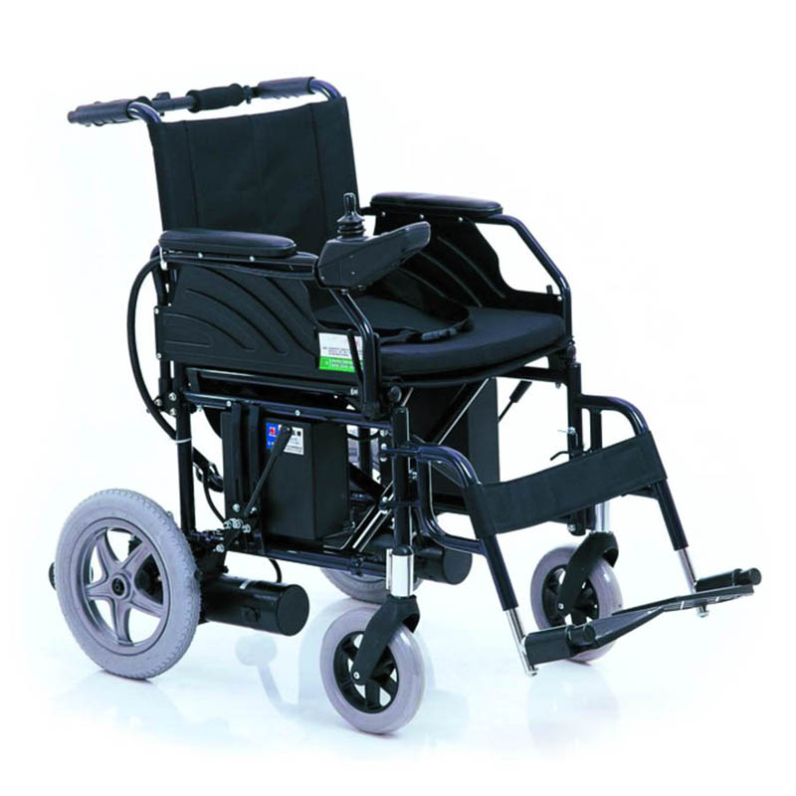

FIG (1)
.

Introduction

In our project we tried to take into account the scientific and academic views with human side, and have forgotten our situation and serve a fairly large private Palestinian society. There are some people with special needs. For example, people with physical disabilities who cannot afford to move permanently.
It is known that the neglect in this segment of Palestinian society is the proportion of very high rate compared with neighboring countries due to wars and intifada fought by our unarmed, innocent, and great people who left handicapped, or disabled because of Israel's savage attack toward them.
In this project we are trying to help this segment and provide them with electric chairs which are high performed with low price compared with those in the local market which do not fit the economic situation in the Palestinian territories. In addition, not taking into account the needs of the disabled .

Subjects we learned in the project:

- Obtain background about mechanism.
- Deep study in motors and there categories.
- Study Motor control.
- Knowledge about batteries.
- Learn microcontroller programming language (MikroC PIC Programming)
- interfacing between microcontroller and other circuit components
- Circuit simulation program

Project block diagram :
Motor
Motor
Voltage regulator
Battery
H-Bridge
H-Bridge

Microcontroller
PWM

Control
Signal

Voltage
Sensor

Fig(2)

Items required

- Power transistors.
- Two DC permanent magnet motors.
- Optocouplers.
- Voltage regulaters.
- Mechanical vehicle.
- Microcontroller.
- Two Batteries 12V,26A
- Relays

BACKGROUND AND MOTIVATION:

For traction applications, the short-term rating, which governs acceleration and hill-climbing ability, the electric motor is superior to the other engine in performance because the electric motor More Effectively. Traditionally, the dc motor has been widely used as the main propulsion motor, the dc compound motor has found more suitable in some special traction where electric braking is required.
The main drawback of dc motors is of course their maintenance requirements. Consequently, constant efforts are being made to develop alternative type of drive systems with equally or almost as good characteristics, but without commutator or brushgear.
Continuous development of semiconductor switching devices and power electronic converters has made it possible to meet the traction requirements for many applications by an induction motor drive system. At present a typical propulsion system for an electric wheelchair consists of a pair of brushed dc internally rotating permanent magnet motors; one for each drive wheel.
The gear train, apart from being a shock absorber when the drive wheels are stuck or under heavy load, serves to reduce the motor speed while proportionally increasing motor torque. This result in a significant reduction of required motor volume leading to a lower manufacturing cost.
The following lists some of the main requirements that must be found in dc electric motors for these applications.
1. The motor should be small and lightweight.
2. High economical efficiency.
3. Durable and easy to maintain.
4. Low noise.
5. Low cost.
6. Must be able to be used under various conditions and humidity.
7. Regenerative braking if it possible.
Transmission options :
The drive train is a mechanical system that transfers power from the motor to the drive-wheels. The conventional drive train is composed of gears, belts, chains and other mechanical elements that serve to reduce motor speed while proportionally increasing the motor torque. Motor and drive train efficiency impacts battery performance and the overall performance of the system. Weather these vehicles are suitable for the appropriate tasks are determined by the characteristics of its motor, drive train, battery and power management system, However among the six mentioned the simplest type of transmission is the direct-drive design. The last few years have seen many developments in direct-drive technology. Although direct-drive is not suitable for every application, their attractive inherent properties have made them a prime candidate for traction purposes.

ASSESSMENT OF BRUSHLESS DIRECT-DRIVE DESIGN

The advantages offered by a direct-drive employing a brushless system over the conventional geared drive design are summarized as follows:
1- with direct-drive the motor is connected directly to the axle of the driven wheel
resulting in both motor and wheel speed being equal.
2- There is no mechanical power transfer by friction wheels or belts. Thus mechanical wear and tear is eliminated. Since the wheel is rigidly coupled to the motor there are no transmission errors such as backlash, belt stretch and gear tooth error. Since there is no mechanical friction, less power is consumed. Thus a high economical efficiency is
achieved due to the low power consumption. There will not be error in the speed
feedback system due to gear slippage. Internal stresses between bearings are also eliminated
3- With fewer moving parts, they offer reduced audible noise. Zero maintenance is required, as the bearings are the only wearing component.
4- The relatively high friction, high compliance transmission components that commonly cause stick-slip in traditionally mechanical transmissions are eliminated in direct-drive systems.
5- Since the coupling between the load and motor is stiff, problems associated with mechanical resonance are eliminated. In direct drive systems the load inertia can be many times greater than the motor inertia without degrading the system performance
6- The usage of the motorized wheel, apart from enabling the complete elimination of the transmission components, reduces the current during the start and acceleration.
7- The controller becomes much simplified in direct-drive systems as the movement regime does not need optimization.
Of course, as with most engineering problems, the advantages offered by direct-drive systems are offset by certain disadvantage . These are summarized in the following:
- Since direct-drive systems have no transmission components, they must provide more torque at a lower speed compared to the geared version.
- They are usually much expensive than traditional transmission systems especially in applications requiring high torque. The cost penalty has to be weighed against improvment in overall system performance in deciding the viability of direct-drives for a given application.
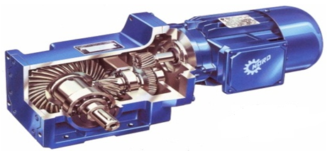
Fig(3)
MOTOR TOPOLOGIES:
Selection of the driving motor depends on the conditions under which it has to operate and the type of load it has to handle. Guiding factors for such a selection can be classified into four main Categories as follows:
- Electrical Considerations: starting and running characteristics, speed
control and braking requirements.
- Mechanical Considerations: type of enclosure, bearings, cooling,
Noise level and method of transmission.
- Size and Ratings: requirement for continuous, intermittent or
- Variable load cycle and overload capacity.
- Cost: capital and running costs.

Conventional dc motors :

The conventional dc motor has a stationary magnetic field (stator) and a rotating armature (rotor). The power delivered depends on the air-gap diameter and effective axial length
and it is work at Full four-quadrant operation occurs without any special provision, as operating conditions are varied. the Torque ripple with shaft rotation is low and the same form of variation of torque with speed is obtained for all set no-load speeds.
From the above, it is no surprise that commutator-type dc motors were identified decades
ago as ideal for traction applications. The main disadvantage of this type of motor is of course the maintenance requirements due to the commutator and brush gear.
motor selection:

in our project we use the permanent magnet motors ,It is more suited to high-speed
applications than the low speeds encountered in direct drives for applications such as wheelchairs. and it is have smooth torque over the operating speed range is required.

Electric Motor GP 90:

AMT electrical motors are DC permanent magnet motors. These motors are characterized by an extremely high degree of efficiency (up to 88%) and by low operating noise (45dB), as well as by their durability. Motors can be run for a short time up to four times their rated torque
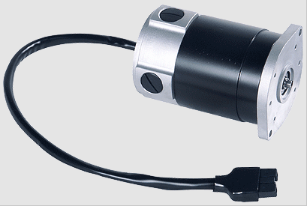

Fig(4)

- rated power from 350 Watt to 550 Watt
- 2 poles.
- rated speed from 1500 to 4000 rpm(revolutions/minute)
- Operating voltage 24V.
- Outfitting with electromagnetic brakes possible.
- Other rated voltage available upon request.
- custom shafts and flanges available upon request.
- connecting cables available upon request with compatible plugs.

Mechanical design :

We will choose the design after a deep search on the web looking for several kinds of motorized chairs, finally we select a model which satisfies our target also simple to implement
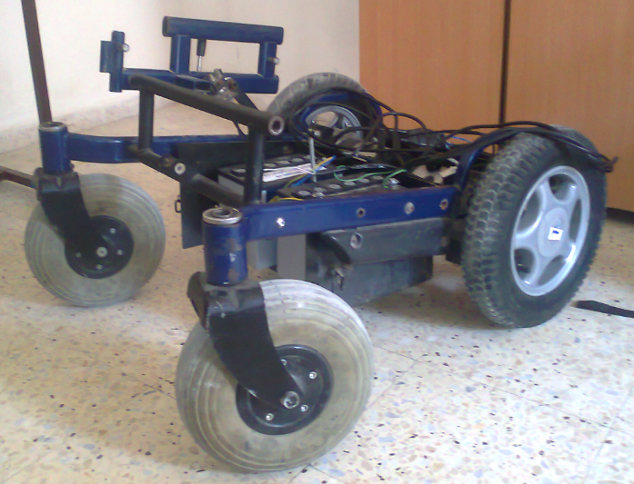

Fig(5)

We use two motors on the back wheels , this is better than use one motor to draw the wheel chair only (instead of using one motor with high rated power) ,and to satisfy an easy control for turning operations when we used two motors .

Fig(6)

Movement and turning operation description:

- If we want to move straight forward we have to operate right and left motors at the same speed(clock wise)
- If we want to move straight backward we have to operate right and left motors at the same speed(count clock wise).
- Turn right:
- If we want to turn right while the wheel chair is move forward (clock wise) or backward (count clock wise),it should increase angular speed for left motor and decrease angular speed for right motor.
- If we want to turn right from stationary station we should run the left motor only either forward (clock wise) or backward (count clock wise),while the right one running in the reverse direction.
- Turn Left:
- If we want to turn Left while the wheel chair is move forward (clock wise) or backward (count clock wise),it should increase angular speed for right motor and decrease angular speed for Left motor.
- If we want to turn Left from stationary station we should run the right motor only either forward (clock wise) or backward (count clock wise),while the Left one running in the reverse direction.
Note:The turning for stationary station enables the wheel chair turn in small turning radius, and this operation increases the wheel chair reliability (specially in the closed area).
Different side views and chair components Arrangement:
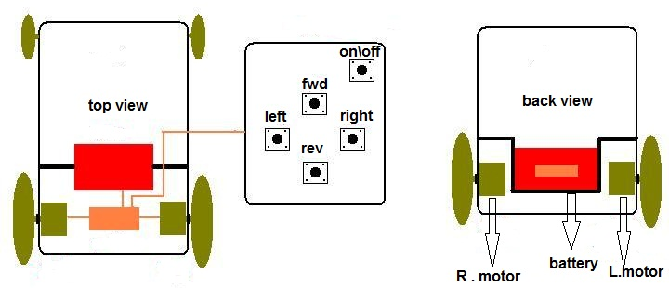

Fig(7)

Here is the wheel chair specifications we choose according to international standard :
- Weight Capacity: 165 Lbs. , 75 kg
- Maximum Speed: in flat surface 6 MPH , 9.5 kmh, : incline sufrace 4 MPH , 6.4 kmh
- Turning Radius: 33'' , 83.8 cm
- Ground Clearance: 4.5" , 11.4 cm
- Range of Travel: 25 miles per charge , 40.25 km
- seat Width 18", 20" / 45.7 cm , 50.8 cm
- Seat Length 16’’ / 40.6
- Seat Depths : 16" , 40.6 cm
- Seat-to-Floor Height 19.5" / 49.5
- Backrest Height 17.5’’ / 44.5
- Overall Length: 41" , 104.1 cm
- Overall Width: 23.5" to 27.5" , 59.7 cm to 69.9 cm
- Overall height : 36.5 , 93 cm
- Wheels: 12.5' , 31.8 cm" Drive /8' , 20.3 cm" Caster
- Heaviest Piece: 100 Lbs ,45 kg
We design for average adults with 75 Kg relating to the international standard, The overall weight assumed to be 120 Kg (the person with the chair) power rated and other related calculations such as torque , angular speed ,velocity etc .
To get right answer on motor rated power we have been back to dynamic in previous semester and we did the necessary calculations, we get a result shows the rated power of our motors should be around from 450 w

Schematic circuit :

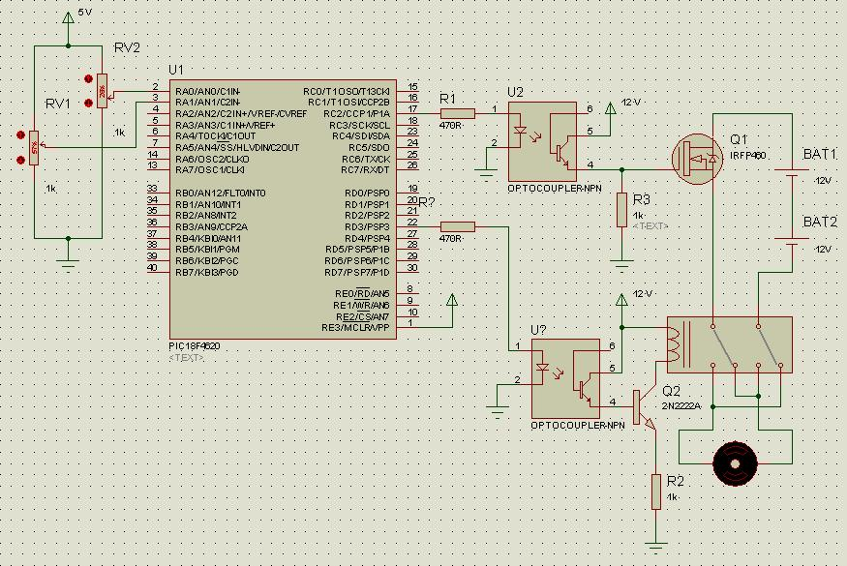

Fig(8)

Microcontroller PIC18 4620
The system controller acts as the “brain” of the wheelchair. It is responsible for accepting input from the joystick to determine the user’s commands and then performing the actions necessary to execute those commands. It receives inputs from the user’s joystick, and analyze this input giving orders for the relays and also generating suitable pulse width modulation signal according to the joystick movement . while noticing the three interrupts (stop increment , speed increment interrupt , speed decrement interrupt) , PIC18 4620 fig() below
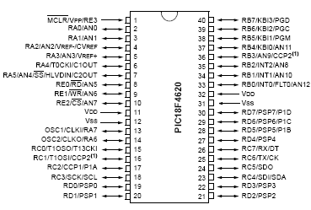

Fig(9)

10-BIT ANALOG-TO-DIGITAL CONVERTER (A/D) MODULE

We use two ADC modules from port A ADCON0 , ADCON1
The Analog-to-Digital (A/D) converter module has 10 inputs for the 28-pin devices and 13 for the 40/44-pin devices. This module allows conversion of an analog input signal to a corresponding 10-bit digital number.
The ADCON0 register, shown in Register fig(), controls the operation of the A/D module. The ADCON1 register, shown in Register fig(), configures the functions of the port pins.

ADCON0: A/D CONTROL REGISTER 0 configuration

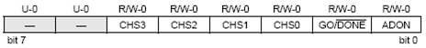
Fig(20)

bit 7-6 : Unimplemented: Read as ‘0’
bit 5-2 : CHS3:CHS0: Analog Channel Select bits [0000 = Channel 0 (AN0)]
bit 1 : GO/DONE: A/D Conversion Status bit
When ADON = 1:
1 = A/D conversion in progress
0 = A/D Idle
bit 0 ADON: A/D On bit
1 = A/D converter module is enabled
0 = A/D converter module is disabled
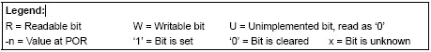
ADCON1: A/D CONTROL REGISTER 1 configuration , table()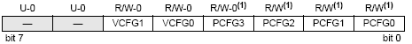
table(1) bit 7-6 : Unimplemented: Read as ‘0’
bit 5 : VCFG1: Voltage Reference Configuration bit (VREF- source)
1 = VREF- (AN2)
0 = VSS
bit 4 : VCFG0: Voltage Reference Configuration bit (VREF+ source)
1 = VREF+ (AN3)
0 = VDD
bit 3-0 : PCFG3:PCFG0: A/D Port Configuration Control bits
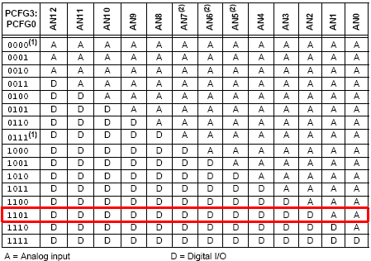

Fig(13)

Capture/Compare/PWM (CCP) Modules
We use two channels of PWM CCP1 , CCP2 one channel for each motor.
PIC18F4620 devices all have two CCP (Capture/Compare/PWM) modules. Each module contains a 16-bit register which can operate as a 16-bit Capture register, a 16-bit Compare register or a PWM Master/Slave Duty Cycle register.
In 40/44-pin devices, CCP1 is implemented as an Enhanced CCP module with standard Capture and Compare modes.

REGISTER 16-1: CCP1CON REGISTER (ECCP1 MODULE, 40/44-PIN DEVICES) configuration
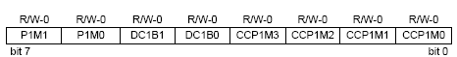
Fig(42)
bit 7-6 : P1M1:P1M0: Enhanced PWM Output Configuration bits
If CCP1M3:CCP1M2 = 00, 01, 10:
xx = P1A assigned as Capture/Compare input/output; P1B, P1C, P1D assigned as port pins If CCP1M3:CCP1M2 = 11:
00 = Single output: P1A modulated; P1B, P1C, P1D assigned as port pins
01 = Full-bridge output forward: P1D modulated; P1A active; P1B, P1C inactive
10 = Half-bridge output: P1A, P1B modulated with dead-band control; P1C, P1D assignedas port pins
11 = Full-bridge output reverse: P1B modulated; P1C active; P1A, P1D inactive

bit 5-4 : DC1B1:DC1B0: PWM Duty Cycle bit 1 and bit 0
Capture mode: Unused.
Compare mode: Unused.
PWM mode: These bits are the two LSbs of the 10-bit PWM duty cycle. The eight MSbs of the duty cycle are found in CCPR1L.
bit 3-0 : CCP1M3:CCP1M0: Enhanced CCP Mode Select bits
1100 = PWM mode; P1A, P1C active-high; P1B, P1D active-high
1101 = PWM mode; P1A, P1C active-high; P1B, P1D active-low
1110 = PWM mode; P1A, P1C active-low; P1B, P1D active-high
1111 = PWM mode; P1A, P1C active-low; P1B, P1D active-low
INTERRUPTS
we use three interrupts on port B Rb0 ,Rb1 ,Rb2
The PIC18F4620 devices have multiple interrupt sources and an interrupt priority feature that allows most interrupt sources to be assigned a high priority level or a low priority level. The high priority interrupt vector is at 0008h and the low priority interrupt vector is at 0018h. High priority interrupt events will interrupt any low priority interrupts that may be in progress .
INTCON: INTERRUPT CONTROL REGISTER configuration , table()
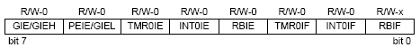

Fig(53)
bit 7 : GIE/GIEH: Global Interrupt Enable bit
When IPEN = 0:
1 = Enables all unmasked interrupts
0 = Disables all interrupts
When IPEN = 1:
1 = Enables all high priority interrupts
0 = Disables all interrupts
bit 6 : PEIE/GIEL: Peripheral Interrupt Enable bit
When IPEN = 0:
1 = Enables all unmasked peripheral interrupts
0 = Disables all peripheral interrupts
When IPEN = 1:
1 = Enables all low priority peripheral interrupts
0 = Disables all low priority peripheral interrupts
bit 5 : TMR0IE: TMR0 Overflow Interrupt Enable bit
1 = Enables the TMR0 overflow interrupt
0 = Disables the TMR0 overflow interrupt
bit 4 : INT0IE: INT0 External Interrupt Enable bit
1 = Enables the INT0 external interrupt
0 = Disables the INT0 external interrupt
bit 3 RBIE: RB Port Change Interrupt Enable bit
1 = Enables the RB port change interrupt
0 = Disables the RB port change interrupt
bit 2 TMR0IF: TMR0 Overflow Interrupt Flag bit
1 = TMR0 register has overflowed (must be cleared in software)
0 = TMR0 register did not overflow
bit 1 INT0IF: INT0 External Interrupt Flag bit
1 = The INT0 external interrupt occurred (must be cleared in software)
0 = The INT0 external interrupt did not occur
bit 0 RBIF: RB Port Change Interrupt Flag bit
1 = At least one of the RB7:RB4 pins changed state (must be cleared in software)
0 = None of the RB7:RB4 pins have changed state

INTCON2: INTERRUPT CONTROL REGISTER 2 configuration ,

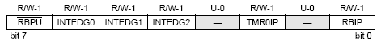
Fig(64)
bit 7 : RBPU: PORTB Pull-up Enable bit
1 = All PORTB pull-ups are disabled
0 = PORTB pull-ups are enabled by individual port latch values
bit 6 : INTEDG0: External Interrupt 0 Edge Select bit
1 = Interrupt on rising edge
0 = Interrupt on falling edge
bit 5 : INTEDG1: External Interrupt 1 Edge Select bit
1 = Interrupt on rising edge
0 = Interrupt on falling edge
bit 4 : INTEDG2: External Interrupt 2 Edge Select bit
1 = Interrupt on rising edge
0 = Interrupt on falling edge
bit 3 : Unimplemented: Read as ‘0’
bit 2 : TMR0IP: TMR0 Overflow Interrupt Priority bit
1 = High priority
0 = Low priority

bit 1 : Unimplemented: Read as ‘0’
bit 0 : RBIP: RB Port Change Interrupt Priority bit
1 = High priority
0 = Low priority

below shows the hardware configuration of the pic 18F4620

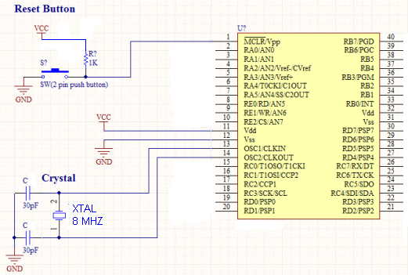

Fig(75)

Joystick
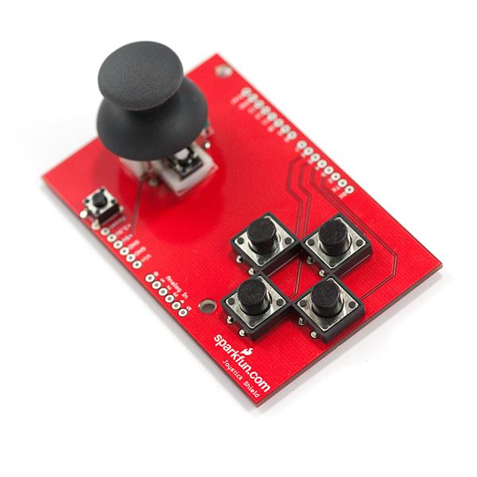

Fig(86)

Description: The Joystick Shield kit contains all the parts you need to enable your microcontroller with a joystick as you see in fig (1) The shield sits on top of your microcontroller and turns it into a simple controller. Five momentary push buttons (4+ joystick select button) and a two-axis thumb joystick gives your microcontroller functionality on the level of old Nintendo controllers. Soldering is required, but it's relatively easy and requires minimal tools.
The momentary push buttons are connected to microcontroller digital pins ; when pressed they will pull the pin high , we use 3 push buttons :
the first push button used As hardware interrupt which will interrupt the whole system and forces the chair to stop even there's an input command from the joystick ,the second push button used to increase the speed (change to a higher speed range and remains within this speed range until we increase it again or decrease it) , the third push button used to decrease the speed (change to a lower speed range and remains within this speed range until we increase it again or decrease it) . For speed ranges see fig (2).
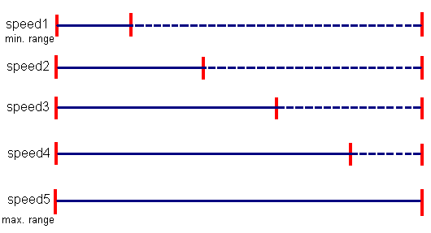

Fig(97)

Vertical movement of the joystick will produce a proportional analog voltage on analog pin AN0, likewise, horizontal movement of the joystick can be tracked on analog pin AN1.see fig (3)

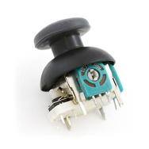

Fig(108)

the voltage rages (0-5) volts giving 2.5 at the steady state condition of the joystick moving the joystick forward will increase the voltage until it reaches 5 volt also moving the joystick reward will decrease the voltage until it reaches 0 volt , this also verified for the left to right movement , the ADC will receive these values and output a PWM value accordingly .

LCD ITM-1602DSTL
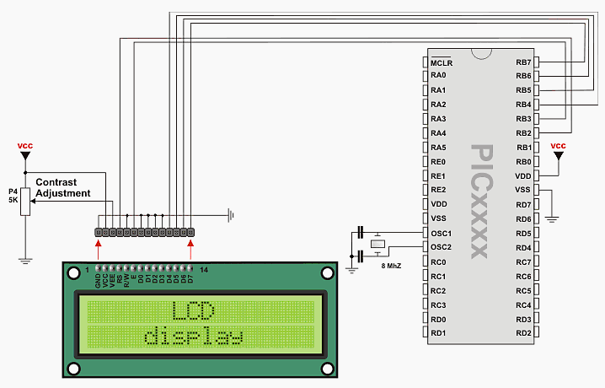

Fig(19)

Block diagram

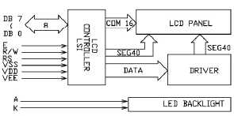

Fig(20)
absolute maximum ratings (25 C )
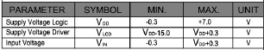

Fig(21)
PIN configuration
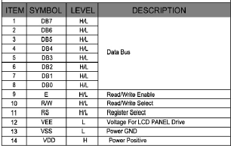

Fig(22)

Pulse-width modulation (PWM)
(PWM), is a commonly used technique for controlling power to inertial electrical devices, made practical by modern electronic power switches.
The average value of voltage (and current) fed to the load is controlled by turning the switch between supply and load on and off at a fast pace. The longer the switch is on compared to the off periods, the higher the power supplied to the load is.
The PWM switching frequency has to be much faster than what would affect the load, which is to say the device that uses the power. The term duty cycle describes the proportion of 'on' time to the regular interval or 'period' of time; a low duty cycle corresponds to low power, because the power is off for most of the time. Duty cycle is expressed in percent, 100% being fully on.
The main advantage of PWM is that power loss in the switching devices is very low. When a switch is off there is practically no current, and when it is on, there is almost no voltage drop across the switch. Power loss, being the product of voltage and current, is thus in both cases close to zero. PWM also works well with digital controls, which, because of their on/off nature, can easily set the needed duty cycle.
The pulse width modulation is used to resolve the problem of power loss in the power transistor .
When we need to run the motor we don’t want to give it DC signal , instead, we will give it pulses like a switching . we mean to run the motor on periods , one time is on and the other time is off . you can see the square pulses that we need in figure(8).
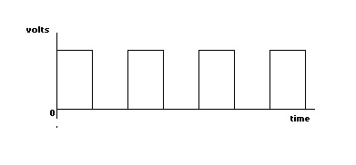

Fig(23)

$$Vavg=\frac{Voltage 1*T on+Voltage2*T off}{T on+T off}$$
Duty cycle = $\frac{T on}{T on+T off}$
first we test the motor operation on the PWM technique using a timer LM555 to give the motor pulses through power transistor, the following figure.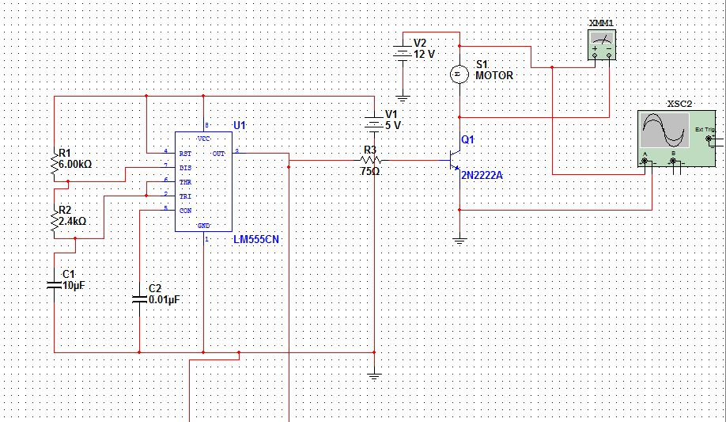

Fig(24)
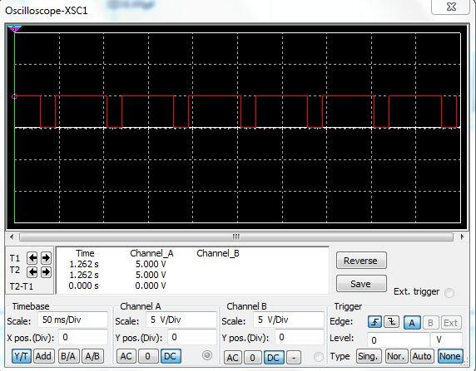

Fig(25)

In timer 555, we use
R1 = 6 KΩ
R2 = 2.4 KΩ
C = 10 µF
We used some calculations to find Ton, Toff and duty cycle .
Ton = 0.693*(R1+R2)*C
T off = 0.693*R2*C

T on = 0.693*(6*10^3 + 2.4*10^3 ) * 10*10^-6 = 0.058 sec .
T off = 0.693*2.4*10^3 *10*10^-6 = 0.016 sec .
Total T = Ton + Toff

Total T = 0.058+0.016=0.074 sec.
Duty cycle = $\frac{0.058}{0.058+0.016}$ = 77.8 %
By using equation 8 we can calculate the output voltage which enter to the motor.
Vdc = battery voltage * duty cycle
Vdc = 24 * 77.8% = 18.6v.
After this experiment we wanted to use microcontroller instead of timer and take pulses from it. We did it, but we had a problem, the noise of machine affects microcontroller. So, we needed to use two batteries(in addition to machine battery)to separate both power circuit and control circuit from each other.

IRF P460
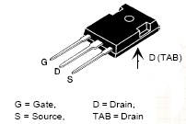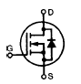

Fig(26)

Features :
Repetitive avalanche energy rated
Fast switching times
Low RDS (on)
Rugged polysilicon gate cell structure
High Commutating dv/dt Rating
Mosfet ratings
VDss = 500 V
ID cont = 20A
RDSon = 0.27 Ω
dv\dt = 3.5 V\ns

Optocoupler 4N35

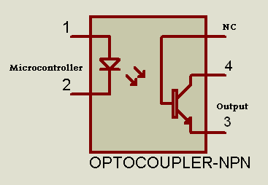

Fig(27)
Optocouplers typically come in a small 6-pin or 8-pin IC package, but are essentially a combination of two distinct devices: an optical transmitter, typically a gallium arsenide LED (light-emitting diode) and an optical receiver such as phototransistor or light-triggered diac . The two are separated by a transparent barrier which blocks any
electrical current flow between the two, but does allow the passage of light. The basic idea is shown in Fig (10), along with the usual circuit symbol for an optocoupler .
Usually the electrical connections to the LED section are brought out to the pins on one side of the package and those for the phototransistor or diac to the other side, to
Physically separate them as much as possible. This usually allows optocouplers to withstand voltages of anywhere between 500V and 7500V between input and output.
Why we need Optocouplers
There are many situations where signals and data need to be transferred from one subsystem to another within a piece of electronics equipment, or from one piece of equipment to another, without making a direct ohmic , electrical connection.
Often this is because the source and destination are (or may be at times) at very different voltage levels, like a microprocessor which is operating from 5V DC but being used to control a triac which is switching 240V AC. In such situations the link between the two must be an isolated one, to protect the microprocessor from overvoltage damage.
The advantage of Optocoupler over the relay
Relays can of course provide this kind of isolation, but even small relays tend to be fairly bulky compared with ICs and many of todays other miniature circuit components. Because they.re electro-mechanical, relays are also not as reliable.
and only capable of relatively low speed operation. Where small size, higher speed and greater reliability are important, a much better alternative is to use an optocoupler. These use a beam of light to transmit the signals or data across an electrical barrier, and achieve excellent isolation.
Optocouplers are essentially digital or switching devices, so theyare best for transferring either on-off control signals or digital data. Analog signals can be transferred by means of frequency or pulse-width modulation.

Dot/bar display driver LM3914
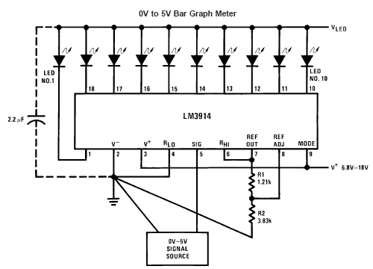

Fig(28)

$$Ref out V=1.25(1+\frac{R2}{R1})$$
$I LED=\frac{12.5}{R1}$
The LM3914 is a monolithic integrated circuit that senses analog voltage levels and drives 10 LEDs, providing a linear analog display. A single pin changes the display from a moving dot to a bar graph. Current drive to the LEDs is regulated and rogrammable, eliminating the need for resistors.
This feature is one that allows operation of the whole system from less than 3V.
The circuit contains its own adjustable reference and accurate 10-step voltage divider. The low-bias-current input buffer accepts signals down to ground, or V−, yet needs no protection against inputs of 35V above or below ground. The buffer drives 10 individual comparators referenced to the precision divider. Indication non-linearity can thus be held typically to 1⁄2%, even over a wide temperature range.
Versatility was designed into the LM3914 so that controller, visual alarm, and expanded scale functions are easily added on to the display system. The circuit can drive LEDs of many colors, or low-current incandescent lamps. Many LM3914s
can be “chained” to form displays of 20 to over 100 segments.
Both ends of the voltage divider are externally available so that 2 drivers can be made into a zero-center meter

Regulator 7805
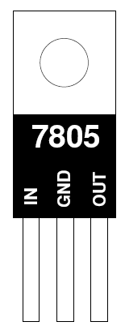

Fig(29)
The 7805 is a VOLTAGE REGULATOR.It looks like a transistor but it is actually an
integrated circuit with 3 legs.
It can take a higher, crappy DC voltage and turn it into a nice, smooth 5 volts DC.
You need to feed it at least 8 volts and no more than 30 volts to do this.
It can handle around .5 to .75 amps, but it gets hot. Use a heatsink.
Use it to power circuits than need to use or run off of 5 volts.
in addition we use two capacitors to make the voltage extra smooth.

Relay
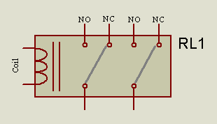

Fig(30)
RELAY APPLICATIONS
Relays are remote control electrical switches that are controlled by another switch, also it can be driven from atransistor. Relays allow a small current flow circuit to control a higher current circuit. Several designs of relays are in use today, 3-pin, 4-pin, 5-pin, and 6-pin, single switch or dual switches.

RELAY OPERATION
All relays operate using the same basic principle. Our example will use a commonly used 6 -pin relay. Relays have two circuits: A control circuit (shown in GREEN) and a load circuit (shown in RED). The control circuit has a small control coil while the load circuit has a switch. The coil controls the operation of the switch.

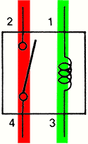

Fig(31)

VOLTAGE SPIKES
When the switch is closed (shown left), current flows through the coil from positive to negative as shown in red. This current flow creates a magnetic field around the coil. The top of the coil is positive, and the bottom is negative.
When the switch is opened (shown on right), current stops flowing through the control circuit coil, and the magnetic field surrounding the coil cannot be maintained. As the magnetic field collapses across the coil, it induces a voltage into itself, creating a reverse polarity voltage spike of several hundred volts. Although the top of the coil is still 12 volts positive, the bottom of the coil produces several hundred positive volts (200+ volts or more); 200 is "more positive" and stronger than 12 volts, so current flow from the bottom of the coil up towards the top.

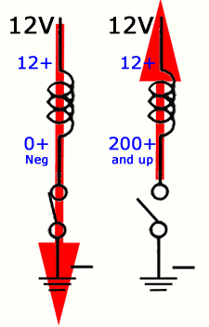

Fig(32)

VOLTAGE SUPPRESSION RELAYS
Relays are often controlled by a computer. When relays are controlled by semicond-
uctors such as transistors, they require some type of voltage suppression device. Solid state circuits are vulnerable to voltage spikes. Voltage spikes slam against transistors, destroying them .
A de-spiking (clamping) diode is connected in parallel with the relay coil. It is in the reverse biased position when the relay is turned on; therefore no current will flow through the diode. When the relay control circuit is opened (turned OFF), current stops flowing through the coil, causing the magnetic field to collapse. The magnetic lines of force cut through the coil and induce a counter voltage (a voltage in reverse polarity) into the winding. The counter voltage begins to raise. When the bottom side of the diode sees .7 volts more positive voltage than the top, the diode becomes forward biased, allowing the excess voltage to pass, completing the circuit to the other end of the coil. The current flows around in the diode and coil circuit until the voltage is dissipated. 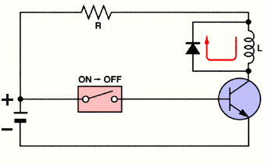
Fig(33)

KSP 2222A transistor
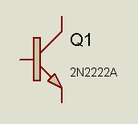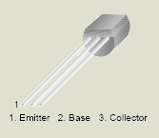

Fig(34)

Collector-Emitter Voltage VCEO = 40 V
VEBO Emitter-Base Voltage 6 V
Collector Power Dissipation PC (max) = 625 mW
Collector Current IC = 600 mA

Heat sink & cooling system: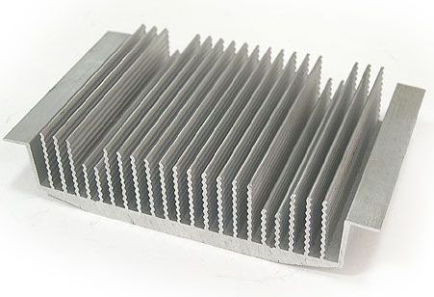

Fig(35)

All semiconductor devices have some electrical resistance, just like resistors and coils , etc. This means that when power diodes, power transistors and power MOSFETs are switching or otherwise controlling reasonable currents, they dissipate power as heat energy. If the device is not to be damaged by this, the heat must be removed from inside the device (usually the collector-base junction for a bipolar transistor, or the drain-source channel in a MOSFET) at a fast enough rate to prevent excessive temperature rise.
The most common way to do this is by using a heat sink To understand how heat sinks work, think of heat energy itself as behaving very much like an electrical current, and temperature rise as the thermal equivalent of voltage drop. We as the thermal equivalent of voltage drop. We known as thermal resistance , which behaves in a very similar way to electrical resistance: the more heat energy flowing through it, the higher the temperature rise across it. As you might imagine metals like copper and aluminum have very low thermal resistance, while air tends to have a relatively high resistance. So do many plastics and ceramic materials. It turns out that there s a thermal equivalent of Ohm s Law, which describes the way heat energy behaves in something like a power transistor .
A heat sink is a passive component that is designed to increase the surface area in contact with the cooling medium surrounding it, such as the air. Approach air velocity, choice of material, fin (or other protrusion) design and surface treatment are some of the factors which affect the thermal performance of a heat sink. Heat sinks are used to cool computer central processing units or graphics processors. Heat sink attachment methods and thermal interface materials also affect the eventual temperature of the integrated circuit . Thermal adhesive or thermal grease fills the air gap between the heat sink and device to improve its thermal performance. Theoretical, experimental and numerical methods can be used to determine a heat sink's thermal performance.
the rate of producing waste heat is called the thermal power, P. Usually the base current IB is too small to contribute much heat, so the thermal power is determined by the collector current IC and the voltage VCE across the transistor:
P = IC × VCE
how to work out the required heat sink rating:
- Work out thermal power to be dissipated, P = IC × VCE
If in doubt use the largest likely value for IC and assume that VCE is half the supply voltage.
For example if a power transistor is passing 1A and connected to a 12V supply, the power P is about 1 × ½ × 12 = 6W.
- Find the maximum operating temperature (Tmax) for the transistor if you can, otherwise assume Tmax = 100°C.
- Estimate the maximum ambient (surrounding air) temperature (Tair). If the heat sink is going to be outside the case Tair = 25°C is reasonable, but inside it will be higher (perhaps 40°C) allowing for everything to warm up in operation.
- Work out the maximum thermal resistance (Rth) for the heat sink using: Rth = (Tmax - Tair) / P
With the example values given above: Rth = (100-25)/6 = 12.5°C/W.
- Choose a heat sink with a thermal resistance which is less than the value calculated above (remember lower value means better heat sinking!) for example 5°C/W would be a sensible choice to allow a safety margin. A 5°C/W heat sink dissipating 6W will have a temperature difference of 5 × 6 = 30°C so the transistor temperature will rise to 25 + 30 = 55°C (safely less than the 100°C maximum).
- All the above assumes the transistor is at the same temperature as the heat sink. This is a reasonable assumption if they are firmly bolted or clipped together. However, you may have to put a mica sheet or similar between them to provide electrical insulation, then the transistor will be hotter than the heat sink and the calculation becomes more difficult. For typical mica sheets you should subtract 2°C/W from the thermal resistance (Rth) value calculated in step 4 above.
also we add a fan , fig (), to increase the reliability of the cooling system

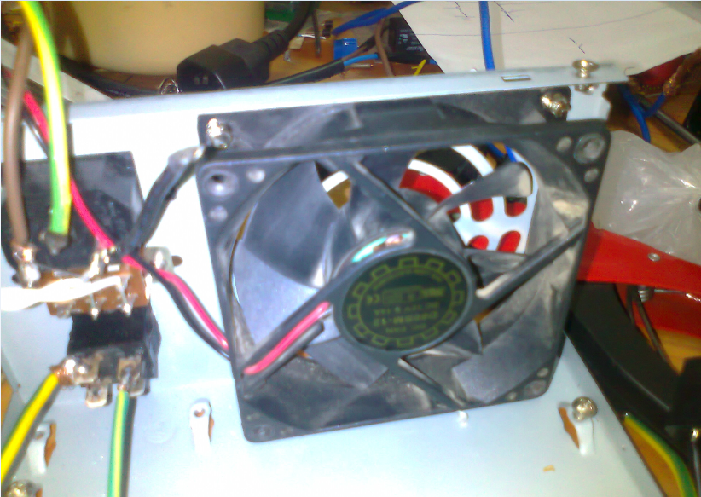

Fig(36).

Economical STUDY:
Device/ service | Price
mechanical structure. | 200 Nis
Motors. | 2*400 Nis
Batteries. | 2*150 Nis
Electrical elements (pic18, joystick  transistors, lCD…..,etc). | 480 Nis
Additional cost. | 120 Nis.
Total cost | 1900 Nis

Comparing our system’s economical needs and the cash flow to be done, with the electrical wheel chair which already existed and sold out locally market and abroad –that exceeds 14000 Nis – including Hardware and Software, we can see the huge difference in the amount of money with our cheap, locally produced system and simple hardware and software with same functionality as electrical wheel chair system.
For sure our project needs more work to be done on it to complete the markets here and abroad, but we can see that Palestinian minds and hands can do it at the end.

Future development:
A wireless data acquisition and control platform has been developed to model
electric
powered wheelchairs. The test-bed integrates sensors, embedded controller, and the motorised mechanical system.
Fig. (22) shows the top level view of the wireless test-bed of the wheelchair control prototyping. Key components of the integrated mechatronics system include hardware and software platform, wireless communication, sensors and motor control.
Bluetooth: Bluetooth was employed for wireless communications between the wheelchair and base PC. The wireless data link enabled the wheelchair to move more freely
Figure (37) Wheelchair instrumentation system overview.

PIC (micro C) Code :
sbit motor_left_dir at PORTD.B3;
sbit motor_right_dir at PORTD.B2;
sbit break_motor at PORTC.B4;
int Adc_value;
int Adc_value1;
int i=0;
char motor_left_pwm=0,motor_right_pwm=0;
char state=0; // 0:stop 1:forward 2:reverse 3:left 4:right
char Stop=1;
char speed=0;
void Read(char div)
{
Adc_value= ADC_Read(0)/div;
Adc_value1=ADC_Read(1)/div;
/*UART1_Write(Adc_value/4);
UART1_Write(Adc_value1/4);*/
}
void setPwm(char val1,char val2)
{
//PWM1_Set_Duty(255);
// PWM2_Set_Duty(255);
if(Stop)
{
switch(speed)
{
case 4:
PWM1_Set_Duty(val1*0.4);
PWM2_Set_Duty(val2*0.4);
break;
case 3:
PWM1_Set_Duty(val1*0.3);
PWM2_Set_Duty(val2*0.3);
break;
case 2:
PWM1_Set_Duty(val1*0.2);
PWM2_Set_Duty(val2*0.2);
break;
case 1:
PWM1_Set_Duty(val1*0.1);
PWM2_Set_Duty(val2*0.1);
case 0:
PWM1_Set_Duty(val1*0.02);
PWM2_Set_Duty(val2*0.02);
break;
}
}
else
{
PWM1_Set_Duty(0);
PWM2_Set_Duty(0);
}
/*UART1_Write(val1);
UART1_Write(val2); */
}
void interrupt() {
if (INTCON.INT0IF) {
Delay_ms(20);
if(PORTB.B0==1)
{
Stop=!Stop;
}
INTCON.INT0IF=0;
}
else if (INTCON3.INT1IF) {
Delay_ms(20);
if(PORTB.B1==1)
{
if(speed < 4)
{
speed++;
}
}
INTCON3.INT1IF=0;
}
else if (INTCON3.INT2IF) {
Delay_ms(20);
if(PORTB.B2==1)
{
if(speed > 0)
{
speed--;
}
}
INTCON3.INT2IF=0;
}
}
void main()
{
OSCCON= 0b01110000; //8 MHz
// OSCTUNE.F6 = 1 ;
RCON.IPEN=1;
INTCON.GIE=1;
INTCON.PEIE=1;
INTCON.INT0IE=1;
INTCON2.RBPU=1;
INTCON3.INT1IP=1;
INTCON3.INT2IP=1;
INTCON3.INT1IE=1;
INTCON3.INT2IE=1;
INTCON2.INTEDG0=1;
INTCON2.INTEDG1=1;
INTCON2.INTEDG0=1;
ADCON1 = 0b00001101;
CMCON = 0X07;
TRISA=0xff;
TRISC=0x00;
TRISD=0x00;
TRISB=0xff;
UART1_Init(9600); // Initialize UART module at 9600 bps
PWM1_Init(5000); // Initialize PWM1 module at 5KHz
PWM2_Init(5000);
Delay_ms(100);
PWM1_Start(); // start PWM1
PWM2_Start();
//forward
motor_left_dir=0;
motor_right_dir=0;
//
while(1)
{
Read(4);
if(Adc_value > 134)
{
//reverse
if(state != 2)
{
setPwm(0,0);
Delay_ms(250);
state=2;
}
break_motor=1;
motor_left_dir=1;
motor_right_dir=1;
motor_right_pwm= motor_left_pwm=(Adc_value);
if(Adc_value1 > 134)
{
//forward
/*motor_left_dir=0;
motor_right_dir=0;*/
//
motor_right_pwm=motor_right_pwm*0.7;
}
else if(Adc_value1 < 120)
{
//forward
/*motor_left_dir=0;
motor_right_dir=0;*/
//
motor_left_pwm=motor_left_pwm*0.7;
}
}
else if(Adc_value < 120)
{
//forward
if(state != 1)
{
setPwm(0,0);
Delay_ms(250);
state=1;
}
break_motor=1;
motor_left_dir=0;
motor_right_dir=0;
motor_right_pwm = motor_left_pwm = (119 - Adc_value) + 130;
if(Adc_value1 > 134)
{
//forward
/*motor_left_dir=0;
motor_right_dir=0;*/
//
motor_right_pwm=motor_right_pwm*0.7;
}
else if(Adc_value1 < 120)
{
//forward
/*motor_left_dir=0;
motor_right_dir=0;*/
//
motor_left_pwm=motor_left_pwm*0.7;
}

}
else
{
//stop
/*motor_left_dir=0;
motor_right_dir=0;
motor_left_pwm=motor_right_pwm=0;*/

if(Adc_value1 > 134)
{
if(state != 3)
{
setPwm(0,0);
Delay_ms(250);
state=3;
}
break_motor=1;
motor_left_pwm=motor_right_pwm=Adc_value1;
//forward
motor_right_dir=0;
//
//reverse
motor_left_dir=1;
//
}
else if(Adc_value1 < 120)
{
if(state != 4)
{
setPwm(0,0);
Delay_ms(250);
state=4;
}
break_motor=1;
motor_right_pwm=motor_left_pwm=(119 - Adc_value1) + 130;
//forward
motor_right_dir=1;
//
//reverse
motor_left_dir=0;
//
}
else
{
if(state != 0)
{
setPwm(0,0);
Delay_ms(250);
state=0;
}
//stop
motor_left_dir=0;
motor_right_dir=0;
//
motor_left_pwm=motor_right_pwm=0;
break_motor=0;
}
}
/*else
{
}*/
/*if(Adc_value >120 & Adc_value < 134)
{
}*/
setPwm(motor_left_pwm,motor_right_pwm); } }

