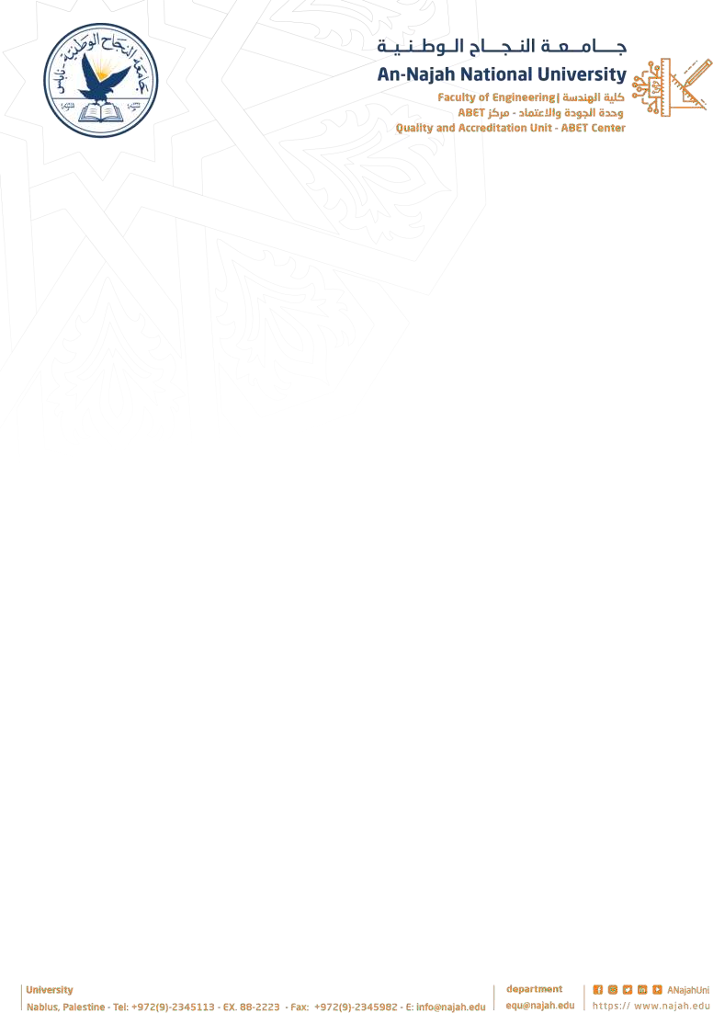

Cover page
Project Title:

Hand Gesture Control Wheelchair for Disabled People
Academic Year: 2026
Group Members: Akram Abu Aisheh
Nagham Fraij Department Name: Computer engineering
Supervisor Name: Dr. Aladdin Masri & Dr. Hanal Abu-Zant

Format:
- Single space, Times New Roman.
- 12 pt,
- Maximum 1 page.

Abstract Body:
Items must be provided in the Abstract:
  - Why do you think this project is important? Please explain the significance of this Project in brief.
  - In your point of view what are the important aspects that should be covered in the project?
  - Objective(s): In your view, please explain the main objectives of the project.
  - Methodology: Give a brief outline of the application development process.
  - Had this project been done before? Are there any similar applications available today?

  - Note: Please deliver this abstract early to ensure that your Project has been approved by the department’s projects committee. Registration will not be done without this approval.

Project’s Abstract:
The “Hand Gesture Control Wheelchair for Disabled People” project aims to develop an accessible, efficient, and intuitive wheelchair control system that empowers individuals with physical disabilities. This project integrates various components such as the Arduino Uno and Nano microcontrollers, motor drivers, motors, the MPU6050 for motion sensing, and the NRF 2401 for wireless communication, to create a system that allows users to control the wheelchair using hand gestures.

By utilizing the MPU6050, the system can accurately detect hand movements, which are then translated into commands that control the wheelchair’s motion, providing the user with a hands-free driving experience. The wireless communication between the two NRF 2401 modules ensures seamless data transmission, enabling remote control capabilities. Additionally, the system features a dual motor driver setup to manage the motors, allowing for precise movement in all directions. This innovative approach provides independence, safety, and mobility to individuals with limited physical capabilities.

The ultimate goal of this project is to enhance the quality of life for disabled people by offering a reliable and simple means of mobility, with the potential for future improvements, such as adding additional sensors and refining the user interface

