Chapter Three
SAP Output Data

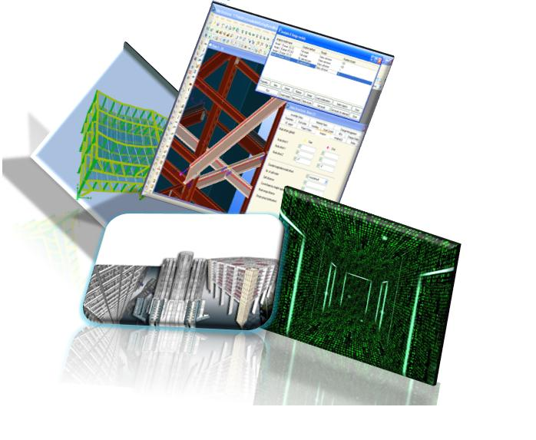

Block A:
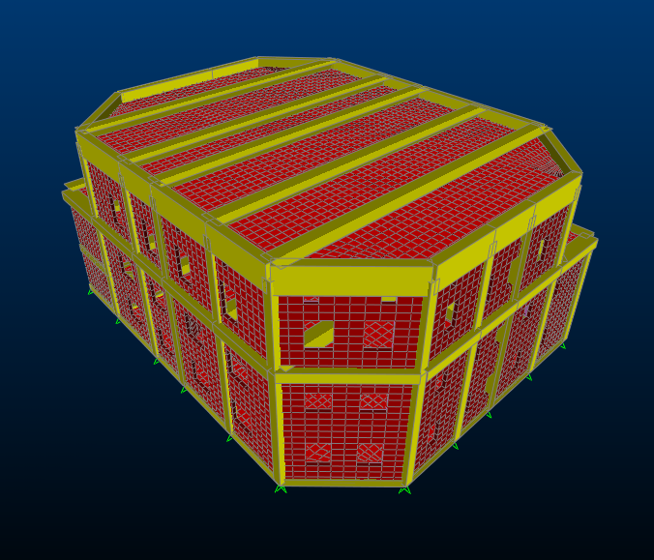
Block B:
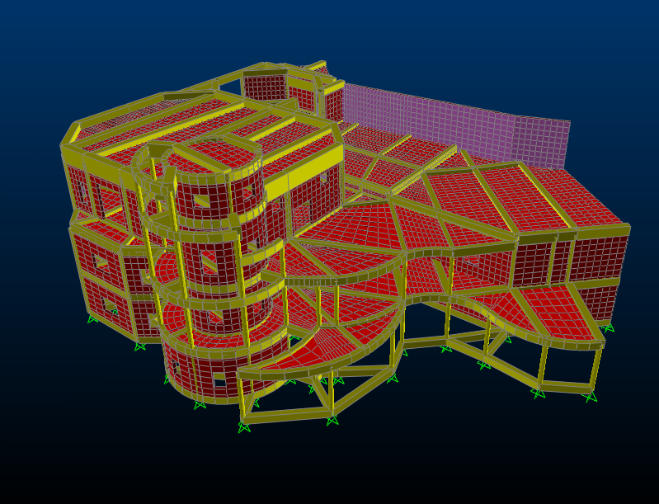
Block C:
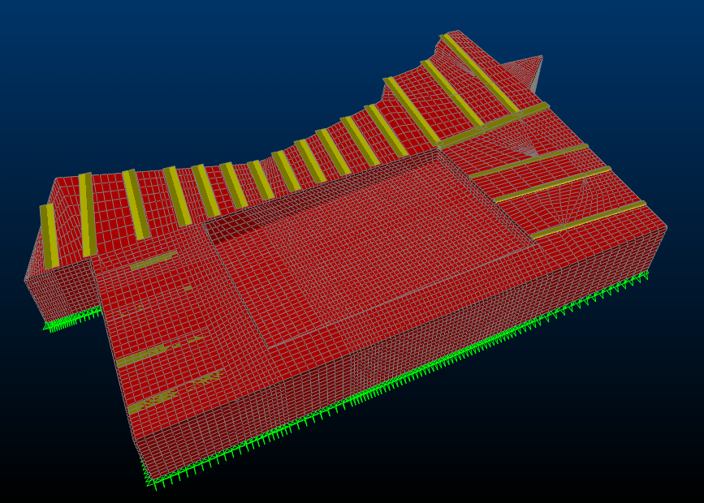

This part clarifies how to deal with the program (SAP2000), and how to input the information and output the results, through this manual calculation will be performed and compared with program result.

3.1 program Input Data:

3.1.1 Material:
Most of material used in the construction of project is concrete and some of changes in its properties are made to cover the other loads that come from the weight of stones, blocks and super imposed dead load, as shown below in figures.
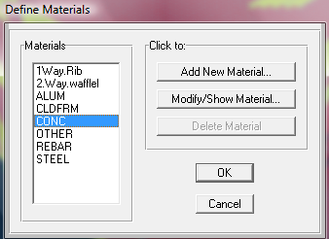
Concrete for columns and beams (concrete wall):
- Concrete compressive strength 𝒇c=240 kg/cm2.
- mass per unit volume = .2446 t/m3
- weight per unit volume=2.4 ton/m3
- modulus of elasticity E=2.34*10⁵ ton/m2
- poisons ratio=0.2
- Yield strength of steel ℱy=4200 kg/cm2
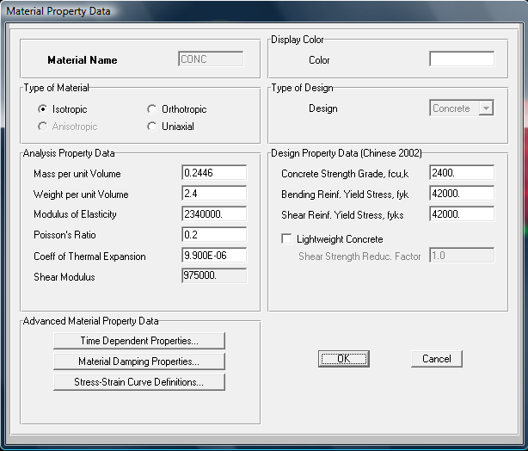
Fig (3-3) properties of concrete column &beam

Concrete for slab in Block A:
For slab One way rib
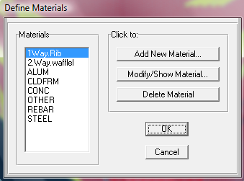
Fig (3-4)type of material of one way

- Concrete compressive strength 𝒇c=240 kg/cm2.
- mass per unit volume = .2396 t/m3
- weight per unit volume=2.35 ton/m3
- modulus of elasticity E=2.34*10⁵ ton/m2
- poisons ratio=0.2
- Yield strength of steel ℱy=4200 kg/cm2

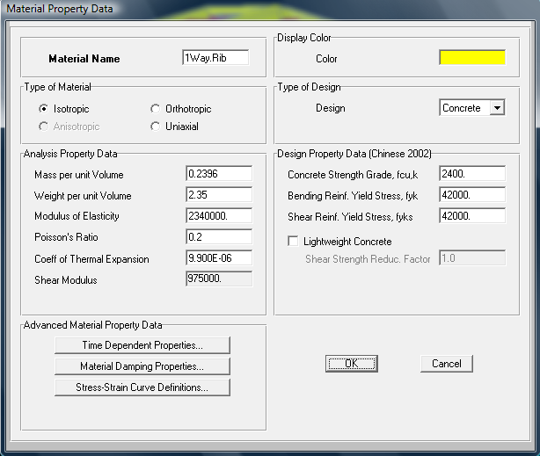
Fig (3-5) property of one way rib concreet

For Two way waffle slab:
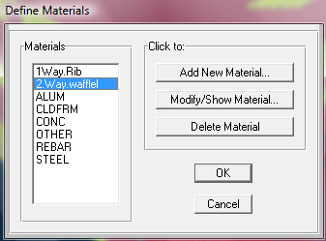
Fig (3-5) type of material of two way waffle

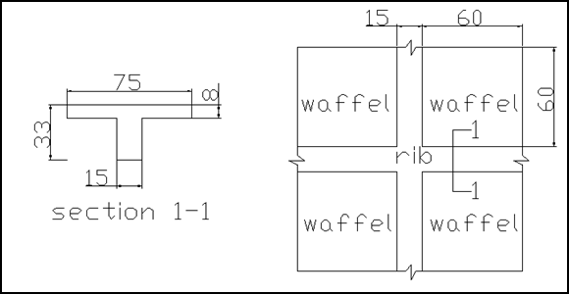
Fig (3-6) Dimension of two way waffle slab

I solid=I waffle
(1/12)(h)³(0.75)= 8.56*10⁻⁴
h=24 cm
To find γ_{equ}:
Weight waffle/ m²
=((0.75*0.75*0.08+0.75*0.15*0.25+0.15*0.25*0.6)*2.4)/0.75²
=0.408t/m²
Weight solid/m²=weight waffle/ m²
γ_{equ}*0.24=0.408
γ_{equ}=1.7 ton/m³
- Concrete compressive strength 𝒇c=240 kg/cm2.
- mass per unit volume = .1733 t/m3
- weight per unit volume=1.7 ton/m3
- modulus of elasticity E=2.34*10⁵ ton/m2
- poisons ratio=0.2
- Yield strength of steel ℱy=4200 kg/cm2
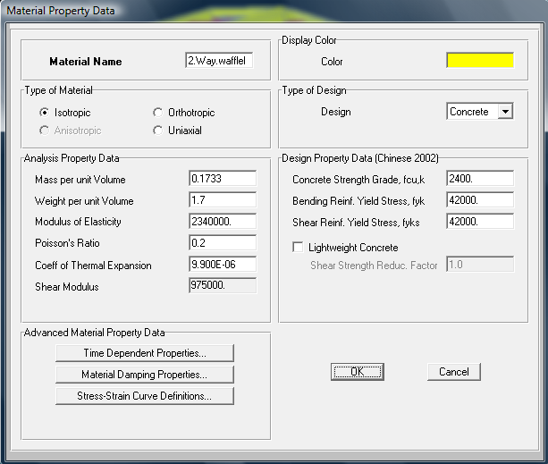
Fig (3-7)properties of material of two way waffle

3.1.2 Frame Section:
Frame section that defined here was calculated in previous section Ch.2, I.e. beam (A) in Block (C) defined as shown in figure:

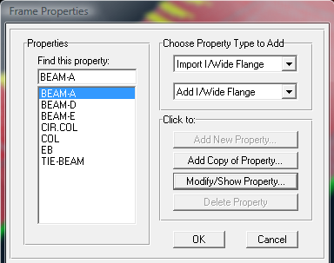
Fig (3-8)Frame section in Block C

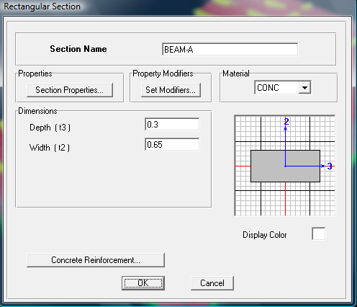
Fig (3-9)Beam A in Block C

the set modifiers button is used to input crack factors of beam and columns for design as recommended in ACI 2002 code .As shown table ( 3-1 ):
Table (3-1) crack factor
crack factor | structural element
0.7 | column
0.35 | beam
0.25 | slab
0.35 | wall

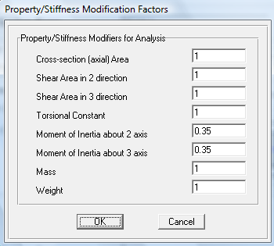
Fig (3-10)Set modifiers for beam

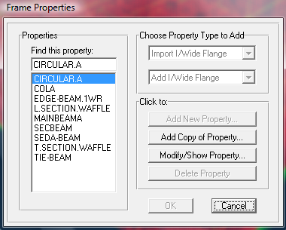
Fig (3-11) Frame properties
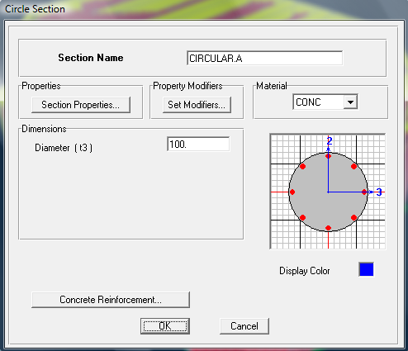
Fig (3-12) circular column in Block A

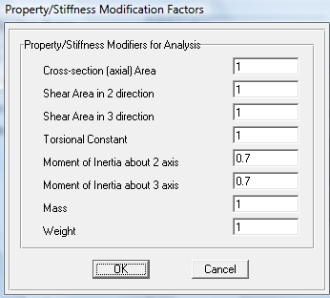
Fig (3-13) Set modifiers of column
Shell element:
There are several names of shell element input in SAP 2000, because the thickness and the properties of each shell are changeable according to its type. (Walls, slabs either one or two way)
The thickness of slabs and walls that previous calculated in Ch.2 will input in SAP2000 program as shown below:
- slab thickness=33 cm
- Equivalent thickness=24 cm
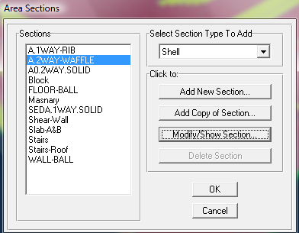
Fig (3-14)Slab properties

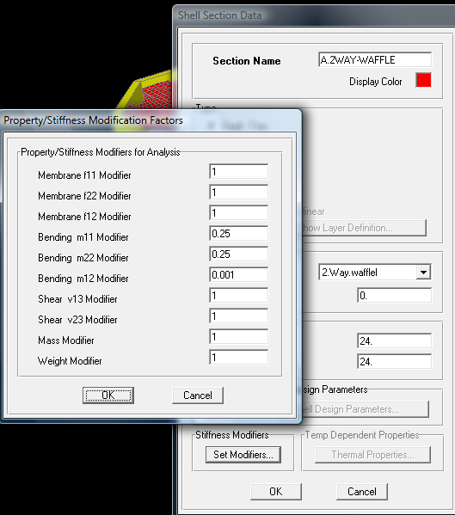
Fig (3-15) Slab set modifiers

3.1.3 Load Cases:
To let SAP2000 programs calculate the own weight of the structure; the value of self weight multiplier must be equal to one, see figure:
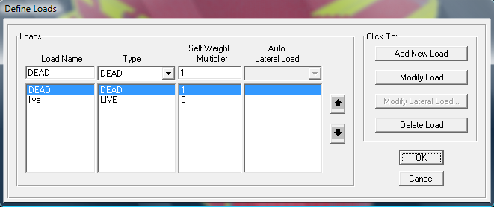
Fig (3-16) Load cases

3.2 Check Computability Of Structure
As shown in figures deformed shape for modal indicates that the structure moves as one unit so that the compatibility is satisfied. And show the fundamental period of structure.

Block A
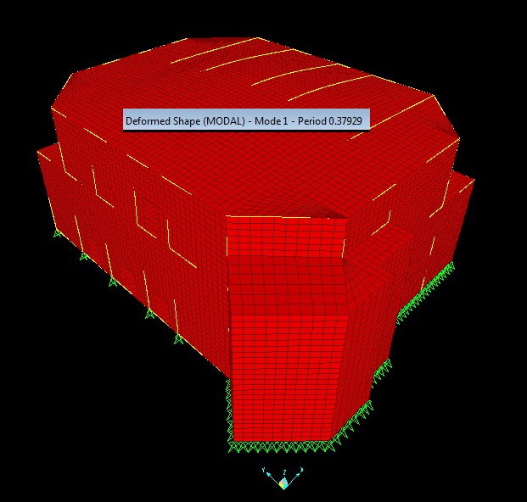
Fig (3-17): deformed shape for modal.

Block B
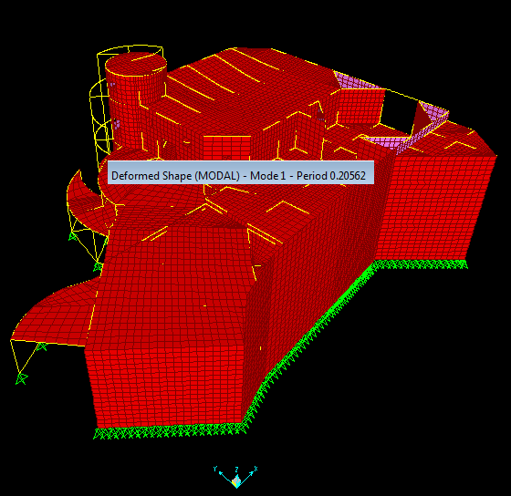
Fig (3-18): deformed shape for modal.

Block C
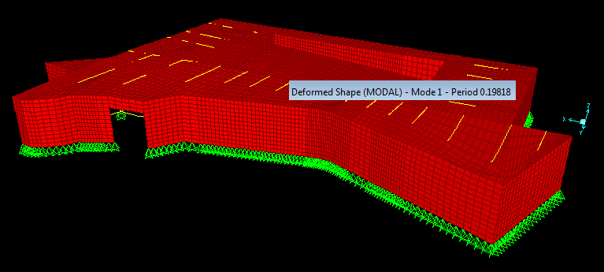
Fig (3-19): deformed shape for modal

3.3 Design of the structural element:

In this section the design is not made but the results of design that obtained from program is used to give good indication about the section adequacy and economical design for structural elements, the design will be carried out in the following parts.

3.3.1 Slab design:

Slabs Design of Block A
Wall pool:
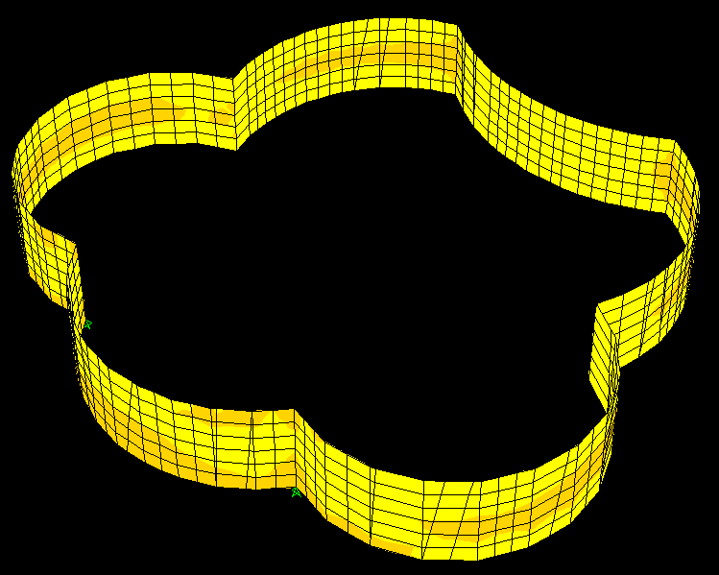
Fig(3-20)Wall pool
Moments from sap in two directions 𝓜 11 & 𝓜 22:
We have two cases
- Pool fills with water

𝓜 ₁₁:
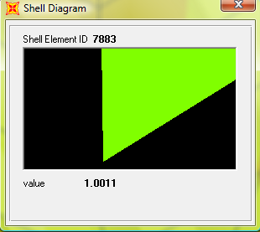` 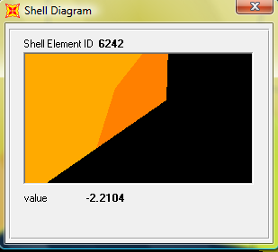
𝓜+ve=1 ton.m 𝓜-ve=2.21 ton.m

𝓜 ₂₂:
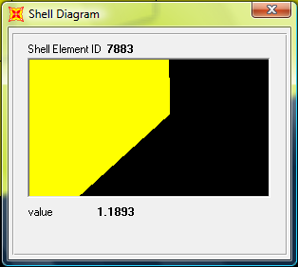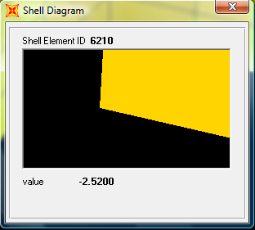𝓜+ve=1.19 ton.m 𝓜-ve=2.52 ton.m

2) Pool is empty
𝓜 ₁₁:
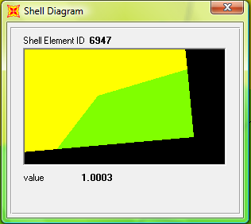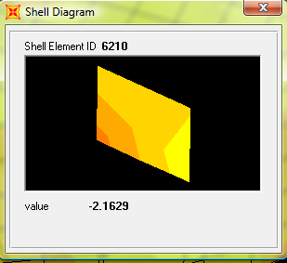𝓜+ve=1 ton.m 𝓜-ve=2.16 ton.m

𝓜 ₂₂:
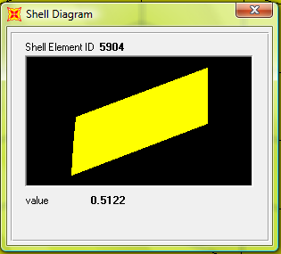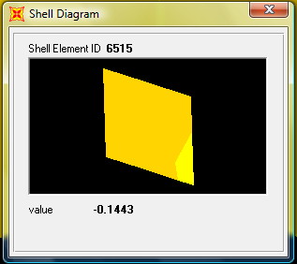
𝓜+ve=0.51 ton.m 𝓜-ve=0.144 ton.m

So the critical case when the Pool fill with water
h=25 cm d=20 cm
𝓜 ₁₁:
𝓜-ve=2.21 ton.m
𝜌=.85𝒇_{c}/ℱy*(1-√ (1-2.35𝓜u/фbd² 𝒇_{c}))
𝜌=.85*240/4200(1-√ (1-2.35*2.21*10⁵/.9*20²*100*240)
𝜌=0.00145
𝜌min=0.0018*ℎ/d=0.0018*25/20=2.25*10⁻³
𝜌< 𝜌min=2.25*10⁻³
As=𝜌*b*d=2.25*10⁻³*100*20=4.5cm²
(ф12) As= (4ф12) S=20 cm)
𝓜-ve=1 ton.m
𝜌min=0.0018*ℎ/d=0.0018*25/20=2.25*10⁻³
𝜌< 𝜌min=2.25*10⁻³
As=𝜌*b*d=2.25*10⁻³*100*20=4.5cm²
(ф12) As= (4ф12) S=20 cm)
𝓜 ₂₂:
𝓜-ve=2.52 ton.m
𝜌min=0.0018*ℎ/d=0.0018*25/20=2.25*10⁻³
𝜌< 𝜌min=2.25*10⁻³
As=𝜌*b*d=2.25*10⁻³*100*20=4.5cm²
(ф12) As= (4ф12) S=20 cm)

𝓜+ve=1.19 ton.m
𝜌min=0.0018*ℎ/d=0.0018*25/20=2.25*10⁻³
𝜌< 𝜌min=2.25*10⁻³
As=𝜌*b*d=2.25*10⁻³*100*20=4.5cm²
(ф12) As= (4ф12) S=20 cm)

Floor Pool:
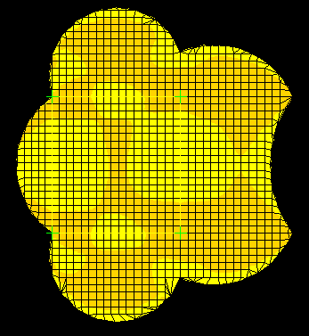
Fig(3-21)Floor Pool

𝓜 ₁₁:
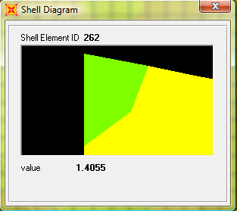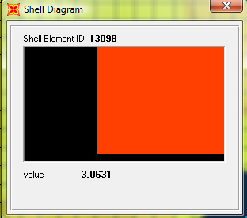
𝓜+ve=1.4 ton.m 𝓜-ve=3.06 ton.m
Design for
𝓜-ve=3.06 ton.m
𝜌=.85𝒇_{c}/ℱy*(1-√ (1-2.35𝓜u/фbd² 𝒇_{c}))
𝜌=.85*240/4200(1-√ (1-2.35*3.1*10⁵/.9*20²*100*240)
𝜌< 𝜌min
As=𝜌*b*d=2.25*10⁻³*100*20=4.5cm²
(ф12) As+=As-= (4ф12) S=20 cm)

𝓜 ₂₂:

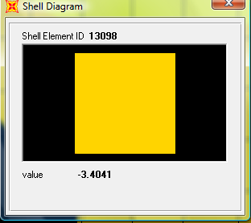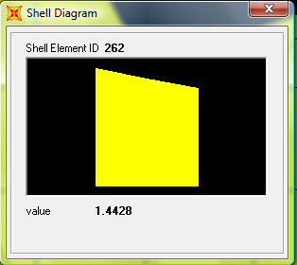
𝓜-ve=3.4 ton.m 𝓜+ve=1.44 ton.m

Design for
𝓜-ve=3.4 ton.m
𝜌=.85𝒇_{c}/ℱy*(1-√ (1-2.35𝓜u/фbd² 𝒇_{c}))
𝜌=.85*240/4200(1-√ (1-2.35*3.4*10⁵/.9*20²*100*240)
𝜌< 𝜌min
As=𝜌*b*d=2.25*10⁻³*100*20=4.5cm²
(ф12) As+=As-= (4ф12) S=20 cm)

A0-two way:
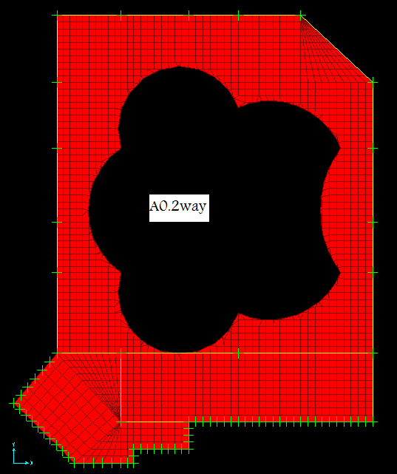
Fig ( 3-22): plan slabs for A0 Block A
As =As_{min}
(4ф12) in both direction

Seda One way solid:
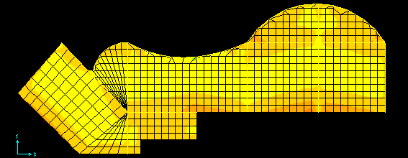
Fig(3-23)Seda One way solid
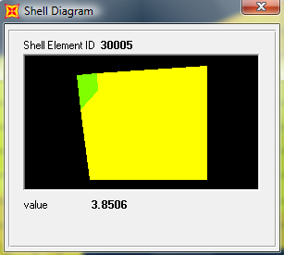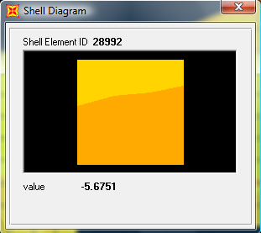
𝓜+ve=3.85 ton.m 𝓜-ve=5.675 ton.m
h= 30 cm, d=26 cm
Design for
𝓜-ve=5.675 ton.m
𝜌=.85𝒇_{c}/ℱy*(1-√ (1-2.35𝓜u/фbd² 𝒇_{c}))
𝜌=.85*240/4200(1-√ (1-2.35*5.675*10⁵/.9*20²*100*240)
𝜌=2.27*10⁻³
𝜌min=0.0018*ℎ/d=0.0018*30/26=2.1*10⁻³
𝜌< 𝜌min=2.25*10⁻³
As=𝜌*b*d=2.27*10⁻³*100*26=5.9cm²
(ф14) As-_{ve}= (4ф14) S=20 cm)
𝓜+ve=3.85 ton.m
𝜌=.85*240/4200(1-√ (1-2.35*3.85*10⁵/.9*20²*100*240)
𝜌=1.53*10⁻³
𝜌=1.53*10⁻³< 𝜌min=2.25*10⁻³
Shrinkage reinforcement:
Ast=0.0018*b*h
=0.0018*100*30=5.4 cm²
(5 ф12), S=20 cm.
Spacing < 45 cm & 5h
Shear reinforcement:
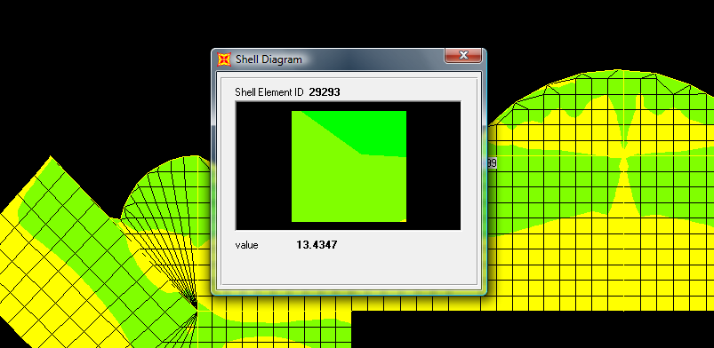
Fig (3-24): Shear force in seda slab (Block A)
Vu=13.4 ton
фVc =0.75*0.53*√240*100*25*10⁻³
=16 ton
Vu< фVc no need shear reinforcement

Two Way Waffle:
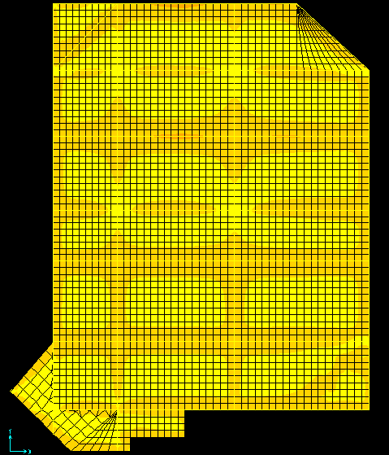
Fig (3-25) Two Way Waffle
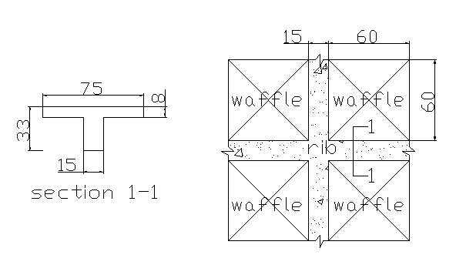
Fig (3-26): Waffle dimension in Block A
d=29 cm
b_{w}=15cm
b_{e}=75 cm
h=33cm
𝓜 ₂₂:

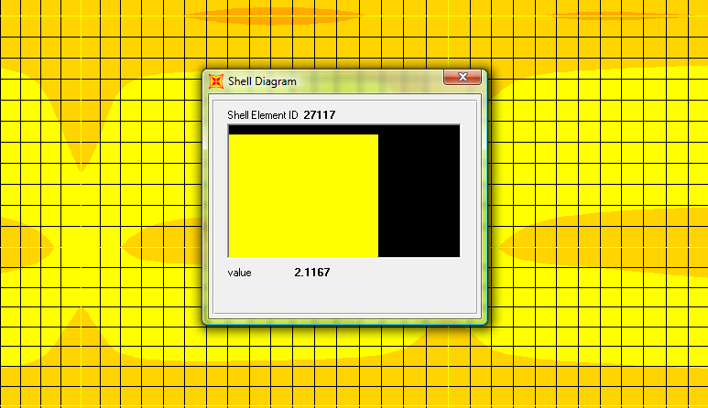
Fig (3-27 ): Moment Y-Y in waffle slab 𝓜+ve=2.11 ton.m

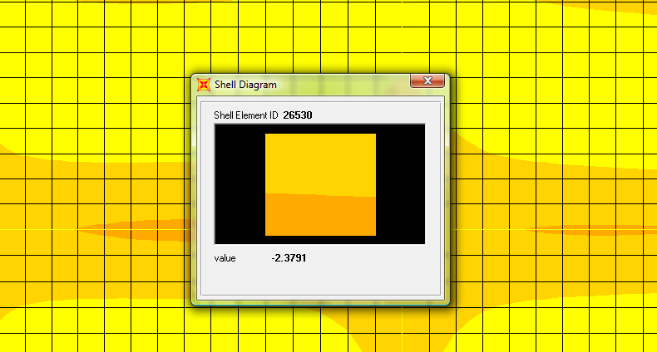
Fig (3-28): Moment Y-Y in waffle slab 𝓜-ve=2.38 ton.m
𝓜+ve(on rib)=2.11*0.75=1.58 ton.m/rib
𝜌=.85*240/4200(1-√ (1-2.35*1.58*10⁵/.9*29²*75*240)
𝜌=0.0007
Ast_{(+ve)}=0.0007*29*75=1.52 cm²
Ast_{(min)}=0.0033*29*15=1.44 cm²
Ast_{(+ve)}=(2 ф12)
𝓜-ve(on rib)=2.38*0.75=1.9 ton.m
𝜌=.85*240/4200(1-√ (1-2.35*1.9*10⁵/.9*29²*15*240)
𝜌=4.16*10⁻³
Ast_{(-ve)}= 4.16*10⁻³*29*15=1.8 cm²
Ast_{(min)}=0.0033*29*15=1.44 cm²
Ast_{(+ve)}=(2 ф12)

𝓜 ₁₁:

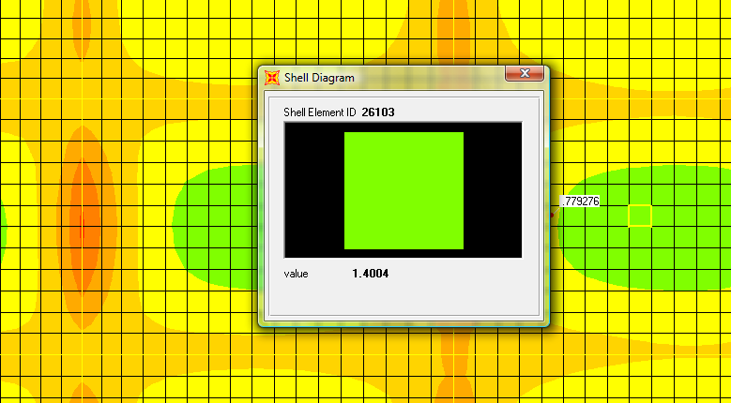
Fig (3-29): Moment X-X in waffle slab 𝓜+ve=1.4 ton.m
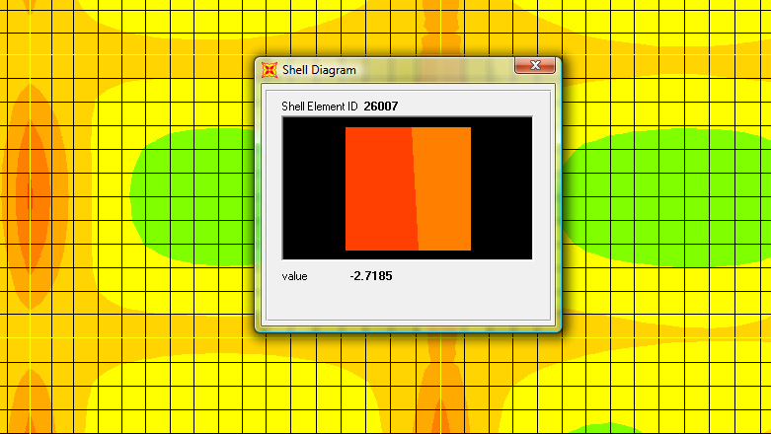
Fig (3-30): Moment X-X in waffle slab 𝓜-ve=2.71 ton.m
Design
𝓜+ve(on rib)=1.4*0.75=1.05 ton.m/rib
Ast_{(+ve)} < Ast_{(min)}= 1.44 cm²
(2 ф12)

𝓜-ve(on rib)=2.75*0.75=2.04 ton.m/rib
𝜌=4.48*10⁻³
Ast_{(-ve)}= 1.95 cm²
Ast_{(-ve)} (2 ф12)
Shrinkage reinforcement:
Ast=0.0018*b*h
=0.0018*100*8=1.44 cm²
(3 ф10),
Spacing < 45 cm & 5h

Shear reinforcement:
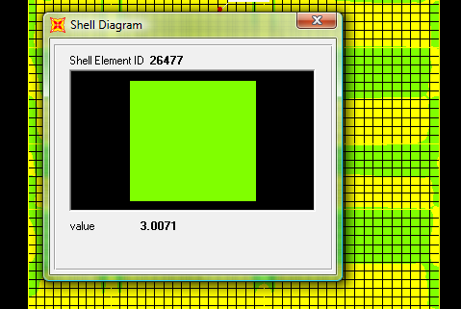
Fig (3-31): Moment Y-Y in Banqueting hall Vu=3*0.75=2.25 ton
фVc=1.1*0.75*0.53*√240*29*15*10⁻³
=2.95 ton
Vu< фVc no need shear reinforcement

One Way Rib (Banqueting hall):
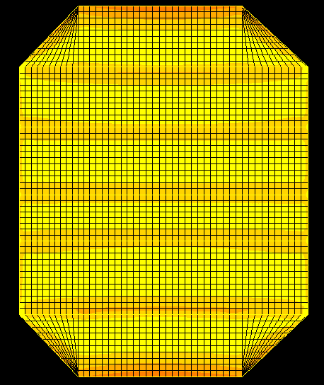
Fig (3-32) One Way Rib (Banqueting hall)
𝓜 ₂₂:
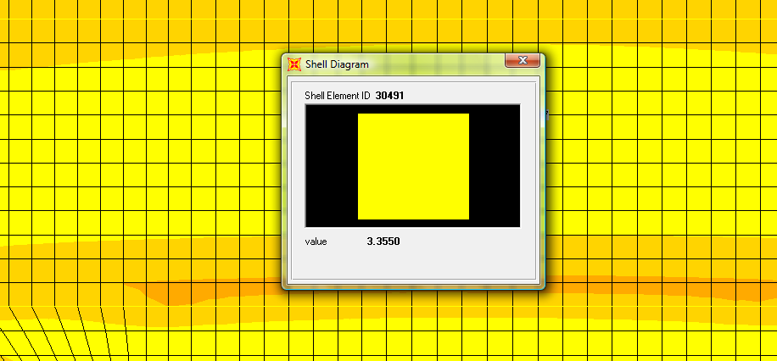
Fig( 3-33 ): Moment Y-Y in Banqueting hall 𝓜+ve=3.36 ton.m
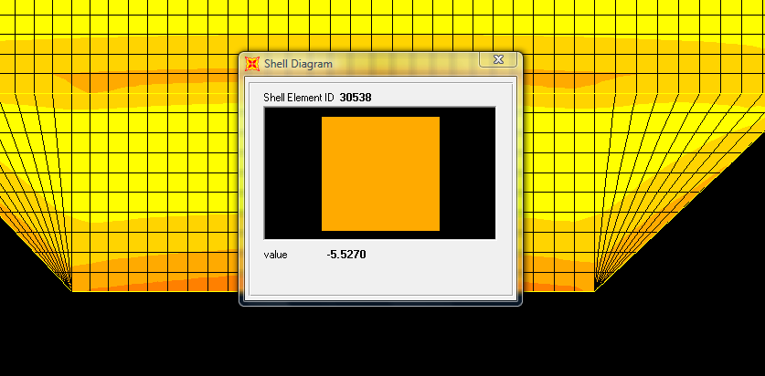
Fig (3-34 ): Moment Y-Y in Banqueting hall 𝓜-ve=5.52 ton.m
Design:
𝓜+ve=3.36 *0.55=1.85 ton.m/rib
𝜌=.85*240/4200(1-√ (1-2.35*1.58*10⁵/.9*26²*55*240)
𝜌=1.33*10⁻³
Ast_{(+ve)}=1.33*10⁻³ *26*55=1.9 cm²
Ast_{(min)}=0.0033*26*15=1.3 cm²
Ast_{(+ve)}=(2 ф12)
𝓜-ve=5.52*0.55=3.04 ton.m
𝜌=.85*240/4200(1-√ (1-2.35*3.04*10⁵/.9*26²*55*240)
𝜌=8.7*10⁻³
Ast_{(+ve)}=8.7*10⁻³ *26*15=3.4 cm²
Ast_{(-ve)}=(3 ф12)
Shrinkage reinforcement:
Ast=0.0018*b*h
=0.0018*100*6=1.08 cm²
(4 ф10), S=25 cm.
Spacing < 45 cm & 5h
(45 cm) or (5*6 cm)
Shear reinforcement:
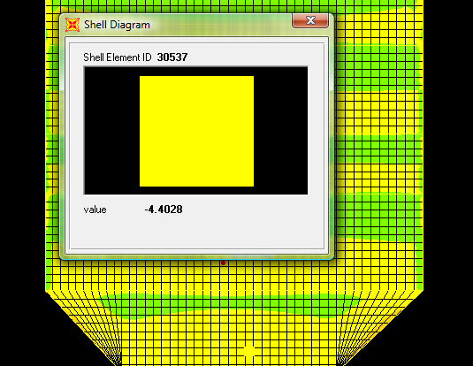
Fig (3-35 ): Shear force in Banqueting hall
Vu=4.4*0.55=2.42 ton
ФVc=1.1*0.75*0.53*√240*26*15*10⁻³
=2.64 ton
Vu< фVc no need shear reinforcement

Slabs Design of Block B

S.0.One Way Rib @ elevation (4 m):
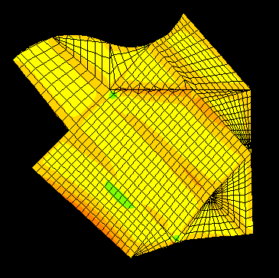
Fig (3-36):Moment on S0.one way
M11
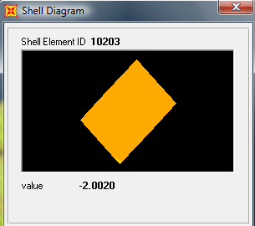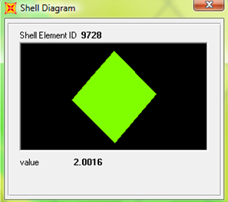𝓜11+ve=2 ton.m 𝓜11-ve=2 ton.m

Design
𝓜+ve=2 *0.55=1.1 ton.m/rib
Ast_{(+ve)}=(2 ф12)
𝓜-ve=2*0.55=1.1 ton.m
Ast_{(-ve)}=(2 ф12)
Shrinkage reinforcement:
Ast=0.0018*b*h
=0.0018*100*8=1.44 cm²
(3 ф10), S=25 cm.
Spacing < 45 cm & 5h
(45 cm) or (5*8 cm)
Shear reinforcement:
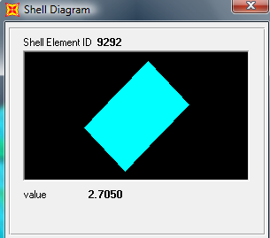
Fig (3-37):Shear force on S0.one way
Vu=2.7*0.55=1.49 ton
фVc=1.1*0.75*0.53*√240*22*15*10⁻³
=2.24 ton
Vu< фVc no need shear reinforcement.

S.0.Two way @ elevation 4 m:
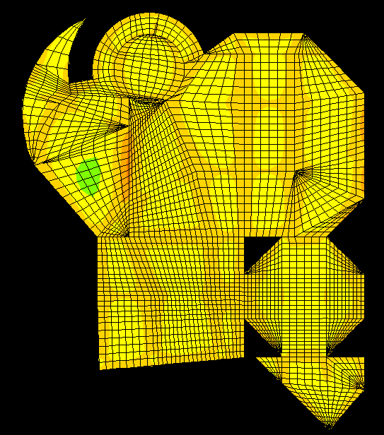
Fig (3-38): plan S0.two way

𝓜 ₂₂:
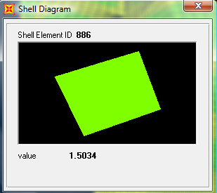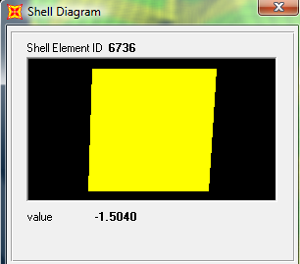
𝓜+ve=1.5 ton.m 𝓜-ve=1.5 ton.m
Design:
𝓜+ve(on rib)=1.5*0.55=0.825 ton.m/rib
Ast_{(+ve)}=(2 ф10)

𝓜-ve(on rib)=1.5*0.55=0.825 ton.m
Ast_{(-ve)}=(2 ф10)

Shear reinforcement:

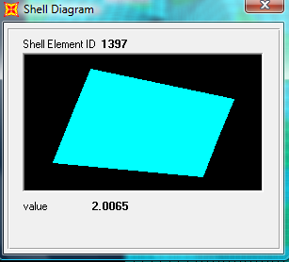
Fig (3-39):Shear force on S0.two way
Vu=2*0.55=1.1 ton
фVc=1.1*0.75*0.53*√240*22*15*10⁻³
=2.24ton
Vu< фVc no need shear reinforcement.

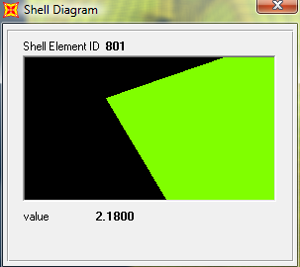
𝓜 ₁₁:
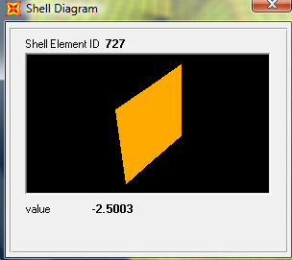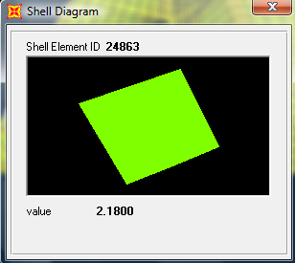
𝓜-ve=2.5 ton.m 𝓜+ve=2.18 ton.m

Design
𝓜+ve(on rib)=2.18*0.55=1.2 ton.m/rib
(2 ф12)
𝓜-ve(on rib)=2.5*0.55=1.375 ton.m/rib
Ast_{(-ve)} (2 ф12)
Shrinkage reinforcement:
Ast=0.0018*b*h
=0.0018*100*8=1.44 cm²
(3 ф10),
Spacing < 45 cm & 5h
Shear reinforcement:
Vu=2*0.55=1.1 ton
фVc =1.1*0.75*0.53*√240*22*15*10⁻³
=2.24ton
Vu<фVcno need shear reinforcement
Fig (3-40):Shear force on S0.two way

S1.two way @ elevation 8 m:
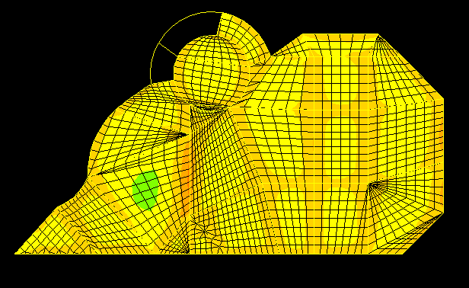
Fig (3-41): plan section for S1 in Block B
𝓜 ₂₂:
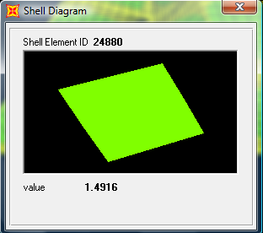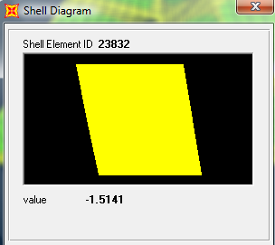
𝓜+ve=1.5 ton.m 𝓜-ve=1.5 ton.m

Design:
𝓜+ve(on rib)=1.5*0.55=0.825 ton.m/rib
Ast_{(+ve)}=(2 ф10)
𝓜-ve(on rib)=1.5*0.55=0.825 ton.m
Ast_{(-ve)}=(2 ф10)
𝓜 ₁₁:
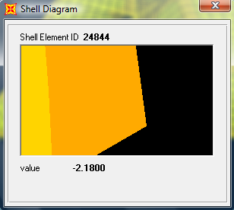
𝓜+ve=2.18 ton.m 𝓜-ve=2.18 ton.m

𝓜+ve(on rib)=2.5*0.55=1.2 ton.m/rib
(2 ф12)
𝓜-ve(on rib)=2.5*0.55=1.2 ton.m/rib
Ast_{(-ve)} (2 ф12)
Shrinkage reinforcement:
Ast=0.0018*b*h
=0.0018*100*8=1.44 cm²
(3 ф10),
Spacing < 45 cm & 5h

Shear reinforcement:
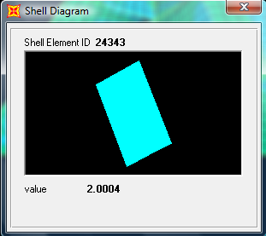
Fig (3-42): Shear force on S1 in Block B
Vu=2*0.55=1.1 ton
фVc =1.1*0.75*0.53*√240*22*15*10⁻³
=2.24ton
Vu< фVc no need shear reinforcement.
S2.one way @ elevation 8.5 m:
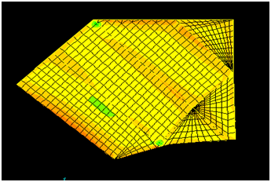
Fig (4-43): plan section S2.one way in Block B

M11:
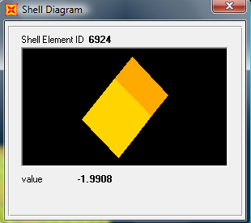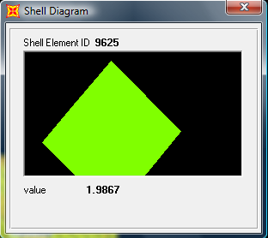
𝓜+ve=2 ton.m 𝓜-ve=2 ton.m

Design:
𝓜+ve(on rib)=2*0.55=1.1 ton.m/rib
(2 ф12)
𝓜-ve(on rib)=2*0.55=1.1 ton.m/rib
Ast_{(-ve)} (2 ф12)
Shrinkage reinforcement:
Ast=0.0018*b*h
=0.0018*100*8=1.44 cm²
(3 ф10),
Spacing < 45 cm & 5h

Shear reinforcement:
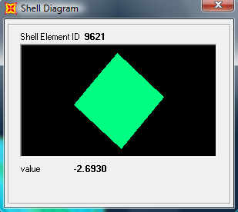
Fig (3-44): Shear force on S2.1w in Block B

Vu=2.7*0.55=1.49 ton
фVc=1.1*0.75*0.53*√240*22*15*10⁻³
=2.24ton
Vu< фVc no need shear reinforcement

S3.two way @ elevation 9 m:
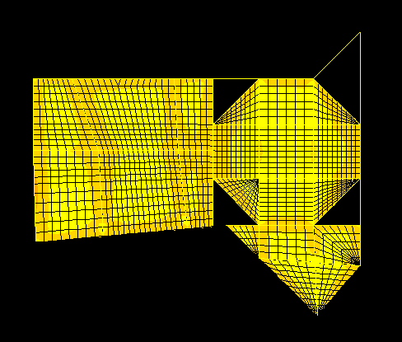
Fig (3-45): plan section S3 in Block B
𝓜 ₂₂:
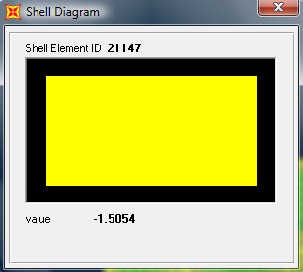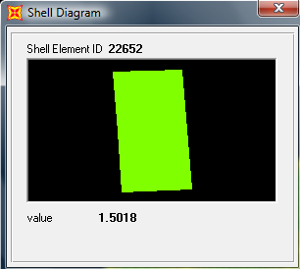
𝓜+ve=1.5 ton.m 𝓜-ve=1.5 ton.m
Design:
𝓜+ve(on rib)=1.5*0.55=0.825 ton.m/rib
Ast_{(+ve)}=(2 ф10)

𝓜-ve(on rib)=1.5*0.55=0.825 ton.m
Ast_{(-ve)}=(2 ф10)
𝓜 ₁₁:
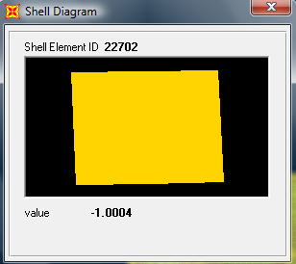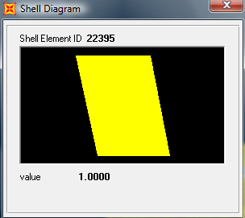
𝓜+ve=1 ton.m 𝓜-ve=1 ton.m
Design
𝓜+ve(on rib)=1*0.55=0.55 ton.m/rib
(2 ф10)
𝓜-ve(on rib)=1*0.55=0.55ton.m/rib
Ast_{(-ve)} (2 ф10)
Shrinkage reinforcement:
Ast=0.0018*b*h
=0.0018*100*8=1.44 cm²
(3 ф10) ,
Spacing < 45 cm & 5h in both direction

Shear reinforcement:
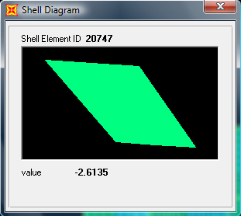
Fig (3-46): Shear force on S3 in Block B

Vu=2*0.55=1.1 ton
фVc= 1.1*0.75*0.53*√240*22*15*10⁻³
=2.24ton
Vu< фVc no need shear reinforcement.

S4.one way @ elevation 13 m:
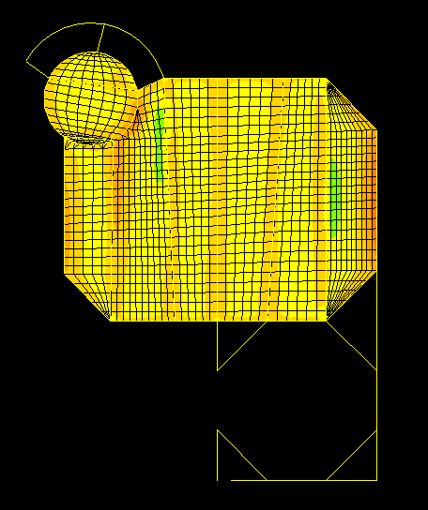
Fig (3-47): plan section S4 in Block B
M11:
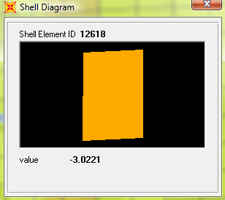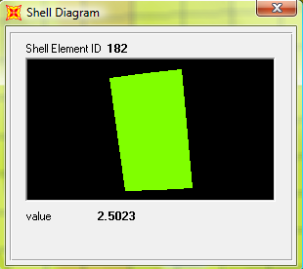
𝓜-ve=3 ton.m 𝓜+ve=2.5 ton.m

Design:
𝓜+ve(on rib)=2*0.55=1.38 ton.m/rib
(2 ф12)
𝓜-ve(on rib)=2*0.55=1.65 ton.m/rib
Ast_{(-ve)} (2 ф12)
Shrinkage reinforcement:
Ast=0.0018*b*h
=0.0018*100*8=1.44 cm²
(3 ф10),
Spacing < 45 cm & 5h

Shear reinforcement:
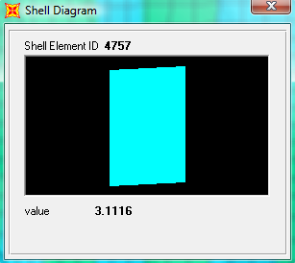
Fig (3-48): Shear force on S4 in Block B
Vu=3.1*0.55=1.71 ton
фVc=1.1*0.75*0.53*√240*22*15*10⁻³
=2.24ton
Vu< фVc no need shear reinforcement

3.3.2 Beam Design:
From the figure for structure all beams have green color, so that there is no problems take place in the beams due to shear and torsion and they are considered safe.
Block A
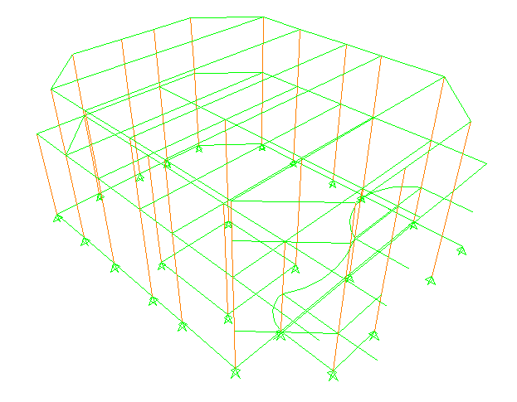
Fig (3-49): safe structural element in Block (A)

Block B
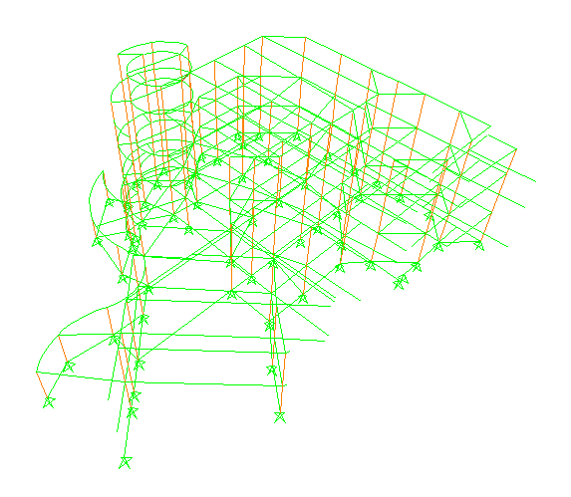
Fig (3-50): safe structural element in Block (B)
Block C
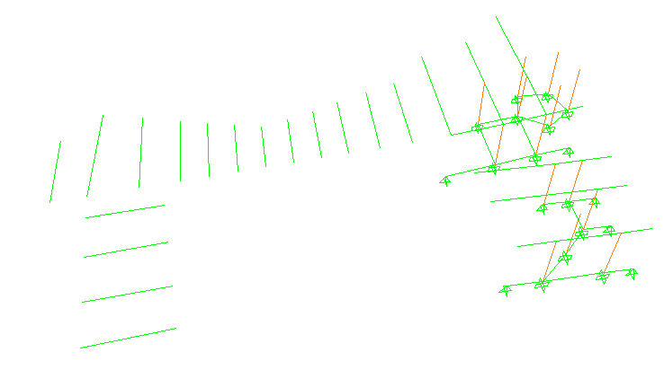
Fig (3-51): safe structural element in Block (C)
Check steel ratio (𝝆) in the beam:
From program 𝝆=0.0094 (Block A).beam name M3 (170*60). As=96.28 cm² which is greater than 𝝆_{min}=.0033, and smaller than 𝝆_{max} =.0154, so that the steel reinforcement in the beam may be considered in good state.
3.3.3 Column Design:
From program steel ratio for column (𝝆) lie between 0.01 and 0.03 which is larger than 𝝆_{min}=.01, since most columns have steel ratio less than .02, so that they may be considered economical structural element from the view point of ACI2002 code.
3.4 Displacements:
- the maximum deflection occurs on the slab for block (A) due to live load equal to 0.14 cm as shown in figures :
For block (A):
$$\frac{L }{Δ}≥360$$
𝓛=5.1m $→$
=1.4 >.14 cm OK
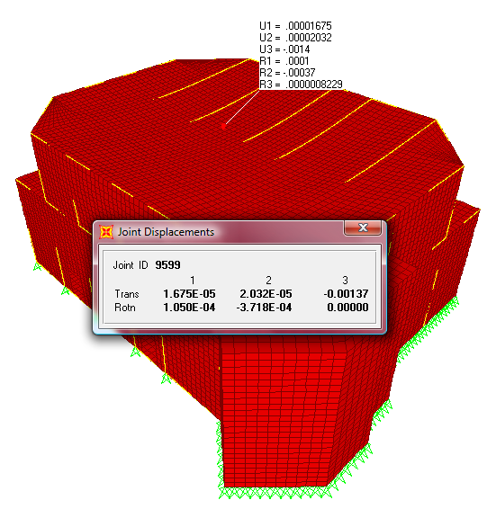
Fig (3-52): max deflection due to live load
- the maximum deflection occurs on the slab for block (B) due to live load equal to 0.8 cm as shown in figures :
For block (B):
$$\frac{L }{Δ}≥360$$
𝓛=6.0m $→$
=1.67 >0.8 cm OK
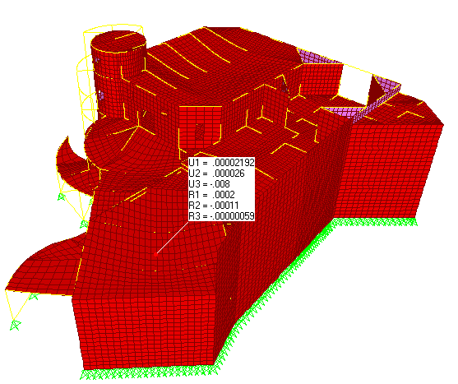
Fig (3-53): max deflection due to live load
- the maximum deflection occurs on the slab for block (C) due to live load equal to 0.68 cm as shown in figures :
For block (C):
$$\frac{L }{Δ}≥360$$
𝓛=5.5m $→$
=1.53 >0.68 cm OK
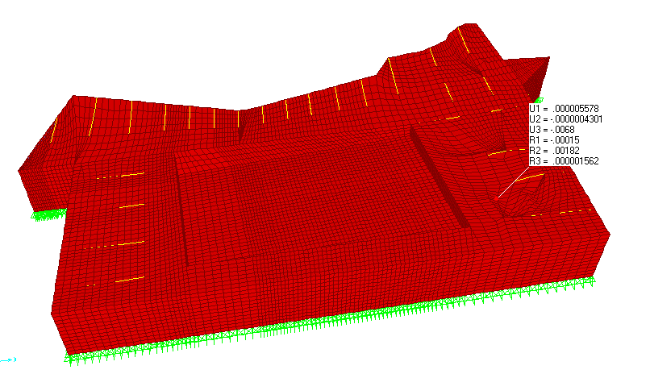
Fig (3-54): max deflection due to live load

3.5 Mode shapes and fundamental periods:
Mode of structure is very important to determine the weakest direction of structure and then design this direction to withstand the applied lateral and vertical loads.

Block | Fundamental period mode1
A | 0.379 sec
B | 0.206 sec
C | 0.198 sec

