﷽̨

An- Najah National University Faculty of Engineering and Information
Technology Computer Engineering
Department


Software Graduation Project


Dr. Suleiman Abu Kharmeh
Student Name | Student Id
Lana Jaara | 12011152
Jodi Kamal | 12029432

Submitted on :
June 2025
Presented in partial fulfillment of the requirements for Bachelor's degree in Computer Engineering.

Table of Contents
Dedication 6
Acknowledgment: 7
Disclaimer 8
Abstract 9
Chapter 1: Introduction 10
  - Statement of Problem 10
  - Objective 10
  - Scope of work 10
  - Importance of the work 11
  - Organization of the report 11
Chapter 2: Constraints, Standards, and earlier course work 12
  - Constraints 12
  - Standards 13
  - Earlier Coursework 13
Chapter 3: Literature Review 14
Chapter 4: Methodology 15
  - Software needs 15
  - Tools 15
  - UML Diagram 16
  - Mobile application 17
  - Web application 71
Chapter 5: Result and Conclusion 104
Chapter 6: Discussion 105
Chapter 7: Future Work 106
Chapter 8: References 107

Table of Figures
Figure 1:Splash Screen 17
Figure 2: Log in Screen 18
Figure 3:Sign up Screen 19
Figure 4:some field are empty ! 20
Figure 5:invalid email address 20
Figure 7:email not yet verified 21
Figure 6:Correct filed 21
Figure 8:verify email on gmail 22
Figure 9: after click on link 22
Figure01 :empty field 23
Figure 11: invalid login information 23
Figure 12:Forgot Password Screen 24
Figure 13:verification code screen 24
Figure 14:Verification code 25
Figure 15:invalid code 25
Figure 16:new password screen 26
Figure01 :passwords do not match 26
Figure01 :home screen 27
Figure 18:home screen 27
Figure 20:new arrivals screen 28
Figure 21:best seller screen 29
Figure 22:section screen 29
Figure 23:Detailed page screen 30
Figure 24:Detailed page screen 30
Figure22 :search screen 31
Figure 26:search suggestion 32
Figure 27:search suggestion 32
Figure 28:search suggestion 32
Figure 31:Result of search screen 33
Figure 29:Detailed page screen 35
Figure 30:Detailed page screen 33
Figure33 :Failed Add to cart 34
Figure 32:Success Add to cart 34
Figure 34:Success add to favorite 35
Figure32 : Remove from favorite 35
Figure 36:Shopping cart screen 36
Figure 37:SOLD OUT 36
Figure 38:Shopping cart total price 37
Figure31 :success remove from shopping cart 37
Figure 40:wishlist icon 38
Figure 41:wishlist screen 38
Figure 42: screen 39
Figure 43:shopping cart check out 40

Figure 44: 40
Figure 45: screen 41
Figure 46: 41
Figure 48: 42
Figure 47: saved 42
Figure 49:option screen 43
Figure 50:Free pick up option 44
Figure 51:our delivery system option 44
Figure 52:order confirmation 45
Figure23 :delete from cart after order 45
Figure22 : 46
Figure 54:Free pick up point notification 46
Figure 56:notification 47
Figure 57: 48
Figure 58: 49
Figure21 49
Figure 60:card option 50
Figure 61:visa screen 50
Figure 62:add visa information 51
Figure 63:notification user 51
Figure 64:payment done 51
Figure 65:our delivery system option 52
Figure 66:chat screen 53
Figure 67:settings screen 54
Figure 68: edit profile screen 55
Figure 69:edit profile successfully 56
Figure11 :edit profile image successfully 56
Figure 71:delete account 57
Figure 72:change password screen 58
Figure13 :wrong old password 61
Figure 74:not match password 61
Figure 75:sucussfully update 59
Figure 76:About us screen 60
Figure 77:n 61
Figure17 :examples of notifications 63
Figure 79:notifications screen 64
Figure 80:login delivery 65
Figure 81:delivery home screen 65
Figure73 :order details screen 66
Figure 82:delivery employee notification 66
Figure74 :delivery map screen 69
Figure 85:select location 69
Figure 86:sent notification order track 67
Figure 87:track order screen 68
Figure 88:log in web 71
Figure 89:log in admin account 71
Figure 90:home admin screen 72
Figure 91:Dashboard screen 73

Figure 92:Orders screen 74
Figure 93:after press on show more 74
Figure 94:filter orders 75
Figure 95:filter by payment method 75
Figure 96:filter by delivery option 76
Figure 97:edit order 76
Figure 98:example edit order 77
Figure 99:edit amount automatically 77
Figure 100:add order dialog 78
Figure 101:add order example 78
Figure 102:press on show more after add order 79
Figure 103:delete order 79
Figure 104:customers screen 80
80
Figure 106:example filter buyer customers 81
Figure 107:edit customer 81
Figure 108:delete customer 82
Figure 109:Add customer 83
Figure 110:after add customer 83
Figure 111:chat screen 84
Figure 112:see received messages 85
Figure 113:reply to messages 85
Figure 114:products screen 86
Figure 115:add product example 87
Figure 116:add product example 87
Figure 117:add product successfully by admin 88
Figure 118:product appear to users successfully 88
Figure 119:add section example 89
Figure 120:add section example 89
Figure 121:uccessfully add section 90
Figure 122:section appear to users successfully 90
Figure 123:product details screen 91
Figure 124:example edit quantity 91
Figure 125:successfully update the quantity and description 92
Figure 126:change image 92
Figure 127:successfully change image 93
Figure 128:delete item 93

Dedication:

First and Foremost, we extend our sincere thanks to God. His blessings have guided us through every step of our educational journey.
To our beloved Mohammad , may God bless him and grant him peace, who conveyed the message and illuminated our path.
To those who taught us the virtues of success and patience, and who exemplified the art of giving selflessly .To those who stood by us, endured challenges, and whose prayers were the source of our success To our families, friends and everyone who supported us with their encouragement and wisdom.
To everyone who contributed to our growth with their knowledge and insight. This humble work is dedicated to all of you.

Acknowledgment:

Firstly, we thank our supervisor, Dr. Suleiman Abu Kharmeh , for his continuous support . also we would like to thank the doctors of Computer Engineering Department for what they gave us during our educational process.

Disclaimer:

This report was written by Lana Jaara and Jodi Kamal at the Computer Engineering Department, Faculty of
Engineering, An-Najah National University. It has not been altered or corrected, other than editorial corrections, because of assessment and it may contain language as well as content errors. The views expressed in it together with any outcomes and recommendations are solely those of Lana Jaara and Jodi Kamal. An-Najah National University accepts no responsibility or liability for the consequences of this report being used for a purpose other than the purpose for which it was commissioned.

Abstract:

Glamzy :

The application supports in mobile and in web.

Chapter 1: Introduction

Statement of Problem

Customers often find that shopping for clothing and fashion accessories online is challenging, especially when they cannot try the items on before purchasing. This can lead to uncertainty and difficulty in making confident buying decisions. Our application simplifies the shopping experience by allowing customers to browse a wide variety of clothing and accessories, access detailed product information, and virtually try on sunglasses by uploading a photo of themselves all from the comfort of their homes. Additionally, the store features a dedicated section for clothing with designs that reflect Palestinian identity and culture, offering unique fashion pieces that blend modern style with cultural significance.

Objective

The objective of this project is to develop an online shopping platform dedicated to clothing and fashion accessories. The application streamlines purchasing by offering an intuitive interface where customers can effortlessly browse a broad range of apparel, access rich product details, and virtually try on sunglasses through an augmented-reality feature that uses a quick selfie. By combining easy navigation, comprehensive information, and realistic visualization, the system empowers shoppers to buy with confidence and convenience. A special collection featuring designs inspired by Palestinian heritage further enriches the catalog, blending cultural significance with contemporary style.

Scope of work

This application provides a personal account for each customer, as well as accounts for the store manager and delivery personnel. The application offers several key features:
    - Dedicated screens for each clothing and accessory category, making it easier for customers to find what they’re looking for.

    - Search functionality to help users quickly locate specific items

    - Messaging system that allows communication between customers and the admin for inquiries or fashion advice, as well as messaging between the admin and delivery personnel for coordination.

    - Virtual try-on feature for sunglasses, allowing users to upload a photo and see how different styles look on them before buying.

    - Secure Payment System.

    - Tracking Order.

Importance of the work

    - Simplifies the online shopping experience with an interactive interface and virtual try-on feature for sunglasses, reducing hesitation and return rates.
    - Enhances user confidence by providing detailed product information and the convenience of shopping from home.
    - Promotes cultural identity through a dedicated section featuring clothing designs inspired by Palestinian heritage.

Organization of the report

The report is structured as follows: In Chapter 2, constraints and standards and Earlier Coursework, we had a thorough detailed discussion about the coursework. The third chapter contains literature review. Methodology , and The resources , techniques at our disposal will be explained in Chapter 4.

The fifth chapter, results and analysis , that we found. Chapter 6 Discussion, which will also emphasize the strengths and weaknesses of the study.

Chapter 2: Constraints, Standards, and earlier course work

Constraints

    - Size and weight:

For the app to download quickly and run smoothly, especially on mobile devices, its lightweight design is crucial. The application size needs to be reasonable to prevent performance latency. To enable consumers to download and save the application on their devices, users' devices' storage space must also be decreased.

Coast:

The project's cost must stay within the within budget.

Communicate with the rest of the design and system:

A third party needs to be integrated into the application, in order to provide secure payment gateways ,a variety of user-friendly payment options like Stripe, the ability to track requests using additional Google services like maps, artificial intelligence-powered recommendation systems that enhance application performance, and a search function, Autocomplete functions such making recommendations while searching for products, can expedite the process.

Specific programming languages or specific systems:

The application requires to be created with a version visible on mobile phones and on web also. Additionally, you should use strong programming languages like Node.js for the back end and Flutter for the front end when creating the app.

Standards

To build an application that works well, grows easily, and is simple to take care of, we followed the agile method during development. This helped us start building the app early, fix problems quickly, and add new features without difficulty.

Earlier Coursework

We used what we learned in web programming to develop our application , also we made advantage of the database design course and Advance Software to build our backend using Node JS .in addition ,to flutter courses.

Chapter 3: Literature Review

The online fashion business has boomed over the last years , growing to a heightened concern for style, convenience plus ease facilitated by e-commerce (Statista 2023). People are using online buying for searching and purchasing clothes as well as accessories , mobile applications present customized experiences that save much time plus effort.

Fashion and personal appearance have an enormous role in emotional wellness at the confidence level and also in social interaction.
Some studies have shown the psychological impact of self-presentation , the effect that fashion choice has no mood and self-respect (Kwon ,2018). This consciousness is what led to much popularity over digital solutions that help customers make more confident fashion choices along with satisfying them.

The COVID-19 pandemic further accelerated the shift to digital shopping. People just didn’t want to go into the stores, they were buying from online sites. This highlited a big problem not being able to try the product before buying it, especially for items like accessories where one person’s fit and look may not be tried on for example, and that is why AR for fashion apps is coming up as a strong solution.

Our app meets this want by giving a virtual try-on option for shades using AR tech. This lets users upload a selfie and see how different styles will look on their face, better decision- making and lowering return rates. Also , the app gives a smooth and easy shopping experience, with a clear product list, simple travel, safe payment choices, and an order tracking system.

While existing platforms like Warby Parker and Lenskart offer AR-based try-on features, our app stands out by combinig fashion with cultural expression such as a special collection inspired by Palestinian tradition and focusing on accessibility and performance across devices (Warby Parker; Lenskart, 2023)

Chapter 4: Methodology

We go into great details on the mobile phone and on web application in this chapter, along with their purposes, to give you a complete grasp of the project and how it operates.

Software needs

    - Database:
Firestore database in Firebase for messaging and notification and order track, MySQL Database to store users and plants.

Programming Language:
- Flutter : use in client side to create mobile and web screens.
- Node Js: use in server side to create the APIs that manage the logic and handle the requests.
- JavaScript :use in client side to connect with server.

Tools

    - Visual Studio Code
    - Android Studio
    - Postman
    - MYSQL Database
    - Firebase
    - Githup








UML Diagram

Mobile application
In our application we have 3 user type (Admin, User, Delivery employee) when the user enter our mobile application the screens will be:

Splash Screen:
When the user open the application its firstly appear the 'splash screen'.
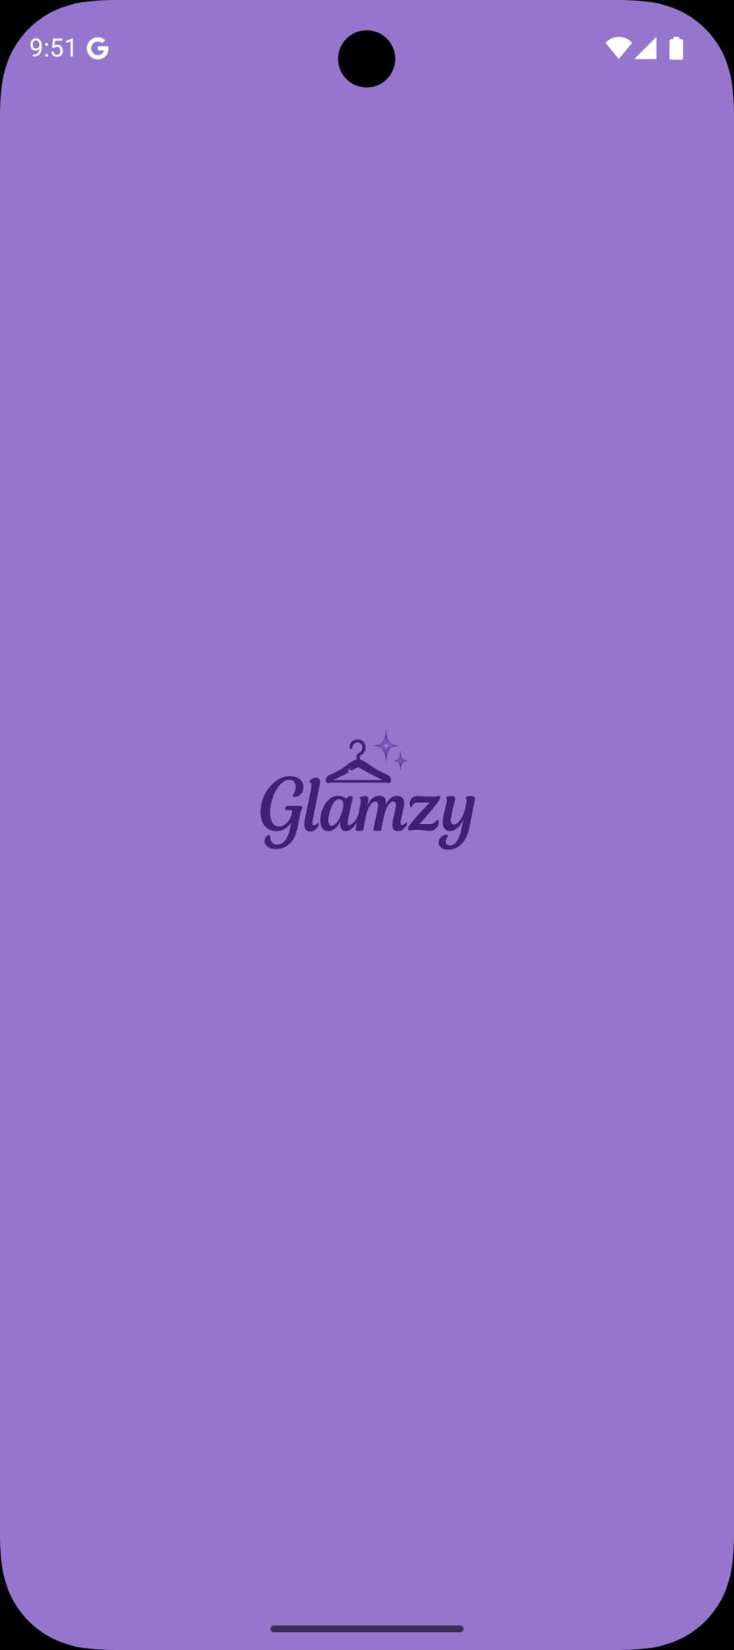

Figure 1:Splash Screen

Log in and sign up Screen's :
If user have account it will login using email and password .
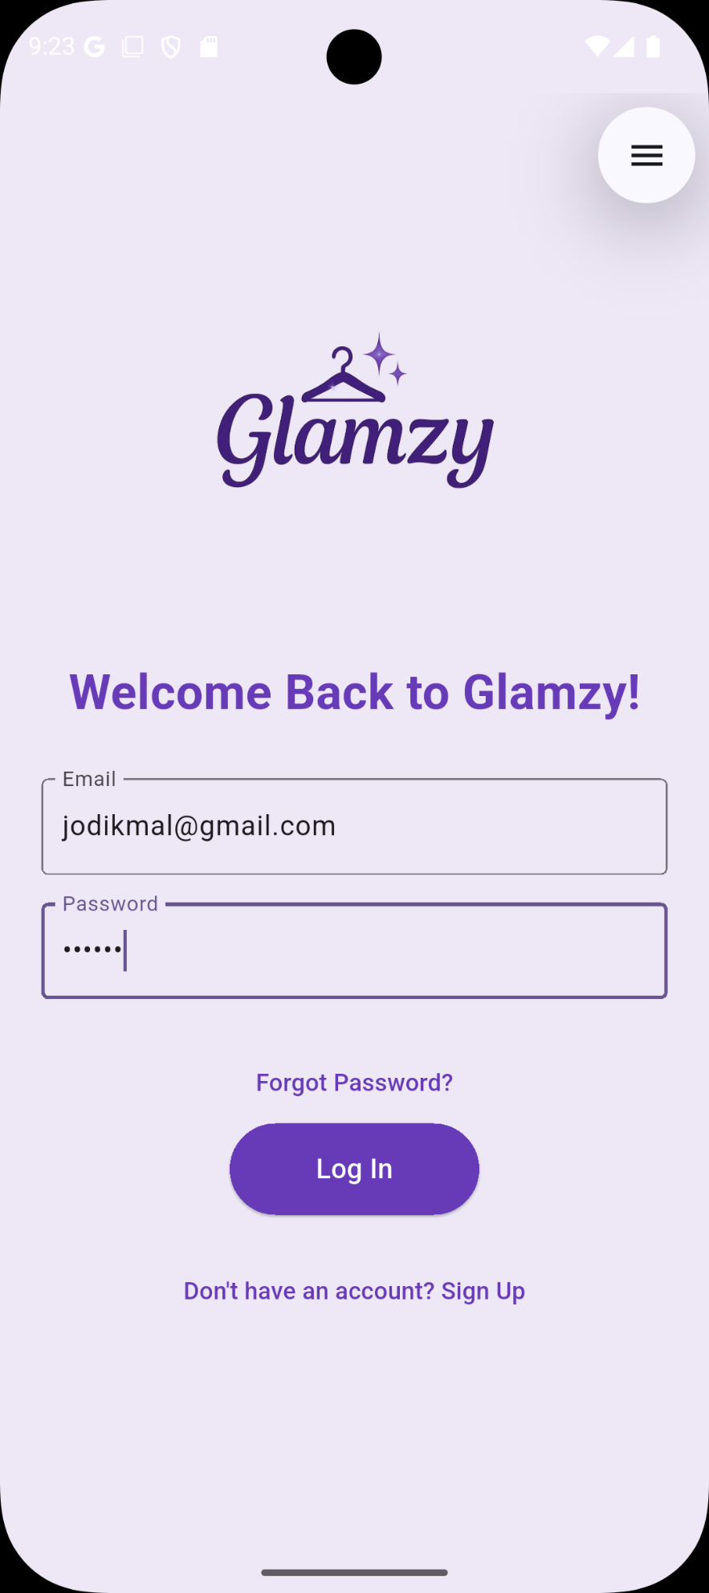

Figure 2: Log in Screen

But if user don’t have account it can press on sign up to appear 'sign up screen'

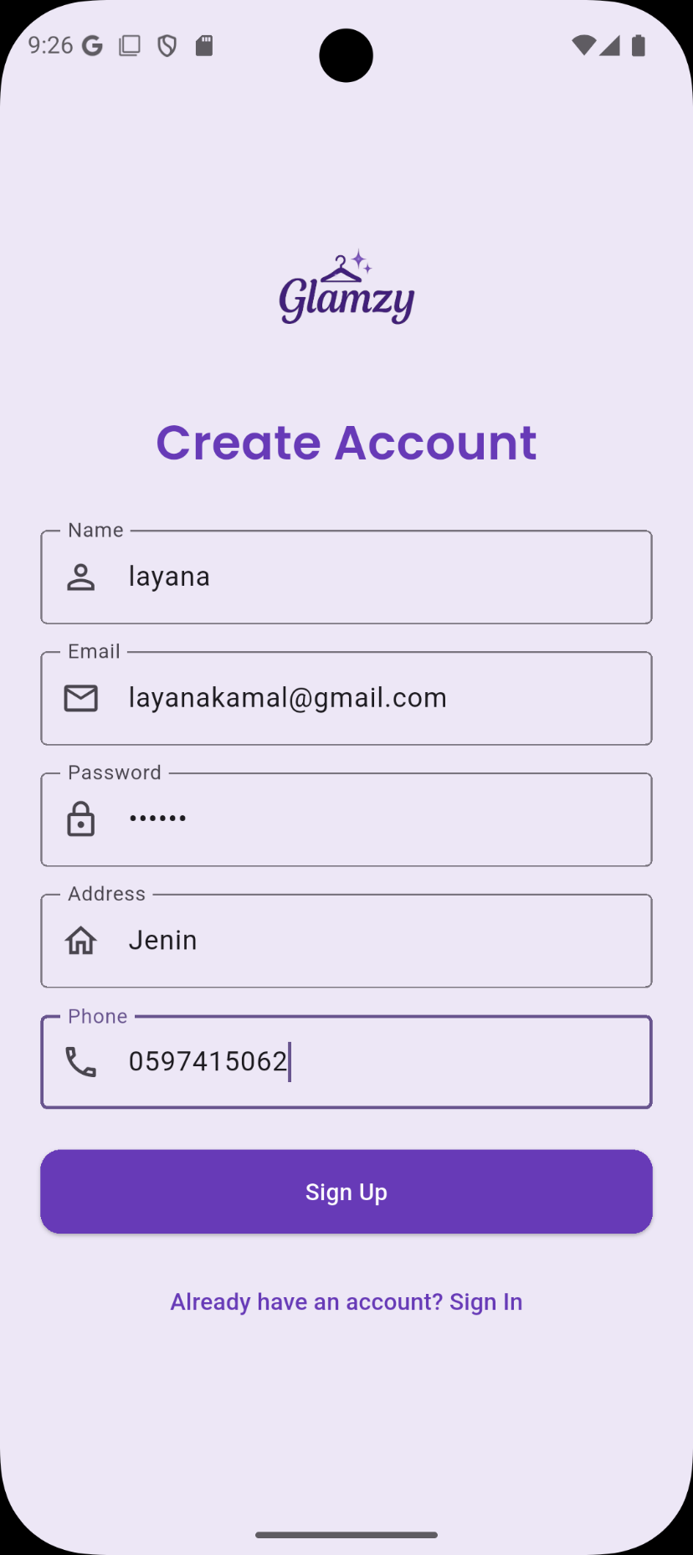
Figure 3:Sign up or Creat Account Screen

In 'sign up screen' we added validation for example some field are empty, invalid email address.

Figure 4:some field are empty ! Figure 5:invalid email address

When enter valid information and press on sign up it will open 'verify email screen' to verify the entered email .

Figure 6:Correct filed Figure 7:email not yet verified

After email verified successfully it will go to login screen…

Figure 8:verify email on gmail
Figure 9: after click on link

In 'login screen' if the user try to log in with empty or wrong field then log in process will fail.

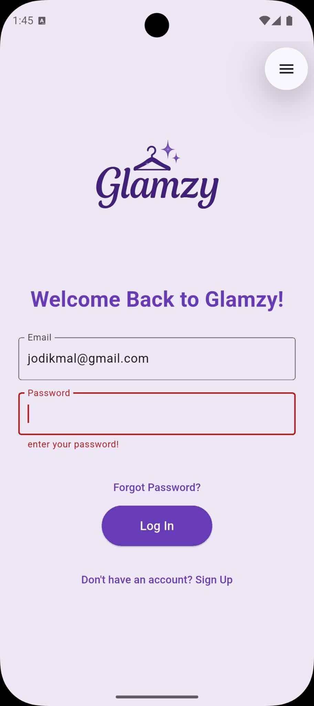
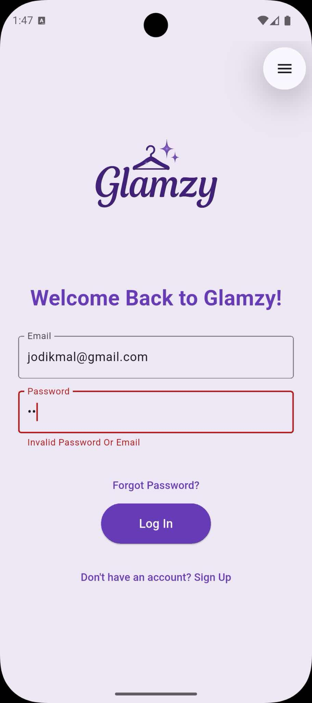

Figure01 :empty field Figure 11: invalid login information

Forgot Password screen's:
If the user forget his password he can click on ‘Forgot Your Password’ shown in Figure 11 then 'Forgot Password screen' will appear where user can enter his email to reset his password.

After enter email and click on ‘Reset Password’ as shown in Figure
12.then 'verification code screen ' will appear as shown in Figure 13.

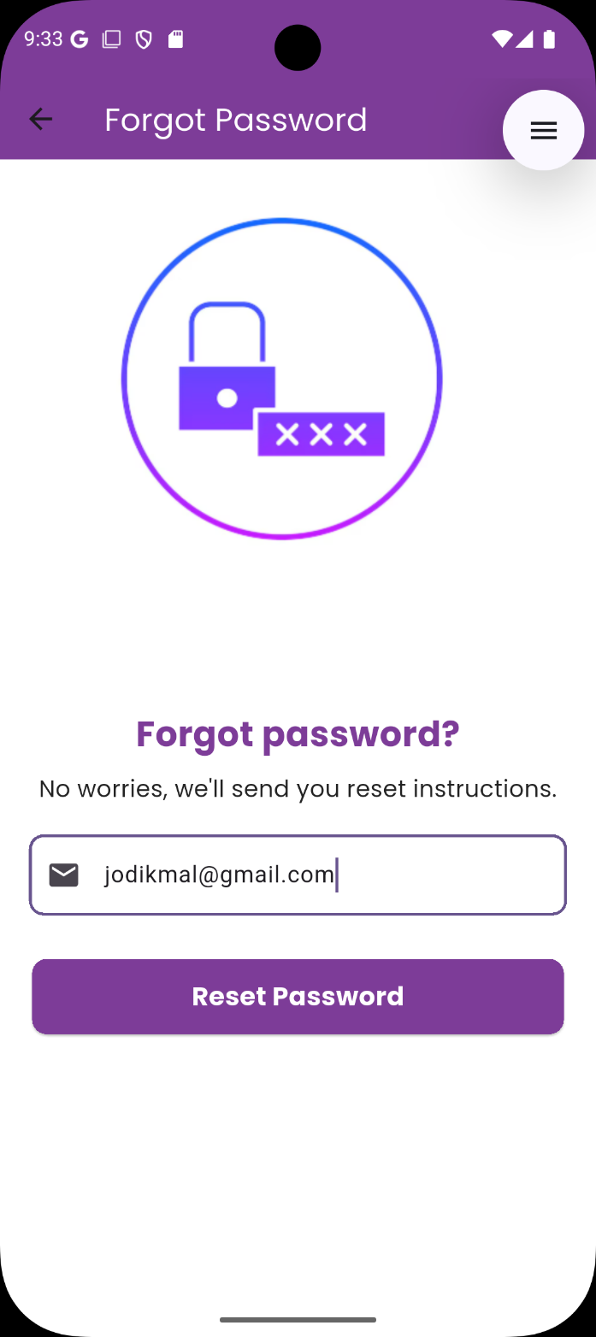

Figure 12:Forgot Password Screen
Figure 13:verification code screen

verification code will send for the entered email its contain 4 Random digits numbers as shown in Figure 14.

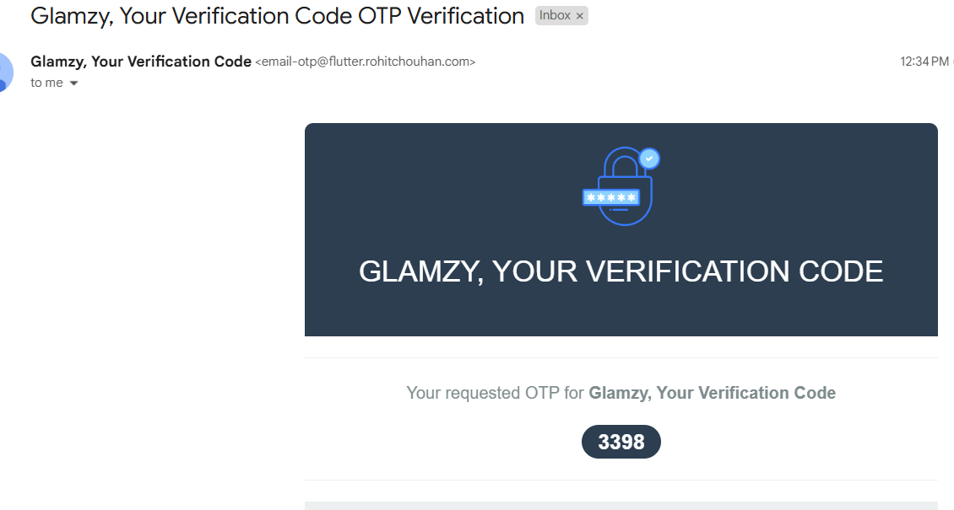

Figure 14:Verification code

when user try to enter invalid verification code as shown in Figure 15.
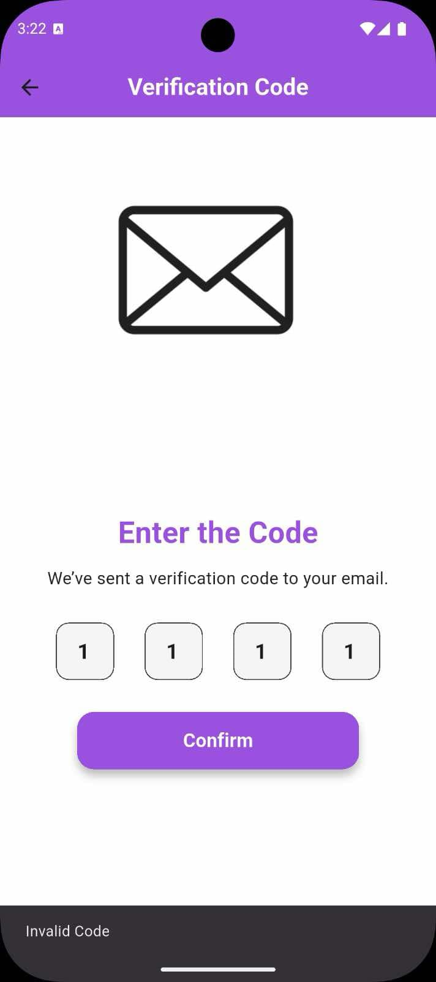

Figure 15:invalid code

Update Password screen:

After user enter correct verification code then it will open 'Update Password screen' as shown in Figure 16 ,where user can update his password.
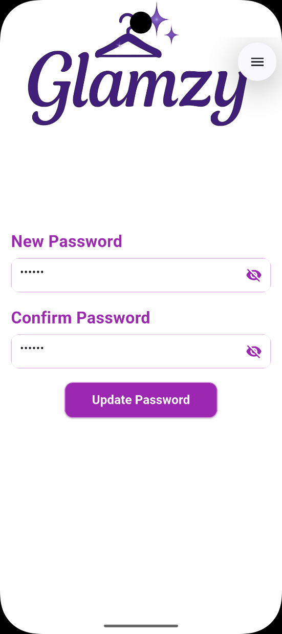

Figure 16:update password screen

After enter match passwords and press on ‘Update Password’ then 'login screen' will appear and now user can login with his email and password to enter 'home screen' as shown in Figure 18 and Figure 19 .

Home screen:
This screen allow user to navigate to multi screen : Section screen
Detailed page screen Search screen
Shopping cart screen
Setting screen
Notification screen
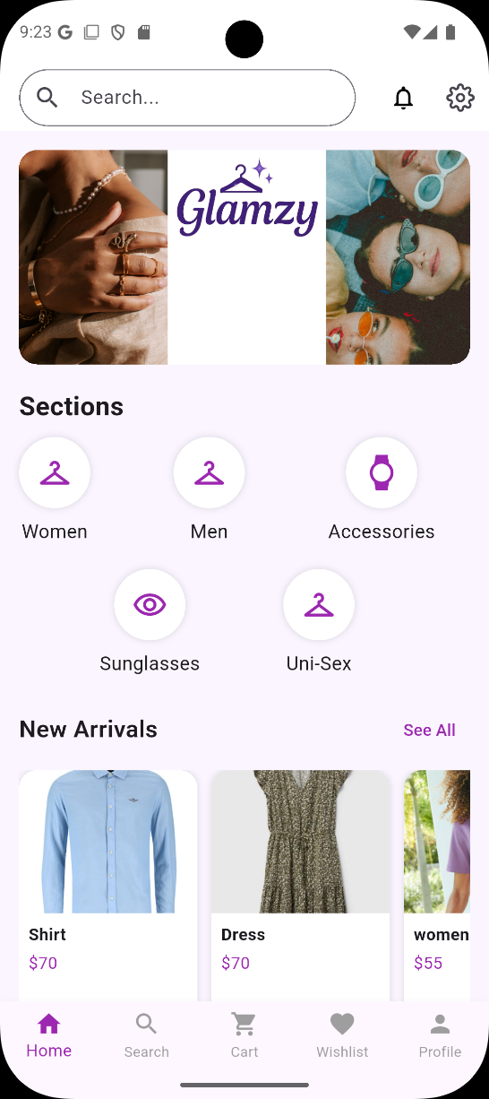

Figure 18:home screen
home page display the section's that we have in our application like women, men, accessories,sunglasses,uni-sex and any other section's the admin will add from his home page (home admin page ) we will explain it later..
on the Home page, the items appears to the user according to five part and we have (new arrivals) & (best seller)as shown in Figure 20 and 21 .

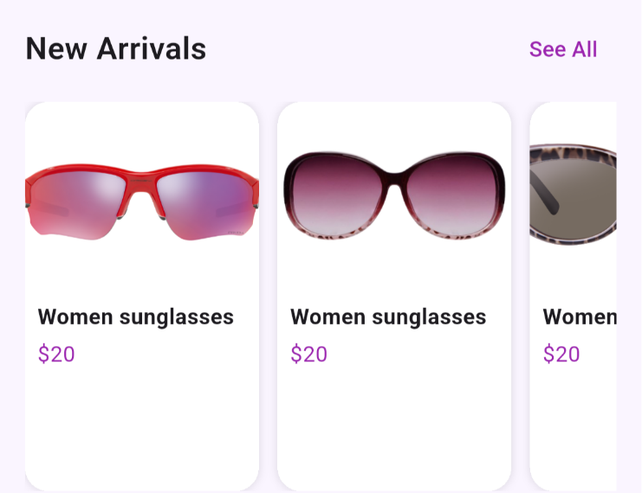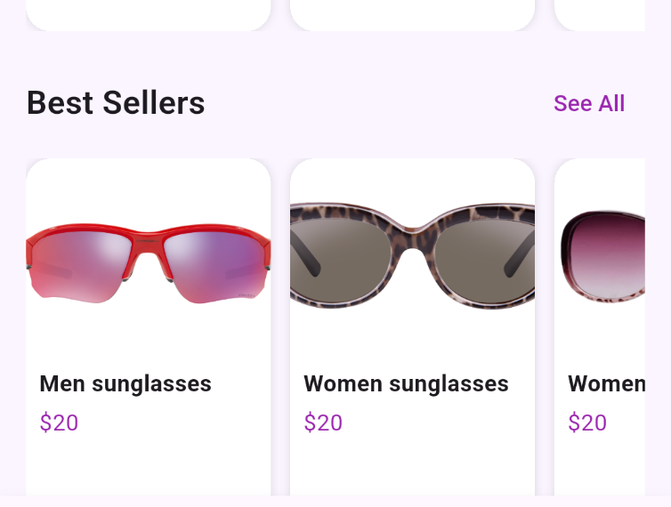

Figure 20: new arrivals screen Figure 21:best seller screen

Section screen:
user can select any section in home page to see all items who belonged to this section as shown in Figure 21, Figure 22.

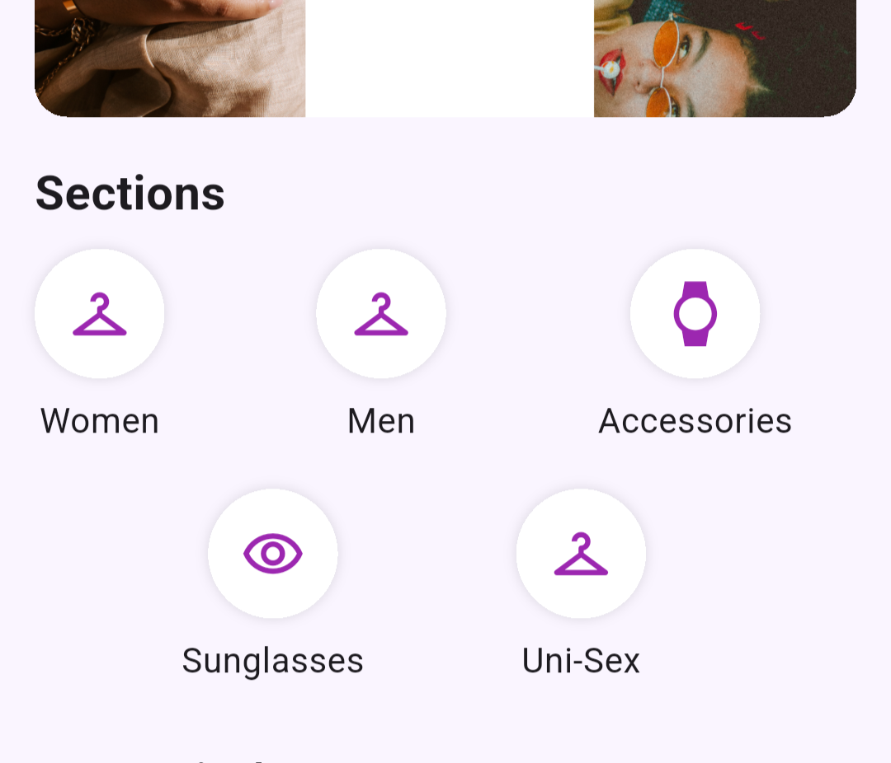

Figure 22: section screen

Detailed page screen:

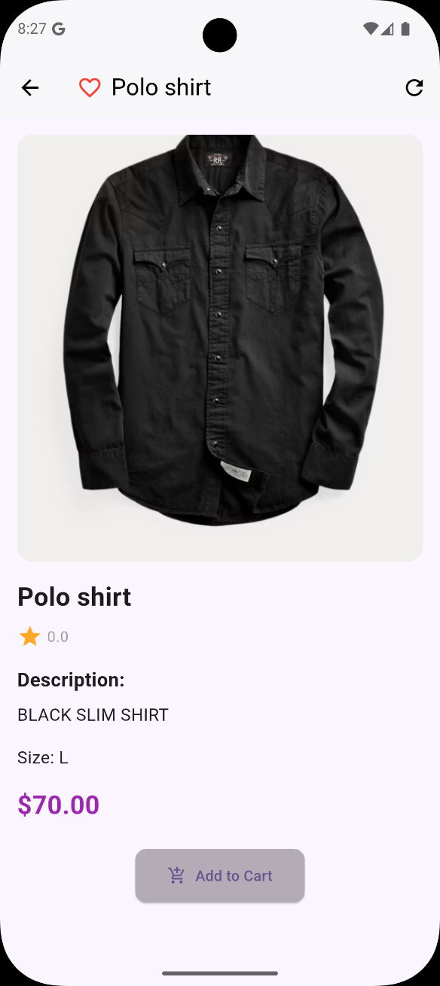
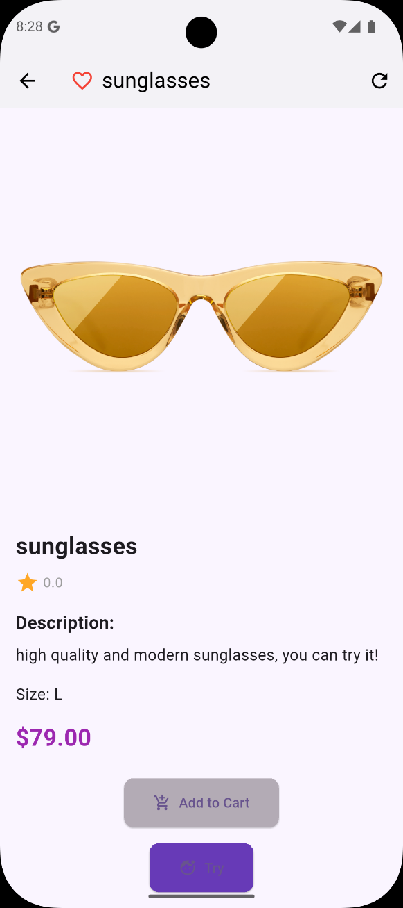

Figure 23:Detailed page screen Figure 24:Detailed page screen

Search screen:

Once we started searching and typed the first letter, it started giving me all the suggestions related to what I typed.

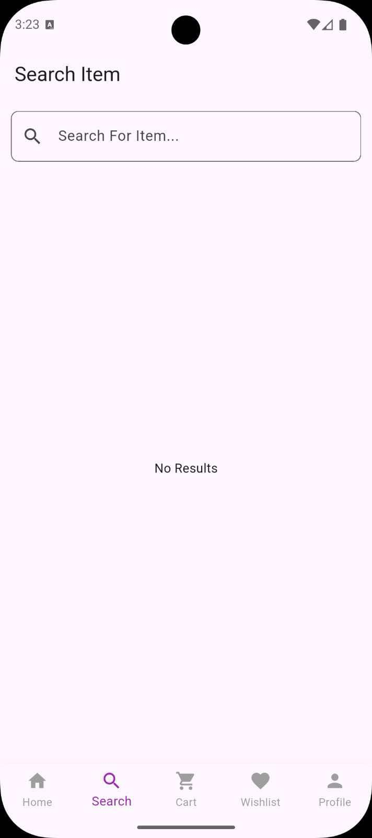

Figure22 :search screen

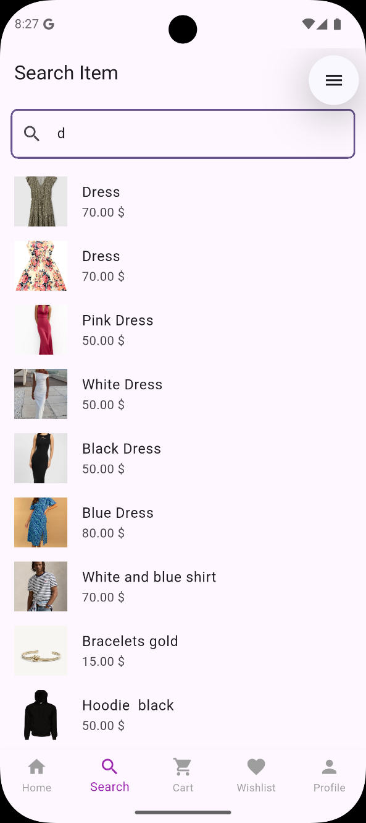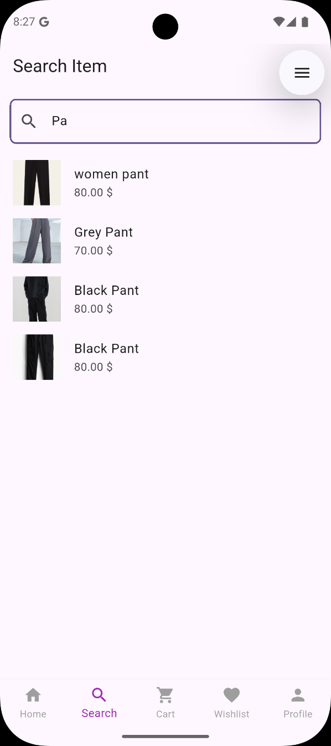
Figure 26:search suggestion Figure 27:search suggestion

Result of search screen:
After user select items from search suggestion All items that have the name you searched for will appear if there is more than one item that has the name as shown in Figure 31.
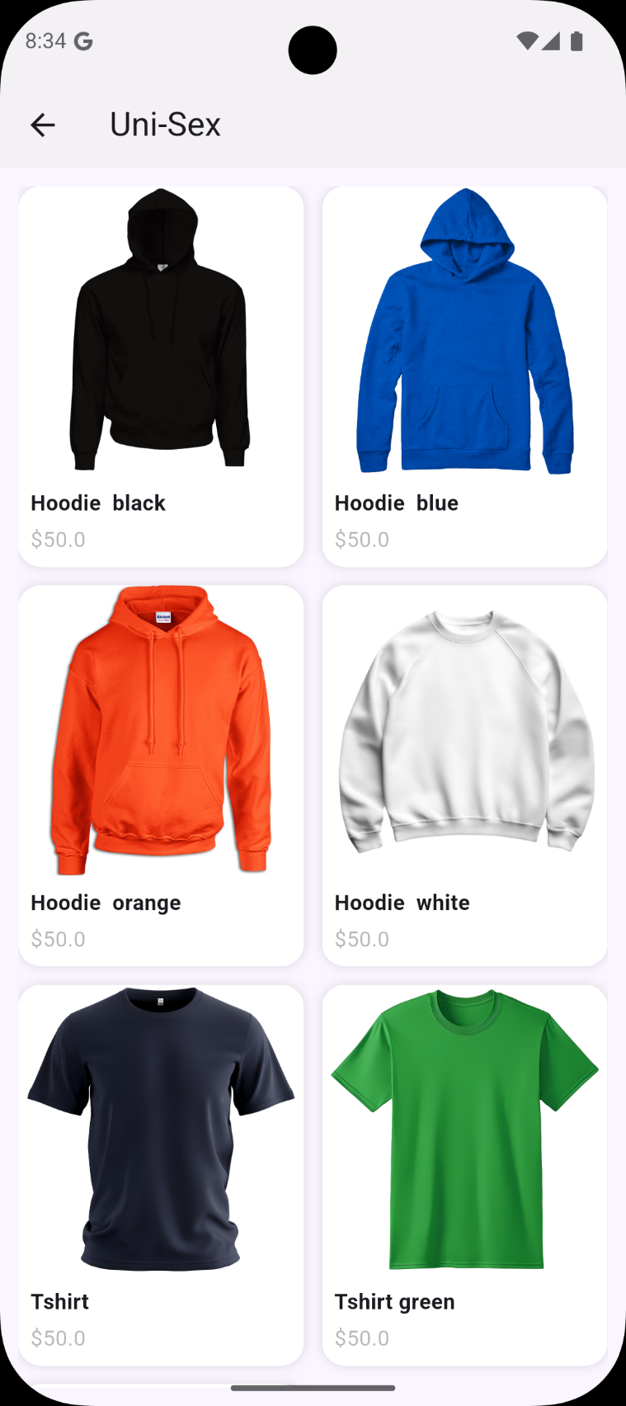
Figure 31:Result of search screen Figure 29: Figure 30:

user can add any items to his shopping cart when he press on ' Add to cart' Then our application will print to user message to show success add to cart as shown in Figure 32.
But if items added before to shopping cart it will not add it again and will print message to user to show failed add to cart as shown in Figure 33.

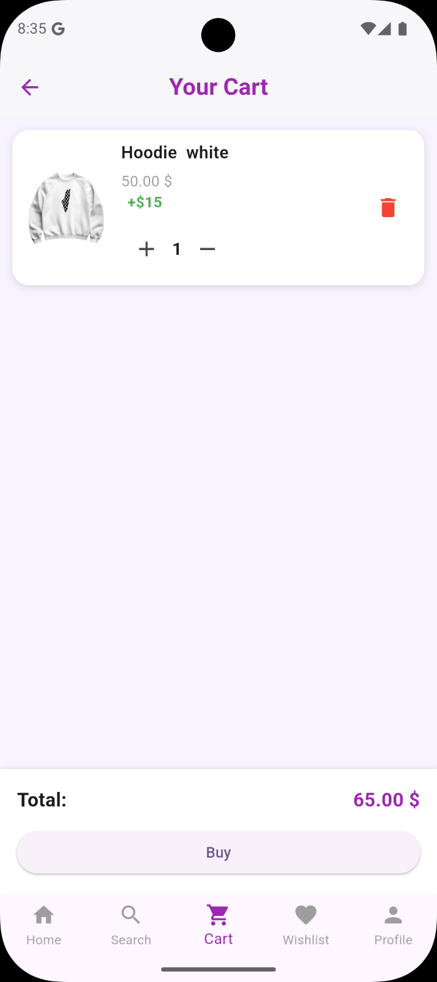
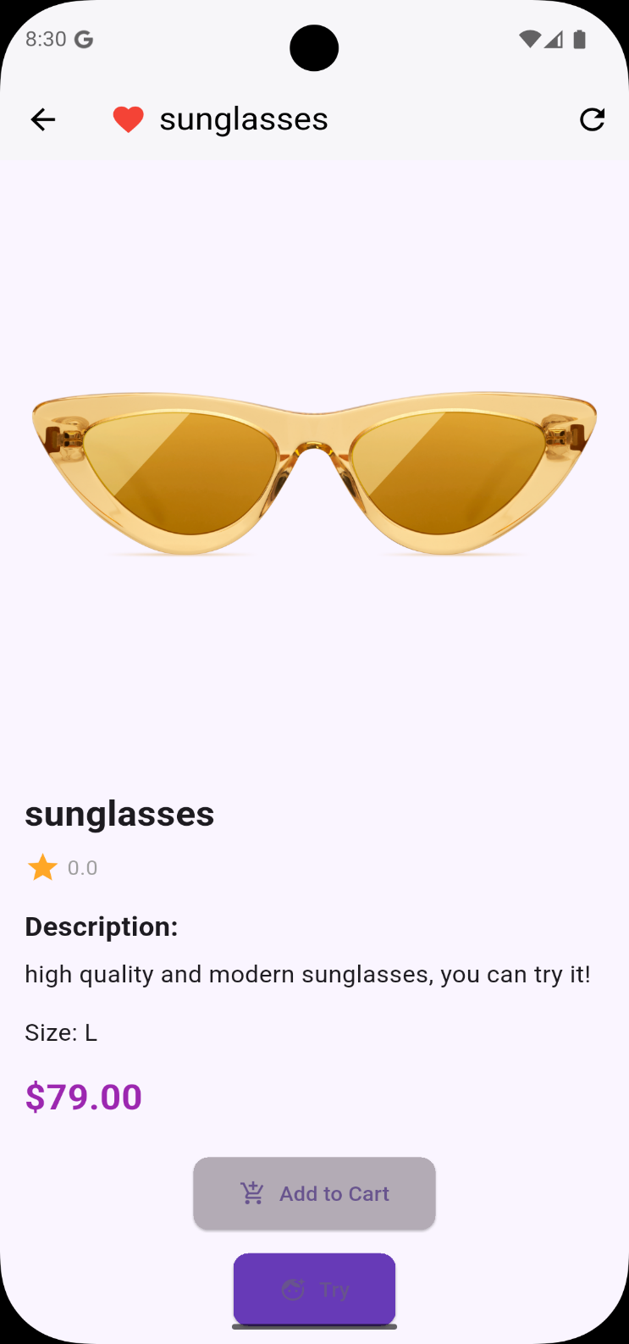

user can add any items to his Wishlist when he press on Love icon Then application will print to user message to show success add to favorite as shown in Figure 34.
Also user can remove items from wishlist Then application will print to user message to show success remove from favorite as shown in Figure 35.

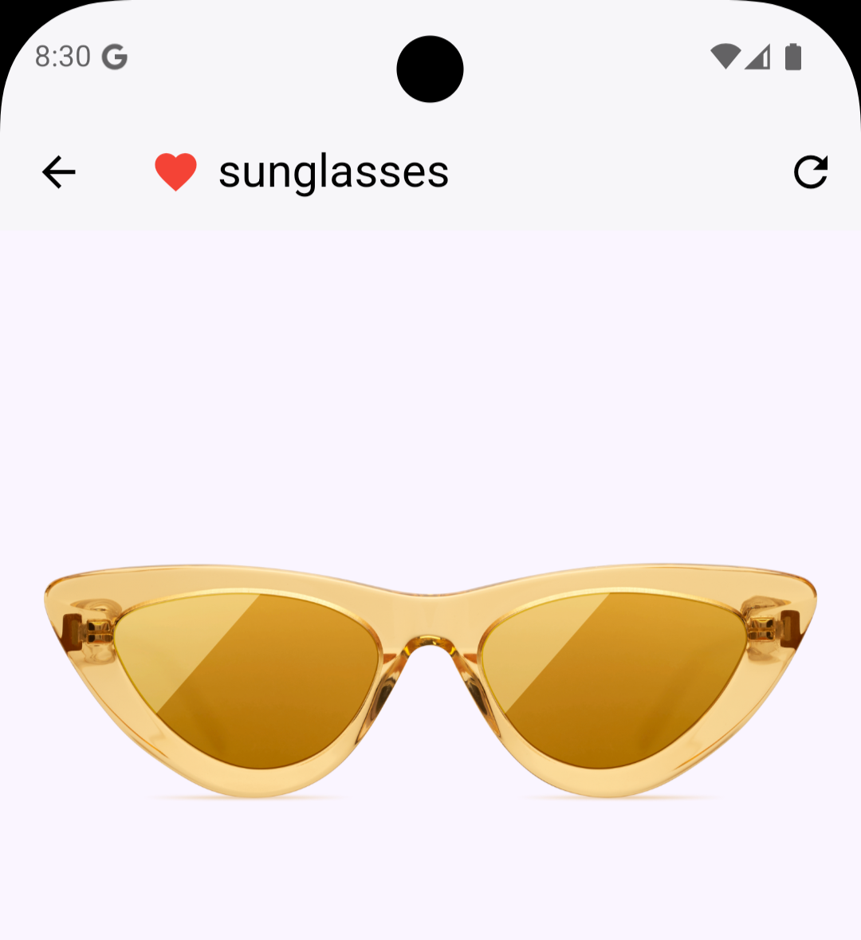

Figure 34:Success add to favorite

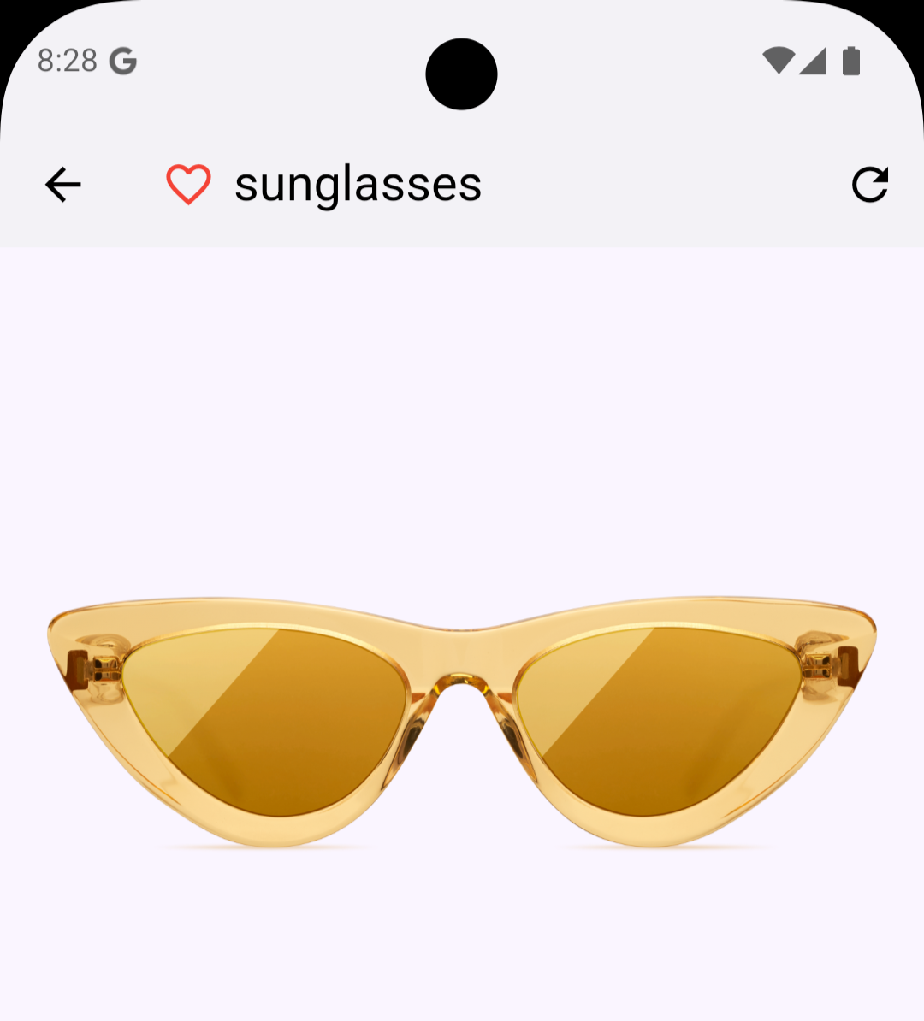

Figure32 :remove from favorite

Shopping cart screen:
user can press on cart icon exist in 'home screen' to see all items added to his shopping cart as shown in Figure 36.
Also user can increase quantity for each item by click on plus icon and can decrease it by click on minus icon.
If user try to increase quantity more than what in stock Then application will print to user message to show Failed increase quantity as shown in Figure 37.

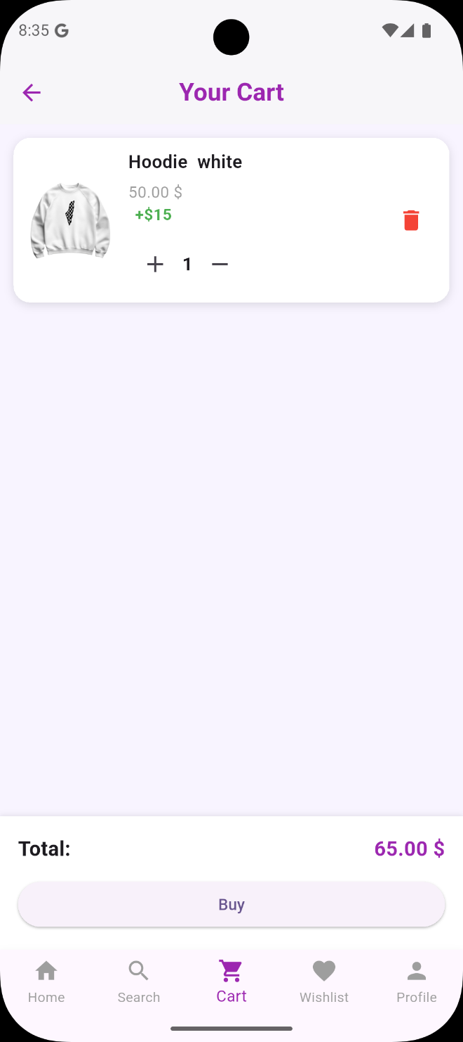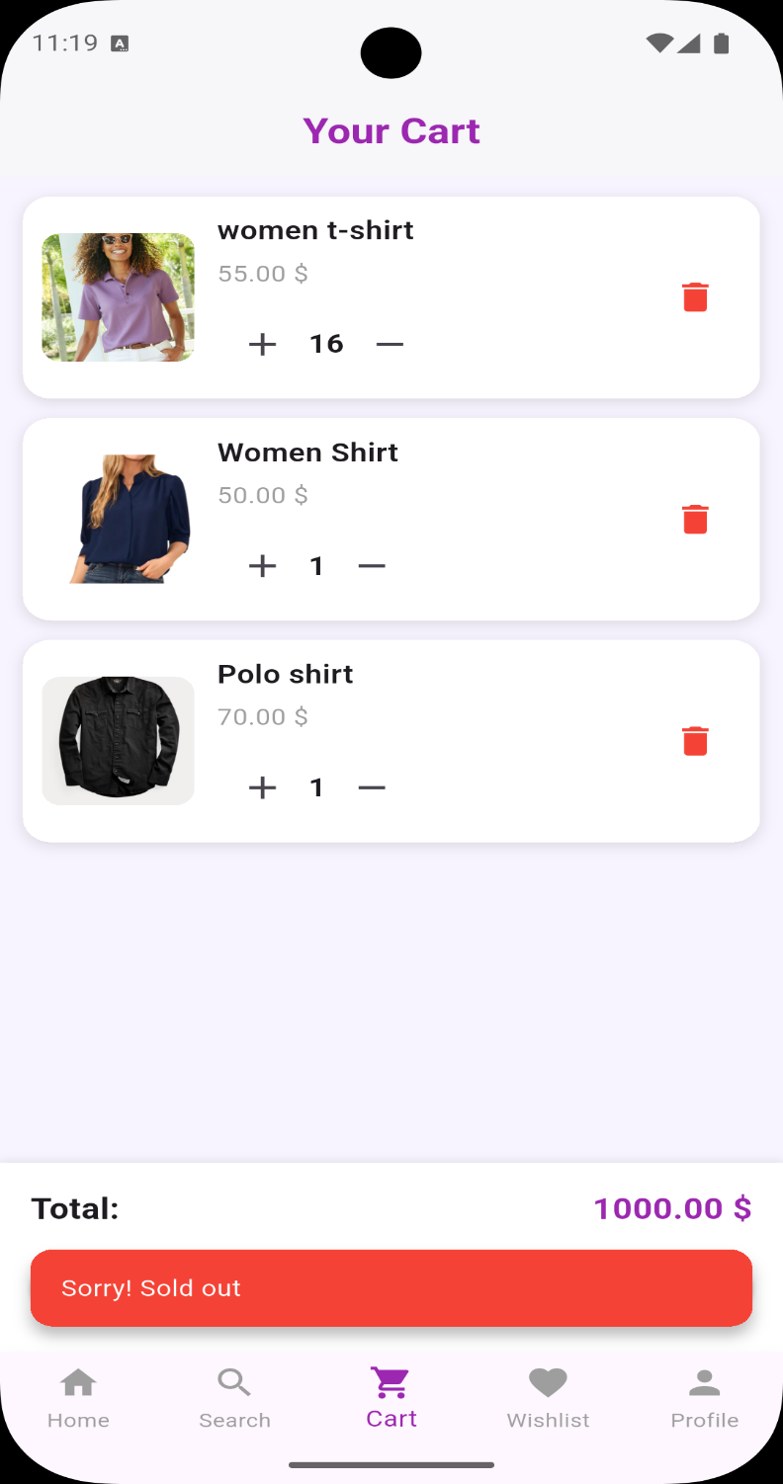

Figure 36:Shopping cart screen Figure 37:SOLD OUT

user can select the clothes he want to buy by placing a checkbox then the total price will display automatically as shown in Figure 38.
Also user can remove plant by press on icon remove Then application will print to user message to show success remove from Shopping cart as shown in Figure 39.

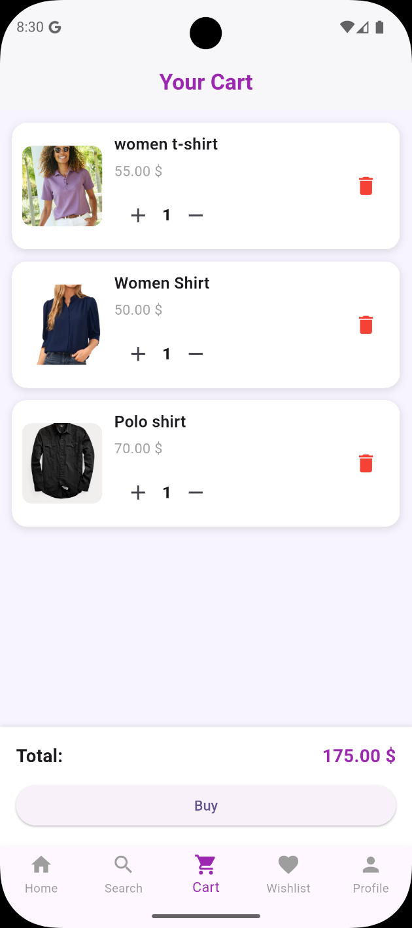

Figure 38:Shopping cart total price
Figure31 :success remove from shopping cart

Wishlist screen:
User can see all items he added to his wishlist by click on love icon as shown in Figure 40.
after click on this icon 'Wishlist screen' will appear as shown in Figure 41.

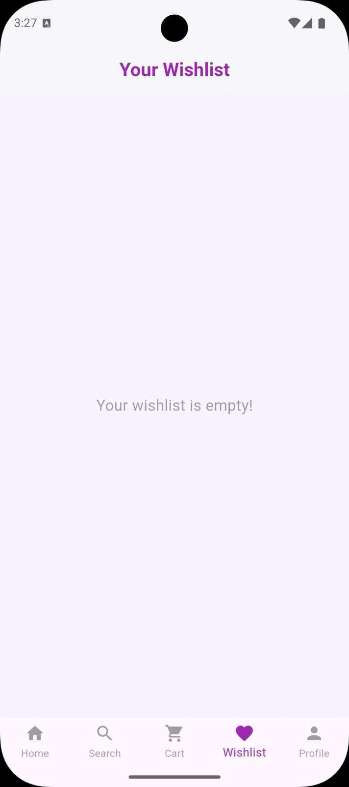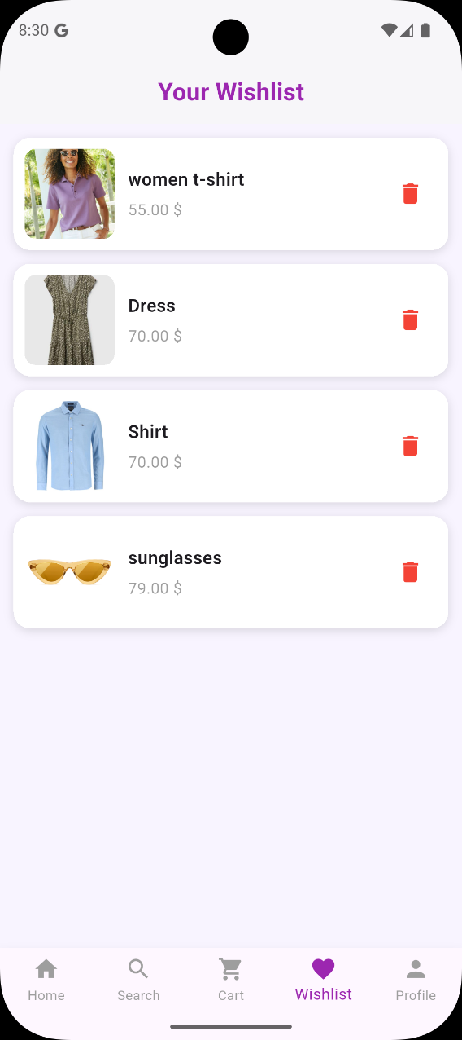

Figure 40:wishlist icon
Figure 41:wishlist screen

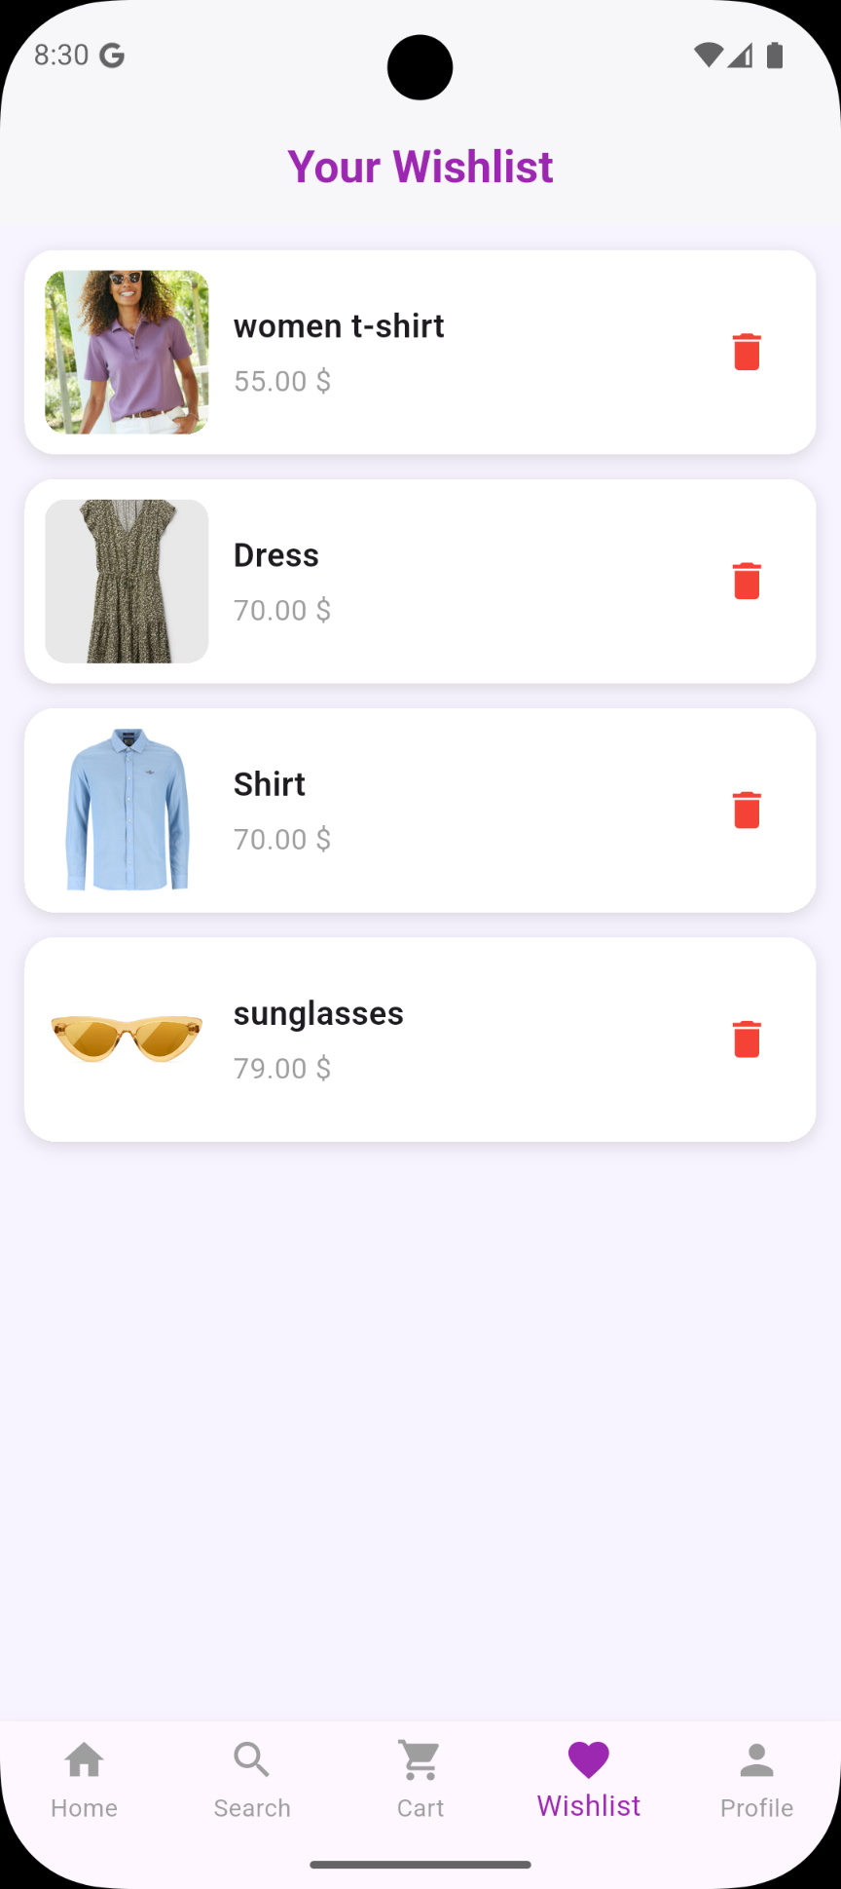
Figure 42:

Shipping Address screen:
After user select the items that he need to buy then he can click on ‘add to cart’ button as shown in Figure 43.

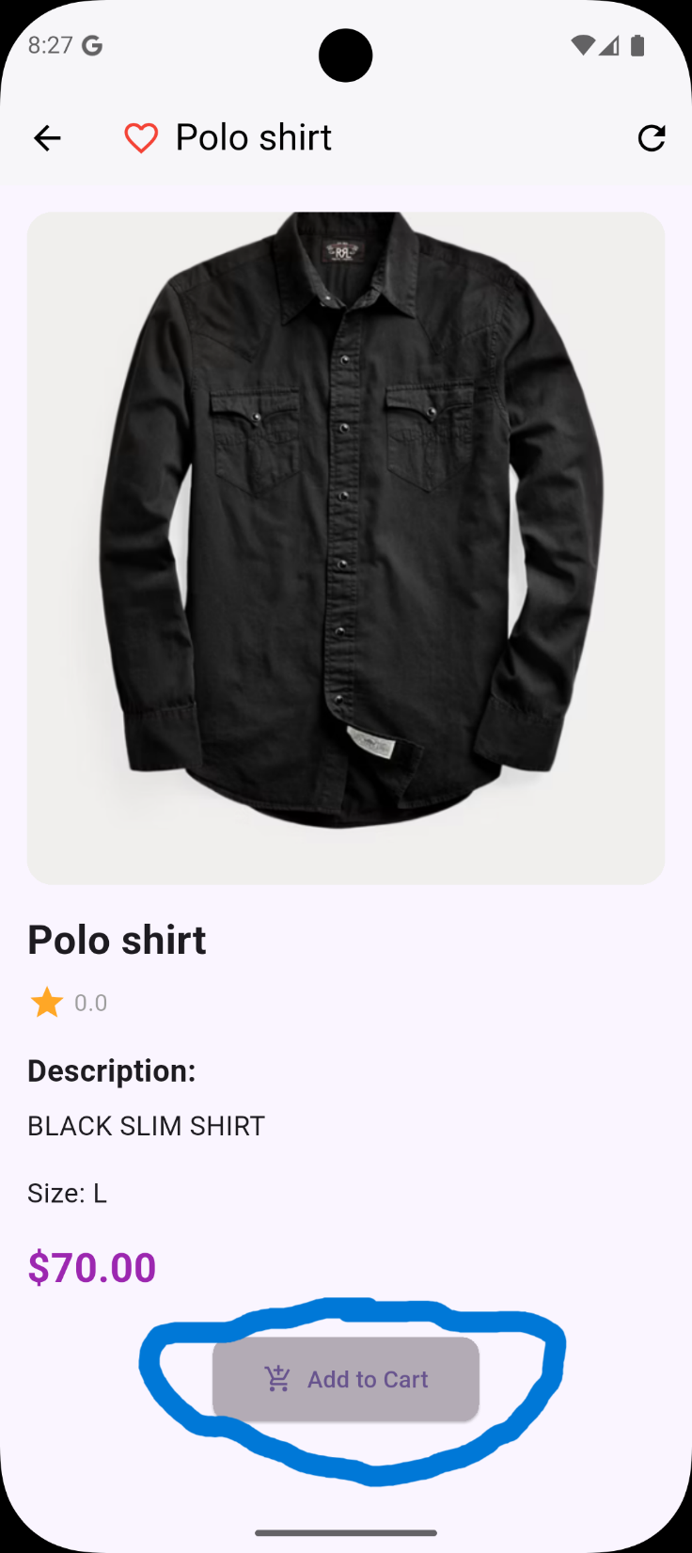

Figure 43:shopping cart

Now After user selected the location he can press on save button exist in 'shipping Address screen' to continue the order process..

Figure 47:selected location saved Figure 48:shipping address new

Option screen:
After press on save button 'option screen' will appear to allow user to select Delivery option and Payment method as shown in Figure 49.
In our application we have two Delivery option :Free pickup point or our delivery system .
Also we have two payment method :using cash or using visa card.

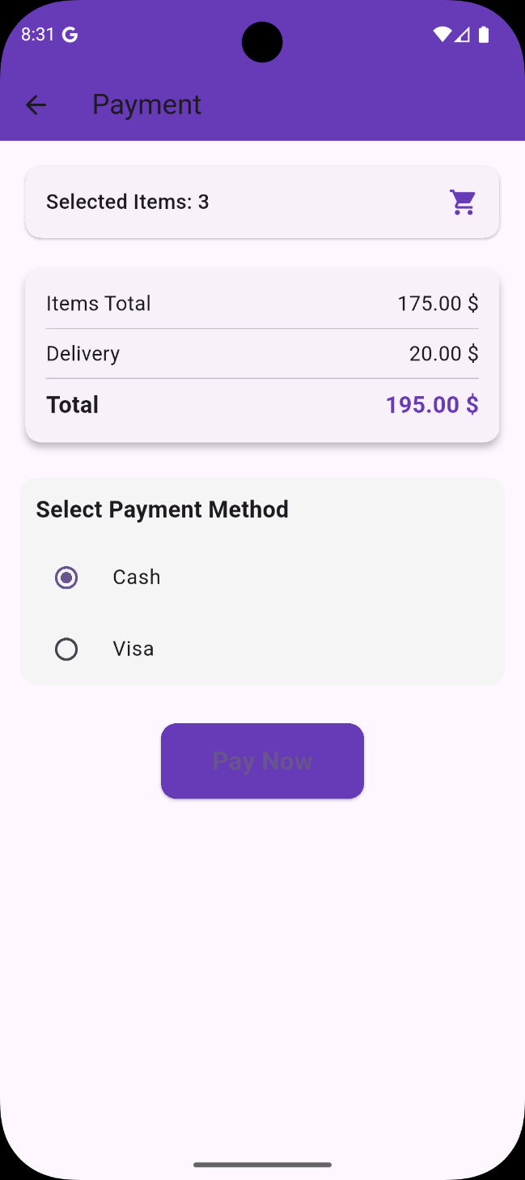

Figure 49:option screen

if user select Free pickup point as Delivery option then Delivery Price equal to zero and Total Price will be the price of items only as shown in Figure 50.
But if user select our delivery system as Delivery option then Delivery Price equal to 20$ and Total Price will be the price of items with add delivery price as shown in Figure 51.

Figure 50:Free pick up option Figure 51:our delivery system option

Try Glasses With Face Detection

We provide a unique feature in our application, which is trying on sunglasses before buying them and knowing whether the buyer will like them or not or whether they will suit his face.
All you have to do is choose the image you want and choose the sunglasses and your picture will appear with the glasses you chose.
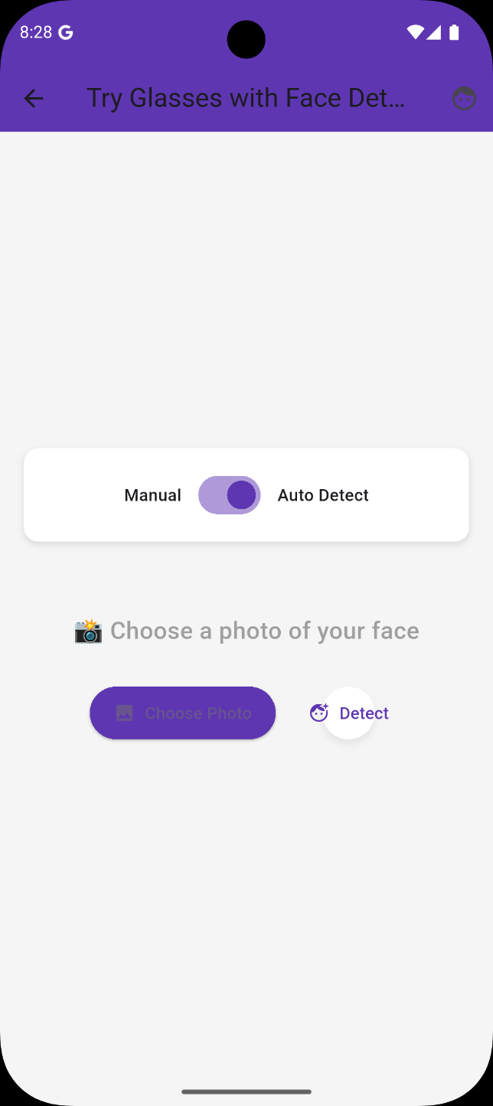
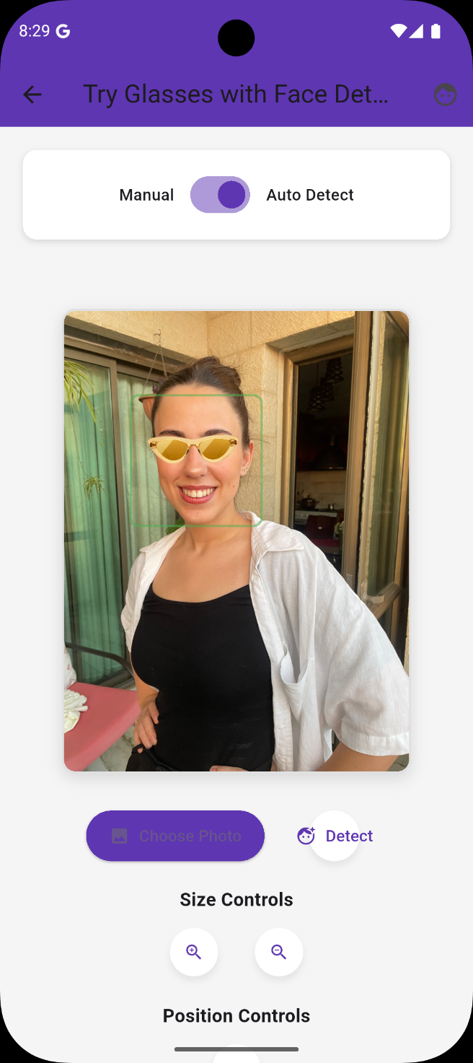

Figure 52:Try glasses with AR Figure23 :upload photo to try
There are also options to adjust the glasses to the face in terms of zooming in, out, and rotating them.
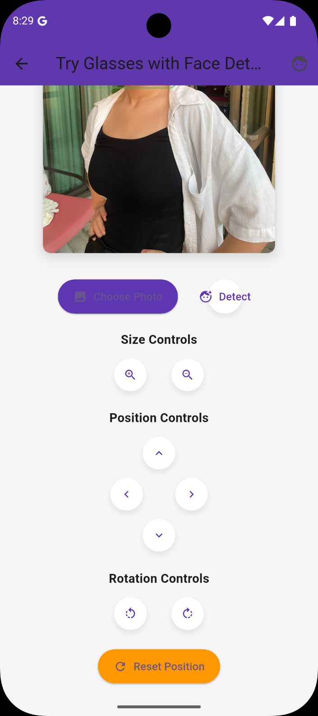

Figure 54: Edit size and position of sunglasses

After user click on notification with title 'Free pick up point' then it will mark as read so its background color convert to white as shown in Figure 56.
The second notification for our case have title 'Rating product' as shown in Figure 56.when user click on this notification our application will open 'Plant Ratings screen' to allow user to Rate the Purchased plants
as we will explain next page.

Figure 56:Rating product notification

Item Ratings screen:
this screen displayed image for each item Purchased by this order as shown in Figure 57 .

Figure 57:Rating screen

user can click on star icons that exist under each item to Rate it as shown in Figure 58. and after he finish Rate he can click on 'Submit'.

Figure21 :after submit

if user make order with select Free pickup point as Delivery option and card as payment method and press 'Done' as shown in Figure 60.Then user can pay by visa as shown in Figure 61.

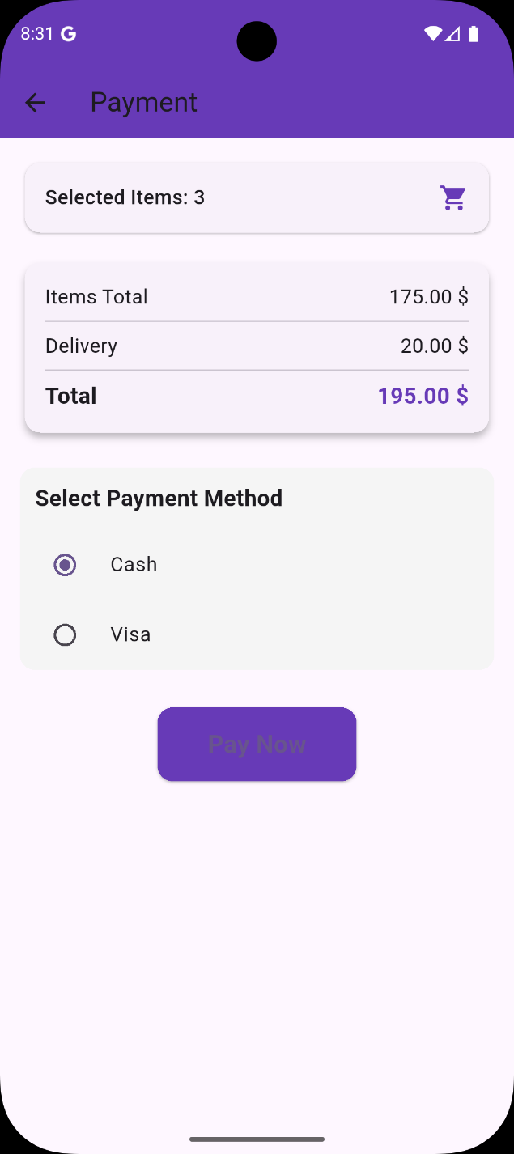
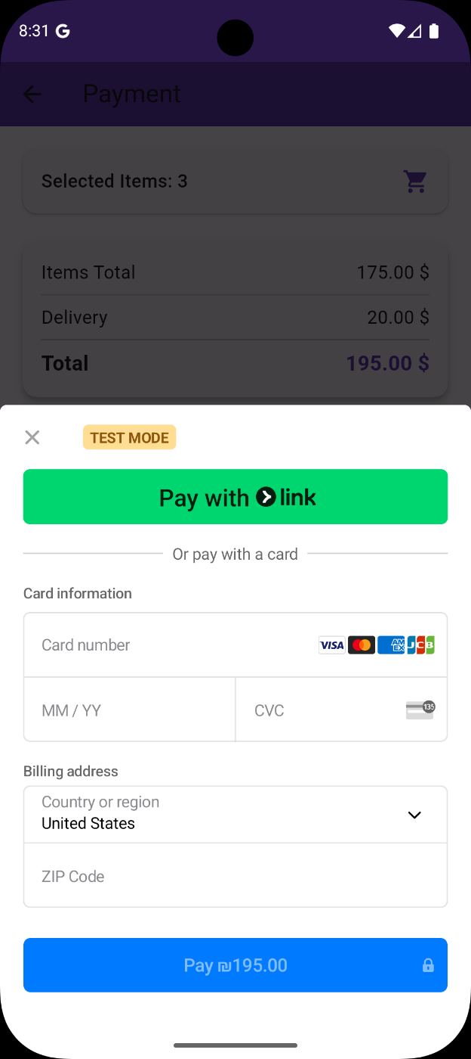

Figure 60:card option Figure 61:visa screen

user can enter details of visa and card number as shown in Figure 62. Also in this case will arrive to user two notification as shown in Figure 63.
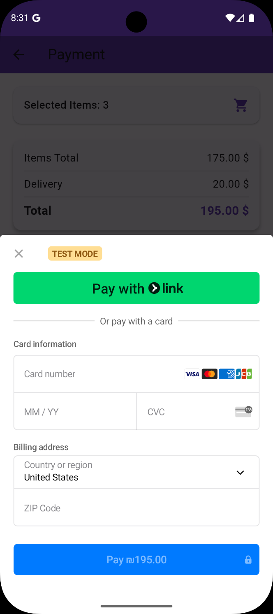
Figure 62:add visa information Figure 63:notification user

Figure 64:payment done

Figure 65:our delivery system option

Chat screen:
user can click on chat icon exist in his home page to ask the professional (Technical support) and take advice about any plant in system. he can chat him use texting and insert image also as shown in Figure 66.

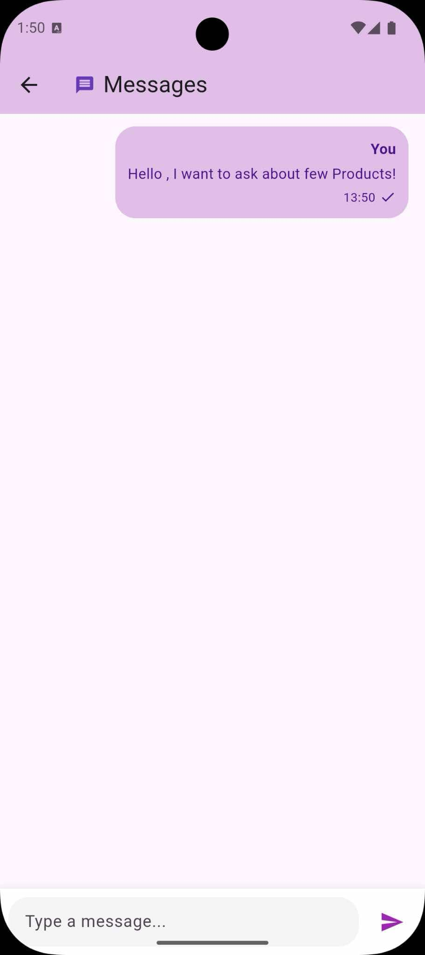

Figure 66:chat screen

Settings screen:
user can click on setting icon exist in his home page and from setting screen he can do multi actions as shown in Figure 67:
- Profile screen
- My orders
Delete account
Change password
Log out
About us

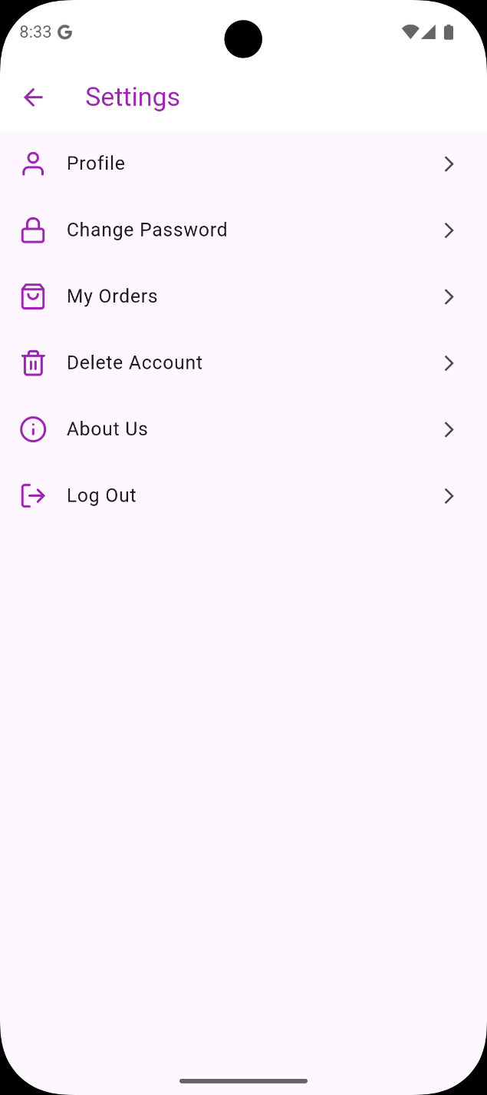
Figure 67:settings screen

Edit profile screen:
if user click on 'profile' from 'settings screen' then he can see all his information as shown in Figure 68.
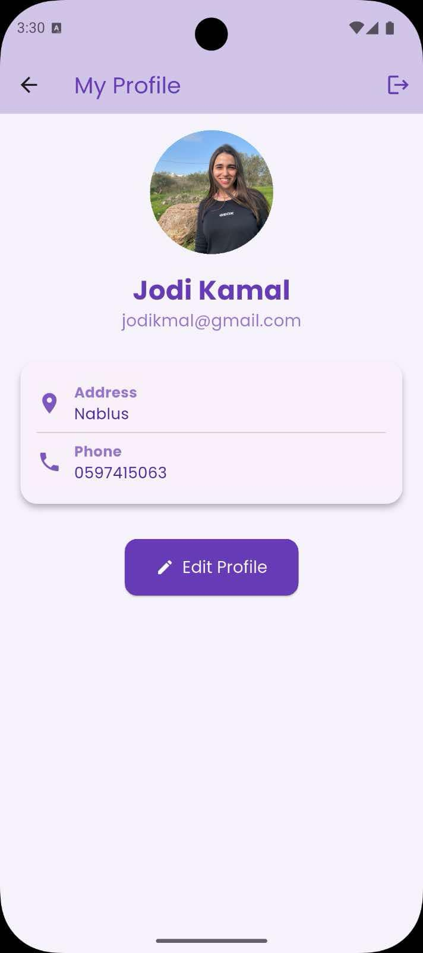

Figure 68: edit profile screen

user can edit any information then press on 'Update' Then application will print to user message to show success update profile as shown in Figure 69.
Also user can edit his profile image by click on pencil icon exist in
'Edit profile screen' and select image from gallery then the new image will appear as shown in Figure 70.

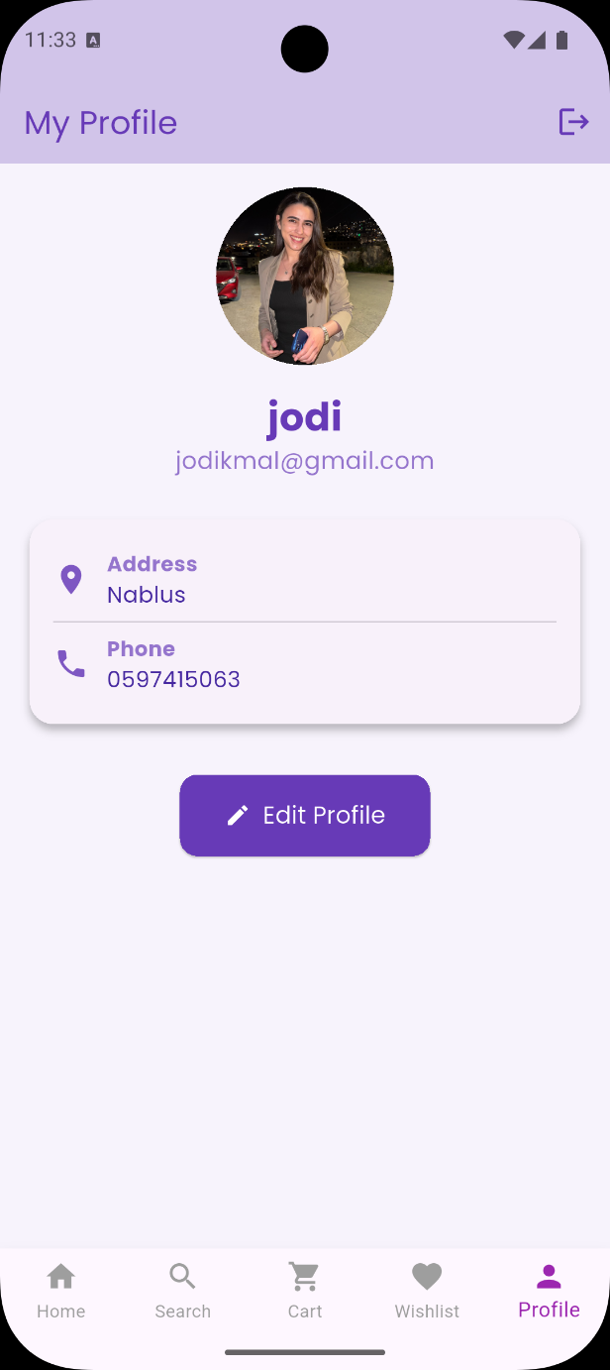

Figure 69:edit profile successfully Figure11 :edit profile image successfully

if user click on 'delete account' from 'settings screen' then the application will display box to ask user if he sure to delete his account as shown in Figure 71.
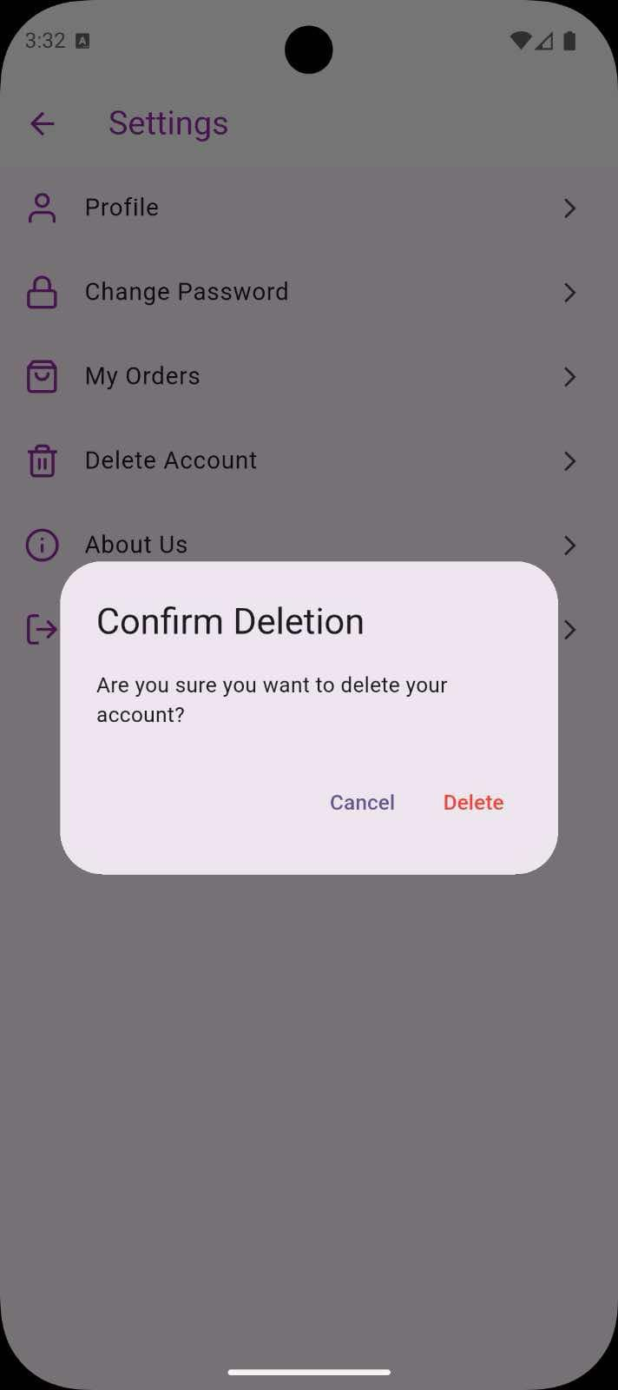

Figure 71:delete account

Change password screen:
if user click on 'change password' from 'settings screen' then 'Change password screen' will appear as shown in Figure 72.

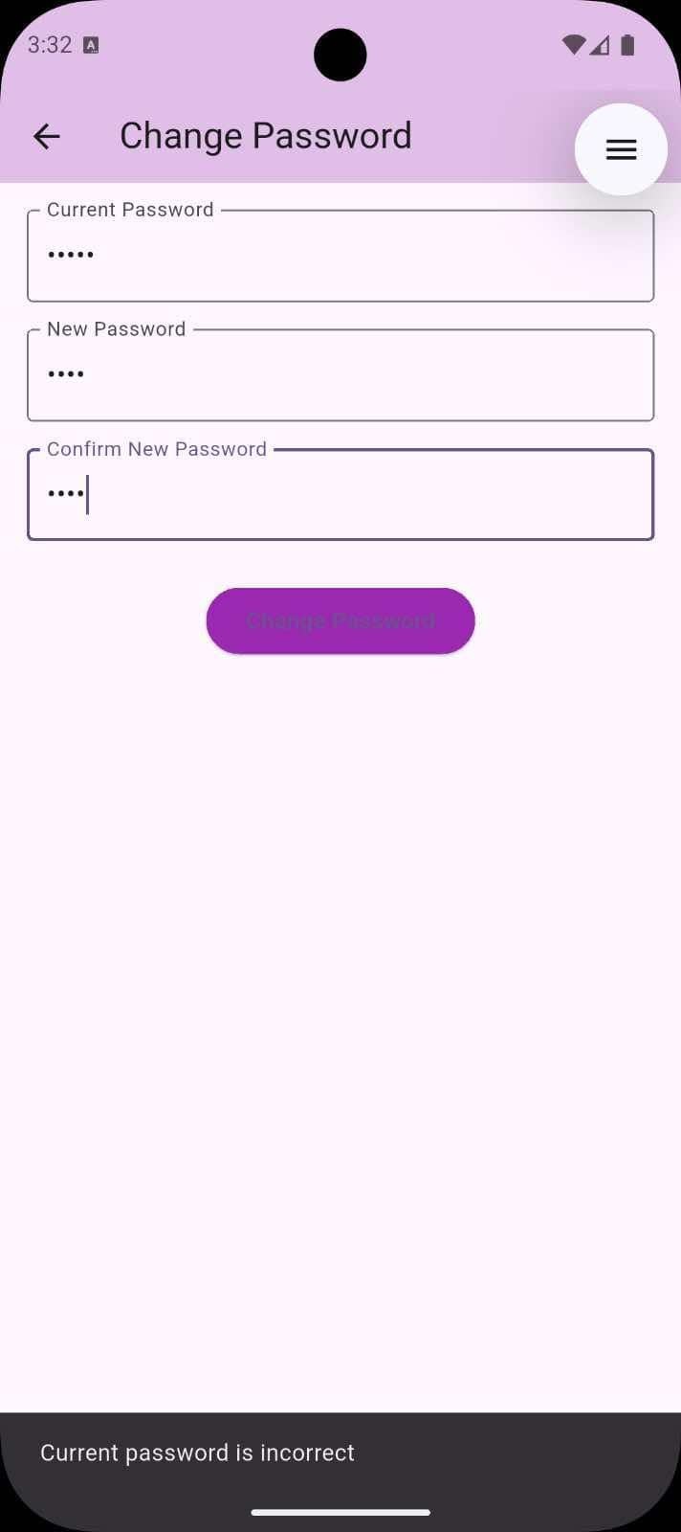
Figure 72:change password screen

user must firstly add his old passwod to allow him to change the password ,if old password is wrong Then application will print to user message as shown in Figure 73.to solve this issue user can click on link 'Forgot Your password' as we explain before then'Forgot Password screen' will appear as shown in Figure 12.
If password update successfully Then application will print to user message to show success update password as shown i

Figure13 :wrong old password
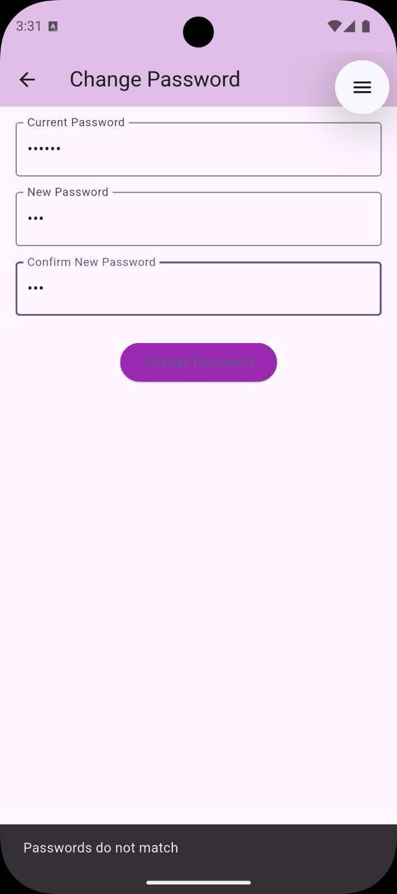

Figure 74:not match password Figure 75:sucussfully update

About us screen:

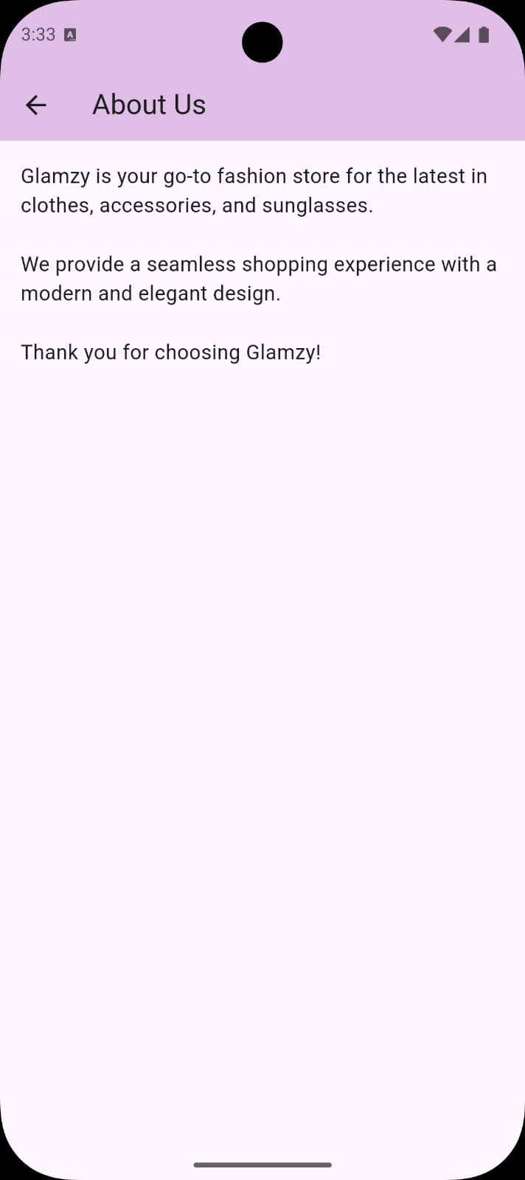

Figure 76:About us screen

Notifications screen:
user can click on notification icon exist in home page to see all notifications that reached to him as shown in Figure 79.

Also, Figure 78 shows examples of a notifications that reaches the user.

'private Reminder' :when user has plant in his cart that nearly becomes sold out this notification is a warning to the user to purchase it before it finished.

'New Collection' : when admin add new plant to the system and its depends on the interest of the user , if user interested with the added plant then our application will send to this user a notification to inform him that the new collection was added.

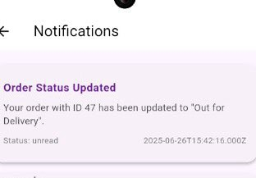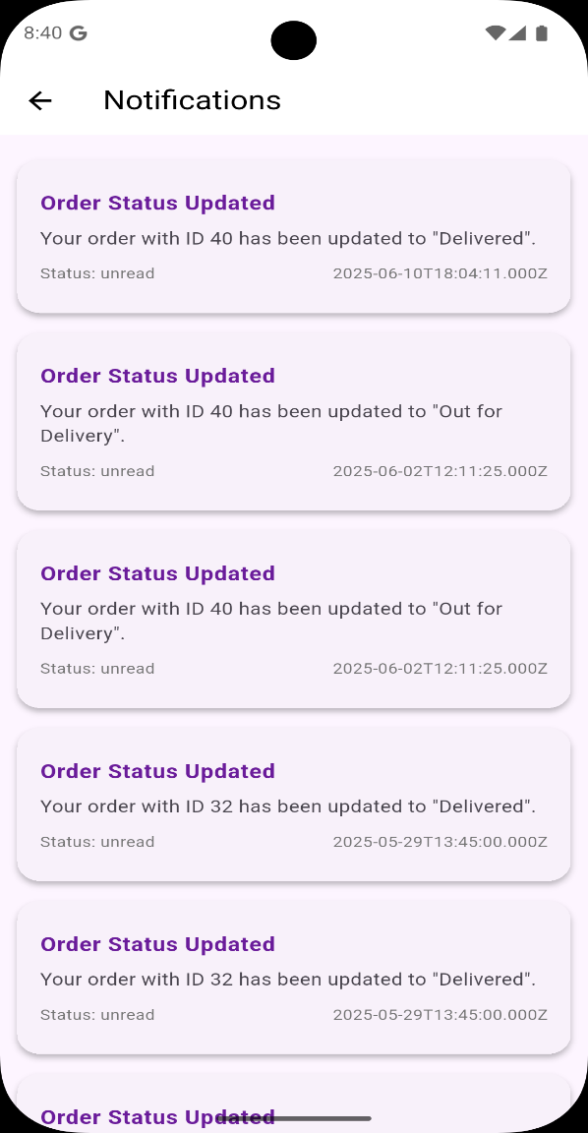

Figure17 :examples of notifications Figure 79:notifications screen

Delivery employee Home screen:
In our application we have one Delivery employee, he can login with his account as shown in Figure 80 .
After our Delivery employee login then 'Delivery employee Home screen' will appear as shown in Figure 81.
in Delivery employee Home screen the delivery can go to multi screen like:
Notifications screen to see all orders from users whose select 'our delivery system' as Delivery option.
Settings screen to see and update his information. Chat screen to chat with admin .

Figure 80:login delivery
Figure 81:delivery home screen

Delivery employee Notifications screen and order Details screen :

When delivery employee press on notification icon exist in his home page then 'Delivery employee Notifications screen' will appear as shown in Figure 82.
delivery employee can click on notification to see 'order details screen' as shown in Figure 83. Also Delivery employee can press on 'open map to start delivery' as we will explain in next page.

Figure 82:delivery employee notification
Figure73 :order details scree

Web application
Our application support user and admin web application with full access as we will explain next pages.

Log in web Screen :
admin can login using this page shown in Figure 88.
If admin login use his account as shown in Figure 89 then home admin page will appear as shown next page.

Figure 88:log in web

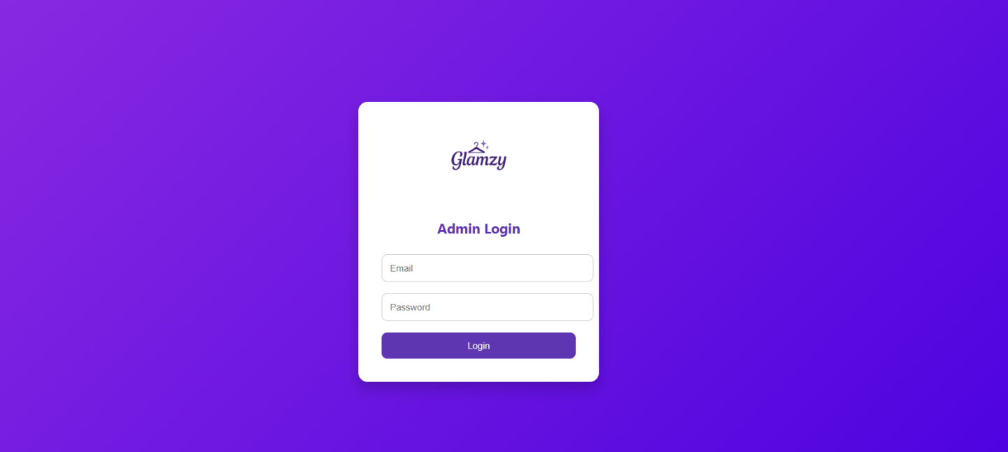

Figure 89:log in admin account

Home admin Screen :
When admin click on drawer as shown in Figure 90, he can go to multi screen like:
Dashboard screen. Orders screen.
Profit Percentage.
- Products screen.
- Messages screen.

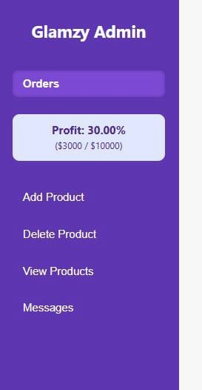

Figure 90:home admin screen

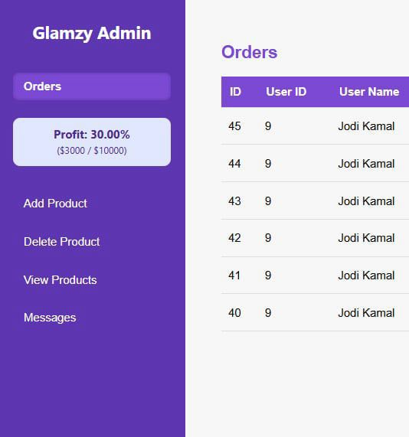

Figure 91:Dashboard screen

Orders screen:
in this screen admin can see all the orders as shown in Figure 92.also he can press on 'show more' to see details for each order as shown in Figure 93.

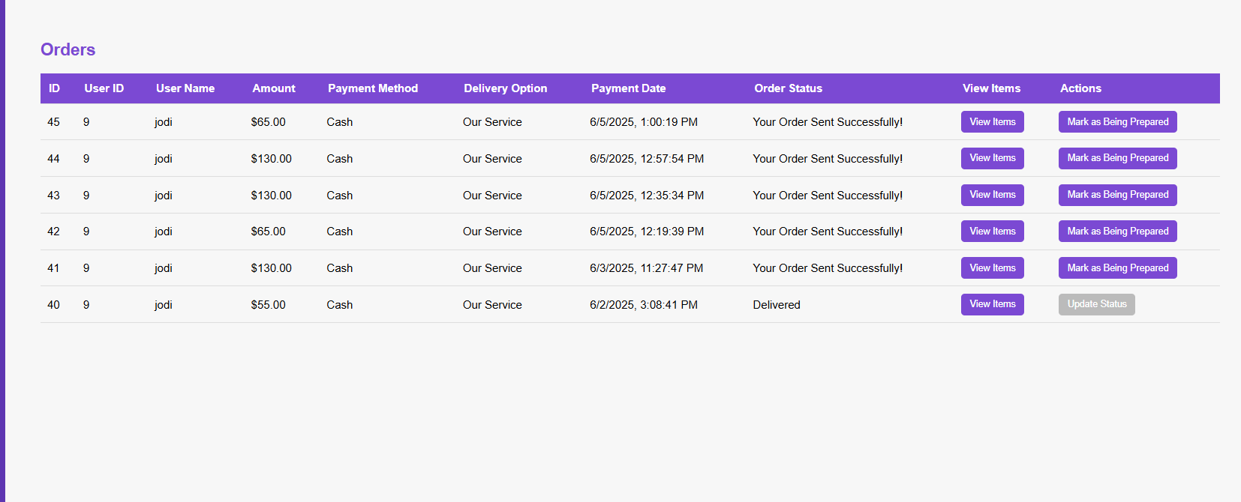

Figure 92:Orders screen

Figure 93:

Admin can also filter the orders as shown in Figure 94, he can filter by payment method as shown in Figure 95 or by Delivery option as shown in Figure 96.

Figure 94:filter orders

Figure 95:filter by payment method

Figure 96:filter by delivery option

admin can select order and then press on pencil icon to edit the order as shown in Figure 97 .

Figure 97:edit order

Figure 98 shows example of edit the count of products in specific order. then the total amount will recompute automatically with the edited information as shown in Figure 99.

Figure 98:example edit order

Figure 99:edit amount automatically

Admin can also add order by press on plus icon then add order Dialog will appear as shown in Figure 100.

Figure 100:add order dialog

Figure 101:add order example

Figure 102:press on show more after add order

Admin can also select order then press on rubbish to delete it as shown in Figure 103.

Figure 103:delete order

Customers screen:
Admin can see all customers exist in system as shown in Figure 104.and he can filter customers by their type as shown in Figure 105.

Figure 104:customers screen

Figure 105:filter customers

Figure 106:example filter buyer customers

admin can select customer and then press on pencil icon to edit customer information as shown in Figure 107.

Figure 107:edit customer

Admin can also select customer then press on rubbish icon to delete it as shown in Figure 108.

Figure 108:delete customer

Admin can also add customer by press on plus icon then add customer Dialog will appear. Figure 109 show example for add customer.

Figure 109:Add customer

Figure 110:after add customer

Chat screen:

Admin can see all received messages from users and from delivery employee as shown in Figure 111.
admin can click on user chat to see the messages come from him as shown in Figure 112 and he can also reply as shown in Figure 113.

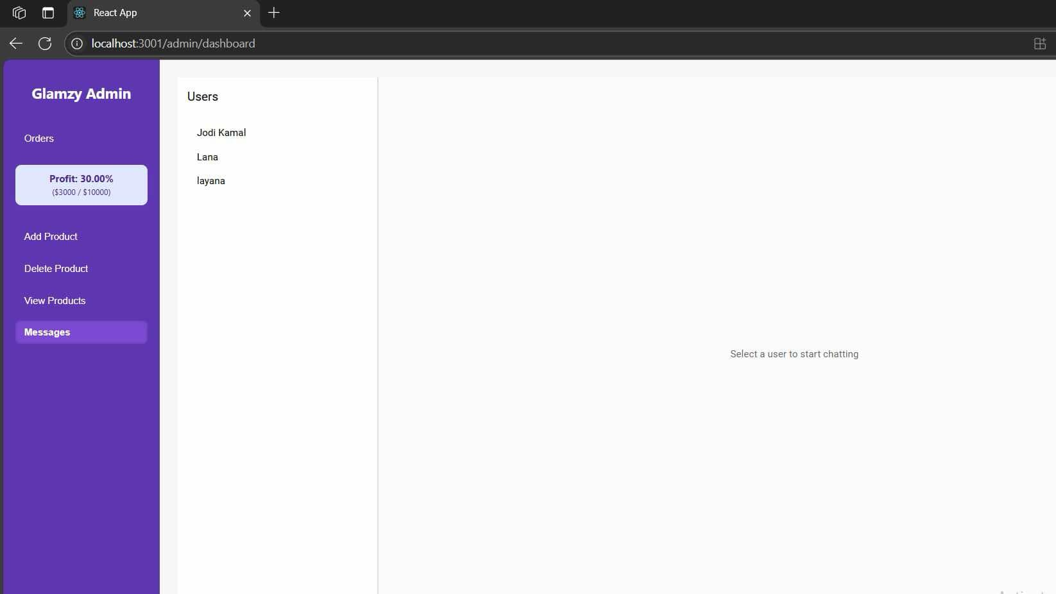

Figure 111:chat screen

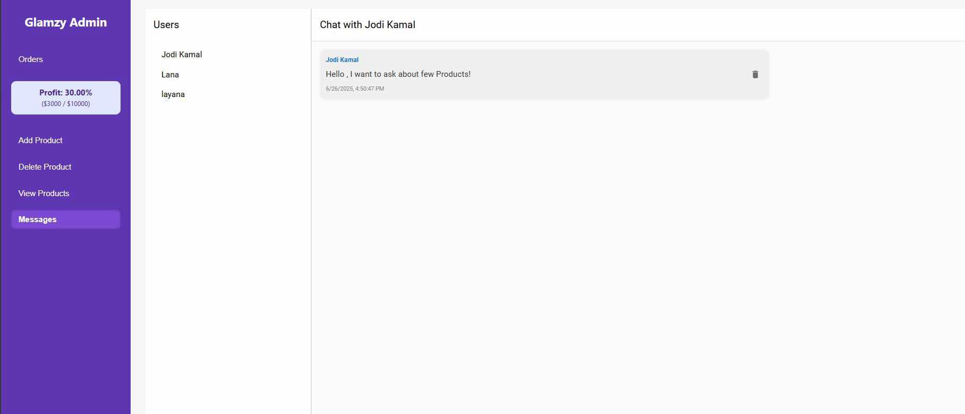

Figure 112:see received messages

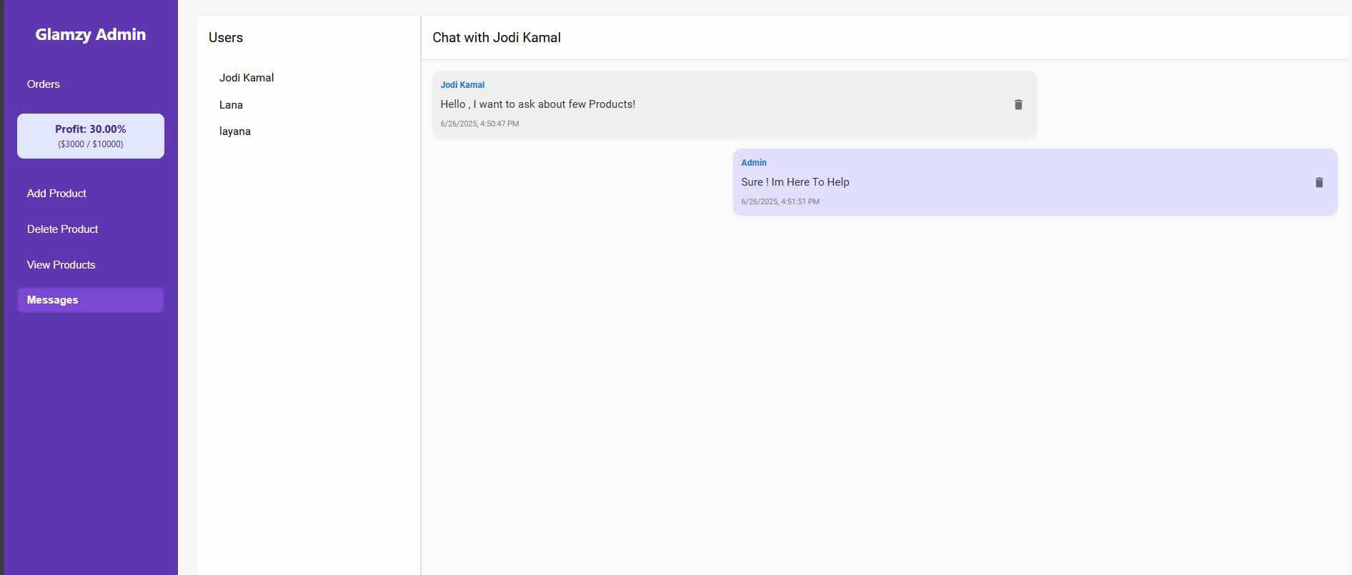
Figure 113:reply to messages

The admin can delete any message from his account by click on trash icon

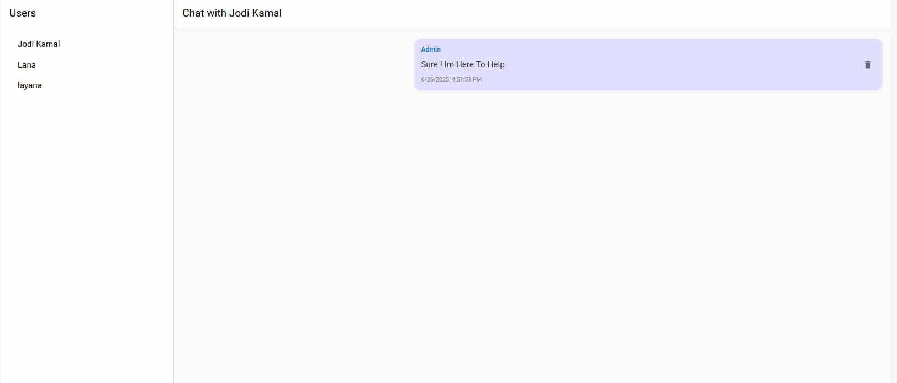

Delete message from admin

Also user can delete messages by move the message to the left and delete it

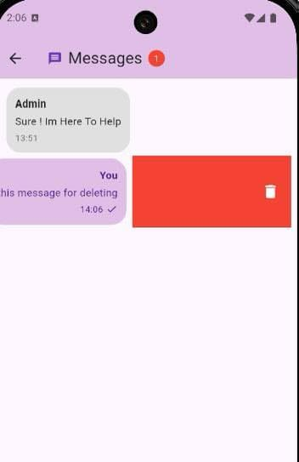

Delete a message from user

products screen:
in this screen admin can do several tasks like : Add product.
Delete product.
- View Products.
- Messages.

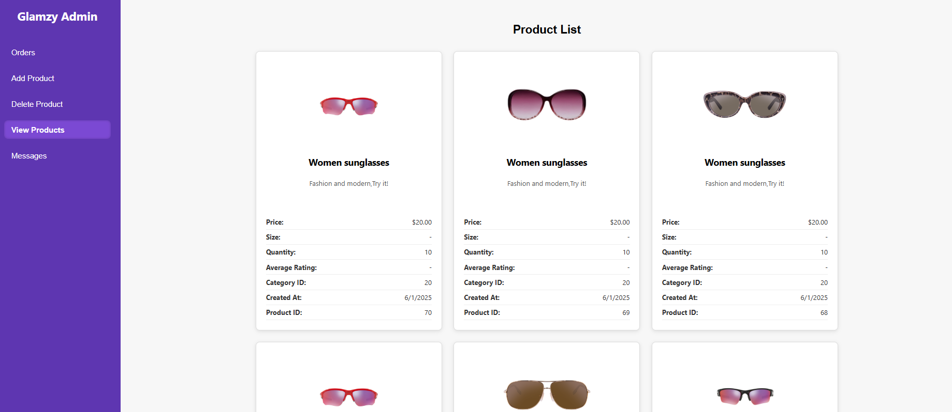

Figure 114:products screen

When Admin press on 'add product' then Add product Dialog will appear.
Figure 115 show example for add new product to the system.
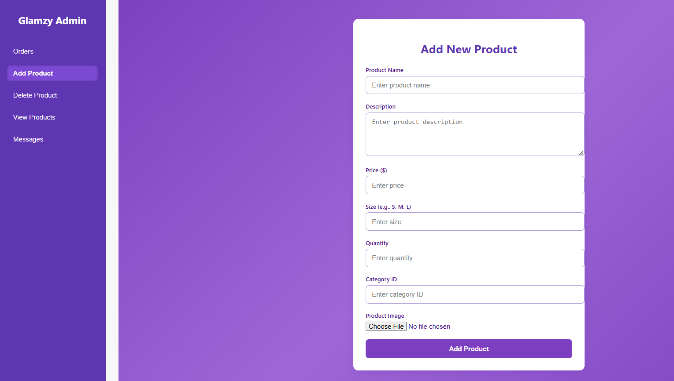

Figure 115:add product example

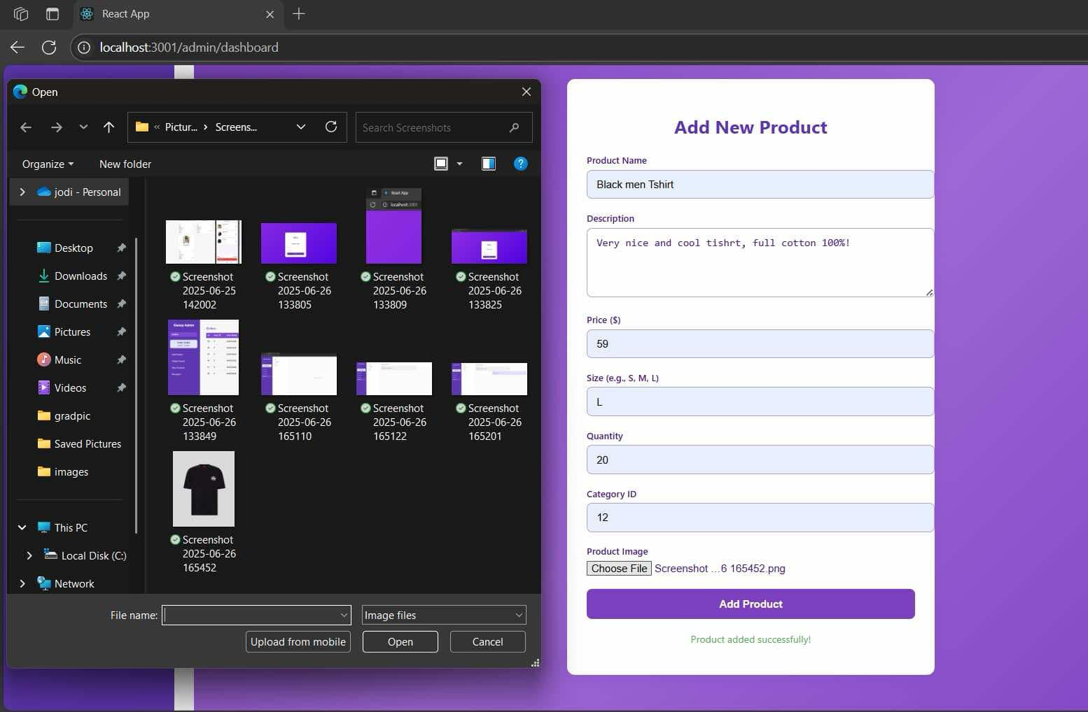

Figure 116:a

Figure 117 shows add product successfully by admin and Figure 118 shows product appear to users successfully in user side.

Figure 117:add product successfully by admin

Figure 118:product appear to users successfully

After admin add the new section now he can add products to it. he can press on 'add product' then he will see the new added section exist in the section options as shown in Figure 121.

Figure 121:uccessfully add section

Figure 122 shows section appear to users successfully in user side.

Figure 122:section appear to users successfully

Product details screen:
admin can see Product details when he press on the product that exist on 'products screen' then 'Product details screen' will appear as shown in Figure 123.
Also he can edit any field when press on pencil icon , Figure 124 shows example for edit the quantity of orders.

Figure 123:product details screen

Figure 124:example edit quantity

Figure 125:successfully update the quantity and description

Admin can also change image for items, as shown in Figure 126 and Figure 127.

Figure 126:change image

Figure 127:successfully change image

Admin can delete product by write the product ID and click on 'Delete' button.

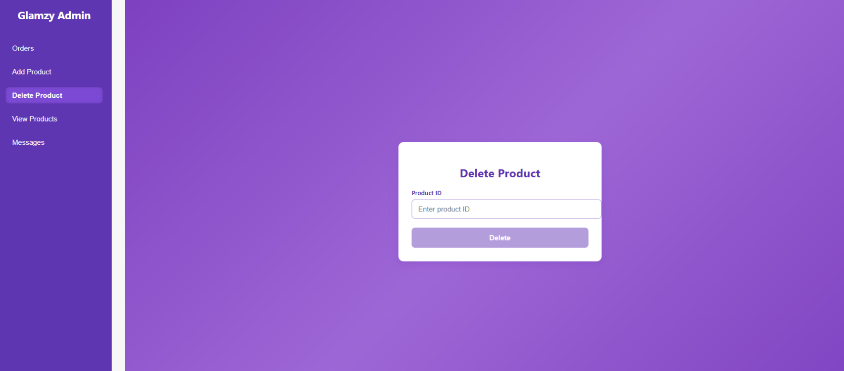
Figure 128:delete product

Chapter 5: Result and Conclusion

The software provides a platform where users can buy clothes and accessories easily, where we have successfully offer simple operate and use program achieves comfort for users in browsing and purchase clothes.
The project's objective was accomplished: develop an online shopping system designed specifically for the sale of clothes with strong functionality .Users now have access to a safe payment option, which promotes security and trust, they also can track their order in easy way
,Users receive recommendations from artificial intelligence, which guarantees the application's success.
We learned a lot of new programming techniques from this project that we not know them before.

Chapter 6: Discussion

Chapter 7: Future Work

1.Expand AR Capabilities

Introduce virtual try-on for additional items such as scarves, hats, or makeup to provide a more immersive shopping experience.

2.AI-Powered Personal Styling

Integrate an AI stylist that recommends outfits based on user preferences, body type, and past purchases.

3.Multi-Language and Localization Support

Add support for multiple languages and regional preferences to serve a wider audience globally.

4.In-App Social Sharing

Enable users to share their favorite items or virtual try-on looks directly to social media platforms from within the app.

Chapter 8: References

