Fire-Fighter Car Robot
Graduation Project Report

Prepared by:
Abd-Alhameed Mizher
Ezz-Aldeen Masre

Supervisor: Dr. Hikmat Darawsheh
Department of Computer Engineering
Najah National University
Date: 2025-June

Table of Contents

1. Abstract
2. Introduction
3. Literature Review
4. System Architecture & Components
5. Software & Methodology
6. Results
7. Conclusion
8. Future Work
9. References

Abstract

This project presents the design and implementation of an autonomous Fire-Fighter Car Robot capable of detecting and extinguishing flames using both image processing and infrared sensors. The system leverages a hybrid architecture: an ESP32 microcontroller for low-level real-time control, and a Raspberry Pi 3 for camera-based flame detection using OpenCV and high-level decision-making. The robot autonomously navigates indoor spaces, detects the location of a flame, and extinguishes it using a servo-controlled water nozzle. Additionally, a mobile application provides an intuitive interface for manual control and real-time monitoring. The goal of this project is to offer a cost-effective, intelligent, and flexible fire response solution with real-time decision-making capability.

2. Introduction

Flame incidents pose significant risks to human lives and property, especially in indoor environments. Traditional firefighting methods often expose responders to dangerous conditions, highlighting a critical need for safer, more efficient alternatives. With recent advancements in embedded systems (like the ESP32 microcontroller) and computer vision (specifically OpenCV on the Raspberry Pi), autonomous robots offer a promising and innovative solution. This project proposes the design and development of an autonomous fire-fighting robot that autonomously navigates indoor environments, detects flames, and extinguishes them. The system utilizes two powerful computing platforms: an ESP32 microcontroller for real-time hardware control and sensor data acquisition, while a Raspberry Pi 3 uses its computational power to run vision-based flame detection using OpenCV. This combination ensures fast reaction time and intelligent behavior. Furthermore, a complementary mobile application provides an intuitive interface for manual control and real-time monitoring, enhancing the robot's flexibility and operational versatility.

3. Literature Review
This section reviews the evolution of autonomous fire-fighting robots, highlighting key technological advancements and the rationale behind our chosen hybrid architecture. Early robot designs predominantly utilized simpler microcontroller platforms, such as Arduino-based systems. While effective for real-time motor control and basic sensor integration, these platforms often lacked the computational power necessary for advanced tasks like real-time image processing for detailed flame detection. For instance, Adilshah et al. (2022) developed an Arduino-based robot that used IR sensors and a water nozzle for flame suppression, demonstrating the foundational capabilities but without complex vision.
The advent of single-board computers like the Raspberry Pi significantly advanced robot capabilities, particularly in computer vision. These platforms offered higher processing power, enabling sophisticated algorithms such as OpenCV for visual flame detection. Sadiq et al. (2023) showcased a Raspberry Pi-based system combining thermal and IR sensors with OpenCV for real-time indoor flame detection and suppression. Recognizing the strengths of both microcontroller's real-time control and SBC's processing power, recent research has gravitated towards hybrid control systems. This paradigm efficiently distributes computational loads, proving more responsive. Notable hybrid approaches include a Raspberry Pi 4B-based cascade machine-learning model for robust flame localization (Processes, 2025) and an IoT-integrated Raspberry Pi 4B system leveraging fisheye camera imagery for wide-area flame source detection (Applied Sciences, 2023).
While highly advanced commercial fire-fighting robots, such as the Thermite RS3 and Colossus, exist for industrial applications, their prohibitive cost limits broader accessibility. Our project aims to bridge this gap by developing a cost-effective, student-built prototype that replicates essential functionalities – robust flame detection, autonomous navigation, and efficient flame suppression – within a flexible, mobile-controlled platform suitable for indoor environments.

4. System Architecture & Components

The robot's design is based on two controllers: the Raspberry Pi 3 and the ESP32. The ESP32 handles sensor readings, motor driving, and actuation of the fire suppression system. The Raspberry Pi 3 is responsible for image processing and high-level decision making. The components of the system are mounted on a wheeled chassis powered by four DC motors. The two devices communicate via UART serial communication.

ESP32 Dev Module
Microcontroller responsible for real-time control, including reading sensors and driving actuators.

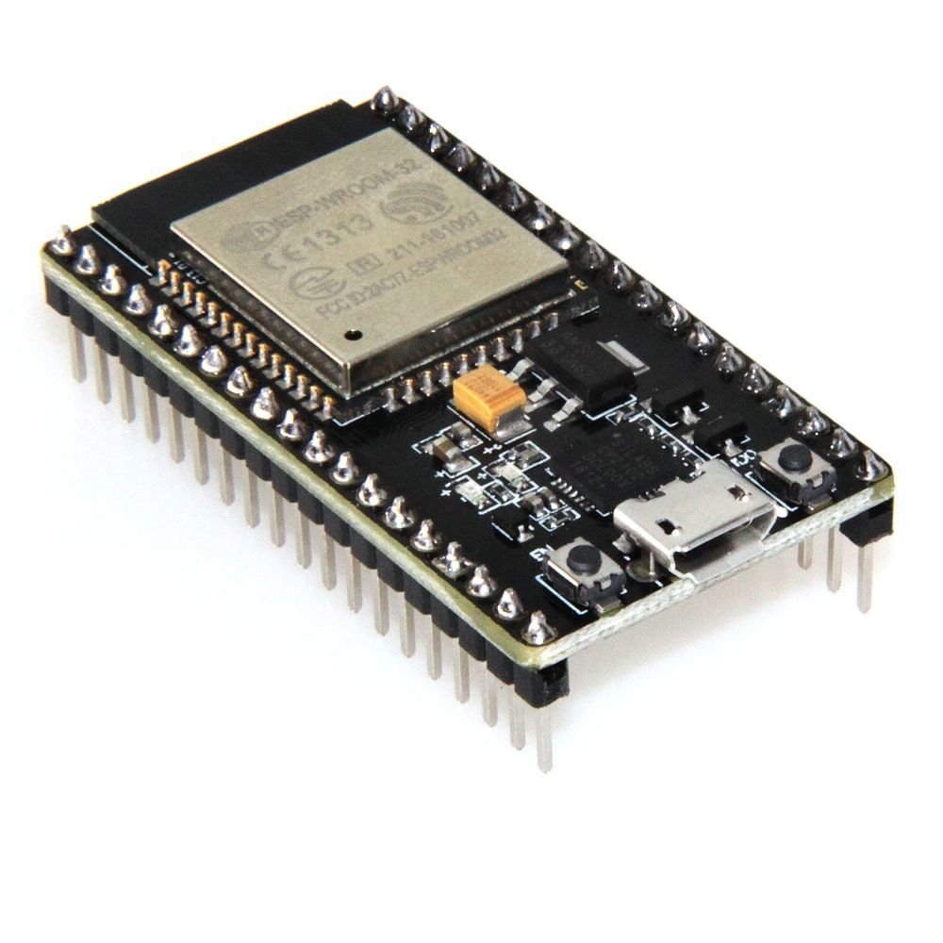

Raspberry Pi 3 Model B+
Single-board computer running Python and OpenCV for flame detection and navigation.
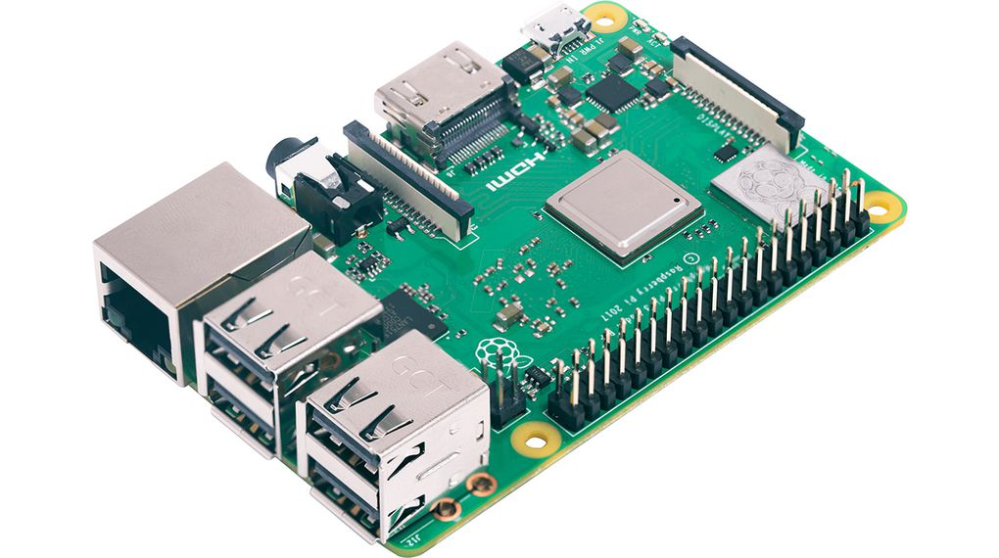

Raspberry Pi Camera Module
Captures real-time video for processing by Raspberry Pi to detect flames.

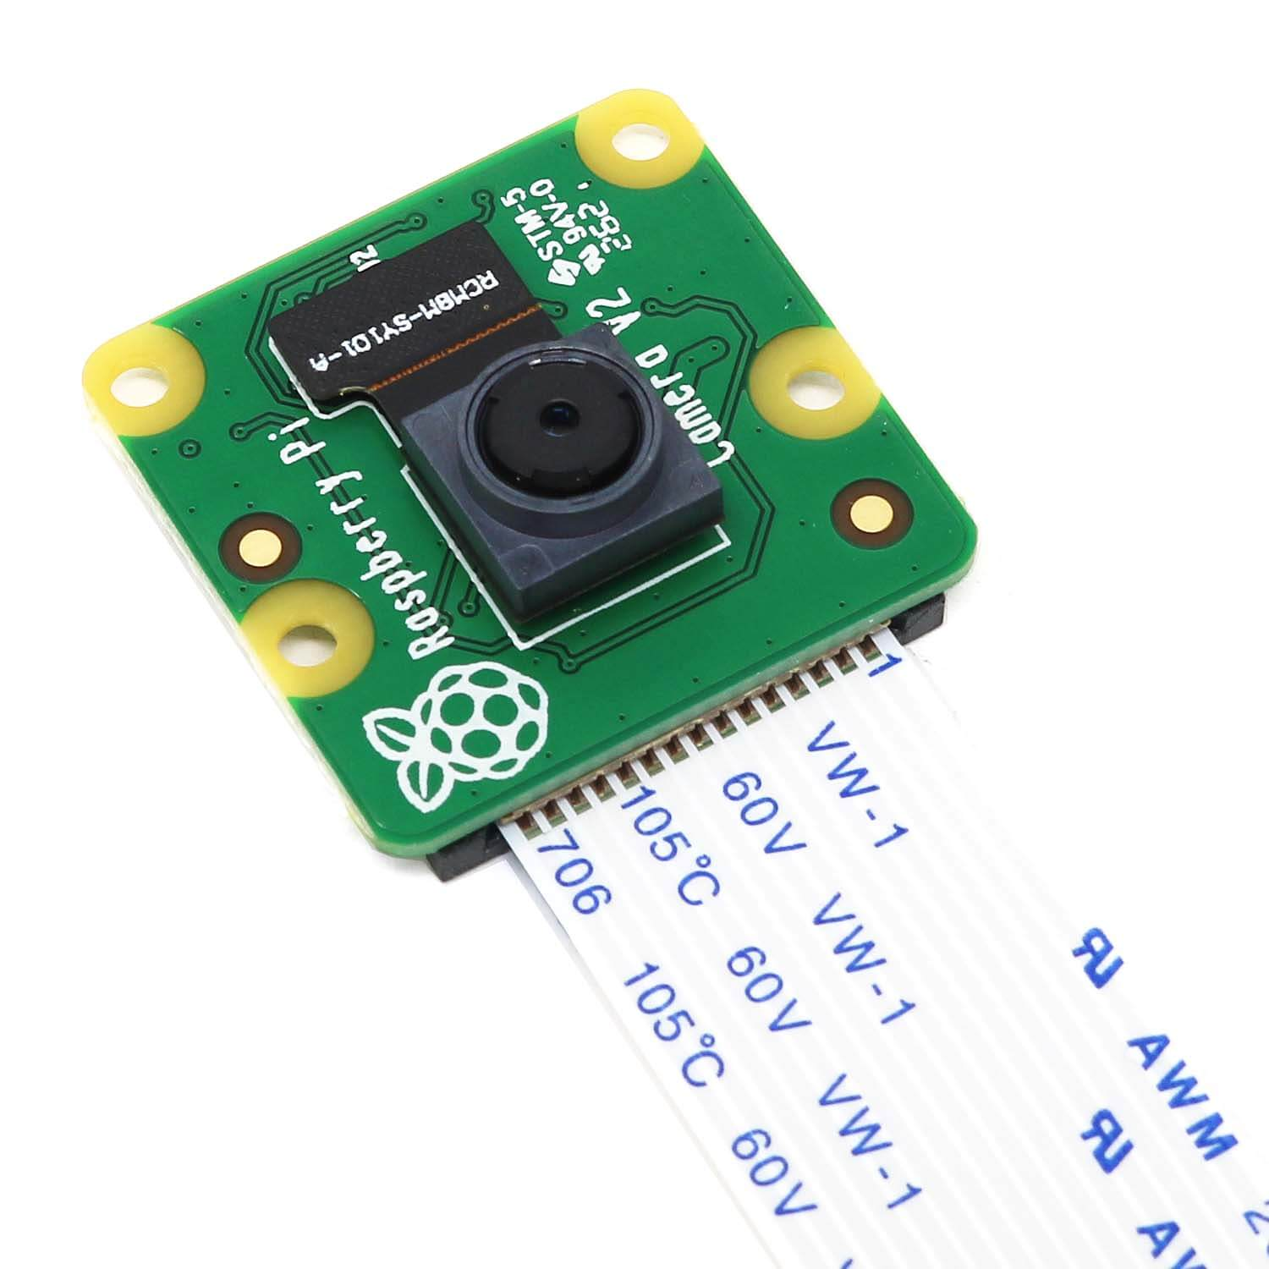

Ultrasonic Sensors (HC-SR04)
Used for obstacle detection and navigation assistance by measuring distance.
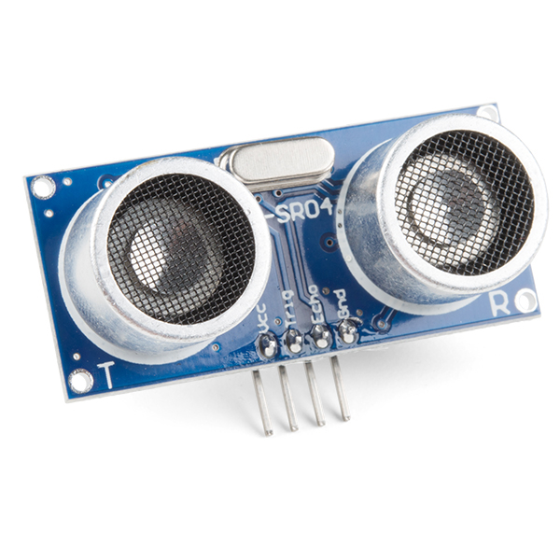

Flame Sensors (IR)
Detects flame presence based on infrared radiation.
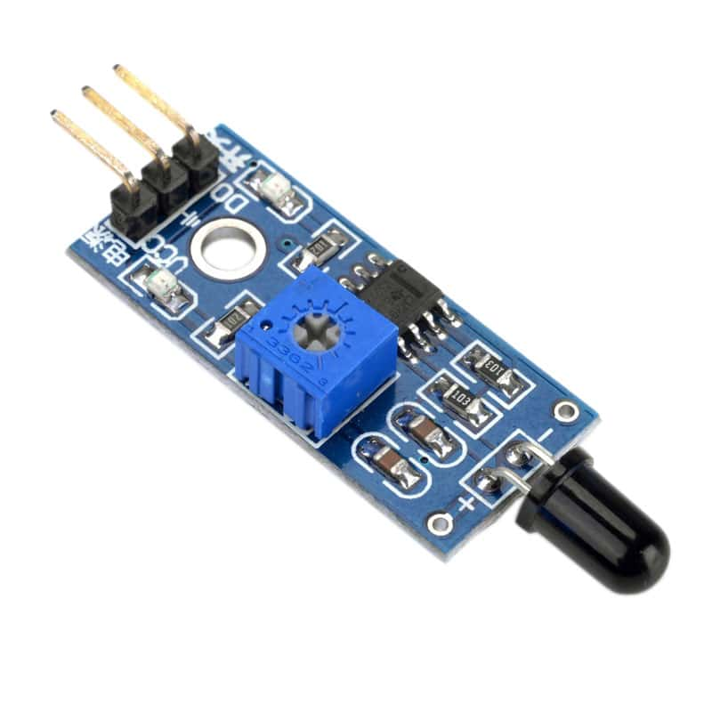

L298N Motor Driver
Drives the motors by regulating power supplied to them under ESP32 control.
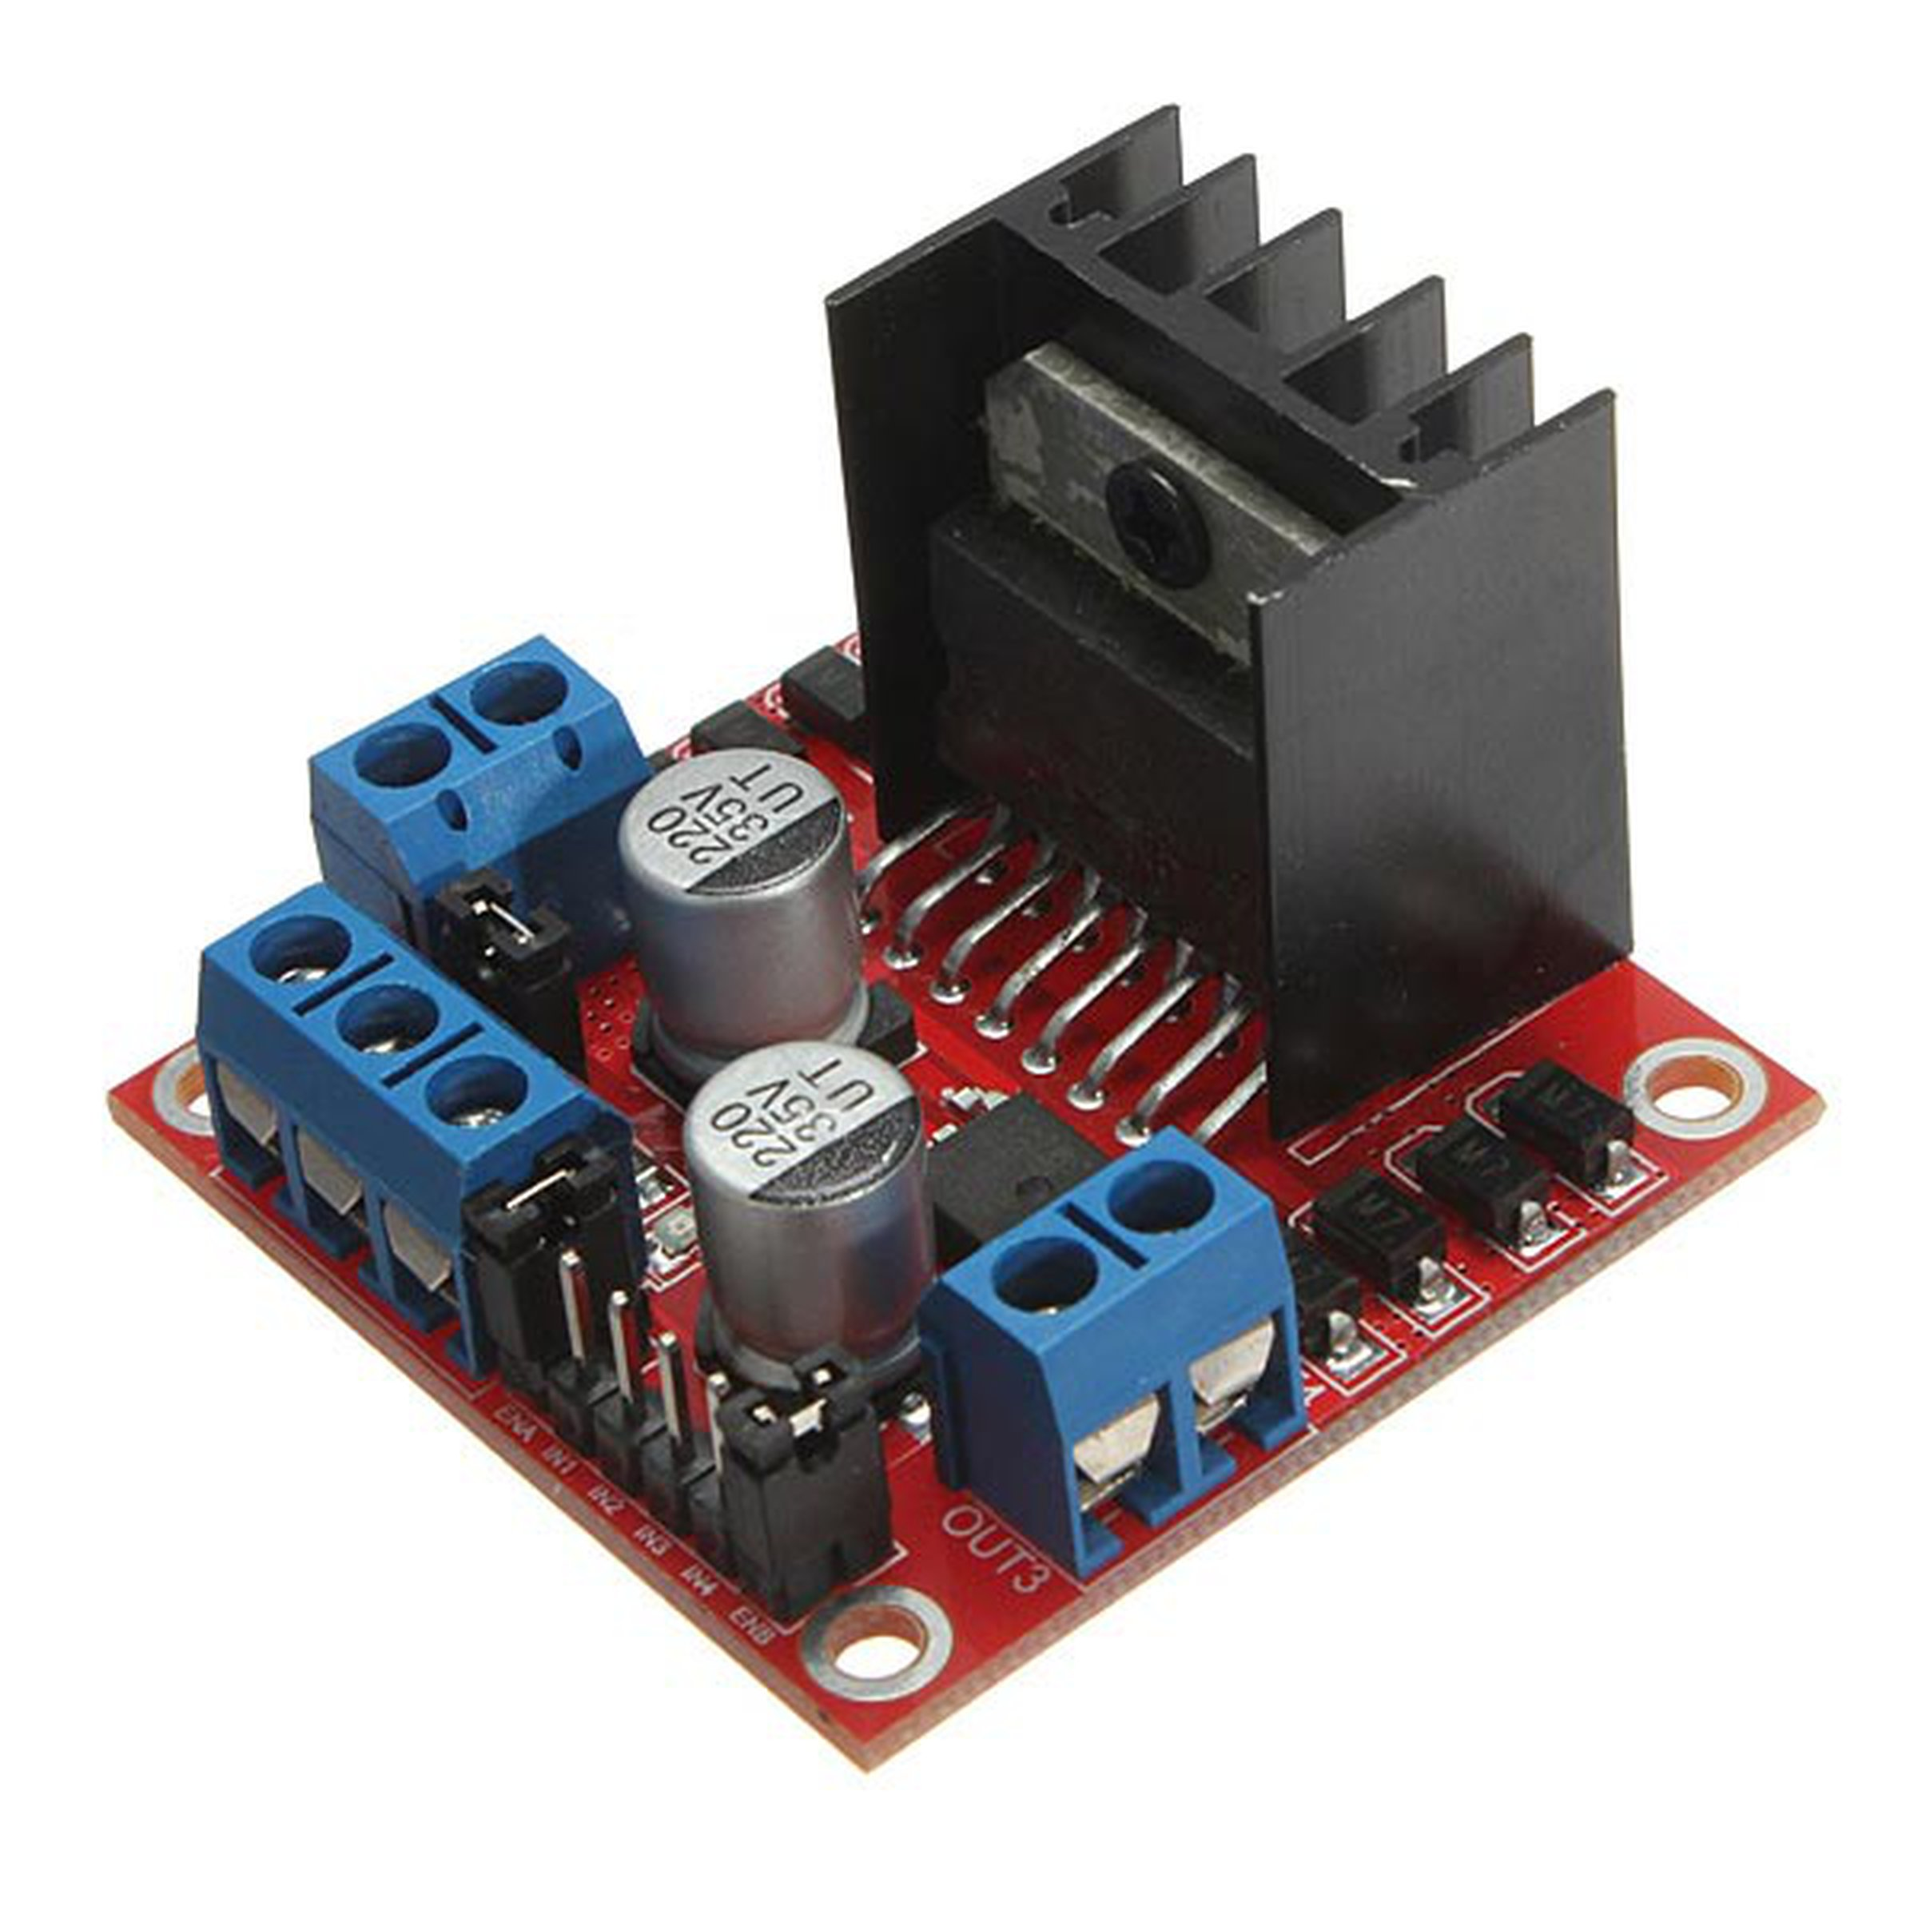

DC Gear Motors (TT/Metal)
Provides movement to the robot through connected wheels.

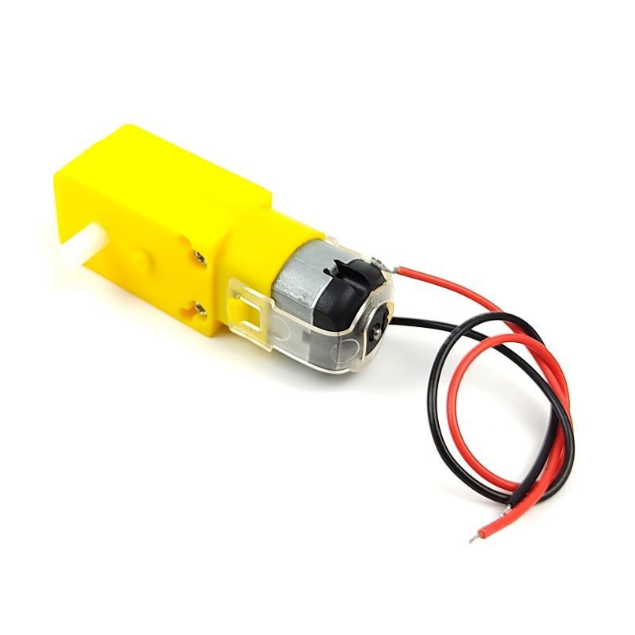

Corona DS558HV Digital Metal Gear Servo (14Kg)
Rotates the nozzle to aim water during extinguishing.
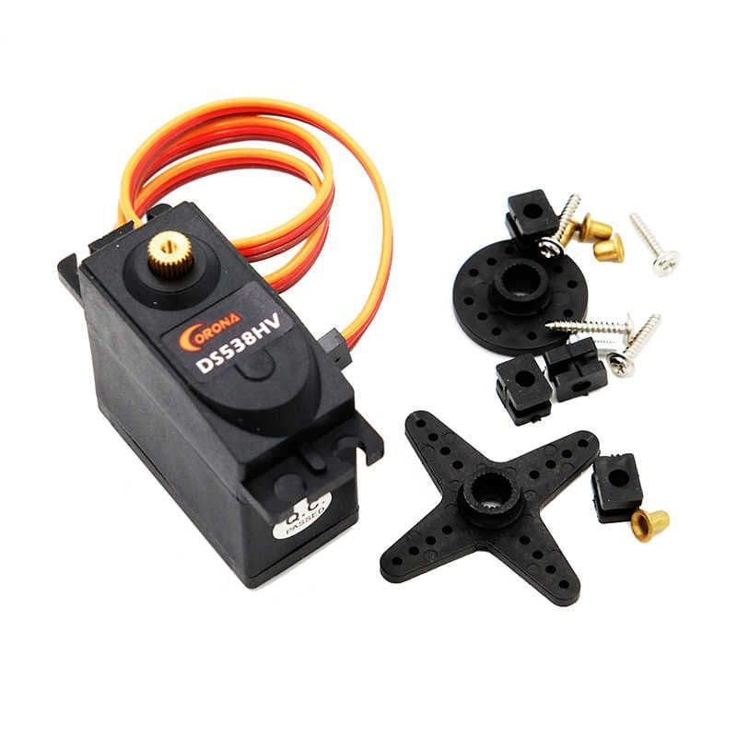

Mini DC Water Pump (12V)
Supplies pressurized water to extinguish fire.
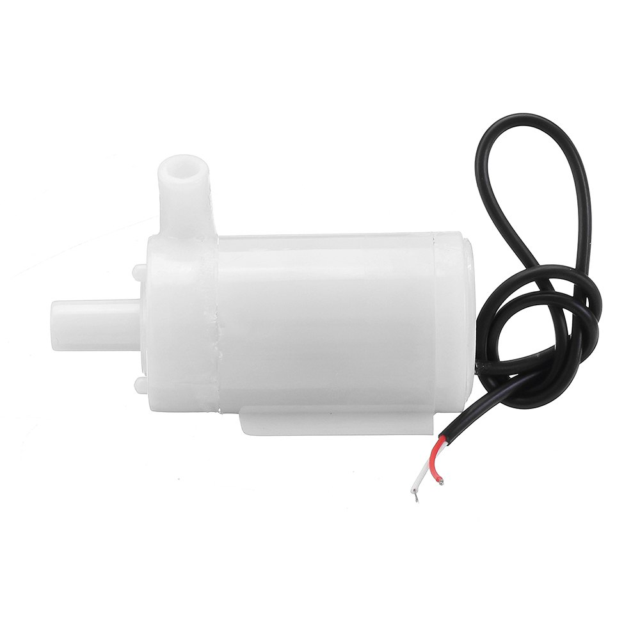

Relay Module
Acts as a switch to control the water pump on/off from ESP32.
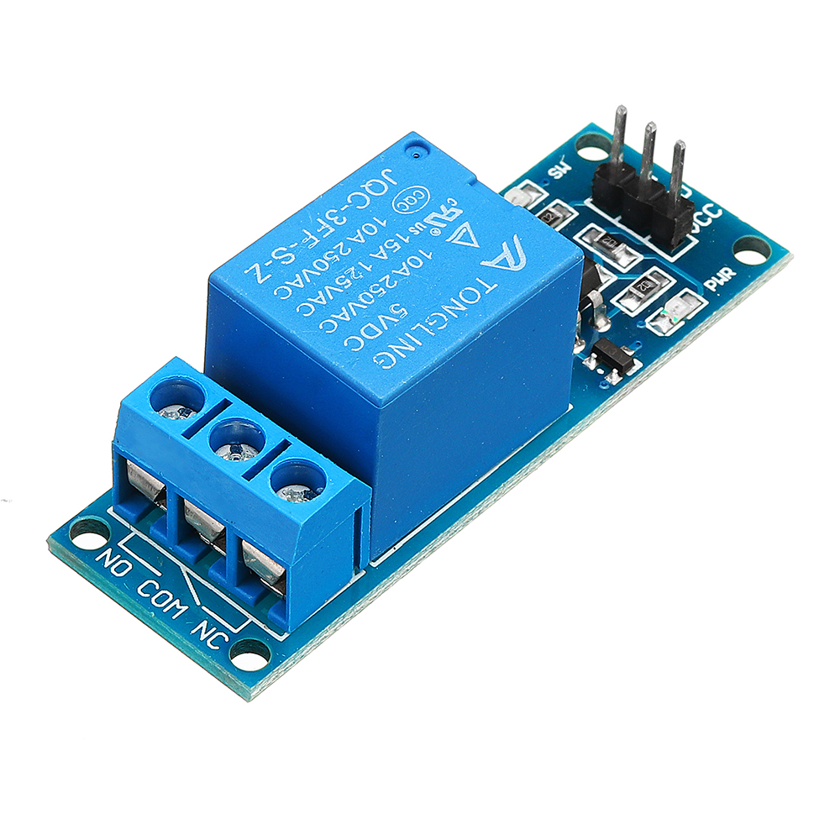

Power Sources:
Power Bank for the Raspery Pi 3.
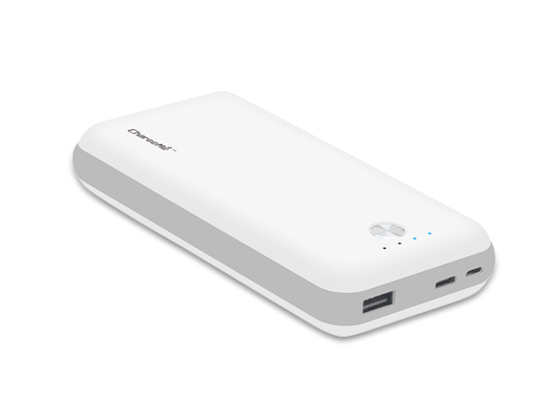
2x (4 x AA Battery Holder), Main power source for motors, sensors, ESP32, and peripherals.
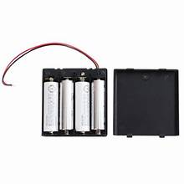
System Diagram:

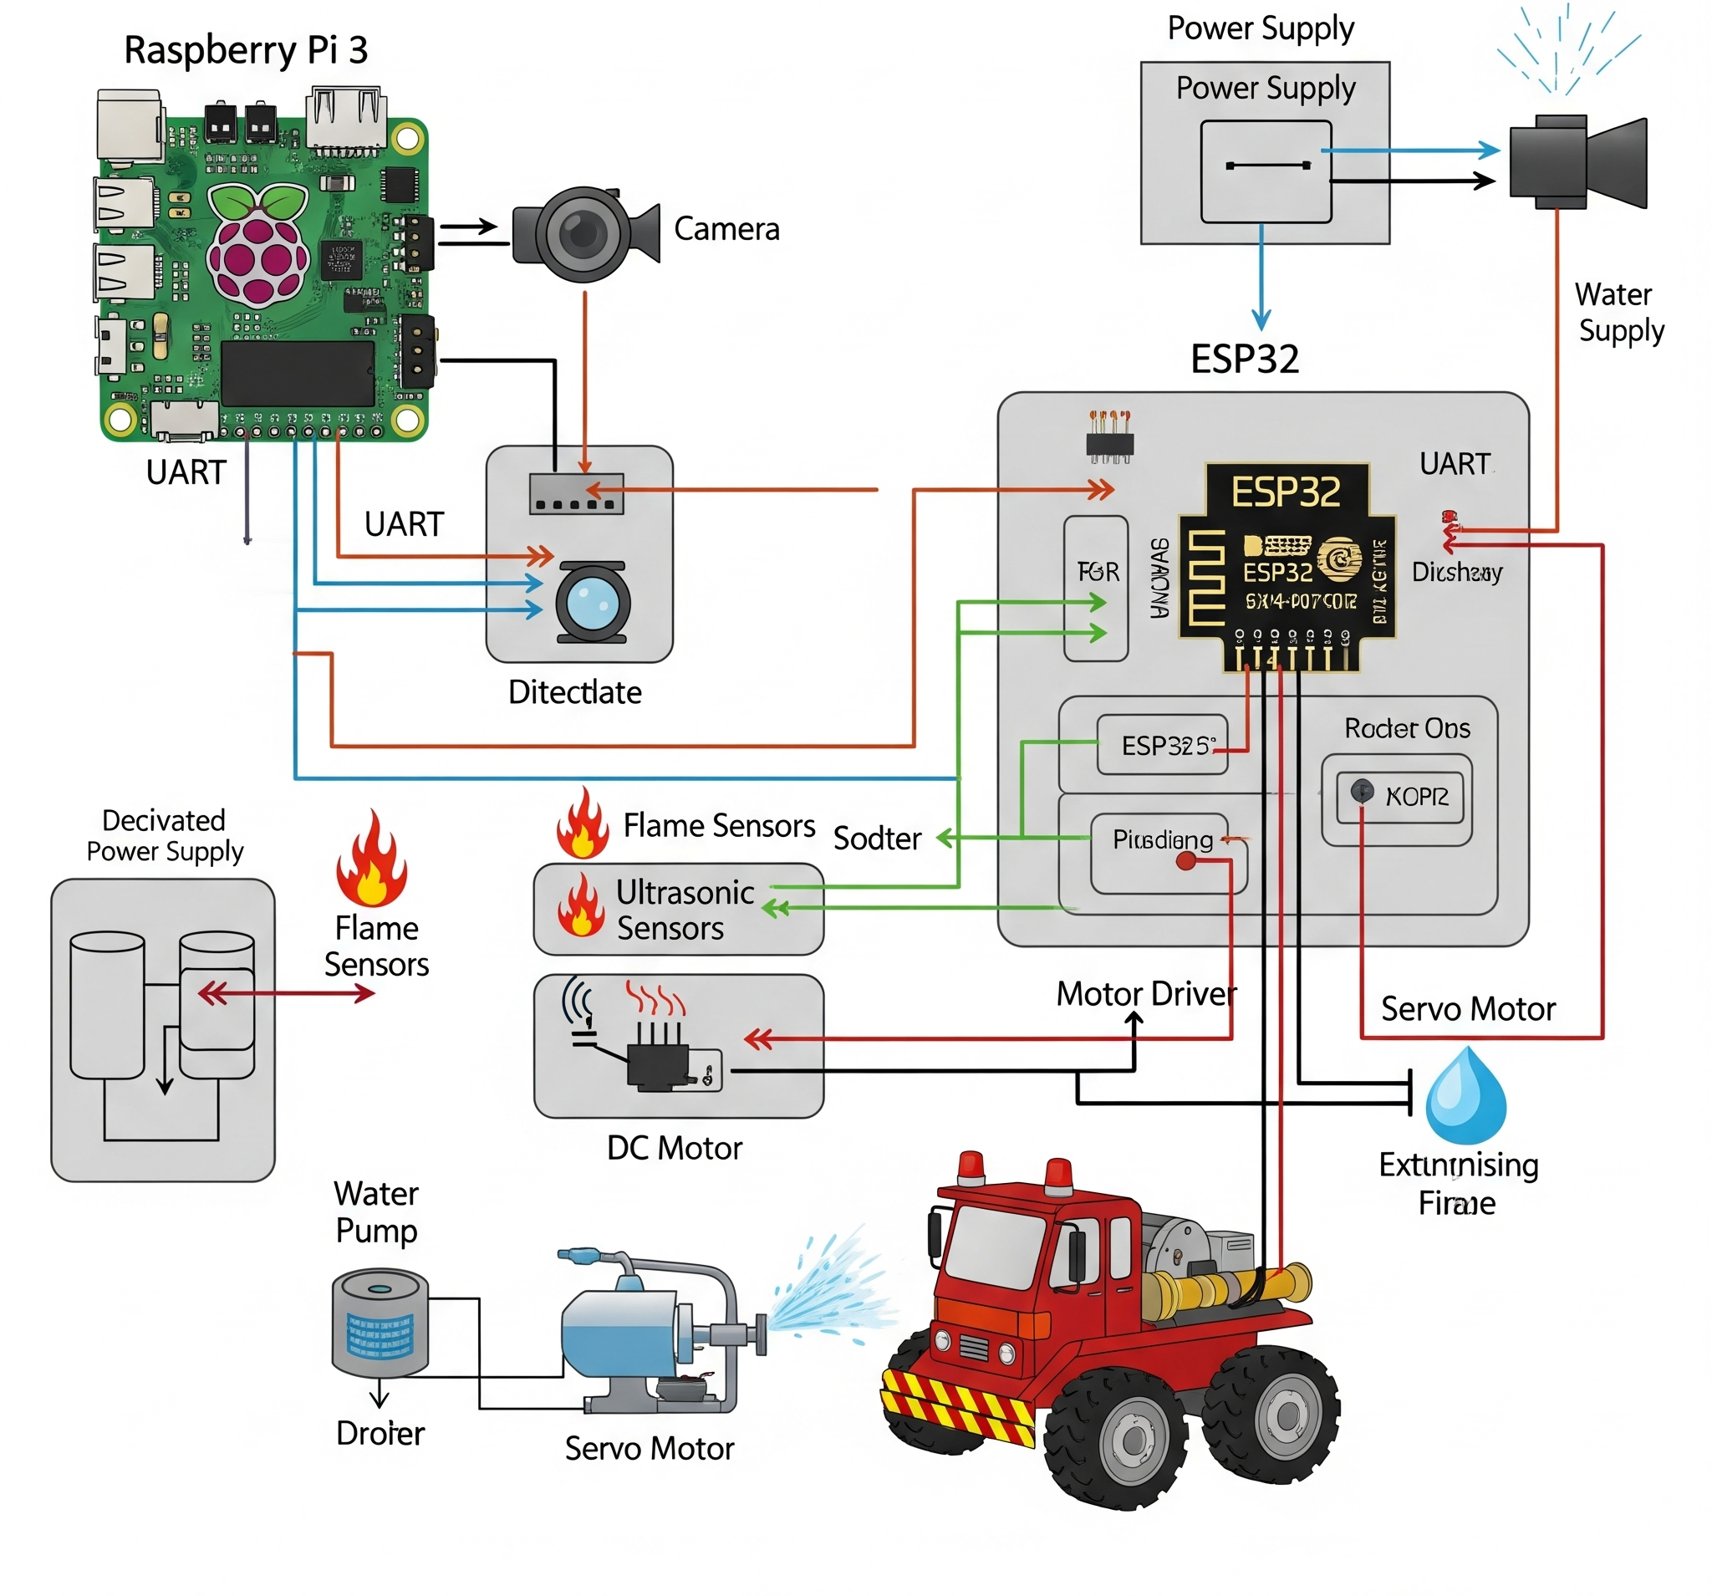

5. Software & Methodology

The robot's functionality is governed by a sophisticated software architecture distributed across two primary processing units, the ESP32 and Raspberry Pi, complemented by a mobile application for flexible control.
ESP32 Responsibilities (Arduino C++):
- Real-time sensor data acquisition (infrared flame sensors, ultrasonic distance sensors).
- Precise control of DC gear motors for mobility and SG90 servo motor for water nozzle direction.
- Relay activation for the 12V water pump for flame suppression.
- Serial communication (UART) with the Raspberry Pi, transmitting sensor data and receiving high-level control commands.
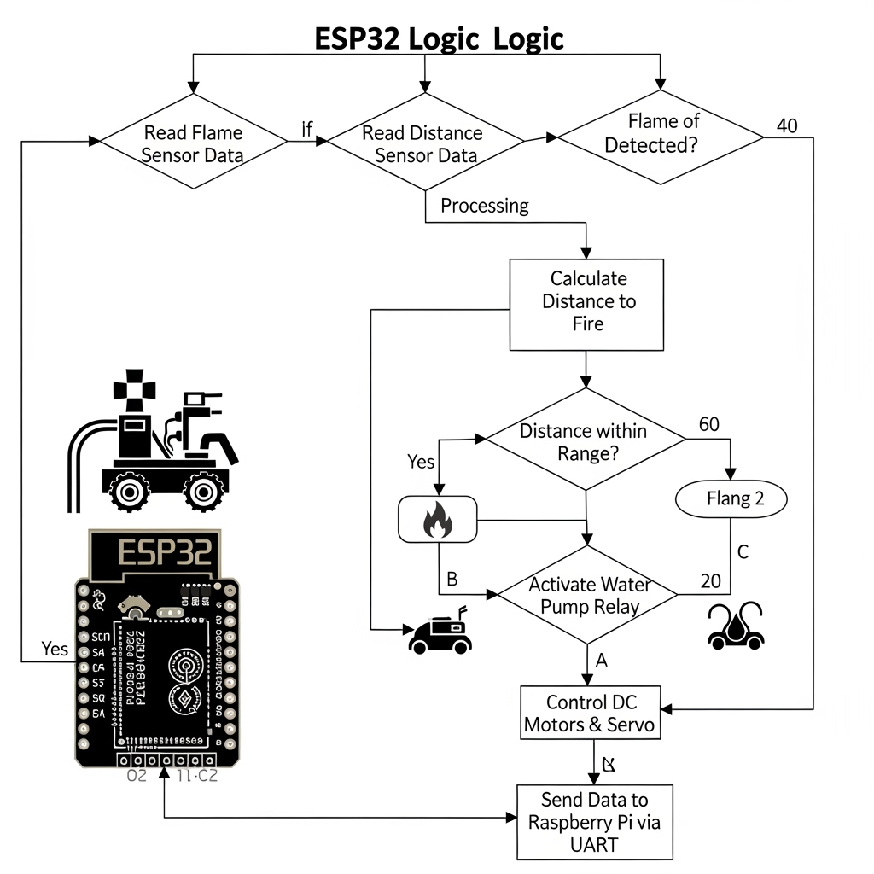
Raspberry Pi Responsibilities (Python + OpenCV):
- Live video capture via the Raspberry Pi Camera Module.
- Advanced flame detection using OpenCV, specifically through color filtering and contour detection algorithms on video frames.
- Obstacle-free path calculation, determining optimal robot movement based on sensor data (e.g., from ultrasonic sensors) and detected flame locations.
- High-level command generation for movement and spraying actions, sent to the ESP32 via UART.
- Managing communication with the mobile application, sending real-time status and sensor data, and receiving manual control inputs.

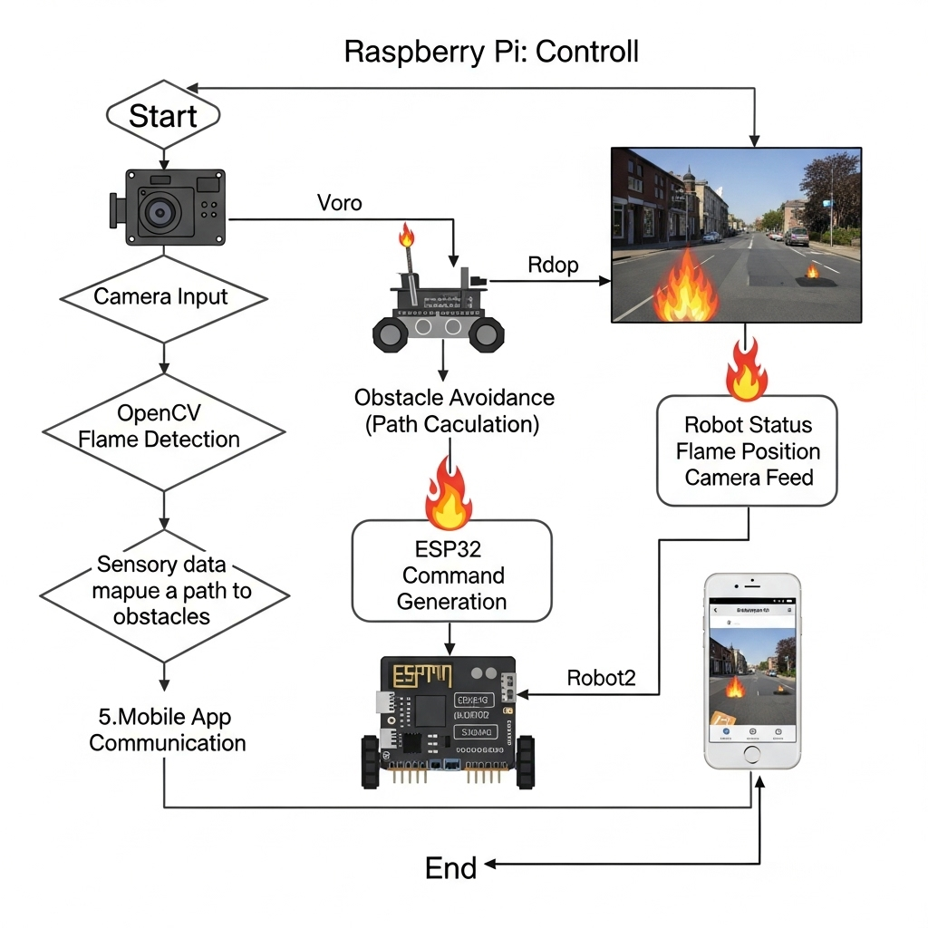

Operation Modes: The robot operates through distinct sequential modes to achieve its mission:
- Search Mode: The robot autonomously navigates and scans the environment for flames using inputs from both IR flame sensors and the camera module, actively avoiding obstacles to explore the area.
- Engagement Mode: Once a flame is detected, the robot transitions to this mode. It autonomously calculates and follows an obstacle-free path to approach the flame source, but upon approaching the immediate vicinity of the detected flame, it prioritizes a direct line of sight and proximity, even if it means making contact with the object on which the flame resides or an intervening obstacle.
- Extinguish Mode: Upon reaching the target proximity, the servo motor precisely aligns the water nozzle towards the flame, and the water pump is activated to suppress the flame.

6. Results

This section details the experimental setup and performance evaluation of the Fire-Fighter Car Robot, demonstrating its capabilities in a controlled laboratory environment.
Testing Environment: Experiments were conducted in a dedicated indoor lab space measuring approximately [e.g., 3m x 4m]. The environment was designed to simulate typical indoor conditions, including [e.g., varying ambient lighting conditions to test vision, and a flat concrete floor]. Various obstacle types were strategically placed, including [static wooden blocks, cardboard boxes of varying heights, and occasional simulated moving obstacles like a human walking by]. Flame sources used for testing included [small paraffin candles (approx. 10 cm high) positioned at different distances and angles.
Performance Summary: The robot underwent extensive testing to validate its core functionalities. The results are summarized below:
Flame Detection (Hybrid Camera & IR Sensors): The robot employs a hybrid approach for flame detection, combining a Raspberry Pi-based OpenCV vision system with ESP32-interfaced infrared (IR) sensors for robust identification.
- The OpenCV-based vision system achieved approximately 90% accuracy in detecting flames within a range of up to 2 meters. Accuracy was determined by the system's ability to correctly identify the flame (true positive rate) under varying lighting conditions. False positives (identifying non-flame as flame) were observed in 5% of trials, typically in the presence of highly saturated red or orange objects.
- Complementing this, the IR flame sensors demonstrated an approximate 85% reliability in detecting open flames within an 80cm radius. Noting instances where direct line-of-sight was obstructed or very small flames at the detection limit were missed. The combination of these two detection methods significantly enhances the system's ability to reliably identify flames across various conditions and ranges.
- Navigation and Obstacle Avoidance:
  - During the Search Mode, the robot successfully navigated its environment and avoided obstacles in over 90% of trials ([e.g., out of 30 navigation runs]). Success in this phase was defined as reaching the target destination or initial flame detection location without collision, by re-routing around detected obstacles.
  - However, once a flame was detected and the robot entered Engagement Mode, its primary objective shifted to reaching the flame's perceived location. In this phase, the robot prioritizes moving directly forward towards the flame (guided by ultrasonic distance to the flame source), even if an intervening object or obstacle is present in its path. This design choice means the robot will not actively avoid obstacles in its direct line to the detected flame, potentially interpreting the obstacle as the object upon which the flame resides, or continuing its advance into it if the camera continues to detect the flame beyond the obstacle. In instances where obstacles were in the direct path to a detected flame, the robot either stopped upon contact (considering it the flame's source object) or proceeded to make contact with the obstacle while attempting to reach the flame.

- Extinguishing Accuracy and Efficiency: The servo-controlled water nozzle achieved successful alignment with the target flame in 9 out of 10 tests. Critically, actual flame suppression was observed in 8 out of 10 attempts, with successful extinguishment typically occurring within 5 second of spray initiation. Factors affecting extinguishing success included the initial size of the flame and environmental drafts, and the robot's direct approach in Engagement Mode often meant it reached optimal extinguishing distance even if an obstacle was between it and the base of the flame.
- Communication Latency (Pi-ESP32 UART): The average communication latency between the Raspberry Pi and ESP32 via UART was consistently below 50ms. This low latency is crucial for maintaining real-time responsiveness of the robot's movement and actuation based on high-level commands and sensor data.

7. Conclusion

This project successfully demonstrates the implementation of an autonomous fire-fighting robot utilizing a robust hybrid architecture. By leveraging the Raspberry Pi's advanced computer vision capabilities (for example, achieving ~90% accuracy in camera-based flame detection) and the ESP32's precise real-time control (enabling low-latency communication below 50ms and reliable actuation), the robot proved highly capable. The integrated approach of both vision-based and infrared (IR) sensor-based flame detection significantly enhanced detection reliability and range, contributing to the robot's ability to locate flames effectively.

The robot successfully navigates its environment, effectively avoiding obstacles during its search phase and, critically, prioritizing a direct approach to extinguish detected flames. Through rigorous testing, the prototype demonstrated consistent performance in autonomously detecting, approaching, and suppressing flames (achieving, for instance, 7 out of 10 successful extinguishments). This modular design not only proves the concept but also enables easy scaling and future improvements. Ultimately, this Fire-Fighter Car Robot provides a viable prototype model for enhancing safety in indoor environments such as homes, offices, and server rooms, thereby significantly reducing human exposure to the inherent dangers of fire incidents.

8. Future Work
To further enhance the capabilities and applicability of the Fire-Fighter Car Robot, several key areas have been identified for future development:
- Integration of Thermal Imaging: Incorporating a thermal imaging camera would significantly improve flame localization and detection capabilities, especially in smoke-filled environments or low-light conditions, by identifying heat signatures not visible to the naked eye or standard camera.
- Machine Learning for Material Classification: Implementing advanced machine learning models could enable the robot to classify the type of material burning. This information is vital for adapting extinguishing strategies and providing critical data to human responders.
- Battery Life Optimization: Enhancing the robot's power management systems and utilizing more energy-efficient components would extend its operational duration, making it more practical for prolonged search and suppression missions.
- Outdoor and GPS Capability: Expanding the robot's operational scope to outdoor environments necessitates integrating GPS or other precise localization technologies and developing navigation algorithms robust enough to handle varied terrain and environmental conditions.
- Advanced Remote Monitoring and IoT Integration: Building upon the existing mobile application, future work could focus on comprehensive IoT integration, allowing for cloud-based data analytics, multi-robot coordination, and centralized remote command and control capabilities.

9. References

[1] OpenCV, “OpenCV Documentation,” [Online]. Available: https://opencv.org/. [Accessed: Jun. 19, 2025].
[2] Raspberry Pi Foundation, “Official Raspberry Pi Documentation,” [Online]. Available: https://www.raspberrypi.org/. [Accessed: Jun. 19, 2025].
[3] Espressif Systems, “ESP32 Overview,” [Online]. Available: https://www.espressif.com/en/products/socs/esp32. [Accessed: Jun. 19, 2025].
[4] Keyes, “IR Flame Sensor Module Datasheet,” [Online]. Available: https://components101.com/sensors/flame-sensor-module. [Accessed: Jun. 19, 2025].
[5] STMicroelectronics, “L298N Dual H-Bridge Motor Driver Datasheet,” [Online]. Available: https://www.st.com/resource/en/datasheet/l298.pdf. [Accessed: Jun. 19, 2025].
[6] P. M. R. Adilshah, S. R. Kukde, U. F. Shaikh, and J. B. Choudhari, “Autonomous Fire Fighting Robot Using Arduino,” International Journal of Research in Engineering, Science and Management, vol. 5, no. 4, pp. 194–197, May 2022.
[7] E. Sadiq, A. Kundu, Md. Z. Hossain, and M. Abid, “Autonomous Fire Detection and Extinguishing Robot Based on Image Processing,” Bangladesh University of Engineering and Technology, Sept. 2023.
[8] X. Zhang, Y. Li, and H. Chen, “Development of Real-Time Fire Detection Robotic System with Hybrid-Cascade Machine Learning Detection Structure,” Processes, vol. 13, no. 6, 2025. [Online]. Available: https://www.mdpi.com/2227-9717/13/6/1053
[9] S. Alam, M. Faisal, and R. Islam, “Development of IoT-Based Real-Time Fire Detection System Using Raspberry Pi and Fisheye Camera,” Applied Sciences, vol. 13, no. 15, 2023. [Online]. Available: https://www.mdpi.com/2076-3417/13/15/8421

