CHAPTER ONE
Introduction
  - Overview
This chapter introduces an overview about our system; it reveals the importance of it, and gives a background on how to use it.

  - Background

Golf simulator, by definition, is something that simulates playing golf on a golf course. It allows for some response and feedback to what a user is actually doing.
This will be a screen that electronically projects a golf shot from where you hit it onto screen and simulates the ball flight.
Using your own clubs, you set up to hit the shot as you would on real courses. The ball will hit a wall consist of 2 layers of thin and solid wood and flexiforce sensors placed on the four corners of wood surface. These sensors will detect how much the strike force.

After every shot the simulator flies, in impressive graphics, along the ball’s trajectory to where the ball ends, ready for the next shot. The distance which reached by the ball depends on the amount of force measured by these sensors.

Virtual golf takes place indoors, where golfers hit the ball against screens with images of various golf courses.
Virtual golf simulators are a huge hit in areas that have longer winters where golfers don’t have the luxury of playing outdoors year round.
Virtual golf simulators thrive in malls, golf equipment stores and at recreation centers.

Our project consists of two parts: hardware and software. In hardware part, all what you need are a high-end PC, and a floor system build using sensors and controllers.
In the software part, the pc will play the golf game, after measuring the force of the Golf ball and the location of the golf that hits the wall we can find the distance where the ball fall.
This information will be used for the 3d Game where the player will hit the ball on a touch surface then it will continue on a 3d software golf game to show the final distance and location of ball.

  - Benefits and goals of our project.
- It allows players to practice or play no matter the weather or time.
- It is suitable if the player have limited budget and can't afford to buy a full system.
- It is suitable if he do not have enough room to fit a full system.
- It can be used as tools to help golf pros; teachers and sales people measure the particulars of a golfer's swing.
- For fun!

CHAPTER TWO
Hardware Part

  - Overview
This chapter introduces the system design of our project, the main components used, electrical circuits designed and the hardware implementation of our project then the calibration of sensors we used. In addition, this chapter discusses the algorithm implementation we developed and finally the problems we face in this part.

  - System Design.
- PIC Microcontroller.
This project was totally dependent on the PIC18F4620
microcontroller. See Figure 2.1

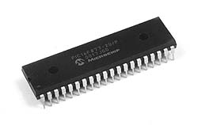
Figure 2.1

PIC Microcontroller is a powerful fully featured processor with internal RAM, EEPROM, Flash memory and peripherals. It has an amazing number of internal peripherals such as timers, 10 bit ADC, an internal oscillator, an analog comparator, and a program memory. Figure 2.2 shows the pin diagram of PIC18 microcontroller.

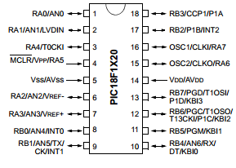
Figure 2.2

We used PIC18F4620 instead of PIC16 or Arduino for many reasons. For example, it has new and improved instruction-set and memory management system, cheaper and we are familiar with this type because we took a microcontroller course last year so it is easy for us to deal with it.

- Flexiforce sensors:
The flexiforce sensor is an ultra-thin and flexible printed circuit (as you see in Figure 2.3) which can be easily integrated into our project. It can measure force between almost two surfaces and is durable enough to stand up to most environments.
The A201 sensor we used is in the following force range:
Sensor A201 – 100 (0-100 lb.): this means that these sensors can measure forces from range of 0 to 100 pound.
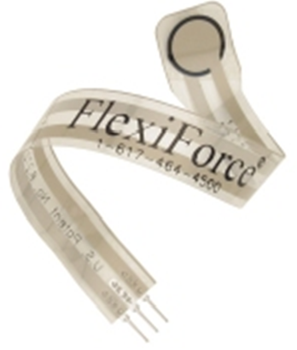
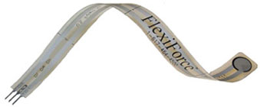
This sensor acts as a variable resistor in an electrical circuit. When the sensor is unloaded, its resistance is very high (greater than 5 Mega-ohm); when a force is applied to the sensor, the resistance decreases.

Figure 2.3

Flexiforce sensors applications:
Flexiforce sensors are used in a wide variety of OEM, Research and Development, and Clinical applications. They are utilized in many applications to:
- Detect and measure a relative change in force or applied load
- Detect and measure the rate of change in force
- Identify force thresholds and trigger appropriate action
- Detect contact or touch.

- UA741 operational amplifier.
It is a very high gain performance amplifier designed to amplify ac and dc voltage voltages. We used it in designing the driving circuit of flexiforce sensors. Figure 2.4 shows the pin diagram of op-amp.

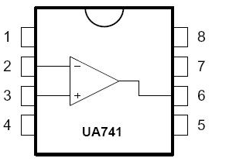
Figure 2.4

- Resistors.
- Capacitors.
- Regulator (7805).
We use it in order to convert AC voltage to fixed voltage (DC).
Figure 2.5 shows the circuit used for regulator.
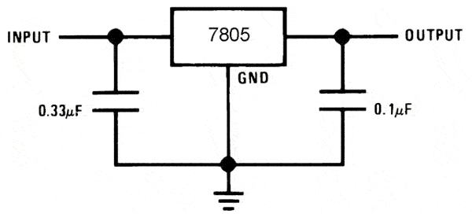
Figure 2.5

  - Electrical circuits

- Basic circuit of microcontroller:

We used PIC18F4620 microcontroller that keeps reading sensor values from ADC converter and manipulates these values to be used in a software game.
We developed an algorithm using this chip to keep reading values from flexiforce sensors then after some calculations –we will discuss later- these values are used to control a 3d graphic game.
Figure 2.6 shows the basic circuit of PIC18F4620.
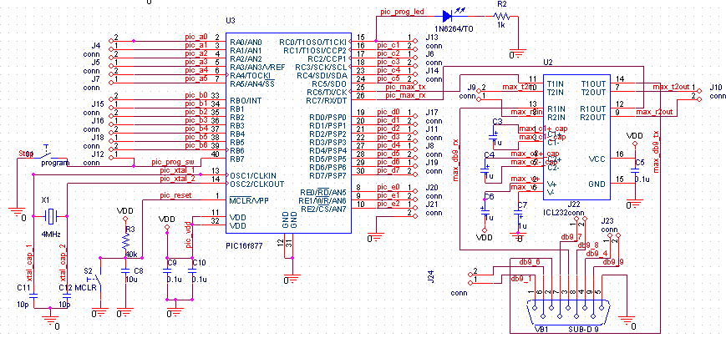
Figure 2.6

- Flexiforce sensor driving circuit

Figure 2.7 shows the recommended circuit of flexiforce sensor. This circuit uses an inverting operational amplifier arrangement to produce an analog output based on the sensor resistance and a fixed reference resistance (RF).
An analog-to-digital converter is used to change this voltage to a digital output.in our project we used the ADC converter in PIC18F4620.

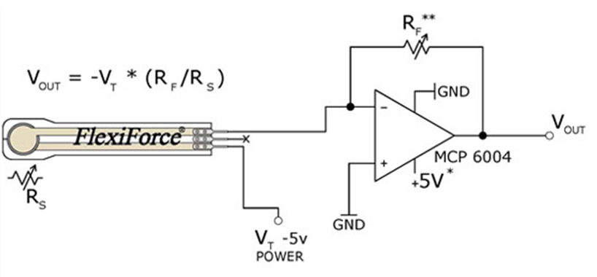
In this circuit, the sensitivity of the sensor could be adjusted by changing the reference resistance (RF) or drive voltage (VT); a lower reference or drive voltage will make the sensor less sensitive, and increase its active force range.

Figure 2.7

  - Surface used in our project.
One of the main parts of our hardware project is the wood wall; the surface of the wall is 0.6 m X 0.6 m which looks like Figure 2.8.
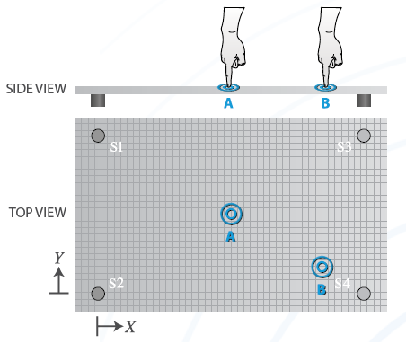
Figure 2.8
We chose a specific type of wood because of many reasons we will talk about them later, but we didn’t use glass material to be the wall because in our case the ball may hits the glass with strong force and this may break it!
Plastic was a bad choice too because it absorbs some force because of its flexibility, there are many types of wood but some of them absorb force and some have curves , we chose the type of wood very carefully .We need a material that have the least absorption of force.
Because of that we changed the material type of the wood which we used many times.

  - Flexiforce sensor calibration.
Conditioning the FlexiForce sensors before every use is recommended. In addition, calibrating the sensors is recommended before initial use because there is a slight variance between sensors, which calibration corrects. When performed in an environment similar to that of the test environment, calibration helps improve repeatability and neutralize drift.
Flexiforce sensor has 5 mega ohms of resistance when starting out at zero loads.
To condition the FlexiForce sensor, we applied a known force to the sensor, and equate the sensor resistance output to this force; we repeated this step with a number of known forces that approximate the load range to be used in testing.
Figure 2.9 shows the results we got from sensors after calibration:

Figure 2.9

Figure 2.9 shows the real values we got from sensors when we applied different forces on it. The ideal curve is shown in Figure 2.10 where the curve resulted from relation between resistance and force is logarithmic curve. In reality, there is an error rate due to some problems during calibration.

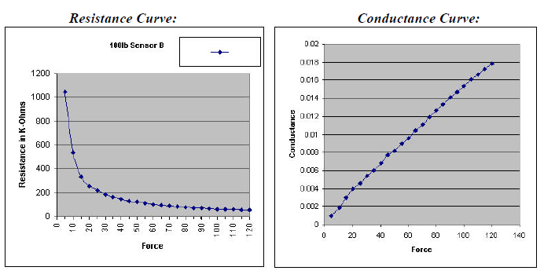
Figure 2.10

  - Hardware Implementation
Our project consists of two main parts Hardware part and software part. The hardware part consists of many main components such as Microcontroller, Force sensors and 2 wood layers.
We placed 4 flexi force sensors at the corners of the first wood layer then we added small rounded pucks above each sensor then we added the second layer of the wood as you see in Figure 2.11.
The pucks collect and concentrate the force to be loaded to the sensing area of the sensors only so that all the force applied on the wood layer moves through the pucks to the sensing area of the flex sensors.
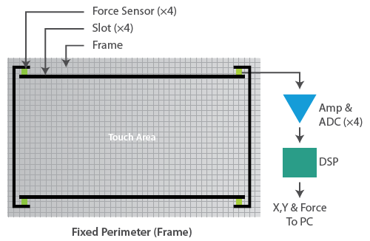
Figure 2.11
In ideal state when there is no force applied on the sensors then the 2 wood layers and the pucks should not affect the sensors or apply any force. we added sponge pieces near to pucks to make sure that the wood layers or the pucks has no force applied in ideal state.
If the golf ball hits the wood layer then the wood layer pushes the pucks which are placed directly above the sensors. The sensor acts as a variable resistor in an electrical circuit.

When the sensor is unloaded, its resistance is very high (greater than 5 Mega-ohm); when a force is applied to the sensor, the resistance decreases.
Each sensor connected to a driven circuit which consists of amplifier and variable resistor. This driven circuit produce output as a voltage. The output of the driven circuit is proportional to the force applied to the sensor; we connected the output voltage with the microcontroller.
The Microcontroller receives the data from the sensors and their driven circuits through 4 channels of ADC.

  - Algorithm implementation.

We implemented our own Algorithm to find the force and the position of the golf ball when it hits the wood layer. Figure 2.12 shows the diagram of our algorithm.
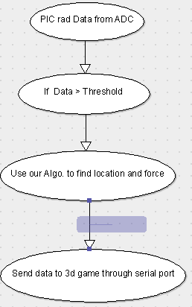
Figure 2.12
First of all we divided the surface into 16 small surfaces as shown here in Figure 2.13
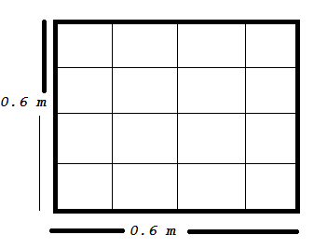
Figure 2.13
Then we combined some surfaces together because these areas share the same properties, after combining some surfaces we got 9 different surfaces as you see in Figure 2.14. We did that because we have only 4 force sensors if we have more than 4 sensors the algorithm works better and in accurate way.

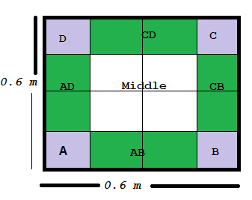
Figure 2.14
As you can see from Figure 2.14 that surfaces A, B, C and D are directly above the flexiforce sensors, other surfaces such as AD, AB, CB and CB are the surfaces which placed between two sensors and finally the middle surface by this division of complete surface and using the data from sensors we could find the position of the ball when it hits the surface.
If the golf ball hits the surfaces that above the flex force sensors directly then the sensor closet to that surface will measure the largest force and send the data to the microcontroller.
If the ball hits the middle surface then all the sensors produce the same ranges of data.
If the ball hits surface between two sensors then the two sensors produce data larger than other two sensors.
So after the ball hits the surface each sensor sends data to the PIC and by some calculations and comparisons we can specify the location of the ball.
The force is the summation of the sensors data.
Our algorithm does the following:
1- Read the analog values from sensors.
2- Converts the analog values in to digital.
3- Determine the location of the shot on the surface.
If the golf ball hits the surfaces that above the flex force sensors directly then the sensor closet to that surface will measure the largest force and send the data to the microcontroller.
If the ball hits the middle surface then all the four sensors produce the same ranges of data.
If the ball hits surface between two sensors then the two sensors produce data larger than other two sensors.

We make many trials of hitting the ball on the wall and we studied the values of each sensor, after manipulating these values we got a relation between them that allows us to write the algorithm.

4- Our algorithm also computes the total force affecting the wall by summing all values of force read by the four sensors.
This total force will determine the distance that the ball will reach on the software game. Higher the force, farther the distance the ball will reach.

  - Problems Popped Up

- We wasted a lot of time on finding the good kind of wood which absorb the least amount of force, so after a lot of trials we found a thin, strong one that minimizes the absorbed force as much as possible.
- When the size of wood layer increases then problems of curves increase so we decreased the size of the wood layer from 1m X 1m to 0.6m X 0.6m.
- Sensing area of flexiforce sensors is very small (about 9.53 mm diameter). We used bucks which play an important role in focusing the force on the sensing area of these sensors.
- We spent a lot of time till we got flexiforce sensors!
- We have some problems in accuracy because of the number of force sensors, if we had more than 4 sensors then our algorithm of specifying the location of the ball game will be more accurate than now

CHAPTER THREE
Software Part

  - Overview
This chapter discusses the 3d graphics game we used in our project; also describes its implementation and how we connect the hardware part with this game.

  - Software Implementation
We worked on an open source code for a game called neverball. It has within it a game called neverputt, which is a software golf game written in C programing language.
Instead of building a golf game from scratch we used an existing game called Neverputt. Neverputt is known to run under Linux, Win2K/XP, FreeBSD, and Mac OSX. Hardware accelerated OpenGL is required. Figure 3.1 shows the start of golf game.

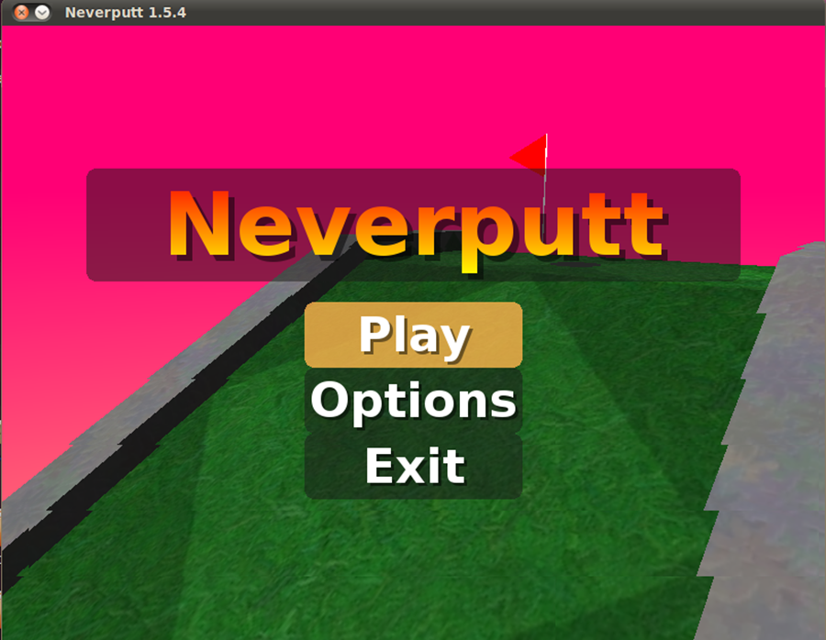
Figure 3.1

What we did!?
First of all we read the source code of the game then try to understand it; we downloaded many libraries on Linux to operate the game such as SDL, PhysicsFS, libvorbis, libpng, libjpeg and other libraries.
To run the game Under Unix and Linux, simply run the command Make.
Instead of controlling the golf game using mouse motion and keyboard events we control the game using our own hardware
.
Our mission is to read values from the serial port ,when the ball make a collision with the surface we implemented an algorithm on the pic184620 to determine the force and the specific direction for the ball and sends them to the game through the serial port. We receive this data and according to them the golf game moves in the right direction and force.
We implemented our own functions which handle events related to our project.
In normal case the ball inside the game moves according to mouse motion and its force determined according to mouse motion and when a key button pressed!
We changed these functions because we want to move the ball according to coordinates which came from microcontroller and according to total force affected the wood surface. So, we added our functions and implementation to control the path and force if the ball inside the 3D golf game! See Figure 3.2.

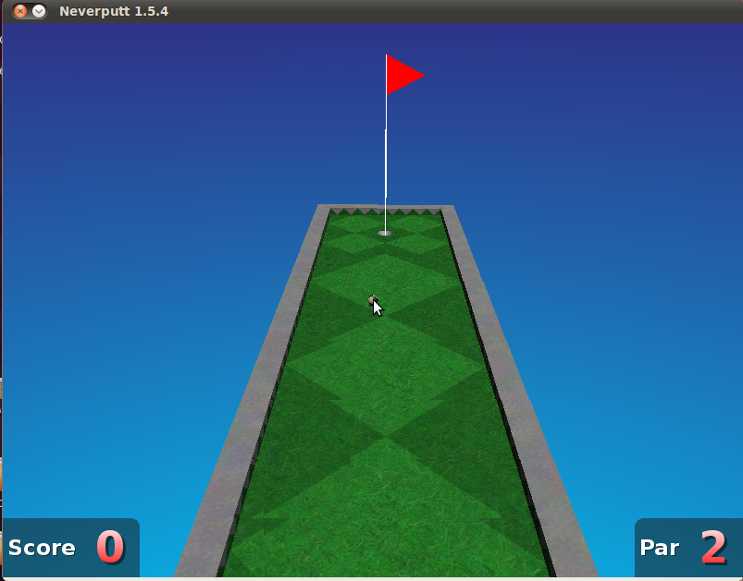
Figure 3.2

  - Hardware and software Integration.

The data which control the golf game was send serially through serial port. We wrote a code in C language which keeps listening to serial port and stores the data when available in a buffer. Figure 3.3 shows the code for opening the port in C and Figure 3.4 shows the code of reading data through serial port on Ubuntu.
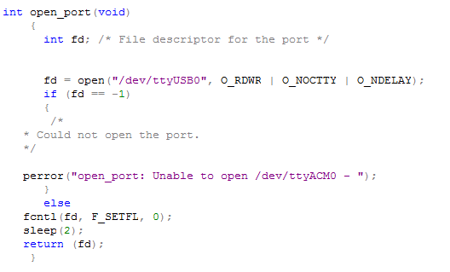
Figure 3.3
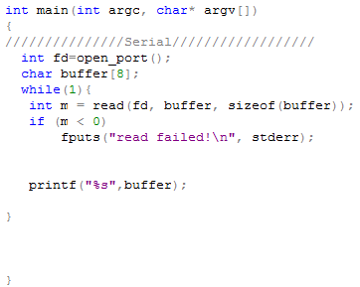
Figure 3.4

CHAPTER FOUR
Conclusion

During this semester we implemented our graduation project in a creative way. We applied all the knowledge we have in programming PIC18F4620 and knowledge in software engineering to implement Golf simulator.
Golf simulator allows you set up to hit the shot as you would on real courses. The ball will hit a wall consist of 2 layers of thin, solid wood and flexiforce sensors placed on the four corners of wood piece. These sensors will detect how much the strike force and the location and continue the ball path inside 3D game.

