

AN-NAJAH NATIONAL UNIVERSITY

FACULTY OF ENGINEERING AND INFORMATION TECHNOLOGY

COMPUTER ENGINEERING DEPARTMENT

Hardware Graduation Project:
Pharmacy-Automation System

SUBMITTED BY
Hamza Khaleel
Hosny Ishtaya

SUPERVISOR
Dr. Abdallah Rashed

Presented in partial fulfillment of the requirements for the Bachelor’s degree in Computer Engineering.

Summer, 2022

Acknowledgment

To all those who helped in making this project possible, to our beloved An-Najah National University that supported this project to make the country and the community better and to make us the students make a difference.
To our supervisor, Dr.Abdallah Rashid who took from his time for us, was supportive, always believed that we could do it.
To all those and many more, who supported us through thick and thin, we give a big “Thank You” straight from our hearts, and we present you this report and project.

Dedication

We would like to thank everyone who supported us those who this work won’t be done without from friends, family, and those people who made it their life’s journey to write articles that help those who are thirsty for knowledge.

DISCLAIMER

This report was written by student(s) at the Computer Engineering Department, Faculty of Engineering, An-Najah National University. It has not been altered or corrected, other than editorial corrections, as a result of the assessment, and it may contain language as well as content errors. The views expressed in it together with any outcomes and recommendations are solely those of the student(s). An-Najah National University accepts no responsibility or liability for the consequences of this report being used for a purpose other than the purpose for which it was commissioned.

Contents

Acknowledgment. . . . . . . . . . . . . . . . .. . . . . . . . . . . . . . . . . . . . . . . . . . . . . . . . . . . . . . . 1
Dedication. . . . . . . . . . . . . . . . .. . . . . . . . . . . . . . . . . . . . . . . . . . . . . . . . . . . . . . . . . . . . . . 2
DISCLAIMER. . . . . . . . . . . . . . . .. . . . . . . . . . . . . . . . . . . . . . . . . . . . . . . . . . . . . . . . . . . . . .3
Images of Module (CNC and the arm) . . . . . . . . .. . . . . . . . . . . . . . . . . . . . . . . . . . . . . . . . . . 6
Image of Box of the Shelves. . . . . . . .. . . . . . . . . . . . . . . . . . . . . . . . . . . . . . . . . . . . . . .7
Abstract. . . . . . . .. . . . . . . . . . . . . . . . . . . . . . . . . . . . . . . . . . . . . . . . . . . . . . . . . . .. . . . . . . .8

- Introduction
  - Problem Statement . . . . . . . . . . . . . . . . . . . . . . . . . . . . . . . . . . . . . . . . . . . . . . . . . 9
  - Significance . . . . . . . . . . . . . . . . . . .. . . . . . . . . . . . . . . . . . . . . . . . . . . . . . . . . . . . . 9
  - Objectives and Scope . . . . . . . . . . . . . . . . . . . . . . . . . . . . . . . . . . . . . . . . . . . . . . . 9
  - Report Organization . . . . . . . . . . . . . . . . . . . . . . . . . . . . . . . . . . . . . . . . . . . . . . . . 9
- Constraints and Earlier Coursework
  - Constraints
    - Inexperience . . . . . . . . . . . . . . . . . . . . . . . . . . . . . . . . . . . . . . . . . . . . . . . . . 10
    - Lack of funds . . . . . . . . . . . . . . . . . . . . . . . . . . . . . . . . . . . . . . . . . . . . . . . . . 10
    - Lack of time . . . . . . . . . . . . . . . . . . . . . . . . . . . . . . . . . . . . . . . . . . . . . . . . . . 10
    - Lack of Mechanical Knowledge. . . . . . . . . . . . . . . . . . . . . . . . . . . . . . . . . . . 10
    - Lack of Tooling. . . . . . . . . . . . . . . . . . . . . . . . . . . . . . . . . . . . . . . . . . . . . . . . 10
  - Earlier Coursework
    - Microcontroller and PIC . . . . . . . . . . . . . . . . . . . . . . . . . . . . . . . . . . . . . . . . 11
    - Wireless and Communications . . . . . . . . . . . . . . . . . . . . . . . . . . . . . . . . . . .11
    - Critical Thinking and Research Skills. . . . . . . . . . . . . . . . . . . . . . . . . . . . . . .11
- Literature Review
  - The Regular Work in Pharmacy. . . . . . . . . . . . . . . . . . . . . . . . . . . . . . . . . . . . . . . 12
  - Pharmacy-Automation System. . . . . . . . . . . . . . . . . . . . . . . . . . . . . . . . . . . . . . . . 12
  - Similar Projects . . . . . . . . . . . . . . . . . . . . . . . . . . . . . . . . . . . . . . . . . . . . . . . . . . . . 12
- Methodology
  - Choosing the Idea . . . . . . . . . . . . . . . . . . . . . . . . . . . . . . . . . . . . . . . . . . . . . . . . . . 14
  - Mechanical Part. . . . . . . . . . . . . . . . . . . . . . . . . . . . . . . . . . . . . . . . . . . . . . . . . . .. 14
    - Mechanical Design. . . . . . . . . . . . . . . . . . . . . . . . . . . . . . . . . . . . . . . . . . . . .14
    - Assembling . . . . . . . . . . . . . . . . . . . . . . . . . . . . . . . . . . . . . . . . . . . . . . . . . . .15
    - Mechanical Parts. . . . . . . . . . . . . . . . . . . . . . . . . . . . . . . . . . . . . . . . . . . . .. .16
  - Controller Part . . . . . . . . . . . . . . . . . . . . . . . . . . . . . . . . . . . . . . . . . . . . . . . . . . . . . 18
    - Arduino. . . . . . . . . . . . . . . . . . . . . . . . . . . . . . . . . . . . . . . . . . . . . . . . . . . . . ..18
      - Electronic Parts. . . . . . . . . . . . . . . . . . . . . . . . . . . . . . . . . . . . . . . . . . . . .19
      - Driving Motors . . . . . . . . . . . . . . . . . . . . . . . . . . . . . . . . . . . . . . . . . . . . 21
      - Controlling the Servo Motor . . . . . . . . . . . . . . . . . . . . . . . . . . . . . . . . . 22
      - Additional features . . . . . . . . . . . . . . . . . . . . . . . . . . . . . . . . . . . . . . . . 23
      - Linear Actuator. . . . . . . . . . . . . . . . . . . . . . . . . . . . . . . . . . . . . . . . . . . .24
- Result and Problem Discussion
  - Drivers. . . . . . . . . . . . . . . . . . . . . . . . . . . . . . . . . . . . . . . . . . . . . . . . . . . . . . . . . . . . . 25
  - Designing the Shelves. . . . . . . . . . . . . . . . . . . . . . . . . . . . . . . . . . . . . . . . . . . . . . . . . 25
  - Gravity and Vibration. . . . . . . . . . . . . . . . . . . . . . . . . . . . . . . . . . . . . . . . . . . . . . . . . 25
  - Arm disconnects. . . . . . . . . . . . . . . . . . . . . . . . . . . . . . . . . . . . . . . . . . . . . . . . . . . . . 25
  - Final Result. . . . . . . . . . . . . . . . . . . . . . . . . . . . . . . . . . . . . . . . . . . . . . . . . . . . . . . . . . 25
- Conclusion
  - Summary. . . . . . . . . . . . . . . . . . . . . . . . . . . . . . . . . . . . . . . . . . . . . . . . . . . . . . . . . . . 26
  - Improvements. . . . . . . . . . . . . . . . . . . . . . . . . . . . . . . . . . . . . . . . . . . . . . . . . . . . . . . 26
  - Future Work. . . . . . . . . . . . . . . . . . . . . . . . . . . . . . . . . . . . . . . . . . . . . . . . . . . . . . . . .26
  - Outcome. . . . . . . . . . . . . . . . . . . . . . . . . . . . . . . . . . . . . . . . . . . . . . . . . . . . . . . . . . . .26
- Bibliography. . . . . . . . . . . . . . .. . . . . . . . . . . . . . . . . . . . . . . . . . . . . . . . . . . . . . . . . . . . 27

Images of Module (CNC and the arm):
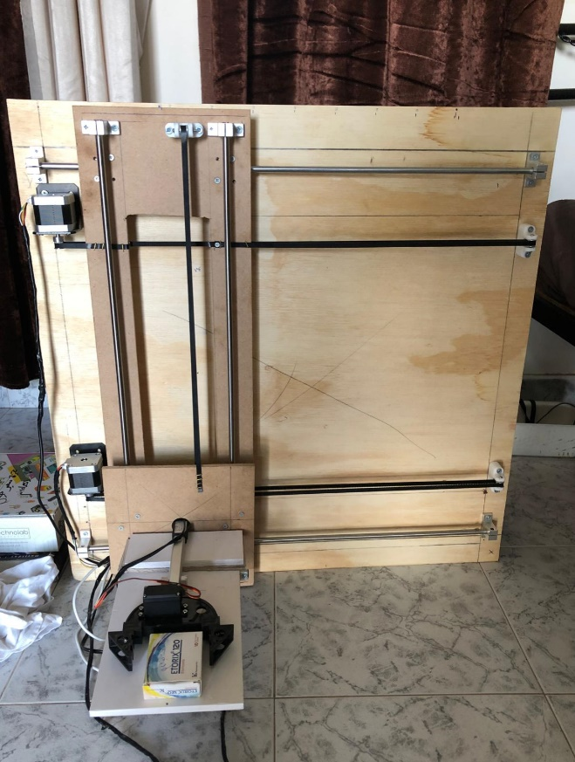 | 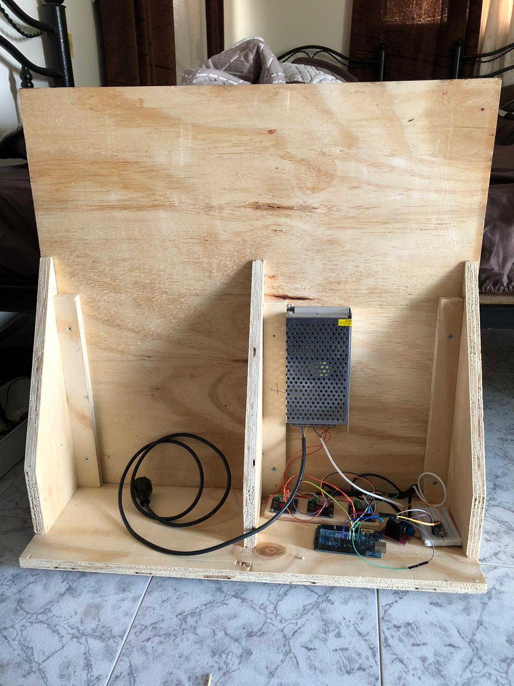
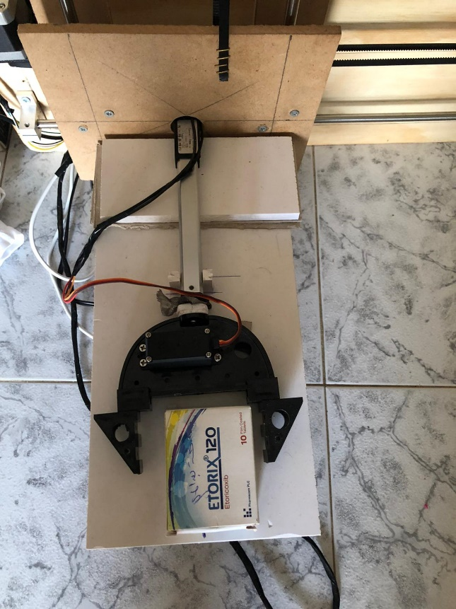 | 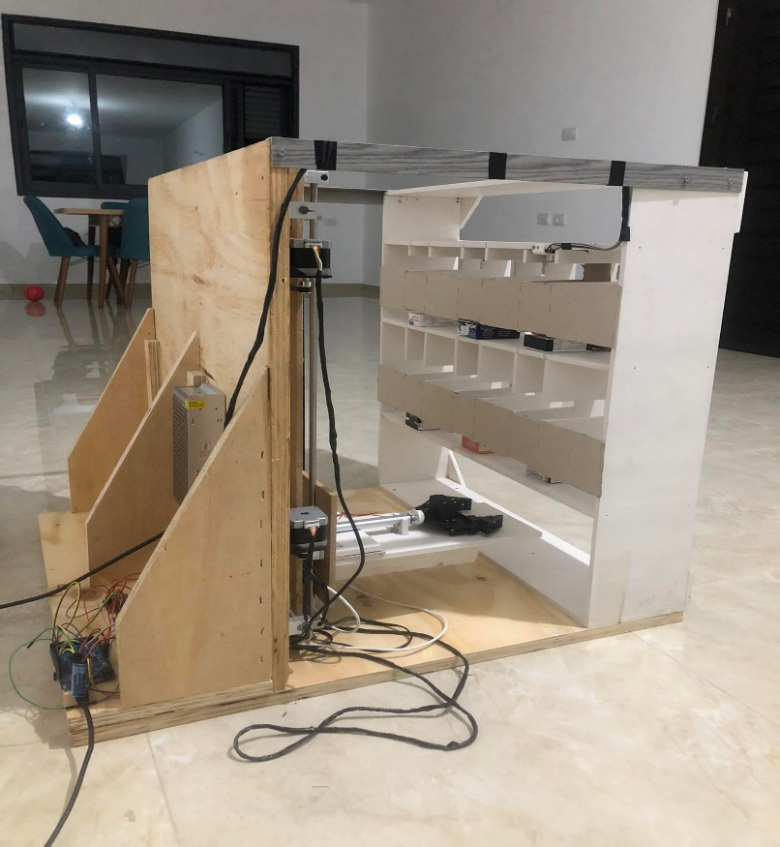

Images of Box of the Shelves:

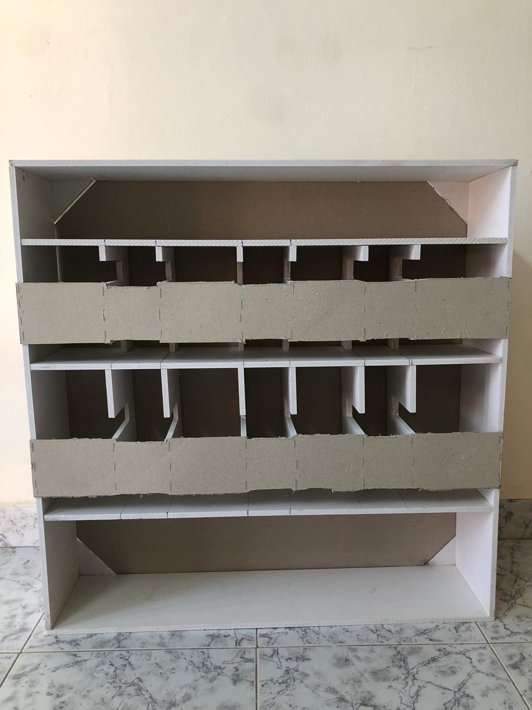

Abstract

Bringing technology and machines into the physical world, facilitating the difficulty of work, and providing the time and accuracy necessary for the work that people can do, Features included in this project:

- The ability to bring the desired drug from the shelf.
- Warning signal in case one of the shelves becomes empty.
- The ability to take out medicines and also the ability to insert them into shelves automatically.
- A robotic arm that can hold the medication to be used.

- Introduction

  - Problem Statement
The "Pharmacy-Auto-System" project aims to solve many problems for certain groups of society, the most prominent of which are:
- Employees in general pharmacies, which makes it easier for them to work and produce quickly and accurately.
- Huge pharmaceutical companies, which makes it easier for them to classify and arrange products in warehouses properly, correctly and without complication.

  - Significance
The main goal of the project is to build a robot that is able to do the input and output process in a proper and easy way. The project contributes by saving time and effort on producing companies in classifying medicines, in addition to that “Pharmacy-Auto-System” can be used in more than one form, such as pharmacies and libraries, in general it is used for insertion and removal from shelves.

  - Objectives and Scope
The purpose of the project "Pharmacy-Auto-System" is to facilitate the complex input and output process, and therefore requires the availability of the following services:
- The ability to order medication from the computer.
- You can select the state in which you want to use the device, either by entering, removing, or changing the name of the shelf.
- The device moved on the x axis and y axis to reach the desired location from the user and carry out the operation according to the case chosen in the second point.
- Return the medicine to the user if the condition is an entry.
- Alert the user or administrator if there is an empty shelf by sending a message to his mobile phone”.

  - Report Organization
    - Second chapter: In this chapter, we covered the important subjects we learned previously, as well as the external courses and the primary constraints and obstacles we encounter while working on the project.
    - Third chapter:
    - Fourth chapter (Methodology): We talked about the mentality through which we built the application, in addition to the features that we offer and the technology’s used.
    - Fifth and final chapter: we talked about the results, as well as the lessons we learned from working on the project and future developments.

- Constraints and Earlier Coursework

  - Constraints

    - Inexperience

We created many modest demos and tests to ensure that the notion we are going for is feasible. However, all of these testing required time that we could have spent on other things.
Even after all of the testing, research, and time invested, we still made certain judgments that are considered safe risks since we couldn't test specific components and couldn't afford for the overall project to fail.

    - Lack of funds
Some options required additional money to create, making the project more expensive and unaffordable, especially at our budget.

    - Lack Of Time

In every operation, time is of the utmost importance. Researching, communicating, testing, designing, analyzing the needs, planning, and wasting time due to inexperience all cost time, which, no matter how trivial, rapidly adds up.

    - Lack Of Mechanical knowledge

The project involves many mechanical aspects that we only partially understood, but even after all of our study, an experienced mechanical engineer was required to answer some problems and arrange the execution effectively.
Considerable 3D printed pieces required some balance and mechanical understanding to repair; thus, the concepts and original drawings were brought to the engineer students for modification.

    - Lack Of Tooling

Some specific tools were necessary to cut, prepare, and assemble all of the pieces, which were either unavailable or too expensive for home usage, so an expert was called in to assist.
Some pieces must be printed using a 3D printer.
A carpenter was also employed to help with the preparation of the outside model, which was built of wood.

  - Earlier coursework

    - Microcontrollers and PIC
These classes covered the fundamentals of the Arduino, including as basic serial communication and controlling steppers and servo motors.

    - Networks and Communication and Wireless

We used the HC_06 module to connect the Arduino with the mobile wirelessly.

    - Critical Thinking and Research Skills

This course has provided me how to conduct research and write a report, and it's one of the few non-technical courses that is also lifetime.

- Literature Review

When building this project, our thinking was about how to solve the problem of speed, time and accuracy in doing this service correctly, and for this we inspected the work in pharmacies and general stores in our towns to see the work near and know the best possible solution. This can be explained as follows:

  - The Regular work in Pharmacy

In the normal situation in drug stores and pharmacies, work in them is easy for the beholder, but difficult and complicated for the worker, and this is represented in the inventory of accounts and medicines, as well as sales statistics and knowledge of inputs and outputs to achieve profit and work on planning in a safe and sound manner.
The pharmacist employee there must have full knowledge of the existing medicines, their locations and their complete classification.
In general, the work is for the customer to come to the pharmacy with a paper from a doctor requesting a specific drug from the pharmacy employee there. He brings the drug from the shelf in which the required drug is located.

  - Pharmacy-Automation System
But what if the pharmacy had a large size and a lot of customers? How do the employees fulfill the requirements correctly, accurately and quickly?
As for the owners of projects and government institutions that provide stores, there is a part of the invested money lost in the process of storage, classification, entry and exit, and despite the money spent in these operations, there are damaged products or simply there are products that are easily lost or stolen without feeling, and this affects the business owner financially and it is possible to destroy a project in its infancy.
Here comes the role of our project by working to provide a device that knows the locations and number of medicines and brings the medicine to you after you request it by typing its name into the computer, and then the device takes care of all the operations of inserting, removing and categorizing, saving time and effort.

  - Similar Projects
There are some of the global and complex projects that I have seen on the Internet that were working on the introduction and removal of medicines automatically, but it turned out to be so complicated that I did not understand the way it worked in a simple way. It is likely that there will be projects like this project.
We worked on building the project from scratch, and we did all the planning from building the model to choosing the parts and designing the CNC individually and with the effort of the team, we tried to look for similar projects to benefit from, and to develop something different, but we did not find a clear project to benefit_from.

- Methodology

This section contains detailed information about the techniques and methods we used to develop the project, from designing and assembling the mechanical structure to controlling the arm and positioning, as well as how they are linked together to produce the final product.

  - Choosing the idea

In the beginning, we did not know what we wanted to do as a graduation project, and there were many ideas on the Internet and many ideas that had been created in the past years by colleagues in the Department of Computer Engineering, and therefore we were rejecting the idea of ​​repeating a project, so we wanted to do a project to be distinguished in it and it was not made Before, that's why we took a lot of time to come up with the idea of ​​the project, which is the pharmacy automation system.

When we were looking at projects on the Internet, an idea caught our attention that you were moving a glass horizontally and making a mixture of drinks so that you only ask for the recipe, this thing caught our attention, and we saw a device that you give the name of a book to check if it is in the library or not No, and from here after more than two weeks we decided to make a device that brings a book to the user automatically so that his name is entered only on the computer, but with time we saw that the book was heavy and needed powerful and expensive electronic parts to complete it, so we transformed the project from bringing a book to bringing a box of medicine to lose weight And to be less expensive for us, at the same time it supports the same idea and does not differ from it.

After we agreed on the idea of ​​the project, we began to think about the primitive form of the project, so we decided to make a device that walks on the y and x axes, in order to reach the place of the drug to be taken, we consulted Dr. Abdullah Rashid about the initial idea and encouraged it, then the parts were purchased and a CNC was built that would go on the x- and y-axis, and then we stopped for a while to think about how to get the medicine from the shelf, we saw that the arm is the most appropriate and only solution to do insertion and removal. There were many other ideas, but they did not work. We also designed the shelves in a way that ensures the success of the entry and exit process easily and properly.

  - Mechanical Part

The mechanical component of the project is in charge of moving the arm along the x, y, and z axes, and this necessitates the presence of motors, belts, and so on to generate movement in collaboration with a controller to direct it. This requires the following steps to be taken:

    - Mechanical Design

In the first step, we worked on designing the external model of the device and installing the motors and rods, and we needed some 3D-printed bodies to help support the model.

    - Assembling
It is the part that demands the use of bolts and drill bits to put the components together, and it must be done correctly for the project to function properly.

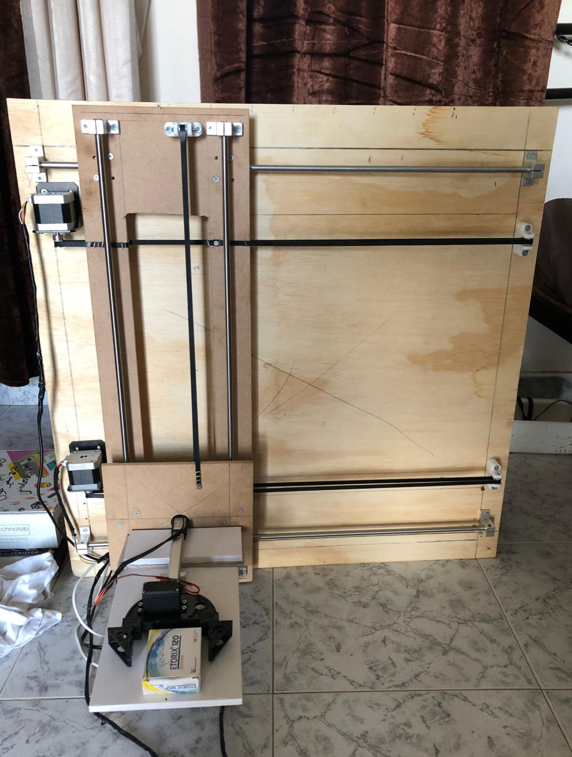

Figure 4.1: Mechanical Body

After we put everything in its place, as shown in the above figure, we began to work on the motors to ensure proper movement and so that there would be no mechanical problems that could disrupt us in the future, such as balance and weight distribution evenly so as not to cause vibrations that would sabotage the project. We also made sure that the arm was working properly, as well as the linear motion piece.
    - Parts
Item Name
Item Image
Quantity

timing belt 6mm width | 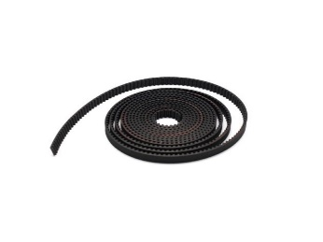 | 3m length
router motion slide | 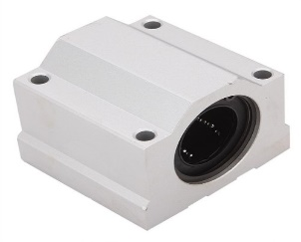 | 6
Stepper Motor | 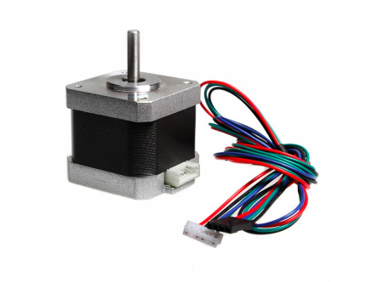 | 3
mounting bracket | 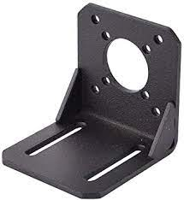 | 3
gt2 pulley 16 teeth 3mm | 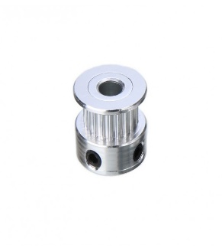 | 3

Table 4.1: Project Parts

Item Name
Item Image
Quantity

steel rod 8mm | 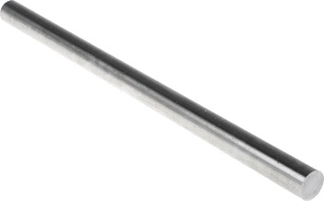 | length 3m
GT2_Timing_Belt_Idler_Pulley_ 16 teeth 3mm | 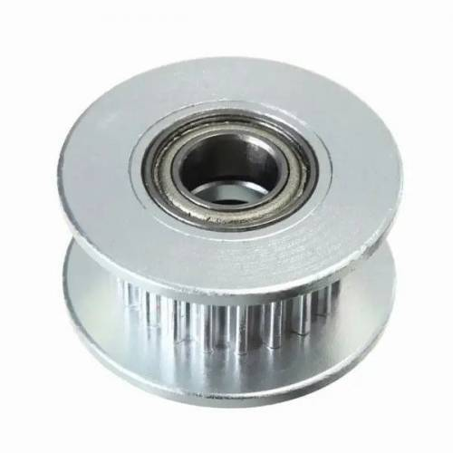 | 3
bearing rail shaft support | 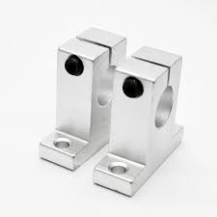 | 8
arm | 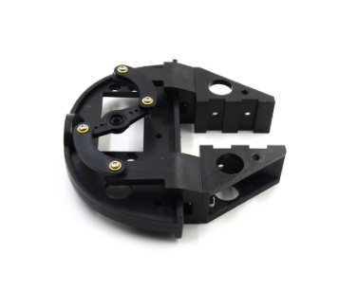 | 1
3d printer piece to catch pulley | 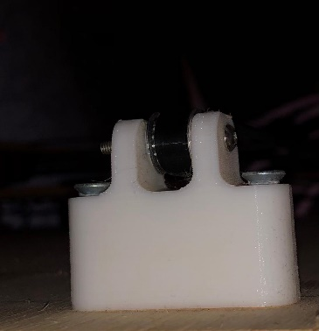 | 3

Table 4.2: Project Parts

Item Name
Item Image
Quantity

liner actuator 12v 100mm | 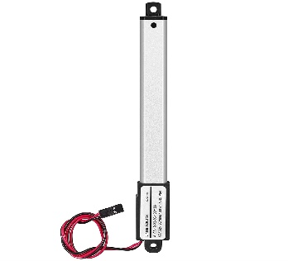 | 1
Printing machine to hold ultrasonic | 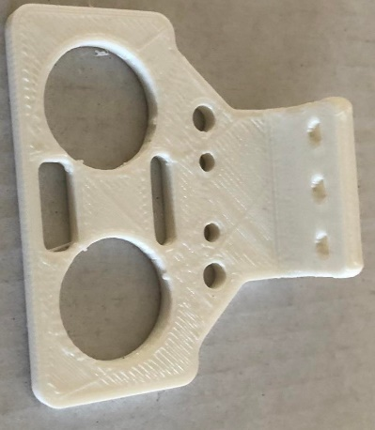 | 1
power supply 10A | 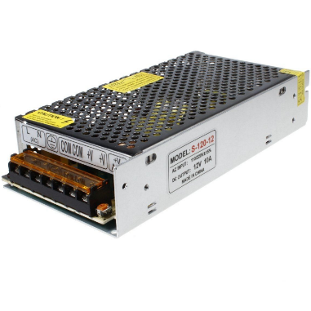 | 1

Table 4.3: Project Parts

  - Controller Part

The controller part is in charge of directing the mechanical part and powering it, and it is made up of Arduino mega:

    - Arduino
We have used the Arduino to control the process of running the motors, to unify some electrical signals and differentiate them from other motors, and to write the code needed to build the project. These are the electronic parts that we needed to run the electronic part of the project:

Parts

Item Name
Item Image
Quantity

Arduino mega 2560 | 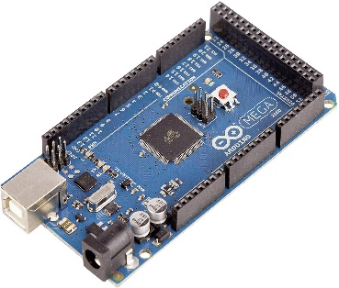 | 1
driver A4988 | 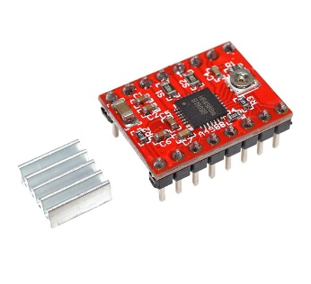 | 3
driver dc motor L298N | 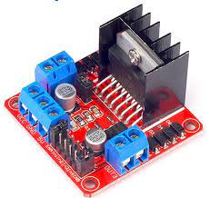 | 1
shield stepper driver 42ch | 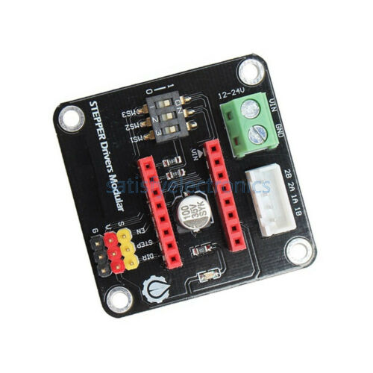 | 3
module cl4015  (12v-5v) | 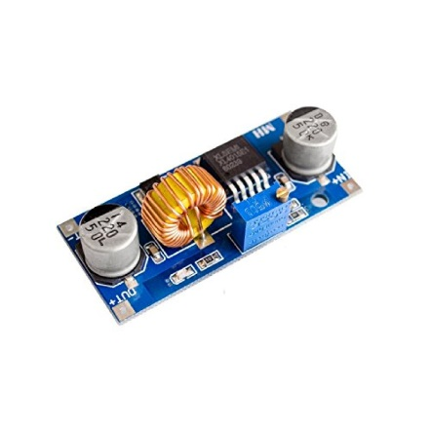 | 1
Ultrasonic  Sr-04 | 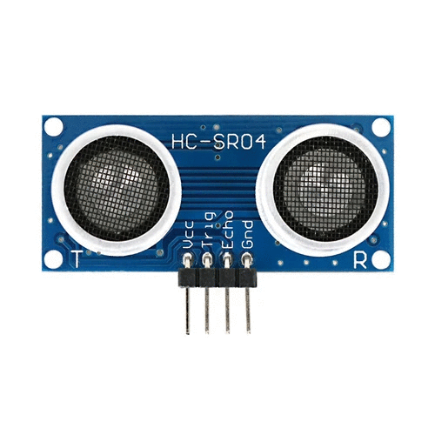 | 1
HC-06  Bluetooth | 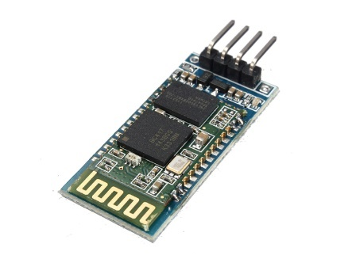 | 1
servo motor mg996r | 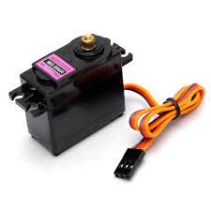 | 1
Bread board | 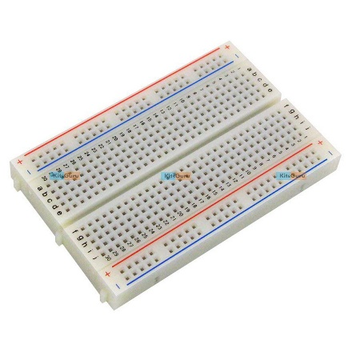 | 1
Basic wires | 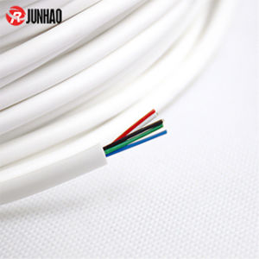
Wires  (female-male) | 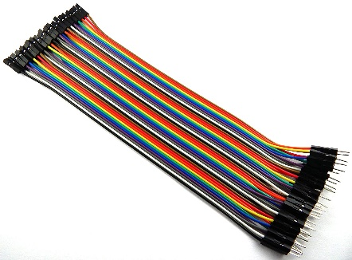

Table 4.4: Parts

Driving Motors

To control the motor, we must use a driver, and for that we used a 4988 driver. To make it easier for us to control with high accuracy, and to protect the motor.
we also used a special shield in that driver to facilitate the process of connecting with the motor and giving it sufficient voltage and to ensure high accuracy.
In order for us to connect the motor with the two-entry coil in the shield driver, where there are four entrances in the shield, especially to the coil, which are (1A,1B,2B,2A) which (1A,1B) mean the first coil, and (2B,2A) the second coil.
To determine the coil, through the wires coming out of the motor, we wrapped each two wires together, and then we twist the motor by hand. If we feel it is difficult to move the motor, these two wires represent a first coil and so on.
Also the shield has 2 input for power supply (12v), input for (step), input for (direction), input for enable, and input for (Vcc,Gnd)-(5v).
Below is a picture of the linking process:

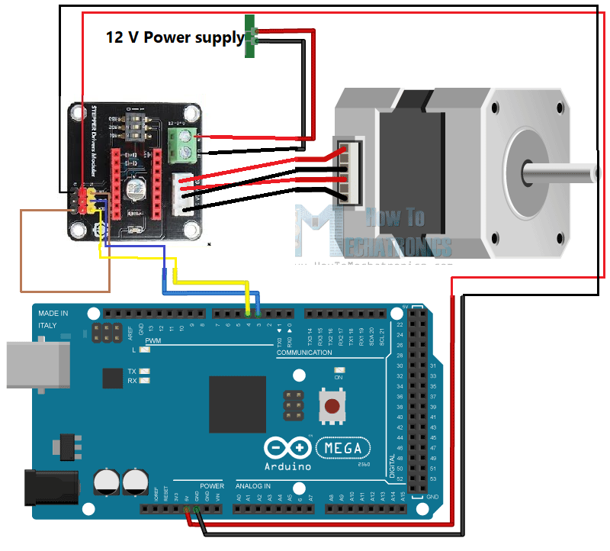

Figure 4.3: Driver Circuit

Moving Stepper motor:

After the connect wire process. through the code, I used the (Stepper.h) library, where this library enables me to create a special object for each motor.
Where this object takes the -Step per revolution that you have installed for all the motors (2500).

Then one of the motors was given a certain number of steps, which is 200 steps. Where the motor moved a quarter of a turn, and thus I was able to know the number of steps required to turn a full lap, which is 800.
In order to move rails, I must know the distance that the belt moves during one revolution.
I counted the number of teeth on the pulley, which is 16, and then I counted these teeth on the belt, and according to this process, the length of the belt for one roll is approximately 32 mm.
Then each 800 steps on motor gave me 32mm on belt.

Controlling The Servo motor

We connected the servo motor after looking at its data sheet.
where there are three wires outcome from it, the red represents (Vcc) and the brown represents (Gnd) this wire represent power supply needed to run that motor, which is (5v). And the orange represents (pwm) where it is connected to one of the Arduino outputs to give it the angles of the crisis.
Below is a picture of the linking process:

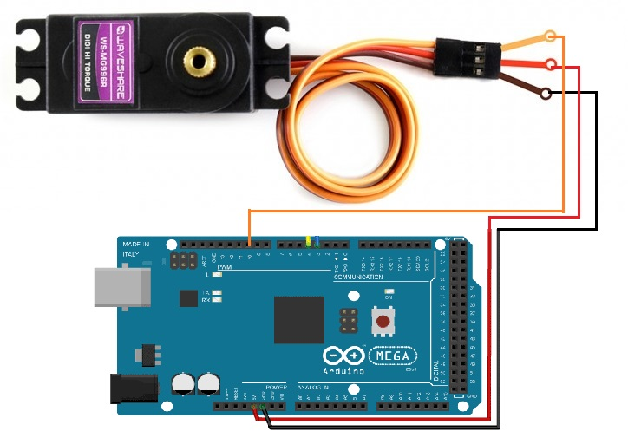
Figure 4.3: servo motor

Moving Servo motor:

We can access the Servo Motor. directly using (Servo.h) library
➔#include <Servo.h>
-we will use a some function the help us to read and write on Servo Motor :
Servo.attach(pin#): to detect which pin (10) is connected with Servo Motor
Servo.Write(angle): to give the angle value to the Servo Motor.

      - Additional features

Ultrasonic:

We want to put a sensor on one of the shelves as an additional feature in the project, and that was the following steps.
At first, we measured the height of the shelf and we measured the height of one unit of medicine, then we programmed the ultrasonic so that if the measured distance was 15 cm (the shelf is empty), he could not take medicine from the shelf because it was empty, and if it was 7 cm (the shelf was full) we could not add a new medicine, because it will be full, otherwise it can make in and out.

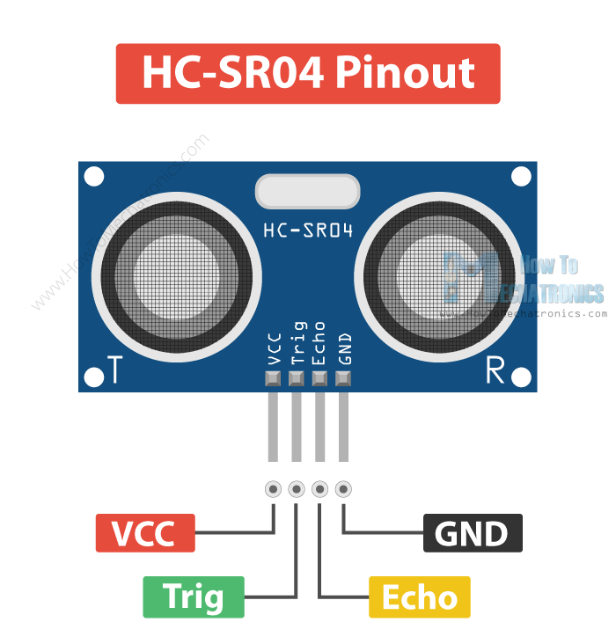

Figure 4.3: ultrasonic

We connect the GND and VCC from the module cl4015 to take 5 V fixed, and trig and echo to Arduino,
We made an object of an” New Ping “library “to attach echo and trigger, and used this object to get the value of the ultrasonic and program it in the code (which is the height of the shelf in current state).

HC_06 Bluetooth:

We used the Bluetooth as an additional feature to the project, to make input and output through the phone serially.

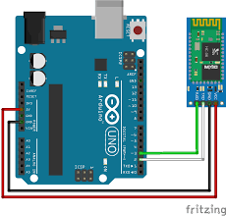
Figure 4.3: HC_06

Liner Actuator

We connected the Linear Actuator after looking at its data sheet.
In order to control the Linear Actuator, we must use a driver to give it a signal to exit and a signal to return.
Where two wires come out of the linear that are connect to the driver by (out1, out2).
And connect (in1, in2) to two Arduino output to give signal of linear by it.
Below is a picture of the linking process:

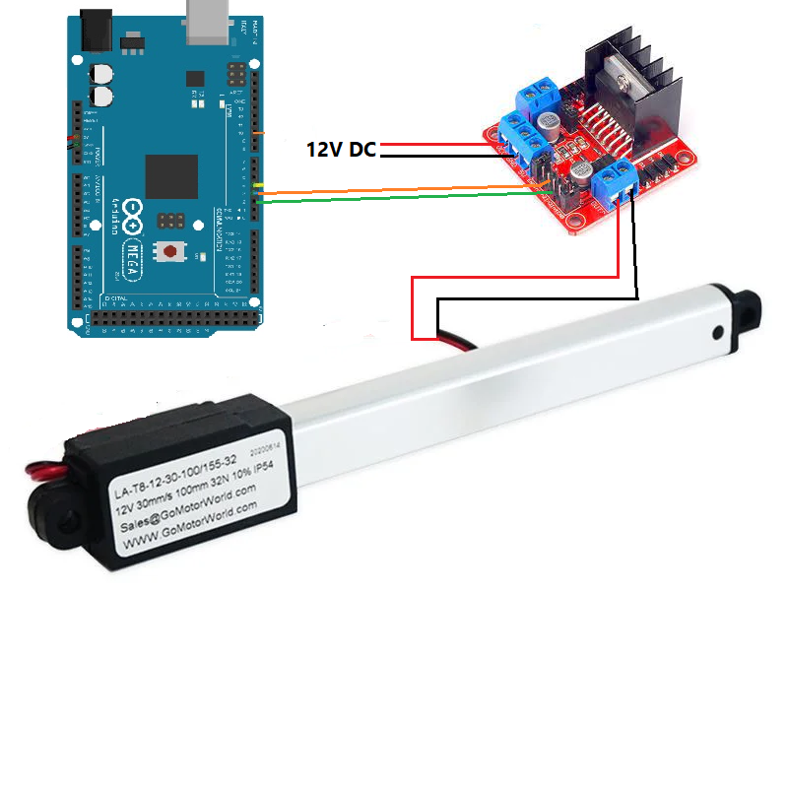
Figure 4.3: linear actuator

Moving Linear Actuator:

The linear move 8mm/s so we put (In1=high, in2=low) represent the linear start open (exit),
Then we put (In1=low, in2= high) represent the linear start close (return),
If we want to open 100mm so 100/8= 12.5 sec so put open mode and delay by (12.5 sec).

- Results And Problems Discussion

  - Drivers
There are many problems that we encountered in building the project, including the problem of drivers, and the problem was that if you touch the drivers with your finger and they are connected to electricity, the drivers are immediately burned, and this problem we faced a lot in the beginning and took us a long time to discover it.

  - Designing the Shelves
There was also a problem in how to design the shelves in a way that fit the arm smoothly in and out smoothly, and it took a while until we designed them appropriately

  - Gravity and Vibrations
We also added two motors to the X-axes movement, so that the moving arm is firmly fixed, and to end all the vibrations that occur, and these vibrations appeared when we flipped the model vertically, so there was the problem of gravity and imbalance, and here we added the two motors on the axis and we gave them the same signal So that they move at the same time, and in order not to break the rods.

  - Arm disconnects

At first, we connected the arm with the Arduino directly, and it worked sometimes and often made mistakes and disconnected while the device was working, due to the low voltage it received, which is less than 5 V.
That is why we purchased a module cl4015, and this module works to convert the voltage from 12 V to 5 V fixed, so we connected the module with the power supply, and we took the output and gave it to the arm, and this was enough to solve the problem completely.

  - Final Results
The end result is a fantastic project that works well in the majority of the scenarios we tested and meets all of our objectives.

Conclusion

Summery

We created a mechanical device with excellent capabilities that made difficult work simple. The project may require some improvements that we were unable to complete due to a lack of time, resources, or even knowledge, but the most important part is that we completed a working project with a lot of room for improvement, and we hope to do so in the future. Being a step in the right direction, and our long-term vision for this project is that it's the first in a series of projects to add to and improve upon.

Improvements

There is a need for some improvements by adding a new raspberry microcontroller in addition to the image proccing that needs a camera. We were able to know the size of the medicine on the shelf and open the servo angle more dynamically. We did not do this because of the lack of money and time,
There are also some vibrations in the CNC movement, which can be resolved by better fixing and tightening the pieces.

Future Work

As for future work, and if this project is implemented on a real and large level, you will need electronic parts that are stronger than the existing ones, we also need the algorithm to go on a complete trip by the device, and in one trip there are more than one input process and more than one output process.

The trip must take place properly and in the shortest way and as quickly as possible (and this shows its importance if the project is applied at the level of large warehouses or large libraries).
Ex: Algorithm is the shortest journey

Outcome

We have built an effective device that is convenient to use and can be applied in more than one place, you can use it in pharmacies, producing companies, libraries, supermarkets, and it is also easy to use for anyone and saves time, effort and accuracy.

Bibliography

Stepper motor datasheet and tutorial: https://components101.com/motors/nema17-stepper-motor
Linear actuator datasheet and tutorial: https://botland.store/linear-actuators/15478-linear-actuator-ld1-32n-30mms-12v-10cm-stroke-5904422343415.html
Servo motor datasheet: https://components101.com/motors/mg995-servo-motor
Driver A4988 datasheet: https://lastminuteengineers.com/a4988-stepper-motor-driver-arduino-tutorial/
Ch42_shield_driver:https://www.infineon.com/dgdl/Infineon-DC_Motor_Control_Shield_with_TLE94112EL_UserManual-UM-v01_00-EN.pdf?fileId=5546d46259d9a4bf015a4755351304ac
L298N dc motor driver: https://components101.com/modules/l293n-motor-driver-module

