An-Najah National University

Graduation Project

Supervisor:
PH. Marwan Mahmoud
Faculty of Engineering
Electrical Engineering Department


Prepared by : - Ahmad Yahya Odeh 10612002 Ashraf hamad 10509450

ABSTRACT

Single Phase Inverter

Using Microcontroller



In this project, a single phase inverter is implemented with hardware setup and software program in PIC-C code.
Inverters are used in a wide range of applications, from small switching power supplies in computers, to large electric utility applications that transport bulk power.
The main feature used in microcontroller is their peripherals to realize sinusoidal pulse width modulation (SPWM).
In this project, we designed the inverter in two ways the first way we use chopper (converter) in the circuit but unfortunately we facing problem Therefore, we have proposed an alternative solution is to use Transformer

Chapter (1)

Theoretical part

1.1 Why single phase inverter?

Because of the losses in the world backup fuels, the increasing demand of the electrical energy through the whole world, and the bad environmental effect of the fuels, the need for new or unused sources of energy became an interest of many governments and companies. This energy is called renewable energy.
Solar energy is an important type of renewable energy which can be used to produce electrical energy. The solar energy is inefficiently exploited. the importance of solar energy is that it’s free, clean and with very high potentials in the future. Photovoltaic systems (PV) are used to convert the solar energy into electrical energy using photovoltaic panels; this energy can be used into domestic electrical applications.
In this project, a stand alone photovoltaic system was designed with 24V batteries backup that can supply an electrical load. we designed the system to supply a 1000 watts load, but due to the high ratings of the 1000 watts load, the unavailability and high cost of the components, and for safety reasons, a 250 watts application system was designed and realized.

1.2 Solar energy system:
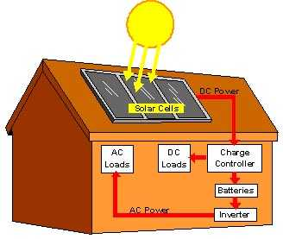
In general, the electric generating stations use all kind of fuel in order to produce the electric energy. this process pollutes the nature by smoking, for this reason scientific people study the using of the alternative energy (Renewable) in order to producing energy (such as solar, wind),this causes decreasing the pollution. The most common renewable energy using to produce electric energy is the solar energy because the sun may exist at each day.

Fig 1.1
Fig 1.1 represents the simple description for the solar energy system (converting from solar energy to electric energy).
1.2.1 Solar cell
Solar cells (which is called PV module) produce DC voltage at the terminal of
them which produce dc-current goes to converter dc output
current from converter goes to inverter which produce AC
current goes to AC load.
PV system can still produce electricity in cloudy day, because diffused radiation of sun light radiation.

Generally , the output power of one solar cell is very small , so connecting 40 solar cells to make Pv-modules (connection of series solar cells in one box) yields output power range from (10-150)w according to the kind of solar cell.
PV-array:
Connection of Pv-modules (series and parallel), you can making a tracking system (marking the sun light directly normally to the surface of Pv-array). this system moves Pv-array to make its surface normal to the sun light line.[1]
Note: Pv-array is designed according to the requirement load power.
Pv- array different characteristics according to the connection of Pv-modules. and we can see in fig 1-2 .the modules that give us the values that we need to our project .

Group B
Contain 5 modules

Group A
Contain 5 modules

Output 24V& 35A (which is max voltage and current)

Fig 1.2

1.2.2 Converter
It’s a designed circuit, the main aims of this circuit:
1- Converting from dc voltage to another dc-voltage level suitable to the input of inverter.
2- Protect the battery by preventing deep discharge and deep charge.
3- Charge controller.

1.2.3 Batteries
Battery is filled with charges to produce dc-voltage at the terminal of the battery cell. Connecting load at the terminal of the battery cell produce dc-current goes through the load.
Regular battery:
Connection of 6-battery cell in series to have VB= 12v.
C Ah output: Amperhoure capacity .this value shows the output current multiply by working hours, its constant value at full charging to the battery.[1]

1.2.4 Inverter
It is the most important circuit in the “Pv-system”, because it’s the major process, converts Dc-voltage to Ac-voltage and the most industrial load and house loads are operating under Ac-voltage. [1]

1.3 Inverter architectures

When designing an inverter there are three basic schemes to convert the fuel cell plus boost module's DC energy into AC. For example, this AC may then be fed into the grid or can be used for stand-alone operation of 230V appliances. (The European wall outlets give 230V, but there is no principle difference for the USA at 120V.)

1.3.1 First type inverter: step-up and chop

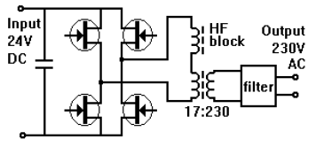

Fig (1.3) Circuit topology of a step-up and chop inverter
This type converts the low voltage into a high voltage first with a square-wave step-up converter and then converts the high-voltage DC into the wanted AC waveform. This is the architecture we chose for our inverter. Advantage of this architecture: insulation between input and output, easy dimensioning of the input converter, Efficiency may be up to 95% for square-wave, slightly lower for sinewave inverters.[2]

1.3.2 Second type inverter: High voltage in, only chop
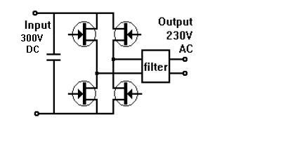

Fig (1.4) Circuit topology of a high voltage in and chop only inverter

This type requires the input voltage to be higher than the output voltage and converts it directly into the wanted AC waveform. The advantage of this is the high efficiency of the inverter, typical 96%. The main disadvantage is the lack of insulation between the solar modules and the grid voltages. Also the input voltages always require a large number of modules.[2]

1.3.3 Third type inverter: chop and transform
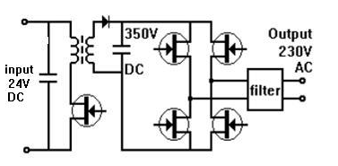

Fig (1.5) Circuit topology of a chop and transform inverter

This type converts the low voltage DC into a low voltage AC first and then converts the low-voltage AC into the wanted AC voltage. The advantages are the low-voltage (=safe) operation, the insulation from the grid after the inverter, the ease with which it makes sine-wave which feeds into the transformer and the most important in many aspects: reliability due to the low number of semiconductors in the power path. Disadvantage is the slightly lower efficiency of the inverter, typically 92%. Also some hum can be generated by the transformer under load. [2]

1.4 Output Waveforms
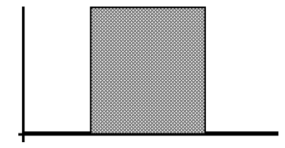
1.4.1 First waveform: square wave

Fig (1.6)
This is the form of the output voltage from a cheap inverter. Basically it switches its output on and off. This is no problem for heaters and light bulbs, but electronic equipment always has a power supply with a capacitor for energy storage. During the steep rise of voltage in a square-wave, the input current to charge the capacitor will destroy the power supply components.[2]

1.4.2 Second waveform: modified square wave
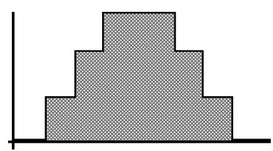

Fig (1.7)

To combat the problems with square wave there have been several changes, one is depicted here: the voltage rises in smaller steps, keeping the current more within rated limits and more closely approximating the sine wave form. Other approaches have added filters to square wave outputs, to make the rising and falling edge less steep (more trapezium-shape). Still electronic equipment will not work properly or get too hot on these types of signals.[2]

1.4.3 Third waveform: sine wave

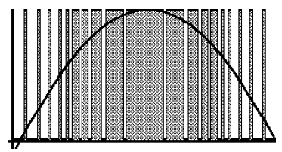

Fig (1.8)

The waveform shown here is a good approximation of a sine wave; all type of equipment will run on this signal. The sine wave is approximated by a high-frequency chopping plus filtering (note that the chopping frequency is much higher than depicted here for readability: typically 10 kHz). This chopping is also known as PWM (Pulse Width Modulation). This is the only waveform allowed to be grid-connected, when the inverter is capable of synchronization to the grid. On the other hand this type was produced in our project. [2]

1.5 Elements of the inverter:
The function of an inverter is to change a dc input voltage to asymmetrical Ac output voltage of desired magnitude and frequency. on the hand inverters are used in a wide range of applications, from small switching power supplies in computers, to large electric utility applications that transport bulk power. The inverter is so named because it performs the opposite function of a rectifier. a variable output voltage can be obtained by varying the input dc voltage and maintaining the gain of the inverter constant. On the other hand if the dc input voltage is fixed and it is not controllable, a variable output voltage can be obtained by varying the gain of the inverter, which is normally accomplished by pulse-width-modulation (PWM) control within the inverter .The inverter gain, may be defined as the ratio of the ac output voltage to dc input voltage. The output voltage waveforms of ideal inverters should be sinusoidal. However, the waveforms of practical inverters are non-sinusoidal and contain certain harmonics. For low-and medium-power applications, square-wave or quasi –square wave voltage may be acceptable; and for high power semiconductor devices, the harmonic contents of output voltage can be minimized or reduced significantly techniques. [3].
The inverter circuit divided in to three main parts which are:
1- Step up voltage.
- Dc to Dc voltage (Dc Chopper).
OR
- Ac to Ac voltage (transformer).
2- Transforming part from Dc to Ac (H Bridge of transistors).
3- Controlling part (using microcontroller to generate SPWM).
First before starting to explain the principle of the above points in our project we use the first method of step up voltage which is Dc Chopper. on the other hand the location of the converter from over all circuit it is the input of the circuit, but the second method of step up voltage which is the transformer and it is the output of the overall circuit which is transform the output of H bridge Ac voltage from level to another level.

1.5.1 Dc Chopper
The Dc Chopper which is boost converter, also known as the step-up converter, this converter produces an output voltage greater than the source. The ideal boost converter has the five basic components, namely a power semiconductor switch, a diode, an inductor, a capacitor and a PWM controller. The basic circuit of the boost converter is shown in Fig. 1.9

Fig (1.9)

There are two operation modes according to the inductor current; continuous operation mode and discontinuous mode. You can do these booster converters because you don't need a precision output and the current draw is mostly constant.
* In general:

The inductor and output capacitor is calculated below. The diode is a stander Schottkey type, but make sure you specify one that can handle the full voltage difference and peak current. The switch just has to be able to handle the max voltage plus some for safety. Note that this design is meant for 'static' output currents, not for variable current draw designs. There is no feedback and its very approximate! This is not for precision electronics!
The boost circuit works by connecting the power inductor L to ground that current can flow through it by turning on Q(Where Q is the IGBT transistor). After a little bit of time, we disconnect the L from ground (by turning off Q) this means that there is no longer a path for the current in L to flow to ground. When this happens, the voltage across the inductor increases (this is the electric property of inductors) and charges up C. When the voltage increases to the level we want, we turn on Q again which allows the current in L to flow back to ground. If we do this fast enough, and C large enough, the voltage on C is smoothed out and we get a nice steady high voltage.
The timing of turning off/on Q allows us to modify the output voltage. Normally there is a feedback resistor to the microcontroller but it is not here because we are running it open-loop. To drive Q we use the PWM output from the microcontroller and adjust the duty cycle to vary brightness. these sorts of designs can be easily made with a 555, once you have the PWM output, connect it up to Q! For this simple calculator, enter in the frequency, voltage ranges and current ranges and the duty cycle, inductor and current requirements will be displayed in practical part form our project!
Analysis of the circuit is carried out based on the following assumptions. The circuit is ideal. It means when the switch is ON, the drop across it is zero and the current through it is zero when it is open. The diode has zero voltages drop in the conducting state and zero current in the reverse-bias mode. The time delays in switching on and off the switch and the diode are assumed to be negligible. The inductor and the capacitor are assumed to be lossless.
- The responses in the circuit are periodic. It means especially that the inductor current is periodic. Its value at the start and end of a switching cycle is the same. The net increase in inductor current over a cycle is zero. If it is non-zero, it would mean that the average inductor current should either be gradually increasing or decreasing and then the inductor current is in a transient state and has not become periodic.
- It is assumed that the switch is made ON and OFF at a fixed frequency and let the period corresponding to the switching frequency be T. Given that the duty cycle is D, the switch is on for a period equal to DT, and the switch is off for a time interval equal to (1 - D)T.
- The inductor current is continuous and is greater than zero.
- The capacitor is relatively large. The RC time constant is so large, that the changes in capacitor voltage when the switch is ON or OFF can be neglected for calculating the change in inductor current and the average output voltage. The average output voltage is assumed to remain steady, excepting when the change in output voltage is calculated. The source voltage V_{S} remains constant.
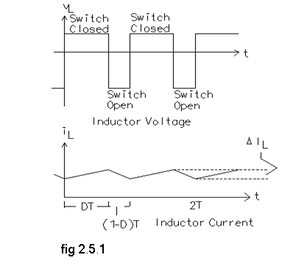
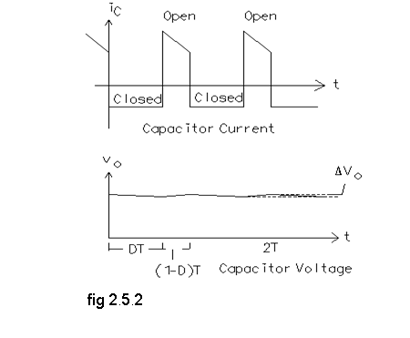
*general curves

Fig (1.10)

*the differences between the two main booster converters:

-In continuous conduction mode the inductor current never reaches zero but at the discontinuous conduction mode the inductor current reaches zero.
- The main problems of continuous operation mode is the instability and the high current value so we decided to design a discontinuous mode booster since discontinuous mode gives more flexibility in choosing the components values and requires less duty ratio to step the voltage to the same value compared with the continuous mode.

1.5.2 H Bridge inverter
The most common single-phase inverter is the H-Bridge inverter as shown in figure 1.11

Fig (1.11)

Since most loads contain inductance, feedback rectifiers or antiparallel diodes are often connected across each semiconductor switch to provide a path for the peak inductive load current when the semiconductor is turned off. The antiparallel diodes are somewhat similar to the freewheeling diodes used in AC/DC converter circuits. the H-bridge inverter consists of four choppers. When transistors T₁ and T₂ are turned on simultaneously, the input voltage V_{s} appears across the load. If transistors T₃ and T₄ are turned on at the same time, the voltage across the load is reversed and is -V_{s}. [4]
1.5.3 PIC Microcontroller
PIC microcontroller was used in this project to obtain the gate signal of the booster switch and to drive the inverter switches using SPWM. PIC 16F877 was used to generate the required signals. Figure (1.12) shows PIC 16F877 layout. Note that it has 40 pins with different functions.
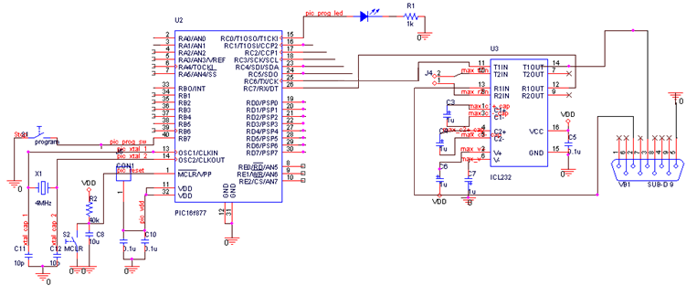
Fig (1.12) PIC Layout
Two PICs were programmed in order to drive the boosters and inverter switches. Program PIC C was used to write the PICs codes. The PICs codes are attached in appendix (A).
1.6 main characteristics of the inverter:

1.6.1 Sinewave inverters

As explained earlier, most DC-AC inverters deliver a modified sine wave. output voltage, because they convert the incoming DC into AC by using MOSFET transistors as electronic switches. This gives very high conversion efficiency, but the alternating pulses. output waveform is also relatively rich in harmonics. Some appliances are less than happy with such a supply waveform, however. examples include light dimmers, variable speed drills, sewing machine speed controls and some laser printers. Because of this, inverter manufacturers do make a small number of models which are designed to deliver a pure sinewave output. Generally speaking these inverters use rather more complex circuitry than the modified sine wave type, because its hard to produce a pure sinewave output while still converting the energy into AC efficiently. As a result pure sinewave inverters tend to be significantly more expensive, for the same output power rating. The most common type of pure sinewave inverter operates by first converting the low voltage DC into high voltage DC, using a high frequency DC-DC converter. It then uses a high frequency PWM system to convert the high voltage DC into chopped AC, which is passed through an L-C low pass filter to produce the final clean 50Hz sinewave output. This is like a high-voltage version of the single-bit digital to analog conversion process used in many CD players. [5]

1.6.2 Voltage spikes
Another complication of the fairly high harmonic content in the output of modified sine wave inverters is that appliances and tools with a fairly inductive load impedance can develop fairly high voltage spikes due to inductive - back EMF - These spikes can be transformed back into the H bridge, where they have the potential to damage the MOSFETs and their driving circuitry. It’s for this reason that many inverters have a pair of high-power zener diodes connected across the MOSFETs the zeners conduct heavily as soon as the voltage rises excessively, protecting the MOSFETs from damage. Or there are transistors with build in diode to protect from these back voltages. [5]

1.6.3 Capacitive loading

Actually there’s a different kind of problem with many kinds of fluorescent light assembly: not so much inductive loading, but capacitive loading. although a standard floury light assembly represents a very inductive load due to its ballast choke, most are designed to be operated from standard AC mains power. As a result they are often provided with a shunt capacitor designed to correct their power factor when they are connected to the mains and driven with a 50Hz sine wave. The problem is that when these lights are connected to a DC-AC inverter with its Modified sine wave output, rich in harmonics, the shunt capacitor doesn’t just correct the power factor, but drastically over corrects. because its impedance is much lower at the harmonic frequencies. As a result, the floury assembly draws a heavily capacitive load current, and can easily overload the inverter. In cases where fluorescent lights must be run from an inverter, and the lights are not going to be run from the mains again, usually the best solution is to either remove their power factor correction capacitors altogether or replace them with a much smaller value. [5]

1.6.4 Frequency stability

Although most appliances and tools designed for mains power can tolerate a small variation in supply frequency, they can malfunction, overheat or even be damaged if the frequency changes significantly. Examples are electromechanical timers, clocks with small synchronous motors, turntables in older. and many reel-to-reel tape recorders. to avoid such problems, most DC-AC inverters include circuitry to ensure that the inverter’s output frequency stays very close to the nominal mains frequency: 50Hz, or 60Hz. in some inverters this is achieved by using a quartz crystal oscillator and divider system to generate the master timing for the MOSFET drive pulses. Others simply use a fairly stable oscillator with R-C timing, fed via a voltage regulator to ensure that the oscillator frequency doesn’t change even if the battery voltage varies quite widely. in our project we programmed IC which is called PIC to give me SPWM with frequency 50Hz. [5]

1.6.5 Effect of Operating Temperature
The power output of an inverter is dramatically decreased as its internal temperature rises (this is sometimes called its 5, 10 & 30 minute rating; but in reality if the inverter cannot remove the heat quick enough, then the power will rapidly drop off). Many of our models are rated at a staggering 40°C, such as Prosine, with a classic comparison between a Pro sine 1000 and a low cost 1500watt modified as follows. The following chart provides a comparison between the Prosine 1000i rated at 40°C and a common 1500watt inverter rated at 25°C. [5]
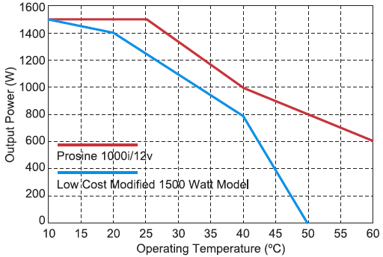

Fig(1.13)

1.6.6 Efficiency
It is not possible to convert power without losing some of it (it's like friction). Power is lost in the form of heat. Efficiency is the ratio of power out to power in, expressed as a percentage. If the efficiency is 90 percent, 10 percent of the power is lost in the inverter. The efficiency of an inverter varies with the load. Typically, it will be highest at about two thirds of the inverter's capacity. This is called its "peak efficiency." The inverter requires some power just to run itself, so the efficiency of a large inverter will below when running very small loads. in a typical home, there are many hours of the day when the electrical load is very low. Under these conditions, an inverter's efficiency may be around 50 percent or less. Because the efficiency varies with load, don't assume that an inverter with 93 percent peak efficiency is better than one with 85 percent peak efficiency. If the 85 percent efficient unit is more efficient at low power levels, it may waste less energy through the course of a typical day. [5]

Chapter (2)

Practical part

2.1 Design Description

2.2 Block Diagrams

Overall block diagram
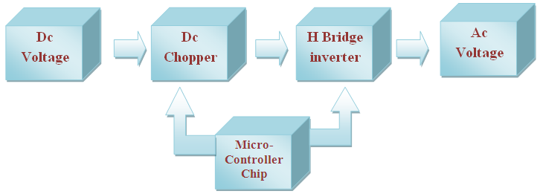

Algorithmic Block Diagram
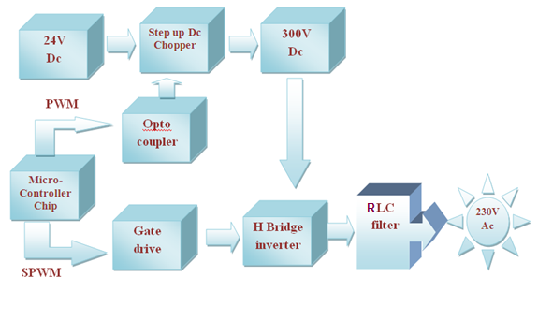

2.3 Full Circuit Preview
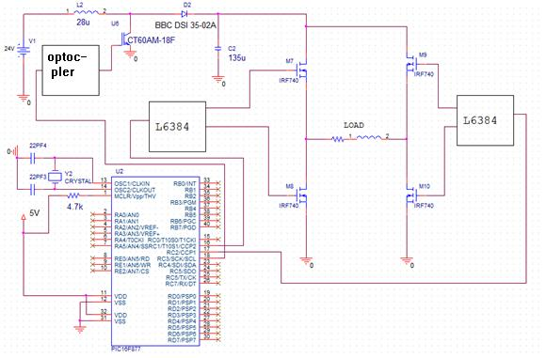

2.4 Hardware

DC chopper
A dc chopper is a dc-to-dc voltage converter that we used to step up voltage from 24V to 300v Dc.
The following circuit represents the circuit which we connected it practically.

Fig (2.1)

As we know there are two operation modes according to the inductor current, the equations of the discontinuous mode are different from the continuous mode equations:
Vo = Vi *(1 + (1+ (4D^2)/K) ^0.5)) / 2 ………………….. 2.1[6]

Where D is the duty ratio

D = Ton/Toff

And K = (2 * L)/ (R +Ts)

Where L: circuit’s inductor

Ts: 1 / switching frequency

To find the circuit’s capacitance we should determine the maximum current that can go through the load:

Iomax = Vo / R

C ≥ Iomax * (1- ((2* L) / (R * Ts)) ^0.5) / fs *ΔVo ……………………………2.2[6]

Requirements and specifications:

The required circuit must step up the voltage from 24V to 220Vrms, with ripple less than 1%. In this section a 250 watts booster was designed.

Booster’s design and components:
Choosing L = 28uH, f = 25000, Io max = 0.85A.
Substituting in (2.2), and trying multiple simulations, the best result was when
C = 135 uF,
D = 0.75.
Figure (2.2) shows the output voltage simulation in the boost converter.

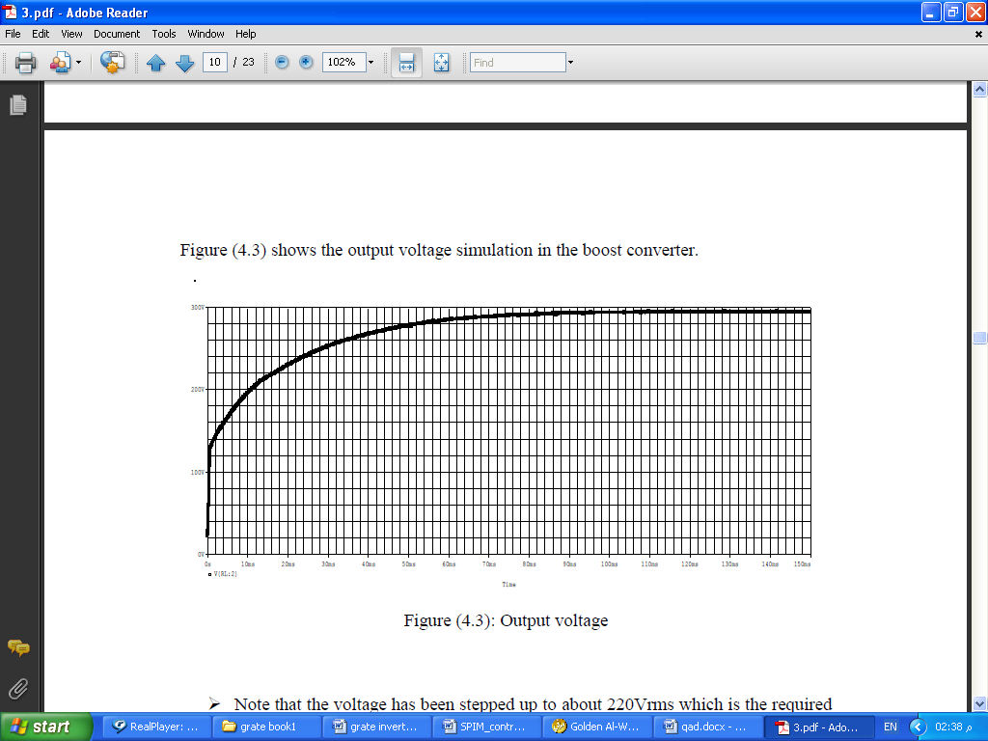

Fig (2.2)

The IGBT chosen was CT60AM-18F which can operate under the designed booster’s conditions. The CT60AM-18F has the datasheet shown in appendix (C).
The diode chosen was 40HFL diode, which can stand with the booster’s amperes and voltages. The pulse generator contains a pulse signal from PIC (0V – 5V), followed by inverter logic circuit to invert this signal (5V- 0V), followed by optocoupler in order to have a signal (0V -15V), because the IGBT triggering at 10V (at VGE) as a minimum voltage .C4X9 is the optocoupler .you can use a gate drive L6384 instead of the inverter logic circuit and the optocoupler. We used inverter logic circuit followed by the optocoupler.

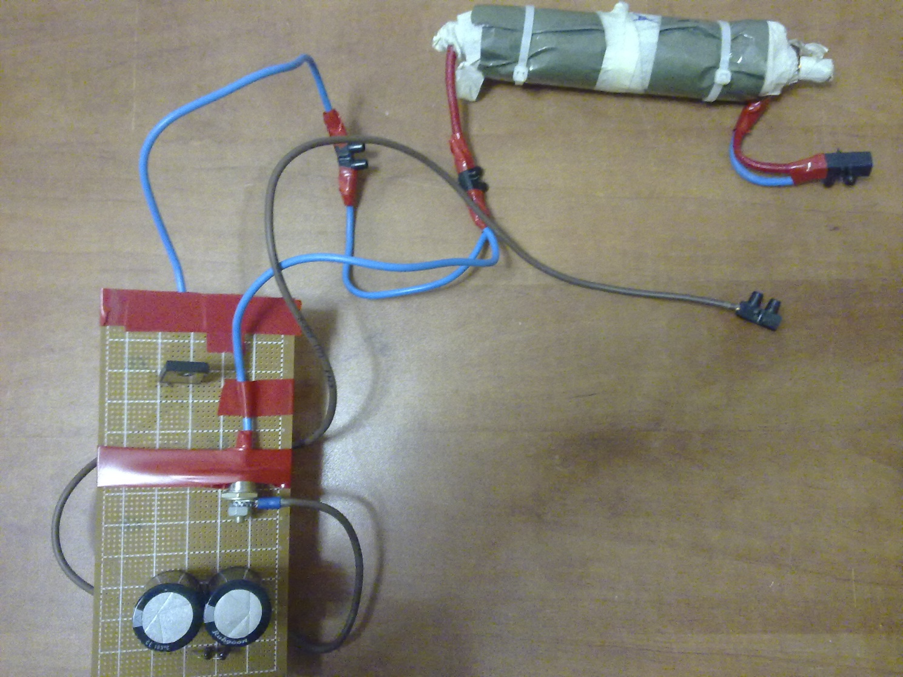
fig (2.3) converter practical

Optocoupler

To the IGBT transistor in the converter we need a frequency generator on an IGBT Gate. in our project we use a PIC microcontroller to generate such needed frequency, but the problem in PIC output signal is it’s maximum output is 5V which is very low to drive an power IGBT that need gate voltages in range (10-20)V. So we go toward isolator to generate like that voltage ranges, there are many types and we work on the following type.
Opto-coupler Isolator:
The general purpose optocouplers consist of a gallium arsenide infrared emitting diode driving a silicon phototransistor in a 4-pin dual in-
line. (we use here C4X9 optocoupler).the opto-coupler used to isolate between high voltage of the inverter and low voltage of the microcontroller, there are many situations where signals and data need to be transferred from one subsystem to another within a piece of electronics equipment ,or from piece of equipment to another, without making a direct ohmic electrical connection. Often this is because the source and destination are ( or maybe at times) at very different voltage levels, like a microcontroller which is operating on 5Vdc but being used to control power inverter which is switching 300Vdc.In such situation the link between the two must be an isolated one to protect the microcontroller from over voltage damage. we used Opto-coupler (C4X9) for isolating between the H bridge inverter gates and the PWM output from the PIC microcontroller.
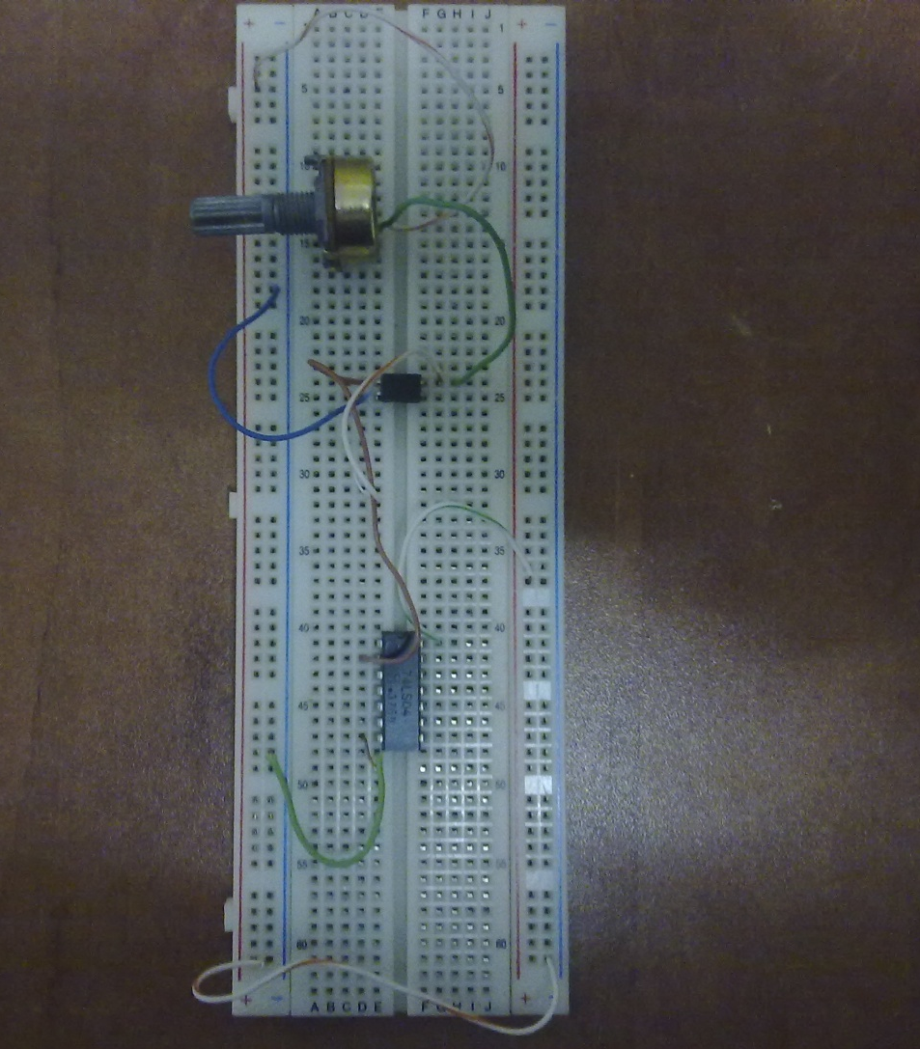

fig (2.4) practical optocoupler

H bridge inverter
H bridge inverter is used to convert DC voltage to AC voltage, and as we saw in theoretical part it consist from four mosfet transistors and we use (IRF740), on the other hand the data sheet of transistor in appendix(C). And the following fig shows the practical H Bridge that we designed it in our project.
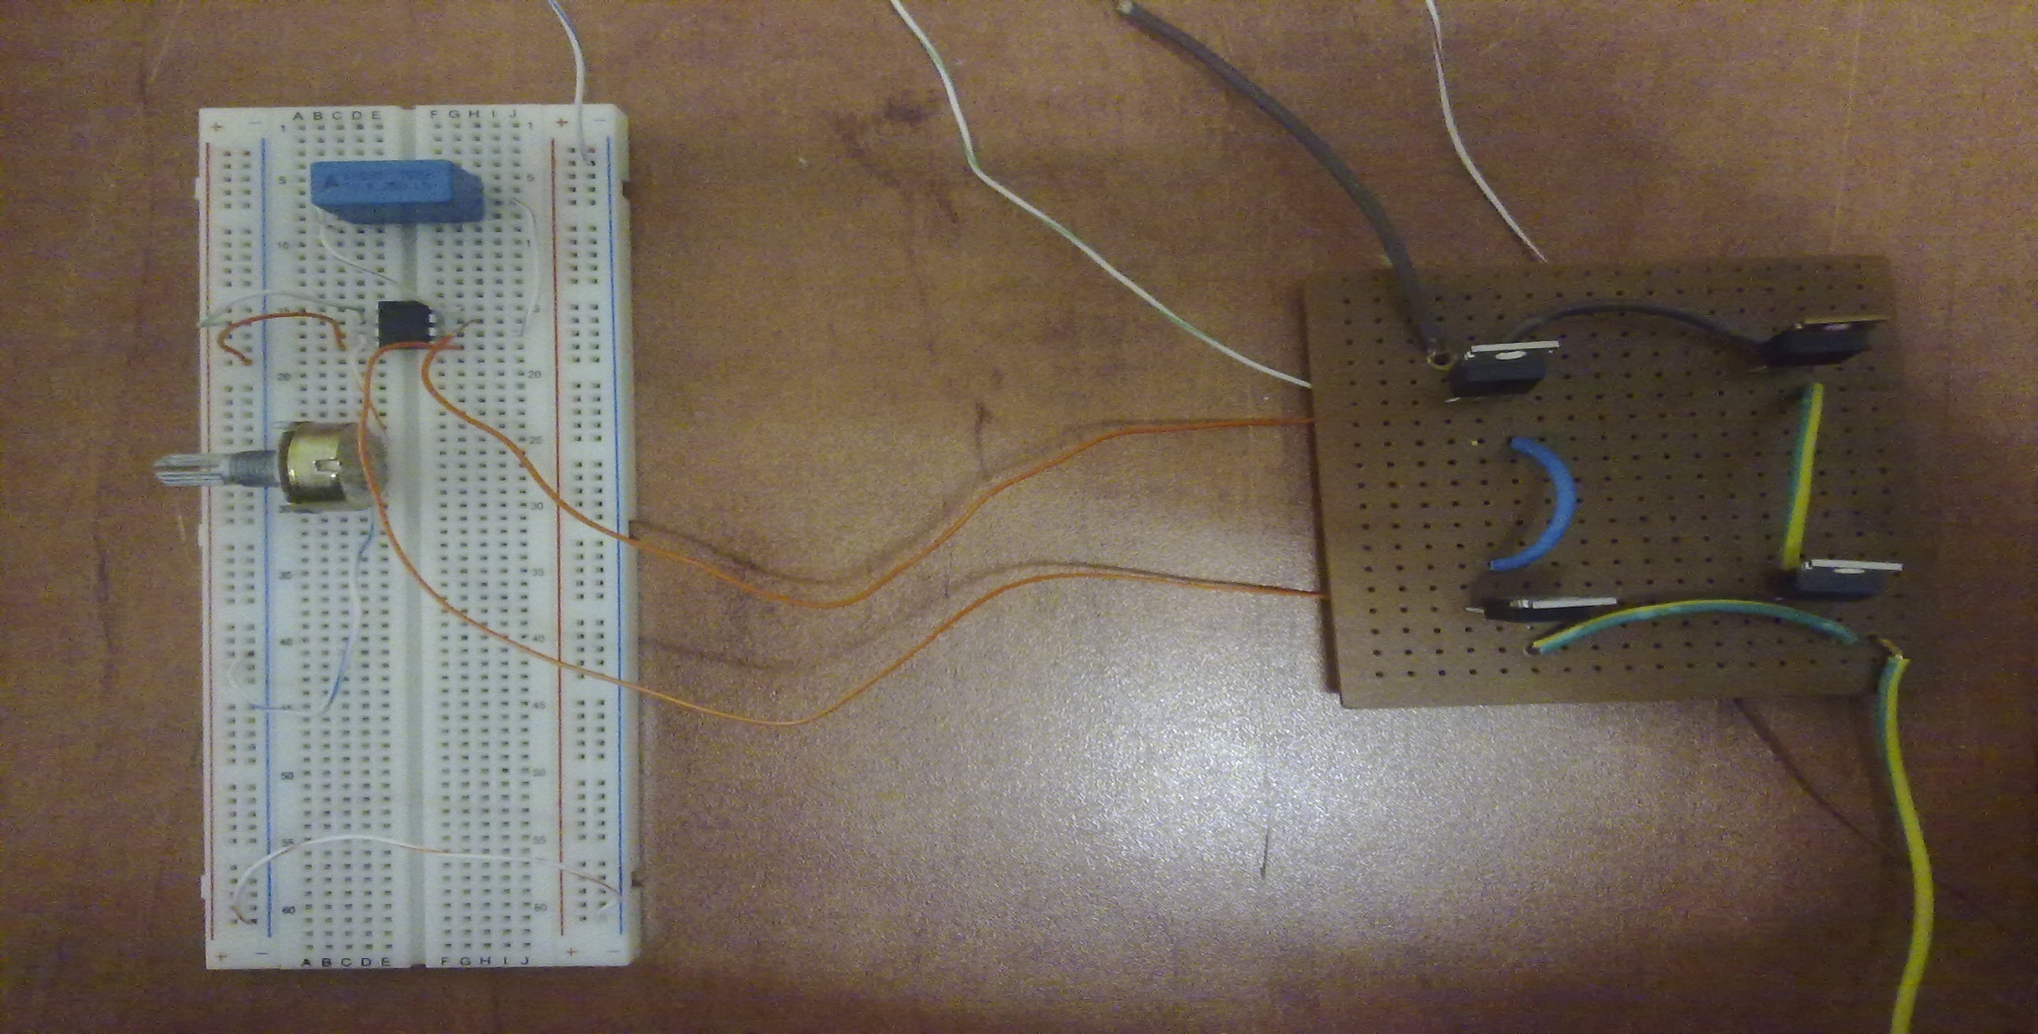

Fig (2.5) practical H Bridge

Gate drive
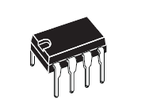
Gate drive is required to supply the switches such as IGBTs and MOSFETs with required voltages and currents since the PIC couldn’t supply the required values. Gate drive L6384 was chosen then to drive the required switches and it finally it worked by the date of writing this report, figure (2.6) shows the gate drive layout.
The Upper (Floating) Section is enabled to work with voltage Rail up to 600V. The Logic Inputs are CMOS/TTL compatible for ease of interfacing with controlling devices. Matched delays between Lower and Upper Section simplify high frequency operation. Dead time setting can be readily accomplished by means of an external resistor.
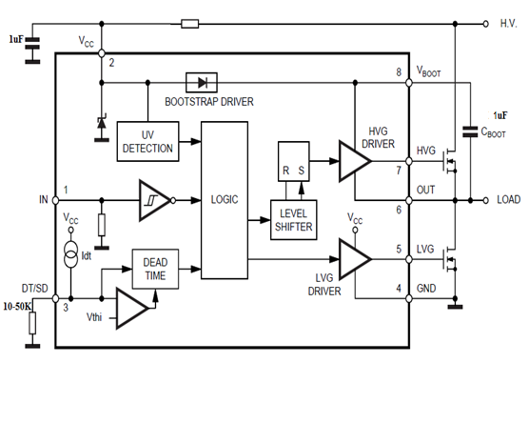

Fig (2.6)

As we can see in fig (2.6) the outputs of gate drive are the input of the gate transistors and pin 6 toward to the output (load) and that to add the voltage of the load to the voltage in the gate of upper transistor (pin 7),on the other hand this addition because VGS means (VG – VS ) which its the voltage that drive the transistor and this is the reason that we use this gate drive not optocoupler; to drive the gates of transistors.
To be more understand about the work of gate drive and to ensure that it work correctly we make an expiremant on this chip with half bridge transistor and we put the input voltage of the system is 20V(H.V. ) . the circuit and waveforms are shown below:
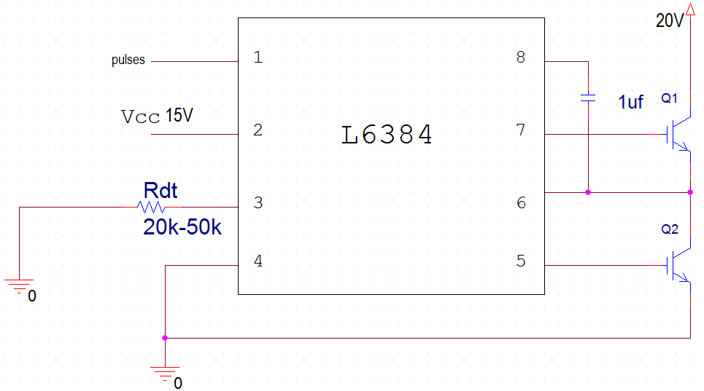
-The circuit of the experiment:
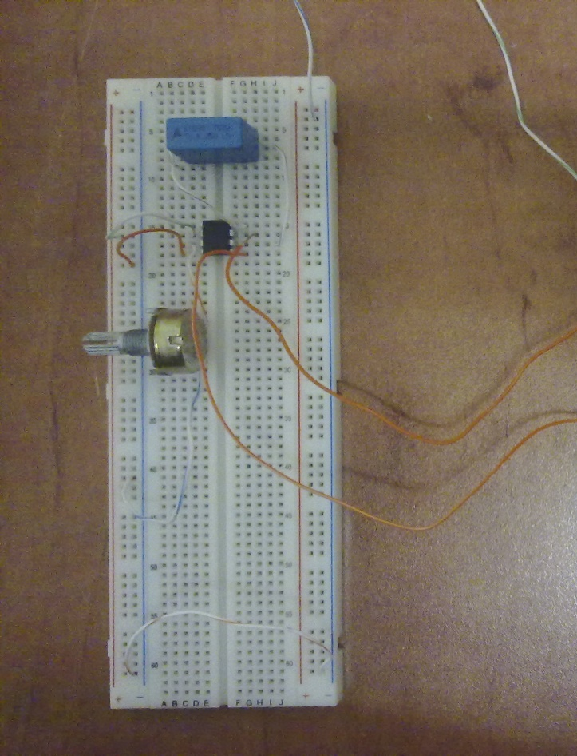

Fig 2.7

-Gate drive input: pulses with magnitude 5 V
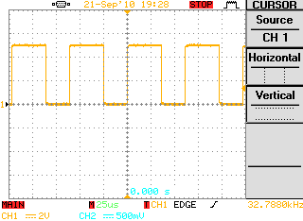

Fig 2.8

-Gate drive output: (on pin 6, note load voltage 20Vis the same H.V.)
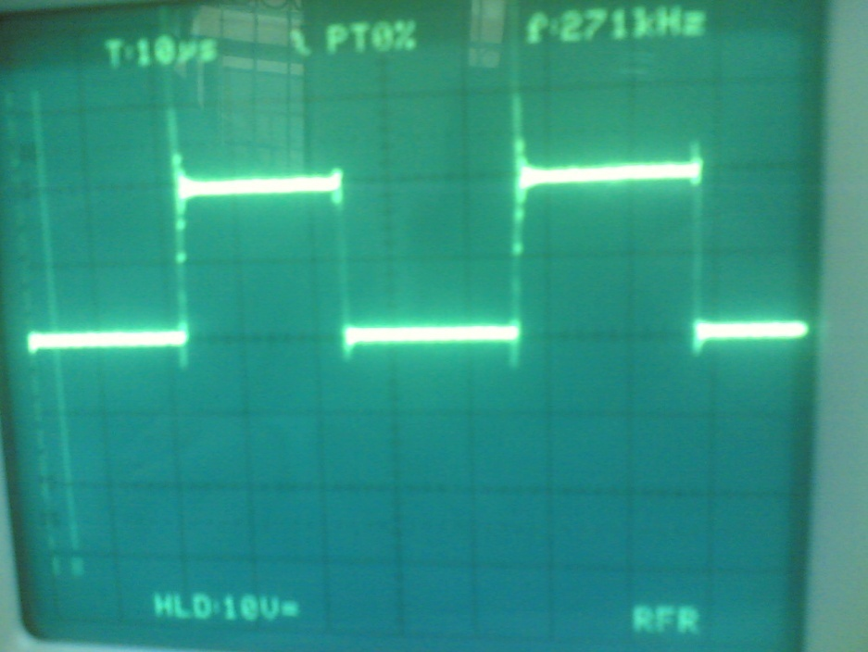

Fig 2.9
-Gate drive output: (on pin 7, note output voltage 35V which is load voltage + gate voltage)
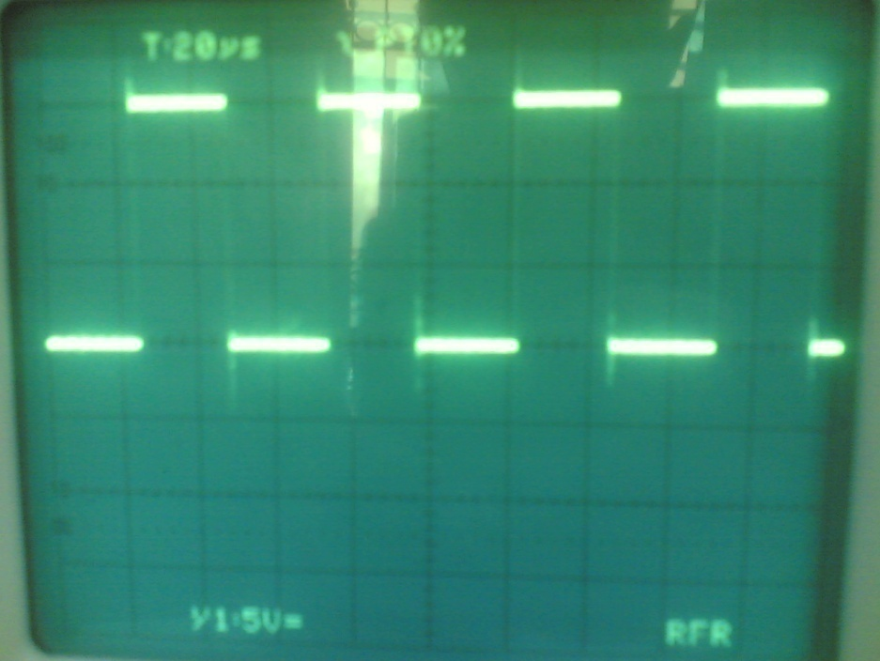

Fig (2.10)
-Gate drive output :( pin 5 which is 15V)
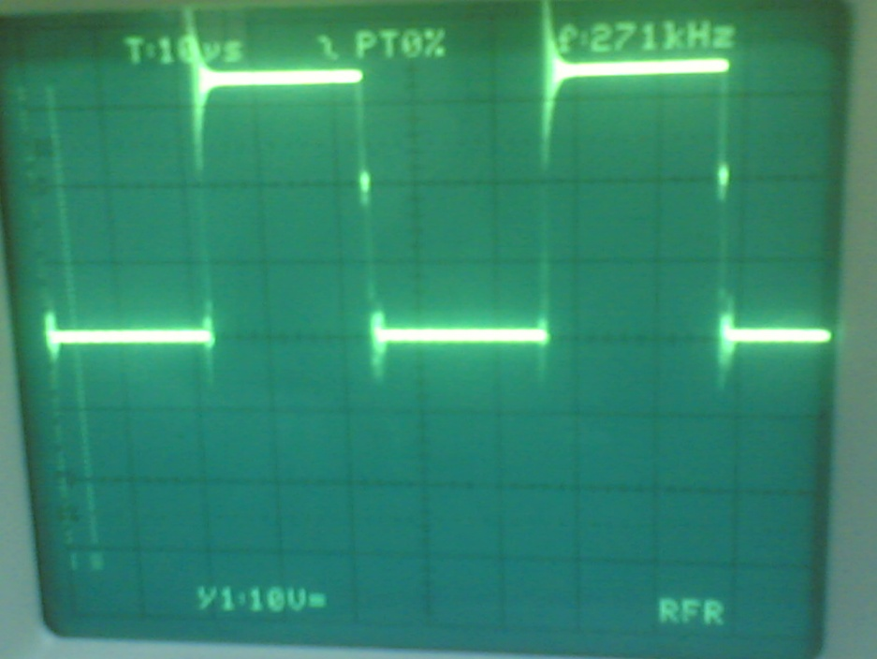

Fig 2.11

RLC Filter
The RLC filter is used to have an approximately sinewave at the output of H Bridge.
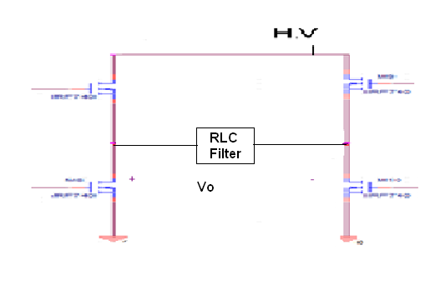

Fig 2.12 H Bridge with LPF

Where RCL circuit represents LPF see the following.
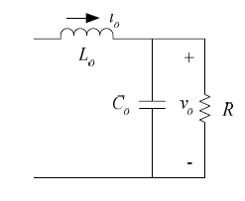

Fig 2.13

We design this LPF depending on the following points and equations:
-A second order RLC passive filter is used at the output stage.
-The cut-off frequency should be a little higher than 50Hz.
The cut-off frequency of a second order RLC filter is determined by the following equations:
$$\frac{Vo}{Vi}=\frac{R}{{\left(j*w\right)}^{2}*R*L*C+j*w*L+R}……………….. 2.3$$
$$\left|\frac{Vo}{Vi}\right|max=1…………………………………………………...2.4$$
At cut of frequency
$$\left|\frac{Vo}{Vi}\right|=\frac{1}{\sqrt{2}}………………………………………………………2.5$$

To solve fc apply the equation 2.5, see the following steps
$$\frac{R}{\sqrt{{\left(W*L\right)}^{2}+{\left(R-W^{2}*R*L*C\right)}^{2}}}=\frac{1}{\sqrt{2}}………………...2.6$$

So, $2*R²={\left(W*L\right)}^{2}+{\left(R-W^{2}*R*L*C\right)}^{2}$

$$let X=\sqrt{{\left(L^{2}-2*L*R*C\right)}^{2}+\left(4*R^{4}*L^{2}*C^{2}\right)}$$

Then,

$$W²=\frac{L^{2}-2*R*L*C+X}{2*R^{2}*L^{2}*C^{2}}……………………….2.7$$

And, $fc=\frac{W}{2*π}…………………………………………..…2.8$
So ,to have fc near 50HZ you must choose a special values for R ,L ,C .
Then we choose these values as follows R=8Ω, L=30mH, C=150µF.
Then $fc=60Hz$
2.6 Software design

Fig 2.14

After constructing the basic circuit of the PIC microcontroller 16F877,and programmed it we use port C ( pin RC1) to output pulses for converter and also port C ( pin RC1 & RC2 ) to SPWM for H bridge.

SPWM (sinusoidal pulse width modulation) signal generation
In this type of the modulation the control voltage (Vc) has a sinusoidal waveform. This control voltage is compared with a triangular waveform to obtain the gates signals of the inverter switches. the triangular waveform is maintained at constant amplitude (Vt) and its frequency called switching or carrier frequency. While the control voltage magnitude (Vc) could be varied to obtain different values of the modulation index, where the modulation index (M) is the ratio of Vc to Vt.

i.e. M= Vc/Vt
The fundamental frequency of the inverter equals the control voltage frequency. The frequency modulation index (mf) is defined as the ratio of the switching frequency (fs)
to fundamental frequency (f1).
i.e. mf = fc/f1

In this project bi-polar SPWM was used. In this type of modulation a single sinusoidal waveform is compared with a triangular. Figure (2.13) shows a bi-polar SPWM with modulation index of 0.7 and frequency modulation index of 10. Note that when VC >Vt then there is a positive voltage and when VC < Vt there is no voltage. So, this signal could be used as a gate signal for the inverter switch.

Fig 2.15
The designed inverter has a required output voltage is of 220Vrms and a frequency of 50Hz.
The output voltage of the inverter is specified in the equation (2.9).

Vo(t) = M*VDC*sin(wt) + harmonics ………………...…………………….(2.9)[6]

Since VDC is equal to 220Vrms, then choosing M to be 1 and using equation (2.9) results in an AC output with a magnitude of 220Vrms.

Hence, the required inverter is an inverter with a modulation index of 1, output voltage of 220Vrms, and a fundamental frequency of 50Hz. Also to eliminate the harmonics that above 50Hz we deigned RLC filter and it was connected after H Bridge.
Experimental results:
After programming the PICs; they were tested in order to show the output signals. Figure (2.16) shows the booster required signal which was generated by the PIC and displayed using the oscilloscope.
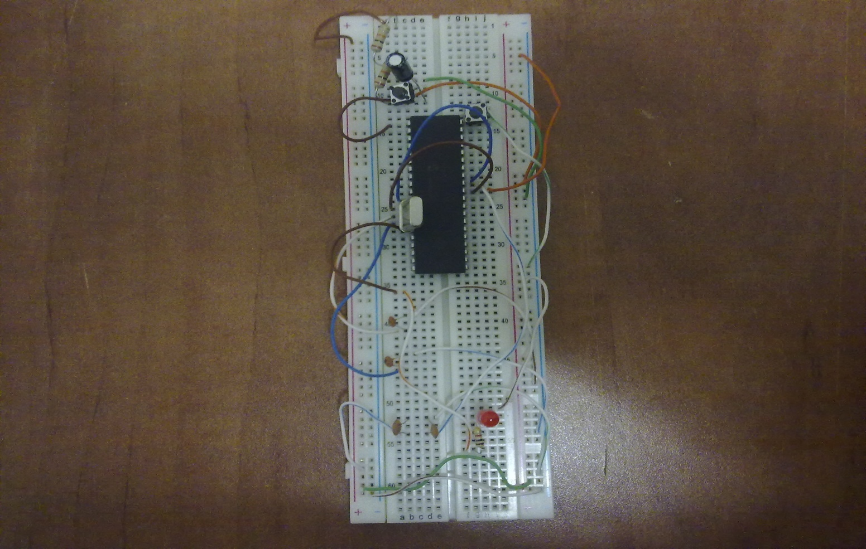

Fig 2.16

Figure (2.17) shows the generated pulses for converter:

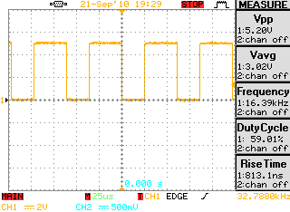

Fig (2.17): Booster switch gate signal

Figure (2.18) shows the generated SPWM signal to drive the inverter switches using the PIC.
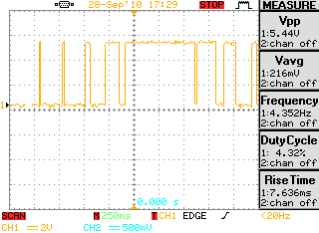

Fig (2.18)

Chapter (3)

Problems & Constraints


Problem #1

DC-Chopper:

After we finished connecting the booster circuit, we didn't find a dc supply having 30A as a maximum current because the peak current goes through the inductor reaches 30A according to the following analysis on MATLAP PROGRAM (shown in appendix (B) for the booster circuit, so we didn't test this circuit practically.

Solution:
Because we can't apply the booster converter practically, we thought about any alternatives that instead of using booster converter. So we using transformer.
How can you use the transformer?
- Now you have 24Vm (17Vrms) at the drain of the above mosfets in H Bridge, because the booster converter didn’t work practically .here you must use a special type of transformer at the output of H Bridge which is called a pulse transformer (step up voltage 17/220Vrms) . the following point increases your information about pulse transformer.
- A pulse transformer for use in a system which transmits digital signals in the form of pulses, e.g., an ISDN, is a wide-band transformer which is mainly intended for the waveform transmission. Pulse transformers are designed to maintain the input pulse waveform and power while transforming the source impedance to a value approximating the load impedance. In the field of electronic circuits, pulse electric technology such as digitization of electronic computers, pulse communication and measuring devices has been developed, and accordingly, there has been an increasing demand for circuit elements which exhibit a high performance in the wave-form transmission. Electrical pulse power systems are utilized in applications including infrared and radar pulse generating systems, microwave applications, and radiant energy systems, including arc lamps and lasers. A common and important application of pulse transformers is the coupling of a load resistance to a source of pulsed power. Radar transmitters, for instance, usually employ an output power tube such as a magnetron, which must be driven at a relatively high voltage and high impedance level. Like conventional transformers, pulse transformers typically consist of an input winding, an output winding, and a core structure of ferromagnetic material to transfer energy from the input winding to the corresponding output winding. Magnetic material is introduced in a special way into the central, concentric aperture of the primary and secondary windings, so that a completely transformative transducer is obtained. An electrical current flowing in the input winding creates a magnetomotive force which induces a flux flow in the ferromagnetic material. This change in flux in the magnetic circuit induces a current in the output winding and thereby effects the energy transfer.[7]
- At the secondary side of the pulse transformer you can put a LPF as shown in fig 2.13 we didn't use this way because we didn't find a pulse transformer in the shops and we didn't know how to built it .
- Now, if you put a LPF as shown in fig 2.12 → now you can use a conventional transformer (17/220V), at the secondary side put your load.

Problem #2

Gate drive

The problem in this chip not in its work but in if it is exist or not .the problem that we face it that we need two gate drive in our project but we find one chip in the market and the other we did not find it in our market so we are still wait, to now to get it from other country.

Problem #3

PIC microcontroller

That when we give the PIC microcontroller a command to take an output of driving square wave, we surprised with the result which is not in the same command, it give a percentage of error which increase with increasing the input frequency (i.e. when order the PIC microcontroller to give an output square wave with f=25 KHz, it give about 16 KHz).

Solution:

To solve this problem there are functions appear to you when you programming the pic and one of these function is a packet data for pulses (PWM) and in this packet you can put the frequency that you need not generation the frequency as we did.

Chapter (4)

The Cost

Device | number | Price for each one
Inductor(28mH) | 1 | 75 NIC
Capacitor (333µf) | 2 | 30 NIC
CT60AM IGBT | 1 | 65 NIC
40HFL diode | 1 | 40 NIC
Optocoupler | 1 | 10 NIC
Variable resister | 3 | 3 NIC
PIC | 2 | 40 NIC
Gate drive | 1 | 45 NIC
White board | 2 | 15 NIC
All small capacitors |  | 10 NIC
All small resistors |  | 10 NIC
Irf540 mosfets | 4 | 15 NIC

Total cost = 500 NIC

Chapter (5)

Conclusion and Recommendation

- Everyone knows that the university must do more technological projects, so the university managers and many teachers and students attend to do these projects.
- Our teacher told us to do a good inverter project, we accepted this and started working last year.
- We know by experiment that applying practical complex project is more different than learning theoretical courses.
- Applying any practical project needs more things such as studying with more concentration and thinking about your project.
- In other hand, many practical problems face you when you applying your project such as the lack of your components project in the market, and the components operating problems.
- Don’t forget the problem of high prices for some components.
- As advice, applying our project needs carefully using for all components. especially using the gate drive, and PIC.
- We hope that the university managers help the students in buying many suitable components that the students need it, and buying modern measuring devices.

Chapter (6)

Appendix

Appendix A

In this appendix we show the two PIC codes which we use them.
The PIC code that uses to have two SPWM signals as follows
#include <16f877a.h> //tells the compiler that we use PIC16F877A.
#device ADC=10 // using 16bit ADC converter.
#include<math.h> // library (math.h) is added
#fuses HS,NOWDT,NOPROTECT
#use delay(clock=20000000) // high speed clock 20MHz.
signed int triangular[20]= {-10,-8,-6,-4,-2,0,2,4,6,8,10,8,6,4,2,0,-2,-4,-6,-8}; // defined values for the triangular signals
double s,tr;
int h=0;
int n=0;
void main() {
set_tris_a(0x0F);
set_tris_b(0x0F);
set_tris_c(0x00);
set_tris_d(0x00);
while(1){
output_high(PIN_C3);
s=10.0*sin((double)pi*h/90.0); // defining sinusoidal signal with a magnitude of 10, so the modulation index will be equal to 1. To get modulation index of 0.7, this signal magnitude must be 7.0.
tr= triangular[n];
if(s>tr) { // comparing the sinusoidal signal with the triangular one
output_high(PIN_C1);
output_low(PIN_C2); // used for generating complement signal
}
else {
output_low(PIN_C1);
output_high(PIN_C2);
}
delay_us(111);
if(n==19){
n=1;
}
if(h==179){
h=0;
}
n++;
h++;
}
}

The PIC code that uses as an input signal for the IGBT in the booster converter
#include <16f877a.h> //tells the compiler that we use PIC16F877A.
#device ADC=10 // using 16bit ADC converter.
#fuses HS,NOWDT,NOPROTECT
#use delay(clock=20000000) // high speed clock 20MHz (oscillator).
void main() {
set_tris_a(0x0F); // Set 4 pins of port A as inputs
set_tris_b(0x00); // Set port B as output
set_tris_c(0x00); // Set port C as output
set_tris_d(0x00); // Set port D as output
while(1) { // Use infinite loop
output_high(PIN_C3); // Pin C3 is on (used to insure that the PIC is operating)
output_high(PIN_C1); // Turn on Pin C3
delay_us(30); // Pin C1 is on for 30us.
output_low(PIN_C1); // Turn off pin C1
delay_us(10); // Pin C1 is off for 10us
}
}

Appendix B
This appendix shows the matlab analyses for our practical circuits
1-booster converter output

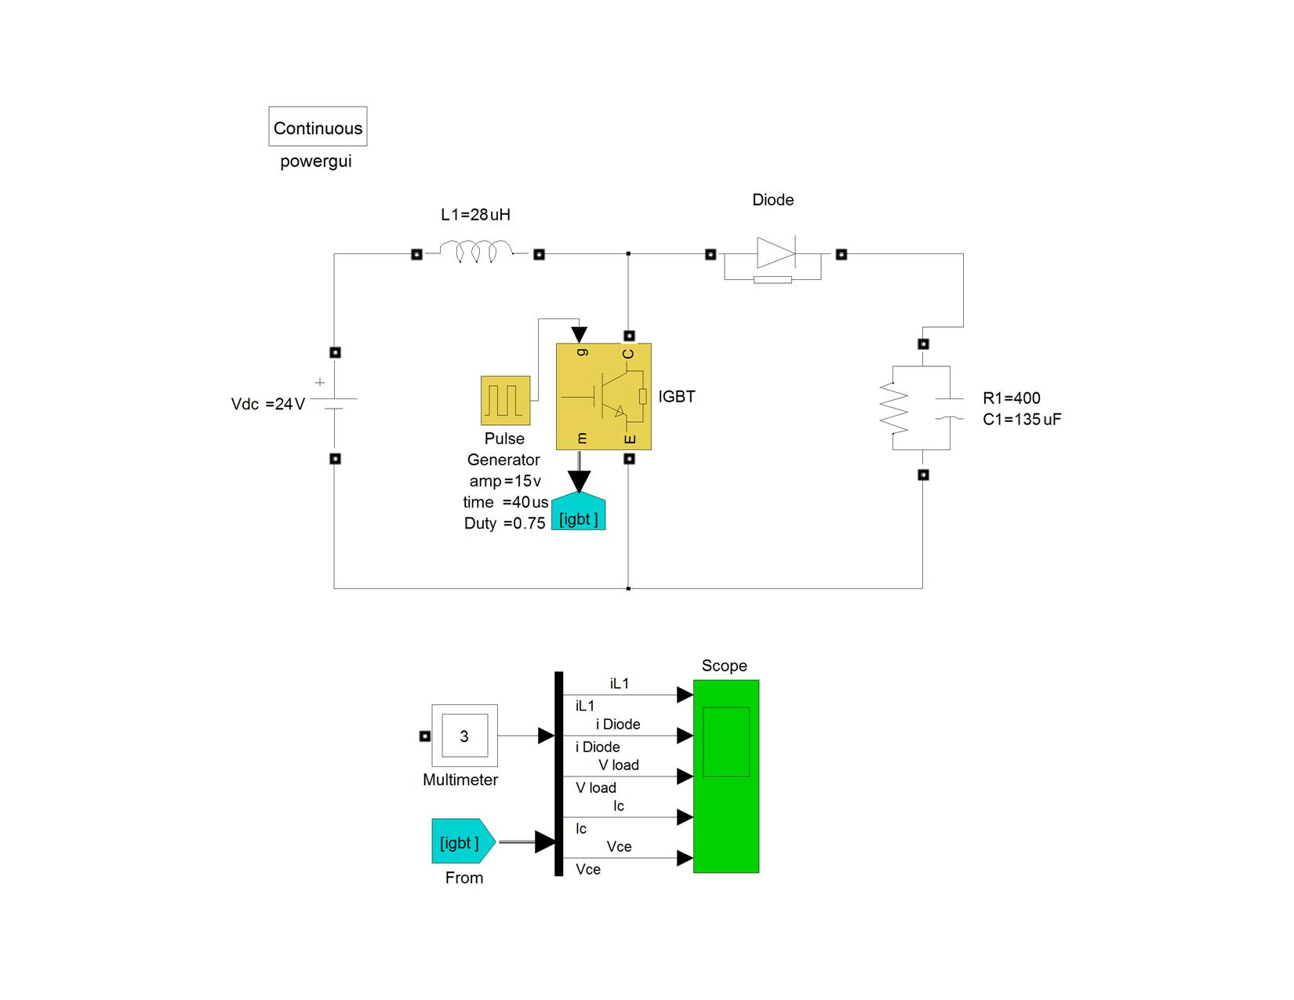

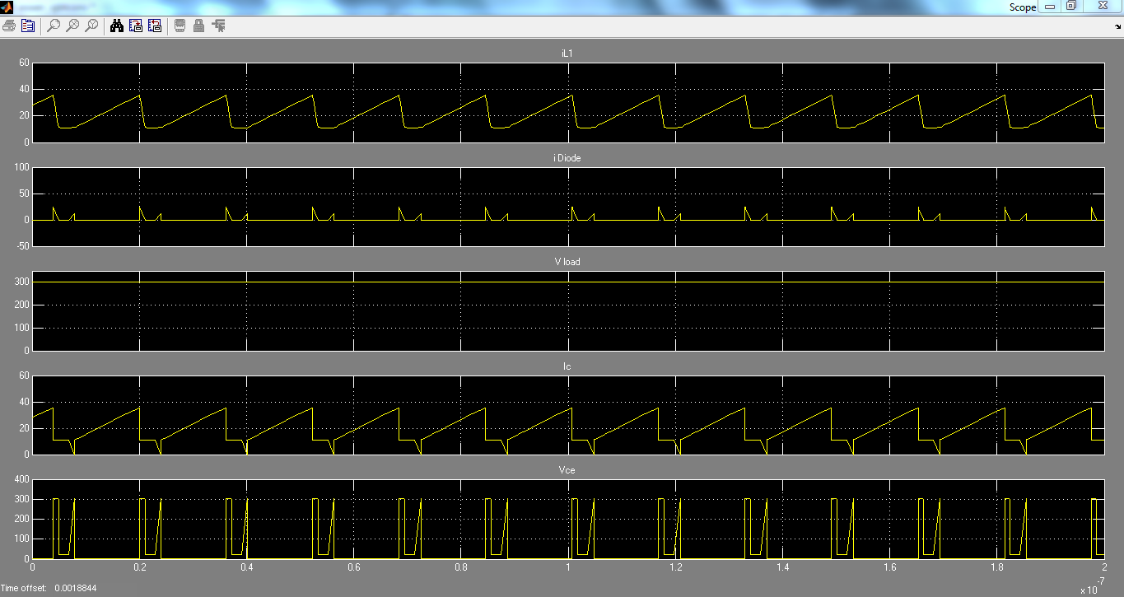
Fig (6.1)
2-H Bridge output without LPF:
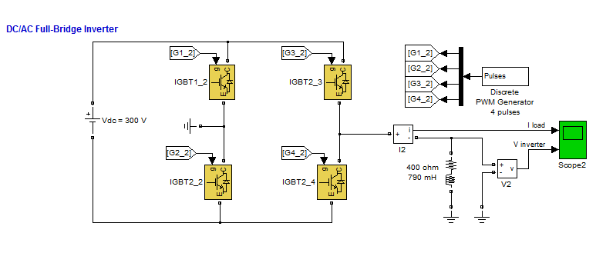

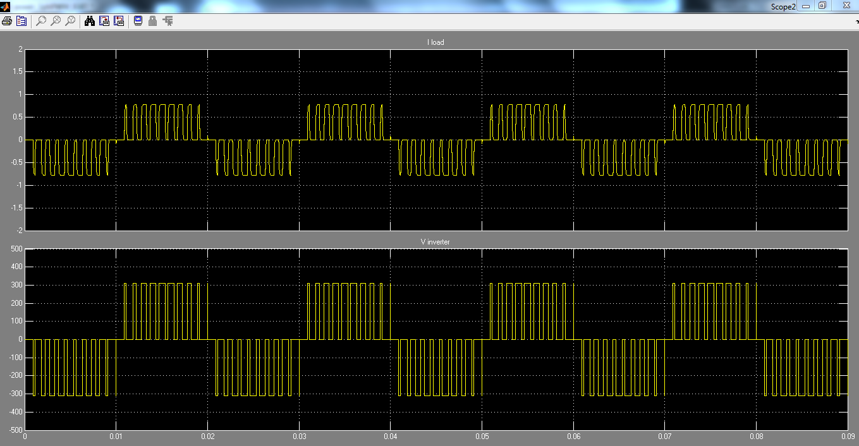
Fig 6.2

3- H Bridge with RLC FILTER
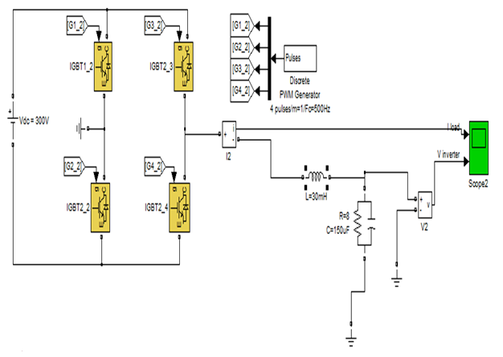

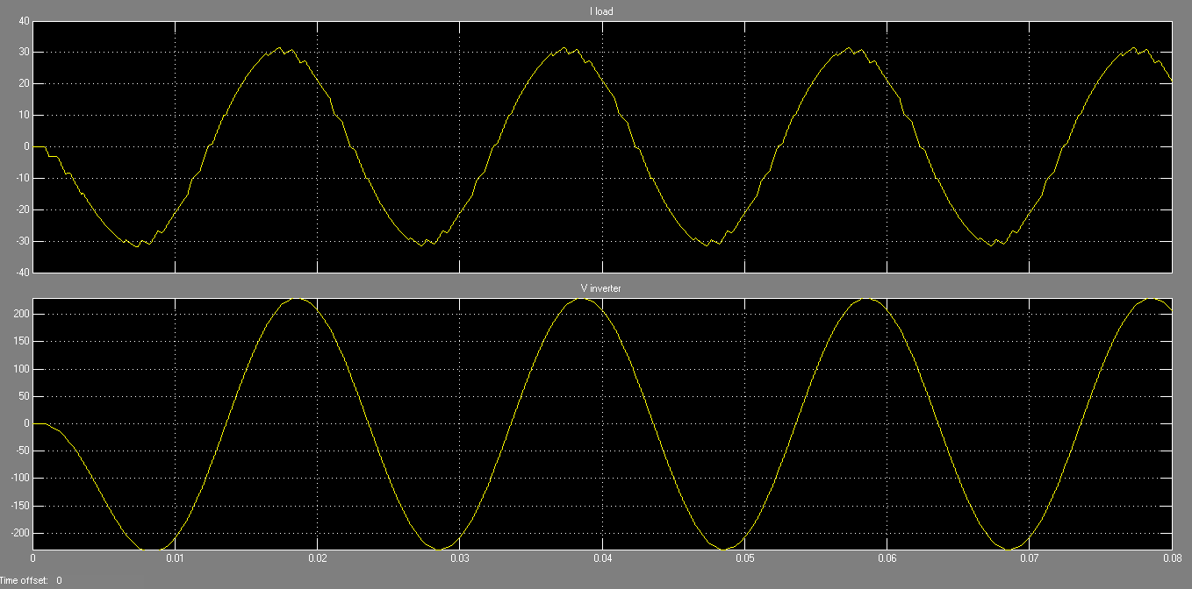
Fig 6.3

Appendix c
This appendix talks about the datasheets for all components in this project .
*CT60AM 18F IGBT :
- General datasheet
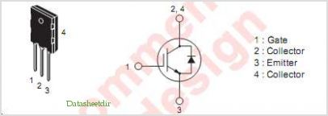
Fig 6.4 data sheet for CT60AM 18F
- Genaral characteristics
• VCES ............................................................................... 900V
• IC .........................................................................................60A
• Integrated Fast-recovery diode
• Small tail loss
• Low VCE(sat)
- APPLICATION
Microwave oven, Electromagnetic cooking devices, Rice-cookers.
- Main characteristic table

Symbol | Parameter | Conditions | Ratings | Unit
VCES | Collector-Emitter Voltage | VGE = 0V | 900 | V
VGES | Gate-Emitter Voltage |  | ±25 | V
VGEM | Peak Gate-Emitter Voltage |  | ±30 | V
IC | Collector Current |  | 60 | A
ICM | Collector Current (Pulse |  | 120 | A
IE | Emitter Current |  | 40 | A
PC | Maximum Power Dissipation |  | 180 | W
Tj | Junction Temperature |  | –40 ~ +150 | °C
Tstg | Storage Temperature |  | –40 ~ +150 | °C

Fig 6.5 main characteristic table for CT60AM 18F
- Operating curves
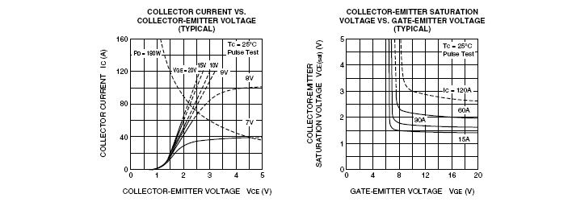
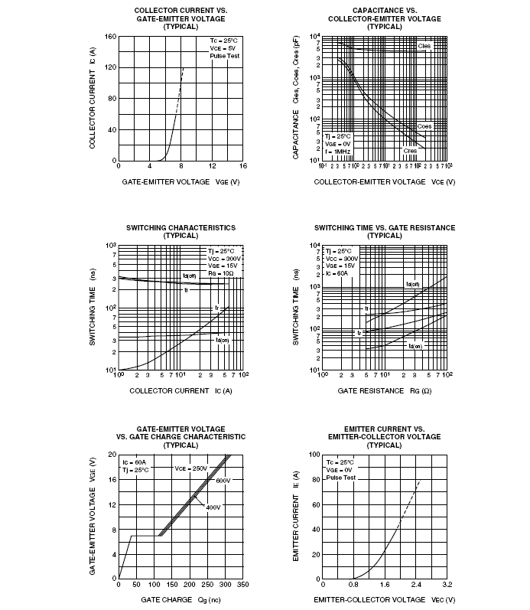
Fig 6.6 operating curves for CT60AM 18F
PC8171xNSZ0F Series OPTOCOUPLER:
- DISCRIPTION
PC8171xNSZ0F Series contains an IRED optically
coupled to a phototransistor.
It is packaged in a 4pin DIP, available in SMT gullwing
lead-form option.
Input-output isolation voltage(rms) is 5.0kV.
Collector-emitter voltage is 80V, CTR is 100% to
600% at input current of 0.5mA and CMR is MIN.
- APPLICATION
1. Programmable controllers
2. Facsimiles
3. Telephones
- FEATURES
1. 4pin DIP package
2. Double transfer mold package (Ideal for Flow Soldering)
3. Low input current type (IF=0.5mA)
4. High collector-emitter voltage(VCEO : 80V)
5. High noise immunity due to high common rejection
voltage (CMR : MIN. 10kV/μs)
6. High isolation voltage between input and output
(Viso(rms) : 5.0 kV)
7. Lead-free and RoHS directive compliant
- INTERNAL CONNECTION DAIGRAM
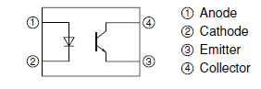
Fig 6.7 internal connection diagram for optocoupler
- ABSOLUTE MAXIMUM RATING
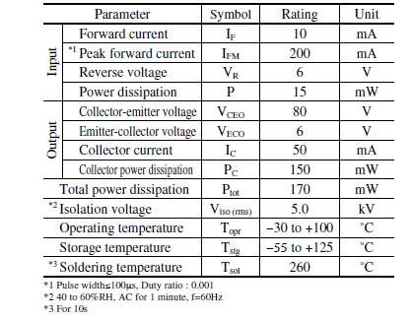
Fig 6.8 maximum values table for optocoubler
- ELECTRO – OPTICAL CHARACTEREISTIC
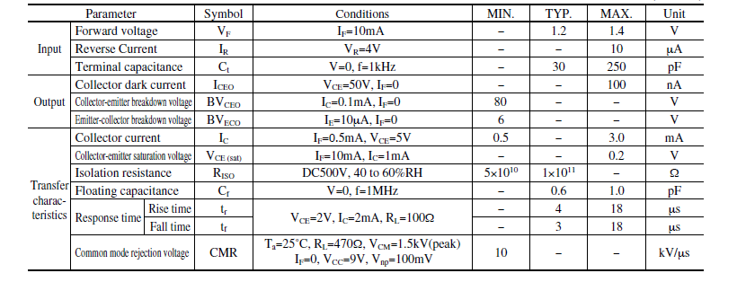
Fig 6.9 electro-optical characteristics table for optocoubler
- GENERAL CONNECTION CIRCUIT
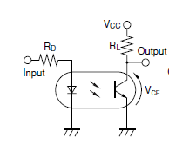
Fig 6.10 general connection circuit for optocoubler
* L6384 GATE DRIVE :
- DISCRIPTION
The L6384 is an high-voltage device. It has an Half - Bridge Driver structure that enables to drive N Channel Power MOS or IGBT. The Upper (Floating) Section is enabled to work with voltage Rail up to 600V. The Logic Inputs are CMOS/TTL compatible for ease of interfacing with controlling devices. Matched delays between Lower and Upper Section simplify high frequency operation. Dead time setting can be readily accomplished by means of an external resistor.

- General characteristics
HIGH VOLTAGE RAIL UP TO 600 V
- dV/dt IMMUNITY +- 50 V/nsec IN FULL TEMPERATURE RANGE
- DRIVER CURRENT CAPABILITY:
400 mA SOURCE,
650 mA SINK
- SWITCHING TIMES 50/30 nsec RISE/FALL WITH 1nF LOAD
- CMOS/TTL SCHMITT TRIGGER INPUTS WITH HYSTERESIS AND PULL DOWN
- SHUT DOWN INPUT
- DEAD TIME SETTING
- UNDER VOLTAGE LOCK OUT
- INTEGRATED BOOTSTRAP DIODE
- CLAMPING ON Vcc
- SO8/MINIDIP PACKAGES

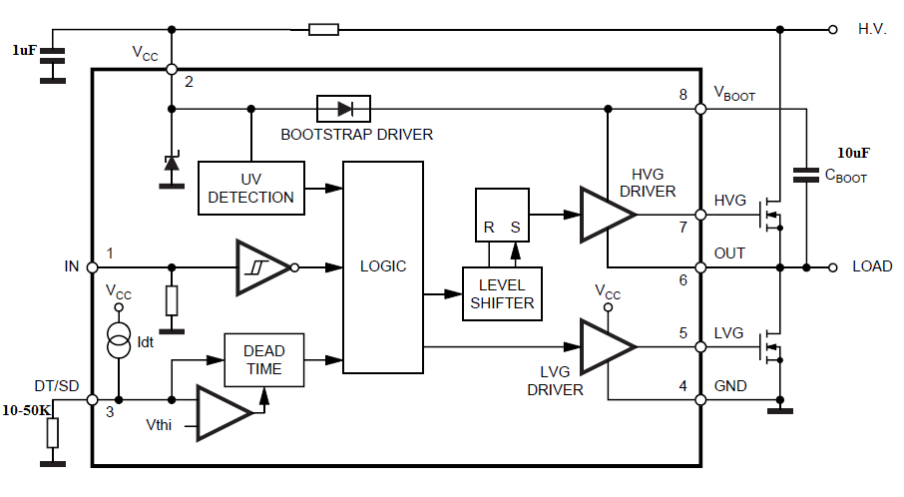
- Internal structure:

Fig 6.11 internal structure of L6384

- Main characteristic table
N. | name | Type | Function
1 | IN(*) | 1 | Logic Input: it is in phase with HVG and in opposition of phase with LVG. It is  compatible to Vcc voltage
2 | VCC | 1 | Supply input voltage: there is an internal clamp [Typ. 15.6V]  There is also an UVLO feature ( Typ. Vccth1 = 12V, Vccth2 = 10V).
3 | DT/SD | 1 | High impedence pin with two functionalities. When pulled to a voltage lower than Vdt  [Typ.0.5V] the device is shut down. A voltage higher than Vdt sets the dead time  between high side and low side gate driver. The dead time value can be set forcing a  certain voltage level on the pin or connecting a resistor between pin 3 and ground.  Care must be taken to avoid spikes on pin 3 that can cause undesired shut down of  the IC. For this reason the connection of the components between pin 3 and ground  has to be as short as possible. This pin can not be let floating for the same reason.  The pin has not to be pulled through a low impedence to Vcc, because of the drop on  the corrent source that feeds Rdt. The operative range is: Vdt ... 270K V Idt, that allows  a dt range of 0.4 - 3.1ms
4 | GND |  | Ground
5 | LVG | 0 | Low side driver output: the output stage can deliver 400mA source and 650mA sink  [Typ. Values].  The circuit guarantees 0.3V max on the pin (@Isink = 10mA) with Vcc > 3V and lower  than the turn on threshold. This allows to omit the bleeder resistor connected between  the gate and the the source of the external mosfet normally used to hold the pin low;  the gate driver ensures low impedence also in SD conditions.
6 | Vout | 0 | Upper driver floating reference: layout care has to be taken to avoid undervoltage  spikes on this pin
7 | HVG | 0 | High side driver output:the output stage can deliver 400mA source and 650mA sink  [Typ. Values].  The circuit guarantees 0.3V max between this pin and Vout (@Isink = 10mA) with Vcc >  3V and lower than the turn on threshold. This allows to omit the bleeder resistor  connected between the gate and the the source of the external mosfet normally used  to hold the pin low; the gate driver ensures low impedence also in SD conditions.
8 | Vboot |  | Bootstrap Supply Voltage: it is the upper driver floating supply. The bootstrap  capacitor connected between this pin and pin 6 can be fed by an internal structure  named ”bootstrap driver” (a patented structure). This structure can replace the  external bootstrap diode.

Fig 6.12 main characteristic table for L6384
*IRF740 MOSFET N-CHANNEL
- General datasheet
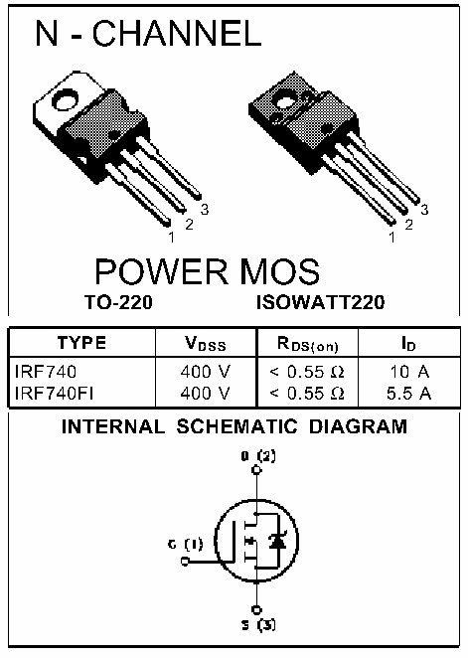
Fig 6.13 datasheet for IRF740
- General informations
• TYPICAL RDS(on) = 0.46Ω
• EXCEPTIONAL dv/dt CAPABILITY
• 100% AVALANCHE TESTED
• LOW GATE CHARGE
• VERY LOW INTRINSIC CAPACITANCES

- DESCRIPTION
The PowerMESH™II is the evolution of the first generation
of MESH OVERLAY™. The layout refinements
introduced greatly improve the Ron*area
figure of merit while keeping the device at the leading
edge for what concerns swithing speed, gate
charge and ruggedness.
- APPLICATIONS
• HIGH-EFFICIENCY DC-DC CONVERTERS
• UPS AND MOTOR CONTROL
- General characteristic table
Symbol | Parameter | Value | unit
VDS | Drain-source Voltage (VGS = 0) | 400 | V
VDGR | Drain-gate Voltage (RGS = 20 kΩ | 400 | V
VGS | Gate- source Voltage | ± 20 | V
ID | Drain Current (continuos) at TC = 25°C | 10 | A
ID | Drain Current (continuos) at TC = 100°C | 6.3 | A
IDM (l) | Drain Current (pulsed) | 40 | A
PTOT | Total Dissipation at TC = 25°C | 125 | A
 | Derating Factor | 1.0 | W/°C
dv/dt(1) | Peak Diode Recovery voltage slope | 4.0 | V/ns
Tstg | Storage Temperature | – 65 to 150 | °C
Tj | Max. Operating Junction Temperature | – 65 to 150 | °C
Fig 6.14 general characteristic table for IRF740
- Operating curves
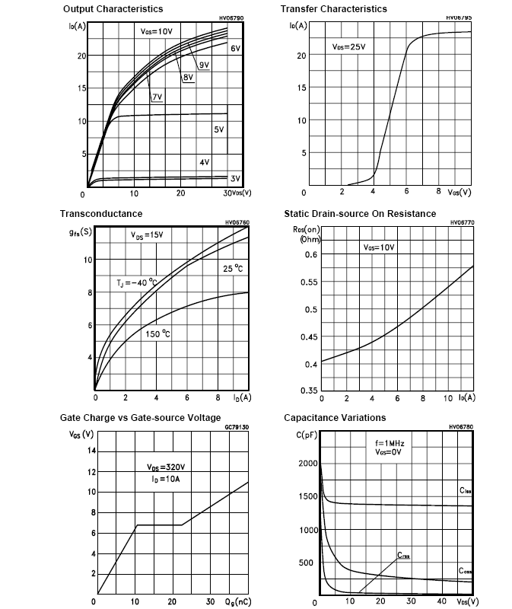
Fig 6.15 operating curves for IRF740

(1.5)

