
Design and Implementation of a High Frequency Local Oscillator (2.4GHz-450MHz)

Prepared by:
Aseel Abdou, Dina Sholi and Isra Subhi
Submitted to:
Dr.Ahmed Masri

Report Submitted in Partial Fulfillment of the Requirements of
B.Sc Degree in Telecommunication
Departments of Telecommunication
Faculty of Engineering
An-Najah National University
April 28th, 2015

Dedication

To
My Mother
Who taught me that even the largest task can be accomplished if it is done one step at a time.

My Father
Who taught me that the best kind of knowledge to have is that which is learned for its own sake.
My whole family and close friends
Your commitment, encouragement and support have been unwavering.

Acknowledgment
First and last, all thanks to Allah for his support and blessing us to complete this project.
We deeply thank our project's supervisor, Dr. Ahmed Masri for giving us the opportunity to work in this project under his guidance. We would also like to thank Dr.Falah Mohammad for his generous support, patience and time throughout the whole project.
We would also like to extend our thanks to Eng. Alla Alden in CPU lab at An-Najah National University and Mohammad Salman who produced our circuit board. Finally, our gratitude is extended to our parents and our friends for their encouragement and support. Without them, nothing would be possible.

Table of Contents
Dedication 2
Acknowledgment 3
List of Tables 8
List of abbreviations: 9
Abstract: 10
Chapter 1: Introduction 11
1.1 Motivations 12
1.2 Aims and Objectives 13
1.3 Related Work 13
1.4 Report Organization 14
Chapter 2: Project Background and Literature Review 16
2.1Oscillator 16
2.1.1 Criteria for Selection of an Oscillator 16
2.1.2 Damped and Undamped Oscillations 17
I-Damped Oscillations: 17
II-Undamped Oscillations: 18
2.1.3 Negative Resistor Oscillator 18
Chapter 3: Constraints and Standards 36
3.1 SWOT Analysis 36
3.1.1 Strengths 37
3.1.2 Weakness 37
3.1.3 Opportunities 37
3.1.4 Threats 38
3.2 Standards 38
Chapter 4: Methodology 41
4.1 Local Oscillator Circuit Design 41
4.2 Mixer design: 45
4.3 Equipment 47
Chapter 5: Results and Analysis 48
5.1 LO results 48
5.2 Mixer results 49
5.2.1 Single balanced mixer 49
5.2.2 Double balanced mixer 50
5.2.3 NLTL mixer 51
Chapter 6: Discussion 53
Chapter 7: Conclusion and Recommendation 54
7.1 Conclusion 54
7.2 Recommendation 54
Chapter 8: References 55

List of figures
Figure (1.1): Block Diagram of LO………………………………………………12
Figure (1.2): “Standards” types of RF oscillator …………………….…………..16
Figure (3.2): Feedback oscillator circuit………………………………………….17
Figure (3.3): Two ports oscillator………………………………………………...19
Figure (3.4): Definition of down conversion and up conversion…………………20
Figure (3.5): Definitions of mixer isolation for L-R, L-I and R-I isolation………24
Figure (3.6): SSB NF…………………………………………………………….25
Figure (3.7): DSB NF……………………………………………………………25
Figure (3.8): Double balanced mixer…………………………………………….27
Figure (3.9): Basic double balanced diode mixer circuit………………………...27
Figure (3.10): Basic double balanced diode mixer circuit……………………….29
Figure (4.1): Negative resistance and oscillation circuit…………………….……..31
Figure (4.2): Our design of the LO………………………………………….…...31
Figure (4.3): Time domain signal…………………………………………….…..32
Figure (4.4): magnitude spectrum of the generated signal………………….……33
Figure (4.5): mixer design…………………………………………………..……33
Figure (4.6): The result of mixer……………………………………………...…..34
Figure (4.7): LO circuit using Eagle software………………………………...….34
Figure (4.8): LPKF device…………………………………………………...…...36
Figure (4.9): Function Generator and Bioscope……………………………..…...36

List of Tables
Table (3.1): Comparison of Positive and Negative Feedback……………………18
Table (3.2): Comparison between double balanced and single balanced mixers…26

List of abbreviations:

Abbreviation | Stands for
LO | Local Oscillator
AMPS | Advanced Mobile Phone System
IP3 | 3rd order intercept
S band | Super High Frequency band
IoTV | Internet over TV band
RF | Radio Frequency
HF | High Frequency
IF | Intermediate Frequency
DC | Direct Current
AC | Alternative Current
ADS | Advanced Design System
USRP | Universal Software Radio Peripheral
MUX | Multiplexer
PCB | Printed Circuit Board
IEEE | Institute of Electrical and Electronics Engineers
ITU | International Telecommunication Union

Abstract:
With the rapid development in the area of RF and wireless communication, the interest in frequency synthesizers has grown rapidly in the last few years. The high frequencies (2.4 GHz or 5 GHz) used by Wi-Fi mean that signals can’t travels for long distances and penetrate buildings so it is difficult to reach the rural areas.
Since the frequency synthesizer depends on a high efficient design of mixer and high frequency local oscillator (LO), our graduation project revolves around how to design the local oscillator at a high frequency 2GHz and describes the implementation and design work of the mixer at 2.4GHz for TV broadcast band (400MHz to 800MHz).
In our design we choose to work on an empty available TV channel at a fixed frequency which is 450MHz.
Our design is implemented by using the negative resistor configuration for oscillator and for the mixer we designed three types and compare between them to prove finally that double balance mixer has a better conversion gain compared to Non Linear Transmission Line (NLTL) and single balance mixers ,Schottky diode was adopted for mixer circuit. Also the simulation and the measurement results are involved in this project.

Chapter 1: Introduction
The fast growing demand of wireless communications for voice and data has driven recent efforts to dramatically increase the levels of integration in RF transceivers. One approach to this challenge is to implement all the RF functions in the low-cost negative resistor technology for Lo, and this is the first aim for our project.
LO responsible for generating the sinusoidal signals necessary for converting the received signals from Radio Frequency (RF) to Intermediate Frequency (IF) applied to baseband, and for tuning these as required to establish the desired sky frequency with the same or even better phase noise performance than its discrete counterpart. Generally a difficult task using conventional approaches with the available low-Q integrated inductors. This is a particularly severe problem in RF systems such as AMPS (Advanced Mobile Phone System) ,where the channel spacing is small and close-in phase noise at level where it must be extremely low[1].

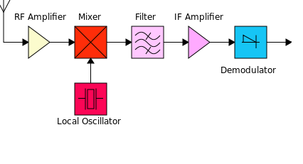
Figure 1.1: Block Diagram of LO
At RF and Microwave frequencies the negative resistance design technique is generally favored for several reasons were discussed in our project 1. And so we choose to work over negative resistor technique [2].

Mixers are electronic devices that are used for many applications, such as are the communication receivers and transmitters. In our design, the RF broadcast is 2.4GHz, in order to mix down to the IF frequency (450MHz). The basics of the mixer circuit design will be clarified in our report.
After a lot of research balanced mixers have been proposed and tested and we find that it is the best choice for our design since it satisfies our design requirements on the contrary of other types such as NLTL mixers in terms of conversion loss and 3rd order intercept (IP3).
Our work is a partial fulfillment of the requirements for the completion of a wider project, that is, Internet Distribution over T.V Networks (IoTV).

1.1 Motivations
The market for wireless communication has grown explosively in recent years with the fast development of new products and services. Current devices on the market, such as cordless/cellular telephones, wireless LAN’s, and GPS/satellite receivers, utilize the frequency spectrum between 800 MHz to 2.5 GHz for communication. As technology advances, today’s the whole world and specially our homeland consumers demand wireless systems that are low-cost, low-power and with a small form-factor. Therefore, we motivated to much recent effort in circuit design for wireless systems and we devoted our project to design a LO and implement it in the low-cost negative resistance technology. Moreover, we are confident there is no available LO with high frequency in our local market also there is no implementer mixer works at high frequency with good conversion gain and this challenge motivate us to work hardly and try to design a mixer with good or slightly better performance results concerning of conversion gain and IP3 at high frequency with low cost. Moreover, as another incentive our work is a partial fulfillment of the requirements for the completion of a wider project, that is, IoTV.

1.2 Aims and Objectives
This report addresses the issues regarding the local oscillator design and implementation in negative resistor technology works at (2 GHz) for wireless applications, and investigates the use of a double balanced diode mixer at (2.4GHz). Detailed analysis is given to estimate the phase noise performance of the LO-based frequency multiplier and apply a simulation for different type of mixers until achieve the best result for conversion loss which expected to be better for balanced one.
In addition, negative resistor design technique of the local oscillator is also presented. For demonstration purposes, an experimental prototype based on the analysis of this paper is designed to meet the specification of IEEE 521- standard for RF Bands [3].

1.3 Related Work
From one hand, there is no such relevant work in Palestine; accordingly, our project is considered a pioneering work on the national level. From another hand, a LO with high frequency considered as a rare work and if it is found it will be a very high cost. There is no doubt that several similar projects have been carried out all around the world by famous research centers and large universities, such as, The Chinese University of Hong [4].
And over the years several RF oscillator configurations have become standard. These are illustrated in Figure 2. The Colpitts, Hartly and Clapp circuits are examples of negative resistance oscillators shown here using bipolars as the active devices.
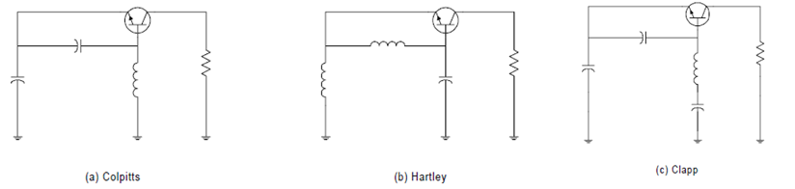
Figure 1.2:” Standards “types of RF oscillator”
And back to 2001, The Chinese University of Hong designed a circuit for a high frequency 2.4GHz Bipolar Local Oscillator.
Our report will now concentrate on a worked example of a Clapp oscillator. The frequency under consideration will be around 2 GHz, which is purposely in S band which is part of the microwave band of the electromagnetic spectrum .which used by weather radar and some communication satellites. It is defined by an IEEE standard for radio waves with frequencies that range from 2 to 4 GHz.
At these frequencies, we see that it is vital to include all stray and parasitic elements early on in the simulation. For example, any coupling capacitances or mutual inductances affect the equivalent L and C values in equation:
$$F=\frac{1}{2}*π*√LC$$
And therefore the final oscillation frequency. Likewise, any extra parasitic resistance means that more negative resistance needs to be generated.
One advantage of unique, new and cheap design of a high frequency oscillator with suitable type of mixer is to down shift the signal into an unused TV channels that Israel occupation prevents using them by local internet providers companies, where is low frequency signals which can travel longer distances than other broadcast signals, design aims to expand coverage of wireless broadband in densely populated urban areas.

1.4 Report Organization
This report is structured into eight chapters as follow:
In Chapter 1, we introduce our work and explain our main objectives and motivations to perform this project.
In Chapter 2, the criteria to choose our LO to fit the work over a HF also mixer is introduced, and its operation principle is described. Also, the most significant parameters and measures of any mixing circuit are discussed and clarified, and their calculation methods are mentioned.
In Chapter 3, the SWOT analysis and recommended IEEE Standards regarding to mixing circuits are taken into account. The importance of these standards comes from the fact that, most of the industrial electronic devices and components are offered in standard parameters and ratings.
In Chapter 4, procedure of our all work is explained. The desired circuits are simulated using the ADS software version 2009.and the hardware of LO is done. The parasitic parameters of the circuit were obtained from its datasheet. The remaining RLC components are typical and they do not need a special technique to simulate for their operation.
In Chapter 5, simulation and measurement results are presented.
In Chapter 6, apply a quick discussion.
In Chapter 7, the conclusion and recommendations are contained.
Finally, references are presented in Chapter 8.

Chapter 2: Project Background and Literature Review
In order to have a high performance design of our LO and for the mixer to complete the IoTV band project, a solid background will be explained in this chapter.

2.1Oscillator
Our project is aimed to down shift the high frequency of access point which broadcast a 2.5 GHz to lower frequency 450 MHz which is TV band unused frequencies. So we need to design a LO that operate at high frequency. Therefore, in the following section we will discuss the operation principle of the oscillator.

2.1.1 Criteria for Selection of an Oscillator
Here are the parameters that are to be noted while selecting an oscillator for a particular application.
- Frequency Range. The oscillator selected for a particular application should be capable of supplying an output signal whose upper and lower frequency limits exceed those required by the application.
In our design Lo works at single frequency 2GHz for wireless application.
- Power and/or Voltage. The oscillator selected for a particular application should be capable of generating the pertinent quantity with a magnitude large enough to meet the requirement.
- Accuracy and Dial Resolution. The accuracy of an oscillator specifies how closely the output frequency corresponds to the frequency indicated on the dial of the instrument. Dial resolution indicates to what percentage of the output frequency value the dial setting can be read.
- Amplitude and Frequency Stability. The amplitude stability is a measure of an oscillator’s ability of maintaining constant voltage amplitude with variations in the output signal frequency. Frequency stability determines how closely the oscillator maintains a constant frequency over a given time period. Sometimes the frequency stability is included in the accuracy specifications of the oscillator.
- Waveform Distortion. This quantity is a measure of how closely the output waveform of the oscillator resembles a pure sinusoidal signal. Sometimes the oscillator is employed as a source in a test used for measuring the tendency of a circuit to distort a sinusoidal signal. In such tests, the distortion caused by the oscillator should be much less than the anticipated distortion because of the circuit under test.
- Output Impedance. The output impedance of an oscillator specifies the impedance value of the load which must be connected to it for maximum power transfer. It is very important that the output impedance of the oscillator be equal to the characteristic impedance of the system to which it is to be connected.
In our case the output impedance is 50 ohm

2.1.2 Damped and Undamped Oscillations

I-Damped Oscillations:
Damped oscillation is clearly shown in the figure 2.1 given below. In such a case, during each oscillation, some energy is lost due to electrical losses (I²R). The amplitude of the oscillation will be reduced to zero as no compensating arrangement for the electrical losses is provided. The only parameters that will remain unchanged are the frequency or time period. They will change only according to the circuit parameters.
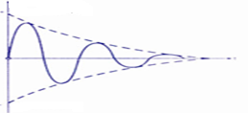
Figure 2.1 : Damped Oscillation

II-Undamped Oscillations:
As shown in figure 2.2, undamped oscillations have constant amplitude oscillations. In the harmonic oscillation equation, the exponential factor e^{_Rt/2L} must become unity. That is, the value of the dissipation component in the circuit, R should be zero. If its value is negative, the amplitude goes on increasing with time t. If its value is positive, the amplitude decreases with time t.
In order to obtain undamped oscillations in any physical circuit, the positive value of the dissipation component, R must be neutralized with a negative resistance such as in our design. The correct amount of undamped oscillations will be obtained only if the correct amount of energy is supplied to overcome the losses at the right time in each cycle. The resulting “undamped” oscillations are called sustained oscillations. Such sustained oscillations or continuous waves are required to be produced by the electronic oscillator circuits.
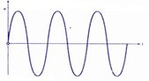
Figure 2.2: Undamped Oscillation

2.1.3 Negative Resistor Oscillator
Negative resistance oscillators make use of negative resistance elements such as tetrodes, tunnel diodes, uni junction transistors etc. There are two types of negative resistance oscillators, which are commonly used for high frequency generation.

2.2 Mixer
2.2.1 Definition
The word ‘mixer’ is somewhat ambiguous as it refers to two different types of electronic devices. The first one is called the linear mixer while the other one is called the non-linear mixer. The linear mixer is a summing device that obeys the superposition principle in the sense that the total output is the linear sum of the individual outputs. For this reason it is sometimes called an adder or summer:
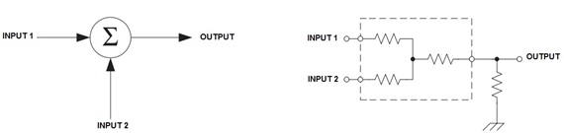
Figure 2.3 Block diagram and circuit implementation of a linear mixer.
The nonlinear mixer however, is a device that violates the superposition, making the total output not equal to the linear sum of the individual outputs. This violation is called the nonlinearity effect of the device. In fact, the nonlinear mixer is simply a multiplier:
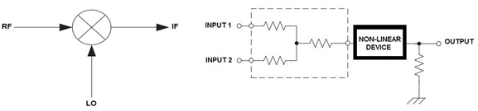
Figure 2.4 Block diagram and circuit implementation of a nonlinear mixer.
As seen in the figure above, the nonlinear mixer consists of two levels; the first one is a linear summation where both inputs are just exposed to one another, while the next level is nonlinear mixing where both inputs are mathematically multiplied. This multiplication causes new terms to show up in addition to the individual outputs.
To be more accurate, the nonlinear mixer deliberately violates the superposition for purposes to be discussed later. But sometimes it may happen that another devices (or transmission channels) start to behave as nonlinear media under certain conditions, and as a result, they disturb their expected outputs. The nonlinear behavior should be avoided unless a new specific term is required to be generated from other terms. Things will be clearer when we get deeper in sections to follow.
In Figure 2.5, the nonlinear device could be a simple diode. The simplest practical circuit for the nonlinear mixer is the single diode circuit shown below:
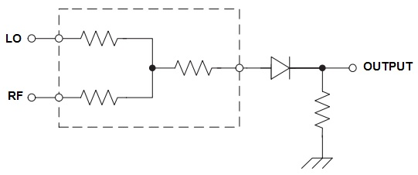
Figure 2.5 Single diode mixer.
In this diode mixing circuit, if the RF input is grounded while the LO input is connected to a signal running at frequency $f_{1}$, the output is simply the half-wave rectified form of LO, which means that the output consists of LO itself and its harmonics:
$$OUTPUT=y(±nf_{1})$$
Where $n$ is an integer$(n=0,1,2,3,…)$.
However, if the input terminals are exposed to two signals each is running at a distinct frequency, then the output will be of the following general form:
$$OUTPUT=y(±nf_{1}±mf_{2})$$
Where $n$ and $m$ are two integers.
The last equation reveals that the output consists of many terms, including both $f_{1}$ and $f_{2}$ and their intermodulation products. This situation is best described by the following amplitude spectrum:
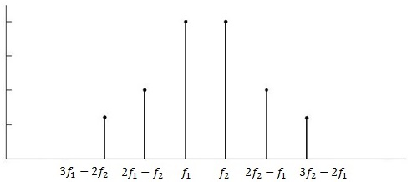
Figure 2.6 Amplitude spectrum for nonlinear combinration of two signals.
For most practical cases, one of the two inputs is adjusted at higher power level than the other signal. By so, the high level signal dominates the switching process of the diode, and therefore, the low level signal will be sampled at a rate equal to that of the high level one. If LO is supposed to be the high level signal, then the output becomes as follows:
$$OUTPUT=y(f_{LO}±mf_{RF})$$

2.2.2 The Mixer Performance Parameters
In regards to electronic circuit implementation, the designer should take into account the frequency range over which the circuit is going to run. Many electrical components are dependent on the source frequency, and therefore, their operation and response at low frequency range will not be the same as that at high frequencies. This means that a ‘neglected’ reactive behavior in any electrical circuit is likely to become of much significance if the frequency had varied too much. Diodes have internal parasitic shunt capacitance due to the layout and depletion region, and also they have a series inductance due to packaging. The same also holds for transistors and FET’s. In addition, since the electrical signal requires time to propagate through a device (time delay), it may happen that the oscillation speed of the incoming signal is much higher than this time delay, a condition that puts the device totally down. For instance, the depletion region within a diode or transistor requires time to switch from the forward bias to the reverse bias, so if the source oscillation is much faster than the diode switching to take effect, the device fails and will not work anymore. It is not only the dc biasing that may affect the mixing circuit, but also many other aspects may disturb the mixer performance. These aspects are called the mixer specifications and are listed below:
- Conversion Loss
- Noise Figure
- Mixing Spurs
- The Image Effect
- Intermodulation Products & 3rd Order IMD
- 1dB Compression Point (P1dB)
- LO Harmonics & Noise
- RF and IF Impedance and Matching
The effect of each of these specifications will be discussed separately (for the DBM in particular), and the best offered solutions will be introduced.
2.2.2.1 Conversion Loss
The mixer conversion loss is simply the total power losses (in decibel) that occur within the device. Mathematically, the conversion loss is the ratio of the input power to the output power in logarithmic scale:
$$L_{C}=10\log\left(\frac{P_{in}}{P_{out}}\right)=10\log\left(\frac{P_{RF}}{P_{IF}}\right)$$
The mixer losses could be attributed to two main reasons:
- Mismatch losses
The mismatch losses are the total power lost due to the reflections that may occur at the mixer ports. For instance, if the IF output impedance is not matched to the load impedance (IF amplifier), then the condition of max power transfer is not satisfied and hence part of the load power will be reflected back to the mixer.
The mismatch losses on any port could be calculated by the following equation:

$$L_{m}=10\log\left(\frac{P_{i}}{P_{i}-P_{r}}\right)=10\log\left(\frac{1}{1-{\left|Γ\right|}^{2}}\right)$$

Since the reflection ratio $Γ$ is related to the voltage standing wave ratio $VSWR$ by the following formula:

$$\left|Γ\right|=\frac{VSWR-1}{VSWR+1}$$

then the mismatch losses per each port could be given in terms of $VSWR$ as follows:

$$L_{m}=10\log\left(\frac{{\left(VSWR+1\right)}^{2}}{4VSWR}\right)$$

Finally, the total mismatches for both RF and IF ports are summed as follows:

$$L_{m}=10\log\left(\frac{{\left({VSWR}_{RF}+1\right)}^{2}}{4{VSWR}_{RF}}\right)+10\log\left(\frac{{\left({VSWR}_{IF}+1\right)}^{2}}{4{VSWR}_{iF}}\right)$$

More than one way is available to overcome such mismatches. Transformers may be the best choice for mixer case as the transformer can serve in this manner as a matching and a balancing element at the same time. The following figure shows the transformer equivalent circuit referred to the high voltage side:
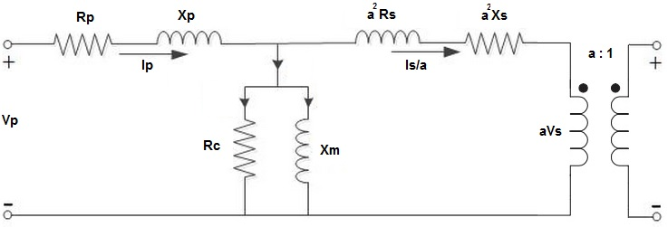
Figure 2.7 Transformer equivalent circuits referred to high voltage side.
$R_{p}$ and $X_{p}$ are the primary-coil impedance while $R_{s}$ and $X_{s}$ are the secondary-coil impedance. The factor ‘$a$’ is the primary to secondary turns ratio. An interesting characteristic of the transformer is that, when looking from the primary side, the secondary impedance and any load connected there will be seen as being multiplied by $a^{2}$, while looking from the secondary side, the primary impedance and any load connected there will be seen as being divided by $a^{2}$. Accordingly, the transformer turns ratio ‘$a$’ could be adjusted such that the connected load on either side will be seen as the same value of the impedance on the other side.
- Diode Losses
The diode internal losses consist mainly of its parasitic losses $L_{p}$ and the junction losses$L_{J}$. Both types are illustrated in the appendix that introduces Schottky Diode. Though, the mathematical form of these losses is mentioned here again for convenience:

$$L_{p}=10\log{(1+\frac{R_{s}}{R_{j}}+ω^{2}C_{j}^{2}R_{s}R_{j})}$$

$$L_{j,min}=2\left[\frac{1+\left(1-2\frac{g_{1}^{2}}{g_{0}}\sqrt{g_{0}+g_{2}}\right)}{1-\left(1-2\frac{g_{1}^{2}}{g_{0}}\sqrt{g_{0}+g_{2}}\right)}\right]$$
where $R_{s}$, $R_{j}$, $C_{j}$ are the diode series resistance, junction (dynamic) resistance, and junction capacitance, respectively, and $g_{0}$, $g_{1}$, $g_{2}$ are the diode conductance’s calculated from the series expansion of its current formula.
To summarize, the mixer conversion loss is the linear sum of the mismatch losses and the diode losses together:
$$L_{C}=10\log\left(\frac{P_{RF}}{P_{IF}}\right)=L_{m}+L_{p}+L_{j,min}$$
2.2.2.2 Noise Figure
One of the important measures for the receiver performance is the noise power at its output terminal. Indeed, this noise comes from the contribution of the noise injected to the mixer at the RF port and the noise internally generated by the mixer diodes and IF amplifier stage. For this reason, the receiver noise contribution could be measured as the ratio of $SNR$ at the input to the $SNR$ at the output. This ratio is called the noise factor:
$$NOISE FACTOR=\frac{{SNR}_{RF}}{{SNR}_{IF}}=\frac{{S_{i}}/{N_{i}}}{{S_{o}}/{N_{o}}}=\frac{S_{i}}{S_{o}}\frac{N_{o}}{N_{i}}$$
The value of the noise factor in decibel is called the receiver overall noise figure:
$$NF=10\log\left(\frac{S_{i}}{S_{o}}\right)+10\log\left(\frac{N_{o}}{N_{i}}\right)$$
The second term could be thought of as the ‘noise gain’, and for this reason it addresses the noise figure of the IF amplifier stage. The first term is not more than the mixer conversion loss. Accordingly, the receiver overall noise figure is defined as the linear sum of the mixer conversion loss and the noise figure of the IF amplifier:
$$NF=L_{C}+{NF}_{IF}$$
As a conclusion, the lower $NF$ values, the better is the receiver performance. The receiver noise figure could be improved (minimized) by the proper selection of the mixing diodes as their parasitic and junction values affect the conversion losses. The conversion loss is also affected by the LO level (as will be discussed later on). Impedance matching also contributes in $NF$ improvement.
It should be noted that, the most accurate value of the noise figure is achieved by adding a third term to the equation, called the ‘noise temperature ratio’. However, for schottky diodes, this term is very small to where it could be neglected.
2.2.2.3 Intermodulation Products
As mentioned in the Chapter 2, if a signal is exposed to a nonlinear medium, the medium produces its harmonics:
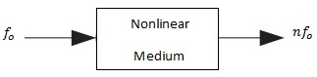
If two signals are exposed to a nonlinear medium, the medium produces the individual harmonics of each signal plus new terms equal to the sums and differences of these harmonics:
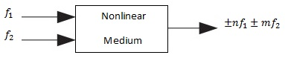
The new terms are referred to as the Intermodulation Products (IP’s) of $f_{1}$ and $f_{2}$. Before proceeding, we mention that the order of any IP is the linear sum of the absolute values of both n and m:
- 1st order : $f_{1}$, $f_{2}$.
- 2nd order : $2f_{1}$, $2f_{2}$, $±f_{1}±f_{2}$.
- 3rd order : $3f_{1}$, $3f_{2}$, $±2f_{1}±f_{2}$, $±f_{1}±2f_{2}$.

And so forth.
In practical systems where signals are to be transmitted from one location to another, these IP’s are disturbing and should be suppressed. For this reason, most of practical systems are built in such a way that the output is a linear function of the input (i.e. linear system). Yet, there are some situations where the nonlinear behavior of a certain system would be the interesting issue since the desired output in such case would be one or more of the systems IP’s. The mixer represents one example of such systems as it is required to produce the sum and difference between the LO and RF in order to deliver the IF signal. However, in addition to the IF amplifier on mixers output port, it has a premixing RF amplifier, and for this reason, the intermodulation products are generated in two places within the mixer that should be distinguished:
- RF Amplifier
In general, if a relatively strong signal overdrives an amplifier, it pushes the amplifier into its nonlinear operation region. So if it happened that a strong signal RF2 close enough to the desired incoming signal RF1 had entered the mixer RF amplifier, its operation becomes nonlinear and intermodulation products between these two signals arise (negative aspect).
- Diode bridge
The mixing stage, in contrast to its prior RF amplifier, is deliberately required to produce the sum and difference between LO and RF (positive aspect).
The IP’s of the RF amplifier disturbs the overall performance of the mixer as they all start to mix with LO inside the bridge, thus turning everything upside down. To explain that, we need to consider the following spectrum of IP’s:
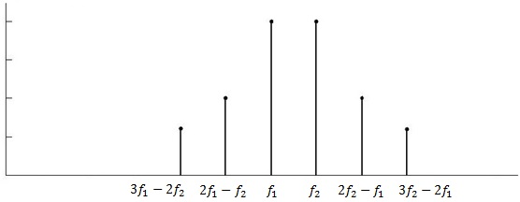
Figure 2.8 Spectrum of intermodulation products.
In the figure above, we assume that $f_{1}$ is the desired RF and $f_{2}$ is an accompanying undesired RF that is strong enough. It is clear that both the 3rd and 5th order IP’s of these two signals are the closest to$f_{1}$, while the other order IP’s are far enough that could be filtered out. The problem here is that since these IP’s are very close to$f_{1}$, and since they will individually mix with LO and produce their corresponding intermediate frequencies on the mixer output, these produced frequencies will be on the order of the desired IF. Hence, the IF filter is likely to fail suppressing them. The effect of the 5th order IP $(3f_{1}-2f_{2})$ could be neglected as its amplitude is most likely below the noise level, leaving the 3rd order IP as the major and most dangerous one.
Since the amplitude of the n^{th} harmonic of any signal is usually (but not exactly) inversely proportional to ‘n’, and since all of$f_{1}$, $f_{2}$, and their IP’s will saturate to the max dc level of the amplifier, then compared to the desired signal gain, the gain of the 2nd order IP is square and the gain of the 3rd order IP is cubic, and so forth. In dB, this corresponds to 2dB and 3dB excess, respectively, for every 1dB gain of the RF signal. According to so, the premixing amplifier gain could be drawn as follows:
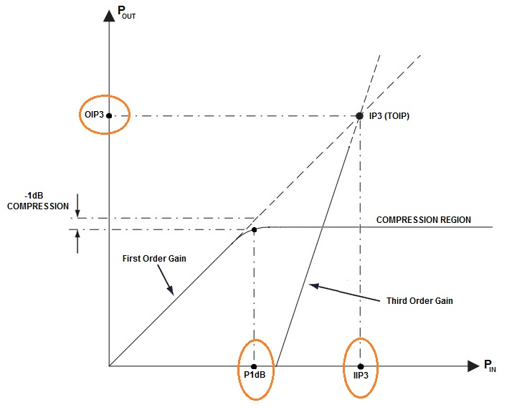
Figure 2.9: Gain of IP orders
In the above figure, the first order gain represents the desired RF signal gain, while the third order gain represents the 3rd order IP’s gain. In this figure, two important points are under interest as they represent a measure for the amplifier linearity, and hence, the mixer performance:
- The Third Order Intercept Point (IP3)
The TOIP is the intersection point of the extensions of the two linear curves. Though it is pure imaginary (since both curves saturate earlier), its value still a good measure for the amplifier linearity. This is because the farther OIP3, the wider is the linear region of the amplifier before the 3rd order IP’s become more significant. Note that someone we may use IIP3 instead of IP3.
- The 1dB Compression Point (P1dB)
The 1dB compression is the input voltage value after which the slope of the linear curve drops by 1dB. After this point, the curve starts to compress and the amplifier enters the saturation region. As mentioned earlier, the mixer amplifiers should operate in their linear regions, and hence, the P1dB represents the max allowable input before the amplifier saturates and starts to produce IP’s.
The 3rd order intercept point of a mixer could be found experimentally as follows: Two signals of the same power $(P_{A})$ are buffered to the RF port, and then a spectrum analyzer is used to find out the power level of the 3rd order IP$(P_{3})$. After so, the value of OIP3 could be calculated by the formula: (Carr, RF Components and Circuits, 2002)
$${OIP}_{3}=\frac{3P_{A}-P_{3}}{3-1}$$
To summarize, a better performance of the mixer is achieved if the IP3 and P1dB values of the mixer are high as possible. The problem of producing intermodulation products by any stage within the mixer is called the intermodulation distortion (IMD). The IMD comes to exist if the input of the mixer amplifiers exceeds the P1dB.

2.2.2.4 The Image Problem
As the main mission of the mixing circuit is to translate the incoming RF signal to the intermediate range IF, a problem may occur if another signal ‘image’ had satisfied the condition of IF. The following figure describes the idea:
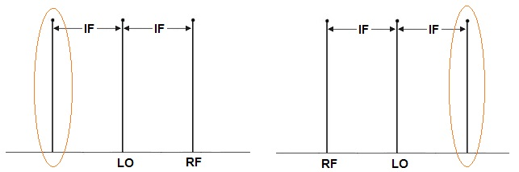
Figure 2.10 Image signals around LO.
In either case of the figure above, the circulated signal is separated a distance IF from the LO signal. This means that the image is a signal that will experience the same translation and hence, both the image and the RF are delivered to the IF stage.
One way to overcome is that, the IF value should be chosen such that the passband of the RF filter is less than 4IF:
$${BW}_{(RF filter)}<4IF$$
The last equation guarantees that the RF filter will suppress the image whether it is on the left side or the right side of LO.
Another way is to improve the ordinary mixer to an image-suppression mixer.
2.2.2.5 LO Respects
The local oscillator level, frequency, harmonics, and interfacing all affect the mixer performance, and hence its output.
The LO level (power) is of too much interest as it affects the mixer operation in many aspects. In fact, the LO level must always be greater than the RF level, since the diode bridge will be totally controlled by the higher level input (If RF level had exceeded the LO level, then RF drives the bridge and therefore, LO would be translated to the IF range instead of RF). In addition, the IMD is inversely proportional to LO level since the latter improves the TOIP. Also, increasing LO level minimizes the mixer products since the higher LO level, the closer is the diode switching mode to the ideal square wave.
If an LO harmonic is supposed to be strong enough, then it will mix with any spurs (noisy signals) that are $±IF$ from its frequency. For this reason, the LO harmonics increase the mixer products, and should be suppressed before entering the diode bridge.
The LO frequency must be IF apart from the RF signal. Otherwise, the RF will be converted to another intermediate frequency rather than the desired one.
Finally, the conversion loss increases for both higher and lower levels of LO. By default, increasing the LO level is a positive effect on the mixer performance. But after a certain level of LO, the junction capacitance of the diodes increases too much, which increases the parasitic losses$L_{p}$, thus the conversion loss starts to increase instead of decreasing. For this reason, increasing LO too much is not a totally positive aspect, a compromise should be taken.

2.2.2.6 Isolation
The port to port isolation is one of the parameters of an RF mixer that we should be aware about. RF mixer isolation is defined as the ratio of the signal power available into one port of the mixer to the measured power level of that signal at one of the other mixer ports in a 50 ohm system. This is measured in dB [12]. Most RF mixer designs aim for the maximum isolation from the LO to the RF ports as the LO signal is normally the highest level. The LO to RF isolation is generally slightly less at the higher frequencies, and this is often important to ensure that the LO signal does not enter the RF drive circuitry and cause problems such as inter modulation. Lastly the RF to IF isolation is the poorest.
The three types of leakage between mixer ports can be represented as the following relations:
$$LO to IF=\frac{LO power at IF port}{LO power at LO}$$
$$LO to RF=\frac{LO power at RF port}{LO power at LO}$$
$$RFto IF=\frac{RF power at IF port}{RF power at RF}$$
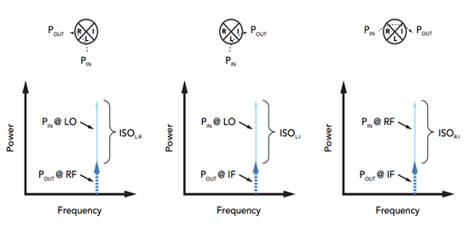
Figure 2.11: Definitions of mixer isolation for L-R, L-I and R-I isolation.
Isolation can be quite important for certain mixer applications. For example, LO to RF leakage can be quite serious in direct conversion receiver architectures because it will remix with the RF and produce a DC offset. Large LO to IF leakage can degrade the performance of a mixer if it is located prior to IF filtering.

2.2.2.7 Noise figure
The noise figure for an RF mixer is important in radio receiver front end circuits. Any noise introduced by the RF mixer at an early stage in the receiver such as the first mixer will degrade the performance of the whole receiver. In this way the noise figure for the RF mixer is important. Noise figure is defined as the ratio between the input and output S/N ratio [5].
Noise figure is defined as the ratio between the input and output S/N ratio.
$$NF (dB) = 10 log[(S/N)in]/[(S/N)out]$$
Any real mixer or amplifier will degrade S/N because noise is added to the signal. The mi minimum detectable signal (MDS) power is determined by noise and corresponds to a signal whose strength just equals the noise. The thermal noise power in bandwidth $Δf$ is given by
$$MDS=10 log (kTΔf)$$
where $k$ is Boltzmann’s constant and $T$ is absolute temperature. Thus,
$$MDS (dBm) = 10 log(kTΔf) + NF$$
SSB or DSB Noise Figure?
There are two definitions used for noise figure with mixers SSB NF assumes signal input from only one sideband, but noise inputs from both sidebands as shown in Fig (2.12), it is relevant for heterodyne architectures.
DSB NF includes both signal and noise inputs from both sidebands, as shown in Fig (2.13), it is appropriate for direct conversion architectures.
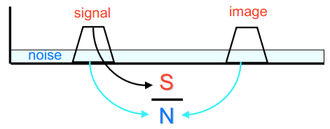
Figure 2.12: SSB NF
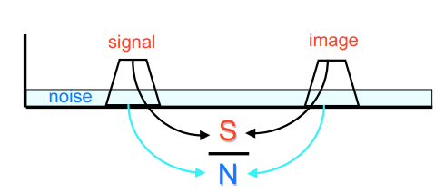
Figure 2.13: DSB NF

2.2.2.8 Spurious signal
The basic mathematics used to illustrate the way in which an RF mixer works assumes that it is a perfect multiplier. Unfortunately this is not the case, and signals in addition to the sum and difference frequencies are generated. The transfer characteristics for the diodes mean that harmonics for the input signals are generated. If the RF mixer was perfectly balanced, then these components would be cancelled out, but again this is not the case, and as a result, the harmonics of the two input signals also mix together. The lower odd ordered mixer products will be the highest level at the IF port or output of the RF mixer.
The levels of the spurious signals are dependent upon a number of factors. These include the LO and RF input levels as well as parameters such as the load impedance, temperature, frequency, etc. Many of these unwanted products will fall outside the required pass band of the mixer, but most manufactured RF mixers will have data for these unwanted products which can be obtained from the manufacturer.
RF mixers are an important element in most RF designs. Accordingly it is necessary to understand their limitations and know how to specify them to obtain the required performance.

2.2.2.9 Input levels
It is important to ensure that the input levels for the RF mixer are met. The RF input will have a maximum input level it can tolerate and it is expected to sweep from -15 dBm to +5 dBm [6]. Beyond this the mixer may become overloaded and the levels of spurious signals will rise above their limits, along with the isolation falling outside its specification.
The LO input is designed to have a certain input level and this should be maintained reasonably accurately. If it raises too high then higher levels of LO signal will appear at the output. Additionally higher levels of spurious may be experienced. If the signal level is too low, then the conversion loss may increase. Typically a tolerance of + / - 3dB is normally acceptable.
There are a few standard LO input levels. 7 dB is standard for many RF mixing applications, whereas higher LO levels may be required where higher levels of RF input level may be needed.

2.2.2.10 RF mixer impedance
The standard impedance for RF mixers is 50 ohms. It is important to ensure that the source impedance for the inputs and the load for the output are accurately matched to the required impedance. Often small attenuators may be added into the line to ensure that this is the case. If the ports are not accurately matched to the required impedance, mixer specifications such as the spurious signal and isolation will be impaired [7].

Chapter 3: Constraints and Standards

3.1 SWOT Analysis
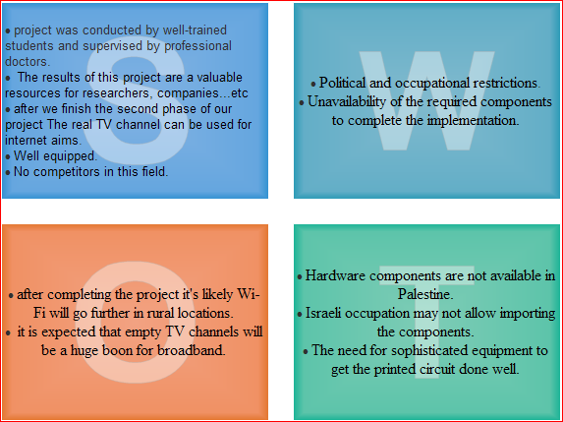
Figure 3.1 SWOT Analysis

3.1.1 Strengths
- Project was conducted by the well-trained students Aseel Abdo, Dina Sholi, and Isra Subhi, who have the solid background in communication, measuring devices and electronic circuit design. In addition, the project is supervised by doctors specialized in relevant fields having done researches about cognitive radio.
- The output of this project which is a high frequency LO is considered to be valuable resources for researchers, companies.
- After we finish the second phase of our project the real TV channel can be used for internet aims.
- Well-equipped report.
- No competitors in this field since our design is the first one that satisfy the requirements of IoTV band project.

3.1.2 Weakness
a. Political and occupational restrictions.
b. Unavailability of the required components to complete the implementation, since we had to wait a long time to import the components and hard to find suitable equipment in our region to prepare PCB layout without any error.

3.1.3 Opportunities
a. after completing the project it's likely Wi-Fi will go further in rural locations since we shift the frequency of access point (2.4 GHz) to lower frequency (450 MHz) which travels a long distances.
b. it is expected that unused TV channels will be a huge boon for broadband since the available frequencies is controlled by the restricted rules of the providers.

3.1.4 Threats
a. Hardware components are not available in Palestine.
b. Israeli occupation may not allow importing the components.
c. The need for sophisticated equipment to get the printed circuit done well.

3.2 Standards
In this section we will mention some of the LO and mixer standards regarded to theirs internal parameters and any other factors that are related to theirs implementation.
3.2.1 Terminology
As the mixer converts an incoming signal from the radio frequency range RF to the intermediate frequency range IF by mixing it with the local oscillator LO signal, the three signals are termed as RF, IF, and LO, respectively. In addition, the three corresponding ports are termed the same way; RF port, IF port, and LO port.
The power of any signal is usually termed as the signals level. Power issues are measured in dBm and dB.
In our work dBm was used. The dBm have a reference of 1mw, 1mw=0dBm, this scale is used in radio, microwave and fiber optic networks as a convenient measure of absolute power because of its capability to express both very large and very small values in a short form.
The mixer level is associated to the its LO level, for instance, a level 7 mixer employs 7dBm LO, and a level 10 mixer employs 10dBm LO, and so forth.
3.2.2 Frequency Range
The upper and lower limits of the mixer frequency capability are both dependent on its internal construction parameters, and they are also affected by its coupling transformers on its ports. No exact range could be determined or even standardized. The RF signal ranges between 3 KHz and 300GHz.
Our LO is specified as an S band which defined by an IEEE association standards and ITU organization for radio waves with frequencies that range from 2 to 4 GHz and a wavelength (15-7.5) cm .
3.2.3 Port Impedance
The impedances of mixer ports should be matched to their each interface. The standard value of its port impedance is around 50Ω.
3.2.4 RF and LO Level
For most applications, a typical 7dBm LO level is used. As the RF level increases, the LO level should also be increased. The 1dB compression point (P1dB) is the best basis for the proper selection of the required LO level for the incoming RF. For diode mixers, it is a good practice to have the LO level being 10dB greater than the RF level. The following table is a typical guide for this issue:
RF level (dBm) | LO level (dBm)
1 | 7
5 | 10
9 | 13
14 | 17
20 | 23
24 | 27
Table 3.1: RF levels vs LO levels in dBm

3.2.5 Intercept Point (IP3)
For diode mixers, the intercept point is typically 15dB above the 1dB compression point (P1dB). Therefore, to pick up a mixer that meets a specific IIP3, subtract 15dB from its value so that you get the P1dB value. Since the latter corresponds to the max RF level, you can decide the mixer level from the previous table.
3.2.6 Port Isolation
The standard port-to-port isolation is defined as the ratio of a signal level at one port to its level at the other port (at the standard 50Ω port impedance).

Chapter 4: Methodology
In this chapter we will discuss the procedure of our work. We have both a software and a hardware design. The oscillator with a software and hard ware design, the mixer with a software design.
Section 1 discuss both the software and hardware methodologies used to get the best design for the LO. Section 2 discusses the software design to get the mixer designs. Section 3 discusses the equipment used to complete this project.

4.1 Local Oscillator Circuit Design
Related to our 1st project, we started with a design for the LO, in the second phase of our project we continue our work on LO to implement the circuit as a hardware, two programs were used, ADS and Eagle.
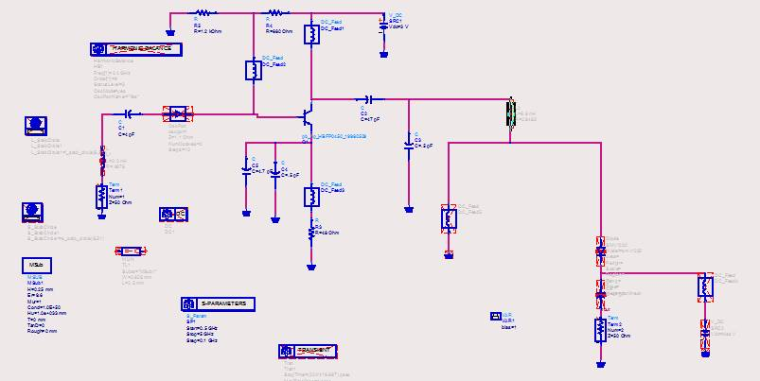
Figure 4.1.1: Negative resistance and oscillation reference circuit.
The next figure shows how we modified the reference circuit on ADS:
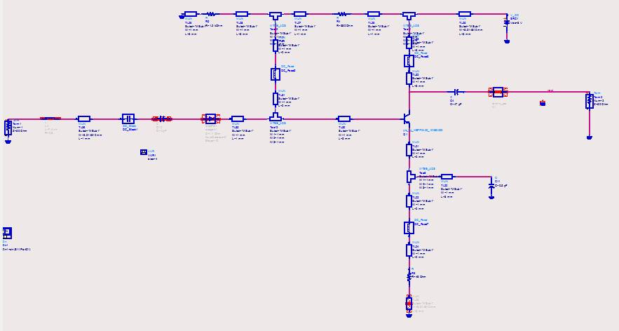
Figure 4.1.2: the modified circuit using ADS
Then, we used Eagle software to get a PCB layout for our modified design, we use this program because it gives both the schematic and layout design.
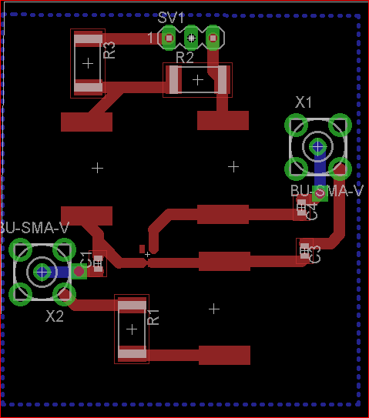
Figure 4.1.3: LO layout using eagle.
Now, it’s the time to show our implementation of the LO
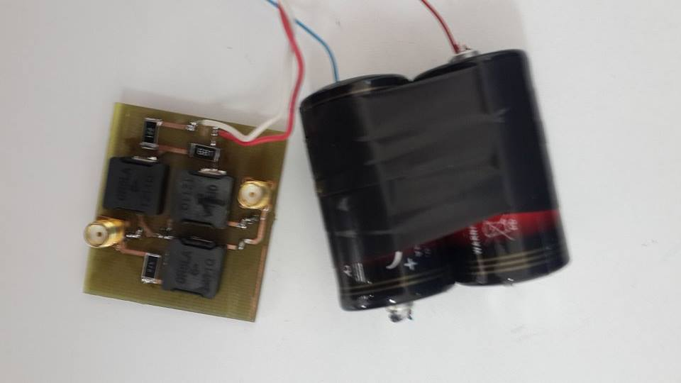
Figure 4.1.4: Photograph of constructed oscillator
After the hardware design, we measured many values to check if our design is working efficiently or not.
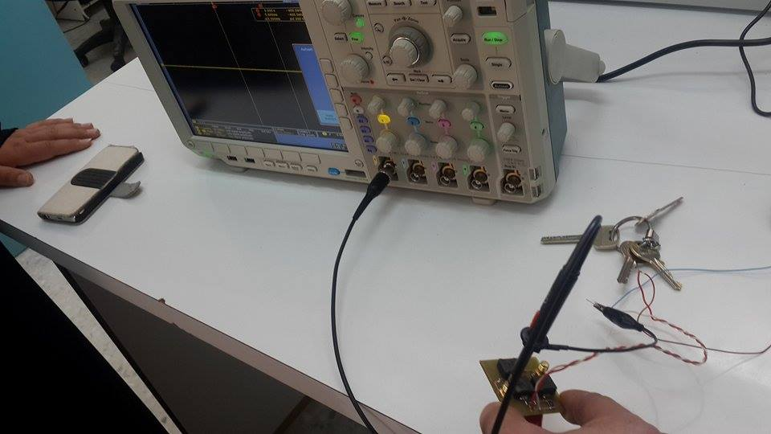
Figure 4.1.5: measurements using network analyzer.
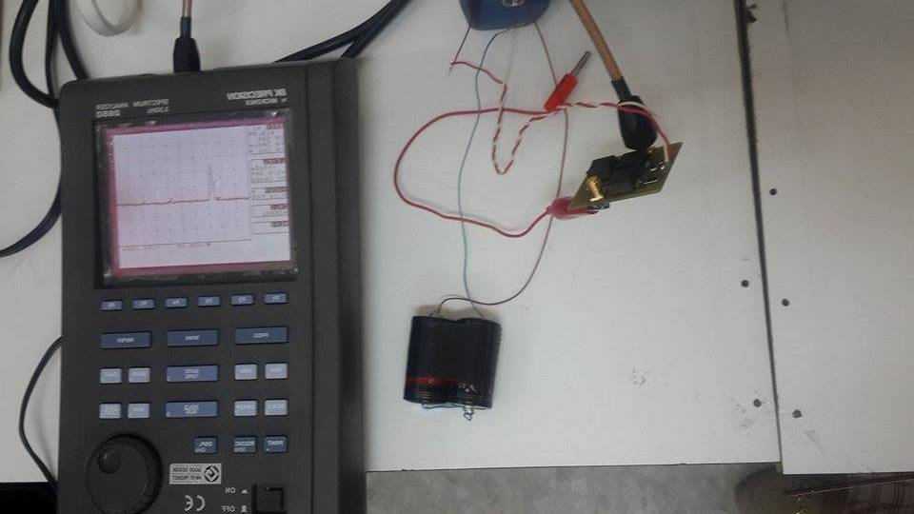
Figure 4.1.6: measurements using spectrum analyzer.
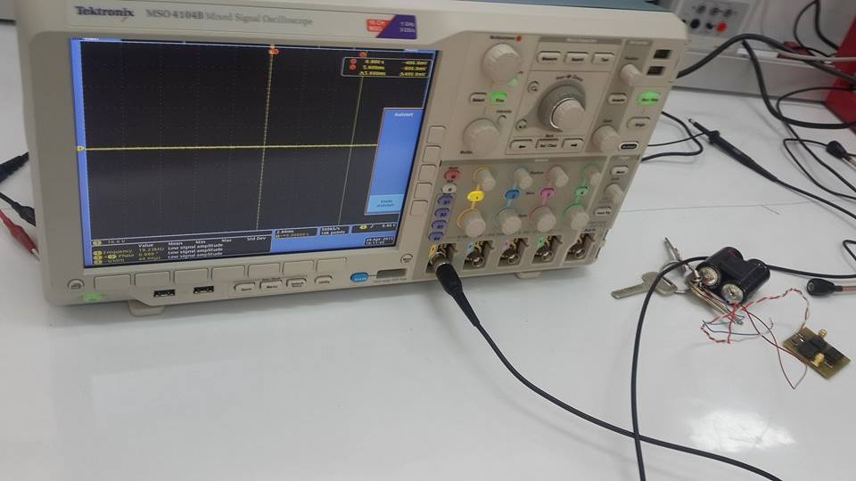
Figure 4.1.7: measurements using mixed signal oscilloscope.
After all of these measurements of LO we noticed that the results that have been obtained not as we expected, so we tried to fix it by removing one of the components after study the effect of each component, so we removed a capacitor with value 0.5pF and replace it with an open circuit as follows:
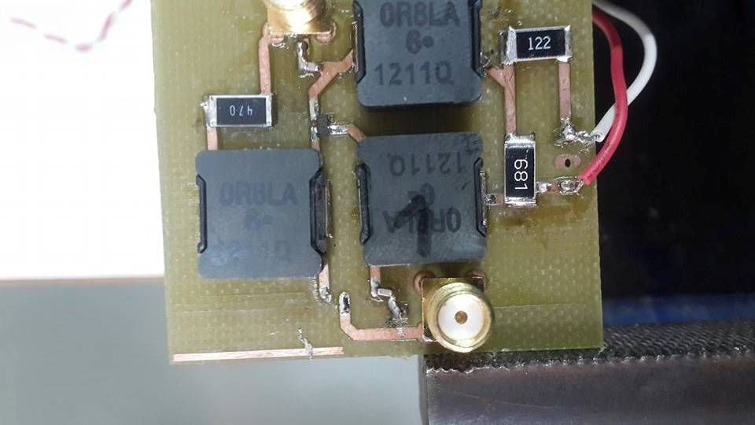
Figure 4.1.8: LO after removing the capacitor.

4.2 Mixer design:
In this section, three types of mixers are simulated using ADS software and discussed, single balanced diode mixer, double balanced diode mixer and NLTL mixer as shown below:
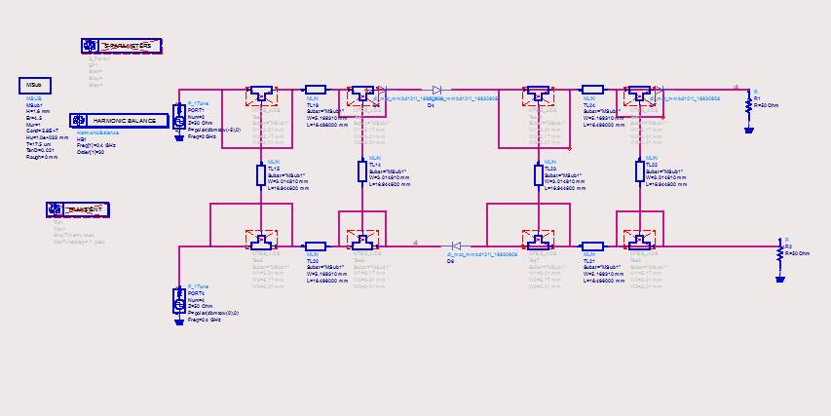Figure 4.2.1: single balanced mixer
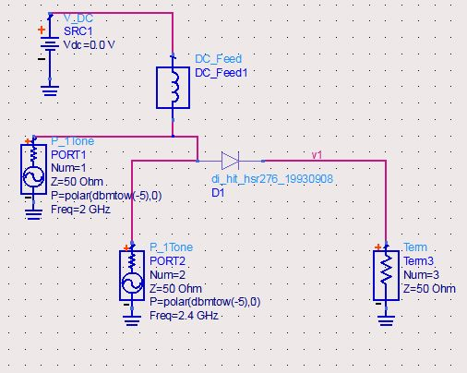
Figure 4.2.2: double balanced mixer
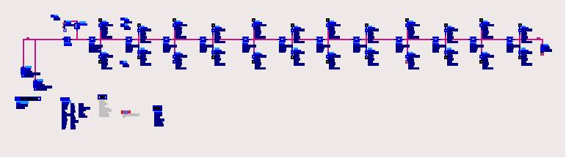
Figure 4.2.3: NLTL mixer
Note that our NLTL circuit which is shown in figure 4.2.3 is too long, so we extend a part of it to make it clear as in figure 4.2.4.
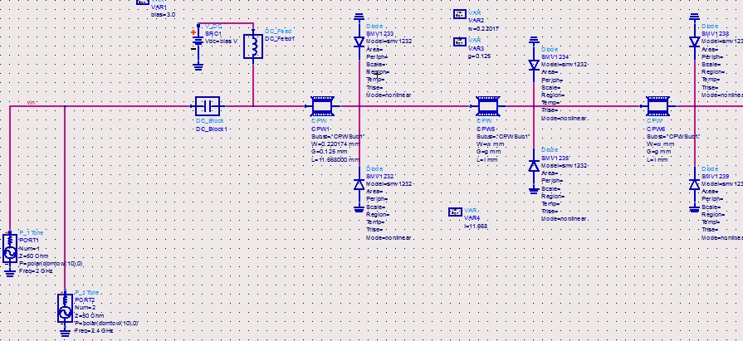
Figure 4.2.4: the extended NLTL mixer

4.3 Equipment
Too many devices used to measure the input and the output of the oscillator such as: network analyzer, spectrum analyzer, and mixed signal oscilloscope. For the software, eagle and ADS were chosen as we mentioned before.

Chapter 5: Results and Analysis
The data was taken after the measurements of the LO and the measurements of each type for the mixer.

5.1 LO results
The following graph shows both the simulated and the measured results of input impedance for the LO.
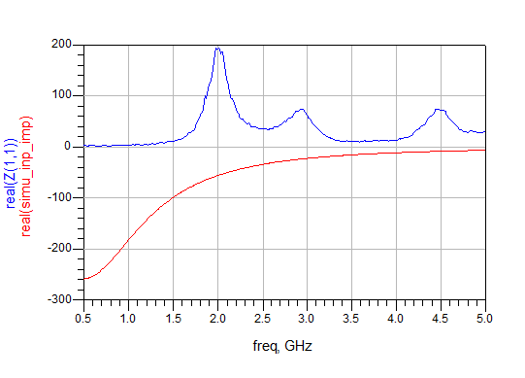
Figure 5.1: simulated and measured results for the LO
We can see that the simulated represents a negative feedback resistor which works at 2.4 GHz while the measured one represents a positive feedback resistor.

The following figure shows the magnitude of S11 and S21 at 2 GHz which the desired frequency and it’s clear that the values are less than one so we get low gain which is the main problem in our design so no oscillation. To fix this problem we will rebuild the LO circuit.
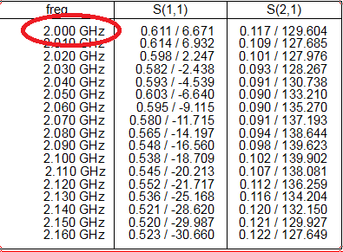
Figure 5.3: S-parameters for the LO

5.2 Mixer results

5.2.1 Single balanced mixer
The following graph shows the output frequency of the single balanced mixer
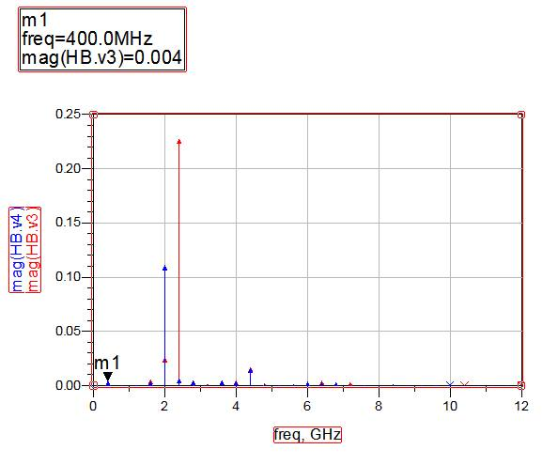Figure 5.1: Output frequency of single balanced mixer.
M1 represents the wanted frequency which equal to 400MHz, the other frequencies are the summation and the difference of the 2 input frequencies and it can be neglected by using a low pass filter.

5.2.2 Double balanced mixer
The following graph shows the output frequency of the double balanced mixer
Figure 5.2: Frequencies of double balanced mixer
Where m1 and m2 represent the input frequencies of the mixer and m3 represents the output frequency which is what we want.

5.2.3 NLTL mixer
The following graph shows the output frequency of NLTL mixer
Figure 5.3:output frequencies of NLTL mixer
This is the worst output we got.

Chapter 6: Discussion
The main two purposes of our design were to implement a negative resistor LO, and to implement a mixer to complete the transmission RF system. Unfortunately, We faced a lot of obstacles, the 1st one is the unavailability of the components in our country, the 2nd one is the hardware design of the LO since we consider the transmission lines as an ideal ones, but in reality, we can't do it. So after the measurements we noticed that the LO works as an antenna or as a positive resistor LO. We tried to fix this problem by restudy the specification of each component, after that, we replace one of the capacitors by an open circuit. For the mixer, we design 3 types of mixers which are: balanced, double balanced, and NLTL mixer. After study the output of each one, we choose the double balanced mixer. Finally, we suggest to implement the double balanced mixer and study the transformers to complete the main project which is IoTV band.

Chapter 7: Conclusion and Recommendation

7.1 Conclusion
In our project, a high frequency local oscillator (2GHz) with the fixed output frequency 450MHz and by negative resistance technique is designed. In addition, three types of mixers are discussed , designed and analyzed to find that the best one is double balanced diode mixer and we recommend to prepare it in the future works.
We designed the schematics, the circuits were simulated by using ADS 2009 and later a PCB layout was created for the LO using Eagle. Finally, we used the spectrum analyzer to test the LO circuit.

7.2 Recommendation
1. We recommend redesign the LO circuit according to our results
2. We recommend designing the double balanced mixer circuit
3. We recommend designing the suitable transformer to get the whole system.

Chapter 8: References
[1]: AT&T Tech Channel (2011-06-13). "AT&T Archives: Testing the First Public Cell Phone Network". Techchannel.att.com. Retrieved 2013-09-28.
[2]: Aseel, Dina, Isra: Design and implementation for a High Frequency Local Oscillator (2.4 GHz-450MHz), An-Najah National University,2015.
[3]: Chattopadhyay, D. (2006). Electronics (fundamentals And Applications). New Age International. pp. 224–225.
[4]: Kong, The Chinese University of Hong. The Design of 2.4GHz Bipolar Oscillator, 2001.
[5]: RF Mixers ,Iulian Rosu, YO3DAC / VA3IUL, http://www.qsl.net/va3iul
[6]: Ferenc Marki & Christopher Marki, Ph.D,"Mixer Basic Primer", RF & Microwave Mixer.
[7]: RF Circuit Design for Wireless Applications – U. Rohde, D. Newkirk.

