Gd
Student Management & Tracking Web-Based System
An-Najah National University
Faculty of Engineering
Department of Electrical Engineering
Spring Semester
2010/2011
Abdulrahman A.A.Aldeek
Luqman S.F.Mara’beh

Dr.Samer Mayaleh

بسم الله الرحمن الرحيم



الاهداء:

الحمد لله الذي هدانا لهذا وما كنا لنهتدي لولا أن هدانا الله , فله الحمد والمنة والشكر العظيم أولا وأخيرا وقبل أي شيء وقبل كل شيء , حمدا يوافي نعمه ويكافئ مزيده بان هداني ووفقني وأكرمني وعلمني ما لم أكن اعلم , فيا رب لك الحمد كما ينبغي لجلال وجهك وعظيم سلطانك وبعد .

فاني اهدي هذا الجهد المتواضع إلى كل من علمني حرفا , واخص بذلك والدي الكريمين الذين ربياني صغيرا وعلماني كبيرا وسهرا على تربيتي التربية الصالحة , فكنت من حسناتهما وثمره من ثمرتهما , فجزآهم الله عني خير الجزاء , واني اسمح لنفسي هنا أن أدعو ربي أن يجعل هذا البحث ونتاج هذه المرحلة والتي توجت بتخرجي في ميزان حسناتهما , وخاصة والدتي التي كانت أخر كلماتها قبل أن تفيض روحها إلى بارئها راضيه مرضيه أن ينعم علي ربي بالنجاح والتوفيق.

إلى أساتذتي الكرام في جامعة النجاح الوطنية و خاصة في قسم الهندسة الكهربائية , الذين لم يألوا جهدا إلا بذلوه في سبيل تقديم كل نافع طيب خير , حتى وصلت إلى ما وصلت إليه من نجاح وتفوق , فبارك الله جهودهم وجزآهم عني خير الجزاء .

كما اهدي هذا الجهد إلى أرواح شهداء الأمة الذين قدموا أغلى ما يملكون في سبيل عزة هذا الدين فأرتقت أرواحهم إلى بارئها , والى كافة أسرى الحرية القابضين على جمرة الدين والوطن وخاصة أسرى جامعة النجاح الوطنية .

كما واهدي بحثي هذا إلى كل من ساعدني في إخراج هذا المشروع , حتى يرى النور سواء كان ذلك في اختيار الفكرة والمراجعة والمناقشة وتصحيح الأخطاء ومراجعة الأفكار , وإضافة ما ينفع واخص بذلك الدكتور سامر ميالة فجزاه الله عني خير الجزاء.

إلى كل هؤلاء والى كل الجنود المجهولين , اللذين يخدمون أهليهم وأوطانهم لا يريدون من وراء ذلك جزاء ولا شكورا لهم مني كل الشكر والتقدير وهذا العمل المتواضع .
لقمان مراعبة

*****************************************************************

ليس هناك من أحد يمكن أن أفكر فيه في هذه اللحظة باستثناء والدتي، تلك المرأة العظيمة التي لم اكن لأكون شيئا لولا مساعدتها و حنانها الدافق أبدا..........إليكي........أهدي هذا العمل البسيط.....و أهدي كل نجاح و أطلب منك السماح و المغفرة على كل زلة صدرت مني بحقك..................

إلى رفاق الامس و اليوم................و الى رفاق المستقبل الذين ستجمعنا بهم الحياة يوما....................

و إليها.........تلك الروح القريبة البعيدة، تلك الروح التي لا أزال أبحث عنها و أرجو بلقائها إيجاد السعادة.......

عبدالرحمن الديك

Table of Contents:

Abstract………………………………………………………………………………….…………………..5
1.Introduction…………………………………………………………...................................6
2.Background……………………………………………………………………………………………..7
- 2.1 system existence………………………………………………………………………….7
- 2.2 How it works?..............................................................................8
- 2.3 Introduction to RFID,GPRS &SMS…………………………………………………9
3.System Description………………………………………………………….………………………12
- 3.1.The Scenario……………………………………………………………………………….12
- 3.2 The Block Diagram of the system……………………………………………..…12
- 3.3 RFID Reader and Tags……………………………………………………..………….13
- 3.4 GSM Module…………………………………………………………..………………....17
- 3.5 School's Monitor Computer………………………………………………………..19

4.Implemetation…………………………………………………………………………………..……………22
- 4.1 PIC microcontroller & serial interface....................................................22
- 4.2 RFID Reader design & usage.................................................................23
- 4.3 GSM Module……………………………………………………………………………………..25
  - 4.3.1 The case of using SMS
  - 4.3.2 The case of using GPRS
  - 4.3.3 The case of using Email
  - 4.3.4 GM 862-GPS, From the inside
- 4.4 Monitor Computer………………………………………………..…………………………..32
5.The Cost……………………………………………………………………………………………………….…33

6-Algorithms……………………………………………………………..………………………..……………..34

7- Conclusion……………………………………………………………………………………………………..39

Appendix A. RFID Reader Datasheet and PCB files.

Abstract:

This report will discuss our final graduation project, which is a student tracking & management web-based system, it will start with an introduction which will discuss the goal of our project and gives a brief information about the technologies that was used or can be used in this project, then the report will give a probable background about the scenario and theoretical information needed for the project.

The second part is the most important, which contains the system components and the implementation chapters, the system components chapter gives the reader some information about specifications of components that we used in order to complete the project.

The implementation chapter explains the process of making the system in details, this chapter is the resultant of our research and experience in the fields of RFID, GSM modules, PIC programming and PCB implementing.

The algorithm of the project and the cost of the project were shown in the report also.

The appendix will contain data about the reader that we implemented and the PCB files of the reader.

1-Introduction:

This project is a student tracking system using RFID technology, at the very simplest level; Radio Frequency Identification (RFID) technologies allow the transmission of a unique serial number wirelessly, using radio waves. The two key parts of the system that are needed to do this are the RFID 'tag' and the 'reader'; attaching an RFID tag to a physical object allows the object to be 'seen' and monitored by existing computer networks and back-office administration systems.

Our goal is to provide tracking for students of elementary schools and kindergartens by a system depends on the technology of RFID, by inserting RFID readers in a specific places in the facilities and transportation buses and providing each student with RFID tag which specifies each student with a certain ID number and other personal information , we are able to estimate the possible location of each student and we also can put an initial scenario of places each student used to go in the facility.

Each RFID reader will be connected to the facility’s web server through a communication device like GSM module, this module will connect the reader via Short Message Service “SMS”, General Packet Radio Service “GPRS” and Email, these communication techniques will convoy data between the readers and the server.

Other communication techniques can be used to perform this project like IEEE 802.15.4 “Zigbee” or Ethernet technology “Xport or WIZnet”.

This project can be also considered as a prototype for many applications that need to identify humans or objects and communicate with a particular server, so it is considered as a very important approach for anyone who has an idea related to many fields like identification, tracking, management and security.

2-Background:

In this section we will remind you with the basic concepts and theoretical information needed to understand our project.

2.1 System Existence:

In general, student tracking & management web-based system can be summarize by the following figure:
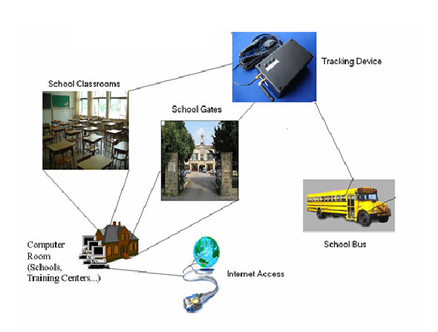
From this figure we can understand that any student tracking & management web-based system is consisting of several tracking devices inserted in critical spots inside the facility like facility's gate and rooms and outside the facility like transportation buses of the facility.

These tracking devices are connected to a web-based server located inside the facility by several protocols like SMS "Short Message Service", GPRS "General Packet Radio Service", RF devices "like ZigBee" and wired internet "using of Ethernet Protocol".

The web-based server receive data from the tracking devices and it is able to process data and make decisions according to a facility management's criteria, also it is able to communicate with parents in certain cases by using of e-mails and SMS and it also gives each parent the right to make a secure access to their child tracking data via the facility website to be always updated about the location of their child.

Tracking devices is consisting of two main parts, the first part is the identification system which is necessary to identify a specific student and must be accurate in identifying characters in order to allow the web-based server to make the right decision with the right person.

The second important part is the device transceiver which provides the ability for the tracking device to communicate with the web-based server by using of a certain protocol or standard.

The communications protocols and standards include the usage of GSM "Global System for Mobile communications" features like SMS" Short message Service" and GPRS "General Packet Radio Service", the usage of RF application "like the usage of Zigbee" and the usage of the Ethernet protocol "IEEE 802.3".

Tracking devices which are used in transportation usually comes which a GPS "Global Positioning System" feature which gives the ability to the management to track and know the location of the facility buses during their routes to pick students and during pieces.

2.2 How it Works?

In general, this system is designed for tracking students inside the facility and during transportation, this process is done by providing each student with an identification card which contains a certain electronic chip, this chip contains information that identify her carrier and it has the ability to communicate with the fixed tracking device.

When the student is in the range of a certain tracking device, the electronic chip which is inserted in his ID card will make a contact with the tracking device which will allow the device to identify the student and to record the time of this event. The device will transmit information to the web-based server which will record this event on this student's data base, each student's data base will be as a log page for this student, this log page will contains the recorded events of the student and each event with also be associated with the time of occurrence. This will make the facility staff able to estimate the possible location of each student and also can put an initial scenario of places each student used to go in the facility.

This system will also provide an easy way to take attendance in each classroom by providing a tracking device in each classroom which will save time in each lecture, because the manual way of taking attendance is just a waste of time and also can be manipulated sometimes by the students.

By inserting tracking devices in the facility gates, classrooms and transportation and other critical spots like the library and the sports complex, we can make a strong tracking system which can provide more security to the educational environment and make parents and staff always aware about their students.

2.3 Introduction to RFID, SMS & GPRS:

In a short introduction, we will speak about the RFID, SMS & GPRS in this background, these three concepts are important for this kind of projects because RFID could be used as An identification system for the tracking device, while SMS, GPRS, Zigbee or Xport could be used as standards of transceive data between the tracking device and the web-based server.

As we mentioned above, the tracking device consists of two main parts, the first part was the identification system which is necessary to identify a specific student and must be accurate in identifying characters in order to allow the web-based server to make the right decision with the right person.

One of the options was the usage of RFID "Radio Frequency Identification" as an identification system to our project.

An RFID system has two main components: the RF reader (known also as the base station or interrogator) and the RF tag (or transponder). When RFID tags are attached to physical objects they enable those objects to identify themselves to RFID readers through the use of radio frequency communication. In principle, and on the very simplest level, RFID tags allow objects to say, “Hello, I’m here and my name is …”. When discussing digital ‘intelligence’ with regard to an object or environment we have to keep in mind that although there are different sorts of tags with different levels of computing capability, the main intelligence resides in the network or application connected to the RFID system. The main purpose of an RFID tag is to act as 'glue' to a digitally mediated world.

General packet radio service (GPRS) is a packet oriented mobile data service available to users of the 2G cellular communication systems global system for mobile communications (GSM), as well as in the 3G systems. In 2G systems, GPRS provides data rates of 56-114 kbit/s.
GPRS data transfer is typically charged per megabyte of traffic transferred, while data communication via traditional circuit switching is billed per minute of connection time, independent of whether the user actually is using the capacity or is in an idle state. GPRS is a best-effort packet switched service, as opposed to circuit switching, where a certain quality of service (QoS) is guaranteed during the connection for non-mobile users.
2G cellular systems combined with GPRS are often described as 2.5G, that is, a technology between the second (2G) and third (3G) generations of mobile telephony. It provides moderate speed data transfer, by using unused time division multiple access (TDMA) channels in, for example, the GSM system. Originally there was some thought to extend GPRS to cover other standards, but instead those networks are being converted to use the GSM standard, so that GSM is the only kind of network where GPRS is in use. GPRS is integrated into GSM Release 97 and newer releases. It was originally standardized by European Telecommunications Standards Institute (ETSI), but now by the 3rd Generation Partnership Project (3GPP).
Short Message Service (SMS) is a communication service component of the GSM mobile communication system, using standardized communications protocols that allow the exchange of short text messages between mobile phone devices. SMS text messaging is the most widely used data application in the world, with 2.4 billion active users, or 74% of all mobile phone subscribers. The term SMS is used as a synonym for all types of short text messaging, as well as the user activity itself, in many parts of the world.
SMS as used on modern handsets was originally defined as part of the Global System for Mobile Communications (GSM) series of standards in 1985 as a means of sending messages of up to 160 characters, to and from GSM mobile handsets. Since then, support for the service has expanded to include other mobile technologies such as ANSI CDMA networks and Digital AMPS, as well as satellite and landline networks. Most SMS messages are mobile-to-mobile text messages, though the standard supports other types of broadcast messaging as well.

3-System Description:

In this section, we will demonstrate the main components of our system, by explaining the proposed scenario, the block diagram of the system and discussing each part of the system in details.

3.1 The scenario:

In our project we will discuss a study case of tracking students in the facility, this case is during the transportation from and to the facility, and this case will use the RFID reader as an identification system and the GSM module as a communication way between the transportation and the facility.

3.2The block diagram of the system:

The diagram of the system can be understood from the following diagram:
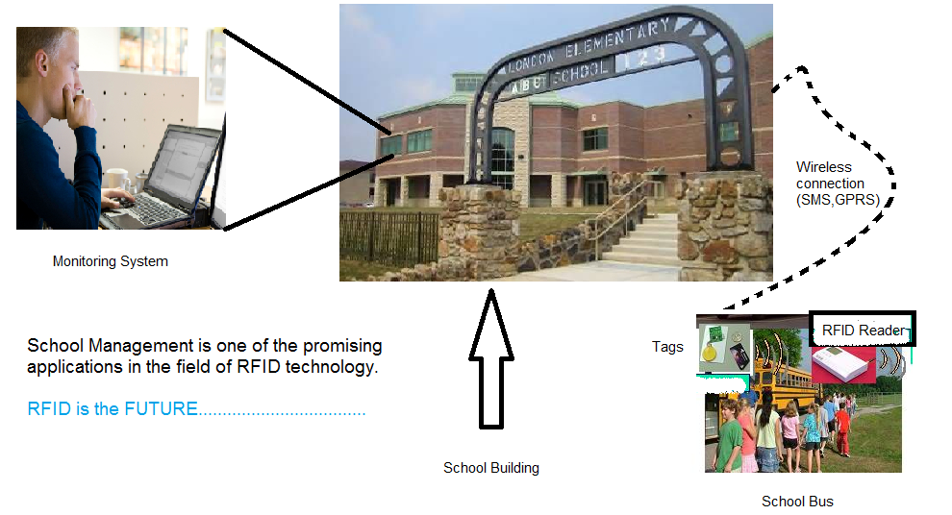
The figure above shows that the system is consisting of:

- RFID Readers & Tags.
- GSM Module.
- Monitor Computer.
3.3 RFID Readers & Tags:

In our project, RFID reader is very important for the system, so we choose to build it and provide a commercial RFID reader with its compatible tags in order to complete the system in the case of the failure in building the reader manually, first we will introduce you to the reader that we built then we will speak about the reader that we brought.

The reader that we built is designed by microchip, it is a FSK anti-collision RFID reader, we used this design because it is the only design that solves the problem of collision between tags, the internet is full of schematics for RFID readers but when you speak about the collision problem, you will be surprised by the fact that the only applicable schematic is the one we used.

The schematic of the reader is shown in the figure below:

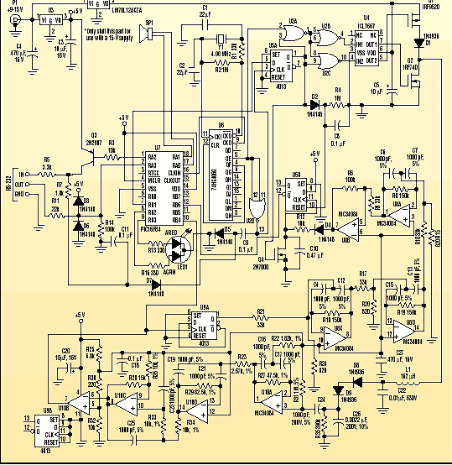
The RFID (radio-frequency identification) system consists of an RFID tag, a reader, and a user-interface computer. The passive RFID tag contains a silicon chip and an LC antenna circuit. The passive tag is energized by an RF field that’s transmitted by the reader (interrogation). Therefore, the tag doesn’t require any batteries for its operation.

When a large volume of tags must be read together in the same RF field, the application needs an anti-collision feature that enables the reader to receive data from the each tag on a one-by-one basis. Microchip’s MCRF250 is an example of an RFID tag IC featuring anti-collision technology. When multiple tags are in the same RF field and transmit data together, the reader must communicate with the tags to prevent collisions of data. This is accomplished by transmitting a “gap pulse” for the MCRF250.

When the tag recognizes the gap pulse, it doesn’t transmit data until it counts a number that’s generated by a random number counter. Each tag will finish counting the number in a different time. Therefore each tag will retransmit its data again in a different time slot. The anti-collision algorithm of the MCRF250 is shown in Figure below:
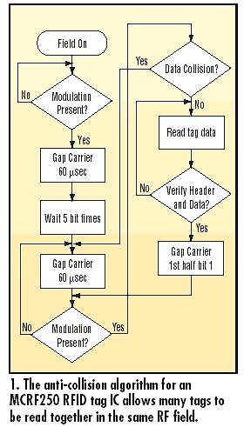
The reader consists of a transmitting and a receiving section. The transmitting section includes a carrier frequency generator, gap signal gate, and an antenna circuit. The receiving section includes a peak detector, a signal amplifier/filter, a signal-collision detector, and a microcontroller for data processing. While this reader is designed to read the MCRF250 anti-collision RFID tag, the concepts described here may be applied to readers based on other products.

The block diagram of the circuit is:

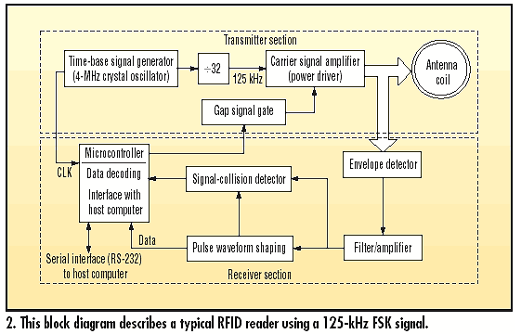

In the FSK communication protocol, a “0” and a “1” are represented by two different frequencies. In the MCRF250 RFID tag, a “0” and a “1” are represented by f_{C}/8 and f_{C}/10, respectively, where fC is the carrier frequency. The MCRF250 sends this FSK signal to the reader via amplitude modulation of the carrier signal.

The reader that we brought is called ID-20 RFID reader from ID-Innovations, This is a very simple to use RFID reader module. With a built in antenna, the only holdup is the 2mm pin spacing.

The ID-20 features are:
- 5V supply
- 125kHz read frequency
- EM4001 64-bit RFID tag compatible
- 9600bps TTL and RS232 output
- Magnetic stripe emulation output
- Read range of 200mm
The ID-20 reader is shown in the following image:

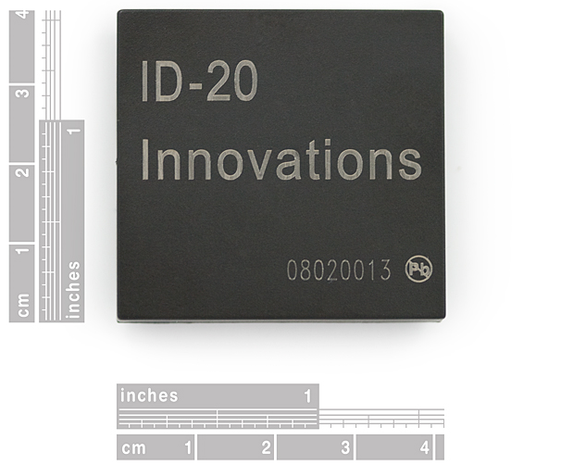

The tag which will used with the ID-20 reader is a simple 125 KHz tag, These tags come with a unique 32-bit ID and are not re-programmable. Card is blank, smooth, and mildly flexible.

The features of these tags are:

- EM4001 ISO based RFID IC
- 125kHz Carrier
- 2kbps ASK
- Manchester encoding
- 32-bit unique ID
- 64-bit data stream [Header+ID+Data+Parity]
3.4 GSM Module:

The GSM module is important in this kind of projects, it provides the ability to send and receive data between the RFID reader in a moving vehicle and a fixed monitoring computer in the facility.

These are two important standards in the transfer of data using GSM network, the first one is the usage of SMS "Short Messages Service" and the second one is the usage of the General Packet Radio Service "GPRS".

The need for these two standards comes from the usage of SMS as a communication way between the reader and the monitoring computer in the case of the lack of enough coverage to establish a GPRS connection; in addition it is used also as communication way between the system and parents in the cases that require contact.

The usage of GPRS as a communication way between the reader and the monitoring computer, GPRS provides the ability to use the internet in sending and receiving data which will reduce the cost of transfer due to the usage of the packet switching in the case of GPRS.

In our project, choosing the GSM module was a priority because we need time to get a proper module and more time to learn how to use and interface it with the RFID microcontroller.

We choose to use the Telit GM 862 GPS module which is shown in the following figure:
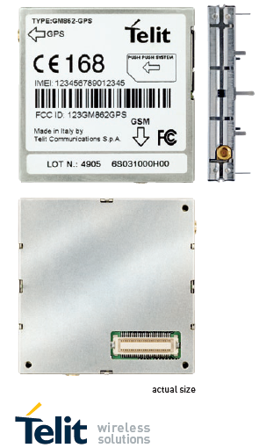

This module needs a special board in order to use it easily and effectively, the board comes with a special voltage regulator which does provides 2 levels of voltage(3.8 and 3.3 v), this board comes with a serial interface (RS 232) in order to make the usage of the module more easier.

The board is shown below:
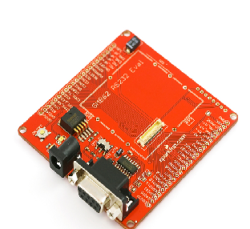
The Telit GM-862 GPS have many specifications like:

• SiRF III High Sensitivity GPS Receiver which is a great advantage of using this module because it provides the ability to use the GPS in tracking the transportation bus of the facility.
• GSM Quad Band (850\900\1800\1900MHz)
• On Board SIM Holder
• Embedded TCP/IP Stack
• GPRS Class 10
• Embedded FTP and SMTP Client
• 17mA average stand-by, 3.5mA in low-power mode
• 250mA average operating current
• Data, Voice, SMS, and Fax
• Data speeds up to 57.6kbps
• Supply voltage : 3.4-4.2V
• CMOS Camera Capable
• 2 x MMCX Antenna Connectors
• Extensive datasheets and forum support

3.5 Monitor Computer:

The monitor computer will be a normal computer has an access the internet via a certain IP address; also it will be connected to a GSM device in order to receive SMS messages from the readers and send messages to parents or other individuals.

The computer will have a certain program and this program functionality is to receive data from the RFID readers from the internet by listening on a certain port in order to get the data from the internet or by receiving SMS from the readers in the case of SMS usage. It will work basically as a log page for students and will provide time of the events which is important to know the last place of each student.

This program can be upgrade to a full control system with the ability of make decisions and understand scenarios and give alarms in some cases.
The GSM module that we used in the project for receiving and Sending SMS is SAMBA 75, it was available with one of the assistants in the department so we used it in order to reduce the fees of the project.

The Falcom Samba 75 is a plug-and-play, compact, light-weight, wireless modem that provides EDGE, GPRS and GSM connectivity for portable, handheld computers and others.

Samba 75 is in the image below:

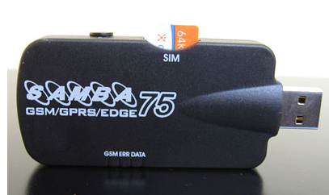

Its features are:
- Integrated Quad Band GSM/GPRS/EDGE Engine
- SAMBA75: 850/900/1800/1900 MHz
- Data, SMS, Fax, MMS, Downloads
- TCP/IP stack implemented
- Audio/Video streaming
- GPRS class 12, class B
- EDGE class 10, class B
- Integrated USB-Hub
- GSM antenna included
- USB serial link
- World-wide applicable

The software of the project can be built using C# programming language, with the assistance of our friends in the department of computer engineering we were able to build the application which will be used for the case of SMS or GPRS usage.

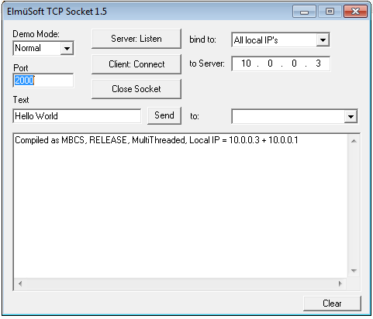

Fig: C# application in order to receive TCP packets from a remote module on a certain port NO.

4-Implementation:

In this chapter we will discuss the process of implementing the hardware and software of the project which is the most important process in any project, what you about to read are an experience we gained in the hard way, the way of searching and trying new technologies, we hope that others will complete the journey that we started.

4.1 PIC Microcontroller & Serial interfacing:

It is the heart of the system, the PIC microcontroller is responsible for commanding GSM module by sending orders to it and its also responsible for receiving data from the GSM module and RFID reader, processing the data which came from the RFID reader in order to identify the tag carrier is also done by the PIC in order to reduce the cost of transferring data between the reader and the web application.

Using RS-232 we can interface the PIC to both the computer if we want to program the system and the GSM module.

The Basic circuit of PIC 16f877A with Max 232 is in the following figure:
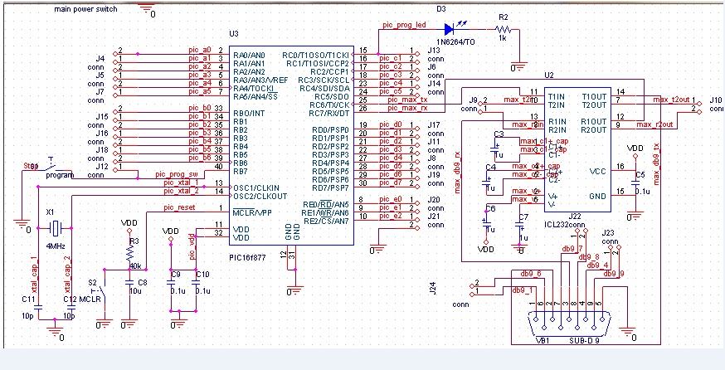

The problem of interfacing three serial devices (computer, GSM module, RFID reader) to one PIC was very critical, because the PIC comes with one known serial pair(two pins, one for transmitting and the other for receiving), in order to solve this problem we were about to use a Tri-state buffer as a hardware solution, Tri-state buffer can solve the problem by allowing one device only to connect to the PIC serially , i.e there was no ability to connect two devices Simultaneously but the device that its buffer had been enabled will connect the PIC serially.

With more searching and asking friends about this problem, a very simple solution was introduced, it was a software solution, this solution was to make virtual serial on the PIC during programming, this could be done by choosing two pins on the PIC, one as a transmitter and the other is a receiver and using a certain programming sentence as a declaration for that new serial, and this solution works with us, so in our project we were able to interface three serial devices to one PIC simultaneously.

4.2 RFID Reader Design and Usage:

As we mentioned before, we built a FSK anti-collision RFID reader for the system and we used a commercial RFID reader in order to complete the system.

We will start with the RFID reader that we built, in order to build the reader we decided to use the printed circuit technology because the circuit is too big to be built manually; we used professional software called Eagle in order to build the schematic of the reader and convert it into a design ready for printing.

We divided the reader into two circuits in order to trace the faults easier and save time, the reader had been divided into two main sections: transmitter and receiver.

The transmitter part contains the microcontroller, a carrier frequency generator, gap signal gate and an antenna circuit. The receiving section includes a peak detector, a signal amplifier/ filter and a signal-collision detector.

The transmitter and receiver schematics and boards are shown in the appendix.
Also the mechanism of this reader will be explained in the appendix.

The commercial RFID reader that we used is ID-20 RFID reader; it is made by a Chinese company called ID-Innovations. The reader came with a breakout chip in order to make it easy to connect the reader’s pins to the other devices.

The reader with the breakout is shown below:

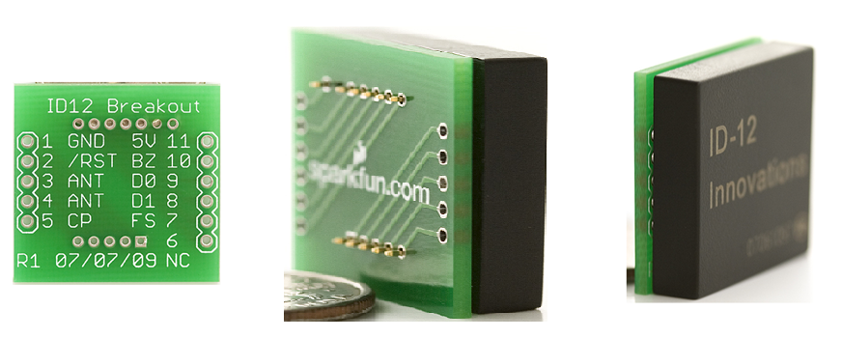

The circuit diagram of the ID-20 activation is the following:

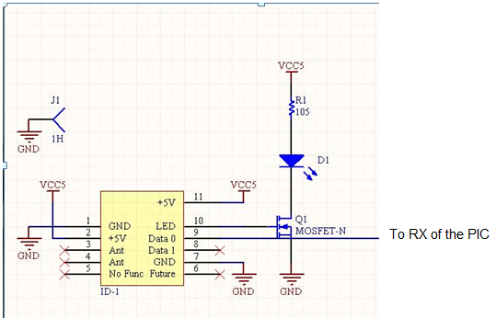

From the figure we notice that PIN 9 will be connected to the RX pin of the PIC, this pin will send serial data to the PIC with a baud rate of 9600 bps when a compatible tag is in the reader’s effective range, this serial data will contain the stored data on each tag, this data consists of 64-bit data stream [Header+ID+Data+Parity], this data will be transferred from the tag to the reader using ASK ”Amplitude Shift Keying” and Manchester encoded, the reader will demodulate and decode the data, then it will be sent from pin 9 to PIC.

Diode will blank if a tag had been read by the reader, it is an indication that the reading process had been done. A transistor had been added in order to protect the reader from high currents if there any.

4.3GSM Module:

As we all know, we used Telit GM 862-GPS as a communication device between the RFID reader and the facility’s computer, in this section we are about to discuss three cases: the case of using SMS, the case of using GPRS and the case of using Email.

We will also speak about the interface between the PIC and the GSM module.

In the first place, configuring the device to work is the most important section in order to start using the device, providing the device with the suitable voltage supply, the suitable serial application like Hyper terminal and the suitable baud rate is very important factors to guarantee that the device will work.

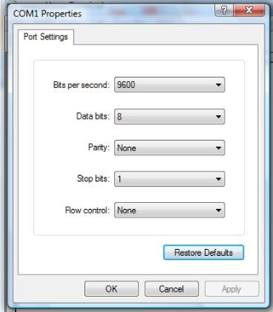

When we started to deal with the device, we thought that the best approach to use this device effectively is to learn how we can use it using computer, so we started using hyper terminal to send the AT commands of the device for configuring the device then for using it to send SMS,GPRS and emails.

Orders like the selection of baud rate, insertion of PIN No.”Personal Identification Number” and the enabling of the extended error results are very important in the three cases that we are about to discuss.

4.3.1 The case of using SMS:

The Telit modules support the Short Message Service to store, delete, write, send and receive an SMS, which is a short text message up to 160 characters long. Before using an SMS, the Short Message Service needs to be configured.

The Telit module supports two SMS formats:
-PDU mode
-Text mode

The PDU is the format used by the module to send a message on the air. The PDU mode enables the User to edit the message in that format “the format that the module uses in order to send the messages”. If the User is familiar with PDU encoding then he/she can operate with PDU by selecting that mode and use the appropriate commands.

Then we have to check the SMS message service center, An SMS is sent by the Telit module to a Service Centre (SMSC) where the message is dispatched towards its final destination or is kept until the delivery is possible. To ensure the correct operation of this service the number of the SMS Service Centre needs to be configured on the module in accordance with the Network Operator used.

We have to be sure that the SMS message service center is inserted correctly using AT commands.

Then we can send or receive messages using the probable AT-Commands.

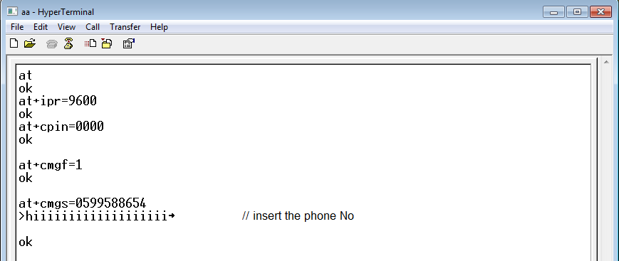

Fig: Sending SMS using the module

4.3.2 The case of using GPRS:

After configuring the module with the essential At commands, the following steps must be done in order to send data using GPRS to a static IP address on a web application in the facility.

First we need to set the context parameter for connection, the context parameters consists in a whole set of information identifying the internet entry point interface provided by the ISP. Using these parameters, the GPRS network identifies the ISP to be used to gain access to the internet, and defines the value of the IP address for the GPRS device, once connected.

Next step is activation of GPRS context which gives as reply the IP of the module assigned by network. Now you can open the connection with the remote host with using its static IP address on the certain port number.

Using static IP for the facility’s computer is very important in order to write the IP in the code and not to change it every time we want from the reader to connect to the facility, but the GSM module will use the dynamic IP, i.e. it will take a new IP once its connect to the internet.

The computer of the facility must be connected to the router (or the gate way) by the usage of static NAT (Network Address Translation) which provides a one-to-one internal to public static IP address mapping, because if we use the Dynamic NAT, the arriving packets from the reader will reach the gateway and stay there because the gateway can’t decide to which computer(host) it will switch the data, but with the usage of Static NAT, the gateway will send the packets to the only client that is connected to it.

For our project we used the dial up connection to test the GPRS connection because Dial up connection doesn’t depend on NAT or private IP’s, but it depends on the usage of real IP’s each time the client uses the connection, i.e. there are no other clients share the same IP as in the case of the usage of private IP’s and NAT and the test was successful.

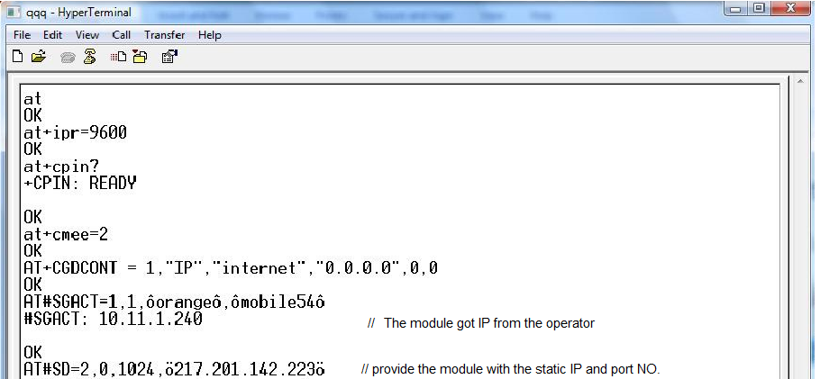

4.3.3 The case of using Email:

Using email is very important because it can reduce the cost of project by saving the fees of the static IP, there will be no need to use static IP when we can use email because email can reach to any computer any where depending on the destination email address.

In general, sending emails can be done by using Simple Mail Transfer Protocol (SMTP), it is an Internet standard for electronic mail (e-mail) transmission across Internet Protocol (IP) networks. So a connection to the SMTP server of the Email domain that we want to use is essential to send an email to any destination.

In order to send an email using the module we need to we need to set the context parameter for connection, set the socket parameters and activate the GPRS connection, then we connect to the SMTP server of the Email domain that we want to use it, if the connection established, we start sending commands in order to log in into our account in the email domain, then we write the email and send it to a certain destination.

Our test of sending emails wasn’t successful because we used the data SIMs of Jawwal in order to use GPRS and send emails, we used the SMTP server of Gmail because it’s free of charge and powerful, but Jawwal doesn’t allow the access to Gmail SMTP server and we had to use its SMTP server which, i.e. to use an email from its domain but that wasn’t available for us.

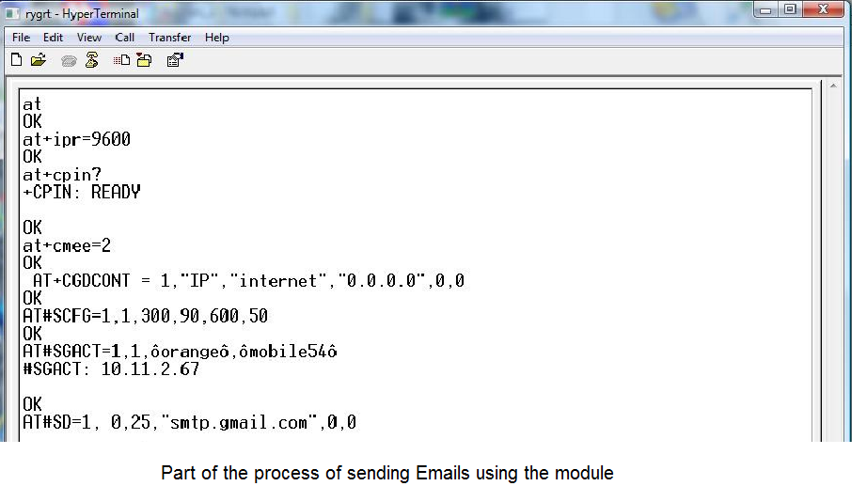

4.3.4 GM 862 GPS, From the inside:

In this section we will give a brief explanation about this component and how to interface it will the computer and PIC microcontroller.

The Telit GM 862 GPS is shown in the following diagram:
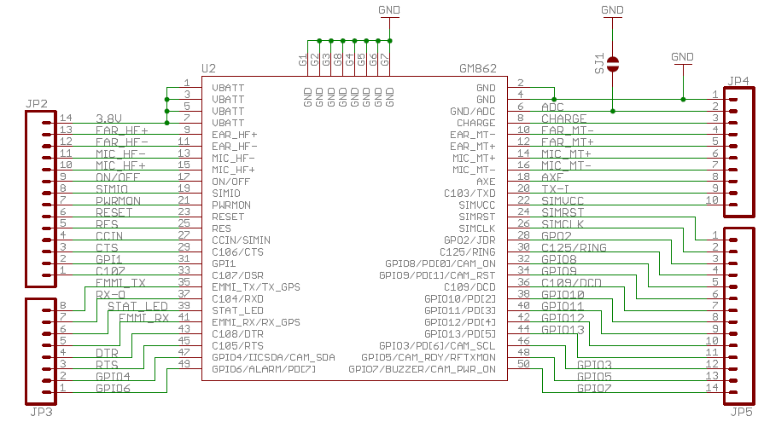
This module needs 2 voltage levels in order to work; the first level is 3.8v which is used to power the module and the second is 2.8v which is used to power up the Max 3232 which we used in order to interface the module with the computer and PIC.

The power supply circuit is shown below:
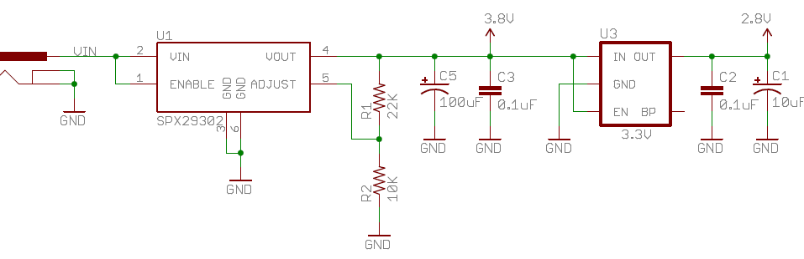
This supply gives two voltage levels by using a special regulator as shown above.

To interface this module to computer and to PIC, the most important note is the voltage level difference between the serial connection of the module and the serial connection of the computer and PIC.

So the solution is to adjust the voltage level and make it equal. A lot of solutions can be done by making circuits to convert voltage from 5v to 2.8 and vice versa for the connection between the module and the PIC, but we used the Max 3232 IC, which is similar to Max 232 but operates on a lower voltage.
The circuit of Max 3232 is shown below:
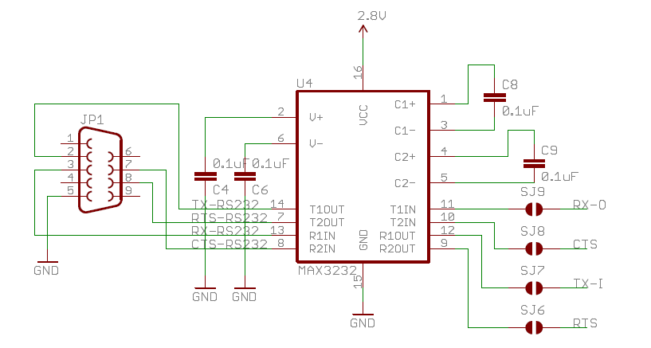
The connection between the PIC and the module can be summarized by the following figure:

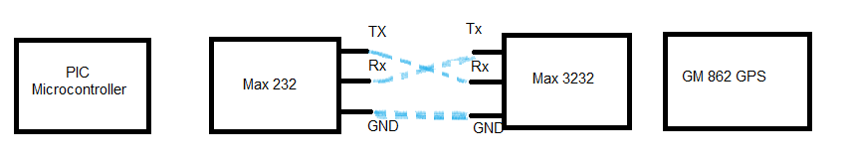

4.4 Monitoring Computer:

The monitor computer will contain a web application made using Microsoft visual studio (C# language), this application will serve as a log page for students and will provide time of the events which is important to know the last place of each student.

This will be done using an application designed for listening on a certain port number for the arrival of TCP packets which had been sent by the reader Using GPRS technology and for receiving SMS sent by the reader in the case of the usage of SMS technology.

Receiving SMS will be done by the Samba 75 module, which will receive the messages and appear them using the application program.

This application could look like:

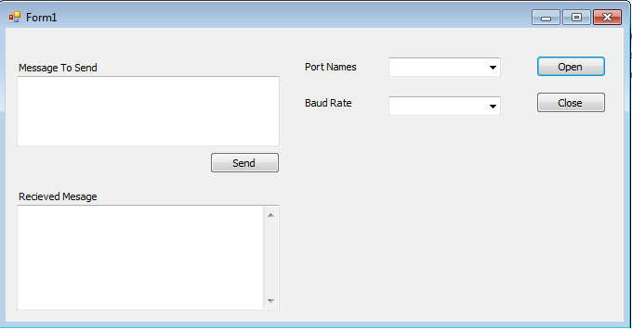

5-The Cost:

In this part we will discuss the total cost of the project, but it will not include the work hours in performing the project, it is the cost of the devices that had been used to complete the project:

Device | Number of needed devices | Cost(NIS)
Telit Gm842 GPS | 1 | 170
Evaluation Board for GSM module | 1 | 315
ID-20 RFID Reader | 2 | 532
Components for Anti-collision reader |  | 290
PIC Microcontroller & base circuit |  | 80
Total Cost |  | 1382

We used two ID-20 readers because the first reader that we get damaged due to exceeded voltage from one of the power supplies in the workshop although we adjust the supply every carefully, the supply that we used was broken and unstable and damage our reader, we knew that after this problem and we had to get another one in order to complete the system so we advise you to never trust any voltage supply and to use regulators and protection devices to keep your components safe.

If we want to calculate the net cost for the system, we need to omit the cost of the components of the Anti-collision reader and the cost of one of the ID-20 RFID readers. The cost will become 826 NIS without including the cost of the software program and the cost of the work hours.

6-Algorithm:

The main algorithm of the system is shown in the diagram below:

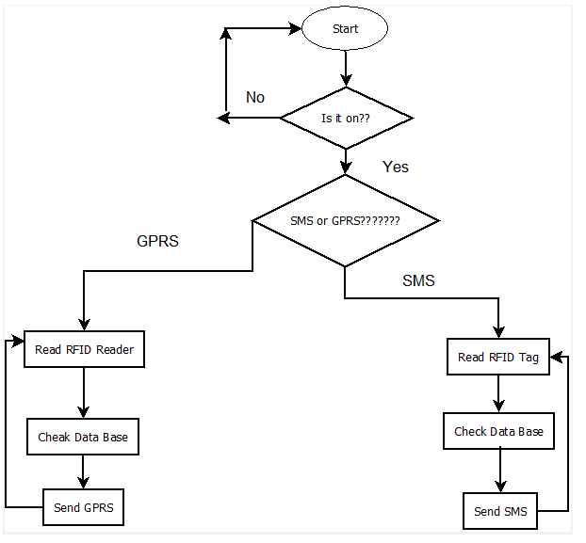

The Algorithm for reading RFID tag is

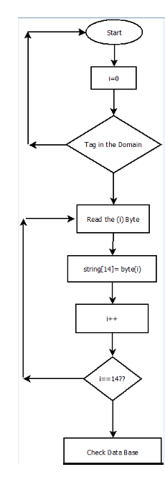

The algorithm for checking the data base is:
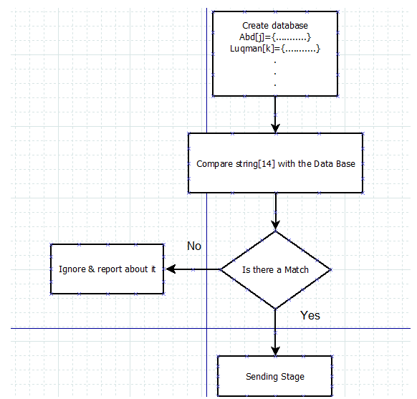

The algorithm for sending SMS is:
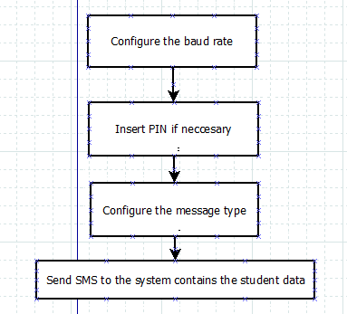

The Algorithm for Sending data using GPRS is:

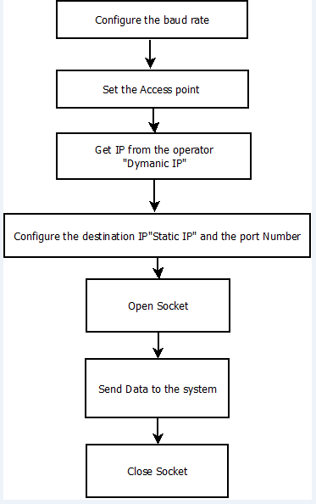

7-Conclusion:

In this report, we discussed the main goal and vision of the project, we started with a brief introduction about the project and the general idea of it, then we moved to give a background about the theoretical information and the scenario of the project.

We discussed the components of our system and illustrate the specifications of the each component then we discussed the implementation process of the system which contains the practical part of the project in details.

We also provide the algorithm and the cost of the project in the end of this report.

Appendix contains the data sheet about the reader that we implemented and the PCB files of the project.

Appendix

