
An Najah National University
2012

Graduation project By: Shifa' Soleiman & Intesar Eshtaya.
Supervisor: Prof. Dr. Marwan Mahmoud .
Faculty of Engineering
Electrical Engineering Department
Individual power electronic circuits for different applications
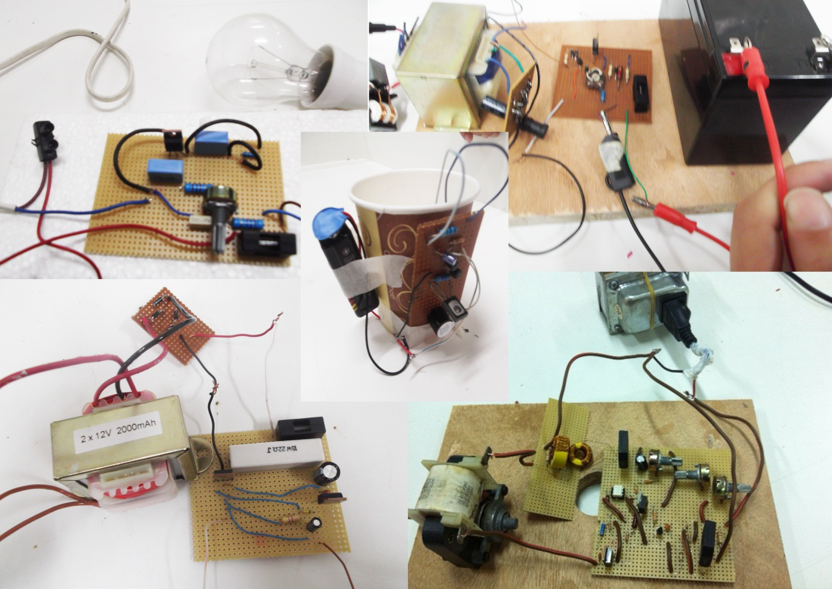
اهداء
لابد لنا ونحن نخطو خطواتنا الأخيرة في الحياة الجامعية من وقفة نعود إلى أعوام قضيناها في رحاب الجامعة مع أساتذتنا الكرام الذين قدموا لنا الكثير باذلين بذلك جهودا كبيرة في بناء جيل الغد لتبعث الأمة من جديد ...
وقبل أن نمضي تقدم أسمى آيات الشكر والامتنان والتقدير والمحبة إلى الذين مهدوا لنا طريق العلم والمعرفة...
إلى جميع أساتذتنا الأفاضل ونخص بالذكر مشرف بحثنا
الدكتور مروان محمود
على رعايته وحفاظه علينا ووقوفه الى جانبنا.

إلى من علمني النجاح والصبر
إلى من افتقده في مواجهة الصعاب
إلى من أفجعتني الدنيا برحيله ولم تمهله الدنيا لأرتوي من حنانه ويراني أكمل الطريق الذي بدأناه سويا وأكمل بحثي ... أبي.

إلى من أرضعتني الحب والحنان
إلى رمز الحب وبلسم الشفاء
إلى القلب الناصع بالبياض... والدتي الحبيبة.
انتصار نعيم اشتيه
يا من أحمل اسمك بكل فخر
يا من أفتقدك منذ الصغر
يا من يرتعش قلبي لذكرك
يا من أودعتني لله أهديك هذا البحث أبي.
إلى حكمتي .....وعلمي
إلى أدبي ........وحلمي
إلى طريقي .... المستقيم
إلى طريق........ الهداية
إلى ينبوع الصبر والتفاؤل والأمل
إلى كل من في الوجود بعد الله ورسوله أمي الغالية.
شفاء عماد سليمان

Contents

Table of figures …………………………………………………………………………………………………………………..4
Abstract 5
Introduction 6
Chapter 1 Power semiconductor devices 7
1.1 Silicon-controlled rectiﬁer (SCR).......... 7
1.1.1 IV characteristics of scr 8
1.1.2 Turning on methods 9
1.1.3 Turning off methods 9
1.1.4 How to test scr 9
1.2 Bidirectional Triode (TRIAC)..... 10
1.2.1 IV characteristics of Triac 11
1.2.2 Applications of Triac 13
1.2.3 How to test a triac 15
1.3 Bidirectional Trigger Diode (DIAC) 16
1.3.1 Construction of a Diac. 16
1.3.2 Operation of a Diac 16
1.3.3 IV characteristics of a Diac 17
1.3.4 Diac applications 18
Chapter 2 Scr applications 20
2.1 Rectification 20
2.1.1 How SCR functions as a Half Wave Rectifier ? 20
2.1.2 How to make a full wave rectifier using SCR ? 21
2.2 Ac power control by phase 22
2.2.1 90° Phase Control of SCR. 22
2.2.2 180 degree Phase Control 23
2.2.3 Pulse Control of an SCR 24
2.3 protection circuits for scr 25
2.3.1 Over-voltage Protection. 25
2.3.2 Over-current Protection 25
2.3.3 Protection against Voltage Surges. 26
2.4 Switching 27
How an SCR functions as a switch ? 27
Chapter 3 Our project circuits 28
3.1 Battery charger based on scr 28
3.1.1Principle of work 28
3.1.2 Our steps to build the circuit 29
3.2 5v dc power supply 30
3.2.1 Principle of work 30
3.2.2 Our steps to build the circuit 30
3.3 Light dimmer circuit 32
3.3.1 How light dimmer circuits work 32
3.3.2 Principle of work 33
3.3.3Our steps to build the circuit 33
3.4 Water Level Alarm Using SCR 35
3.4.1 Principle of work 36
3.4.2 Our steps to build the circuit 36
3.5 ac speed motor controller 37
3.5.1Principle of work 37
3.5.2 Our steps to build 38
Conclusion ………………………………………………………………………………………………………………………….39
References 40
Appendix 41

Table of figures

Figure 1: scr diagram & symbol 8
Figure 2: iv characteristics of scr 8
Figure 3: circuit for testing scr 10
Figure 4: triac basic structure 11
Figure 5: iv characteristics of triac 12
Figure 6: power lamp switching by triac 14
Figure 7: power control by tria 14
Figure 8: circuit for testing triac 15
Figure 9: diac basic structure 16
Figure 10: iv characterstics of diac 17
Figure 11: triac lamp dimmer circuit 18
Figure 12: diac heat control circuit 19
Figure 13: scr half wave rectifier 20
Figure 14: scr full wave rectifier 22
Figure 15: scr 90 degree phase control 22
Figure 16: scr 180 degree phase control 23
Figure 17: scr pulse control circuit 24
Figure 18: over voltage protection circuit 25
Figure 19: over current protection circuit 25
Figure 20: scr as switch 27
Figure 21: battery charger 28
Figure 22: battery charger 29
Figure 23: 5v dc power supply circuit 30
Figure 24: 5v dc power supply 31
Figure 25: 5v dc power supply 31
Figure 26: light dimmer circuit 33
Figure 27: light dimmer circuit 34
Figure 28: resistive load current(and voltage) for different firing angles a 34
Figure 29: scr water level alarm 35
Figure 30: scr water level alarm 36
Figure 31: ac speed motor controller 37
Figure 32: ac speed motor controller circuit 39

Abstract

Power electronic circuit convert electric power from one form to another form using electronic devices and functions by using semiconductor devices as switches.
Power electronics circuits are circuits handling transformers, rectifiers, Thyristors, Traices and Diacs with other conventional elements such as resistors, capacitors, coils, diodes and transistors. In our project we learn how to design and build these circuits with appropriate elements ratings. These circuits will include the different applications of Thyristor and thus provides a data base of principles and basics for a power electronic laboratory.

Power semiconductor devices are the most important functional elements in all power conversion applications such as scr (silicon controlled rectifier), the bidirectional Triode (TRIAC), and the bidirectional Trigger Diode (DIAC). The power devices are mainly used as switches to convert power from one form to another. They are used in motor control systems, uninterrupted power supplies, high-voltage dc transmission, power supplies, induction heating, and in many other power conversion applications. A review of the basic characteristics of these power devices is presented in the first chapter.
This report is divided into three main chapters, the first chapter about power electronic semiconductor devices as we mentioned above, the second chapter will include the application of Thyristors that we study in our project and the third part will include the circuit we build and study in our project.

Introduction

Power electronics is the application of solid-state electronics for the control and conversion of electric power. It also refers to a subject of research in electrical engineering which deals with design, control, computation and integration of nonlinear, time varying energy processing electronic systems with fast dynamics.
Power electronic systems are virtually in every electronic device. For example, around us:
• DC/DC converters are used in most mobile devices (mobile phone, pda and etc) to maintain the voltage at a fixed value whatever the charge level of the battery is. These converters are also used for electronic isolation and power factor correction.
• AC/DC converters (rectifiers) are used every time an electronic device is connected to the mains (computer, television and etc)
• AC/AC converters are used to change either the voltage level or the frequency (international power adapters, light dimmer). In power distribution networks AC/ AC converters may be used to exchange power between utility frequency 50 Hz and 60 Hz power grids.
• DC/AC converters (inverters) are used primarily in UPS or emergency light. During normal electricity condition, the electricity will charge the DC battery. During blackout time, the DC battery will be used to produce AC electricity at its output to power up the appliances.

Chapter 1 Power semiconductor devices
A various Thyristors are now available but some of these devices have similar or related characteristics. Most applications which involve power control are therefore handled with a few basic components. The Thyristors that are most widely used are the Silicon Controlled Rectifier (SCR), the Bidirectional Triode (TRIAC), and the Bidirectional Trigger Diode (DIAC). . A summary of these power devices that we used in our project is presented in this chapter.

  - Silicon-controlled rectiﬁer (SCR)
SCR is a controlled rectifier constructed of a silicon semiconductor material with a third terminal for control purposes. Silicon was chosen because of its high temperature and power capabilities. The basic operation of the SCR is different from that of an ordinary two-layer semiconductor diode in that a third terminal called a gate, determines when the rectifier switches from the open-circuit to short-circuit state. It is not enough simply to forward-bias the anode-to-cathode region of the device. In the conduction state the dynamic resistance of the SCR is typically 0.01 to 0.1 ohm and reverse resistance is typically 100 kilo ohm or more. It is widely used as a switching device in power control applications. It can control loads by switching on and off up to many thousand times a second. It can switch on for a variable length of time duration, thereby delivering desired amount of power to the load. Thus, it possesses the advantage of a rheostat as well as a switch with none of their drawback. A schematic diagram and symbolic representation of an SCR are shown in figure1. SCR is a three-terminal four-layer semiconductor device, the layers being alternately of P-type and N-type. The junctions are marked J1, J₂ and J₃ ₍junctions J1 and J3 operate in forward direction while middle junction J2 operates in the reverse direction) whereas the three terminals are anode (A), cathode (C) and gate (G) which is connected to the inner P-type layer. The function of the gate is to control the firing of SCR. In normal operating conditions, anode is positive with respect to cathode.

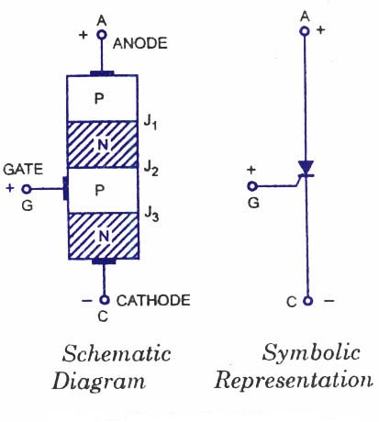
Figure 1: scr diagram & symbol

The anode to cathode is connected in series with the load circuit. Essentially the device is a switch. Ideally it remains off (voltage blocking state), or appears to have an infinite impedance until both the anode and gate terminals have suitable positive voltages with respect to the cathode terminal. The Thyristor then switches on and current flows and continues to conduct without further gate signals. Ideally the Thyristor has zero impedance in conduction state. For switching off or reverting to the blocking state, there must be no gate signal and the anode current must be reduced to zero. Current can flow only in one direction.

1.1.1 IV characteristics of scr
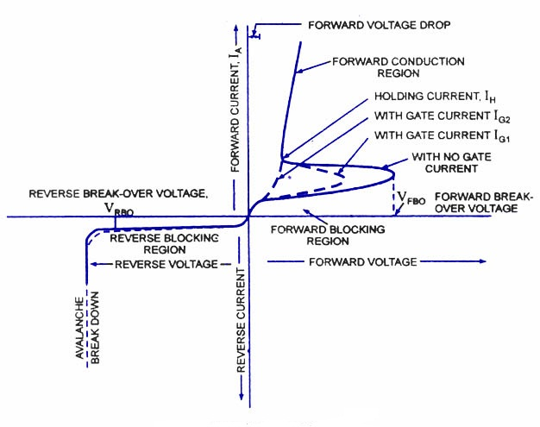
Figure 2: iv characteristics of scr
It can be seen from figure2 that the SCR has two stable and reversible operating states. The change over from off-state to on-state, called turn-on, can be achieved by increasing the forward voltage beyond V_{FB0}. A more convenient and useful method of turn-on the device employs the gate drive. If the forward voltage is less than the forward break-over voltage, V_{FB0}, it can be turned-on by applying a positive voltage between the gate and the cathode. This method is called the gate control. Another very important feature of the gate is that once the SCR is triggered to on-state the gate loses its control.

1.1.2 Turning on methods
There are five basic methods of triggering on scr:
1-Thermal triggering
2-Radiation triggering
3-Voltage triggering
4-Dv/dt triggering
5-Gate triggering
Turning on of Thyristors by gate triggering is simple, reliable and efficient, it is therefore the most usual method of firing the forward biased SCR.

1.1.3 Turning off methods
Once the SCR is fired, it remains on even when triggering pulse is removed. This ability of the SCR to remain on even when gate current is removed is referred to as latching. So SCR cannot be turned off by simply removing the gate pulse.
There are three methods of switching off the SCR, namely natural commutation, reverse bias turn-off and gate turn-off.

1.1.4 How to test scr
There are two ways to test a scr:
- using a multimeter
A multimeter can be used to test SCRs quite effectively. The first procedure is to check the diode action between the gate and cathode terminals of the SCR. This test is just like what you have done in the case of testing a silicon diode (see testing a silicon diode).
Now put the multimeter selector switch in a high resistance position. Connect the positive lead of multimeter to the anode of SCR and negative lead to the cathode. The multimeter will show an open circuit. Now reverse the connections and the multimeter will again show an open circuit.
Then connect the anode and gate terminals of the SCR to the positive lead of multimeter and cathode to the negative lead. The multimeter will show a low resistance indicating the switch ON of SCR. Now carefully remove the gate terminal from the anode and again the multimeter will show a low resistance reading indicating the latching condition. Here the multimeter battery supplies the holding current for the triac. If all of the above tests are positive we can assume the SCR to be working fine.

Circuit for testing SCR
This is another method for testing an SCR. Almost all types of SCR can be checked using this circuit. The circuit is just a simple arrangement for demonstrating the basic switching action of an SCR. Connect the SCR to the circuit as shown in figure3 and switch S2 ON. The lamp must not glow. Now press the push button switch S1 ON and you can see the lamp glowing indicating the switch ON of SCR. The lamp will remain ON even if the push button S1 is released (indicates the latching).If the above checks are positive then we can conclude that the SCR is fine.

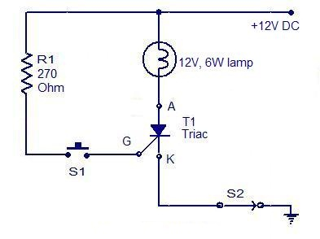
Figure 3: circuit for testing scr

Bidirectional Triode (TRIAC)
The triac is another three-terminal ac switch that is triggered into conduction when a low-energy signal is applied to its gate terminal. Unlike the SCR, the triac conducts in either direction when turned on. The triac also differs from the SCR in that either a positive or negative gate signal triggers it into conduction. Thus the triac is a three terminal, four layer bidirectional semiconductor device that controls ac power whereas a scr control dc power or forward biased half cycles of ac in a load. Because of its bidirectional conduction property, the triac is widely used in the field of power electronics for control purposes. Triacs of 16 kW rating are readily available in the market.
“Triac” is an abbreviation for three terminal ac switch. ‘Tri’-indicates that the device has three terminals and ‘ac’ indicates that the device controls alternating current or can conduct in either direction.

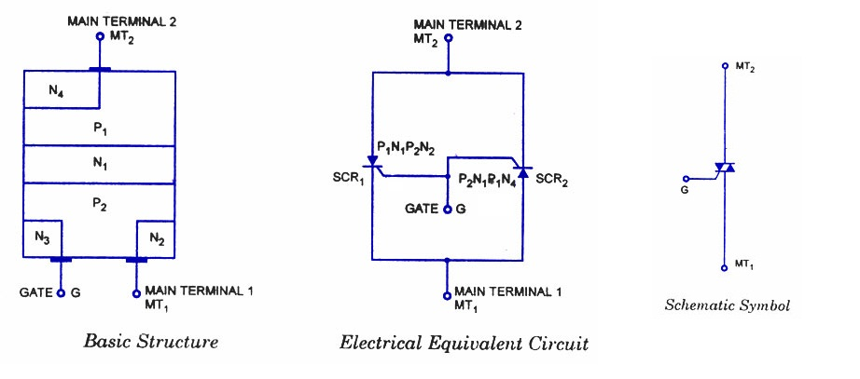
Figure 4: triac basic structure

Triac is a three terminal, four layer bilateral semiconductor device. It incorporates two SCRs connected in inverse parallel with a common gate terminal in a single chip device. The arrangement of the triac is shown in figure4. As seen, it has six doped regions. The gate terminal G makes ohmic contacts with both the N and P materials. This permits trigger pulse of either polarity to start conduction. Electrical equivalent circuit and schematic symbol are shown in figure4 also. Since the triac is a bilateral device, the term “anode” and ”cathode” has no meaning, and therefore, terminals are designated as main terminal 1. (MT₁), main terminal 2 (MT₂) and gate G. To avoid confusion, it has become common practice to specify all voltages and currents using MT₁ as the reference.

1.2.1 IV characteristics of Triac

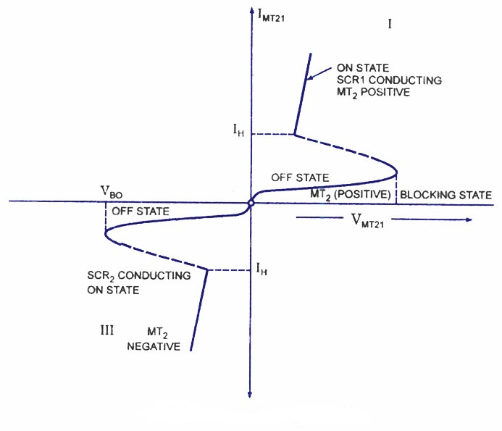
Figure 5: iv characteristics of triac

Typical V-I characteristics of a triac are shown in figure. The triac has on and off state characteristics similar to SCR but now the char acteristic is applicable to both positive and negative voltages. This is expected because triac consists of two SCRs connected in parallel but opposite in direc tions.
MT₂ is positive with respect to MT_{X} in the first quadrant and it is negative in the third quad rant. As already said in previous blog posts, the gate triggering may occur in any of the following four modes.
Quadrant I operation : V_{MT2}, positive; V_{G1} positive
Quadrant II operation : V_{MT21} positive; V_{Gl} negative
Quadrant III operation : V_{MT21} negative; V_{Gl} negative
Quadrant IV operation : V_{MT21} negative; V_{G1} positive
where V_{MT21} and V_{Gl} are the voltages of terminal MT₂ and gate with respect to terminal MT₁.
The device, when starts conduction permits a very heavy amount of current to flow through it. This large inrush of current must be restricted by employing external resist ance, otherwise the device may get damaged.
The gate is the control terminal of the device. By applying proper signal to the gate, the firing angle of the device can be controlled. The circuits used in the gate for triggering the device are called the gate-triggering circuits. The gate-triggering circuits for the triac are almost same like those used for SCRs. These triggering circuits usually generate trigger pulses for firing the device. The trigger pulse should be of sufficient magnitude and duration so that firing of the device is assured. Usually, a duration of 35 us is sufficient for sustaining the firing of the device.
A typical triac has the following voltage/current values:
- Instantaneous on-state voltage – 1.5 Volts
- On-state current – 25 Amperes
- Holding current, I_{H} - 75 milli Amperes
- Average triggering current, I_{G} – 5 milli Amperes

1.2.2 Applications of Triac
Next to SCR, the triac is the most widely used member of the Thyristor family. In fact, in many of control applications, it has replaced SCR by virtue of its bidirectional conductivity. Motor speed regulation, temperature control, illumination control, liquid level control, phase control circuits, power switches etc. are some of its main applications.
However, the triac is less versatile than the SCR when turn-off is considered. Because the triac can conduct in either direction, forced commutation by reverse-biasing cannot be employed. So turn-off is either by current starvation, which is usually impracticable, or else by ac line commutation. There are two limitations enforced on the use of triac at present state of commercially available devices (200 A and 1,000 PRV). The first is the frequency handling capability produced by the limiting dv/dt at which the triac remains blocking when no gate signal is applied. This dv/dt value is about 20 Vmicros⁻¹ compared with a general figure of 200 Vmicro s⁻¹ for the SCR, so that the limitation of frequency is at the power level of 50 Hz. The same dv/dt limitation means the load to be controlled is preferably a resistive one. When high frequencies and high dv/dt are involved then the back-to-back SCRs cannot be replaced by the triac.

High Power Lamp Switching.
Use of the triac as an ac on/off switch is shown in figure6. When the switch S is in position 1, the triac is cut-off and so the lamp-is 'dark. When the switch is put in position 2, a small gate current flowing through the gate turns the triac on and so the lamp is switched on to gives rated output.
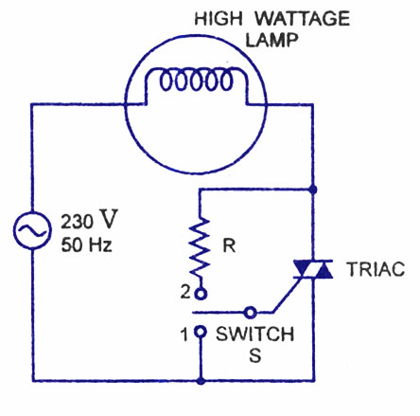
Figure 6: power lamp switching by triac

AC Power Control.
A triac control circuit is shown in figure7. Here it is controlling ac power to load by switching on and off during the positive and negative half cycles of the input sinusoidal signal.
During the positive half cycle of the input voltage, diode D₁ is forward biased, D₂ is reverse-biased, and the gate terminal is positive with respect to A₁ During the negative half cycle, the diode D₂ is forward biased and diode D₁ is reverse-biased, so that the gate becomes positive with respect to terminal A₂- The point of commencement of conduction is controlled by adjusting the resistance R₂.

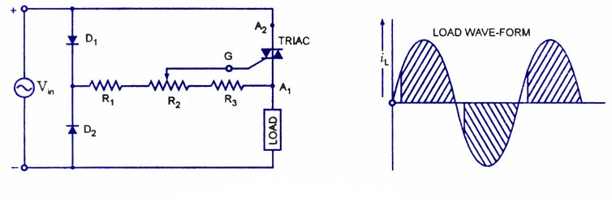
Figure 7: power control by tria

1.2.3 How to test a triac

a- Using a multimeter.

A multimeter can be used to test the health of a triac. First put the multimeter selector switch in a high resistance mode (say 100K), then connect the positive lead of multimeter to the MT1 terminal of triac and negative lead to the MT2 terminal of triac (there is no problem if you reverse the connection).The multimeter will show a high resistance reading (open circuit).Now put the selector switch to a low resistance mode, connect the MT1 and gate to positive lead and MT2 to negative lead. The multimeter will now show a low resistance reading (indicating the switch ON).If the above tests are positive then we can assume that the triac is healthy. Anyway this test is not applicable triacs that require high gate voltage and current for triggering.

b-Circuit for testing a triac.

This is another approach for testing a triac. Almost all type of triacs can be tested using this circuit. This circuit is nothing but a simple arrangement to demonstrate the elementary action of a triac. Connect triac to the circuit as shown in circuit diagram and switch S2 ON. The lamp must not glow. Now press the push button switch S1.The lamp must glow indicating the switching ON of triac. When you release the push button, you can see the lamp extinguishing. If the above tests are positive you can assume that the triac is healthy.
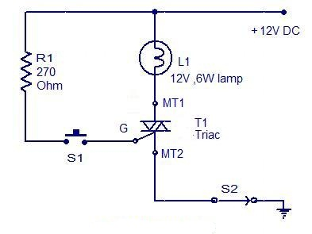
Figure 8: circuit for testing triac

1.3 Bidirectional Trigger Diode (DIAC)
A diac is an important member of the Thyristor family and is usually employed for triggering triacs. A diac is a two-electrode bidirectional avalanche diode which can be switched from off-state to the on-state for either polarity of the applied voltage. This is just like a triac without gate terminal, as shown in figure. Its equivalent circuit is a pair of inverted four layer diodes. Two schematic symbols are shown in figure. Again the terminal designations are arbitrary since the diac, like triac, is also a bilateral device. The switching from off-state to on-state is achieved by simply exceeding the avalanche break down voltage in either direction.

1.3.1 Construction of a Diac.
A diac is a P-N-P-N structured four-layer, two-terminal semiconductor device, as shown in figure9. MT₂ and MT_{X} are the two main terminals of the device. There is no control terminal in this device. From the diagram, a diac unlike a diode, resembles a bipolar junction transistor (BJT) but with the following exceptions.
- there is no terminal attached to the middle layer (base),
- the three regions are nearly identical in size,
- the doping level at the two end P-layers is the same so that the device gives symmetrical switching characteristics for either polarity of the applied voltage.

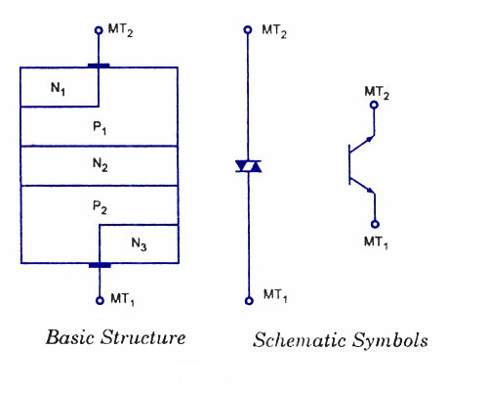
Figure 9: diac basic structure

1.3.2 Operation of a Diac
When the terminal MT₂ is positive, the current flow path is P₁-N₂-P₂-N₃ while for positive polarity of terminal MT₁ the current flow path is P₂-N₂-P₁-N₁. The operation of the diac can be explained by imagining it as two diodes connected in series. When applied voltage in either polarity is small (less than breakover voltage) a very small amount of current, called the leakage current, flows through the device. Leakage current caused due to the drift of electrons and holes in the depletion region, is not sufficient to cause conduction in the device. The device remains in non-conducting mode. However, when the magnitude of the applied voltage exceeds the avalanche breakdown voltage, breakdown takes place and the diac current rises sharply, as shown in the characteristics shown in figure10.

1.3.3 IV characteristics of a Diac

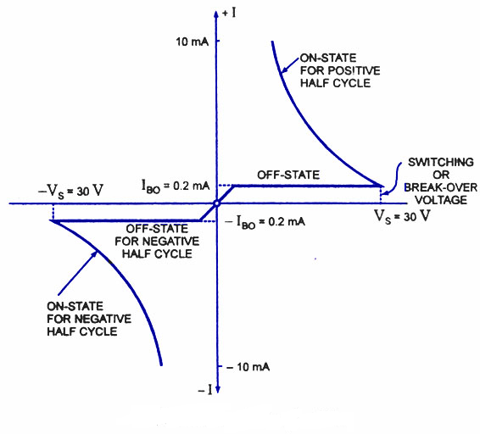
Figure 10: iv characterstics of diac

Volt-ampere characteristic of a diac is shown in figure. It resembles the English letter Z because of the symmetrical switching characteristics for either polarity of the applied voltage.
The diac acts like an open-circuit until its switching or breakover voltage is exceeded. At that point the diac conducts until its current reduces toward zero (below the level of the holding current of the device). The diac, because of its peculiar construction, does not switch sharply into a low voltage condition at a low current level like the SCR or triac. Instead, once it goes into conduction, the diac maintains an almost continuous negative resistance characteristic, that is, voltage decreases with the increase in current. This means that, unlike the SCR and the triac, the diac cannot be expected to maintain a low (on) voltage drop until its current falls below a holding current level.

1.3.4 Diac applications
The diacs, because of their symmetrical bidirectional switching characteristics, are widely used as triggering devices in triac phase control circuits employed for lamp dimmer, heat control, universal motor speed control etc.
Although a triac may be fired into the conducting state by a simple resistive triggering circuit, but triggering devices are typically placed in series with the gates of SCRs and triacs as they give reliable and fast triggering. Diac is the most popular triggering device for the triac. This is illustrated in the following applications.

Triac Lamp Dimmer Circuit.
The circuit for a triac controlled by an R-C phase-shift network and a diac is given in figure11. This circuit is an example of a simple lamp dimmer. The triac conduction angle is adjusted by adjusting the potentiometer R. The longer the triac conducts, the brighter the lamp will be. The diac acts like an open-circuit until the voltage across the capacitor exceeds its breakover or switching voltage (and the triac’s required gate trigger voltage).

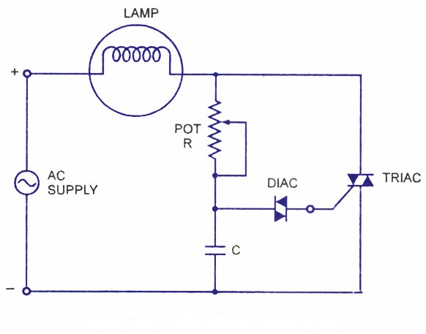
Figure 11: triac lamp dimmer circuit

Heat Control Circuit.
A typical diac-triac circuit used for smooth control of ac power to a heater is shown in figure12. The capacitor C₁in series with choke L across the triac slows-up the voltage rise across the device during off-state. The resistor R₄ across the diac ensures smooth control at all positions of potentiometer R₂. The triac conduction angle is adjusted by adjusting the potentiometer R₂. The longer the triac conducts, the larger the output will be from the heater. Thus a smooth control of the heat output from the heater is obtained.
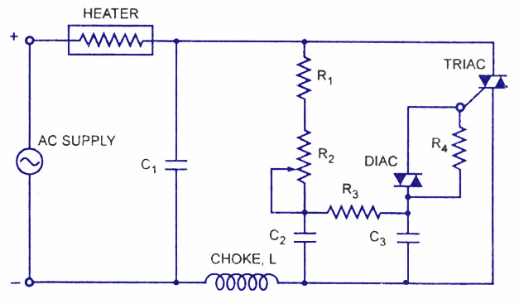
Figure 12: diac heat control circuit

Chapter 2 Scr applications

Here we will consider some applications of SCR that we study in our project, we can't mention all applications due to the large amount and diversity of scr applications, we choose these applications because it should be basic and principles for any power electronic study:

2.1 Rectification
A rectifier is an electrical device that converts alternating current (AC), which periodically reverses direction, to direct current (DC), which flows in only one direction. The process is known as rectification. Rectifiers have many uses, but are often found serving as components of DC power supplies and high-voltage direct current power transmission systems. Rectification may serve in roles other than to generate direct current for use as a source of power.
There are two types of rectifiers: half wave rectifier and full wave rectifier.

2.1.1 How SCR functions as a Half Wave Rectifier?

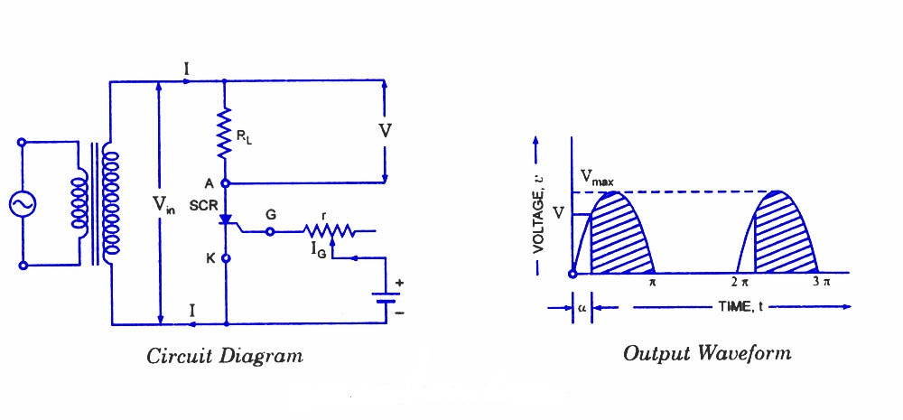
Figure 13: scr half wave rectifier

SCRs are very useful in ac circuits where they may serve as rectifiers whose output current can be controlled by controlling the gate current. An example of this type of application is the use of SCRs to operate and control dc motors or dc load from an ac supply. The circuit using an SCR as a half-wave rectifier is shown in figure13. The ac supply to be rectified is applied to the primary of the transformer ensuring that the negative voltage appearing at the secondary of the transformer is less than reverse breakdown voltage of the SCR. The load resistance R_{L} is connected in series with anode. A variable resistance r is inserted in the gate circuit for control of gate current.
If the angle at which the SCR starts conducting (i.e. firing angle) is a, the conduction will take place for (∏ – α) radians.
The average output from such a half-wave rectifier connected to a secondary voltage of
v= V_{max} sin θ is given by an expression
Average output voltage, V_{av} = V_{MAX}/2∏ (1 + cos α)
Average current, I_{av} = V_{MAX}/2∏R_{L} (1 + cos α)
Thus the desired value of average current, I_{av} can be obtained by varying firing angle α.
I_{av} = V_{MAX}/∏R_{L} when α = 0
I_{av} = V_{MAX}/2∏R_{L} when α = ∏/2
That is average current decreases with the increase in value of firing angle α.
The worth noting point is that in an ordinary half-wave rectifier using a P-N diode, conduction current flows during the whole of the positive cycle whereas in SCR half-wave rectifier the current can be made to flow during the part or full of the positive half cycle by adjustment of gate current. Hence SCR operates as a controlled rectifier and hence the name silicon controlled rectifier.
The output voltage from the SCR rectifier is not a purely dc voltage but also consists of some ac components, called the ripples, along it. The ripple components are undesirable and need to be removed or filtered out. This is accomplished by placing a filter circuit between the rectifier and load, as shown in figures.
During the negative half cycles of ac voltage appearing across the secondary, the SCR does not conduct regardless of the gate voltage, because anode is negative with respect to cathode and also peak inverse voltage is less than the reverse breakdown voltage. The SCR will conduct during the positive half cycles provided appropriate gate current is made to flow. The gate current can be varied with the help of variable resistance rinserted in the gate circuit for this purpose. The greater the gate current, the lesser will be the supply voltage at which SCR will start conducting.
Assume that gate current is such that SCR starts conducting at a positive voltage V, being less than peak value of ac voltage, V_{max}. From fig.b, it is clear that SCR will start conducting, as soon as the secondary ac voltage becomes V in the positive half cycle, and will continue conducting till ac voltage becomes zero when it will turn-off. Again in next positive half cycle, SCR will start conducting when ac secondary voltage becomes V volts.

2.1.2 How to make a full wave rectifier using SCR ?
For full-wave rectification two SCRs are connected across the center taped secondary, as shown in figure14. The gates of both SCRs are supplied from two gate control supply circuits. One SCR conducts during the positive half cycle and the other during the negative half cycle and thus unidirectional current flows in the load circuit. The main advantage of this circuit over ordinary full-wave rectifier circuit is that the output voltage can be controlled by adjusting the gate current.

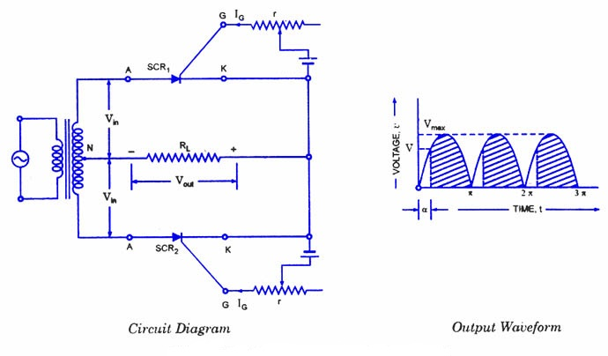
Figure 14: scr full wave rectifier

Now if the supply voltage v = V_{MAX} sin θ and the firing angle is a, then average voltage output will be given by the expression
V_{av} = V_{MAX} / ∏ (1 + Cos α)
That is, average voltage output of full-wave rectifier circuit is double of that of half-wave rectifier circuit, which is obvious.
I_{av} = V_{MAX} / ∏R_{L} (1 + Cos α)

2.2 Ac power control by phase

2.2.1 90° Phase Control of SCR.

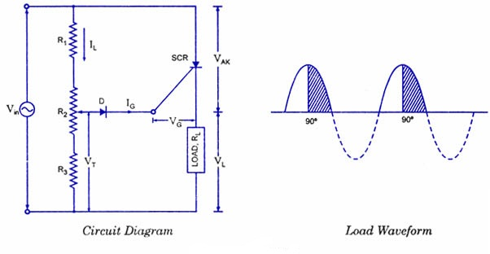
Figure 15: scr 90 degree phase control
In ac circuits, the SCR can be turned on by the gate at any angle a with respect to the applied voltage. This angle α is called the firing angle. Power control is obtained by varying the firing angle and this is known as phase control. In the phase-control circuit given in figure15, the gate triggering voltage is derived from the ac supply through resistors R₁, R₂ and R₃. The variable resistance R₂ limits the gate current during positive half cycles of the supply. If the moving contact is set to the top of resistor R₂, resistance in the circuit is the lowest and the SCR may trigger almost immediately at the commencement of the positive half cycle of the input. If, on the other hand, the moving contact is set to the bottom of resistor R₂, resistance in the circuit is maximum, the SCR may not switch on until the peak of the positive half-cycle. By adjusting R₂ between these two extremes, SCR can be switched on somewhere between the commencement and peak of the positive half-cycle, that is between 0° and 90°. If the triggering voltage V_{T} is not large enough to trigger SCR at 90°, the device will not trigger on at all, because V_{T} has the maximum value at the peak of the input and decreases with the fall in voltage. This operation is sometimes referred to as half-wave variable-resistance phase control. It is an effective method of controlling the load power.
Diode D is provided to protect the SCR gate from the negative voltage that would otherwise be applied during the negative half cycle of the input. It can be seen from the circuit diagram shown in figure15, that at the instant of turning on of the SCR gate current flows through R_{L} and diode. So

V_{T}=V_{D} + V_{G} + I_{G}R_{L}

2.2.2 180 degree Phase Control

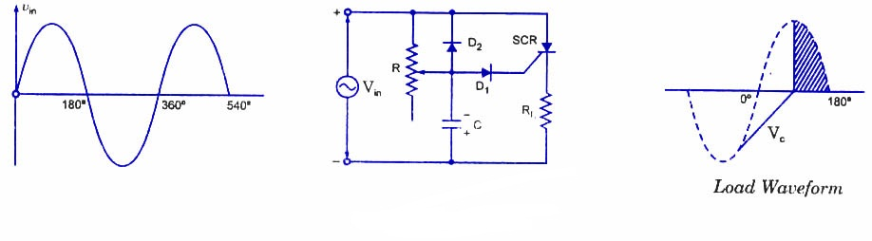
Figure 16: scr 180 degree phase control

The circuit shown in figure16, can trigger the SCR from 0° to 180° of the input waveform. In the circuit shown here, the resistor R and capacitor C determine the point in the input cycle at which the SCR triggers. During the negative half cycle of the input, capacitor C is charged negatively (with the polarity shown in the figure) through diode D₂ to the peak of the input voltage because diode D₂ is forward-biased. When the peak of the input negative half cycle is passed, diode D₂ gets reverse-biased and capacitor C commences to discharge through resistor R. Depending upon the time constant, that is CR, the capacitor C may be almost completely discharged at the commencement of the positive half cycle of the input, or it may retain a partially negative charge until almost 180° of positive half cycle has passed. So long as the capacitor C remains negatively charged, diode D₁, is reverse-biased and the gate cannot go positive to trigger the SCR into conduction. Thus R and /or C can be adjusted to affect SCR triggering anywhere from 0° to 180° of the input ac cycle

2.2.3 Pulse Control of an SCR

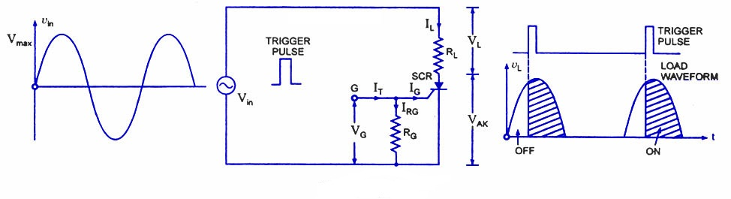
Figure 17: scr pulse control circuit
The simplest of SCR control circuits is shown in figure17. If SCR were an ordinary rectifier, it would develop half-wave rectified ac voltage across the load R_{L}. The same would be true if the gate of the SCR had a continuous bias voltage to keep it on when the anode-cathode voltage V_{AK} goes positive. A trigger pulse applied to the gate can switch the device at any time during the positive half-cycle of the input. The resultant load waveform is a portion of positive half cycle commencing at the instant at which the SCR is triggered. Resistor R_{G} holds the gate-cathode voltage, V_{G} at zero when no trigger input is present. The instantaneous level of load current can/be determined from the following relation

2.3 protection circuits for scr
SCRs are sensitive to high voltage, over-current, and any form of transients. For satisfactory and reliable operation they are required to be protected against such abnormal operating conditions. Because of complex and expensive protection, usually some margin is provided in the equipment by selecting devices with ratings higher (3 or 4 times higher) than those required for normal operation. But it is always not economical to use devices of higher ratings, hence their protection is imperative.

2.3.1 Over-voltage Protection.

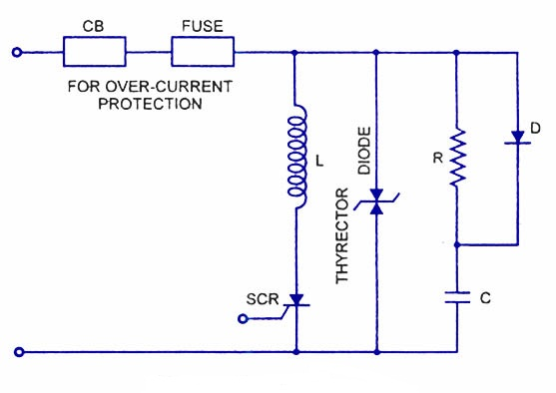
Figure 18: over voltage protection circuit

High forward voltage protection is inherent in SCRs. The SCR will breakdown and start conducting before the peak forward voltage is attained so that the high voltage is transferred to another part of the circuit (usually the load). The turn-on of SCR causes a large current to flow and poses a problem of over-current protection as shown in figure18.

2.3.2 Over-current Protection

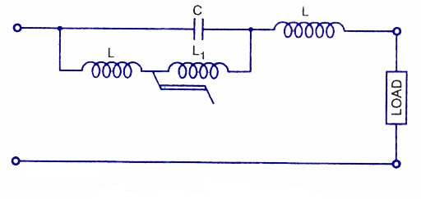
Figure 19: over current protection circuit
Over-current protection can be provided by connecting a circuit breaker and a fuse in series with the SCR, as usually done for the protection of any circuit. However, there are some reservations to their use. A semiconductor device is capable of taking overloads for a limited period, so the fuse used should have high breaking capacity and rapid interruption of current. There must be a similarity of SCR and fuse I²t rating without developing high voltage transients which endanger those SCRs in the off or infinite impedance condition. These are contradictory requirements necessitating voltage protection when fast-acting fuses are employed. Fuses when used, their arc voltages are kept below 1.5 times the peak circuit voltage. For small power applications it is pointless to employ high speed fuses for circuit protection because it may cost more than the SCR. Current magnitude detection can be employed and is used in many applications. When an over-current is detected the gate circuits are controlled either to turn-off the appropriate SCRs, or in phase commutation, to reduce the conduction period and so the average value of the current.
If the output to the load from the SCR circuit is alternating current, LC resonance provides over-current protection as well as filtering. A current limiting device employing a saturable reactor is shown in figure. With normal currents the saturable reactor L₁ offers high impedance and C and L are in series resonance to offer zero impedance to the flow of current of the fundamental harmonic. An over-current saturates L₁ and so gives negligible impedance. There is LC parallel resonance and hence infinite impedance to the flow of current at the resonant frequency.

2.3.3 Protection against Voltage Surges.
There are many types of failure due to voltage surges as SCRs do not really have a safety factor included in their ratings. External voltage surges cannot be controlled by the SCR circuit designer. Voltage surges often lead to either malfunctioning of the circuit by unintentional turn-on of SCR or permanent damage to the device due to reverse breakdown. SCR can be protected against voltage surges by employing shunt connected non-linear resistance devices. Such protective devices register a fall in resistance with the increase in voltage and so develop a virtual short-circuit across the SCR when a high voltage is applied. An over-voltage protection circuit employing thyrector-diode, which has low resistance at high voltage and vice-versa, is shown in figure19. Inductor L and capacitor C provides protection to SCR against large dV/dt and dI/dt.

2.4 Switching

How an SCR functions as a switch ?

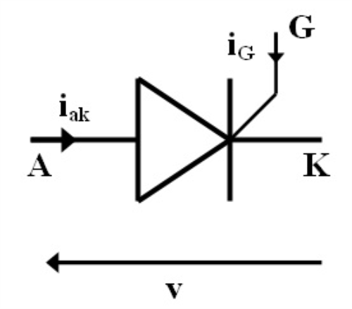
Figure 20: scr as switch
We have seen that SCR operates either in on-state or in off-state and no other state in between, that is SCR behaves like a mechanical switch. As such it is called electronic switch.

An SCR has following advantages over a mechanical switch or electro-mechanical relay:
- Noiseless operation owing to absence of moving parts.
- Very high switching speed (say 10⁹ operations per second).
- High efficiency.
- Low maintenance.
- Small size and trouble free service for long period.
- Large control current range (say from 30 A to 100 A) with small gate current of few mA.
- Long life as no wear and tear is involved.

However, SCR suffers from the following drawbacks:
- Cut-off current is not exactly zero.
- There is some voltage drop across SCR when in on-state; hence there is some wastage of power.
- It is more costly and need more care in handling.

Chapter 3 Our project circuits
Here are the circuits that we build in our project

3.1 Battery charger based on scr
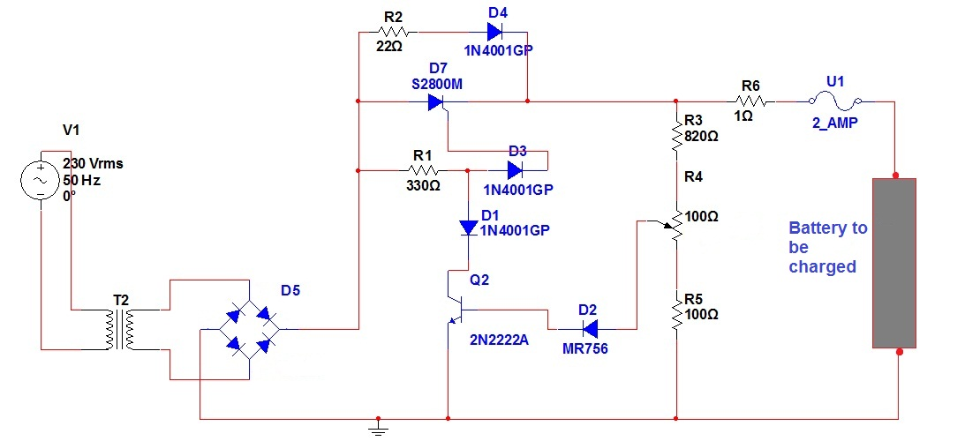
Figure 21: battery charger

3.1.1Principle of work
A simple battery charger based on SCR is shown in figure21 .Here the SCR rectifies the AC mains voltage to charge the battery. When the battery connected to the charger gets discharged the battery voltage gets dropped. This inhibits the forward biasing voltage from reaching the base of the transistor Q1 through R4 and D2.This switches off the transistor. When the transistor is turned OFF, the gate of SCR (H1) gets the triggering voltage via R1 & D3.This makes the SCR to conduct and it starts to rectify the AC input voltage. The rectified voltage is given to the battery through the resistor R6(5W). This starts charging of the battery.
When the battery is completely charged the base of Q1 gets the forward bias signal through the voltage divider circuit made of R3,R4,R5 and D2.This turns the transistor ON. When the Q1 is turned ON the trigger voltage at the gate of SCR is cut off and the SCR is turned OFF. In this condition a very small amount of charge reaches the battery via R2 and D4 for trickle charging. Since the charging voltage is only half wave rectified, this type of charger is suitable only for slow charging. For fast charging full wave rectified charging voltage is needed.

3.1.2 Our steps to build the circuit
We build this circuit on welding plate, we used step down transformer 230V primary, 18V /3A secondary, tic116c scr, we control the voltage of the battery by varying potentiometer (R4) and we connect the battery to the circuit by using crocodile clips as you can see in figure22.

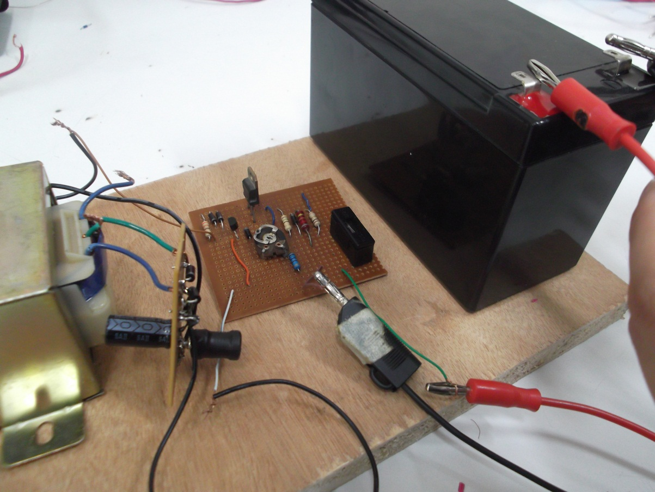
Figure 22: battery charger

When we run the circuit it gives a voltage up to 15v before we connect the battery, this voltage was enough to charge our battery (ratings 12V, 7AH )

3.2 5v dc power supply
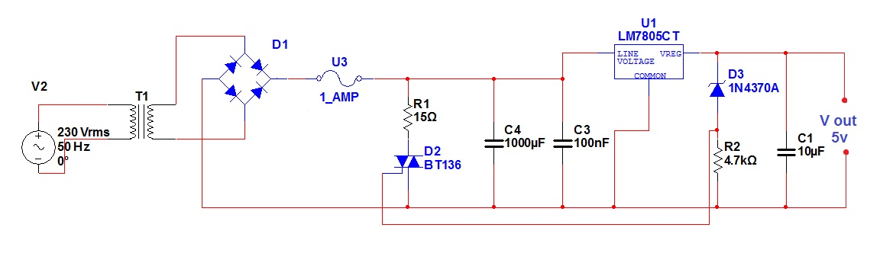
Figure 23: 5v dc power supply circuit

This circuit include the over voltage protection application by using power electronic devices.

3.2.1 Principle of work
For circuits using TTL ICs the supply voltage is a great concern and a slight increase in supply from the rated 5V may damage the IC. Using fuses alone does not solve the problem because a fuse may take several milliseconds to blow off and that’s enough time for the IC to get damaged.
In this circuit a crowbar scheme is used in which a triac short circuits the power supply and burns the fuse. The burning time of the fuse is not a concern because the power supply is already shorted by the triac and the output voltage will be zero. When the output voltage exceeds 5.6 volts the zener diode D2 conducts and switches ON the triac T1.Now T1 acts as a closed switch, shorting the circuit. The output voltage drops to zero and fuse gets burned off. Since the switching of triac takes place within few micro seconds there will be no damage to the TTL ICs or any other such voltage sensitive components in the load circuit.

3.2.2 Our steps to build the circuit
We build this circuit on welding plate, we used step down transformer 230V primary, 12V/2A secondary, BT136 triac, we build the bridge rectifier using four 1N4007 diodes and we put a thermal resistance (22 ohm, 15 watt) in series with the triac in order when high current pass through it could handle and dissipated the energy as heat as you can see in the figure24.
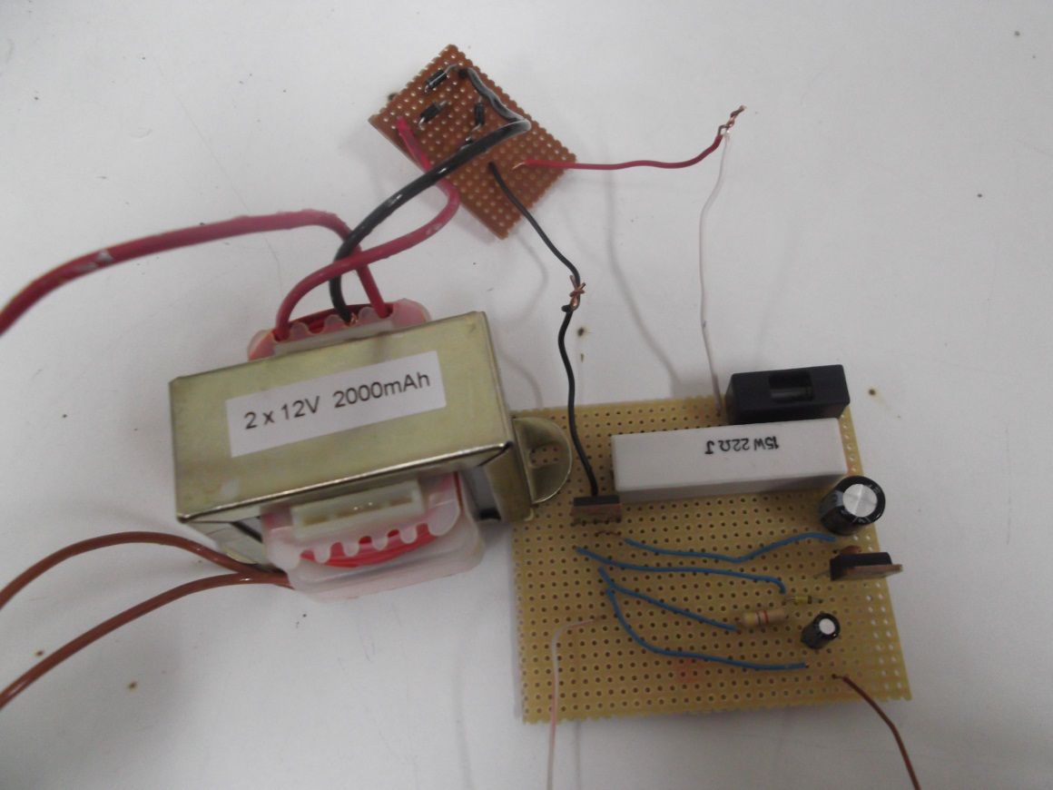
Figure 24: 5v dc power supply
After we run the circuit it gives us a constant voltage of 5.05v as you can see on multimeter in figure25. 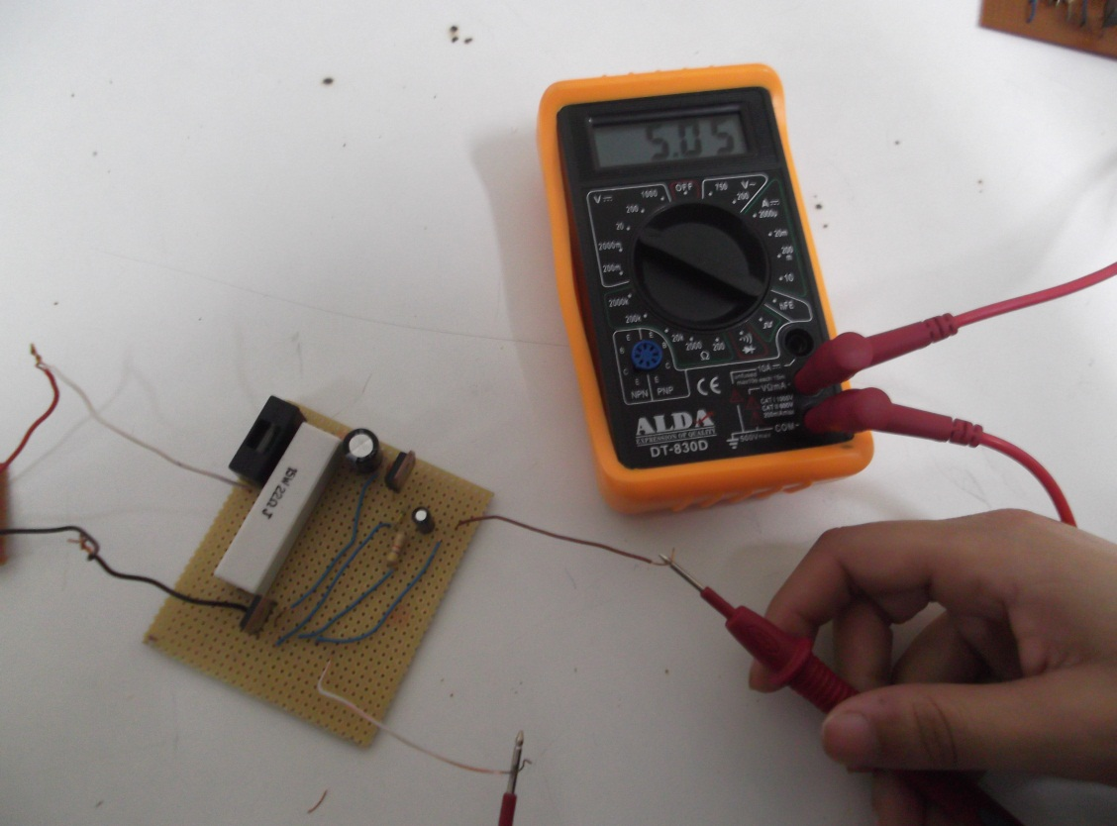
Figure 25: 5v dc power supply

3.3 Light dimmer circuit

3.3.1 How light dimmer circuits work
A light dimmer works by essentially chopping parts out of the AC voltage. This allows only parts of the waveform to pass to the lamp. The brightness of the lamp is determined by the power transferred to it, so the more the waveform is chopped, the more it dims.
Mains power is comprised of an alternating current that flows in one direction and then in the other, along the cable, at the rate of 50 or 60 cycles per second (known as Hertz). The value 50 or 60Hz is dependent on the countries power system. The current alternates back and forth changing direction at the zero point. If we were to look at this waveform it would appear as a stretched S shape on its side ~. Draw a line through the middle and this is what is called the zero crossing point. At this instant in time no current is flowing in either direction. This is the point at which a dimmer is electronically synchronized to turn the power ON or OFF. By chopping the waveform at the zero-crossing point, smooth dimming can be achieved without the lamp flickering. This turning on and off of the power device occurs every time the mains crossing point is reached (half phase), 100 or 120 times per second.
Typically light dimmers are manufactured using a Triac or Thyristor as the power control device. These electronic parts are semiconductors not dissimilar to transistors. A Thyristor is a Uni.-directional device and hence, because AC power flows in both directions, two are needed. A triac is a bidirectional device and therefore only one is needed. An electronic circuit determines the point in time at which they turn ON (conduct). The ON state continues until the next zero-crossing point, at which point the device turns itself OFF. The electronic circuit then provides a delay, which equates to the dimness of the lamp, before turning the control device back on. The slight capacitance of the load, filters the chopped waveform resulting in a smooth light output.
Some controllers use a microprocessor control with the above timing function being handled by an analogue circuit. More sophisticated systems, called digital dimmers, operate the switching direct from microprocessor. This has the advantage of greater reliability, quieter operation, lower cost and smaller controls.
We choose the following light dimmer circuit to study
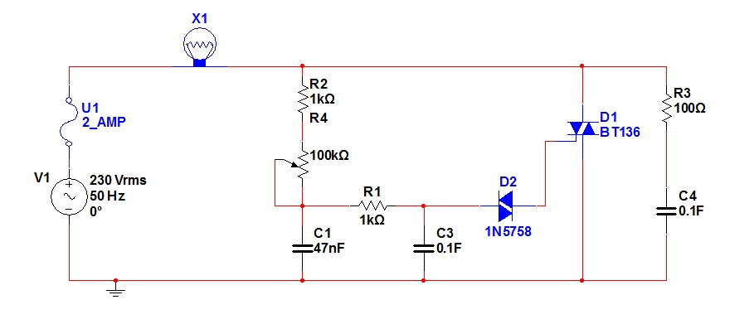
Figure 26: light dimmer circuit

3.3.2 Principle of work
This is the circuit diagram of the simplest lamp dimmer or fan regulator. The circuit is based on the principle of power control using a Triac. The circuit works by varying the firing angle of the Triac. Resistors R1, R2 and capacitor C2 are associated with this. The firing angle can be varied by varying the value of any of these components. Here R1 is selected as the variable element. By varying the value of R1 the firing angle of Triac changes (in simple words, how much time should Triac conduct) changes. This directly varies the load power, since load is driven by Triac. The firing pulses are given to the gate of Triac T1 using Diac D1. In addition a snubber circuit consisting of resistor R4 and capacitor C3 is included to improve the performance of the triac T1. A fuse is also included for better safety.

3.3.3 Our steps to build the circuit
We build this circuit on welding plate, the load whether lamp, fan or anything should be less than 200 Watts we used a 35 watt lamp. To connect higher loads you should replace the Triac BT 136 that we used with a higher Watt capacity Triac as shown in figure27.
Caution: All parts of the circuit are active with potential shock hazard. So you need to be careful. You should isolate the circuit from the mains or we advise to test the circuit with a low voltage supply (say 12V or 24V AC) and a small load (a same volt bulb), before connecting the circuit to mains.

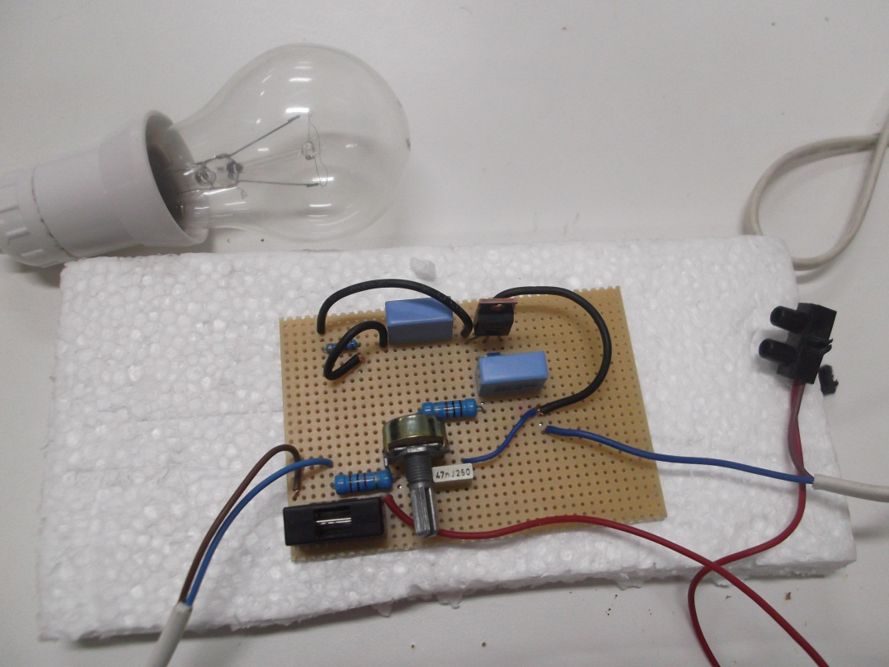
Figure 27: light dimmer circuit
A light dimmer regulates power flow to a resistive load, such as an incandescent light bulb, in an efficient way by allowing only a portion of the 50Hz current to pass through. Thus, this method is known as “subcycle” control. Example current (and voltage) waveforms to a resistive load are shown in Figure 1 for firing angles α= 30º, 90º, and 150º. Firing angle is controlled by a potentiometer (R4), RC circuit, and diac. The variation of load power with α is shown in Figure 28.
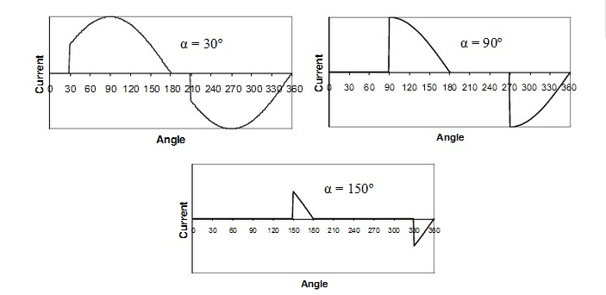
Figure 28: resistive load current(and voltage) for different firing angles a

3.4 Water Level Alarm Using SCR
Unlike transistors, which may show an exponentially varying output current pattern, equivalent to the applied input switching current, SCRs have specific triggering levels below which they may not conduct properly. However, once the trigger level crosses the optimal value, an SCR may swing into full conduction.
Another typical property associated with SCRs is their “latching” behavior with DC operated loads, where the anode to cathode conduction through the load latches or “holds-on” even after the gate trigger is inhibited. However, with AC operated loads the above drawback, or rather benefit, is not available and the load is switched ON or OFF exactly in response to the switching of the SCR’s gate triggers.
The following simple SCR circuit is based on the above properties of the device. Let’s learn how the discussed features can be exploited for some useful applications

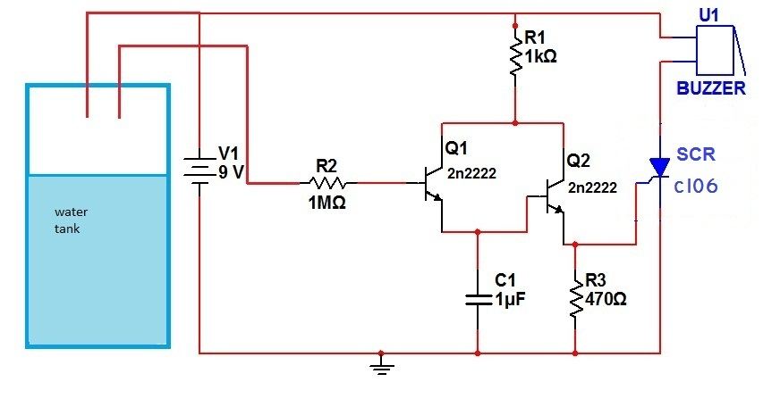
Figure 29: scr water level alarm

3.4.1 Principle of work
The diagram in figure29 shows a simple SCR circuit configuration, incorporating a Darlington pair transistor for sensing the rising level of water in the tank and an SCR which triggers through the voltage received from the emitter of the above transistor.
Referring to the diagram, when the water in the tank reaches the overflowing level to touch the set trigger points, T1 gets triggered by the voltage leaking across its base and the positive. The signal received from the emitter of the conducting transistors immediately triggers the SCR and the connected DC buzzer which alarms the whole area of the situation.

3.4.2 Our steps to build the circuit
We built this circuit on welding plate, we use c106d scr, dc buzzer for alarming, a cup to indicate the tank and dc battery of 9v as you can see in figure 30.
When the water reaches the marked level with two wires the dc buzzer alarms, because of latching property of scr the buzzer want shut down until the water goes down again or separates the dc battery.


Figure 30: scr water level alarm

3.5 Ac speed motor controller

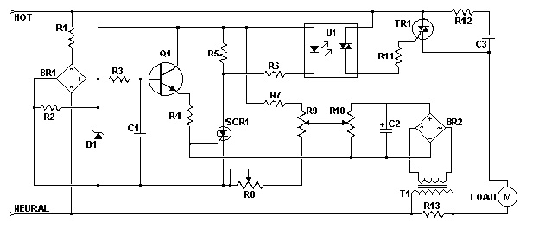
Figure 31: ac speed motor controller

3.5.1 Principle of work
This AC motor speed controller can handle most universal type (brushed) AC motors and other loads up to about 250W. It works in much the same was a light dimmer circuit; by chopping part of the AC waveform off to effectively control voltage. Because of this functionality, the circuit will work for a wide variety of loads including incandescent light bulbs, heating elements, brushed AC motors and some transformers. The circuit tries to maintain a constant motor speed regardless of load so it is also ideal for power tools. Note that the circuit can only control brushed AC motors. Inductive motors require a variable frequency control.

Parts list:
R1 | 27K 1W Resistor
R2 | 10K 1/4W Resistor
R3 | 100K 1/4W Resistor
R4 | 33K 1/4W Resistor
R5 | 2.2K 1/4W Resistor
R6 | 1K 1/4W Resistor
R7 | 60K Ohm 1/4W Resistor
R8 | 3K Linear Taper Trim Pot
R9 | 5K Linear Taper Pot
R10 | 4.7K Linear Taper Trim Pot
R11 | 3.3K 1/4W Resistor
R12 | 100 Ohm 1/4W Resistor
R13 | 47 Ohm 1W Resistor
C1, C3 | 0.1uF Ceramic Disc Capacitor
C2 | 100uF 50V Electrolytic Capacitor
D1 | 6V Zener Diode
Q1 | 2N2222 NPN Transistor
SCR1 | 2n6504
TR1 | TRIAC (See Notes)
U1 | DIAC Opto-Isolator
BR1, BR2 | 5A 50V Bridge Rectifier
T1 | Transformer

3.5.2 Our steps to build
We build this circuit on welding plate, TR1 must be chosen to match the requirements of the load, U1 (moc 3014) is chosen to match the ratings of TR1, T1 is any small transformer with a 1:10 turns ratio, The circuit is designed to run on 120V, we didn't find appropriate 120V to 12V transformer so we wind T1 on a transformer core using a primary of 25 turns, a secondary of 200 turns, potentiometer (R9) to adjust motor speed, R10 is a trim pot used to fine tune the governing action of the circuit. R8 fine tunes the feedback circuit to adjust for proper voltage at the gate of SCR1. It should be adjusted to just past the minimum point at which the circuit begins to operate

About U1 (diac Optoisolater)
An opto-isolator is a solid state device designed to provide electrical isolation between input and output. The input consists of a light emitting diode (LED) in a six or eight pin dip (IC) package depending on type. The output can be a photo transistor, photo diac, etc. There is no electrical contact between input and output. When the LED is turned on, the diac, transistor, etc. will conduct from the light emitted from the diode thus turning on the triac like a switch. The MOC3011 series is made to connect to triacs, the MOC301x types for 110 volts, and the MOC302x types for 240 volts.
This circuit wants function well with us so we didn't get the required result and run the motor.

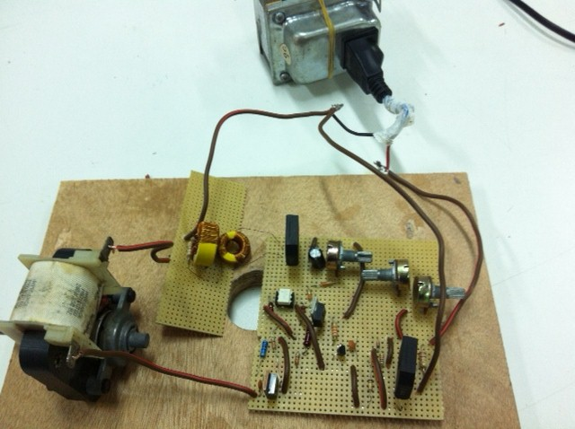
Figure 32: ac speed motor controller circuit

At the end of our work and building the circuits we gathering them in one box so as to be easy for presentation.

Conclusion
Power electronic circuits are very important and it has many applications in our life. We hope that this project offer a wide range of power electronic application through our chosen circuits and constitute a good and basic data base for power electronic laboratory as one of our aims of the project. There is always a need for development. In future we hope that students of power electronic moving toward analyzing and building more circuits in order to recognize the different application of power electronics in our life

References

- http://en.wikipedia.org/wiki/Power_electronics
- http://www.sprags.com
- http://www.circuitstoday.com
- http://www.brighthub.com
- http://www.aaroncake.net/circuits/acmotcon.asp
- http://www.scribd.com/doc/91443185/02-Triac-Light-Dimmer
- electronic devices and circuits, A.B.GodseU.A.Bakshi, 2008

Appendix
Here you can find all data sheet for our project semiconductor devices
BT136 Triac

C106d Scr
Moc 3041
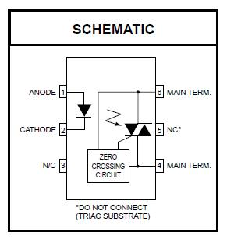
Tic 116 Scr

2n6504 Scr

See appendix for datasheet
See appendix for datasheet
See appendix for datasheet
See appendix for datasheet
See appendix for datasheet
See appendix for datasheet

