Pv tracer
  - Under gradation project

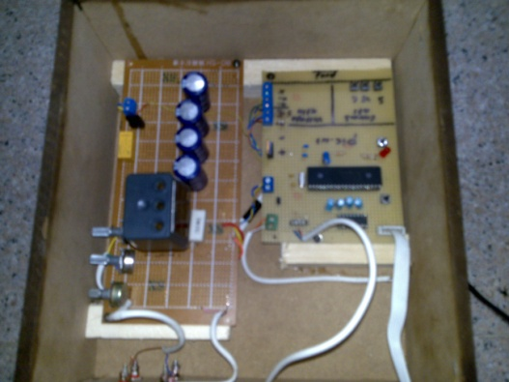
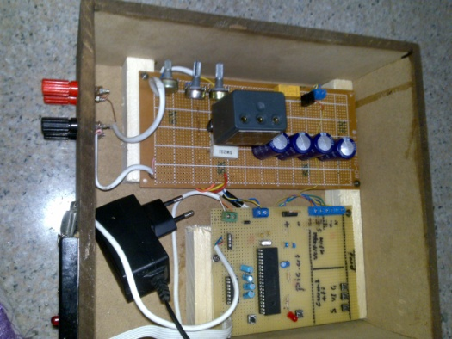

  - 12/15/2010
  - Alnajah university
  - Prepared by: Laila abughosh
  - Supervised by:prof. marwan mahmoud

