AN-Najah National University

Faculty of Engineering
Computer Engineering Department

Nablus e-Municipality
With e-MAP
(GIS System support)

Prepared By:

Mayy Kamel Abdul-Hadi
Samah Faleh Mustafa

Supervised By:
Dr. Raed Al-Qadi
Dr. Loai Malhees
Eng. Haya Sama’neh

Dec 2007

Statement of purpose
System: E-Nablus Municipality

General Description:
This system deals with E-Services of Nablus Municipality, supports also E-Complaint system, E-Billing System and E-MAP for Nablus built by GIS.
Observations:
We get a lot of observations for information on activities, relationships and services to municipal clients. These observations were useful in better understanding of the work procedures. And also we discussed much to work with the Geographic Information System (GIS); in order to provide high quality for Nablus E-MAP, we will talk later about it.
The main disadvantage that faces us in observation is that sometimes there were secret information they couldn’t let us know about it . Also the departments in the municipality are great and their transaction lifecycle are more complicate, so need more time to represents all these in this project ,so we select one department to represent it’s real-lifecycle (for electrical department Transactions.
The cycles for any form requested by the customer to the municipality, is worked as in real life as possible, we made several interviews with the electricity department’s employee and get the cycles for their work so represented in this site
Also, the difficulty we would like to tell about is the E-MAP, that we built with GIS, not in image processing way, that it will provide high quality map processing, like searching, zooming , Locator, etc

System Users
unregistered users
registered users
employees
electricity department employees
e-complaint system employees
editor employee, for the news, bid announcement, etc …
Brief Description for System users
- Unregistered Users:
They can browse the site, without the participation of them,knowing the services the municipality provides to its customers, seeing the latest news, bids and announcements, etc…
The services found in the site index of Nablus, i.e. Hospitals, Universities, restaurants, etc…, Description for Nablus-Municipality, registration ability in the site.
They also can access Nablus E-Map.

- Registered Users:
In addition they can access the web as registered users can, they can also access the services the municipality provide to its customer through this site, so they can request for a service from the electricity department, and be on-touch with it; that the customer can know any update to its request, where does it reach, which employee has add any notes to its request, also the customer can send messages to the employees if he would to add notes or requests or any questionnaire for his request.
Also, registered users can access e-billing services, choosing e-pay (shown in the bill page) so it will direct the customer to the page asking him to choose which bank he would to pay the bill through, then it will direct him to that bank to pay the bill through his account, will be shown later more obviously .
Now for the electricity department services, there will be three types of request, will be mentioned later, the customer can send a request to the department, filling appropriate information in the request, will be shown later, so when send it, it will reach to certain employee according to the request code or class, known as (نوع الطلب\رمز الطلب). After sending the request, I will be able to the customer to show his sent requests with updates added to it by the employees, so he can update the request, reply to the employee who added the note and he can know if it is ok for his request or it has a problem, so needing check the request.

- Employees
According to employees, we categorize them according to type of work they do, so they are:

electricity department employees: who can receive the forms requested by the customer, each employee received these forms according to his stage and (نوع الطلب\رمز الطلب) which specified the type of the request by customer, each employee will received certain forms from the customer, what will he do with this form? He will approved this form, that means he accept the form and no problems found, so when accept it, the form then will be transmitted to the next employee, next employee means to the employee who the form next needs to be approved by. If the employee sees there is a problem in the form requested, he will add his note to the form; this note will be seen to the form’s customer so to send or update any required information.

e-complaint system employees: who can receive any complaints, notifications and suggestions from the citizens, our aim is to continue improving the quality of services provided by Nablus Municipality. Any citizen can send any complaints, notifications and suggestions to the municipality by providing confirmed information about him, the e-complaint employee then receive this and he can either ignore it by deleting if it was not good one, or send this one to appropriate department (the manager to that department), the manager then decide what to do with this complaint, so by this scenario we will achieve contribution between the municipality and the citizens, and this also will make the citizens feel appreciate to their thoughts.

editor employee: in this site, we include news services, through which the municipality can announce its news, bids to the citizens or companies, so as to know the latest news to the municipality and to be on touch between it and its customers.

Nablus E-Municipality

Home Page Screen before Registration:
3
2
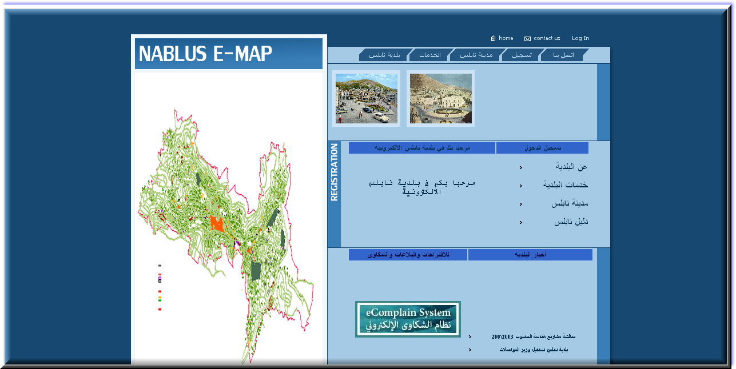
4
5
6
1
Figure1. 1
- Go to E-MAP access.
- Menu Bar for going through the site without registration.
- Native menu, through it you can register or log in if you have an account or contact to the municipality, etc…
- Through this, you can do as you can through the menu no. 2 or go to login page.
- Municipality News, through pressing any news appears, you will be directed to that news’s page.
- E-Complaint System, through this you will go the complaint page, to add your complaints or suggestions.

Registration Page:
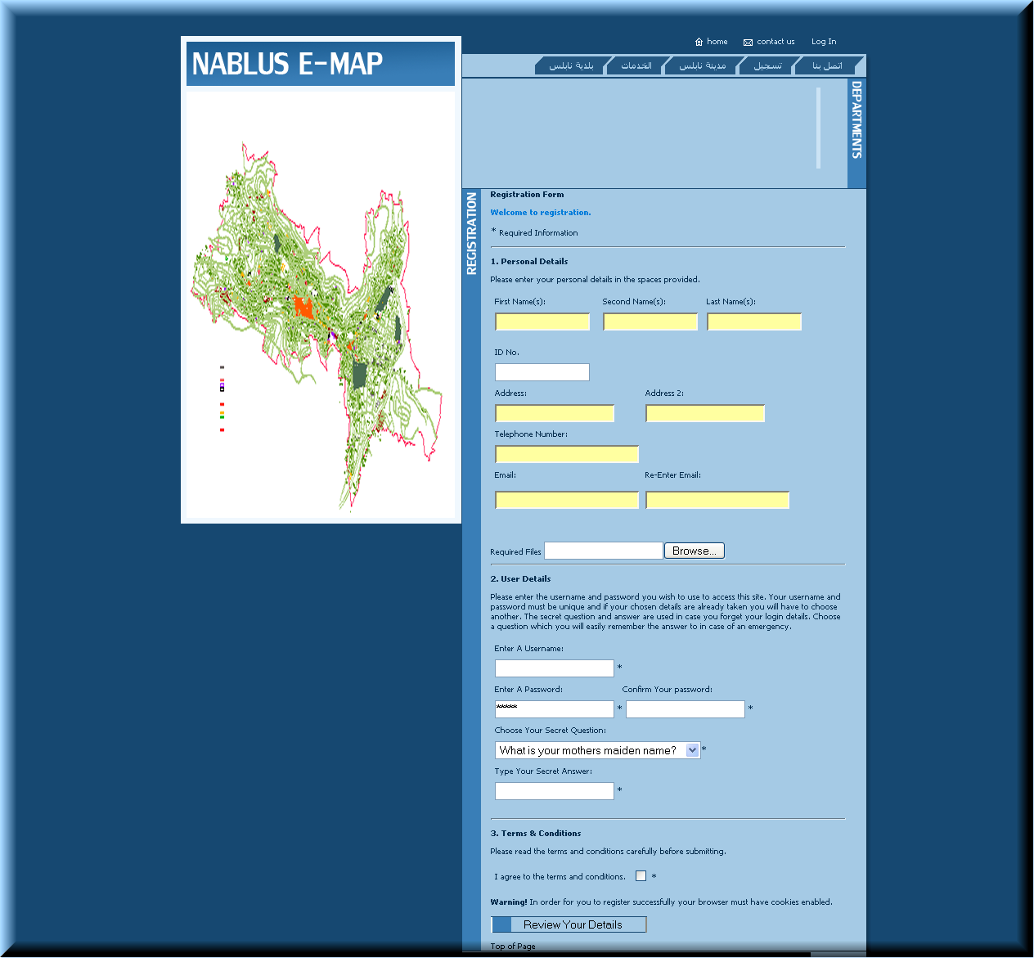
Figure1. 2
Through this page, the customer can register in the site, to have an account in it so to have a connection with the services from the municipality.
The information required from the user to fill in this page is:
Customer’s first name, second name and final name, with his address, phone number, email address, and he can upload confirmation s paper related to him, finally there is a secret question the user can choose a question and answer it, this is for providing quality for recovering the account if the user has a problem with his account.
When the customer has finished from filling the required information, he should check the agree check box then submitting the information will direct him to successful registration message then to login page so as to access his account.
In addition, after filling information, the information will be reviewed by the site to check for valid information, such as the name should be string only, the phone and ID numbers should be only numbers, also the email address should be unique, that is should not be registered before as ID number should not be registered, if invalid information found, it will direct the user back to this registration page and focus the invalid information.
Recovering Account:
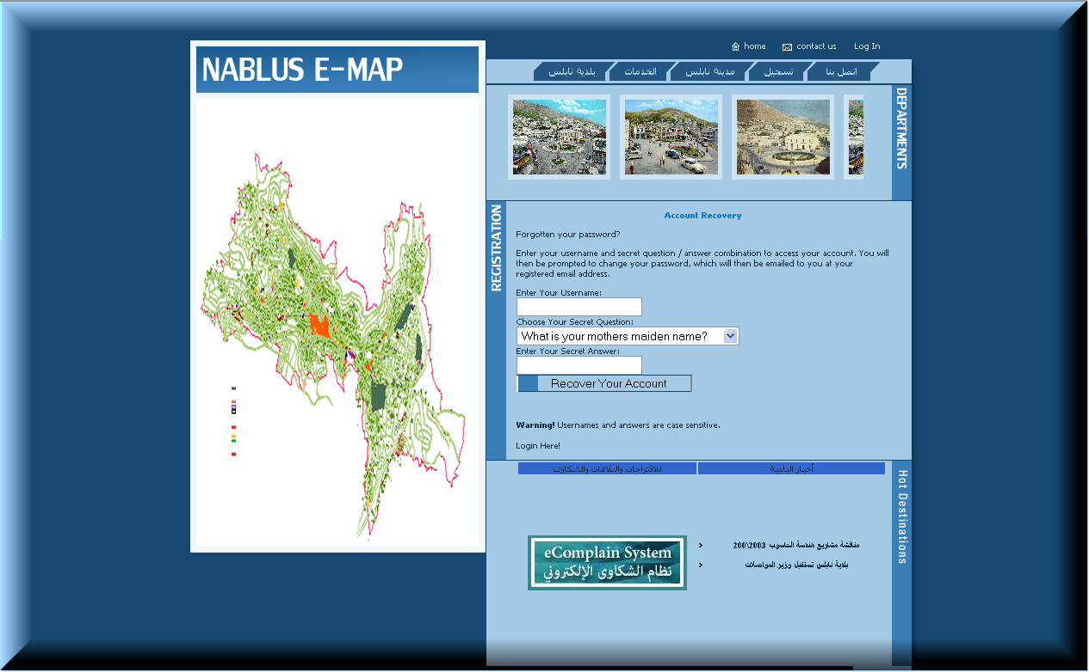
Figure1. 3
Through this page, the customer can provide his secret question and answer, then the password will be sent to the email he provided in this page, this provide the maintenance for the accounts on this site.

Contact Us Page:
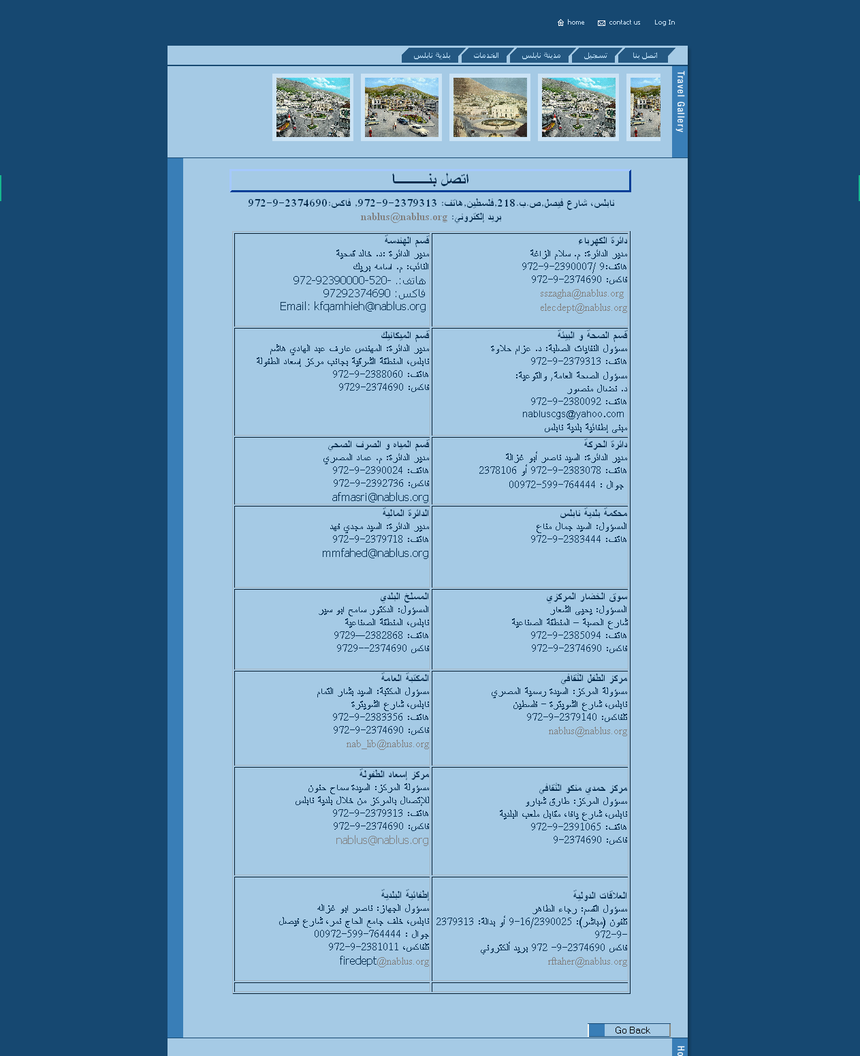
Figure1. 4
This page, the customer can retrieve information about the municipality which gives the user information about each department to facilitate the connection to any department the customer want to contact.

Nablus e-Map:

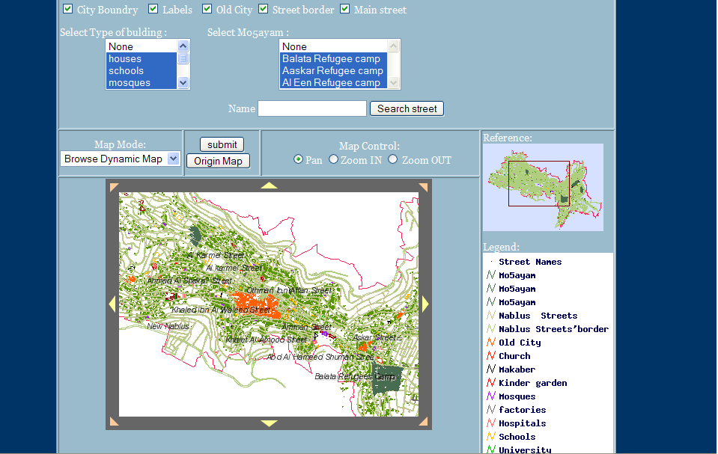
Through this page any user can navigate through it to locate any location they want.
1-they can determine any layer they want or combination of more than one as they need
2-also they can use labels to view street names.
3-user can search for any street in the city by inserting it’s name in the name box, the map will lead him to that street.
4-any shot of the map the user can save it by selecting the map mode[static map].
5-he can use Map Controls to zoom in/out or pan .
6-if he lost in the map he can go back to the origin map.
7-Also the reference image can help him to determine his location from Nablus.
8-the legend tells the user the meaning of each color in the map.
**when the customer fill a transaction it is needed to determine his location by this map
And that is the way for the employees to know the work area they should work in.
This map can be easily modified for each department in the municipality
By changing these layers with the specified layers for that department
Such as Electricity Grid lines for electricity department to be easy for both user and employee to determine the work area
Also for Licenses buildings they need layers for Figures for lands and buildings and the same thing for all departments.
(we have only these layers for our map as we were unable to obtain these maps and layers)
***This map was built with GIS tools
We started from AutoCAD file ,each layer in it was converted to a separated shapefile (.shp,.shx,.dbf)
These files contain information about these layers [location, colours , data base about each point]
These layers were added to a mapfile that contain these shapefilees and properties for each one as colour, name, labelling ,description for this shapefile.
Also the mapfile contain properties for the whole map as extent and background......
To view the mapfile we used the mapserv.exe to display the map
This mapserver needs parameters to view the map (zoom factor,layers,extent....)
This server was installed at a separated server from the database one.

Nablus Municipality Services:
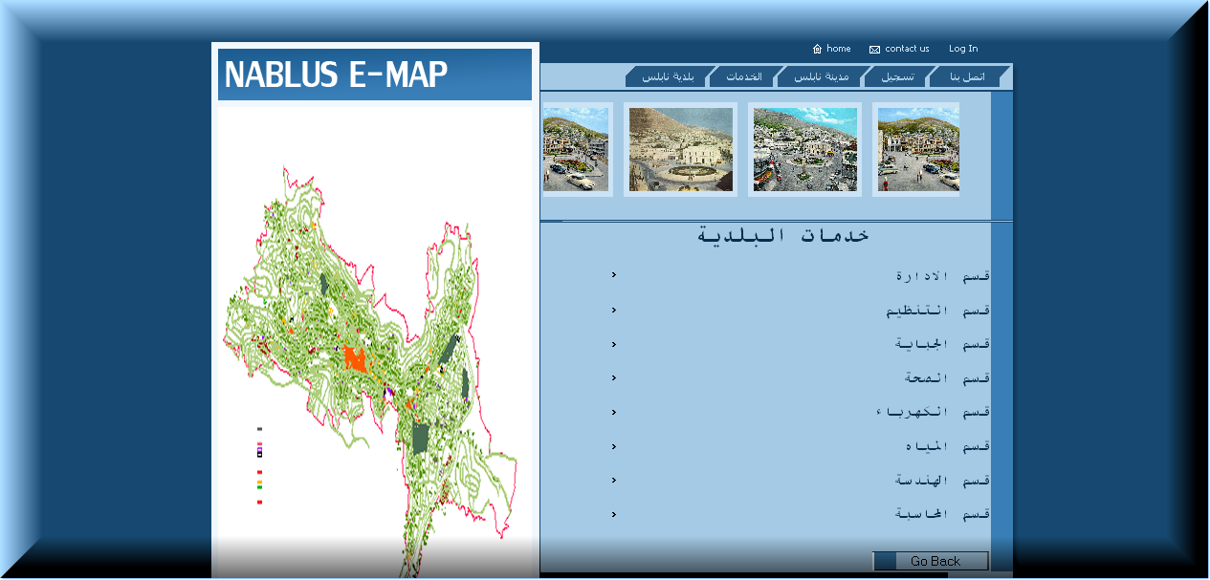
Figure1. 5
When the customer chooses from the age shown in figure1.1, the Municipality services (خدمات البلدية) this page in figure1. 5, will provides the user to choose any department he wants to know about it and the services this department provide, let us choose the engineering department as an example, the page for this department services is shown below:

Engineering Department Services:
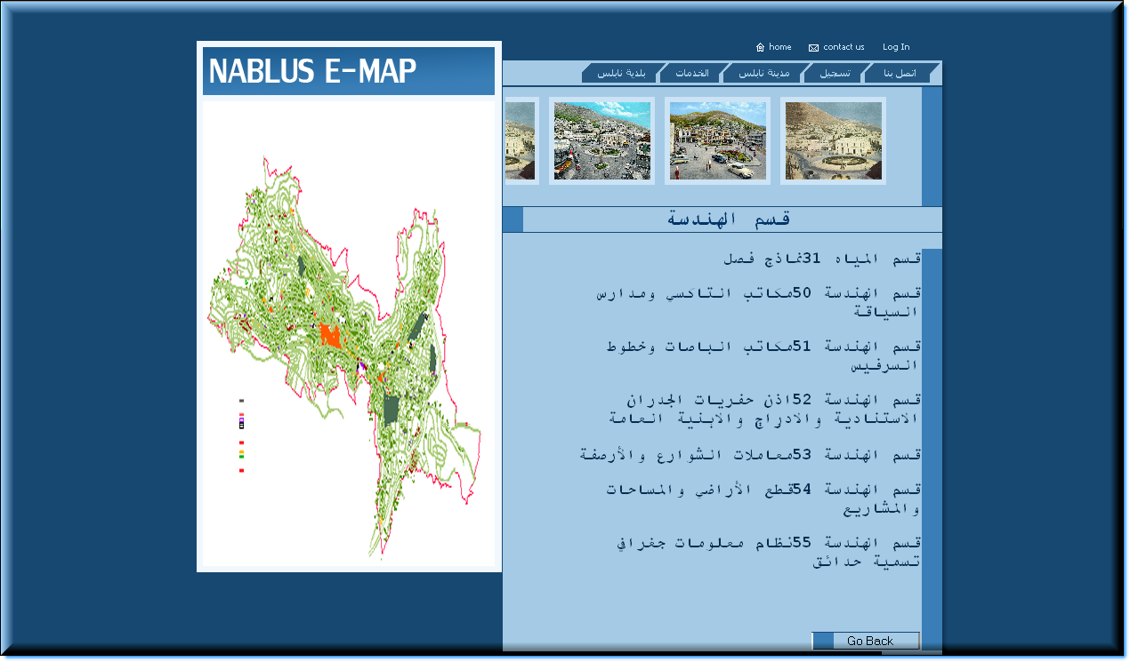
Figure1. 6
This page gives the services this department provides in the word document form, choosing any service will open the word document talking about the asked service.
News Display Page:
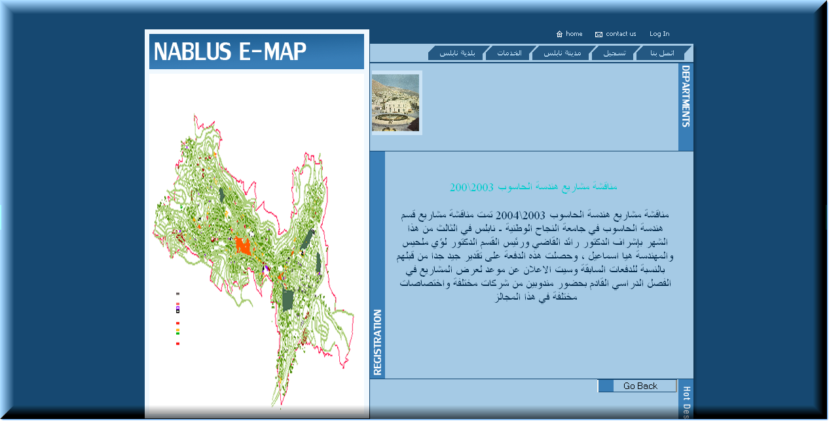
Figure1. 7
When the user choose any news like ones appear in the home page in figure1. 1, he will be directed to this page shown above, with the complete news which he chooses.

Pages for the Registered Users:
Welcome Page – Account first page:
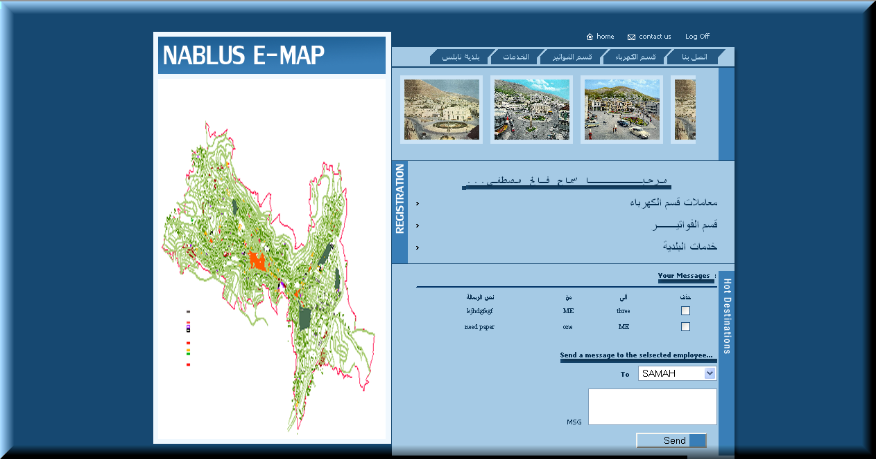
Figure1. 8
This is a page represents the first page in the customer account, through this page the user can choose one of three services, which are:

Electrical Department Services

E-Billing Services

Municipality Services
Also, the user can Send messages to any employee selected from the combo box shown in the messages section in the figure above, and the received messages will be shown also in this section, the user can show the messages, reply to the sender or delete the selected messages.

For the Electrical Department Services:
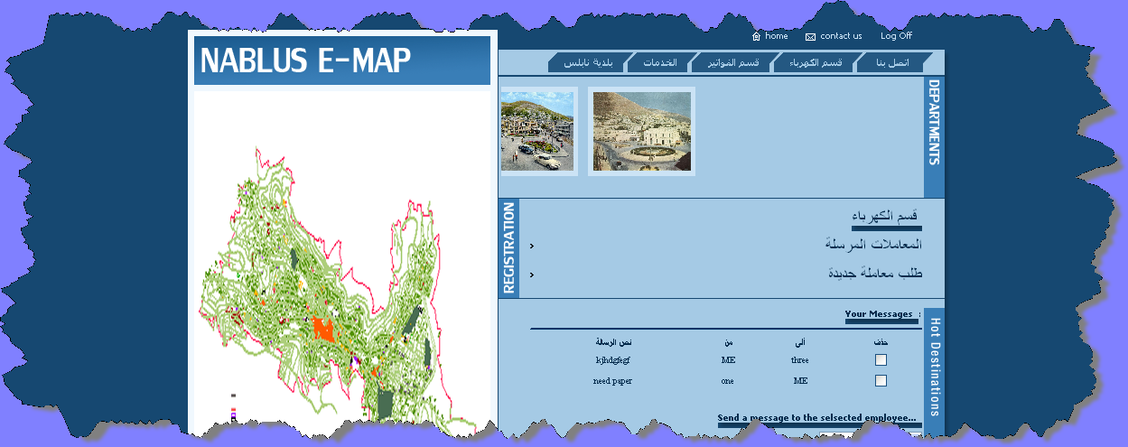
Figure1. 9
In this page after the user choose the Electricity Services, the user can choose a new form request (طلب معاملة جديدة) for certain service will be select in this field, or he can retrieve the forms he requested before from choosing (المعاملات المرسلة).
For a New Form Request:
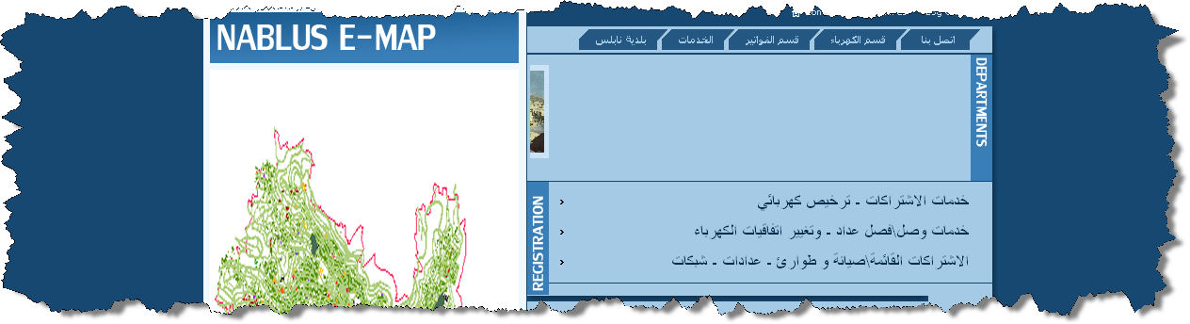
Figure1. 10
There are three types of the forms provided by the electrical department, these are:
- خدمات الاشتراك – ترخيص كهربائي
- خدمات وصل\فصل عداد – وتغيير اتفاقيات الكهرباء
- الاشتراكات القائمة \صيانة وطوارئ – عدادات – شبكات

خدمات الاشتراك – ترخيص كهربائي
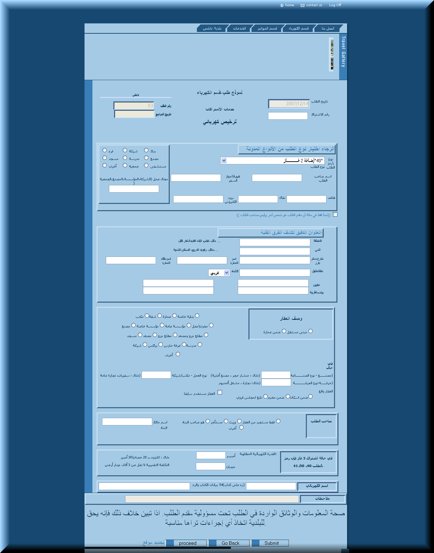
*
Figure1. 11
From the above, the user can fill the information required, be aware that all the fields are under validation rules, after filling the information the user send it to the department, so it will be inside the municipality’s cycle until it finished.
*Through the proceed button the customer can determine the location related to this transaction
(For this form [خدمات الاشتراكات]the customer determine the location through Nablus e-Map and it will be saved as all the fields above )
The other forms are so likely, but differ about the type of the service requested.
For the Sent Forms:
The sent forms are the forms which the user had requested and sent them to the municipality.
These are three types as the above; the user can select them from the shown table from (المعاملات المرسلة).
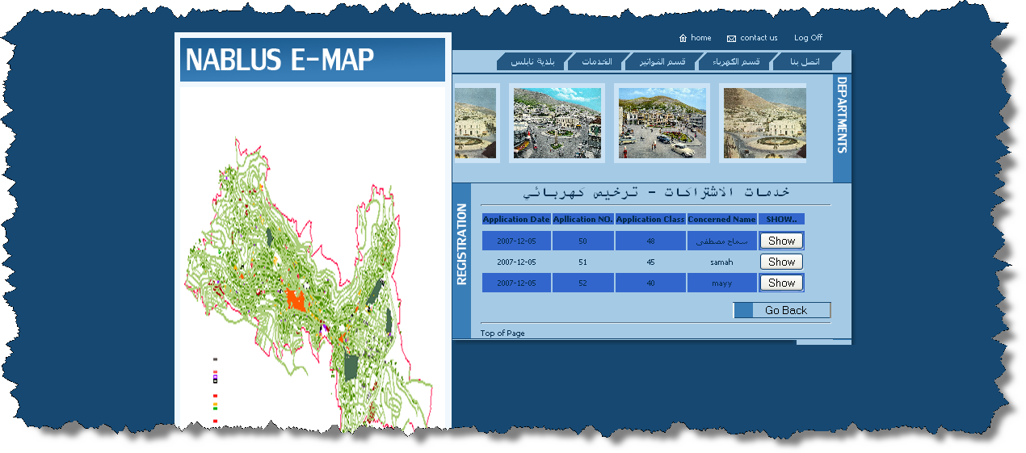
Figure1. 12
From the above table the user can choose any form he sent to show it and to know where did it reach in the municipality, also he can see the notes added to it, as shown below.

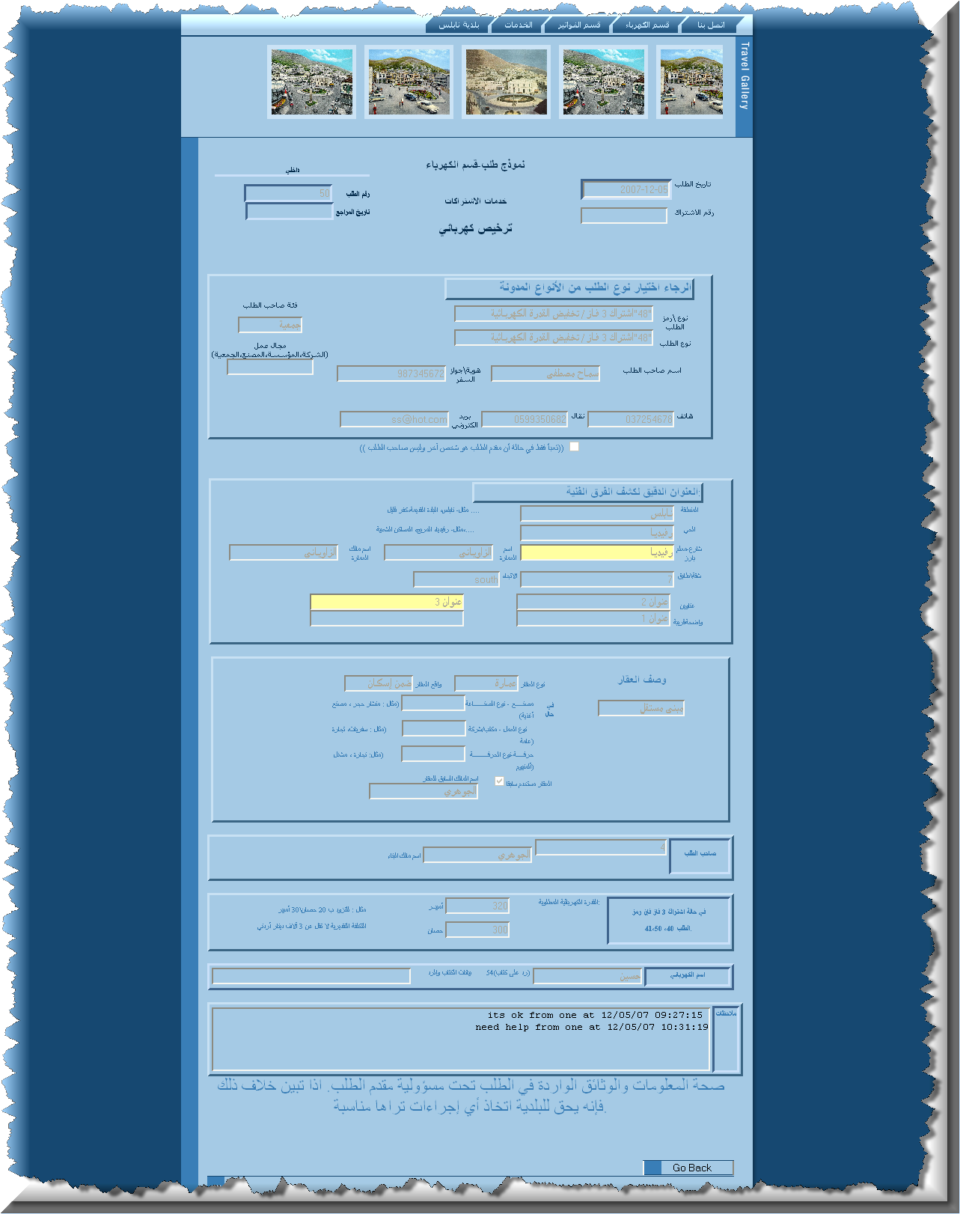
*
As shown in the last of the picture, the user can see the notes added by the employee and at which time.
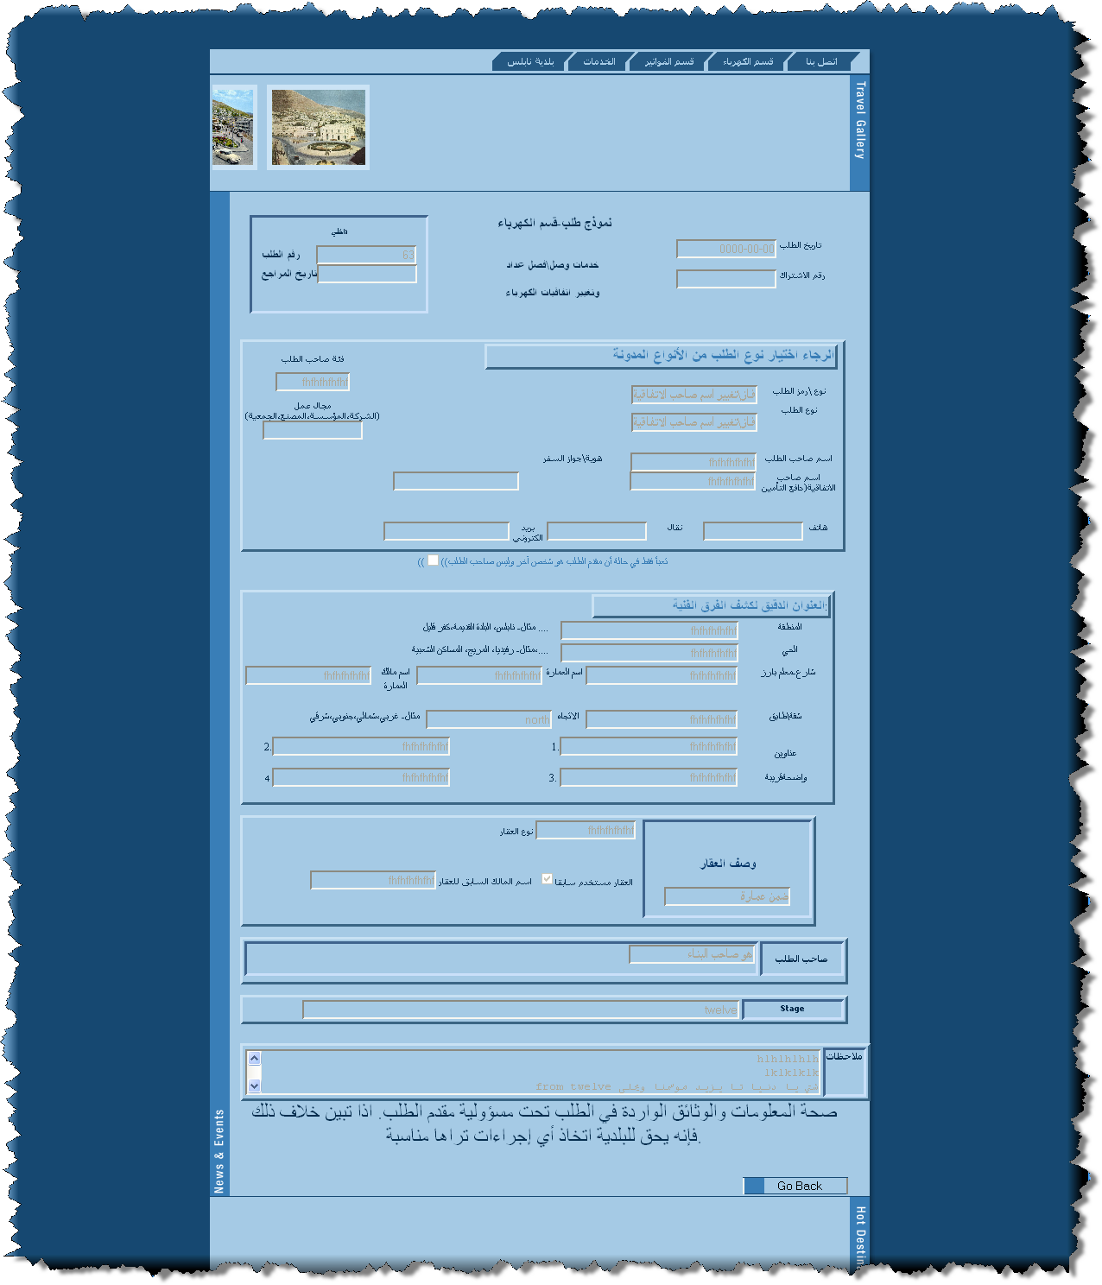
*

As shown above, also the stage is equal to twelve that the form is reached to the employee twelve.

Pages for Employees:
Each employee in the Electricity department can open his account, sees each form arrived to him, they will be as follows:
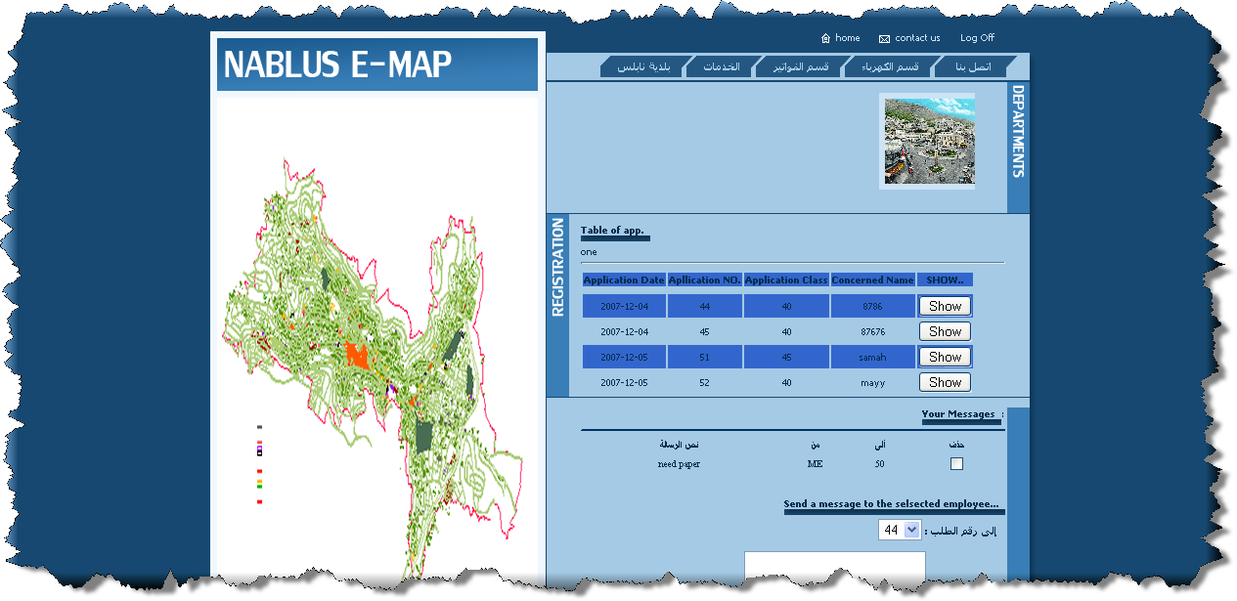
Figure1. 13
In addition, each employee can send a message to specified form number, so will reach to the customer concerned, also can add his notes to this form, or approves it then the form will go to next employee in the cycle of the work.
As shown figure below, the employee can add his notes, as in 1.
And he can approve the form, as in 2.
Also he can determine the work area for this transaction from Go To Location link
(This will take the employee to the correct location in the Nablus e-Map )

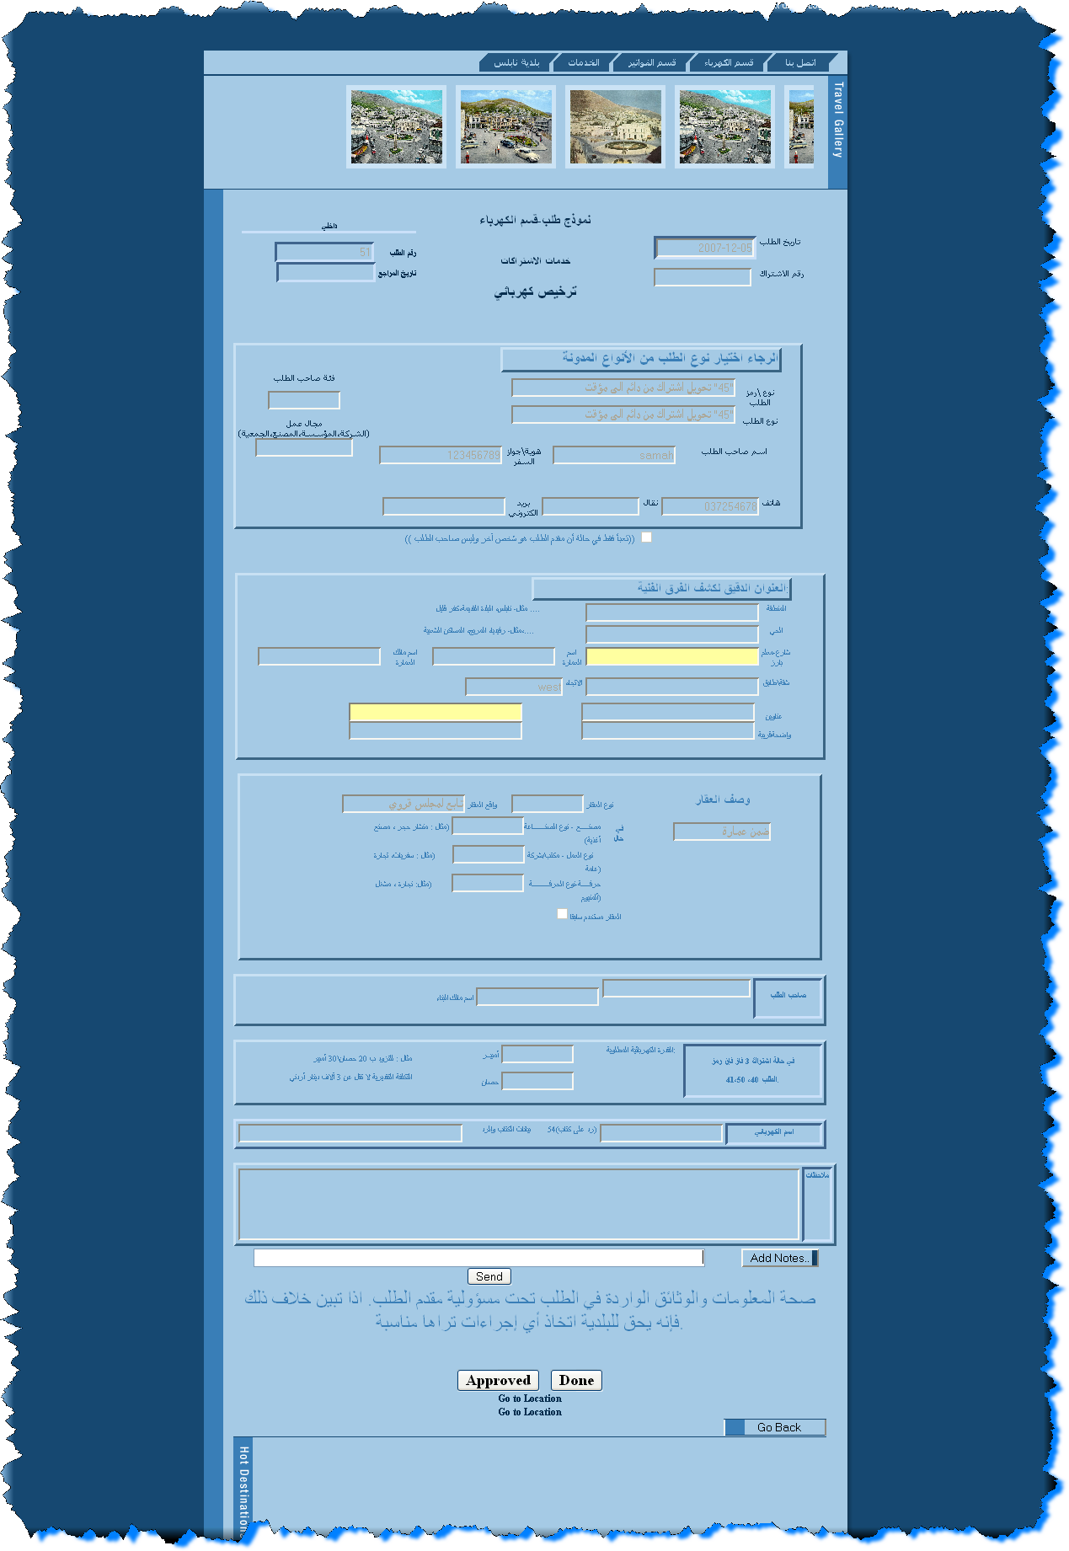
2
1
Figure1. 14

For the News – Editor Employee:
This employee has an account for accessing the news in the system, adding the latest news about the municipality, update them or deleting as shown below.
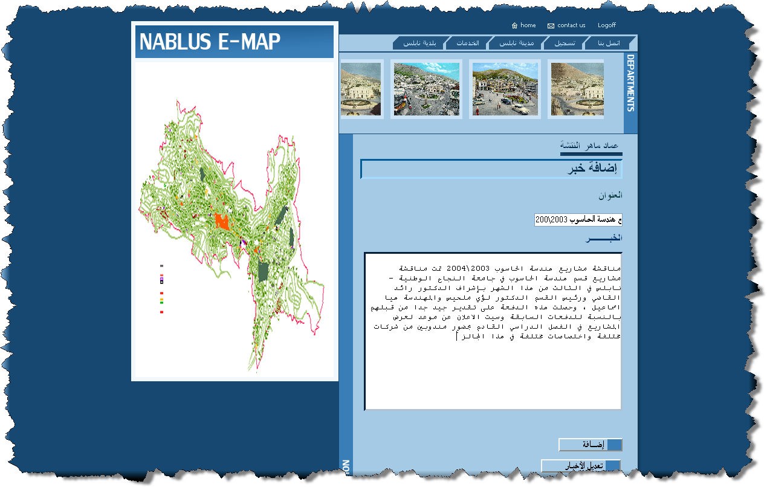
Figure1. 15
When he choose (إضافة) add, the news will be added to the site, anyone can reading it, it will facilitate for accessing the news through the web instead of accessing it through the database.
When choosing edit (تعديل) it will allow the editor to edit the news or delete old ones.

For the E-Complaint System Employee:
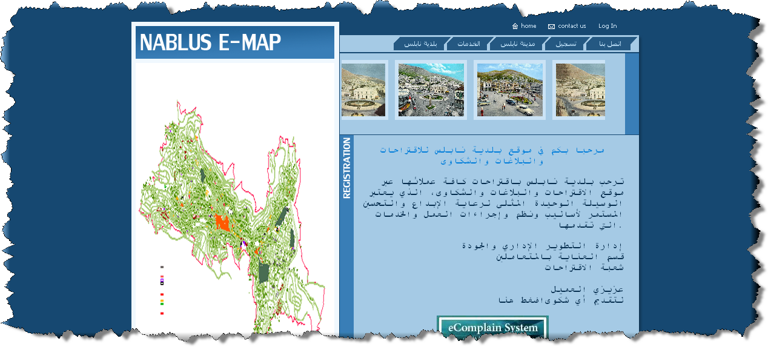
1
Figure1. 16
E-Complaint System has a user, for receiving any complaints, notifications and suggestions from the municipality clients, who will send these suggestion from the page shown below:
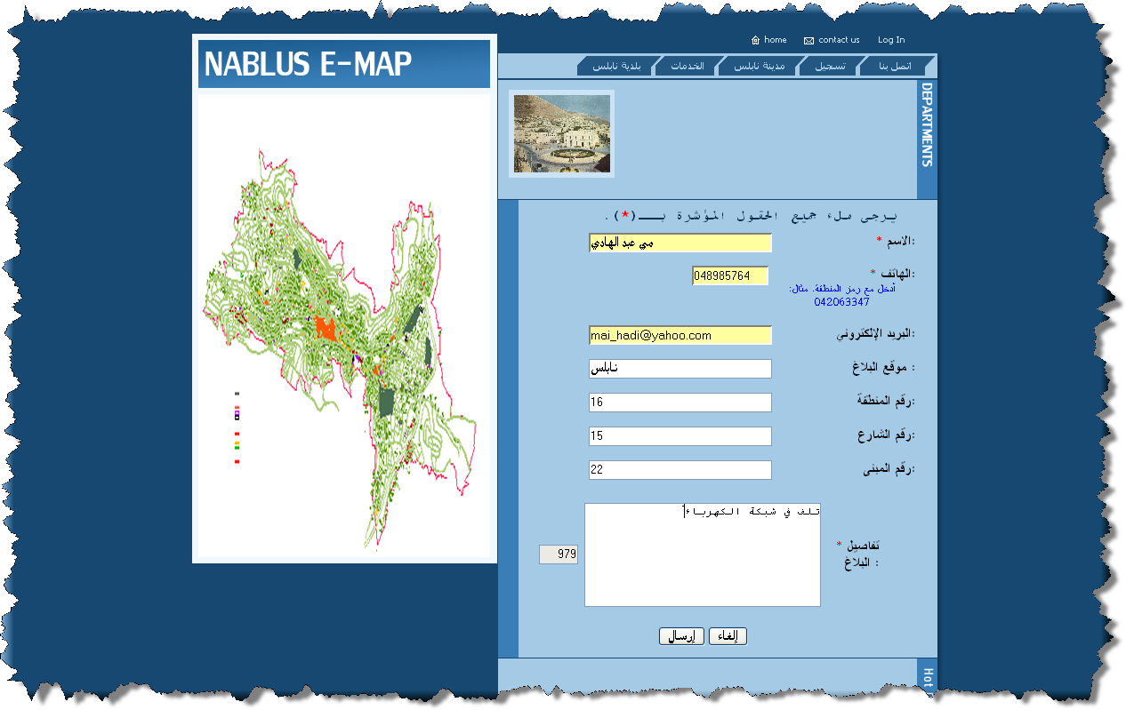
Figure1. 17
As shown in figure 1.17, the client can fill required information, with the specified complaint, and send it to the municipality.
The employee, who will receive these complaints (complaint distributer), will either ignore it or send this to the concerned department which will look at the suggestion or the complaints and search for the solution, the cycle for this is shown below in figures.

Complaint Distributor
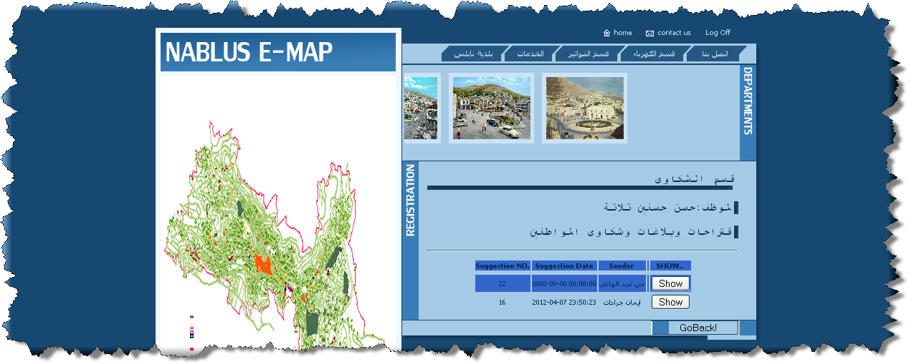
Figure1. 18
Here the distributer can delete the complaints (حذف), or choose the concerned department and sent it (إرسال).
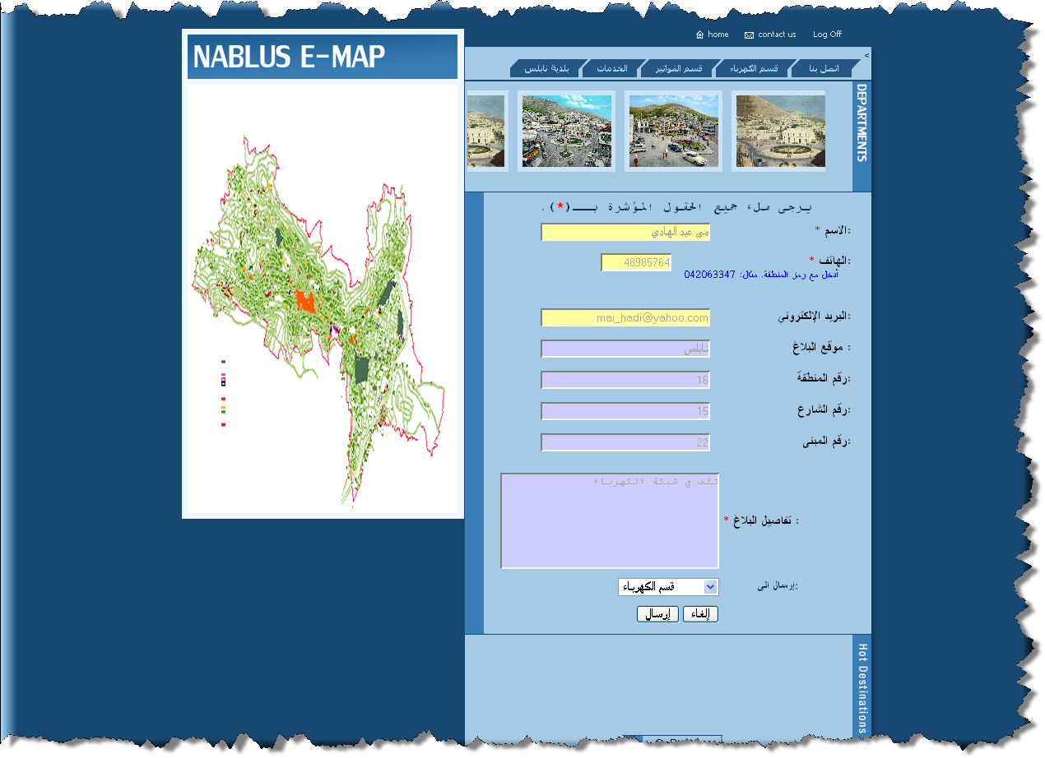
Figure1. 19

Department to which the distributor send the complaints:
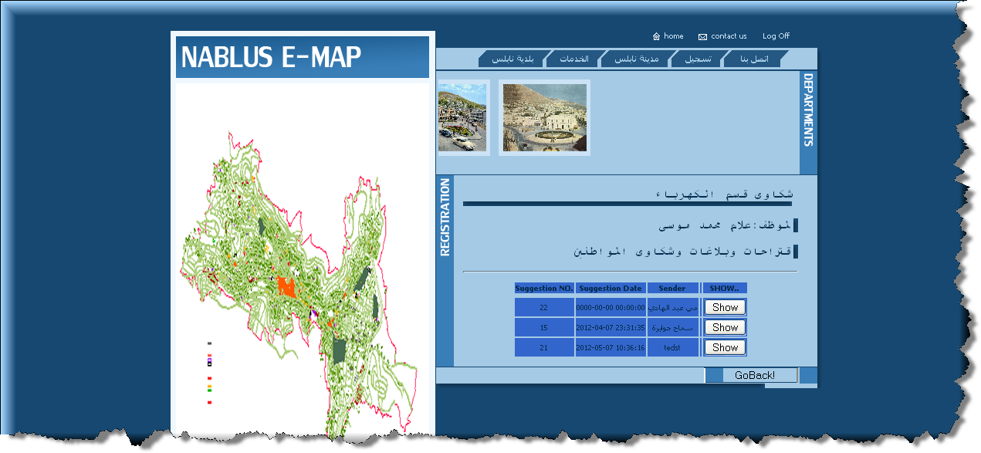
Figure1. 20
When the manager for the department show the complaint as below,
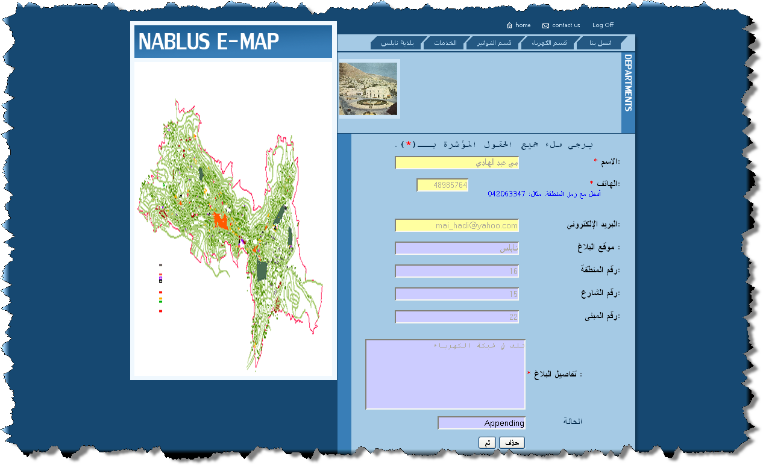
Figure1. 21
As shown from the figure, the manager can also delete the complaint and see the status of that complaint, (Appending or Approved), and update its stage (الحالة).

