

An_najah National university

Project Name:Electronic Menu

Team members:
Sondos Ibrahim Sarah Khdair
Supervisors:
Dr. Luai Malhees
Instructor Haya Samaaneh

Abstract
Our project aims at automating any ordering process accommodating to everything else in life .As an application we have chosen a Restaurant Menu.

Introduction
The electronic menu consists mainly of two parts. The first is display, and the other is transport method which we have chosen to be Wireless.
First you place your order with the help of the display then your order will be sent wirelessly to the other end at the kitchen to be processed after that it will be sent to the cashier where you can pay your bill.

Used Equipment :
- Display>>> GLCD
--unfortunately we had some problems acquiring some of the project planned parts for this part we wanted to use a touchscreen but the screen’s connector didn’t arrive. We tried building one of our own but machines in the country don’t support such a resolution.
touchscreen | GLCD
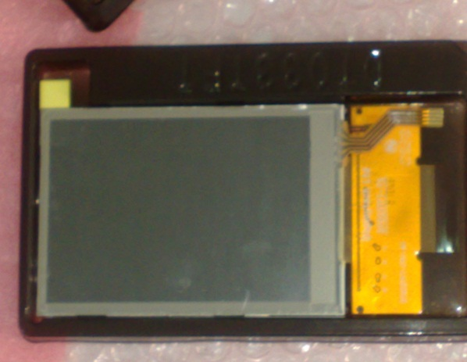 | 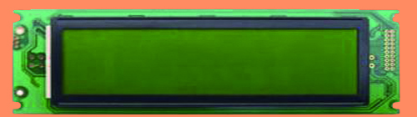
Parallel connector | Parallel & serial connector
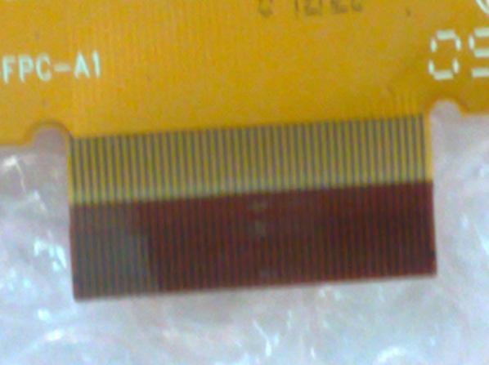 | 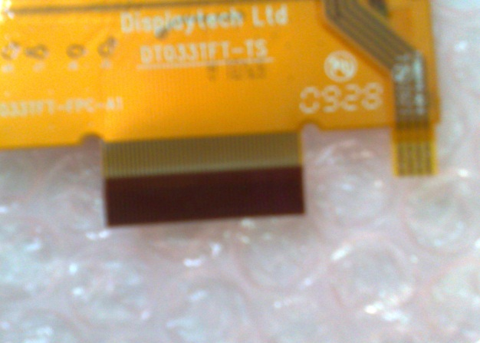

- 4 *4 keypad to place the order
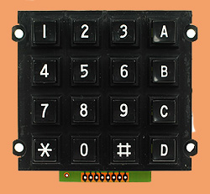
- Wireless>>> MRF24J40MA
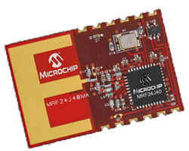
- Microcontroller
                - PIC18LF4620
                - PIC18F4620

  - Used Programs:
    - MPLAB 810
    - PIC C compiler
    - Microsoft Visual studio 2010

How to use it:

On the display you will be presented with the suggested menu with the help of the keypad you will be able to place your order this is processed using PIC18F4620 microcontroller.
After you’re done you can submit your order to be sent to PIC18LF4620 where it will be processed to be sent wirelessly using MIWI protocol using the MRF24J40MA to the other end where it will be received by another MRF24J40MA to be then transmitted to a PIC18LF4620 microcontroller to be processed and displayed at a normal LCD
And to be then sent serially to a C# desktop application to be listed as a Bill and viewed to the cashier employer and the Bill number and value will be inserted into a database for later use.
Programming:

Target Market:

Company cafeterias

Coffee shops

Opportunities, Risks, Issues and Countermeasures

Main problem was to decide on components suitable and affordable according to the project’s budget and bringing them to the country.

Future expectations

Building the project as was planned on the first place with a touchscreen and more proper components and markets it.

