

Hayat
Students
Qusai Hijaz - 11210279
Tamer Haj ALI -

Supervisor
Dr. Baker abdullhaq

An-Najah National University
2018 / 2017

Table of Contents
Abstract 4

Chapter One - Introduction
1 Introduction 5
1.1 Project Scope 6
1.2 Problem Specification 6
1.3 Goals and Objectives 7
1.4 Motivation 7
1.5 System Requirements 8
1.6 Project Plan and Schedule 9

Chapter Two - Literature and Methodology
2 Introduction 10
2.1 Current System 11
Advantages of the current system 11
Disadvantages of the current system 12
2.2 Proposed System 13
Advantages of the proposed system 13
Disadvantages of the proposed system 14
2.4 Methodology 14
3 Introduction 15

Chapter Three - Requirements
3.1 System Analysis 15
3.1.1 Requirements Collection 15
3.1.2 Requirements Studied 17
3.2 System Design 18
3.2.1 ERD Model 18
3.2.2 Usecase Model 19
3.2.3 Sequence Diagram 20
3.2.4 Sequence Diagram 21
3.2.5 Activity Diagram 22
3.2.6 Activity Diagram 23

Chapter Four - System Implementation
4.1 Programming Language Tools 23
4.2 Implementation 23
4.2.1 Introduction 23
4.2.2 Sample of forms 24

Chapter Five - The Conclusion
5.1 The Conclusion 31
5.2 Future work 31

Abstract
Hayat is a website which is specialized in the category of people with special needs. It can connect organizations that specialize in this field which each other. It can also provide a lot of services and financial assistance and other aids such as tools, equipment and supplies for the category of people with special needs.
This site will also be the interface that represents this category of society and cares about them and their news, details and activities. Moreover, it supports and develops them by collecting these institutions in one location.
Hayat will contain a directory for all institutions with the possibility of searching through a search engine for each organization according to several things such as the region, the Specialization of the institution, etc.

Chapter One

Introduction

Introduction
Hayat is an online system that cares for people with special needs and brings them together in one place with the institutions they care about. The role of this site is as a link that facilitates communication among them. They can apply for help and meet their needs, chairs and speakers through this system which will work to communicate with the institutions.
Each organization will have an account on the system and will place all its information, such as the organization's budget, equipment and supplies available in the organization in this account. The organization will periodically modify its information.
When you request help from an institution through this system, our system will communicate with other institutions and display the availability of the institutions. The system will display the results and the institutions will provide our order. This process depends on several things such as the place, the institution's budget and the type of disability that the institution is interested in. After that, the system selects the best institution and therefore the selected institution provides the requested service.

Project Scope

Hayat is a link between the institutions concerned with people with special needs. The scope the work will be on the basis of helping people with special needs by applying for assistance to the system by institutions or individuals, and thus the system will choose the best available options from the institutions.
The site will be a comprehensive site and contain news and projects and activities of this category. It will include a guide to all institutions in different regions.
The project will be delivered within 4 months, at the end of December 2017.

Problem Specification

In this system it is easy to connect all institutions with each other and ask for help from some of them electronically instead of contact in a traditional way. The system provides all needs of people with special through the website.
This system will have a positive impact, and will increase cooperation between the institutions. The system will also encourage disabled people to apply for assistance because they do not need time and effort.

Goals and Objectives

1. A link between all institutions interested in the category of people with special needs.

2. Saving time and effort for the category of people with special needs because you can request assistance electronically.

3. To encourage the people with special needs to apply for assistance and provide them with their needs.

4. Increase cooperation among institutions and increase social relations among them.

5. The site will represent the category of special needs and attention to their news and activities.

6. To encourage people to help this class of society.

7. Attention to the category of people with special needs and raise awareness about their rights in society.

Motivation

The idea of the project is to facilitate the help of people with special needs through their contact with the institutions and associations that are interested in them.
In addition, the exploitation of the project's material resources and the possibilities of institutions and associations in providing services and assistance to the largest number of this people .
The site will provide enough knowledge to the protesters to request assistance from government institutions and charity. Because of this, we have created the idea of this system.

System Requirements

The ability to register in the system as a user or an institution to have a password and a user id .

As a User’s (organizations):
- Add news
- Receive an assistance request from admin.
- Modify the money amount and inventory.
- Communicate with the site.
- Ability to edit and update profile.
- Agree or reject the assistance request.

As a User (Special Needs):
1. Submit a request for assistance
2. Communicate with the site
3. Show basic information (name, age, type of disability, City)
4. Ability to edit and update profile

As an admin:
1. Ability to add or delete institutions and users.
2. Presentation of all institutions and individuals on the site
3. Respond to requests for assistance and offer institutions that provide needs.
4. Choose the institution that we want to get help from them.
5. provide assistance from inventory of hayat.

Project Plan and Schedule

This project started at the end of September, 2016 and should be completed by the end of November, 2016.

 | Task | Start Date | Finish Date | Status
-1 | Gathering information and do some research on the project. | 27/9/2017 | 30/9/2017 | completed
-2 | Analysis the information and researches. | 1/10/2017 | 10/10/2017 | completed
3- | Define the system requirement and specification for each module in the system. | 11/10/2017 | 20/10/2017 | completed
4- | Design interface for the system. | 21/10/2017 | 30/10/2017 | completed
5- | Implementation phase | 1/11/2017 | 30/11/2017 | completed
6- | Testing phase | 1/12/2017 | 8/12/2017 | completed
7- | System delivery |  |  | completed

Chapter Two
Literature and Methodology

Introduction

Hayat is a system that allows the disabled to request the needs, equipment and money online without the need to move from one institution to another, where the user can access the site and apply for help, whether money or equipment, and will show him the best results and the best institutions that can provide assistance .
The basic principle of the presentation of the best results (institutions that will provide assistance) will be based on the institution's location and the field in which the institution is specialized. The system will look at four ways to present the institutions that can help.
It will show results in the order according to:-
1-Show the societies which are at the same city of the handicapped (Who made a request for assistance) and specialized in the same area of the disability.
2- Show the societies that are at the same city of the handicapped (who made a request for assistance) but of not the same area of disability.
3- Show the societies which are not at the same city of the handicapped but specialized in the same area of the disability.
4- Show all the societies which can help regardless the city and the area of disability.
Hayat also has inventory (money and equipment) if we do not find any results from the institutions, Hayat will apply for help.

Current System

In the current system, the disabled person or his or her family needs a long time and a great effort to move and search from one institution to another to meet the needs, ensuring that the effectiveness of this is not guaranteed because it can be searched in many institutions and in the end cannot find demand.

For Handicapped (disabled person):
The disabled or his family to move from one institution to another’s to request equipment require him like a wheelchair or crutches, and if he was looking for money to perform surgery or to buy Medicines it will not be effective because it is difficult to find his request if found .
Even if the disabled person is registered with an institution, the institution may be late in meeting its requests, and it is difficult to seek help from another institution.

For institution:
In the current system, the needs of the disabled will be unorganized, random and on paper, and this will cause a lot of information to be lost. And not ensuring the assistance of all disabled persons. The system will be tired compared to the proposed new system.

Advantages of the current system:

- It does not require an internet service to request help from institutions.

2. The disabled person or his / her relatives meet the owners of the institutions personally and explain their situation and needs in a better way.
Disadvantages of the current system:

1. The disabled person needs a lot of time and effort to move from one institution to another and find out if them can help him or not.
2. The disabled person cannot visit all institutions and know if he has his requests and needs.
3. This system is ineffective and may extend the period to a long time to meet the needs of the disabled.
4. The aid system is irregular and random and on paper, with the possibility of forgetting or losing the next orders.
5. Not guaranteeing assistance to all disabled persons.

Proposed System

In our proposed system, everything will be different for the traditional system, where it will provide assistance requests online, where assistance can be provided with the equipment that the disabled person wants or request financial assistance, and after request assistance will show the best results and offer the best institutions that can provide assistance.
Then we can choose which institution we would like to get help from, and all of this will be done electronically instead of the traditional way, which would take a long time and a great effort to search for needs.
Our system recommends that the disabled be classified according to the area of disability, Based on this, the best results will show based on the institutions are specialized in the same field of disability and also from the same disabled city.
Advantages of the proposed system:

- Ask for assistance from institutions without wasting time and effort, and all that is required is to apply online without moving from place to place.
- Show all organizations that can help you just choose from these institutions.
- Meet the needs of the disabled immediately and respond with approval or rejection.
- Help all disabled people in need of help.
- Encourage the people with special needs to apply for assistance and provide them with their needs.
- Increase cooperation among institutions and increase social relations among them.
- The system is structured and stores all requests for assistance in the database and identifies the executed orders and the unmet requests.

Disadvantages of the proposed system:

- The proposed system need internet service ‘wired or wireless’ to surf the system. So, the system works only where the internet service available.

- There may be a lack of trust between institutions and the disabled; Trust issue is the main challenge for the system.

Methodology

After studying this system deeply, Agile methodology is chosen to be used. That refers to many reasons , First of all the user wants this system in short time period and the agile achieves that since each evolution is only on a small part of the whole project , Secondly Agile methodology deals with the unstable and changing environment (changing in requirements, needs , priorities, technology ..etc.) by keeping the development team in contact with the user , Finally Agile methodology builds a collaborative team environment since they work together to find better ways of solutions.

Chapter Three
Requirements

Introduction

In this chapter, we will talk about system analysis and system design model.

System Analysis

In this chapter, we will discuss how collect the requirements and method we use to collect the requirement, then classify this requirement based on the actors, so the system has more than one actor.

3.1.1 Requirements Collection

- Using document analysis:
That comes by trying to elicit information from relevant documentations and viewing existing institutions such as http://www.mosa.gov.ps/ and to study and understand some details.

- Using interviews:
We met disabled people and their families and asked them about how to get their needs, and whether there is difficulty in obtaining the needs, through which we concluded that the current system is difficult and ineffective.

System Design

3.2.1 ERD Model

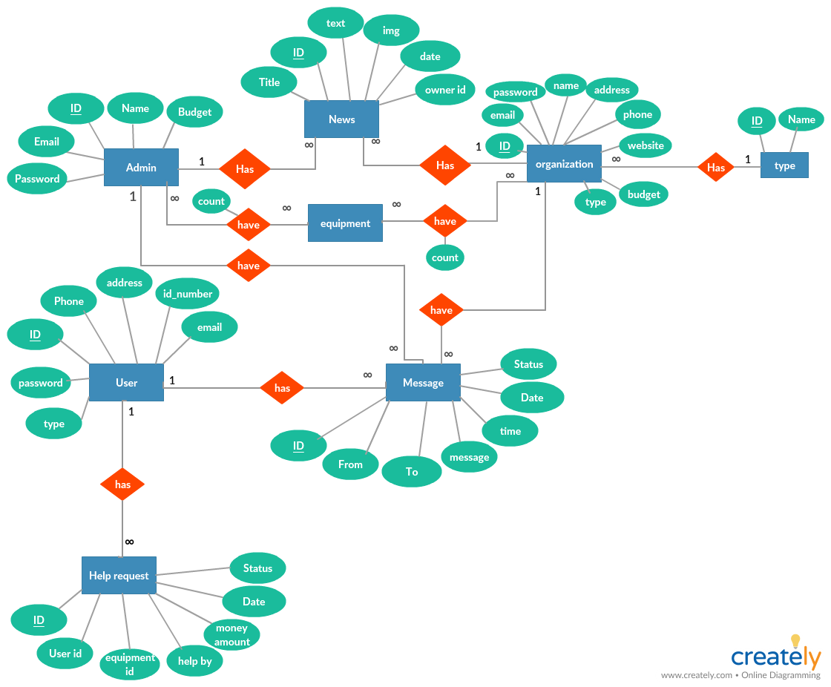

3.2.2 Usecase Model

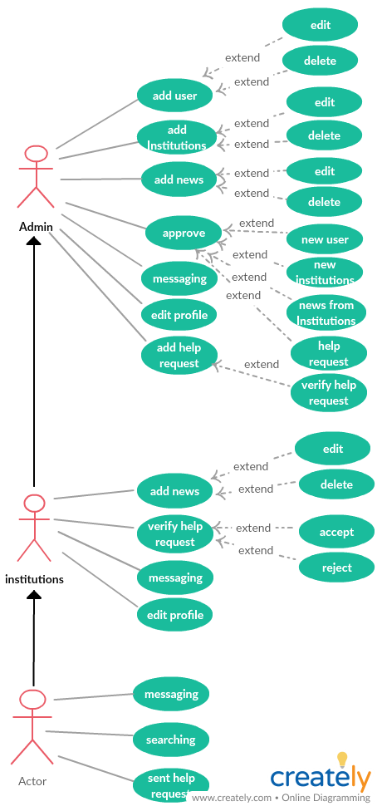

3.2.3 Sequence Diagram

Sent assistance request (from Admin)

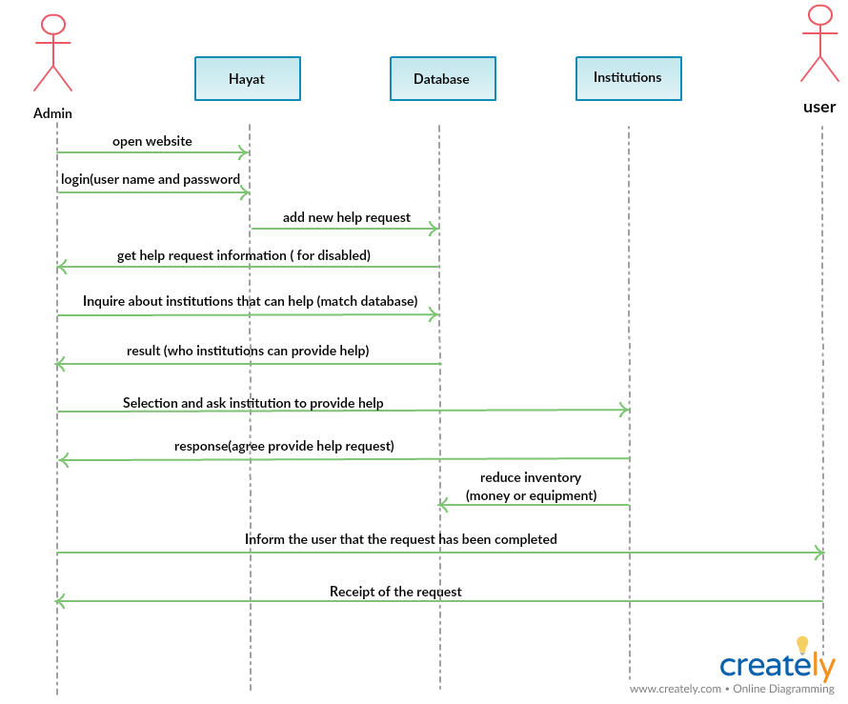

3.2.4 Sequence Diagram

Sent assistance request (from User)

Case A (agree) :

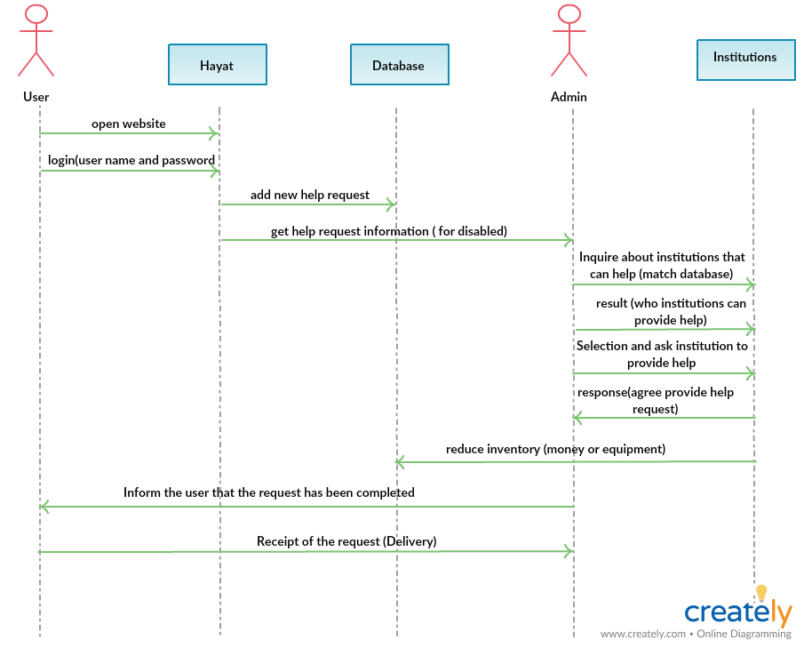

Case B (reject):

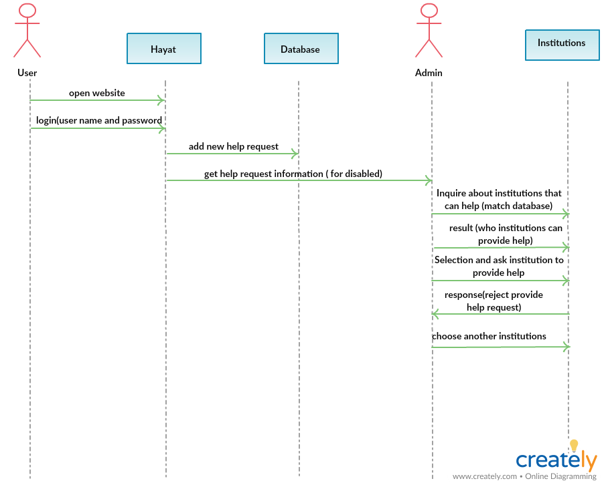

3.2.5 Activity Diagram

Sent assistance request (from Admin)

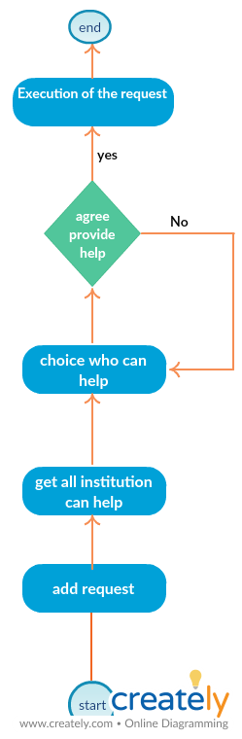

3.2.6 Activity Diagram
Sent assistance request (from User)

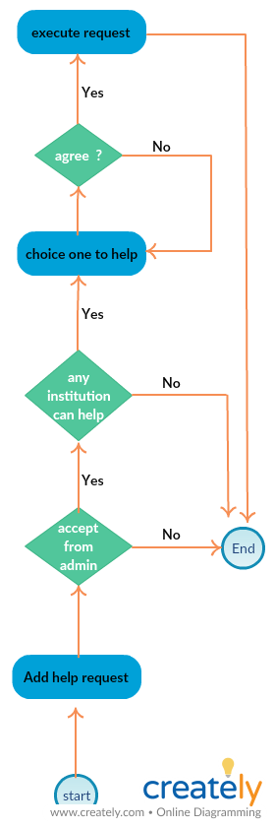

Chapter Four
System Implementation

Programming Language Tools

4.1.1 What are we used

- NetBeans IDM
- PHP Language
- Bootstrap
- HTML5
- MySQL Database

Implementation
4.2.1 Introduction
At the beginning, we created website design through we design screens, forms, and we created more than one design until we came to the final design. After that we create the database and it was modified during the design phase.

4.2.2 Sample of forms
Register form(user )
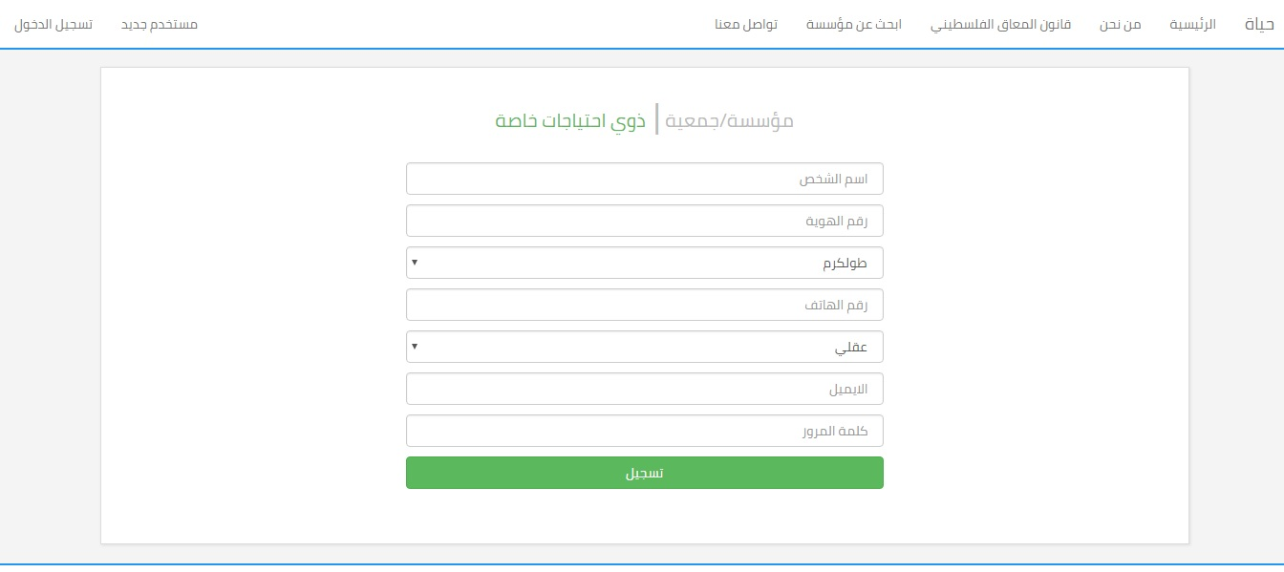

Register form (institutions)

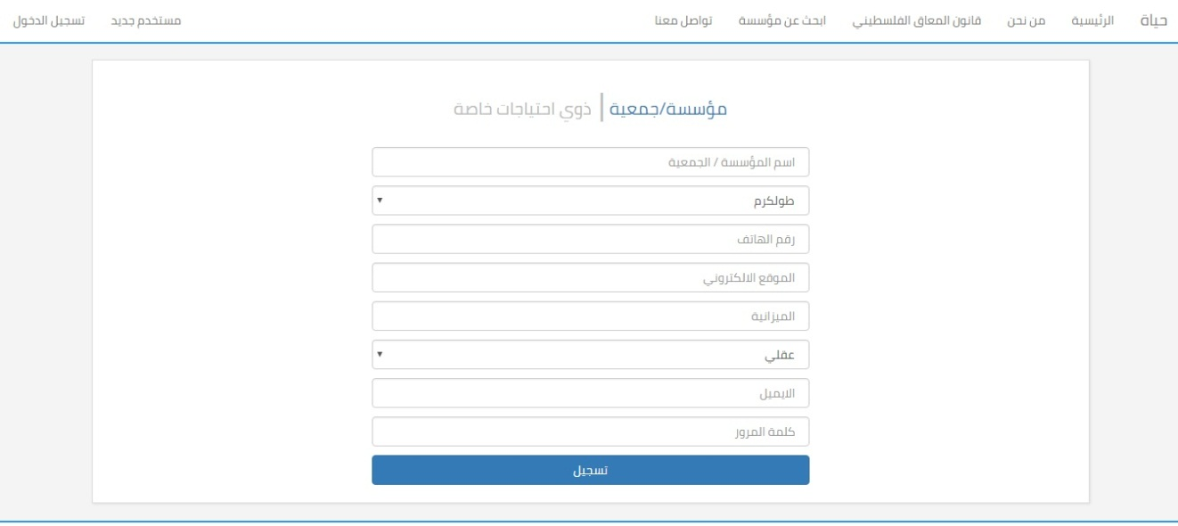

Login form (users and institutions)
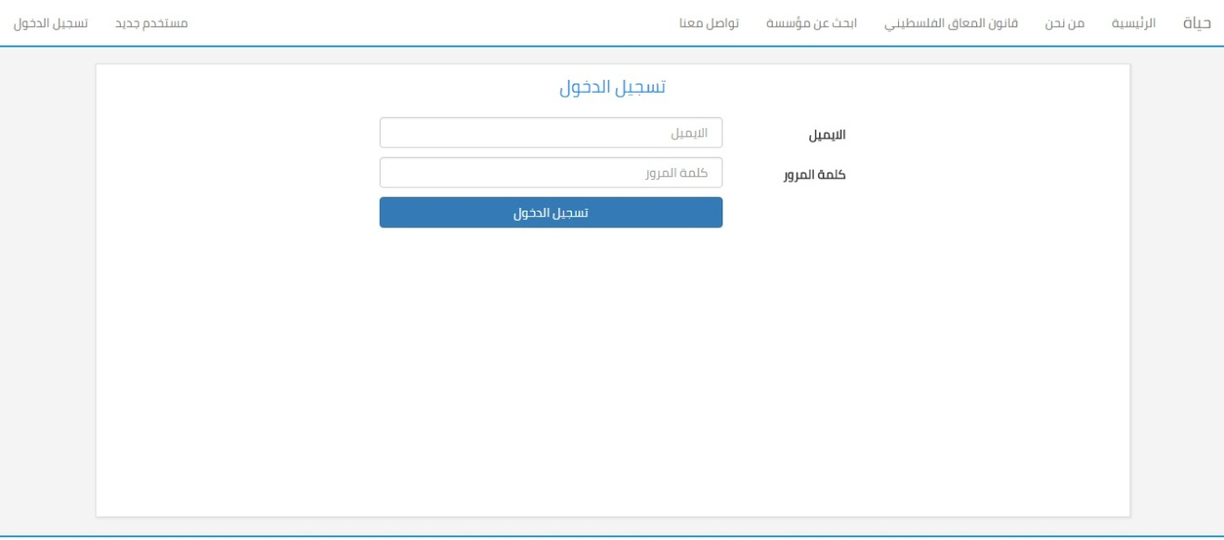

Login form (admin)
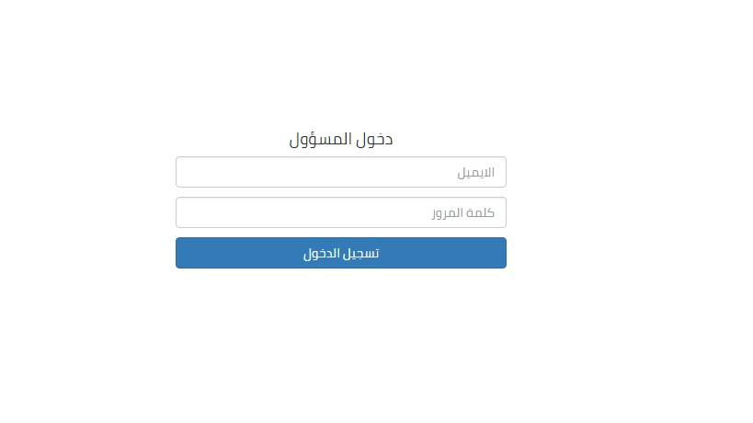

Add users from admin 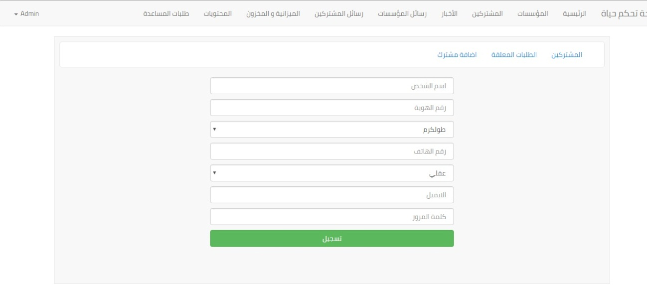

Add equipment to inventory

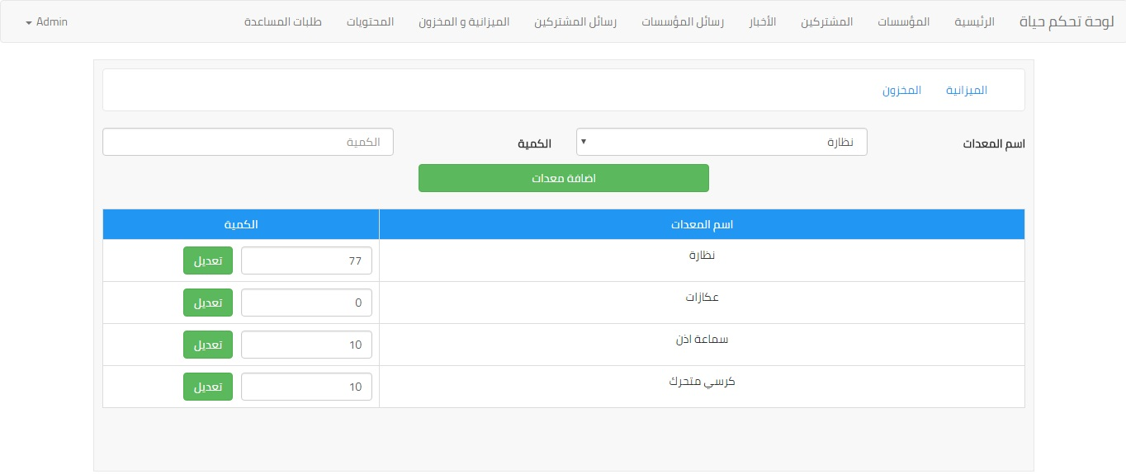

Messaging
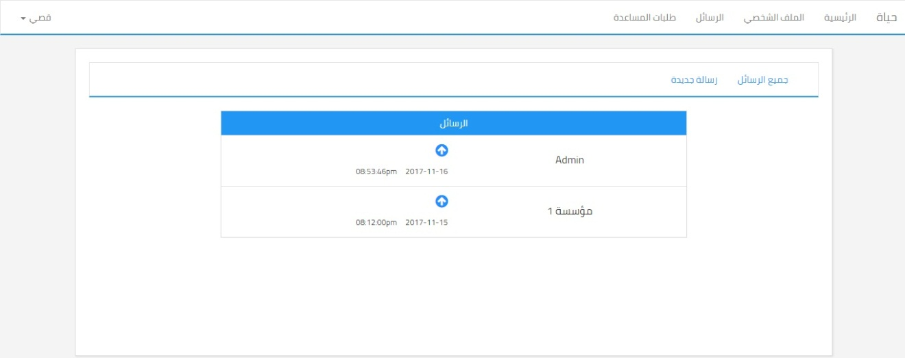
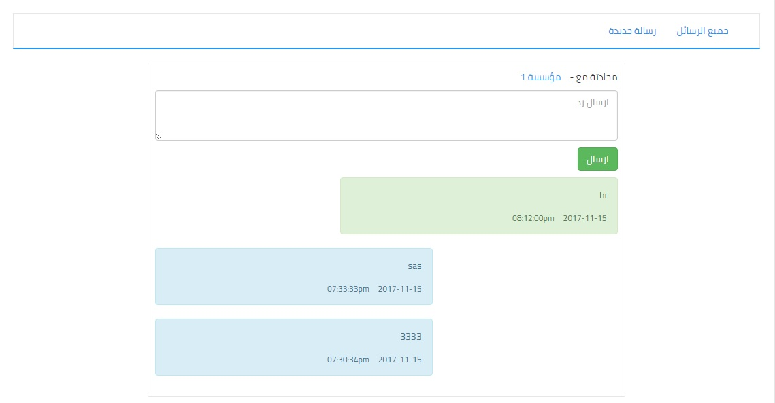

Assistance request form
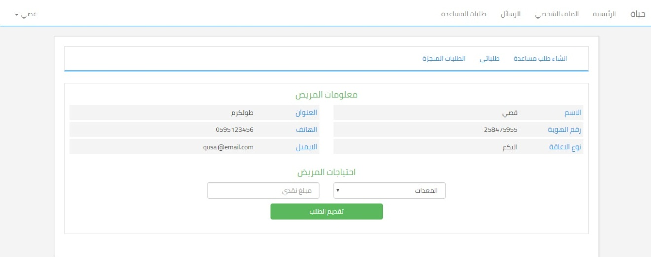

Executed request
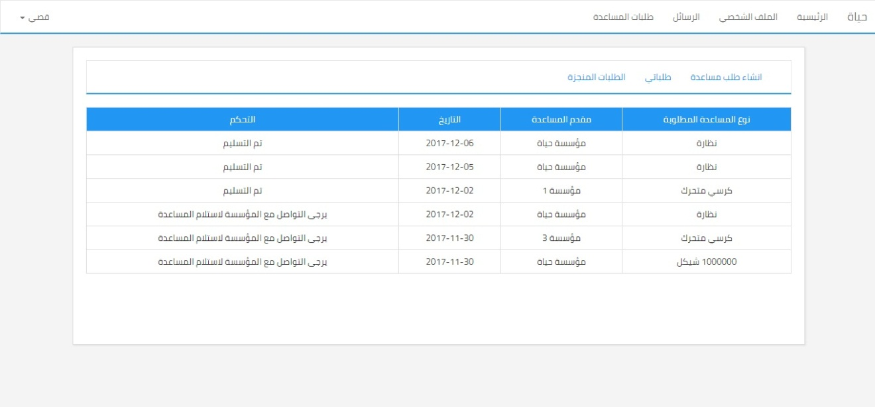

Waited request
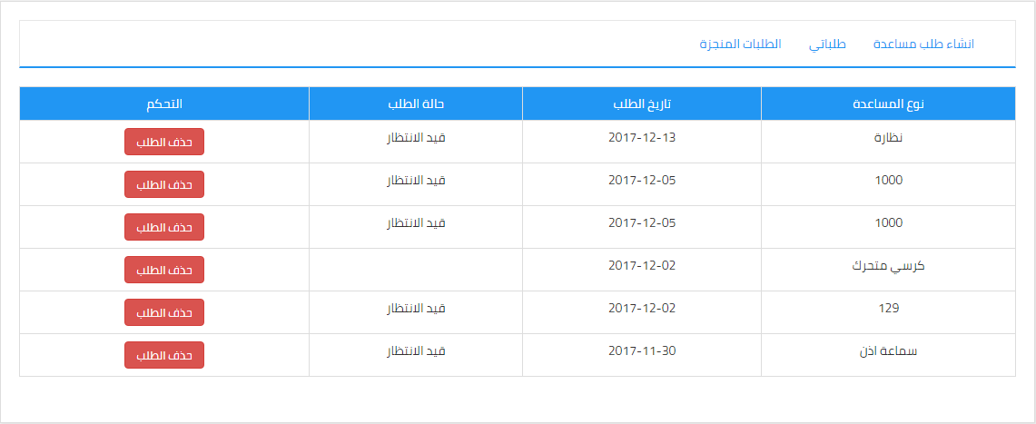

Add news
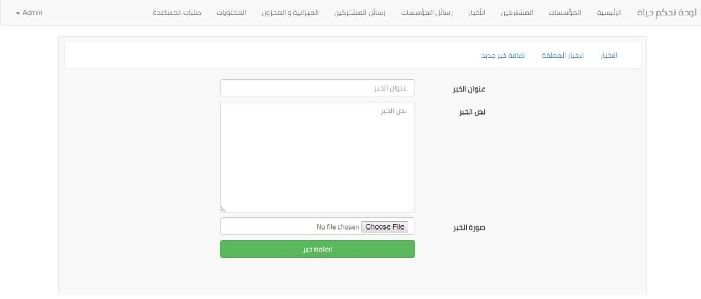

Add disabled type
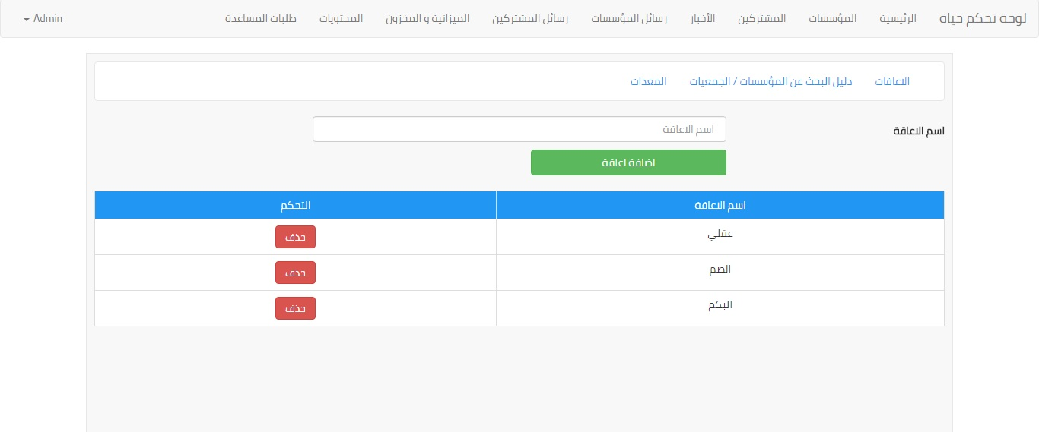

Admin control panel

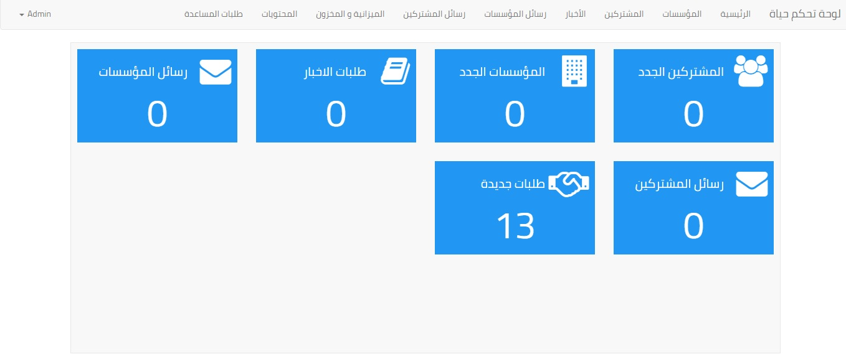

Chapter Five
The Conclusion

The Conclusion

Hayat is an electronic interface that combines people with special needs with institutions that are interested in this category of society and seeks to raise their status and help them in the fastest and easiest ways, and be the life that is representing this category and take care of all their activities and details.

Future work
We seek to improve the ways to search for the best results and provide assistance intelligently through the use of artificial intelligence in finding the best results to provide assistance to people with special needs, and also the participation of more than one institution to apply assistance for the same person.

The End

