
An-Najah National University

Faculty of Engineering and Information Technology Electrical Engineering Department and Telecommunications Engineering
Graduation Project 1
Presented in partial fulfilment of the requirements for Bachelor degree in

Electrical Engineering and Telecommunications Engineering

Real Time Adaptive Active Noise Cancellation (ANC)
Prepared by:

Hind AL Haj (11925021)
Elham AlHasan (11610504)
Roaa Khamous (11611104)

Supervised by: Dr.Omar Tamimi

بِسْمِ اللهِ الرَّحْمنِ الرَّحِيم

قال تعالى : { وَقُلِ اعْمَلُوا فَسَيَرَى اللَّهُ عَمَلَكُمْ وَرَسُولُهُ وَالْمُؤْمِنُونَ وَسَتُرَدُّونَ إِلَى عَالِمِ الْغَيْبِ وَالشَّهَادَةِ فَيُنَبِّئُكُمْ بِمَا كُنْتُمْ تَعْمَلُونَ}
[التوبة: 105]

{ ‏‏يَرْفَعِ اللَّهُ الَّذِينَ آمَنُوا مِنكُمْ وَالَّذِينَ أُوتُوا الْعِلْمَ دَرَجَاتٍ }

[المجادلة: 11]

صدق الله العظيم

Dedication:

For Our Palestine …
For Our University
For Our Teachers …
For Our Family …
We Present This Research …

Acknowledgment:

- First and foremost, we express our gratitude to the Almighty for providing us with the strength and guidance to successfully complete our research project.

-We extend our heartfelt appreciation to An-Najah National University, which played a crucial role in facilitating our research endeavors. The support and resources provided by our esteemed university were invaluable in the realization of this project.
- Our deepest thanks go to our parents, who have selflessly dedicated their lives to our well-being and success. Their unwavering encouragement and support have been instrumental in our journey.
- Special thanks are due to Dr. Omar Tamimi for his valuable advice, guidance, and unwavering support throughout the research process. His expertise and mentorship have been invaluable.
- We would also like to express our gratitude to all the professors and instructors at NNU who have contributed to our academic growth and development.
- Our appreciation extends to our friends for their assistance and encouragement throughout this project.

Finally, we would like to express our gratitude to everyone who, in any way, contributed to the successful completion of this research. Your support and collaboration have been deeply appreciated.

Contents:
Chapter one: Introduction 1
1.1 Overview 1
1.2 Statement of the Problem 1
1.3 ANC Principle 2
1.4 Objective 2
Chapter Two: Theoretical Background……………………………………………………………………...3
2.1 Types Of ANC System 3
2.1.1 Signal-channel and Multiple-channel system.............................................................................3
2.1.2 Feedforward systems..................................................................................................................6
2.1.3 Feedback systems...................................................................................................................... .7
2.2 Adaptive Controller 8
2.2.1 Adaptive Filter...........................................................................................................................8
2.2.2 Adaptive Algorithms………………………………………………………………………….9
2.2.3 Adaptive filtering application………………………………………………………………….11
2.3 ANC Algorithms …………………………………………………………………………….. …16
2.3.1 ANC as system identification.....................................................................................................17
2.3.2 Filtered-x LMS Algorithm........................................................................................................18
2.3.3 Secondary path modelling..........................................................................................................22
2.3.4 Band limited Modified FxLMS algorithm.................................................................................26
2.3.5 Mirrored MFxLMS algorithm....................................................................................................30
2.4System Considerations...................................................................................................................32
2.4.1 Coherence...................................................................................................................................33
2.4.2 Causality……………………………………………………………………………………....33
2.4.3 Sampling rate and Filter Length………………………………………………. ………………36
. 2.5 ANC headset system......................................................................................................................37
Chapter Three: Software And Hardware…………………………………………………………………….40
3.1 Hardware Approach……………………………………………………………………………….42
    - Components …………………………………………………………………………………42
3.1.2 Idea behind the Circuit…………………………………………………………………………..43
  - Algorithm Testing……………………………………………………………………………….45
3.2.1 Least Mean Square (LMS) Algorith…...........................................................................................45
3.2.2 Normalized Least Mean (NLMS) Square…………………………………………………….........47
3.2.3 Recursive Least Square……………………………………………………………………....49
3.2.4 Simulation Results Comparison and Implementation Decisions…………………………….51
3.3 Appendix 51
3.3.1 Appendix A. MATLAB Codes…………………………………………………………..……51
3.3.1.1 Least Mean Square…………………………………………………………………………..51
3.3.1.2 Normalized Least Mean Square………………………………………………………….….52
3.31.3 Recursive Least Squares……………………………………………………………………...53
Chapter Four: Analog Active Noise Cancellation 56
4.1 Introduction to analogue ANC …………………………………………………………………..56
4.2 Basic principles of analogue ANC ……………………………………………………………….57
4.3 Components of analogue ANC system……………………………………………………….......66
4.4 Case study Analog vs. Digital Active Noise Cancellation in Premium Headphones……………..68
4.5 Applications of analogue ANC…………………………………………………………………….70
4.6 Advantages and Limitations of analogue ANC……………………………………………………73
4.7 Technological Innovations and Trends…………………………………………………………….75
4.8 Futur Developments and challenges………………………………………………………………..76
Chapter Five: Results and Analysis ……………………………………………………………………….…79
5.1 Current Achievements……………………………………………………………………………..79
5.1.1 Acoustic noise Canceler…………………………………………………………………………….79
5.1.2 Adaptive Filters Convergence Demo………………………………………………………………..80
5.1.3 Adaptive Noise Cancellation Demo…………………………………………………………………82
5.1.4 Active Noise Control Using a Filtered-X LMS FIR Adaptive Filter…………………………….......84

Chapter Six: Conclusions and Recommendation…...........................................................................................91

6.1 REALISTIC CONSTRAINTS………………………………………………………………………91
6.1.1Engineering Standards………………………………………………………………………………91
6.1.2 Environmental Constraints…………………………………………………………………………91
6.1.3 Sustainability Constraints…………………………………………………………………………..91
6.1.4 Manufacturability Constraints…………………………………………………………………...…91
6.1.5 Ethical Considerations and Constraints………………………………………………………….…92
6.1.6 Health and Safety Constraints………………………………………………………………….…..92
6.1.7 Social Constraints………………………………………………………………………………..…92
6.1.8 Political Constraints……………………………………………………………………………...…93
6.2 Conclusions…………………………………………………………………………………………..93

References……………………………………………………………………………………………………….42

List of figures:
Figure 1: Signal Cancellation of two waves 180° out of phase. 2
Figure 2: Broadband feedforward ANC system.. 4
Figure 3: Equivalent sampled-time block diagram 5
Figure 4: The acoustic ANC system. 7
Figure 5: Feedforward and feedback ANC system. 8
Figure 6: Block diagram of adaptive filter. 10
Figure 7: Block diagram of digital FIR (transversal) filter. 12
Figure 8: Adaptive system identification. ....................................................................................................16
Figure 9: System Identification Approach to feedforward ANC………………………………………….18
Figure 10: Real single-channel feedforward ANC system………………………………………………...19
Figure 11: Block diagram of ANC system including the secondary path.....................................................21
Figure 12: Experimental set up of secondary path modeling. 23
Figure 13: Block diagram of an online secondary-path modeling. 25
Figure 14: Overall on-line modeling algorithm. 26
Figure 15: Block diagram of ANC system using the FxLMS algorithm. 28
Figure 16: Block Diagram of the Feedback ANC System. 30
Figure 17: Block diagram of the Bandlimited feedback MFxLMS algorithm. 31
Figure 18: Block diagram of the MMFxLMS algorithm……………………………………………………33 Figure 19: Group delays in system…………………………………………………………………. 37
Figure 20: Wave interference schematic 42
Figure 21: Block Diagram of Noise Cancelling Circuit……………………………………………………44
Figure 22: LMS Code Output………………………………………………………………………………45
Figure 23: Square Error for 10000 Iterations……………………………………………………………….46
Figure 24: Convergence curve for the 15th filter tap for 10000 iterations………………………………....46
Figure 25: The result of the LMS code in MATLAB………………………………………………………47
Figure 26: NLMS Code Output…………………………………………………………………………….47
Figure 27: Square error for 10000 iterations……………………………………………………………….48
Figure 28: Convergence curve for the 15th filter tap………………………………………………………48
Figure 29: The result of the NLMS code in MATLAB…………………………………………………….49
Figure 30: RLS Filter Magnitude and Phase responses…………………………………………………….49
Figure 31: Comparison of the desired signal and the filtered signal……………………………………….50
Figure 32: Comparison of the filtered signal to the distorted signal……………………………………….50
Figure 33: Acoustic front-end with ambient noise x (t) ……………………………………………………56
Figure 34: Circuit Diagram of Noise Cancelling Hardware 57
Figure 35: Acoustic noise Canceler………………………………………………………………………..79
Figure 36: Acoustic Environment box……………………………………………………………………..80
Figure 37: Adaptive Filters Convergence Demo…………………………………………………………..81
Figure 38: Adaptive Filters Convergence Result…………………………………………………………..81
Figure 39: Adaptive Noise Cancellation Demo……………………………………………………………82
Figure 40: Filter Taps………………………………………………………………………………………82
Figure 41: Filter Response…………………………………………………………………………………83
Figure 42: Result…………………………………………………………………………………………...83
Figure 43: Second path response…………………………………………………………………………..85
Figure 44: Secondary Identification using NLMS Adaptive Filter………………………………………..86
Figure 45: Secondary Path Impulse Response Estimation……………………………………………………87
Figure 46: Primary Impulse Response………………………………………………………………………..88
Figure 47: Spectrum Analyzer………………………………………………………………………………..90
List of tables:
Table 1: Selected Components Used for Noise Cancelling Hardware (Figure 20) 8

Abstract:

Real-Time Adaptive Active Noise Cancellation (ANC) is an important project related to its potential to significantly improve the quality of life and enhance different industries by addressing the issue of unwanted background noise.
Real-Time Adaptive Active Noise Cancellation holds immense significance as it addresses noise-related challenges across different sectors, improves overall well-being, enhances communication and productivity, and opens doors to innovative applications. Its potential impact on quality of life and the way we experience sound underscores its importance in modern society.
several important aspects should be carefully considered and addressed to ensure its effectiveness, reliability, and real-world applicability .Such as Signal Processing and Algorithms, Microphone Array Design, Real-Time Processing, Power Efficiency, Hardware Integration, Audio Quality Preservation.
The main objectives of a Real-Time Adaptive Active Noise Cancellation (ANC) project are to develop a sophisticated technology that can effectively reduce or eliminate unwanted background noise in real-time, enhancing the quality of audio experiences and improving various aspects of daily life. Such as Noise Reduction, Real-Time Processing, Adaptability, High-Quality Audio, Enhanced Communication, Energy Efficiency.
follows a seven-step methodology to create a Real-Time Adaptive ANC application that can dynamically and effectively filter out or cancel unwanted background noise in real-time
- Conceptualization and Requirements Gathering: This step establishes the project’s scope, objectives, specifications, and constraints, which are focused on developing a Real-Time Adaptive ANC application that can adjust to different noise environments and user preferences, maintain the audio quality and naturalness, and achieve high performance and energy efficiency.
- Research and Feasibility Analysis: This step performs literature review, market analysis, user research, and technical feasibility studies to determine the best practices, methods, tools, and resources for the project.
- Algorithm Development: This step creates, tests, and optimizes the algorithms for noise cancellation, signal processing, adaptation, and audio quality preservation.
- Microphone Array Design and Integration: This step chooses, arranges, and integrates the microphones for capturing and processing the sound signals from different directions and distances.
- Real-Time Processing Implementation: This step implements the algorithms on a suitable hardware platform that can meet real-time processing requirements such as speed, accuracy, latency, memory, and power consumption.
- Testing and Evaluation: This step verifies the functionality, performance, usability, and user satisfaction of the application in various scenarios and environments.
- Deployment and Maintenance: This step deploys the application to the target users or customers and provides ongoing support and updates.
Real-Time Adaptive Active Noise Cancellation (ANC) projects have been undertaken before, and there are several similar applications available today across various industries.

Chapter one: Introduction

1.1 OVERVIEW

Acoustical noise may be viewed or defined as an unwanted or disturbing sound perceived by the human auditory system. Its rising levels are a widespread problem in society since in industrial, office, transportation and home environments there are motors, transformers, compressors and fans adding to the ambient noise . This contributes to the degradation of our quality of living because prolonged exposure to excessive levels of acoustic noise can cause permanent hearing loss, safety problems, lower worker productivity and physical and psychological health issues .

1.2 Statement of the problem:

During the last decades, interest in noise pollution has grown likewise the number of tools to face the problem. In noise control, we can differentiate two methods: passive and active. Until now, the mainly used method has been the passive one, in which sound barriers and variating absorption materials are used to block sound transmissions or to resurface spaces to alter their response. Nowadays vast improvements in active noise cancellation(i.e. ANC) have made these type of solutions to become increasingly important, especially for those low audio frequencies (20Hz-160Hz) where passive methods encounter more difficulties. The application fields are being, on one hand, the industry (machinery vibrations reduction, ventilation ducts, heating systems, etc.) and, on the other hand, very controlled environments like aircraft cabins, automobiles, phone and video calls and headphones, in which the progress is resulting very significant.

1.3 ANC Principle
The Active Noise Cancellation concept relies on the superposition principle. In order to achieve the ANC, a “cancelling signal” is reproduced by a secondary source in order to cause a destructive interference which would cancel the unwanted noises of the primary source (Fig.1). The biggest challenge is to identify the primary source without any delay in order to well perform the superposition and minimize, therefore, the residual noise after cancellation.
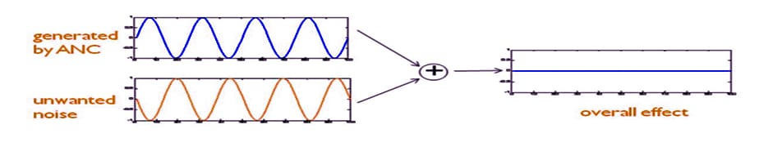
Figure1 : Signal Cancellation of two waves 180° out of phase

1.4 Objectives
Given the recent progresses in active noise cancellation and its potential application fields, we have seen the opportunity to study this type of systems for outdoor open spaces, which are less controlled and less investigated environments. Nevertheless, the absence of interfaces to test this type of systems has made very difficult to carry out the planned experimentations. Therefore the objectives of this work have been the development and implementation of an application to test different active noise cancellation systems and the analysis of their performance in outdoor spaces.
The application has four different systems to test, the two first ones are static simple approaches in which the unwanted noise is previously known or instantaneously captured and then just cancelled. The two last ones are adaptive solutions based on LMS error.

Chapter Two: Theoretical Background

This chapter does a small introduction to all of the important theoretical knowledge necessary to understand the project implementation and the results discussion. It is expected for the reader to be familiar with signals and systems, signal processing, filter theory and optimization

2.1 Types of ANC systems
In this section, concepts important for the physical description of ANC system are introduced.
multiple-channel systems classification is presented. It depends on the geometry of the sound field to control, which in turn depends on the acoustic space where the cancellation will occur.
Then feedforward and feedback system, the two configurations which ANC systems may be realized, are introduced. The systems are classified as such depending on whether or not the noise controller benefits of a separate reference input signal, acquired by a reference sensor, in an attempt to cancel the noise. It should be noted that the combination of both, hybrid systems, also exist.

2.1.1 Multiple-channel systems

A noise field is more complicated in an enclosure or three-dimensional space than in a narrow duct. It is generally necessary to use a multiple-channel ANC system with several secondary sources, error sensors, and perhaps even several reference sensors to achieve global cancellation, or to create a large-size quiet zone. The locations of error sensors are very important to obtain the best estimate of the total acoustic potential energy .
A general multiple-reference/multiple-output ANC system using the FXLMS algorithm has been proposed . The convergence behavior of the multiple-channel ANC system is analyzed in the frequency domain in terms of the convergence of individual secondary signals, cost function, and control effort . This frequency-domain analysis can be applied to narrowband ANC systems that control one or more harmonics of periodic noise. Suppose the multi-channel ANC system uses a single reference sensor, M secondary sources, and N error sensors. Then, the corresponding multi-channel FXLMS algorithm consists of M adaptive filters and M × N secondary path models. Therefore, the computational complexity of the multi-channel ANC system increases significantly with more transducers deployed, and this represents one of the major challenges for applying multi-channel ANC systems in large-scale applications.
Broadband feedforward ANC
The single-channel broadband feedforward ANC system is illustrated in Fig. 2

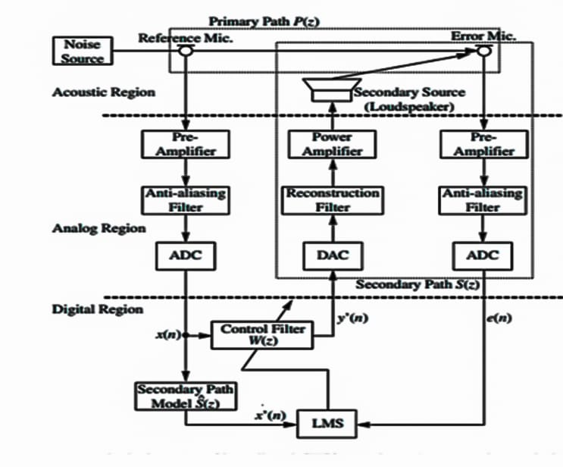
figure 2 : Broadband feedforward ANC system

where acoustic, analog, and digital regions are clearly distinguished. Noise propagating from the noise source is picked up by a reference sensor such as a microphone, and then the digital (sampled-time) reference signal x(n) is obtained through a preamplifier, an anti-aliasing filter, and an ADC. The reference signal is processed by the control filter W(z) to generate the sampledtime anti-noise signal y(n) that drives a secondary source such as a loudspeaker through a DAC a reconstruction filter, and a power amplifier. The error sensor (microphone) is used to monitor the performance of the ANC system by the sampled-time residual noise signal e(n), which is obtained through a preamplifier, an anti-aliasing filter, and ADC. The primary path P (z) consists of the acoustic response from the reference sensor to the error sensor, as shown in Fig. 2. The adaptive filter W(z) minimizes the error signal e(n) by adapting filter coefficients automatically using the LMS algorithm. The use of the adaptive filter for the ANC application shown in Fig. 2 is necessary to compensate for the secondary-path transfer function S(z) from y(n) to e(n), which includes the DAC, reconstruction filter, power amplifier, loudspeaker, acoustic path from the loudspeaker to the error microphone, preamplifier, anti-aliasing filter, and DC. Here, Fig. 2 shows the exact block diagram including the acoustic, analog, and digital regions. On the other hand, the equivalent sampled-time block diagram shown in Fig. 3
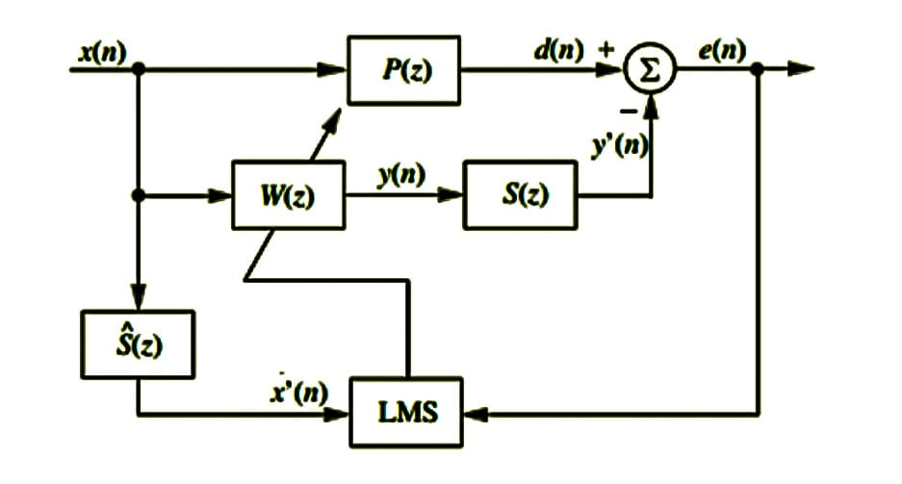
figure 3 : equivalent sampled-time block diagram
is generally used for understanding and analyzing the system and its performance. Henceforth, we utilize equivalent sampled-time block diagrams to explain other ANC structures, unless otherwise noted. The optimal solution of the adaptive filter W(z) is given by the following optimal transfer function in the steady state: Wo (z) = P (z) S(z) . (1) Therefore, the adaptive filter W(z) has to simultaneously model P (z) and inversely model S(z). The performance of an ANC system largely depends on the transfer function of the secondary path S(z) [2]. As illustrated in Fig. 3, after the reference sensor picks up the reference noise, the controller needs time to calculate the anti-noise and send it to the secondary loudspeaker. If this delay becomes longer than the acoustic delay from the reference microphone to the secondary loudspeaker, the performance of the ANC system to cancel broadband random noise will be degraded because the action to exactly cancel the noise would require it to be non-causal. However, even if the causality condition is not met, the ANC system is still capable of canceling narrowband periodic noise.

    - Narrowband feedforward ANC
A narrowband ANC system reduces periodic and narrow band noises using a signal generator to synthesize the reference signal x(n).
This technique has several advantages:
1- Prevents acoustic feedback from the secondary loudspeaker back to the reference microphone
2- Avoids nonlinearities and aging problems associated with the reference microphone
3- Relaxes causality constraint
4- Can control individual harmonics independently.
5- Is only necessary to model plants at frequencies of the harmonics, thus, an FIR filter with a lower order may be sufficient.
The reference signal generator is triggered by a synchronization pulse from a non-acoustic sensor, such as a tachometer signal from an automotive engine. Two types of reference signal are commonly used in narrowband ANC systems:
- an impulse train with a period equal to the inverse of the fundamental frequency of the periodic noise
- sine waves of the same frequencies as the corresponding harmonics to be canceled. The first technique is called the waveform synthesis method, whereas the second technique embodies the adaptive notch filter, which was originally developed for the cancellation of tonal interference .

The adaptive notch filter offers easy control of bandwidth, an infinite null, and the capability to adaptively track the exact frequency of narrowband noise. In practical applications, periodic noise usually contains multiple tones at a fundamental frequency and several harmonic frequencies. In general, the realization of multiple notches requires a higher-order filter, which can be realized in direct, parallel, direct/parallel, or cascade . The convergence analysis of the direct and direct/parallel forms related to the frequency separation between the adjacent harmonics is presented in . It is shown that the convergence rate of the direct form can be increased using the direct/parallel form, which increases the frequency separation. The narrowband feedforward ANC utilizes the synchronization signal, which is obtained by timing signal sensors such as a tachometer. However, actual sensors contain some errors because of aging and fatigue damage accumulation. These errors consequently cause frequency mismatch between the reference signal and the primary noise to be canceled. the noise reduction of the narrowband feedforward ANC system degrades significantly even for a 1 frequency mismatch. Recently, some approaches considering the frequency mismatch have been proposed , which utilize a frequency adjuster or estimate the correct frequencies. A convergence analysis of narrowband ANC systems has been conducted , resulting in the development of some novel algorithms, which can improve the convergence property and/or the noise reduction ability.

    - Feedback path
The acoustic ANC system shown in Fig. 4
Figure 4: The acoustic ANC system
uses a reference microphone to pick up the reference noise and generates anti-noise to cancel primary noise acoustically. Unfortunately, anti-noise from a loudspeaker also radiates upstream to the reference microphone, resulting in an undesired acoustic feedback that may cause instability. The simple approach to solving the feedback problem is to use a feedback cancellation (or neutralization) filter that models the feedback path from the secondary loudspeaker to the reference sensor, which is exactly the same technique used in acoustic echo cancellation . Since primary noise highly correlates with anti-noise, the adaptation of the feedback neutralization filter must be inhibited when the ANC system is in operation. Thus, the feedback neutralization filter is usually obtained using an offline adaptive modeling of the feedback path at the training stage, which can be performed simultaneously with the offline secondary-path modeling.
    - Hybrid ANC
The hybrid ANC system is a combination of both feedforward and feedback ANC systems. The canceling signal y(n) is generated on the basis of the outputs of both the reference and error sensors, as shown in Fig 5.
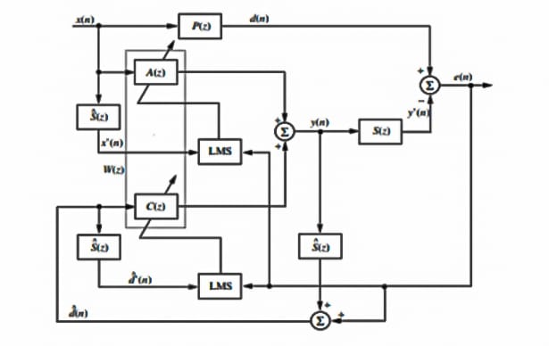
Figure 5: feedforward and feedback ANC system
The hybrid ANC system plays a dual role in canceling the primary noise picked up by the reference sensor of the feedforward ANC, A(z), and the residual noise component (or plant noise) that is only picked up by the error sensor of the feedback ANC, C(z). The hybrid ANC, therefore, offers better performance in terms of both narrowband and broadband noise cancellations, and provides higher flexibility than either the feedforward or feedback ANC system . The computational complexity of the hybrid ANC can be reduced because a lower order of FIR or IIR filters can be used to achieve the same performance as that using the feedforward or feedback ANC system alone.

2.2 Adaptive Controller

Adaptive controllers change the controller parameters to adapt to changes in the process that occur with time, e.g. a change in plant load. If the transfer function of the plant changes then there needs to be retuning of the controller if optimum control conditions are to occur. An adaptive controller thus determines the values of Kp, Ki and Kd needed to adapt to new process conditions and makes the necessary changes.

The self-tuning, often termed auto-tuning that exists with many commercially available controllers is a form of adaptive control. When the operator presses a button on the controller, the controller injects a small disturbance into the system and determines the system’s response. This is then compared with the desired response and the control parameters adjusted to bring the actual response closer that required.

2.2.1 Adaptive Filters
An adaptive filter is a system composed of a linear filter that has a transfer function controlled by variable parameters and a means to adjust those parameters according to an optimization algorithm. Because of the algorithms’ complexity, almost all adaptive filters are digital filters.
Contrary to digital filter with fixed coefficients, where it is necessary to assume time-invariance, know the filter specifications and the desired output signal a priori [25], with adaptive filters the time invariance restriction is removed in order to allow them to automatically adapt (self-optimize) to unknown changing environments and track time variations of the input signals.
Figure 6 depicts a general adaptive filter. Its inputs are the desired response (or primary input signal) d(n), and the reference input signal, x(n). The output signals are the output of a programmable digital filter driven by x(n), y(n), and the error signal e(n), obtained from the difference between d(n) and y(n) at time n. The algorithm objective is to update the filter weights to find a filter to be applied to x(n), in a way that the output y(n) is as close as possible to d(n). This will result in the error being progressively minimized on a sample-by-sample basis .
- Adaptive filters are defined by four aspects :
•The signals being processed by the filter;
• The structure that defines how the output signal of the filter is computed from its input signal.
• The coefficients within this structure that can be iteratively changed to alter the filter’s input-output relationship
• The adaptive algorithm that describes how the coefficients are adjusted from one time instant to the next.
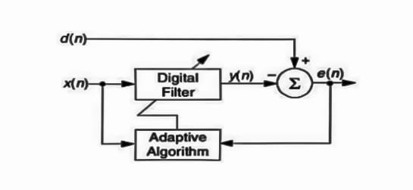
Figure 6: Block diagram of adaptive filter

The linear filter may be realized using finite impulse response (FIR) or infinite impulse response (IIR). FIR filters incorporate only zeros and hence they are always stable and can provide a linear phase response. They are realized with a transversal structure or as lattice filters, a very useful structure for adaptive filtering tasks. They are useful for applications which need to model an all-zeroes unknown system or as a simple and robust solution.
IIR filters can describe the response of a system more accurately or model an all-pole or pole-zero unknown system with a lot less taps and arithmetic operations than a FIR filter approximation for the same system. Thus they are used when computational complexity becomes an important issue. However, their feedback structure make their transfer function very sensitive to changes in the coefficients making this class of filters unstable for certain applications and optimization procedures. They may be realized with various structures types, such as direct form I and II, their transposes, cascaded biquads

2.2.2 : Adaptive Algorithms
A versatile channel is a framework with a direct channel that has an exchange capability constrained by factor boundaries and a way to change those boundaries as indicated by an enhancement calculation. On account of the intricacy of the improvement calculations, practically all versatile channels are advanced channels. Versatile channels are expected for certain applications since certain boundaries of the ideal handling activity (for example, the areas of intelligent surfaces in a reverberant space) are not known ahead of time or are evolving. The shut circle versatile channel involves criticism as a mistake sign to refine its exchange capability.
The shut circle versatile cycle, by and large, includes the utilization of an expense capability, which is a measure for ideal execution of the channel, to take care of a calculation, which decides how to change channel move capability to limit the expense on the following emphasis. The most well-known cost capability is the mean square of the blunder signal.
As the force of computerized signal processors has expanded, versatile channels have become substantially more typical and are currently regularly utilized in gadgets like cell phones and other specialized gadgets, camcorders and advanced cameras, and clinical checking gear.
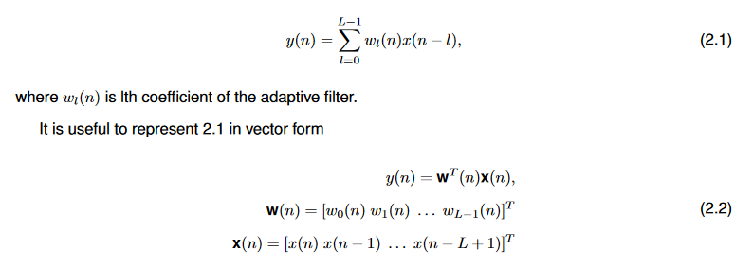

with x(n) as the tap-input vector at time example n and w(n) as the tap-weight vector at time occasion n.
Such frameworks are right now more well known than versatile IIR channels on the grounds that the FIR channel structure for any arrangement of fixed coefficients ensures the info yield soundness , and variation of IIR channels can combine to a nearby least rather than a worldwide least of the ideal channel coefficients space, thusly FIR calculations are less complex. One more justification for IIR channels somewhat slender application stems from the lacking examination of versatile IIR channel hypothesis, since their investigation incorporates nonlinear frameworks of high order

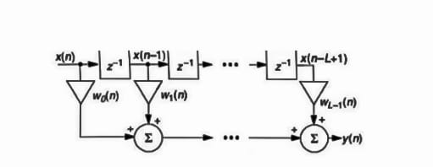
Figure 7: Block diagram of digital FIR (transversal) filter

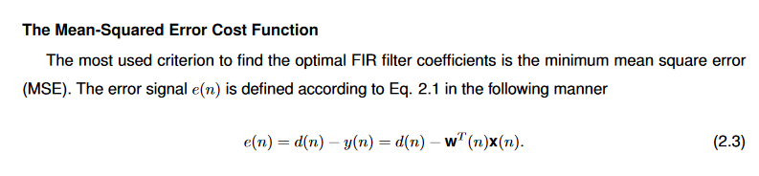

The MSE cost function is represented as
C(n) = E[e(n)^2], (2.4)
where C(n) is a cost function at time instant n and E denotes the expectation value operator. The MSE is useful for adaptive FIR filters because it is a quadratic function and therefore :
• It has a well-defined minimum with respect to the coefficients in w(n);
• The coefficient values obtained at this minimum are the ones that minimize the power in e(n), indicating that y(n) has approached d(n);
• It is a smooth function of each of the coefficients in w(n), such that it is differentiable with respect to each of the coefficients in w(n) .
To find the optimum coefficients that minimize the MSE, the gradient of the cost function with respectto the coefficients is equated to zero.
∇C(n) = −2E[x(n)e(n)] = 0, (2
Continuing to develop Eq. 2.5 with Eq. 2.3, assuming that e(n), d(n) and x(n) are stationary (the statistical properties of these signals do not change with time) and that the elements of the vector w are constant, yields
(2.5)
where w∗ denotes the optimum weight vector. The above equation can be rewritten as Rw∗ = p , (2.6)
Where R is the autocorrelation matrix of the reference input signal and p is the cross-correlation vector of The reference input signal and the desired response. The above equation is known as the Wiener-Hop equations and provides a solution to the adaptive filtering problem in principle. However, in practical applications with non-stationary noise, it is not possible to calculate the optimal filter coefficients from correlation properties of the incoming signals, since R and p are not available.
The Steepest Drop Technique
The ideal arrangement can be tracked down by the deeply grounded streamlining favorable to cedure called steepest drop, which utilizes the slope vector to bit by bit slide bit by bit to the least of the blunder capability. It isn't the quicker strategy anyway it is the most straightforward. This technique changes every boundary of the framework as per applications with non-stationary noise, it is not possible to calculate the optimal filter coefficients from correlation properties of the incoming signals, since R and p are not available.
The Steepest Descent Procedure the optimum solution can be found by the well-established optimization procedure called steepest descent, which uses the gradient vector to gradually descend step by step to the minimum of the error function. It is not the faster method however it is the simplest. This procedure adjusts each parameter of the system according to
w(n + 1) = w(n) –( μ\2) ∆wC (2.7)
where μ is the step size and ∆wC is a vector of derivatives ∂C(n)/∂wi(n). In other words, the it parameter of the system is altered according to the derivative of the cost function with respect to the it parameter. This algorithm cannot be used in real-time applications because it requires exact knowledge of the MSE, when in practice only d(n) and x(n) are available. An approximate version of the method of steepest descent that depends on the signal values is used instead. This procedure is known as the

LMS algorithm
he LMS algorithm was developed based on the Wiener filter, but the difference is that it does not assume any statistical knowledge of the signals .
Given that usually there is not enough information about the signals to calculate the autocorrelation and cross-correlation, Windrow used the instantaneous squared error, e^2 (n), to estimate the mean- square error given in equation 2.8. Therefore, the gradient estimate used by the LMS algorithm is simply the instantaneous gradient of a single squared error sample, i.e. ∂E{e2(n)}/∂w(n) (2.8) is replaced
by ∂e^2(n)/∂w(n).
The instantaneous gradient of a single squared error sample is

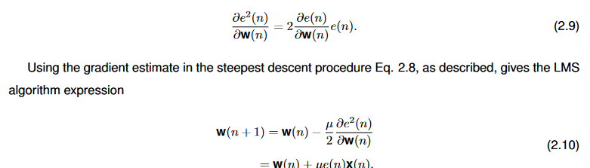

where μ is the convergence factor (or step size) and e(n) is the error at time instance n.
Important performance measures for adaptive algorithms are their stability, convergence time and, for algorithms using the minimum MSE criterion, misadjustment. Stability is related to the algorithm ability to converge to the desired filter. In order for this algorithm to be stable μ should verify
0 < μ < 2\ LPx .
where L is the versatile channel length and Px is the force of x(n). One of the ends one can take (strength condition) is that little μ ought to be utilized for enormous request channels, since μ is conversely relative to L .
Combination time is the time expected for the calculation to merge to the ideal least squares arrangement. It relies upon the step size, since the bigger the μ the quicker the combination. Anyway it is a main issue for the LMS calculation, since it is delayed to meet for signals with a huge ghastly dynamic reach, or identically an enormous eigenvalue spread1. Misadjustment is the abundance MSE over the base MSE. It is corresponding to channel length, step size furthermore, input signal power. There is a tradeoff between combination time and misadjustment. When μ builds, the union is quicker yet misadjustment increments; if μ diminishes, the combination is increasingly slow abatements .
Regardless of its constraints, the LMS calculation is exceptionally well known and the most broadly utilized learning algorithm for its straightforwardness, simplicity of calculation, low memory necessities, since it doesn't need disconnected angle assessments or reiterations of information . It has hearty execution since it is model autonomous , meaning it can work agreeably with not well adapted information (for example very loud climate, change in signal or potentially clamor models).

2.2.3 : Adaptive filtering application
Versatile channels have a great many applications which can be depicted regarding more-general issue classes that portray the expected connection among d(n) and x(n). These are, for the most part, four essential classes: distinguishing proof, opposite displaying, forecast, and impedance dropping. To get a better comprehension of the ANC calculations introducing the framework ID problem is valuable.
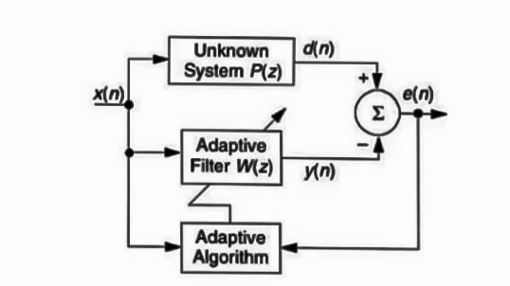
Figure 8: Adaptive system identification

Versatile framework distinguishing proof Framework distinguishing proof is an exploratory way to deal with the displaying of an interaction or a plant. The essential thought is to gauge the signs created by the framework and to utilize them to develop a model.
Figure 8 shows the overall issue of framework ID, where P (z) is an obscure framework to be recognized also, W (z) is a versatile channel to appraise P (z) .
It works by astonishing both the obscure framework P (z) and the versatile model W (z) with a similar information signal x(n). The versatile channel changes itself to limit the blunder signal e(n), processed with the distinction between the actual framework reaction d(n) and versatile model reaction y(n). When e(n) has been limited, the versatile model recreates P (z), inferring that preferably y(n) = d(n). In real applications, in any case, there will typically be added substance clamor present at the versatile channel input thus the channel design won't precisely match that of the obscure framework.

2.3 ANC Algorithms
With the knowledge acquired up until this point it is still not possible to implement an ANC system in an effective and robust way. This is because a real ANC system, realized on a DSP, has aspects that need to be taken into account in the filter-weight update algorithm. These are the presence of acoustical and electrical paths which modify the signals propagating in the system. Their transfer functions should be identified and their effects compensated by the controller. Therefore, this section will present ANC algorithms capable of compensating the path common to all system configurations, the secondary path.
It begins by describing the single-channel feedforward system as a system identification problem, with the existing electro-acoustical paths detailed. Then, one of the most widely used ANC algorithms, the filtered-x LMS algorithm (FxLMS), is explained. The secondary path modelling methods are presented next. Two examples of the FxLMS various forms, also included in this work, are introduced. They are the product of adapting the FxLMS to the mentioned estimation methods or to compensate for other effects.
The definitions are all made with the feedforward system as example. However, as stated, the feedback system can be interpreted as a feedforward system with a synthesized reference signal. Thus, the synthesis process will be described in more detail in this section.
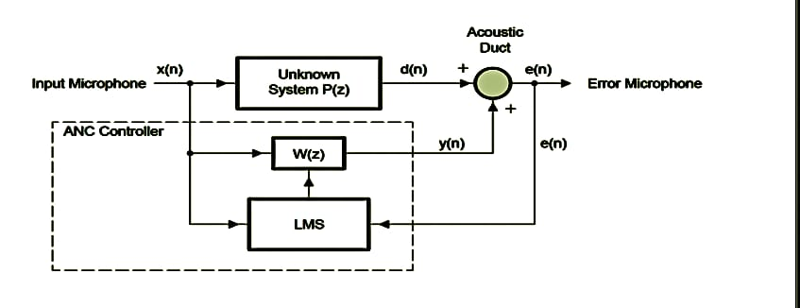
figure 9 : System Identification Approach to Feedforward ANC

2.3.1 ANC as system identification
ANC systems can be described in a system identification framework as shown in Figure 9. The ideal ANC system uses an adaptive filter W(z) to estimate an unknown plant P(z). The unknown plant, also called primary path, consists of the acoustic response from the reference sensor to the error sensor. If the plant is dynamic, the adaptive algorithm then has the task of continuously tracking time variations of the plant dynamics.
It is convenient to make a correspondence of the ANC signals, to the adaptive filter signals, thus bringing those to the context of active noise cancellation. The desired response 2 d(n) corresponds to the primary noise as captured by the error microphone. Furthermore, the control signal of ANC coincides with the output of the adaptive filter y(n), the reference signal to the reference input signal x(n) and the error signal to e(n).
An important difference between the system depicted in Figure 9 and the traditional system identification scheme (Figure 10) lies in how e(n) is obtained. Instead of a subtractive junction, the summing junction used in Figure 9 represents the acoustic superposition occurring in the space from the cancelling loudspeaker to the error microphone, where the primary noise d(n) is combined with the secondary noise, generated by y(n). To force the destructive interference the control signal must be subject to a sign change before forwarding to the acoustical summing junction, thus generating the error signal. So, one can represent an ANC system block diagram with the subtractive junction, as in the adaptive filter convention, since the inversion will be implicit.
The block diagram of Figure 9 suggests that the control signal is directly combined with the primary noise and the resulting error signal is directly fed back to the control. However, in practice, that system is incomplete. The reason is that a real feedforward system, represented in Figure 10, has a number of electro-acoustic paths whose transfer functions must be included in the model.
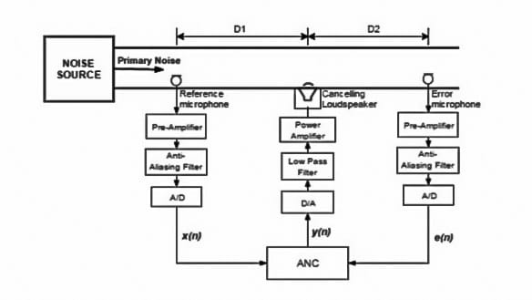
figure 10: Real single-channel feedforward ANC system
On these terms, the primary path description can be improved. The electrical reference signal x(n) is obtained from the acoustic pressure picked by a microphone but one can interpret the conversion backwards and see it as driving the plant and the adaptive filter. Therefore the primary path transfer function P(z) consists of the A/D (analogue-to-digital) converter (ADC), the anti-aliasing filter, the pre-amplifier, the reference microphone and the acoustic path from reference microphone to error microphone transfer functions cascaded. Note that the ADC and anti-aliasing filter frequency response appear inverted in the expression of the path. If the A/D and D/A are symmetric then their responses cancel out and the result is only the acoustic path.
- Secondary path
As mentioned before, the electrical error signal is sensed from the residual acoustic noise using an error microphone. This pressure wave results from the acoustic superposition of the primary noise and the anti-noise, generated from a loudspeaker driven by the control signal y(n). Therefore, it is necessary to compensate for the secondary-path, also called cancellation path, transfer function S(z) from y(n) to e(n). This path includes the D/A (digital-to-analog) converter (DAC), reconstruction filter, power amplifier, loudspeaker, acoustic path from loudspeaker to error microphone, error microphone, preamplifier, antialiasing filter, and ADC .
Observing Figure 10 one can point out that the primary path and secondary path share the path from the cancelling loudspeaker to the error microphone. However, as demonstrated in , the primary path transfer function and secondary path can be considered as separate entities and the feedforward ANC system can be represented through the system identification viewpoint as in Figure 11.
To compensate the secondary path effects the transfer function must be modelled, also using a system identification approach, and the estimate must be included in the adaptive algorithm as seen in the following section.
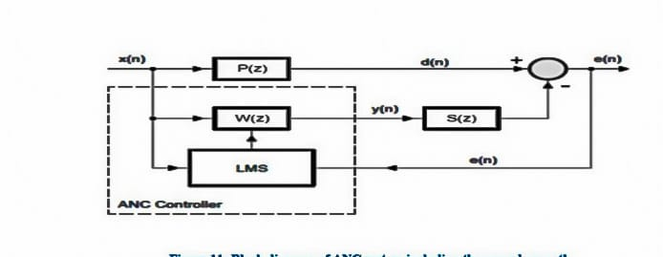
Figure 11: Block diagram of ANC system including the secondary path
- Acoustic feedback
The use of a reference microphone introduces the possibility of undesired feedback from the secondary source to the reference input microphone. Thus the overall system forms a closed loop, complicating the problem of adaptation, or rendering the system unstable. This path is the acoustic feedback path with transfer function A(z).
There are many more of these path in multiple-channel systems so 18 this is a major problem for applications needing that type of system. It should be noted that an acoustic feedback path is not formed between the error microphone and the secondary source. This is because the error signal is used by the adaptive algorithm and the secondary noise is generated by filtering the reference signal, meaning they are electrically isolated from each other during operation and no loop is formed.
One can avoid acoustic feedback by using directional reference microphones pointing away from the secondary source or using non-acoustic reference sensors, as they are insensitive to the cancelling sound .
It is also advantageous to locate the reference microphone far upstream from the cancelling loudspeaker in order to have a reduced acoustic feedback. Another approach is to use an algorithm which compensates for the path’s effects in the same way as with the secondary path.
2.3.2 Secondary path modeling
The FxLMS algorithm needs an estimate of the secondary path transfer function Sˆ(z) to obtain the filtered-x signal x’(n), because the secondary path transfer function S(z) is unknown. It’s important for Sˆ(z) to be fast and reasonably accurate in order to ensure adequate performance, stability and convergence speed of the system.
The model can be constructed with the system identification approach of adaptive filters. However, the secondary path transfer function is time varying due to effects such as aging of the loudspeaker, changes in temperature, and air flow in the secondary path.
So, the method to obtain the estimate Sˆ(z) depends on the degree and speed of variation. The variations can be classified into three types :
•if the variation of S(z) is within a small range, the model may be obtained off-line during a training stage and be used permanently in the control filter weight-update algorithm.
•if the change is slow or irregular, but extensive over a long period of time, the control system must implement the secondary path modelling on-line. This means the model identification is occasionally or continuously done at the same time as the weight-update of the control filter.
•if S(z) varies rapidly by a large amount the FxLMS algorithm might not be suitable for the application if it cannot determine the correct Sˆ(z) in a short time.
- Off-line modelling approach
As stated, if S(z) is time-invariant but unknown, off-line modelling can be used to construct the model Sˆ(z) during an initial training stage. At the end of the training interval, the estimated model Sˆ(z) is fixed and used for ANC operation.
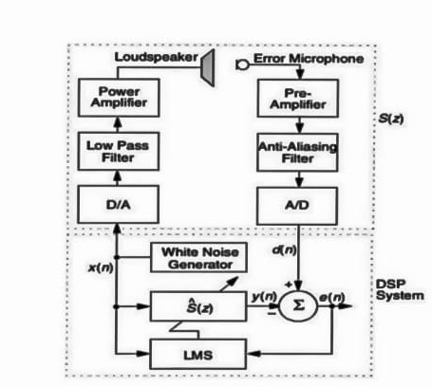
Figure 12: Experimental set up of secondary path modeling
The experimental set up for direct off-line system modelling is shown in Figure 12. An internal white noise signal is internally generated by the DSP system, depicted as the random noise generator, and sent to the speaker. White noise is used as a training signal because it has a constant spectral density at all frequencies. This makes the LMS algorithm converge fast. The microphone picks up the noise and its output is subtracted from the filter output to form the error signal. A LMS algorithm updates the filter coefficients to minimize the error signal. After convergence, the modelling filter Sˆ(z) is an estimate of the unknown secondary path transfer function, S(z) .
Although the off-line modelling technique results in a functional ANC system, slight changes in the environment during system operation may lead the adaptive algorithm to instability. A phase difference between S(z) and Sˆ(z) in excess of 90◦ will force this result. Even though the system remains stable, convergence will slow appreciably as the phase difference approaches 90◦. A way to counter this is to block noise control for frequencies whose phase error usually exceeds 90◦, or use the on-line modelling approach for slow and continuous variations.
- On-line modelling approach
Adaptive on-line modelling of the secondary path should be used when S(z) continuously varies in real time. S(z) can be either occasionally or continuously estimated and the most recent estimate Sˆ(z) used in the weight update of the controller. Provided that S(z) changes slowly, the controller adaptation and secondary-path estimation functions can be considered separately.
The additive random noise technique is a popular method of on-line secondary path modelling. In summary, it adds to the control signal an internally generated white noise to drive the secondary source. Thus, the error signal will have a component tied to the primary noise and a component tied to the white noise. The algorithm will try to use each component separately to weight update the control filter for the first component, and the secondary path model for the second component.
However to do that is not trivial and may degrade the performance of each process. While this may seem to be a somewhat counter-productive exercise, injecting an additional disturbance into a system targeted for active control, the level of the modelling disturbance can be very low (say, 30 dB below the unwanted primary disturbance) and still provide a model of suitable accuracy over a relatively long period of time.
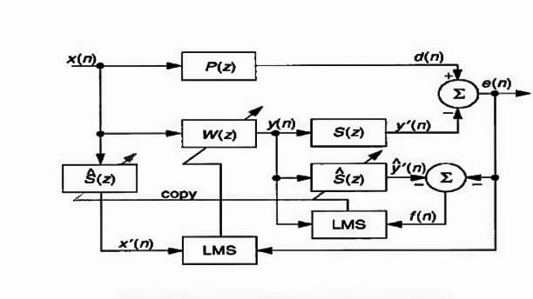
Figure 13: Block diagram of an online secondary-path modeling
The overall modelling algorithm (OMA) used in an algorithm in this work, is another popular method of on-line secondary path modelling. Instead of using a generated training system it uses the existing signals in the system to estimate the secondary path transfer function.
To explain it, it is useful to first present a secondary path modelling technique proposed, represented in Figure 13. The optimal solution of Szˆ for this system is:
Sˆ*(z) = S(z) − P(z) \W(z) . ,(2.11)
This equation shows that the estimate Sˆ(z) is biased by P(z)/W(z). It is useful to try to eliminate the bias because the adaptive filter Sˆ(z) can correctly identify S(z) only if P(z) = 0 [or equivalently, d(n) = 0].

That is exactly the objective of the OMA, depicted in Figure 14 It tries to model P(z) with the adaptive filter Pˆ(z) to filter the reference signal with Pˆ(z). The output is then used to cancel the primary noise thus cancelling the effects of the biasing term.
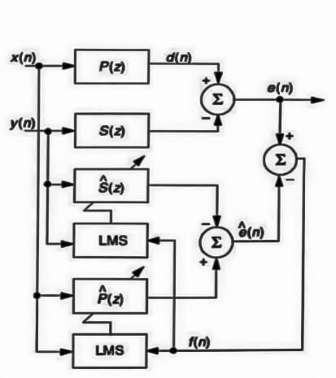
Figure 14: Overall on-line modeling algorithm
Comparing both methods, the first on-line modelling approach, which involves injecting low-level random noise into the control signal, is superior in terms of convergence speed of both the control filter and secondary path modelling filter, for speed of response to modifications in the primary noise and the secondary path, for independence between the primary noise attenuation and the on-line secondary path identification, and for minimal computational complexity. However, the second approach does not add any additional noise into the system and usually requires less memory to implement.

2.3.3 Filtered-x LMS Algorithm
As represented in Figure 11, there is a transfer function after the adaptive filter. In the ideal case, the optimal filter coefficients are the same as in the primary path transfer function, but with the secondary path the optimal filter becomes
W*(z) = P(z) \ S(z) . ,(2.12)
The performance of an ANC system is tied to the secondary path transfer function S(z) and, to ensure convergence, the secondary path needs to be compensated. Morgan suggested two ways to modify the LMS algorithm to compensate the secondary path:
•to place an inverse filter, 1/S(z), in series with S(z) to remove its effect.
•to place an identical filter in the reference signal path to the weight update of the LMS algorithm.
realizing the so-called filtered-X (FxLMS) algorithm. Since an inverse does not necessarily exist for S(z) and placing it in the secondary path would need a sharp filter with long delay , the FxLMS algorithm is generally the most effective approach.
- Derivation of FxLMS algorithm
Figure 15 shows an active noise control system scheme with the secondary path located at the output of the adaptive filter and its estimate placed at the input of the LMS algorithm. The signals can be expressed as:
e(n) = d(n) – y’(n) (2.13)
= d(n) − s(n) ∗ y(n) = d(n) − s(n) ∗ [w^{T} (n)x(n)] (2.14)
where s(n) is the impulse response of secondary path S(z) at time n, * denotes linear convolution, y’(n) is the anti-noise,
w(n) = [w₀(n) w₁(n) . . . w_{L-1}(n)]^{T} (2.15)
is the coefficient vector of W(z) at time instance n,
x(n) = [x(n) x(n − 1) . . . x(n − L + 1)]^{T} (2.16)
is the signal vector at time instance n, and L is the order of filter W(z).
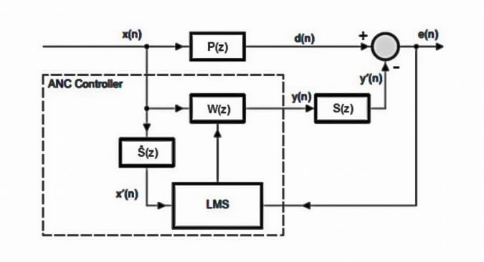
Figure 15: Block diagram of ANC system using the FxLMS algorithm
Substituting Equation 2.17 in the LMS expression (Equation 16) and solving the gradient gives the expression for the FxLMS algorithm
W (n + 1) = w (n) + µe (n)*X’ (n), (2.17)
Where
X’ (n) = [x’ (n) x’ (n − 1) . . . x’ (n − L + 1)] ^{T} (2.18)

And
x’ (n) = s(n) * x(n). (2.19)
In practical ANC applications S(z) is unknown and estimate of it Sˆ(z) is used. So, x’(n) is evaluated as:
x’(n) = sˆ(n) * x(n). (2.20)
where sˆ(n) is the coefficient vector of the estimate of the secondary-path filter impulse response.
- Leaky FxLMS Algorithm
The leaky FxLMS algorithm solves another problem introduced by the direct application of the FxLMS, besides the problems presented in section 2.2,2.1. This problem is the occurrence of non-linear distortion on the secondary source from overdriving it with the control signal due to high noise levels associated with low frequency resonances.
The use of the leakage factor limits the output power of the secondary source to avoid the nonlinear distortion. It has been shown that the introduction of a leakage factor has a considerable stabilizing effect on the adaptive algorithm, especially when very large source strengths are used.

- Feedback FxLMS algorithm
In a single-channel feedback ANC system the reference input microphone is not used, therefore a reference signal is not available. An advantage of this is that it avoids the acoustic feedback problem inherent in the two-microphone feedforward systems, that were discussed previously.
From Equation 2.4 one can conclude that the primary noise signal d(n) can be expressed in the z-domain as:
D(z) = E(z) + S(z)Y (z), [2.12]
where E(z) is obtained from the error microphone and Y (z) is the output of the adaptive filter. If the transfer function S(z) of the secondary path is modelled by Sˆ(z), D(z) can be approximated as:
Dˆ(z) = E(z) + Yˆ’(z). [2.13]
Where
Yˆ’ (z) = Sˆ(z) Y(z). [2.14]
s an estimate of the anti-noise. In essence, an anti-noise estimate yˆ’(n) and e(n) are added to electrically undo the destructive interference, thus synthesizing the reference signal x(n) as an estimate of the primary noise d^(n).
Then, the feedback FxLMS algorithm takes the form depicted in Figure 16. What effectively happens in the algorithm is the regeneration of the periodic signal and then trying to cancel the phase difference between the regenerated reference signal and the primary noise.
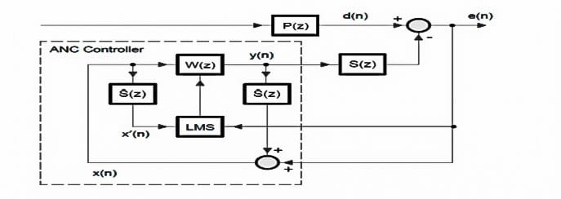
Figure 16: Block Diagram of the Feedback ANC System
2.3.4 Band limited Modified FxLMS algorithm
A way to circumvent instability stemming from excessive phase error between S(z) and Sˆ(z), after using the off-line method for secondary path modelling during the training stage, is to block noise control for the frequencies where this phenomenon occurs more frequently, as mentioned. This ”undesired band” can be identified by doing a series of off-line secondary path modelling trials, computing the maximum phase difference between the estimates and analysing which frequencies the phase error is superior to 90◦ .
A way to impede the noise control is to filter out the undesired frequencies from the anti-noise, by putting a band limiting filter before the secondary source. However this approach would need a sharp filter with long delay, which is undesirable in ANC systems, since the controller would try to invert this filter. Instead, a band limited modified FxLMS (MFxLMS) algorithm can be used. It is interesting to use this algorithm in a feedback system to compare the differences in performance between the feedback FxLMS and feedback band limited MFxLMS. The band limited feedback MFxLMS (BMFxLMS) is illustrated in Figure 17.
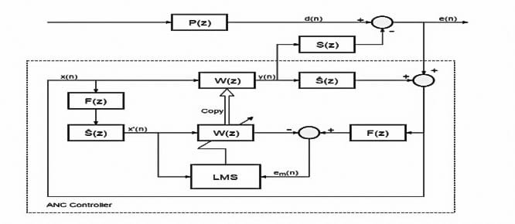
Figure 17: Block diagram of the Bandlimited feedback MFxLMS algorithm
Another way could be by limiting the band of interest by filtering the primary noise d(n), which corresponds to filtering the anti-noise. However, obviously, an acoustic signal cannot be electrically filtered so, alternatively, one can suppress the influence of the primary noise on the system by band limiting all the signals generated or derived from d(n). The reference signal x(n) can be filtered but, for a controller using the FxLMS algorithm, the error signal is acoustically obtained from the primary noise and anti-noise superposition.
Thus, it is also difficult to filter the component of the error tied to the primary noise. That is where the MFxLMS algorithm turns out to be useful.
The MFxLMS algorithm predicts the error that would have been obtained if the current controller coefficients had been fixed over all time. The modified error e_{m}(n) is obtained by using an internal model of the secondary path Sˆ(z) to derive an estimate of the primary noise d^(n), which is then subtracted to the reference signal filtered by Sˆ(z) and the adaptive controller W(z). This way the adaptation is done with an electrical model of the ANC system. Thus, all the necessary signals are electrically available and what is left is to band limit them and adapt the control filter using them.
This algorithm is also possible to realize for feedback systems. All it is needed is to use d^(n) as a reference signal, as aforementioned, and filter both by the band limiting filter F(z) before the weight update process of the control filter. Note that by filtering the reference and the desired signal the optimum filter is not changed. However the filter will not adapt on undesirable frequencies. This should be used in conjunction with the leaky LMS to make sure the filter goes to zero at these frequencies.

2.3.5 Mirrored MFxLMS algorithm
As stated, the problem of variation of the secondary path can be solved with the on-line methods presented in the previous section. However, most of these algorithms become unstable after sudden changes, since they are only suitable to deal with slow changes. The mirrored MFxLMS (MMFxLMS) algorithm however, is stable even with incorrect secondary path models and deals very well with sudden changes.
It is a variation of the MFxLMS algorithm, with the OMA embedded in the algorithm for on-line modelling of the primary and secondary paths. However, instead of estimating the primary noise by adding an anti-noise estimate to the error signal, like the normal MFxLMS, it passes the reference signal through the primary path estimate Pˆ(z) obtaining the primary noise estimate d^(n). The mirrored term comes from the fact that after obtaining the primary and secondary paths models one can construct a mirror copy of the acoustic paths, and then use the MMFxLMS.
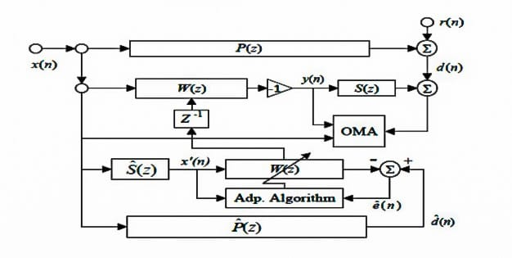
Figure 18: Block diagram of the MMFxLMS algorithm

2.4 System Considerations
There are other limiting aspects of the system that limit the performance of the ANC system, which cannot be compensated by the controller. If they are not optimized the system may fail and therefore it is necessary to apply appropriate design techniques to assist the digital adaptive control. This section will discuss the physical factors that limit the performance of this system, such as coherhence, causality, sampling rate and filter length. The properties of acoustic spaces are not studied since they are more important in multiple-channel systems. Regardless, the use of a commercial headset for the system implementation has this problem, in principle, dealt with.
    - Coherence
The coherence function indicates how much of the output signal y(t) that is linear dependent of the signal v(t).
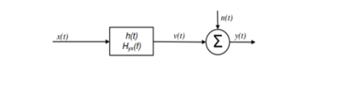

The ordinary coherence is limited between 0 ≤ γ^2 (f) ≤ 1 which states the ordinary coherence function

To use the coherence function in practice an estimator is needed. Gvv(f) is the auto spectrum of the signal v(t) and Gyy(f) is the auto spectrum of the output signal y(t). Gvv(f) can also be noted as.
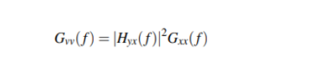
In this derivation the H1 estimator in
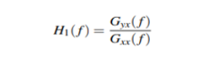

Gyx(f) is the cross spectrum between the output signal y and the input signal x and Gxx(f) is the auto spectrum of the input signal. The H1 estimator assumes there is noise at the output and the H2 estimator assumes the noise is at the input. Substitute Hyx(f) in
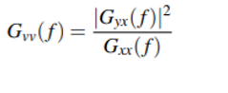
Finally substitute Gvv(f) and an estimate of the ordinary coherence function γˆ 2 (f) is obtained.
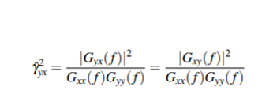
The coherence function was derived with the H1 estimator. But the coherence function is not dependent of the model of the noise which the H1 and H2 states, since the coherence function will be the same wherever the noise is added .The coherence is important in an ANC system because the noise shall be correlated with the noise at the reference sensor and at the actuator. In other words the noise at the actuator shall be the same as at the reference sensor but delayed δA seconds. If the duct is described as a linear time invariant system where the x(t) can be assumed to be the reference sensor and y(t) is the error sensor. The optimal impulse response h(t) should of course only be a delay but in practical systems this is often not the case. The disturbances can occur by many reasons but the most usual in a
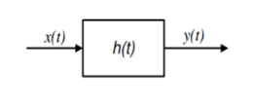

Ventilation system that provides bad coherence is different flow patterns and turbulence at the sensors. Because of this, a good setup for the sensors should be used to minimize the coherence dips. Other types of disturbance can be electrical noise from cables and equipment, resonance from the duct and disturbance from other equipments in the surroundings. To estimate how much the coherence dip will limit the attenuation in the ANC system could be used to calculate the theoretical maximum attenuation

    - Causality
Causality in an ANC system is that the electrical delay should be shorter than the acoustical delay. To attenuate the noise, the anti-noise must be generated and have been excited to the plant before the noise has passed the attenuator. If this criterion is not fulfilled the ANC system will have lower performance broad banded noise applications. If the source is periodic or narrow banded the source can be reduced due to the periodicity and predictability of the narrowband signal. Since only broad band noise will be used in this thesis the causality constraint is important and will be taken into consideration. The acoustic delay between the reference sensor and the actuator can be calculated with

where L is the distance in meters between the reference sensor and the actuator, δA is the acoustic delay in seconds in the same distance and v is speed of sound. The electrical delay can be expressed with
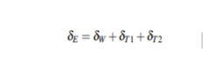

where δW is the group delay of the adaptive filter in the (DSP) digital signal processor, δT1 is the delay of the anti aliasing filter on reference sensor and the (ADC) analog-to-digital converter, δT2 is the delay of the (DAC) digital-to-analog converter, the reconstruction filter, the amplifier and the actuator.
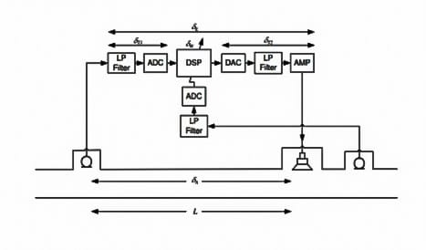
Figure 19: Group delays in system

To fulfill the causality constraints the total electrical delay δE should be smaller than the acoustic delay δA

Use Eq.to calculate the smallest distance between the sensor and the actuator.

where v is the speed of sound.

2.4.3 Sampling rate and Filter Length
As stated, the controller must complete the entire signal processing task before the primary noise arrives at the loudspeaker. Real-time digital signal processing requires that the processing time tp be less than the sampling period T_{s}. That is:
T_{p} < T_{s} = 1 \ F_{s} , [1]
where F_{s} is the sampling rate, which must be held high enough to satisfy the Nyquist criterion. That is:
F_{s} ≥ 2f_{M}, [2]
where f_{M} is the highest frequency of interest, approximately 500 Hz for most practical ANC applications.
However the choice of sampling rate is more complicated than choosing the Nyquist rate of the band of interest. The reason is the coder-decoder (CODEC) 3 having sampling rate limitations and since there are advantages and disadvantages to high sample rates comparing to low sampling rates.
As stated before, high sample rate is desirable because it would reduce the delay between the reference noise and anti-noise in a feedforward system, thus improving the conditions to meet the causality condition. Even though there is no causality condition for feedback systems delay is of importance anyway, because excessive delays would limit the achievable performance and stability margin in a feedback system. This is especially important for ANC applications that generally involve relatively large bandwidth.

However, there are several points that may prohibit the use of high sample rates. First, low processing time would not allow for filters with a large number of coefficients. With not enough time to compute the filtering, causality issues would appear. Also, with a low bandwidth of interest, the effective control bandwidth of the system will be a small portion of the total frequency span. This results in the need for very high order FIR filters to ensure adequate accuracy in the magnitude and phase response. Lastly, numerical problems may arise so that a filter may easily become unstable.
So, it would be useful to process the data at a rate as low as the Nyquist frequency to enjoy the high processing time, lower filter order and still sample at the highest rate possible for the low delay. The multirate signal processing technique solves such problems as it combines the advantages of low delay, from high sampling frequency, with the FIR filter characteristics and performance, from low frequency. More specifically the reference and error signals are oversampled at the CODEC and the control computations are performed at a lower rate. A small introduction to multirate signal processing is made in Appendix A.
The length of the noise control filter depends upon the acoustics of the duct since the required length is reduced by the addition of passive damping material.
A trade-off must be considered when trying to meet the filter order condition. The reason is that, when cancelling broadband noise it is necessary that the filters be long enough to account for the distances of the paths. This is because the distance is related to the acoustic delay and, to model long delays, the appropriate number of samples to capture the impulse response.
However, the filter order also depends upon the sampling rate. If, for example, a high sampling rate is used to reduce the delay even more the number of coefficients will be even bigger. Then, the processing time might not be enough to process the signals creating causality issues anyway. Thus, care must be had when dimensioning the feedforward system for broadband noises. For periodic signals such as sine waves, this constraint no longer applies, because only adjustments to phase over one cycle of the sine wave are required.
Another limitation imposed on the system is that the direct modelling filter must be sufficiently long to ensure adequate accuracy in the magnitude and phase response of the filter at the lowest frequency of interest.

2.5 ANC headset system
Active headsets enhance the performance of conventional passive earmuffs at low frequencies (usually below 500 Hz). The active system cancels low-frequency noises and the ear shell (passive) system attenuates high-frequency noises. Active headsets can be interpreted as a problem of noise propagating in ducts, since plane waves in ducts and the sound field in a hearing protector are both one-dimensional problems, thus enabling good results to be achieved with a single-channel control system. Another reason for the good results is the size of the ear shell combined with the ear duct being about the same dimensions as the diameter of the cancellation volume near the error microphone. For example, a noise 29 of 500Hz corresponds to a radius of λ/10 ≈ 7 cm.
There are two main types of control system for active headsets; feedback and feedforward. In addition, feedback types may be further classified into analogue(fixed) and digital(adaptive), however analogue control, although the most widespread commercial headset controller, will not be focused in this work. Adaptive feedback headset systems are rather simple since the only design constraint is the choice and positioning of the loudspeaker and error microphone to avoid stability issues. As mentioned, it can only cancel narrowband noise but they don’t have the problems inherent to feedforward system and therefore are the most used configuration.
Due to the advantages of feedforward systems such as better stability and robustness (without acoustic feedback), attenuation, bandwidth and ability to cancel broadband noise, it is desirable to implement the headset with such configuration. However, design of active feedforward headsets is more complicated due to considerations one should have with them.
Though, the acoustic feedback, a critical problem in other feedforward applications, is virtually negligible in headset applications. That is because the loudspeaker is directionally pointed to the ear and the anti-noise is blocked by the ear-shell, thus not creating a closed loop between the loudspeaker and the reference microphone.
There should be special care with the causality condition, because the available space is very limited, so the reference microphone will be very close to the error microphone. This means that the controller must act very fast or else causality will not be maintained and reduction of random noise will be limited. The noise source position referent to the sensors is especially important since it may cause causality problems.
Maintaining coherence is another important problem because the reference microphone is located outside generally attached to the shell. Thus its measurements are heavily corrupted by wind and the ambient noise level will be high compared to the primary noise. To counter these effects it is recommended, whenever possible, to obtain a synchronisation signal from a non-acoustic sensor. The system will be a lot more simplified since there will be no problems of coherence, however these kinds of systems only control narrowband noise.
Although it has been omitted, the used materials for passive cancellation, the shape of the shell and the tightness of the seal of the ear cup are also very important in the performance of an active headset.

Chapter Three:
3.1 HARDWARE APPROACH
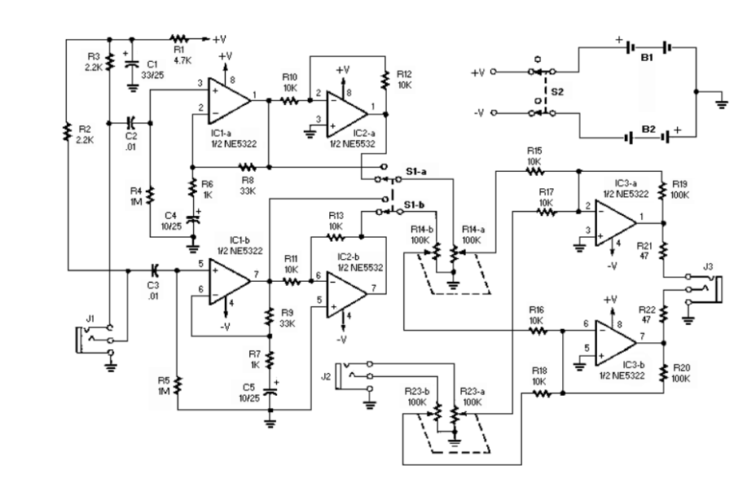
Figure 20: Circuit Diagram of Noise Cancelling Hardware
3.1.1 Components:

R1 and C1 decouple the bias voltage from the power supply by being placed in a voltage
dividing network. R8 and R6 were chosen to be 33kΩ and 1kΩ for a gain of 31dB for the
amplifying stage. A large value for R4 was chosen (1MΩ) to give a good ground reference for
the amplifying stage. C2/R4 and C4/R6 are high-pass filters blocking any DC before the
amplifier. Lower capacitor values are chosen for these, 0.01µF. The next stage is the unity gain
inverting amplifiers. So 10kΩ resistors were chosen for R10 and R12 to keep unity gain. The
gain of the last stage (summing stage) is set by R19 and R15, which were chosen to be 100kΩ and
10kΩ. R17 is added to create a summing amplifier, chosen to be 10kΩ to interact with the 100kΩ
potentiometer logarithmically. Since this is stereo there is a right and left, so configuration and
set up is mirrored for the opposite side.

Label | Component | Value
R1 | Resistor | 4.7kΩ
R2-3 | Resistor | 2.2kΩ
R4-5 | Resistor | 1MΩ
R6-7 | Resistor | 1kΩ
R8-9 | Resistor | 33kΩ
R10-13, R15-18 | Resistor | 10kΩ
R14, R23 | Dual-Gang Potentiometer | 100kΩ
R19-20 | Resistor | 100kΩ
R21-22 | Resistor | 47Ω
IC1-3 | Integrated Circuit | NE5532
C1 | Electrolytic Capacitor | 33µF
C2-3 | Mylar Capacitor | 0.01µF
C4-5 | Electrolytic Capacitor | 10µF
S1 | DPDT Switch
J1-3 | 1/8 Inch Audio Jack

Table 1: Selected Components Used for Noise Cancelling Hardware (Figure 20)

3.1.2 Idea behind the Circuit:
The noise cancelling circuit is composed of three separate stages. The first stage (IC1a-b) is a non-inverting amplifier stage. This stage simply takes the input from the audio jack (J1) and amplifies the signal.
Amplifying this signal is crucial since the microphone produces a smaller signal that is difficult to work with. The gain of this stage is set by one plus R8 and R6 (33kΩ and 1kΩ for a gain of approximately 31dB).

The second stage of the circuit (IC2a-b) is a phase inverting configuration that inverts the amplified signal from the first stage. This stage is supposed to invert the phase so that the output added with the ambient sound from outside the headphones deconstructively interferes. The DPDT switch (S1) was added to help with the timing delay issues the circuit has. That is the time at which the user hears the noise from outside the headphones must match the time at which the circuit is producing the inverting noise. The switch is to help with this timing issue. Switching the switch to non-inverting or inverting can help with the timing of the ambient noise the user hears. This is determined by the user, if the noise is quieter in the non-inverting position then the delay was significant enough to cause it to be out of phase with the ambient noise. The distance the microphone is from the user’s ear also helps with the timing delays.
These delays are produced from the signal traveling through the circuit and back to the user’s ears.
The potentiometer (R14) is used to attenuate the signal from the second stage (microphone). Noise heard by the user will most likely be muffled due to the headphones covering a portion of the ear. Attenuating the signal produced by the microphone will help match the amplitudes of the ambient noise and the output of the circuit.
Last stage of the noise cancelling circuit is a summing, non-inverting, amplifying stage. The gain of this circuit is set by R19 and R15, and R17 is essential to making this stage a summing op-amp. Summing is only used when the user is also listening to music (plugged into 9 audio jack, J2). Modified noise from the second stage and the music from J2 will be added together and sent to the output at J3. This allows the user to hear their music while the ambient noise is still being cancelled by deconstructive interference. In summary, the noise signal is amplified and then inverted. This noise is produced by a microphone connected to audio jack, J1. Amplified and inverted noise is produced at the output of the circuit, thus, deconstructively interfering with the ambient noise.

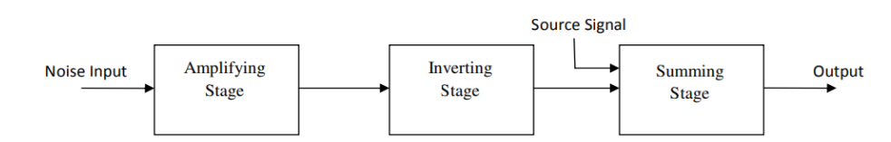

Figure 21: Block Diagram of Noise Cancelling Circuit

3.2 ALGORITHM TESTING
3.2.1 Least Mean Square (LMS) Algorithm:
For the following inputs:
• Reference frequency: Fr = 100 kHz
• Sampling Frequency: Fs = 10MHz
• Desired Signal: d[n] = sin (2$π$Fr n+ ϕ)
• Filter order: 31
• Step-size: µ = 0.001
System output:
• Mean square error: e̅2 = 1.6874 × 10^-4
• Maximum error: emax = 0.0962
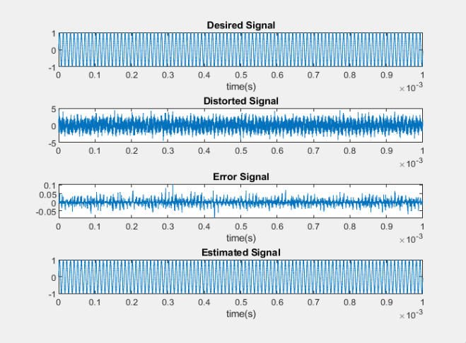
Figure 22: LMS Code Output
As illustrated in figure 24, the filtered signal greatly matches the desired signal.

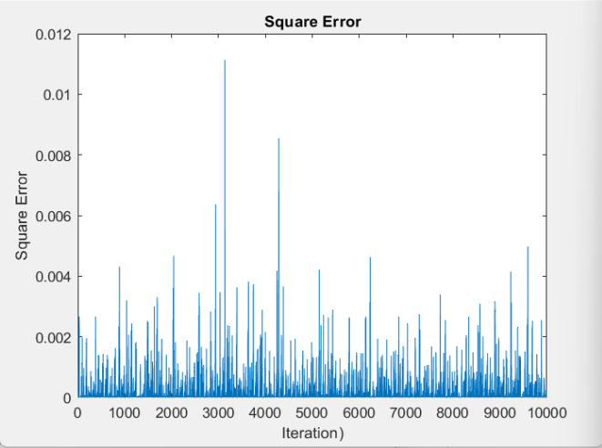
Figure 23: Square Error for 10000 Iterations
In figure 25, the square error of the system for 10000 samples is illustrated. The error is fairly contained within a range, and only rarely spikes. In figure 26, it can be seen that the 15th filter tap (W15 (n)) quickly converges to a mean value, for 10000 iterations.
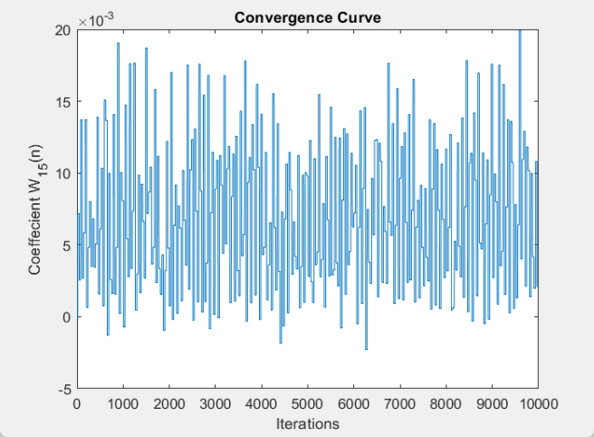
Figure 24: Convergence curve for the 15th filter tap for 10000 iterations

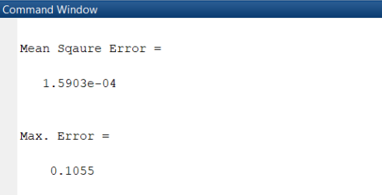
Figure 25: The result of the LMS code in MATLAB
3.2.2 Normalized Least Mean (NLMS) Square Algorithm
For the following inputs:
• Reference frequency: Fr = 100 kHz
• Sampling Frequency: Fs = 10MHz
• Desired Signal: d[n] = sin (2$π$Fr n+ ϕ)
• Filter order: 31 • Step-size: β = 0.001
System output:
• Mean square error: e̅2 = 0.8513 • Maximum error: emax = 40.9899
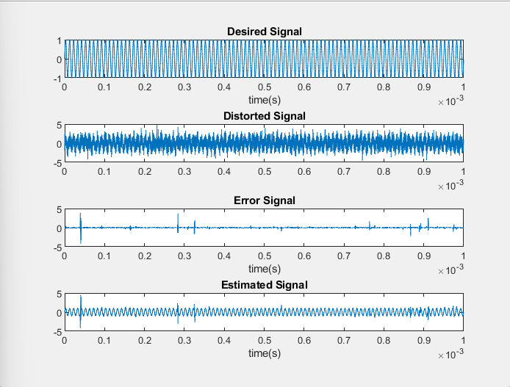
Figure 26: NLMS Code Output

As shown in figure 28, the NLMS system suffers from error surges frequently. The results correlate with the mean squared error and max error calculated by the code.
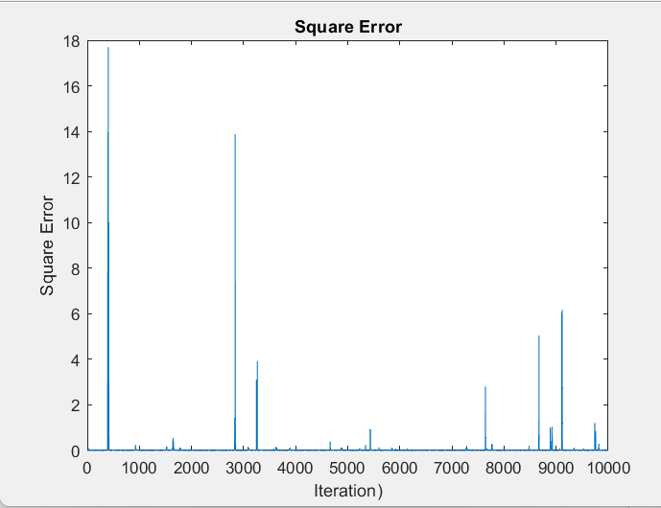
Figure 27: Square error for 10000 iterations
In figure 29, the square error very frequently surges to significant values, with a mean squared error of 0.8513.
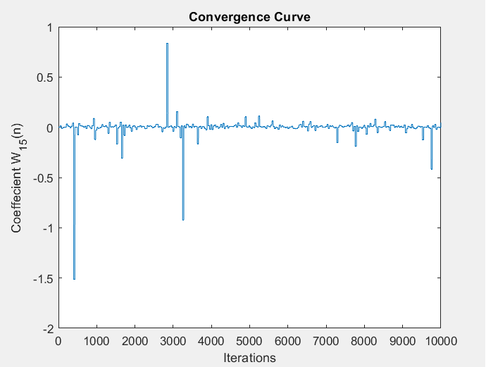
Figure 28: Convergence curve for the 15th filter tap

Figure 30 shows that the weight of the 15th filter tap shifts significantly at various iterations of 1000 testing iterations.

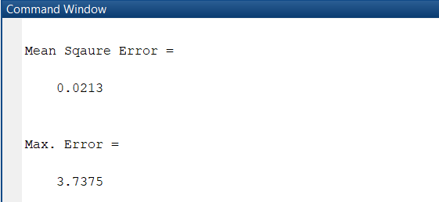
Figure 29: The result of the NLMS code in MATLAB

3.2.3 Recursive Least Square

The RLS algorithm’s complexity, in terms of the mathematical model and coding process is much greater than the previously tested variations of the LMS algorithm. The RLS algorithm’s main advantage is that it focuses on the most recent tap weights, by multiplying older coefficients with small values, their effect on the error correction is minimized, which leads to much faster convergence and smaller error. Another advantage of the RLS algorithm is that the algorithm’s performance is much better than LMS at a much lower order. Using the code in Appendix, the following results were obtained:

Order =4

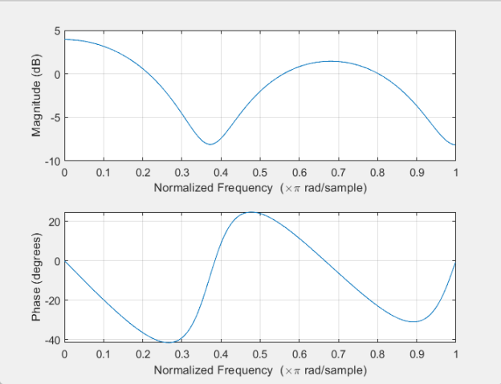
Figure 30: RLS Filter Magnitude and Phase responses.
Figure 32 shows the frequency magnitude and phase responses of the filter that results from the RLS MATLAB code.
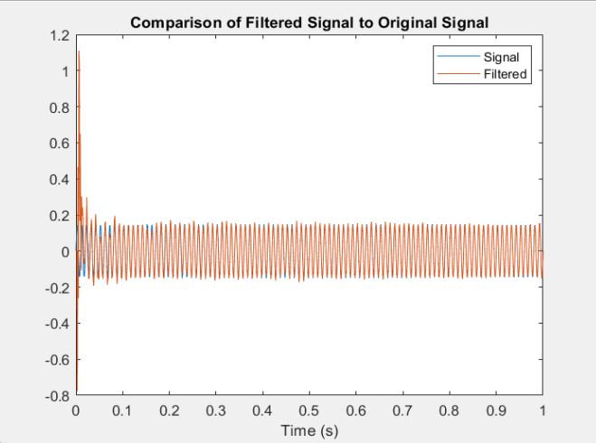
Figure 31: Comparison of the desired signal and the filtered signal
As seen in figure 33, the estimated signal very quickly converges and follows the desired signal, at a very low order (4).
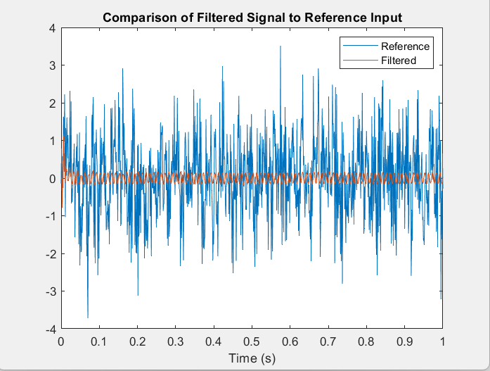
Figure 32: Comparison of the filtered signal to the distorted signal

Figure 34 shows the magnitude of the filtered signal is very small compared to the distorted signal.

3.2.4 Simulation Results Comparison and Implementation Decisions:

From the obtained results in sections (3.2.1-3.2.3), it was deduced that the RLS algorithm

gives the best results for the lowest orders.

Based on the following reasons the final decision for the adaptive algorithm was made:

1. Instructor and examiner comments.

2. Lower order filters were prioritized.

3. Fastest convergence.

4. Stability.

LMS greatly lacks in terms of stability, and NLMS compromises error performance for

stability.

Both LMS and NLMS require high order to function satisfactorily.

Based on the superior performance, the final decision for hardware implementation is to use

RLS.

3.3 APPENDICES.

3.3.1 Appendix A. MATLAB Codes

3.3.1.1 Least Mean Square:

close all

clc

clear

fr=100e3;

Fs=100e5;

dt=1/Fs;

mu=0.001;

M=32;

w=zeros([1,M]);

v=0;

t=0:dt:0.001-dt;

d=sin(2*pi*fr*t);

N=randn(size(d));

x=d+N;

for i=1:length(t)

e(i)=w(i-v)*x(i);

y(i)=d(i)-e(i);

w(i+1-v)=w(i-v)+mu*y(i)*x(i);

q(i)=w(15);

if (i-v)==M

v=v+M;

end

end

figure

subplot(4,1,1),plot(t,d);title('Desired Signal');xlabel('time(s)');

subplot(4,1,2),plot(t,x);title('Distorted Signal');

subplot(4,1,3),plot(t,e);title('Error Signal');xlabel('time(s)');

subplot(4,1,4),plot(t,y);title('Estimated Signal');xlabel('time(s)');

figure

plot(e.^2);xlabel('Iteration)');ylabel('Square Error');title('Square Error');

figure

plot(q);xlabel('Iterations');ylabel('Coeffecient W_1_5(n)');title('Convergence Curve');

display(mean(e.^2),'Mean Sqaure Error')

display(max(e),'Max. Error')

3.3.1.2 Normalized Least Mean Square:

close all

clc

clear

fr=100e3;

Fs=100e5;

dt=1/Fs;

B=0.001;

M=32;

w=zeros([1,M]);

v=0;

t=0:dt:0.001-dt;

d=sin(2*pi*fr*t);

N=randn(size(d));

x=d+N;

for i=1:length(t)

e(i)=w(i-v)*x(i);

y(i)=d(i)-e(i);

w(i+1-v)=w(i-v)+B*y(i)*x(i)/(x(i)^2);

q(i)=w(15);

if (i-v)==M

v=v+M;

end

end

figure

subplot(4,1,1),plot(t,d);title('Desired Signal');xlabel('time(s)');

subplot(4,1,2),plot(t,x);title('Distorted Signal');

subplot(4,1,3),plot(t,e);title('Error Signal');xlabel('time(s)');

subplot(4,1,4),plot(t,y);title('Estimated Signal');xlabel('time(s)');

figure

plot(e.^2);xlabel('Iteration)');ylabel('Square Error');title('Square Error');

figure

plot(q);xlabel('Iterations');ylabel('Coeffecient W_1_5(n)');title('Convergence Curve');

display(mean(e.^2),'Mean Sqaure Error')

display(max(e),'Max. Error')

3.1.1.3 Recursive Least Squares:
function [e,w] = RLSFilterIt(n,x,fs)
close all;
clear all;
clc;
tic
%--------------------------------------------------------------------------
% Generate Data
%--------------------------------------------------------------------------
% Generate data if no inputs provided
if nargin < 1
% Data Parameters
numPts = 1000; % number of points to generate
freq = 100; % frequency of fundamental tone
filtord = 4; % filter order
filt = rand(filtord, 1); % filter coefficients
nVar = 1; % white noise variance
SNR = -20; % signal to noise ratio of tone

% Generate the data!
[n,x,s,fs] = genData(numPts, freq, filt, nVar, SNR);

end
%--------------------------------------------------------------------------
% Filtering
%--------------------------------------------------------------------------
% Filter Parameters
p = 4; % filter order
lambda = 1.0; % forgetting factor
laminv = 1/lambda;
delta = 1.0; % initialization parameter
% Filter Initialization
w = zeros(p,1); % filter coefficients
P = delta*eye(p); % inverse correlation matrix
e = x*0; % error signal
for m = p:length(x)
% Acquire chunk of data
y = n(m:-1:m-p+1);
% Error signal equation
e(m) = x(m)-w'*y;

% Parameters for efficiency
Pi = P*y;

% Filter gain vector update
k = (Pi)/(lambda+y'*Pi);

% Inverse correlation matrix update
P = (P - k*y'*P)*laminv;
% Filter coefficients adaption
w = w + k*e(m);
% Counter to show filter is working
%if mod(m,1000) == 0
% disp([num2str(m/1000) ' of ' num2str(floor(length(x)/1000))])
%end

end
toc
max_error=max(abs(e))
e0=mean(abs(e).^2);
e0
w
%--------------------------------------------------------------------------
% Plot
%--------------------------------------------------------------------------
% Plot filter results
t = linspace(0,length(x)/fs,length(x));
figure;
plot(t,x,t,e);
title('Result of RLS Filter')
xlabel('Time (s)');
legend('Reference', 'Filtered', 'Location', 'NorthEast');
title('Comparison of Filtered Signal to Reference Input');
% Plot comparison of results to original signal (only for generated data)
if nargin < 1
figure;
plot(t,s,t,e);
title('Result of RLS Filter')
xlabel('Time (s)');
legend('Signal', 'Filtered', 'Location', 'NorthEast');
title('Comparison of Filtered Signal to Original Signal');
end
% Calculate SNR improvement
SNRi = 10*log10(var(x)/var(e));
disp([num2str(SNRi) 'dB SNR Improvement'])
return
function [n,x,s,fs] = genData(numPts, freq, filt, nVar, SNR)
% Generate time values
t = linspace(0,1,numPts)';

fs = numPts;

% Generate tone
s = sin(2*pi*freq*t);

% Generate noise
n = sqrt(nVar)*randn(numPts,1);

% Filter noise
addnoise = filter(filt, 1, n);

% Plot filter
freqz(filt,1,1000)

% Adjust SNR of tone
s = s/sqrt(var(s)/(10^(SNR/10)*var(n)));
disp(['Calculated SNR = ' num2str(10*log10(var(s)/var(n)))])

% Add noise to signal
x = s + addnoise;

return

Chapter Four: Analog Active Noise Cancellation

4.1. Introduction to Analogue ANC
Active Noise Cancellation (ANC) technology has become a pivotal feature in the realm of audio devices, revolutionizing the way we experience sound. Within the vast landscape of ANC, there exists a distinctive category known as Analogue ANC. This chapter delves into the fundamental principles, components, applications, and nuances that define Analogue ANC, offering a comprehensive understanding of this technology.
Defining Analogue ANC:
Analogue ANC stands as a testament to the intricate synergy between engineering and audio excellence. Unlike its digital counterpart, which relies on complex algorithms and signal processing, analogue ANC operates through real-time analog circuitry. This technology is designed to detect external ambient noise and generate an anti-noise signal to cancel out unwanted sounds, delivering a cleaner and more immersive audio experience.
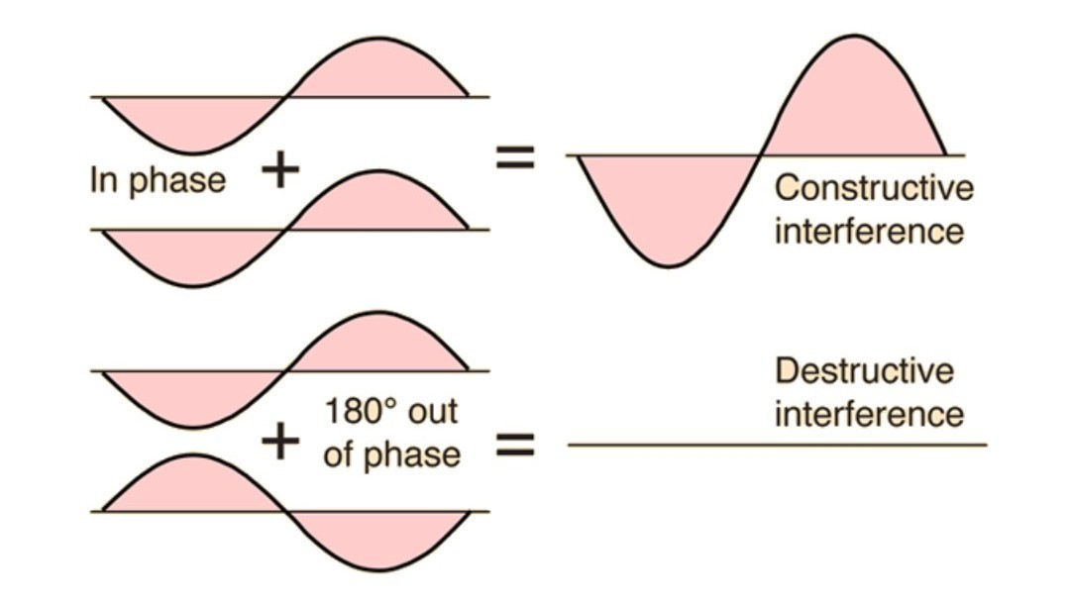
Figure 33: Wave interference schematic

A Glimpse into History:
To truly appreciate the advancements in Analogue ANC, it is essential to trace its roots. The concept of noise cancellation dates back several decades, with early attempts involving basic analog circuits. Over time, continuous refinements and innovations have led to the development of sophisticated Analogue ANC systems, enhancing their efficacy and versatility.
Basic Principles of Analogue ANC:
At its core, Analogue ANC relies on the principles of destructive interference. Utilizing microphones to capture ambient noise, the system analyzes and generates an anti-noise signal with an inverted waveform. When combined with the original noise, these inverted signals interfere with each other, resulting in a cancellation effect. The real-time nature of this process distinguishes Analogue ANC, making it a compelling choice in various audio applications.
4.2 Basic Principles of Analogue ANC
To create as cancellation signal, information about the disturbance is necessary. This information can be provided by an internal microphone, recording the inner disturbance, and/or an external microphone, recording the ambient noise. Fig. 1 shows the structure of an ANC headphone, divided into acoustic front-end and electronic back-end. Using the external microphone signal x(n) 1 and a filter W(z) to create the cancellation signal y(n), the system is called a feedforward system. When using the internal microphone e(n) and a filter K(z) to create the cancellation signal u(n) .
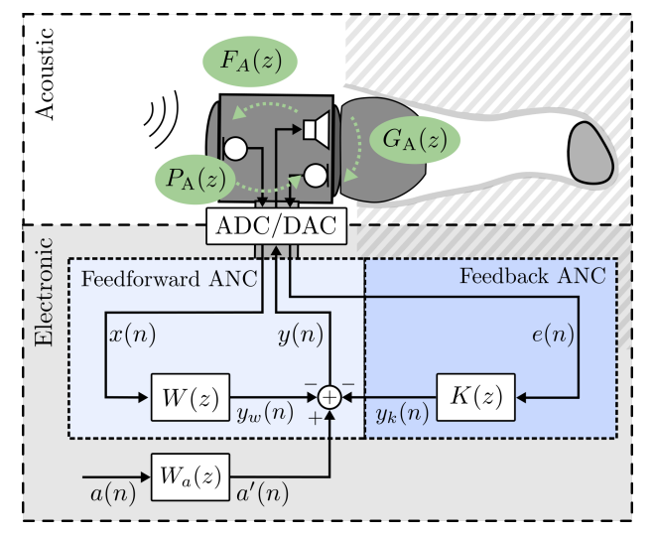
Figure 34: Acoustic front-end with ambient noise x(t)
the system is called a feedback system. These two systems can be combined into a feedforward-feedback system, sometimes termed as hybrid, as indicated in Fig. 2 .A desired audio signal is a(n). As the headphone is typically used to listening to music or for communication purposes. The perception of a(n) should be improved by ANC in the presence external disturbance. This requires an additional model filter Gˆ(z) to compensate for linear distortions due to the feedback ANC. All these components create a combined y˜(n) = y(n) +u(n) +a(n).
The feedforward and feedback systems can be realized in analog circuitry or by digital signal processing. For the latter the analog signals are digitized by analog-to-digital conversion (ADC) and processed by a digital signal processor (DSP) or application specific integrated circuits (ASIC) and then converted back by digital-to-analog conversion (DAC). Also hybrid systems with analog and digital parts are possible . Three transmission paths, indicated in Fig. 2, are crucial for ANC systems: the primary path P(z), the secondary path G(z) and the acoustic feedback path G f(z). The primary path P(z) 2 is defined as the transfer function from the external to the internal microphone. The secondary path G(z) includes the transmission from the digital output y˜(n) to the digital input e(n) of the internal microphone.
Thus, it is a combination of different components, namely DA-conversion GDAC(z), anti-image filtering GAI(z), loudspeaker characteristic Gspk(z), acoustic transmission GA(z), microphone characteristic Gmic(z), anti-aliasing filtering GAA(z) and AD-conversion GADC(z). The acoustic feedback path Gf(z) is the transmission from the digital output y˜(n) to the digital input x(n) of the external microphone. Analog it yields Gf(z) = Gf,DAC(z)· Gf,AI(z)· Gf,spk(z)· Gf,A(z)· Gf,mic(z)·Gf,AA(z)·Gf,ADC(z). The acoustic feedback degrades the feedforward performance and can lead to instabilities.

- Noise Detection
The first crucial step in the process of Analogue ANC involves the detection of ambient noise. This step is fundamental to creating an effective anti-noise signal that will cancel out the undesired sounds.
- Microphone Placement:
Analogue ANC devices are equipped with microphones strategically placed to capture surrounding sounds. These microphones act as the ears of the system, picking up a broad spectrum of frequencies from the environment.
- Omnidirectional or Adaptive Microphones:
The microphones used in Analogue ANC systems are often designed to be omnidirectional or adaptive. Omnidirectional microphones capture sound from all directions, while adaptive microphones can adjust their sensitivity based on the incoming noise.
- Capturing Ambient Noise:
The microphones capture the ambient noise, which includes a mix of various frequencies and amplitudes. This could range from low-frequency hums like engine noise to higher-frequency sounds such as voices or the rustling of leaves.
- Frequency Analysis:
The incoming noise signals are analyzed in terms of their frequency content. This analysis helps identify the specific frequencies that need to be countered by the anti-noise signal.
- Real-Time Monitoring:
Analogue ANC systems continuously monitor the ambient noise in real-time. This dynamic monitoring allows for immediate adjustments, ensuring that the anti-noise signal remains synchronized with changes in the noise profile.

- Signal Conditioning:
The detected noise signals may undergo signal conditioning, which involves amplification, filtering, or other processing to prepare them for the subsequent stages of noise cancellation.
- Signal Processing :
Once ambient noise has been detected, the next critical stage in the Analogue ANC process is signal processing. Unlike digital ANC, which relies on digital signal processing (DSP) algorithms, Analogue ANC employs analog circuitry to manipulate the signals in real-time.
- Analog Circuit Elements:
Analogue ANC systems utilize analog circuit elements such as operational amplifiers, resistors, and capacitors for signal processing. These components are configured to perform specific functions in shaping and manipulating the incoming noise signals.
- Amplification:
The detected noise signals may undergo amplification to ensure that they are at a suitable level for further processing. Amplification helps in maintaining signal integrity and allows for precise adjustment of the anti-noise signal.
- Filtering:
Analog filters are employed to isolate specific frequency components within the noise signals. This step is crucial for targeting the frequencies that contribute most significantly to the undesired noise. Filters can be designed to attenuate or boost certain frequency ranges as needed.
- Phase Inversion:
A key principle in Analogue ANC is phase inversion. The noise signals are processed to create an anti-noise signal with an inverted waveform. This means that the peaks of the anti-noise signal align with the troughs of the original noise signal, and vice versa.
- Dynamic Adjustments:
The analog circuitry allows for dynamic adjustments based on real-time changes in the ambient noise. This adaptability is crucial for maintaining optimal noise cancellation performance in various environments.
- Anti-Noise Signal Generation:
The processed signals, now including the inverted anti-noise signal, are combined to form the final output. This anti-noise signal is carefully crafted to counteract the original noise when they combine.
- Continuous Monitoring:
Throughout the signal processing stage, Analogue ANC systems continuously monitor the noise signals to ensure that the anti-noise signal remains synchronized with the incoming noise. This real-time monitoring and adjustment contribute to the system's effectiveness.
- Minimal Latency:
The use of analog circuitry often results in minimal latency compared to digital processing, contributing to a more instantaneous and responsive noise cancellation experience.

- Creation of Anti-Noise Signal:
The creation of the anti-noise signal is a pivotal step in the active noise cancellation (ANC) process, particularly in the analogue domain. This step involves generating a signal with characteristics that are precisely opposite to the detected ambient noise, enabling destructive interference.
- Inversion of Waveform:
The core principle in creating the anti-noise signal is the inversion of the waveform. This means that if the original noise signal has peaks at certain points, the anti-noise signal is generated with troughs at the corresponding points and vice versa. This inversion sets the stage for destructive interference.
- Phase Relationship:
The anti-noise signal is carefully crafted to maintain a specific phase relationship with the incoming noise. This relationship is crucial for achieving optimal cancellation when the two signals combine. The goal is to have the peaks and troughs of the anti-noise signal align precisely with those of the original noise.
- Amplitude Calibration:
The amplitude of the anti-noise signal is calibrated to match that of the original noise. Achieving balance in amplitude ensures that the destructive interference is effective across the entire frequency spectrum.
- Real-Time Adjustment:
The creation of the anti-noise signal is not a static process. Analogue ANC systems continuously monitor the ambient noise in real-time and dynamically adjust the characteristics of the anti-noise signal to match changes in the noise profile. This adaptability ensures consistent and effective noise cancellation in dynamic environments.
- Frequency-Specific Anti-Noise:
Depending on the design and application, Analogue ANC systems can generate frequency-specific anti-noise signals. This allows for a more targeted approach, addressing specific frequencies associated with common ambient noises.
- Integration with Processed Noise Signals:
The anti-noise signal, having been crafted with inverted waveforms and calibrated amplitude, is integrated with the processed noise signals. This integration occurs in real-time, ensuring that the anti-noise signal remains synchronized with the incoming noise.
- Summation of Signals:
The final output is achieved through the summation of the processed noise signals and the anti-noise signal. This summation results in destructive interference, canceling out the unwanted ambient noise and providing the user with a quieter and more enjoyable listening experience.
- Consistent Monitoring:
Throughout the creation and integration of the anti-noise signal, Analogue ANC systems maintain a vigilant and consistent monitoring process. This monitoring enables the system to adapt to changes in the noise environment, ensuring ongoing optimal noise cancellation performance.
- Cancellation Effect:
The cancellation effect is the ultimate goal of Analogue Active Noise Cancellation (ANC), and it represents the reduction or elimination of unwanted ambient noise to enhance the overall audio experience.
- Destructive Interference:
The core mechanism driving the cancellation effect is destructive interference. The anti-noise signal, generated with an inverted waveform, is combined with the processed noise signals. When the peaks of the original noise align with the troughs of the anti-noise signal (and vice versa), the two signals interfere destructively, leading to a significant reduction in overall sound level.
- Targeted Noise Reduction:
Analogue ANC systems can be designed to target specific frequencies associated with common ambient noises. This allows for a more tailored approach to noise reduction, focusing on frequencies that are particularly bothersome in a given environment.
- Steady-State Noise Reduction:
The cancellation effect is particularly effective for steady-state or continuous noises, such as the hum of an airplane engine, the rumble of a train, or the drone of traffic. Analogue ANC excels in attenuating these types of persistent sounds.

- Improved Signal-to-Noise Ratio:
By canceling out ambient noise, Analogue ANC significantly improves the signal-to-noise ratio in the audio playback. This means that the desired audio, such as music or spoken words, becomes more prominent and clear in comparison to the background noise.
- Enhanced Listening Experience:
The cancellation effect contributes to an enhanced listening experience, allowing users to enjoy audio content without the distraction of external noise. This is particularly valuable in environments where noise pollution can impact concentration and overall enjoyment.
- Adaptability to Dynamic Environments:
The real-time monitoring and adjustment capabilities of Analogue ANC contribute to its adaptability in dynamic environments. Changes in ambient noise are quickly detected and countered, ensuring a consistent cancellation effect.
- Minimal Latency:
Analogue ANC often operates with minimal latency, providing users with an instantaneous response to changes in the noise environment. This real-time performance is crucial for maintaining a seamless and natural audio experience.
- Balanced Frequency Response:
The cancellation effect is designed to maintain a balanced frequency response, ensuring that the anti-noise signal effectively counters noise across the entire spectrum. This contributes to a well-rounded and high-fidelity audio experience.
- Frequency Response:
Frequency response is a crucial aspect of Analogue Active Noise Cancellation (ANC) systems, influencing their ability to effectively counteract ambient noise across different frequency ranges.
- Broad Spectrum Analysis:
Analogue ANC systems are designed to capture and process ambient noise across a broad spectrum of frequencies. This includes low-frequency sounds like engine rumble and high-frequency sounds such as voices or rustling leaves.
- Filtering for Target Frequencies:
Analog filters are employed to selectively target specific frequency components within the ambient noise. This filtering process helps in customizing the noise reduction strategy, focusing on frequencies that are most problematic in a given environment.
- Tailored Noise Cancellation:
By addressing specific frequencies, Analogue ANC can tailor its noise cancellation efforts to the characteristics of the ambient noise. This targeted approach enhances the overall effectiveness of noise reduction.
- Balanced Frequency Attenuation:
The goal of Analogue ANC is to maintain a balanced frequency response in both the incoming noise signals and the generated anti-noise signals. This balance contributes to a natural and high-fidelity audio experience, avoiding distortions or colorations in the sound.
- Customization for Specific Environments:
The ability to customize the frequency response allows Analogue ANC to be optimized for specific environments. For example, in an airplane, emphasis might be placed on attenuating low-frequency engine noise, while in a crowded cafe, the focus could shift to mid-range frequencies associated with human conversation.
- Preservation of Desired Audio Frequencies:
A well-designed Analogue ANC system ensures that the cancellation of ambient noise does not compromise the clarity and fidelity of the desired audio content. The frequency response is carefully managed to preserve the integrity of music, speech, or other audio signals.

- Enhanced User Experience:
The fine-tuning of frequency response contributes to an enhanced user experience, allowing individuals to enjoy audio content with minimal interference from external noise. This is particularly important in scenarios where background noise could detract from the overall enjoyment of the audio.
4.3. Components of Analogue ANC Systems
The effectiveness of Analogue Active Noise Cancellation (ANC) systems relies on a set of key components working together cohesively.
- Microphones:
Function: Microphones are strategically placed to capture ambient noise in the surrounding environment.
Role in ANC: The detected noise signals serve as the input for the ANC system to analyse and generate an anti-noise signal.
- Analog Circuitry:
Function: Analog circuit elements, such as operational amplifiers, resistors, and capacitors, process the incoming noise signals in real-time.
Role in ANC: The analog circuitry shapes and manipulates the noise signals, preparing them for the creation of the anti-noise signal.
- Anti-Noise Signal Generator:
Function: This component generates the anti-noise signal with an inverted waveform, carefully calibrated amplitude, and specific phase relationships.
Role in ANC: The anti-noise signal is a critical element that, when combined with the processed noise signals, leads to destructive interference, canceling out unwanted ambient noise.

- Real-Time Monitoring System:
Function: The ANC system continually monitors the ambient noise in real-time.
Role in ANC: Real-time monitoring enables the system to dynamically adjust the characteristics of the anti-noise signal, ensuring that it remains synchronized with changes in the noise environment.
- Amplifiers:
Function: Amplifiers are employed to adjust the amplitude of the noise signals as needed.
Role in ANC: Amplification ensures that the noise signals are at suitable levels for further processing and integration with the anti-noise signal.
- Filters:
Function: Analog filters are used to isolate specific frequency components within the noise signals.
Role in ANC: Filtering helps customize the noise reduction strategy by targeting particular frequencies associated with common ambient noises.
- Adaptive Algorithms (Optional):
Function: Algorithms that dynamically adjust parameters based on real-time changes in the ambient noise environment.
Role in ANC: Adaptability ensures that the ANC system remains effective in dynamic environments, optimizing noise cancellation performance.
- Signal Integration Module:
Function: This module integrates the anti-noise signal with the processed noise signals.
Role in ANC: The integrated signals undergo summation, leading to destructive interference and the cancellation of unwanted ambient noise.

- User Interface :
Function: Interface components such as buttons, switches, or touch controls for user interaction.
Role in ANC: Users may have the option to control ANC settings, toggle between modes, or adjust the level of noise cancellation.
- Power Supply:
Function: Provides the necessary electrical power to operate the ANC system.
Role in ANC: Ensures continuous and reliable operation of the ANC components.

4.4 Case Study Analog vs. Digital Active Noise Cancellation in Premium Headphones
Background: In the competitive market of premium headphones, manufacturers are constantly seeking technological advancements to enhance the listening experience for consumers. One critical feature in this pursuit is Active Noise Cancellation (ANC), a technology designed to reduce ambient noise and provide a more immersive audio experience. In this case study, we explore the considerations and implications of choosing between Analog ANC and Digital ANC for a new line of premium headphones.

Objective: To determine the most suitable ANC technology for a line of premium headphones that prioritizes a balance between performance, cost-effectiveness, and power efficiency.
- Analog Active Noise Cancellation (ANC):
Advantages:
- Proven Technology: Analog ANC has a long-standing history and has been successfully implemented in various audio devices.
- Power Efficiency: With simpler processing requirements, analog ANC systems tend to be more power-efficient, making them suitable for prolonged use without frequent recharging.
- Cost-Effectiveness: The implementation of analog ANC is often more economical due to the simplicity of the required components.
Limitations:
- Precision: Analog ANC systems may struggle with precise frequency targeting, limiting their effectiveness in canceling out dynamic or complex noises.
- Adaptability: Limited adaptability to different noise profiles or environments, potentially requiring manual adjustments to analog filters.
Digital Active Noise Cancellation (ANC):
Advantages:
- Advanced Noise Cancellation: Digital ANC, relying on sophisticated signal processing algorithms, offers superior noise cancellation across a broader range of frequencies.
- Flexibility: Digital ANC systems can adapt to different noise sources and optimize their performance accordingly.
- Audio Quality: Generally provides better audio quality without introducing significant artifacts due to precise frequency cancellation.
Challenges:
- Higher Power Consumption: Digital ANC systems typically require more power due to the computational demands of advanced algorithms.
- Cost Considerations: Implementation of digital ANC involves more complex processing algorithms and hardware, potentially increasing production costs.
Decision Factors:
Target Audience:
- If the target audience values prolonged use without frequent recharging and is willing to compromise on some adaptability, analog ANC may be suitable.
- If audiophiles seeking the highest audio quality and adaptability are the primary audience, digital ANC may be the preferred choice.

Budget Constraints:
- If production costs are a primary concern, analog ANC might be a cost-effective solution.
- If the budget allows for a more sophisticated ANC system, digital ANC may be a justifiable investment.
Performance Requirements:
- If the headphones are primarily used in environments with consistent ambient sounds, analog ANC's moderate noise reduction capabilities may suffice.
- If the headphones are intended for versatile use in various environments with dynamic noise profiles, digital ANC's adaptability and advanced noise cancellation may be essential.
Conclusion:
Choosing between Analog ANC and Digital ANC for the premium headphone line depends on a careful consideration of the target audience, budget constraints, and performance requirements. While Analog ANC offers simplicity, power efficiency, and cost-effectiveness, Digital ANC provides advanced noise cancellation, adaptability, and superior audio quality. A well-informed decision must balance these factors to meet the expectations of discerning consumers in the premium headphone market.

4.5. Applications of Analogue ANC
Analogue Active Noise Cancellation (ANC) technology has found widespread applications in various audio devices, significantly enhancing the listening experience in diverse environments.
- Headphones:
Overview: ANC-equipped headphones utilize analogue technology to cancel out external noise, providing users with a more immersive and focused audio experience.
Benefits: Ideal for users in noisy environments such as offices, public transportation, or airplanes, where ANC helps reduce or eliminate constant background noise.
- Earphones:
Overview: Earphones with analogue ANC offer a portable solution for noise reduction. They are suitable for individuals on the go who want to enjoy audio content without being disturbed by surrounding sounds.
Benefits: Particularly effective in urban settings, during workouts, or while commuting, where ambient noise can interfere with the audio experience.
- Wireless Earbuds:
Overview: ANC technology has been integrated into many wireless earbuds, providing users with a cable-free and noise-free listening experience.
Benefits: Wireless earbuds with analogue ANC are popular for activities like exercising or commuting, where a compact and wire-free design is desirable.
- Gaming Headsets:
Overview: ANC has made its way into gaming headsets to provide an immersive gaming experience by isolating the user from external distractions.
Benefits: Enhances focus during gaming sessions, allowing users to fully immerse themselves in the audio details of the game without being disturbed by background noise.
- Conference and Communication Devices:
Overview: ANC technology is integrated into communication devices such as headsets and conference call systems for clearer audio during calls.
Benefits: Improves communication by reducing background noise, ensuring that voice clarity is maintained even in noisy environments.
- Professional Audio Monitoring:
Overview: Analogue ANC is utilized in professional audio monitoring systems, allowing audio engineers and musicians to work in studios or live settings with reduced external noise interference.
Benefits: Facilitates critical listening and accurate audio production by minimizing the impact of ambient noise in studio environments.
- In-Car Audio Systems:
Overview: Some high-end car audio systems incorporate ANC to minimize road and engine noise, providing a quieter and more enjoyable in-car audio experience.
Benefits: Enhances the overall driving experience by creating a more peaceful and controlled acoustic environment within the vehicle.
- Home Audio Systems:
Overview: High-quality audio systems for home use may integrate analogue ANC to improve the signal-to-noise ratio, allowing users to enjoy audio content with greater clarity.
Benefits: Creates a more immersive listening environment in homes, reducing the impact of external noises and distractions.
Enhancements in Different Environments:
- Public Transportation:
ANC technology is highly effective in reducing the droning noise of engines, chatter, and other ambient sounds during bus, train, or air travel, providing a more comfortable journey.
- Open Offices:
In workplaces with open office layouts, analogue ANC helps employees concentrate by minimizing the impact of background conversations, office equipment, and other noises.
- Gyms and Workout Environments:
During workouts or in noisy gym environments, ANC in earphones or headphones allows users to focus on their fitness routines without being disturbed by surrounding noise.
- Urban Settings:
In bustling urban environments with traffic, construction, and street noise, ANC technology proves valuable for individuals seeking solace and concentration.
- Study or Workspaces:
ANC in headphones or earphones is beneficial in study environments or offices, where concentration is crucial, and external noises can be a distraction.
- Home Entertainment:
For home entertainment systems, ANC contributes to a cinematic experience by reducing any external disturbances and allowing users to fully immerse themselves in movies or music.

4.6. Advantages and Limitations of Analogue ANC
- Advantages of Analogue ANC
- Real-Time Processing:
Advantage: Analogue ANC operates in real-time, providing immediate response to changes in the ambient noise environment.
Benefit: Users experience seamless noise cancellation, making it highly effective in dynamic settings where noise conditions can fluctuate rapidly.
- Low Latency:
Advantage: Analogue ANC systems typically exhibit minimal latency in processing noise signals.
Benefit: Low latency ensures that there is minimal delay between the detection of ambient noise and the generation of the anti-noise signal, contributing to a more natural and instantaneous noise cancellation experience.
- Simplicity of Circuitry:
Advantage: The analog nature of ANC technology often results in simpler circuitry compared to digital counterparts.
Benefit: Simplicity can lead to cost-effective manufacturing and design, making analogue ANC more accessible for a wider range of audio devices.

- Power Efficiency:
Advantage: Analogue ANC systems may require lower power consumption compared to digital alternatives.
Benefit: Improved power efficiency can contribute to longer battery life in portable devices such as headphones or earphones.

- Lower Complexity:
Advantage: Analog ANC systems are generally less complex in terms of algorithms and signal processing requirements.
Benefit: Reduced complexity can result in easier implementation, maintenance, and troubleshooting, making it an attractive option for various applications.
- Smooth Frequency Response:
Advantage: Analogue ANC systems often provide a smooth and natural frequency response.
Benefit: A balanced frequency response ensures that the anti-noise signal complements the desired audio content without introducing distortions or artifacts.

- Limitations and Challenges of Analogue ANC Technology
- Signal Degradation:
Challenge: Analog processing may introduce some level of signal degradation, potentially impacting the overall audio quality.
Consideration: Careful design and engineering are required to minimize signal degradation and maintain high-fidelity audio reproduction.
- Limited Adaptability:
Challenge: Analogue ANC may have limitations in adapting to highly dynamic noise environments.
Consideration: Some systems may struggle to adjust rapidly to sudden changes in noise conditions, potentially affecting the effectiveness of noise cancellation.
- Dependency on Circuit Components:
Challenge: The performance of analogue ANC is dependent on the quality of analog components, such as operational amplifiers and filters.
Consideration: Ensuring high-quality components is essential to maintaining the efficacy of the ANC system over time.
- Less Precision in Filtering:
Challenge: Analog filters may provide less precision compared to digital filtering.
Consideration: While analogue filters are effective, they may have limitations in precisely targeting specific frequencies, potentially leading to suboptimal noise cancellation in certain scenarios.

- Difficulty in Customization:
Challenge: Tailoring analogue ANC systems for specific applications or environments may be more challenging than with digital systems.
Consideration: Manufacturers need to carefully design and tune analogue ANC systems to accommodate various use cases and user preferences.
- Limited Features and Modes:
Challenge: Analogue ANC systems may have limitations in offering advanced features and modes compared to digital alternatives.
Consideration: Users looking for a wide range of customizable features may find digital ANC solutions more suitable for their needs.

4.7. Technological Innovations and Trends
- Potential Technological Innovations in Analogue ANC
- Improved Signal Processing Algorithms:
Ongoing research and development may lead to advancements in analogue signal processing algorithms, enhancing the precision and adaptability of analogue ANC systems.
- Miniaturization and Integration:
Innovations in component design and manufacturing processes may lead to smaller and more integrated analogue ANC modules, allowing for seamless integration into smaller devices like earbuds or wearable.
- Enhanced Power Efficiency:
Improvements in energy-efficient components and circuit design could contribute to even lower power consumption in analogue ANC systems, extending battery life in portable devices.
- Customizable Frequency Response:
Future analogue ANC systems might offer more user customization options for tailoring the frequency response, allowing users to adjust noise cancellation preferences based on their unique environments.
- Adaptive Noise Cancellation Profiles:
Advances in real-time monitoring and adaptive algorithms could lead to more sophisticated noise cancellation profiles, dynamically adjusting to different types of ambient noise.
- Emerging Trends and Future Directions
- Hybrid ANC Systems:
A potential trend could be the development of hybrid ANC systems that combine analogue and digital technologies. This approach might leverage the strengths of both to achieve even more effective noise cancellation.
- Artificial Intelligence Integration:
Integration with artificial intelligence (AI) could play a role in enhancing the adaptive capabilities of ANC systems. AI algorithms might learn from user preferences and optimize noise cancellation strategies accordingly.
- Voice Assistants and Communication Integration:
Future analogue ANC devices may integrate seamlessly with voice assistants and communication systems, enhancing the overall user experience during phone calls or interactions with voice-controlled devices.
- Environmental Awareness:
Developments in environmental awareness could allow analogue ANC systems to intelligently respond to various acoustic environments, providing a more natural and context-aware noise cancellation experience.
- Application in New Devices:
As ANC technology continues to evolve, its application in various devices might expand. For instance, we might see analogue ANC being integrated into new categories of devices beyond traditional audio products.
- Smart Environments:
The integration of analogue ANC with smart home or office environments could be a future trend. Devices might automatically adjust noise cancellation settings based on contextual cues or user preferences.

4.8. Future Developments and Challenges
- Potential Future Developments
- Advanced Adaptive Algorithms:
Future developments may focus on refining adaptive algorithms in analogue ANC systems, enabling more precise and dynamic adjustments to various noise environments.
- Intelligent Context Awareness:
Analogue ANC could evolve to incorporate intelligent context awareness, allowing devices to understand the user's surroundings and adjust noise cancellation settings accordingly.
- Customizable Noise Profiles:
Users might have the ability to create and save personalized noise cancellation profiles, tailoring the ANC system to their specific preferences in different situations.
- Improved Signal Processing Techniques:
Advancements in signal processing techniques may enhance the overall efficiency and performance of analogue ANC, reducing potential signal degradation and improving audio quality.
- Enhanced Environmental Noise Identification:
Future developments might focus on better identification and categorization of environmental noises, allowing for more accurate and targeted noise cancellation.

- Integration with Wearable Technologies:
Integration with wearable technologies, such as smart glasses or augmented reality devices, could become a future trend, expanding the application of analogue ANC beyond traditional audio devices.
- Energy Harvesting for Power Efficiency:
Researchers may explore innovative ways, such as energy harvesting technologies, to further improve the power efficiency of analogue ANC systems, reducing the impact on device battery life.
- Real-Time User Feedback and Monitoring:
Future analogue ANC systems may incorporate real-time user feedback mechanisms, enabling continuous monitoring of user preferences and optimizing noise cancellation performance accordingly.
- Challenges in Advancing Analogue ANC
- Signal Integrity and Quality:
Maintaining signal integrity and audio quality remains a challenge in analogue ANC, especially as systems become more complex. Researchers will need to address potential signal degradation issues.
- Adaptability to Highly Dynamic Environments:
Analogue ANC systems may face challenges in rapidly adapting to highly dynamic noise environments. Overcoming this challenge is crucial for providing effective noise cancellation in diverse settings.
- Precision in Frequency-Specific Cancellation:
Achieving precision in frequency-specific noise cancellation with analogue components can be challenging. Innovations are needed to improve the accuracy of targeting specific frequency ranges.
- User Interface and Interaction:
Designing intuitive user interfaces and interaction mechanisms for adjusting and customizing analogue ANC settings poses a challenge. Balancing simplicity with functionality is key for user adoption.
- Integration with Emerging Technologies:
Integrating analogue ANC with emerging technologies, such as artificial intelligence and advanced sensor systems, may require addressing compatibility issues and ensuring seamless interoperability.
- Size and Form Factor Constraints:
Miniaturizing analogue ANC components while maintaining performance can be challenging, particularly for integration into smaller devices like earbuds or wearables.
- Cost-Effectiveness and Accessibility:
Balancing cost-effectiveness with performance is a perennial challenge. Ensuring that the benefits of analogue ANC technology are accessible across a wide range of devices and price points is essential.

- Environmental Considerations:
As technology advances, it's crucial to consider the environmental impact of manufacturing and disposing of analogue ANC devices. Sustainable design practices and materials should be a focus.

Chapter Five: Results and Analysis
This chapter will include the results and discussion of our project.

5.1 Current Achievements:

5.1.1 Acoustic noise Canceler

In this Model how to use the Least Mean Square (LMS) algorithm to subtract noise from an input signal. The LMS adaptive filter uses the reference signal on the Input port and the desired signal on the Desired port to automatically match the filter response. As it converges to the correct filter model, the filtered noise is subtracted and the error signal should contain only the original signal.

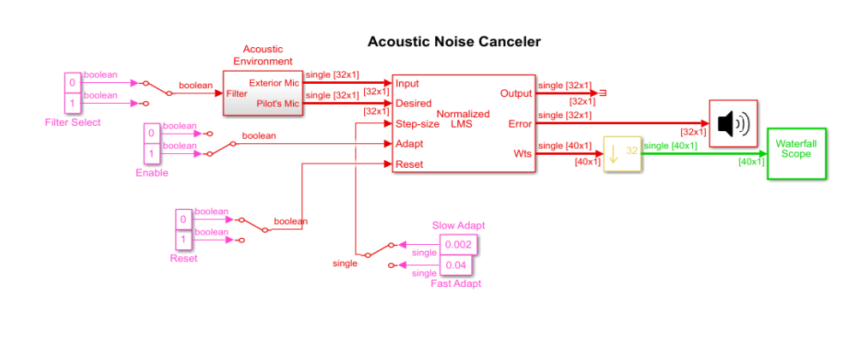
Figure 35: Acoustic noise Canceler
In Fig 35 , the signal output at the upper port of the Acoustic Environment subsystem is white noise. The signal output at the lower port is composed of colored noise and a signal from a .wav file. This example model uses an adaptive filter to remove the noise from the signal output at the lower port. When you run the simulation, you hear both noise and a person playing the drums. Over time, the adaptive filter in the model filters out the noise so you only hear the drums.
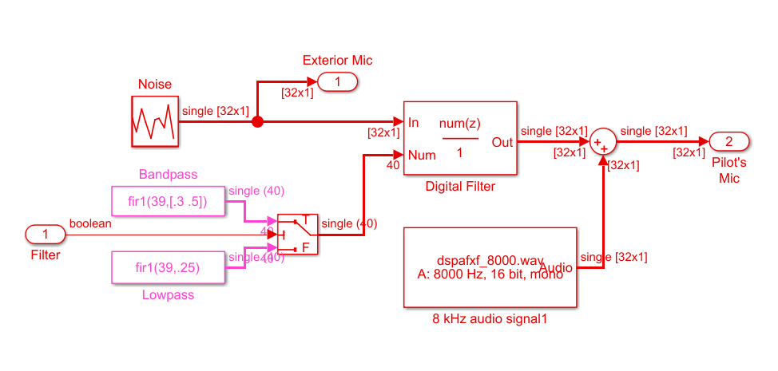
Figure 36: Acoustic Environment box
By running this model, we can listen to the audio signal in real time (while running the simulation). The stop time is set to infinity. This allows us to interact with the model while it is running.

5.1.2 Adaptive Filters Convergence Demo
In This Model ,The convergence path taken by different adaptive filtering algorithms. The plot is a sequence of points of the form (w1,w2) where w1 and w2 are the weights of the adaptive filter. The blue dots in the figure indicate the contour lines of the error surface.

This Model does not depict the convergence speed of the different algorithms.
Each of the adaptive filters can be enabled or disabled separately:
- LMS - Least Mean Square algorithm.
- NLMS - Normalized LMS algorithm.
- SELMS - Sign-Error LMS algorithm.
- SSLMS - Sign-Sign LMS algorithm.

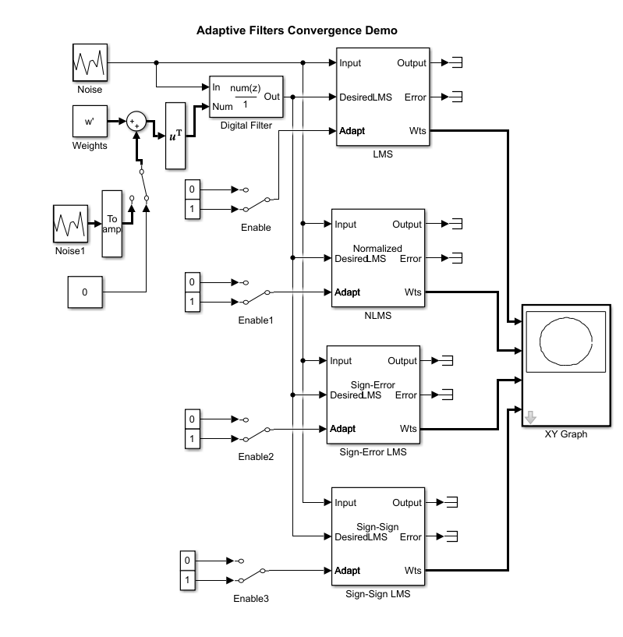
Figure 37: Adaptive Filters Convergence Demo

In Figure 38 , Shows how each type affects noise
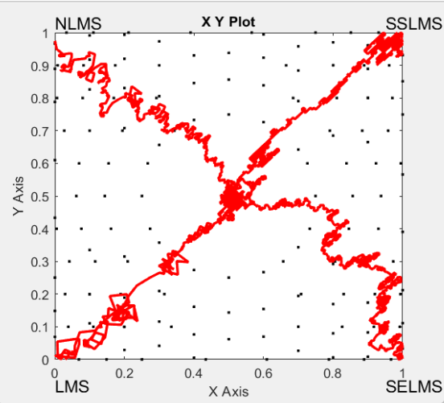

Figure 38: Adaptive Filters Convergence Result.

5.1.3 Adaptive Noise Cancellation Demo
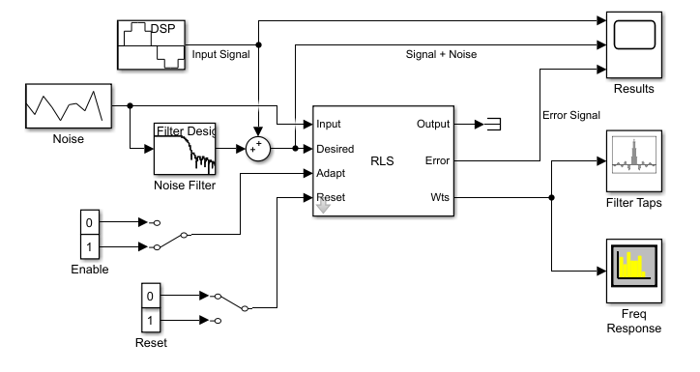
Figure 39: Adaptive Noise Cancellation Demo.

Figure 39 shows how to subtract noise from an input signal using the Recursive Least Squares (RLS) algorithm. The RLS adaptive filter uses the reference signal on the Input port and the desired signal on the Desired port to automatically match the filter response in the Noise Filter block. As it converges to the correct filter, the filtered noise should be completely subtracted from the "Signal+Noise" signal, and the "Error Signal" should contain only the original signal.

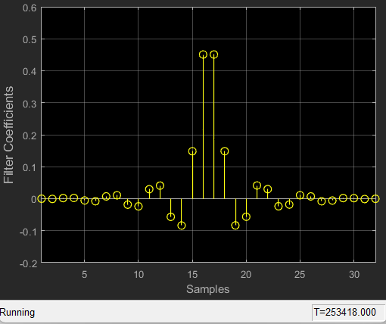
Figure 40: Filter Taps

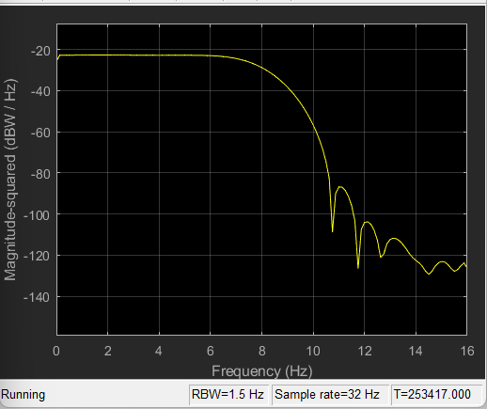
Figure 41: Filter Response.
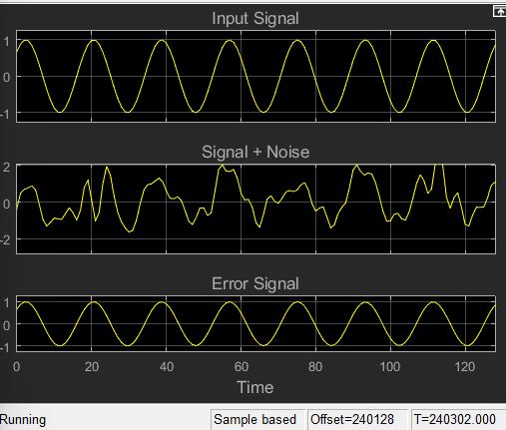
Figure 42: Result.

5.1.4 Active Noise Control Using a Filtered-X LMS FIR Adaptive Filter.

In active noise control, one attempts to reduce the volume of an unwanted noise propagating through the air using an electro-acoustic system using measurement sensors such as microphones and output actuators such as loudspeakers. The noise signal usually comes from some device, such as a rotating machine, so that it is possible to measure the noise near its source. The goal of the active noise control system is to produce an "anti-noise" that attenuates the unwanted noise in a desired quiet region using an adaptive filter. This problem differs from traditional adaptive noise cancellation in that: - The desired response signal cannot be directly measured; only the attenuated signal is available. - The active noise control system must take into account the secondary loudspeaker-to-microphone error path in its adaptation.

The Secondary Propagation Path

Fs = 8e3; % 8 kHz
N = 800; % 800 samples@8 kHz = 0.1 seconds
Flow = 160; % Lower band-edge: 160 Hz
Fhigh = 2000; % Upper band-edge: 2000 Hz
delayS = 7;
Ast = 20; % 20 dB stopband attenuation
Nfilt = 8; % Filter order

% Design bandpass filter to generate bandlimited impulse response
filtSpecs = fdesign.bandpass('N,Fst1,Fst2,Ast',Nfilt,Flow,Fhigh,Ast,Fs);
bandpass = design(filtSpecs,'cheby2','FilterStructure','df2tsos', ...
'SystemObject',true);

% Filter noise to generate impulse response
secondaryPathCoeffsActual = bandpass([zeros(delayS,1); ...
log(0.99*rand(N-delayS,1)+0.01).* ...
sign(randn(N-delayS,1)).*exp(-0.01*(1:N-delayS)')]);
secondaryPathCoeffsActual = ...
secondaryPathCoeffsActual/norm(secondaryPathCoeffsActual);

t = (1:N)/Fs;
plot(t,secondaryPathCoeffsActual,'b');
xlabel('Time [sec]');
ylabel('Coefficient value');
title('True Secondary Path Impulse Response');

The secondary propagation path is the path the anti-noise takes from the output loudspeaker to the error microphone within the quiet zone. The following commands generate a loudspeaker-to-error microphone impulse response that is bandlimited to the range 160 - 2000 Hz and with a filter length of 0.1 seconds. For this active noise control task, we shall use a sampling frequency of 8000 Hz.
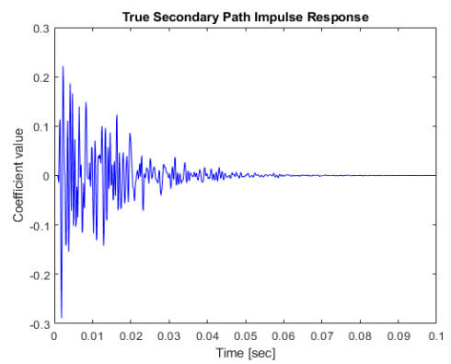
Figure 43: Second path response.
Estimating the Secondary Propagation Path

ntrS = 30000;
randomSignal = randn(ntrS,1); % Synthetic random signal to be played
secondaryPathGenerator = dsp.FIRFilter('Numerator',secondaryPathCoeffsActual.');
secondaryPathMeasured = secondaryPathGenerator(randomSignal) + ... % random signal propagated through secondary path
0.01*randn(ntrS,1); % measurement noise at the microphone

The first task in active noise control is to estimate the impulse response of the secondary propagation path. This step is usually performed prior to noise control using a synthetic random signal played through the output loudspeaker while the unwanted noise is not present. The following commands generate 3.75 seconds of this random noise as well as the measured signal at the error microphone.

Designing the Secondary Propagation Path Estimate

Typically, the length of the secondary path filter estimate is not as long as the actual secondary path and need not be for adequate control in most cases. We shall use a secondary path filter length of 250 taps, corresponding to an impulse response length of 31 ms. While any adaptive FIR filtering algorithm could be used for this purpose, the normalized LMS algorithm is often used due to its simplicity and robustness. Plots of the output and error signals show that the algorithm converges after about 10000 iterations.

M = 250;
muS = 0.1;
secondaryPathEstimator = dsp.LMSFilter('Method','Normalized LMS','StepSize', muS, ...
'Length', M);
[yS,eS,SecondaryPathCoeffsEst] = secondaryPathEstimator(randomSignal,secondaryPathMeasured);

n = 1:ntrS;
figure, plot(n,secondaryPathMeasured,n,yS,n,eS);
xlabel('Number of iterations');
ylabel('Signal value');
title('Secondary Identification Using the NLMS Adaptive Filter');
legend('Desired Signal','Output Signal','Error Signal');

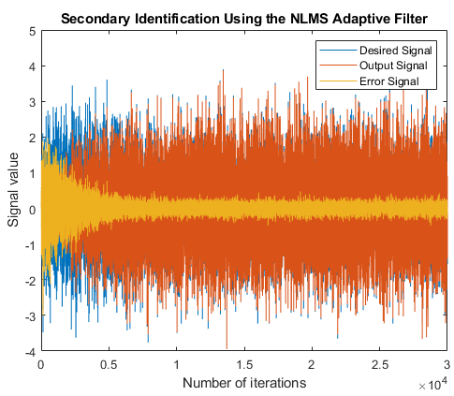
Figure 44: Secondary Identification using NLMS Adaptive Filter.

Accuracy of the Secondary Path Estimate
How accurate is the secondary path impulse response estimate? This plot shows the coefficients of both the true and estimated path. Only the tail of the true impulse response is not estimated accurately. This residual error does not significantly harm the performance of the active noise control system during its operation in the chosen task.
figure, plot(t,secondaryPathCoeffsActual, ...
t(1:M),SecondaryPathCoeffsEst, ...
t,[secondaryPathCoeffsActual(1:M)-SecondaryPathCoeffsEst(1:M); secondaryPathCoeffsActual(M+1:N)]);
xlabel('Time [sec]');
ylabel('Coefficient value');
title('Secondary Path Impulse Response Estimation');
legend('True','Estimated','Error');

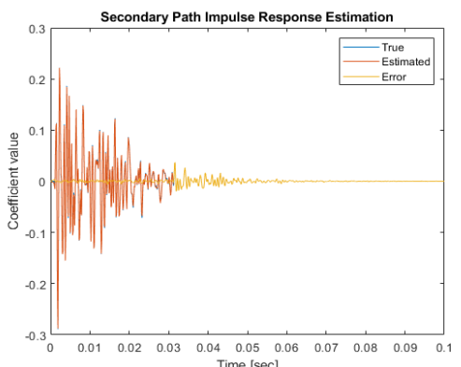
Figure 45: Secondary Path Impulse Response Estimation.

The Primary Propagation Path
A linear filter can also characterize the propagation path of the noise to be cancelled. The following commands generate an input-to-error microphone impulse response that is bandlimited to the range 200 - 800 Hz and has a filter length of 0.1 seconds.
delayW = 15;
Flow = 200; % Lower band-edge: 200 Hz
Fhigh = 800; % Upper band-edge: 800 Hz
Ast = 20; % 20 dB stopband attenuation
Nfilt = 10; % Filter order

% Design bandpass filter to generate bandlimited impulse response
filtSpecs2 = fdesign.bandpass('N,Fst1,Fst2,Ast',Nfilt,Flow,Fhigh,Ast,Fs);
bandpass2 = design(filtSpecs2,'cheby2','FilterStructure','df2tsos', ...
'SystemObject',true);

% Filter noise to generate impulse response
primaryPathCoeffs = bandpass2([zeros(delayW,1); log(0.99*rand(N-delayW,1)+0.01).* ...
sign(randn(N-delayW,1)).*exp(-0.01*(1:N-delayW)')]);
primaryPathCoeffs = primaryPathCoeffs/norm(primaryPathCoeffs);

figure, plot(t,primaryPathCoeffs,'b');
xlabel('Time [sec]');
ylabel('Coefficient value');
title('Primary Path Impulse Response');

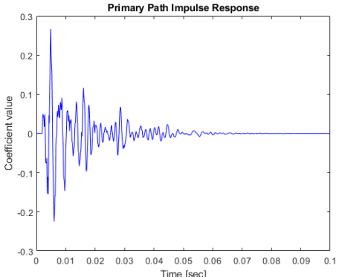
Figure 46: Primary Impulse Response.

The Noise to Be Cancelled
Typical active noise control applications involve the sounds of rotating machinery due to their annoying characteristics. Here, we synthetically generate noise that might come from a typical electric motor.

Initialization of Active Noise Control
The most popular adaptive algorithm for active noise control is the filtered-X LMS algorithm. This algorithm uses the secondary path estimate to calculate an output signal whose contribution at the error sensor destructively interferes with the undesired noise. The reference signal is a noisy version of the undesired sound measured near its source. We shall use a controller filter length of about 44 ms and a step size of 0.0001 for these signal statistics.
% FIR Filter to be used to model primary propagation path
primaryPathGenerator = dsp.FIRFilter('Numerator',primaryPathCoeffs.');

% Filtered-X LMS adaptive filter to control the noise
L = 350;
muW = 0.0001;
noiseController = dsp.FilteredXLMSFilter('Length',L,'StepSize',muW, ...
'SecondaryPathCoefficients',SecondaryPathCoeffsEst);

% Sine wave generator to synthetically create the noise
A = [.01 .01 .02 .2 .3 .4 .3 .2 .1 .07 .02 .01];
La = length(A);
F0 = 60;
k = 1:La;
F = F0*k;
phase = rand(1,La); % Random initial phase
sine = audioOscillator('NumTones', La, 'Amplitude',A,'Frequency',F, ...
'PhaseOffset',phase,'SamplesPerFrame',512,'SampleRate',Fs);

% Audio player to play noise before and after cancellation
player = audioDeviceWriter('SampleRate',Fs);

% Spectrum analyzer to show original and attenuated noise
scope = dsp.SpectrumAnalyzer('SampleRate',Fs,'OverlapPercent',80, ...
'SpectralAverages',20,'PlotAsTwoSidedSpectrum',false, ...
'ShowLegend',true, ...
'ChannelNames', {'Original noisy signal', 'Attenuated noise'});

Simulation of Active Noise Control Using the Filtered-X LMS Algorithm
Here we simulate the active noise control system. To emphasize the difference we run the system with no active noise control for the first 200 iterations. Listening to its sound at the error microphone before cancellation, it has the characteristic industrial "whine" of such motors.
Once the adaptive filter is enabled, the resulting algorithm converges after about 5 (simulated) seconds of adaptation. Comparing the spectrum of the residual error signal with that of the original noise signal, we see that most of the periodic components have been attenuated considerably. The steady-state cancellation performance may not be uniform across all frequencies, however. Such is often the case for real-world systems applied to active noise control tasks. Listening to the error signal, the annoying "whine" is reduced considerably.
for m = 1:400
% Generate synthetic noise by adding sine waves with random phase
x = sine();
d = primaryPathGenerator(x) + ... % Propagate noise through primary path
0.1*randn(size(x)); % Add measurement noise
if m <= 200
% No noise control for first 200 iterations
e = d;
else
% Enable active noise control after 200 iterations
xhat = x + 0.1*randn(size(x));
[y,e] = noiseController(xhat,d);
end
player(e); % Play noise signal
scope([d,e]); % Show spectrum of original (Channel 1)
% and attenuated noise (Channel 2)
end
release(player); % Release audio device
release(scope); % Release spectrum analyzer

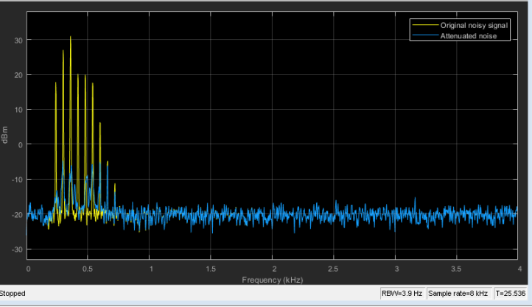
Figure 47: Spectrum Analyzer.

Chapter Six: Conclusions & REALISTIC CONSTRAINTS

6.1 REALISTIC CONSTRAINTS

6.1.1Engineering Standards

A. The completed system will follow all ISO manufacturing at all point throughout the

design and testing of the system.

B. Chosen components are up to all necessary electrical standards.

C. All measurements on the device will follow ANSI standards and be in metric units.

D. The device will be properly tested and use the optimal materials for the application, per

ASTM standards.

E. The product will follow all IEEE standards for electrical components, writing, and signal

6.1.2 Environmental Constraints
. All power wires and electronics will be UL listed to ensure the safety for the system and its operation. B. The product should be able to withstand the voltage and current input and output without overheating, potentially causing off gassing of toxic chemicals. C. The product should not catch fire as this would be extremely dangerous to potential users and their property. D. This design should be well implemented specially the wire of power source that have direct connection to the vehicle’s power engine. Not paying attention in this area can cause problem for the vehicle system itself. E. The device must be able to withstand a temperature range of -45°C to 65°C, the typical interior temperature of a vehicle.
6.1.3 Sustainability Constraints
The product will be configured to draw the least amount of power while consistently providing quality ANC for the vehicle. The vehicle’s battery is charged by the alternator when the vehicle is running.
6.1.4 Manufacturability Constraints
The device will have to be mobile, functional, and easy to be assembled so anyone can use and learn its features.

6.1.5 Ethical Considerations and Constraints
A. Final product and all parts of the system must be manufactured and produced in a workplace that follows the Fair Labor Standards Act (FLSA).
B. If a patent made the final product, it should not make any problem for other component that currently working on the system.
C. The product should follow every legal requirement in manufacturing, usage, marketing, and economic.
D. The product maker cannot be blamed if the use of the Active Noise Control (ANC) system causes the driver to not hear or recognize objects or person outside of the vehicle, which can result in injury or death.

6.1.6 Health and Safety Constraints
A. This product should not overlay the emergency sounds such as closing seat belt alarm, speed limit alert etc.
B. Electrical parts must be checked based of the standards to not be harmful for users such as making problem for engine, car electricity, electric shocks, and fire.
C. Parts of the system should not put the driver on limits of having less visual of road and making risk for driver safety.
D. Also, the system should not remove sounds that came from outside of the car that are required for the driver to know.
6.1.7 Social Constraints
A. The system should not cancel the music inside of the car, interrupt passengers’ conversations and dialogues, and making problems for car assistance such as map speaker guide.
B. The product must be professional and well made to not bring any disturbance for passengers by making extra noises.
C. The design should not interrupt or cancel out any sound feature while they are active in smart and electrical vehicles such as Tesla that their focus of these cars is bringing maximum comfort for the occupants of the cars

6.1.8 Political Constraints
A. This product must be sold through legal markets, so it properly taxed and agreed with the law of each county that this product is selling.
. This product must follow the standards for the similar products on the market, so it reaches the maximum faith and trust for the customers to see this system as a legitimate product.
C. This product must only be sold in markets that they have no limitation for any individual race or believe.

6.2 Conclusions
The comparison between hardware and software methodologies for noise cancellation reveals that the software approach is undoubtedly the superior one. The software exhibits numerous advantages over the hardware. Notably, the software experiences virtually no timing delays, and the computational capabilities of the algorithms in MATLAB are exceptionally rapid. The implementation of the RLS algorithm for cancelling noise in periodic signals achieves near-complete elimination of noise, resulting in a remarkably clear signal. In terms of their fundamental nature, the hardware and software approaches for this project differ significantly. Hardware operates as an active process, wherein noise cancellation occurs simultaneously with noise production. In contrast, the software employs preassembled noise and signal files in conjunction with MATLAB to eliminate noise. A potential enhancement for this project could involve utilizing MATLAB to actively cancel noise in real-time. However, it is worth mentioning that this suggestion is contingent upon further investigation. approaches make it challenging to draw a direct comparison. It is evident that software is most effective in dealing with periodic signals, but its performance is subpar when dealing with non-periodic signals. The accuracy of software is the primary factor contributing to this discrepancy.Both hardware and software have demonstrated success in mitigating noise. The hardware approach effectively yields a greater reduction in noise emission; however, it falls short of completely eliminating the noise. On the other hand, the software approach, employing the Recursive Least Squares (RLS) algorithm, exhibits the capability to entirely eradicate periodic noise. Conversely, the hardware approach outperforms the software methodology when dealing with non-periodic signals, as the latter inadvertently introduces a more cacophonous signal.

References:
[1] Saleh, Adel A.M., "Frequency-Independent and Frequency-Dependent Nonlinear Models of TWT Amplifiers," IEEE® Transactions on Communications, Vol. COM-29, No. 11, November 1981.
[2] Kasdin, N.J., "Discrete Simulation of Colored Noise and Stochastic Processes and 1/(f^alpha); Power Law Noise Generation," The Proceedings of the IEEE, Vol. 83, No. 5, May, 1995.
[3] Kasdin, N. Jeremy, and Todd Walter, "Discrete Simulation of Power Law Noise," 1992 IEEE Frequency Control Symposium.
[4] Sklar, Bernard, Digital Communications: Fundamentals and Applications, Englewood Cliffs, N.J., Prentice Hall, 1988.
[5] Haykin, S., Adaptive Filter Theory, 3rd Ed., Prentice-Hall, 1996.
[6] Sen M Kuo and Dennis S Morgan, ‘Active Noise Control: A Tutorial Review’, Proceedings of the IEEE, Vol. 87, No. 6, June 1999, Pgs 943-973
[7]. Wikipedia.org, ‘Active Noise Control’. Retrieved 11-07-2013
[8]Wikipedia.org, ‘FxLMS Algorithm’. Retrieved 11-07-2013
[9] L. L. Beranek and I. L. Ver, Noise and Vibration Control Engineering: Principles and Applications. New York: Wiley,1992.
[10] Simon Haykin and Thomas Kailath, Adaptive Filter Theory, Pearson Education, 2003
[11] D P Das, S R Mohapatra, A Routray, & T K Basu. ‘Filtered-SLMS algorithm for multi-channel active noise control of nonlinear noise processes’. IEEE Transactions on Audio, Speech and Language Processing (2006), 14(3), 1875–1880.
[12] D P Das & G Panda. ‘Active mitigation of nonlinear noise processes using a novel filtered-S LMS algorithm’. IEEE Transactions on Audio, Speech and Language Processing (2004), 12(3), 313–322
[13] https://www.youtube.com/watch?v=--c0tiIZG6o
[14] https://www.youtube.com/watch?v=mlkAIlL5Bqs
[15] https://www.electronicproducts.com/mouser-electronics-active-noise-cancellation-block-diagram/?fbclid=IwAR0p_UWIP16SQ2HQKiu25MmtZj3vqMACA5biz1quqQS7R__eEwCeBW9VYio
[16] https://rf-power.eetimes.com/?utm_source=popup&utm_medium=website&utm_campaign=rfpower23
[17] https://www.mathworks.com/help/supportpkg/raspberrypi/ref/get-started-with-audio-signal-processing-using-raspberry-pi.html?fbclid=IwAR2wd57IBzfz7ka1HK6WzdNfG_HWMXV_VcsCqPXlYeoRwYboIenU_QWggus
[18] https://www.analogictips.com/active-noise-cancellation-part-1-concept-and-principles-faq/?fbclid=IwAR115j1RU_03CSjHqDpG9MYFUTcYysYTXPkte_Qlvy_UagqC--85wIo8eHQ
[19] https://www.analogictips.com/active-noise-cancellation-part-2-implementation-faq/?fbclid=IwAR2a7Hid7IIIG-Wd_62RD36bv8jlSODpGsjjMyoyC8fsS0IO6yDA_CeY4_M
[20] https://www.mathworks.com/help/audio/ug/active-noise-control-with-simulink.html?fbclid=IwAR22TYfNxa1q8IhjC-5_cnPI3nTSKmhBQTw9zdmRQUtTYHrky0TKM7JiYuw

