

An-Najah National University
Faculty of Engineering and Information Technology
Chemical Engineering Department

Graduation project ΙΙ (10626390)

Life cycle assessment of Carbon nanodots
synthesis from olive solid wastes.

Prepared by:
Hala Awwad
Yara Bustami
Manar Zamel

Supervised by:
Dr. Shadi Sawalha

This project is submitted for partial fulfillment of the requirements of BSc. degree in Chemical Engineering

First semester 2020-2021

December 22, 2020

Abstract
Palestine is considered one of the olive oil producing countries. As the world annual production amount of olive and olive oil reaches 120 and 24 thousand tons respectively, this means that the production of pomace will be large and will impose an environmental damage. Therefore, it is important to think of a process to get rid of this waste, one process is to produce carbon nano dots (CNDs) by processing olive solid waste through several stages.
In this study the environmental impact of the CNDs synthesis was studied by applying life cycle assessment (LCA), and the cost per unit of 1 kg production of CNDs was estimated. Moreover, CNDs synthesis process was compared in terms of its life cycle environmental impacts with two different scenarios used for the treatment and utilization of olive pomace, the two other scenarios are bio-fuel pallets and compost synthesis.
LCA was performed by using Open LCA software, the data base usda 1901009 and the method CML 2001, while the studied environmental aspects were climate change, human toxicity, acidification and eutrophication potential, after that the overall impact scores were estimated to compare between the studied processes.
The results obtained showed that the CNDs synthesis affects the climate change due to carbon dioxide and carbon monoxide emissions during the carbonization stage, and it also contributes to photochemical oxidation impact due to phenol emissions produced from the olive solid waste cleaning stage. On the other hand, the comparison results showed that compost synthesis is the one with the highest environmental impact while bio-fuel pellets is the most environmentally friendly option. It is true that CNDs production is not as eco-friendly as bio-fuel pellets synthesis, but it is the most economically efficient option with a moderate overall environmental impact of 0.3 and a highly competitive cost per unit of $ 9626.1 related to 150 kg annual production.

Contents:

1. Introduction 1
2. Work methodology 3
2.1 Synthesis 3
2.1.1 Synthesis of Carbon Nano-dots 3
2.1.2 Synthesis of Compost 4
2.1.3 Synthesis of Biofuel Pellets 4
2.2 Goal and Scope Definition 4
2.3 Life Cycle Assessment Methodology 5
2.4 System Boundaries 5
2.5 Life Cycle Inventory (LCI) 7
3. Results and Discussion: 9
3.1 Climate change 9
3.2 Acidification potential 10
3.3 Human Toxicity 11
3.4 Photochemical Oxidation 11
3.5 Eutrophication 12
3.6 Overall Impact Scores 12
4. Cost Analysis 15
5. Conclusion 19
6. Reference: 20

List of Figures
Figure 1: Explanation of life cycle assessment[11] 1
Figure 2: CNDs synthesis steps 3
Figure 3: System boundary diagram for proudaction CNDs. 5
Figure 4: System boundary diagram for production of bio- fuel pellets. 6
Figure 5: System boundary diagram for proudaction of compost. 7
Figure 6: Climate change impact for each process in kg CO₂. 10
Figure 7: acidification impact for each process in kg SO₂. 10
Figure 8: Human toxicity impact for each process in kg 1,4-DCB. 11
Figure 9: Photochemical oxidation impact for each process in kg ethylene. 12
Figure 10: Eutrophication impact for each process in kg NO_{x}. 12
Figure 11: Normalized values of all categories for CNDs synthesis. 13
Figure 12: Normalized values of all categories for bio-fuel pellets synthesis. 14
Figure 13: Normalized values of all categories for compost pellets synthesis. 14
Figure 14: Normalized values of all categories for compost pellets synthesis. 15

List of Tables
Table 1 : Inventory data for scenario 1. 7
Table 2: Inventory data for scenario 2. 8
Table 3: Inventory data for scenario 3. 9
Table 4: Fixed capital investment 15
Table 5: variable cost of production. 16
Table 6 : fixed cost of production. 17
Table 7: Characterization expense. 18
Table 8: Table showing price change with the annual CNDs output 18

Introduction
Carbon nano-dots (CNDs) are defined as small carbon nano scale bodies less than 10 nanometers in size [1]. However carbon is a black substance with low solubility in water and fluorescence[2]. A-wide attention has been focused on carbon nano-dots because of their good solubility and strong luminescence, for which they are referred to as carbon nano lights[3]. CNDs are distinguished by several characteristics, the most prominent of which are bright brilliance, low cost[4], ease of synthesis , also has a high solubility in water and very low toxicity[5], high sensitivity to the external environment, chemical inertness and wide range light absorption[6].
Carbon nano-dots have many important applications, the most prominent of which is drug delivery, bio-imaging, microfluidics marker, light emitting diode (LED), sensing, and logic gates[7]. Most of CNDs are synthesized through simple routes(top –down or bottom up ) and by using different precursors either of natural origin or man-made starting materials [8].
CNDs as new emerging carbon nano-allotropes, their synthesis processes from different recourses could adversely affect the environment, but this is still unclear. Therefore, life cycle assessment (LCA) could be a useful tool to measure a product, process or activity's environmental load during the life cycle of CNDs [9]. LCA assesses the potential environmental impacts throughout the life cycle of the product starting from the stage of production or extraction of raw materials and through the different stages of the production[10], furthermore , the distribution and uses until the stage of disposal of the product are considered in studying LCA (see Figure 1) .
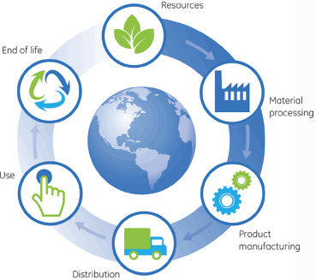

Figure 1: Explanation of life cycle assessment[11]
LCA is a methodological framework that quantifies all the environmental impact caused by a product or a process during the life time of a product [11].
Moreover, life cycle assessment is a study that determines the environmental impacts of emissions of some harmful gases such as nitrogen oxide, carbon dioxide, and other gases that are determined according to the nature of the product and the stages it goes through during manufacturing. It also determines the impact of these emissions on water and soil [12].
The performed LCA studies are conformed to the international standards ISO 14040 and 14044, respectively. As specified by ISO 14040 and ISO 14044, life cycle assessment is the compilation and evaluation of the inputs and outputs and the possible environmental impacts of a product system during the lifetime of a product [13].

In this work, the LCA will be applied to the process of CNDs production from olive solid wastes. The LCA herein will be applied gate-to-gate covering all the process steps which mainly consists of cleaning, drying, carbonization, oxidation, centrifugation, filtration and lyophilization. All inputs except the olive solid waste will be considered in performing the LCA. Furthermore, the cost per unit of produced CNDs will be estimated. Besides the LCA of CNDs, LCA have been done for other two scenarios of the treatment and utilization of olive pomace. The first scenario is the production of bio- fuel pellets and the second is the compost preparation. A comparative analysis of the environmental impacts will be compared between the different scenarios.
The life cycle assessment carried in this project will be conformed to the ISO14040 system too.

2. Work methodology
In this section, the synthesis processes, goal and scope of the LCA study, the methodology used and life cycle inventory (LCI) related to different utilization scenarios of olive solid waste are provided.

2.1 Synthesis

2.1.1 Synthesis of Carbon Nano-dots
CNDs were prepared by pyrolysis of olive solid wastes (OSWs) at 600°C for 1hr [14]. Firstly, OSWs were purified from residual oil and impurities by the mean of Soxhlet extraction using hot water at 90° C. Afterwards the OSWs were pyrolyzed (carbonized) into carbonized olive solid wastes (COSWs). After cooling to room temperature COSWs were mechanically ground into fine powder. 0.1g of the obtained powder was dispersed in 10 ml of deionized water containing 150µl of 30 wt% H₂O₂ solution prepared in and oxidized for 90 min under refluxing. CNDs were separated from larger carbon particles by centrifugation at 8000 rpm (9900 rcf) for 20 min. The supernatant was collected and filtrated through 0.2 µm microfilter. Finally, the CNDs were lyophilized for 36 hrs to obtain a dry brown powder.
After purification and lyophilization, CNDs are obtained with a production yield of 10%. The unreacted residual COSWs can be recycled and used as a precursor for a new batch, minimizing or eliminating the waste byproduct of the reaction[15]. A schematic diagram showing, detailed steps is illustrated in Figure 2.
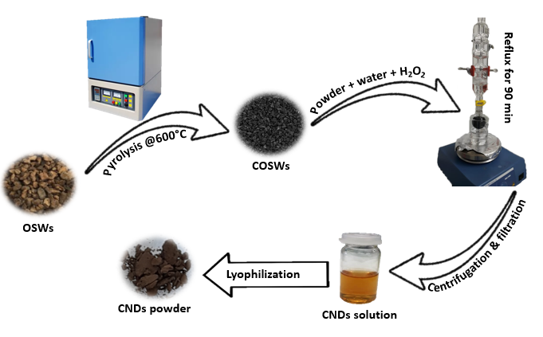
Figure 2: CNDs synthesis steps
The above process will be scaled up to 1kg of CNDs production to perform the LCA analysis, therefore, all inputs outputs will be scaled. The results will be presented in the inventory section.

2.1.2 Synthesis of Compost

2.25 kg of solid olive waste is used to synthesize 1 kg of compost by mixing 0.34 kg of white straw and 0.67 kg of poultry manure. The amount of water used through the process was 4.19 kg and the energy was 1.85 MJ [16].

2.1.3 Synthesis of Biofuel Pellets
3.96 kg of solid olive waste is used to synthesize 1 kg of bio-fuel pellets. The process began with drying and then extraction using 0,001 kg of hexane. The amount of energy that was used through the process was 1.43 MJ [16].

2.2 Goal and Scope Definition
The goal and scope definition of the LCA is to provide a description of the product system in terms of the system boundaries and a functional unit[17]. The stated primary goal of the functional unit in LCA is to ensure comparability of LCA results[18].

Goal definition and scoping is identifying the objective of the LCA and the study's expected products and deciding the boundary (what is and is not included in the study) and assumptions based on the description of the target

The goal and scope of the project is to determine the potential environmental impacts during production of the carbon nano dots from olive solid wastes by applying gate to gate LCA. The functional unit was defined as 1 kg production of carbon nano dots.

There are other alternatives for utilizing olive solid wastes, for example; Synthesis bio fuel pellets and using olive solid waste as a compost. As for the CNDs, the function unit for both products from the two scenarios is also1 kg production.

2.3 Life Cycle Assessment Methodology
The LCA is carried in this project by the use of open LCA software version 1.10.3 with the data base type select usda-1901009 and using CML 2001 method. This study is based on a gate-to-gate approach. The impact on the following environmental categories were considered in this study:
Climate change GWP 100a, human toxicity- HTP100a, photochemical oxidation, acidification potential, eutrophication potential.

2.4 System Boundaries
The system boundary of a process is often illustrated by a flow diagram showing the main input and output streams. Figure 3 shows the system boundary of the carbon nano dots synthesis, showing the input and output in each stage.
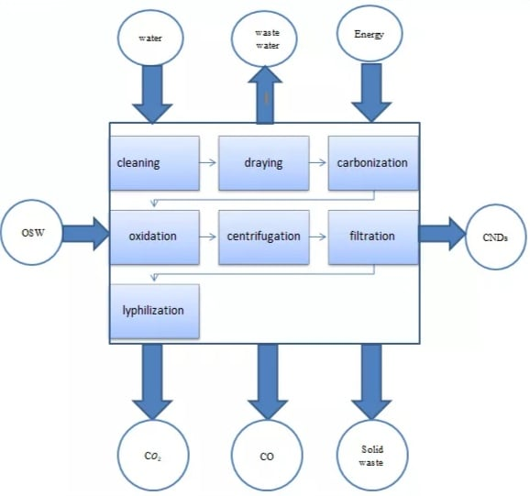

Figure 3: System boundary diagram for proudaction CNDs[16].
Figure 4 and Figure 5 respectively show the system boundaries for the production of bio fuel pellets and the production of compost from olive solid wastes

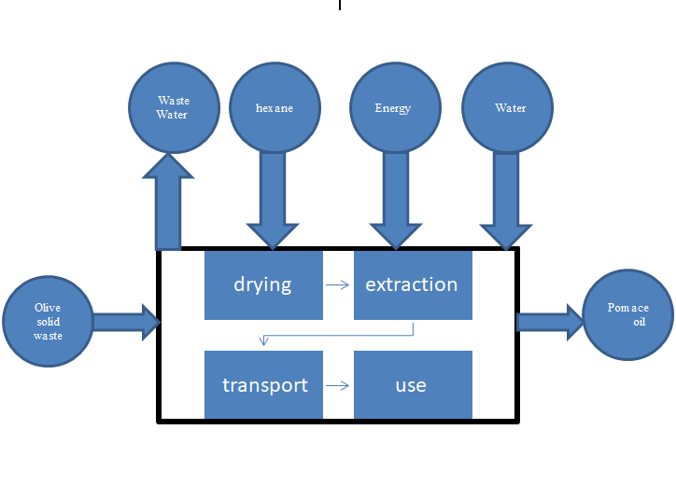

Figure 4: System boundary diagram for production of bio- fuel pellets[16].

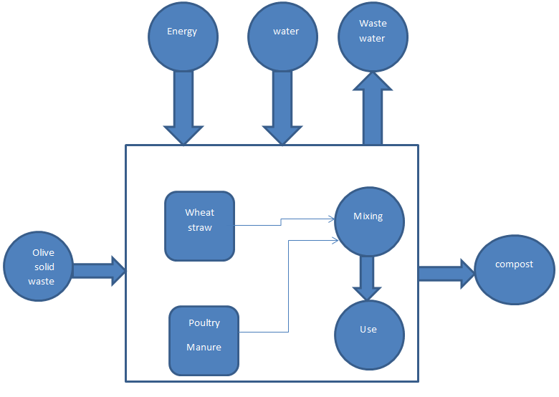
Figure 5: System boundary diagram for proudaction of compost[16].

2.5 Life Cycle Inventory (LCI)
In this study all data, both mass and energy inputs/outputs regarding the production of CNDs, have been estimated by performing mass and energy balance calculations. The life cycle inventory (LCI) data for scenario 1 (CNDs synthesis) are presented in Table 1. Table 1 contains the amounts entering and leaving the process in addition to the quantities of energy needed.

Table 1 : Inventory data for scenario 1.
Flow | category | Amount  (Inputs/outputs)
Paper, free sheet  CO | Paper/pulp  Emission to air | 0.00240 kg  4.0700 kg
Waste water/out | Emission to water | 120 L
H₂O₂ | Emission to air | 16.98 L
Water vapor | Emission to air | 1049.80 kg
CO₂ | Emission to air | 4.41 kg
CNDs |  | 1 kg
Phenol  Total electricity | Emission to water  utilities | 0.77 kg  70.2 kWh

As for the life cycle assessment of biofuel pellets synthesis, the used data is obtained from a study that was conducted in Turkey[16]. Table 2 shows the inputs and outputs of biofuel synthesis process which were used in LCA.

Table 2: Inventory data for scenario 2.
Flow | Category | Amount (inputs/outputs)
Carbon dioxide | Emission to air | 0.7314 kg
Carbon monoxide | Emission to air | 0.06210kg
Disposal | Waste management | 0.84 L
Hexane | Emission to water | 0.00069 kg
Sulfuric peroxide | Emission to air | 0.6200 g
Heat, natural gas  Electricity  Biofuel pellets | Heat/ gas  Total utilities | 0.53130 MJ  0.6554 MJ  1 kg

Finally, the third scenario is related to the study of compost effect. The information used and input into the LCA software are shown in Table 3.
Table 3: Inventory data for scenario 3.
Flow | Category | Amount (inputs/outputs)
Wheat straw | Crop production | 0.16290 kg
CUTOFF poultry manure | Water supply | 0.32093 kg
Methane | Emission to air | 0.00958 kg
Ammonia | Emission to air | 0.00029 kg
carbon monoxide  Nitrous oxide  Phosphorus fertilizer | Emission to air  Emission to air  fertilizers | 0.00024 kg  0.00958 kg  0.03353 kg
Electricity | utilities | 0.40233 MJ
Compost 1 kg

The following assumptions have been made during the calculations for CNDs production (scenario 1):
- In the cleaning stage, the amount of phenol is calculated based on its content in olive solid waste and its solubility in the water which is equal to 0.08 g/ml[19].
- In the carbonization stage it was assumed that 60% of the amount would be converted to volatile matters (CO2, CO, … etc.).
- In the centrifugation stage the solids are completely separated.
- In the filtration stage, it was assumed that there was a loss of 2%.

3. Results and Discussion:

An environmental impact comparison was done using Open LCA program between three processes which are CNDs, bio-fuel pellets and compost synthesis. The categories which have been studied are climate change (global warming potential), photochemical oxidation, human toxicity, acidification and eutrophication potential.

Climate change
The global warming potential results for each one of the studied processes is illustrated in figure 6.

Figure 6: Climate change impact for each process in kg CO₂.

As shown in figure 6, bio-fuel pellets have no environmental impact as it does not include any fossil carbon dioxide emissions during the synthesis, while both CNDs and compost production emits carbon dioxide and carbon monoxide, as for CNDs synthesis the climate change impact could be ascribed to the carbonization process.

Acidification potential
In terms of acidification potential, the environmental impacts are plotted in figure 7.

Figure 7: acidification impact for each process in kg SO₂.
As shown in figure 7, both CNDs and bio-fuel pellets synthesis processes are considered environmentally friendly when talking about acidification potential as there is no expected acidification effect for CNDs, and minimum impact for bio-fuel pellets production due to sulfur dioxide emissions during combustion. On the other hand, compost production process includes acidification impact due to ammonia emissions.

Human Toxicity
As for the probability of human toxicity the obtained results are shown in figure 8.

Figure 8: Human toxicity impact for each process in kg 1,4-DCB.
It was noticed that CNDs synthesis is a process at which no toxic emissions occur, while the compost manufacturing process is the most hazardous one as it includes some ammonia emissions which is considered toxic. Bio-fuel pellets on the other hand are less toxic, the human toxicity impact is due to sulfur dioxide emissions produced after using the pellets.

Photochemical Oxidation
The photochemical oxidation category was also studied and the results obtained are shown in figure 9.

Figure 9: Photochemical oxidation impact for each process in kg ethylene.
It was observed that bio-fuel pellets and compost synthesis processes have low environmental effects in terms of Photochemical oxidation, while CNDs production leads to some environmental effects as a certain amount of phenol is produced during the olive solid waste cleaning process.

Eutrophication
The following figure shows the obtained results in terms of eutrophication impact assessment.

Figure 10: Eutrophication impact for each process in kg NO_{x}.
It was noticed that the only process related to eutrophication is compost production due to certain amount of ammonia emitted to air which in their turn can afterwards create this issue.
In Palestine olive solid waste exists in abundance amount and endangers the surrounding environment, thus a treatment process is needed. Based on the results obtained from this study, CNDs synthesize process, unlike both bio-fuel pellets and compost synthesize processes, produce an eco-friendly product which has multiple applications and almost mild environmental effects. Also, this process is not associated with any human toxicity or eutrophication, thus is considered the most valid one.

Overall Impact Scores

The overall impact score was estimated in order to make a clear comparison between the studied procedures and to obtain the environmental impacts in a value between 1 and -1, since without normalization different categories will have different orders of magnitude. First, the normalized impacts for each process and each category were estimated by dividing each impact of a category over the square root of the sum of squares [16] of all impacts related to that particular category. Figure 11 shows the normalized impacts of CNDs synthesis.

Figure 11: Normalized values of all categories for CNDs synthesis.
It was noticed that CNDs synthesis is the main influential process in terms of global warming and photochemical oxidation impacts, while is not related to any of the other environmental impacts.

Figure 12 shows the normalized impacts of bio-fuel synthesis.

Figure 12: Normalized values of all categories for bio-fuel pellets synthesis.
As shown in figure 12, bio-fuel synthesis is related to human toxicity, photochemical oxidation and acidification impacts.

Figure 13 shows the normalized impacts of compost synthesis.

Figure 13: Normalized values of all categories for compost pellets synthesis.
Figure 13 clearly indicates that compost synthesis is the main effective process in terms of causing eutrophication, acidification and human toxicity effects, and it is also related to the other studied environmental impacts including climate change and photochemical oxidation, therefore it is expected to have the largest environmental effect among the studied processes.
After that, since eutrophication and human toxicity are considered as the most destructive effects, the impact weights were assumed as: 30% human toxicity, 10% climate change, 30% eutrophication, 20% photochemical oxidation and 10% acidification. Then, the overall score of each process was calculated by multiplying the normalized impacts by the given weights for each particular impact. Figure 14 shows the overall impact scores of the studied processes.

Figure 14: Normalized values of all categories for compost pellets synthesis.
According to the obtained results, which are shown in figure 14, compost synthesis is the process with the highest environmental effect while bio-fuel synthesis is considered as the most eco-friendly option. On the other hand, CNDs appears to lie in between, however it is the most economically efficient option as will be in cost analysis section.

4. Cost Analysis

Cost analysis was performed to estimate the cost per unit (1 kg CNDs production), including variable and fixed expenses of production in addition to depreciation.
The fixed investment cost includes the ISBL and OSBL, which cover the cost for all equipment’s used in the process of CNDs synthesis, which are drying oven, muffle furnace, sonication bath, heating plate, reflux condenser, centrifuge and Freeze dryer. Then, the OSBL was assumed as 40% of ISBL. (OSBL: all expenses paid for the preparation of the infrastructure)
Table 4 shows the fixed capital cost of all equipment’s being used throughout the CNDs synthesis.

Table 4: Fixed capital investment
 | Instrument |  | cost ($)
 | Drying Oven |  | 1000
 | Muffle furnace |  | 3000
 | Sonication bath |  | 300
 | Heating plate |  | 200
 | reflux condenser |  | 20
 | Centrifuge |  | 1000
 | Freeze dryer |  | 2500
 | Total |  | 8020
 | Installation (20%)  Inside battery limits investment |  | 1604  9624
 | OSBL (40% ISBL) |  | 3849.6
 | Total Fixed Capital Investment |  | 13473.6

On the other hand, the variable cost includes the cost of all input materials which are olive solid waste, distilled water and hydrogen peroxide with 30% concentration. It also includes the cost of consumed filters, electricity and packaging expenses.
Table 5 shows the variable cost estimation.

Table 5: variable cost of production.
Item | Unit |  | Price /unit | Quantity |  |  | Total $/kg  CNDs
Olive solid waste |  | Kg | 0.15 | 14.9 |  |  | 2.2
Hydrogen peroxide (30%) |  | L | 117.5 | 15.3 |  |  | 1797.8
Distilled water |  | L | 3 | 1169 |  |  | 3507.0
Consumables (filters, ….) |  | 5% raw materials |  |  |  |  | 265.3
Packaging |  | 100 ml size |  | 10000 |  |  | 1500.0
Electricity |  | kWh | 0.27 | 70.2 |  |  | 19.0
Total |  | $ |  | 15.3 |  |  | 7091.3

Fixed cost of production:
Table 6 includes the fixed cost production estimation results. It is important to mention that the price of labor was assumed as indicated in the table, also a percentage of the price of the supervision expense were assumed. Other fixed costs were calculated based on percent’s of labor and supervision as illustrated in Table 6[20].
Table 6 : fixed cost of production.
Item | Note | Price/year | Quantity | Total/year
Labor | - | 12000 | 1 | 12000
Supervision | - | 18000 | 1 | 18000
Direct salary | 40% of labor and supervision | - | 0.4 | 12000
Maintenance | 5% of ISBL | - | 0.05 | 481.2
Property taxed and insurance | 2% of ISBL | - | 0.02 | 192.48
Rent | - | 3000 | 1 | 3000
General overheads | 65% tot. Labor | - |  | 27781.2
Allocated Environmental charges | 1% (ISBL+OSBL) | - | 0.01 | 134.736
Running License | 10% ISBL | - | 0.1 | 962.4
Total |  |  |  | 74552.016

Characterization expense:
Herein are the expenses of CNDs characterizations, three CNDs samples will be tested in order to assess their quality. The tests include Transmission Electron Microscopy Testing (TEM), X-ray Photoelectron Spectroscopy (XPS), Fourier Transform Infrared Spectroscopy (FTIR) and UV-Vis test. Table 7 shows those tests expenses in ($).

Table 7: Characterization expense.
Test |  | Cost$
TEM | 1 sample | 425
XPS | 1 sample | 200
Fluorescence | 1 sample | 20
UV-Vis | 1 sample | 15
FTIR | 1 sample | 15
Total | 1 sample | 675
 | 3 samples | 2025

Depreciation:
The depreciation was estimated as 20% of ISBL expenses for 1 kg of production
Table 8 shows the cost per kg of CNDs at different amount of annual production including all previous estimated costs (variable, fixed and depreciation)

Table 8: Table showing price change with the annual CNDs output
Annual production (kg) |  | 1 |  | 5 | 10 | 20 | 50 | 100 | 150
Cost per 1kg  of CNDs |  | 85593.1 |  | 24411.7 | 16763.9 | 12940.1 | 10645.8 | 9881 | 9626

Table 8 also shows that the cost of producing 1 kg of CNDs in this project is equal $85593.1 that is equivalent to 275609.8 ILS. It is assumed that the selling price of 1 kg CNDs is twice the cost of production, that would be about 551219.6 ILS, this price still very low in comparison to its global price. For example, the Israeli company MeRck sells 10 ml of CNDs with a concentration of 0.2% at a price of 908 ILS. That means, 1kg of CNDs is worth 45.4 million ILS. This is a very high price and can be described as fictional compared to the initial price that was set to 1 kg of CNDs produced using the process described in this study.
As for eBay, CNDs are sold at a price of 112.54 ILS per each 15 ml, that means a kilogram would be sold for about 5.6 million ILS, which is still very expensive. According to the selling prices obtained from both MeRck and eBay websites, the global price range of CNDs can be considered as (5- 46) million ILS, while the suggested selling price of CNDs produced by processing olive solid waste, using the previously mentioned synthesis process, is around 551219.6 ILS. This product is therefore considered with low cost, as its selling price is much lower than the minimum international range of 5 million ILS, and it will remain so even if it is sold with a higher profit margin.

Conclusion

In this study, the life cycle environmental impacts of utilizing olive pomace, which is created as a result of olive oil production, were estimated. Open LCA software and CML2001 method were used. Three different scenarios were compared which are the synthesis of CNDs, biofuel pellets and compost from olive pomace, at which a gate-to-gate approach was employed. The calculated normalized impact scores showed that CNDs synthesis scenario is the most influential one in terms of climate change and photochemical oxidation due to phenol, carbon dioxide and carbon monoxide emissions, while in terms of human toxicity, acidification and eutrophication, compost synthesis scenario is the one associated with the largest environmental damage due to ammonia gas emissions. Also, the scenario involving fuel pellet production turned out to have the lower environmental impacts. While on the other hand, the compost synthesis is the one with the highest environmental impact, meaning that CNDs synthesis process lies in between. In this study, the estimated cost of producing 1kg of CNDs was equal to $ 9626.1, while when searching for the global price, every 10 ml CNDs are sold at about $ 281.48. From that, we can note that if the product in our study was sold at this price, the interest would be excellent and exceeds by far any other treatment processes. Also, it is possible to sell the product at a bit lower price, which would make it more economical and preferable to consumers.

Reference:

1. Shen, L.-M. and J. Liu, New development in carbon quantum dots technical applications. Talanta, 2016. 156-157: p. 245-256.
2. Das, R., R. Bandyopadhyay, and P. Pramanik, Carbon quantum dots from natural resource: A review. Materials Today Chemistry, 2018. 8: p. 96-109.
3. Wang, Y. and A. Hu, Carbon quantum dots: synthesis, properties and applications. Journal of Materials Chemistry C, 2014. 2(34): p. 6921-6939.
4. Li, D., et al., Supra-(carbon nanodots) with a strong visible to near-infrared absorption band and efficient photothermal conversion. Light: Science & Applications, 2016. 5(7): p. e16120-e16120.
5. Devi, P., S. Saini, and K.-H. Kim, The advanced role of carbon quantum dots in nanomedical applications. Biosensors and Bioelectronics, 2019. 141: p. 111158.
6. Sciortino, A., A. Cannizzo, and F. Messina, Carbon Nanodots: A Review—From the Current Understanding of the Fundamental Photophysics to the Full Control of the Optical Response. C, 2018. 4(4): p. 67.
7. Xiao, L. and H. Sun, Novel properties and applications of carbon nanodots. Nanoscale Horizons, 2018. 3(6): p. 565-597.
8. Lim, S.Y., W. Shen, and Z. Gao, Carbon quantum dots and their applications. Chemical Society Reviews, 2015. 44(1): p. 362-381.
9. Roy, P., et al., A review of life cycle assessment (LCA) on some food products. Journal of Food Engineering, 2009. 90(1): p. 1-10.
10. Joshi, S., Product Environmental Life-Cycle Assessment Using Input-Output Techniques. Journal of Industrial Ecology, 1999. 3(2‐3): p. 95-120.
11. Brusseau, M.L., Chapter 32 - Sustainable Development and Other Solutions to Pollution and Global Change, in Environmental and Pollution Science (Third Edition), M.L. Brusseau, I.L. Pepper, and C.P. Gerba, Editors. 2019, Academic Press. p. 585-603.
12. Miettinen, P. and R.P. Hämäläinen, How to benefit from decision analysis in environmental life cycle assessment (LCA). European Journal of Operational Research, 1997. 102(2): p. 279-294.
13. Guinée, J.B., et al., Life Cycle Assessment: Past, Present, and Future. Environmental Science & Technology, 2011. 45(1): p. 90-96.
14. Sawalha, S. and A. El-Hamouz, Improvements of the Tensile Properties of Recycled High Density Polyethylene (HDPE) by the Use of Carbonized Olive Solid Waste. Polymer-Plastics Technology and Engineering, 2010. 49(4): p. 387-393.
15. Sawalha, S., et al., Tailoring the sensing abilities of carbon nanodots obtained from olive solid wastes. Carbon, 2020. 167: p. 696-708.
16. duman, A., G. Özgen, and F. Uçtuğ, Environmental life cycle assessment of olive pomace utilization in Turkey. Sustainable Production and Consumption, 2020. 22.
17. Rebitzer, G., et al., Life cycle assessment: Part 1: Framework, goal and scope definition, inventory analysis, and applications. Environment International, 2004. 30(5): p. 701-720.
18. Esterman, M., Jr., et al. A Framework for the Integration of System Engineering and Functional Analysis Techniques to the Goal and Scope of Life Cycle Assessment. in ASME 2012 International Design Engineering Technical Conferences and Computers and Information in Engineering Conference. 2012.
19. Realini, P.A., Determination of Priority Pollutant Phenols in Water by HPLC. Journal of Chromatographic Science, 1981. 19(3): p. 124-129.
20. Sinnott, R.K., J.M. Coulson, and J.F. Richardson. Coulson & Richardson's chemical engineering. Vol. 6, 5 th edition2009,Butterworth-Heinemann
.

