

An-Najah National University
Faculty of Engineering and Information Technology Computer Engineering Department
Graduation Project 2

Milkshake Factory


Prepared By:

Osama Salah
Mohammad Kittani

Supervisor:
Dr. Anas Toma

Presented in partial fulfillment of the requirements for the Bachelor’s degree in Computer engineering

February 3, 2025

Acknowledgment
Always and forever, praise be to Allah, Lord of the Worlds, and prayers and peace be upon the most honorable of the prophets and messengers. Thanks to God and His success to us, we were able to complete our second graduation project successfully and distinguishably. We thank Allah Almighty for the blessings He has bestowed on us. As the product of this distinguished project is nothing but the generosity and grace of God on us. And we ask God Almighty to help us in our scientific and practical lives.
We offer special thanks to our dear parents and friends for their support and encouragement to do this beautiful project, and this encouragement and motivation is what supported us and motivated us to patience and continuity in working hard and diligently and feeling the hope of achieving our dreams. Your love is in our hearts.
We also express our deep thanks to our respected supervisor, Dr.Anas Toma for his support and valuable guidance during the construction of the project from the first step until the end of our graduation project, where his guidance and constructive criticism played a major role in the success and progress of the project. Words are unable to describe and express our gratitude to our respected supervisor. Thank you for your continuous support to us, which has increased our knowledge.

Disclaimer Statement
This report was written by a team consisting of two students at An-Najah National University, Department of Computer Engineering, Osama Salah and Mohammad Kittani. We continue our studies at An-Najah National University. The authors acknowledge full responsibility for any errors identified within. The ideas, suggestions, findings, and opinions expressed in this paper solely belong to the authors and do not reflect the viewpoint of An-Najah National University.

Contents
Contents
Acknowledgment 2
Disclaimer Statement 3
Contents 3
Abstract 4
Introduction 5
2.1 Statement of the problem 5
2.2 Objectives of the work 5
2.3 Scope of the work 5
2.4 Significance of our work 6
2.5 Organization of the report 6
Constraints, Standards/Codes and Earlier course work 7
3.1 Constraints and limitations 7
3.2 Standards and Codes 8
3.3 Earlier coursework 8
Literature Review 9
Methodology 10
5.1 Hardware Components 10
5.2 Hardware Implementation 20
Results and Discussion 21
Conclusion and Recommendation 22
7.1 Conclusion 22
7.1 Summary 22
7.1 Recommendations 22
7.1 What we have learned 23
7.1 Future work 23
8.References 23

List of Figures

Figure 5.1: Arduino Mega2560……………………………………………………..…………………………………………………12
Figure 5.2: WiFi ESP. ……………………………………………………..……………………………………….………………………13
Figure 5.3: Stepper motor name 17. ……………………………………………………..………………….……………………14
Figure 5.4: Water Pump. ……………………………………………………..…………………………………………………………14
Figure 5.5: Pump Connection. ……………………………………………………..…………………………………………………14
Figure 5.6: Water Pump Connection. ……………………………………………………..………………………………………15
Figure 5.7: Ultrasonic sensor. ……………………………………………………..…………………………………………………15
Figure 5.8: Ultrasonic sensor Connection. ……………………………………………………..………………………………15
Figure 5.9: LCD 16*4 With I2C. ……………………………………………………..……………………………………………….16
Figure 5.10: LCD 16*4 With I2C Connection. ……………………………………………………..…………………………..16
Figure 5.11: 4*4 Keypad. ……………………………………………………..………………………..………………………………16
Figure 5.12: 5 volt Relay. ……………………………………………………..………………………………..………………………17
Figure 5.13: Water tubes. ……………………………………………………..…………………………………….…………………17
Figure 5.14:IR sensore. ……………………………………………………..……………………………………………………………18
Figure 5.15: H-bridge. ……………………………………………………..……………………………………………………..………19
Figure 5.16:A4988 driver. ……………………………………………………..…………………………………………………….…19
Figure 5.17: DC-Motor. ……………………………………………………..………………………………………………..…………20
Figure 5.18: RF-ID. ……………………………………………………..………………………………………………………………….20
Figure 5.19: Power Supply. ……………………………………………………..…………………………………………………..…21
Figure 5.20: Electrical Wires. ……………………………………………………..………………………………………………..…21
Figure 5.21:Final Design. ……………………………………………………..……………………….………..………………………21
Figure 5.22:Web Page. ……………………………………………………..…………………………….………..……………………22
Figure 5.23:Block Diagram. ……………………………………………………..……………………….…….………………………23

Abstract
The Milkshake Factory project is a modern physical device that automates shake fabrication and packaging processes. The components of this system are very user-friendly, which makes the installation process effortless. The milkshake milkshake maker is highly customizable and ergonomic. The reliable components used by the device guarantee that every serving of milkshake is of top quality standards apart from being very flexible to changes depending on the users requirements.
The device is composed of four sequential units, each of which is manufactured and organized in a manner that enhances their efficacy and uniformity:

Cup Dispensing & Selection:
Everything is initiated by an automated cup dispenser, which chooses and places a cup on the feed conveyor. At this point, users can finely tune the composition for their milkshake by recently introduced percentage of the various ingredients that are going to be put in, all of which are available in varying quantity. All these selections are under the supervision of a control unit, which makes the required adjustments so that there is no invariant in the milkshakes made by different users.

Ingredient Dispensing:
Having the cup put on a moving conveyor belt initiates its movement towards an ingredient addon section. At this place, milk, Oreo any other ingredients in the specified recipe are poured into the mixer as per the set measurement. This is a vital stage as it maintains the balance of ingredients and keeps the taste and texture uniform.
Mixing process:
After the ingredients are added, they flow into the mixer, where the blending process begins. The cup itself remains separate at this point, waiting to receive the final product. Inside the blending station, the ingredients are thoroughly mixed to achieve the desired creaminess and consistency. This process ensures that all components are evenly incorporated, preventing layering or separation.
Once the mixing is complete, the perfectly blended milkshake is poured into the cup, ensuring a smooth, high-quality texture. The system is designed to minimize splashing and maintain hygienic handling throughout the process. The final product is now ready to proceed to the sealing and packaging stage, where it will be covered and prepared for serving.
Sealing and Packaging:
Finally, the shake is sent to the cup sealing unit which applies a lid on the cup in a machine, readying it for serving or takeaway. This eliminates any hygienic problems and spills as well as makes it easier to carry without losing freshness.

Introduction

Statement of the problem
Crafting milkshakes with bare hands proves to be a tedious task and can result in inconsistent taste and lack of quality. Many companies find it challenging to measure components precisely which subsequently slows down the drink preparation rate, especially when an influx of clients hits it.
Primitive techniques can result in mistakes, loss of ingredients, and additional waiting time, making it difficult to meet the need. Customers also desire to have personalized milk shakes and that is where the majority of the systems spring issue which is the accurate measurement of ingredients.
The Milkshake Factory is a solution to these concerns through automating the milkshake making process. This guarantees improvement in quality, production rates, and customization features, thus allowing customers to design their dream milkshakes effortlessly.

Objectives of the work

Through the Milkshake Factory project, the goal is to develop a machine that produces milkshakes and makes the whole process easier while not compromising on quality and productivity. The system’s key features are cup dispensing, adding ingredients, mixing the milkshakes, and sealing the cups. It aims to ensure milkshakes have the same taste and texture, to increase output to meet demand, and to reduce waste by using more precise measurements. Additionally, the project focuses on allowing users to customize their milkshakes by changing the percentage of the ingredients used. This will all be done on an easy to use interface.

Scope of the work

The Milkshake Factory project constitutes a complete automated system to make milkshakes-from ingredient selection to packaging the end product. The system affords a user customizable recipes of milkshakes and automates the vital steps of cup dispensing, ingredient addition, mixing, and sealing.

The project hence involves the hardware designing including conveyors, ingredient dispensing, and software control of the system. It will thus help small and medium industry milkshake-making operations to cut production time and consistently make quality milkshakes while reducing their wastage. The project will not concern large-scale industries for production or provide customer-order-recuperating features.

CHAPTER 2. INTRODUCTION 2.4. SIGNIFICANCE OF OUR WORK

Significance of our work
The big significance of The Milkshake Factory project is that it solves practical problems. Firstly, it solves the problem of inconsistency in taste and long preparation time of a milkshake. The entire process is automated and therefore ensures consistent quality of each milkshake while reducing manual labor and making production efficient.
Moreover, the ability to customize milkshakes to precise ingredient ratios meets the increasing consumer need for personalization. It allows a business to serve special milkshakes according to individual tastes while using less raw material.
This project would finally prove itself cost-efficient and scalable to suit small to medium businesses and help save time, create customer satisfaction, and maintain high-quality standards.

Organization of the report

There are several sections in this report. The first part is a summary of the entire project, stating what will be included.
The next section gives a brief description of the scope and limitations of the study.
The third section discusses the approach and methodology adopted by the project, outlining the steps that were followed in executing it.
The fourth section summarizes the results and findings obtained from the study, including challenges encountered, and how they were overcome. The fifth section explains the relevance or potential implications of the project. Finally, the conclusion summarizes the main points highlighted and gives recommendations for future projects. The appendices include additional resources, lists, and specific project-related information.
Most importantly, through various sections, this report is organized.
The first part purports to restate everything that is to be covered in the entire project. The next section will provide a very short overview of the scope and limitations of this study. Section three discusses the approach and methodology adopted by the project, and outlines the steps that were followed in executing it. The fourth section talks about the results and findings obtained from the study, including the challenges encountered, and how they were solved.
The fifth section explains the relevance or potential implications of the project. Finally, the conclusion summarizes the main points highlighted and gives recommendations for future projects.
The appendices are intended to include other resources, lists, and specific project-related informati

Chapter 3

Constraints, Standards/Codes and Earlier course work

Constraints and limitations
    - Time limitation: We faced big challenges while finishing this project in the Autumn term, as it was our first time building a complete big system with many mechanical and electronic parts we hadn’t worked with before. These parts needed a lot of power and different voltage levels (3.3 V, 5 V, 12 V, 220 V). We had to figure out the overall system structure, pick the right parts, and learn how to use them. We also had to get familiar with Arduino and write code for the hardware, then put together the whole system.
    - Project Size and Weight: Due to the relatively large scale of the design, we encountered an issue of not being able to transport it and carry out the work elsewhere apart from the university. After installing most of the mechanical components in their respective positions, our main work was scheduled during specific hours, including university working hours, which caused some delays in our progress to some extent.
    - Safety and Security: Due to the project’s concept, we were compelled to utilize liquids as a fundamental element in representing the project. Additionally, mechanical and electrical components were employed that only operate at a voltage of 220. Therefore, testing the project, given its inclusion of potent water, milk, and electricity, was a delicate matter that required precision and attention.
    - Precision and Attention: Our project includes various processes such as pouring water into the mixer as well as milk and other components like oreo, vanilla, cerelac, and biscuits. All this required accurate process calibration of many mechanical components. Such accuracy is necessary for its proper functioning due to the great variety of components used. In addition, we crafted the design of the project by hand using wooden and plastic pieces. The project is designed with precision, safety, and skill.

    - Power Distribution: As we talked about earlier, this is the first time we’ve taken on such a big project. This led to a problem with powering all the parts we’re using to build it. These parts need different amounts of electricity and voltage. For example, we employed three pumps and two DC motors that operate at 12 volts, five steeper motors that operate on 5 and 12 volts and mixer that operates on 220 volts

Standards and Codes
A developed Arduino program is one of the software components of the project. Numerous libraries and functions are integrated into this application, including, Arduino.h, Keypad.h, LiquidCrystalI2C.h, wire.h, WiFi.h, webserver.h, MFRC522.h and SPI.h. Furthermore, web platform was used in the creation of the UI. Standards and recommendations relevant to the industry were followed in the design and implementation of the system’s software components.

Earlier coursework
The Microcontroller Using PIC Controller course was really helpful since it improved our knowledge of microcontroller programming, which was crucial for creating our Arduino Mega-powered device.
We taught how to work with various components and use tools like I2C for LCDs. The code for the Milkshake factory, which included the required algorithm, was effectively constructed by us.We needed to attend an Arduino course in order to develop the Milkshake factory since it equipped us with the skills necessary to use the Arduino Mega board. In order to create the control system, the course gave us hands-on experience programming and troubleshooting the Arduino board.
Additionally, one of the most crucial things that enabled us to think appropriately when building the project was the research and critical thinking skills training, which aided us in identifying issues and finding the most economical solutions. Additionally, we took certain crucial courses that helped us transfer the proper power to the electronic components of the project, such digital electronic circuit design.

Literature Review

The food and beverage sector has increasingly embraced automation at an alarming rate to boost productivity, achieve uniformity, and increase personalization. Numerous researches showcase how automated systems increase production rates, reduce human mistakes, and deliver quality that is consistent throughout. A number of burger joints and drink manufacturers have integrated robotic systems to increase output and accommodate rising consumer expectations.

The art of making milkshakes, for example, is still done in an old-fashioned way where one prepares it by hand which can vary in final taste and ratio of ingredients used. Studies on our automated drink-making vending machine proves that accurate ingredient quantification paired with automated mixing makes for better products with less waste. Increasing trends in tailored drinks demanded by customers are addressed in these studies as well.

Emerging automated milkshake machines can build on the already existing technology of self-service soda guns and coffee vending machines. These devices combine ingredient and dispensing control elements with powerfully active mixers to quickly create delicious drinks. On the other hand, most of the proposed solutions on the market today are too simple and do not allow users to customize drinks with several competing flavors thus there is low sip satisfaction.
The Milkshake Factory builds upon these advancements by creating a fully automated system that allows users to customize their milkshake composition while ensuring consistency and speed. This project bridges the gap between automation and personalization, offering an innovative solution for businesses to enhance product quality and customer satisfaction.

Methodology

The hardware components utilized to construct the system, their connections, and the overall system design will all be covered in this chapter. We will also go through how the system functions, as well as how the software and mobile app.

Hardware Components

Microcontrollers
      - Arduino Mega 2560
The Arduino Mega stands as a microcontroller platform established upon the ATmega2560. It encompasses 54 pins designed for both receiving and transmitting digital signals, (with 14 of these capable of serving as outputs for pulse-width modulation). Moreover, it integrates 16 analog inputs, boasts 256k of Flash Memory, and accommodates 4 UARTs for hardware-based serial communication, houses a 16 MHz crystal oscillator, features a USB link, and incorporates a power jack, incorporates an ICSP header, and incorporates a reset button. The Mega 2560 R3 version introduces further enhancements, such as the inclusion of SDA and SCL pins positioned adjacent to the AREF pin. Furthermore, two novel pins have been introduced near the RESET pin One of these is labeled IOREF and serves to enable shields to adjust their voltage requirements in accordance with the board. The second pin remains unconnected and has been reserved for prospective applications. The Mega 2560 R3 is fully compatible with all existing shields while also being adaptable to upcoming shields designed to make use of these supplementary pins.
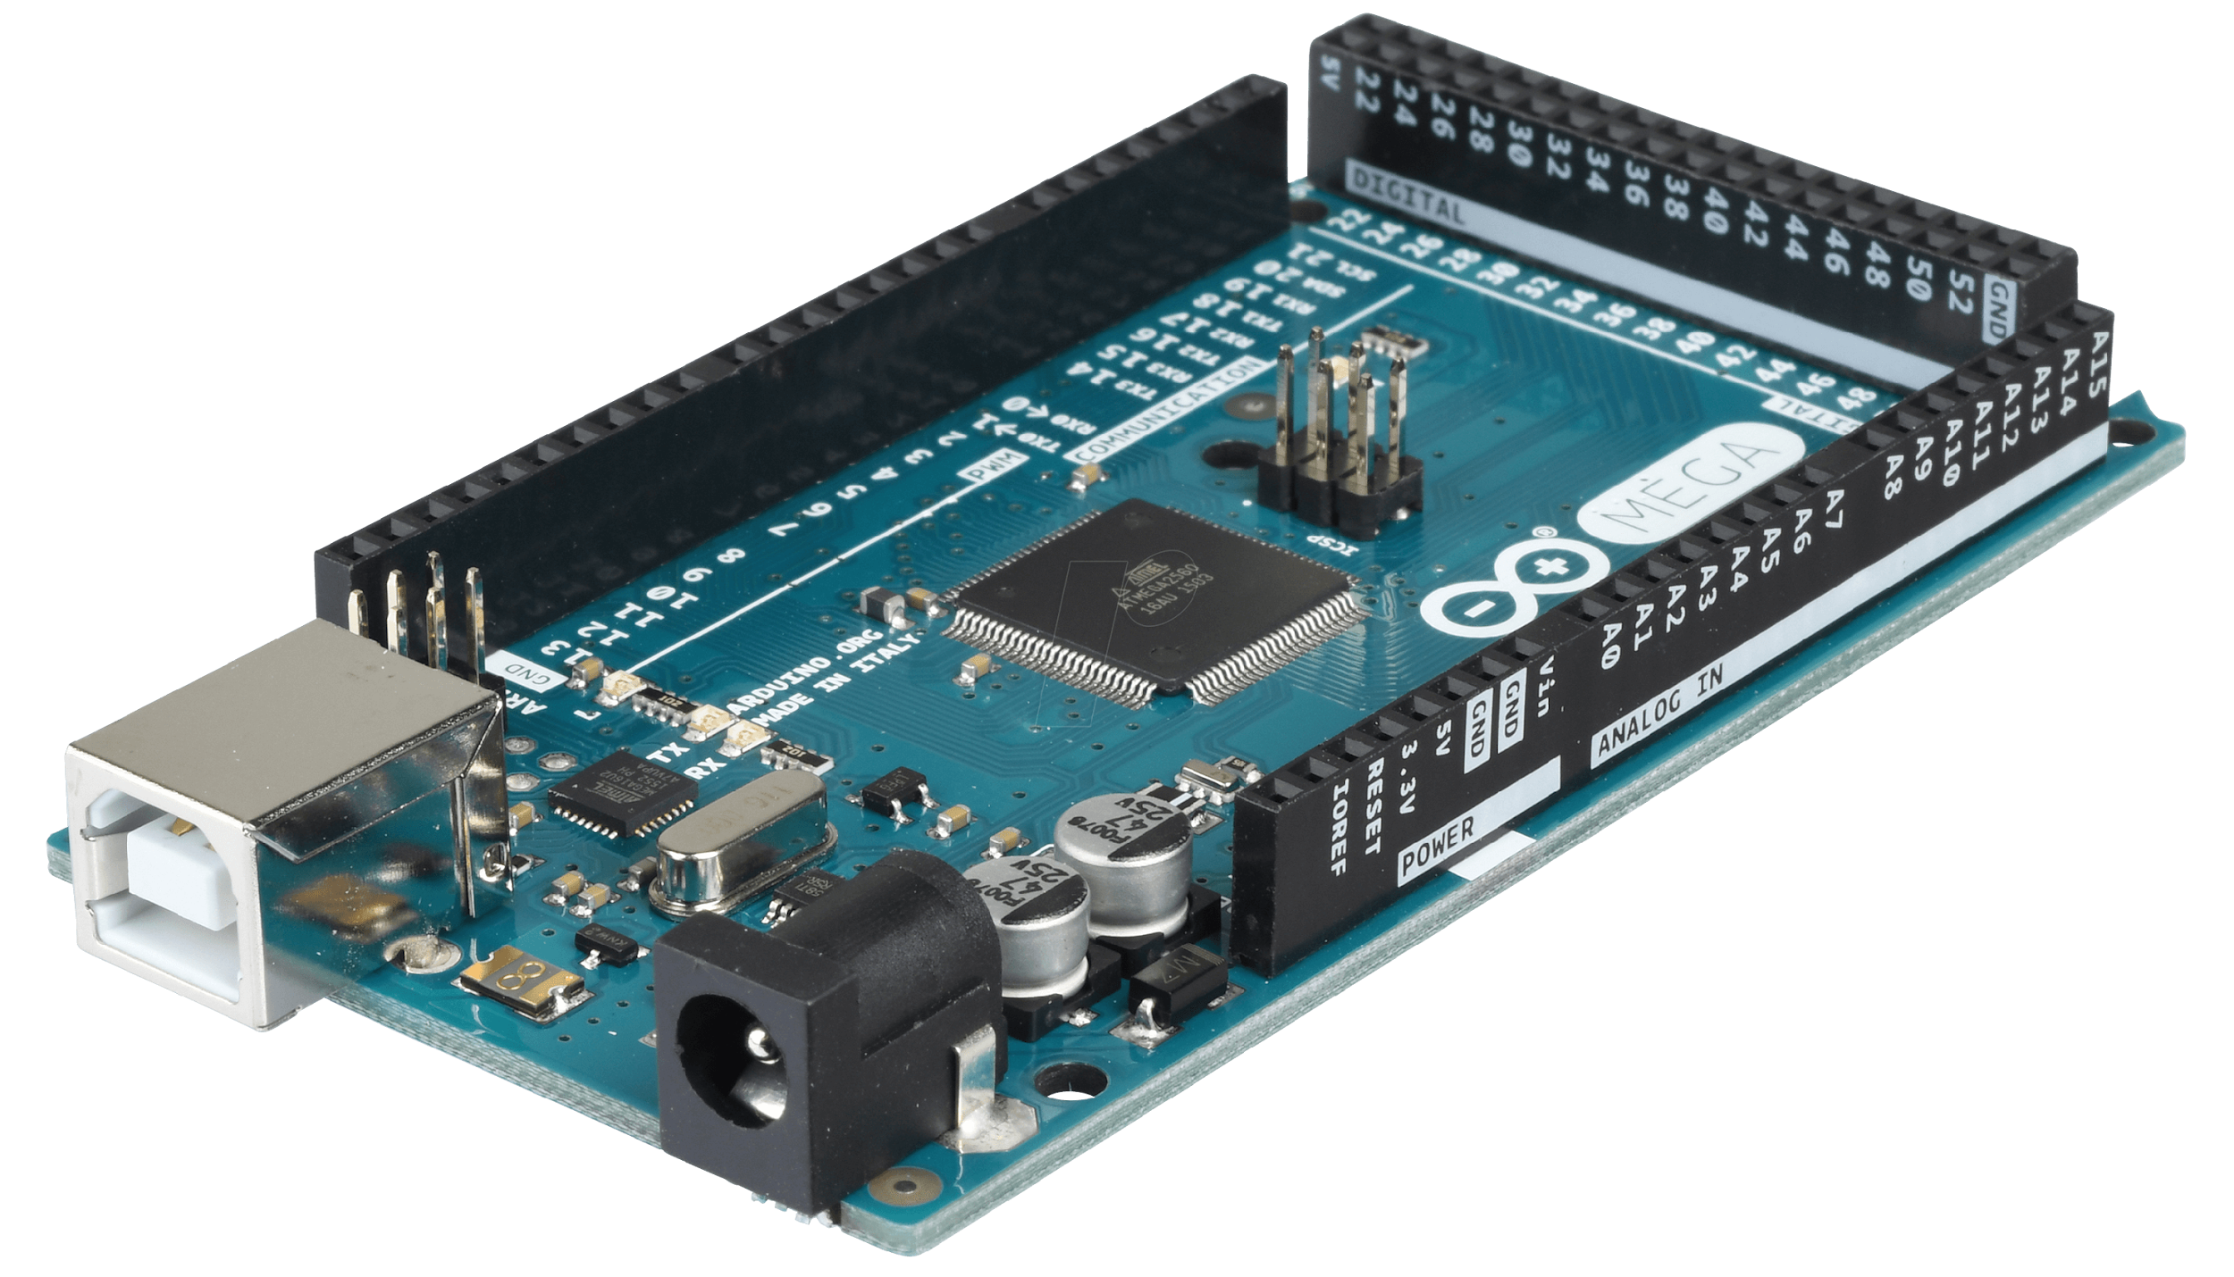
Figure 5.1: Arduino Mega2560.

      - WiFi ESPWROOM 32

Within the project, a connection was established between microcontroller ESP and Arduino Mega, through that we built a web application to the user to track their order easily and keep in touch with what process is currently operating

The ESP-WROOM-32 is a multipurpose and influential Wi-Fi and Bluetooth module established by Espressif Systems. It contains a dual-core ESP32 microcontroller that can burn up to 240 MHz and yield robust performance for multiple applications. This module receives both Wi-Fi (802.11 b/g/n) and Bluetooth (classic and BLE) signals besides, so, it’s the most suitable for IoT projects as well as wireless communication tasks. Its tremendous GPIOs, ADCs, DACs, and in-built multichannel serial port (I2S) interface along with support for different communication protocols make these devices very flexible for developers. The ESP-WROOM-32 is well-suited for popular development designs like the Arduino IDE and ESP-IDF, which facilitate the transformation of the creation to deployment of applications. With its low power consumption and high processing power, it is a very good choice for both battery-powered and main-powered projects.
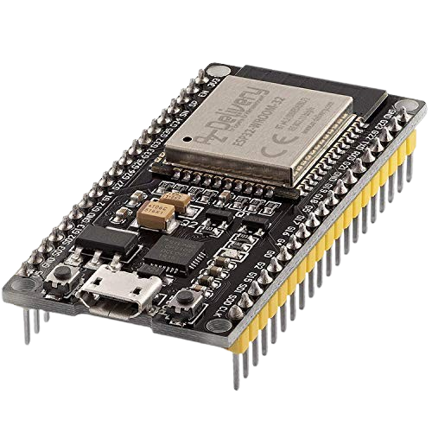

Figure 5.2: WiFi ESP.

3. Stepper motor nema 17

NEMA 17 stepper motors are among the most popular motors in automation projects because of their high precision, reliability, and ease of control. Its pulse-controlled operation allows moving in fixed steps eliminating the need for feedback sensors. NEMA 17 motors are used to control the movement in CNC machines, 3D printers and robotics where precision is paramount.

In the Milkshake Factory project, we incorporated the NEMA 17 stepper motor for the control of Oreo, vanilla, cereal and biscuit milkshake ingredient dispensing. The motor ensures that each ingredient is added in the correct amount by controlling the movement of dispensers. Accurate step control of the motor ensures proportional increment of the ingredients, therefore making sure that no resources were wasted and consistency is achieved in every milkshake produced. Additionally, the stepper motor's anti-slip attributes aid in maintaining a steady position as ingredients are dispensed, making the motor ideal for this project.

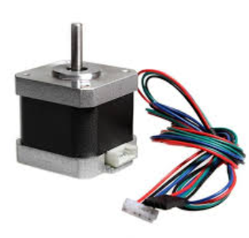
Figure 5.3: Stepper motor name 17.

Pumps
- Water Pumps

Two pumps were each operating at 12 volts, were used. The first pump is for pumping water from the water tank to the mixer, the second pump is for pumping the mixer contents into the cup.

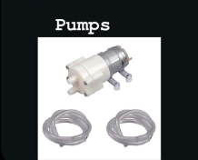

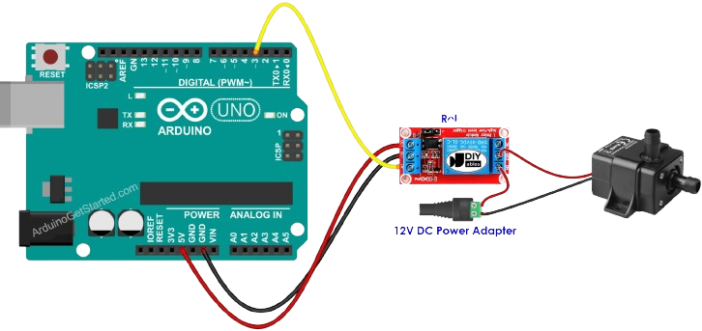
Figure 5.4: Water Pump.
Figure 5.5: Pump Connection.

- Milk Pumps
This pump used for pumping milk from the milk tank into the Mixer.
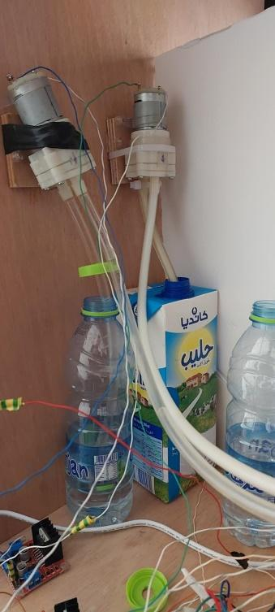
Figure 5.6: Water Pump Connection.

Tank Sensors
- Ultrasonic sensors

We used four of them to check and monitor the ingredients levels in the containers
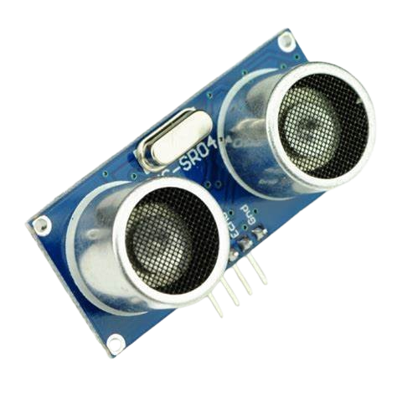

Figure 5.7: Ultrasonic sensor.
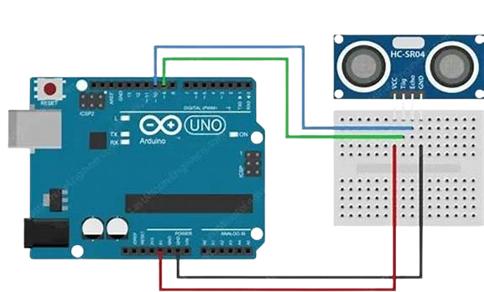

Figure 5.8: Ultrasonic sensor Connection.

Input/Output Devices
- LCD 16*4 with I2C

To display some of the necessary inputs and outputs, such as displaying the things that we have selected from the keypad, displaying the state of the order has reached at this time.
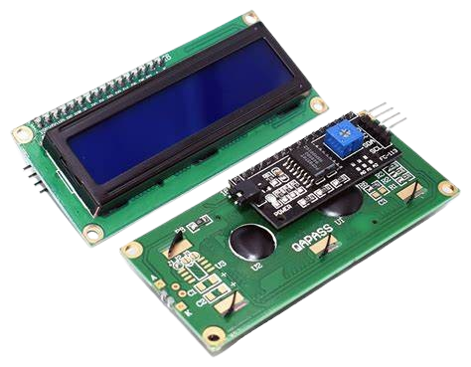

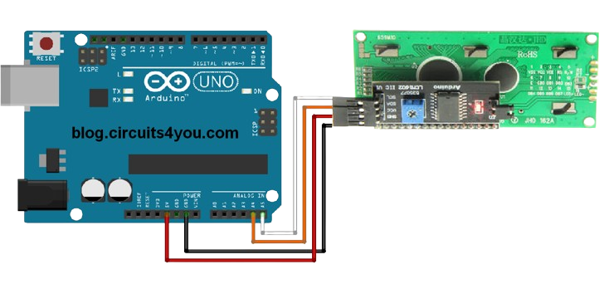
Figure 5.9: LCD 16*4 With I2C.

Figure 5.10: LCD 16*4 With I2C Connection.

- Keypad
We used the keypad to allow the user to choose an order from a wide option list
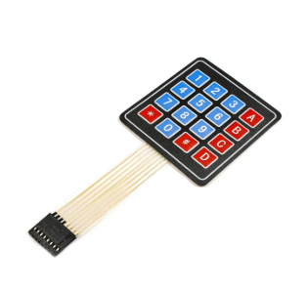

Figure 5.11: 4*4 Keypad.

- Relays

Since the Arduino operates on 5-volt, it can’t control the 220-volt devices such as the mixer and the pump. But we can use a 5-volt relay to switch the high voltage and use the Arduino to control the relay. We used 4 relays, 3 of them to control the pumps, one to control the mixer

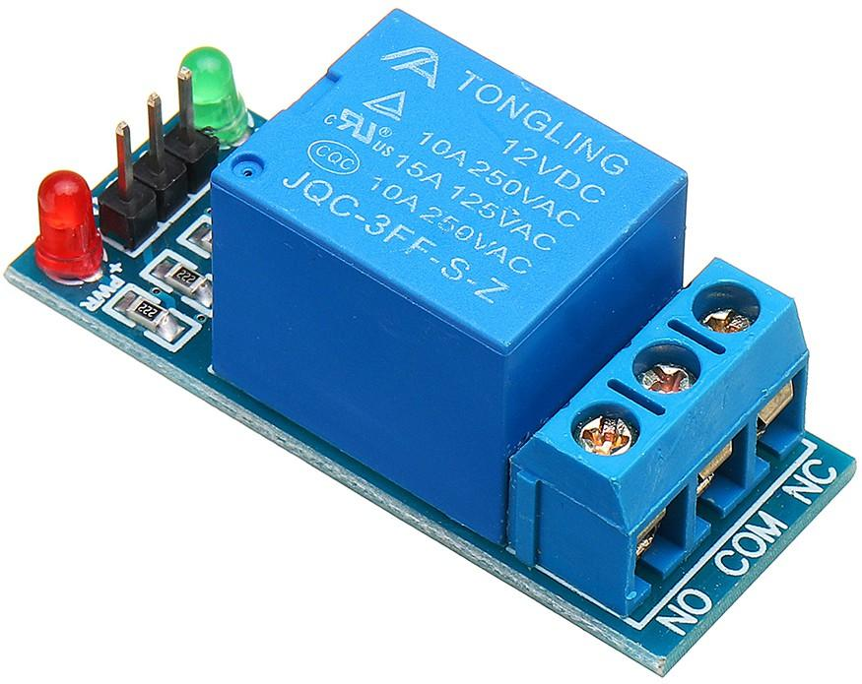

Figure 5.12: 5 volt Relay.

- Water tubes

Various types of it were used, with different sizes and fasteners for their installation.
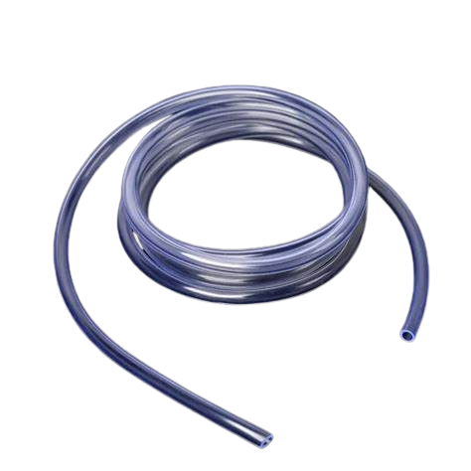

Figure 5.13: Water tubes.

- IR

An infrared (IR) sensor is a device which is able to sense the presence of objects, measure distances and sense motion by means of infrared light. It works by casting an infrared light beam and receiving the reflection from an object. Because of their efficiency and absence of physical contact with the object, IR sensors are extensively applied in automation, robotics, and security systems.

In the project of Milkshake Factory, we incorporated an IR sensor to sense the existence and location of the cup on the belt conveyor. After a cup passes an IR sensor located at a certain point, the IR sensor sends a signal that activates the control system to commence the next step, such as dispensing ingredients, mixing, or sealing. In this way, steps are done when and as they are supposed to, thus eliminating errors and improving overall efficiency. The IR sensor enabled us to fully automate the cup detection process, which limited the amount of manual monitoring and optimally streamlined the system processes.

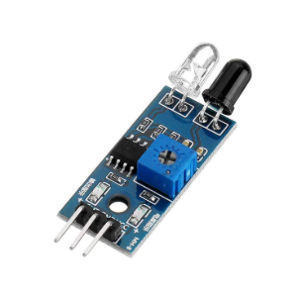

Figure 5.14:IR sensore.

- H-Bridge

An H-Bridge is a circuit that will enable a DC motor to rotate in either clockwise or counterclockwise direction by changing the polarity of voltage across the motor terminals. It is extensively used in robotics, automation, and motor control. The circuit comprises four switches (transistors or MOSFETs) arranged in an "H" pattern, allowing current to pass through in various directions so as to change the rotation of the motor.

For our Milkshake Factory project, we used an H-Bridge to control the motion of an NEMA 17 stepper motor managing ingredient dispensing of Oreo, vanilla, cereal, and biscuits. The H-Bridge enabled precise control of the motor for accurate and smooth dispensing of ingredients by varying the direction and speed of the motor. This facilitated accurate ingredient portions for each milkshake so that consistency and efficiency in the automation process are assured.

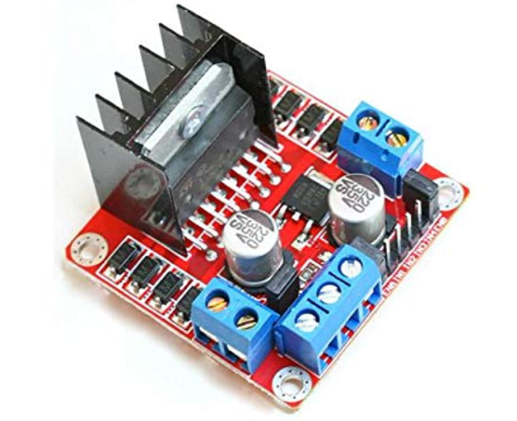

Figure 5.15: H-bridge.

- A4988 driver
A4988 is a compact and high-functioning bipolar stepper motor driver, just perfect for NEMA 17 stepper motors. It enhances control of motor movements through microstepping, which provides smoothness and accuracy. The A4988 features built-in current limiting and over-temperature protection and is capable of adjusting step resolution from full to half, quarter, eighth, and sixteenth steps. The input for the control mechanisms of the motor rotation requires the machine to accept step and direction signals via a microcontroller.

In the Milkshake Factory project, the A4988 driver was used to control the NEMA 17 stepper motor responsible for dispensing the ingredients such as Oreo, vanilla, cereal, and biscuits. It gave us control over speed, direction, and step precision to dispense ingredients accurately and reliably. By being able to change the step resolution, we were able to control how much of each ingredient was really put into the mixer, thereby cutting waste and improving the overall throughput of the system.
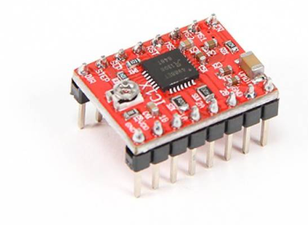
Figure 5.16:A4988 driver.

- DC-motor
A DC motor is one that uses direct current (DC) electrical energy to develop mechanical movement. It generates a magnetic field, interacts with a rotating armature, and produces torque for driving the mechanical part. DC motors are generally preferred in automation, robotics, and conveyor systems because of their simple designs, reliability, and capacity for speed control.

In the Milkshake Factory project, we used a DC motor for the conveyor belt that moves the cups through different stages of making a milkshake, And for closing the led of the cup The smooth and uniform movement provided by the conveyor motor allows the cups to stop at designated stations for dispensing ingredients, mixing, and sealing. Control of the speed and direction of the motor by using an H-Bridge allowed us to synchronize cup movement with other automated components in the system to improve overall efficiency and accuracy.

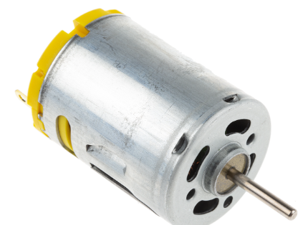

Figure 5.17: DC-Motor.

- RF-ID

Radio Frequency Identification (RFID) is a technology in which objects are identified and tracked using radio waves. There are two components involved: an RFID tag that contains the information, and the RFID reader that scans the tag and retrieves data from it. Due to the fast, contactless identification provided by RFID, it has gained significance in inventory management, access control, and automation systems.

In the Milkshake Factory project, RFID was employed to identify and customize various milkshake orders. Any customer or order could have an RFID tag assigned, which holds information about that customer's preferred milkshake ingredients and proportions. As soon as the cup with the RFID tag comes to rest on the conveyor, an RFID reader scans the tag and sends the order information to the control system. On a basis of stored data, the dispensing of ingredients takes place automatically, leading to the making of a personalized and efficient milkshake.

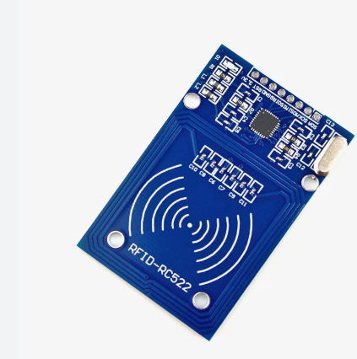

Figure 5.18: RF-ID.

Power Devices

- Power supply

We decided to use a computer power supply since it can offer the required 5 volts for numerous devices and 12 volts for pumps, valves, Peltier and LED strips in order to meet the voltage specifications for our project. The power supply also provides a sufficient current output to suit the requirements of our project
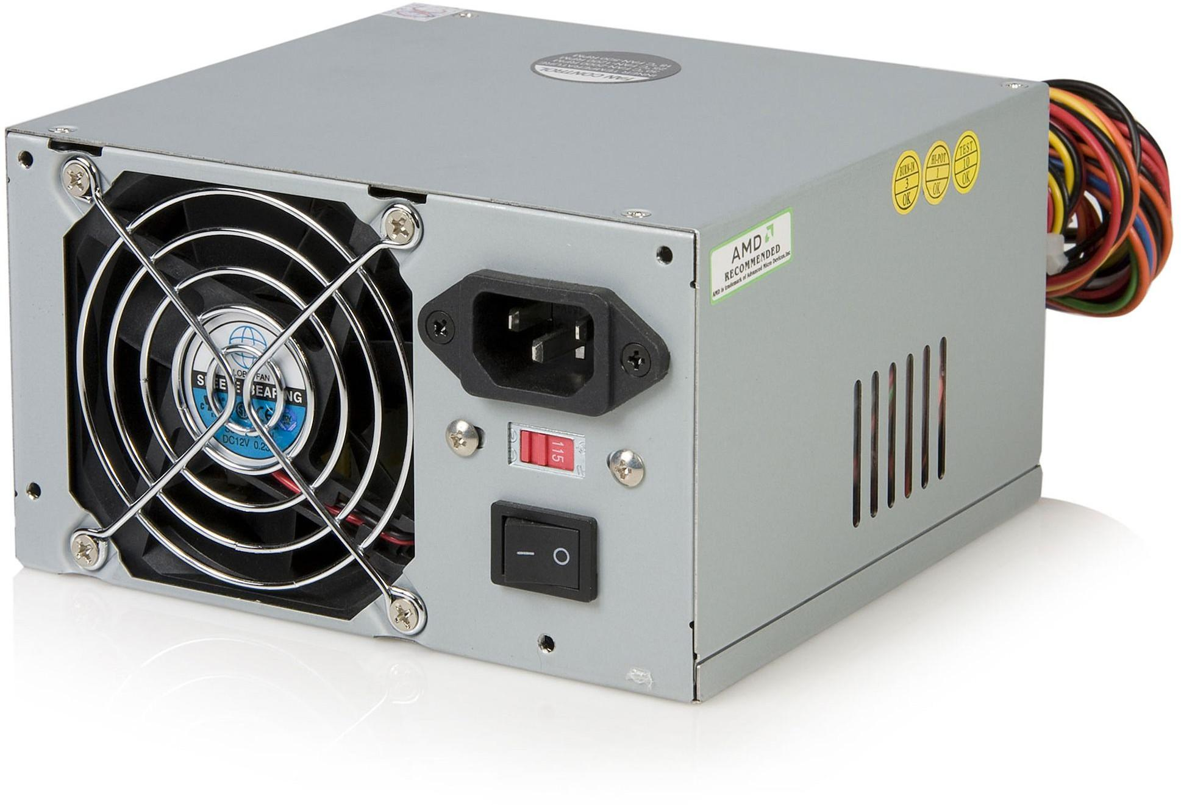

Figure 5.19: Power Supply.

- For various connections, we used male-to-male, female-to-female, and male-to-female wires.
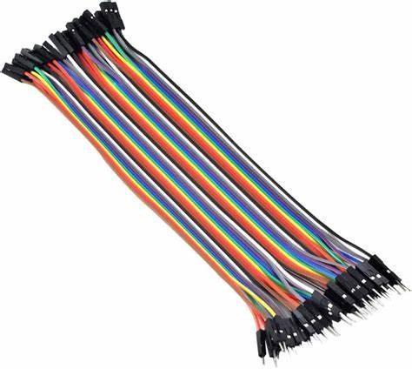

Figure 5.20: Electrical Wires.

Final Design:
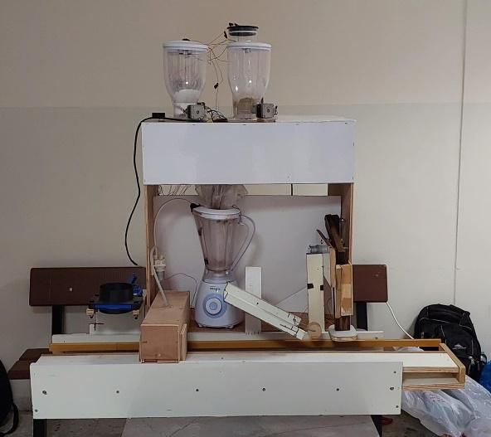
Figure 5.21:Final Design.

  - Hardware Implementation

Over view of the system

Automatic Milkshake Factory is an automated system aimed at easing and improving the processes of making and packing milkshake products. This project combines various hardware components like stepper and DC motors, IR sensors, RFID, and an H-Bridge motor driver to deliver a seamless and efficient system process. There are four main stages of operation for this process: cup dispensing, ingredient dispensing, mixing, and sealing.

At the outset, a cup will be dispensed automatically onto a conveyor belt, which will carry it through the various stations. Then, using RFID technology, the system records the customer preference for the particular type of milkshake so that the milkshake can be personalized. Ingredients consisting of Oreo, vanilla, cereal, and biscuits must be dispensed in controlled amounts with precision by NEMA 17 stepper motors working with an A4988 driver. Next, mixing should thoroughly mix the ingredients before sealing, making it ready to be served.

Automatic Milkshake Factory makes for an increase in efficiency, consistency, and customization in milkshakes preparation. By making the process more automated, it ensures less manual work, less wastage of ingredients, and uniformity of quality and taste for each milkshake. It is meant to be installed in any restaurant, café, or chain of fast food places that need a rapid and dependable, scalable availability in the food and beverage world.

Web Interface
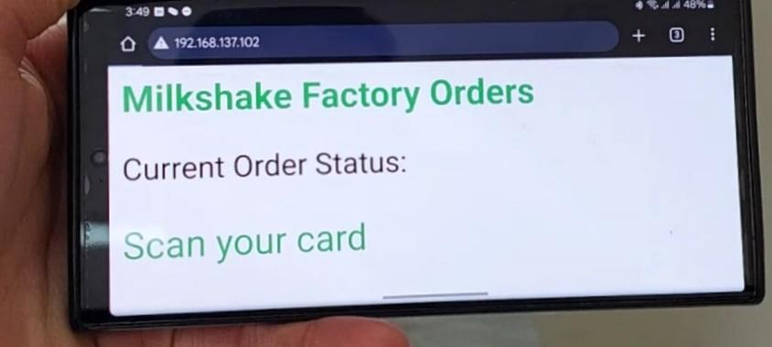
Figure 5.22:Web Page.

The function creates an HTML page using a String variable.
A meta refresh tag (<meta http-equiv='refresh' content='1'>) refreshes the page every 1 second to make sure the order status displayed is updated.
Styling and Content:

This page uses simple inline CSS to create a clean, modern look.
The background is set to #f7f7f7 (light gray), while text is styled using Arial for readability.
The title (<h2>) is "Milkshake Factory Orders" in green (#4CAF50), which makes it stand out.
The current status of the order is displayed in a <p> tag utilizing the message variable, which most probably contains the latest details of the order from the system.
Footer Section:

A footer is added at the bottom, displaying "Milkshake Factory - Powered by ESP32", giving credit to the system's hardware.
Sending the Response:

The command server.send(200, "text/html", html); sends the generated HTML page to the client-usually a web browser-for display.
Function Purpose:
The goal is to offer an easy interface to any user to see in real time the status of their milkshake order. Provide a simple web page which should refresh automatically in real-time. An ESP32 module will handle that request and would have already dynamically updated information about the orders arriving from the user.

Block diagram
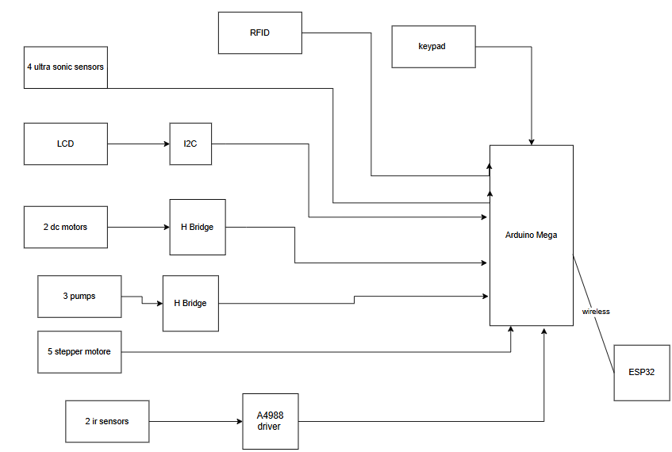
Figure 5.23:Block Diagram.

Results and Discussion

The Milkshake Factory project makes use of technology to respect the milkshake making activity. Our tests have shown that it prepares milkshakes at an improved speed, which helps businesses serve more customers in less time. Customization of milkshakes satisfies customers with better control over ingredients. Many of the initial problems we faced like uneven mixing, cup misalignment and inconsistencies in ingredient dispensation has been cured by alleviating the cup positioner and fine tuning the mixing speed. Increased production speed greatly cuts down ingredients wasted through irrational measurements. Overall, the project is a good base for further development and business use.

Conclusion and Recommendation
  - Conclusion
The Milkshake Factory project has been able to automate the milkshake making process while ensuring efficiency and customization. Through the combination of automatic cup dispensing, ingredient measuring, mixing and sealing, the assembly line is able to reduce manual labor without compromising quality.
The system increases production speed, improves ingredient control, and lowers wastage, which proves its reliability and scalability. Even though there were initial concerns, changing the orientation of the dispenser, mixer and cup proved very effective.
The addition of advanced sensors and internet ordering systems can further improve effectiveness. All in all, this innovation reveals the capability that exists for automation in the food and beverage sector and marks the place for further improvements and breakthroughs.

Summary
Receives a Focused Perspective within the Context of Its Impact on the Rest of the Project Roster Milkshake Factory is posied for launching owing to the fact that it has the most to gain given the current business realities of Rwanda based on the existing market gaps.
It is evident that they are trained on data to get a broader view of what such structures would function ut It does not miss the deadline for the academic calendar year Rinse Aid NelAid Maskature Rinse Aid provides the responsiveness as well as thorough research conducted by the Mask & Ferment Company. The open palm, bent, and elbow outwards with bent fingers hold the cup in midair with straight and upright fingers.

Recommendations
To enhance the Milkshake Factory system further, various improvements can be evaluated:
1.Sophisticated Ingredient Sensors – Utilizing sensors to monitor ingredient quantities and flow rates can enhance precision in dispensing.
2.Digital Ordering Integration – Linking the system to a mobile application or touchscreen interface enables users to quickly choose and personalize milkshakes.
3.Enhanced Mixing Mechanism – Upgrading the mixing system with variable speed control can guarantee superior texture and consistency.
4.Cup Detection and Alignment System – Implementing optical sensors or mechanical guides can avoid misalignment on the conveyor belt.
5.Automated Cleaning System – Incorporating a self-cleaning feature will decrease maintenance time and enhance system durability.
6.Scalability for Greater Production– Modifying the system for larger production levels can render it appropriate for larger companies and franchises.
7.Energy Efficiency Improvement – Introducing energy-saving functionalities can lower operational expenses and enhance the system's sustainability.
These enhancements will boost the efficiency, dependability, and userfriendliness of the Milkshake Factory, rendering it even more suitable for business applications.

What we have learned

The Milkshake Factory project brought valuable experience in automation, system design, and process optimization. We learned how to integrate hardware parts such as dispensers, mixers, and conveyors with software controls for a smooth and efficient system. Understanding the importance of the accurate measuring of ingredients allowed us to reduce waste and maintain the quality of the finished product.

Other challenges included the accuracies of ingredient dispensing, mixing uniformity, and cup alignment; these taught us how to troubleshoot and refine system performance. We listened to and learned about trends where interest in customizable food and beverage solutions increases, putting the focus on ease of use via interfaces and personalization. In sum, this project furthered our understanding of food production automation, problem-solving in the development of systems, and where efficiency and scalability could be improved in the future.

Future work

Several further improvements can be added to The Milkshake Factory: Smart sensors track ingredient levels for accurate dispensing, without waste; the addition of a digital ordering system via a touchscreen or through a mobile app would serve users much better and allow advanced options for customization.

Further refinement of the mixing mechanism could be introduced with a variable speed control to further improve the texture and consistency of milkshakes. Development of an automated cleaning system will help in maintaining hygiene and reducing maintenance time. Scaling the system for large-scale production will make it suitable for bigger businesses and commercial applications.

Other future enhancements could involve the optimization of energy efficiency, optimizing power consumption to reduce operational costs. With such improvements, the Milkshake Factory will be better equipped to provide an efficient, reliable, and user-friendly solution for the food and beverage industry.

8.References
Arduino Mega 2560 Rev3.
https://docs.arduino.cc/hardware/mega-2560
. 2 Stepper motor Tb6600 and tutorial.
https://www.instructables.com/Nema-Stepper-
Motor-17-With-Tb6600-Driver-With-Ardu/ 3 ESP32 Tutorials.
https://randomnerdtutorials.com/installing-the-esp32-board-in-
arduino-ide-windows-instructions/?fbclid=IwAR1QOf-rmBSVUqzWyaFbDvnrZV3kf3JnphQMY q6riaj3L479rdc 4 7 Types of Robots in Warehousing: AutoStore & Beyond 5 YouTube.

9. Code:
the Arduino code :
#include <Wire.h>
#include <LiquidCrystal_I2C.h>
#include <Keypad.h>
#include <SPI.h>
#include <MFRC522.h>
#include <SoftwareSerial.h>

// Define motor pins
const int motorPin1 = 9, motorPin2 = 8, dcEnablePin = 10;
const int motorPin3 = 33, motorPin4 = 34, dcEnablePin2 = 32;
const int cupsStepPin = 3, cupsDirPin = 4, cupsEnablePin = 5;
const int oreoStepPin = 12, oreoDirPin = 13;
const int vanillaStepPin = 5, vanillaDirPin = 6;
const int cerelacStepPin = 2, cerelacDirPin = 7;
const int biscuitsStepPin = 30, biscuitsDirPin = 31;

// Sensors
const int irSensorPin = 36; // IR sensor connected to pin 36
const int irPin = 11; // IR sensor connected to pin 11

// Relay
const int relayPin = 35;

// Pump pins
const int pumpEnablePin = 37;
const int pumpInt1Pin = 38;
const int pumpInt2Pin = 39;

// Water pump pins
const int waterPumpEnablePin = 40;
const int waterPumpInt3Pin = 41;
const int waterPumpInt4Pin = 42;

// Cleaning pump pins
const int cleaningPumpEnablePin = 43;
const int cleaningPumpInt1Pin = 44;
const int cleaningPumpInt2Pin = 45;

// RFID setup
#define RST_PIN 53
#define SS_PIN 49
MFRC522 rfid(SS_PIN, RST_PIN);
const String authorizedCardID = "1924818533";

// LCD setup
LiquidCrystal_I2C lcd(0x27, 16, 2);

// Keypad setup
const byte ROW_NUM = 4, COLUMN_NUM = 4;
char keys[ROW_NUM][COLUMN_NUM] = {
{'1', '2', '3', 'A'},
{'4', '5', '6', 'B'},
{'7', '8', '9', 'C'},
{'*', '0', '#', 'D'}
};
byte pin_rows[ROW_NUM] = {22, 23, 24, 25};
byte pin_column[COLUMN_NUM] = {26, 27, 28, 29};
Keypad keypad = Keypad(makeKeymap(keys), pin_rows, pin_column, ROW_NUM, COLUMN_NUM);

// Stepper motor settings
const int initialStepperSteps = 200;
const int stepDelay = 3000;
const int stepDelaycup = 3000;
const int stepsFor90Degrees = 40;
const int stepsForcer= 40;

// Global variables
int selectedOption = 0;
bool isAuthorized = false;
bool objectDetected = false;

enum State { WAIT_FOR_RFID, WAIT_FOR_KEYPAD, PROCESS } state = WAIT_FOR_RFID;

// Function to display messages
void displayMessage(const char *message) {
Serial.println(message); // Send message to ESP32
Serial1.println(message); // Send message to ESP32
// Serial.flush();
lcd.clear();
lcd.print(message);
}

void setup() {
Serial.begin(9600);
Serial1.begin(115200); // Serial Monitor
// mySerial.begin(9600); // Communication with ESP32
SPI.begin();
rfid.PCD_Init();
lcd.init();
lcd.backlight();

// Set motor pins as outputs
pinMode(motorPin1, OUTPUT); pinMode(motorPin2, OUTPUT); pinMode(dcEnablePin, OUTPUT);
pinMode(motorPin3, OUTPUT); pinMode(motorPin4, OUTPUT); pinMode(dcEnablePin2, OUTPUT);
pinMode(cupsStepPin, OUTPUT); pinMode(cupsDirPin, OUTPUT); pinMode(cupsEnablePin, OUTPUT);
pinMode(oreoStepPin, OUTPUT); pinMode(oreoDirPin, OUTPUT);
pinMode(vanillaStepPin, OUTPUT); pinMode(vanillaDirPin, OUTPUT);
pinMode(cerelacStepPin, OUTPUT); pinMode(cerelacDirPin, OUTPUT);
pinMode(biscuitsStepPin, OUTPUT); pinMode(biscuitsDirPin, OUTPUT);

// Set sensor and relay pins
pinMode(irSensorPin, INPUT);
pinMode(irPin, INPUT);
pinMode(relayPin, OUTPUT);

// Set pump pins
pinMode(pumpEnablePin, OUTPUT);
pinMode(pumpInt1Pin, OUTPUT);
pinMode(pumpInt2Pin, OUTPUT);

// Set water pump pins
pinMode(waterPumpEnablePin, OUTPUT);
pinMode(waterPumpInt3Pin, OUTPUT);
pinMode(waterPumpInt4Pin, OUTPUT);

// Set cleaning pump pins
pinMode(cleaningPumpEnablePin, OUTPUT);
pinMode(cleaningPumpInt1Pin, OUTPUT);
pinMode(cleaningPumpInt2Pin, OUTPUT);

digitalWrite(relayPin, HIGH); // Ensure relay is off initially

displayMessage("Scan your card");
}

void loop() {
switch (state) {
case WAIT_FOR_RFID:
handleRFID();
break;
case WAIT_FOR_KEYPAD:
handleKeypad();
break;
case PROCESS:
handleProcess();
state = WAIT_FOR_RFID;
break;
}

if (Serial1.available() > 0) {
// Read the incoming byte from Serial1
char incomingByte = Serial1.read();
// Send the byte to Serial0 (connected to the laptop)
Serial.write(incomingByte);
}
}

void handleRFID() {
if (!rfid.PICC_IsNewCardPresent() || !rfid.PICC_ReadCardSerial()) {
return;
}

String cardID = "";
for (byte i = 0; i < rfid.uid.size; i++) {
cardID += String(rfid.uid.uidByte[i], DEC);
}
Serial.print("Card ID: ");
Serial.println(cardID);

if (cardID == authorizedCardID ) {
isAuthorized = true;
displayMessage("Card Approved");
delay(2000);
displayMessage("Select option: 1, 2, 3, 4");
state = WAIT_FOR_KEYPAD;
} else {
displayMessage("Card Denied");
delay(2000);
displayMessage("Scan your card");
}
}

void handleKeypad() {
char key = keypad.getKey();
if (key) {
if (key == '1' || key == '2' || key == '3' || key == '4') {
selectedOption = key - '0';
state = PROCESS;
} else {
displayMessage("Invalid option! Try again.");
}
}
}

void handleProcess() {

displayMessage("Running Cup motor...");
delay(1000);
runcupStepper(cupsStepPin, cupsDirPin, initialStepperSteps, HIGH);
delay(1000);
displayMessage("Cup motor done.");

displayMessage("First DC motor running...");
runDCMotor();

while (true) {
if (digitalRead(irSensorPin) == LOW) {
stopDCMotor();
break;
}
}

if (selectedOption == 1) runOreoAndVanilla();
else if (selectedOption == 2) runVanillaAndCerelac();
else if (selectedOption == 3) runVanillaAndBiscuits();
else if (selectedOption == 4) {
displayMessage("Running cleaning pump...");
delay(1000);
runCleaningPump(13000); // Run cleaning pump for 4 seconds
displayMessage("Cleaning pump stopped.");
delay(1000);
digitalWrite(relayPin, LOW);
delay(20000);
digitalWrite(relayPin, HIGH);

displayMessage("Relay process completed.");
delay(2000);
displayMessage("Running main pump...");
delay(1000);
runPump(20000); // Run pump for 4 seconds
displayMessage("Main Pump stopped.");
delay(1000);
runDCMotor();
displayMessage("Cleaning is Done.");

goto osama;

}
delay(1000);
// Run the water pump after relay process for 4 seconds
displayMessage("Running Milk pump...");
//milk
runWaterPump(13000); // Run the water pump for 4 seconds
displayMessage("Milk pump stopped.");
delay(1000);
// Relay logic
digitalWrite(relayPin, LOW);
displayMessage("Mixer started.");
delay(20000);
digitalWrite(relayPin, HIGH);
delay(1000);
displayMessage("Mixer finished.");

// Run the pump
delay(1000);
displayMessage("Running main pump...");
runPump(20000); // Run pump for 4 seconds
displayMessage("Main Pump stopped.");
delay(1000);

runDCMotor();
osama:

while (true) {
if (digitalRead(irPin) == LOW) {
stopDCMotor();
displayMessage("Running second DC motor...");
runSecondDCMotorForRotations();
stopSecondDCMotor();
delay(2000);
break;
}
}
runDCMotor();
delay(10000);
stopDCMotor();
displayMessage("Order is done.");
delay(5000);
displayMessage("Scan your card.");

}

void runDCMotor() {
digitalWrite(motorPin1, HIGH);
digitalWrite(motorPin2, LOW);
analogWrite(dcEnablePin, 255);
}

void stopDCMotor() {
digitalWrite(motorPin1, LOW);
digitalWrite(motorPin2, LOW);
analogWrite(dcEnablePin, 0);
displayMessage("First DC motor stopped.");
}

void runPump(int duration) {
digitalWrite(pumpInt1Pin, HIGH);
digitalWrite(pumpInt2Pin, LOW);
analogWrite(pumpEnablePin, 255); // Adjust the value if needed
delay(duration);
stopPump();
}

void stopPump() {
digitalWrite(pumpInt1Pin, LOW);
digitalWrite(pumpInt2Pin, LOW);
analogWrite(pumpEnablePin, 0);
}

void runWaterPump(int duration) {
digitalWrite(waterPumpInt3Pin, HIGH);
digitalWrite(waterPumpInt4Pin, LOW);
analogWrite(waterPumpEnablePin, 255); // Adjust the value if needed
delay(duration);
stopWaterPump();
}

void stopWaterPump() {
digitalWrite(waterPumpInt3Pin, LOW);
digitalWrite(waterPumpInt4Pin, LOW);
analogWrite(waterPumpEnablePin, 0);
}

void runCleaningPump(int duration) {
digitalWrite(cleaningPumpInt1Pin, HIGH);
digitalWrite(cleaningPumpInt2Pin, LOW);
analogWrite(cleaningPumpEnablePin, 255); // Adjust the value if needed
delay(duration);
stopCleaningPump();
}

void stopCleaningPump() {
digitalWrite(cleaningPumpInt1Pin, LOW);
digitalWrite(cleaningPumpInt2Pin, LOW);
analogWrite(cleaningPumpEnablePin, 0);
}

void runOreoAndVanilla() {
displayMessage("Running Oreo...");
delay(1000);
runStepper(oreoStepPin, oreoDirPin, stepsFor90Degrees, HIGH);
runStepper(oreoStepPin, oreoDirPin, stepsFor90Degrees, LOW);

delay(3000);
displayMessage("Running Vanilla...");
delay(1000);
runStepper(vanillaStepPin, vanillaDirPin, stepsFor90Degrees, HIGH);
runStepper(vanillaStepPin, vanillaDirPin, stepsFor90Degrees, LOW);

}

void runVanillaAndCerelac() {
displayMessage("Running Vanilla...");
delay(1000);
runStepper(vanillaStepPin, vanillaDirPin, stepsFor90Degrees, HIGH);
runStepper(vanillaStepPin, vanillaDirPin, stepsFor90Degrees, LOW);
delay(3000);
displayMessage("Running Cerelac...");
delay(1000);
runStepper(cerelacStepPin, cerelacDirPin, stepsForcer , HIGH);
runStepper(cerelacStepPin, cerelacDirPin, stepsForcer, LOW);

}

void runVanillaAndBiscuits() {
displayMessage("Running Vanilla...");
delay(1000);
runStepper(vanillaStepPin, vanillaDirPin, stepsFor90Degrees, HIGH);
runStepper(vanillaStepPin, vanillaDirPin, stepsFor90Degrees, LOW);

delay(3000);
displayMessage("Running Biscuits...");
delay(1000);
runStepper(biscuitsStepPin, biscuitsDirPin, stepsFor90Degrees, HIGH);
runStepper(biscuitsStepPin, biscuitsDirPin, stepsFor90Degrees, LOW);

}

void runcupStepper(int stepPin, int dirPin, int steps, bool direction){
digitalWrite(dirPin, direction);
for (int i = 0; i < steps; i++) {
digitalWrite(stepPin, HIGH);
delayMicroseconds(stepDelaycup);
digitalWrite(stepPin, LOW);
delayMicroseconds(stepDelaycup);
}
}
void runStepper(int stepPin, int dirPin, int steps, bool direction) {
digitalWrite(dirPin, direction);
for (int i = 0; i < steps; i++) {
digitalWrite(stepPin, HIGH);
delayMicroseconds(stepDelay);
digitalWrite(stepPin, LOW);
delayMicroseconds(stepDelay);
}

}

void runSecondDCMotorForRotations() {
int rotationTime = 2000; // Adjust for 2 rotations
digitalWrite(motorPin3, LOW);
digitalWrite(motorPin4, HIGH);
analogWrite(dcEnablePin2, 255);
delay(rotationTime);
stopSecondDCMotor();
digitalWrite(motorPin3, HIGH);
digitalWrite(motorPin4, LOW);
analogWrite(dcEnablePin2, 255);
delay(rotationTime);
stopSecondDCMotor(); // Stop the motor after running for the rotation time
}

void stopSecondDCMotor() {
digitalWrite(motorPin3, LOW);
digitalWrite(motorPin4, LOW);
analogWrite(dcEnablePin2, 0);
displayMessage("Second DC motor stopped.");
delay(1000);
}
the esp32 code:
#include <WiFi.h>
#include <WebServer.h>

const char* ssid = "osama"; // Replace with your WiFi SSID
const char* password = "osama2002"; // Replace with your WiFi Password

WebServer server(80); // Create web server on port 80
String message = "Waiting for milkshake orders...";

void handleRoot() {
String html = "<html><head><meta http-equiv='refresh' content='1'></head>";
html += "<body style='font-family: Arial, sans-serif; background-color: #f7f7f7;'>";
html += "<h2 style='color: #4CAF50;'>Milkshake Factory Orders</h2>";
html += "<p style='font-size: 20px;'>Current Order Status:</p>";
html += "<p style='font-size: 24px; color: #4CAF50;'>" + message + "</p>";
html += "<footer style='position: absolute; bottom: 10px; width: 100%; text-align: center;'>"
"<p style='font-size: 14px; color: #777;'>Milkshake Factory - Powered by ESP32</p></footer>";
html += "</body></html>";
server.send(200, "text/html", html);
}

void setup() {
Serial.begin(115200);
Serial2.begin(115200, SERIAL_8N1, 16, 17); // RX2 = GPIO 16, TX2 = GPIO 17
WiFi.begin(ssid, password);

while (WiFi.status() != WL_CONNECTED) {
delay(1000);
Serial.println("Connecting to WiFi...");
}

Serial.println("Connected to WiFi");
Serial.print("ESP32 IP Address: ");
Serial.println(WiFi.localIP());

server.on("/", handleRoot);
server.begin();
Serial.println("Web server started");
}

void loop() {
if (Serial2.available()) {
message = Serial2.readStringUntil('\n'); // Read message from Arduino
Serial.println("Received: " + message);
}
server.handleClient();
}

