
An-Najah National University
Faculty of Engineering
Electrical Engineering Department

Classification of plastics using infrared spectroscopy

A report submitted as partial fulfilment of the requirements for the Bachelor Degree of Electrical Engineering.

Submitted by:

Sundos Ghaith
Mozon Shadid
Sameeh Yaseen

Supervisor
Dr. Naser Abu Zaid

Table of Contents
list of figures iv
list of tables v
abstract viii
CHAPTER ONE: introductioN 1
  - Recycling definition 2
  - Importance of plastic recycling 2
1.2.1 Environmental Benefits 2
    - Economic Benefits 3
1.3 Aim and objectives 3
1.3.1 Aim 3
1.3.2 Objectives 3

CHAPTER TWO: CONSTRAINTS, STANDARDS/Codes and Earlier coursework 4
  - Constrains 5
2.1.1 Time 5
    - Hardware constrains 5
2.1.3 Software Constrains 5
2.2 Standards and Codes 6

CHAPTER THREE: Theoretical Background 7
  - Overview of plastics 8
  - Types of plastics 8
  - Recyclable plastics 9
  - Methods of sorting plastics 10
  - Reasons for choosing NIR Spectroscopy 11
  - Spectroscopy 11
    - Common types of spectroscopy: 11
    - Infrared spectroscopy 12
3.6.2.1 Infrared radiation (IR) 12
    - Infrared spectroscopy working principle 14
    - Infrared spectroscopy in plastics 14
CHAPTER FOUR: Methodology 16
  - System components 17
    - Equipment 17
    - Infrared radiation emitter and detector 24
  - Controller 26
4.2.1 Voltage divider circuit using the controller 26
  - System design 27
  - Procedure 28
CHAPTER FIVE: RESULTS AND DISCUSSION 30
  - Type 1(PETE) Results…………………………..……………………..……………….31
  - Type 2 (HDPE) 36
  - TYPE 3&5 (PVC & PP) 39
CHAPTER SIX: conclusion and recommendations 43
  - Conclusion 44
  - Recommendations 44
References 45
List of Figures
Figure 3.1: The wavelength range of infrared radiation 12
Figure 3.2: The reflectance of each plastic type vs. the wavelength 14
Figure 3.3: Difference between white and black PVC reflection vs. the wavelength 15
Figure 3.4: The reflection of blue and green HDPE vs. the wavelength 15
Figure 4.1: Valve operation 17
Figure 4.2: Push Button 18
Figure 4.3: Conveyer Belt 18
Figure 4.4: Shaft Coupling 19
Figure 4.5: Bearings 19
Figure 4.6: DC Motor 19
Figure 4.7: Air Compressor 20
Figure 4.8: Air Nozzle 20
Figure 4.9: Pneumatic Air Manifold Splitter Block 21
Figure 4.10: Pipe 21
Figure 4.11: Light Dependent Resistor (LDR) 21
Figure 4.12: Laser Diode 22
Figure 4.13: Infrared Light Emitting Diode 24
Figure 4.14: Photodiode responsivity VS the wavelength 24
Figure 4.15: System Design 26
Figure 4.16: Circuit diagram of the entire system 27
Figure 4.17: The process flow diagram 28
Figure 5.1: Data analysis of Type 1 (PETE) 34
Figure 5.2:: Data analysis of Type 2 (HDPE) 37
Figure 5.3: Data analysis of Type 3&5 (PVC & PP) 40
Figure 5.4: Boxplot of the 3 types 42

List of Tables
Table 3.1: Different types of plastics with each type uses and products that can be made from each one after recycling. 8
Table 3.2: The recyclable types of plastics 9
Table 3.3: Advantages and disadvantages of mid infrared spectrum 13
Table 3.4: Advantages and disadvantages of near infrared spectrum 13
Table 4.1: The equipments and their uses 22
Table 4.2: Specification of the sensor 25
Table 5.1: Type 1 (PETE) Results 31
Table 5.2: Type 2 (HDPE) Results 36
Table 5.3: Type 3&5 (PVC & PP) Results 37

Dedication
Every challenging work needs self-effort as well as guidance of elders, especially those who were very close to our hearts. We dedicate our humble effort to our parents whose affection, love, encouragement and prayers of day and night made us able to get such success and honour.

Acknowledgment
We would like to express deep gratitude to our advisor Dr. Naser Abu Zaid for inspiring us to conceive this project, for his guidance and his gracious support throughout the course of our work that motivated us to operate in this area and for his faith in us at every stage of this project.
A special thanks and appreciation for all staff and our colleagues for supporting us and providing any assistance requested.

Abstract:
Plastics are used in thousands of products that add comfort, convenience, and safety to our everyday lives, due to their short lifetime, it is not surprising that they account for large amounts of waste that is generated. This increases the urgency and importance of plastic recycling.
For efficient recycling we need efficient sorting. Difficulties in applying manual separation techniques led to the modification of several automated methods.
In this project, an automated system is developed for the identification and separation of plastic types, based on near infrared reflectance spectroscopy. We favored this method over many other methods because of the ease of generating and sensing infrared radiation, in addition to that, it has a lower price compared to other automated sorting methods.

chapter ONE: introduction

  - Recycling definition
The world population is growing, not shrinking, and currently each human being adds significant waste to the planet over his lifetime. Therefore, it’s vital to reuse materials; so as to reduce the consumption of raw material and minimize the amount of waste. This can only be achieved through the process of recycling.
Recycling can be defined in simple words, as the process of breaking down and re-using materials that would otherwise be thrown away as trash.
To be more precise we can define the recycling process scientifically as the process of converting waste materials into reusable objects to prevent waste of potentially useful materials, reduce the consumption of fresh raw materials, energy usage, air pollution from incineration and water pollution from landfilling by decreasing the need for conventional waste disposal.

  - Importance of plastic recycling
Among all materials that can be recycled, plastics gain more importance since it’s a non-biodegradable material i.e. not be broken down by microorganisms, which in result clogs up landfills and overburden waste-processing facilities.
    - Environmental Benefits
- For every 1 ton of plastic that is recycled, it is estimated that 7 yards of landfill space is saved.
- By recycling plastic, 80% of the total energy that goes into manufacturing new plastic products is conserved.
- Recycling plastic conserves the natural resources that would be required to produce plastic from scratch.

    - Economic Benefits
- Properly run recycling programs cost the government less money than waste programs.
- People can even make money by collecting approved materials to a nearby recycling facility that will pay for the product.
- Conserving the natural resources and energy by recycling plastics, not only has a beneficial impact on the environment, but also saves a lot of money.

  - Aim and objectives:
1.3.1 Aim:
In order to achieve efficient recycling of plastics, a good sorting way must be chosen. therefore, our aim is to sort plastic materials automatically through NIR spectroscopy.

1.3.2 Objectives:
- To identify the type of plastics using NIR spectroscopy
- To be able to classify and sort plastics automatically after identifying its type.

CHAPTER TWO: CONSTRAINTS, STANDARDS/Codes and Earlier coursework

  - Constraints
    - Time:
There was not enough time to make a lot of tests, but we managed to do several tests to recognize the right way of work and then made an enough database to differentiate between readings.
    - Hardware Constraints:

- Finding the proper IR LED was a challenge, moreover choosing a suitable dark area that can be covered with its rays and adjusting the resistance value of the receiver (IR photodiodes) in the range of [5-20] KΩ, which was obtained by the right connection of IR receiver was not easy, specially that all the tests and readings will depend on how right our decisions were from the beginning.

- Measuring the proper and enough height between the receiver and transmitter to take an accurate reading and to let the piece move freely.

- Building the project model to fit our needs was challenging.

- The size of some equipment didn’t fit our needs such as the air nozzles, therefore we used pens and had satisfying results.

- Using proper materials to install the equipment without affecting the results.

    - Software Constraints:
- Writing the program to simulate the functionality of our project and learning new ideas to facilitate the task.

  - Standard used in the project
- ISO 8573 ( Air Compressor )

- IEC 60617 ( LDR )
- ISO 14001: 2004 ( Dc Motor 12V )
- ISO 15106-2 ( IR receiver )
- ISO 15106-2 ( IR transmitter )
- ISO 11145 (laser diode )

CHAPTER THREE: Theoretical Background

  - Overview of plastics
The term 'plastic' comes from the Greek work 'plastikos' which means 'to mold' or 'to form'. Plastic are synthetic or semi-synthetic material that can be molded into shape and then set. They are derived from organic materials such as crude oil, natural gas, salt, coal and, in more recent years, from bio-matter.
Plastics are made out of very long molecule chains called polymers, many people use the terms polymer and plastic interchangeably even though not all polymers are plastic. Polymers are actually made up of monomers, in chemistry, the term monomer just refers to a small molecule, which can be chained together to create polymers, this chemical reaction is called polymerization. The structure and length of these chains dictate the properties of the plastic created, and thus have different kinds of plastics that are categorized by a resin code.
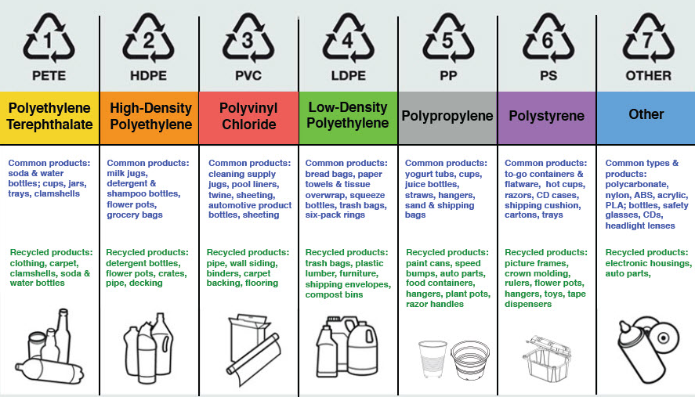
  - Types of plastics
Table 3.1: Different types of plastics with each type uses and products that can be made from each one after recycling.

3.3 Recyclable plastics
The structure of the polymers also affects the recyclability of plastics. Some polymers fail and break down under mechanical or thermal stress; this affects their ability to be recycled.

Table 3.2: The recyclable types of plastics
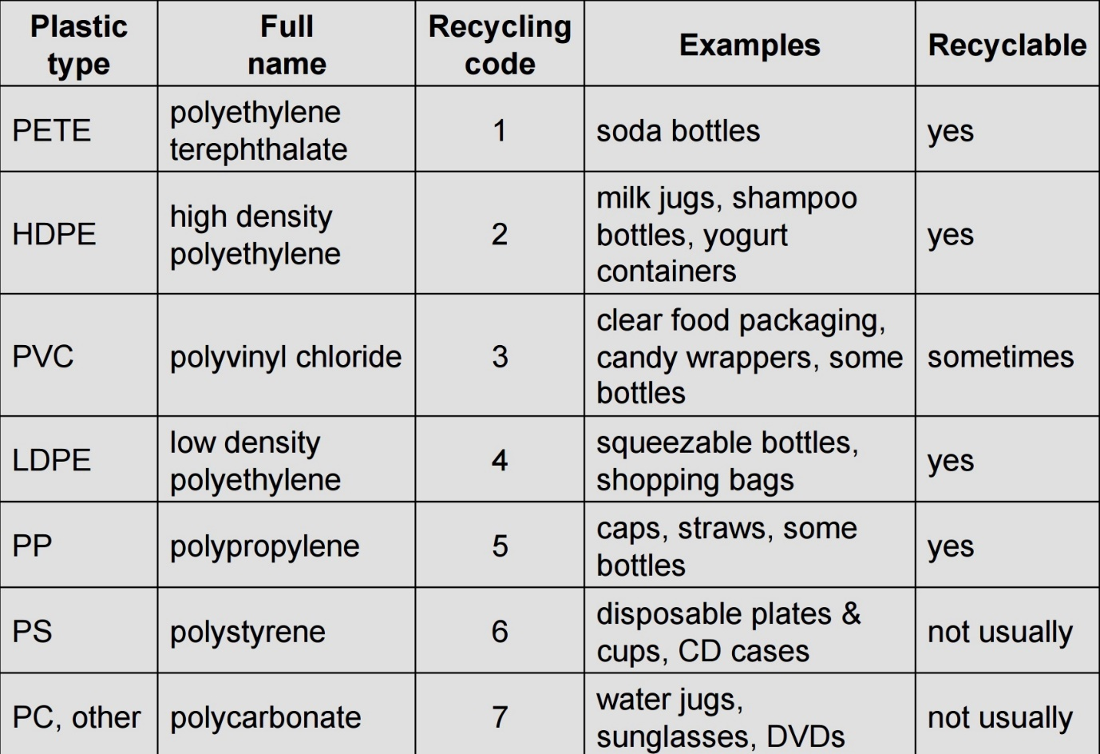

3.4 Methods of sorting plastics
Sorting and separation techniques are usually based on chemical, optical, electrical or physical property differences between the various plastics to be sorted.
Methods for identification and sorting of waste plastics range from manual sorting to advanced automated technologies such as:
- Air sorting
Here the flakes of the commingled material are fed vertically into the air, causing lighter particle to be separated from heavier ones and material is sorted based on the specific gravity.
- Electrostatic sorting technique
Separation can also be achieved by employing electrostatic charging of different plastics. This method separates the plastic materials through their differences in electrostatic charges.
- NIR spectroscopy
This technique involves irradiating plastics with near-infrared waves. When the infrared light reflects off the surface of the plastic, each resin’s characteristic infrared absorption band can be measured and then compared to known polymer values to determine the resin type.
- Mechanical sorting
Mechanical sorting method involves centrifugal force, specific gravity, elasticity, particle shape, and mechanical properties.

- Sorting by melting
This sorting technique is suitable for sorting only two plastic kind at the time. To be able to use this method, it is essential that melting temperatures of the plastics are significantly different.
- Sink float sorting method
This method is based on density differences of plastics. In this technique, plastics that has to be separated are placed in fluid which have density in between the materials making it possible for less dense material to float and heavier to sink.
3.5 Reasons for choosing NIR spectroscopy
NIR spectra of common plastics are quite distinct, for this reason it is ideal for plastic identification and sorting. This method of sorting offers many advantages; it enables rapid, reliable and accurate identification. Moreover, it is sufficiently robust to operate in industrial environment.
3.6 Spectroscopy
Spectroscopy is the study of the interaction between matter and electromagnetic radiation, it is a fundamental exploratory tool in the fields of physics, chemistry, and astronomy, allowing the composition, physical structure and electronic structure of matter to be investigated at atomic scale, molecular scale, macro scale, and over astronomical distances. Spectroscopy is used to refer to the measurement of radiation intensity as a function of wavelength, and it is often used to describe experimental spectroscopic methods. Spectral measurement devices are referred to as spectrometers, spectrophotometers, spectrographs or spectral analysers.
    - Common types of spectroscopy:
  - Atomic Spectroscopy
  - Ultraviolet and Visible Spectroscopy
  - Infrared Spectroscopy
  - Raman Spectroscopy

    - Infrared spectroscopy
Is the spectroscopy that deals with the infrared region of the electromagnetic spectrum, it is one of the most common and widely used spectroscopic techniques which is very useful in the identification and structure analysis of a variety of substances in almost any phase, including both organic and inorganic compounds.
3.6.2.1 Infrared radiation (IR)
Is a region of the electromagnetic radiation spectrum where wavelengths range from about 0.75 um to 1000 um. Infrared waves are longer than those of visible light, but shorter than those of radio waves.
Infrared light is invisible to the human eye, although longer infrared waves can be sensed as heat. It does, however, share some characteristics with visible light, it can be focused, reflected and polarized.
There are multiple spectral regions, or bands of infrared, based on wavelength; however, there is no uniform definition of each band's exact boundaries. Infrared is commonly separated in terms of wavelength or frequency into three regions:
• Near: 0.75 – 2.5 um
• Middle: 2.5 – 25 um
• Far: 25 – 1000 um
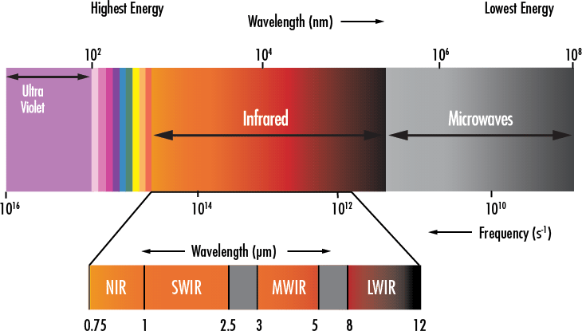
Figure 31: The wavelength ranges of infrared radiation
The following comparison helps to choose the appropriate region of infrared radiation to be used in infrared spectroscopy.
- Advantages and Disadvantages of Mid Infrared Spectrum
Table 3.3: Advantages and disadvantages of mid infrared spectrum
Advantages | Disadvantages
- Good for qualitative and quantitative identification of functional groups  - Calibration data in the mid-IR is much more generic than that in the NIR and thus is more readily transferable from instrument to instrument | - Energy drops off rapidly with increasing wavelengths  - Expensive transmitting material  - High absorption means path lengths have to be small  - Sample preparation required
- Advantages and Disadvantages of Near Infrared Spectrum
Table 3.4: Advantages and disadvantages of near infrared spectrum
Advantages | Disadvantages
- Cheap transmission with glass optics  - Instruments are simpler and cheaper to manufacture  - Weak water absorption enables analysis of high moisture products.  - Lower absorption means longer path length  - Extremely high signal to noise ratio  - No sample preparation required | - Less Information contained in spectrum  - Relies on chemometrics  - Generally, can’t identify components less than 1% in product
From this comparison, it was clearly noticed that the NIR range is more applicable to be used in infrared spectroscopy

    - Infrared spectroscopy working principle
Chemical compounds have different chemical properties due to the presence of different functional groups, thus each molecule has a characteristic spectrum often referred to as the fingerprint which makes it easy to identify a molecule or atom by comparing its absorption peak to a data bank of spectra.
Infrared Spectroscopy is the analysis of infrared light interacting with a molecule. This can be analysed in three ways by measuring absorption, emission and reflection. Although It covers a range of techniques, it is mostly based on absorption spectroscopy. By passing infrared light through a sample and measuring the absorption or transmittance of light at each frequency, an infrared spectrum is obtained, with peaks corresponding to the frequency of absorbed radiation.
    - Infrared spectroscopy in plastics
- The reflectance of each plastic type is unique, thus it can be classified easily.

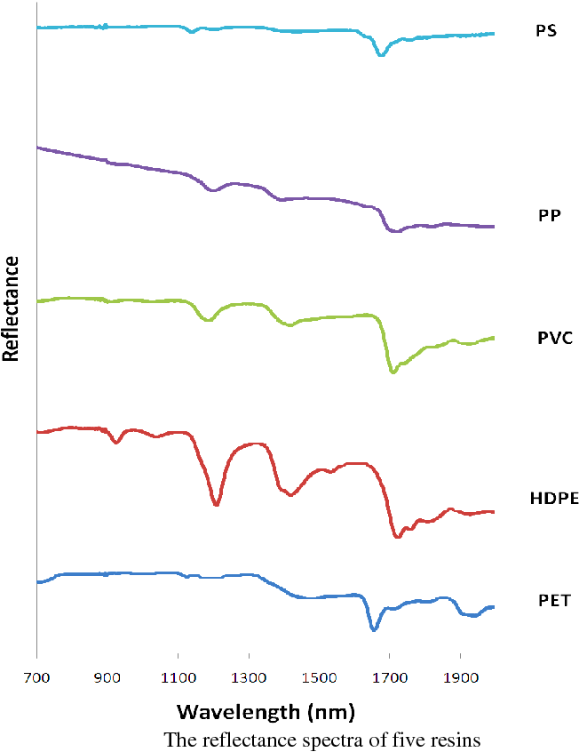
Figure 3.2: The reflectance of each plastic type vs. the wavelength

- Since dark material absorb almost all radiation incident to it, no spectral structure can be obtained for black plastic using NIR reflectance spectroscopy, thus this method can’t be used for dark colored plastic.
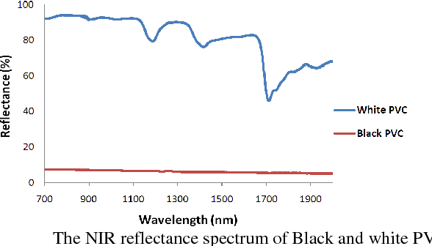
Figure 3.3: The large difference between white and black PVC reflection vs. the wavelength

- Except for dark color, the overall shape of spectra in the NIR region do not change even with variation in color.
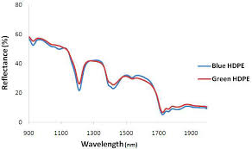
Figure 3.4: The reflection of blue and green HDPE vs. the wavelength

CHAPTER FOUR: Methodology

4.1 System components
4.1.1 Equipment
- Electronic Solenoid Valve
Solenoid valves fig. (4.1) make automation of fluid and gas control possible. It is an electromechanical device, available for both DC and AC electricity, used for controlling liquid or gas flow. The solenoid valve is controlled by electrical current. When the current passes through the coil, it energizes it, thus a magnetic field is created, causing a plunger inside the coil to move. Depending on the design of the valve, the plunger will either open or close the valve. When electrical current is removed from the coil, the valve will return to its de-energized state.
The valve used is a four-way, air-pilot valve with a spool design that requires an input pressure supplied to port P to actuate. The valve will not actuate when no pressure is applied. As shown in the diagrams below, when the coil is de-energized (left diagram), the spool is held in Position 1 by an internal spring. When the coil is energized (right diagram), the solenoid lifts the plunger & the spool is pushed into Position 2 using the supplied pressure from port P. The pressurized flow is show in the diagrams below in purple; the exhaust flow is shown in blue.
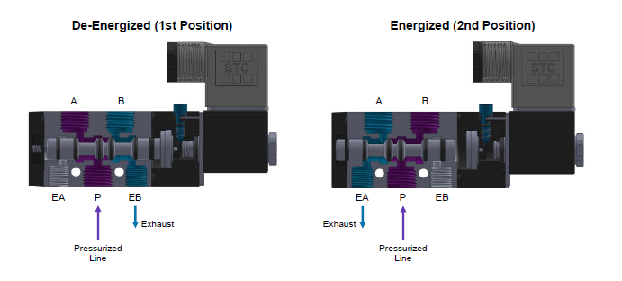
Figure 4.1: Valve Operation

- Push-Button
A push-button fig. (4.2) or simply button is a simple switch mechanism for controlling some aspect of a machine or a process. Buttons are typically made out of hard material, usually plastic or metal.
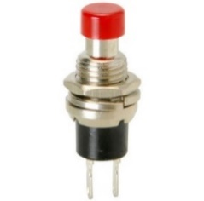
Figure 4.2: Push Button
- Conveyor Belt
A conveyor belt fig. (4.3) is the carrying medium of a belt conveyor system. A belt conveyor system consists of two or more pulleys, with a loop of carrying medium—the conveyor belt—that rotates about them. One or both of the pulleys are powered, moving the belt and the material on the belt forward. The powered pulley is called the drive pulley while the unpowered pulley is called the idler pulley.
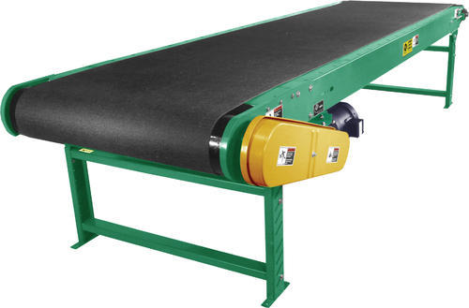
Figure 4.3: Conveyer Belt

- Shaft Coupling
Shaft coupling fig. (4.4) refers to a device that connects two shafts, which rotates together during the transmission of motion and power, and does not disengage under normal conditions. Sometimes used as a safety device to prevent the connected parts from being subjected to excessive loads and to protect against overload.
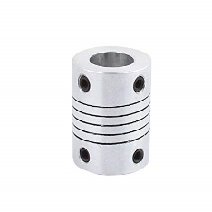
Figure 4.4: Shaft Coupling

- Bearings
A bearing fig. (4.5) is a machine element that constrains relative motion to only the desired motion, and reduces friction between moving parts.
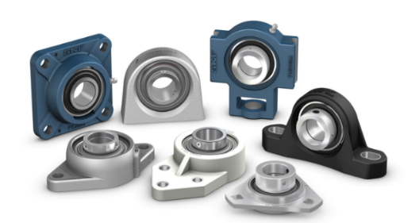
Figure 4.5: Bearings
- DC Motor
A DC motor is any of a class of rotary electrical machines that converts direct current electrical energy into mechanical energy.

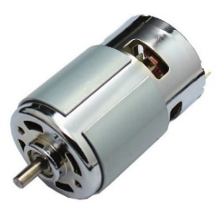
Figure 4.6: DC Motor

- Air Compressor
An air compressor is a device that converts power using an electric motor, diesel or gasoline engine, into potential energy stored in pressurized air.

Figure 4.7: Air Compressor
- Nozzle
A nozzle is a device designed to control the rate of flow, speed, direction, and the pressure of a fluid liquid or gas, as it exits or enters an enclosed pipe.
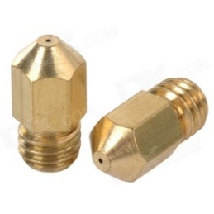
Figure 4.8: Air Nozzle

Pneumatic Air Manifold Splitter:
Pneumatic manifolds provide a convenient junction point for the distribution of fluids or gases through multiple lines from a single source. Air manifolds come in various port options and different material types for low and high-pressure applications.
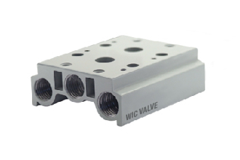
Figure 4.9: Pneumatic Air Manifold Splitter Block
- Pipe
A pipe is used for the passage of fluids or gasses.
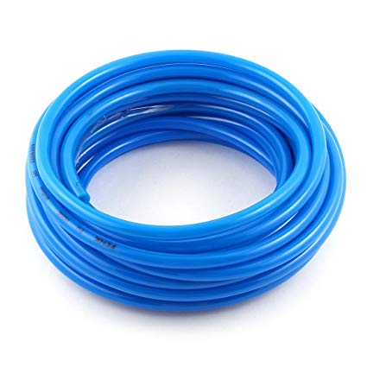
Figure 4.10: Pipe

Light Dependent Resistor (LDR)

An LDR is a component that has a variable resistance that changes with the light intensity that falls upon it. This allows them to be used in light sensing circuits.

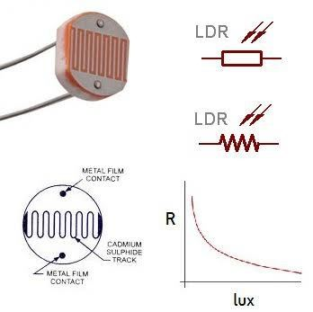
Figure 4.11: Light Dependent Resistor (LDR)

Laser Diode
A semiconductor device that generates coherent light of high intensity is known as laser diode. Coherent radiation means the light waves generated by the device have the same frequency and phase.
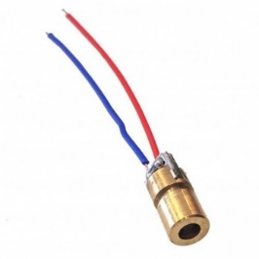
Figure 4.12: Laser Diode

Table 4.1: The equipment and the use of each
Equipment | How it is used in the project
Electronic solenoid valve | Controls the flow of the compressed air.
Push –Button | To start /stop the process.
Conveyor belt | Moves the plastic flakes through all stages.
Bearings | Reduces the fraction between the surface of the bearing and the surface it’s rolling over.
Shaft coupling | Used to connect between the shaft and motors to avoid them from being subjected to excessive loads.
DC Motor | Used to move the conveyor belt.
Air compressor | Source of compressed air used for sorting the plastic flakes.
Air Nozzle | Used to classify the different types of plastics by directing the compressed ait towards then so as to be placed in the right bucket according to their type.
Pneumatic Air Manifold Splitter Block | Distribution of the compressed air.
Pipe | Used for the passage of compressed air.

    - Infrared radiation emitter and detector
The emitter of infrared radiation is an Infrared Light Emitting Diode and the detector is an Infrared Photodiode.
- Infrared Light Emitting Diode
An Infrared light emitting diode (IR LED), is a special purpose LED made of gallium arsenide or aluminium gallium arsenide. It is used to emit infrared rays ranging from 700 nm to 1 mm wavelength. Different IR LEDs may produce infrared light of differing wavelengths, just like different LEDs produce light of different colours.
In this project an IR LED array is going to be used, in order to increase the intensity of the infrared radiation incident on the plastic flakes. We might also connect the IR LED array to an amplifier in order to get an amplified signal with minimum noise.
Since we are working on near infrared radiation, the wavelength of the IR LED array is chosen to be 960 nm.
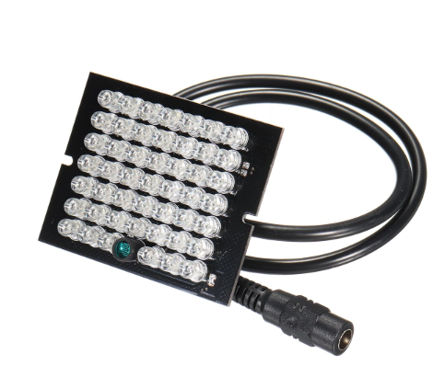
Figure 4.13: Infrared Light Emitting Diode
- Infrared Photodiode
The Infrared Photodiode is sensitive to the infrared light emitted by an IR LED. The photo-diode’s resistance and output voltage change in proportion to the infrared light received.
If the IR photodiode is used to detect infrared radiation of a wavelength very close to its peak wavelength, it will have higher responsivity as shown in fig. (4.14).
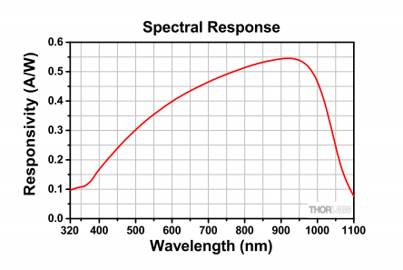
Figure 4.14: The photodiode responsivity VS the wavelength
The wavelength chosen for the IR photodiode must be the same as the IR LED array, therefore a 960 nm IR photodiode is used. Table 4.2 shows the specification of the sensor.
Table 4.2: Specification of the sensor
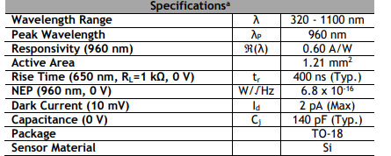

  - Controller
The controller is used to control the whole process. Arduino, which is an open-source platform, is going to be used. Here is a list of facilities of it, that explains our choice of the controller.
- Inexpensive.
- Open source.
- Easy to use.
- Based on simple programming language.
- IDE Software operate on any operating system.
- Doesn’t need an external programming device (Burner).
- Arduino hardware components are cheaper in relation with other controllers.

4.2.1 Voltage divider circuit using the controller
As mentioned before the photo-diode’s resistance changes in proportion to the infrared light incident on it, this change helps to identify the plastic type. To know the amount of change in its resistance, we need to implement a voltage divider circuit, and instead of having it as a hardware circuit, we can make use of the controller to implement it. This way helps to get more accurate results.
  - System design
Figure 4.15: System Design

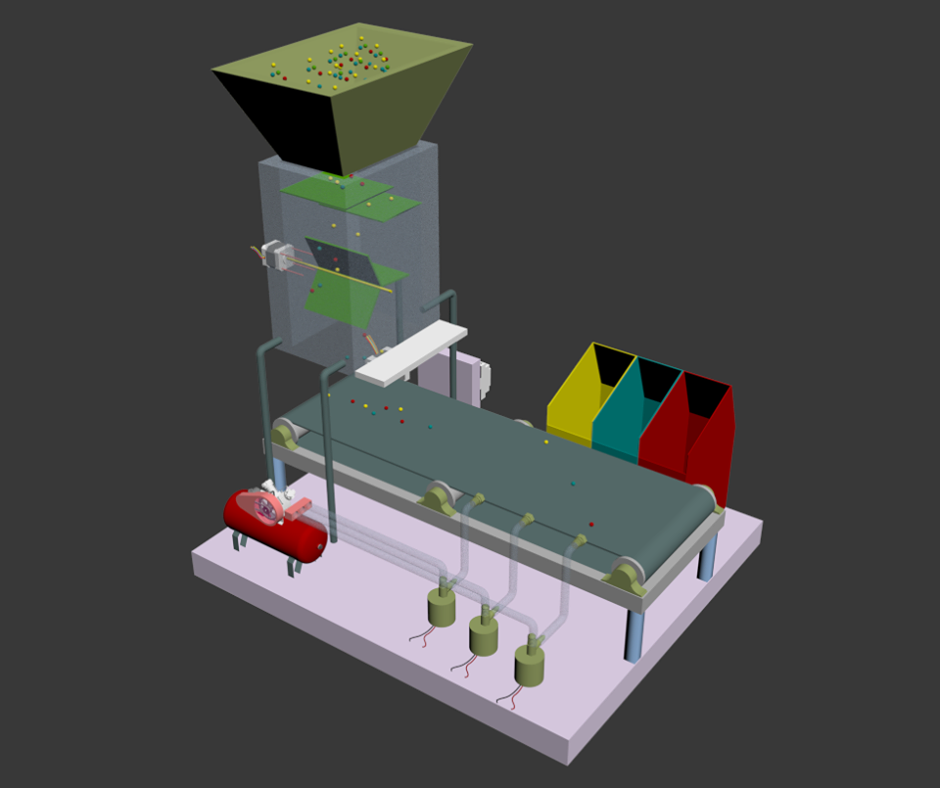
Based on the existing systems and the research papers that we have read, we came up with this design for our project, which was done using 3D MAX program.
  - Circuit diagram

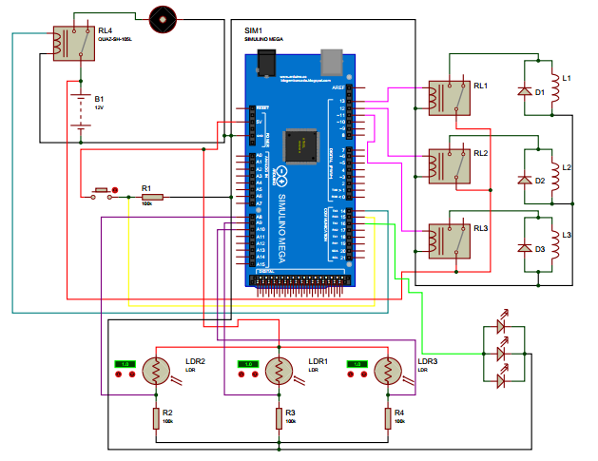
Figure 4.16 : Circuit diagram of the entire system.

  - Procedure
We summed up the procedure of the whole process in a flow chart fig. (4.17) :
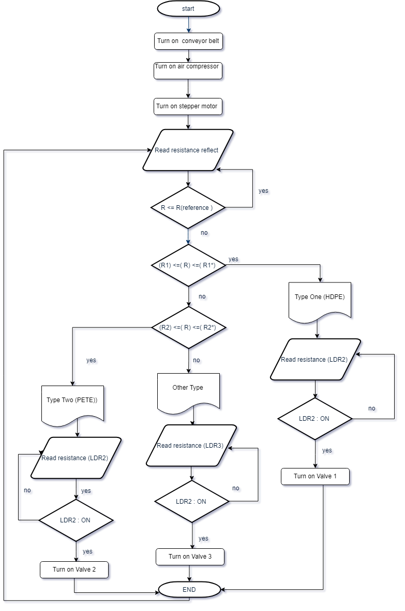
Figure 4.17: The process flow diagram
The operation of the system is briefly explained in the following points:
- At first, we insert the plastic flakes into a funnel. This is done after washing and cutting them into small parts.
- When plastic flakes enter the funnel, they are moved to the area where the stepper motor is located. When the stepper motor moves, it reduces the amount of fallen plastic pieces on the conveyor belt, by scattering them apart from each other. This is done to ease the classification process.
- The conveyor belt starts moving, and the pieces are transferred, so as to undergo the process of plastic identification.
- To classify the plastic flakes, we need an IR source and detector. In this system they will be installed above the conveyor belt.
- When the radiation source is on, and the plastic flakes has not yet reached, the energy measured by the detector will be reflected from the fallen beam on the conveyor belt itself, showing that no plastic is present.
- When a piece of plastic passes, some of the IR radiation will be absorbed while the rest will be reflected, as a result the type of it is identified by the amount of reflected radiation, which is obtained from the sensors and processed by a controller.
- The amount of radiation absorbed and reflected depends on the construction of each material molecules, which helps in identifying each type. As the sensor detects the reflected IR radiation, it causes a change in voltage, current, resistance or power. This change is measured and sent to the controller, which in turn decides the type of plastic according to the data it holds about each type of plastic.
- As the conveyor belt continues to move, the plastic piece will move until it reaches the side of its container, and to make sure that the piece reached the container, a laser and an LDR are used; when the piece arrives it interferes the laser beam incident on the LDR, resulting in changing in its resistance from few kilo-ohms to mega-ohm. The following two conditions must be achieved:
a. It is identified as a plastic of type X.
b. The laser beam is cut off by the plastic piece.
- After fulfilling the previous conditions, the controller sends an order to the electric valve to open, which in turn emits high-pressure air. This pressure will act as a force on the plastic piece allowing it to enter its own container.

CHAPTER FIVE: RESULTS AND DISCUSSION

In this chapter we will interpret the results that we got for the various types of plastics (177 samples in total).
Each sample was tested from the four sides; each time a side was tested so as to have an approximate of the amount of IR radiations reflected by the sample; which results in a precise average of the resistance change in the IR receiver.
The values of the resistance change in the IR receiver made by each type is recorded in 3 tables. From these tables we were able to know the range of resistance change for each type.
A histogram is used to know the frequency of sample occurrences in each subrange of resistance.
Excel and Minitab program was used to analyse the data.
  - Type 1 / PETE Results

Table 5.1: Type 1 (PETE) Results
# | Rx1 | Rx2 | Rx3 | Rx4 | Average
1 | 1.1 | 1.16 | 0.96 | 0.95 | 1.0425
2 | 1.07 | 0.91 | 1.13 | 0.83 | 0.985
3 | 0.92 | 1.03 | 1.32 | 0.94 | 1.0525
4 | 1.3 | 1.54 | 1.01 | 1.34 | 1.2975
5 | 1.39 | 0.97 | 1.01 | 1.52 | 1.2225
6 | 1.18 | 1.33 | 0.94 | 1.13 | 1.145
7 | 1.05 | 1.02 | 1.09 | 0.91 | 1.0175
8 | 1.02 | 1 | 1.13 | 1.36 | 1.1275
9 | 1.06 | 0.85 | 0.97 | 0.98 | 0.965
10 | 1.52 | 1.02 | 1.12 | 1.84 | 1.375
11 | 2.98 | 0.88 | 1.09 | 1.09 | 1.51
12 | 1.77 | 1.11 | 1.32 | 1.53 | 1.4325
13 | 1.36 | 1.08 | 0.89 | 2.01 | 1.335
14 | 1.5 | 1.1 | 0.95 | 1.02 | 1.1425
15 | 1.67 | 1.16 | 1.01 | 1.12 | 1.24
16 | 2.65 | 1.28 | 1 | 1.04 | 1.4925
17 | 1.81 | 1 | 0.97 | 1.33 | 1.2775
18 | 3.28 | 1.06 | 1.24 | 2.27 | 1.9625
19 | 0.92 | 2.26 | 0.89 | 0.96 | 1.2575
20 | 1.04 | 2.97 | 1.98 | 1.29 | 1.82
21 | 1.36 | 1.8 | 1.28 | 1.75 | 1.5475
22 | 2.67 | 1.26 | 3.43 | 1.88 | 2.31
23 | 1.64 | 1.61 | 0.99 | 2.56 | 1.7
24 | 1.73 | 1.08 | 1.07 | 2.94 | 1.705
25 | 1.05 | 1.74 | 1.3 | 1.3 | 1.3475
26 | 1.24 | 1.2 | 1.41 | 0.91 | 1.19
27 | 1.14 | 1.6 | 0.73 | 1.63 | 1.275
28 | 1.34 | 0.71 | 1.04 | 1.05 | 1.035
29 | 0.77 | 2.67 | 1.97 | 1.82 | 1.8075
30 | 0.84 | 2.81 | 1.21 | 1.43 | 1.5725
31 | 0.74 | 2.45 | 1.26 | 1.55 | 1.5
32 | 1.04 | 1.5 | 0.88 | 0.92 | 1.085
33 | 0.89 | 1.2 | 1.37 | 3.31 | 1.6925
34 | 0.72 | 1.25 | 1.62 | 2.03 | 1.405
35 | 1.38 | 1.28 | 2.85 | 0.82 | 1.5825
36 | 0.94 | 1.61 | 1.87 | 1.11 | 1.3825
37 | 1.19 | 0.92 | 1.88 | 2.08 | 1.5175
38 | 1.02 | 0.86 | 1.3 | 1.59 | 1.1925
39 | 2.99 | 1.15 | 0.96 | 3.26 | 2.09
40 | 3.49 | 0.8 | 2.01 | 2.47 | 2.1925
41 | 1.2 | 1.22 | 1.43 | 1.23 | 1.27
42 | 1.19 | 1.05 | 1.4 | 1.22 | 1.215
43 | 1.29 | 1.16 | 1.15 | 1.15 | 1.1875
44 | 1.09 | 1.12 | 1.17 | 2.05 | 1.3575
45 | 2.05 | 2.04 | 2.04 | 2 | 2.0325
46 | 1.32 | 0.93 | 1.22 | 0.87 | 1.085
47 | 1.01 | 1.51 | 1.59 | 1.02 | 1.2825
48 | 0.97 | 0.95 | 1.17 | 1.05 | 1.035
49 | 1.36 | 1.19 | 1.24 | 1.61 | 1.35
50 | 0.87 | 1.03 | 1.21 | 1.2 | 1.0775
51 | 1.68 | 1.17 | 0.85 | 1.67 | 1.3425
52 | 1.16 | 1.15 | 1.11 | 1.62 | 1.26
53 | 1.05 | 1.25 | 1.09 | 0.96 | 1.0875
54 | 1.72 | 1.24 | 0.96 | 1.29 | 1.3025
55 | 1.38 | 1.02 | 1.13 | 2.49 | 1.505
56 | 1 | 0.95 | 1.7 | 1.21 | 1.215
57 | 0.98 | 1.07 | 0.96 | 0.96 | 0.9925
58 | 1.08 | 1.27 | 0.99 | 1.09 | 1.1075
59 | 1.11 | 1.18 | 2.03 | 1.26 | 1.395
60 | 1.19 | 1.15 | 1.31 | 1.28 | 1.2325
61 | 1.02 | 1 | 1.05 | 0.92 | 0.9975
62 | 1.33 | 1.11 | 0.97 | 1.49 | 1.225
63 | 0.79 | 0.83 | 0.84 | 0.85 | 0.8275
64 | 1.34 | 1.86 | 1.04 | 0.99 | 1.3075
65 | 1.08 | 0.91 | 1.22 | 1.34 | 1.1375
66 | 0.94 | 0.92 | 1.11 | 1.3 | 1.0675
67 | 1.04 | 1.04 | 1.33 | 1.22 | 1.1575
68 | 1.09 | 1.06 | 0.91 | 1.23 | 1.0725
69 | 1.18 | 0.97 | 1.24 | 1.43 | 1.205
70 | 0.86 | 0.89 | 0.97 | 1.02 | 0.935
71 | 2.09 | 2.51 | 1.03 | 1.31 | 1.735
72 | 2.24 | 1.19 | 0.91 | 1.13 | 1.3675
73 | 1.48 | 0.95 | 1.71 | 0.87 | 1.2525
74 | 1.03 | 1.05 | 0.88 | 1.27 | 1.0575
75 | 1.21 | 1.34 | 2.04 | 0.95 | 1.385
76 | 0.85 | 1.02 | 0.95 | 0.79 | 0.9025
77 | 1.15 | 1.03 | 0.86 | 0.62 | 0.915
78 | 1.61 | 1.03 | 1.24 | 1.47 | 1.3375
79 | 1.41 | 1.7 | 1.39 | 2.44 | 1.735
80 | 2.5 | 1.03 | 0.87 | 0.88 | 1.32
81 | 1.16 | 0.83 | 1.27 | 1.21 | 1.1175
82 | 1 | 0.94 | 0.84 | 1.26 | 1.01
83 | 0.93 | 0.96 | 0.95 | 0.86 | 0.925
84 | 0.88 | 0.78 | 1.01 | 0.87 | 0.885
85 | 0.76 | 0.94 | 0.98 | 0.61 | 0.8225
86 | 1.01 | 0.95 | 1.01 | 1.14 | 1.0275
87 | 1.01 | 0.96 | 0.94 | 1.27 | 1.045
88 | 1.02 | 1.13 | 0.97 | 0.91 | 1.0075
89 | 0.94 | 1.13 | 1.83 | 2.54 | 1.61
90 | 2.43 | 1.23 | 1.07 | 2.93 | 1.915
91 | 0.8 | 1.22 | 1.09 | 1.76 | 1.2175
92 | 1.38 | 1 | 0.95 | 1.67 | 1.25
93 | 1.15 | 1.04 | 0.89 | 0.88 | 0.99
94 | 1.97 | 1.22 | 1.11 | 2.71 | 1.7525
95 | 1.36 | 1.07 | 2.43 | 1.12 | 1.495
96 | 0.98 | 1.36 | 2.12 | 1.18 | 1.41
97 | 0.94 | 1.22 | 1.04 | 2.13 | 1.3325
98 | 0.77 | 0.81 | 1.19 | 1.01 | 0.945
99 | 1.52 | 1 | 1.14 | 2.04 | 1.425
100 | 0.72 | 0.72 | 1.1 | 1.03 | 0.8925
101 | 1.12 | 1.11 | 1.08 | 1.26 | 1.1425
102 | 0.69 | 0.83 | 1.17 | 1.57 | 1.065
103 | 1.87 | 1.04 | 1.16 | 1.79 | 1.465
104 | 1.51 | 1.01 | 1.07 | 1.55 | 1.285

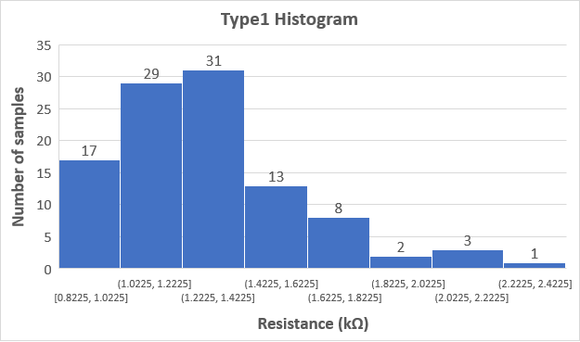

Figure 5.1: Data Analysis of Type 1 (PETE)
As illustrated in fig (5.1); Type 1 / PETE samples (N=104) reflected infrared radiation that made a change in the resistance of the IR receiver in the range of [0.82-1.96] kΩ. Most of the samples made a change of around 1.3 kΩ (Mode).
The data in the histogram is skewed to the right; which shows that most of the samples are on the left side of the histogram.
The distribution is very close to the normal distribution with little skewness towards the right.
The boxplot shows the skewness again and the range of data [0.82-1.96] kΩ. In addition to that it shows outliers if present in the data, here we’ve four outliers (samples that are not related to the data).
The standard deviation (0.3028) and variance (0.0917) for type 1 are relatively small which is a good indication that the data are concentrated around a specific range and not spread out.

  - Type 2 / HDPE Results
Table 5.2: Type2 (HDPE) Results
# | Rx1 | Rx2 | Rx3 | Rx4 | Average
1 | 3.99 | 3.95 | 4.01 | 3.94 | 3.9725
2 | 4.26 | 4.17 | 3.99 | 4.1 | 4.13
3 | 4.51 | 4.42 | 4.3 | 4.4 | 4.4075
4 | 4.15 | 4.08 | 3.94 | 4.05 | 4.055
5 | 4.01 | 3.89 | 4.09 | 4.2 | 4.0475
6 | 3.96 | 3.91 | 3.82 | 3.79 | 3.87
7 | 3.79 | 3.69 | 3.84 | 3.91 | 3.8075
8 | 3.79 | 3.81 | 3.85 | 3.92 | 3.8425
9 | 3.89 | 4.08 | 3.96 | 4.04 | 3.9925
10 | 4.07 | 3.83 | 3.88 | 4.03 | 3.9525
11 | 3.9 | 4.04 | 4.13 | 4.44 | 4.1275
12 | 3.83 | 3.48 | 3.98 | 4.01 | 3.825
13 | 3.9 | 4.01 | 4.01 | 3.91 | 3.9575
14 | 4.09 | 4.06 | 4.35 | 4.3 | 4.2
15 | 4.02 | 4.19 | 4.17 | 3.8 | 4.045
16 | 3.64 | 3.74 | 3.84 | 3.67 | 3.7225
17 | 3.58 | 3.59 | 3.79 | 3.23 | 3.5475
18 | 3.64 | 4.02 | 4 | 4.08 | 3.935
19 | 3.98 | 4.01 | 3.96 | 4.02 | 3.9925
20 | 3.53 | 3.75 | 3.68 | 3.54 | 3.625
21 | 3.44 | 3.35 | 4.19 | 4.09 | 3.7675
22 | 4.08 | 4.17 | 3.87 | 4.05 | 4.0425
23 | 4.13 | 4.19 | 4.26 | 4.28 | 4.215
24 | 4.3 | 4.21 | 4.27 | 4.4 | 4.295
25 | 4.26 | 4.28 | 4.14 | 4.15 | 4.2075
26 | 3.92 | 3.82 | 3.94 | 3.7 | 3.845
27 | 4.08 | 3.94 | 4 | 4.14 | 4.04
28 | 4 | 3.92 | 3.93 | 3.99 | 3.96
29 | 3.67 | 3.82 | 3.85 | 3.85 | 3.7975
30 | 4.13 | 4.15 | 4.09 | 4.28 | 4.1625
31 | 3.92 | 3.49 | 3.49 | 3.65 | 3.6375
32 | 3.94 | 3.93 | 4.18 | 3.88 | 3.9825
33 | 4.15 | 4.01 | 3.93 | 4.09 | 4.045
34 | 4.06 | 3.74 | 3.77 | 3.88 | 3.8625
35 | 3.85 | 3.95 | 4.05 | 3.99 | 3.96
36 | 4 | 3.74 | 3.78 | 3.73 | 3.8125
37 | 3.83 | 3.99 | 3.82 | 4.11 | 3.9375
38 | 4.04 | 4.24 | 4.08 | 4.19 | 4.1375
39 | 3.92 | 3.84 | 3.94 | 3.38 | 3.77
40 | 4.06 | 3.86 | 3.86 | 3.91 | 3.9225

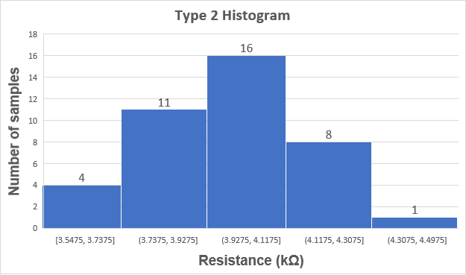

Figure 5.2: Data Analysis of Type 2 (HDPE)
Fig (5.2) shows some samples of Type 2 / HDPE (N=40) and it represents the amount of change these samples made on the resistance of the IR receiver, this change is in the range of [3.54-4.29] kΩ. Most of the samples made a change of around 3.95 kΩ (Mode).
The data in the histogram is skewed to the left; which shows that most of the samples are on the right side of the histogram.
The distribution is very close to the normal distribution with little skewness towards the left.
The boxplot shows the skewness again and the range of data [3.54-4.29] kΩ. In addition to that it shows outliers if present in the data, here we have one outlier.
The standard deviation (0.1844) and variance (0.034) for type 2 are relatively small which is a good indication that the data are concentrated around a specific range and not spread out.

  - Type 3 & 5 / PVC & PP Results

Table 5.3: Type 3 &5 (PVC & PP) Results
# | Rx1 | Rx2 | Rx3 | Rx4 | Average
1 | 2.93 | 3.26 | 2.22 | 2.26 | 2.6675
2 | 3.77 | 3.16 | 2.2 | 3.51 | 3.16
3 | 3.34 | 3.2 | 3.06 | 2.84 | 3.11
4 | 3.39 | 3.3 | 3.32 | 3.7 | 3.4275
5 | 3.92 | 2.99 | 2.51 | 1.96 | 2.845
6 | 3.17 | 2.16 | 2.44 | 2.99 | 2.69
7 | 3.19 | 3.21 | 2.46 | 2.69 | 2.8875
8 | 3.13 | 2.14 | 1.62 | 2.79 | 2.42
9 | 3.09 | 2.24 | 3.16 | 1.76 | 2.5625
10 | 3.04 | 3.09 | 1.95 | 1.93 | 2.5025
11 | 3.31 | 3.1 | 3.15 | 3.33 | 3.2225
12 | 3.3 | 3.12 | 3.21 | 3.15 | 3.195
13 | 3.41 | 2.54 | 3.71 | 3.69 | 3.3375
14 | 3.29 | 2.88 | 2.35 | 3.36 | 2.97
15 | 3.35 | 3.6 | 2.74 | 2.87 | 3.14
16 | 3.7 | 3.12 | 3.65 | 3.03 | 3.375
17 | 3.35 | 2.27 | 3.2 | 3.22 | 3.01
18 | 3.51 | 2.81 | 3.17 | 1.49 | 2.745
19 | 2.31 | 3.36 | 3.41 | 3.57 | 3.1625
20 | 3.72 | 3.33 | 3.32 | 2.7 | 3.2675
21 | 3.35 | 2.88 | 2.96 | 1.57 | 2.69
22 | 2.46 | 3.36 | 3.51 | 3.06 | 3.0975
23 | 3.02 | 3 | 3.57 | 2.52 | 3.0275
24 | 2.62 | 2.93 | 1.97 | 3.01 | 2.6325
25 | 3.35 | 2.36 | 3.4 | 2.45 | 2.89
26 | 3.29 | 2.84 | 2.44 | 3.42 | 2.9975
27 | 3.18 | 2.99 | 3.04 | 3.47 | 3.17
28 | 2.77 | 3.67 | 2.01 | 2.64 | 2.7725
29 | 2.66 | 2.42 | 1.82 | 2.25 | 2.2875
30 | 1.82 | 2.82 | 2.23 | 2.86 | 2.4325
31 | 3.41 | 3.36 | 2.87 | 3.16 | 3.2
32 | 2.17 | 2.82 | 3.67 | 3.35 | 3.0025
33 | 3.71 | 1.96 | 1.44 | 4.03 | 2.785

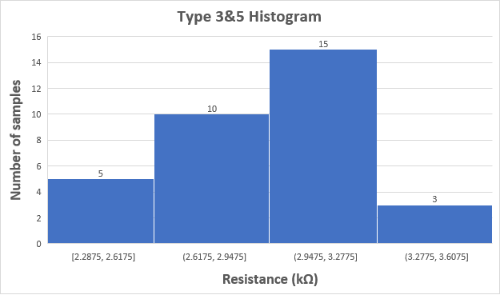

Figure 5.3.: Data Analysis of Type 3 & 5 (PVC & PP)
Fig (5.3) demonstrates Type 3 & 5 / PVC & PP samples and the amount of change made on the resistance of the IR receiver, which is around this range [2.28-3.42] kΩ. Most of the samples made a change of around 3.2 kΩ (Mode).
The data in the histogram is skewed to the left; which shows that most of the samples are on the right side of the histogram.
The distribution is very close to the normal distribution with little skewness towards the left.
The boxplot shows the skewness again and the range of data [2.28-3.42] kΩ. In addition to that it shows outliers if present in the data, here we don’t have any outlier.
The standard deviation (0.2985) and variance (0.0891) for type 3 & 5 are relatively small which is a good indication that the data are concentrated around a specific range and not spread out.

-
Figure 5.4: Boxplot of the 3 types

Fig (5.4) shows a comparison of the boxplot of the three categories Type1, Type2, and Type3&5. Each boxplot illustrates the range of resistance change. It is clear from this comparison that there is no interference between the three ranges.

CHAPTER SIX: conclusion and recommendations

  - Conclusion
The classification of plastics can be obtained using measurements of the NIR reflectance spectroscopy. Using automatic sorting through NIR spectroscopy, plastic recycling can become economical, turn trash into a renewable resource, remove large amounts of material from the garbage stream, and make the earth a greener place.
6.2 Recommendation
There are several ways to improve our project, for instance:
- Increase the accuracy of sorting.
- Increase the speed of sorting
- Ensuring our design is optimum.

References:
- D. A. Wahab, A. Hussain, E. Scavino, M.M. Mustafa and H. Basri ,” Development of a Prototype Automated Sorting System for Plastic Recycling”.
- Hamed Masoumi, Seyed Mohsen Safavi, and Zahra Khani , “Identification and Classification of Plastic Resins using Near Infrared Reflectance Spectroscopy”.
- CSIR - Central Electronic Engineering Research Institute, Chennai Centre, CSIR Madras Complex, Chennai - 600 1 1 3 , “Design of an Embedded based Control System for efficient sorting of Waste Plastics using Near Infrared Spectroscopy”.
- Electronic Devices and Circuit Theory 11th edition.
- 3D MAX program.
- Minitab program.
- Proteus program.
- Excel.
- Arduino IDE.
- https://www.thorlabs.com/index.cfm.
- https://www.electronicshub.org/ir-sensor/
- http://www.circuitstoday.com/ohmmeter-using-arduino
- https://circuitglobe.com/
- https://www.conserve-energy-future.com/why-is-recycling-important.php

