AN-NAJAH NATIONAL UNIVERSITY


FACULTY OF ENGINEERING AND INFORMATION TECHNOLOGY COMPUTER ENGINEERING DEPARTMENT

Graduation Project I

YOU MATTER

Done by:
Adlah Faqih
Reem AbuRajab

Supervisor:
Dr.Muhannad Al-jabi

Presented in partial fulfillment of the requirements for a Bachelor’s degree in Computer Engineering.

Jan-202

We would like to express our deepest gratitude to our family for their unwavering support throughout this academic journey. Your encouragement, understanding, and patience are truly appreciated, and we feel blessed to have you by our side.
To our friends, thank you for your camaraderie and shared moments during this project.
A special appreciation goes to Dr. Muhannad Al-jabi, our esteemed supervisor. Your insightful feedback, dedication, and encouragement fueled our passion for the project and contributed significantly to its success.
Finally, we acknowledge the immense blessings from Allah, as it is through His motivation, strength, and wisdom that we were able to accomplish this undertaking.

This study was authored by Reem and Adlah, students from the computer engineering department at Al-Najah National University. It is important to note that the study may contain grammatical or informational errors. The content presented in this study does not reflect the responsibility of An-Najah National University. Furthermore, the university holds no liability for any misuse of this study for purposes other than its intended use.

List of Figures 4
- Abstract 6
- Introduction 7
  - Motivation 7
  - Project objectives 7
  - Scope of the work 7
  - Organization 7
- Constraints, Standards and Earlier Course- work 8
  - Constraints Limitations 8
  - Standards 8
  - Earlier coursework 8
- Literature Review 9
- Methodology 10
  - Tools,Methods and programming Languages 10
    - programming language 10
    - Tools 10
    - Database 10
  - System Features Implementation (application mobile): 13
    - common features: 13
  - System Features Implementation (website): 23
- Results and Discussion 30
- Conclusion 30
  - Summary 30
  - Future Work 31
  - References 31

List of Figures

- UserDB 10
- PatientDB 11
- DoctorDB 11
- ContentDB 11
- AppointmentDB 11
- FeedbackDB 12
- SuggestionDB 12
- PaymentDB 13
- ReportDB 13
- Main page , About 13
- User(Doctor and patient) Login and Register 14
- Contact Us 14
- profile and edit profile 15
- chat and video call 15
- Lists of all Doctors and Content Management 16
- Notification 16
- Appoiments 17
- The Main page 17
- Suggestion Form 18
- review page 18
- payment 19
- Navbar

Abstract

YOU MATTER is a haven of support and healing on the journey to emotional well-being. Our website is designed to be a trusted resource for finding solace, guidance, and professional therapeutic services. At YOU MATTER, we understand that life's challenges can weigh heavily on you, impacting your mental and emotional health. Our mission is to provide a safe, compassionate, and nurturing space where you can embark on a path toward self-discovery, resilience, and personal growth. Our website offers a comprehensive range of therapeutic services, including individual counselling, and specialized support for a variety of emotional concerns. Our experienced and compassionate therapists are here to listen, understand and help you navigate life's complexities. Through insightful therapy sessions via chat, voice or video call, evidence-based techniques, and a commitment to your well-being, we aim to empower you to overcome obstacles, build stronger relationships, and achieve greater emotional balance. Our website offers valuable resources, articles, analyisis tests, and tools to support your journey to mental and emotional health. YOU MATTER is dedicated to promoting mental health, promoting resilience, and fostering a sense of inner peace. Take the first step toward a brighter tomorrow by exploring our website, connecting with our compassionate therapists, and investing in your emotional health. We believe that healing is possible, and our website is here to guide you on your path to personal transformation. Your journey to emotional wellness starts here.

This project represents the culmination of our academic endeavors, leveraging a tech-stack fusion of HTML, CSS, JavaScript, and Flutter for the frontend, while Node.js orchestrates the backend, seamlessly integrating with a MongoDB database.

Introduction

Motivation
The inception of the "YOU MATTER" project was propelled by a profound recognition of the pressing need for accessible and empathetic mental health support in our contemporary society. In an era marked by the accelerating pace of life, the demand for effective therapeutic interventions has become increasingly apparent. Factors such as geographical barriers, stigmas surrounding mental health, and the fast-paced nature of modern life often hinder individuals from seeking traditional in-person therapy. The motivation behind developing the "YOU MATTER" app was to bridge these gaps and provide a user-friendly, digital platform that connects individuals with professional therapists. This project stems from a deep-seated commitment to enhancing mental well-being by leveraging technology to create a space where users feel heard, supported, and empowered to prioritize their mental health. The aim is to facilitate an inclusive and judgment-free environment that transcends physical boundaries, making mental health resources and support readily available to all who seek it. Ultimately, "YOU MATTER" is driven by a dedication to fostering a positive impact on individual lives and contributing to the ongoing global conversation surrounding mental health awareness and accessibility.

Project objectives
The system comprises three distinct interfaces: one for administrators, another for healthcare professionals (doctors), and a third for individuals seeking therapy (patients). The primary goal is to facilitate seamless interaction between patients and online therapists, empowering users to connect with professional support easily. The system allows patients to request therapy sessions without limitations, creating a flexible and user-centric approach to mental health care. An innovative map feature will guide patients to the nearest available therapists, presenting detailed information about the services offered. Additionally, the system aims to streamline administrative tasks for healthcare professionals and administrators, ensuring efficient management of therapy sessions, schedules, and user data. The "YOU MATTER" platform emphasizes accessibility, user-friendliness, and the creation of a secure space for therapeutic interactions.

Scope of the work

Our program offers provide a flexible and user-centric platform connecting individuals with online therapists. It encourages users to explore various therapeutic options, making decisions based on their unique preferences and mental health needs. The project aims to create a comprehensive online environment through both the website and mobile application interfaces, ensuring accessibility and choice in seeking personalized online therapy services.

Organization

This report has organized as follows:

    - Chapter one: Overview about objectives and importance of this project.
    - Chapter two: the description for constraints, standards
    - Chapter three: Literature Review.
    - Chapter four: Followed methodology for the implementation of the project.
    - Chapter five: Result and Discussion.
    - Chapter six: summarize the report, and provide information about future work.

Constraints, Standards and Earlier Course- work

Constraints Limitations
    - Limited time constraints prevented us from incorporating numerous additional ideas into our app. Despite the abundance of potential features, we had to prioritize and focus on the most essential ones to meet our project deadlines
    - We encountered challenges in linking the website and the mobile application with the same database , we stucked there for a while .
    - learning Node.js and Flutter, with the limited timeframe available. The complexity of Node.js for backend server operations and Flutter for cross-platform mobile application development presented a challenge in terms of mastering the intricacies of both simultaneously.

Standards
    - frontend:
      - admin interface: html , css ,js, flutter
      - user(doctor,patients) interface: html,css,js,flutter

    - backend:
      - admin interface: Node.js
      - user (doctor,patients) interface: Nodejs

Earlier coursework

We have acquired our knowledge of programming languages through various courses we have taken at the university, including web development and database courses, as well as online courses. Ad- ditionally, we have learned proper coding practices .

Literature Review

In the dynamic landscape of mental health interventions, the confluence of technology and therapeutic services has significantly reshaped the paradigm, placing a substantial emphasis on online platforms and mobile applications. The amalgamation of web-based services and mobile applications within the realm of digital mental health has emerged as a powerful strategy, promising heightened accessibility and increased user engagement. Extensive research into online therapy has underscored its efficacy, establishing it as a compelling alternative to traditional face-to-face counseling, especially for individuals encountering barriers to in-person support. Simultaneously, the proliferation of mental health apps has enriched the field with an array of self-help tools and resources, albeit facing persistent challenges related to user engagement. Against this multifaceted backdrop, the "YOU MATTER" graduation project takes center stage, ambitiously seeking to seamlessly connect users with online therapists through a cohesive web and mobile interface. This innovative initiative not only draws upon the documented benefits of online therapy but also harnesses the convenience and ubiquity inherent in mobile applications. By skillfully unifying these elements, the project aims to provide users with a comprehensive and easily accessible mental health support system. As digital mental health interventions continue to evolve, "YOU MATTER" stands as a noteworthy contribution, offering a holistic approach that emphasizes the synergies between online therapy and mobile applications for the enhancement of mental health services.

The consideration of ethical and privacy implications is paramount in this digital mental health landscape, necessitating a comprehensive understanding of user data protection and informed consent. By embracing these considerations, the "YOU MATTER" project poised to adapt to the evolving needs and expectations of its users while maintaining ethical standards and data security.

Methodology

Tools,Methods and programming Languages

programming language

Our application was built using three different languages:

      - Flutter for the frontend.
      - Node-JS for the backend.
      - HTML, CSS, JS for the website.

Tools
- Node-JS.
- Flutter.
- Xampp.
- Visual Studio Code.
- MongoDB.
- To test our project, we utilized an emulator that simulates the functionality of a REST API. A REST API, based on the principles of the REST architecture, enables communication through HTTP requests, facilitating various CRUD operations such as creating, reading, updating, and deleting data. By leveraging a REST API, we were able to seamlessly access our database and interact with the necessary data. This approach provided us with a flexible and efficient means of testing and validating our project’s functionalities.

Database

For our project, we opted for the utilization of a MongoDB database. Which is NoSQL database (No Relations)

- Users : Each individual user possesses their unique account.
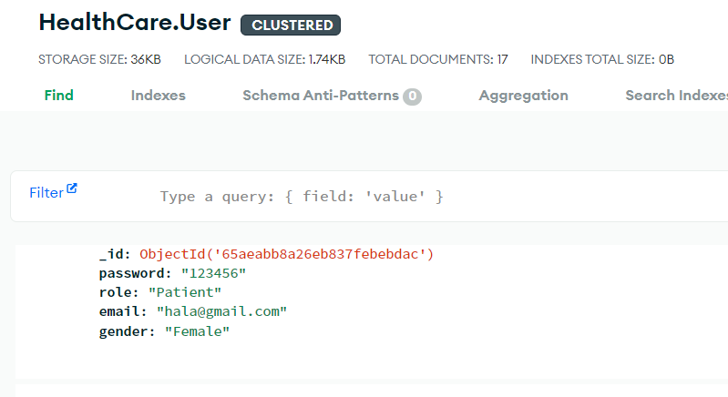
Figure 1: UserDB

- Patient : patients are provided with their individual accounts.
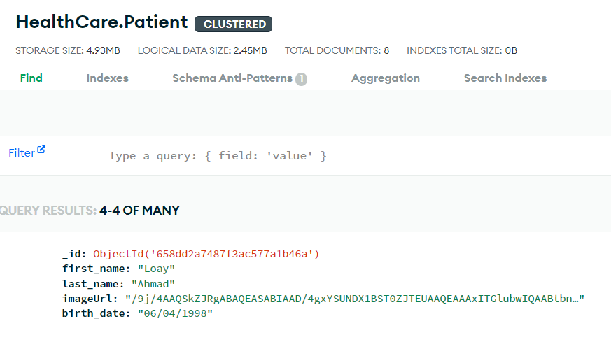
Figure 2: PatientDB

- Doctor: Every Doctor has his own account.
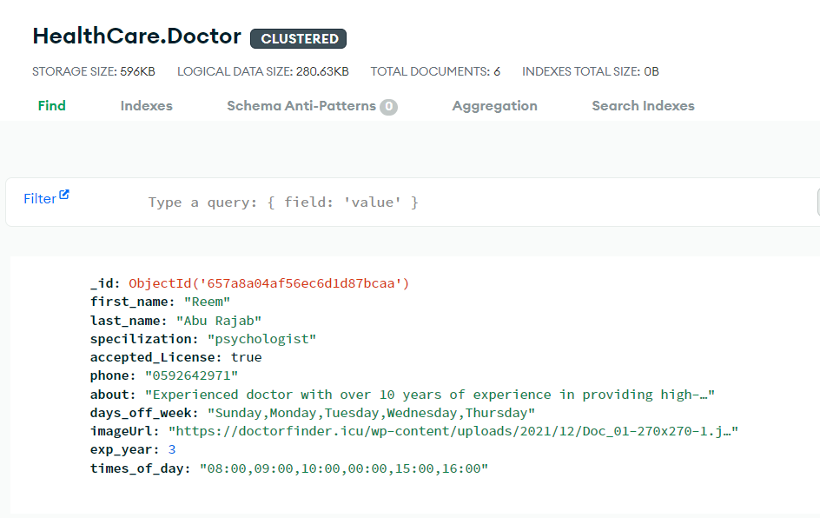
Figure 3: DoctorDB

- Content :
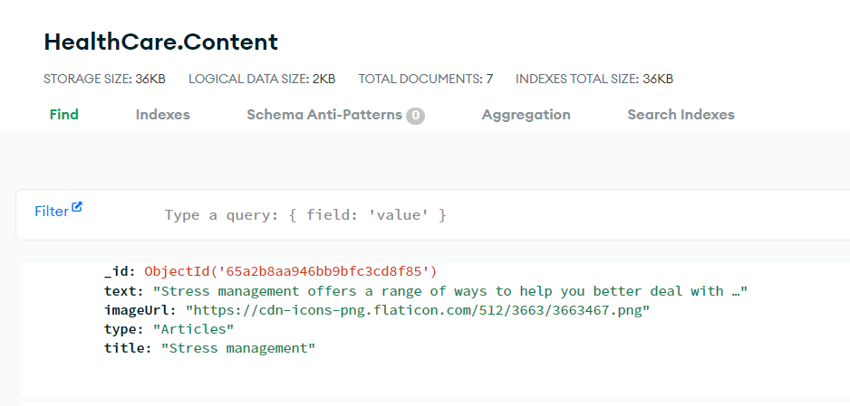
Figure 4: ContentDB

- Appointment :
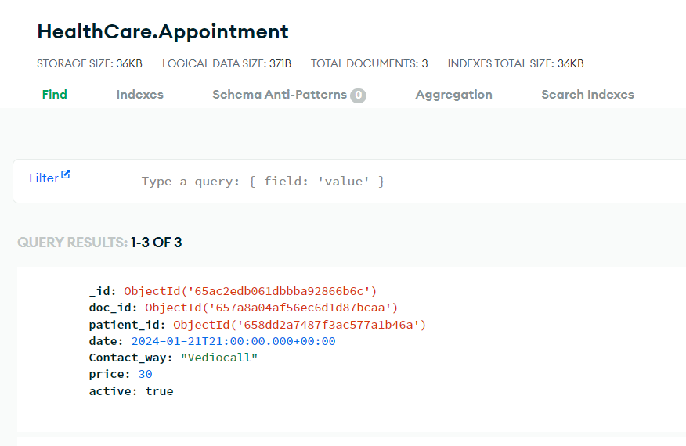

Figure 5: AppointmentDB

- Feedback : Each patient can send feedback .
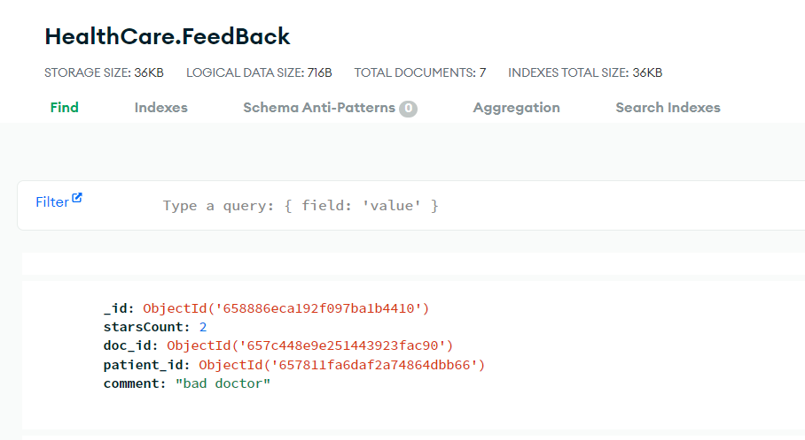
Figure 6: FeedbackDB

- Suggestion:
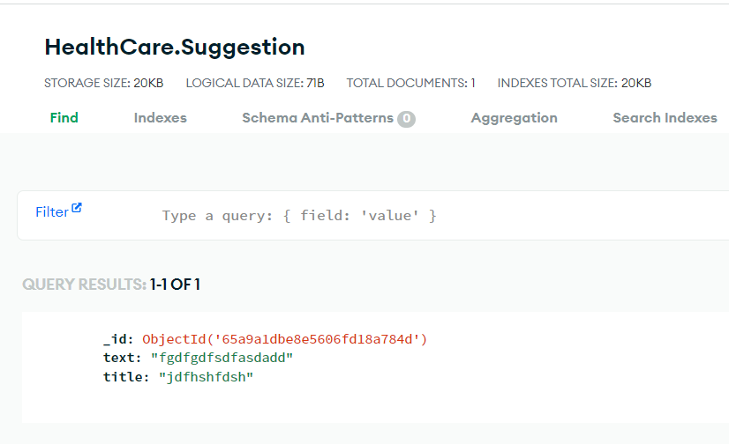
Figure 7: SuggestionDB

Payment :
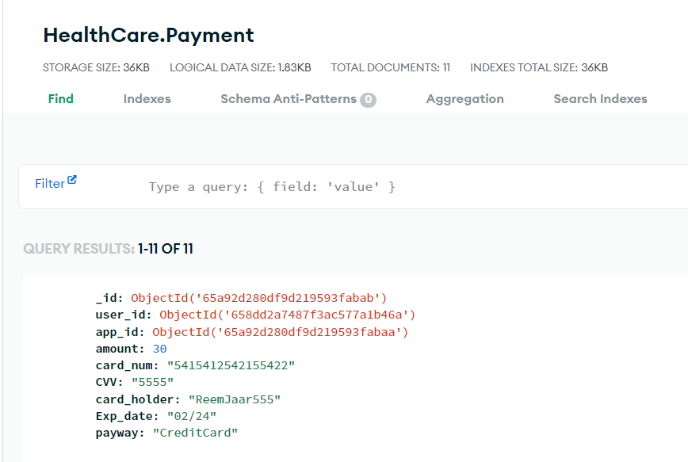
Figure 8: PaymentDB
Report :
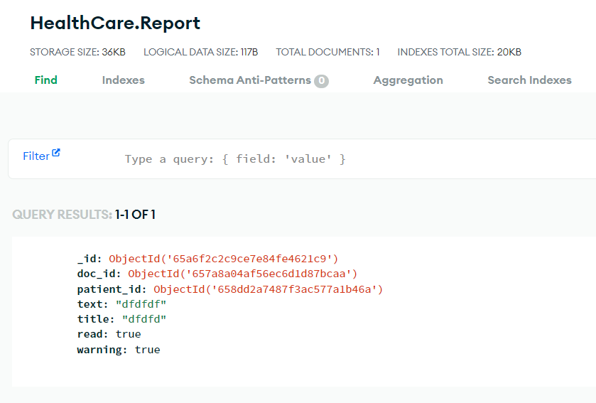
Figure 9: ReportDB

System Features Implementation (application mobile):

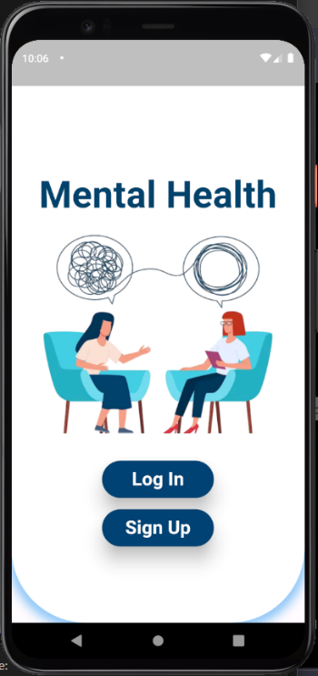
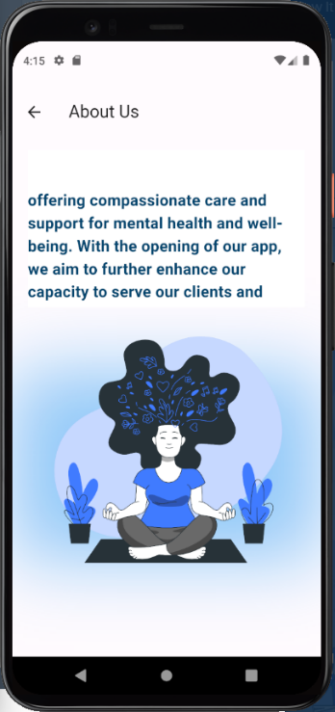
common features:

Figure 10: Main page , About

Patients and Doctors create accounts immediately , they allowed to log in , when Doctor sign up he will upload his license and he must wait to an confirm email to log in .
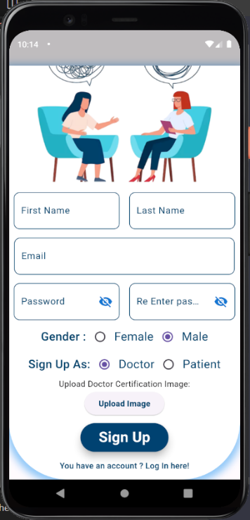
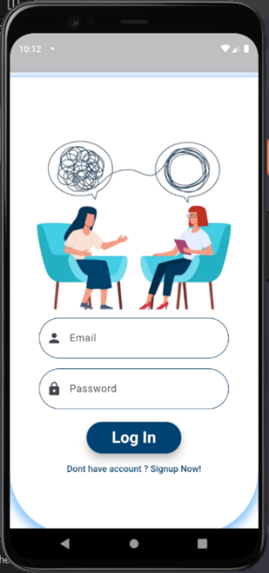

Figure 11: User(Doctor and patient) Login and Register

patients and doctors can contact with the admin through the phone or the email account
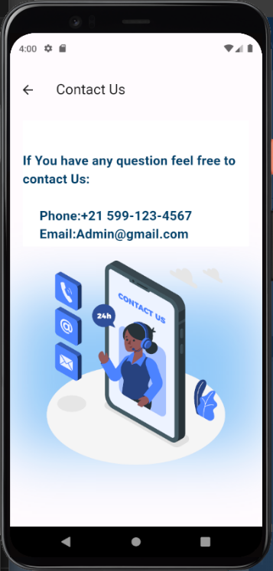

Figure 12: Contact Us

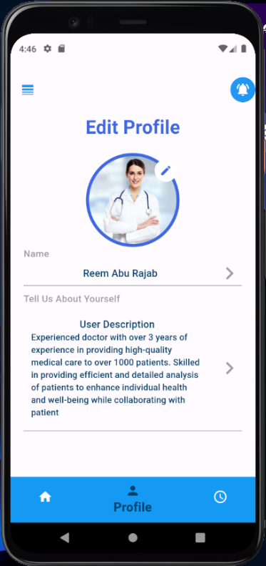
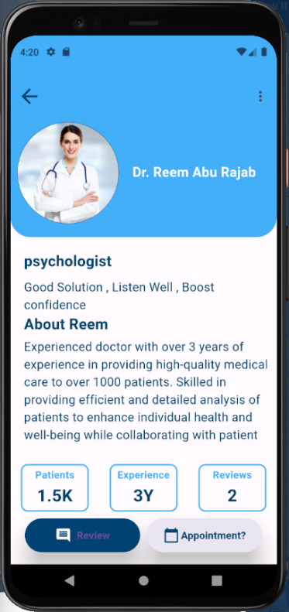
Figure 13: profile and edit profile

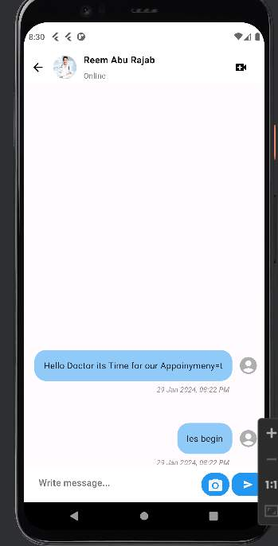
Patient take his session with the doctor through the chat and voice/video call in the system
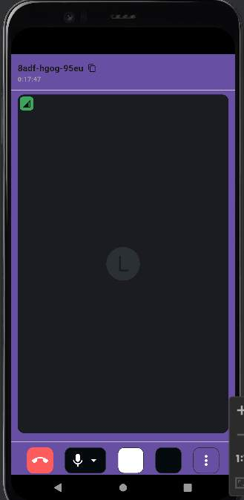

Figure 14: chat and video call

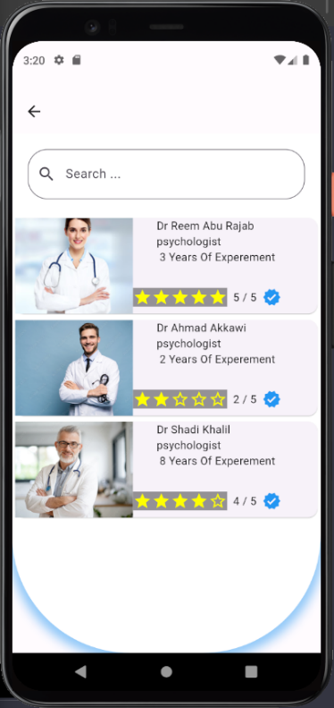
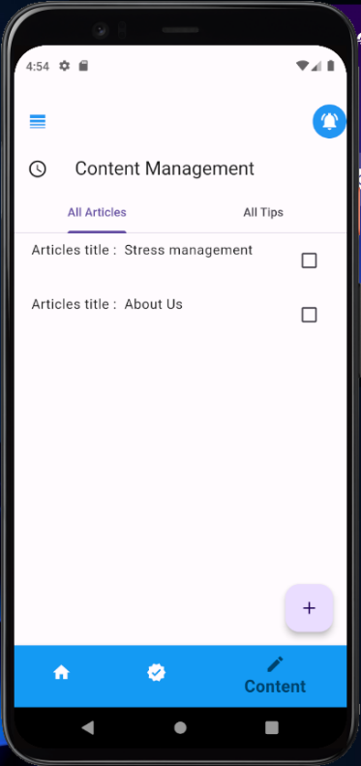
admin can see all the Doctors in the system and manage the contents .

Figure 15: Lists of all Doctors and Content Management

The patient will receive a notification as a reminder for the session , and admin will receive one for the report come from patient .
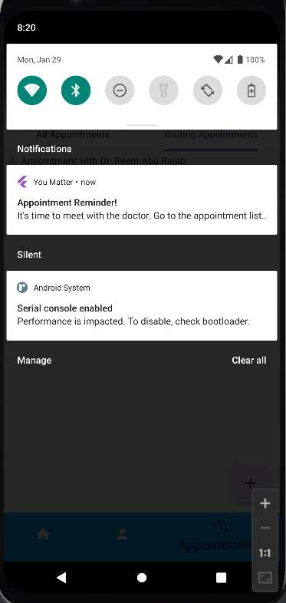
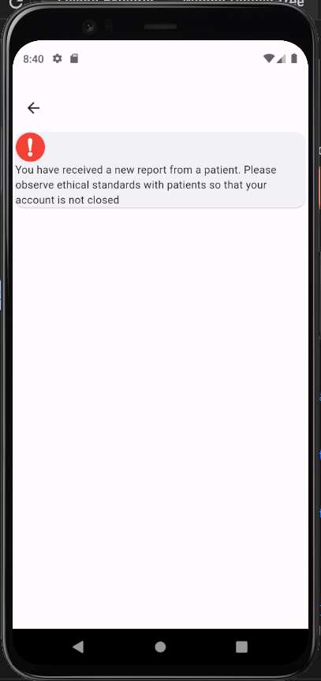

Figure 16: Notification

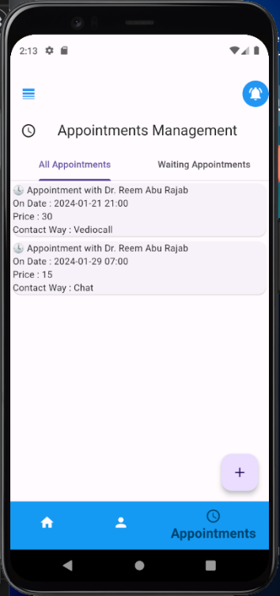
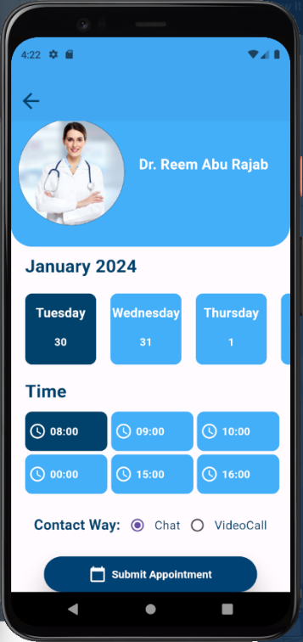
Doctor add time available so patient book an appointment depends on it .

Figure 17: Appointments

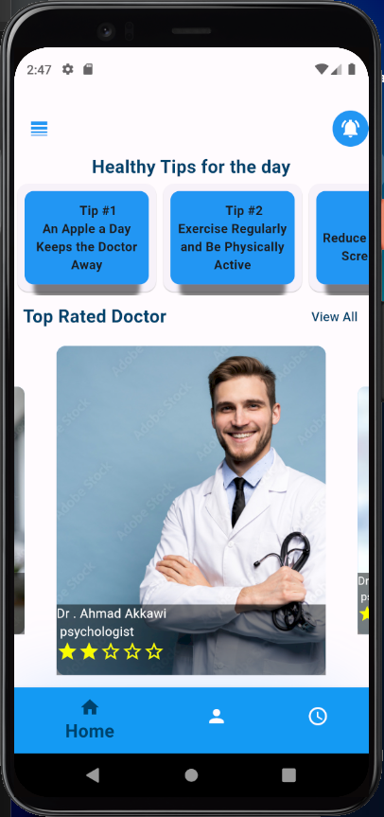

Figure 18: The main page

patient can submit a suggestion to improve our system .

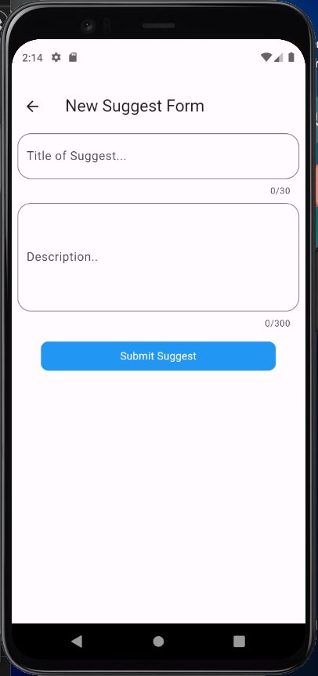
Figure 19: Sugession Form

patients can rate the Doctors and that’s showed in the review page.

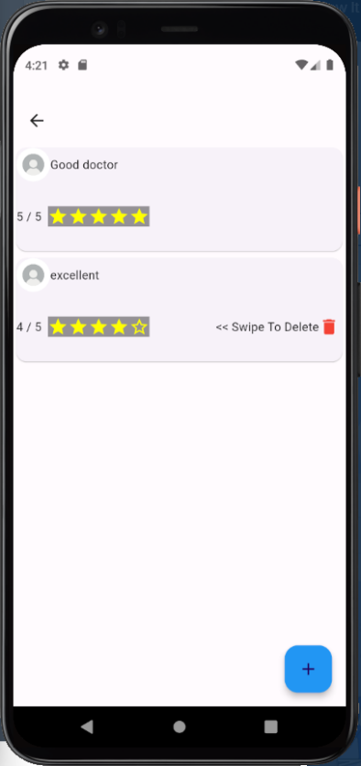
Figure 20: Review page

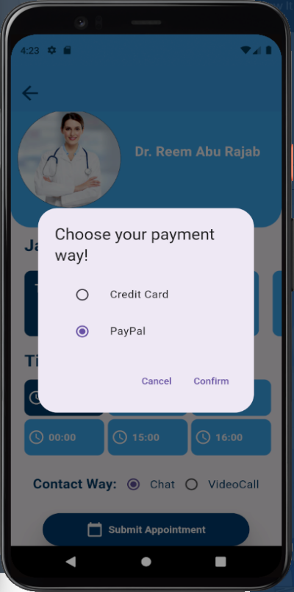
the patient can pay through the credit card or paypal.

Figure 21: Payment

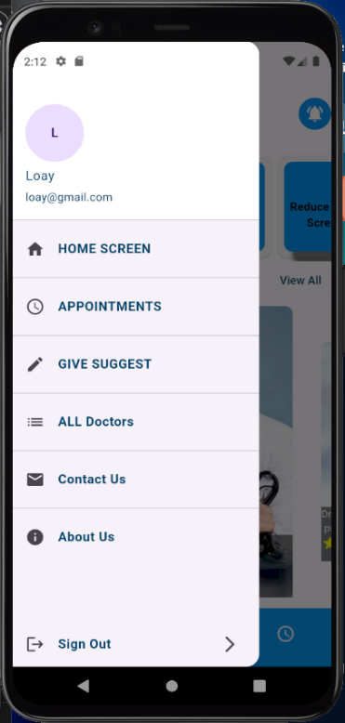
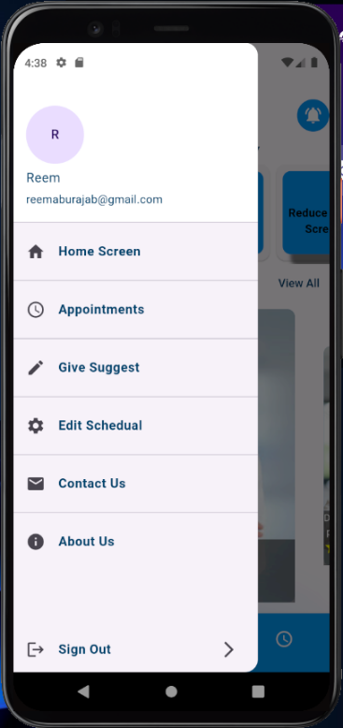

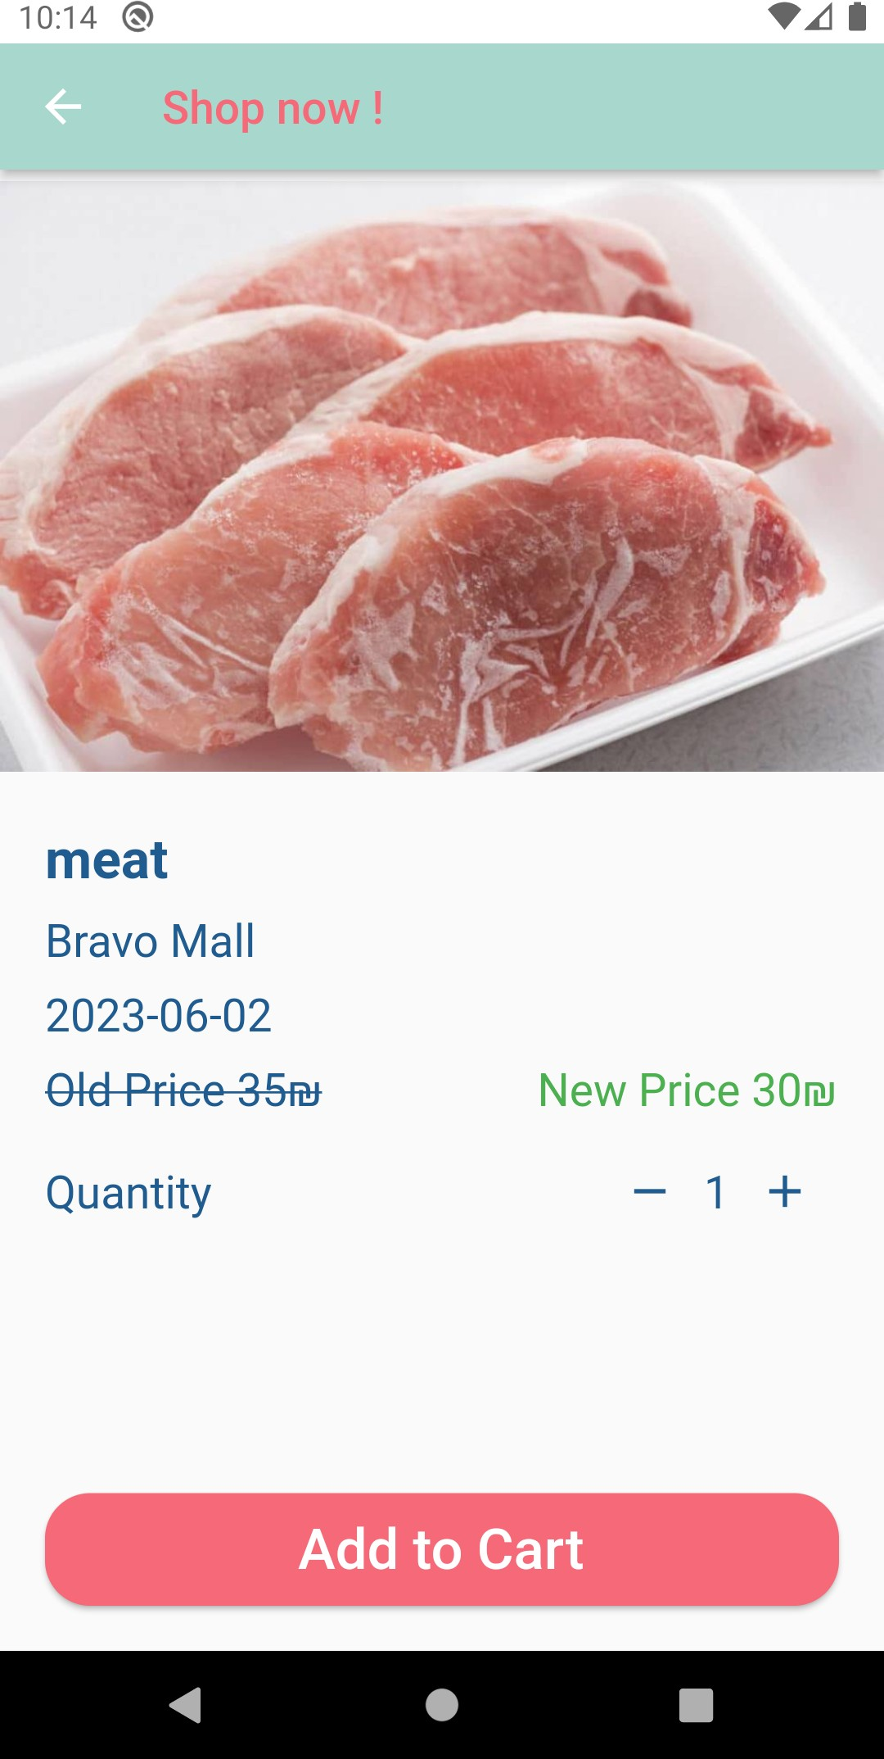
Figure 22: Navbar

System Features Implementation (website):

Main page ,Login and Sign Up :

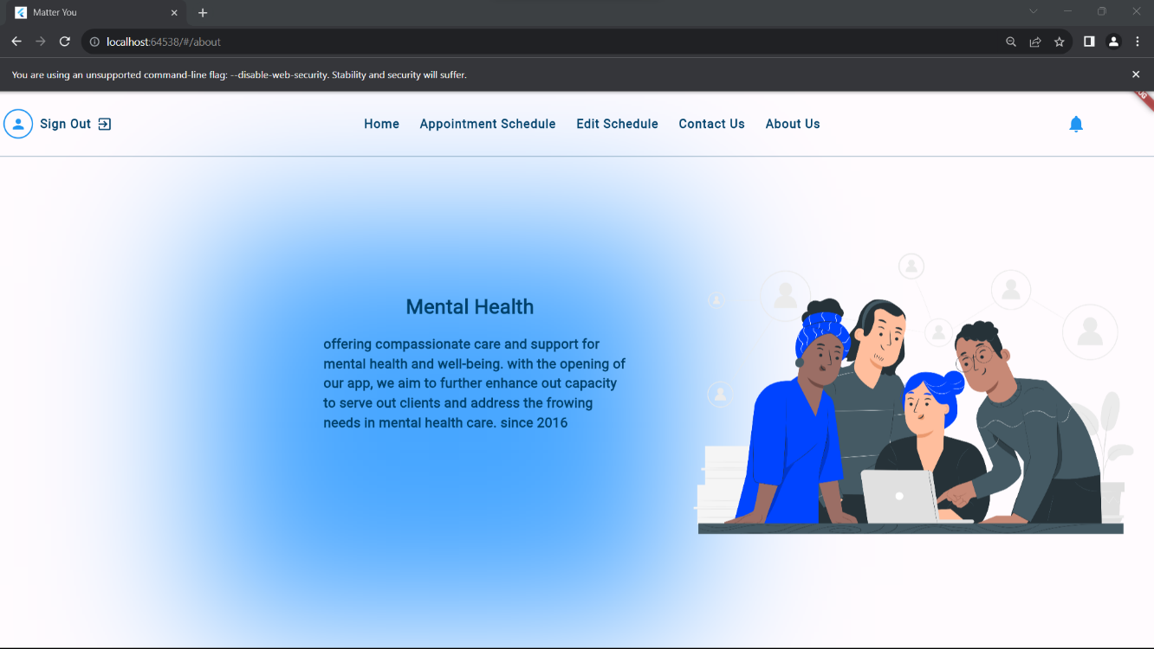

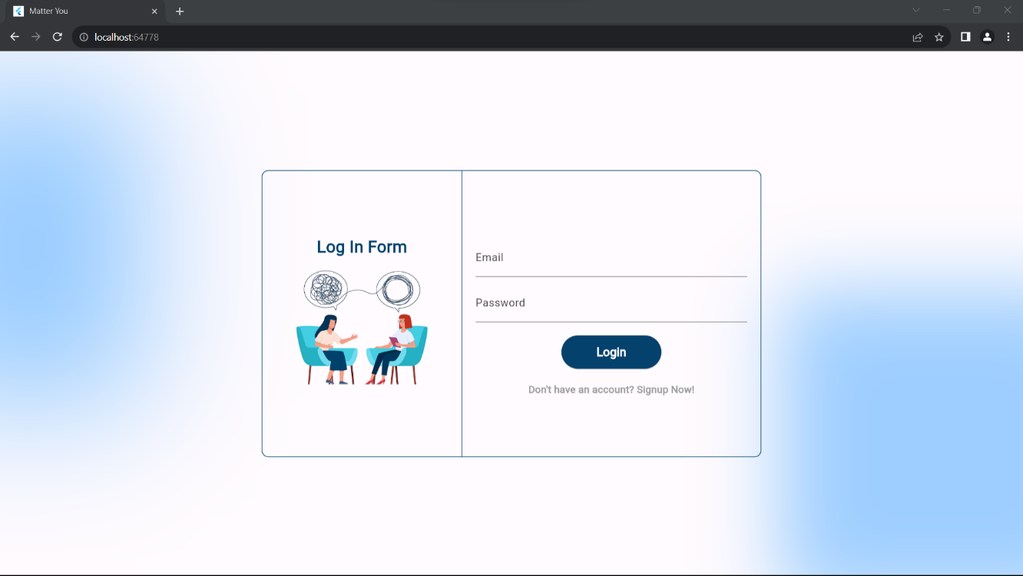

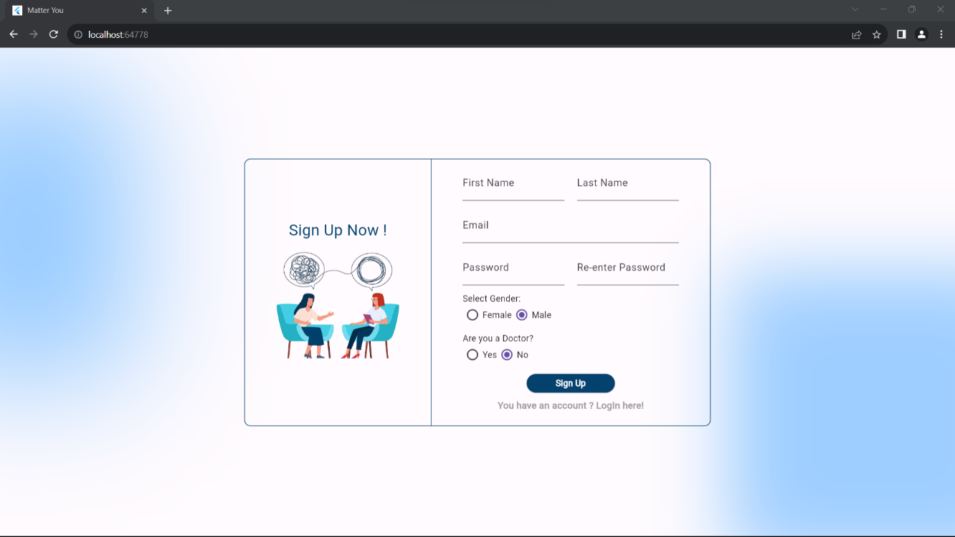

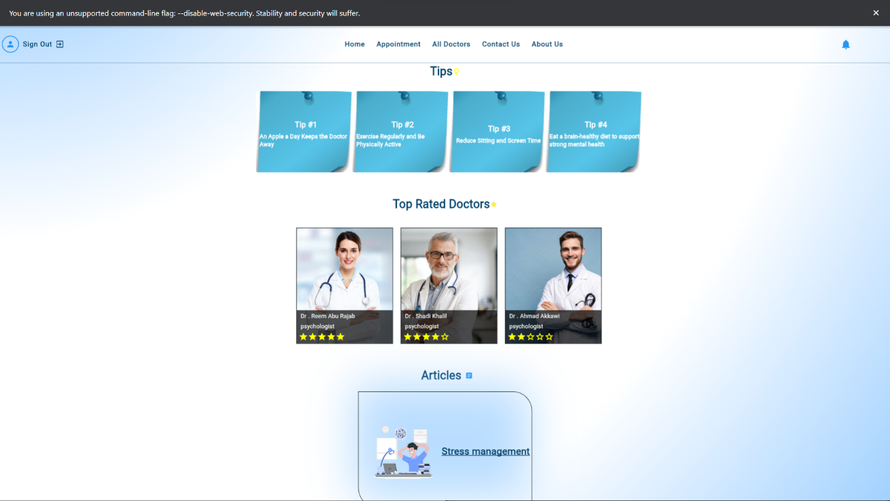

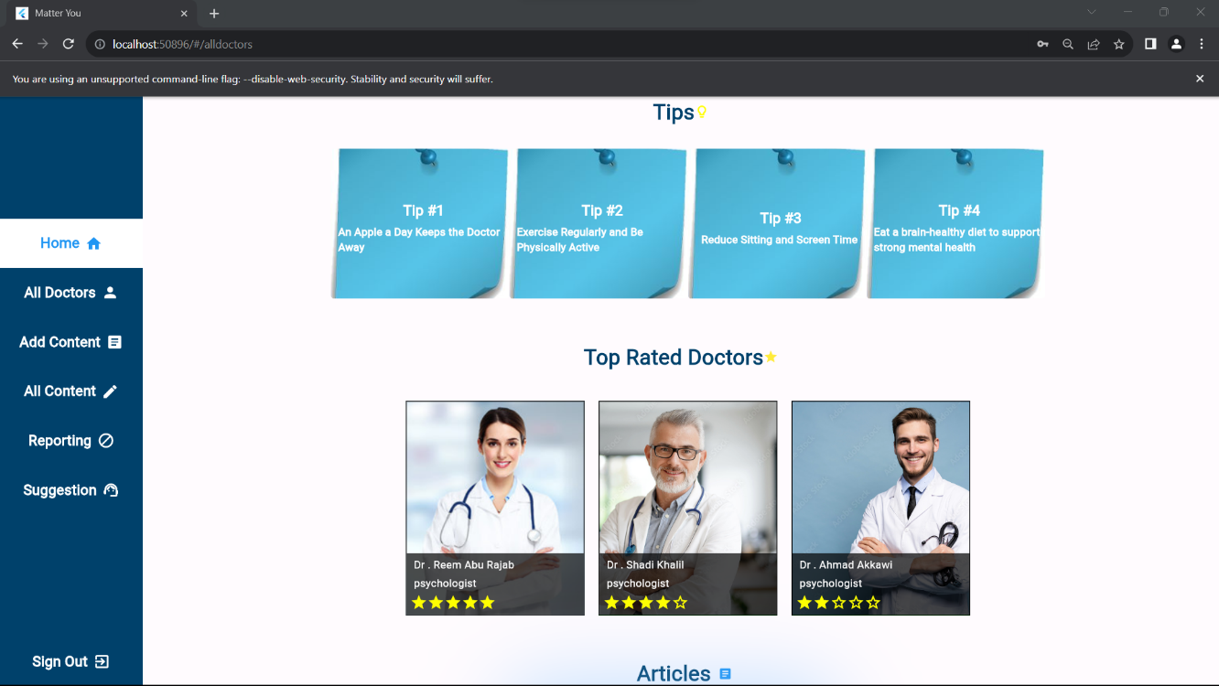
Admin page :
He can see all apointments and the waiting one
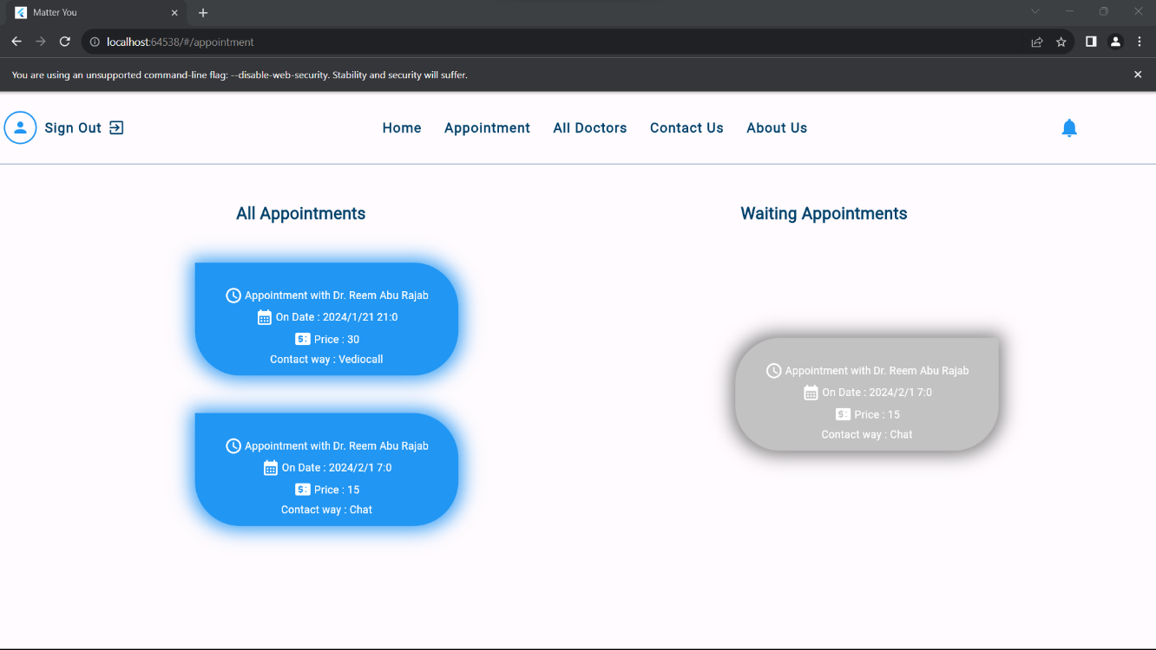

He can manage the contents

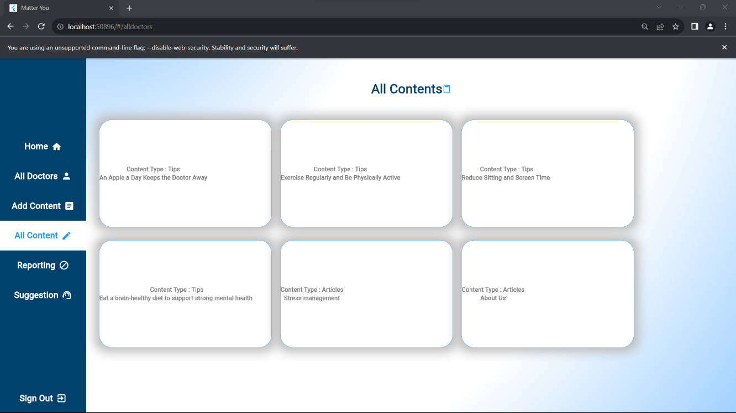

He can see all the doctors in the system
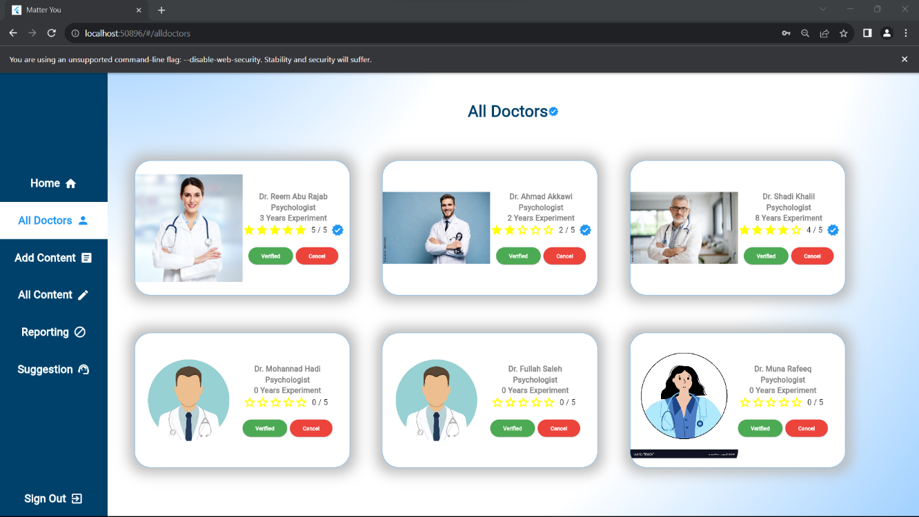

He can insert an articleor tip
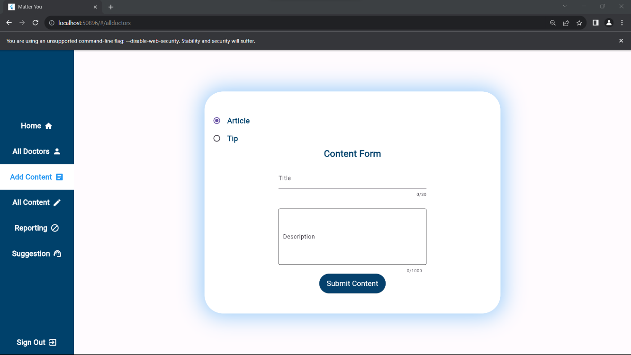

he can see reporing page
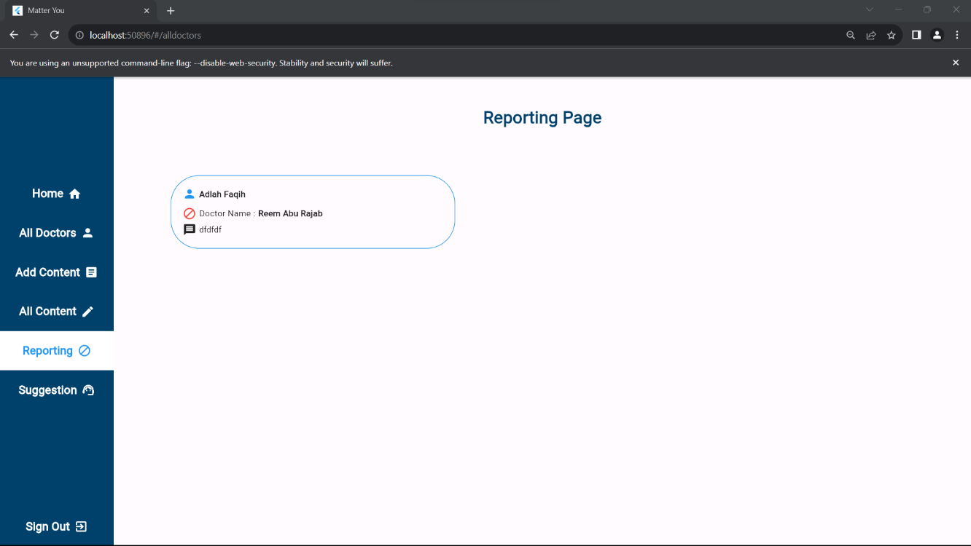

He can see the patient’s suggestion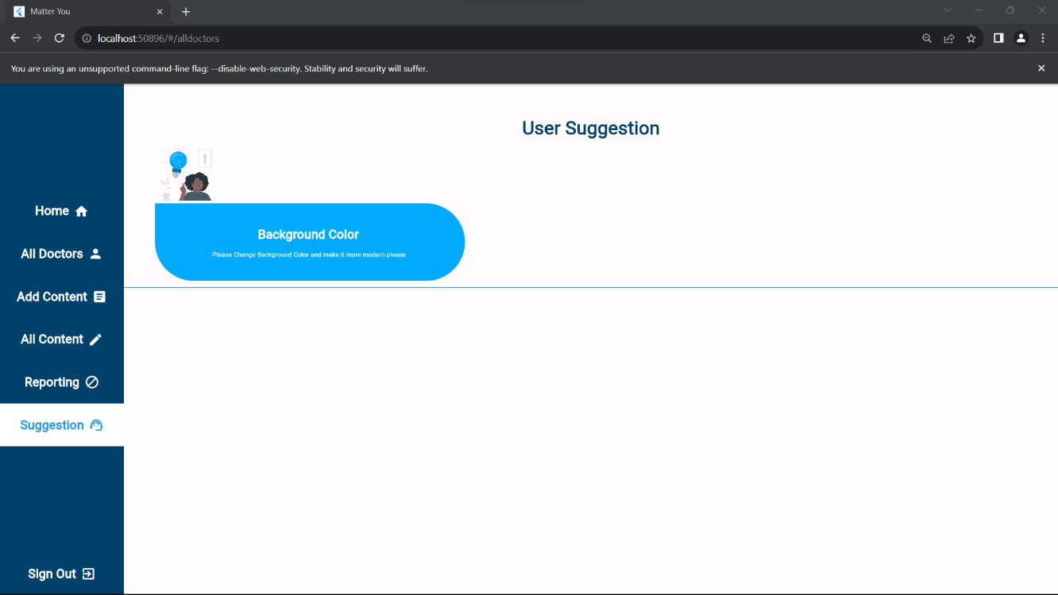

For patient :
He can read an articles
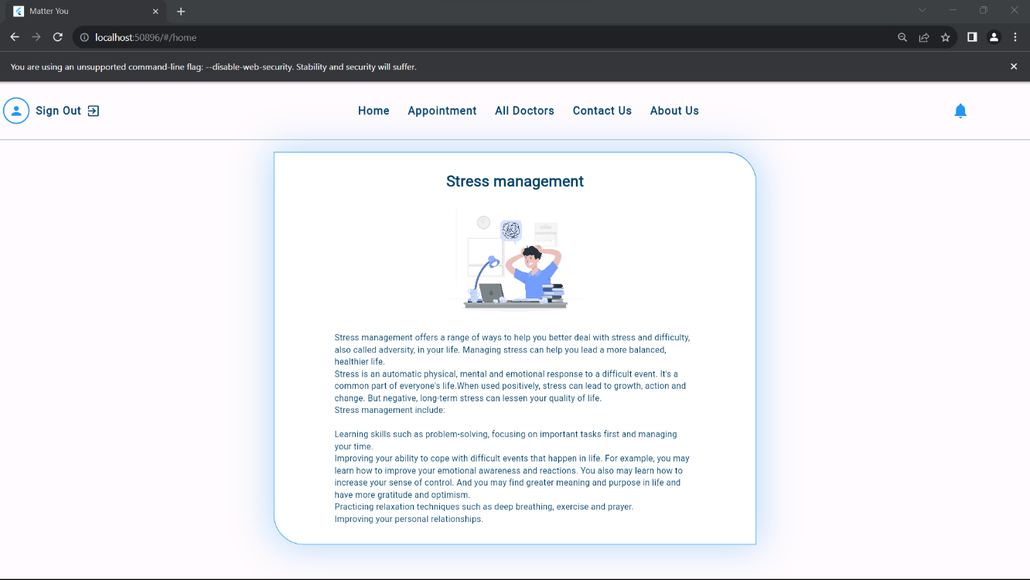

Doctor pages :
Profile and edit profile
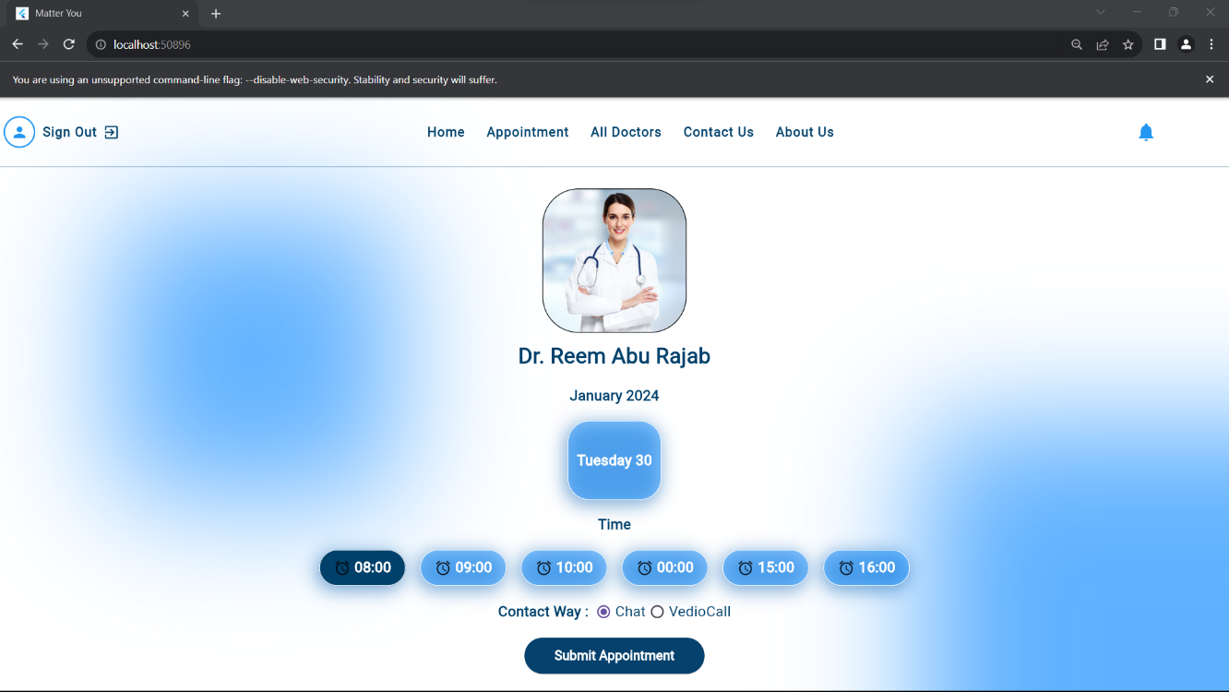

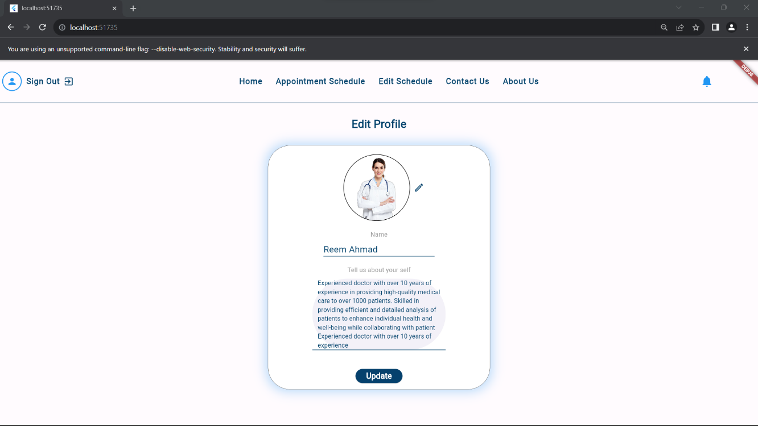

Results and Discussion
The project has yielded significant outcomes, seamlessly connecting users with online therapists through the integrated website and mobile application components. The user registration and therapy scheduling processes demonstrated high efficiency, supported by the responsiveness of the Node.js backend. The Flutter framework contributed to a unified and engaging mobile interface, enhancing user satisfaction. The MongoDB database effectively managed user data, fostering secure information exchange. Direct communication features received positive responses, empowering users to connect with therapists remotely, positively impacting user motivation. Challenges, such as learning curves, were addressed strategically. Overall, "YOU MATTER" proves it can be a successful digital platform, poised to enhance accessibility and user experience in digital mental health support, with future considerations for refinements based on user feedback and security enhancements.

Conclusion
In conclusion, the "YOU MATTER" project has demonstrated successful implementation and positive user feedback, establishing itself as an effective digital platform for connecting individuals with online therapists. The seamless integration of technologies and user-friendly interfaces contributes to its potential impact on enhancing accessibility and user experience in the realm of digital mental health support.
Future iterations may involve further refinements based on user feedback, continued security enhancements, and potential expansion of features to enrich the overall user-therapist interaction.

Summary

Our application’s major objective is to make it easier for the individual to face the challenges of emotional life, as emotion greatly affects the individual and his decisions, by connecting him to the appropriate psychotherapist for him, and he can see the comments of other users so he knows that he is not alone, we concentrated on a few essential features throughout the project:
Chat Functionality: One of the ways that patient can have his session with the doctor .
Notifications: Our application comes with a robust notification system. The patient will receive a notification as a reminder for the session , and admin will receive one for the report come from patient .
Feedback: We have set aside a specific area within the application for users to rate the application and provide contact information in the event of a poor rating.
Paypal : users can pay remotely pay paypal and credit card .

By incorporating these features and focusing on usability and functionality, our application simplifies the healing process and offers a platform for effective communication and feedback, ultimately enhancing the overall treatment experience for users.

Future Work

We hope to expand our application soon to allow treatment for more than one person per session. For example, couples can conduct a session together in one chat, voice call, or video call, in addition to adding an interface for users that will enable them to add and track healthy habits in their lives, in addition to create a list Music helps relax and heal from anxiety , another suggestion is to make a community forum in the sysem.

References
- Zhu, Y., Liu, Z., & Yuan, D. (2019). Flutter-based mobile application development: A cost-effective approach for both iOS and Android. In 2019 IEEE International Conference on Software Maintenance and Evolution (ICSME) (pp. 546-550). IEEE.
- https://arabtherapy.com
- https://www.w3schools.com/nodejs/

