

An-Najah National University
Faculty of Engineering & Information Technology

Department of Computer Engineering

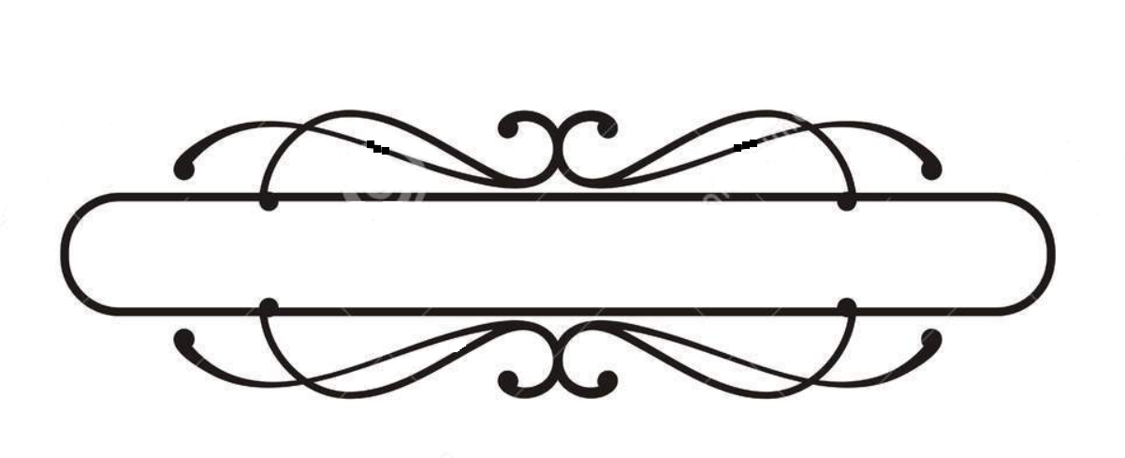

Automatic Lawn Mower

Prepared by: Murad Dweikat & Waddah Janajreh
Supervisors: Dr.Read Qadi and Dr.Hanal Abuzant

Presented in partial fulfillment of the requirements for Bachelor degree in Computer Engineering department.

Acknowledgment:

We Murad & Waddah, wish to express our deep thanks to Allah who
Owns the first and last thank, and to our families who offer us everything we need to reach this stage, through supporting us to make the better they hope from us all the time. We are thankful for our project supervisors Dr.Raed Qadi and Dr.Hanal Abuzant who encouraged us every moment and we indebted for their support and all help that they provides for us.
We also wish to express our sincere gratitude to the Computer Engineering Department staff representatives by Dr.Sofuan Samara and all the staff who present everything to make the students of the department as they are now and for their supporting for all the students who have projects.

Disclaimer:

This report was written by Murad Dweikat & Waddah Janajreh at the Computer Engineering Department, Faculty of Engineering An-Najah National University. It has not been altered or corrected, other than editorial corrections, as a result of assessment and it may contain language as well as content errors. The views expressed in it together with any outcomes and recommendations are solely to us. An-Najah National University accepts no responsibility or liability for the consequences of this report being used for a purpose other than the purpose for which it was commissioned.

Contents
Acknowledgment: 2
Disclaimer: 3
Acknowledgment: 7
Disclaimer: 8
Abstract: 9
Chapter one: 10
10
1.1 Introduction: 10
1.2 Organization of the report: 10
Chapter Two: 11
Constraints and Earlier Course Work: 11
The Component and the tools needed: 11
The Time: 11
Standards and Codes: 11
Chapter Three: Literature Review: 13
2.1 Existing Technology: 13
2.1.1 Advantages and Disadvantages of Existing Technology 14
2.2 Design Method Considerations 15
Chapter Four: Methodology: 16
4.1: Tools and Equipment: 16
4.2: The mechanical design of the lamp: 16
4.4: The Arduino and the hardware circuits: 19
❖ The RGB LEDs Circuit: 19
❖ The LDR Circuit [4]: 20
❖ The PIR Motion Sensor Interfacing: 21
❖ LCD Keypad Module: 22
❖ Bluetooth Module: 24
4.5: Android Application: 24
4.6: Image Processing Using OpenCV with C++: 25
4.7: Reading and Writing Modes: 25
Chapter Five: Discussion: 26
Chapter Six: 27
Conclusion and Recommendations: 27
Future Work: 28
❖ References: 28

Table of Figures:
Figure 1: Satechi Smart LED Desk Lamp 13
Figure 2: Arduino Mega 14
Figure 3: PIR Sensor 14
Figure 4: Bluetooth Module 14
Figure 5: Lamp Base Design 15
Figure 6: Vertical Arm Design 15
Figure 7: Horizontal Arm Design 16
Figure 8: LEDs, LDR and Webcam Holder 16
Figure 9: Interfacing RGB LED with Arduino 17
Figure 10: Interfacing LDR with Arduino 18
Figure 11: Interfacing PIR Sensor with Arduino 19
Figure 12: Interfacing LCD with Arduino 20
Figure 13: Interfacing Push Buttons with Arduino 20
Figure 14: Interfacing Bluetooth with Arduino 21
Figure 15: Speech Recognition Application 22
Figure 16: Mobile APP to control The Lamp 22
Figure 17: Smart Desk Lamp final Design 24

Abstract:

An automatic lawn mower is a device or robot that help human to cut grass automatically. Due to rapid development, many robots have turn into an autonomous robot. In this project, the movement or the path of the automatic lawn mower is based on a path planning technique. Camera Sensors are used to provide feedback from outside world. For this lawn mower, Arduino Mega microcontroller is utilized as the microcontroller. Every action of the lawn mower is monitored by the microcontroller with the help of the sensor. Furthermore.

- Benefits:

- This project can be used by anyone without previous experience in a way easy and interesting as he controls the car remotely.
- No need to use traditional methods of cleaning the garden of grass where they can use the robot in the grass cut and clean it after cutting directly.

Chapter one: Introduction:

This project provides a design method of an automated lawn mower, whose task is to cut grass whilst following a specified pattern with no need of user interaction. This task is expected to be made possible by using sensors to provide a microcontroller with measurement of distance. The device is expected to determine the path to follow, as shown in Figure 23, calculate its position and stop upon completion of its tasks. The project aims to produce a machine which would relieve people from a regular task of cutting grass in their garden. The present report will provide an understanding the sensor selection process, an analysis of the microcontroller to be used and the relevant functions it has to execute, a study of the relevant motors used and a system overview. For this progress report some areas are incomplete.

Organization of the report:

The report is organized as follows:

- In Chapter 2 we will talk about the project constraints and how we come over it.
- In Chapter 3 we will show similar product to our project and show the differences between them.
- In Chapter 4 we will describe the methodology of the hardware design, the Arduino interfacing circuits and the software used.
- In Chapter 5 we will discuss more about the work limitation.
- In Chapter 6 we will discuss the conclusion and the recommendation in addition to the future work.

Chapter Two: Constraints and Earlier Course Work:

2.1 Constraints:
This chapter presents the constraints we faced during the implementation of this project. In addition, it lists the courses that helped us in developing our project.

In this project we faced the following constraints:

2.1.1 The Component and the tools needed:
Because of the political restrictions we face in Palestine there is a limitation on the components allowed to be delivered to Palestine, for example we ordered a Car wheels suitable for grass.

2.1.2 The Time:
The other constraint was the amount of time we spend working on the chassis car design.
In addition to the time spent on finding the better way to do the car tracking.

2.2 Standards and Codes:

This section is divided into two parts:
- Arduino:
Arduino is an open-source prototyping platform based on easy-to-use hardware and software, in our project we use Arduino Mega 2560 as a microcontroller that connect all the circuits to work integrally.
Why we use Arduino:
Thanks to its simple and accessible user experience, Arduino has been used in thousands of different projects and applications. The Arduino software is easy-to-use for beginners, yet flexible enough for advanced users. And the following advantages:
1. Inexpensive.
2. Cross-platform.
3. Simple, clear programming environment.
4. Open source and extensible software.
5. Open source and extensible hardware.
And especially we use Arduino Mega because it has large number of pins detailed as the following: It has 54 digital input/output pins (of which 14 can be used as PWM outputs), 16 analog inputs, 4 UARTs (hardware serial ports) and we need this.

- Android Programming.
Android Framework:
“Android provides a rich application framework that allows you to build innovative apps and games for mobile devices in a Java language environment.” [1].
Android is one of an Open source platforms. It is created by Google and owned by Open Handset Alliance. It is designed with goal “accelerate innovation in mobile” As such android has taken over a field of mobile innovation. It is definitely free and open platform that differs hardware from software that runs on it. It results for much more devices be running the same application. Also it gives possibility of friendlier environment for developers and consumers. Android it is complete software package for a mobile device. Since the beginning android team offers the developing kit (tool and frameworks) for creating mobile applications quick and easy as possible. In some cases you do not specially need an android phone but you are very welcome to have one. It can work right out of the box, but of course users can customize it for their particular needs. For manufactures it is ready and free solution for their devices. Except specific drivers android community provides everything else to create their devices.

- OpenCV using C++:
OpenCV (Open Source Computer Vision) is a library of programming functions mainly aimed at real-time computer vision, originally developed by Intel's research center in Nizhny Novgorod (Russia), later supported by Willow Garage and now maintained by Itseez. The library is cross-platform and free for use under the open-source BSD license [2].

Chapter Three: Literature Review:

3.1 Existing Technology:
Existing automated lawn mowers each have a distinct working principle, for instance the Robomow from Friendly Robotics (2011) requires the user to perform a onetime set up where the garden perimeter is set. The perimeter is set using a battery powered wire that is laid around the outer edges of the garden and any area where the robot is not to cover. Special sensors inside Robomow enable the wires to be recognized and the robot is therefore kept within the designated area. The robot travels on the garden in a systematic criss-cross pattern, as shown in Figure 21, several times from side to side to ensure that the entire area is covered and that the grass is cut from different angles (Friendly Robotics, 2011).

Figure 1 - Robomow criss-cross cutting pattern (Friendly Robotics, 2011)
Other technologies work around a similar principal as the Robomow, in the sense that it requires a perimeter wire to limit its cutting area. A difference between them may be added features and the cutting pattern, for instance the LawnBott and the Husqvarna both have a random operating principle (LawnBott 2011, p. 7 and 8), in the sense that they do not follow any specific cutting pattern as illustrated in Figure 22.

Figure 2- LawnBott random cutting pattern (LawnBott, 2011)

3.1.1 Advantages and Disadvantages of Existing Technology
The operation method of the Robomow (described in section 2.1) although effective, is to a certain degree inefficient and contribute to a quite costly end product. The main advantages of their design include, virtually any size or shape of garden can be specified, it is flexible and it can work without requiring the user intervention at any stage, can operate at surface areas with slopes, these points can also constitute a disadvantage. The system design has the following disadvantageous aspects:
• The size and shape of the garden – as wires have to be placed in the garden area to be covered by the robot; the cost of the entire system may be considerably higher depending on the size. In the case of many plants being in the middle of the garden area, the setup can become cumbersome.
• Damage or faults – the wires are set on the grass and although the company mentions the fact that they would typically be covered by grass and become unnoticeable in a matter of
2 to 3 weeks (Friendly Robotics, 2011), the wires are prone to damage. The damage can be from any origin for example, pets can dig up and damage the wire, over time due to weather it can wear off, amongst others. A fault on the wire can provide incorrect information to the device and as consequence the device will not work as expected.
• Cutting pattern inefficiency – the criss-cross pattern (as shown in Figure 21) for Robomow and the random one used by LawnBott and Husqvarna (shown in Figure 22) are all not very efficient due to the fact that it is required that the robot crosses the same location more than once, consequently more energy is dissipated and the overall completion time is extended.

3.2 Design Method Considerations
It is extrapolated from existing technology (section 2.1) that in order to achieve an end product that is better than that currently available and at a lower cost, the overall design of the system described in the present report would have to operate with the following considerations:
• The system would be required to be made such that it follows a certain path and more efficient cutting pattern.
• A garden area limiting method that can be of long term, resistant life cycle and more cost effective; that is a better solution than that of the guide wire.
• Good cutting methodology
• More cost effective sensor array arrangement that would enable for obstacle and garden limit determination.
• Use of a two wheeled vehicle opposed to any other number would enable to the robot to easily navigate around the track.
• Opposed of the robot relying on additional electronics set in the garden area; it should be chosen that all electronics are onboard and that the device is able to determine all relevant parameters in this manner.

Chapter Four: Methodology:

4.1: Tools and Equipment:
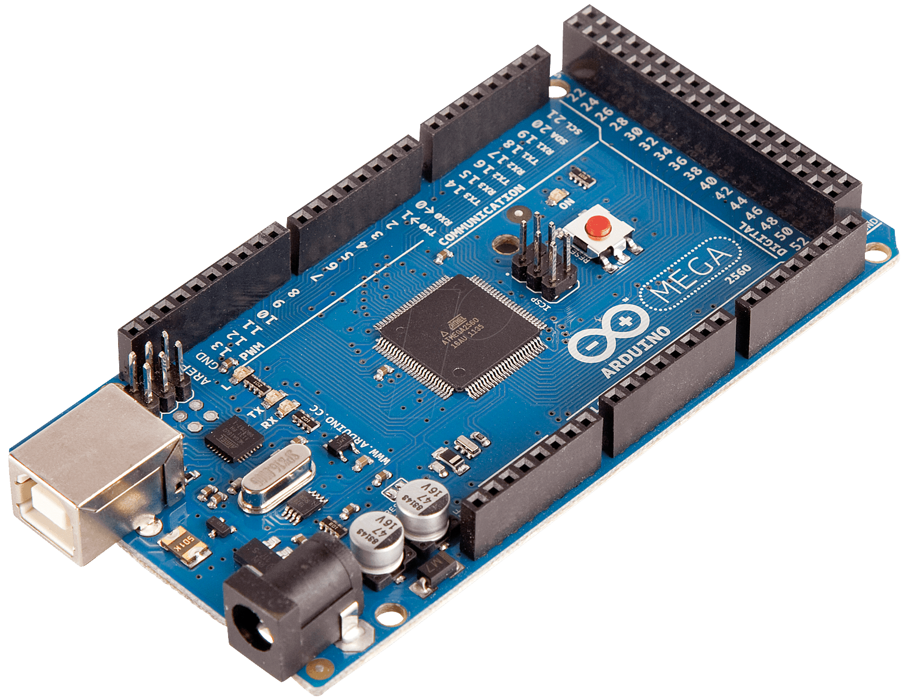
In our project we used the following tools and equipment’s to get it to its final stage:
- Stainless steel Material (chassis car).
- 9 DC Motors.
Figure 3: Arduino Mega
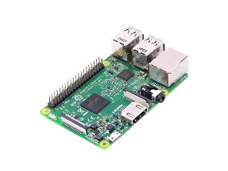
- Arduino Mega 2560 Microcontroller.
- Raspberry Pi 3
- 10 RGB LEDs.
- Bluetooth Module.
- Web Camera.
Figure 4: Raspberry Pi
- H-Bridge.
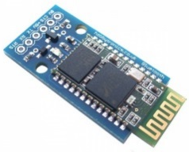

Figure 5: Bluetooth Module

4.2: The mechanical design of the lamp:
This phase was a challenging one. First of all we started to study several desk lamps design to select the best one fitting the requirements that we need to implement, we also read a lot of documentations about servo motors and its limitation. As a result, we came up with different potential designs materials. In the end, we made our decision about the design material especially the vertical and horizontal arms to be suitable for the torque of the servo motor we have chosen
We choose the Polyvinyl chloride (PVC) material to produce the design as we need because of the cheap cost of this material and the ease to shape and form it, actually we have three main parts in our design which are the base of the lamp, the vertical arm and the horizontal arm, and each one of these parts are explained below.

Lamp base:
The lamps base is designed to hold the LCD keypad module in addition to the Arduino microcontroller inside it, Figure 5 shows the AutoCAD design of the base from the top and bottom sides:
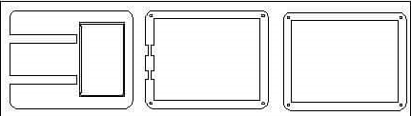
Figure 6: Lamp Base Design

Vertical Arm:
The Vertical Arm designed to hold one servo motor which moves in the Y-axis (up and down), so when we designed the vertical arm we took in consideration the torque of the servo motor to be suitable for the servo motor torque to let it move freely as shown in figure 6.
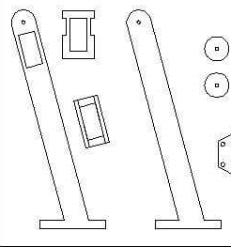
Figure 7: Vertical Arm Design

Horizontal arm:
The horizontal arm designed to hold the servo motor which move on the X-axis, so also as the vertical arm when we designed the vertical arm we took in consideration the torque of the servo motor to be suitable for the servo motor torque to let it move freely as shown in figure 7 below.
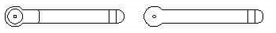
Figure 8: Horizontal Arm Design
In addition to holding the servo motor it also hold the LEDs Strips which form the light source to the lamp, the LDR sensor on the top of the model and the web camera to do the image processing needed to control the two servo motors, figure 8 shows the design of the model hold the LEDs, LDR sensor and the webcamera.

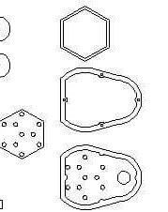
Figure 9: LEDs, LDR and Webcam Holder

4.4: The Arduino and the hardware circuits:

The RGB LEDs Circuit:
The RGB LEDs circuit is the main circuit in the project which form the source of the light in the smart desk lamp.Figure 9 shows the interface between RGB LED and Arduino:
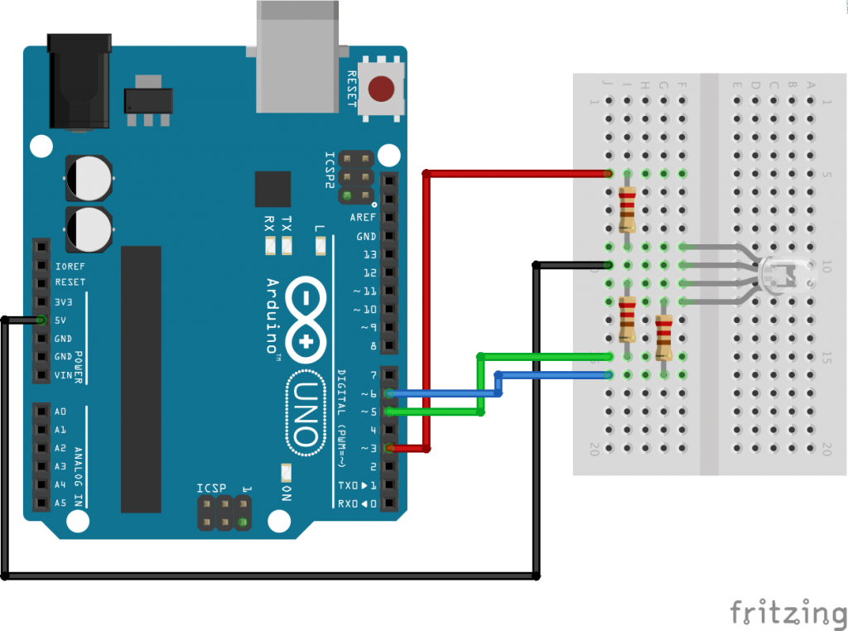
Figure 10: Interfacing RGB LED with Arduino
Figure 9 shows the general idea of how to connect the RGB LED with Arduino but in our project we used 10 RGB LEDs connected as strips on three groups 6 LEDs, 3 LEDs and 1 LED respectively, so every pin of the LED has the same color connected to the similar one and the common also the same to control them simultaneously, we used the RGB LEDs because of the ease to control the brightness and the color of the LEDs, moreover that we use the colors to notify the user of different actions such as incoming calls or received messages.

The LDR Circuit [4]:
The LDR Circuit used to control the level of lighting or the brightness of the LEDs according the to the light in the surrounding environment automatically, figure 10 shows the interface between the LDR and Arduino:
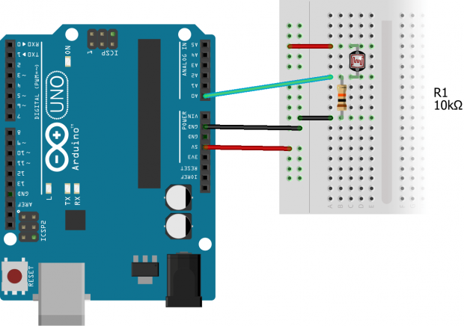
Figure 11: Interfacing LDR with Arduino
In our project, the LDR circuit is placed on the top of the lamp to only detect the light in the surrounding environment excluding the light emitted from the lamp. A sensor is used to detect the light amount, and the code will process it letting the controller control the lighting level automatically by increasing or decreasing the brightness which may save the power, also the user can control the brightness manually by the LCD Keypad or by the mobile application.
The LDR works depends on the resistance, so When the light level decreases, the resistance of the LDR increases. As resistance increases, the voltage drop across the LDR increases also increase, allowing higher voltage amount to be obtained by the LEDs [4].

The PIR Motion Sensor Interfacing:
The PIR Motion Sensor is used to control the LEDs in state that the user go out suddenly and didn’t turn the lamp off or may be the user forced to sleep because he became tired so the PIR Motion will detect these situations and turn the lamp off, figure 11 shows the interface between the PIR sensor and Arduino:
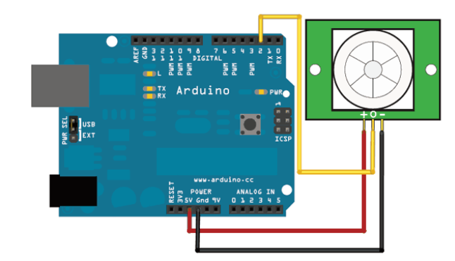
Figure 12: Interfacing PIR Sensor with Arduino
We placed the PIR Motion Sensor to be directed to the user, if the user get out for a specific time period the lamp will be turned off gradually, and if the user returned it will be turned on automatically.
The PIR sensor consist of two slots, each slot is made of a special material that is sensitive to infrared (IR). When there is no motion detected, both slots detect the same amount of IR. When a warm body like a human by, the first slot intercepts one half of the PIR sensor, which causes a positive differential change between the two slots. When the human leaves the sensing area, the reverse happens, whereby the sensor generates a negative differential change [5].

LCD Keypad Module:
We used the LCD with push buttons to produce an LCD keypad module to provide a way to control the lamp manually, as we mentioned in the constraints section (chapter 2) we planned to use touch screen instead of the LCD that we have already used, but the problems we faced forced us to get this as an alternative, figure 12 shows the interface between the LCD and Arduino:
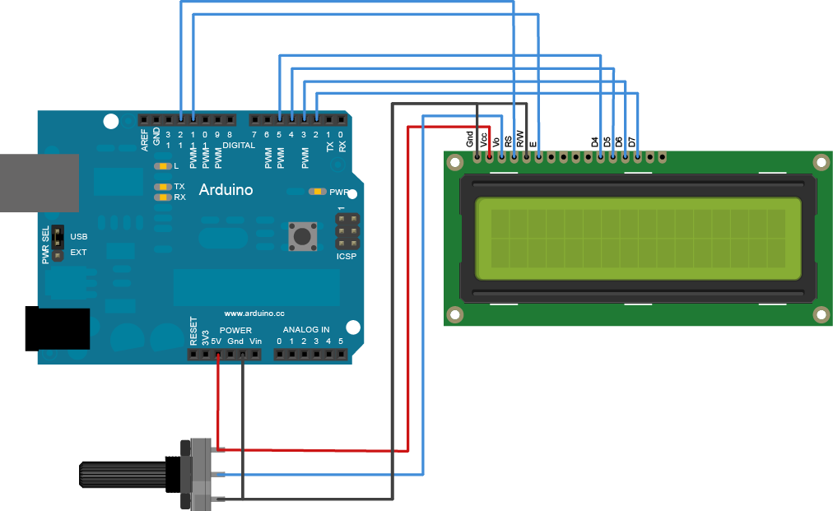
Figure 13: Interfacing LCD with Arduino
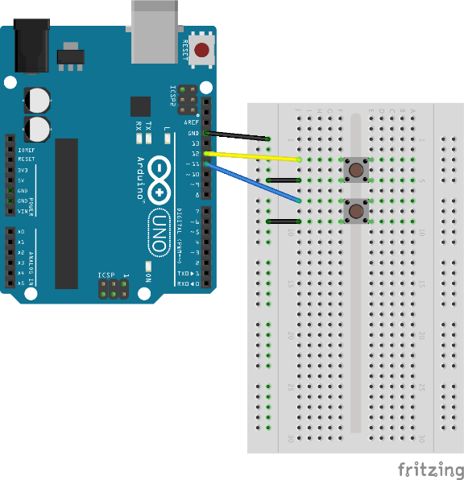

Figure 14: Interfacing Push Buttons with Arduino

Push Buttons:
We used 6 push buttons to implement main functionalities such as turning on/off the lamp, control the brightness of the lamp light, choosing between reading or writing mode and switching to control by the smart phone.

Bluetooth Module:
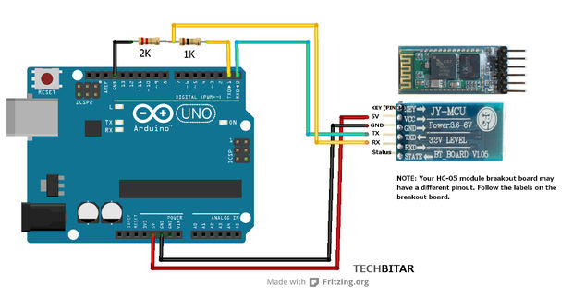
We used the Bluetooth to provide another way to control the lamp by the smart phone or by the voice, figure 14 shows the interface betwee the Bluetooth and Arduino:
Figure 15: Interfacing Bluetooth with Arduino

4.5: Android Application:
We used Android Application to provide control over Bluetooth by sending commands to Arduino, for example changing the RGB color values by controlling single values for red, green and blue [6].

As we mentioned before we provided android application with full functionality to control the lamp remotely when the user away from the lamp through Bluetooth, moreover that we implement the controlling over the voice but in this feature we used ready App that do the speech recognition and in the Arduino side we read the voice and perform actions as we need, the figures below show the application we used to control the lamp and the other used to recognize speech [7].
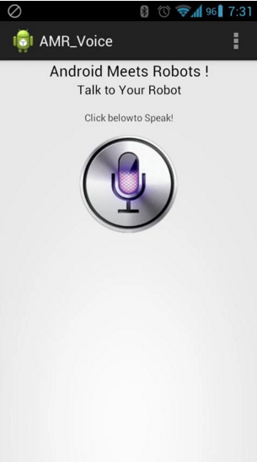
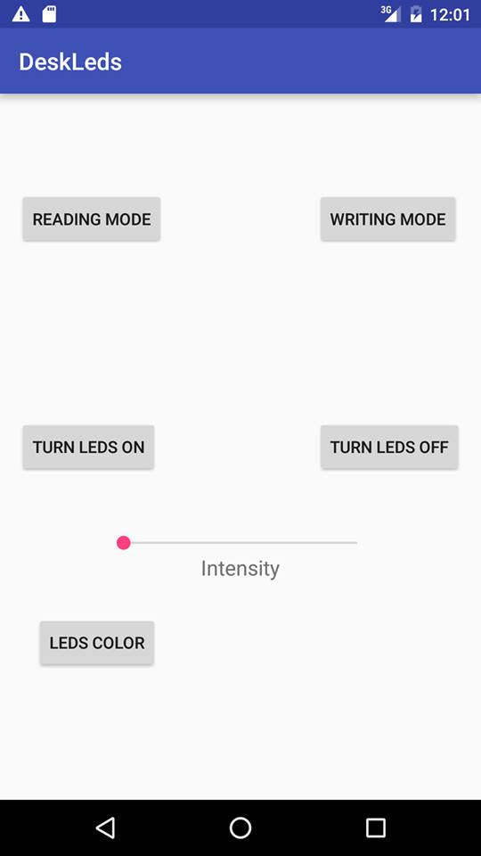
Figure 16: Speech Recognition Application
Figure 17: Mobile APP to control The Lamp

4.6: Image Processing Using OpenCV with C++:
We used image processing in the writing mode option to move the lamp’s light according to the hand’s position by detecting the hand’s movement. We tested this and we found a problem with the hand detection as it provided wrong coordinates for the hand. Therefore, we decided to detect read objects instead of the hand. The red object could be a pen or pencil.

4.7: Reading and Writing Modes:
The core feature of the project is the writing and reading mode, in this features we got benefit of the image processing, so when the user press or choose the writing mode, there is an camera which is the input to a visual studio OpenCV project to detect the hand or red object such a pen/pencil and move with the user hand movement by control the servo motors installed on the horizontal and the vertical arm of the lamp.
The level of light is also changed to let the user notice the concentration of the light to do the job successfully.
When the user choose the reading mode the camera will be turned off and the servo motors return to their initial state and position. Even the user choose the writing or the reading mode the other automatic subsystems will continue its own work such controlling the brightness and the sleep or the presence mode.

Chapter Five: Discussion:

We finished the project and when we tested it we faced a small problem in the image processing that the detection may affected by the light intensity so it will give a wrong coordinates which make the servo motor to move in wrong sequence, but the percent of this very small about 30%.
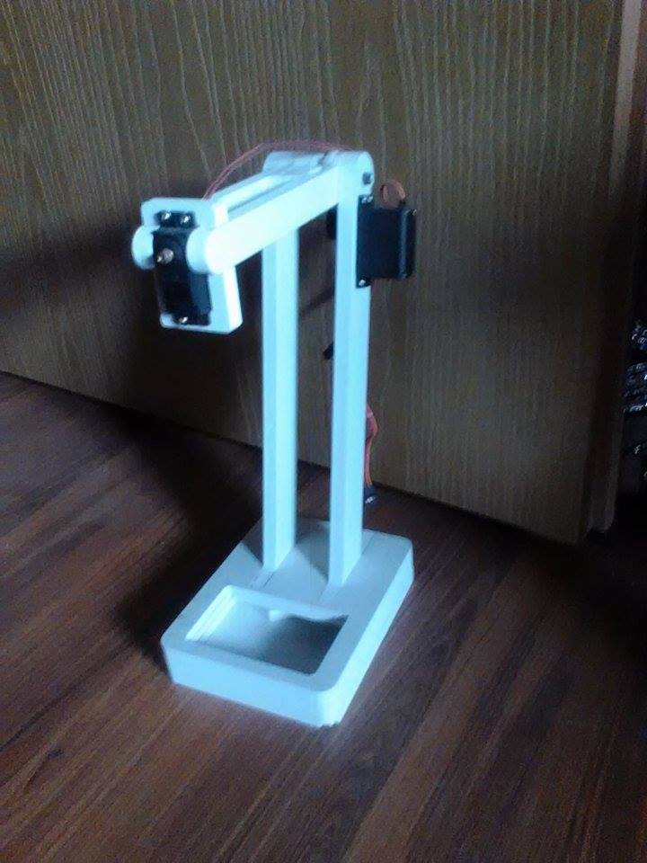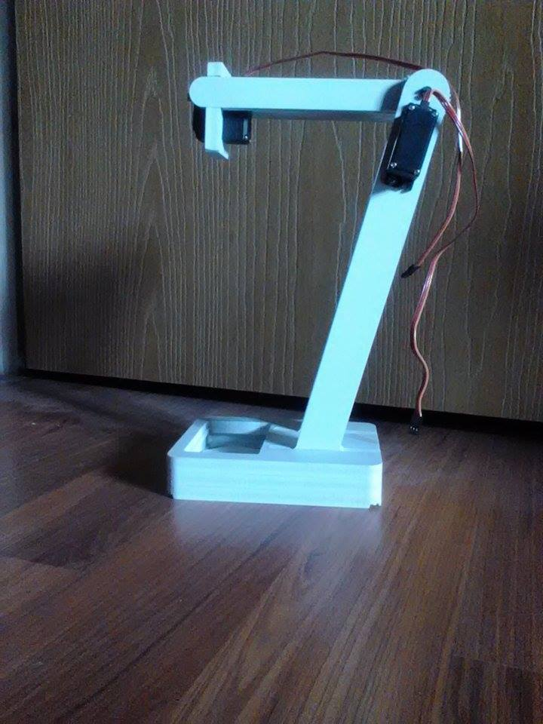
Figure 18: Smart Desk Lamp final Design

Our project enhanced the existing product and make it more interactive with the user, moreover that it provide a comfortable environment to do the works and save the money due to save the power consumption.
Although the project has many useful features, it has some limitations such as; the speech recognition application need the internet to work properly, and the other one is the control over Bluetooth which don’t allow the user to control the lamp across long distance.

Chapter Six:

Conclusion and Recommendations:

In conclusion, our system and its development introduced us to a whole new world of thinking. It made us think out of the box in developing existing products to become smarter. Our system will be able to help a lot of students and business men by offering them a comfortable and interactive environment.

Future Work:
[1]As a future work there is several features we can add to the project to be more interesting and interactive, the main thing to do is to use good quality touch screen, moreover that, add the scanner which enable the user to scan the papers and convert it to a plain text which is editable and finally we wish to add the feature which enable the user to respond for his incoming calls without using the mobile phone.

References:
[1]. Android Developers. Retrieved April 2016 from
https://developer.android.com/index.html.
[2].OpenCV | OpenCV. Retrieved April 2016 from
http://opencv.org/
[3]. Satechi Smart LED Desk Lamp with Smart Phone Charger. Retrieved April 2016 from
http://www.satechi.net/index.php/satechi-smart-led-desk-lamp-with-touch-control-dimmable-lighting-1-hour-off-timer-smart-phone-charging-port-black.
[4]. How an LDR (Light Dependent Resistor) Works | Kitronik. Retrieved April 2016 from
https://www.kitronik.co.uk/blog/how-an-ldr-light-dependent-resistor-works/.
[5].Adafruit learning system 2016. PIR motion sensor.
[6]. How to connect an Arduino Uno to an Android phone via Bluetooth | 42 Bots. Retrieved April 2016 from
http://42bots.com/tutorials/how-to-connect-arduino-uno-to-android-phone-via-bluetooth/
[7]. BT Voice Control for Arduino - Android Apps on Google Play. Retrieved April 2016 from
https://play.google.com/store/apps/details?id=robotspace.simplelabs.amr_voice

