(يَرْفَعِ اللَّهُ الَّذِينَ آمَنُوا مِنْكُمْ وَالَّذِينَ أُوتُوا الْعِلْمَ دَرَجَاتٍ )



An-Najah National University

Auto-Leveling Control System

Graduation Project 2

A bachelor's degree in (Electricals Engineering)

Prepared by:

Khalid Mujahed Jaara

Supervised by: Falah Mohammed

Chapter 1:

1.1 Abstract:

In this graduation project, a low-cost camera base prototype is implemented using two independent Arduino Uno boards.
Arduino A performs automatic stabilization on a single axis (Pitch) using the MPU6050 sensor and a servo motor.
At startup, a reference pitch angle is captured while the platform is held still. During operation, the current pitch is
filtered and compared to the reference; when the error exceeds a defined threshold, the servo is moved step-by-step to
compensate and reduce the tilt.
Arduino B is dedicated to user interaction and lighting. It receives Bluetooth commands (HC-05/HC-06) to manually rotate
the base servo, automatically turns an LED light ON/OFF based on a digital LDR module (with optional manual override),
and displays live status on a 16x2 I2C LCD.
The two subsystems are intentionally not connected to simplify wiring, improve reliability, and make debugging easier.

1.2 Introduction:

The gyroscope has evolved from simple spinning tops to sophisticated devices used in navigation and stabilization, with significant contributions from various inventors over the centuries.

Early Origins

The concept of the gyroscope can be traced back to the spinning top with a mirrored surface. When spun, it would maintain a level position, enabling sailors to align the reflection of the sun or stars to find the true horizon, a simple toy that demonstrated the principles of angular momentum and balance.
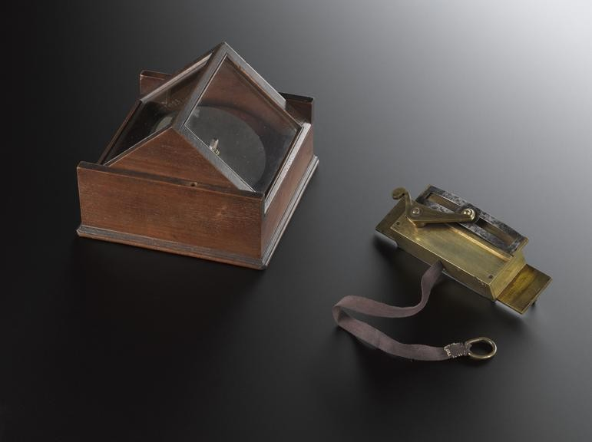
This was particularly useful when the natural
horizon was obscured. Serson's invention can be seen as a precursor to modern gyroscopes, which are now integral to various navigation systems.

This fascination with spinning objects laid the groundwork for the development of gyroscopic
technology. fig 1: Whirling Speculum 1743

The first known apparatus resembling a gyroscope was the "Whirling Speculum" invented by John Serson in 1743, which was used to locate the horizon in foggy condition

Key Developments

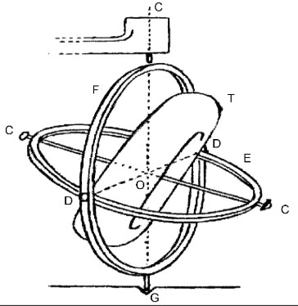

fig 2 : Bohnenberger's Machine (1817)
- Bohnenberger's Machine (1817): Johann Bohnenberger created a device that utilized a rotating sphere, which he referred to as the "Machine".
This marked one of the first instances of a gyroscope-like instrument.

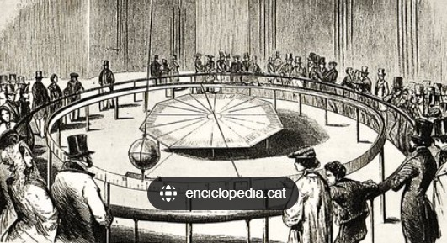
- Foucault's Experiment
(1852): Léon Foucault
famously demonstrated the Earth's rotation using a
gyroscope, which he named in 1852.
His experiments showcased
the gyroscope's ability to fig 3 : Foucault's Experiment (1852)
maintain its orientation
despite external movements.
Advancements in Technology

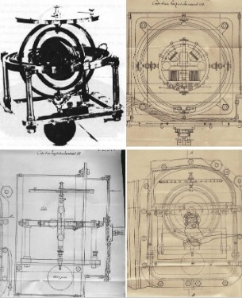
The advent of electric motors in the 1860s allowed gyroscopes to spin indefinitely, leading to the development of the gyrocompass, patented by Hermann Anschütz-Kaempfe in 1904.
This device became crucial for navigation in ships and other applications.

fig 4 : Gyrocompass 1904
1.3 Modern Applications:

Today, gyroscopes are found in various technologies, including Smartphone, ship maintenance, and Off-Road and On-Road All Wheel Drive Vehicles.
They are essential for inertial navigation systems, helping to maintain orientation and stability in dynamic environments.
Modern gyroscopes, such as MEMS (Micro-Electro-Mechanical Systems) gyroscopes, are compact and widely used in consumer electronics for motion sensing and
screen orientation.

1.4 Problem Statement:

In many practical applications such as camera stabilization systems, precision platforms, and interactive educational projects, maintaining a stable and level orientation is a critical requirement. Traditional stabilization methods often rely on complex mechanical structures or high-cost control systems, which makes them unsuitable for low-cost academic and educational environments.

Additionally, integrating sensor data processing, real-time control, user interaction, and visualization within a single embedded system can lead to performance limitations, increased latency, and reduced system reliability. These challenges become more significant when real-time motion sensing (such as tilt detection) and manual user control are required simultaneously.

There is a need for a low-cost, modular, and efficient auto-leveling system that can accurately detect platform inclination, perform real-time corrective actions, and allow flexible user interaction without compromising system responsiveness. Such a system should separate time-critical sensor processing from user interface and communication tasks to ensure stable performance and ease of expansion.

This project addresses these challenges by designing and implementing a dual-Arduino auto-leveling control system, where motion sensing and stabilization tasks are handled independently from user interaction, display, and communication. The proposed solution aims to achieve reliable real-time leveling, reduced system latency, and improved modularity, making it suitable for academic, experimental, and educational applications.
1.5 Objectives:

The main objective of this project is to design and implement a low-cost, reliable auto-leveling system using embedded control techniques and motion sensing. The system aims to demonstrate accurate tilt detection, stable corrective control, and flexible user interaction within an educational and experimental framework.

The specific objectives of this project are:

- To design an auto-leveling platform capable of detecting inclination using an MPU6050 motion sensor.
- To process tilt data in real time and generate corrective servo motor movements to maintain platform stability.
- To implement a dual-microcontroller architecture that separates motion control tasks from user interface and communication tasks in order to improve system performance and responsiveness.
- To provide both automatic and manual control modes for the servo motor, allowing flexible user interaction.
- To integrate a Bluetooth-based control interface for real-time monitoring and manual commands via a mobile application.
- To display system status information using an LCD module, including servo position, lighting state, and operating mode.
- To implement an automatic lighting control system based on ambient light conditions using an LDR sensor.
- To ensure system stability by minimizing control delay, signal noise, and mechanical oscillations.
- To develop a modular and expandable system architecture suitable for future enhancements and educational demonstrations.

1.6 Methodology:

In this project, the methods as the following :

- Line strip orientation :

  - The MPU-6050 Arduino Microprocessor gyroscope measures rotational velocity along one or more axes, making it ideal for applications like robots, and motion detection.
With Arduino, gyroscopes such as the MPU-6050 or L3GD20H can be interfaced to measure angular velocity and orientation.

  - Understanding the X-axis in a Gyroscope:
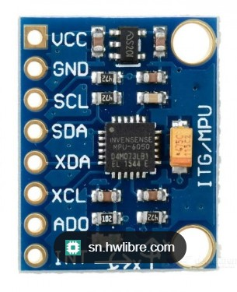
fig 5 : MPU-6050
Gyroscope

A gyroscope measures angular velocity (rotation speed) around its axes:
- X-axis → rotation like tilting forward/backward (pitch)
- Y-axis → rotation like tilting side-to-side (roll)
- Z-axis → rotation like spinning left/right (yaw)

If only the X-axis orientation readings was token, the reading of the gyroscope’s X-axis angular velocity will be integrated over time to get the angle.

  - Recommended Sensor
The MPU6050 is a popular and inexpensive choice, it has both a gyroscope and accelerometer, so it can be combined for more stable orientation readings

- Newton Third Law (Action and Reaction) :

  - Newton's laws of motion describe the relationship between the motion of an object and the forces acting on it, forming the foundation of classical mechanics.
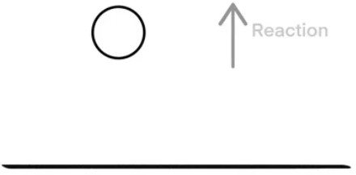
  - For every action, there is an equal and opposite reaction.
This means that when one object exerts a
force on another, the second object exerts a force of equal magnitude but in the opposite
direction on the ﬁrst object. This law highlights ﬁg 6 : Motion Third Law
the interactions between objects.
  - By using Newten Third Law, the weight of camera base will be determined for
further selection of the motor - weight handling as the weight will be determined of the attached camera base which is mostly gonna be slices of thin wood.
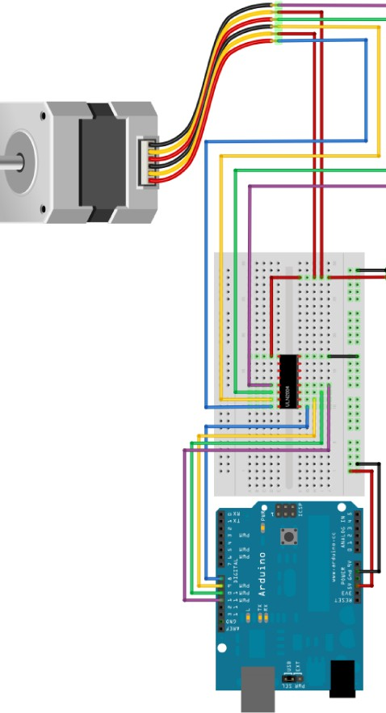
3- Servo motors

- Servo motors were selected for this project due to their built-in position control and smooth response. In the final prototype, two servos are used but with different roles: (1) a stabilization servo on Arduino A to correct the pitch axis, and (2) a base rotation servo on Arduino B controlled manually through Bluetooth.

- Servo control is achieved by PWM signals from the Arduino, which simplifies hardware requirements. To improve stability, safe angle limits are enforced in software, and step-based movements are used in Arduino A to avoid oscillation and reduce jitter.
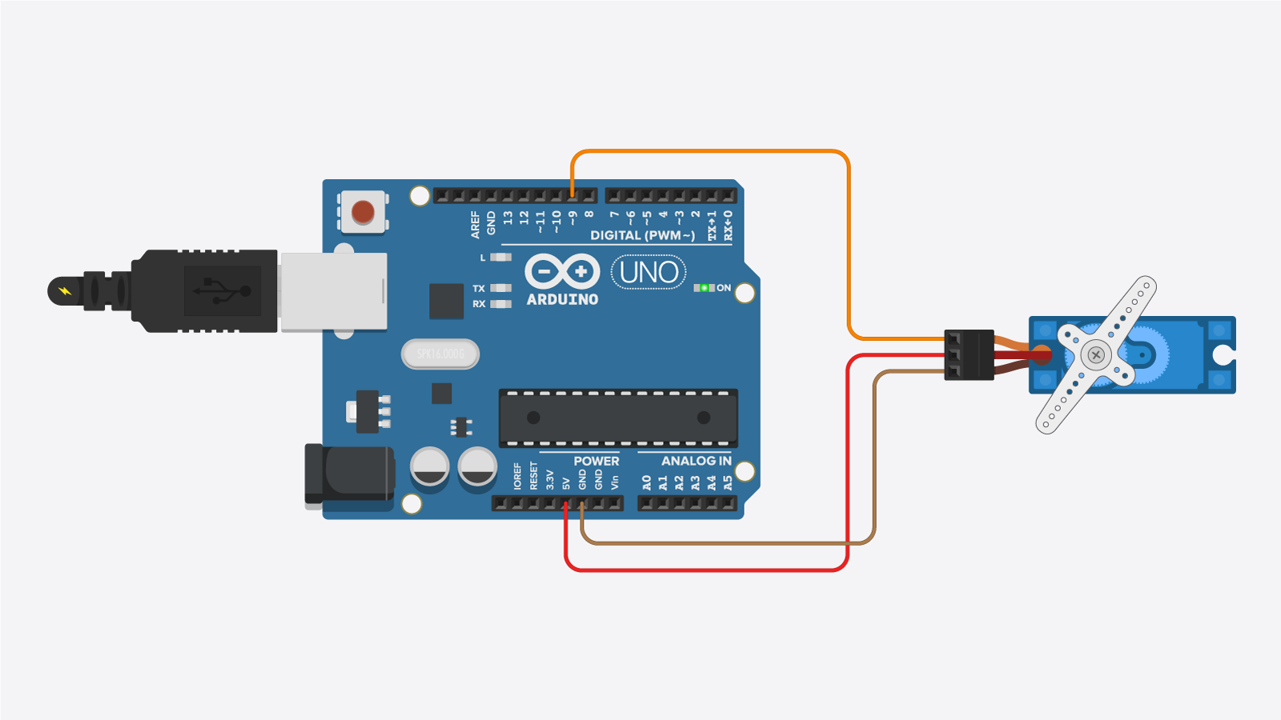
fig 7 : Servo motors integrated with Arduino

1.7 System Model:
This section describes the functional model of the implemented prototype. The system is divided into two independent subsystems: Stabilization (Arduino A) and Control + Lighting (Arduino B).

Inputs
  - MPU6050 module (accelerometer + gyroscope): used on Arduino A to estimate the platform pitch angle.
  - LDR digital module: used on Arduino B to detect ambient light state (DARK/BRIGHT).
  - Bluetooth commands (HC-05/HC-06): used on Arduino B for manual servo control and lighting mode commands.

Processing
  - Angle estimation (Arduino A): pitch is computed mainly from accelerometer readings and smoothed using a simple low-pass filter.
  - Reference capture (Arduino A): a stable reference pitch is calculated at startup as the average of multiple samples.
  - Control law (Arduino A): step-based correction with threshold + confirmation count + cooldown to reduce noise-induced movement.
  - Lighting logic (Arduino B): automatic ON/OFF based on LDR state with confirmation; manual override is available via Bluetooth.

Outputs
  - Stabilization servo (Arduino A): provides real-time correction on a single axis (Pitch) within safe limits.
  - Base servo (Arduino B): provides manual rotation of the base via Bluetooth commands.
  - LCD 16x2 with I2C (Arduino B): displays servo angle, light status, mode (Auto/Manual), and LDR state.
  - Bluetooth telemetry (Arduino B): optional status messages sent back to the mobile device for monitoring.

Chapter 2:-

2.1 Block Diagram(Flowchart):

Arduino A – Stabilization Subsystem Flowchart

This flowchart illustrates the operational logic of Arduino A, which is responsible for platform stabilization. The process begins with system initialization, including I2C configuration, MPU6050 sensor verification, and servo positioning at the neutral reference angle. The controller then acquires a reference pitch value while the platform is stationary.

During normal operation, the MPU6050 continuously provides acceleration data, from which the pitch angle is calculated and passed through a low-pass filter to reduce noise. The filtered pitch is compared against the reference value to determine the error. If the error exceeds a predefined threshold for a sufficient number of consecutive readings, the servo is incrementally adjusted. A cooldown timer prevents excessive oscillations and mechanical stress.

This flowchart clearly demonstrates the closed-loop nature of the stabilization process and highlights the safety and reliability mechanisms integrated into the control logic.

Arduino B – Control and Lighting Subsystem Flowchart

This flowchart presents the operational logic of Arduino B, which handles user interaction and auxiliary control. The process starts with system initialization, including Bluetooth communication setup, LCD initialization, servo positioning, and LDR configuration.

During operation, Arduino B continuously listens for Bluetooth commands from the mobile application using non-blocking serial communication. Received commands are filtered and interpreted to control the base servo manually, toggle lighting modes, or request system status. Simultaneously, the LDR sensor is periodically sampled to determine ambient light conditions. When automatic mode is enabled, lighting is controlled based on confirmed light/dark readings to avoid flickering.

The LCD is updated at fixed intervals to display servo position, lighting status, and operating mode. This flowchart emphasizes the modular design of the system, where user control and environmental sensing are handled independently from stabilization.

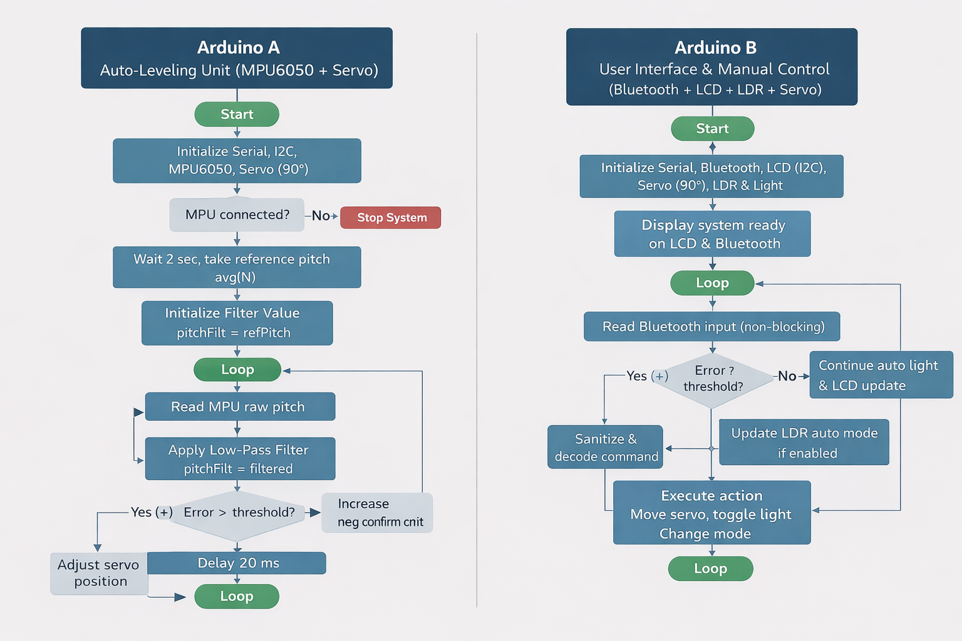
Figure 1-3: block digram

2.2 Electronic components:

1. Arduino Uno
The Arduino Uno is an open-source microcontroller board based on the ATmega328P microcontroller. It is widely used in academic and industrial applications due to its simplicity, reliability, and strong community support. The board provides multiple digital and analog input/output pins, serial communication capabilities, and compatibility with a wide range of sensors and actuators, making it suitable for real-time control and embedded system applications.

In this project, two Arduino Uno boards were used to implement a distributed control architecture. The first board (Arduino A) was dedicated exclusively to sensor data processing and automatic platform leveling. It handled real-time data acquisition from the MPU6050 sensor, applied filtering techniques, calculated tilt angles, and generated corrective signals for the servo motor. Separating this functionality ensured stable and responsive control without delays caused by additional tasks.

The second board (Arduino B) was responsible for user interaction and system management. It controlled Bluetooth communication, LCD display updates, light control based on LDR readings, and manual servo movement commands. This separation significantly improved system stability, reduced computational load on each microcontroller, and minimized timing conflicts, which is critical in real-time control systems. The dual-Arduino approach enhanced modularity, scalability, and maintainability of the overall system.

2. MPU6050 Gyroscope and Accelerometer Sensor

The MPU6050 is a six-degree-of-freedom (6-DOF) motion tracking sensor that integrates a three-axis accelerometer and a three-axis gyroscope in a single compact module. It is capable of measuring both linear acceleration and angular velocity, which allows accurate estimation of orientation and movement in three-dimensional space. The sensor communicates with the microcontroller via the I2C protocol, enabling fast and efficient data transmission.

In this project, the MPU6050 was the core sensing component used to detect platform tilt. Accelerometer data was utilized to calculate the pitch angle of the platform, which represents its inclination relative to the horizontal plane. To improve accuracy and reduce noise, software filtering techniques were applied to the raw sensor data before processing.

The calculated pitch angle served as feedback for the automatic leveling system. Any deviation from the reference position triggered corrective actions by the servo motor to restore balance. The use of the MPU6050 enabled continuous real-time monitoring of platform orientation, making the system capable of responding smoothly to disturbances and ensuring stable operation.

3. Servo Motor

A servo motor is an electromechanical actuator designed to provide precise control of angular position. Unlike standard DC motors, servo motors use internal feedback mechanisms to accurately reach and maintain a desired angle. This makes them ideal for applications requiring controlled movement and stabilization.

In this project, servo motors were used as the primary actuators for adjusting the platform position. The servo connected to Arduino A played a crucial role in the automatic leveling mechanism. Based on the pitch angle calculated from the MPU6050 sensor, the servo motor was incrementally rotated to counteract the detected tilt and bring the platform back to its reference position.

Additionally, a second servo motor connected to Arduino B allowed manual control via Bluetooth commands. This dual-mode operation enabled both automatic stabilization and user-controlled movement. The precise angle control of the servo motors ensured smooth and predictable motion, contributing significantly to the overall effectiveness and reliability of the system.

4. Bluetooth Module (HC-05 / HC-06)

The Bluetooth module provides wireless serial communication between the microcontroller and external devices such as smartphones or computers. Modules like HC-05 and HC-06 are commonly used in embedded systems due to their low cost, ease of configuration, and reliable data transmission over short distances.

In this project, the Bluetooth module was connected to Arduino B and used as the main interface between the system and a mobile application. Through this interface, users could send commands to control servo movement, switch between automatic and manual modes, and manage lighting functions. The module also transmitted system status data back to the mobile application, enabling real-time monitoring.

Wireless communication eliminated the need for physical connections between the user and the system, increasing flexibility and usability. The Bluetooth module significantly enhanced the interactive aspect of the project and demonstrated the integration of embedded systems with modern mobile technologies.

5. LCD Display (16x2 with I2C Interface)

The 16x2 LCD display is a commonly used output device capable of displaying two lines of text, each containing up to sixteen characters. The I2C interface allows communication with the microcontroller using only two data lines, reducing wiring complexity and improving system organization.

In this project, the LCD display was used to provide real-time visual feedback to the user. Information such as servo angle, operating mode (automatic or manual), lighting status, and ambient light condition detected by the LDR sensor was continuously displayed.

The LCD enabled standalone operation of the system without requiring a smartphone or computer for monitoring. This feature improved system usability and made debugging and demonstration easier, especially during testing and presentation phases.

6. Light Dependent Resistor (LDR) Sensor

A Light Dependent Resistor (LDR) is a passive sensor whose resistance varies according to the intensity of ambient light. It is commonly used in automatic lighting systems and environmental monitoring applications.

In this project, the LDR sensor was used to detect surrounding light conditions. Its digital output allowed the system to determine whether the environment was bright or dark. Based on this information, Arduino B automatically controlled the lighting output.

This component demonstrated sensor-based environmental interaction and automation. Additionally, the lighting system could be overridden manually via Bluetooth commands, providing flexibility and user control. The use of the LDR sensor added an intelligent environmental response feature to the project.

7. LED / Light Output

The LED or light output serves as an electronically controlled illumination source. LEDs are energy-efficient, durable, and easy to control using digital signals from a microcontroller.

In this project, the light output was controlled based on LDR sensor readings or manual Bluetooth commands. When low light conditions were detected, the system automatically turned the light ON, and turned it OFF when sufficient light was present.

This feature demonstrated practical automation principles and highlighted the system’s ability to respond dynamically to environmental changes while still allowing manual user intervention.

8. Power Supply

A stable and reliable power supply is essential for the proper operation of electronic systems. Voltage fluctuations can lead to unstable behavior, communication errors, or unexpected system resets.

In this project, a regulated power supply was used to provide appropriate voltage levels to both Arduino boards, sensors, Bluetooth module, LCD display, and servo motors. Special attention was given to grounding to ensure a common reference voltage between components.

Proper power management ensured consistent system performance, especially during servo motor operation, which can cause sudden current spikes.

9. Connecting Wires and Breadboard

Connecting wires and breadboards are essential tools for prototyping and experimental development. They allow components to be connected without permanent soldering, facilitating easy modification and debugging.

In this project, jumper wires and breadboards were used extensively to interconnect all electronic components. This approach allowed flexible testing, rapid troubleshooting, and iterative development throughout the project lifecycle.

2.3 Hardware Connection Diagram Description:
The figure illustrates the complete hardware architecture and wiring configuration of the proposed dual-Arduino automatic leveling and control system. The system is divided into two independent yet complementary subsystems, each implemented using an Arduino Uno board, to ensure stable performance and clear task separation.

Arduino A – Sensor Processing and Automatic Leveling Unit

Arduino A is dedicated to motion sensing and automatic platform leveling. It is connected to the MPU6050 accelerometer and gyroscope sensor through the I2C communication interface (SDA and SCL pins). The MPU6050 continuously measures the platform orientation and provides acceleration data, which is used to calculate the pitch angle.

Based on the calculated pitch angle, Arduino A controls a servo motor connected to a PWM pin. The servo motor acts as an actuator that adjusts the platform angle in small incremental steps to counteract any detected tilt and restore balance. This closed-loop feedback system allows smooth and stable automatic leveling.

Arduino A and its servo motor are powered using a dedicated battery supply to isolate power fluctuations caused by motor operation and ensure consistent sensor readings. Proper grounding is maintained between the components to guarantee reliable operation.

Arduino B – User Interface, Control, and Display Unit

Arduino B serves as the main user interaction and system management unit. It is connected to a Bluetooth module (HC-05/HC-06), enabling wireless communication with a mobile application. Through this interface, users can send commands to control servo movement, toggle operating modes (automatic/manual), and manage lighting functions.

A 16x2 LCD display with an I2C interface is connected to Arduino B to provide real-time system feedback. The display shows important parameters such as servo position, operating mode, light status, and ambient light condition, allowing the system to operate independently without requiring a smartphone connection.

Arduino B also interfaces with an LDR (Light Dependent Resistor) module, which detects ambient light levels. Based on the LDR readings, Arduino B automatically controls an LED/light output, turning it ON or OFF depending on environmental lighting conditions. Manual override of this function is also available via Bluetooth commands.

A second servo motor is connected to Arduino B to allow manual movement control through the mobile application. This enables user interaction and testing without interfering with the automatic leveling functionality handled by Arduino A.

Similar to Arduino A, Arduino B and its peripherals are powered using a separate battery supply to ensure electrical stability, particularly during servo and Bluetooth operation.

2.4 System Architecture Overview:

The dual-Arduino design shown in the diagram reflects a modular and distributed control approach. By separating sensor processing and automatic control (Arduino A) from user interface and peripheral management (Arduino B), the system minimizes processing delays, avoids timing conflicts, and improves overall reliability.

This hardware configuration allows the system to achieve accurate real-time stabilization while maintaining flexible user control and clear system monitoring, making it suitable for academic demonstration and practical applications such as camera stabilization platforms or automated leveling systems.

Chapter 3:

During and after conducting the project, there were some findings and results.
The finding can be characterized as following :

  - Findings :

  - Low torque occurred with using a phone or heavy case for the phone.
● High Current usage and a suturing of the motor due to the heavy

load of the case and the phone
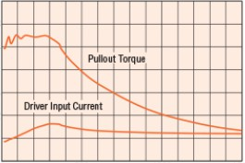
- Minor servo jitter was observed under heavy load. This was addressed by improving the power supply
stability and limiting the working angle within safe bounds.
1. A slice of wood used to fabricate the
the case of the camera base.

Fig 13 : Torque-Current Relation

- A sticker of a phone is attached to the camera base to make simulation of a real phone.

During and after conducting the project, there were some findings and results.
The finding can be characterized as following :

- Gyroscope zero X Axis value

  - In order to get zero X-axis value multiple experiment was token

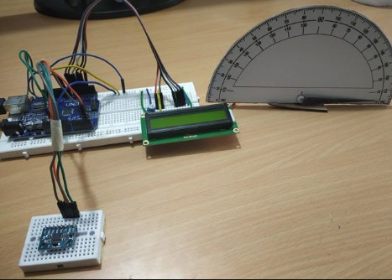
  - Due to double-faCe sticker level and its uneven distribution of the sticking material that was used to stick the
gyroscope to the wooden board,
there was multiple values recorded for the gyroscope.

Fig 14 : Gyroscope zero X Axis value

  - The problem was solved by taking an approach for the zero value of the gyro scope as its zero x-axis value.

During and after conducting the project, there was some findings and results.
The finding can be characterized as following :

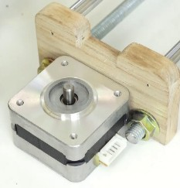

- Servo mounting and alignment were initially challenging, especially when defining the neutral (zero) position
for both X and Y axes.

- Multiple tests were conducted to calibrate the platform so that the servo neutral angles match the MPU6050 roll/pitch zero reference.

- The issue was solved by using a simple mechanical reference for leveling and then saving calibrated offsets in the Arduino code.

fig 15 : Servo calibration and mounting

3.2 Analysis:

The Analysis of the Auto-Leveling Camera Base can be shown as following :

- Taking the gyroscope reading of the X axis

  - By taking the gyroscope readings, this allows us to see the camera base level whether it was zero or having a value.

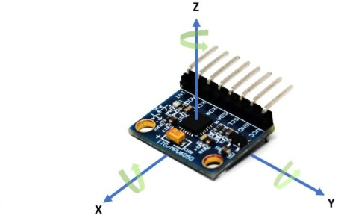
  - After taking the readings, the arduino code with turn it to angular value form the X-axis zero status.
This will determine whether the camera is leveled to zero angle of or having an X-axis tilted angle.

After calculating the roll/pitch angles, the Arduino sends correction commands to the two servo motors. If the platform tilts clockwise on an axis, the corresponding servo rotates counter-clockwise (and vice versa)
to keep the base level.

The Analysis of the Auto-Leveling Camera Base can be shown as following :

- Central Leveling Control

  - As it was mentioned before there are two types of level control as following :

    - Edge Leveling Control :

This type of leveling uses four 90 degree angles of the plate to level the plate.
The motors tend to be fixed on the four angles of the leveling plate.

    - Central plate leveling :

This type of leveling tended to fix the rotation perpendicular to the

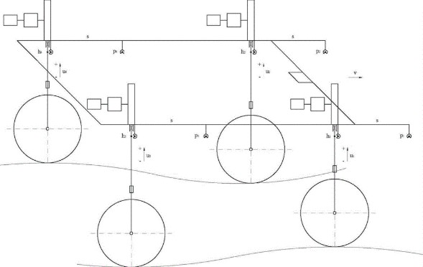

Fig 17 : edge leveling

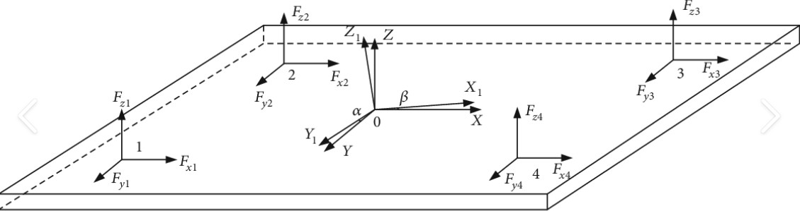

center of the load. Fig 18 : center leveling

- The Center leveling was used in this project to adjust the Camera base

3.3 Conclusion:
This project successfully demonstrated the design and implementation of an automatic leveling and control system based on a dual-Arduino architecture. The system was developed to address the challenge of maintaining platform stability while providing flexible user control and real-time monitoring. By combining motion sensing, actuator control, wireless communication, and visual feedback, the project achieved its primary objective of creating a reliable and modular embedded system suitable for practical applications.

One of the key achievements of this project is the clear separation of responsibilities between the two Arduino units. Arduino A was dedicated exclusively to sensor data acquisition and automatic leveling using the MPU6050 sensor and a servo motor. This separation allowed precise and smooth control of the platform orientation without interference from other system tasks. The use of filtering techniques and threshold-based decision logic further improved system stability and minimized unwanted oscillations or jitter in servo movement.

Arduino B, on the other hand, focused on user interaction, system monitoring, and auxiliary functions. Through the integration of a Bluetooth module, the system enabled wireless communication with a mobile application, allowing users to control servo movement, switch between automatic and manual modes, and manage lighting functions. The addition of an LCD display provided real-time feedback, making the system easier to operate and debug without relying solely on a mobile device.

The modular design approach adopted in this project proved to be highly effective. By distributing the workload across two microcontrollers, the system avoided timing conflicts, reduced processing delays, and improved overall reliability. This design choice was particularly important given the real-time nature of sensor reading and servo actuation, where delays or blocking operations could significantly degrade system performance.

From a practical perspective, the system demonstrated strong potential for real-world applications such as camera stabilization platforms, automated leveling mechanisms, and smart control systems. The ability to combine automatic stabilization with manual override enhances usability and makes the system adaptable to different operational scenarios. Additionally, the use of commonly available and low-cost components ensures that the system can be reproduced or extended with minimal resources.

Despite the successful implementation, the project also highlighted several challenges and limitations. Integrating multiple functionalities into a single microcontroller initially resulted in timing issues and unstable behavior, which ultimately motivated the transition to a dual-Arduino solution. Power management was another important consideration, particularly due to the current demands of servo motors. These challenges provided valuable learning experiences in system design, debugging, and hardware-software integration.

Overall, this project achieved its intended goals and provided a comprehensive learning experience in embedded systems design. It demonstrated the importance of modular architecture, real-time control, and thoughtful integration of hardware and software components. The final system reflects a balance between functionality, reliability, and simplicity, making it a solid foundation for further development and enhancement.
3.4 Resources:

- www.softschools.com/inventions/history/gyroscope_history/215/

- www.ion.org/museum/Machine-of-Bohnenberger.cfm

- www.phys.ksu.edu/personal/rprice/SpeedofLight.pdf

- www.anschuetz.com/company/history/

- randomnerdtutorials.com/arduino-mpu-6050-accelerometer-gyroscope/

- www.sciencefacts.net/newtons-third-law.html

- monolithicpower.com/en/learning/resources motors-basics-types-uses

- arduino.cc/reference/en/libraries/servo/

- www.makerguides.com/hc-05-bluetooth-module-arduino/

3.5 Attached Code
The following Arduino code reflects the final implemented prototype using two independent Arduino boards:
Appendix A: Arduino A (MPU6050 + stabilization servo on pin D6)
Appendix B: Arduino B (Bluetooth + LCD + LDR + LED + base servo on pin D5)
Note: There is no communication between Arduino A and Arduino B in the final version.
Appendix A - Arduino A Code (Stabilization Unit)

#include <Wire.h>
#include <Servo.h>
#include <Adafruit_MPU6050.h>
#include <Adafruit_Sensor.h>

Adafruit_MPU6050 mpu;
Servo servoY;

const int SERVO_PIN = 6;

// ====== Simple settings ======
int servoPos = 90;
const int STEP = 2;
const int THRESH_DEG = 10;
const int SERVO_MIN = 5;
const int SERVO_MAX = 160;

const unsigned long COOLDOWN_MS = 80;
unsigned long lastMoveMs = 0;

float refPitch = 0.0;

// Protection against noisy decisions
int confirmCountPos = 0;
int confirmCountNeg = 0;
const int NEED_CONFIRM = 2;

// Invert direction if needed
const bool SERVO_INVERT = true;

// ====== Simple smoothing filter ======
float pitchFilt = 0.0;
const float ALPHA = 0.25; // 0.2-0.35 (higher = faster)

float getPitchDegRaw() {
sensors_event_t a, g, temp;
mpu.getEvent(&a, &g, &temp);

float ax = a.acceleration.x;
float ay = a.acceleration.y;
float az = a.acceleration.z;

return atan2(-ax, sqrt(ay * ay + az * az)) * 57.2958;
}

float takeReferencePitch() {
float sum = 0;
const int N = 50;
for (int i = 0; i < N; i++) {
sum += getPitchDegRaw();
delay(10);

}
Fig. X. Complete wiring diagram showing Arduino A (MPU6050 + Servo) and Arduino B (Bluetooth + LCD + LDR + LED + Servo).
Figure: Wiring Diagram of the Prototype (Fritzing).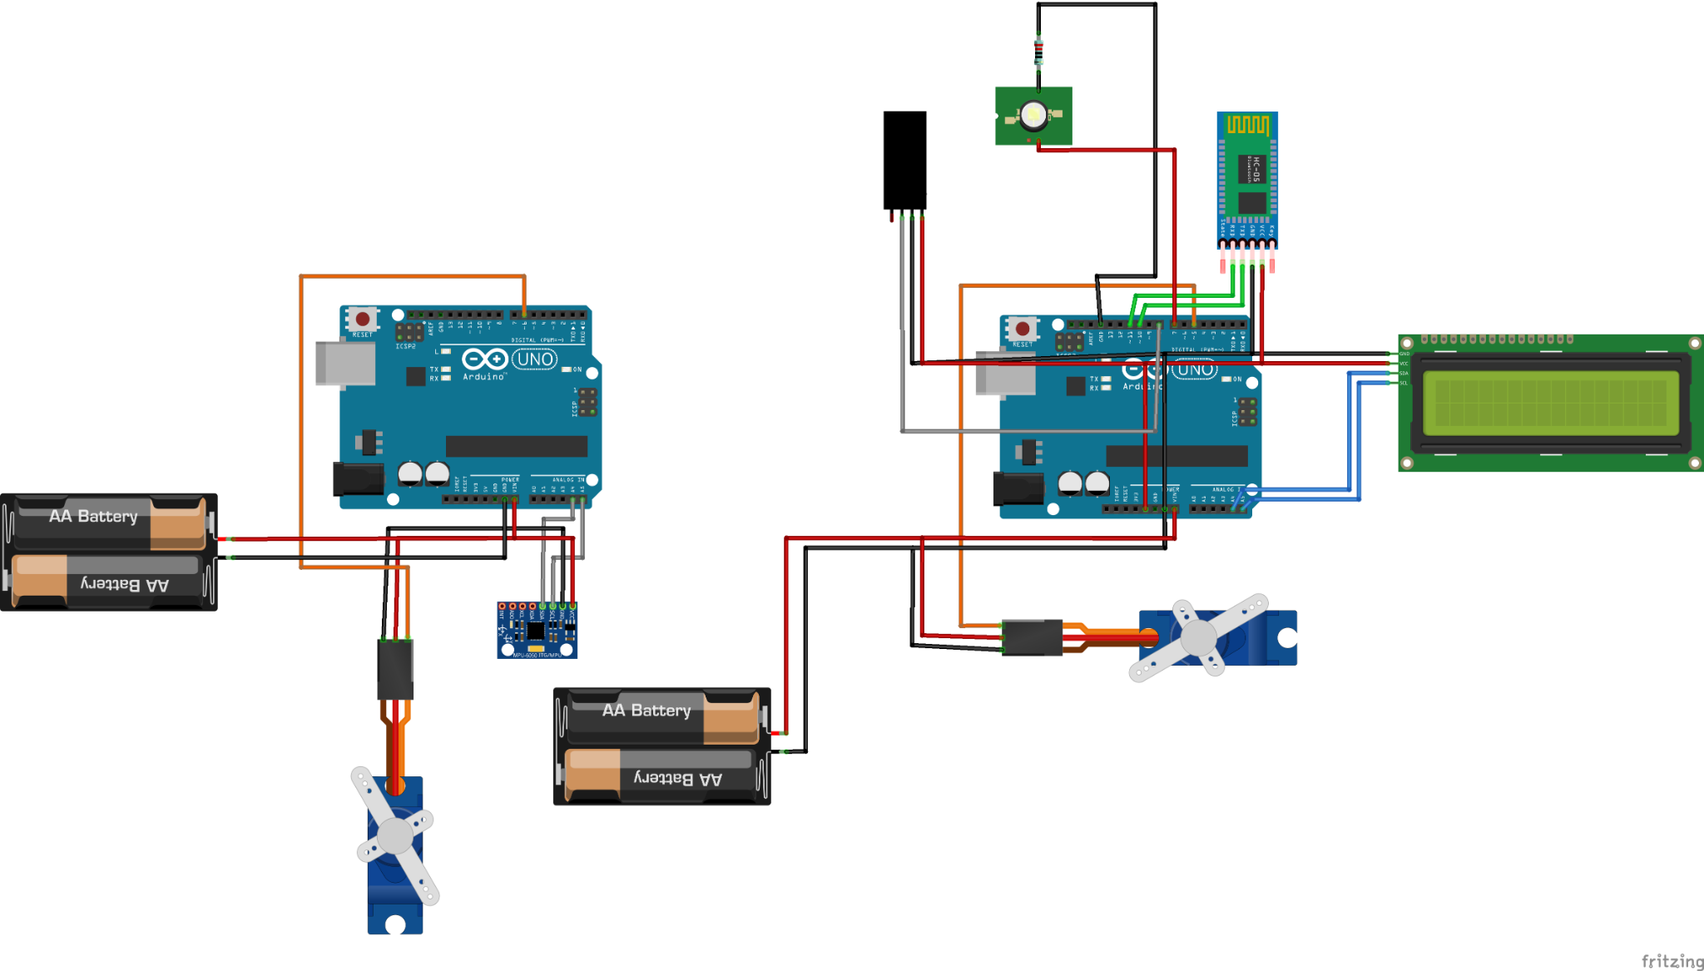
- I2C Bus:
- Arduino A: A4=SDA, A5=SCL connected to MPU6050.
- Arduino B: A4=SDA, A5=SCL connected to LCD I2C.
(Note: each Arduino has its own I2C bus.)
- Servos:
- Arduino A stabilization servo signal -> D6.
- Arduino B base servo signal -> D5.
External 5V supply is recommended for servos; make sure each subsystem has a common GND with its servo supply.
- Bluetooth:
- HC-05/HC-06 TX -> D10 (SoftwareSerial RX)
- HC-05/HC-06 RX -> D11 (SoftwareSerial TX)
Use a voltage divider to protect the Bluetooth RX pin if required by the module.
- LDR (digital module): DO -> D8, VCC -> 5V, GND -> GND. Sensitivity is adjusted using the on-board potentiometer.
- Lighting:
- LED/light control -> D7. If using a high-power LED/strip, use a transistor/MOSFET/relay driver and external power.

Wire.begin();
- Arduino A (Stabilization): always-on automatic pitch stabilization after capturing the reference angle at startup.
Arduino B (Control + Lighting):
- AutoLight mode: LED turns ON/OFF based on LDR.
- Manual override: Bluetooth commands LON/LOFF force the LED state; LAUTO returns to AutoLight.
- Servo control: Bluetooth commands adjust base servo position.

if (!mpu.begin()) {
Serial.println("MPU6050 not found!");
while (1) {}
}

mpu.setAccelerometerRange(MPU6050_RANGE_8_G);
mpu.setGyroRange(MPU6050_RANGE_500_DEG);
mpu.setFilterBandwidth(MPU6050_BAND_21_HZ);

servoY.attach(SERVO_PIN);
servoPos = 90;
servoY.write(servoPos);

Serial.println("Hold STILL... taking reference in 2s");
delay(2000);

refPitch = takeReferencePitch();
pitchFilt = refPitch;

Serial.print("Reference Pitch = ");
Serial.println(refPitch, 2);
}

void loop() {
float pitchRaw = getPitchDegRaw();
pitchFilt = pitchFilt + ALPHA * (pitchRaw - pitchFilt);
float error = pitchFilt - refPitch;

Serial.print("Pitch: ");
Serial.print(pitchFilt, 1);
Serial.print(" | Ref: ");
Serial.print(refPitch, 1);
Serial.print(" | Err: ");
Serial.print(error, 1);
Serial.print(" | Servo: ");
Serial.println(servoPos);

unsigned long now = millis();
if (now - lastMoveMs < COOLDOWN_MS) {
delay(10);
return;
}

if (error > THRESH_DEG) {
confirmCountPos++;
confirmCountNeg = 0;
} else if (error < -THRESH_DEG) {
confirmCountNeg++;
confirmCountPos = 0;
} else {
confirmCountPos = 0;
confirmCountNeg = 0;
}

if (confirmCountPos >= NEED_CONFIRM) {
servoPos += SERVO_INVERT ? -STEP : STEP;
servoPos = constrain(servoPos, SERVO_MIN, SERVO_MAX);
servoY.write(servoPos);
confirmCountPos = 0;
lastMoveMs = now;
}

if (confirmCountNeg >= NEED_CONFIRM) {
servoPos += SERVO_INVERT ? STEP : -STEP;
servoPos = constrain(servoPos, SERVO_MIN, SERVO_MAX);
servoY.write(servoPos);
confirmCountNeg = 0;
lastMoveMs = now;
}

delay(20);
}

Appendix B - Arduino B Code (Bluetooth + LCD + LDR + LED + Base Servo)

#include <Wire.h>
#include <Servo.h>
#include <SoftwareSerial.h>
#include <LiquidCrystal_I2C.h>

// ====== Bluetooth (HC-05/HC-06) ======
SoftwareSerial BT(10, 11); // RX, TX

// ====== LCD I2C 16x2 ======
LiquidCrystal_I2C lcd(0x27, 16, 2); // try 0x3F if needed
unsigned long lastLcdMs = 0;
const unsigned long LCD_PERIOD_MS = 1000;

// ====== Base Servo ======
Servo servoBase;
const int SERVO_PIN = 5;
int servoPos = 90;
const int SERVO_MIN = 5;
const int SERVO_MAX = 160;
const int SERVO_STEP = 7;

// ====== LDR Digital Module + Light ======
const int LDR_DO_PIN = 8;
const int LIGHT_PIN = 7;
const bool LDR_INVERT = true;

bool lightOn = false;
bool autoLight = true;

unsigned long lastLdrMs = 0;
const unsigned long LDR_PERIOD_MS = 50;

int darkConfirm = 0;
int brightConfirm = 0;
const int NEED_CONFIRM = 2;

// ====== Bluetooth line buffer ======
String btLine = "";

// ====== Helpers ======
bool readIsDark() {
int raw = digitalRead(LDR_DO_PIN);
bool isDark = (raw == LOW); // often LOW = dark
if (LDR_INVERT) isDark = !isDark;
return isDark;
}

void updateLdrAuto() {
unsigned long now = millis();
if (now - lastLdrMs < LDR_PERIOD_MS) return;
lastLdrMs = now;

bool isDark = readIsDark();
if (isDark) { darkConfirm++; brightConfirm = 0; }
else { brightConfirm++; darkConfirm = 0; }

if (darkConfirm >= NEED_CONFIRM) { lightOn = true; darkConfirm = 0; }
if (brightConfirm >= NEED_CONFIRM) { lightOn = false; brightConfirm = 0; }

digitalWrite(LIGHT_PIN, lightOn ? HIGH : LOW);
}

void applyServoPos(int pos) {
servoPos = constrain(pos, SERVO_MIN, SERVO_MAX);
servoBase.write(servoPos);
}

void printStatusSerialBt() {
bool isDark = readIsDark();

Serial.print("Servo="); Serial.print(servoPos);
Serial.print(" | Auto="); Serial.print(autoLight ? "ON" : "OFF");
Serial.print(" | Light="); Serial.print(lightOn ? "ON" : "OFF");
Serial.print(" | LDR="); Serial.println(isDark ? "DARK" : "BRIGHT");

BT.print("Servo="); BT.print(servoPos);
BT.print(" Auto="); BT.print(autoLight ? "ON" : "OFF");
BT.print(" Light="); BT.print(lightOn ? "ON" : "OFF");
BT.print(" LDR="); BT.println(isDark ? "DARK" : "BRIGHT");
}

void updateLcd(bool forceNow=false) {
unsigned long now = millis();
if (!forceNow && (now - lastLcdMs < LCD_PERIOD_MS)) return;
lastLcdMs = now;

bool isDark = readIsDark();

char line1[17];
snprintf(line1, sizeof(line1), "S:%3d L:%s %c",
servoPos, lightOn ? "ON " : "OFF", autoLight ? 'A' : 'M');

char line2[17];
snprintf(line2, sizeof(line2), "LDR:%s", isDark ? "DARK " : "BRIGHT");

lcd.setCursor(0, 0); lcd.print(line1);
lcd.setCursor(0, 1); lcd.print(line2);
}

void handleBtCommand(String cmd) {
cmd.trim();

// Clean: keep only useful ASCII chars
String clean = "";
for (int i = 0; i < cmd.length(); i++) {
char ch = cmd[i];
bool ok = (ch >= 'A' && ch <= 'Z') || (ch >= 'a' && ch <= 'z') ||
(ch >= '0' && ch <= '9') || (ch == '=') || (ch == '?');
if (ok) clean += ch;
}
cmd = clean;
cmd.toUpperCase();
if (cmd.length() == 0) return;

if (cmd.startsWith("Y=")) {
applyServoPos(cmd.substring(2).toInt());
} else if (cmd == "LEFT" || cmd == "DOWN") {
applyServoPos(servoPos - SERVO_STEP);
} else if (cmd == "RIGHT" || cmd == "UP") {
applyServoPos(servoPos + SERVO_STEP);
} else if (cmd == "CEN") {
applyServoPos(90);
} else if (cmd == "LON") {
autoLight = false; lightOn = true; digitalWrite(LIGHT_PIN, HIGH);
} else if (cmd == "LOFF") {
autoLight = false; lightOn = false; digitalWrite(LIGHT_PIN, LOW);
} else if (cmd == "LAUTO") {
autoLight = true;
} else if (cmd == "?" || cmd == "STATUS") {
// status only
} else {
BT.print("Unknown: "); BT.println(cmd);
}

printStatusSerialBt();
updateLcd(true);
}

void readBluetoothNonBlocking() {
while (BT.available()) {
char c = BT.read();

if (c == '\n' || c == '\r' || c == ' ') {
if (btLine.length() > 0) {
handleBtCommand(btLine);
btLine = "";
}
} else {
if (btLine.length() < 40) btLine += c;
else btLine = "";
}
}
}

void setup() {
Serial.begin(115200);
BT.begin(9600);

pinMode(LDR_DO_PIN, INPUT);
pinMode(LIGHT_PIN, OUTPUT);
digitalWrite(LIGHT_PIN, LOW);

servoBase.attach(SERVO_PIN);
applyServoPos(90);

Wire.begin();
delay(50);

lcd.begin();
lcd.backlight();
lcd.clear();
lcd.setCursor(0, 0); lcd.print("Arduino B Ready");
lcd.setCursor(0, 1); lcd.print("BT+Servo+LDR");
delay(800);
lcd.clear();

updateLcd(true);
BT.println("READY");
printStatusSerialBt();
}

void loop() {
if (autoLight) updateLdrAuto();
updateLcd(false);
readBluetoothNonBlocking();
}

