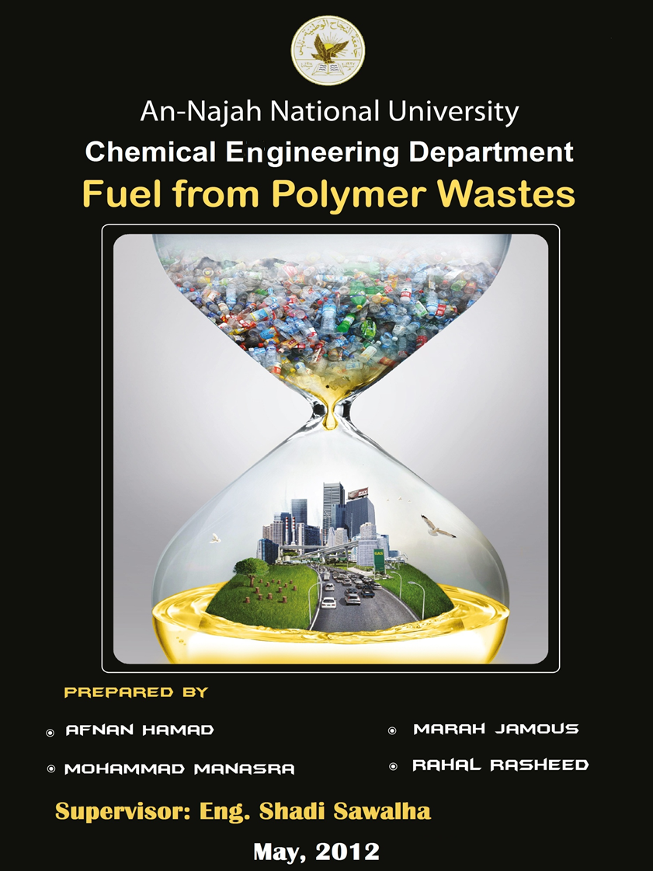


An-Najah National University
Chemical Engineering Department

Production of Fuel from Polymer Waste.

Prepared by:
        - Afnan Hamad
        - Marah Jamous
        - Mohammad Manasra
        - Rahal Rasheed

Supervisor: Eng. Shadi Sawalha.

A graduation Project Submitted to Chemical Engineering Department in Partial Fulfillment of the Requirements for the Degree of Bachelor’s in Chemical Engineering

May, 2012


Disclaimer
This report was written by: Afnan Hamad, Marah Jamous, Mohammad Manasra, and Rahal Rasheed at the Chemical Engineering Department, Faculty of Engineering, An-Najah National University. It has not been altered or corrected, other than editorial corrections, as a result of assessment and it may contain language as well as content errors. The views expressed in it together with any outcomes and recommendations are solely those of the student. An-Najah National University accepts no responsibility or liability for the consequences of this report being used for a purpose other than the purpose for which it was commissioned.

Abstract:
This century can be called “Plastic age”, plastics play a major role in our modern life, plastic was alternative for most industrial materials due to its fabulous properties, there is an increase in the production and consumption of plastics day by day, the quantum of solid waste is increasing due to increasing in population, developmental activities, and changes in life style.
All plastics need to be disposed after their usage, as waste. The need to manage this waste from plastic becomes more essential for the environmental concern.
This project aims to participate in minimizing the impact of plastic waste on environment by converting it into beneficial fuel, to achieve this objective a device was designed and constructed to crack the plastic waste using two methods: thermal, and catalytic cracking, the device was a fixed bed reactor provided with condenser, receiver, and a safety bubbler.
A sample of 1 kg of LDPE was examined using the two methods, thermal cracking was heated to 540°C, the reaction time was about 70 minutes, it produced a dark black liquid fuel with yield of 55.1% and a conversion of 67.04%. Whereas the catalytic cracking was heated up to 500°C, the reaction time was about 50 minutes, it produced a clear yellow liquid fuel with yield of 61.24% and conversion of 77.41%.
The resulted products from LDPE catalytic and thermal cracking were mostly similar to the specifications of diesel and gasoline respectively.
Other types of plastics were experimented only using catalytic cracking, HDPE, PP, and PS has given yields of 62.78%, 44.10%, and 42.30% respectively. And conversions of 78.98%, 72.10%, and 70.00% respectively.

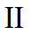

Table of Contents
Abstract: II
Introduction: 5
polymer 9
plastic waste amounts 14
cracking: 18
Reactors : 25
Fuel 30
work methodology: 34
result and Discussion 44
conclusion 53
Recommendation: 55
references: 57

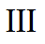

List of Tables

Table 1: Types of plastics and their symbols. 16
Table 2: Percentage of sources of solid waste in Palestine. 18
Table 3: Amount of waste according to nature of locality. 19
Table 4: Amounts of solid waste in different cities. 19
Table 5: Types and percentages of solid waste in Palestine. 20
Table 6: Diesel gas oil analysis. 44
Table 7: Winter gasoline unleaded 95 analysis 45
Table 8: Kerosene analysis. 46
Table 9: Data obtained from experiments. 48
Table 10: Catalytic and thermal cracking of LDPE. 49
Table 11: Thermal analytical report. 50
Table 12: Catalytic analytical report. 51

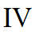
List of Figures

Figure 1: Types and percentages of solid wastes in Palestine 20
Figure 2: Activation energy of chemical reaction with and without a catalyst 23
Figure 3: Thermal cracking process. 24
Figure 4: Packed bed reactor. 29
Figure 5: Fluidized bed reactor. 30
Figure 6: Fixed bed reactor. 31
Figure 7: Rotary kiln reactor. 32
Figure 8: Double pipe heat exchanger. 39
Figure 9: Heater. 40
Figure 10: Control panel. 41
Figure 11: Plant process of apparatus. 42
Figure 12: Thermal and catalytic cracking samples. 53

Due to its fabulous properties, plastic plays an important role in almost every aspect of human’s lives. Most products or tools used involve plastic or were manufactured from plastic such as bags, covers, toys, etc. The widespread use of plastics demands proper end of life management.
The quantum of solid waste is ever increasing due to increase in population, developmental activities, changes in life style, and socio-economic conditions, Plastics waste is a significant portion of the total municipal solid waste (MSW). The environmental hazards due to mismanagement of plastics waste include the following aspects:
- Littered plastics spoils beauty of the city and choke drains and make
Important public places filthy;
- Garbage containing plastics, when burnt may cause air pollution by
emitting polluting gases;
- Garbage mixed with plastics interferes in waste processing facilities
and may also cause problems in landfill operations;
- Recycling industries operating in non-conforming areas are posing
unhygienic problems to the environment. [1]
It is estimated that 200 million tones of plastic are produced each year and less the 3.5% is recycled. The world plastic production is increasing at 3.5% per year. This means every twenty years the amount of plastic we produce doubles. [2]
Plastic waste affects our environment , it cause pollution to the oceans , garbage has been discarded into the oceans for as long as humans have sailed the seven seas or lived on seashores or near waterways flowing into the sea. Plastic also affect the landscape, once they are used, most plastic bags go into landfill, or rubbish tips. Each year more and more plastic bags are ending up littering the environment. Once they become litter, plastic bags find their way into our waterways, parks, beaches, and streets. And, if they are burned, they infuse the air with toxic fumes. Notes that the decomposition of plastic bags takes about 1000 years [3].

There are three main methods that used to dispose the plastic waste around the world which is:
1) Plastic Biodegradation in Landfills
2) Reduced Use and Recycling

3) Burning Plastic
All the previous methods have their advantages and disadvantages, humans started to deal with waste by burning, then by dumping, and now recycle is used. But the main point is not only get rid of plastic wastes; it’s how possible to exploit as much as possible.
The new method strategy is to convert waste plastic into fuel, this requires feedstock’s which are non hazardous and combustible. In particular each type of waste plastic conversion method has its own suitable feedstock. The composition of the plastics used as feedstock may be very different and some plastic types might contain undesirable substances (e.g. additives such as pigments, plasticizers, fillers, and etc) which pose potential risks to humans and to the environment, these additives will remain as residues mixed with the long chain carbons, and can be used for further applications according to the residues’ properties.
So to overcome the abundance plastics waste problem and also to increase its economic value the convert of plastics waste into fuels using catalytic cracking process is one of the most economic methods used.
By this process, plastic can be converted into monomers, fuels, and chemicals, despite of that, fuels from chemical recycling process also can be used as alternative energy, replacing natural gas and crude oils.

The process is really simple, if plastic waste heated in non oxygen environment in the presence of catalyst; it will melt, but will not burn. After it has melted, it will start to boil and evaporate, the out coming gas is then run through a condenser which reduces the temperature to liquefy the gas and some of the vapors with shorter hydrocarbon lengths will remain as a gas.

This process has a lot of advantages such as:
- Available raw material, (waste plastic).
- A good quality fuel.
- Simple system.
- Low operating cost.
- Safe & environmentally friendly process.
- Doesn’t require accurate separation

Alka Zadgaonkar, who lives and works as an applied chemistry professor in the central Indian town of Nagpur, began to work her magic almost 2 years ago. A zero pollution industrial process to convert non-biodegradable - and mostly non-recyclable plastic waste into liquid hydrocarbons is quietly underway in the Butibori industrial estate.
After that the world started to think in this strategy to convert plastic wastes into a very useful fuel so many companies appear in the world. [4]
In March of 2008, GPI completed their first production prototype that is said to be capable of processing 100 tons of municipal and other waste per day in a low heat and low pressure, proprietary catalytic system, converting the feedstock into high grade fuel, including diesel, kerosene, and fuel oil; as well as electricity and an asphalt component. [5]

The idea of this innovation is to find a suitable yet cheap solution for the increasing problem of plastic waste, which is to manufacture a device that produces fuel from plastic waste; that can be used in many applications. This method provides a great solution for the problem of waste, and also the problem of decreasing fossil fuels that are extracted from underground because fossil fuels are expensive and non-renewable source of energy, the world needs a solution to that problem and this is the solution.

1.1 Polymers:
The word polymer is derived from classical Greek poly meaning ―many and meres meaning ―parts. Thus a polymer is a large molecule built up by the repetition of small chemical units. Polymer is prepared by stringing together a low molecular weight species (monomer; e.g., ethylene) into an extremely long chain, much as one would string together a series of bead to make a necklace. Polymers are an important part of everyday life; products made from plastics range from sophisticated products, such as clothes and knee joints, to disposable food bags. [6, 7]

Classification of Polymers
Polymers can be classified in many different ways. The most obvious classification is based on the origin of the polymer, i.e., natural vs. synthetic. Other classifications are based on the polymer structure, polymerization mechanism, preparative techniques, or thermal behavior. Polymers may also be classified as fibers, plastics, or elastomers. The reason for this is related to how the atoms in a molecule (large or small) are hooked together. To form bonds, atoms employ valence electrons. [7, 8]
Background of plastic:
Plastics were first invented in 1860, but have only been widely used in the last 30 years. They are light, durable, mouldable, hygienic and economic, making them suitable for a wide variety of applications including food and product packaging, car manufacturing, agriculture and housing products. Plastics are made up of long chain molecules called polymers, these polymers can then be made into granules, powders and liquids, becoming the raw materials for plastic products. [8, 9]
1.2 Types of plastics:

Thermosets or thermosetting: are plastics that can soften and melt but take shape only once. They are not suitable for repeated heat treatments; therefore if heat is reapplied they will not soften again but they stay permanently in the shape that they solidified into. Thermosets are widely used in electronics and automotive products. Thermoset plastics contain alkyd, epoxy, ester, melamine, formaldehyde, phenol formaldehyde, silicon, urea formaldehyde, polyurethane metalized and multilayer plastics etc. Of the total post-consumer plastics waste in India, thermoplastics constitute 80% and the remaining 20% correspond to thermosets. Similar percentages are also representative in the rest of the world. [9, 10]
Thermoplastics: are plastics that can be repeatedly soften and melt when heat is applied and they solidify into new shapes or new plastics products when cooled. Thermoplastics include Polyethylene Terephthalate (PET), Low Density Poly Ethylene (LDPE), Poly Vinyl Chloride (PVC), High Density Poly Ethylene (HDPE), Polypropylene (PP) and Polystyrene (PS) among others. [11]

1.3 Thermoplastics Type:
The types of plastics that are most commonly reprocessed are polyethylene (PE), polypropylene (PP), polystyrene (PS), polyethylene terephthalate (PET) and polyvinyl chloride (PVC).

Polyethylene (PE): The two main types of polyethylene are low density polyethylene (LDPE) and high density polyethylene (HDPE). LDPE is soft, flexible and easy to cut, with the feel of candle wax. When it is very thin it is transparent; when thick it is milky white, unless a pigment is added. LDPE is used in the manufacture of film bags, sacks and sheeting, blow molded bottles, food boxes, flexible piping and hosepipes, household articles such as buckets and bowls, toys, telephone cable sheaths, etc. HDPE is tougher and stiffer than LDPE, and is always milky white in color, even when very thin. It is used for bags and industrial wrappings, soft drinks bottles detergents and cosmetics containers, toys, crates, jerry cans, dustbins and other household articles. [12, 13]
Polypropylene (PP): Polypropylene is more rigid than PE, and can be bent sharply without breaking. It is used for stools and chairs, high quality home ware, strong moldings such as car battery housings and other parts, domestic appliances, suitcases, wine barrels, crates, pipes, fittings, rope, woven sacking, carpet backing, netting, surgical instruments, nursing bottles, food containers, etc. [14]
Polystyrene (PS): In its unprocessed form, polystyrene is brittle and usually transparent. It is often blended (copolymerized) with other materials to obtain the desired properties. High impact polystyrene (HIPS) is made by adding rubber. Polystyrene foam is often produced by incorporating a blowing agent during the polymerization process. PS is used for cheap, transparent kitchen ware, light fittings, bottles, toys, food containers, etc. [14]
Polyethylene Terephthalate (PET): PET exists as an amorphous (transparent) and as a semi-crystalline (opaque and white) thermoplastic material. Generally, it has good resistance to mineral oils, solvents and acids but not to bases. The semi-crystalline PET has good strength, ductility, stiffness and hardness while the amorphous type has better ductility but less stiffness and hardness. PET has good barrier properties against oxygen and carbon dioxide. Therefore, it is utilized in bottles for mineral water. Other applications include food trays for oven use, roasting bags, audio/video tapes as well as mechanical components and synthetic fibers. [13, 14]
Polyvinyl chloride (PVC): Polyvinyl chloride is a hard, rigid material, unless plasticizers are added. Common applications for PVC include bottles, thin sheeting, transparent packaging materials, water and irrigation pipes, gutters, window frames, building panels, etc. If plasticizers are added, the product is known as plasticized polyvinyl chloride (PPVC), which is soft, flexible and rather weak, and is used to make inflatable articles such as footballs, as well as hosepipes and cable coverings, shoes, flooring, raincoats, shower curtains, furniture coverings, automobile linings, bottles, etc. [12,14]

Table (1) illustrates the most common types of plastics used, their applications and the symbol which is often used to identify them on forms of plastic packaging. [12]
Table 1: Types of plastics and their symbols.
Plastic Types | Examples of applications | Symbol
Polyethylene Terephthalate | Fizzy drink and water bottles. Salad trays. | 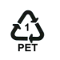
High Density Polyethylene | Milk bottles, bleach, cleaners and most shampoo bottles. | 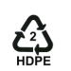
Polyvinyl Chloride | Pipes, fittings, window and door frames (rigid PVC). Thermal insulation (PVC foam) and automotive parts. | 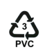
Low Density Polyethylene | Carrier bags, bin liners and packaging films. | 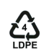
Polypropylene | Margarine tubs, microwaveable meal trays, also produced as fibers and filaments for carpets, wall coverings and vehicle upholstery. | 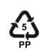
Polystyrene | Yoghurt pots, foam hamburger boxes and egg cartons, plastic cutlery, protective packaging for electronic goods and toys. Insulating material in the building and construction industry. | 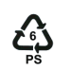
Unallocated References | Any other plastics that do not fall into any of the above categories - for example polycarbonate which is often used in glazing for the aircraft industry

2.1 General background on the solid wastes sector in the Palestinian Territory:
The amount of solid waste produced in the Palestinian Territory is estimated, according to the Palestinian Central Bureau of Statistics, at 78’644 tons per month, with organic waste constituting about 70% of that amount. The daily production rate of residential solid waste (SW) was estimated in 2009 at about 2’321 tons per day ( 1’710 in West Bank, 611 in Gaza Strip). The average daily residential solid waste production per dwelling is 3.5 kg/ day (3.9 in West Bank and 2.7 in Gaza Strip), at an average rate of 0.6 kg/ capita. Day (0.7 in West Bank, 0.4 in Gaza Strip). The quantity of solid wastes produced varies according to the type of locality (city, village, refugee camp), and according to the type of prevailing economic activity and consumption patterns. [15]
This estimation is varying between villages, camps and cities based on living and consumptions. Tables (2) (3) and (4) shows the percentage of wastes in Palestine according to the source of it, and the rate production of solid waste in Palestine according to the locality. [16,17]
The solid waste in Palestine can be classified according to its source:
- Domestic sector.
- Industrial sector
- Commercial sector.
- Agriculture sector.
- Others sectors.

Table 2: Percentage of sources of solid waste in Palestine.
Others | Agricultural | Commercial | Industrial | Domestic | Source of waste
0 – 4% | 8% - 12% | 20% - 25% | 15% - 20% | 45% - 50% | Percentage

Table 3: Amount of waste according to nature of locality.
Amount of waste ( kg / person .day) | The local
0.8 -1 | Cities
0.5 - 0.7 | Villages
0.4 – 0.6 | Camps

The following table shows the quantities of solid wastes in Palestine cities.
Table 4: Amounts of solid waste in different cities.
Amount of waste ( kg / person. day) | City
0.94 | Jenin
0.90 | Nablus
0.74 | Tubas
0.65 | Tulkarm
0.85 | Qalqilia
1.1 | Jericho
1.1 | Salfeet
2.16 | Ramallah
1.00 | Bait Lethem
0.77 | Hebron
1.1 | Jerusalem
0.72 | North Gaza
0.11 | Gaza Organization

2.2 The Constituents of the solid wastes:
Many studies evaluated and discussed the types of solid waste in Palestine, whether for scientific purposes, for research, or to determine the material that can be recycle. This include the identification of the source of the waste ( domestic, industrial, agricultural, etc. ) and the components of the waste according to its source such as food waste, paper, plastic, metal, glass, wood and others. This helped to know the feasibility of separating or reducing the solid waste produced, such as separation of metals, plastic, paper for recycling. [18, 19]
The following figure shows the types of waste in Palestine.
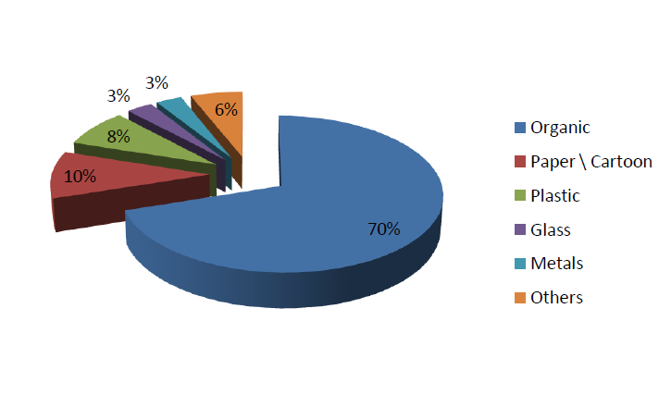

Figure 1: Types and percentages of solid wastes in Palestine
Table 5: Types and percentages of solid waste in Palestine.
Type of waste | Percentage | Amount of wastes produces (ton/month)
Organic | 70 % | 55050.8
Paper/ Cartoon | 10 % | 7864.4
Plastic | 8 % | 62915.2
Glass | 3 % | 23593.2
Metals | 3 % | 23593.2
Others | 6 % | 47186.4

3.1Thermal and Catalytic Degradation:
In the prior chapter, this research project concentrates on tertiary recycling because of its great importance in future industry. Both thermal and catalytic degradation belong to the group of tertiary recycling processes. When the process temperature reaches a certain value, the structure of the polymer molecules becomes unstable; this causes the carbon chain to break into several feedstock molecules with less carbon atoms belonging to each molecule than the original. [20]

Among the feedstock (tertiary) recycling methods, we should consider:
- Pyrolysis: thermal decomposition of polymer chains.
- Gasification: decomposition under oxygen or stream conditions to yield synthesis gas.
- Hydrogenation: chain breaking with hydrogen.
- Catalytic cracking: polymer chain breaking through the action of a catalyst.
The so-called cracking process involves breaking down the plastics at high temperatures (thermal degradation) or at lower temperatures in the presence of a catalyst (catalytic degradation) back to feedstock material. These molecules contain
smaller carbon chains than the un-cracked molecules and the number of carbon atoms
in a molecule varies more or less (the distribution depends on the catalyst. This feedstock can be used as basic material of lower quality for any chemical production process (e.g. polymerization or fuel fabrication), so that the original value of the raw material is lost. [20]

The number of carbon atoms per molecule varies, so that the cracking product shows a wide distribution of different kinds of feedstock. For this reason, a further upgrading process is necessary to filter the large molecules out of the product. By using thermal degradation as a recycling mechanism, process temperatures up to 500°C are required and the product distribution is very wide. Thermal cracking process using kilns or fluidized beds are very well known in case of pilot plant experiments. [21]

Figure 2: Activation energy of chemical reaction with and without a catalyst

Therefore, the energy costs on the one hand and the costs of subsequent upgrading
procedures on the other hand are lower, so that catalytic degradation is a cheaper alternative to thermal degradation

3.2 Thermal Cracking:
It is defined as the thermal decomposition, under pressure, of large hydrocarbon molecules to form smaller molecules. Lighter, more valuable hydrocarbons may thus be obtained from such relatively low value stocks as heavy fuel/gas oils and residues. This is conducted without any catalyst. Thermal cracking is normally carried out at temperatures varying from 450C to 750C and pressure ranging from atmospheric to 1000 psig. [22]
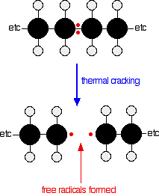
Figure 3: Thermal cracking process.
The rate at which hydrocarbon crack, is strongly dependent on temperature. Depending upon the pressure and temperature employed for the cracking and the characteristics of feed, there are various thermal cracking processes in which the product yields and characteristics are different. Mainly there are four commercial processes employed for thermal cracking in oil refineries. They are: Dubbs thermal cracking process, Pyrolysis , Visbreaking process and Coking. [22]
Pyrolysis: Pyrolysis is a form of treatment that chemically decomposes organic materials by heat in the absence of oxygen. Pyrolysis typically occurs under pressure and at operating temperatures above 430C (800F). In practice, it is not possible to achieve a completely oxygen-free atmosphere. Because some oxygen is present in any pyrolysis system, a small amount of oxidation occurs. If volatile or semi-volatile materials are present in the waste, thermal desorption will also occur. [23]

3.3 Catalytic Cracking:
Catalytic polymer cracking is one of the actual alternatives of feedstock recycling since very valuable products can be obtained. These technologies can be applied to HDPE, LDPE and PP, which represent around 60% in plastic wastes, although certain polyamides can be efficiently depolymerized. Moreover, in principle, any kind of plastic may be recycled, providing the right catalyst, the right reaction system and the right operation conditions. [24]
This process involves catalytic degradation of waste plastic into fuel range hydrocarbon i.e. petrol, diesel and kerosene etc. A catalytic cracking process in which waste plastic were melted and cracked in the absence of oxygen and at very high temperature, the resulting gases were cooled by condensation and resulting crude oil was recovered. From this crude oil various products petrol, diesel and kerosene etc.

By catalytic cracking in the presence the yield of process is high; the share of liquid condensate represents 70 to 80 % wt, besides about 15 % wt of gaseous products and about 5 % wt of residue. There are no problematic wastes; the cracking residue can be used for energetic purposes. The liquid condensate has similar properties to fossil fuels gasoline and diesel fuel. [25]
Important benefits of the catalytic cracking of polymer waste with respect to other chemical feedstock recycling methods is the possibility of controlling the selectivity towards desired products and the possibility of reducing energy consumption. The use of cheap catalysts is central under the actual circumstances and some of the current best options are natural materials and waste catalysts from other industries. To use existing industrial facilities is a way for much cost reduction. Since the catalysts and the reaction mechanism of the polymer catalytic cracking are about the same as for the hydrocarbon fluid catalytic cracking (FCC), it is possible to incorporate plastic waste into the FCC refinery feed, with the added benefit that plastic waste has almost no sulfur content and no heavy metals content[20]

The advantages of catalytic degradation compared to thermal degradation are
- The lower cracking temperature (due to lower activation energy) and a shorter cracking time is required,
- The higher cracking ability of plastics,
- The lower concentration of solid residue in the product, and the narrow product distribution with peaks at lighter hydrocarbons in the boiling point range of motor fuel and a higher selectivity to liquid products

Active plastic waste catalytic cracking materials involve Brönsted acid sites, present in zeolite catalysts. The several solid acid catalysts we tested yield gas and liquid products from for example the LDPE cracking reaction. The gas products consist of a mixture of ethane, propane, butane and pentane, all of them of interest for petrochemical industries or as domestic energy source. Liquid products consist of gasoline, kerosene, gas oil, and fuel oil, corresponding to fuel fractions obtained in industrial petroleum refinery plants. The selectivity towards particular products depends mainly on the choice of catalyst and reaction conditions. [20]

During any catalytic reaction the following steps occur:
- Transport of reactants and energy from the bulk fluid up to the catalyst pellet exterior surface.
- Transport of reactants and energy from the external surface into the porous pellet
- Adsorption, chemical reaction, and desorption of products at the catalytic sites
- Transport of products from the catalyst interior to the external surface of the pellet.
- Transportation of products into the bulk fluid. [26]

The thermal and catalytic degradation of structurally different types of polyethylene
including (HDPE) high density polyethylene, (LDPE) low density polyethylene,
,into fuel oil both in the absence on (thermal) and presence of the catalyst in liquid phase contact has also been studied In the thermal degradation, HDPE produced significant amounts of wax-like compounds and the yields of liquid product were lower than that for LDPE.
The latter polymers also produced less quantity of wax-like compounds. Their findings suggested polyethylenes with a branching structure on its backbone like LDPE degrade more easily to liquid hydrocarbon products than the long straight chain
PE.
Commercial cracking catalysts have been used in catalytic degradation of polymers
and have shown promising results. Reports that these catalysts give a high liquid yield and low coke content; this makes them suitable for large-scale recycling processes. Potentially a refinery’s cracking unit could have a co-fed plastic waste stream. This approach could potentially save some of the cost of constructing new facilities purpose-built for polymer recycling. [21]
As a summary, zeolite cracking catalysts have the following advantages:
- High activity,
- Good activity retention,
- Good thermal and hydrothermal stability,
- High gasoline yields,
- Low coke and gas yields,
- Good attrition resistance (regarding the regeneration process).

Reactor is the heart of a chemical process. It is the only place in the process where raw materials are converted into products, the desired product of the process was fuel, from the inert material which is plastic, there are many types of reactors to do the mission, this section describes the most used types of reactors to turn the plastic waste into fuel in the presence of catalyst.

- 4.1 Packed bed reactors
The most used industrial reactor is the catalytic packed bed reactor. This is typically a tank or tube filled with catalyst pellets with reactants entering at one end and products leaving at the other. The fluid flows in the void space around the pellets and reacts on and in the pellets as illustrated in figure (4). [27]
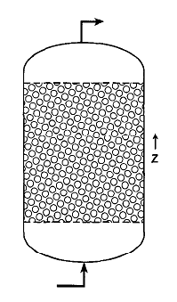
Figure 4: Packed bed reactor.
Flow through packed bed occurs in reactors with solid catalysts. The particles may be rounded or shaped into rings, saddles, or other structures that provide a desirable ratio of surface and void volume. Natural porous media may be consolidated (solids with holes in them), or they may consist of unconsolidated, discrete particles.
Passages through the beds may be characterized by the properties of porosity, permeability, and connectivity. [28]

- 4.2 Fluidized bed reactors
The essential features of a ﬂuidized bed reactor are that the solids are held in suspension by the upward ﬂow of the reacting fluid; this promotes high mass and heat-transfer rates and good mixing. The solids may be a catalyst; a reactant in ﬂuidized combustion processes; or an inert powder, added to promote heat transfer. [29]
The ﬂuid catalytic cracking process is the most widely used process and is characterized by the use of a catalyst that is moved through the processing unit. The catalyst particles are of such a size that when aerated with hydrocarbon vapors, the catalyst behaves like a liquid and can be moved through pipes. Thus, vaporized plastic samples and ﬂuidized catalyst ﬂow together into a reaction chamber where the catalyst, still dispersed in the hydrocarbon vapors, forms beds in the reaction chamber and the cracking reactions take place. The cracked vapors pass through cyclones located in the top of the reaction chamber, and the catalyst powder is thrown out of the vapors by centrifugal force, figure (5) shows a sketch of a fluidized bed reactor. [32]
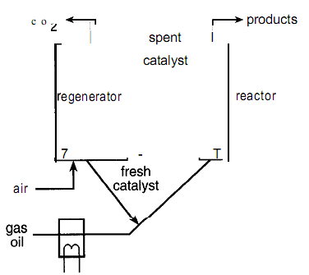
Figure 5: Fluidized bed reactor.
Though the principal advantage of a ﬂuidized bed over a ﬁxed bed is the higher heat transfer rate, ﬂuidized beds are also useful where it is necessary to transport large quantities of solids as part of the reaction processes, such as where catalysts are transferred to another vessel for regeneration. [29]

- 4.3 Fixed bed reactors
Catalytic fixed bed reactors are the most important type of reactor for the synthesis of large scale basic chemicals and intermediates. In these reactors, the reaction takes place in the form of a heterogeneously catalyzed gas reaction on the surface of catalysts that are arranged, they are called fixed bed in the reactor. [30]
In the ﬁxed-bed process, the catalyst in the form of small lumps or pellets were made up in layers or beds in several (four or more) catalyst-containing drums called converters. Feedstock vaporized at about certain temperature and pressure, passed through one of the converters where the cracking reactions took place.
Fixed-bed processes have now generally been replaced by moving-bed or fluid-bed processes, for more details see figure (6). [31]
Most solid catalytic processes employ fixed beds. Although fluidized beds have the merit of nearly uniform temperature and can be designed for continuous regeneration, they cost more and more, difficult to operate, require extensive provisions for dust recovery, and suffer from back mixing. [29]

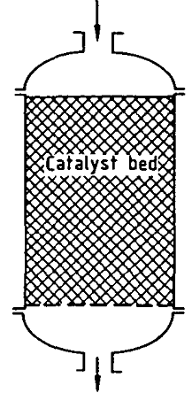
Figure 6: Fixed bed reactor.

- 4.4 Kiln reactors
A Rotary kiln is a preprocessing device used to raise materials to a high temperature (calcinations) in a continuous process, this type of reactors differs from other types by the continuity of the feedstock flow rate, the most used type of kiln reactors and the most suitable for the production of fuel from plastic waste is the rotary kiln reactor, it has many applications as reactors specially between gases and solids. The kiln is a long narrow cylinder with a length-to-diameter ratio of 10-20. General purpose kilns are 100-125 ft long; it depends from one process to another. An inclination to the horizontal of 2-5 deg is sufficient to move the solid along. Speed of rotation usually between 0.25-2 rpm. Lumps up to 1 in. diameter or fine powders are usual. Heating mostly is with combustion gases, or by electrical heaters; to accomplish high temperatures for the process, figure 7 shows a sketch of a kiln reactor. [28, 32]

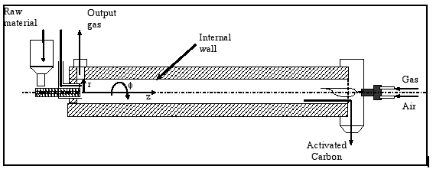
Figure 7: Rotary kiln reactor.

Fuel is any substance stores energy that can later be extracted to perform mechanical work in a controlled manner, the substances classified as fuel must necessarily contain one or several of the combustible elements: carbon, hydrogen, sulfur, etc. Fuel most processes used by humans used to convert fuel into energy include various other exothermic chemical reactions and nuclear reactions. Hydrocarbons are by far the most common source of fuel used by humans, but many other substances, such as radioactive metals, are currently used as well. [33]
There is various types of fuels (like liquid, solid and gaseous fuels) that are available depend on various factors such as costs, availability, storage, handling, pollution and landed boilers, furnaces and other combustion equipments.
The knowledge of the fuel properties helps in selecting the right fuel for the right purpose and for the efficient use of the fuel. Laboratory tests are generally used for assessing the nature and quality of fuels. [34]
A fuel is considered good or valuable fuel if it has a low ignition temperature, and produces a large quantity of heat, that is, its calorific value it high, and also should be easy to store, leave behind little ash after being burnt, and burn easily. Their burning should produce no unwanted by-products. Coal, petroleum and natural gas meet nearly all these conditions. They are cheap, easily available, produce no harmful odor while burning, can be transported easily and their combustion can be controlled. [35]
There are many ways for classifying fuels. Two ways are discussed here one based on their physical state, and the other according on their occurrence.

5.1 On the basis of their physical state

In this classification the fuel founded in nature as solid, liquid and gaseous state.
- Solid fuel:

Solid fuels are mainly classified into two categories, i.e. natural fuels, such as wood, coal, etc. and manufactured fuels, such as charcoal, coke, briquettes, etc. These types of fuel have some advantages like they are easy to transport, and convenient to store without any risk of spontaneous explosion, the cost of production of this type is low and they possess moderate ignition temperature. In addition, there are some disadvantages of these fuels like; the ash content of this type is high, their large proportion of heat is wasted, also they burn with clinker formation, their combustion operation cannot be controlled easily and the cost of handling this fuel is high.[35 -38]
- Liquid fuels:
The liquid fuels can be classified as natural or crude oil, and artificial or manufactured oils. Liquid fuels are predominantly used in industrial applications. This type of plastic has a lot of advantages, they possess higher calorific value per unit mass than solid fuels, they burn without dust, ash, clinkers, the firing of the liquid fuels is easier and also can be extinguished easily by stopping its supply, also the transport of it through pipes is easy, and so liquid fuel can be stored indefinitely without any loss, moreover they are clean in use and economic to handle, the loss of heat in chimney is very low due to its greater cleanliness, these types of fuel require less excess air for complete combustion and also less furnace space for combustion. The disadvantages of these fuels summarized as follow, the cost of liquid fuel is relatively much higher as compared to solid fuel, that’s because of the special storage tanks that required for storing them, they are more hazardous and dangerous, particularly, in case of highly inflammable and volatile liquid fuels, and also the bad odor of these fuels. [35 - 38]
- Gaseous fuels :

Gaseous fuels occur in nature, besides being manufactured from solid and liquid fuels. The selection of a particular gas fuel depends on availability, efficiency required, engine application (mobile or not), initial cost and cost of operation. The amount of heat a fuel is capable of producing depends on the basic structure of the fuel. Dry gases vary in heat content as do gasoline, diesel fuel or other fuels. Propane and butane have considerably higher heat values than do methane and ethane.

Gaseous fuels due to erase and flexibility of their applications, possess the following advantages over solid or liquid fuels, they can be conveyed easily through pipelines to the actual place of need, thereby eliminating manual labor in transportation and they can be lighted at ease, they also have high heat contents and hence help in having higher temperatures. Also they can be pre-heated by the heat of hot waste gases, thereby affecting economy in heat. Their combustion can readily by controlled for change in demand like oxidizing or reducing atmosphere, length flame, temperature, etc. These types of fuel are clean in use, do not require any special burner; because they can burn without any shoot, smoke or ash and they are free from impurities founded in solid or liquid fuels. The disadvantages of these fuels are they need very large storage tanks, and they are highly flammable, so chances of fire hazards in their use is high. [35- 39]

5.2 On the basis of their occurrence
Some fuels occur naturally while other are derived by means of physical or chemical processes. On the basis of their occurrence fuels are classified as following:
- Natural fuels:
These fuels are used in the form in which they occur in nature. For example, wood, coal, natural gas, petroleum, cattle dung, agricultural waste obtained from crops, biogases, etc. all natural fuels can be used directly to produce heat. Natural fuels are also called primary fuels. They occur in all the three states of matte. [35]
- Processed fuels:
These fuels are derived from natural fuels by various physical or chemical processes. Therefore, they are also called secondary fuels. For example, charcoal, coke, petrol, diesel, kerosene, water gas, coal gas, etc, are processed or manufactured secondary fuels. Processed fuels are also co three types- solid, liquid and gaseous. [35]

6.1 Production of samples :
There are many methods to produce fuel from waste plastic, only two methods were considered, thermal cracking and catalytic cracking.
Most experiments were done by catalytic cracking, but to compare between these methods, thermal and catalytic cracking were done on the same type of plastic, under different conditions.
Four types of plastic were examined catalytically, low density polyethylene (LDPE), high density polyethylene (HDPE), polypropylene (PP) and polystyrene (PS).
6.2 Design of apparatus:
Instead of doing experiments on small scale amounts, a device was designed and proceeded to produce greater amounts of fuel more efficiently.
The device consists of many parts, the heart of the device is the reactor, a fixed bed reactor made from carbon steel with dimensions of 6” ( 15 cm) in diameter, 50 cm in length, and a thickness of 7 mm, the reactor have a capacity of approximately 10 L of plastic waste.
The reactor have two outputs, one contains a safety valve, and a pressure gauge. The safety valve releases the gases inside the reactor if the pressure inside the reactor exceeds 8 bar. The pressure gauge measures the pressure inside the reactor, its maximum reading is 6 bar. These parts insure the safety for the user if the pressure increased inside the reactor for any reason. The maximum pressure for the reactor is about 8 bar.
The gate used to close the reactor contains special thermal cascades. The closing is so strong to ensure there is no transfer of air inside the reactor, or any gas leakage to the environment, and to be more accurate, all the pipes and fittings close to the reactor are all welded.
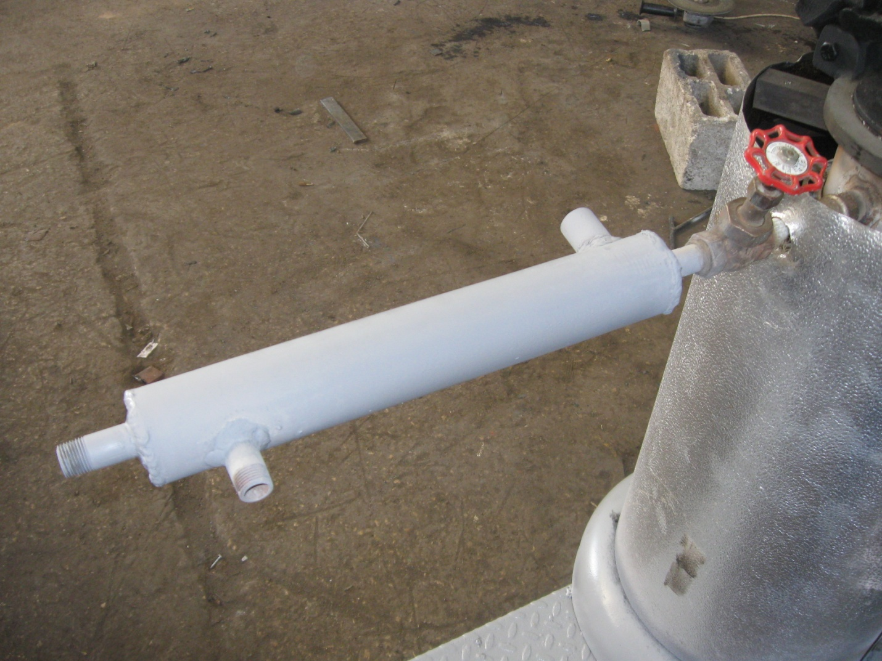
The other output from the reactor is a ½” pipe to transfer the gas inside the reactor to the condenser, the condenser which is double pipe heat exchanger, where the hot gas enters the condenser which will be cooled to 25 – 35 °C, using cold water at 0 °C. to be more efficient a pump of 0.3 kW was used to pump the cold water from the refrigerator to the condenser in counter current flow, the refrigerator consumes about 500 W electricity only. See figure (8) for the condensation system.
Figure 8: Double pipe heat exchanger.
A ball valve is used to control the condensation rate to make it suitable to have a high yield of liquid, the liquid is stored in the receiver which is a clear glass pot that is easily to collect and gather fuel in it, and also is easy to clean. The receiver has an output for the non-condensable gases to transfer the gases by a cupper duct to a safety bubbler; to ensure not to allow the air to enter the reactor. A bubbler containing water will capture the last liquid forms of fuel and leave only gas that is then burned or collected. If the cooling of the condenser is efficient, there will be no fuel in the bubbler, but if not, the water will capture all the remaining fuel that will float above the water and can be poured off the water easily.
This device works on electricity (3 phase), it has 3 heaters as heating elements and consumes a total of 6kW (2 kW each heater). Heating is achieved by using 3 heaters, each heater is connected to a separate phase to gain more power; and so give more heating, the reactor holds the heaters very well. The heaters are turned on and off a relay the relay is controlled by a digital thermostat with a temperature sensor fixed on a heater. A sensor is attached to the heaters to read the temperature of the reactor, so when the temperature reaches the set point, the rely cuts the current on the heaters and turn them off, the sensor reads to 1000 °C, and so does the digital temperature controller. Figure (9) shows one of the heaters used for the device.
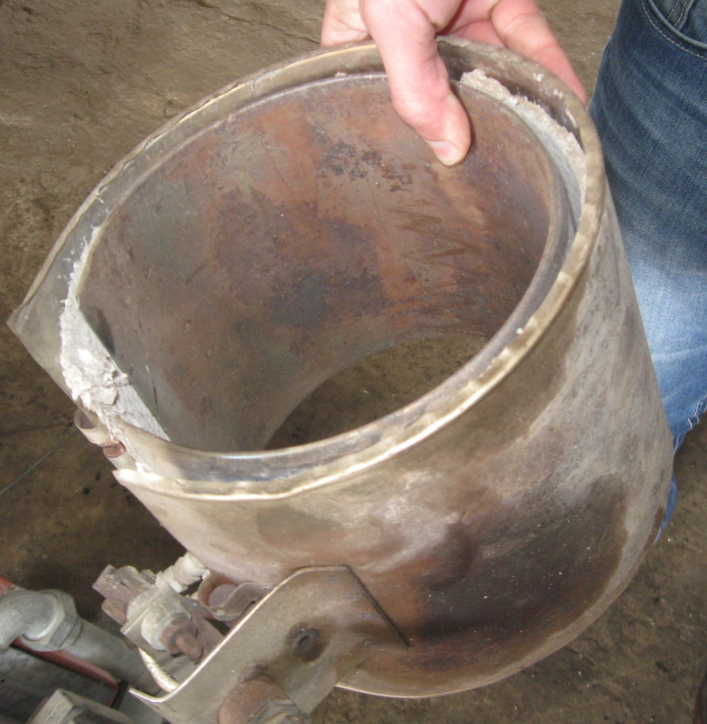
Figure 9: Heater.

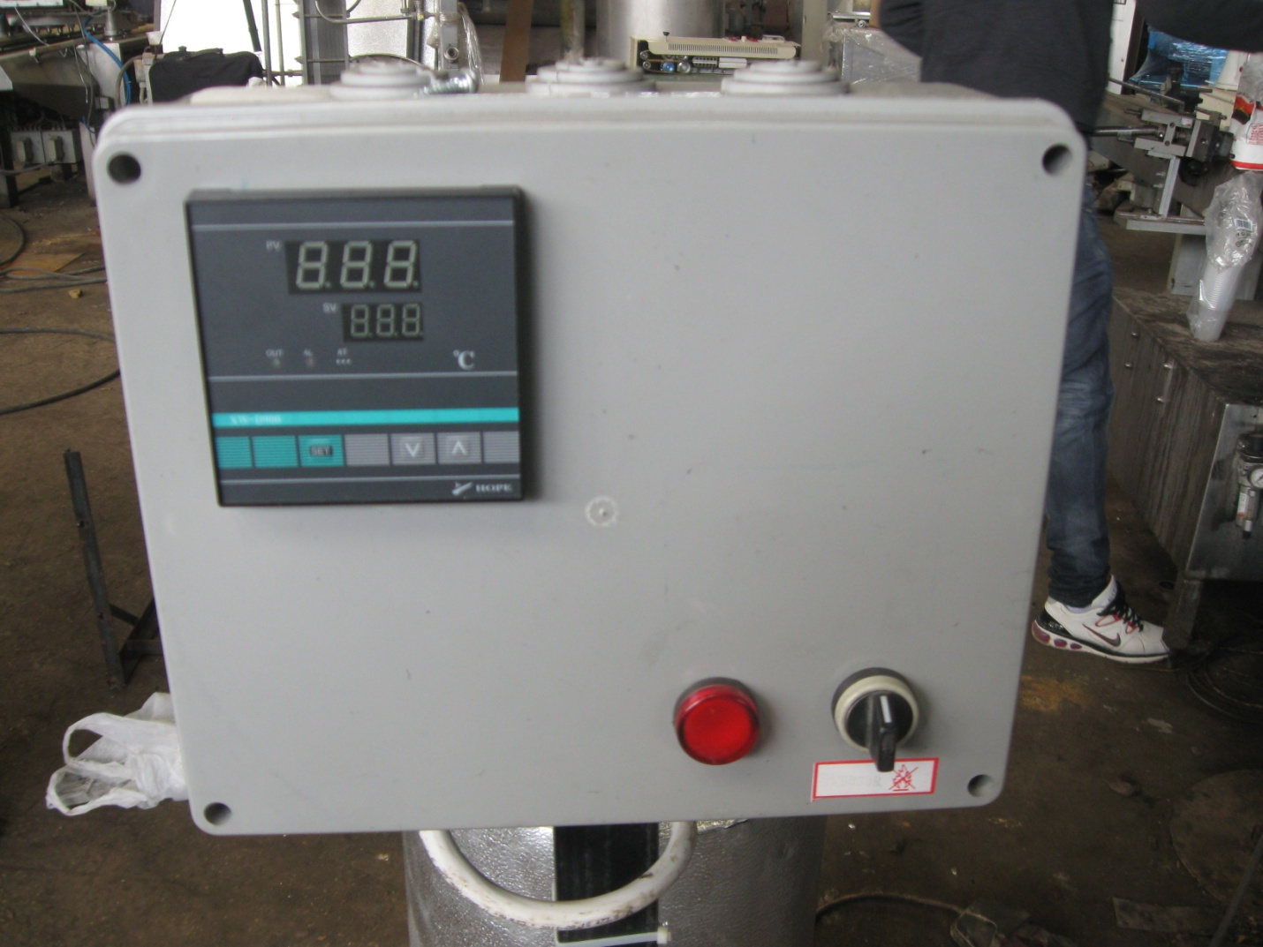
Figure 10: Control panel.
The device is isolated using rock wool filled between two layers of sheets of aluminum (the inside sheet that covers the heaters), and the stainless steel sheet is the main cover for the whole device. The device is welded to a base of four wheels with breaks to move it easily.
The illustration in figure (11) shows the parts of the device.
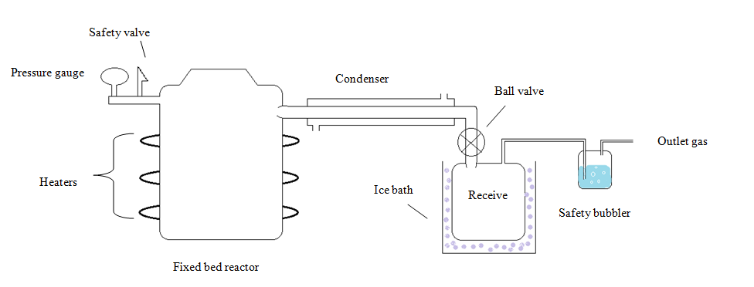
Figure 11: Plant process of apparatus.
6.3 Experimental work:
Most experiments were done for only 1 kg of shredded cleaned plastic samples, the plastic was weighted and mixed well with 2% of catalyst, then the sample was placed into the reactor, and the reactor was closed very well.
Before start heating, the condensation system (refrigeration and condenser) was ready, the temperature of the water should be approximately zero to guarantee cold environment for the outlet gas from the reactor. The device was turned on, heating was done gradually to avoid cracking of catalyst and to get the most possible efficiency, the total time for the experiment was about 1 hour, this time includes the time of the experiment and the time for the device to cool after the process, the steps during the experiment will be discussed later.

6.4 Testing:
After collecting plastic waste and processing it to get fuel, it is necessary to check if the produced fuel is useable and applicable or not, the first step to check the produced fuel is to analyze its properties and compare them to the commercial fuel, and the second step is simpler, just try it on a small motor or machine, and note the results.
Many tests were done on the produced fuel, only two samples were examined, both are LDPE, one was experimented critically, and the other is thermally.
The samples were examined in specialized laboratories belong to the Petroleum Unit in Birzeit University. Tables below tables show some liquid fuel properties and their limits according to the ASTM testing method.
American Society for Testing and Materials (ASTM)

Table 6: Diesel gas oil analysis.
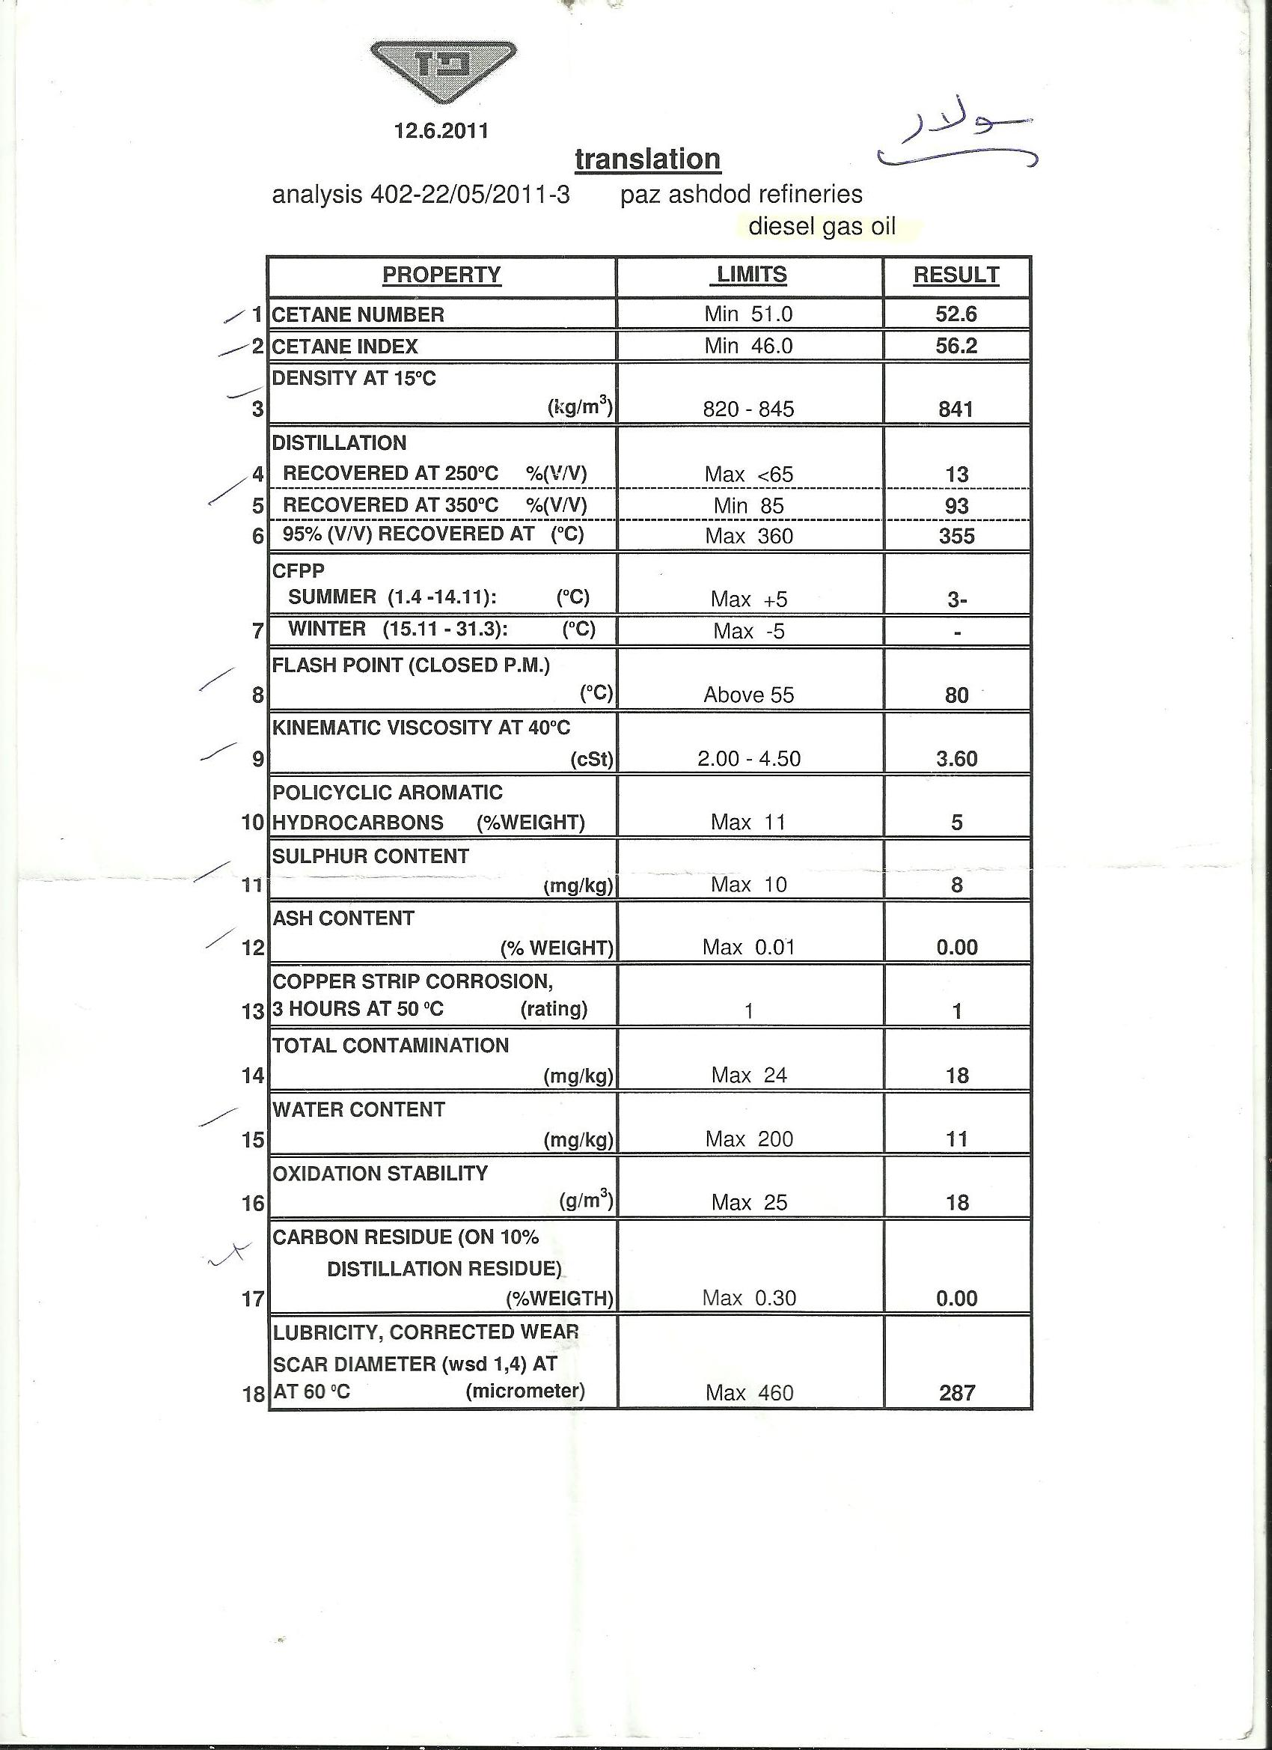

Table 7: Winter gasoline unleaded 95 analysis
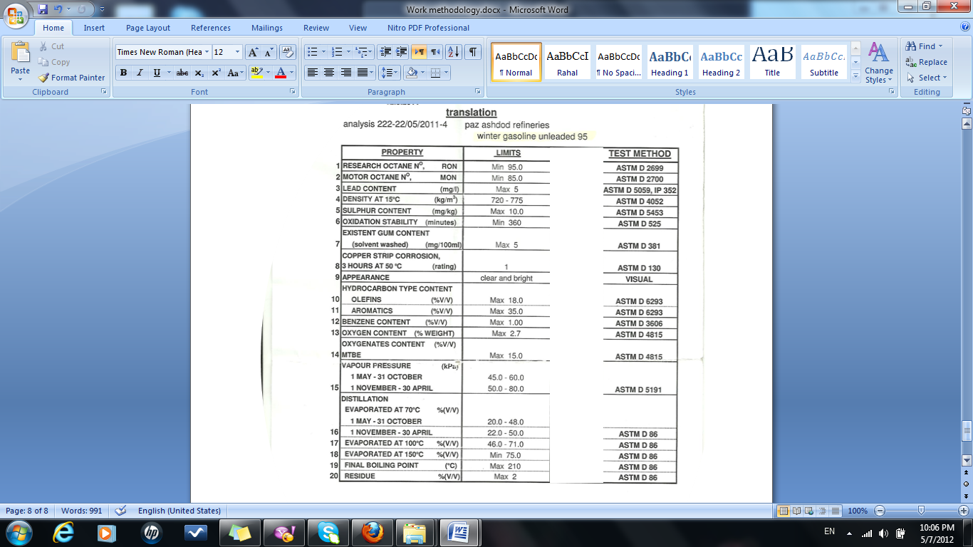

Table 8: Kerosene analysis.
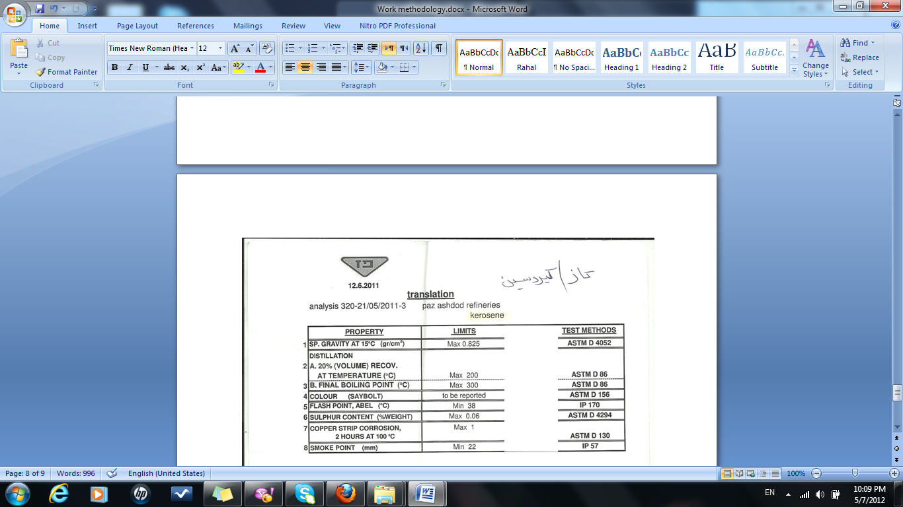

And for the calculations of yield and conversion for each type of plastic, the following equations were used to obtain the results.
Equation (1) Yield % = $\frac{Weight of produced liquid fuel }{Initial weight of sample}$ X 100%
Equation (2) Conversion % =$\frac{Weight of produced liquid fuel + weight of residue}{Initial weight of sample}$ X 100%

Results:
The first type of plastic was examined is HDPE, the conversion obtained was 78.98% according to equation (2), this was the highest comparing to other plastic types, the yield was 62.78% according to equation (1), it produced a waxy yellow fuel with a low melting temperature. The second type of plastic was LDPE, this type of plastic obtained a conversion of 77.42% with a percentage of yield of 61.24%, the product was a yellow liquid clear fuel. The third type of the plastic was examined is PP which produced a clear yellow liquid too, with a conversion of 72.1% and a yield of 44.1%. The last type of plastic was PS, which also produced a clear yellow fuel; it obtained a conversion of approximately 70%.
The following table illustrates the data obtained from the experiments
Table 9: Data obtained from experiments.
Type of polymer | HDPE | LDPE | PP | PS
Weight of polymer (g) | 1000 | 1000 | 1000 | 1000
Percent of catalyst % | 2 | 2 | 2 | 2
Weight of liquid (g) | X | 612.40 | 441.00 | 423.00
Weight of wax (g) | 627.80 | X | X | X
Weight of residue (g) | 162.00 | 161.70 | 280.00 | 250.00
Weight of non condensable gasses(g) | 210.20 | 225.90 | 279.00 | 327.00
Yield % | 62.78 | 61.24 | 44.10 | 42.30
Conversion % | 78.98 | 77.41 | 72.10 | 70.00

For LDPE, two types of cracking were experimented on it, thermal and catalytic cracking, to compare between the product from each experiment. It was obvious that thermal cracking needs more temperature than catalytic cracking and also it takes more time for the experiment, in addition the thermal cracking gives a black color fuel, in the other hand the product from the catalytic cracking was a clear yellow color fuel. Thermal cracking obtained a conversion of 67% and a liquid yield of 55%, gas yield 33%, and a solid yield of 12%, it was clear that there is a big difference in the conversion. The liquid yield of catalytic cracking is higher than in thermal, but on the other hand, the gas yield of thermal cracking is higher than in catalytic cracking.
There are further differences in the percentage and components of the produced fuel, table (10) describes the differences between thermal and catalytic cracking; furthermore the tests analysis compare between their properties, they are described in table (11) and table (12).
Table 10: Catalytic and thermal cracking of LDPE.
Type of polymer | Catalytic | Thermal
Weight of polymer (g) | 1000 | 1000
Percent of catalyst % | 2 | 0
Weight of liquid (g) | 627.80 | 550.10
Weight of residue (g) | 162.00 | 120.32
Weight of non condensable gasses(g) | 210.20 | 329.58
Yield % | 62.78 | 55.10
Conversion % | 78.98 | 67.04

Table 11: Thermal analytical report.
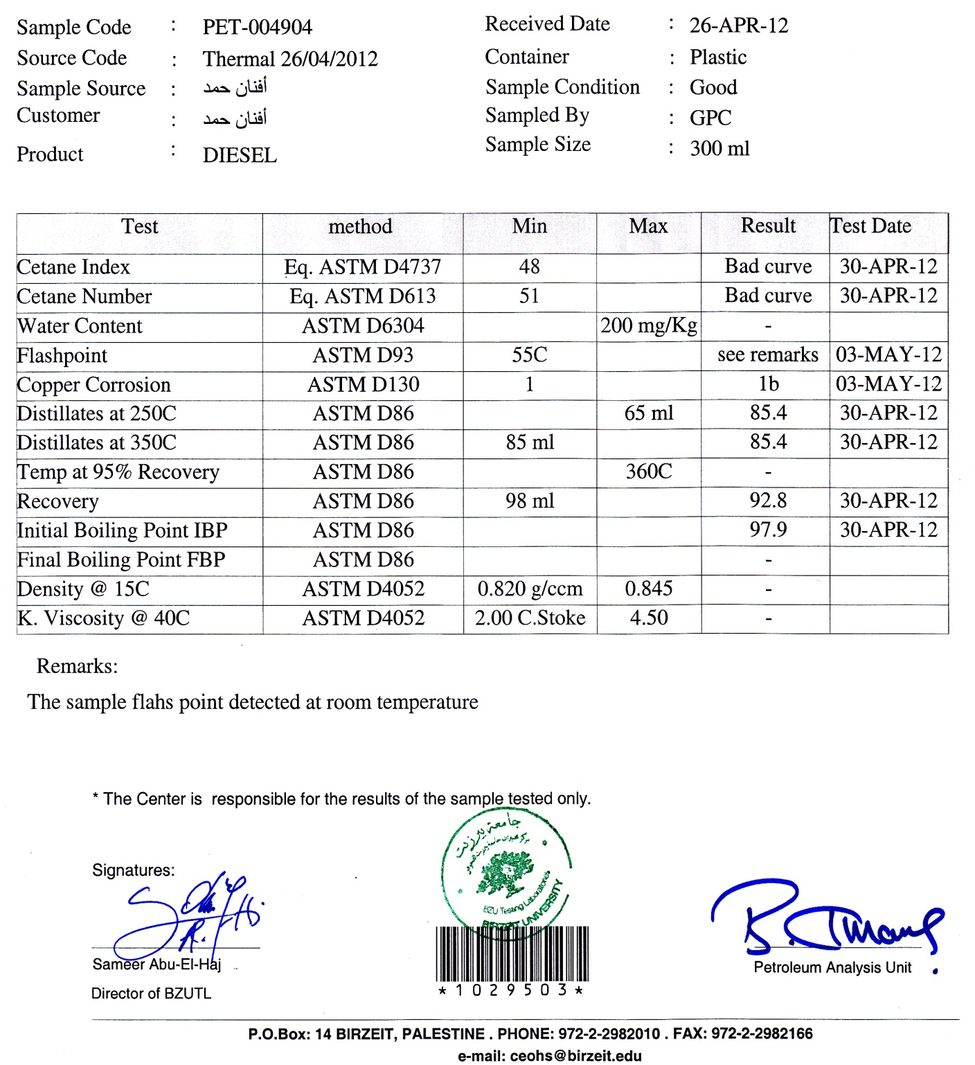

Table 12: Catalytic analytical report.
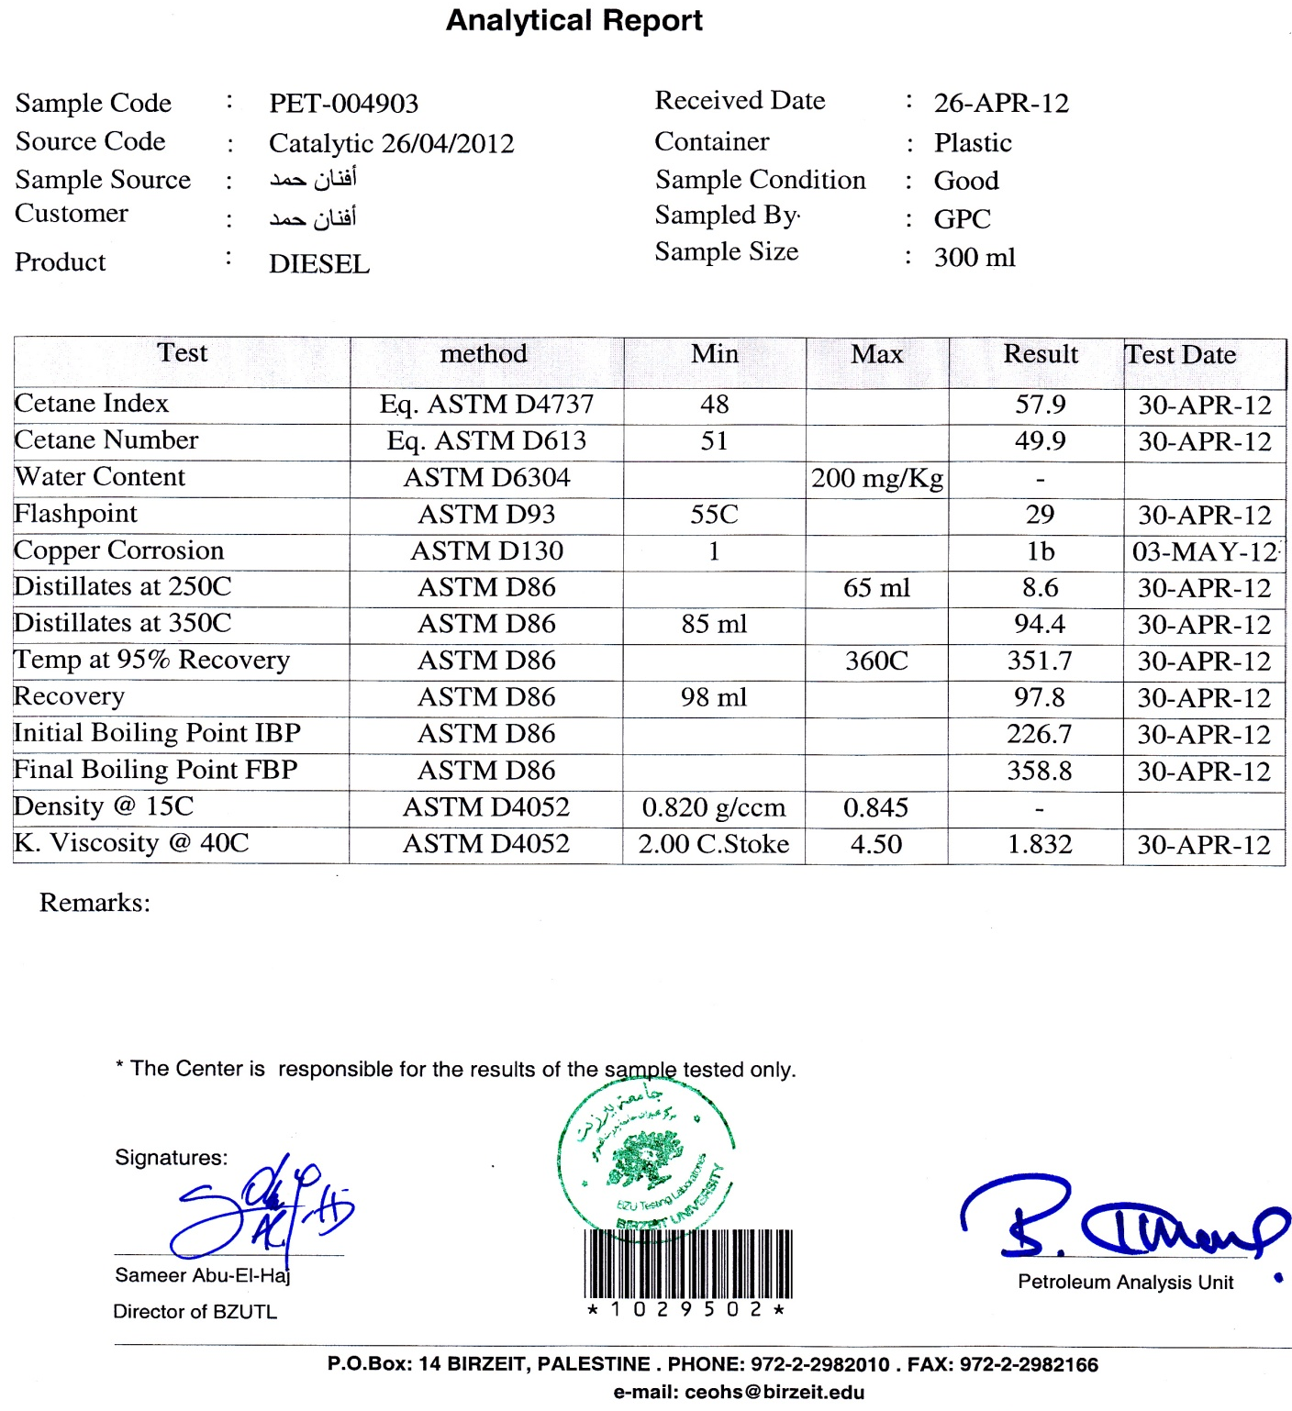

Discussion:
Table (11) shows that the thermal sample is very closely match the specifications of the gasoline fuel, its initial boiling point is 97.7C°, this boiling point in the range of gasoline fraction (C5 - C12), this sample is a mixture of different types of fuel, where the gasoline has the highest percentage.
The flash point thermal sample was detected at room temperature; due to the high volatile matters presence in the sample, this was also reflected to the viscosity of the sample which was relatively low, flash point can be increased using steam stripping to remove any hydrocarbon vapors.
Cetane number and cetane index gave a bad curve, because those tests are especially for diesel, while the thermal sample was mostly gasoline.
For the catalytic cracking sample analysis in table (12), most of the results were in the range of specifications, initial boiling point and final boiling point (226.70 – 358.80) °C respectively, shows that the fraction of catalytic fuel sample is in the range of diesel and fuel oil (C13- C18), so the fuel has a high percentage of diesel with other types of fuel like kerosene and oil fuel. The resulted flash point was 29°C, less than the specifications of diesel fuel; because the sample was a mixture of many types of fuel that contains volatile matters, which also affected the viscosity and decreased it lower than the diesel viscosity specification. The resulted cetane index and cetane number were very good and in the range of the diesel specifications, the temperature at 95% recovery was 351.70, and the distillates at 250 and 350 °C indicate that this sample is mostly from diesel fuel.
Thermal cracking sample has produced a dark black fuel figure (12); this refers to the cracking at high temperatures which decomposed the carbon bonds between atoms and resulted shorter chains in the produced liquid.
Catalytic cracking has been performed on different types of plastics, HDPE has resulted a waxy fuel; due to the low degree of branching between its molecules and thus stronger intermolecular forces, which need a higher temperature to crack its molecules.
But for LDPE it produced a clear yellow liquid figure (12), LDPE molecules have high degree of short and long chain branching, so cracking the chains between molecules by heating was sufficient, the presence of catalyst breaks the long-chain molecules of the high-boiling hydrocarbon liquids into much shorter molecules, where atoms rearrange their selves to form a liquid product.
PP consist of tertiary carbon atoms, these atoms are cracked at relatively high temperature to form yellow liquid fuel, PS has molecules consist of long chains of styrene bonded to each, long and non- branched chains are easy to crack and in the presence of catalyst, they will form a liquid product.
During experimentation on LDPE, the catalyst percent was increased to 15%, this was resulted due to the deactivation of the catalyst; because its shelf life was ended, so a higher percentage of catalyst was used to overcome the deactivation. However, as the polymer to catalyst mass ratio increases, the system becomes less active [36].
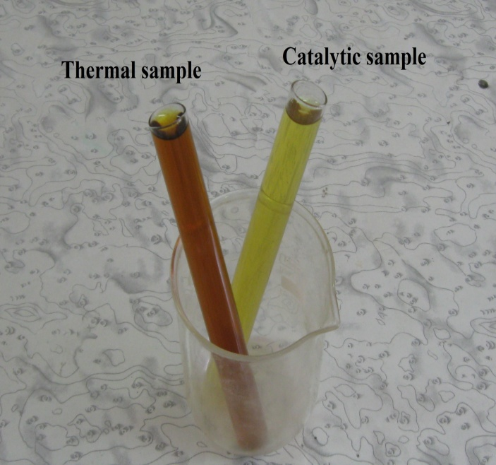
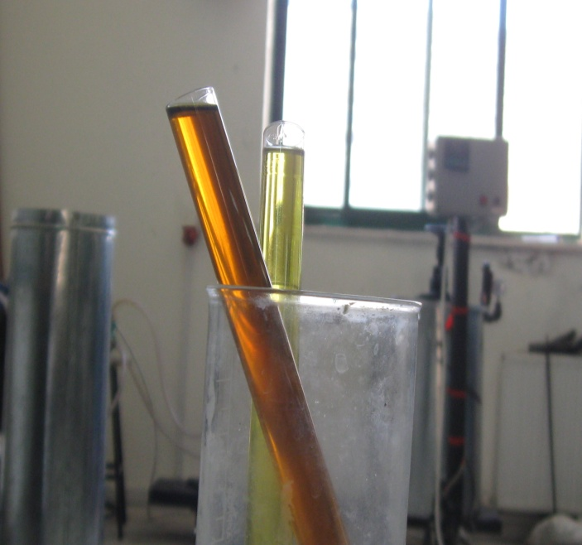

Figure 12: Thermal and catalytic cracking samples.

When the apparatus was started, the heating was achieved by increasing the temperature gradually until the set point ( 500 °C) was reached, after 10 minutes the gases started to go out from the reactor, and after 20 minutes liquid started to form; the condensable gases formed after a while than the initial non-condensable gases.
During the experiment the gas flow was continuous and non condensable gases were passed through a safety bubbler prevent the return of air to the reactor, and also to absorb vaporized liquid fuel, it was noticed that the flammable gases started to flow at the temperature of 380°C, the gas products consist of a mixture of ethane, propane, butane and pentane. [37]
After about 40 minutes of the process the gas flow would start to decrease because the sample in the reactor is disappearing with time.
When the cracking process of the sample ended, the sample finish releasing gases; which means the process is completed. The apparatus was turned off and let to be cooled. Then the reactor was opened in order to clean. The residue was a small amount of black coal and ash.
The previous procedure was done for both thermal and catalytic cracking, except for thermal cracking there was no catalyst adding to the sample and it required higher temperature (540°C), temperature was higher than in catalytic cracking, so the needed time to finish the process was longer due to the time needed to crack the bonds between molecules without the help of catalyst. This process requires more energy and heat; however the gas yield in thermal cracking was greater than the gas yield of catalytic cracking, because as the temperature increases, the residue amounts decrease, the temperature crack the chains into smaller chains.
If the condensation rate was not enough to cool all the gases comes from the reactor, the condensable gases will be totally lost and stay as gases, a secondary condenser (ice bath) was added to the receiver to condense as much gases as possible, to increase the liquid yield.
A ball valve was used to control the flow of gas and liquid to the receiver, using this valve will allow the gases to stay longer time in the condenser and to be condensed into a liquid.

Having an alternative source of energy which is cheap and efficient will get many benefits to our lives, in the same the problem of the waste plastic amounts can be managed better in an environmentally way.
- Fuel from plastic waste could be used for more than one uses :
  - As a mixture in the heavy engines and motors, boilers and power plants.
  - The produced gas could be used for cooking purposes.
  - Also the mixture could be separated easily to use each type of fuel individually, gasoline for vehicles, diesel for heating purposes and etc.
- The produced fuel can be used serenely without suspicions, all the tests and analyzes confirm that its properties are very closed to the commercial fuel.
- A sample was examined and tested on a motor and it went very well.
- The cost of 1 liter of the produced fuel + the amounts of gases is 3.7 NIS.
- If a complete system or plant building with more sophisticated equipments, laboratories, and more time and budget for research and development, for larger scales and hundreds of tons daily. The prime cost will decrease, and the profits will be greater.
- This project is a good solution for the plastic waste problem around the world.

The most important thing is to determine the optimum conditions for the process, to obtain the highest efficiency, the greatest yield, and increase the profits.
- The apparatus can be used for multipurpose:
  - It can be used as reactor for fuel production, either thermal or catalytic cracking.
  - Can also used as a carbonization chamber to produce coal.
  - A tube furnace – it is supplied with inlet and outlet plugs-.
- The apparatus is simple and it is easy to add/ remove parts from it for further processes.
- Further modifications to improve the apparatus are possible for future work, for example:
  - Heat requirements: to decrease the amount of electricity, it is possible to add a chamber to use the outlet gases or liquids for the heating process, a thermostat used to control the temperature of heating; the amount of electricity will be decreased.
  - A better and more efficient cooling system: instead of using a refrigerator, pump, and a double pipe heat exchanger, it is preferable to add a simpler cooling system to the same apparatus, and to cool using cooling gases or solutions.
  - Adding a catalyst bed in the reactor to use external catalyst, this allows to reuse the catalyst moreover.
  - It is possible to add a distillation system to separate each type of fuel immediately according to its boiling point.
  - Instead of filtrating the sample after receiving the liquid, a filtration system also is required, and also if the fuel passes through a packed of coal; it can absorb any unpleasant odors.

- Central Pollution Control Board, Plastic Waste Management, 2009
- Http://www.timelinetothefuture.com/index.php/en/prepare/sustainable-living/no-plastic, retrieved 23.03.2012
- Http://www.waterencyclopedia.com/Po-Re/Pollution-of-the-Ocean-by- Plastic-and-Trash.html, retrieved 24.03.2012
- Http://www.scribd.cometwww.rexresearch.com/zadgnkar/zadgnkar.htm, retrieved 23.03.2012
- Http://peswiki.com/index.php/Directory:Green_Power_Inc%27s_NanoDiesel:Catalytic_Pressureless_Depolymerization_%28Oiling%29,retrieved 26.03.2012
- P. J. Flory, Principles of Polymer Chemistry, Cornell University, Ithaca, NY
- David A. Katz, Chem. Educator, Polymers, 1998.
- Billmeyer, F.W., Jr., Textbook of Polymer Science, 3rd ed., Interscience, New York, 1984
- James E. Mark, Physical Properties of Polymers Handbook, 2nd Edition, 2008.
- W. D. Callister Jr Materials Science and Engineering: An introduction Fifth edition, Wiley, 2000
- UNEP, Converting waste plastic into a resource, 2009.
- Handbook of plastics technologies, Charles A. Harper, Editor- in-Chief, Technology seminars, Inc., Lutherville, Maryland, 2008
- http://www.worldofplastic.net/PolyethyleneTerephthalate.htm, retrieved on 23. 03. 2012

Handbook of Plastic Foams: Types, Properties, Manufacture and Applications, Arthur H. Landrock, Volume 3, 1998
- Handbook of Plastic Films, Prof. E. Abdel-Bary, 2003.
- Palestine Central Bureau of Statistics, 2009.
- Applied Research Institute - Jerusalem (Arid), 2006, solid waste management in the Palestinian territories
- Search Sub-group \ National Strategy for Solid Waste Management in Palestine, 2009.
- Applied Research Institute - Jerusalem (Arid), solid waste management in the occupied Palestinian territories, 2006.
- UNEP Desk study on the Environment in the occupied Palestinian territories-4
Sub-Working Group - Report of the ERM
- ACS Monograph Zeolite Chemistry and Catalysis, Rabo, J. Ed., American Chemical Society, Washington D.C., 171, (1976).
- Plastic Catalytic Degradation Study of the role of external catalytic surface, Catalytic Reusability and Temperature Effects, by Toju S. Kpere-Daibo.
- Babu, B. V. and Rishinder Pal Singh. Proceedings of All-India seminar on Chemical Engineering Progress on Resource Development. Bhubaneswar, India, March 11, (2000).
- Http://www.cpeo.org/techtree/ttdescript/pyrols.htm, retrieved in 30.04.2012 .
- Catalytic degradation of plastic waste into fuel range hydrocarbons ,Tiwari D.C.*1, Ejaz Ahmad2, Kumar Singh, retrieved in 16.04.2012.
- Cracking articles, The Encyclopedia of Earth, 2011.
- Nob Hill Publishing, LLC Fixed Bed Catalytic Reactors, 2001 .
- Lanny D. Schmidt, The Engineering of Chemical Reaction, volume 5.
- Http://www.knovel.com/web/portal/browse/display?_EXT_KNOVEL_DISPLAY_bookid=401, retrieved in 15.03.2012.
- James G. Speight, The Chemistry and Technology of Perteum, 4th edition,2007.
- S. H. Oh, J. C. Cavendish, and L. L. Hegedus. Mathematical modeling of catalytic converter lightoff: Single-pellet studies. AIChE J.,1980.
- Gerhart Eigenberger, Encyclopedia of Industrial Chemistry, 2000.
- Http://www.scielo.org.ar/img/revistas/laar/v37n3/3a07g01.png, retrieved in 29.04.2012
- EG&G Technical Services, Fuel Cell Handbook, Seventh Edition, 2004.
- Combustion Engineering and Fuel Technology, Oxford & IBH Publishing Company - A.K.Shaha, 2007.
- Environmental Science and Health, Plastic catalytic pyrolysis to fuels as tertiary polymer recycling method: Effect of process conditions, volume 45, pp. 908-915, 2010.
- (Luis Noreña, Julia Aguilar, Violeta Mugica, Applied Chemistry Research Group, Departamento de Ciencias Básicas, Universidad Autónoma Metropolitana, Azcapotzalco, D. F.Mexico, 2011, p. 20)

