Introduction:
The traditional electro-mechanical meter, still widely used today collection of meter readings is also inefficient, because a meter reader has to physically be on site to take the reading. This method of collecting of meter readings becomes more problematic and cost when readings have to be collected from vast.
In addition there are different new types of KWH meters and efficient ways for readings KWH meters (energy consumption).
In our country almost people use electro-mechanical KWH meter, so it’s difficult and cost to replace these KWH meters by a new types.
We look for more efficient way than replacing meter, our idea in this project talk about to eliminate the need for the meter reader to enter the home by making some improvements on traditional meters, to send data (energy consumption) automatically.
Also, in this project we will try to overcome the problem of non-technical losses.
The metering module consists of a microcontroller and GSM/GPRS modem, connected with a computer server.

Chapter One
Electricity meter:
An electric meter or energy meter is a device that measures the amount of electrical energy supplied to a residence or business. These are customers of an electric company.
The most common type is more properly known as a KWH meter or a joule meter utilities records the values measured by these meter to generate an invoice for the electricity. They may also record other variables including the time when the electricity was used.
The most common unit of measurement on the electricity meter is the KWH which is equal to the amount of energy used by a load of one kilowatt over a period of one hour, or 3,600,000 joules.
Types of meters:
- Electro-Mechanical Meters:
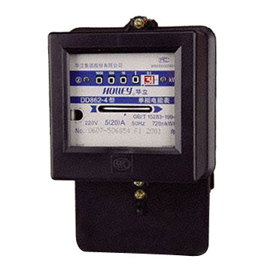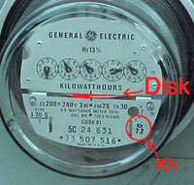
The most common type of electricity meter is the electro-mechanical induction meter.
The electromechanical induction meter operates by counting the revolutions of an aluminum disc which is made to rotate at a speed proportional to the power. The number of revolutions is thus proportional to the energy usage. It consumes a small amount of power, typically around two watts.
The metallic disc is acted upon two coils. One coil is connected in such a way that it produces a magnetic flux in proportion to the voltage, and the other produces a magnetic flux in proportion to the current. This produces eddy current in the disc and the effect is such that a force is exerted on the disc in proportion to the product of the instantaneous current and voltage. A permanent magnet exerts an opposing force proportional to the speed of rotation of the disc this acts as a brake which causes the disc to stop spinning when power stops being drawn rather than allowing it to spin faster and faster. This causes the disc to rotate at a speed proportional to the power being used.
The type of meter described above is used on a single phase ac supply different phase configurations use additional voltage and current coils.
How it works:
The aluminum disc is supported by a spindle which has a worm gear which drives the register. The register is a series of dials which record the amount of energy used. The dials maybe of a cyclometer type, an odometer-like display that is easy to read where for each dial a single digit is shown through a window in the face of the meter, or of the pointer type where a pointer indicate each digit. It should be noted that with the dial pointer type, adjacent pointers generally rotate in opposite directions due to the gearing mechanism.
Most domestic electricity meters must be read manually, whether by a representative of the power company or by the customer. Where the customer reads the meter, the reading may be supplied to the power company by telephone, post or over the internet. The electricity company will normally require a visit by a company representative at least annually in order to verify customer-supplied readings and to make a basic safety check of the meter.

- Prepayment Meters:
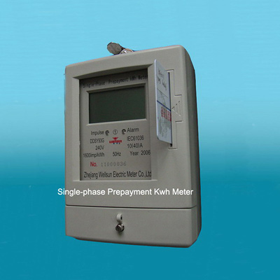
Prepayment meter and magnetic strip token, from a rented accommodation in the UK. The button labeled a displays information and statistics such as current tariff and remaining credit. The button labeled B activates a small amount of emergency credit should the customer run out.
The standard business model of electricity retailing involves the electricity company billing the customer for the amount of energy used in the previous month or quarter. In some countries, if the retailers believe that the customer may for whatever reason not pay the bill, a prepayment meter may be installed. This requires the customer to make advance payment before electricity can be used. If the available credit is exhausted then the supply of electricity is cut off by a relay.
- Solid State Meters:
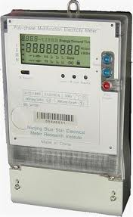
Some newer electricity meters are solid state and display the power used on an LCD, while newer electronic meters can be read automatically.
In addition to measuring electricity used, solid state meters can also record other parameters of the load and supply such as maximum demand, power factor and reactive power used etc. they can also include electronic clock mechanisms to compute a value, rather than an amount, of electricity consumed, with the pricing varying of by the time of day, day of week, and seasonally.
Readings of Meters:
In our country the KWH’s are monitored by employing a specific people for the purpose of KWH monitoring, they start to take read of KWH meter in the end of each month, this method is Non-technically useful because its takes a lot of time, also this method increase the probability of error in taking the reading of KWH’s in additional to lack of synchronization in taking readings, also these employees cannot monitor the KWH meter continuously during the month, so there’s a lot of customers that try to take the electrical energy by non-technically methods, thus the electric network will suffer from non-technically losses.
Human resources:
The electricity plant employs a lot of people to account and monitor the residential and industrial load, these human resources needs salaries, and we need to replace these human resources by efficient and accurate electrical system.
Non-Technical losses:
A non-technical loss is defined as any consumed energy or service, which is not billed because of measurement equipment failure or ill-intentioned and fraudulent manipulation of said equipment. Therefore, detection of non-technical losses includes detection of fraudulent users. Electricity theft is defined as a conscience attempt by a person to reduce or eliminate the amount of money he will owe the utility for electric energy. This could range from tampering with the meter to create false consumption information used in billings, to making unauthorized connections to the power grid. Nonpayment, as the name implies, refers to cases where customers refuse or are unable to pay for their electricity consumption. It is estimated that electricity theft costs in our country is in cores in a year. Electricity theft is part of a phenomenon known as “Non-Technical Losses” (NTL) in electrical power systems. This thesis aims to investigate the nature of non-technical losses in power systems, their sources, the measurement of non-technical losses, some measures taken by selected utilities to reduce them, and possibly their impact on the power system. Power flow calculations of load flow studies are used to discuss relevant aspects of technical losses and the effects of adding NTL in a simplified power system. The results of those simulations are presented.

Techniques of Electricity Theft:

- Most of consumer try to take a phase and neutral lines from the grid system, before the KWH meters, so the KWH meters will not measuring the total energy consumption, as in the following figure.
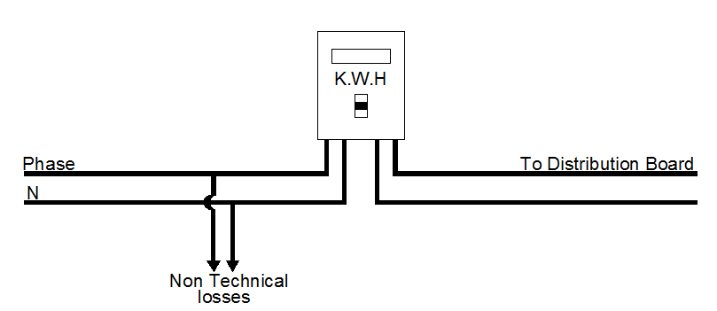
- Other consumers try to cut off the entire wires of KWH meters and connect it directly, i.e. bypass the KWH meters as the following figure.
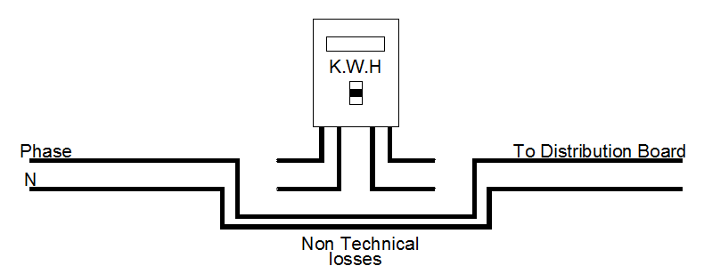

In our country, the grid system having a total power loss of (25%-30%), the non-technical loss reaches 10% of total power loss; this is a huge percentage, i.e. in NABLUS the total bill approx. 100 million NIS per month hence, the nontechnical losses approx. 10 million NIS per month.

Chapter Two
Definition and solving of the problem:
As we said before, the problem of collecting readings of KWH by human resources which provide discontinues monitoring to KWH meter and the error of readings that taken by human is what we need to solve in this project.
In our project we will adjust the KWH meter in order to monitor the electrical energy consumption continuously, also using communication system to send the data about the energy consumption to the plant server monthly; the monitoring system will also detect the illegal consumption of electrical energy by the customer.
In order to prevent the non-technical losses by the customers we will use two current sensors after and before the KWH meter to take reading of current flowing to the loads and compare between them, if there is mismatch between the two readings our system will alarm the electrical plant for that, in additional to if the KWH meters doesn’t work and the sensor of current reading a current flowing our system will alarm the electrical plant for that.
In order to achieve our goal in this project we need to use a Microcontroller (PIC Microcontroller), a GSM/GPRS modem (Communication system) in order to transfer data by using local network GSM system (Jawwal, Watanyia).
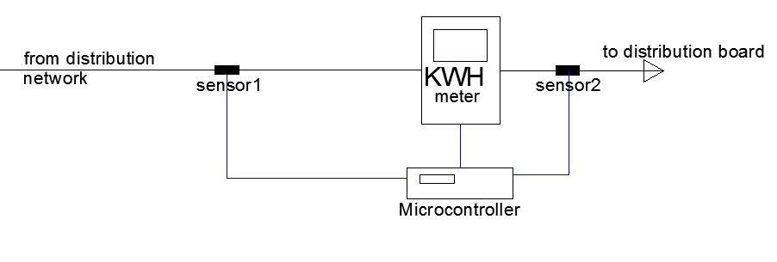
Figure 1: collecting all elements for the system
Elements of our projects:
- Electro-Mechanical Meters.
- Reflective Object Sensor (QRD1114), for detection the revolutions of rotating magnetic disk.
- Current Transformer (60/5) A, in order to reduce the current that flowing in a wires with a ratio k = 1/12.
- Operational amplifiers circuits, to amplify the AC signal and convert it to DC voltage.
- GSM module, in order to send the data to the electrical distribution companies.
- PIC microcontroller (PIC16f877), it’s the control of our system that detects the energy and read the current from C.T and gives the commands to send data through the GSM module.
- C# program on PC computers, used to read data messages and analyze it.

In the rest of this report we will explain the objectives of all elements in details.

Chapter Three
Revolution Detection:
In our country we have two types of KWH meters that we need to monitor the electrical energy consumption in it
- Electro-Mechanical KWH meter:
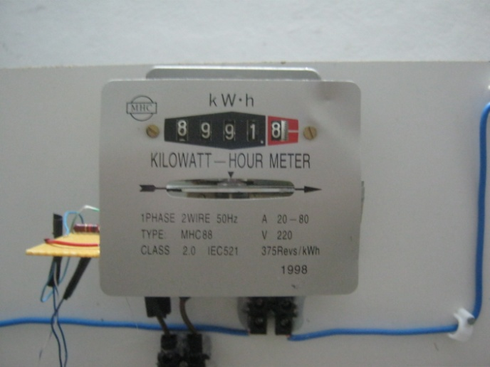
- Digital KWH meter:
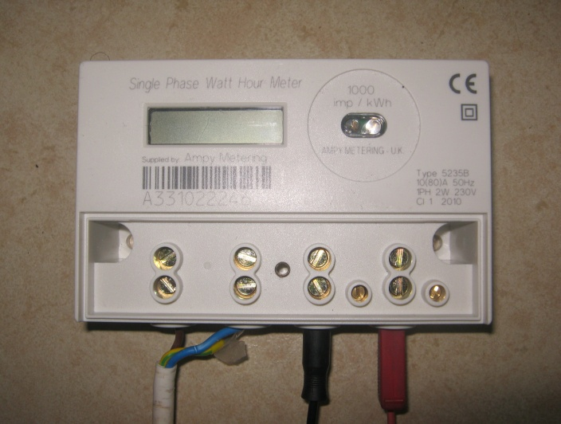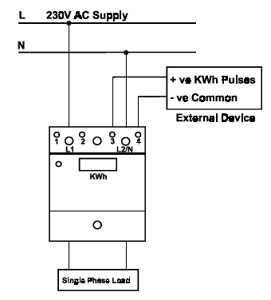

We will use the photo-electric sensor to detect the revolutions in Electro-Mechanical KWH meter, but digital KWH meter having external biasing transistor circuit in order to give pulses proportional to the energy consumption.
Reflective object sensor (QR1114):
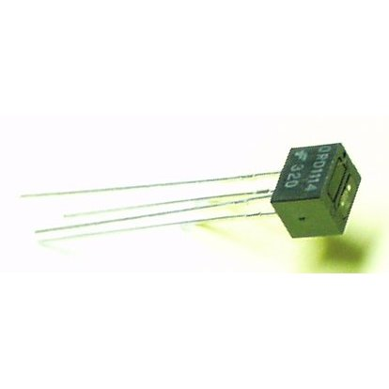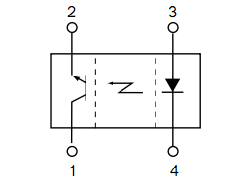
Features:
• Phototransistor Output.
• No contact surface sensing.
• Unfocused for sensing diffused surfaces.
• Compact Package.
• Daylight filters on sensor.
This sensor send an infrared signal using emotion light diode, and this sensor contain a phototransistor, the voltage between emitter and collector of the phototransistor becomes 0 when the light reach to the base of transistor in order to detect infrared when it reflect.
We will use the following circuit in order to make a dc biasing to the phototransistor:
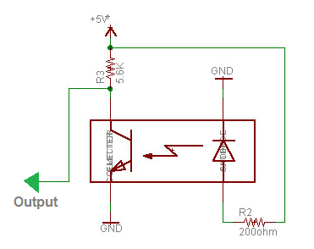
When the infrared signal reflects to the base of phototransistor the output of this circuit equals zero, and when the infrared signal doesn’t reflects to the base of the phototransistor the output will be approx. 5V.

We use a cupper board to build the previous circuit by wielding then we will put this circuit inside the KWH Electro-Mechanical meters.
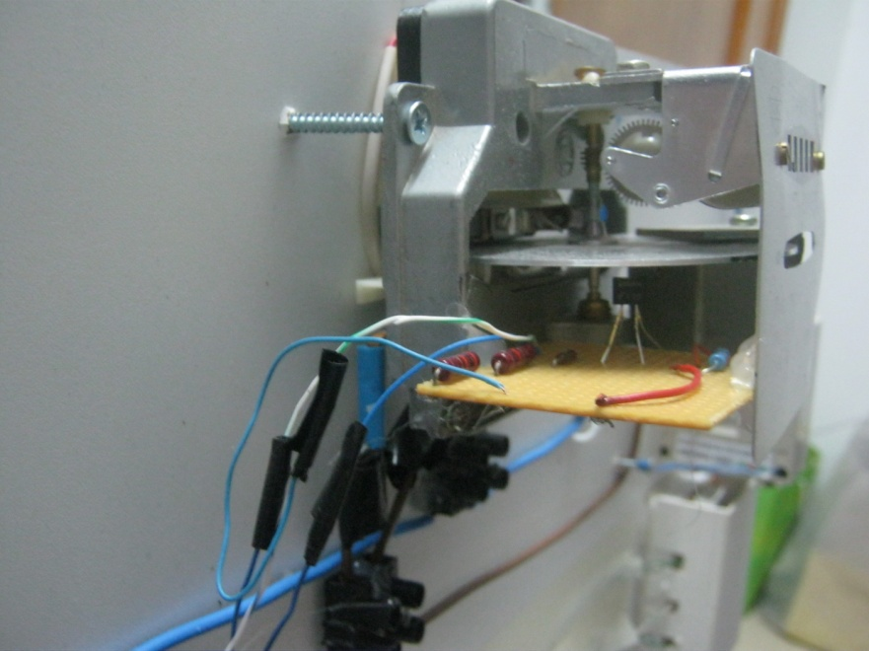

We put a black thin blaster on the rotating disk in order to make the sensor give output of 5V to the specific input of PIC microcontroller.

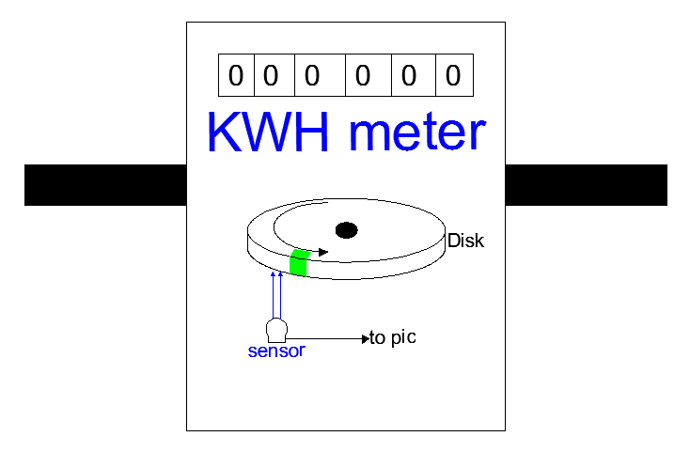
In out project we will use electro-mechanical meter has 375 Revolution per KWH, that’s mean each revolution equivalent to 0.002667 KWH.

Chapter Four
Current Transformer (Instrument Transformer):
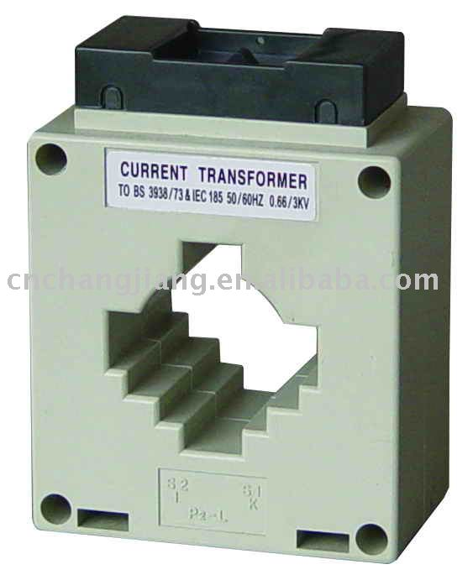
In electrical engineering, a current transformer (CT) is used for measurement of electric currents. Current transformers, together with voltage transformers (VT) (potential transformers (PT)), are known as instrument transformers. When current in a circuit is too high to directly apply to measuring instruments, a current transformer produces a reduced current accurately proportional to the current in the circuit, which can be conveniently connected to measuring and recording instruments. A current transformer also isolates the measuring instruments from what may be very high voltage in the monitored circuit. Current transformers are commonly used in metering and protective relays in the electrical power industry.

Like any other transformer, a current transformer has a primary winding, a magnetic core, and a secondary winding. The alternating current flowing in the primary produces a magnetic field in the core, which then induces a current in the secondary winding circuit. A primary objective of current transformer design is to ensure that the primary and secondary circuits are efficiently coupled, so that the secondary current bears an accurate relationship to the primary current.
The most common design of CT consists of a length of wire wrapped many times around a silicon steel ring passed over the circuit being measured. The CT's primary circuit therefore consists of a single 'turn' of conductor, with a secondary of many hundreds of turns. The primary winding may be a permanent part of the current transformer, with a heavy copper bar to carry current through the magnetic core. Window-type current transformers are also common, which can have circuit cables run through the middle of an opening in the core to provide a single-turn primary winding. When conductors passing through a CT are not centered in the circular (or oval) opening, slight inaccuracies may occur.
Shapes and sizes can vary depending on the end user or switchgear manufacturer. Typical examples of low voltage single ratio metering current transformers are either ring type or plastic molded case. High-voltage current transformers are mounted on porcelain bushings to insulate them from ground. Some CT configurations slip around the bushing of a high-voltage transformer or circuit breaker, which automatically centers the conductor inside the CT window.
The primary circuit is largely unaffected by the insertion of the CT. The rated secondary current is commonly standardized at 1 or 5 amperes. For example, a 4000:5 CT would provide an output current of 5 amperes when the primary was passing 4000 amperes. The secondary winding can be single ratio or multi ratio, with five taps being common for multi ratio CTs. The load, or burden, of the CT should be of low resistance. If the voltage time integral area is higher than the core's design rating, the core goes into saturation towards the end of each cycle, distorting the waveform and affecting accuracy.
In our project we choose the current transformer that converts from (60/5) A.
The current transformer that we used is designed to measuring using Ammeters device, so its capacity is very small and equal 5 VA, and in our project we must convert the secondary current of C.T into voltage by connects small resistor at the terminal of C.T to make the burden losses at least as possible, and the power consumed in this resistor mustn’t exceeds 5 watt.
We choose a thermal resistor having a value 0.39ohm, we know that the maximum current in residential loads doesn’t exceed 32A so the maximum power consumed by the resistor:

Burden Losses:
The errors in ratio and phase angle depend on the impedance connected to the secondary of the transformer; this impedance is commonly referred to as “burden”, when we start working with C.T, we firstly decide to use a resistor of 5 ohm, then we see that the C.T doesn’t work in linear region anymore the C.T ratio is changed, to avoid this problem we must use a small as possible resistor.
We connect the following circuit and make some tests on current transformer with burden resistor and we get the following result:
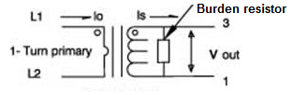
Primary Current | Secondary Current | V_{out} (RMS)
3 A | 0.24 A | 0.093 V
6 A | 0.47 A | 0.18 V
9 A | 0.74 A | 0.28 V
12 A | 0.99 A | 0.37 V

The Interface Circuit with PIC (16F877):
The PIC16F877 can read the analog dc voltage with range (0-5) volt, by internal ADC (analog to digital converter), so we need to convert the AC voltage on the burden resistor into DC voltage within range (0-5) volt, to do this we have many methods as following:
- Half-Wave Rectifier: we use the half wave rectifier technique in order to get the DC voltage required by building the following schematic circuit.
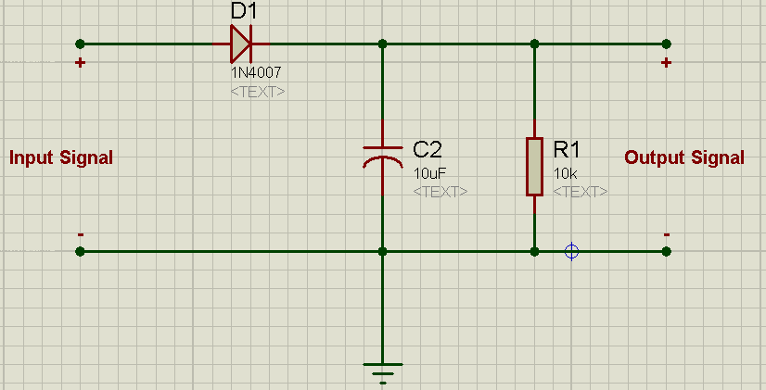
Unfortunately, the input voltage must be at least 0.8 V to bypass the diode, and from the table above we can see that the voltages are very small less than the required voltages, so we start to look for another efficient method.

- Peak detection: in this method we add a dc value to the AC signal of the resistor, in order to make all values of the signal positive, and try to take very large of readings during 1 period by ADC, and detect the peak value of this signal, then we can calculate the real R.M.S current value inside the PIC by mathematical equation.

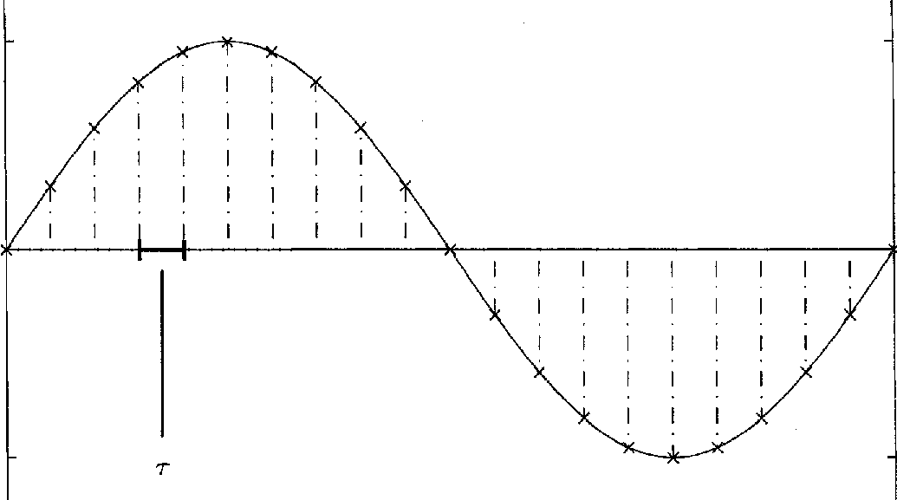

The schematic diagram of the circuit:
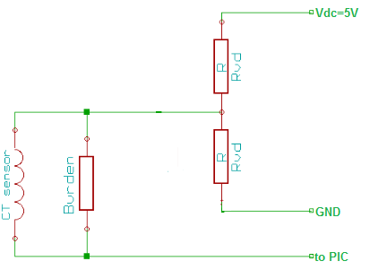
We use the Multisim program to analyze the previous circuit:
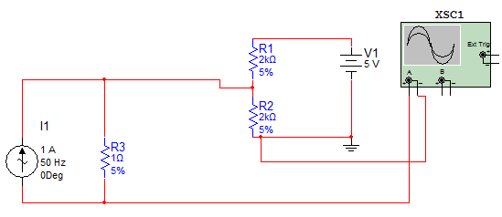
The input signal on virtual OSC as follows:
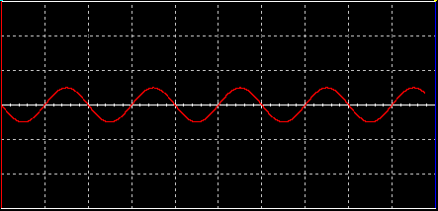

The output signal on virtual OSC as follow:
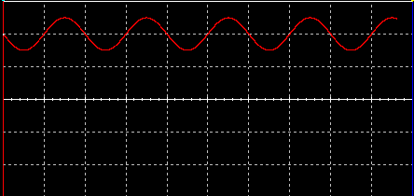
How we can calculate the current in this method:
In the first we detect the maximum value:
We tried this method to calculate the current but unfortunately, the error in readings was very large (exceeds 1 A), so we think again in another method in order to decrease the error in readings current.

- Rectifier Circuit using operational amplifier:
The optimum methods that we use the operational amplifier, we implement the operational amplifier in two stage, the first stage is to amplify the voltage on the burden resistor due to the low voltage signal, then we rectifier the amplify AC signal in order to convert it into DC signal.
The advantage of this circuit that its convert the AC signal that have very small values (less than 0.7 Volt), and convert it into DC voltage equal the average value of full wave rectifier.
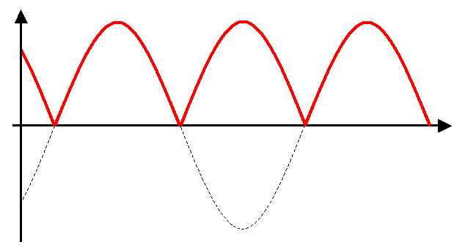
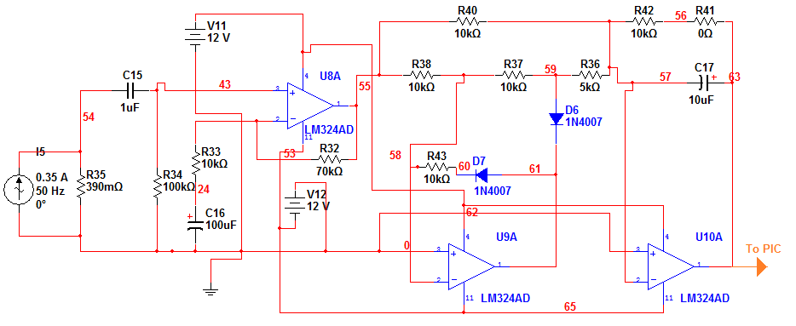

The first op-amp on the left, used to amplify the AC signal by the following equation:
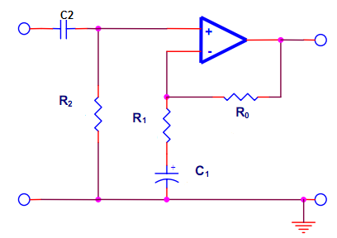

The second stage of the circuit is converting the AC amplified signal into average DC voltage:

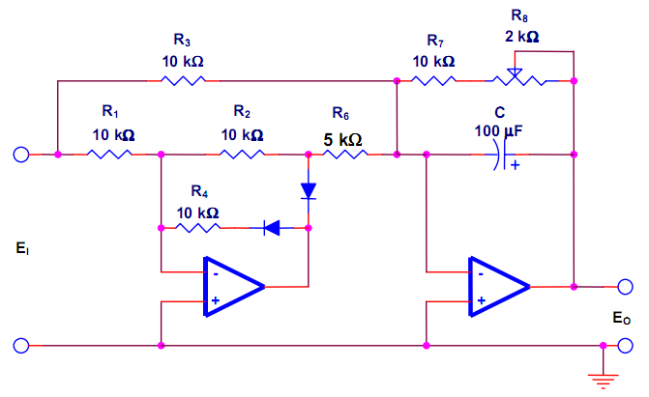

In our project, the output of this circuit equal
So we can read the output of this circuit by ADC then divide it by 0.234 to get the real value of R.M.S load current.
We used Multisim program to verify the operating of this circuit and we get the following result:
If the current is 12 A:
The voltage of Burden resistor:
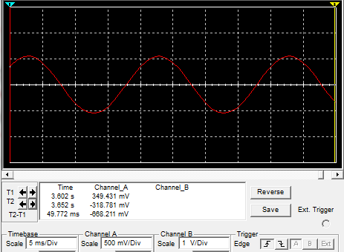

Output of Operational Amplifier stage:
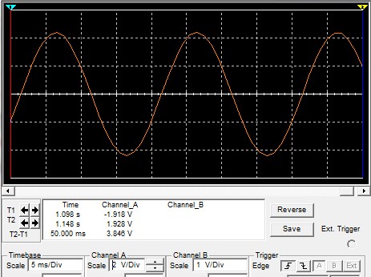
The final average DC output:
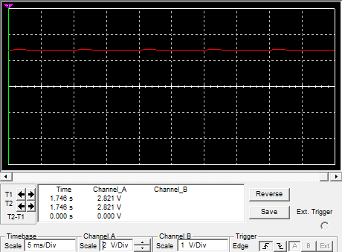

- Each photo from previous has voltage division (channel A) and time division highlighted in the bottom of each photo.

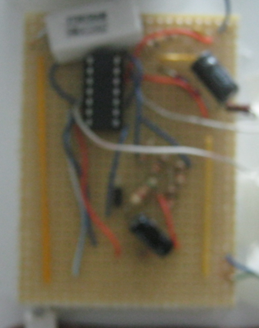
We built the real life circuit using cupper board and welding tools in the following photo our final circuits:

The advantages of this method are:
- The error is very small (doesn’t exceed 0.3 A).
- The ration of the transformer still constant and worked in linear region
(I_{load} = V_{out}/0.234).

The disadvantage of this method we need to +12 V and -12 V power supply.

Chapter Five

Transferring Data in Our Project
We have many methods to transfer the data from PIC microcontroller into PC server as GPRS, Power line Communication (PLC) and GSM, but we always look for the optimum method such that the cost of the method is small as possible, so in our project we decide using GSM modem in order to transfer the magnitude of the total energy for each consumer to distribution companies.
We will send the Data by short messages service (SMS) and we will use special program-we create it- in PC server in order to analysis this message and calculate the bill for each consumer.

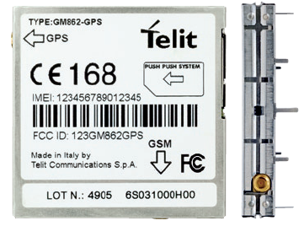
The GM862-GPRS module:
In our project we will use the GM862-GPRS module to transfer data from PIC to PC server.

This GM862 Module offers the advantages of GPRS technology:
- Easy GPRS relieves you from writing the TCP/IP code and making your internet access as simple as dialing a phone number.
- Always connected with higher data transmission speed.
- Small, lightweight and easy to integrate.
- Low power consumption.
- Internal SIM card reader and option on external SIM card reader.
- Full RS232 on CMOS level with flow control (RX,TX,CTS,RTS,CTS and RI).
- High performance on low price.

Product Features:
- E-GSM 900/1800/1900 MHz and GPRS class B class 8 compliant with GSM phase 2/2+.
- Output power Class 4 (2 watt) at GSM 900 MHz and Class 1 (1 watt) at GSM 1800 MHz.
- Control via AT commands (ITU, GSM, GPRS and manufacturer supplementary).
- Supply voltage range 3.4V-4.2V, nominal 3.8V.
- Power consumption: Idle mode: <3.5 mA, speech mode: 250 mA (average).
- Dimensions (mm): 6 * 43.9 * 43.9 and weight (gm): 20 including shielding).
Temperature range (operating): -20 to +70 degree Celsius.

Interfaces:
Due to the distinct voltage level between the PIC Microcontroller and the GM862 module we need an interface circuit between them; we will use the following circuit (KIT) for GPRS modem for purpose of interfacing.
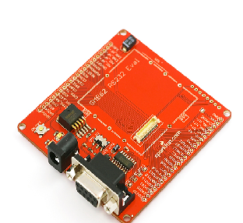
We use the AT command in order to make this device send data from PIC microcontroller into PC server or from PC Server into PIC microcontroller, the AT command is array of characters (string) send to GM862 by serial cabal from PIC microcontroller.

How it works:
When we send AT command to GM862 from PIC, the GM862 will send response to PIC like (OK, ERROR, RING, etc.), in the following we will show some examples by connect this modem with computer and using Hyper- terminal program to send and receive the Data.
- Dialing a Phone Number (Voice Call)
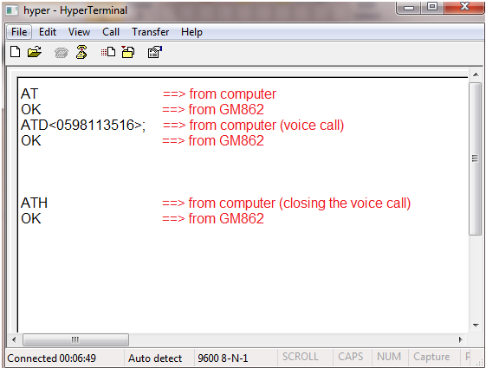

- Turning On or Turning Off the module
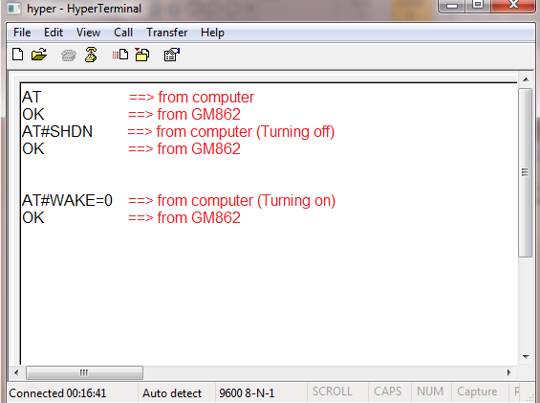

- Sending a New SMS
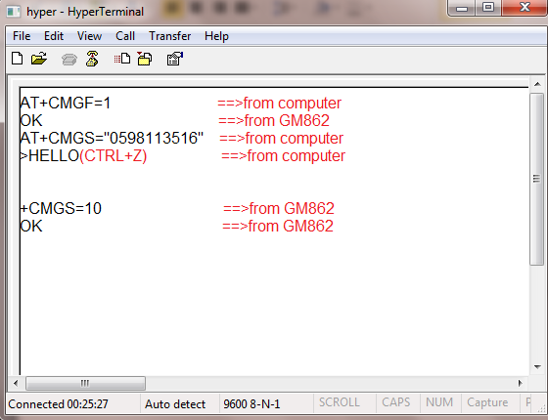
- Reading the Current Date and Time
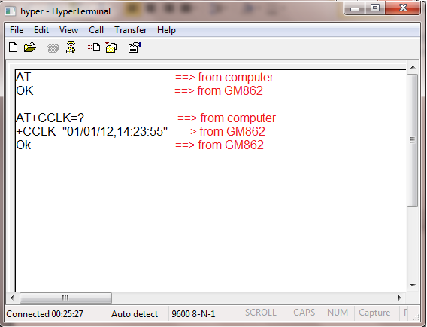

This GSM/GPRS module have a manual user guide, we use it to learn this AT command it contain huge Commands for various purposes.

We need to one SMS message from each consumer in the end of each month in order to send the total of the Energy consumption, and we know that the cost of SMS message is very small (doesn’t exceed 0.2NIS).

Chapter Six
Microcontroller PIC16F877:
Basically, a microcontroller is a device which integrates a number of the components of a microprocessor system onto a single microchip and optimize to interact with the outside world through on-board interfaces, i.e. it’s a little gadget that houses a microprocessor, ROM (Read Only Memory), RAM (Random Access Memory), I/O (Input Output functions), and various other specialized circuits all in one package.
In the world there a various type of microcontroller Aurdino, Atmel, PIC microchip, we choose PIC microcontroller PIC16F877 for the following specifications:
- It’s cheap.
- It’s a flash programmable device (no need for Ultra Violet erasers etc, which mean a very rapid program-cycle).
- It has a built in EEPROM (non-volatile memory).
- It is in-circuit programmable (only a small circuit needs to be built for programming).
- It has supported for various boot-loaders.
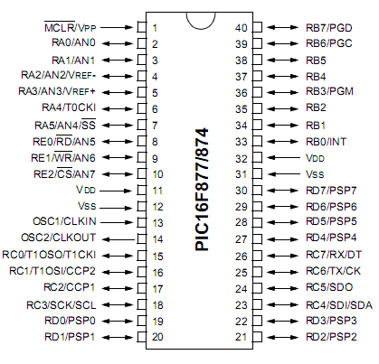

PIC Microcontrollers will also combine other devices such as:
- A Timer module to allow the microcontroller to perform tasks for a certain time periods.
- A Serial input output port to allow data to flow between the microcontroller and other devices such a PC or another microcontroller.
- An ADC to allow the microcontroller to accept analogue input data for processing.
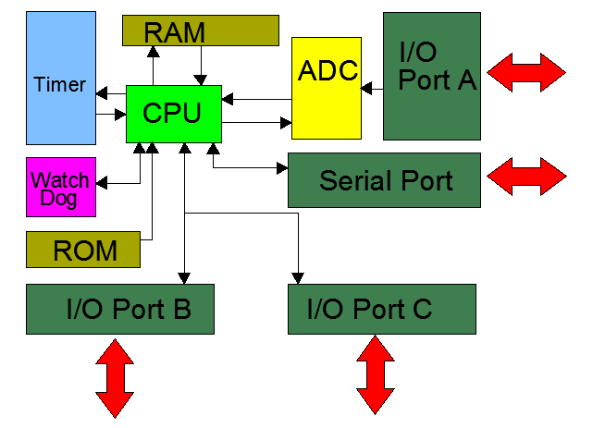

Basic circuit of PIC16F877:
In order to work with this microcontroller programming and executing the program of our project we need some special circuit called Basic Circuit, this circuit allow us to communicate with PC computers, GSM/GPRS modules … etc.
The basic contains LED indicator, MAX232 for communicate with PC and GSM/GPRS modules, 4 MHz crystals oscillator.

This is the Basic circuit of PIC16F877:
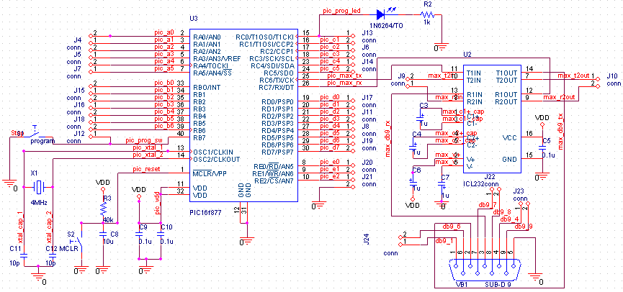
We build this basic circuit by cupper board, and welding, and then we test it and programmed it very well:
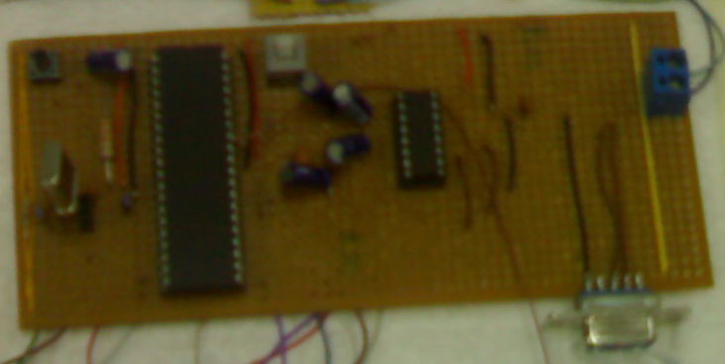

Analog to Digital Converter (ADC):
An analog-to-digital converter (abbreviated ADC, A/D or A to D) is a device that converts a continuous quantity to a discrete time digital representation.
Typically, an ADC is an electronic device that converts an input analog voltage or current to a digital number proportional to the magnitude of the voltage or current.
Accuracy for ADC:
In our project we use ADC has a 10 bits output, so this ADC divide the analog voltage (0-5)V into 1023 level, each level represented by binary number of 10 bits, and the difference between two consequently level is 0.00489 volt, for example if the input of ADC is equal 0 volt the output equal (0000000000)₂, but if the input equal 0.00489 volt, the output of ADC equal (0000000001)₂. And we calculate this Accuracy by the following equation:

The Flowchart of the final program:

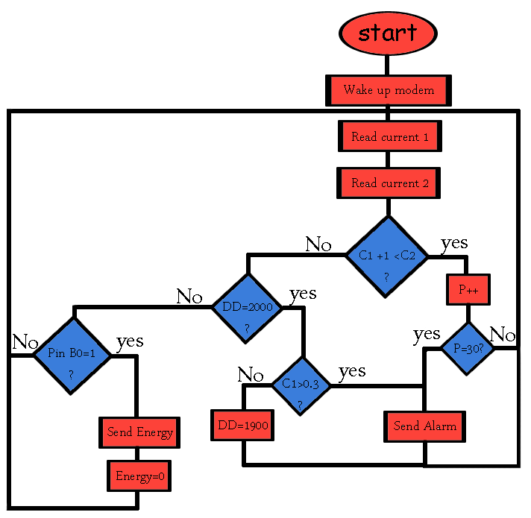

In the first the microcontroller will turn on the modem, then we will read current before KWH meter (C1), and current after KWH meter (C2), and compare between them, if C2 more than C1 + 1A, the PIC16F877 will check this condition 30 times, if the condition still satisfy the PIC will send alarm message into the distribution company by the modem, but if C2 C1 the PIC will check the time(DD) from the last pulse reaches, if the time more than 2 hours, then it will check the C1, if the C1 more than 0, that’s mean there is non-technical losses (theft), so the PIC will send alarm message to the distribution company, if the second condition doesn’t satisfy the program will restart.
In each cycle the PIC will test Pin B0, in order to send the total energy consumption if the company request it.
To detect the revolution of rotating magnetic disk in KWH meters the microcontroller will execute another program then back to the main program.
The flowchart of detecting pulses subprogram:

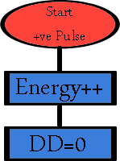

We will write this code in Computer by special program called PICC program
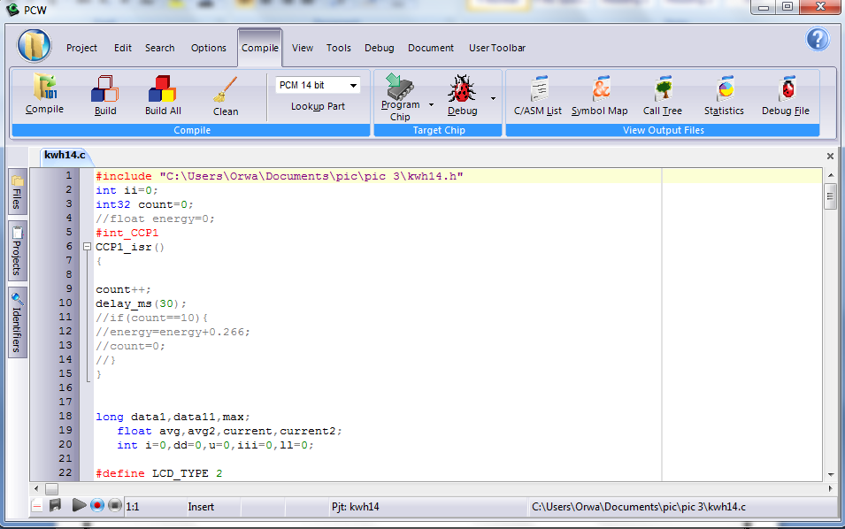

Then we will install this code in PIC by TR program
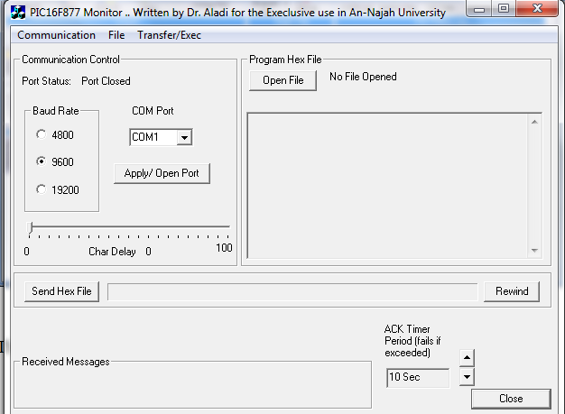

Proteus 7 Professional program Simulation:
In our project we test our code and PIC microcontroller, and see how the projects will behave in further steps using Proteus 7 Professional program, the following picture is a simple photo to the program.
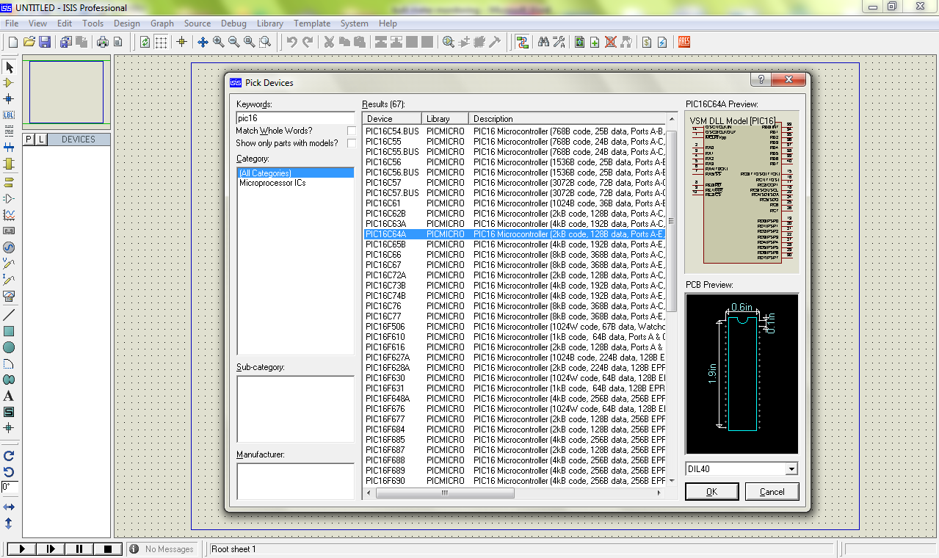

We use the Proteus 7 professional, because it can handle with PIC microcontroller and other electronic devices that we need in our project like LCD, we don’t put the amplifier circuit because we handle it in another program in previous chapter by MULTISIM.

We make simple simulation to our projects, to take a look to the result how it would be and we simple the following schematic using the program and it would be like the following photo.
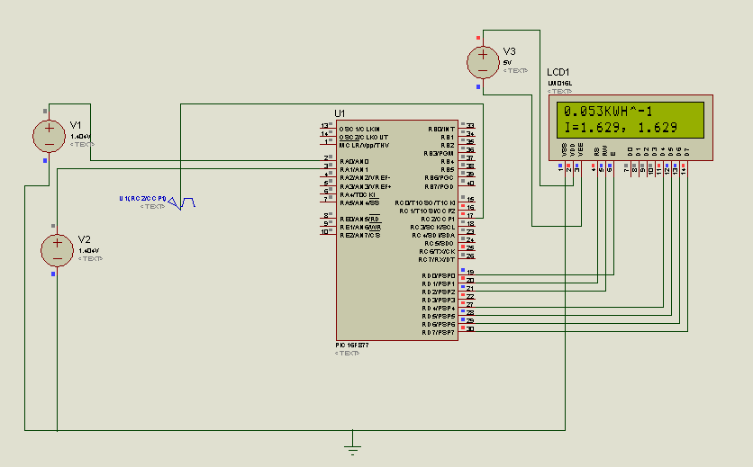
If we make mismatch in current on ADC0 and ADC1 channels, by making ADC2>ADC1 we have a nontechnical losses and we can see that on LCD:
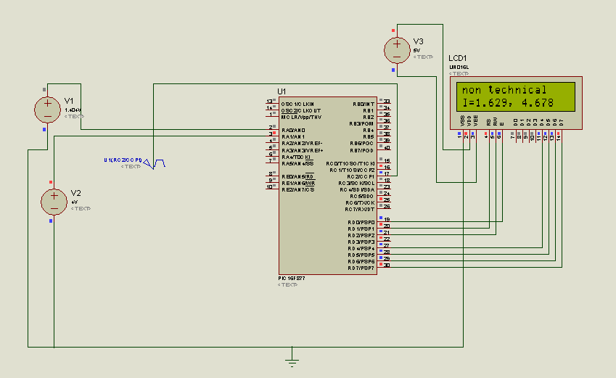
Also, we can see if the condition that get the pulse then back to normal due to dialing operation, the program must respond the request by sending data and we can see it in the following photo:
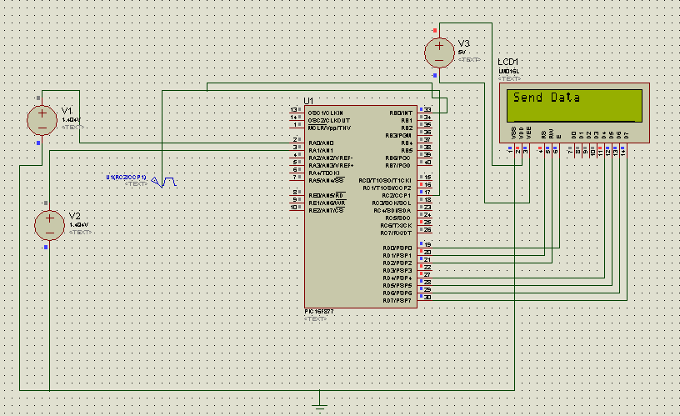

Finally, we connect the microcontroller PIC16F877, GSM/GPRS module, LCD 2*16, and make a fine board to control unit on real, it be:
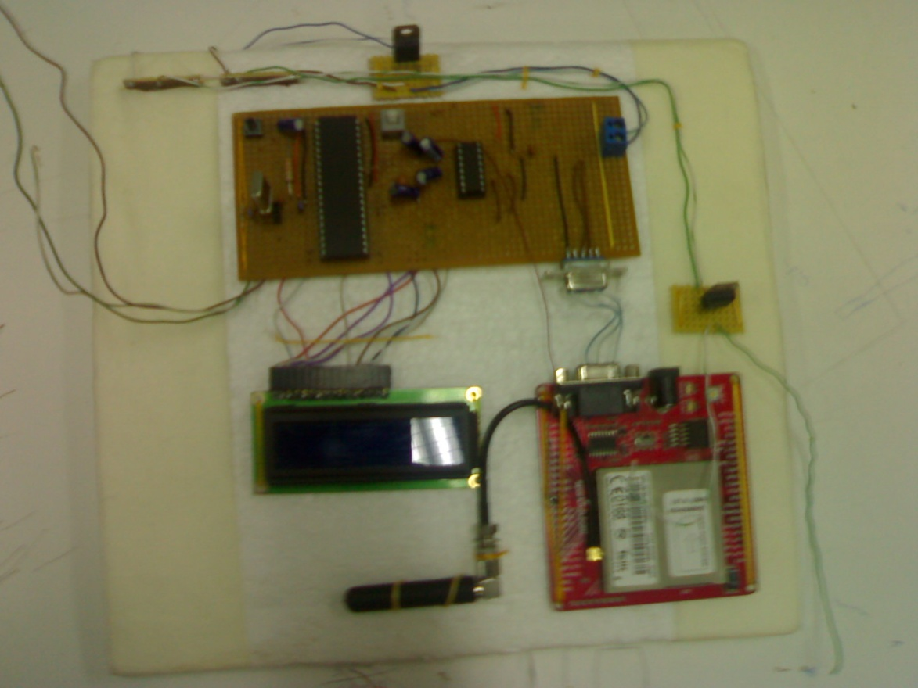

Chapter Seven
In this chapter we will discuss simply how we can analyze our data that we receive from PIC16F877 microcontroller, from previous discussion we see that we have two different messages we will receive depends on different conditions must the PIC16F877 check it, the first one is period message arrive every month depend in the request of the company, the second one is a non-technical losses message it’s just a notification to master PC tell if there a theft or not.

The main idea in our project is to use another GSM/GPS module, in the Electrical company side in order to send and receive data, which will be controlled by the PC computers there, unfortunately we can’t provides another GSM/GPS module, so we will use the mobile NOKIA 7230 due to its capability with NOKIA PC Suit in transfer and receive messages from PC computer in easy way.

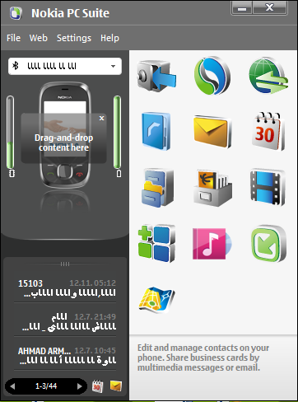
The first thing we do in this step, is to take the message from mobile and save it in PC computer, due to the shortage of knowledge and time in PC programming language, we will use the Nokia PC Suit in order to save the message from mobile then we will start processing to obtain the required data received.

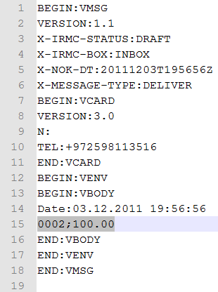
We can get the required message from Nokia PC Suit simply by mouse, then if we open it using a Text program viewer it will be like the figure in the right this sample message is a consumption type message that will arrive when request from our system, we see that our data is in line 15, the first number is indicator to the consumer, the second number is the energy consumption of the consumer from the previous one until now, it also contain a date of message in line 14.

- The semicolon (;) in the data message, we use it to separate the indicator of the consumer from the energy consumption in (KWH multiplied by 10).

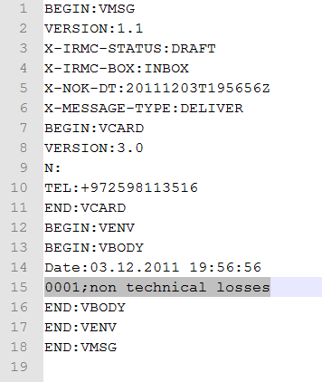
The second sample message is a non-technical losses message type it’s contain indicator to the consumer and text message “non technical losses” separated with semicolon (;).

We need to program a PC program to read these two messages then analyze the data and give us results.

C# programming language:
In our project we use the C# programming language that in come in visual studio group, we use the version Visual Studio 2010 – Visual C# windows applications.
This product is provided by Microsoft

C# is a multi-paradigm programming language encompassing strong typing, imperative, declarative, functional, generic, object-oriented (class-based), and component-oriented programming disciplines. It was developed by Microsoft within its .NET initiative and later approved as a standard by Ecma (ECMA-334) and ISO (ISO/IEC 23270). C# is one of the programming languages designed for the Common Language Infrastructure.
This programming language is intended to be a simple, modern, general-purpose, object-oriented programming language. The most recent version is C# 4.0, which was released on April 12, 2010.
We use the C# programming language because its offer a good programming library’s, in additional to the ease of using it, we can in C# build our interface program then put programming element’s then start program every element and connect the whole element together, the final program is and (.exe) application, any operating system can run it and use it.

The interface program flow steps will be:
- Enter the indicator number of the consumer.
- Read the mobile short text messages of each consumer, its format (.vmg) and convert it to (.txt),
- Read the consumer indicator number that received and print it read the date of message and print it.
- Read if the message is non-technical losses notification if it true the program will print on screen that, if not it will be energy consumption message and will continue to calculation part.
- The program will check the consumption of the consumer, if it below the minimum consumption level in the electrical company it will print the minimum cost, in Nablus City its 20 KWH equal to 11.68 NIS, if it above the minimum consumption level we have here a multiple tariff topology, it will be:

This multiple tariff topology is applied in Nablus city electrical system.
- Then the program will print on screen the energy consumption in KWH, and the cost in NIS.

This is the interface program that we worked on by using C#:

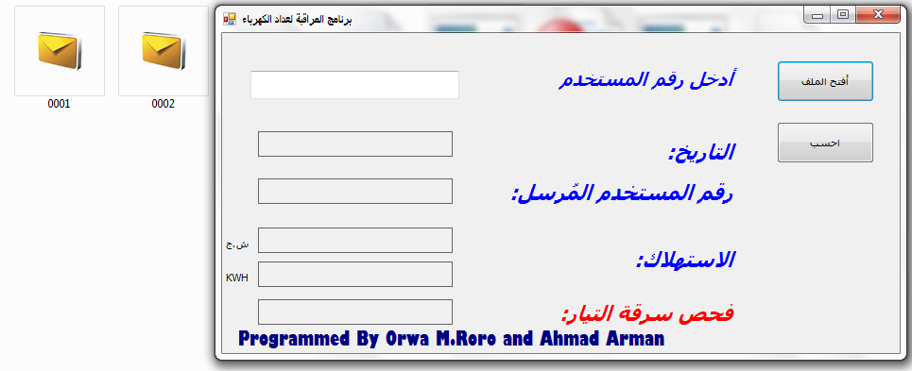
In the left is tow different messages the 0001.vmg is a sample for non-technical losses messages we received in our test to the project, the second one is 0002.vmg is an energy consumption message we received on the test to the project also, our interface programmed as we said before need to enter the indicator number of the consumer only and he will worked as we said in the steps above.
Let us now apply the first consumer to the program:
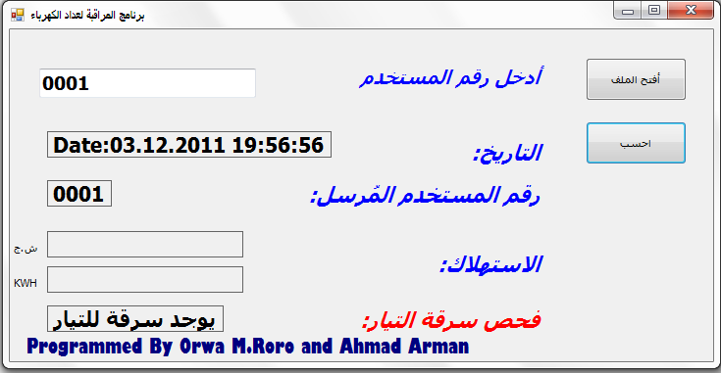
As we said the program open the 0001.vmg and read the data then give us a result that the consumer 0001 is a theft.

If now apply the next message to the program and see the result:
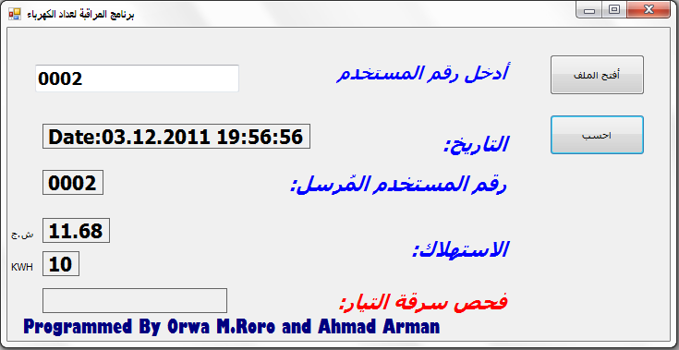
The program here open the 0002.vmg message, and print the sending consumer indicator number, and the date, then calculating the consumption its 10 KWH so it under the minimum level consumption 20 KWH, its print the minimum cost, there is no theft so it will leave the theft check box empty.
If we take now another case another message with consumption 230 KWH:
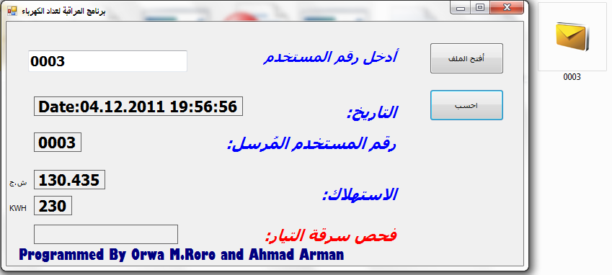
The user 0003 is consumed 230 KWH, we enter its number to the program, if we check the result:
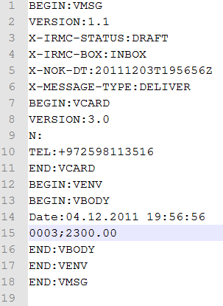
From message on the right the consumption is 2300.00 KWH * 10, divide over 10 it will be 230 KWH now it’s not under the minimum, it lies in the third range:
As we see the third condition in the tariff is satisfied and the cost is equal to the program result.

Chapter Eight
KWH meter monitoring project specifications:
- Monitoring the electricity consumption (KWH), and show it on the LCD screen.
- Measuring the current instantaneously with error does not exceed 0.5 Ampere, and showing it on the LCD screen.
- the project contain GSM- module that used to send the energy consumption and the notification if there is a non technical losses by the consumer, we use the GSM module because its coverage a valuable everywhere in our country and other country (i.e.: Jawwal, Watanya), so we don’t need the internet in the consumer side in order to send data.
- the project contain an EEPROM memory built in PIC microcontroller, that used to store the consumption energy in periodic time to keep the energy value consumed, without losing it in case if the power is cut-off on our system.
- The electricity company or the person who work on the systems can send for a request of consumption energy in any time in the month and he doesn’t need to wait the end of the month.
- the project also contain a program that programmed in C# on PC computers in order to calculate the energy consumption and analyze the data message depending on consumer unique number, basically the program analyze the data message and decide if it consumption message by calculating the consumption or if it non technical losses notification.
- The whole electronic circuits in our projects consume a small amount of energy the maximum power consumption doesn’t exceed P= 9v * 70 mA = 0.63 watt.
- We can use a one GSM module to send data for multiple consumers that lives in one place (i.e. who lives in apartment building and have one mainly distribution board).

Economic study:
In order to make our project successful we must study the cost of all elements in our project and calculate the total saving cost , if we can retrieve the investment cost in less than 2 years that’s mean our project is very profitable.
In first we will calculate the total cost in certain city for example Nablus, in Nablus ,The North Electrical Distribution Company (NEDCO) have 50,000 consumers ,40,000 consumers of 50,000consumers have electro-mechanical meters .
The Total Cost = Number of Consumers * the Cost of the Project

The Cost of the Project:
The elements | The Cost | Number | Total cost
PIC Microcontroller | 20 NIS | 1 | 20 NIS
Current Transformer | 50 NIS | 2 | 100 NIS
Basic Circuit+ LCD | 80 NIS | 1 | 80 NIS
Rectifier Circuit | 15 NIS | 2 | 30 NIS
GSM Module | 460 NIS | 1 | 460 NIS

The Total Cost of the Project = 20+100+80+30+460= 690 NIS
The Total Cost = 50000*690=34500000 NIS

The losses in Nablus equal 20% of Total energy consume and these losses divide into Technical losses (equal =12%) and Non-Technical losses (8%) , and we know that the total bill of Nablus equal 100,000,000 Nis every month ,so the Non-Technical losses equal 8 million NIS every month.
And we can say that The Non-Technical losses divide into error in KWH Meters (3 Million NIS) and the theft losses (5 Million NIS), so in our project we will prevent the theft losses and we will consider this cost as saving cost.
And The North Company in Nablus employ 50 person to reading the KWH meters and the company pay salaries to them approximately 2000 NIS for each employer
Annual Saving Cost =(5,000,000 NIS * 12)+(12*2000*50)=61,200,000 NIS per year

Simple Payback Period:
We need to seven months in order to retrieve the Investment Cost, so our Project is very profitable.

Collecting All Elements Together:
We will create model to simulate the system at consumer and we will test all condition to insure that the project working properly.
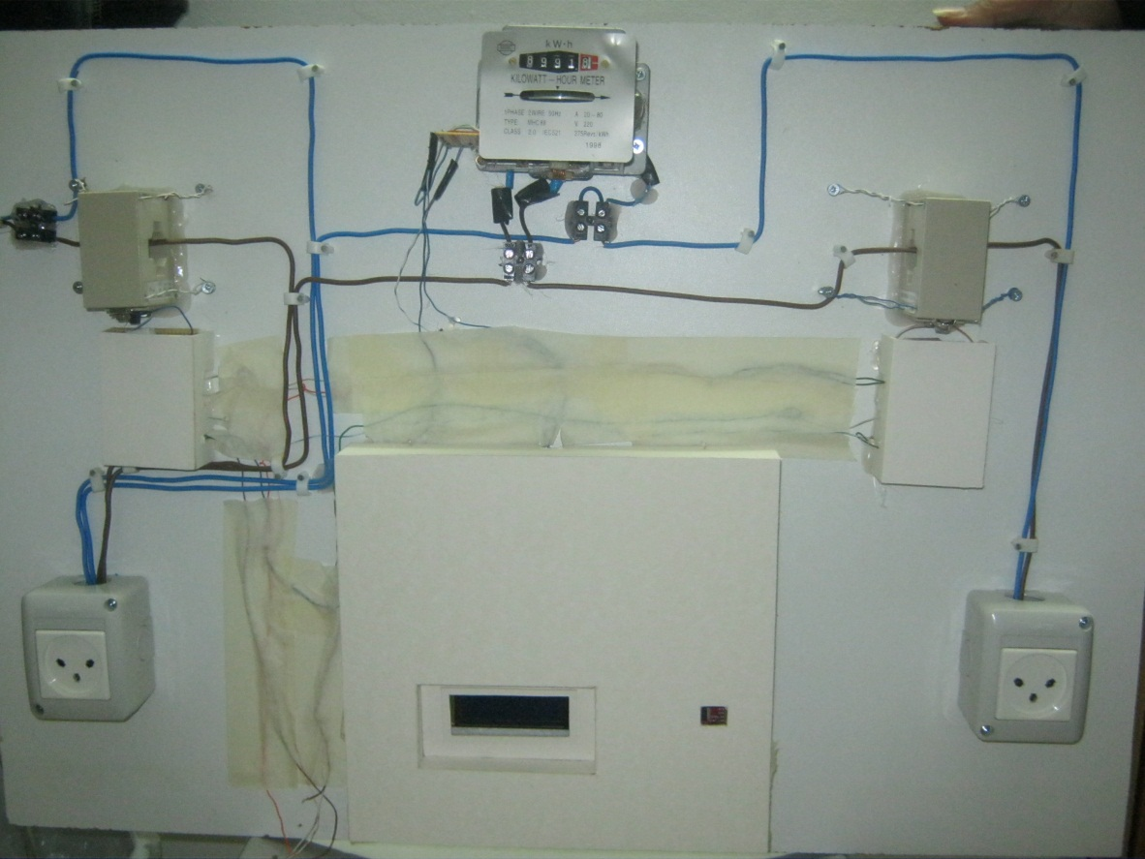
References:
- Sparkfun company http://www.sparkfun.com/search/results?term=acs712&what=products.
- Krein, Philip T... Elements of Power Electronics. New York: Oxford University Press, USA, 1997.
- FAIRCHILD SEMICONDUCTOR ……… www.Fairchildsemi.com
- Telit Modules Software User Guide.
- GM862 Family Hardware User Guide.
- http://en.wikipedia.org/wiki/Current_transformer.
- www.ccsinfo.com.
- www.csharp-station.com/Tutorial.aspx.

