Cover page
Project Title: Dual Axis Solar Tracker system . Academic Year: 2022-2023
Department Name: Electricity and communication
Group Members: 1. Ali Bsharat 11819756
2. Lana Saed 11820393
3. Malak Azzam 11822762

Supervisor Name: Raed Jaber
Format:
- Single space, Times New Roman.
- 12 pt,
- Maximum 1 page.
Abstract Body:
Items must be provided in the Abstract:
- Why do you think this project is important? Please explain the significance of this
Project in brief : It is important because it is considered a method of generating energy from sunlight and taken from natural resources and tracking the light coming to it.
And by rotating in all directions, it takes a larger proportion of the sun and stores it, and for that it receives an important signal.
- In your point of view what are the important aspects that should be covered in the project?
Knowing how to track the light, whether sunlight or other, using the solar energy system.

- Objective(s): In your view, please explain the main objectives of the project.
The main objective of this project is to design a highly accurate dual axis solar tracker that tracks the sun in all directions , Also, one of the most important goals of tracking is to provide

a way to improve the performance of solar energy facilities as well as improve the performance of the sun during the summer and spring, when the sun is in a higher position in the sky.
- Methodology: Give a brief outline of the application development process.
Project working principle diagram :
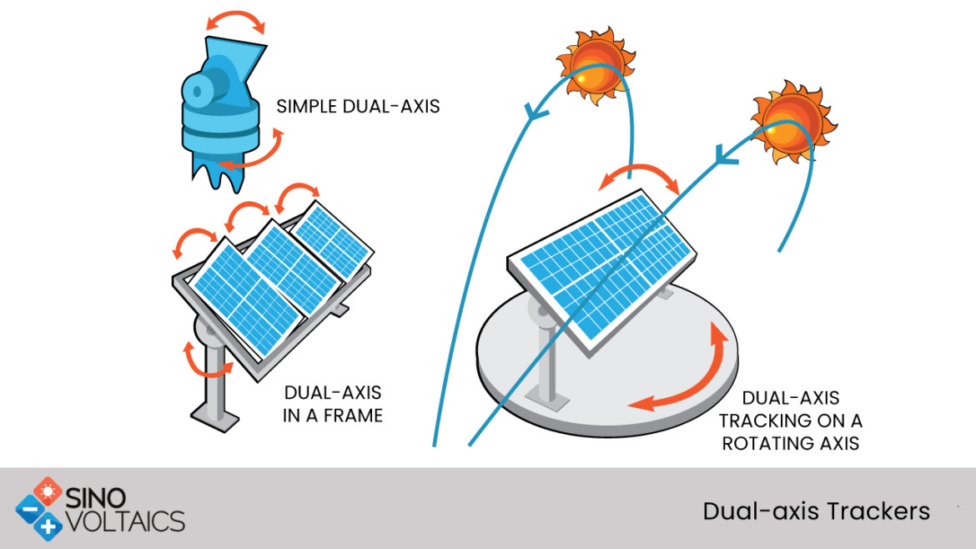
- Dual axis solar system project is one of the most popular projects recently and Arduino projects.
- It is just a system that follows the sunlight according to its intensity.
- it can increase the power collected through the sunlight by the solar system.

- Had this project been done before? Similar work, but not the same principle
- Are there any similar applications available today? There are many applications about cells, but I do not think there is anything similar or similar to it.

- Note: Please deliver this abstract early to ensure that your Project has been approved by the department’s projects committee. Registration will not be done without this approval.

Project’s Abstract:
Solar energy is the most abundant renewable energy source on the Earth. It is one of the best replacement of fossil fuel which is considered as a secure, lower-risk renewable energy source. Solar energy comes from the sun and can be captured by various technologies primarily Solar Panel.

We will do this project by taking one of the solar energy systems, which is the solar energy tracking system:
Solar tracker, a system that positions an object at an angle relative to the sun. The most-common applications for solar trackers are positioning solar panels (photovoltaic panels) so that they remain perpendicular to the Sun’s rays and can determine the proper Sun’s direction. Solar trackers adjust the direction that a solar panel is facing according to the position of the Sun in the sky.
By keeping the panel perpendicular to the Sun, more sunlight strikes the solar panel, less light is reflected, and more energy is absorbed.
That energy can be converted into power.Solar tracking system is mainly of two types: Single-axis solar tracking system and Dual-axis solar tracking system.
In this project,We will explain to you how to make dual-axis solar tracker with arduino. Dual-axis trackers continually face the sun because they can move in two different directions. Types include tip-tilt and azimuth-altitude. Dual-axis tracking is typically used to orient a mirror and redirect sunlight along a fixed axis towards a stationary receiver. Because these trackers follow the sun vertically and horizontally they help obtain maximum solar energy generation at a time.

Dual Axis Solar Tracker The main title of the project, where this type of system is designed to increase the collection of solar energy throughout the year to rotate in all directions (north, south, east and west) and track the sun's rays to obtain and store the largest possible amount of sun.
A dual-axis tracker allows your panels to move on two axes, aligned both north-south and east-west. This type of system is designed to maximize your solar energy collection throughout the year by using algorithms and sensors that track seasonal variations in the height of the sun in addition to normal daily motion. Typically, dual-axis trackers (made by companies like AllEarth Renewables) are a much less popular option for solar installations, even among large, utility-scale projects.

