

An-Najah National University
Electrical and Telecommunications Engineering
Departments

GRADUATION PROJECT 2

VR Earthquake Simulator

Supervisor: Prof. Allam Mousa

Students Name:
Ro’ya Al-aqraa
Ahmad Ghabbish

Academic year: 2023/2024

Disclaimer:

This report was written by Ro’ya AL-aqraa and Ahmad Ghabbish in the Department of Telecommunications Engineering, College of Engineering, An-Najah National University. It has not been modified or corrected, as a result of the evaluation, and may contain errors in the language as well as the content. The opinions expressed in it together with any findings and recommendations are only those of Ro’ya AL-area and Ahmad Ghabbish, An-Najah National University assumes no responsibility or liability for the consequences of using this report for a purpose for which it was assigned.

List of Content
Disclaimer 2
List of Tables 5
List of Figures 6
List of Abbreviations 7
Abstract 8

Chapter 1: Introduction:
  - Overview
  - Problem Statements
  - Project Objectives
  - Project Significance
Chapter 2: Constraints, Standards, Codes and Earlier course work
  - Constraints
  - Standards
    - Main Standers
    - VR Environment representation
  - Earlier course work
Chapter 3: Literature Review
Chapter 4: Methodology

  - The used technology: Metaverse.
    - Virtual reality
    - Development process

Development process using untiy

Chapter 5: Results, Conclusion
5.1 Results.
5.2 Conclusion

Chapter 6: References

List of Tables:
Table (1): Transforms operations 13
Table (2): Game view control bar 15

- List of Figures:

Figure 1: VR triangle contains. 8
Figure 2: transform component 12
Figure 3 : showing the color coding of axis 12
Figure 4 :scene view 13
Figure 5:Game view 14
Figure 6: virtual collaboration in VR 18
Figure 7: oil transform practice 19
Figure 8 AR in health care 19
Figure 9:VR square 20
Figure 10: Oculus quest2 21
Figure 11:Oculus SDK1 22
Figure 12: HTC vive 22
Figure 13:Scrum diagram. 23
Figure 14: interaction system from unity 24
Figure 15:XR rig(origin) 25
Figure 16:VIEW 1 FROM OCULUS 26
Figure 17:VIEW 2 FROM OCULUS 26
Figure 18:System architecture. 27

List of Abbreviations:

3D | 3-Dimensional
VR | Virtual Reality
AR: | Augmented Reality
MR | Mixed Reality
AI | Artificial Intelligence
VRML | Virtual Reality Modeling Language
X3D | Extensible 3D
DRM | Data Representation Model
EDCS | Environmental Data Coding Specification
SEDRIS | Synthetic Environment Data Representation and Interchange Specification
SRM | Spatial Reference Model
FBX | Film Box- File Formats of 3d Model
2D | 2-Dimensional
UV | texturing is an alternative to projection mapping
API | Application program interface
UI | user interface
UX | user experience
VRTK | virtual reality toolkit
IVR immersive virtual reality
SG serious game

Abstract:

it’s a concept that has gained popularity in recent years, and it’s a decentralized nature, this mean that the users have control on their own data and assist , also can interact with others without need for intermediaries.
The understanding of metaverse relies on two main types of interaction, Human-computer interaction (HCI) and Human spatial interaction (HIS), let’s define each one
HCI: hardware and software devices with its addition, such as keyboard, mouse, and audio in computer, but in metaverse understanding it’s the devices that enable you to enter the metaverse world like headsets devices, controllers, and head straps.
HIS: types of media that enable you to enter the metaverse through, called XR (extended reality ), which contains Virtual-Reality (VR), Augmented-Reality (AR), and Mixed-Reality(MR).
VR: a system that isolates the real environment world, by putting the user in a completely other environment.
AR: is a system that enhances the real world by superimposing computer-generated information.
MR : enhance the real world with real imagination .
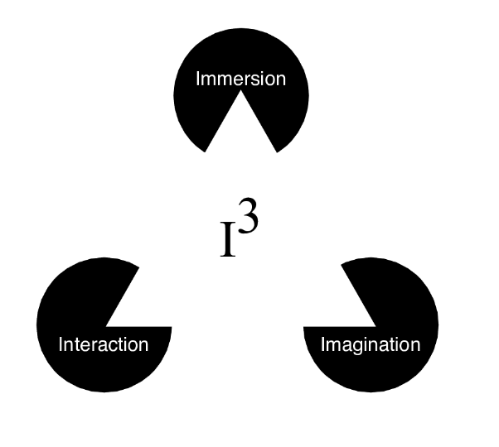
Figure 19: VR triangle contains.
Improving how individuals behave during earthquakes and their readiness to evacuate after these events can significantly raise their survival prospects and minimize the number of injuries following the event. While traditional methods of preparedness enhancement, such as workshops, informational posters, instructional videos, or practice exercises, are in use, they often fail to engage participants fully and lack the ability to increase high-risk situations for effective training purposes. Utilizing cutting-edge digital technologies like Immersive Virtual Reality (IVR) and Serious Games (SG) offers a new way to develop training tools that exceed these challenges.

Chapter 1: Introduction:
  - overview introduction
There are many definitions of virtual reality. Some are focused more on the technical aspects, some on the sociological and psychological. A lot are just a marketing language to convince people that anything that is digital is virtual so it's part of virtual reality.

Virtual Reality is the use of computer technology to create the effect of an interactive three-dimensional world in which the objects have a sense of spatial presence.
“Computer technology” is required to distinguish VR from telepresence and other remote sensing approaches. This requirement is driven by the ability to use computer programs to create interesting and novel tailor-made environments, which is where I think a lot of the popular interest in VR comes from.
“Effect” rather than “illusion” because I feel that it is a cognitive effect that is achieved (more on this later), rather than an illusion. Saying “effect” rather than “illusion” also undercuts the presumption of “fooling” the user.
“Interactive” to distinguish VR from conventional animation. I also think that it is the ability to interact with the virtual world which is behind much of the popular excitement. “Three-dimensional world” to exclude text-based environments and to limit discussion away from 1D and 2D programs (which would encompass essentially all of interactive computer graphics).
“Objects have a sense of spatial presence” means that the objects seem to have a spatial location independent of both the user and the display technology. This is, I feel, at the heart of what is special about VR.
Our research presents a novel training system, in Immersive Virtual Reality and Serious Games IVR-SG, designed to support the skills necessary for responding to earthquakes and for evacuating safely afterward.
We selected a traditional home location for our experimental application of this IVR SG-based training module. The system contains a diversity of simulation scenarios, each crafted to reflect top-tier evacuation strategies.
We enrolled a home, covering both material and decoration, as well as the user, to participate in these simulations.
We evaluated the efficacy of their training by examining two key areas: their understanding of the optimal evacuation procedures and their confidence in managing earthquake-related crises. The data indicated a marked improvement in both knowledge and self-efficacy post-training. Furthermore, participants expressed that the IVR SG system provided an effective, enjoyable, and user-friendly method for learning about the best practices for evacuation.

problem statement
Earthquakes are a natural phenomenon that cannot be controlled, and we cannot create a real environment similar to earthquakes, just as we cannot predict the time of their occurrence, and people in our country need awareness of how to deal with earthquakes when occur.
so that we allow people to live a virtual experience with the least possible losses, similar to the truth. This project will simulate an earthquake environment in a virtual reality way.
On the other hand, it’s a good starting point to enter the world of VR development which will enhance our ability in different types of learning such as programming and 3d modeling, and using new software.
Globally, earthquakes are frequent catastrophise , with approximately 100 significant tremors surprising various regions annually, causing different degrees of damage to both structures and their contents.
Enhancing a building's structural integrity is a recognized method to prevent falls. Additionally, rapid and correct actions during and after earthquakes are fatal in mitigating the effects of damage unrelated to the structure.
In regions prone to seismic activity, the "Drop, cover, and hold" technique, alongside subsequent behaviors, is advocated as the gold standard in safety protocols. Traditional educational methods aimed at building occupants, such as workshops, informational displays, or educational films, have been implemented to promote these safety behaviors. However, these methods often fail to make a strong impression and emotional reaction and lack the replication of true hazardous events, potentially leading to a trivial shift towards adopting recommended safety behaviors. In addition to such educational methods, practical evacuation exercises are also used for training.
suggest that there might be a conflict between how participants behave during drills against actual earthquake evacuations, as drills may not accurately simulate real dangers. This lack of realism could lessen the effectiveness of the training and the resulting behavioral adjustments. Moreover, individuals rarely receive personalized feedback on their commitment to best practices after drills, which is essential for improving future performance. Without this evaluative feedback, there's a risk that occupants might carry over ineffective behaviors into real emergencies, thus reducing the overall impact of these educational and training approaches on learning and behavior modification.

Project Objectives

This project aims to build a virtual reality Earthquake Simulator try it on Oculus Quest2 wireless. Enhance the imagination with realistic life to add anything to the project. Dealing with new software and devices such as unity and Oculus. Virtual reality Earthquake is a useful tool for spreading awareness among people.

In our study, we introduce a pair of prototype training tools using Virtual Reality and Serious Games tailored for earthquake evacuation. The initial prototype is designed to study the behavior of humans during an earthquake, while the second aims to educate occupants on effective responses to such crises.

We delve into critical design considerations necessary for the creation of these prototypes in the subsequent sections. These considerations include:

(a) identifying the characteristics that accurately represent an earthquake event.

(b) determining the appropriate way to depict both existing and newly constructed buildings within the VR setting.

(c) exploring the representation of building damage within the virtual environment to ensure a realistic and educational experience for the users.

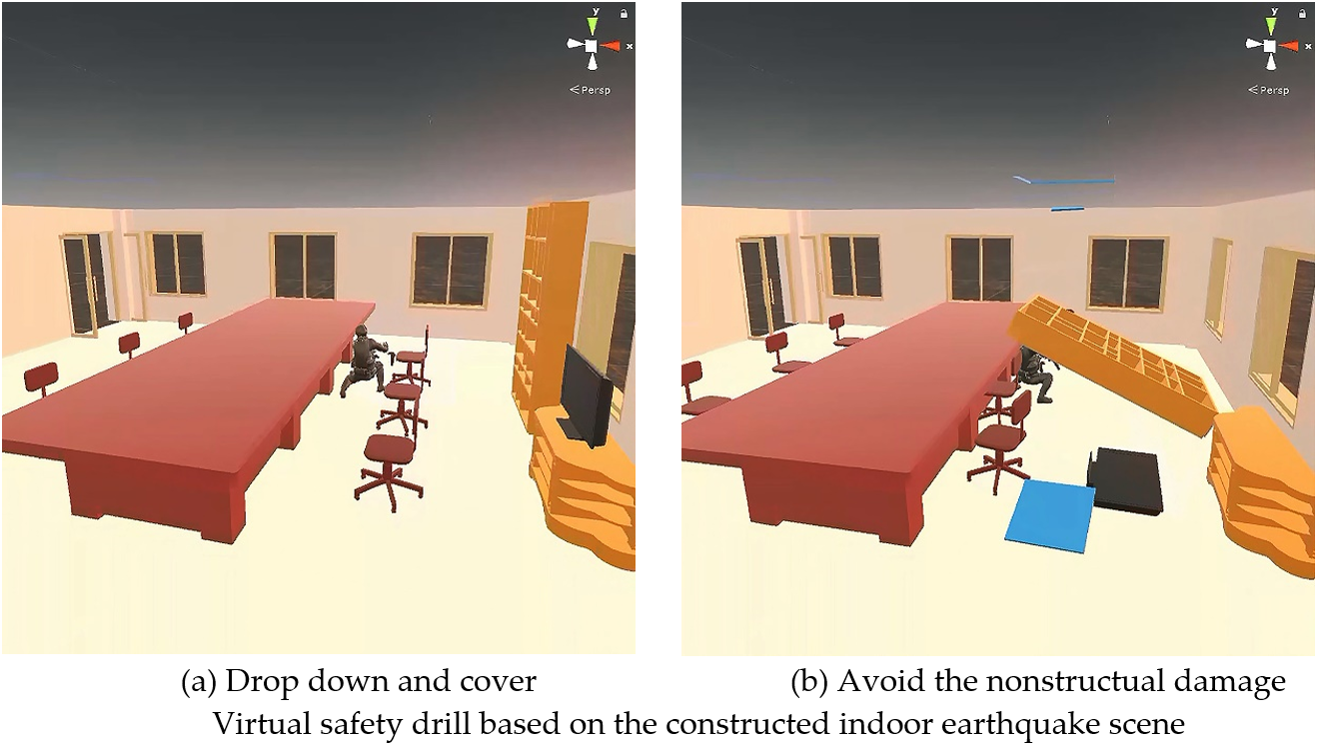

  - Project Significance

Using virtual reality in spreading awareness and community service sector, and improve the ability to handle and control human behaviors during catastrophes like earthquakes, and how to be safe as well as, in addition, it might be the reason to save someone’s life, and decrease the stress between people.

Chapter 2: Constraints, Standards, and earlier course work

Constraints
During our way to complete this project, we encountered many risks, which were successfully overcome.so Understanding the constraints and opportunities for designing in Virtual Reality (VR) is essential. Balancing immersion, usability, and experience is just one of the many challenges. Choosing the best and easiest application to build our project so we choose a Unity environment. Then we had a problem dealing with it so we followed and watched tutorials on Udemy. Also, we ran into drawing the house in 3D max. After that we load the house at Oculus2.
So here are the main constraints:
- Dealing with many software at the same time, unity, and 3dmax.
- Computational load in PC and Oculus device.
- Entering the field of VR development because of a lack of resources.
- Hardware issues with devices (oculus and PC).
- Software issues, handling with errors.
- Coding issues and the price of some packages.
- Support from interior design students.
- Unity editor, there is a difference in Unity editor that supports VR games.
- There is not enough information about this type of experience on Internet,
- AI tools help with limitations.

2.2 Standards

2.2.1 MAIN STANDERS

The mains standards that should we care about:

The VR development process like android application development because the oculus quest is an Android device with a lens and controller.

Using the latest version of the software (the latest version of Unity).

Study the impact of earthquakes

Dealing with Oculus device and how it works.

The importance of packages that unity provides to make the developing process easier.

Keeping in mind what is the input and output of the system.

Setting up and downloading files to configure the project for Oculus device.

Relation between 3d max and unity editor.

The basics of C# coding.

The ability to use the desire packages in suitable location.

Adding additional things such as voice and instruction will make the experience better.

How to move inside VR and teleport using the standard packages form Unity.

Controlling the objects that will shake by coding.

Add the prober audio for the experience.

All of the above require a good background in unity and coding.

Virtual Environment Representation

The first step is drawing our environment using proper software and having accepted format for the Unity application, so 3D max is the best choice to create the virtual environment.
Second, importing this asset to unity with standards coordinates for position, rotation, and scaling as in the following picture:
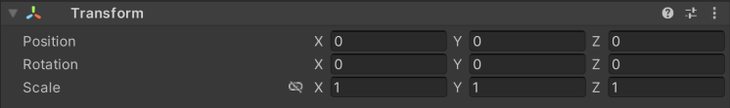
Figure 20: transform component
Transforms are manipulated in 3D space in the X, Y, and Z axes or in 2D space in just X and Y. In Unity, these axes are represented by the colors red, green, and blue respectively.
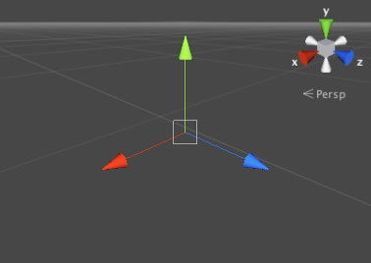
Figure 21 : showing the color coding of axis

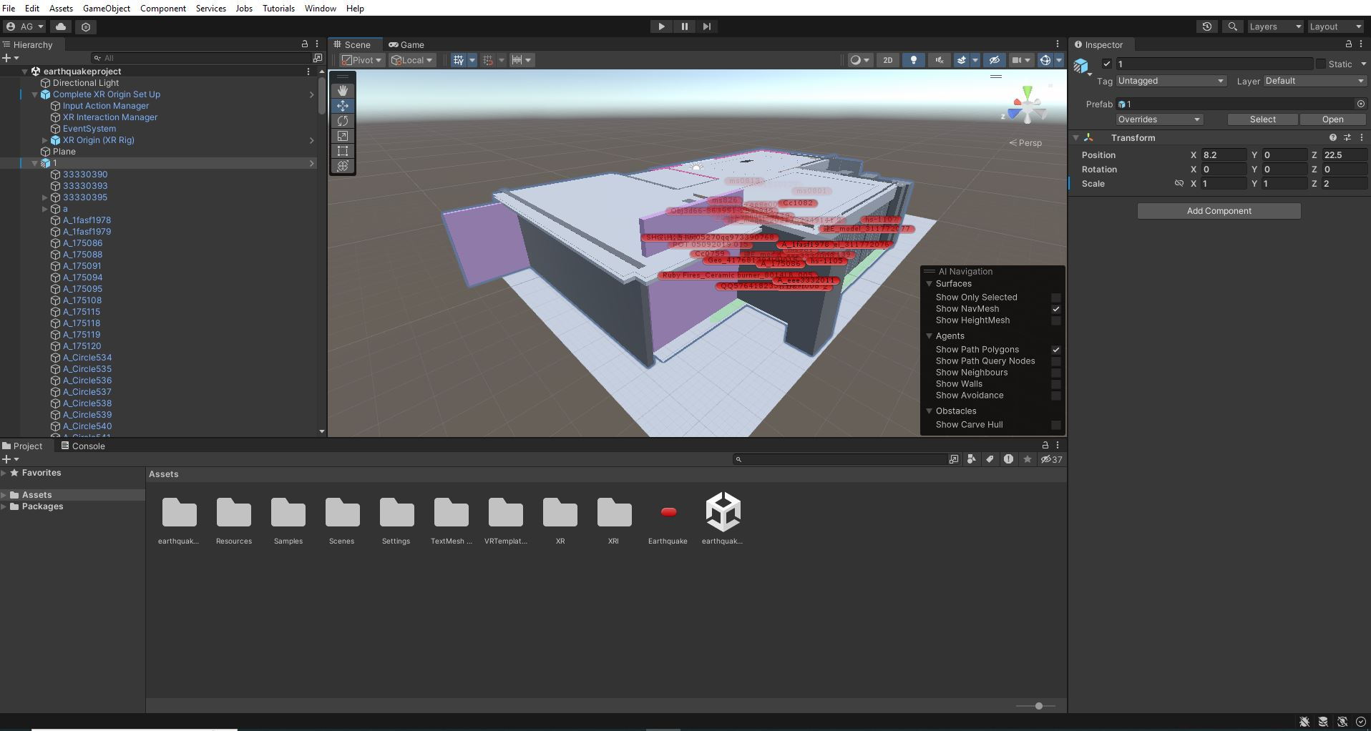
Figure 22 3D MODEL

Property: | Function:
Position | Position of the Transform in X, Y, and Z coordinates.
Rotation | Rotation of the Transform around the X, Y, and Z axes, measured in degrees.
Scale | Scale of the Transform along X, Y, and Z axes. Value “1” is the original size (size at which the object was imported).  Select the link icon next to the values to toggle proportional scaling. Proportional scaling adjusts the scale values proportionately to each other. For example, if your GameObject’s x, y and z axis values are (1, 2, 4) and you double the x-axis value to 2, the y and z-axis values change to 4 and 8 respectively. When enabled, proportional scaling also applies to changes you make using the Scale tool in the Scene view.  If any scale value is zero, it is grayed out and does not automatically adjust when proportional scaling is enabled.  Note: You can assign a keyboard shortcut to enable or disable proportional scaling
Table(1): Transforms operations

And the scene view of the user interface (UI), should be like this picture:
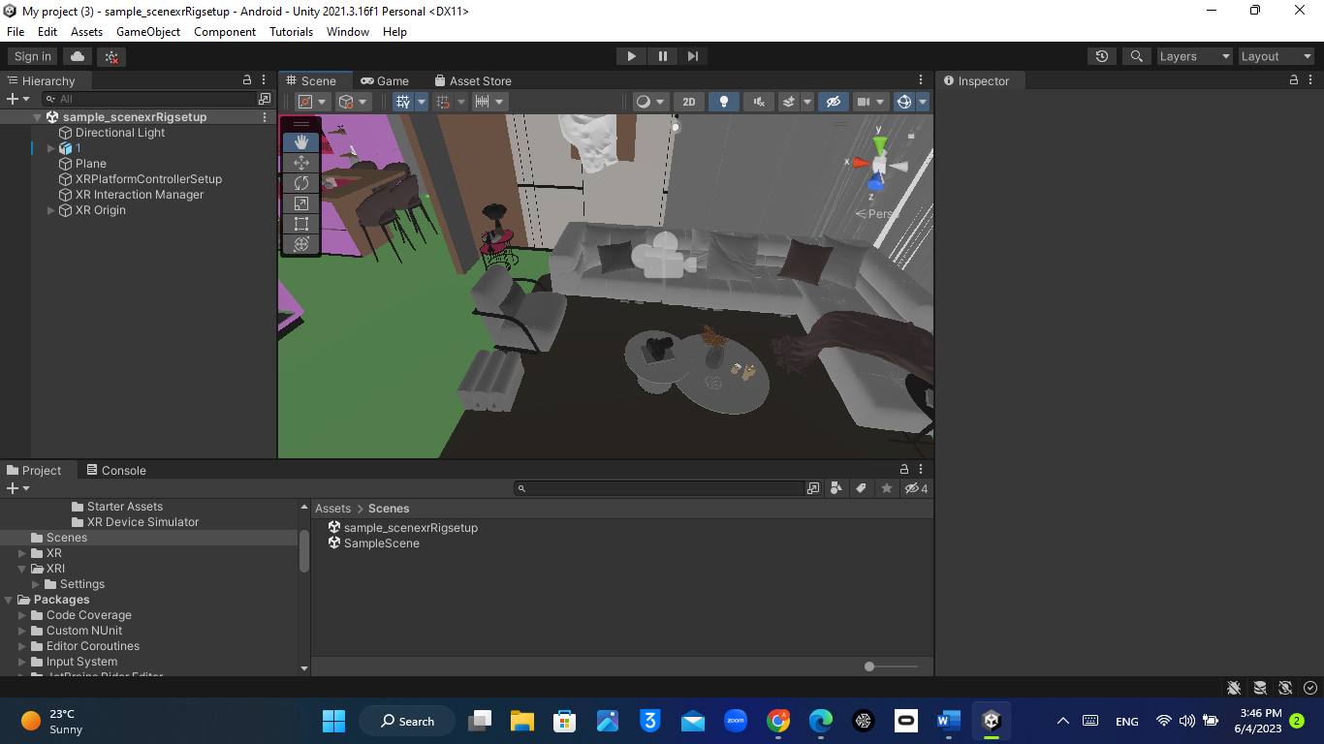
Figure 23 :scene view
The asset view (Game view)
The Game view is rendered from the Camera(s) in your application. It represents your final, published application. You need to use one or more Cameras to control what the player sees when they are using your application. For more information about Camera.
c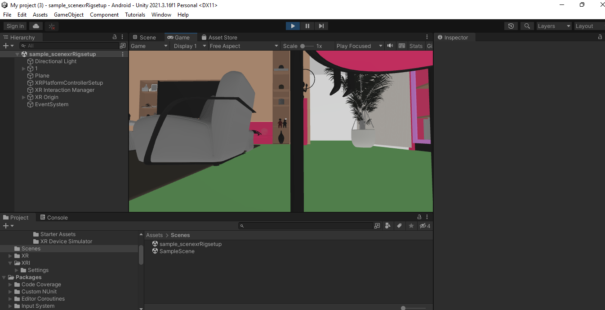
Figure 24:Game view

And this table show the game view control bar :
Button | Function
Game/Simulator | Click to enable the Game or Simulator view from the drop-down menu.
Display | Select this to choose from a list of Cameras if you have multiple Cameras in the Scene. This is set to Display 1 by default. You can assign Displays to Cameras in the Camera module, under the Target Display drop-down menu.
Aspect | Select different values to test how your game looks on monitors with different aspect ratios. This is set to Free Aspect by default.
Low Resolution Aspect Ratios | Enable Low Resolution Aspect Ratios to emulate the pixel  density of older displays: this reduces the resolution of the Game view when an aspect ratio is selected. It is always enabled when the Game view is on a non-Retina display.
VSync (Game view only) | Enable VSync (Game view only) to give priority to the Game view. This option might add some vertical sync, which is useful when recording a video, for example. Unity attempts to render the Game view at the monitor refresh rate, though this is not guaranteed. When this option is enabled, it is still useful to maximize the Game view in Play mode to hide other views and reduce the number of views that Unity renders.
Scale slider | Scroll right to zoom in and examine areas of the Game screen in more detail. This slider lets you zoom out to see the entire screen where the device resolution is higher than the Game view window size.
Maximize on Play | Click to enable: use this to maximize the Game view (100% of your Editor window) for a full-screen preview when you enter Play mode.
Mute audio | Click to enable: use this to mute any in-application audio when you enter Play mode.
Stats | Click this to toggle the Statistics overlay, which contains renderingoft your application’s audio and graphics.
Gizmos | Click this to toggle the visibility of Gizmos. To only see certain types of Gizmo during Play mode, click the drop-down arrow next to the word Gizmos and only enable the Gizmo types you want to see.
Table(2): Game view control bar

earlier course work

During the last year, we studied many courses that added a lot of knowledge and Skills. Some of these courses helped us with this project:
- Udemy course about VR basics development.
- During the summer semester, we took training in NVAR Under the supervision of PROF. Allam Mousa on virtual reality technology and how to use it,
- Metaverse Academy course (MA Q3001An-Najah), and this course helped us I is very much in understanding Metaverse more deeply.
- EON-XR starter course and it regarded as the first step to this field.
- Some workspaces with DR.Ahmad Al-Amm which is special in this field.

Chapter 3: Literature Review

Catastrophic events like earthquakes necessitate effective strategies for enhancing public awareness and preparedness. Virtual Reality (VR) has emerged as a promising tool to engage individuals and educate them on the impacts of earthquakes. This review aims to explore the existing literature on the usage of VR in spreading awareness and promoting preparedness for earthquake disasters.

VR for Immersive Scenarios:

Virtual Reality provides an immersive platform that simulates earthquake scenarios and offers a realistic experience to users. Research shows that immersive VR environments engage users effectively, creating a feeling of presence and improving comprehension of the potential consequences of earthquakes. By immersing users in a virtual environment, VR can elicit emotional responses that improve learning and retention of earthquake-related information.

Influence on Knowledge Acquisition and Retention:

Studies prove that Virtual Reality experiences significantly enhance knowledge acquisition and retention compared to traditional educational methods. VR provides an interactive learning experience by allowing users to interact with realistic earthquake scenarios. The ability to visualize and experience earthquake-related events promotes understanding and long-term memory recall, leading to a better understanding of safety measures and preparedness strategies.

Promoting Behavior Change and Preparedness:

Virtual Reality can influence behavior change by providing users with firsthand experiences of earthquake situations. Through VR simulations, individuals can observe the immediate and long-term outcomes of earthquakes, promoting a greater sense of personal responsibility and preparedness. The immersive nature of VR experiences motivates individuals to adopt safety measures, such as securing furniture, creating emergency kits, and developing evacuation plans.

Targeting Vulnerable Populations:

Virtual Reality has the potential to reach and educate vulnerable populations who may be at higher risk during earthquakes. Research demonstrates that VR experiences can be tailored to specific audiences, such as children, the elderly, and individuals with disabilities. By adapting the content and delivery of VR experiences, it becomes possible to address the unique needs and challenges faced by different populations, ensuring inclusive and effective awareness campaigns.

Collaboration and Community Engagement:

Virtual Reality can facilitate collaboration and community engagement in earthquake preparedness efforts. VR platforms enable individuals and organizations to share experiences, knowledge, and best practices, fostering a collective understanding and a sense of community resilience. By creating shared VR environments, stakeholders can collaborate, plan, and practice response strategies, enhancing overall disaster preparedness within communities.

Virtual Reality can be a powerful tool for earthquake preparedness. By immersing users in realistic earthquake scenarios, it can create a deep emotional impact and enhance understanding of the human impact of earthquakes. The multi-sensory approach of VR can significantly improve earthquake awareness campaigns, and it's remote training capabilities mean even those in remote or underserved communities can access valuable knowledge. VR can also be used to evaluate evacuation and response strategies in a controlled and repeatable way, improving disaster preparedness and response efforts. By integrating with other emerging technologies, such as augmented reality and artificial intelligence, VR can offer personalized recommendations for preparedness actions.

Virtual Reality can make people feel strong emotions and a sense of understanding when they face a realistic earthquake scenario. Studies have shown that this experience creates a deep emotional connection that motivates individuals to take action and prepare for such disasters. In addition, virtual reality allows for a comprehensive and unforgettable learning experience that engages all senses. It can also provide remote training and education that is accessible to everyone.

regardless of where they live. With its ability to evaluate evacuation and response strategies, researchers and professionals can use virtual reality to improve disaster preparedness and response efforts. Furthermore, by integrating with emerging technologies such as augmented reality and artificial intelligence, virtual reality can provide personalized feedback and recommendations for preparedness actions.

Chapter 4: Methodology

4.1 The used technology: Metaverse.
Metaverse is used in many sectors of our daily life, such as Snapchat filters it’s a part of AR, And it’s used in medical education, Engineering training, safety, and social interaction.
In social interaction, the metaverse is a fantastic tool for connecting people and providing opportunities for interactive entertainment. Its virtual spaces offer a setting for socializing with a wide variety of people, attending events, and immersing oneself in exciting experiences. Virtual communities are an excellent way to develop enduring relationships that reach beyond the limitations of physical barriers, with virtual reality games, chat rooms, and concerts providing a great way to have fun and escape to another world, some examples of this application in VR spatial meeting, Rec Room, and multi-users games.
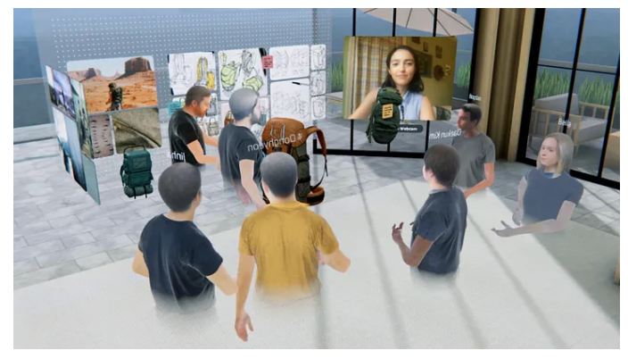
Figure 25: virtual collaboration in VR

In education and training, the metaverse offers exciting opportunities for learning and development. Through virtual classrooms and training environments, students and professionals can immerse themselves in interactive and engaging simulations, experiments, and collaborative projects. With the metaverse, educational resources and expertise are accessible globally, effectively bridging geographical and socioeconomic barriers.
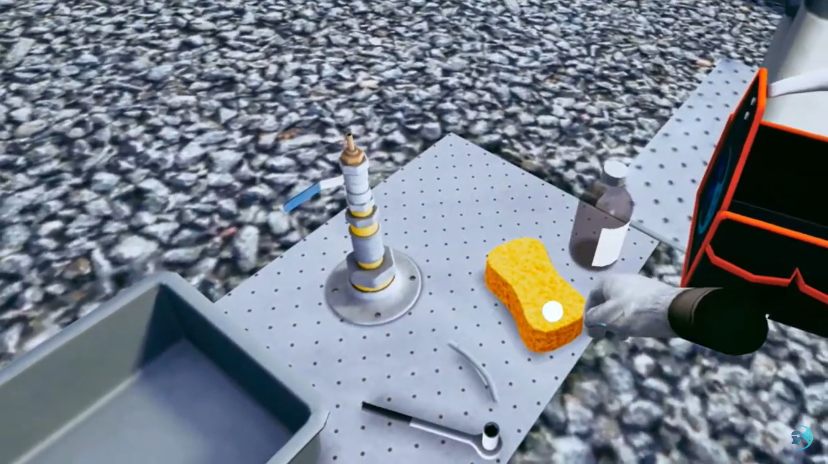
Figure 26: oil transform practice
In health care and therapy, the potential of the metaverse in healthcare and therapy is immense. With VR applications within the metaverse, pain management, mental health, and rehabilitation can be supported. Virtual environments can replicate real-life situations, providing safe spaces for exposure therapy and phobia treatment. The metaverse can also improve telemedicine and remote consultations, making healthcare services accessible to people in remote regions. Overall, the metaverse offers exciting possibilities for advancing healthcare and therapy, there is also training programs for students, to enhance them to practice more without any concerns, and to achieve learning by playing, witch mean that learning is correlated with playing.
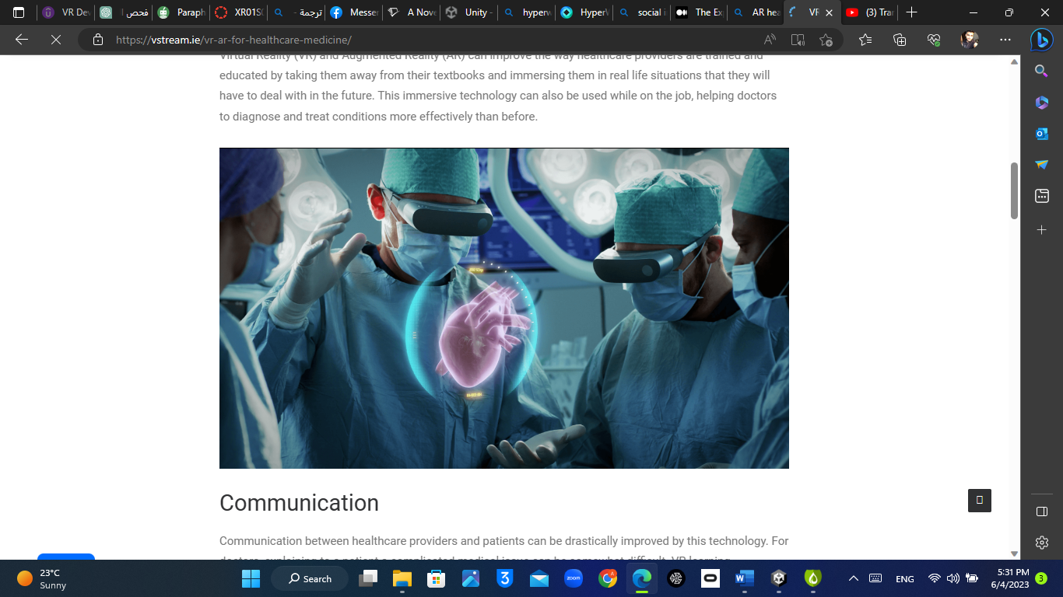
Figure 27 AR in health care

virtual reality
Virtual Reality is the use of computer technology to create the effect of an interactive three-dimensional world in which the objects have a sense of spatial presence.
Computer technology: is required to distinguish VR from telepresence and other remote sensing approaches. This requirement is driven by the ability to use computer programs to create interesting and novel tailor-made environments, which is where I think a lot of the popular interest in VR comes from.
Effect: rather than “illusion” because I feel that it is a cognitive effect that is achieved (more on this later), rather than an illusion. Saying “effect” rather than “illusion” also undercuts the presumption of “fooling” the user.
Interactive: to distinguish VR from conventional animation. I also think that it is the ability to interact with the virtual world that is behind much of the popular excitement.
Three-dimensional world: to exclude text-based environments and to limit discussion away from 1D and 2D programs (which would encompass essentially all interactive computer graphics).
Objects have a sense of spatial presence: means that the objects seem to have a spatial location independent of both the user and the display technology. This is, I feel, at the heart of what is special about VR.
Look at virtual reality square bellow :
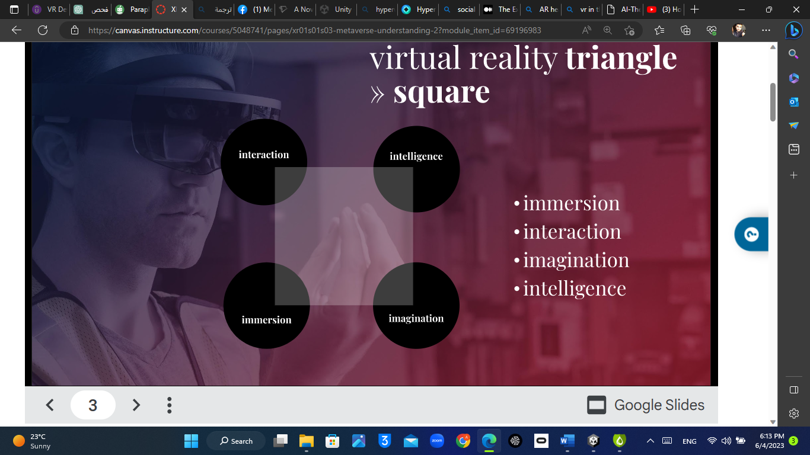
Figure 28:VR square
The VR square contains:
- interaction.
- immersion.
- intelligence.
- imagination.
Imagination: the experience that we think of (earthquake simulator)
Intelligence: it supported by computer, bring intelligence between humans and computers to reach the desired VR experience.
Interaction: make the human interact and control the environment.
Immersion: depend on how much the user is affected by the experience.
We note that the human is the center of all, so the metaverse concept is a combination of HCI and HSI.
Also the ability of software to build imagination, it mean that if the imagination very complex, it will become more harder to simulate.

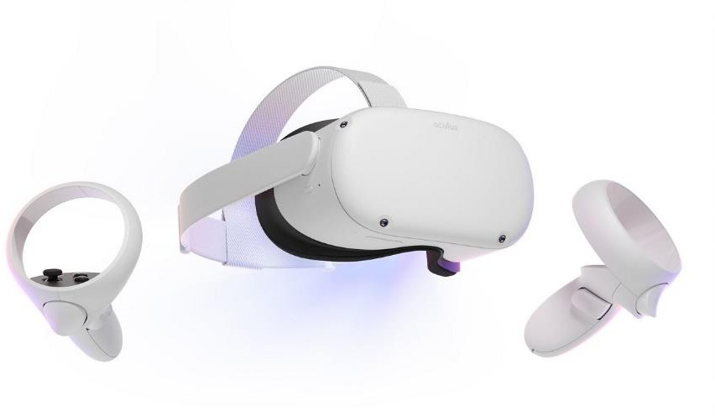
Here are some VR headsets:
t
Figure 29: Oculus quest2
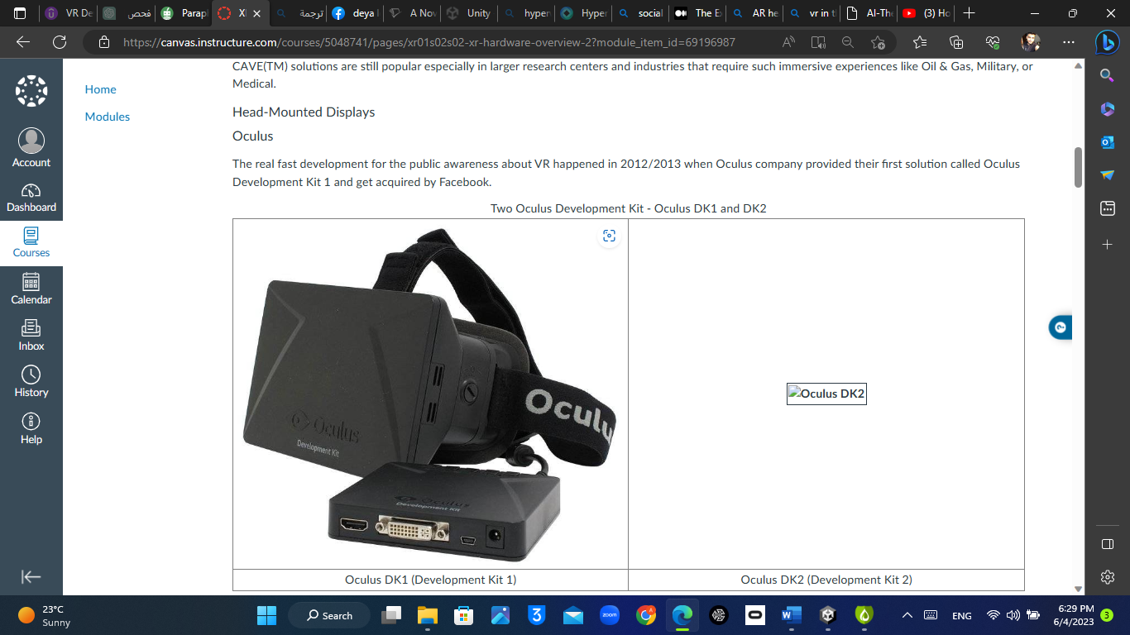
Figure 30:Oculus SDK1
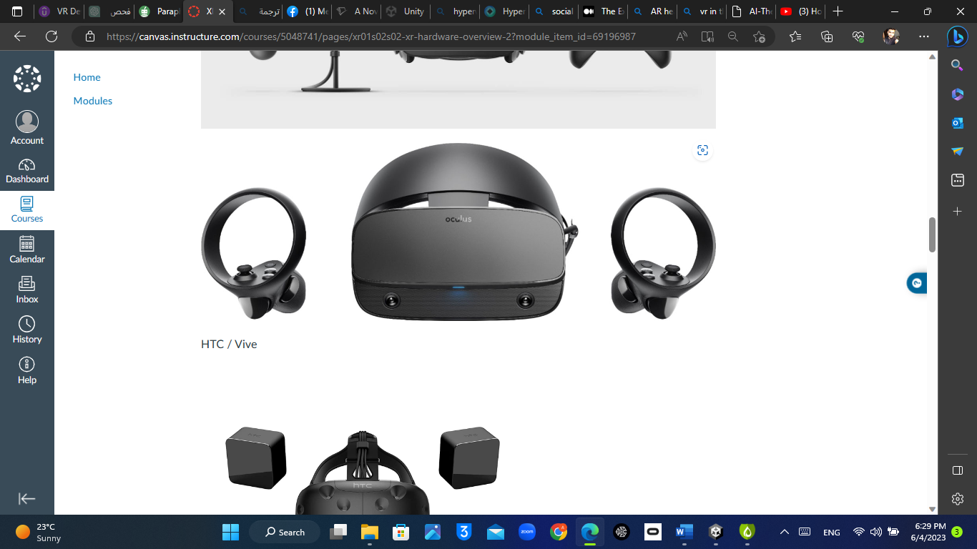
Figure 31: HTC vive

DEVELOPMENT PROCESS

Scrum method used during all development process which is an agile process for how to contact software development. It focuses on some simple concepts, such as having a standup meeting every day, split the development process into short iterations called Sprints, and at the end of such an iteration, having a Sprint review, followed by a Sprint retrospective. This review will allow the product owner and stakeholders to calibrate and adjust the requirements and expectations for the next sprint. It's also a good way for the team to focus on what is end-user benefits, since after each sprint, the features must be possible to show and demo.

And some typical rules of a scrum team In a Scrum team, there is a Scrum master, that facilitates the work being done by the team members. This person is interfacing with external stakeholders and will take the lead to remove any blocking issues raised by the other team members. The idea is that by having this person on the team, the other members can concentrate on doing the work and not be distracted by all administrative work or similar. The Scrum master will also hold the stand-up scrum meeting.

This means that we go parallel with work, and everyone in the team achieves different tasks from others to make brainstorming between team members more effective and accurate to accomplish tasks.

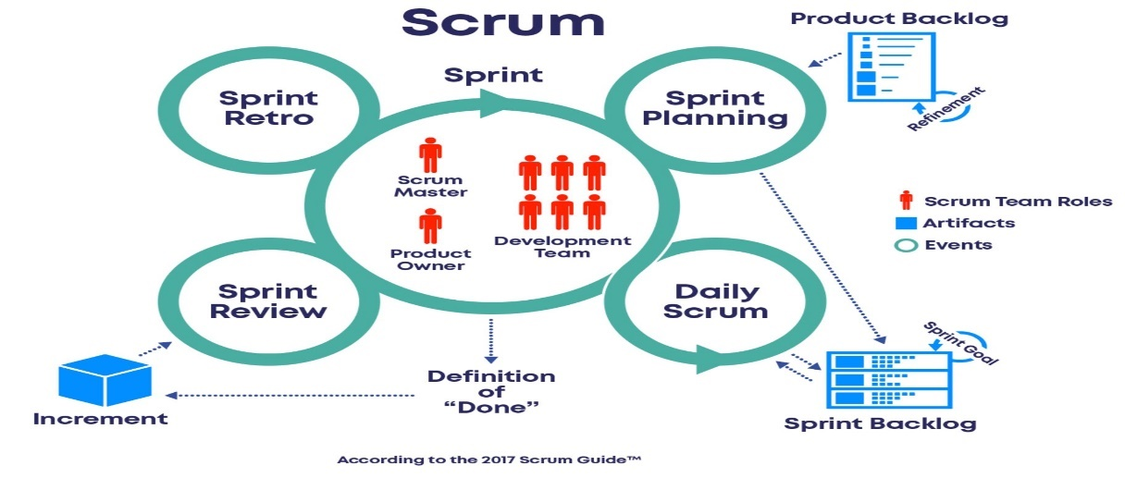
Figure 32:Scrum diagram.

    - DEVELOPMENT PROCESS USING UNITY

Here is the interaction system from followed to create VR or AR experience:

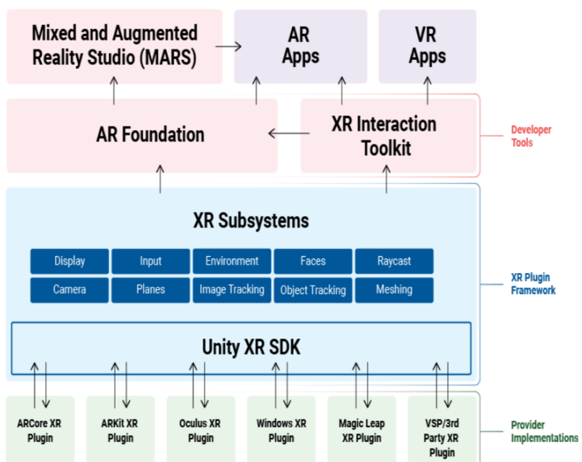
Figure 33: interaction system from unity
The interaction system show that the development process includes different layers
The first layer called developer tools, which contain XR interaction tool kit that consider the bridge between XR subsystem and VR apps.
XR interaction tool kit combines different packages and setups to make the development process easier such as:
- XR rig(Origin): it will put us into the scene, and give us our virtual hand controllers, also it basically and it contain:
a) camera offset witch is the height of the camera from ground and we select the floor as a reference and it defines the height of the person that will wear the Oculus.
b) main camera: it shows me the changes that happen to my project in the scene to show me any changes happening in my project, and it's the first scene in the Oculus.
c) left and right-hand controller: this takes the action from the controller to the headset, for example, there are 3 basic operations turn, move, and teleport, and each one of these has its own C# script to work, to be more specific I let the moving with two way first moving free using real legs, second moving using joysticks in the right controller and the same thing for teleporting but the difference I am teleport with the left controller not right.

- The game object that holds the VR headset and controller, will become more handy when we implement the movement component unit.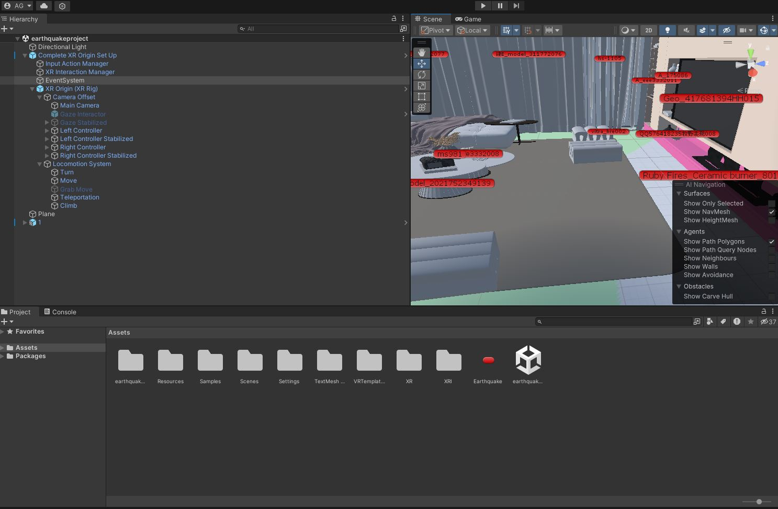
Figure 34:XR rig(origin)
- XR interaction manager: like a bridge between interiors and interactable, by interactor, you can think of them as hands for example, because you will be using the hand controller to touch things. In the scene, intractable will be like the objects to grab or touch or kick,also XR interaction manager help us with configure the project at Oculus device and it define with a special script.
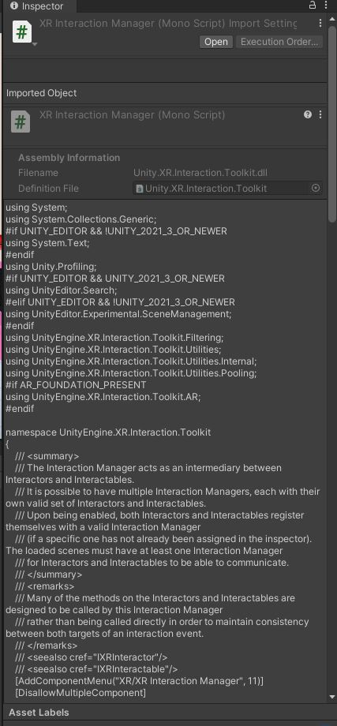
Figure 35Xr INTERACTION MANAGER SCRIPT
- Locomotion system : Locomotion systems are essential in virtual reality (VR) as they define how users move and interact within a 3D virtual space. The goal is to create a system that provides an intuitive experience while reducing the risk of motion sickness. Here is an overview of several standard VR locomotion systems:

Teleportation:

Overview: Users select a destination in the virtual space and, with a button click, instantly move there.
Benefits: This method is favored in VR for its ability to minimize motion sickness by eliminating continuous motion and allows users to navigate large areas without physical exertion.
Smooth Locomotion:

Overview: Characterized by fluid movement through the environment, often controlled by VR controller joysticks or touchpads.
Considerations: While offering a realistic sense of motion, this can sometimes lead to user discomfort due to the discrepancy between visual movement and actual physical stillness. Gradual acceleration and deceleration features can alleviate discomfort.
Snap Turning:

Overview: Users turn their viewpoint in set increments rather than with fluid rotation.
Benefits: Snap turning combats the unease that can come with continuous rotation by allowing users to change direction in fixed angles, thus reducing motion sickness. This is especially handy in situations where real-world turning isn't possible.
Arm Swinging:

Overview: Users replicate the action of walking or running by swinging their arms while holding motion controllers.
Benefits: Arm swinging leverages the natural movement of arms to translate into motion in VR, creating a more engaging and immersive experience, particularly for simulations that are enhanced by mimicking real-life actions.
Physical Movement:

Overview: Actual walking or the use of treadmill systems enable movement in the virtual space.
Benefits: This method is highly immersive as it directly translates the user's physical actions into the VR environment. However, it requires ample physical space and potentially specialized equipment.
Climbing and Grabbing:

Overview: Users physically reach out and grab to climb surfaces or interact with objects in VR.
Benefits: This system allows for more hands-on interaction with the virtual world, making it ideal for experiences that require detailed manipulation and engagement with virtual objects.

- The script that will make the earthquake: it makes an earthquake after 20 seconds from starting the project and the shake duration will be 15 seconds then i attached the script to each object i want to shake to simulate the earthquake, here is the code that will make the shake
using System.Collections;
using UnityEngine;
using UnityEngine.XR;

public class Earthquake : MonoBehaviour
{
// Duration of earthquake simulation in seconds
public float earthquakeDuration = 40f;

// Delay before earthquake simulation starts in seconds
public float delayBeforeEarthquake = 20f;

// Intensity of the shake
public float shakeIntensity = 0.1f;

// Reference to the VR device (change this if using a different VR SDK)
private XRNode node = XRNode.RightHand;

private Vector3 originalScale;
private Quaternion originalRotation;

private void Start()
{
originalScale = transform.localScale;
originalRotation = transform.localRotation;

StartCoroutine(StartEarthquake());
}

IEnumerator StartEarthquake()
{
yield return new WaitForSeconds(delayBeforeEarthquake);

float startTime = Time.time;

while (Time.time - startTime < earthquakeDuration)
{
ShakeObject();
yield return null;
}

// Reset to original position after the earthquake
transform.localScale = originalScale;
transform.localRotation = originalRotation;
}

void ShakeObject()
{
// You can choose to either rotate or scale the object during the shake
// Uncomment either the rotation or scale line based on your preference

// Rotate the object
transform.localRotation = originalRotation * Quaternion.Euler(Random.insideUnitSphere * shakeIntensity);

// Scale the object
transform.localScale = originalScale + Random.insideUnitSphere * shakeIntensity;
}
}

Every object with red mark mean that is the shake script apply on it, so if i need more object shake i will just drag the shake script and drop it in object in hierarchy window.

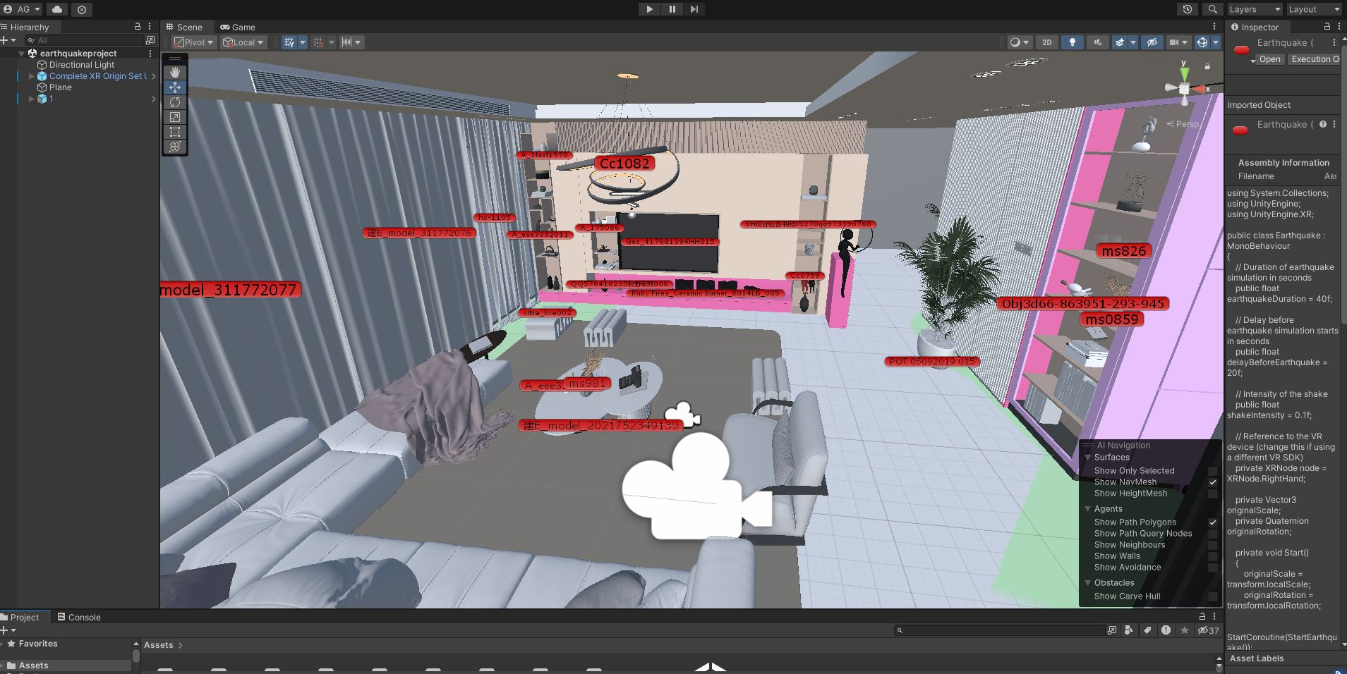
Figure 37objects that will shake
- Audio file : selected the desired audio file and download it, then add the audio file into my project scene , the audio file gives instruction about how should behave during earthquake .
- Input action manager: it define what the is the input of my project and it have auniqe script for the :
using System;
using System.Collections.Generic;
using UnityEngine.InputSystem;

namespace UnityEngine.XR.Interaction.Toolkit.Inputs
{
/// <summary>
/// Use this class to automatically enable or disable all the inputs of type <see cref="InputAction"/>
/// in a list of assets of type <see cref="InputActionAsset"/>.
/// </summary>
/// <remarks>
/// Actions are initially disabled, meaning they do not listen/react to input yet. Use this
/// class to mass enable actions so that they actively listen for input and run callbacks.
/// </remarks>
/// <seealso cref="InputAction"/>
[AddComponentMenu("Input/Input Action Manager")]
[HelpURL(XRHelpURLConstants.k_InputActionManager)]
public class InputActionManager : MonoBehaviour
{
[SerializeField]
[Tooltip("Input action assets to affect when inputs are enabled or disabled.")]
List<InputActionAsset> m_ActionAssets;
/// <summary>
/// Input action assets to affect when inputs are enabled or disabled.
/// </summary>
public List<InputActionAsset> actionAssets
{
get => m_ActionAssets;
set => m_ActionAssets = value ?? throw new ArgumentNullException(nameof(value));
}

/// <summary>
/// See <see cref="MonoBehaviour"/>.
/// </summary>
protected void OnEnable()
{
EnableInput();
}

/// <summary>
/// See <see cref="MonoBehaviour"/>.
/// </summary>
protected void OnDisable()
{
DisableInput();
}

/// <summary>
/// Enable all actions referenced by this component.
/// </summary>
/// <remarks>
/// Unity will automatically call this function when this <see cref="InputActionManager"/> component is enabled.
/// However, this method can be called to enable input manually, such as after disabling it with <see cref="DisableInput"/>.
/// <br />
/// Enabling inputs only enables the action maps contained within the referenced
/// action map assets (see <see cref="actionAssets"/>).
/// </remarks>
/// <seealso cref="DisableInput"/>
public void EnableInput()
{
if (m_ActionAssets == null)
return;

foreach (var actionAsset in m_ActionAssets)
{
if (actionAsset != null)
{
actionAsset.Enable();
}
}
}

/// <summary>
/// Disable all actions referenced by this component.
/// </summary>
/// <remarks>
/// This function will automatically be called when this <see cref="InputActionManager"/> component is disabled.
/// However, this method can be called to disable input manually, such as after enabling it with <see cref="EnableInput"/>.
/// <br />
/// Disabling inputs only disables the action maps contained within the referenced
/// action map assets (see <see cref="actionAssets"/>).
/// </remarks>
/// <seealso cref="EnableInput"/>
public void DisableInput()
{
if (m_ActionAssets == null)
return;

foreach (var actionAsset in m_ActionAssets)
{
if (actionAsset != null)
{
actionAsset.Disable();
}
}
}
}
}

CHAPTER 5 : RESULTS, CONCLUSION:

5.1 RESULTS:
- Here is the main result Dealing with XR interaction toolkit.
- XR rig setup to attach the input action(controller).
- Configuring, Optimizing the project for oculus quest 2 build.
- Installing APK files to oculus quest 2.
- The final expected result is to make a VR earthquake simulator and put a scenario to escape from this room and avoid harmful injuries.
- Design a traditional home using 3d max application with many details, and the following pictures show the home from different locations, and unity environment which is a software specialist in gaming production and application, in addition, it supports different operating systems (IOS, Android, etc…), and many developing modes (VR, AR, 2D, 3d).

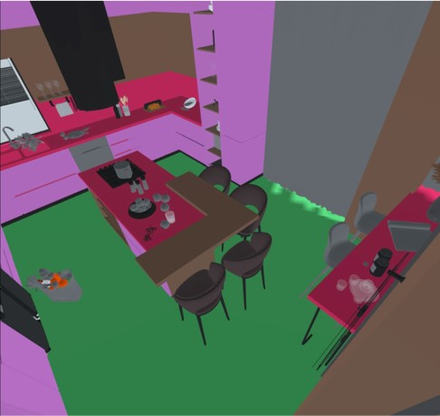
Figure 38:VIEW 1 FROM OCULUS
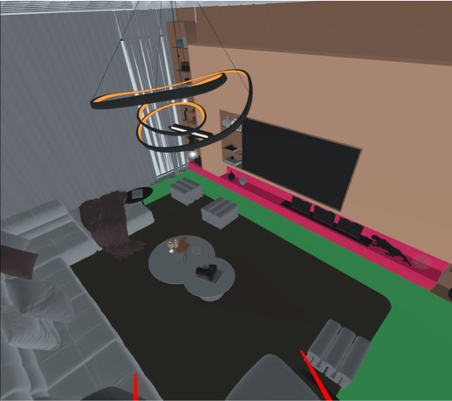
Figure 39:VIEW 2 FROM OCULUS
- Make different type of moving inside home in my project using joystick and trigger button in hand controller and the same thing for teleporting .
- Applying the shake at different objects in the game scene to simulate a IVR-SG.
- Making audio file for earthquake sound and smash object to give the project more realistic.

5.2 CONCLUSION:
- The VR development is considered as part of Android development, because the operating system for Oculus is Android, let’s consider Oculus Quest as an Android mobile phone with lenses and controllers.
- it includes dealing with different things at the same time and synchronization between mobile phones, oculus devices, and computer devices.
- Here is a diagram showing the architecture of the simulation system:
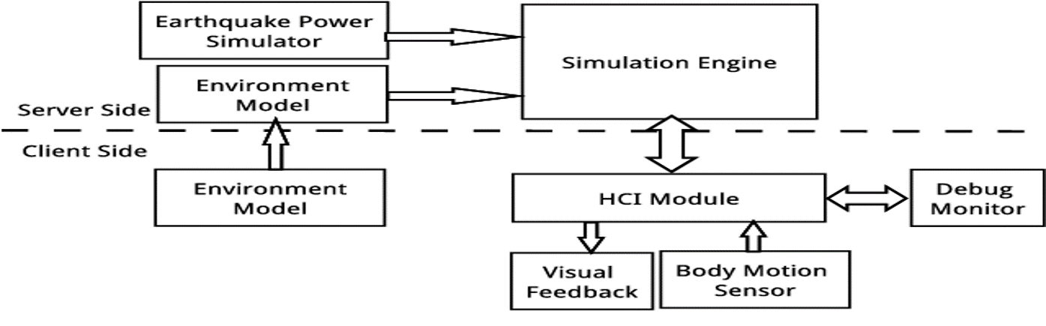
Figure 40:System architecture.

CHPTER (6): REFRENCES:
1] Gong, X., & Liu, C. (2019). A Novel Earthquake Education System Based on Virtual Reality .
[2] Todd, Christopher. "Game development in unity using oculus quest vr."

