

**An-Najah National University**

**Faculty Of Engineering**

**Electrical Engineering Department**

**Introduction To Graduation Project**

**Azzoun and Al_Nabi Elyas Networks Analysis**



**Supervisor : Dr. Imad Braik**

**Prepared By : Qais Radwan**

**Mahmoud Radwan**

**Ekrema Hawwari**

**Index**

**Introduction**

**Abstract**

**Chapter 1**

**Description of Azzoun & Al-Nabi Elyas Network**

* 1. Azzoun Network :
     1. Introduction
     2. Information about the Azzoun network
     3. Energy bills in 2010
     4. Energy consumption and losses

1.2 Al-Nabi Elyas Network :

* + 1. Introduction
    2. Information about the Al_Nabi Elyas network
    3. Electrical loads
    4. Energy bills in 2010

**Chapter 2**

**Energy Consumption In The Networks**

2.1 Introduction

2.2 Residential Sector :

2.2.1 For Azzoun Electrical Network

2.2.2 For Al-Nabi Elyas Network

2.3 Industrial Sector :

2.3.1 For Azzoun Network

2.3.2 For Al-Nabi Elyas Network

2.4.Street lighting :

2.4.1 For Azzoun Network

2.4.2 For Al-Nabi Elyas Network

2.5 Water Pumping

2.6 Overall daily load

2.7.Problems in the distribution electrical networks and solutions :

2.7.1.Electrical losses

2.7.2 High drop voltage ∆V

**Chapter 3**

**Energy Conservation In Azzoun Network**

3.1 Introduction

3.2 E tap Analysis

3.3 Maximum case

3.4 Minimum Case

3.5 ECONOMICA Study

**Chapter 4**

**Energy Conservation In Residential Sector**

4.1 Introduction

4.2 Lighting sector :

4.2.1 Simple comparison between tungsten and CFL lamps

4.2.2Energy Conservation Study

4.3 Refregeration sector

**Chapter 5**

**Energy Conservation In street Lighting**

5.1 Introduction

5.2 Methodology

5.3 Energy saving study in street lighting at Al-Nabi Elyas

5.4 Energy saving study in street lighting at Azzoun

**Chapter six**

**Power Factor Controller**

6.1 Introduction

6.2 Part of project

6.3 Block diagram

6.4 the flow chart

6.5 The result

6.6 The code

**appendix**

**References**

**Abstract :**

*Our project is to make a load flow study and analysis for AZZOUN and AL-NABI ELIAS Electrical Network*

*Using ETAP software to improve the power factor and to reduce the electrical losses in the network*

*,and to reduce the total bill for the municipality ,and use PIC to control of regulated capacitor that connect to the transformer*

**To do that we will follow the sequence bellow :**

* Build one line diagram on ETAP.
* Collect correct data and run it on software (ETAP) to getting the results .
* Give recommendation and conclusion
* Build the circuit of PIC .

**Introduction**

Energy resources and their availability are extremely

significant for every country. Energy is considered to be an

important component in the social, industrial, technological,

economic, and sustainable development of any country.

Among all forms of energy, electrical energy is regarded as

high grade energy and has been the major driver for

technological and economic development. In all developed

countries, extensive programs for energy conservation,

efficiency, and load management are planned and

implemented for decades . The impact of these programs on

energy and demand reduction is tremendous.

Palestine is considered as one of the poorest countries

considering the availability of energy resources. Nearly all

main energy resources like fossil fuels and electricity are

imported from Israel. This makes Israeli control the

quantity, price, tariff, condition and form of each source of energy to Palestine.

**Chapter One**

**Description Of The Networks :**

**Azzoun network**

**Al-Nabi Elyas network**

**1.1 Azzoun Network :**

***1***.***1.1 Introduction***

Azzoun feed of electricity from electrical Israeli company , with maximum load consumed in the Azzoun to 0.7 MW , the project work at one level of voltage 33KV , the Qatari-Israeli company jugged Azzoun at high voltage tariff .

***1.1.2:*** ***Information about the network Azzoun***

* ***Classification of load Azzoun village:***

|  |  |
| --- | --- |
| 52% | Residential |
| 15% | Commercial |
| 15% | Industrial |
| 14% | Water pumping |
| 4% | street lighting |

* ***As a sector:***



* ***Cables and transmission lines****:*

Azzoun consist two types of transmission line:

* ACSR(over head transmission) .
* XLPE (underground transmission).

XLPE=120 mm2 and it has R=0.325ohm/Km and X=0.124ohm/Km.

I rated=335A

ACSR=95/15 mm2 and it has R=0.37ohm/Km and X=0.279ohm/Km.

I rated=359A

* ***Distribution transformers***:

We have in Azzoun 10 transformers

|  |  |
| --- | --- |
| Number | capacity(KVA) |
| 6 | 400 |
| 1 | 250 |
| 2 | 160 |
| 1 | 100 |

* ***Loads connected to Azzoun substation***:

We divided it to 3 types: industrial , industrial and residential , commercial and residential

|  |  |
| --- | --- |
| number of transformers | Types |
| 1 | Industrial |
| 2 | industrial and residential |
| 7 | commercial and residential |

***1.1.3 Energy bills in 2010***

|  |  |  |  |  |  |
| --- | --- | --- | --- | --- | --- |
| **%losses** | **Losses** | **The amount of electricity (from electrical Israel company)** | **People Consumption** | **the price** | **Month** |
| **3.68** | **16115** | **438090** | **421975** | **0.3656** | **1** |
| **31.07** | **172104** | **553950** | **381846** | **0.3711** | **2** |
| **7.09** | **31085** | **438720** | **407635** | **0.3436** | **3** |
| **9.69** | **41566** | **428760** | **387194** | **0.33** | **4** |
| **5.65** | **24313** | **430500** | **406187** | **0.33** | **5** |
| **7.28** | **39687** | **545160** | **505473** | **0.33** | **6** |
| **4.97** | **25323** | **509700** | **484377** | **0.33** | **7** |
| **12.06** | **82130** | **681270** | **599140** | **0.33** | **8** |
| **24.87** | **158605** | **637800** | **479195** | **0.33** | **9** |
| **9.4** | **46439** | **494280** | **447841** | **0.33** | **10** |
| **32.27** | **193032** | **598260** | **405228** | **0.33** | **11** |
| **9.9** | **44284** | **447150** | **402866** | **0.33** | **12** |
| **14.099** | **72890.3** | **516970** | **423519** | **0.3375** | **Monthly rate** |

* + 1. ***Energy consumption and losses :***

The total average consumption over 12 months and losses in network .

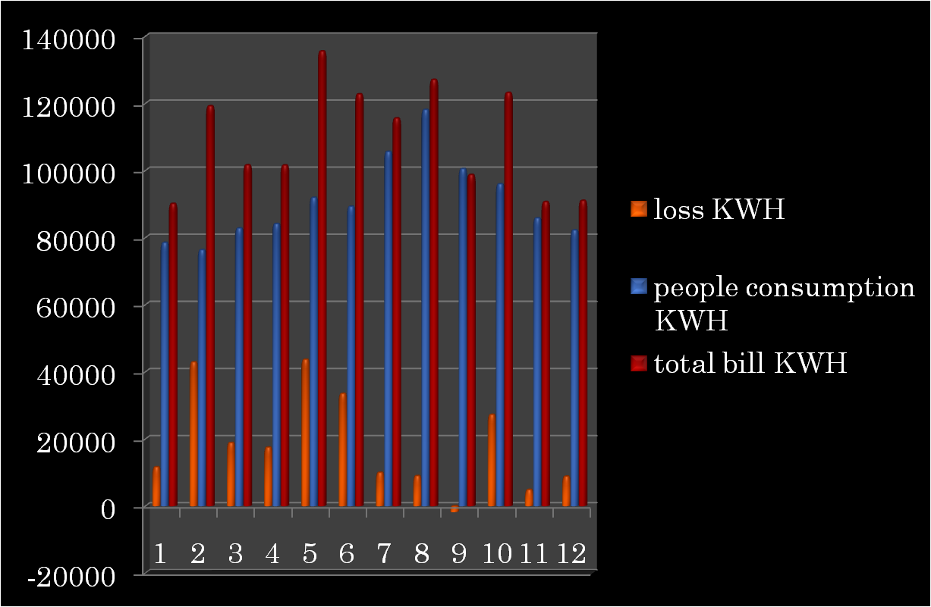

**1.2 Al-Nabi Elyas Network :**

***1.2.1 Introduction***

Al_Nabi Elias is supplied with electricity from one point from Qatari _Israeli company at 33kv level.

The maximum load of the village is about 0.15 MW and it is increasing now due to the new buildings and the increment in the people consumption .looking to the last five years the consumption of same buildings was increased by the factor 1.3 .

***1.2.2 Al_Nabi Elias electric network consist of :***

**1)One transformer**

630KVA, 33/.4KV.(∆/Y)

**2) Control Rome .**

*The control room contains:*

**a) *bus bars***

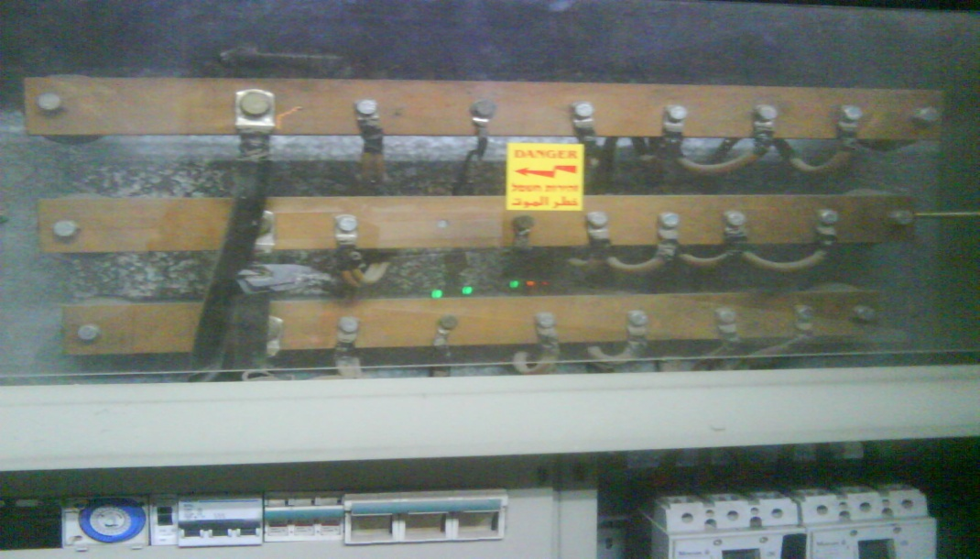

It consist of 5 bus bars ;three for three phase ,one for neutral and one for earth.

**b) *circuit breakers*.**

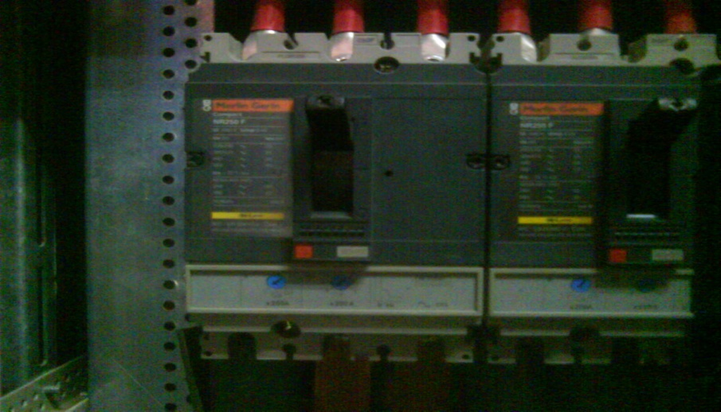

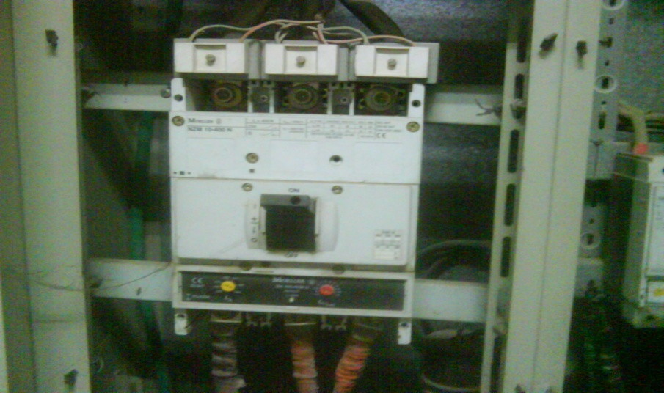

We have two types of circuit breakers with different ratings .we have two315 A C.B , two 65A C.B and one for street lighting of 16A and all of them work at 0 .4 KV.

***c) street light control circuit.***

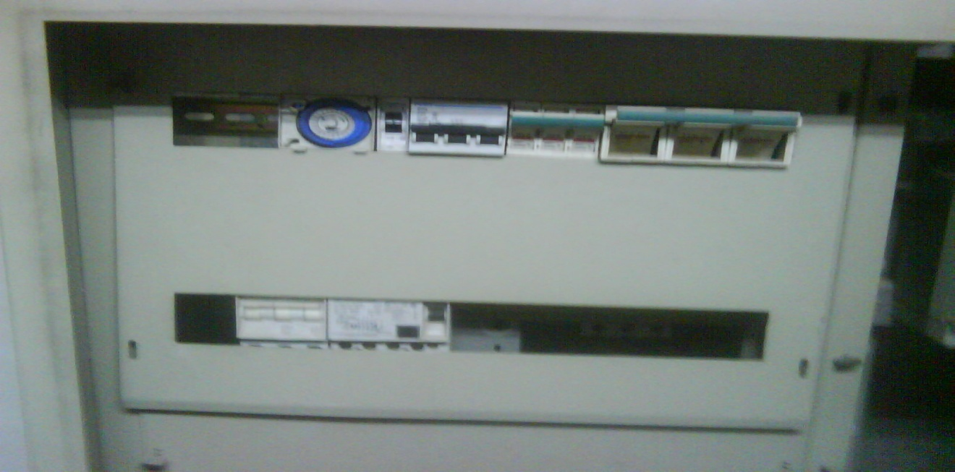

This circuit designed to turn on/ off street lights at variable time .

***d) earthing system.***

It consist of a cupper wire connected to the foundation of the room also connected with an electrode slotted in the ground .

***e) MPR50 network analyzer , ammeters , watt meter.***

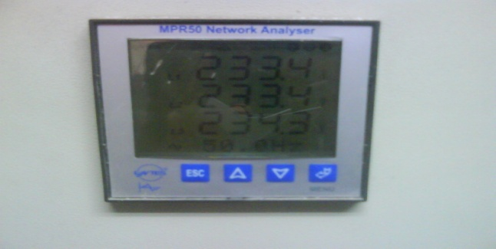

This device give exact value of the voltage on the feeders ,and also the frequency .

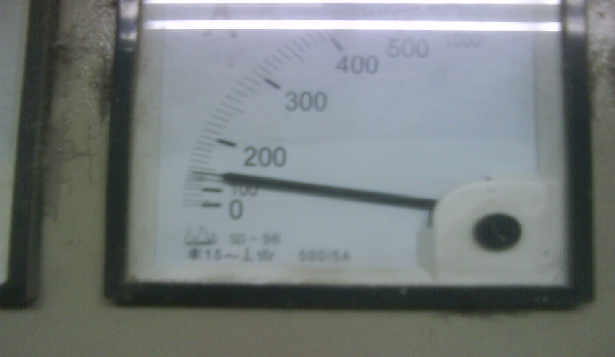

***3****.* ***Wires****.*

We have about 5 km of ABC_90 overhead cables distributed all over the network.

***4. Loads***

The loads divided into residential ,commercial , industrial , other as shown in section 4_3.

***1.2.3 Electrical loads***

The total number of consumers in the village equal to 350 .and the average consumption is about 55000 shekel/month.

Its clearly shown below that the residential sector is the largest one and its about 50%of over all consumption due to the nature of the village ,then comes the commercial and the industrial sector which is about 45% of the consumption.

|  |  |  |  |  |  |
| --- | --- | --- | --- | --- | --- |
| **others** | **street light** | **commercial** | **industrial** | **residential** |  |
|  | **80lamp/80w** | **50** | **40** | **260** | **# of consumers** |
| **4000** | **3000** | **45000** | **21080** | **75920** | **Average consumption kwh/ month** |

* ***As sector:***

**load distribution**

commercial

30%

industrial

14%

residential

51%

street lighting

3%

others

2%

Street lighting

others

commercial

industrial

residential

* Most of the loads in this networks are residential loads .

***1.2.4 Energy bills in 2010***

The table below shows the total bills in 2010 ,people consumption and the losses in KWh and in shekel .

|  |  |  |  |  |  |
| --- | --- | --- | --- | --- | --- |
| **loss KWH** | **people consumption in shekel** | **people consumption KWH** | **total bill in shekel** | **total bill KWH** | **Month** |
| **11610** | **54150** | **78500** | **35827** | **90110** | **1** |
| **42900** | **52850** | **76320** | **51061** | **119220** | **2** |
| **18840** | **57310** | **82790** | **40408** | **101630** | **3** |
| **17460** | **58700** | **84100** | **40380** | **101560** | **4** |
| **43640** | **63500** | **91910** | **53895** | **135550** | **5** |
| **33496** | **61450** | **89254** | **47782** | **122750** | **6** |
| **9970** | **73150** | **105610** | **53421** | **115580** | **7** |
| **8970** | **81240** | **118100** | **58755** | **127070** | **8** |
| **-1770** | **69200** | **100500** | **39255** | **98730** | **9** |
| **27225** | **66170** | **95965** | **48980** | **123190** | **10** |
| **4855** | **59160** | **85805** | **36046** | **90660** | **11** |
| **8810** | **56770** | **82210** | **36190** | **91020** | **12** |
| **18833.83333** | **62804.16667** | **90922** | **45166.66667** | **109755.8333** | **Average** |

**The average losses = 18833.8*.39=7345.2 NIS .**

We can see that the network have high losses looking to its size .

* ***Energy consumption and losses :***

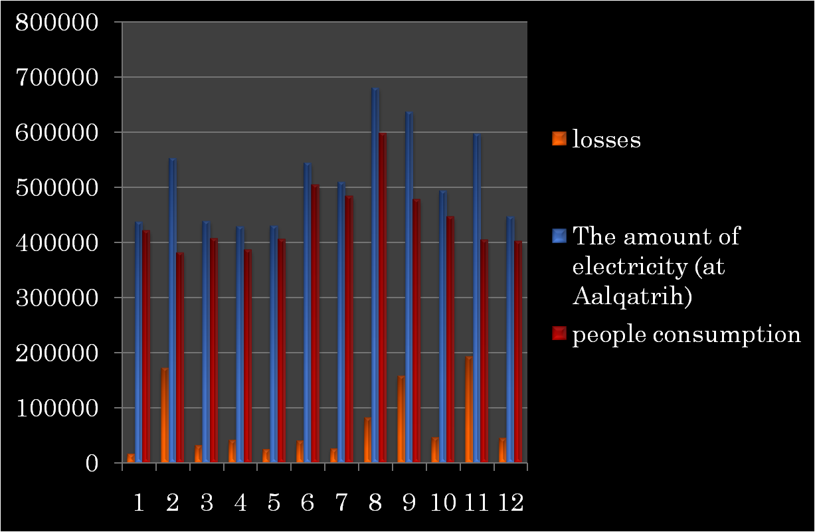

* This figure shows the total average consumption over 12 months and losses in network .

**Chapter Two**

**Energy Consumption In The Networks**

***2.1 Introduction***

In this chapter we are going to show the amount of electrical consumption in residential , industrial , commercial and street lighting sectors , and we are going to draw the daily load carve for each one showing the average energy consumption during the day .

* 1. ***Residential Sector :***

People should be more sensitive about wasting energy in their homes . Energy consumption in residential can take different forms such as lighting , cooling , heating and sometimes small water pumps , so energy consumption can be reduced by studying each part and apply the right methods for saving energy to get more efficient houses with less energy consumption and more money benefits .

***2.2.1 For Azzoun Electrical Network***

The residential sector has 52% of Azzoun electrical consumption . The data that we consider in our study represents the consumption in 2010 over 12 months , we took a fifty houses as sample and represent the daily load curve for it . Because the most loads of residential sector are lighting we find that the period for max consumption is from 6 pm to 11 pm and we distribute all the rest loads like refrigerators , televisions and other appliances at all the day .

* The table bellow shows the average daily consumption :

|  |  |
| --- | --- |
| **Time** | **Residential daily load (KW)** |
| 0 | 250 |
| 2 | 250 |
| 4 | 300 |
| 6 | 360 |
| 8 | 500 |
| 10 | 570 |
| 12 | 480 |
| 14 | 450 |
| 16 | 600 |
| 18 | 1300 |
| 20 | 1310 |
| 22 | 990 |
| 24 | 400 |

* The daily load curve represents the data above :
  + 1. ***For Al-Nabi Elyas Network***

The same procedures were done to make an average daily load curve for this village , and the following data represents the average consumption for 30 house sample .

* **The table bellow shows the average daily consumption :**

|  |  |
| --- | --- |
| **Time** | **Residential daily load (KW)** |
| 0 | 39 |
| 2 | 45 |
| 4 | 55 |
| 6 | 60 |
| 8 | 90 |
| 10 | 91 |
| 12 | 92 |
| 14 | 93 |
| 16 | 95 |
| 18 | 120 |
| 20 | 195 |
| 22 | 190 |
| 24 | 50 |

* **The daily load curve represents the data above :**

***2.3 Industrial Sector :***

In industrial sectors there are many electrical devices that can draw large amount of currents ,such as huge motors , boilers , furnaces , pumps ,lighting , air conditioning … etc .Also these devices draw large amount of reactive power which cause the power factor to decrease under its allowed value which mean more money paid for taxes to the electrical company . More than ,large currents means increasing the energy loss in transmission lines .

***2.3.1 For Azzoun Network :***

In Azzoun village the industrial loads consists of furnaces and stone factories that have a lot of low efficient induction motors that draw high currents . the data that we collect from 15 samples with different loads . we realized that the maximum consumption happens from 10 am to 6 pm and according to these results we draw a daily load carve that represents the average consumption during the day .

* **The table bellow shows the average daily load :**

|  |  |
| --- | --- |
| **Time** | **Industrial daily load (KW)** |
| 0 | 32 |
| 2 | 34 |
| 4 | 60 |
| 6 | 90 |
| 8 | 150 |
| 10 | 200 |
| 12 | 310 |
| 14 | 400 |
| 16 | 350 |
| 18 | 250 |
| 20 | 34 |
| 22 | 32 |
| 24 | 30 |

* **The daily load curve represents the data above :**

***2.3.2.For*** ***Al-Nabi Elyas Network***

The industrial loads in Al-Nabi Elyas vellage consists of the stone factors which is 8 factors and some other industrial loads . We collect the data from all and draw the average daily load curve as follows :

* **The table bellow shows the average daily load :**

|  |  |
| --- | --- |
| **Time** | **Industrial load (KW)** |
| 0 | 4 |
| 2 | 5 |
| 4 | 6 |
| 6 | 14 |
| 8 | 15 |
| 10 | 39 |
| 12 | 79 |
| 14 | 80 |
| 16 | 87 |
| 18 | 80 |
| 20 | 39 |
| 22 | 18 |
| 24 | 8 |

* **The daily load curve represents the data above :**

***2.4.Street lighting***

Street lighting became an important at every city today .Different types of lamps are used for this purpose with different efficiency and different power consumption , so its important to study this sector to minimize the power consumption as possible .

***2.4.1 For Azzoun Network***

The street lighting in Azzoun village consist of 325 high-pressure mercury lamp with 150 watt for each , and it has 4% of Azzouns load consumption .

The consumption of street lighting section is around 25000 KWh per month . It works for 11 hours in average ,the following data and figure represents the daily load curve :

* **The table bellow shows the average daily load :**

|  |  |
| --- | --- |
| **Time** | **street lighting load (KW)** |
| 0 | 42 |
| 2 | 42 |
| 4 | 42 |
| 6 | 42 |
| 8 | 0 |
| 10 | 0 |
| 12 | 0 |
| 14 | 0 |
| 16 | 0 |
| 18 | 42 |
| 20 | 42 |
| 22 | 42 |
| 24 | 42 |

* **The daily load curve represents the data above :**

***2.4.2 For Al-Nabi Elyas Network***

The street lighting in Al-Nabi Elyas village consist of 85 high-pressure mercury lamp with 120 watt for each , and it has 3% of Al-Nabi Elyas load consumption .

The consumption of street lighting section is around 3670 KWh per month . It works for 11 hours in average ,the following data and figure represents the daily load curve :

* **The table bellow shows the average daily load :**

|  |  |
| --- | --- |
| **Time** | **street lighting load (KW)** |
| 0 | 6.5 |
| 2 | 6.5 |
| 4 | 6.5 |
| 6 | 6.5 |
| 8 | 0 |
| 10 | 0 |
| 12 | 0 |
| 14 | 0 |
| 16 | 0 |
| 18 | 6.5 |
| 20 | 6.5 |
| 22 | 6.5 |
| 24 | 6.5 |

* **The daily load curve represents the data above :**
  1. ***Water Pumping***

In Azzoun village there is tow water pumping which is another example on the energy consumption equipments ,it consumes a lot of energy since it has a huge induction motors . it occupies 15% of its energy consumption .

The energy consumption for the first pump is 75000 KWh in average and works each day 18 hours in average , the other one consumes 15000 KWh and work as same period .

* **The table bellow shows the average daily load :**

|  |  |  |
| --- | --- | --- |
| **Time** | **water pump #1 (KW)** | **water pump # 2 (KW)** |
| 0 | 0 | 0 |
| 2 | 0 | 27 |
| 4 | 138 | 27 |
| 6 | 138 | 27 |
| 8 | 138 | 27 |
| 10 | 138 | 27 |
| 12 | 138 | 27 |
| 14 | 138 | 27 |
| 16 | 138 | 27 |
| 18 | 138 | 27 |
| 20 | 138 | 27 |
| 22 | 0 | 0 |
| 24 | 0 | 0 |

* **The daily load curve represents the data above :**

***2***.***6 Overall daily load*** :

* **The overall daily load curve for Azzoun load :**

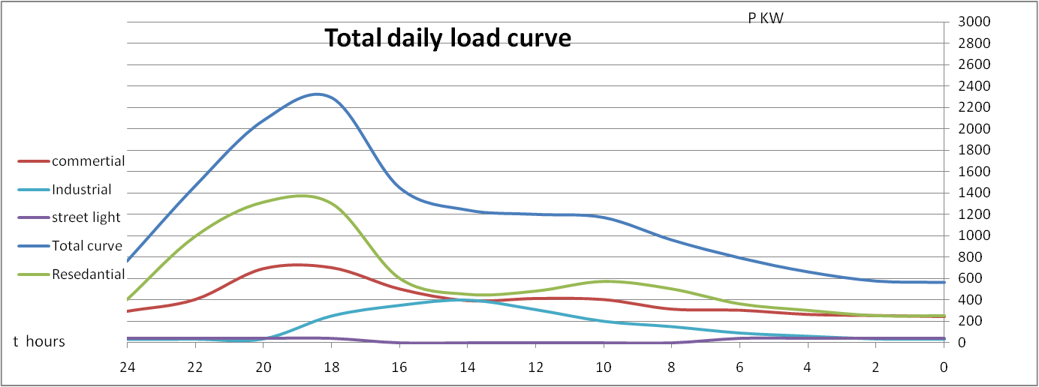

* **The overall daily load curve for Al-Nabi Elyas load :**

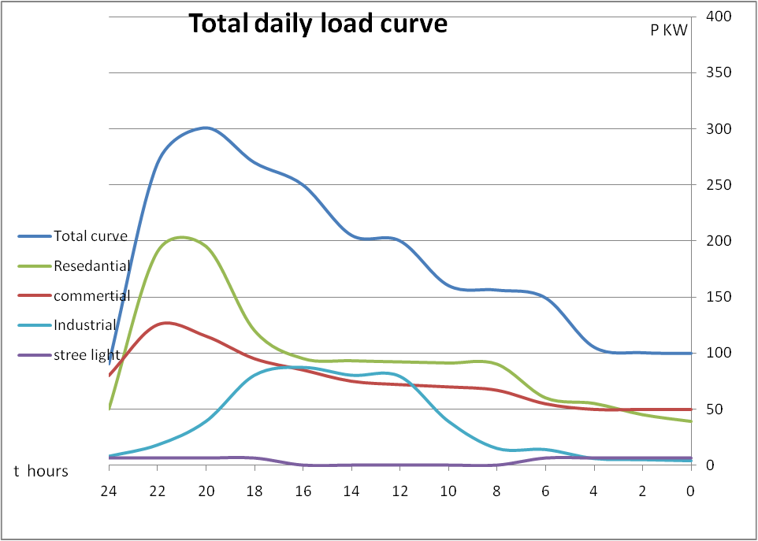

***2.7.Problems in the distribution electrical networks and solutions :***

***2.7.1.Electrical losses:***

The average losses to be acceptable is ∆P = (8-10)%.

* **Solution :**

1. *power factor correction :*

by adding capacitor bank on the load

S(kVR)

Q (KVAR)

Q-Qc(KVAR)

QC(KVAR)

P(Kw)

1. *By improving the cross sectional area (A):*

Because increasing the area case decreasing the resistance of the line as shown ;

∆P= I2R;

R = ;

∆P= I2*R ∆P =

1. *Symmetrical Loads*

Another problem is that the loads is not distributed efficiently , and the sum of phases currents should equal zero , so there is losses in the nutral line .

In = Ia + Ib + Ic ≠ 0 ;

And , ∆P= (In)2Rn ,

1. *Improving the performance of the distribution transformers by :*
2. Choosing the suitable capacity of transformer according to the load so that the load factor in range (0.65-0.75) .

b-Selecting the optimum setting of the tap changer .

***2.7.2*** ***High drop voltage ∆V*** ***:***

Another serious problem in network that should be solved is drop voltage , drop voltage should not exceeds 5%Vnominal .

* **Solution :**

1. *Reducing the current of the load by :*
2. Improving power factor .
3. Improving cross sectional area .
4. Improving the sending voltage .

1. *Reducing the impedance by :*
2. Increase the cross sectional area .
3. Minimize the length of the feeders .

**Chapter Three**

**Energy Conservation In Azzoun Network**

***3.1 Introduction:***

In this chapter we will study the Azzoun network to study the voltages level and power flow in the network in order to enhance it to reduce the energy losses and drop voltage . In addition ,we are going to study the minimum and maximum case of the network .to do this we will use the E tap program , this program has many advantages :

1. Easy to learn and use .
2. All calculations are on the one line diagram .
3. Easy to inter the values and change .
4. The short circuit calculation property .
5. One can add any element in the power system to the one line diagram simply .
6. Easy run and fast results .

* Azzoun Network :

This net work consist of 10 transformers with different loads , the table below shows the average load on each transformer and its rated capacity :

|  |  |  |
| --- | --- | --- |
| Transformer number | Rated capacity (KVA) | Average load (KVA) |
| Transformer 1 | 400 | 330 |
| Transformer 2 | 400 | 290 |
| Transformer 3 | 250 | 200 |
| Transformer 4 | 400 | 280 |
| Transformer 5 | 400 | 320 |
| Transformer 6 | 160 | 130 |
| Transformer 7 | 400 | 300 |
| Transformer 8 | 160 | 130 |
| Transformer 9 | 400 | 250 |
| Transformer 10 | 100 | 80 |

***3.2 E tap Analysis :***

The table below shows the resistance and reactance for the medium voltage lines (33 KV) :

|  |  |  |  |
| --- | --- | --- | --- |
| Line number | Resistance (ohm) | | Reactance(ohm) |
| Line 1 | 1.0138 | | 0.7645 |
| Line 2 | 0.104 | | 0.0379 |
| Line 3 | 0.2701 | | 0.204 |
| Line 4 | 0.559 | | 0.3211 |
| Line 5 | 0.1665 | | 0.1256 |
| Line 6 | 0.182 | | 0.069 |
| Line 7 | 0.1658 | | 0.063 |
| Line 8 | 0.3185 | | 0.1215 |
| Line 9 | 0.182 | | 0.069 |
| Line 10 | | 0.0033 | 0.0022 |

One Line Diagram :

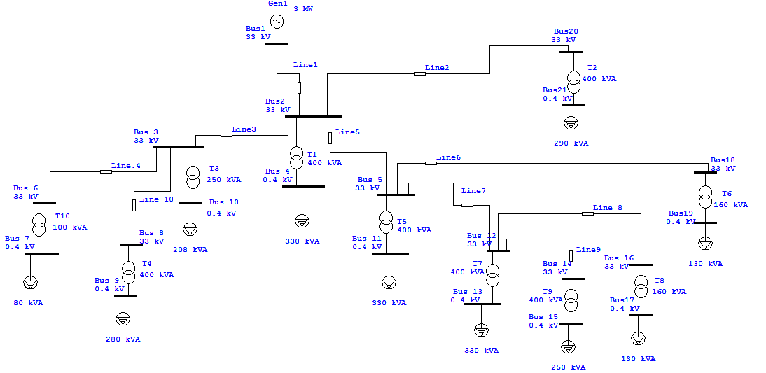

***3.3 Maximum case :***

One Line Diagram Before Adding Capacitors

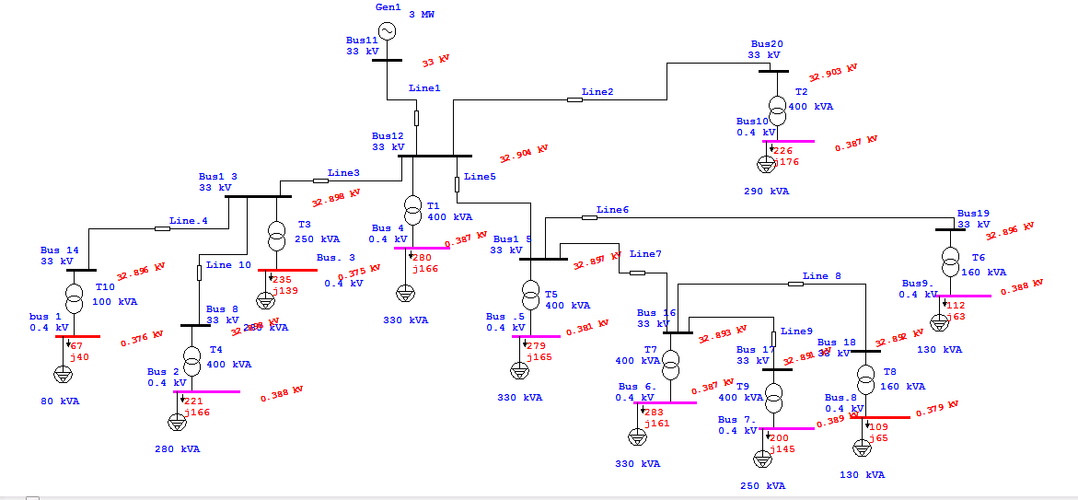

We can notice from the results that there is some buses don’t inter the required range (-2% , +2%)Vn , so in order to solve this problem we can do the following steps :

1. Increase the voltage of the generator up to 10% , but in our case we cant do this since the source is the Electrical Israeli Company .
2. Change the tab changer settings of the distribution transformers up to 5% .
3. Adding capacitors to the load bus so as to increase the voltage and enhance the power factor .

In this case we add capacitors to the network with different values and all buses become in the required range .

the table below shows the number of capacitors and its values :

|  |  |
| --- | --- |
| Capacitors | Value (KVAR) |
| C 1 | 20 |
| C 2 | 100 |
| C 3 | 70 |
| C 4 | 80 |
| C 5 | 80 |
| C 6 | 80 |
| C 7 | 100 |
| C 8 | 30 |
| C 9 | 30 |
| C 10 | 120 |

The table below shows the comparison between net before and after adding capacitors :

|  |  |  |
| --- | --- | --- |
| The Bus Number | Voltage Before (KV) | Voltage After(KV) |
| Bus 1 | 0.378 | 0.386 |
| Bus 2 | 0.387 | 0.392 |
| Bus 3 | 0.382 | 0.384 |
| Bus 4 | 0.387 | 0.391 |
| Bus5 | 0.387 | 0.391 |
| Bus 6 | 0.387 | 0.391 |
| Bus 7 | 0.388 | 0.393 |
| Bus 8 | 0.378 | 0.386 |
| Bus 9 | 0.388 | 0.391 |
| Bus 10 | 0.386 | 0.393 |

One Line Diagram After Adding Capacitors

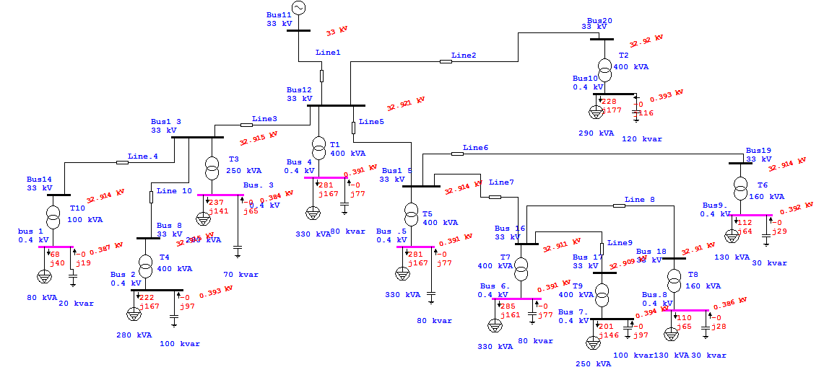

The table shows the effect of capacitor on the power factor

|  |  |  |
| --- | --- | --- |
| New power factor | Old power factor | Bus number |
| 0.90 | **0.86** | **Bus 1** |
| 0.85 | **0.80** | **Bus 2** |
| 0.90 | **0.86** | **Bus 3** |
| 0.90 | **0.86** | **Bus 4** |
| 0.90 | **0.86** | **Bus 5** |
| 0.91 | **0.87** | **Bus 6** |
| 0.86 | **0.81** | **Bus 7** |
| 0.94 | **0.86** | **Bus 8** |
| 0.91 | **0.87** | **Bus 9** |
| 0.85 | **0.79** | **Bus 10** |

* 1. ***Minimum Case :***

In the minimum case we reduce the loads to the half ,

and we add capacitors to the buses 1,3 and 8 in the network as follows:

|  |  |  |
| --- | --- | --- |
| Capacitor number | | Value (KVAR) |
| C1 | | 15 |
| C2 | | 20 |
| C3 | 15 | |

One Line Diagram Before Adding Capacitors :

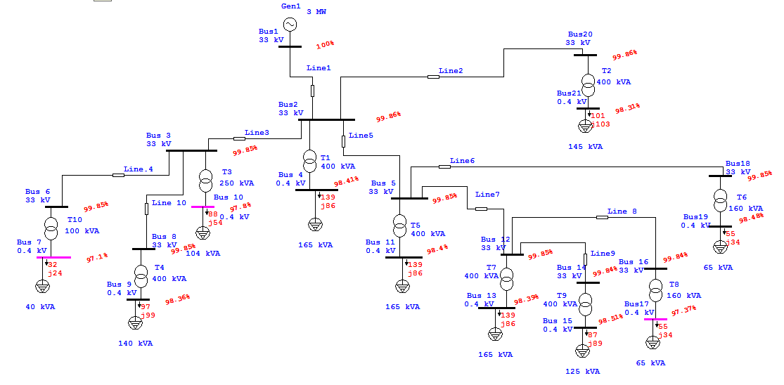

We can notice that there is three buses that is out of the range .

One Line Diagram After Adding Capacitors :

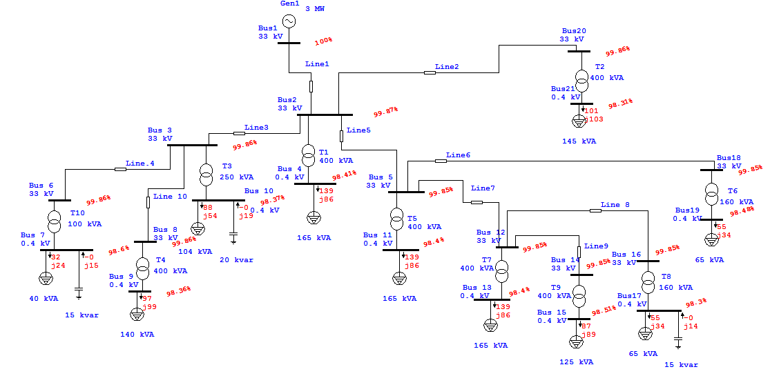

The table below shows the comparison between bus voltages before and after adding capacitors :

|  |  |  |
| --- | --- | --- |
| Bus number | Voltage before(KV) | Voltage after(KV) |
| Bus 1 | 0.376 | 0.394 |
| Bus 2 | 0.387 | 0.393 |
| Bus 3 | 0.375 | 0.393 |
| Bus 4 | 0.387 | 0.394 |
| Bus 5 | 0.381 | 0.394 |
| Bus 6 | 0.386 | 0.394 |
| Bus 7 | 0.388 | 0.394 |
| Bus 8 | 0.378 | 0.393 |
| Bus 9 | 0.388 | 0.394 |
| Bus 10 | 0.387 | 0.393 |

***3.5 ECONOMICA Study :***

In this project it is important to study the economical calculation, so the improvement of any project must succeed economically , we consider the capacitors used in the min case are fixed while in the max are regulated .

|  |  |  |  |  |
| --- | --- | --- | --- | --- |
| Bus number | Min case (KVAR) | Max case (KVAR) | Fixed capacitor | Regulated capacitor |
| Bus 1 | 15 | 20 | 15 | 5 |
| Bus 2 | 0 | 100 | 0 | 100 |
| Bus 3 | 20 | 70 | 20 | 50 |
| Bus 4 | 0 | 80 | 0 | 80 |
| Bus 5 | 0 | 80 | 0 | 80 |
| Bus 6 | 0 | 80 | 0 | 80 |
| Bus 7 | 0 | 100 | 0 | 100 |
| Bus 8 | 15 | 30 | 15 | 15 |
| Bus 9 | 0 | 30 | 0 | 30 |
| Bus 10 | 0 | 120 | 0 | 120 |

* The cost of regulated capacitor per MVAR = 10000 $/MVAR.
* The cost of fixed capacitor per MVAR = 4000 $ /MVAR.
* The total fixed capacitors = 50 KVAR
* The regulated capacitors = 660 KVAR

* ∆P =∆P1 - ∆P2
* Z∆p =∆∆P *T*C
* Kc = Cc * Qc
* Zc = EH* Kc

Where ;

C =100 $/MWh

Cc : cost of capacitor per MVAR .

Z∆p : Annual power saving per year ($/year).

Kc : capital cost of capacitors ($/MVAR).

T = 3800 hours ( average working hours per year).

∆P1 : losses in max case before adding capacitors.

∆P2 : losses in max case after adding capacitors.

Zc: Annual cost of capacitors .

EH :Capital recovery factor .

* ∆P = 32.1 KW – 20.6 KW = 11.5 KW.
* Z∆p = 0.0115 MW*3800 hour* 100 $/MWh = 4370 $/year.
* Kc = (4000 $/MVAR* 0.05 MVAR) + (10000 $/MVAR *0.66 MVAR ) =6800$.
* Zc =0.22 *6800 =1496 $/year.
* ∆Z = Z∆p –Zc =4370 - 1496 =2874 $/year. (saving per year)
* S.P.B.P = Kc/∆Z

= 6800 / 2874 = 2.3 year .

**Chapter Four**

**Energy Conservation In Residential Sector**

***4.1 Introduction***

In this chapter we are going to study the energy conservation in the residential sector , this chapter is very important because the amount of energy that can be saved with low cost and most of people can do and save their money .

The most two parts that commonly used and energy can be saved through is lighting and refrigeration ,so we are going to apply the energy conservation study and do the economical study in this section .

* 1. ***Lighting sector :***

In our study we took a sample of 50 houses from two villages Azzoun and Al-Nabi Elyas to study the lighting sector and the possibility of energy conservation , we found that the average number of tungsten lamps 5 units and 8 flourecent lamps . The average operation time for tungsten is 2 hours and 5 hours for flourecent for each house .

So , we decided to replace all tungsten lamps with CFL lamps .

* **The table below shows the statistics of both tungsten and CFL**

|  |  |  |
| --- | --- | --- |
|  | Tungsten lamp | CFL |
| Life | 1000 hours | 50000 hours |
| Power | 75 Watt | 18 Watt |
| Luminous flux | 900 lumen | 900 lumen |
| Luminous efficiency | 12 lumen/Watt | 50 lumen/Watt |
| Cost | 1.5 NIS | 1. NIS |

***4.2.1 Simple comparison between tungsten and CFL lamps:***

We can see from table above that the life period for CFL is five times greater than the tungsten and according to this each CFL lamp equal five tungsten lamps . Another important thing on tungsten lamp is that 98% of its energy is heat and just 2% for lighting .

We consider the cost of 1 KWh = .65 NIS

Total cost = fixed cost + running cost

* For tungsten lamps :

Total cost = 1.5(NIS)*5(units) +.075(KW)*5000(hour)*0.65(NIS) = 251.25 NIS

* For CFL lamp :

Total cost = 13 + 0.018*5000*0.65 = 71.5 NIS

So , we can see that the total cost of tungsten lamps is 3.5 times more than the total cost of CFL lamp in the same period .

* + 1. ***Energy Conservation Study :***

Demand Factor for lighting = 0.8 .

* Average energy consumed by tungsten = 5(units) *0.075(KW)* 2(hours)*0.8 = 0.6 KWh/day (for each house)
* Average energy consumed by CFL = 5(units)*0.0 18(KW) * 2(hours)* 0.8 = 0.144 KWh/day
* Energy saved per month = (0.6 -0.144) *30 =13.68 KWh/month
* Money saved per month = 13.68*0.65(NIS)= 8.9 NIS/month .
* Money saved in An-Nabi Elyas residential sector = 260(house)* 8.9(NIS/month) =2312 NIS/month
* Money saved in Azzoun residential sector =1324(house)* 8.9(NIS) = 11782 NIS/month
* S.P.B.P(for each house) = Investment / Annual saving

= 13(NIS)*5(unit)/8.9(NIS/month)*12 = 6.5 months

Taking in consideration the life cycle of CFL lamp is about 6.5 years .

* 1. ***Refrigeration sector :***

Another way to conserve energy in the residential sector is through refrigeration . the average power consumption of the most used refrigerators is about (2.5-3) KWh per day and these refrigerators are low efficient , and it works 9 hours in average.

So ,in this section we are going to study the energy saving if we replace it with (1-1.2)KWh high efficient one .

* The energy saved per day = 3-1.2 = 1.8 KWh/day.
* Annual energy saving = 1.8 (KWh)* 365 (day) = 657 KWh/year.
* Annual money saving = 657 * 0.65(NIS) = 427 NIS .
* Salvage value for old refrigerator = 500 NIS .
* S.P.B.P = (Investment-Salvage)/Annual saving

= (2500-500)/427(NIS) = 4.6 years .

**Chapter Five**

**Energy Conservation In street Lighting**

***5.1 Introduction***

The street lighting is a very essential issue in conserving energy since we can reduce the amount of energy consumed by this section . several types of lamps used in street lighting such as high/low pressure sodium , high pressure mercury and metal halide . So , in this chapter we are going to apply the energy conservation on this section .

***5.2 Methodology :***

The lamps in An-Nabi Elyas village that used in street lighting is High Pressure Mercury and have a power of 120 W , the number of lamps is 85 . In Azzoun village there 325 lamps divided into two types :the first type is 50 lamps , low pressure sodium ,120 W . The second type is 275 lamps , high pressure mercury , 150 W .

We are going to replace all units by 80 W Low Pressure Sodium . The table below shows the properties of Low Pressure Sodium and high pressure mercury to be replaced :

|  |  |  |  |  |
| --- | --- | --- | --- | --- |
|  | *Efficacy (lumens/watt)* | *Lifetime (hours)* | *Color Temperature (K)* | *Indoors/Outdoors* |
| *Low-Pressure Sodium* | *60–150* | *12,000–18,000* | *2000 (warm)* | *Outdoors* |
| *High-Pressure Mercury* | *25–60* | *16,000–24,000* | *3200–7000 (warm to cold)* | *Outdoors* |
| *High-Pressure sodium* | *50–140* | *16,000–24,000* | *2100 (warm)* | *Outdoors* |

* 1. ***Energy saving study in street lighting at Al-Nabi Elyas :***
* energy consumed by old units = 120 (w)*85(unit)*11(hours/day)= 112.2 KWh/day = 3366 KWh /month
* energy consumed by new units = 80 (w)*85(unit)*11(hours/day) =74.8 KWh/day = 2244 KWh/month
* energy saving /month = 3366-2244 = 1122 KWh/month
* money saving /month =1122 * 0.39 (NIS/KWh)= 437.7 NIS/month
* ***Economical Study :***

here we calculate the simple payback period (S.P.B.P)

S.P.B.P (year) = investment / annual saving

Investment = 85 (unit)* 40(NIS/unit) =3400 NIS

Annual saving = 437.7 *12 =5252.4 NIS

S.P.B.P = 3400/5252.4 =7.76 months .

looking to the life cycle of the lamps (16 000- 24000) hours which equals to 4.5 years of 11 working hours/day we can see that S.P.B.P a good indication .

***5.4 Energy saving study in street lighting at Azzoun :***

* energy consumed by old units =120(w)*50(unit)*11(hour/day)+ 150(w)*275(unit)*11(hour/day) = 519.8 KWh/day = 15592.5 KWh/month
* energy consumed by new units =80(w)*325(unit)*11(hour/day) =286 KWh/day = 8580 KWh/month
* energy saving/month =15592.5-8580 = 7012.5 KWh/month
* money saving/month =7012.5*0.33(NIS/KWh) = 2314 NIS/month

* ***Economical Study :***
* here we calculate the simple payback period (S.P.B.P)
* cost of each unit = 40 NIS .
* S.P.B.P (year) = investment / annual saving
* Investment = 325(unit)* 40(NIS/unit) =13000 NIS
* Annual saving = 2314 *12 =27768.8 NIS
* S.P.B.P = 13000/27768.8 = 5.6 months .
* looking to the life cycle of the lamps (16000 - 24000) hours which equals to 4.5 years of 11 working hours/day we can see that S.P.B.P a good indication

**Chapter six**

**Power Factor Controller**

***6.1 Introduction :***

It is important to take into account the importance of power Factor loads in it which can be reduced the current of the load, so, reduction the power losses and it important to reduce the amount of electricity from the network. Then that cause reduction of the pill and this is what we're aiming for in the project

* ***Definition:***

Power factor (p.f) is the ratio between actual power to apparent power .

**P.F = KW/KVA** .

For a purely resistive load the power factor is unity . active and reactive power are designated by P&Q respectively . The average power in a circuit is called active power and the power that supplies the stored energy in reactive elements is called reactive power .

* ***Needs of power factor controller***

Power factor correction (PFC) is a technique of counteracting the undesirable effects of electric loads that create a power factor that is less than one. Power factor correction may be applied either by an electrical power transmission utility to improve the stability and efficiency of the transmission network or correction may be installed by individual electrical customers to reduce the costs charged to them by their electricity supplier.

* ***Measure power factor*:**

Power factor is an important measurement for two main reasons. First, an overall power factor of less than 1 means that an electricity supplier has to provide more generating capacity than actually is required.

Secondly, the current waveform distortion that contributes to reduced power factor is a cause of voltage waveform distortion and overheating in the neutral cables of three-phase systems

**KVAH = $\sqrt{{KWh}^{2}+{KVARh}^{2}}$**

Average power factor over month

**P.F = $\frac{KWh}{KVAh}$**

* ***Case of low power factor :***

A poor power factor can be the result of either significant phase different between the voltage and current at the load terminals or it can be due to a high harmonic content or discontinuous current waveform . Poor load current phase angle is generally the result of poor load current phase angle is generally the result of an inductive load such as an induction motor , power transformer , lighting ballasts , welder or induction furnace , induction generators , wind mill generators and high intensity discharge lightings .

A distorted current waveform can be the result of a rectifier variable speed drive , switched mode power supply discharge lighting or other electronic load .

* ***Disadvantage of low power factor:***
* Increase heating losses in the transformers and distribution equipments.
* Reduce plant life
* Unstabilise voltage levels
* Increase power losses
* Upgrade costly equipments
* Decrease energy efficiency.
* Increase electricity costs by paying power factor surcharges

Most load on an electrical distribution system fall into one of three categories ; resistive , inductive or capacitive . In most common is likely to be inductive . Typical examples of this include transformers , fluorescent lighting and conductive coil winding to produce an electromagnetic field , allowing the motor to function

All inductive loads require two kinds of power to operate :

* ***Active power*** (KW) – to produce the motive force
* ***Reactive power***(KVAR) – to energize the magnetic field

The operating power from the distribution system is composed of both active (working) and reactive (non-working) elements . The active power does useful work in driving the motor whereas the reactive power only provides the magnetic field .

The amount of power Capacitor KVAR required to correct a system to a desired power factor level is :

**Qc = P (tan old – tan new)**

The most efficient location for power factor capacitor at the load . Capacitors work from the point of installation back to the generating source . Individual motor correction is not always practical , sometimes it is more practical to connect larger capacitors on the distribution bus or install an automatic system at the incoming service along with fixed capacitors at the load .

* ***Advantage of power factor correction:***
* Eliminate power factor penalties.
* Increase system capacity .
* Reduce line losses in distribution systems .
* Conserve energy .
* Improve voltage stability .
* Increase equipment life .
* Save on utility cost .
* Enhance equipment operation by improving voltage .
* Improve energy efficiency .
* Reduction in size of transformers , cables and switchgear in new installations .
* Delay costly upgrades .
* Less total plant KVR for the same KW working power .
* Improve voltage regulation due to reduced line voltage drop .

***6.2 Part of project*** :

The project divide for two type : hardware and software, let's begin of description on hardware , the project consist from main part :

* current transformer : to step down the phase current , in the project we consider the current input as voltage wave form through resistor 6.8 ohm .
* voltage transformer : to step down the phase voltage ,we use 220v/6v transformer .
* circuit to change the phase shift consist from inductor and variable resistor , design it on current measurement due to make the power factor lagging , because the load always have lagging power factor .
* PIC Controller : we use PIC 18F877A due to :
* Simplicity .
* Easy to use .
* Cheap .
* More common .
* Relays : to control of the capacitor bank by switching on and off ,that's controlled from PIC
* Hyper terminal : to see the result on the computer screen

***6.3 Block diagram :***

Current transformer

Voltage transformer

PIC

18F877A

***The photo of hardware :***

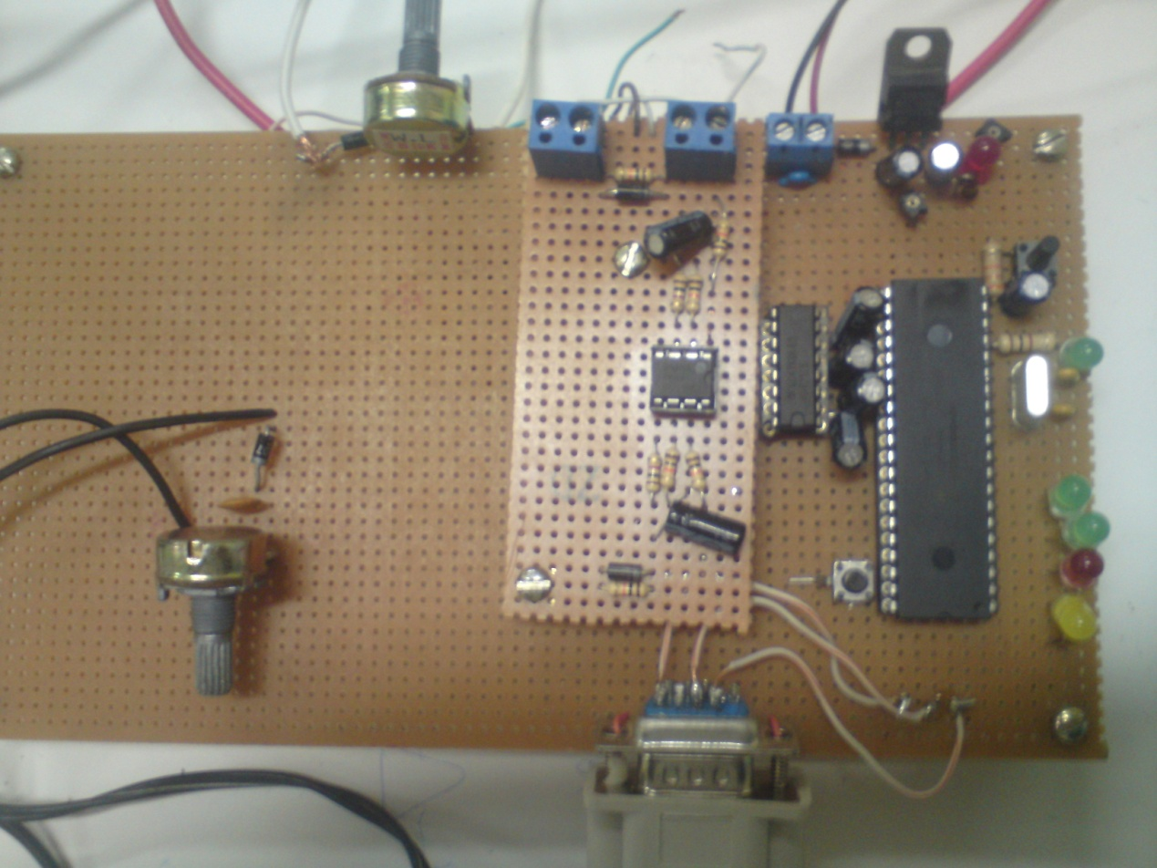

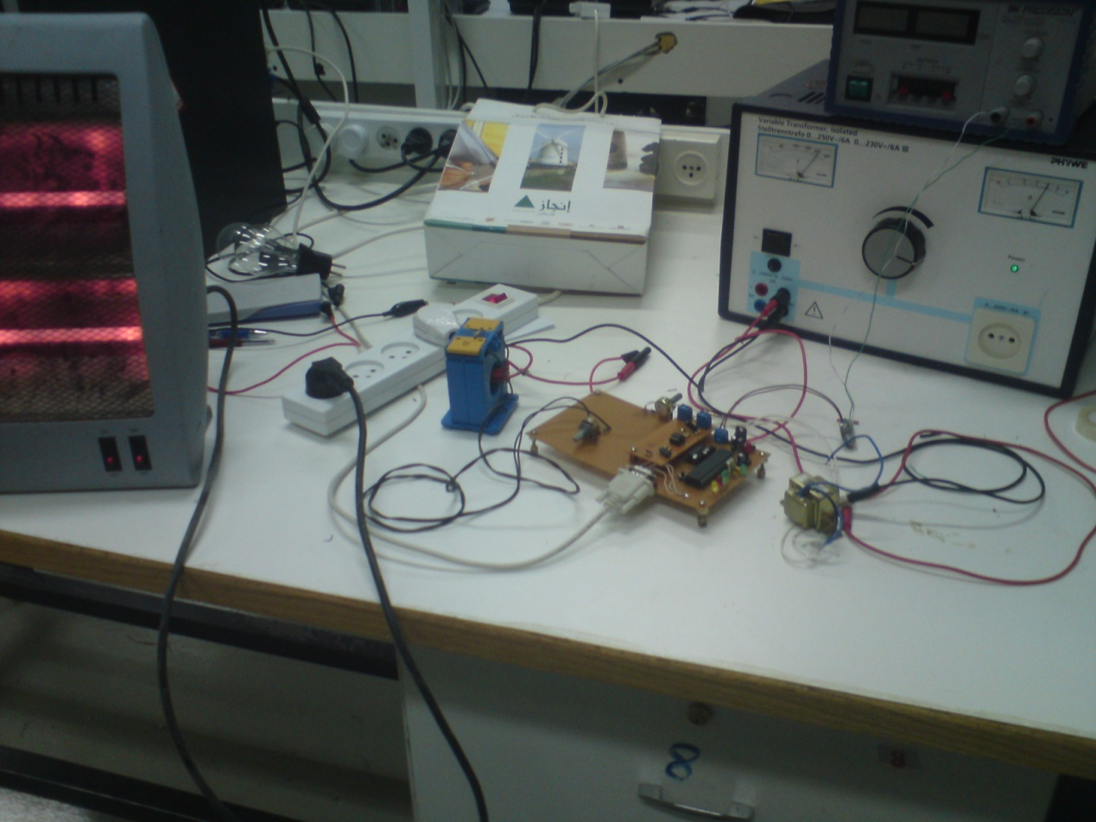

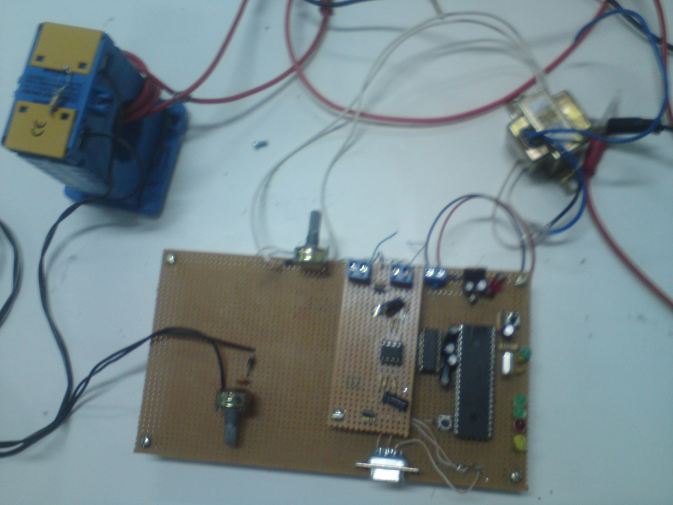

**How to measure the phase shift ?**

We can see from the photo below , that the voltage and current wave divided to many sample , the program work as :

Read the first sample from the voltage waveform and Compares them with earlier old if it greater take it , if not take the next sample , then the taken sample compare with the next sample if less read the next sample if not then this sample is the max sample ,save it as maximum value of voltage and start timer .

Same thing to current , when reach the maximum value of current take the sample and stop timer .

So, the time measured which can be calculated the power factor , and from the sample we can also calculate the value of input current and voltage .

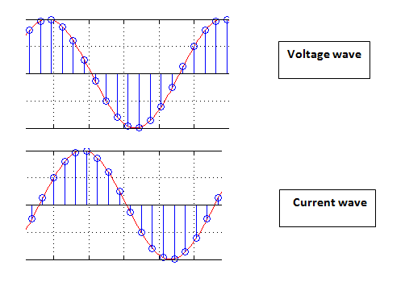

***The performance of program :***

After calculated the current , voltage and phase shift . the value of Qc added depend them , but this not the end of program , the load is changing , then we need to add another capacitor if the power factor less than 0.92 or separated capacitor if the power factor greater than 0.96 .how we do that?

We want to save the value of the capacitor on the output pin of PIC , and we check the power factor every 30 minutes then chick if the power factor decrease add the smallest capacitor then calculate P.F if still less 0.92 , add another capacitor gradually until the P.F reach 0.95 , the value of capacitor can written on the output pin of PIC as 4 bit binary

* First bit : 50 VAR
* Second bit : 100 VAR
* Third bit : 200 VAR
* Forth bit : 400 VAR

Then the principle become easy as if the power factor decrease add (0001) to the save capacitor . And if the power factor increase mines (0001)

***6.4 The flow chart :***

Voltage data

Current data

Divided it to sample

Read voltage sample

V(i)

V(i)>V(i-1)

No

yes

V(i)>V(i+1)

yes

i=i+1

No

Start timer

Read current sample

I(i)

No

yes

I(i)>I(i-1)

I(i)>I(i+1)

yes

No

i=i+1

Stop timer

Calculate:

Phase shift

Voltage ,current, Real power reactive power (Qc) .

Save output capacitor as binary

check

P.F < 0.92

yes

No

P.F >0.96

yes

No

Add 0001 to saved capacitor

Minus 0001 from saved capacitor

Calculate new:

Phase shift

Current , reactive power (Qc)

Delay

30 minutes

***6.5 The result :***

* **First experiment :**

The shape of input

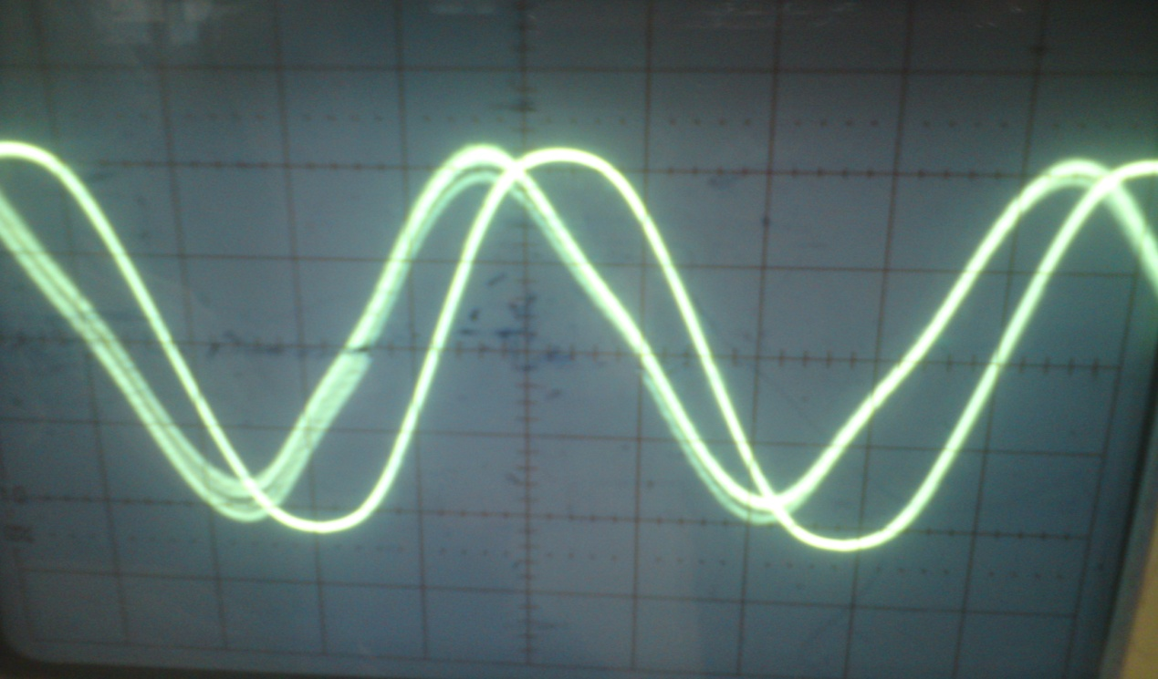

The output

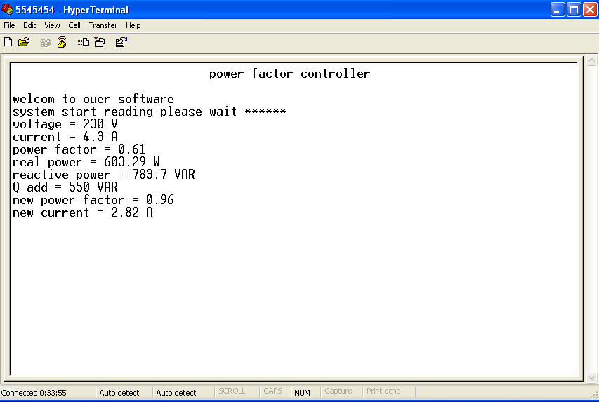

* **Second experiment** :

The shape of input

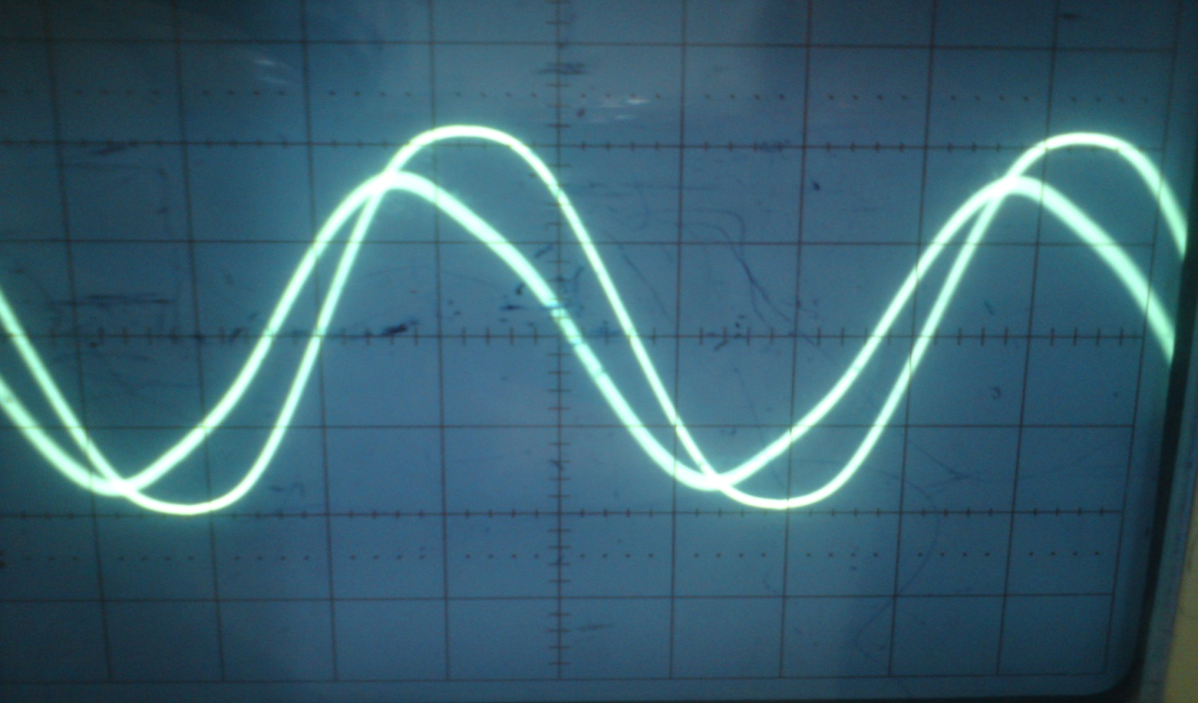

The out put

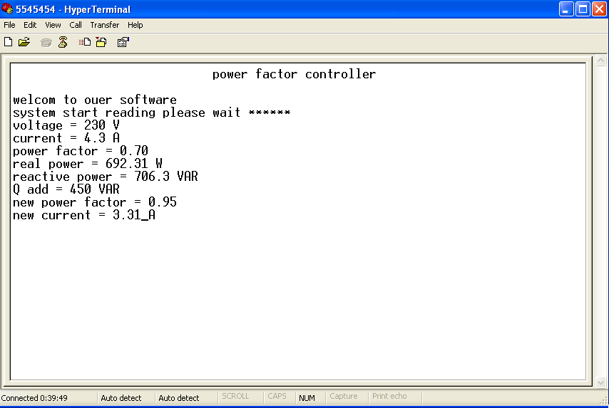

***6.6 The code:***

#include "D:\project's\picc\liala GP -code00\code00.h"

void main()

{

int x=0;

int y=0; // input arrangments

int z=0;

int count0=0;

long G1=0;

long V1=0;

long I1=0;

float G=0.0;

float V=0.0;

float I=0.0;

setup_adc_ports(AN0_AN1_AN3);

setup_adc(ADC_CLOCK_INTERNAL);

setup_psp(PSP_DISABLED);

setup_spi(FALSE);

setup_timer_0(RTCC_INTERNAL|RTCC_DIV_1);

setup_timer_1(T1_DISABLED);

setup_timer_2(T2_DISABLED,0,1);

setup_comparator(NC_NC_NC_NC);

setup_vref(FALSE);

printf(" Wellcome To My Software \n");

restart_wdt();

// TODO: USER CODE!!

while(true){

if(!input(pin_B0)){

x=1;

printf("The G value : ");

printf("\n");

}

else x=0;

//---------------------------------------

if(!input(pin_B1)){

y=1;

printf("The V and I points :");

printf("\n");

}

else y=0;

//---------------------------------------

if(!input(pin_B2)){

printf("END");

printf("\n");

reset_cpu();

}

// ----------------- code for G.value ------------------

if(x==1){

set_adc_channel(0);

delay_ms(10);

G1=read_adc();

delay_us(100);

G=(float)(G1*5)/1023;

delay_ms(10);

G=G/0.00459;

printf("G = %f " G);

printf("\n");

x=0;

z=1;

}

else x=0;

//--------------------------- end G. code ---------------

//------------------- V,I points code -------------------

while(y==1&&z==1){

set_adc_channel(1);

delay_ms(10);

V1=read_adc();

delay_us(100);

V=(float)(V1*5)/1023;

time = set_timer0();

delay_us(10);

printf(" V %d = %f " count0,V);

printf("\n");

delay_us(100);

restart_wdt();

set_adc_channel(3);

delay_ms(10);

I1=read_adc();

delay_us(100);

I=(float)(I1*5)/1023;

time = get_timer0();

delay_us(10);

printf(" I %d = %f " count0,I);

printf("\n");

delay_us(100);

if(!input(pin_B2)){

y=0;

z=0;

printf("END");

}

}

p.f=((360*time)/6.28);

printf("%f".p.f);

p=Vi*Ii*cos(p.f);

Q=Vi*Ii*sin(p.f);

Qc=P(tan(time)-0.3278));

if(Qc<=100){

output_b(0x00);

}

else if(Qc<150){

output_b(0x02);

}

else if(Qc<200){

output_b(0x03);

}

else if(Qc<250){

output_b(0x04);

}

else if(Qc<300){

output_b(0x04);

}

else if(Qc<350){

output_b(0x06);

}

else if(Qc<4000){

output_b(0x07);

}

else if(Qc<450){

output_b(0x08);

}

else if(Qc<500){

output_b(0x09);

}

else if(Qc<550){

output_b(0x0a);

}

else if(Qc<6000){

output_b(0x0b);

}

qin =Qc;

if(p.f<0.92){

#add Qc,1;

}

if(p.f>0.96){

#sub Qc,1;

}

Inw=((squre(P^2+(Q-Qc)^2))/Vi);

printf("%f",Inw);

p.fn=(P/(Q-Qc));

printf("%f",p.fn);

restart_wdt();

t---------------- END calculation code ---------------

restart_wdt();

}

}

**References :-**

1. Azzoun municipality , Al-Nabi Elyas Council .
2. [Sources of Energy](http://www.cbc.ca/news/background/energy/sources.html), CBC News Online, 20-May-2004
3. [Electricity around the world](http://users.telenet.be/worldstandards/electricity.htm), Conrad H. McGregor, April 2010
4. [What are amps, watts, volts and ohms?](http://science.howstuffworks.com/question501.htm), HowStuffWorks.com, 31 October 2000. Last accessed: 27 June 2010
5. Marshall Brain, "[How Power Grids Work](http://science.howstuffworks.com/environmental/energy/power.htm)", howstuffworks.com, 1st of April 2000.
6. [Practical Applications of Electrical Conductors](http://www.scribd.com/doc/26247685/Practical-Applications-of-Electrical-Conductors), Stefan Fassbinder, Deutsches Kupferinstitut, January 2010.
7. <http://en.wikipedia.org/wiki/Electric_power_system>
8. <http://www.opamp-electronics.com/tutorials/energy_losses_2_09_09.htm>
9. <http://www.esat.kuleuven.be/electa/publications/fulltexts/pub_1080.pdf>
10. <http://en.wikipedia.org/wiki/Amorphous_metal_transformer>
11. <http://www.leonardo-energy.org/energy-saving-reducing-no-load-loss-distribution-transformers>
12. <http://www.energyvortex.com/energydictionary/high_voltage_transmission_lines.htm>
13. <http://en.wikipedia.org/wiki/Power_factor>
14. <http://home.earthlink.net/~jimlux/hv/pfc.htm>