
An–Najah National University
Faculty of Engineering and
Information Technology

جامعة النجاح الوطنية
كلية الهندسة وتكنولوجيا المعلومات

Graduation Project- ΙI
Modelling of solar radiation potential on Mars using
Artificial Neural Network and determining
solar-temperature belt

By:
Orjowan Abu Najeeb 11316026
Zainab Hnini 11317449

Under supervision of: Dr. Tamer Khatib

Submitted in partial Fulfillment of the requirement for Bachelor degree in Energy and Environmental Engineering

Spring/summer 2018

DEDICATION

We dedicate our work to our creator whom we seek his acceptance in this work. We also dedicate this work to our parents, teachers, friends and everybody who encouraged us to do this research. Special dedication to Jerusalem, which is our source of motivation.

ACKNOWLEGEMENT

We would like to thank everyone who helped us in our search. A special gratitude we give to our supervisor Tamer Khatib. We also acknowledge Ehouarn Millour, France and Viorel Badescu, Romania who provided us with the needed data for our research. Finally, we thank An-Najah National University with all staff.

Table of Contents

ABSTRACT IX
1. INTRODUCTION 1
1.2 Extraterrestrial solar radiation 2
1.3 Optical depth and terrestrial radiation 3
2. METHODOLOGY: Modeling Solar Radiation using ANN 6
2.1 Collecting data 7
2.2 Pre-processing data 8
2.3 Building the network 9
2.4 Training the network 9
2.5 Testing the network 9
2.6 Using ANN for choosing the best location for Solar systems 9
3. RESULTS AND DISCUSSION 10
3.1 Network optimization 10
3.2 Best locations for solar systems 12
4. CONCLUSION AND RECOMMENDATIONS 14
APPENDICES
APPENDIX-A 16
APPENDIX-B 39
REFERENCES 40

Table of Figures

Figure 3.1: Relation between predicted and actual values for monthly mean instantaneous solar radiation for the first month as plotted by Matlab 11
Figure 3.2: Plot for solar radiation vs. number of iterations as plotted by Matlab for the first month. Blue curve presents actual radiation and red curve presents predicted radiation 11
Figure 3.3: Representation of mean solar radiation on Mars Map for the first Martian month. The legend shows values in W/m² 14
Figure 3.4: Representation of mean temperature on Mars Map for the first Martian month. The legend shows values in K 14
Figure 5: Relation between predicted and actual values for monthly mean instantaneous solar radiation for the second month as plotted by Matlab 16
Figure 6: Relation between predicted and actual values for monthly mean instantaneous solar radiation for the third month as plotted by Matlab 16
Figure 7: Relation between predicted and actual values for monthly mean instantaneous solar radiation for the fourth month as plotted by Matlab 17
Figure 8: Relation between predicted and actual values for monthly mean instantaneous solar radiation for the fifth month as plotted by Matlab 17
Figure 9: Relation between predicted and actual values for monthly mean instantaneous solar radiation for the sixth month as plotted by Matlab 18
Figure 10: Relation between predicted and actual values for monthly mean instantaneous solar radiation for the seventh month as plotted by Matlab 18
Figure 11: Relation between predicted and actual values for monthly mean instantaneous solar radiation for the eighth month as plotted by Matlab 19
Figure 12: Relation between predicted and actual values for monthly mean instantaneous solar radiation for the ninth month as plotted by Matlab 19
Figure 13: Relation between predicted and actual values for monthly mean instantaneous solar radiation for the tenth month as plotted by Matlab 20
Figure 14: Relation between predicted and actual values for monthly mean instantaneous solar radiation for the eleventh month as plotted by Matlab 20
Figure 15: Relation between predicted and actual values for monthly mean instantaneous solar radiation for the twelfth month as plotted by Matlab 21
Figure 16: Plot for solar radiation vs. number of iterations as plotted by Matlab for the second month. Blue curve presents actual radiation and red curve presents predicted radiation 21
Figure 17: Plot for solar radiation vs. number of iterations as plotted by Matlab for the third month. Blue curve presents actual radiation and red curve presents predicted radiation 22
Figure 18: Plot for solar radiation vs. number of iterations as plotted by Matlab for the fourth month. Blue curve presents actual radiation and red curve presents predicted radiation 22
Figure 19: Plot for solar radiation vs. number of iterations as plotted by Matlab for the fifth month. Blue curve presents actual radiation and red curve presents predicted radiation 23
Figure 20: Plot for solar radiation vs. number of iterations as plotted by Matlab for the sixth month. Blue curve presents actual radiation and red curve presents predicted radiation 23
Figure 21: Plot for solar radiation vs. number of iterations as plotted by Matlab for the seventh month. Blue curve presents actual radiation and red curve presents predicted radiation 24
Figure 22: Plot for solar radiation vs. number of iterations as plotted by Matlab for the eighth month. Blue curve presents actual radiation and red curve presents predicted radiation 24
Figure 23: Plot for solar radiation vs. number of iterations as plotted by Matlab for the ninth month. Blue curve presents actual radiation and red curve presents predicted radiation 25
Figure 24: Plot for solar radiation vs. number of iterations as plotted by Matlab for the tenth month. Blue curve presents actual radiation and red curve presents predicted radiation 25
Figure 25: Plot for solar radiation vs. number of iterations as plotted by Matlab for the eleventh month. Blue curve presents actual radiation and red curve presents predicted radiation 26
Figure 26: Plot for solar radiation vs. number of iterations as plotted by Matlab for the twelfth month. Blue curve presents actual radiation and red curve presents predicted radiation 26
Figure 27: Mean Solar Radiation distribution for the first Martian month 27
Figure 28: Mean Solar Radiation distribution for the second Martian month 27
Figure 29: Mean Solar Radiation distribution for the third Martian month 28
Figure 30: Mean Solar Radiation distribution for the fourth Martian month 28
Figure 31: Mean Solar Radiation distribution for the fifth Martian month 29
Figure 32: Mean Solar Radiation distribution for the sixth Martian month 29
Figure 33: Mean Solar Radiation distribution for the seventh Martian month 30
Figure 34: Mean Solar Radiation distribution for the eighth Martian month 30
Figure 35: Mean Solar Radiation distribution for the ninth Martian month 31
Figure 36: Mean Solar Radiation distribution for the tenth Martian month 31
Figure 37: Mean Solar Radiation distribution for the eleventh Martian month 32
Figure 38: Mean Solar Radiation distribution for the twelfth Martian month 32
Figure 39: Mean temperature distribution for the first Martian month 33
Figure 40: Mean temperature distribution for the second Martian month 33
Figure 41: Mean temperature distribution for the third Martian month 34
Figure 42: Mean temperature distribution for the fourth Martian month 34
Figure 43: Mean temperature distribution for the fifth Martian month 35
Figure 44: Mean temperature distribution for the sixth Martian month 35
Figure 45: Mean temperature distribution for the seventh Martian month 36
Figure 46: Mean temperature distribution for the eighth Martian month 36
Figure 47: Mean temperature distribution for the ninth Martian month 37
Figure 48: Mean temperature distribution for the tenth Martian month 37
Figure 49: Mean temperature distribution for the eleventh Martian month 38
Figure 50: Mean temperature distribution for the twelfth Martian month 38

Table of Tables

Table 3.1: Correlation coefficients for neural network 12

ABSTRACT

Missions to the planet Mars need a power source. One of the most compatible sources is photovoltaic system. Because photovoltaic systems are based on exploiting energy from the sun, solar radiation intensity should be known for design. In this study, feed-forward back-propagation artificial neural network(ANN) was used to predict solar radiation according to longitude, latitude, time of the day, temperature, altitude, pressure, amount of dust and volume mixing ratio of water ice clouds. Data used in the model was obtained from Mars Climate Database. Fitness between predicted and actual values of solar radiation indicates that feed-forward back-propagation ANN was an accurate method for prediction compared to other methods. The minimum correlation coefficient for testing the network was 0.97. This model was used to predict mean solar radiation and mean temperature for every location on Mars and then the data was presented on Mars maps in order to determine the best location for harvesting energy from the sun by using photovoltaic power systems. The radiation-temperature belt on Mars was decided to be between latitudes 20°S and 15°N.

INTRODUCTION

1.1 Background
Exploring Mars needs a power source to power Mars exploration vehicles. Most of space missions are powered either by nuclear energy or solar energy. Current work nowadays is focusing on exploiting energy from the sun using concentrating or non-concentrating techniques. Solar radiation on Mars is affected by Mars-sun distance and rotation, Martian atmospheric properties and topography of the surface of the planet.
To study photovoltaic systems, we need to model solar radiation, temperature, and surrounding weather conditions. In this study, we are focusing on solar radiation as a basic factor that influences photovoltaic systems operation. Appelbaum and Flood (1990) set an equation to calculate solar radiation. The problem with his equation is that he was not able to give an explicit relation between solar radiation and weather conditions. Badescu (2001) developed a simple relationship between a parameter called optical depth which is correlated with solar radiation and various meteorological parameters. The accuracy of these relations is not good as the author stated. Another model for optical depth calculation is stated in (Appelbaum et al., 1993), where optical depth is calculated only during dust storms. Because of the complexity of the relation between solar radiation and other parameters, we used Artificial Neural Network (ANN) to model and predict solar radiation depending on previous data. Many models were developed for prediction of solar radiation on Earth using ANN as in Saudi Arabia in (Mohandes et al., 1998) and (Rehman and Mohandes, 2009), Malaysia in (Khatib et al., 2012) and (Kadirgama et al., 2014), and Turkey (Sözen et al., 2004).
The most suitable places for photovoltaic systems on Mars in terms of solar radiation and in terms of temperature have to be specified in order to help choose the best habitable place and the best place for exploration landers. Golombek et al. (2003) explain that one of the constraints for choosing landing sites for rovers is latitude (from 10° north to 15° south) for maximum solar power. On Earth, sun belt region is the place around equator that has mean solar radiation above 200 W/m² and is located between latitudes 35°S and 35°N. However, equatorial regions are not the most suitable area for the operation of PV systems because of the frequent existence of clouds. Therefore, sub-equatorial regions are more suitable. Similar to Earth, Mars belt can be determined mainly by solar radiation, but not only. Surrounding temperature is also an important parameter for choosing the best location for the Martian photovoltaic belt. In our work we will use both constraints: mean solar radiation intensity and mean temperature to determine the photovoltaic belt.
The first successful mission to Mars was in 1964 when Mariner 3 carried the first flybys of Mars. In 1976, the first spacecraft named Viking Lander 1 landed safely on the surface of Mars, followed by Viking Lander 2. Missions to Mars continued, but we will mention the main fly-by probes, orbiters and landers which the collected data in our research had been collected from. Mars Global Surveyor arrived in 1997, Mars Odyssey arrived in 2001, Mars Reconnaissance Orbiter arrived in 2006 (NASA, 2017).
The atmosphere of Mars is very thin with density of 0.02 kg/m³, about 1% of the density of atmosphere on Earth. It consists mainly of dust particles, water ice clouds and gas molecules with percentages 95.32% carbon dioxide, 2.7% nitrogen, 1.6% argon, 0.13% oxygen, 0.08% carbon monoxide and minor amounts of water, nitrogen oxide, neon, hydrogen-deuterium-oxygen, krypton and xenon. Atmospheric pressure of Mars varies from 4.0 to 8.7 mb depending on the season. Average atmospheric temperature is -63 ℃ and ranges between -140 to 20 ℃.(Williams, 2016)
Unlike Earth, dust on Mars exists in big amounts that should be considered when studying any issue related to the atmosphere of Mars. Because of generally very low temperatures on Mars, ice clouds exist in the atmosphere. Variation in atmospheric temperatures, CO₂ sublimation and ice clouds cycle makes the atmosphere dynamic.
The intensity of solar radiation on the surface of Mars depends on Mars-Sun distance, areocentric longitude, zenith angle of the sun, atmospheric properties, properties of the surface, position of the planet and time of the day.

1.2 Extraterrestrial solar radiation
Kepler's first law states that the orbit is an ellipse with the sun at one of the two foci. The Mars –sun distance is given by the equation (Appelbaum and Flood, 1990):
$r=\frac{a(1-e^{2})}{1+ecosӨ} ( SEQ Equation \backslash * ARABIC 1.1)$
a: Mars semi major axis and equals 1.5236915AU.
e: Mars eccentricity ≈0.093377.
$Ө$: true anomaly given by $Ө$=$L_{s}-248˚$ .
$L_{s}$: areocentric longitude.
$248˚$: areocentric longitude of mars perihelion.
Eccentricity of Mars results in a variation of intensity of solar radiation of about 19% lower or higher in the course of one year (Matz et al., 1998).
The mean beam insolation at the top of Martian atmosphere is 590 W\$m^{2}$.(Appelbaum and Flood, 1990) found an equation to calculate instantaneous extraterrestrial radiation given by:
$$G_{0}=\frac{590{[1+ecos\left(L_{s}-248˚ \right)]}^{2}}{(1-e^{2})} ( 1. SEQ Equation \backslash * ARABIC 2)$$

(Vicente-Retortillo et al., 2015), used the following expression to determine extraterrestrial solar radiation:
$E=E_{m}$[ sin ɛ sin $L_{s}$sin ϕ + (1-sin² ɛ sin² $L_{s}$)^{1/2} × cos ϕ cos 2πt/p ] [ 1+$\frac{e\cos\left(L_{s}-L_{sp}\right)}{(1-e^{2})}$ ]² (1.3)
Where $E_{m}$is the spectral irradiance at the mean distance between the sun and Mars(1.52 AU), $e$ = 0.0934 is the eccentricity of the orbit of Mars, $L_{sp}$ = 251° is the solar longitude at the perihelion, ɛ = 25.2° is the Martian obliquity, p = 88775 is the length of a sol (Martian day), ϕ is the latitude, t is the time measured in seconds from local noon.

1.3 Optical depth and terrestrial radiation
The atmospheric optical depth is an indicator of solar radiation attenuation in the atmosphere (Badescu, 2001).
Bee’s law gives the exponential relation between extraterrestrial and terrestrial radiation by:
$\frac{I_{gruond }}{I_{Top}}$= $e^{τ/cosθz}$ (1. 4)

Where $τ$ is the atmospheric optical depth.
$θz$: zenith angle.
$I_{gruond }$: solar radiation at the surface of Mars.
$I_{Top}$: solar radiation at the top of atmosphere.

The most important factors that influence the variation in optical depth are gases, dust and ice clouds. The main gas is CO₂, which emits and absorbs radiation at 15μm wavelengths in the UV region (Vicente-Retortillo et al., 2015). Absorption and scattering optical depth changes with wavelength of the radiation (Vicente-Retortillo et al., 2015).
The role of dust in atmosphere is reduction and selection by absorption and scattering during clear or dusty days (Vicente-Retortillo et al., 2015). It increases the infrared atmospheric heat flux and absorbs radiation emitted by the surface (Appelbaum et al., 1993). The amount of dust particles in the atmosphere is not constant, when local and global dust storms occur, it increases depending on intensity, frequency and duration of the storm (Appelbaum and Flood, 1990).
The dust particles sizes that can be lifted by wind are in the range (50-100) μm (Landis and Jenkins, 2002). Wind existence is correlated with dust storms formation (Appelbaum et al., 1993). The sun heats atmosphere and causes convection currents which lifts dust particles up to the atmosphere. Dust particles absorbs energy and heats the atmosphere further. As heating process continues, dust storms develops (Gierasch and Goody, 1972). Dust optical depth has the highest values in the source regions, where global dust storms begin (Appelbaum et al., 1993). Global dust storm occurs in perihelion one or two times a year, and sometimes it does not occur. Local dust storms occur approximately at all latitudes and times of the year, and most frequently between latitudes 10° to 20° north and 20° to 40° south (Appelbaum and Flood, 1990).
Optical depth is maximum during the northern autumn and winter due to global dust storms and it is minimum during northern spring and summer (Appelbaum and Flood, 1990). At sunrise and sunset, optical depth values are low. The morning values are higher than afternoon values because of the existence of fog and water ice hazes in the atmosphere in the morning (Badescu, 2001).
Water ice clouds have a radiative effect that plays an essential role in Mars climate. Water ice clouds warm the atmosphere during the day because of the absorption of infrared radiation, and cool it during night by infrared cooling. That causes changes in the temperature gradient of the atmosphere. Radiative effects of water ice clouds depend on the scattering properties of ice particles which depends mainly on particle size, and it changes with the growth of ice crystals. Water ice absorption optical depth values range from 0 to 0.2. Most values are larger near the equator (Madeleine et al., 2012). The Equatorial Cloud Belt (also referred to “the Aphelion Cloud Belt’) occurs during spring and summer and covers the equatorial regions between 10°S and 30° north. Thick clouds form along the flacks of the major volcanoes. It is formed during the day where moisture is carried in upslope flows, and it is cooled adiabatically. Its opacity is higher than 0.5 in the visible.
First calculation of optical depth was obtained in 1976 when cameras on Viking Lander 1 and Viking Lander 2 measured direct solar radiation (Badescu, 2001). Because data of optical depth are less available, models relating optical depth with other meteorological data are needed. (Badescu, 2001) used least square and linear methods to make a relation between optical depth and ambient temperature, pressure and areocentric longitude. The relation with pressure was directly proportional, but with temperature was inversely proportional. No obvious relation was obtained between areocentric longitude or local solar time and optical depth.
Another model was developed by (Appelbaum et al., 1993) with the first and second global dust storms in 1977 at altitudes -30° and -10° at times L_{s} = 215° and L_{s} = 295° respectively. The model is based on the assumption that the variation of dust in the atmosphere depends on the local and global dust storms intensity and location where the dust storm is originated, referred to as ‘source area’. His model calculates optical depth only during dust storms and assumes that the least value of optical depth is 0.5.
Terrestrial insolation is affected by zenith angle, optical depth and albedo. Because of the high effect of atmospheric components, diffused radiation has a high percentage of the surface solar radiation and during high optical depth seasons, it is more than direct radiation.
Many researchers have developed models for calculating terrestrial solar radiation (Appelbaum et al., 1993) sat an equation for global solar radiation on horizontal surface:
$G_{H}=G˳\cos{θz\frac{f\left(θz,τ,a\right)}{1-a}}$ (1.5)
Where $G˳$is the beam irradiance at the top of the Martian atmosphere
$f\left( θz,τ,a\right)$ is the normalized net flux function
$τ$ is the optical depth of the atmosphere
$a$ is the albedo
$θz$ is the angle between direct solar radiation and the perpendicular to the surface.
The problem with this model is that there is no clear way to calculate the normalized net flux function.

METHODOLOGY: Modeling Solar Radiation using ANN
Artificial Neural Network is an excellent tool to handle non-linear function approximation (Tymvios et al., 2008). Neural Networks learn to solve a problem rather than being programmed to do so. Learning is achieved through training (Khatib et al., 2012). An ANN consists of many interconnected identical processing units called neurons (Mohandes et al., 1998). A neuron is the artificial imitation of the human neural cell. It is designed to respond to the applied inputs and to behave consistently (Tymvios et al., 2008). Each neuron computes a weighted sum of its n input signals x. For j = 1, 2, ……, n, and then applies a nonlinear activation function to produce an output signal y.
y = φ[$\sum_{j=1}^{n}{ }$w_{j} x_{j}] (1.6)
where φ is the activation function, w_{j} is the weight for the specific input (Mohandes et al., 1998). The weights are adjusted during the training process to achieve the desired input/output radiation of the network (Rehman and Mohandes, 2009).
ANN use the help of special training algorithms referred as learning rules (Tymvios et al., 2008). The network consists of an input layer, some hidden layers and an output layer. The nodes in the hidden layer are important to implement the nonlinear mapping between the input and output patterns (Kadirgama et al., 2014).
In this research, a model for solar radiation on Mars was designed using Feed-Forward Back-propagation Artificial Neural Network. It is a supervised training rule with multilayer network in which the network weights are moved along the negative of the gradient of the mean square error to minimize the difference between predicted and actual value(Fadare, 2009).

2.1 Collecting data
Data was obtained from Mars Climate Database (MCD) developed by LMD (Paris), AOPP (Oxford), Dept. Physics & Astronomy (The Open University) and IAA (Granada) with the support of the European Space Agency and the Centre National d’Etudes Spatiales. This data includes scenarios for Mars Years 24 to 32 that contains statistics on temperature, wind, pressure, radiative fluxes and atmospheric composition. (E. Millour and Lewis, 2017)
The major factor which governs the variability in the Martian atmosphere is the amount and distribution of suspended dust because of the variability and since even for a given year the details of the dust distribution and optical properties can be uncertain, multi-annual model integration were carried out for the Mars Climate Database (MCD), assuming various dust scenarios (F. Forget, 2017).
In (MCD), the data sets are based on observations of the Martian atmosphere from April 1999 to July 2013 made by different orbiting instruments: The Thermal Emission Spectrometer (TES) aboard Mars Global Surveyor, The Thermal Emission Imaging System (THEMIS) aboard Mars Odyssey, and the Mars Climate Sounder (MCS) aboard Mars Reconnaissance Orbiter (MRO).
In (MCD), they have access to the daily evolution of Martian Atmospheric dust loading as well as to the daily evaluation of the EUV received at Mars from the sun for Mars years 24 to 31 (earth years 1999 to 2013). The associated outputs correspond to the best representation of the Martian climate over these specific years.
There are 12 mean values (for every month) corresponding to 12 solar times of day (i.e. every 2 hours). The variables we have used in our model are:
Flux surf: solar radiative flux to surface (W\m2).
Temp: Kelvin (atmospheric temperature of altitude 4.5m).
Time: 12 solar times of day (every 2 hours)
Longitude: it from 180 to -180.
Latitude: from -90 to 90.
CO2 column: molecules / cm²
Water ice mixing ratio: mol/mol
Dust mass mixing ratio: kg/kg
Surface pressue: Pa
Atmospheric density: kg/m³
Vertical(up-down) wind: m/s
Altitude: meters

2.2 Pre-processing data
Choosing the input variables should be according to past knowledge from the researcher about the factors that may affect the output of the ANN (Kumar et al., 2015). The inputs used in this model are longitude, latitude, time of the day, temperature, altitude, pressure, amount of dust and volume mixing ratio of water ice clouds. As on Earth, solar radiation differs with longitude and latitude and hour of the day as mentioned in (Badescu, 2009). Temperature of the atmosphere is an indicator of the amount of radiation. Pressure is the best optical depth effective factors during both clear and dusty skies (Badescu, 2001), and so it is predicted to be one of the most influential factor in the model. While dust particles have the major effect on solar radiation, ice clouds have a minor effect. (Madeleine et al., 2012). Altitude of Mars surface affects solar radiation because atmospheric components change with elevation.

2.3 Building the network
We designed feed-forward back propagation network using Matlab. The network consists of three layers: input layer, hidden layer and output layer. There are eight input parameters into the network: longitude, latitude, time of the day, temperature, altitude, pressure, amount of dust and volume mixing ratio of water ice clouds, and one output parameter: solar radiation intensity, as shown in Figure 2.1. The number of neurons was 10. The code is shown in APPENDIX-B.
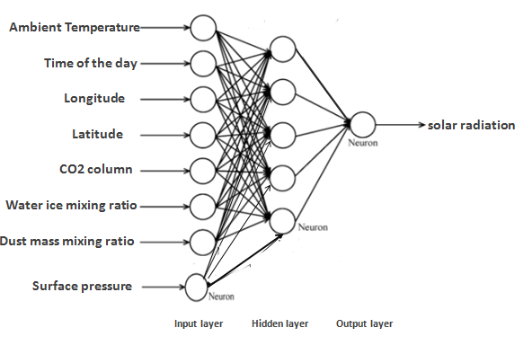
Figure 2.1 Network layers showing eight inputs and one output

2.4 Training the network
We used data for two Martian years 28 and 29 to train the network. For each target and datasets, the number of training datasets is 75264 for each input. We have applied the model for 12 Martian months. Maximum number of iterations is 100.

2.5 Testing the network
We used the data for the Martian year 30 to test the network’s performance. The number of testing values is 37632. The performance of the network is measured by correlation coefficient between the predicted(output) and actual(target) in order to determine the prediction efficiency.

2.6 Using ANN for choosing the best location for Solar systems
To determine the potential habitability of a location on Mars, science objective and engineering parameters should be defined as elevation, latitude, wind and rock abundance to determine acceptable surface and atmospheric habitability (Grant et al., 2011). In our work, we are concerned in best locations for solar systems only. Latitude is a constraint in choosing landing sites for rovers for maximum solar power. Low elevations are also chosen in order to have a thick atmosphere in that site to deploy the parachute for landing (Golombek et al., 2003). For our work, we may need the opposite. Because concentration of dust particles at high altitudes is less, solar radiation is expected to be higher at high altitudes. Solar cell degradation in performance due to dust deposition is 28% per Martian day over the initial 30 Martian days of the landed mission(Landis and Jenkins, 2002). Because of lifetime requirements, solar panel efficiency degradation due to dust accumulation, and low temperatures, the landing site latitude location is 15° South to 10° north for Mars exploration rovers. Near the subsolar latitude sites (where the sun strikes the surface of earth with 90° angle) receive more solar radiation (Golombek et al., 2003).

In our research, we presented daily mean solar radiation and daily mean temperature on maps for Mars we obtained from(NASA, 2000). Data for temperature and solar radiation was available from the model we developed for 12 hours along the day. We summed the 12 values and divided them by the total 12 hours, even though there are zero values of radiation during night.
To choose the most suitable location for solar systems we have chosen that the radiation must be above 200 W/m² and the temperature must be above 190 K for the operation of electronics and semiconductors.

RESULTS AND DISCUSSION

Network optimization
Table 3.1 shows the correlation coefficient (R-value) between the predicted and the actual values for monthly mean instantaneous solar radiation for 12 months. The minimum values of R are 0.97048, 0.96976, 0.97009, 0.97031 for training, validation, testing and whole dataset. These values of R indicate that the accuracy is very good. Figure 3.2 shows the relation between the predicted and the actual values for monthly mean instantaneous solar radiation for the first month. The rest of months are shown in the Figures 6-16 in APPENDIX-A. Figure 3.3 shows that the predicted values fit well with the actual dataset. See also Figures 17-27 in APPENDIX-A.
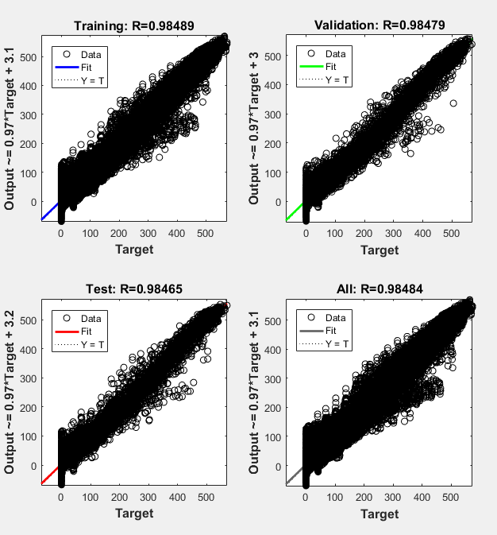
Figure 3.1 Relation between predicted and actual values for monthly mean instantaneous solar radiation for the first month as plotted by Matlab
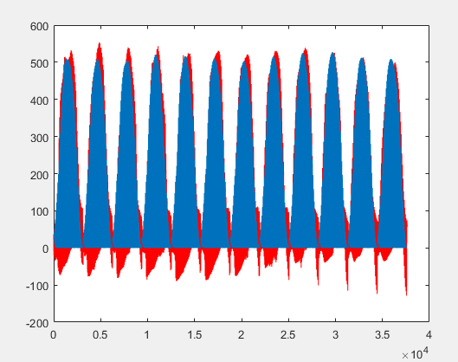
Figure 3.2 Plot for solar radiation vs. number of testing datasets as plotted by Matlab for the first month. Blue curve presents actual radiation and red curve presents predicted radiation

Table 3.1 Correlation coefficients for neural network
Month | Correlation coefficient (R-value)
Month | Training | Validation | Testing | All
1 | 0.98489 | 0.98479 | 0.98465 | 0.98484
2 | 0.98428 | 0.98571 | 0.98505 | 0.98461
3 | 0.98956 | 0.98925 | 0.98932 | 0.98948
4 | 0.98026 | 0.9801 | 0.98011 | 0.98021
5 | 0.97923 | 0.97927 | 0.9785 | 0.97913
6 | 0.98453 | 0.98536 | 0.98524 | 0.98476
7 | 0.99075 | 0.99041 | 0.99 | 0.99059
8 | 0.97048 | 0.96976 | 0.97009 | 0.97031
9 | 0.98435 | 0.98437 | 0.98471 | 0.98441
10 | 0.997248 | 0.9728 | 0.97163 | 0.9724
11 | 0.98212 | 0.98139 | 0.9826 | 0.98208
12 | 0.9861 | 0.98618 | 0.98591 | 0.98608

3.2 Best locations for solar systems
The Martian year begins at the vernal equinox with Northern spring. During the first Martian month, the mean solar radiation has higher values approximately between latitudes 25°S to 20°N as shown in Figure 3.4. Figures for the rest of months are shown in Figures 28-39 in APPENDIX-A. There is a shift in the second month in the area of high solar radiation towards the northern hemisphere between latitudes 5°S and 60°N. During the third month, the mean solar radiation has higher values approximately between latitudes 0° and 65°N. In the fourth month, summer season begins and solar radiation concentration shifts further towards north and it is between latitudes 10°N and 90°N. In the fifth month, the area of high concentration of solar radiation is approximately between latitudes 0° to 85°N. After that, the shift is back to the southern hemisphere and the concentration of solar radiation in the sixth Martian month is between latitudes 15°S to 55°N. Then with the beginning of northern autumn, dust storm period begins and continues during the rest of the year. Solar radiation concentrations in the seventh, eighth and ninth Martian months are between latitudes 50°S to 30°N, 60°S to 0 and 90°S to 0°. Winter begins in the tenth month which, in general, has lower Solar radiation than other months and the area of concentration of solar radiation is approximately between latitudes 90°S to 30°S. The eleventh month has the concentration area approximately between latitudes 70°S to 0°, and the twelfth, when dust storm period ends, has the concentration area approximately between latitudes 50°S to 30°N. Therefore, the solar radiation belt for the planet Mars is approximately between 25°S to 30°N.
To determine the temperature belt of Mars we followed the same way we used above for determining the solar radiation belt. In the first Martian month, Figure 3.5 shows that the mean temperature values are very low, but there are small regions that have the desired mean temperature. Figures for the rest of the months are shown in Figures 40-51 in APPENDIX-A. In the second, third, fourth, fifth, sixth Martian months most areas that have higher mean temperature values are in the northern hemisphere but in the seventh, eighth, ninth, tenth, eleventh, twelfth Martian months the most areas that have higher mean temperature are in the southern hemisphere. Therefore, the temperature belt of Mars is between latitudes 20°S to 15°N.
Radiation-temperature belt is determined by the intersect of radiation belt and temperature belt. As a result, radiation-temperature belt on Mars is between latitudes 20°S and 15°N.
In the first, second and twelfth month, the area between longitudes 180° and 240° has low solar radiation but high temperatures. However, there are areas with low mean temperature around longitude 0° in some months in spite of high mean solar radiation. This may be due to dust. As mentioned before, dust decreases the amount of insolation and increases temperature of the atmosphere.
Mean atmospheric temperatures are higher in the southern hemisphere than in northern hemisphere. An expected explanation for this is that the dust clouds in the southern hemisphere are more than in the northern hemisphere as measured by Viking Orbiter Infrared Thermal Maper, Viking Orbiter VIS data and historical record of dust clouds occurrence observed from telescopes on Earth(Appelbaum et al., 1993).
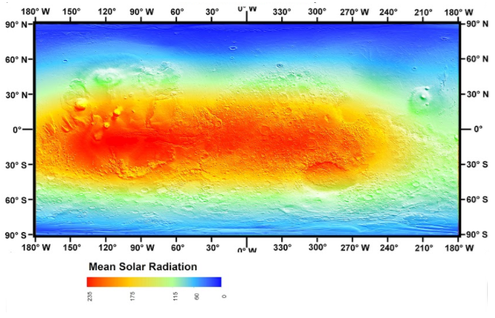
Figure 3.3 Representation of mean solar radiation on Mars Map for the first Martian month. The legend shows values in W/m²

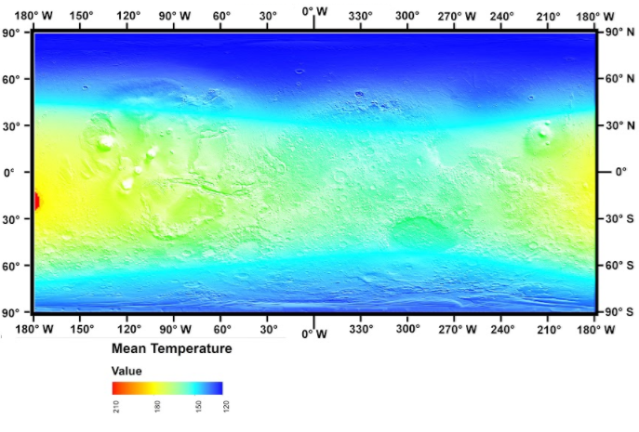
Figure 3.4 Representation of mean temperature on Mars Map for the first Martian month. The legend shows values in K

CONCLUSION AND RECOMMENDATIONS

A new model for prediction of solar radiation using Artificial Neural Network was developed. Results indicate that the model is accurate for prediction of solar radiation. The inputs used in this model are longitude, latitude, time of the day, temperature, altitude, pressure, amount of dust and volume mixing ratio of water ice clouds. We used this model to predict mean solar radiation and mean temperature for all locations on Mars and presented these predictions on maps in order to determine the radiation-temperature belt. The belt is located between latitudes 20°S to 15°N.

APPENDICES APPENDIX-A
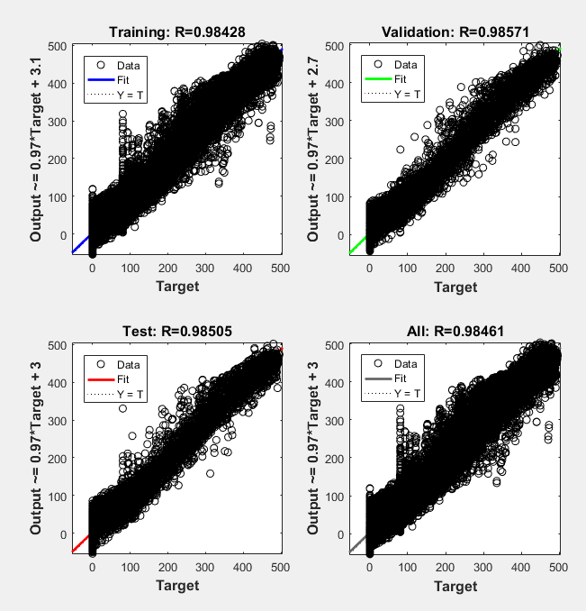
Figure 5 Relation between predicted and actual values for monthly mean instantaneous solar radiation for the second month as plotted by Matlab
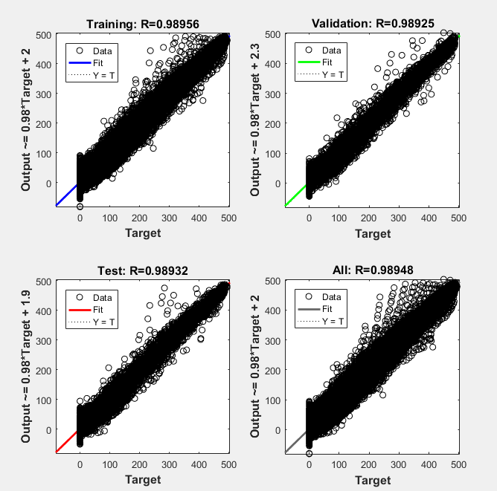
Figure 6 Relation between predicted and actual values for monthly mean instantaneous solar radiation for the third month as plotted by Matlab
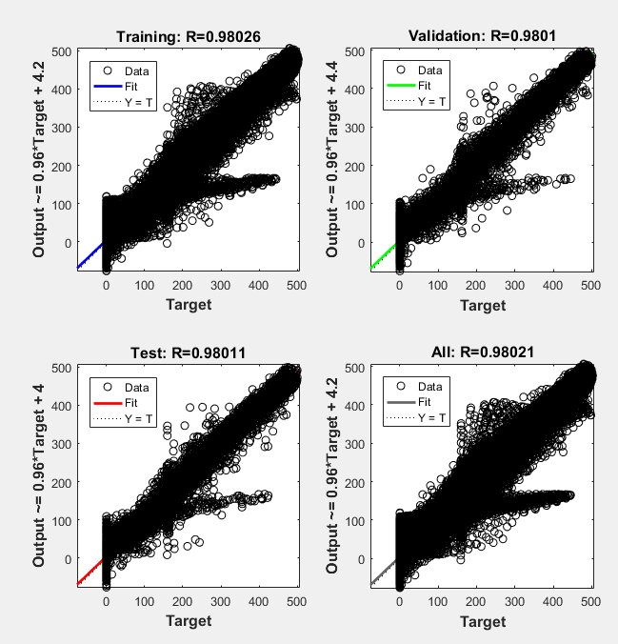
Figure 7 Relation between predicted and actual values for monthly mean instantaneous solar radiation for the fourth month as plotted by Matlab
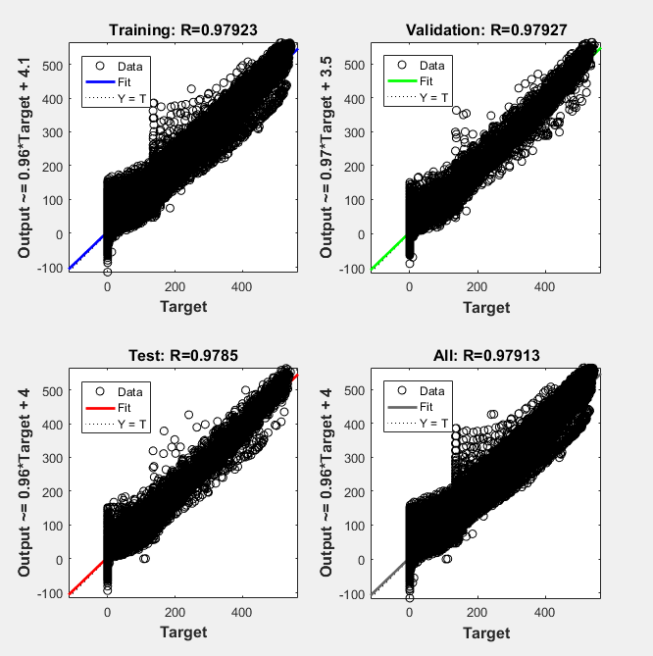
Figure 8 Relation between predicted and actual values for monthly mean instantaneous solar radiation for the fifth month as plotted by Matlab
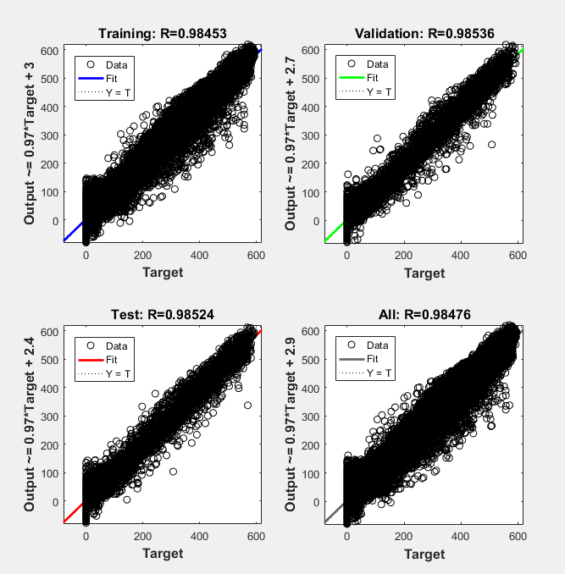
Figure 9 Relation between predicted and actual values for monthly mean instantaneous solar radiation for the sixth month as plotted by Matlab
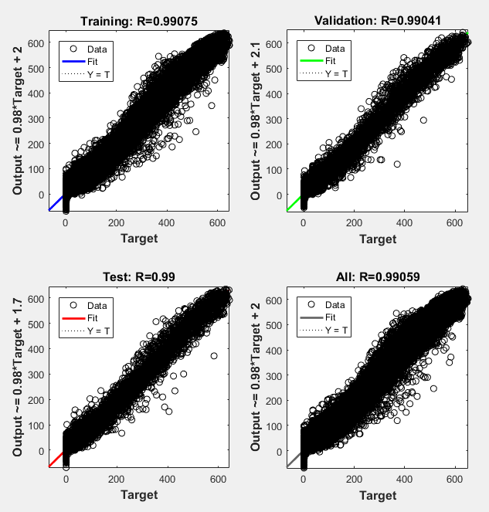
Figure 10 Relation between predicted and actual values for monthly mean instantaneous solar radiation for the seventh month as plotted by Matlab
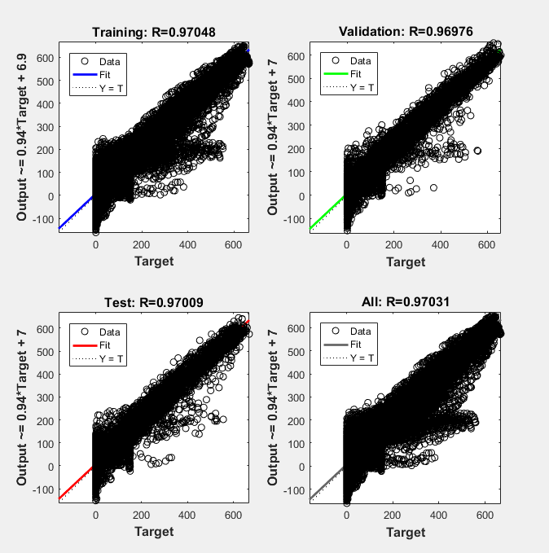
Figure 11 Relation between predicted and actual values for monthly mean instantaneous solar radiation for the eighth month as plotted by Matlab
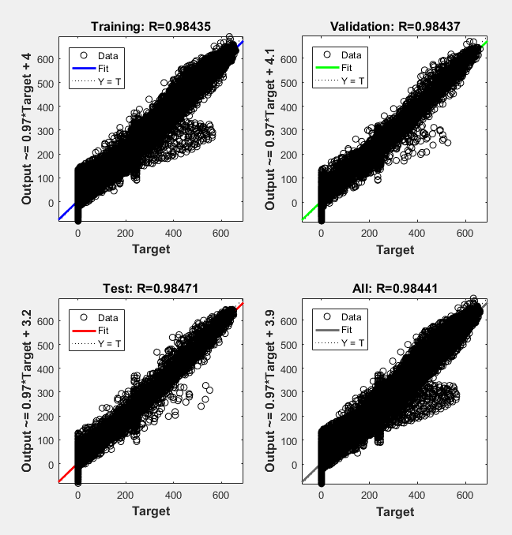
Figure 12 Relation between predicted and actual values for monthly mean instantaneous solar radiation for the ninth month as plotted by Matlab
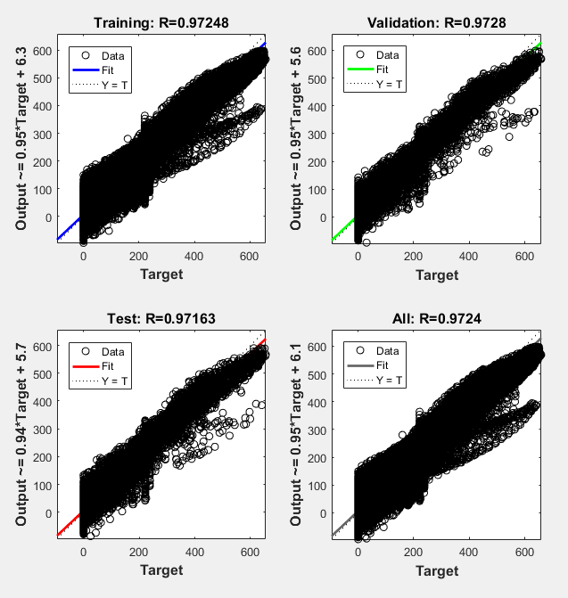
Figure 13 Relation between predicted and actual values for monthly mean instantaneous solar radiation for the tenth month as plotted by Matlab
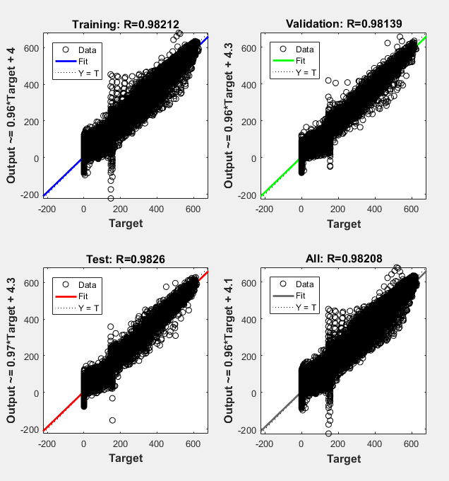
Figure 14 Relation between predicted and actual values for monthly mean instantaneous solar radiation for the eleventh month as plotted by Matlab
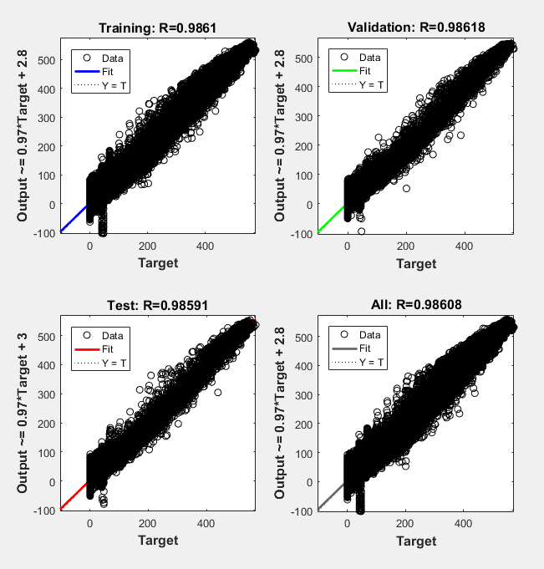
Figure 15 Relation between predicted and actual values for monthly mean instantaneous solar radiation for the twelfth month as plotted by Matlab
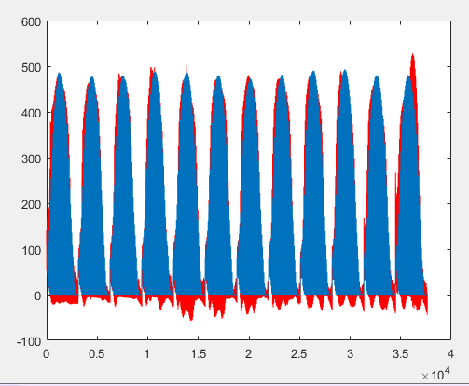
Figure 16 Plot for solar radiation vs. number of testing datasets as plotted by Matlab for the second month. Blue curve presents actual radiation and red curve presents predicted radiation
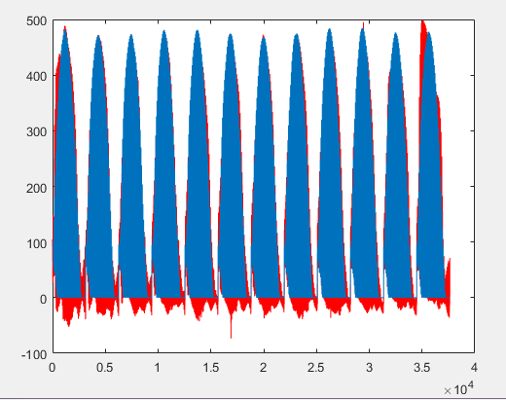
Figure 17 Plot for solar radiation vs. number of testing datasets as plotted by Matlab for the third month. Blue curve presents actual radiation and red curve presents predicted radiation

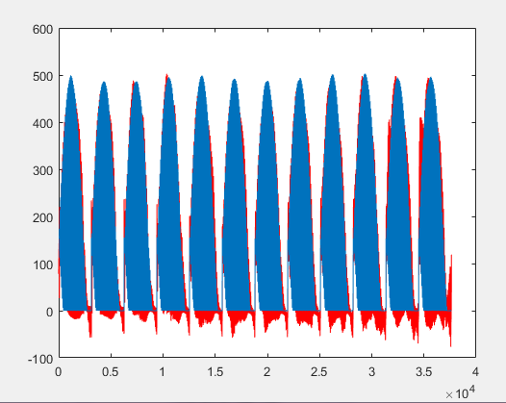
Figure 18 Plot for solar radiation vs. number of testing datasets as plotted by Matlab for the fourth month. Blue curve presents actual radiation and red curve presents predicted radiation
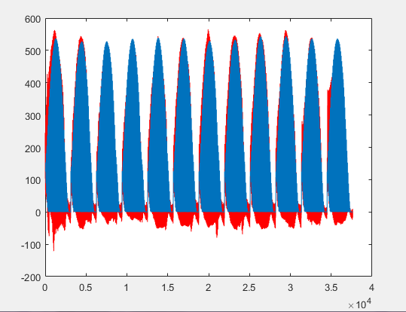
Figure 19 Plot for solar radiation vs. number of testing datasets as plotted by Matlab for the fifth month. Blue curve presents actual radiation and red curve presents predicted radiation

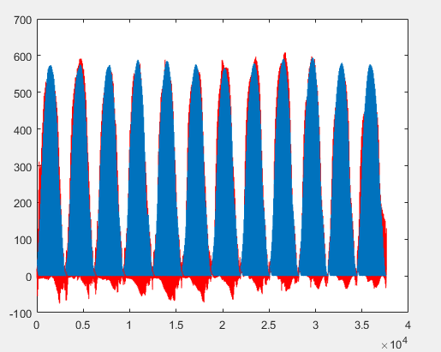
Figure 20 Plot for solar radiation vs. number of testing datasets as plotted by Matlab for the sixth month. Blue curve presents actual radiation and red curve presents predicted radiation

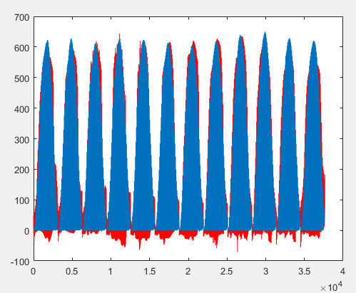
Figure 21 Plot for solar radiation vs. number of testing datasets as plotted by Matlab for the seventh month. Blue curve presents actual radiation and red curve presents predicted radiation

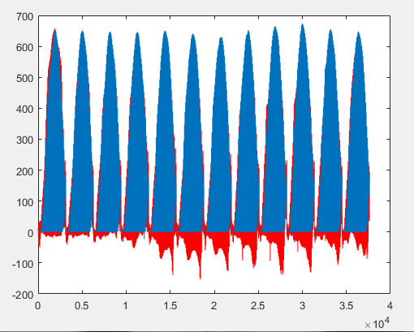
Figure 22 Plot for solar radiation vs. number of testing datasets as plotted by Matlab for the eighth month. Blue curve presents actual radiation and red curve presents predicted radiation
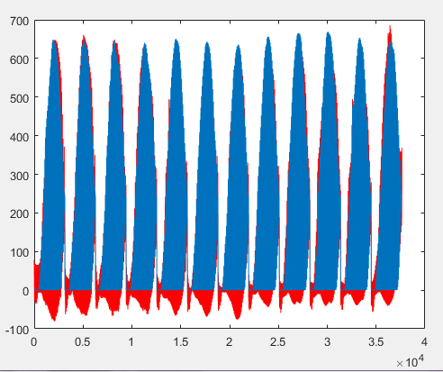
Figure 23 Plot for solar radiation vs. number of testing datasets as plotted by Matlab for the ninth month. Blue curve presents actual radiation and red curve presents predicted radiation

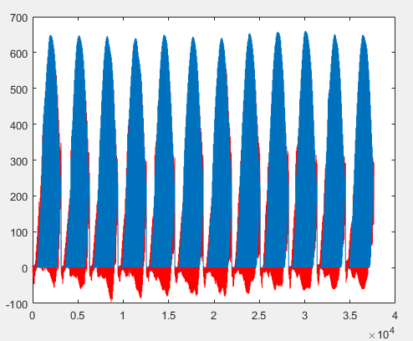
Figure 24 Plot for solar radiation vs. number of testing datasets as plotted by Matlab for the tenth month. Blue curve presents actual radiation and red curve presents predicted radiation

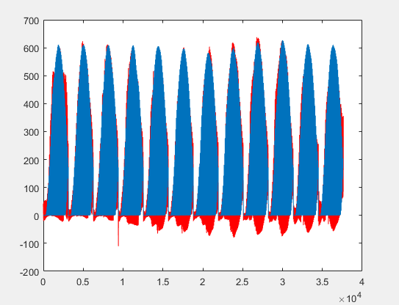
Figure 25 Plot for solar radiation vs. number of testing datasets as plotted by Matlab for the eleventh month. Blue curve presents actual radiation and red curve presents predicted radiation

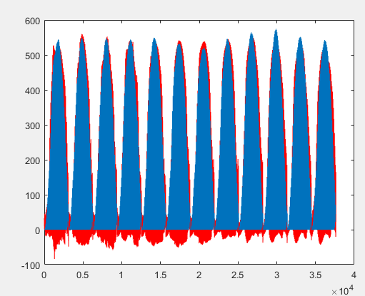
Figure 26 Plot for solar radiation vs. number of testing datasets as plotted by Matlab for the twelfth month. Blue curve presents actual radiation and red curve presents predicted radiation

Figure 27 Mean Solar Radiation distribution for the first Martian month

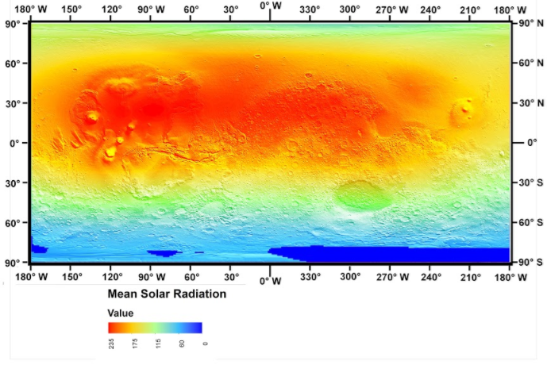
Figure 28: Mean Solar Radiation distribution for the second Martian month

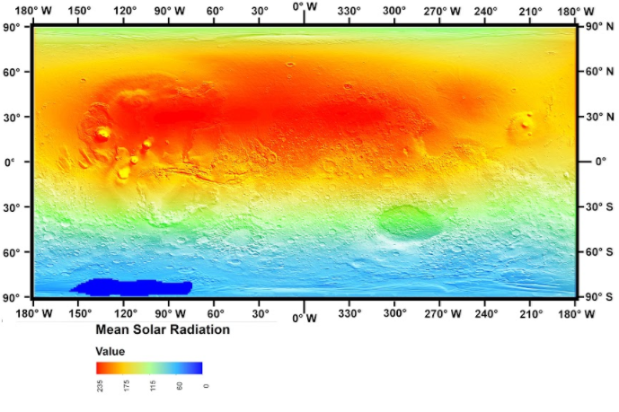
Figure 29: Mean Solar Radiation distribution for the third Martian month

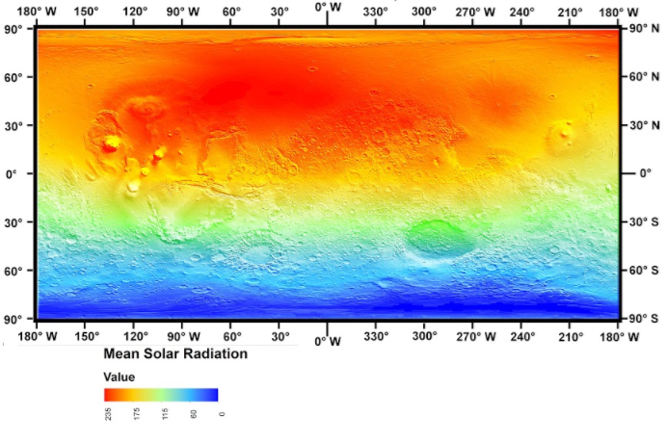
Figure 30: Mean Solar Radiation distribution for the fourth Martian month
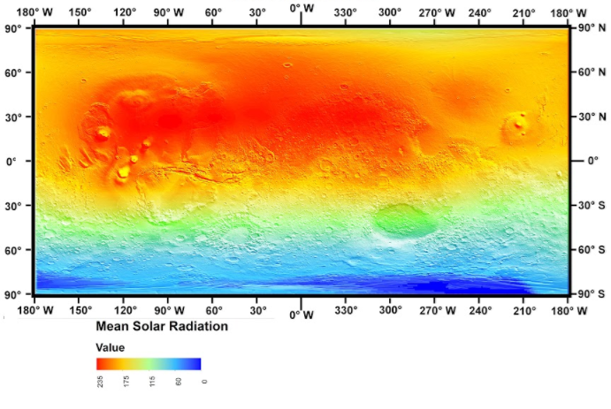
Figure 31: Mean Solar Radiation distribution for the fifth Martian month

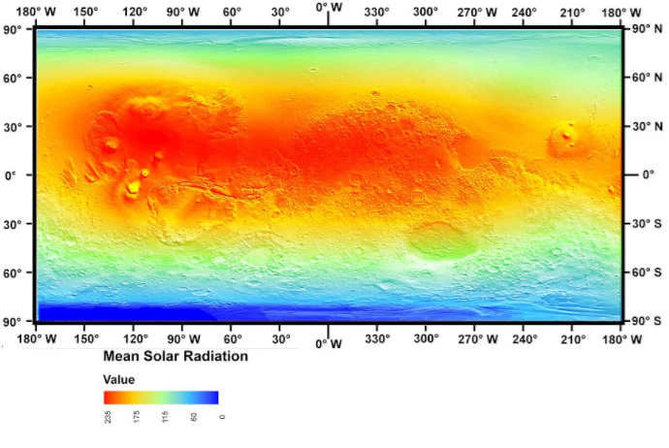
Figure 32: Mean Solar Radiation distribution for the sixth Martian month
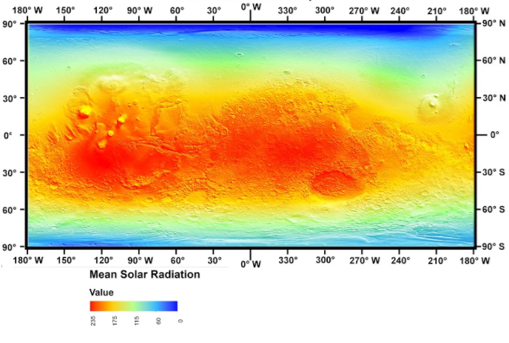
Figure 33: Mean Solar Radiation distribution for the seventh Martian month

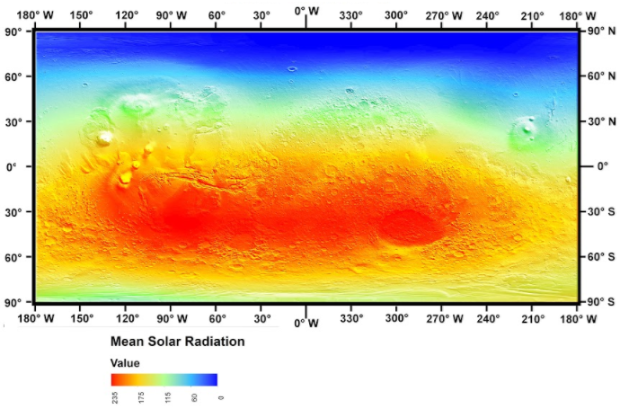
Figure 34: Mean Solar Radiation distribution for the eighth Martian month

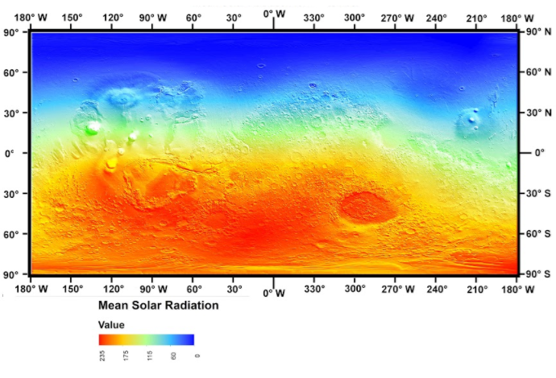
Figure 35: Mean Solar Radiation distribution for the ninth Martian month

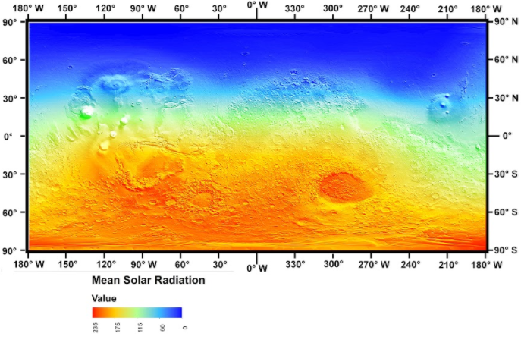
Figure 36: Mean Solar Radiation distribution for the tenth Martian month

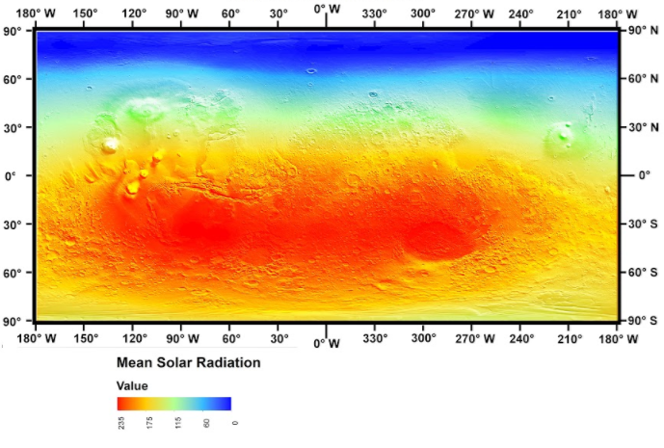
Figure 37: Mean Solar Radiation distribution for the eleventh Martian month

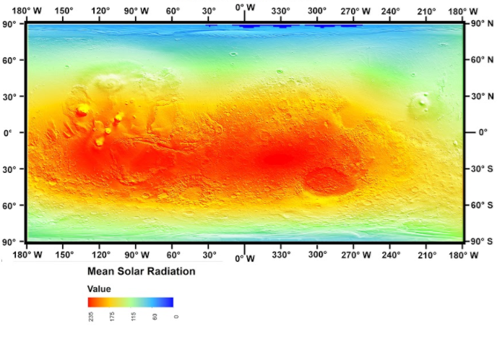
Figure 38: Mean Solar Radiation distribution for the twelfth Martian month

Figure 39: Mean temperature distribution for the first Martian month

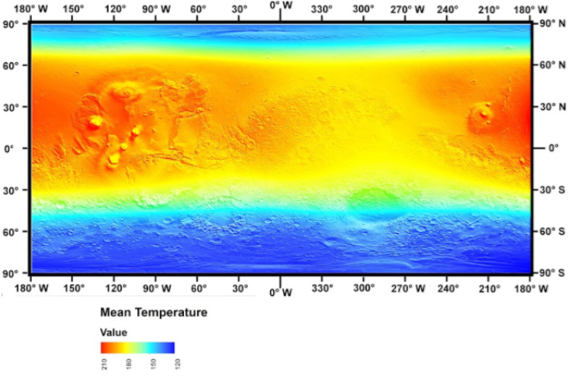
Figure 40: Mean temperature distribution for the second Martian month

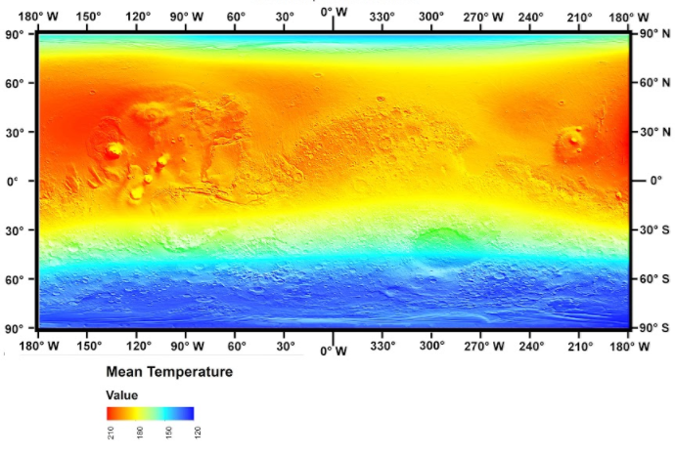
Figure 41: Mean temperature distribution for the third Martian month

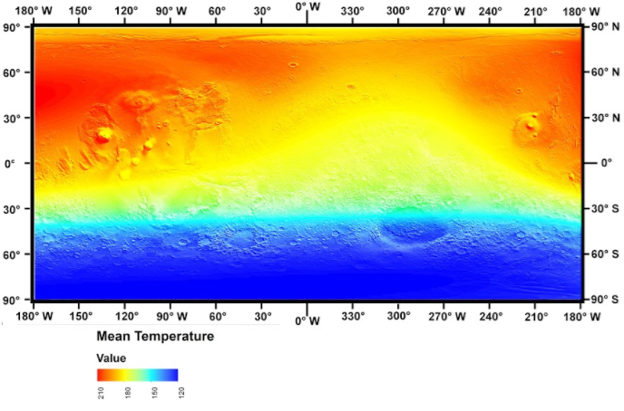
Figure 42: Mean temperature distribution for the fourth Martian month

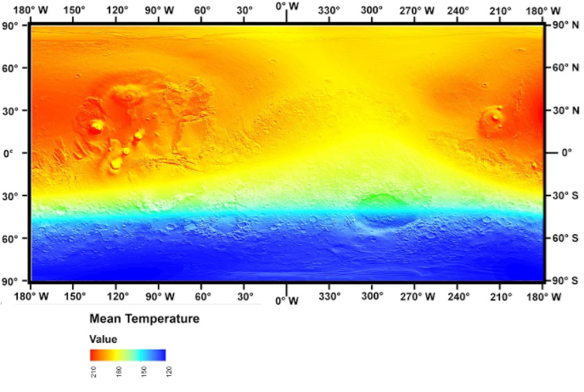
Figure 43: Mean temperature distribution for the fifth Martian month

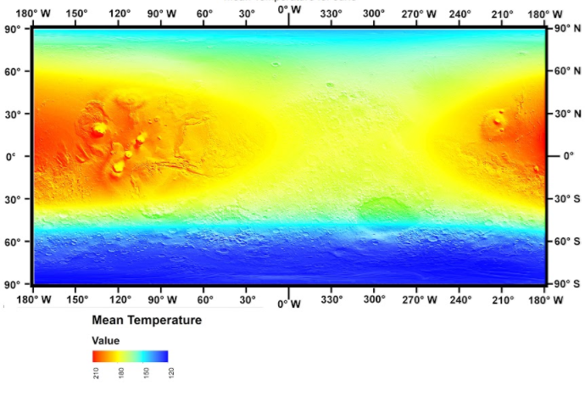
Figure 44: Mean temperature distribution for the sixth Martian month

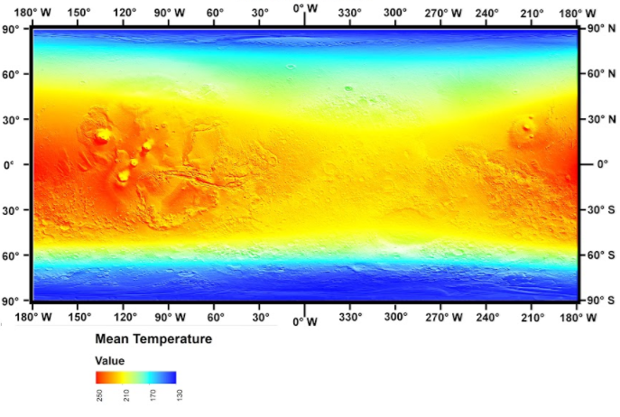
Figure 45: Mean temperature distribution for the seventh Martian month

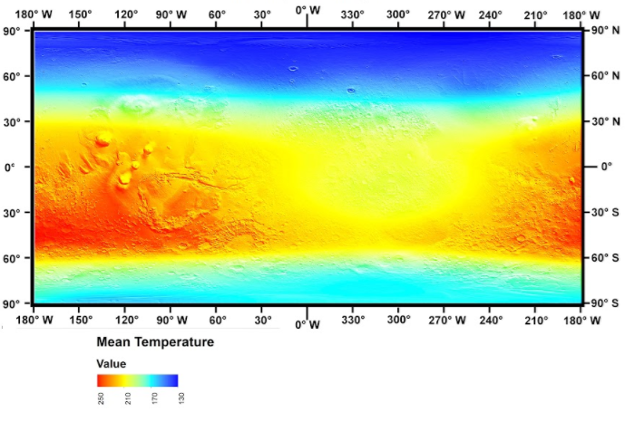
Figure 46: Mean temperature distribution for the eighth Martian month

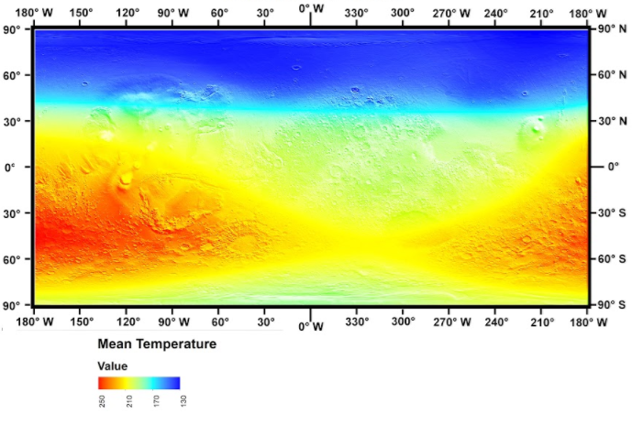
Figure 47: Mean temperature distribution for the ninth Martian month

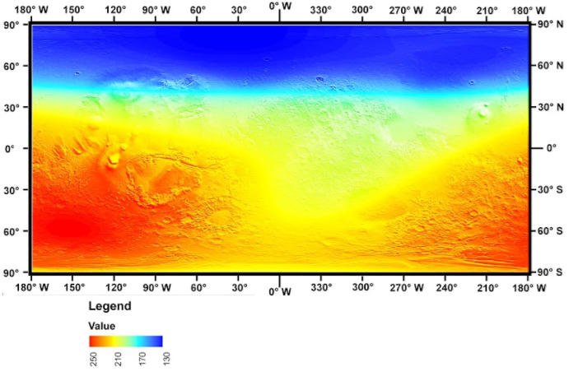
Figure 48: Mean temperature distribution for the tenth Martian month

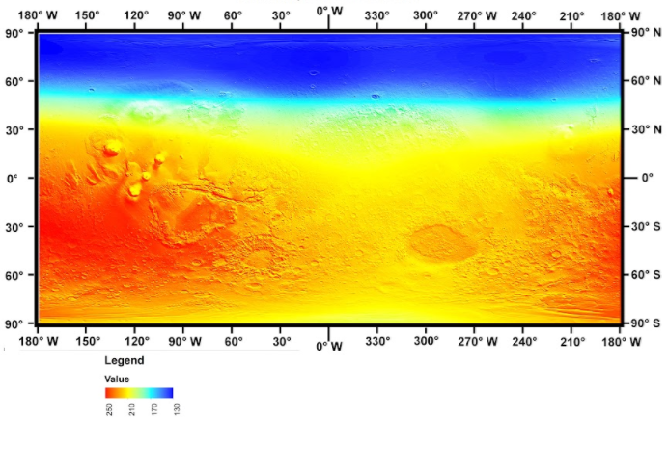
Figure 49: Mean temperature distribution for the eleventh Martian month

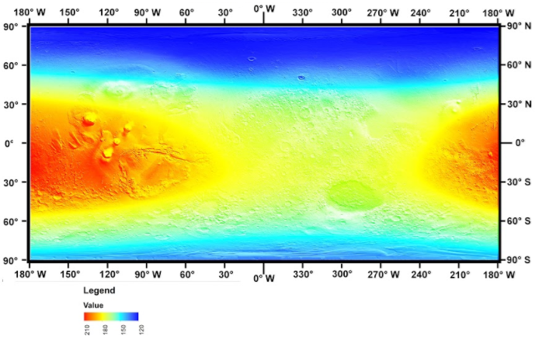
Figure 50: Mean temperature distribution for the twelfth Martian month

APPENDIX-B

fileName= 'trial1.xlsx';
sheetName= 'm5';
LOD = xlsread(fileName, sheetName , 'A2:A75265');
L = xlsread(fileName, sheetName , 'B2:B75265');
T= xlsread(fileName, sheetName , 'C2:C75265');
Temp= xlsread(fileName, sheetName , 'F2:F75265');
alt = xlsread(fileName, sheetName , 'G2:G75265');
ps = xlsread(fileName, sheetName , 'H2:H75265');
dustq = xlsread(fileName, sheetName , 'I2:I75265');
vmrh2oice = xlsread(fileName, sheetName , 'L2:L75265');
Flux= xlsread(fileName, sheetName , 'E2:E75265');

%----testing data----
Test_LOD = xlsread(fileName, sheetName , 'A75266:A112897');
Test_L = xlsread(fileName, sheetName , 'B75266:B112897');
Test_T= xlsread(fileName, sheetName , 'C75266:C112897');
Test_Temp= xlsread(fileName, sheetName , 'F75266:F112897');
Test_alt = xlsread(fileName, sheetName , 'G75266:G112897');
Test_ps = xlsread(fileName, sheetName , 'H75266:H112897');
Test_dustq = xlsread(fileName, sheetName , 'I75266:I112897');
Test_vmrh2oice = xlsread(fileName, sheetName , 'L75266:L112897');
Test_Flux= xlsread(fileName, sheetName , 'E75266:E112897');
%------------------------------------------------------------------------
inputs = [L, LOD, T, Temp, ps, alt, vmrh2oice, dustq ];
I=inputs';
targets= Flux;
Z=targets';
%//////////////////////// Create the Network /////////////////////////////
net = newff(I,Z,10);
Y = sim(net,I);
net.trainParam.epochs = 100;
net = train(net,I,Z);
%////////////////////Testing the Network//////////////////////////////////
test=[Test_L, Test_LOD, Test_Temp, Test_T, Test_alt, Test_ps, Test_vmrh2oice, Test_dustq ];
Test1=test';
Flux_predicted_i = sim(net,Test1);
Flux_predicted= Flux_predicted_i';

plot(Flux_predicted, 'red');
hold on
plot(Test_Flux)

REFERENCES

APPELBAUM, J. & FLOOD, D. J. 1990. Solar radiation on Mars. Solar Energy, 45, 353-363.
APPELBAUM, J., LANDIS, G. A. & SHERMAN, I. 1993. Solar radiation on Mars—update 1991. Solar Energy, 50, 35-51.
BADESCU, V. 2001. Inference of atmospheric optical depth from near-surface meteorological parameters on Mars. Renewable Energy, 24, 45-57.
BADESCU, V. 2009. Available Solar Energy and Weather Forecasting on Mars Surface. Mars. Springer.
E. MILLOUR, F. F. & LEWIS, S. R. 2017. MARS CLIMATE DATABASE v5.3 USER MANUAL.
F. FORGET, E. M., M. VALS, V. ZAKHAROV (LMD) AND S.R. LEWIS (OU 2017. MARS CLIMATE DATABASE v5.3
DETAILED DESIGN DOCUMENT.
FADARE, D. 2009. Modelling of solar energy potential in Nigeria using an artificial neural network model. Applied energy, 86, 1410-1422.
GIERASCH, P. J. & GOODY, R. M. 1972. The effect of dust on the temperature of the Martian atmosphere. Journal of the Atmospheric Sciences, 29, 400-402.
GOLOMBEK, M., GRANT, J. A., PARKER, T., KASS, D., CRISP, J., SQUYRES, S. W., HALDEMANN, A., ADLER, M., LEE, W. & BRIDGES, N. 2003. Selection of the Mars Exploration Rover landing sites. Journal of Geophysical Research: Planets, 108.
GRANT, J. A., GOLOMBEK, M. P., GROTZINGER, J. P., WILSON, S. A., WATKINS, M. M., VASAVADA, A. R., GRIFFES, J. L. & PARKER, T. J. 2011. The science process for selecting the landing site for the 2011 Mars Science Laboratory. Planetary and Space Science, 59, 1114-1127.
KADIRGAMA, K., AMIRRUDDIN, A. & BAKAR, R. 2014. Estimation of solar radiation by artificial networks: east coast Malaysia. Energy Procedia, 52, 383-388.
KHATIB, T., MOHAMED, A., SOPIAN, K. & MAHMOUD, M. 2012. Solar energy prediction for Malaysia using artificial neural networks. International Journal of Photoenergy, 2012.
KUMAR, R., AGGARWAL, R. & SHARMA, J. 2015. Comparison of regression and artificial neural network models for estimation of global solar radiations. Renewable and Sustainable Energy Reviews, 52, 1294-1299.
LANDIS, G. A. & JENKINS, P. P. 2002, Dust mitigation for mars solar arrays, Photovoltaic Specialists Conference, Conference Record of the Twenty-Ninth IEEE, 2002. IEEE, 812-815.
MADELEINE, J. B., FORGET, F., MILLOUR, E., NAVARRO, T. & SPIGA, A. 2012. The influence of radiatively active water ice clouds on the Martian climate. Geophysical Research Letters, 39.
MATZ, E., APPELBAUM, J., TAITEL, Y. & FLOOD, D. 1998. Solar cell temperature on Mars. Journal of propulsion and power, 14, 119-125.
MOHANDES, M., REHMAN, S. & HALAWANI, T. 1998. Estimation of global solar radiation using artificial neural networks. Renewable Energy, 14, 179-184.
NASA. 2000. Color-coded elevations on Mars, MOLA Altimeter, MGS Mission. NASA Goddard Spaceflight Center.
NASA. 2017. Robotic Mars Exploration [Online]. National Aeronautics and Space Administration. Available: https://www.nasa.gov/mission_pages/mars/missions 2018].
REHMAN, S. & MOHANDES, M. 2009. Estimation of diffuse fraction of global solar radiation using artificial neural networks. Energy Sources, Part A, 31, 974-984.
SÖZEN, A., ARCAKLIOǦLU, E., ÖZALP, M. & KANIT, E. G. 2004. Use of artificial neural networks for mapping of solar potential in Turkey. Applied Energy, 77, 273-286.
TYMVIOS, F. S., MICHAELIDES, S. C. & SKOUTELI, C. S. 2008. Estimation of surface solar radiation with artificial neural networks. Modeling solar radiation at the earth’s surface. Springer.
VICENTE-RETORTILLO, Á., VALERO, F., VÁZQUEZ, L. & MARTÍNEZ, G. M. 2015. A model to calculate solar radiation fluxes on the Martian surface. Journal of Space Weather and Space Climate, 5, A33.
WILLIAMS, D. D. R. 2016. Mars Fact Sheet [Online]. Greenbelt, MD 20771: NASA Goddard Space Flight Center. Available: https://nssdc.gsfc.nasa.gov/planetary/factsheet/marsfact.html 2018].

