

An-Najah National University

Faculty of Engineering & Information Technology
Department of Computer Engineering, Critical Thinking and Research Skills
Software Graduation Project

Medics

Students: | Supervisor:
- Mohamad Jondi | Dr. Amjad Abu Hassan
- Ahmad Amira

25 June 2024

ACKNOWLEDGMENTS

First and foremost, I thank God for providing me with the strength, wisdom, and perseverance to see this project through to the end. Without His guidance and blessings, none of this would have been possible.

To Our beloved family, Your unwavering support, love, and encouragement have been my foundation throughout this journey. To Our parents, thank you for always believing in us and for your constant sacrifices to ensure we had the best opportunities.

I would also like to extend my sincere thanks to our professors, who thanks to we were able to become great engineers, Thanks for an Amazing 5 years. I am especially grateful to Dr Amjad Abu Hassan, our project advisor, without him we wouldn’t have achieved much, Your mentorship has been crucial to our development both as a students and as a professionals.

ABSTRACT

This medical assistant application addresses the critical need for EHR (Electronic Health Record) that
is centralized and easy to accesses by the public, by organizing patient medication, medical history,
appointments, and facilitating communication between doctors and patients. The project aims to
enhance healthcare efficiency, reduce administrative burdens, and improve the effectiveness of the
medicine by alarming the patient of the right way and time to consume it.
Key features include medication organization, appointment scheduling, verifying the right
prescriptions to the patients, warning them if two prescriptions were to nullify or interact with each
other, and secure doctor-patient communication for non-emergencies, and the ambulance if the app
detects an abnormal activity, the project emphasizes user-friendly interfaces.
Objectives include improving patient outcomes, minimizing medical errors through accurate
medication management, addressing some minor problems like getting the wrong prescription from
the drug store, optimizing appointment scheduling, and fostering a more connected healthcare
environment.
While various healthcare applications exist, this proposed medical assistant stands out by trying to be
a one shoe fits all kind of app, making it tackle multiple problems at once, the only app you need to
make sure you are in good hands and in safe hands.

DISCLAIMER

Mohamad Jondi and Ahmad Amira collaborated on the completion of this paper. The authors acknowledge full responsibility for any errors identified within. The ideas, suggestions, findings, and opinions expressed in this paper solely belong to the authors and do se not reflect the viewpoint of An-Najah National University.

Table Of Content
ACKNOWLEDGMENTS 1
ABSTRACT 2
DISCLAIMER 3
INTRODUCTION 1
Statement of the problem 1
Objective 1
Significance of the Project 1
Organization of the report 2
CONSTRINTS, STANDARDS AND EARLIER COURSEWORK 3
Constraints 3
Standards 3
Earlier coursework 3
LITERATURE REVIEW 4
METHODOLOGY 5
Non-Functional Requirements 5
Authentication and Authorization And User Privacy : 5
Database Choice 5
Backend 5
Frontend 6
Design 6
Login and Registration 6
Chatting System 6
Vaccinations monitor 7
Notification 7
Rating and Reviews 7
RESULTS AND USER INTERFACE 8
Landing page, Signup, and Login page 8
Login page 8
Sign up 9
Forget Password 10
Doctor Home page 11
Notification page 13
Chat and Contacts pages 14
Appointment details page 15
Doctor Calendar page 16
Patient Home page 17
Book Appointment page 18
The Medical Patient info page 19
The Patient Calendar Page 20
The nurse Home page 21
The nurse Patient details page 22
The mother home page 23
Admin page 24
Admin Nurses Approval 25
Backend API Examples 26
Discussion and Conclusion 28
Discussion and Future Work 28
Conclusion 28

CHAPTER 1

INTRODUCTION

Statement of the problem

The current healthcare system faces significant challenges in managing patient records, scheduling appointments, and ensuring effective communication between doctors and patients. The lack of a centralized and easily accessible system for Electronic Health Records (EHR) complicates the management of patient information and can lead to inefficiencies and medical errors.

Objective

The primary objective of this project is to develop a comprehensive medical assistant application that centralizes EHRs, organizes patient medication and medical history, facilitates appointment scheduling, and ensures secure communication between doctors and patients.
The application also aims to integrate a nurse monitoring system and a system for mothers to monitor their children’s vaccinations. The application aims to improve healthcare efficiency, reduce administrative burdens, and enhance patient outcomes.

Significance of the Project
This project is significant because it addresses the critical need for an integrated healthcare solution specially in our beloved Palestine, that improves the management of patient information, reduces the risk of medical errors, and make the communication between healthcare experts and patients better.
By leveraging modern technology, this application aims to transform the healthcare experience for both patients and providers.

Organization of the report
This report is organized as follows:

    - Chapter1:Introduction

    - Chapter2:Constraints, Standards, and prior coursework

    - Chapter3:Literature Review

    - Chapter4:Methodology

    - Chapter5:Results and User Interface

    - Chapter6:Discussion and Conclusion

CHAPTER 2

CONSTRINTS, STANDARDS AND EARLIER COURSEWORK

Constraints
Some limitations to this project is the lack of medical data that we could’ve gathered, so the size of the data set of the drugs gathered was inefficient to create an all out Drug To Drug APis, but we have overcome this issue by making it only a prototype, another limitation is after trying to get medical statistics from apple watch we found many obstacles in testing on real devices.

Standards

Domain-Driven Design (DDD) principles were applied to ensure that the application’s architecture aligns with the complex requirements of the healthcare domain.
This approach facilitates the development of a robust and scalable system.

Earlier coursework
This project builds on knowledge and skills acquired in prior coursework throughout the 5 years of studying, including software engineering, database management, and web development courses.
The application of these principles is critical to the successful implementation of the project.
.

CHAPTER 3

LITERATURE REVIEW

Medics is trying to be an all in one medical application were your trying to maintain all your medical need from reminding you to take your pills on time to get an appointment at the doctor which have the best rating and allowing you to mange your sick loved ones in times of their need by monitoring their cases and bills, and it allows mothers to monitor their children vaccinations dates and appointments.
One of the standout features in Medics is the DDI (drug to drug interaction ) and DAI (drug to Allergy interaction ) feature which trying to help the doctor making less medical errors and Beyond these features, Medics is great at time management for the doctor and the patient alike.

Medics is not just a time management platform; it's a friendly guide that simplifies getting the right medication and treatment because everyone have the right to medicament. With its easy-to-use features and recent enhancements, Medics is the future for managing everything medical and unlike websites like Drugbank and it’s predecessors Medics is a one shoe fits all kind of app.
CHAPTER 4

METHODOLOGY

Non-Functional Requirements

Authentication and Authorization And User Privacy :
Using JWT we implemented a secure Authentication and Authorization system and we added the emergency contact who is the only person with access to the user Data other than the user and responsible for giving permissions to doctors in case of emergencies .

Database Choice

Our project utilizes a SQL server database, leveraging its relational model to efficiently organize and manage data. Utilizing an ORM like entity Framework to manipulate the data entry easily from our backend .

Backend

The backend of the application is developed using C# and .NET Core, providing a reliable and scalable service. It handles data processing, business logic, and communication with the database also ASP.NET MVC (Model-View-Controller) supports a clean separation of concerns, making it easier to manage complex applications..

Frontend
We use the Flutter framework and Dart programming language for our frontend development. Flutter lets us keep one codebase for both web and mobile apps, making the user experience the same across platforms. Dart's easy-to-understand syntax and Flutter's widget-based design help us build efficient and easy-to-maintain UIs.

Design

Login and Registration
In Medics to register as patient is easy and user friendly all you need to do is click on the register button and enter your relevant information that will be helpful in the future and then go to your email to enter the verification code that you received and that’s it , you’re good to go and use all the features available to a patient or a Parent figure to your Child , registering as a nurse or a doctor is more complicated than that specially if your registering as a Doctor or a second medical opinion doctor to work online were you are required to provide your qualifications and wait for admin to verify your information which takes time and when verified you will recive an email welcoming you to our platform
If by any chance you forgot your password you just click on forgot password and a verification number would be sent to your email and then you can Change your password for your account

Chatting System
Our application boasts a real-time chat system designed for individual users, leveraging socket technology to facilitate instant message delivery. This streamlined communication experience empowers users to engage in swift and responsive conversations with one another.

Case Management

As a patient when you enter a hospital in emergency room or a registered appointment with a doctor, a case will be created for you by either the doctor or the nurse and would enter all your symptoms and the description for your case and might create a new appointment for you for this case and or create a treatment plan for you and all of these can be monitored by a second opinion doctor you can chose from the app to review your case and your doctors work so far to give you assurance and confidence in your doctor .

Doctor Helper system

When the doctor reads your medical history in the app he/she might have forget something like allergies or a previous pills that your on so we developed a system to try to minimize medical errors as much as possible , when the doctor goes to add a drug to your treatment plan our software will make sure there is no conflicts between your allergies and this new drug or your previous drugs.

Vaccinations monitor
Our application includes a feature for parents to monitors their children vaccinations dates and shots left to increase user satisfaction and not to miss any appointments

Appointment System
One of our main features is managing the scheduling for the doctors and patients where the calendar will help them keep track of their appointments and it gives the doctors flexibility to push appointments up to 15 minutes to take a break and if a patient didn’t make it to the appointment the system will give him a chance by shifting his appointment one appointment over after up to two times then the appointment will be canceled, if the patient did this more than once he will be flagged and should make a request to re-enable his appointment scheduling features

Notification
Our application notifies users for the time of their pills to be taken and their closest appointments to make sure the best time management and better recovery.

Rating and Reviews
Our application features a robust rate and review system, allowing patients to review their doctors and giving better doctors the advantage on the search engine to get more customers.

CHAPTER 5

RESULTS AND USER INTERFACE

Landing page, Signup, and Login page

Login page

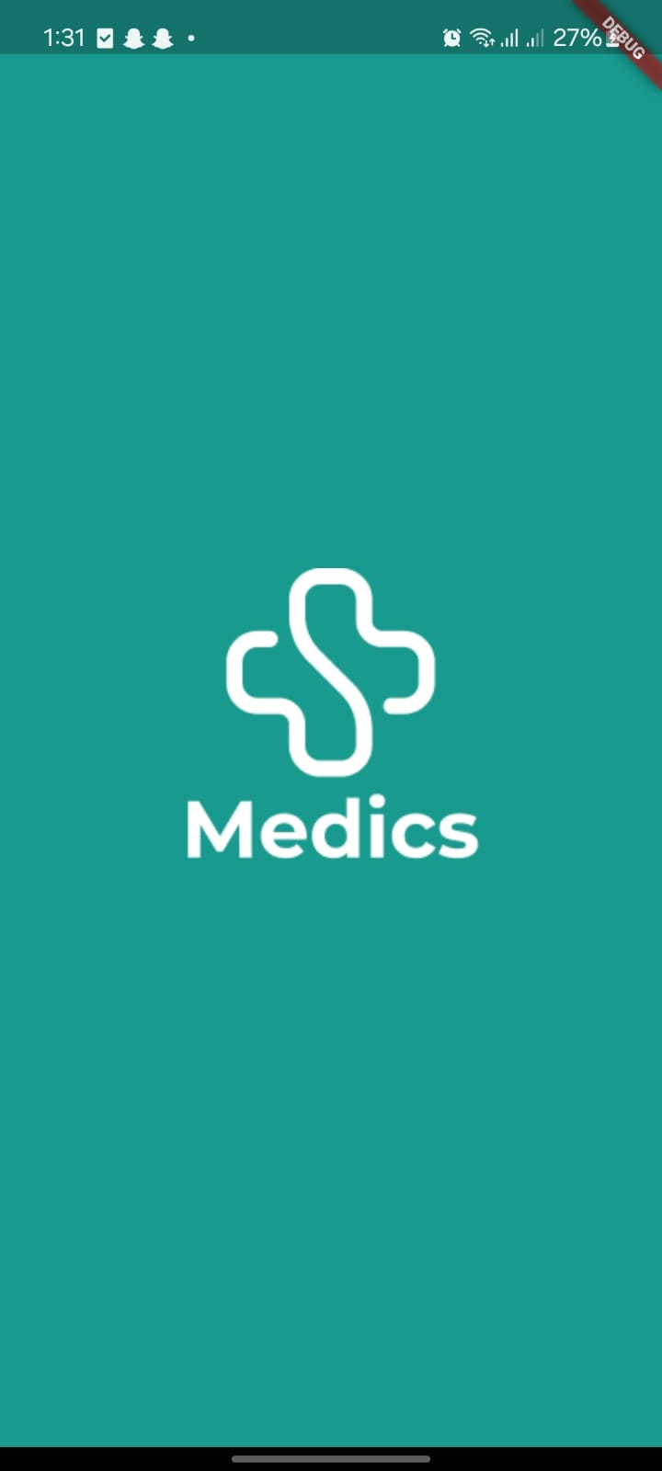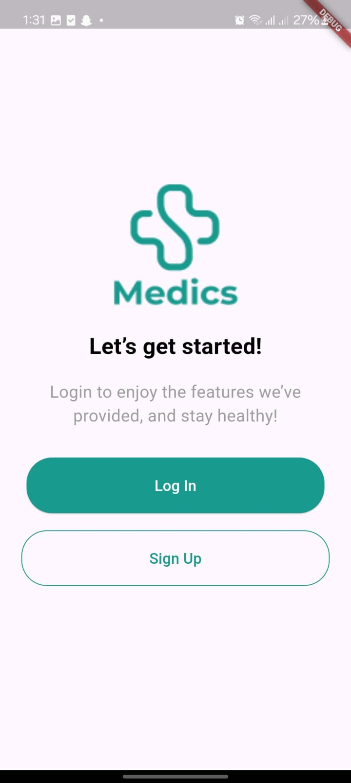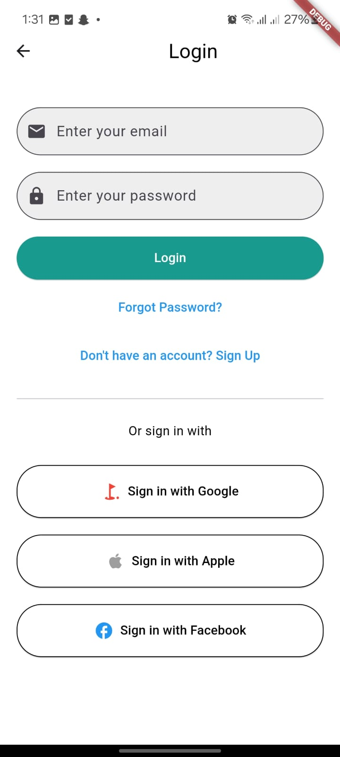

Figure 1: Login Page

Sign up
There are four types of users that can signup into our system each one with the specific information I will attach the one for the doctor

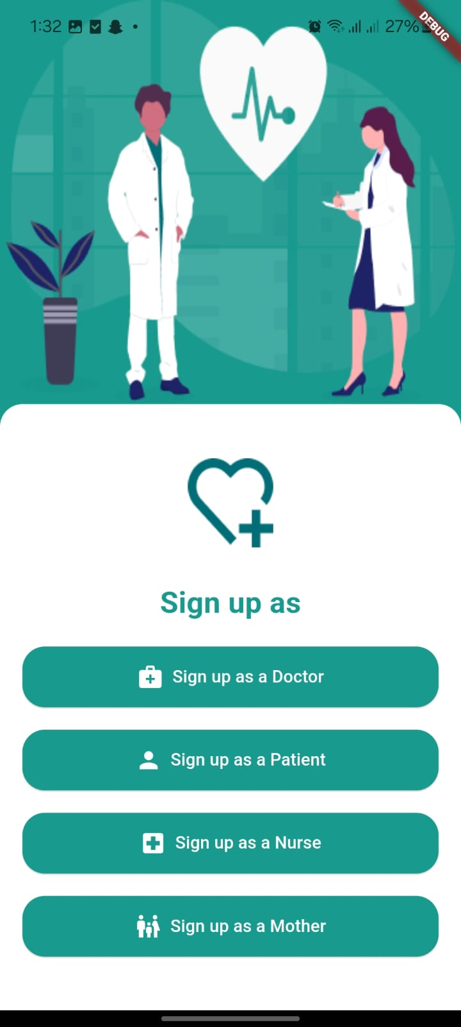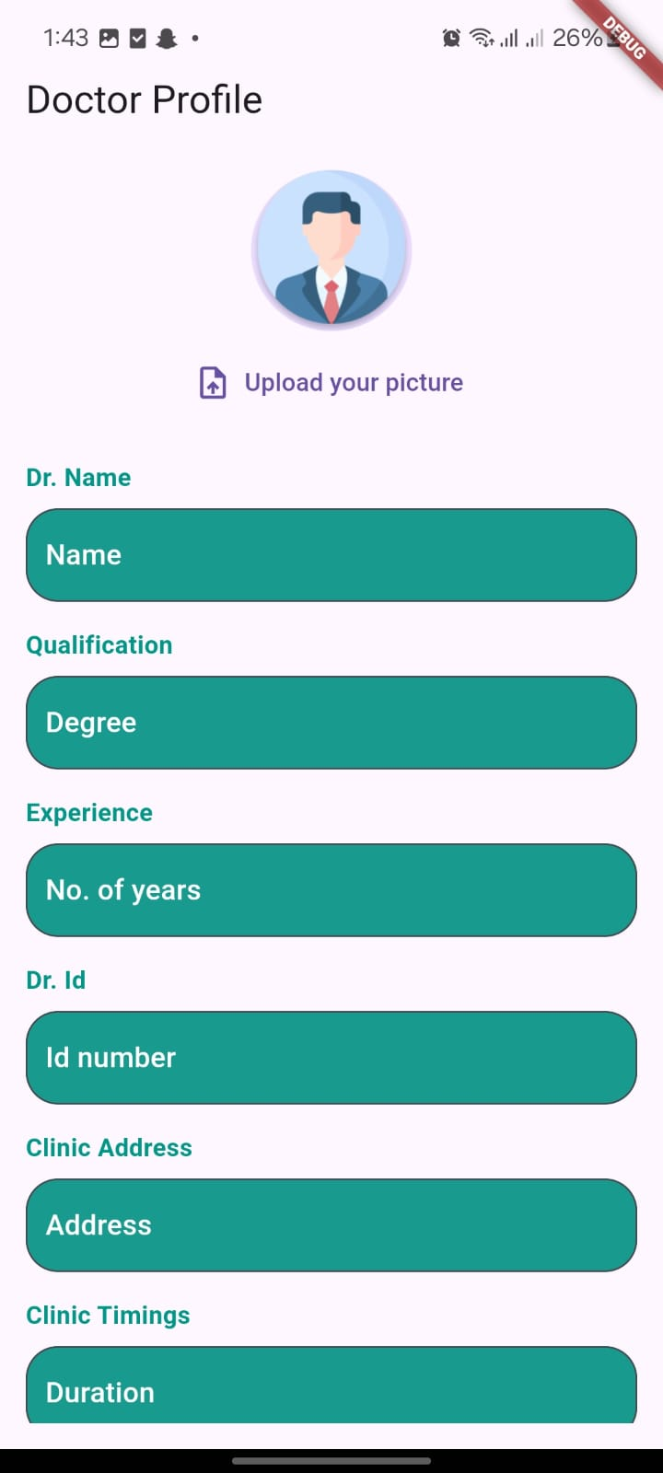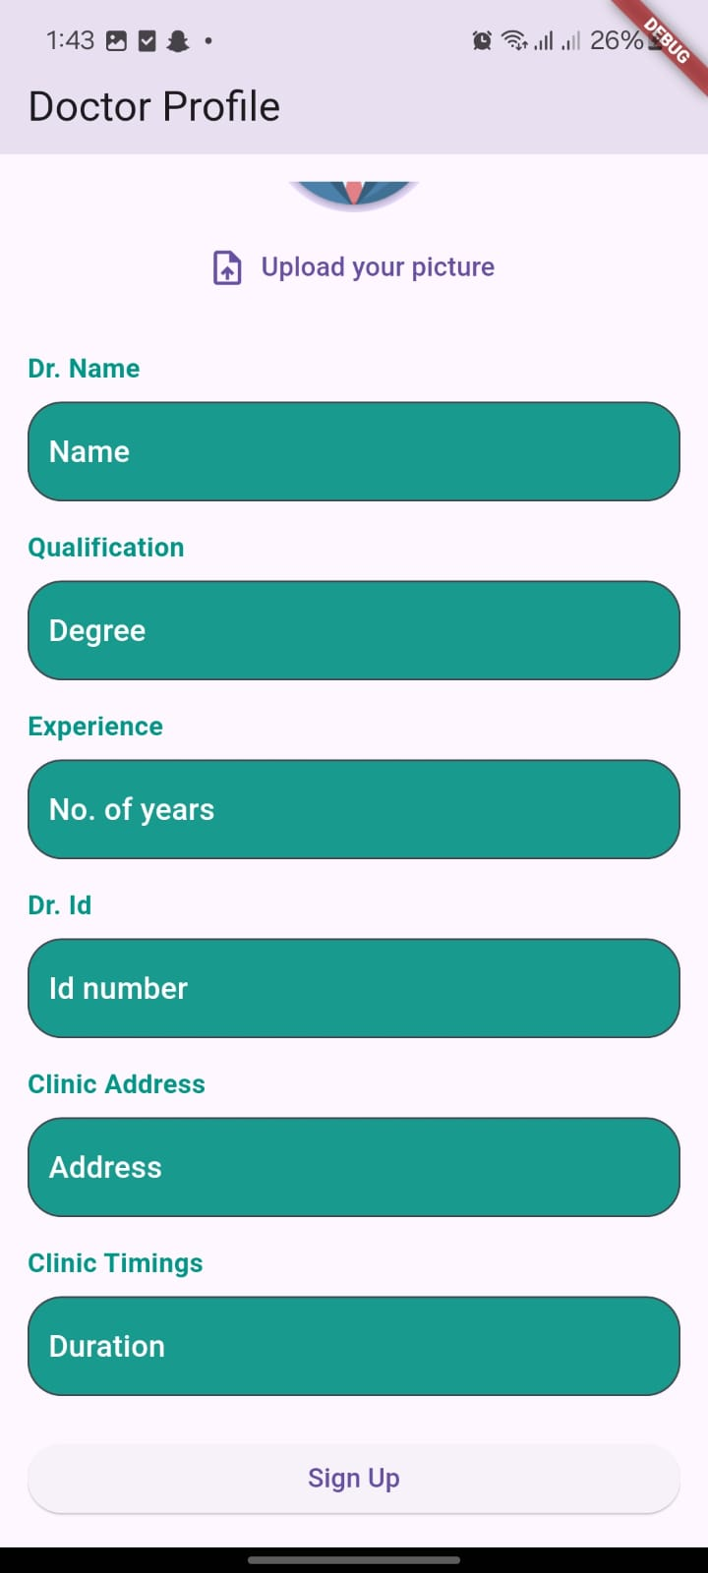
Figure 2: Signup Page

Forget Password
When user wants to reset his password, he will get a verification code on his email, he need to enter it correctly to reset his password
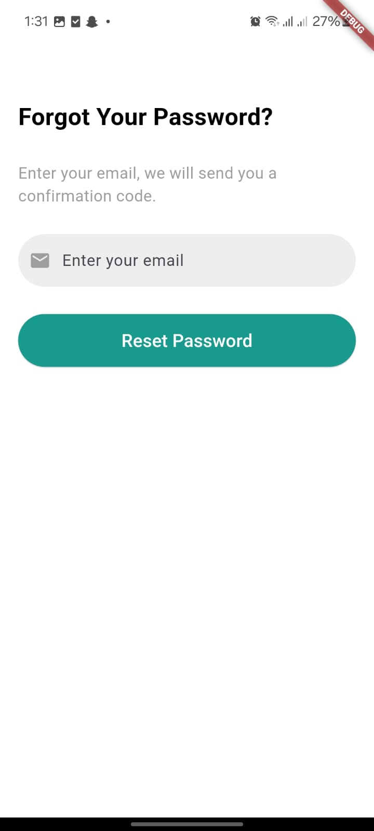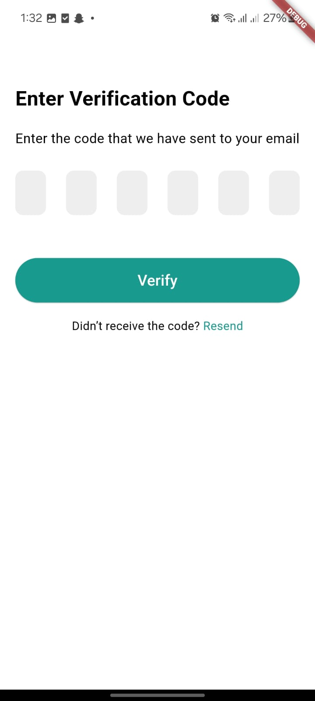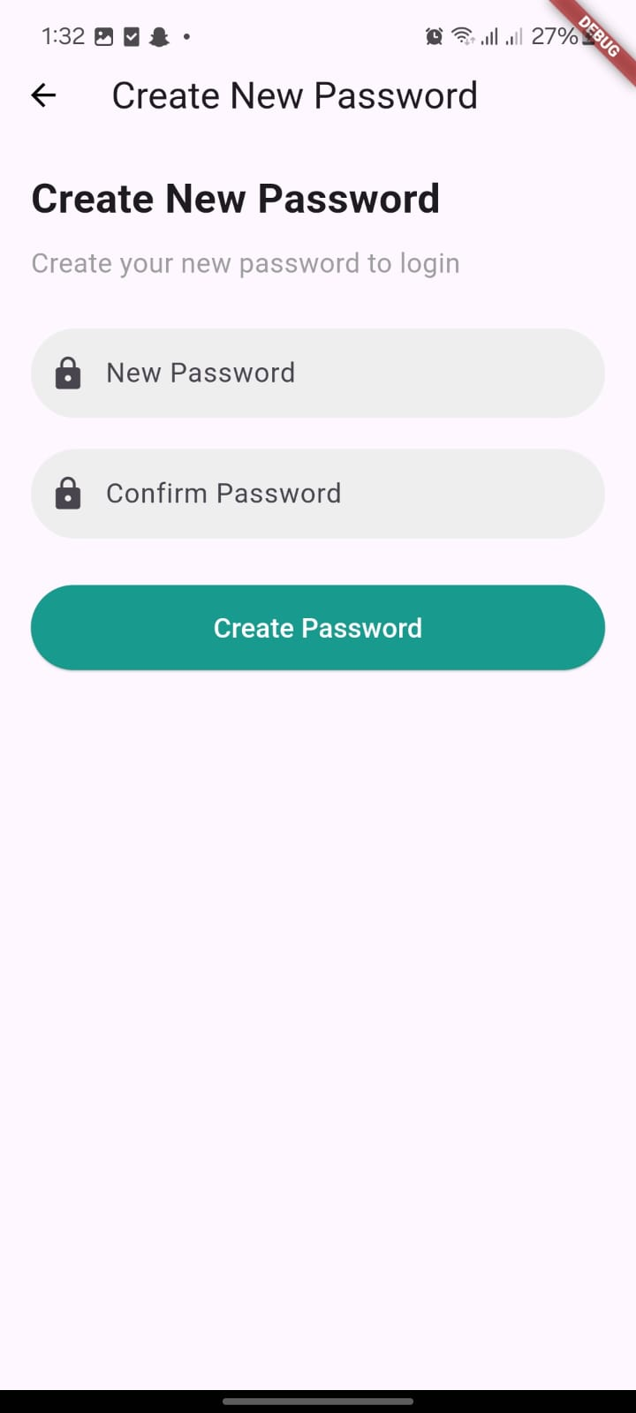

Figure 3: Forget Password

Doctor Home page
The Doctor home page that contains the upcoming and pending appointments
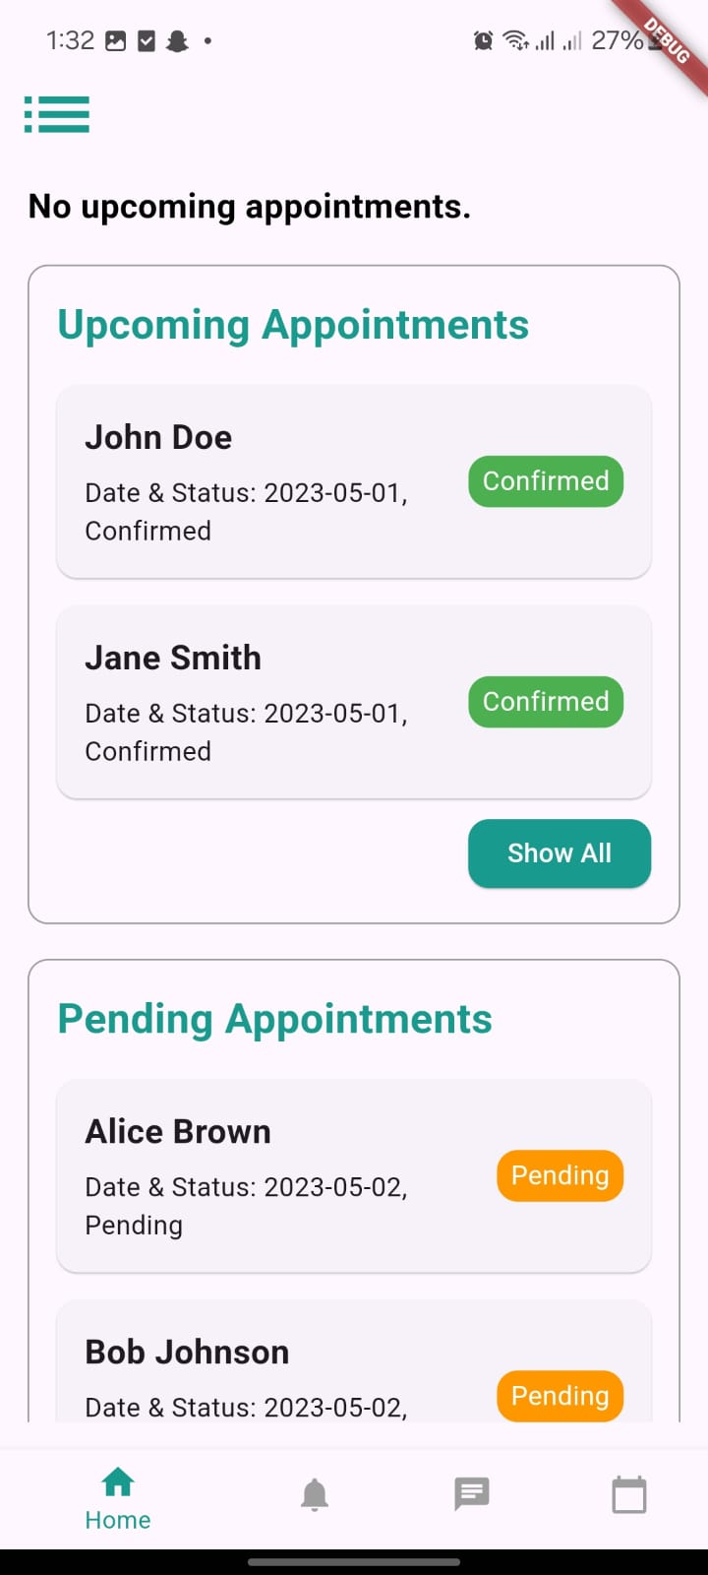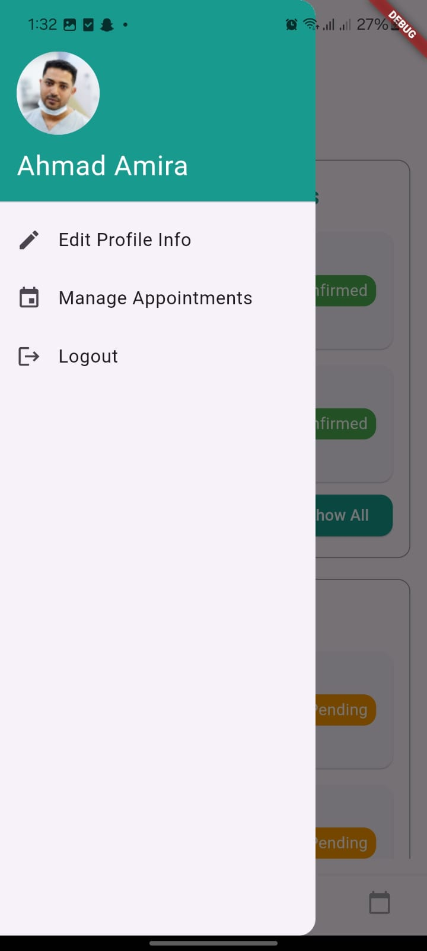

Figure 4: Doctor Home Page

The show all pages for pending and upcoming appointments and the manage appointments page

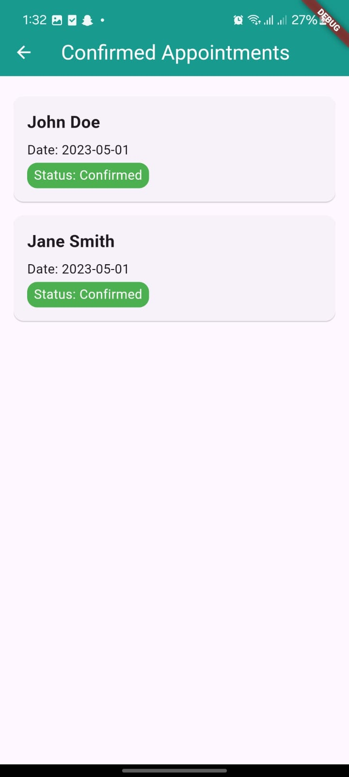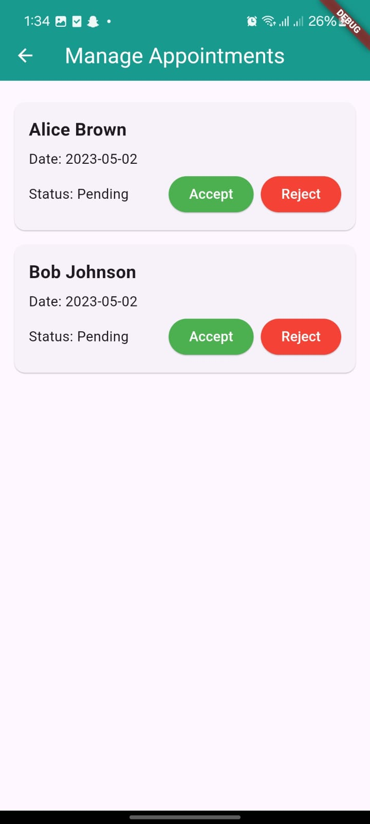

Figure 5: Manage Appointments page

Notification page
All of the four users have the same pages for the notifications
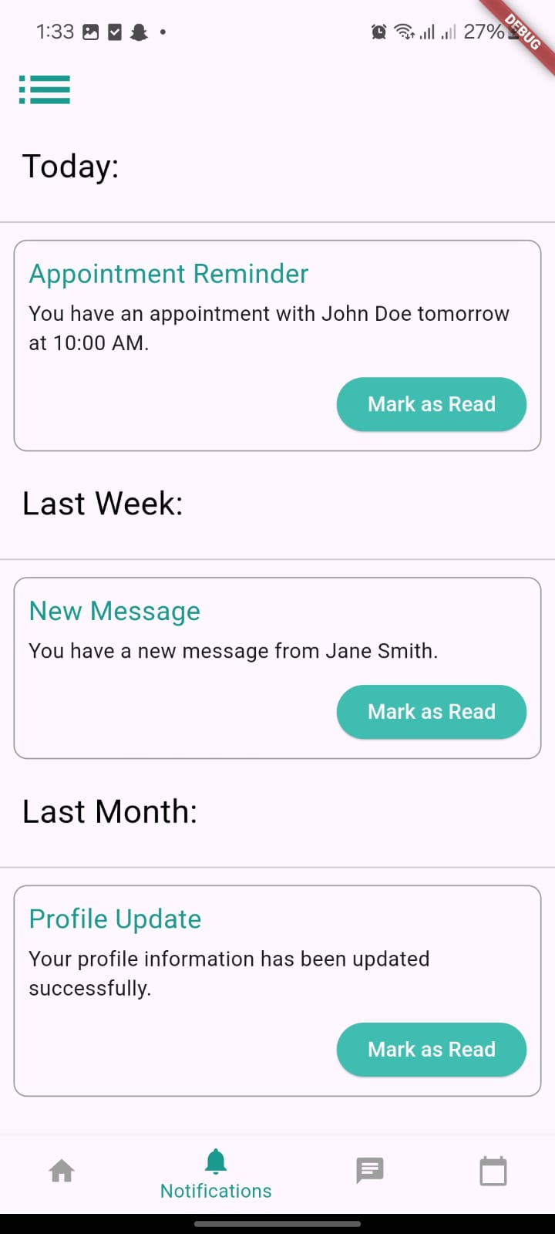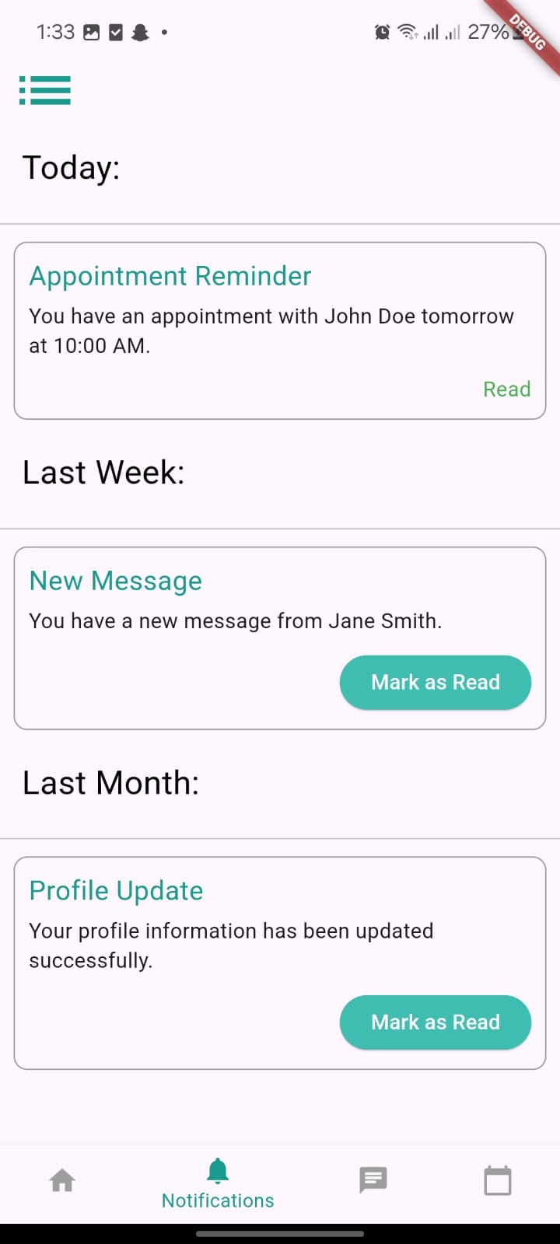

Figure 6: Notification Page

Chat and Contacts pages
All of the four users have the same chat and contacts pages.
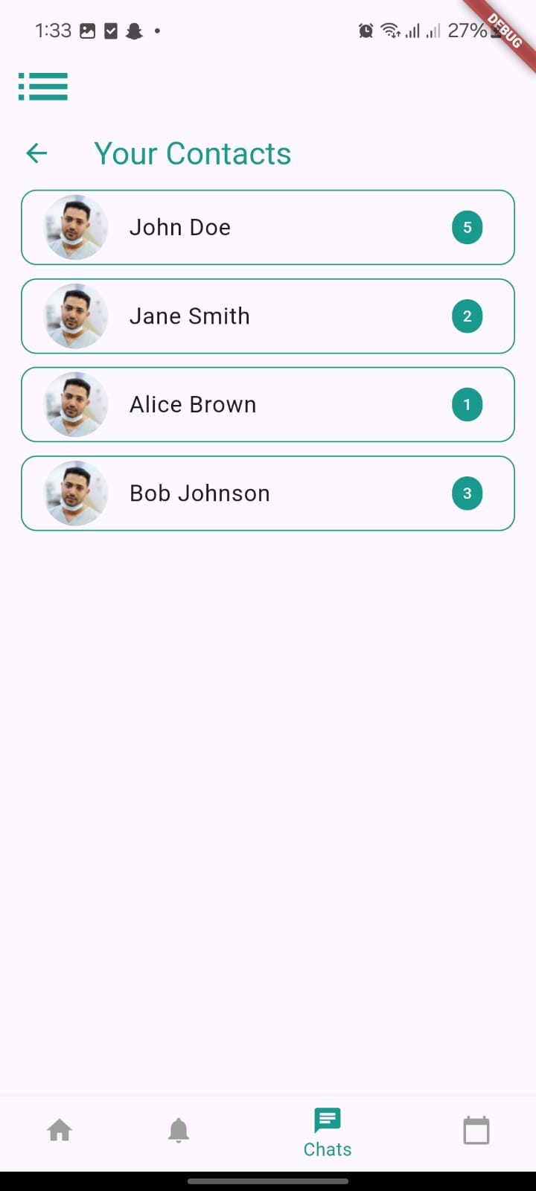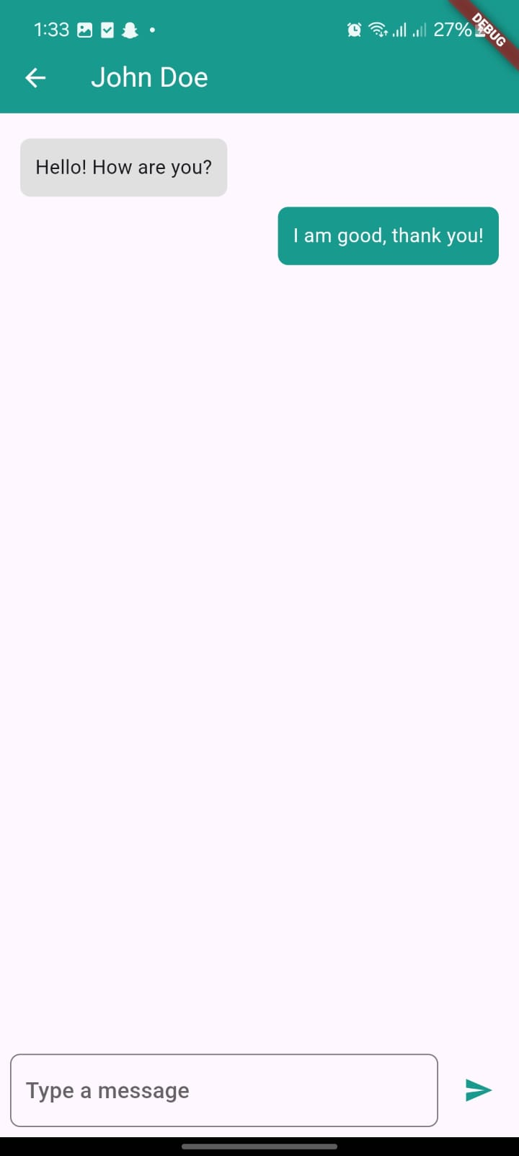

Figure 7: Chat Page

Appointment details page
This page is for the doctor to see the details of the appointment and to approve or reject the appointment if it is pending
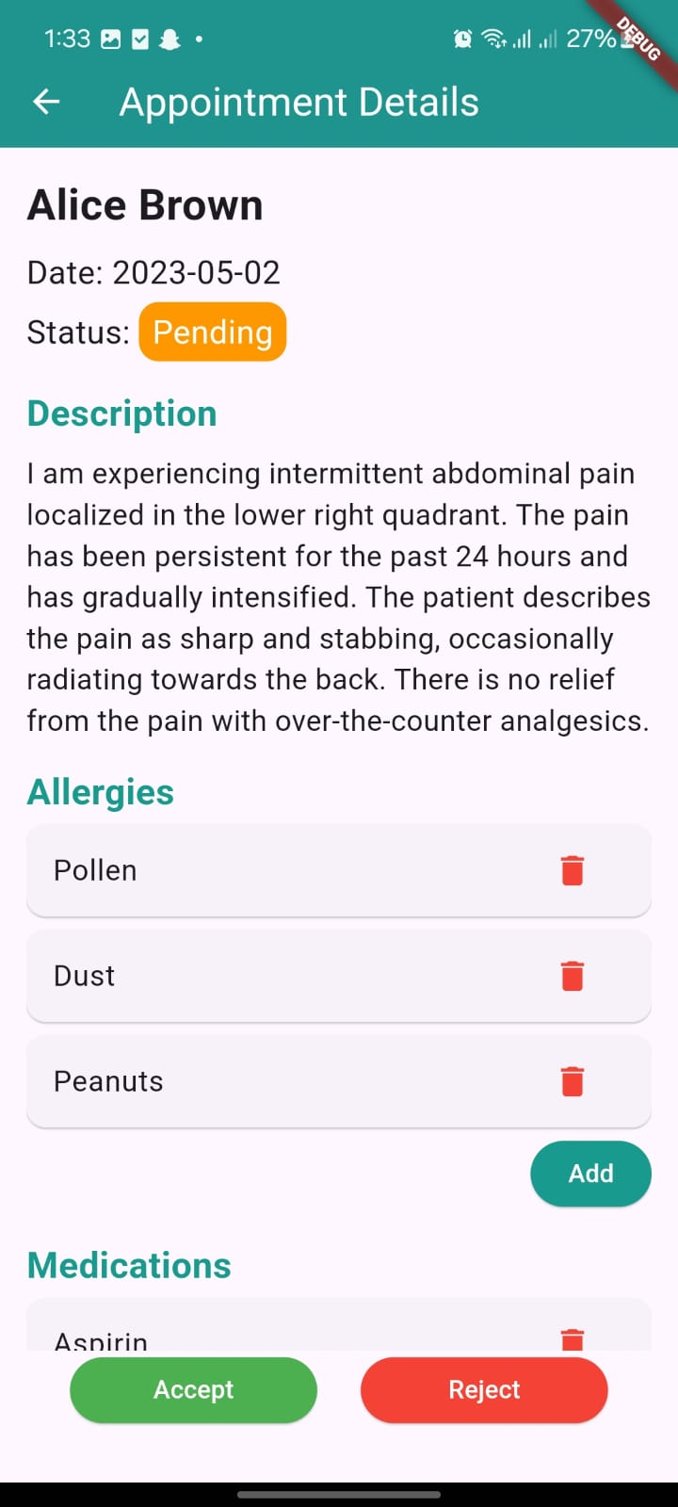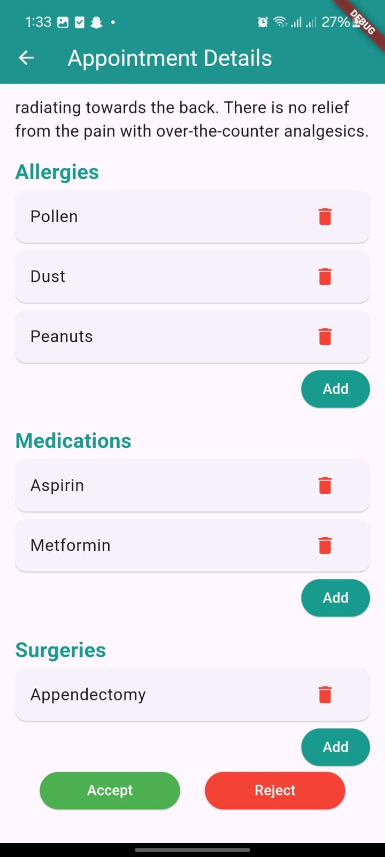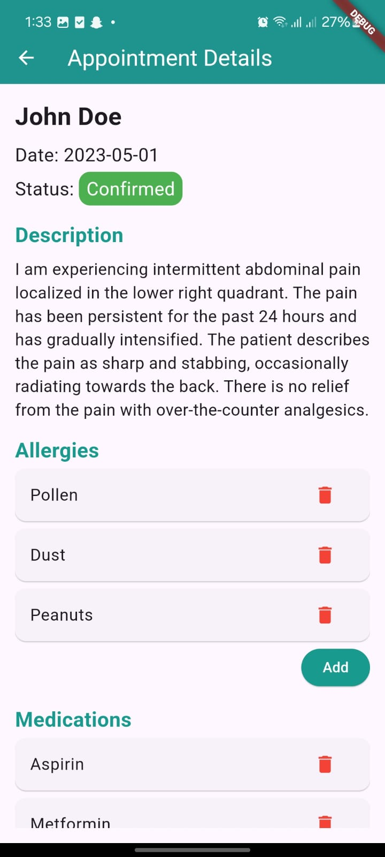

Figure 8: Appointment details page

Doctor Calendar page
This page is for the doctor to see the appointments on the calendar where he can press on the day to see the appointments on that day
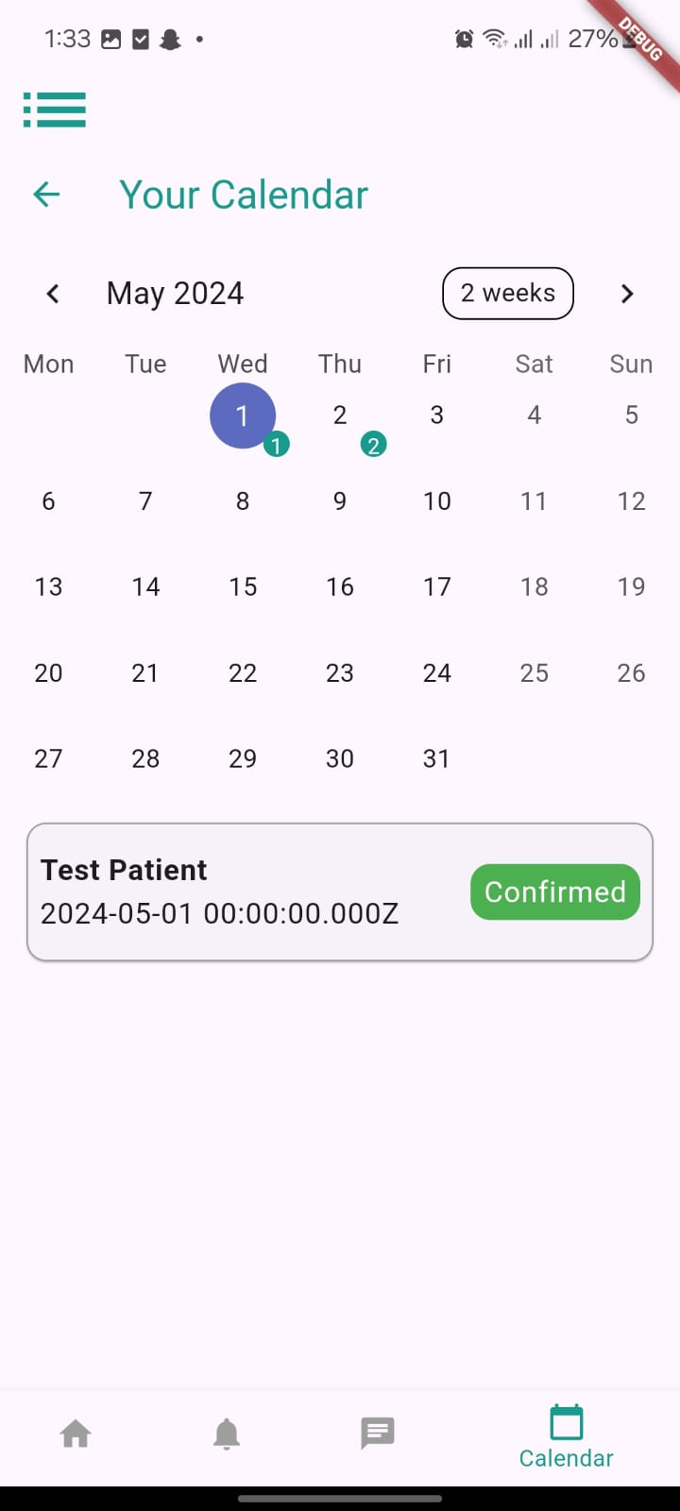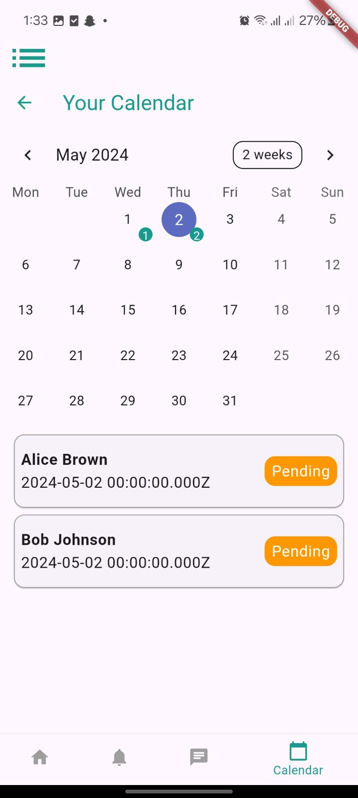

Figure 9: Calendar page

Patient Home page

This is the Patient home page where he see and search for doctors
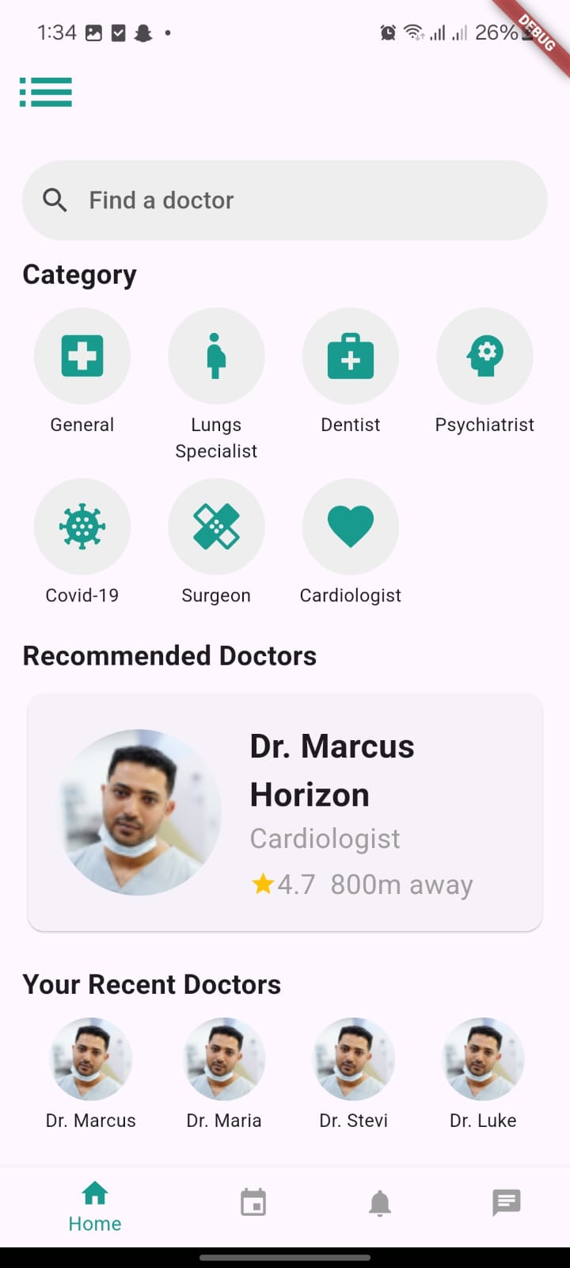

Figure 10: Patient home page

Book Appointment page
When the patient presses on a doctor the book appointment page will appear
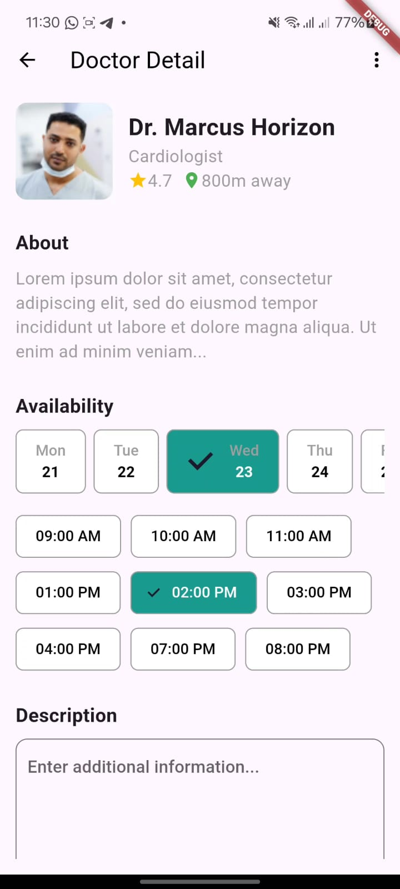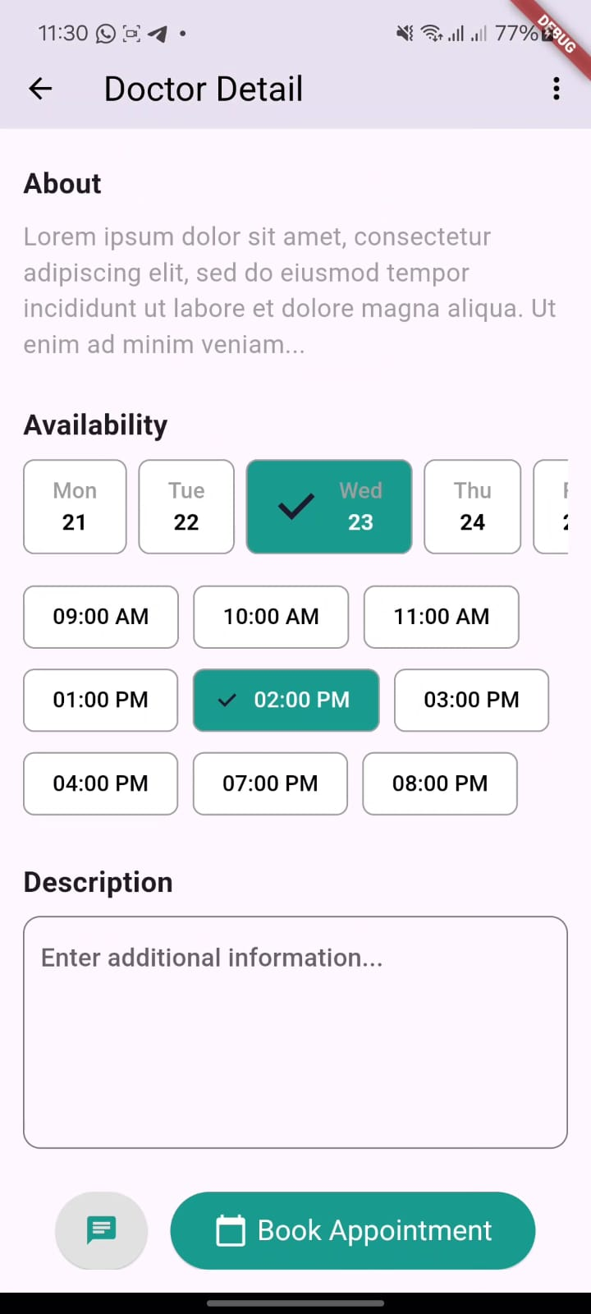

Figure 11: Book Appointment page

The Medical Patient info page

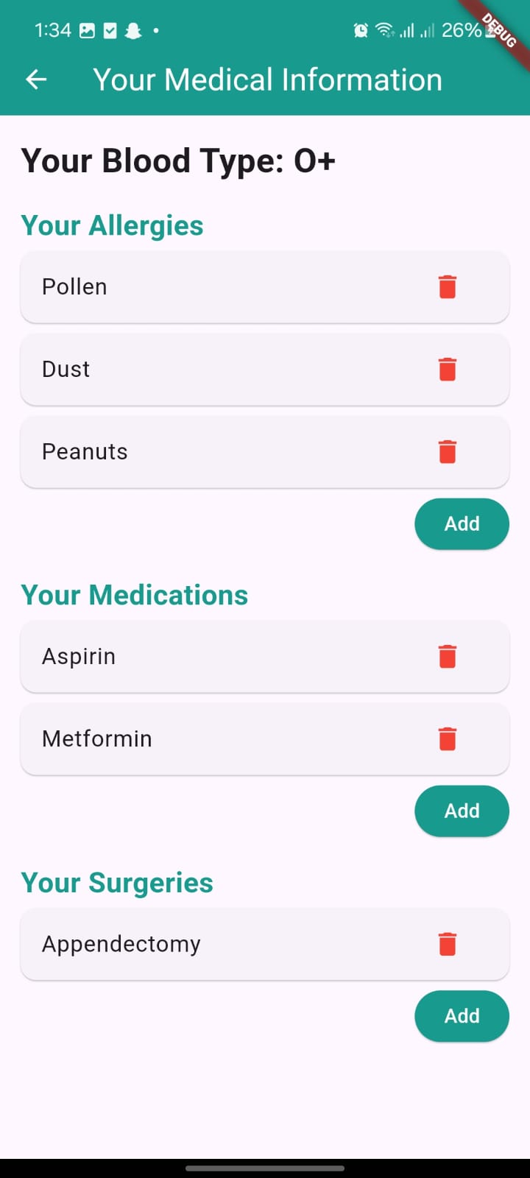

The Patient Calendar Page

In this page, the patient can see the completed, upcoming appointments, and the canceled appointments
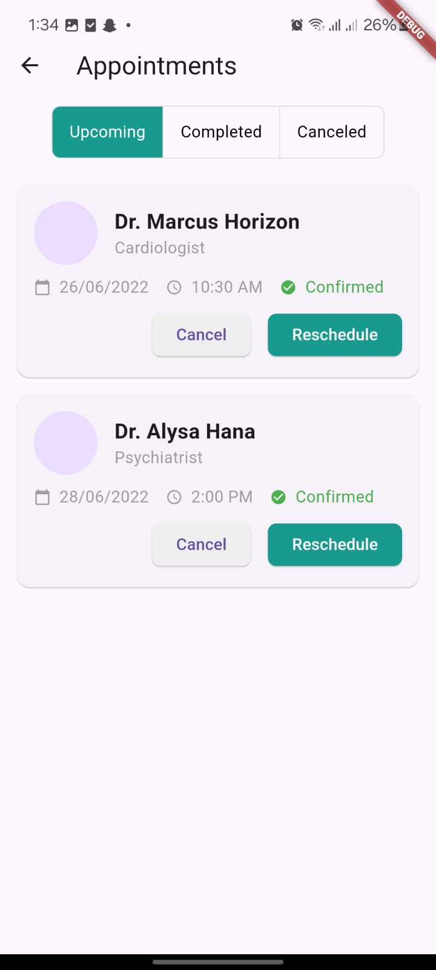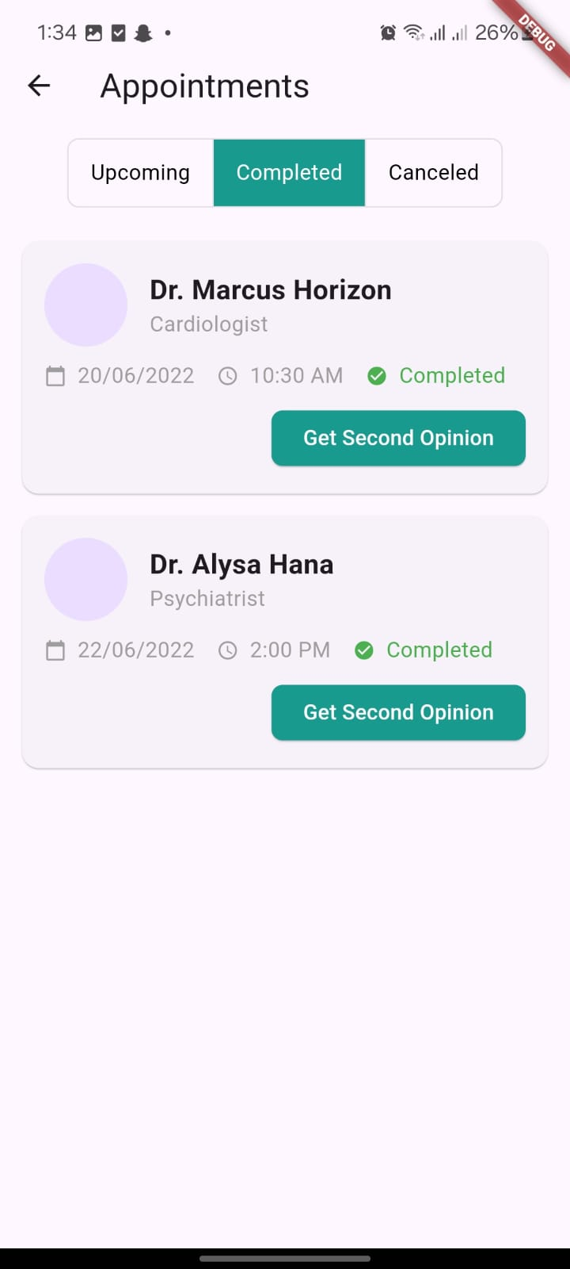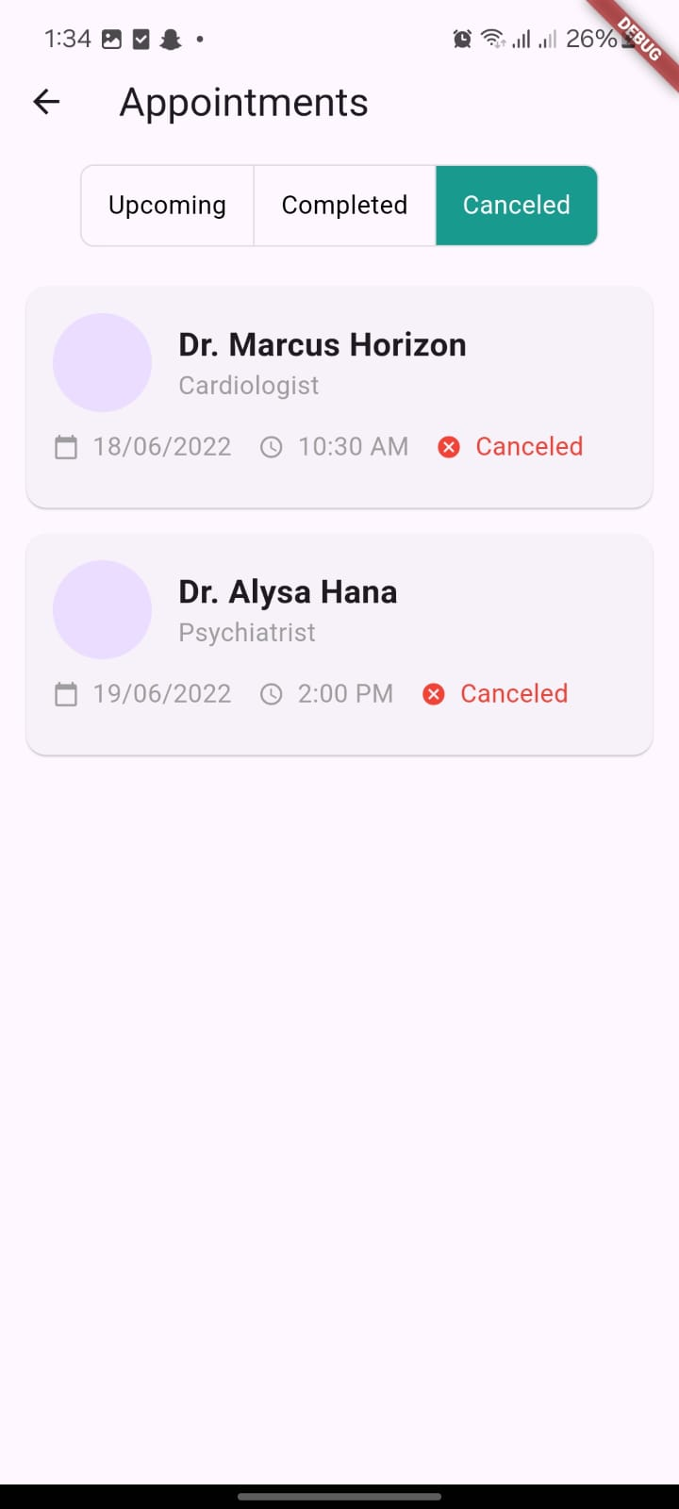

Figure 12: Patient Calendar Page

The nurse Home page
The nurse home page contains the patients that the nurse is responsible for
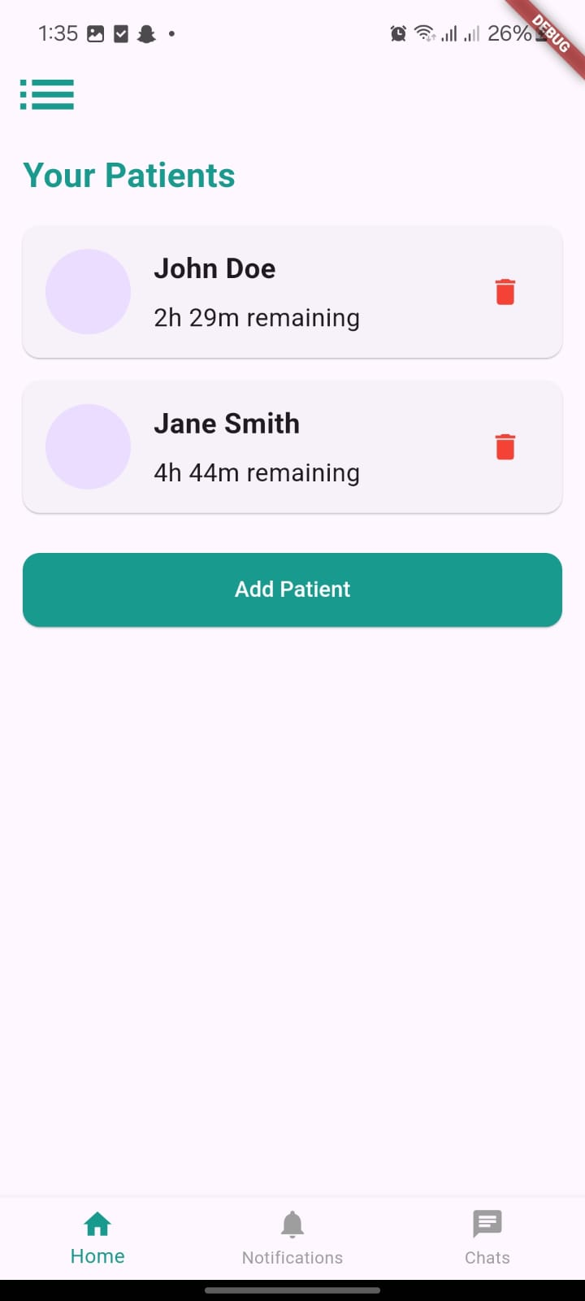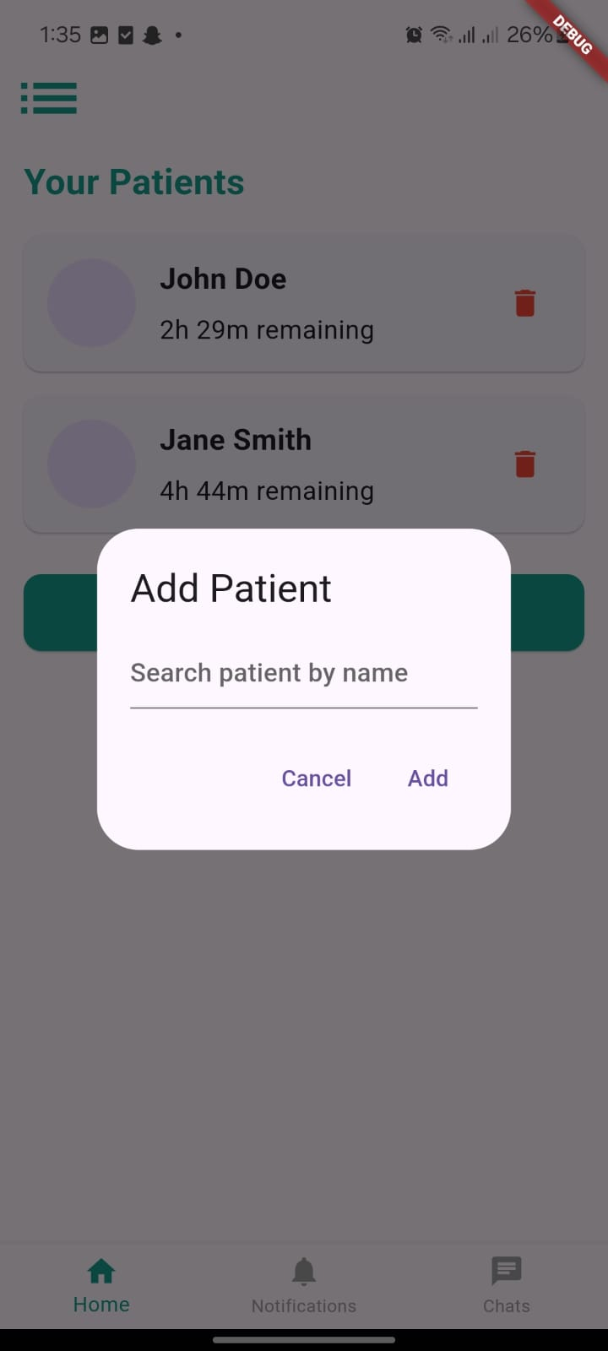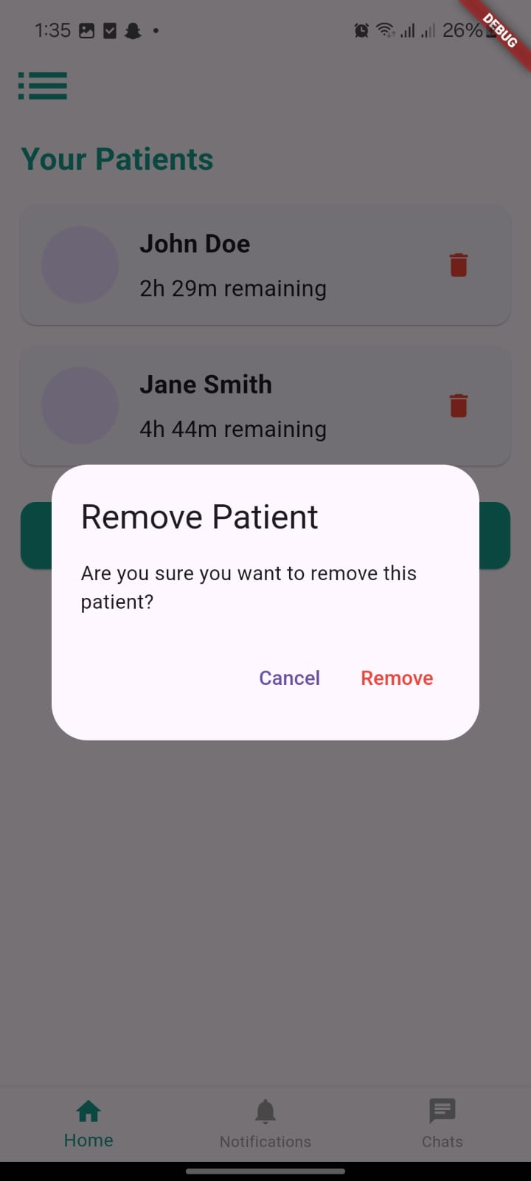

Figure 13: Nurse home page

The nurse Patient details page

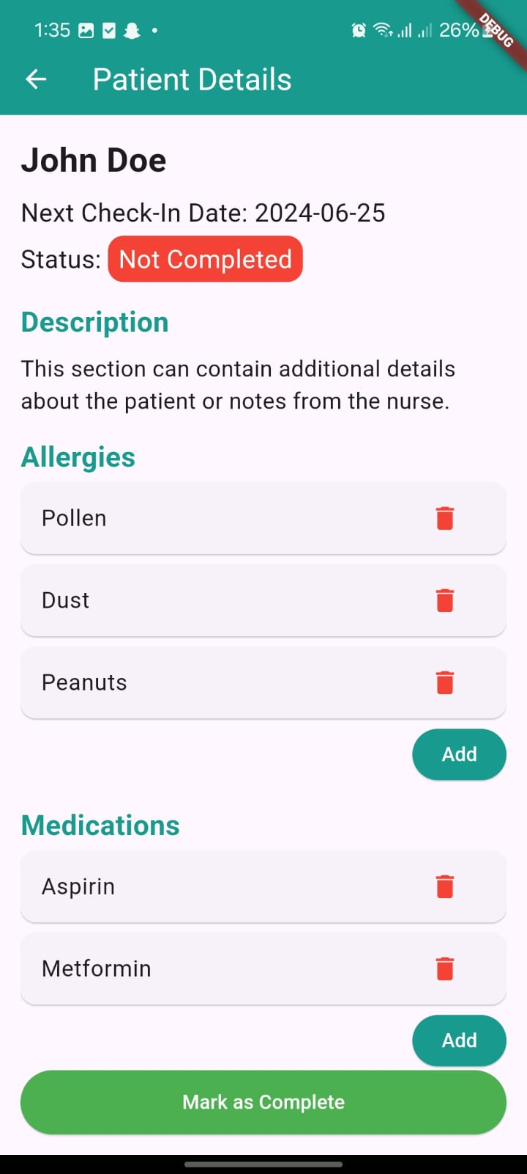

Figure 14: Chalet owner requests and Request Details

The mother home page
The mother home page contains the children that the mother is responsible for
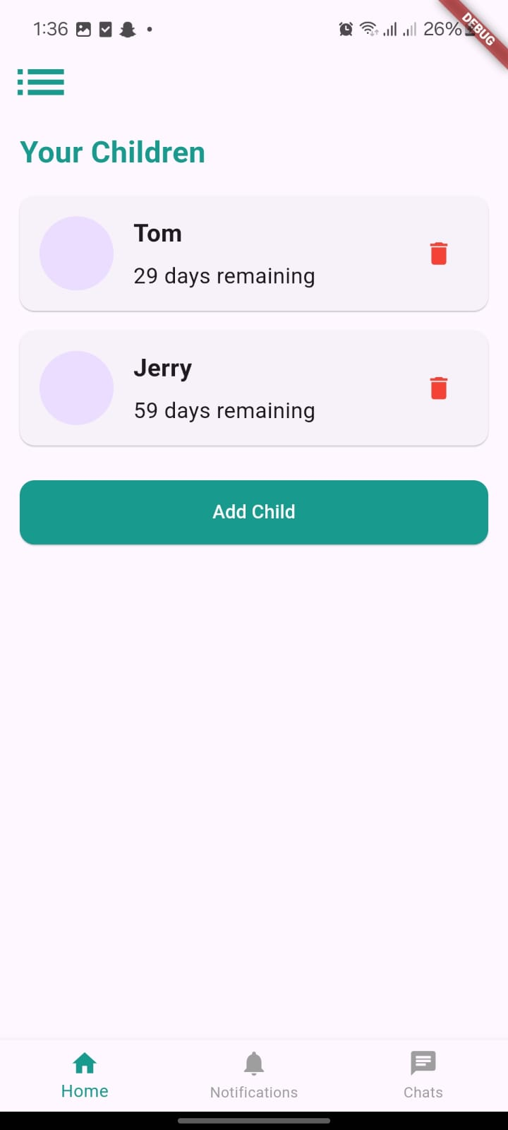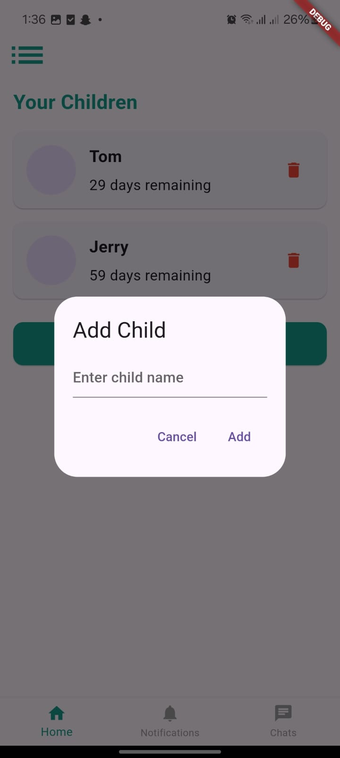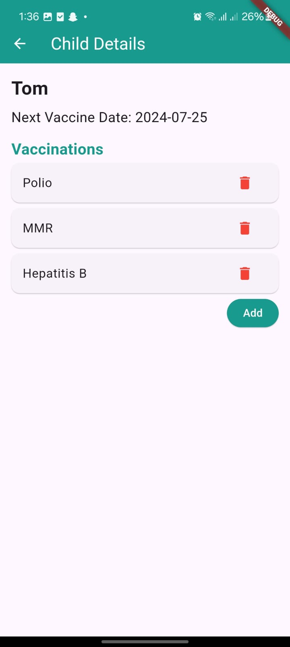

Figure 15: Mother Home Page

Admin page
This the page where the admin can approve or reject Doctors and Nurses applications
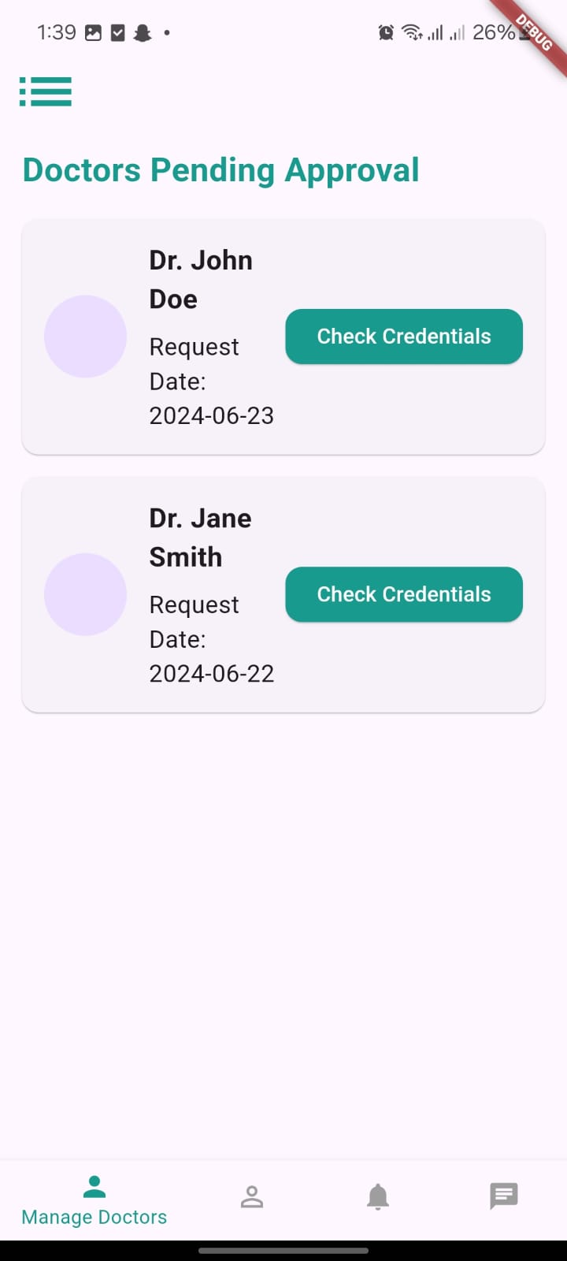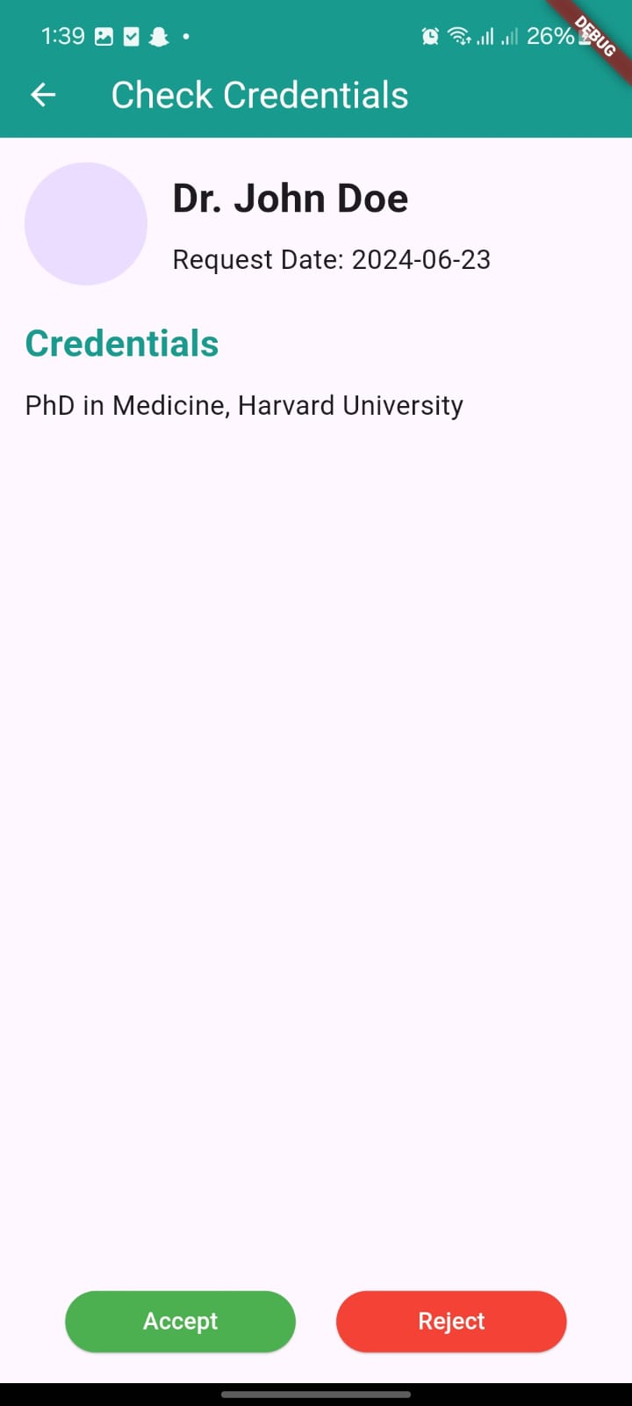

Figure 16: Admin Doctor Approval

Admin Nurses Approval

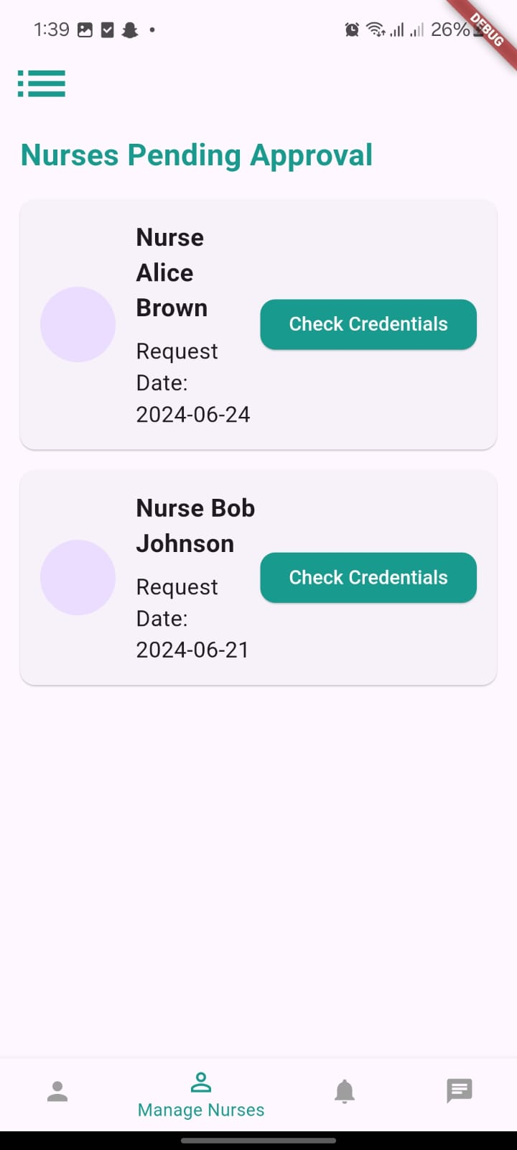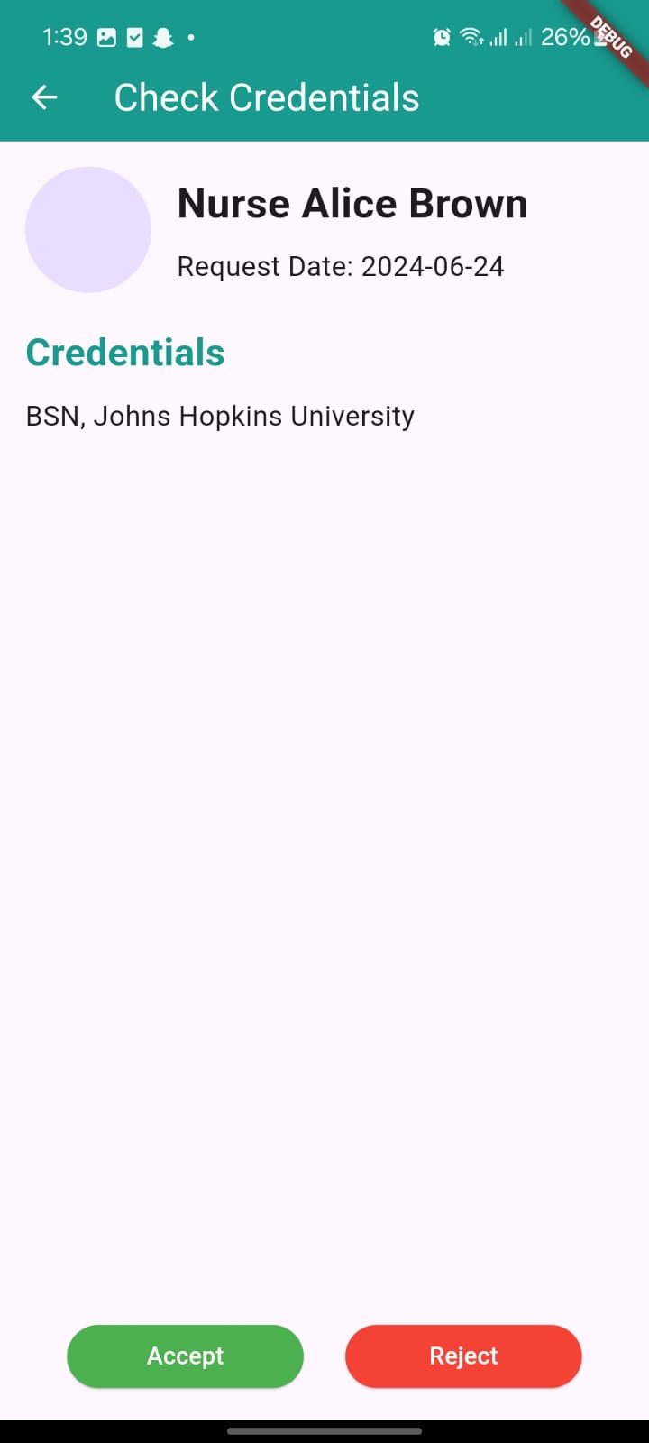

Figure 17: Nurse Admin Approval

Backend API Examples
Here are some examples of the API’s implemented
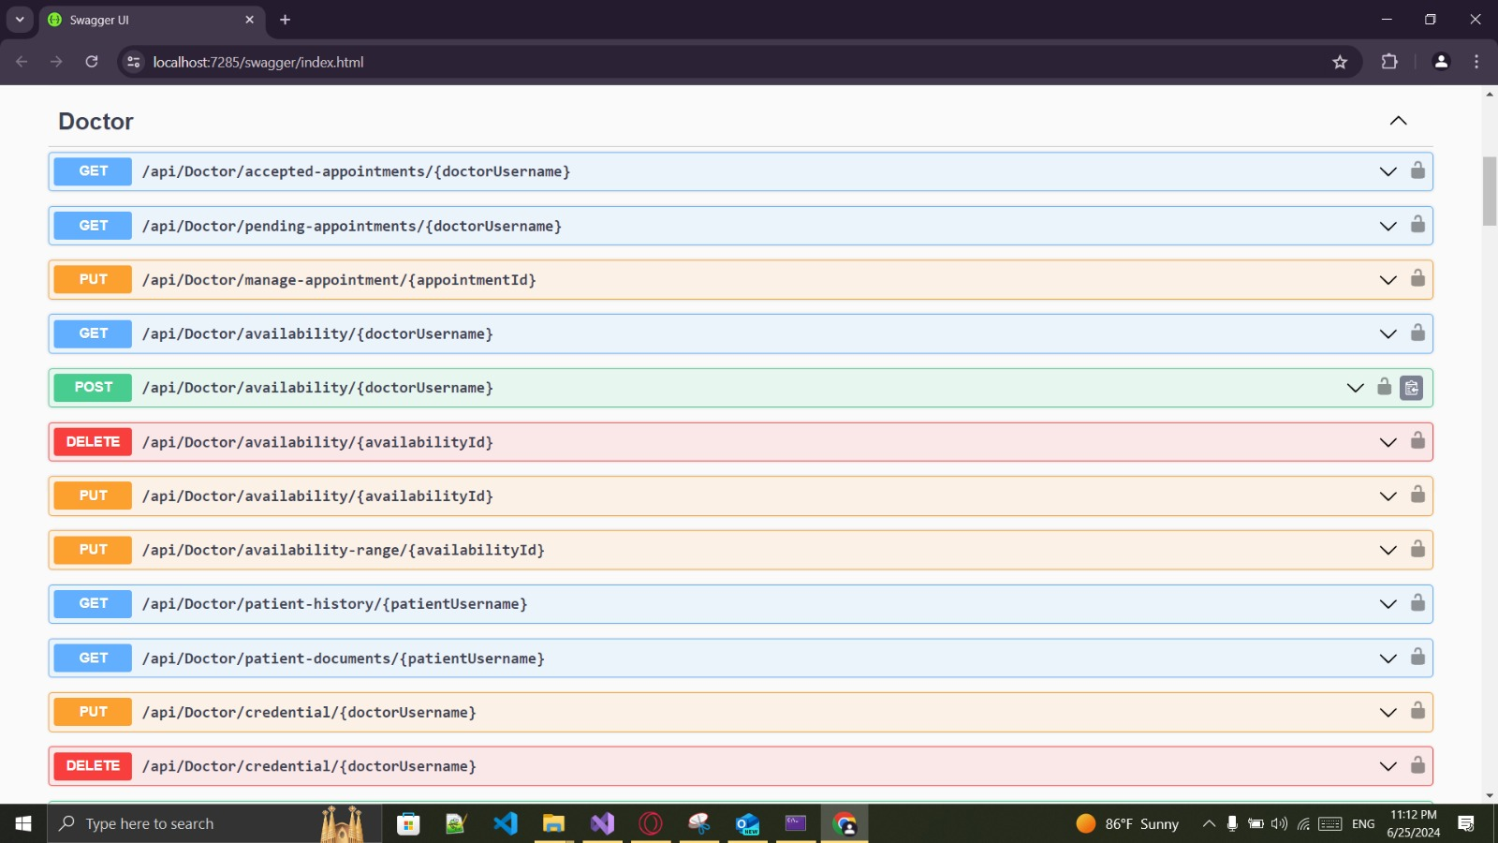

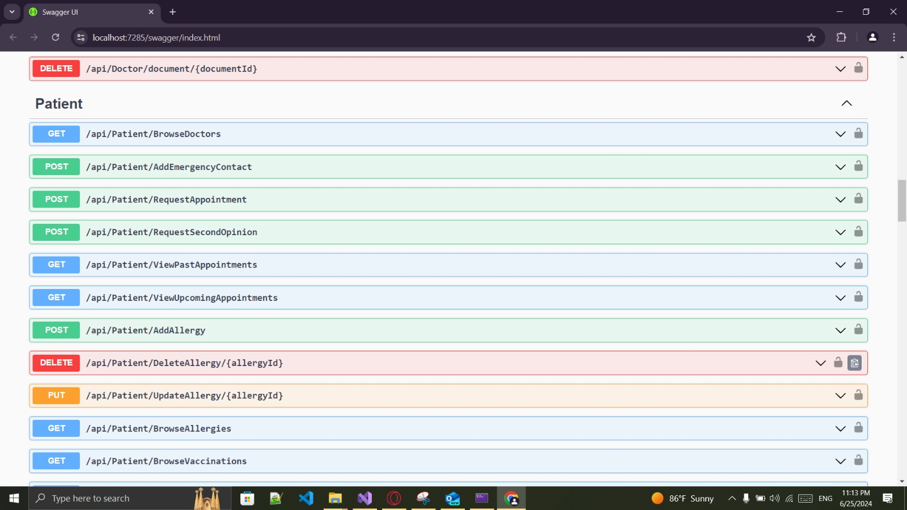

Figure 18: API Examples

CHAPTER 6

Discussion and Conclusion

Discussion and Future Work

Working on this project made me realize how far behind our medical system in Palestine is, but made me also realize how we can acutely make a difference, and the amount of untapped potential that we shrug off because of not enough time or recourses to develop such a massive app so for future work on this project would be to integrate this system with the drug store system that can manage drugs on phone to tell you where to get this drug that was described by doctor John doe , also to integrate smart watches to monitor vital signs for patients to get ahead of the illness and catch it early.

Conclusion
In conclusion, the collective impact of the implemented features in our application significantly The development of this EHR system has been a profound learning experience, highlighting the gaps in the current medical infrastructure and the potential for technological solutions to bridge these gaps. This project not only aims to improve the efficiency and effectiveness of medical records management but also sets the stage for future enhancements that can further revolutionize healthcare in Palestine. By integrating drug store systems and wearable health monitoring technologies, we can move towards a more connected, proactive, and patient-centric healthcare system. This project is a step forward in that direction, demonstrating that with the right tools and vision, significant improvements in healthcare delivery are within our reach.

