
An-Najah National University
Faculty of Graduate Studies

Recycling Stone-Cutting Waste for Eco-Friendly Kerbstone Production in Hebron, Palestine

Prepared by
Amer Mutlak Zalloum

Supervisor
Dr. Abdel Fattah Hasan

This Thesis is Submitted in Partial Fulfillment of the Requirements for the Degree of Master of Water and Environmental Engineering, Faculty of Graduate Studies, An-Najah National University, Nablus, Palestine.
2026

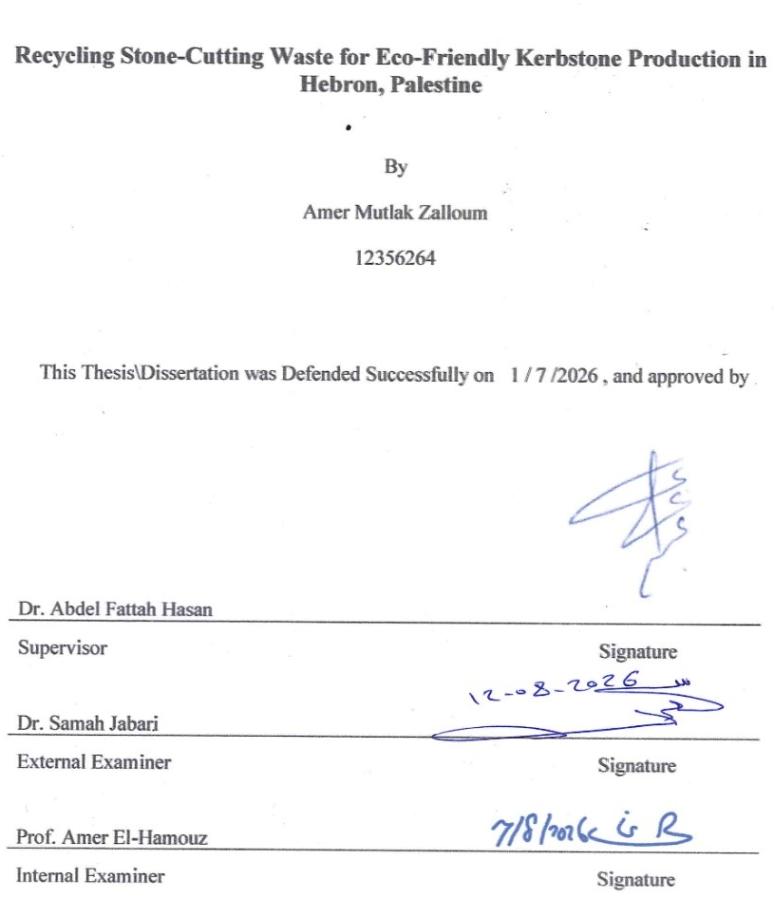

Dedication

To everyone who supported me with a word, time, or prayer, I dedicate this work. It is the fruit of a joint effort that would not have seen the light of day without you.

Acknowledgements

I extend my sincere thanks, appreciation, and gratitude to my supervisor and distinguished Dr. Abdel Fattah Hasan, who, after God Almighty, played a major role in the completion of this work. He generously gave me his time and effort, and was generous with his wise guidance and valuable comments, which helped me develop and formulate this research in an appropriate manner. His continuous support and constant encouragement were a source of inspiration and motivation throughout my studies.

I also extend my sincere thanks to all the department professors and my fellow researchers for their constructive comments and intellectual support, which greatly enriched and broadened this research. I cannot fail to thank everyone who helped me directly or indirectly, whether by providing information, observations, or even a kind word.

I cannot but express my deep gratitude to my esteemed family, who have been my support and help throughout my academic career. Their sincere prayers and constant encouragement have been a strong motivation for me to overcome all difficulties and challenges. To my dear parents and wife, I offer my deepest love and gratitude for the effort and sacrifices they have made to educate and guide me.

Finally, I extend my deepest gratitude to everyone who has extended a helping hand, whether young or old. I ask God to reward them all abundantly and to make this work sincerely for His sake and beneficial to knowledge and its people.

Declaration
I, the undersigned, declare that I submitted the thesis entitled:

Recycling Stone-Cutting Waste for Eco-Friendly Kerbstone Production in Hebron, Palestine.

I declare that the work provided in this thesis, unless otherwise referenced, is the researcher’s own work, and has not been submitted elsewhere for any other degree or qualification.

Student's Name:
Signature:
Date:

Table of Contents
Dedication iii
Acknowledgements iv
Declaration v
Table of Contents vi
List of Tables ix
List of Figures x
List of Abbreviations xi
List of Appendices xii
Abstract xiii
Chapter One: Introduction and Theoretical Background 1
1.1 General Background 1
1.2 Problem Statement 2
1.3 Aim of Study 2
1.4 Research Questions 3
1.5 Importance of the Study 3
1.6 Thesis Organization 4
Chapter Two: Literature Review 5
2.1 International Context: Demolition, Construction and Stone Cutting Waste 5
2.2 National Context: The Stone Industry in Palestine 6
2.2.1 Economic Significance 6
2.2.2 Stone Cutting Waste Management Crisis 6
2.3 Local Context: The Stone Industry in Hebron 6
2.3.1 General Background about the Study Area 6
2.3.2 Stone Cutting Waste Management Crises in Hebron 7
2.3.3 Sustainable Future Outlook 8
2.4 Hebron Stone Cutting Waste Characterization 8
2.4.1 General Background on Stone Cutting Waste in Hebron 8
2.4.2 High Concentration Liquid Slurry 9
2.4.3 Physical Characterization of Stone Cutting Waste in Hebron 9
2.4.4 Chemical Characterization of Stone Cutting Waste in Hebron 10
2.4.5 Liquid Stone Cutting Waste Treatment Efforts in Hebron 11
2.4.6 Statistical SCW Homogeneity Analysis 13
2.5 Theoretical Framework for SCW Incorporation in Concrete 16
2.6 Dry Stone Cutting Waste Applications 16
2.6.1 International Context for Recycling 16
2.6.2 National Context for Recycling 19
2.7 Liquid Slurry Applications (Without Dewatering) 20
2.7.1 International Context for Recycling 20
2.7.2 National Context for Recycling 21
2.8 The Preferred Maximum Level of LS Incorporation in Concrete Production 22
2.9 Concrete Kerbstone Technology and Standards 23
2.9.1 International Standards 23
2.9.2 National Standards 24
2.10 Palestinian Specifications and Technical Environmental Regulations 24
2.10.1 Connecting to the Public Sewage Network 24
2.10.2 Legislation Regulating LS Disposal 25
2.11 Research Gaps and Opportunities 25
Chapter Three: Materials and Methods 27
3.1 Materials 28
3.1.1 Stone Cutting Waste (Liquid Slurry) 28
3.1.2 Aggregate 29
3.1.3 Cement 30
3.1.4 Water 30
3.1.5 Plasticizer Admixture 30
3.2 Experiment Design 31
3.2.1 Concrete Mix Design 31
3.2.2 Preparing and Testing Samples 33
3.2.3 Experimental Replication and Scope of Interpretation 35
3.3 Statistical Analysis 35
3.4 Comparative Evaluation of the Tested LS Incorporation Levels 37
3.5 Environmental and Economic Benefits Analysis 38
3.5.1 Environmental Benefits Analysis 38
3.5.2 Economic Benefits Analysis 39
Chapter Four: Analysis and Results 40
4.1 Brief Introduction 40
4.2 Analysis of Mechanical Results 40
4.2.1 Compressive Strength Analysis 40
4.2.2 Flexural Strength Analysis 42
4.2.3 Abrasion Resistance Analysis 45
4.2.4 Statistical Summary and Robustness of the Observed Results 48
4.3 Compliance with Palestinian Standards 48
4.3.1 KS Compression Strength Complies with Palestinian Specifications 49
4.3.2 KS Flexural Strength Complies with Palestinian Specifications 49
4.3.3 KS Abrasion Resistance Complies with Palestinian Specifications 50
4.4 Best-Performing Tested LS Incorporation Level 50
4.4.1 Best-Performing Tested Level in Unplasticized Mixes 51
4.4.2 Best-Performing Tested Level in Plasticized Mixes 52
4.5 Quantify Environmental and Economic Benefits 52
4.5.1 Environmental Benefits Analysis 54
4.5.2 Cost Benefits Analysis 58
Chapter Five: Discussion of Results 60
5.1 Primary Findings 60
5.2 Comparative Analysis and Literature Validation 60
5.2.1 Validation of LS-Induced Mechanical Improvements against Previous Literature 60
5.2.2 Observed Performance Decline at the 20% LS Level 62
5.2.3 Observed Influence of Plasticizer Addition 63
5.3 Environmental and Economic Feasibility 63
Chapter Six: Conclusions and Recommendations 65
6.1 Conclusions 65
6.2 Study Limitations 65
6.3 Recommendations for Future Research 66
6.4 Practical Implications 67
References 68
Appendices 74

List of Tables
Table 1 Obtained Stone Cutting Waste Samples Codes and Origin. 11
Table 2 SCW Chemical Characterization. 11
Table 3 SCW Alkalinity. 11
Table 4 PSD and Homogeneity of SCW Byproducts Based on Sourced Physical Form (Hebron and Bethlehem). 13
Table 5 Concrete Mix Matrices 33
Table 6 Compressive Strength Test Results for Concrete Mixes with Various LS Substitution Levels. 40
Table 7 Flexural Strength Test Results for Concrete Mixes with Various LS Incorporation Levels. 43
Table 8 AR Test Results for Concrete Mixes with Various LS Substitution Levels. 45
Table 9 Normalized Mechanical-Performance Scores of the Tested Concrete Mixes. 51
Table 10 Environmental Trade-Off between Total Treatment and Recycling of LS. 55
Table 11 Environmental Trade-Off between Transporting the Entire Dewatered LS and Direct Recycling. 57
Table 12 The Economic Trade-Off between Full Treatment and Partial Recycling of LS. 58

List of Figures
Figure 1 Location Map of the Study Area (Hebron) and the Distribution of Stone-Cutter 7
Figure 2 Particles Size Distribution of Dewatered Slurry Powder. 9
Figure 3 Location of the Grabbed LS Sample Collection Site in the HIZ. 15
Figure 4 Systematic Flowchart of the Experimental Methodology for Using LS in Producing Eco-Friendly KS. 27
Figure 5 Effect of LS Incorporation on 28-Day Compressive Strength of Unplasticized Concrete. 41
Figure 6 Effect of LS Incorporation on 28-Day Compressive Strength of Plasticized Concrete. 42
Figure 7 28-Day Compressive Strength by LS Incorporation and Plasticizer Addition. 42
Figure 8 Effect of LS Incorporation on 28-Day Flexural Strength of Unplasticized Concrete. 43
Figure 9 Effect of LS Incorporation on 28-Day Flexural Strength of Plasticized Concrete. 44
Figure 10 28-Day Flexural Strength by LS Incorporation and Plasticizer Addition. 45
Figure 11 Effect of LS Incorporation on 28-Day Abrasion Depth of Unplasticized Concrete. 46
Figure 12 Effect of LS Incorporation on 28-Day Abrasion Depth of Plasticized Concrete. 47
Figure 13 28-Day Abrasion Depth by LS Incorporation and Plasticizer Addition. 47
Figure 14 Normalized Mechanical-Performance Scores of the Tested Concrete Mixes. 51
Figure 15 Composite Performance Score at the Tested LS Levels: Unplasticized Mixes. 52
Figure 16 Composite Performance Score at the Tested LS Levels: Plasticized Mixes. 52
Figure 17 Spatial Relationship between KS Manufacturing Facilities, CTU, and Al-Minya Disposal Site. 53

List of Abbreviations
AR: Abrasion Resistance.
CEN: European Committee for Standardization
CoV: Coefficient of Variation.
CS: Compressive Strength.
CTU: Central Treatment Unit.
EIA: Environmental Impact Assessment.
EQA: Environmental Quality Authority.
FS: Flexural Strength.
GDP: Gross Domestic Product.
HIZ: Hebron Industrial Zone.
HM: Hebron Municipality.
HRWWTP: Hebron Regional Waste Water Treatment Plant.
KS: Kerbstone.
LS: Liquid Slurry.
PF: Press Filters.
PSD: Particles Size Distribution.
PSI: Palestinian Standard Institution.
PWA: Palestinian Water Authority.
SCFF: Stone Cutting and Forming Factories.
SCW: Stone-Cutting Waste.
SG: Specific Gravity.
WC: Water Content.

List of Appendices
Appendix A Characterization of coarse stone aggregate (Foul) 74
Appendix B Characterization of fine stone aggregate (Simsim) 78
Appendix C Chemical and physical characterization of cement 82
Appendix D Mineral fresh water characterization 84
Appendix E Concrete Mix Design 85

Recycling Stone-Cutting Waste for Eco-Friendly Kerbstone Production in Hebron, Palestine
By
Amer Mutlak Zalloum
Supervisor
Dr. Abdel Fattah Hasan

Abstract
The stone industry in Palestine is a major contributor to the Palestinian national economy, with 153 stone cutting factories in the Hebron region alone. The primary problem lies in the massive environmental challenges caused by this industry along the Hebron valley. Approximately 500 $m^{3}$of liquid stone cutting waste (liquid slurry), are disposed of through the sewage system, ultimately ending up in the valley and causing widespread environmental and economic challenges along the Hebron valley.
This research investigated the sustainable recycling of liquid slurry as a partial replacement for mixing water in eco-friendly Kerbstones production, reducing the need for costly pre-treatment of liquid slurry. This methodology includes three different levels of liquid slurry/water volumetric replacement ratios, namely 0%, 10%, and 20%, with or without the addition of plasticizer. This yield six concrete matrices were evaluated for mechanical and abrasion resistance at 28 days after 28 days.
The observed results showed that 10% LS was the best-performing incorporation level among the three tested levels. The C-10-SP mixture recorded the highest observed combined performance, with a mean compressive strength of 45.3 MPa, flexural strength of 5.72 MPa, and abrasion depth of 2.01 mm. Plasticized mixtures showed higher observed performance for several comparisons, but the limited replication did not permit a statistically conclusive general observed plasticizer response.
Using the best-performing tested incorporation level of 10% as the calculation basis, this methodology contributes to a more sustainable environmental and economic approach. On a daily production scale expected to reach a maximum capacity of 1000 $m^{3}$ of kerbstones, this approach can incorporate up to 18 $m^{3}$ of liquid slurry, yields direct environmental benefits, including a reduction in the annual carbon dioxide emissions of 55.1 tons
Economically, switching from traditional disposal to direct recycling reduces annual operating costs by approximately 284000 shekels. Therefore, the recycling system described in this thesis offers acceptable feasibility and may contribute to the adoption of more sustainable environmental solutions related to stone cutting waste.
Keywords: Stone cutting waste, Liquid slurry, Eco-friendly kerbstones.

Chapter One: Introduction and Theoretical Background

General Background
The stone and marble sector is one of the key Palestinian industries, with an annual sales volume of around $600 million, which accounts about 4.8% of Palestine Gross Domestic Product (GDP) (Seureca et al., 2020). Over time, this industry, "rooted in Palestinian history," has evolved from traditional manual methods in stone quarries to more advanced methods.
The modern methods rely primarily on automation, machinery, and equipment in stone-cutting facilities, known as stone-cutting and forming factories (SCFF). In the city of Hebron, which is located to the south of the West Bank, there are 153 SCFF concentrated in the industrial area of the city, which is called Al-Fahas area (Seureca et al., 2020).
Palestinian limestone is highly valued in regional and global markets because it has unique physical and chemical properties. For example, it is very pure calcium carbonate (${\text{CaCO}}_{\text{3}}$), which makes up 94% to 98% of its components. It is also easy to shape, does not absorb water, and is very bright white. Because of these unique qualities, Palestinian stone has a special place in both local and global markets (Al-Joulani & Salah, 2014).
However, the massive expansion of the stone industry in Hebron and the huge increase in demand for Palestinian stone coupled with a general weakness in oversight and planning, have created environmental and economic challenges that pose an existential threat to this industrial entity.
Cutting saws of different sizes, which are cooled directly by water, are the main tools used to shape and cut stone in Hebron's SCFF. This water carries the small, solid stone pieces that were made during the cutting process. After that, the water is moved to suspended silos so that the solid particles can settle. The water is reused in the cooling process after it has settled, and the high-concentration liquid slurry (LS) that has built up at the bottom of the silos is disposed of. Current estimates say that LS is made in Hebron every day at a rate of about 500 $m^{3}$/day. It has a specific gravity of 1.5 kilograms per liter and solids content of between 30% and 40% (Seureca et al., 2020).
The disposal of LS is primarily carried out through the main sewage lines in the area, causing environmental, technical, and economic problems that extend beyond the Hebron industrial zone (HIZ) to encompass all areas along the Hebron valley, reaching as far as the Mediterranean Sea.
The high alkalinity of stone cutting waste (SCW) causes pH levels in wastewater conveyance and treatment systems to rise dramatically and significantly, which kills the biological treatment processes that are needed to break down organic waste (Prinčič et al., 1998) . This chemical interference has made the new Hebron Regional Wastewater Treatment Plant (HRWWTP) inoperable. This is a substantial loss of public money and the ability to protect the environment (Palestinian Water Authority (PWA), 2018).

Problem Statement
The core of the research problem lies in the improper disposal of SCW in the Hebron area. Approximately 500 $m^{3}$/day of LS are discharged into the sewage networks located in the industrial zone south of Hebron. Due to the high solids content of this waste, the improper disposal of the LS causes frequent blockages in the sewage networks, resulting in recurring health hazards due to the overflow of domestic and industrial wastewater. Furthermore, the high alkalinity of the LS hinders the completion and operation of the regional wastewater treatment plant in Hebron (HRWWTP).
Stone LS finds its way to the Hebron Valley on a journey of about 45 km along the valley before it is treated behind the Green Line, causing major environmental and economic problems. This material accumulates on the banks of the valley, causing environmental problems including air, water, and soil contamination, and increasing the severity of flooding in the valley during the rainy season, causing significant losses for farmers and residents there. In addition to the above, the Israeli occupation deducts millions of shekels from Palestinian task revenues to treat this LS from domestic and industrial wastewater (PWA, 2013).

Aim of Study
The ultimate goal of this research is to contribute to long-standing environmental solutions for SCW or LS in the Hebron area by investigate the technical, economic, and environmental feasibility of recycling LS as a partial replacement for mixing water in the production of eco-friendly kerbstones (KS) in Hebron, Palestine.

Research Questions
This research aimed at answering the following questions:
- RQ1: How might replacing part of the mixing water with LS affect the long-term and mechanical performance in terms of compressive strength (CS), flexural strength (FS), and abrasion resistance (AR) of the produced KS?
- RQ2: How does the integration of a plasticizer, in combination with LS, influence the performance (CS, FS, and AR) of the produced KS?
- RQ3: To what degree do the properties KS produced with LS comply with the Palestinian Standard Institution (PSI) specifications?
- RQ4: What are the potential economic outcomes and net benefits identified through a preliminary Cost-Benefit Analysis of LS recycling into KS production at the best-performing incorporation level?
- RQ5: What is the estimated environmental impact, specifically concerning CO2 emission reduction, when directly recycling LS into KS at the best-performing incorporation level compared to energy-intensive treatment technologies?

1.5 Importance of the Study
Through this research, evaluation of the potential use of LS directly without treatment in the production of eco-friendly KS was demonstrated by incorporating LS as a partial replacement of concrete mixing water at three different levels.
Using LS in concrete mixes as a partial water replacement could contribute to mitigating the demand for fresh water in the KS industry. Furthermore, this approach suggests a reducing in the LS treatment and dewatering cost. This, in turn, will contribute in the controlling the environmental problems caused by LS at a reasonable cost increasing the viability of the ultimate product, in addition to reducing costs associated with improper disposal, such as environmental and infrastructure remediation costs and occupation taxes.

1.6 Thesis Organization
This thesis consists of six integrated chapters:
Chapter One (Introduction): provides a general overview of the study topic, a clear definition of the problem, and a general explanation of the study's objectives.
Chapter Two (Literature Review): This chapter provides a general review of studies and technical reports related to the objectives of this thesis
Chapter Three (Materials and Methods): This chapter aims to build a roadmap and a general reference for the experiment of this thesis in order to ensure the possibility of repeating the experiment in similar circumstances.
Chapter Four (Results and Analysis): This chapter summarizes all the results of laboratory experiments necessary to evaluate the effect of adding LS on the concrete mixture needed to make KS. This chapter also presents the best-performing mix among six different concrete mixes, in addition to quantifying the environmental and economic benefits that can be achieved by adopting this recycling system under the best-performing LS incorporation level.
Chapter Five (Discussion): This chapter provides a recall of the most important results of the laboratory experiment and then provides a detailed discussion of these results and comparing them with the results of similar experiments.
Chapter Six (Conclusion and Recommendations): acknowledges potential shortcomings in the research and offers recommendations for future research.

Chapter Two: Literature Review

International Context: Demolition, Construction and Stone Cutting Waste
The construction industry, in both its building and demolition sectors, contributes approximately 30-40% of the world's solid waste, posing a significant environmental challenge and placing considerable pressure on natural resources (Petrović & Thomas, 2024). On the other hand, the extraction of natural resources, such as building stones from quarries, contributes to the destruction of wildlife and habitats, in addition to being a consumer of non-renewable energy, which increases greenhouse gas emissions and contributes to the intensification of global warming and climate change.
Stone cutting waste, as a specific type of demolition and construction waste, poses a significant environmental challenge. The volume of these wastes produced annually exceeds 64 million tons, representing about 20% of the total raw rocks in the world (Mishra & Jain, 2026). This enormous volume poses particular challenges to managing these materials, whether through processing them to separate the solids from the water, or through disposing of them properly in environmentally approved landfills. Therefore, to reduce pressure on natural resources, such as energy sources and land designated for waste disposal, recycling emerges as a strategic solution for managing this waste.
However, the high fineness of the SCW with an average diameter of d50 ranging between 10–25 μm and the high purity of the calcium carbonate material (>95% ${\text{CaCO}}_{\text{3}}$) makes this material of particular importance in recycling, especially in construction fields. Conversely, improper disposal of this material, such as in valleys, creates a negative environmental reality that affects the air, water, and soil, as the continuous accumulation of this material leads to a decrease in soil porosity, suffocation of roots, and an increase in dust concentrations in the air, causing a profound impact on the social, economic, and health situation (Union of Stone & Marble Industry - Palestine (USMI)), 2022).

National Context: The Stone Industry in Palestine

2.2.1 Economic Significance
Palestinian limestone, or what is known locally as white gold, constitutes a fundamental resource in the Palestinian national economy, as it constitutes approximately 4.8% of the Palestinian gross national product, with sales reaching $600 million annually and an annual production volume estimated at 22 million tons of building stones which is ranking Palestine in the top 12 globally in terms of stone production volume (USMI, 2022).
In terms of local consumption and export, the Palestinian domestic market consumes about 20% of the total production of building stones, while the remainder, which constitutes about 25% of total Palestinian exports, is exported (Salem, 2021).

2.2.2 Stone Cutting Waste Management Crisis
In Palestine there is around 470 SCFF, most of these facilities locate to the south of west bank (Hebron and Bethlehem). Anyway, the total production volume of SCW or LS vary from 700000 to 1000000 tons annually. The huge volume and weight of stone cutting byproducts make unsafe or even safe disposal of SCW form a strong pressure on the environment. The huge volume and weight, fine PDS, high alkalinity and chemical characterization of the SCW increase the burden on natural resources such as land, soil, air, and water (Al-Joulani, 2011).

Local Context: The Stone Industry in Hebron

2.3.1 General Background about the Study Area
Hebron is located in the southern West Bank, approximately 30 kilometers south of Jerusalem, the capital of Palestine. Hebron City is situated over a limestone mountainous terrain, on a mountain range ranging in altitude from 750 to 1020 meters above sea level. The climate of Hebron City is characterized by rainy winters and hot, dry summers, with an average annual rainfall of about 595 mm. Demographically, Hebron is the most densely populated city in the West Bank, with approximately 250,000 inhabitants.
Hebron is the heart of Palestinian commercial and industrial activity. Among the most prevalent industries is the stone industry, in which Hebron holds the leading position in Palestine. Approximately 153 SCFF are located to the south of the city, representing about 25% of all stone facilities in the West Bank. All of these facilities are located south of Hebron in the HIZ known as the Al-Fahs area.
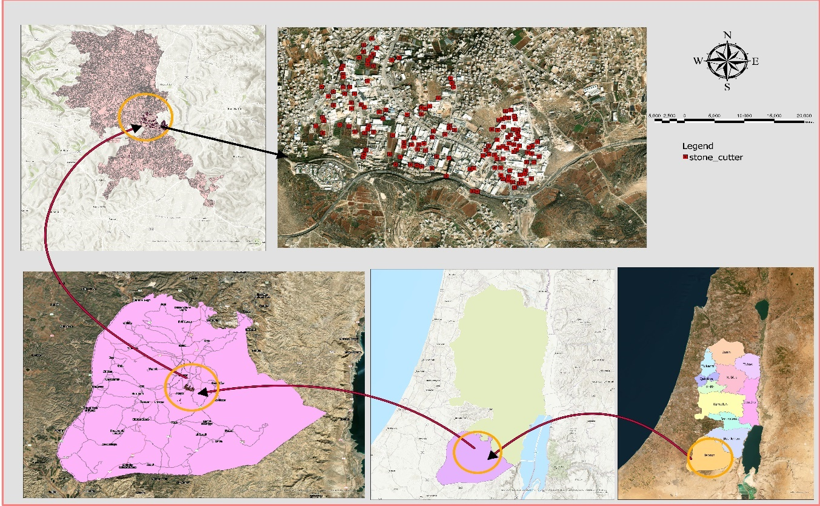
Figure 1 Location Map of the Study Area (Hebron) and the Distribution of Stone-Cutter

2.3.2 Stone Cutting Waste Management Crises in Hebron
Hebron city constitutes the largest part of Palestinian stone industry. With around 153 SCFF, the daily production of LS is estimated at around 500 $m^{3}$ or around 160000 $m^{3}$ annually, which is form around 22% of total generated SCW in the Palestine (Seureca et al., 2020).
SCW form around 55% of total solid waste in Hebron. LS, which contains approximately 30% solids by volume, produces about 400 tons daily, assuming a specific gravity of approximately 2.7 kg/m³ for the solids (Seureca et al., 2020). Meanwhile, the total daily solid waste production of Hebron's 250,000 residents does not exceed 330 tons (around 1.31 kg per capital).
This significant volume and weight of SCW produced daily in Hebron, even if treated and disposed of in environmentally licensed landfills, represents a massive drain on natural resources, both in terms of raw material production and the land area it occupies during disposal.
The most common method of disposing of LS in Hebron is by discharging it into sewage networks, causing environmental, economic, and agricultural problems along the 45 km Hebron Valley, before this mixture of sewage and industrial wastewater is treated in the occupied territories beyond the Green Line (Seureca et al., 2020).

2.3.3 Sustainable Future Outlook
Balancing economic returns with environmental and health responsibility is crucial for the sustainability of the stone industry. Therefore, it is possible to maintain the sector's sustainability by improving production chains through better control of the manufacturing process and reducing raw material consumption and waste generation.
The sustainability of this sector in Hebron extends beyond improving production chains to include exploring various recycling methods. These efforts require laws and regulations to govern them, as well as cooperation between law enforcement agencies (government and municipalities) and private sector stakeholders on a win-win basis, especially given the difficult and complex economic, security, and political conditions faced by Palestinians in Hebron, particularly since this area is classified as Area H2 under the Oslo Accords (USMI, 2021).

Hebron Stone Cutting Waste Characterization

2.4.1 General Background on Stone Cutting Waste in Hebron
The West Bank mountains form a source for a high-quality large lime stone blocks. The extracted stone blocks from these mountains, which weigh thousands of kilograms, undergo multiple forming and cutting activities, which break them into small building stones can be used in various construction activities.
The transformation process uses large stone saws, which require water to control saws operational temperature. The stone-cutting process produces dust while the cooling water captures the dust to form a light white liquid material called low-concentration stone slurry that contains 98% water content (Seureca et al., 2020).

2.4.2 High Concentration Liquid Slurry
Due to the scarcity of water in the southern West Bank regions, all SCFF carry out a simple physical treatment pattern that relies mainly on thickening the low concentration LS in silos. Where water is recovered from the upper part of the silos to be reused in cooling the stone saws again, while the highly concentrated slurry is produced as a sedimentation byproduct in the lower part of the silos. In this process, water content was reduced from 98% to (70% - 60%) depending on the time of residence inside the silos (Seureca et al., 2020).

2.4.3 Physical Characterization of Stone Cutting Waste in Hebron
Based on the results of researches and technical studies conducted on the stone sector in the southern West Bank, which considered statistical analysis and the spatial and temporal distribution of the test samples. However, it was found that the percentage of suspended solids “TSS” in the highly concentrated LS, which is disposed of through sewage networks, is estimated at approximately 30% of the LS volume. Meanwhile, the SG of the liquid is estimated at approximately 1.5 ton/$m^{3}$(Seureca et al., 2020).
Regarding the Particle Size Distribution (PSD) of samples taken from six SCFFs in the Hebron and Bethlehem area, the distribution was described as well graded, with an average diameter of 20 µm (DAI, 2014). This suggests the potential for a water-slurry mixture, at carefully considered incorporation ratios, to improve the mechanical properties of concrete (Carsten Vogt, 2010).

Figure 2 Particles Size Distribution of Dewatered Slurry Powder.
(Adapted from DAI, 2014).
Since the PSD of the material indicates a very fine texture with diameters ranging from 1-400 micrometers, further testing of the solid’s absorption was necessary. The results showed that the material's oil absorption rate was approximately 25 ml/100g (DAI, 2014). Incorporation of high oil absorption fine particles in concrete mixture tend to increase water demand, reduce concrete mixture workability and compromise long term performance (Mapa Mudiyanselage, 2019).

2.4.4 Chemical Characterization of Stone Cutting Waste in Hebron
Based on the properties of limestone, which is one of the purest sedimentary rocks in the world, especially given its high calcium carbonate content compared to the other components, the main chemical component of the waste from cutting stones after drying is calcium carbonate. A study conducted by DAI showed that the chemical composition of dried stone paste powder in the Bethlehem and Hebron areas contains at least 94% calcium carbonate, while ${\text{CaCO}}_{\text{3}}$, ${\text{Mg}\text{CO}}_{\text{3}}$ and ${\text{Si}\text{O}}_{2}$ make up about 99% of the chemical content of this powder (DAI, 2014). This high purity of Palestinian limestone makes the waste resulting from stone-forming processes an opportunity for recycling and investment in many medical and agricultural fields, especially in the construction sector.
Conversely, improper disposal of dry limestone or LS with a high calcium carbonate content may lead to long-term problems, such as soil and groundwater salinization, increased air pollution, and the creation of an alkaline environment. Some samples of stone-cut slurry taken in Hebron showed a high alkalinity level of about 10, which may hinder efforts to treat wastewater flowing through the Hebron Valley (DAI, 2014). Tables 1, Table 2 and Table 3 detail the origin of the samples and some of the chemical properties of SCW samples taken from the southern West Bank in the Hebron and Bethlehem areas.

Table 1 Obtained Stone Cutting Waste Samples Codes and Origin.
Sample Code | physical State | Origin
Factory 1 | Slurry | Mixture of  Sheiukh, Khalet Hejjeh, and Tarqumia stone cutting waste
Factory 2 | Slurry | Mixture of  Sheiukh, Khalet Hejjeh, Tarqumia, Beit Fajjar, Jenin, Taffouh and Grey Beir Zeit stone cutting waste
Factory 3 | Cake and slurry | Mixture of  Beit Fajjar, Jenin, Taffouh and Grey Beir Zeit stone powder
Factory 4 | Cake  from filter press | Mixture of  Sheiukh and Yellow Beir Zeit stone powder
Factory 5 | Cake  from filter press | Mixture of many stone powders from Nassar Company
Factory 6 | Cake  from filter press | Mixture of many stone powders from Zaffaran Company
(Adapted from DAI, 2014)
Table 2 SCW Chemical Characterization.
Test | Factory 1 | Factory 2 | Factory 3 | Factory 4 | Factory 5 | Factory 6
${\text{CaCO}}_{\text{3}}$​ % | 93.97 | 98.39 | 96.67 | 95.84 | 95.87 | 97.77
${\text{CaCO}}_{\text{3}}$​+${\text{MgCO}}_{\text{3}}$​ % | 96.83 | 99.10 | 97.84 | 97.02 | 96.85 | 98.68
Fe2​O3​ % | 0.03 | 0.02 | 0.03 | 0.02 | 0.11 | 0.02
Fe2​O3​+Al2​O3​ % | 0.08 | 0.07 | 0.07 | 0.08 | 0.15 | 0.05
SiO2​ % | 1.04 | 0.31 | 0.53 | 0.98 | 0.78 | 0.46
Al2​O3​ % | 0.06 | 0.05 | 0.04 | 0.06 | 0.04 | 0.03
(Adapted from DAI, 2014)
Table 3 SCW Alkalinity.
TEST | Factory 1 | Factory 2 | Factory 3 | Factory 4 | Factory 5 | Factory 6
pH | 9.48 | 9.51 | 9.52 | 9.52 | 9.24 | 9.40
(Adapted from DAI, 2014)

2.4.5 Liquid Stone Cutting Waste Treatment Efforts in Hebron
The primary efforts in treating liquid SCW always aim to reduce the water content of the material or recover the solid part of the material through a process known as dewatering (Ramahi et al., 2023). Anyway, there are three main levels of LS treatment, which can be classified as follows:
Level 1: A simple sedimentation process takes place inside the silos, with a retention time of approximately two hours. Coagulants are used in this process to increase the efficiency and speed of sedimentation and decrease the volume of stone sludge to be processed. This stage is basic to any subsequent treatment (Fahiminia et al., 2013). This process creates high-concentration SCW (LS) with a water content of 60% to 70% (Seureca et al., 2020). Approximately 30% to 40% of the water content in the stone sludge is recovered from this process and reused for cooling stone saw blades.
However, in the city of Hebron, all 153 SCFF use this treatment technology because it is inexpensive and recovers a good percentage of water in an area that suffers greatly from water scarcity (Seureca et al., 2020).
Level 2: The LS produced in level one undergoes further treatment aimed at separating the solids from the liquid. Press filter (PF) is the most common system used in Hebron. This separation system involves feeding a set of bags with the LS, then applying high pressure via a hydraulic press to the bags. This forces the water out through tiny pores, while the solids remain inside the bags to be removed later as a completely solid waste (cake) while the moisture content decreases from 70% to 30% (The MBR Site, 2025).
In Hebron, 47 out of 153 SCFF use the second stage of treatment. This means that only 31% of the factories treat the highly concentrated stone LS before disposal. The reason for this low percentage is the high cost of the second stage of treatment; the cost of treating one cubic meter of highly concentrated LS is estimated at approximately 50 shekels, while the cost of purchasing one cubic meter of water is only 5 to 15 shekels. Consequently, in the absence of law enforcement in the southern Hebron area, most factory owners resort to directly disposing of the highly concentrated LS through the sewage system (Seureca et al., 2020).
Level 3: The third step of processing is meant to make it possible to invest in more areas of LS material that has been completely dried (powder). This process has several steps to dry, burn, and grind the limestone ore until it has the right PSD for the recycling use that has been chosen. This stage facilitates the absorption of larger quantities of SCW (treated lime) due to the increased potential for reuse, taking into account SCW or lime produced in industry. For example, treated lime constitutes approximately 60% of the components of cement (Aliabdo et al., 2014).
The high cost of grinding and kiln drying is still the biggest problem, and it could make the market less competitive. The third stage of processing is missing in Hebron because energy prices are high and there is not much advanced technology. This yield that recycling lime powder in the industry costs more than the finished product.

2.4.6 Statistical SCW Homogeneity Analysis
By reviewing the outputs of DAI's technical report on the study of the physical and chemical properties of SCW in Hebron and Bethlehem governorates, the previous results showed that there is a great similarity in the chemical properties, especially for the content of ${\text{CaCO}}_{\text{3}}$, ${\text{MgCO}}_{\text{3}}$ and ${\text{SiO}}_{2}$ reaches conformity (more than 99% of the SCW content as described in Section 2.4.4). These results make sense since the limestone extracted from the mountains of Palestine was subjected to the same geological conditions as before. This chemical similarity gives satisfaction by adopting a representative sample of LS for the entire SCW in Hebron.
Physically, the evidence of the results of the technical report of the consulting firm DAI indicates that there is a physical difference related to the PSD difference of the fillers, this physical difference is mainly attributed to the pre-sample treatment conditions, where the samples treated in the same way showed similarity among themselves in the PSD, Table 4 shows the PSD of each of the samples taken, where the samples were divided based on the initial treatment conditions and the analysis of the similarity of the results statistically for each group.
Table 4 PSD and Homogeneity of SCW Byproducts Based on Sourced Physical Form (Hebron and Bethlehem).
Diameter (mm) | Factory 1  (Slurry) | Factory 2  (Slurry) | Factory 3  (Cake and Slurry) | Factory 4  (cake) | Factory 5  (Cake) | Factory 6  (Cake)
0.002 | 8 | 8 | 15 | 22 | 18 | 12
0.005 | 16 | 18 | 32 | 40 | 31 | 35
0.010 | 22 | 34 | 43 | 63 | 56 | 58
0.020 | 35 | 40 | 53 | 72 | 65 | 70
0.050 | 58 | 58 | 68 | 83 | 79 | 80
0.100 | 80 | 75 | 80 | 89 | 87 | 90
0.200 | 96 | 92 | 98 | 99 | 93 | 98
0.400 | 100 | 98 | 100 | 100 | 99 | 100
Average Particles Size (D50)(mm) | 0.0390 | 0.0370 | 0.0170 | 0.0072 | 0.0087 | 0.0083
(µ)(mm) | 0.0380 |  | 0.0170 | 0.0081
(σ)(mm) | 0.0010 |  |  | 0.0008
COV % | 2.6 |  |  | 9.6
(Adapted fromDAI,2014).
Note: A simple statistical analysis was performed on the outputs of the PSD of the DAI study, where the outputs were divided according to the condition of the samples taken at that time (dewatered cake or slurry).
Justifications for adopting a single LS sample:
The PSD data shown in Table 4 indicate that the specific processing line at the source plant (Level 1 or Level 2 as described in Section 2.4.5) directly affects the physical properties of SCW residues. For the LS group or Level 1 processing (which includes factories 1 and 2 in Table 4), the statistical evaluation shows a remarkable similarity; the average particle size (D50) stabilized at 0.038 mm with a small standard deviation (σ = 0.001 mm), which is reflected in a low coefficient of variation (CoV) of only 2.6%.
For the Phase II treated SCW as described in Section 2.4.5, the filtration treated SCW group (comprising factories 4, 5 and 6) exhibited a consistent internal pattern, resulting in a CoV of 9.6%. Since the two calculated CoV values are significantly lower than the safe threshold of 15% traditionally adopted in the Materials Science and Civil Engineering specifications to assess statistical stability, these results statistically confirm the homogeneity of the PSD of the waste in a specific SCW treatment mode and that they do not arise randomly from the active production and treatment lines. This gives the impression that it has a high degree of physical homogeneity, which justifies sufficing with one representative sample of LS.
Based on the preceding results, the use of a single representative LS sample for the entire statistical population in Hebron can be supported as follows:
- Chemical and Physical Homogeneity: The LS samples showed chemical homogeneity, represented by a very high purity percentage for calcium carbonate exceeding 94% for all samples taken. Meanwhile, the LS samples tested showed exceptional physical homogeneity with a CoV of 2.6%. Although the total number of tested samples still represents a statistical deficiency, the PSD of all tested samples, whether treated in the first or second stage, is that of fine materials passing through a No. 200 sieve (all particles have a size smaller than 0.075 mm). This naturally means that the use of SCW in concrete technology is treated as a filler material in all cases, its effect being limited to increasing the density of the concrete and its internal surface area.
- Sampling Logistics and Final Product: From a practical field perspective, the pilot program did not rely on an isolated or random sample from a single factory. Instead, the sample was extracted directly from a major central industrial drainage line in the HIZ. As shown in the geographic survey maps (Figure 3), this industrial network collects the wastewater from approximately 78 active SCFF, representing nearly 50% of the total SCFF in HIZ. Anyway, this research aims to recycle the resulting LS into KS (a non-critical construction product), allowing for some tolerance in the chemical and physical variations of this material.
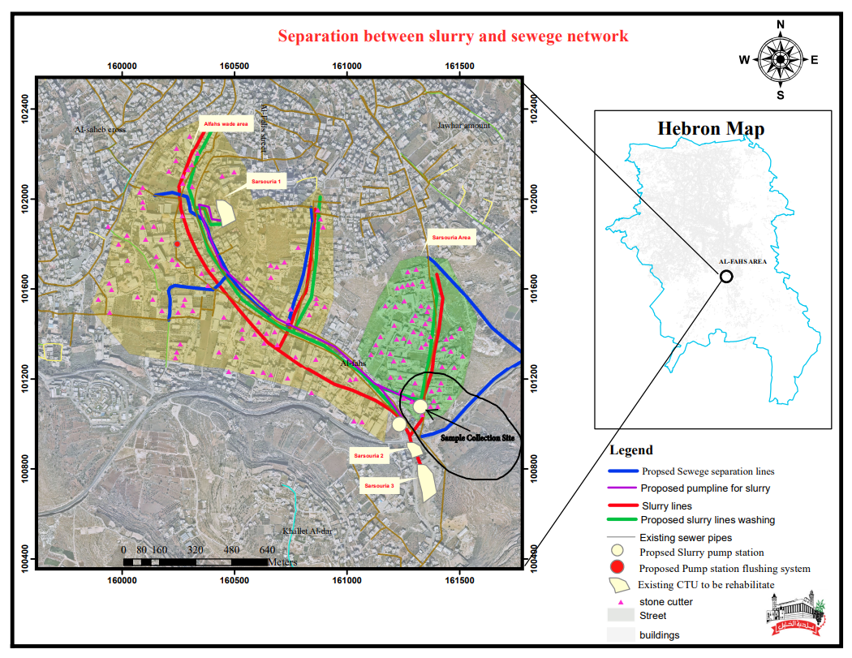
Figure 3 Location of the Grabbed LS Sample Collection Site in the HIZ.
(Hebron municipality, 2025).
Note: The sample was taken from the Sarsouriya industrial drainage line, which represents about 50% of the stone-cutting facilities in Hebron.

Theoretical Framework for SCW Incorporation in Concrete
Physical and chemical characteristics of SCW play a crucial role in identifying the potential uses of SCW. However, having a comprehensive understanding of the theoretical bases facilitates the prediction of the performance of produced waste-modified products. Concrete forms the most well-known field for recycling SCW, in which the final performance of the produced concrete is largely affected by the physical and chemical properties of SCW.
Physically, the moisture content and PSD of the solid particles are the most important physical properties of SCW. Incorporating of fine or ultrafine have the ability to improve the particle size distribution of the produced concrete mix, fill microscopic voids, improve density and modified interfacial transition zone (ITZ) thus enhance the performance of produced concrete. Conversely, continued addition of fine materials negatively affects the performance of the produced concrete, leading to uneven PSD, increased internal surface area, reduced workability of the concrete mix, decreased compaction efficiency, and weakened ITZ bonding due to particle interference (Hilal, 2016).
Chemically, the internal chemical components of SCW plays an important role in identifying the characteristics of produced concrete including the mechanical performance. The chemical structure of the SCW is mainly depends on calcium carbonate (${\text{CaCO}}_{\text{3}}$). The presence of ${\text{CaCO}}_{\text{3}}$ catalyzes certain secondary chemical reactions with cement hydration products, which increase the strength of the resulting concrete, such as the reaction of calcium carbonate to produce calcium carbonate aluminate hydrate (Wang et al., 2018).

Dry Stone Cutting Waste Applications

2.6.1 International Context for Recycling

2.6.1.1 Construction Applications
Construction waste in general and SCW in particular, are of great interest to environmental researchers. Although these wastes are not toxic as is the case with LS they are produced in large quantities, volume, and weights, making them environmentally and economically costly. LS is characterized by diverse physical and chemical properties that distinguish it from place to place based on the properties of the original stone, the method of cutting, and the treatment of the resulting waste. These characteristics are the initial starting point for considering the potential and areas for reusing this waste.
Stone cutting waste, in both LS and solid powder forms, has been extensively studied, with researchers like Rana et al. (2016) establishing that a 20% replacement of fine aggregate is feasible without significantly affecting strength. Wang et al. agree with Rana’s experiment that the high amount of calcium carbonate (${\text{CaCO}}_{\text{3}}$) in SCW may improve the properties of concrete produced when it is replaced by fine aggregate. Rana and Wang agree that the incorporation of cured lime can improve the long-term strength and internal structure of concrete through physical and chemical mechanisms.
Mashaly et al. (2016) tested replacing cement with marble sludge in amounts up to 40%. They observed the performance of the mixtures from the time they mixed until they were fully hardened (after 28 days). The results showed the addition of up to 20% of marble waste could improve the concrete performance.
Kumar and Kumar (2015) conducted experiments to replace cement with dried and treated marble waste (grains larger than 0.9 mm) in the ratios of 0, 5, 10, 15 and 20%, keeping a water to cement ratio of 0.43. Its results showed the best replacement level was 12.5%, making the CS 10% better and the FS strength 15% better. Bahar Demirel (2010) conducted a study that examined significantly higher substitution levels of fine sand with dry marble waste, ranging from 25% to 50%, using small particles (less than 0.25 mm). Both researchers agree that stone waste improves mechanical properties by improving the filling of microscopic spaces and increasing the density of the concrete matrix; however, they differ greatly in the best effective dosage and PSD of the filler.

2.6.1.2 Environmental Applications
The use of lime or LS is not limited to different construction sectors; it also includes environmental applications such as eliminating pollutants from factory smoke. Takashina et al. (2001) conducted innovative research on the ability of limestone to absorb sulfur dioxide gas produced by chemical operations in factories. The idea is based on the ability of calcium ions (Ca²⁺) to undergo chemical reactions at 50°C to form gypsum (CaSO₄.2H₂O). Overall, the efficiency of the process depends on the lime concentration and particle size.
Increasing the lime concentration in the LS increases the amount of alkali available for the neutralization and absorption reaction, while decreasing particle size increases the surface area for the reaction, thus improving the rate of dissolution and release of the Ca²⁺ ions necessary for the reaction with CaSO₄²⁻H₂O. In general, the experiment showed that combining the optimal slurry concentration with the ideal particle size (less than 25 micrometers) has the ability to achieve high efficiency in SO₂ removal, exceeding 95% of factory smoke in the Flue gas desulfurization (FGD) plant.
Lime powder can also be used to clean up the environment by killing bacteria in wastewater and sewage treatment sludge. Smith et al. (2017) used lime to kill pathogens from the sludge of treatment processes. This is because lime has a lot of calcium carbonate, which can raise the pH to very high and sterile levels, reaching 12.
In addition to raising the alkalinity of treated wastewater and sludge, lime’s exothermic reactions play an important role in improving the sterilization of pathogens without affecting the organic content of the resulting sludge, allowing it to be used later to improve soil properties such as permeability, structure, moisture recovery, and pH adjustment. E. coli bacteria can be inactivated to 99.99% or 4 log inactivation in as little as 30 minutes by a high temperature of 70 degrees and a dosage that can increase the pH to 12.

2.6.1.3 Non-Construction Industrial Applications
The use of dried lime slurry extends beyond the construction industries and environmental applications efforts to more expansive industrial sectors. The pharmaceutical and healthcare fields are common consumers of calcium carbonate, where it is used as an antacid and calcium supplement (Fritz et al., 2023).
Calcium carbonate is also an important ingredient in the pharmaceutical industry where it is used as a filler and a binder in tablets. Precipitated calcium carbonate (PCC), which is a very pure form, is thought to be the best way to make sure that tablets have a good quality and have the same consistency (Alsiano, n.d.).
In addition to the medical industries, the paint industry is a possible field for the reuse of lime, as treated lime constitutes about 37% of the volume of the paint mixture (Gaber, 2012).
Beyond medicines and paints, processed lime is also a staple in paper manufacturing. It is usually mixed into the pulp at around 20% to 25%, serving as a filler that helps manage the paper’s whiteness while effectively cutting down on the amount of raw pulp needed (Dölle, 2021).
In rubber production, adding purified and treated calcium carbonate powder at 20 parts per hundred parts of rubber (phr) can improve the process ability as well as the durability and tear resistance of the rubber, and reduce the cost (Wongsorat et al., 2011).
In the ceramics industry, treated calcium carbonate, in the form of calcite, can be added to ceramic clay at a rate of up to 5% of the weight of the clay mixture, and still maintain excellent performance, as it acts as a fluxing agent, increases FS, reduces water absorption and linear shrinkage, and increases the bonding of the ceramic coating (Melhem, 2014).

2.6.2 National Context for Recycling
In the Palestinian context, Al-Joulani and Salah (2014) conducted a laboratory experiment to recycle leaching-treated SCW (Level II, as described in Section 2.4.5) with a moisture content of up to 28% in the form of SCW cake. The main recycling approach for this waste was to replace natural sand with the SCW in varying proportions to produce conventional concrete (B300). Although the addition of the aggregate resulted in a slight decrease in compressive strength, it ultimately exceeded the 300 MPa threshold on day 28.
In another study, Al-Joulani (2014) investigated the possibility of using SCW in the manufacture of artificial stones. For this purpose, the study used fully dried marble powder (treated in the third stage as described in Section 2.4.6). The dried stone powder was incorporated at three different cement ratios (15%, 20%, and 30%) with several types of cement and different concrete compaction pressures (4, 8, and 12 MPa). The study showed that the optimal conditions were achieved with a 30% cement integration ratio, Portland cement, and a high compaction pressure of 12 MPa. These conditions resulted in increased compressive strength of the produced stones, reduced absorption, and a maximum density within the statistical sample under investigation.
Al-Joulani (2012) also investigated the possibility of recycling limestone powder to improve soil properties. The experiment results revel that adding limestone powder at three different percentages of the total weight of the soil (10%, 20%, and 30%). The experiment showed that incorporating limestone powder at a rate of 30% led to a 50% improvement in the angle of internal friction in the soil, while reducing soil cohesion by 51%. Related to the compaction properties, adding limestone powder at a rate of 30% reduces the maximum dry density by 19% and increases the optimum moisture content by 13.5%. The most important result of this experiment is the ability of adding 30% of lime powder to improve the California Test tolerance from 5.2 to 18, thus reducing the need for the thickness of the treated soil from 38 cm to 17 cm.

Liquid Slurry Applications (Without Dewatering)
In countries where technology is too expensive, direct reuse of waste without treatment is a unique opportunity. In Hebron, which greatly suffers under occupation, energy and water costs are exorbitant, compounded by a severe inability to meet consumer needs. Therefore, cost-effective solutions such as the direct reuse of LS produced in the first stage of treatment, without further treatment in the second or third stages (as described in Section 2.4.5), offer a unique opportunity to ensure environmentally friendly products with greater economic viability and competitiveness. Numerous potential investment opportunities for high-concentration liquid stone slurry can be outlined below.

2.7.1 International Context for Recycling

2.7.1.1 Construction Applications
The direct application of LS in concrete mixes has been a subject of significant academic interest, particularly regarding its effect on hydration and mechanical performance. Al-Zboon and Al-Zou'by (2015) pioneered this field by demonstrating that 25% of fresh mixing water can be replaced with LS without a serious impact on Compressive Strength (CS).
Alzboon & Mahasneh, (2009) proposed a simple and inexpensive engineering solution to deal with the low workability of LS-modified concrete by carrying out a simple pretreatment of LS based on settling it in basins for 30 minutes and extracting the resulting water after settling and reusing it in preparing the concrete, as this improved the performance of the produced concrete and its workability with higher efficiency.
In addition of using LS to replace mixing water, some researchers have looked at using it as a partial substitute for cement itself. Metaxa et al. (2025) followed this method by replacing 5%, 10%, 15% and 20% of cement by marble slurry at different water to cement ratios. They found that the optimum results were obtained from a 5% lime mix with a 0.5 w/c ratio, which actually increased the compressive strength of the concrete by 6% and increased the electric resistance by 22%.

Incorporating marble slurry into concrete mixes has emerged as a practical alternative to traditional sand in their study, Kushwah et al. (2015) looked at how adding marble slurry -at levels starting from 0% up to 30%- actually affects the mix. They noticed the best results for compressive strength happened exactly when they used a 15% replacement ratio. This suggests that while more slurry can be used; there is a specific limit to get the strongest concrete.
All previous research has shown the possibility of incorporating LS into concrete mixes through different mechanisms, but it should be noted that there are always an optimal value and a maximum value for this incorporation that should not be exceeded.

2.7.1.2 Environmental Applications
Stone-cutting slurry, whether it is in a semi-dry cake form or LS, can also be used for more than just construction to include environmental reclamation as well. For example, Tozsin et al. (2014) looked into using marble-cutting slurry as a natural way to modify acidic soil. They found in their study on soil with a pH of 4.7 that applying marble slurry could raise the pH level to 6.84. In another study, Tozsin and others show that rising pH from 4.71 up to 5.88 enhanced harvests from about 1120 kg/ha to over 1605 kg/ha.

2.7.2 National Context for Recycling
In the field of direct replacement of concrete mixing water with liquid stone slurry, Palestinian researcheres Al-Joulani and Awad (2019) conducted an experiment. The experiment deals with replacing the mixing water with LS at three different percentages (0%, 20%, and 100%) within two different water/cement ratios (0.6% and 0.7%). Performance evaluation of the concrete mixes on day 28 revels that adding the LS improved the overall CS properties. This resulted in a 13.9% increase in CS compared to the control mix at a water/cement ratio of 0.6 and a 20% integration rate. It also led to a 16.85% improvement in CS at a 100% integration rate and a water/cement ratio of 0.7. According to this research, this improvement is due to the ability of the LS to fill microscopic voids, increase the density of the produced concrete, and reduce the water/cement content without affecting the completion of the hydration reaction.
However, this study revealed a significant decrease in workability (from 95 mm at zero mix to 20 mm at 100% replacement). According to the researchers, this substantial decrease is attributed to the reduced water/cement ratio, as the replacement is volumetric, and the volume of suspended solids displaces the water. Additionally, the significant increase in internal surface area necessitates the use of a large quantity of cement and water for encapsulation (Al-Joulani & Awad, 2019).

The Preferred Maximum Level of LS Incorporation in Concrete Production
In the modern concrete world, one common way to increase the density of the mix and fill those tiny microscopic spaces is the use of fine fillers like LS. But there is a “tipping point” where the benefits stop and the structure starts to weaken because of poor PSD. Kabeer and Vyas (2019) gave a clear warning about this; they found that when fine-powdered content goes past 23% of the stone aggregate, drying shrinkage starts to skyrocket. This triggers what is known as "Particle Interference", where small grains literally push against the larger ones, breaking the internal bond that holds everything together.
This idea of a "safe limit" is something Aruntaş et al., (2010) also backed up, suggesting that a 10% replacement rate for dried stone waste is the sustainable "sweet spot”. Even Kabeer and Aruntas agree that crossing these lines is dangerous, they do not agree on the reason. Kabeer puts the blame on shrinkage issues, while Aruntas argues the real threat is the massive increase in internal surface area, which traps air and makes the mix harder to work with. Regardless of which theory should be followed, the outputs are the same: there is a cretical limit for LS incorporation.
ASTM C33 (2018) limits the material passing the #200 sieve based on aggregate type and exposure. The limits for the fine passing through sieve #200 are 3.0% of the coarse aggregate for concrete subject to surface abrasion (the focus of this thesis) and 5.0% for other applications. Related to manufactured sand or quarries powder, these thresholds increase to 5.0% and 7.0%.

Concrete Kerbstone Technology and Standards

2.9.1 International Standards
Sidewalk stones and KS are a form of precast concrete pieces. These stones are characterized by harsh exposure conditions that affect them from heavy loads and constant friction in addition to harsh weather factors, so it is always seen that there are strict standards for these stones to ensure their mechanical and long-lasting performance such as EN 1340 (European Committee for Standardization (CEN),2003). Therefore, the recycling of waste, including LS in the production of these concrete blocks, needs to be thoroughly evaluated for the impact of these additives.
Adding waste to the production of KS does not necessarily mean that it should negatively affect the performance and quality of the construction. This was confirmed by Janković et al. (2021) where the KS produced fully complied with the EN 1340 standard at the optimal replacement ratio of recycled aggregates as a substitute for natural aggregates of 10%. This trajectory is consistent with the findings of a study conducted by Sardinha et al. (2016) noting that SCW substitution of natural aggregates at higher ratios (higher than 10%) affects the long-term performance of KS especially resistance to freeze-thaw cycles.
In Hong Kong, Poon and Chan (2006) proposed the replacement of natural aggregate with demolition residues. Although the addition of demolition debris increased the porosity and absorption of these stones and reduced their density, this study shows that the replacement of about 50% of natural aggregate with crushed mud bricks still meets the requirements of paving stones in pedestrian areas. Furthermore, the addition of 25% of crushed bricks has successfully achieved the specifications required for the production of Class B paving stones suitable for certain vehicles and heavy loads in accordance with the CEN standard EN:1340 (2003).

2.9.2 National Standards
The standards and specifications for KS as stipulated in PS 84-2008 (PSI, 2008) can be summarized as follow:
- Dimensions: The most common dimensions in Palestine are 250 mm (height) x 300 mm (width) x 1000 mm (length). The maximum tolerance for length is ±5 mm, and the maximum tolerance for width and height is ±3 mm.
- Compressive Strength (CS) at 28 Days: The minimum permissible CS at 28 days is 50 MPa.
- Flexural Strength (FS) at 28 Days: The minimum permissible flexural strength at 28 days is 4.6 MPa.
- Abrasion Resistance (AR) at 28 Days: The maximum permissible abrasion depth at 28 days is 3.6 mm.

Palestinian Specifications and Technical Environmental Regulations

2.10.1 Connecting to the Public Sewage Network
According to the Palestinian Standards Institution (PSI), discharging stone LS into sewage networks is prohibited. Discharging the LS violates several bylaws, most importantly:
- Total Suspended Solids: Discharging any material with total suspended solids content exceeding 600 mg/L into the sewage network is prohibited (Palestinian Cabinet, 2013). Stone LS, processed in the first stage inside silos, produces solids concentration exceeding 800000 mg/L. High total suspended solids content leads to complete HRWWTP failure, which has a maximum design capacity of approximately 700 mg/L (Seureca et al., 2020).
- pH and permissible acidity levels: The acceptable pH range is between 6 and 9 (Palestinian Cabinet, 2013), while the pH of highly concentrated LS around 10 (DAI, 2014). High alkalinity threatens the operation of the activated sludge system in wastewater treatment due to its ability to sterilize the biological content.

2.10.2 Legislation Regulating LS Disposal
After reviewing the laws and regulations governing the stone sector in Palestine, the following articles criminalize the disposal of LS through the sewage system (Palestinian Cabinet, 2010) and (Palestinian Cabinet, 2019):
- Article 12: Emphasizes the necessity of carrying out preliminary treatment in consultation and coordination with the Environmental Quality Authority (EQA).
- Article 13: Every SCFF is required to provide a sufficient number of sedimentation and drying ponds. The recovered water must be reused in the stone-forming process. As per the EQA's instructions, each sawmill must also clean the drying and sedimentation ponds on a regular basis and store the sedimentation byproducts in a safe place for the environment.
- Article 14: The disposal of secondary treated stone waste, whether solid or sludge, must be done through environmentally approved landfills.
- Article 16: The transport or disposal of SCW is strictly prohibited except through designated and licensed means of transport. Disposing of this waste through valleys or surface or groundwater sources is also strictly prohibited.
- The supplementary framework (Solid Waste Management System 2019): emphasizes that the owner of the stone cutting plant is responsible for carrying out on-site treatment, reusing the recovered water, ensuring safe disposal, and preventing the spillage or disposal of this material through valleys.

Research Gaps and Opportunities
Some of the scientific gaps regarding the recycling of certain waste materials in the manufacture of concrete parts can be summarized as follows:
- Long term performance: One of the biggest problems with studies that look at recycling industrial waste in concrete is that they focus too much on short-term mechanical properties (like compressive strength at 28 days) and almost completely ignore how the industrial waste-modified concrete matrix will break down over time, especially when it is exposed to harsh weather conditions like freeze-thaw cycles and long-term friction.
- The absence of an economic feasibility study: Previous research has predominantly concentrated on the technical dimensions, examining the influence of waste integration on the performance of the final product, while neglecting its competitiveness with conventional goods in the marketplace, both technically and economically. In addition, consumer satisfaction, the roles of government and legislation, and other factors that affect the economic viability of the waste-modified products are all important for the success of the recycling process and the ability to get rid of waste-modified materials.
- Adapting Research to the Palestinian Context: Palestinian limestone has a unique mineral composition, meaning solutions from other countries cannot simply be copied. Beyond the chemistry, the sector deals with a mix of logistical bottlenecks and political constraints that are not found in standard textbooks. This is why it is so critical to move toward "site-specific" interventions. By focusing on the local reality, the current situation can be better gauged to build a recycling strategy that is not just a theory, but also a practical boost for local communities and the national economy.

Chapter Three: Materials and Methods
This chapter provided extensive detail about all the materials needed for the experiment, such as LS, cement, aggregate, water, and plasticizer. It also explained how the concrete mixes were made and how the concrete samples were tested afterward. The main goal of this chapter was to make a clear plan that could be used as a standard for quality control, making sure that the experiment could be repeated under the same conditions. The following flowchart showed the logical steps that were followed through this experiment.
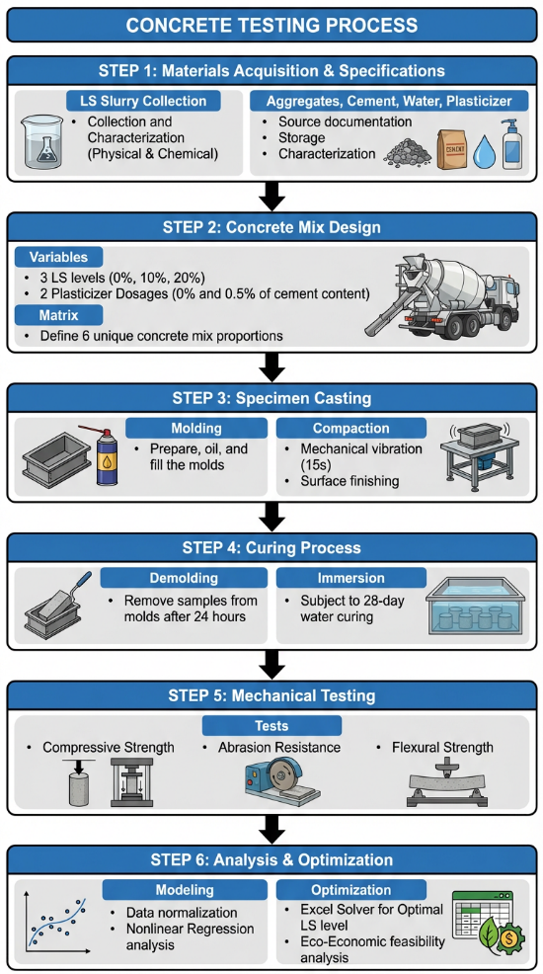
Figure 4 Systematic Flowchart of the Experimental Methodology for Using LS in Producing Eco-Friendly KS.

3.1 Materials

3.1.1 Stone Cutting Waste (Liquid Slurry)
- Source: Stone slurry was collected from the HIZ (an area called Al-Fahs), which is the heart of this industry in the West Bank. The sample was taken from the outlet line coming out from a group of sedimentation silos (represent around 50% of LS production in Al-Fahs area), which contains the sediments called high-concentration stone cutting slurry or LS.
- Collection date and time: Sunday, November 8, 2025 at 12:45 pm.
- Number of samples: one sample.
- Sample volume: 16 liters stored in a plastic bucket.
- Sample weight: 24.08 kg.
- Pre-use homogenization: The sample was taken from an industrial drainage line belonging to 78 SCFF and continuously mixed for 30 sec before integrated in each produced mix sample using a metal rod.
- Treatment level: Level 1 treatment as described in section 2.4.5 Low-concentration stone-cutting slurry was allowed to settle the suspended solids for two hours inside a silo with the addition of the coagulant FeCl3, giving results similar to those obtained in the technical studies Sourca and DAI.
- Physical properties: Under the aforementioned processing conditions, the physical properties aligned with the descriptions provided in Section 2.4.3, and were summarized as follows:
- SG: 1505 kg/m³.
- Water content: 70%.
- Particle size: Ranges from 1 to 400 micrometers.
- Medium volume (diameter of the sieve opening through which 50% of the sample passes): 38 micrometers.
- Oil absorption: 25 ml/100 g of material.

- Chemical properties:
- Chemical and mineral content: Referring to section 2.4.4, it is noted that the main solids content in LS is calcium carbonate, ranging from 94% to 98%, while the content of suspended solids of ${\text{CaCO}}_{\text{3}}$, ${\text{MgCO}}_{\text{3}}$, and ${\text{SiO}}_{\text{2}}$ reaches 99%.
- pH and alkalinity: Referring to section 2.4.4, it is noted that all the samples exhibited strong alkalinity with an average pH of approximately 9.5.

3.1.2 Aggregate

3.1.2.1 Coarse Aggregate (Foul)
The experiment used stone aggregate (Foul) samples that were tested and found to meet Palestinian standards. The following is a summary of the properties of the chosen aggregate samples, which can be found in Appendix A:
- Specific density: 2.501 >2; accepted according to ASTM C 127-04 (ASTM, 2015).
- Size distribution: The Particle Size Distribution (PSD) of the coarse aggregate (Foul) samples met the Palestinian standards PS48-2019 (PSI, 2019).
The coarse aggregate (Foul) had a fineness modulus (passing through Sieve #200) of about 0.4%, which was still well below the 1% limit. As a result, these results met the standards for coarse aggregate used in concrete production set by ASTM C136 (ASTM, 2014) .
- Abrasion: The test used eleven steel spheres, each weighing 3744 g. After 500 cycles, the total abrasion was 25.12%, which was below the maximum allowable limit of 28% set by ASTM C131 (ASTM, 2020).
- Absorption: The coarse aggregate sample absorbed 1.63% of its dry weight in water. This value was still within the compliance range because it was less than the maximum allowable absorption limit of 3% set by ASTM C 127-04 (ASTM,2015).

3.1.2.2 Coarse Aggregate (Simsim)
The study used stone aggregate (Simsim) samples that were tested and found to meet Palestinian standards. Appendix B lists the technical properties of the chosen aggregate, which were summarized as follows:
- Specific density “dry”: 2.313 >2; accepted according to ASTM C 127-04 (2015).
- Size distribution: The PSD of the coarse aggregate (Simsim) sample met the Palestinian standards set out in PS48-2019 (PSI, 2019).
The fineness modulus (specifically the fraction that went through Sieve #200) for the coarse aggregate (Simsim) was about 0.8%, which is still below the 1% limit. As a result, these results met the standards set by ASTM C136 (ASTM, 2014) for coarse aggregate used in making concrete.
- Abrasion: Eight steel spheres weighing a total of 4518 g were used for the test. After 500 cycles, the total amount of abrasion was found to be 22.08%. This result was still below the ASTM C131 (ASTM, 2020)maximum limit of 28%.
- Absorption: The coarse aggregate sample absorbed 1.714% of its weight when it was oven-dry. This value was well within the compliance limits because it was less than the maximum allowable absorption level of 3% set by ASTM C 127-04 (2015).

3.1.3 Cement
The cement used is ordinary Portland cement (CEM I 52.5) Produced by Al Rajhi Jordanian Company. Chemical and physical characteristics According to the manufacturer can be accessed through the Appendix C.

3.1.4 Water
The water used in the concrete mix is ​​fresh mineral water produced by Arwa Company. Its chemical properties can be found in the Appendix D.

3.1.5 Plasticizer Admixture
A liquid plasticizer called Homerat, produced by the company Dr Ayan, was used to improve the workability of concrete mixes at a dosage of 0.5% of the weight of cement used in the concrete mix.

3.2 Experiment Design

3.2.1 Concrete Mix Design

3.2.1.1 Constant Variables
The mix proportions were determined to align with PSI specifications, especially for producing Class A KS with a CS of 50 MPa. The foundational mix designs (B-20 to B-40) were obtained from Zalloum Construction Company in accordance to ACI 211.1 and C94 (ASTM, 2023), as detailed in Appendix E. Furthermore, the proportions for higher grades (B-45 and B-50) were derived through non-linear Extrapolation based on the company's established data trends.
- Cement content: 450 kg/m³.
- Stone aggregate: The stone aggregate content was determined to be 1209 kg/m³. To achieve a higher concrete density for the concrete mix, a wide gradation of aggregates was used, including sizes of 12.5 mm and 4.75 mm at proportions of 45% to 55% respectively.
- Sand =556 kg/m3.
- Plasticizer admixture Humertat: 0.5 % of cement weight.

Liquid Slurry and Mixing Water
During this experiment, LS was incorporated as a volumetric substitute for the mixing water used in three percentages (0, 10 and 20%) with or without the presence of plasticizer. The selection of the replacement ratios within the budget set for this study mainly focused on not exceeding the maximum permissible fine material for the stone aggregate used in the exposed concrete mixture (about 3%) (ASTM, 2018).
At the maximum substitution level of this study of 20%, the total weight of the fine materials passing through the sieve No. 200 can be calculated using the following equations:
$${\text{V}}_{\text{ls}}=RL*{\text{V}}_{\text{IW}}$$ | (1)
$${\text{V}}_{\text{s}}={\text{V}}_{\text{ls}}*{\text{SC}}_{\text{LS}}$$ | (2)
$${\text{M}}_{\text{S}}={\text{V}}_{\text{s}}*{\text{SG}}_{\text{S}}$$ | (3)
TF=${\text{M}}_{\text{S}}+AGGf$ | (4)
Where:
${\text{V}}_{\text{ls}}$: Volume of the introduced limestone slurry per each $m^{3}$ of KS (L).
$RL$: Volumetric replacement ratio of the mixing water.
${\text{V}}_{\text{IW}}$: Total initial volume of mixing water per each $m^{3}$of KS (based on a W/C =.4; ${\text{V}}_{\text{IW}}$=180 L).
${\text{V}}_{\text{s}}$: Net volume of the introduced solid filler particles per each $m^{3}$ of KS.
${\text{SC}}_{\text{LS}}$: Solid content of the limestone slurry (0.3).
${\text{M}}_{\text{S}}$: Final dry mass of the introduced filler per each $m^{3}$ of KS (kg).
${\text{SG}}_{\text{S}}$: Specific gravity of the limestone filler (around 2.7 kg/L).
TF: Total Filler mass (kg).
$AGGf$: Existing filler in the coarse aggregate (based on Appendix A and Appendix B around 0.6% of aggregate weight or 7.3 kg per each $m^{3}$ of KS)
$${\text{V}}_{\text{ls}}=RL*{\text{V}}_{\text{IW}}$$ | =0.2*180 | =36 L
$${\text{V}}_{\text{s}}={\text{V}}_{\text{ls}}*{\text{SC}}_{\text{LS}}$$ | =36*0.3 | =10.8 L
$${\text{M}}_{\text{S}}={\text{V}}_{\text{s}}*{\text{SG}}_{\text{S}}$$ | =10.8*2.7 | =29.2 kg
TF=${\text{M}}_{\text{S}}+AGGf$ | =29.2+7.3 | =36.5 kg
It can be seen from the previous results that the selection of a maximum of 20% for water replacement with LS was in line with ASTM C33 (2018) standards, which determined the proportion of fillers between 1% and 5% of the total weight of aggregates where the total amount of fillers added was about 36.5 kg/m³, equivalent to approximately 3% of the total weight of coarse aggregates. Substitution rates exceeding 20% would have raised the proportion of fillers in the mixture to above the 3% limit set in the standard for weather-exposed concrete elements.
The water content within the LS was estimated at 70%, as previously detailed in Section 2.4.3. To maintain a constant replacement ratio, a specific proportion (A) of LS was incorporated to replace an equivalent ratio (A) of fresh water. Consequently, the water-to-cement (W/C) ratio decreased in accordance with the incorporation ratio (A). This adjusted W/C ratio was estimated using the following equation, based on a constant cement mass of 1000 grams and a control W/C ratio of 0.40:
W/C= $\frac{400 * \left(1 - A\right)+ 400* A*WC}{1000}$ | (5)
where:
A: LS incorporation or water replacement ratio.
WC: A constant that describes the water content in LS, which is estimated at 0.7.
$${W/C }_{A=0}$$ | =$\frac{400 * \left(1 - 0\right)+ 400* 0*0.7}{1000}$ | =0.40
$${W/C }_{A=0.1}$$ | =$\frac{400 * \left(1 - 0.1\right)+ 400* 0.1*0.7}{1000}$ | =0.39
$${W/C }_{A=0.2}$$ | =$\frac{400 * \left(1 - 0.2\right)+ 400* 0.2*0.7}{1000}$ | =0.38

3.2.1.3 Mixing Matrix
Table 5 Concrete Mix Matrices
Mix ID | LS Slurry Substitution Level (%) | Plasticizer (SP) % of cement | Cement content kg/m³ | W/C ratio | Stone aggregate kg/m³ | sand kg/m³
C-0-N | 0.00 | No | 450.00 | 0.40 | 1209.00 | 556.00
C-10-N | 10.00 | No | 450.00 | 0.39 | 1209.00 | 556.00
C-20-N | 20.00 | No | 450.00 | 0.38 | 1209.00 | 556.00
C-0-SP | 0.00 | 0.50 | 450.00 | 0.40 | 1209.00 | 556.00
C-10-SP | 10.00 | 0.50 | 450.00 | 0.39 | 1209.00 | 556.00
C-20-SP | 20.00 | 0.50 | 450.00 | 0.38 | 1209.00 | 556.00
Note 1: Constant variables for concrete mix designs were adopted by developing a forecasting model (attached in Appendix E) based on standard mixes received from Zalloum Construction Company in accordance to ACI 211.1 and C94 (ASTM, 2023).
Note 2: Incorporating LS at percentages of 0%, 10%, and 20% corresponds to reducing the fresh water content of the concrete mix by 0%, 10%, and 20%, respectively.

3.2.2 Preparing and Testing Samples
Based on C192/C192M–19 (ASTM,2019) for preparing concrete test cubes, especially low- or zero-slump concrete with a water/cement ratio less than 0.40, as used in this research, and in compliance with Palestinian specifications related to the performance of KS (PSI, 2008). The steps followed in preparing concrete test samples at different levels of LS incorporation and plasticizer can be summarized as follows:
  - Sample preparation: Standard Concrete samples 10 x 10 x 10 cm, 7 x 7 x 3.5 cm and 10 x 10 x 40 cm were prepared in a laboratory. The test molds were thoroughly cleaned and lightly coated with oil. Due to the low slump value and low water content of the concrete (zero slump), the concrete was poured into the steel molds in two layers. Each layer was vibrated on a vibrating table for 15 seconds and then compacted using a standard 16 mm diameter rod 25 hits per each 100 per layer. The surface of the samples was then smoothed using a trowel.
  - Curing Conditions: The samples were cured for 28 days under conditions of relative humidity of not less than 80% by immersion in water at a temperature of not less than 10 degrees and not more than 27 degrees Celsius.

  - Compressive Strength at 28 Days:
- The CS test was performed on samples with the following dimensions: 100 mm (height) x 100 mm (width) x 100 mm (length).
- The average CS of two samples per each concrete mix was measured in the laboratory using Compression Testing Machine.
4- Abrasion Resistance at 28 Days:
- The AR test was performed on samples with the following dimensions: 70 mm (height) x 70 mm (width) x 35 mm (length).
- The average AR of two samples per each concrete mix was measured in the laboratory using Böhme Abrasion Tester.
- Flexural Strength at 28 Days:
- The FS test was performed on samples with the following dimensions: 100 mm (height) x 100 mm (width) x 400 mm (length).
- The average FS of two samples per each concrete mix was measured in the laboratory using the third-order loading method by Flexural Testing Machine.

3.2.3 Experimental Replication and Scope of Interpretation
For each type of concrete mix, two samples were put to the test, and their performance was evaluated based on several key indicators. The number of samples tested was limited by the resources available in the lab and the budget for the study. Should be noted that testing only two samples from each mixture does not give a complete picture of the variances within that mixture, and is not enough to draw definitive conclusions about all samples based on statistics.
The results of each sample were maintained individually and studied accurately using averages, standard deviation, range and extent of variance. The results of the experiment are a starting point for understanding the performance of different mixtures, and not definitive answers that apply to all LS sources, production batches, or manufacturing methods in an industrial environment.
To better understanding of the current experimental results, the consistency of the results in terms of CS, FS, and AR was examined by comparing the average performance at the three LS substitution levels, whether the mixes were plasticized or unplasticized. Overall, these results primarily represent a pattern of effect variation and are not statistically definitive.

3.3 Statistical Analysis
The data of the different mixtures were analyzed for each of the performance indicators. The following results were obtained for individual data values, averages, and standard deviations of the samples, as well as the observed values of range and CoV as a percentage. Because the three performance indicators are measured at different measures (i.e. in different units), they cannot be analyzed as if they were a single variable. Therefore, the data of CS, FS, and AR of KS were analyzed separately.
The CoV was calculated as follows:
COV (%) = (SD / x̄) × 100 | (6)
Where SD is the sample standard deviation and x̄ is the arithmetic mean.
For the evaluation of the influence of the LS addition on a series of mixes (3 performance indicators) the 10 % and 20 % addition mixes have been compared to their 0 % addition counterparts. The percentage of change of the performance indicators of the 10 % and 20 % addition mixes in comparison to the 0 % addition mixes (using the same amount of plasticizer) have been calculated and described by the initial effects (no use for a statistical testing of the effects).
As a result of the small number of test specimens for each test situation (n = 2) the results for the estimates of variability as well as for the confidence intervals for the differences between the average values of the relevant test situations are very imprecise. Thus, the results for a test situation have to be evaluated by taking into account the sign of the effect as well as the size of the effect in addition to the results for the three test parameters and the variability of the results. Since only two specimens for each test situation were tested the results have to be considered with reserve. Thus, a statistically not significant difference between two averages does not necessarily mean that there is no effect at all and a statistically significant difference does not necessarily mean that the effect is relevant (Wasserstein & Lazar, 2016).
Scoreij $=(\frac{Xij - Xminj}{Xmaxj - Xminj}$)*100 | (7)
CS and FS of the concrete were evaluated as benefit criteria, for which the normalized scores were calculated using the following equations:
Where:
Scoreij: The normalized score for sample i regarding performance indicator j (CS or FS).
$Xij$: The measured average value of performance indicator j for sample I (MPa).
$Xminj$: The minimum average value of performance indicator j among all samples (MPa).
$Xmaxj$: The maximum average value of performance indicator j among all samples (MPa).
Scorei,(AR) $=(\frac{Xmax,\left(AR\right)- Xi,(AR)}{Xmax,\left(AR\right)- Xmin,(AR)}$)*100 | (8)
The Abrasion Resistance (AR) indicator has been considered as a cost criterion in this work. As the lowest value of Abrasion Resistance for a specimen under test indicates the best Abrasion Resistance of that specimen, the normalized scores have been calculated as follows:
Where:
Scorei,(AR): The normalized score for sample i regarding abrasion resistance
$Xi,(AR)$: The measured abrasion resistance value for sample i (mm).
$Xmin,(AR)$: The minimum average abrasion resistance value among all tested samples (mm).
$Xmax,(AR)$: The maximum average abrasion resistance value among all tested samples (mm).
All indicators (benefit and cost) for all mixtures were then weighted equally and the resulting scores summed up to give a composite score for each individual mixture. A dominance check was then performed to see if a better mixture existed. A mixture was defined as dominant to another mixture if it performed better or equally for all of the individual performance indicators (Composite score).
The experiment can also be evaluated as a balanced 3 × 2 factorial design. Herein, three levels of LS were mixed into one base compound and two different plasticizer conditions were investigated. For the CS ,FS as well as for the abrasion depth, two-way fixed-effects ANO2A (ANOVA) were carried out in order to determine the main effects of the levels of LS as well as the effect of the plasticizer addition and their possible interaction. The O2A models were evaluated for significance on the α-level of 0.05. In addition to the corresponding p-values, the effect estimates as well as the corresponding 95%-confidence intervals and the partial eta-squared were recorded. Due to the fact that for every treatment combination only two independent observations were carried out, the results of the ANOVA have to be considered as exploratory and not as confirmatory (Montgomery, 2017).

3.4 Comparative Evaluation of the Tested LS Incorporation Levels
The comparative evaluation aimed to identify the best-performing LS incorporation level among the three experimentally tested levels. moving from numerical analysis of each variable individually to multi-objective numerical analysis, through which the best-performing incorporation level was found by numerical Excel program. The following steps were followed to build the evaluation model using Excel:
- Determining the weight based on the importance of each test: All three tests, CS, FS and AR, are mandatory tests to judge the conformity of the KS product based on PSI requirements. So, all of these tests are equally important, and the importance weight for each test is 1/3.
- Composite evaluation and data normalization: Through the results of the structural tests (CS, FS, and AR), a score is given from 0 to 100 depending on how close or far of result i from the best results for specific performance indicator j based on the equations 7 and 8.
- Compiling the result: The result of each of the six samples is compiled based on its result in each test, with the sum being algebraic and the total sum being multiplied by 1/3, which is the equal weight of importance for each test.
- Dominance evaluation: The performance of each tested LS level was compared across CS, FS, and abrasion depth. A tested level was considered preferable when it was no worse for all indicators and better for at least one indicator.
- Identification of the best-performing tested level: The incorporation level with the highest composite score and consistent dominance across the individual indicators was identified as the best-performing level among 0%, 10%, and 20%. No interpolation was used to claim an exact optimum between the tested levels.

3.5 Environmental and Economic Benefits Analysis
To quantify the significance of the research, it was necessary to assess the environmental and economic benefits that the recycling of LS into KS production could introduce.

3.5.1 Environmental Benefits Analysis
As explained in Section 2.10, the safe disposal of LS required a first drying stage and then placement in a licensed landfill. Recycling, on the other hand, became a strategic choice that not only had clear economic benefits but also had an observed impact in the environment. By incorporating construction waste, especially LS, directly into the recycling stream, greenhouse gas emissions, especially carbon dioxide, were significantly reduced as well as the need for energy-intensive drying was eliminated.
To assess the environmental feasibility of this approach, the anticipated decrease in non-renewable energy consumption and the corresponding reduction in carbon emissions were estimated using the following methodology:
- Dewatering Energy Analysis: Calculate the daily energy required to dry LS to reduce its moisture content from 70% to 30%.
- Conventional Logistics Assessment: Determine the daily fuel consumption for transporting LS to the dewatering station and the daily fuel consumption for transporting the dried SCW to the nearest environmentally licensed landfill.
- Measuring productivity performance: Estimate the daily production volume of KS in the Hebron area.
- Material Integration Capacity: Quantify LS that can be used daily based on the experimental results.
- Recycling Logistics Assessment: Estimate the fuel consumption required to transport the LS to the main KS factory in Hebron.
- Carbon Emission Conversion: Compile the net energy and fuel savings achieved by prioritizing LS recycling over conventional drying/disposal, and convert these figures into an annual reduction in carbon dioxide emissions (measured in tons per year).

3.5.2 Economic Benefits Analysis
To assess the economic feasibility of incorporating limestone slurry into KS production, the anticipated decrease in treatment cost was estimated using the following methodology:
- Cross-border treatment obligations: Estimating the cost of treating one cubic meter of LS crossing the border into the occupied territories, based on data from the PWA.
- Compliance and disposal costs: Estimating the cost of dewatering and disposing of one cubic meter of LS according to Palestinian environmental standards.
- Market-driven volumetric integration: Estimating the possible quantity of LS to incorporate into KS, based on the results of the experiment, taking into account the market demand for KS in Hebron.
- Logistical Expenditure: Estimating the cost of incorporating one cubic meter of LS into the manufacture of KS (transportation).
- Comparative economic analysis: Comparing and calculating the economic benefits.

Chapter Four: Analysis and Results

4.1 Brief Introduction
This chapter deals with the performance results of concrete mixes formulated according to the criteria defined in the previous chapter, where the experimental matrix focused on determining the effects of replacing LS (at percentages of 0%, 10%, and 20%) and adding plasticizer at percentages of 0% and 0.5% of the cement weight, resulting in six unique mix matrices that were evaluated for compressive strength (CS), flexural strength (FS), and abrasion resistance (AR).

4.2 Analysis of Mechanical Results

4.2.1 Compressive Strength Analysis
Since the vertical compressive load is the most significant load affecting these manufactured stones, CS is the most crucial criterion for characterizing the performance of manufactured concrete used for paving or KS. The results of CS tests conducted on the six concrete samples made in accordance with the guidelines provided in the materials and methods chapter are shown in Table 6.
Table 6 Compressive Strength Test Results for Concrete Mixes with Various LS Substitution Levels.
Mix ID | LS Slurry (%) | SP (%) Of Cement | Specimen 1 (MPa) | Specimen 2 (MPa) | Average Strength (MPa) | Standard Deviation (MPa) | COV (%) | Change (%) from mix C-0-N
C-0-N | 0.00 | No | 41.70 | 39.70 | 40.70 | 1.41 | 3.47 | Reference
C-10-N | 10.00 | No | 48.30 | 42.00 | 45.15 | 4.45 | 9.87 | 10.93
C-20-N | 20.00 | No | 38.50 | 37.10 | 37.80 | 0.99 | 2.62 | -7.13
C-0-SP | 0.00 | 0.50 | 47.30 | 42.70 | 45.00 | 3.25 | 7.23 | 10.57
C-10-SP | 10.00 | 0.50 | 45.90 | 44.70 | 45.30 | 0.85 | 1.87 | 11.30
C-20-SP | 20.00 | 0.50 | 42.30 | 40.10 | 41.20 | 1.56 | 3.78 | 1.23
Note. Results are based on two tested specimens per mix. SD denotes sample standard deviation, and CoV denotes coefficient of variation. These statistics describe the observed variability but do not establish the statistical adequacy of the sample size.

4.2.1.1 Discussion of Compressive strength Results for Unplasticized Concrete Mixes at Different LS Incorporation Levels
It is found that substituting some of the mixing water with LS has an observed impact on CS when the effect of adding the plasticizer to the zero-slump concrete mix is isolated. The CS increased by 10.93%, from 40.7 MPa in the reference mix (C-0-N) to 45.15 MPa in the (C-10-N), when 10% of the mixing water was substituted with LS. On the other hand, CS decreased by 7.13% to 37.8 MPa when the LS incorporation was doubled to 20% (C-20-N). Figure 5 shows the impact of adding LS on CS values for unplasticized KS samples.
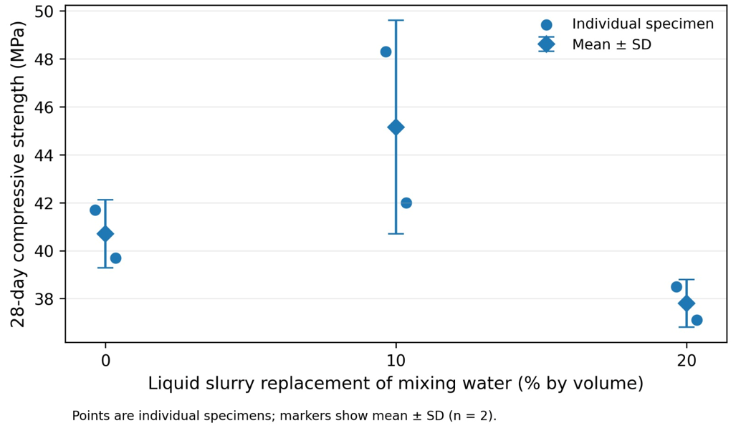
Figure 5 Effect of LS Incorporation on 28-Day Compressive Strength of Unplasticized Concrete.
Note: Error bars represent the range of CS of two tested samples per each unplasticized concrete mix matrix.

4.2.1.2 Discussion of Compressive Strength Results for Plasticized Concrete Mixes at Different LS Incorporation Levels
The plasticized C-0-SP, C-10-SP, and C-20-SP mixtures recorded mean compressive strengths of 45.00, 45.30, and 41.20 MPa, respectively. Relative to the corresponding unplasticized mixtures, these values represent observed increases of 10.57%, 0.33%, and 9.00%, respectively. These differences describe the observed means and should not be interpreted as statistically confirmed observed plasticizer response. Figure 6 shows the impact of adding LS on CS values for plasticized KS samples while Figure 7 shows the impact of adding plasticizer on the CS values.

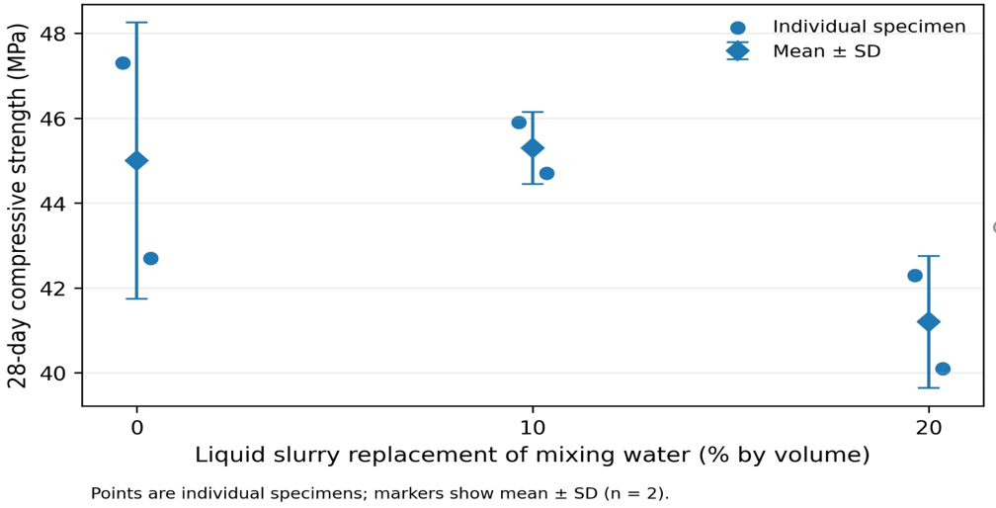
Figure 6 Effect of LS Incorporation on 28-Day Compressive Strength of Plasticized Concrete.
Note: Error bars represent the range of CS of two tested samples per each plasticized concrete mix matrix.
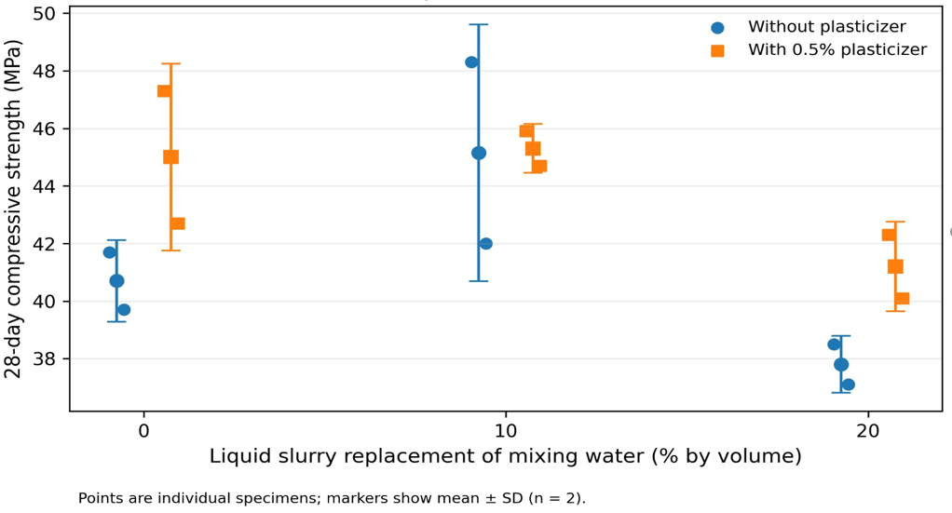
Figure 7 28-Day Compressive Strength by LS Incorporation and Plasticizer Addition.

4.2.2 Flexural Strength Analysis
The FS of a KS is another important measure for judging performance. Even though the main loads on KS are compressive vertical loads, FS of KS is still an important performance indicator around the world. Table 7 shows the results of FS analysis for the six KS concreate mixes.
Table 7 Flexural Strength Test Results for Concrete Mixes with Various LS Incorporation Levels.
Mix ID | LS Slurry (%) | SP (%) Of Cement | Specimen 1 (MPa) | Specimen 2 (MPa) | Average Strength (MPa) | Standard Deviation (MPa) | COV (%) | Change (%) from mix C-0-N
C-0-N | 0.00 | No | 4.85 | 4.15 | 4.50 | 0.50 | 11.02 | Reference
C-10-N | 10.00 | No | 5.84 | 4.91 | 5.37 | 0.66 | 12.30 | 19.48
C-20-N | 20.00 | No | 5.31 | 4.67 | 4.99 | 0.45 | 9.10 | 11.04
C-0-SP | 0.00 | 0.50 | 5.02 | 4.44 | 4.73 | 0.41 | 8.73 | 5.19
C-10-SP | 10.00 | 0.50 | 6.19 | 5.26 | 5.72 | 0.66 | 11.54 | 27.27
C-20-SP | 20.00 | 0.50 | 5.14 | 4.91 | 5.02 | 0.17 | 3.29 | 11.69
Note. Results are based on two tested specimens per mix. SD denotes sample standard deviation, and CoV denotes coefficient of variation. These statistics describe the observed variability but do not establish the statistical adequacy of the sample size.

4.2.2.1 Discussion of Flexural Strength Results for Unplasticized Concrete Mixes at different LS Incorporation Levels
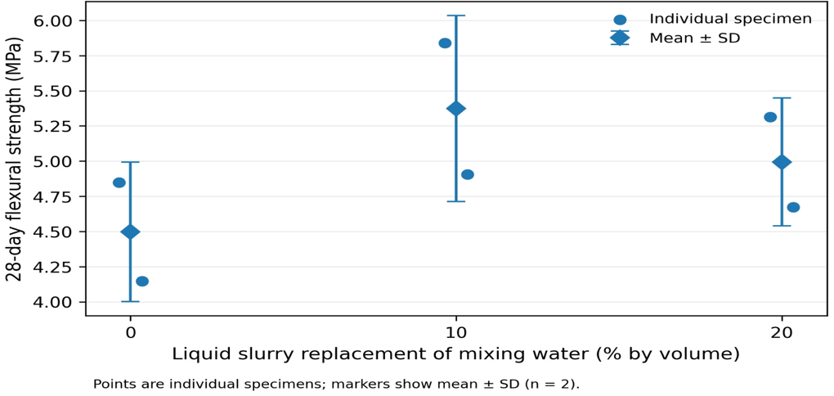
Figure 8 Effect of LS Incorporation on 28-Day Flexural Strength of Unplasticized Concrete.
Note: Error bars represent the range of FS of two tested samples per each unplasticized concrete mix matrix.
The addition of LS as a substitute for mixing water had an observed effect on FS of produced KS samples as shown in Table 7. At 10% replacement ratio, the FS value increased from 4.5 MPa to 5.37 MPa, recording an improvement of 19.48%, while at a 20% replacement ratio, the FS decreased from 5.37 MPa to 4.99 MPa, recording a decrease of 8.44%. Figure 8 shows the impact of adding LS on FS values for unplasticized KS mixes.
4.2.2.2 Discussion of Flexural Strength results for Plasticized Concrete Mixes at Different LS Incorporation Levels
The plasticized C-0-SP, C-10-SP, and C-20-SP mixtures recorded mean FS of 4.73, 5.72, and 5.02 MPa, respectively. Relative to the corresponding unplasticized mixtures, the observed increases were 5.19%, 6.52%, and 0.58%, respectively. The largest observed FS response occurred in C-10-SP; however, the limited replication prevents these differences from being interpreted as conclusive evidence of a general observed plasticizer response. Figure 9 shows the impact of adding LS on FS values for plasticized KS mixes while Figure 10 shows the impact of adding plasticizer of FS values.
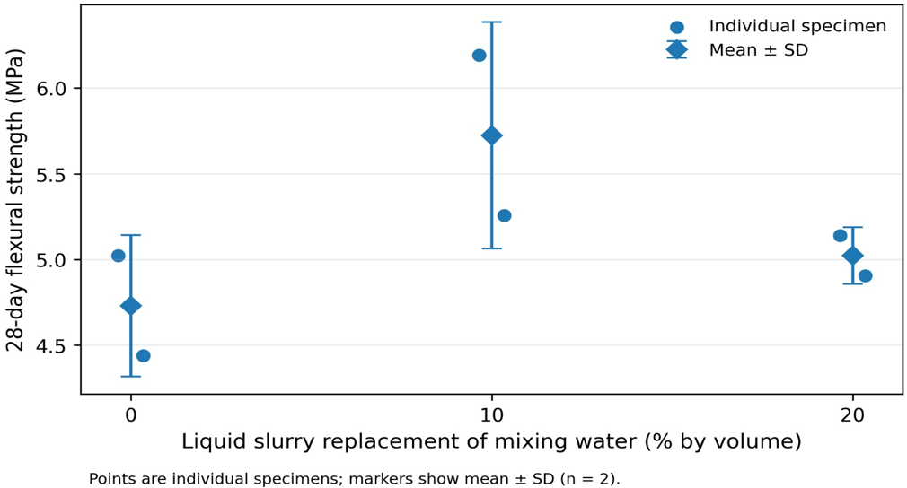
Figure 9 Effect of LS Incorporation on 28-Day Flexural Strength of Plasticized Concrete.
Note: Error bars represent the range of FS of two tested samples per each plasticized concrete mix matrix.
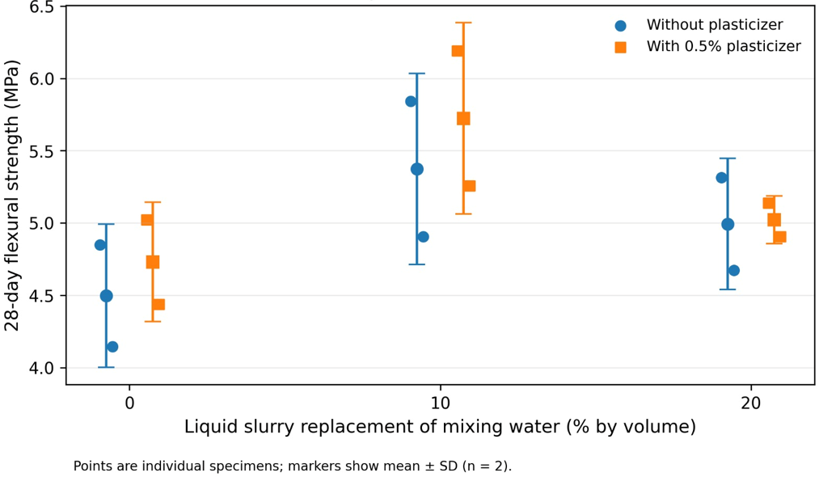
Figure 10 28-Day Flexural Strength by LS Incorporation and Plasticizer Addition.

4.2.3 Abrasion Resistance Analysis
The third requirement for evaluating the performance of concrete produced for KS according to PSI requirements is AR. Table 8 illustrates the direct relationship between LS addition and AR, in addition to noting the effect of plasticizer addition on AR.
Table 8 AR Test Results for Concrete Mixes with Various LS Substitution Levels.
Mix ID | LS Slurry (%) | SP (%) Of Cement | Specimen 1 (mm) | Specimen 2 (mm) | Average Strength (mm) | Standard Deviation | COV (%) | Change (%) from mix C-0-N
C-0-N | 0.00 | No | 2.97 | 2.30 | 2.64 | 0.47 | 17.98 | Reference
C-10-N | 10.00 | No | 2.46 | 2.17 | 2.32 | 0.21 | 8.86 | -12.14
C-20-N | 20.00 | No | 2.65 | 2.52 | 2.59 | 0.09 | 3.56 | -1.90
C-0-SP | 0.00 | 0.50 | 2.82 | 2.75 | 2.79 | 0.05 | 1.78 | 5.69
C-10-SP | 10.00 | 0.50 | 2.19 | 1.83 | 2.01 | 0.25 | 12.66 | -23.72
C-20-SP | 20.00 | 0.50 | 2.60 | 2.25 | 2.43 | 0.25 | 10.21 | -7.97
Note. Results are based on two tested specimens per mix. SD denotes sample standard deviation, and CoV denotes coefficient of variation. These statistics describe the observed variability but do not establish the statistical adequacy of the sample size.

4.2.3.1 Discussion of Abrasion Resistance Results for Unplasticized Concrete Mixes at Different LS Incorporation Levels
It is found that substituting some of the mixing water with LS has an observed impact on AR when the effect of adding the plasticizer to the zero-slump concrete mix is isolated. The AR improved by 12.14% % as a result of reducing the abrasion depth from 2.64 mm in the reference mix (C-0-N) to 2.32 mm in the (C-10-N), when 10% of the mixing water was substituted with LS. On the other hand, AR is declined again by 10.24% to 2.59 mm when the LS incorporation was doubled to 20% (C-20-N). Figure 11 shows the impact of adding LS on AR values for unplasticized KS samples.
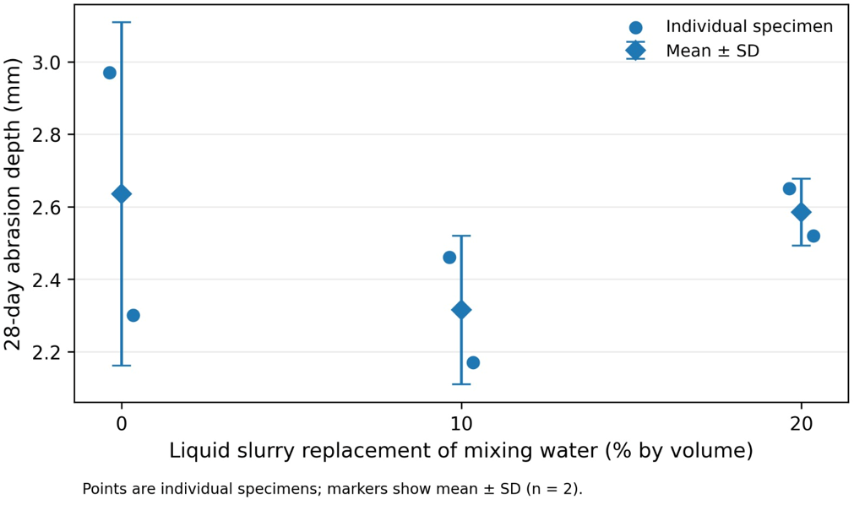
Figure 11 Effect of LS Incorporation on 28-Day Abrasion Depth of Unplasticized Concrete.
Note: Error bars represent the range of AR of two tested samples per each unplasticized concrete mix matrix.

4.2.3.2 Discussion of Abrasion Resistance Results for Plasticized Concrete Mixes at Different LS Incorporation Levels
Plasticizer addition produced different abrasion responses at the three LS incorporation levels. At 10% LS, the mean abrasion depth decreased from 2.315 to 2.010 mm, corresponding to an observed improvement in AR of 13.17%. At 20% LS, the mean abrasion depth decreased from 2.585 to 2.425 mm, corresponding to an observed improvement in AR of 6.19%. In contrast, at 0% LS, abrasion depth increased from 2.635 to 2.785 mm, indicating an observed deterioration of 5.69%. Consequently, the results do not demonstrate a uniform observed plasticizer response across all LS levels. Figure 12 shows the impact of adding LS on abrasion depth values for plasticized KS mixes while Figure 13 shows the impact of adding plasticizer of AR values.
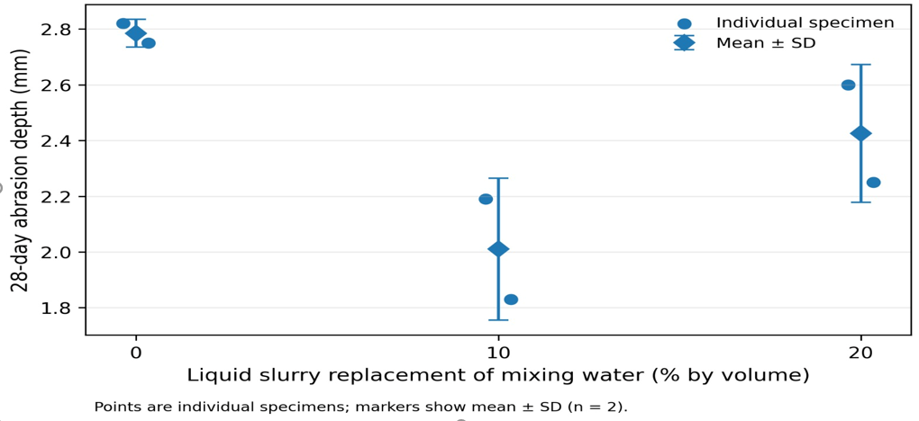
Figure 12 Effect of LS Incorporation on 28-Day Abrasion Depth of Plasticized Concrete.
Note: Error bars represent the range of AR of two tested samples per each plasticized concrete mix matrix.
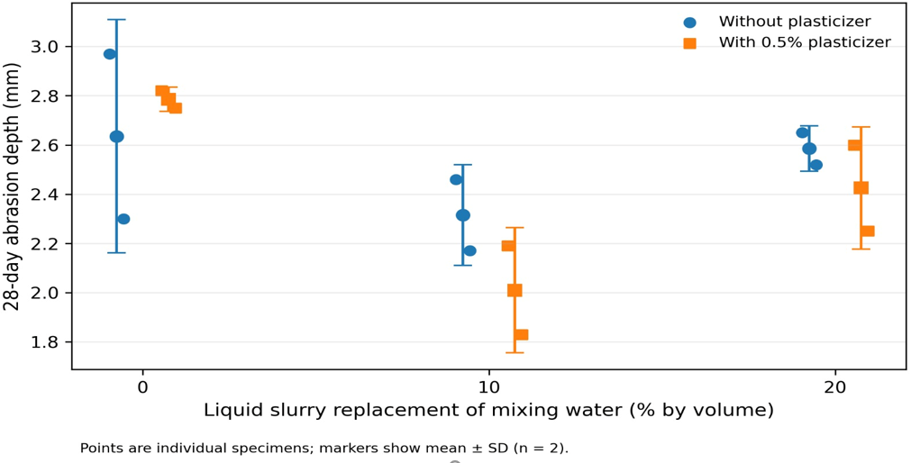
Figure 13 28-Day Abrasion Depth by LS Incorporation and Plasticizer Addition.

4.2.4 Statistical Summary and Robustness of the Observed Results
Summary statistics for the individual mixes show a considerable scatter for the single specimens of every mix. Due to the small number of available data points for every mix every single value has to be treated with care.
Directional consistency test: For each of the three indicators within the unplasticized as well as the plasticized mixtures the 10% level of LS performed better than the 0% and 20% levels of LS. This is to say that for all 12 possible directional comparisons between the 10% level of LS and the other levels of LS the 10% level of LS performed better.
The highest values for all three test parameters were obtained for the C-10-SP mixture. Thus, the best of all test mixtures was the C-10-SP mixture. It did not only obtain the highest composite score because of equal weighting, but the highest value for each test parameter. The results of the work are a robust descriptive result within the work, but not a validated statistical result for the whole population, due to the limited number of specimens used in the work.
The exploratory two-way analysis of variance indicated an effect of LS incorporation level on CS F (2, 6) = 5.430, p = 0.045. However, the effects of slurry level on FS, F (2, 6) = 3.470, p=0.100, and AR, F (2, 6) = 4.550, p =0.063, did not reach the statistical significance level of 0.050. Likewise, no statistically significant overall effect of the plasticizer was observed on CS, F (1, 6) = 3.370, p = 0.116; FS, F (1, 6) = 0.490, p = 0.509; or AR, F (1, 6) = 0.490, p=0.509. No statistically significant interactions were identified between slurry level and plasticizer addition. The 95% confidence intervals for the estimated overall plasticizer effect included zero for all three performance indicators. Accordingly, the wording of the results was revised to describe observed differences in the means rather than statistically confirmed general effects.

4.3 Compliance with Palestinian Standards
Although the main focus of this thesis is to show the effect of adding LS on the specifications of KS produced under different conditions, the study provided a complete description of the PSI specifications and tests of KS in section 2.9.2, this characterization is mainly aimed at identifying the tests necessary to control the quality of the produced KS, in addition to giving numbers to later domesticate the extent of the ability to achieve the standard within the laboratory environment and the previous selection of constant and non-constant variables in section 3.2, especially since this type of precast structural elements is often produced in factories that rely on mechanical presses to handle this low workable concrete.

4.3.1 KS Compression Strength Complies with Palestinian Specifications
The first criterion for judging the quality of the concrete product used in the manufacture of KS is CS, where the PS-55-4-1 standard has set the minimum mean CS for the KS samples examined to be 50 MPa (PSI, 2008). In any case, the results attached in Table 6 showed the inadequacy of the examined KS samples to achieve the minimum required specification with a percentage of inadequacy ranging from 9.4 to 24.4%.
The inability to achieve the specifications mentioned in Section 2.9.2 can be explained by field conditions, particularly in the context of a manual work during the preparation of concrete samples. Unlike giant hydraulic presses, which rely on high pressure, heat, and intensive vibration to produce zero-slump mixes (used to manufacture KS), the manual compaction and vibration methods used in zero-slump KS sample preparation remain incapable of achieving high air removal rates. This ultimately results in air remaining trapped within the cement paste, significantly reducing its CS.

4.3.2 KS Flexural Strength Complies with Palestinian Specifications
Under certain conditions, and due to the unsoundness of the KS foundation or base, these stones are affected by some bending forces. Therefore, the PSI (PS-55-4-2) stipulates a minimum mean FS is 4.6 MPa.
In reality, the FS values ​​stipulated in the Palestinian specifications are somewhat modest. Therefore, it is observed that all prepared KS concrete samples except C-0-N achieve the required specification with a high margin of safety, ranging from 2.85% to 24.43% with respect to PSI stipulated limits mentioned in section 2.9.2.
Related to the sample C-0-N, the inability to achieve the minimum FS (4.6 MPa) is attributed to the field testing conditions, particularly the low water-to-cement ratio and the difficulty in handling the concrete mix, which may ultimately lead to lower-than-expected performance values. Therefore, the experiment primarily focuses on the mechanism of performance variation resulting from the incorporation of LS. The degree of approximation to achieving Palestinian specifications is considered a preliminary indicator of the suitability of the concrete mix structure, including constant and non-constant parameters as well as the preparation and testing methodology.

4.3.3 KS Abrasion Resistance Complies with Palestinian Specifications
The PSI has strict limits on how much KS can be worn down within specification PS-55-3 because it has to deal with a lot of friction. The maximum mean depth of wear should not be more than 3.6 mm.
AR is mostly based on how stiff the concrete matrix is, which is greatly affected by how stiff the aggregates are that are used in the concrete mix. Appendices A and B show that both coarse and fine aggregates did well in the AR test. So, it was thought that the samples that were made later would also do well in the AR test if the right concrete matrix was used.
All of prepared concrete samples had a high safety margin in the depth of abrasion compared to the maximum allowable limit. The percentage ranged from 22.64% for sample C-0-N to 44.17% for sample C-20-SP.

4.4 Best-Performing Tested LS Incorporation Level
The comparative evaluation described in Section 3.4 was used to identify the best-performing level among the three experimentally tested LS incorporation levels. The assessment was based on the individual normalized scores for CS, FS, and AR, the equal-weighted composite score, and the consistency of the ranking across the three indicators.
Table 9 and Figure 14 shows that C-10-SP achieved a composite score of 100 because it recorded the highest mean CS, the highest mean FS, and the lowest mean abrasion depth among the six tested mixtures. C-10-N achieved the second-highest composite score. These results indicate that 10% was the best-performing tested LS level under both plasticizer conditions.

Table 9 Normalized Mechanical-Performance Scores of the Tested Concrete Mixes.
Mix ID | LS (%) | SP (%) of cement |  | Average Compressive Strength (MPa) | Score | Average Flexural Strength (MPa) | Score | Average Abrasion (mm) | Score | Composite Score
C-0-N | 0.00 |  | No | 40.70 | 38.67 | 4.50 | 0.00 | 2.64 | 19.35 | 19.34
C-10-N | 10.00 |  | No | 45.15 | 98.00 | 5.37 | 71.43 | 2.32 | 60.65 | 76.69
C-20-N | 20.00 |  | No | 37.80 | 0.00 | 4.99 | 40.48 | 2.59 | 25.81 | 22.09
C-0-SP | 0.00 |  | 0.50 | 45.00 | 96.00 | 4.73 | 19.05 | 2.79 | 0.00 | 38.35
C-10-SP | 10.00 |  | 0.50 | 45.30 | 100.00 | 5.72 | 100.00 | 2.01 | 100.00 | 100.00
C-20-SP | 20.00 |  | 0.50 | 41.20 | 42.86 | 5.02 | 42.86 | 2.43 | 46.45 | 44.88

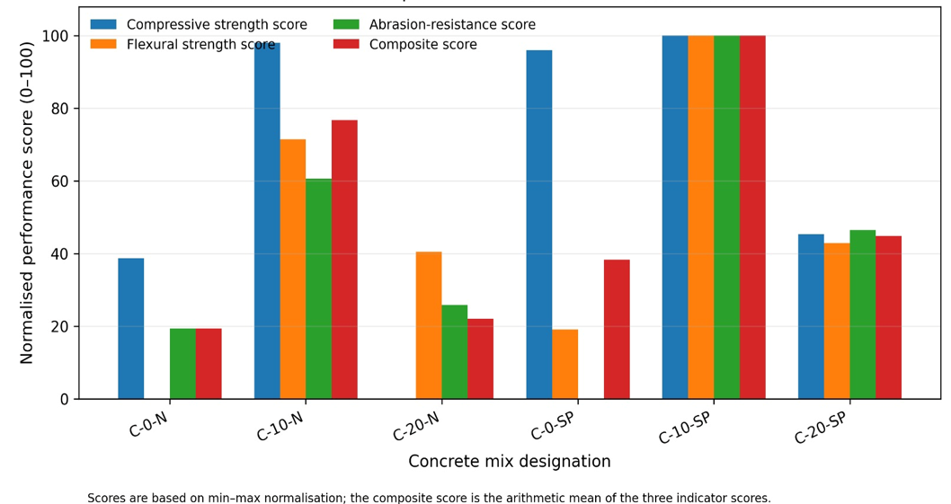
Figure 14 Normalized Mechanical-Performance Scores of the Tested Concrete Mixes.

4.4.1 Best-Performing Tested Level in Unplasticized Mixes
Among the unplasticized mixtures, the composite scores at 0%, 10%, and 20% LS were 19.34, 76.69, and 22.09, respectively as shown in Table 9 and Figure 15. The 10% mixture also produced the highest mean CS and FS and the lowest mean abrasion depth within this group. Therefore, 10% was identified as the best-performing tested level for unplasticized concrete. The experiment does not establish whether an incorporation level between the three tested values would produce a higher response.
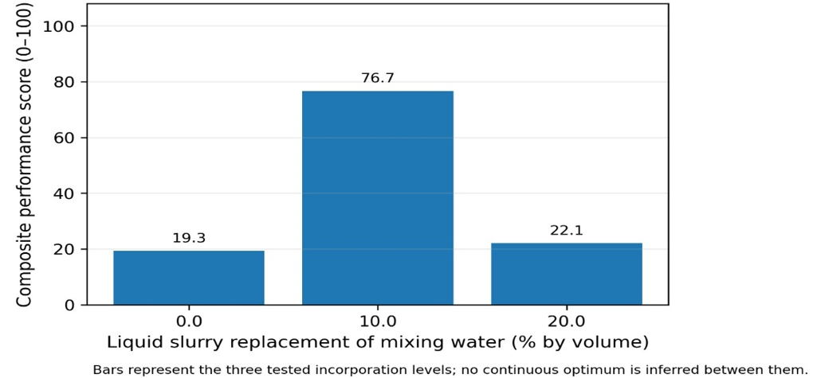
Figure 15 Composite Performance Score at the Tested LS Levels: Unplasticized Mixes.

4.4.2 Best-Performing Tested Level in Plasticized Mixes
Among the plasticized mixtures, the composite scores at 0%, 10%, and 20% LS were 38.35, 100.00, and 44.88, respectively as shown in Table 9 and Figure 16. The 10% mixture recorded the highest mean CS and FS and the lowest mean abrasion depth within this group and across the complete experimental matrixes. Therefore, 10% was identified as the best-performing tested LS level for plasticized concrete.
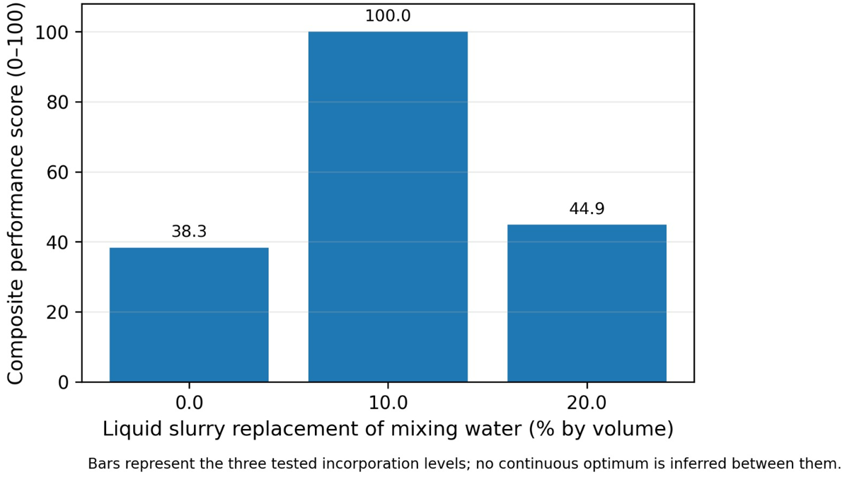
Figure 16 Composite Performance Score at the Tested LS Levels: Plasticized Mixes.

4.5 Quantify Environmental and Economic Benefits
The comparative assessment in Section 4.4 identified 10% as the best-performing incorporation level. For the preliminary environmental and economic assessment, this tested level was adopted as the calculation basis. The assessment should not be interpreted as evidence that 10% is the exact population optimum.
There are four main KS manufacturing plants in Hebron, all located within close proximity of the HIZ as shown in the Figure 17. Obtaining a fixed daily production figure proved challenging due to the seasonal fluctuations in market demand.
The daily production volume of KS of 1000 m³ was selected as a calculation basis unit for the purposes of economic and environmental assessment. In any case, this number was not imposed arbitrarily, as this number is almost in line with the production capacity of four main factories of KS in Hebron Governorate. This approach constitutes a preliminary feasibility study and a simulated scenario of the local reality in Hebron Governorate, and not a comprehensive life cycle assessment.
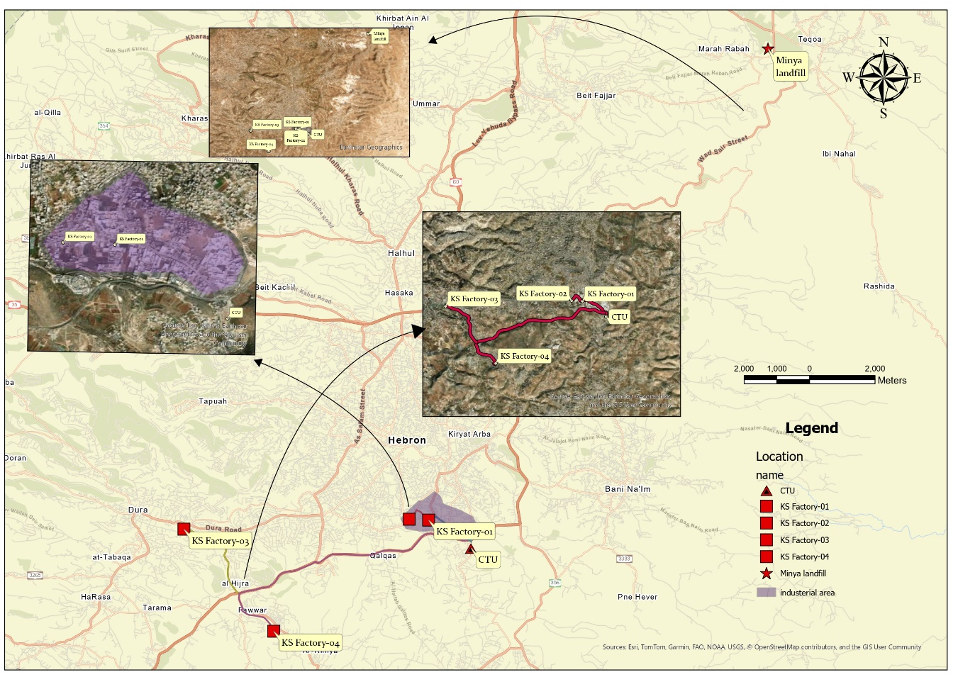
Figure 17 Spatial Relationship between KS Manufacturing Facilities, CTU, and Al-Minya Disposal Site.
Based on the water/cement ratio 0.4 which is used for the reference mix matrices (C-0-N and C-0-SP), the daily water demand for KS production in HIZ under the aforementioned conditions is estimated by 180 m³.
Adopting the best-performing LS incorporation level 10% obtained from the comparative assessment in Section 4.4, approximately 18 m³ of LS can be incorporated into the production of KS under the aforementioned conditions. This quantity represents approximately 3.6% of the daily LS production in the HIZ. Equation 9 illustrates the previous numbers.
$LSdv=KSv*WC*MLS$ | (9)
Where:
LSdv: Daily volume of recycled LS in KS production (m³).
KSv: Production volume of KS in the HIZ (m³).
WC: Control water/cement ratio which is equal 0.40.
MLS: Maximum allowable LS incorporation ratio.
$LSdv=450*0.4*0.1$=18 m³/day.
This section will address the topic of quantitative of the environmental and economic benefits of including 18 m³ of LS out of the 500 m³ produced daily in the HIZ, which constitutes approximately 3.6% of the total LS production in HIZ, directly into the KS manufacturing process instead of drying it in the central plant in the Al-Fahs area.

4.5.1 Environmental Benefits Analysis
The environmental significance of this study lies in reducing the carbon dioxide emissions by minimizing the need to dewatering LS at the CTU and then disposing of byproduct solid at Al- Minya landfill as a covering material for solid waste there. The study demonstrated that it is possible to reduce the volume of slurry to be treated from 500 m³ per day to 482 m³ per day if it is recycled in the production of KS according to the aforementioned conditions.
It is estimated that the daily electricity consumption for drying LS waste in the CTU is 7500 kWh/day. This means that drying one cubic meter of LS consumes about 15 kW assuming the daily production of LS equal 500 m³ (Seureca et al., 2020).
To convert the energy consumption of one cubic meter of LS (in kilowatts) to the weight of carbon dioxide emissions in kg, equation 10 can be used:
CO2e= En*EM. | (10)
Where:
CO₂e: Weight of gas emitted from electricity consumed for dewatering one cubic meter of LS (kg).
En: Energy consumption rate for drying one cubic meter of LS (kWh).
EM: The emission factor is estimated at 0.5 kg CO₂ per kWh (International Energy Agency (IEA), 2025).
CO₂e=15*0.5=7.5 kg/m³.
Based on the result above, the weight of carbon dioxide gas produced from dewatering one cubic meter of LS is estimated at approximately 7.5 kg.
Table 10 Environmental Trade-Off between Total Treatment and Recycling of LS.
Comparison Aspect | Option 1: Processing Total Daily Production (500 m³) | Option 2: Recycling 18 m3 (Processing 482 m³ only)
Daily Volume for Treatment/Landfill m³ | 500 | 482
Daily Energy Consumption (dewatering) kWh | 7,500 | 7,230
Daily CO2​ Emissions kg | 3,750 | 3,615
Daily Environmental Impact, CO2 reduction (kg/day) | - | 135
Annual CO2​ Reduction (kg) |  | 425250
Annual CO2​ Reduction (ton) | - | 42.525
Table 10 shows the results of the environmental benefits analysis. Results show that recycling LS to make KS is better for the environment than common treatment (dewatering) methods because it has a smaller carbon dioxide emission. Recycling LS in this approach save about 270 kWh of electricity every day if you cut down on the amount of LS that needs to be dewatered from 500 m³ to 482 m³. Converting these energy savings means a reduction in carbon dioxide emissions, as this recycling could reduce carbon dioxide emissions by 135 kg per day, or 43 tons per year (assuming 315 working days per year).
The impact of recycling LS on reducing the carbon dioxide emissions is not limited to reducing the carbon dioxide emissions resulting from electricity consumption, but also includes reducing the volume of solid materials that must be disposed of through the Minya landfill. Transporting the dried slurry to the Minya landfill requires transporting 405 tons daily via 27 trips, each covering approximately 50 kilometers round trip, with a fuel consumption rate of 30 liters per 100 kilometers, this yields a daily fuel consumption of approximately 405 liters (Seureca et al., 2020). Based on the above, the process of disposing of dewatered slurry (cake) through AL-Minya landfill consumes approximately 0.81 liters of diesel fuel per cubic meter of LS. The following equation was used to estimate the carbon dioxide emissions per cubic meter of LS transported towards the landfill.
CO2f= Fl*EM. | (9)
Where:
CO2f: Weight of gas emitted from fuel consumed for transporting one cubic meter of LS (kg) to the landfill.
Fl: Fuel consumption rate for transporting one cubic meter of LS (Litter).
EM: The emission factor is estimated at 2.68 kg CO₂ per liter diesel (United States Environmental Protection Agency (EPA), 2025).
CO2f=0.81*2.68=2.2 kg/m³.
Table 11 Environmental Trade-Off between Transporting the Entire Dewatered LS and Direct Recycling.
Comparison Aspect | Option 1: Disposing of Total Production (500 m³) | Option 2: Recycling 18 m3 (Transporting 482 m³only)
Round trip for trip (km) | 50 | 50
Weight of cake produced daily (ton) | 405 | 391
Load capacity per trip (ton/trip) | 15 | 15
Number of daily trips | 27 | 26
Total daily travel distance (km) | 1350 | 1300
Vehicle fuel consumption rate(L/100km) | 30 | 30
Total Daily Fuel Consumption litter/day | 405 | 390
CO2​ Emission (kg/L) | 2.68 | 2.68
CO2​ Emission (kg/day) | 1085.4 | 1045
Saved CO2 Emission (kg/day) | 40
Annual Working Day | 315
Annual saved CO2 Emission (kg) | 12600
Annual Saved CO2 Emission (ton) | 12.6
Table 11 shows the trade-off between fully dewatering LS made every day in Hebron and recycling 3.6% of LS directly into KS. This means that daily travel will be reduced by 50 kilometers. This shorter daily travel distance greatly lowers the carbon dioxide emissions of LS transporting to Al-Minay landfill, which in turn lowers carbon dioxide emissions by 12.6 tons per year.
Neglecting the carbon dioxide emissions trade-off of transporting LS to its final destination, whether it be the KS manufacturing plant or the CTU, given that the distance of these facilities is close to each other within the industrial area; recycling LS produced daily from the industrial area within the possible values ​​as presented in this study can lead to a reduction in carbon dioxide emissions by 55.1 tons annually, as a result of reducing the electrical energy required for drying, in addition to reducing the quantity of transported dewatered slurry (cake).

4.5.2 Cost Benefits Analysis
The unprecedented financial deductions imposed by the occupation for treating wastewater flowing through Wadi al-Khalil, particularly SCW, have forced the Palestinian Authority to seek sustainable and cost-effective solutions for treating this waste, including the establishment of a CTU in the HIZ. Despite its importance, the construction of this CTU in Hebron will take several years. Following its establishment, the consulting firm Seureca et al. (2020) prepared a detailed technical study encompassing the project, including the treatment costs for this industrial waste.
The operating and maintenance costs for the proposed CTU (excluding initial capital) are estimated at approximately 50 Israeli shekels per cubic meter of LS. While this cost seems quite reasonable compared to the fees charged by the Israeli occupation for treating one cubic meter of LS -estimated at around 250 shekels per cubic meter according to information from the PWA - it remains a high cost that must be reduced.
Recycling 18 m³ of LS daily, as recommended by this study, to produce KS could be a cost-effective alternative that does not require significance initial investment in KS factories. This is because the logistical equipment (water storage silos) is already in place at these factories, and transportation distances are short, as all these facilities are located within a short distance from HIZ. Table 12 illustrates the comparison between two options: fully treating the LS generated from the HIZ or recycling a portion and treating the remainder.
Table 12 The Economic Trade-Off between Full Treatment and Partial Recycling of LS.
Comparison Aspect | Option 1: Treating Total Daily Production (500 m^3) | Option 2: Recycling 18 m3 (Treating 482 m^3 only) | Daily Savings/Benefit | unit
Daily Treatment Volume | 500 | 482 | 18 | M^3
O&M Costs (50 NIS/m^3) | 25,000 | 24100 | 900 | ILS
Annual Cost Of Treatment (315 Working Days) | 7875000 | 7591500 | 283500 | ILS
Table 12 shows that recycling 18 m³ of LS for KS production can save up to 283500 shekels annually in dewatering costs. These direct economic benefits do not include the economic advantages such as the increased price of environmentally friendly KS, as the LS used improves the mechanical properties of this product. Furthermore, the savings from reducing the daily consumption of 18 m³ of fresh water are not considered, as this will be offset by a slight increase in transportation costs for the LS.

Chapter Five: Discussion of Results

5.1 Primary Findings
This study showed that 10% LS was the best-performing incorporation level among the three tested levels. The unplasticized C-10-N mixture recorded mean CS, FS, and abrasion-depth values of 45.15 MPa, 5.37 MPa, and 2.315 mm, respectively. The plasticized C-10-SP mixture recorded corresponding values of 45.30 MPa, 5.72 MPa, and 2.010 mm and was the best-performing tested mixture across the three LS incorporation levels. These findings represent observed trends within the limited experimental dataset and require confirmation using additional independent batches and specimens.
While the statistical scope focused on a single representative slurry source, this approach is justified by prior characterizations showing high homogeneity and correlation among LS sources in Hebron (factory 1 and factory 2) as detailed in section 2.4.6. In addition, the fact that the recycled LS will be used as non-structural infrastructure parts instead of critical load-bearing parts allowing for higher tolerance.
The chosen levels of LS incorporation (0%, 10%, and 20%) helped clarify the performance trend. The study's focus on these specific variables suggests a limited statistical population. However, the results still provide a positive indication of the environmental and economic benefits for this approach of recycling.

5.2 Comparative Analysis and Literature Validation

5.2.1 Validation of LS-Induced Mechanical Improvements against Previous Literature
By returning to laboratory results for CS, FS, and AR, the observed results showed a consistent performance response of adding LS on the performance of the produced concrete. When the mixing water was replaced with LS by 10%, all the samples tested showed an improvement in performance. The improved performance is attributed to the ability of LS and its fine particles to improve the density of the KS samples produced by filling the microscopic voids with fine lime granules instead of air. In addition to the above, the ability of the chemical properties of lime to enter into a secondary chemical reaction that improves the hardness properties of the produced concrete is consistent with the findings of Wang's study (2018).
In numbers, the addition of LS in the best-performing ratio (10%) to the concrete mixture led to the improvement of mechanical and abrasion resistance at 28 days, represented by CS, FS, and AR by 10.93%, 19.48%, and 12.14%, respectively. This is similar to the outputs of previous studies, such as Kumar and Kumar study (2015), where Kumar's study showed that the optimal ratio of CS and FS corresponds to a water/cement ratio estimated at 0.43, and percentage of the integration of fine materials as a substitute for cement is 10%. At these percentages, the CS of the produced concrete improved by about 12.5% and the FS by about 10% with respect to the reference performance. However, the main difference between the two experiments remains the replacement materials; while the replacement approach concentrates on cement itself in Kumars study, this study relied on water replacement, achieving additional percentages of reduction in the W/C ratio, as this path made the replacement sensitivity more effective.
However, other studies have shown results close to the outcomes of this experiment. For example, the experience of Al-Jolani and Awwad (2019) concluded that the ability to replace LS by 20% improved the mechanical properties, represented by an improvement in CS by 13.9%. While both studies are similar in the substitution methodology, where mixing water is replaced with LS, the two studies differ on the ratio of water to cement; as the study of Al-Jolani and Awwad adopts a ratio of water to cement estimated at about 0.6, and this ratio is suitable for the production of medium-performance concrete, this study adopts a much lower W/C ratio (0.4) suitable for the production of high-performance concrete.
Compared to the results of the study of Al-Zboon & Al-Zou’by (2015), it showed that the optimal replacement rate of the mixing water with the LS is about 50%, as this substitution ratio enhanced the CS by 21%, FS by 18%. While the two studies are similar in the methodology of replacing the mixing water with LS, the two studies differ in the specifications of the substituted material; as the study of Al-Zboon & Al-Zou’by relied on the replacement of untreated or low concentration LS as described in section 2.4.1 (where the solid content of the used LS is estimated at about 4.8% ) while this study used LS with a solid content about 30%, so this study showed lower allowable replacement level ratios.
However, all previous studies have concluded that adding fine materials to the concrete mixture would eventually lead to a reduction in the workability of the concrete mixture and a decrease in the values of the slump tests. This reduces the efficiency of compaction processes and compromises density, which is a serious problem for the performance of the concrete mixture at certain integration ratios. Therefore, many previous studies have suggested the importance of adding a plasticizer to restore the workability of the concrete mixture and disperse the fine materials as much as possible.

5.2.2 Observed Performance Decline at the 20% LS Level
The laboratory results showed that the best-performing substitution level in this experiment was around 10%. When the replacement ratio was doubled to 20%, the concrete mixtures showed a general decrease in mechanical performance and abrasion resistance at 28 days.
Doubling the percentage of LS incorporation to 20% led to a decrease in the performance of unplasticized KS samples in CS, FS, and AR with respect to the best-performing results (at 10% level) by 18.06%, 8.44% and 10.24% respectively. This decline is attributed to the imbalance of PSD within the concrete matrix. In addition, the increase in the concentrations of ultra-fine materials leads to the particles interference, where fine aggregate crowd the coarse aggregates on the space, causing a weakness in the internal cohesion of the concrete matrix and the disintegration of the bonds in the interfacial transition zone (ITZ).
Returning to the literature, it can be observed a general consensus towards a decline in concrete performance at a certain level. The study of Kabeer and Vyas (2019) confirmed that the integration of marble cutting waste powder in the production of masonry mortars at high percentages leads to the phenomenon of dry shrinkage, the difference remains that Kabeer and Vyas replaced sand with stone powder in the production of low-resistance mortar clay. While this study adopted the production of high-stress concrete for the production of KS.
Returning to the study of Metaxa et al. (2025) , it can be seen a great similarity with the findings of this study. The study verified the optimal replacement ratio and found that when high percentages of marble slurry are added, the mechanical performance decreases significantly. The study attributed this decline to a significant increase in the internal surface area, which negatively affected the completion of the rehydration reaction. In addition, the concentration of the ITZ around the inert marble particles explains the simultaneous decreases of different durability factors such as CS and elasticity coefficient according to the study. The study also showed that these changes become more severe as the ratio of water to cement decreases, and this is consistent with the outputs of this study, which mainly relied on a very low water-to-cement ratio (0.4).

5.2.3 Observed Influence of Plasticizer Addition
At the best-performing LS incorporation level (10%), plasticizer addition was associated with observed changes of +0.33% in CS, +6.52% in FS, and a -13.17% in abrasion depth with respect to the unplasticized counterparts. However, the plasticizer response was not uniform across all LS levels. For example, the 0% plasticized mixture showed a higher abrasion depth than its unplasticized counterpart. The results therefore suggest that plasticizer performance may depend on the LS level and concrete-mixture condition rather than producing a consistent general improvement.
Compared to the literature review outputs in this study, this study shows a logical correlation with the outputs of other studies in this regard. For example, in its study, Sardinha et al. (2016) confirmed that the optimal incorporation level of the marble sludge is about 10%, while the addition of plasticizer improves the allowable incorporation level to 20%. While this study is similar to Sardina's study, where the plasticizer has the ability to improve viability of incorporation higher level of LS, the two pathways differ in the form of addition, as Sardina focuses on replacing the cement itself.

5.3 Environmental and Economic Feasibility
This thesis included a quick survey of the direct economic and environmental benefits of adopting a direct recycling system for LS. This system provided an opportunity to recycle the slurry in its liquid form instead of recycling the slurry after treatment (Stage 2 or Stage 3 as mentioned in Section 2.4.5), which gave initial environmental and economic benefits. The direct environmental benefits of this approach at the best-performing replacement ratio (10%) were represented in the reduction of the quantities to be treated in the proposed CTU by about 3.6%, and this was directly reflected in the reduction of fuel and electricity consumption required for dewatering and transporting the treatment residues, which caused a direct reduction in carbon dioxide emissions by around 55.1 tons annually.
Economically, the costs of dewatering and treating LS in the CTU proposed in the Seureca and Veolia report were estimated at about 50 ILS/$m^{3}$ to make it environmentally safe for disposal in demolition landfills.
Regardless of the modest figures of the previous direct benefits, the recycling of a waste is a comprehensive system that overlaps with a wide range of factors, including environmental costs, political determinants, indirect economic costs, the social aspect, the local market, etc.... Therefore, the comprehensive LS recycling system can be integrated with a range of small activities to give zero waste ultimately.

Chapter Six: Conclusions and Recommendations

6.1 Conclusions
Based on the laboratory findings and comparative statistical evaluation, the following conclusions are drawn:
- Within the tested experimental matrixes, 10% LS was consistently the best-performing incorporation level for CS, FS, and AR under both plasticizer conditions. The findings support the technical potential of LS incorporation but should be interpreted as exploratory because of the limited specimen replication and tested incorporation intervals.
- Adding plasticizers to low or no-slump mixes gives a considerable boost to the performance of the final product. C-10-SP recorded the highest observed combined performance. However, the plasticizer response was not uniform across all LS levels, and the available dataset did not establish a statistically conclusive general observed plasticizer response.
- For the best-performing tested LS incorporation level, this study has shown that it is possible to achieve some of economic and environmental benefits that contribute to adopting a more sustainable system for dealing with SCW in Hebron.

6.2 Study Limitations
It should be noted that the main limitations of this research, particularly regarding the scope of laboratory testing and sample size, stem directly from strict budget constraints and a lack of dedicated funding. As a result, some overall durability assessments, automated testing setups, and overall statistical construction of both the number of samples tested and the level of LS integration had to be postponed to future work. Some of the main shortcomings of this study can be listed as follows:
- Relying on a single representative sample of LS material demonstrates a statistical inadequacy in representing the entire population, even though the results of the statistical analysis performed in Section 2.4.6 showed good statistical homogeneity among the samples examined in the DAI report. Furthermore, the selected replacement ratios are highly discontinuous, which may miss the true best-performing point for incorporating LS material as a water replacement in the concrete mix.
- KS samples were prepared using manual mixing and casting, whereas industrial production typically employs mechanical compaction and automated vibration. This procedural difference suggests that factory-scale units might achieve a higher density and a more refined microstructure than is possible under laboratory conditions.
- The long-term performance evaluation in this study was mainly limited to AR, whereas the long-term performance evaluation of the produced KS system requires a more comprehensive evaluation that includes water absorption, freeze-thaw cycles, and sulfate resistance to fully verify the durability of the KS system combined with LS under harsh environmental conditions.

6.3 Recommendations for Future Research
- Conducting multi-batch sampling across various seasons and SCFF to establish a broader statistical profile for LS mineralogical consistency.
- Casting and compacting the mix design using automated mechanical compaction and vibration systems to replicate real-world manufacturing conditions.
- The KS material modified with LS technology should be evaluated in terms of water absorption, freeze-thaw cycles, and carbonation resistance to provide higher reliability for the long-term performance of the KS.
- Exploring the synergy between LS and nano-materials or chemical activators to potentially increase viable substitution levels beyond 10%.
- Investigating a more incorporation levels of replacement percentages (e.g., 2.5%, 5%, 7.5%, 12.5%, and 15%) to enhance statistical reliability and precisely identify the best-performing substitution level of LS in concrete mixes used for KS production.
Test additional LS incorporation levels close to 10%, such as 5%, 7.5%, 12.5%, and 15%, using independently replicated batches. Response-surface or regression modelling should only be applied after sufficient intermediate levels and residual degrees of freedom are available to evaluate model fit and prediction uncertainty.

6.4 Practical Implications
- Utilizing 18 $m^{3}$of LS daily would directly reduce the transboundary pollution in the Hebron Valley and mitigate the risk of sewage system blockages, leading to an annual reduction of 55.1 tons of CO2 emissions.
- The transition from traditional disposal methods to direct recycling in KS production offers a potential annual operational saving of approximately 283,500 NIS, excluding the avoidance of heavy environmental fines.

References

AL - Joulani, N. (2012). Effect of Stone Powder and Lime on Strength, Compaction and CBR Properties of Fine Soils. Jordan Journal of Civil Engineering, Volume 6, No. 1, 2012, volume 6.
AL - Joulani, N. (2014). UTILIZATION OF STONE SLURRY POWDER IN PRODUCTION OF ARTIFICIAL STONES. Research Journal in Engineering and Applied Sciences, 3, 245–249.
Aliabdo, A. A., Abd Elmoaty, A. E. M., & Auda, E. M. (2014). Re-use of waste marble dust in the production of cement and concrete. Construction and Building Materials, 50, 28–41. https://doi.org/10.1016/j.conbuildmat.2013.09.005
Al-Joulani, N., & Awad, R. (2019). Reuse of Wastewater from the Stone Industry in Production of Cast Stone. In Palestine Polytechnic University & An-Najah National University (Eds.), International Conference on Civil Engineering - Palestine. Engineers Association - Palestine Palaces.
Al-Joulani, N. M. A. (2011). Sustainable Utilization of Stone Slurry Waste in the West Bank. Geo-Frontiers 2011, 1345–1354. https://doi.org/10.1061/41165(397)138
Al-Joulani, N., & Salah, N. (2014). The Stone Slurry in Palestine from Environmental Burden to Economic Opportunities—Feasibility Analysis. Journal of Environmental Protection, 05(12), 1075–1090. https://doi.org/10.4236/jep.2014.512106
Alsiano. (n.d.). Fillers for nutraceuticals. Alsiano. Retrieved July 8, 2026, from https://www.alsiano.com/solutions/fillers-for-nutraceuticals/
Al-Zboon, K., & Al-Zou’by, J. (2015). Recycling of stone cutting slurry in concrete mixes. Journal of Material Cycles and Waste Management, 17(2), 324–335. https://doi.org/10.1007/s10163-014-0246-x
Alzboon, K., & Mahasneh, K. (2009). Effect of Using Stone Cutting Waste on the Compression Strength and Slump Characteristics of Concrete. 1. https://www.researchgate.net/publication/238791165_Effect_of_Using_Stone_Cutting_Waste_on_the_Compression_Strength_and_Slump_Characteristics_of_Concrete
Aruntaş, H. Y., Gürü, M., Dayı, M., & Tekin, İ. (2010). Utilization of waste marble dust as an additive in cement production. Materials & Design, 31(8), 4039–4042. https://doi.org/10.1016/j.matdes.2010.03.036
ASTM. (2014). Test Method for Sieve Analysis of Fine and Coarse Aggregates. ASTM International. https://doi.org/10.1520/C0136_C0136M-14
ASTM. (2015). Test Method for Relative Density (Specific Gravity) and Absorption of Coarse Aggregate. https://doi.org/10.1520/C0127-15
ASTM. (2018). Specification for Concrete Aggregates. ASTM International. https://doi.org/10.1520/C0033_C0033M-18
ASTM. (2019). Practice for Making and Curing Concrete Test Specimens in the Laboratory. ASTM International. https://doi.org/10.1520/C0192_C0192M-19
ASTM. (2020). Test Method for Resistance to Degradation of Small-Size Coarse Aggregate by Abrasion and Impact in the Los Angeles Machine. ASTM International. https://doi.org/10.1520/C0131_C0131M-20
ASTM. (2023). Specification for Ready-Mixed Concrete. ASTM International. https://doi.org/10.1520/C0094_C0094M-23
Carsten Vogt. (2010). Ultrafine particles in concrete: Influence of ultrafine particles on concrete properties and application to concrete mix design [Doctoral Thesis, Royal Institute of Technology University]. https://kth.diva-portal.org/smash/get/diva2:304967/FULLTEXT01.pdf
DAI. (2014). Sludge New Product Pre-Feasibility Study & Analysis Project.
Demirel, B. (2010). The effect of the using waste marble dust as fine sand on the mechanical properties of the concrete. International Journal of the Physical Sciences, 5, 1372–1380. https://www.researchgate.net/publication/228506057_The_effect_of_the_using_waste_marble_dust_as_fine_sand_on_the_mechanical_properties_of_the_concrete
Dölle, K. (2021). In-Situ Precipitated Calcium Carbonate Paper Filler Material: A Review. Journal of Engineering Research and Reports, 38–58. https://doi.org/10.9734/jerr/2021/v21i1117502
EN 1340:2003: Concrete Kerb Units - Requirements and Test Methods, European Committee for Standardization (CEN) 78 (2003). https://standards.iteh.ai/catalog/standards/cen/84647ce9-386d-4a39-8406-47d56f64692b/en-1340-2003
Fahiminia, M., Ardani, R., Hashemi, S., & Alizadeh, M. (2013). Wastewater Treatment of Stone Cutting Industries by Coagulation Process. Archives of Hygiene Sciences, 2(1), 16–22. https://www.researchgate.net/publication/255791587_Wastewater_Treatment_of_Stone_Cutting_Industries_by_Coagulation_Process
Fritz, K., Taylor, K., & Parmar, M. (2023). Calcium Carbonate. StatPearls Publishing. https://www.ncbi.nlm.nih.gov/books/NBK562303/
Gaber, M. (2012). Evaluation of Samalout and Beni Khalid “Minia” Limestone for Producing Paint Extender Pigment.
Hilal, A. A. (2016). Microstructure of Concrete. In High Performance Concrete Technology and Applications. InTech. https://doi.org/10.5772/64574
International Energy Agency (IEA). (2025). Global Energy Review 2025: CO2 Emissions. https://www.iea.org/reports/global-energy-review-2025/co2-emissions
Janković, K., Bojović, D., Stojanović, M., Despotović, I., & Antić Aranđelović, L. (2021). Properties of concrete kerbs with recycled aggregate from precast elements. Proceedings of the 2nd International Conference CoMS 2020/21, 148–153. https://rims.institutims.rs/handle/123456789/863
Kabeer, K. I. S. A., & Vyas, A. K. (2019). Experimental investigation on utilization of dried marble slurry as fine aggregate in lean masonry mortars. Journal of Building Engineering, 23, 185–192. https://doi.org/10.1016/j.jobe.2019.01.034
Kumar, R., & Kumar, S. K. (2015). Partial Replacement of Cement with Marble Dust Powder. International Journal of Engineering Research and Applications, 5(8), 106–114.
Kushwah, R. P. S., Sharma, I. C., & Chaurasia, P. B. L. (2015). Utilization of “Marble Slurry” In Cement Concrete Replacing Fine Agreegate. American Journal of Engineering Research, 4(1), 55–58. https://www.ajer.org/papers/v4(01)/H0401055058.pdf
Mapa Mudiyanselage, D. (2019). Enhancing Concrete Pavement Service Life Using Multiple Strategies to Reduce Cracking Potential by Dhanushika Mapa Mudiyanselage [Doctoral Dissertation, University of South Florida]. https://www.proquest.com/openview/e9ec37cf868b84eac1f958dffb3d39a0/1?pq-origsite=gscholar&cbl=18750&diss=y
Mashaly, A. O., El-Kaliouby, B. A., Shalaby, B. N., El – Gohary, A. M., & Rashwan, M. A. (2016). Effects of marble sludge incorporation on the properties of cement composites and concrete paving blocks. Journal of Cleaner Production, 112, 731–741. https://doi.org/10.1016/j.jclepro.2015.07.023
Melhem, M. (2014). The Effect of Calcite Additives on Clay for Ceramic Tile Manufactory. QUALICER ’14 (World Congress on Ceramic Tile Quality). https://www.qualicer.org/recopilatorio/ponencias/pdfs/37%20PON%20ING.pdf
Metaxa, Z. S., Koryfidou, S., Grigoriadis, L., Christodoulou, E., Ekmektsis, A., & Mitropoulos, A. C. (2025). Waste Marble Slurry as Partial Substitution for Cement: Effect of Water-to-Cement Ratio. Applied Sciences, 15(19), 10451. https://doi.org/10.3390/app151910451
Mishra, S., & Jain, V. (2026). Utilization of Marble Slurry Waste for Environmental and Industrial Applications: A Sustainable Approach. International Journal of Creative Research Thoughts, 14(6), 294–279. https://www.ijcrt.org/papers/IJCRT2606457.pdf
Palestine Standards Institution (PSI). (2008). PS 84-2008: Precast Concrete Kerbs and Channels.
Palestine Standards Institution (PSI). (2019). PS 48-2019: Mineral Aggregates from Natural Resources.
Palestinian Cabinet. (2010). Palestinian Cabinet Decree No. (25) of 2010 Concerning the Environmental Regulation for Stone and Marble Cutters, Tile Factories, and Ready-Mix Concrete Plants. https://mjr.ogb.gov.ps/Decrees/ViewText/23174/%D9%82%D8%B1%D8%A7%D8%B1-%D9%85%D8%AC%D9%84%D8%B3-%D8%A7%D9%84%D9%88%D8%B2%D8%B1%D8%A7%D8%A1-%D8%B1%D9%82%D9%85-25-%D9%84%D8%B3%D9%86%D8%A9-2010%D9%85-%D8%A8%D9%86%D8%B8%D8%A7%D9%85-%D8%A7%D9%84%D8%B4%D8%B1%D9%88%D8%B7-%D8%A7%D9%84%D8%A8%D9%8A%D8%A6%D9%8A%D8%A9-%D9%84%D9%85%D9%86%D8%A7%D8%B4%D9%8A%D8%B1-%D8%A7%D9%84%D8%AD%D8%AC%D8%B1-%D9%88%D9%85%D8%B5%D8%A7%D9%86%D8%B9-%D8%A7%D9%84%D8%A8%D9%84%D8%A7%D8%B7-%D9%88%D8%A7%D9%84%D8%A8%D8%A7%D8%B7%D9%88%D9%86-%D8%A7%D9%84%D8%AC%D8%A7%D9%87%D8%B2-%D9%81%D9%84%D8%B3%D8%B7%D9%8A%D9%86
Palestinian Cabinet. (2013). Palestinian Cabinet Decree No. (16) of 2013 Concerning the Regulation on Connecting Housing and Facilities to the Public Sewerage Network. https://mjr.ogb.gov.ps/Decrees/Download/?p=467d0e05-3992-4621-bd0d-8544aef9611c.pdf&d=%D9%82%D8%B1%D8%A7%D8%B1-%D9%85%D8%AC%D9%84%D8%B3-%D8%A7%D9%84%D9%88%D8%B2%D8%B1%D8%A7%D8%A1-%D8%B1%D9%82%D9%85-16-%D9%84%D8%B3%D9%86%D8%A9-2013-%D8%A8%D8%B4%D8%A7%D9%86-%D8%B1%D8%A8%D8%B7-%D8%A7%D9%84%D9%85%D8%B3%D8%A7%D9%83%D9%86-%D9%88%D8%A7%D9%84%D9%85%D9%86%D8%B4%D8%A6%D8%A7%D8%AA-%D8%A8%D8%B4%D8%A8%D9%83%D8%A9-%D8%A7%D9%84%D9%85%D8%AC%D8%A7%D8%B1%D9%8A-%D8%A7%D9%84%D8%B9%D8%A7%D9%85%D8%A9-%D9%81%D9%84%D8%B3%D8%B7%D9%8A%D9%86
Palestinian Cabinet. (2019). Palestinian Cabinet Decree No. (3) of 2019 Concerning the Regulation on Solid Waste Management. https://maqam.najah.edu/legislation/456/
PALESTINIAN WATER AUTHORITY. (2013). National Water Policy and Strategy-Full report + Annexes-version 12 30/06/2013 1 National Water and Wastewater Strategy for Palestine Toward Building a Palestinian State from Water Perspective. https://www.lacs-mopic.ps/public/files/Strategies%20&%20Plans/Water%20and%20Sanitation%20Strategies/Water%20Strategy%20Fina%20final%20final.pdf
Palestinian Water Authority (PWA). (2018). Wastewater Management Program – Hebron. PWA.
Petrović, E. K., & Thomas, C. A. (2024). Global Patterns in Construction and Demolition Waste (C&amp;DW) Research: A Bibliometric Analysis Using VOSviewer. Sustainability, 16(4), 1561. https://doi.org/10.3390/su16041561
Poon, C. S., & Chan, D. (2006). Paving blocks made with recycled concrete aggregate and crushed clay brick. Construction and Building Materials, 20(8), 569–577. https://doi.org/10.1016/j.conbuildmat.2005.01.044
Prinčič, A., Mahne, I., Megušar, F., Paul, E. A., & Tiedje, J. M. (1998). Effects of pH and Oxygen and Ammonium Concentrations on the Community Structure of Nitrifying Bacteria from Wastewater. Applied and Environmental Microbiology, 64(10), 3584–3590. https://doi.org/10.1128/AEM.64.10.3584-3590.1998
Ramahi, A., Saleh, Y., Binsaddig, R., Ghozzi, R., Abu Baker, B., Khateeb, A., Jodallah, S., Assaf, R., Kanan, M., & Al-Sartawi, A. (2023). Assessing the Waste Management Practices in Stone and Marble Industry in Palestine: Practical Implications. Applied Mathematics & Information Sciences, 17(4), 663–671. https://doi.org/10.18576/amis/170415
Rana, A., Kalla, P., Verma, H. K., & Mohnot, J. K. (2016). Recycling of dimensional stone waste in concrete: A review. Journal of Cleaner Production, 135, 312–331. https://doi.org/10.1016/j.jclepro.2016.06.126
Salem, H. S. (2021). Evaluation of the Stone and Marble Industry in Palestine: environmental, geological, health, socioeconomic, cultural, and legal perspectives, in view of sustainable development. Environmental Science and Pollution Research, 28(22), 28058–28080. https://doi.org/10.1007/s11356-021-12526-4
Sardinha, M., de Brito, J., & Rodrigues, R. (2016). Durability properties of structural concrete containing very fine aggregates of marble sludge. Construction and Building Materials, 119, 45–52. https://doi.org/10.1016/j.conbuildmat.2016.05.071
Seureca, Veolia, & WEE Pros. (2020). TECHNICAL ASSISTANCE FOR HEBRON WASTEWATER MANAGEMENT PROJECT GENERAL INFORMATION Title of the document Feasibility Study Final Report Project References SWS (Consortium SEURECA VEOLIA-WEE Pros-SES).
Smith, J. E., Rubin, A. R., Francis, H. L., & Reimers, R. S. (2017). Using Lime to Beneficially Manage Wastewater Treatment Plant Residuals: A Review and Assessment of the Practice for Producing an Exceptional Quality Product. Proceedings of the Water Environment Federation, 2017(1), 1032–1051. https://doi.org/10.2175/193864717821495429
TAKASHINA, T., HONJO, S., UKAWA, N., & OISHI, T. (2001). Effect of Limestone Concentration and Particle Size on SO2 Absorption in Wet FGD Process. JOURNAL OF CHEMICAL ENGINEERING OF JAPAN, 34(6), 810–818. https://doi.org/10.1252/jcej.34.810
The MBR Site. (2025). Filter presses for sludge dewatering. Filter Presses for Sludge Dewatering. https://www.thembrsite.com/filter-presses-sludge-dewatering
Tozsin, G., Arol, A. I., Oztas, T., & Kalkan, E. (2014). Using marble wastes as a soil amendment for acidic soil neutralization. Journal of Environmental Management, 133, 374–377. https://doi.org/10.1016/j.jenvman.2013.12.022
Union of Stone & Marble Industry - Palestine (USMI)). (2022). Palestinian Stone Handbook 2022.
Union of Stone & Marble Industry (USM). (2021). Administrative and Financial Report 2021. https://usm-pal.ps/wp-content/uploads/2024/03/%D8%A7%D9%84%D8%AA%D9%82%D8%B1%D9%8A%D8%B1-%D8%A7%D9%84%D8%A5%D8%AF%D8%A7%D8%B1%D9%8A-%D9%88%D8%A7%D9%84%D9%85%D8%A7%D9%84%D9%8A-2021.pdf
United States Environmental Protection Agency (EPA). (2025, January). GHG Emission Factors Hub. EPA.
Wang, D., Shi, C., Farzadnia, N., Shi, Z., & Jia, H. (2018). A review on effects of limestone powder on the properties of concrete. Construction and Building Materials, 192, 153–166. https://doi.org/10.1016/j.conbuildmat.2018.10.119
Wasserstein, R. L., & Lazar, N. A. (2016). The ASA Statement on p -Values: Context, Process, and Purpose. The American Statistician, 70(2), 129–133. https://doi.org/10.1080/00031305.2016.1154108
Wongsorat, W., Suppakarn, N., & Jarukumjorn, K. (2011). Influence of Filler Types on Mechanical Properties and Cure Characteristics of Natural Rubber Composites. Advanced Materials Research, 264–265, 646–651. https://doi.org/10.4028/www.scientific.net/AMR.264-265.646

Appendices

Appendix A Characterization of coarse stone aggregate (Foul)
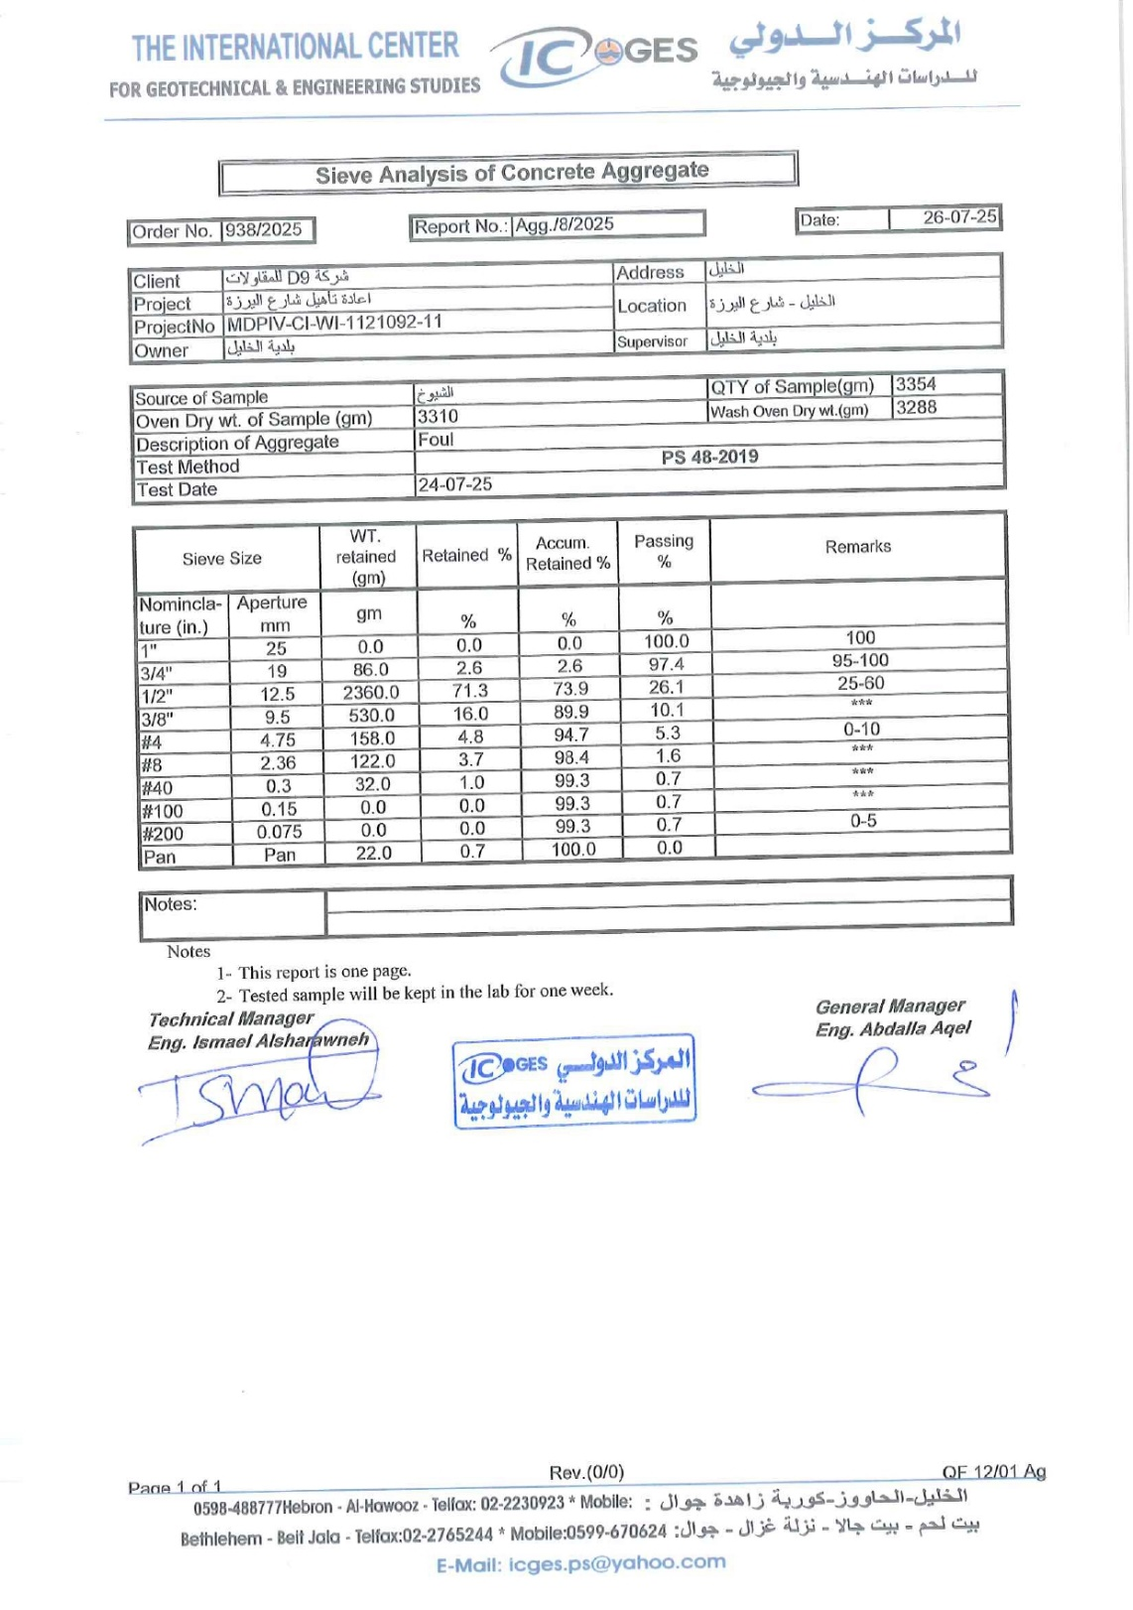
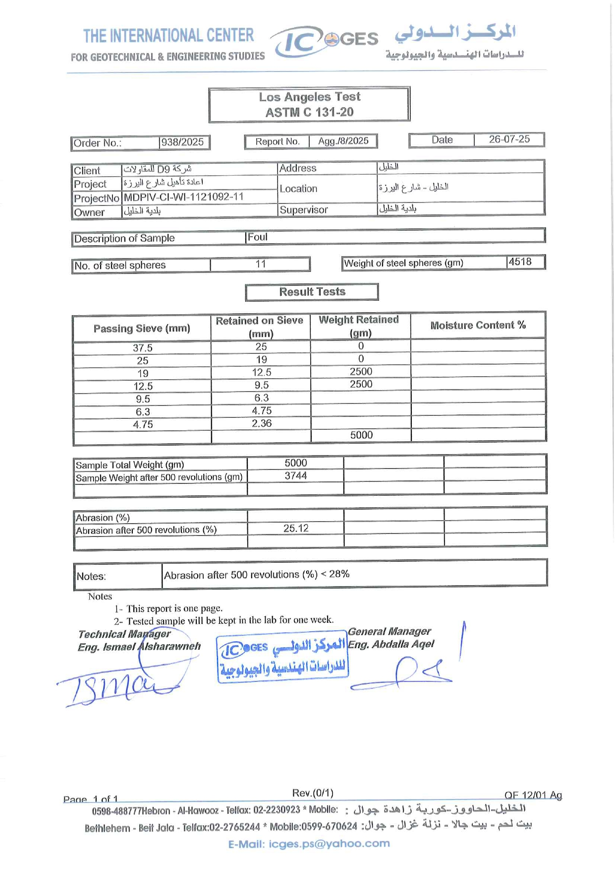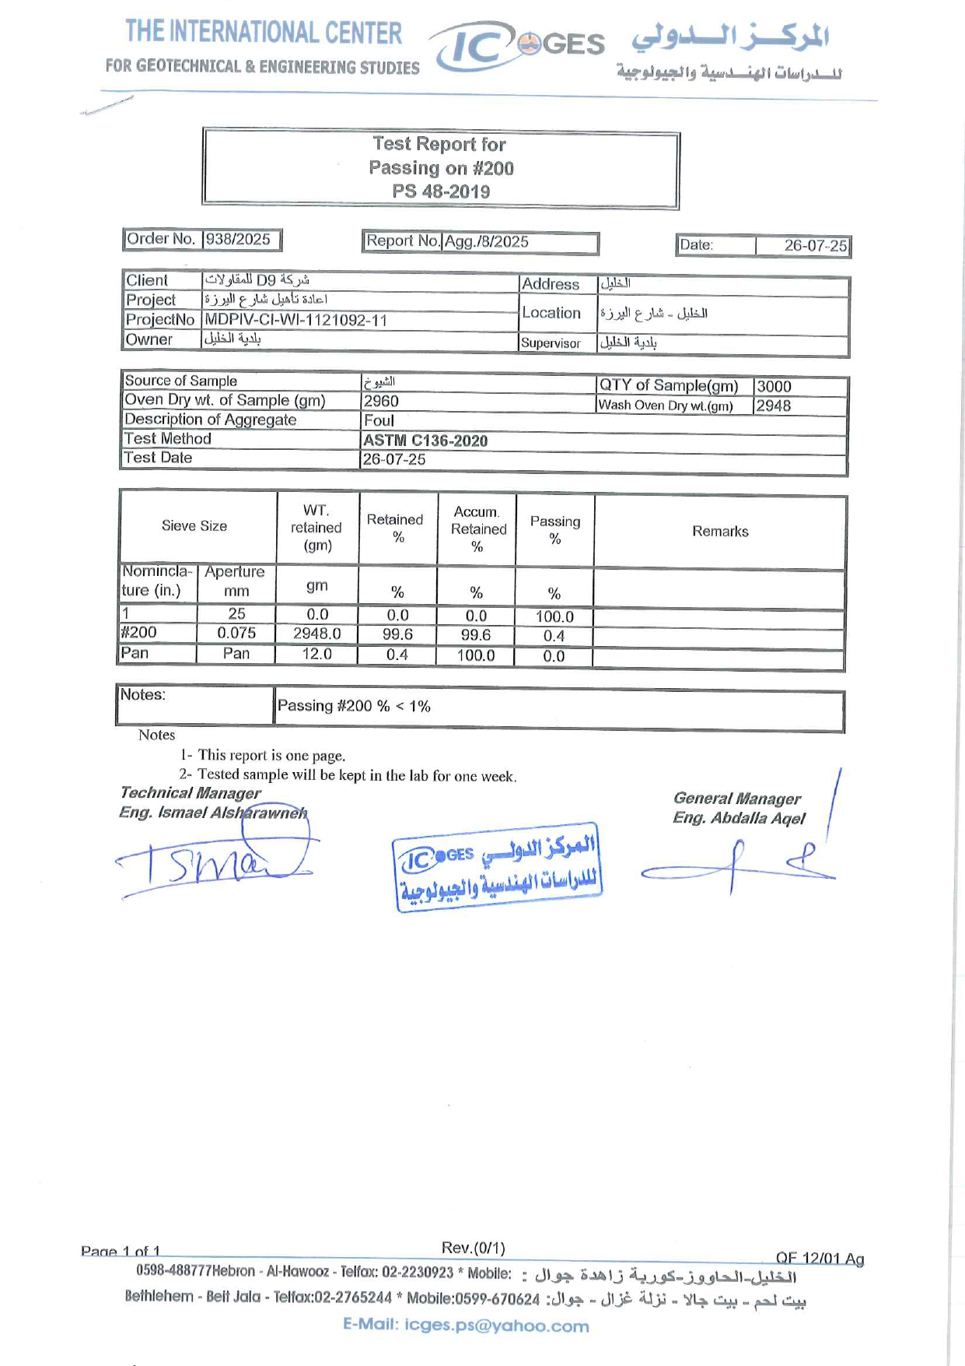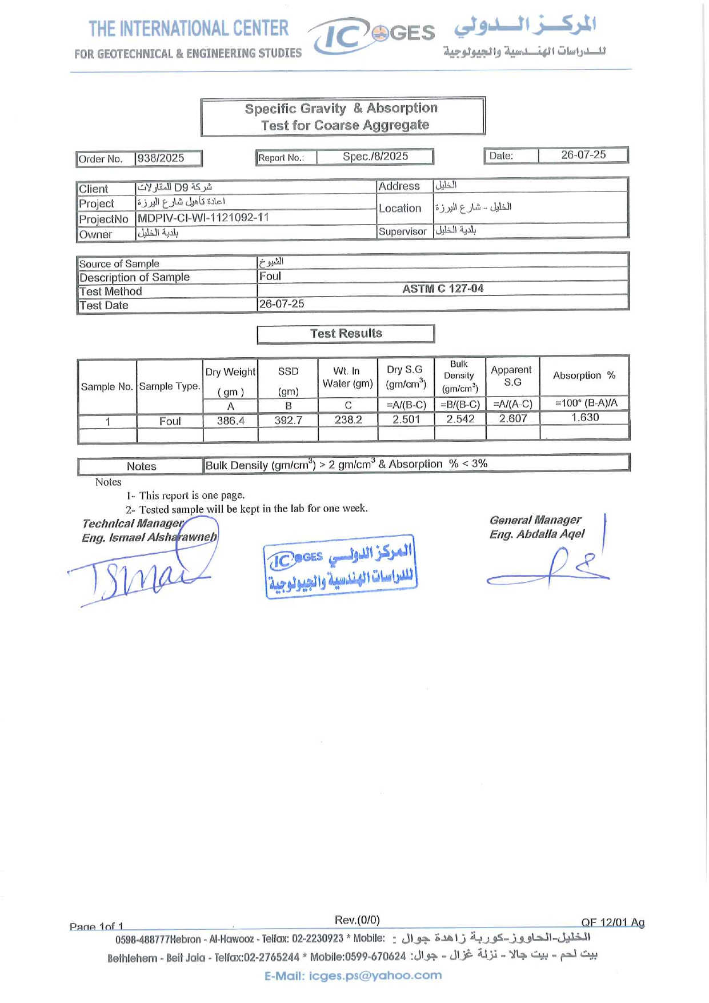

Appendix B Characterization of fine stone aggregate (Simsim)
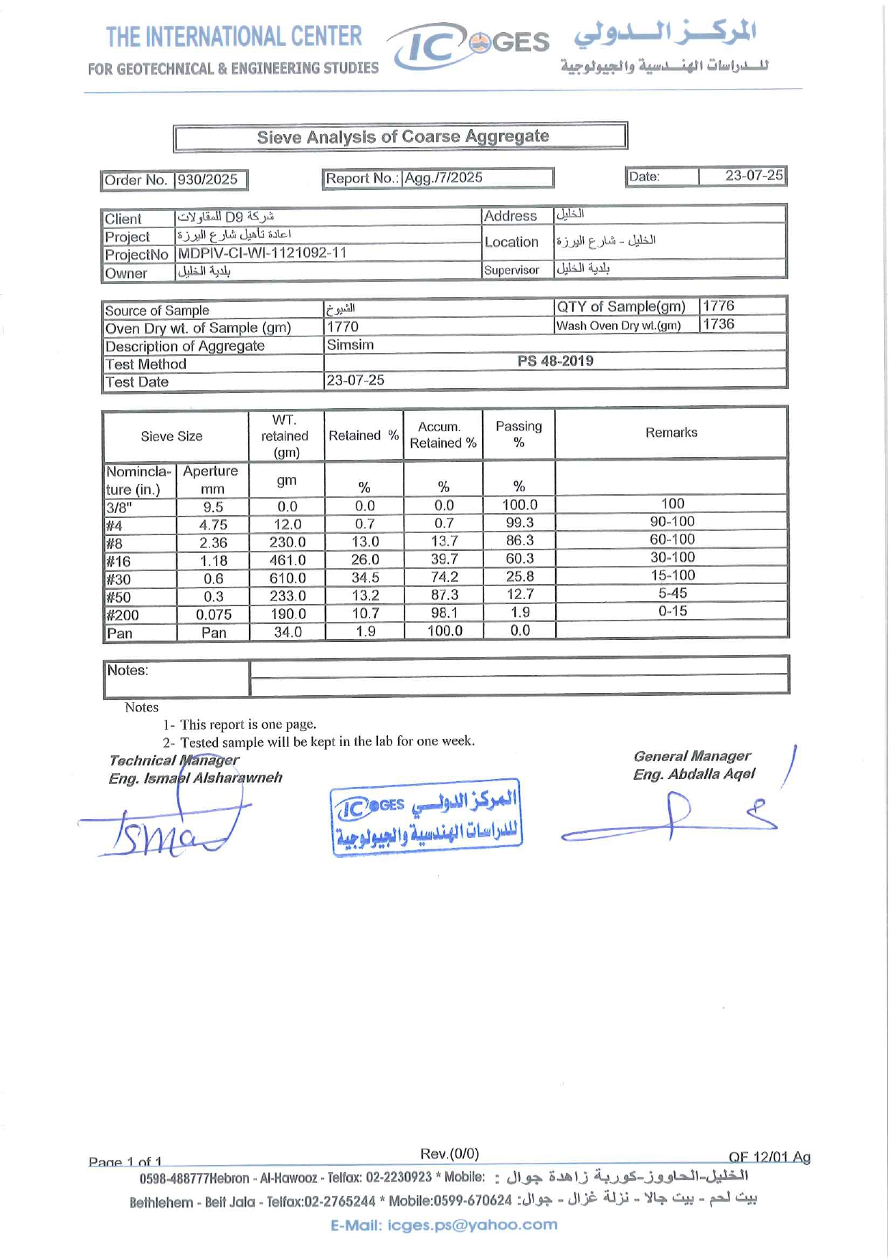
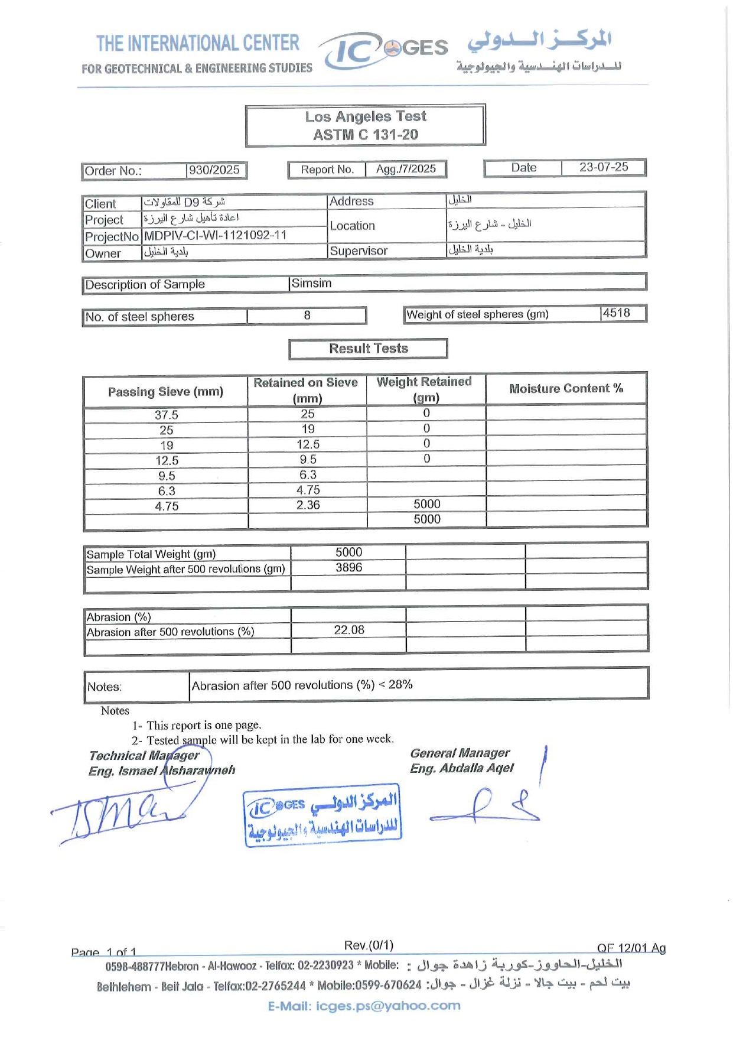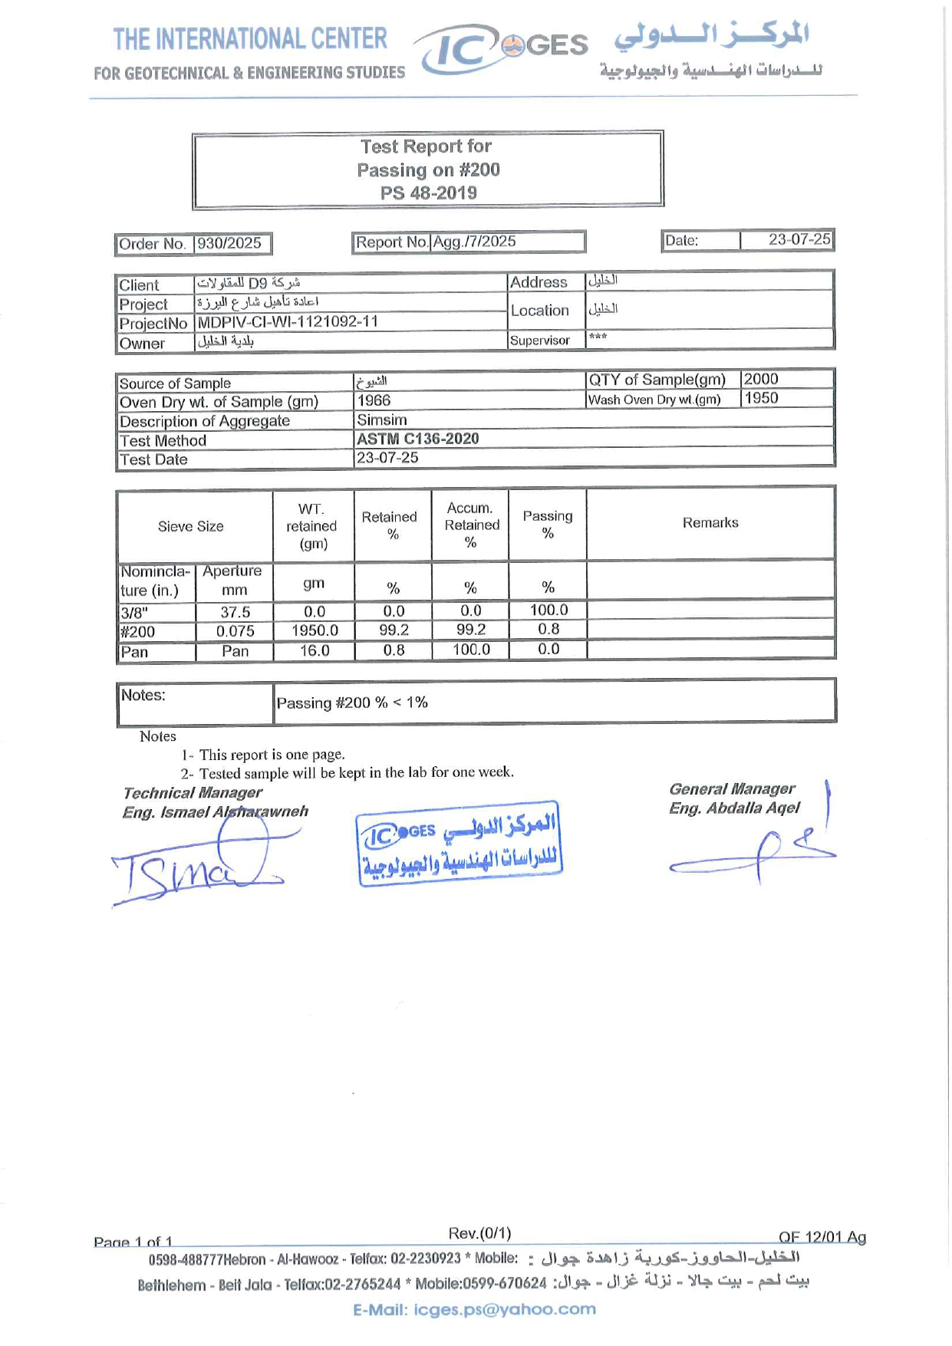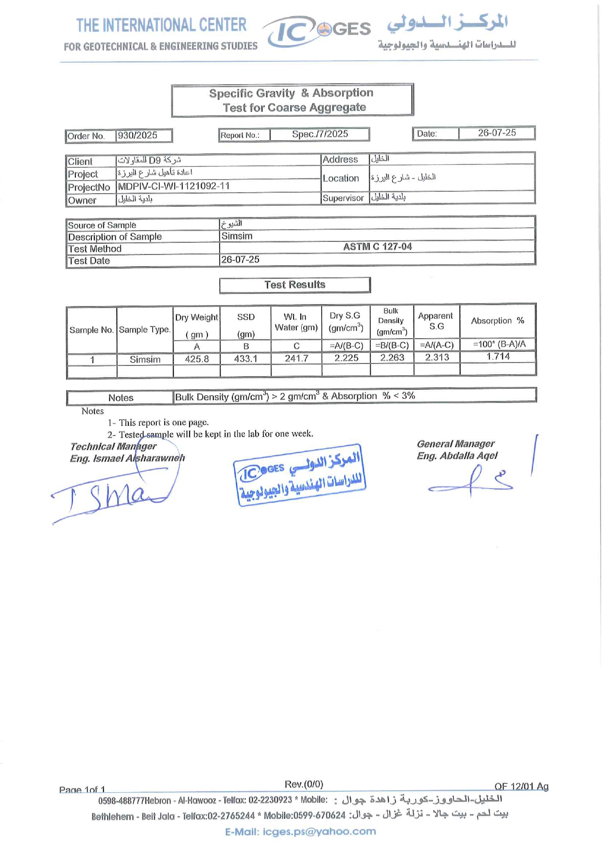

Appendix C Chemical and physical characterization of cement
Table C.1
Manufacturer
Parameter | Detail
Sample type | Ordinary Portland Cement (CEM I 52.5)
Manufacturer's name | Al Rajhi
country of origin | Jordan

Table C.2
Chemical Characterization of Cement
Type of Test | Results | Unit | Ranges | Test Method
MgO | 3.23 | % | - | BS EN 196-2:2013
Fe2​O3​ | 3.83 | % | - | -
L.O.I (Loss on Ignition) | 3.5 | % | ≤5.00 | -
SiO2​ | 20.27 | % | - | -
K2​O | 0.59 | % | - | -
CaO | 56.68 | % | - | -
Al2​O3​ | 5.11 | % | - | -
Chloride Cl | 0.057 | % | ≤0.100 | SOP NO: 71/02/02/05/25 Issue 1
Insoluble in HCl & Na2​CO3​ | 3.05 | % | ≤5.00 | BS-EN 196-2:2013-4.4.3
Sulfate as SO3​ | 3.63 | % | ≤4.00 | BS-EN 196-2:2013-4.4.2

Table C.3
Physical Characterization of Cement
Type of Test | Results | Unit | Ranges | Test Method
Initial setting time | 130 | min | ≥45 | -
Standard Consistency | 30 | % | - | JS 2238-3:2019
Soundness by Le Chatelier Method | 0 | mm | ≤10 | BS EN 196-3:2016
CS At (2) day | 35.5 | N/mm2 | ≥22.0 | JS 2238-1:2019
CS At (28) day | 61.1 | N/mm2 | ≥54.0 | BS EN 196-1:2016

Appendix D Mineral fresh water characterization
Table D.1
Mineral Fresh Water Characterization
Name of chemical compound | chemical formula | Concentration (mg/L)
Bicarbonate | HCO3​ | 250
Calcium | Ca | 55
Chloride | Cl | 44
Sulphate | SO4​ | 30
Sodium | Na | 26
Magnesium | Mg | 25
Nitrate | NO3​ | 16
Potassium | K | 1
Fluoride | F | 0.4
Iron | Fe | ≈0.0
Nitrite | NO2​ | ≈0.0

Appendix E Concrete Mix Design
Table E.1
Concrete Mix Proportions and Compressive Strengths for Various Concrete Classes
Class | Compressive Strengths (MPa) | Source | Foul (12.5 mm) | Simsim (4.75 mm) | Stone aggregate | Sand | Cement | Water | water/cement | Unit
B-20 | 200 | Zalloum Construction Company | 597 | 710 | 1307 | 619 | 270 | 197 | 0.73 | kg/m³
B-25 | 250 | Zalloum Construction Company | 580 | 690 | 1270 | 602 | 300 | 207 | 0.69 | kg/m³
B-30 | 300 | Zalloum Construction Company | 570 | 678 | 1248 | 591 | 320 | 214 | 0.67 | kg/m³
B-35 | 350 | Zalloum Construction Company | 561 | 668 | 1229 | 581 | 340 | 218 | 0.64 | kg/m³
B-40 | 400 | Zalloum Construction Company | 555 | 661 | 1216 | 573 | 380 | 216 | 0.57 | kg/m³
B-45 | 450 | Extrapolation | 549 | 659 | 1208 | 560 | 410 | 200 | 0.49 | kg/m³
B-50 | 500 | Extrapolation | 548 | 661 | 1209 | 556 | 450 | 180 | 0.40 | kg/m³
 |  |  | 45% | 55%

Figure E.1
Trend Analysis of Mix Proportions Relative to Concrete Compressive Strength

جامعة النجاح الوطنية
كلية الدرسات العليا

إعادة تدوير نفايات قص الأحجار لإنتاج أحجار أرصفة صديقة للبيئة في الخليل، فلسطين

اعداد
عامر مطلق زلوم

اشراف
د.عبد الفتاح حسن

قدمت هذه الرسالة/الأطروحة استكمالا لمتطلبات الحصول على درجه الماجستير/دكتو اره في اسم البرنامج، من كلية الد ارسات العليا، في جامعة النجاح الوطنية، نابلس- فلسطين
2026

اعادة تدوير نفايات قص الأحجار لإنتاج أحجار أرصفة صديقة للبيئة في الخليل، فلسطين
اعداد
عامر مطلق زلوم
اشراف
د.عبد الفتاح حسن
الملخص
تُعتبر صناعة الحجر في فلسطين مساهماً رئيسياً في الاقتصاد الوطني الفلسطيني، حيث تضم منطقة الخليل وحدها 153 مصنعاً لقص الحجر. وتكمن المشكلة الأساسية في التحديات البيئية الهائلة التي تسببها هذه الصناعة على طول وادي الخليل؛ إذ يُتخلص من نحو 500 متر مكعب من نفايات قص الحجر السائلة (الروبة السائلة) عبر شبكة الصرف الصحي، لتنتهي في النهاية بالوادي وتتسبب في تحديات بيئية واقتصادية واسعة النطاق على طوله.
بحثت هذه الدراسة في إعادة التدوير المستدامة للروبة السائلة كبديل جزئي لماء الخلط في إنتاج حجر الرصيف (جبه الرصيف) الصديق للبيئة، مما يقلل الحاجة إلى المعالجة المسبقة المكلفة للروبة. وشملت هذه المنهجية ثلاثة مستويات مختلفة من نسب الاستبدال الحجمي للروبة السائلة مقابل الماء، وهي: 0%، و10%، و20%، مع إضافة الملدن أو بدونه. ونتج عن ذلك تقييم ست خلطات خرسانية من حيث الأداء الميكانيكي والاداء طويل الأمد بعد 28 يوماً.
وأظهرت النتائج الملاحظة أن نسبة دمج 10% من الروبة السائلة كانت الأفضل أداءً بين المستويات الثلاثة المُختبرة؛ حيث سجلت خلطة (C-10-SP) أعلى أداء مجتمع، بمعدل مقاومة انضغط بلغ 45.3 ميجاباسكال، ومقاومة انحناء بلغت 5.72 ميجاباسكال، وعمق تآكل بلغ 2.01 مم. كما أظهرت الخلطات الحاوية على الملدن أداءً أعلى في عدة مقارنات، إلا أن التكرار المحدود لم يسمح بالتوصل إلى أثر إحصائي قاطع لتعميم فائدة الملدن.
وباعتماد مستوى الدمج الأفضل أداءً (10%) كأساس للحسابات، تسهم هذه المنهجية في تحقيق نهج بيئي واقتصادي أكثر استدامة. فعلى مستوى إنتاج يومي يُتوقع أن يصل إلى طاقة قصوى تبلغ 1000 متر مكعب من جبه الرصيف، يمكن لهذه الآلية دمج ما يصل إلى 18 متراً مكعباً من الروبة السائلة، مما يحقق فوائد بيئية مباشرة، تشمل خفض الانبعاثات السنوية لثاني أكسيد الكربون بمقدار 55.1 طناً.
أما اقتصادياً، فإن التحول من التخلص التقليدي إلى التدوير المباشر يقلل التكاليف التشغيلية السنوية بنحو 284,000 شيكل. وبناءً عليه، يقدم نظام إعادة التدوير الموصوف في هذه الأطروحة جدوى مقبولة، وقد يسهم في تبني حلول بيئية أكثر استدامة فيما يتعلق بنفايات قص الحجر.
الكلمات المفتاحية: مخلفات قص الحجر، الروبة السائلة، أحجار رصيف صديقة للبيئة.

