AN-NAJAH NATIONAL UNIVERSITY



Computer Engineering Department

Hardware Graduation Project

VistaBright

Students
Adam Abahri and Gais Salamma

Under the supervision of
Dr.Suleiman Abu Kharmeh

A report submitted in partial fulfillment of the requirements for bachelor’s degree in computer engineering in the Faculty of Engineering
Information Technology - Hardware Project June 2025

Acknowledgements
We would like to express our gratitude to everyone who contributed to this initiative. It would not have been possible if it weren't for their assistance and support. Many thanks to Dr. Sulieman Abu Kharmeh for his leadership, tenacious oversight, and assistance in seeing the project through to completion. Our families' support during this trying and stressful period, our coworkers' moral and technical support, and the people who volunteered their time are all greatly appreciated.

1

Disclaimer
The authors of this research are Adam Abahri and Gais Salamma from the Faculty of Engineering's Department of Computer Engineering at An-Najah National University. It has not been altered or corrected, other than editorial corrections, as a result of assessment and it may contain language as well as content errors. The views expressed in it together with any outcomes and recommendations are solely those of the authors. An-Najah National University accepts no responsibility or liability for the consequences of this report being used for a purpose other than the purpose for which it was commissioned.

Contents
1 Introduction 6
2 Constraints and Earlier course work 7
2.1 Constraints 7
2.2 Early Courses 7
3 Methodology 8
3.1 Standards and Specifications 8
3.2 Design Overview 8
3.3 Control and Automation 8
3.4 Programming and Circuit Integration 9
3.5 Safety Measures 9
3.6 Component List and Description 9
4 Results and Discussion 16
4.1 The Design 16
4.2 Financial Analysis and Economic Viability 17
4.3 Final Project The final outcome of the VistaBright: 18
4.4 Project Outcomes 18
5 Conclusions and Recommendation 19
5.1 Conclusions 19
5.2 Recommendations 19
5.3 Future Work 20
6 References 21
Appendix A 22
Appendix B 23
Appendix C 27
Appendix D 35

List of Figures

Figure 1 9
Figure 2 10
Figure 3 10
Figure 4 10
Figure 5 11
Figure 6 11
Figure 7 12
Figure 8 12
Figure 9 12
Figure 10 13
Figure 11 13
Figure 12 13
Figure 13 14
Figure 14 14
Figure 15 14
Figure 16 15
Figure 17 16
Figure 18 16
Figure 19 16
Figure 20 16

Abstract
Because of their height, surface area, and safety considerations, modern high-rise buildings—especially those with large glass facades—present considerable maintenance and cleaning challenges. In addition to being risky, traditional cleaning techniques that rely on manual labor and suspended platforms are also expensive and time-consuming. This project addresses this issue by introducing VistaBright, an automated façade cleaning system that replaces manual window washing in a way that is safer, more effective, and more economical.
VistaBright combines software, electronics, and mechanical parts into a single unit that can operate manually or automatically. Three microcontrollers—ESP32, Arduino Uno, and Arduino Mega—that are coordinated using UART-based serial communication form the core of the system, and ESP-NOW protocol for communicate the ESP’s. Users can choose between manual and automated cleaning modes using the ESP32's web-based control interface, which is available over Wi-Fi. Every function (such as brush movement, water spraying, and controlling the servo’s angle) can be independently controlled in manual mode. When the system operates in automatic mode, the user enters the building's height and the direction they want it cleaned. The system then determines the best time to move vertically utilizing a lift mechanism that is driven by a Gear DC motor.
A water pump for targeted spraying, ultrasonic sensors for boundary detection, a temperature sensor for thermal safety, a water level sensor to guarantee continuous operation, and a 12V motor with a cylindrical brush for surface scrubbing are essential parts. All electronics are kept in a sealed box to guard against water damage, and the cleaning module is contained in a galvanized metal frame that is resistant to weather. When sensors identify hazardous situations, the system also has safety halts and emergency stop procedures.
VistaBright was successfully prototyped and tested in spite of limitations including restricted local access to components and problems with the power supply in the development environment. The results showed that it could effectively clean while using less water, power, and human intervention. Future commercial deployment in the smart building sector is made possible by the design's scalability and modularity.
VistaBright is a prime example of how automation, embedded systems, and sensor networks can be used practically to solve problems in the real world. In addition to confirming that automated facade cleaning is feasible, this initiative creates new avenues for innovation, like using computer vision to identify dirty areas and enhancing thermal drying.

Introduction
Historically, cleaning the façade of tall buildings—particularly glass structures—has required physical labor using rope-based access or suspended platforms, which is labor-intensive, expensive, and presents serious safety issues. The necessity for a practical, secure, and economical solution has increased with the popularity of high-rise glass buildings in contemporary cities. By creating VistaBright, an automated facade cleaning system that uses sensor technologies and embedded systems to carry out cleaning duties on its own, this project seeks to overcome these issues.
The system combines a number of parts, such as motors, water pumps, environmental sensors, ESP32 and Arduino controllers, to perform manual and automated cleaning tasks using a web interface. It uses ultrasonic sensors to identify impediments, monitors temperature and water levels, reacts intelligently to information about building height, and instantly notifies users. With its modular, user-friendly design, enhanced water and energy efficiency, and removal of human operating risks, this system provides a practical and scalable solution for the contemporary facade maintenance sector. It is particularly promising for commercial use in smart building applications because to its affordability and versatility.

Organization of the Report:
This report is organized into six main chapters. Chapter 1 introduces the project motivation and objectives. Chapter 2 outlines the constraints faced during development and summarizes the relevant coursework that supported the project. Chapter 3 details the methodology, including standards, system design, automation logic, and hardware components. Chapter 4 presents the implementation, financial feasibility, and outcomes of the VistaBright system. Chapter 5 draws conclusions from the project and offers recommendations for improvement and future work. Chapter 6 lists all the references cited throughout the report.

Constraints and Earlier course work

2.1 Constraints
During the development of this project, several practical constraints emerged that impacted the design and implementation process:

- Brush Unavailability: The primary cleaning brush intended for the system was not available locally in the West Bank. As a result, we had to manually craft and improvise the brush mechanism. Even when attempting to purchase it online, it was only available in bulk quantities, which was not feasible for our limited project scope.
- Power Supply Limitations: The workshop lacked functional power supply units for more than a month and a half after the semester began. This limitation hindered our ability to properly measure current consumption or deliver accurate voltage to specific components, thereby delaying testing and affecting reliability.
- Mobility and Political Barriers: The Israeli occupation imposed significant mobility challenges. Checkpoints, security inspections, and the risk of component confiscation or suspicion severely restricted our freedom to travel from home to university. This led to fewer available workdays and increased safety concerns for team members.
- No Glass Faced : There was no glass faced in the place we work so the test be perfect as needed.

2.2 Early Courses
While we benefited from all the courses in our academic journey, certain ones proved particularly impactful in the successful development of our automated facade cleaning system. These courses provided a strong combination of theoretical knowledge and hands-on experience, enabling us to design a system that is both technically sound and practically viable.
We were first introduced to wireless communication and ESP32 programming in the Digital 3 course, where we developed a smoke detector project using the ESP32 microcontroller. The PIC Lab further deepened our understanding of automation and sensor-based logic through practical work with various microcontrollers, especially the Arduino Uno. The Microcontrollers and Microcontrollers Lab courses refined our skills in hardware-software integration, while the CPU Lab equipped us with essential technical abilities such as soldering, wiring, and debugging—skills that proved invaluable during system assembly.
The Electronic Circuits course enhanced our understanding of electrical behavior and circuit design, enabling us to confidently connect and manage power across system components. Additionally, the Critical Thinking and Scientific Research course played a vital role in improving our research capabilities and our ability to interpret and apply technical documentation effectively.
Finally, the Technology Project Management course was instrumental in shaping the business and strategic aspects of the project. It introduced us to market analysis, feasibility studies, cost management, and overall project planning—ensuring that our system could be considered not just as a technical prototype but as a market-ready product.
Together, these courses formed the backbone of our knowledge and skillset, allowing us to approach the project from both engineering and practical business perspectives.

Methodology
The methodology for developing the automated facade cleaning system was structured to achieve an efficient and safe cleaning operation for high-rise buildings. The system integrates multiple hardware components, sensors, and microcontrollers to provide both manual and automatic cleaning modes.

3.1 Standards and Specifications
In designing the control and communication systems, we adopted relevant engineering standards such as the IEEE 802.11 standard for Wi-Fi communication. This standard governs how the ESP32 microcontroller connects wirelessly to the user interface, allowing real-time control and monitoring. ESP-NOW protocol for communicate both ESP’s together. The use of UART (Universal Asynchronous Receiver Transmitter) protocol also follows standard serial communication practices, ensuring consistent and error-free data transmission between the ESP32, Arduino Uno, and Arduino Mega.
All electrical components were selected to operate within a 5V or 12V range, aligning with standard low-voltage DC safety practices.

3.2 Design Overview
The project is divided into three main subsystems:
- Cleaning Mechanism: This includes a water pump, cylindrical brush motor, sprayer controlled by servo motors, and a drying fan. The cleaning process begins with water spraying, followed by brushing, wiping, and drying.
- Lifting System: A vertical lift mechanism powered by a motor controlled via relays allows the system to move up and down the building facade.
- Control and Communication System: This includes two IC’s of ESP32 connected together via ESP-NOW protocol, Arduino Mega, and Arduino Uno. The ESP32 acts as the central communication and user interface module, while Mega and Uno control different components via serial commands.

3.3 Control and Automation
- The ESP32 hosts a dual-mode control interface: manual and automatic.
- In manual mode, users control each function (water pump, brush, lift motor, etc.) via a web interface.
- In automatic mode, the user inputs the building height, width, and direction. Based on a predefined cleaning speed (e.g., seconds per meter), the system calculates the time required for upward or downward cleaning.
- The ESP32 sends commands to the Uno for vertical movement, and to the Mega for brush, pump and servo operations.
- Ultrasonic sensors detect proximity to the ground or top of the building. If an obstacle is detected at a distance below a certain threshold, the system stops and notifies the user.
- The system also includes a water level sensor to pause operation when the tank is empty and a temperature sensor in the box of the electrical components to stop operations under overheating conditions.

3.4 Programming and Circuit Integration
- The Arduino Mega was programmed to control the brush, pump, fan, and servo-based ultrasonic based on received commands.
- The Arduino Uno handles the up/down motor via a relay module through an H-bridge.
- The ESP32 web interface was developed using HTML, CSS, and embedded C++ to allow real-time control.
- ESP-NOW for connecting the ESP’s.
- Serial communication between devices was configured using different Serial ports (Serial1, Serial2, etc.) to separate Mega and Uno communication.
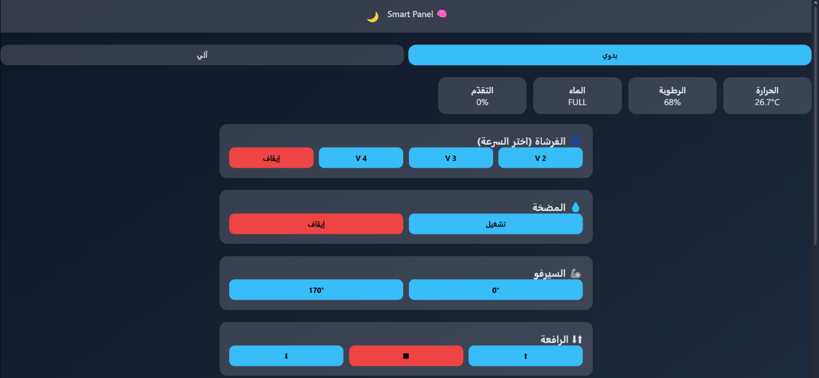 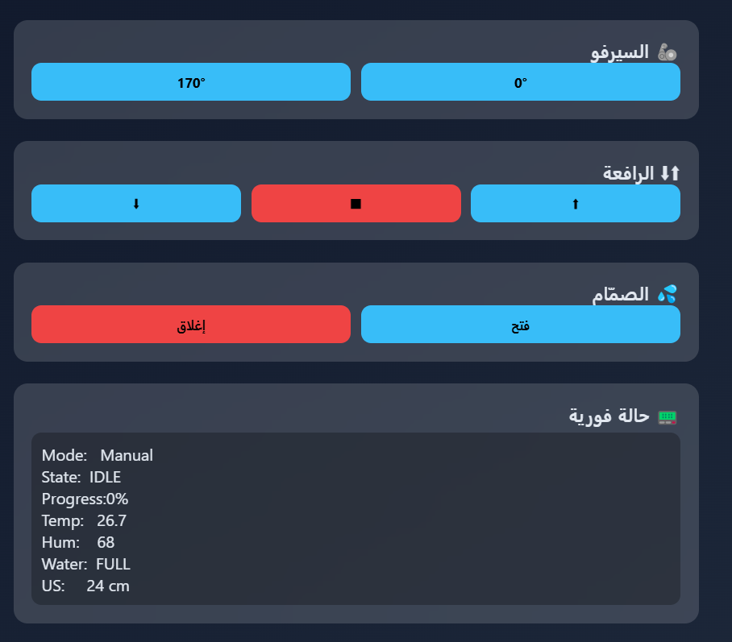
……………………………………………………………………………………………….
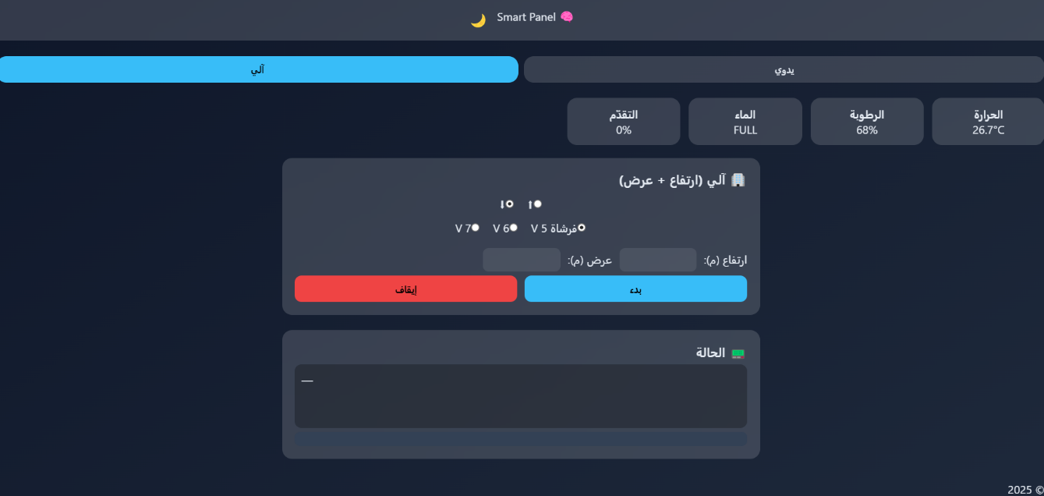

3.5 Safety Measures
- Emergency stop options were implemented in both manual and automatic modes.
- All exposed wires and power rails were insulated, and relays were used to control high-current devices safely.
- The brush and lift motors were tested under load to ensure current ratings remained within safe limits.

3.6 Component List and Description
The system is built using the following key hardware components:
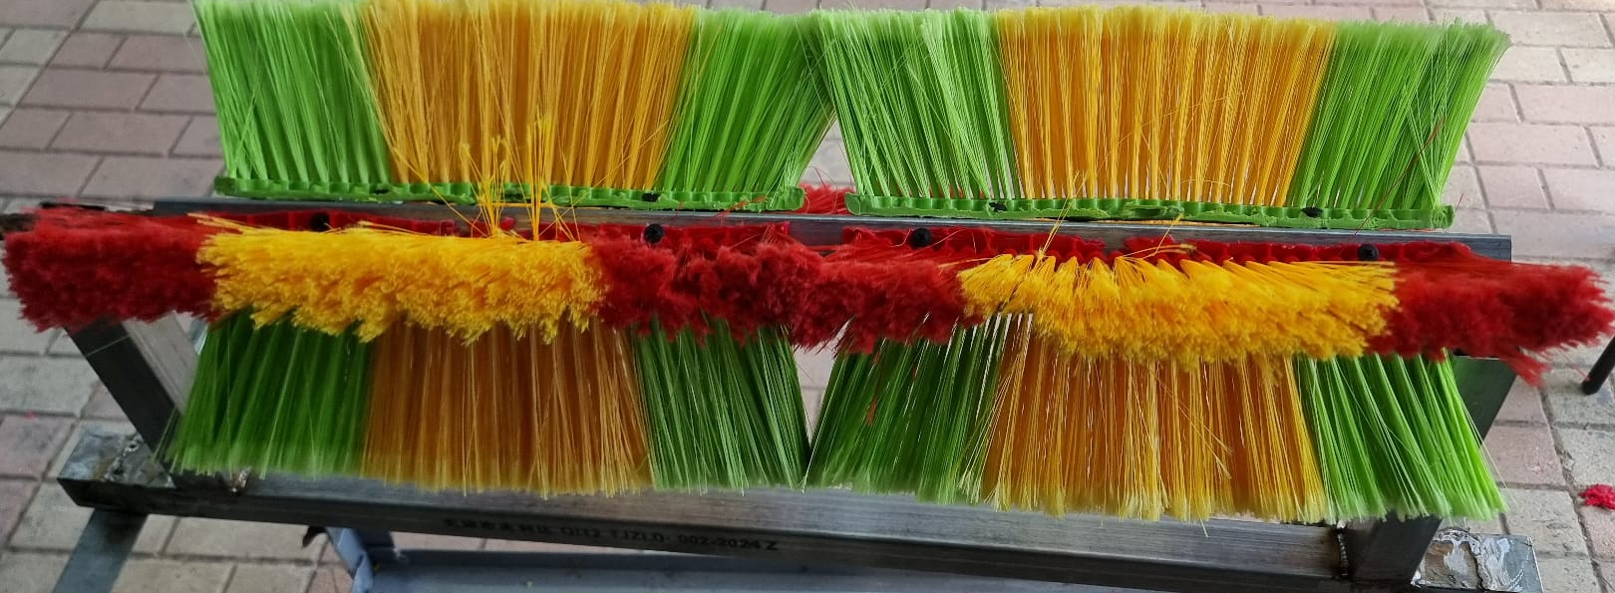
- Cylindrical Brush: A custom housing was fabricated due to the unavailability of commercial units in the West Bank.
Figure 1

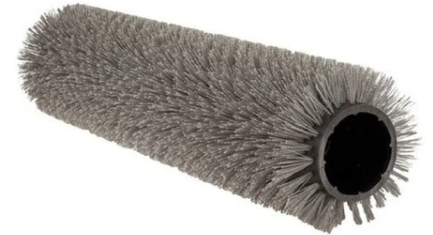
- Cylindrical Brush: Which we tried to provide it

Figure 2

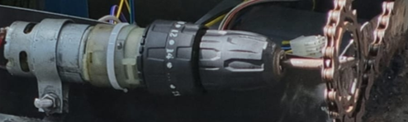
- 12V DC Motor for Cylindrical Brush:
Figure 3

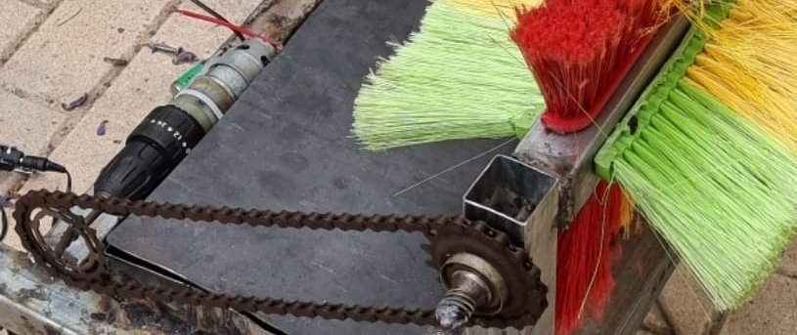
Figure 4

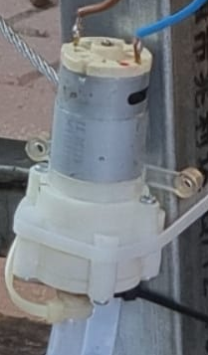
- Water Pump: A 12V DC pump used for spraying water on the glass surface.

Figure 5

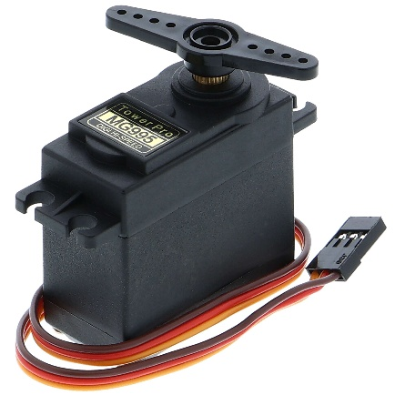
- Servo Motor: Used to control the angular position of the sprayer and align ultrasonic sensors.

Figure 6

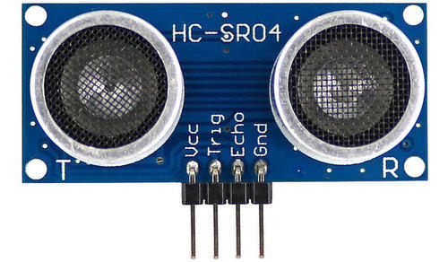
- Ultrasonic Sensors (HC-SR04): For proximity detection at top and bottom edges of the cleaning track.
Figure 7

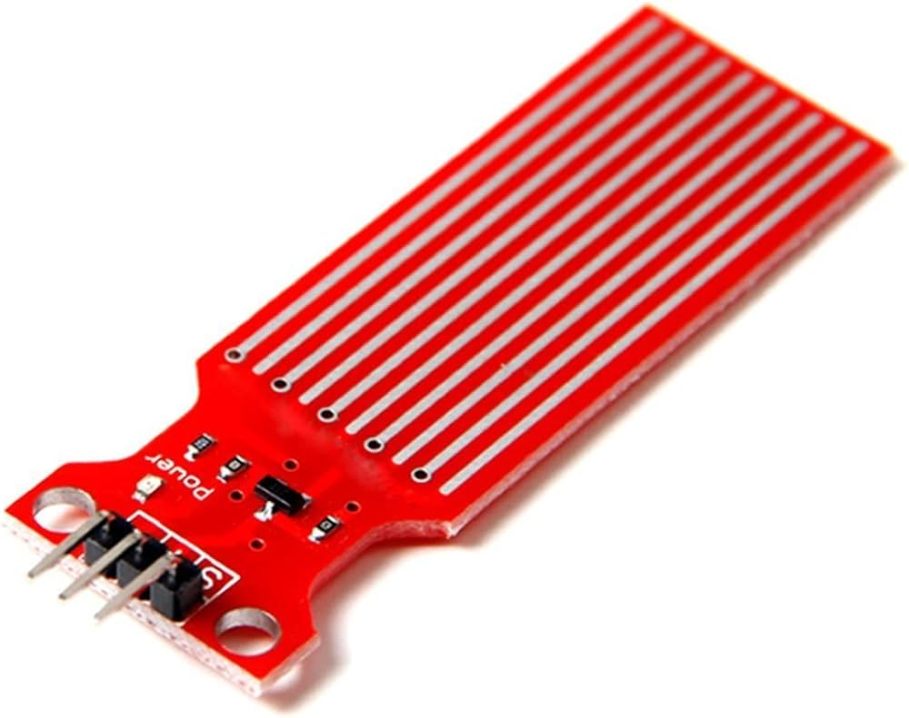
- Water Level Sensor: Detects when the water tank is empty.
Figure 8

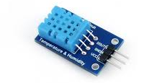
- Temperature Sensor (DHT11):
Figure 9

- Power Supply:
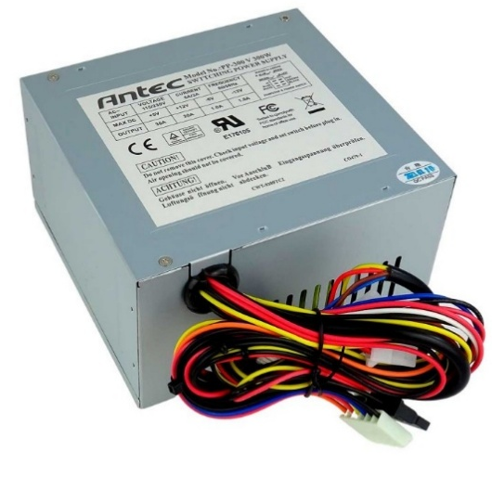
Figure 10

- Arduino Mega and Uno: For controlling hardware.
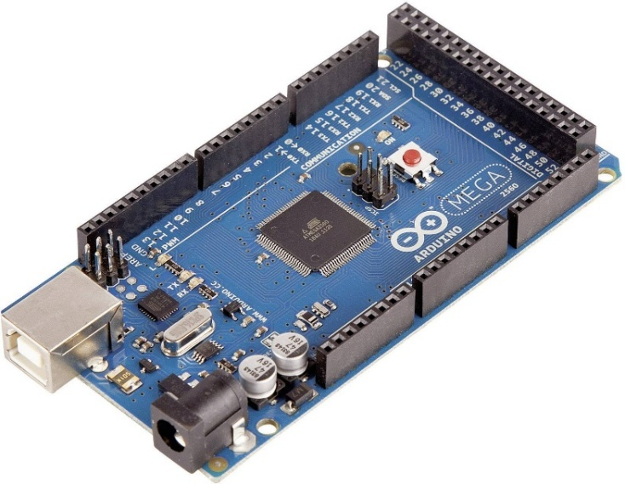
Figure 11
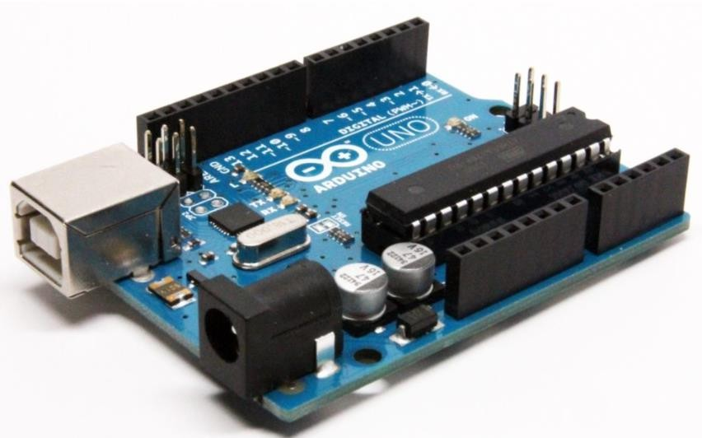
Figure 12

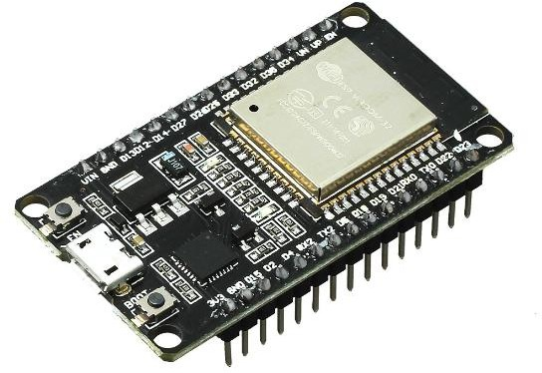
- ESP32: For hosting the Wi-Fi interface and coordinating logic.
Figure 13

- Relay Modules: Used to switch motors and high-power components.
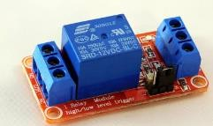
Figure 14

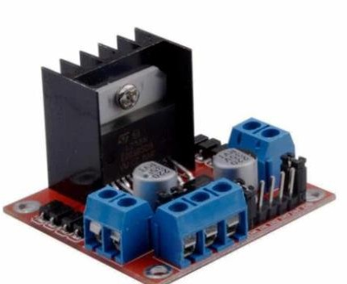
- H-Bridge (L298N): Controls bidirectional movement of the lift motor, Additionally, used to drive the 12V water pump, providing reliable switching and direction control.
Figure 15
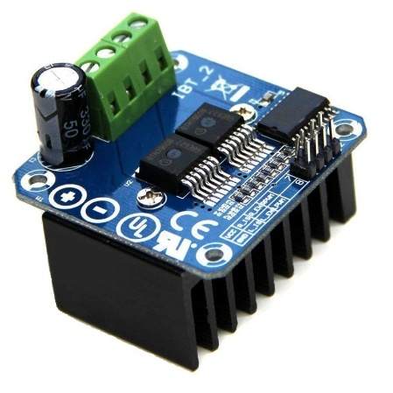
- H-Bridge (BTS7960): Used to control Brush Motor providing stability, high-current PWM control for smooth and adjustable motor speed.
Figure 16
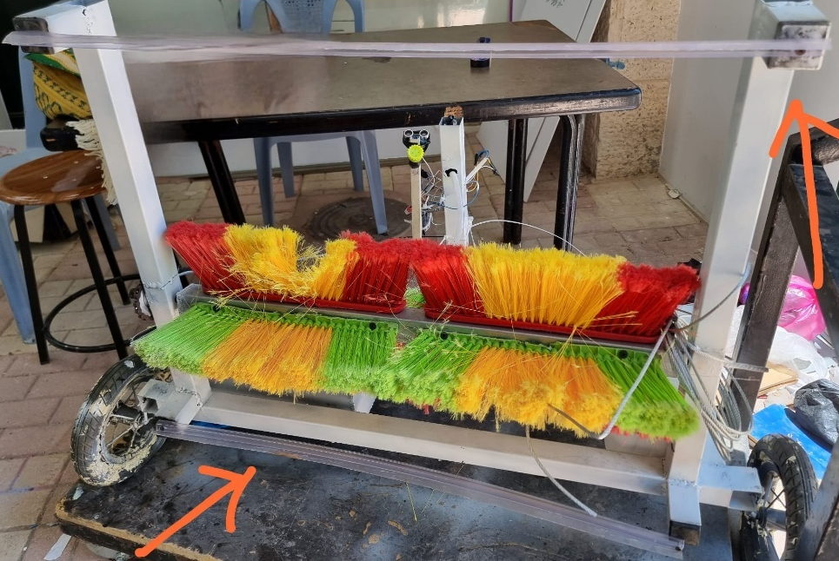
- Wipers: A fixed wipers to the surface.

Figure 17

Results and Discussion

The Design
We designed the frame using galvanized iron to ensure it's rust-proof.
A metal enclosure was used to protect the electronic components from water.
We avoided using wood because it deteriorates over time when exposed to water.

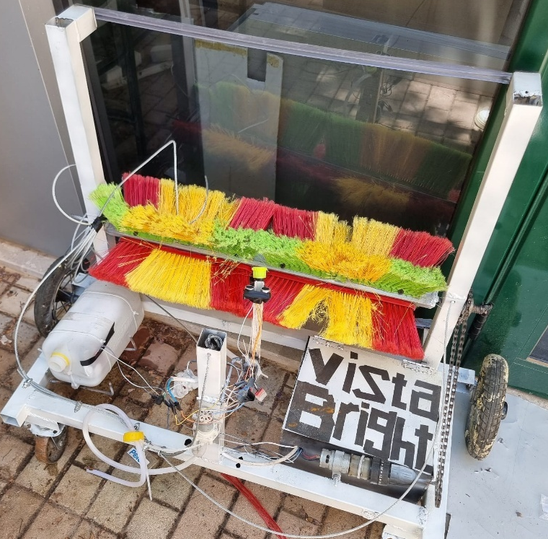
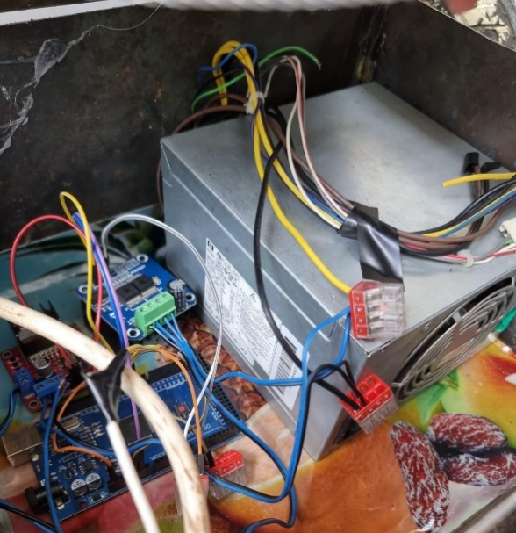
Figure 18

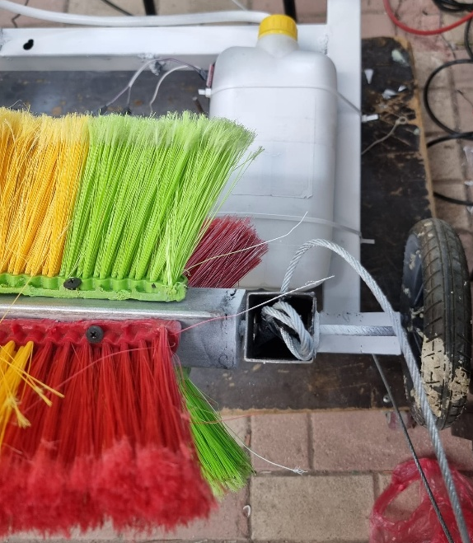
Figure 19
Figure 20

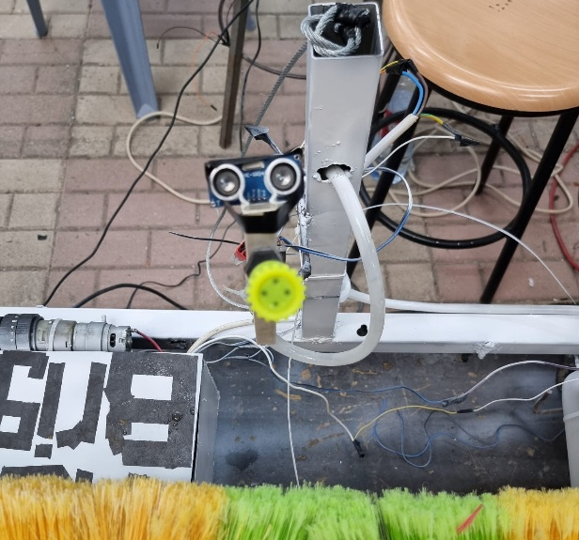
Figure 21

Financial Analysis and Economic Viability

Component Cost Breakdown
The following table summarizes the bill of materials (BOM) and estimated costs :
Item | Cost (NIS)
Frame & wheels | 50 + 30
Brush + brush motor | 40 + 50
Power supply | 50
12 V water pump | 40
Spray nozzle | 10
Additional drive motors | 60
Cooling fans | 20
Hoisting rig & safety ropes | 100
Arduino Mega, ESP32, drivers | 150
Sensors (water, ultrasonic, temp/humidity) | 30
Total hardware | 630 NIS
Assembly, wiring & QA | ~200 NIS
All-in cost | ≈ 830 NIS (~US $237)

Revenue Models
- Direct Sale
Launch price: 5,000–7,000 NIS (US $1,400–2,000)
Gross margin per unit: > 500%
Payback on R&D: after one unit sold
- Service Contract
Rate: 4 NIS/m² (≈ 30% below manual rates)
Example: 3,000 m² façade ⇒ 12,000 NIS per visit
Consumables & power cost < 70 NIS
Profit per visit: > 11,900 NIS
Device cost recouped after one job; ROI > 1,400% yearly

Financial Highlights
- Break-even point: one unit sold or one service contract
- Payback period: days (service), one sale (hardware)
- Capital at risk: < 1,000 NIS (low for hardware projects)
- Scalability: 20–25% BOM reduction possible with bulk sourcing
- Risk mitigation: use certified safety equipment; stock spare electronics for quick maintenance

Strategic Value
The robot cuts labor costs by ~30%, eliminates dangerous high-rise work, and provides a low-cost, locally made alternative to imported drones. With minimal capital exposure and extremely fast ROI, the project is economically compelling and highly attractive to potential investors.

Final Project
The final outcome of the VistaBright:
- A spray-pump mechanism for effective water dispersion across the surface.
- A cylindrical brush powered by a 12V DC motor for consistent cleaning action.
- A fixed dual wiper blades above and under the brush.
- Ultrasonic sensors to detect the top and bottom boundaries of the facade.
- A water sensor to check whether the tank is empty.
- A temperature sensor inside the box of electronics components.
- A lifting mechanism allowing the cleaning module to move vertically along the structure.
- Manual and automatic mode selection for flexible user control.

Project Outcomes
The project successfully met its key objectives:
- It now provides an effective alternative to manual cleaning, significantly reducing the need for human labor and the risks associated with working at heights.
- It achieved largely satisfactory cleaning results, supported by accurate sensor readings that ensure reliable performance.
- Operated with optimized power usage and minimum water wastage.
- Enabled the user to control the system through straightforward input modes and interface.
- Introduced a prototype suitable for scaling into commercial facade cleaning applications.
- Validated the integration of mechanical, electronic, and software components in a unified system.

Conclusions and Recommendation
  - Conclusions
This project successfully demonstrated the development of an automated facade cleaning system, VistaBright, that offers a safer and more efficient alternative to manual cleaning methods. Through the integration of embedded systems, mechanical components, and sensor-based automation, the prototype effectively reduced the need for human labor and the inherent risks of working at heights.
The system fulfilled its design goals by achieving:
- Effective Cleaning Performance: The surfaces of the glass facade were satisfactorily cleaned thanks to the spray pump, cylindrical brush, and wiper blades working in unison.
- Reliable Sensor Integration: Real-time safety halts and system responsiveness were made possible by the precise operation of temperature, water level, and ultrasonic sensors.
- Operational Efficiency: By optimizing water and power utilization through control logic and programmed automation, resource efficiency was increased.
- User-Friendly Control: Even non-technical operators could easily operate the system thanks to the dual-mode web interface's easy manual and automatic controls and monitoring.
- System Scalability: The system is appropriate for possible commercial implementation in high-rise building maintenance due to its modular architecture and affordable hardware options.
Additionally, the successful collaboration of mechanical, electronic, and software elements validated the robustness of the interdisciplinary design approach taken throughout the development.
  - Recommendations
While the core objectives were successfully achieved, several enhancements are recommended to further improve the system’s efficiency, reliability, and commercial viability:
- Upgrade the Brush Mechanism: Future versions should incorporate a commercially available facade-cleaning brush to ensure durability and better cleaning performance.
- Use of Cameras with Image Processing: Integrating cameras with image processing capabilities would greatly improve the system's intelligence by detecting areas that remain dirty after a single cleaning cycle, allowing the system to re-clean only where needed.
- Integration of a Heating Element with a Fan for Drying: Adding a thermal resistor (heating element) to the airflow used for drying would enhance the drying process, especially under humid or cold environmental conditions.

  - Future Work

While the current prototype demonstrates strong potential, future efforts could explore:

- Horizontal Traversing: Implementing a horizontal movement mechanism to enable full facade coverage without manual repositioning.

- Battery Optimization: Developing an energy management system for battery-powered operation would enhance portability and deployment flexibility.

References
[1] https://www.youtube.com/watch?v=dCjB-XcTnSU
This video was a key inspiration for the development of our project.

[2] Arduino Mega 2560 Datasheet: https://docs.arduino.cc/resources/datasheets/ABX00067-datasheet.pdf
[3] Arduino Uno Datasheet: https://docs.arduino.cc/resources/datasheets/A000066-datasheet.pdf

[3] ESP32-WROOM-32 Datasheet: https://www.espressif.com/sites/default/files/documentation/esp32-wroom-32_datasheet_en.pdf
[7] IEEE Standard 802.11 for Wireless LANs, Institute of Electrical and Electronics Engineers, 2016.
Referenced for ESP32-based wireless integration.

Appendix A

Arduino Uno code :

// ===== Arduino Uno – Lift Motor (2-Relay) + Valve (H-Bridge) =====

/* ---- رفع/خفض الموتور عبر ريليه ثنائي القناة ---- */
const uint8_t RELAY_DOWN = 4; // يشغل جهة النزول
const uint8_t RELAY_UP = 5; // يشغل جهة الصعود

/* ---- صمام الماء عبر H-Bridge ---- */
const uint8_t VALVE_IN1 = 6; // فتح = HIGH/LOW
const uint8_t VALVE_IN2 = 7; // غلق = LOW/HIGH

void setup() {
Serial.begin(9600); // ↔ ESP32 (مطابق للكود الرئيسي)

pinMode(RELAY_DOWN, OUTPUT);
pinMode(RELAY_UP, OUTPUT);
digitalWrite(RELAY_DOWN, LOW);
digitalWrite(RELAY_UP, LOW);

pinMode(VALVE_IN1, OUTPUT);
pinMode(VALVE_IN2, OUTPUT);
digitalWrite(VALVE_IN1, LOW);
digitalWrite(VALVE_IN2, LOW);
}

void loop() {
if (!Serial.available()) return;

int cmd = Serial.parseInt();
while (Serial.available()) Serial.read(); // تنظيف الباقي

switch (cmd) {

/* ===== Lift motor ===== */
case 21: // Up
digitalWrite(RELAY_DOWN, LOW);
digitalWrite(RELAY_UP, HIGH);
break;

case 23: // Down
digitalWrite(RELAY_UP, LOW);
digitalWrite(RELAY_DOWN, HIGH);
break;

case 22: // Stop
digitalWrite(RELAY_UP, LOW);
digitalWrite(RELAY_DOWN, LOW);
break;

/* ===== Valve ===== */
case 24: // Open valve
digitalWrite(VALVE_IN1, HIGH);
digitalWrite(VALVE_IN2, LOW);
break;

case 25: // Close valve
digitalWrite(VALVE_IN1, LOW);
digitalWrite(VALVE_IN2, HIGH); // عكس التيار للإغلاق
/* إذا كان الصمام لولبي ويكفي قطع التغذية، استخدم LOW/LOW */
break;
}

Appendix B

Arduino Mega code :

// ============ Arduino Mega – Brush (BTS7960) + Pump + Sensors ============
#include <Servo.h>
#include <DHT.h>

/* ---------- DHT ---------- */
#define DHTPIN 52
#define DHTTYPE DHT11
DHT dht(DHTPIN, DHTTYPE);

/* ---------- Brush Motor (BTS7960) ---------- */
const uint8_t RPWM = 5; // PWM
const uint8_t REN = 7; // Enable R
const uint8_t LEN = 8; // Enable L
const uint8_t RAMP_STEP = 2;

/* جهد التغذية = 12 V → نحسب الـ PWM المقابل لكل جهد مطلوب */
const uint8_t PWM_5V = 42; // ≈ 2 V
const uint8_t PWM_6V = 63; // ≈ # V
const uint8_t PWM_7V = 85; // ≈ 4 V

uint8_t targetPWM = PWM_5V; // القيمة المطلوبة
uint8_t currentPWM = 0; // القيمة الحالية-الآنية
bool brushOn = false; // حالة الطلب (تشغيل/إيقاف)

/* ---------- Pump (L298N) ---------- */
const uint8_t pumpIN1 = 9;
const uint8_t pumpIN2 = 10;
bool pumpEnabled = false;
const unsigned long pumpOnTime = 3000; // ms
const unsigned long pumpOffTime = 1500; // ms
unsigned long lastPumpToggle = 0;
bool pumpState = false;

/* ---------- Servo ---------- */
Servo myServo;
const uint8_t servoPin = 3;

/* ---------- Water sensor ---------- */
const uint8_t waterSensorPin = 2; // LOW = خزان فارغ
const unsigned long DEBOUNCE_MS = 200;
bool waterEmpty = false;
bool rawWaterState = false;
bool pendingWaterState = false;
unsigned long changeT0 = 0;

/* ---------- Ultrasonic ---------- */
const uint8_t trigPin = 12;
const uint8_t echoPin = 13;
long duration;
int distance;
unsigned long lastUSsend = 0;

/* ---------- setup ---------- */
void setup() {
Serial.begin(115200);
Serial1.begin(115200); // ↔ ESP32

pinMode(RPWM, OUTPUT);
pinMode(REN, OUTPUT);
pinMode(LEN, OUTPUT);
digitalWrite(REN, HIGH); // تمكين القناتين دائماً
digitalWrite(LEN, HIGH);

pinMode(pumpIN1, OUTPUT);
pinMode(pumpIN2, OUTPUT);

pinMode(waterSensorPin, INPUT_PULLUP);
pinMode(trigPin, OUTPUT);
pinMode(echoPin, INPUT);

myServo.attach(servoPin);
myServo.write(0);

dht.begin();
}

/* ---------- loop ---------- */
void loop() {
handlePump();
handleBrushMotor();
handleWaterSensor();
handleUltrasonic();
handleSerialInput();
delay(25); // ≈ 40 Hz
}

/* ---------- Brush motor ramp ---------- */
void handleBrushMotor() {
if (brushOn && currentPWM < targetPWM) {
currentPWM = constrain(currentPWM + RAMP_STEP, 0, targetPWM);
} else if (!brushOn && currentPWM > 0) {
currentPWM = constrain(currentPWM - RAMP_STEP, 0, currentPWM);
}
analogWrite(RPWM, currentPWM);
}

/* ---------- Pump ON/OFF timing ---------- */
void handlePump() {
if (!pumpEnabled || waterEmpty) {
digitalWrite(pumpIN1, LOW);
digitalWrite(pumpIN2, LOW);
return;
}
unsigned long now = millis();
if (pumpState && now - lastPumpToggle >= pumpOnTime) {
pumpState = false; lastPumpToggle = now;
} else if (!pumpState && now - lastPumpToggle >= pumpOffTime) {
pumpState = true; lastPumpToggle = now;
}
digitalWrite(pumpIN1, pumpState);
digitalWrite(pumpIN2, !pumpState);
}

/* ---------- Water level sensor (debounced) ---------- */
void handleWaterSensor() {
rawWaterState = (digitalRead(waterSensorPin) == LOW); // LOW = EMPTY
if (rawWaterState != pendingWaterState) {
pendingWaterState = rawWaterState;
changeT0 = millis();
}
if (pendingWaterState != waterEmpty &&
millis() - changeT0 >= DEBOUNCE_MS) {
waterEmpty = pendingWaterState;
Serial1.println(waterEmpty ? "W:0" : "W:1"); // 0 = EMPTY, 1 = FULL
}
}

/* ---------- Ultrasonic ---------- */
void handleUltrasonic() {
digitalWrite(trigPin, LOW); delayMicroseconds(2);
digitalWrite(trigPin, HIGH); delayMicroseconds(10);
digitalWrite(trigPin, LOW);
duration = pulseIn(echoPin, HIGH, 30000);
distance = (duration > 0) ? duration * 0.034 / 2 : -1; // cm

if (distance > 0 && millis() - lastUSsend >= 500) {
Serial1.println(String("US:") + distance);
lastUSsend = millis();
}
}

/* ---------- Serial commands from ESP32 ---------- */
void handleSerialInput() {
if (!Serial1.available()) return;
int cmd = Serial1.parseInt();
while (Serial1.available()) Serial1.read(); // تنظيف البفر

switch (cmd) {
/* ---- Brush motor ---- */
case 1: // تشغيل على ≈ 5 V
targetPWM = PWM_5V; brushOn = true; break;
case 2: // إيقاف الفرشاة
brushOn = false; break;
case 3: // تشغيل على ≈ 6 V
targetPWM = PWM_6V; brushOn = true; break;
case 4: // تشغيل على ≈ 7 V
targetPWM = PWM_7V; brushOn = true; break;

/* ---- Pump ---- */
case 6: pumpEnabled = true; break;
case 7: pumpEnabled = false; break;

/* ---- Servo ---- */
case 8: myServo.write(0); break;
case 9: myServo.write(170); break;

/* ---- Detailed status ---- */
case 10:
Serial1.print("STATUS:T="); Serial1.print(dht.readTemperature());
Serial1.print(",H="); Serial1.print(dht.readHumidity());
Serial1.print(",D="); Serial1.print(distance);
Serial1.print(",W="); Serial1.print(waterEmpty ? "EMPTY" : "FULL");
Serial1.print(",B_PWM="); Serial1.println(currentPWM);
break;

default: break;
}
}

Appendix C

Cleaning ESP32 code:

/**************************************************************************
* SmartCleaningPanel_v2.ino — لوحة تحكم (Manual + Auto)
* تاريخ: 25-Jun-2025
*
* • Soft-AP : SSID = ControlPanel | PASS = 12345678
* • واجهة : http://192.168.4.1
* • أوامر الرفع/الصمام (21-25) تُرسل بالـ ESP-NOW إلى ESP32-BT ثم إلى Uno
* • بقية الأوامر ↔ Mega عبر Serial-1
**************************************************************************/

#include <WiFi.h>
#include <WebServer.h>
#include <esp_now.h>
#include "esp_wifi.h"

/* ===== UART ↔ Mega ===== */
#define MEGA_RX 16
#define MEGA_TX 17
HardwareSerial MegaBus(1); // Serial-1 ↔ Mega

/* ===== ESP-NOW peer (بدّل عند الحاجة) ===== */
uint8_t peerMAC[] = {0x7C, 0x87, 0xCE, 0x2D, 0x35, 0xFC};

/* ===== Wi-Fi Soft-AP ===== */
const char* AP_SSID = "ControlPanel";
const char* AP_PASS = "12345678";

/* ==== ثوابت ==== */
const uint16_t US_STOP_CM = 35; // التوقف عند ≤ 35 سم
const float OFFSET_STEP_M = 0.75;

/* ==== أوضاع ==== */
enum class Mode { NONE, MANUAL, AUTO };
enum class State { IDLE, WORKING, REF_ASC, REF_FILL,
REF_DESC, WAIT_CONFIRM, DONE };

Mode curMode = Mode::NONE;
State curState = State::IDLE;
String travelDir = "down"; // up / down

/* ==== تقدّم ==== */
uint8_t progress = 0; // %
float widthRemainM = 0; // م تبقّت

/* ==== حساسات من Mega ==== */
float dhtTempC = NAN;
float dhtHumPct = NAN;
int usDistCM = -1;
bool waterEmpty = false;
uint8_t brushPWM = 0;

/* ==== إعداد فرشاة ==== */
int brushCmd = 1;

/************************ صفحة الويب ************************/
const char PAGE[] PROGMEM = R"====(
<!DOCTYPE html><html lang="ar" dir="rtl"><head><meta charset="utf-8">
<meta name="viewport" content="width=device-width,initial-scale=1">
<title>لوحة التنظيف الذكية</title>
<link href="https://fonts.googleapis.com/css2?family=Cairo:wght@400;600&display=swap" rel="stylesheet">
<style>:root{--bg1:#0f172a;--bg2:#1e293b;--glass:#ffffff26;--blur:12px;--accent:#38bdf8;--good:#22c55e;--bad:#ef4444;--txt:#e2e8f0;--radius:14px}
body.light{--bg1:#f8fafc;--bg2:#e2e8f0;--glass:#00000011;--txt:#0f172a}
*{box-sizing:border-box;margin:0;padding:0;font-family:'Cairo',sans-serif}
body{background:linear-gradient(145deg,var(--bg1),var(--bg2)) fixed;color:var(--txt);min-height:100vh;display:flex;flex-direction:column;transition:background .4s}
header{padding:16px 18px;display:flex;justify-content:center;gap:12px;background:var(--glass);backdrop-filter:blur(var(--blur))}
header button{border:none;background:none;font-size:22px;cursor:pointer;color:var(--txt)}
nav{display:flex;gap:8px;justify-content:center;margin:22px 0}
nav button{flex:1 1 160px;padding:10px;border:none;cursor:pointer;font-weight:600;background:var(--glass);color:var(--txt);border-radius:var(--radius);transition:.3s}
nav button.active,nav button:hover{background:var(--accent);color:#000}
main{flex:1;width:min(680px,94%);margin:auto}.sec{display:none}@keyframes fade{from{opacity:.2}to{opacity:1}}
.sec.active{display:block;animation:fade .4s}
.card{background:var(--glass);backdrop-filter:blur(var(--blur));border-radius:var(--radius);padding:18px;margin-bottom:22px}
.ctrls{display:flex;flex-wrap:wrap;gap:10px;justify-content:center}
.ctrls button{flex:1 1 100px;padding:10px;border:none;border-radius:10px;background:var(--accent);font-weight:700;cursor:pointer}
.ctrls button.stop{background:var(--bad)}
.radio{display:flex;gap:18px;justify-content:center;margin:12px 0}
input[type=number]{width:110px;padding:8px;border:none;border-radius:8px;background:#ffffff15;color:var(--txt);text-align:center;margin:6px}
pre{background:#0004;border-radius:10px;padding:10px;min-height:90px;margin-top:6px;direction:ltr}
.progress{height:20px;background:#334155;border-radius:8px;overflow:hidden;margin-top:6px}
.progress div{height:100%;width:0;background:var(--good);transition:width 1s}
.dash{display:grid;grid-template-columns:repeat(auto-fit,minmax(120px,1fr));gap:12px;width:min(680px,94%);margin:auto 0 18px}
.metric{background:var(--glass);backdrop-filter:blur(var(--blur));border-radius:var(--radius);padding:12px;text-align:center}
.toast-wrap{position:fixed;bottom:22px;left:22px;display:flex;flex-direction:column-reverse;gap:8px;pointer-events:none}
.toast{background:var(--accent);color:#000;padding:10px 14px;border-radius:10px;font-weight:600;animation:toastIn .4s}
@keyframes toastIn{from{opacity:.2;transform:translateY(20px)}to{opacity:1}}</style></head><body class="dark">
<header><span>🧠 Smart Panel</span><button id="themeToggle">🌙</button></header>
<nav><button data-view="man" class="active">يدوي</button><button data-view="auto">آلي</button></nav>

<section class="dash">
<div class="metric"><h4>الحرارة</h4><span id="mTemp">–</span></div>
<div class="metric"><h4>الرطوبة</h4><span id="mHum">–</span></div>
<div class="metric"><h4>الماء</h4><span id="mWater">–</span></div>
<div class="metric"><h4>التقدّم</h4><span id="mProg">0%</span></div>
</section>

<main>
<!-- Manual -->
<section id="man" class="sec active">
<article class="card"><h3>🌀 الفرشاة (اختر السرعة)</h3><div class="ctrls">
<button data-c="1" data-msg="فرشاة 2V">2 V</button>
<button data-c="3" data-msg="فرشاة 3">3 V</button>
<button data-c="4" data-msg="فرشاة 4">4 V</button>
<button data-c="2" class="stop" data-msg="إيقاف الفرشاة">إيقاف</button>
</div></article>

<article class="card"><h3>💧 المضخة</h3><div class="ctrls">
<button data-c="6">تشغيل</button><button data-c="7" class="stop">إيقاف</button></div></article>

<article class="card"><h3>🦾 السيرفو</h3><div class="ctrls">
<button data-c="8">0°</button><button data-c="9">170°</button></div></article>

<article class="card"><h3>⬆⬇ الرافعة</h3><div class="ctrls">
<button data-c="21">⬆</button><button data-c="22" class="stop">⏹</button><button data-c="23">⬇</button></div></article>

<article class="card"><h3>💦 الصمّام</h3><div class="ctrls">
<button data-c="24">فتح</button><button data-c="25" class="stop">إغلاق</button></div></article>

<article class="card"><h3>📟 حالة فورية</h3><pre id="statusM">—</pre></article>
</section>

<!-- Auto -->
<section id="auto" class="sec">
<article class="card"><h3>🏢 آلي (ارتفاع + عرض)</h3>
<div class="radio"><label><input type="radio" name="adir" value="up">⬆</label>
<label><input type="radio" name="adir" value="down" checked>⬇</label></div>

<div class="radio"><label><input type="radio" name="aspd" value="1" checked>فرشاة 5 V</label>
<label><input type="radio" name="aspd" value="3">6 V</label>
<label><input type="radio" name="aspd" value="4">7 V</label></div>

<label>ارتفاع (م): <input id="aH" type="number" step="0.1"></label>
<label>عرض (م): <input id="aW" type="number" step="0.1"></label>
<div class="ctrls"><button id="aGo">بدء</button><button id="aStop" class="stop">إيقاف</button></div></article>

<article class="card"><h3>📟 الحالة</h3><pre id="statusA">—</pre>
<div class="progress"><div id="progA"></div></div>
<div id="confirmWrap" class="ctrls" style="display:none;margin-top:12px">
<button id="confirm">✅ تأكيد</button>
</div>
</article>
</section>
</main>

<footer>© 2025</footer>
<div class="toast-wrap" id="toastWrap"></div>

<script>
const $=q=>document.querySelector(q),$$=q=>document.querySelectorAll(q),T=$("#toastWrap");
const map={"1":"فرشاة 5 V","2":"إيقاف الفرشاة","3":"فرشاة 6 V","4":"فرشاة 7 V",
"6":"تشغيل المضخة","7":"إيقاف المضخة","8":"السيرفو 0°","9":"السيرفو 170°",
"21":"رفع الماكينة","22":"إيقاف الرافعة","23":"إنزال الماكينة",
"24":"فتح الصمّام","25":"إغلاق الصمّام"};
const toast=m=>{const d=document.createElement("div");d.className="toast";d.textContent=m;T.append(d);setTimeout(()=>d.remove(),2500);}
$("#themeToggle").onclick=()=>{document.body.classList.toggle("light");
$("#themeToggle").textContent=document.body.classList.contains("light")?"☀️":"🌙";}
$("nav").onclick=e=>{const b=e.target.closest("button[data-view]");if(!b)return;
$$("nav button").forEach(x=>x.classList.toggle("active",x===b));
$$(".sec").forEach(s=>s.classList.remove("active"));
$("#"+b.dataset.view).classList.add("active");}

$$("[data-c]").forEach(b=>b.onclick=()=>fetch("/cmd?c="+b.dataset.c)
.then(()=>toast("🚀 "+(b.dataset.msg||map[b.dataset.c]))))

$("#aGo").onclick=()=>{
const h=$("#aH").value||0,w=$("#aW").value||0,
d=$("input[name='adir']:checked").value,
s=$("input[name='aspd']:checked").value;
fetch(`/auto?height=${h}&width=${w}&dir=${d}&spd=${s}`)
.then(()=>toast("🛠 وضع آلي بدأ"));}

$("#aStop").onclick=()=>fetch("/stop").then(()=>toast("⏹ تم الإيقاف"));
$("#confirm").onclick=()=>fetch("/confirm").then(()=>toast("✅ تأكيد"));

setInterval(()=>fetch("/status").then(r=>r.text()).then(t=>{
$("#statusM").innerText=t;
if(t.includes("Mode: Auto"))$("#statusA").innerText=t;
const p=(/Progress:(\\d+)/.exec(t)||[0,0])[1];
$("#mProg").textContent=p+"%";$("#progA").style.width=p+"%";
$("#mTemp").textContent=(/Temp:\\s+([\\d\\.]+)/.exec(t)||["–","–"])[1]+"°C";
$("#mHum").textContent=(/Hum:\\s+(\\d+)/.exec(t)||["–","–"])[1]+"%";
$("#mWater").textContent=t.includes("Water: EMPTY")?"EMPTY":"FULL";
$("#confirmWrap").style.display=t.includes("WAIT_CONFIRM")?"flex":"none";
}),1000);
</script></body></html>
)====";

/************************ أدوات إرسال ************************/
void megaSend(int c){ MegaBus.println(c); }

/* إرسال متسلسل مع فاصل 30 ms لضمان وصول كل أمر */
void megaSendSeq(std::initializer_list<int> cmds){
for(int c:cmds){ MegaBus.println(c); delay(30); }
}

void unoSend(int c){ uint8_t v=(uint8_t)c; esp_now_send(peerMAC,&v,1); }
inline void sendCmd(int c){ (c>=21&&c<=25) ? unoSend(c) : megaSend(c); }

/* ==== آلة الحالات ==== */
inline void setState(State s){ curState=s; }

/* ==== إيقاف شامل ==== */
void stopAll(){
unoSend(22); // وقف الرافعة
megaSendSeq({2,7}); // فرشاة OFF ثم مضخة OFF
curMode=Mode::MANUAL; setState(State::IDLE);
}

/* ==== إيقاف مؤقت للعائق أو تعبئة الماء ==== */
void pauseForConfirm(){
unoSend(22);
megaSendSeq({2,7});
setState(State::WAIT_CONFIRM);
}

/* ==== تحليل رسائل Mega ==== */
void parseMega(String ln){
if(ln.startsWith("US:")){ usDistCM=ln.substring(3).toInt(); return; }

if(ln.startsWith("STATUS:")){
int idx=7;
while(idx<ln.length()){
int c=ln.indexOf(',',idx); if(c==-1)c=ln.length();
String kv=ln.substring(idx,c); int eq=kv.indexOf('=');
String k=kv.substring(0,eq), v=kv.substring(eq+1);
if(k=="T") dhtTempC=v.toFloat();
else if(k=="H") dhtHumPct=v.toFloat();
else if(k=="W") waterEmpty=(v=="EMPTY");
else if(k=="B_PWM") brushPWM=v.toInt();
idx=c+1;
}
}
else if(ln=="W:0" && curState==State::WORKING){ // خزان فارغ
pauseForConfirm(); setState(State::REF_ASC); unoSend(21);
}
else if(ln=="W:1" && curState==State::REF_FILL){ // انتهى التعبئة
unoSend(23); setState(State::REF_DESC);
}
}

/************************ HTTP ************************/
WebServer server(80);

void hPanel(){ server.send_P(200,"text/html",PAGE); }

String stateName(State s){
switch(s){
case State::IDLE: return "IDLE"; case State::WORKING: return "WORKING";
case State::REF_ASC: return "REF_ASC"; case State::REF_FILL: return "REF_FILL";
case State::REF_DESC: return "REF_DESC"; case State::WAIT_CONFIRM: return "WAIT_CONFIRM";
case State::DONE: return "DONE";
} return "";
}

void hStatus(){
String s="Mode: "+String((curMode==Mode::AUTO)?"Auto":"Manual")+"\n";
s+="State: "+stateName(curState)+"\nProgress:"+String(progress)+"%\n";
s+="Temp: "+String(isnan(dhtTempC)?NAN:dhtTempC,1)+"\n";
s+="Hum: "+String(isnan(dhtHumPct)?NAN:dhtHumPct,0)+"\n";
s+="Water: "+String(waterEmpty?"EMPTY":"FULL")+"\n";
s+="US: "+String(usDistCM)+" cm\n";
server.send(200,"text/plain",s);
}

/* /cmd (يدوي) */
void hCmd(){
if(!server.hasArg("c")){ server.send(400,"text","arg"); return; }
sendCmd(server.arg("c").toInt()); server.send(200,"text","OK");
}

/* /auto */
void hAuto(){
if(!server.hasArg("width")||!server.hasArg("dir")||!server.hasArg("spd")){
server.send(400,"text","arg"); return;
}
widthRemainM=server.arg("width").toFloat();
travelDir =server.arg("dir");
brushCmd =server.arg("spd").toInt();

progress=0; curMode=Mode::AUTO;

megaSendSeq({brushCmd,6}); // فرشاة ثم مضخة
megaSend(travelDir=="up"?8:9); // إمالة السيرفو
unoSend(travelDir=="up"?21:23); // حركة الرافعة
setState(State::WORKING);

server.send(200,"text","Auto");
}

/* /confirm */
void hConfirm(){
if(curState!=State::WAIT_CONFIRM){ server.send(200,"text","No"); return; }
widthRemainM-=OFFSET_STEP_M;
if(widthRemainM<=0){ stopAll(); server.send(200,"text","Done"); return; }
travelDir=(travelDir=="up")?"down":"up";
megaSendSeq({brushCmd,6});
megaSend(travelDir=="up"?8:9);
unoSend(travelDir=="up"?21:23);
setState(State::WORKING);
server.send(200,"text","Resume");
}

/* /stop */
void hStop(){ stopAll(); server.send(200,"text","Stopped"); }

/************************ setup ************************/
void setup(){
Serial.begin(115200);
MegaBus.begin(115200,SERIAL_8N1,MEGA_RX,MEGA_TX);

WiFi.mode(WIFI_AP_STA);
WiFi.softAP(AP_SSID,AP_PASS,6);

if(esp_now_init()!=ESP_OK){ Serial.println("ESP-NOW init failed"); return; }
esp_now_peer_info_t p{}; memcpy(p.peer_addr,peerMAC,6); p.channel=WiFi.channel();
esp_now_add_peer(&p);

server.on("/",hPanel); server.on("/status",hStatus);
server.on("/cmd",hCmd); server.on("/auto",hAuto);
server.on("/confirm",hConfirm); server.on("/stop",hStop);
server.begin();

Serial.println("Ready → http://192.168.4.1");
}

/************************ loop ************************/
uint32_t lastReq=0;

void loop(){
server.handleClient();

while(MegaBus.available()) parseMega(MegaBus.readStringUntil('\\n'));

if(millis()-lastReq>=1000){ megaSend(10); lastReq=millis(); }

if(curMode==Mode::AUTO && curState==State::WORKING
&& usDistCM!=-1 && usDistCM<=US_STOP_CM){
pauseForConfirm();
}

}
Appendix D
Cleaning ESP32 code:
#include <WiFi.h>
#include <esp_now.h>
#include "esp_wifi.h"

#define TX_TO_UNO 17 // السلك الذاهب إلى RX في أردوينو Uno
#define RX_UNUSED 16 // غير مستخدم
#define LED_PIN 2 // لمبة التأكيد (غالبًا مدمجة)

HardwareSerial uartToUno(1); // استخدام Serial1

void onReceive(const esp_now_recv_info *info, const uint8_t *data, int len) {
if (len == 1) {
uint8_t val = data[0];

// طباعة في السيريال
Serial.print("Received from ESP-NOW: ");
Serial.println(val);

// إرسال إلى أردوينو أونو
uartToUno.write(val);

// وميضة تأكيد باللمبة
digitalWrite(LED_PIN, HIGH);
delay(50); // لمبة لمدة 50 ملي ثانية
digitalWrite(LED_PIN, LOW);
}
}

void setup() {
Serial.begin(115200);
uartToUno.begin(115200, SERIAL_8N1, RX_UNUSED, TX_TO_UNO);

pinMode(LED_PIN, OUTPUT);
digitalWrite(LED_PIN, LOW);

WiFi.mode(WIFI_STA);
esp_wifi_set_channel(6, WIFI_SECOND_CHAN_NONE); // نفس قناة القطعة الأولى

if (esp_now_init() != ESP_OK) {
Serial.println("ESP-NOW init failed!");
return;
}

esp_now_register_recv_cb(onReceive);
Serial.println("Receiver ready. Forwarding to Uno + LED flash.");
}

void loop() {}

