

An-Najah National University
Faculty of Engineering & Information Technology
Graduation Project :
Smart Robotic Warehouse Management System

Done by:

Mohammad Murad Esawi & Jawad Nimer Hamdan
Supervised by:
Dr. Raed Qadi

Academic Year: 2025 / 2026
Acknowledgment
First and foremost, we would like to express our sincere gratitude to Dr. Read Qadi for his invaluable guidance, continuous support, and expertise throughout the development of this project. His insightful feedback and constant encouragement played a vital role in shaping this work, and we are truly grateful for the opportunity to learn and grow under his mentorship.
Finally, we extend our deepest appreciation to our families and friends for their unwavering support, encouragement, and motivation throughout this academic journey.
Disclaimer
This report was prepared by Mohammad Esawi and Jawad Hamdan, students of the Computer Engineering Department at the Faculty of Engineering, An-Najah National University. Except for minor editorial revisions, the content of this report has not been modified as a result of the evaluation process and may contain unintentional errors in language or technical content.
The opinions, conclusions, and recommendations expressed in this report are solely those of the authors. An-Najah National University bears no responsibility or liability for any consequences resulting from the use of this report for purposes other than its intended academic use.

Abstract
The rapid growth of e-commerce and logistics industries has increased the demand for efficient, accurate, and automated warehouse management solutions. This project presents the design and implementation of a robotic warehouse system that integrates mechanical automation, and web-based software control to optimize storage and retrieval operations. The proposed system utilizes a robotic arm mounted on a linear motion rail, a conveyor belt for product transportation, RFID technology for product identification, and multiple sensors for position and occupancy detection.
The system is controlled by a microcontroller-based architecture and communicates with a centralized server through wireless connectivity. A web-based control interface enables both manual and automatic operation modes, allowing real-time monitoring, task scheduling, and storage strategy selection. Several storage strategies are implemented, including fixed and nearest-available placement, ensuring efficient space utilization while preventing collisions and incorrect storage.
Experimental testing demonstrates that the system improves storage accuracy, reduces human intervention, and enhances operational efficiency compared to traditional manual warehouse processes. The modular and scalable design of the system allows for future expansion and integration with intelligent optimization algorithms, making it suitable for small to medium-scale warehouse applications.
Table of Contents
Chapter 1: Introduction 8
1.1 Background and Motivation 8
1.2 Problem Statement 8
1.3 Project Objectives 9
1.4 Project Scope 9
1.5 Report Organization 10
Chapter 2: Constraints, Standards/ Codes and Earlier course work 11
2.1 Power Stability Issues 11
2.2 Sensor Noise and Accuracy 11
2.3 RFID Reading Reliability 11
2.4 Timing and Synchronization 11
Chapter 3: Literature Review 12
3.1 Principles 12
3.2 Automated Storage and Retrieval Systems 12
3.3 Sensor Technologies 12
3.4 Actuators 12
Chapter 4: Theoretical Background and Previous Work 15
Chapter 5: Methodology 17
5.1 Overview 15
5.2 Mechanical Compononts 15
5.2.1 Stepper Motors 16
5.2.2 Arduino and Servos 17
5.2.3 Power Supply and ESP32 18
5.3 Software Design 18
5.3.1 Implementation1 18
Chapter 6: Assembly and System Integration 19
6.1 Mechanical Structure Assembly 19
6.2 Conveyor and Storage Integration 20
6.3 Sensors and Feedback Integration 20
6.4 Power Management 25
Chapter 7: Results and Dsicussion 21
Chapter 8: Conclusion and Future Work 22
8.1 Conclusion 22
8.2 Future work 23
References 37

List Of figures
Figure 1Stepper Motors 16
Figure 2Limit Switches 17
Figure 3Servo Motors 17
Figure 4Arduino Mega 18
Figure 5Stepper Motor Drivers: A4988 18
Figure 6LCD 16×2 (I2C) 19
Figure 7RFID Module(PN532) 19
Figure 8IR Sensors 19
Figure 9 ESP32 20
Figure 10Power Supply 20
Figure 11ultrasonic 20
Figure 12main full project Figure 13The Conveyor 21
Figure 14The rfid PN532 22
Figure 15Loading Zone 22
Figure 16The Cells 23
Figure 17The Arm 23
Figure 18 The screen of website 24

Chapter 1: Introduction

1.1 Background and Motivation
With the rapid expansion of e-commerce, logistics, and automated supply chains, the demand for intelligent warehouse management systems has significantly increased. Traditional warehouse operations often rely on manual handling, which can lead to inefficiencies, human errors, delayed processing, and limited scalability. To overcome these challenges, robotic warehouse systems have emerged as an effective solution by automating storage, retrieval, and inventory management processes. Such systems improve accuracy, enhance operational speed, and reduce dependency on human labor while ensuring safer and more organized warehouse environments.

1.2 Problem Statement
Modern warehouse operations increasingly demand fast, accurate, and reliable storage and retrieval of products to meet the growing needs of logistics and e-commerce industries. Traditional manual warehouse management systems are often inefficient, time-consuming, and prone to human error, particularly in environments with high item turnover and limited space. These challenges lead to delays, misplaced products, increased labor costs, and reduced operational efficiency.
Additionally, many existing automated warehouse solutions are expensive and complex, making them unsuitable for small to medium-scale applications or educational environments. There is a need for a cost-effective, scalable, and flexible warehouse automation system that can accurately identify, transport, and store products while providing real-time monitoring and control.
This project addresses these challenges by developing a robotic warehouse system that integrates a robotic arm mounted on a movable base, a conveyor system, sensors, and product identification technologies. The system aims to reduce human intervention, improve storage accuracy, and demonstrate a practical approach to warehouse automation using embedded systems and software integration.

1.3 Project Objectives
The main objectives of this project are:
- Design and implement an automated robotic warehouse system capable of storing and retrieving products efficiently.
- Develop robotic arm integrated with a conveyor system for automated material handling.
- Utilize RFID technology to identify and track products accurately within the warehouse.
- Implement multiple storage strategies to optimize space utilization and prevent incorrect placement.
- Provide real-time monitoring and control through a web-based interface supporting both manual and automatic modes.
- Integrate sensors to detect product presence, positions, and system safety conditions.
- Enable wireless communication between hardware components and a centralized server for task coordination and system control.

1.4 Project Scope
The scope of this project is focused on the design, development, and testing of a robotic warehouse system that automates basic storage and retrieval operations. The system includes a robotic arm mounted on a movable base along a linear rail, a conveyor belt for product transportation, and an identification mechanism to recognize and track stored items. The project covers both hardware and software aspects, including mechanical design, embedded control, sensor integration, and system communication.
The implemented system supports manual and automatic operation modes, real-time monitoring through a web-based interface, and predefined storage strategies for organizing products within storage cells. The scope also includes the integration of sensors for position detection, product presence verification, and safe operation.
However, the project is limited to a prototype-level implementation intended for educational and small-scale demonstration purposes. Large-scale industrial deployment, advanced robotic manipulation, and full warehouse management system integration are beyond the scope of this work. Future enhancements, such as intelligent optimization algorithms, vision-based identification, and cloud-based control, are considered outside the current implementation and are addressed as potential future work.

1.5 Report Organization
This report is organized into the following sections:
• Introduction – Presents the background, objectives, and significance of the project.
• Literature Review – Discusses related works, existing warehouse automation systems, and relevant technologies.
• Methodology – Describes the hardware architecture, software design, and system workflow.
• Assembly and System Integration – Explains the mechanical assembly, wiring, and integration of system components.
• Results and Discussion – Evaluates system performance, accuracy, and operational efficiency.
• Conclusions and Recommendations – Summarizes the project outcomes and suggests future enhancements.

Chapter 2: Constraints, Standards/ Codes and Earlier course work

2.1 Power Stability Issues:

When multiple system components, such as motors, sensors, and communication modules, operate simultaneously, fluctuations in the power supply may occur. These fluctuations can lead to unstable motor behavior, sensor malfunction, or temporary system interruptions.

2.2 Sensor Noise and Accuracy:
Sensor readings are sometimes affected by electrical noise and environmental interference, which can result in inaccurate or inconsistent data, particularly during real-time operation. This limitation requires additional filtering and validation techniques to ensure reliable system performance.

2.3 RFID Reading Reliability:

The accuracy of RFID tag detection is highly dependent on tag orientation and distance from the reader. Poor alignment or interference can lead to delayed or missed readings, affecting the overall efficiency of the storage and retrieval process.

2.4 Timing and Synchronization:
Proper synchronization between the conveyor belt movement and the robotic arm actions is critical. Any mismatch in timing may cause positioning errors, missed pickups, or inefficient task execution, especially during high-speed or continuous operation.

Chapter 3: Literature Review

3.1 Principles

Robotic warehouse systems have gained significant attention in recent years due to the increasing demand for efficient, accurate, and automated storage solutions in logistics and manufacturing industries. These systems aim to optimize warehouse operations by minimizing human intervention, reducing errors, and improving overall throughput. The integration of robotics, embedded systems, sensor technologies, and web-based control platforms has enabled the development of intelligent warehouses capable of real-time monitoring and autonomous decision-making.

3.2 Automated Storage and Retrieval Systems

Modern systems Modern automated storage and retrieval systems commonly rely on robotic mechanisms to handle product placement and retrieval tasks. Such systems typically employ robotic arms, linear motion rails, and conveyor belts to transport items between storage locations and loading zones. Studies have shown that these systems significantly improve operational efficiency, reduce handling time, and enhance storage accuracy compared to manual warehouse processes. The use of predefined or dynamic storage strategies further optimizes space utilization and minimizes unnecessary movement.

3.3 Sensor Technologies

Sensors play a critical role in robotic warehouse systems by providing real-time feedback and ensuring safe and accurate operation. Commonly used sensors include infrared (IR) sensors for detecting the presence or absence of items in storage cells and along the conveyor path, optical or light-based sensors (LDRs) for monitoring object movement and triggering automated actions, and limit switches for detecting mechanical end positions and ensuring safe operation of linear and rotational axes. Together, these sensors enable precise positioning, collision prevention, and reliable task execution within automated warehouse environments.

3.4 Actuators

Actuators are essential components that enable physical movement within robotic warehouse systems. Stepper motors are widely used for controlling linear motion and robotic arm positioning due to their high precision and repeatability. Servo motors are commonly employed for gripping, releasing, or rotational movements that require controlled angles. Conveyor systems driven by DC or stepper motors facilitate the continuous transportation of items between different sections of the warehouse. Together, these actuators form the mechanical foundation of automated storage and retrieval operations.

3.5 Microcontroller Integration

Microcontrollers, such as Arduino-based platforms, are commonly used to integrate sensors, actuators, and communication modules within robotic systems. They handle real-time motor control, sensor data acquisition, and command execution. In warehouse automation applications, microcontrollers act as the bridge between physical hardware and higher-level control systems, ensuring synchronized operation and reliable system performance.

3.6 Networking and Web Control
Wireless communication technologies play a vital role in modern robotic warehouse systems. Modules such as ESP-based devices enable communication between the robotic hardware and centralized servers. Web-based control interfaces allow operators to monitor warehouse status, manage tasks, and switch between manual and automatic operation modes. This integration of networking and web technologies enhances system flexibility, scalability, and user accessibility.

3.7 Conclusion

Existing research demonstrates that effective robotic warehouse systems rely on the seamless integration of mechanical design, sensor feedback, actuator control, embedded systems, and networked communication. Building upon these established concepts, this project implements a robotic warehouse system that combines a conveyor-based transport mechanism, an RFID-enabled robotic arm, and a web-controlled management platform to achieve efficient and accurate storage and retrieval operations.

Chapter 4: Theoretical Background and Previous Work

4.1 Background
This chapter presents the theoretical foundations and related studies that support the design and implementation of the robotic warehouse system developed in this project. It discusses key concepts in warehouse automation, robotic manipulation, sensor-based control, and embedded system integration. In addition, this chapter reviews previous work and existing approaches in automated storage and retrieval systems, highlighting commonly used technologies and design strategies.
By analyzing related research and established methodologies, this chapter provides a conceptual framework that guided the system architecture and design decisions of the proposed solution. The reviewed work also helps identify limitations in existing systems and demonstrates how the current project builds upon and extends previous solutions to achieve efficient and reliable warehouse automation.

Chapter 5: Methodology

5.1 Overview
The methodology of this project is centered on the design and implementation of a smart robotic warehouse system that automates product storage and retrieval operations. The system integrates mechanical, electronic, and software components to achieve accurate, efficient, and reliable warehouse management. The proposed design combines a robotic arm mounted on a linear motion rail, a conveyor belt for product transportation, and an RFID-based identification system to track items within the warehouse.
The overall system is coordinated through microcontroller-based control units and a centralized server, enabling both manual and automatic operation modes. Sensors are used to detect product presence, positions, and system states, while actuators execute precise movements for handling and placement tasks. A web-based control interface allows real-time monitoring, task management, and interaction with the robotic system. This integrated approach ensures synchronized operation between hardware and software components while maintaining flexibility and scalability for future enhancements.

5.2 Mechanical Components
Stepper Motors:
NEMA 17 motors are used to move the robotic arm on the linear rail and to rotate the conveyer to move product from LDR1 to LDR2.
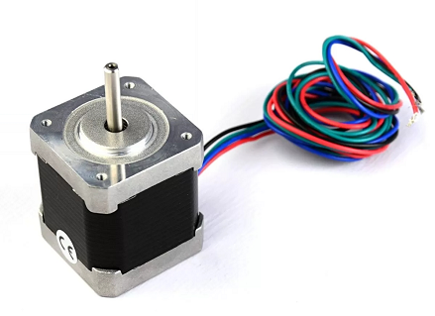
Figure 1Stepper Motors

Limit Switches: Installed at the start of the rail to indicate the default position of the arm on the rail.
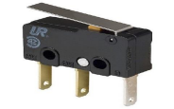
Figure 2Limit Switches

Servo Motors:6 servos at each joints of the arm for different angles for each cell, and one servo at the base of the arm for rotation.
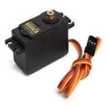
Figure 3Servo Motors

Arduino Mega :Main controller for the entire system.
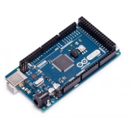
Figure 4Arduino Mega

Stepper Motor Drivers: A4988 for NEMA 17 motors:2 Drivers for stepper motors
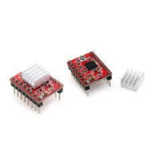
Figure 5Stepper Motor Drivers: A4988

LCD 16×2 (I2C): previews the state of the system.
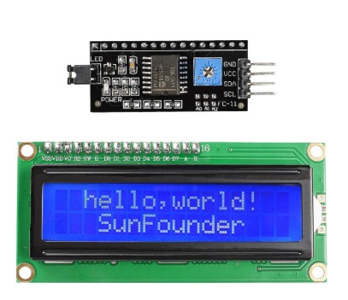
Figure 6LCD 16×2 (I2C)

RFID Module(PN532): for product detection and monitoring
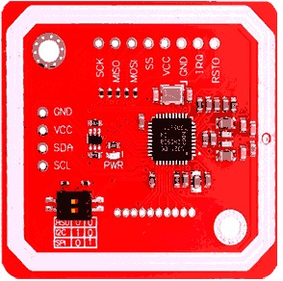
Figure 7RFID Module(PN532)

IR Sensors: Detect presence of products in cells and on the conveyor
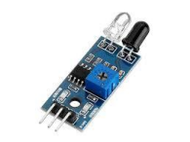
Figure 8IR Sensors
ESP32 for communication with web application
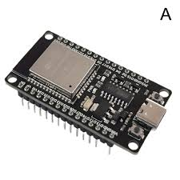
Figure 9 ESP32

Power Supply: 12V base supply

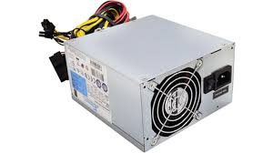
Figure 10Power Supply

ultrasonic:
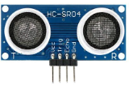
Figure 11ultrasonic

main full project :
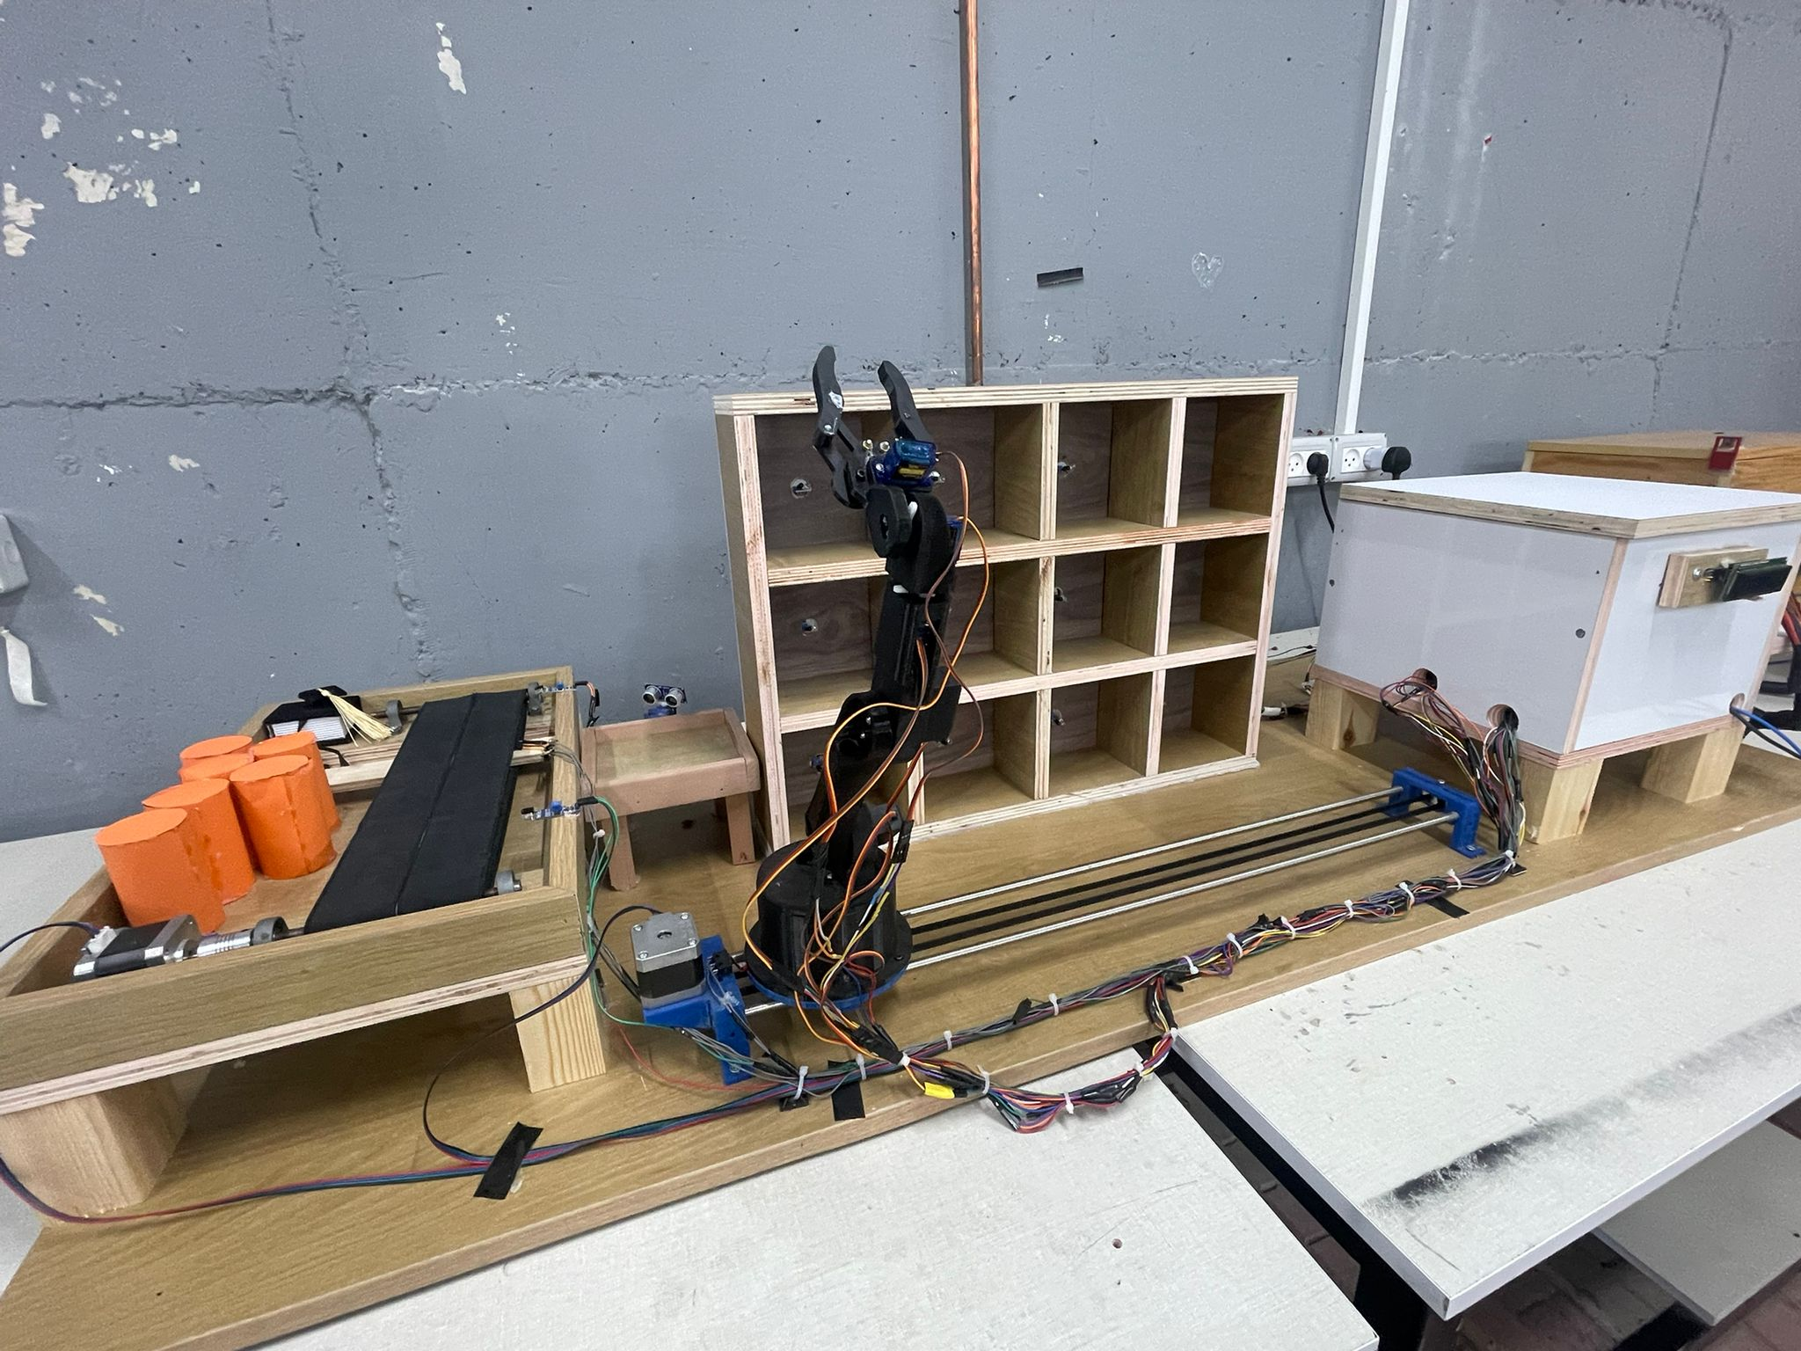
Figure 12main full project
The Conveyor:
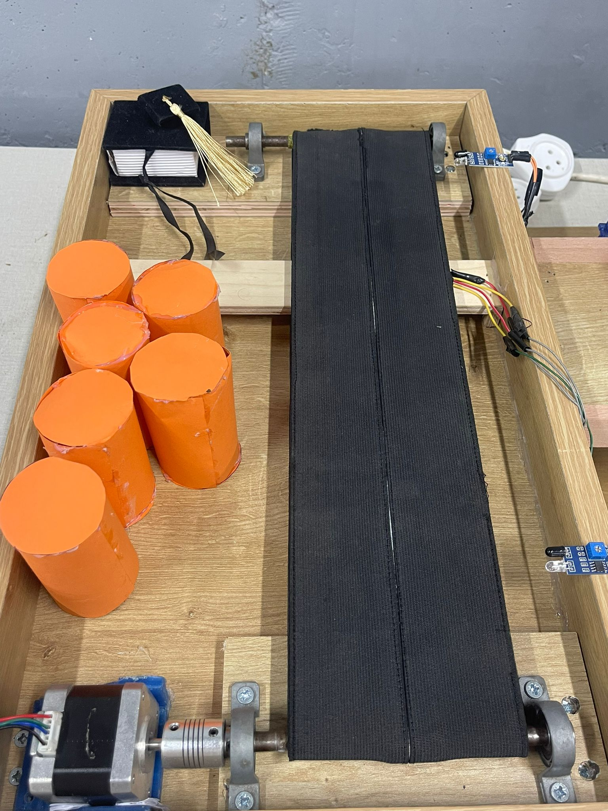
Figure 13The Conveyor
The rfid PN532:
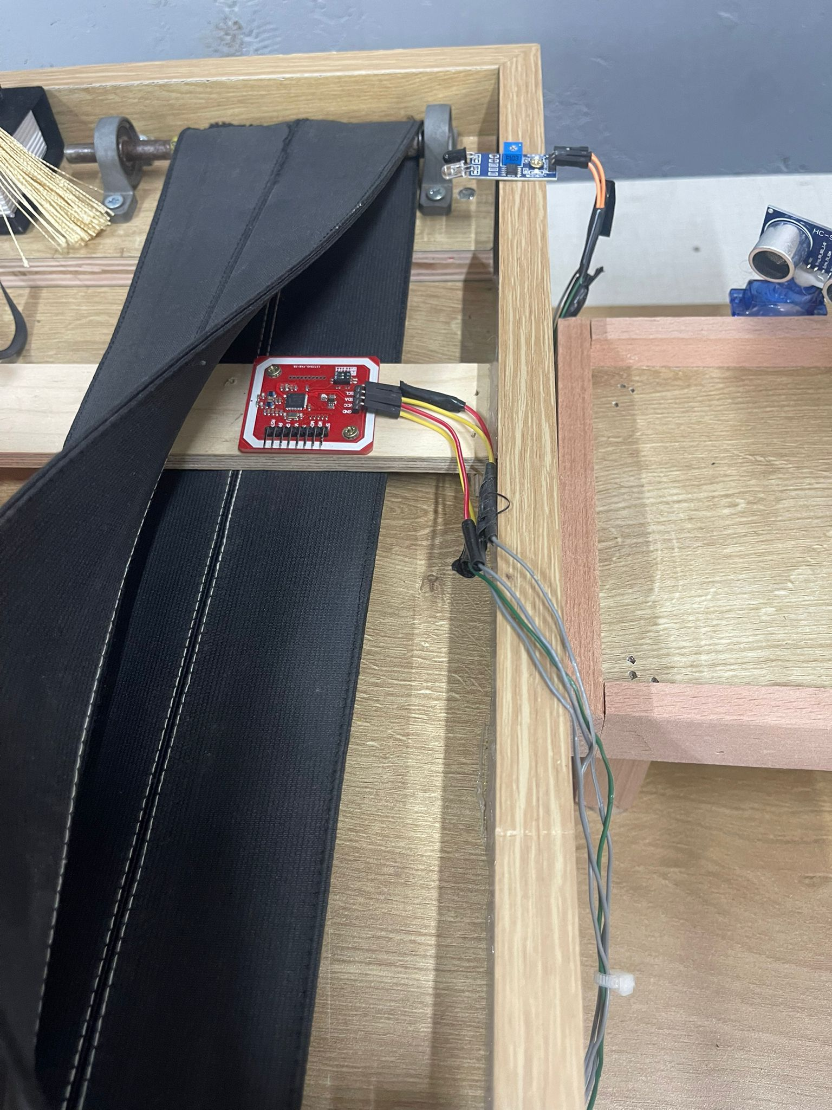
Figure 14The rfid PN532
Loading Zone :
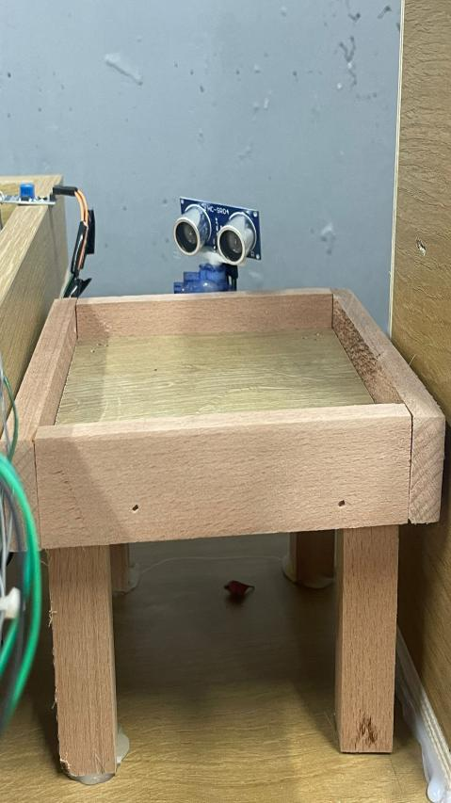
Figure 15Loading Zone
The Cells:
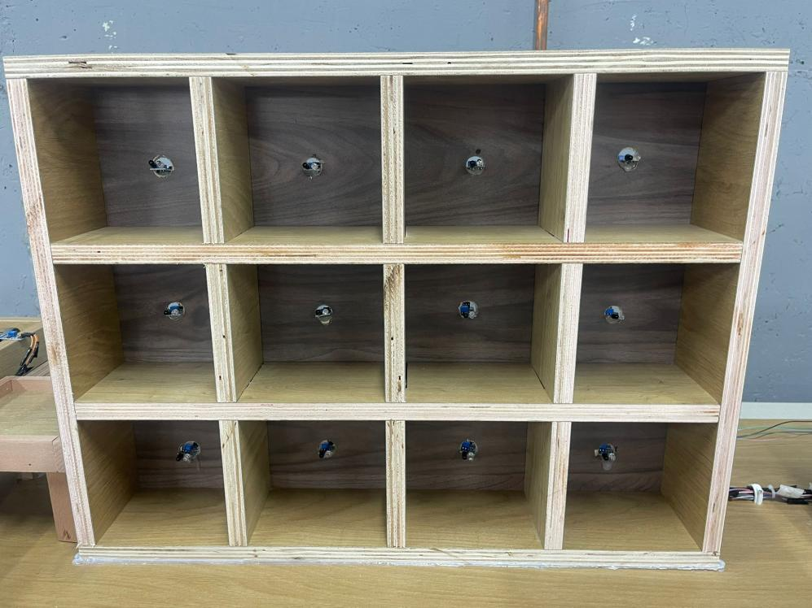
Figure 16The Cells
The Arm:
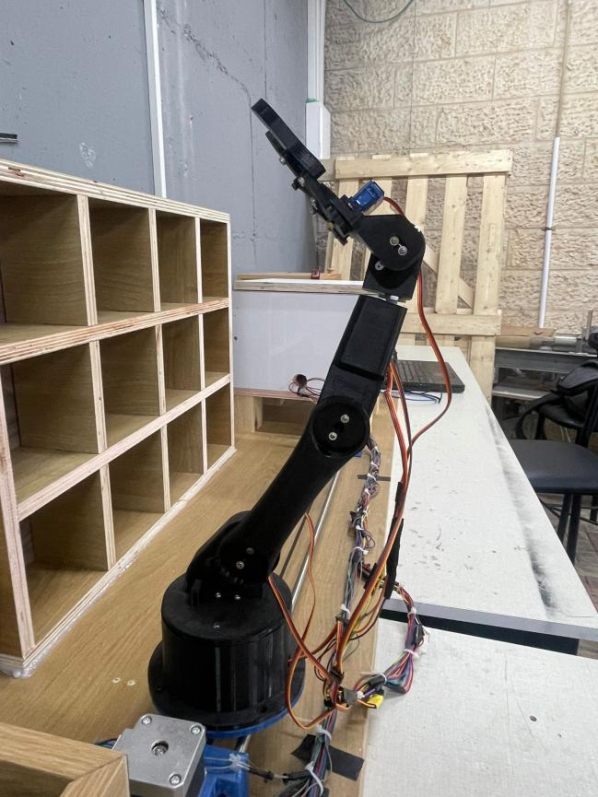
Figure 17The Arm
5.3 Software Design

5.3.1 Implementation
The software of the robotic warehouse system was developed using the Arduino IDE, with programs written in C/C++ for the Arduino Mega and ESP-based communication module. The control software is responsible for coordinating all warehouse operations, including conveyor movement, robotic arm positioning, product pickup and placement, and sensor monitoring.
The control logic manages precise motion of the robotic arm along the linear rail and the angles among the cells, enabling accurate pick-and-place operations. RFID processing is used to identify products before storage, ensuring correct tracking and placement within the warehouse cells. Sensor data from IR sensors, limit switch, and optical sensors is continuously monitored to maintain synchronization between the conveyor system and robotic arm actions.
Communication between the microcontroller and a centralized server allows real-time task execution, system monitoring, and mode selection (manual or automatic). A web-based interface provides operators with visual feedback, warehouse status updates, and control over system operations. Serial and wireless communication protocols are used to ensure reliable data exchange between hardware components and the server.
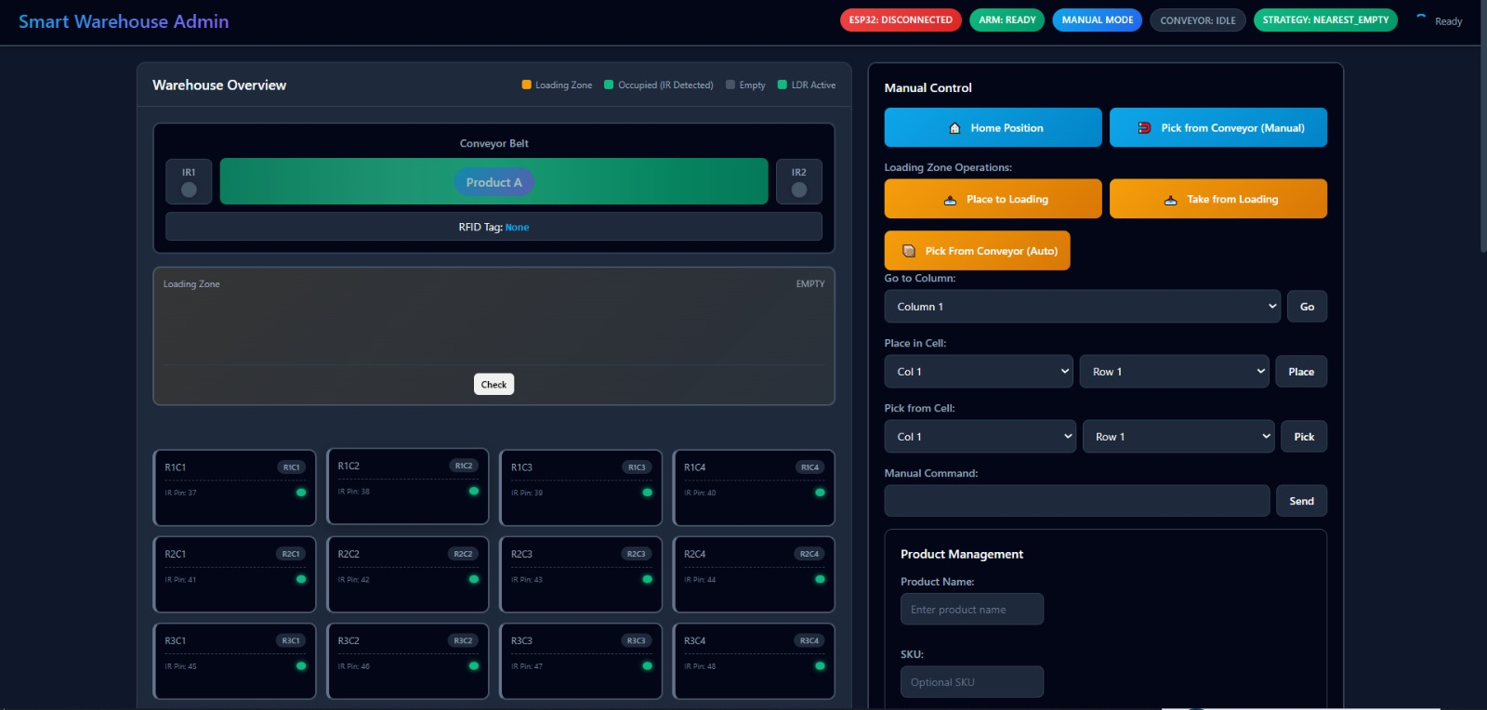
Figure 18 The screen of website

Chapter 6: Assembly and System Integration

6.1 Mechanical Structure Assembly
- A mechanical arm with servos at its joints was constructed on a base on top of a linear rail to support horizontal motion and access to the cells of the storage.
- Stepper motors were mounted securely and connected using couplings and belts to drive the motion for the conveyor that moves the products, and another stepper that moves the arm base along the rail.
- Limit switch were installed at the beginning of the rail to identify the start position that has the default state of the arm.

6.2 Conveyor and Storage Integration

- A conveyor belt system was installed to transport products from the first ldr to the pickup position(ldr2).
- Storage cells were arranged in a structured grid layout, allowing organized placement and retrieval of items.
- Sensors were positioned near storage cells to detect occupancy and confirm successful placement.

6.3 Electronic Setup

- The Arduino Mega was connected to all sensors, actuators, and motor drivers and served as the main control unit.
- Stepper motor drivers were connected and configured to supply appropriate current levels to the motors.
- Communication modules were connected to enable data exchange between the robotic system and the server.

6.4 Sensors and Feedback Integration
- Two LDRs were installed to the conveyor one at the beginning to detect a product and at the end to detect that the product reached the pickup position.
- Limit switch were integrated for start position and default state of the arm.
- Visual and software-based feedback mechanisms were implemented through the web interface for system monitoring.

6.5 Power Management

- A regulated 12V DC power supply was used as the primary power source for motors and control electronics.
- Voltage regulation modules were employed to provide stable operating voltages for microcontrollers and sensors.
- Proper grounding and power distribution were implemented to minimize noise and ensure system stability.

Chapter 7: Results and Analysis

The robotic warehouse system was successfully implemented and tested in both manual and automatic modes. The system was able to transport products using the conveyor belt, identify them through RFID, and store them in the correct storage cells using the robotic arm. Overall operation was stable, and the system performed the intended storage and retrieval tasks with minimal human intervention.
The robotic arm demonstrated reliable positioning after calibration using limit switch. Stepper motors provided adequate precision for movement, while sensors effectively detected product presence and prevented incorrect placement. RFID identification worked correctly in most cases; however, occasional reading issues occurred when tags were not properly aligned.
Communication between the microcontroller and the server allowed real-time monitoring and control through the web interface. Task execution followed the correct sequence, ensuring that each operation was completed before the next one began. Some timing adjustments were required to maintain synchronization between conveyor movement and arm actions.
Power stability and sensor noise were identified as the main limitations during testing, especially when multiple components operated simultaneously. Despite these challenges, the system achieved satisfactory performance for a prototype and demonstrated the practicality of using embedded systems and robotics for warehouse automation.

Chapter 8: Conclusion and Future Work

8.1 Conclusion

This project presented the design and implementation of a robotic warehouse system aimed at automating product storage and retrieval operations. The system integrates a robotic arm mounted on a movable base along a linear rail, a conveyor belt for product transportation, sensor-based detection, and RFID identification to achieve reliable and efficient warehouse management. Through coordinated hardware and software control, the system successfully reduced manual intervention while improving storage accuracy and operational organization.
Experimental results demonstrated that the system can accurately identify, transport, and store products using synchronized conveyor and robotic arm movements. Real-time sensor feedback and web-based monitoring enabled stable operation under both manual and automatic modes. Although certain limitations related to power stability, sensor noise, and identification accuracy were observed, the overall performance confirms the feasibility of implementing a low-cost, embedded robotic warehouse prototype. The project effectively demonstrates the practical application of robotics, embedded systems, and software integration in modern warehouse automation.

8.2 Future Work

Several enhancements can be considered to further improve the robotic warehouse system. Adding a second robotic arm would enable faster handling of products and allow direct transfer from the loading zone to delivery trucks, increasing system throughput. Replacing RFID technology with a camera-based vision system for QR code recognition could improve identification accuracy and reduce dependency on tag orientation.
In addition, the system can be enhanced by incorporating AI-based storage optimization algorithms to intelligently select storage locations and improve space utilization. Finally, integrating mobile or cloud-based control applications would enable remote monitoring, system scalability, and easier integration with larger warehouse management systems.

References

• Arduino Project Hub - https://projecthub.arduino.cc/
• Espressif Systems - https://www.espressif.com/
• PN532-NFC-RFID -
https://www.circuits-diy.com/interfacing-pn532-nfc-rfid-module-with-arduino/

