An-Najah National University
Department of Electrical Engineering
Project
Alarm System

Prepared by:
Mai Abusalha Safa' futian
Supervisor :
Dr. Samer Mayaleh.
Content

Introduction of project.

Control in microcontroller.

Send data from microcontroller By :

Using embedded device server ( Xport direct+).

Open serial port with C sharp .

Methods of sending SMS.

Design of web site.

Economical study.

Reference.

Appendix.

CH “1”
“Introduction Of project“
“ Alarm System Network”

Introduction

We have a very wide range of monitoring alarm systems available, from security monitoring systems, temperature monitoring, 24 hour fire monitoring systems, freezer alarms or freezer monitoring , and any other type of alarming system .

New construction systems are predominately hardwired for economy. Retrofit installations often use wireless systems for a more economical and quicker install. Some systems serve a single purpose of burglary or fire protection.

Regular scheduled reports can be delivered by email or SMS texts directly to your mobile phone giving details of fire monitoring, the web-based alarm monitoring system is second to none in terms of flexibility and performance.

** Monitoring System by using Website:--
Website monitoring is the process of testing or tracking (monitoring) how end-users interact with a website or web application. Website monitoring is often used by businesses to ensure that their customers are able to access their online applications and perform actions such as searching, online shopping, checking an account balance, or simply researching . You may monitor a single page of your website, but you can also monitor a complete business process (often referred to as multi-step transactions) such as Monitoring of fires in buildings through a web page.
Monitoring is essential to ensure that a website is available to users and downtime is minimized. Users that rely on a website or an application for work or pleasure will get frustrated or even stop using the application if it is not reliably available. Monitoring can cover many things that an application needs to function, like network connectivity, Domain Name System records, database connectivity, bandwidth, and computer resources like free RAM, CPU load, disk space, events, etc. Commonly measured metrics are response time and availability (or uptime), but consistency and reliability metrics are gaining popularity.

** Inside or outside monitoring :-
Website monitoring can be done from both inside and outside of a corporate firewall. Traditional Network Management solutions focus on inside the firewall monitoring, whereas external performance monitoring will test and monitor performance issues across the Internet backbone and in some cases all the way to the end-user. External performance monitoring is also known as end-user monitoring or end-to-end performance monitoring.
** protocol Website monitoring :--
Many Various types of protocol Website monitoring service can check HTTP pages, HTTPS, FTP, SMTP, POP3, IMAP, DNS, SSH, Telnet, SSL, TCP, PING and a range of other ports with great variety of check intervals from every 4 hours to every one minute. Typically, most website monitoring services test your server anywhere between once-per hour to once-per-minute.
**Alarm monitoring Services :--
The list of services to be monitored at a Central Station has expanded over the past few years to include: Access Control, CCTV Monitoring, Environmental Monitoring, Intrusion Alarm Monitoring, Fire Alarm & Sprinkler Monitoring, Critical Condition Monitoring, Medical Response Monitoring, Elevator Telephone Monitoring, Hold-Up or Panic Alarm Monitoring, Duress Monitoring, Auto Dialer tests, Open & Close Signal Supervision & Reporting, Exception Reports, and PIN or Pass code Management. Increasingly, the Central Stations are making this information available directly to end users via the internet and a secure log-on to view and create custom reports on these events themselves.
**System Idea :--
The project and development of a very low-cost and small electronic prototype, especially designed for monitoring and controlling existing home alarm systems (intruder, smoke, gas, flood, etc.), via TCP/IP, with a typical web browser. Its use will allow home owners to be immediately alerted and aware when an alarm event occurs, and being also able to interact with their home automation alarm system, disarming, arming and watching event alerts, with a personal wireless Wi-Fi PDA or Smartphone logged on to a dedicated predefined web page, and using also a PC or Laptop.
The mail goal for this project was to build a very low-cost electronic prototype, with the use of an embedded standard web-server, with built-in IP connectivity, to allow receiving and sending digital commands, via TCP/IP , for all existing alarm and notification home automation models, and without the need to have a dedicated server PC or even special software.
** The important of project in general :--
In order this project we can protect many of buildings and persons from any dangerous occurs . We can useful in schools , university , factors , and hospital ………etc .
** The idea of project :--
Alarm services in hospital suffering from lack of ability to accurately determine the place of danger .
Alarm system are important from out sides and this causes :--
- High cost to install the alarm system .
- High cost maintenance .
- It can not indicates more than two position occurs at the same of time .
** Advantage of Project :--
- We can distinguish the location of problem thus moving directly toward without wasting time .
- We can distinguish a problem in more than one room simultaneously through the control web page of the situation described every room .
- Investigation protection or hospital 24 hours .
- There are is no need some one to watch on the web site 24 hours (By send short message SMS to mobile the person responsible ).

** FIG (1): Alarm System Network **

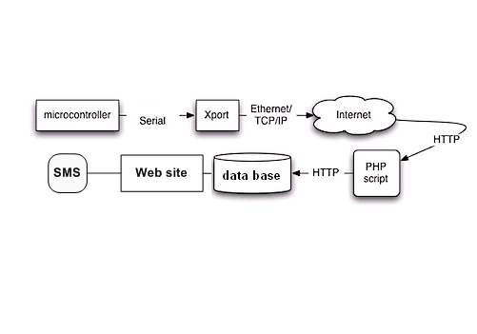

** FIG (2): Alarming control board schematic diagram**

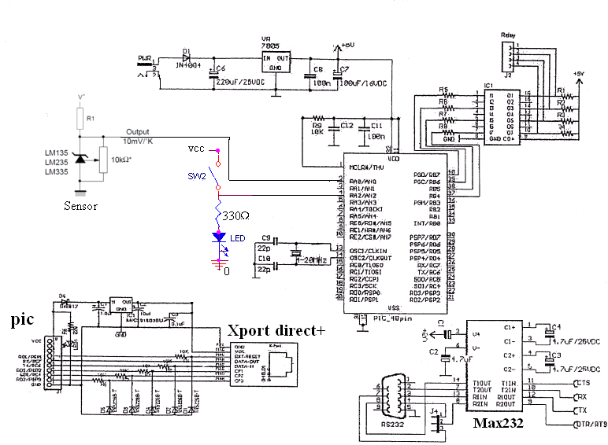

CH “2”
Control In Microcontroller

*PIC16F877 Microcontroller*
We use the pic to control some external devices, a microcontroller executes a user program which is loaded in its program memory. in our project we received data from Detectors located in rooms, then data is sent to external output devices and Send the address of each room in which has a problem.
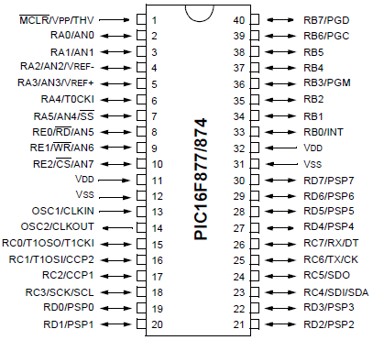
** FIG (3): logic symbol of PIC16F877**

Initially we write a program in pic( assembly) language but we find some problem to convert this code to pic(c) because we cannot find some Necessary instruction to allow the conversion program to convert this code to the pic(c) ,To avoid this problem we write a code in pic (c) direct. You Will find the code written (in assembly and pic) in the Appendix file .

**Algorithm of Microcontroller :--

** FIG (4): Flow Chart of Microcontroller **

You Will find the code written (PIC code) in Appendix file .

The input pins of PIC take data from heat sensors (digital Signal ) and then convert it to high input or low input by some equations in order to compare with some variable stories in memory of PIC , such as in our code if the input is greater than value (2.7) that means burns occur in building so put output pins high and send address of room . If no one of inputs greater than (2.7) send null that means no burns in building (Safety building).
Check all of input pins when execute program and continually in this process at all time .
Note :--
When we build the PIC code must all of inputs type are analog to can take analog signal from sensor .
** Precision temperature sensor :--
The LM335 are precision temperature sensors which can be easily calibrated. They operate as a 2-terminal Zener and the breakdown voltage is directly proportional to the absolute temperature at 10mV/K. The circuit has a dynamic impedance of less than 1 Ω and operates within a range of current from 450μA to 5mA without alteration of its characteristics.

Calibrated at +25oC, the LM335 have a typical error of less than 1oC over a 100oC temperature range. Unlike other sensors, LM335 have a linear output.

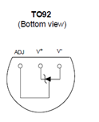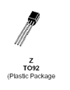

** FIG (5): Temperature Sensor data sheet **

** Application Hints :--

There is an easy method of calibrating the device for higher accuracies .
The single point calibration works because the output of the LM335 is proportional to the absolute temperature with the extrapolated output of sensor going to 0V at 0K ( –273.15oC).

** Temperature Sensor calibration :--

We make calibration for this sensor by building the following circuit , then measuring the output voltage while changing the temperature the sensor exposure to .
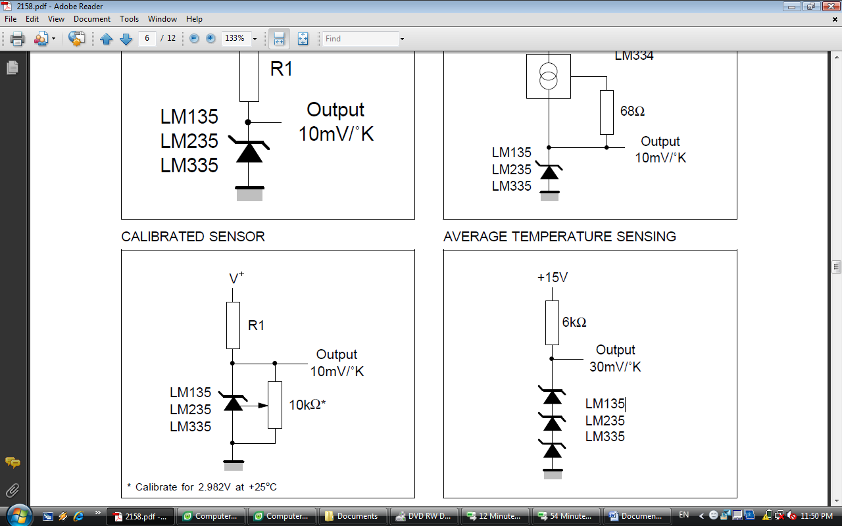

** FIG (6): Temperature Sensor circuit diagram **

** The practical calibration :--
- At 25 c° the output voltage = 2.59 V.
- At T> 25c° the output voltage > 2.7 V.

We have some proposals in order to make the controller support more area of building :

- using multiplexer at the input of the pic (8 input →3 output)
input represent →room detector.
output represent →address of room(pic pen).

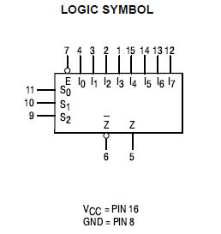
** FIG (7): logic symbol of multiplexer **

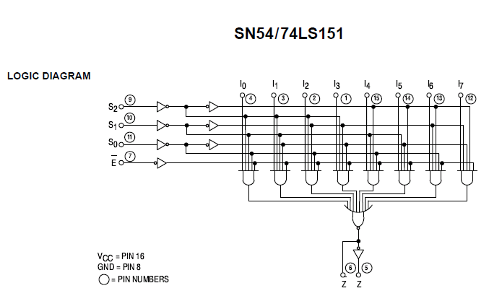

** FIG (8): logic diagram of multiplexer **

** If we need use multiplexer then we change PIC algorithm .

- if we use all the pins of pic we can use another microcontroller to cover all the building.

** We can find two ways in order to send data from microcontroller to web site page :--
- By using Xport direct + embedded device .
- By open serial port with C sharp .

CH “3”

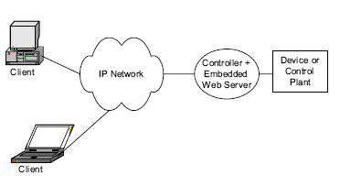

* XPort Direct+*

Embedded Device Server
Powerful and affordable networking for any device with a serial interface on its microcontroller
- Integrated module with RJ45 and dedicated networking SoC.
- Web server, TCP/IP protocol stack and Windows deployment software.
. Serial Line Formats Data bits: 7 or 8.
Stop bits: 1 or 2.
Parity: odd, even, none.
. Data Rates 300 bps to 921 kbps.
. Three GPIO pins.
- RS-232/RS-485 ready.
- 256-bit AES encryption for secure communications.
The compact XPort Direct+ is an embedded device server module delivering high-performance Ethernet connectivity and web server capabilities. Affordably web-enable virtually any device with a serial interface on its microcontroller.
Serial data from the device microcontroller’s CMOS logic-level serial port is packetized and delivered over an Ethernet network via TCP or UDP data packets.
XPort Direct+ features a built-in web server for communications with a device via a standard Internet browser. Web capability can be used for remote configuration, real-time monitoring, upgrades and troubleshooting. XPort has 512 KB of on module Flash for web pages and firmware upgrades.

Xport direct+ is Ethernet Connectivity and Powerful Web server ( what is web server???):-

Web servers are computers on the internet that host websites, serving pages to viewers upon request. This service is referred to as web hosting. Every web server has a unique address so that other computers connected to the internet know where to find it on the vast network.

Eliminating the need to negotiate the intricacies of Transmission Control Protocol (TCP) or Internet Protocol (IP), XPort Direct+ incorporates:

- Robust embedded operating system .
- Full-featured network protocol stack .
- Proven, parameter configurable, ready-to-use serial-to-Ethernet application .
- Built-in web server for device communication and configuration via a standard browser.
- 256-bit AES encryption.

Connect the XPort Direct+ Demonstration Board :--
Follow the steps below:
- Connect the RS-232 cable to the serial interface of the XPort Direct Demonstration Board.
- Connect the RS-232 cable to an available serial port on the back of your PC.
- Connect the other end of the Ethernet cable to your network hub.
- Connect one end of the Ethernet cable to the XPort Direct.
- Connect the Universal Power Supply to the Xport Direct Demonstration Board.
- Select the appropriate power plug adaptor for your Geographical location. Insert it into the slot on the Universal Power Supply; then plug the power.
LEDs
The XPort Direct+ contains the following LEDs:

􀂋 Link (Green LED)
􀂋 Activity (Yellow LED)

Verification Check: If powered up correctly, the XPort Direct+ Demonstration Board power LED indicator lights blue and remains on. This LED is near the reset switch.

Xport direct + block diagram

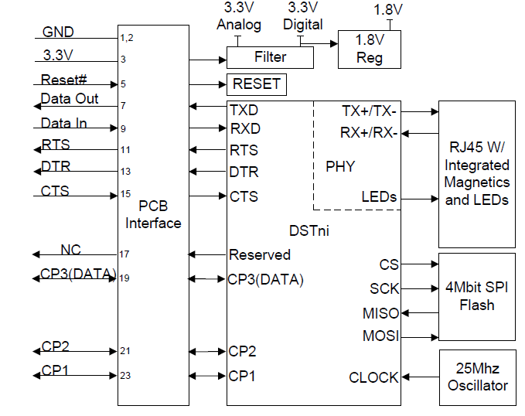

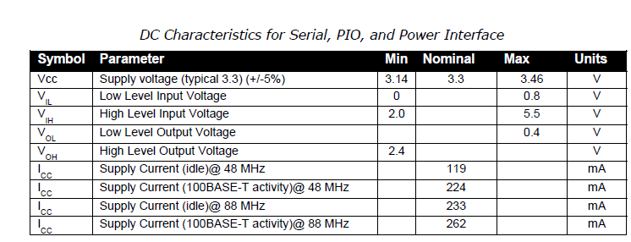
**Included Software:
- Web manager.
- Windows®98/ME/NT/2000/XP/Vista-basedDevice Installer™ configuration software.
- Com Port Redirector™ software and related utilities.
**Device Installer:
- Open Device Installer on the CD-ROM.
If the CD does not launch automatically:
a. Click the Start button on the Task Bar and select Run.
b. Enter your CD drive letter, colon, backslash, Launch.exe (e.g., D:\Launch.exe).
2- Respond to the installation wizard prompts.
**Hardware Address:
You need to know the unit’s hardware address (also known as a MAC address). It is on the product label, in the format: 00-20-4a-XX-XX-XX, where the XXs are unique numbers/letters assigned to the product.
Hardware Address: 00-20-4a-_____-_____-_____
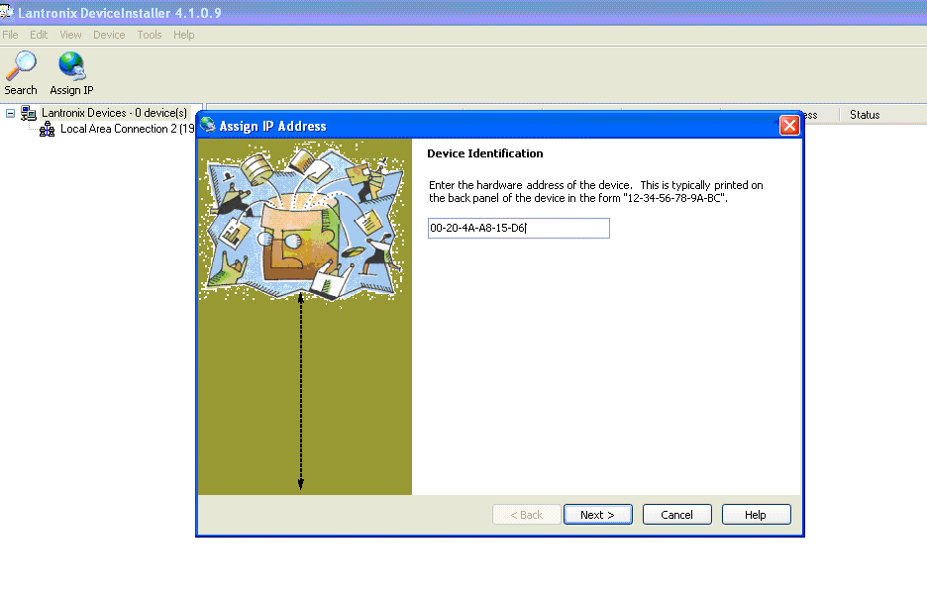
**Assign IP:--
The unit’s IP address is normally set to 0.0.0.0 at the factory. The hardware address is onthe product label. The unit is DHCP enabled as the default.
Click Start Programs Lantronix DeviceInstaller. If your PC has more than one network adapter, a message displays. Select an adapter and click OK.
We can configure xport direct + by tow way:
- web configuration.
- telnet configuration.
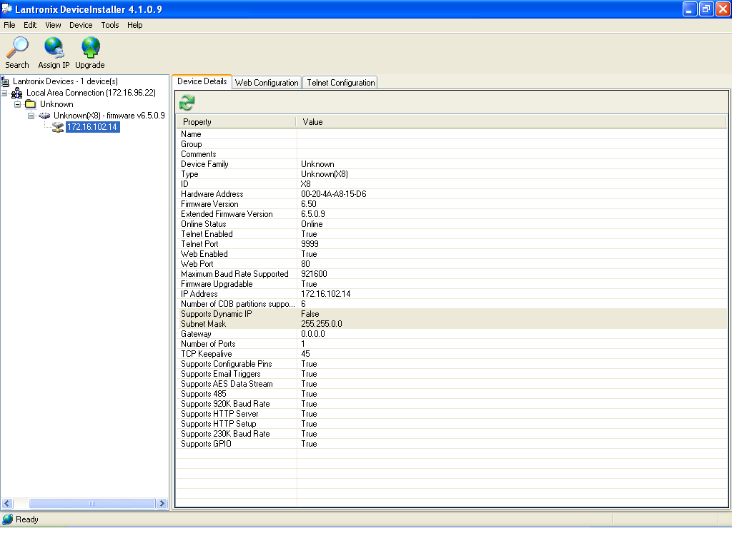
Using web configuration:--
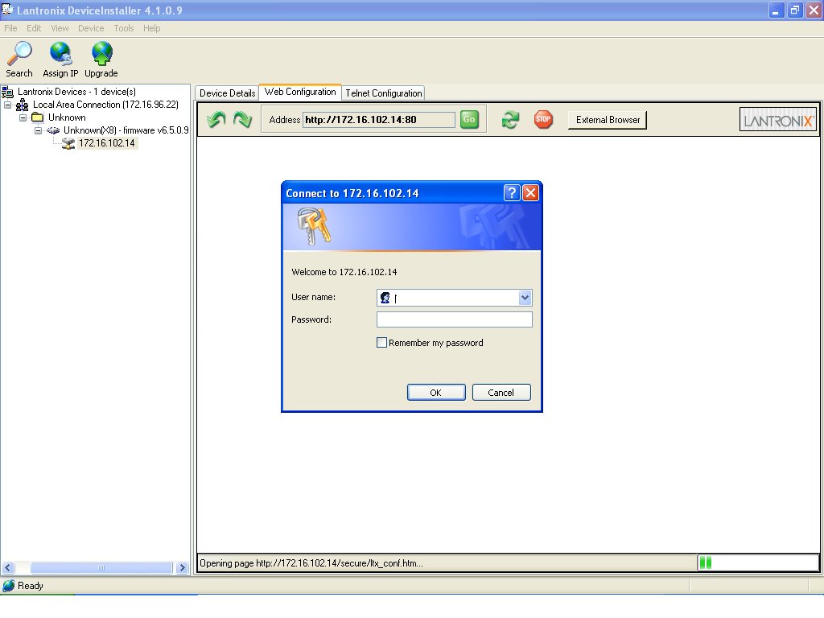

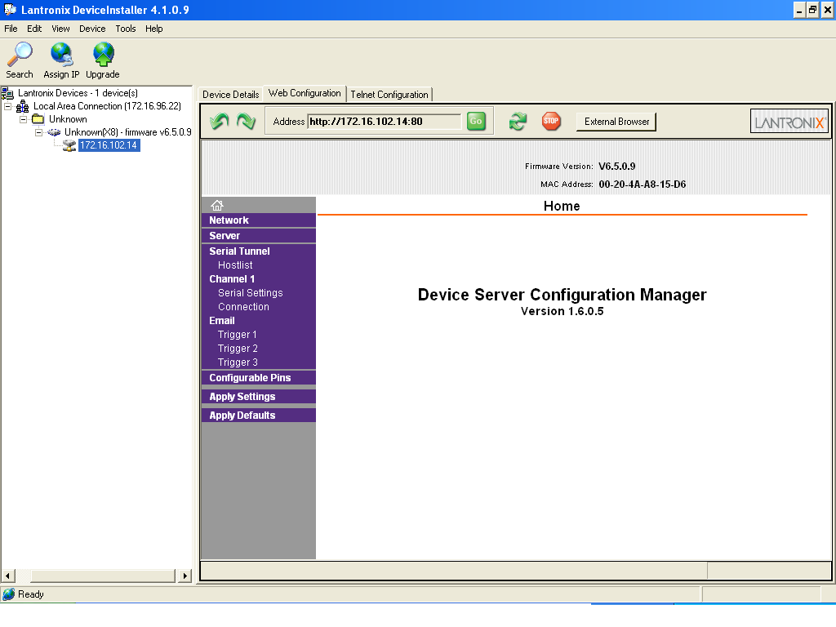
Using telnet configuration:--
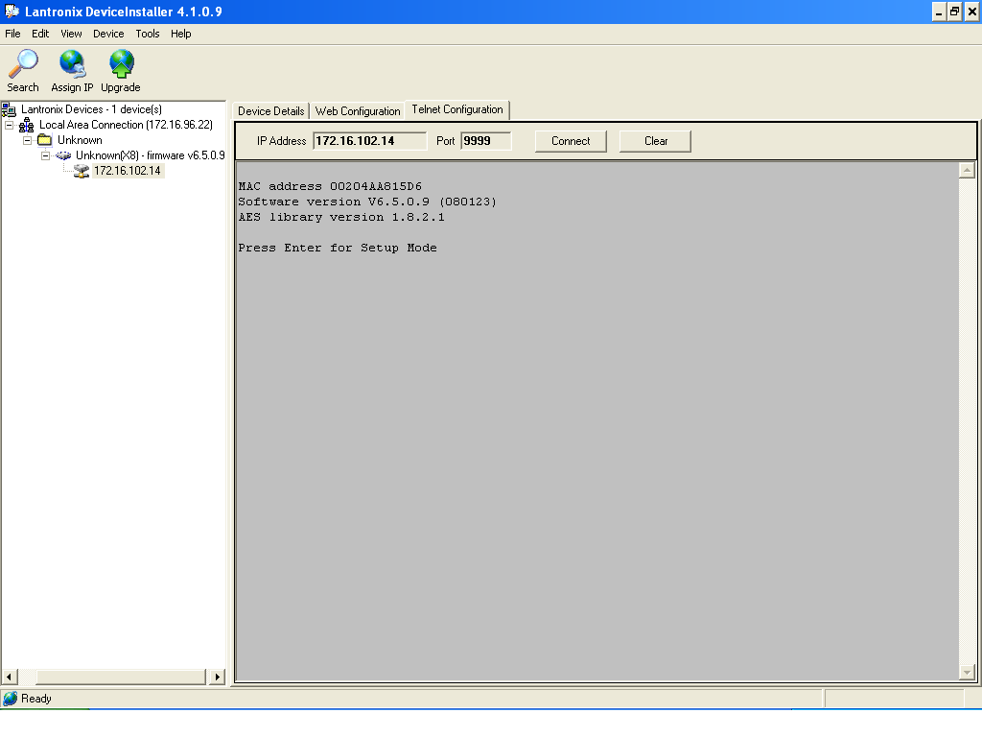

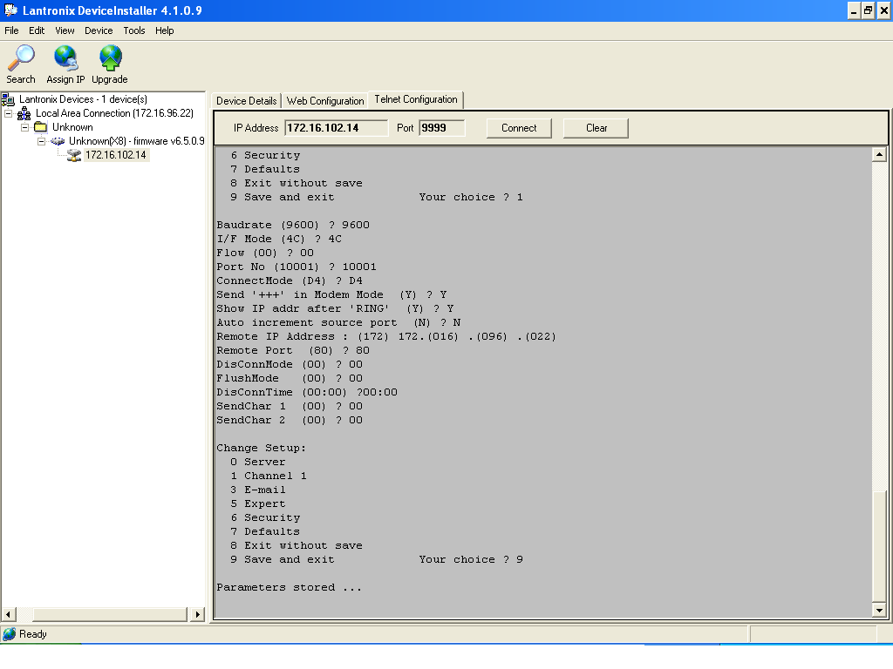
Com Port Redirector™ software:--
The Serial/IP® COM Port Redirector creates virtual COM ports for applications to use networked serial servers. Virtual serial ports lets you send or receive data over a TCP/IP port .

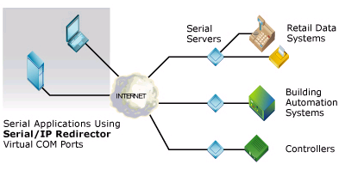

- Open the CPR program:

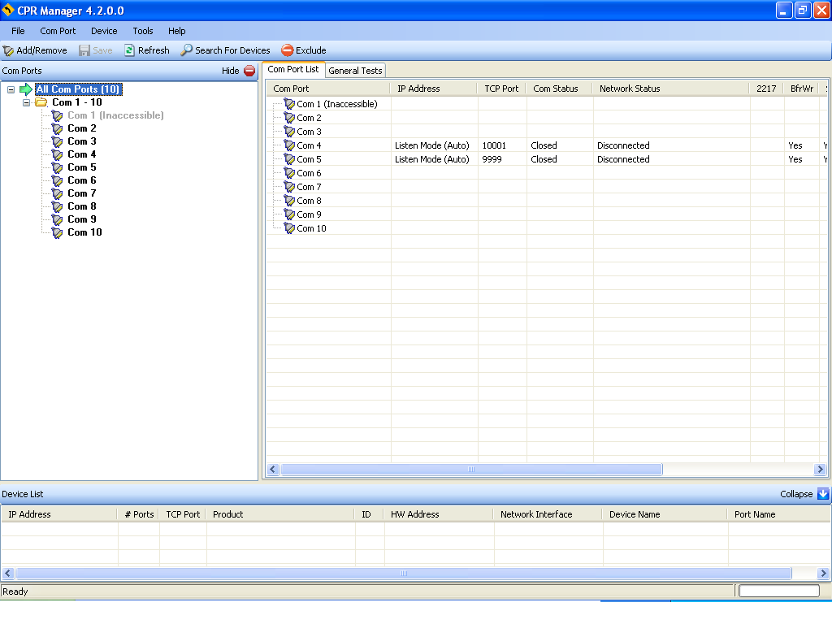
- determine the port you need to use it:

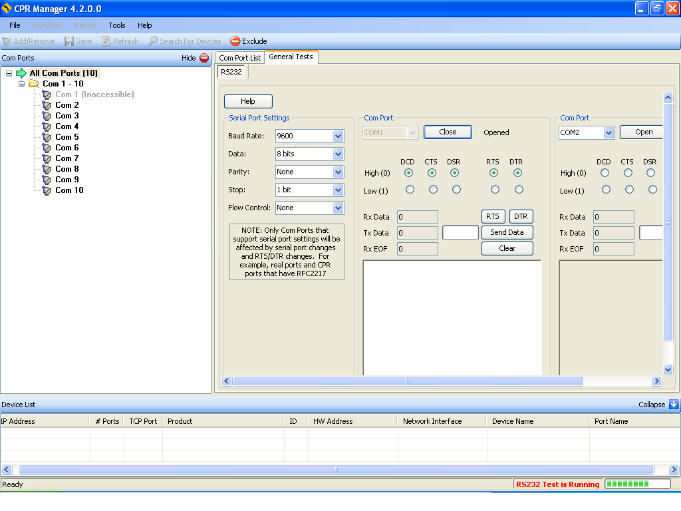
- We receive the data :

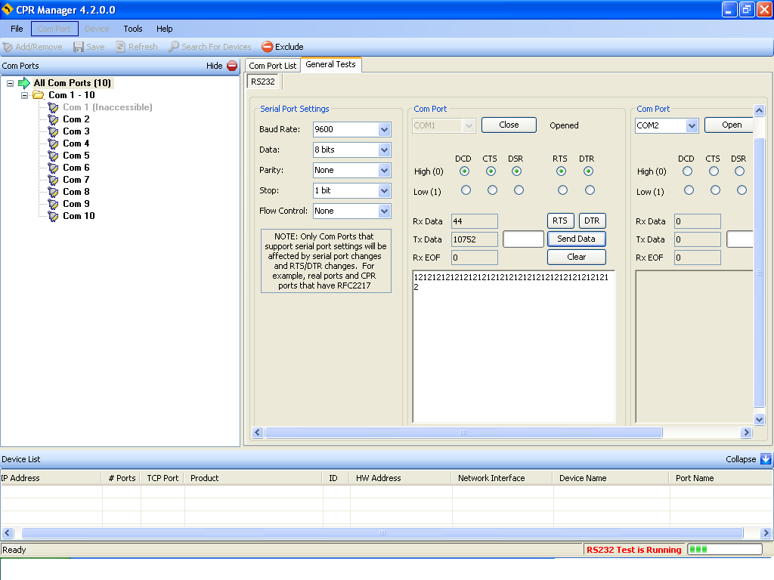
Control application over IP network by using xport direct +:

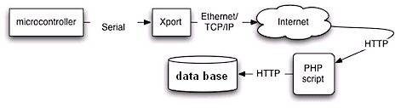
How microcontroller work with xport direct+:
XPort Settings by using device installer:
The following are the important settings to configure on the XPort for this example:
*** Channel 1
Baudrate 9600, I/F Mode 4C, Flow 00
Port 10001
Remote IP Adr: --- none ---, Port 00000
Connect Mode : D4
Disconn Mode : 00
Flush Mode : 00

Xport direct + work as the algorithm under:
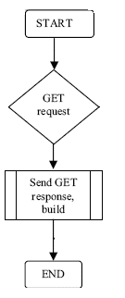

- Make a connection with the server you need.
- Determine web port (80).
- Determine the ip of the host that work on it(172.16.96.22).
- Name the page that request the data.

**Manual Connection :
Attempts to connect when directed by a command string received from the serial port. The first character of the command string must be a C (ASCII 0x43), and the last character must be either a carriage return (ASCII 0x0D) or a line feed (0x0A). No blanks or space characters may be in the command string. Between the first and last command string characters must be a full or partial destination IP address and may be a destination port number.
The IP address must be in standard decimal-dot notation and may be a partial address, representing the least significant 1, 2, or 3 bytes of the remote IP address. The period is required between each pair of IP address numbers.
If present, the port number must follow the IP address, must be presented as a decimal number in the range 1-65535, and must be preceded by a forward slash (ASCII 0x2F). The slash separates the IP address and the port number. If you omit the port number from a command string, the internally stored remote port number starts a connection.
If a partial IP address is presented in a command string, it is interpreted to be the least significant bytes of the IP address and uses the internally stored remote IP address to provide the most significant bytes of the IP address. If the IP address entered is 0.0.0.0/0, the device server enters Monitor Mode.

Code(picc):
int xport_connect()
{
printf("c172.16.96.22/80,10");
}

- Make http request : we make page (s.php) this page request the variable to determine from where the alarm come.
Code(php):
if(isset($_REQUEST["room-adress"]))
{
$x=$_REQUEST["room-adress"];
}
code:
printf("GET /s.php?room-adress=1");
printf(" HTTP/1.1,10");
printf("HOST: localhost,10");
printf("User-Agent: PIC/XPort");
printf("10,10");

The data come through xport direct + to the variable "room-address" then to send the data to mysql we use this code:

<?php

$con = mysql_connect("localhost","room-adress","date");
if (!$con)
{
die('Could not connect: ' . mysql_error());
}
?>
Before we send the data to my sql we should create the table of database:

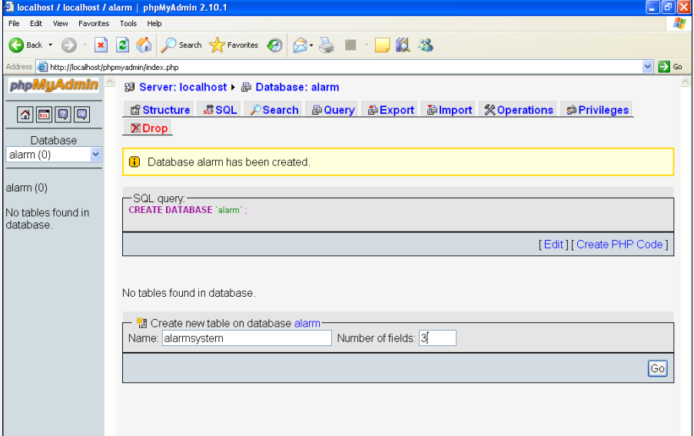

Table data base:

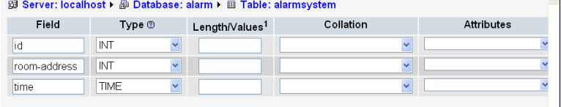

CH “4”
Open Serial Port With
C sharp


*Open serial port with C sharp*

In this chapter we explain how to read data from serial port and save it in MS Access file by using C sharp language .
** Create a MS Access Database:--
To create a MS – Access Database we need this steps :--
- Select Start All program .
- Microsoft Office Microsoft Access Database.



- Click to Database Create.


- Create a column in table we need ( ID, Command, DataTime).
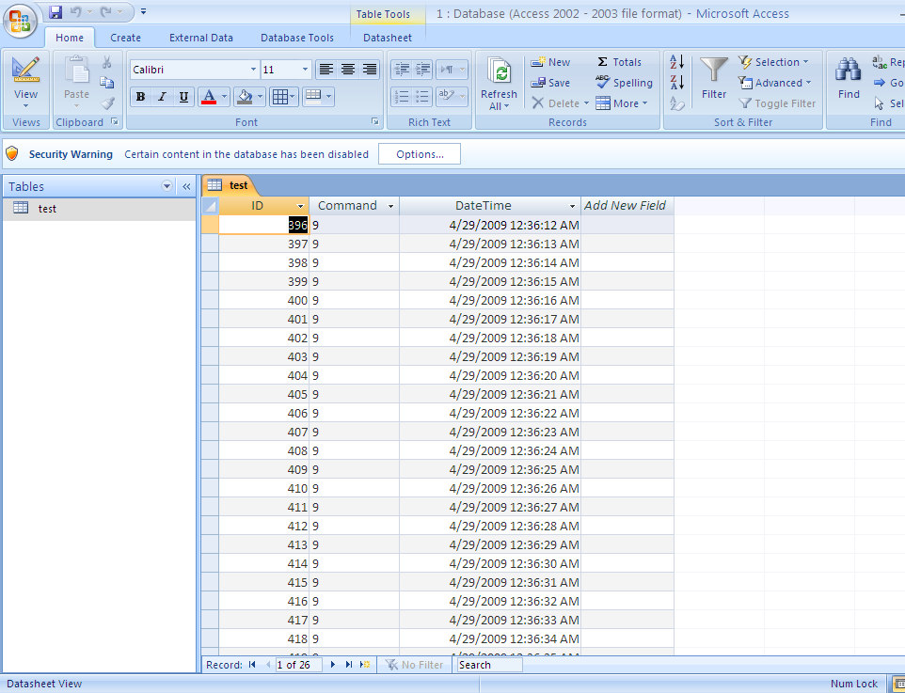

** ODBC connection to a MS Access Database:-
To create an ODBC connection to a MS Access Database we need this steps :-
- Open the Administrative Tools icon in your Control Panel.

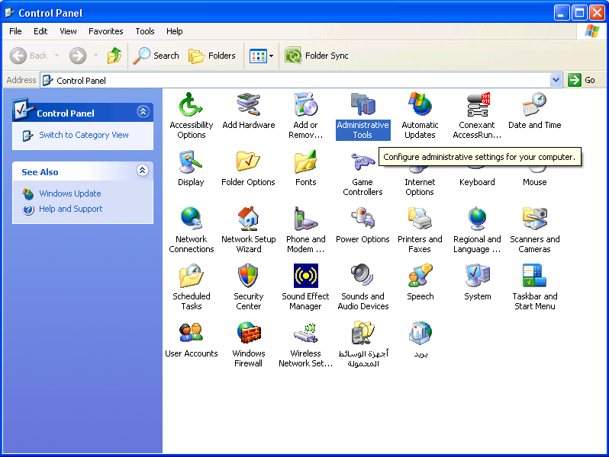

- Double-click on the Data Sources (ODBC) icon inside.
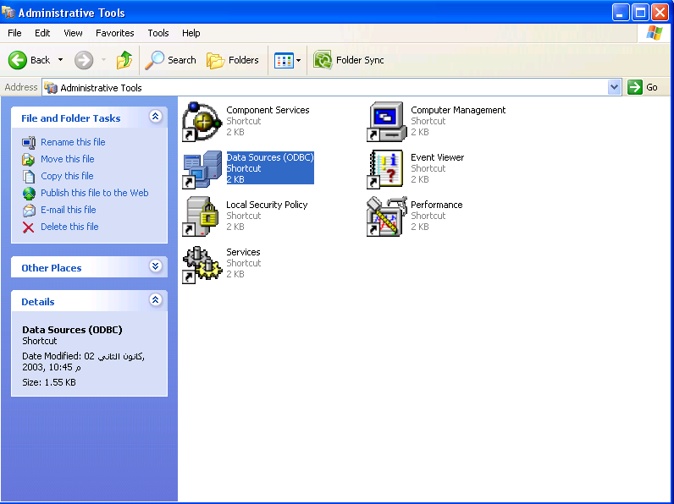

- Choose the System DSN tab.
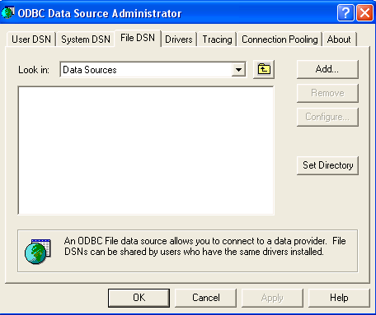
- Click on Add in the System DSN tab.
- Select the Microsoft Access Driver Next.

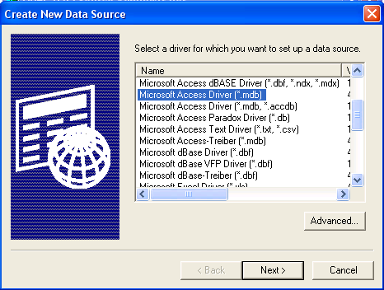

- In the next screen, click Select to locate the database.
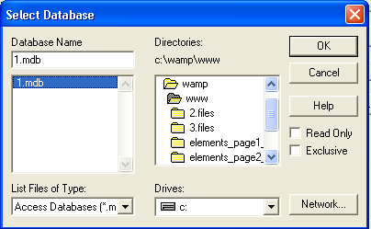

- Give the database a Data Source Name (DSN).
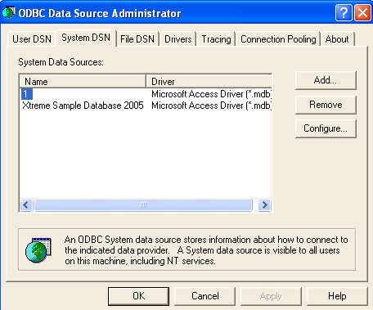
- Click OK.

** C sharp code and connection with database :--
To create an C sharp project we need this steps :--
- Select Start All program .
- Choose Microsoft Visual Studio .
- Create new project by click to create project in the screen or select File New Project .

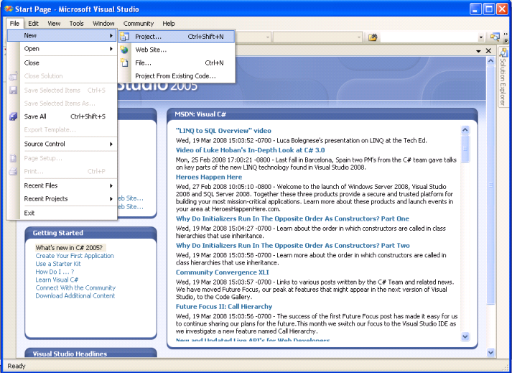

- Fill in Name, i.e ("Web based alarm").
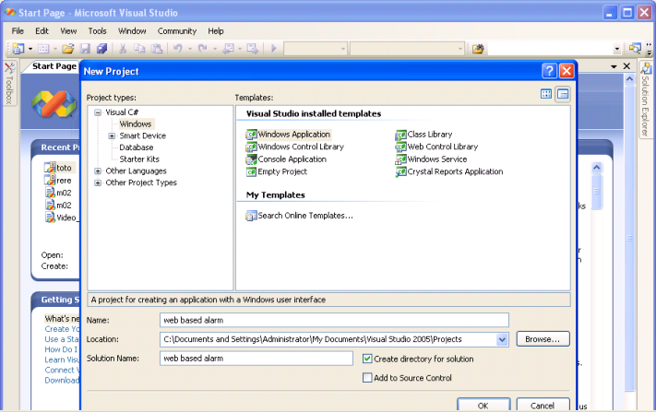

- Click Ok.

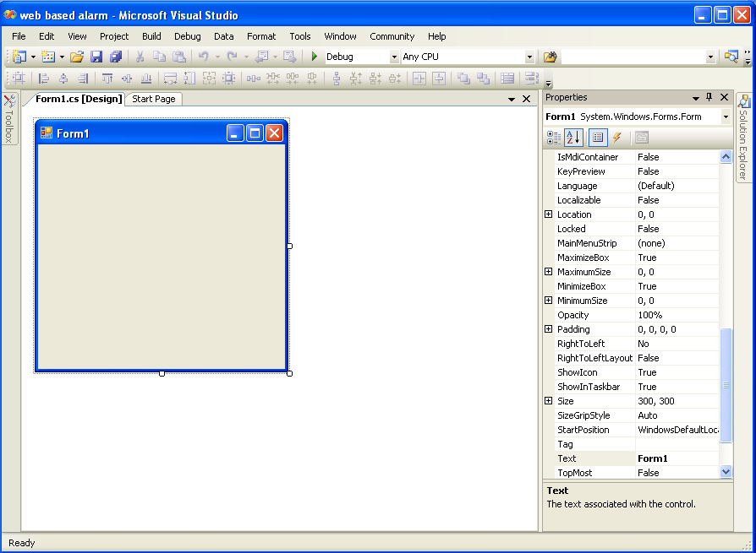
- Select the Toolbox from tool bar.
- Click to the serial port and withdrawn to the (Form1.cs), then double click on it .

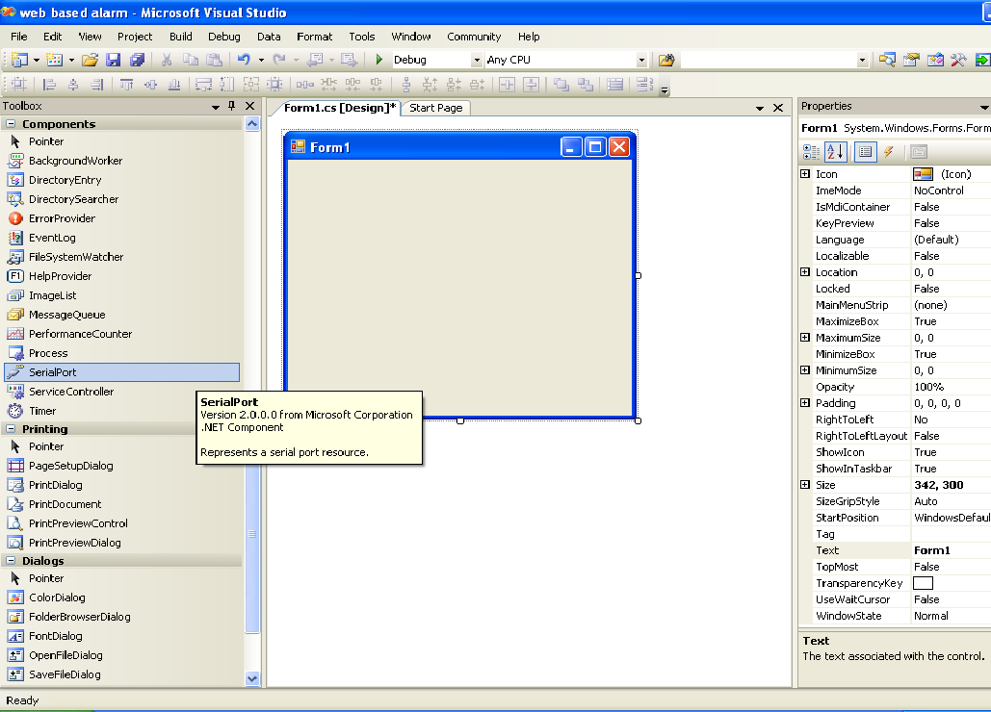

- Right click to the serial port properties Event Select Data Received by double click .

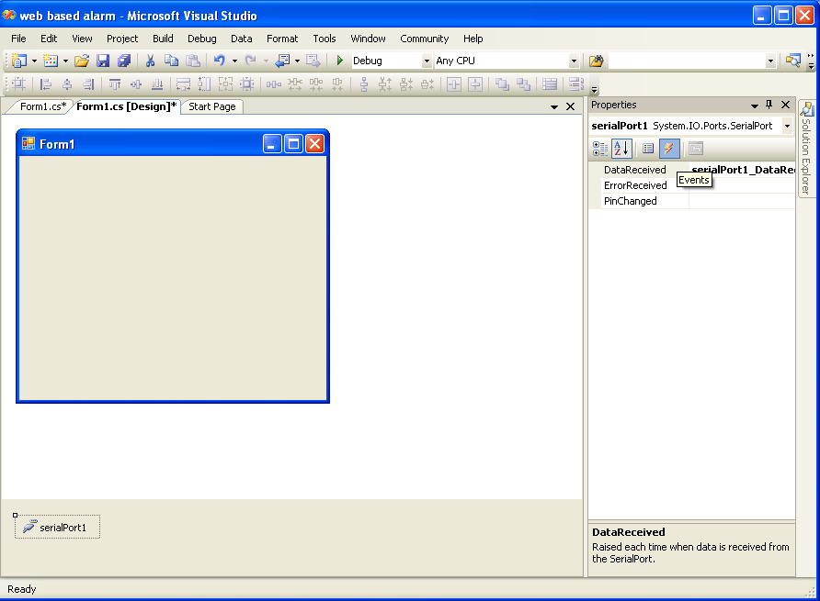

- So then show in Form1.cs function of serial port_ Data Received.
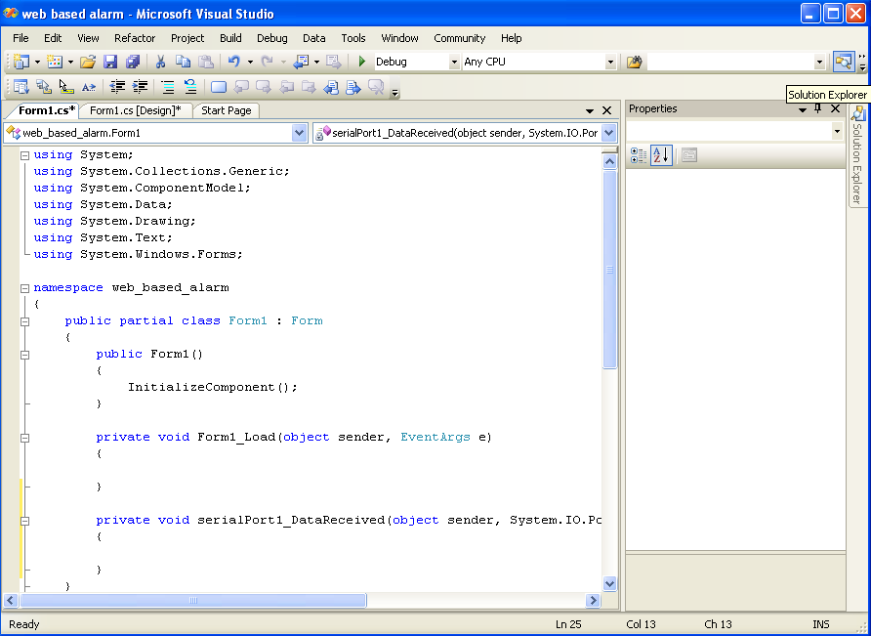
- Now we need to write code in (Form1.cs ) .
using System;
using System.Collections.Generic;
using System.ComponentModel;
using System.Data;
using System.Drawing;
using System.Text;
using System.Windows.Forms;
using System.Data.OleDb;

namespace web_based_alarm
{
public partial class Form1 : Form
{
public Form1()
{
InitializeComponent();
}

private void Form1_Load(object sender, EventArgs e)
{
serialPort1.Open();
}

private void serialPort1_DataReceived(object sender, System.IO.Ports.SerialDataReceivedEventArgs e) {
try
{
// MessageBox.Show(serialPort1.ReadExisting());
string g = serialPort1.ReadExisting().Trim();
if (g == "" || g == null || g == "\0" || g == " " || g == " " || g == "null")
{
OleDbConnection oleConnTestLucky = new OleDbConnection();
oleConnTestLucky.ConnectionString = @"Provider=Microsoft.Jet.OLEDB.4.0;Data Source=1.mdb";
oleConnTestLucky.Open();
OleDbCommand cmdSelect = new OleDbCommand();
cmdSelect.CommandText = "delete from test";
cmdSelect.Connection = oleConnTestLucky;
int c = cmdSelect.ExecuteNonQuery();
}
else
{
if (g == "1" || g == "2" || g == "3" || g == "4" || g == "5" || g == "6" || g == "7" || g == "8" || g == "9" || g == "10" || g == "11" || g == "12" || g == "13" || g == "14")
{
OleDbConnection oleConnTestLucky = new OleDbConnection();
oleConnTestLucky.ConnectionString = @"Provider=Microsoft.Jet.OLEDB.4.0;Data Source=1.mdb";
oleConnTestLucky.Open();
OleDbCommand cmdSelect = new OleDbCommand();
cmdSelect.CommandText = "insert into test (Command) values('" + g + "')";
cmdSelect.Connection = oleConnTestLucky;
int c = cmdSelect.ExecuteNonQuery();
oleConnTestLucky.Close();
}
else
{
OleDbConnection oleConnTestLucky = new OleDbConnection();
oleConnTestLucky.ConnectionString = @"Provider=Microsoft.Jet.OLEDB.4.0;Data Source=1.mdb";
oleConnTestLucky.Open();
OleDbCommand cmdSelect = new OleDbCommand();
cmdSelect.CommandText = "insert into test (Command) values('" + g + "')";
cmdSelect.Connection = oleConnTestLucky;
int c = cmdSelect.ExecuteNonQuery();
oleConnTestLucky.Close();

}

}
}
catch (Exception gh)
{
MessageBox.Show("An Error is Occurred, please Reopen the application " + gh.Message);
}
** In order to connect C sharp file with Ms Accesses data file we need to doing this steps :-

- Select solution Explorer from Tool bar .

- Right click to the name of file, i.e (Web based alarm), Add Existing Items.

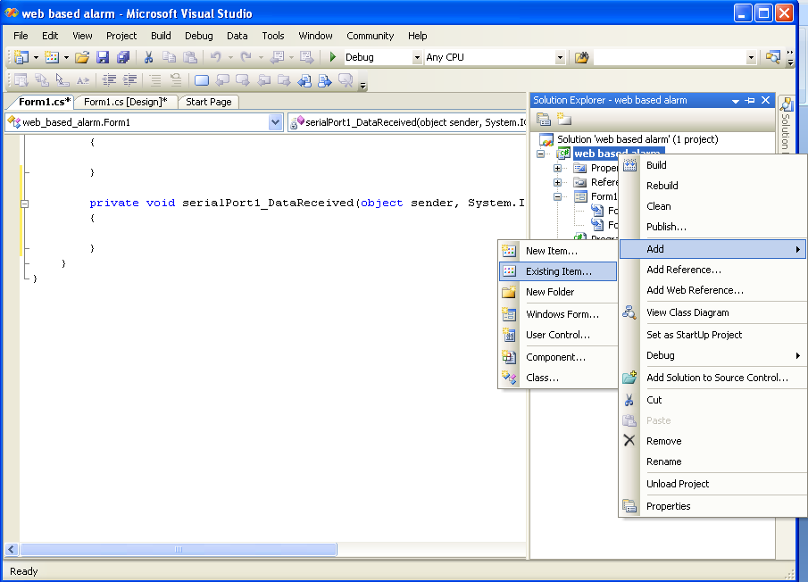

- Select Data files from Type of file .
- Then select your Ms Accesses data file i.e (1.mdb) Add. 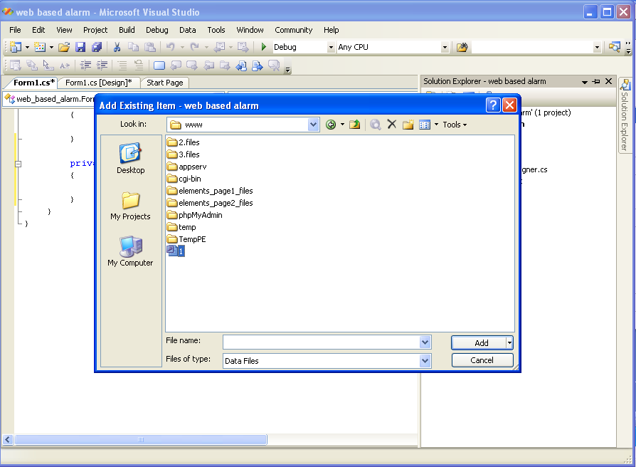

- Select which data base objects do you want in your data set such as (tables, Views).
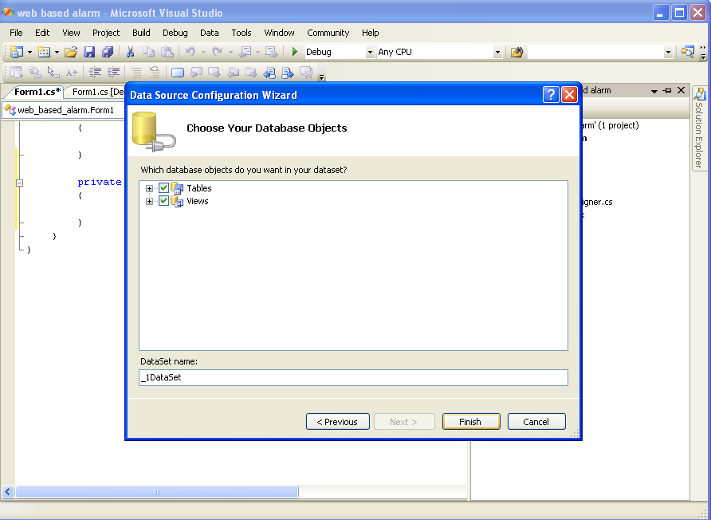
- Click to Finish .
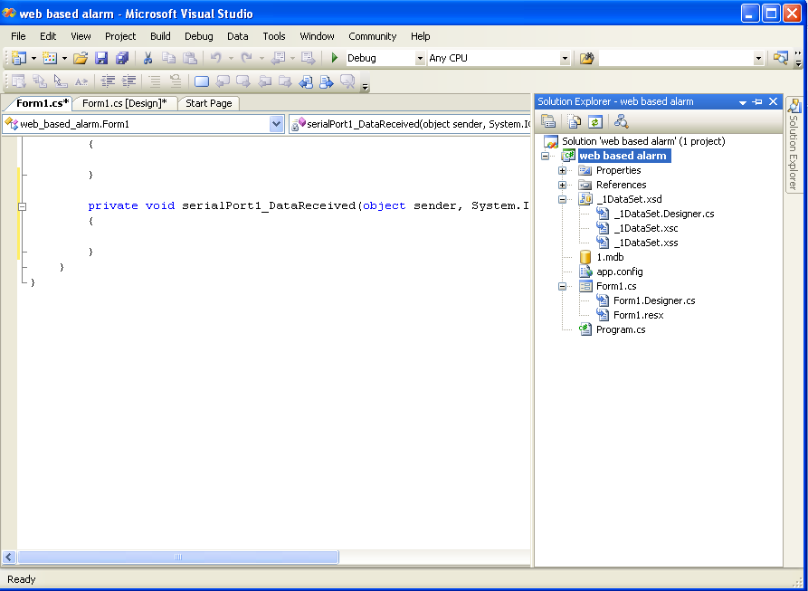
- Now we need to execute C sharp code Click to Debug from Tool bar .
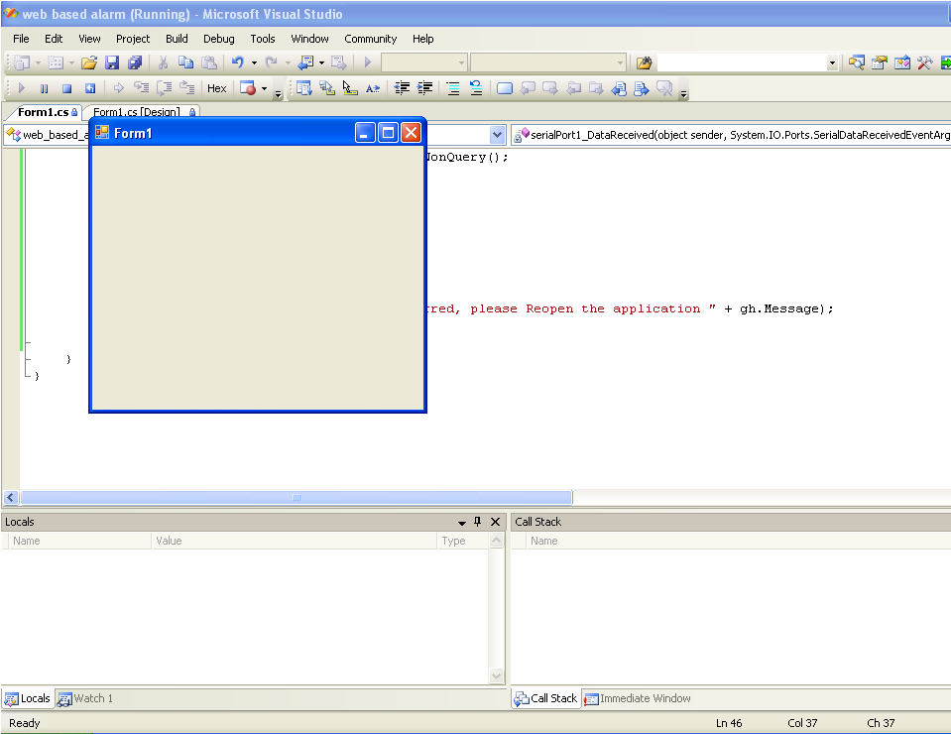
** Now to Read Data from MS-Access Database table in PHP we need write this code :-
<html>
<body>
<?php
$conn=odbc_connect('1','','');
if (!$conn)
{exit("Connection Failed: " . $conn);}
$sql="SELECT * FROM test order by (test.DateTime) ";
$rs=odbc_exec($conn,$sql);
if (!$rs)
{exit("Error in SQL");}
//echo "<table><tr>";
//echo "<th>ID</th>";
//echo "<th>Command</th></tr>";
while (odbc_fetch_row($rs))
{
$id=odbc_result($rs,"ID");
$com=odbc_result($rs,"Command");
//echo "<tr><td>$id</td>";
//echo "<td>$com</td></tr>";

}

//echo $com;
odbc_close($conn);

odbc_close($conn);
//echo "</table>";
?></body>
</html>

CH “5”
SMS

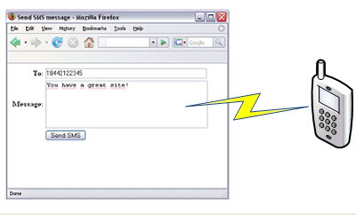

*SMS*
The message help the person who responsible about monitoring .We can send message by tow way:
- send message by using modem .
- send message from website .

**AT command:--
we write the AT command in the code on the microcontroller we tested this part by :
- we prepared code in php scripting language that send the at command to the txt file.
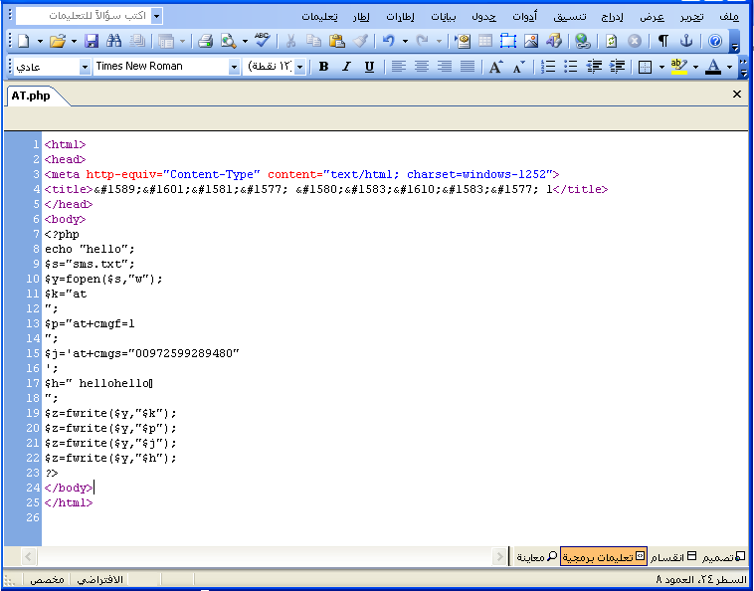

- then we connect modem.
- open hyper terminal.
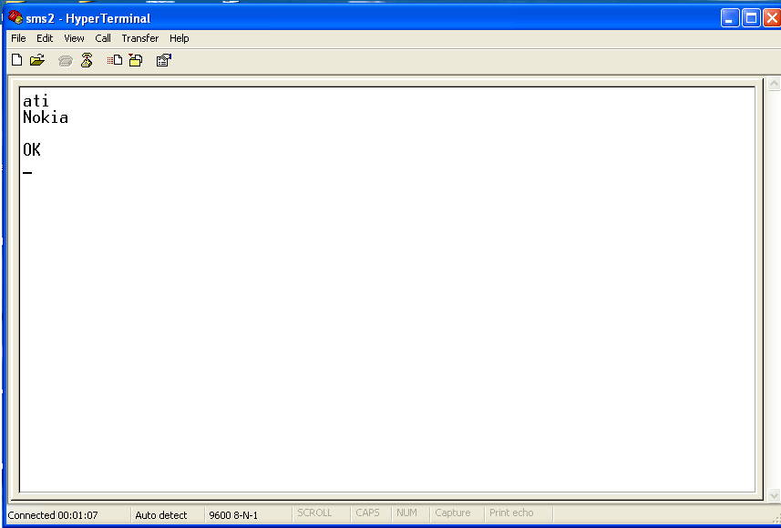

- select transfer send txt file

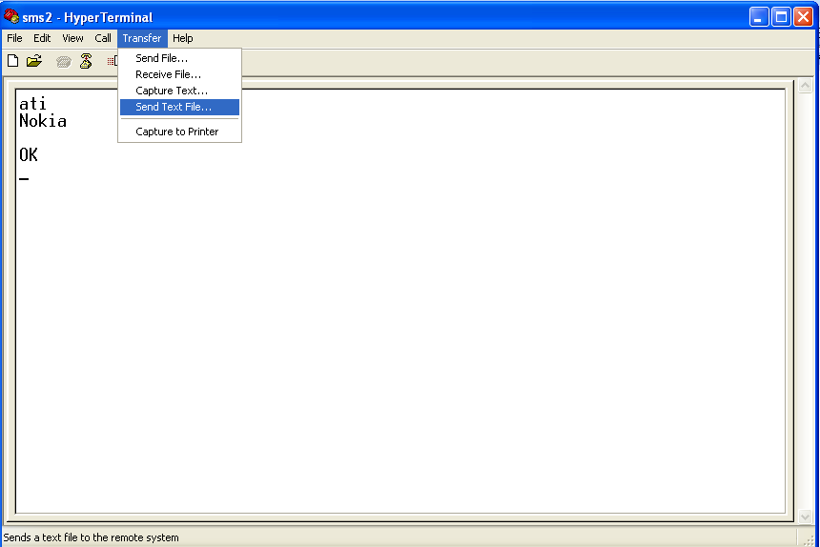
If you do this point you can send message:-
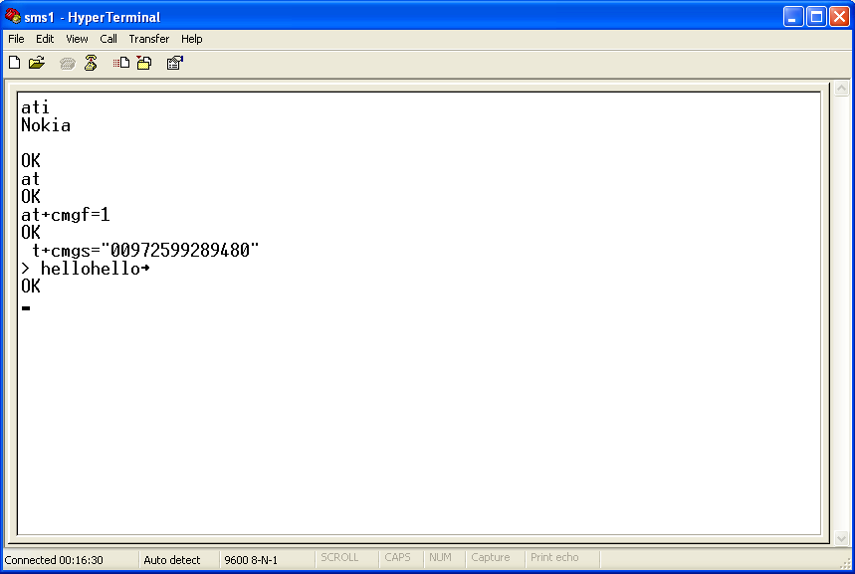

After this we can write AT command on code of pic and only open hyper terminal then you receive the require message.

** Send SMS by using program:--
To do that We need a modern software .we search in the internet and we find program equivalent to this software.
http://www.h-sms.com/index.php.
Headwind SMS Suite is a modern software for sending message using your PC and a mobile phone or GSM modem.
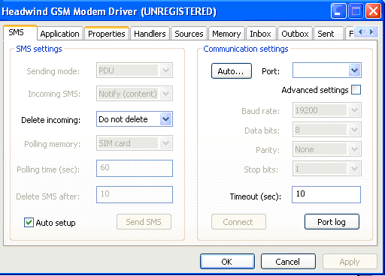
- Put a sample PHP script(file front page) into your www directory:
<?php
// Get address and message
$addr = $_GET['addr'];
$body = $_GET['body'];
// Open Headwind GSM Modem Driver
$hgsmdrv = new COM("HeadwindGSM.SMSDriver");
// Connect to GSM modem
$hgsmdrv->Connect();
// Create message
$sms = new COM("HeadwindGSM.SMSMessage")or die("Unable to create SMS message");
$sms->To = $addr;
$sms->Body = $body;
// Send message
$sms->Send();
//free the objects
$hgsmdrv = null;
$sms = null;
echo "Message '$body' has been sent to '$addr'";
?>
Save this code in your www directory as sms.php, then type in the web browser the following URL (replace '12345678' to your mobile phone number):
http://localhost/sms.php?addr=12345678&body=Hello
The web server must open Headwind GSM Modem Driver and send an SMS to you.
The web server must open Headwind GSM Modem Driver and send an SMS to you

**Send message from web site without using modem:--
The company need to make account visit http://www.palhost-solutions.com/cs/service. The request to send a SMS is made to our server http://srvX.palhost.ps/api/sendsms.php.We need the following variables.
Username : Your API username .
Password :Your API password.
to :Destination phone number.
from : Sender ID.
text :Message Text.
zcode : 5 digits number .
<?php
function sms()
{
$user = "manresc";
$password = "manresc123";
$zcode = "24830";
$baseurl = "http://srv1.palhost.ps";
$text = urlencode("please help me the address is najah university ");
$to = "972599289480";
$from="Man-Resc";
$url="$baseurl/api/sendsms.php?username=$user&password=$password&zcode=$zcode&from=$from&to=$to&text=$text";
// do sendmsg call
$ret = file($url);
//echo($ret[0]);
$send =file($url);
//echo($ret[0]);
$send = split(",",$ret[0]);
if($send[0] == "1")
{
echo("success<br>message ID: ". $send[1]);
}
else
{echo"send massege failed";}
}
sms();
?>
I configured the second server for MY account so now u can use also the following base url:
"http://srv2.palhost-solutions.com"
in PHP :
$baseurl =http://srv2.palhost-solutions.com;

CH “6”
Design Web Site
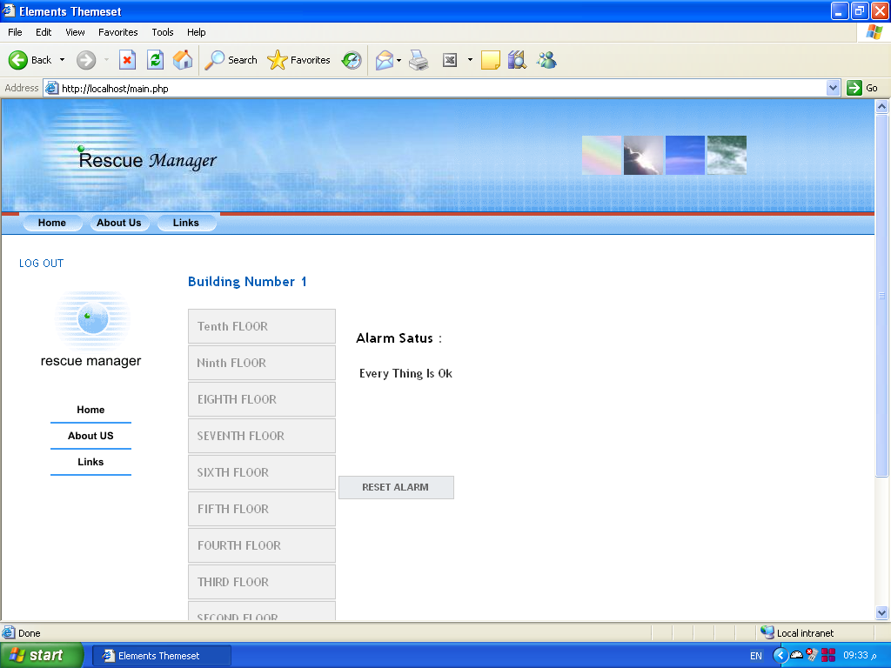

*Manager rescue (web site)*
We design the web site in php language by :
- we should download Microsoft front page.
- Download the apache server .

Main page for monitor

When detect any alarm you see:

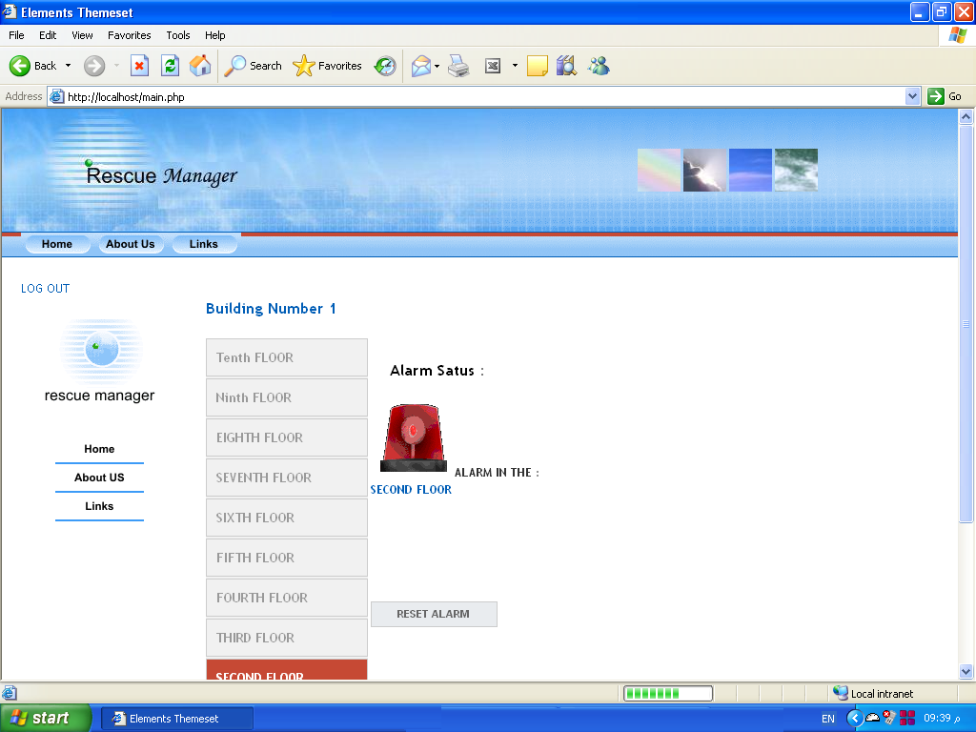

There alarm in first floor:

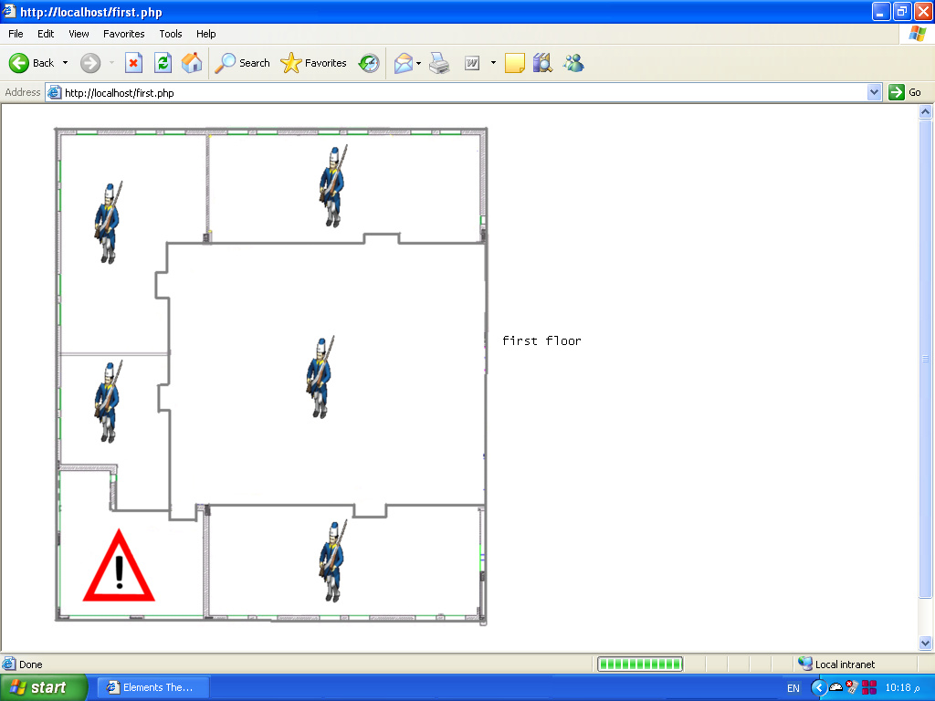

Every think is in the normal state in the second floor:
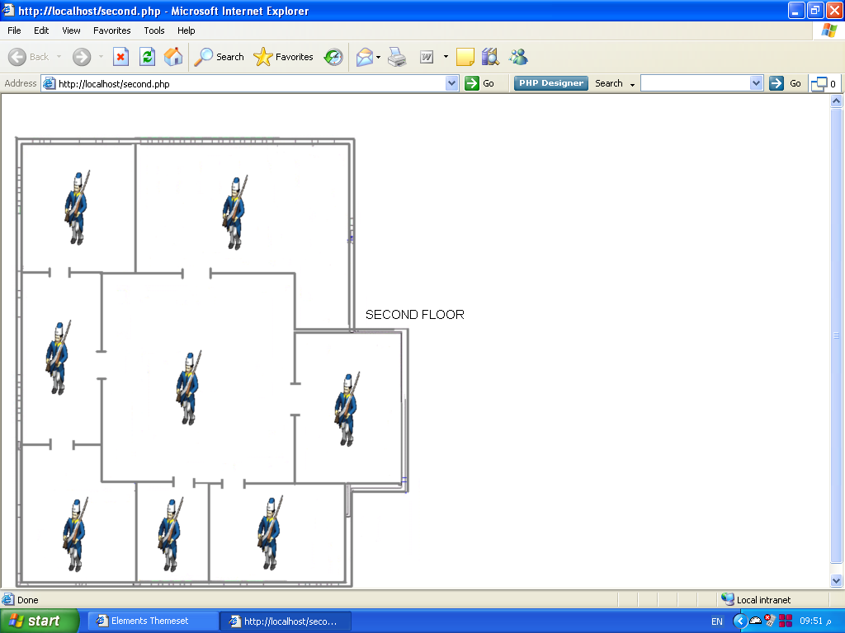

We try to explain how the code of website is working by this algorithm:--

Note:--
The system reset in every 5 minute.
We face big problem by how to make the system reset alarm automatically and this algorithms explain how we solve the problem.

The system send message in three case:
- When the first alarm (when any sensor detect any fire ).
- When you make reset alarm manually.
( the problem was solved).
- When you make reset alarm manually.
( need quick help)
The algorithm explain how sms is sent:

CH “7”
Economical study

** Economical study **
If we take 1$ = 3.5 NIS, then 200$=700NIS, 60$ = 210NIS.
No of equipment | Equipment | Values | Price
1 | GSM Modem | ------- | 200$
1 | Export direct+ | ------- | 60$
1 | PIC16F877 | ------- | 50 NIS
8 | Resister | 3.3 kΩ | 2.5 NIS
5 | Resister | 10 kΩ | 3.75 NIS
1 | Resister | 33 kΩ | 1 NIS
1 | Resister | 1.0 kΩ | 0.5 NIS
1 | Resister | 220 Ω | 0.25 NIS
4 | Zanier Diode | 1N5228B | 12 NIS
1 | Zanier Diode | 1N5817 | 2 NIS
1 | Crystal | 4GH | 3 NIS
1 | Voltage regulator | KA7805 | 5.5 NIS
2 | Led | ------- | 1 NIS
5 | Capacitor | 1.0 µF | 15 NIS
1 | Capacitor | 10 | 2 NIS
3 | Capacitor | 100 nF | 2 NIS
2 | Capacitor | 22 PF | 0.5 NIS
1 | Max232 | ------- | 16 NIS
1 | ULN2003 | ------- | 13 NIS
1 | Relay | 220v | 20 NIS
1 | Cable | serial | 10 NIS
1 | Board | ------- | 5 NIS
Total | --------- | -------- | 1075NIS  307.14$
** table (1): Details of Cost **

No of equipment | Equipment | Price
16 | Resister | 8 NIS
5 | Zanier Diode | 14 NIS
11 | Capacitor | 19.5 NIS
1 | Crystal | 3 NIS
2 | Led | 1 NIS
1 | Voltage regulator | 5.5 NIS
1 | Max232 | 16 NIS
1 | ULN2003 | 13 NIS
1 | PIC16F877 | 50 NIS
1 | Relay | 20 NIS
1 | Cable | 10 NIS
1 | Board | 5 NIS
1 | GSM Modem | 200 $
1 | Export direct+ | 60 $
Total |  | 1075 NIS  307.14 $
** Table (2): In general cost of Alarm System **

CH “8”
Reference

* Reference *
- http://www.oshonsoft.com/picexamples.htm.

- http://www.melabs.com/resources/win_ide.htm#Studio.

- http://www.melabs.com/support/mplab.htm.

- http://forums.clickatell.com/index.php?topic=7799.0.

- http://www.hittconsulting.com/imgs/sxb.pdf.

- http://itp.nyu.edu/physcomp/sensors/Code/ProcessingPHPTextfileClient.

- http://www.w3schools.com/PHP/php_file.asp.

- http://www.lantronix.com/device-networking/embedded-device-servers/?tab=0.

- http://www.lantronix.com/device-networking/embedded-device-servers/xport-direct.html.

- http://www.lantronix.com/device-networking/utilities-tools/com-port-redirector.html.

- http://www.controlglobal.com/industrynews/2005/164.html.

- http://alarmagent.comhttp://ar.wikipedia.org/wiki/%D8%A3%D8%AF%D9%88%D8%A8%D9%8A_%D8%AF%D8%B1%D9%8A%D9%85%D9%88%D9%8A%D9%81%D8%B1/.

- http://www.racoman.com/alarmagent.html.

- http://www.qariya.com/electronics/fusemntr.htm.

- http://www.qariya.com/vb/showthread.php?t=9533.

- http://alarmagent.com/products_services.htm#alarmagent.

- http://holoelectronics.net/modules/xfsection/article.php?articleid=16.

- http://www.i2cchip.com/.

- http://www.lancos.com/webtherm.html.

- http://www.electronics-lab.com/projects/sensors/034/index.html.

- http://www.boosla.com/showArticle.php?Sec=Net&id=33.

- http://www.lantronix.com/support/documentation.html.

CH “9”
Appendix

** Appendix**
** CODE OF PIC IN PIC(ASSEMBLY ) :--
list p=16f877, st=OFF, X=OFF, n=0
errorlevel -302
#include <p16f877.inc>
CONFIG_BODEN_OFF & _CP_OFF & -PWRTE_ON &_WDT_ON & _WRT_ENABLE_ON & _XT_OSC
& _DEBUG_OFF & _CPD_OFF & _DP_OFF
ORG 0x003
Main : Bank0
CALL SET_PORTS
CALL SerialSetup
CLRF INTCON
Z : MOVF PORTD , 1
MOVF f,0
MOVWF PORTB
MOVLW .0
MOVWF CNTR1
MOVLW .8
MOVWF CNTR2
X : RRF f,1
INCF CNTR1,0
MOVWF CNTR1
DECF CNTR2,0
MOVWF CNTR2
BTFSS STATUS,C
GOTO X
BSF PORTE,1
MOVF CNTR1,0
CALL Serial Transmit
BTFSC CNTR2,1
GOTO X
BTFSC CNTR2,2
GOTO X
BTFSC CNTR2,3
GOTO X
BTFSC CNTR2,4
GOTO X
GOTO Z

;--------------------------------------------------------------------------------------------------------

SerialSetup: Bank0
CLRF PORTC
Bank1
BSF TRISC,7
movlw BAUD_CONSTANT
movwf SPBRG
bsf TXSTA<BRGH
bsf TXTA<TXEN
goto RDD
movlw '$'
return
RDD : movf RCREG,W
return

SerialTransmit : Bank0
wtxx : btfsc PIR1,TXIF
goto TRR
clrwdt
goto wtxx
TRR : movwf TXREG
return
testest : Bank0
clrwdt
return

;------------------------------------------------------------------------------

BAUD_CONSTANT EQU 0x19
SAV_PCH EQU 20H
SAV_FSR EQU 21H
SAV_STAT EQU 22H
SAV_W EQU 23H
DL_COUNT EQU 24H
BL_CNTR EQU 25H
rec_char EQU 26H

MIN_COUNT EQU 070H
LDL_COUNT EQU 073H

TMP1 EQU 0X71
CNTR1 EQU 0X72
CNTR2 EQU 0X73

;---------------------------------------------------------------
Bank0 MACRO
bcf STATUS,RP0
bcf STATUS,RP1
ENDM

Bank1 MACRO
bsf STATUS,RP0
bcf STATUS,RP1
ENDM

Bank2 MACRO
bcf STATUS,RP0
bsf STATUS,RP1
ENDM

Bank3 MACRO
bsf STATUS,RP0
bsf STATUS,RP1
ENDM
; ---------------------------------------------------------------------------------------------------------------------------------------------
INTERUPT
;---------------------------------------------------------------------------------------------------------------------------------------------
ORG 0004H
INT_POLL
MOVWF SAV_W
SWAPF STATUS,W
BANK0
BCF STATUS,IRP
MOVEF SAV_STAT
SWAPF FSR_W
MOVWF SAV_FSR
SWAPF PCLATH,W
MOVWF SAV_PCH
BCF PIR1, RCIF

CALL Serialtransmit

noserial;
INT_RETRN
Bank0
BCF STATUS,IRP
SWAPF SAV_PCH,W
MOVWF PCLATH
SWAPF SAV_FSR,W
MOVWF FSR
SWAPF SAV_STAT,W
MOVWF STUTUS
SWAPF SAV_W,F
SWAPF SAV_W,W
RETURN
;----------------------------------------------------------------------------------------------
SET_PORTS

CLRF PORTC
CLRF PORTD
CLRF PORTE
CLRF PORTB

BANK1
CLRF INTCON
CLRF TRISD
MOVLW B'00000000'
MOVWF TRISB
MOVLW B'000'
MOVWF TRISE
MOVLW B'11111111'
MOVWF TRISD
MOVLW B'00000000'
MOVWF TRISC
BANKO

RETURN
end

** CODE OF PIC IN PIC(C ):--
#include "C:\Documents and
Settings\Administrator\Desktop\Monitor+Examples\flower.h"
int x;
float x2;

void main() {

setup_adc_ports(AN0);
setup_adc(ADC_CLOCK_INTERNAL);
setup_psp(PSP_DISABLED);
setup_spi(FALSE);
setup_timer_0(RTCC_INTERNAL);setup_wdt(WDT_2304MS);
setup_timer_1(T1_DISABLED);
setup_timer_2(T2_DISABLED,0,1);
setup_comparator(NC_NC_NC_NC);
setup_vref(FALSE);
while(1)
{

x=read_adc();
x2=x*5.0/255.0;

if (x2>2.7)
{
output_high(pin_B6);
output_high(pin_B5);
output_high(pin_B4);
output_high(pin_B3);
printf("1");
delay_ms(1000);
}
if (!(x>2.7))
{
output_low(pin_B6);
output_low(pin_B5);
output_low(pin_B4);
output_low(pin_B3);
}
if (input (pin_A1))
{
output_high(pin_B6);
output_high(pin_B5);
output_high(pin_B4);
output_high(pin_B3);
printf("2");
delay_ms(1000);

}
restart_wdt();
if (!input (pin_A1))
{
output_low(pin_B6);
output_low(pin_B5);
output_low(pin_B4);
output_low(pin_B3);

}
restart_wdt();

if (input (pin_A2))
{
output_high(pin_B6);
output_high(pin_B5);
output_high(pin_B4);
output_high(pin_B3);
printf("3");
delay_ms(1000);

}
restart_wdt();
if (!input (pin_A2))
{
output_low(pin_B6);
output_low(pin_B5);
output_low(pin_B4);
output_low(pin_B3);

}
restart_wdt();

if (input (pin_A3))
{
output_high(pin_B6);
output_high(pin_B5);
output_high(pin_B4);
output_high(pin_B3);
printf("4");
delay_ms(1000);

}
restart_wdt();
if (!input (pin_A3))
{
output_low(pin_B6);
output_low(pin_B5);
output_low(pin_B4);
output_low(pin_B3);

}
restart_wdt();
if (input (pin_A4))
{
output_high(pin_B6);
output_high(pin_B5);
output_high(pin_B4);
output_high(pin_B3);
printf("5");
delay_ms(1000);

}
if (!input (pin_A4))
{
output_low(pin_B6);
output_low(pin_B5);
output_low(pin_B4);
output_low(pin_B3);

}
restart_wdt();
if (input (pin_A5))
{
output_high(pin_B6);
output_high(pin_B5);
output_high(pin_B4);
output_high(pin_B3);
printf("6");

delay_ms(1000);

}
if (!input (pin_A5))
{
output_low(pin_B6);
output_low(pin_B5);
output_low(pin_B4);
output_low(pin_B3);

}
restart_wdt();
if (input (pin_E0))
{

output_high(pin_B6);
output_high(pin_B5);
output_high(pin_B4);
output_high(pin_B3);
printf("7");
delay_ms(1000);
}
restart_wdt();
if (!input (pin_E0))
{
output_low(pin_B6);
output_low(pin_B5);
output_low(pin_B4);
output_low(pin_B3);

}
restart_wdt();
if (input (pin_E1))
{

output_high(pin_B6);
output_high(pin_B5);
output_high(pin_B4);
output_high(pin_B3);
printf("8");
delay_ms(1000);

}
restart_wdt();
if (!input (pin_E1))
{
output_low(pin_B6);
output_low(pin_B5);
output_low(pin_B4);
output_low(pin_B3);

}
restart_wdt();
if (input (pin_E2))
{
output_high(pin_B6);
output_high(pin_B5);
output_high(pin_B4);
output_high(pin_B3);
printf("9");
delay_ms(1000);

}
restart_wdt();
if (!input (pin_E2))
{
output_low(pin_B6);
output_low(pin_B5);
output_low(pin_B4);
output_low(pin_B3);

}
restart_wdt();
if (input (pin_C1))
{
output_high(pin_B6);
output_high(pin_B5);
output_high(pin_B4);
output_high(pin_B3);
printf("10");
delay_ms(1000);

}
restart_wdt();
if (!input (pin_C1))
{
output_low(pin_B6);
output_low(pin_B5);
output_low(pin_B4);
output_low(pin_B3);

}
restart_wdt();
if (input (pin_C2))
{
output_high(pin_B6);
output_high(pin_B5);
output_high(pin_B4);
output_high(pin_B3);
printf("11");
delay_ms(1000);

}
restart_wdt();

if (!input (pin_C2))
{
output_low(pin_B6);
output_low(pin_B5);
output_low(pin_B4);
output_low(pin_B3);

}
restart_wdt();
if (input (pin_C3))
{
output_high(pin_B6);
output_high(pin_B5);
output_high(pin_B4);
output_high(pin_B3);
printf("12");
delay_ms(1000);

}
restart_wdt();

if (!input (pin_C3))
{
output_low(pin_B6);
output_low(pin_B5);
output_low(pin_B4);
output_low(pin_B3);

}
restart_wdt();
if (input (pin_D0))
{
output_high(pin_B6);
output_high(pin_B5);
output_high(pin_B4);
output_high(pin_B3);
printf("13");
delay_ms(1000);

}
restart_wdt();

if (!input (pin_D0))
{
output_low(pin_B6);
output_low(pin_B5);
output_low(pin_B4);
output_low(pin_B3);

}
restart_wdt();
if (input (pin_D4))
{
output_high(pin_B6);
output_high(pin_B5);
output_high(pin_B4);
output_high(pin_B3);
printf("14");
delay_ms(1000);

}
restart_wdt();

if (!input (pin_D4))
{
output_low(pin_B6);
output_low(pin_B5);
output_low(pin_B4);
output_low(pin_B3);

}
if((!input (pin_A0)) && (!input (pin_A1)) && (!input (pin_A2)) && (!input (pin_A3)) && (!input (pin_A4)) && (!input (pin_A5)) && (!input (pin_E0)) && (!input (pin_E1)) && (!input (pin_E2)) && (!input (pin_C1)) && (!input (pin_C2)) && (!input (pin_C3)) && (!input (pin_D0)) && (!input (pin_D4) ) )
{
printf("null");
delay_ms(1000);
}

restart_wdt();
}

}

Php code
Main .php
<html>
<head>
<title>Elements Themeset</title>
<meta http-equiv="Content-Type" content="text/html; charset=iso-8859-1">
<link rel="stylesheet" href="install.css" type="text/css" />
<script src="clienthint.js"></script>
<object classid="clsid:CFCDAA03-8BE4-11CF-B84B-0020AFBBCCFA" id="real1"
width="0" height="0">
<param name="AUTOSTART" value="0">
<param name="SHUFFLE" value="0">
<param name="PREFETCH" value="0">
<param name="NOLABELS" value="0">
<param name="LOOP" value="0">
<param name="NUMLOOP" value="0">
<param name="CENTER" value="0">
<param name="MAINTAINASPECT" value="0">
<param name="BACKGROUNDCOLOR" value="#000000">
<embed name="real1"
id="real1"
border="0"
controls="play"
height=0
width=0
type="audio/x-pn-realaudio-plugin">
</object>
<script language=JavaScript type="text/javascript">
var fileName = "C:\\AppServ\\www\\sound.wma";
function butPlay_onclick()
{
document.real1.SetSource("file:///C:\\AppServ\\www\\sound.wma");

document.real1.DoPlay();
}
function butStop_onclick()
{
document.real1.DoStop();
}
function window_onload()
{
var plugInInstalled = false;
if (navigator.appName.indexOf("Microsoft") == -1)
{
var plugInCounter;
for (plugInCounter = 0; plugInCounter < navigator.plugins.length;
plugInCounter++)
{
if (navigator.plugins[plugInCounter].name.indexOf("RealPlayer") >= 0)
{
plugInInstalled = true;
break;
}
}
}
else
{
if (real1.readyState == 4)
{
plugInInstalled = true;
}
}
if (plugInInstalled == false)
{
window.location.replace("NoRealPlayerPage.htm");
}
}</script>

<?php
require("file.php");
$taf=date('i');
$saa=fopen("reset.txt","r");
$cond= fgets($saa);
if($cond==0)
{
$tb=date('i');
$pan="time1.txt";
$pss=fopen($pan,"w");
$zss=fwrite($pss,$tb);
fclose($pss);
}
$sa=fopen("time1.txt","r");
$time=fgets($sa);
$tfi=$time+5;
if ($taf==$tfi)
{
$cond=0;
$pan="reset.txt";
$pss=fopen($pan,"w");
$zss=fwrite($pss,$cond);
$reset=1;
}
if($taf!=$tfi)
{$reset=0;
$cond=1;
$pan="reset.txt";
$pss=fopen($pan,"w");
$zss=fwrite($pss,$cond);
fclose($pss);
}
require("file.php");
if($reset==1){
$orders= file($filename);//read file
$number_of_orders= count($orders);
$fpx = fopen("main.inc", "w") or die("Impossible open the file");
$fpy = fopen("temp.inc", "w") or die("Impossible open the file");
if(!$fpx||!$fpy)
{
echo " can not open file";
exit;
}
$str= '<?php $number='.$number_of_orders.'; ?>';
fwrite($fpx,$str);
$str='<?php ?>';
fwrite($fpy,$str);
fclose($fpx);
fclose($fpy);
unset($reset);
}
?>
<?php

require("file.php");
$reset=$_POST["reset"];
if($reset==1)
{
$baseurl = "http://localhost/ends.php";
$url = "$baseurl?reset=$reset";
$ret = file($url);
$ma=1;
$y="test.txt";
$p=fopen($y,"w");
$z=fwrite($p,"$ma");
$orders= file($filename);//read file
$number_of_orders= count($orders);
$fpx = fopen("main.inc", "w") or die("Impossible open the file");
$fpy = fopen("temp.inc", "w") or die("Impossible open the file");
if(!$fpx||!$fpy)
{
echo " can not open file";
exit;
}
$str= '<?php $number='.$number_of_orders.'; ?>';
fwrite($fpx,$str);
$str='<?php ?>';
fwrite($fpy,$str);
fclose($fpx);
fclose($fpy);
unset($reset);
}
?>
<style type="text/css">
<!--
table {
font: 9pt "trebuchet ms", arial, sans-serif
}
body {
color: #333333;/*themecolour6%0;*/
background-color: #FFFFFF;/*themecolour6;*/
background-image: url(elements_page1_files/elements_page1_topstrip.gif);
background-repeat: repeat-x;
font-family: "trebuchet ms", Arial, sans-serif;
font-size: 9pt;
}
p {
margin-top: 0px;
margin-bottom: 0px;
}

#content ul {
color: #333333;/*themecolour6%0;*/
margin-top: 0px;
margin-bottom: 0px;
list-style-image: url(elements_page1_files/elements_page1_bullet.gif);
}

#content blockquote {
margin-top: 0px;
margin-bottom: 0px;
color: #333333
margin-right: 0px;
}

#content ol {
margin-top: 0px;
margin-bottom: 0px;
color: #333333
}
#header {
position: absolute;
height: auto;
width: auto;
left: 0px;
top: 0px;
visibility: visible;
}

#logo {
position: absolute;
height: auto;
width: auto;
left: 10px;
top: 165px;
}

#hnavigation {
position: absolute;
height: auto;
left: 20px;
top: 129px;
z-index: 5;
background-color: #3c9bf7;/*themecolour1;*/
}

#vnavigation {
position: absolute;
height: auto;
width: auto;
left: 20px;
top: 320px;
}

.imageborder {
border-left-width: 1px;
border-left-style: solid;
border-left-color: #FFFFFF;
}

#imagebar {
position: absolute;
height: auto;
width: auto;
right: 60px;
top: 25px;
z-index: 6;
}
.imagebox {
border: 1px solid #FFFFFF;
}

#content {
position: absolute;
height: auto;
width: auto;
left: 20px;
top: 180px;
right: 60px;
}

h1 {
font-size: 16px;
color: #005db6;/*themecolour5;*/
margin-top: 0px;
margin-bottom: 3px;
}
h2 {
font-size: 16px;
color: #000000;/*themecolour6%0;*/
margin-top: 0px;
margin-bottom: 3px;
}
#content a:link {
color: #005db6;/*themecolour5;*/
}
#content a:visited {
color: #999999;
}
#content a:link:hover {
color: #3c9bf7;/*themecolour1;*/
}

.content {
padding-left: 20px;
}
-->
</style>
</head>

<body leftmargin="0" topmargin="0" onload="return window_onload()">
<noembed>
<h2>This Page requires a browser supporting Plug-ins or ActiveX controls</h2>
</noembed>
<div id="header">
<table width="100%" cellspacing="0" cellpadding="0">
<tr>
<td width="520" valign="top"><img src="elements_page1_files/elements_page1_heading.jpg" editor="Webstyle4" moduleid="new (Project)\elements_page1_heading.xws" border="0" /></td>
<td width="100%" align="center">
<table cellspacing="3" cellpadding="0">
<tr>
<td valign="top"><img src="elements_page1_files/elements_page1_image1.jpg" editor="Webstyle4" moduleid="new (Project)\elements_page1_image1.xws" border="0" /></td>
<td valign="top"><img src="elements_page1_files/elements_page1_image2.jpg" editor="Webstyle4" moduleid="new (Project)\elements_page1_image2.xws" border="0" /></td>
<td valign="top"><img src="elements_page1_files/elements_page1_image3.jpg" editor="Webstyle4" moduleid="new (Project)\elements_page1_image3.xws" border="0" /></td>
<td valign="top"><img src="elements_page1_files/elements_page1_image4.jpg" editor="Webstyle4" moduleid="new (Project)\elements_page1_image4.xws" border="0" /></td>
</tr>
</table> </td>
</tr>
</table>
</div>
<div id="hnavigation">
<script Webstyle4>document.write('<scr'+'ipt src="elements_page1_files/xaramenu.js">'+'</scr'+'ipt>');document.write('<scr'+'ipt src="elements_page1_files/elements_page1_hnavbar.js">'+'</scr'+'ipt>');/*img src="elements_page1_files/elements_page1_hnavbar.gif" moduleid="new (Project)\elements_page1_hnavbar_off.xws"*/</script>
</div>
<div id="image"></div>
<div id="image2"></div>
<div id="image3"></div>

<div id="content">
<table border="0" cellspacing="0" cellpadding="0">
<tr><a href="index.php">LOG OUT</a>
<td valign="left"> <p><img src="elements_page1_files/elements_page1_logo.gif" editor="Webstyle4" moduleid="new (Project)\elements_page1_logo.xws" border="0" /></p>
<p align="center">
<script Webstyle4>document.write('<scr'+'ipt src="elements_page1_files/xaramenu.js">'+'</scr'+'ipt>');document.write('<scr'+'ipt src="elements_page1_files/elements_page1_vnavbar.js">'+'</scr'+'ipt>');/*img src="elements_page1_files/elements_page1_vnavbar.gif" moduleid="new (Project)\elements_page1_vnavbar_off.xws"*/</script>

</p></td><td>&nbsp;</td> <td>&nbsp;</td>
<td valign="top" class="content">
<h1>Building Number 1</h1><br>
<P> <div id="stepbar">
<script type=text/javascript>checkfile( )</script>
<?php
/*** work ***/
// while(1) {
echo "<script type=text/javascript>checkfile( )</script>";

//}
?>
<span id="txtHint"></span>
<!-- -->
</div></p>
<p><h2><br>&nbsp;&nbsp;&nbsp; <b>Alarm Satus :<b></b></h2> </p><p>&nbsp;&nbsp;
</p><p>&nbsp;&nbsp;<span id="set"></span></p>
<p>&nbsp;&nbsp;</p>
<p>&nbsp;&nbsp;</p>
<p>&nbsp;&nbsp;</p>
<p>&nbsp;&nbsp;</p>
<p>&nbsp;&nbsp;</p>
<p>&nbsp;&nbsp;</p>
<form action="<?php echo $PHP_SELF ?>" method="post">
<input class="button" type="submit" name="next" value=" RESET ALARM "/></P>
<input type=hidden name=reset value=1>
<td>&nbsp;</td>
</form>
</td>
</tr>
</table>
<META HTTP-EQUIV='Refresh' Content=2;URL='main.php'>
</div>
</body>
</html>

Gethint.php :-
<?php
$zz=0;
function action(){
require("main.inc");//$number
require("file.php");//file name
$setalarm=0;

$orders= file($filename);//read file
$number_of_orders = count($orders);

if($number_of_orders>=$number)
{
$def=$number_of_orders-$number;//number of alarms

for ($i=0; $i<$number_of_orders; $i++)
{
$line = explode( "\t", $orders[$i] );

$set[]=$line[3];

}
/*******************/

$ss=count($set);
$dd=$def;
//********************************* conserve *********************************************//
$tt=$ss-1;
while($dd){
$xx=($set[$tt]-1)/6;
$fval[]=$set[$tt];
$xx++;$xx=(int)($xx);
$sd[]=$xx;//echo $xx;
$tt--;
$dd--;
}
/*******************/

$strx[9]="<div class=step-off>First FLOOR</div>";
$strx[8]="<div class=step-off>SECOND FLOOR</div>";
$strx[7]="<div class=step-off>THIRD FLOOR</div>";
$strx[6]="<div class=step-off>FOURTH FLOOR</div>";
$strx[5]="<div class=step-off>FIFTH FLOOR</div>";
$strx[4]="<div class=step-off>SIXTH FLOOR</div>";
$strx[3]="<div class=step-off>SEVENTH FLOOR</div>";
$strx[2]="<div class=step-off>EIGHTH FLOOR</div>";
$strx[1]="<div class=step-off>Ninth FLOOR</div>";
$strx[0]="<div class=step-off>Tenth FLOOR</div>";

// check floor//
$chk=1;
for($i=0;$i<$def;$i++)if($sd[$i]==3&&$chk){
$chk=0;$setalarm=1;$zz=8;
$strx[8]="<div class=step-on>THIRD FLOOR</div>"; $second1=1;
}
$chk=1;
for($i=0;$i<$def;$i++)if($sd[$i]==2&&$chk)
{
$chk=0;$setalarm=1;$zz=8;

$strx[8]="<div class=step-on>SECOND FLOOR</div>";$second1=1;
}

$chk=1;
for($i=0;$i<$def;$i++)if($sd[$i]==1&&$chk)
{
$chk=0;$setalarm=1;$zz=9;
$strx[9]="<div class=step-on>First FLOOR</div>";$first1=1;
}
}

$res=$strx[0];

for($i=1;$i<10;$i++)$res=$res.$strx[$i];
if($setalarm==1){
$res=$res."<input type=hidden name=alarm id=alarm value=1><input type=hidden name=xx id=xx value=".$zz."><input type=hidden name=first id=first value=$first1><input type=hidden name=second id=second value=$second1>";
$trt=count($fval);
if($first1==1||$second1==1){
$ts="<?php \n";
for($i=0;$i<$trt;$i++){
$fval[$i]=(int)$fval[$i];
$ts=$ts.'$x['.$i.']='.$fval[$i].';'."\n";
}
$ts=$ts."?>";

$fp = fopen("temp.inc", "w+") or die("Impossible open the file");
if(!$fp)
{
echo " can not open file";
exit;
}
fwrite($fp,$ts);
fclose($fp);

}

}
else{
$jj="<input type=hidden name=xx id=xx value=none><input type=hidden name=first id=first value=$first1><input type=hidden name=second id=second value=$second2>";
$res=$res."<input type=hidden name=alarm id=alarm value=0>".$jj;

}
//end main if

//output the response
//include("2.php");

$response=$res;
echo $response;
unset($res);

}
action();
?>

<html>
<body>
<?php
$conn=odbc_connect('1','','');
if (!$conn)
{exit("Connection Failed: " . $conn);}
$sql="SELECT * FROM test order by (test.DateTime) ";
$rs=odbc_exec($conn,$sql);
if (!$rs)
{exit("Error in SQL");}
//echo "<table><tr>";
//echo "<th>ID</th>";
//echo "<th>Command</th></tr>";
while (odbc_fetch_row($rs))
{
$id=odbc_result($rs,"ID");
$com=odbc_result($rs,"Command");

}

odbc_close($conn);

odbc_close($conn);
//echo "</table>";
?></body>
</html>

<html><body>
<link rel="stylesheet" href="install.css" type="text/css" />
<?php
if($com=="1")$x=1;
if($com=="2")$x=2;
if($com=="3")$x=3;
if($com=="4")$x=4;
if($com=="5")$x=5;
if($com=="6")$x=6;
if($com=="7")$x=7;
if($com=="8")$x=8;
if($com=="9")$x=9;
if($com=="10")$x=10;
if($com=="11")$x=11;
if($com=="12")$x=12;
if($com=="13")$x=13;
if($com=="14")$x=14;
if($x==1||$x==2||$x==3||$x==4||$x==5||$x==6||$x==7||$x==8||$x==9||$x==10||$x==11||$x==12||$x==13||$x==14)
{
$s=1;
$gg="ff.txt";
$p=fopen($gg,"w");
$z=fwrite($p,"$s");
fclose($p);
}
else
{
$fr=o;
$kk="ff.txt";
$n=fopen($kk,"w");
$m=fwrite($n,"$fr");
fclose($n);
}
$ma = fopen("test.txt", "r") ;
$dod= fgets($ma);

if(($x==1||$x==2||$x==3||$x==4||$x==5||$x==6||$x==7||$x==8||$x==9||$x==10)&&($dod==1))
{
$baseurl = "http://localhost/write.php";
$url = "$baseurl?x=$x";
$ret = file($url);
}

//echo " <br> x=".$x."<BR>";
//echo $next."<br>";
$time=date('h:i:s');
$date=date('m/d/y');
// echo $time;
// echo "<br>".$date;
require("file.php");//file name
/**** opening file ********/
if (file_exists($filename)) {
// echo "The file $filename exists";
$fp = fopen($filename, "a+") or die("Impossible open the file");
if(!$fp)
{
//echo " can not open file";
exit;
}
$orders= file($filename);
// to count number of records
$number_of_orders = count($orders);
if ($number_of_orders == 0)
{
// echo "<p><strong>no data in the file </strong></p>";
}
for ($i=0; $i<$number_of_orders; $i++)
{
$line = explode( "\t", $orders[$i] );
$num=$line[0];

}

$num++;
/****************************************************************************************/
} else {
/****************************************************************************************/
$fp = fopen($filename,"w+") or die("Impossible open the file");
if(!$fp)
{

exit;
}
$num=1;
/*******************************************************/
}
/**** end open file *****/
if(isset($com)){
$str=$num."\t".$date."\t".$time."\t".$x."\n";
fwrite($fp,$str);
fclose($fp);

}
unset($com);
?>

</body></html>

Write.php ;-
<?php
if(isset($_REQUEST["x"]))
{
$f=$_REQUEST["x"];
}
if($f==1||$f==2 ||$f==3 ||$f==4||$f==5||$f==6||$f==7||$f==8||$f==9||$f==10||$f==11||$f==12||$f==13||$f==14)
{
$mi=0;
$y="test.txt";
$p=fopen($y,"w");
$z=fwrite($p,"$mi");
$user = "manresc";
$password = "manresc123";
$zcode = "24830";
$baseurl = "http://srv2.palhost-solutions.com";
$text = urlencode("help! fire in engineering faculty");
$to = "972522511815";
$from="Man-Resc";
$url = "$baseurl/api/sendsms.php?username=$user&password=$password&zcode=$zcode&from=$from&to=$to&text=$text";
//do sendmsg call
$ret = file($url);
echo($ret[0]);
$send =file($url);
echo($ret[0]);
$send = split(",",$ret[0]);
if($send[0] == "1")
{

echo("success<br>message ID: ". $send[1]);}
else
{
echo"send massege failed";
}}
?>
**Some picture of Hardware :--

