Comparison Between South-North and East-West PV Installation in terms of the Harmonics effect on the network

Prepared By:
Eng. Baraa Zaghloul
Eng. Osama Shirri
Eng. Rashad Alawneh
Eng. Ahmad Ibrahim

Supervisor: Dr. Kamel Sobhi

2022-2023

Graduation Project 2
Table of Contents
Abstract 6
Chapter 1 : Introduction 8
1.1 Motivation 8
1.2 Aims and Objectives 8
Chapter 2 : Standards, Constraints and Earlier Coursework 9
2.1 Standards 9
2.2 Constraints 10
2.3 Earlier Coursework 11
Chapter 3 : Literature Review 12
3.1 Arrangements and orientations 12
Chapter 4 : Alternative solutions 15
Chapter 5 : Methodology 16
5.1 PV Array 16
5.2 Boost-Converter 18
5.2.1 Continuous conduction mode 19
5.2.2 Discontinuous conduction mode 21
5.2.3 MPPT Control using Perturb & Observe (P&O) method 21
5.3 Three phase inverter 23
5.3.1 VSC control 25
5.3.1.1 d-q control 25
5.4 LC Filter 29
5.5 Design and Results 30
5.5.1 Simulation design 30
5.5.2 Simulation results and discussion 33
5.6 Injection of PV harmonics 58
5.6.1 Sungrow inverter 59
5.6.2 Generated harmonics form PV 59
5.6.3 Total harmonic distortion for the network 60
5.6.4 Buses voltages 68
5.6.5 Power losses in the network 68
Chapter 6 : Conclusion and recommendations 71
References: 72
Appendix A: 74
Appendix B: 75
Appendix C: 84

List of figures
Figure ‎1.1: Diagrams of a standard PV array arrangement (S-shape) and an M-shape PV array arrangement (M-shape) [1]. 5
Figure ‎1.2: generation of power using different PV arrangements 5
Figure ‎1.3: PV system model 6
Figure ‎3.1: Irradiation for different installation methods. 11
Figure ‎3.2: Power output and efficiency versus tilt angle. [6] 12
Figure ‎3.3: tilt angles of the PV module in Perlis, Malaysia. [6] 12
Figure ‎3.4: Minimum, maximum and average monthly global solar irradiance. [7] 13
Figure ‎5.1: Grid connected PV system. 15
Figure ‎5.2: Graph plotting current versus voltage for different irradiance levels. 16
Figure ‎5.3: graph plotting power versus voltage for different irradiance levels. 17
Figure ‎5.4: block diagram of Boost converter in solar system. 17
Figure ‎5.5: Schematic of boost converter. [10] 18
Figure ‎5.6: Mode-1 of boost converter during $Ton$. [12] 18
Figure ‎5.7: Mode-2 of boost converter during $Toff$. [12] 19
Figure ‎5.8: Waveforms at continuous conduction mode. [12] 19
Figure ‎5.9:Waveforms at discontinuous conduction mode. [12] 20
Figure ‎5.10: Block diagram of MPPT controller. 21
Figure ‎5.11: Perturb & Observe method flowchart. [16] 21
Figure ‎5.12: Slope (dP/dV) variation. [17] 22
Figure ‎5.13: 3-level inverter using IGBTs and switching table. [16] 23
Figure ‎5.14: VSC main controller. 24
Figure ‎5.15: Vector control’s three frames the abc frame and α–β frame and d-q frame. [19] 25
Figure ‎5.16: Equivalent circuit from the inverter to the load. 26
Figure ‎5.17: Grid connected LC filter. 28
Figure ‎5.18: Grid connected PV system. 29
Figure ‎5.19: MPPT Control. 30
Figure ‎5.20: VSC Controller. 31
Figure ‎5.21: Utility grid. 31
Figure ‎5.22: Tilt-15-AZ-EW-system. 32
Figure ‎5.23: Tilt-30- SN optimal-system. 40
Figure ‎5.24: Two axis tracking system. 48
Figure ‎5.25: comparasion of THD for each installation through sunrise and sunset for each season 56
Figure ‎5.26: IEEE 15-bus network. 57
Figure ‎5.27: Harmonic source. 58
Figure ‎5.28: Month 1 third hour THD(i) in percentage 59
Figure ‎5.29: Month 1 third hour THD(v) in percentage. 59
Figure ‎5.30: Month 1 fourth hour THD(i) in percentage. 60
Figure ‎5.31: Month 1 fourth hour THD(v) in percentage. 60
Figure ‎5.32: Month4 third hour THD(i) in percentage. 61
Figure ‎5.33: Month4 third hour THD(v) in percentage 61
Figure ‎5.34: Month4 fourth hour THD(i) in percentage. 62
Figure ‎5.35: Month4 fourth hour THD(v) in percentage. 62
Figure ‎5.36: Month7 third hour THD(i) in percentage. 63
Figure ‎5.37: Month7 third hour THD(v) in percentage 63
Figure ‎5.38: Month7 fourth hour THD(i) in percentage 64
Figure ‎5.39:Month7 fourth hour THD(v) in percentage 64
Figure ‎5.40: Month10 third hour THD(i) in percentage 65
Figure ‎5.41: Month10 third hour THD(v) in percentage 65
Figure ‎5.42: Month10 fourth hour THD(i) in percentage 66
Figure ‎5.43: Month10 fourth hour THD(v) in percentage 66
Figure ‎5.44: Power losses for each season. 67
Figure ‎5.45: Power losses for one year. 68

List of tables
Table ‎2.1: The standard distortion limit for each odd harmonic 9
Table ‎5.1: PV Array specifications. 16
Table ‎5.2: Boost converter parameters used in Simulink. 31
Table ‎5.3: East-West system harmonic orders distortion. 34
Table ‎5.4: South-North system harmonic orders distortion. 42
Table ‎5.5: Two-axis tracking system harmonic orders distortion. 50
Table ‎5.6: third sun rise hour 60
Table ‎5.7: first sunset hour 61
Table ‎5.8: third sunrise hour. 62
Table ‎5.9: first sunset hour. 63
Table ‎5.10: Third sunrise hour 64
Table ‎5.11: First sunset hour. 65
Table ‎5.12: Third sunrise hour 66
Table ‎5.13: First sunset hour 67
Table ‎5.14: Power losses values for each season. 69
Table ‎5.15:Values of power losses for one year. 70
Table A.1: Inverter harmonics percentage. [20]……………………………………………………………..............74

Table B.1: Harmonic currents for EW system (first season). 75
Table B.2: Harmonic currents for EW system (second season). 75
Table B.3: Harmonic currents for EW system (third season). 76
Table B.4: Harmonic currents for EW system (fourth season). 76
Table B.5: Harmonic currents for SN-30 system (first season). 77
Table B.6:Harmonic currents for SN-30 system (second season). 77
Table B.7:Harmonic currents for SN-30 system (Third season). 78
Table B.8:Harmonic currents for SN-30 system (fourth season). 78
Table B.9:Harmonic currents for SN-20 system (first season). 79
Table B.10:Harmonic currents for SN-20 system (second season). 80
Table B.11:Harmonic currents for SN-20 system (third season). 80
Table B.12:Harmonic currents for SN-20 system (fourth season). 81
Table B.13:Harmonic currents for SN-15 system (first season). 81
Table B.14:Harmonic currents for SN-15 system (second season). 82
Table B.15: Harmonic currents for SN-15 system (third season). 82
Table B.16: Harmonic currents for SN-15 system (fourth season). 83

Table C.1: Third sunrise IH5 85
Table C.2: first sunset IH5 85
Table C.3: Third sunrise IH7 86
Table C.4: first sunset IH7 86
Table C.5: Third sunrise IH11 87
Table C.6: first sunset IH11 87
Table C.7: Third sunrise IH13 88
Table C.8: first sunset IH13 89
Table C.9:Third sunrise IH5 89
Table C.10:first sunset IH5 90
Table C.11: Third sunrise IH7 90
Table C. 12: first sunset IH7 91
Table C.13: Third sunrise IH11 91
Table C.14: first sunset IH11 92
Table C.15:Third sunrise IH13 93
Table C.16:first sunset IH13 93
Table C.17: Third sunrise IH5 94
Table C.18: first sunset IH5 94
Table C.19: Third sunrise IH7 95
Table C.20: first sunset IH7 95
Table C.21:Third sunrise IH11 96
Table C.22: first sunset IH11 97
Table C.23:Third sunrise IH13 97
Table C.24:first sunset IH13 98
Table C.25:Third sunrise IH5 98
Table C.26:first sunset IH5 99
Table C.27:Third sunrise IH7 99
Table C.28: first sunset IH7 100
Table C.29: Third sunrise IH11 101
Table C.30: first sunset IH11 101
Table C.31:Third sunrise IH13 102
Table C.32: first sunset IH13 102

Abstract
The growth in global renewable energy generation has increased drastically to more than 2351 GW last years. Most of the renewable energy generation is from wind and solar energy with solar energy continues to dominate the generation. Adjusting and optimizing the energy structure and systems is a necessity to protect the environment and increase power generation. For the PV system, there are two ways to install the PV arrays: -one called M-shape (East-west) and the other called S-shape (South-North) as shown in figure 1.
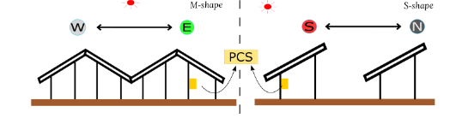
Figure ‎1.1: Diagrams of a standard PV array arrangement (S-shape) and an M-shape PV array arrangement (M-shape) [1].
The amount of power generated from the two arrangements is shown in figure 2. As the graph shows if panels are mounted according to the M-shape, the output is greater in the morning and evening than that generated from the S-shape arrangement
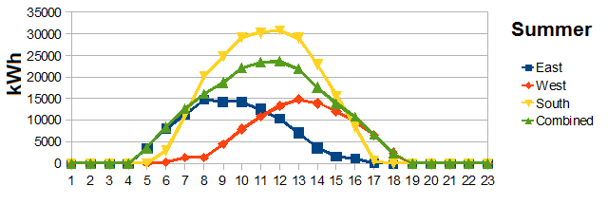
Figure ‎1.2: generation of power using different PV arrangements
The fact that M-shape arrangement of the PV arrays produce more power in the morning and evening will be studied in details to investigate if this can help in reducing the harmonics injected to the grid from the PV source during these times and compare the results with the harmonics injected by the S-shape arrangement of the PV system. It is well known that Total Harmonic Distortion (THD) at the output of the PV source at the morning and evening will be very high in the S-shape arrangement due to the low power generated.
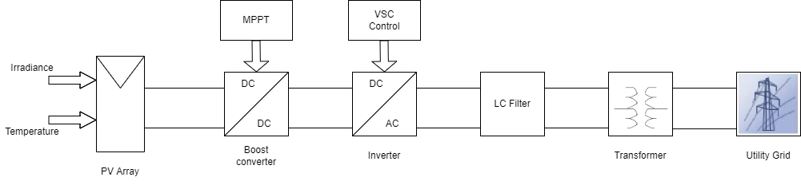
The project will include an accurate modelling of the whole PV system including the PV model, DC-DC converter and the inverter as shown in figure 3.
Figure ‎1.3: PV system model
Then, irradiation data for both the M-shape and S-shape PV arrangements obtained from field will be fed to the system and the harmonic content at different time will be measured.
And these harmonics from the different PV arrangements will be injected in IEEE network to simulate what will happen to the network due to these harmonics.

: Introduction

Motivation

Energy systems around the world aim to produce energy in a green manner. There is wind energy and solar energy, which is used more widely because it is an inexhaustible source of energy, and this rapid change in energy production has implications for electrical systems, and now that these solar PV systems are part of the grid as an energy distributor With centralized power plants, this creates additional challenges for maintaining power quality (PQ).[2]
The harmonic distortion attracts many researchers to find solutions and improve the system harmonics,[3] and this problem is due to the presence of nonlinear power electronics based components and loads||. This harmonics can be described as AC voltages and currents with frequencies that are integer multiples of the fundamental frequency[4].
One of the problems that these harmonics may cause is the high temperature of the electrical parts like the circuit breakers, as well as a reduction in the power factor.

1.2 Aims and Objectives

The aim of this research is to make a comparison between the different installation methods (M-shape and S-shape) to different degrees and to find the total harmonic distortion (THD) which is the result of each installation method.
As these readings used in this research were taken from the field and placed in a simulation to reach logical and realistic results.

: Standards, Constraints and Earlier Coursework

2.1 Standards
The standards that are going to be followed and considered are based on or inspired by The IEEE standards, upcoming is the standards that are related to this project.

IEEE Std 929-2000: “Recommended Practice for Utility Interface of Photovoltaic (PV)”. It is stated in this standard that there should be a match in the operation characteristics of the small PV systems and the Utility grid that it’s connected on.
This is originally to avoid or minimize the nuisance tripping of that said system. which can be achieved through out choosing an operating window that guarantees the capability of the PV system to run at values similar to those normally experienced on the interconnected utility grid. The recommended operating window is specified as follows:
For a base of 120 V, the voltage for the PV system must be in the range of 106-132 V. Which is about 88-110% of the nominal voltage of the grid. This makes trip points at both 105V and 133V. In addition, it stated that there should regulations for the waveform distortion. The output of the PV system has to have low current distortion in order to guarantee the safety of the other equipment that are connected to said utility grid.[5] This standard requires the following:
The output of the PV system has to comply to “Clause 10 of IEEE Std 519-1992”, this will define the acceptable distortion levels for the system which are as follows:
The Total Harmonic Distortion (THD) must be less than 5% of the fundamental frequency of the current at rated inverter output. The harmonics must be limited to the percentages listed in the following Table 2.1.
Distortion limits as recommended in IEEE Std 519-1992 for six-pulse converters odd harmonics Distortion limit are a percentage of the fundamental frequency current at full system output. Even harmonics in these ranges shall be <25% of the odd harmonic limits listed.
Table ‎2.1: The standard distortion limit for each odd harmonic
Odd Harmonics | Distortion Limit
3rd -9th | <4.0%
11th -15th | <2.0%
17th -21st | <1.5%
23rd -33rd | <0.6%
Above 33rd | <0.3%

Another standard that we are concerned with in this issue is the power factor recommended values. It is recommended that the power factor of the PV system has to be greater than 0.85 either leading or lagging when the output is 10% of the rated Power of the PV system. Also, the PV inverter normally run at values close to unity.[5]

2.2 Constraints
The project’s execution went successfully in the end, the operation had had it fair share of minor difficulties most of which had been the majority of the issues have been handled well and overcome and most of them aren’t worth mentioning. But some of them had to be addressed to ensure complete awareness of the projects’ circumstances.
The first and most impactful constraint is the constraint of Time limitation, the project tasks had to be completed across a 4-month semester packed with other assignments for different courses, as a result of that more effort had to be done in order to finish the tasks in a hurry which might result in minor human errors. In addition to that the study samples had to be reduced to finish faster with most accurate results.
The second constraint is the power limitation due to the lack of time and data-collecting related issues we had to resort to a relatively smaller power system which can lead to inaccurate representations of the actual PV systems

2.3 Earlier Coursework
A lot of the courses that are presented in our program have contributed to our progress in the project the following courses aided in the operation of designing and/or studying the results of the project, the courses are related to the main concepts of the study.
Advanced Electrical engineering courses that introduced the new terms and concepts that were crucial in this study, most importantly the signals and systems knowledge that was introduced in the ‘Systems and Signal Analysis’ course this course was the gateway for the whole project, it enabled the students to better understand the different types of electrical signals and introduced further properties that can be studied, the most important of which was the harmonics. It also helped when dealing with filters.
Practical Applications of the electrical and electronic elements: a vital course that was a cornerstone in this project was the ‘Power Electronics’ course, it introduced the most important system in the PV systems, the Inverter, and the course also aided in better understanding the relationships between the different components of the project.
The software that was used in the project is better explained and more utilized in the ‘Control of electrical machines course’ this course has better explained the control methods that are used in the project. It mainly helped and provided new and useful skills that were used when operating with the MATLAB software group. Most importantly The Simulink Program.
Additional skills and language related courses: such as programming languages like C++ that was studied in ‘computer programming’ course.
Optional courses have also further enriched the understanding of some concepts for instance ‘Special Topics in Power’ explained inverters and converters in details making it possible to be able to design the suitable system for any application, ‘Electrical Systems Modelling’ helped in getting the required and essential MATLAB software skills.

: Literature Review

This chapter discusses the literature review of photovoltaic systems in different installation methods and orientations.

3.1 Arrangements and orientations
The irradiation of the two installation methods, M-shape (East-West) and S-Shape (South-North) shown in Figure 3.1. The figure shows that the irradiation for M-Shape is better in earlier morning and evening.
Figure ‎3.1: Irradiation for different installation methods.
Also, the performance of a photovoltaic (PV) is highly influenced by its orientation and its tilt angle with the horizontal, since both the orientation and tilt angle change the amount of solar radiation reaching the surface of the PV module.
Many Papers compared different tilt angles and showed that the solar irradiance that falls on the module surface is affected. Figure 3.2 shows the output power of PV module at different tilt angles. The highest power output of 57 W and the maximum efficiency of 15% occur near a 15-degree tilt angle in outdoor conditions. The effect of module tilt change on power output and efficiency and found that a drop occurs after increasing the tilt angle over 15-degree.[6]

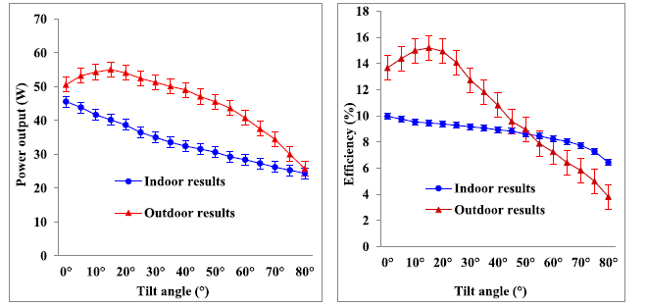
Figure ‎3.2: Power output and efficiency versus tilt angle. [6]
Another study in Perlis, Malaysia, shows a PV with different tilt angles throughout the year as shown in Figure 3.3. Positive angles indicate the PV module surface facing south, negative angles indicate the PV module surface facing north, and zero indicates it is on a horizontal surface.

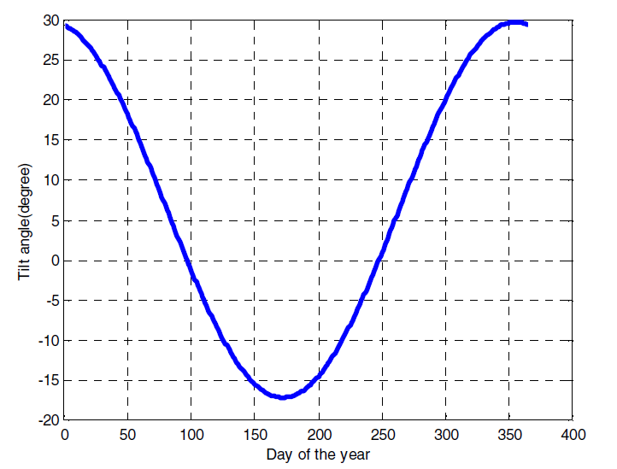
Figure ‎3.3: tilt angles of the PV module in Perlis, Malaysia. [6]
When the tilt angles of the PV module are positive (the 1st of January to the 6th of April and the 6th of September to the 31st of December), the global solar irradiance around 1038 $W/m^{2}$ to 1120$W/m^{2}$ , the minimum and maximum global solar irradiance happen on the 6th of September and on the 1st of January, respectively. When the tilt angle of the PV module is zero (the 7th of April and the 5th September), the solar irradiance is around 1062 $W/m^{2}$. When the negative tilt angles of the PV module (the 8th of April to the 4th September), the minimum and maximum solar irradiance are 991.5 W/m2 on the 28th of June and 1061 $W/m^{2}$on the 8th of April, respectively. For one year, on the 28th of June and -17-degree of tilt angle the solar irradiance is minimum (991.5 $W/m^{2}$ ) .[7]
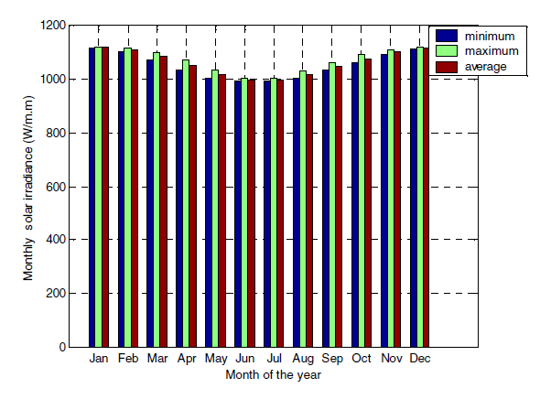
Figure ‎3.4: Minimum, maximum and average monthly global solar irradiance. [7]
Generally, the change in tilt angle will affect the amount of solar irradiance on the panels.

: Alternative solutions

VSC techniques are used to settle the current and voltage delivered by the DC/AC Inverter while providing adaptation between the DC/AC Inverter and grid [7], as it can present in the currents. The voltages generated in the grid can be maintained at the desired values. Using the VSC controller makes the grid current and voltage obtained after a DC/AC in good values balanced in 3-phases. The currents are in phases with the voltages in the grid. It can also provide three-phase active power and acts as a static compensator for the reactive power compensation.
There are three ways to control the inverter in an on-grid PV system to solve the problem that the transmitted power cannot reach the optimum limit of the unstable small-signal model.
The first way is advanced vector-current control to completely decouple the - outer-loop control by optimizing the control parameters. However, this way is quite complicated, and it is not suitable for frequent and rapid power changing. [8]
The second way is to adopt power synchronization control (PSC) as the primary control strategy. It is similar to power angle control. This way will not cause stable operating problems in fragile AC systems. However, it behaves at a relatively low response speed due to the lack of the inner-loop current control, and hence it cannot satisfactorily meet the requirement of the AC system. [9]
The third way is changing the phase-locked-loop (PLL) parameters, especially the proportional gain in the PI controller. It has been recognized that the PLL dynamics cause the challenge for VSCs operating in weak AC systems. The response speed and small-signal stability are contradictory characteristics of the system. With a high proportional gain, the system response becomes quicker. At the same time, the power transfer limitations decrease, but the PLL has a negative impact on the stability of VSC connected to a weak AC system with a reduced-order model. [10]

: Methodology

This chapter discusses the methodology of the project. The following figure shows a block diagram of the whole system.
Figure ‎5.1: Grid connected PV system.

5.1 PV Array

PV arrays are the first step in generating the power through collecting the sun’s irradiance energy then converting it to electrical potential. The PV arrays are a semiconductor device that use sunlight energy to generate a direct current DC electricity.

Each array consists of multiple PV modules that are combined together make either a series or a parallel connected Array that produces energy which varies depending on many outside environmental variables but the most important and impactful of which are Temperature and Irradiance from the sun.

The arrays are connected to the boost converter that is controlled by the MPPT to get the maximum power from the system by varying the operating voltages of the arrays. [8]
For this simulation the module model that was used is SunPower spr-305e-wht-d.
Those have a nominal power of 305.226 W for each module. The whole array consists of 66 parallel strings with each string containing 5 modules connected in series.

Table ‎5.1: PV Array specifications.
Open circuit voltage | 64.2 V
Short circuit current | 5.96 A
Voltage at maximum power | 54.7 V
Current at max Power | 5.96 A

The following figure represents the relation between irradiance and the power output as current vs voltage.
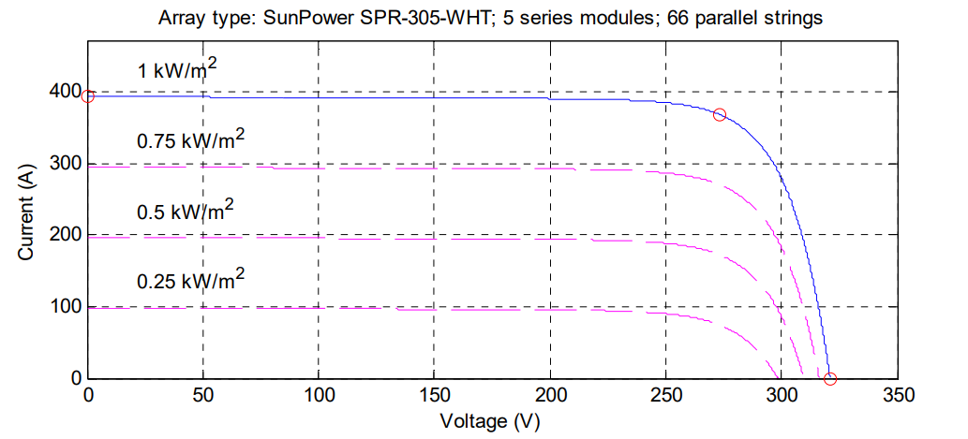
Figure ‎5.2: Graph plotting current versus voltage for different irradiance levels.
It’s notable that the higher the irradiance the higher the current at a certain voltage.

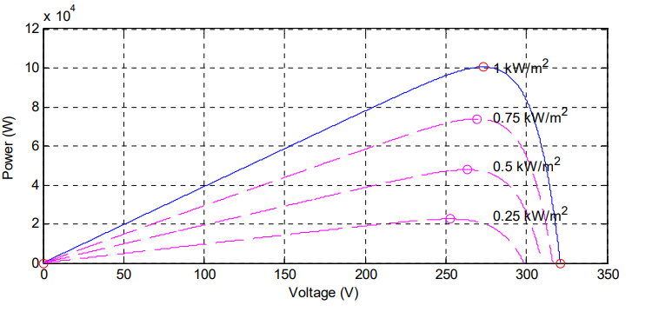
Figure ‎5.3: graph plotting power versus voltage for different irradiance levels.
The small purple circles show the maximum power that can be achieved by changing the voltage to the according value.

5.2 Boost-Converter
As demonstrated in the figure below, renewable energy sources like solar energy use boost converters as a medium of power transmission to absorb and inject energy into loads. In renewable energy systems, a boost converter converts uncontrolled dc voltage to a higher constant output voltage required by loads and batteries. The efficiency, output power, and ease of design are all important factors in the design and development of boost converters. [9].
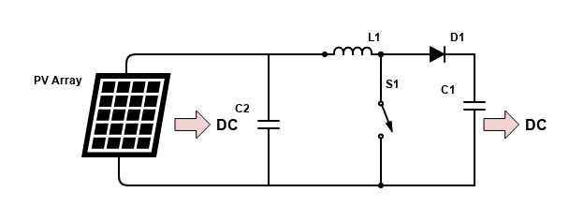
Figure ‎5.4: block diagram of Boost converter in solar system.

A combination of four components, including an inductor, electronic switch, diode, and output capacitor, performs the energy absorption and injection operation. Figure 5.5 illustrates the connection of a boost converter [9] , Sometimes an input capacitor is included to minimize ripples in the input voltage.
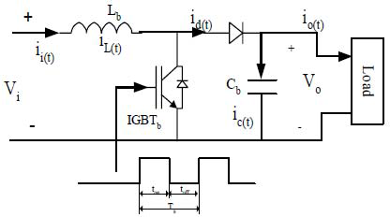
Figure ‎5.5: Schematic of boost converter. [10]
The switch on and off duration with constant switching frequency controls the average output voltage. The switching duty cycle is the ratio of on-time to switching time. The converter will operate in two modes: continuous conduction mode and discontinuous conduction mode, depending on the relative length of the switching time. [11]

5.2.1 Continuous conduction mode

There are two modes in the continuous conduction mode. When the switch SW is turned on at t = ton, as indicated in Figure 5.6, Mode 1 starts. The rising input current will flow through the Inductor L and switch SW. The inductor stores energy in this mode. When the switch at t = toff, Mode 2 starts. As shown in Figure 5.7, the current flowing through the switch would pass through inductor L, diode D, output capacitor C, and load R. The inductor current decreases until the switch is turned on again in the next cycle.
Again, the inductor will supply energy to the load. As a result, the output voltage is greater than the input voltage and is expressed as:
$V_{out}=\frac{V_{in}}{1-D}$ (5.1)
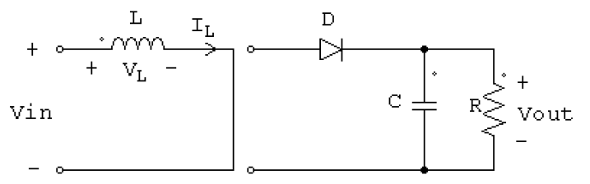
Figure ‎5.6: Mode-1 of boost converter during $T_{on}$. [12]
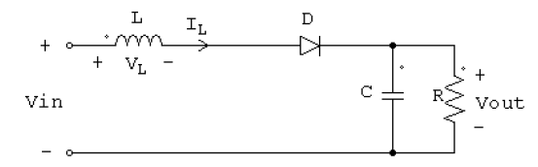
Figure ‎5.7: Mode-2 of boost converter during $T_{off}$. [12]
In order to operate the converter in continuous conduction mode, the inductance must be calculated so that the inductor current IL never falls to zero, as shown in Figure 5.8. As a result,
$L_{\min{.}}=\frac{{\left(1-D\right)}^{2} DR}{2f}$ (5.2)
$L_{min}$ is the minimum inductor value whose load current will be continuous. The inductance value should be greater than the minimum inductance so that the current will be continuous with less ripple.
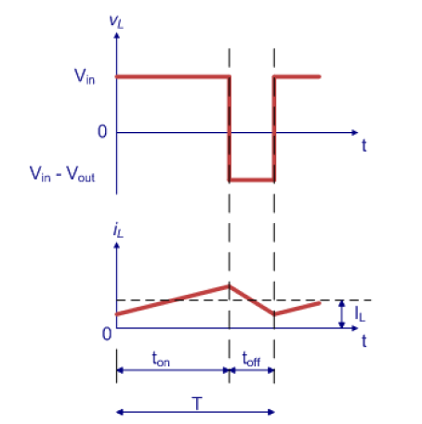
Figure ‎5.8: Waveforms at continuous conduction mode. [12]
The output capacitance required to get the desired output voltage ripple is found as follows:
$C_{min}=\frac{D}{R f V_{r}}$ (5.3)
Where C is the minimum capacitance value for which the capacitor voltage is continuous. The capacitance value should never be less than the minimum value to get continuous voltage with minimum ripple and is the output voltage ripple factor which is the ratio of the output ripple to the output voltage. [12]

5.2.2 Discontinuous conduction mode

The inductor current IL does not flow continuously in discontinuous conduction mode. As shown in Figure 5.9, there is a period when the current is zero before the next turn on of switch SW. Since the minimum inductance to operate in continuous conduction mode was calculated previously, any L value less than that will cause the boost converter to run in discontinuous conduction mode[12].
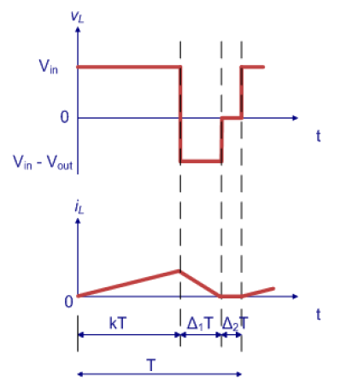
Figure ‎5.9:Waveforms at discontinuous conduction mode. [12]

5.2.3 MPPT Control using Perturb & Observe (P&O) method

Many systems use the MPPT algorithm to obtain maximum power from the solar panel. Irradiation and temperature are the primary determinants of peak power generation. As radiation increases, the peak power increases. As a result, power variation is mainly determined by temperature and irradiation amount. As a result, the MPPT algorithm can be used to track maximum power.[13]

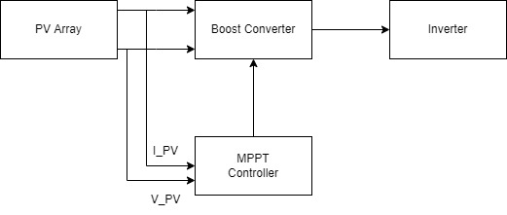
Figure ‎5.10: Block diagram of MPPT controller.
The Perturb & Observe (P&O) technique uses the PV voltage and current perturbation to compute PV output power and power change.
The tracker continuously increases or decreases the solar array voltage at regular intervals. If the output power of the PV increases (decreases) for a given perturbation, subsequent perturbations in the same (opposite) direction occur, as shown in Figure 5.11. As a result, the DC-DC converter's duty ratio is adjusted correspondingly, and the process is repeated until the maximum power point is reached.[14]
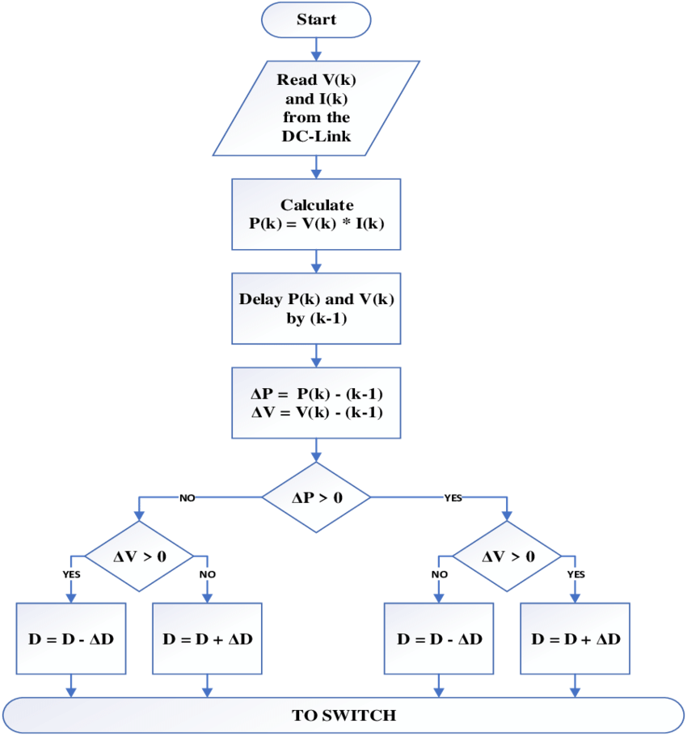
Figure ‎5.11: Perturb & Observe method flowchart. [16]

Variation in slope (dP/dV) on the P-V curve of PV modules, as seen in Figure 5.12. It indicates that as the operating voltage of PV modules increases and the power consumed by PV modules increases, the operating point gets closer to the MPP. On the other hand, if the PV module's power consumption decreases, the point is operating away from the MPP. As a result, the voltage perturbation will reverse its direction.[15]
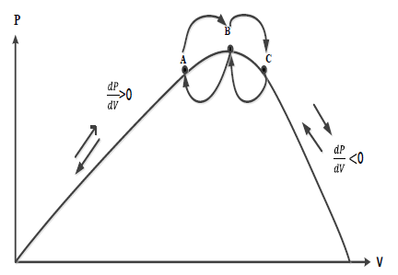
Figure ‎5.12: Slope (dP/dV) variation. [17]

5.3 Three phase inverter
A 3 phase full bridge inverter is used (modelled) in this study, the switches that has been used is IGBT’s as it can take very large power and stay functional, which is suitable for this PV system.
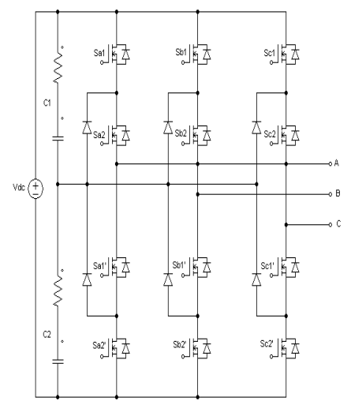
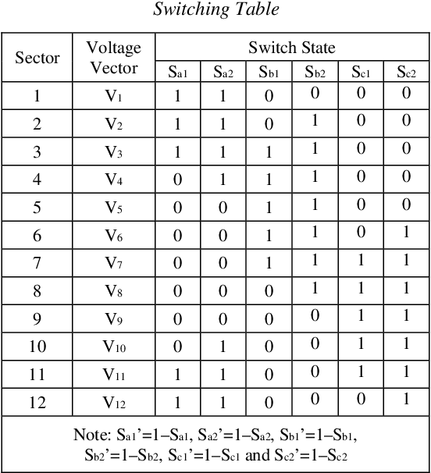
Figure ‎5.13: 3-level inverter using IGBTs and switching table. [16]

The inverter switching is controlled by a VSC (Voltage source Converters) controller which drive the gates of the IGBTs.
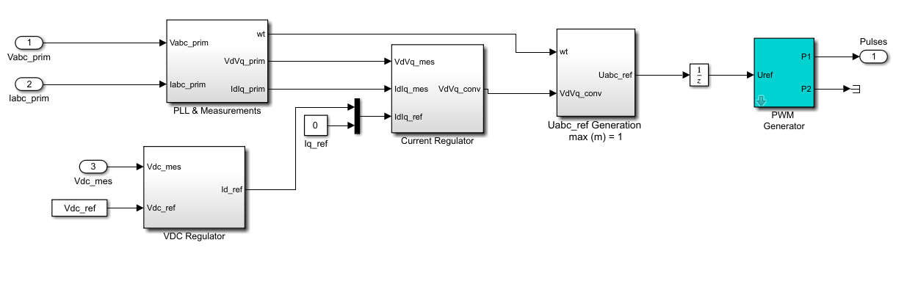
Figure ‎5.14: VSC main controller.

5.3.1 VSC control
The VSC (Voltage Source Converter) has several advantages compared to other controllers like HVDC, some of this advantages are independent control of active and reactive power, dynamic voltage support at the converter bus for enhancing the stability, reversed power do not affect the polarity od DC Voltage.[17]
Usually we control the magnitude of AC output of the converter by using PWM (pulse width modulation) without changing the magnitude of DC voltage.
Even so the three level converter topology can also get the voltage by changing the β angle with changing the fundamental switching frequency.[18]

5.3.1.1 d-q control
So to convert the three–phase abc stationary coordinate system to a two–phase α–β stationary coordinate system; this is done by Clark’s transformation, Then, this two phase α–β stationary coordinate system is converted into a two–phase d–q rotating coordinate system which is called Park’s transformation.
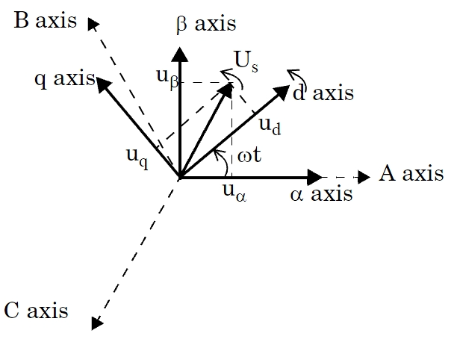
Figure ‎5.15: Vector control’s three frames the abc frame and α–β frame and d-q frame. [19]
The Clark’s transformation can be shown that:
$\left[\begin{matrix}V_{α} \\ V_{β}\end{matrix}\right]=\left[\begin{matrix}1 & -\frac{1}{2} & -\frac{1}{2} \\ 0 & \frac{\sqrt{3}}{2} & -\frac{\sqrt{3}}{2}\end{matrix}\right]\left[\begin{matrix}V_{a} \\ V_{b} \\ V_{c}\end{matrix}\right]$ $\left(5.4\right)$
We can find $V_{α} and$ ${ V}_{β}$by using Clark’s transformation equation where they are quantities in the stationary reference frame, representing control signals in stationary two–phase frame.
The stationary reference components $V_{α} and$ ${ V}_{β}$ are converted into d–q components using Park’s transformation:
$\left[\begin{matrix}v_{d} \\ v_{q}\end{matrix}\right]=\left[\begin{matrix}\cos{θ} & \sin{θ} \\ -sin{θ} & \cos{θ}\end{matrix}\right]\left[\begin{matrix}v_{α} \\ v_{β}\end{matrix}\right]$ $\left(5.5\right)$
Assuming the following equivalent circuit of a source, an inverter, and a nonlinear load, dynamic equations can be derived.
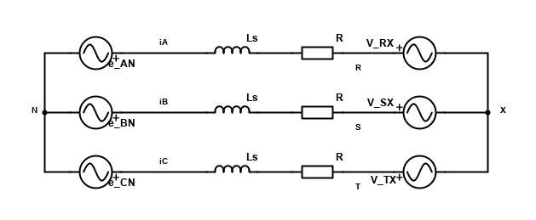
Figure ‎5.16: Equivalent circuit from the inverter to the load.
The equations of the equivalent circuit for each phase are:
$e_{AN}=L\frac{di_{A}}{dt}+Ri_{A}+V_{RX}+V_{XN}$ $\left(5.6\right)$
$e_{BN}=L\frac{di_{B}}{dt}+Ri_{B}+V_{SX}+V_{XN}$ $\left(5.7\right)$
$e_{CN}=L\frac{di_{C}}{dt}+Ri_{C}+V_{TX}+V_{XN}$ $\left(5.8\right)$
The matrix form of these equations is the following:
$\left[\begin{matrix}e_{AN} \\ e_{BN} \\ e_{CN}\end{matrix}\right]=\left[L\frac{d}{dt}+R\right]\left[\begin{matrix}i_{A} \\ i_{B} \\ i_{C}\end{matrix}\right]+\left[\begin{matrix}V_{RN} \\ V_{SN} \\ V_{TN}\end{matrix}\right]$ $\left(5.9\right)$
Where $V_{RX}+V_{XN}=V_{RN}$.
Now to convert from $αβ$ frame to abc frame it’s been used the following calculations:
$\left[\begin{matrix}e_{A} \\ e_{B} \\ e_{C}\end{matrix}\right]= \left[\begin{matrix}\frac{2}{3} & 0 \\ -\frac{1}{3} & \frac{1}{\sqrt{3}} \\ -\frac{1}{3} & \frac{1}{\sqrt{3}}\end{matrix}\right]\left[\begin{matrix}e_{α} \\ e_{β}\end{matrix}\right]$ $\left(5.10\right)$
If $\left[T\right]= \left[\begin{matrix}\frac{2}{3} & 0 \\ -\frac{1}{3} & \frac{1}{\sqrt{3}} \\ -\frac{1}{3} & \frac{1}{\sqrt{3}}\end{matrix}\right]$, $\left(5.11\right)$
Substituting $\left(5.10\right)$ into $\left(5.11\right)$ gives:
$\left[T\right]\left[\begin{matrix}e_{α} \\ e_{β}\end{matrix}\right]=\left[L\frac{d}{dt}+R\right]\left[T\right]\left[\begin{matrix}i_{α} \\ i_{β}\end{matrix}\right]+\left[T\right]\left[\begin{matrix}V_{α} \\ V_{β}\end{matrix}\right]$ $\left(5.12\right)$
By cancelling out $\left[T\right]$, the following can be found in stationary frame:
$\left[\begin{matrix}e_{α} \\ e_{β}\end{matrix}\right]=\left[L\frac{d}{dt}+R\right]\left[\begin{matrix}i_{α} \\ i_{β}\end{matrix}\right]+\left[\begin{matrix}V_{α} \\ V_{β}\end{matrix}\right]$ $\left(5.13\right)$
The dynamic equation of the three–phase system in stationary frame is:
$e_{αβ}=\left(L\frac{d}{dt}+R\right)i_{αβ}+V_{αβ}$ $\left(5.14\right)$
Converting from stationary frame to d–q synchronous frame is done using the following equation:
$e_{αβ}=e_{dq}e^{jω_{e}t}$ $\left(5.15\right)$
Substituting $\left(5.14\right)$ into $\left(5.15\right)$:
$e_{dq}e^{jω_{e}t}=\left(L\frac{d}{dt}+R\right)e_{dq}e^{jω_{e}t}+ V_{dq}e^{jω_{e}t}$ $\left(5.16\right)$
Applying the product rule on $\left(5.16\right)$:
$e_{dq}e^{jω_{e}t}=L\frac{di_{dq}}{dt}e^{jω_{e}t} +{jω}_{e}Li_{dq}e^{jω_{e}t}+Ri_{dq}e^{jω_{e}t}+V_{dq}e^{jω_{e}t}$ $\left(5.17\right)$
Cancelling out $e^{jωet}$:
$e_{dq}=L\frac{di_{dq}}{dt} +{jω}_{e}Li_{dq}+Ri_{dq}+V_{dq}$ $\left(5.18\right)$
By separating $\left(5.18\right)$ into two parts, a real and an imaginary part can be obtained:
- Real part: $e_{d}=\left(L\frac{d}{dt}+R\right)i_{d}+V_{d}-ω_{e}Li_{q}$
- Imaginary part: $e_{q}=\left(L\frac{d}{dt}+R\right)i_{q}+V_{q}+ω_{e}Li_{d}$
At steady state, all d–q axis variables are constant (DC). Assuming the d–axis lines up with the input voltage vector $V_{s}$, then $V_{q}=0$, and:
$P=V_{d}i_{d}+ V_{q}i_{q}$ $\left(5.19\right)$
$Q=-(V_{d}i_{q}+ V_{q}i_{d})$ $\left(5.20\right)$
With $V_{q}=0$, $\left(5.21\right)$ and $\left(5.22\right)$ become:
$P=V_{d}i_{d}$ $\left(5.21\right)$
$Q=-V_{d}i_{q}$ $\left(5.22\right)$
It is now clear that current $i_{d}$ controls real power from the supply, while current $i_{q}$ controls reactive power drawn from the supply. When setting $i_{q}=0$, a unity power factor is obtained at the inverter side [19].

5.4 LC Filter
LC filter is used to attenuate the lowest order harmonic output voltage waveform and minimize distortion for linear or nonlinear loads. The increase of the filter capacitance value leads to an increase in the inverter power rating due to the reactive power increase; this decreases the filter cut-off frequency and limits the system's dynamic response [21].
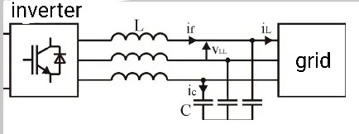
The LC filter is depicted in Fig. Below. It has a simple configuration, is easy to design, and works mainly without problems.
Figure ‎5.17: Grid connected LC filter.
The own design of the LC filter is a compromise between the value of the capacity and inductance. The high capacity has positive effects on the voltage quality. On the other hand, a higher inductance value is required to achieve demanded cut-off frequency of the filter. Connecting a system with this kind of filter to the supply grid, the resonant frequency of the LC filter becomes dependent on the grid impedance.[22].
The LC filter is a crucial part of designing the grid inverter because the LC filter is needed to filter out undesired switching frequency components of the inverter output current spectrum. The LC filter, which is connected to the output of the inverter circuit, should be able to generate a sinusoidal output current with low THD. The low-pass LC filter is designed accordingly so that the cut-off frequency fc is higher than the grid frequency and lower than the inverter switching frequency.

5.5 Design and Results

5.5.1 Simulation design

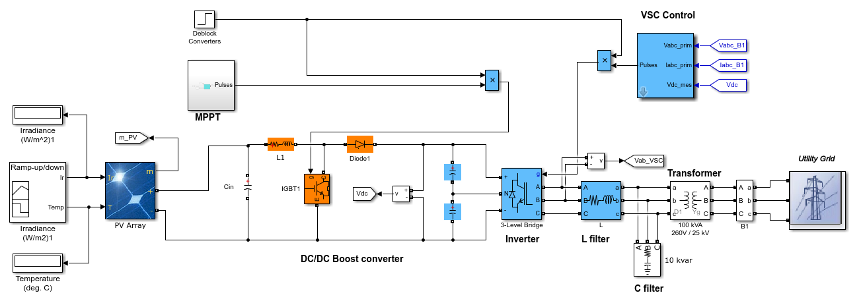
The figure below (Figure 5.18) demonstrates a system with a 100-kW array and a three-phase three-level Voltage Source Converter connected to a 25-kV grid via a DC-DC boost converter (VSC). The "Perturbed & Observe" technique implements Maximum Power Point Tracking (MPPT) in the boost converter.
Figure ‎5.18: Grid connected PV system.

5.5.1.1 System components

1) PV Array
PV array delivering a maximum of 100 kW at 1000 W/m2 sun irradiance. The array consists of 66 strings of 5 series-connected modules connected in parallel (66*5*305.2 W= 100.7 kW).

2) Boost converter with MPPT control
A 5-kHz boost converter increases the voltage from PV natural voltage (272 V DC at maximum power) to 500 V DC. The MPPT controller optimizes the switching duty cycle using the "Perturb and Observe" technique to generate the appropriate voltage to extract maximum power.
Table ‎5.2: Boost converter parameters used in Simulink.
Input capacitance ($C_{in}$) | $$100μF$$
Inductance (L) | $$5mH$$
Output capacitance ($C_{out})$ | 12$mF$

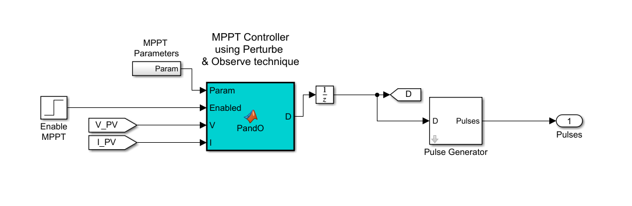
Figure ‎5.19: MPPT Control.

3) 3-level bridge and VSC
The three-level Bridge and VSC maintain a unity power factor by regulating DC bus voltage at 500 V and converting 500 V DC to 260 V AC. An external control loop regulates DC link voltage to +/- 250 V, and an internal control loop regulates Id and Iq grid currents (active and reactive current components). The output of the DC voltage external controller is the Id current reference. The Iq current reference is zero to maintain the unity power factor.
The current controller's Vd and Vq voltage outputs are transformed to three modulating signals Uref ABC, which the PWM three-level pulse generator utilizes.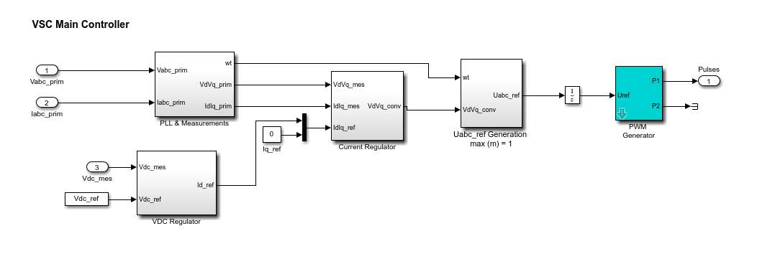
Figure ‎5.20: VSC Controller.

4) LC Filter
Used to filter the harmonics produced by 3-level VSC.

5) Three phase transformer
100-kVA 260V/25kV three-phase coupling transformer.

6) Utility grid
Utility grid model (25-kV distribution feeder + 120 kV equivalent transmission system).
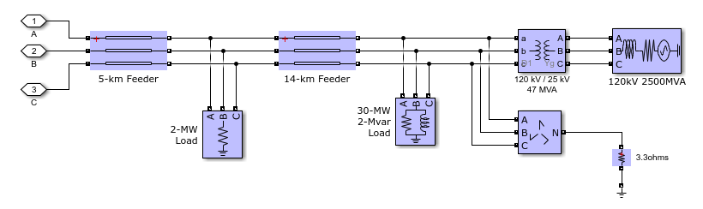
Figure ‎5.21: Utility grid.

5.5.2 Simulation results and discussion

Figure ‎5.22: Tilt-15-AZ-EW-system.

The figure above shows the total harmonic distortion for the East-West installation. Generally, the total harmonic distortion for This system appears to be near to the standard value of total harmonic distortion, which is 5%. The total harmonic distortion is approximately 9.5% during the fall season, which is the highest compared with other seasons. Generally, the fall and winter seasons may have the worst values due to the cloudy weather.

The table below shows the harmonic orders magnitudes for different time for east-west system:

Table ‎5.3: East-West system harmonic orders distortion.
Date | Time | Irradiance | image
3/1 | 7:00 | 269.13 | 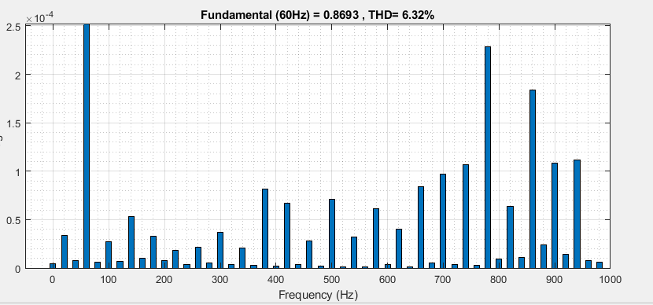
3/1 | 8:00 | 574.85 | 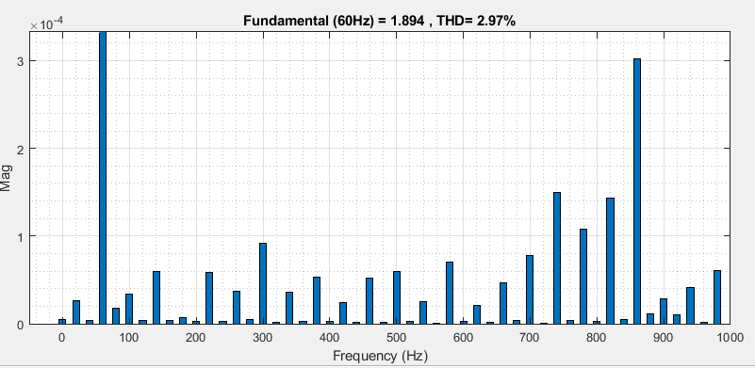
3/1 | 9:00 | 895.25 | 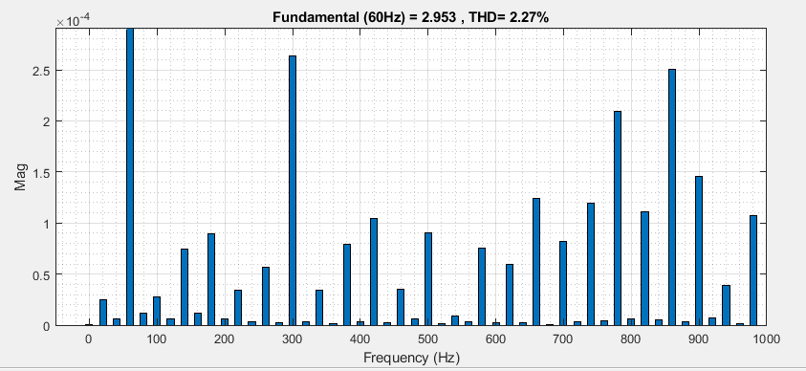
3/1 | 14:00 | 753.75 | 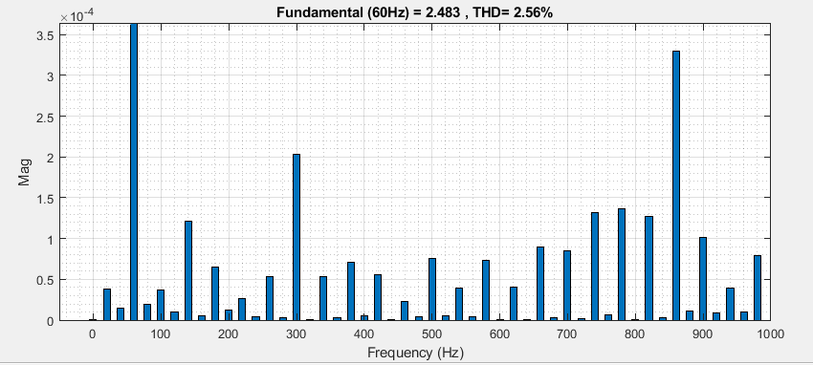
3/1 | 15:00 | 399.08 | 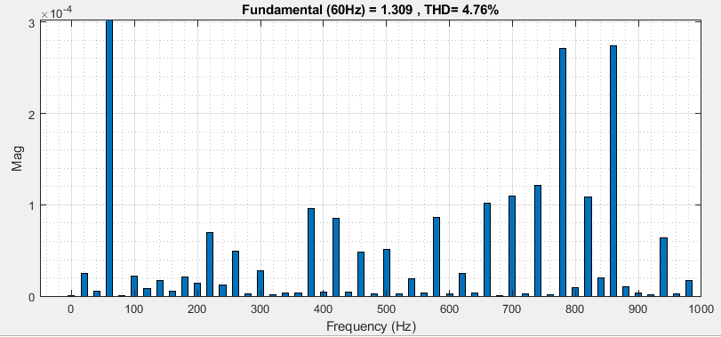
3/1 | 16:00 | 17.6259 | 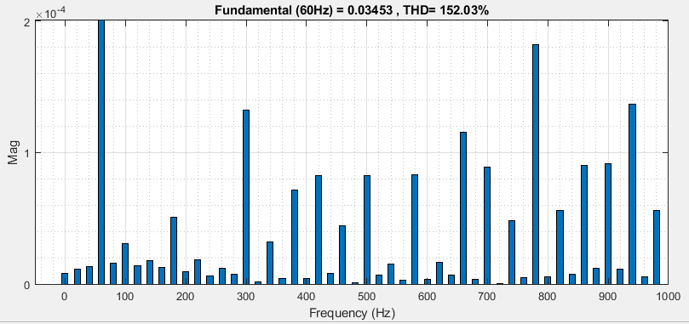
4/4 | 6:00 | 274.011 | 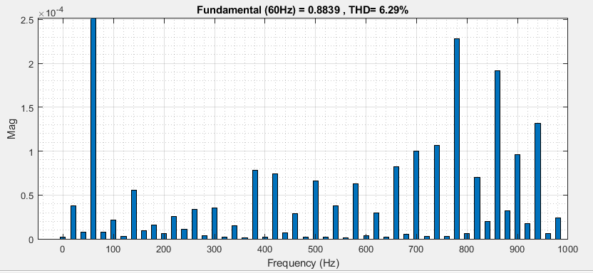
4/4 | 7:00 | 620.87 | 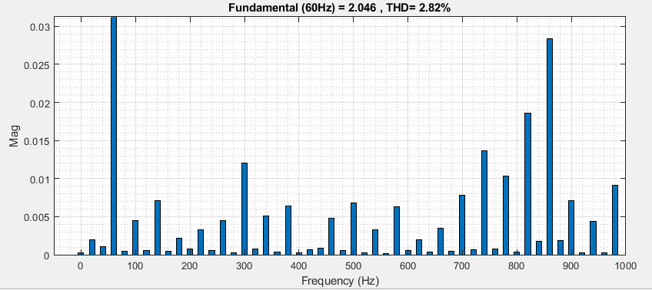
4/4 | 8:00 | 917.26 | 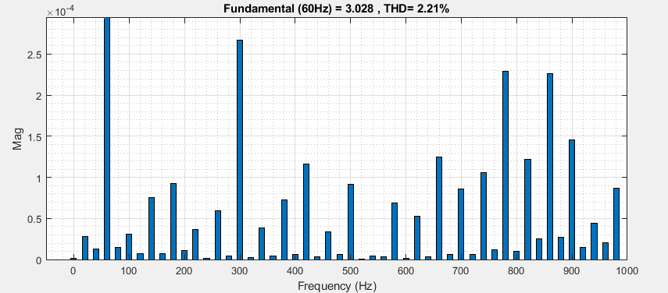
4/4 | 15:00 | 791.1 | 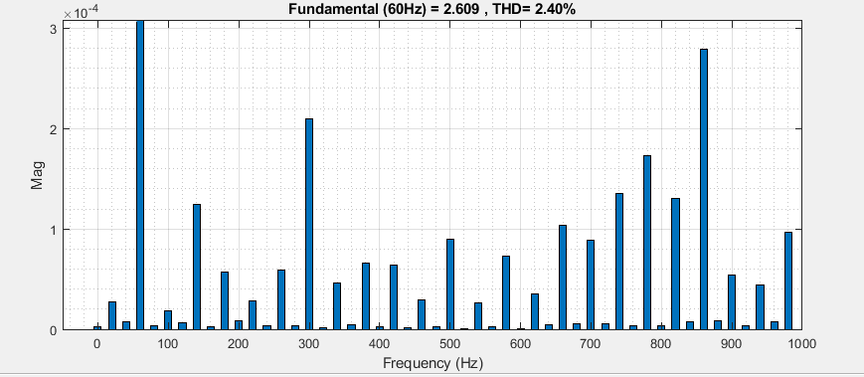
4/4 | 16:00 | 436.47 | 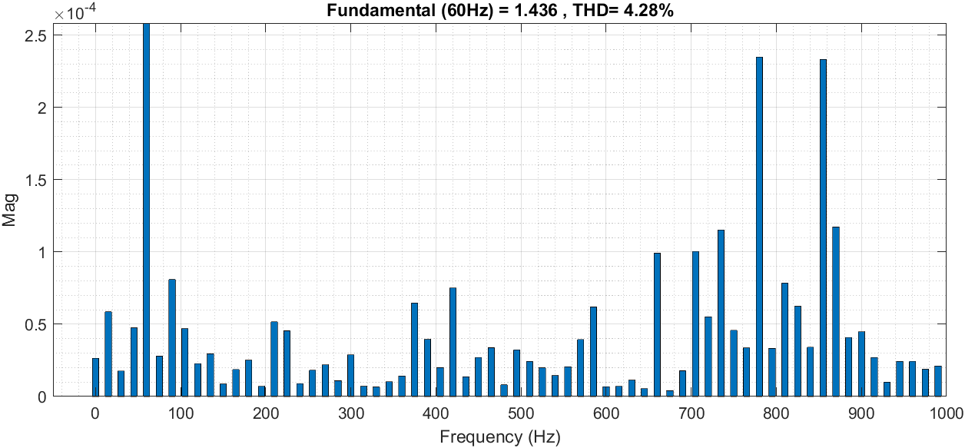
4/4 | 17:00 | 55.884 | 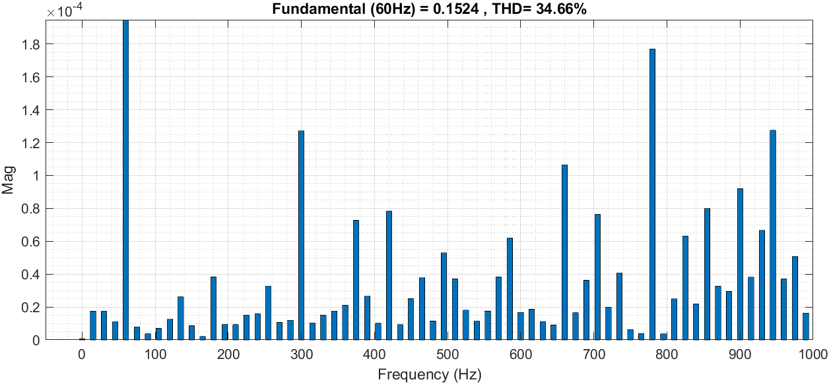
3/7 | 5:00 | 222.127 | 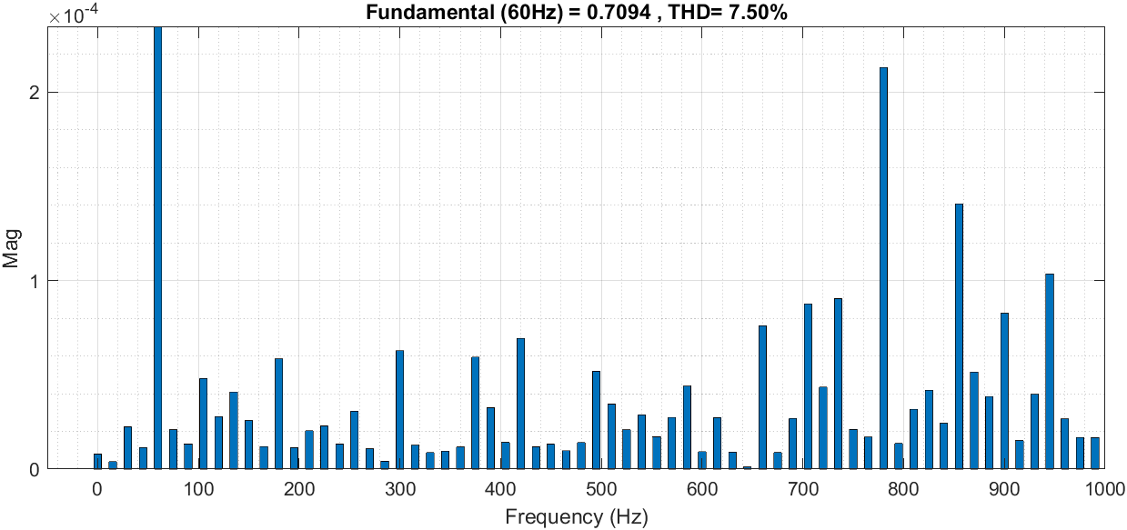
3/7 | 6:00 | 534.5 | 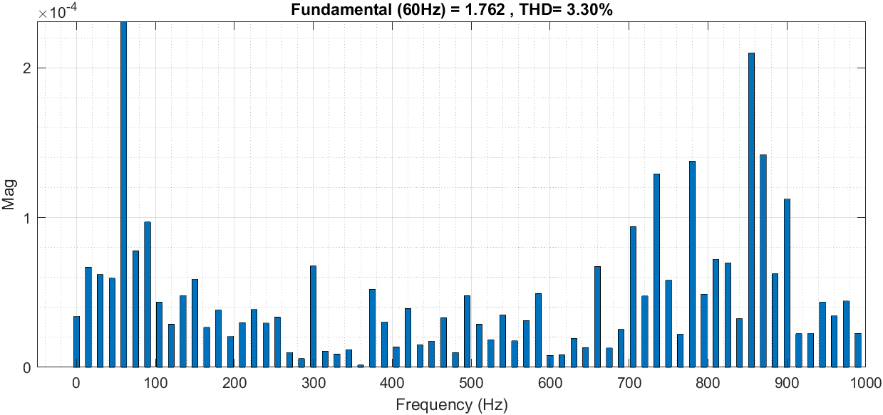
3/7 | 7:00 | 925.14 | 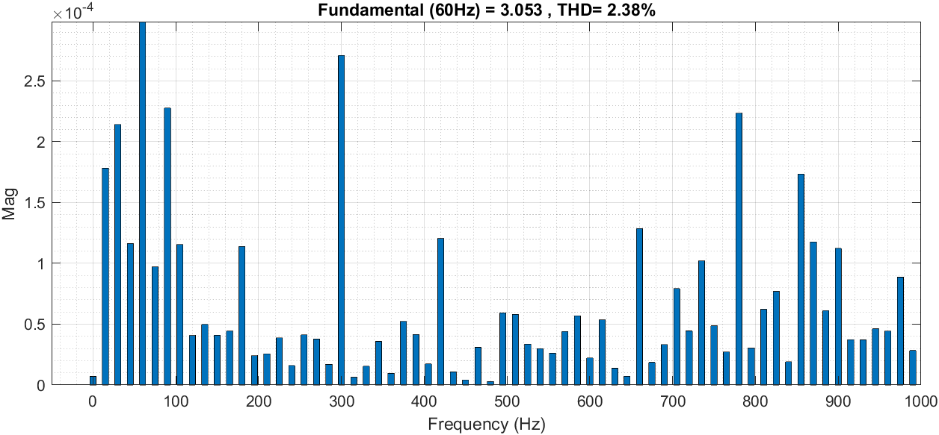
3/7 | 16:00 | 736.62 | 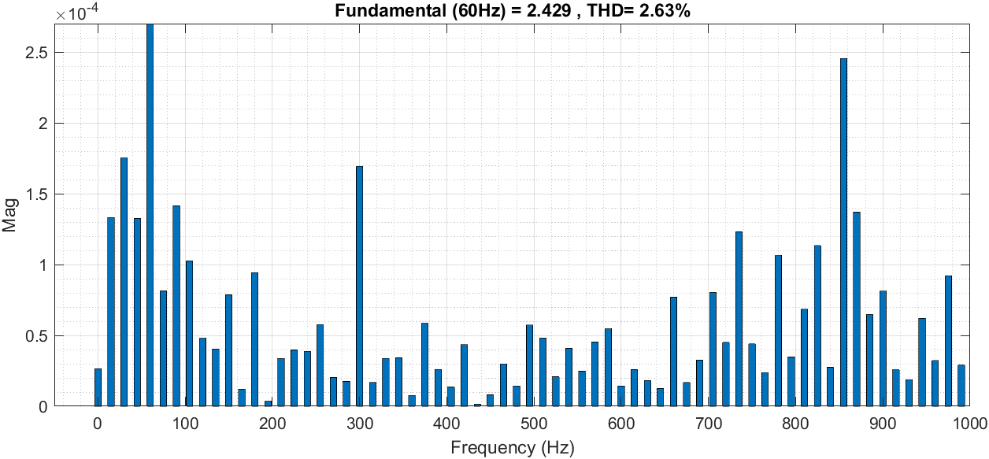
3/7 | 17:00 | 351.252 | 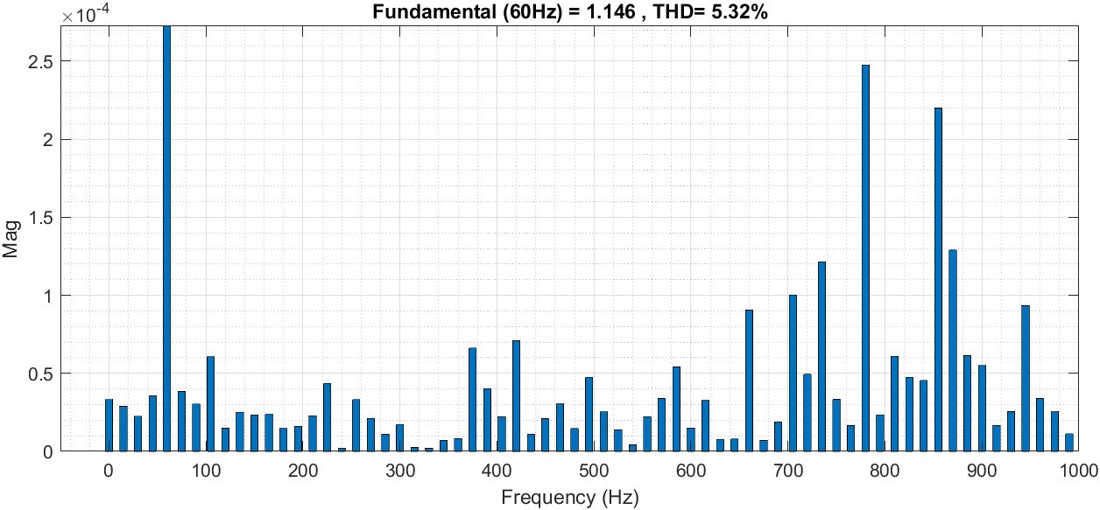
3/7 | 18:00 | 23.98 | 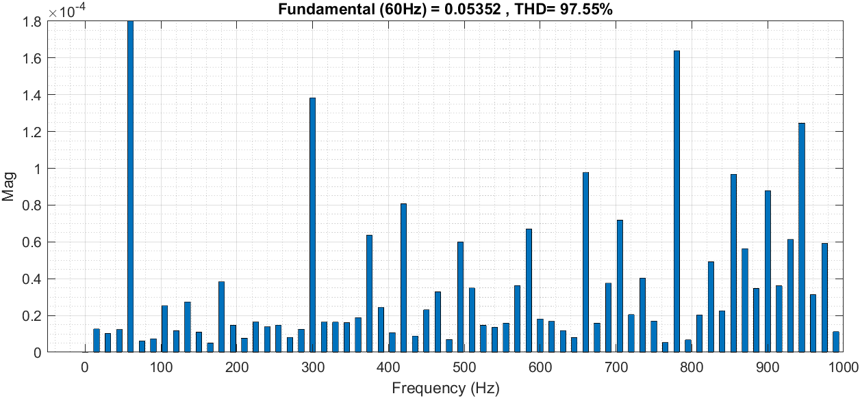
3/10 | 6:00 | 193.187 | 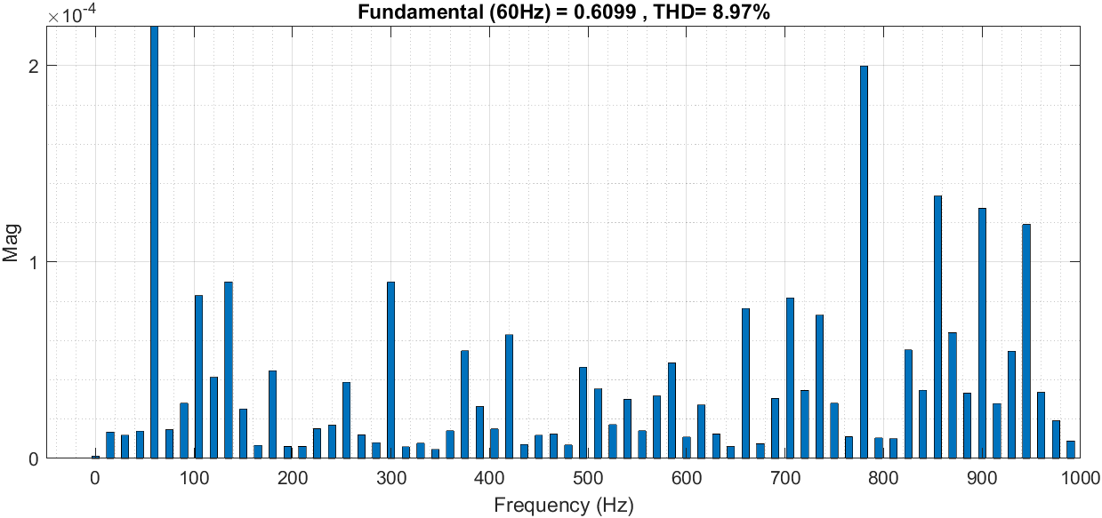
3/10 | 7:00 | 464.93 | 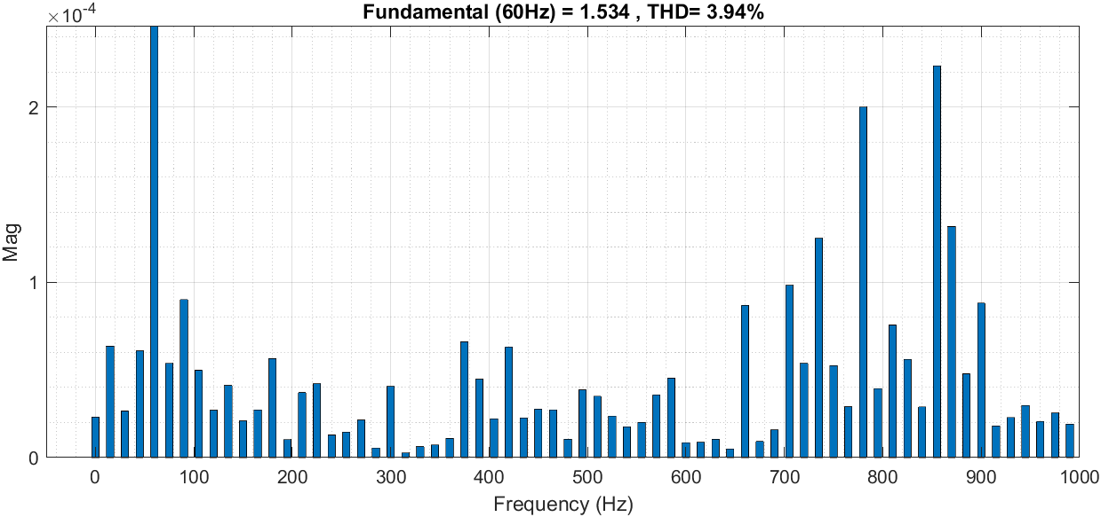
3/10 | 8:00 | 813.85 | 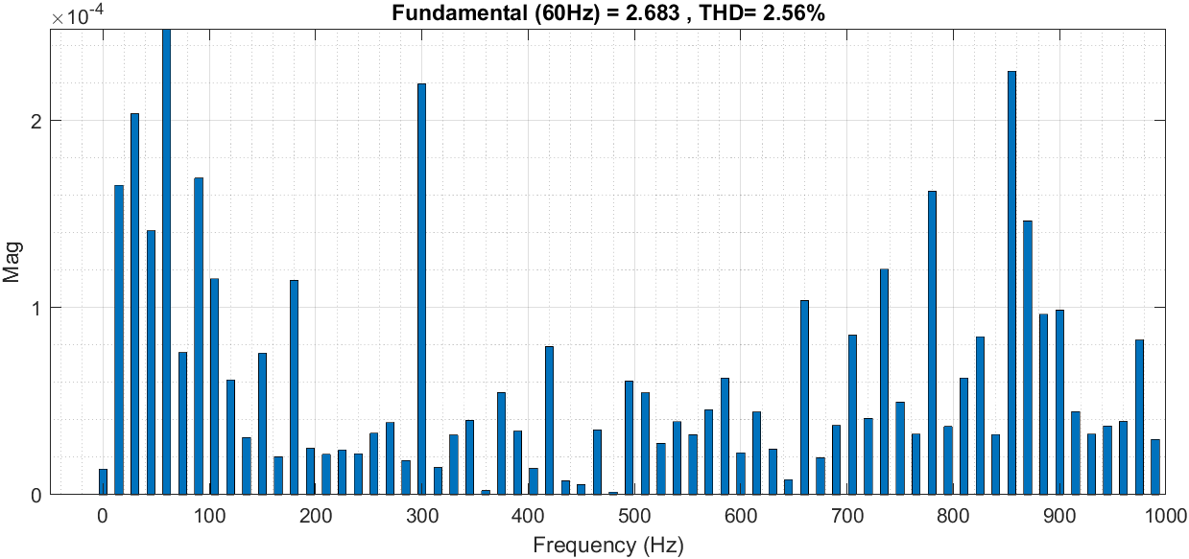
3/10 | 14:00 | 991.9 | 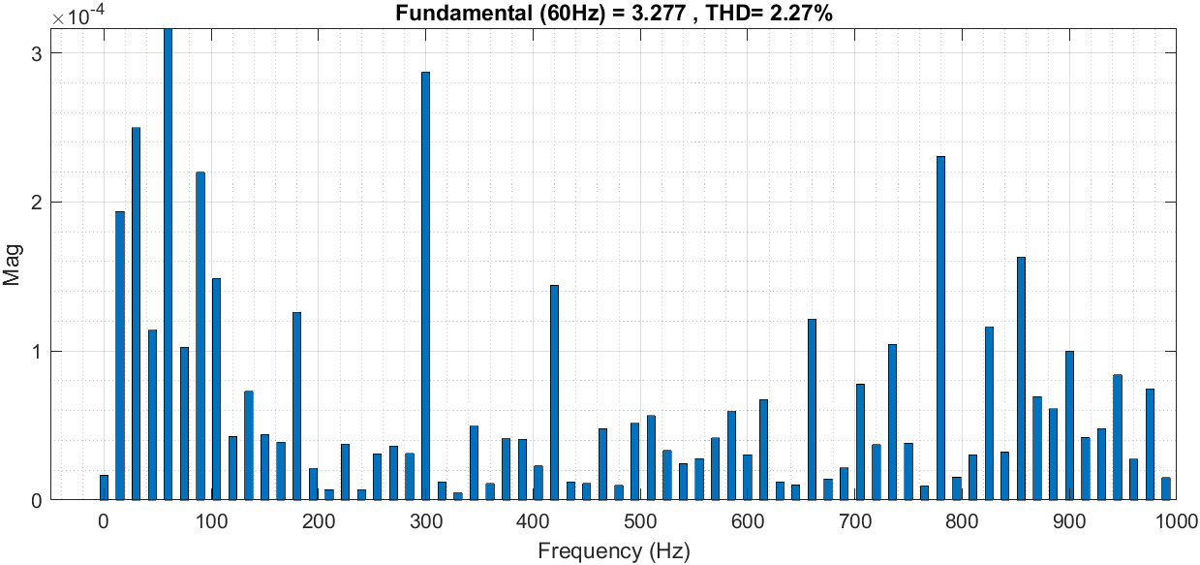
3/10 | 15:00 | 605.12 | 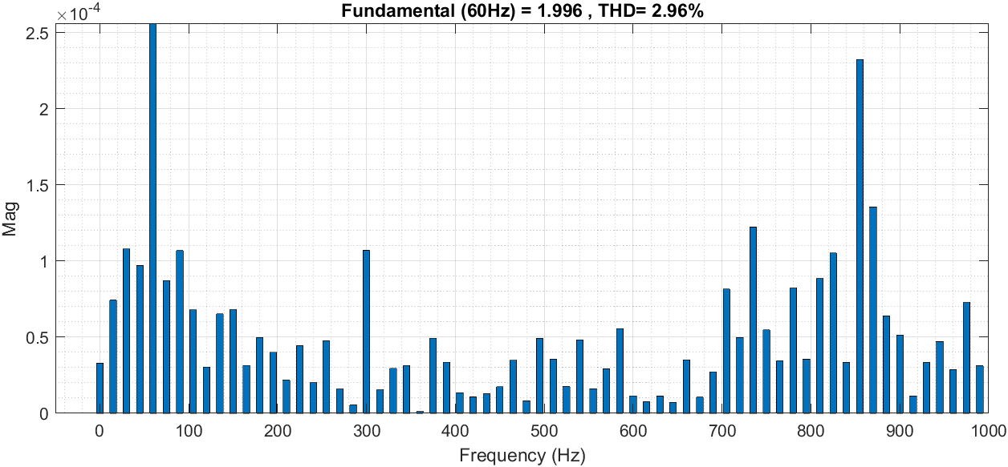
3/10 | 16:00 | 296.568 | 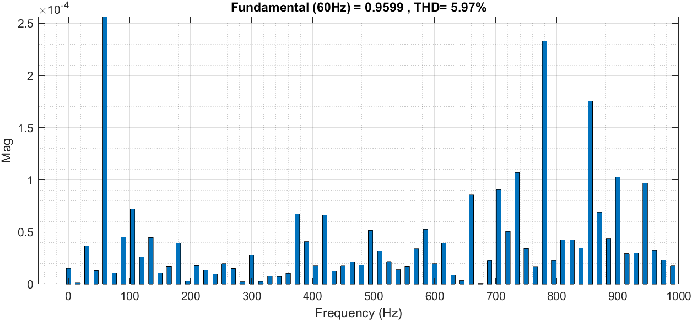

Figure ‎5.23: Tilt-30- SN optimal-system.
For the South-North system, the results are shown in figure 5.23. Total harmonic distortion is very high during these periods; its values exceeded the “5%”. Generally, the total harmonic distortion will be very small during the whole sunrise time.
The table below shows the harmonic orders magnitudes for different time for south-north system:

Table ‎5.4: South-North system harmonic orders distortion.
Date | Time | THD% | image
1/1 | 8:00 | 72.59 | 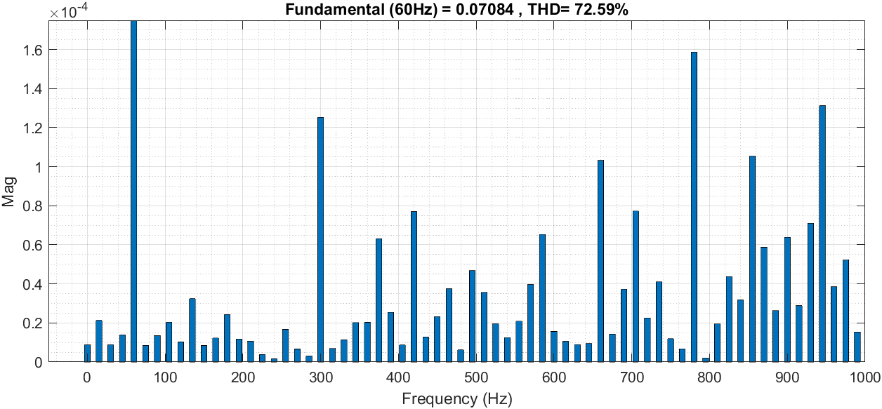
1/1 | 9:00 | 23.47 | 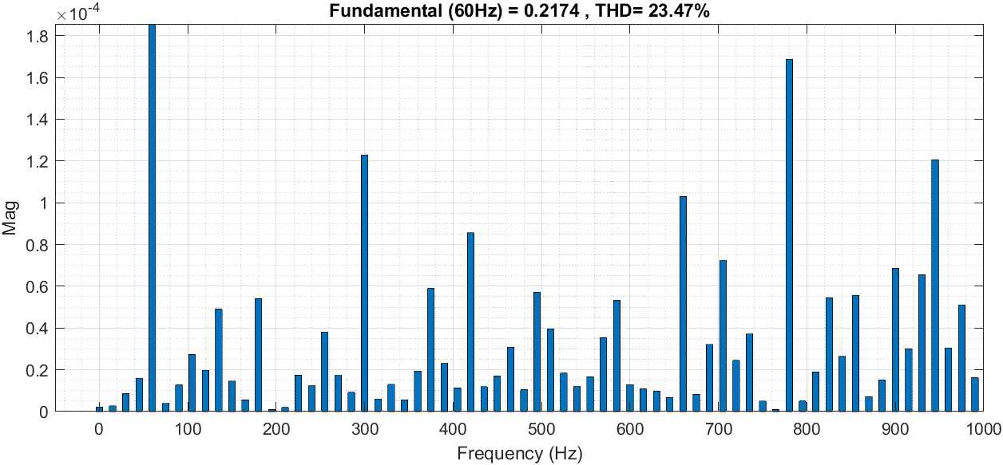
1/1 | 10:00 | 9.25 | 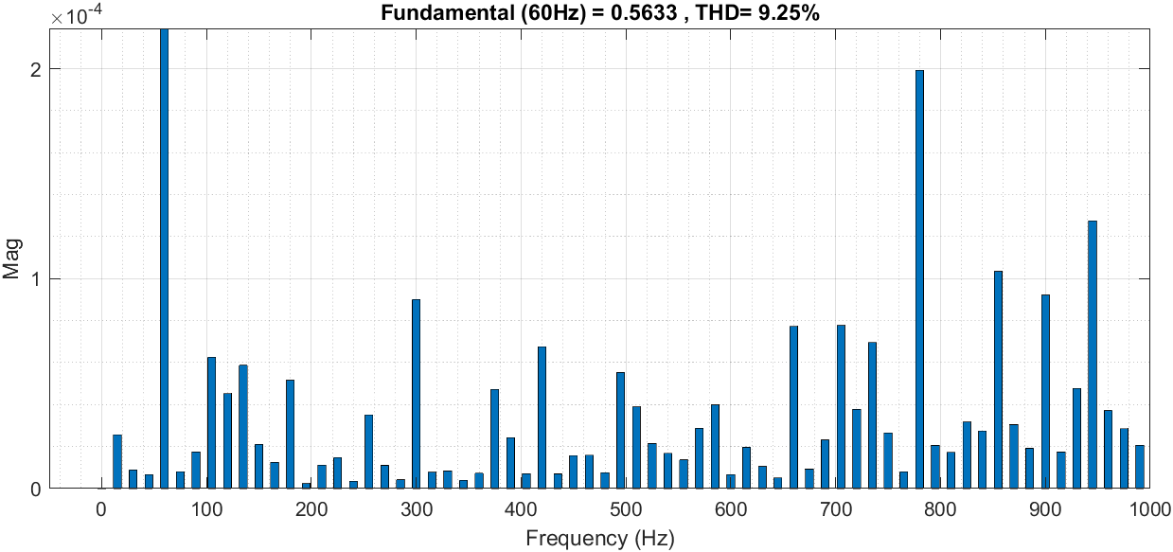
1/1 | 13:00 | 9.88 | 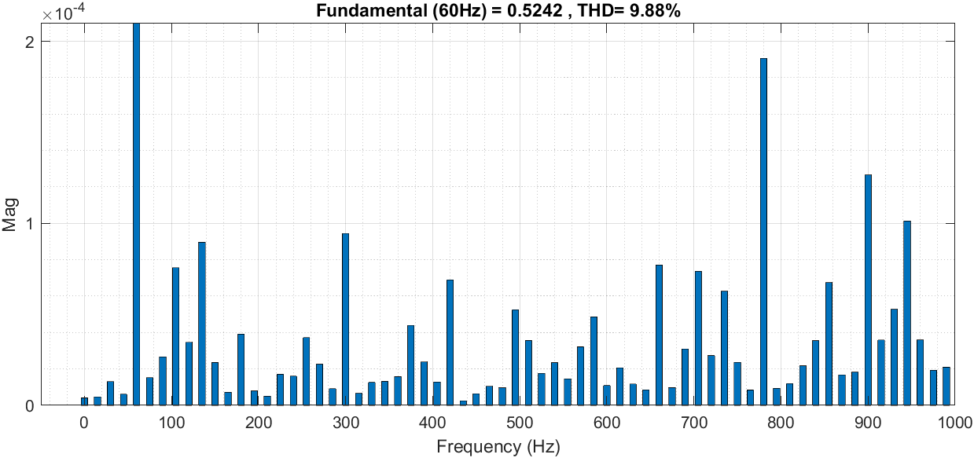
1/1 | 14:00 | 12.18 | 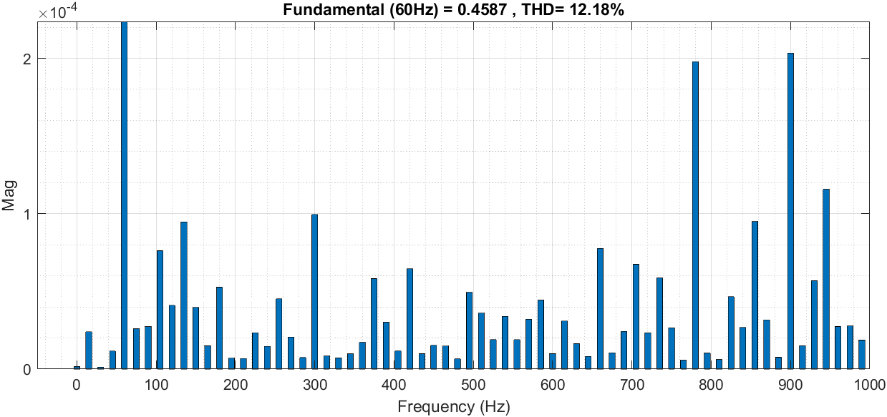
1/1 | 15:00 | 32.63 | 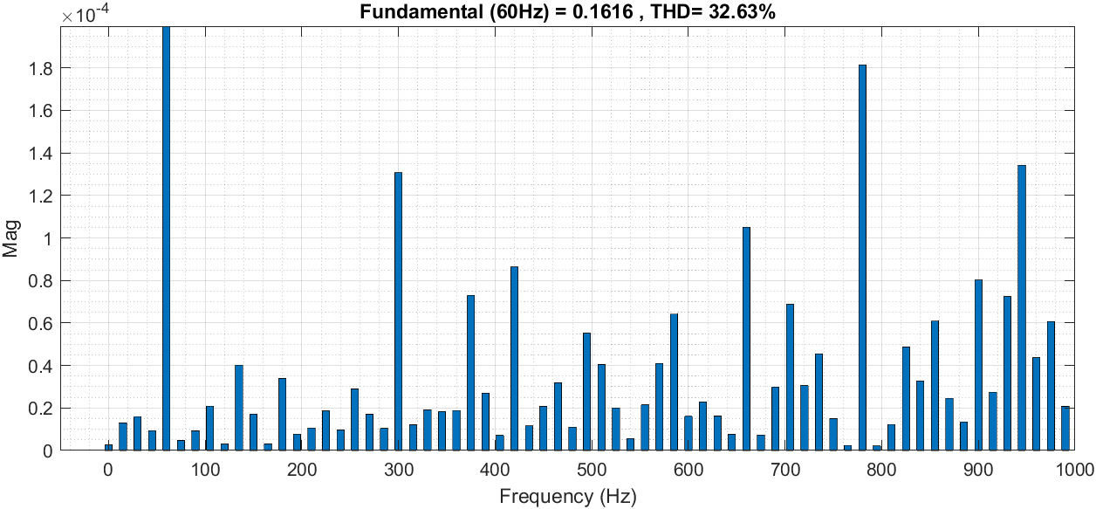
1/4 | 6:00 | 21.49 | 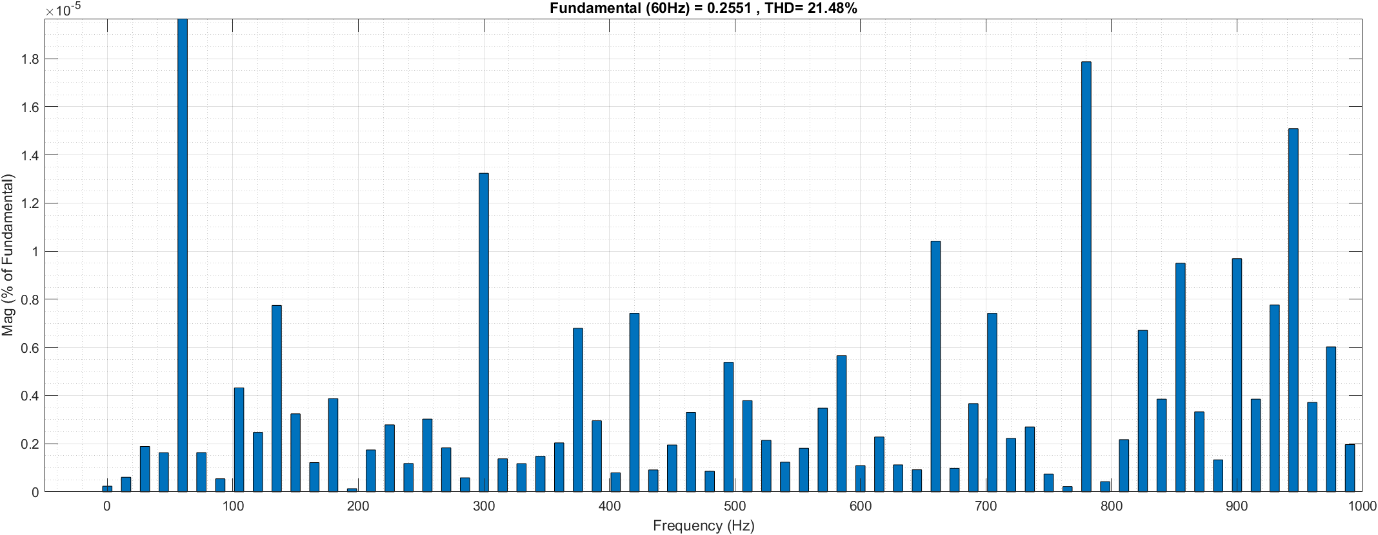
1/4 | 7:00 | 7.69 | 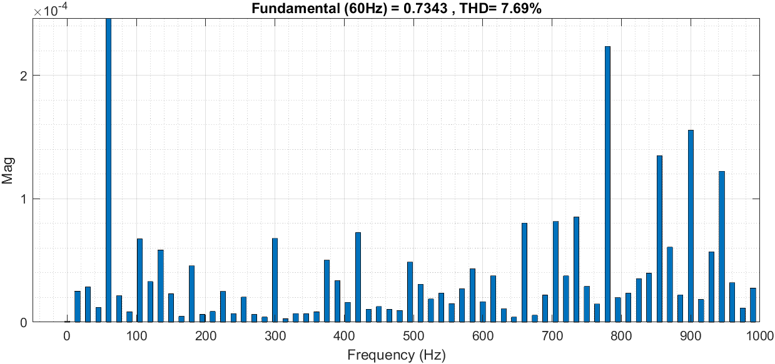
1/4 | 8:00 | 5.69 | 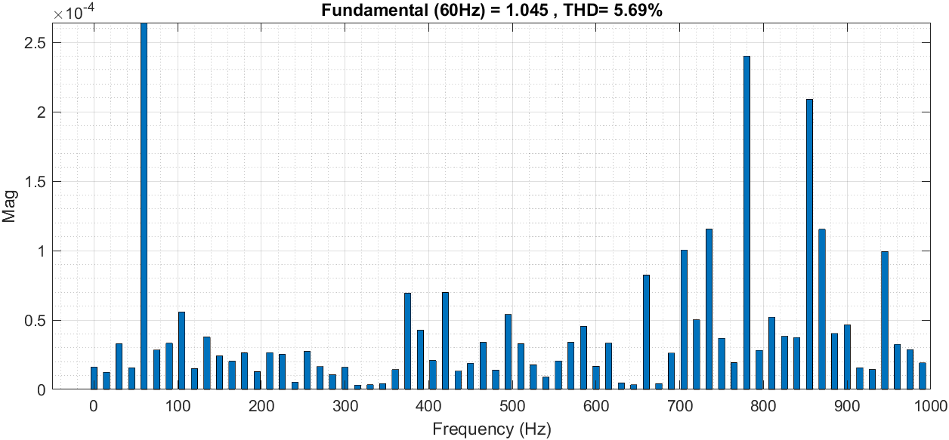
1/4 | 15:00 | 3.86 | 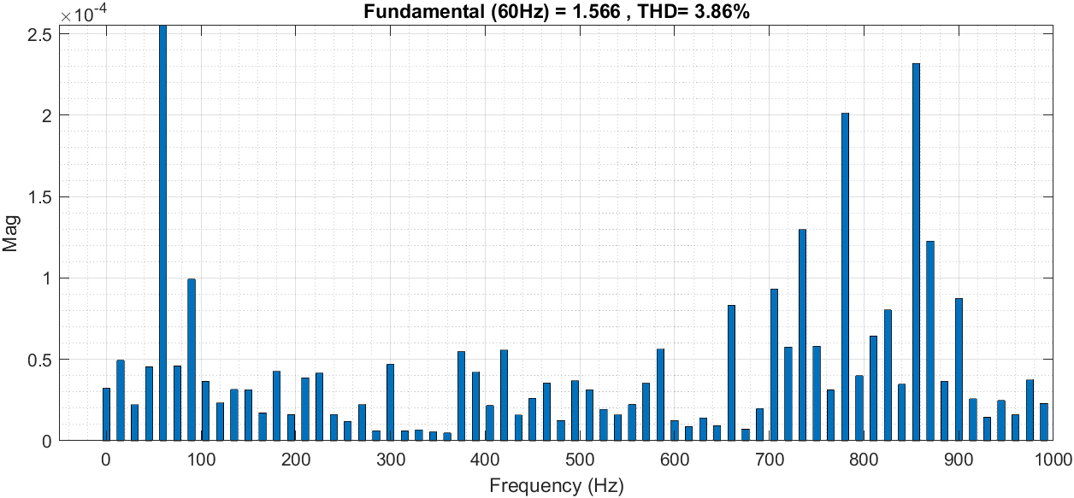
1/4 | 16:00 | 6.44 | 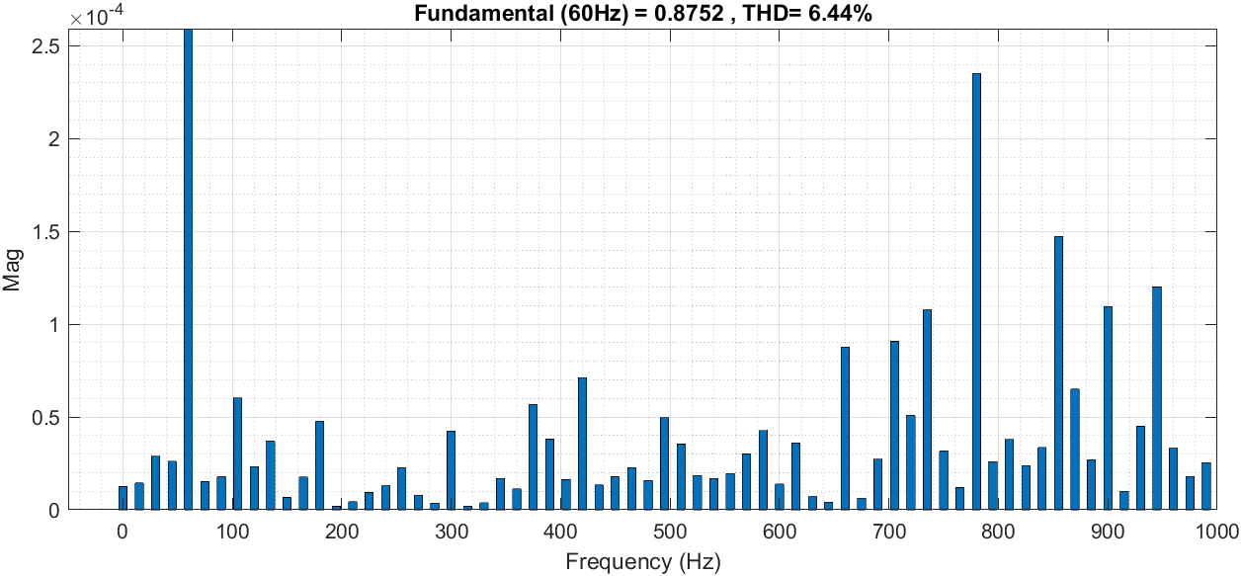
1/4 | 17:00 | 85.34 | 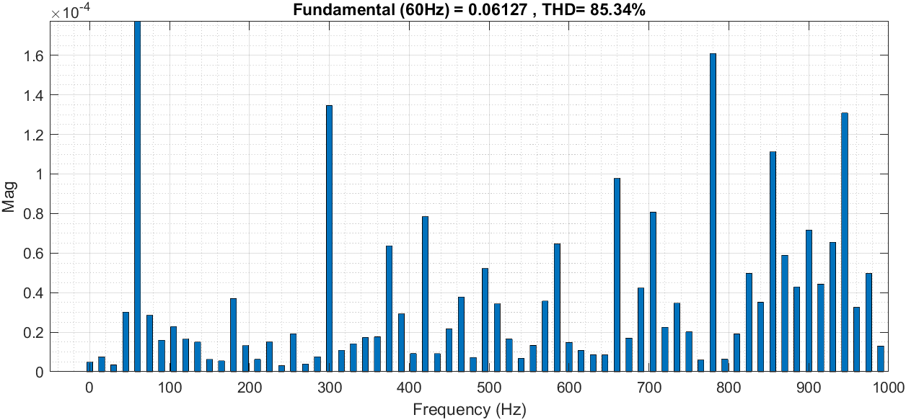
1/7 | 5:00 | 45.16 | 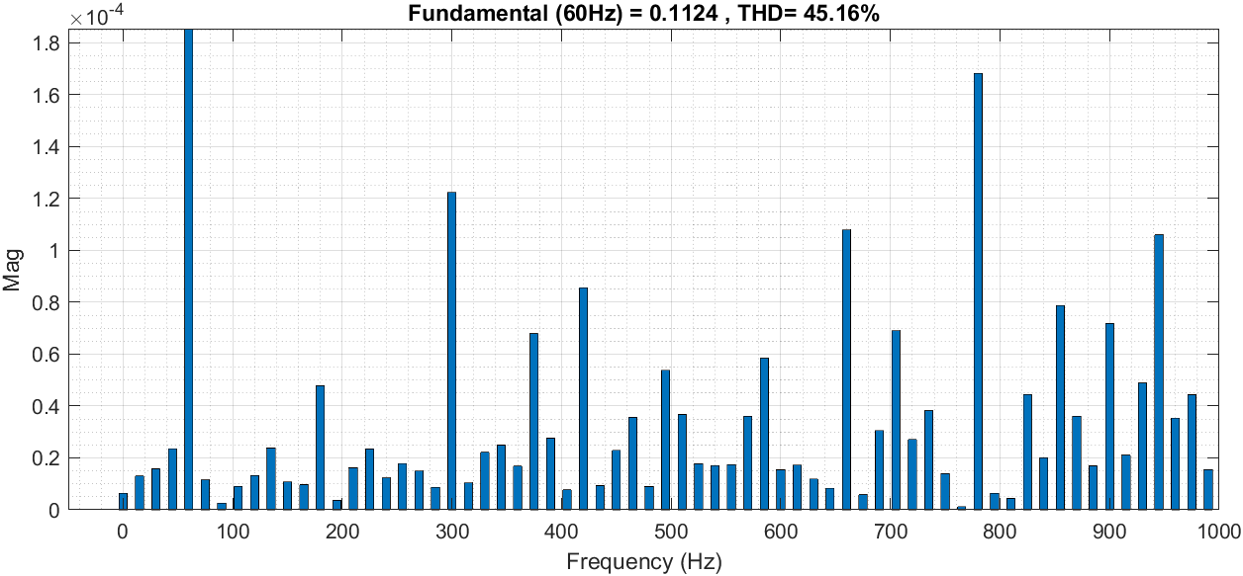
1/7 | 6:00 | 8.86 | 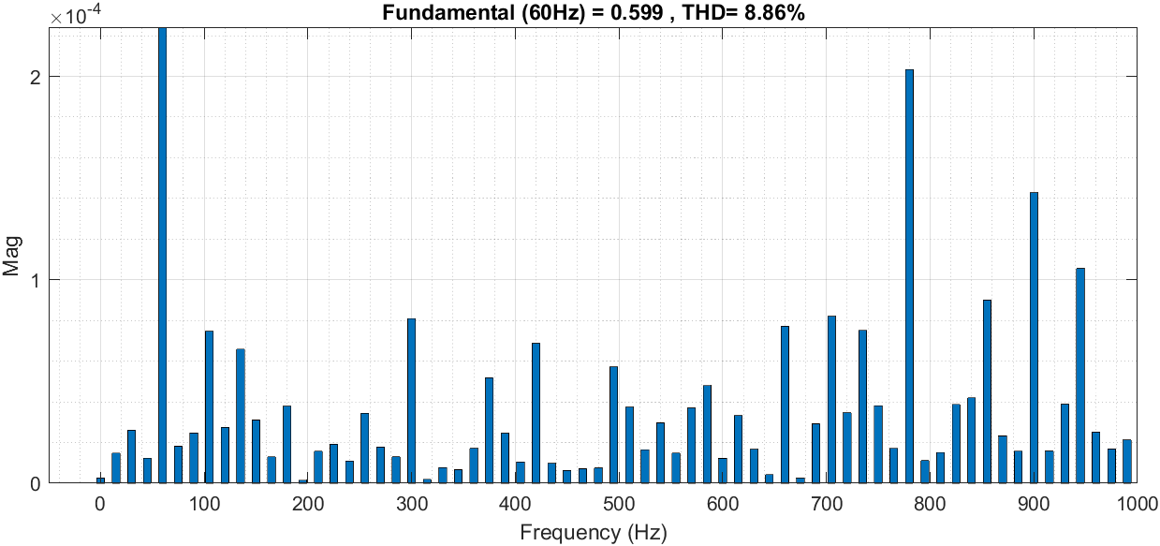
1/7 | 7:00 | 4.5 | 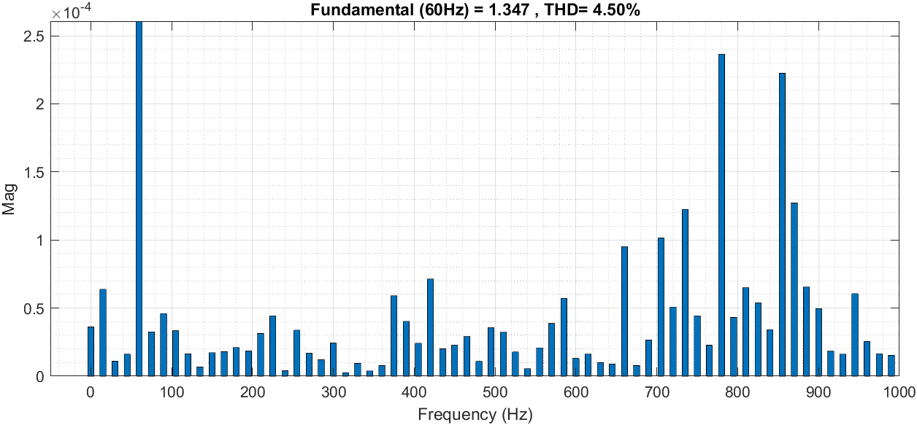
1/7 | 16:00 | 6.26 | 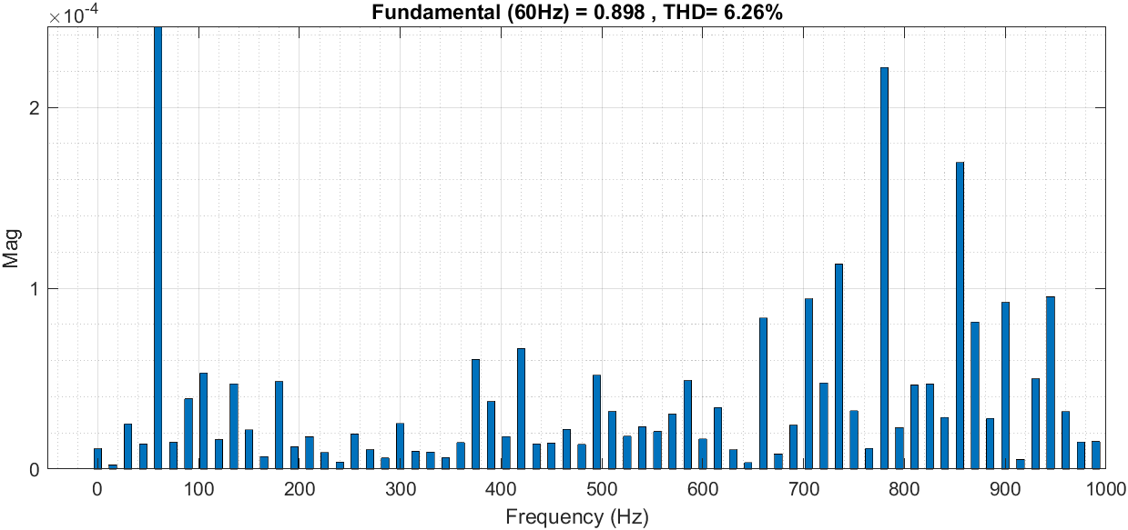
1/7 | 17:00 | 22.06 | 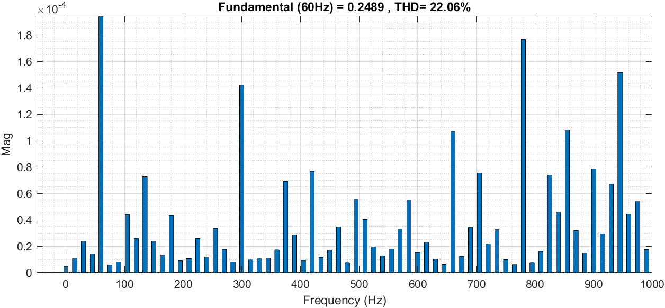
1/7 | 18:00 | 460.5 | 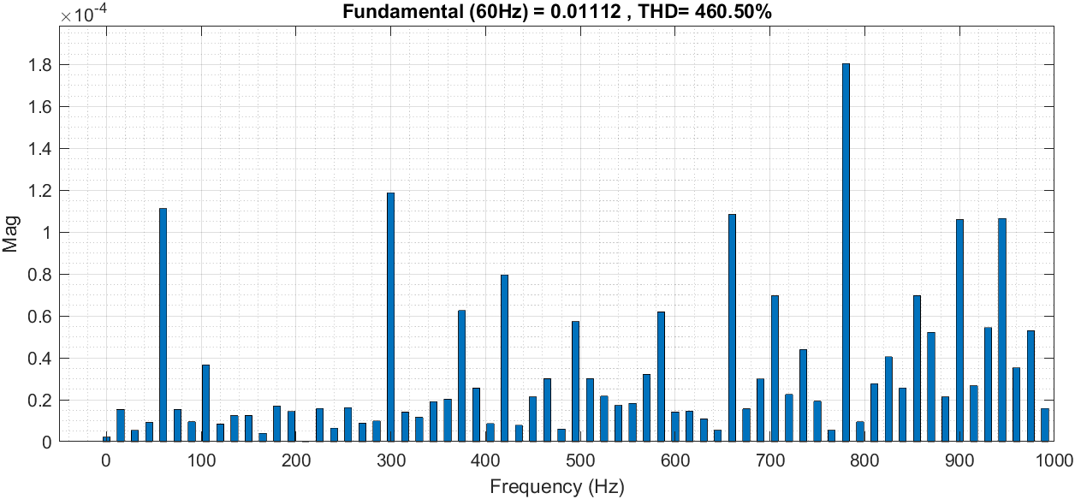
1/11 | 6:00 | 13.84 | 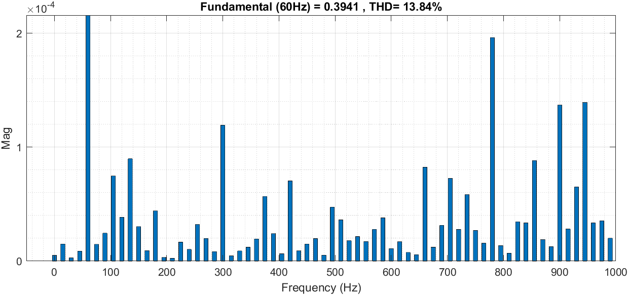
1/11 | 7:00 | 4.94 | 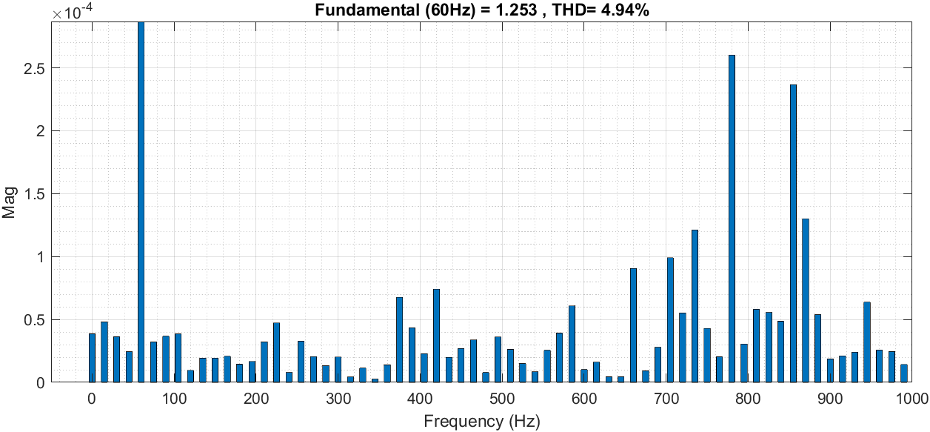
1/11 | 8:00 | 5.24 | 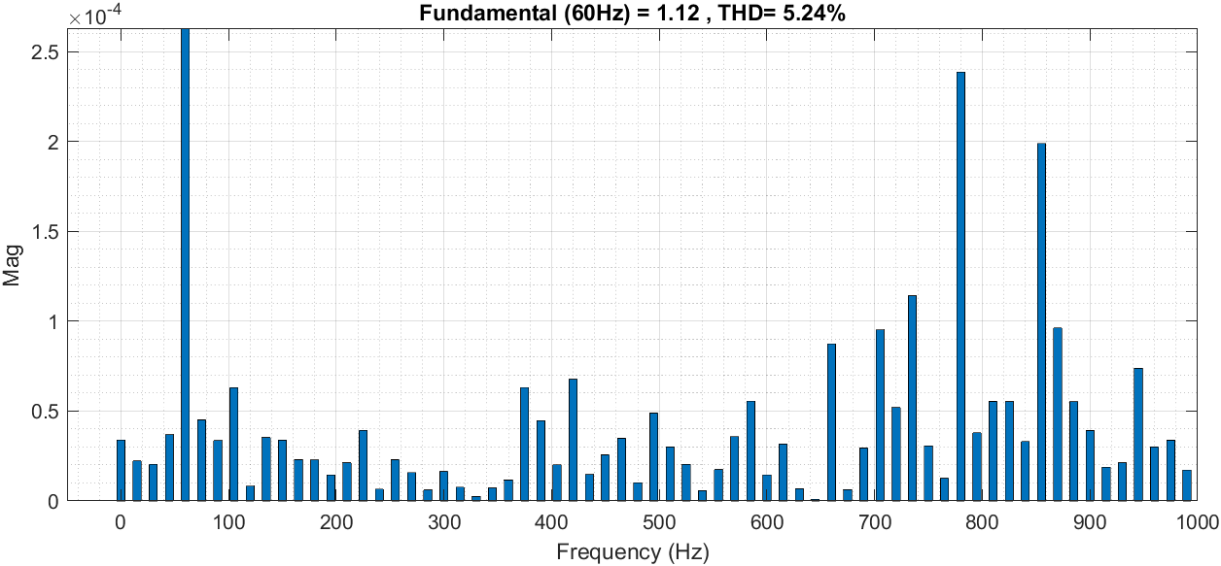
1/11 | 14:00 | 3.89 | 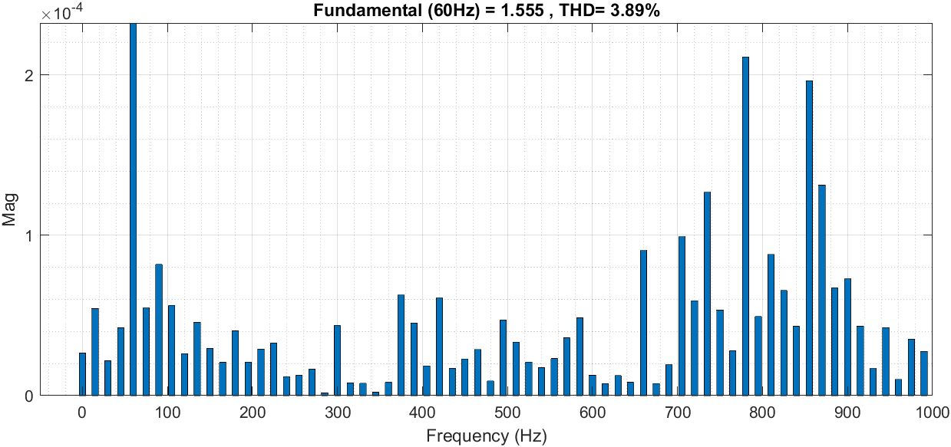
1/11 | 15:00 | 6.70 | 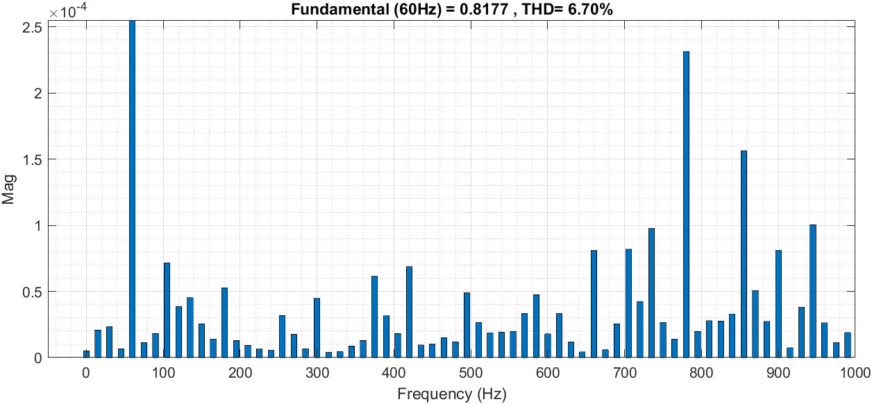
1/11 | 16:00 | 220.26 | 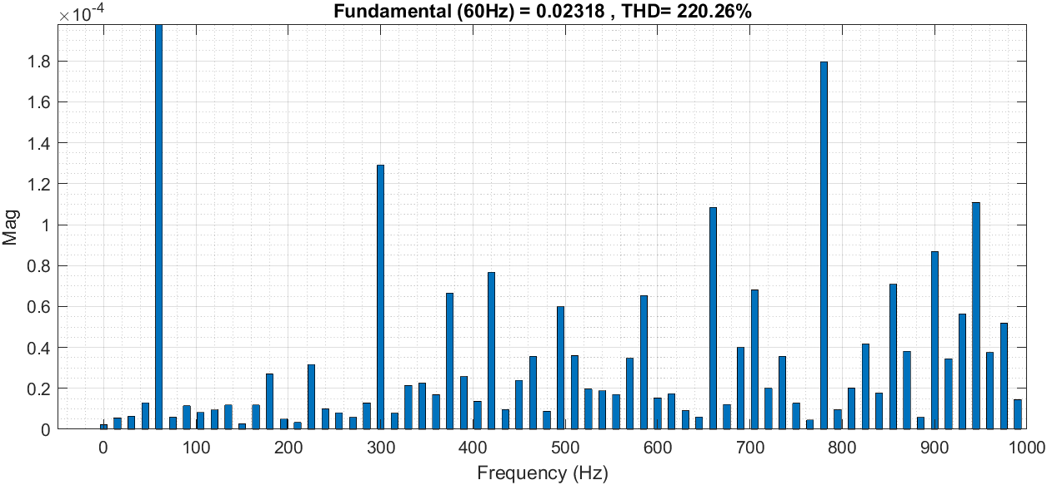

Figure ‎5.24: Two axis tracking system.
The results of a two-axis tracking system are shown in Figure 5.24. The two-axis tracking system can track the sun's path. Because the THD values are within the specified range given in the standards, this system appears to be quite efficient in the summer. Due to the cloudy weather during the winter and spring, however, there are extreme THD values at sunrise and sunset. Because of the sunny days, it is expected that total harmonic distortion will be higher in the summer and spring than in the other seasons.

The table below shows the harmonic orders magnitudes for different time for Two-axis tracking system:

Table ‎5.5: Two-axis tracking system harmonic orders distortion.
Date | Time | Irradiance | image
1/1 | 8:00 | 20 | 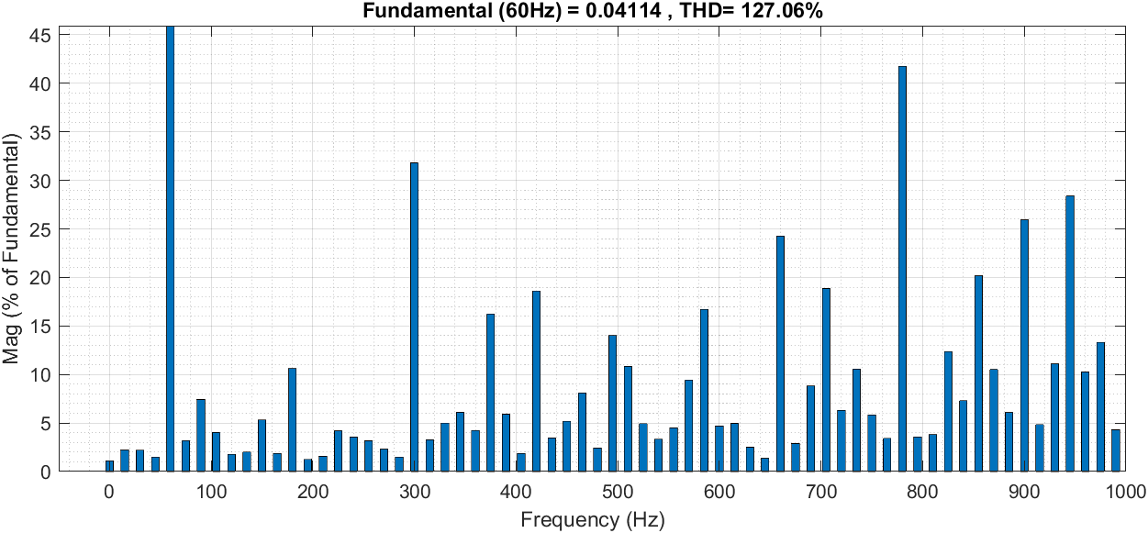
1/1 | 9:00 | 60 | 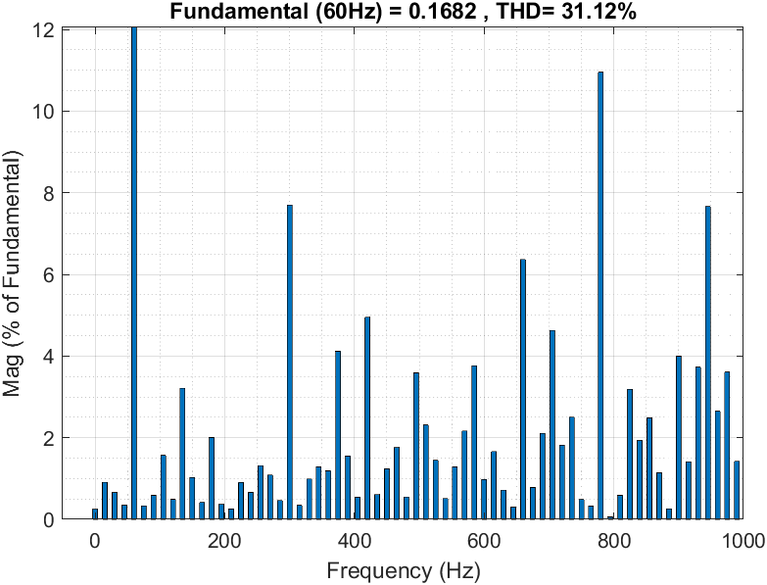
1/1 | 10:00 | 156 | 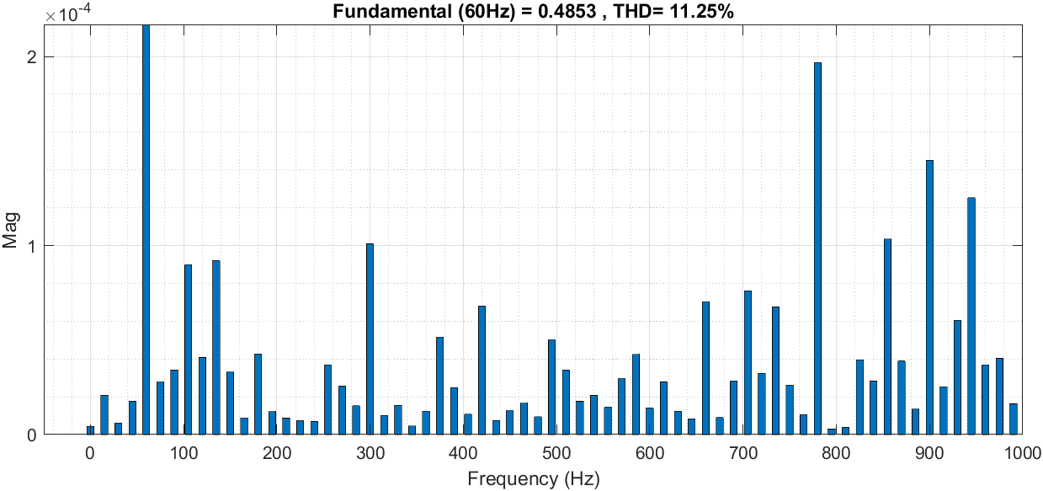
1/1 | 13:00 | 145 | 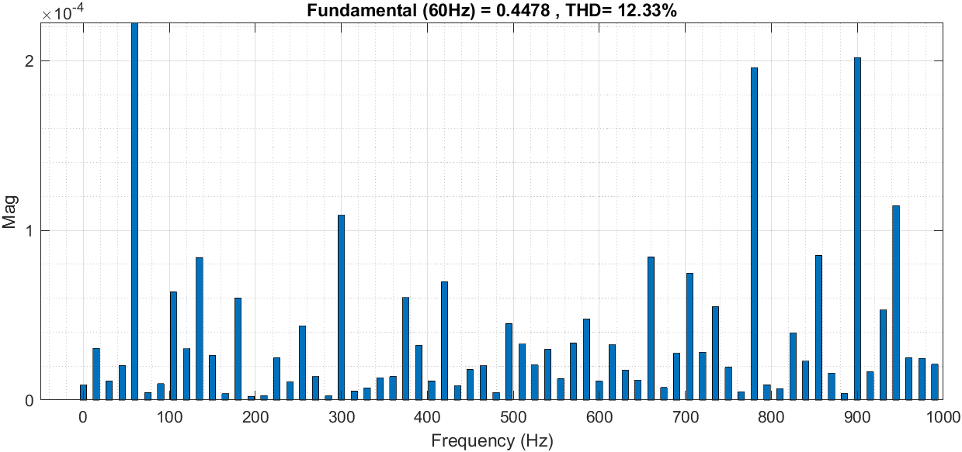
1/1 | 14:00 | 130 | 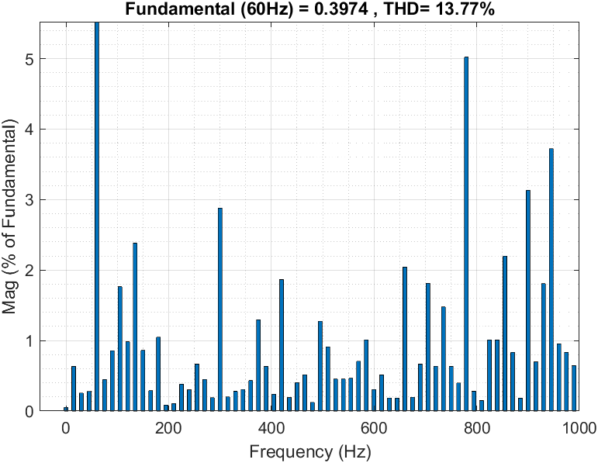
1/1 | 15:00 | 40 | 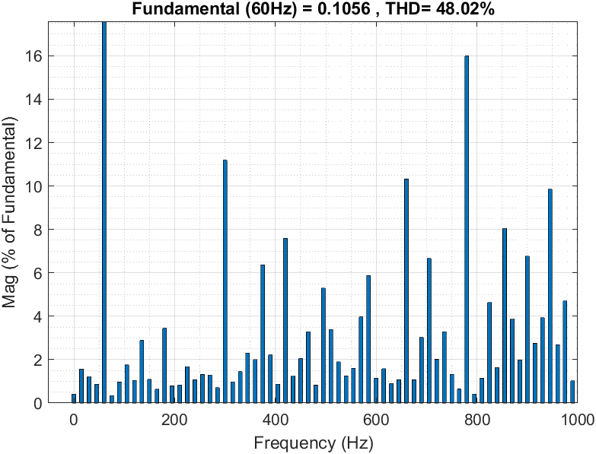
1 / 4 | 6:00 | 145 | 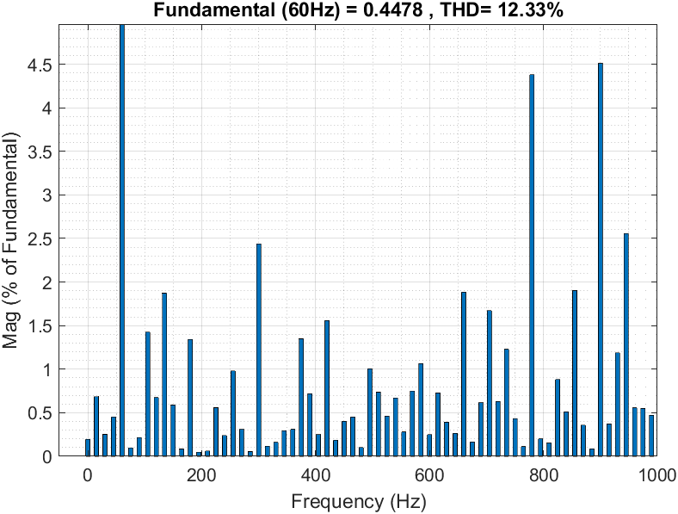
1 / 4 | 7:00 | 303 | 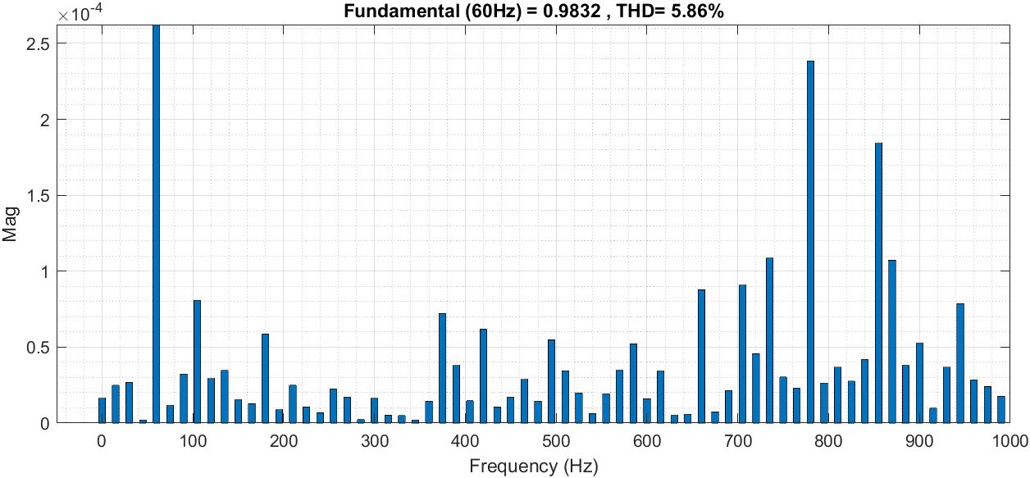
1/4 | 8:00 | 362 | 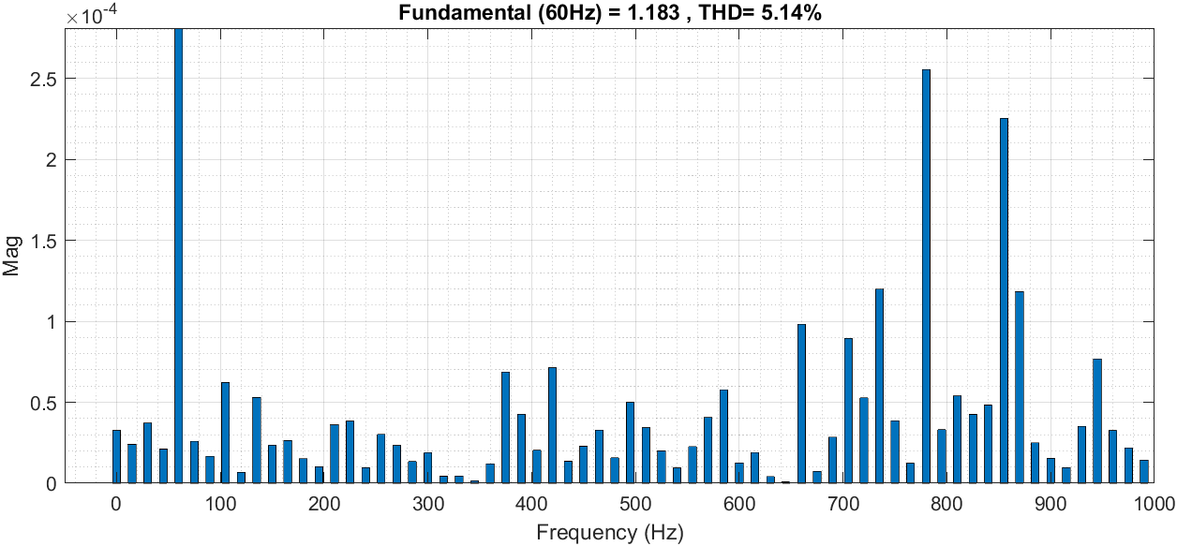
1/4 | 15:00 | 799 | 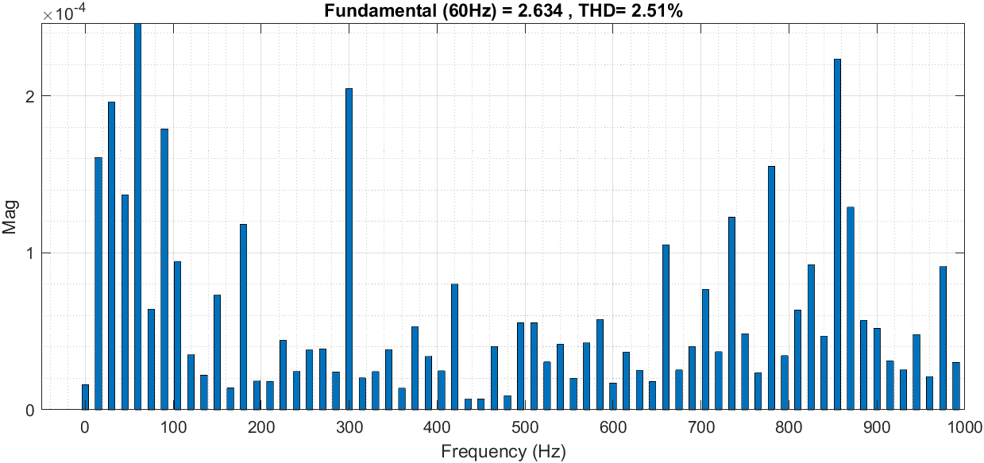
1 / 4 | 16:00 | 680 | 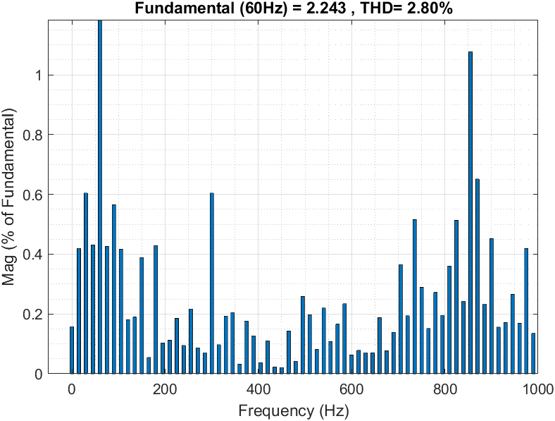
1 / 4 | 17:00 | 20
1/7 | 5:00 | 430 | 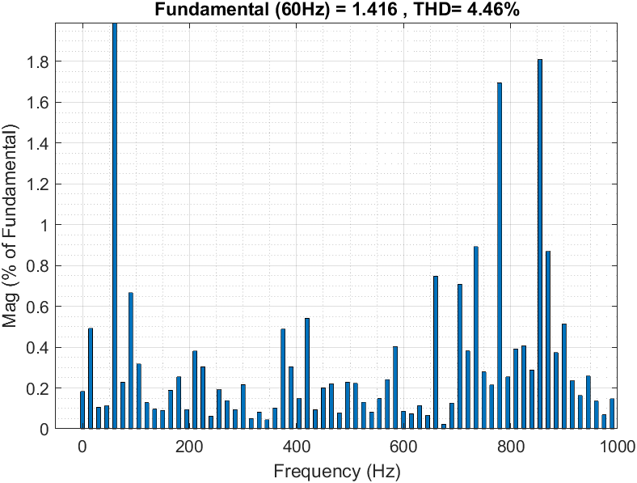
1/7 | 6:00 | 730 | 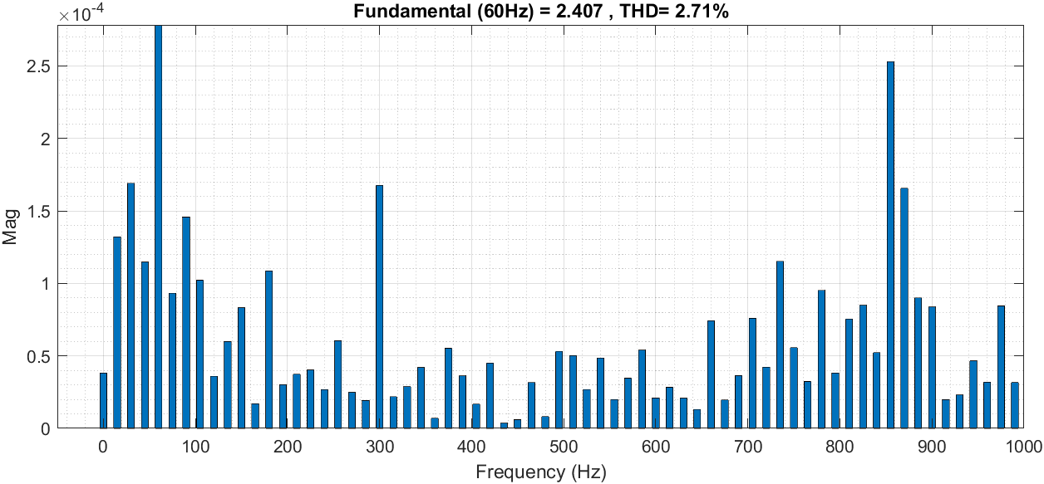
1/7 | 7:00 | 890 | 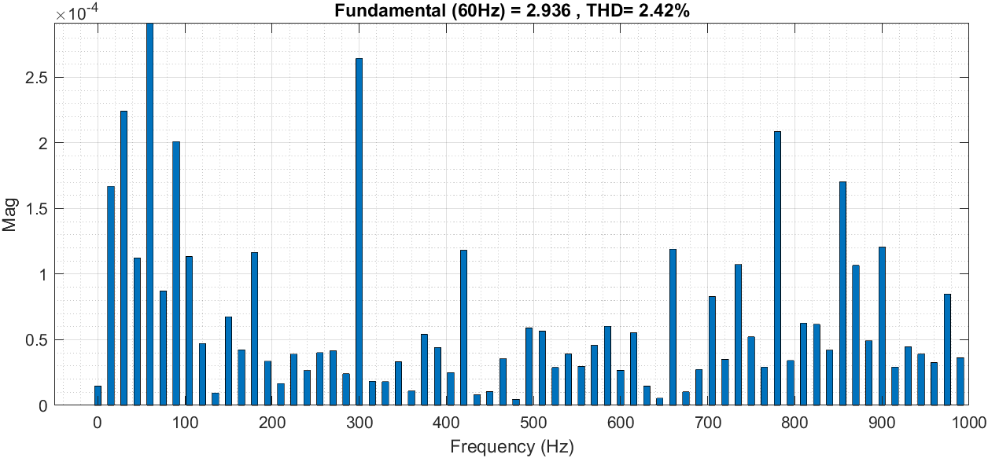
1/7 | 15:00 | 881 | 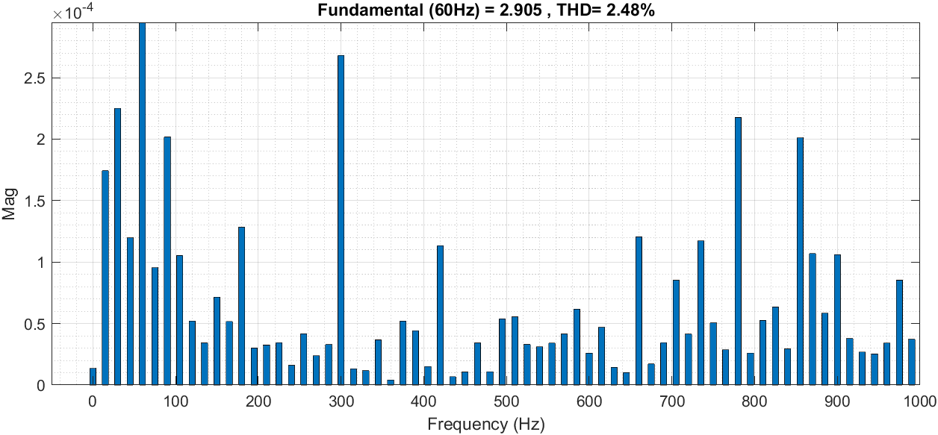
1/7 | 16:00 | 770 | 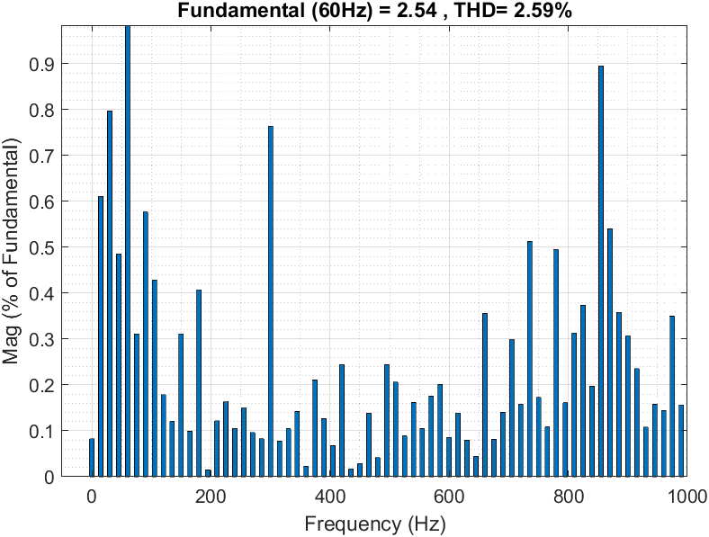
1/7 | 17:00 | 560 | 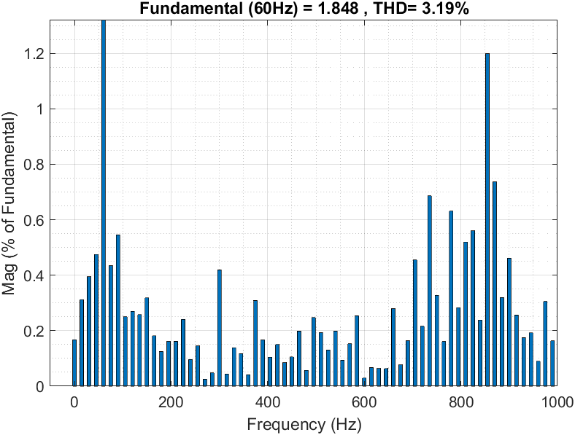
1/11 | 6:00 | 370 | 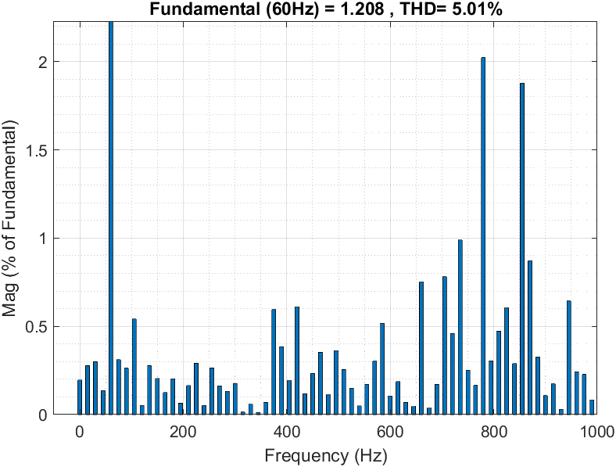
1/11 | 7:00 | 690 | 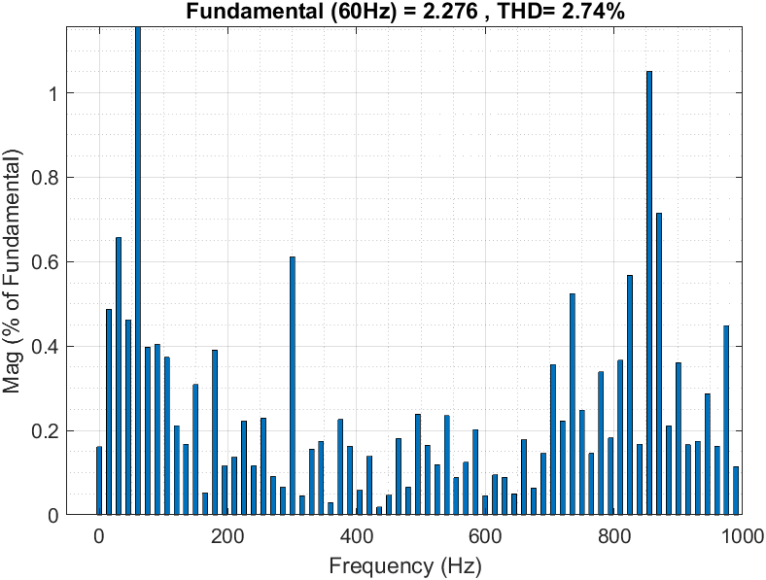
1/11 | 8:00 | 408 | 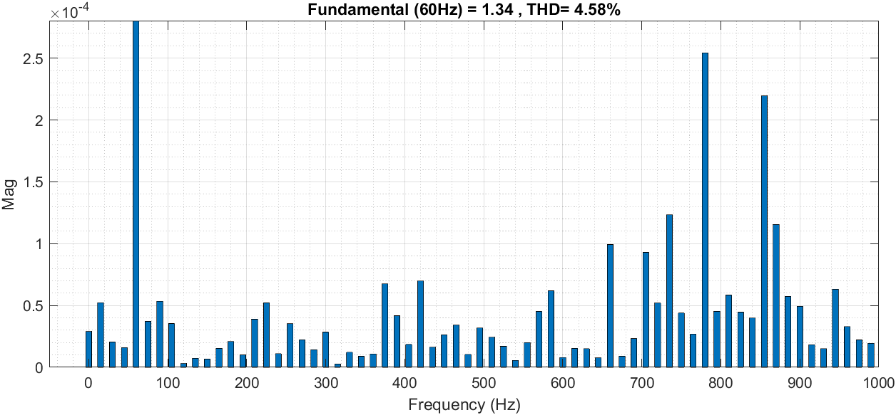
1/11 | 13:00 | 636 | 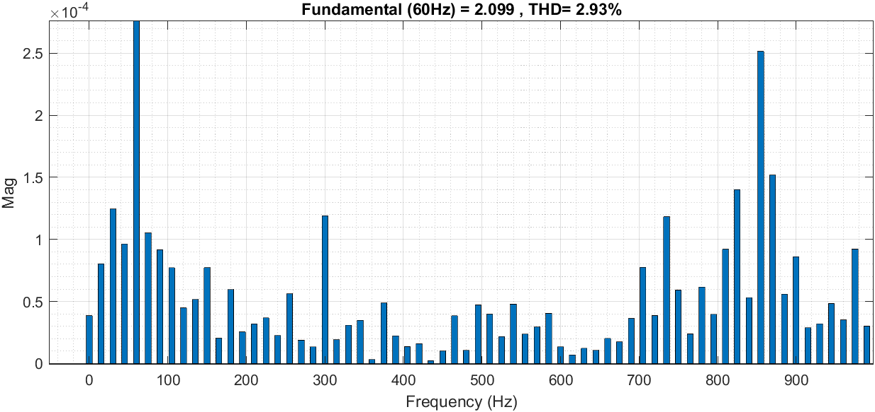
1/11 | 14:00 | 670 | 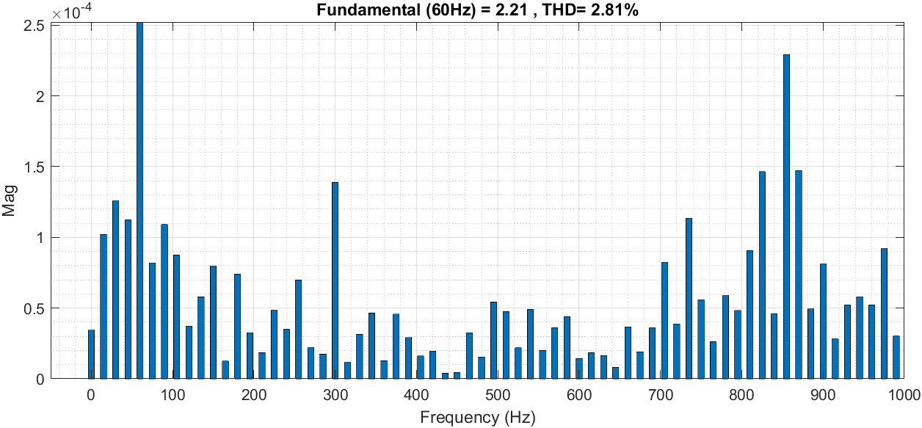
1/11 | 15:00 | 485 | 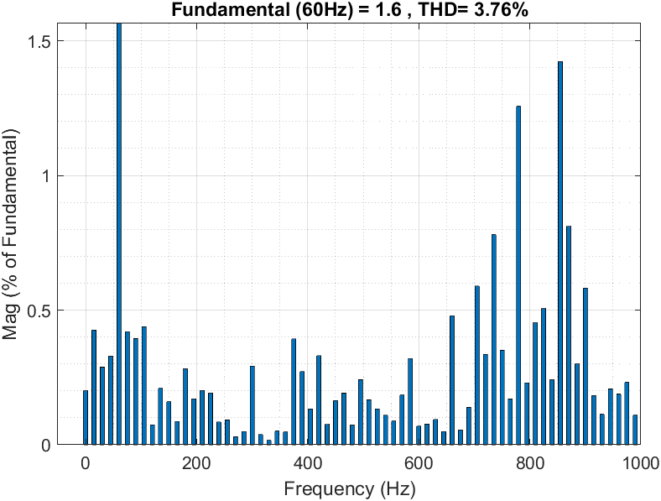

Figure ‎5.25: comparasion of THD for each installation through sunrise and sunset for each season
Figure 5.25 shows a comparison of all of the systems listed above. The results demonstrate that both the east-west and tracking systems outperform the south-north system; because solar radiation is higher at sunrise and sunset, the total harmonic distortion is quite low compared to the south-north system. The total harmonic distortion will vary depending on the weather. So, regardless of cost, both east-west and two-axis tracking systems are more efficient than south-north tracking systems.

5.6 Injection of PV harmonics

Here have been used the IEEE 15 bus network to simulete the effect of the harmonics when it is injected to the network.
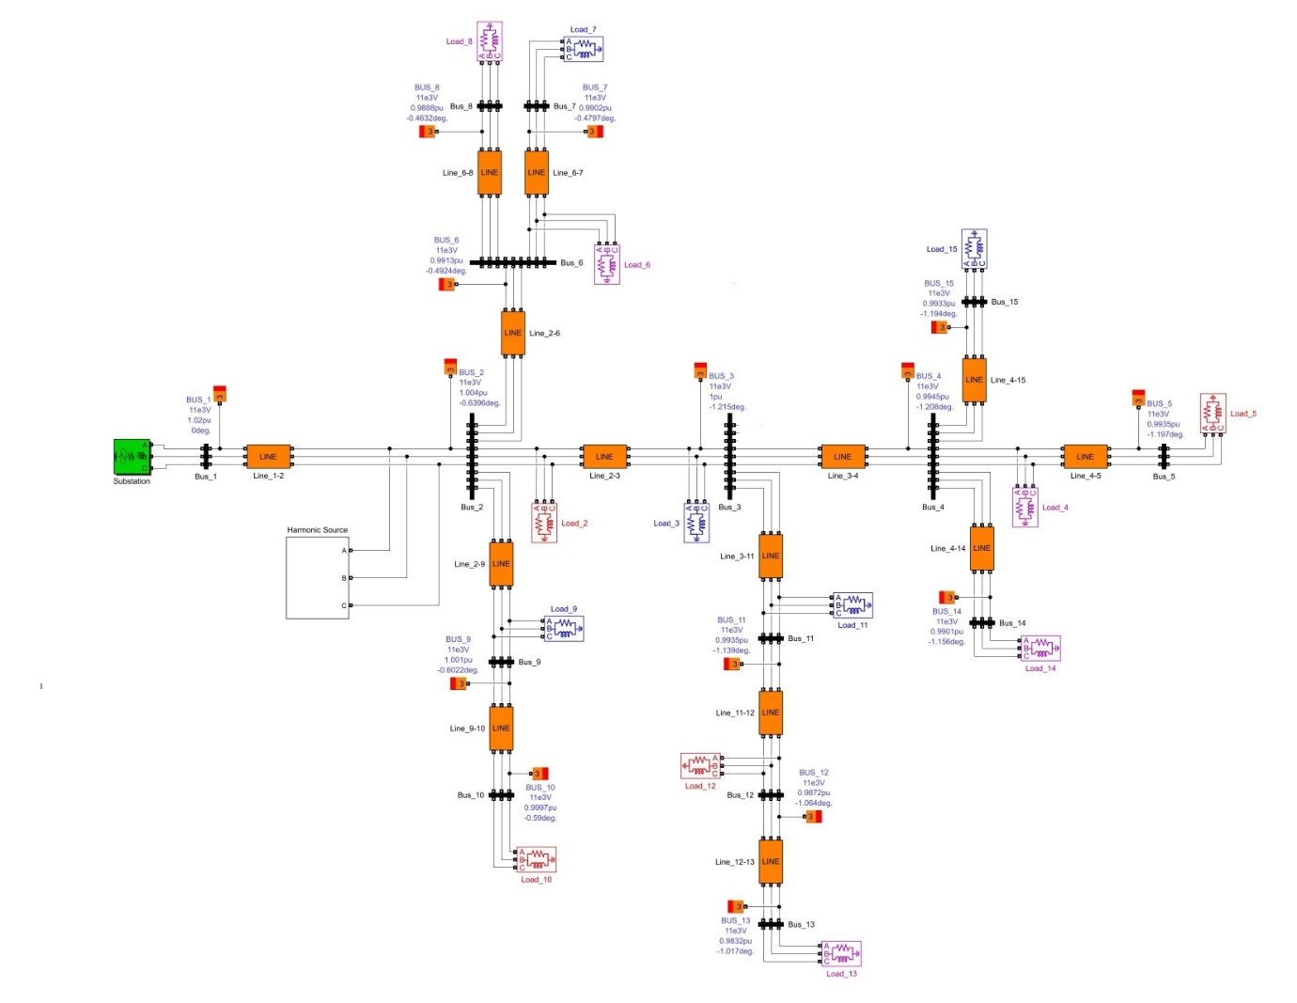
Figure ‎5.26: IEEE 15-bus network.
The network operates at 400V and 60Hz frequency. It consists of 15-bus with different loads. The generated harmonics will be injected at the source side as shown in Figure 5.27.

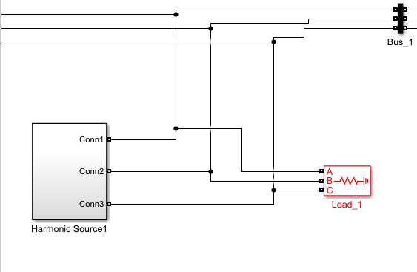
Figure ‎5.27: Harmonic source.
The following harmonics were considered in this study:
- 5th harmonic.
- 7th harmonic.
- 11th harmonic.
- 13th harmonic.

5.6.1 Sungrow inverter

The results is been got by using the sungrow model SG320HX inverter.
The inverter’s data sheet shows that the percentage of harmonics will differ for different power efficiency. You can see each value of the harmonic’s percentage in the appendix A.

5.6.2 Generated harmonics form PV

In this study, the following systems were considered to investigate the effect of the injected harmonics:
- East-West system with tilt angle of $15°$.
- South-North system with tilt angle of $30°$.
- South-North system with tilt angle of $20°$.
- South-North system with tilt angle of $15°$.
The generated harmonics form these are shown in the appendix B.
And these readings show the solar radiation at sunrise and sunset time. Every hour has an output power and a harmonic current associated with it. The harmonic percentages were taken from the inverter's datasheet using the interpolation method, and the fundamental current represents the current at full efficiency.

5.6.3 Total harmonic distortion for the network
To investigate the effect of the injected harmonics, first, we will study the (THD) of the voltages and currents at each bus. The tables below show the total harmonic distortion for these harmonics at one hour from the sunrise and one hour from the sunset for different seasons.
Table ‎5.6: third sun rise hour
Month1 | radiance: 895.25  EW_tilt15 |  | radiance: 766.03  SN-tilt 30 |  | radiance: 680.71  SN-tilt 20 |  | radiance: 630.81  SN-tilt 15
Buses | THD(v) % | THD(i) % | THD(v) % | THD(i) % | THD(v) % | THD(i) % | THD(v) % | THD(i) %
bus1 | 7.68 | 0.36 | 8.72 | 0.4 | 9.48 | 0.43 | 9.7 | 0.44
bus2 | 5.23 | 5.34 | 5.95 | 6.1 | 6.52 | 6.76 | 6.72 | 7.05
bus3 | 4.54 | 4 | 5.17 | 4.56 | 5.69 | 5.03 | 5.89 | 5.22
bus4 | 4.51 | 4.45 | 5.14 | 5.07 | 5.65 | 5.57 | 5.86 | 5.77
bus5 | 4.51 | 4.51 | 5.14 | 5.14 | 5.65 | 5.65 | 5.85 | 5.85
bus6 | 5.22 | 4.2 | 5.94 | 4.78 | 6.51 | 5.24 | 6.71 | 5.4
bus7 | 5.22 | 4.68 | 5.94 | 5.33 | 6.51 | 5.83 | 6.71 | 6.01
bus8 | 5.22 | 3.73 | 5.94 | 4.24 | 6.51 | 4.64 | 6.71 | 4.79
bus9 | 10.42 | 2.72 | 11.86 | 3.12 | 13.01 | 3.5 | 13.43 | 3.68
bus10 | 7.81 | 2.91 | 8.89 | 3.33 | 9.74 | 3.73 | 10.05 | 3.93
bus11 | 10.87 | 9.89 | 12.4 | 11.29 | 13.69 | 12.48 | 14.24 | 12.99
bus12 | 10.65 | 9.54 | 12.15 | 10.89 | 13.43 | 12.04 | 13.98 | 12.53
bus13 | 10.65 | 9.54 | 12.15 | 10.89 | 13.43 | 12.04 | 13.98 | 12.53
bus14 | 4.51 | 4.04 | 5.14 | 4.61 | 5.65 | 5.07 | 5.85 | 5.25
bus15 | 4.51 | 4.51 | 5.14 | 5.14 | 5.65 | 5.65 | 5.85 | 5.85

Figure ‎5.28: Month 1 third hour THD(i) in percentage

Figure ‎5.29: Month 1 third hour THD(v) in percentage.

The results above show how the EW system injects fewer harmonics into the network, and the SN-tilt15 system injects more harmonics than any other system due to the amount of solar radiation falling on it.
Table ‎5.7: first sunset hour
Month1 | radiance: 1025.13  EW_tilt15 |  | radiance: 853.93  SN-tilt 30 |  | radiance: 763.71  SN-tilt 20 |  | radiance: 710.49  SN-tilt 15
Buses | THD(v) % | THD(i) % | THD(v) % | THD(i) % | THD(v) % | THD(i) % | THD(v) % | THD(i) %
bus1 | 6.66 | 0.33 | 7.68 | 0.36 | 8.78 | 0.4 | 9.1 | 0.42
bus2 | 4.54 | 4.64 | 5.23 | 5.34 | 5.99 | 6.14 | 6.3 | 6.52
bus3 | 3.95 | 3.47 | 4.54 | 4 | 5.21 | 4.59 | 5.5 | 4.86
bus4 | 3.92 | 3.86 | 4.51 | 4.45 | 5.17 | 5.1 | 5.49 | 5.39
bus5 | 3.92 | 3.92 | 4.51 | 4.51 | 5.17 | 5.17 | 5.46 | 5.46
bus6 | 4.53 | 3.65 | 5.22 | 4.2 | 5.98 | 4.81 | 6.29 | 5.06
bus7 | 4.53 | 4.06 | 5.22 | 4.68 | 5.98 | 5.36 | 6.29 | 5.64
bus8 | 4.53 | 3.24 | 5.22 | 3.73 | 5.98 | 4.27 | 6.29 | 4.49
bus9 | 9.04 | 2.37 | 10.42 | 2.72 | 11.94 | 3.14 | 12.56 | 3.36
bus10 | 6.78 | 2.53 | 7.81 | 2.91 | 8.95 | 3.36 | 9.4 | 3.59
bus11 | 9.43 | 8.59 | 10.87 | 9.89 | 12.48 | 11.37 | 13.22 | 12.05
bus12 | 9.24 | 8.28 | 10.65 | 9.54 | 12.23 | 10.96 | 12.96 | 11.62
bus13 | 9.24 | 8.28 | 10.65 | 9.54 | 12.32 | 10.96 | 12.96 | 11.62
bus14 | 3.92 | 3.51 | 4.51 | 4.04 | 5.17 | 4.64 | 5.46 | 4.9
bus15 | 3.92 | 3.92 | 4.51 | 4.51 | 5.17 | 5.17 | 5.46 | 5.46

Figure ‎5.30: Month 1 fourth hour THD(i) in percentage.

Figure ‎5.31: Month 1 fourth hour THD(v) in percentage.

These results show how the EW system injects less harmonic into the network and as we can see that most of the THDs are less than five percent, and the SN-tilt15 system injects more harmonics than any other system, and this is due to the amount of radiation falling on it.
Note that the EW system is the best at the end of this season and has the least harmonic currents. Also, the SN-tilt30 system performs better in the case of injected currents than other SN systems.
Table ‎5.8: third sunrise hour.
Month4 | radiance: 917.26  EW_tilt15 |  | radiance: 616.9  SN-tilt 30 |  | radiance: 611.84  SN-tilt 20 |  | radiance: 545.2  SN-tilt 15
Buses | THD(v) % | THD(i) % | THD(v) % | THD(i) % | THD(v) % | THD(i) % | THD(v) % | THD(i) %
bus1 | 7.3 | 0.35 | 9.7 | 0.45 | 9.72 | 0.45 | 9.83 | 0.46
bus2 | 4.97 | 5.07 | 6.74 | 7.12 | 6.77 | 7.16 | 6.94 | 7.49
bus3 | 4.32 | 3.8 | 5.93 | 5.26 | 5.96 | 5.29 | 6.15 | 5.49
bus4 | 4.29 | 4.23 | 5.89 | 5.81 | 5.92 | 5.84 | 6.12 | 6.03
bus5 | 4.29 | 4.29 | 5.89 | 5.89 | 5.92 | 5.92 | 6.11 | 6.11
bus6 | 4.97 | 4 | 6.73 | 5.42 | 6.76 | 5.44 | 6.93 | 5.58
bus7 | 4.96 | 4.45 | 6.73 | 6.04 | 6.76 | 6.06 | 6.93 | 6.21
bus8 | 4.96 | 3.54 | 6.73 | 4.81 | 6.76 | 4.83 | 6.93 | 4.95
bus9 | 9.91 | 2.58 | 13.48 | 3.73 | 13.54 | 3.76 | 13.91 | 4
bus10 | 7.43 | 2.76 | 10.09 | 3.98 | 10.14 | 4.01 | 10.4 | 4.25
bus11 | 10.32 | 9.4 | 14.35 | 13.1 | 14.43 | 13.18 | 15.01 | 13.72
bus12 | 10.11 | 9.06 | 14.09 | 12.64 | 14.18 | 12.71 | 14.77 | 13.24
bus13 | 10.11 | 9.06 | 14.09 | 12.64 | 14.18 | 12.71 | 14.77 | 13.24
bus14 | 4.29 | 3.84 | 5.89 | 5.28 | 5.92 | 5.31 | 6.11 | 5.48
bus15 | 4.29 | 4.29 | 5.89 | 5.89 | 5.92 | 5.92 | 6.12 | 6.12

Figure ‎5.32: Month4 third hour THD(i) in percentage.

Figure ‎5.33: Month4 third hour THD(v) in percentage

These results show how the EW system injects less harmonic into the network, and the SN-tilt15 system injects more harmonic than any other arrangement due to the amount of radiation falling on it.
Table ‎5.9: first sunset hour.
Month4 | radiance: 1113.43  EW_tilt15 |  | radiance: 616.9  SN-tilt 30 |  | radiance: 611.84  SN-tilt 20 |  | radiance: 466  SN-tilt 15
Buses | THD(v) % | THD(i) % | THD(v) % | THD(i) % | THD(v) % | THD(i) % | THD(v) % | THD(i) %
bus1 | 6.16 | 0.32 | 9.7 | 0.45 | 9.72 | 0.45 | 9.75 | 0.48
bus2 | 4.24 | 4.39 | 6.74 | 7.12 | 6.77 | 7.16 | 7.03 | 7.83
bus3 | 3.7 | 4.27 | 5.93 | 5.26 | 5.96 | 5.29 | 6.31 | 5.67
bus4 | 3.68 | 3.63 | 5.89 | 5.81 | 5.92 | 5.84 | 6.28 | 6.19
bus5 | 3.68 | 3.68 | 5.89 | 5.89 | 5.92 | 5.92 | 6.28 | 6.28
bus6 | 4.23 | 3.41 | 6.73 | 5.42 | 6.76 | 5.44 | 7.03 | 5.66
bus7 | 4.23 | 3.8 | 6.73 | 6.04 | 6.76 | 6.06 | 7.03 | 6.3
bus8 | 4.23 | 3.02 | 6.73 | 4.81 | 6.76 | 4.83 | 7.03 | 5.03
bus9 | 8.45 | 2.27 | 13.48 | 3.73 | 13.54 | 3.76 | 14.16 | 4.27
bus10 | 6.34 | 2.42 | 10.09 | 3.98 | 10.14 | 4.01 | 10.58 | 4.53
bus11 | 8.89 | 8.1 | 14.35 | 13.1 | 14.43 | 13.18 | 15.56 | 14.25
bus12 | 8.72 | 7.81 | 14.09 | 12.64 | 14.18 | 12.71 | 15.33 | 13.75
bus13 | 8.72 | 7.81 | 14.09 | 12.64 | 14.18 | 12.71 | 15.33 | 13.75
bus14 | 3.68 | 3.3 | 5.89 | 5.28 | 5.92 | 5.31 | 6.28 | 5.63
bus15 | 3.68 | 3.68 | 5.89 | 5.89 | 5.92 | 5.92 | 6.28 | 6.28

Figure ‎5.34: Month4 fourth hour THD(i) in percentage.

Figure ‎5.35: Month4 fourth hour THD(v) in percentage.

The results above show how the EW system injects the least harmonic currents into the network. As shown in the figures, most buses have a THD of less than five percent except for the buses (11, 12, 13), and the SN-tilt15 system injects more harmonics than any other system due to the amount of solar radiation falling on the panels.
At the end of the spring season, it is clear significantly that the EW system is the best, and the other SN systems are not doing that well, and they inject more harmonic to the network.

Table ‎5.10: Third sunrise hour
Month7 | radiance: 925.14  EW_tilt15 |  | radiance: 763.09  SN-tilt 30 |  | radiance: 639.38  SN-tilt 20 |  | radiance: 598.43  SN-tilt 15
Buses | THD(v) % | THD(i) % | THD(v) % | THD(i) % | THD(v) % | THD(i) % | THD(v) % | THD(i) %
bus1 | 7.26 | 0.35 | 8.75 | 0.4 | 9.62 | 0.44 | 11.77 | 0.59
bus2 | 4.94 | 5.03 | 5.97 | 6.12 | 6.66 | 6.99 | 8.63 | 9.83
bus3 | 4.29 | 3.77 | 5.19 | 4.57 | 5.85 | 5.18 | 7.81 | 7.05
bus4 | 4.26 | 3.747 | 5.16 | 5.08 | 5.81 | 5.73 | 7.77 | 7.66
bus5 | 4.26 | 1.22 | 5.15 | 5.15 | 5.81 | 5.81 | 7.77 | 7.77
bus6 | 4.93 | 3.97 | 5.96 | 4.8 | 6.65 | 5.36 | 8.62 | 6.95
bus7 | 4.93 | 4.42 | 5.96 | 5.34 | 6.65 | 5.97 | 8.62 | 7.74
bus8 | 4.93 | 3.52 | 5.96 | 4.25 | 6.65 | 4.75 | 8.62 | 6.17
bus9 | 9.84 | 2.57 | 11.9 | 3.13 | 13.32 | 3.56 | 17.45 | 5.43
bus10 | 7.38 | 2.74 | 8.92 | 3.34 | 9.97 | 3.85 | 13.03 | 5.75
bus11 | 10.25 | 9.33 | 12.44 | 11.33 | 14.13 | 12.89 | 19.42 | 17.81
bus12 | 10.04 | 9 | 12.19 | 10.92 | 13.86 | 12.43 | 19.16 | 17.19
bus13 | 10.04 | 9 | 12.19 | 10.92 | 13.86 | 12.43 | 19.16 | 17.19
bus14 | 4.26 | 3.82 | 5.15 | 4.62 | 5.81 | 5.21 | 7.77 | 6.97
bus15 | 4.26 | 4.26 | 5.16 | 5.16 | 5.81 | 5.81 | 7.77 | 7.77

Figure ‎5.36: Month7 third hour THD(i) in percentage.

Figure ‎5.37: Month7 third hour THD(v) in percentage

As we can see here, the results show how the EW system injects less harmonics into the network. The SN-tilt15 system injects more harmonics than any other system due to the amount of solar radiation falling on it. The difference between these results is significantly high. For example, at bus 11, the amount of total harmonic distortion at that bus from the EW system is 9.33, and the SN_tilt15 is 17.81. The difference between them is huge, which makes a difference in the power losses and the stability of the network.
Table ‎5.11: First sunset hour.
Month7 | radiance: 1090.89  EW_tilt15 |  | radiance: 662.63  SN-tilt 30 |  | radiance: 696.76  SN-tilt 20 |  | radiance: 434.94  SN-tilt 15
Buses | THD(v) % | THD(i) % | THD(v) % | THD(i) % | THD(v) % | THD(i) % | THD(v) % | THD(i) %
bus1 | 6.63 | 0.33 | 9.54 | 0.43 | 9.43 | 0.42 | 9.74 | 0.49
bus2 | 4.5 | 4.59 | 6.58 | 6.85 | 6.46 | 6.67 | 7.09 | 7.98
bus3 | 3.91 | 3.44 | 5.75 | 5.09 | 5.63 | 4.97 | 6.38 | 5.75
bus4 | 3.88 | 3.83 | 5.72 | 5.63 | 5.59 | 5.51 | 6.35 | 6.28
bus5 | 3.88 | 3.88 | 5.71 | 5.71 | 5.59 | 5.59 | 6.35 | 6.35
bus6 | 4.5 | 3.67 | 6.57 | 5.29 | 6.45 | 5.19 | 7 | 5.71
bus7 | 4.5 | 4.03 | 6.57 | 5.89 | 6.45 | 5.78 | 7 | 6.35
bus8 | 4.5 | 3.21 | 6.57 | 4.69 | 6.45 | 4.6 | 7 | 5.07
bus9 | 8.99 | 2.34 | 13.13 | 3.56 | 12.89 | 3.43 | 14.3 | 4.38
bus10 | 6.74 | 2.5 | 9.83 | 3.79 | 9.65 | 3.66 | 10.68 | 4.64
bus11 | 9.34 | 8.5 | 13.87 | 12.64 | 13.53 | 12.33 | 15.8 | 14.48
bus12 | 9.15 | 8.2 | 13.6 | 12.2 | 13.26 | 11.89 | 15.58 | 13.97
bus13 | 9.15 | 8.2 | 13.6 | 12.2 | 13.26 | 11.89 | 15.58 | 13.97
bus14 | 3.88 | 3.48 | 5.71 | 5.12 | 5.59 | 5.01 | 6.35 | 5.7
bus15 | 3.88 | 3.88 | 5.72 | 5.72 | 5.59 | 5.59 | 6.35 | 6.35

Figure ‎5.38: Month7 fourth hour THD(i) in percentage

Figure ‎5.39:Month7 fourth hour THD(v) in percentage

Moreover, the results above show how the EW system injects less harmonics into the network, and the SN-tilt15 PV arrangement injects more harmonics than any other system.
Also, at the end of the summer season, the EW system injects less harmonic than other SN systems, and the difference is remarkable. Generally, in the summer season, the harmonics will be less than in any other season.
Table ‎5.12: Third sunrise hour
Month10 | radiance: 813.85  EW_tilt15 |  | radiance: 710.77  SN-tilt 30 |  | radiance: 685.96  SN-tilt 20 |  | radiance: 767.7  SN-tilt 15
Buses | THD(v) % | THD(i) % | THD(v) % | THD(i) % | THD(v) % | THD(i) % | THD(v) % | THD(i) %
bus1 | 8.18 | 0.38 | 9.38 | 0.42 | 9.47 | 0.43 | 8.7 | 0.39
bus2 | 5.57 | 5.7 | 6.41 | 6.58 | 6.5 | 6.73 | 5.94 | 6.08
bus3 | 4.84 | 4.26 | 5.58 | 4.91 | 5.67 | 5.01 | 5.16 | 4.55
bus4 | 4.81 | 4.74 | 5.54 | 5.46 | 5.64 | 5.55 | 5.13 | 5.05
bus5 | 4.81 | 4.81 | 5.54 | 5.54 | 5.63 | 5.63 | 5.12 | 5.12
bus6 | 5.57 | 4.48 | 6.4 | 5.15 | 6.45 | 5.22 | 5.93 | 4.77
bus7 | 5.56 | 4.99 | 6.4 | 5.74 | 6.49 | 5.82 | 5.93 | 5.32
bus8 | 5.57 | 3.97 | 6.4 | 4.57 | 6.49 | 4.63 | 5.93 | 4.23
bus9 | 11.11 | 2.91 | 12.78 | 3.38 | 12.97 | 3.48 | 11.84 | 3.11
bus10 | 8.32 | 3.11 | 9.58 | 3.6 | 9.72 | 3.71 | 8.84 | 3.33
bus11 | 11.59 | 10.55 | 13.37 | 12.18 | 13.64 | 12.43 | 12.37 | 11.2
bus12 | 11.36 | 10.18 | 13.1 | 11.75 | 13.36 | 11.99 | 12.12 | 10.86
bus13 | 11.36 | 10.18 | 13.1 | 11.75 | 13.38 | 11.99 | 12.12 | 10.86
bus14 | 4.81 | 4.31 | 5.54 | 4.96 | 5.63 | 5.05 | 5.12 | 4.59
bus15 | 4.81 | 4.81 | 5.54 | 5.54 | 5.63 | 5.63 | 5.13 | 5.13

Figure ‎5.40: Month10 third hour THD(i) in percentage

Figure ‎5.41: Month10 third hour THD(v) in percentage

Here the results show how the EW PV arrangement injects less harmonic into the network, and the SN-tilt20 PV arrangement injects more harmonic than any other arrangement due to the amount of radiation falling on it.
Table ‎5.13: First sunset hour
Month10 | radiance: 991.9  EW_tilt15 |  | radiance: 652.52  SN-tilt 30 |  | radiance: 634.67  SN-tilt 20 |  | radiance: 742.89  SN-tilt 15
Buses | THD(v) % | THD(i) % | THD(v) % | THD(i) % | THD(v) % | THD(i) % | THD(v) % | THD(i) %
bus1 | 6.84 | 0.33 | 9.57 | 0.43 | 9.64 | 0.44 | 9 | 0.4
bus2 | 4.65 | 4.73 | 6.61 | 6.91 | 6.68 | 7.03 | 6.14 | 6.3
bus3 | 4.04 | 3.55 | 5.79 | 5.12 | 5.87 | 5.2 | 5.35 | 4.71
bus4 | 4.01 | 3.95 | 5.75 | 5.67 | 5.83 | 5.75 | 5.31 | 5.23
bus5 | 4.01 | 4.01 | 5.75 | 5.75 | 5.83 | 5.83 | 5.31 | 5.31
bus6 | 4.64 | 3.74 | 6.6 | 5.31 | 6.68 | 5.37 | 6.14 | 4.94
bus7 | 4.64 | 4.16 | 6.6 | 5.92 | 6.67 | 5.98 | 6.14 | 5.5
bus8 | 4.64 | 3.32 | 6.6 | 4.71 | 5.57 | 4.77 | 6.14 | 4.38
bus9 | 9.26 | 2.41 | 13.2 | 3.59 | 13.36 | 3.67 | 12.25 | 3.23
bus10 | 6.95 | 2.57 | 9.88 | 3.83 | 10 | 3.91 | 9.18 | 3.45
bus11 | 9.64 | 8.77 | 13.96 | 12.74 | 14.18 | 12.94 | 12.81 | 11.676
bus12 | 9.44 | 8.46 | 13.7 | 12.28 | 13.92 | 12.48 | 12.55 | 11.25
bus13 | 9.44 | 8.46 | 13.7 | 12.28 | 13.92 | 12.48 | 12.55 | 11.25
bus14 | 4.01 | 3.59 | 5.75 | 5.15 | 5.83 | 5.23 | 5.31 | 4.76
bus15 | 4.01 | 4.01 | 5.75 | 5.75 | 5.83 | 5.83 | 5.31 | 5.31

Figure ‎5.42: Month10 fourth hour THD(i) in percentage

Figure ‎5.43: Month10 fourth hour THD(v) in percentage

Here the results show how the EW PV arrangement injects less harmonic into the network, and as we can see that at all the buses, the current harmonics are less than five percent except for the buses (11, 12, 13) and the SN-tilt20 PV arrangement injects more harmonic than any other arrangement, and this is due to the amount of radiation falling on it.
In the fall season, the difference is not significantly remarkable at sunrise hours, but at sunset hours, the difference is remarkable, as shown in the figures above.

5.6.4 Buses voltages

The tables in Appendix C show the voltage at each bus for different systems and times. The Highest voltage drops were due to the 7th harmonic. On the other hand, the least voltage drops were in the EW system, and the highest voltage drops differ depending on the season. It is clear that at all the seasons, the 7th harmonic made the most significant voltage drops, then the 5th harmonic. As the voltage drops increase, it will make the network unstable.

5.6.5 Power losses in the network

The injected Harmonic currents from the PV system affect the network losses. As these currents increase, the network's total losses will also increase. We observed that the 7th harmonic currents for all systems were the highest, causing high losses to the network.
The following graph shows the losses for each system across a whole annual season.
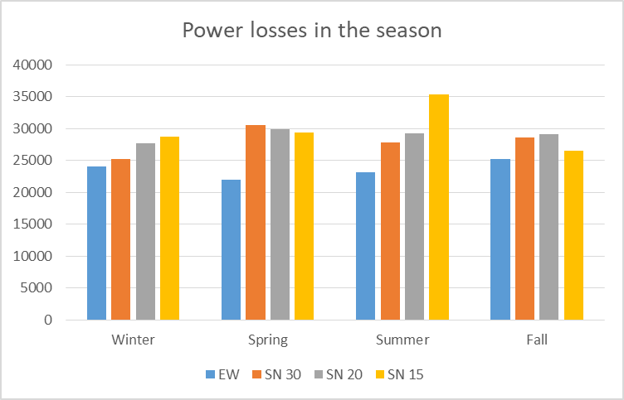
Figure ‎5.44: Power losses for each season.

Table ‎5.14: Power losses values for each season.
 | EW | SN 30 | SN 20 | SN 15
Winter | 24098.004 | 25267.77 | 27683.532 | 28691.73
Spring | 22001.094 | 30586.32 | 29898.72 | 29428.47
Summer | 23120.73 | 27772.65 | 29205.243 | 35331.03
Fall | 25249.41 | 28568.61 | 29080.17 | 26542.62

Figure 5.44 shows that the EW system has the least power losses than the other SN systems. Also, at spring season it has the least power losses than the other seasons.
and for the SN as we can see that in winter the best arrangement is at SN tilt 30 and at spring the best arrangement is SN tilt 15 and at summer the best is at SN tilt 30, finally in winter the best arrangement is at SN tilt 15.

And this is the power losses for the whole year.
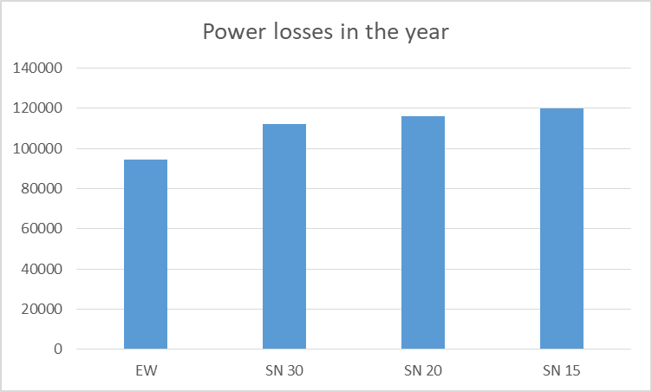
Figure ‎5.45: Power losses for one year.

Table ‎5.15:Values of power losses for one year.
System | Losses in Watt
EW | 94469.238
SN 30 | 112195.35
SN 20 | 115867.665
SN 15 | 119993.85

From figure 5.45 we can see that the EW PV arrangement makes less power losses than other SN PV arrangements and the best between SN PV arrangements is SN tilt 30 it makes less power losses than the other two SN PV arrangements.

: Conclusion and recommendations

This research discussed the total harmonic distortion of a grid-connected PV system. As discussed before, the solar radiation will be low at sunrise and sunset, causing less power generation and high harmonics injected to the network.

The main objective of this research is to compare the total harmonic distortion for M-Shape and S-Shape arrangements, especially at sunrise and sunset periods.

The results discussed in the earlier section show that the solar radiation at these periods is higher for the M-shape than the S-Shape, so the total harmonic is less for higher radiation.
As we can see in the results above the THD is lower for East-West than South-North in all the seasons (winter, spring, summer, fall) and even better than the tracking in some seasons, furthermore most of the time the THD for East-West is under the standard harmonic (>>5%), nevertheless most of the THD for the South-North is above the standard harmonic (>>5%).

From the harmonics that injected to the network we can see that the EW PV arrangement is better than any other system and it make less voltage drops than the other arrangements, also it make less power losses in the network which gone save money to any investor and make the network more stable so we benefit in two directions.

At the power losses the most harmonic that makes most of the power losses is the 7th harmonic and it make the most voltages drops in the buses.

It’s obvious that the east-west PV installations have the potential to generate less harmonic distortion during the sunrise and sunset hours when compared to south PV installations. This is because the output of east-west PV panels will be more consistent during these times, as the panels will be exposed to more consistent levels of sunlight.

Finally, it’s recommended to consider the arrangements of the PV system in the design stage due to the effect of the harmonics on the network that may affect the network quality. In addition, the tilt and azimuth angles must be considered in the design stage because it affects the generated power, so the amount of generated harmonics will vary. Furthermore, the harmonics are also affected because the PV system connection point to the network affects the power flow. These points are very important to be considered, which will help stabilise the network.

References:

[1] Y. Huang, R. Shigenobu, A. Yona, P. Mandal, Z. Yan, and T. Senjyu, “M-Shape PV arrangement for improving solar power generation efficiency,” Appl. Sci., vol. 10, no. 2, 2020, doi: 10.3390/app10020537.
[2] A. Zahedi, “A review of drivers, benefits, and challenges in integrating renewable energy sources into electricity grid,” Renew. Sustain. Energy Rev., vol. 15, no. 9, pp. 4775–4779, 2011, doi: 10.1016/j.rser.2011.07.074.
[3] A. Chidurala, T. Saha, and N. Mithulananthan, “Harmonic characterization of grid connected PV systems & validation with field measurements,” IEEE Power Energy Soc. Gen. Meet., vol. 2015-Septe, pp. 9–13, 2015, doi: 10.1109/PESGM.2015.7286198.
[4] A. Asgharzadeh, C. Deline, J. Stein, and F. Toor, “A Comparison Study of the Performance of South/North-facing vs East/West-facing Bifacial Modules under Shading Conditi,” 2018 IEEE 7th World Conf. Photovolt. Energy Conversion, WCPEC 2018 - A Jt. Conf. 45th IEEE PVSC, 28th PVSEC 34th EU PVSEC, pp. 1730–1734, 2018, doi: 10.1109/PVSC.2018.8548185.
[5] IEEE Standards Coordinating Committee 21 on Fuel Cells Photovoltaics Dispersed Generation and Energy Storage, IEEE Recommended Practice for Utility Interface of Photovoltaic ( PV ) Systems, vol. 2000. 2000.
[6] M. A. A. Mamun, M. M. Islam, M. Hasanuzzaman, and J. Selvaraj, “Effect of tilt angle on the performance and electrical parameters of a PV module: Comparative indoor and outdoor experimental investigation,” Energy Built Environ., vol. 3, no. 3, pp. 278–290, 2022, doi: 10.1016/j.enbenv.2021.02.001.
[7] I. Daut, M. Irwanto, Y. M. Irwan, N. Gomesh, and N. S. Ahmad, “Clear sky global solar irradiance on tilt angles of photovoltaic module in Perlis, Northern Malaysia,” InECCE 2011 - Int. Conf. Electr. Control Comput. Eng., pp. 445–450, 2011, doi: 10.1109/INECCE.2011.5953923.
[8] A. H. M. Nordin and A. M. Omar, “Modeling and simulation of photovoltaic (PV) array and maximum power point tracker (MPPT) for grid-connected PV system,” 3rd ISESEE 2011 - Int. Symp. Exhib. Sustain. Energy Environ., no. June, pp. 114–119, 2011, doi: 10.1109/ISESEE.2011.5977080.
[9] T. F. Wu and Y. K. Chen, “Modeling PWM DC/DC converters out of basic converter units,” IEEE Trans. Power Electron., vol. 13, no. 5, pp. 870–881, 1998, doi: 10.1109/63.712294.
[10] M. M. Amin, M. A. Elshaer, and O. A. Mohammed, “DC bus voltage control for PV sources in a DC distribution system infrastructure,” IEEE PES Gen. Meet. PES 2010, no. November 2016, 2010, doi: 10.1109/PES.2010.5589625.
[11] N. and O. Mohan, “Power Electronics ; Converters Applications and Design THIRD EDITION INTERNATIONAL EDITION INCLUDES,” p. 824, 2003, [Online]. Available: http://www.amazon.com/Electronics-Converters-Applications-INTERNATIONAL-INCLUDES/dp/0471429082.
[12] N. Agbaria et al., “Prevalence of post-traumatic stress disorder among Palestinian children and adolescents exposed to political violence: A systematic review and meta-analysis,” PLoS One, vol. 16, no. 8 August 2021, pp. 1–17, 2021, doi: 10.1371/journal.pone.0256426.
[13] M. A. Chewale, V. B. Savakhande, and V. R. Sagar, “MPPT Based Boost Converter for Photovoltaic Application.”
[14] F. Liu, Y. Kang, Z. Yu, and S. Duan, “Comparison of P&O and hill climbing MPPT methods for grid-connected PV converter,” 2008 3rd IEEE Conf. Ind. Electron. Appl. ICIEA 2008, no. July 2016, pp. 804–807, 2008, doi: 10.1109/ICIEA.2008.4582626.
[15] V. B. Waghmare and C. N. Swapnali, “A drift free perturb & observe MPPT in PV system,” Proc. 2017 2nd IEEE Int. Conf. Electr. Comput. Commun. Technol. ICECCT 2017, 2017, doi: 10.1109/ICECCT.2017.8118022.
[16] R. Dharmaprakash and J. Henry, “Switching table based 2-level inverter and 3-level diode clamped inverter,” J. Theor. Appl. Inf. Technol., vol. 60, no. 2, pp. 380–389, 2014.
[17] B. T. Ooi and X. Wang, “Voltage Angle Lock Loop Control of the Boost Type PWM Converter for HVDC Application,” IEEE Trans. Power Electron., vol. 5, no. 2, pp. 229–235, 1990, doi: 10.1109/63.53160.
[18] E. J. Stacey, “UPFC - Unified Power Flow Controller : Theory , Modeling , and Applications UPFC - Unified Power Flow Controller :,” no. February 1998, 2021.
[19] K. R. Padiyar and N. Prabhu, “Modelling, control design and analysis of VSC based HVDC transmission systems,” 2004 Int. Conf. Power Syst. Technol. POWERCON 2004, vol. 1, no. December 2004, pp. 774–779, 2004, doi: 10.1109/icpst.2004.1460096.
[20] Fabiana Meijon Fadul, EMC Test Report,” 2019.

Appendix A:
Table A.1: Inverter harmonics percentage. [20]
Pn (%) | 0 | 10 | 20 | 30 | 40 | 50 | 60 | 70 | 80 | 90 | 100 | Max (%)
Order | Ih(%) | Ih(%) | Ih(%) | Ih(%) | Ih(%) | Ih(%) | Ih(%) | Ih(%) | Ih(%) | Ih(%) | Ih(%) | Max (%)
2 | 0.00 | 0.02 | 0.02 | 0.02 | 0.02 | 0.04 | 0.05 | 0.06 | 0.08 | 0.09 | 0.10 | 0.10
3 | 0.00 | 0.05 | 0.05 | 0.05 | 0.07 | 0.07 | 0.07 | 0.08 | 0.08 | 0.09 | 0.11 | 0.11
4 | 0.00 | 0.02 | 0.02 | 0.02 | 0.02 | 0.03 | 0.03 | 0.03 | 0.04 | 0.04 | 0.05 | 0.05
5 | 0.00 | 0.73 | 0.70 | 0.61 | 0.45 | 0.32 | 0.23 | 0.19 | 0.21 | 0.21 | 0.23 | 0.73
6 | 0.00 | 0.01 | 0.01 | 0.01 | 0.01 | 0.02 | 0.01 | 0.01 | 0.01 | 0.01 | 0.01 | 0.02
7 | 0.00 | 0.78 | 0.98 | 1.01 | 0.92 | 0.79 | 0.65 | 0.58 | 0.54 | 0.52 | 0.51 | 1.01
8 | 0.00 | 0.01 | 0.01 | 0.01 | 0.01 | 0.01 | 0.01 | 0.01 | 0.01 | 0.02 | 0.02 | 0.02
9 | 0.00 | 0.04 | 0.04 | 0.04 | 0.04 | 0.04 | 0.04 | 0.05 | 0.04 | 0.04 | 0.04 | 0.05
10 | 0.00 | 0.01 | 0.01 | 0.01 | 0.01 | 0.02 | 0.01 | 0.01 | 0.01 | 0.01 | 0.01 | 0.02
11 | 0.00 | 0.49 | 0.25 | 0.37 | 0.46 | 0.48 | 0.38 | 0.33 | 0.27 | 0.23 | 0.17 | 0.49
12 | 0.00 | 0.01 | 0.01 | 0.01 | 0.01 | 0.01 | 0.01 | 0.01 | 0.01 | 0.01 | 0.01 | 0.01
13 | 0.00 | 0.43 | 0.21 | 0.16 | 0.27 | 0.31 | 0.27 | 0.25 | 0.21 | 0.19 | 0.17 | 0.43
14 | 0.00 | 0.01 | 0.01 | 0.01 | 0.01 | 0.01 | 0.01 | 0.01 | 0.01 | 0.01 | 0.01 | 0.01
15 | 0.00 | 0.02 | 0.03 | 0.02 | 0.02 | 0.02 | 0.02 | 0.02 | 0.02 | 0.02 | 0.03 | 0.03
16 | 0.00 | 0.01 | 0.01 | 0.01 | 0.01 | 0.01 | 0.01 | 0.01 | 0.01 | 0.01 | 0.01 | 0.01
17 | 0.00 | 0.18 | 0.35 | 0.20 | 0.16 | 0.23 | 0.24 | 0.25 | 0.23 | 0.18 | 0.16 | 0.35
18 | 0.00 | 0.01 | 0.01 | 0.01 | 0.01 | 0.01 | 0.01 | 0.01 | 0.01 | 0.01 | 0.01 | 0.01
19 | 0.00 | 0.23 | 0.25 | 0.23 | 0.12 | 0.16 | 0.20 | 0.21 | 0.20 | 0.18 | 0.16 | 0.25
20 | 0.00 | 0.01 | 0.01 | 0.01 | 0.01 | 0.01 | 0.01 | 0.01 | 0.01 | 0.01 | 0.01 | 0.01
21 | 0.00 | 0.02 | 0.02 | 0.02 | 0.02 | 0.02 | 0.02 | 0.02 | 0.02 | 0.02 | 0.03 | 0.03
22 | 0.00 | 0.01 | 0.01 | 0.01 | 0.01 | 0.01 | 0.02 | 0.01 | 0.01 | 0.01 | 0.01 | 0.02
23 | 0.00 | 0.17 | 0.10 | 0.18 | 0.10 | 0.08 | 0.13 | 0.12 | 0.14 | 0.12 | 0.13 | 0.18
24 | 0.00 | 0.01 | 0.01 | 0.02 | 0.01 | 0.01 | 0.01 | 0.01 | 0.01 | 0.01 | 0.01 | 0.02
25 | 0.00 | 0.11 | 0.11 | 0.17 | 0.12 | 0.07 | 0.10 | 0.12 | 0.12 | 0.12 | 0.13 | 0.17
26 | 0.00 | 0.02 | 0.02 | 0.02 | 0.02 | 0.02 | 0.02 | 0.02 | 0.02 | 0.02 | 0.02 | 0.02
27 | 0.00 | 0.03 | 0.02 | 0.03 | 0.02 | 0.02 | 0.03 | 0.03 | 0.03 | 0.03 | 0.03 | 0.03
28 | 0.00 | 0.02 | 0.02 | 0.02 | 0.02 | 0.02 | 0.02 | 0.02 | 0.02 | 0.02 | 0.02 | 0.02
29 | 0.00 | 0.12 | 0.13 | 0.07 | 0.15 | 0.10 | 0.12 | 0.13 | 0.12 | 0.15 | 0.12 | 0.15

Appendix B:
Table B.1: Harmonic currents for EW system (first season).
January | Time | Irradiance | Power(kw) | Harmonic | 5 | 7 | 11 | 13
January | Time | Irradiance | 25.75 | fundamental (A) | 254 | 254 | 254 | 254
January | 07:00 | 269.13 | 25.75 | % | 0.7 | 0.98 | 0.25 | 0.21
 |  |  |  | value | 1.778 | 2.4892 | 0.635 | 0.5334
January | 08:00 | 574.85 | 56.5 | fundamental (A) | 254 | 254 | 254 | 254
 |  |  |  | % | 0.61 | 1.01 | 0.37 | 0.16
 |  |  |  | value | 1.5494 | 2.5654 | 0.9398 | 0.4064
January | 09:00 | 895.25 | 89.78 | fundamental (A) | 254 | 254 | 254 | 254
 |  |  |  | % | 0.23 | 0.65 | 0.38 | 0.27
 |  |  |  | value | 0.5842 | 1.651 | 0.9652 | 0.6858
January | 13:00 | 1025.13 | 102.9 | fundamental (A) | 254 | 254 | 254 | 254
 |  |  |  | % | 0.194 | 0.571 | 0.317 | 0.241
 |  |  |  | value | 0.49276 | 1.45034 | 0.80518 | 0.61214
January | 14:00 | 753.75 | 75.48 | fundamental (A) | 254 | 254 | 254 | 254
 |  |  |  | % | 0.3 | 0.77 | 0.45 | 0.31
 |  |  |  | value | 0.762 | 1.9558 | 1.143 | 0.7874
January | 15:00 | 399.08 | 39.45 | fundamental (A) | 254 | 254 | 254 | 254
 |  |  |  | % | 0.62 | 1 | 0.35 | 0.17
 |  |  |  | value | 1.5748 | 2.54 | 0.889 | 0.4318

Table B.2: Harmonic currents for EW system (second season).
April | Time | Irradiance | Power(kw) | Harmonic | 5 | 7 | 11 | 13
April | Time | Irradiance | 26.79 | fundamental (A) | 254 | 254 | 254 | 254
April | 06:00 | 274.011 | 26.79 | % | 0.7 | 0.955 | 0.28 | 0.237
 |  |  |  | value | 1.778 | 2.4257 | 0.7112 | 0.60198
April | 07:00 | 620.87 | 61.99 | fundamental (A) | 254 | 254 | 254 | 254
 |  |  |  | % | 0.406 | 0.875 | 0.466 | 0.28
 |  |  |  | value | 1.03124 | 2.2225 | 1.18364 | 0.7112
April | 08:00 | 917.26 | 92.01 | fundamental (A) | 254 | 254 | 254 | 254
 |  |  |  | % | 0.21 | 0.62 | 0.358 | 0.26
 |  |  |  | value | 0.5334 | 1.5748 | 0.90932 | 0.6604
April | 14:00 | 1113.43 | 111.8 | fundamental (A) | 254 | 254 | 254 | 254
 |  |  |  | % | 0.206 | 0.547 | 0.28 | 0.217
 |  |  |  | value | 0.52324 | 1.38938 | 0.7112 | 0.55118
April | 15:00 | 791.1 | 79.27 | fundamental (A) | 254 | 254 | 254 | 254
 |  |  |  | % | 0.27 | 0.713 | 0.425 | 0.29
 |  |  |  | value | 0.6858 | 1.81102 | 1.0795 | 0.7366
April | 16:00 | 436.47 | 43.25 | fundamental (A) | 254 | 254 | 254 | 254
 |  |  |  | % | 0.61 | 1.01 | 0.37 | 0.16
 |  |  |  | value | 1.5494 | 2.5654 | 0.9398 | 0.4064

Table B.3: Harmonic currents for EW system (third season).
July | Time | Irradiance | Power(kw) | Harmonic | 5 | 7 | 11 | 13
July | Time | Irradiance | 21.57 | fundamental (A) | 254 | 254 | 254 | 254
July | 05:00 | 222.127 | 21.57 | % | 0.715 | 0.88 | 0.37 | 0.32
 |  |  |  | value | 1.8161 | 2.2352 | 0.9398 | 0.8128
July | 06:00 | 534.5 | 53.21 | fundamental (A) | 254 | 254 | 254 | 254
 |  |  |  | % | 0.494 | 0.945 | 0.435 | 0.24
 |  |  |  | value | 1.25476 | 2.4003 | 1.1049 | 0.6096
July | 07:00 | 925.14 | 92.81 | fundamental (A) | 254 | 254 | 254 | 254
 |  |  |  | % | 0.21 | 0.615 | 0.355 | 0.26
 |  |  |  | value | 0.5334 | 1.5621 | 0.9017 | 0.6604
July | 15:00 | 1090.89 | 109.5 | fundamental (A) | 254 | 254 | 254 | 254
 |  |  |  | % | 0.2 | 0.56 | 0.3 | 0.26
 |  |  |  | value | 0.508 | 1.4224 | 0.762 | 0.6604
July | 16:00 | 736.62 | 73.74 | fundamental (A) | 254 | 254 | 254 | 254
 |  |  |  | % | 0.305 | 0.767 | 0.464 | 0.303
 |  |  |  | value | 0.7747 | 1.94818 | 1.17856 | 0.76962
July | 17:00 | 351.252 | 34.6 | fundamental (A) | 254 | 254 | 254 | 254
 |  |  |  | % | 0.662 | 0.992 | 0.3 | 0.189
 |  |  |  | value | 1.68148 | 2.51968 | 0.762 | 0.48006

Table B.4: Harmonic currents for EW system (fourth season).
October | Time | Irradiance | Power(kw) | Harmonic | 5 | 7 | 11 | 13
October | Time | Irradiance | 18.67 | fundamental (A) | 254 | 254 | 254 | 254
October | 06:00 | 193.187 | 18.67 | % | 0.72 | 0.84 | 0.416 | 0.36
 |  |  |  | value | 1.8288 | 2.1336 | 1.05664 | 0.9144
October | 07:00 | 464.93 | 46.14 | fundamental (A) | 254 | 254 | 254 | 254
 |  |  |  | % | 0.573 | 0.99 | 0.39 | 0.185
 |  |  |  | value | 1.45542 | 2.5146 | 0.9906 | 0.4699
October | 08:00 | 813.85 | 81.57 | fundamental (A) | 254 | 254 | 254 | 254
 |  |  |  | % | 0.256 | 0.69 | 0.41 | 0.2816
 |  |  |  | value | 0.65024 | 1.7526 | 1.0414 | 0.715264
October | 14:00 | 991.9 | 99.56 | fundamental (A) | 254 | 254 | 254 | 254
 |  |  |  | % | 0.19 | 0.58 | 0.33 | 0.25
 |  |  |  | value | 0.4826 | 1.4732 | 0.8382 | 0.635
October | 15:00 | 605.12 | 60.39 | fundamental (A) | 254 | 254 | 254 | 254
 |  |  |  | % | 0.42 | 0.89 | 0.464 | 0.28
 |  |  |  | value | 1.0668 | 2.2606 | 1.17856 | 0.7112
October | 16:00 | 296.568 | 29.07 | fundamental (A) | 254 | 254 | 254 | 254
 |  |  |  | % | 0.7 | 0.98 | 0.25 | 0.21
 |  |  |  | value | 1.778 | 2.4892 | 0.635 | 0.5334

Table B.5: Harmonic currents for SN-30 system (first season).
January | Time | Irradiance | Power(kw) | Harmonic | 5 | 7 | 11 | 13
January | 07:00 | 271.29 | 26.6 | fundamental (A) | 254 | 254 | 254 | 254
 |  |  |  | % | 0.704 | 0.952 | 0.283 | 0.24
 |  |  |  | value | 1.78816 | 2.41808 | 0.71882 | 0.6096
January | 08:00 | 541.83 | 54.14 | fundamental (A) | 254 | 254 | 254 | 254
 |  |  |  | % | 0.483 | 0.938 | 0.441 | 0.246
 |  |  |  | value | 1.22682 | 2.38252 | 1.12014 | 0.62484
January | 09:00 | 766.03 | 76.9 | fundamental (A) | 254 | 254 | 254 | 254
 |  |  |  | % | 0.285 | 0.736 | 0.441 | 0.294
 |  |  |  | value | 0.7239 | 1.86944 | 1.12014 | 0.74676
January | 13:00 | 853.93 | 85.91 | fundamental (A) | 254 | 254 | 254 | 254
 |  |  |  | % | 0.23 | 0.65 | 0.38 | 0.27
 |  |  |  | value | 0.5842 | 1.651 | 0.9652 | 0.6858
January | 14:00 | 670.4 | 67.25 | fundamental (A) | 254 | 254 | 254 | 254
 |  |  |  | % | 0.358 | 0.828 | 0.474 | 0.298
 |  |  |  | value | 0.90932 | 2.10312 | 1.20396 | 0.75692
January | 15:00 | 420.36 | 41.75 | fundamental (A) | 254 | 254 | 254 | 254
 |  |  |  | % | 0.617 | 1.007 | 0.3607 | 0.1638
 |  |  |  | value | 1.56718 | 2.55778 | 0.916178 | 0.416052

Table B.6:Harmonic currents for SN-30 system (second season).
April | 07:00 | 229.14 | Power(kw) | Harmonic | 5 | 7 | 11 | 13
April | 07:00 | 229.14 | 22.26 | fundamental (A) | 254 | 254 | 254 | 254
 |  |  |  | % | 0.71 | 0.89 | 0.36 | 0.31
 |  |  |  | value | 1.8034 | 2.2606 | 0.9144 | 0.7874
April | 08:00 | 322.05 | 31.66 | fundamental (A) | 254 | 254 | 254 | 254
 |  |  |  | % | 0.68 | 0.99 | 0.28 | 0.2
 |  |  |  | value | 1.7272 | 2.5146 | 0.7112 | 0.508
April | 09:00 | 545.89 | 54.55 | fundamental (A) | 254 | 254 | 254 | 254
 |  |  |  | % | 0.479 | 0.936 | 0.443 | 0.25
 |  |  |  | value | 1.21666 | 2.37744 | 1.12522 | 0.635
April | 14:00 | 616.9 | 61.79 | fundamental (A) | 254 | 254 | 254 | 254
 |  |  |  | % | 0.407 | 0.877 | 0.466 | 0.283
 |  |  |  | value | 1.03378 | 2.22758 | 1.18364 | 0.71882
April | 15:00 | 475.41 | 47.2 | fundamental (A) | 254 | 254 | 254 | 254
 |  |  |  | % | 0.56 | 0.98 | 0.4 | 0.19
 |  |  |  | value | 1.4224 | 2.4892 | 1.016 | 0.4826
April | 16:00 | 271.45 | 26.54 | fundamental (A) | 254 | 254 | 254 | 254
 |  |  |  | % | 0.7 | 0.95 | 0.28 | 0.24
 |  |  |  | value | 1.778 | 2.413 | 0.7112 | 0.6096

Table B.7:Harmonic currents for SN-30 system (Third season).
July | 07:00 | 390.41 | Power(kw) | Harmonic | 5 | 7 | 11 | 13
July | 07:00 | 390.41 | 38.7 | fundamental (A) | 254 | 254 | 254 | 254
 |  |  |  | % | 0.636 | 1 | 0.335 | 0.174
 |  |  |  | value | 1.61544 | 2.54 | 0.8509 | 0.44196
July | 08:00 | 602.99 | 60.37 | fundamental (A) | 254 | 254 | 254 | 254
 |  |  |  | % | 0.421 | 0.891 | 0.464 | 0.279
 |  |  |  | value | 1.06934 | 2.26314 | 1.17856 | 0.70866
July | 09:00 | 763.09 | 76.69 | fundamental (A) | 254 | 254 | 254 | 254
 |  |  |  | % | 0.286 | 0.738 | 0.443 | 0.295
 |  |  |  | value | 0.72644 | 1.87452 | 1.12522 | 0.7493
July | 14:00 | 662.63 | 66.46 | fundamental (A) | 254 | 254 | 254 | 254
 |  |  |  | % | 0.365 | 0.835 | 0.473 | 0.296
 |  |  |  | value | 0.9271 | 2.1209 | 1.20142 | 0.75184
July | 15:00 | 484.47 | 48.28 | fundamental (A) | 254 | 254 | 254 | 254
 |  |  |  | % | 0.549 | 0.975 | 0.404 | 0.201
 |  |  |  | value | 1.39446 | 2.4765 | 1.02616 | 0.51054
July | 16:00 | 283.81 | 27.87 | fundamental (A) | 254 | 254 | 254 | 254
 |  |  |  | % | 0.7 | 0.98 | 0.25 | 0.21
 |  |  |  | value | 1.778 | 2.4892 | 0.635 | 0.5334

Table B.8:Harmonic currents for SN-30 system (fourth season).
October | 07:00 | 347.83 | Power(kw) | Harmonic | 5 | 7 | 11 | 13
October | 07:00 | 347.83 | 34.36 | fundamental (A) | 254 | 254 | 254 | 254
 |  |  |  | % | 0.663 | 0.992 | 0.298 | 0.189
 |  |  |  | value | 1.68402 | 2.51968 | 0.75692 | 0.48006
October | 08:00 | 549.55 | 54.92 | fundamental (A) | 254 | 254 | 254 | 254
 |  |  |  | % | 0.474 | 0.934 | 0.446 | 0.252
 |  |  |  | value | 1.20396 | 2.37236 | 1.13284 | 0.64008
October | 09:00 | 710.77 | 71.36 | fundamental (A) | 254 | 254 | 254 | 254
 |  |  |  | % | 0.32 | 0.79 | 0.48 | 0.31
 |  |  |  | value | 0.8128 | 2.0066 | 1.2192 | 0.7874
October | 13:00 | 652.52 | 65.42 | fundamental (A) | 254 | 254 | 254 | 254
 |  |  |  | % | 0.374 | 0.844 | 0.471 | 0.293
 |  |  |  | value | 0.94996 | 2.14376 | 1.19634 | 0.74422
October | 14:00 | 494 | 49.25 | fundamental (A) | 254 | 254 | 254 | 254
 |  |  |  | % | 0.538 | 0.969 | 0.41 | 0.209
 |  |  |  | value | 1.36652 | 2.46126 | 1.0414 | 0.53086
October | 15:00 | 305.74 | 30.09 | fundamental (A) | 254 | 254 | 254 | 254
 |  |  |  | % | 0.69 | 0.983 | 0.262 | 0.204
 |  |  |  | value | 1.7526 | 2.49682 | 0.66548 | 0.51816

Table B.9:Harmonic currents for SN-20 system (first season).
January | Time | Irradiance | Power(kw) | Harmonic | 5 | 7 | 11 | 13
January | 07:00 | 223.65 | 24.37 | fundamental (A) | 254 | 254 | 254 | 254
 |  |  |  | % | 0.708 | 0.921 | 0.321 | 0.275
 |  |  |  | value | 1.79832 | 2.33934 | 0.81534 | 0.6985
January | 08:00 | 470.61 | 46.72 | fundamental (A) | 254 | 254 | 254 | 254
 |  |  |  | % | 0.567 | 0.986 | 0.394 | 0.189
 |  |  |  | value | 1.44018 | 2.50444 | 1.00076 | 0.48006
January | 09:00 | 680.71 | 68.07 | fundamental (A) | 254 | 254 | 254 | 254
 |  |  |  | % | 0.35 | 0.82 | 0.475 | 0.3
 |  |  |  | value | 0.889 | 2.0828 | 1.2065 | 0.762
January | 13:00 | 763.71 | 76.49 | fundamental (A) | 254 | 254 | 254 | 254
 |  |  |  | % | 0.288 | 0.74 | 0.445 | 0.296
 |  |  |  | value | 0.73152 | 1.8796 | 1.1303 | 0.75184
January | 14:00 | 590.05 | 58.86 | fundamental (A) | 254 | 254 | 254 | 254
 |  |  |  | % | 0.434 | 0.9 | 0.462 | 0.275
 |  |  |  | value | 1.10236 | 2.286 | 1.17348 | 0.6985
January | 15:00 | 356.63 | 35.15 | fundamental (A) | 254 | 254 | 254 | 254
 |  |  |  | % | 0.658 | 0.993 | 0.305 | 0.186
 |  |  |  | value | 1.67132 | 2.52222 | 0.7747 | 0.47244

Table B.10:Harmonic currents for SN-20 system (second season).
April | 07:00 | 234.85 | Power(kw) | Harmonic | 5 | 7 | 11 | 13
April | 07:00 | 234.85 | 24.37 | fundamental (A) | 254 | 254 | 254 | 254
 |  |  |  | % | 0.708 | 0.921 | 0.32 | 0.274
 |  |  |  | value | 1.79832 | 2.33934 | 0.8128 | 0.69596
April | 08:00 | 328.4 | 32.29 | fundamental (A) | 254 | 254 | 254 | 254
 |  |  |  | % | 0.676 | 0.987 | 0.281 | 0.196
 |  |  |  | value | 1.71704 | 2.50698 | 0.71374 | 0.49784
April | 09:00 | 548.3 | 54.62 | fundamental (A) | 254 | 254 | 254 | 254
 |  |  |  | % | 0.478 | 0.935 | 0.444 | 0.25
 |  |  |  | value | 1.21412 | 2.3749 | 1.12776 | 0.635
April | 14:00 | 611.84 | 61.07 | fundamental (A) | 254 | 254 | 254 | 254
 |  |  |  | % | 0.414 | 0.884 | 0.465 | 0.28
 |  |  |  | value | 1.05156 | 2.24536 | 1.1811 | 0.7112
April | 15:00 | 472.12 | 46.87 | fundamental (A) | 254 | 254 | 254 | 254
 |  |  |  | % | 0.565 | 0.984 | 0.395 | 0.19
 |  |  |  | value | 1.4351 | 2.49936 | 1.0033 | 0.4826
April | 16:00 | 274.44 | 26.84 | fundamental (A) | 254 | 254 | 254 | 254
 |  |  |  | % | 0.7 | 0.955 | 0.279 | 0.236
 |  |  |  | value | 1.778 | 2.4257 | 0.70866 | 0.59944

Table B.11:Harmonic currents for SN-20 system (third season).
July | 06:00 | 217.96 | Power(kw) | Harmonic | 5 | 7 | 11 | 13
July | 06:00 | 217.96 | 24.37 | fundamental (A) | 254 | 254 | 254 | 254
 |  |  |  | % | 0.7 | 0.921 | 0.32 | 0.274
 |  |  |  | value | 1.778 | 2.33934 | 0.8128 | 0.69596
July | 07:00 | 427.44 | 42.33 | fundamental (A) | 254 | 254 | 254 | 254
 |  |  |  | % | 0.613 | 1.01 | 0.365 | 0.161
 |  |  |  | value | 1.55702 | 2.5654 | 0.9271 | 0.40894
July | 08:00 | 639.38 | 63.87 | fundamental (A) | 254 | 254 | 254 | 254
 |  |  |  | % | 0.388 | 0.858 | 0.469 | 0.288
 |  |  |  | value | 0.98552 | 2.17932 | 1.19126 | 0.73152
July | 14:00 | 696.76 | 69.7 | fundamental (A) | 254 | 254 | 254 | 254
 |  |  |  | % | 0.335 | 0.805 | 0.477 | 0.305
 |  |  |  | value | 0.8509 | 2.0447 | 1.21158 | 0.7747
July | 15:00 | 520.64 | 51.8 | fundamental (A) | 254 | 254 | 254 | 254
 |  |  |  | % | 0.509 | 0.953 | 0.426 | 0.228
 |  |  |  | value | 1.29286 | 2.42062 | 1.08204 | 0.57912
July | 16:00 | 321.44 | 31.59 | fundamental (A) | 254 | 254 | 254 | 254
 |  |  |  | % | 0.68 | 0.986 | 0.275 | 0.199
 |  |  |  | value | 1.7272 | 2.50444 | 0.6985 | 0.50546

Table B.12:Harmonic currents for SN-20 system (fourth season).
October | 07:00 | 333.92 | Power(kw) | Harmonic | 5 | 7 | 11 | 13
October | 07:00 | 333.92 | 32.85 | fundamental (A) | 254 | 254 | 254 | 254
 |  |  |  | % | 0.673 | 0.988 | 0.285 | 0.195
 |  |  |  | value | 1.70942 | 2.50952 | 0.7239 | 0.4953
October | 08:00 | 529.59 | 52.71 | fundamental (A) | 254 | 254 | 254 | 254
 |  |  |  | % | 0.499 | 0.947 | 0.432 | 0.235
 |  |  |  | value | 1.26746 | 2.40538 | 1.09728 | 0.5969
October | 09:00 | 685.96 | 68.6 | fundamental (A) | 254 | 254 | 254 | 254
 |  |  |  | % | 0.345 | 0.815 | 0.476 | 0.302
 |  |  |  | value | 0.8763 | 2.0701 | 1.20904 | 0.76708
October | 13:00 | 634.67 | 63.39 | fundamental (A) | 254 | 254 | 254 | 254
 |  |  |  | % | 0.393 | 0.863 | 0.468 | 0.287
 |  |  |  | value | 0.99822 | 2.19202 | 1.18872 | 0.72898
October | 14:00 | 479.97 | 47.67 | fundamental (A) | 254 | 254 | 254 | 254
 |  |  |  | % | 0.556 | 0.979 | 0.4 | 0.197
 |  |  |  | value | 1.41224 | 2.48666 | 1.016 | 0.50038
October | 15:00 | 296.21 | 29.04 | fundamental (A) | 254 | 254 | 254 | 254
 |  |  |  | % | 0.697 | 0.98 | 0.253 | 0.208
 |  |  |  | value | 1.77038 | 2.4892 | 0.64262 | 0.52832

Table B.13:Harmonic currents for SN-15 system (first season).
January | Time | Irradiance | Power(kw) | Harmonic | 5 | 7 | 11 | 13
January | 07:00 | 197.4 | 24449.8 | fundamental (A) | 254 | 254 | 254 | 254
 |  |  |  | % | 0.7 | 0.922 | 0.319 | 0.273
 |  |  |  | value | 1.778 | 2.34188 | 0.81026 | 0.69342
January | 08:00 | 429.9 | 42732 | fundamental (A) | 254 | 254 | 254 | 254
 |  |  |  | % | 0.61 | 1 | 0.368 | 0.16
 |  |  |  | value | 1.5494 | 2.54 | 0.93472 | 0.4064
January | 09:00 | 630.8 | 63214 | fundamental (A) | 254 | 254 | 254 | 254
 |  |  |  | % | 0.394 | 0.864 | 0.471 | 0.293
 |  |  |  | value | 1.00076 | 2.19456 | 1.19634 | 0.74422
January | 13:00 | 710.4 | 711336 | fundamental (A) | 254 | 254 | 254 | 254
 |  |  |  | % | 0.322 | 0.792 | 0.479 | 0.27
 |  |  |  | value | 0.81788 | 2.01168 | 1.21666 | 0.6858
January | 14:00 | 543.6 | 54319 | fundamental (A) | 254 | 254 | 254 | 254
 |  |  |  | % | 0.481 | 0.937 | 0.442 | 0.248
 |  |  |  | value | 1.22174 | 2.37998 | 1.12268 | 0.62992
January | 15:00 | 320.9 | 31631 | fundamental (A) | 254 | 254 | 254 | 254
 |  |  |  | % | 0.68 | 0.986 | 0.275 | 0.199
 |  |  |  | value | 1.7272 | 2.50444 | 0.6985 | 0.50546

Table B.14:Harmonic currents for SN-15 system (second season).
April | Time | Irradiance | Power(kw) | Harmonic | 5 | 7 | 11 | 13
April | 07:00 | 236.19 | 24449 | fundamental (A) | 254 | 254 | 254 | 254
 |  |  |  | % | 0.708658 | 0.92228 | 0.319264 | 0.273492
 |  |  |  | value | 1.79999132 | 2.3425912 | 0.81093056 | 0.69466968
April | 08:00 | 329.42 | 32947 | fundamental (A) | 254 | 254 | 254 | 254
 |  |  |  | % | 0.672442 | 0.989186 | 0.286744 | 0.19469
 |  |  |  | value | 1.70800268 | 2.51253244 | 0.72832976 | 0.4945126
April | 09:00 | 545.2 | 54461 | fundamental (A) | 254 | 254 | 254 | 254
 |  |  |  | % | 0.48 | 0.936 | 0.443098 | 0.249342
 |  |  |  | value | 1.2192 | 2.37744 | 1.12546892 | 0.63332868
April | 13:00 | 603.71 | 60451 | fundamental (A) | 254 | 254 | 254 | 254
 |  |  |  | % | 0.419905 | 0.889 | 0.46463 | 0.27926
 |  |  |  | value | 1.0665587 | 2.25806 | 1.1801602 | 0.7093204
April | 14:00 | 466 | 46403 | fundamental (A) | 254 | 254 | 254 | 254
 |  |  |  | % | 0.570288 | 0.987662 | 0.392338 | 0.187302
 |  |  |  | value | 1.44853152 | 2.50866148 | 0.99653852 | 0.47574708
April | 15:00 | 273.53 | 26829 | fundamental (A) | 254 | 254 | 254 | 254
 |  |  |  | % | 0.37212 | 0.9356 | 0.30328 | 0.25884
 |  |  |  | value | 0.9451848 | 2.376424 | 0.7703312 | 0.6574536

Table B.15: Harmonic currents for SN-15 system (third season).
July | Time | Irradiance | Power(kw) | Harmonic | 5 | 7 | 11 | 13
July | 06:00 | 224.84 | 24449 | fundamental (A) | 254 | 254 | 254 | 254
 |  |  |  | % | 0.7 | 0.922 | 0.319 | 0.273
 |  |  |  | value | 1.778 | 2.34188 | 0.81026 | 0.69342
July | 07:00 | 424.38 | 42151 | fundamental (A) | 254 | 254 | 254 | 254
 |  |  |  | % | 0.614 | 1 | 0.364 | 0.162
 |  |  |  | value | 1.55956 | 2.54 | 0.92456 | 0.41148
July | 08:00 | 598.43 | 59909 | fundamental (A) | 254 | 254 | 254 | 254
 |  |  |  | % | 0.775 | 1.245 | 0.409 | 0.169
 |  |  |  | value | 1.9685 | 3.1623 | 1.03886 | 0.42926
July | 14:00 | 434.94 | 43232 | fundamental (A) | 254 | 254 | 254 | 254
 |  |  |  | % | 0.605 | 1.007 | 0.372 | 0.162
 |  |  |  | value | 1.5367 | 2.55778 | 0.94488 | 0.41148
July | 15:00 | 345.35 | 34111 | fundamental (A) | 254 | 254 | 254 | 254
 |  |  |  | % | 0.665 | 0.991 | 0.296 | 0.19
 |  |  |  | value | 1.6891 | 2.51714 | 0.75184 | 0.4826
July | 16:00 | 235.73 | 24449.8 | fundamental (A) | 254 | 254 | 254 | 254
 |  |  |  | % | 0.7 | 0.922 | 0.319 | 0.273
 |  |  |  | value | 1.778 | 2.34188 | 0.81026 | 0.69342

Table B.16: Harmonic currents for SN-15 system (fourth season).
October | Time | Irradiance | Power(kw) | Harmonic | 5 | 7 | 11 | 13
October | 07:00 | 376.52 | 37285.9 | fundamental (A) | 254 | 254 | 254 | 254
 |  |  |  | % | 0.6451 | 0.998 | 0.323 | 0.227
 |  |  |  | value | 1.638554 | 2.53492 | 0.82042 | 0.57658
October | 08:00 | 586.36 | 58032 | fundamental (A) | 254 | 254 | 254 | 254
 |  |  |  | % | 0.441 | 0.911 | 0.461 | 0.272
 |  |  |  | value | 1.12014 | 2.31394 | 1.17094 | 0.69088
October | 09:00 | 767.7 | 77088 | fundamental (A) | 254 | 254 | 254 | 254
 |  |  |  | % | 0.284 | 0.734 | 0.44 | 0.294
 |  |  |  | value | 0.72136 | 1.86436 | 1.1176 | 0.74676
October | 13:00 | 742.89 | 74544 | fundamental (A) | 254 | 254 | 254 | 254
 |  |  |  | % | 0.3 | 0.759 | 0.458 | 0.3
 |  |  |  | value | 0.762 | 1.92786 | 1.16332 | 0.762
October | 14:00 | 580.01 | 58032 | fundamental (A) | 254 | 254 | 254 | 254
 |  |  |  | % | 0.441 | 0.911 | 0.461 | 0.272
 |  |  |  | value | 1.12014 | 2.31394 | 1.17094 | 0.69088
October | 15:00 | 357.56 | 35300 | fundamental (A) | 254 | 254 | 254 | 254
 |  |  |  | % | 0.657 | 0.994 | 0.306 | 0.186
 |  |  |  | value | 1.66878 | 2.52476 | 0.77724 | 0.47244

Appendix C:
Table C.1: Third sunrise IH5
Month1 | radiance: 895.25  EW_tilt15 | radiance: 630.81  SN-tilt 15 | radiance: 680.71  SN-tilt 20 | radiance: 766.03  SN-tilt 30
Buses | Voltages | Voltages | Voltages | Voltages
bus1 | 2.72 | 4.66 | 4.14 | 3.37
bus2 | 1.86 | 3.18 | 2.83 | 2.30
bus3 | 1.39 | 2.39 | 2.12 | 1.73
bus4 | 1.26 | 2.16 | 1.92 | 1.56
bus5 | 1.22 | 2.09 | 1.85 | 1.51
bus6 | 1.78 | 3.05 | 2.71 | 2.21
bus7 | 1.69 | 2.89 | 2.57 | 2.09
bus8 | 1.73 | 2.97 | 2.63 | 2.15
bus9 | 1.32 | 2.26 | 2.01 | 1.63
bus10 | 1.04 | 1.77 | 1.57 | 1.28
bus11 | 1.13 | 1.93 | 1.72 | 1.40
bus12 | 0.89 | 1.53 | 1.36 | 1.11
bus13 | 0.89 | 1.53 | 1.36 | 1.11
bus14 | 1.22 | 2.08 | 1.85 | 1.51
bus15 | 1.24 | 2.12 | 1.89 | 1.54

Table C.2: first sunset IH5
Month1 | radiance: 1025.13  EW_tilt15 | radiance: 710.49  SN-tilt 15 | radiance: 763.71  SN-tilt 20 | radiance: 853.93  SN-tilt 30
Buses | Voltages | Voltages | Voltages | Voltages
bus1 | 2.30 | 3.81 | 3.41 | 3.37
bus2 | 1.57 | 2.60 | 2.33 | 2.30
bus3 | 1.18 | 1.95 | 1.74 | 1.73
bus4 | 1.06 | 1.76 | 1.58 | 1.56
bus5 | 1.03 | 1.71 | 1.53 | 1.51
bus6 | 1.50 | 2.49 | 2.23 | 2.21
bus7 | 1.42 | 2.36 | 2.11 | 2.09
bus8 | 1.46 | 2.42 | 2.17 | 2.15
bus9 | 1.11 | 1.85 | 1.65 | 1.63
bus10 | 0.87 | 1.45 | 1.30 | 1.28
bus11 | 0.95 | 1.58 | 1.41 | 1.40
bus12 | 0.75 | 1.25 | 1.12 | 1.11
bus13 | 0.75 | 1.25 | 1.12 | 1.11
bus14 | 1.03 | 1.70 | 1.52 | 1.51
bus15 | 1.05 | 1.73 | 1.55 | 1.54

Table C.3: Third sunrise IH7
Month1 | radiance: 895.25  EW_tilt15 | radiance: 630.81  SN-tilt 15 | radiance: 680.71  SN-tilt 20 | radiance: 766.03  SN-tilt 30
Buses | Voltages | Voltages | Voltages | Voltages
bus1 | 7.86 | 10.45 | 9.92 | 8.90
bus2 | 5.27 | 7.01 | 6.65 | 5.97
bus3 | 3.90 | 5.18 | 4.92 | 4.42
bus4 | 3.53 | 4.69 | 4.45 | 3.99
bus5 | 3.41 | 4.53 | 4.30 | 3.86
bus6 | 5.05 | 6.71 | 6.36 | 5.71
bus7 | 4.78 | 6.36 | 6.03 | 5.42
bus8 | 4.91 | 6.52 | 6.19 | 5.56
bus9 | 3.84 | 5.10 | 4.84 | 4.35
bus10 | 2.94 | 3.90 | 3.71 | 3.33
bus11 | 3.22 | 4.27 | 4.06 | 3.64
bus12 | 2.53 | 3.37 | 3.20 | 2.87
bus13 | 2.53 | 3.37 | 3.20 | 2.87
bus14 | 3.40 | 4.52 | 4.29 | 3.85
bus15 | 3.47 | 4.61 | 4.37 | 3.92

Table C.4: first sunset IH7
Month1 | radiance: 1025.13  EW_tilt15 | radiance: 710.49  SN-tilt 15 | radiance: 763.71  SN-tilt 20 | radiance: 853.93  SN-tilt 30
Buses | Voltages | Voltages | Voltages | Voltages
bus1 | 6.91 | 9.58 | 8.95 | 7.86
bus2 | 4.63 | 6.42 | 6.00 | 5.27
bus3 | 3.43 | 4.75 | 4.44 | 3.90
bus4 | 3.10 | 4.30 | 4.01 | 3.53
bus5 | 2.99 | 4.15 | 3.88 | 3.41
bus6 | 4.43 | 6.15 | 5.74 | 5.05
bus7 | 4.20 | 5.83 | 5.45 | 4.78
bus8 | 4.31 | 5.98 | 5.59 | 4.91
bus9 | 3.37 | 4.68 | 4.37 | 3.84
bus10 | 2.58 | 3.58 | 3.34 | 2.94
bus11 | 2.83 | 3.92 | 3.66 | 3.22
bus12 | 2.23 | 3.09 | 2.88 | 2.53
bus13 | 2.23 | 3.09 | 2.88 | 2.53
bus14 | 2.99 | 4.14 | 3.87 | 3.40
bus15 | 3.04 | 4.22 | 3.95 | 3.47

Table C.5: Third sunrise IH11
Month1 | radiance: 895.25  EW_tilt15 | radiance: 630.81  SN-tilt 15 | radiance: 680.71  SN-tilt 20 | radiance: 766.03  SN-tilt 30
Buses | Voltages | Voltages | Voltages | Voltages
bus1 | 4.96 | 6.15 | 6.19 | 5.75
bus2 | 3.16 | 3.92 | 3.95 | 3.67
bus3 | 2.26 | 2.80 | 2.83 | 2.63
bus4 | 2.04 | 2.52 | 2.54 | 2.36
bus5 | 1.97 | 2.44 | 2.46 | 2.28
bus6 | 3.02 | 3.75 | 3.78 | 3.51
bus7 | 2.87 | 3.55 | 3.58 | 3.33
bus8 | 2.94 | 3.65 | 3.68 | 3.42
bus9 | 2.38 | 2.95 | 2.97 | 2.76
bus10 | 1.72 | 2.14 | 2.16 | 2.00
bus11 | 1.89 | 2.34 | 2.36 | 2.19
bus12 | 1.47 | 1.82 | 1.84 | 1.71
bus13 | 1.47 | 1.82 | 1.84 | 1.71
bus14 | 1.96 | 2.43 | 2.45 | 2.28
bus15 | 2.00 | 2.48 | 2.50 | 2.32

Table C.6: first sunset IH11
Month1 | radiance: 1025.13  EW_tilt15 | radiance: 710.49  SN-tilt 15 | radiance: 763.71  SN-tilt 20 | radiance: 853.93  SN-tilt 30
Buses | Voltages | Voltages | Voltages | Voltages
bus1 | 4.13 | 6.25 | 5.80 | 4.96
bus2 | 2.64 | 3.99 | 3.70 | 3.16
bus3 | 1.89 | 2.85 | 2.65 | 2.26
bus4 | 1.70 | 2.57 | 2.38 | 2.04
bus5 | 1.64 | 2.48 | 2.30 | 1.97
bus6 | 2.52 | 3.81 | 3.54 | 3.02
bus7 | 2.39 | 3.61 | 3.36 | 2.87
bus8 | 2.46 | 3.71 | 3.45 | 2.94
bus9 | 1.98 | 3.00 | 2.79 | 2.38
bus10 | 1.44 | 2.17 | 2.02 | 1.72
bus11 | 1.58 | 2.38 | 2.21 | 1.89
bus12 | 1.23 | 1.85 | 1.72 | 1.47
bus13 | 1.23 | 1.85 | 1.72 | 1.47
bus14 | 1.64 | 2.47 | 2.30 | 1.96
bus15 | 1.67 | 2.52 | 2.34 | 2.00

Table C.7: Third sunrise IH13
Month1 | radiance: 895.25  EW_tilt15 | radiance: 630.81  SN-tilt 15 | radiance: 680.71  SN-tilt 20 | radiance: 766.03  SN-tilt 30
Buses | Voltages | Voltages | Voltages | Voltages
bus1 | 3.69 | 4.01 | 4.10 | 4.02
bus2 | 2.29 | 2.49 | 2.55 | 2.50
bus3 | 1.61 | 1.75 | 1.79 | 1.75
bus4 | 1.44 | 1.57 | 1.60 | 1.57
bus5 | 1.39 | 1.51 | 1.55 | 1.52
bus6 | 2.19 | 2.38 | 2.43 | 2.39
bus7 | 2.08 | 2.25 | 2.31 | 2.26
bus8 | 2.13 | 2.31 | 2.37 | 2.32
bus9 | 1.74 | 1.89 | 1.94 | 1.90
bus10 | 1.23 | 1.33 | 1.37 | 1.34
bus11 | 1.34 | 1.45 | 1.49 | 1.46
bus12 | 1.03 | 1.12 | 1.15 | 1.13
bus13 | 1.03 | 1.12 | 1.15 | 1.13
bus14 | 1.39 | 1.51 | 1.54 | 1.51
bus15 | 1.42 | 1.54 | 1.58 | 1.54

Table C.8: first sunset IH13
Month1 | radiance: 1025.13  EW_tilt15 | radiance: 710.49  SN-tilt 15 | radiance: 763.71  SN-tilt 20 | radiance: 853.93  SN-tilt 30
Buses | Voltages | Voltages | Voltages | Voltages
bus1 | 3.30 | 3.69 | 4.05 | 3.69
bus2 | 2.05 | 2.29 | 2.51 | 2.29
bus3 | 1.44 | 1.61 | 1.76 | 1.61
bus4 | 1.29 | 1.44 | 1.58 | 1.44
bus5 | 1.24 | 1.39 | 1.53 | 1.39
bus6 | 1.96 | 2.19 | 2.40 | 2.19
bus7 | 1.85 | 2.08 | 2.28 | 2.08
bus8 | 1.90 | 2.13 | 2.34 | 2.13
bus9 | 1.56 | 1.74 | 1.91 | 1.74
bus10 | 1.10 | 1.23 | 1.37 | 1.23
bus11 | 1.20 | 1.34 | 1.47 | 1.34
bus12 | 0.92 | 1.03 | 1.13 | 1.03
bus13 | 0.92 | 1.03 | 1.13 | 1.03
bus14 | 1.24 | 1.39 | 1.52 | 1.39
bus15 | 1.27 | 1.42 | 1.56 | 1.42

Table C.9:Third sunrise IH5
Month4 | radiance: 917.26  EW_tilt15 | radiance: 545.2  SN-tilt 15 | radiance: 611.84  SN-tilt 20 | radiance: 616.9  SN-tilt 30
Buses | Voltages | Voltages | Voltages | Voltages
bus1 | 2.49 | 5.68 | 5.66 | 5.67
bus2 | 1.70 | 3.88 | 3.86 | 3.87
bus3 | 1.27 | 2.91 | 2.89 | 2.90
bus4 | 1.15 | 2.63 | 2.62 | 2.63
bus5 | 1.11 | 2.54 | 2.53 | 2.54
bus6 | 1.63 | 3.71 | 3.70 | 3.71
bus7 | 1.54 | 3.52 | 3.51 | 3.51
bus8 | 1.58 | 3.61 | 3.60 | 3.61
bus9 | 1.20 | 2.75 | 2.74 | 2.75
bus10 | 0.95 | 2.16 | 2.15 | 2.16
bus11 | 1.03 | 2.35 | 2.35 | 2.35
bus12 | 0.81 | 1.86 | 1.86 | 1.86
bus13 | 0.81 | 1.86 | 1.86 | 1.86
bus14 | 1.11 | 2.54 | 2.53 | 2.53
bus15 | 1.13 | 2.59 | 2.58 | 2.58

Table C.10:first sunset IH5
Month4 | radiance: 1113.43  EW_tilt15 | radiance: 466  SN-tilt 15 | radiance: 611.84  SN-tilt 20 | radiance: 616.9  SN-tilt 30
Buses | Voltages | Voltages | Voltages | Voltages
bus1 | 2.44 | 4.97 | 4.90 | 4.82
bus2 | 1.67 | 3.39 | 3.35 | 3.29
bus3 | 1.25 | 2.54 | 2.51 | 2.46
bus4 | 1.13 | 2.30 | 2.27 | 2.23
bus5 | 1.09 | 2.22 | 2.19 | 2.16
bus6 | 1.59 | 3.25 | 3.20 | 3.15
bus7 | 1.51 | 3.08 | 3.04 | 2.99
bus8 | 1.55 | 3.16 | 3.12 | 3.06
bus9 | 1.18 | 2.41 | 2.37 | 2.33
bus10 | 0.93 | 1.89 | 1.87 | 1.83
bus11 | 1.01 | 2.06 | 2.03 | 1.97
bus12 | 0.80 | 1.63 | 1.61 | 1.58
bus13 | 0.80 | 1.63 | 1.61 | 1.58
bus14 | 1.09 | 2.22 | 2.19 | 2.15
bus15 | 1.11 | 2.26 | 2.23 | 2.19

Table C.11: Third sunrise IH7
Month4 | radiance: 917.26  EW_tilt15 | radiance: 545.2  SN-tilt 15 | radiance: 611.84  SN-tilt 20 | radiance: 616.9  SN-tilt 30
Buses | Voltages | Voltages | Voltages | Voltages
bus1 | 7.50 | 11.32 | 10.62 | 11.32
bus2 | 5.03 | 7.59 | 7.49 | 7.59
bus3 | 3.72 | 5.62 | 5.71 | 5.62
bus4 | 3.36 | 5.08 | 5.22 | 5.08
bus5 | 3.25 | 4.91 | 5.06 | 4.91
bus6 | 4.81 | 7.26 | 7.20 | 7.26
bus7 | 4.56 | 6.89 | 6.83 | 6.89
bus8 | 4.68 | 7.07 | 7.00 | 7.07
bus9 | 3.66 | 5.53 | 5.51 | 5.53
bus10 | 2.80 | 4.23 | 4.63 | 4.23
bus11 | 3.07 | 4.63 | 4.31 | 4.63
bus12 | 2.42 | 3.65 | 3.36 | 3.65
bus13 | 2.42 | 3.65 | 3.36 | 3.65
bus14 | 3.24 | 4.89 | 5.05 | 4.89
bus15 | 3.31 | 4.99 | 5.14 | 4.99

Table C. 12: first sunset IH7
Month4 | radiance: 1113.43  EW_tilt15 | radiance: 466  SN-tilt 15 | radiance: 611.84  SN-tilt 20 | radiance: 616.9  SN-tilt 30
Buses | Voltages | Voltages | Voltages | Voltages
bus1 | 6.62 | 10.76 | 10.04 | 10.61
bus2 | 4.44 | 7.21 | 7.09 | 7.11
bus3 | 3.28 | 5.33 | 5.40 | 5.26
bus4 | 2.97 | 4.82 | 4.93 | 4.76
bus5 | 2.87 | 4.66 | 4.79 | 4.60
bus6 | 4.25 | 6.90 | 6.81 | 6.81
bus7 | 4.03 | 6.54 | 6.46 | 6.45
bus8 | 4.13 | 6.71 | 6.62 | 6.62
bus9 | 3.23 | 5.25 | 5.21 | 5.18
bus10 | 2.47 | 4.02 | 4.37 | 3.96
bus11 | 2.71 | 4.40 | 4.08 | 4.34
bus12 | 2.13 | 3.46 | 3.18 | 3.42
bus13 | 2.13 | 3.46 | 3.18 | 3.42
bus14 | 2.86 | 4.65 | 4.77 | 4.59
bus15 | 2.92 | 4.74 | 4.86 | 4.68

Table C.13: Third sunrise IH11
Month4 | radiance: 917.26  EW_tilt15 | radiance: 545.2  SN-tilt 15 | radiance: 611.84  SN-tilt 20 | radiance: 616.9  SN-tilt 30
Buses | Voltages | Voltages | Voltages | Voltages
bus1 | 4.67 | 5.78 | 5.79 | 5.78
bus2 | 2.98 | 3.69 | 3.70 | 3.69
bus3 | 2.13 | 2.64 | 2.64 | 2.64
bus4 | 1.92 | 2.37 | 2.38 | 2.37
bus5 | 1.85 | 2.29 | 2.30 | 2.29
bus6 | 2.85 | 3.53 | 3.53 | 3.53
bus7 | 2.70 | 3.34 | 3.35 | 3.34
bus8 | 2.77 | 3.43 | 3.44 | 3.43
bus9 | 2.24 | 2.77 | 2.78 | 2.77
bus10 | 1.63 | 2.01 | 2.02 | 2.01
bus11 | 1.78 | 2.20 | 2.21 | 2.20
bus12 | 1.38 | 1.71 | 1.72 | 1.71
bus13 | 1.38 | 1.71 | 1.72 | 1.71
bus14 | 1.85 | 2.29 | 2.29 | 2.29
bus15 | 1.89 | 2.33 | 2.34 | 2.33

Table C.14: first sunset IH11
Month4 | radiance: 1113.43  EW_tilt15 | radiance: 466  SN-tilt 15 | radiance: 611.84  SN-tilt 20 | radiance: 616.9  SN-tilt 30
Buses | Voltages | Voltages | Voltages | Voltages
bus1 | 3.65 | 6.06 | 6.06 | 6.08
bus2 | 2.33 | 3.87 | 3.87 | 3.88
bus3 | 1.67 | 2.77 | 2.77 | 2.78
bus4 | 1.50 | 2.49 | 2.49 | 2.50
bus5 | 1.45 | 2.40 | 2.41 | 2.41
bus6 | 2.23 | 3.70 | 3.70 | 3.71
bus7 | 2.11 | 3.51 | 3.51 | 3.52
bus8 | 2.17 | 3.60 | 3.60 | 3.61
bus9 | 1.75 | 2.91 | 2.91 | 2.92
bus10 | 1.27 | 2.11 | 2.11 | 2.12
bus11 | 1.39 | 2.31 | 2.31 | 2.32
bus12 | 1.08 | 1.80 | 1.80 | 1.80
bus13 | 1.08 | 1.80 | 1.80 | 1.80
bus14 | 1.45 | 2.40 | 2.40 | 2.41
bus15 | 1.47 | 2.45 | 2.45 | 2.45

Table C.15:Third sunrise IH13
Month4 | radiance: 917.26  EW_tilt15 | radiance: 545.2  SN-tilt 15 | radiance: 611.84  SN-tilt 20 | radiance: 616.9  SN-tilt 30
Buses | Voltages | Voltages | Voltages | Voltages
bus1 | 3.56 | 3.41 | 3.42 | 3.42
bus2 | 2.21 | 2.12 | 2.12 | 2.12
bus3 | 1.55 | 1.49 | 1.49 | 1.49
bus4 | 1.39 | 1.33 | 1.34 | 1.34
bus5 | 1.34 | 1.29 | 129.00 | 1.29
bus6 | 2.11 | 2.02 | 2.03 | 2.03
bus7 | 2.00 | 1.92 | 1.92 | 1.92
bus8 | 2.05 | 1.97 | 1.97 | 1.97
bus9 | 1.68 | 1.61 | 1.61 | 1.61
bus10 | 1.18 | 1.13 | 1.14 | 1.14
bus11 | 1.29 | 1.24 | 1.24 | 1.24
bus12 | 1.00 | 0.95 | 0.96 | 0.96
bus13 | 1.00 | 0.95 | 0.96 | 0.96
bus14 | 1.34 | 1.28 | 1.28 | 1.29
bus15 | 1.37 | 1.31 | 1.31 | 1.31

Table C.16:first sunset IH13
Month4 | radiance: 1113.43  EW_tilt15 | radiance: 466  SN-tilt 15 | radiance: 611.84  SN-tilt 20 | radiance: 616.9  SN-tilt 30
Buses | Voltages | Voltages | Voltages | Voltages
bus1 | 2.97 | 3.82 | 3.83 | 3.87
bus2 | 1.84 | 2.37 | 2.38 | 2.40
bus3 | 1.29 | 1.66 | 1.67 | 1.69
bus4 | 1.16 | 1.49 | 1.50 | 1.51
bus5 | 1.12 | 1.44 | 1.45 | 1.46
bus6 | 1.76 | 2.27 | 2.27 | 2.30
bus7 | 1.67 | 2.15 | 2.15 | 2.18
bus8 | 1.71 | 2.20 | 2.21 | 2.23
bus9 | 1.40 | 1.80 | 1.81 | 1.83
bus10 | 0.99 | 1.27 | 1.27 | 1.29
bus11 | 1.08 | 1.39 | 1.39 | 1.41
bus12 | 0.83 | 1.07 | 1.07 | 1.08
bus13 | 0.83 | 1.07 | 1.07 | 1.08
bus14 | 1.12 | 1.44 | 1.44 | 1.46
bus15 | 1.14 | 1.47 | 1.47 | 1.49

Table C.17: Third sunrise IH5
Month7 | radiance: 925.14  EW_tilt15 | radiance: 598.43  SN-tilt 15 | radiance: 639.38  SN-tilt 20 | radiance: 763.09  SN-tilt 30
Buses | Voltages | Voltages | Voltages | Voltages
bus1 | 2.49 | 9.17 | 4.59 | 3.39
bus2 | 1.70 | 6.26 | 3.14 | 2.31
bus3 | 1.27 | 4.69 | 2.35 | 1.73
bus4 | 1.15 | 4.25 | 2.13 | 1.57
bus5 | 1.11 | 4.11 | 2.06 | 1.52
bus6 | 1.63 | 6.00 | 3.00 | 2.21
bus7 | 1.54 | 5.68 | 2.85 | 2.10
bus8 | 1.58 | 5.83 | 2.92 | 2.15
bus9 | 1.20 | 4.44 | 2.22 | 1.64
bus10 | 0.95 | 3.49 | 1.75 | 1.29
bus11 | 1.03 | 3.80 | 1.90 | 1.40
bus12 | 0.81 | 3.01 | 1.51 | 1.11
bus13 | 0.81 | 3.01 | 1.51 | 1.11
bus14 | 1.11 | 4.09 | 2.05 | 1.51
bus15 | 1.13 | 4.18 | 2.09 | 1.54

Table C.18: first sunset IH5
Month7 | radiance: 1090.89  EW_tilt15 | radiance: 434.94  SN-tilt 15 | radiance: 696.76  SN-tilt 20 | radiance: 662.63  SN-tilt 30
Buses | Voltages | Voltages | Voltages | Voltages
bus1 | 2.37 | 7.16 | 3.97 | 4.32
bus2 | 1.62 | 4.89 | 2.71 | 2.95
bus3 | 1.21 | 3.66 | 2.03 | 2.21
bus4 | 1.10 | 3.32 | 1.84 | 2.00
bus5 | 1.06 | 3.21 | 1.78 | 1.93
bus6 | 1.55 | 4.68 | 2.59 | 2.82
bus7 | 1.47 | 4.44 | 2.46 | 2.68
bus8 | 1.51 | 4.55 | 2.52 | 2.75
bus9 | 1.15 | 3.47 | 1.92 | 2.09
bus10 | 0.90 | 2.72 | 1.51 | 1.64
bus11 | 0.98 | 2.97 | 1.64 | 1.79
bus12 | 0.78 | 2.35 | 1.30 | 1.42
bus13 | 0.78 | 2.35 | 1.30 | 1.42
bus14 | 1.06 | 3.20 | 1.77 | 1.93
bus15 | 1.08 | 3.26 | 1.81 | 1.97

Table C.19: Third sunrise IH7
Month7 | radiance: 925.14  EW_tilt15 | radiance: 598.43  SN-tilt 15 | radiance: 639.38  SN-tilt 20 | radiance: 763.09  SN-tilt 30
Buses | Voltages | Voltages | Voltages | Voltages
bus1 | 7.44 | 15.06 | 10.38 | 8.93
bus2 | 4.99 | 10.10 | 6.96 | 5.99
bus3 | 3.69 | 7.47 | 5.15 | 4.43
bus4 | 3.34 | 6.75 | 4.65 | 4.00
bus5 | 3.22 | 6.53 | 4.50 | 3.87
bus6 | 4.77 | 9.66 | 6.66 | 5.73
bus7 | 4.53 | 9.16 | 6.31 | 5.43
bus8 | 4.64 | 9.40 | 6.48 | 5.57
bus9 | 3.63 | 7.35 | 5.07 | 4.36
bus10 | 2.78 | 5.63 | 3.88 | 3.34
bus11 | 3.04 | 6.16 | 4.25 | 3.65
bus12 | 2.40 | 4.85 | 3.34 | 2.88
bus13 | 2.40 | 4.85 | 3.34 | 2.88
bus14 | 3.22 | 6.51 | 4.49 | 3.86
bus15 | 3.28 | 6.64 | 4.57 | 3.94

Table C.20: first sunset IH7
Month7 | radiance: 1090.89  EW_tilt15 | radiance: 434.94  SN-tilt 15 | radiance: 696.76  SN-tilt 20 | radiance: 662.63  SN-tilt 30
Buses | Voltages | Voltages | Voltages | Voltages
bus1 | 6.77 | 12.18 | 9.74 | 10.10
bus2 | 4.54 | 8.17 | 6.53 | 6.77
bus3 | 3.36 | 6.04 | 4.83 | 5.01
bus4 | 3.04 | 5.46 | 4.37 | 4.53
bus5 | 2.94 | 5.28 | 4.22 | 4.38
bus6 | 4.35 | 7.82 | 6.25 | 6.48
bus7 | 4.12 | 7.41 | 5.92 | 6.14
bus8 | 4.23 | 7.60 | 6.08 | 6.31
bus9 | 3.31 | 5.95 | 4.75 | 4.93
bus10 | 2.53 | 4.55 | 3.64 | 3.77
bus11 | 2.77 | 4.98 | 3.98 | 4.13
bus12 | 2.18 | 3.92 | 3.14 | 3.25
bus13 | 2.18 | 3.92 | 3.14 | 3.25
bus14 | 2.93 | 5.26 | 4.21 | 4.37
bus15 | 2.99 | 5.37 | 4.29 | 4.45

Table C.21:Third sunrise IH11
Month7 | radiance: 925.14  EW_tilt15 | radiance: 598.43  SN-tilt 15 | radiance: 639.38  SN-tilt 20 | radiance: 763.09  SN-tilt 30
Buses | Voltages | Voltages | Voltages | Voltages
bus1 | 4.63 | 5.34 | 6.12 | 5.78
bus2 | 2.96 | 3.40 | 3.90 | 3.69
bus3 | 2.11 | 2.44 | 2.79 | 2.64
bus4 | 1.90 | 2.19 | 2.51 | 2.37
bus5 | 1.84 | 2.12 | 2.43 | 2.29
bus6 | 2.83 | 3.26 | 3.73 | 3.53
bus7 | 2.68 | 3.09 | 3.54 | 3.34
bus8 | 2.75 | 3.17 | 3.63 | 3.43
bus9 | 2.22 | 2.56 | 2.94 | 2.77
bus10 | 1.61 | 1.86 | 2.13 | 2.01
bus11 | 1.77 | 2.03 | 2.33 | 2.20
bus12 | 1.37 | 1.58 | 1.81 | 1.71
bus13 | 1.37 | 1.58 | 1.81 | 1.71
bus14 | 1.83 | 2.11 | 2.42 | 2.29
bus15 | 1.87 | 2.15 | 2.47 | 2.33

Table C.22: first sunset IH11
Month7 | radiance: 1090.89  EW_tilt15 | radiance: 434.94  SN-tilt 15 | radiance: 696.76  SN-tilt 20 | radiance: 662.63  SN-tilt 30
Buses | Voltages | Voltages | Voltages | Voltages
bus1 | 3.91 | 4.85 | 6.22 | 6.17
bus2 | 2.50 | 3.10 | 3.97 | 3.94
bus3 | 1.79 | 2.22 | 2.84 | 2.82
bus4 | 1.61 | 1.99 | 2.56 | 2.53
bus5 | 1.55 | 1.93 | 2.47 | 2.45
bus6 | 2.39 | 2.96 | 3.80 | 3.77
bus7 | 2.26 | 2.81 | 3.60 | 3.57
bus8 | 2.32 | 2.88 | 3.69 | 3.66
bus9 | 1.88 | 2.33 | 2.99 | 2.96
bus10 | 1.36 | 1.69 | 2.17 | 2.15
bus11 | 1.49 | 1.85 | 2.37 | 2.35
bus12 | 1.16 | 1.44 | 1.84 | 1.83
bus13 | 1.16 | 1.44 | 1.84 | 1.83
bus14 | 1.55 | 1.92 | 2.46 | 2.44
bus15 | 1.58 | 1.96 | 2.51 | 2.49

Table C.23:Third sunrise IH13
Month7 | radiance: 925.14  EW_tilt15 | radiance: 598.43  SN-tilt 15 | radiance: 639.38  SN-tilt 20 | radiance: 763.09  SN-tilt 30
Buses | Voltages | Voltages | Voltages | Voltages
bus1 | 3.56 | 2.31 | 3.94 | 4.04
bus2 | 2.21 | 1.43 | 2.45 | 2.51
bus3 | 1.55 | 1.01 | 1.72 | 1.76
bus4 | 1.39 | 0.90 | 1.54 | 1.58
bus5 | 1.34 | 0.87 | 1.48 | 1.52
bus6 | 2.11 | 1.37 | 2.34 | 2.39
bus7 | 2.00 | 1.30 | 2.22 | 2.27
bus8 | 2.05 | 1.33 | 2.27 | 2.33
bus9 | 1.68 | 1.09 | 1.86 | 1.90
bus10 | 1.18 | 0.77 | 1.31 | 1.34
bus11 | 1.29 | 0.84 | 1.43 | 1.46
bus12 | 1.00 | 0.65 | 1.10 | 1.13
bus13 | 1.00 | 0.65 | 1.10 | 1.13
bus14 | 1.34 | 0.87 | 1.48 | 1.52
bus15 | 1.37 | 0.89 | 1.51 | 1.55

Table C.24:first sunset IH13
Month7 | radiance: 1090.89  EW_tilt15 | radiance: 434.94  SN-tilt 15 | radiance: 696.76  SN-tilt 20 | radiance: 662.63  SN-tilt 30
Buses | Voltages | Voltages | Voltages | Voltages
bus1 | 3.56 | 2.22 | 4.17 | 4.05
bus2 | 2.21 | 1.38 | 2.59 | 2.51
bus3 | 1.55 | 0.96 | 1.82 | 1.76
bus4 | 1.39 | 0.87 | 1.63 | 1.58
bus5 | 1.34 | 0.84 | 1.57 | 1.53
bus6 | 2.11 | 1.31 | 2.48 | 2.40
bus7 | 2.00 | 1.25 | 2.35 | 2.28
bus8 | 2.05 | 1.28 | 2.41 | 2.34
bus9 | 1.68 | 1.05 | 1.97 | 1.91
bus10 | 1.18 | 0.74 | 1.39 | 1.35
bus11 | 1.29 | 0.80 | 1.51 | 1.47
bus12 | 1.00 | 0.62 | 1.17 | 1.13
bus13 | 1.00 | 0.62 | 1.17 | 1.13
bus14 | 1.34 | 0.83 | 1.57 | 1.52
bus15 | 1.37 | 0.85 | 1.60 | 1.55

Table C.25:Third sunrise IH5
Month10 | radiance: 813.85  EW_tilt15 | radiance: 767.7  SN-tilt 15 | radiance: 685.96  SN-tilt 20 | radiance: 710.77  SN-tilt 30
Buses | Voltages | Voltages | Voltages | Voltages
bus1 | 3.03 | 3.37 | 4.08 | 3.79
bus2 | 2.07 | 2.30 | 2.79 | 2.59
bus3 | 1.55 | 1.72 | 2.09 | 1.94
bus4 | 1.40 | 1.56 | 1.89 | 1.75
bus5 | 1.36 | 1.50 | 1.83 | 1.70
bus6 | 1.98 | 2.20 | 2.67 | 2.48
bus7 | 1.88 | 2.08 | 2.53 | 2.35
bus8 | 1.93 | 2.14 | 2.60 | 2.41
bus9 | 1.47 | 1.63 | 1.98 | 1.83
bus10 | 1.15 | 1.28 | 1.55 | 1.44
bus11 | 1.26 | 1.39 | 1.69 | 1.57
bus12 | 0.99 | 1.10 | 1.34 | 1.24
bus13 | 0.99 | 1.10 | 1.34 | 1.24
bus14 | 1.35 | 1.50 | 1.82 | 1.69
bus15 | 1.38 | 1.53 | 1.86 | 1.72

Table C.26:first sunset IH5
Month10 | radiance: 991.9  EW_tilt15 | radiance: 742.89  SN-tilt 15 | radiance: 634.67  SN-tilt 20 | radiance: 652.52  SN-tilt 30
Buses | Voltages | Voltages | Voltages | Voltages
bus1 | 2.25 | 3.56 | 4.65 | 4.43
bus2 | 1.54 | 2.42 | 3.18 | 3.02
bus3 | 1.15 | 1.82 | 2.38 | 2.26
bus4 | 1.04 | 1.64 | 2.15 | 2.05
bus5 | 1.01 | 1.59 | 2.08 | 1.98
bus6 | 1.47 | 2.32 | 3.04 | 2.89
bus7 | 1.39 | 2.20 | 2.88 | 2.74
bus8 | 1.43 | 2.26 | 2.96 | 2.82
bus9 | 1.09 | 1.72 | 2.25 | 2.14
bus10 | 0.86 | 1.35 | 1.77 | 1.68
bus11 | 0.93 | 1.47 | 1.93 | 1.84
bus12 | 0.74 | 1.16 | 1.53 | 1.45
bus13 | 0.74 | 1.16 | 1.53 | 1.45
bus14 | 1.00 | 1.58 | 2.08 | 1.98
bus15 | 1.02 | 1.62 | 2.12 | 2.02

Table C.27:Third sunrise IH7
Month10 | radiance: 813.85  EW_tilt15 | radiance: 767.7  SN-tilt 15 | radiance: 685.96  SN-tilt 20 | radiance: 710.77  SN-tilt 30
Buses | Voltages | Voltages | Voltages | Voltages
bus1 | 8.35 | 8.40 | 9.86 | 9.56
bus2 | 5.60 | 5.63 | 6.61 | 6.41
bus3 | 4.14 | 4.17 | 4.89 | 4.74
bus4 | 3.74 | 3.77 | 4.42 | 4.29
bus5 | 3.62 | 3.64 | 4.27 | 4.14
bus6 | 5.36 | 5.39 | 6.33 | 6.13
bus7 | 5.08 | 5.11 | 6.00 | 5.81
bus8 | 5.21 | 5.24 | 6.15 | 5.97
bus9 | 4.08 | 4.10 | 4.81 | 4.67
bus10 | 3.12 | 3.14 | 3.68 | 3.57
bus11 | 3.41 | 3.44 | 4.03 | 3.91
bus12 | 2.69 | 2.71 | 3.18 | 3.08
bus13 | 2.69 | 2.71 | 3.18 | 3.08
bus14 | 3.61 | 3.63 | 4.26 | 4.13
bus15 | 3.68 | 3.70 | 4.35 | 4.21

Table C.28: first sunset IH7
Month10 | radiance: 991.9  EW_tilt15 | radiance: 742.89  SN-tilt 15 | radiance: 634.67  SN-tilt 20 | radiance: 652.52  SN-tilt 30
Buses | Voltages | Voltages | Voltages | Voltages
bus1 | 7.02 | 9.18 | 10.44 | 10.21
bus2 | 4.70 | 6.16 | 7.00 | 6.85
bus3 | 3.48 | 4.55 | 5.18 | 5.07
bus4 | 3.15 | 4.12 | 4.67 | 4.58
bus5 | 3.04 | 3.98 | 4.52 | 4.42
bus6 | 4.50 | 5.89 | 6.70 | 6.55
bus7 | 4.27 | 5.58 | 6.35 | 6.21
bus8 | 4.38 | 5.73 | 6.52 | 6.37
bus9 | 3.43 | 4.48 | 5.10 | 4.98
bus10 | 2.62 | 3.43 | 3.90 | 3.81
bus11 | 2.87 | 3.76 | 4.27 | 4.18
bus12 | 2.26 | 2.96 | 3.36 | 3.29
bus13 | 2.26 | 2.96 | 3.36 | 3.29
bus14 | 3.03 | 3.97 | 4.51 | 4.41
bus15 | 3.09 | 4.05 | 4.60 | 4.50

Table C.29: Third sunrise IH11
Month10 | radiance: 813.85  EW_tilt15 | radiance: 767.7  SN-tilt 15 | radiance: 685.96  SN-tilt 20 | radiance: 710.77  SN-tilt 30
Buses | Voltages | Voltages | Voltages | Voltages
bus1 | 5.35 | 5.74 | 6.21 | 6.26
bus2 | 3.41 | 3.66 | 3.96 | 4.00
bus3 | 2.44 | 2.62 | 2.83 | 2.86
bus4 | 2.20 | 2.36 | 2.55 | 2.57
bus5 | 2.12 | 2.28 | 2.46 | 2.48
bus6 | 3.26 | 3.50 | 3.79 | 3.82
bus7 | 3.09 | 3.32 | 3.59 | 3.62
bus8 | 3.18 | 3.41 | 3.69 | 3.72
bus9 | 2.57 | 2.75 | 2.98 | 3.01
bus10 | 1.86 | 2.00 | 2.16 | 2.18
bus11 | 2.04 | 2.19 | 2.37 | 2.39
bus12 | 1.59 | 1.70 | 1.84 | 1.86
bus13 | 1.59 | 1.70 | 1.84 | 1.86
bus14 | 2.12 | 2.27 | 2.46 | 2.48
bus15 | 2.16 | 2.32 | 2.51 | 2.53

Table C.30: first sunset IH11
Month10 | radiance: 991.9  EW_tilt15 | radiance: 742.89  SN-tilt 15 | radiance: 634.67  SN-tilt 20 | radiance: 652.52  SN-tilt 30
Buses | Voltages | Voltages | Voltages | Voltages
bus1 | 4.30 | 5.98 | 6.10 | 6.14
bus2 | 2.75 | 3.81 | 3.90 | 3.92
bus3 | 1.97 | 2.73 | 2.79 | 2.81
bus4 | 1.77 | 2.45 | 2.51 | 2.52
bus5 | 1.71 | 2.37 | 2.42 | 2.44
bus6 | 2.63 | 3.65 | 3.73 | 3.75
bus7 | 2.49 | 3.46 | 3.53 | 3.55
bus8 | 2.56 | 3.55 | 3.62 | 3.65
bus9 | 2.07 | 2.87 | 2.93 | 2.95
bus10 | 1.50 | 2.08 | 2.12 | 2.14
bus11 | 1.64 | 2.28 | 2.33 | 2.34
bus12 | 1.28 | 1.77 | 1.81 | 1.82
bus13 | 1.28 | 1.77 | 1.81 | 1.82
bus14 | 1.70 | 2.36 | 2.42 | 2.43
bus15 | 1.74 | 2.41 | 2.46 | 2.48

Table C.31:Third sunrise IH13
Month10 | radiance: 813.85  EW_tilt15 | radiance: 767.7  SN-tilt 15 | radiance: 685.96  SN-tilt 20 | radiance: 710.77  SN-tilt 30
Buses | Voltages | Voltages | Voltages | Voltages
bus1 | 3.85 | 4.02 | 4.13 | 4.24
bus2 | 2.39 | 2.50 | 2.56 | 2.63
bus3 | 1.68 | 1.75 | 1.80 | 1.85
bus4 | 1.50 | 1.57 | 1.61 | 1.66
bus5 | 1.45 | 1.52 | 1.56 | 1.60
bus6 | 2.29 | 2.39 | 2.45 | 2.52
bus7 | 2.17 | 2.26 | 2.32 | 2.38
bus8 | 2.22 | 2.32 | 2.38 | 2.45
bus9 | 1.82 | 1.90 | 1.95 | 2.00
bus10 | 1.28 | 1.34 | 1.37 | 1.41
bus11 | 1.40 | 1.46 | 1.50 | 1.54
bus12 | 1.08 | 1.13 | 1.16 | 1.19
bus13 | 1.08 | 1.13 | 1.16 | 1.19
bus14 | 1.45 | 1.51 | 1.55 | 1.60
bus15 | 1.48 | 1.54 | 1.59 | 1.63

Table C.32: first sunset IH13
Month10 | radiance: 991.9  EW_tilt15 | radiance: 742.89  SN-tilt 15 | radiance: 634.67  SN-tilt 20 | radiance: 652.52  SN-tilt 30
Buses | Voltages | Voltages | Voltages | Voltages
bus1 | 3.42 | 4.10 | 3.93 | 4.01
bus2 | 2.12 | 2.55 | 2.44 | 2.49
bus3 | 1.49 | 1.79 | 1.71 | 1.75
bus4 | 1.34 | 1.60 | 1.53 | 1.57
bus5 | 1.29 | 1.55 | 1.48 | 1.51
bus6 | 2.03 | 2.43 | 2.33 | 2.38
bus7 | 1.92 | 2.31 | 2.21 | 2.25
bus8 | 1.97 | 2.37 | 2.27 | 2.31
bus9 | 1.61 | 1.94 | 1.85 | 1.89
bus10 | 1.14 | 1.37 | 1.31 | 1.33
bus11 | 1.24 | 1.49 | 1.43 | 1.45
bus12 | 0.96 | 1.15 | 1.10 | 1.12
bus13 | 0.96 | 1.15 | 1.10 | 1.12
bus14 | 1.29 | 1.54 | 1.48 | 1.51
bus15 | 1.31 | 1.58 | 1.51 | 1.54

