
An-Najah National University
Faculty Of Engineering And Information Technology
Computer Engineering
Cereal Breakfast
Student Names : Adlah Faqih & Mosab Dwikat
Supervisor : Dr. Ala`a Aldin Masri & Dr.Loay Malhis
Presented in partial fulfillment of the requirements for Bachelor degree in (Computer Engineering).
”Hardware Graduation Project”
June 2024
Acknowledgment
In the name of Allah, the Beneficent, the Merciful.
We begin by expressing our gratitude for Allah’s guidance and blessings throughout our first study.
Without her support, we could not have reached this milestone in our learning journey.
Acknowledgments to our supervisor, Dr. Ala`a Aldin Masri and Dr. Loay Malhis, And We are deeply grateful to Abdullah Hinnawi, whose unwavering encouragement and support were invaluable in the organization and success of our project.
The physicians and laboratory supervisors in the Department of Computer Engineering and other technical departments receive our sincere appreciation Their valuable support and guidance was helpful. Their encouragement and expert advice helped us overcome the challenges and complete this project successfully.
Additionally, we sincerely thank our friends and family for their inspiration, unwavering support and understanding throughout this journey.

Disclaimer
The data presented in this paper are the result of research and analysis by Adlah Faqih and Mosab Dwikat. The views and opinions expressed herein are those of the authors and do not necessarily represent the views of the University.
We have taken great care to ensure that the information provided is accurate and complete. However, we do not guarantee the accuracy, completeness or usefulness of any information provided in this document.
Readers are encouraged to use their own judgment and discretion in interpreting and applying the information contained in this document, and to seek professional advice if necessary The authors accept no responsibility or liability for damages, losses or remuneration deviating from or relying on the use of any information contained in this document.
Contents
Abstract ......................................................................................................................................... 5 1 Introduction ....................................................................................................................... 8
1.1 Problem ............................................................................................................................. 8
1.2 Objectives .......................................................................................................................... 8
1.3 Scope of the work .............................................................................................................. 8
1.4 Organization of the report .................................................................................................. 9 2 Constraints and Earlier coursework .................................................................................. 10
2.1 Constraints and limitation ................................................................................................ 10
2.2 Earlier coursework ........................................................................................................... 11
3 Literature Review ............................................................................................................. 12 4 Methodology .................................................................................................................... 13
4.1 Technical Choices ............................................................................................................. 13
4.1.1 Arduino ........................................................................................................................ 13
4.1.2 libraries ........................................................................................................................ 13
4.2 Methods and techniques .................................................................................................. 14
4.2.1 Electronic Components ................................................................................................. 14
4.2.2 External design ............................................................................................................. 22
4.2.3 Application .................................................................................................... 26
- Results, Analysis and Discussion ....................................................................................... 27
- Conclusions, Recommendation and Future Work ............................................................. 28

Tables Of Figures
Arduino 1 .................................................................................................................................................................................13
CD ROM 1.................................................................................................................................................................................14
Sensor IR 1 ................................................................................................................................15
Oled and Keypad 1 ...........................................................................................................................................15
L298N Dual H-Bridge Motor Drive Module B 1 ...................................................................................................16
Switch 1 ....................................................................................................................................................................................16
Esp32 1 ...............................................................................................................................................................................16
Power supply 1....................................................................................................................................................................17 Male to Male 1 .......................................................................................................................................................................17 female to female 1...............................................................................................................................................................18 female to male 1 ...................................................................................................................................................................18 USB A to USB B cable for Arduino Mega 1 ..............................................................................................................19
Relay 1 ......................................................................................................................................................................................19
Pumps 1....................................................................................................................................................................................20
.......................................................................................................................................................................20 Water ............................................................................................................................................................................................21 stepper motor 1 ...................................................................................................................................................................21 servo motor 1 ........................................................................................................................................................................21 Ultrasonic distance sensor 1 .........................................................................................................................................22
Fall Design 1...........................................................................................................................................................................23
Gmail send 1 ..........................................................................................................................................................................23
Keypad ordering 1 .............................................................................................................................................................24
Switch and moving place 1 .............................................................................................................................................25
Heating System 1 .................................................................................................................................................................25
Pumps in the Design 1 ......................................................................................................................................................26
Application1 .................................................................................................................................................................................26

Abstract

This capstone project report details the design and development of a breakfast cereal vending machine, which aims to be accessible 24 hours a day.

It has an easy-to-use interface with screen and keyboard equipped with options.

The products offered by the machine include a variety of flavored cereals and toppings such as nuts and dried kiwi. Additionally, it uses advanced sensors to monitor stock levels and system status, facilitating efficient reloading.

This project aims to highlight the integration of technology across sectors that enhances individual interest.

The breakfast cereal vending machine provides personalized solutions for individuals, promoting healthy breakfasts and contributing to community well-being.

1 Introduction

1.1 Problem
In today’s fast-paced world, many people struggle to make time for a healthy breakfast due to their busy schedules. This often leads to skipping breakfast and making unhealthy or quick choices. Lack of access to a convenient and nutritious breakfast, especially after regular mealtimes,can negatively affect individuals’ well-being and productivity.
By providing convenient and nutritious breakfast solutions, our Cereal Breakfast Machine aims to promote healthy eating and enhance the well-being of the entire community.
1.2 Objectives
To develop a cereal breakfast vending machine that is available at any time or place and can be easily used and produced by the general public. This solution can help address individuals’ inability to access healthy breakfast options due to store closures or distance. Placing these vending machines in convenient locations such as public places or transit areas allows individuals to access nutritious breakfast cereals at any time of the day in addition to convenience of the machines using it and understanding it allows individuals to enjoy a healthy breakfast even if they have limited knowledge on how to make such foods without the help of providers.

1.3 Scope of the work
The scope of this project is a snack cereal breakfast vending machine that can dispense cereals, nuts and dried fruits in various flavors the vending machine will have a keypad and LCD screen for users to choose cereals will combine desired
Advanced sensors will be added to monitor inventory levels, ensuring that supplies are replenished as needed. The system will be protected with a password-protected keypad to ensure that only authorized personnel can access the machine for maintenance and reinstallation In addition, in the event of any faults or problems, system shall notify the administrator.
The project will be completed within a specific time and budget, and rigorous testing and maintenance will be carried out to ensure the product’s optimum performance and efficiency.

1.4 Organization of the report
To get a complete overview of the Cereal Breakfast Vending Machine industry, this report is split into several segments. It begins with an introductory chapter covering subsections such as problem statement, objectives, project scope, and reporting structure. Chapter 2 discusses Limitations, followed by a literature review in Chapter 3 .

Chapter 4 details the specific methods used, and describes the specific methods and techniques used throughout the project, including equipment design, development and testing Chapter 5 presented the results and discussion presents, presents the findings of the instrumental testing and analysis and discusses their implications.

Finally, the report concludes with a section on conclusion and future work, summarizing key findings and recommendations of the project, and discussing possible future improvements or extensions in the instrument is discussed.

2 Constraints and Earlier coursework

2.1 Constraints and limitation
Here are some examples of the constraints we faced while working on our project:
Short time: We found it very challenging to build this project during the semester, because the first time we had to build a device with many different electronic parts, requiring a lot of power, different voltages (3.3) v, 5v,12V) and hardware components No knowledge. We had to learn components and learn how to use them, learn about communication, as well as learn Arduino and write code for its devices, then build a complete system that worked well and was relatively robust because we did that on under the pressure of a summer semester, where we had other commitments such as project topics and activities.

Precision and Accuracy: Our work includes a few ways to lower the cup to the right position and guide the cup to specific areas to fill it with ingredients, and this feature is the exact amount of ingredients used to Cereal and milkThis means that the parts must be made tough to accept.

Size and Weight: We struggled a bit with the layout of our project due to size and weight. Systems must generally impose specific size and weight limits. This may be due to lack of space in the device or device or the need for system lightness to reduce energy consumption or increase portability.

Power Distribution: Power Distribution: As mentioned earlier, first of all we have designed a device with multiple components and each one requires a different amount of power and energy. For example, we used an OLED screen and keyboard that takes 5 volts, and a motor on a CD drive also takes 5. Another topic.

2.2 Earlier coursework
We conducted some practical courses under our education section in computer engineering, digital programming, microprocessors, electrical circuits, electronic circuits, microcontrollers and many other courses, which helped us develop this program me. Also, we took an online course for our needs to get the job done and learned a lot of basics about Arduino and writing code.

3 Literature Review
We reviewed several previous automated vending machines to leverage their concepts in developing our graduation project. However, what sets our project apart is that our machine is specifically designed for dispensing cereal breakfasts, and it features automatic cup dispensing and tank refilling capabilities.
In this section of the report, we will discuss some of the machines that we examined.
• MECHANICAL ENGINEERING DESIGN PROJECT CLASS: The automatic breakfast machine will include two types of cereal, two types of toppings and a blender. When the user selects the desired cereal and toppings, the machine delivers the required amount of cereal, milk and toppings to the containers in a bowl The product has an internal rotary motor the arrow mixes the material. In addition, there is a vaporizer that puts hot water in a bowl, and the powder is mixed with milk supplements. The final product is a healthy breakfast, and the device is designed for residential use. [1] .

• Automated Microcontroller-based Cereal Breakfast
Dispenser: This paper focuses on the development of a microcontroller-based rice breakfast system that can serve a healthy breakfast at the push of a button. The device uses three microcontrollers as the brains of the system, where the functions of each module are programmed sequentially. It has a set of pre-defined policies and procedures that govern rice production, which is governed by the mechanism.
The machine has two dispenser sets that are responsible for adding the rice and toppings to the mixing container. A relay-controlled submersible pump sends milk or water through a hose pipe to a container. The microcontroller system controls and controls the quantity of each product to be dispensed. The ingredients are blended by a simple process by distributing the appropriate amounts in the mixing medium. Once mixed, the grain is loaded into the bowl through a valve controlled by a servomotor.
The amount of material in each container is controlled by a sensor inside the container. The system is capable of delivering a bowl of breakfast in just seconds, offering a selection of pre-programmed cereals and topping combinations, as well as custom ones, all at the touch of a button so [2].

4 Methodology

4.1 Technical Choices

4.1.1 Arduino
The Arduino Mega is a microcontroller board based on the ATmega2560. It has 54 digital input/output pins (14 of which can be used as PWM outputs), 16 analog inputs, 256k flash memory, 4 UARTs (hardware serial ports), a 16 MHz crystal oscillator, USB connectivity, a power jack, an ICSP header , again with the set button.
The Mega 2560 R3 also adds SDA and SCL pins to the AREF. In addition, two additional pins are installed near the RESET pin. One is the IOREF, which allows the shield to adjust to the voltage from the board. Another exception reserved for the future. The Mega 2560 R3 works with all existing shields but can adapt to new shields that use these additional pins.
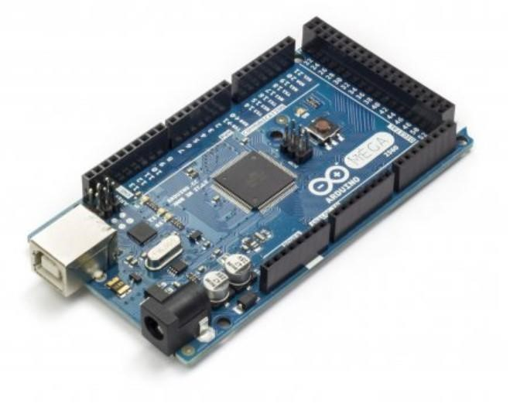
Arduino 1

4.1.2 libraries
- SPI: library in Arduino is used to enable communication between the Arduino board and other devices
- Keypad: We had included it to be able to use Keypad.
- Stepper: We had included it to be able to use stepper motor.
- SSD1306Ascii: for oled screen
- MFRC522 : for paying system (RFID)

4.2 Methods and techniques

4.2.1 Electronic Components
- CD ROM: We used 1 CD-ROM drive into our machine, we use it to download the plate to the right place.
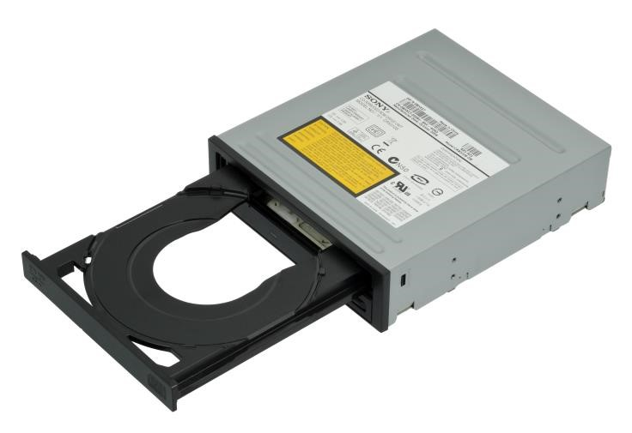
CD ROM 1
- IR Sensor: We employed one IR sensors to check if the plate is downloaded right or if there is a cup also we put more than one in the contains places to know the plate is here
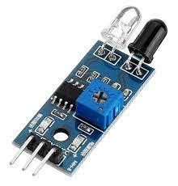
Infrared Reflectance Sensor IR 1

- oled and Keypad : we use as another way to order the cereal .

oled and Keypad 1

- H-bridge: To control the CD ROM and the stepper motor and DC motor.
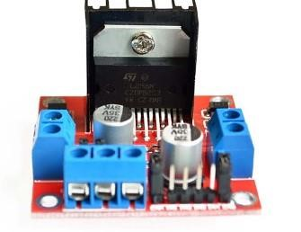
L298N Dual H-Bridge Motor Drive Module B 1

Switch 1
  - At the first We use it with application to order from it, second we use it to send an email if any of the item is finished to refill it and it’s connected to the Arduino and it use serial communications.
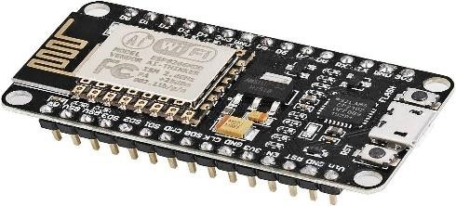
Esp8266 1
  - power supplies: we use to give one voltage to more than one amperes divided as we explain before.
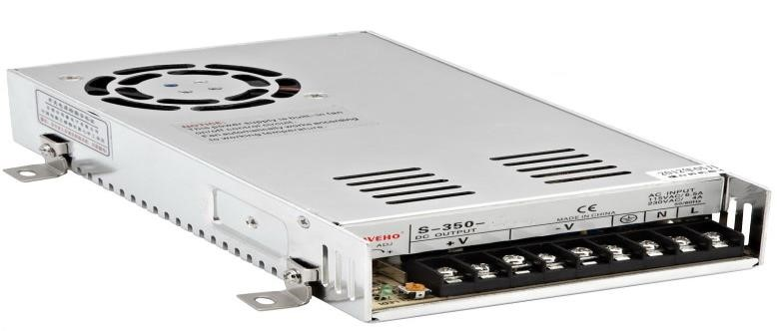
Power supply 1

Arduino wires: We used three types of Arduino wires which are male to male, male to female and female to female.
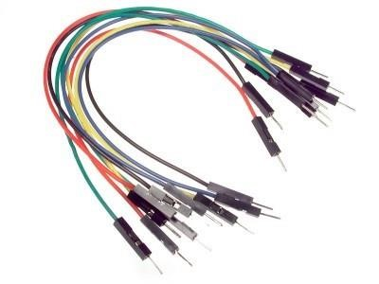
Male to Male 1
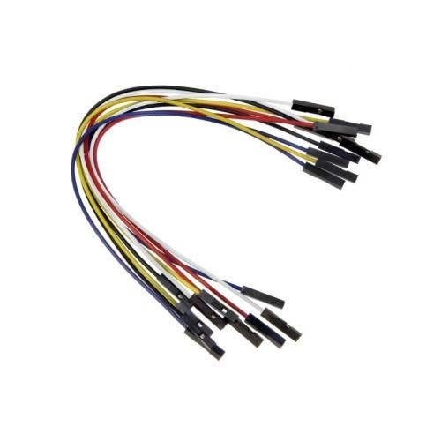
female to female 1
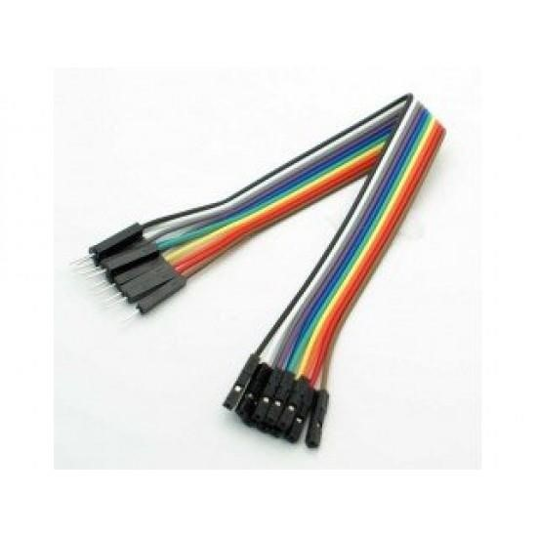
female to male 1
- USB A to USB B cable for Arduino Mega: This cable connects the Arduino with Laptop.
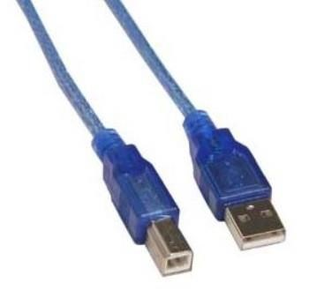
USB A to USB B cable for Arduino Mega 1

- Relay: electrically operated switches that open and close the circuits(pump) by receiving electrical signals from Arduino, also we use it with the Temperature and Humidity Sensor and the mixer and Water Heater
Relay 1

- Pump: pump for milk and pump for water also we use it as a mixer

Pumps 1
- DC motor : to move the plate moving place between the items.
- Stepper Motor: to download the cereal flavors to the plate

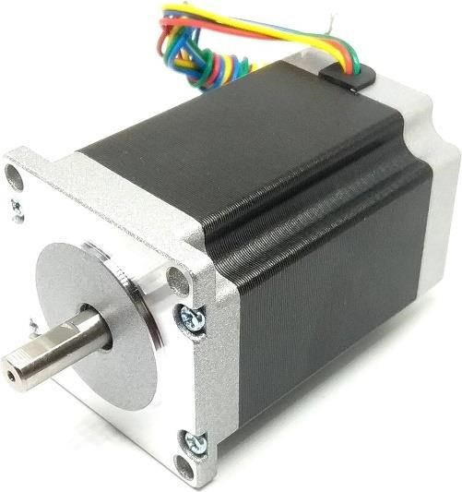

stepper motor 1

- Ultrasonic distance sensor: we use it if there is a good amount in the cereal tanks
Ultrasonic distance sensor 1
- Temperature and Humidity Sensor: to measure the water heat in the heater
- Water Heater: to Heating the water to pump to the mixer and mix it with the milk

4.2.2 External design
The entire vending machine design is shown below. First, we have two small tanks for cereal flavors and two smaller tanks for additives. There is a tank for heating water and a tank for powdered milk. Each tank contains a stepper motor and an ultrasonic sensor first to detect the quantity and sensors to know where the plate has arrived. The blade is used to remove the amount of cereal, then hot water and powdered milk are dropped to mix them in a cup and then placed on a plate. After that, the blades are rotated to drop the required additions onto the cereal. We also used a DC motor to download the cups from the box cup using the CD. Finally, we used a stepper motor and an IR sensor to move the location of the cup and the second one to see if there was a cup.
Fall Design 1

Gmail send 1

The left side of the machine have the first way of order that’s OledKeypad as we shown below:

Keypad ordering 1

We have two switches to know where is the cup moving place if it’s in the begin it will be ready to order if it’s in the end the cup is ready to serve.

Switch and moving place 1
If the cup was taken at any stage (not complete) the moving place will go to the start point and will start over from the begging (take order stage).
Also we a heating system to make sure the water it hot. as shown below

Heating System 1
Finally, we have Three pump the first one is for the water ,second for the water and milk , third for mixer to mix the hot water and the milk powder.
as shown below:

Pumps in the Design 1
Application for ordering
It’s the second way for ordering as we shown below:
Application 1

We select the flavour of cereal and the additions and it’s will start to create them and will open a white page to prevent us from ordering until the plate finished creating.

5 Results, Analysis and Discussion
The results of the breakfast cereal vending machine project demonstrated the successful implementation of the system and its functions. We have been able to design and develop a machine that provides easy and round-the-clock access to items. An application or an LCD keyboard. During testing, inventory levels were monitored using advanced sensors built into the device. These sensors effectively detect when the supply is finished.

The OLED Keypad and app proved to be intuitive and easy to use, even for individuals with limited knowledge of language barriers. Users were able to navigate through the menu options and select the required items from the device without any difficulties, in the same way as with the application.

Another function of our project is that when the items are finished there will be a Gmail that will be sent to the owner that one of the items is finished and if this item is pills, toppings or water it will be automatically refilled manually.

By implementing this breakfast cereal vending machine, we aim to enhance the overall convenience and accessibility of basic cereal supplies, especially when there is not enough time to get them or there is no place to sell them in the same area or near us. The self-service nature of the machine allows for a healthy breakfast quickly and easily.

Although our project was generally successful, we faced some challenges and limitations. One limitation we faced was time constraints. Building such a complex machine with multiple electronic components requires extensive research, learning, and troubleshooting. Balancing this project alongside coursework and other commitments has proven difficult.

Precision and accuracy were crucial factors in the design and implementation of our machine including some mechanisms to ensure the cup is lowered into the correct place and the cup is pushed into precise locations to fill it with items.

Power distribution was also a challenge due to the different voltage requirements of different components. To address this issue, we used a switching control power supply to provide the necessary power and voltage levels for the system to operate effectively

6 Conclusions, Recommendation and Future Work
In conclusion, the development of a cereal vending machine provides access to a healthy breakfast anywhere and anytime we want, especially in a time of epidemic such as Corona, or we can use it in companies.

Integrating sensors to monitor inventory levels and system status adds an additional layer of efficiency and convenience. Automated notifications sent to the owner about expired items ensure that the risk of out of stock is minimized in a timely manner.

Overall, this graduation project successfully demonstrates the feasibility and effectiveness of a cereal vending machine to have our breakfast anywhere or anytime with an easy to use interface.

In the future, we can update some of the machine's features, such as adding more than one type of cereal or more than one additional ingredient, such as kiwi, cinnamon, and sugar, and we can make the machine faster and take more than one order at the same time.

References

- Wu, Richard and Nassar, Alex and Lathrum, Keegan, "The automatic bartender," 2017.
- Asuncion, Raphael M and Prodigalidad, Ryan D and Ramirez, Danuel V and Tomelden, Luisito R, "An automated microcontroller-based cocktail mixer and dispenser," DLSU Engineering e-Journal, vol. 1, pp. 111--125, 2007.

