

AN-NAJAH NATIONAL UNIVERSITY
FACULITY OF ENGINEERING
COMPUTER ENGINEERING DEPARTMENT

Auto Parallel Parking Car

Supervisors: | Students:
Dr.Sufian Samarah  Dr.Alaa Almasre | Amina Sami Daoud  Tasneem Eshqair

2010 – 2011 Semester
1.1 Introduction:
A car that identifies a parking space and parallel park by itself was created in this project. The Car drives down a street searching for a parking space to its right using a distance sensor. When the car identifies a space, it checks to see whether that space is large enough to park in.
If it determines that there is sufficient space, the car will begin parallel parking into that space. It uses information from sensors placed on front, right, and rear of the car to direct the car into the parking space. Once the car was parked, it will remain in that position until it is reset.

1.2 High Level Design:

1.2.1 Logical structure:
The project is broken down into two major components: the control system and the move car algorithm. The move car algorithm directs the car and the control system implements the directions of the move car algorithm.
Park Car
Detect Parking
Move car

Sensor Data

Figure 1.1: shows the logical structure

1.2.3 Control System:
The control system contains all the hardware and its associated software. It allows the parking and parking detection algorithms to interface with the car. The software in this module is broken up into two major sections: the Left-Right/Front-Back (LR/FB) state, and distance calculations. The LR/FB state machines determines which direction to move the car the detect parking space and park car algorithms. Once the LR/FB state machine decide which direction to move the car, by sending the correct input and enable signals to the H-Bridge. The distance calculations implemented independently.

1.2.3 Move Car:
Move car contains the detect parking space and parallel parking algorithms. The parking space detection and parking algorithms use information from the distance sensors to set this movement and guide the car.
Moving the car works by initializing the movement state of the car. It sets the car on a default trajectory and then detect parking space. Once a parking space has been detected, the parking algorithm is starting. After the car has successfully parked, it idles until it is reset.

1.3 Hardware:
- Car.
- Motors of the Car.
- Microcontroller.
- H-bridge L298HN .
- Distance Sensors /sharp GP2Y0A21YK0F .

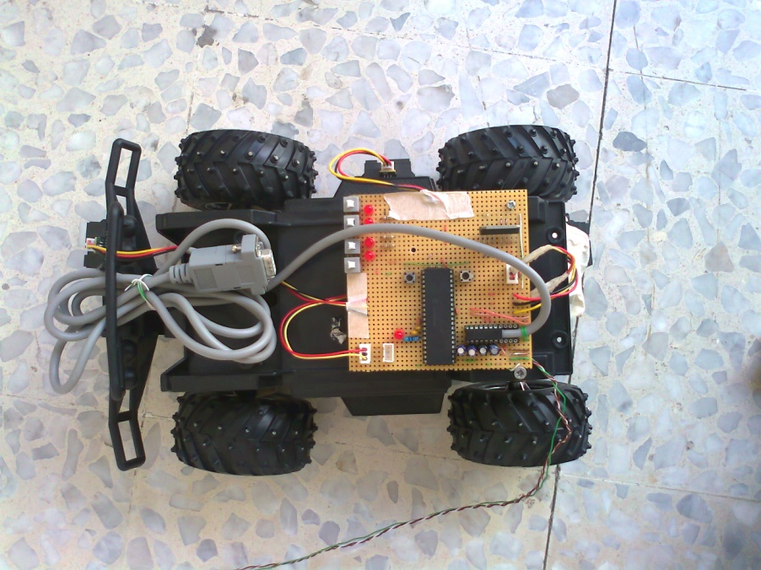
Figure 1.3.1: Photo for the car used in the project.
1.3.2 Distance Sensors:
Three infrared distance sensors were used to determine the distance between the car and nearby objects. A sensor was pleased on the front, the right side, and the rear of the car. For the front and rear, a 4-50cm sensor was used. For the right side, a 7-80cm sensor was used. A sensor with a larger range used for the side so that more easily detect a parking space.
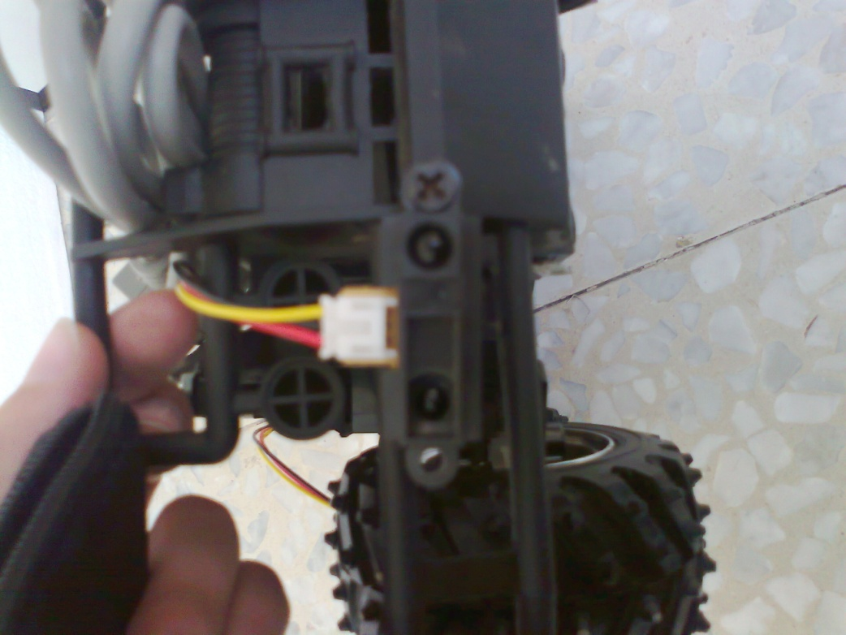

Figure 1.3.2: Photo for the sensor used in the project
1.3.3 Studying the Sensors:
The output of each sensor at various distance values was used, linear the plot, curve fit the line, and implemented an analog to digital conversion so that we had reliable distance values.
Plots of our tow sensors (distance/digital value) point and how to take lines from two adjacent points, And treat every line as single line equation .

Figure 1.3.3(a): Gives the plot diagram for (4-50cm) sensor.

Figure 1.3.3(b): Lines from two adjacent points:

Figure 1.3.3(c): Gives the plot diagram for (7-80cm) sensor.

1.3.4 How we take the data from sensors?
- X=Digital value from sensor.
- X0<X <X1.
- (X0,Y0) ,(X1,Y1).
- Interpolate function:
- value = ((y₀ - y₁) * (X -x₀)) / (x₁ -x₀).
- value = y₀ – value // distance in cm.
When we wants any distance we takes analog value from sensors and convert to digital value while reading (ADC) ,then using our calculations and plots to take the nearly exactly distance seen by the sensors.
1.3.5 H-Bridge:
L298HN H-Bridge was used to control the motors of the Car. It allows us to switch between +/-5V across the motor. It also allows us to source the power while using the microcontroller to control the H-Bridge. The control algorithm turns the appropriate transistors on/off, applying the proper voltage across the motor. The H-Bridge is connected using the following configuration:
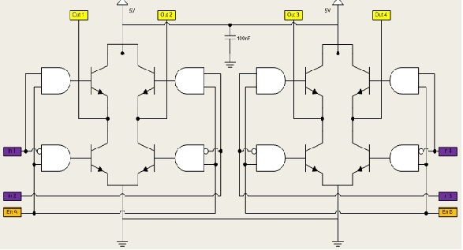
- H-bridge Schematic :
Figure 1.3.5: shows the H-bridge schematic
The first H-Bridge (to the left) is used to control the front motor of the car. This motor turns the front wheels either left or right. The second H-Bridge (the the right) is used to control the rear motor, which is used for the forward and reverse functionality of the car. The inputs and enables of the H-Bridge are connected to port B.

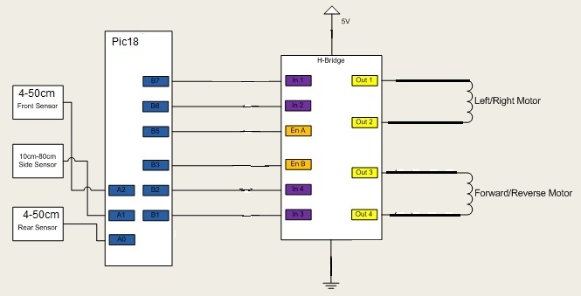
Figure 1.3.6: High level schematic for the project.

1.4 Software:

Algorithm for park the Car:

When the park is detected by the sensor the Car will be stopped.

Go back until the beginning of the gap that detect by the Side sensor when it goes back.

After that stopped then turn the wheel left.

Go forward outside of the gap then stop.

Turn the wheel right then go back inside the gap.

Turn left go back to the side wall avoid touch it by takes the data from rear sensor.

Turn right close to side wall.

Go forward avoid touch the front wall using data from sensor.

Turn wheel
left

Go back until beginning of Gap

Go forward /stop

Forward until Detect Park

turn right close to rear wall

Go Forward /sensor /STOP

Turn left go back to side wall/ sensor

turn wheel right go back inside space

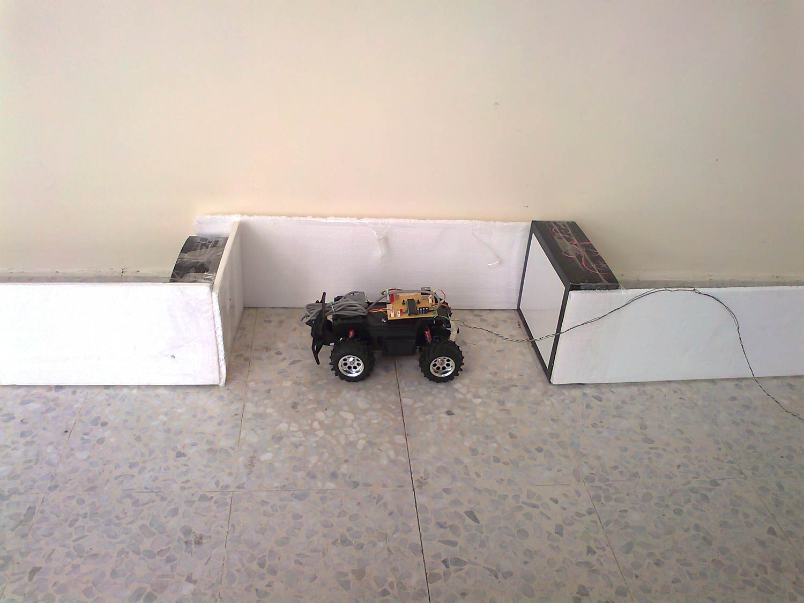

1.5 Problems :
- Mechanical problems
- The problem of overcoming the force of friction between the wheel and the ground

