*Chapter three:

3.1 Improving The Network By Using Capacitors Banks:

3.1.1Power Factor Correction

In electric power distribution, capacitors are used for power factor correction. Such capacitors often come as three capacitors connected as a three phase load. Usually, the values of these capacitors are given not in farads but rather as a reactive power in volt-amperes reactive (VAr). The purpose is to counteract inductive loading from devices like electric motors and transmission lines to make the load appear to be mostly resistive. Individual motor or lamp loads may have capacitors for power factor correction, or larger sets of capacitors (usually with automatic switching devices) may be installed at a load center within a building or in a large utility substation.
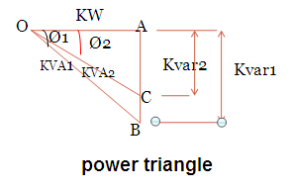
So, there are two types of capacitors fixed and regulated one and the fixed is more expensive because it has control circuit .
we use the law below to calculate the reactive power needed to increase the power factor to a certain number:
Q=P(tana(old)-tana(new))
Or by using the readings of energy analyzer (VIP) to get the value of reactive power and draw it to divide it to steps and then find the value of capacitors.

3.2 Max case after improvement: the table below shows the voltages , capacitors and taps used.
^{Transformer} | ^{% actual}  ^{(KV) of 0.4} | ^{Cap. (KVAR)} | ^{% taps}
^{ALBATHAN}
^{ESKANDER} | ^{93.95} | ⁰ | ⁵
^{ALMASAKEN(1)} | ^{94.64} | ²⁵ | ⁵
^{ALMASAKEN(2)} | ^{94.99} | ⁰ | ⁵
^{ALSERAFE} | ^{90.41} | ⁹⁰ | ⁵
^{ALBADAN PUMP (1)} | ^{89.9} | ²⁸⁵ | ⁵
^{ALBADAN PUMP (2)} | ^{89.9} | ²⁸⁵ | ⁵
^{TALOZA SHARQ} | ^{90.47} | ⁰ | ⁵
^{YASED} | ^{90.32} | ⁰ | ⁵
^{TALOZA} | ^{89.92} | ²⁵ | ⁵
^{ALKASARAT} | ^{90.17} | ⁰ | ⁵
^{ALMONTAZAHAT} | ^{89.8} | ²⁵ | ⁵
^{AKFARAA ROAD} | ^{90.39} | ⁰ | ⁵
^{ALFARAA PUMP} | ^{89.66} | ²²⁵ | ⁵
^{TALOZA SCHOOL} | ^{89.5} | ⁰ | ⁵
^{SOUK ALKHUDAR}
^{SOUK ALKHUDAR} | ^{109.49} | ⁰ | ⁵
^{ALFOWAT} | ^{104.83} | ²⁵ | ⁵
^{ALTITE} | ^{104.32} | ⁶⁵ | ⁵
^{ALZALMOUT} | ^{104.88} | ²⁵ | ⁵
^{ROZ} | ^{104.81} | ²⁵ | ⁵
^{BLATASHKAR(2)} | ^{104.19} | ⁶⁵ | ⁵
^{BLATASHKAR(1)} | ^{104.63} | ²⁵ | ⁵
^{NWASER (1)}
^{Abdul baset} | ^{104.87} | ⁷⁵ | ⁵
^{NWASER} | ^{104.94} | ⁰ | ⁵
^{ALAGBAR} | ^{104.87} | ⁰ | ⁵
^{ALDUHANAT} | ^{104.88} | ⁰ | ⁵
^{BORHAN YA3ES} | ^{104.88} | ⁰ | ⁵
^{COMUNICATION} | ^{104.46} | ⁰ | ⁵
^{ALKARTON} | ^{104.29} | ⁷⁵ | ⁵
^{MADANI} | ^{104.35} | ⁰ | ⁵
^{Transformer} | ^{% actual}  ^{(KV) of 0.4} | ^{Cap. (KVAR)} | ^{% taps}
^{HIRBAWI} | ^{104.25} | ⁰ | ⁵
^{KUFR QALEL} | ^{103.39} | ⁶⁵ | ⁵
^{HENDEYAH} | ^{103.32} | ⁶⁵ | ⁵
^{EIN SEREEN} | ^{103.67} | ⁰ | ⁵
^{ABO WARDEH} | ^{103.87} | ²⁵ | ⁵
^{NWASER (2)}
^{ALMASLAKH} | ^{104.4} | ¹⁶⁰ | ⁵
^{ALMOUNSHAR} | ^{104.35} | ¹⁶⁰ | ⁵
^{ALHIJAWI} | ^{104.2} | ⁹⁰ | ⁵
^{ALAQAD} | ^{104.16} | ²⁵ | ⁵
^{INDNSTIAL B (1)} | ^{103.89} | ²⁵ | ⁵
^{INDNSTIAL B(2)} | ^{103.85} | ¹⁶⁰ | ⁵
^{ABU-EBAID} | ^{103.88} | ²⁵ | ⁵
^{ALKARMEL} | ^{103.78} | ¹⁶⁰ | ⁵
^{ALZAGAL} | ^{103.77} | ¹⁶⁰ | ⁵
^{NAJEM} | ^{103.76} | ²⁵ | ⁵
^{ESKAN RUJEB} | ^{103.75} | ⁰ | ⁵
^{ALTHALAJAT}
^{ALMOJAM3 ALM} | ^{104.27} | ⁰ | ⁵
^{VEGETABLES M(1)} | ^{104.98} | ²⁵ | ⁵
^{VEGETABLES M(2)} | ^{104.89} | ²⁵ | ⁵
^{VEGETABLES M(3)} | ^{104.58} | ²⁵ | ⁵
^{ALDAJANI} | ^{104.27} | ¹⁶⁰ | ⁵
^{MOUSA KHADER} | ^{104.18} | ¹⁶⁰ | ⁵
^{ALMATAHEN} | ^{103.4} | ¹⁶⁰ | ⁵
^{ALLEFTAWE} | ^{104.26} | ¹⁶⁰ | ⁵
^{ALROKHAM ARA} | ^{103.9} | ²⁵ | ⁵
^{HIJAWE COLLEG} | ^{104.1} | ²⁵⁰ | ⁵
^{ZAYED} | ^{104.33} | ²⁵ | ⁵
^{ALMADFA3} | ^{104.28} | ⁰ | ⁵
^{ASKAR NEW} | ^{104.1} | ⁰ | ⁵
^{OLD ASKAR} | ^{103.96} | ¹³⁵ | ⁵
3.3 Min Case After Improvement: the table below shows the voltages , capacitors and taps used
Transformer | Voltages  (%) | Cap.  (KVAR) | Tap(%)
HIRBAWI | 101.55 | 0 | 0
KUFR QALEL | 101.37 | 25 | 0
HENDEYAH | 101.34 | 25 | 0
EIN SEREEN | 101.35 | 0 | 0
ABO WARDEH | 101.4 | 0 | 0
NWASER (2)
ALMASLAKH | 101.62 | 135 | 0
ALMOUNSHAR | 101.6 | 135 | 0
ALHIJAWI | 101.46 | 0 | 0
ALAQAD | 101.45 | 0 | 0
INDNSTIAL B (1) | 101.28 | 0 | 0
INDNSTIAL B(2) | 101.3 | 135 | 0
ABU-EBAID | 101.28 | 0 | 0
ALKARMEL | 101.25 | 135 | 0
ALZAGAL | 101.25 | 135 | 0
NAJEM | 101.21 | 0 | 0
ESKAN RUJEB | 101.11 | 0 | 0
ALTHALAJAT
ALMOJAM3 ALM | 101.84 | 0 | 0
VEGETABLES M(1) | 101.82 | 0 | 0
VEGETABLES M(2) | 101.77 | 0 | 0
VEGETABLES M(3) | 101.7 | 0 | 0
ALDAJANI | 101.53 | 135 | 0
MOUSA KHADER | 101.47 | 135 | 0
ALMATAHEN | 101.44 | 135 | 0
ALLEFTAWE | 101.52 | 135 | 0
ALROKHAM ARA | 101.44 | 0 | 0
HIJAWE COLLEG | 101.55 | 225 | 0
ZAYED | 101.55 | 0 | 0
ALMADFA3 | 101.59 | 25 | 0
ASKAR NEW | 101.3 | 0 | 0
OLD ASKAR | 101.35 | 100 | 0
Transformer | Voltages  (%) | Cap.  (KVAR) | Tap(%)
ALBATHAN
ESKANDER | 99.74 | 0 | 0
ALMASAKEN(1) | 99.17 | 25 | 0
ALMASAKEN(2) | 99.7 | 0 | 0
ALSERAFE | 100.35 | 25 | 2.5
ALBADAN PUMP (1) | 100.26 | 25 | 2.5
ALBADAN PUMP (2) | 100.26 | 25 | 2.5
TALOZA SHARQ | 100.21 | 0 | 2.5
YASED | 100.19 | 0 | 2.5
TALOZA | 99.61 | 25 | 2.5
ALKASARAT | 99.91 | 0 | 2.5
ALMONTAZAHAT | 99.53 | 25 | 2.5
AKFARAA ROAD | 100.19 | 0 | 2.5
ALFARAA PUMP | 100.25 | 100 | 2.5
TALOZA SCHOOL | 99.17 | 0 | 2.5
SOUK ALKHUDAR
SOUK ALKHUDAR | 101.97 | 0 | 0
ALFOWAT | 101.87 | 0 | 0
ALTITE | 101.83 | 25 | 0
ALZALMOUT | 101.82 | 0 | 0
ROZ | 101.85 | 0 | 0
BLATASHKAR(2) | 101.5 | 0 | 0
BLATASHKAR(1) | 101.8 | 0 | 0
NWASER (1)
Abdul baset | 102.04 | 0 | 0
NWASER | 101.88 | 0 | 0
ALAGBAR | 101.83 | 0 | 0
ALDUHANAT | 101.85 | 0 | 0
BORHAN YA3ES | 101.85 | 0 | 0
COMUNICATION | 101.65 | 0 | 0
ALKARTON | 101.77 | 0 | 0
MADANI | 101.62 | 0 | 0

3.4 All The capacitors Used
And the tables below shows all the capacitors we need in our project :
Transformer | Rated  (KVA) | CAP.  (KVAR)
ALBATHAN
ESKANDER | 400 | 40
ALMASAKEN(1) | 250 | 25
ALMASAKEN(2) | 630 | 50
ALSERAFE | 630 | 90
ALBADAN PUMP (1) | 1000 | 100
ALBADAN PUMP (2) | 1000 | 185
TALOZA SHARQ | 400 | 0
YASED | 400 | 40
TALOZA | 250 | 25
ALKASARAT | 400 | 0
ALMONTAZAHAT | 250 | 25
AKFARAA ROAD | 400 | 0
ALFARAA PUMP | 1600 | 225
TALOZA SCHOOL | 160 | 0
SOUK ALKHUDAR
SOUK ALKHUDAR | 300 | 0
ALFOWAT | 630 | 25
ALTITE | 400 | 65
ALZALMOUT | 630 | 25
ROZ | 630 | 25
BLATASHKAR(2) | 400 | 65
BLATASHKAR(1) | 630 | 25
NWASER (1)
Abdul baset | 630 | 75
NWASER | 400 | 25
ALAGBAR | 160 | 0
ALDUHANAT | 400 | 25
BORHAN YA3ES | 400 | 25
COMUNICATION | 250 | 0
ALKARTON | 630 | 75
MADANI | 250 | 0
Transformer | Rated  (KVA) | CAP.  (KVAR)
HIRBAWI | 400 | 25
KUFR QALEL | 400 | 65
HENDEYAH | 400 | 65
EIN SEREEN | 630 | 50
ABO WARDEH | 630 | 25
NWASER (2)
ALMASLAKH | 630 | 160
ALMOUNSHAR | 630 | 160
ALHIJAWI | 400 | 115
ALAQAD | 400 | 75
INDNSTIAL B (1) | 400 | 75
INDNSTIAL B(2) | 630 | 160
ABU-EBAID | 400 | 75
ALKARMEL | 630 | 160
ALZAGAL | 630 | 160
NAJEM | 400 | 75
ESKAN RUJEB | 250 | 0
ALTHALAJAT
ALMOJAM3 ALM | 150 | 25
VEGETABLES M(1) | 250 | 25
VEGETABLES M(2) | 250 | 25
VEGETABLES M(3) | 400 | 75
ALDAJANI | 630 | 160
MOUSA KHADER | 630 | 160
ALMATAHEN | 630 | 160
ALLEFTAWE | 630 | 160
ALROKHAM ARA | 400 | 75
HIJAWE COLLEG | 1000 | 250
ZAYED | 400 | 75
ALMADFA3 | 630 | 50
ASKAR NEW | 250 | 0
OLD ASKAR | 630 | 165
TOTAL (KVAR) | 4110

3.5 Economical study:
We have 4110 KVAR and each 1KVAR costs 15$ so, the capacitors cost 4110*15=61650$. 61650*3.7=228105NIS. *Saving = saving in power+ saving in panalities. Saving(power)= 64 kw *8760*0.715*0.45= 180385.92 NIS/year panalities = 330,000NIS/year simple payback period(S.P.B.P)= Investment/saving so, [ 228105/(180385.92+ 330000 )]=163.1 day and by using cash flow the diagram is:
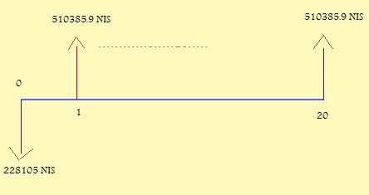
P.W=[-228105+510385.92(P/A,10%,20)] >0 So, the project is feasible.

3.6 Replacing transformers: we note the villages locate on wide ranges of lands so, we cant put one transformer in the village because of high voltage drop during the cables and this will be clear in Taloza village as below:
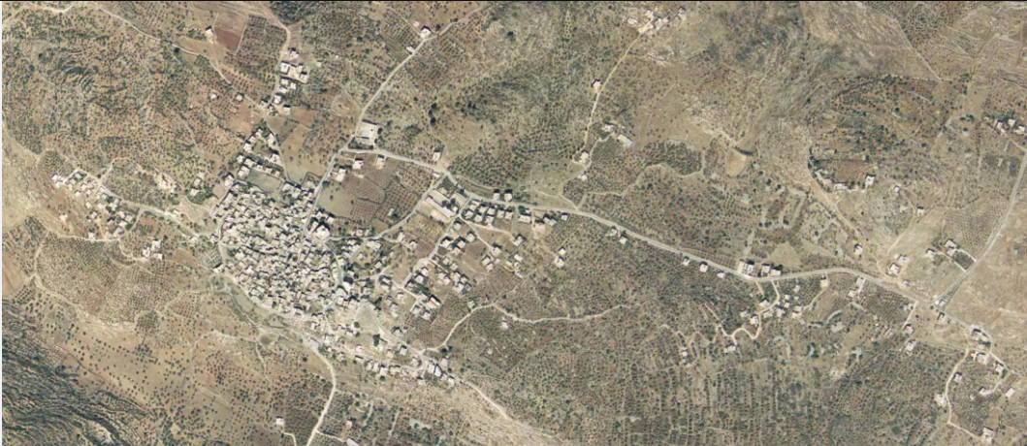
And with feeders we see:
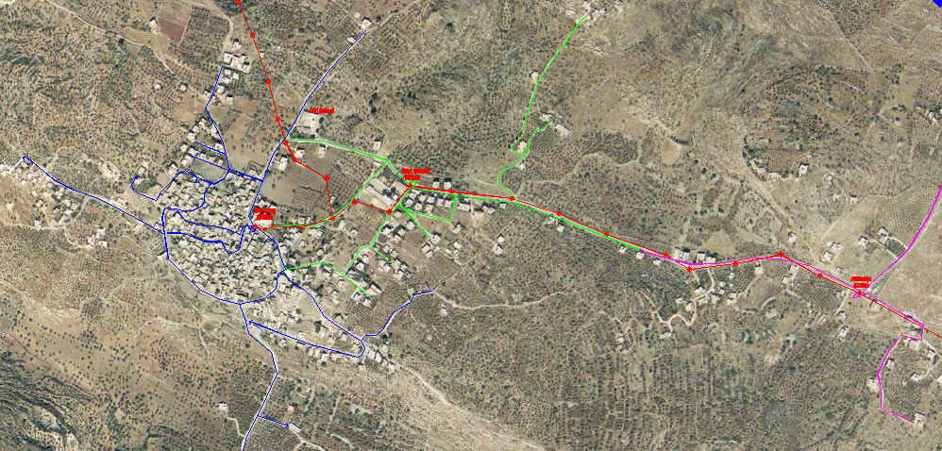

And for a certain tower we note:
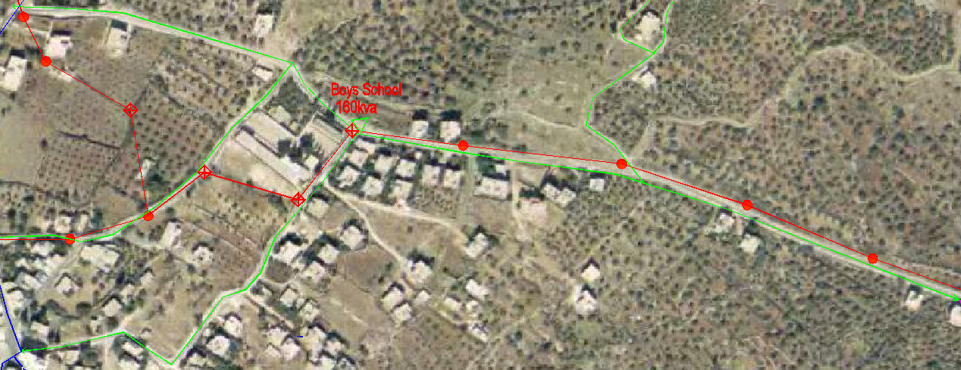
So, we will make replacing transformers for a Market feeder from Askar network.
It is called Market feeder and it contains 7 transformers.
The table below shows the values of apperent power and the load factor before and after the replacing.

Load factor | Capacity after | Load factor | Capacity before | S max  (KVA) | transformers
74.34 | 50 | 5.9 | 630 | 37.170 | zalmout
74.34 | 50 | 5.9 | 630 | 37.170 | Fowat
74.34 | 50 | 5.9 | 630 | 37.170 | Roz
74.34 | 50 | 5.9 | 630 | 37.170 | Balata askar1
88.12 | 250 | 55.075 | 400 | 220.3 | Teti
88.12 | 250 | 55.075 | 400 | 220.3 | Balata askar2
52.85 | 100 | 17.61 | 300 | 52.85 | Market
*Below there are two diagram before and after replacing of transformers and it shows the values of saving power.
Before replacing:
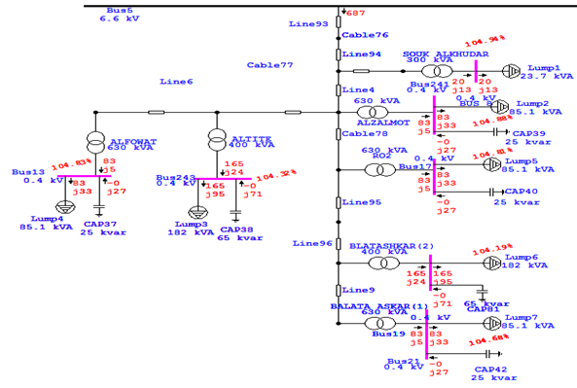
Note the feeder is fed by: kw687
After replacing:
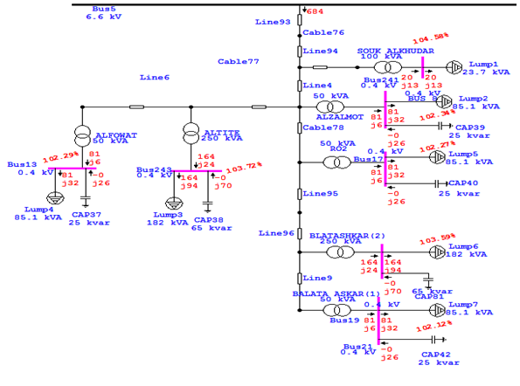
Note the feeder is fed by: 684kw so, the saving = 3kw*8760*0.71*0.45= 8396.46 NIS/year 8396.46/3.7= 2269.3 $/year
3.7Low tension analysis: we will take boys school as an example for a low tension analysis . the transformer contains 3 feeders and the data for one feeder as below: Assume A=4*95 mm2, R=0.308 ohm/km and the feeder long=515m
VA3 | VA2 | VA1 | IN | IC | IB | IA
19.754 | 14.357 | 13.0133 | 23.616 | 85.12 | 61.44 | 55.893

P.F3 | P.F2 | P.F1
0.946 | 0.954 | 0.931

The shape of the feeder as below: (green colour)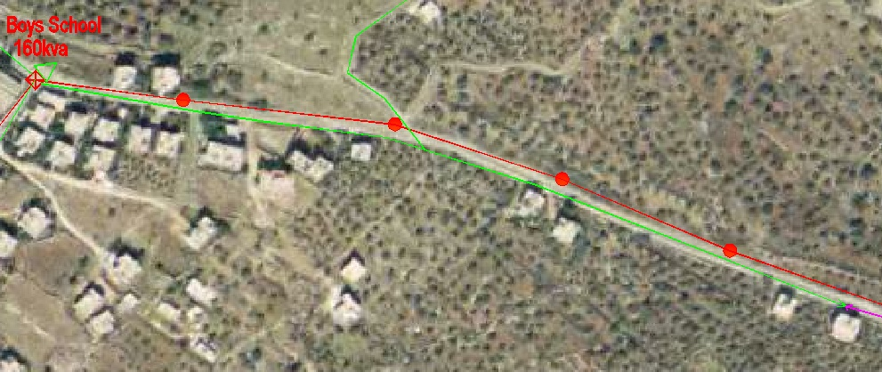
And the figure below shows the circuit:

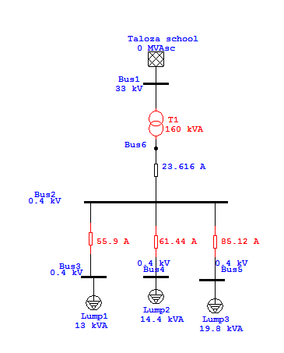
Vn drop= 0.515*0.305*23.616= 3.71v Pn losses= 3.71*23.616=87.615w
for phase A: Vdrop= 55.893*0.308*0.515= 8.866v VA = 233(according to vip system)-(8.866+3.71)= 220.424v Ploss= 8.866*55.893=495.55w
for phase B: Vdrop= 61.44*0.308*0.515= 9.746v VB = 233.8(according to vip system)-(9.746+3.71)= 220.344v Ploss= 9.746*61.44=598.79w
for phase C: Vdrop= 85.12*0.308*0.515= 13.5v VC = 232.2(according to vip system)-(13.5+3.71)= 215v Ploss= 13.5*85.12=1149.12w
sum of power losses= 87.615+ 495.55+598.79+1149.12=2331 w
so, load factor of the daily load curve for the transformer =average/max. And it will be calculated from the energy analyzer. Load factor= 0.61
Therefore, 2331*8760*0.61=12456kw/year 12456*0.45=5605.17 NIS , 5605.17/3.7=1514.9$/year

3.8 Operation mode of medium voltage distribution feeders:
Medium voltages (MV) are traditionally used radialy. But we should construct ring network to insure back-up connections during disturbance and to improve the reliability of the system.
So , in askar network we should construct rings for all four main feeders (on 6.6kv) after the switch gear ,between every two adjacent feeders , the main transmission line can Carries an electric current up to 395A.
But at worst condition they carry currents as the following
Feeder | Rated current | Actual current
SOUK ALKHODAR | 395 | 65
NWASER(1) | 395 | 85
NWASER (2) | 395 | 195
ALTHALAJAT | 395 | 235

*We cant make full ring technique for all loads for the 2 feeders NWASER (2) and ALTHALAJAT because the current will exceed than rated current .so, we will make different rings for different parts of cables to carry the value of current.
We make the ring between SOUK ALKHODAR and NWASER (1) as follows:

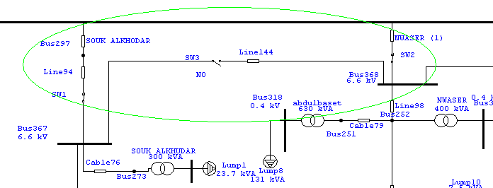
And the same for the other feeders as follows :
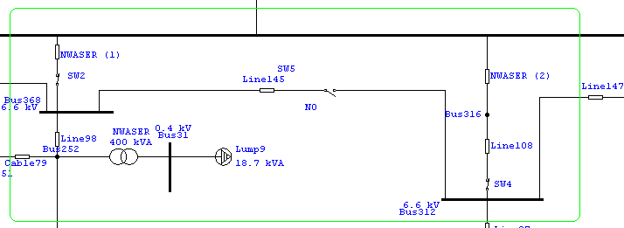
NWASER(1) and NWASER(2)
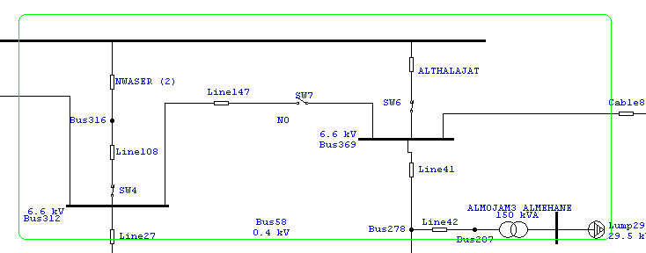
NWASER (2) and ALTHALAJAT

And we made many rings inside the network , because the fault may not occur on the main feeders
And we did that as follows :
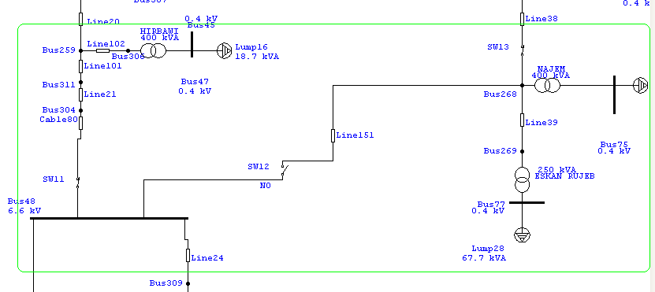
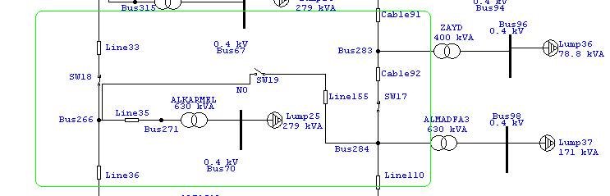

3.9 Comparing between two cases (different voltages level on the same transformer):
6.6KV

11KV

We will calculate the losses through the transformers if we rise the voltages from 6.6kv to 11kv. The law is: Plosses=Pcore+(S actual/S rated)^2*Pcopper.
For 6.6kv: average power=1.247kw and energy losses=11010.7kwh/year For 11 kv: average power=1.157kw and energy losses= 10135.3kwh/year
Difference=857.422kwh and it is =393.94 NIS or 106.47$

3.10Transformation the network from 6.6kv to 11kv:
6.6 kv level :
if we use 6.6 kv the network will consume a certain real power and reactive power as the picture below:
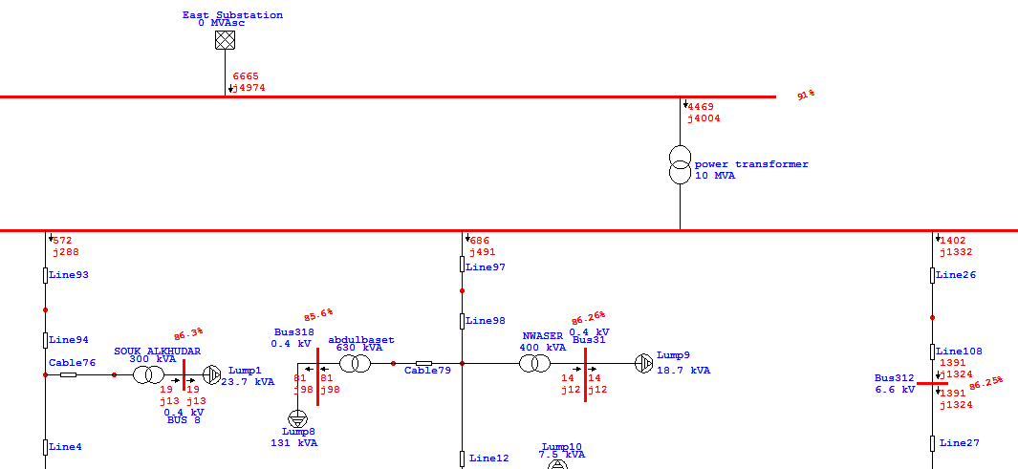
We note how the system 33-6.6kv consumes 4469kw+4004kvar in max load without any improving.
11kv level: when we rise the system voltages from 6.6kv to 11kv we will decrease the losses through the network and the power consumed from the source will be decreased so, we will save money if we use this step.
The figure below will explain the difference in power between two systems.
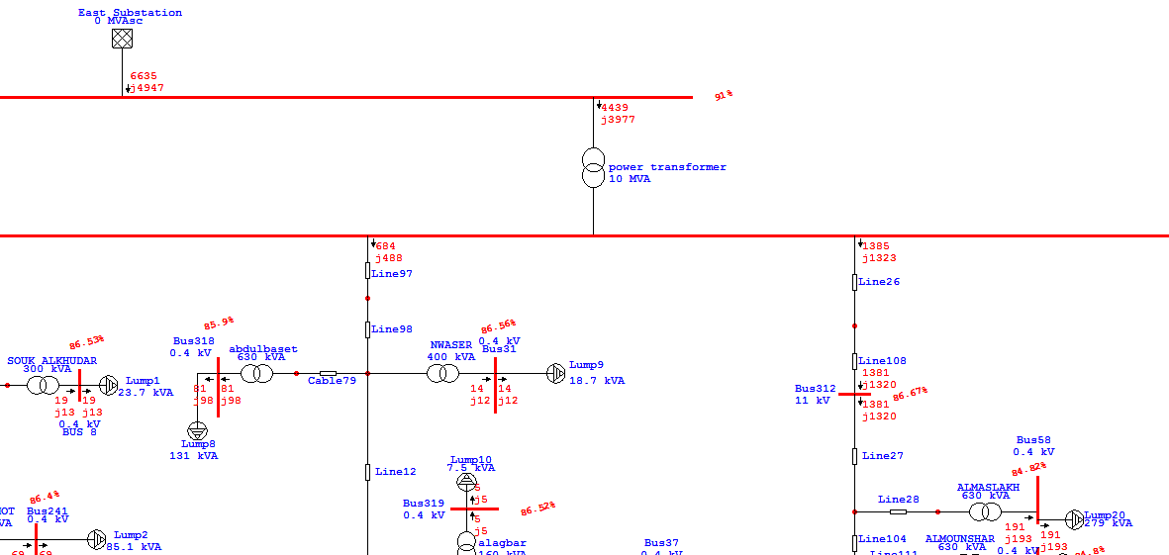
We note how the system 33-11kv consumes 4939kw+3977kvar in max load without any improving.
*The difference between two consumed power is: 4469+j4004-(4939+3977)=30kw+27kvar.
* Saving= 30*8760*0.71=186588 kwh/year. 186588*0.45=83964.6 NIS/year 83964.6/3.7=22693.135 $/year.

3.11Pumps : we have two area have motors the first one is AL-Bathan and the second is AL-Faraa pumps.
the table below shows the information about the pumps numbers and its efficiency.

Effeciency(%) | Output(hp) | Type(US motors) | Area
95 | 500 | well | AL-Bathan
95 | 500 | Boster1
95 | 500 | Boster2
95 | 600 | Boster3
95 | 500 | well | AL-Faraa
95 | 175 | Boster

*chapter four:

4.1Problems of AL-BATHAN feeder:

he problem of Askar network that the voltage decreases even it reaches from 33kv to 30kv in max load so,AL-BATHAN feeder converts the voltages from 33kv to 0.4 kv through the transformers and in max load the voltages are low on secondary side, some of transformers the voltages reach 89% of nominal value if we know the acceptable voltage at least -5% of nominal value so, that must be solution for this problem.
In our project we suggest three solutions :
1-using double lines.
2-using large cross section area cable.
3-connecting part of feeder with another substation.
And the details as below:
*NOTICE: the figures below show part of AL-BATHAN feeder and not all of the feeder.
a) The original case:

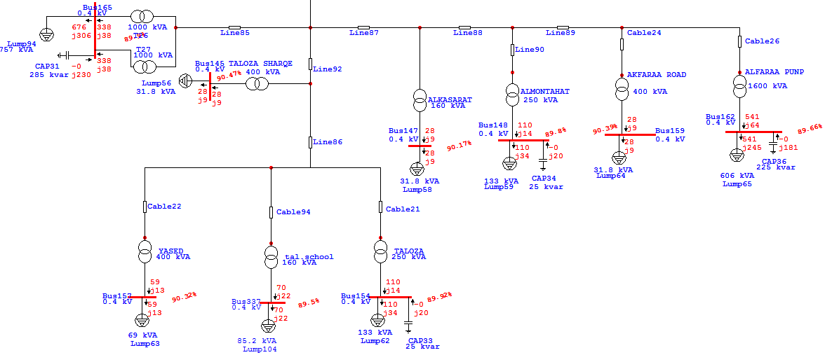

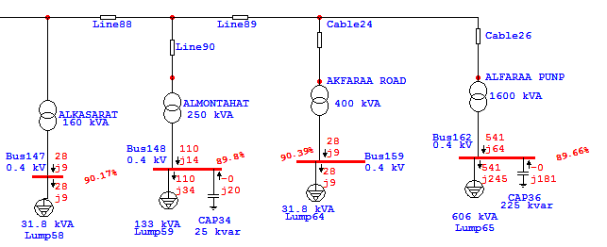
The figure shows the decreasing of voltages.
b) Solution by using double cables:
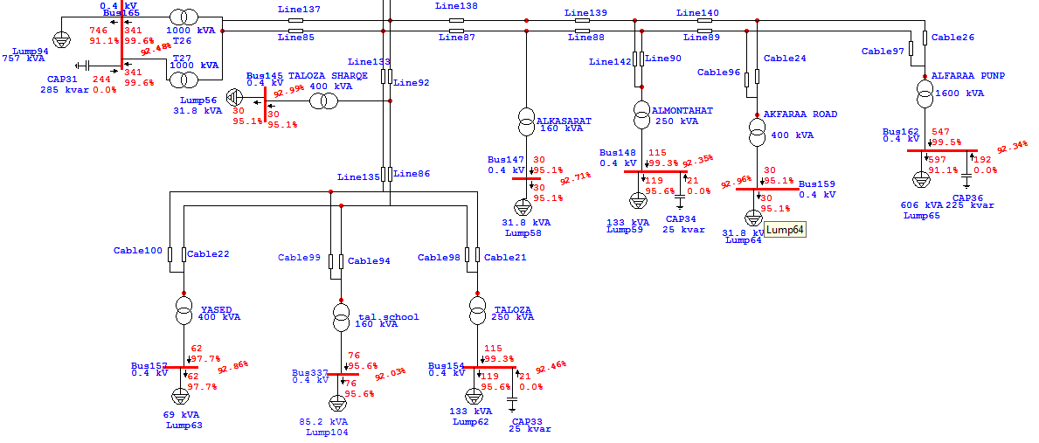
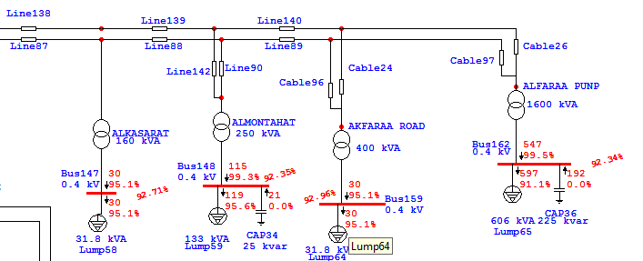
As we see the voltage rises from (89.66%) to( 92.34%) as AL-FARAA pump transformer but this solution is cost but the reliability is high.
c) Solution by using large cable:
We choice 225mm2 with R= 158 ohm/km and X= 252 ohm/km.
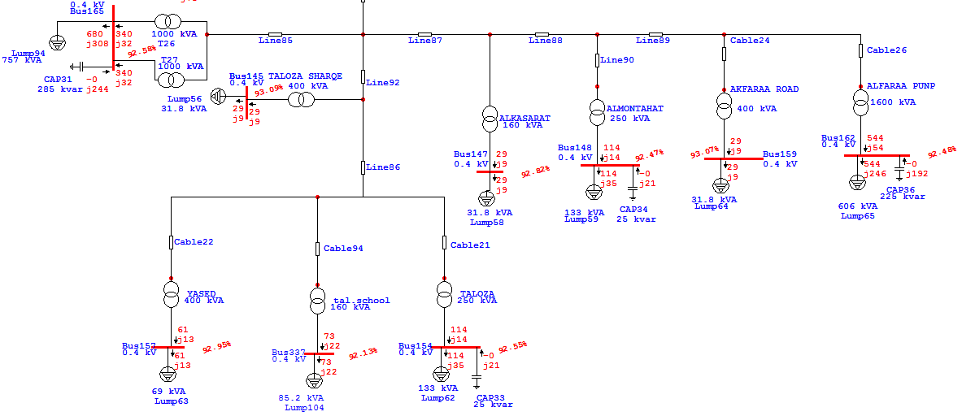

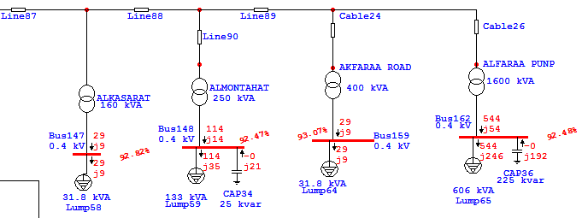
And the voltage result as the double line.

d)Solution by using connection with other substation:
In this case we assume the voltage coming from the substation in max. Load not 33kv and it is 30kv. But we will see the difference between this solution and previous solutions and how this solution is more better for the AL-BATHAN network.
*substation is called AL-NASSARIYYA substation.
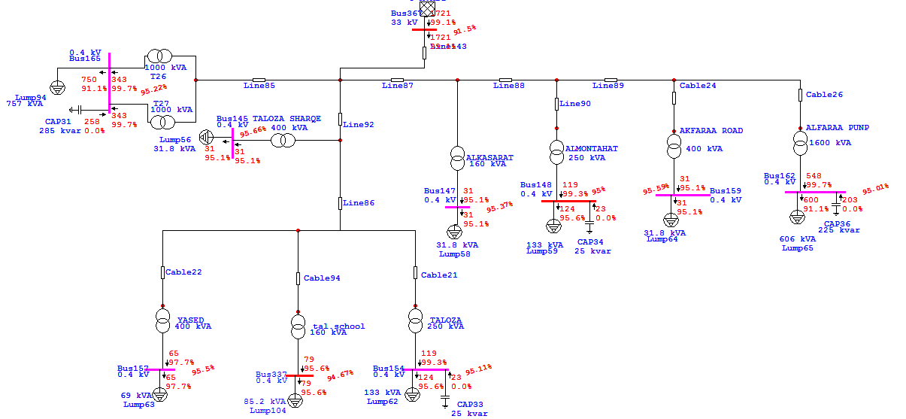

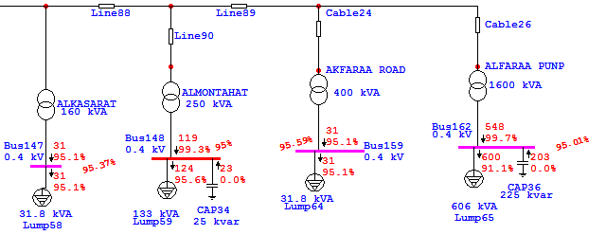

The minimum voltage decreases by 5% from nominal value at most and at worst case if the voltage coming from the substation is 30kv.

