

An-Najah National University
Faculty of Graduate Studies

Patterns and Factors Influencing Traffic Crashes in Ramallah and Al Bireh Governorate

By
Bashar Khader M. Amro

Supervisor
Prof. Khaled Ahmad J. Al Sahili

This Thesis is Submitted in Partial Fulfillment of the Requirements for the Degree of Master program of Highway and Transportation Engineering, Faculty of Graduate Studies, An-Najah National University, Nablus - Palestine.
2026

Patterns and Factors Influencing Traffic Crashes in Ramallah and Al Bireh Governorate

By
Bashar Khader Amro

This Thesis\Dissertation was Defended Successfully on January 00, 2026, and approved by
Prof. Khaled Al-Sahili  Supervisor | Signature
Insert Name  Co-Supervisor | Signature
Insert Name  External Examiner | Signature
Insert Name  Internal Examiner | Signature

Dedication
This thesis is dedicated to my mother, my father, my wife Alaa, and my children, Kenan and Carmel, for their love, patience, and constant support throughout this journey.

Acknowledgements

I would like to express my sincere gratitude to my supervisor, Professor Khaled Al Sahili, for his continuous guidance, valuable feedback, and patient support throughout all stages of this research. His academic experience and thoughtful comments played a crucial role in shaping this study and improving its quality.
I am also grateful to An-Najah National University for providing a supportive academic environment during my studies.
Special thanks go to the Palestinian Traffic Police Directorate for their cooperation and for providing the official traffic data used in this research.
Finally, I would like to thank everyone who supported and encouraged me during the preparation of this thesis, especially my wife and my parents, for their constant support, understanding, and encouragement throughout this journey. Their support meant a lot to me and helped me complete this thesis.

Declaration

I, the undersigned, declare that I submitted the thesis entitled:

Patterns and Factors Influencing Traffic Crashes in Ramallah and Al Bireh Governorate

I declare that the work provided in this thesis, unless otherwise referenced, is the researcher’s own work and has not been submitted elsewhere for any other degree or qualification.

Bashar Khader Mohammad Amro | Student's Name:
Bashar Khader M. Amro | Signature:
June, 2026 | Date:

Table of Contents
Dedication III
Acknowledgements IV
Declaration V
List of Tables IX
List of Figures IX
List of Appendices X
Abstract XI
Chapter One 6
1.1General and Theoretical Background 6
1.2 Literature Review 8
1.2.1 International Studies 9
1.2.2 Regional Studies 14
1.2.3 Local Studies 16
1.2.4 Summary 19
1.3 Problem Statement 21
1.4 Problem Justification and Research Gap 22
1.5 Data and Contextual Constraints 23
1.6 Research Objectives 26
1.7 Study Area 26
1.8 Thesis Outline 27
Chapter Two 28
Methodology 28
2.1 Data and Sources 28
2.2 Study Design 29
2.3 Spatial Data Preparation 29
2.4 Analytical Methods 30
2.5.1 Kernel Density Estimation (KDE) 31
2.5.2 Spatial Autocorrelation (Global and Local Moran’s I)) 33
2.5.3 Chi-Square Tests 35
2.6 Study Procedures 35
2.7 Ethical Considerations 36
Chapter three 37
Crash Data, Analysis, and Results 37
3.1 Descriptive Trend Analysis of Traffic Crash Patterns 37
3.1.1 Analysis of dominant crash causes by year 37
3.1.2 Seasonal Pattern of Traffic Crashes in Ramallah and Al-Bireh 6
3.1.3 Age-Related Patterns of Traffic Crash Outcomes 8
3.2 Data Overview of Traffic Crash Records (2019–2024) 9
3.3 Kernel Density Estimation (KDE): Detailed GIS Workflow 10
3.3.1 Purpose of KDE in this study 11
3.3.2 Input data and layers used 11
3.3.3 Preparing crash locations in ArcMap 12
3.3.5 Definition of black spots and selection approach (2019–2024, reference year 2024) 13
3.3.7 Map production and visualization 14
3.3.8 Interpretation notes 14
3.4 Spatial Autocorrelation Analysis (Moran’s I) 6
3.4.1 Purpose of Moran’s I in this study 6
3.4.2 Global Moran’s I: GIS workflow (ArcMap) 6
3.4.3 Global Moran’s I: results (reported values) 6
3.4.4 Global Moran’s I: Interpretation of Reported Values 7
3.4.5 Interpretation of the Global Moran’s I outcome 9
3.5 Local Moran’s I (LISA) 9
3.5.1 Why Local Moran’s I (LISA) was needed after the Global test 11
3.5.2 Applying Local Moran’s I 12
3.5.3 Local Moran’s I: GIS workflow (ArcMap) 12
3.5.4 Output classification and interpretation framework 13
3.5.5 Local Moran’s I: results for Ramallah and Al-Bireh Governorate 13
3.5.7 Contribution of Local Moran’s I to the overall analysis 14
3.6 Chi-square Test 14
3.6.1 Chi-square analysis 15
3.6.2 Objectives of the Chi-square analysis 16
3.6.3 Methodology and Excel-based workflow 17
3.6.4 Results and interpretation 18
3.6.5 Contribution of the Chi-square analysis to the study 19
Chapter Four 21
Discussions 21
4.1Introduction 21
4.2 Kernel Density Estimation (KDE) Results Discussion 22
4.3 Spatial Autocorrelation Analysis (Global Moran’s I) 22
4.4 Local Moran’s I (LISA) 23
4.5 Chi-square Test 24
4.6 Integrated Discussion of Study Findings 25
Chapter Five 27
Conclusions and Recommendations 27
5.1 Conclusion and Recommendations 27
5.2 Study Limitations 29
List of Abbreviations 32
References 33
Appendices 36
Appendix A 37
Appendix B 40
Appendix C 46
Appendix D 47
Appendix E 48
Appendix F 51

List of Tables
Table 1.1: Overview of International Research on Road Crash Patterns and Contributing Factors. 21
Table 1.2: Summary of Regional Studies Related to Road Crash Patterns and Safety Behavior 25
Table 1.3 summarizes the main local research on road safety in Palestinian cities and governorates. 28
Table 1.3: Summary of Local Studies on Road Safety and Crash Characteristics in Palestine 28
Table 3.1: Global Spatial Autocorrelation (Moran’s I) Results for Traffic Crashes 43
Table 3.2: Results of Local Moran’s I (LISA) for Traffic Crash Black Spots in Ramallah and Al-Bireh Governorate 44
Table 3.3: Summary of Pearson Chi-square Test Results for Traffic Crash Characteristics by Year 45

List of Figures
Figure 1.1 7
Political (Oslo Areas A, B, and C) and Administrative Divisions of the West Bank 7
Figure 1.2 7
Total Reported Traffic Crashes by Governorate (2024), Fatalities in Road Traffic Crashes by Governorate (2024) 7
Figure 1.3 22
Crash Involvement by Road User Type – Ramallah & Al Bireh (2024), Primary Contributing Violations in Crashes – Ramallah & Al Bireh (2024). 22
Figure 1.4 25
Impact of the COVID-19 Lockdown on Economic Activity and Mobility in the West Bank 25
The entire methodological approach that was used in the research is depicted in Figure 2.1. 36
Figure 2.1 36
Methodological workflow of spatial and statistical analysis applied in the study 36
Figure 3.1 6
Types of the most frequent crashes of the years 2019-2024. 6
Figure 3.2.a 6
Monthly distribution of traffic crashes by year in the West Bank, Palestine 6
Figure 3.2.b 7
Aggregated monthly distribution of traffic crashes in the West Bank, Palestine (all study years) 7
Figure 3.3 9
Age-Based Trends of Traffic Crash Injuries and Fatalities in Ramallah and Al-Bireh Governorate (2019–2024) 9
Figure 3.4 15
Spatial Distribution of Traffic Crash Hotspots Using Kernel Density Estimation (KDE) in Ramallah and Al-Bireh Governorate 15
Figure 3.5 6
Kernel Density Estimation (KDE) of Traffic Crashes with Zoomed-in View of High-Density Areas in Ramallah and Al-Bireh Governorate 6
Figure 3.6 10
Local Moran’s I (LISA) Cluster and Outlier Map of Traffic Crashes 10

List of Appendices
Appendix A 79
Appendix B 82
Appendix C……………………………………………………….……………………82
Appendix D……………………………………………………………………………..83
Appendix E..……………………………………………………………………………84
Appendix F……………………………………………………………...……………...88

Patterns and Factors Influencing Traffic Crashes in Ramallah and Al Bireh Governorate
By
Bashar Khader Amro
Supervisor
Prof. Khaled Al Sahili

Abstract
Traffic crashes in Ramallah and Al-Bireh Governorate increased due to population growth, urban expansion, and the rising number of vehicles on the roads, placing sustained pressure on the road network between 2019 and 2024. This thesis addresses a local evidence gap by combining official crash records from the General Directorate of the Palestinian Police (GDPP) and the Palestinian Central Bureau of Statistics (PCBS) to examine where crashes occur, how severe they are, and which factors are most consistently associated with them.
The analysis followed three stages. First, data collection and validation were completed using police and PCBS records. Second, spatial analysis was performed using Kernel Density Estimation (KDE) and Global and Local Moran's I to identify concentration patterns and spatial outliers. Third, Chi-square tests and descriptive trend analysis were used to assess how crash cause, crash type, and severity varied over time.
Results show a persistent concentration of crashes in urban corridors and major intersections, while global spatial autocorrelation was not statistically significant at the governorate scale. Local Moran's I identified a limited number of locally distinct sites, including an outlier segment on Al-Tireh Main Road. Chi-square outputs showed significant year-to-year variation in crash characteristics.
The findings were interpreted against prior local, regional, and international studies, with explicit attention to data-quality limits such as underreporting of minor crashes and mobility disruptions during COVID-19 and later political restrictions.
This thesis provides an evidence base for targeted enforcement, infrastructure prioritization, and safer mobility planning in Ramallah and Al-Bireh Governorate.
Keywords:
Traffic crashes, GIS analysis, Kernel Density Estimation, Moran’s I, spatial patterns, road safety, crash hotspots

Chapter One

1.1General and Theoretical Background
Traffic crashes are a serious problem affecting public safety and urban growth in Palestine and many developing countries. In recent years, this problem has become more noticeable in Ramallah and Al Bireh Governorate due to rapid population growth, increased car ownership, and heavy traffic congestion. According to the Palestinian Central Bureau of Statistics (PCBS, 2024), the population of the governorate increased by more than 33,000 people between 2015 and 2024, adding pressure to the already limited and aging road network (Palestinian Central Bureau of Statistics [PCBS], 2024).
As the main administrative and economic center of the West Bank (as shown in Fig. 1.1), Ramallah and Al Bireh Governorate receive tens of thousands of vehicles every day. According to Al Hayat Newspaper, more than 100,000 vehicles enter the governorate daily, many coming from nearby areas. This large volume of traffic puts heavy pressure on the road network, especially around offices, commercial areas, and universities. In many locations, road development has not kept pace with city growth, leading to traffic congestion, unsafe intersections, and inadequate pedestrian facilities (Al-Hayat Newspaper, 2023). Moreover, Ramallah and Al Bireh Governorate recorded the highest number of recorded traffic crashes among all West Bank Governorates, while ranking third in road traffic fatalities (General Directorate of the Palestinian Police [GDPP], 2024).
Figure 1.2 demonstrates the state of traffic crashes and fatalities in Palestinian Governorates in 2024 based on the data presented by the General Directorate of the Palestinian Police (see Appendix B). Ramallah and Al-Bireh had the highest number of crashes, and 4,156 cases were reported. The other governorates, such as Nablus (2,871 crashes) and Hebron (1,839 crashes), had lower values. These variations are more closely related to the population of the governorate and the level of day-to-day traffic movement within the governorate.

Figure 1.1
Political (Oslo Areas A, B, and C) and Administrative Divisions of the West Bank 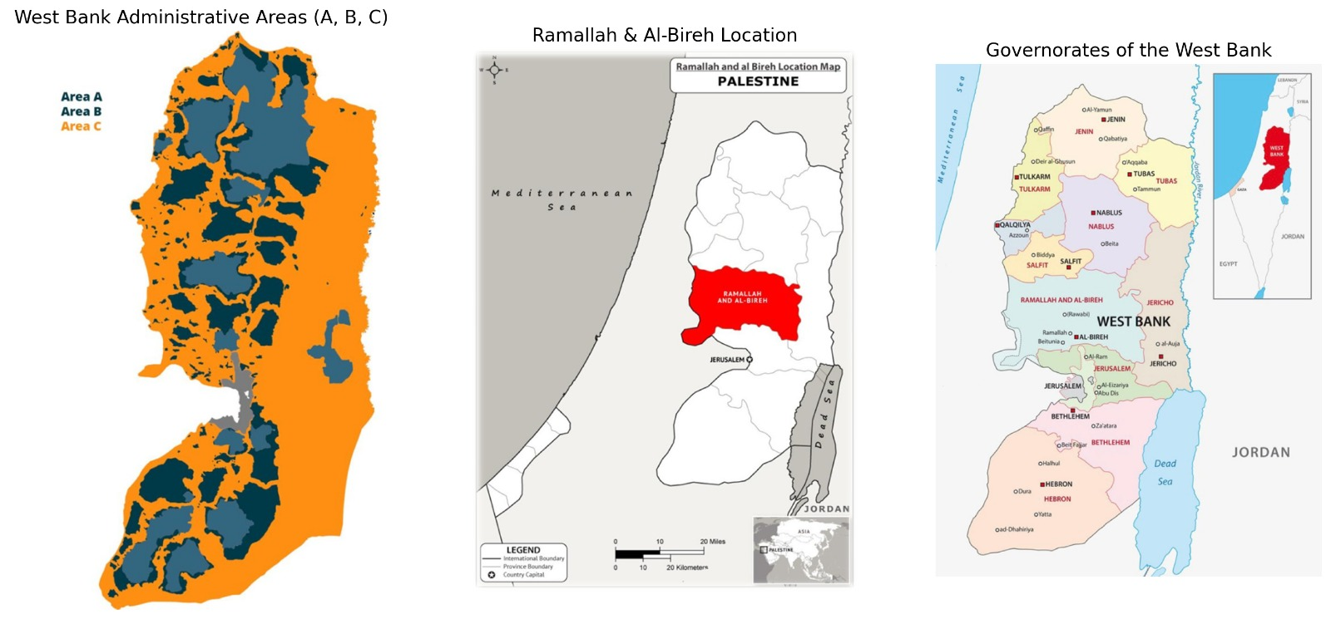
Source: Palestinian Central Bureau of Statistics (PCBS), 2024.
Figure 1.2
Total Reported Traffic Crashes by Governorate (2024), Fatalities in Road Traffic Crashes by Governorate (2024)
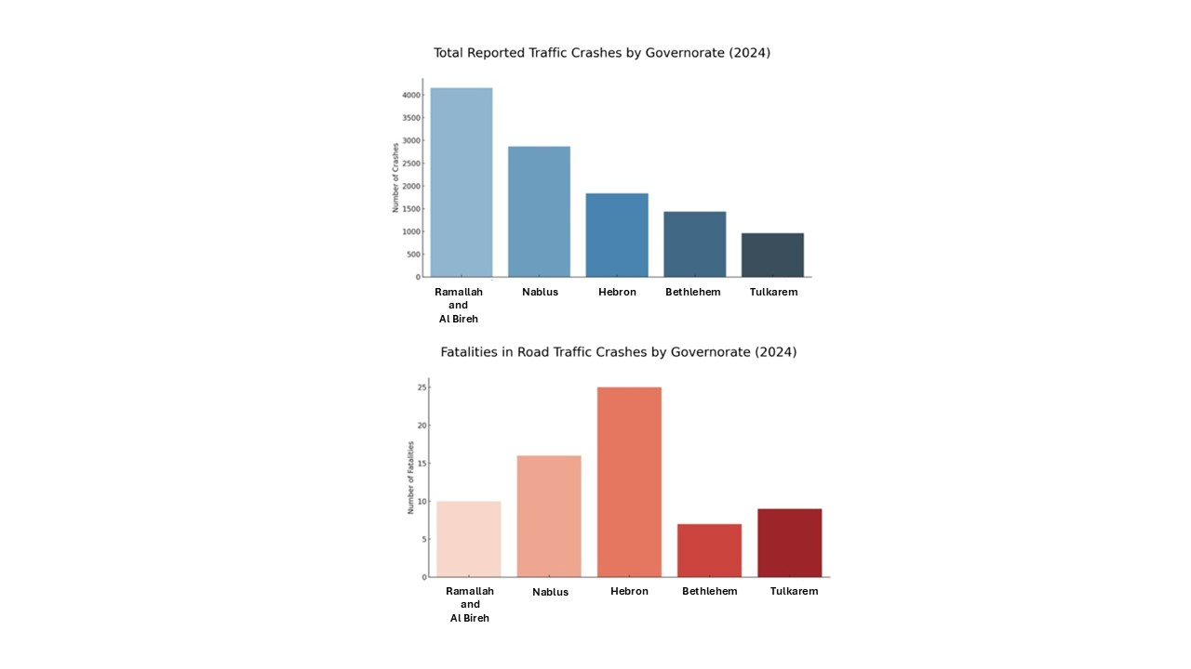
Source: General Directorate of the Palestinian Police [GDPP], 2024.
Comparing the fatalities, the outcome is not directly correlated to the number of crashes. Although Ramallah and Al-Bireh reported the highest number of crashes, the governorate recorded 10 fatalities, which is fewer than those reported in Hebron (25 fatalities) and Nablus (16 fatalities). This shows that crash frequency alone does not explain fatal outcomes, as several other factors may affect crash severity.
In general, road traffic crashes remain a major issue at the national level. According to the General Directorate of the Palestinian Police, 15,094 crashes and 111 fatalities were registered across Palestinian Governorates in 2024. Many of these crashes occurred in urban areas and near major intersections, where traffic volumes are high, and conflicts between road users are more likely (GDPP, 2024).
According to official reports and documented crash records, the causes of road traffic crashes are varied and include factors such as poor road conditions, weak enforcement, and unsafe driving behaviors, including speeding and failure to yield. High-risk locations (black spots) were identified based on official data, particularly in areas characterized by intense interaction between vehicles and pedestrians and limited safety control measures. These observations highlight the importance of conducting a detailed and data-driven analysis of crash statistics and their contributing factors to support the development of effective safety interventions.

1.2 Literature Review
In Palestine and other places, initial research primarily depends on descriptive examination and elementary total crashes to record traffic safety measures. With the increased availability of more detailed traffic data, statistical analyses were used to study the nature of crashes and some of their contributing factors in greater detail. Spatial analysis techniques were subsequently incorporated following enhanced access to geographic information, to gain a better insight into where crashes repeat and the existence of different patterns in different locations. Techniques such as Kernel Density Estimation and measures of spatial autocorrelation allowed the researchers to connect crashes to actual traffic conditions rather than treating them as outliers.
Past research involves international, regional, and local studies. International work offers general methodological outlooks, whereas regional studies concentrate on areas that have comparable geographic and social environments. Local research in Palestine analyzes the traffic accidents in some of the governorates by means of the available data and the corresponding analytical software. The review of this literature can assist in determining what has been done and underline the necessity that more integrated spatial and statistical analysis should be done in Ramallah and Al-Bireh Governorate. The methodological decisions embraced in the present study are supported by this background.

1.2.1 International Studies
Azami et al. (2024) examined the pattern of road crashes in Malaysia based on police reported cases from 2012 to 2022. It examined the frequency of the crashes in these years of the time and their distribution across states. The research was also attentive to the type of road users who were the most frequent in the crash data and the severity of the crashes. To analyze these problems, the researchers adopted linear trend analysis and K-means clustering. The findings indicated that most of the reported crashes were motorcycle-related, and the Selangor area recorded the highest figures in crashes and deaths. It was also found in the study that the number of fatalities decreased temporarily during the COVID-19 lockdowns, primarily because traffic levels were significantly lower.
The findings of the research are in line with what is familiar in most other nations regarding road safety issues. Some of the factors associated with the outcomes of crashes identified in the work include the road conditions and the nature of the vehicles involved, and these are also significant in planning how to mitigate accidents. Using K-means clustering, the study grouped states into categories that were determined by the severity of their records on crashes, and thus, it was easier to see the differences between regions. Such findings can also be used by policymakers in Malaysia, particularly in the preparation of safety measures in states that have high risks of crashes, like Selangor.
Rodrigo (2024) empirically analyzed the number of vehicle crashes throughout Minnesota, with 2016-2022 being the time span of the study. The study aimed to analyze the variation of the degree of crashes in space and time, and which environmental and contextual factors were statistically correlated with more severe consequences. The approach involved using Kernel Density Estimation (KDE) to identify crash hotspots, Global Moran’s I to estimate spatial autocorrelation, and Chi-square tests to establish correlations between crash severity and categorical variables (e.g., road surface, lighting condition, vehicle count, etc.). The results showed a clear concentration of crashes in the metropolitan region of Twin Cities. Seasonal variation indicated that the rate of crashes was high in winter months and during poor road conditions, such as icy environments.
The result of spatial analysis proved the presence of considerable clustering (Moran’s I = 0.179, z = 52.68, p = 0.001), which supports the role of the geographic location in the crash results. Chi-square findings were that such factors as wet or icy pavement, poor lighting, and a single-vehicle crash were closely linked to an increase in the severity of injuries. Integrating spatial statistics in conjunction with geographic information systems (GIS), the research provides meaningful information on the geographic variation of the risk of crash. These results suggest that place-specific safety measures can be more efficient than overall measures.
The spatial-temporal approach used by Rodrigo can be well related to the analytical methodology that was adopted in this thesis and is a consistent source of precedent when it comes to considering the environmental context during traffic safety evaluation.
Hossain et al. (2021) examined road traffic accidents in Khulna City, Bangladesh, to learn which circumstances have more serious consequences. This research was based on the accident records of 2010-2019 and was interested in the ratio between fatal and non-fatal cases. On 266 accidents that were recorded, a binomial logistic regression model was applied. These variables were the number of injuries and deaths, the speed of the vehicle, the nature of the collision, and whether the vehicle was a public or a private vehicle. This was to provide a clearer illustration of the influences that might result in more serious accidents, and that safety planning could be better. The researchers dealt with secondary data that was gathered by the Khulna Metropolitan Police and included information regarding the time of accidents, types of vehicles, and the degree to which the accident occurred. The SPSS software was used to clean the data, after which the regression was run, and tests on collinearity and likelihood ratios, among others, were done to select the most reliable variables in the model.
The researchers observed that the 266 accidents used in the study were those that were reported by the police only. It has been reported that the reporting system was outdated and had not been updated on a regular basis, and this implies that most of the minor crashes or incidents without severe injuries may not have been reported. Due to this reason, the dataset may not represent the actual number of crashes that occur in a big city such as Khulna. The data was stated to apply to statistical modelling, yet the results are to be considered with the realization that the reporting system is incomplete. Its results revealed that an increased vehicle speed, rear collision, and an increased number of deaths were all associated with a more substantial outcome. Public vehicles, particularly buses, had higher chances of causing serious accidents compared to personal vehicles. The research also established that morning rush hours and crashes that happened at night were more likely to cause fatal injuries. These findings can provide effective advice to policymakers of Khulna City, particularly in enhancing speed limits, surveillance of people transportation, and planning protection during periods of high risk of the day.
Toran Pour et al. (2017) have studied the relationship between age and gender and the occurrence of pedestrian crashes throughout Melbourne in Australia. The goal of the study was to highlight locations and periods when the risk was greater to allow implementing more effective plans aimed at improving pedestrian safety. The authors (2014) utilized crash data from 2004 to 2013 and applied GIS to the data to examine the presence of spatial patterns related to various age groups and genders. They also analyzed the time of the crashes of people with the spider plots, and Kernel Density Estimation (KDE) was applied to display centers where pedestrian crashes were likely to be concentrated. The research demonstrated that the number of pedestrian crashes varied significantly according to age and gender. The young pedestrians, particularly the young ones below 18 years of age, were mostly involved during school hours and mostly in the areas near schools. The age group between 18 and 34 years experienced more crashes during the night, which were mainly near bars or other nighttime places. The elderly pedestrians, who were mostly aged 65 and above, were engaged in more daytime crashes, mostly around the community centers or health facilities. There were also evident gender differences in the results. The male pedestrians were more susceptible to nighttime crashes, whereas the female pedestrians were more susceptible to daytime crashes. The trends indicate that age and gender are very effective determinants of the time and place of pedestrian crashes. The research has identified some of the potential safety precautions that may be implemented, including reducing the speed of traffic around schools, better lighting in nighttime spots, and improving walking infrastructure around locations frequented by the elderly.
According to Kim et al. (2013), the severity of the driver injury in the single-vehicle crashes was also investigated based on age and gender in California. The aim of conducting the study was to learn how the driver’s characteristics and crash conditions affect the probability of severe or fatal injuries. The authors analyzed data of 18,183 single-vehicle crashes that occurred between the years 2003 and 2004 through a mixed logit model. The model assisted in explaining variations both between drivers and under different circumstances, with emphasis on age and gender being the key variables that were related to the severity of injuries. The analysis also covered other aspects, including the use of seatbelts, age of the car, conditions on the road, and the surrounding environment.
The research determined that older drivers, especially those aged 65 and above, were much more susceptible to fatal injuries than their younger counterparts. Male drivers also had higher chances of receiving severe injuries, and this was even more evident in drivers who had newer vehicles. Some of the driving conditions also enhanced the risk of sustaining severe injuries, such as driving under the influence, speeding, and traveling at night on roads where there is inadequate lighting. Based on these findings, it was highlighted that special safety precautions should be taken to address vulnerable populations and enhance vehicle and road safety and conditions.
Table 1.1 gives a summary of the main international studies that explored the factors of road crash patterns and severity in various regions. It brings out the various methodological strategies between statistical models and the use of spatial analysis techniques such as KDE and Moran’s I. The most frequent have been environmental conditions, driver’s behavior, and location effects on the outcome of a crash. The table facilitates a wider comprehension of issues of traffic and safety all around, and analytic approaches.
Table 1.1: Overview of International Research on Road Crash Patterns and Contributing Factors.
Author(s) and Year | Study Area | Study Period | Objective | Methodology and Tools Used | Main Findings
Azami et al. (2024) | Malaysia | 2012–2022 | To analyze national and regional road crash dynamics and identify trends in crash frequency and severity. | Linear Trend Analysis and K-means Clustering using official data from the Royal Malaysian Police. | Motorcycles were most involved; Selangor recorded the highest crashes and fatalities. Fatalities decreased temporarily during the COVID-19 lockdowns.
Rodrigo (2024) | Minnesota, USA | 2016–2022 | To investigate spatial and temporal patterns of road crashes and determine factors influencing crash severity. | KDE for hotspot detection, Moran’s I for spatial autocorrelation, and Chi-square tests | Crashes clustered around urban metro areas; severity linked to icy roads, poor lighting, and vehicle count. Strong spatial autocorrelation found.
Hossain et al. (2021) | Khulna City, Bangladesh | 2010–2019 | To identify key factors influencing the severity of road traffic accidents. | Binomial Logistic Regression on 266 crash cases using secondary police data. | High vehicle speed, rear-end collisions, and public vehicle involvement increased fatal crash probability. Highlights policy focus on speed control and transport regulation.
Toran Pour et al. (2017) | Melbourne, Australia | 2004–2013 | To assess pedestrian crash patterns by age and gender across space and time. | GIS Spatial Autocorrelation, KDE, and Spider Plots for temporal analysis. | Younger pedestrians are involved near schools, adults near nightlife, elderly near healthcare areas. Recommend tailored pedestrian safety measures.
Kim et al. (2013) | California, USA | 2003–2004 | To examine driver demographics’ effect on single-vehicle crash injury severity. | Mixed Logit Model applied to 18,183 cases with driver and environmental variables. | Older (65+) and male drivers had higher fatality risks; speeding, alcohol, and poor lighting aggravated severity. Supports targeted policies for high-risk groups.

1.2.2 Regional Studies
Kamh et al. (2024) conducted a study in the Najran region of Saudi Arabia to determine and define places that were at risk of having traffic crashes. The research used GIS instruments in conjunction with unsupervised machine-learning techniques to enhance the identification of crash hotspots and traffic safety planning using real information. The researchers employed official crash data of 2022 and employed several spatial methods, such as Kernel Density Estimation (KDE), Point Density Analysis, and Thiessen Polygons, to demonstrate the intensity of a crash across the urban network. DBSCAN (Density-Based Spatial Clustering of Applications with Noise) and Hierarchical Agglomerative Clustering (HAC) were also used to group crash locations based on their proximity to each other and the frequency of occurrence of the crash.
As the research revealed, the major concentration of traffic accidents in Najran was in the central and southern urban centers, which are characterized by high residential and traffic density. The two clustering techniques achieved distinct patterns and highlighted areas where crashes were more prevalent, and this means that accidents within the area occur in a spatial pattern and not randomly. The authors made a conclusion that GIS-based mapping combined with clustering methods contributes to the enhancement of the accuracy of detecting crash hotspots and provides a viable foundation for developing specific safety interventions within the fast-developing urban environments.
Hazaymeh et al. (2022) have conducted research in the Irbid Governorate, Jordan, to investigate the space and time distribution of road traffic accidents and the places where accidents are more frequent. It was planned to observe whether such accidents were random or had clear spatial patterns, and to give information that would allow local authorities to deal with safety issues in the high-risk areas. The authors worked with the official data on accidents provided by the Jordanian Traffic Department in the period between 2015 and 2019. They used a number of GIS tools in the analysis. The KDE was employed to demonstrate the locations where accidents were localized. Moran’s I spatial autocorrelation was employed to evaluate whether accidents were clustered statistically significantly.
The research established that a substantial number of the crashes in Irbid were inclined to take place on the principal roads traversing the city and intersections where traffic is typically dense. Using KDE maps, the researchers found that several spots had significantly more accidents. These clusters were confirmed to be real patterns and not random accidents scattered about the area by the I also by Moran. It is on this basis that the study proposed that basic visual maps combined with statistical tests would provide a better view of the real problem areas and could be used to direct the activities in the city towards enhancing safety.
In Timmermans et al. (2022), the authors investigated the perceptions of Egyptians toward traffic safety and risky behavior on the road. The research was meant to learn about these attitudes and categorize drivers into groups regarding their treatment of safety. The questionnaire was distributed to 559 drivers in various social places, including the car dealerships and government service centers. The survey also collected background information, their driving experience, and their self-reported violations and previous accidents. Having analyzed the answers with the help of the exploratory factor analysis and hierarchical clustering methods, the researchers revealed that there are three major groups, namely drivers who adhere to the rules most of the time, drivers who avoid safety measures, and one more group that demonstrates a more liberal approach to regulations.
The research found that most drivers were comfortable with certain forms of violations, including speeding, but other violations, including driving after consuming alcohol or failing to wear a seat belt, were strongly disapproved. It also indicated differences based on age. The younger drivers were more likely to disregard simple measures of safety, and middle-aged drivers were more likely to commit high-risk behaviors such as texting and driving. These trends suggest that the safety programs should be altered to ensure that they concentrate on the way drivers think about the violation, and the social norms that encourage risky driving in Egypt are addressed.
Table 1.2 shows a sample of regional research that examines the issue of traffic safety in the countries of choice in the Arab region, both in terms of crash distribution and user behavior. The articles utilize spatial instruments and behavioral analysis to reveal the trends in crash hotspots and risk perception. The typical issues identified in the findings include urban clustering, demographic impacts, and infrastructure gaps. The table also gives pertinent information used to inform context-sensitive interventions around the study.
Table 1.2: Summary of Regional Studies Related to Road Crash Patterns and Safety Behavior
Author(s) and Year | Study Area | Study Period | Objective | Methodology and Tools Used | Main Findings and Relevance to Current Study
Kamh et al. (2024) | Najran, Saudi Arabia | 2022 | To identify and model high-risk crash zones using GIS-based clustering. | KDE, DBSCAN, HAC, and Moran’s I were integrated with spatial analysis tools. | Found significant clustering in dense urban corridors; combining GIS and clustering improved hotspot identification and supported targeted interventions.
Hazaymeh et al. (2022) | Irbid Governorate, Jordan | 2015–2019 | To detect spatiotemporal patterns and crash hotspots. | KDE and Moran’s I use GIS accident data. | Revealed significant crash clusters; confirmed statistical dependence via Moran’s I; supports the spatial analysis component of the current study.
Timmermans et al. (2022) | Egypt | — | To analyze Egyptian drivers’ safety attitudes and classify risky behaviors. | Questionnaire survey (n = 559); EFA and Hierarchical Cluster Analysis. | Identified three behavioral clusters; younger drivers showed higher risk-taking. Relevant for understanding user behaviors in the regional safety context.

1.2.3 Local Studies
Abdul Hadi (2023) studied motorcycle safety in Nablus City to develop a crash profile and analyze motorcyclist behavior. Crash records were obtained from the Nablus Traffic Police Department for the period from January 2019 to November 2021, with additional demographic and registration data from the Palestinian Central Bureau of Statistics. Spatial mapping was used to locate hazardous zones, and the behavior of motorcyclists at a representative high-risk intersection was observed through video footage. An Analysis-of-Variance (ANOVA) test was then applied to identify significant differences in observed behaviors. The results showed that crashes were most frequent in May and September, on Saturdays, and during the hour 15:00-16:00, with unsecured lane changing as the most common cause. Al-Qirawan in Rafidia was identified as the most hazardous zone. At the observed intersection, 70% of motorcyclists committed at least one violation, and helmet use was very low: only 12.7% among delivery riders and 5.1% among private riders. Abdul Hadi concluded that motorcyclists generally do not comply with traffic regulations and that enforcement is weak, and recommended stricter enforcement, public education, and targeted training.
Teebi (2022) studied traffic safety at intersections in Tulkarem Governorate, with the aim of building a profile of crash patterns, severity, and contributing factors at intersection sites. Crash data from July 2016 to 2021 were obtained from the Tulkarem Traffic Police Department, along with additional data from the Palestinian Central Bureau of Statistics and the Ministry of Transportation. Two methods were used to identify the most critical sites: severity of injuries at intersections and crash rate relative to traffic volume. Analyses were carried out at three levels: the governorate, Tulkarem city, and the COVID-19 pandemic period. Tulkarem city, and Zone 6 within the city, were identified as the most critical locations. Thursday recorded the highest number of intersection crashes at all levels, and spring was the most frequent season, followed by summer, autumn, and winter. The peak hours differed by level: 10:00-16:00 at the governorate level, 12:00-20:00 in the city, and 10:00-14:00 during the pandemic. Males were injured more often than females across all levels. "Not giving the right of way" was the leading cause of intersection crashes at the governorate level, while "over-speeding" was the main cause within the city itself. Pedestrian crashes made up 15.88% of all intersection crashes at the governorate level, and most injuries occurred among the 11-30 age group. Teebi concluded that user behavior was responsible for most crashes, and recommended nationwide awareness campaigns for drivers, passengers, and pedestrians, together with the creation of a national traffic safety program.
Hassouna et al. (2020) studied long-term trends of road traffic crashes in Palestine and developed a model to forecast future crashes. The analysis covered several decades, with the modeling focused on the period since the establishment of the Palestinian National Authority in 1994. Data were obtained from the Palestinian Central Bureau of Statistics and included annual crash rates, registered vehicles, population, and Gross National Product (GNP). The researchers also examined how political, socioeconomic, and demographic factors affected traffic safety during this period. An ARIMA time-series model was developed and tested in several forms. ARIMA (3,2,3) was selected as the most suitable, based on Root Mean Squared Error (RMSE) and Mean Absolute Percentage Error (MAPE). Model verification showed a difference of only 6.1% between the observed and forecasted crashes for 2017. The results showed a generally rising trend in crashes since 1994, linked to population growth, increased vehicle ownership, and political and socioeconomic conditions. The forecast indicated that this upward trend is expected to continue. The authors emphasized the need for a national traffic safety program and targeted interventions to reduce crash rates and improve road safety in Palestine.
Al-Sahili and Khader (2016) attempted to determine the principal causal factors involved in road traffic accidents in the City of Nablus. It was supposed to know the relationship between road conditions and driver behavior, and the occurrence of accidents, as well as to facilitate the improvement of traffic safety in urban areas. The study utilized official crash documents of the Palestinian Traffic Police, which included a few years of documented cases. Descriptive statistics and spatial mapping were used to determine the time and the place of the highest frequency of crashes. The research also analyzed the impact of road type and weather on the extent of accidents as well as human behavior. The findings revealed that there were numerous crashes that occurred in major urban roads, which had poor geometric design and limited or imperfect signage. Speeding and distracted driving were found to be the number one cause of accidents in human behavior. Based on these findings, the research indicated that a better road network, increased enforcement of the traffic laws, and enhanced education for drivers were the solutions to the problem that affected the safety of such cities as Nablus.
Table 1.3 summarizes the main local research on road safety in Palestinian cities and governorates.

Table 1.3: Summary of Local Studies on Road Safety and Crash Characteristics in Palestine
Author(s) and Year | Study Area | Study Period | Objective | Methodology and Tools Used | Main Findings and Relevance to Current Study
Abdul Hadi (2023) | Nablus City | 2019–2021 | To assess causes and risk factors in motorcycle crashes. | Crash profile, spatial analysis, video observation, and ANOVA | Crashes most frequent on Saturdays in May/September; Al-Qirawan in Rafidia is the highest-risk zone; 70% violation rate; very low helmet use (12.7% delivery, 5.1% private)
Teebi (2022) | Tulkarem Governorate | 2016–2021 | To develop a profile of intersection crashes including patterns, severity, and contributing factors. | Two-method site identification (injury severity + crash rate per traffic volume); analysis at three levels (governorate, city, COVID-19). | Tulkarem city and Zone 6 most critical; Thursdays and spring peak; males more affected; "not giving right of way" main cause at governorate, "over-speeding" in city; pedestrians = 15.88% of crashes.
Hassouna et al. (2020) | Palestine (National Level) | Since 1994 (covering several decades) | To forecast traffic crash trends for safety planning. | Time-series modeling (ARIMA). | Identified a generally rising trend in crashes since 1994; ARIMA (3,2,3) model selected with 6.1% verification accuracy for 2017; forecast continued upward trend.
Al-Sahili and Khader (2016) | Nablus City | Multiple years | To identify the main factors contributing to urban road crashes. | Descriptive statistics and spatial mapping of crash data. | Poor road design and speeding were key causes; emphasized engineering improvements and driver education.

These researchers used spatial and statistical methods in order to examine crash patterns, behaviors, and environmental factors. Poor road infrastructure, lack of traffic compliance, and enforcement are some of the common themes. The practical findings identified in the table will point to the relevance of the current study in terms of its practical significance and localization.

1.2.4 Summary
The reviewed international studies showed that crashes are caused by a combination of factors, including driver behavior, demographic characteristics, and environmental conditions. A range of analytical techniques have been used to identify high-risk locations and to examine the spatial distribution of crashes, including regression models (Hossain et al., 2021; Kim et al., 2013), Kernel Density Estimation (Rodrigo, 2024; Toran Pour et al., 2017), Moran's I (Rodrigo, 2024), and clustering methods (Azami et al., 2024). The work of Azami et al. (2024) also highlighted the importance of considering changes over time and space, and showed how unusual events such as the COVID-19 pandemic can affect crash patterns by altering travel volumes and mobility behavior.
Research from the Middle East, including Saudi Arabia (Kamh et al., 2024), Jordan (Hazaymeh et al., 2022; Shehadeh et al., 2024), and Egypt (Timmermans et al., 2022), showed that GIS tools combined with clustering techniques can help identify locations where traffic crashes tend to cluster. These studies also indicated that local practices and social aspects influence road safety in the region. Driving habits, pedestrian behavior, and the economic conditions of the population are among the factors that contribute to crash risk in these countries.
In Palestine, local studies have shown a growing use of GIS tools and statistical methods to examine where and how crashes occur, particularly in urban areas such as Nablus (Abdul Hadi, 2023; Al-Sahili & Khader, 2016) and Tulkarem (Teebi, 2022). These studies have repeatedly found that human behavior, including speeding, non-compliance with traffic rules, and other risky actions, is the main cause of most road crashes. The methods applied were also similar, including KDE, Moran's I, and regression models. National-level work by Hassouna et al. (2020) added a long-term perspective and confirmed a generally rising trend in crashes in Palestine since 1994. Taken together, these studies suggest that combining spatial analysis with statistical methods is a sound approach for evaluating road safety in the Palestinian context.
The literature reviewed in this chapter provides a general background on road safety issues relevant to Ramallah and Al-Bireh Governorate. The studies show that spatial and statistical tools help reveal where crashes occur and how human behavior contributes to these patterns, and that the same tools also support the design of practical, data-driven safety measures. At the same time, the review shows that spatial work focused specifically on crash characteristics in Ramallah and Al Bireh Governorate has been limited. The present study addresses this gap by providing new evidence that can support traffic safety planning in Palestine.

1.3 Problem Statement
The issue of road traffic crashes continues to be a primary problem in Palestinian cities since they pose a safety risk and may impose social and economic effects on society in the long term. The threat is further escalated by the fact that in the Ramallah and Al-Bireh Governorate, the population is very high, there is daily movement of people and automobiles, and the road network is incapable of accommodating the daily traffic.
The Palestinian Police releases national crash statistics that present an overall picture, but it does not reflect a particular mobility pressure within each of the governorates. A second glance at the crash causes in Al-Bireh and Ramallah (see Appendix A). As Fig.1.3 indicates, actions like speeding, distraction, failure to yield, as well as wrong use of lanes by the drivers still significantly contribute. These offenses mirror normal driving and the pressure of driving on congested roads. The variations in the riskiness of road user types, as indicated by crash involvement by road user type (Fig. 1.3), also indicate who is at the greatest risk. There is greater exposure to pedestrians, motorcyclists, and passengers of the public transit, in part due to mixed-use streets and minimal pedestrian facilities. These trends indicate the relevance of research on crash trends at the governorate level to better understand the most affected people, the causes of crashes, and the actions to be taken to mitigate these risks.
The cumulative numbers show the percentage distribution of crashes by type of road user and the principal violations of crashes in Ramallah and Al-Bireh. The number of reported crashes involving private vehicles is the highest, followed by taxis and trucks, which indicates that the policy measures need to be more concentrated on the specified categories. Meanwhile, the most common violations that are the most significant, with speeding and driver distraction being the most important ones, indicate that behavioral aspects in the governorate are crucial contributors to the risk of a crash.
Collectively, these trends underscore the necessity of interventions that do not only target the types of vehicles that have the highest proportions of accidents but also target the actions of dangerous drivers that lead to accidents.

Figure 1.3
Crash Involvement by Road User Type – Ramallah & Al Bireh (2024), Primary Contributing Violations in Crashes – Ramallah & Al Bireh (2024).
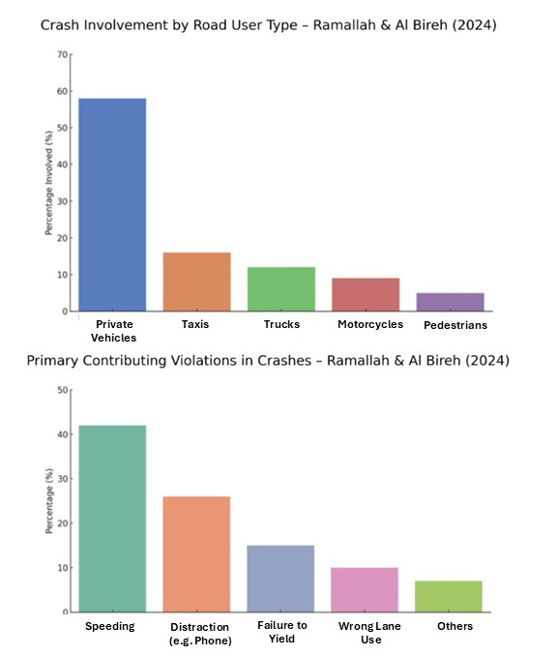
Source: General Directorate of the Palestinian Police, 2024.

1.4 Problem Justification and Research Gap
Prior spatial analyses of traffic crashes in the West Bank, including Teebi (2022) in Tulkarem and Abdul Hadi (2023) in Nablus, have shown that geographic methods can reveal patterns that aggregate statistics miss. Yet such approaches remain uncommon in Palestinian research, and Ramallah and Al-Bireh Governorate has received no comparable treatment. Existing analyses of the governorate rely on descriptive summaries that do not account for spatial clustering, road typology, demographic variation, or infrastructure conditions. Without this kind of analysis, planners and enforcement authorities have limited basis for identifying where crashes concentrate or why, which weakens the case for targeted safety investment.
The gap matters particularly in this governorate given its administrative complexity, high traffic volumes, and mixed urban character. Conditions here are not well represented by national-level data, and the absence of governorate-specific spatial evidence has practical consequences: resources are allocated without a clear geographic rationale, and safety interventions are not systematically tied to the locations and attributes of actual crashes.
This study addresses that gap directly. It applies spatial statistics and categorical testing to official crash records from 2018 to 2023, producing an analysis that links crash locations, road characteristics, and temporal patterns within a single analytical framework. Official police records are connected to contextual variables processed in GIS, improving the usefulness of findings for planning and enforcement decisions. Data limitations, particularly underreporting and uneven enforcement coverage, are handled transparently so that conclusions carry appropriate qualification. The output is intended to support corridor prioritization, intersection treatment, and targeted enforcement in areas where the evidence points most clearly to elevated risk.

1.5 Data and Contextual Constraints
Some data and contextual issues complicate this gap in research. The nature of the available traffic data is one of the limited factors. Even though Ramallah and Al Bireh had the largest number of registered vehicles in Palestine by 2024, which is 134,043 vehicles (The Ministry of Transport, 2024), the figure is not an accurate measure of real traffic movement within the governorate. Several vehicles are registered in Ramallah and Al Bireh Governorate, while they operate in other locations. Furthermore, thousands of vehicles come to the governorate every day from the nearby regions. As mentioned, Al Hayat Newspaper estimated over 100,000 cars come into the city daily; the number varies regularly based on the situation in the country (Al-Hayat Newspaper, 2023).
The other significant drawback is the unusual occurrences that took place between the year 2019 and 2024. The COVID-19 pandemic (2020-2022) and the war in Gaza, which began in 2023, had a strong influence on traffic behavior in this period. Such occurrences resulted in lockdowns and travel bans that greatly transformed the amount of traffic and movement patterns. To illustrate this point, the West Bank was significantly impacted by the lockdown imposed between March 5 and May 31, 2020, with general movement and activity related to traffic significantly declining by 5063 per cent over the three months, as Fig. 1.4 depicts. This effect can be reasonably applied to indicate mobility conditions throughout the broader COVID-19 Pandemic in the West Bank (Palestinian Central Bureau of Statistics [PCBS], 2020). In addition, travel between West Bank Governorates became challenging after October 2023. This was a case that had an impact on the daily commute. There were increased checkpoints and roadblocks in the region. It is reported that it exceeded 700 (United Nations Office for the Coordination of Humanitarian Affairs [OCHA], 2023). This caused slow travel between governorates and restricted access to such cities as Ramallah.
Behavioral and environmental factors compound these structural gaps. Pedestrian crashes are common along commercial and mixed-use corridors where formal crossing infrastructure is limited or absent. The growing presence of electric scooters and bicycles on roads not designed to accommodate them increases exposure to conflict with heavier vehicles. Speeding and distracted driving remain frequent in areas where enforcement is inconsistent. Taken together, the density of activity, the diversity of road users, and the uneven provision of safety infrastructure in Ramallah and Al-Bireh make the governorate a practical focus for spatial and statistical analysis of crash patterns.

Figure 1.4
Impact of the COVID-19 Lockdown on Economic Activity and Mobility in the West Bank
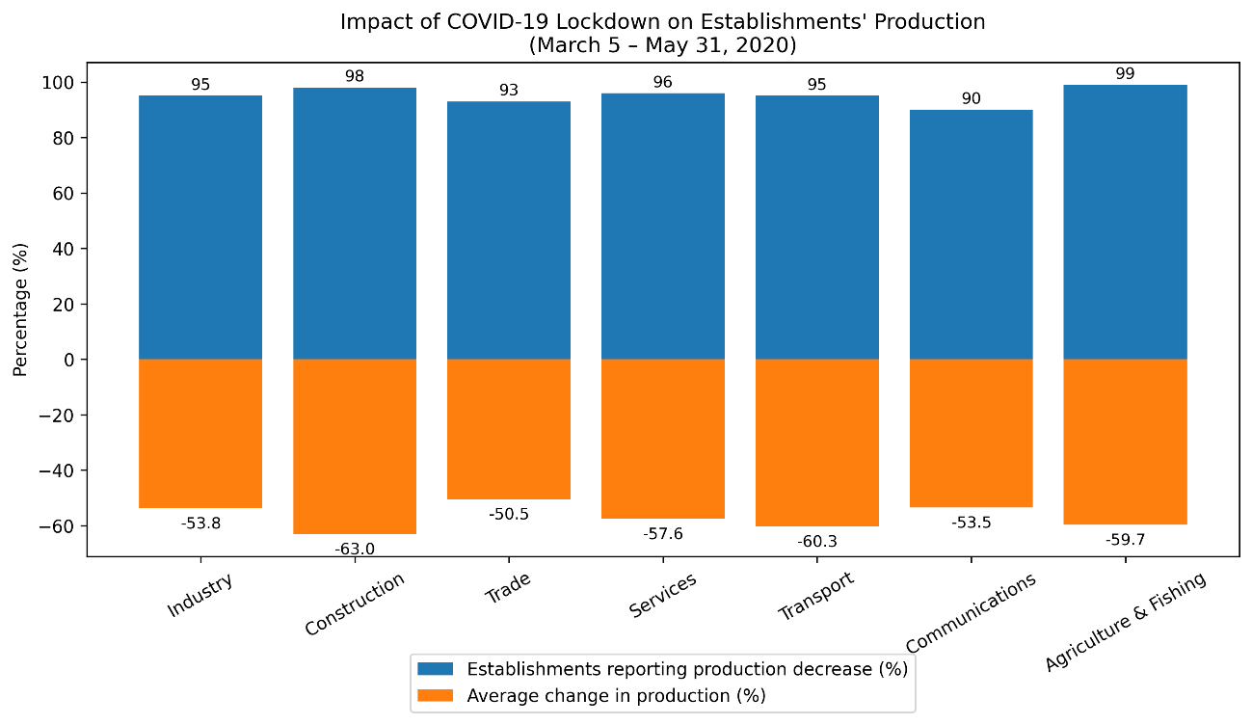
Source: Palestinian Central Bureau of Statistics (PCBS), 2020.
Furthermore, there is underreporting. Palestine has numerous minor traffic collisions, most of which involve no injuries or only minor property damage, that are resolved either privately by the drivers or even by insurance companies without the involvement of the police. Such incidents are not captured in the official police files, and hence, the actual number of crashes is probably higher than reported. This makes the data less complete, and it should be considered when assessing the situation in general. Besides, administrative limits influence the special accuracy of crash records.
Ramallah and Al Bireh Governorate occupy large portions that are either in area B or C, with minimal or no control of the Palestinian police. Consequently, such crashes might not be completely documented, and it might leave data gaps, particularly in rural or outer areas. Strategic implementation of the lack of traffic enforcement in these areas could result in an increase in violations, i.e., speeding, unlicensed driving, and the neglect of traffic control equipment. If a special study reveals that there are high concentrations in these areas, a major challenge to be solved will be how to implement effective law enforcement in areas where authority is limited.

1.6 Research Objectives
The key objective of the research is to learn more about the patterns of traffic crashes in Ramallah and Al-Bireh Governorate, 2019-2024. Particularly, the research will aim at:
- Investigate the distribution of the traffic crashes throughout the governorate and determine the points where the crashes are more prevalent.
- Explain the key features of the registered traffic crashes relying on the official police statistics, the level of severity, when they happen, types of road users, demographics, and the road conditions.
- Investigate the relationships between various characteristics of the crash as they can be related to the spatial location, focusing on the role of location and driver-related factors.
- Display the findings using simple maps and statistical plots that show the patterns and changes in the crashes over a period.
- Contribute practical, evidence-based insights that can assist traffic safety planning and infrastructure decision-making in Ramallah and Al-Bireh Governorate, while considering data limitations such as underreporting and administrative constraints.

1.7 Study Area
The study targets Ramallah and Al Bireh Governorate as one of the central areas within the West Bank that has political, economic, and institutional significance. It is the administrative base of the Palestinian National Authority and houses major government ministries, universities, hospitals, trade areas, and major transportation corridors. All these activities attract masses of people and vehicles daily; the population of the governorate is more than 400,000 people (PCBS, 2024).
The Ramallah and Al Bireh Governorate is at the geographic and functional center of the West Bank. The governorate is administrative and geographically heterogeneous. It covers both the urban center and low-density rural villages, and under the Oslo Accord, classes A, B, and C. All these contexts come with diverse conditions of the roads, traffic volumes, and enforcement issues. Due to this complexity, a wide-scale analysis in space is required to take into consideration the variation in the exposure and risk levels at the barrier zones. Fig. 1.1 depicts the allocation of areas A, B, and C across the West Bank, which indicates the administrative disintegration that defines the low enforcement and delivery of infrastructure.
Fig. 1.1 is an administrative map of all West Bank Governorates, which assists in putting the area of the study in the broader regional context.

1.8 Thesis Outline
This thesis is organized into five chapters, along with the abstract, references, and appendices.
Chapter One introduces the research, the problem statement, and the study area, and presents the objectives, significance of the work, and a review of related international, regional, and local studies.
Chapter Two describes the research methodology, including the data sources used for the period 2019-2024, the main variables, the data limitations, and the analytical methods (descriptive statistics, Kernel Density Estimation, Moran's I, and Chi-square tests).
Chapter Three reports the results of the analysis, covering the general crash characteristics, the spatial distribution maps, and the outcomes of the spatial and statistical tests.
Chapter Four discusses the findings considering previous studies and considers the influence of exceptional circumstances, such as the COVID-19 lockdowns and the political situation, together with the main limitations of the analysis.
Chapter Five presents the main conclusions and recommendations for improving road safety and outlines directions for future research.

Chapter Two

Methodology

2.1 Data and Sources
The study relies on official secondary data obtained from recognized institutions. Statistical data related to traffic crashes, black spots, crash causes, and aggregated figures on fatalities and injuries were obtained from the General Directorate of the Palestinian Police – Traffic Police Department and the Palestinian Central Bureau of Statistics (PCBS) for the years 2019–2024.
The research was conducted in Ramallah and Al-Bireh Governorate, situated in the middle of the West Bank. Spatial datasets used for GIS analysis were obtained from two main sources: municipal boundaries and selected road network shapefiles were provided by Ramallah Municipality, while additional spatial datasets, including administrative boundaries and supporting geographic layers, were obtained from the Humanitarian Data Exchange (HDX) platform maintained by the United Nations Office for the Coordination of Humanitarian Affairs (OCHA). These datasets define the spatial extent of the analysis and enable consistent spatial processing and visualization. All datasets were reviewed and cross-checked before analysis to ensure consistency. No simulated or estimated data were used.
The study population includes traffic crash black spots identified within Ramallah and Al-Bireh Governorate for the period 2019–2024, based on criteria adopted by the General Directorate of the Palestinian Police – Traffic Police Department. A black spot refers to a location where traffic crashes recur over a minimum of three consecutive years and result in fatalities, injuries, or material damage, with at least eight recorded crashes (Palestinian Traffic Police Directorate, 2024). This definition is consistent with international practice, where black spot identification typically combines a crash frequency threshold with a severity component (Elvik, 2008; Cheng & Washington, 2005). Black spots are represented spatially either as intersections or as linear road segments with lengths ranging from 500 to 1000 meters, depending on reporting practices and spatial accuracy requirements (Palestinian Traffic Police Directorate, 2024).
No sampling procedure was applied. The analysis is based on all available and verified records that fall within the defined temporal and geographic scope, ensuring that results reflect the recorded characteristics of traffic crashes within the study area. Any missing or underreported incidents are treated as data limitations rather than sampling issues.

2.2 Study Design
The current study is conducted under the quantitative approach of analysis, relying on the GIS to examine traffic crashes. The analysis is informed by the records of traffic crashes that were officially recorded by the authorities concerned and were made available for research purposes. These records were utilized without alteration and the creation of extra data.
The analytical procedure is aimed at analyzing the distribution of traffic crashes in space and learning how the characteristics of crashes differ in different places. Spatial methods are used to determine the areas where a crash is most likely to happen again, whereas statistical tests are employed to determine whether the patterns are significant or not. KDE is to be employed to indicate the areas that are relatively high in the number of crashes, and Global Moran's I to determine the spatial clustering (Getis & Ord, 1992). Moreover, Chi-square tests are adopted to test the relationships between crash severity, factors that contribute to crashes, and space classifications. The study combines the KDE and Moran's I, as has been applied in similar traffic safety studies (Rodrigo, 2024, and Hazaymeh et al., 2022). The research did not use surveys, experimental evidence, or prognosis, and is constrained to obtaining crash records from official sources. The data on traffic crashes that were collected during the study period were analyzed to investigate spatial and statistical trends over several years.

2.3 Spatial Data Preparation
All spatial analyses were performed using ArcMap (ArcGIS 2015), produced by Esri (Environmental Systems Research Institute, Redlands, California, USA). Traffic crashes and black spot records were converted into point feature layers using their geographic coordinates. All spatial layers were projected into a unified coordinate reference system to ensure accuracy in spatial calculations.
Reference datasets to give spatial context were created as boundary and road network layers. The preparation of data involved checking the accuracy of coordinates, eliminating duplicate records, and matching the attribute tables with the datasets. Statistical calculations for the Chi-square analysis were performed using Microsoft Excel (Microsoft Corporation), as detailed in Chapter Four.

2.4 Analytical Methods
The choice of analytical methods in this study was based on the nature of the available data and the research objectives. The dataset consists of geographically referenced traffic crash records with categorical attributes such as crash severity, contributing factors, and administrative classification. This combination of spatial and categorical data requires an integrated analytical framework that can describe both where crashes concentrate and which factors are associated with them.
Kernel Density Estimation (KDE) was selected as the main tool for hotspot identification because it produces a continuous density surface that captures crash concentration patterns without depending on predefined administrative boundaries. KDE has been applied in regional studies such as Hazaymeh et al. (2022) in Irbid Governorate and Rodrigo (2024) in Minnesota.
Global and Local Moran's I were chosen to complement KDE by providing statistical confirmation of the spatial patterns identified visually. KDE on its own produces a descriptive surface, while Moran's I test whether the observed clustering is statistically significant or could have occurred by chance (Getis & Ord, 1992). The combined use of KDE and Moran's I is established in spatial crash analysis (Hazaymeh et al., 2022; Kamh et al., 2024; Rodrigo, 2024), and it addresses the risk of relying on visual interpretation alone.
The Chi-square test was added to examine relationships between categorical variables that cannot be assessed through spatial methods. It is a standard statistical tool for testing associations between categorical attributes such as crash severity, causes, and location type, and is suitable for the type and size of the dataset used in this study. The three methods cover the main analytical needs of this research: identifying where crashes cluster, testing whether the clustering is statistically meaningful, and examining how crash characteristics relate to one another.

2.5.1 Kernel Density Estimation (KDE)
Kernel Density Estimation is a non-parametric statistical method used to estimate the probability density function of a set of point observations. In spatial analysis, it converts a discrete set of point locations into a continuous density surface, which makes it possible to identify zones of relatively high concentration in a visual and quantitative form. KDE is commonly used in road safety research because it can highlight crash hotspots without imposing predefined administrative boundaries, and the resulting density surface can be classified into intensity levels that are easy to interpret on a map. In this study, KDE was applied to identify zones of recurring traffic crashes within Ramallah and Al-Bireh Governorate, following an approach like that used by Hazaymeh et al. (2022) and Rodrigo (2024).
It is a technique used to measure the intensity of traffic crashes by estimating the cumulative impact of the location of crashes in a specified area. KDE also considers both distance and frequency of crashes to compute a smooth density surface, instead of crash points being considered as a single observation point, as a description of how the crashes are distributed spatially around every point.
A cell size of 50 meters was selected during the Kernel Density Estimation (KDE) process to provide sufficient spatial detail for identifying localized crash concentration patterns within the urban road network of Ramallah and Al-Bireh Governorate. This resolution was considered appropriate for maintaining a balance between spatial precision and map readability, particularly in densely built urban corridors and intersection areas where crashes tend to cluster.
Mathematically, the density value at any location $x$is estimated using the kernel density function:
$$\hat{f}(x)=\frac{1}{nh^{2}}\sum_{i=1}^{n}{K}\left(\frac{d_{i}}{h}\right)$$
In this expression, $\hat{f}(x)$ represents the estimated crash density at location $x$, while $n$denotes the total number of crash-related observations included in the analysis. The parameter $h$is the bandwidth (search radius), which controls the spatial extent over which nearby crashes influence the density value. The term $d_{i}$refers to the distance between the evaluation location $x$ and crash point $i$, and $K\left(⋅\right)$ represents the kernel function that determines how the influence of a crash decreases with distance.
In practice, this equation implies that every crash has a weighted contribution to the nearby sites, with the weighted contribution decreasing with the distance. The contribution is zero when the distance is more than the bandwidth h. This is a distance-decay effect, that is, closer crashes have more impact on local density than far-away crashes. In the given study, the calculation of the KDE was performed in ArcMap through a division of the study area into a raster grid with a cell size of 50 meters. The values of densities were calculated at the center of every raster cell. All crash points were found on each cell center, within a 300-meter bandwidth area. Each of these points was then subjected to the kernel function, and the values obtained were added together to give a single density value of the same cell.
When crash frequency was available, KDE was calculated using a weighted form of the estimator, expressed as:
$$\hat{f}(x)=\frac{1}{h^{2}}\sum_{i=1}^{n}{w_{i}} K\left(\frac{d_{i}}{h}\right)$$
Here, $w_{i}$ represents the total number of crashes associated with the black spot $i$. This weighting ensures that locations with higher crash counts contribute more strongly to the density surface than locations with fewer recorded crashes, allowing the KDE output to reflect crash intensity rather than simple point frequency.
The outcome of these procedures is a continuous density surface, where a raster cell contains a value of relative crash intensity per unit area. The values are not probabilities or statistically significant results, but a comparative measure of the change in the crash concentration across the study area.
In the end, maps of KDE on the locations in Ramallah and Al-Bireh Governorate are revealed as a zone that has a relatively high-density value. In terms of computation, such regions are raster cells in which the contribution of the nearby crash points is summed after distance decay, and the weight is bigger than in other areas. This practically means that crashes have continuously taken place within proximity during the study period and constitute high-density zones instead of isolated incidents.

2.5.2 Spatial Autocorrelation (Global and Local Moran’s I))
Spatial autocorrelation refers to the degree to which the values of a variable observed at one location are related to the values observed at neighboring locations. Global Moran's I provides a single index that summarizes the overall spatial dependence across the study area, while Local Moran's I (LISA) breaks down this measure to identify specific clusters and spatial outliers at the level of individual locations. The combined use of Global and Local Moran's I has become a common component of spatial crash analysis because it tests whether the visual patterns produced by tools such as KDE are statistically significant or could have arisen from a random spatial process (Getis & Ord, 1992). In this study, both versions of the statistic were applied to test whether the crash distribution in Ramallah and Al-Bireh Governorate shows significant clustering at the governorate level and at the level of individual locations, in line with the approach used by Kamh et al. (2024) and Hazaymeh et al. (2022).
Global and Local Moran’s I statistics were used to test spatial autocorrelation to determine whether there are non-random spatial patterns of traffic crashes. The I in Global Moran measures the dependence on space in the whole study area through the similarity of the crash values within the neighboring locations. It is calculated using the following expression:
$$I=\frac{n}{W}⋅\frac{\sum_{i=1}^{n}{\sum_{j=1}^{n}{w_{ij}}}(x_{i}-\overset{ˉ}{x})(x_{j}-\overset{ˉ}{x})}{\sum_{i=1}^{n}{(}x_{i}-\overset{ˉ}{x})^{2}}$$
where $n$ represents the number of spatial units, $x_{i}$ and $x_{j}$ are the crash values at locations $i$ and $j$, $\overset{ˉ}{x}$ is the mean crash value, $w_{ij}$ is the spatial weight between locations $i$and $j$, and $W$is the sum of all spatial weights.
Global Moran I is usually between +1 and -1. Positive values are values that show that the similar crash values are spatially clustered, negative values are values that show that the similar values are spatially dispersed, and values near zero depict that there is a random spatial distribution. A p-value and a Z-score are used to provide statistical significance. The value of the absolute Z-score is more than 1.96, and a p-value that is lower than 0.05 indicates that the spatial pattern within a sample is statistically significant. Otherwise, the trend is not much different than spatial randomness. Since Global Moran I is one of the collective measures of the whole area of study, Local Moran I was later used to study the spatial patterns at the level of the location. Local Moran’s I identifies specific clusters and spatial outliers by evaluating each location relative to its neighbors and is calculated as:
$$I_{i}=\frac{\left(x_{i} − \overset{ˉ}{x}\right)}{S^{2}}\sum_{j=1}^{n}{w_{ij}}(x_{j}-\overset{ˉ}{x})$$
where $I_{i}$ represents the local statistic for the location $i$, and $S^{2}$ is the variance of the crash values.
Local Moran I is used to interpret the results of local Z-score and p-values. The locations with p-values of less than 0.05 are said to be statistically significant, and are classified into cluster types, including High-High, Low-Low, High-Low, and Low-High, depending on the relationship between a location and its immediate neighbors. Where the p-value is above 0.05, then it is considered not significant.
The joint application of Global and Local Moran’s I, in this study, made it possible to detect the overall spatial structure, as well as localized spatial behavior. Although Global Moran I did indeed evaluate the spatial dependence of the crash distribution across the governorate, Local Moran I did so in great detail, giving a detailed view of the locations that display statistically important clustering, or outliers.

2.5.3 Chi-Square Tests
The Chi-square test is a classical statistical method used to assess whether two categorical variables are independent or whether a statistically significant association exists between them. It compares the observed frequencies in a contingency table with the frequencies expected under the assumption of independence, and is appropriate for crash data, where many of the most relevant variables (such as crash severity, contributing causes, and location categories) are categorical in nature. In this study, Chi-square tests were used alongside the spatial methods to examine relationships between categorical crash characteristics that cannot be fully described through spatial analysis on its own.
These tests were used to test the relationships among the selected categorical variables, such as the severity of the crash, the causes that contributed to the crash, the administrative area classification, and the type of black spot location. These were tests that were undertaken to determine the statistical significance of observed differences between categories. A similar approach was used by Rodrigo (2024) to test associations between crash severity and categorical variables such as road surface, lighting conditions, and vehicle count.
The categorical variables included in the Chi-square analysis were selected based on the structure of the official traffic crash dataset obtained from the General Directorate of the Palestinian Police and the Palestinian Central Bureau of Statistics. Variables such as crash cause, crash type, and crash severity were chosen because they were consistently available across the study years and are commonly used in previous traffic safety studies reviewed in the literature, particularly in studies examining temporal variation and crash characteristics.

2.6 Study Procedures
The analytical process involved the following steps:
- Preparation and compiling of official crash and black spot records.
- Preparation of spatial and attribute datasets.
- Importing datasets into ArcMap and projecting all layers consistently.
- KDE applied to locate areas of concentration of crashes.
- Performance of I by Moran to determine spatial clustering.
- Chi-square statistical analysis.
- Visualization and documentation of results.
The entire methodological approach that was used in the research is depicted in Figure 2.1.

2.7 Ethical Considerations
This research is founded solely on secondary data and anonymized official information. No individual names or numbers were given, and no direct contact with anyone was made. The study also meets the academic ethical requirements regarding data confidentiality and responsible use of data. There were no human subjects, and thus no formal ethical approval was needed.
Figure 2.1
Methodological workflow of spatial and statistical analysis applied in the study

Chapter three

Crash Data, Analysis, and Results
This chapter presents the data collected and the main results of the study as outlined in the identified hypotheses.

3.1 Descriptive Trend Analysis of Traffic Crash Patterns
This section presents a descriptive overview of traffic crash records in Ramallah and Al-Bireh Governorate for the period 2019 to 2024. Prior to the spatial and statistical analyses, it is useful to examine the general characteristics of the data, including the distribution of crash causes, seasonal patterns, and age-related outcomes. The figures and tables presented here provide the contextual background necessary for interpreting the analytical results in the sections that follow.

3.1.1 Analysis of dominant crash causes by year
Figure 3.1 shows the variation in the causes of the crash with time and presents the three most common causes of the crash in each of the years of study.
The inability to keep a safe distance seems to be among the primary factors in most years. This denotes a persistent problem of driving behavior in heavy traffic. The deviation of lanes also forms part of the frequent leading causes, especially during the later stages of the research, which could indicate difficult experiences concerning the discipline of the lane and the road structure. The reasons, such as speeding and mis-turning, have evident changes from year to year. Even though their relative significance evolves with time, they are some of the primary contributors at various periods.
These shifts in the relative frequency of crash causes across years suggest that traffic crash patterns in the governorate are shaped by evolving conditions rather than a fixed set of factors.

Figure 3.1
Types of the most frequent crashes of the years 2019-2024.
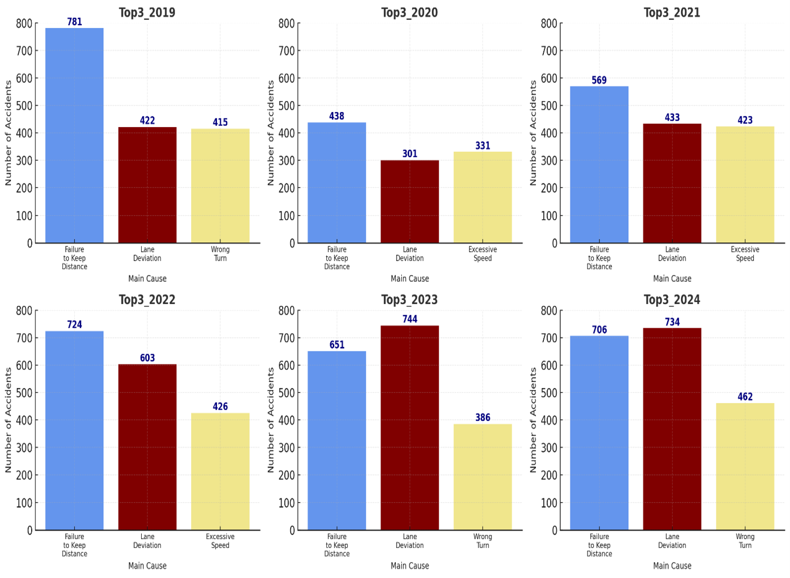
Source: General Directorate of the Palestinian Police [GDPP], 2024.

3.1.2 Seasonal Pattern of Traffic Crashes in Ramallah and Al-Bireh
Figure 3.2.a presents the monthly number of reported traffic crashes in the West Bank, Palestine, for each year of the study period separately. Figure 3.2.b shows the combined monthly distribution of traffic crashes for all study years aggregated together.
Figure 3.2.a
Monthly distribution of traffic crashes by year in the West Bank, Palestine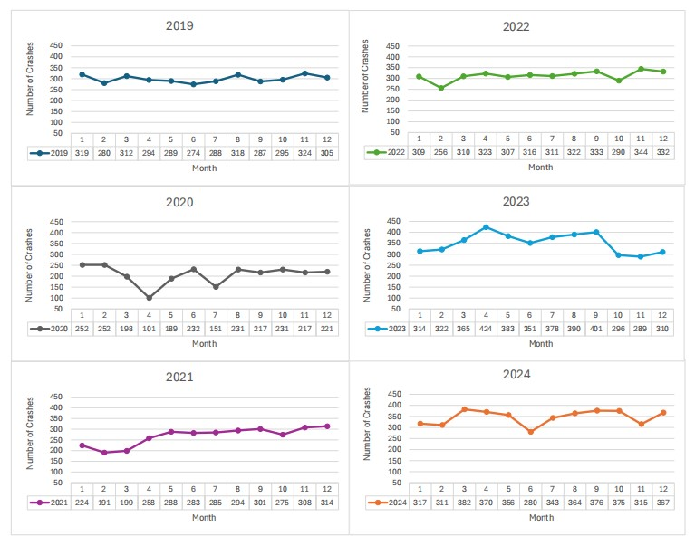
Source: General Directorate of the Palestinian Police [GDPP], 2024.

Figure 3.2.b
Aggregated monthly distribution of traffic crashes in the West Bank, Palestine (all study years)

Source: General Directorate of the Palestinian Police [GDPP], 2024.
Figure 3.2.a illustrates the monthly and aggregated seasonal distribution of traffic crashes during the study period (see Appendix D). The results show noticeable variation in crash frequency across different months, with relatively higher crash counts observed during periods of increased daily movement and traffic activity. In contrast, some months recorded lower crash frequencies, which may be associated with reduced mobility, holidays, weather conditions, or exceptional movement restrictions during certain periods of study years.
The aggregated monthly pattern shown in Figure 3.2.b indicates that crash occurrence was not evenly distributed throughout the year, suggesting the presence of seasonal variation in traffic crash activity within the study area. These observations support the descriptive trend analysis presented in this section and provide additional context for understanding temporal changes in traffic movement and crash occurrence.

3.1.3 Age-Related Patterns of Traffic Crash Outcomes
Table 3.1 shows the distribution of traffic crashes by age group, with noticeable differences across the population, and the distribution was represented in two graphs (number of injuries and number of fatalities). They illustrate that injuries and fatalities are more common within certain age categories, while other groups record much lower numbers. Individuals within the working-age range (i.e., economically active population, typically between 18 and 45 years old, who are most engaged in daily travel for employment, education, and other routine activities) are involved more often in crashes resulting in injuries or fatalities. In contrast, both younger age groups and older adults appear less frequently in the recorded outcomes (see Appendix E).
In general, the graphs reflect an age-related pattern in traffic crash outcomes in Ramallah and Al-Bireh Governorate, as shown in Fig. 3.3. This finding is in line with the descriptive and spatial analysis above and explains the relationships between traffic crash involvement in various forms of age groups.
Table 3.1: Distribution of Traffic Crash Injuries and Fatalities by Age Group in Ramallah and Al-Bireh Governorate (2019–2024)
Ramallah & Al Bireh Gov. |  | Years
 |  | 2019 | 2020 | 2021 | 2022 | 2023 | 2024
Number of Injuries/Age | Under age 7 | 6% | 16% | 6% | 6% | 7% | 5%
Number of Injuries/Age | Under age 18 | 8% | 28% | 10% | 10% | 11% | 12%
Number of Injuries/Age | Under age 45 | 75% | 26% | 75% | 73% | 69% | 71%
Number of Injuries/Age | Over age 45 | 6% | 16% | 6% | 6% | 7% | 5%
Number of fatalities/Age | Under age 7 | 15% | 18% | 29% | 0% | 18% | 10%
Number of fatalities/Age | under age 18 | 15% | 0% | 12% | 0% | 6% | 20%
Number of fatalities/Age | Under age 45 | 31% | 64% | 41% | 44% | 59% | 50%
Number of fatalities/Age | Over age 45 | 38% | 18% | 18% | 56% | 18% | 20%

Figure 3.3
Age-Based Trends of Traffic Crash Injuries and Fatalities in Ramallah and Al-Bireh Governorate (2019–2024)
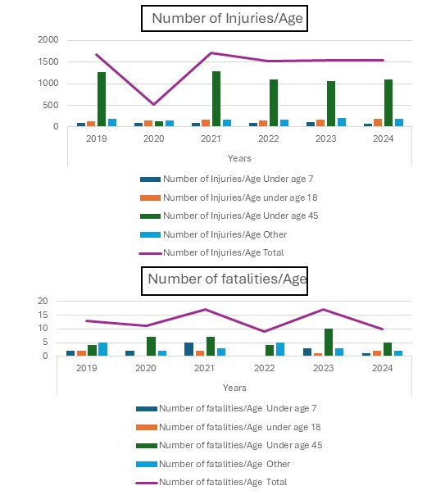
Source: General Directorate of the Palestinian Police [GDPP], 2024.

3.2 Data Overview of Traffic Crash Records (2019–2024)
Before examining the spatial clustering and distribution of traffic crashes, it is useful to establish a broad picture of the dataset and the general trends it contains. The crash records for Ramallah and Al-Bireh Governorate span several years and include a range of crash characteristics that together describe the overall safety situation on roads in the study area.
The data shows an observable variation in the number of reported crashes across the study years, with annual totals differing in ways that reflect both real changes in traffic conditions and possible fluctuations in reporting coverage (see Appendix A). Property damage crashes account for the majority of recorded incidents, while injury crashes represent a smaller but consistent proportion. Fatal crashes are relatively rare in absolute terms, though their consequences make them a distinct category of concern. Among injury crashes, simple injuries are the most common outcome, with moderate and severe injuries occurring less frequently. Fatalities do not follow a clear annual pattern and appear to be distributed unevenly across the study period.
The temporal analysis adds further detail to this picture. Certain causes of crashes, including failure to maintain a safe following distance, lane deviation, and improper turning, appear consistently across multiple years, suggesting that these reflect persistent driver behavior rather than isolated incidents. Other causes vary in relative frequency from one year to the next, which indicates that crash patterns are not entirely stable and may respond to changing conditions such as enforcement activity, infrastructure changes, or shifts in traffic volume. At the monthly level, crash frequency tends to decline during winter months, pointing to a seasonal pattern that may be linked to reduced travel activity rather than adverse weather alone. Age-based figures show that individuals in working-age groups are more frequently involved in injury and fatal crashes, a finding consistent with their higher exposure as active road users.
Pedestrian incidents appear throughout the study period and reflect the risks associated with crossing activity on urban roads. Crashes involving animals or other special conditions are recorded but remain a small share of total incidents.
This descriptive background serves as the foundation for the spatial and statistical analyses that follow. Rather than focusing on precise numerical summaries, the intent here is to establish the primary attributes of the crash data so that the clustering and distribution results presented in subsequent sections can be interpreted within an appropriate context.

3.3 Kernel Density Estimation (KDE): Detailed GIS Workflow
Black spots of traffic crashes in Ramallah and Al-Bireh Governorate were applied to KDE with ArcMap. The density surface obtained indicates that the concentration of crashes varies within the study area. The higher density levels are concentrated mostly in the main urban sections of the governorate, and the lower density levels are in the peripheral and rural regions.

3.3.1 Purpose of KDE in this study
The main reason for using KDE is that it converts discrete crash locations into a density surface. This makes it easier to identify areas with higher crash intensity (hotspots) compared to using point locations alone. All GIS processing and mapping were completed using ArcMap (ArcGIS 2015).
3.3.2 Input data and layers used
The KDE workflow relied on official police data and supporting GIS layers. The main datasets were:
A) Police crash table
- An Excel table that contains black spot locations with coordinate fields (Easting and Northing).
- A field representing the total number of crashes recorded at each black spot for the study period 2019–2024 (an aggregated value per spot).
B) Spatial layers (shapefiles/feature classes):
- West Bank Governorates (Polygon shape file): contains a boundary for each governorate in the West Bank.
- Ramallah_Governorate (Polygon shape file): boundary of Ramallah and Al-Bireh Governorate extracted from the West Bank Governorates boundary shapefile.
- Roads_Ramallah (line Shape file): roads clipped to the governorate boundary for map context.
- Black_Points (point Shape file): created from the police table after converting XY coordinates into a point feature class.
- Additional context Shape files: villages/towns, Oslo Geopolitical Classification.
3.3.3 Preparing crash locations in ArcMap
This step ensured that the police crash table could be used for spatial analysis.
Step 1: Import the crash table
The Excel table was added to ArcMap. The coordinate fields were checked to confirm that they were numeric (not stored as text) and that no missing or invalid coordinate values existed.
Step 2: Display XY Data
The crash records were mapped using the Display XY Data tool. The Easting field was assigned to the Y Palestinian coordinate and the Northing field to the X Palestinian coordinate, based on the project coordinate system. This created an event layer showing the crash locations as points.
Step 3: Export to a permanent point shape file
The event layer was exported as a permanent point feature class named Black_Points. Saving the points as a feature class was required because most spatial analysis tools in ArcMap work on feature classes rather than temporary event layers.
3.3.4 Aggregating crash locations using a 20-meter spatial tolerance
During data preparation, small positional differences were observed in the police-recorded coordinates. These differences can occur because crashes are sometimes recorded with slightly different coordinates even when they happen at the same functional location (e.g., the same intersection or road segment).
To reduce this issue, crash locations were aggregated within a 20-meter spatial tolerance. This was done using a buffer-based spatial join approach, where points within 20 meters were treated as representing the same location. This step expands consistency and reduces artificial repetition caused by minor coordinate difference.
As a result, the KDE analysis better reflects crash intensity at functional locations rather than showing multiple nearby points as separate hotspots.
3.3.5 Definition of black spots and selection approach (2019–2024, reference year 2024)
The KDE analysis relied on officially recognized black spots provided by the Traffic Police Directorate for the years 2019–2024. To focus on locations that remain active and unresolved, the black spots list of 2024 was used as the main reference layer.
Based on the Traffic Police Directorate criteria, “A black spot is a location where traffic crashes repeatedly occur and cause fatalities, injuries, or material damage over at least three years, with a minimum of eight crashes at the same location. A black spot may represent an intersection, a known coordinate point, or a road segment of up to 500 meters, depending on reporting practice and required accuracy” (General Traffic Administration, 2024).
After selecting the 2024 black spots, all crashes recorded at these locations were collected retrospectively for 2019–2024. The aggregated crash totals were then used in the KDE workflow to produce a heat map that reflects crash intensity and relative risk.
3.3.6 Running Kernel Density Estimation (KDE)
KDE was performed in ArcMap using:
Spatial Analyst Tools → Density → Kernel Density
The following parameters were used:
- Input features: Black_Points Population field (weight/ crash count): If a crash total field is available (total crashes per black spot for 2019–2024), it is used as a weight to reflect differences in crash frequency among points.
- Output cell size: 50 meters
This cell size provides relatively great spatial detail suitable for governorate-scale analysis and for identifying localized crash concentration patterns.
- Search radius (bandwidth):300 meters
This bandwidth was selected to highlight meaningful crash concentration patterns while reducing over-smoothing. A larger radius could spread density too widely, while a smaller radius might produce fragmented results.
The KDE output was produced as a raster dataset (e.g., KDE_Ramallah), representing crash density across the study area.
3.3.7 Map production and visualization
The final KDE raster was displayed as shown in Fig. (3.4) using a clear color ramp (low to high density). The governorate boundary was shown with high transparency or as an outline to avoid hiding the KDE surface. Roads and towns were included only for context.
The final KDE maps were produced in Layout View and exported in high resolution for thesis use (300 dpi), including map elements such as title, legend, scale bar, and north arrow.
3.3.8 Interpretation notes
The KDE maps show, as shown in Fig. (3.5), that crash density is higher in the central urban areas of Ramallah and Al-Bireh and decreases in rural and peripheral areas. The spatial distribution of black spots in Ramallah and Al-Bireh Governorate indicates that most locations are concentrated within a relatively small central part of the governorate (see Appendix C). This concentration appears despite the large overall administrative area and is mainly related to where traffic is heavier rather than to the size of the area itself. Most recorded crashes are linked to urban roads with high traffic volumes, main intersections, and central activity zones, especially within the built-up areas of Ramallah and Al-Bireh cities.

Figure 3.4
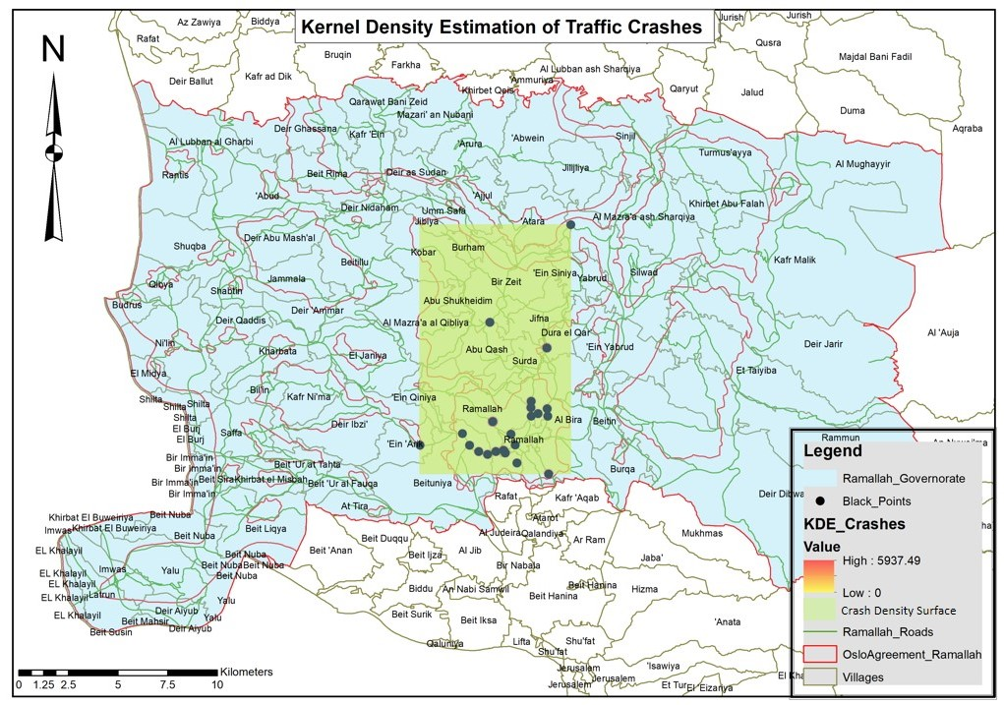
Spatial Distribution of Traffic Crash Hotspots Using Kernel Density Estimation (KDE) in Ramallah and Al-Bireh Governorate

Figure 3.5
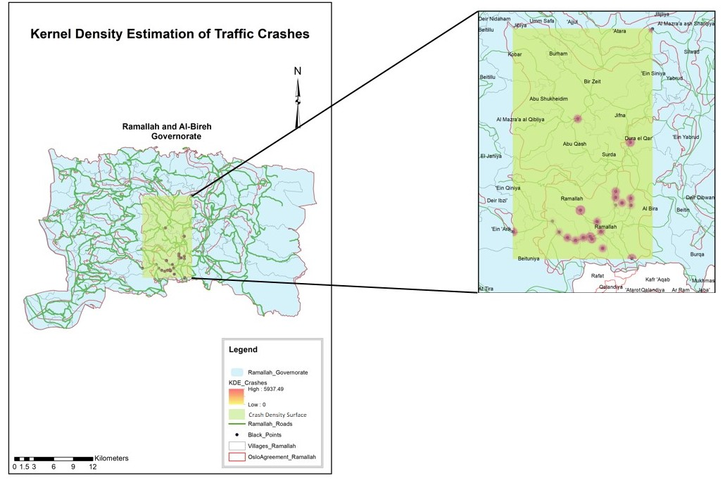
Kernel Density Estimation (KDE) of Traffic Crashes with Zoomed-in View of High-Density Areas in Ramallah and Al-Bireh Governorate

3.4 Spatial Autocorrelation Analysis (Moran’s I)

3.4.1 Purpose of Moran’s I in this study
While KDE provides a clear visual representation of crash concentration patterns, it does not indicate whether these patterns are statistically significant. For this reason, spatial autocorrelation analysis using Global and Local Moran’s I was applied in the next stage to examine whether the observed crash patterns reflect significant spatial clustering or random distribution.

3.4.2 Global Moran’s I: GIS workflow (ArcMap)
Tool used (ArcMap / ArcGIS 2015):
Spatial Statistics Tools → Analyzing Patterns → Spatial Autocorrelation (Moran’s I)
Main inputs (as applied in the project):
- Input Feature Class: Black_Points
- Input Field: the crash-related field used in the run (the same field shown in the results window, i.e., the crash count/total field linked to black spots)
- Conceptualization of Spatial Relationships: Inverse Distance
- Distance Method: Euclidean Distance
- Standardization: None
- Distance units: meters (as reported in the output)
After running the tool, ArcMap produced a window containing the results of Global Moran’s I statistics and system messages.

3.4.3 Global Moran’s I: results (reported values)
Statistics of the Global Moran were performed to evaluate the total spatial autocorrelation of the location of traffic crashes in Ramallah and Al-Bireh Governorate. The result of the analysis gave a value of [−0.025595] of Moran’s I, a Z-score of [0.365767], and a P-value of [0.714539]. These findings show that the spatial distribution of the traffic crashes at the governorate level does not show statistically significant global spatial autocorrelation. Table 3.2 shows the output table produced by ArcMap.
Table 3.2: Global Spatial Autocorrelation (Moran’s I) Results for Traffic Crashes
Value | Statistic
Moran’s I Index | −0.025595
Expected Index | −0.047619
Variance | 0.003626
Z-score | 0.365767
P-value | 0.714539
Distance Measurement | Meters
Spatial Relationship | Inverse Distance

Distance measured in meters

3.4.4 Global Moran’s I: Interpretation of Reported Values
Moran’s I Index (−0.025595)
The Global Moran’s I statistic was used to describe the general spatial pattern of traffic crashes across the study area. It offers an overall impression of whether crashes tend to occur near one another, are more widely distributed, or do not follow any clear spatial pattern at the governorate level.
Moran’s I is commonly interpreted using a scale that runs from −1 to +1. Higher positive values point to clustered spatial patterns, whereas negative values indicate that locations tend to be more evenly spread. Values near zero are generally taken to mean that no clear spatial pattern is present.
Analyzing the data in this analysis, Moran’s I value is slightly negative and is very close to zero, which shows that the crashes caused by the traffic in Ramallah and Al-Bireh Governorate do not demonstrate a clear global spatial pattern.
Z-score (0.365767)
The Z-score shows the number of standard deviations by which the Moran’s I value observed is not equal to its expected value, assuming that the spatial distribution is random. It is employed to determine whether the spatial pattern was statistically significant. The Z-score values exceeding ±1.96 normally signify statistically significant spatial autocorrelations at the 95 percent level. The given Z-score is low and approximately zero, which indicates that the spatial pattern in question does not vary significantly from a random distribution.
P-value (0.714539)
The P-value is the likelihood of the observed spatial pattern having happened due to mere chance. It is the main value applied in determining the statistical significance of the results. To reject the null hypothesis of spatial randomness, the P-value should be less than 0.05. The P-value (0.714539) is high in this instance, and this confirms that the null hypothesis is not rejected, and the spatial distribution of traffic crashes is not statistically significant at the global level.
Expected Index (−0.047619)
Moran’s I Theoretical Expected Index is the value of Moran’s I under the assumption of a totally random spatial distribution of events. Its calculation is determined by the quantity of spatial units in the analysis. The observed and expected values of Moran’s I can also be compared to know the direction and extent of the deviation from spatial randomness.
Variance (0.003626)
The variance represents the statistical dispersion of possible Moran’s I values around the expected index. It is used in calculating the Z-score and reflects the reliability and stability of the spatial autocorrelation test.
A smaller variance contributes to a more precise assessment of statistical significance.
System warnings shown in the results window:
- “A minimum of 30 input features for analysis is ideal.”
This appeared because the number of input features (black points) was below the recommended threshold in the program (the analysis still runs normally, but ArcMap flags that results can be less stable with small samples).
- “The default neighborhood search threshold was 6314.8479 meters.”
This means ArcMap automatically selected a distance threshold (≈ 6314.8479 m) to define “neighbors” for the calculations under the chosen settings.
It should be noted that ArcMap system warnings indicated a relatively small number of input features for the Global Moran’s I analysis and an automatically selected distance threshold. These factors may affect the stability of the statistical output; therefore, the results should be interpreted alongside KDE and Local Moran’s I for a more reliable spatial interpretation.

3.4.5 Interpretation of the Global Moran’s I outcome
The p-value = 0.714539 is much larger than common significance levels (e.g., 0.05). This indicates that the observed spatial pattern does not provide statistical evidence of clustering at the governorate-wide level. The Z-score = 0.365767 is also close to zero, which supports the same conclusion.
Although Moran’s I value is slightly negative (−0.025595), it is very close to zero and, combined with the high p-value, it does not represent a meaningful dispersed pattern. Overall, the Global Moran’s I test suggests that, at the full-governorate scale and under the applied distance settings, the pattern is not significantly different from random.

3.5 Local Moran’s I (LISA)
The Local Moran’s I analysis was done to determine the local spatial patterns related to the study area. The findings indicate that most black-spot locations are not statistically significant. One site, which was emphasized in blue color and was situated along Al-Tireh Main Road, was recognized as a High-Low (HL) cluster. The Local Moran I cluster map, which is shown in Figure 3.6, indicates how the crash locations are classified spatially within the governorate.
The classification of spatial patterns in Local Moran’s I analysis, including High–High (HH), Low–Low (LL), High–Low (HL), Low–High (LH), and non-significant locations, is based on the Local Indicators of Spatial Association (LISA) framework developed by Anselin (1995) as shown in Table 3.3. These categories are widely used in spatial analysis to identify local clusters and spatial outliers by measuring the relationship between each spatial unit and its surrounding neighbors. In this study, these standard classifications were directly derived from the ArcGIS spatial statistics output and used to interpret localized crash patterns without manual reclassification.

Figure 3.6
Local Moran’s I (LISA) Cluster and Outlier Map of Traffic Crashes
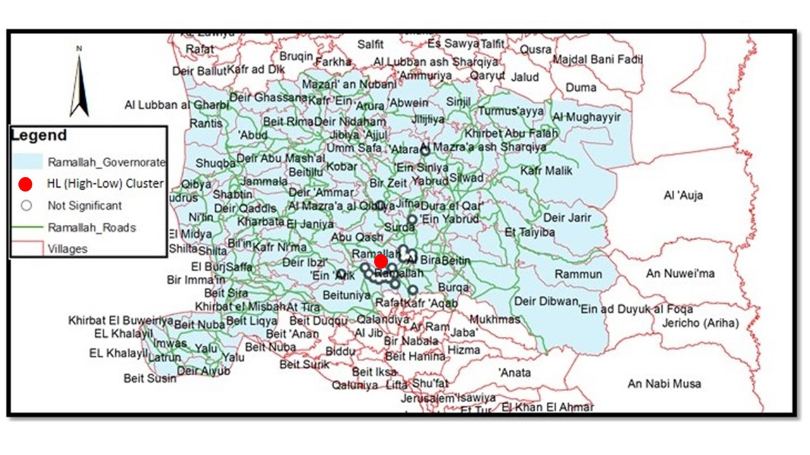

Table 3.3: Results of Local Moran’s I (LISA) for Traffic Crash Black Spots in Ramallah and Al-Bireh Governorate
OBJECTID | Source ID | Crash Count | Local Moran’s I | Z-score | P-value | Cluster Type
1 | 0 | 87 | -0.000136 | 0.185913 | 0.852513 | Not Significant
2 | 1 | 213 | -0.000502 | -0.232402 | 0.816226 | Not Significant
3 | 2 | 101 | -0.000260 | 0.144158 | 0.885376 | Not Significant
4 | 3 | 203 | -0.000131 | 0.146931 | 0.883187 | Not Significant
5 | 4 | 571 | -0.009734 | -5.749528 | 0.000000 | HL
6 | 5 | 108 | 0.000537 | 0.357967 | 0.720368 | Not Significant
7 | 6 | 155 | 0.000555 | 0.272427 | 0.785293 | Not Significant
8 | 7 | 130 | -0.000001 | 0.205204 | 0.837413 | Not Significant
9 | 8 | 108 | 0.000240 | 0.321258 | 0.748015 | Not Significant
10 | 9 | 89 | 0.000063 | 0.248266 | 0.803929 | Not Significant
11 | 10 | 235 | -0.000429 | -0.311113 | 0.755715 | Not Significant
12 | 11 | 82 | -0.000228 | 0.162245 | 0.871113 | Not Significant
13 | 12 | 48 | 0.001334 | 0.681972 | 0.495257 | Not Significant
14 | 13 | 117 | -0.000017 | -0.078882 | 0.937126 | Not Significant
15 | 14 | 92 | 0.001304 | 0.593784 | 0.552657 | Not Significant
16 | 15 | 94 | 0.000885 | 0.520391 | 0.602791 | Not Significant
17 | 16 | 119 | -0.000014 | 0.201340 | 0.840433 | Not Significant
18 | 17 | 150 | -0.000054 | 0.174328 | 0.861608 | Not Significant
19 | 18 | 86 | -0.000413 | 0.084286 | 0.932829 | Not Significant
20 | 19 | 42 | 0.000290 | 0.371838 | 0.710013 | Not Significant
21 | 20 | 13 | -0.000402 | 0.001167 | 0.999069 | Not Significant
22 | 21 | 16 | 0.001176 | 0.590243 | 0.555027 | Not Significant

3.5.1 Why Local Moran’s I (LISA) was needed after the Global test
Global Moran’s I produces a single statistic for the entire governorate. This is useful as a first check, but it can hide local conditions. In road safety studies, it is common to have localized concentrations (e.g., specific intersections or short corridors) even when the overall pattern across a large area does not appear clustered statistically.
For this reason, the analysis moved to Local Moran’s I (LISA) after the Global result. LISA is used to:

- examine clustering at a local level (location-by-location),
- detect local hotspots and cold spots that may exist inside the governorate,
- identify spatial outliers (points that behave differently from their surrounding area),
- support and explain patterns suggested visually by KDE by adding a location-specific statistical perspective.
In other words, Global Moran’s I answers: “Is the entire governorate clustered?”
While LISA answers: “Where exactly are the clusters or outliers, if they exist?” Following Global Moran’s I output, Local Moran’s I was run to move from the general governorate-level statement to a more detailed spatial understanding.
3.5.2 Applying Local Moran’s I
Following Global Moran’s I output, Local Moran’s I was run to move from the general governorate-level statement to a more detailed spatial understanding.
3.5.3 Local Moran’s I: GIS workflow (ArcMap)
Local Moran’s I was carried out in ArcMap using the following tool:
Spatial Statistics Tools → Mapping Clusters → Cluster and Outlier Analysis (Anselin Local Moran’s I).
The analysis was applied using the following inputs and settings:
- Input Feature Class: Black Points
- Input Field: the crash-count shape file assigned to each black spot (the same field used in the Global Moran’s I analysis)
- Spatial relationship: Inverse distance
- Distance method: Euclidean distance
- Distance units: meters
- Significance level: default ArcMap settings
The output of the analysis was a new feature layer containing statistical fields for each location. These fields indicate the local spatial relationship of each black point and whether the result is statistically significant.
3.5.4 Output classification and interpretation framework
The Local Moran’s I result classifies each location into one of the following categories based on the relationship between a point and its surrounding neighbors:
- High–High (HH): a high-value point surrounded by high-value neighbors (local hotspot)
- Low–Low (LL): a low-value point surrounded by low-value neighbors (local cold spot)
- High–Low (HL): a high-value point surrounded by low-value neighbors (spatial outlier)
- Low–High (LH): a low-value point surrounded by high-value neighbors (spatial outlier)
- Not Significant: no statistically meaningful local spatial relationship
Only locations with statistically significant p-values are classified into HH, LL, HL, or LH categories.
3.5.5 Local Moran’s I: results for Ramallah and Al-Bireh Governorate
The final Local Moran’s I map, as shown in Fig.3.6, shows that only one black spot location was identified as statistically significant. This location is a section of Al-Tireh Main Road and was classified as High–Low (HL). This result shows that the number of crashes at this road segment is higher than in the surrounding locations. Although the surrounding regions show a lower value of crashes, the segment is particularly high in crash level. This makes the Al-Tireh road segment a local outlier compared to its immediate environment. The rest of the black spot locations in the governorate were deemed to be of type Not Significant, that is, they do not show statistically significant local clustering or outlier conduciveness, given the space and distance parameter settings.
3.5.6 Interpretation of the Local Moran’s I findings
The local-scale analysis is important because of the identification of a single HL site within the Al-Tireh Main Road. Although the results of the Global Moran’s I test indicated the existence of an abnormal spatial pattern in the governorate, the results of the Local Moran I test indicate that even individual road stretch segments could be characterized by an abnormal pattern of crashes, considering the immediate environment. Table 3.3 reveals the results of the analysis, which indicate that no extra clusters of High-High (HH) and Low-Low (LL) were observed. It implies that the black spot areas in Ramallah and Al-Bireh are not clear local clusters when viewed on a small spatial scale. Rather, the instances of crashes seem to be different at each place. Such a difference is, more probably, due to local conditions, e.g., to the volume of traffic, road structure, intersection type, and reporting style, than to a single consistent spatial distribution over the governorate.
3.5.7 Contribution of Local Moran’s I to the overall analysis
The Local Moran’s I analysis provides a valuable statistical add-on to the spatial interpretation. Whereas KDE was valuable in identifying areas where the crashes appear to focus in a visual form, the I in Local Moran was used to conclude whether the trends are statistically significant at sites. The combination of the two approaches gave a better understanding of the traffic crash and allowed to reduce the focus to areas that might need more thorough investigation or specific safety interventions.

3.6 Chi-square Test
To further analyze the non-spatial patterns of traffic crashes, the Chi-square test of independence was used to analyze the crash data. The analysis was employed to determine whether the characteristics of traffic crashes that have been selected are spread evenly across the years of study, or if there exists any observable time variance. The test is an analytical measure of time-varying factors of crashes by comparing the observed frequencies with the expected ones. The chi-square analysis findings are contained in Table 3.4, which provides the statistical values and the variables that can make the most contribution to the patterns observed in traffic crashes in the study period.

Table 3.4: Summary of Pearson Chi-square Test Results for Traffic Crash Characteristics by Year
Categorical variables | Test Statistic | χ² Value | Degrees of Freedom (df) | p-value | Significance
Cause X year | Pearson Chi-square | 1845.20 | 75 | < 0.001 | Statistically Significant
Crash severity X years | Pearson Chi-square | 68.80 | 15 | < 0.001 | Statistically Significant
Crash type X year | Pearson Chi-square | 133.40 | 15 | < 0.001 | Statistically Significant
Note:
p-values reported as “p < 0.001” reflect rounding limitations in Excel outputs.
Table 3.4 presents the results of the Pearson Chi-square tests conducted to examine whether selected traffic crash characteristics varied across the study years (2019–2024). Three categorical variables were tested against the year variable: crash cause, crash type, and crash severity. These variables were selected because they were consistently available in the official crash records and represent key dimensions commonly examined in traffic safety analysis.
The results showed statistically significant relationships between year and the tested crash characteristics (see Appendix F), indicating that the distribution of crash causes, crash types, and severity levels changed over the study period. These variations may reflect differences in traffic movement patterns, driver behavior, road conditions, and external circumstances affecting mobility during different years of the analysis period.

3.6.1 Chi-square analysis
The spatial analysis was done with the help of Kernel Density Estimation (KDE) and Moran’s I, after which a Chi-square test of independence was used as a supplementary measure. This test was aimed at evaluating whether the key differences in traffic crashes had been present between the years included in the study (2019-2024). This is done to potentially explain whether the changes that can be detected over time are changes that have occurred in the data or are rather caused by chance variation.
The Chi-square analysis focused on three categorical variables derived from official traffic police records:
- Crash Cause
This variable is the major behavioral or operational indicator that is ascribed to every crash, such as failure to exercise priority, speeding, deviation from lanes, or violation of traffic control devices. The investigation of the causes of crashes helps understand the behavior of drivers and their changes over time.
- Crash Type
This variable explains the overall nature of the crash incident, such as fatal crashes, injury crashes, material damage only crashes, general crashes, and pedestrian crashes. Crash type analysis will give information on the change in nature and severity of crashes in various years.
- Crash Severity
Crash severity is a measure of the consequences of the crash, including human impact and fatalities, severe injuries, moderate injuries, and minor injuries. The given variable is critical to assessing the changes in the risk of road safety and changes in the impact on human health over time. The temporal variable applied in all the analyses was the Year (2019-2024) to assess whether these characteristics were distributed in the same way or varied during the study.

3.6.2 Objectives of the Chi-square analysis
The Chi-square test was applied to achieve the following sub-objectives:
- To evaluate whether crash severity levels differed significantly from year to year.
- - To identify whether the causes of crashes vary statistically across the years or are independent of them.
- To identify specific category–year combinations that contribute most to observed differences.
- To determine how the proportions of the types of traffic crashes varied during the period of the study.

3.6.3 Methodology and Excel-based workflow
1. Preparation of observed frequency tables
A contingency table in Microsoft Excel has been made up of each variable, where:
- Rows represent the categories of the studied variable (cause, type, or severity).
- Columns represent the years from 2019 to 2024.
- Each cell $O_{ij}$contains the observed number of crashes for a given category in a specific year.
- Row totals, column totals, and the grand total (N) were calculated as the sum of all observed values
2. Calculation of expected frequencies
The expected frequencies are the number of crashes that would have been expected in each cell, assuming that the variable under study and the year under study were statistically independent. Each cell was identified as expected by use of:
$$E_{ij}=\frac{\left({\text{Row Total}}_{i})×({\text{Column Total}}_{j}\right)}{N}$$The expected table was constructed with the same structure as the observed table to allow direct cell-by-cell comparison.
3. Cell-level Chi-square contributions
To quantify the deviation between observed and expected values, a Chi-square contribution was calculated for each cell:
$$χ_{ij}^{2}=\frac{\left(O_{ij} − E_{ij})^{2}\right.}{E_{ij}}$$
This step enables one to identify personal causes, types of crashes, or categories of severity that have the greatest contribution to the total Chi-square statistics.
The total Chi-square value was obtained by summing all individual cell contributions:
$$χ^{2}=\sum_{i}{\sum_{j}{χ_{ij}^{2}}}$$
4. Degrees of freedom and significance testing
Degrees of freedom were calculated as:
$$df=(r-1)(c-1)$$
where r is the number of category rows, and c is the number of years.

The p-value was computed in Excel using:
=CHISQ.DIST. RT (calculated_chi_square, degrees_of_freedom)
It is necessary to point out that extremely small p-values can be reported as zero in Excel because of rounding; thus, the falsely negative results are reported as correct p < 0.001.

3.6.4 Results and interpretation
A) Crash Cause × Year (2019–2024)
χ² = 1845.2
df = 75
p < 0.001
This finding means that there is a statistically significant correlation between causal factors of crashes and the year. Crash causes did not stay the same during the whole study period and varied according to time. A review of the Chi-square contribution values indicates that several categories of causes had large deviations of observed and expected frequencies in certain years. Specifically, the violation of traffic rules, lane diversion, over-speeding, and other categories made significant contributions to the total Chi-square value, which meant that they were major causes of temporal deviation.
B) Crash Type × Year (2019–2024)
χ² = 133.435
df = 15
p ≈ 0.000
There was a statistically significant change between the crash type and the year, which showed that the proportional representation of various types of crashes varied over the years. Some types of crashes were overrepresented in certain years, which indicated that crash characteristics changed in the study years.
C) Crash Severity × Year (2019–2024)
χ² = 60.22
df = 15
p < 0.001
The severity of the crash was also established to have a significant association with the year. This outcome shows that the spread of deaths and the degree of injuries were not time-homogeneous during the study. Even the cells that contributed to the Chi-square most likely indicated that there was a certain degree of severity in the results taking place in the same year that contributed to this statistical value.

3.6.5 Contribution of the Chi-square analysis to the study
The Chi-square test was adopted to reinforce the study in an analytical (non-spatial) view. Whereas the spatial analyses were concerned with the place and distribution of traffic crashes, the Chi-square test was used to investigate the change in characteristics of crashes with time. This analysis has helped examine the trends of causes of crashes, the types, and the severity of the same across the various years, but not just the location. Using spatial findings and statistical analysis, the research will examine traffic crash data in Ramallah and Al-Bireh Governorate from two complementary perspectives. Such a methodology assists in explaining the patterns of crashes and influencing factors of the crashes, which is aligned with the overall goal of the research. The mentioned results, presented in Table 3.4, therefore, give a better premise to analyze changes in traffic crash behavior during the study period and to address the possible measures associated with safety concerns.

Chapter Four

Discussions

4.1Introduction
This chapter shows findings of the spatial and statistical tests that have been made to investigate the patterns and factors of traffic crashes in Ramallah and Al-Bireh Governorate. The analyses were conducted through ArcMap (ArcGIS), whereby ArcGIS was used to systematize, process, and present data on the traffic crashes, which were obtained through official sources. This study began with the spatial analysis of the research question, which used KDE to analyze the location of higher concentrations of traffic crashes in the study area. KDE was mainly used to visually examine the distribution of officially identified black spots and to provide an initial understanding of crash concentration patterns. The main GIS steps followed to produce the density (heat) maps are described in the corresponding section.
After completing the KDE analysis, Global Moran’s I was applied to check whether traffic crash locations across the governorate follow a clustered pattern or are randomly distributed. Because Global Moran’s I gives only one general value for the whole governorate, Local Moran’s I (LISA) was also applied to look at spatial patterns in more detail. This step made it possible to detect locations where crashes tend to cluster locally, as well as locations that behave differently from their surrounding areas.
Alongside the spatial analysis, Chi-square tests were used to explore relationships between traffic crash characteristics and selected variables. This analysis was carried out to support the spatial results and to better understand how different factors are related to traffic crash occurrence. In general, the crash data from official sources were first analyzed descriptively and spatially. Additional statistical analyses were then conducted to explore other influencing factors related to traffic crashes. The results of these analyses help in identifying clear patterns of traffic crashes in the governorate and provide a basis for proposing practical recommendations and possible solutions to improve road safety.

4.2 Kernel Density Estimation (KDE) Results Discussion
The KDE results indicate that traffic crashes in Ramallah and Al-Bireh Governorate are concentrated mainly within the central urban areas, particularly near major intersections, commercial centers, and roads with heavy daily traffic movement. This reflects the strong relationship between crash occurrence and traffic activity, where areas with higher mobility and congestion tend to experience greater crash intensity. The concentration of hotspots within a relatively limited urban zone also suggests that the spatial distribution of crashes is influenced more by movement patterns and land use activities than by the overall size of the governorate.
The results further show that urban roads experience more complex interactions between vehicles, pedestrians, and public transportation, increasing the probability of conflicts and traffic violations. In contrast, rural and peripheral areas recorded lower crash densities, which may be associated with lower traffic volumes and reduced urban activity. However, this does not necessarily mean that these areas are completely safe, since factors such as underreporting and limited enforcement may affect the completeness of crash records in some locations.
From a planning perspective, the KDE maps help identify priority areas that require traffic safety improvements. These may include better intersection management, traffic calming measures, pedestrian protection facilities, and stricter monitoring of risky driving behaviors. The analysis also demonstrates the importance of spatial techniques in supporting transportation planning, as KDE provides a clearer understanding of crash concentration patterns compared with traditional descriptive statistics alone.

4.3 Spatial Autocorrelation Analysis (Global Moran’s I)
The Global Moran’s I results indicate that traffic crashes in Ramallah and Al-Bireh Governorate do not exhibit a statistically significant spatial pattern at the governorate-wide level. Although the KDE analysis showed visible areas of higher crash concentration, the Moran’s I test suggests that these concentrations are not strong enough to confirm a consistent global clustering pattern across the entire study area. This difference highlights the importance of combining visual spatial analysis with statistical testing when interpreting traffic crash distributions.
The slightly negative Moran’s I value, together with the high p-value and low Z-score, indicates that the observed distribution is close to random under the selected spatial relationship settings. In practical terms, this means that crash locations are not evenly clustered throughout the whole governorate, but are instead influenced by localized urban conditions and traffic activity within specific areas.
One possible explanation for this result is the uneven urban structure of Ramallah and Al-Bireh Governorate. Traffic activity is concentrated mainly in central urban corridors, while large peripheral and rural parts of the governorate experience much lower traffic volumes. As a result, crash concentration appears locally within urban centers rather than forming a strong and continuous spatial pattern at the broader governorate scale.
The findings may also be influenced by the relatively limited number of officially identified black spots included in the analysis. ArcMap itself indicated that a larger number of input features would improve the statistical stability of the test. In addition, factors such as underreporting of minor crashes, variations in police reporting practices, and limited enforcement coverage in some areas may reduce the ability of the analysis to detect stronger spatial autocorrelation.
Despite the absence of statistically significant global clustering, the results remain important for traffic safety planning. The KDE analysis still identified locations with relatively higher crash intensity, particularly in densely urbanized areas. Therefore, the lack of significant global autocorrelation does not mean that traffic risk is absent, but rather that crash concentration is localized and context-dependent rather than uniformly distributed across the governorate.

4.4 Local Moran’s I (LISA)
The Local Moran’s I analysis provided a more detailed understanding of the spatial behavior of traffic crashes within Ramallah and Al-Bireh Governorate. While the Global Moran’s I results indicated that crashes do not form a statistically significant clustering pattern at the governorate-wide scale, the local analysis revealed that spatial irregularities still exist at specific locations. This demonstrates the importance of examining crash patterns at multiple spatial levels rather than relying only on a single global indicator.
The identification of one statistically significant High–Low (HL) location along Al-Tireh Main Road suggests that this road segment experiences a crash level that is unusually high compared with its surrounding environment. In other words, the road section behaves as a local spatial outlier rather than as part of a wider clustered hotspot area. This may indicate that localized factors, such as road geometry, intersection configuration, traffic congestion, driver behavior, or pedestrian activity, play a stronger role at this location than broader governorate-level spatial processes.
The absence of additional significant HH or LL clusters also suggests that traffic crashes in the governorate are spatially heterogeneous and influenced by site-specific conditions rather than by one continuous spatial pattern. This finding is important because it indicates that traffic safety problems in Ramallah and Al-Bireh may require localized interventions tailored to the characteristics of each road segment instead of applying one generalized solution across the entire governorate.
The Local Moran’s I results also complement the KDE analysis. KDE visually highlighted areas with higher crash intensity, particularly within urbanized zones, while LISA added a statistical perspective by identifying whether these concentrations were significant relative to surrounding locations. Together, the two techniques improved the interpretation of crash patterns and provided a stronger basis for identifying locations that may require detailed engineering assessment or targeted traffic safety measures.
From a planning perspective, the findings emphasize the importance of focusing on specific high-risk road segments, especially those that behave differently from their surrounding areas. Such locations may represent priority areas for future field investigation, traffic management improvements, or infrastructure upgrades aimed at reducing crash occurrence and improving urban road safety.

4.5 Chi-square Test
The Chi-square analysis results indicate that there are statistically significant associations between the study year (2019–2024) and all examined traffic crash characteristics, including crash cause, crash type, and crash severity. This confirms that crash distributions were not constant over time, but instead showed measurable temporal variation across the study period.
The strongest association was observed in the relationship between crash cause and year (χ² = 1845.20, df = 75, p < 0.001), indicating substantial variation in how crash causes were distributed across different years. This suggests that the frequency distribution of reported crash causes differed significantly from one year to another.
Similarly, crash type showed a statistically significant relationship with year (χ² = 133.40, df = 15, p < 0.001). This indicates that the proportional distribution of crash types was not stable across the study period, and that the composition of crash types varied between years.
Crash severity was also significantly associated with year (χ² = 68.80, df = 15, p < 0.001), showing that the distribution of severity outcomes differed across time. This reflects temporal variation in how crashes were categorized in terms of their outcomes (e.g., injury levels and fatalities).
When interpreted alongside the spatial findings (KDE and Moran’s I), these results provide a complementary temporal dimension to the analysis. While the spatial analysis identifies where crashes tend to cluster, the Chi-square results demonstrate that the internal characteristics of crashes also change over time. Together, these findings confirm that both spatial distribution and temporal composition of traffic crashes are not static in the study area during 2019–2024.
Importantly, the Chi-square results identify statistical dependence between year and crash characteristics but do not by themselves explain the underlying causes of these changes. Therefore, interpretation should remain limited to describing observed variation rather than attributing it to specific external factors without additional supporting evidence.

4.6 Integrated Discussion of Study Findings
This discussion section makes a combined discussion of spatial and statistical This section synthesizes the main findings from the spatial (KDE, Global and Local Moran’s I) and statistical (Chi-square) analyses in order to provide an overall interpretation of traffic crash patterns in Ramallah and Al-Bireh Governorate during the study period. It does not introduce new results but integrates the key outputs from the previous sections.
The KDE results indicate that traffic crashes are spatially concentrated in the central urban areas and along major road networks, while lower densities are observed in peripheral and rural areas, reflecting differences in traffic exposure and land-use intensity.
However, the Global Moran’s I results show that this spatial concentration does not form a statistically significant clustering pattern at the governorate level, suggesting that crashes are not globally clustered but rather locally influenced.
This interpretation is supported by the Local Moran’s I results, which identify only a limited number of statistically significant local patterns, including a single High–Low (HL) outlier along Al-Tireh Main Road, while most locations show no significant local clustering.
The Chi-square analysis further complements these findings by showing significant temporal variation in crash characteristics across the study period, indicating that crash causes, types, and severity are not uniformly distributed over time.
Overall, the combined results suggest that traffic crashes in the study area are shaped by localized spatial conditions and temporal variability rather than a single uniform spatial or temporal pattern.

Chapter Five

Conclusions and Recommendations

5.1 Conclusion and Recommendations
The research has discussed the traffic-related crash rates and crash determinants in Ramallah and Al-Bireh Governorate through a blend of both spatial and statistical analysis. The combination of Kernel Density Estimation (KDE) and Global and Local Moran I, Chi-square, and trend analysis of descriptors allowed the research to draw a detailed picture of the location of traffic crash occurrence, their changes across time, and the factors that are associated most with their occurrence. The spatial findings reveal that traffic crashes in Ramallah and Al-Bireh Governorate are not just a coincidence. Rather, the points of crashes occur in regions, particularly those in dense urban centers and on major traffic routes. This is well indicated by the KDE maps that show that there are still a few locations that have a high number of crashes recorded over several years, and this indicates that these black spots are yet to be solved.
Based on the analyses presented in this thesis, it is possible to make a number of crucial conclusions. The local patterns of traffic crashes in Ramallah and Al-Bireh Governorate are characterized by the evident local spatial concentration, i.e., within urban centers and major road networks. Yet these local clusters are not reflected in a heavy global pattern of spatial autocorrelation in the whole governorate.
Temporal analysis proves that the nature of traffic crashes differs drastically with year of occurrence, meaning that the patterns of the crashes do not stay the same with time but are dynamic. Seasonal variations further bring out the role of the level of traffic activities in causing crashes, as it is noted that the number of crashes is lower in winter.
Demographic data indicate that working-age groups are more often engaged in injuries and fatal crashes, which represent an increased exposure to traffic risks. This observation highlights that population mobility and daily travel behavior should be taken into consideration when planning traffic safety.
Generally, the combination of spatial and statistical analyses gives complete knowledge of how traffic crashes are spread and how they vary with time at Ramallah and Al-Bireh Governorate. The findings are validated by the fact that a composite of spatial concentration, temporal variation, and human factor determine traffic safety issues in the study area.
These observations indicate the necessity of some location-specific and direct interventions. An alternative that can be put into practice is to use fixed traffic surveillance cameras at black spots with the highest and greatest records of crashes. This may assist traffic officers in monitoring dangerous driving habits and create necessary action to tackle them promptly. The sole use of targeted monitoring instead of long-term observation can serve as one of the factors that can assist in prompt corrective measures and curtail injuries, death, and property damage due to traffic crashes.
The analysis of results by the Local Moran of the local area revealed that one segment of the road along Al-Tireh Main Road was a High-Low (HL) spatial outlier. This implies that the segment achieves relatively high crash values when compared with those of its adjoining locations, although there are other areas that may record the same levels of crash intensities, but these areas are not immediately adjacent. This result is an indication that the Al-Tireh road segment should be treated with special attention and local consideration. Greater policing of traffic, a complete road safety audit, and operational performance of this site are thus suggested as the priority measures.
Also, in the data quality, the study emphasizes the need to enhance the completeness of data on traffic crashes. One of the most crucial problems that were revealed in the process of data collection is that certain traffic accidents, especially minor ones, can be resolved under insurance schemes without being reported to the police. To fill this gap, it is advised that crash and compensation records of insurance firms be interconnected with the database of the traffic police. Such integration would improve the accuracy of data, decrease underreporting, and give a more realistic depiction of traffic crash patterns throughout the governorate.
The cause analysis of crashes revealed that a high percentage of crashes, particularly at black spot areas, is always linked with the inability to keep a safe distance and lane deviation. These trends indicate driver negligence as one of the key factors. In line with this, there is a need to have a tightening of rules regarding traffic-related violations. The tougher action required is making these acts stricter and more on-road surveillance to act as a deterring measure and also to curb the frequency of accidents due to unsafe driving behaviors.
The analysis, as per age, indicated that people in the working age category are disproportionately involved in traffic crashes, injuries, and deaths. This result demonstrates an increase in exposure to an elevated level because of daily commuting and traveling to the workplace. To this end, a wider range of policies is prescribed, such as the development and the upgrading of road systems which support key employment areas to alleviate congestion and traffic stress. Concurrently, special awareness programs must be established in collaboration with the large employers in the private sector, state institutions, and semi-government organizations to enhance safe driving behaviors amongst this group of people. With a consistent and apparent application of traffic law enforcement, such programs are likely to minimize the risk of crashes among the most exposed population groups to everyday traffic flow.
Overall, the findings of this research indicate that traffic accidents in Ramallah and Al-Bireh Governorate have some predictable spatial patterns and depend not only on driver behavior but also on time variations. These results show that road safety issues in the governorate are such that they need specific responses, focusing on the real risk areas and crash features, but not general and non-specific ones. Using the findings of the study in the form of targeted enforcement measures, the targeted improvement of infrastructure, improved coordination of sources of crash data, and realistic awareness measures can contribute to more successful and sustainable increases in the safety of traffic.

5.2 Study Limitations
Although a total spatial and statistical analysis has been carried out in the study, there are a few limitations that ought to be recognized.
First, the analysis is fully based on the officially registered data on traffic crashes acquired by associated authorities. As is the case with most crash datasets, there is a possibility of underreporting, especially of minor crashes that do not cause severe injury or fatalities, especially in the region where Palestinian police are incapable of accessing or effectively implementing traffic law, following the political divisions within the West Bank. Such a situation invites the application of insurance accident claim adjudication to attain legal protections as opposed to the adherence to official police procedure that could make accidents in official police records fewer in number, especially minor accidents. Such a weakness can impact the absolute number of crashes documented, but it is less probable to influence the general spatial and temporal trends.
Second, the spatial analyses utilize the point location information, that is, the crash locations. Although the KDE and the spatial autocorrelation techniques are useful in determining spatial patterns, they fail to establish the fine detail of road geometry, traffic volumes, and real-time road conditions at the specific point of each individual crash. Therefore, the findings depict distributions of space as opposed to causal processes.
Third, one of the main weaknesses of the study is related to the year 2020, which corresponded to the highest implementation of traffic closures and mobility restrictions in Palestinian Governorates due to the COVID-19 pandemic. This time, a state of emergency was declared throughout the country, and a row of official measures was adopted by the Palestinian Council of Ministers, which limited the movement between the cities and diminished the activity of traffic in general. These steps led to a clear change in the behavior of travel and the amount of traffic, and the results were experienced in the reduction of the number of traffic accidents recorded at the end of that year. Black spots that were regularly reported in police reports throughout the years preceding the study period were not reported in 2020 in some cases. Therefore, reductions observed in crash numbers during that year should be interpreted as an outcome of exceptional mobility conditions rather than as an indication of a long-term change in traffic crash patterns across the study period (Palestinian Council of Ministers, 2020).
Lastly, the research concentrates on the observed relationships of variables without making any efforts to model, predict, or cause. The findings must be viewed as both descriptive and analytical, but not predictive.

List of Abbreviations
Abbreviation | Meaning
ARIMA  ArcMap  GMI  GDPP  GIS  GNP  HDX  KDE  LISA  OCHA  PCBS  p-value  WHO  Z-score  ANOVA  COVID-19  DBSCAN  EFA  HAC  MAPE  RMSE  SPSS | Auto-Regressive Integrated Moving Average  ArcGIS Mapping Application  Global Moran’s I  General Directorate of the Palestinian Police  Geographic Information System  Gross National Product  Humanitarian Data Exchange  Kernel Density Estimation  Local Indicators of Spatial Association  United Nations Office for the Coordination of Humanitarian Affairs  Palestinian Central Bureau of Statistics  Probability Value (used for significance testing)  World Health Organization  Standardized Score  Analysis of Variance  Coronavirus Disease 2019  Density-Based Spatial Clustering of Applications with Noise  Exploratory Factor Analysis  Hierarchical Agglomerative Clustering  Mean Absolute Percentage Error  Root Mean Squared Error  Statistical Package for the Social Sciences

References
- Abdul Hadi, M. (2023). Study of motorcycle safety in Nablus City (Master’s thesis). An-Najah National University.
- Accident Analysis & Prevention, 186, 107052. https://doi.org/10.1016/j.aap.2023.107052
- Al-Hayat Newspaper. (2023, September 15). Traffic congestion and road safety in Ramallah and Al-Bireh. https://www.alhayat.ps.
- Al-Sahili, K., & Khader, H. (2016). Reality of road safety conditions at critical locations in Nablus City, Palestine, with a road map for future interventions. An-Najah University Journal for Research - a Natural Sciences, 30 (1), 141–172. https://doi.org/10.35552/anujr.a.30.1.1181
- Anselin, L. (1995). Local indicators of spatial association—LISA. Geographical Analysis, 27(2), 93–115. https://doi.org/10.1111/j.1538-4632.1995.tb00338.x
- Anselin, L., Syabri, I., & Kho, Y. (2006). GeoDa: An introduction to spatial data analysis. Geographical Analysis, 38(1), 5–22. https://doi.org/10.1111/j.0016-7363.2005.00671.x
- Azami, M. F. A. M., Misro, M. Y., & Hamidun, R. (2024). Road crash dynamics in Malaysia: analysis of trends and patterns. Heliyon, 10(18), e37457. https://doi.org/10.1016/j.heliyon.2024.e37457
- B’Tselem. (2022). Restrictions on movement in the West Bank. B’Tselem – The Israeli Information Center for Human Rights in the Occupied Territories. https://www.btselem.org
- Fotheringham, A. S., Brunsdon, C., & Charlton, M. (2002). Geographically weighted regression: The analysis of spatially varying relationships. Wiley.
- General Directorate of the Palestinian Police (GDPP). (2024). Annual traffic crash report 2024. Palestinian Ministry of Interior.
- Getis, A., & Ord, J. K. (1992). The analysis of spatial association by use of distance statistics. Geographical Analysis, 24 (3), 189–206. https://doi.org/10.1111/j.1538-4632.1992.tb00261.x
- Hassouna, F. M. A., Abu-Eisheh, S., & Al-Sahili, K. (2020). Analysis and modeling of road crash trends in Palestine. Arabian Journal for Science and Engineering, 45(10), 8515–8527. https://doi.org/10.1007/s13369-020-04740-y
- Hazaymeh, K., Almagbile, A., & Alomari, A. H. (2022). Spatiotemporal analysis of traffic accident hotspots based on geospatial techniques. ISPRS International Journal of Geo-Information, 11(4), 260. https://doi.org/10.3390/ijgi11040260
- Hossain, M. E., & Zaman, M. U. (2021). Analyzing the factors influencing road traffic accident severity: a case study of Khulna City. Plan Plus, 11(1). https://doi.org/10.54470/planplus.v11i1.10
- Kamh, H., Alyami, S. H., Khattak, A., Alyami, M., & Almujibah, H. (2024). Exploring road traffic accident hotspots using clustering algorithms and GIS-based spatial analysis. IEEE Access, 13, 60944–60954. https://doi.org/10.1109/access.2024.3443245
- Kim, J., Ulfarsson, G. F., Kim, S., & Shankar, V. N. (2013). Driver-injury severity in single-vehicle crashes in California: a mixed logit analysis of heterogeneity due to age and gender. Accident Analysis & Prevention, 50, 1073–1081. https://doi.org/10.1016/j.aap.2012.08.011
- Palestinian Central Bureau of Statistics (PCBS). (2020). Impact of COVID-19 lockdown on economic activity and mobility in Palestine. PCBS.
- Palestinian Central Bureau of Statistics (PCBS). (2024). Statistical Yearbook of Palestine 2024. PCBS. https://www.pcbs.gov.ps

- Rodrigo, B, K. P. N. (2024). Vehicle crashes in Minnesota: spatial and temporal patterns and contributing factors to crash severity. (Doctoral dissertation). University of North Dakota. https://commons.und.edu/theses/6390
- Saha, D., Alluri, P., & Gan, A. (2023). Spatiotemporal analysis of traffic crash hotspots using kernel density estimation and spatial clustering techniques. Teebi, M. (2022). Traffic safety at intersections: the case of Tulkarem, Palestine. (Master’s Thesis). An-Najah National University.
- Scott, D. W. (2015). Multivariate density estimation: Theory, practice, and visualization. Wiley.
- Timmermans, C., Shawky, M., Alhajyaseen, W., & Nakamura, H. (2022). Investigating the attitudes of Egyptian drivers toward traffic safety. IATSS Research, 46(1), 73–81. https://doi.org/10.1016/j.iatssr.2021.11.007
- Toran Pour, A., Moridpour, S., Tay, R., & Rajabifard, A. (2017). Influence of pedestrians’ age and gender types on spatial and temporal distribution of pedestrian crashes. Traffic Injury Prevention. https://doi.org/10.1080/15389588.2017.1341630Alireza Toran Pour, Sara Moridpour, Richard Tay & Abbas Rajabifard. (2017).
- United Nations Office for the Coordination of Humanitarian Affairs (OCHA). (2023). Movement and access in the West Bank: October 2023 update. https://www.ochaopt.org
- Wang, C., Quddus, M., & Ison, S. (2013). The effect of traffic and road characteristics on road safety: A spatial analysis. Accident Analysis & Prevention, 51, 170–180.
- World Health Organization (WHO). (2018). Global status report on road safety 2018. WHO. https://www.who.int/publications/i/item/9789241565684
- Yao, S., Loo, B. P. Y., & Corcoran, J. (2022). Spatial analysis of road traffic crashes: A review of methods and applications. Accident Analysis & Prevention, 166, 106544. https://doi.org/10.1016/j.aap.2021.106544

Appendices

Appendix A
Annual Statistical Summary of Road Crash Causes (2019–2024)
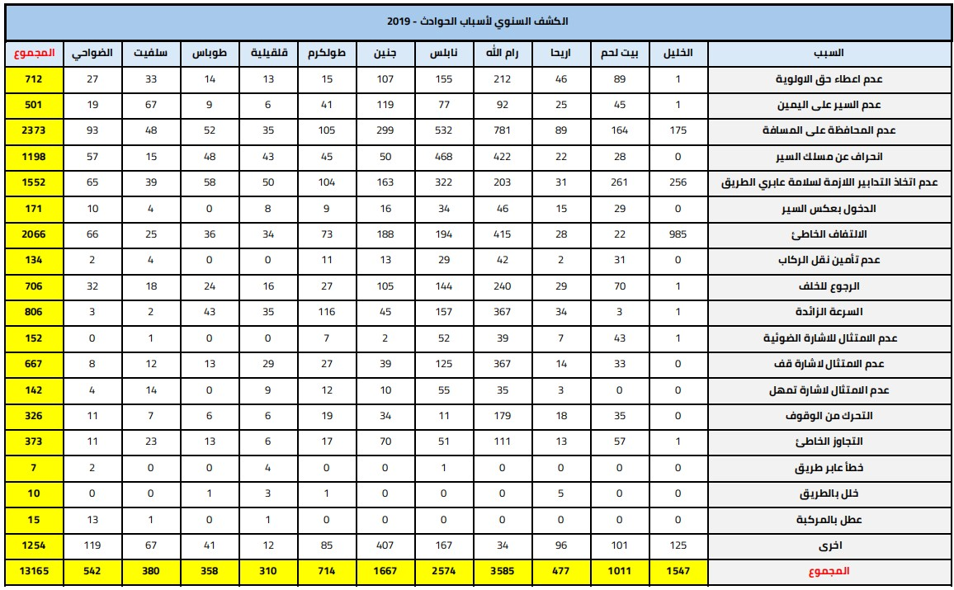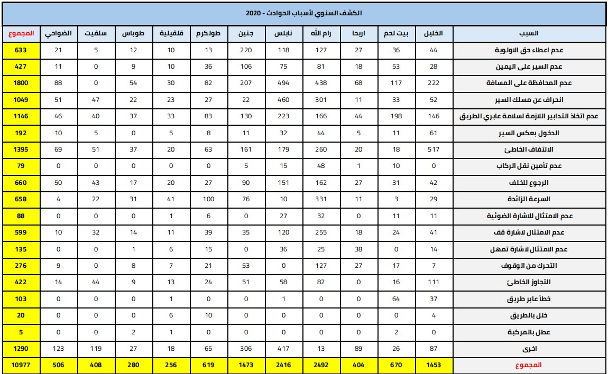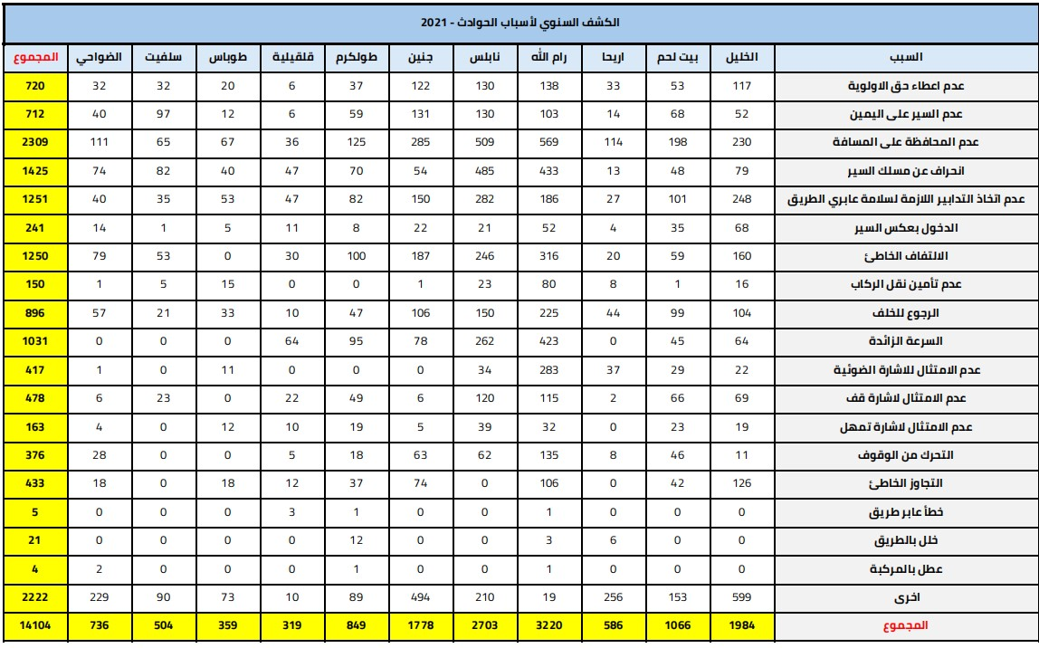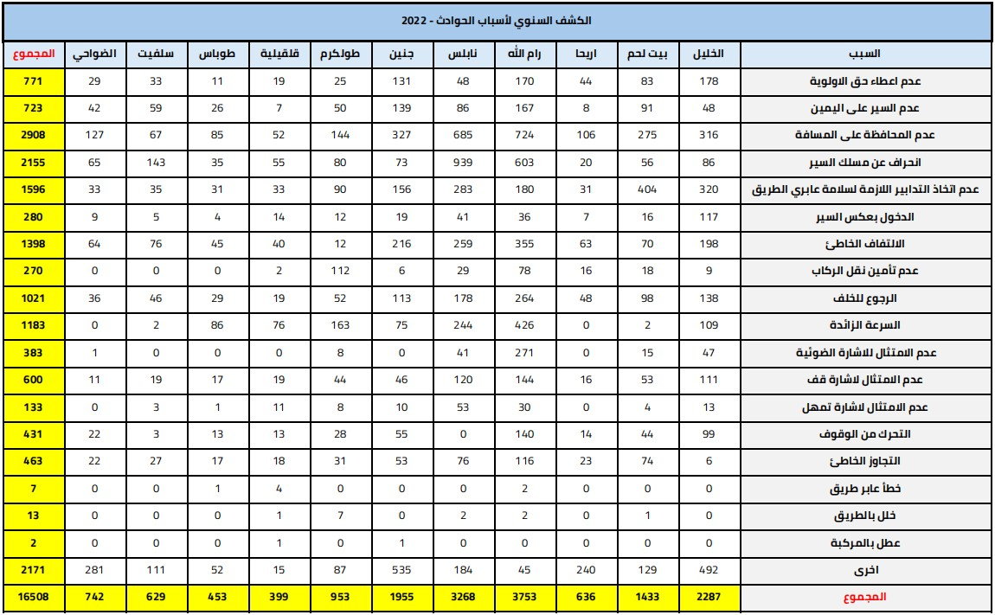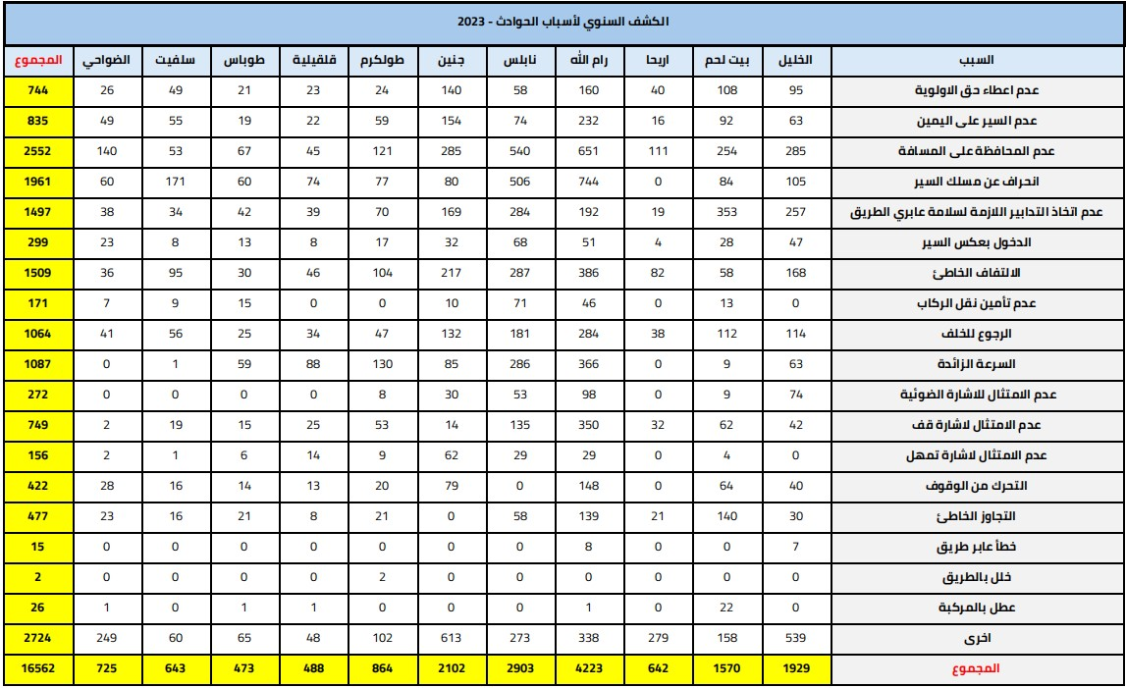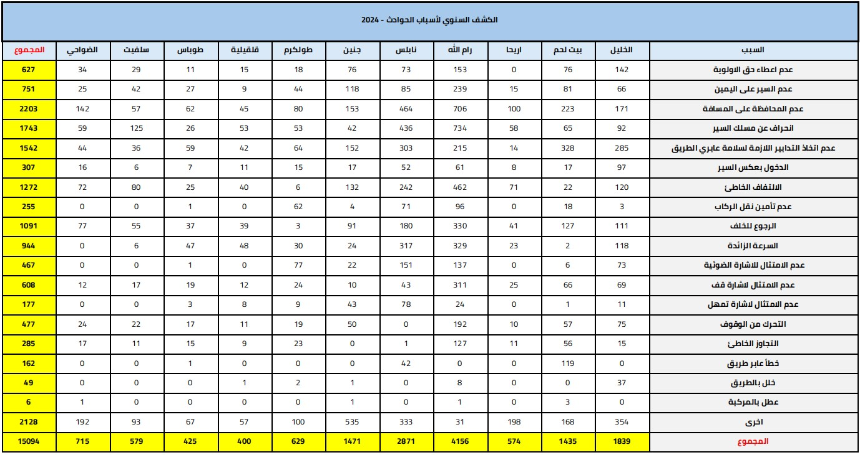

Appendix B
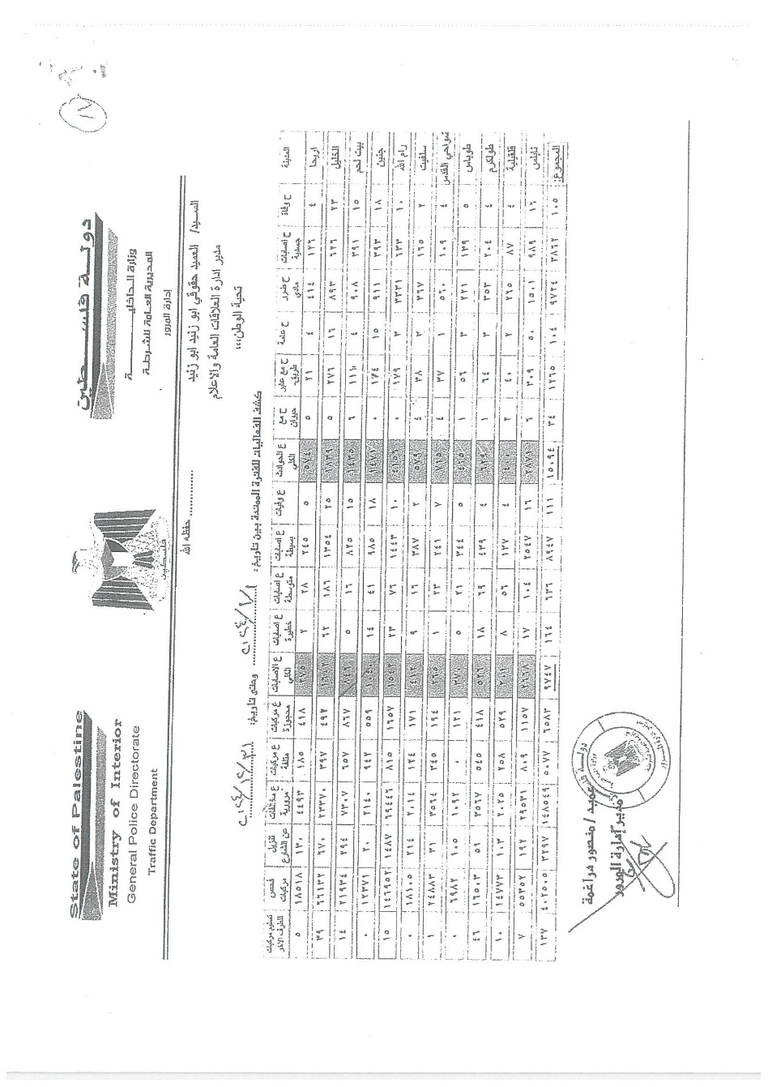
Annual Records of Traffic and typew by the Palestinian Police (2019–2024)

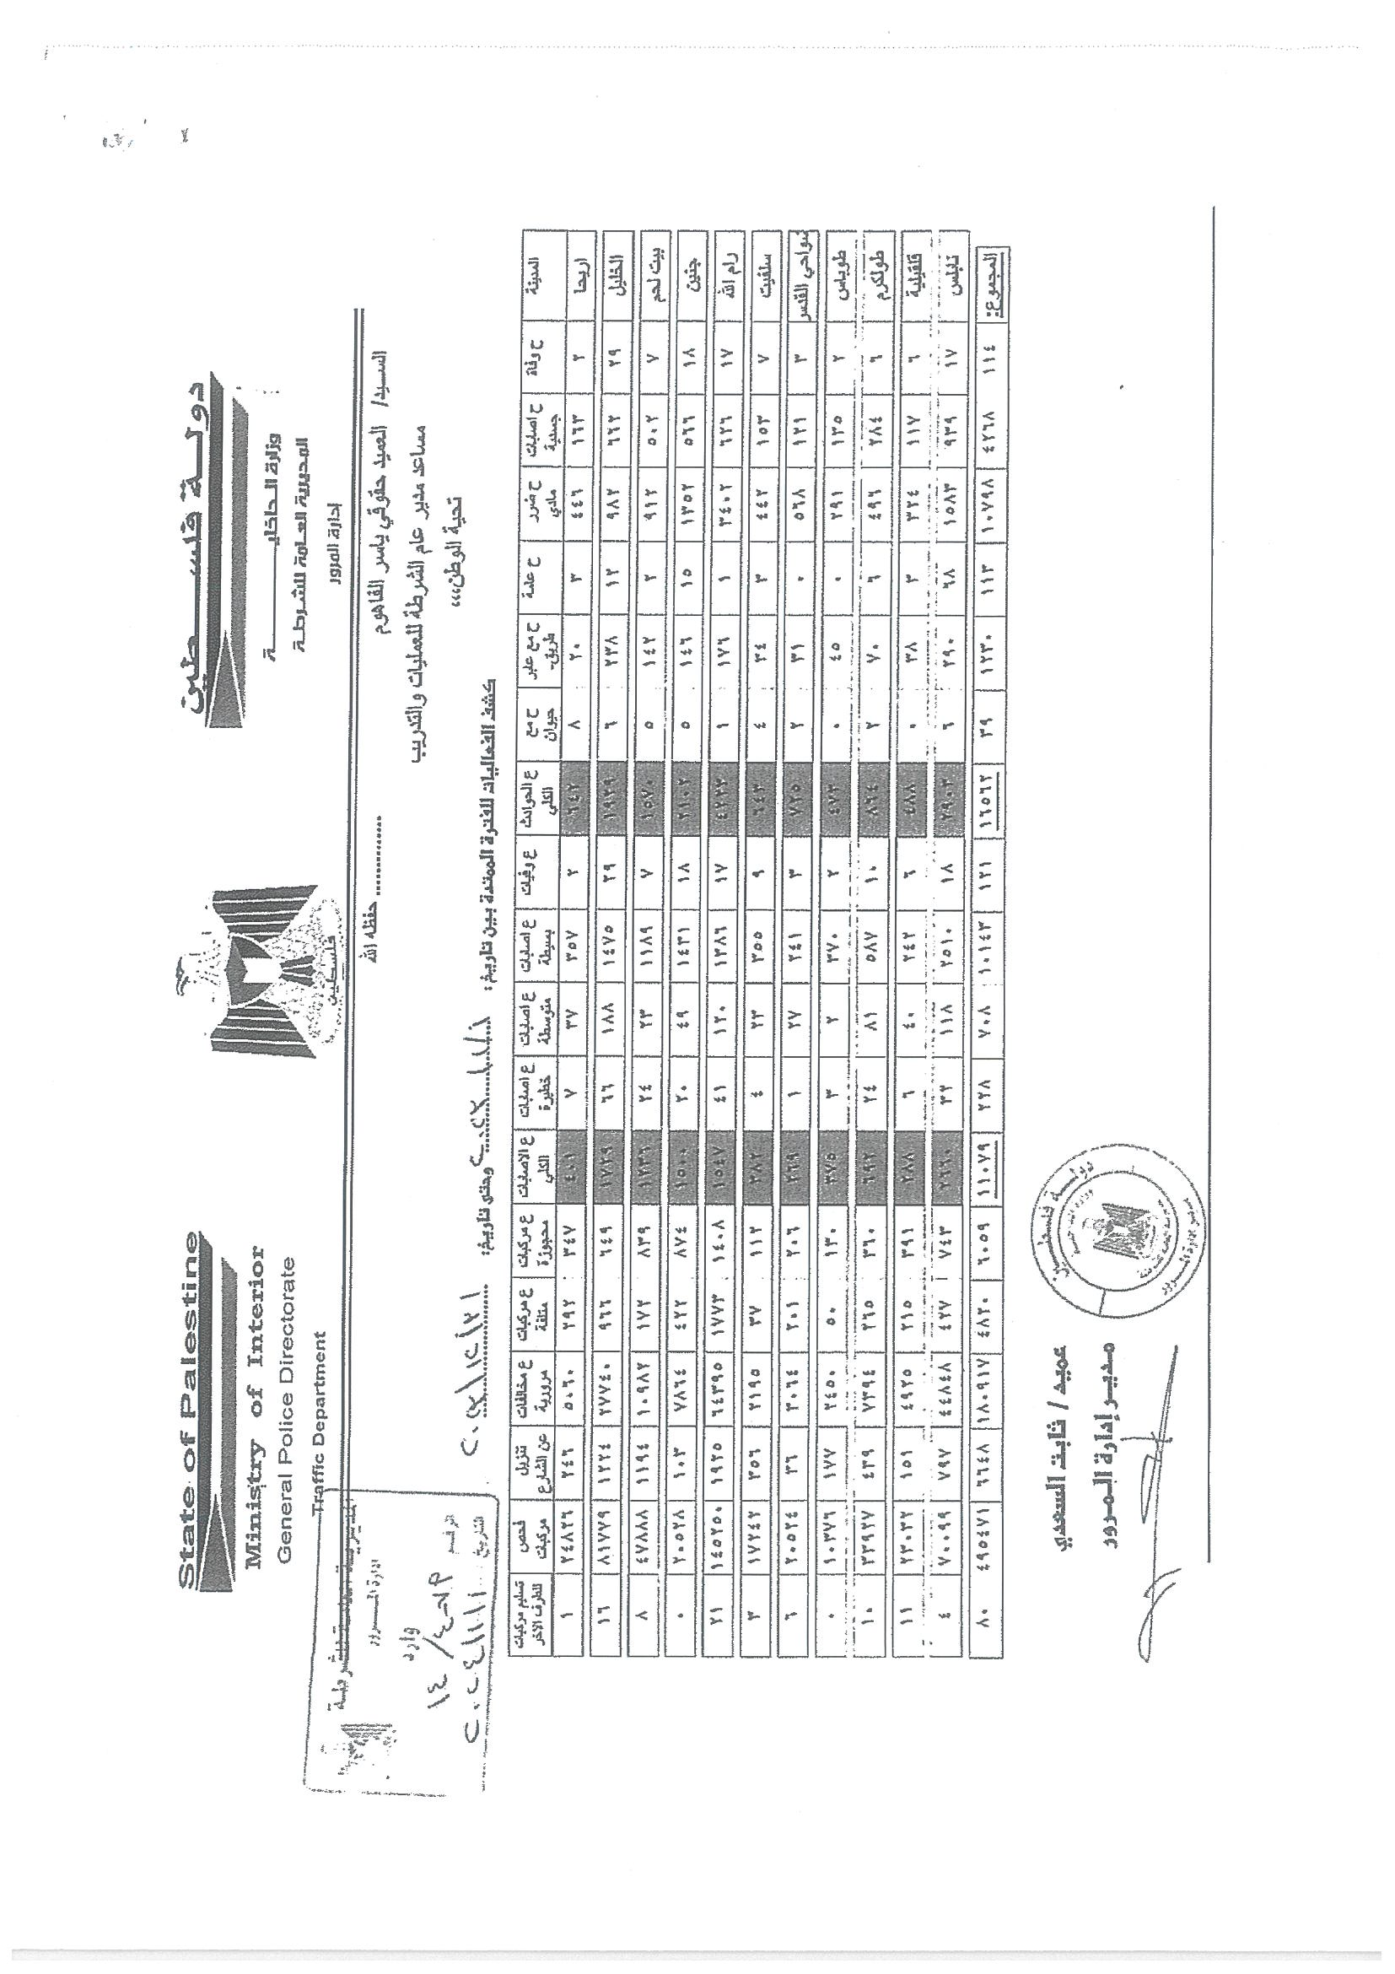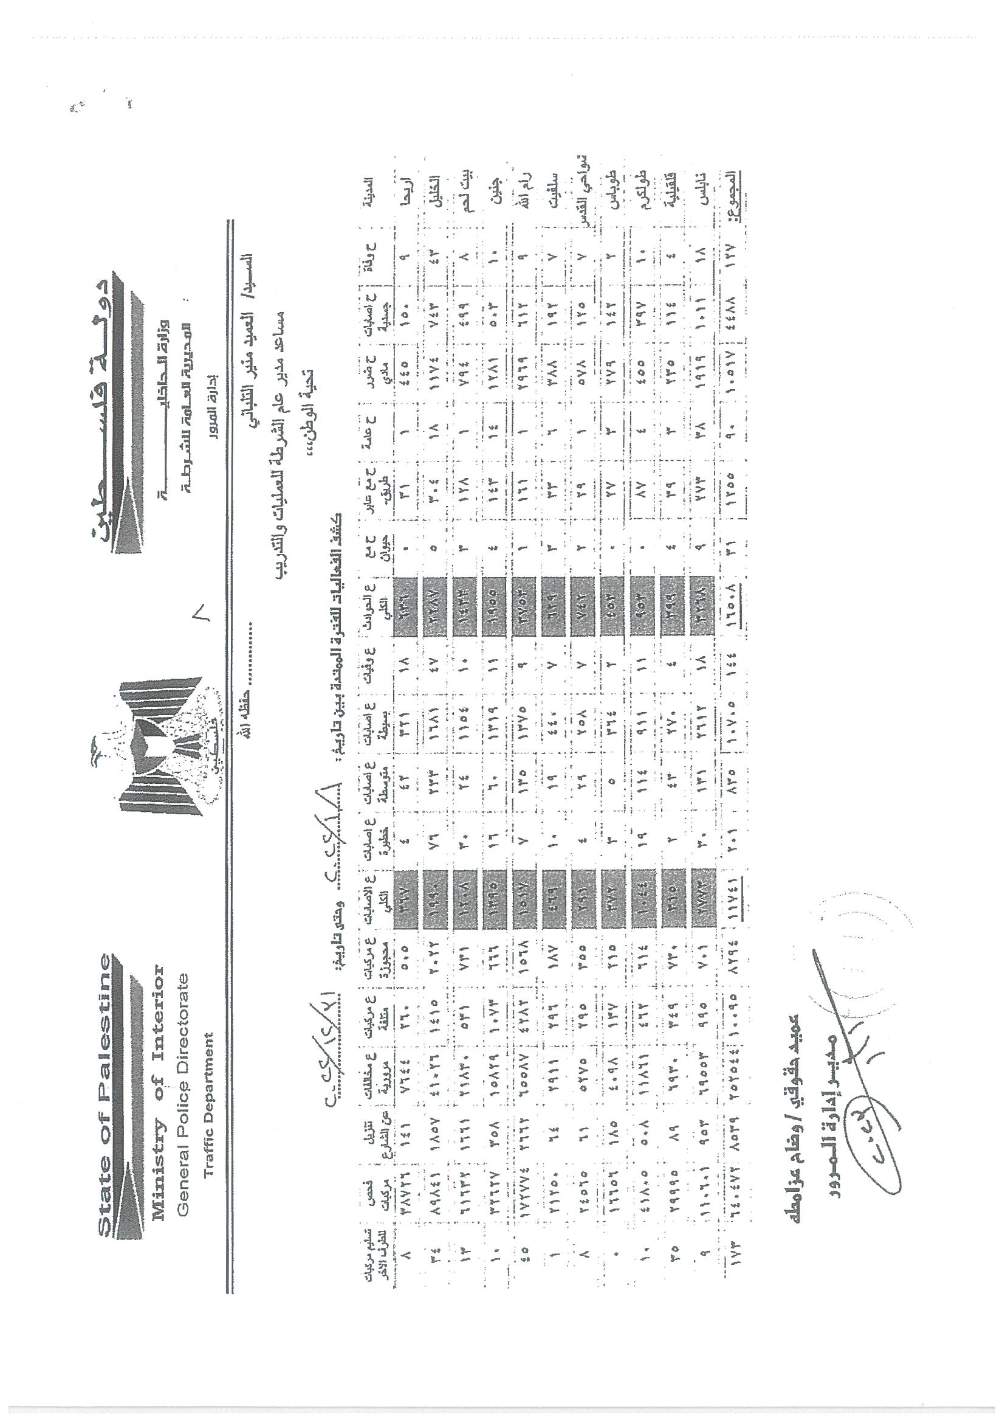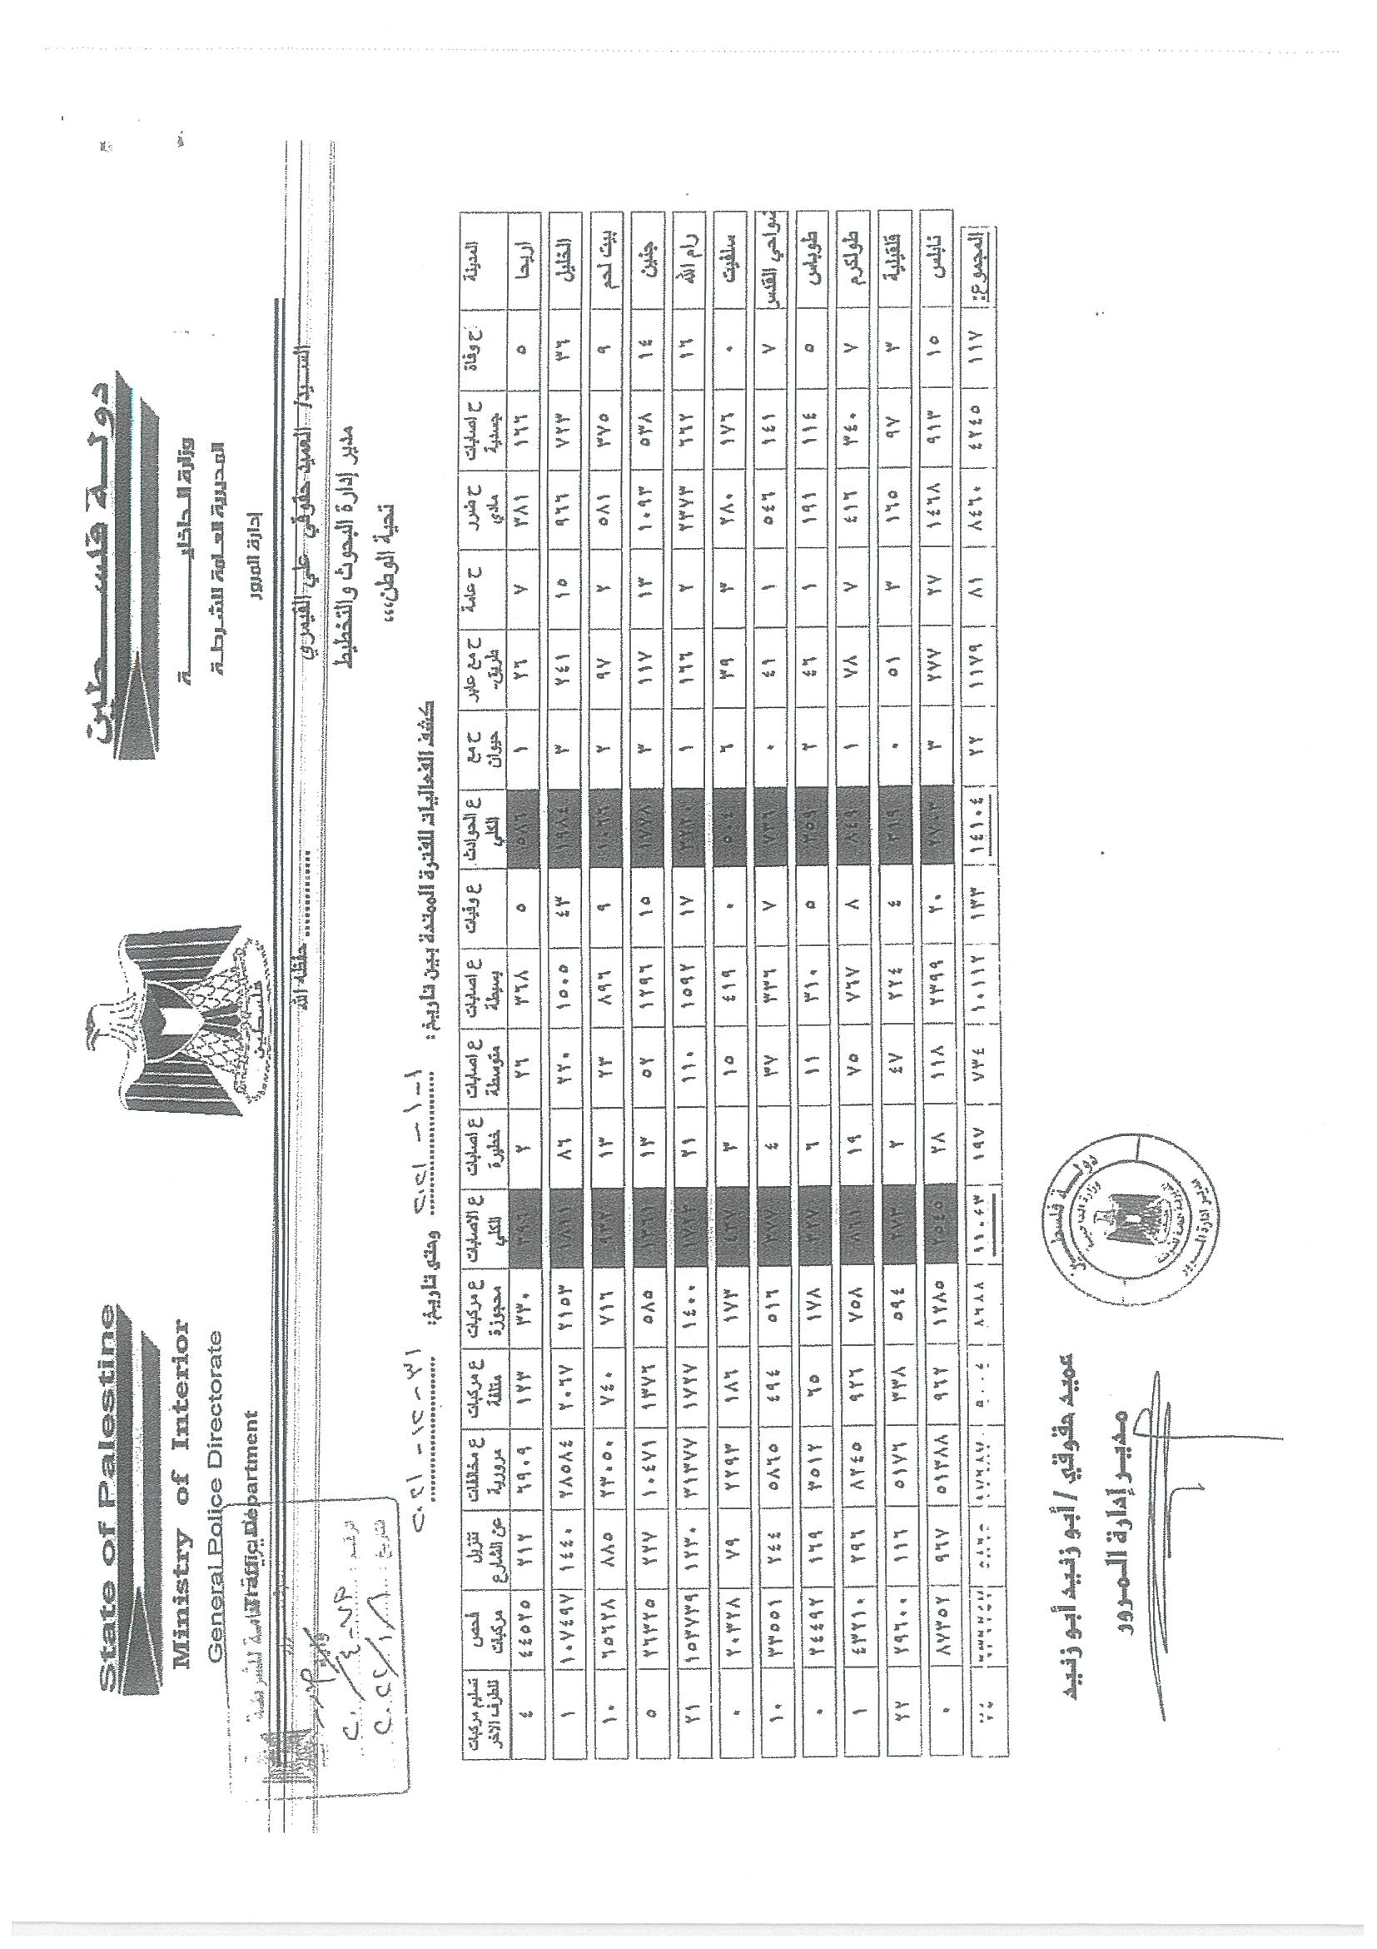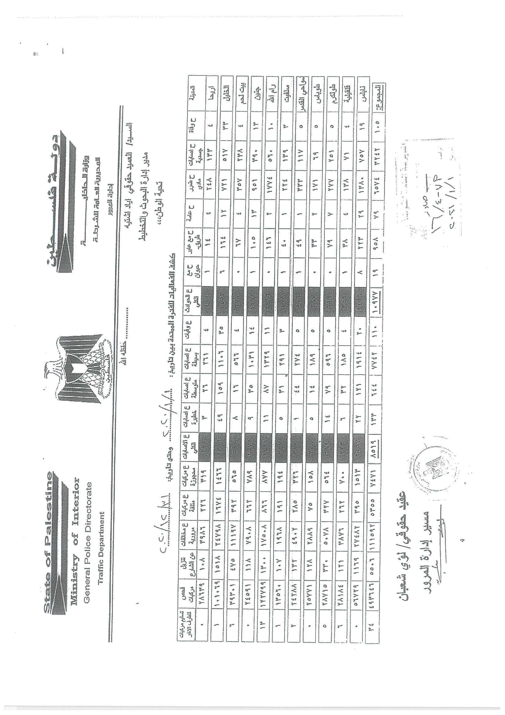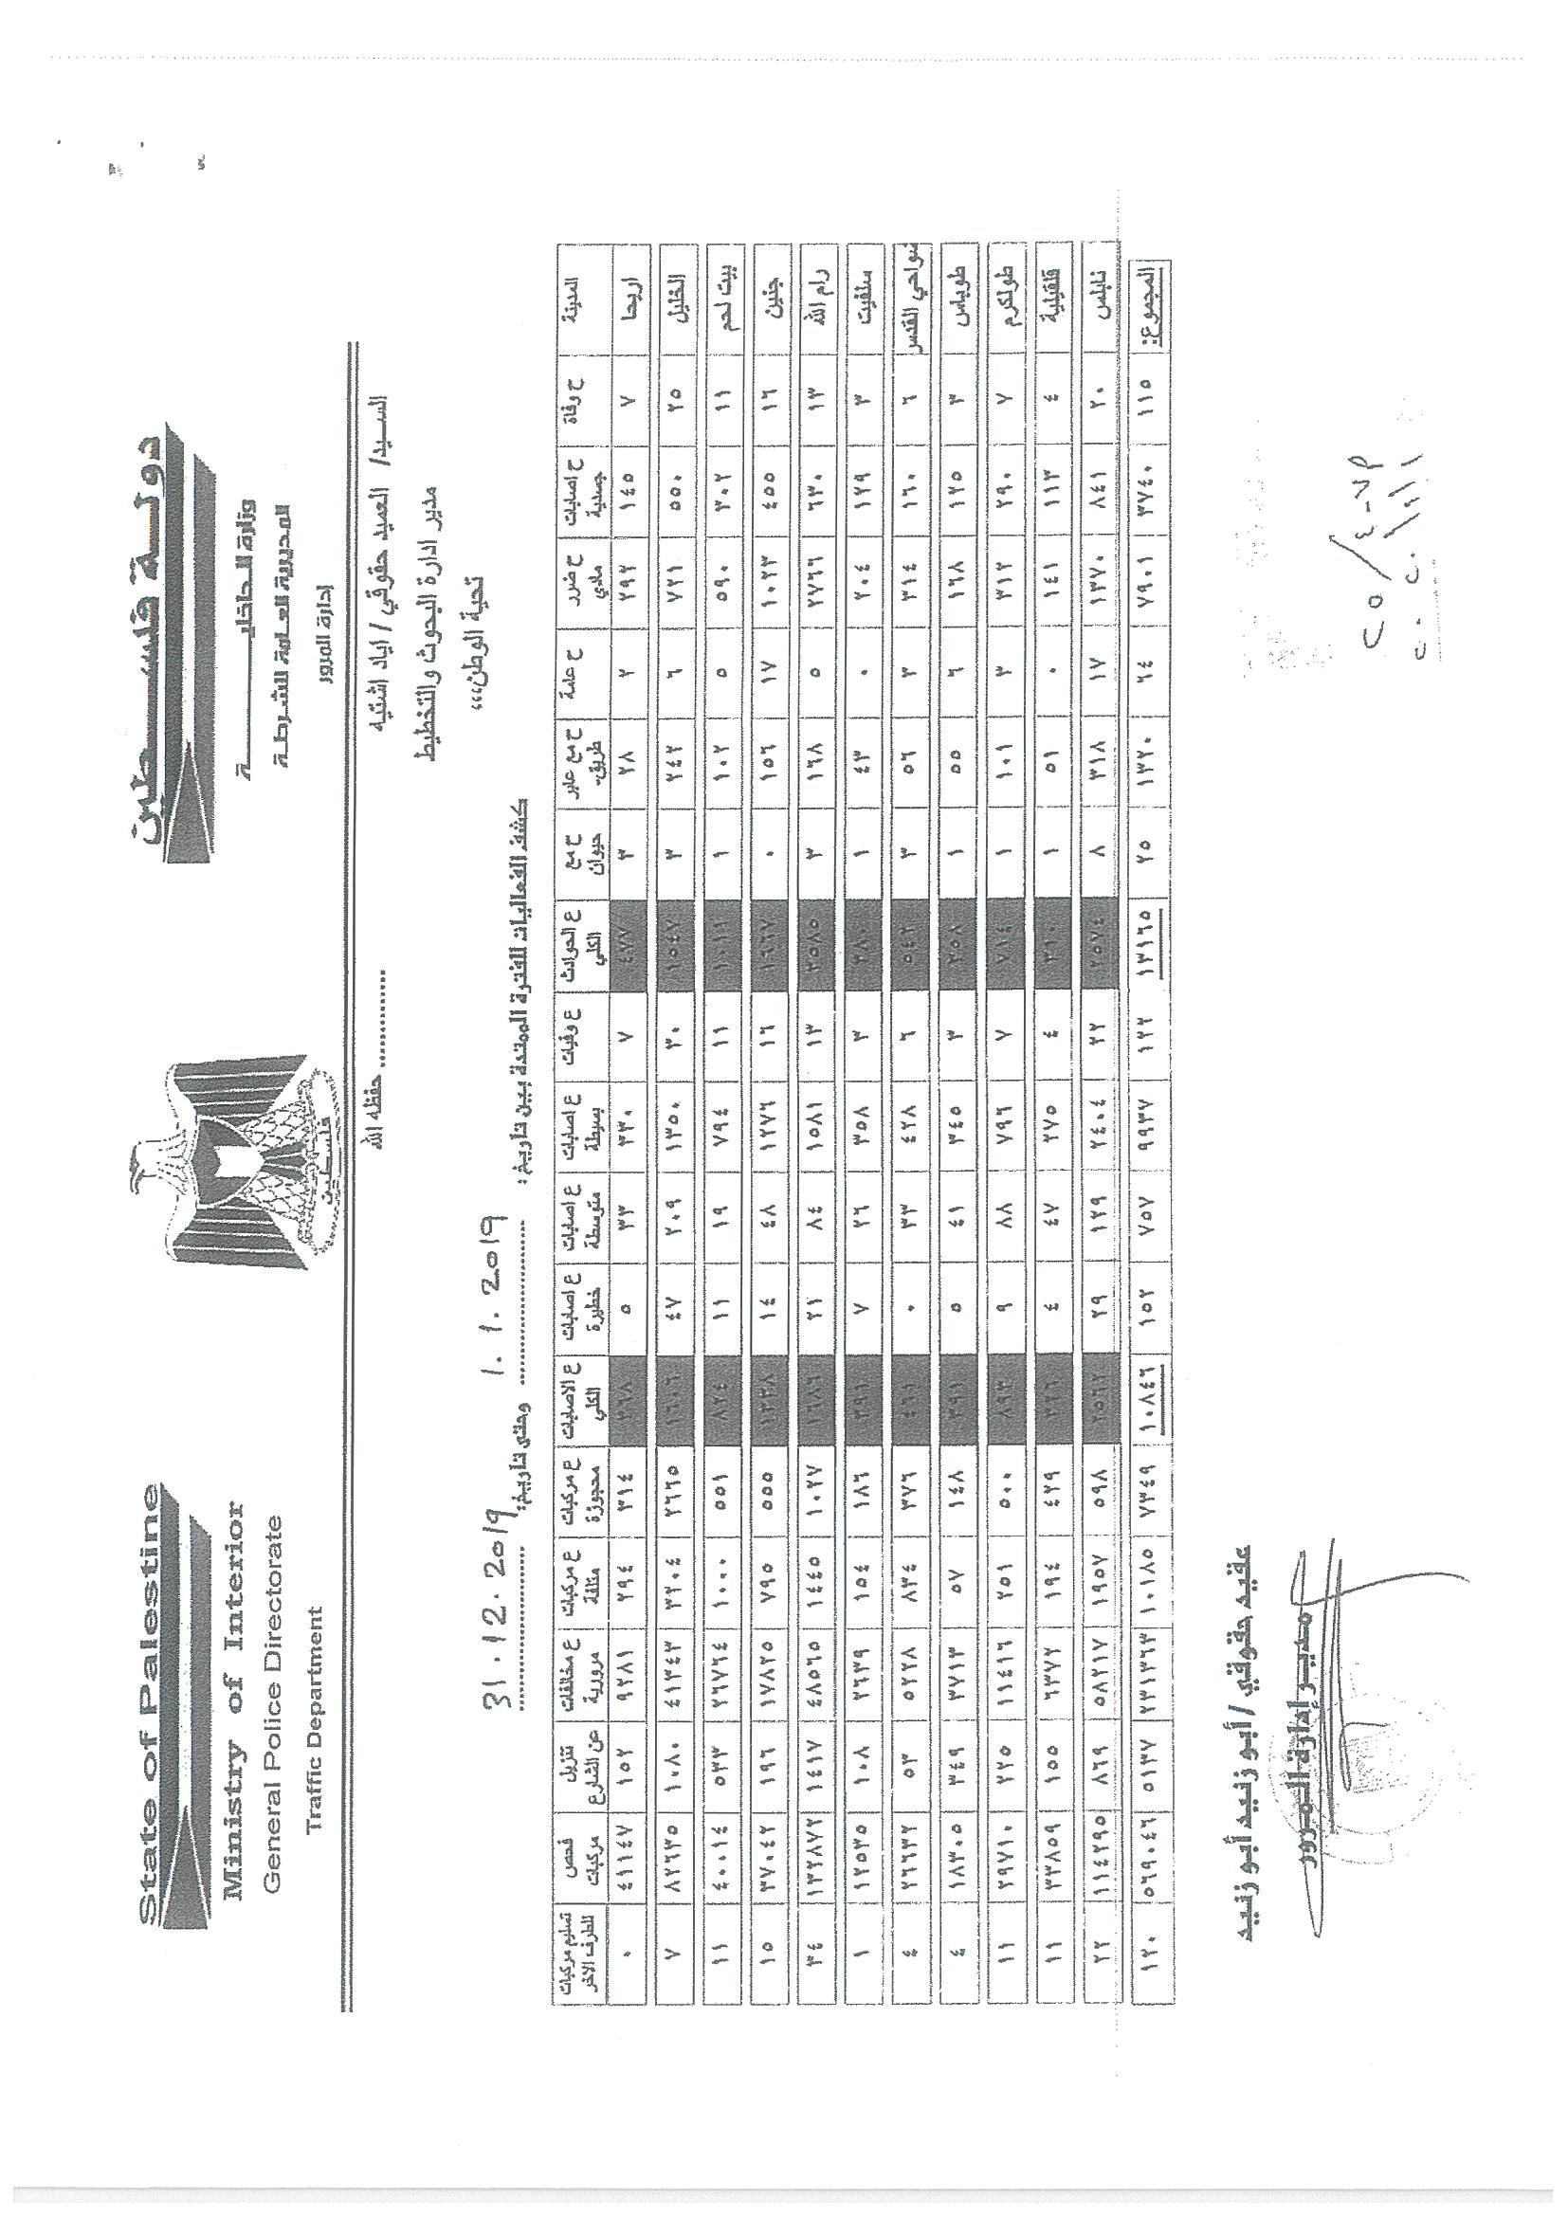

Appendix C
Official Definition and Methodology for Identifying Black Spots by the Palestinian Traffic Police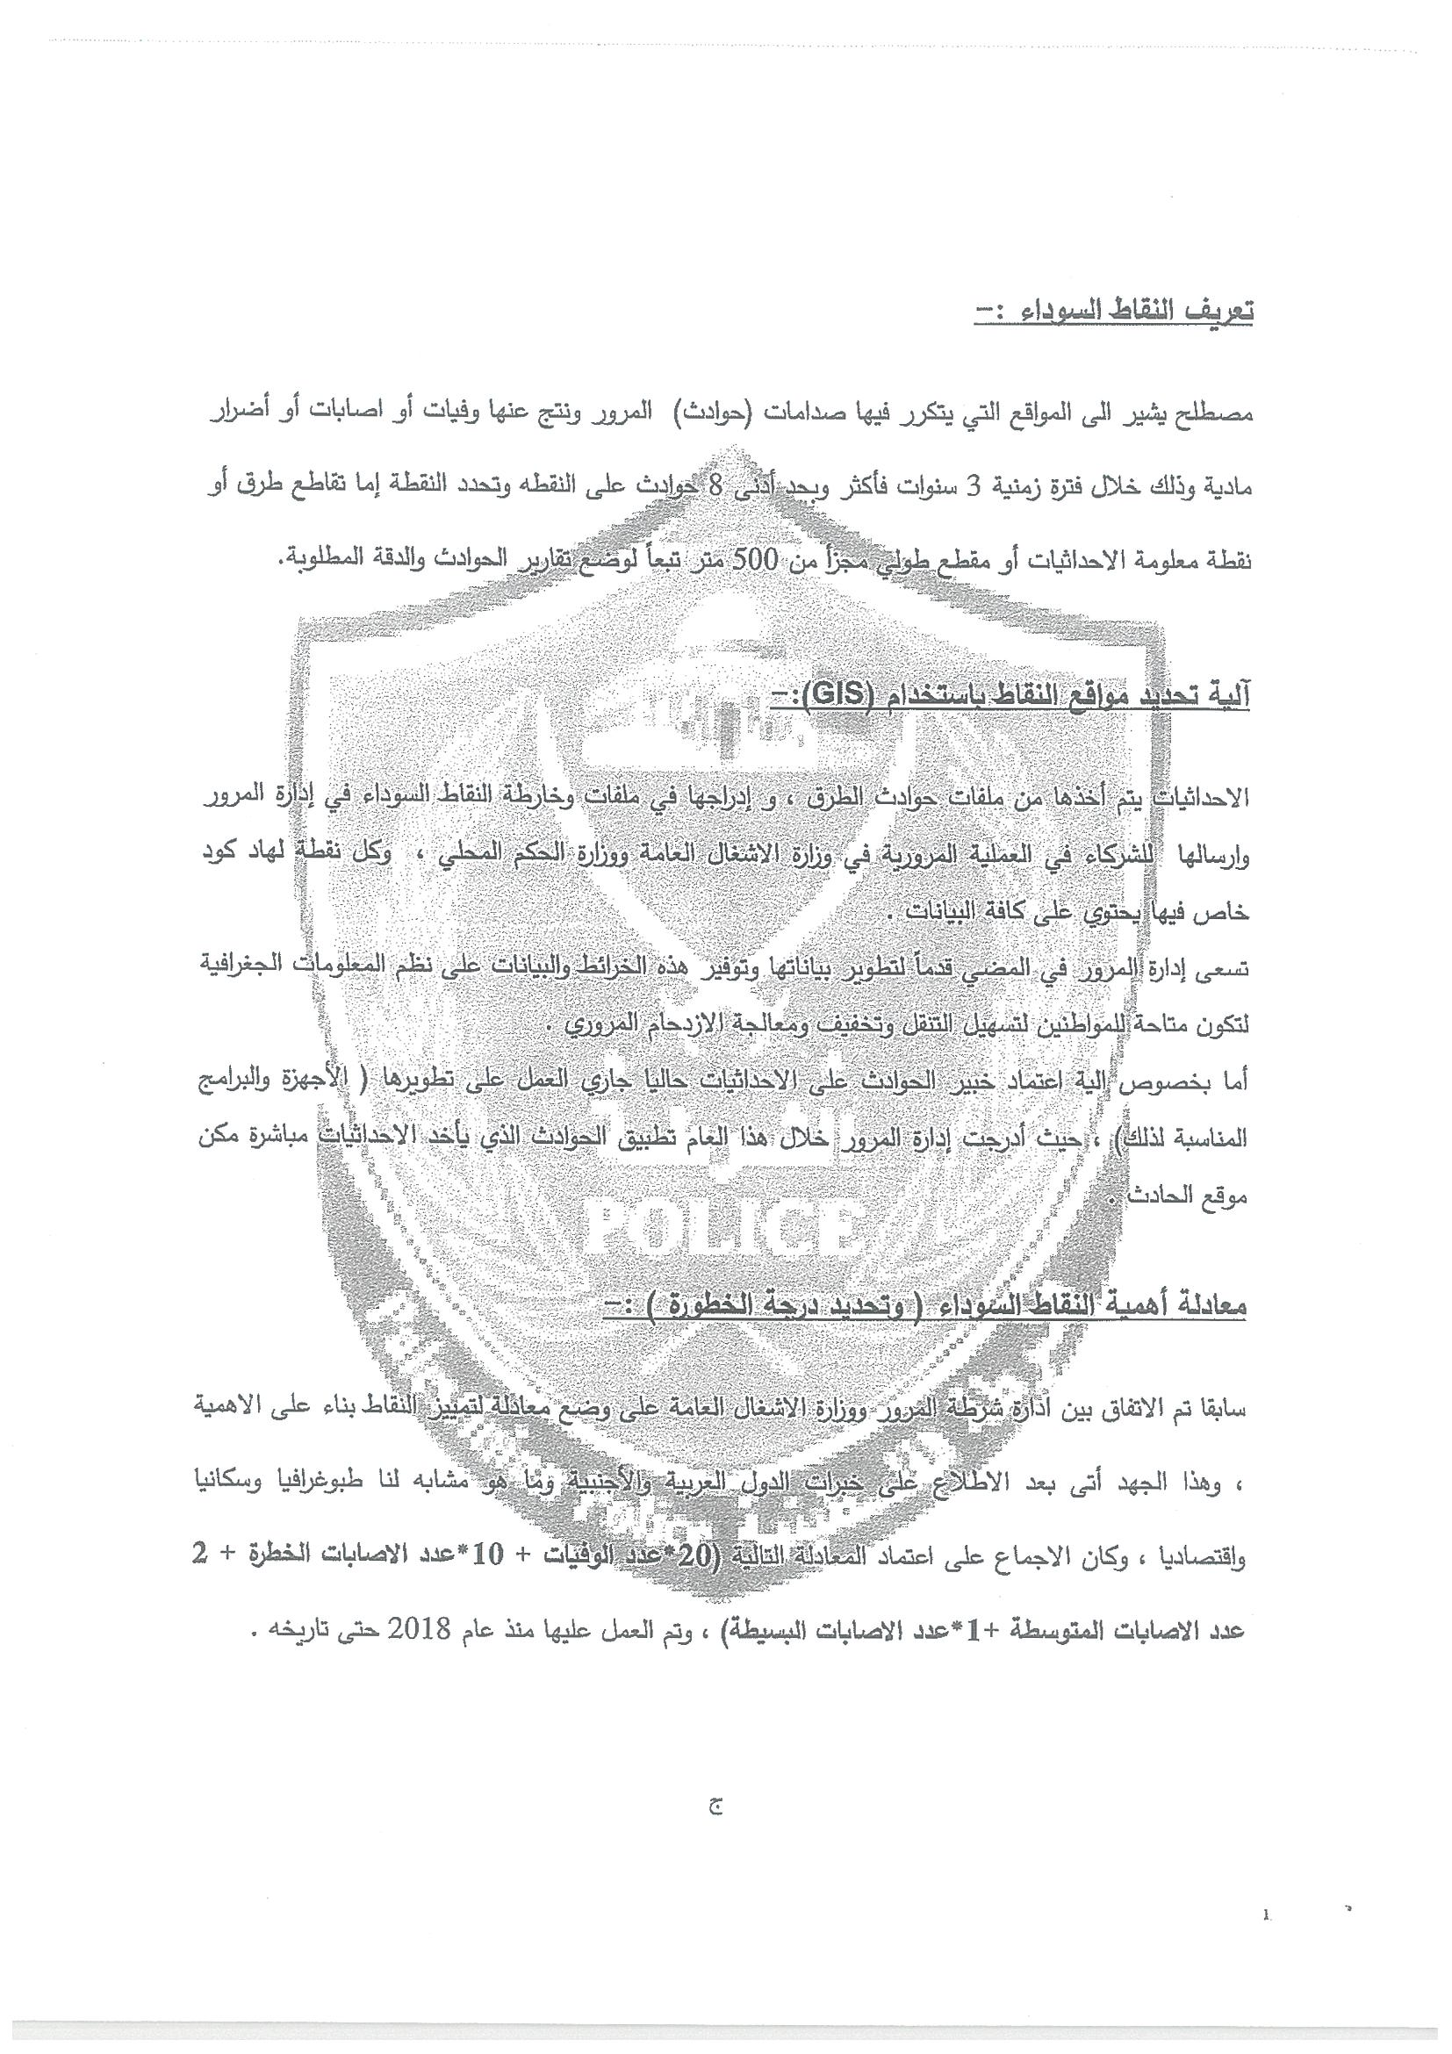

Appendix D
Monthly Distribution of Traffic Crashes in Ramallah and Al-Bireh Governorate (2019–2024)
Jan. | Feb. | Mar. | April | May | June | July | Aug. | Sept. | Oct. | Nov. | Dec. | Year
317 | 311 | 382 | 370 | 356 | 280 | 343 | 364 | 376 | 375 | 315 | 367 | 2024
314 | 322 | 365 | 424 | 383 | 351 | 378 | 390 | 401 | 296 | 289 | 310 | 2023
309 | 256 | 310 | 323 | 307 | 316 | 311 | 322 | 333 | 290 | 344 | 332 | 2022
224 | 191 | 199 | 258 | 288 | 283 | 285 | 294 | 301 | 275 | 308 | 314 | 2021
252 | 252 | 198 | 101 | 189 | 232 | 151 | 231 | 217 | 231 | 217 | 221 | 2020
319 | 280 | 312 | 294 | 289 | 274 | 288 | 318 | 287 | 295 | 324 | 305 | 2019

Appendix E
Annual Distribution of Traffic Crash Injuries and Fatalities by Age Group (2019–2024)

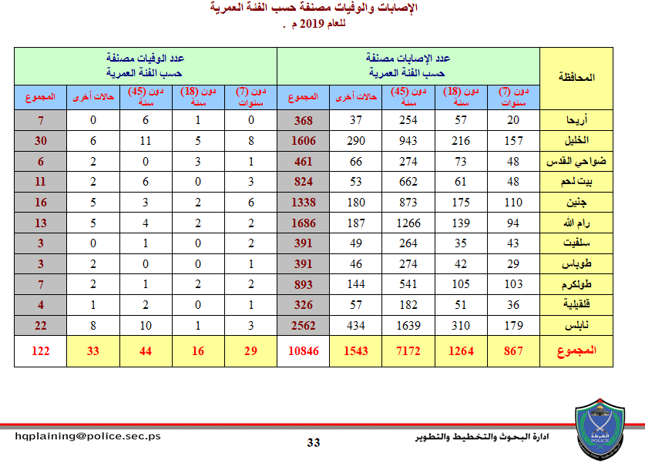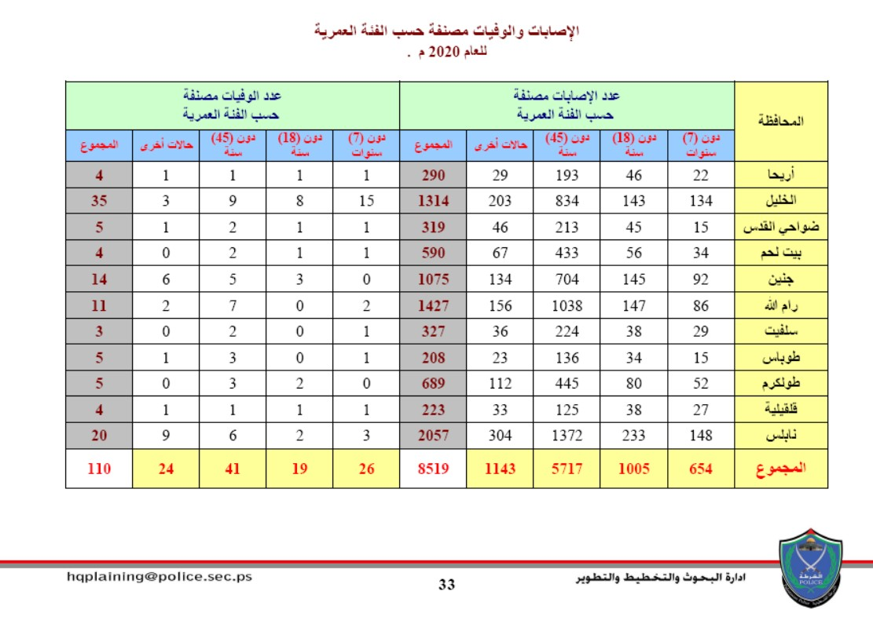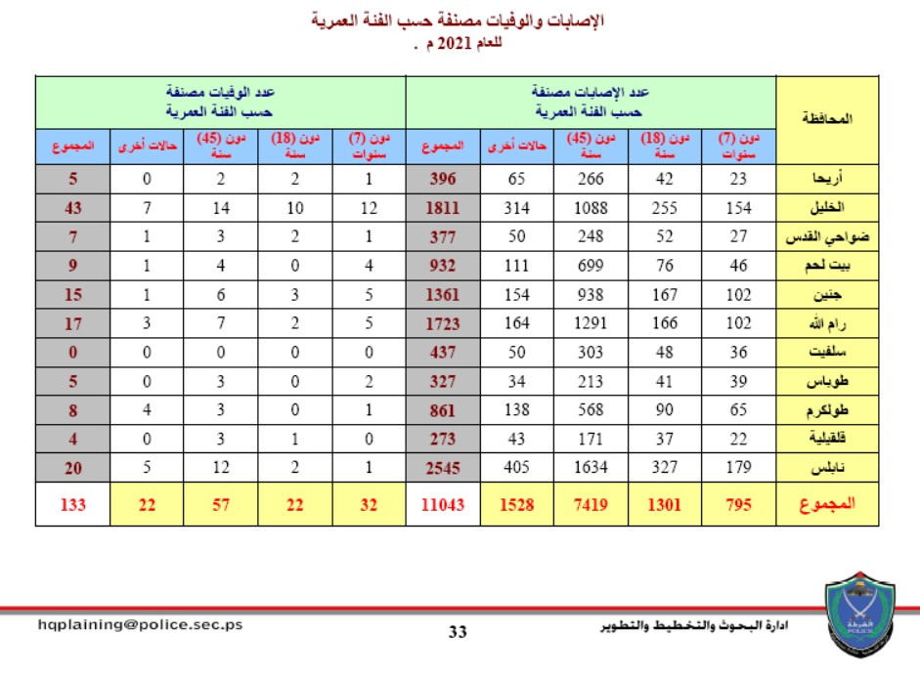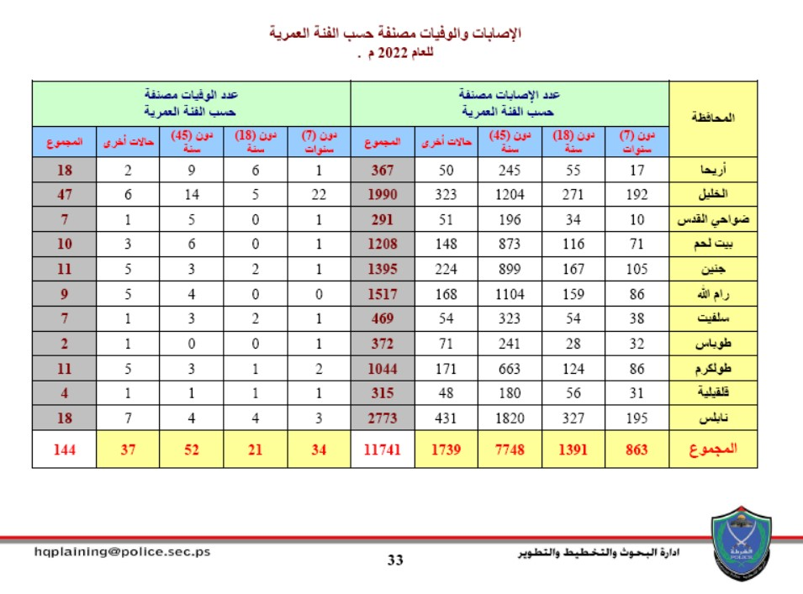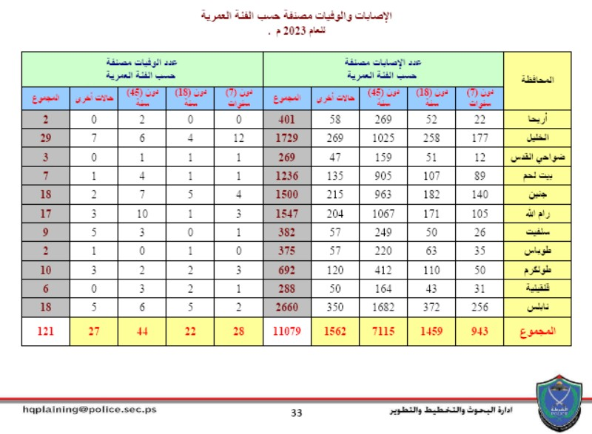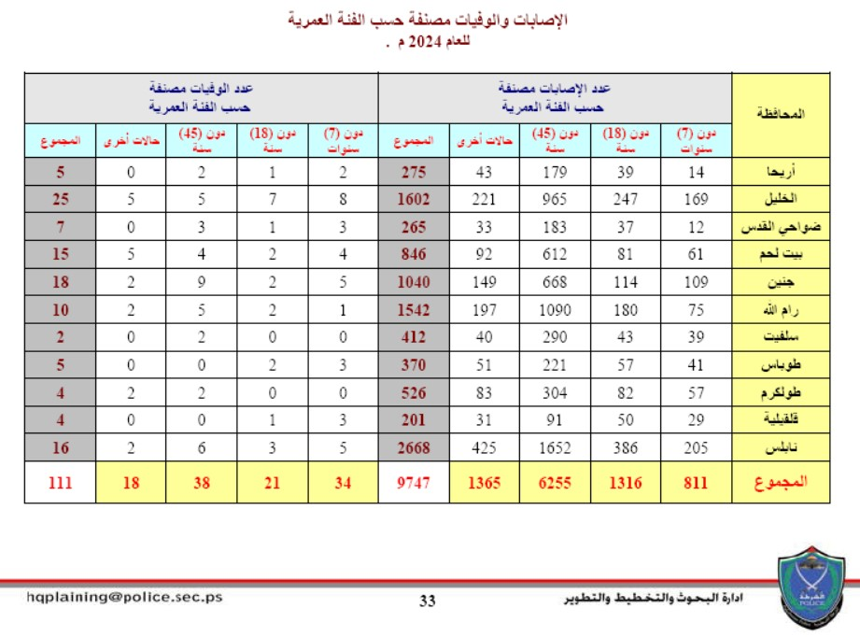

Appendix F
Chi-Square Test Results for Traffic Crash Characteristics (2019–2024)
- Appendix F1 (Cause X Year)
- Appendix F2 (Crash Severity X Year)
- Appendix F3 (Crash Type X Year)

جــــامعــــــــة النجاح الوطنية
كليـــــة الدراســــــــات العليــــــا

الأنماط والعوامل المؤثرة على الحوادث المرورية في محافظة رام الله والبيرة

إِعداد
بشار خضر محمد عمرو

إشراف
أ.د. خالد أحمد جميل الساحلي

قدمت هذه الرسالة/الأطروحة استكمالاً لمتطلبات الحصول علي درجه الماجستير في برنامج هندسة الطرق والمواصلات، من كلية الدراسات العليا، في جامعة النجاح الوطنية، نابلس- فلسطين.
2026

الأنماط والعوامل المؤثرة على الحوادث المرورية في محافظة رام الله والبيرة
إعداد
بشار خضر محمد عمرو
إشراف
أ.د. خالد أحمد جميل الساحلي

الملخص
يهدف هذا البحث إلى تحليل أنماط حوادث المرور والعوامل المؤثرة فيها في محافظة رام الله والبيرة خلال الفترة الممتدة من عام 2019 إلى عام 2024، بالاعتماد على بيانات رسمية صادرة عن شرطة المرور الفلسطينية والجهات ذات العلاقة. جاءت هذه الدراسة استجابة للحاجة إلى فهم مكاني وتحليلي أدق لتوزيع الحوادث المرورية، خاصة في ظل التوسع الحضري وزيادة الكثافة المرورية داخل المحافظة.
اعتمدت الدراسة على منهجية تحليلية متكاملة تجمع بين التحليل المكاني باستخدام نظم المعلومات الجغرافية والتحليل الإحصائي الوصفي والاستدلالي. تم تنفيذ جميع التحليلات المكانية باستخدام برنامج ArcMap (ArcGIS)، حيث استُخدم أسلوب Kernel Density Estimation (KDE) لإنتاج خرائط كثافة تعكس تركز الحوادث المرورية مكانياً، وتمكنت هذه الأداة من إبراز المواقع عالية الخطورة (النقاط السوداء) وتوضيح الفروقات في شدة التركز المكاني للحوادث داخل المحافظة.
ولتعزيز نتائج التحليل المكاني، تم تطبيق مؤشر Global Moran’s I لقياس درجة الترابط المكاني العام لتوزيع الحوادث على مستوى المحافظة، وقد أظهرت نتائجه أن نمط التوزيع العام لا يعكس تجمّعاً مكانياً شاملاً ذا دلالة إحصائية. وبناءً على ذلك، جرى استخدام Local Moran’s (LISA) للكشف عن الأنماط المحلية، حيث ساهم هذا التحليل في تحديد مواقع محددة أظهرت سلوكاً مكانياً غير نمطي يستدعي الدراسة والتدخل.
استنادًا إلى نتائج التحليل المكاني والإحصائي لحوادث المرور في محافظة رام الله والبيرة، توصي هذه الدراسة بمجموعة من الإجراءات العملية التي يمكن أن تسهم في الحد من الحوادث وتحسين مستوى السلامة المرورية داخل المحافظة.
أولًا، تُبرز نتائج التحليل المكاني استمرار تسجيل الحوادث في عدد محدود من النقاط السوداء ذات الخطورة العالية، ما يستدعي تركيب كاميرات مراقبة مرورية ثابتة في هذه المواقع، واعتماد هذا الإجراء كخيار وقائي يساعد شرطة المرور على التدخل السريع ومعالجة السلوكيات الخطرة قبل تفاقم آثارها بدلاً من الاكتفاء بتجميع البيانات على مدى سنوات طويلة قبل التدخل.
ثانيًا، تشير النتائج إلى ضرورة زيادة الرقابة المرورية والدراسة الميدانية لمقطع شارع الطيرة الرئيسي، الذي أظهر سلوكًا غير مستقر مقارنة بمحيطه، الأمر الذي يتطلب معالجة مباشرة سواء على مستوى الضبط المروري أو تقييم الخصائص الهندسية للمقطع.
كما بينت الدراسة أن غالبية الحوادث، خصوصًا في النقاط السوداء، تعود إلى أسباب سلوكية متكررة مثل عدم الحفاظ على مسافة الأمان والانحراف عن مسلك السير، وهو ما يستدعي تطبيقًا أكثر صرامة لقانون السير، مع تشديد العقوبات المرتبطة بهذه المخالفات تحديدًا لتعزيز الردع والالتزام المروري.
وتوصي الدراسة كذلك بضرورة ربط بيانات شركات تأمين المركبات مع قاعدة بيانات الشرطة، بما يضمن توثيقًا أدق للحوادث المرورية بمختلف أنواعها، ويساعد في توفير بيانات أكثر شمولية تعكس الواقع المروري داخل المحافظة بصورة أفضل.
وأخيرًا، أظهرت النتائج أن الفئة العمرية العاملة هي الأكثر تعرضًا للإصابات والوفيات الناتجة عن الحوادث المرورية، ما يؤكد أهمية توجيه الجهود التوعوية نحو هذه الفئة، بالتعاون مع المؤسسات الحكومية وشبه الحكومية والشركات الكبرى، إلى جانب دراسة حلول تخطيطية تخفف الضغط عن الطرق الرئيسية المرتبطة بمناطق العمل.
تؤكد هذه التوصيات مجتمعة على أن التعامل مع السلامة المرورية في محافظة رام الله والبيرة يتطلب تدخلات مركزة ومبنية على البيانات، بدل الاكتفاء بالإجراءات العامة، بما يساهم في تقليل الخسائر البشرية والمادية وتحقيق نتائج أكثر استدامة.

