

An-Najah National University
College of Engineering and Information Technology
Department of Management Information Systems

Graduation project
Traveleyeser Website

Supervised by Dr. Kamal Irshaid

By:
Shaima Azzam Faqih
Raghad Hatem Fattouh
Sami Jahed Dwaika
Abstract :
Traveleyeser is a fully integrated tourist site . The site serves anyone who wants to travel and covers all the areas necessary for tourism , including access to international and local (between cities in the same country) airline tickets and choose the flight at the price and time that suits him according to the currency he wants and all the international airlines and airlines (LCC) . and also search in all languages for train stations , airports and bus stations in all cities and countries of the world. and also the site provides for traveler the possibility of knowing weather forecasts and includes up to 6 days of information and forecasts In the destination he want to travel to . and see the most popular tourist places in the world .

نبذة مختصرة عن المشروع :
Traveleyeser هو موقع سياحي متكامل . يخدم الموقع لأي شخص يرغب بالسفر و يغطي جميع المجالات اللازمة للسياحة بما في ذلك الاطلاع على أسعار تذاكر السفر الدولية و المحلية ( بين المدن بنفس الدولة ) و أختيار الرحلة بالسعر و الوقت الذي يناسبه و حسب العملة التي يريدها وعلى جميع شركات الطيران العالمية و شركات الطيران منخفضة التكلفة ( lcc ) . و أيضا البحث بجميع لغات العالم عن محطات القطارات و المطارات و محطات الباصات في كل مدن و دول العالم . و أيضا يوفر الموقع للمسافر أمكانية معرفة الأحوال الجوية والتوقعات المتعلقة بالطقس و يشمل ما يصل إلى 6 أيام من المعلومات و التوقعات في الوجهة التي يريد السفر اليها . والاطلاع على أشهر الاماكن السياحية في العالم .

We started the study and research by empowering our educational abilities in different subjects which are very important to accomplish the idea . After a period of about one to two months, the period of study, detection and contamination of the idea and the programs to be used, the required programming languages, flight booking sites to be used. We also examined our capabilities in different subjects so that we can determine our capabilities and determine our destination and make a decision to implement the project .
Topics studied and searched before starting work:
1) Web services
2) XML : eXtensible Markup Language
3) RESTful : Representational state transfer
4) REST services
5) REST API
6) SOAP : Simple Object Access Protocol
7) WSDL : Web Services Description Language
8) XML schema for describing web services
9) GDS : global distribution systems For publishing airlines , hotel cars , availability + possibility for reservation
10) Authentification
11) SSL : Secure Sockets Layer
12) API : application programming interface
13) OAuth 2 and other types of authentication

Our project is a site based on the application programming interface (API),is a set of subroutine definitions, communication protocols, and tools for building software. In general terms, it is a set of clearly defined methods of communication among various components. A good API makes it easier to develop a computer program by providing all the building blocks, which are then put together by the programmer. An API may be for a web-based system, operating system, database system, computer hardware, or software library. allows you to open up data and functionality to other developers and to other businesses. It is increasingly the way in which agencies and companies exchange data and services, both internally and externally.

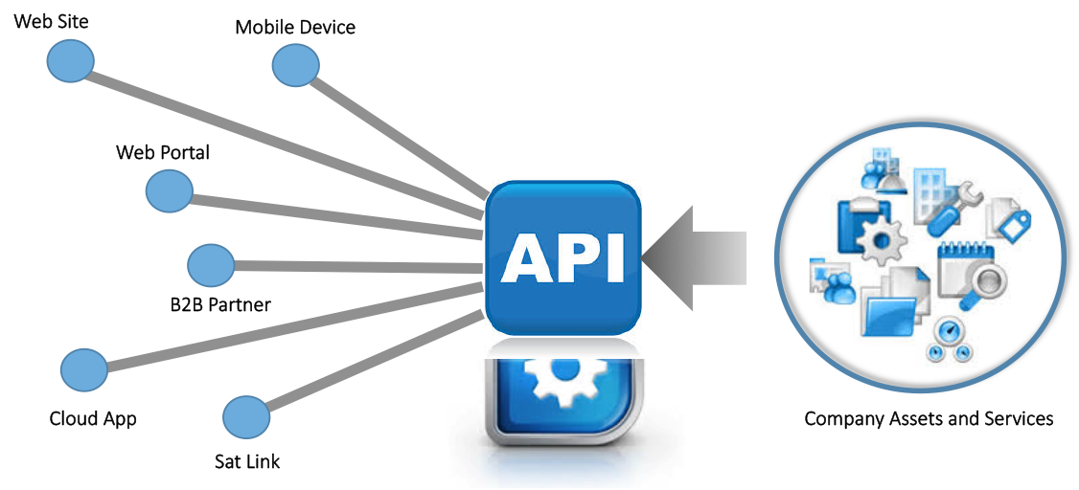

It was our first choice to take API data from a popular site called Travelport , which is a technology company that makes the experience of buying and managing travel continually better for everyone. It operates a travel commerce platform providing distribution, technology, payment and other solutions for the global travel and tourism industry. The Company facilitates travel commerce by connecting the world’s leading travel providers with online and offline travel buyers in a proprietary business-to-business (B2B) travel platform .



We initially create an account on Travelport and waited for a reply from them. After a brief period, the response was received from Travelport via Gmail, and we were provided with the code key, username and a password for use it in the code obtained from The github site to run it and get the data in the form of xml schema.

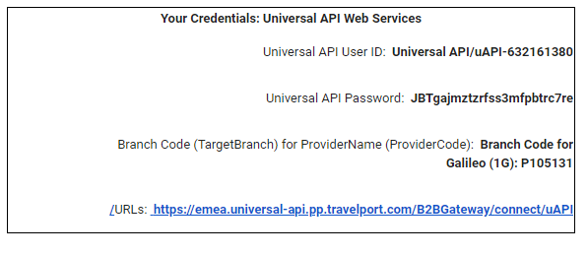
We used the sublime text editor to run the code using the username, password and the key inside the code and get the first APIdata(airlines data) as xml schema as follows:

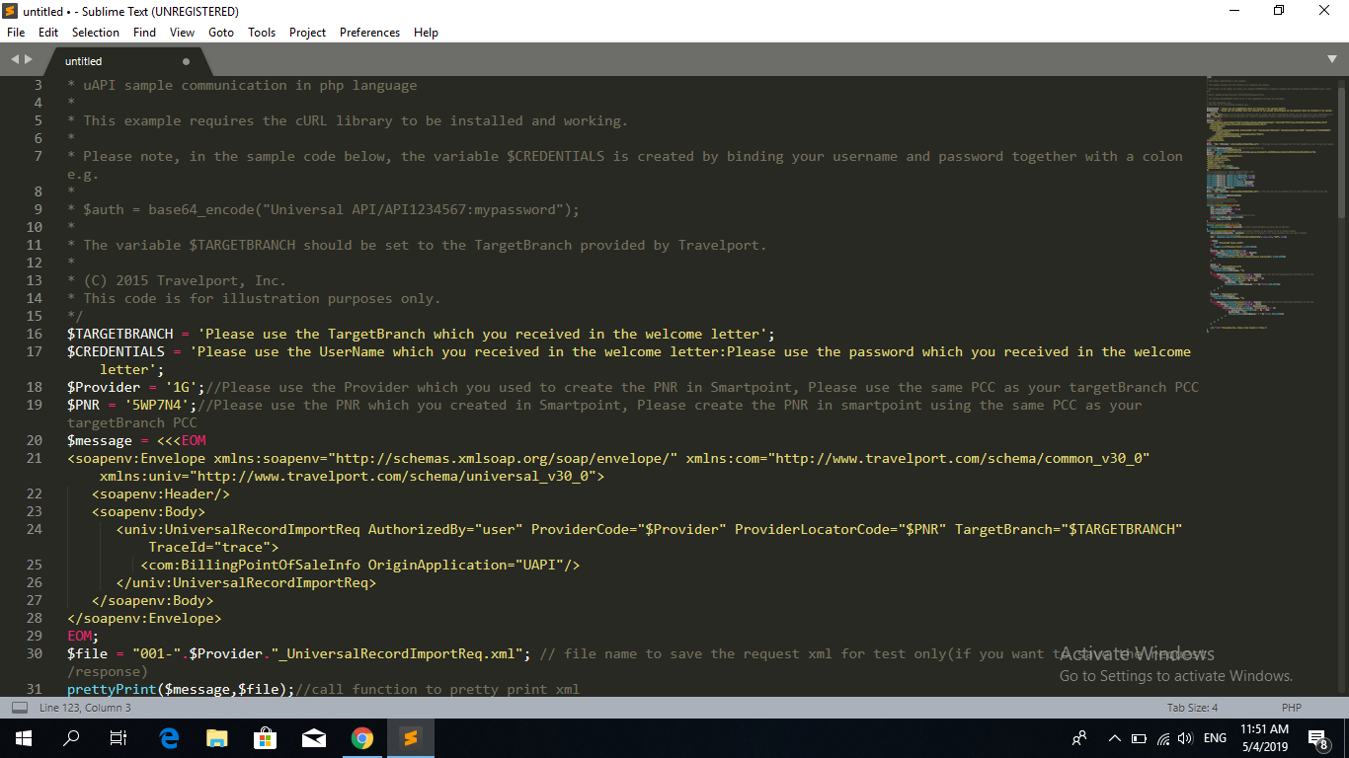

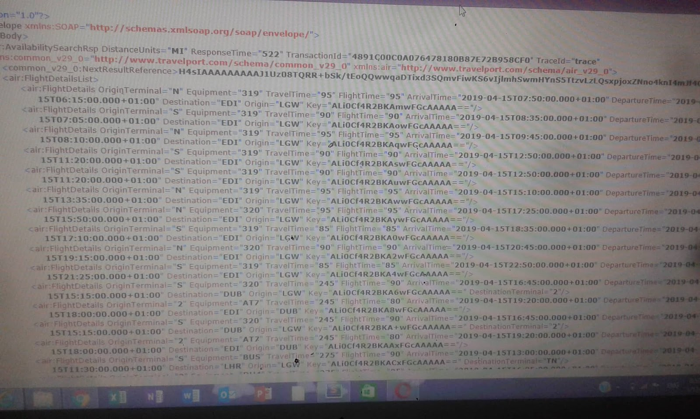
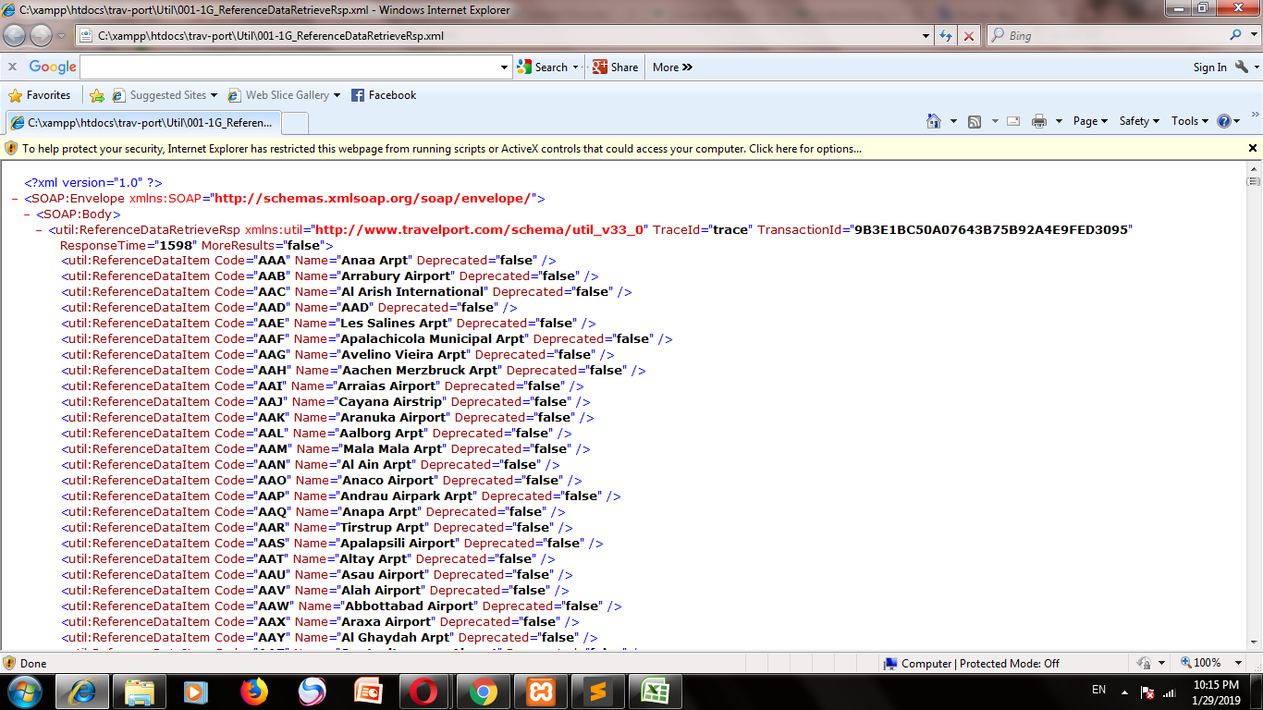

We used an online tool called (CodeBeautify) to understand the xml data schema that we have as follows:

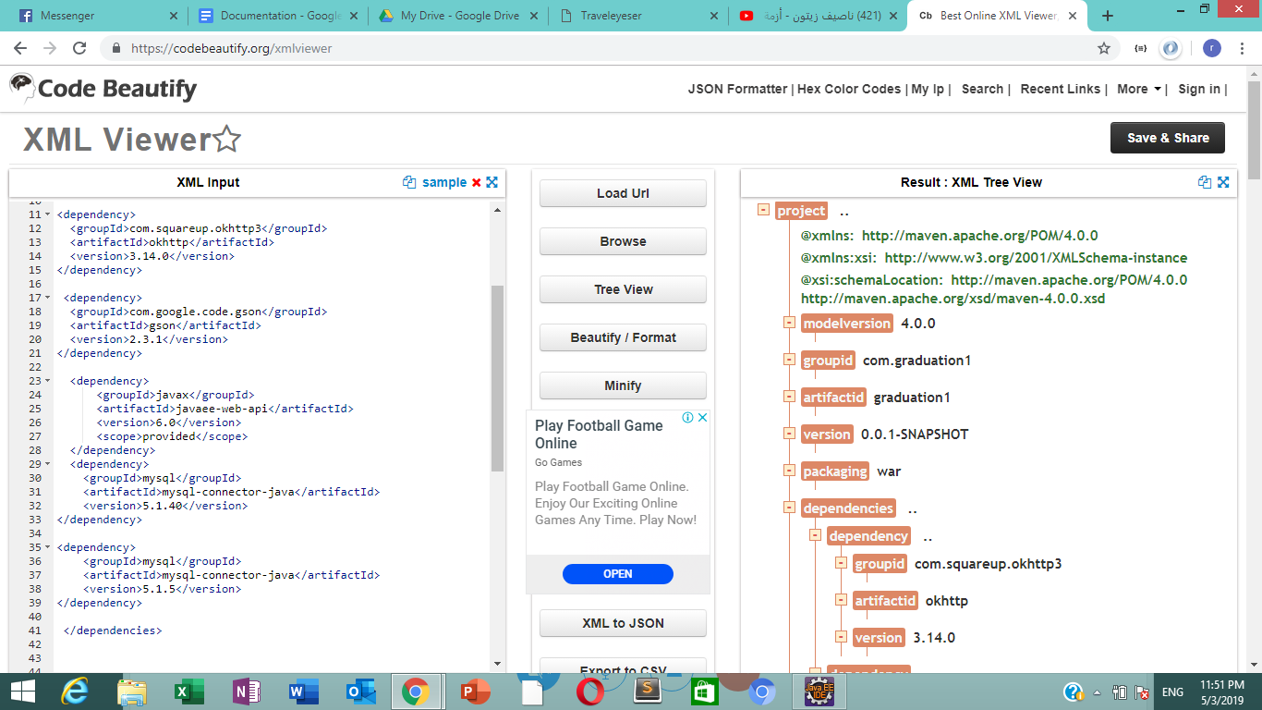
After that we tried to get the rest of the API data (hotels,universal,vehicle) , we bumped into a problem in the code, we have to insert a PNR code (Passenger name record), which is the number of file reservation trip. this code is created in a software called Galileo Desktop and Travelport Smart Point by using PCC (pseudo city code) which we can only get it if we are a certified airline company and a partner with Travelport .
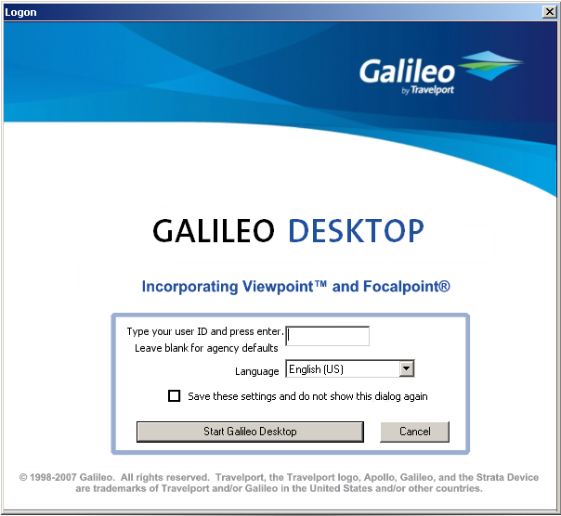

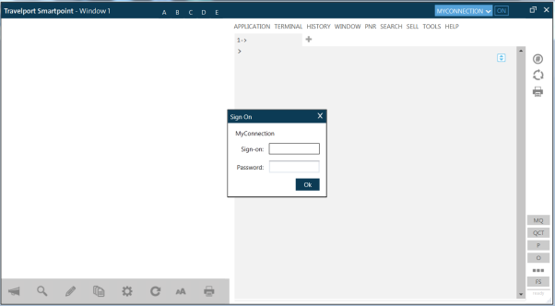
This could not be completed because of the difficulty of documenting us as a company.
And here we had a turning point in the project after month and half passed ,all our efforts failed, and we needed an alternative route not less than what was planned for.
We went to a website that supports developers and helps them to perform tests for real APIdata with limited behavior called
kiwi .com .

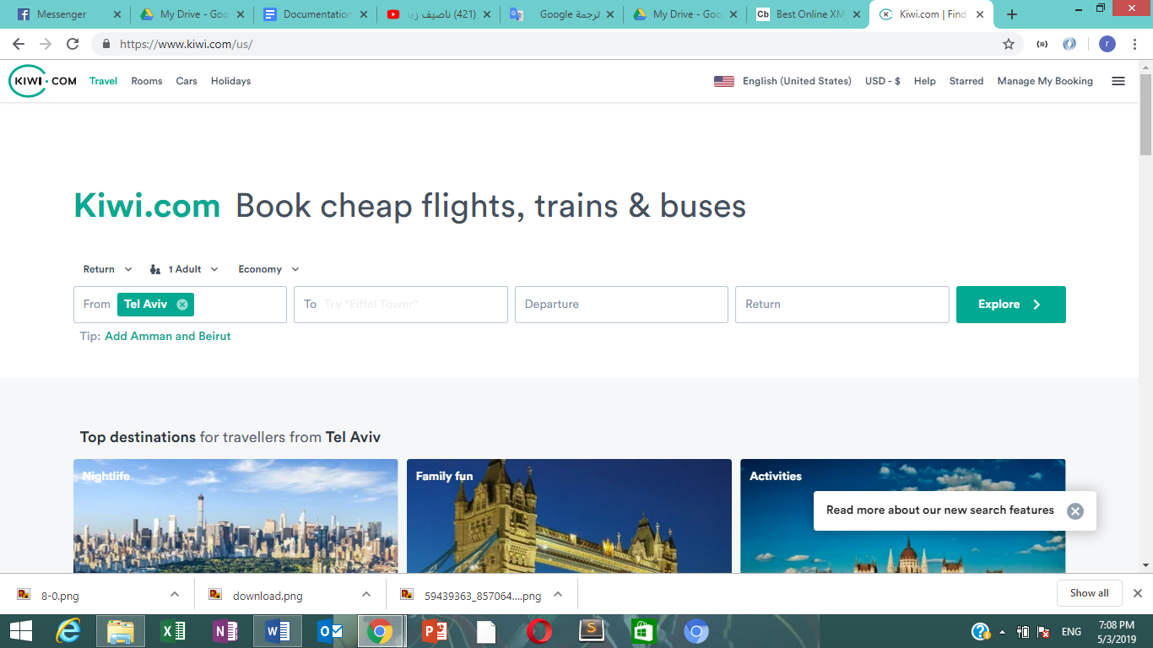

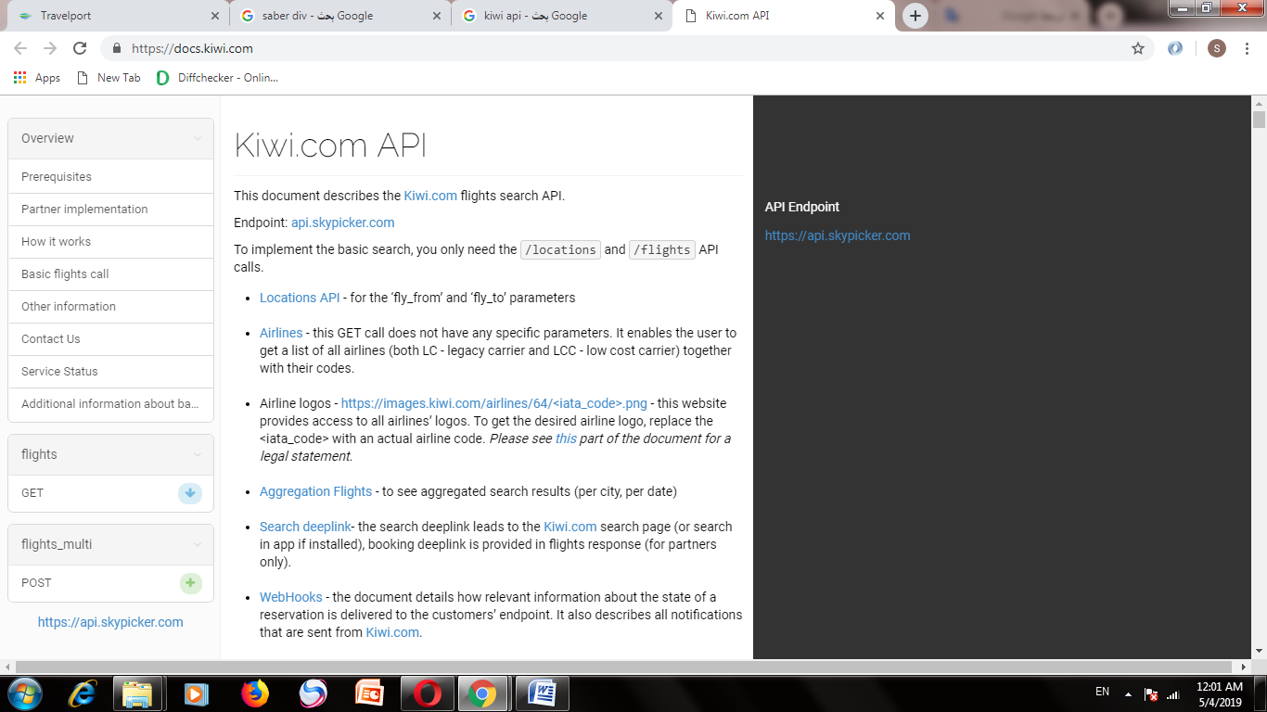
KIWI Is a flight reservation site that gives API data to developers and partner. The API available are (flights reservations API, tourist sites API, airports, train stations and buses around the world API).
we used several API data that provided by KIWI.COM ,that is a GET HTTP method ,so we used locations API data ,places APIdata ,Airlines API data ,Search flights API data ;thats include check flights API data . and this photo explain how the site provide the API data to developers .

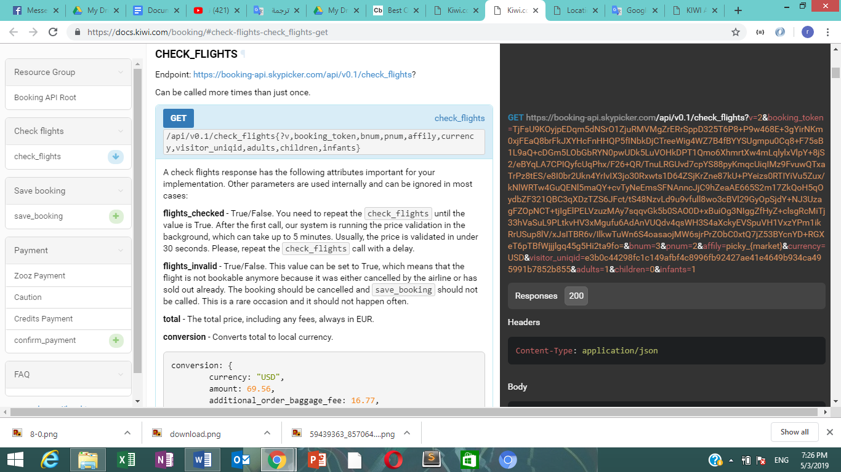

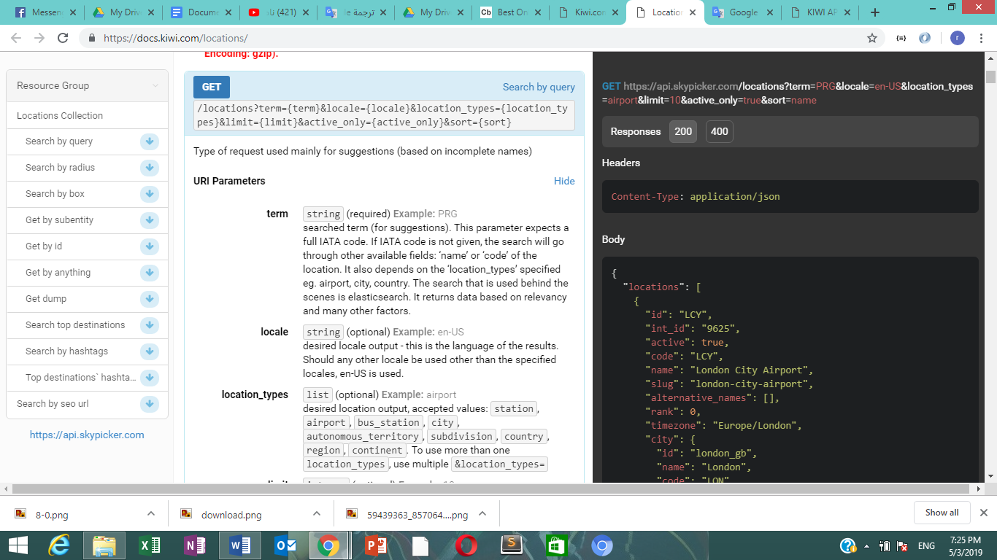
Then we got to the code-building phase and modeling the data,we were have two choices for the programming language that we will used (php or jsp with servlet ).so we decided to use java programming language with jsp( because of its security and functionality ) and servlet by using eclipse ide software for developers .
The data we got from the API were in a Json format .so We used an online tool called json viewer which was added to the browser to display the Json data as a tree to be easy to understand . and we also used another online tool called convert to pojo ; to convert the data from Json to classes in Java called ,with hard editing with this classes to make correct and suitable for our codes and API.
API data before a Json viewer tool.
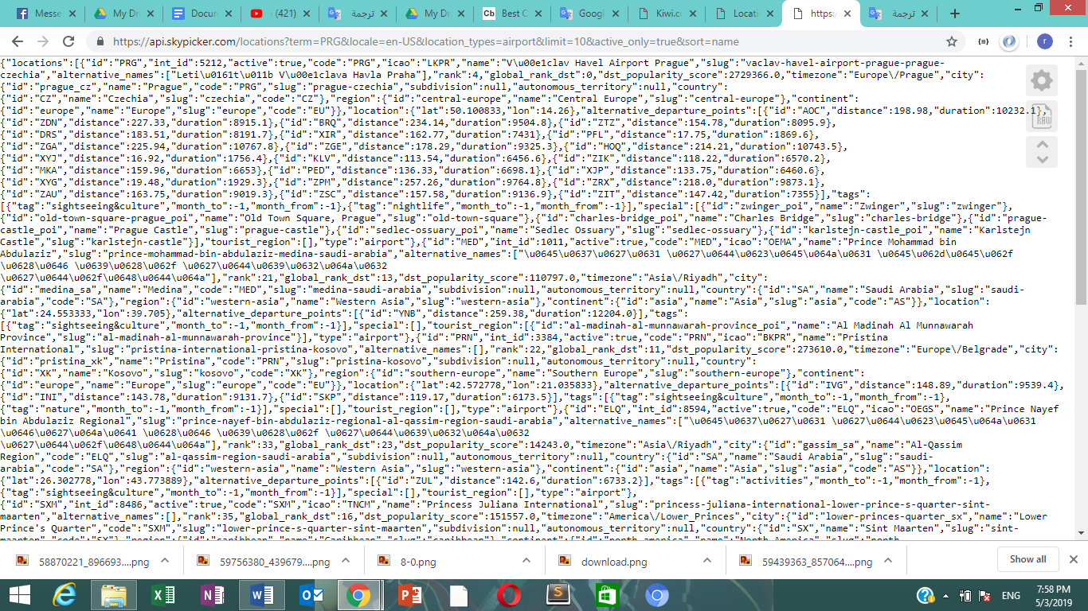

API data after a Json viewer tool.
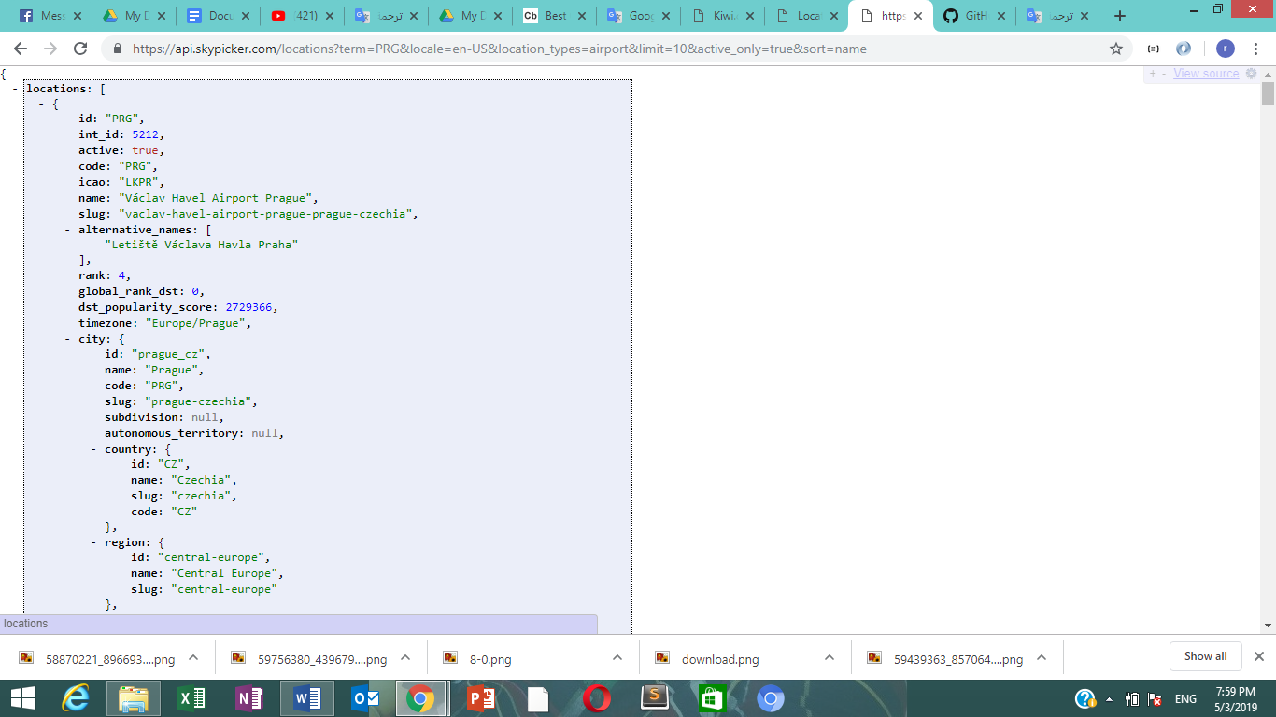

Finally we building the code that include a servlet, and consumer classes for processing the API and others functions in our website ,and jsp files for displaying our functionality as a services in the web browser .

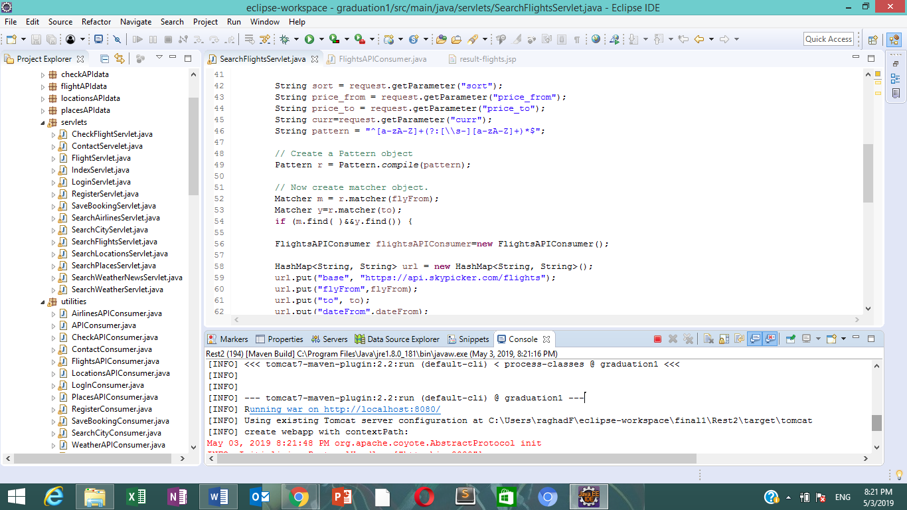

Finally we finished our website a Traveleyeser Website , At Traveleyser, our mission is to provide customers with the best value, high quality travel-related services from the most preferred and reliable suppliers in the travel industry.

