Table of Content
List of Figures………………………………………………………………………(3)
List of Tables………………………………………………………………………..(4)
Chapter (1): Introduction
  - The Whey Defined………………………………………………………….(7)
    - What is whey?................................................................................................(7)
    - Types of whey………………………………………………………………(7)
    - Properties and composition of whey………………………………………..(8)
    - Uses of Whey ………………………………………………………………(9)
1.2)The Whey Issue in Palestine…………………………………………………..(10)
1.2.1) Dairy industry in Palestine………………………………………………….(10)
1.2.2) Whey production in Palestine………………………………………………(10)
1.2.3) Properties of Palestinian Whey……………………………………………..(11)
1.2.4) Whey as an environmental problem facing dairy industry in Palestine…….(12)
1.3)Processed cheese……………………………………………………………....(12)
1.4)Objective………………………………………………………………………(13)
Chapter (2):Literature Review

2.1) Literature Review…………………………………………………………….(15)
Chapter (3):Methodology
3.1)Materials……………………………………………………………………....(20)
3.2) Methods………………………………………………………………………(20)
3.2.1) Whey collecting…………………………………………………………….(20)
3.2.2)Whey protein recovery from cheese whey by using water bath method……(21)
3.2.3)Preparation of spread cheese from recovered whey (direct heat)…………...(21)
3.2.4) Preparation of curds and whey from raw milk……………………………..(23)

3.2.5) Preparation of spread cheese from raw milk……………………………..…(25)
3.2.6) Preparation of spread cheese from raw milk and recycled whey mixtures…(26)
3.2.7) Sampling by Taste……………………………………………………….….(26)
3.2.8) Whey Analysis……………………………………………………………...(27)
Chapter (4) Result and Discussion
4.1) Result& Discussion………………………………………………………….(29)
4.2) Spread Cheese Questionnaire Results……………………………………….(32)
Chapter (5) Conclusion and Recommendation

5.1) Conclusion……………………………………………………………………(42)
5.2) Recommendation……………………………………………………………..(42)
References..............................................................................................................(43)
Attachments……………………………………………………………………...(44)

List of Figures:
Figure (2.1.1): Schematic flow chart of the basic steps involved in process cheese manufacturing…………………………………………………(17)
Figure (3.2.2.1):Whey protein recovery from cheese whey by using water bath………………………………………………………….....(21)
Figure (3.2.3.1): Whey protein appears on the surface of whey without vinegar........................................................................................(22)
Figure (3.2.3.2): Whey protein from surface of cheese whey…(22)
Figure (3.2.3.3): Whey protein as spread cheese after cooling …………………………………………………………………(23)
Figure (3.2.4.1): Coagulated crude from milk after adding white vinegar…....................................................................................(23)
Figure (3.2.4.2): Coagulated crude from milk after adding Apple vinegar………………………………………………………....(24)
Figure (3.2.4.3): Milks crude after whey removal by cheesecloth…………………………………………………….(24)
Figure (3.2.5.1): crude from raw milk with butter…………………………………………………………..(25)
Figure (3.2.5.2): Final spread cheese from raw milk……………………………………………………………(26)
Figure (4.2.1): Distribution of Gender………………………..(33)
Figure (4.2.2):frequency of each opinion about Q2…………..(34)
Figure (4.2.3) :frequency of each opinion about Q3………….(35)
Figure (4.2.4):frequency of each opinion about Q4…………..(36)
Figure (4.2.5):frequency of each opinion about Q5…………..(37)
Figure (4.2.6):frequency of each opinion about Q6…………..(38)
Figure (4.2.7):frequency of each opinion about Q7…………..(39)

List of Tables:
Table (1.1.3.1):Properties of whey……………………………………………..(8)
Table (1.2.1.1) :The amount of dairy product from raw milk in Al-Safa factory…………………………………………………………………………..(10)
Table(1.2.3.1): Ingredients of cheese whey sample……………………………(11)
Table(1.2.3.2): Ingredients of Labaneh whey sample………………………….(11)
Table (1.3.1): Some properties of different type of cheese…………………………………………………………………………..(13)
Table (4.1.1):Type of material used with pH………………………………….(29)
Table (4.1.2): Amount of whey, vinegar added, and pH measure……………..(29)
Table (4.1.3): Amount of milk, vinegar added, pH and viscosity measure……(30)
Table (4.1.4): Type of vinegar and properties of product………………………(30)
Table (4.1.5.): Amount of final product from raw material……………………(31)
Table (4.1.6): final properties of product………………………………………(31)
Table (4.2.1): Likert Scale Ranges and Explanations for Each Range...................................................................................................................(32)
Table(4.2.3): The descriptive statistics of all question in questionnaire………...…………………………………………………………(33)
Table (4.2.4): Analysis of 'What is your opinion about the general taste of sample?'…………………………………………………………………….......(34)
Table(4.2.5):Analysis of 'What is your opinion about the milk taste of sample?'………………………………………………………………..……….(35)
Table(4.2.6):Analysis of 'What is your opinion about the salt percentage & taste of sample?'…………………………………………………………………………(36)
Table(4.2.7):Analysis of 'What is your opinion about Acidity of sample?'………………………………………………………………………….(37)
Table(4.2.8):Analysis of 'What is your opinion about general structure of sample?'………………………………………………………………………….(38)
Table(4.2.9):Analysis of' Would you buy this product if it is offered in the local market?'…………………………………………………………………………(39)

Chapter (1)

Introduction

1.1)The Whey Defined.

1.1.1) what is whey?

The liquid that residue of cheese and casein production is called Whey. It's an important reservoir of food protein still remaining largely outside human consumption. About 80-90% of the total milk volume entering the dairy process will remain as by-product known as whey which is contains about 50% of nutrients in the original milk like proteins, lactose, vitamins and minerals. There are two kinds of whey, the first is sweet whey produced from the manufacturing of cheese and rennet casein and has a PH of 5.9-6.6. Acid whey is the second kind and is produced from the manufacturing of mineral-acid precipitated casein and has PH of 4.3-5.1. [1]

1.1.2) Types of whey.

Whey is classified according to the method of precipitation. Sweet whey is a by-product of cheese making at which precipitation take place due to rennet-enzyme. The range of acidity for sweet whey differs slightly according to references, its 5.9-6.6. Sweet whey is produced during the manufacturing of hard, semi hard or soft cheese likes Cheddar, Swiss and Mozzarella.
On the other hand, acid whey is obtained during making of acid type of cheese such as Cottage cheese, Curd cheese. Acidity of the acid whey is less than 5.1; in general it's between 4.3-5.1.
There are two reasons for decreasing the PH in acid whey from cheese manufacturing; the addition of bacteria which produces lactic acid and the direct addition of inorganic acids.
Sweet whey is better to dry than acid whey due to its high content of lactic acid which is very hygroscopic and so will agglomerate. Acid whey needs special treatment to mitigate its rather bitter, metallic taste. Acid whey has higher content of calcium, phosphorus and lactic acid. [2]
In Palestine, the major sources of whey are Labaneh (acid whey) and white cheese.[3]

1.1.3) Properties and composition of whey.
The main component of whey are lactose, protein, fat and minerals. The portions of the above components vary depending on the cheese making process. Lactose is the primary part of total solid of whey (between 63-75% of total whey solid).This ratio differs depending on the type of whey; acid whey appears to have low lactose content due to the fermentation of lactose into lactic acid. Protein is the most important whey component. It is between 9-11% of dry matter. The important of proteins resulting from their high nutrients value.
On the other hand, the two types of whey shows variations in the minerals content. In general, acid whey has higher content of minerals than sweet whey, especially in calcium and phosphorus.
The traditional whey have greenish color due to presence of riboflavin which is sensitive to light ,so the whey will appear in green color. Whey may also appear in yellow color due to prolonged heating or by the use of water soluble annatto in cheese making process. Most of the produced whey shows turbidity as a result of casein fines.
The physicochemical properties of acid and sweet whey show variations that result from different acidity and content of both types. Calcium and acidity are important in whey protein heat stability while potassium is the reason of saltiness and together with lactose for the osmolality of whey. Some of the physicochemical properties of whey are listed in table(1.1.3.1).[4]
Table (1.1.3.1):properties of whey.
Property of whey | measurement
Viscosity (m Pa s) | 1.2
Surface tension (dyne/cm) | 42
Freezing point (°C) | -0.5
Stability against heat coagulation (standard PH) | Unstable
Stability against acid coagulation (No heat) | Stable

Table (1.1.3.1) show properties of whey in general which differ depending on kind. Heat stability is one of the important properties of whey. The acidity, temperature, calcium content and heating time are main factor that affect heat stability of whey. Whey which contains little content of calcium (sweet, decalcified acid whey or solution of whey protein isolate) will show turbidity but no precipitation upon heating. protein will not precipitate will precipitate if heating above 90 °C for 20 min or more if pH is lower than 3.9. protein will precipitate if heating above 70 °C and pH over than 3.9 with good calcium content.
1.1.4) Uses of Whey :
A number of product are obtained from whey processing like:
- Human food.
- Animal feed.
- Lactose.
- Sweet Cakes.
- Candy.
- Chocolate.
- Fudge.
- Coffee whiteners.
- Fruit beverages.
- Mayonnaise.
- Ice cream.
- Sport drink.[5]

1.2)The Whey Issue in Palestine
1.2.1) Dairy industry in Palestine
Dairy industry is one of the important industry in Palestine, such that large amount of the raw milk are used to this industry and many farmers sell the milk to dairy factories, and many workers are employed in this industry.
For this reasons , the dairy industry is considered as improvement of economy.
There are many dairy factories in Palestine but the major are:
- Safa in Nablus.
- Al-Rayyan& Al-Binar in Ramallah.
- Hamoda in Jerusalem.
- Al-Qaysi in Tulkarm.
- Al-Jibreeni& Al- Junidi in Hebron.

In Al-Safa factory, for example , the amount of milk in put equals (15000-19000) liter/day.
This amount is divided to produce many types of dairy products as shown in table (1.2.1.1).
Table(1.2.1.1) : The amount of dairy product from raw milk in Al-Safa factory.[3]
Type of dairy product | Percentage of origin milk
Yogurt | 20%
White Cheese | 15%
Labaneh | 25%
UHT milk, chocco and banana flavored taste | 40%

1.2.2) Whey production in Palestine
The white cheese and Labaneh are the main sources for whey production in Palestinian dairy industry . It estimated that (82-84)% of milk used in white cheese production ends up as whey; while in labaneh this function is (60-63)%.[3]

1.2.3) Properties of Palestinian Whey:
The different kinds of whey have the same components (protein, lactose, minerals,……), the variation between these kinds is in the fraction of each component. For example, all types of whey contain protein in there composition , but the percentage differ from type to type.
There are two reasons for this difference:
- Source of milk.
- Type of dairy process.
Its important before the choice of the suitable application for whey to know the accurate composition. So that, two different samples of whey (cheese &labaneh)
From Al-Safa factory were analyzed by chemical , Biological center at An-Najah university ,the results are listed in table (1.2.3.1) and (1.2.3.2).
Table(1.2.3.1): Ingredients of cheese whey sample.[6]
Test | Result | Unit
Protien | Non detective | %
Soluble solid | 3700 | ppm
Total solid | 6.58 | %
Conductivity | 5500 | µs/cm
Sodium | 280 | ppm
Phosphorus | 144 | ppm
Table(1.2.3.2): Ingredients of Labaneh whey sample.[6]
Test | Result | Unit
Protien | Non detective | %
Soluble solid | 3800 | ppm
Total solid | 5.00 | %
Conductivity | 7700 | µs/cm
Sodium | 300 | ppm
Phosphorus | 159 | ppm

1.2.4) Whey as an environmental problem facing dairy industry in Palestine.
Whey represents a serious environmental problem due to the presence of high concentration of dissolved organic substances.
The biochemical oxygen demand (BOD) of whey varies from 30000-50000 ppm depending upon the source of milk and lactose is mainly responsible for this high value. While (COD) of whey is 70000 ppm.
In general, waste products may occur as wastewater, solid material, and volatile compound. Discharging of wastewater with whey to surface water affected by:
Discharge of biodegradable organic compounds may cause a strong reduction of the amount of dissolved oxygen, which in turn may lead to reduced levels of activity or even death of aquatic life.[7]

1.3)Processed cheese:
Processed cheese is a dairy product which differ from natural cheese in the fact that process cheese is not made directly from milk. However, the main ingredient of process cheese is natural cheese. Processed cheese is produced by blending natural cheese of different ages and degree of maturity in the presence of emulsifying salts and other dairy and non-dairy ingredient followed by heating and continuous mixing to form a homogeneous product with an extended shelf life .
There are many different types of cheese, but each is made using similar principles of coagulating the proteins in milk to form curds, and then separating the curds from the liquid.
Cream cheese is a soft fresh acid-coagulated cheese product. Cheese is a naturally rich source of many nutrients including calcium, phosphorous, which good source of protein can be trusted highly in preventing boned calcification, fat soluble and B vitamins, the carbohydrate content of cream cheeses is in a minimum extent so would not add on weight to your body.
Soft cheese can be made at home. Processed cheese is produced boiling milk, then adding vinegar and stir continuously until the whey water and cheese separate. The vinegar provides the acid that causes the milk to curdle and produces the acid flavor. The traditional method of producing the acid is to use a culture of acid producing bacteria.

The main quality factors for cheese are the color, taste and texture. The color is

determined mostly by the amount of heating during processing and the fat content of

the milk. The taste and texture are both determined by the amount of lactic acid produced during the fermentation.
The products with high quality should have a uniform white to light cream color with a lightly lactic acid and cultured dactyl flavor and aroma. The texture of the products should be smooth without lumps, grittiness and with the ability to spread at room temperature.

Cheeses may be broadly grouped into soft, semi-hard and hard cheeses.[2]
Table (1.3.1): Some properties of different type of cheese.
Type of cheese | Moisture content(%) | Fat content(%) | Texture
Soft cheese | 45-75 | <40 | Soft, white, spreadable
Semi hard cheese | 35_75 | <35 | Firm, crumbly
Hard cheese | 30_40 | <30 | Very firm

1.4)Objective:
The objective of this project is to develop an optimal recipe for manufacturing spread cheese with well-defined properties. In addition, the study aims also at extracting whey protein from cheese wastewater to be utilized in the production of the spread cheese whey will be collected from dairy plants, then thermally treated to get whey protein concentrate. After that, the whey protein will be utilized in making spread cheese.

Chapter (2)

Literature Review

2.1) Literature Review:
In the previous studies different experiments have been done on cheese whey, we summarized the results and we relied on it in our project. These results were as follows:
1) (Siew Kim Lee,Skelte G. Anema) studied the effect of pH at cooking on the properties of processed cheese spreads containing whey proteins. They prepared cheese sample with added whey portions, WPC (15.36 g) was added to water (67.64 g) and stirred for30 min to form a well dispersed solution. Rennet casein (55.08 g) and NaCl (6 g) were added to a calcium chelator solution containing water (170 g), trisodium citrate (TSC) and citric acid (CA) to achieve different pH of the processed cheese during cooking. The mixture was rapidly stirred for a few minutes at room temperature where the slurry set into a gel-like material. The WPC and gelled rennet casein solutions were allowed to hydrate for 12 h in a refrigerator set to5 C.
The sun flower oil (192 g) was heated for 1 min at a temperature setting of 100 C at speed 1(100 rpm),after which the temperature setting was lowered to 60 C.
The hydrated rennet casein, WPC and additional water (48.7 g) were added to the warm oil and the mixture was cooked at a temperature setting of 90C for 2 min at speed 4 (2000 rpm),after which the temperature setting was lowered to 80C and held at this setting for 5 min. The remaining CA or TSC was dissolved in water (20 g) and added to the mixture. The mixture was then cooked for a further 2 min at 80 C at speed4 (2000 rpm). This late addition of CA or TSC shifts the processed cheese from its cook pH to a final pH of 5.7. The final temperature of the molten processed cheese was 85 C. The molten processed cheese was poured into plastic containers and then stored at 5 C. The target composition of the processed cheese spreads was 52.1% moisture,10.1% protein (80% casein from rennet casein, 20% whey protein from WPC), 33.2% fat, 2.6% calcium chelating salts (ratio TSC:CA = 3.2:1) and 2.0% minerals. This composition is typical of processed cheese spread products.
Then they prepared process cheese with no whey added. After that tests were done on cheese like: the moisture content, pH, rheological properties, and level of whey protein denaturation .
The result shows that varying the cook pH in a processed cheese system containing whey proteins affected the whey protein denaturation and interactions to form different structures, which ultimately control the rheological and textural properties of the final product.
In the samples where no whey proteins, varying the cook pH did not affect the textural properties of these processed cheese spreads. [7]

2) (Ana R. Prazeres, Fatima Carvalho, Javier Rivas)published a research about cheese whey management. They studied cheese whey characterization, whey treatment methods which are:
    - Biological without valorization by aerobic digestion.
    - Biological with valorization by aerobic digestion, lactose hydrolysis, fermentation whey to ethanol or hydrogen or lactic acid.
    - Physicochemical treatment includes protein precipitation with coagulant/flocculation agents like sodium polyphosphate, and iron salts (FeCl3).This method provides clarified supernatants with low fat and protein content. And removes lactose content.
    - Membrane separation .This method includes RO produce protein/lactose concentration , with protein recovery 87-100% and lactose recovery 89-100%.[8]

3) Another review,(RohitKapoor and LioydE.Metzger) published research with title (Process cheese: Scientific and Technological Aspects _A Review).
In this study, they talked about process cheese manufacturing, the major steps in process cheese manufacturing can be divided into 2 stages:
- Ingredient selection and formulation:
- Selection a natural cheese (based on age, pH, flavor, and casein content).
- Selection emulsifying salt
- Formulation ingredients in order to meet wanted value of moisture,
Fat, salt, and pH.
- Process cheese processing and storage:
- Cooking (heating+ mixing).
- Packaging, cooling, and storage.

Addition of ingredients:
-Dairy protein.
-Dairy fat.
-Preservative.
-Coloring agents.
-Flavoring agents.
-Water.
-salt.
-Acidulants.

of natural cheese electionS
Grinding

Blending

Processing
Packaging
Emulsifying salts.
-disodium phosphate.
- trisodium citrate.

Cooling

Figure (2.1.1): Schematic flow chart of the basic steps involved in process cheese manufacturing.

The study also include process cheese physicochemical properties and micro structure. This section talked about casein and natural cheese, process cheese, and technique for measuring process cheese physicochemical properties and microstructure (Spectroscopic technique and Analytical techniques involving wet chemistry).
The next is about process cheese functional properties, these properties grouped into two major categories: Un melted properties and melted textural properties.
After that , the authors defined factors controlling process properties, these factors are total calcium content, intact casein content, pH, emulsifying salts, lactose content, whey protein content, and finally effect of ingredients.

Also, processing conditions have been studied, which are temperature, time, Mixing speed, and rate of cooling after manufacture.
Finally, the authors discussed defects in cheese such as crystal development, color change and oil separation.[9]

Chapter (3)

Methodology

Materials and Methods:

3.1)Materials:
Waste cheese whey was collected from Al-Safa dairy factory (Nablus, Palestine). Raw cow milk was obtained from (local cow farms, Tubas, Palestine). Butter (from local supermarket) was added during cheese production to enhance texture. (Vinegar: white, grape, Apple & acetic acid/Al-Shinnar Company, Nablus, Palestine) was added to the milk to adjust the pH during cheese making process.

3.2) Methods:

3.2.1) Whey collecting:
Same way was standardized in the collection of raw whey regardless of cheese whey or Labaneh whey. For labaneh whey, the yogurt was filled in cloth packages which enable the whey to separate and pass through the cloth. Since there was some of yogurt will pass with whey at the beginning, the collection was achieved after certain time when the whey separate free from yogurt. In case of cheese whey, after the competition of cheesing process ,the whey will appear as yellow-greenish liquid above the cheese and it was preferred to drain the early whey and perform the collection process after certain time to get stabilized whey.
For both types, the collection process was achieved using clean bottle of 4 L capacity.
The bottle was placed under the drainage valve for tank containing whey then cool the whey to 4ºC to stop the growth of bacteria.

3.2.2)Whey protein recovery from cheese whey by using water bath method:
1 liter of waste cheese whey was placed in a beaker, and then put it in a water bath at a temperature of 95 ºC for (30-45) minute. Once the whey waste reached the required temperature, whey protein starts to precipitate the bottom of the beaker which is then recovered using a peace of filter cloth.
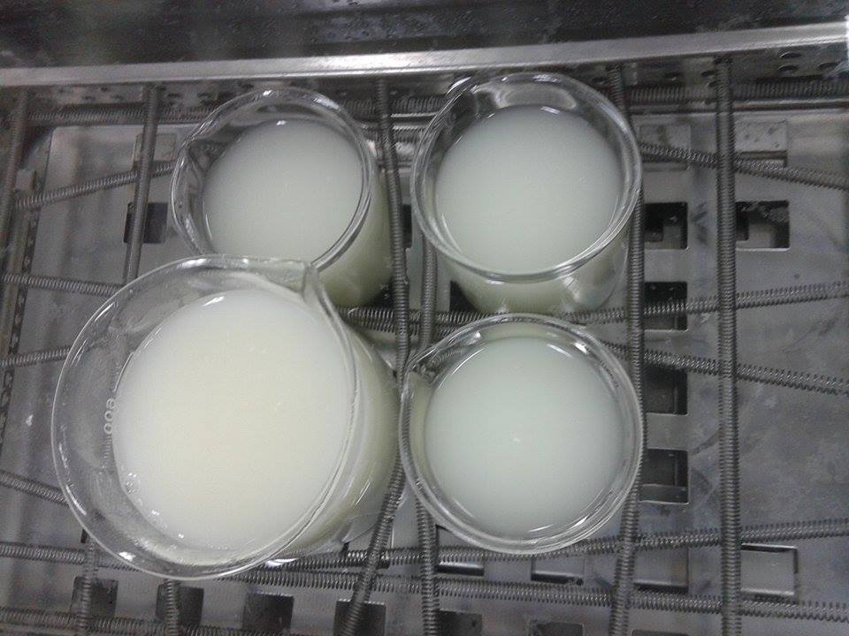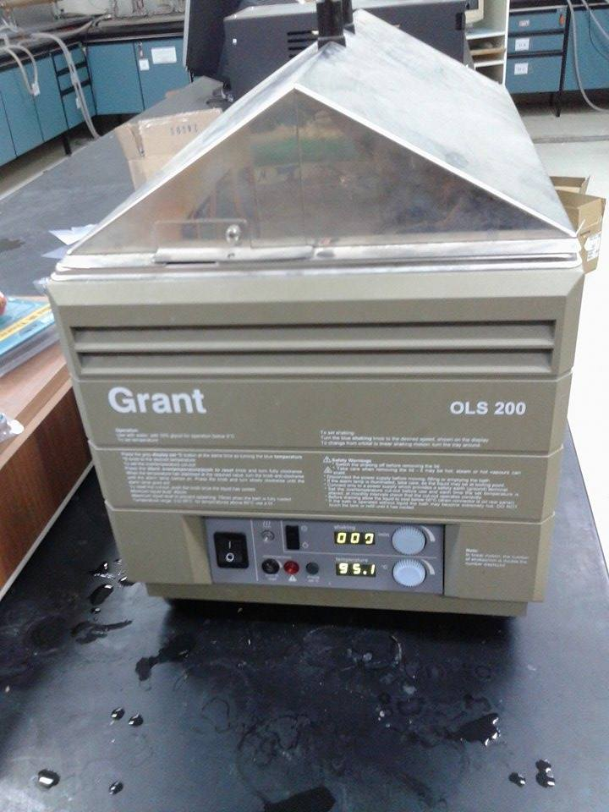
Figure (3.2.2.1):Whey protein recovery from cheese whey by using water bath.

3.2.3)Preparation of spread cheese from recovered whey:
A direct heat:
In order to make spread cheese from whey, we have been extracted whey protein from cheese whey by direct heat method, then added to it salt and butter, mix it for 6 minutes, and finally put it in refrigerator for 3 hours.
As first step, save the whey from making cheese, cover the whey and let it sit for at least 12 hours at room temperature to develop sufficient acidity. Pour the 4 liter whey into a saucepan and heat it while stirring, taking care to avoid sticking or burning. Heat until the temperature has risen to about 80 ºC and at which a white cloud appears at the surface (see figure 3.2.3.1). Continue heating and stirring until the temperature reaches 93 ºC.
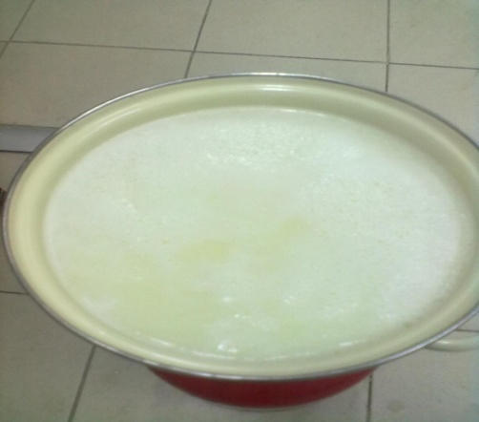
Figure (3.2.3.1): Whey protein appears on the surface of whey without vinegar.
After that, remove the white clouds from the surface slowly , then drain the whey through the cloth as shown in (figure 3.2.3.2) It can take 2-3 hours for the whey to completely drain.
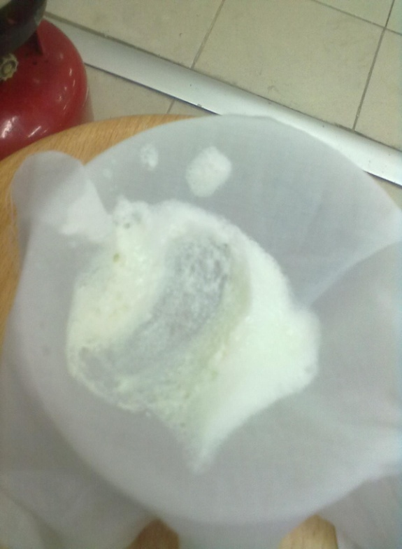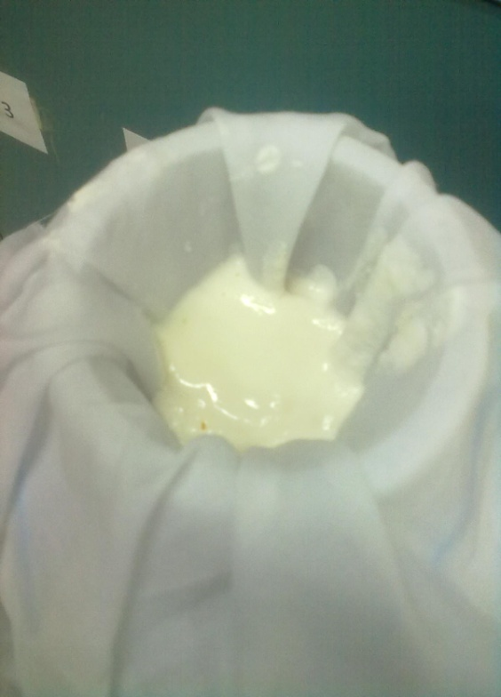
Figure (3.2.3.2): Whey protein from surface of cheese whey.
Finally, add 4 gram of salt (NaCl) and20 gram soft butter to cheese, then mix it with blender for 3-6 minute, in this step you may add some whey to get the required texture.
Take cheese and put it in the refrigerator and let it cool (see figure 3.2.3.3) for spread cheese after cooling).
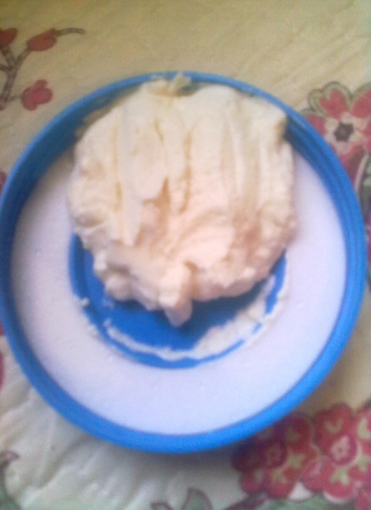
Figure (3.2.3.3): Whey protein as spread cheese after cooling.

3.2.4) Preparation of curds and whey from raw milk:

Cruds had been obtained by using raw milk with direct heating treatment:
Firstly, put one liter of cow milk in a saucepan, heat it over moderate heat allow it to heat until it reaches 95ºC. When the mixture is hot enough, turn off the heat and move the saucepan so the milk can begin to cool. It should take about 5 minutes to reach the correct temperature. Stir the mixture as it's heating to prevent it from scorching on the bottom. Slowly add the vinegar; use one hand to stir constantly while the other hand slowly pours the vinegar into the heated milk .The vinegar will cause the curds to coagulate and separate from the whey. Solid bits formed and coagulated in whey liquid (see figure 3.2.4.1). Keep stirring until all of the vinegar has been added.

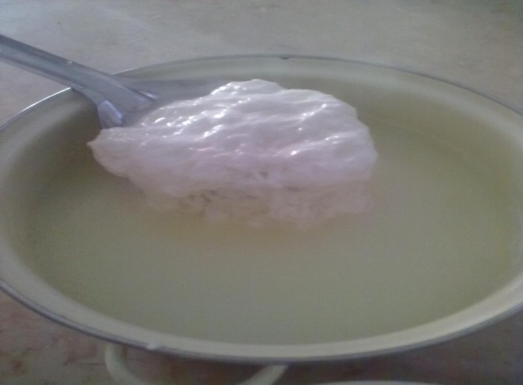

Figure (3.2.4.1): Coagulated crude from milk after adding white vinegar.
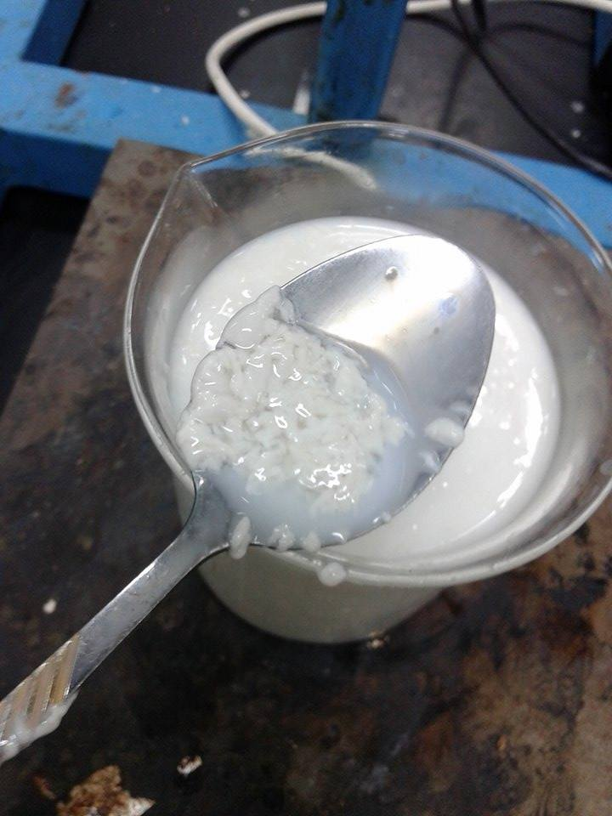
Figure (3.2.4.2): Coagulated crude from milk after adding Apple vinegar.
Finally, prepare the fine-mesh strainer with a large piece of cheesecloth, and set it over the bowl as shown in (figure3.2.4.3). Pour the mixture of crude and whey on it and wait 5 minute to separate crude from whey.
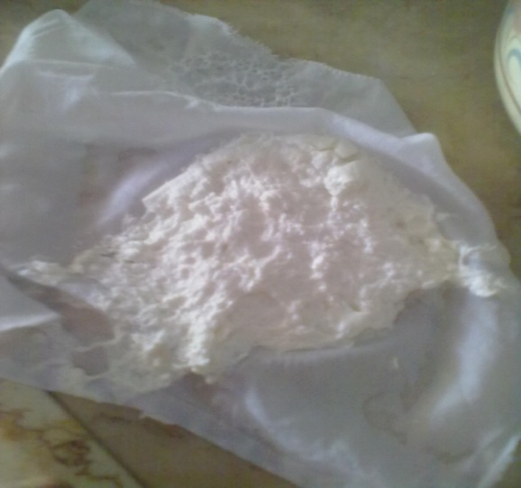
Figure (3.2.4.3): Milks crude after whey removal by cheese cloth.

3.2.5) Preparation of spread cheese from raw milk:

Pour 3 liter of raw milk in saucepan, then put it on fire until its start produce some foaming. Add mixture of white vinegar and lemon (1/3 cup) to the milk and let milk to coagulate and stir it gently. After that, Pour the mixture of crude and whey on fine-mesh strainer with a large piece of cheesecloth and wait 5 minute to separate crude from whey, then take a crude from cheesecloth , add 60 g of butter , salt and a little of natural lemon juice (see figure 3.2.5.1).

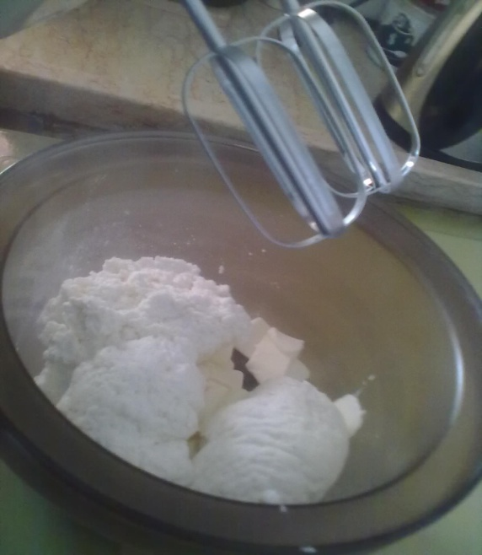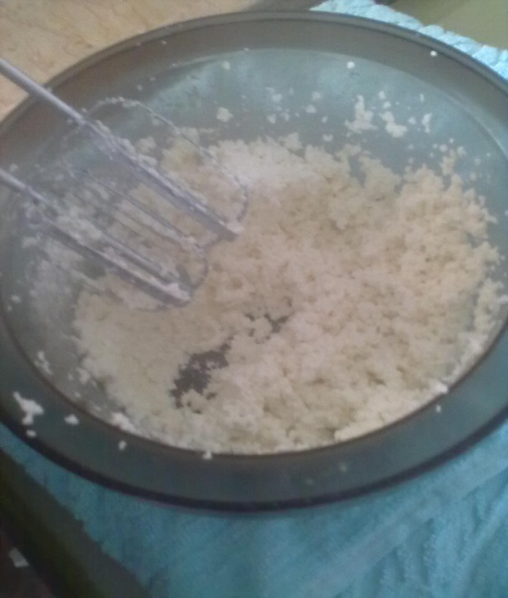
Figure (3.2.5.1): crude from raw milk with butter.

Then, put the mixture in a blender. Mix for 6-10 minute until the mixture become Smooth and coherent as shown in (Figure 3.2.5.2)

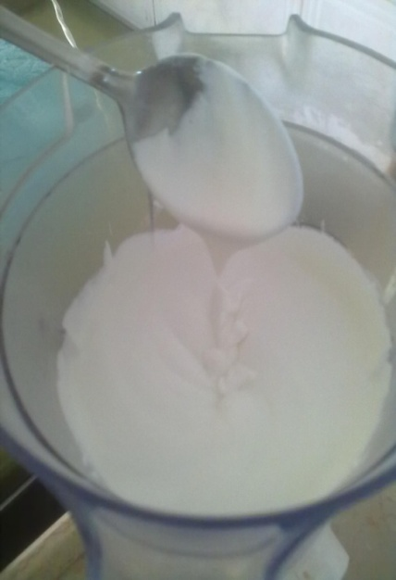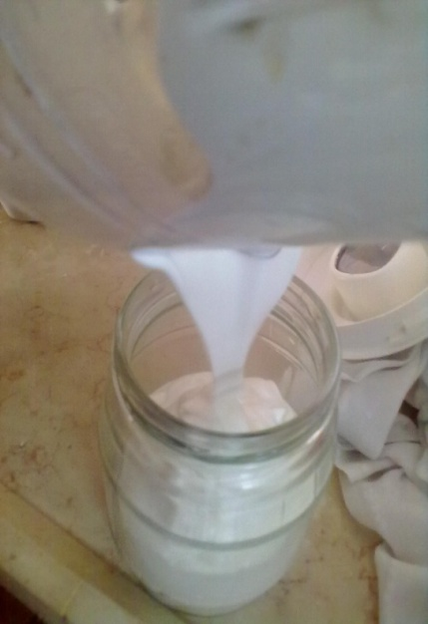
Figure (3.2.5.2): Final spread cheese from raw milk.

Finally, put spread cheese in refrigerator for 3–5 hours.
3.2.6) Preparation of spread cheese from raw milk and recycled whey mixtures:
In order to get spread cheese from milk and whey together, follow the previous two processes to obtain final whey protein from cheese whey, and crude from raw milk. After that many samples were made with different percentage
- Spread cheese from 50% milk and 50% whey.
- Spread cheese from 70% milk and 30% whey.
- Spread cheese from 30% milk and 70% whey.
then add to it butter and salt. Finally mix it in a blender for 5 minute. Cool cheese in refrigerator is important step after mixing.
3.2.7) Sampling by Taste:
After the samples were done, it tasted by students and employees found in laboratory to test smell, acidity, saltiness, structure, and strength of flavor. There comment were recorded.

3.2.8) Whey Analysis:
Tow different sample of whey (cheese & labaneh) from Al-Safa factory were analyzed at An-Najah university.
To measure the accurate composition of whey, the following equipments were used:
Protein:
    - Digestion System 20(1015 Digester).
    - Distillation System 1026 (KJELTEC SYSTEM).
Total soluble solid:
    - Moisture Balance EB-340 MOC.
Sodium:
    - Flame photometer.
pH:
    - pH meter.
Phosphorous:
    - UV-1601 PC.

Chapter (4)

Result and Discussion

4.1) Result& Discussion:
In the current study, the whey is recovered from the wastewater of cheese processing by heating and adjusting the pH. The recovery process requires acidic environment which was achieved by adding different types of food grade vinegar. Table (4.1.1) shows the initial pH of types of vinegar used and some of the dairy products.
Table (4.1.1):initial pH values of different types of vinegar and some of the dairy products.
Type | pH
Pure Whey (cheese) | 7.07
Pure Whey (Labaneh) | 6.8
Raw milk | 6.89
White vinegar | 3.15
Apple vinegar | 4.2
Acetic Acid | 4.53

Table (4.1.2) shows the effect of the amount of vinegar added on the pH of the whey during whey recovery process. The results showed that the maximum amount of recovered whey is obtained with a pH of 5.42 by using white vinegar.
Table (4.1.2): Amount of whey, vinegar added, and pH measure.
Number of sample | Volume of whey  (liter) | Added vinegar(ml) | pH
1 | 1 | 10 | 5.70
2 | 1 | 15 | 5.42

Table (4.1.3) shows selected results of the effect of the amount of vinegar added and type of vinegar on the pH and viscosity of the milk during crude recovery process. The volume of added the vinegar is not the same as the types of vinegar used are food grade ones obtained from the local market and their initial pH values are not the same(see Table 4.1.1). Many experiments were (more than 50 experiments) performed to obtain the optimal type and amount of vinegar that should be added to achieve the maximum crude recovery. The results showed that the maximum amount of recovered crude was obtained with a pH of 5.6by using white vinegar with viscosity of18011mPa.s. Furthermore, the effect of the type and amount of vinegar on the final spread cheese product was investigated. Table (4.1.4) shows the amount and type of vinegar used to obtain the optimal recipe of final product, It was found that the white vinegar. is most appropriate for the production of spread cheese in terms of taste and yield.

Table (4.1.3): Amount of milk, vinegar added, pH and viscosity measure.
Number of sample | Volume of milk (liter) | Type of vinegar | Added volume (ml) | pH | Viscosity  mPa.s))
1 | 1 | White | 12 | 5.6 | 18011
2 | 1 | White | 20 | 5.26 | 18000
3 | 1 | Apple | 16 | 4.6 | 17784
4 | 1 | Grape | 15 | 5.1 | 17985
5 | 1 | Acetic Acid | 18 | 4.3 | 17453

Table (4.1.4): Type of vinegar and properties of product.
Type of vinegar | Properties of product
Grape Vinegar | Good product with desired property for customers
Apple Vinegar | Un-desired product(it has undesired odor)
Acetic acid | Un-desired product(it has undesired and strong odor, also it is very concentrate)

After a detailed experimental study of the ingredients that can be used in the preparation of spread cheese through a thorough optimization process a well-defined recipe of the first Palestinian spread cheese is achieved and the results are shown in Tables (4.1.5)&(4.1.6). The prepared spread cheese has a pH equal 5.68and Viscosityof18011 (mPa.s).
Table (4.1.5.): Amount of final product from raw material.
Material | Amount | Unit
Milk | 1000 | Ml
White vinegar | 12 | Ml
Salt | 2.5 | Gram
Final product | 105.43 | Gram
Table (4.1.6): final properties of product
Properties | Our product | Commercial product  (pock cheese) | Note
pH | 5.68 |  | -
Viscosity | 18011 (mPa.s) |  | Error = 28%

4.2) Spread Cheese Questionnaire Results:
After many trials attempting to obtain the optimal spread cheese recipe as shown in table 4.5, it was important to consult the customers about product through a questionnaire. This questionnaire is composed of 7 questions focusing on the public opinion and customer satisfaction of our spread cheese. The SPSS program was used to analyze the result of the questionnaire according to the Likert Scale method. It is a five point scale used to analyze questionnaires according to respondents answers. First the range of each period is determined. This equals to the difference between the maximum and minimum values.
Table (4.2.1): Likert Scale Ranges and Explanations for Each Range.
Mean Range | Explanation
1.00-1.79 | Strongly Against, Very Bad
1.80-2.59 | Against , Bad
2.60-3.39 | No Opinion , Fair
3.40-4.19 | With , Good
4.20-5.00 | Strongly with , Very Good(Excellent)

Analysis for the Collected Questionnaires
After exclusion of some questionnaires due to missing of some question answers or some questions were answered in a wrong way, the remaining were 110 out of the 130 distributed questionnaires. This includes 47males and 63 females as shown in figure (4.2.1) and table (4.2.2).

Figure (4.2.1): Distribution of Interviewed Persons According to Gender
Table(4.2.3): The descriptive statistics of all question in questionnaire.
Descriptive Statistics
 | N | Minimum | Maximum | Mean | Description
Q1(Gender) | 110 | 1 | 2 | 1.10
Q2 | 110 | 1 | 5 | 3.55 | Good
Q3 | 110 | 1 | 5 | 3.45 | Good
Q4 | 110 | 1 | 5 | 3.41 | Good
Q5 | 110 | 1 | 5 | 3.79 | Good
Q6 | 110 | 1 | 5 | 3.50 | Good
Q7 | 110 | 1 | 5 | 3.50 | Good

Question 2: What is your opinion about the general taste of sample?
From Table(4.2.4) it can be concluded that the total frequency is 110. The maximum opinion is good with frequency of 46 and percent 41.8 %, while the least is no opinion with 10% percentage. The mean of the answers is 3.55 which belong to the range of (3.4-4.19), which can be explained as good rating according to Likert Scale.
Table (4.2.4): Analysis of question 2:'What is your opinion about the general taste of sample?'
Q2
Answer | Frequency | Percent | Valid Percent
No opinion | 11 | 10 | 10
Medium | 35 | 31.8 | 31.8
Good | 46 | 41.8 | 41.8
Excellent | 18 | 16.4 | 16.4
Total | 110 | 100 | 100

Figure (4.2.2) shows the chart of frequency of each opinion about Q2.

Figure (4.2.2):frequency of each opinion about Q2.

Question 3: What is your opinion about the milk taste of sample?
This question investigates opinion the of public about milk taste in sample. As shown in figure (4.2.3) and table(4.2.5),most of interviewed persons said its medium with a percentage of 43.6%, followed by excellent with percentage of 24.5%, while the least is bad with a percentage of 2.7%.The mean of the answers is 3.45 which belong to the range of (3.4-4.19), which can be explained as good rating according to Likert Scale.
Table(4.2.5):Analysis of question 3'What is your opinion about the milk taste of sample?'
Q3
Answer | Frequency | Percent | Valid Percent
No opinion | 11 | 10 | 10
Bad | 3 | 2.7 | 2.7
Medium | 48 | 43.6 | 43.6
Good | 21 | 19.1 | 19.1
excellent | 27 | 24.5 | 24.5
Total | 110 | 100 | 100

Figure (4.2.3) :frequency of each opinion about Q3.

Question 4: What is your opinion about the salt percentage & taste of sample?
This question asks about salt percent and taste in sample. As shown in figure (4.2.4) and table (4.2.6), about 8.18 % of persons evaluate it as bad and 10% as no opinion. Medium rating is chosen by 28.18 % of interviewed persons. About 15.45% evaluate it as excellent and 38.18% choose very good rating. The mean of the answers is 3.41 which belong to the range of (3.4-4.19), which can be explained as good rating according to Likert Scale.
Table(4.2.6):Analysis of question 4'What is your opinion about the salt percentage & taste of sample?'
Q4
 | Frequency | Percent | Valid Percent
no opinion | 11 | 10.00 | 10.00
Bad | 9 | 8.18 | 8.18
medium | 31 | 28.18 | 28.18
Good | 42 | 38.18 | 38.18
Excellent | 17 | 15.45 | 15.45
Total | 110 | 100.00 | 100.00

Figure (4.2.4):frequency of each opinion about Q4.

Question 5: What is your opinion about acidity of sample?
This question asks about acidity taste in sample. As shown in figure (4.2.5) and table (4.2.7), about 3.63 % of persons evaluate it as bad and 10% as no opinion. Medium rating is chosen by 17.27 % of interviewed persons. About 33.64% evaluate it as excellent and 35.45% choose very good rating. The mean of the answers is 3.79 which belong to the range of (3.4-4.19), which can be explained as good rating according to Likert Scale.
Table(4.2.7):Analysis of question 5 'What is your opinion about acidity of sample?'
Q5
 | Frequency | Percent | Valid Percent
no opinion | 11 | 10.00 | 10.00
Bad | 4 | 3.64 | 3.64
Medium | 19 | 17.27 | 17.27
Good | 39 | 35.45 | 35.45
Excellent | 37 | 33.64 | 33.64
Total | 110 | 100.00 | 100.00

Figure (4.2.5):frequency of each opinion about Q5.

Question 6: What is your opinion about general structure of sample?
This question asks about product structure . As shown in figure (4.2.6) and table (4.2.8), about 4.55% of persons evaluate it as bad and 10% as no opinion. Medium rating is chosen by 30.91 % of interviewed persons. About 20% evaluate it as excellent and 34.55% choose very good rating. The mean of the answers is 3.50 which belong to the range of (3.4-4.19), which can be explained as good rating according to Likert Scale.
Table(4.2.8):Analysis of question 6 'What is your opinion about general structure of sample?'
Q6
 | Frequency | Percent | Valid Percent
no opinion | 11 | 10.00 | 10.00
Bad | 5 | 4.55 | 4.55
Medium | 34 | 30.91 | 30.91
Good | 38 | 34.55 | 34.55
Excellent | 22 | 20.00 | 20.00
Total | 110 | 100.00 | 100.00

Figure (4.2.6):frequency of each opinion about Q6.

Question 7: Would you buy this product if it is offered in the local market?
This question asks someone would buy the product .As shown in figure (4.2.7) and table (4.2.9), about 7.3% of persons evaluate it as no 'bad' and 10% as no opinion. Medium rating is chosen by 25.50 % of interviewed persons. About 20% evaluate it as excellent and 37.30% choose very good rating. The mean of the answers is 3.50 which belong to the range of (3.4-4.19), which can be explained as good rating according to Likert Scale.
Table(4.2.9):Analysis of question 7 ‘Would you buy this product if it is offered in the local market?'
Q7
 | Frequency | Percent | Valid Percent
no opinion | 11 | 10.00 | 10.00
no bad | 8 | 7.30 | 7.30
yes medium | 28 | 25.50 | 25.50
yes good | 41 | 37.30 | 37.30
yes excellent | 22 | 20.00 | 20.00
Total | 110 | 100.00 | 100.00

Figure (4.2.7):frequency of each opinion about Q7.

The result of questionnaire shows that the majority of people rate our spread cheese as good for general taste ,milk taste ,structure ,odor, acidity and salt content and most important they would buy it if it is offered in the local market

Chapter (5)

Conclusion and Recommendation

5.1) Conclusion:
In this study optimal recipe for manufacturing spread cheese with well-defined properties was successfully developed. The developed recipe composed of raw milk (1000 ml), white vinegar (12 ml) and salt (2.5g) to obtain (105 g) of the final product. The pH and viscosity of the obtained spread cheese was approximately 5.68 and 18011 mPa.s. respectively. In addition, whey protein from cheese wastewater was recovered and utilized in the production of the spread cheese. The recovery process of whey protein from cheese whey by using water bath and direct heating. In first method the addition of vinegar included, and the most appropriate amount is 15 ml for a liter of whey and the final pH=5.42.
. The result of a questionnaire that was conducted on a sample of 110 persons shows that the majority of people rate our spread cheese as good for general taste , milk taste , structure ,odor, acidity and salt content and most importantly they would certainly buy it if it is offered in the local market.
5.2)Recommendation:
We strongly recommend the local dairy industry to invest in manufacturing spread cheese locally as there is no Palestinian spread cheese available in the market. We would be happy to cooperate with the local industry in developing such a product as this project provide a solid background for starting with the production of spread cheese.
Our project was an important step toward the recycle of whey but it is very important to increase acceptance of product between the public. Also, more biological study and tests should be made to know the accurate shelf life of product and its healthy effects on people.

References:
[1]:Lund,G"Sea,Dairy Processing Hand book 1995,Tetra Pak processing system AB.
[2]: Onwulata, C. andHuth, P.(2008).Whey Processing, Functionality and Health Benefits, 1st edition), Jhon Wiley, USA.
[3]: Private communication with staff members in Al-Safafactory,Nablus, Palestine.
[4]: Frederick J.Francis, Encyclopedia of Dairy chemistry,A Chapman and Hall food Science Book,NewYourk 1988.
[5]:IDFA (International Dairy Food Association), Assessed on (22, Mar, 2015) from
http://www.idfa.org/news-views/media-kits/cheese/types-of-cheeses .
[6]:Chemical ,Biological Analyzer center at An-Najah University.
[7]: Food and Agriculture Organization of the United Nation,Assessed on (22, Mar, 2015) fromwww.fao.org .
[7]:(Lee, S.K andAnema,S.G. (2009).The effect of the pH at cooking on the properties of processed cheese spreads containing whey proteins, Food Chemistry, New Zealand, 1373-1380).
[8]: Prazeres, A. R,Carvalho,FandRivas,J.(2012). Cheese whey management: A review, Journal of Environmental Management, 68,2-3.
[9]: (Kapoor,RandMetzger,L.E.(2008). Process cheese: Scientific and Technological Aspects _A Review, Comprehensive Reviews in food science and food safety, 195-214)

Attachments:

Label of our spread cheese :

