
Faculty Of Engineering
And Information Technology

Human Resources Management System for Small Businesses

BY:
Hamed Saleh Hamdan
Mahmoud Adnan Suboh

supervised by:
Dr.Kamal Irshaid
Dr.Amjad Hawash

Introduction:

Before starting we would like to thank everyone who had a role in our university life
especially family, friends and lecturers .
This project is a summary of years of learning at the university and we tried to combine all concepts which we learned in lectures to configure the project in all its parts through the concepts of software and management .
The importance of human resources has received much attention in Palestine in recent years and we seek through this project to find solutions in human capital in small business especially in Palestine Where the number of institutions in Palestine more than 135 thousand institutions 93% of them classified as SMEs (Small and medium-sized enterprises).

Definition :
As a small business manager, you'll always be involved in human resource management. Good or bad, it will always be there for you to handle.
It can become the single largest consumer of your time and energy if you do not know how to handle things well. And, it's still a big consumer of your time and energy, even if your adept at handling such things.
That's just how it is. The only way to avoid employee issues is to do everything yourself.
So what is HR and why we use it?
A Human Resource Management System or (HRIS): is a form of HR software that combines a number of systems and processes to ensure the easy management of human resources, business processes and data .
Human resources (HR) is the department within a business that is responsible for all things worker-related. That includes recruiting, vetting, selecting, hiring, on boarding, training, promoting, paying, and firing employees and independent contractors.

The users of HRMS in the business is all employee in organization from CEO to worker all according to its validity and function and in this project we focus in the structure of small business , the structure that all section can easily reach each other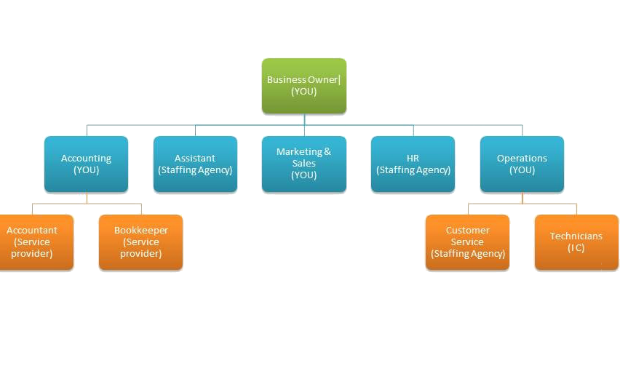,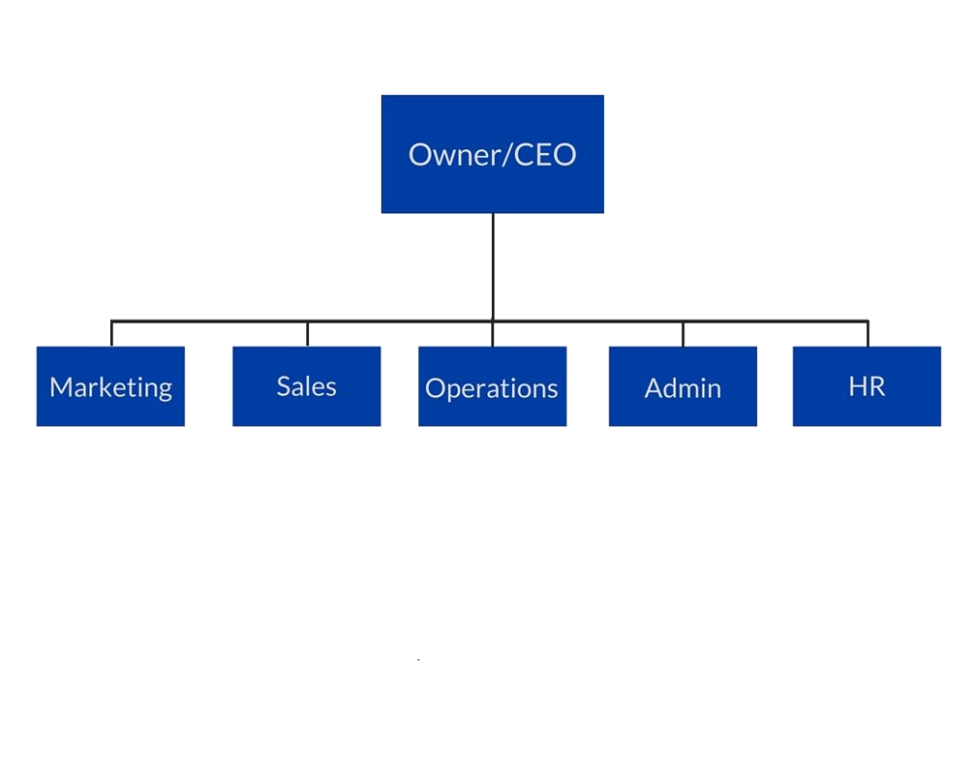
Why we use HRMS in small business ? or what is the problem in small business?
- Cash Flow Issues

Money problems in their various forms are top of most lists of company woes, and for small businesses the major worries are clients stalling payments, unexpected outgoings, and outstanding bills that won’t wait to be paid

Employee Relations

A company that lacks human resources may have difficulty developing and maintaining a solid relationship with employees.

- Hiring Process

Managers and owners need a lot of time to finding qualified employees when positions open up. owners and managers can’t focus on their daily tasks .

- commitment of employees

One of the most important problems in any organization is commitment people are the key factor to success and stability of any organization more than technology , if the culture in organization is does not promote stability the business will fail .

- control , supervision and monitoring issue

The organization should find the best way to control the staff without affecting the productivity and mutual relationship between employees.
Project Objective Statement:

HRMS is useful not only to organization, but the employees working therein.

Organizational Objectives
HRMS is a means to achieve efficiency and effectiveness. It serves other functional areas, so as to help them to attain efficiency in their operations and attainment of goals to attain efficiency.
Financial objective
The project give a salary system that can control all cash flow in organization in simple way and that help all section in organization to make financial report .

Management Objectives

Reducing repetitive administrative tasks and automating some processes within a company improves overall ,also make employee monitoring and control easier .

Time & attendance management
This feature tracks employees’ work hours and ensures that employees are properly compensated for working overtime. Without an HRMS, this information is difficult to monitor without missing any details.

use-cases diagram
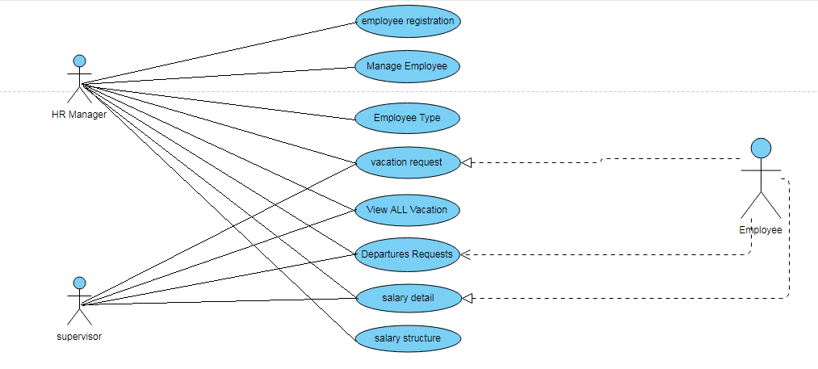
ERD Diagram:

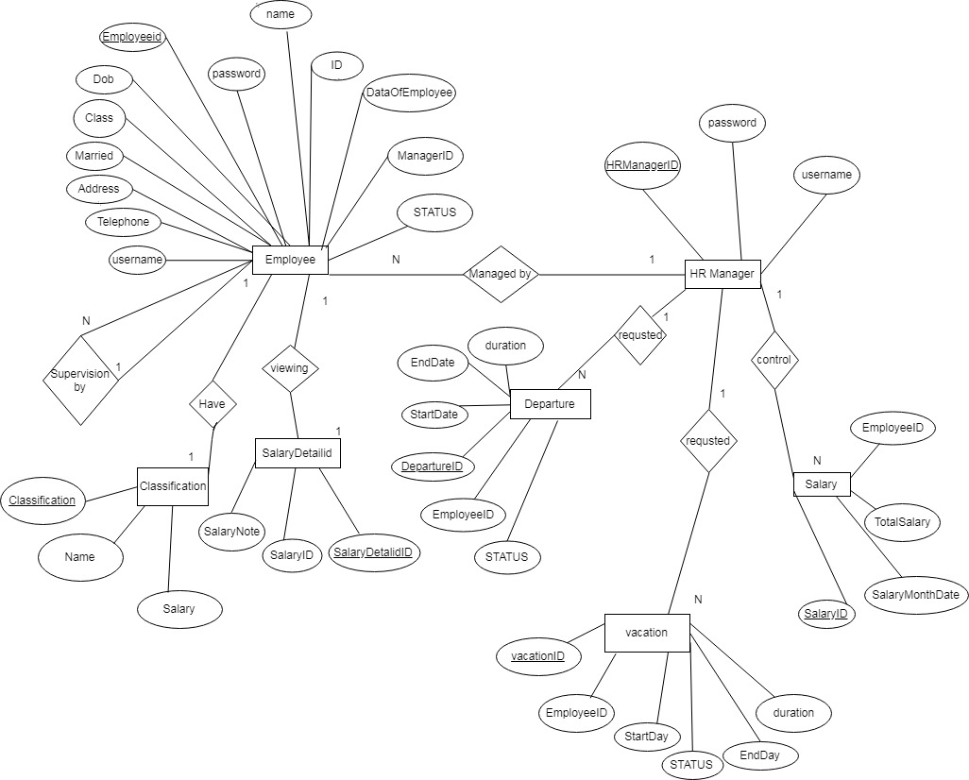

Output and Input Design
HRMS project developed in PHP, MYSQL, HTML, CSS, Bootstrap and JavaScript. This project is developed in Xampp Server
Here are some examples of designs

Employee main page
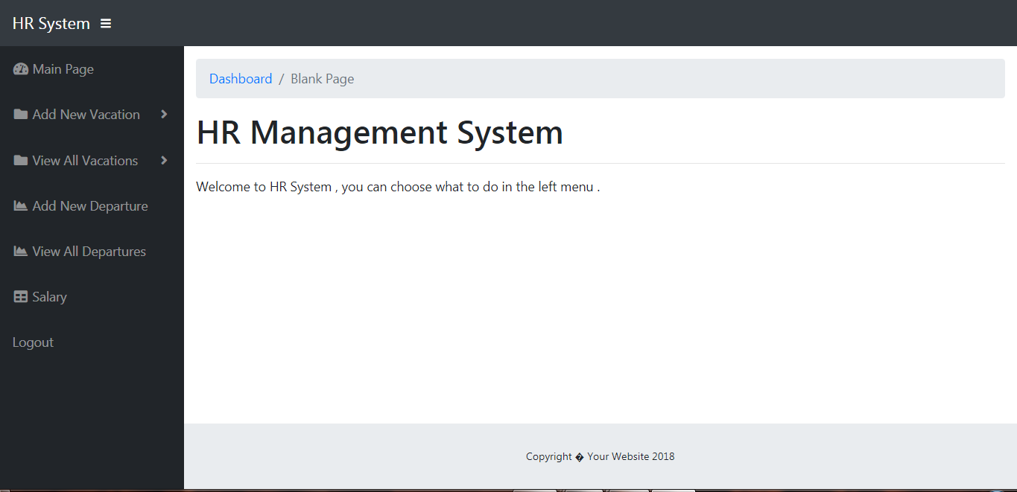

Employee add vacation
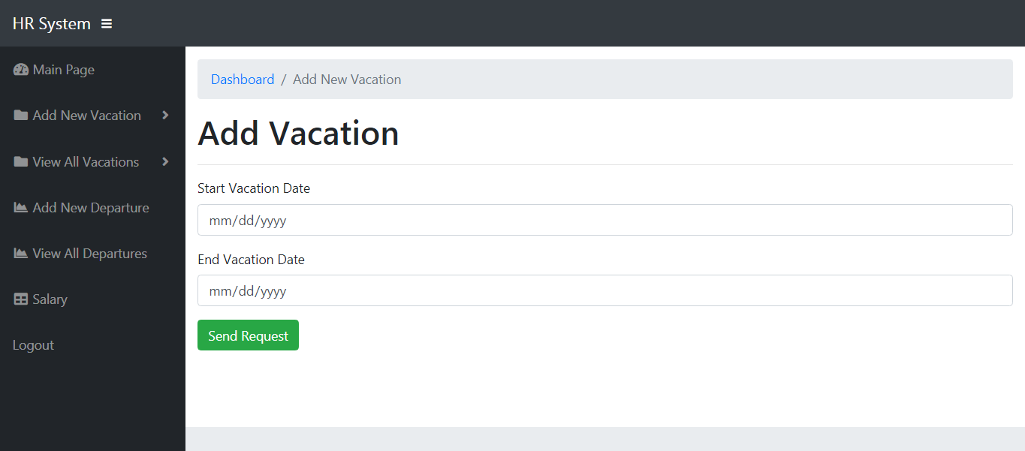

Employee view vacation
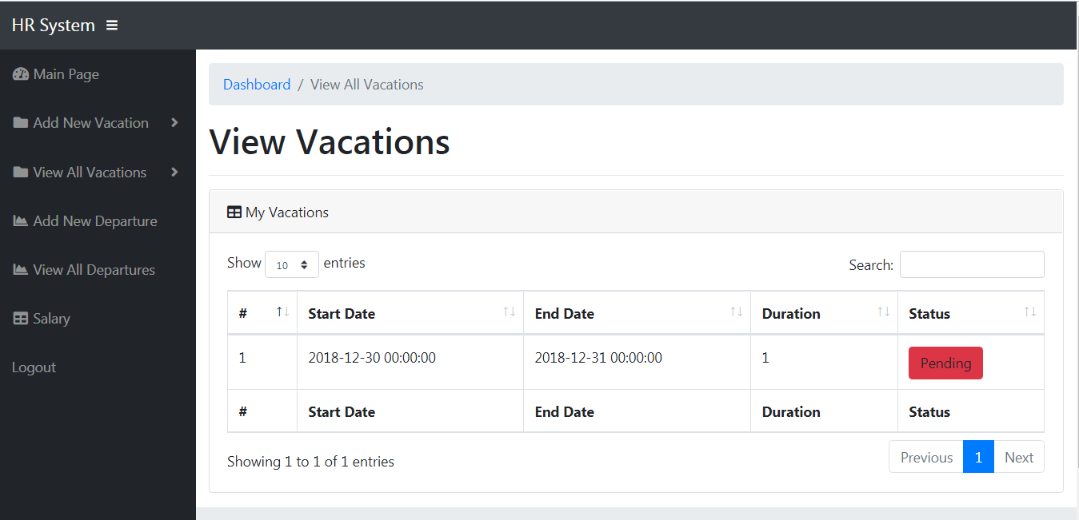

Employee Salary

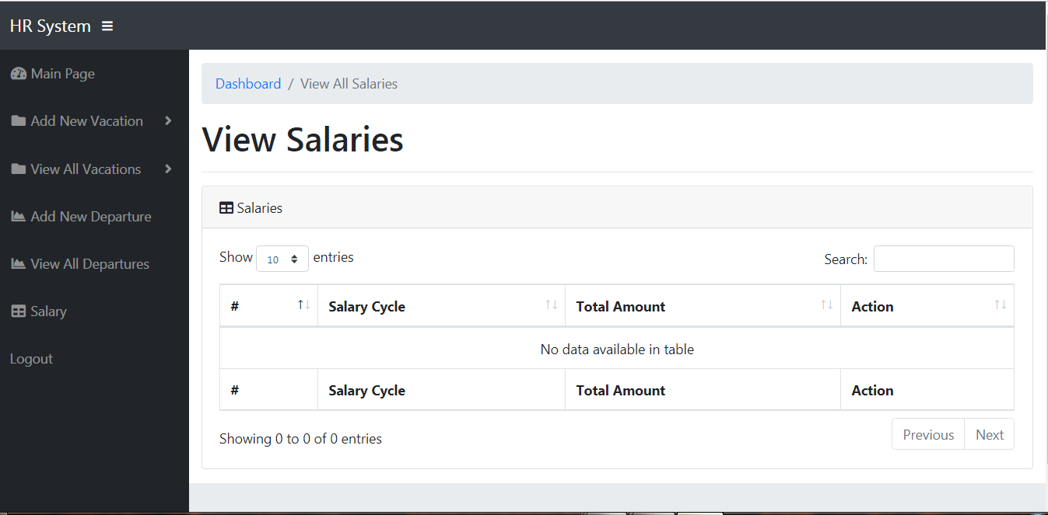

Database schema and Data Dictionaries
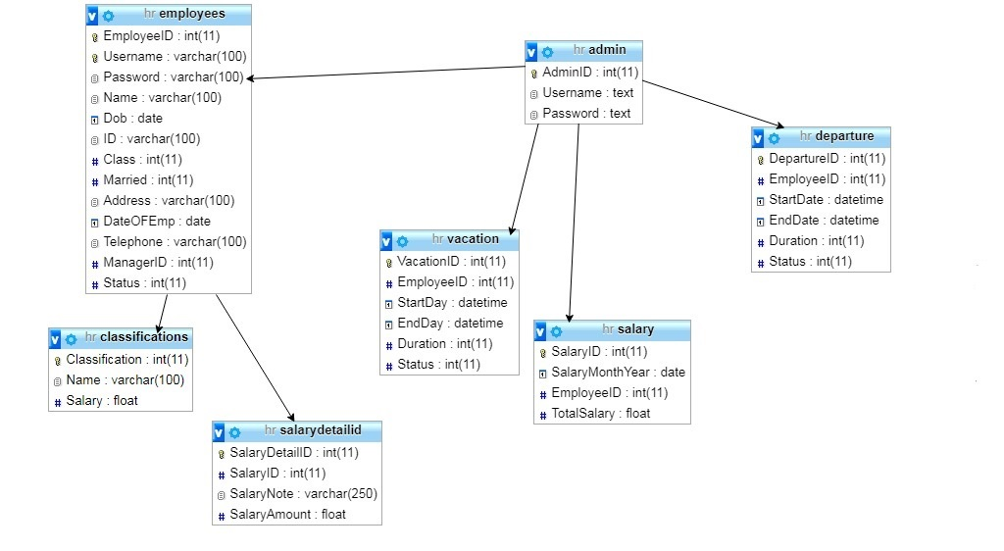

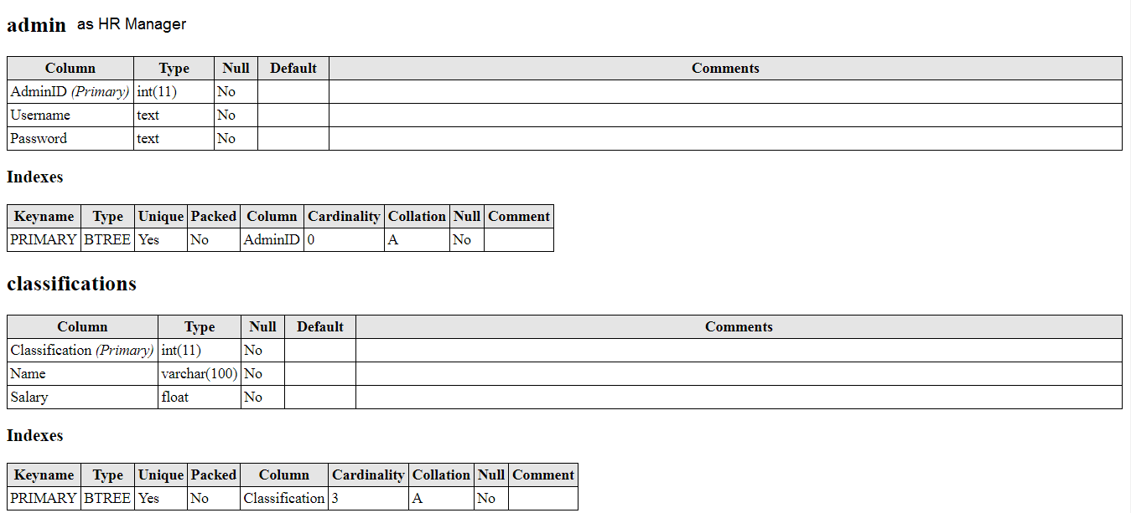
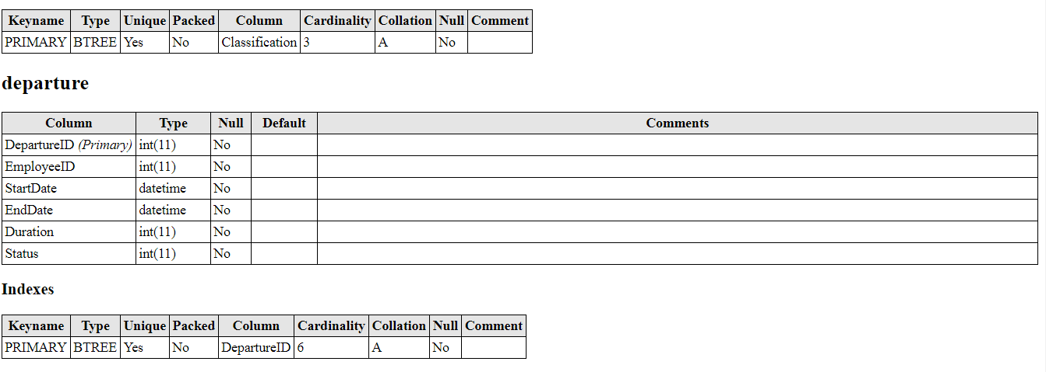

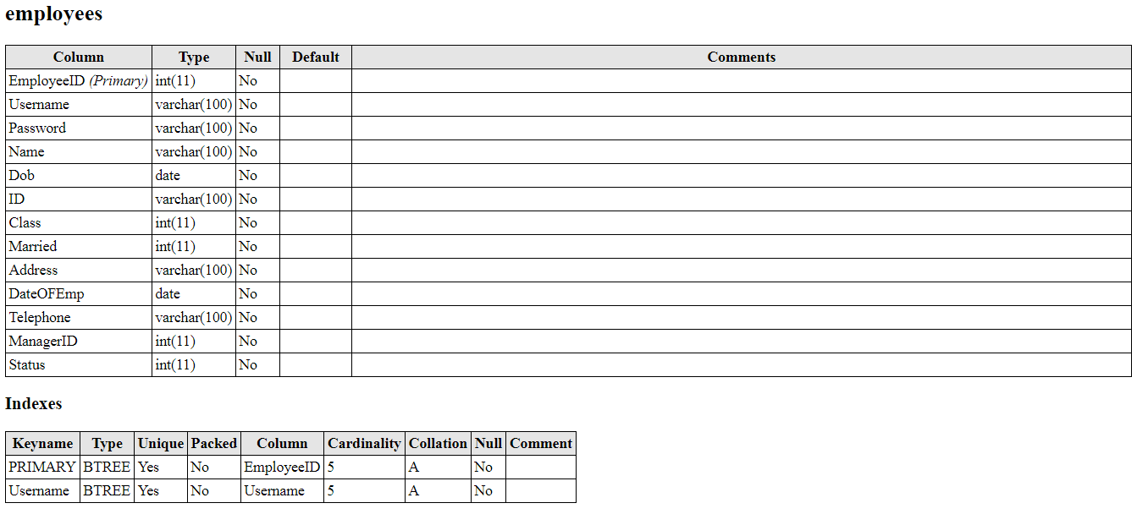
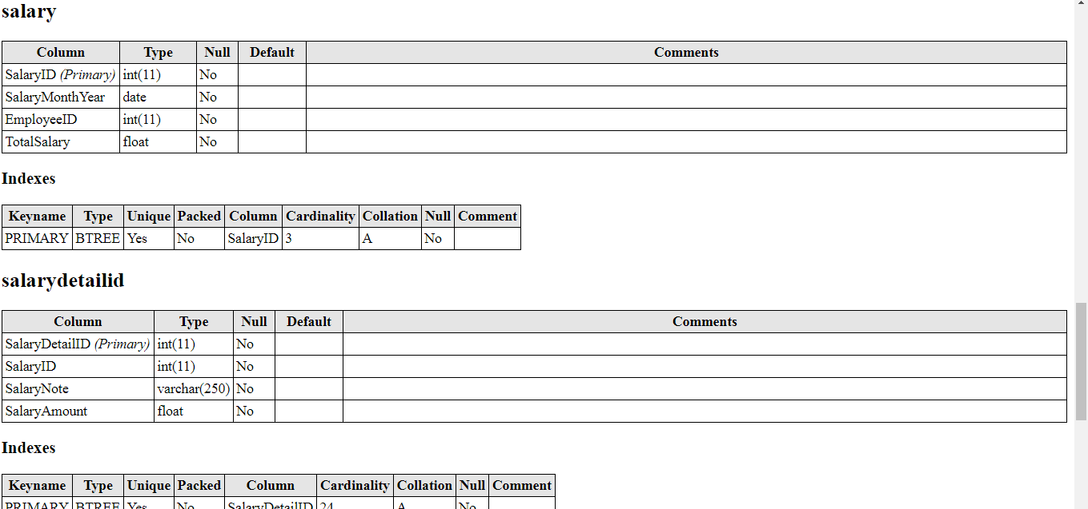

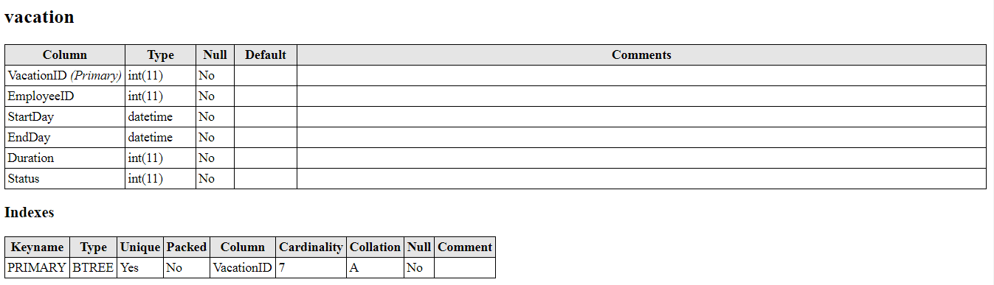

Features And Implementation

- Leave Management System

A leave management system is an all-in-one platform that handles all employee departure requests while ensuring smooth functioning of their operations.

As an employee

You request Departure and waiting for your reply from your supervisor or HR manager (if supervisor was not present) .
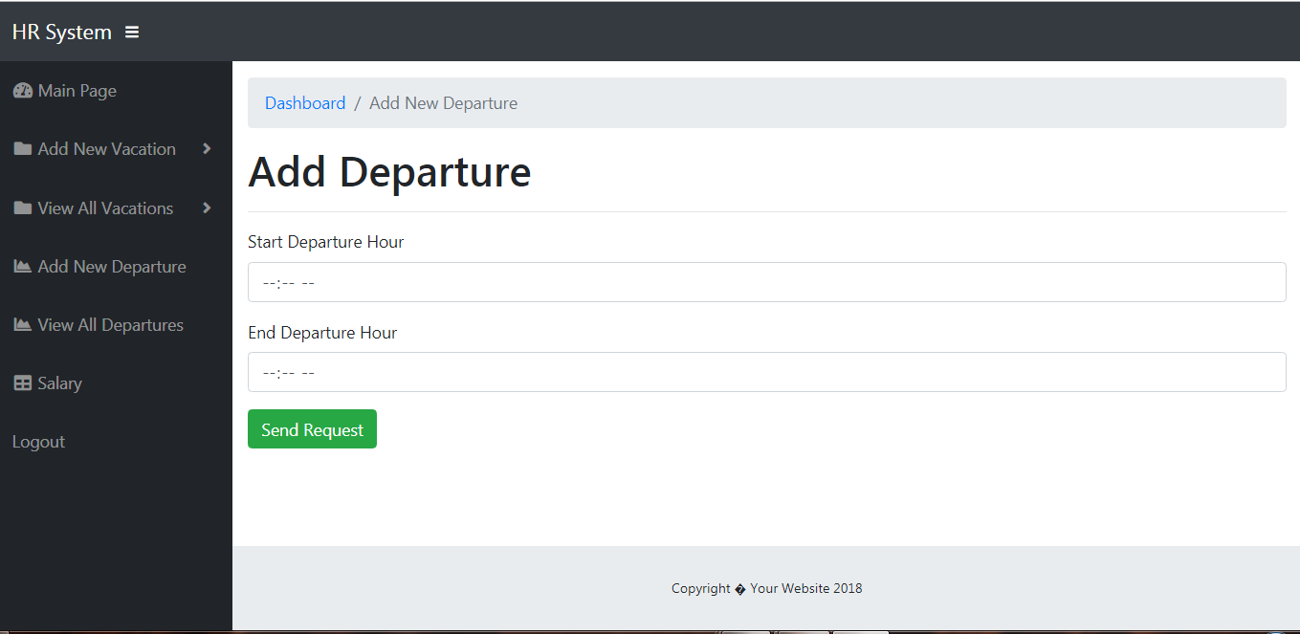

As a supervisor

You respond to the request by rejection or acceptance , supervisor can also request Departure and waiting for your reply from HR manager.

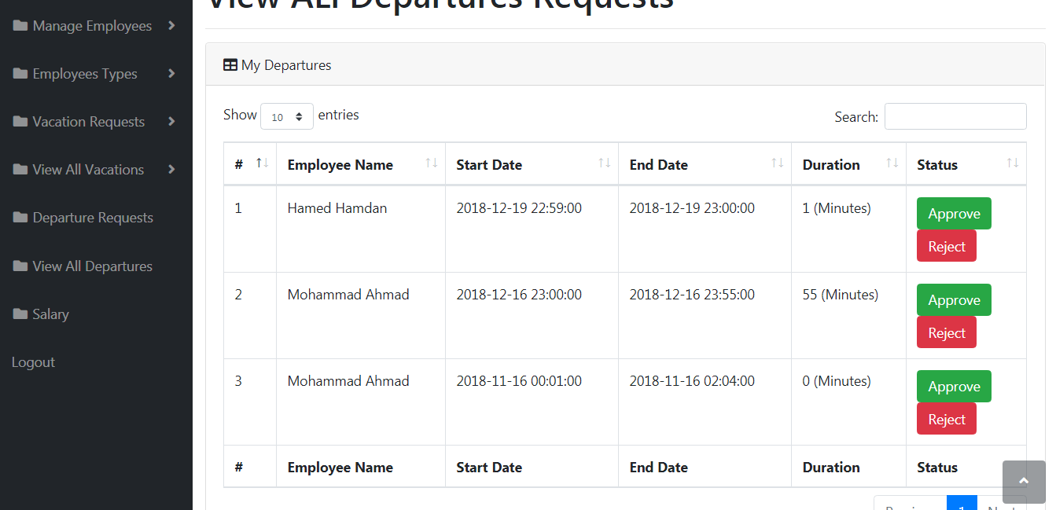

As HR manager

You respond to the request by rejection or acceptance to employee and supervisor.

- vacation management system

A leave management system is an all-in-one platform that handles all employee departure requests while ensuring smooth functioning of their operations.

As an employee

You request a vacation and waiting for your reply from your supervisor or HR manager (if supervisor was not present) .

As a supervisor

You respond to the request by rejection or acceptance , supervisor can also request Departure and waiting for your reply from HR manager.

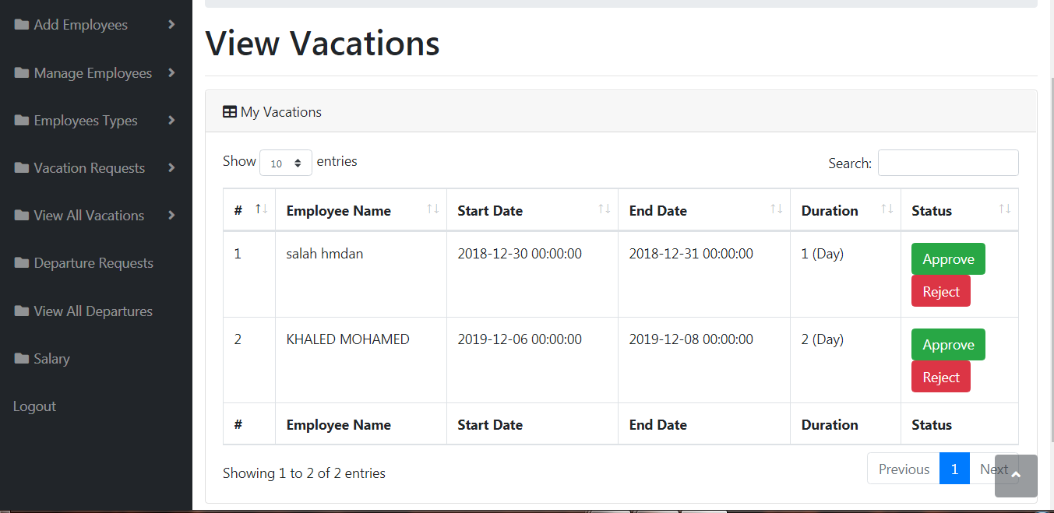

As HR manager

You respond to the request by rejection or acceptance to employee and supervisor.

- Employee Profile Management System

An Employee management system is designed to simplify the process of record maintenance of employees in an organization. It helps in managing the information of employees for HR functions. In general, employee management system is a part of a comprehensive Human Resource Management System.

HR manager is responsible for adding Employee and adjusting them .
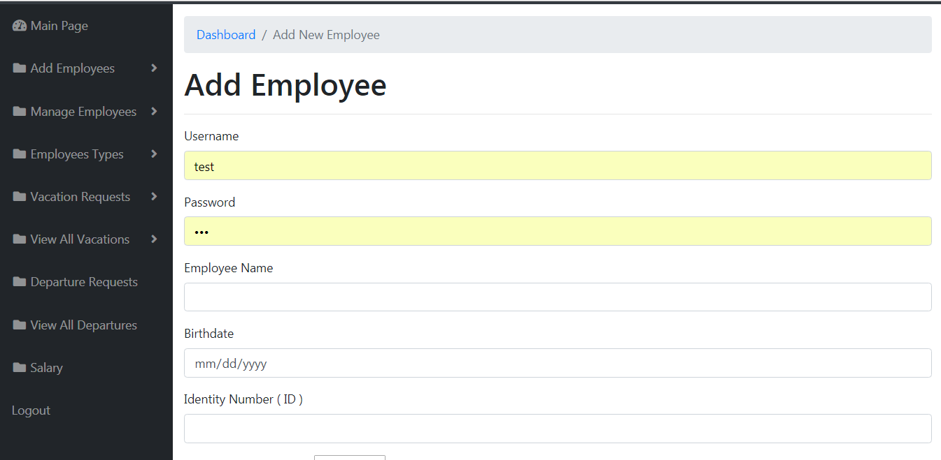

Even for minor modifications such as personal information changes, employee has to request for HR manager permission as the administrator has all the privileges to modify the employee's information.

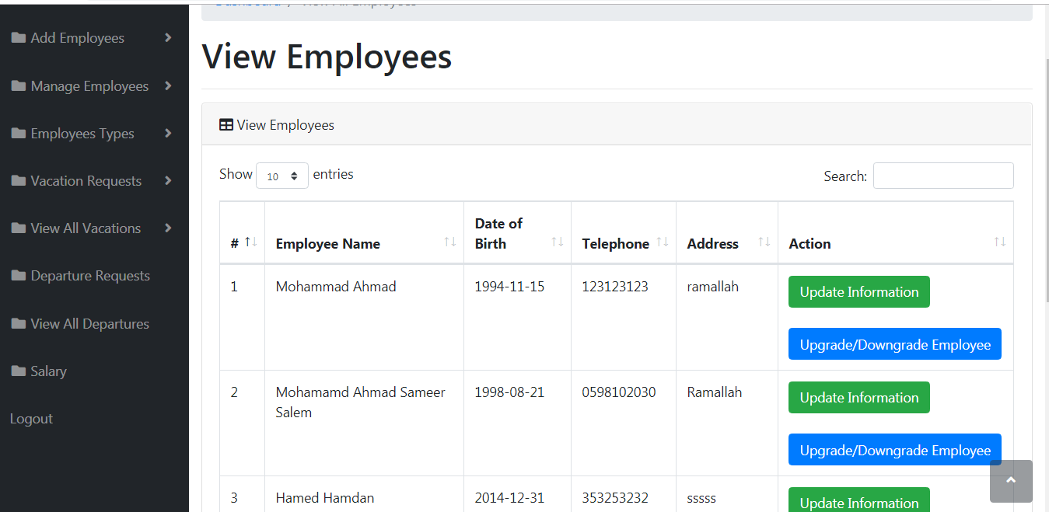

HR Manager also responsible too add classification to employee like classification name and salary.

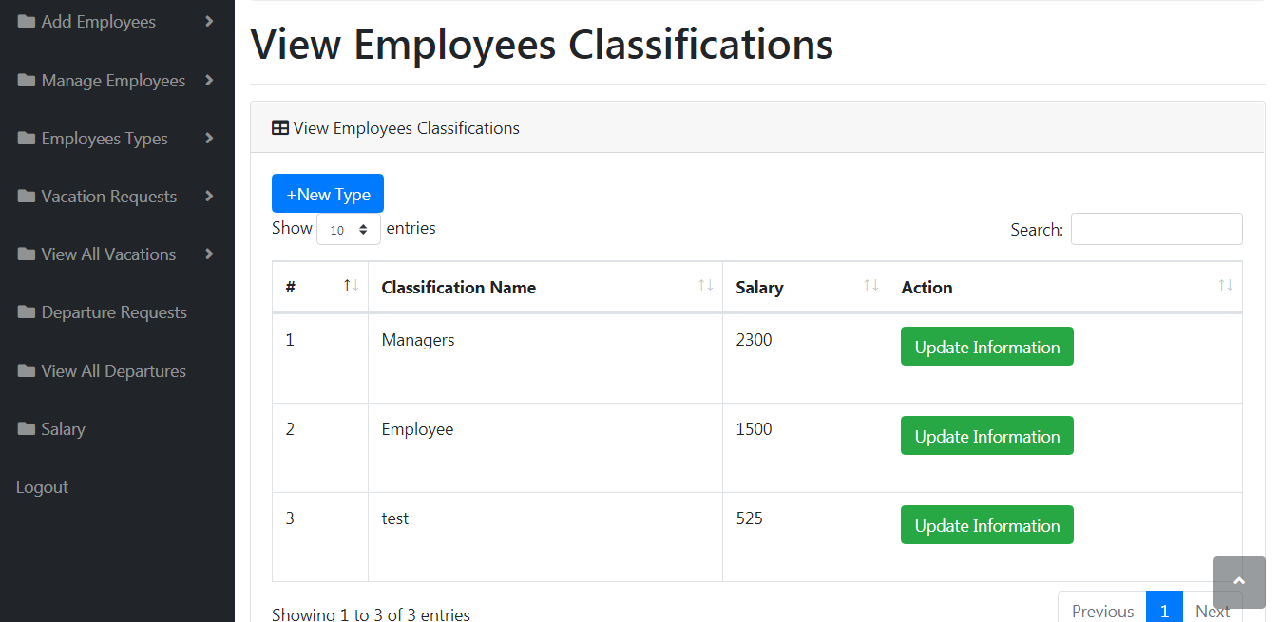

- Salary Management System

process refers to the administration of an employee's financial records which includes the salaries, wages, bonuses, deductions, and net pay .

HR manager is responsible for create salary cycle to all employee and know total amount of salaries to prepare the financial report .

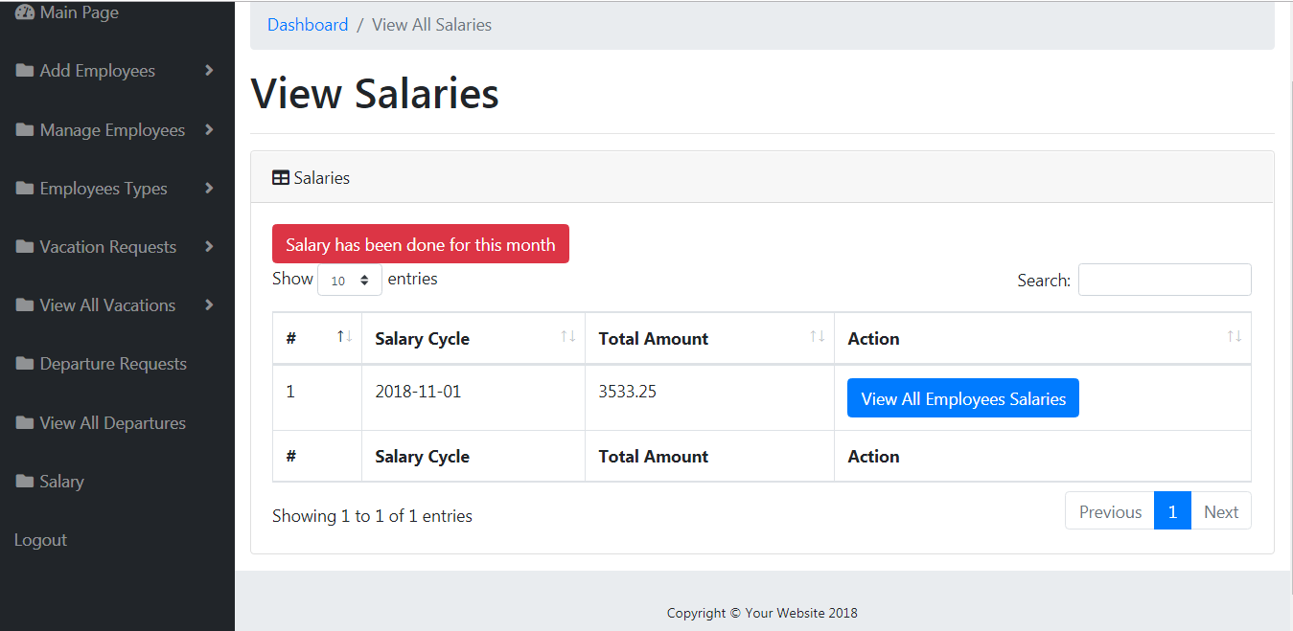

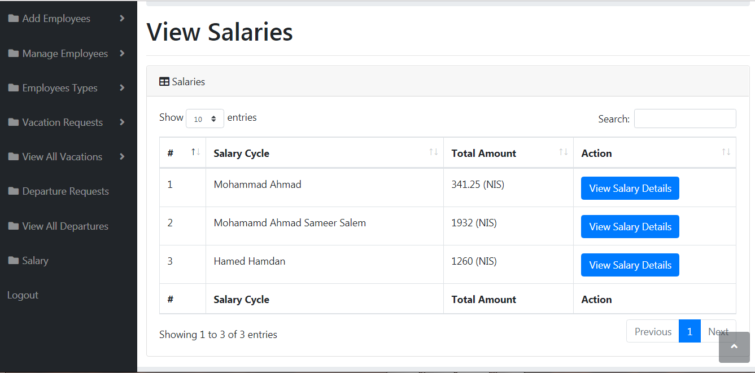

In the case of an employee or supervisor he can only watch his own salary .

Salary system calculation

DayWork = MainSalary/NumofDays

VacationAmount = -1 * $VacationCount * $DayWork

DepartureAmount = -1 * (DepartureCount/8) * DayWork

SalaryBVat = MainSalary + VacationAmount + DepartureAmount

Vat = -1 * SalaryBVat * 0.16

Total = SalaryBVat + Vat;

VAT: value added tax

Finally HRMS not limited to several concepts and systems ,the function that used in this field is wide, we discussed in this project basic concepts and we can developing this project by adding new function that any business can achieve its goal effectively and efficacy.

