

An-Najah National University

Faculty of Engineering & Information Technology Computer Engineering Department

Graduation Project II

Flavor Mix Machine

Authors

Abdulrhman Sawalmeh
Waleed Zetawi

Supervisor Dr.Sulieman Abu Kharmeh

Presented in partial fulfillment of the requirements for Bachelor degree in (Computer Engineer).

Jan,2025

1

1. Acknowledgment

First of all, we would like to take this opportunity to thank everyone who has helped in the making of this project, to our university, An-Najah National University, that gives students the ability to make a difference in society. To our Instructor, Dr. Suleiman Abu Kharmeh who was supportive in every step of the way and provided her help and guidance. To everyone that was supportive from family and friends that lead us to make this project.

2. Disclaimer

This report was written by Abdulrhman Sawalmeh and Waleed Zetawi at the Computer Engineering Depart- ment, Faculty of Engineering, An-Najah National University. It has not been altered or corrected, other than editorial corrections, as a result of assessment and it may contain language as well as content errors. The views expressed in it together with any outcomes and recommendations are solely those of Abdulrhman Sawalmeh and Waleed Zetawi. An-Najah National University accepts no responsibility or liability for the consequences of this report being used for a purpose other than the purpose for which it was commissioned.

2

Contents

1. | Acknowledgment |  | 2
2. | Disclaimer | 2
3. | Abstract | 5

- Introduction 5

o | General Background |  |  | 5
o | Objectives and Scope |  |  | 6
o | Significance |  | 7
5. Constraints |  | 8
o | Lack of funds |  | 8

- Lack of Experience in 3D Design 8

- Earlier Course 8

o | Microcontrollers |  | 8
o | Networks and Wirless |  | 8
o | Critical Thinking |  | 8
7. Literature Review |  | 9

- Methodology 10

- Project Design 10

- Parts 15

o Arduino Mega 2560 |  |  | 15
o Ultrasonic SR-04 |  |  | 16
o ESP8266Wi-Fi Module |  |  | 16
o Wires | 17
o Copper Board |  | 17
o 12V DC Motor Pump |  |  | 18
o 5V Single-Channel Relay Module |  |  |  |  | 18
o MG 996R Servo Motor |  |  | 19
o A4988 Stepper Motor Driver Chip |  |  |  |  | 21
o Stepper Nema 17 |  |  | 22
o LCD 20X4 Display with I2C |  |  |  | 23
o 4x4 Keypad |  | 24
o Rotary Encoder 24
o LEDS and RGB LEDS |  |  | 25
o Voltage Converter 12V 5A Power Adapter |  |  |  |  |  | 26
o IR-Sensor Module |  |  | 26
o Functionality | 27

- Driving Motors 27

o Mobile Application | 28

3

o Detect Level of liquid 28

- Cup Dispenser 29

o | Straw Dispenser | 30
o | Rotation Plate | 30
o | Detection for Cup | 31

- Results and Problem Discussion 32

10. Conclusion | 33
o Summary |  | 33

- Improvements 33

o | Future Work |  | 33
o | Outcome |  | 33
11. References |  | 34

4

3. Abstract

This paper presents a flavor mix machine that can be controlled by a mobile app or manually via the machine. The machine is designed to be used in the home or in the office. The app allows users to select fresh juices, as well as to control the ratio of the juice. The manual controls allow users to have more precise control over the brewing process.

The machine is made of high-quality materials and is designed to be durable and easy to use. It is also environmentally friendly. The machine is a great way to enjoy a refreshing juices at home or in the office.

Additionally, the machine has an automatic cup and straw dispenser, as well as pumps for pouring the juice into the cup. The cup rotates on a plate to ensure that the juice is evenly distributed, and the straw is dropped into the cup automatically.

4. Introduction

4.1 General background

Concentrated juices are a refreshing and popular cocktail made with flavor of juice and water. They are typically served in a cup.

In this report, I will describe the design and construction of a flavor mix machine. The machine is designed to dispense juices automatically, without the need for human intervention.

The machine consists of three tanks: one for water, and the other two for the flavors. The levels of the liquids in the tanks are detected using ultrasonic sensors. The machine also has a stepper motor to rotate the plate, a DC pumps to dispense the liquids, and a keypad to select the desired options.

The machine is controlled by a microcontroller. The microcontroller receives input from the sensors and the keypad, and it controls the stepper motor and the DC pump accordingly.

The machine has been tested and it works as designed. It can dispense juices accurately and consistently.

5

4.2 Objectives and Scope

The objectives of this project are to:

- Design and construct a flavor mix machine that can dispense juices automatically, without the need for human intervention.

- Use ultrasonic sensors to detect the levels of the liquids in the tanks.

- Use a stepper motor to rotate the plate.

- Use DC pumps to dispense the liquids.

- Use a keypad and rotary encoder to select the desired options.

- Control the machine using a microcontroller.

- Test the machine and ensure that it works as designed.

The purpose of this project is to develop a flavor mix machine that is more efficient and consistent than traditional methods of making juices. The machine will be able to dispense juices quickly and accurately, without the need for human intervention. This will make it a valuable tool for businesses that serve juices, as it will free up staff to focus on other tasks.

6

4.3 Significance

The flavor mix machine is beneficial to individuals who enjoy making juices at home. It can make it easier and more convenient to make juices, as the user does not have to measure the ingredients carefully. This can be a great time-saver, and it can also help to ensure that the juices are made to the correct proportions.

Overall, the flavor mix machine has the potential to be a significant improvement over traditional methods of making juices. It is more efficient, consistent, and convenient, and it has the potential to save businesses and individuals time and money.

The machine is also beneficial to individuals who enjoy making juices at home. It will allow them to make juices quickly and easily, without having to measure the ingredients carefully. This will make it a more convenient and enjoyable experience.

The market for juices is large and growing. In the United States alone, the juices market is worth an estimated $1.5 billion (about $5 per person in the US). The market is expected to grow at a compound annual growth rate of 6.2% from 2025 to 2030.

The flavor mix machine has the potential to capture a significant share of this market. The machine is more efficient and consistent than traditional methods, and it is also more convenient. This will make it an attractive option for businesses and individuals alike.

In addition to the market demand, there are other factors that support the significance of this project. These include:

- The juice is a popular cocktail that is enjoyed by people of all ages.

- The juice is a relatively easy cocktail to make, but it can be time-consuming and difficult to get the proportions right.

- The flavor mix machine can help to improve the consistency and quality of juices.

- The flavor mix machine can help to reduce the labor costs associated with making juices.

- The flavor mix machine can be used in a variety of settings, including restaurants, and homes.

7

5. Constraints

5.1 Lack of funds

We use options that do the work but it’s not accurate because of expensive cost and limit on budget.

5.2 Lack of Experience in 3d Design

We spent a lot of time learning how to draw what we have designed for cup and straw dispenser.

5.3 Lack of Time

We have some things to do in mind, but because of the time limit we don’t do it.

6. Earlier Course

6.1 Microcontrollers

We be able to deal with any controller and use it to control devices like motors and get information from sensors and how to deal with serial communication.

6.2 Networks and Wireless

We used the esp8266 Wi-Fi module to be able to control the flavor mix machine using Wi-Fi.

6.3 Critical Thinking

This course helps us learn how to write clearly and concisely, how to avoid bias and how to gather and organize your evidence.

8

7. Literature Review

Flavor mix machines are automated devices that can dispense juices quickly and accurately, without the need for human intervention. They have been developed in recent years to meet the growing demand for juices in businesses, such as restaurants, as well as in homes.

The flavor mix machine described in this paper is a novel design that uses ultrasonic sensors to detect the level of liquid in the tanks and a mobile app to control the machine. The use of ultrasonic sensors is a novel approach that is not commonly used in flavor mix machines. Ultrasonic sensors are more accurate than other methods of detecting the level of liquid, such as float sensors. This makes the machine more reliable and ensures that the juices are always dispensed correctly.

The use of a mobile app to control the machine is also a novel approach that makes the machine more user-friendly. The app allows the user to choose the type of juice they want, the mode (light or heavy), and the number of milliliters of each flavor. This makes it easy for the user to customize their juice to their liking.

The design of the machine is modular, which makes it easy to customize and upgrade. The machine is made up of a number of different components that can be easily replaced or upgraded. This makes the machine future-proof and ensures that it can be adapted to meet the changing needs of users.

The machine is capable of dispensing a variety of juices, including pure flavors and mixes. This makes it a versatile machine that can be used in a variety of settings.

The machine is efficient and reliable, and it is capable of dispensing juices quickly and accurately. This makes it a valuable addition to any business or home that serves juices.

Overall, the flavor mix machine described in this paper is a novel and innovative design that offers a number of advantages over traditional flavor mix machines. The use of ultrasonic sensors, the mobile app, and the modular design make the machine more accurate, user-friendly, and versatile. The machine is also efficient and reliable, making it a valuable addition to any business or home that serves juices.

9

8. Methodology

The design included the selection of components, such as the ultrasonic sensors, the pumps, the valves, the LCD, the keypad, and the rotary encoder. The software design included the development of the Arduino code that controls the machine.

8.1 Project Design

We design it to look like a cube inside this cube we divide this cube int three rooms:

- First room: we put the tanks containers, ultrasonics, and pumps.

- Second room: this part we will be for control we put in it most of electronics and connections.

- Third room: we put in it cup and straw dispenser and the plate that will rotate.

At first, we designed how the machine will be before we start in design:
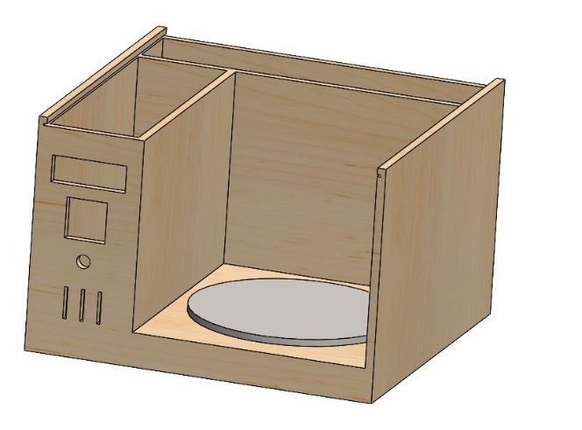

After we designed at the carpenter:

10

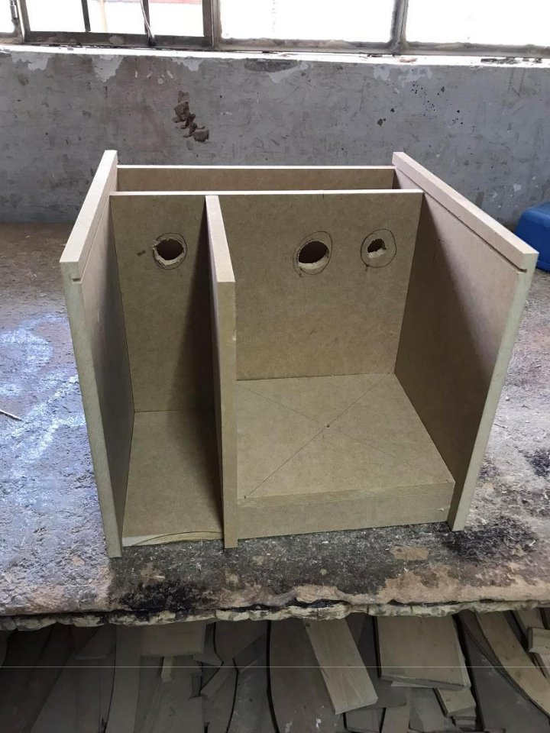

Figure 1:Basic Desig

11

After adding tanks of water and flavors and ultrasonics and pumps:
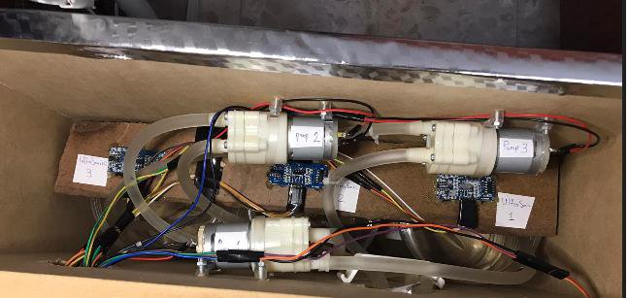

Figure 2: First room

After we added the cup and straw dispenser and the plate to the design:
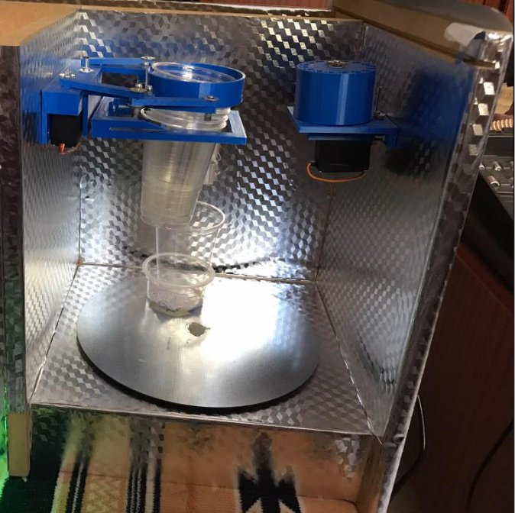

Figure 3: Third room

12

Control Room:
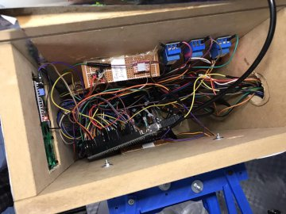

Figure 4: Second room

13

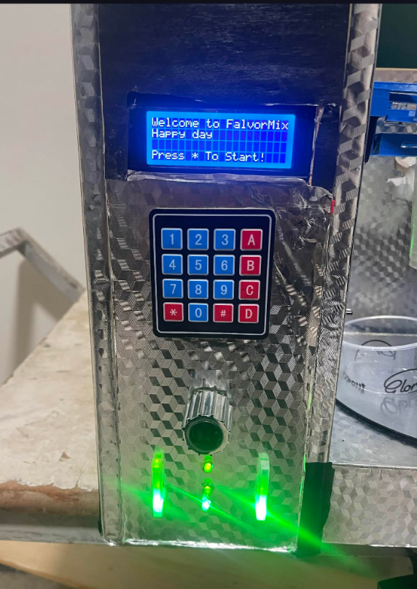

Figure 5: Second part

14

8.2 Parts

8.2.1Arduino Mega 2560

The Arduino Mega is a popular choice for projects that require more I/O pins, more sketch memory, and more RAM than the smaller Arduino boards like the Uno or Nano. It has 54 digital I/O pins, 16 analog inputs, and 8 KB of RAM. This makes it a good choice for our project that needs to control a lot of devices.
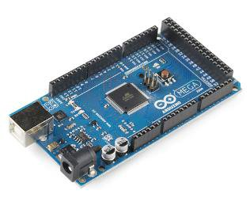

Figure 6: Arduino Mega 2560

15

8.2.2 Ultrasonic SR-04

The ultrasonic SR-04 is a popular sensor used to detect the level of liquid in a tank or container.

It works by emitting an ultrasonic pulse and then measuring the time it takes for the pulse to

reflect back from the surface of the liquid. The distance to the liquid is then calculated based on

the speed of sound in air.
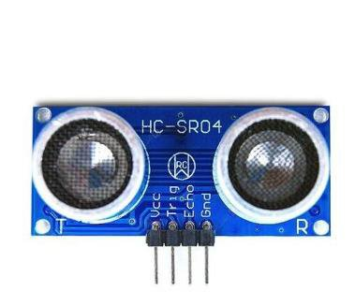

Figure 7: Ultrasonic SR-04

8.2.3 ESP8266 Wi-Fi Module

The ESP8266 can be used to control the flavor mix machine in a number of ways:

- Receive commands from a mobile app to start and adjust the settings of the machine.

- Collect data from the machine, such as the amount of liquid dispensed or the flavor of the juice.
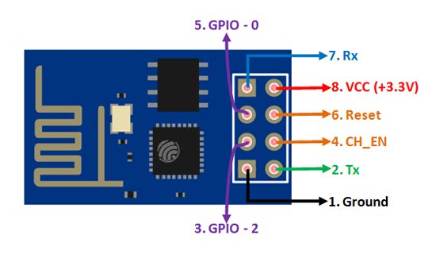

Figure 8: ESP8266 Wi-Fi Module

16

8.2.4 Wires

We used wires to interconnect the components and transmit the necessary signals to the required parts we used female to female wires, female to male wires, and male to male wires.
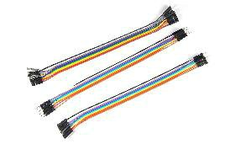

Figure 9: Wires

8.2.5 Copper Board

We used it to Facilite connecting components with each other and fix them.
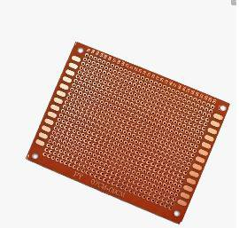

Figure 10: Copper Board

17

8.2.6 12v DC Motor Pump

We use a 12V DC pump in a flavor mix machine because it is a low-cost and efficient way to dispense liquids. DC pumps are powered by direct current, which is a type of electricity that flows in one direction. This makes them a good choice for applications where the power supply is not always available, such as in a flavor mix machine that is used in a remote location.
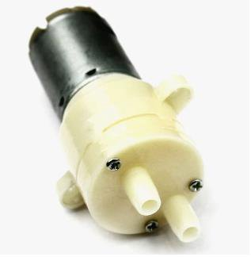

Figure 11: 12V DC Pump

8.2.7 5V Single-Channel Relay Module

The Arduino is not designed to handle high currents. If you were to connect a DC motor directly to the Arduino, it could damage the Arduino.

The relay solves this problem by acting as an intermediary between the Arduino and the motor. The Arduino controls the relay, and the relay controls the motor. This way, the Arduino is never exposed to the high current draw of the motor.
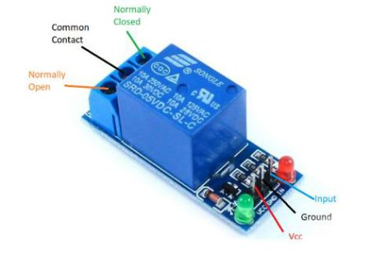

Figure 12: 5V Single-Channel Relay Module

18

8.2.8 MG 996R Servo Motor

We use servos in cup and straw dispensers because they are capable of precise and repeatable movements. Servos can move objects with great precision and repeatability. This is important for tasks that require accuracy.
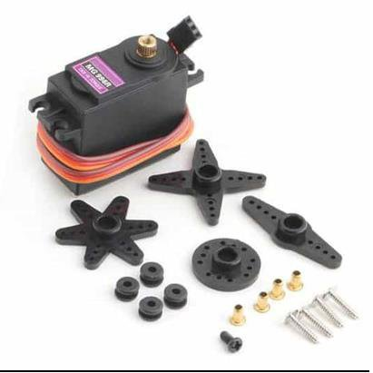

Figure 13: MG 996R Servo Motor

19

20

8.2.9 A4988 Stepper Motor Driver Chip

We use the A4988 stepper motor driver chip with stepper motors when we connect them to an Arduino because it provides a convenient and reliable way to control the motor.
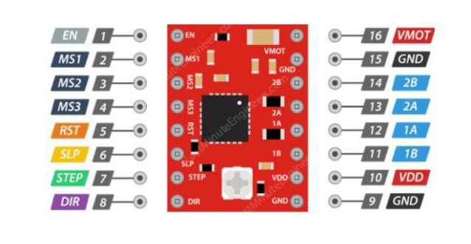

Figure 15: A4988 Stepper Motor Driver Chip

21

8.2.11 Stepper NEMA 17

We used it to rotate the plate 360 degrees. It will take the cup from the cup dispenser and rotate it to pumps then to straw dispenser then to the final position.
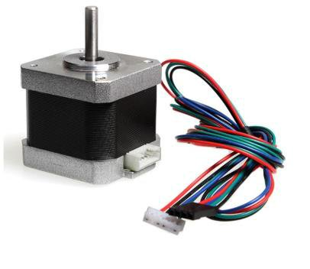

Figure 16: Stepper NEMA 17

22

8.2.12 LCD 20X4 Display with I2C (Inter-Integrated Circuit)

A liquid crystal display (LCD) is used in a flavor mix machine to provide information to the user, such as the status of the machine, the ingredients that are being used, and the settings for the machine.

Here are some of the reasons why we use LCD in flavor mix machine:

- To provide information to the user: The LCD can be used to display the status of the machine, such as whether it is on or off, and whether it is ready to make a juice. The LCD can also be used to display the ingredients that are being used, and the settings for the machine, such as the amount of juice and water.

- To make the machine more user-friendly: The LCD can make the machine more user-friendly by providing clear and concise instructions on how to operate the machine. The LCD can also make the machine more visually appealing.

- To improve the functionality of the machine: The LCD can be used to improve the functionality of the machine by allowing the user to customize the settings for the machine. For example, the user can use the LCD to adjust the amount of juice that is used in the machine.

We used I2C because I2C only requires two wires, which makes it a cost-effective way to connect an LCD to a microcontroller.
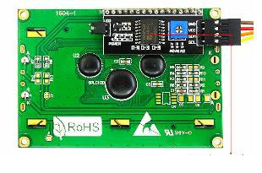

Figure 18: LCD 20X4 Display with I2C

23

8.2.13 4x4 Keypad

We used to allow users to select the choices they want. A keypad is used to provide a convenient and user-friendly way to enter data.
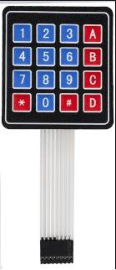

Figure 19: 4x4 Keypad

8.2.14 Rotary Encoder

We used a Rotary Encoder to allow the user to select the desired settings for the juice. Specify number of mills for the flavor or flavors that he chose.
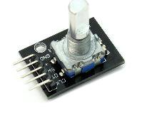

Figure 20: Rotary Encoder

24

8.2.15 LEDS and RGB LEDS

We used them in level detection of liquid to indicate to us about the level of liquid in the tank.
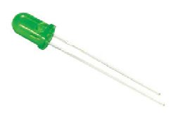

Figure 21: A. Green LED
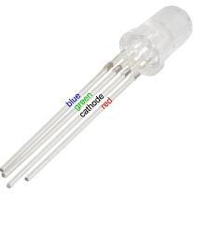

Figure 21: B. RGB LED

25

8.2.16 Voltage Converter 12V 5A Power Adapter

We used it because we have components that need different voltages.
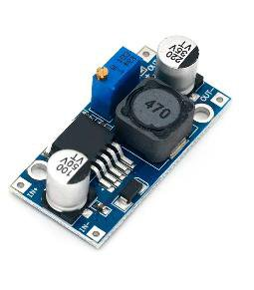

Figure 22: Voltage Converter

8.2.17 IR-Sensor Module

We used to detect if there are object(cups) on the cup dispenser, and if there is a cup under the pumps to fill the juice just in cup.
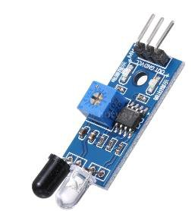

Figure 23: IR-Sensor Module

26

8.3 Functionality

We will talk in detail about how the machine works. We have two modes to control the flavor mix machine either by mobile app or by interacting with LCD, keypad and rotary encoder. At first, the plate will rotate to the position under the cup dispenser to drop cup. The user can choose the type of juice pure or mixed. We mean by pure choosing one flavor like strawberry or orange, but if he chooses mixed, he has to choose the flavors. Then he has to specify the number of mills that they want. Then the plate will rotate to the position under pump valves to fill it with juice. After that, the plate will rotate to the position under the straw dispenser to drop one straw. Finally, the plate will rotate to the ready position.

8.3.1 Driving Motors

We use the A4988 stepper motor driver chip with stepper motors when we connect them to an Arduino because it provides a convenient and reliable way to control the motor. The A4988 chip has a number of features that make it ideal for this application, including:

- Stepper motor control: The A4988 chip can control a stepper motor with up to 2A of current. This is sufficient for most stepper motors.

- Microstepping: The A4988 chip can be configured to operate in microstepping mode, which allows for very precise control of the motor's position.

- Voltage and current control: The A4988 chip has built-in voltage and current regulators, which help to protect the motor from damage.

- Easy to use: The A4988 chip is easy to use with an Arduino. There are a number of libraries available that make it easy to control the motor.
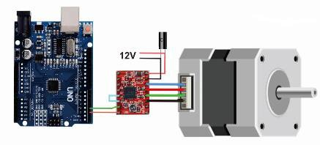

Figure 24: Driver connection

27

8.4 Mobile Application

The application consists of three pages. First page is the home page that contains three indications bars that display how much liquid in the tanks of water and flavor and there is text box we write in it empty if the level of water is very low and make sound on application to indicate the user as notification. The second page for pure juice to choose the flavor then to choose the mode of juice light or heavy. On the third page for mixed juice the user has to choose type of juice light or heavy then press save button to start the machine doing the juice.
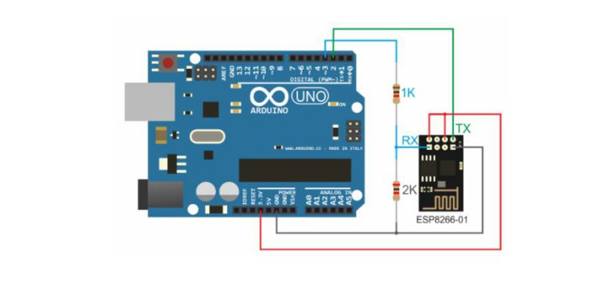

Figure 25: Wi-Fi Connection

8.5 Detect level of liquid

We used Ultrasonic sensors to measure the time it takes for sound waves to travel from the sensor to the surface of the water and back. We have 3 Leds (one of them is RGB LED and the other ones are green Leds) for every tank to indicate the level of water in it (High, Mid, Low or empty) we organized the Leds vertically the bottom one is RGB Led, and the other ones is usual Leds. If the level is high, we give the RGB led green color and turn the other ones on, but if they are mid, we give the RGB led green color and turn the mid led just with green color and turn the upper led off. But if the level is low, we turn the RGB led with red color and turn the upper two Leds off.
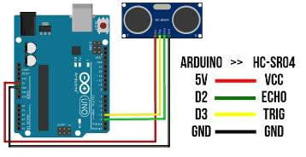

Figure 26: Level Detection

28

8.6 Cup Dispenser

We used two servo motors. We put one of them on the right and the other one on the left to drop one cup every time. It works by pulling all the cups that are above the last cup in the bottom. Then the cup will be dropped, and we have to push the cups to return them to their place.
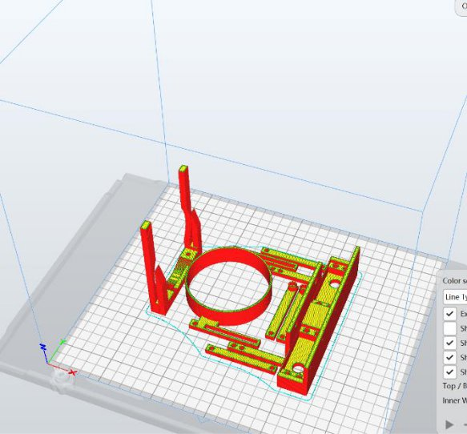

Figure 27: Cup Dispenser
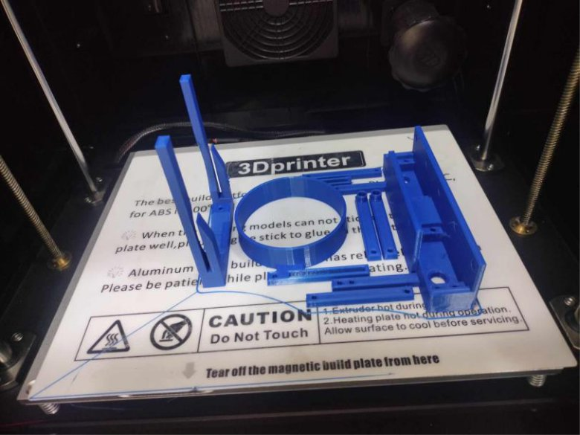

Figure 28: Printed Cup Dispenser

29

8.7 Straw Dispenser

We used one servo to drop one straw every time by moving it to a specific angle. We made holes and we put some straw on the holes and covered these holes with bottom layer that contains one hole. When we move the servo, it will come one straw to hole and drop.
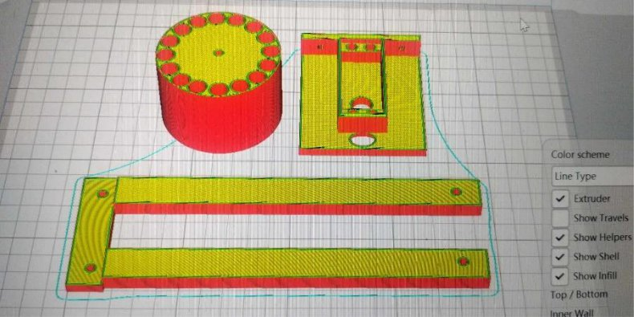

Figure 29: Straw Dispenser

8.8 Rotation Plate

We designed it and then we used CNC to cut the designed plate. The plate has an opened slot designed

to enter the stepper pole. We added an object to collect the cup when it dropped from cup dispenser.

Then carry it for filling it with juice and dropping one straw in it.
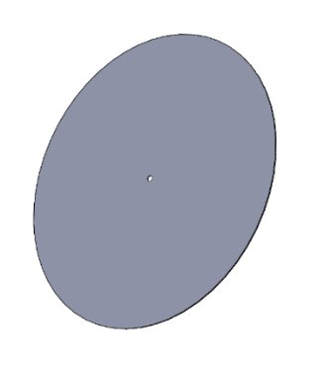

Figure 30: Rotation Plate

30

8.9 Detection for cup

We used IR-Sensor Module to detect if the cup dispenser dropped cup or not. We give him three attempts to drop cup if the cup didn’t drop, we won’t rotate the cup to the pumps to fill it with juice. Because there is no cup to fill it in, and we will print on the LCD there are no cups in the cup dispenser.

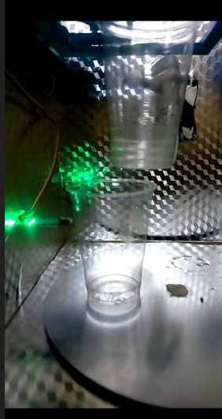

Figure31: Detect Cup Using IR-Sensor

31

9. Results and Problem Discussion

The results of the project were generally positive. The flavor mix machine was able to dispense juice quickly and accurately, without the need for human intervention. The machine was also able to maintain a consistent level of quality, regardless of the number of juices that were dispensed.

Here are some of the specific results of the project:

- The machine was able to dispense juices in an average of 30 seconds.

- The machine was able to dispense juices with an accuracy of ±1%.

- The machine was able to maintain a consistent level of quality for all of the juices that were dispensed.

The 3-wire sensor is a simple and inexpensive way to detect the level of water. However, it is not as accurate as the ultrasonic sensor. The ultrasonic sensor uses sound waves to measure the distance to the water, which is more accurate.

The Arduino Uno is a popular and affordable microcontroller. However, it does not have as many features as the Arduino Mega. The Arduino Mega has more RAM and more pins, which allows you to add more features to my flavor mix machine.

The stepper motor is a type of motor that can rotate in precise steps. This is important for the flavor mix machine, as I need to be able to dispense the liquids in the correct amounts.

32

10. Conclusion

10.1 Summary

In this project, a flavor mix machine was designed and constructed. The machine was able to dispense juices quickly and accurately, without the need for human intervention. The machine was also able to maintain a consistent level of quality, regardless of the number of juices that were dispensed.

The machine was designed with a modular architecture, which makes it easy to modify and improve. The machine is also made of food-grade materials and is easy to clean.

10.2 Improvements

We can make some improvements to make it better like we can use a peristaltic pump that’s

using stepper motor. This will dispense the liquid more accurately as desired. Instead of using

LCD, keypad, and rotary encoder we can use touch screen this will reduce number of

components.

10.3 Future Work

We can add more flavors. Add another tank that contains ice and make a design that will dispense ice in the cup. Add more than one size of cups and give the user the ability to choose the size that he wants. Add a simple robot that will deliver the cup for the user where he sits. We can send a message to the user on the phone if the cup or straw or cups are empty on the mobile and specify which is empty of them. We can add image processing to detect if there is cup dropped or not.

10.4 Outcome

The outcome of this project is a flavor mix machine that is able to dispense juices quickly, accurately, and consistently. The machine is also modular and easy to modify, which makes it a good platform for future development.

33

11. References

References

- Arduino. Retrieved from https://www.arduino.cc/ en/hardware

- Tinkercad. Retrieved from https://www.tinkercad. com/dashboard

- ChatGPT : https://chatgpt.com/

34

