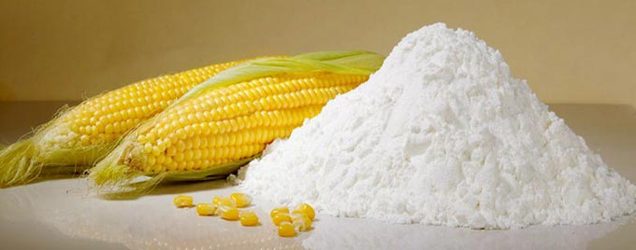  Biodegradable Starch  Polymers  Producing, Enhancing and Testing | a brief look,  Petroleum based plastic polymers are being replaced by natural polymers, due to environmental aims. In the last decades, scientists are searching for biodegradable renewable polymers like thermoplastic starch polymer.  Graduation Project


AN NAJAH NATIONAL UNIVERSITY
NABLUS, PALESTINE
DEPARTMENT OF CHEMICAL ENGINEERING

Producing, Enhancing and Testing of Biodegradable Starch Polymers

Done by
Amani Hudhud
Rawand Odeh
Riham Refa’i

Under the supervision of:
Eng. Shadi Sawalha

Submitted on partial fulfillment for the BSc degree of chemical engineering

May 2016

Acknowledgments
We would like to express my gratitude to our supervisor, Eng. Shadi Sawalha, for his support, patience, and encouragement throughout our graduate project. Hopefully all those efforts give resonate. It is not often that one finds a supervisor that always finds the time for listening to the little problems and roadblocks that unavoidably crop up in the project.
To our parents, receive our deepest gratitude and love for their dedication and the many years of support during our undergraduate studies that provided the foundation for this work. You have been so supreme, you have nurtured our learning, supported our dreams! Here’s hoping your populations will flourish, forever and EVER!
Special thanks for all the helpers, Mr. Yousif Ratrout for his help in the laboratory, Dr. Walid Basha from the medical department for his help in the digestive capability test, all the workers in Abu-Dees University for their help in the mechanical and thermal tests.
Amani, Rawand and Riham.

Abstract
The project’s objectives were to produce a biodegradable polymer from an available renewable source in a way that uses local agricultural waste as an additive. Also testing the properties of the polymer.
Starch was polymerized using tap water, three different acids were used (acetic acid, citric acid and fresh lemon juice). Glycerin was used as a plasticizer and olive waste as an additive. The polymerization process needed heat, a polymer sheet resulted after casting and cooling the polymer solution.
The effect of different acids, adding glycerin, replacing acetic with citric acid and the effect of adding olive waste on the mechanical and thermal properties of the polymer was tested using the tensile test machine (Sinowon Testing Machines ST Series), the Differential scanning calorimetry machine (Perkin Elmer, Jade DSC). The biodegradability was tested by soaking the polymer in water until it decomposes forming septic. The digestive properties was tested on laboratory mice.
The acetic acid sample had the highest strength and modulus of elasticity among the three acids 6.30362, 287.454 MPa respectively and the lower ductility 3.42% this indicated a high crystallinity percentage which was proven using the DSC machine where its enthalpy of melting (ΔH) was the highest (135.3884 kJ/kg), thus it was chosen as a base for the enhancing. The acetic acid polymer’s strength and elasticity increased by lowering the glycerin composition and so its crystallinity, where its ductility decreased. The opposite happened when gradually replacing the acetic acid with citric acid. The strength and elasticity decreased along with the increase in the ductility when olive waste was added but the crystallinity increased.
For the digestive test, the citric polymer started to digest in the mice’s stomach within one to one and a half an hour, the polymer also reached the intestines of the mice and got out of its system. All the polymer samples degraded within 7 days of soaking in water.

Contents
Acknowledgments
Abstract i
Chapter 1 Introduction 1
Chapter 2 Biodegradable Polymers 5
Chapter 3 Starch 8
Early uses of maize (corn) starch 9
Starch structure 9
Starch applications 10
Chapter 4 Thermoplastic Starch Polymer 12
TPS Process 14
Plasticizer in TPS 15
Chapter 5 Literature Review 17
Chapter 6 Experimental Work 21
6.1 Methodology 22
6.2 Results 25
6.3 Discussion 31
6.4 Conclusion 38
References 39

Table of figures
Figure 1: Structure of Amylose (1) 9
Figure 2: Structure of Amylopectin. (1) 10
Figure 3: Linear and Branched Starch Polymer 13
Figure 4: Transition of Starch Through Gelatinization and Aging. 14
Figure 5: Powdered Dyed C3 Sample Mixed with Water. 27
Figure 6: C3 Sample under the Microscope. 28
Figure 7: The Separation of the Dye from the Polymer. 28
Figure 8: The Digested Polymer in the Stomach. 29
Figure 9: The Digested Polymer in the Intestines of the Mice. 29
Figure 10: Samples After 4 days of Soaking in Water. 30
Figure 11: Decomposed Polymer. 30
Figure 12: Acid Effect on the Strength and Modulus of Elasticity of the Polymer. 31
Figure 13: Acid Effect on Ductility (%EL). 31
Figure 14: Glycerin Effect on the Strength and Modulus of Elasticity of the Polymer. 32
Figure 15: Glycerin Effect on the Polymer's Ductility. 33
Figure 16: Replacing Acetic with Citric Effect on the Polymer. 34
Figure 17: Citric Acid Effect on the Polymer's Ductility 34
Figure 18: Olive Waste Effect on the Polymer’s Strength and Elasticity. 35
Figure 19: Olive Waste Effect on the Ductility of the Polymer. 35

List of tables
Table 1: Samples Numbering and Composition. 23
Table 2: Acid Effect on Starch Polymer. 25
Table 3: Glycerin Effect on Acetic Acid and Citric Acid. 25
Table 4: Replacing Acetic Acid with Citric Acid Effect. 26
Table 5: Olive Effect on Acetic Acid Polymer. 26

Chapter 1
Introduction

Polymers have existed in natural form since life began, and those such as DNA, RNA, proteins and polysaccharides play crucial roles in plant and animal life. From the earliest times, man has exploited naturally-occurring polymers as materials for providing clothing, decoration, shelter, Tools, weapons, writing materials and other requirements. The origins of today's polymer industry commonly are accepted as being in the nineteenth century when important discoveries were made concerning the modification of certain natural polymers.
Due to the diversity of polymers they were classified into categories depending on their properties. Some classifications are: type of monomers, behavior toward temperature, line structure, polymerization process and morphology. [1]
- Classifying the polymer on the basis of morphology
Crystallinity and amorphous (non-crystalline): The term "crystal' refers to material whose atoms or molecules are arranged into a regular, ordered, three-dimensional array. [2]
- Classifying the polymer depending on its behavior towards temperature
- Thermoplastics: often referred to just as plastics, are linear or branched polymers which become liquid upon the application of heat. They can be molded (and remolded into any shape using processing techniques such as injection molding and extrusion. Generally, thermoplastics do not crystallize easily upon cooling to the solid state. [1]
- Thermosets: normally they are rigid materials and network polymers in which chain motion is greatly restricted by a high degree of crosslinking. As for elastomers, they are intractable once formed and degrade rather than become fluid upon the application of heat. [1]
- Classifying the polymer on the basis of degradation
- Non-biodegradable polymers.
Non-biodegradable polymers are those that require a substantially longer time to degrade than the duration of their application. [3]
- Biodegradable polymers.
Degradation is a process of polymer chain scission by the cleavage of bonds between the monomers in the polymer backbone, degradable plastic in which the degradation results from the action of naturally occurring microorganism such as bacteria, fungi and algae. As an example of this type is starch.
As the starch content is increased, the polymer composites become more biodegradable and leave less recalcitrant residues. [4]
Starch is an attractive bio-based polymer because of its low cost base and hence cost competitiveness compared to conventional plastics, its bio-degradability, its abundance, and its renewable source. Starch-based bio-degradable plastics were first developed in the 1970s. Starch is the principal source of dietary calories to the world’s human population, is the major polysaccharide reserve material present in photosynthetic tissues and in many types of plant storage organs such as seeds, tubers, roots, and fruits. Its occurs in nature as water insoluble granules, which are essentially composed of two main polysaccharides, amylase and amylopectin, with some minor components such as lipids and proteins, which can interact with the polysaccharides.
The principal industrial production of starch are based only on four main resources with maize, cassava, wheat, and potatoes, which represent 76%, 12%, 7%, and 4%, respectively. Where thermoplastic starch (TPS) polymers were produced from starch and selected plasticizers and additives (e.g., glycerol, water, urea, and salts). [5]
As an important application of starch is Thermoplastic starch polymer, it is plasticized starch that has been processed (using heat and pressure) to completely destroy the crystalline structure of starch to form an amorphous thermoplastic starch. The process involves an irreversible order (disorder) transition termed gelatinization. Starch gelatinization is the disruption of molecular organization within the starch granules and this process is affected by starch water interactions. Most starch processing involves heating in the presence of water and some other additive. [6]
Preparing the polymer was done in three steps, the first step was mixing the ingredients; the starch was added to water at room temperature and mixed until a homogenous solution formed, after all the starch had been dissolved the acid and the plasticizer (if used) were added directly and mixed. The second step was mixing the polymer components using a heater at an approximated temperature of 80 ᴼC. The third step was casting the mixture over a surface and let it cool overnight. For the olive waste samples, the olive waste weight was taken from the starch’s, so it’s 2.5% and 10% from the starch weight. Mechanical, thermal and biodegradability properties were tested along with the digestive capability.
In the following chapters, a general look at biodegradable polymers, starch and thermoplastic starch polymer will be shown in chapters 2, 3 and 4 respectively. In chapter 5 a thermoplastic starch studies will be discussed as literature review. As for the other chapters the experimental tests and their results will be shown and finally the last chapter will talk about the future work it is attempted to be done in the next semester.

Chapter 2
Biodegradable Polymers

Biodegradable plastics and polymers were first introduced in 1980s. There are many sources of biodegradable plastics, from synthetic to natural polymers. Natural polymers are available in large quantities from renewable sources, while synthetic polymers are produced from non-renewable petroleum resources. Several factors affect extent of polymer biodegradation that most important of them are polymer structure, polymer morphology, molecular weight, Radiation and chemical treatments. [7]
The rate of degradation of a material manufactured to be biodegradable has to be consistent with the disposal method and other components.
Material must biodegradable safely and not negatively impact on the disposal process or the use of end product of the disposal.
When working with biodegradable materials, the obvious question is why some polymers biodegradable and other do not. To understand this, one needs to know about the mechanisms through which polymeric materials are biodegraded, although biodegradation is usually defined as degradation caused by biological activity (especially enzymic action)
Important features affecting chemical polymer degradation and erosion include:
- The type of chemical bond.
- The pH.
- The temperature. [8]

Examples of biodegradable polymers
- Biopolymers from mineral origins include four sub-groups:
- Aliphatic polyesters (e.g., polyglycolic acid, polybutylene succinate, polycaprolactone)
- Aromatic polyesters or blends of the two types (e.g., polybutylene succinate terephthalate)
- Polyvinylalcohols
- Modiﬁed polyoleﬁns (polyethylene or polypropylene with speciﬁc agents’ sensitive to temperature or light).
- Biopolymers from natural origins include, from a chemical point of view, six sub-groups:
- Polysaccharides (e.g., starch, cellulose, lignin, chitin)
- Proteins (e.g., gelatine, casein, wheat gluten, silk and wool)
- Lipids (e.g., plant oils including castor oil and animal fats)
- Polyesters produced by micro-organism or by plants (e.g., polyhydroxy-alcanoates, poly-3 hydroxybutyrate)
- Polyesters synthesised from bio-derived monomers (polylactic acid)
- A ﬁnal group of miscellaneous polymers (natural rubbers, composites). [5]
One of the biodegradable polymers that came from natural origins is thermoplastic starch polymer, starch is traditionally the largest source of carbohydrates in human diet. Being polysaccharide polymers, starch has been intensively studied in order to process it into a thermoplastic polymer in the hope of partially replacing some petrochemical polymers. The resultant melt-processable starch is often termed thermoplastic starch (TPS). To destruct the crystalline structure of starch and allow flow ability, large contents of plasticizers are used in the preparation of TPS. Depending on the amount of plasticizers used, TPS materials range from glassy to rubbery state. In addition, cellulosic natural fibers have long been used as load-bearing materials to reinforce polymer matrix. Similar to starch and cellulose, Soy protein plastic (SP) is an abundant, low cost, and renewable biopolymer which shows great potential in polymer industry as a replacement for petrochemical polymers in many applications. [9]

Chapter 3
Starch

Early uses of maize (corn) starch
Humans and their ancestors have always eaten starchy foods derived from seeds, roots, and tubers. It is fascinating to read the known history of crops and specially to follow the very early agricultural production of grain crops such as barley, rice, wheat and corn, with the latter having become the major source of isolated starch.
Corn has been the staple food for countless generations of natives of North and South America. The diverse seed types were probably selected and cultivated by primitive farmers in response to food preferences. ‘Mahys’ specimens were taken to Spain by Columbus on an early voyage, who introduced corn to Europe. The ﬁrst recorded planting of corn was near Seville in 1494, from where it subsequently spread to all of Europe, Asia Minor and eventually to the Far East. It is interesting that a mutant of considerable industrial importance, waxy maize, was ﬁ rst discovered in China in 1909. 4 Flint types of corn gradually became an important crop across southern Europe and Turkey. However, it was the development of American dent types and their eventual hybridization that propelled corn to agricultural dominance as the most cost-effective feed grain, so important in the development of today’s highly specialized animal agriculture. [10]

Starch structure
Starch is a polymer of D-glucose organized in two major constituents of huge molecular weights: amylose and amylopectin. Amylose contains amorphous and crystalline regions. It forms a linear structure constituted by repeating units of 1-4a-glucose (Fig. 1.1). Amylopectin is branched on amylose in starch (Fig. 1.2) The natural crystalline structure of starch must be dismantled in order to produce a thermoplastic material. It is achieved by the application of heat, pressure, mechanical work or by addition of plasticisers such as glycerine, polyols or water. [4]
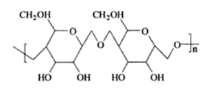
Figure 1: Structure of Amylose (1)

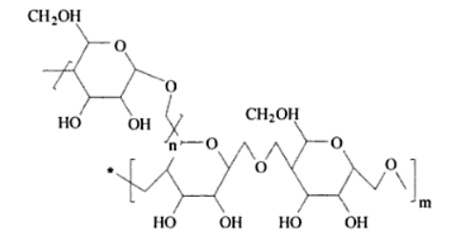
Figure 2: Structure of Amylopectin. (1)

Starch applications
Starch has many uses and applications in our lives here are some of the main application that starch can be as a primary production raw material or a secondary one:
- Ingredient for food preparation:
- Basic home cooking ingredient.
- Food manufacturing (noodles, crackers etc).
- Adhesive and glue: Its relatively high viscosity affords an appreciable binding capacity, which is why starch finds much favorite in the adhesive industry.
- Plywood: Tapioca starch is applied for making glue which is an important raw material of the plywood industry. The strength and the quality of plywood depend largely on the quality of glue.
- Conversion industry: It is widely used by industries manufacturing downstream products like liquid glucose, sorbitol, malt dextrin, etc.
- Animal feed: Starch is highly economical and therefore extensively used as filler in the manufacturing of compounded animal feeds.
- Pharmacy: Native starch is used as binders, fillers and disintegrating agents for tablet production.
- Textiles: Starch is perfect for textile applications. This is why it is widely used in the sizing of yarns and finishing of cotton and polyester fabrics.
- Paper: Starch was used in three stages of production process; Beater Sizing or Wet-end, Surfacing Sizing or Size-press and Surface Coating.
- Confectionery: Native tapioca starch and diverse types of modified starch are used in confectionery for different purposes such as gelling, thickening, texture stabilizing, foam strengthening, crystal growth control, adhesion, film foaming and glazing.
- Jellies and gums: Low viscosity tapioca starch is widely used in gelled confectioneries. [11]
Because of its low cost and renewability, starch is an attractive natural polymer for a variety of purposes. For example, it can be readily converted into thermoplastic starch (TPS) for the production of biodegradable commodities, including blends and composites.

Chapter 4
Thermoplastic Starch Polymer

Thermoplastic starch can be obtained by suitable treatment with temperature and pressure in the presence of a plasticizer, such as water, glycerol, or sorbitol. The plasticizer penetrates into the starch granules and disrupts the initial crystal lographic structure. Because of temperature and shear forces, the material under goes a melting process and forms a continuous amorphous mass that no longer exhibits diffraction. If the total thermal and mechanical energy provided to the starch is insufficient the product will show non-molten starch granules of clear or B-type crystallographic structure and with characteristic patterns in X-ray diffractograms. Similarly, use of an insufficient amount of plasticizer may result in incomplete destruction of the crystallographic structure of starch.
The mechanical properties of TPS depend on the starch production temperature and water content, as well as the quantity and type of added plasticizers and auxiliary materials. The most notable influence on changes in mechanical properties proved to be the amounts of plasticizer and auxiliary materials. The most common plasticizers, such as glycerol, glycol, or sorbitol, possess hydroxy groups similar to those that appear in starch, and so are compatible with starch macro granules. [12]
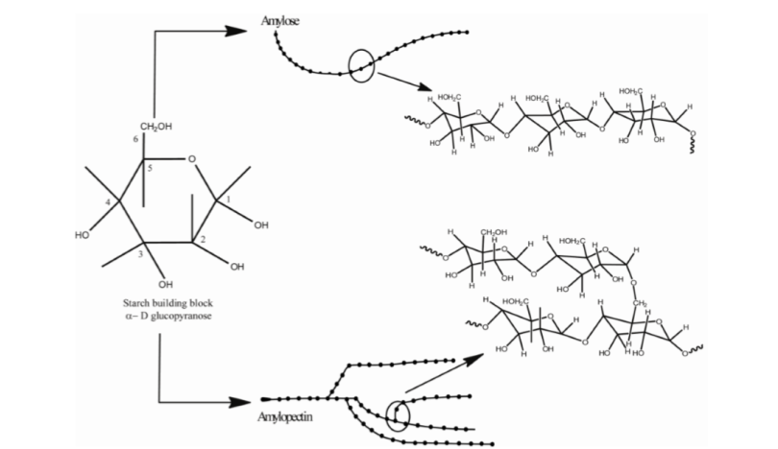
Figure 3: Linear and Branched Starch Polymer

TPS Process
The thermal processing of starch-based polymers involves multiple chemical and physical reactions, e.g. water diffusion, granule expansion, gelatinization, decomposition, melting and crystallization. Gelatinization is the most important phase transition, it involves all these processes and thermoplastic conversion of starch is based on it. Figure 4 shows a schematic representation of the phase transitions of starch during gelatinization and retrogradation. Heating in water destroys the crystalline structure of starch granules and forms amorphous amylopectin (Figure 4 a and b). Gelatinized amorphous amylopectin still contains small quantities of un-gelatinized amylopectin. Nevertheless, gelatinization destroys the double-helical crystalline structure formed by the short-branched chains in amylopectin.
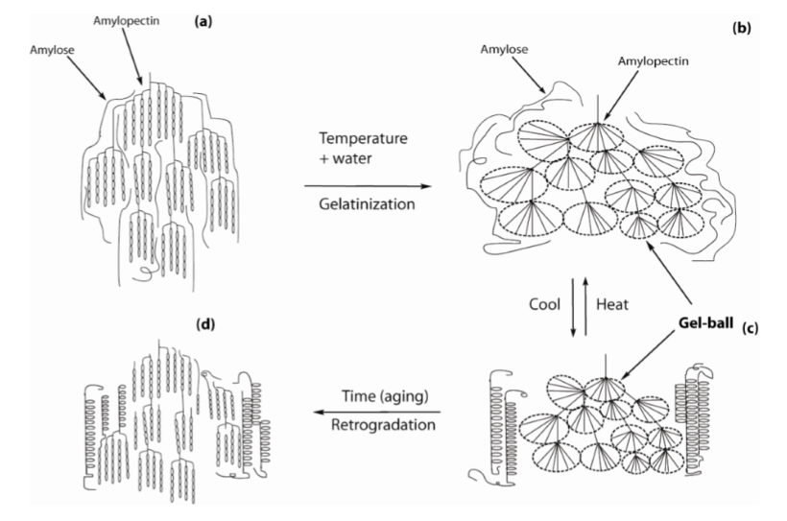
Figure 4: Transition of Starch Through Gelatinization and Aging.
Furthermore, the starch decomposition temperature is higher than its pregelatinization melting temperature and consequently, starch has a high glass transition temperature (Tg). Due to free volume relaxation and retrogradation, brittleness also increases with time. To overcome these problems and to make starch more flexible and easy to use, plasticizers are blended with starch. Water plays two roles in the starch gelatinization: it breaks the structure of the native granule and acts as a plasticizer. However, TPS containing only water has little value in practical applications because of poor mechanical properties. A second plasticizer is necessary besides water, such as poyols, urea, formamide, acetamide, and citric acid. All have been evaluated as additional plasticizers that will allow melting phases at a temperature lower than that of starch degradation and they make starch flexible. During starch processing, the combination of shear, temperature and plasticization allows the preparation of molten thermoplastic material. The properties of plasticized starches depend very much on moisture contents. Relative humidity changes the material properties, through a sorption-desorption mechanism. Even when moisture and temperature are controlled, the properties of the material remain dynamic, changing into lower elongation at break and higher rigidness. So in order to improve the moisture impermeability of starch products, starch is formulated with renewable, natural or synthetic polymers.
Most common polymers used in blends with thermoplastic starch are
- Poly(vinyl acetate) PVAc
- Poly(methacrylic acid-co-methyl methacrylate) MAA/MMA
- Poly(vinyl alcohol) PVA
- Poly(acrylic acid) PAA
- Poly(ethylene-co-acrylic acid) EAA.
- Poly(ethylene-co- vinyl alcohol) EVOH.
- poly(caprolactone) PCL.
- Poly(ethylene-vinyl acetate).
- Polyethylene.
- Poly(ester-urethanes).
- Poly(D,L-Lactic acid) PLA.
- Poly(3-hydroxybutyrate) PHB.
- Poly(3-hydroxybutyrate-co-3-hydroxyvalerate) PHBV.
- Poly(butylene succinate adipate) PBSA.
- Polyesteramide PEA.
- Zein.
- Lignin.
- Cellulose and its derivatives.
- Natural rubber.

Plasticizer in TPS
Various other plasticizers were evaluated to improve the processing properties and product performance of TPS blends e.g. glycerol, urea, formamide, sorbitol, citric acid, glycol, and amino acids. The most common plasticizer used after water is glycerol due to its high boiling point, availability, and low cost. The plasticizer- starch interaction can be very specific. The plasticizer interacts through hydrogen bonding with starch chains in a wide temperature range. The interaction increases at higher temperatures, probably due to H-bond formation. As a consequence, the material behaves like a rubber, with a rise in matrix mobility and a decrease in viscosity. Plasticizers containing amide groups were tested for TPS plasticization using glycerol as reference. Amide groups were effective to inhibit starch retrogradation. The mechanical properties and retrogradation of TPS blends mainly depends on the hydrogen bond-forming ability between plasticizers and starch molecules. This ability increases in the following order: urea > formamide > acetamide > polyol. The moisture affinity of TPS blends depend on the plasticizer concentration and hydrophilic nature. [13]

Chapter 5
Literature Review

Many additives was added to TPS in an experiment that was carried by D. S. Rosa, et. al. a mixture of high density polyethylene (HDPE) and polypropylene (PP), both post-consumer polymers were blended with thermoplastic starch (TPS). This experiment showed that the addition of TPS reduced the melting ﬂow index of PP and increased of HDPE and HDPE/PP blends. TPS also decreased the tensile strength and elongation at break, and increased the rigidity of the materials. Scanning electron microscopy showed separation of phase between the poly-oleﬁns and TPS. [14] In a similar experiment biodegradable that was carried out by M. ALBERTA ARA ´UJO, et. al., blends of corn starch with poly(ethylene-vinylalcohol) copolymer (SEVA-C) have been studied and reported after running the experiment the results were: the glycerol leaches quickly out during the ﬁrst few days of immersion, stabilizing thereafter, presenting greater diffusion coefﬁcients for thicker samples. As the quantity of saccharides in the solution remains almost invariable along the experiments, their work also conﬁrms that the degradation process is difﬁcult without the action of enzymes. [15] Another similar experiment that was carried by Ranumas Thipmaneea, Sam Lukubirac, Amod. Ogalec, Amporn Sanea was to explore the effect of zeolite ZSM-5 (ZSM5) incorporation sequence on the phase morphology, microstructure, and performance of polyethylene/thermoplastic starch (PE/TPS) films. Two processing sequences were used for preparing PETPS/ZSM5 composites at a weight ratio of PE to TPS of 70:30 and ZSM5 concentrations of 1-5 wt%: (i) melt compounding of PE with ZSM5 prior to melt blending with TPS (SI); and (ii)TPS was compounded with ZSM5 prior to blending with PE (SII). Distributive mixing and mechanical properties of PETTPS blend were greatly enhanced when ZSM5 was incorporated via Sll. These were caused by both the higher affinity between PE and ZSM5, compared to that of TPS and ZSM5, and the reduction of TPS viscosity after compounding with ZSM5, leading to migration of ZSM5 from TPS dispersed phase toward PE matrix and increase in breakup of TPS droplets during SII sequence. [16]
Other biodegradable polymer additives can also be used in the TPS blend for an example an experiment that was carried by Vitor Brait Carmona, Ana Carolina et. al., a Biodegradable ternary blends of thermoplastic starch (TPS), poly(e-caprolactone) (PCL) and poly(lactic acid) (PLA) were prepared by one-step extrusion based on the complementary mechanical properties between both ductile PCL and rigid PLA and also low cost TPS. TPS/ PCL/PLA blend was prepared using equal mass fraction of each component and presented as an incompatible material and then evaluated the addition of citric acid, maleic anhydride and methylene diphenyl diisocyanate (MDI) as compatibilizing agents in the ternary blend. They did not signiﬁcantly affect thermal stabilities of the ternary blends but induced PCL and PLA crystallization. Adding 2 wt% of MDI caused an increase in melt viscosity of the ternary blend suggesting that urethane linkages were formed with TPS and it also was efﬁcient in order to obtain notable improvements in tensile strength and ductility of the ternary blend. [17] another example for a biodegradable polymer additive is an experiment that was carried out by J.F .Mano et. al., in this work the thermal behavior of thermoplastic blends of corn starch with some biodegradable synthetic polymers (poly(e-caprolactone), cellulose acetate, poly(lactic acid) and ethylene vinyl alcohol copolymer) structurally complex materials were investigated. The endothermic gelatinization process evaporation) observed by differential scanning calorimetry (DSC) in starch is also observed in the blends Special attention was paid to the structural relaxation that can occur in the blends with during its body temperature that may change the physical properties were application as a biomaterial. At least three degradation mechanisms identified in the blends by means of using TGA, being assigned to the mass loss due to the plasticizer leaching, and to the degradation of the starch and the synthetic polymer fractions. Different integral kinetics of the decomposition processes was analyzed using two of methods. The analysis included the calculation of the activation energy the correspondent reactions. [18]
A new trend is going toward the use of nanoclay as an additive for the TPS in an experimental work that was carried by Yachuan Zhang, Qiang Liu, et. al., the use of montmorillonite (MMT) nanoclay as an additive with different concentrations and studied how it inﬂuences physical and mechanical properties of thermoplastic starch (TPS), which was produced by a conventional extrusion procedure. Transmission electron microscopy (TEM) showed most MMT platelets existed in tactoid structure in the starch matrix. In addition, FTIR spectra indicated TPS/MMT nanocomposites kept chemically stable after the extrusion. Thermal property tests exhibited the glass transition temperature (Tg) of the nanocomposites decreased with increasing MMT from 0 to 8 %, indicating MMT nanoclay had a plasticization effect. [19] another experiment that was carried by Hwan-man park, won-ki lee, et. al., attempted to develop environmentally friendly polymer hybrids, biodegradable thermoplastic starch (TPS)/clay nanocomposites were prepared through melt intercalation method. Natural montrorillonite (Na+ MMT; Cloisite Na+) and one organically modiﬁed MMT with methyl tallow bis-2-hydroxyethyl ammonium cations located in the silicate gallery (Cloisite 30B) were chosen in the nanocomposite preparation. It was observed that the TPS/Cloisite Na+ nanocomposites showed higher tensile strength and thermal stability, better barrier properties to water vapor than the TPS/Cloisite 30B nanocomposites as well as the pristine TPS, due to the formation of the intercalated nanostructure. The effect of clay contents on the tensile, dynamic mechanical, and thermal properties as well as the barrier properties of the nanocomposites were investigated. [20]
In a study carried out by Ata Taghizadeh. et. al., thermoplastic starch (TPS) was prepared with different molecular weight polyol plasticizer: glycerol, sorbitol, dieglycerol, polyglycerol. Dieglycerol-TPS and polyglycerol-TPS show significantly lower moisture uptake and higher temperature stability when compared to conventional glycerol-TPS. This study explained that the mechanical properties indicate an overall similar performance for dieglycerol, polyglycerol and sorbitol as compared to glycerol, In addition the increased chain flexibility and lower cohesive energy forces of diglycerol and polyglycerol lead to a more homogenous TPS phase. [21]
Retrogradation of amorphous thermoplastic starch (TPS) films obtained by compression moulding of spray dried amorphous powder was investigated by Muhammad Bilal Khan Niazi, et. al., the aim of their work was to study the influence of malto-oligosaccharide molecular weight, i.e. dextrose equivalents (DE), on the performance of the powders and the films. Amorphous TPS films were obtained, irrespective of the additive used. At a relative humidity (RH) of 0 and 50% all samples maintained their amorphous nature while at RH100% retro-gradation was suppressed for all formulated starch films. It was shown that the rate of moisture uptake, and as a consequence, the rate of retro-gradation, depends on the molecular weight of the additive. FT-IR and TGA measurements proved a more effective interaction of starch with low molecular weight additives such as maltose and glucose syrup (DE 38.2) than for the higher molecular weight maltodextrine (DE 19.1). [13]

Chapter 6
Experimental Work

6.1 Methodology
- Materials
The thermoplastic polymer blend consists of four primary elements; starch, water, plasticizer and acid. Each of these elements composition has its effect on the properties of the product. All materials used in this project were supplied from the local market, they were:
- Corn starch
- Plasticizer: glycerin
- Acids: citric acid, acetic acid and fresh lemon juice
- Water
- Agricultural waste as additive: olive waste.

- Sample preparation
The methodology used in preparing the polymer was 4 steps; the first step was mixing the ingredients; the starch was added to water at room temperature and mixed until a homogenous solution formed, after all the starch had been dissolved the acid and the plasticizer (if used) were added directly and mixed. The second step was mixing the polymer components using a heater at an approximated temperature of 80 ᴼC. The third step was casting the mixture over a surface and let it cool overnight. For the olive waste samples, the olive waste weight was taken from the starch’s, so it’s 2.5% and 10% from the starch weight. All prepared samples are shown in Table (1).

Table 1: Samples Numbering and Composition.
component  samples | Sample symbol | Acid(s) | plasticizer | starch | water | %Olive waste
Sample 1 | A1 | Acetic acid | High glycerin | Yes | yes | 0%
Sample 2 | A2 | Acetic acid | Low glycerin | Yes | yes | 0%
Sample 3 | A3 | Acetic acid | No glycerin | Yes | yes | 0%
Sample 4 | C1 | Citric acid | High glycerin | Yes | yes | 0%
Sample 5 | C2 | Citric acid | Low glycerin | Yes | yes | 0%
Sample 6 | C3 | Citric acid | No glycerin | Yes | yes | 0%
Sample 7 | L1 | Lemon juice | Low glycerin | Yes | yes | 0%
Sample 8 | L2 | Lemon juice | No glycerin | Yes | yes | 0%
Sample 9 | 2/3A-1/3C | Acetic & citric | High glycerin | Yes | yes | 0%
Sample 10 | 1/2A-1/2C | Acetic & citric | High glycerin | Yes | yes | 0%
Sample 11 | 1/3A-2/3C | Acetic & citric | High glycerin | Yes | yes | 0%
Sample 13 | LOW | Acetic acid | High glycerin | Yes | yes | 2.5%
Sample 13 | HIGH | Acetic acid | Low glycerin | Yes | yes | 10%

- Testing

- Tensile test
Tensile test was carried out by using Sinwon Test Machine ST Series at constant speed 5mm/min and at room temperature. For each sample, three specimens were tested. The samples were 45 to 50 mm gauge length, Tensile Test provides values of the tensile strength, modulus of elasticity by 1% strain secant method and ductility as percent elongation at break.

- Differential Scanning Calorimeter (DSC)
The thermal properties of some prepared samples were evaluated using a differential scanning calorimeter (DSC) model Pyrix-6, Perk in Elmer, Corporation, U.K. 4.3 to 5.4 mg samples, encapsulated in a hermetically sealed aluminum pan, were prepared. The same temperature profile was applied to all samples. Samples were heated at 10°C/min. The thermal transition such as fusion was scanned in a temperature profile of 20-230°C. Melting temperature and heat of fusion of the samples were obtained from the maximum peak and area under the peak respectively, where the last is essential in estimating the percentage of crystalline regions.
- Digestion capability
Five laboratories mice were used in testing the digestion capability of the C3 sample, since it was expected to be non-toxic to the mice. The mice were inoculated orally with powdered dyed polymer mixed with water. The stomach and intestines of the mouse was tested using a x2000 microscope magnification to track the polymer traces. Each mouse was tested within a period of half-an-hour, the test took2 and half an hour to test all five mice.

- Biodegradability
A 0.1 g of samples from 1 to 7 was soak in water for several days until they decomposed.

6.2 Results
- Mechanical and thermal properties testing
From the tensile test the strength, modulus of elasticity and ductility were calculated, the thermal properties (enthalpy of melting and the melting temperature) was obtained from the DSC diagram, the results were as follow:
- Acid effect on polymer
The effect of acid type on mechanical and thermal properties of starch polymer is shown in Table (2)
Table 2: Acid Effect on Starch Polymer.
 | Strength (MPa) | Modulus (MPa) | ductility | Enthalpy of melting (kJ/kg) | Tm (ᴼC)
Acetic (A1) | 6.30 | 287.45 | 3.42 | 135.00 | 76.76
Lemon (L1) | 3.31 | 133.51 | 21.78 | --------
Citric (C1) | 1.33 | 16.70 | 65.15 | 127.87 | 94.61

The acetic sample had the highest strength and modulus of elasticity but the lowest ductility which was approved by the DSC results, where the enthalpy of melting of acetic sample was the highest, that was the reason why the acetic acid was chosen as a base for the other tests.
- Glycerin effect on Acetic acid sample and Citric acid samples
The effect of glycerin as a plasticizer was studies and results are shown in Table (3)
Table 3: Glycerin Effect on Acetic Acid and Citric Acid.
 | Strength (MPa) | Modulus (MPa) | ductility | Enthalpy of melting (kJ/kg) | Tm (ᴼC)
acetic high | 6.30 | 287.45 | 3.42 | 135.00 | 76.76
acetic low | 6.83 | 392.25 | 1.89 | 175.80 | 85.62
citric high | 1.33 | 16.70 | 65.15 | 127.87 | 94.61
citric low | 4.96 | 328.00 | 1.90 | ------- | --------

From this table it is clear that glycerin weaken the mechanical properties of the samples and also decrease the crystallinity.
- Replacing Acetic Acid with Citric acid effect
The effect of percentage of citric acid (replacing Acetic acid) on mechanical properties was studied and the results are shown in Table (4)
Table 4: Replacing Acetic Acid with Citric Acid Effect.
 | Strength (MPa) | Modulus (MPa) | Ductility | Enthalpy of melting (kJ/kg) | Tm (ᴼC)
100% Acetic | 6.30 | 287.45 | 3.42 | 135.00 | 76.76
1/3 Citric | 1.34 | 16.98 | 66.26 | -------- | ---------
½ Citric | 1.01 | 8.23 | 73.13 | 63.34 | 84.79
2/3 Citric | 1.15 | 14.55 | 67.31 | 77.46 | 90.49
100% citric | 1.33 | 16.70 | 65.15 | 127.87 | 94.61

Replacing the acetic acid with citric acid decreased the strength and the modulus of elasticity but increased the ductility, it also decreased the crystallinity, when the citric composition overcame the acetic composition the strength, modulus of elasticity and the crystallinity increased but didn’t reach the pure acetic sample properties.
- Olive effect on acetic acid polymer
Olive solid waste as a natural additive was added to starch polymer to observe its effect on both mechanical and thermal properties, results are shown in Table (5)
Table 5: Olive Effect on Acetic Acid Polymer.
 | Strength (MPa) | Modulus (MPa) | ductility | Enthalpy of melting (kJ/kg) | Tm (ᴼC)
0% olive | 6.30 | 287.45 | 3.42 | 135.00 | 76.76
2.5% olive | 1.95 | 99.56 | 24.05 | ------ | ------
10% olive | 1.62 | 58.08 | 31.52 | 168.57 | 82.60

As the percentage of olive waste increased the strength and modulus decreased but the ductility increased. For the crystallinity, it increased as the olive waste percentage increased.

- Digestion capability test
At first the polymer was crushed to form a powder then mixed with water, the powdered polymer mixed with water is shown in Figure (5):
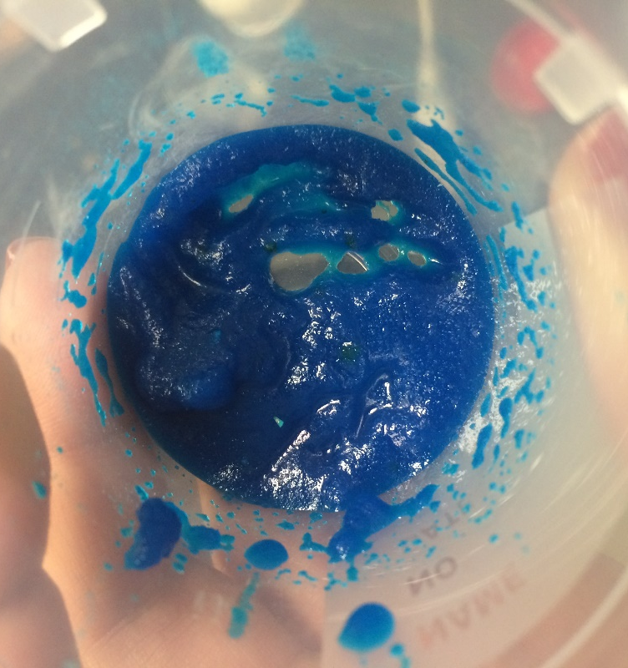
Figure 5: Powdered Dyed C3 Sample Mixed with Water.
First the polymer was tested under the microscope by itself to compare it with the polymer after fed to mice, the micrograph is shown in Figure (6).
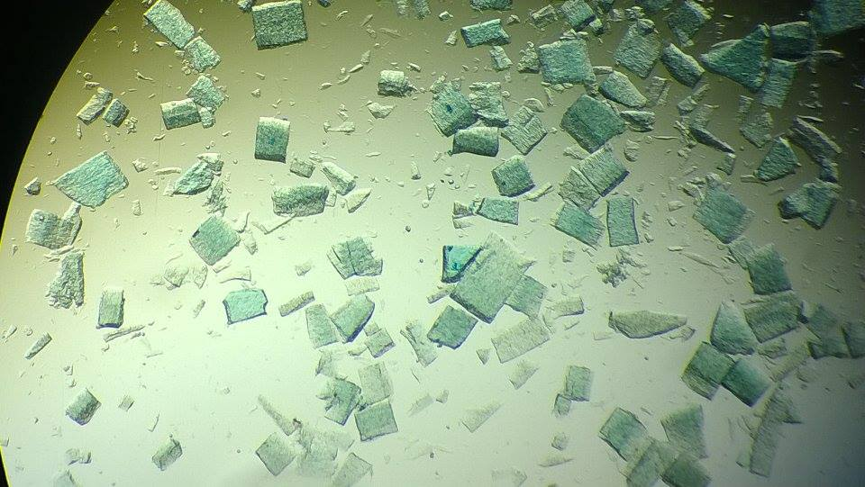
Figure 6: C3 Sample under the Microscope.
Different samples were taken from the stomach and intestines at half of an hour periods.
At first the dye separated from the polymer as shown in the following figure, Figure (7)
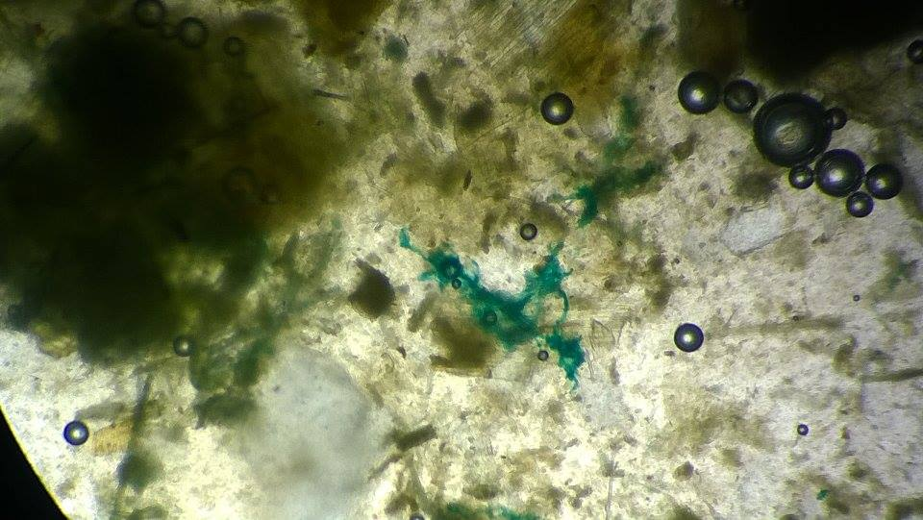
Figure 7: The Separation of the Dye from the Polymer.
After almost an hour the polymer started to get digested in the stomach which is clear from the edges of the polymer pieces, Figure (8)
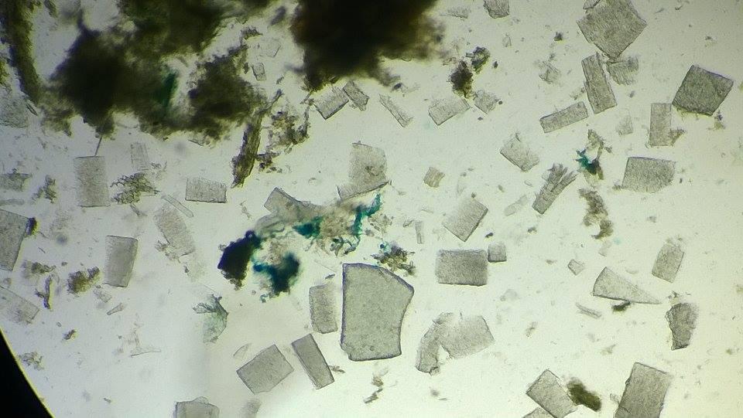
Figure 8: The Digested Polymer in the Stomach.

The digested polymer in the intestines of the mouse, where it became almost transparent and with digested edges.
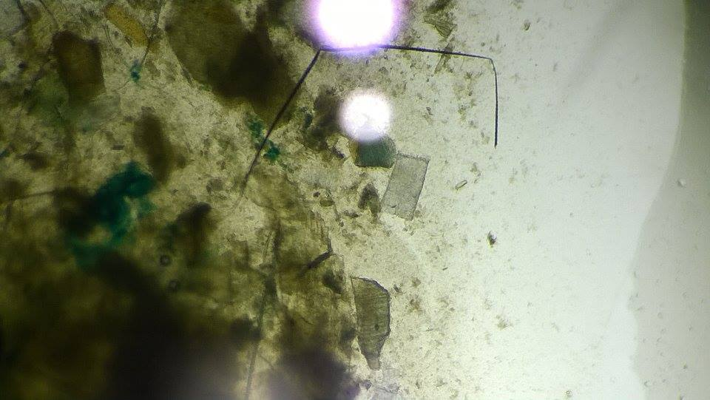
Figure 9: The Digested Polymer in the Intestines of the Mice.
Biodegradability of the polymer
The 7 samples that were soaked in water after 4 days as shown in Figure (10):
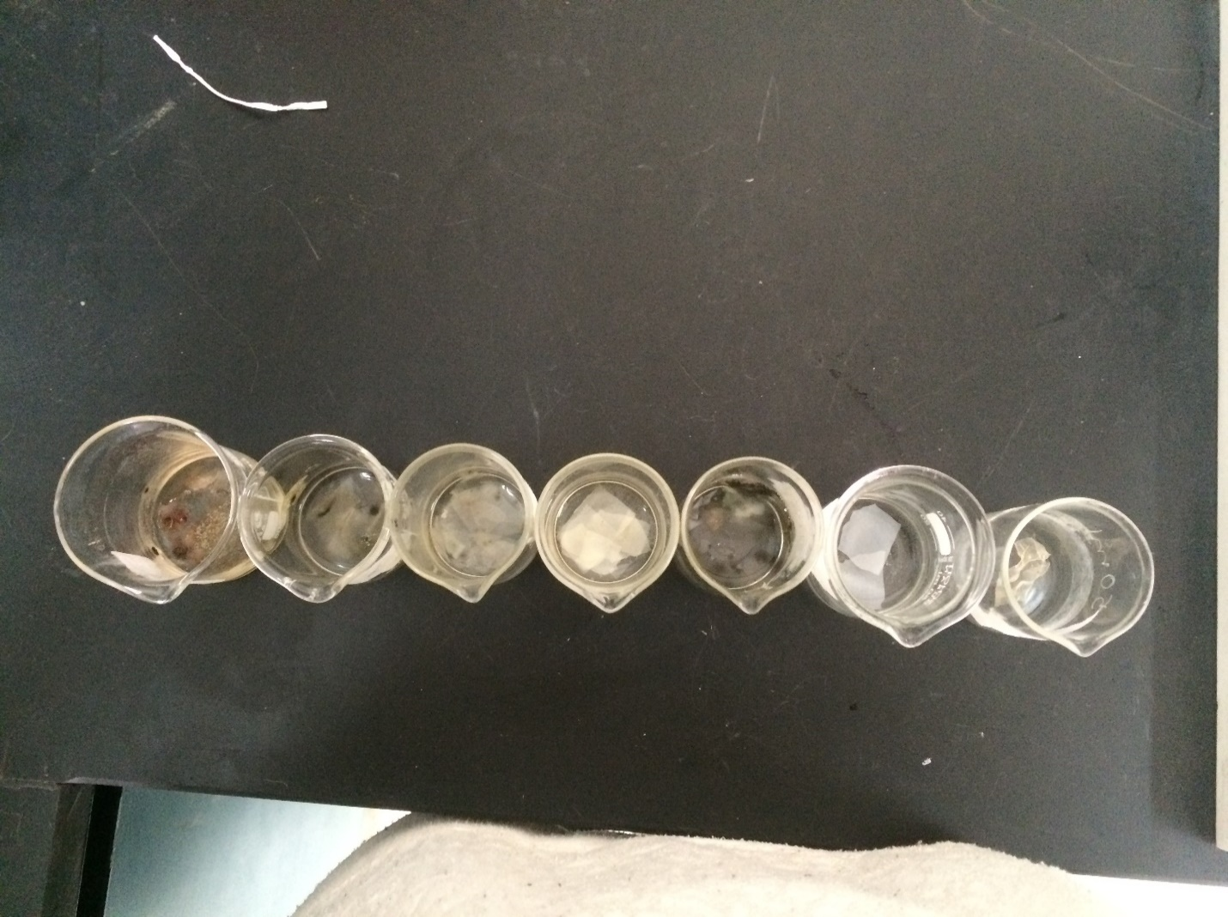
Figure 10: Samples After 4 days of Soaking in Water.
The first two from the left were acetic acid samples with high and low glycerin (they didn’t degrade yet), the second three were citric acid samples and the final two were lemon samples.
The first and fourth sample had high glycerin contents, followed by the second and fifth samples, the rest had no glycerin in their compositions.
A closer look at a composed sample:
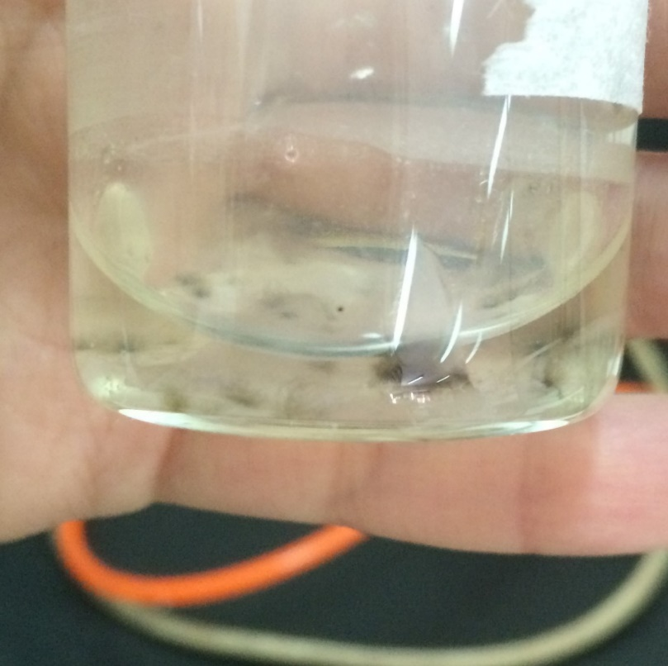
Figure 11: Decomposed Polymer.

6.3 Discussion
1. Mechanical and thermal properties
- Acid effect on the polymer
The effect of different acids (acetic (A), Lemon (L) and Citric (C)) on tensile strength and modulus of elasticity of prepared starch polymers is shown on Figure (12)

Figure 12: Acid Effect on the Strength and Modulus of Elasticity of the Polymer.
It’s clear from Figure (12) that the acetic acid has the highest strength and modulus followed by the lemon and finally the citric, the opposite happens with the ductility as shown Figure (13), where the citric sample has the highest ductility followed by the lemon samples and finally the acetic samples. This is a normal relation between the strength and ductility.

Figure 13: Acid Effect on Ductility (%EL).
The citric acid’s melting temperature is higher than the melting temperature of the acetic, 76.76 and 94.61 respectively as shown in table 2, despite the fact that the acetic acid has higher crystallinity with 135 kJ/kg melting enthalpy than the crystallinity of citric sample with 127.87 kJ/kg melting enthalpy, this might be due to crossed-linked regions that are formed because of the citric acid this was proven by N.Reddy and Y.Young when they used citric acid as -crosslinking agent. [21]

- Glycerin effect on the polymer
The effect of glycerin on both acetic and citric samples was studied and the results regarding mechanical properties (Tensile strength and Modulus of elasticity) are shown in Figure (14).

Figure 14: Glycerin Effect on the Strength and Modulus of Elasticity of the Polymer.
Increasing the glycerin decreases the strength and modulus of elasticity as Figure 14 shows, this might be due to the decrease in crystallinity. This effect can be justified by knowing the effect of adding glycerin to the TPS as a plasticizer, which involves the introduction of side chains that reduce the intermolecular forces between the polymer molecules themselves and causes a decrease in crystallinity and melting temperature. As E. H. IMMERGUT and H. F. MARK proved in their publication [22]
Glycerin has larger effect on the citric samples more than the acetic samples, since plasticizer molecule will have much more difficulty in penetrating the crystalline regions, where there is a minimum of free space between the polymer chains than the amorphous regions; the acetic sample is more crystalline with an enthalpy of melting equals to 135 kJ/kg which is higher than the citric sample with 127.87 kJ/kg enthalpy of melting. Crystallinity should, therefore, be considered as a factor opposing plasticization. [23].
As the crystallinity increases the ductility decreases as shown in the Figure (15)

Figure 15: Glycerin Effect on the Polymer's Ductility.

- Replacing the acetic acid with citric acid
Acetic acid was replaced partially by citric acid to study the effect of this combination on mechanical and thermal properties; results for strength and modulus are shown in Figure (16)

Figure 16: Replacing Acetic with Citric Effect on the Polymer.
when adding citric to acetic the randomness increases and so the crystallinity decreases, this is why the half-acetic half-citric sample has the lowest melting enthalpy, strength and elasticity as shown in figure (16), but the highest ductility as shown in Figure (17). When the citric composition start to overcome the acetic composition the crystallinity went up again, but not as when the acetic composition is higher than the citric, this is due to the higher crystallinity in pure acetic sample with 135 kj/kg melting enthalpy than pure citric sample with 127.87 kj/kg melting enthalpy.

Figure 17: Citric Acid Effect on the Polymer's Ductility
- Olive waste effect
Olive solid waste was selected as a natural waste to be added to starch polymer to observe its effect on properties as shown in Figures (18) and (19)

Figure 18: Olive Waste Effect on the Polymer’s Strength and Elasticity.
As shown in Figure (16) Tensile strength and modulus of elasticity decrease with increasing olive solid waste percentage and that might be due to formed of the voids that resulted from the poor compatibility between the polymer and the olive waste have, as for the ductility it should decrease because of the voids but apparently it behaves oppositely as shown in Figure (17) , the reason is that the olive waste wasn’t fully-dried and had small percentage of oil, and the oil could act as a plasticizer.

Figure 19: Olive Waste Effect on the Ductility of the Polymer.
Table (5) shows an increase in crystallinity where the enthalpy of melting jumped from 135 to 168.57 kJ/kg, this contradicts with the strength and the elasticity results, this can be justified by assuming some cross-linking occurred due to an addition of olive solid waste which may contain some active materials such as metallic polymeric compounds (poylmerin), a study done by BOLAÑOS, JUAN FERNÁNDEZ-, ET AL proved the effect of polymerin on crystallinity and cross-linking [24].

2. Digestion Capability
The citric acid with no glycerin sample (C3) is used for testing the digestive capability for two reasons; first for the expectations of no toxicity from the citric acid, also glycerin might cause some intestines problems for the mice. The polymer didn’t form a solution with the water but a mixture as shown in figure 6, the reason why is because starch polymer doesn’t dissolve in water under the normal conditions. The dye separated from the polymer because of the incompatibility between the polymer and the dye as shown in figure 7. As for the short periods of half an hour it’s because of the small digestive system the mice have, that gets rid of what’s in the mice’s digestive system within 2 to 2:30 hours.
The polymer starts to digest in the mice’s stomach after almost 1 hour which is shown in figure 8, when the edges of the polymer starts to get less sharper than they normally were in figure 6, also the digestion doesn’t stop in the stomach, more polymer is digested in the intestines of the mice as shown in figure 9. This is a proof of the digestive capability of the polymer for both humans and animals.

3. Biodegradability
The samples that has no glycerin in their composition decompose within the first 3 days of soaking, the lemon sample with glycerin degrades faster than the citric sample, where it took the lemon with glycerin sample 4 days to degrade and the citric 5 days. The slowest one to degrade was the acetic samples (high and low glycerin composition), they took almost 7 days to start degradation.
The lemon juice has high citric acid in its components along with the ascorbic acid and malic acid according to the Modern Gastronomy: A to Z book [25] that’s why the lemon juice samples has closer degradation properties to the citric acid samples. The reason why it takes the acetic acid more time to degrade might be due to higher crystallinity, thus stronger bonds between the polymer molecules that the bacteria can’t easily penetrate and decompose.

6.4 Conclusion
- Strength and modulus of elasticity are directly proportional to the crystallinity in case of no other disturbances, and inversely proportional with the percentage of ductility.
- The acetic acid gives higher crystallinity to the polymer than the lemon juice and the citric acid.
- Glycerin acts as a crystallinity opposing agent.
- Glycerin gives the polymer higher ductility, but it lowers the strength and modulus of elasticity.
- Increasing the randomness in the polymer definitely will decrease the crystallinity.
- Citric acid forms cross-linking in the polymer.
- Olive waste creates voids in the polymer, thus it lowers the strength and modulus of elasticity.
- Olive waste contains polymerin which enhance the crystallinity in the polymer.
- Olive oil residue in the olive waste may act as a plasticizer.
- The starch polymer can be digested and it cause no harm to the digestive system.
- The starch polymer is a biodegradable polymer.
- Thermoplastic starch polymer is an environmental friendly polymer.

References
1. Young, R. and lovell, P. Introduction of polymers. third edition. united state : CRC press, 2011.
2. Wainwright, S. Mechanical Design in Organisms. london : Edward arnold, 1976.
3. Gopferich, A. The Biomaterials: Silver Jubilee Compendium: Silver Jubilee Compendium. germany : elsevier, 1996.
4. Smith, R. Biodegradable polymers for industrial applications. Woodhead Publishing Limited: england, 2005.
5. Halley, P. and Averous, l. [ed.]. Starch Polymer. Elsevier, UK : 2014.
6. Rieger, B., Künkel, A., Coates, G., Reichardt, R., Dinjus, E., Zevaco, Th.[ ed.]. synthetic biodegradable polymers. london : springer, 2012.
7. Ghanbazadeh, B. and Hadi, A. biodegradable polymers. Iran : intech, 2013.
8. Bastioli, C. [ed.]. handbook of biodegradable polymers. United kingdom : Rapra Technology Limited, 2005.
9. Kutz, M. [trans.]. Applied Plastics Engineering Handbook .Elsevier, NY, USA : 2011.
10. Miller, J. and Whistler, R. [ed.]. STARCH: CHEMISTRY AND TECHNOLOGY. united kingdom : Elsevier Inc., 2009.
11. Aarhus, S., International Starch Trading. Starch. starch applications. [Online] 2003. [Cited: october 6, 2015.] http://www.starch.dk/isi/applic/tapiocavarious.htm.
12. Janssen, L. and Moscicki, L. Thermoplastic Starch. weinheim : Wiley-VCH, 2009.
13. Niazi, M. and Bilal, K. Production of plasticized thermoplastic starch by spray drying. Pakistan : University of Groningen, Groningen, 2013.
14. Rosa, D., Guedes, C. and Carvalho, C. Processing and thermal, mechanical and morphological characterization of post-consumer polyoleﬁns/thermoplastic starch blends. Springer Science+Business Media, 52, 2007.
15. Jo, A. et al. Determination of diffusion coefﬁcients of glycerol and glucose from starch based thermoplastic compounds on simulated physiological solution. JOURNAL OF MATERIALS SCIENCE: MATERIALS IN MEDICINE, 16, potugal 2005.
16. Thipmanee, R. et al. Enhancing distributibe mixing of immiscible polyethylene/thermoplastic starch blend through zeolite ZSM-5 compounding sequance. : elsevier, 136, thailand, 2015.
17. Carmona, V. et al. Properties of a Biodegradable Ternary Blend of Thermoplastic Starch (TPS), Poly(e-Caprolactone) (PCL) and Poly(Lactic Acid) Springer Science+Business Media PLA. 89, new york, 2014.
18. Mano, J., Koniarova, D. and Reis, R. thermal properties of thermoplastic starch/synthetic polymer blends with potential biomedical applicability. kluwer academic publishers, 14, portugal , 2003.
19. Zhang, Y. et al. Characterization of Extruded Thermoplastic Starch Reinforced by Montmorillonite Nanoclay. Springer Science+Business Media, 21, Canada, 2013.
20. Park, H. et al. Environmentally friendly polymer hybrids. Kluwer Academic Publishers, 38, korea :, 2003.
21. Taghizadeh , A., Sarazin , P. and Favis, B. High molecular weight plasticizers in thermoplastic starch/ polyethylene blend. Springer Science+Business Media, 48, canada, 2012.
22. Reddy, Narendra and Yang, Yiqi, "Citric acid cross-linking of starch films" (2009).Faculty Publications - Textiles, Merchandising and Fashion Design. Paper 25.
23. IMMERGUT , EDMUND H and MARK, HERMAN F. Principles of Plasticization., New York : Polytechnic Institute of Brooklyn, 1965.
24. Bolaños, Juan Fernández-, et al Extraction of interesting organic compounds from olive oil waste.. 57, spain : Food Biotechnology Departament, Instituto de la Grasa (CSIC) , 2006.
25. Adria, Ferran. Modern Gastronomy: A to Z. united state : CRC press, 2006.

