

An-Najah National University
Faculty of Engineering
Computer Engineering Department

Blind’s Slide Creator
2/5/2018

Supervisor:
Dr. Sufyan Samara
Accomplished by:
Razan Onab
Nabeel Zanabeet
Presented in Partial fulfillment of the requirement for Bachelor degree in Computer Engineering



Dedication

This is for you. For every person who ever helped. For every teaching member fight for us. For all family members. For colleges & friends. For every person who we cross path with in the computer department of An Najah University on our way up to bachelor degree.
Thank you all.

Acknowledgment

We would like to express our special thanks of gratitude to our supervisor Dr. Sofian Samara for his great supervision, also to everyone who contributed and helped us in any way.

DISCLAIMER

This report was written by Razan Onab and Nabeel Zanabeet at the Computer Engineering Department, Faculty of Engineering, An-Najah National University. It has not been altered or corrected, other than editorial corrections, as a result of assessment and it may contain language as well as content errors. The views expressed in it together with any outcomes and recommendations are solely those of the students. An-Najah National University accepts no responsibility or liability for the consequences of this report being used for a purpose other than the purpose for which it was commissioned.

Table of contents

Abstract ……………………………………………………..…………………………… 7
1 Introduction ……………………………………………………………………………. 8
  - problem statement ………………………………………………... 8
  - Objectives ……………………………………………………………..… 8
  - Scope of work & importance …………………………………… 8

- Constraints & earlier course work …………………………………………. 10
  - Constraints ……………………………………………………………….10
    - Demand for simplicity & optimism ……….10
    - Lack of free resources ………………………….10
    - Time ……………………………………………………..10
  - Earlier course work …………………………………………………..11

- Literature Review …………………………………………………………………..12
- Methodology ……………………………………………………………………...…13
  - Technical Choices ………………………………………………………….13
    - Laravel Framwork (MVC) …………………………13
    - Bootsrap …………………………………………..…….14
    - Google slides API ………………………………..…..14
    - Google drive API ………………………………..……14
    - Web Speech API ………………………………..……15
    - ResponsiveVoice.JS ……………………………..….15
    - PHP Apache Server ………………………………….15
    - MySql DataBase ………………………………………15
    - Composer &NPM commands ………………….16
    - GitHub +Trello ………………………………..……..16
  - Methods & Techniques ……………………………………………….16
    - Landing page ………………………………………….…..16
    - Registration & login ……………………………………….18
    - Guide & Navigation Shortcuts ………………….…..19
    - Generating slides …………………………………….…….19
      - Commands & Instructions …………20
      - Instruction mechanism ………………20
      - Interactivity …………………………………21
      - Inserting methods ……………………….21
      - Key shortcuts ………………………………22
      - Saving ………………………………………….22
      - Text Compiling …………………………….23
      - Errors ………………………………………….23
    - Automatic Download ……………………………………23
    - Navigation through the slides ………………………24
- Results and conclusion ……………………………………………….……………27
- References ……………………………………………………………………………….28

Table of figures

Figure 1(Home page) 16
Figure 2 (Login) 17
Figure 3(Dashboard) 18
Figure 4(demo) 23
Figure 5(Contact Page) 24
Figure 6(About page) 25

Abstract

One of the most valuable skills that any graduated student should master is public speaking & presentation production, it would be great whenever you use high technical software to generate and to present your slides, that provides a prop to communicate with audience and a clear understanding of your idea.
What if a blind person intends to make his own slide! So here comes the idea of this project, is to implement a smart web application (Blind’s Slide Creator) that manage and guide blind people to create slides of their own whenever they want, all of this is through a complete voice system.
The website will guide him through the whole process, he will have a wide choice of voice commands to manipulate the slides keeping the procedure simple and easy, after that a PowerPoint presentation will be downloaded automatically, next he will be able to start his own show enhanced by also voice instruction to notify him with the alive changes occur on the screen through the presentation.

1. Introduction

  - Problem Statement
A lot among us don’t even realize that blind or visual impaired always do public speaking. They do study in universities between us and having their own presentation assignments or discussions, but they always refer to their friends to do the slide show for them since there is no software provide the ease for them to do that. They can’t use PowerPoint as it requires a lot of handling with long term of options and details.

  - Objectives
Here comes this project. A dynamic website specialized for blinds to provide them the ability to create a slide show totally by their own with voice guides & other needed requirements needs to handled automatically.

  - Scope of work & Importance
We live in the age of software’s & technologies. We developers in the other side having a responsibility to use this knowledge to help other in many different fields.

Blind people reach a point that they can use smart phones and computers using voice navigators and keys shortcuts. They learn to use these things in schools specialized for this purpose.
Now along with this evolvement. It becomes possible for them also to create a slide show and navigate throw the hole process by themselves. This adds a lot to their confidence & independency.
This could be the start of a huge navigation system for blind people to create documents, slide shows, excel sheets and manage their google docs & google drive. All of this with some simple written or spoken voice commands.

2. Constraints and Earlier course work
  - Constraints

    - Demand for simplicity and automatism
The natural of this website as it deals with mainly blind people needs to be much simple as possible and straight. It also must handle most of the job done automatically like the login, the generation of slides and the automatic download It should be dynamic and interact with the user as much as possible.

    - Lack of free resources
There is lack of free software’s or open source code for office or websites that create slides. So the website works mainly with API’s. That are still new and in beta version like google slides API, google drive API and google Web Speech API along with their constraints and limited functionalities.

    - Time
Many ideas and features couldn’t be fully implemented due to short semester period. Also, we took some time learning Laravel PHP Framework which was chosen to implement website. Also it took us time to understand the API’s and implement the authentication stuff.

  - Earlier course work
Courses which have been taken in the computer engineering department help implementing and developing the application like OOP, software engineering, web and Networking which was very important to make the application authentication and implementation & communication mechanism with API’s. Beside other external courses and tutorial to learn Laravel and how to deal with client object, authentication, json requests plus reading up documentations.

3. Literature Review

Blind’s Slide Creator ideas and features are unique and there is no service that provide the blind with this functionality to create slides, but it combines several services in one application. In this chapter, previous and similar services will be discussed and point out how it helps the blind people.
Microsoft is a leader in finding a way for blinds to use the computer called Window Narrator. Narrator is a light-duty screen reader utility in the operating system. There is a version also in all Windows Phones. Narrator is a useful piece of built-in accessibility software that help blind people in installing a full-function screen reader. Narrator reads dialog boxes (Reads anything in the screen basically) and add window controls in a number of (shortcuts) more basic application for Windows. Developed by Professor Paul Blenkhorn in 2000, the utility made the Windows operating system more accessible for blind and visually impaired users.
In the other side, Apple has powerful features for those who are blind or low vision, like VoiceOver, Siri and etc. VoiceOver is a screen reader built into Apple Inc.'s macOS, iOS, tvOS, watchOS, and iPod operating systems. that lets you know what’s happening on your device, even if you can’t see the screen. Siri with its ability to translate voice commands has the potential to make life so much easier for visually impaired individuals. Using voice commands to look up phone numbers, set reminders, schedule meetings, and handle other everyday tasks you want to handle with it quickly and easily.

So blinds Slide Creator try to add more feature that reduce blind limitation in using computer which is creating they own slides presentation themselves depending on the previous existing software’s and taking in mind to utilizes their capabilities in our website to provide a full simple enhanced control and accessibility for our users.

4. Methodology
In this chapter, we will discuss technical choices we use to implement the project, it will discuss the application, requests made and technologies used to implement the website, discussing each one separately.

4.1 Technical Choices
4.1.1 Laravel Framework (MVC)
Laravel is a PHP MVC framework, that implements the basics to write a full dynamic & responsive web applications based on Model View Controller architecture. Its required for this website as it deals and perform a lot of requests implicitly or explicitly with the API’s. And includes a lot of live time interaction with the user. Also since it deals with private and sensitive data and account like drive, it is convenient to use this module as it has much more safety and security to prevent any further or direct interact with the data.

4.1.2 Bootstrap
Bootstrap is an open source toolkit for developing with HTML, CSS, and JS. It is used to write up responsive pages in easy structured way. It also great when connected with Laravel as it provides the ability to write templates to have more dynamic structured and faster website.

4.1.3 Google slides API
This API is new and still in beta version. It’s a set of application programming interface developed by Google. All the functionalities that runs up google slides website are provided through this API. This lets you access and update presentations programmatically, integrating data from various sources and producing finished presentations in a fraction of the time.

4.1.4 Google drive API
Drive AP needed in consistent with the slides API to be able to store the slide show in the user drive account before redirect him to the download automatically.

4.1.5 Web Speech API
Web speech API is also founded by google. It’s a service that converts speech to text (Speech recognition). It can be implemented as a functional script with some main function like (startListing). It has an accuracy greater than 97.5% as it uses the huge neural network that google founded and trained since 2008 it’s the same used in all google products like google home.

4.1.6 ResponsiveVoice.JS
This script does the opposite of web speech API. It converts text to speech. To provide the blind with guidance through all pages. Also to provide interactivity for him along the process of generating slides.

4.1.7 PHP Apache Server
PHP server were used to do the authentication stuff and to run up the framework

4.1.8 MySql DataBase
This local data base of the website used to store user’s information and login data (authentication codes & tokens). Also to store the project of the user if he decided to continue later on.

4.1.9 Composer & NPM commands
These two libraries of commands used to stall all of the required packages or dependencies remotely.

4.1.10 GitHub + Trello
These two services were used to achieve team work as much as possible. GitHub version control management system were used to push and pull the project to keep things synchronized and updates. And Trello to divide the project into tasks and features.

4.2 Methods & Techniques
This section will explain how application works and how user can interact in make use of application services.
4.2.1 Landing page
Once a blind person loads the website, he has no required usage in the home page so he will hear a voice asking him to hit a shortcut keys ”If you are a blind person hit Tab+L to be forwarded to log in then the dashboard page” to redirect him to log using google+ then to start writing commands in the operating dashboard page.

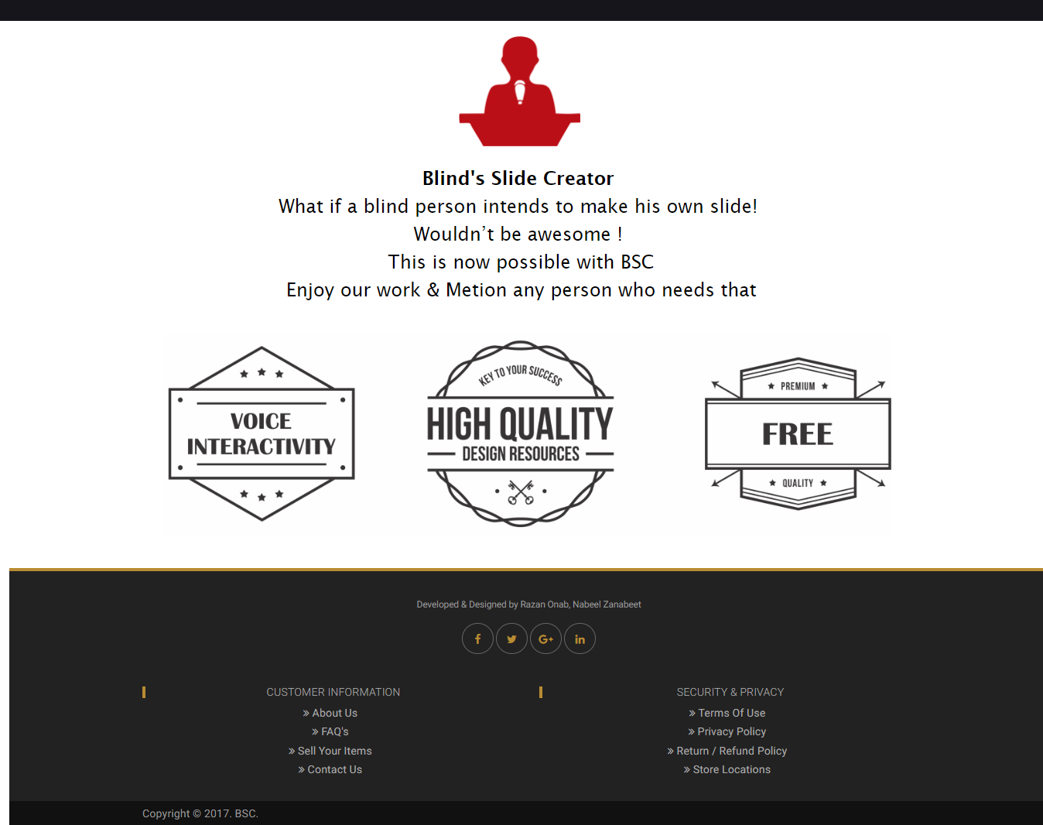
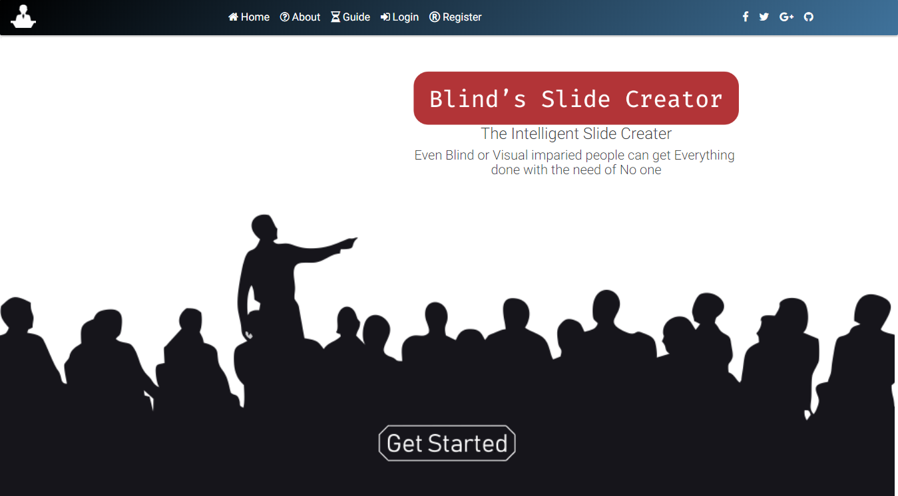

Figure1(Home Page)
Figure 1(Home page)

4.2.2 Registration & login
The mechanism for logging in and registration is done only by google account because blind people tend always to log in using their google or facebook accounts as its simple and direct. It is needed specially here to take an access to the user google drive account and update the authentication token to be able to trigger google slides API functions. Other login services provided for normal people maybe to try the website.
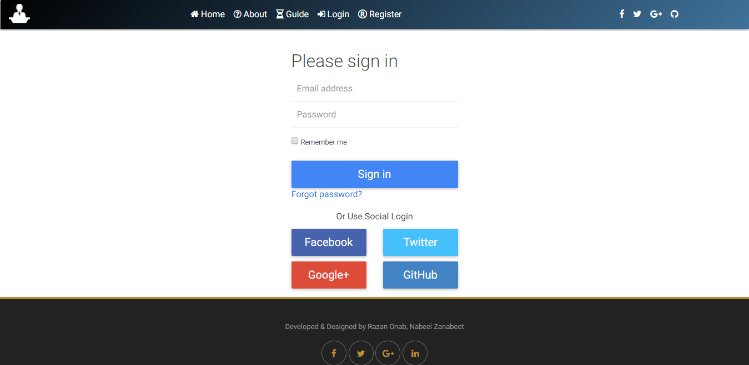
Figure 2 (Login)

After a successful login all of the authentication stuff are ready to perform command and generate slides. Now he will be directed to the dashboard page.

4.2.3 Guide & Navigation Shortcuts
The website offers the blind with a spoken guide telling him all the basic key shortcuts and available commands to generate slides. Also the mechanism that he should follow to keep everything set up right. Like hitting (TAB+G) will run the voice guide for him, (TAB+J) Generates the slide after writing the commands in the dashboard form
4.2.4 Generating slides
It is assumed that the blind person has lessen to the guide and have some quick tutorials maybe in schools to use the website as he learned how to use window narrator or smart phone assistance. So he will start entering his commands into the dashboard form then generates and download his slide show.
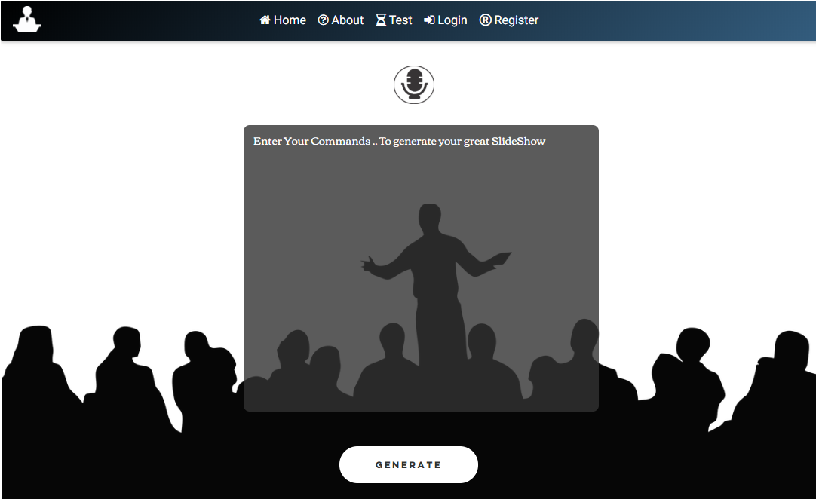
Figure 3(Dashboard)

4.2.4.1 Commands & Instructions
The user is provided with basic instruction to generate slides:
- Create Presentation (presentation Name)
This will create an empty slide show with the name provided between brackets.
- Create Title Slide (title)
This will create a slide with a big title in the middle
- Create Introduction Slide (Introduction)
This will create only a paragraph in the slide starting from the left side
- Create Paragraph or Conclusion slide (paragraph)
Same as above but the font sizes will defer
- Create Number Slide (number)
Adds a slide with big number in the middle
- Change Background Color (color)
- Change Font Color (color)
The default colors are a black background and white font, but he can change the colors and the changes is applied to all slides
- Create Table Slide (rows * columns)
Inserts a table in a new slides
4.2.4.2 Instruction mechanism
All of the previous instructions needs to be written in a specific scenario.
- The first command should be Create presentation or the slide file would be untitled.
- Each parameter should be written in a new line.
-The order of the slide follows the order of the instruction.
-For the table instruction the user should fill the data row by row
(ROW1 COLUM1) CELL
(ROW1 COLUM2) CELL
(ROW2 COLUM1) CELL
-Changing the background or font color is applied to all slides.

4.2.4.3 Interactivity
An interactive voice will follow up the process of filling the instructions. Once the user writes “Create Presentation” a voice would raise telling him ‘Now start a new line and insert the presentation name’. This is provided for each different command. The form also mimics the way window narrator use to help the blind to write. It spells out the letters then the word after hitting the space.

4.2.4.4 Inserting methods
The user has the choice to either writes the commands using the keyboard (Blind people have special keyboard that they can use and some of them use the two dashes on J & F keys as a reference). Or they can speak to enter text using web speech API, but they need to follow up the mechanism and say new line whenever needed.
4.2.4.5 Key Shortcuts
Since the need for simplicity that should be offered to the blind person to give him the easiest navigation through the website, shortcuts were used instead of buttons and clicks.
Tab is the main key:
- (Tab+H) This shortcut will navigate him to Home Page.
- (Tab+D) This opens the dashboard page.
- (Tab+S) This will save the current inserted commands so he will be able to continue later on.
- (Tab+O) To open the last saved instructions.
- (Tab+L) To login with google+ (He need to authentication only in the first time).
- (Tab+Q) To Logout.
- (Tab+J) To generate the slides and download them.
- (Tab+R) To reload the download again.
- (Tab+G) Play the guide again.
- (Tab+I) Listen to the available instructions that can be used.

4.2.4.6 Saving
To provide more reliability and dependency as it’s an online website. The user could save the last collection of instruction inserted to be able to continue later on.

4.2.4.7 Text Compiling
The algorithm used to handle the instructions is to parse the form string and split it by lines. Then differentiate between commands and parameters by comparison to provided instructions, register each command parameter and the number or occurrence. Then define a batch request that includes callings to all needed authentication and API functions to perform at once to save time instead of calling each command in a separate request.

4.2.4.8 Errors
The website includes dynamic voice interactions but at the meantime, there is no error handling or debugging, if the user does not follow up with the rules the request will fail, he needs to figure the error out by himself and make sure to follow the commands format and overall rules.

4.2.5 Automatic Download
Once the blind fill in all the instructions he needs, all he needs is to hit the shortcut (Tab+J) to generate the request then redirect him to the download link automatically so he can fine the slides as a PPT file in the download directory.

4.2.6 Navigation through the show
Window navigators do this for us, after downloading the PowerPoint file. The blind would open it to start his presentation. Windows narrator will keep up with him telling him by voice the current slide being viewed to the audience.
- Demo Example:
Figure 4(demo)
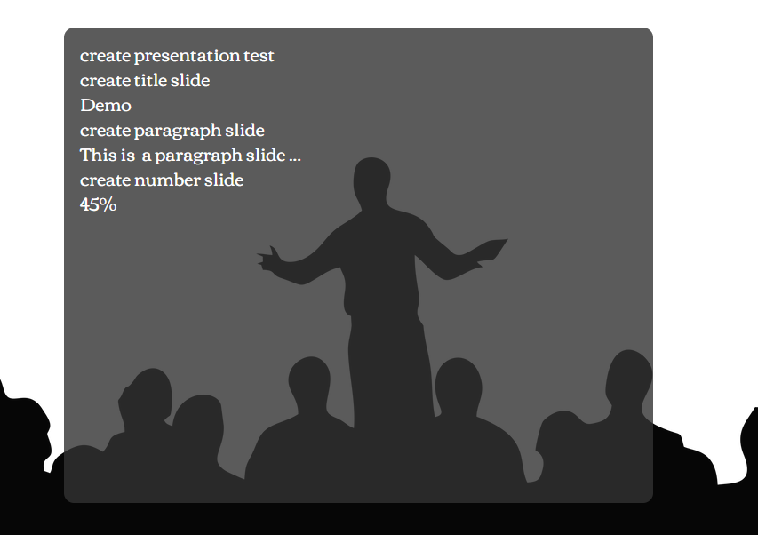

These commands will generate the following slides:
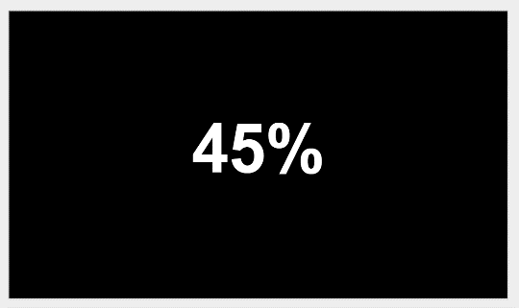
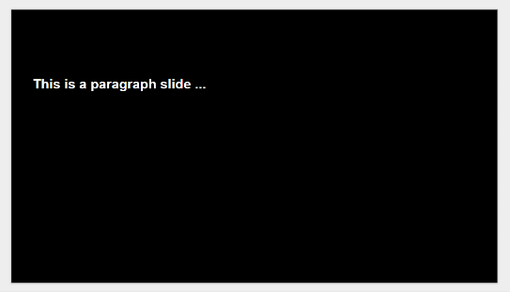
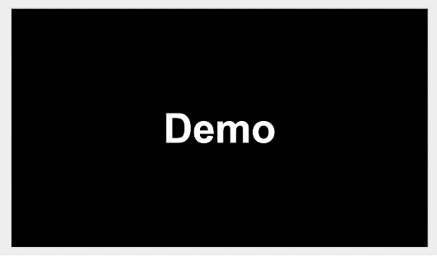

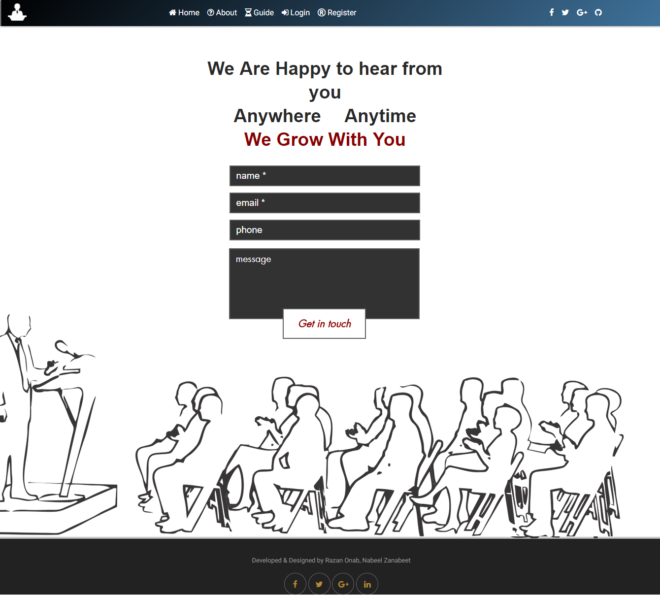
Figure 5(Contact Page)

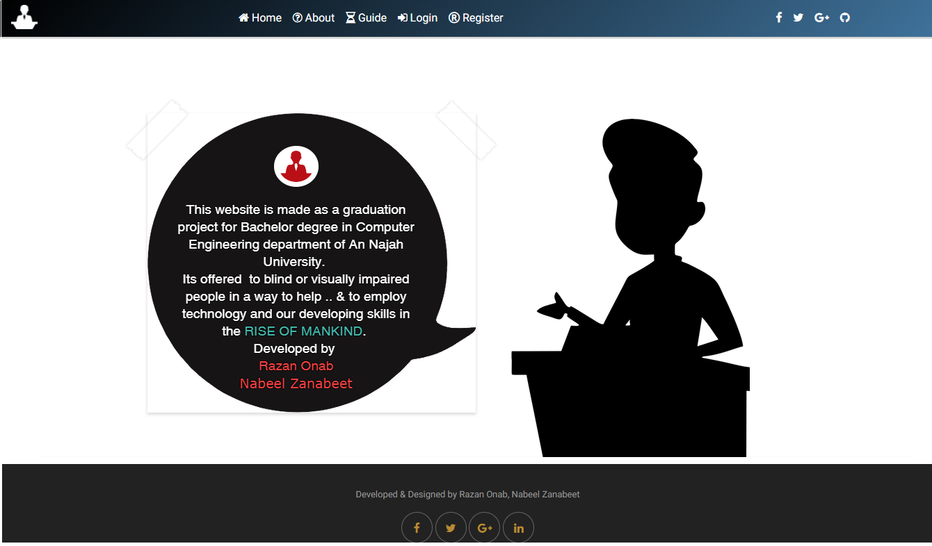
Figure 6(About page)

5- Results and Conclusion
Blinds slide creator is a website that gives blind people the opportunity to make their slides presentation through entering a specific command by voice or writing, to generate a complete presentation ready to be used. Blind’s Slide Creator offers many features to blind person to allow him take the full control of the whole process, which makes him feel more comfortable and confident to display his own work.

After research we found that Blind’s Slide Creator is a unique idea which can be a successful business and returns revenues in several ways. That’s can be improved by adding advanced features to make it global website. And so, can adding a small fee on the some of this advanced features as it would be directed to normal people as well.

This project is the born of a full management intelligent system for visual impaired people, to control their google drive account and docs, generating slides, word and excel sheets. It could be also imbedded into Siri, Bixby & Cortana assistance as well. Or maybe used by normal people to create their slide show while they head to their work or meetings.

6- References
- https://laravel.com/docs/5.6
- https://developers.google.com/slides/reference
- https://getbootstrap.com/docs/4.1

