5. Footing Design

5.1 Introduction:
Footings are defined as the substructure whose function is to transmit safely the high concentrated column or wall reaction, or lateral loads from retaining walls to the soil stratum. So the function of footings can be summarized in the following.
1) To transmit the load of the structure to the soil stratum. 2) Spread the load over large area of the stratum to minimize the bearing pressure.
Footings are classified into deferent types as follows:
1) Isolated footing, they have a rectangular, or square shape. This type of footing is used for small loads.
2) Combined footing, it is used to connect two columns if columns very close to each other.
3) Wall footing, is a continuous footing along the length of the wall, the reinforcement of flexure are placed in the short direction.
4) Piles footing, are structural elements of plain concrete or steel, they used where the bearing capacity of soil is very low.
5) Strap footing, this type carrying more than one column on longitudinal line, it is design as beam.
6) Mat foundation, is large concrete slab supporting all the columns and walls in the structure. It's used when soil conditions are poor but piles are not used.
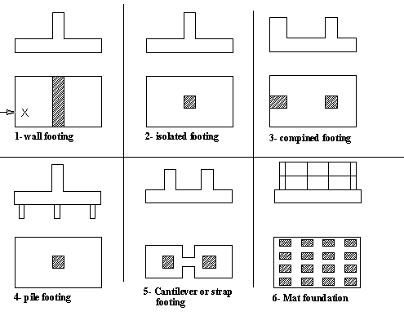
Fig (5-1) types of footing
In this Chapter we design two types of footing, single footing and wall footing, because there is a shear wall and the column are nearly almost far distance between them.

5.2 Footing design:
From chapter six we consider that the allowable bearing capacity of the soil is Q_{all} =2 kg/cm2 and this value is very important in designing the footings.

5.3 Design of isolated and wall footings:
The procedure required in the design of an isolated footing is summarized in the following steps:
1) Establish the required area or the footing by dividing the total service load by the allowable bearing capacity of soil.
A =
2) Find the effective depth of the footing d from wide beam shear.
The Vu that we taken is at distance d from the column face
3) Check footing depth for punching shear.
Where:-
Pu:-punching force
= as the figure below:-
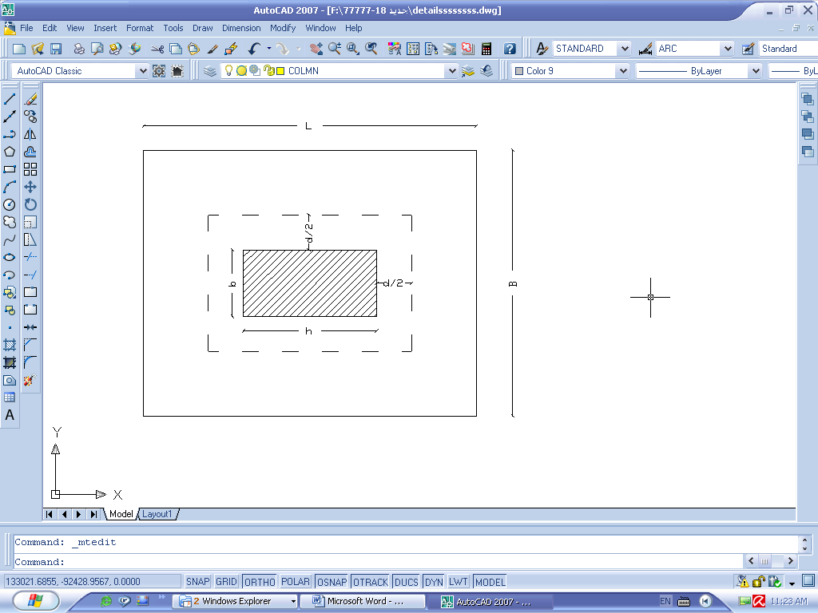
Fig (5-2) Isolated footing of Block B
Where Acr: is the Area which can be resist punching shear. ((b+d)*(h+d))
And vcp the minimum of
Where:-
Φ=0.75 according to the code (ACI 2002)
4) Flexural reinforcements:
The footing will be treated as cantilever solid slab resisting the ultimate soil pressure. The critical section for bending moment is at the face of the column. The reinforcement is distributed uniformly a cross the width of the footing.
In this case we took isolated footing and wall footing as a sample of designing for Block (A) & (B).

5.3.1 Block A
a) Design of Wall footing:
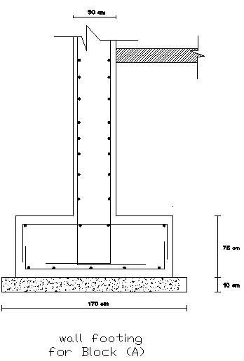
Fig(5-3) Wall footing Block A
Service dead load=25.5 ton/m.
Service live load =4.4 ton/m.
Ultimate load=1.2*DL+1.6*LL
Ultimate load=1.2*28.5+1.6*4.4=41.24 ton/m.
Width of wall footing:
B=service load/q_{all}.soil
=28.5+4.4/20=1.65 m
Use B=170 cm.
qu=ultimate load/area
=41.24/1*1.7=24.23 ton/m2
Depth of wall footing:
Vu=qu*L*1
=(24.23*1/2) *(1.7-d)
=20.6-12.12d
фVc=ф*0.53*√ 𝒇c* bo*d
фVc=0.75*0.53*√2400*1*d=19.47d
Vu= фVc
20.6-12.12d=19.47d
d=0.65
h=75 cm, d=69 cm.
Use footing (1.7X0.75) m

Longitudinal reinforcement:
𝓜=qu*L²/2
=24.23*0.775²/2 =7.28 ton.m/m.
$$ρ=0.85\frac{f_{c}}{f_{y}}\left(1-\sqrt{\left(1-\frac{{2.35M}_{u}}{{∅bd}^{2}f_{c}}\right)}\right)$$
𝜌=0.85*240/4200(1-√ (1-2.35*7.28*105/0.9*692*100*240)
𝜌=0.00041.
As= 0.00041*100*69=2.76 cm2.
As_{min}=0.002*100*69=13.8 cm2.
(7ф16).
b) Design of Single footing:
For exterior column C5:
And interior column C20:
Exterior C5:
Ultimate load=212.5 ton.
Service live load=20.22 ton.
Service dead load=150.12 ton.
Area=service load/qall
=150.12+20.22/20=8.52 m2
Area=9 b=h=3m.
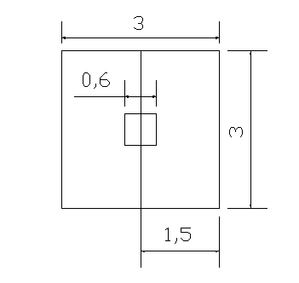
Fig (5-4 ): dimension of single footing for column C15
Footing depth:
Check wide beam shear:
qu=Pu/Area =212.5/9=23.61 ton/m2.
Vu=qu*L*B
=23.61*3*((3/2)-(0.6/2)-d)).
=85-70.83d.
фVc =0.75*0.53*√2400*1*d=19.47d
Vu= фVc
85-70.83d=19.83d d=0.94 m.
h=105 cm, d=99cm.

Check for bunching shear:
Vu=qu*{3*3-(h+d) (b+d)}
=23.61{9-(0.6+d) + (0.6+d)
Vu=204-28.33d-23.61d2
Bc=0.6/0.6=1<2
bo=2(h+d)+2(b+d) 4(h+d)
=2.4+4d
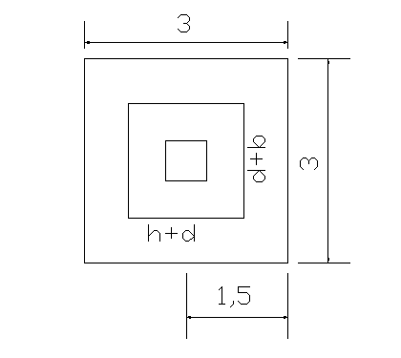
Fig (5-5): Punching shear for single footing

фVc=0.75*√ 𝒇c* bo*d/3
=0.75*0.33*√2400*(2.4+4d) d
=30d+50d2
Vu= фVc 204-28.33d-23.61d2=30d+50d2
d=1.315 m.
d=1.34 m, h=1.4 m
bo/d=(2.4+4*1.34)/1.34=5.8<20 ok.
Flexural Steel:
𝓜_{max}=qu*L2*L1²/2
=(23.61*3*1.2²)/2
Mu=51 ton.m
𝜌=0.85*240/4200(1-√ (1-2.35*51*105/0.9*1342*300*240)
𝜌=0.00025< 𝜌min=0.002
Asmin= 𝜌min*b*d=0.002*300*134=80.4 cm2
(16ф26) in both direction
Development length=0.73* ℱy*db* 𝒮/√fc
=0.37*412*26*0.8/√23.5*1000
=1.29 m
1.2+1.29=2.49<3m ok.
Load transfer from column to footing:
Pu=1.2d+1.6L Pu=212.5 ton.
Pv=0.65*0.85*fc*A_{gcolumn}
=0.65*0.85*240*60*60*10-3
=477.36 ton
PV>212.5 no need for duel reinforcement.
Interior circular column C20:
Pu=251.77 ton
Service DL=158.28 ton
Service LL=38.64 ton
Area =(158.28+38.64)/20 =9.85 m2
Area of footing=3.2X3.2 m.
Footing depth=Pu/Area
=251.77/3.22=24.59 ton/m2
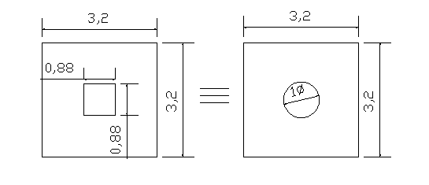
Fig (5-6) equivalent dimension
Check wide beam shear:
qu=Pu/Area =212.5/9=23.61 ton/m2.
Vu=qu*L*B
=24.59*3.2*((3.2/2)-(.88/2)-d)).
=91.26-78.67d
фVc=0.75*0.53*√2400*1*d=19.47d
Vu= фVc
91.26-78.67d=19.47d d=0.93 m.
h=100 cm, d=94cm.
Check for bunching shear:
Vu=qu*{Area-(h+d)(b+d)}
=24.59{10.24-(0.88+d)+(0.88+d)
Vu=232.76-43.28d-24.5d2
Bc=0.88/0.88=1<2
bo=2(h+d)+2(b+d) 4(0.88+d)
=3.52+4d
фVc=0.75*√ 𝒇c*bo*d/3
=0.75*0.33*√2400*(3.52+4d)d
=43.12d+49d2
Vu= фVc 73.59d2+86.4d-323.76=43.1d+49d2
d=1.19 m.
d=1.2 m, h=1.25 m
bo/d=(3.52+4*1.2)/1.2=6.93<20 ok.

Flexural Steel:
𝓜max=qu*L₂*L₁²/2
=(24.59*3.2*1.162)/2
Mu=52.94 ton.m
𝜌=.85*240/4200(1-√ (1-2.35*52.94*105/.9*1202*320*240)
𝜌=0.0003< 𝜌min=0.002
Asmin= 𝜌min*b*d=0.002*320*120=76.8 cm2
(15ф26) in both direction

Development length=0.73* ℱy*db* 𝒮/√fc
=0.37*412*26*0.8/√23.5*1000
=1.29 m
1.16+1.29=2.45<3.2m ok.

Load transfer from column to footing:
Pu=1.2d+1.6L Pu=251.77 ton.
Pv=0.65*0.85*fc*Ag_{column}
=0.65*0.85*240*88*88*10-3
=1027 ton
Pv>212.5 we don't need duel reinforcement.
5.3.2 Block B
a) Design of Wall footing:
Service dead load=10.66 ton/m.
Service live load =1.76 ton/m.
Ultimate load=1.2*10.66+1.6*1.76=15.6 ton/m.
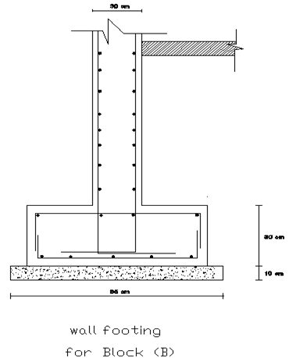
Fig(5-7) Wall footing Block B

Width of wall footing:
B=service load/qall.soil
=10.66+1.76/20=.62 m
Use B=65 cm.
qu=ultimate load/area
=15.6/1*0.65=24 ton/m2
Depth of wall footing:
Vu=qu*L*1
= (24*1/2) *(0.65/2-d)
=7.8-24d
ФVc=0.75*0.53*√240*1*d=19.47d
Vu= фVc
7.8-24d=19.47d
d=0.18
h=30 cm, d=25 cm.
Use footing (0.65X0.25) m
Longitudinal reinforcement:
𝓜=qu*L²/2 L= (0.65-0.3)/2 =0.175 m.
=24*0.175 2/2 =0.37 ton.m/m.
𝜌=0.85*240/4200(1-√ (1-2.35*0.7*105/0.9*252*100*240)
𝜌< 𝜌min=0.002
As_{min}=0.002*100*25=5cm2.
(4ф14).
b) Design of Single footing for (C56):
Interior:
Ultimate load=85.45ton.
Service live load=17.36 ton.
Service dead load=48.06 ton.
Area=service load/q_{all}
=48.06+17.36/20=3.271 m²
Area=3.6 b=h=1.9m.
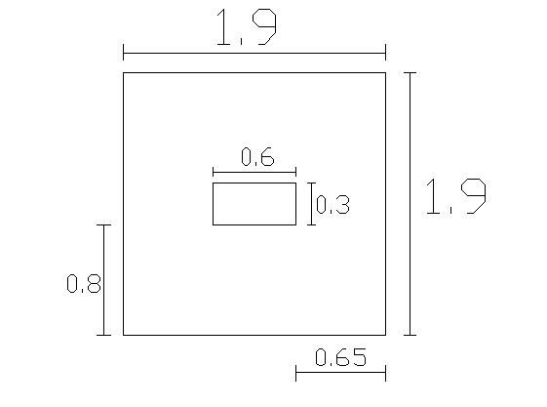
Fig (5-8): dimension of single footing for column (C56)

Footing depth:
Check wide beam shear:
q_{u}=Pu/Area =85.45/1.9²=23.67 ton/m².
Vu=q_{u}*L*B
=23.67*1.9*(0.8-d)
=36-45d
фVc=0.75*0.53*√2400*1*d=19.47d
Vu= фVc
36-45d=19.83d d=0.65 m.
h=65 cm, d=58cm.

Check for bunching shear:
Vu=q_{u}*{Area-(h+d)(b+d)}
=23.67{1.9²-(0.6+d) + (0.3+d)
Vu=81.2-21.3d-23.67d²
Bc=0.6/0.3=2=2 ok
b_{o}=2(0.6+d)+2(0.3+d)
=1.8+4d
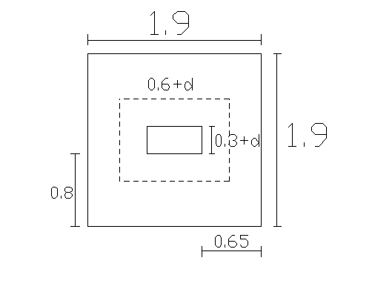
Fig (5-9): Punching shear for single footing

фVc=0.75*√ 𝒇c* bo*d/3
=0.75*0.33*√2400*(1.8+4d) d
=22.05d+49d²
Vu= фVc 81.2-21.3d-23.67d²=22.05d+49d²
d=0.8 m.
d=0.8 m, h=0.85 m
b_{o}/d=(1.8+4*0.8)/0.8=5.25<20 ok.
Flexural Steel:
In Short direction:
𝓜_{max}=q_{u}*L₂*L₁²/2
= (23.67*1.9*0.65²)/2
𝓜_{max} =9.5 ton.m
𝜌=0.85*240/4200(1-√ (1-2.35*9.5*10⁵/0.9*80²*190*240)
𝜌=0.0002< 𝜌_{min}=0.002
As_{min}= 𝜌_{min}*b*d=0.002*190*80=30.4 cm²
(10ф20) in both direction
Development length=0.73* ℱy*d_{b}* 𝒮/√fc
=0.37*412*20*0.8/√23.5*1000=1 m
0.65+1=1.65<1.9m ok
In long direction:
𝓜_{max}=q_{u}*L₂*L₁²/2
= (23.67*1.9*0.8²)/2
𝓜_{max} =14.39 ton.m
𝜌=.85*240/4200(1-√ (1-2.35*14.39*10⁵/.9*134²*300*240)
𝜌=0.0003< 𝜌_{min}=0.002
As_{min}= 𝜌_{min}*b*d=0.002*190*80=30.4 cm²
(10ф20) in both direction
Load transfer from column to footing:
Pu=1.2D+1.6L Pu=85.45 ton.
Pv=0.65*0.85*f_{c}*Ag_{column}
=0.65*0.85*240*60*30*10⁻³
=238.7 ton
P_{V}>85.5 we don't need duel reinforcement.

Exterior footing for column (C30):
Ultimate load=158.28ton.
Service live load=18 ton.
Service dead load=107.9 ton.
Area=service load/q_{all}
=107.9+18/20=6.3 m²
Area=6.7 b=h=2.6m.
Footing depth:
Check wide beam shear:
q_{u} =Pu/Area =158.28/2.6²=23.41ton/m².
Vu=q_{u}*L*B
=23.41*2.6*(1.15-d)
=70-60.87d
фVc=0.75*0.53*√2400*1*d=19.47d
Vu= фVc
70-60.87d=19.47d d=0.9 m.
h=95 cm, d=90cm.
Check for bunching shear:
𝓥u=q_{u}*{Area-(h+d) (b+d)}
=23.41{2.6²-0.18-0.9d-d²}
𝓥u=154-21.1d-23.41d²
B_{C}=0.6/0.3=2=2 ok
b_{o} =1.8+4d
фVc =0.75*√ 𝒇c* bo*d/3
=0.75*0.33*√2400*(1.8+4d) d
=22.05d+49d²
Vu= фVc 154-21.1d-23.41d²=22.05d+49d²
d=1.19m.
d=1.2 m, h=1.25 m
b_{o}/d=(1.8+4*1.2)/1.2=5.5<20 ok.
Flexural Steel:
In Short direction:
𝓜_{max}=q_{u}*L₂*L₁²/2
= (23.41*2.6*1²)/2
Mu=30.43 ton.m
𝜌=.85*240/4200(1-√ (1-2.35*30.43*10⁵/0.9*80²*190*240)
𝜌=0.0002< 𝜌_{min}=0.002
As_{min}= 𝜌_{min}*b*d=0.002*260*120=62.4cm²
(12ф26) in both direction
Development length=0.73* ℱy*d_{b}* 𝒮/√fc
=0.37*412*26*0.8/√23.5*1000
=1.29 m
1.29+1=2.29<2.6m ok.
In long direction:
𝓜_{max}=q_{u}*L₂*L₁²/2
= (23.41*2.6*1.15²)/2
𝓜=40.25 ton.m
𝜌=.85*240/4200(1-√ (1-2.35*40.25*10⁵/.9*134²*300*240)
𝜌=0.0003< 𝜌_{min}=0.002
As_{min}= 𝜌_{min}*b*d=0.002*190*80=30.4 cm²
(12ф26) in both direction
Load transfer from column to footing:
Pu=1.2D+1.6L Pu=158.28 ton.
Pv=0.65*0.85*f_{c}*Ag_{column}
=0.65*0.85*240*60*30*10⁻³
=238.7 ton
Pv>158.28 we don't need duel reinforcement.

